CONSERVATION OF ARCHEOLOGICAL WOOD USING NON-REDUCING SUGARS

by

Adeem Tahira

A Senior Honors Project Presented to the
Honors College
East Carolina University
In Partial Fulfillment of the
Requirements for
Graduation with Honors
by
Adeem Tahira
Greenville, NC
May 2015

Approved by:
Dr. Anthony Kennedy
Department of Chemistry, Thomas Harriot College of Arts and Sciences

Abstract

In the conservation field there are many different thoughts on the best way to conserve waterlogged archaeological wood. The current method uses polyethylene glycol(PEG), a hydrophilic organic compound, to replace water within the wood. PEG, which is highly effective in the short term, is hygroscopic at low molecular weights and can reabsorb water leading to problems later on, such as the formation of acid within the wood and break down of PEG itself. These problems have proved especially difficult to deal with in the Vasa, a Swedish Viking ship, which is conserved with PEG. As a result conservators have been studying alternative treatments to PEG. Sugars such as sucrose have proven to be effective in the short term but can still reabsorb water, in addition to leaving crystalline deposits on the woods surface. Sucralose and trehalose, both analogs of sucrose, are non-reducing and less likely to reabsorb moisture. Our study evaluates the effective of these non-reducing sugars as a conservation practice. Tongue depressors serve as simple models for archaeological waterlogged wood. Samples are chemically degraded and then treated with varying concentrations of sugar solutions. Data collected from dimensional analysis, before and after drying, indicates that this method is effective in conserving degraded samples. Additional mechanical analysis shows that chemically degraded wood has increased elasticity and much lower mechanical strength, as is expected. Chemically degraded wood samples treated with sugars show improved mechanical properties, measured using a three point mechanical testing method. These results will demonstrate that non-reducing sugars are an effective consolidant for samples such as these and may prove to be more effective than PEG for improving the long-term stability of wooden artifacts.
Introduction
Preserving our past provides current and future generations a window into their own history so that they may learn about the culture and events that have shaped their region. If historical archaeological artifacts are not preserved they will disappear, leaving future generations unable to understand their history. In eastern North Carolina much of the history is filled with legends of swashbuckling piracy, so much so that East Carolina University’s mascot is a pirate. Many of these legends are being brought to life in our region’s conservation laboratories and museums with the resurrection of one of America’s treasures, Blackbeard’s flagship Queen Anne’s Revenge. The federal governments, the state of North Carolina, and private donors have invested millions of dollars to recover the remains of this pirate ship. The Queen Anne’s Revenge is a wooden ship that has undergone severe degradation after being underwater for centuries (Lawrence & Wilde-Ramsing, 2001). This internal damage to the wood is one of the central issues for conservators, whose role is to stabilize the ship, as well as other artifacts, as best as possible before they are displayed in museums. Although there are different thoughts about which treatment is most effective for conserving wood, both in the short-term and long-term, the most commonly used treatment requires concurrent replacement of the water and impregnation of the wood with polyethylene glycol (PEG). Before we can begin to consider treatment or conservation of artifacts like these we must first learn about the structure of wood and the processes that lead to chemical degradation. This can help us devise strategies for helping to conserve archaeological wooden artifacts to ensure they are properly preserved for future generations.

Composition of Wood
Wood is composed primarily of three main components, namely cellulose, hemicellulose, and lignin. Cellulose, which accounts for approximately 45% of wood, is a polymer made of long chains of glucose molecules. The role of cellulose is to provide the foundation of the plant cell wall in a fiber matrix structure with hemicellulose and lignin (Greer, 2008). Hemicellulose is the second most abundant component, and accounts for approximately 20% of the weight of wood. Unlike the homogenous nature of cellulose, hemicellulose is a heterogeneous polymer of five different sugars with far more flexibility than cellulose. Hemicellulose is embedded in the cell walls and functions to cross-link cellulose and lignin fibers, thereby providing structural strength not only within the cells but also to the macroscopic structure of the wood. In addition to this, hemicellulose has been shown to play a role in the pattern formation and aggregation of cell wall components (Atalla, 2005). The third major component of wood is lignin, a hydrophobic polymer that contains aromatic ring structures that give it chemical stability. Because of this stability lignin is the last major component to degrade in wood (Colombini et al, 2009). Lignin serves to connect cellulose fibers and builds a matrix with the two other components to provide wood with additional internal strength, which prevents it from collapsing under its own weight (Kaye, 1995).

Waterlogged Wood
Wood that has been exposed to or submerged in water for an extended period of time becomes drastically altered from its original composition, as it undergoes degradation and decay. During this process of degradation and decay the cellulose and hemicellulose components are relatively quickly degraded, leaving only the lignin matrix. These wood samples are typically considered waterlogged, as the cells of the wood are become completely saturated and filled with water. This process can take place in various environments including peat bogs, wet soils, ponds, rivers, and large marine sites such as bays or oceans (Hamilton, 1999). Different levels of degradation can occur in waterlogged wood with increased percent water content indicating more degradation. The degradation of these components leaves a wood sample that resembles the original structure of the wood. However, because the major components providing structural strength are no longer present, the water within the wood is essentially the only thing providing any structural strength. When wood samples, such as these, are removed from water they begin to dry, become unstable and weak, and can shrink, bend, warp and crack (Endo, Kamei, Iida, & Kawahara, 2008). These changes occur on tangential, transverse, and radial planes with the damage being the greatest in wood that had the highest percent water content (Hamilton, 1999).
In addition to losing most of its structural components, waterlogged wood may also uptake chemicals such as sulfates, acids, and metals from the water. After excavation, the reactions between these chemicals and the surrounding environment can lead to increased deterioration of the wood. For example the Vasa, a 17th century wooden ship declared to be the largest of its size at the time, is currently deteriorating due to the chemical reactions between iron and sulfate deposits from the water. Sulfur deposits formed sulfuric acid, which has hydrolyzed and degraded the internal composition of the wood even further (Sandstrom, 2005). Specifically located in the hull timbers of the Vasa, these oxidations reactions between hydrogen sulfide and iron have left the wood in a precarious position only 40 short years since conservation began (Fors, Jalilehvand, & Sandstrom, 2011). The Mary Rose, a 16th century Tudor wooden warship, has also shown evidence of iron-sulfide oxidation (Preston, 2014). After remaining on the ocean floor for over 400 years the Mary Rose was raised in 1982. Methods of removing sulfuric acid from the timbers of the ship include using alkaline nanoparticles. Strontium Carbonate reacts with remaining sulfides to pull acidic deposits out of the wood (Chadwick, Howland, Went, Schofield, & Jones, 2014). While acid buildup in the Mary Rose can be removed, the issue of iron contamination is still a major factor. Counteracting this degradation and decay from environmental factors poses the greatest challenge to conservators.

Conservation of Archaeological Wood
Obviously archaeological wood samples are no different to other wood samples, except that they have specific cultural value. In a waterlogged environment these wood samples will undergo the same degradation and deterioration processes as normal wood. Clearly a problem if conservation of wooden archaeological artifacts is the goal, this problem represents the main issue for conservators. The goal of any conservator working with wood is to produce a museum ready artifact that is aesthetically pleasing (wood should look like wood), looks like the original object, and will continue to do so for as long as possible. There are three main goals to consider during the conservation of archeological wood. The first of these goals is to find a way to remove the excess water within the wood without causing shrinkage or distortion. The second goal is to incorporate a material into the wood that replaces the water and provides the wood with long-lasting mechanical strength (Christensen, 1970). Lastly the conservation process must be reversible (S0URCE 3). It is clear that the first two goals cannot be considered separate steps and must be accomplished at the same time. In other words, the water must be replaced by some material that not only displaces water but also consolidates the structure.

History of conservation treatments
The history of conservation treatments for waterlogged archaeological wood dates back to the 19th century. Around 1850 the alum method began to be used in Scandinavian nations. Alum, potassiumaluminiumsulphate, is a double salt containing both Potassium and Aluminum, with the form used for conservation having twelve additional water molecules. This colorless form is made up of crystals that decompose at temperature around 100 degrees Celsius (Lindahl, Sahlstedt, Sandstrom & Wikstad, 2006). The conservation process begins with soaking the wet artifacts in a high concentration of alum solution, which allows for the artifacts to become saturated with alum. This solution is boiled over several hours with larger sized objects requiring longer boiling times. Artifacts are then removed from the solution and allowed to dry. Linseed oil is liberally applied, and after the artifacts are dried a coating of clear varnish is applied to seal the oil inside the wood. Linseed oil functions to keep air and moisture out of the object while it dries (Christensen, 1970). The effectiveness of the alum method has been thoroughly studied. While some small artifacts still maintain their original shape to this day, the internal structure of these artifacts is severely compromised. Some objects are full of a dry yellow powder, which is extremely brittle and weak, while other objects are porous and full of cavities. In addition to this instability, alum has the ability to reabsorb moisture from the environment. These fluctuations in humidity cause deformities in the physical appearance of the wood such as cracking, shrinking, and bending (Lindahl, 2006). Additionally alum treated samples have increased levels of acid within the wood, pH 1-2.5, and the presence of sulfur deposits adds to chemical degradation of the artifact (Barovac & Kutzke, 2012). The alum technique remained the exclusive method for conservators for almost 100 years. During that time some scientists, such as Georg Rosenberg, began to experiment with glycerol in addition to the alum method. However, poor results, limited resources, and burdensome large-scale operations prevented the glycerol method from taking off (Christensen, 1970).
Another method that was explored during this time was the kerosene/linseed oil method. This method required artifacts to be coated in a mixture of kerosene and boiled linseed oil throughout the air-drying process (Christensen, 1970). Kerosene served as the solvent that would displace the water, and linseed oil served to seal the kerosene inside. While this method is effective on dry wood, waterlogged wood does not perform as well due to poor water for kerosene exchange and inadequate dimensional stability (Unger, Schniewind, & Unger, 2001).
The use of alcohol to dehydrate liquid in wood is also another tactic often used by conservators. Waterlogged wood is allowed to soak in baths of ether or isopropanol, followed by baths of acetone. The acetone helps replace all the water in the wood. Lastly, ethyl ether replaces the acetone in the wood and the wood is dried in a vacuum (Hamilton, 1999). Variations to this process include using methanol and dimethyl ether instead of isopropanol and ethyl ether. Dehydration is measured by testing the specific gravity of each bath in the process. This alcohol method can be followed up with the use of a hard wax-mixture to seal the alcohol in the wood. Using a hard wax- mixture is very time consuming, but does have effective results in terms of dimensional changes. The usage of polymethylmetacrylate, a synthetic polymer often used in glass, has also been studied. After dehydration with ethanol, samples undergo polymerization in a bath of polymethylmetacrylate. This method is tricky and requires precise timing (Christensen, 1970). Freeze drying using an alcohol is also another method explored by conservators. This method requires freezing wood and then storing it in a freeze dryer at temperatures of -32 to -40 degrees Celsius. Once the wood reaches -25 degrees Celsius a vacuum is used to further dry the wood. Through the freezing process sublimation of ice crystals occurs and water vapor is frozen onto condenser coils. This process continues till all the water in the wood is removed, which is assessed by weight/volume measurements. While this process can be effective, using an alcohol, such as tertiary butanol, has shown to speed up the freezing process. Some of these alcohol based methods have shown satisfactory results however, the high costs of materials and equipment are deterrents for conservators. Also the increased flammability of these materials poses an extra risk. Additionally, these methods are not always reversible which may present problems if conservators prefer to try a new treatment or to remove a past treatment. After many trial and error experiments with these treatments described, conservators eventually came to the use of polyethylene glycol (PEG) as a treatment in the early 1950’s (Christensen, 1970).
The current treatment method of choice is PEG, polyethylene glycol. PEG is a synthetic polyether compound that is water-soluble, non-odorous, non-toxic, and non-volatile. Different molecular weights of PEG exist ranging from 300 to 20,000. Lower molecular weight PEGs (300-600) are liquids, intermediates (1000-1500) semi-liquids, and high molecular weight (3250 up) waxes (Hamilton, 1999). As these molecular weights increase the melting point also increases. Inversely, hygroscopicity decreases. Ideally conservators wanted to find a relatively low hygroscopic molecular weight that could also bulk up the wood easily (Christensen, 1970) The PEG process is fairly simple in comparison to the other treatments described. Similar to past treatments the goal of conservators is to remove all excess water from the wood while also bulking up the wood at the same time. Artifacts are soaked in a bath of PEG and solvent, either water or an alcohol. Alcohol serves to lower overall treatment time. Over the span of days, weeks or even years, determined by size and degradation status of the wood, the PEG concentration is increased simultaneously with the temperature of the bath up to 60 degrees Celsius. During this time PEG is allowed to infiltrate into the wood as water begins to leach out. Excess PEG is removed from the surface of artifacts and the artifacts are allowed to cool. The concentration of PEG in the artifact can range from 70 to 100% (Hamilton, 1999). Previous studies have helped determine which molecular weight to use. Christensen, in Denmark, showed that PEG 4000 is the most effective molecular weight for bulking up the wood and also resisting water reabsorption from humidity in the environment (Christensen, 1970). PEG treatments are so commonly used because of the low cost for materials and equipment, as well as the satisfactory results attained in the short term. However, in the long term, many consequences of using PEG have arisen. PEG 4000 is a relative low molecular weight polymer, which means it is more hygroscopic than higher weight PEGs. This increased hygroscopicity causes artifacts to eventually reabsorb water. The evaporation and absorption of water in wood increases and decreases internal moisture content, which may cause cracks to develop along the grain of the wood (Bjurhager, Ljungdahl, Wallstrom, Gamstedt, & Berglund, 2010). This gain and loss of moisture also causes the wood to be more susceptible to oxidative chemical reactions with any leftover chemicals, such as sulfates, in the wood (Sandstrom, 2005). Currently, the Vasa continues to lose internal structural integrity due to these chemical reactions, as well as the long term instability of the PEG treatment utilized on the ship. Once the wood is treated with moist PEG, oxidation of iron compounds can occur further degrading the ship. In the hull of the Vasa the leeching out of past PEG treatments has caused the timbers of the wood to start to sag and become further degraded (Almkvist, 2008). Additionally, side products can often be formed from the oxidation of terminal alcohol groups on PEG’s chemical structure. These side products include polyethers, which may lead to further degradation of the wood (Kawai, 2002). PEG’s bulking abilities, as well as its relative affordability, make it easily the current method of choice. However, negative long-term effects push conservators to continue to study other treatments that would better preserve wooden artifacts.
Because of the negative long-term effects of PEG, conservators are now exploring additional treatment options to conserve archeological wood. One option worth exploring is the use of sugars as a conservation treatment. Sugars are organic compounds made up of combinations of saccharides organized in a ring structure. Sucrose, commonly known as table sugar, has similar bulking properties to low molecular weight PEG and is also cheap, easily accessible, non-toxic, and non-volatile. Treating wood with sucrose is relatively simple and requires soaking cleaned waterlogged artifacts in increasing concentrations (weight/volume) of sucrose. After reaching the desired concentration, and allowing adequate time for the sugar to soak into the wood, artifacts are dried in atmospheric controlled settings over a longer period of time than other treatment methods. This slow drying process lessens the risk of osmotic collapse (Meide, (2002). Studies, from the 1980’s, show that sucrose has satisfactory bulking capabilities comparable to PEG. The Anti-Shrink Efficiency, a model for assessing the dimensional change of a treated sample in comparison to a control sample, for sucrose treated samples was 87%. An ASE value of 75% or higher is seen as acceptable for conservation treatments (Parrent, 1985). As effective as sucrose is, just like PEG, there are negative long-term effects that limit sucrose in its use as a treatment of choice. Over time sucrose will hydrolyze and break down into glucose and fructose, which are both hygroscopic and reabsorb moisture from the air. The consequence of reabsorption of water has been previously explained (Parrent, 1985). Additionally, sucrose treatment may leave a brown sticky deposit on the surface of the wood making it aesthetically unappealing to conservators. For example, pre-historic canoes, dating from 2430 B.C to 1400 A.D, found in Lake Phelps, North Carolina, underwent a sucrose treatment for conservation in 1985(O'Cain, Watkins-Kenney, Kennedy, & Kenney, 2010). By examining the image (Figure 1) one can clearly see some of the issues associated with the use of sucrose. The sample shown exhibits substantial cracking and bending as well as deposits of crystallized sugar forming a hard crust on the outside surface of these canoes. (O'Cain et al., 2010).
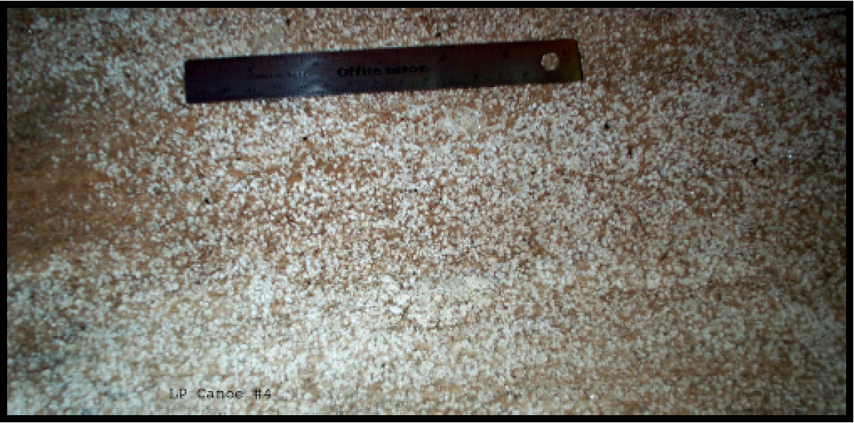
Figure 1. Crystallized sugar deposits on a canoe from Lake Phelps, North Carolina.
While sucrose may not be as effective in the long-term, promising results have pushed conservators to study analogs of sucrose. Common analogs such as lactitol, mannitol, and trehalose have been extensively studied and often have more satisfactory results than sucrose treated samples (Jones, Slater, Jones, Ward, & Smith, 2009). These sugars differ from sucrose in that they are non-reducing meaning they will not hydrolyze, a critical issue with the PEG and sucrose treatments. Two additional non-reducing analogues that have received very little attention are trehalose and sucralose (Fors et al., 2011). Previous work in our lab, focused on dimensional analysis of samples treated with these two sugars, indicates that trehalose and sucralose are just as, if not more effective than sucrose (Pennington & Kennedy, 2014). Keeping cost in mind, trehalose and sucralose are more expensive than both sucrose and PEG but provide an added benefit of long-term stability, which may appeal to conservators. However, despite initial promising results additional studies are necessary to investigate the possible use of these sugars as long term replacements for PEG. In order to be considered effective treatments one would hope that the application of these sugars does not weaken the wood and that the sugars do not break down over time. The first of these issues may be examined by mechanical testing methods, looking at the elasticity and breaking strength of wood samples treated with sucralose and trehalose. The data obtained from mechanical testing measurements on control wood samples, chemically degraded wood samples and degraded samples treated with sugars forms the main body of this thesis. The issue of long term storage was not examined as part of this study although it can be examined using accelerated aging studies as the next step in the assessment process of these promising treatments..

Purpose
This study focuses on investigating the effectiveness of using high concentrations of non-reducing sugars as a conservation treatment. Sucrose, trehalose, and sucralose treated samples are compared in terms of dimensional change and mechanical analysis properties. Specific sugar treatments that preserve experimental wood models best, in terms of anti-shrink efficiency, are seen as most effective. Mechanically, samples that can withstand sufficient stress loads as well as keeping adequate elasticity levels are seen as the best preserved. The treatment methods explored in this study may aid conservators in achieving all of their goals when conserving wooden artifacts. Locally, our efforts are most related to preserving the Queen Anne’s Revenge. Allowing current and future generations the chance to continue to learn about the culture behind their current situation is an invaluable experience that is sure to be enjoyed and historically appreciated.

Materials & Methods
Sample Preparation
A batch of white birch medical tongue depressors was chemically degraded in a 1% (v/v) sodium hydroxide (pH~14) solution for one week (Parrent, 1985). After this time the samples were neutralized by soaking in distilled water, which was regularly replaced, over one to three days, until the samples tested at a pH of 7. A subset of these neutralized chemically degraded tongue depressors were removed and left to air dry for one week with dimensional changes being measured before and after drying. Length and width measurements on all samples were recorded with Vernier calipers (±0.05mm) and thickness measurements were recorded with a micron screw gauge (±0.005mm). Each dimension was measured three times and the average was recorded and used for calculations.
Treatment of Degraded Samples
The remaining chemically degraded tongue depressors were separated into equal groups of ten. Each group was treated with a specific sugar (sucrose, sucralose, or trehalose). Sucrose (99% purity, 342.30 g/mol, Fisher Scientific), sucralose (anhydrous, 397.64 g/mol, 98% purity, Fisher Scientific) and D-trehalose (anhydrous, 342.296 g/mol, 99% purity,Fisher Scientific) were all used without further treatment or purification. Appropriate concentrations of each sugar were added to distilled water to obtain a 15% concentration (w/v). Samples were left to soak for one week and then additional sugars were added to achieve a 30% concentration. This process was repeated for 45%, 60%, 75% and 100% concentrations. Samples were then removed from the sugar solutions and left to dry. Dimensional changes due to air-drying were recorded.

Additional Sample Preparation
In order to obtain consistent data more waterlogged white birch tongue depressors were chemically degraded and treated with sugars. All samples were originally degraded in a 1% (v/v) sodium hydroxide (pH~14) solution for one week and then neutralized to a pH of 7. A subset of these degraded samples was left to dry flat on a piece of paper under a ceramic plate for two weeks. The other degraded samples went into 60% (w/v) concentration solutions of sucrose, sucralose, and trehalose for two weeks. These samples were then removed and left to dry flat on a piece of paper under a ceramic press for two weeks. Dimensional changes due to air-drying were recorded.

Mechanical Testing
Mechanical testing was done using a three-point bend press that measures stress versus strain. This machine is called an Intron Mechanical Testing System. All samples were tested at a 70mm span. Testing was completed on control samples, chemically degraded samples, waterlogged samples, and sugar treated samples. Data collected included stiffness, elasticity, maximum deflection, maximum load, and flexural stress.

Discussion and Results

Dimensional Analysis

Data for dimensional analysis was obtained from a previous study that allowed for the continuation of research on these samples. For baseline measurements experiments were conducted on untreated samples of tongue depressors. Fresh untreated samples served as controls. Data on waterlogged samples was obtained by using ten tongue depressors that were soaked in water for over three years. These samples were left out to dry for one week under normal atmospheric conditions. Data on chemically degraded samples was obtained similarly by soaking ten tongue depressors in 1% sodium hydroxide for one week and then drying them for one week under normal atmospheric conditions.
For sugar treated samples 36 waterlogged tongue depressors were separated into groups of 3. Each group received a different sugar treatment; sucrose, sucralose, and trehalose. Each group was placed starting in 15% weight by volume sugar solution for one week. After one week three tongue depressors were removed and left to dry under normal atmospheric conditions for one week. After one week at 15% the concentrations of the sugars were increased to 30%. This pattern followed with three tongue depressors being removed and dried at each concentration. The sugar concentrations were increased to 45%, 60% for all three sugar types. The maximum concentration of sucralose was 60% due to sucralose reaching its saturation point around this mark. Sucrose and trehalose samples were extended to 75% and 100% concentrations.
Changes in length, width, and thickness measurements from pre and post drying are used to determine shrinkage. The least amount of change among measurements corresponds to greater efficiency of treatment. This change can be directly measured by the Anti-shrink Efficiency (ASE) using equation 1;
$$ASE= \frac{β_{0}-β_{1}}{β_{0}} x 100\% …………Equation 1$$
where β_{o} is the shrinkage of untreated samples and β₁ is the shrinkage measured for treated samples.
Chemically degraded samples had the greatest change in width and thickness dimensions, with significant visible changes present including bending and warping. In comparison treated tongue depressors performed better in terms of ASE. As shown in table 1 higher concentrations of sugar corresponded to increased ASE, with 100% trehalose having the highest overall value. However, it should be noted that differences among sugars at the same concentration are relatively low. When comparing individual sugars sucralose does perform better than both sucrose and trehalose at the same concentrations but these samples also had some bending and warping present. On the other hand trehalose performs just as well as sucrose at most concentrations, even exceeding sucrose, in ASE, at 100% concentration. Trehalose treated samples did not have as much bending and warping as sucralose samples but small amounts of crystalline deposits were visible on the surface of the wood at higher concentrations.
Table 1: Anti shrink efficiency (% ASE) of each sugar at various concentrations (% w/v) on each set of samples are shown. The relative standard deviations (%) are given in parentheses.

 | Anti Shrink Efficiency
Sugar Treatment | 45% (w/v) Sugar | 60% (w/v) Sugar | 75% (w/v) Sugar | 100% (w/v) Sugar
Sucrose  Sucralose  Trehalose | 46.2% (2.5)  58.7% (1.9)  46.6% (2.1) | 59.0% (3.1)  63.2% (3.9)  61.8% (3.0) | 70.4% (3.4)  64.8% (3.1) | 85.9% (3.2)  92.2% (3.0)

The similar performance of trehalose to sucrose in terms of ASE can be attributed to the structure and configuration of the molecule itself. Due to similarities in molecular weight it is reasonable to assume that trehalose would perform in the same manner as sucrose. While there are some minor differences in the structure of these two sugars their response to any leftover components in the wood is expected to be the same. Conversely, when comparing the structure of sucralose to sucrose there are great differences. Sucralose has three chlorine atoms, which replace the original hydroxyl groups found in sucrose. These substitutions are what allow sucralose to maintain stability; however they may also play a factor in preventing hydrogen bonding interactions between remaining wood components and sugar molecules. It would seem that disruptions in hydrogen bonding would lead to decreases in the effectiveness of the treatment. Due to sucralose performing just as well, if not better, than sucrose and trehalose these limitations in hydrogen bonding may not be as important as originally thought.
While both sucralose and trehalose performed well in terms of ASE, differences in physical appearance such as bending and warping in sucralose samples and crystalline deposits in trehalose samples may limit the extent to which these treatments could replace sucrose in conserving archaeological wood.

Mechanical Strength Part I
To calculate different components of mechanical strength five tongue depressors from each untreated and treated category were tested using the Intron testing machine. After initial testing of previous atmospheric dried samples a second round of testing was done on untreated and 60% treated samples dried under a ceramic plate. Bend Test results are indicative of the stiffness, maximum load sustainable, modulus of elasticity, and maximum stress that a sample can withstand. After each sample is tested under the Intron testing machine, data including the compressive extension and compressive load is compiled into a spreadsheet. The compressive extension and compressive load data is isolated and plotted in a XY scatter plot for each specimen. These plots essentially measure stress versus strain. An example of this scatter plot is represented in Figure 2. This first plot has a very linear relationship between extension and load until the sample undergoes catastrophic failure, which is observed as a sudden and dramatic decrease in the observed load. Not all plots of samples were as consistent as this sample. Figure 3 shows a stress vs. strain plot where the sample cracks, readjusts and continues to sustain more stress until it ultimately fails.
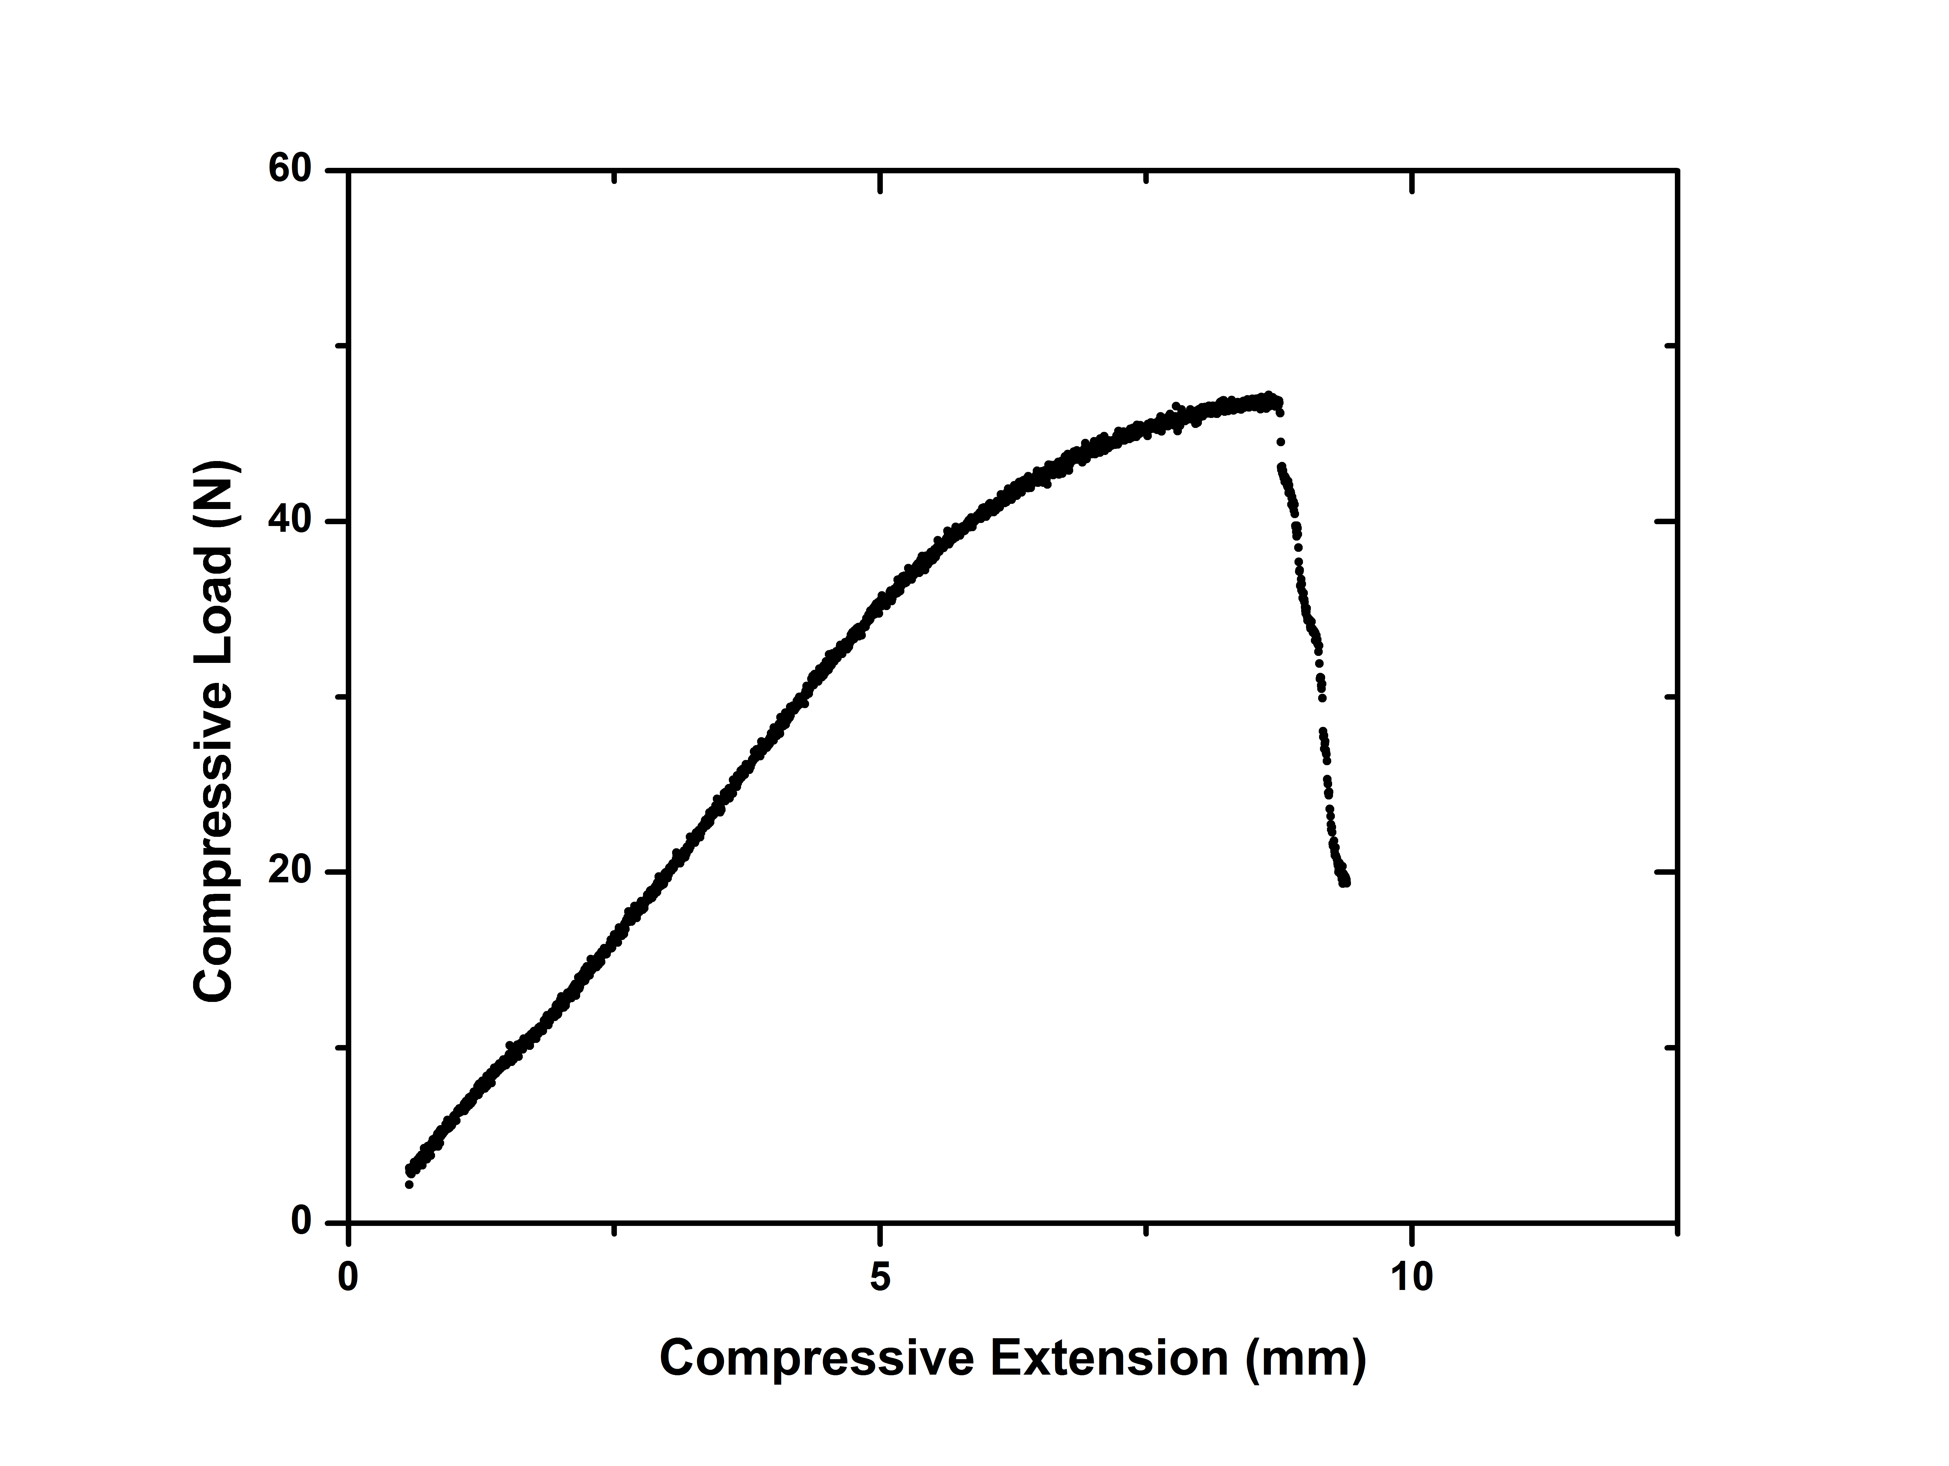
Figure 2: Stress vs. Strain for Control Sample 2 obtained using the three point bending measurements. The sample clearly breaks (catastrophic failure) when the load reaches approximately 48 Newtons and this failure is observed as a sudden and dramatic decrease in the measured load.
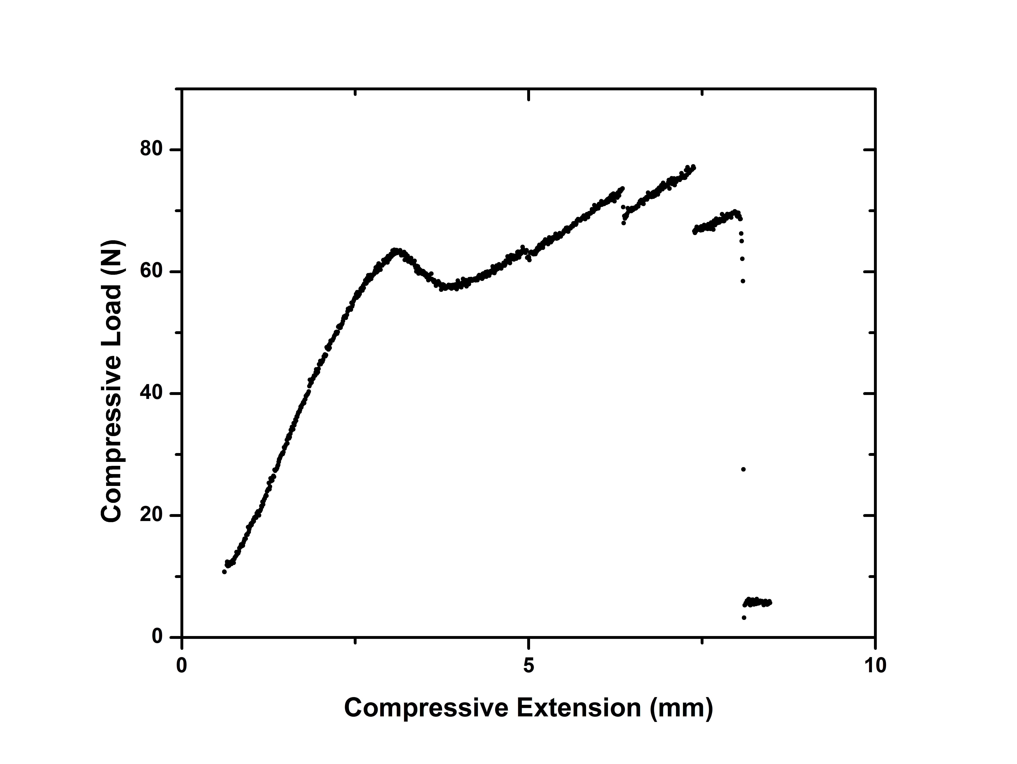
Figure 3: Stress vs. Strain for 60% concentration Trehalose sample 3 obtained using the three point bending measurements. The sample first cracks around 6mm and then readjusts and continues to sustain a greater load (Newtons) before cracking again. These cracks cause the sample to break (catastrophic failure) at a lower load than ultimately sustainable by the sample.

Stresses vs. strain graphs are indicative of many mechanical strength properties. When the linear portion of the graph is isolated and a linear trend line is added, the slope represents the stiffness of the sample. Stiffness is a measure of the rigidity of an object. It can also be referred to as the force needed to cause a deflection of one mm. From graphs of load versus deflection for each sample the stiffness can be calculated by isolating the slope from the most linear portion of the graph. After stiffness is determined it can be used as the spring constant in the Young’s Modulus of Elasticity equation. Like stiffness this equation measures the rigidness of an object however it differs in that the Modulus of Elasticity is an intrinsic property and depends on geometrical dimensions. The Young’s modulus of Elasticity was used to calculate this value for all samples
The Young’s Modulus of Elasticity is calculated using equation 2;
$$E=\left(\frac{F}{δ}\right)\frac{L^{3}(12)}{48\left(wt^{3}\right)}=k\left(\frac{L^{3}}{4wt^{3}}\right) …..Equation 2.$$
where:
$F$ = load applied at mid-span
$L$ = span of the beam (distance between supports)
$E$ = Modulus of elasticity of the material
$I$ = Moment of inertia of the cross-section
k = spring constant
For a rectangular cross-sections,
$$I=\frac{1}{12}wt^{3} …..Equation 3.$$
Where $w$ and $t$are the width and thickness of the cross section, respectively.
Figure 5 shows the Modulus of Elasticity of untreated and 45% and 60% sugar treated samples. All sugar treated samples had a higher modulus of elasticity, MOE, than both control and chemically degraded samples. Sucralose at 45% had the highest MOE when compared to other sugars.
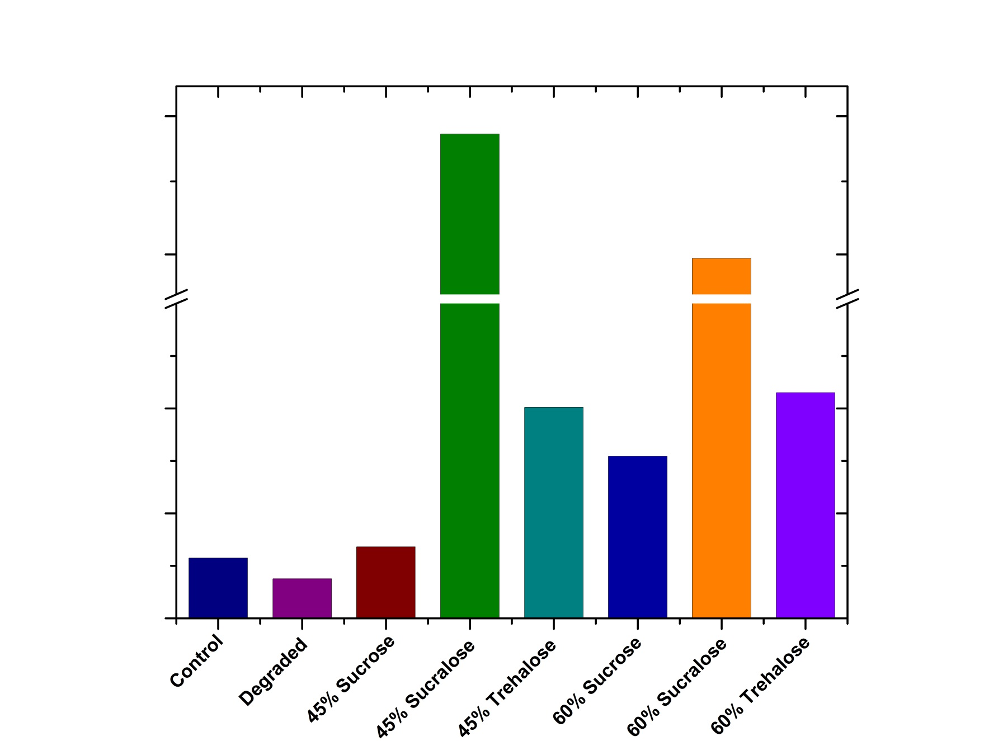
Figure 4: Modulus of Elasticity of untreated, 45% and 60% concentration treated samples as determined by the Young’s Modulus of Elasticity equation.

Once the Modulus of Elasticity is determined the ultimate stress can be calculated using the maximum load. The maximum deflection of a sample is used to determine the correct maximum load before catastrophic failure. This maximum deflection is calculated by plotting the average extension versus the second derivative of the load. By using the second derivative a precise deflection measurement can be determined. The corresponding maximum load to the deflection load is indicative of the highest force the tongue depressor can withstand without catastrophic failure. Figure 6 highlights the results from samples tested. All treated samples could sustain a higher load than untreated samples. Out of the sugar treated samples trehalose samples could sustain the highest load at both 45% and 60% concentrations, with 45% trehalose sustaining the highest load overall.
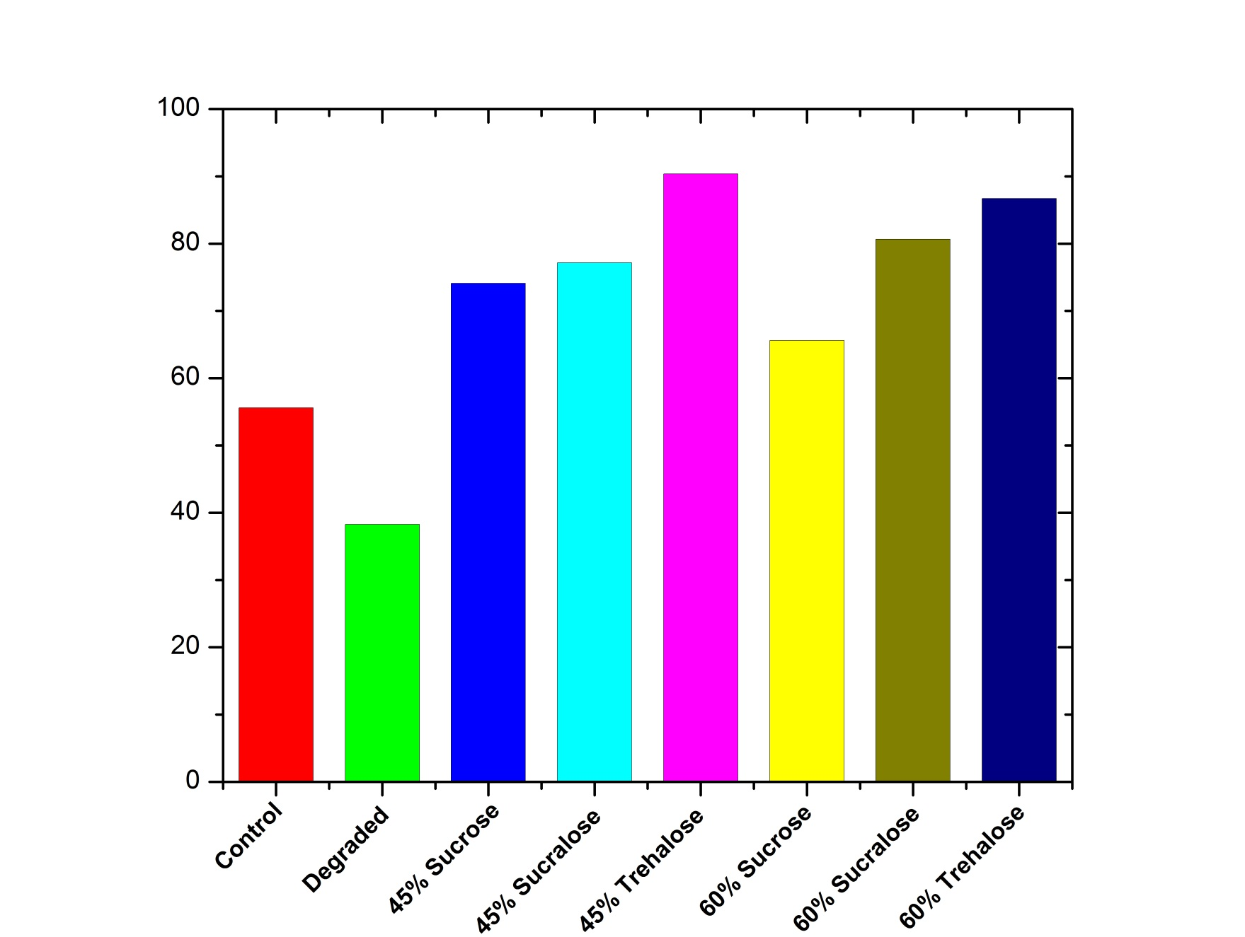
Figure 5: Maximum load sustainable at catastrophic failure of untreated, 45% and 60% concentration treated samples.

Mechanical Strength Part II
To obtain more uniform samples for mechanical analysis, testing was redone on samples that had minimized warping, twisting, and bending. As before, all samples were degraded and then treated with sugars. This time in the drying process a ceramic plate was placed on top of the samples to limit the amount of bending that could occur. 60% concentration was chosen for all treated samples as it showed the most promising results from the first phase of mechanical testing.
All samples were mechanically tested in the same way and stiffness, modulus of elasticity, and maximum load values were all determined as before. The modulus of elasticity for these samples is represented in Figure 7. All sugar treated samples were more rigid than untreated samples with trehalose increasing the rigidity of the wood the most in comparison to sucrose and sucralose.
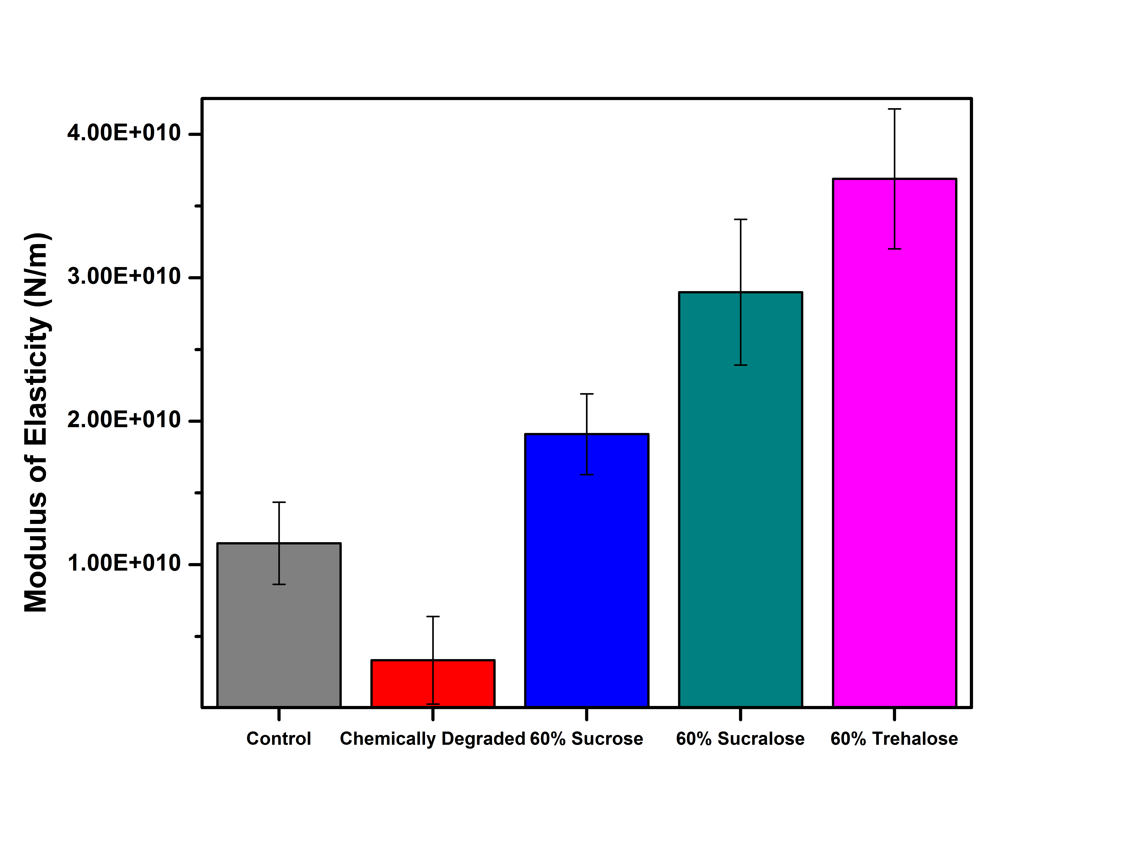
Figure 6: Modulus of Elasticity for untreated and 60% concentration treated samples as determined from the Young’s Modulus of Elasticity equation.

Maximum load was also determined of this second batch of samples as before. Figure 8 shows the maximum load till catastrophic failure of untreated and treated samples. When comparing maximum load till catastrophic failure of these samples all sugar treated samples performed better than untreated samples. The resulting mechanical strength of these samples is greater than fresh control samples that were not subjected to any degradation process.
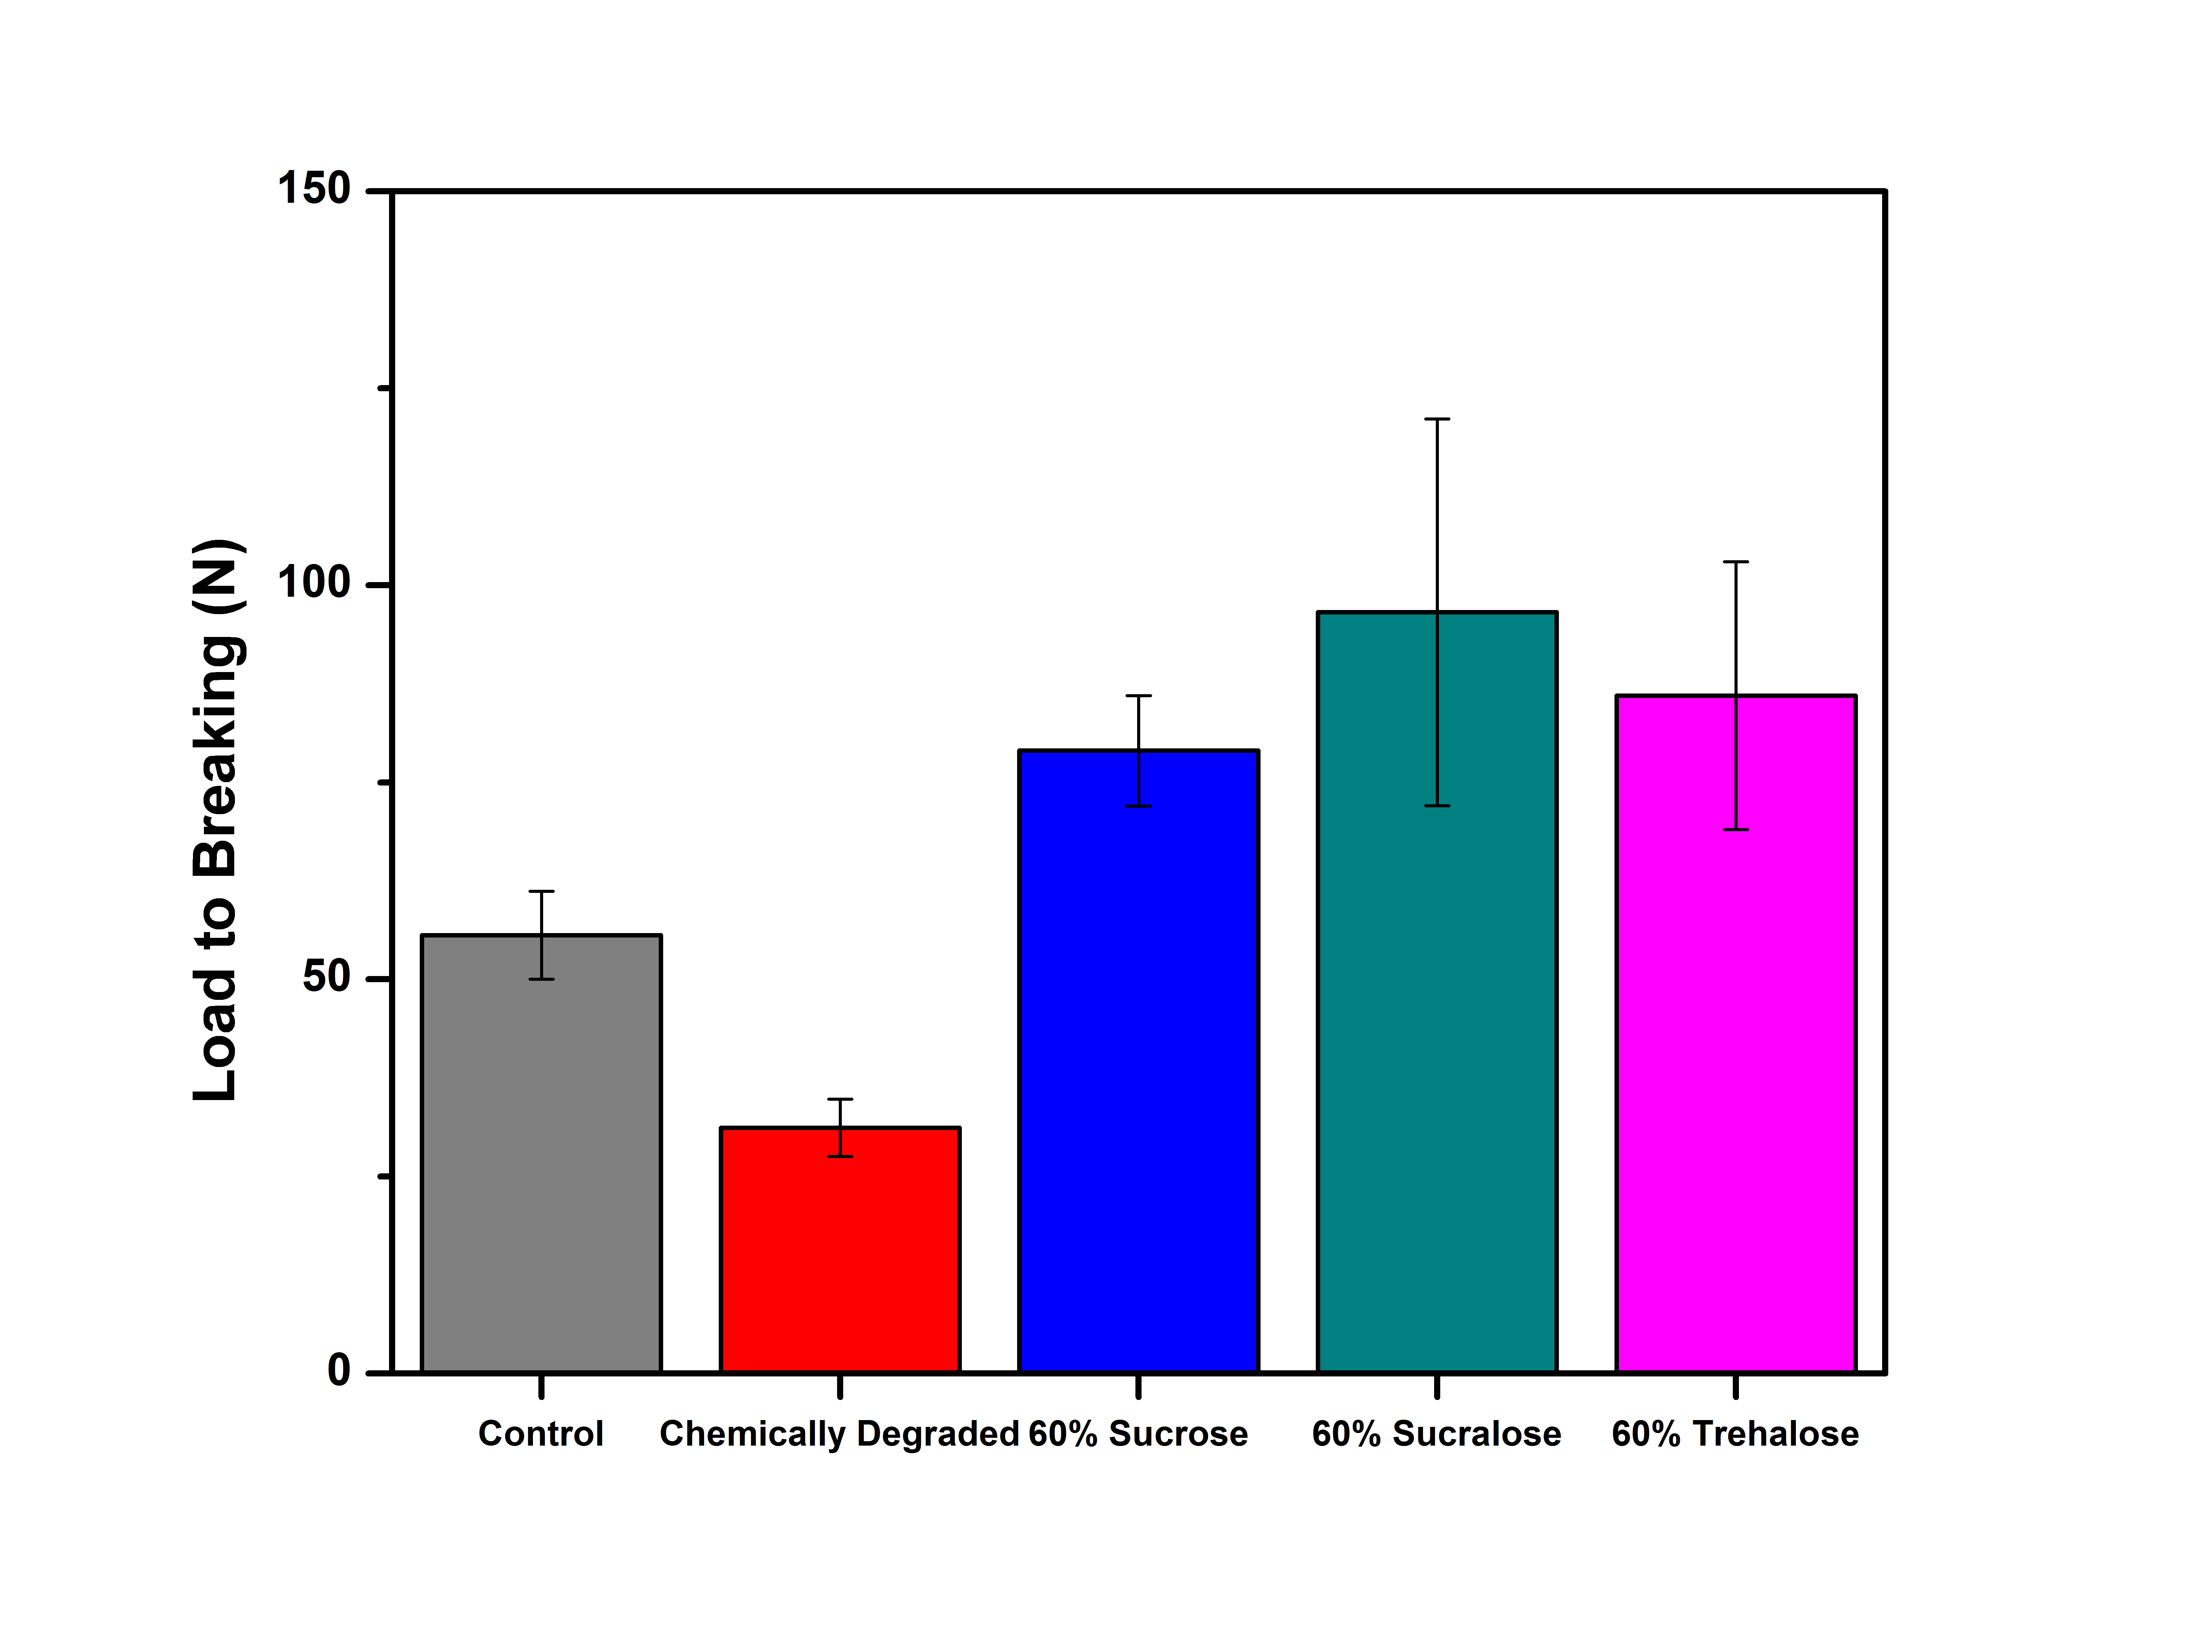
Figure 7: Maximum load sustainable at catastrophic failure of untreated and 60% treated samples.

The Modulus of Elasticity and maximum load can be utilized to compare to internal structural strength of each type of tested sample. Chemically degraded samples had lower modulus of elasticity’s indicating that they are less rigid and more elastic than control samples and treated samples. Similarly, in terms of maximum load sustainable before catastrophic failure chemically degraded samples had lower values indicating weaker structural strength than control and treated samples. These results can be expected, as these samples have no bulking agents to provide any structural strength to the wood.
Unlike chemically degraded and even control samples, all sugar treated samples had higher Modulus of Elasticity values and could sustain higher loads before catastrophic failure. These greater values indicate that the sugar treated samples are stronger and less elastic. Sugar treated samples are also more brittle than untreated samples. It was expected that sugar treated samples would have greater overall mechanical strength than degraded samples but it was unexpected for them to be stronger than control samples. A possible explanation to why these samples are stronger than control samples could be sugar crystallization. When sugar molecules permeate into the wood and are allowed to dry they may crystallize, or harden, into a natural lattice formation. This sugar lattice, which is not present in control samples, causes the wood to be stronger, with increased rigidity and the ability to sustain greater loads. Overall mechanical strength data indicates vastly improved properties in treated samples compared to untreated samples.

Conclusion

Both dimensional analysis and mechanical strength data indicate that sucralose and trehalose are as effective as sucrose for treating chemically degraded wood. However the ability of sucralose and trehalose to withstand hydrolysis makes them more attractive possibilities for the long term conservation of degraded wooden artifact, thereby serving as possible replacements for polyethylene glycol. In fact, dimensional analysis indicates that these sugars perform almost as well as PEG in reducing the shrinkage of treated wood samples.
Although we have no data obtained on samples treated with PEG to directly compare the mechanical strength, anecdotal evidence indicates that PEG does not impart much in terms of added strength to degraded wood samples. In fact researchers treating the Vasa have indicated (REF PERSONAL COMMUNICATION) that timbers from that ship are bending and bowing under their own weight indicating a high degree of elasticity and a lack of basic mechanical strength.
The combination of dimensional analysis and mechanical testing data indicates that both trehalose and sucralose should be investigated further. Long-term studies must be performed to assess the effectiveness of these sugars before they can be fully recommended as conservation treatments for archaeological wood. These studies should include accelerated aging studies on treated samples and sugar stability studies.

Works Cited

Almkvist, G. (2008). The chemistry of the Vasa-iron, acids, and degradation. Uppsala. 57.
Atalla, R. (2005). The role of the hemicelluloses in the nanobiology of wood cell walls: a systems theoretic perspective. Proceedings of the Hemicelluloses Workshop. 2005, 37-57.

Bjurhager, I., Ljungdahl, J., Wallstrom, L., Gamstedt, E., & Berglund, L. (2010). Towards improved understanding of PEG-impregnated waterlogged archaeological wood: a model study on recent oak. Holzforschung: International Journal of the Biology, Chemistry, Physics, & Technology of Wood. 64(2). 243-250.

Barovac, S., & Kutzke, H. (2012). The presence of sulfuric acid in alum-conserved wood – origin and consequences. Journal of Cultural Heritage. 13(3). S203-S208.

Chadwick, A., Howland, K, Went, M., Schofield, E., & Jones, A. (2014). The application of ionic nanoparticles in the conservation of archaeological wood. Macromolecular Symposia. 337(1). 74-79.

Christensen, B. (1970). The conservation of waterlogged wood in the national museum of denmark. Copenhagen: Andelsbogtrykkeriet i Odense

Colombini, M., Lucejko, J., Modugno, F., Orlandi, M., Tolppa, E., & Zoia, L. (2009). A multi-analytical study of degradation of lignin in archaeological waterlogged wood. Talanta. 80(1). 61-70.

Endo, R., Kamei, K., Iida, I., & Kawahara, Y. (2008). Dimensional stability of waterlogged wood treated with hydrolyzed feather keratin. Journal of Archaeological Science. 35(5). 1240-1246.

Fors, Y., Jalilehvand, F., & Sandstrom, M. (2011). Analytical aspects of waterlogged wood in historical shipwrecks. The Japan Society for Analytical Chemistry. 27(8). 785-792

Greer, L. (2008) The structure of wood. Retrieved January 15, 2015 from http://www.doitpoms.ac.uk/tlplib/wood/structure_wood_pt1.php

Hamilton, D. (1999). Methods for conserving archaeological materials from underwater sites. Conservation of Archaeological Resources I. 1. 22-29.

Jones, S., Slater, N., Jones, M., Ward, K., & Smith, A. (2009). Investigating the processes necessary for satisfactory freeze-drying of waterlogged archaeological wood. Journal of Archaeological Science. 36(10). 2177-2183.

Kawai, F. (2002). Microbial degradation of polyethers. Applied Microbiology Biotechnology. 58(1). 30-38.

Kaye, B. (1995). Conservation of waterlogged archaeological wood. Chemical Society Reviews. 24, 35-53.

Lawrence, R., & Wilde-Ramsing, M. (2001). In search of Blackbeard: Historical and archaeological research at shipwreck site 0003bui. Southeastern Geology, 40(1)​, 1-9.

Lindahl, K., Sahlstedt, M., Sandstrom, T., & Wikstad, E. (2006). Saving alum-treated archaeological wood – report from a research project underway. Third Triennial Conservation Conference

Meide, C. (2002) Sucrose (sugar) treatment of waterlogged wood. Retreived February 8, 2015 from http://www.staugustinelighthouse.org/LAMP/Conservation/sucrose-treatment

O'Cain, F., Watkins-Kenney, S., Kennedy, A., & Kenney, J. M. (2010). Analysis of Sugars Used for Conservation of pre-Columbian Dugout Log Canoes Recovered from Lake Phelps, North Carolina. International Conference on Wet Organic Archaeological Materials ICOM-WOAM 2010.

Parrent, J. (1985). The conservation of waterlogged wood using sucrose. Studies in Conservation. 30(2). 63-72.

Pennington, E. & Kennedy, A.(2014). Conservation of chemically degraded waterlogged wood with sugars. Studies in Conservation, 59(3), 194-201.

Preston, J., Smith, A., Schofield, E., Chadwick, A., Jones, M., & Watts, J. (2014). The effects of Mary Rose conservation treatment on iron oxidation processes and microbial communities contributing to acid production in marine archaeological timber. PLoS One. 9(2). E84169.

Sandstrom, M., Jalilehvand, F., Damian, E., Fors, Y., Gelius, U., Jones, M., Salome, M. (2005). Sulfur accumulation in the timbers of King Henry VIII's warship Mary Rose: A pathway in the sulfur cycle of conservation concern. Proceedings of the National Academy of Sciences of the United States of America. 102(40). 14165-14170.

Unger, A., Schniewind, A., & Unger, W. (2001). Conservation of wood artifacts: A handbook. Berlin, NY: Springer.

