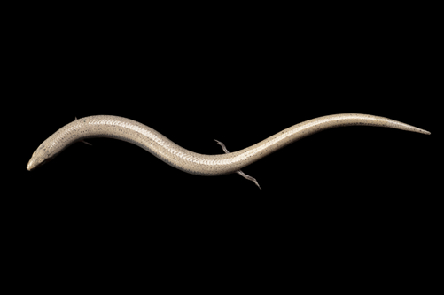

East Carolina University

Thomas Harriot College of Arts and Sciences & The Honors College

Present:

P

**EFFECT OF ACHILLES TENDON MOMENT ARM ON KNEE JOINT CONTACT FORCES**

BY ASHLEY WARREN

Mentored by John D. Willson



**APRIL 22, 2016**

**2-3 PM**

**HOWELL N102**