Healthcare Providers’ Knowledge and Educational Needs in Addressing Childhood Obesity
Tennillya Pearce
East Carolina University

Table of Contents
CHAPTER 1: INTRODUCTION……………………………………………………........5
Introduction of Problem…………………………………………………………..5
Purpose and Objectives…………………………………………………………...5
Background of Problem……………….………………………………………….6
Significance of Problem………………………………………………………….7
Project Support by Practice Setting………………………………………….......7
CHAPTER 2: RESEARCH BASED EVIDENCE………………………………………9
Literature Review………………………………………………………………..9
Critical Analysis of Literature …………….…….………………………………9
Literature Synthesis…………………………………………………………….12
Concepts and Definitions………………………………………………………13
Theoretical Framework ………………….…………………………………….14
CHAPTER 3: METHODOLOGY…..…………………………………………………17
Design…………...……………………………………………………………..17
Setting……….…………………………………………………………………17
Sample…............................................................................................................18
Method…………………………………………………………………………18
Protection of Human Subjects………………………………………………….20
Instruments…………………………………………………………………......20
Data Collection Method……………………………………………………......21
Data Analysis Plan…………………………………………………………......22
Cost Analysis/ Budget………………………………………………………….22
CHAPTER 4: RESULTS.………………………………………………………….......23
Barriers to Implementation………………………………………………….....23
Limitations……………………………………………………………………..23
Intended Outcomes………………………………………………………….....24
Findings………………………………………………………………………..24
Table 1 Percentage of Children Screened, Assessed, & Counseled…………..26
Table 2 Missed Opportunities to Address Childhood Obesity………………..27
CHAPTER 5: IMPLICATIONS FOR NURSING PRACTICE………………………28
AACN DNP Essentials………………………………………………………..28
DNP Essentials and its Significance to Nursing Practice……………………..33
CHAPTER 6: CONCLUSION………………………………………………………..35
Final Conclusion………………………………………………………………35
Future Recommendations……………………………………………………..35
REFERENCES…………………………………………………………………………37
APPENDICES…………………………………………………………………………40
Appendix A- (IRB Letter)……..………………………………………………40
Appendix B- (Project Site Approval)………………………………………....41
Appendix C- (Invitation to Participate).……………………………………....42
Appendix D- (Tools)……….…………………………………………………43
Appendix E- (Chart Review Checklist)………………………………………52
Appendix F- (Timeline)………………………………………………………55
Appendix G- (Literature Matrix).…………………………………………….57

Chapter 1
Childhood obesity is a major health problem that has tripled since the late 1970s, leading to chronic conditions such as diabetes, heart disease, sleep apnea, asthma, depression and musculoskeletal problems (CDC, 2017). In the United States, approximately 30% of children are overweight and obese (Shaikh, Nettiksimmons, Joseph, Tancredi, & Romano, 2014). Although any child is at risk of becoming overweight or obese, childhood obesity is more prevalent in rural areas and rates are highest amongst the Hispanic, Indian, and African American populations (CDC, 2017).
Despite numerous research studies, programs, and guidelines that have been enacted to reduce childhood obesity, this issue continues to be of great concern. Many children are developing comorbidities at a younger age, resulting in a decrease in their quality of life and an increase in healthcare costs. Since healthcare providers have a critical role in improving healthcare through the Triple Aim Initiatives (Institute for Healthcare Improvement, 2017), being able to consistently screen, assess, and implement ways that would improve the quality of life for the child and parent is of significance. However, to be able to address these issues with the parent and child in a supportive way depends on healthcare providers’ actively addressing childhood obesity.
Purpose and Objectives
The purpose of this project was to develop, implement, and evaluate a childhood obesity management program in a rural health department utilizing the American Academy of Pediatric guidelines (Daniels & Hassink, 2015). The goal was that healthcare providers would consistently address children’s body mass indexes greater than or equal to 85% at each visit and add ICD-10 diagnostic code Z68.53 for overweight or Z68.54 for obesity. In addition to the overweight and obesity ICD 10 codes, ICD 10 diagnostic code Z72.9 would also be added indicating that there was a problem related to lifestyle and that counseling regarding childhood obesity complications and management with the child and family was done.
Background of Problem
In North Carolina, the percentage of overweight children ranges from 15.5% in 2-4 years old, 14.7% in 5-11 years old, and 12.6% in 12-19 years old, while the percentage of obese children within these age groups are 14.2%, 14.8% and 22.6%, respectively (NC-PedNESS, n.d.). These numbers are disturbing when considering the health risks and increase health care costs associated with being overweight and obese, along with the psychological affects it may have on the child. Not only does this pose a problem as a child, but many of these children are at an even greater risk of being an overweight or obese adult resulting in a decrease in their overall quality of life (Schalkwijik et al., 2016).
However, even though childhood obesity is of importance, there are various factors that hinder healthcare providers from adequately addressing this issue with the child and parent each visit. These factors may include but are not limited to, the healthcare providers’ current knowledge and skills regarding childhood obesity, the allotted time for the visit, or fear of how the parent or child will respond when approached with this subject (Schalkwijik et al., 2016; Mazur et al., 2013). Being able to overcome these obstacles and address this issue with the parent and child on a continuous basis is critical and will determine how the parent and child proceeds in managing the current and future health of the child (Schalkwijik et al., 2016).

Significance of Problem
Although there are a myriad of studies, programs, and guidelines that have been recommended to reduce childhood obesity, the number of overweight and obese children continues to be of significance (Black & Hager, 2013; Daniels & Hassink, 2015; Findholt, Davis, & Michael, 2013; Mazur et al., 2013; Sealy et al., 2012; Schalkwijk et al., 2016; Shaikh et al., 2014). In a study done by Mazur et al. (2013), the results revealed that the reason that the percentages of overweight and obese children was increasing was not due to the development of guidelines, but lack of consistent implementation of guidelines for management of childhood obesity amongst healthcare providers. Shaikh et al. (2014) also found that even though expert guidelines recommend healthcare providers evaluate children’s growth at each health visit using the body mass index percentile and provide families with dietary and physical activity counseling, the number of healthcare providers that actually adhere to these guidelines are few. Therefore, being able to consistently screen, assess, and implement evidence-based guidelines with these children and their families is vital in adequately addressing and managing childhood obesity (Mazur et al., 2013; Shaikh et al., 2016).
Project Support by Practice Setting
In the practice setting in which this scholarly project was implemented, a community health assessment is performed every four years with the primary focus of improving and maintaining quality health for the citizens in this community. Since the last community health assessment in 2015, results collected from surveys in addition to health data in this community revealed major health issues to be addressed during 2015-2019. These major health concerns are chronic diseases, physical activity, nutrition, and obesity. As a result of these findings, this scholarly project, “Healthcare Providers’ Knowledge and Educational Needs in Addressing Childhood Obesity gained support from the health department staff. A written letter of support for this project was received from the Health Director as well as a verbal support from the lead public health educator (Appendix A). Permission to access charts for a retrospective chart audit and educational sessions was also received.

Chapter 2: Research Based Evidence
Literature Review
The literature search for this project was performed initially using the Google Scholar database with the key terms “childhood obesity and healthcare perceptions”. The search utilizing this database with filters set at articles ranging from 2012-2017 revealed 12,700 articles. With these key terms being so broad, another search was performed using the PubMed database with keywords “childhood obesity, prevention, interventions, and guidelines”. The search filters for this database was set at full text and publications within the last five years ranging from 2012-2017 resulting in 42 articles. The inclusion criteria were studies that focused mainly on childhood obesity prevention, management, and interventions based on evidence-based guidelines. Gray literature was also included in this project with information being obtained from the Centers for Disease Control and Prevention website and the Eat Smart and Move More NC website.
Critical Analysis of Literature
Childhood obesity has become a chronic health issue in our society that has significantly impacted our youth and has extended from childhood into adulthood crippling their quality of life and increasing health care costs. Despite the time, money, and resources that numerous researchers and organizations have contributed in trying to manage this problem, childhood obesity continues to be an ongoing health issue with multidimensional aspects. Black & Hager (2013) states that the reasoning behind the failed attempts to prevent or manage childhood obesity is because the strategies used to target childhood obesity are single level interventions with the focus being only on the child and their family. In fact, Black & Hager (2013) acknowledges that childhood obesity is influenced by multiple factors and extends beyond the individual and their family, but also into the community. Understanding the different factors that impact childhood obesity and addressing these factors are critical to adequately managing and treating this medical problem. As a result, multiple studies where reviewed to evaluate the effectiveness of various interventions and the needs and barriers associated with addressing childhood obesity.
Sealy et al. (2012) qualitative study took on an ecological approach which consisted of inventions such as healthcare providers’ interviews, parent focus groups, and the development of the Obesity in Children Action Kit to address childhood obesity in children between the ages of 2-18 years old in New York City. Motivational interviewing, assessing parent health literacy and utilizing health promotion tools were all important techniques based on theory and practice that impacted healthcare providers clinical behavior, improved the health literacy of parents and children, and promoted a partnership amongst the patient, the parent, and the healthcare provider. The results of this study showed a significant increase in the number of healthcare providers that reported assessing for overweight or obesity in children using BMIs and counseling patients on healthy eating, physical activity, and reducing their intake of sweetened beverages.
Similar findings were seen in Shaikh et al. (2014) quality improvement study that assessed adherence to implementing evidence-based practices and quality improvement strategies for preventing childhood obesity through a virtual learning network called the Healthy Eating Active Living TeleHealth Community of Practice (HEALTH COP). The results from the 7 rural clinics participating in this study showed that the quality improvement network was successful in helping healthcare providers adhere to clinical guidelines. This resulted in an improvement in documentation practices by healthcare providers in weight assessment, while counseling of various topics also increased with the focus being on reducing the number of sweetened beverages the child drinks and reducing the amount of time spent watching television and playing video games.
A qualitative study by Schalkwijk et al. (2016) investigated the barriers and needs of implementing an integrated health care standard for obese and overweight children based on the perception of healthcare providers by utilizing focus groups, interviews, and internet surveys. The results from this study revealed that barriers to implementing health care standards were healthcare providers’ reluctance to raise the subject of weight, lack of time for optimal treatment, lack of long-term interventions, no structural multidisciplinary approaches, financial constraints, and lack of feedback (Schalkwijk et al., 2016). The needs for integrating health care standards in managing obese and overweight children were also addressed in this study and defined as a deficit in obesity knowledge/ awareness, financial reimbursement, task rearrangement, and feedback information (Schalkwijk et al., 2016).
Other perceived barriers, resources, and training needs where also identified in Findholt, Davis, & Michael (2013) study in managing childhood obesity with the focus being on healthcare providers in rural settings. This study was conducted using in-depth interviews in which the interviewer would ask open-ended questions giving the interviewer a better understanding of what issues healthcare providers faced in managing childhood obesity in rural settings when compared to urban areas (Findholt et al., 2013) The results revealed that healthcare providers in rural areas faced similar but also different obstacles in implementing childhood obesity guidelines. These similar barriers included time constraints, lack of reimbursement, healthcare providers’ limited knowledge regarding childhood obesity, the families’ lifestyle, and the sensitivity of the topic (Findholt et al., 2013). Barriers that differ in rural areas included fewer opportunities to detect obesity, lack of parent involvement or motivation to change, low family income, lack of health insurance, lack of pediatric subspecialists and multidisciplinary services in these areas (Findholt et al., 2013). In addition to limited resources within these communities to assist the child and their families in managing childhood obesity.
Literature Synthesis
In reviewing multiple studies addressing childhood obesity, many different approaches to implementing evidence-based guidelines have been successful in preventing, assessing, and managing childhood obesity (Black & Hager, 2013; Daniels & Hassink, 2015; Findholt, Davis, & Michael, 2013; Mazur et al., 2013; Sealy et al., 2012; Schalkwijk et al., 2016; Shaikh et al., 2014). However, even though previous studies have proven that implementation of clinical guidelines is an effective method for preventing, assessing, and treating childhood obesity, it was only effective when used consistently (Mazur et al., 2013). Unfortunately, when considering the number of overweight and obese children in our society, we can see that this is not being done by all healthcare providers on a regular basis. Although there are numerous reasons why healthcare providers may not implement evidence-based practice on a continuous basis (Schalkwijik et al., 2016; Findholt et al., 2013), there is not one reason that justifies this action, when considering the damaging effects, it has on children’s health. Therefore, the failure to consistently screen and assess a child’s body mass index, diet, and physical activity level has had and will continue to have long-term ramifications.
For children living in rural areas, their risk is even greater because of unhealthy diets, poorer access to healthcare, lack of physical activity, and limited financial resources. These factors contribute to the increase number of overweight and obese children in these areas when compared to other settings (Shaikh et al., 2014; Findholt et al., 2013). In fact, youth are experiencing chronic health problems earlier because of being overweight or obese and for many of these children these extra pounds along with chronic health problems are continuing on into adulthood. In our communities, more and more people are overweight and obese due to our unhealthy eating patterns and sedentary lifestyles in which many people have accepted as a cultural norm. The healthcare system has also been negatively impacted due to the rising cost in managing and treating childhood obesity. As a result, healthcare providers must become active and proactive in addressing childhood obesity to decrease the number of children that are overweight and obese. As recent studies have shown, this can be done successfully when healthcare providers consistently screen, assess, and implement evidence-based guidelines in their day to day practice (Black & Hager, 2013; Daniels & Hassink, 2015; Findholt, Davis, & Michael, 2013; Mazur et al., 2013; Sealy et al., 2012; Schalkwijk et al., 2016; Shaikh et al., 2014).
Concepts and Definitions
The major concepts in this project are body mass index, overweight, and obesity. The CDC defines body mass index (BMI) as the person’s weight in kilograms divided by the height in meters squared (CDC, 2015). For children, the body mass index or BMI is age and gender specific and utilized as a screening tool for measuring overweight and obesity (CDC, 2015). Overweight is defined by CDC as a body mass index equal to or greater than 85% but less than 95% (CDC, 2015). Obesity is defined as a body mass index equal to or greater than 95% (CDC, 2015).

Theoretical Framework
The theoretical framework for this project is Nola Pender’s Health Promotion Model. This middle range theory entails three key elements that influences the “multidimensionality of individuals, as they interact interpersonally and within their physical environment to pursue health” (Masters, 2015, p. 397). According to Masters (2015), these three elements are 1) the individual’s personal characteristics and experiences, 2) behavior-specific cognition and affect, and 3) behavioral outcomes.
The first key element is the individual’s personal characteristics which includes personal factors such as biological, psychological, sociocultural, and socioeconomic status (Masters, 2015). These modifiable and non-modifiable personal factors along with past experiences are significant in determining how an individual respond interpersonally and within the environment. Pender’s Health Promotion Model suggests that personal factors and past experiences can have either a direct or indirect effect on health promoting behaviors (Masters, 2015). The direct effect of personal factors and past experiences on health promoting behaviors is developed through habit formation, while the indirect effect is evident by behavior-specific cognition and affect (Masters, 2015).
The second key element is behavior-specific cognition and affect. This is how the individual perceives the benefits of the action, barriers to the action, self-efficacy, and the affect received from the activity (Masters, 2015). These modifiable behavioral variables are impacted by interpersonal factors such as family, peers, or healthcare providers, in addition to situational factors such as resources available and the individual’s environment (Masters, 2015). Pender’s Health Promotion Model acknowledges that these differences exist and that each person’s unique characteristics determines the successfulness of the individual in addressing and implementing health promoting behaviors. Healthcare providers must take this into consideration when performing assessments and implementing interventions, to ensure that the plan of care is always tailored to meet the diverse needs of the individual to promote adherence.
The last key element in the health promotion theory is behavioral outcomes. This refers to the commitment of the individual to act and begins the behavior event (Masters, 2015). In the Health Promotion Model, these interventions focus on “raising consciousness related to health promoting behaviors, promoting self-efficacy, enhancing the benefits of change, controlling the environment to support behavior change, and managing the barriers to change” (Masters, 2015, p. 399). The result of these interventions is that the individual will develop and continue to implement health promoting behaviors.
Pender’s Health Promotion Model was selected as the framework for this scholarly project because it adequately addresses the “multidimensionality of individuals interacting with their interpersonal and physical environment as they pursue health” (Masters, 2015, p. 397). Since childhood obesity is multidimensional, optimal treatment involves a plan of care that is personalized to meet the diverse needs of each child and their families, while also including the community. As a result, this project will allow healthcare providers to promote behaviors that will enhance the child’s health and improve their quality of life by raising awareness in parents and children about childhood obesity, the complications associated with it, and ways to modify their lifestyles to improve the overall health of the child.
In addition to this project, Pender’s Health Promotion Model has also been used in other studies involving children. One example of this is Rosario et al. (2017) study, which implemented health promoting behaviors with the primary focus on overweight and obesity prevention in seven elementary Portuguese schools. Interventions included twelve educational sessions for teachers, with various topics on nutrition and physical activities. After each session, teachers would develop and implement activities that would complement the topic being taught and actively engage student participation (Rosario et al., 2017). This resulted in a healthier lifestyle for the children involved, by increasing their physical activity and improving their selection of food choices.

Chapter 3: Methodology
Design
The DNP scholarly project “Healthcare Providers’ Knowledge and Educational Needs in Addressing Childhood Obesity” is designed as a quality improvement project utilizing the American Academy of Pediatric Guidelines in a rural health department to tackle the growing childhood obesity epidemic. This design is suitable for this project because it allows healthcare providers to focus on specific areas of performance, evaluate progress, make changes accordingly, and then re-implement interventions based on the data collected, while at the same time, implementing evidence-based guidelines. Healthcare providers will then be able to further strengthen the Triple Aim Initiatives by providing patients with safe, effective, patient-centered care in a timely and efficient way to promote health and achieve the desired health outcome.
Setting
The setting for this project is a rural health department located in the northeast Piedmont region of North Carolina. In this county, the percentage of overweight children is higher than the state level among 2-4 years old at 16.6% and 5-11 years old at 17.7%, but lower in the 12-19 years old at 12.1% (NC-PedNESS, n.d.). The percentage of obese children in this county is also higher for the 2-4 years old at 23.1%, but lower in the 5-11 years old and 12-19 years old at 11.8% and 14.6% when compared to the state (NC-PedNESS, n.d.). In the child health clinic within this rural health department, a report was created from the Patagonia Health EHR from January 2016- December 2016 to determine how many children were seen at this site with a BMI greater than or equal to 85%. In this report, there were 272 children seen from January 2016- December 2016 between the ages of 4-17 years old that were categorized as either being overweight or obese. Out of this group of children, four of the teens in this clinic weighed over 300lbs each. As a result, these findings along with other data collected by the county’s community health assessment team, obesity was identified as a major health concern in this community and indicates the need for further improvements in managing childhood obesity and preventing obesity in adulthood.
Sample
Convenience sampling was the procedure used to select participants for this scholarly project. The participants include a pediatrician, physician assistant, a nurse practitioner, and nurses that provided direct patient care in a rural health department. The total number of participants is nine. Each of these healthcare providers had various levels of expertise and a combine total of greater than 40 years of pediatric experience.
Methods
The methods that were utilized in this quality improvement project were invitations to participate, an initial educational session to establish a protocol for implementing evidence-based practice guidelines daily, additional educational sessions addressing issues identified from bi-weekly data collections and providers’ feedback, and a retrospective chart review on children seen who were overweight or obese and were between the ages of 4 to 17 years old. The criteria for overweight and obese children was based on the CDC’s definition of overweight as a body mass index equal to or greater than 85% but less than 95% and obese as a body mass index equal to or greater than 95% (CDC, 2015).
The invitation to participate (Appendix C) was sent out to all healthcare providers in the health department who provided direct patient care for the pediatric population. An initial educational session was held at the start of this project to provide the health department staff with the goals of this scholarly project. The American Academy of Pediatric guidelines was also provided to establish a standard of care in which these guidelines could be implemented daily without interrupting their current workflow. Healthcare providers who had agreed to participate were then given the opportunity to implement these new changes that where discussed in the educational sessions.
A retrospective chart review (Appendix E) was done every two weeks on all children seen in the clinic between the ages of 4 - 17 years old whose body mass index (BMI) was greater than or equal to 85% to determine if healthcare providers were consistently screening, assessing, and implementing ways to address childhood obesity at each visit. This was determined by the diagnostic code of either Z68.53 for overweight or Z68.54 for obesity along with the diagnostic code of Z72.9 indicating that there was a problem related to lifestyle and that the health care provider has addressed this issue with the child and family. After reviewing the EHR for all children seen within the last 2 weeks who met the criteria for this project, the DNP student analyzed the results by recording the frequency of children between the ages of 4 to 17 years old who met the criteria; the number of children who met the criteria and received childhood obesity counseling; and the number of children who met the criteria and did not receive counseling. The DNP student then reviewed information collected bi-weekly from chart reviews and healthcare providers’ feedback, re-evaluated the current plan of action using the PDSA cycle, and then implemented new changes based on the data collected. This information was then relayed back to staff through educational sessions such as morning huddles and individual conferences. A new plan of action was implemented to improve outcomes based on previous findings and re-evaluated to make sure goals were being met.
Protection of Human Subjects
Participants in this project were healthcare providers that provided direct care to pediatric patients inside a rural health department. Information collected was obtained from chart reviews and provider feedback, but no personal information about participants were collected for purposes of this project. Since this project was deemed as a quality improvement initiative, Franklin County Health Department and the East Carolina University Office of Research Integrity and Compliance has concluded that this project is exempt from IRB review. Each participant in this study has voluntarily agreed to participate in this quality improvement initiative, and therefore were able to withdraw from the study at any time without penalty.
Instrument
The guidelines that were used in this project are the American Academy of Pediatrics updated guidelines from the clinical report entitled “The Role of the Pediatrician in Primary Prevention of Obesity” (Daniels & Hassink, 2015). These updated guidelines replace the “2003 American Academy of Pediatric policy statement for Prevention of Pediatric Overweight and Obesity and complements the AAP-endorsed 2007 expert committee report on Recommendations for Prevention of Childhood Obesity” (Daniels & Hassink, 2015. p e275). The reliability and validity of these guidelines have proven effective in managing childhood obesity through the positive results of numerous studies that consistently screened and assessed children’s body mass indexes greater than or equal to 85%, counseled children and their families regarding ways to modify their lifestyles to better control and manage childhood obesity, such as through healthy eating and physical activity, while also educating the child and parents on obesity complications (Black & Hager, 2013; Daniels & Hassink, 2015; Findholt, Davis, & Michael, 2013; Mazur et al., 2013; Sealy et al., 2012; Schalkwijk et al., 2016; Shaikh et al., 2014).
These measures and the critical components of early identification and diagnosis were the keys to what made these guidelines practical and beneficial. With so many overweight and obese children being underdiagnosed, the need to implement evidence-based guidelines is evident. Therefore, these guidelines also served as the basis for educational sessions and the tool used to determine if outcomes were met in the children that were classified as overweight or obese. Through consistent implementation of these guidelines, healthcare providers will be able to address childhood obesity with parents and children each visit, in a non-biased manner, and implement evidence-based interventions.
Data Collection Method
Data for this project was collected from the Patagonia Health EHR for all children seen within the last 2 weeks who met the criteria for this project during the period between September 4 – October 27, 2017. Inclusion for this project were children between the ages of 4 to 17 years old with a body mass index equal to or greater than 85%. Overweight children had a body mass index equal to or greater than 85% but less than 95% and a diagnostic code of Z68.53. Obese children had a body mass index equal to or greater than 95% and a diagnostic code of Z68.54. Overweight and obese children that had been counseled also had the code of Z72.9 in addition to their weight code of Z68.53 for overweight or Z68.54 for obese. All information collected was synthesized and documented in the Chart Review Checklist (Appendix E) for analysis.

Data Analysis Plan
The information collected bi-weekly was analyzed to determine if the goals were met or not met. If goals were met, the course of action was to continue with current plan. If goals were not met, the DNP student determined the reason goals were not met, documented the reason in the chart review checklist, and then implemented a revise plan of action based on the information collected. This information was then relayed back to the providers through meetings and individual conferences. The DNP student then continued to review, develop, implement, re-evaluate and revise the plan of action accordingly based on data collected and feedback from healthcare providers to improve outcomes. As a result, the goal was that healthcare providers would consistently screen and assess children’s body mass index greater than or equal to 85%. Each child and their family meeting this criterion would be counseled regarding childhood obesity, complications, and management to improve the health of the child.
Cost Analysis/Budget
The budget to implement this project was estimated at $300.00. This included the cost of educational brochures for patients and their families, the invitations to participate, the initial educational toolkits, reminder cards, thank you cards, and food for staff. All funds were contributed by the DNP student, in addition to personal time in which she collected, evaluated, organized, and synthesized data collected.

Chapter 4: Results
Barriers to Implementation
Implementation of this project has led to the discovery of various obstacles. One barrier was the timing of the project. By scheduling the initial education session prior to an extended holiday weekend, and beginning implementation immediately after, healthcare providers may have forgotten what they needed to do to implement this scholarly project since it was not part of their daily routine. Not only did this pose as a barrier but integrating this project into the staff’s work routine with minimal disruption to their current workflow was also a challenge.
Time constraints were another obstacle. Each visit is scheduled for 15 minutes, unless it was a physical, in which an additional 30 minutes was allotted for. This served as a barrier when there were multiple issues to address, the parent did not understand the child’s diagnosis or plan of care, and/or if the child/parent did not speak English. Healthcare providers must address these issues in addition to fulfilling the required tasks for each visit in a constricted time frame. This has caused healthcare providers to inconsistently screen and assess children for childhood obesity, as well as under document assessments and counseling.
Limitations
In addition to the barriers in implementing this project, there were also limitations. One limitation noted was the timeframe for the project. Although this project was 8 weeks in duration, the children seen between September and October did not accurately represent the 272 children seen last year in this clinic that were categorized as either obese or overweight. One reason for this is that many children may have already received their physicals or check-ups prior to September, due to the start of school. Another reason could be that since school had started parents may not want their child to miss school time, thus resulting in a lower number of overweight and obese children being seen during the time frame.
Intended Outcomes
The purpose of this project was to target the rising number of overweight and obese children in North Carolina, by developing, implementing, and evaluating a childhood obesity management program utilizing the American Academy of Pediatric Guidelines in a rural health department. The objectives for this study were that healthcare providers would consistently address children’s body mass indexes greater than or equal to 85% at each visit, add ICD-10 diagnostic code Z68.53 for overweight or Z68.54 for obesity. The diagnostic code Z72.9 would also be added to the chart indicating that there is a problem related to lifestyle, and that the healthcare provider has counsel the child and family regarding this issue. The intended outcomes of this project were that all children’s BMIs would be assessed at each visit and the children’s whose body mass indexes were greater than or equal to 85% would be screened, assessed, and counseled on childhood obesity complications and management. While healthcare providers also documented the related ICD-10 codes for weight and counseling. This would allow healthcare providers the opportunity to screen, assess, and manage childhood obesity earlier and prevent complications that are often associated with childhood obesity, while promoting healthy eating habits and physical activity.
Findings
In the first week of the project, a total of six children were seen in the clinic who met the criteria for the scholarly project. Out of these six children, two were classified as overweight and four were obese with 50% of these children being screened, assessed, and counseled. In the second week, six children were seen, in which two children were overweight and four children were obese. The results of week 2 was that 17% of the children were screened, assessed, and counseled. During the third week, a total of seven children were seen. Four children were overweight and three were obese with 29% of the children being screened, accessed, and counseled. Week four had a total of fourteen children. Nine were overweight and five were obese with a total of 36% being screened, assess, and counseled. Week five had a total of twelve children being seen. Two were overweight and ten were obese, with 25% being screened, assessed, and counseled. Week six had a total of seven children, in which five were overweight and two were obese. The results for week 6 was that 71% of the children were screened, assessed, and counseled. Week seven had a total of twelve children. Five children were overweight and seven were obese with 58% being screened, assessed, and counseled. Week eight had a total of ten children being seen. One was overweight and nine were obese with the total number of children being screened, assessed, and counseled at 30%.

TABLE 1
Percentage of Children Screened, Assessed, and Counseled
 | Total Number of Children  Overweight Obese | Children that were Screened, Assessed, and Counseled
Week 1 | 2 4 | 50%
Week 2 | 2 4 | 17%
Week 3 | 4 3 | 29%
Week 4 | 9 5 | 36%
Week 5 | 2 10 | 25%
Week 6 | 5 2 | 71%
Week 7 | 5 7 | 58%
Week 8 | 1 9 | 30%
Note. N = 74
The findings from this project revealed that between September 4, 2017 thru October 27, 2017, a total of 74 children were seen in this clinic who met the criteria for this scholarly project. Out of the 74 children seen, 30 were overweight with a BMI greater than or equal to 85% but less than 95%, and 44 children were obese with a BMI greater than 95%. Out of these totals, the total number of children that were screened, assessed, and counseled was 39% based on the diagnostic codes obtained from the EHR.

TABLE 2
Missed Opportunities to Address Childhood Obesity
 | Total Number of Children  Overweight Obese | Missed Opportunities
Week 1 | 2 4 | 3**
Week 2 | 2 4 | 5**
Week 3 | 4 3 | 5*
Week 4 | 9 5 | 9*
Week 5 | 2 10 | 9**
Week 6 | 5 2 | 2*
Week 7 | 5 7 | 5*
Week 8 | 1 9 | 7**
Note. N=74. Missed opportunities refers to the number of children that were not screened, assessed, and counseled.
*Indicates that there were more overweight children not screened, assessed, and counseled.
**Indicates there were more obese children not screened, assessed, and counseled.

Chapter 5: Implications for Nursing Practice
AACN DNP Essentials
Childhood obesity has become a major health challenge in our society today. With the growing number of overweight and obese children and the rising cost of healthcare to treat childhood obesity complications, the need to consistently screen, assess, and implement evidence-based guidelines is evident. As healthcare providers, being knowledgeable of current evidence-based practices and applying these guidelines to clinical settings consistently is critical in reducing childhood obesity and improving the health of our children, families, and communities. Doctorally prepared nurse practitioners are at an advantage in utilizing evidence-based guidelines in their daily practices due to a rigorous plan of study that is practice-focused. This plan of study is outlined by the American Association of Colleges of Nursing (AACN) and details the Essentials in Doctoral Education for Advanced Practice Nursing. These guidelines consist of eight competencies and serves as the foundation for all advanced practitioner roles.
Essential I is the scientific underpinning for practice (AACN, 2006). This essential provides the scientific basis or foundation for advance nursing practice by applying concepts, research, and theories in the development and implementation of interventions that are evidence-based. Evidence-based practice refers to research that has proven to be effective based on patient preference and clinical judgment (Schmidt & Brown, 2015). In this scholarly project, research was done on childhood obesity to determine how healthcare providers could address this issue with children and their families in a supportive way to reduce the number of overweight and obese children. The scientific underpinning of this project was Pender’s Health Promotion Model and the American Academy of Pediatrics guidelines. Pender’s Health Promotion Model served as the theoretical framework and the American Academy of Pediatric guidelines were evidence-based interventions that were implemented to improve health outcomes and delivery by bridging the gap between theory and practice.
Organization and systems leadership for quality improvement and systems thinking is Essential II (AACN, 2006). This essential focus on providing quality care that eliminates health disparities, promotes safety, and delivers patient-centered care that is diverse, cost effective, and evidence based. Critical thinking and effective communication skills are key components of Essential II. Hence providing doctoral prepared nurse practitioners leadership skills to identify quality issues, develop innovative interventions to address these issues, while facilitating changes within the health care system to improve health outcomes as evident with this scholarly project. Essential II was exhibited throughout this project through the purpose, objectives, methodology, and results. The purpose was to develop, implement, and evaluate a childhood obesity management program utilizing the American Academy of Pediatric guidelines that provide quality care that was patient centered, cost effective, safe, and evidence based. The goals of this project were to help healthcare providers in addressing childhood obesity on a regular basis to reduce the number of or overweight and obese children. The methodology and results of this project also emphasized the importance of essential II in providing quality care but promoted critical thinking skills and effective communication when evaluating interventions, developing a new PDSA cycle, and communicating the results of this project.
Essential III is clinical scholarship and analytical methods for evidence-based practice (AACN, 2006). This essential refers to evaluating, integrating, applying, and disseminating evidence-based practices to promote quality care that is safe, efficient, and equitable (AACN, 2006). This essential was present in the methodology, results, and future recommendations. The evaluation process involved critically analyzing past and current health care practices to determine the best practices for patient outcomes. This served as the tool used to measure effectiveness or ineffectiveness of intended goals in producing the desired health outcomes. Integration and application synthesizes the knowledge obtained from literature reviews and applies this information to health care to improve future health care practices. By disseminating these results through various venues such as poster presentations or journal articles, doctoral prepared nurse practitioners are promoting quality health care through collaborative research.
Information systems/technology and patient care technology for improving and transforming health care are components within Essential IV (AACN, 2006). Information systems/technology provides a mechanism to which health information can be used in various ways to improve health outcomes. These ways include but are not limited to electronic communication, online documentation, data mining, or telemedicine and was utilized for in this project’s methodology and results. Information technology was also used to evaluate and monitor patient outcomes as well as consumer health information. Doctoral prepared nurse practitioners utilize information systems technology through meaningful use. Meaningful use is the use of an electronic health record to provide data capturing and sharing, promote health information exchange, and improve health outcomes for patients as well as the communities.
Essential V is health care policy for advocacy in health care (AACN, 2006). This essential emphasizes the importance of advance nursing practice and their involvement in health care policy. Since health care policies can either “facilitate or impede the delivery of health care services or the ability of the provider to engage in practice to address health care needs” (AACN, 2006, p. 13), doctoral prepared nurse practitioners have a critical role in developing or redesigning the health care system to meet the needs of all patients. This is done by educating stakeholders and policymakers about the nursing profession, health policies, and its effect on patient outcomes. Moreover, advocating for health care that is equal, ethical, and cost efficient in improving health care delivery and outcomes. As a result, doctoral prepared nurse practitioners are leaders capable of developing and evaluating health care policies that shape health care cost, practice regulations, and health care delivery.
Interprofessional collaboration for improving patient and population health outcomes is Essential VI (AACN, 2006). The benefits of this essential is that it allows health care providers of multiple disciplines to work together with the common goal of restoring or maintaining high quality patient-centered care. Robert Wood Johnson Foundation (2015) best defines interprofessional collaboration as “active participation of each discipline in patient care, where all disciplines are working together and fully engaging patients and those who support them, and leadership on the team adapts based on patient needs” (p.10). It also “enhances patient- and family-centered goals and values, provides mechanisms for continuous communication among caregivers, and optimizes participations in clinical decision-making within and across disciplines. It fosters respect for the disciplinary contributions of all professional” (Robert Wood Johnson Foundation, 2015, p.10). Since healthcare is multifactorial being able to address its many facets is key to improving patient and population health outcomes, by promoting continuity and making health care more accessible. This can be done by connecting children and their families with the resources they need such as pediatric subspecialist and multidisciplinary services to improve the child, family, and community’s health outcomes.
Essential VII is clinical prevention and population health for improving the nation’s health outcomes (AACN, 2006). While emphasis is foremost on health promotion, such as preventing a disease or illness from occurring, risk reduction is also an element of this essential. In fact, illnesses and disorders have impacted many individuals before they decide to seek medical assistance and often the reason for the visit. An example of this is childhood obesity. Many of these children are seen in the clinics due to health problems often related to being overweight or obese, but rarely are they seen for just their weight. For these individuals and others, health care providers should be culturally competent and willing to address gaps in health care by reinforcing the importance of health promotion and disease prevention. Doctoral prepared nurse practitioners are culturally competent in developing a plan of care tailored to meeting the unique health needs of individuals and communities. This is done by “analyzing epidemiology, biostatistics, occupational, and environmental data” (AACN, 2006, p. 15), and then applying this information locally and nationally to facilitate improvements in health care delivery and outcomes.
The last competency of the AACN Essentials for Doctoral Education is advanced nursing practice (AACN, 2006). Advanced nursing practice is a nursing profession in which registered nurses have received advanced training and have acquired advanced clinical decision-making skills, critical thinking, leadership, accountability, and cultural competency. This advance knowledge and mastery of skills within a nursing specialty equips nurse practitioners with the expertise needed to meet the rising demands of health care (AACN, 2006). Doctoral prepared nurse practitioners can adapt in various healthcare settings, collaborate with other professionals, mentor fellow nurses, and develop therapeutic relationships with patients and their families. This is extremely important when managing childhood obesity. Since childhood obesity has many aspects being able to address the multidimensions are best handle when there is interprofessional collaboration. In addition to providing guidance and education to patients and families as they transition through the health care system. Doctoral prepared nurse practitioners are also proficient in assessing, diagnosing, planning, implementing, and evaluating evidence-based care to promote quality and improve health outcomes as evident throughout this scholarly project. Although this essential encompasses many aspects, the primary goal is to provide quality care that is diverse, culturally sensitive, cost-efficient, and grounded by evidence-based practice.
DNP Essentials and its Significance to Nursing Practice
Doctorally prepared nurse practitioners have a pivotal role in transforming health care to improve the quality of individual/population health outcomes and health care delivery through utilization of the AACN Essentials for Doctoral Education. This scholarly project, “Healthcare Providers’ Knowledge and Educational Needs in Addressing Childhood Obesity” identifies a topic that is profoundly impacting our youth’s quality of life. Although childhood obesity is preventable, it continues to be a major health issue in our society. Identifying ways to reduce or eliminate the number of children affected is significant, especially when considering the affects it has on the child and the cost associated with treatment. Therefore, the significance of this project to nursing practice is that conquering childhood obesity is a collaborative effort and will take all healthcare providers consistently, screening, assessing, and implementing evidence-based guidelines to adequately address and manage childhood obesity.
As a result, the findings from this study re-enforced previous studies that showed that the reason why the number of overweight and obese children was steadily rising was not because of lack of evidence-based guidelines, but instead due to inconsistency in assessing and screening of these children by healthcare providers. Since barriers are a common factor in the inconsistency in addressing childhood obesity, more research is needed on ways to remove these barriers such as incorporating a childhood obesity template into the EHR, allotting more time for visits for children who are overweight or obese, or having a network system in place for rural health providers.
Chapter 6: Conclusion
Healthcare providers have a critical role in the fight against childhood obesity, by obtaining a complete medical, family, and social history, performing a detailed review of systems and a physical exam, while also assessing the child’s BMI are all factors that can and will help to determine the child’s risk factors for becoming obese. Identifying at risk children early on, puts healthcare providers at an advantage in helping the child and their families modify their lifestyles to prevent childhood obesity and complications that concur with it. Although expert guidelines do recommend healthcare providers evaluate children’s growth at each health visit using the body mass index percentile and provide the patient and family with counseling regarding diet and physical activity, the number of healthcare providers that cohere to these guidelines are few. In fact, this DNP scholarly project and previous studies shows that healthcare providers are not consistently addressing childhood obesity at each visit as evident by the rising number of overweight and obese children in society.
However, to adequately address childhood obesity, healthcare providers must be proactive and active in screening and assessing children’s BMIs at each visit. In fact, even though there are various studies proving the effectiveness of utilizing guidelines, it was only beneficial when used consistently. Therefore, being able to implement evidence-based interventions consistently would improve the quality of life for the child, their family, and the community, while also reducing health care cost.
Future Recommendation
Since childhood obesity is a preventable disorder, future recommendations for this project is to eliminate barriers that impede healthcare providers from consistently addressing childhood obesity at each visit. In this project the two main barriers where “forgetting to document counseling” and “time constraints”. A solution for resolving the under-documentation is to install a childhood obesity template into the EHR to make sure healthcare providers are accurately documenting all that they do. For the children that are overweight or obese, allotting extra time for visits to allow healthcare providers the opportunity to address childhood obesity with the patient and their families without feeling rushed. Each of these solutions have potential in eliminating some of the barriers healthcare providers face in addressing childhood obesity. However, to reduce the number of overweight and obese children all healthcare providers must be willing to actively assess, screen, and counsel all children whose BMI is greater than or equal to 85% at each visit.

References
American Association of Colleges of Nursing. (2006). The essentials of doctoral education for
advanced nursing practice. Retrieved from https://www.aacnnursing.org/Portals/42/Publications/DNPEssentials.pdf
Black, M. & Hager, E. (2013). Commentary: Pediatric Obesity: Systems science strategies for
prevention. Journal of Pediatric Psychology, 38(9). 1044-1050. Doi.10.1093/jpepsy/jst071
Center for Disease. (2015). Healthy weight-about child and teen bmi. Retrieved from https://
www.cdc.healthyweight/assessing/bmi/childrens_bmi/about_childrens_bmi.html
Center for Disease. (2017). Obesity facts. Retrieved from https://
www.cdc.gov/healthyschools/obesity/facts.htm
Daniels, S., & Hassink, S. (2015). The role of the pediatrician in primary prevention of obesity.
Pediatrics, 136(1), e275-e292. Doi: 10.1542/peds.2015-1558
Findholt, N., Davis, M., & Michael, Y. (2013). Perceived barriers, resources, and training needs
of rural primary care providers relevant to the management of childhood obesity,
The Journal of Rural Health, 29, s17-s24. Doi:10.1111/jrh.12006
Institute for Healthcare Improvement. (2017). The IHI triple aim initiatives. Retrieved from
http://www.ihi.org/Engage/Initiatives/TripleAim/Pages/default.aspx
Masters, K. (2015). Models and theories focused on nursing goals and functions. In J. Butts &
K. Rich (Eds.). Philosophies and Theories for Advanced Nursing Practice (2nd edition)
(pp 377-405) Burlington, MA: Jones and Bartlett Learning
Mazur, A., Matusik, P., Revert, K., Nyankovskyy, S., Socha, P., Binkowska-Bury, M.,
Grzegorz, T., Malecka-Tendera, E. (2013). Childhood obesity: Knowledge, attitudes,
and practices of european pediatric care providers. Pediatrics, 132(1), e100-108.
DOI: 10.1542/peds.2012-3239
NC-PedNESS 2014. (n.d.) Eat Smart, Move More NC website. Retrieved March 5, 2017, from
http://www.eatsmartmovemorenc.com/Data/ChildAndYouthData.html
Robert Wood Johnson Foundation. (2015). Lessons from the field: Promoting interprofessional
Collaboration practices. Retrieved from https://www.rwjf.org/content/dam/farm/reports/2015/rwjf418568
Rosario, R., Araujo, A., Padrao, P., Lopes, O., Moreira, A., Pereira, B., & Moreira, P. (2017).
Health promotion intervention to improve diet quality in children: A randomized trial.
Health Promotion Practice, 18(2), 253-262. Doi: 10.11777/1524839916634096
Schalkwijk, A., Nijpels, G., Bot, S., & Elders, P. (2016). Health care providers’ perceived
barriers to and need for the implementation of a national integrated healthcare
standard on childhood obesity in the Netherlands-a mixed methods approach.
Biomed Central Health Research, 16(83), 1-10. Doi:10.1186/s12913-016-1324-7
Schmidt, N., & Brown, J. (2015). Evidence-based practice for nursing appraisal and application
of research (3rd edition) (pp 3-41). Burlington, MA: Jones and Bartlett Learning
Sealy, Y., Zarcadoolas, C., Dresser, M., Wedemeyer, Short, L., & Silver, L. (2012). Using public
health detailing and a family-centered ecological approach to promote patient-provider-
parent action for reducing childhood obesity. Childhood Obesity, 8(2), 132-146.
Doi:10.1089/chi.2011.0025
Shaikh, U., Nettiksimmons, J., Joseph, J., Tancredi, D., & Romano, P. (2014). Collaborative
practice improvement for childhood obesity in rural clinics: the healthy eating living
telehealth community of practice. American Journal of Medical Quality, 29 (6), 467-475.
Doi:10.1177/1062860613506252

Appendix A- IRB Letter
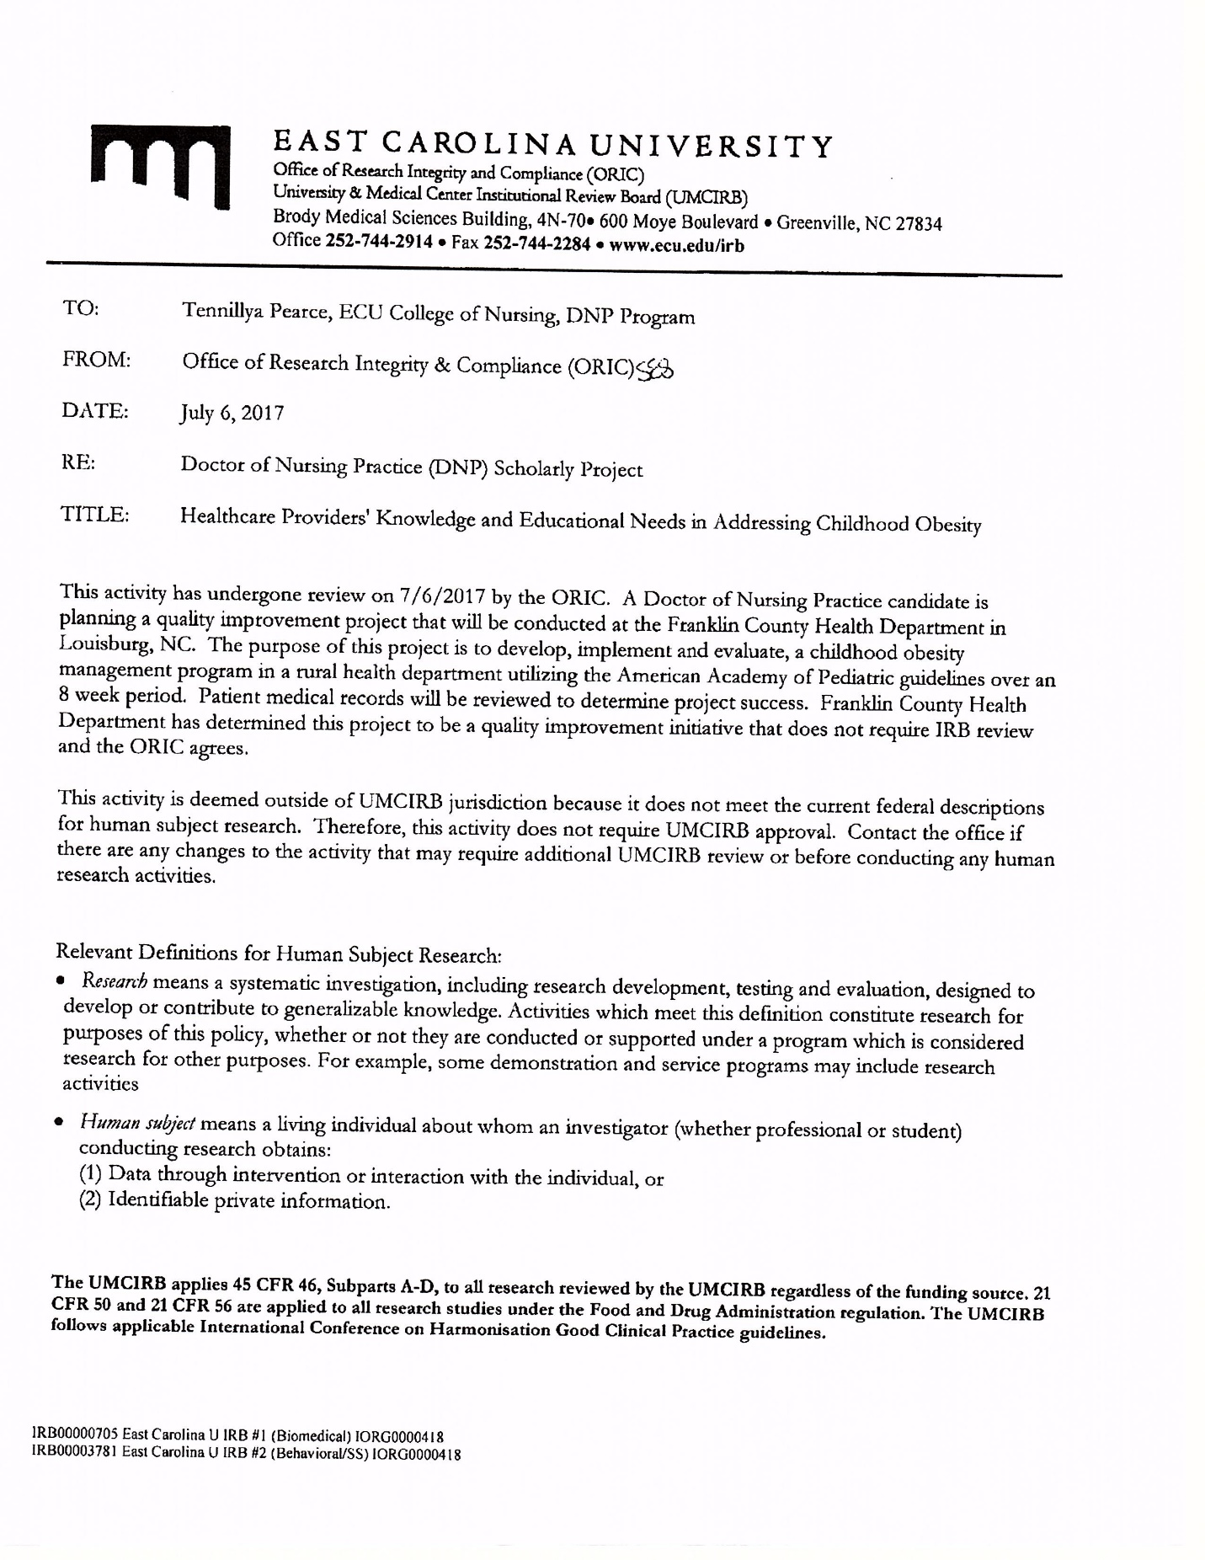
Appendix B- Project Site Approval Letter
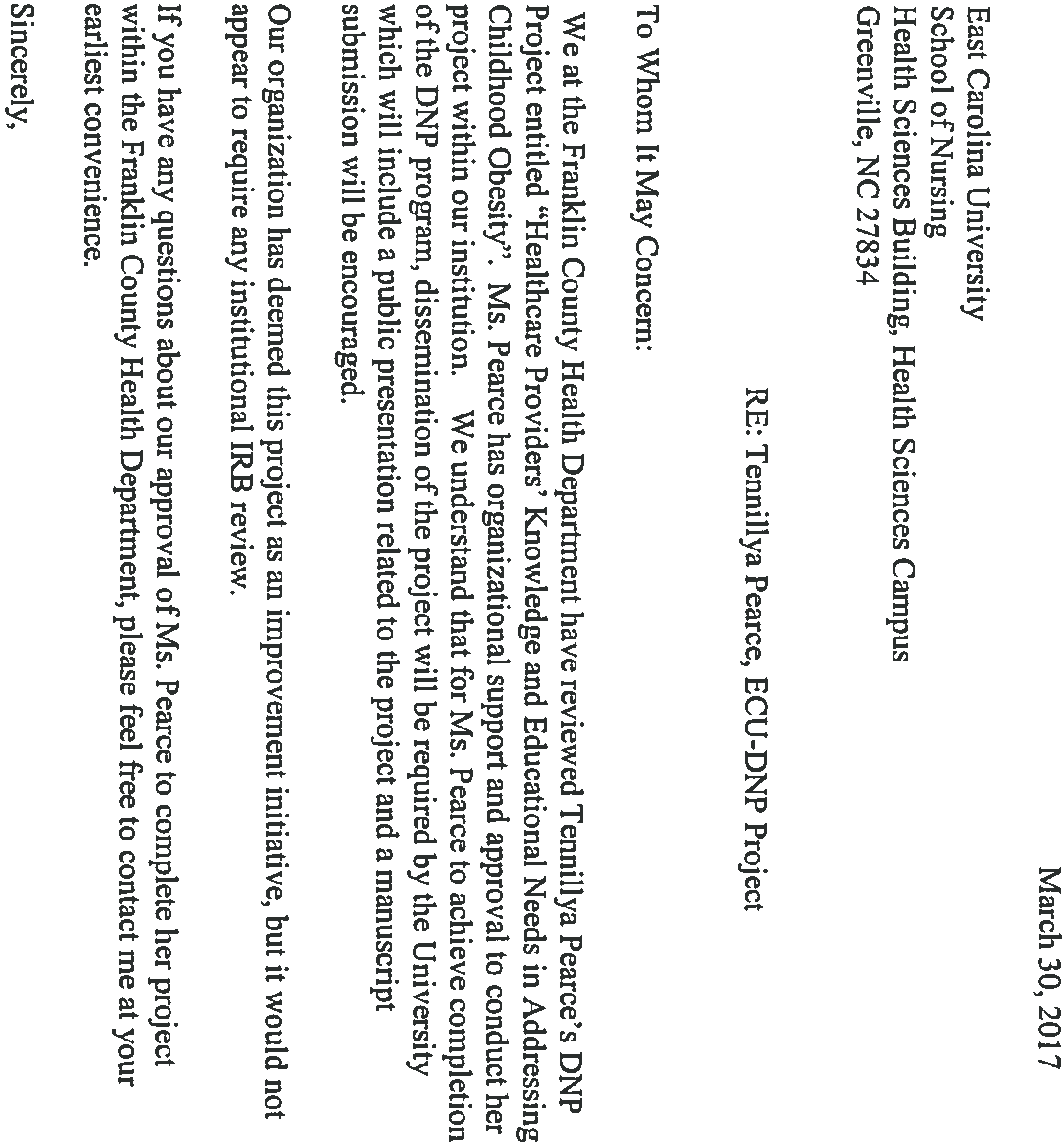
Appendix C- Invitation to Participate in Scholarly Project

Dear Healthcare Provider,
My name is Tennillya Pearce and I am a DNP student at East Carolina University. As one of my requirements for graduation, I have been given the opportunity to develop, implement, and evaluate a project in the clinical setting that could improve the quality of healthcare. Since, I have had the pleasure to work with many of you through my clinical rotation and see first hand the high quality of care and dedication you provide each patient, I am contacting you with hopes that you would be willing to participate in a quality improvement project focusing on childhood obesity. The purpose of this project is to develop, implement, and evaluate a childhood obesity management program in a rural health department utilizing the American Academy of Pediatric guidelines.
Healthcare providers who choose to participate in this project will be responsible for identifying children with body mass indexes greater than or equal to 85% each visit, adding ICD-10 diagnostic code Z68.53 for overweight or Z68.54 for obesity, counseling the patient and family regarding childhood obesity complications and management utilizing the AAP guidelines, while also adding diagnositic code Z72.9 to the child’s electronic health record indicating there is a problem related to lifestyle and that the healthcare provider has addressed this issue with the child and family.
Although participation is voluntary, I do hope you will agree to partipate. For those, who do choose to participate, please fill out the enclosed card and return to box at nursing station. If you have any questions about this project, please feel free to contact me by email at pearcet15@students.ecu.edu or by phone at (252)237-6144. Thank you again for your time.

Sincerely,
Tennillya Pearce, ECU-DNP student

Appendix D- Tools
Initial Educational Session
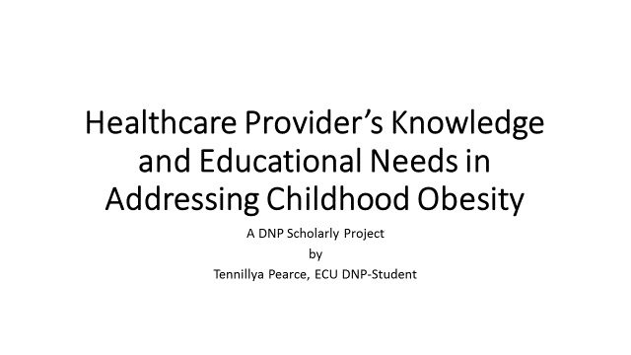
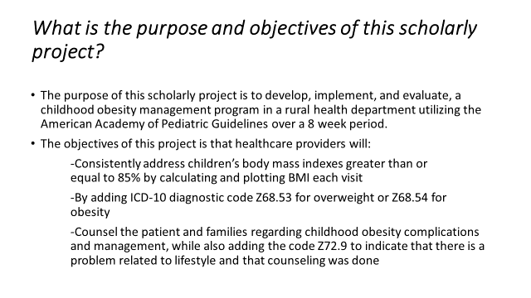
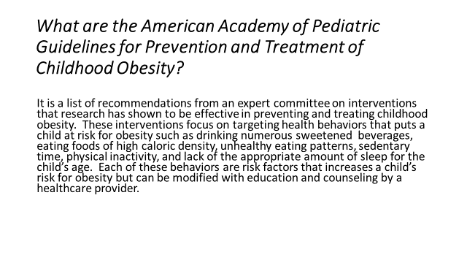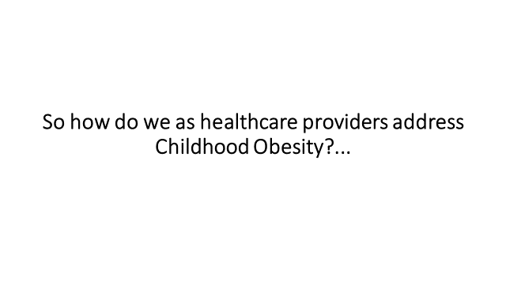
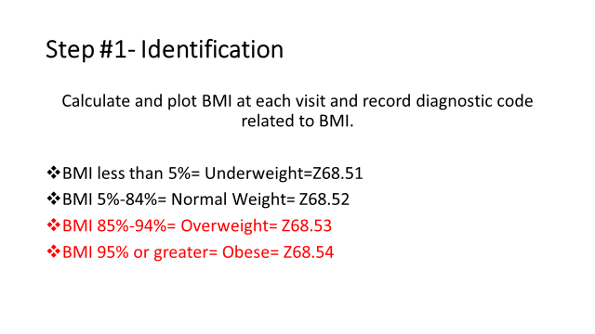
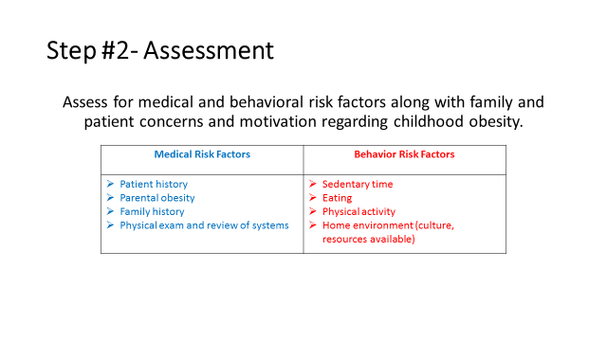

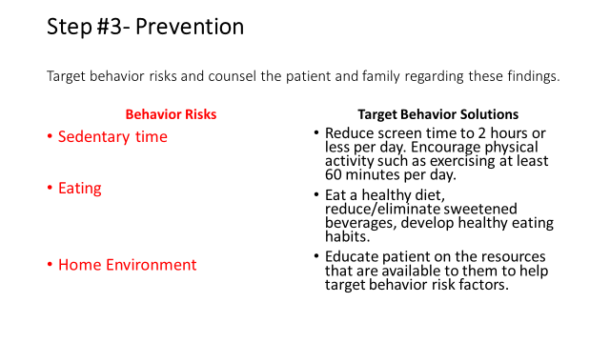
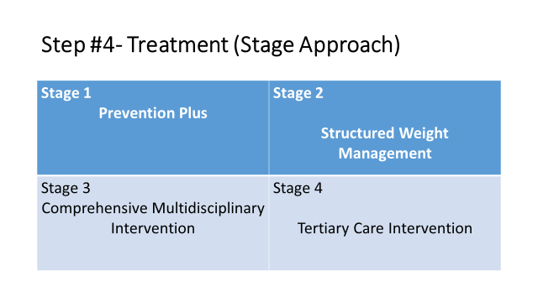

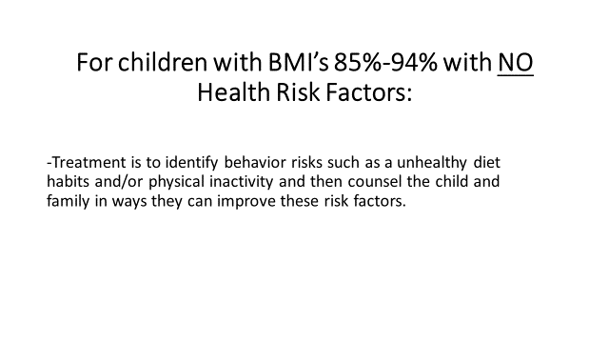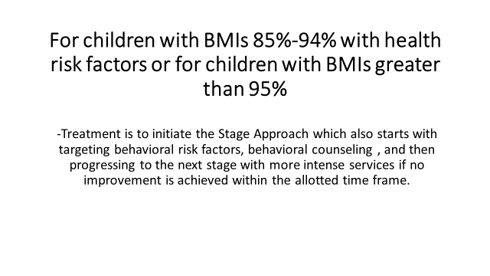
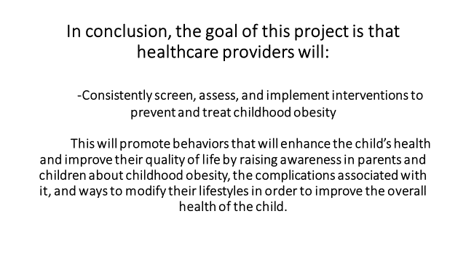
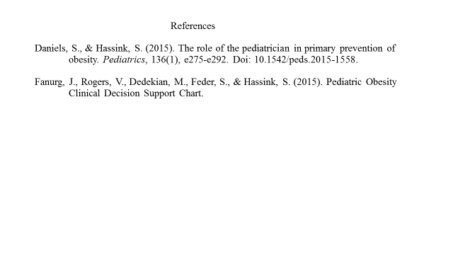

English Brochure
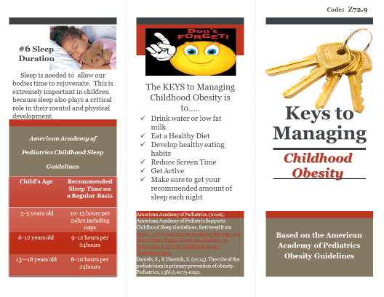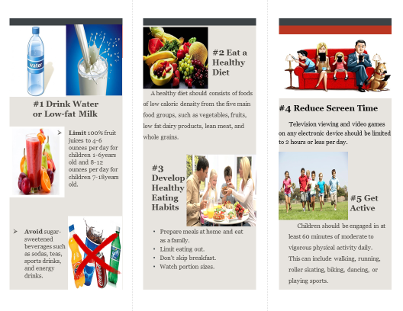
Spanish Brochure
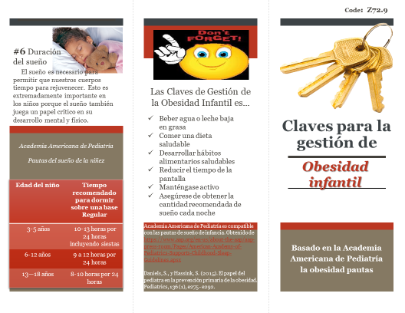
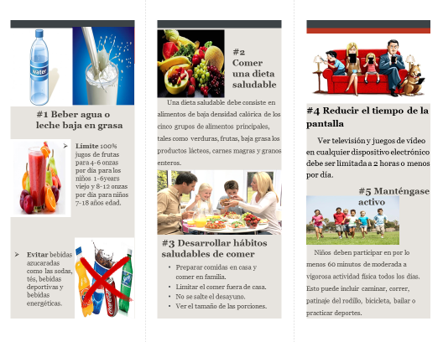

Reminder Notecards

Name:

Appendix E- Chart Review Checklist for Scholarly Project
Chart Checklist for Scholarly Project
Week | Total of children between the ages of 4 -17 years old, who were seen in the clinic and Met Criteria for  project  (Diagnostic Codes Z68.53 for overweight; Z68.54 for obese) | Total of children between the ages of 4- 17 years old, who were seen that Met Criteria for project  and was screened, assessed, and counseled  (Diagnostic Code Z72.9 for problem related to lifestyle and healthcare provider addressed this issue with child and family) | Total of children between the ages of 4-17 years old, who were seen that Met Criteria for project but were not screened, assessed, or counseled. | Goal Met  Or Not Met  (If not met reason why and how to improve for next time.)
Week #1  September 4-September 8 | Overweight= 2  Obese= 4 | 1  2 | 1  2 | Not met
Week #2  September 11-  September 15 | Overweight =2  Obese = 4 | 1  0 | 1  4 | Not Met  Plan- Nursing Administrator to remind staff in morning huddle.
Week #3  September 18-  September 22 | Overweight = 4  Obese = 3 | 0  2 | 4  1 | Not Met
Week #4  September 25-  September 29 | Overweight = 9  Obese = 5 | 1  4 | 8  1 | Not Met  Plan- Speak individually with healthcare providers about findings.
Week #5  October 2-  October 6 | Overweight = 2  Obese = 10 | 0  3 | 2  7 | Not Met
Week #6  October 9-  October 13 | Overweight = 5  Obese = 2 | 3  2 | 2  0 | Not Met  Plan- Provided Reminder Cards
Week #7  October 16-  October 20 | Overweight = 5  Obese = 7 | 2  5 | 3  2 | Not Met
Week #8  October 23-  October 27 | Overweight = 1  Obese = 9 | 0  3 | 1  6 | Not Met  End of Project

Appendix F - Timeline
Timeline for DNP Scholarly Project
Date | Task
January 2017 | -Develop new topic based on outpatient setting (#2)  -Review literature for new topic (#4)  -Define project topic (#3)  -Search for new project site and project champion (#1)
February 2017 | -Continue to research literature on topic. (#2)  -Submit project proposal. (#3)  -Attend DNP intensives. (#4)  -Secure project site and project champion (#1)
March 2017 | -Continue to research literature on topic (#5)  -Submit DNP timeline (#4)  -Submit Project Proposal for approval (#3)  -Submit Project Site Contract and 2nd team member CV (#2)  -Secure project site and project champion (#1)  -Complete ECU CITI training (#6)
April 2017 | -Secure project champion and submit CV (#1)  -Continue to research literature on topic (#2)  -Submit first draft of final paper (#3)  -Submit final paper for Scholarly Project I (#4)
May 2017 - July 2017 | -Continue to research literature on topic (#1)  -Develop a synthesis of literature and literature matrix (#2)  -Submit project for IRB approval (#3)  - Develop budget and implementation timeline (#5)  - Develop design of project (#4)  - Submit final paper for Scholarly Project II (#6)
August 2017 – December 2017 | -Continue to review literature on topic (#1)  - Finalize steps in implementation process (#2)  -Implement project (#3)  -Identify barriers in implementing project along with project limitations (#3 & #4)  -Analyze data and lessons learned from project (#5)  -Submit final paper for Scholarly Project III (#6)
January 2018 – April 2018 | -Evaluate project outcomes and identify ways to strengthen DNP project for future implementation (#1)  -Present project outcomes at project site (#3)  -Develop a poster presentation for DNP project (#2)  - Submit final paper for Scholarly Project IV (#4)  - Continue research on how to reduce childhood obesity. (#5)

Appendix G – Literature Matrix
Literature Matrix
Title of Project: Healthcare Providers’ Knowledge and Educational Needs in Addressing Childhood Obesity
Year & Journal | Authors | Purpose | Study Design  &  Level of Evidence | Sample Size | Key Points
2013  Journal of Health Care for the Poor and Underserved | Ariza, A., Hartman, J., Grodecki, J., Clavier, A., Ghaey, K., Elsner, M., Moore, C., Reina, O., & Binns, H. | To implement practice strategies to address childhood obesity by linking families to community nutrition and physical activity programs. | Pilot Study  Level III | 26 Primary Care Providers in Chicago | -In this study, motivational interviewing was a technique used to help overweight and obese children and their families achieve lifestyle changes in addition to connecting them with community programs that aided in their lifestyle modifications.  -Barriers noted in this study was the families’ motivation to make lifestyle changes, lack of willingness to travel to community program sites, discomfort with the use of public transportation, lack of knowledge of their neighborhood, financial issues, and scheduling conflicts.  -Pros for this study was improvements in documentations for BMIs, dietary counseling, physical activity counseling, and connecting children and families with community resources to improve their health.
2015  Postgrad Medical Journal | Bass, R. & Ihuoma, E | The purpose of this article was to define the term severe childhood obesity; describe the genetic and early childhood factors that predispose children to the development of a severely obese phenotype; compare and contrast the rates and severity of cardiovascular, pulmonary, musculoskeletal and hepatological comorbidities; and describe the effectiveness of lifestyle, pharmacological and surgical treatments available for patients with severe obesity. | N/A  Level V | N/A | -Early screening and identification of children at risk for the development of obesity is key to effective prevention.  -A child’s environment strongly impacts his/ her risk for developing obesity, with some factors occurring as early as in utero.  -Methods used for treating obesity include lifestyle/ dietary modifications, pharmacotherapy, and bariatric surgery.
2013  Journal of Pediatric Psychology | Black, M. & Hager E. | To implement a framework that incorporates the multiple interacting factors that influence pediatric obesity to implement obesity prevention programs. | N/A  Level III | N/A | -Obesity is influenced by multiple factors that extend beyond the individual but into the community.  -“The failure of single-level interventions highlights the emphasis on multilevel interventions and the need for models to guide integrated interventions.”  -A system science framework encompasses the complex relationships amongst systems, which is influenced by positive and negative responses.  -Recommendations that can be incorporated into a systems science design include 1) Healthy and Safe Environments; 2) Clinical and Community Services; 3) Empowering People; 4) Elimination of Health Disparities; 5) Targeting Early in life (pre-pregnancy through toddlerhood); and 6) Multilevel Multidisciplinary Interventions
2014  Journal of Obesity | Bonnet, J., George, A., Evans, P., Silberberg, M., & Dolinsky, D. | The purpose of this study is to assess the perception of primary care providers in a university-based family medicine network surrounding the barriers of preventing and treating obesity in young children and analyzing primary care providers’ behaviors at well-child checks. | Descriptive Design  Level III | 11 Duke Primary Care Practices was utilized for this study in which 78 family medicine physicians, 8 physician assistants, & 7 nurse practitioners participated. | -Five barriers to treating pediatric obesity were 1) physical inactivity; 2) families often eat fast food meals instead of healthy foods; 3) parent is not motivated to change diet or lifestyle; 4) families watch too much TV; 5) the child is not motivated to change diet or lifestyle.  -PCP are inconsistent when initiating discussions on physical activity, fruit and vegetable selection, screen time, juice and other beverage choices.  -The goals of obesity prevention and treatment are beneficial when started early and target interventions prior to the adoption of adverse lifestyle choices.  -“Research shows that a rapid transition occurs between the 1 and 2 year well-child checks, when diet habits seemingly shift to favor fast foods, with the French fry as the number one consumed vegetable consumed by two-year olds.  - Since most children will have had their first French fry before they turn two years old, having a “French Fry Discussion” could take the form of a purposeful talk with family members about the importance of avoiding fast foods, fried foods, and sweetened beverages.
2013  Clinical Pediatrics | Brandt, K., Booker, J., & McGrath, J. | To demonstrate the feasibility and value of simple interventions for improving pediatric care and to address the additional needs of overweight and obese children. | Quality Improvement  Level III | 16 pediatricians in New Mexico at 5 different sites. | -This study showed that prior to the implementation of guidelines for this study, BMI tracking was not routinely done in the 5 different practices.  - With the implementation of the 2007 Expert Committee Recommendations, significant improvements were noted in the assessment/documentation of children’s BMIs, counseling for nutrition and physical activity.
2014  The New England Journal of Medicine | Cunningham, S., Kramer, M., & Narayan, K. | The purpose of this study was to estimate the annual incidence of obesity, the cumulative incidence over 9 years, and the incidence density overall and according to sex, socioeconomic status, race or ethnic group, birth weight, and kindergarten weight. | Longitudinal Study Design  Level III | 7,738 children in the United States that were in kindergarten. Out of this group 6807 of these children were not obese at baseline. | -Overweight kindergartners were 4x more likely to become obese by the age of 14 years old.  -Children who had a birth weight greater than 4000g and had become overweight by the age of 5 years old were 5.1X likely to become obese during the subsequent 9 years, representing more than 36% of those who were obese at the age of 14 years old.  - Evidence in this study supports that body weight and eating patterns early in life are strongly related to subsequent obesity risk and that a substantial component of childhood obesity is established by the age of 5 years old. This study also reveals questions about how early the trajectory to obesity begins and the roles that the home, preschool environment, intrauterine factors and genetics have on childhood obesity.
2015  Pediatrics | Daniels, S. & Hassink, S. | To provide healthcare providers with recommendations and guidelines in preventing and managing childhood obesity. | N/A  Level VI | N/A | -Prevention should be tailored to the child’s developmental stage and family characteristics.  -Children aged 2years and older should have their BMI documented on the CDC growth chart at every visit so that obesity prevention interventions can be implemented when the child starts to trend upwards before they hit the 85% or 95% mark.  -Prenatal risk factors for obesity are parental obesity, maternal gestational diabetes, and maternal smoking during pregnancy.  -Child risk factors are never being breastfeed, rapid infant weight gain, short sleep duration, depression, and having a disability.  -Food and activity targets for preventing childhood obesity include: 1) Beverages. Avoid sugar-sweetened beverages, instead drink low fat milk or water; 2) Eat energy dense foods. A healthy diet should be rich in foods with low caloric density such as vegetables, fruits, whole grains, low fat dairy products, legumes, lean meats and fish. 3) Eating Habits, Context, and Schedule. Prepare meals at home and eat as a family, limit eating out, avoid skipping breakfast and watch portion sizes. 4) Screen Time. Limit screen time to 2hours or less per day. 5) Leisure and Lifestyle Physical Activity. Encourage children and families to get active by recommending a least 60 minutes of moderate to vigorous physical activity daily. 6) Sleep Duration.  -“Children who received less than 9 hours of sleep had 1.5 times the risk of being obese compared with those who received greater than 11 hours of sleep per night.”  -“For each hour increase in sleep, the risk of overweight/obesity was reduced, on average, by 9% for children younger than 10years old.
2013  Indian Journal of Pediatrics | Dolinsky, D., Armstrong, S., & Kinra, S. | The purpose of this study was to summarize three recent guidelines and recommendations and describe a current childhood obesity treatment program in the United States. The recent guidelines and recommendation will come from the Scottish Intercollegiate Network, the American Academy of Pediatrics and the United Kingdom National Institute for Health and Clinical Excellence. | N/A  Level I | N/A | This review article compares and contrast three different organizations guidelines and recommendations for clinical treatment of childhood obesity. All three guidelines focus on treatment in the outpatient setting using a multicomponent lifestyle intervention.  -Scottish Intercollegiate Guidelines Network (SIGN) suggests that a reduction in total energy intake, increased physical activity, reduction in sedentary behaviors, and changes in the family’s lifestyle are all effective in treating overweight and obese children.  -American Academy of Pediatrics (AAP) proposes a four-staged approach in which the child placement in each stage depends on the child’s individual progress in BMI change in prior stages, the child’s age, the presence of obesity-related comorbidities, and the presence of parental obesity. Each stage has multi-components including behavioral, physical activity, and dietary counseling to target childhood obesity.  -United Kingdom National Institute for Health and Clinical Excellence (NICE) recommends treatment primarily by pediatricians in the outpatient clinical setting, but other healthcare providers may be included for children with significant comorbidities or complex health or psychological needs. Treatment should be multi-component with behavioral treatments that will increase physical activity, improve eating habits, and encourage healthy eating patterns.
2014  Journal of the American Board of Family Medicine | Endevelt, R., Elkayam, O., Cohen, R., Peled, R., & Tal-Pony, L. | To examine the effects of intensive treatment of a parent-child lifestyle modification to reduce weight in a family health care clinic for obese and overweight children with prior unsuccessful treatment attempts. | Experimental  Design  Level II | 100 obese/overweight children (63 girls and 37 boys) aged 5 to 14 years old along with their parents and 943 comparison children (43.7% girls and 56.3% boys) and their parents. | -An intense parent-child treatment program consisting of parent educational groups on nutrition and healthy behaviors, children’s individual therapy, and physical activity groups for the children with individual physical fitness monitoring proved beneficial in reducing weights.  -Although overweight and obese children benefitted from this program, a greater reduction in weight was noted in the obese children in which this study contributed it to parents of obese children being more aware of their child’s condition and the underestimation of the overweight children’s condition impairing the parents’ motivation to adopt weight control measures.
2013  The Journal of Rural Health | Findholt, N., Davis, M., Michael, Y. | To explore perceived barriers, resources, and training needs of rural primary care providers in implementing the American Medical Association Expert Committee recommendations for assessment, treatment, and prevention of childhood obesity. | Exploratory Study  Level II | 13 rural primary care providers in Oregon consisting of 4 family physicians, 2 pediatricians, 4 family nurse practitioners, 1 pediatric nurse practitioner, and 2 physician assistants. | -In rural areas the rate of obese and overweight children and adolescents are higher.  -Rural children “were about 25% more likely to be overweight than their metropolitan counterparts.”  -Practice related barriers were time constraints, lack of reimbursements, and few opportunities to detect obesity.  -Clinician barriers were limited knowledge regarding dietary evaluation and modification.  -Family/Patient Barriers were family lifestyles, lack of parent motivation to change, low family income, lack of health insurance, and the sensitivity of the issue.  -Community Barriers consisted of lack of pediatric subspecialists and multidisciplinary/tertiary care services as well a few community resources to assist children and families with weight loss.  -Sociocultural Barriers- included sociocultural influences and the high prevalence of childhood obesity.
2016  Journal of the American Association of Nurse Practitioners | Gibson, S. | To implement clinic system and provider practice changes that support evidence-based guidelines for childhood obesity prevention. | Quality Improvement  Level III | 2 rural health clinics that are part of a Midwest healthcare system and the clinic’s primary care providers and front-line staff. | -Correctly diagnosing overweight and obese children and educating and counseling these children and their families are critical steps in reducing childhood obesity.  -Primary care providers are not effectively using evidence and incorporating guidelines into clinical practice.  -Providers’ barriers were time constraints, unfamiliarity with billing codes, lack of reimbursement by third party payers, lack of parent recognition and motivation, and lack of well-developed data systems and health information technology, inadequate training regarding childhood obesity, unfamiliar with evidence-based practice guidelines and how to diagnose, educate, and counsel children and families on childhood obesity.  -Significant changes in documentation of BMIs (from 27% to 98%), education and counseling (from 9% to 87%), and accurate diagnosis of overweight or obesity (0% to 32%) were noted in this study after implementing evidence-based guidelines through the 5210 programs.
2013  Pediatrics | Mazur, A., Matusik, P., Revert, K., Nyankovskyy, S., Socha, P., Binkowska-Bury, M., Grzegorz, T., & Malecka-Tendera, E., | To determine and compare childhood obesity management attitudes, skills, and practices in 4 European countries with different obesity prevalence, healthcare systems, and economic situations. | Descriptive Design  Level III | 1119 Primary Care Providers from Ukraine (358), France (343), Poland (271), and Italy (147). | -In this study, most of the healthcare providers understood their role in childhood obesity management but did not feel sufficiently competent in addressing it effectively.  -In fact, some healthcare providers did not address childhood obesity and had no interest to with the explanation being “that obesity is mainly a parental problem.”  -Others stated barriers as lack of education and financial support for obesity treatment and poor response to therapeutic interventions.
2016  World Journal of Clinical Pediatrics | Messiah, S., Jiang, S., Kardys, J., Hansen, E., Nardi, M., & Forster, L. | To link primary care providers to evidence based programming in childhood obesity prevention efforts and have incorporated technology to create bi-directional communication between primary care providers and community providers to track patient progress. For patients and their families, it provides them with a 10-month afterschool health and wellness program that is affordable and accessible. | Pilot Study  Level II | Children between the ages of 6-14 years old who are seen at the University of Miami Miller School of Medicine Pediatric Clinics, have a body mass index equal to or greater than 85% for age and sex, are physically inactive, has systolic and/or diastolic pre-hypertension, or hypertension, or has a strong family history of Type II DM and/or cardiovascular disease, and parent is willing to enroll their child in a Fit-2-Play program close to their home and have them attend 5 days per week. | -Integrating primary care, public health and community-based efforts are important factors when developing a program to tackle childhood obesity.  -Wellness programs should focus on physical activity and nutrition education.
2015  Childhood Obesity | Nelson, J., Vos, M., Walsh, S., O’Brein, L., & Welsh, J. | To assess the baseline perceptions and practices amongst healthcare providers in Georgia regarding lifestyle and weight related counseling done during well-child visits and determine the extent to which these perceptions and practices vary by provider type. | Correlational  Design  Level II | Total of 656 primary care providers consisting of 265 pediatricians, 143 family practice physicians, 248 nurse practitioners/physician assistants | -This study emphasized the importance of utilizing “screening tools such as the BMI, becoming proficient in assessment of diet and physical activity, learning effective weight management related counseling techniques and creating a medical home where high risk children can be monitored closely”.  -Results showed that Pediatricians were more likely than FPs and NP/PAs to assess diet, physical activity, and screen time.  - Provider barriers for evaluating and effectively managing patients’ diet/nutrition, physical activity, and weight were insufficient time, inadequate training, and inadequate reimbursement.  -Patient barriers were lack of patient interest, resistance from parents/caregivers, fear of offending patient, and patients unable to change behaviors.  -Community/resource barriers included inadequate referral services, lack of effective tools and information for patients/parents, and lack of effective treatments.
2013  Jornal de Pediatria | Poeta, L., Fatima da S. Duarte, M., C.B. Giuliano, I., & Mota, J. | To determine the effects of an intervention program on the health-related quality of life of obese children, utilizing nutritional counseling and physical exercise through recreational activities. | A controlled clinical trial.  Level III | Initial Sample Size was 44 children, with 22 in the case study and 22 in control study.  At the completion of study, there was a total of 32 children with 16 in each group. | -This study demonstrated the importance of a multidimensional interventions on the health-related quality of life for obese children through a 12-week intervention program that consisted of nutritional counseling for parents and children weekly, along with three weekly 60-minute sessions for physical exercise through recreational activities. Results from this study showed reduction in the case study’s BMI and an overall improvement in quality of life in their physical, emotional, social, and  psycho-social domains.
2017  Health Promotion Practice | Rosario, R., Araujo, A., Padrao, P., Lopes, O., Moreira, A., Pereira, B., & Moreira, P. | To evaluate the impact of an intervention program, taught by trained teachers, on foods and nutrients components of the Diet Quality Index-International (DQI-1). | Experimental Design  Level III | 464 children between the ages of 6-12 years old from seven elementary schools in Portuguese.  (239 were girls and 225 were boys) | -This study was aimed at promoting a healthier active lifestyle by encouraging children to become physically active and helping them to choose healthier food choices within the school setting.  -The interventions used were 12 educational sessions each 3 hours long over a 6-month period with various topics on nutrition and physical activity. The teachers would then develop and implement a lesson plan that would engage the children in learning healthier behaviors through exercise and diet.
2012  Childhood Obesity | Sealy, Y., Zarcadoolas, C., Dresser, M., Wedemeyer, Short, L., & Silver, L. | The purpose of this study was to impact healthcare providers clinical behaviors, improve the health literacy of patients and children, initiate patient-provider-parent conversation, and change family practices to prevent obesity. | Quality Improvement  Level III | 237 healthcare providers in New York City who worked with children between the ages of 2- 18 years old. | This study consisted of interventions such as healthcare providers’ interviews, parent focus groups, and the development of the Obesity in Children Action Kit which proved beneficial in helping children and their parents the importance of eating healthy and being active. Not only did it help children and their families it also improve healthcare providers’ clinical behavior in addressing childhood obesity at each visit.
2016  Biomed Central Health Research | Schalkwijk, A., Nijpels, G., Bot, S., & Elders, P. | The purpose of this study is to understand the needs of healthcare providers and the barriers they face in implementing a national integrated health care standard. | Quality Improvement  Level III | 27 general practitioners | -This study utilized focus groups, interviews, and internet surveys to investigate the barriers and needs in implementing an integrated health care standard for obese and overweight children based on healthcare providers’ perceptions.  -Barriers to this project included lack of parent motivation and knowledge, negative response from previous lifestyle programs, reluctance by healthcare providers to raise the subject of weight, financial constraints, time constraints, and lack of long term intervention, no structural multidisciplinary approaches, and lack of feedback.  -Needs identified were healthcare providers/ parents/ children’s knowledge and awareness on obesity, financial reimbursement, task rearrangement, and feedback information.
2013  Health Policy | Schwiebbe, L., Talma, H., van Mil, E., Fetter, W., HiraSing, R., & Renders, C. | To determine the diagnostic procedures and treatment of childhood obesity by pediatricians in the Netherlands. | Descriptive Design  Level V | 290 pediatricians with 88 of these pediatricians specialized in treatment of obese children. | -In the Netherlands, curative medicine and preventive medicine have separate care systems. Preventive medicine or Child Public Health (CHP) is delivered by well child clinics for children less than 4years old and the Youth Health Care services is available for children less than 19years old.  -In this study most Dutch pediatricians diagnosed children as being overweight or obese based on the adult criteria of a BMI, with overweight being a BMI greater than or equal to 25 but less than 30 and obese as a BMI greater than or equal to 30.  -For the pediatricians that were specialized in treating childhood obesity, less than half used the age and sex adjusted IOTF BMI-criteria for diagnosing overweight or obesity and all 88 specialized pediatricians measured weight and height.  - As a result of using the adult BMI criteria, the number of obese and overweight children in the Netherlands will be underestimated.  -Of the pediatricians requesting blood work, the most common tests ordered for these children are the fasting glucose level, lipid profile, TSH, free thyroid hormone, and cortisol levels.  - Other complementary tests ordered included an ultrasound of the liver/gallbladder, and polysomnography.  -Interventions used included nutrition, physical activity, a behavioral counseling, group sessions, parental involvement, and a multidisciplinary team consisting of pediatricians, dieticians, physiotherapists, psychologists, and sport instructors.
2014  American Journal of Medical Quality | Shaikh, U., Nettiksimmons, J., Joseph, J., Tancredi, D., & Romano, P. | To evaluate the impact of participation in a virtual quality improving network on adherence to clinical guidelines on childhood obesity prevention in rural clinics. | Prospective Pre-Post Design  (Quality Improvement)  Level III | 288 children between the ages of 2-11years old from 7 primary care clinics in rural California. | -This study utilized a virtual learning network called the Healthy Eating Active Living Telehealth Community of Practice (HEALTH COP) to help healthcare providers adhere to clinical guidelines. -The results of this study showed a significant increase in healthcare providers’ adherence to clinical guidelines for childhood obesity through documentation, counseling, and improved access to recommended care for rural and underserved children who were at high risk for obesity.
2016  The Journal for Nurse Practitioners | Sharpe, L., Bishop, C., Devries, A., & Derouin, A. | To evaluate the effectiveness of the Starting the Conversation 4-12 Screening and Counseling Tool in capturing nutrition and exercise behaviors while also facilitating a nonthreatening discussion with children and their families regarding lifestyle modifications. | Quality Improvement  Level III | 60 children between the ages of 3-16 years old and their parents. | -Healthcare providers barriers are insufficient time and resources, lack of effective interventions, perceived treatment futility, lack of parent/caregiver involvement, low patient motivation, and parents’ inaccurate perception of their child’s weight.  -Parents’ barriers are healthy foods are costly, they eat out because of their busy schedules, and they lack confidence in tackling multiple recommendation.  -The Starting the Conversation 4-12 tool proved to be beneficial in identifying unhealthy behaviors and initiating targeted counseling regarding childhood obesity.  -It consisted of 20 nutrition and physical activity questions with Likert-type responses that can be completed in less than 5 minutes.  -A modified 7 question STC 4-12 tool was also developed to expedite screening and capture the most beneficial information for a brief targeted intervention.  -Problems identified through the study were children received less than the recommended amount of fruits and vegetables per day, eating in front of the TV or computer, the perception that healthy foods were expensive, greater than 3hours of screen time per day, and less than the recommended amount of physical activity.
2017  The Journal of Clinical Endocrinology and Metabolism | Styne, D., Arslanian, S., Connor, E., Farooqi, I., Murad, M., Silverstein, J., & Yanovski, J. | To formulate clinical practice guidelines for assessment, treatment, and prevention of childhood obesity. | Grounded Theory  Level VI | An Endocrine Society-appointed Task Force of 6 experts, a methodologist and a medical writer | -BMIs should be used as the primary method to diagnose overweight and obesity in children and adolescents starting at the age of 2 years old.  -Routine blood work for secondary causes should be avoided unless short statue plus evidence of another disorder is present.  - Overweight/obese children should have routine testing for lipid disorders and diabetes.  -These children should also have their liver enzymes checked since they are at a higher risk for nonalcoholic fatty liver disease.  -Monitor these children for hypertension, sleep apnea, and polycystic ovarian syndrome.  -Genetic testing should be offered to children who are extremely obese by the age of 5 years old, have features of a genetic syndrome, or a family history of extreme obesity.  -Intake of whole fruit versus fruit juice and water in place of sugar-sweetened beverages.  -Children should have 60minutes of exercise daily with 20minutes in vigorous activity.  -Screen time should be less than 2hours per day.  -Childhood obesity management should include the whole family.  - If lifestyle changes are inadequate, and the child is at least 16years old medications may be considered.  -Medications should be stopped after 12 weeks if no significant weight loss.  -Bariatric surgery is also an option for obese adolescents who are in Tanner 4 or 5 stage and lifestyle changes and medications have been unsuccessful.
2013  Journal of the American Medical Association Pediatrics | Taveras, E., Gillman, M., Kleinman, K., Rich-Edwards, J., & Rifas-Shiman, S. | To examine the extent in which racial/ethnic disparities in adiposity and overweight and obesity among a cohort of school aged children are explained by differences in risk factors during pregnancy, infancy, and early childhood. | Longitudinal Study  Level III | 1,116 mother-child pairs (63% Caucasian, 17% African American, 4% Hispanic) | -This study found that the prevalence of overweight and obesity among African Americans and Hispanic children at the age of 7 years old was almost double that of Caucasian children.  -Racial/Ethnic disparities in childhood obesity may be explained by factors operating in infancy and early childhood.  -“These factors include differences in modifiable early feeding behaviors, such as breastfeeding and timing of the introduction of solid foods, accelerated infant weight gain, and early childhood obesity related risk factors, including insufficient sleep, the presence of a television set in the room where the child sleeps, and consumption of sugar-sweetened beverages and fast foods” which was prevalent amongst African Americans and Hispanics when compared with Caucasians.  -Interventions that modify early life risk factors may reduce disparities in the prevalence of childhood obesity.  -The best times to prevent obesity is infancy and early childhood when behaviors are developing and easily modifiable to “establish tastes for a variety of foods, the enjoyment of active play, and good sleep habits”.  -During infancy and early childhood parents are easily accessible (through primary care, child care, and early education) and parents/caregivers are highly sensitized to the child’s needs.
2017  Ochsner Journal | Thomas, K., & Urrego, F. | The purpose of this study was first to determine if pediatricians at the pediatric clinic in the Ochsner Health System was documenting children with an overweight or obese body mass index as a diagnosis in the medical record. The second purpose was to determine the demographics of all pediatric patients in the Ochsner Health System to help with program development. | Pilot Study utilizing Retrospective Medical Record Review  Level I | 175,066 records were analyzed. | -Results from this study revealed that pediatricians are not consistently screening for patients that are overweight and obese at each visit. In fact, in this 4-year study (from April 1, 2012 thru April 1, 2016) 175,066 medical records were reviewed, 875 children or 0.5% were documented with the diagnosis of being overweight, and 2,311 or 1.32% were documented with the diagnosis of being obese. However, when analyzing the results, 53,237 children (30.41%) were overweight, and 50,174 children (28.66%) were obese based on the CDC criteria for obesity and overweight.

