Increasing HPV Vaccination Rates Through Provider Intervention
Aimee I. Love
East Carolina University

Abstract

Background: Human papillomavirus (HPV) is the most commonly sexually transmitted infection in the US. A vaccination is available that protects against the most common strands of the virus, however, uptake is low. A strong provider endorsement has been shown to increase vaccination rates. The project site had a 44% rate of vaccination prior to implementation.
Objectives: The aim of this quality improvement project was to increase HPV vaccination rates using an educational intervention for healthcare providers.
Methods: An educational intervention was carried out with providers at a primary care clinic in North Carolina. After the intervention, weekly vaccination rates were assessed for 12 weeks. Electronic surveys were sent weekly to providers for feedback about vaccination practices.
Results: During the implementation phase 999 adolescents were eligible for HPV vaccination, at the end of implementation the 44% rate of HPV vaccination was unchanged. The rate of vaccinated males at the practice site was 45.2%, which is significantly higher than the national average of 28.1%. The overall response rate to the provider survey was 60.4%. Commonly reported reasons for declination of the vaccine, according to the providers were that parents wanted to wait and that vaccination was unnecessary.
Conclusion: These findings substantiate that there is not one simple solution to increasing HPV vaccination rates. Although the providers in this project were motivated this did not translate into increased vaccination rates. Future projects should focus on educating parents on why vaccination is required at an early age and provider communication techniques.

Acknowledgements

I would first like to thank my project advisor, Dr. Debra Kosko, for all of the support and guidance provided throughout this project. She made it an amazing learning process and it would not have been possible without her. Next, I would like to thank my site champions, Dr. Rob Rosen and Caroline Grandis, along with the staff at Ardmore Family Practice. Finally, my husband Michael, and son, Miles for always being supportive along my entire journey.

Table of Contents
Page
Chapter One: Introduction 6
Problem Statement 7
Justification of Study 8
Theoretical Framework 8
Assumptions 9
Project Question 9
Definition of Terms 10
Summary 10
Chapter Two: Literature Review 11
Rates of Vaccination in the United States 13
Economic Impact of HPV Infection 14
Barriers to Vaccination 14
Provider Techniques to Improve HPV Vaccination Rates 16
The Health Belief Model and Vaccination 18
Summary of Research Findings 19
Chapter Three: Methodology 20
Design 20
Setting 21
Sample 21
Methods 22
Protection of Human Subjects 23
Instruments 23
Data Collection 24
Data Analysis 24
Limitations 24
Chapter Four: Results 24
Sample Characteristics 25
Major Findings 25
Chapter Five: Discussion 27
Introduction 27
Implication of Findings 28
Limitations 29
Delimitations 30
Recommendations 30
References 32
Appendix A 36
Appendix B 44
Appendix C 46
Appendix D 50
Appendix E 51
Appendix F 53
Appendix G 54
Appendix H 55

Introduction
Human papillomavirus (HPV) is a group of viruses that can infect the genital tract of males and females (Schuiling & Likis, 2017). It is the most common sexually transmitted infection in the United States (U.S.), with up to 80% of people becoming infected during their lifetime (Centers for Disease Control and Prevention [CDC], 2013). A large number of people with HPV do not know they are infected because they have no symptoms, which leads to unintentional spread of the virus. However, HPV infections can lead to genital warts, occurring in about 1% of the population at any given time (CDC, 2017a). Most HPV infections clear on their own, but sometimes they lead to cancer. Over 25,000 cancers per year can be attributed to HPV (CDC, 2017a). HPV commonly causes cancers of the cervix, vagina, vulva, penis, anus, rectum and oropharynx (CDC, 2016b).
Several vaccines have been developed and approved to prevent HPV infection. The only vaccine currently being used in the U.S. is the 9-valent HPV vaccine known as Gardasil 9 (Meites, Kempe & Markowitz, 2016). This vaccine protects against nine common strands of HPV: 6, 11, 16, 18, 31, 33, 45, 52 and 58. Most cancers are caused by strands 16 and 18 and genital warts are commonly caused by 6 and 11 (Meites et al., 2016).
It is recommended that boys and girls receive the two-dose series of this vaccine beginning at the age 11 or 12 (CDC, 2017a). The vaccine is recommended for all men up until the age of 21 and all women, gay or bisexual men and men with compromised immune systems up until the age of 26 (CDC, 2017a). Originally, vaccination was recommended in a three-dose series, but these guidelines changed in 2016. If vaccination is initiated at 9-14 years of age it is recommended that the girl or boy receive two doses of the vaccine at least 6 months apart. If initiated between the ages of 15-26 or in immunocompromised persons, a three-dose vaccination series should be utilized (Meites et al., 2016).
The safety and effectiveness of the HPV vaccine has been studied extensively. Since the vaccine was introduced in 2006, over 80 million doses have been administered (CDC, 2016a). Some commonly experienced side effects of vaccination are pain, redness and swelling at the injection site (CDC, 2016a). Fainting has also been reported after receiving the vaccination, however, adolescents are more likely to faint after receiving any type of vaccination (CDC, 2016a). The side effects and risks of HPV vaccination are small when compared to the benefits provided by vaccination (CDC, 2016a).
Despite the safety and effectiveness of the HPV vaccine, rates of uptake are low. Only 28.1% of males and 41.9% of females had completed the vaccination series in 2015 (Reagan-Steiner et al., 2016). Provider recommendation has been found to be one of the largest culprits in the low rates of vaccination. Studies show that providers are not giving a strong endorsement of the vaccine due to inaccurate perception of patient risk, overestimation of parental concerns and not recommending co-administration with Tdap and MenACWY vaccines (Reagan-Steiner et al., 2016).

Problem Statement
Infection with the HPV virus can lead to genital warts and various types of cancers, which can have a great impact on the patient and healthcare system. There is a vaccine available that prevents the 9 most common and most oncogenic strands of this virus, yet rates of uptake are low. The purpose of this project is to increase the HPV vaccination rate of eligible adolescents in a family practice in Forsyth County, North Carolina. The aim of this project is to increase the rate of HPV vaccination using an educational intervention for healthcare providers.

Justification of Project
Healthy People 2020 is a national health promotion plan that seeks to improve the health and wellness of Americans by outlining specific health-based goals. The Healthy People 2020 goal for HPV is an 80% vaccination rate of eligible adolescents (Healthy People, 2017). The practice in this project was selected because their rate of HPV vaccination is only 41%. The providers all agree that vaccination is important and they would like to learn how to do a better job of recommending the vaccine.
Increased rates of HPV vaccination can have a profound impact on the health of Americans. Most people, over 80%, will be infected with the HPV virus in their lifetime (CDC, 2017a). The virus can lead to genital warts or various types of cancers. If over 80% of the population was vaccinated then all of these infections could be avoided and potentially over 25,000 cancers per year could be prevented (CDC, 2017a). In fact, the vaccine is so effective that Markowitz et al. (2013) found a 56% reduction in vaccine-type HPV infection rates in the first 4 years of administration, despite low vaccine uptake. HPV could be mainly a thing of the past like other diseases eradicated by vaccines. Healthcare providers have an ethical responsibility to ensure this vaccine is endorsed to its fullest extent.

Theoretical Framework
This quality improvement project will be guided by the Health Belief Model (HBM). The HBM helps determine what influences people to participate in the uptake of different health services, such as screenings and immunizations. It was developed in the 1960s and utilizes motivation theory to predict individual health behaviors (Rosenstock, 1966; Guvenc, Seven & Akyuz, 2016). There are five main constructs in the HBM: perceived severity, perceived susceptibility, cues to action, perceived benefits and perceived barriers (Jones, Smith & Llewellyn, 2014).
Typically, the HBM is applied to determine an individual’s motivation for engaging in health behaviors, however, it is also appropriate for determining a healthcare provider’s motivation for recommending vaccinations. The healthcare provider’s beliefs regarding the different constructs can be considered when developing programs to increase HPV vaccination rates. Does the provider understand the perceived severity of HPV infection? How does the provider perceive the susceptibility of their patients to HPV infection? What cues to action can be given to the provider to help provide a better endorsement of the vaccine? Does the provider believe the vaccination provides enough benefits to the patient to warrant its risks? What barriers does the provider anticipate encountering when recommending this vaccination? Constructing the intervention in this study based on these questions will be the key to developing a successful intervention and increasing HPV vaccination rates.

Assumptions
This project relies on several assumptions throughout its implementation. It is assumed that all the healthcare providers at the practice will participate in the intervention provided and will be interested in implementing the strategies they are given. Also, it is assumed that patients will want to avoid becoming infected with HPV once they learn of its detrimental health effects and their provider’s endorsement. Finally, this project assumes that a strong provider endorsement is enough to affect HPV vaccination rates at this practice.

Project Question
This project aims to answer the following question: If an educational intervention on the HPV vaccine is given to healthcare providers, will the rates of HPV vaccination increase? This will be determined by comparing the rates of immunization prior to the educational intervention with the rates post intervention. A T-test will be performed to test for a statistically significant increase in immunization rates.

Definition of Terms
Human papillomavirus (HPV): is a group of viruses that can infect the genital tract of males and females (Schuiling & Likis, 2017).
Gardasil 9: Vaccine that protects against the 9 most common types of HPV virus (Meites, Kempe & Markowitz, 2016).

Summary
HPV is a common virus that most adults in the U.S. will encounter during their lifetime. Although the virus is normally benign it can cause genital warts and multiple types of cancers. Fortunately, there is a vaccine available that protects patients from the most common and most oncogenic strands of the virus. Despite the availability of this cancer preventing vaccine, rates of uptake are low. The purpose of this project is to implement quality improvement measures at a family practice to increase rates of HPV vaccination among eligible adolescents.
The project will focus on the provider for intervention and be guided by the Health Belief Model. The intervention will be based on the American Cancer Society (2016) guide to increasing HPV rates. It will be presented to providers in a one-hour educational session that will include: latest updates on HPV and vaccination, tips for talking to parents along with card prompts and establishment of a staff HPV vaccination champion.
The rates of HPV vaccination will be measured 3 months after the intervention and compared with baseline data. During the data collection period weekly feedback will be elicited from the providers. The ultimate goal will be to see an increase in the vaccination rates of eligible adolescents at the end of the project.

Literature Review

Rates of Vaccination in the United States
Rates of vaccine uptake remain low in the US despite the endorsement of the vaccine by the following organizations: American Academy of Family Physicians, American Academy of Pediatrics, American Cancer Society, American College of Obstetricians and Gynecologists, American Nurses Association, Association of Immunization Mangers, CDC, Council of State and Territorial Epidemiologists, Immunization Action Coalition, National Association of School Nurses, National Foundation for Infectious Diseases, National Hispanic Medical Associate and President’s Cancer Panel (National Foundation for Infectious Diseases [NFID], 2014).
Reagan-Steiner et al. (2016) utilized the National Immunization Survey-Teen (NIS-Teen) to determine HPV vaccination trends across the U.S. from 2014-2015. They found that despite modest increases the overall vaccination rates remain low. The rates of males who received at least one dose of the vaccine were 49.8% and 3 doses was 28.1%. The rates of females who received at least one dose of the vaccine were 62.8%. For all adolescents the rates of vaccination with at least one dose of the vaccine were 56.1%, at least two doses were 45.4% and at least 3 doses were 34.9%. The administration rates of at least one dose of the meningitis vaccine were 81.3% (Reagan-Steiner et al., 2016). Several limitations to this study were declared by the authors. The overall response rate was only 33% leading to possible non-representative data. Also, multiple statistical analyses were conducted and chance may have accounted for some of the statistical significance. Finally, rates of meningitis vaccination may be underreported because administration of age greater than 18 years was not included (Reagan-Steiner et al., 2016).

Economic Impact of HPV Infection
Medical costs related to HPV infection place a significant burden on patients and healthcare systems. Chesson et al. (2012) found the direct cost of preventing and treating HPV related illness to be 8 billion dollars annually in the U.S. This amount included costs associated with cervical cancer screening, HPV-associated cancers and treatment of genital warts (Chesson et al., 2012). Despite this staggering amount, this does not include indirect healthcare costs. Marsh, Chapman, Baggaley, Largeron & Bresse (2014) found that most studies underestimated the financial burden of HPV related illness by not including indirect costs in their estimates. Their study reviewed eight previously published estimates of HPV financial burden throughout various countries. These studies were found by using a search in PubMed up until the year of 2011 (Marsh et al., 2014). They determined that most studies did not include loss of patient productivity, non-health related costs, utility-in-anticipation and reductions in health inequality (Marsh et al., 2014). The authors did not report any limitations to this study.

Barriers to Vaccination
Numerous studies have been conducted on HPV vaccination uptake due to the significant controversy surrounding this vaccine. The reasons for this controversy can be divided into two subgroups: provider barriers and patient barriers to vaccination. Barriers to vaccination uptake attributed to parental and/or patient factors include: confounding information about whether boys or girls should be vaccinated, young age at administration, moral objections and cost (Nichols, Girotto, Mitchell-Van Steele & Stoffella, 2017). Although the patient factors exist, this project will focus on provider barriers to vaccination.
It is important to first establish if providers are recommending HPV vaccination. Multiple studies have been conducted to determine who is actually recommending the vaccine. Luque, Tarasenko, Dixon, Vogel & Tedders (2014) conducted a statewide survey of Georgia Vaccines for Children provider practices to determine recommendation and administration practices of the HPV vaccine five years after ACIPs recommendation for HPV vaccination. They found that among these providers only 46% reported always recommending the vaccine to females and only 41% had vaccinated their female patients. Astoundingly, only 20% of participants always recommended that 11-12-year-old male patients receive the vaccine (Luque et al., 2014).
A surprising barrier to HPV vaccination can be financial concerns. Luque et al. (2014) found that the largest physician reported barrier (73%) was the cost of stocking the vaccine. Sixty-eight percent of providers stated there was a lack of adequate reimbursement for the vaccine and 63% reported failure of some insurance companies to cover the cost of vaccination (Luque et al., 2014). These findings suggest significant financial barriers as the culprit for dismal vaccination rates, despite the participants being mainly part of the VFC program. This program provides a reduced upfront cost of purchasing the vaccination and the capability to charge administration fees for providing them (Luque et al., 2014).
Several limitations to this study exist. The surveys may have been filled out by nurse managers or office managers based on their perception of how vaccines are recommended. Secondly, all VFC offices may have not been included in the study, as these offices were determined by utilizing the Immunization Section of the Division of Public Health. Finally, the results were based upon physician report and not on actual data from medical records (Luque et al., 2014).
Another common barrier to HPV vaccination is inconsistent provider recommendation. Gilkey, Malo, Shah, Hall & Brewer (2015) completed a national survey of pediatricians and family physicians about their HPV vaccine recommendation practices. They found that a majority of providers reported recommending HPV vaccination either inconsistently, off schedule or with little importance (Gilkey et al., 2015). Also, 59% of physicians in the survey were using a risk-based approach to decide when to recommend the vaccine. This method is problematic and not advised because determining a patient’s individual risk is incredibly difficult. The vaccine should be administered before sexual contact occurs, ideally around ages 11-12 (CDC, 2017a). Another issue was that 49% of providers were not recommending the vaccine the same day that it was discussed (Gilkey et al., 2015). This is problematic because visits to healthcare providers decrease during adolescence and another opportunity for vaccination may not present for over a year (Gilkey et al., 2015).
In addition to inconsistent, off schedule and unimportant recommendations, they found physician’s knowledge of HPV vaccine lacking. The majority of participants were unaware that being sexually active and an older age increased the odds of HPV infection, making the popular risk based recommendation even more inappropriate (Gilkey et al., 2015). They also believe that the physician’s weak recommendation of the vaccine may contribute to parental hesitancy and the belief the vaccine is optional (Gilkey et al., 2015). Another barrier identified in the study was provider anticipation of an uncomfortable conversation with parents about sex. This barrier is reported repeatedly in literature but has been proven to be overestimated by providers (Gilkey et al., 2015). Limitations of this study were self-reporting by physicians instead of determining true practice trends and modest response rates (Gilkey et al., 2015).
The strength of provider recommendation has been continually showed to have a large impact on HPV vaccination rates. In a national survey of family physicians and pediatricians, Allison et al. (2016) found that only 60% of pediatricians and 59% of family physicians strongly recommend the HPV vaccine to 11-12-year-old girls and 52% and 41% for boys, respectively. Physicians were more likely to recommend the vaccine for girls and older age groups (Allison et al., 2016). Several reasons were commonly reported for not discussing the vaccine such as, the patient is not sexually active, the patient is too young, the patient is scheduled for other vaccines this visit and expectation of the parents’ refusal of the vaccine (Allison et al., 2016). They also found that the anticipation that the parent will decline the vaccine may cause the provider to avoid bringing up the discussion altogether (Allison et al., 2016). Limitations of this study were similar to previously discussed studies, the information was based on self-report rather than actual practice trends and the sample may not have been representative (Allison et al., 2016).
An updated review of relevant research in regards to HPV vaccination trends was completed by Bratic, Seyferth & Bocchini (2016). They confirmed that HPV vaccination rates remain low as compared to other vaccines recommended for this age group. They also noted the previously mentioned phenomenon of recommending the vaccine based on risk factors, which has been shown to be especially problematic (Bratic, Seyferth & Bocchini, 2016). Recommending the HPV vaccine last was another important theme that arose during their review, which could lead the parents to perceive it being less important as the other vaccines. They also confirmed that strength of provider recommendation is paramount to parents and that provider knowledge of HPV and the vaccine is lacking (Bratic, Seyferth & Bocchini).

Provider Techniques to Improve HPV Vaccination Rates
Understanding the barriers to HPV vaccination is important when developing a plan to address them (Bratic, Seyferth & Bocchini, 2016). Numerous techniques have been studied and suggested to improve HPV vaccination rates.
The impact of provider communication style when recommending the HPV vaccination was observed by Brewer et al. in a 2017 study. Their focus was on announcement versus participatory conversations with parents when recommending HPV vaccination. A one-hour training program was conducted, where either the announcement or participatory conversations were taught to providers (Brewer et al., 2017). The announcement style of communication advised providers to announce the child is due for 3 vaccines and proceed with vaccination. The participatory group was taught to start a conversation about HPV vaccination then proceed to vaccination. If parents expressed concern in either group, the provider was to ease the main concern then provide a strong recommendation and if they still encountered resistance have them follow-up in 2 months (Brewer et al., 2017).
Six months after the provider intervention the announcement group had seen a 5.4% increased rate of HPV vaccination, translating to 37 additional patients receiving the vaccine. The participatory conversation and control group saw no statistically significant increase in HPV vaccination rates (Brewer et al., 2017). The authors of this study disclosed several limitations. This study was conducted in the southeastern US and may not be generalizable to other parts of the country (Brewer et al., 2017). Participating clinics may also have been highly motivated because a large portion of contacted clinics declined participating in the study or did not respond at all (Brewer et al., 2017). Finally, the researchers did not directly observe or measure provider recommendation techniques after the intervention was given, it is possible there was a confounding factor that influenced the increase (Brewer et al., 2017).
Perkins et al. (2015) also conducted a study that focused on provider intervention with positive results. They completed an intervention aimed at providers that had several components and provided continuing medication education (CME) credits for participation (Perkins et al., 2015). Components of the intervention included an educational update on the latest information surrounding HPV and vaccination including morbidity, mortality, vaccine safety and efficacy (Perkins et al., 2015). They also advised strongly recommending the vaccine to 11-12 year olds and checking vaccination status at all visits, including sick visits (Perkins et al., 2015). They found a statistically significant increase in vaccination rates at practices who received provider intervention as compared to controls (Perkins et al., 2015). Limitations of this study include only 2 intervention practices and 6 controls, as well as the timing of the study coinciding with a state program that provided free HPV vaccination for adolescent boys (Perkins et al., 2015).
The American Cancer Society (2016) has released a step by step guide to improve vaccination rates. Step one recommends creating a team with a specific vaccine champion, and starting a quality improvement team that may include clinical and non-clinical staff. This step also encourages utilizing any outside sources of support within the community. The second step involves developing a practice specific plan. This is done by identifying specific opportunities, measuring baseline data and solidifying a strategy to increase HPV vaccination rates. Third in the process is actively engaging and promoting the strategy to all employees, not just clinical staff. The final step is to vaccinate all eligible patients prior to turning thirteen. This can be accomplished by endorsing a strong vaccination recommendation, creating prompts for providers, increasing patient access to vaccinations and finally measuring performance and improve areas that need improvement (American Cancer Society, 2016).
The National Foundation for Infectious Diseases [NFID] (2014) has also released a call to action document for all providers involved in adolescent care. The recommendations were determined via a multidisciplinary team discussion with subject matter experts in the field (NFID, 2014). Critical strategies were highlighted in this document for providers to increase HPV vaccination uptake. They recommend giving a strong vaccination endorsement to parents the same way they would with other adolescent vaccines, becoming knowledgeable about HPV infection and HPV vaccination, collaborating with colleagues, highlighting the benefits of the vaccination at every possible opportunity with patients and making HPV vaccination a routine practice (NFID, 2014).

The Health Belief Model and Vaccination
The HBM has been used to help predict various health behaviors of patients and providers. Despite the importance of all HBM constructs, Bean & Catania (2013) found the constructs with the most impact on vaccination behaviors were perceived susceptibility and perceived severity of illness or vaccine-related event. They completed a small qualitative study in Oregon, with traditional and nontraditional healthcare providers to determine vaccine perceptions and practice. Through hour-long interviews they found that these two constructs had the most impact on perception and practice, along with other factors related to vaccination such as, contextual, personal experience and group norms (Bean & Catania, 2013). Limitations to this study were a small number of participants and the use of semi-structured interviews (Bean & Catania, 2013).
Mergler et al. (2013) conducted a larger study and they also found that HBM constructs have an influence on healthcare provider and parental decisions on vaccination. They conducted a survey of the association of vaccine related attitudes and beliefs across 4 states in the U.S. The survey was based on HBM constructs. There were positive associations with all HBM constructs but statistical significance was reached with perception of disease severity and perception of vaccine safety (Mergler et al., 2013). They found that the beliefs of healthcare providers and parents usually aligned (Mergler et al., 2013). There was strength in the size of the study with almost 2000 participants answering surveys, however, they were unable to determine if provider attitudes influenced patient attitudes or if patients sought out like-minded providers (Mergler et al., 2013). The data was also collected between 2002-2005 and this timeframe might not accurately reflect on vaccination beliefs and behaviors in the current healthcare climate (Mergler et al., 2013).

Summary of Research Findings
There is a vaccine available for HPV that prevents genital warts and numerous cancers including cancers of the cervix, vagina, vulva, penis, anus, rectum and oropharynx (CDC, 2016b). The effectiveness and safety of this vaccine has been extensively researched and proven, yet the rates of uptake continue to be dismal, with only 28.1% of males and 41.9% of females having completed the vaccination series in 2015 (Reagan-Steiner et al., 2016). Numerous barriers to vaccination exist and are encountered at different levels of healthcare including, patient-related, provider-related and system-related (Bratic, Seyferth & Bocchini, 2016). This project will focus on provider-related barriers.
Studies consistently report that strong provider recommendation is the biggest determining factor for HPV vaccine uptake. The first step to a stronger provider recommendation is providing a quick and concise update on HPV and vaccination facts to providers, as studies indicate knowledge is lacking. A strong recommendation includes a brief presumptive style or announcement aimed at 11-12-year-old males and females, regardless of their individual provider perceived risk of HPV infection. They should emphasize to parents that the vaccine is effective, safe, routine and prevents cancer rather than focusing on the sexual nature of HPV infection. This recommendation should be given at the same time as recommending the Tdap and MenACWY vaccines.
Administration of this vaccine is heavily endorsed by multiple healthcare entities. Guides for increasing vaccination rates have even been created by the American Cancer Society and the National Foundation for Infectious Disease. A major theme of these guides is strong provider recommendation. However, they include additional strategies such as collaborating with the entire healthcare team, utilizing every patient encounter as a vaccination opportunity and creating provider prompts (ACS, 2016; NFIC, 2014).

Methodology

Design
This is a quality improvement project aimed at filling the gaps between research and practice. Quality improvement programs implement changes throughout a health system to improve patient outcomes (Health Resources and Services Administration [HRSA], 2017). These programs help improve patient health, increase the efficiency of clinical processes and reduce healthcare costs (HRSA, 2017). These team based projects focus on patient health by implementing processes based on established and proven research methods.
This project is based on a well-recognized problem within health literature. Research studies have established numerous contributing factors for the lack of HPV vaccination rates. This project will translate that information into practice by implementing known provider-focused strategies to increase HPV vaccination rates into practice. The outcomes of these interventions will be measured at the end of the project with the goal of improved health outcomes for patients.

Setting
This project will take place in a family practice in Forsyth County, North Carolina (NC) where the current rate of HPV vaccination is 41%. The rate of HPV series completion among females in NC was 37.8% in 2015, which was lower than the national average of 41.9% of females (Reagan-Steiner et al., 2016). The rate of series completion among males in NC was 29.8% in 2015, which was slightly higher than the national average of 28.1% (Reagan-Steiner et al., 2016). The practice has 17,681 patients and accepts Medicaid, Medicare, private and self pay patients. Most of their patients are Caucasian, followed by African-American and Hispanic races. The practice is independently owned and employs 2 medical doctors and 4 nurse practitioners. It has been open for over 30 years and cares for patients of all ages.

Sample
The sample will include all patients eligible for HPV vaccination. The vaccine is generally recommended starting at ages 11-12, but all males and females aged 9-26 years of age are eligible for the vaccine. Eligibility will be determined by date of birth in the electronic medical record (EMR) and confirmed by the provider. There are some patients in this age group who should not get the HPV vaccine. The following reasons exclude patients from getting vaccinated: severe allergic reaction to previous dose of HPV vaccine, severe allergy to any components of the vaccine, current pregnancy or if the patient is moderately to severely ill at the time of vaccination (CDC, 2017b). These patients will be excluded from the project.

Methods
The Health Belief Model will guide this quality improvement project and focus on how the provider’s actions can impact vaccine uptake. An educational session will be presented based on the American Cancer Society’s (2016) guide to increasing HPV vaccination uptake. This information will be delivered to providers in office during a one-hour session. A one-page handout, summarizing key topics of the session will be given to providers. There will be a meal provided during the session.
The session will begin with an overview of updated information on HPV and vaccination recommendations. Prevalence of HPV infection and reasoning for immunization at the age of 11-12 years of age, as well as the safety, effectiveness and routine nature of the vaccine will be discussed in length. The flaws of risk-based recommendation of the vaccine will be specifically reviewed. Tips for talking to parents will be given, emphasizing the announcement style recommendation versus participatory conversations. Quick and concise answers to commonly encountered parental questions will be given. This will help providers with concerns of time constraints when discussing vaccinations. Also, the predetermined HPV vaccination champion will be introduced to the group with a short explanation of her role. Finally, a discussion of collaborating with the entire healthcare team will be recommended, specifically the provider’s assistant’s role in increasing vaccination rates. The assistant’s role will be to use the medical record to determine if the patient is eligible for the HPV vaccination. They will then write this information on the patient information sheet that the provider uses during the patient encounter. Although the staff are familiar with this task, the office manager will review the process with staff individually. At the end of the session there will be time to have an open discussion and address concerns or specific site related barriers among providers and the project lead.
Data collection will begin the day following the educational session. The clinic’s EMR system will be used to pull the rates of vaccination on a weekly basis for three months. The project lead will be in contact with the HPV site champion weekly, eliciting any provider feedback or concerns via Qualtrics survey (Appendix I). The following questions will be asked of each provider weekly in an online survey sent to their email: "Have you recommended the vaccine this week? What barriers have you encountered? and Any additional feedback/comments you’d like to add?” This process will last for three months. At the end of the three months, the final rates of HPV vaccination of eligible adolescents will be compared with the starting rate of 44%.

Protection of Human Subjects
HPV vaccination is part of routine care of adolescents. No direct patient contact and no patient identifying factors will be utilized in this quality improvement project. All collected data will be stored on a password protected computer. The intervention reinforces standard vaccination protocols that have been put in place by the Advisory Committee on Immunization Practices. This project has been reviewed and approved by East Carolina University’s IRB (Appendix F).

Instruments
The American Cancer Society (2016) has created a guide with steps for increasing the rates of HPV in practice for providers in conjunction with Vaccinate Adolescents against Cancers (Appendix A). The format of the educational session will be based upon this guide. It was modified from a successful guide that provided steps to increase colorectal cancer screening rates and created in collaboration with HPV vaccination researchers (ACS, 2016). This guide was developed off the most current HPV vaccination research and puts the information into an easily understood format.

Data Collection
The rates of HPV immunization prior to the educational intervention will be compared with the rates post intervention via EMR. The data collection period will begin immediately after the intervention and last 3 months. Weekly updates on vaccination rates and provider feedback will be completed on a designated day each week. The data will be analyzed by November 2017. The results of this project will identify strategies to increase HPV vaccination uptake by the interdisciplinary healthcare team in family practice settings.

Data Analysis
The rates of immunization prior to the educational intervention will be compared with the rates post intervention. A T-test will be performed to test for a statistically significant increase in immunization rates.

Limitations
Several limitations to this project exist. The project will be completed in a small practice in the piedmont area of North Carolina, therefore, will not be generalizable. The data collection period will only last for three months due to time constraints of the project. It is possible that different results would be obtained over a longer period of time.
Results
Overview
An educational intervention aimed at increasing HPV vaccination rates among eligible adolescents was delivered to providers at a family practice in Winston-Salem, NC. The focus of this provider based intervention was providing an update on HPV infection and vaccination rates, as well as the benefits of a strong provider endorsement of vaccination. The rates of HPV vaccination at the practice were compared prior to the intervention and ninety days after the intervention. The 44% rate of HPV vaccination among eligible adolescents at the project site was unchanged at the end of the project implementation phase. During the implementation phase, a weekly survey was sent to the provider electronically. The survey response rate was 60.4%.
Sample Characteristics
The sample included males and females aged 9-26 who were eligible for HPV vaccination within the study practice. Eligibility was determined by date of birth in the electronic medical record (EMR) and confirmed by the provider. Some adolescents were excluded from getting vaccinated due to severe allergic reaction to a previous dose of HPV vaccine, severe allergy to any components of the vaccine and pregnancy. The final sample size in this project was N=999, which consisted of 521 females and 478 males. The racial breakdown of the sample was 47.9% White, 38.5% Black, 9.3% Hispanic, 1.1% Asian, 1.2% Other and 1.9% declined to specify.
At the beginning of the project the site had 6 providers who were planning on participating in the educational intervention. However, 2 providers were absent during the intervention presentation, one of which left the practice during the implementation phase of the project.
Major Findings
The 44% HPV vaccination rate among eligible adolescents remained unchanged throughout the 90-day implementation period. The rate of vaccination among females was 42.8%, as compared to the national rate of 41.9% (Reagan-Steiner et al., 2016). The rate of vaccination among males was 45.2% (n=223), as compared to the national rate of 28.1% (n=216) (Reagan-Steiner et al., 2016). Table 1 provides further breakdown of the vaccinated males sample characters.
Table 1

Sample Characteristics of Vaccinated Males
Characteristic | n | Percentage
Black | 100 | 46.3%
White | 84 | 38.9%
Hispanic | 23 | 10.6%
Asian | 6 | 2.8%
Other | 3 | 1.4%
Age 9-12 | 97 | 45.4%
Age 13-16 | 66 | 30.6%
Age 17-26 | 53 | 24.6%

Throughout the implementation period weekly feedback was elicited from the participating providers via online survey (Appendix I). The survey was sent electronically 12 times to 4 providers. The overall response rate to the weekly survey was 60.4% with more detail provided in Table 2.

Table 2

Weekly Survey Responses by Provider

Survey Week | Provider A | Provider B | Provider C | Provider D
1 | x | x
2 | x | x
3 |  |  | x
4 | x | x | x
5 |  | x
6 |  | x | x | x
7 | x | x | x
8 |  | x | x
9 | x | x |  | x
10 |  | x | x | x
11 | x | x | x | x
12 | x |  | x

Provider responses to the weekly surveys are summarized in Tables 3-6 (Appendix I). The most commonly cited reason for declination of the vaccine was that the parent wanted to wait until the child was older. Another commonly reported reason for declination was the parents’ concerns about the sexual nature of the vaccine, followed by the theme that the vaccine was not necessary for their child.
Discussion
Introduction
The rates of HPV vaccination among eligible adolescents remained unchanged after a provider-based intervention was implemented. Although the safety and effectiveness of the HPV vaccine has been proven, rates of uptake are low. Research has shown that a lack of strong provider recommendation is one of the largest culprits in the low rates of vaccination. A provider-based intervention was implemented based off of the American Cancer Society’s guide to increasing vaccination rates in this project and rates of vaccination were monitored for 90 days. Despite the intervention, rates of HPV vaccination remained constant.
Implication of Findings
Multiple factors have been implicated in the low rates of HPV vaccination among adolescents in the US. This project focused on the medical provider’s role in this disparity through implementation of a provider-based intervention. Although the vaccination rate was unchanged during the project period, this does not necessarily alleviate all responsibility from the provider. However, these findings highlight other factors that contribute to the low rates of vaccination. The findings in this project substantiate that many factors contribute to low uptake and there is not one simple solution to increasing HPV vaccination rates.
Research has found that parents site their child being too young as a common reason for declining the vaccine and this commonly noted misconception was also found during this project. This belief is associated with another barrier to vaccination which is the underlying sexual connotation of the vaccine. Research has identified parents believe their children do not need the vaccine since they are not sexually active. However, the current recommendation is to begin vaccination well before the child’s sexual debut. Since the age an adolescent will become sexually active is difficult to predict, ages 11-12 is the standard recommendation, but can be given as early as age 9. Targeted education aimed at helping parents understand the reasoning behind the standard recommendation is warranted. It is important for parents to know that over 80% of the US population will become infected with the HPV virus at some point in their lives. The high prevalence of this virus makes it likely the vaccine will have a positive impact on their child’s health.
The weekly survey response rate was 60.4%, suggesting the providers at the practice were highly motivated and engaged in the project. Despite their engagement, the percent of vaccination remained unchanged. Engagement by the providers could be used as an asset in future projects. Educating clinical providers about communication styles that have been found to be effective when recommending HPV vaccination. One such technique is provider position statements that include an announcement versus shared-decision making style. This communication style has been shown to increase vaccination uptake and emphasizes announcing the adolescent is due for vaccination, rather than questioning the parent if they would like their child to have the vaccine (Brewer et al., 2017).
Limitations
This quality improvement project had several limitations. Less providers than originally planned participated in the project. One provider left the practice during the implementation phase of this project. The project site had 6 providers at the beginning, but the day of implementation only 4 providers were present, as 2 providers were on vacation. A copy of the presentation was left for the absent providers, however, it is unlikely they reviewed the information as they did not respond to the online surveys. During the course of the project only 4 providers consistently participated in providing weekly feedback via the Qualtrics online survey. Contact with the providers occurred almost exclusively via online communication. The providers’ preferred method of communication may have influenced their participation. The physical presence of the project lead at the project site may have encouraged more participation in the project.
The project intervention was an educational session based on the American Cancer’s Society’s recommendation for increasing vaccination rates in practice. Emphasis was placed on updating the providers with current facts and statistics on HPV infection and vaccination, and the impact of a strong provider recommendation. Since only an educational intervention was implemented, how the providers incorporated this information into their practice while interacting with patients was not measured.
During the educational session a prompt was recommended. The prompt would be added to the patient information sheet that the provider uses during the patient encounter by their assistant. It was agreed upon that the office manager would reinforce the addition of the prompt with the staff. However, a formal training did not occur and this practice was only added to the patient encounter sheet sporadically.
Finally, the project lead did not have first-hand access to data at the project site. The data was pulled weekly by a staff member at the office and sent to the project lead. The report only consisted of the percentage of eligible patients who had been vaccinated. The staff member was not able to provide a report on the vaccination rate at practice for the previous year, or a report on patient demographics prior to the implementation phase. At the end of the implementation phase of the project it was discovered that the practice had a much higher rate of vaccination for males as compared to the national average. This was not known at the beginning of the project and was unable to be assessed retrospectively. If this missing data were to have been obtained more meaningful comparisons may have been made.
Delimitations
This project had several delimitations. The implementation phase of this project was only 90 days. Optimally, an implementation phase of at least 6 months was desired. Also, the project was limited to one small family practice in Winston-Salem, NC.
Recommendations
Several modifications could be made that may optimize the final results of similar quality improvement projects in the future. A longer implementation phase to monitor the effects of the intervention would be desirable. This would minimize the impact of seasonal trends in patient encounters, such as the abundance of sick visits during the winter. Finally, a project that also includes specific techniques on how providers can incorporate the information provided in the educational session would be beneficial. More emphasis would be placed on the communication style of the provider when interacting with a patient who is declining the vaccination. Just providing education to providers does not guarantee the provider finds utility in the information given, and even if they do, it does not ensure the recommendations are incorporated into the provider’s practice properly or consistently. Therefore, multiple interventions may demonstrate greater impact on vaccine uptake.

References
Allison, M. A., Hurley, L. P., Markowitz, L., Crane, L. A., Brtnikova, M., Beaty, B. L., . . . Kempe, A. (2016). Primary care physicians' perspectives about HPV vaccine. Pediatrics, 137(2). doi:10.1542/peds.2015-2488
American Cancer Society. (2016). Steps for increasing HPV vaccination in practice. Retrieved from: https://www.mysocietysource.org/sites/HPV/ResourcesandEducation/Lists/Clearinghouse/Attachments/217/Steps%20for%20Increasing%20HPV%20Vaccination%20in%20Practice.pdf
Bean, S. J., & Catania, J. A. (2013). Vaccine perceptions among oregon health care providers. Qualitative Health Research, 23(9), 1251-1266. doi:10.1177/1049732313501891
Bratic, J. S., Seyferth, E. R., & Bocchini, J., Joseph A. (2016). Update on barriers to human papillomavirus vaccination and effective strategies to promote vaccine acceptance. Current Opinion in Pediatrics, 28(3), 407-412. doi:10.1097/MOP.0000000000000353
Brewer, N. T., Hall, M. E., Malo, T. L., Gilkey, M. B., Quinn, B., & Lathren, C. (2017). Announcements versus conversations to improve HPV vaccination coverage: A randomized trial. Pediatrics, 139(1), e20161764. doi:10.1542/peds.2016-1764
Centers for Disease Control and Prevention. (2013). Basic information about HPV and cancer. Retrieved from: https://www.cdc.gov/cancer/hpv/basic_info/
Centers for Disease Control and Prevention. (2016a). HPV vaccine safety and effectiveness. Retrieved from: https://www.cdc.gov/vaccines/vpd/hpv/hcp/safety-effectiveness.html.
Centers for Disease Control and Prevention. (2016b). Human papillomavirus. Retrieved from: https://www.cdc.gov/hpv/parents/whatishpv.html
Centers for Disease Control and Prevention. (2017a). Genital HPV infection: Fact sheet. Retrieved from: https://www.cdc.gov/std/hpv/stdfact-hpv.htm
Centers for Disease Control and Prevention. (2017b). Who should not get vaccinated with these vaccines? Retrieved from: https://www.cdc.gov/vaccines/vpd/should-not-vacc.html#hpvgardasil-9.
Chesson, H. W., Ekwueme, D. U., Saraiya, M., Watson, M., Lowy, D. R., & Markowitz, L. E. (2012). Estimates of the annual direct medical costs of the prevention and treatment of disease associated with human papillomavirus in the united states. Vaccine, 30(42), 6016. doi:10.1016/j.vaccine.2012.07.056
Gilkey, M. B., Malo, T. L., Shah, P. D., Hall, M. E., & Brewer, N. T. (2015). Quality of physician communication about human papillomavirus vaccine: Findings from a national survey. Cancer Epidemiology, Biomarkers & Prevention, 24(11), 1673-1679. doi:10.1158/1055-9965.EPI-15-0326
Guvenc, G., Seven, M., & Akyuz, A. (2016). Health belief model scale for human papilloma virus and its vaccination: Adaptation and psychometric testing. Journal of Pediatric and Adolescent Gynecology, 29(3), 252-258. doi:10.1016/j.jpag.2015.09.007
Health Resources and Services Administration. (2017). Quality improvement. Retrieved from: https://www.hrsa.gov/quality/toolbox/methodology/qualityimprovement/index.html.
Healthy People 2020. (2017). Immunization and infectious diseases. Retrieved from: https://www.healthypeople.gov/2020/topics-objectives/topic/immunization-and-infectious-diseases/objectives.
Jones, C. J., Smith, H. & Llewellyn, C. (2014). Evaluating the effectiveness of health belief model interventions in improving adherence: A systematic review. Health Psychology Review, 8(3), 253-269. doi:10.1080/17437199.2013.802623
Luque, J. S., Tarasenko, Y. N., Dixon, B. T., Vogel, R. L., & Tedders, S. H. (2014). Recommendations and administration of the HPV vaccine to 11- to 12-year-old girls and boys: A statewide survey of georgia vaccines for children provider practices. Journal of Lower Genital Tract Disease, 1. doi:10.1097/LGT.000000000000001.
Markowitz, L. E., Hariri, S., Lin, C., Dunne, E. F., Steinau, M., McQuillan, G., & Unger, E. R. (2013). Reduction in human papillomavirus (HPV) prevalence among young women following HPV vaccine introduction in the united states, national health and nutrition examination surveys, 2003-2010. The Journal of Infectious Diseases, 208(3), 385-393. doi:10.1093/infdis/jit192
Marsh, K., Chapman, R., Baggaley, R. F., Largeron, N., & Bresse, X. (2014). Mind the gaps: What's missing from current economic evaluations of universal HPV vaccination? Vaccine, 32(30), 3732-3739. doi:10.1016/j.vaccine.2014.05.007
Meites, E., Kempe, A. & Markowitz, L. E. (2016). Use of a 2-dose schedule for human papillomavirus vaccination: Updated recommendations of the advisory committee on immunization practices. Morbidity and Mortality Weekly Report, 65, 1405–1408. DOI: http://dx.doi.org/10.15585/mmwr.mm6549a5
Mergler, M. J., Omer, S. B., Pan, W. K. Y., Navar-Boggan, A. M., Orenstein, W., Marcuse, E. K., . . . Salmon, D. A. (2013). Association of vaccine-related attitudes and beliefs between parents and health care providers. Vaccine, 31(41), 4591. doi:10.1016/j.vaccine.2013.07.039
National Cancer Institute. (2016). Human papillomavirus (HPV) vaccines. Retrieved from: https://www.cancer.gov/about-cancer/causes-prevention/risk/infectious-agents/hpv-vaccine-fact-sheet#r28.
National Foundation for Infectious Diseases. (2014). Call to action: Hpv vaccination as a public health priority. Retrieved from: http://www.nfid.org/homepage/additional-offerings/hpv-call-to-action.pdf.
Nichols, K., Girotto, J., Mitchell-Van Steele, A. & Stoffella, S. (2017). Duty to advocate: Human papillomavirus vaccination. Journal of Pediatric Pharmacological Therapy, 22(1), 74-76.
Perkins, R. B., Zisblatt, L., Legler, A., Trucks, E., Hanchate, A., & Gorin, S. S. (2015). Effectiveness of a provider-focused intervention to improve HPV vaccination rates in boys and girls. Vaccine, 33(9), 1223-1229. doi:10.1016/j.vaccine.2014.11.021
Reagan-Steiner, S., Yankey, D., Heyarajah, J., Elam-Evans, L., Curtis, R., MacNeil, J., … Singleton, J. A. (2016). National, regional, state and selected local area vaccination coverage among adolescents aged 13-17 years: United states, 2015. Morbidity and Mortality Weekly Report, 65, 850–858. Retrieved from: https://www.cdc.gov/mmwr/volumes/65/wr/mm6533a4.htm.
Rohrbach, M. R. & Wieland, A. M. (2017). A survey of Wisconsin pediatricians’ knowledge and practices regarding the human papillomavirus vaccine. Otolaryngology—Head and Neck Surgery, 156(4), 636-641. DOI: 10.1177/0194599817695806.
Rosenstock, I. M. (1966). Why people use health services. The Milbank Memorial Fund Quarterly, 44(3), 94-127.
Schuiling, K.D., & Likis, F.E. (2017). Women’s gynecologic health (3rd ed.). Burlington, MA: Jones & Bartlett Learning

Appendix A
Steps for Increasing HPV Vaccination in Practice
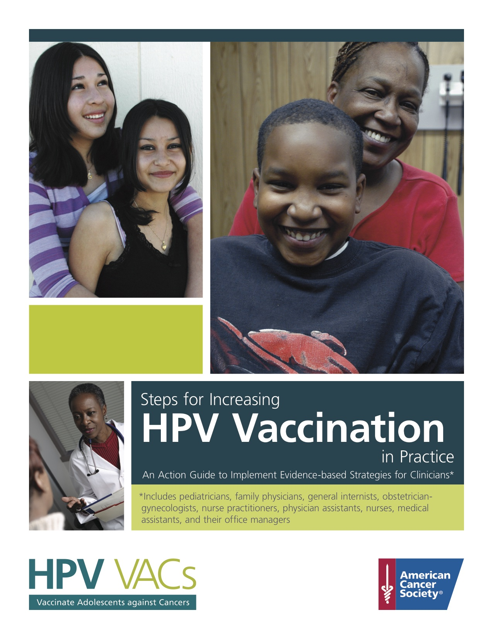
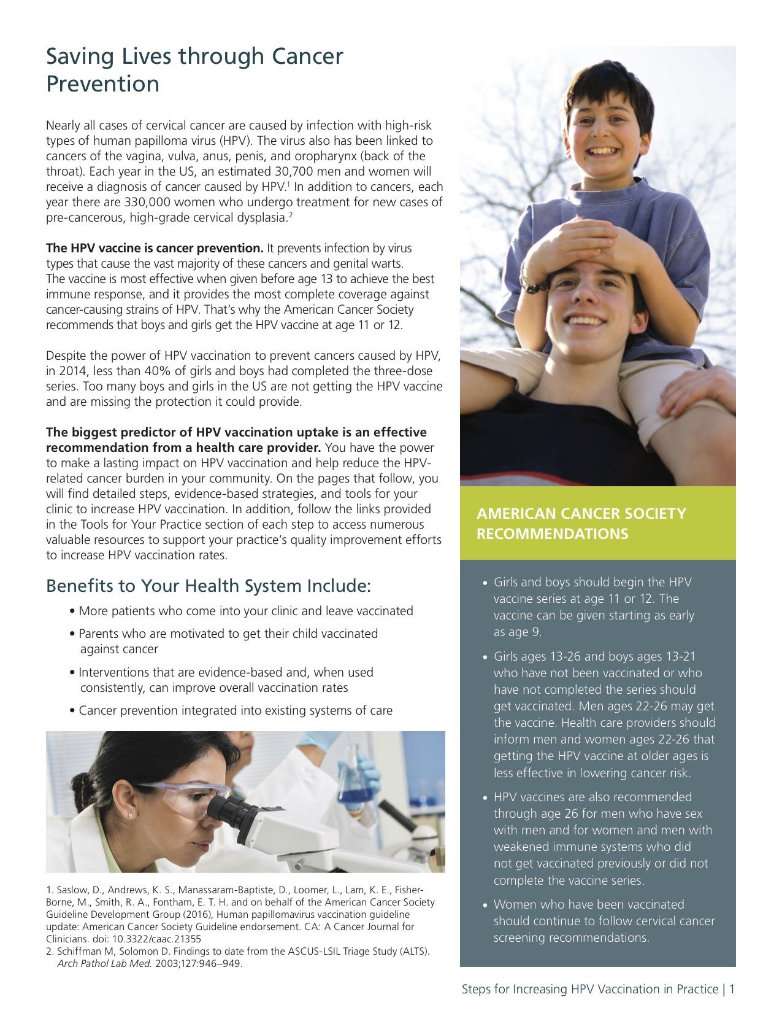
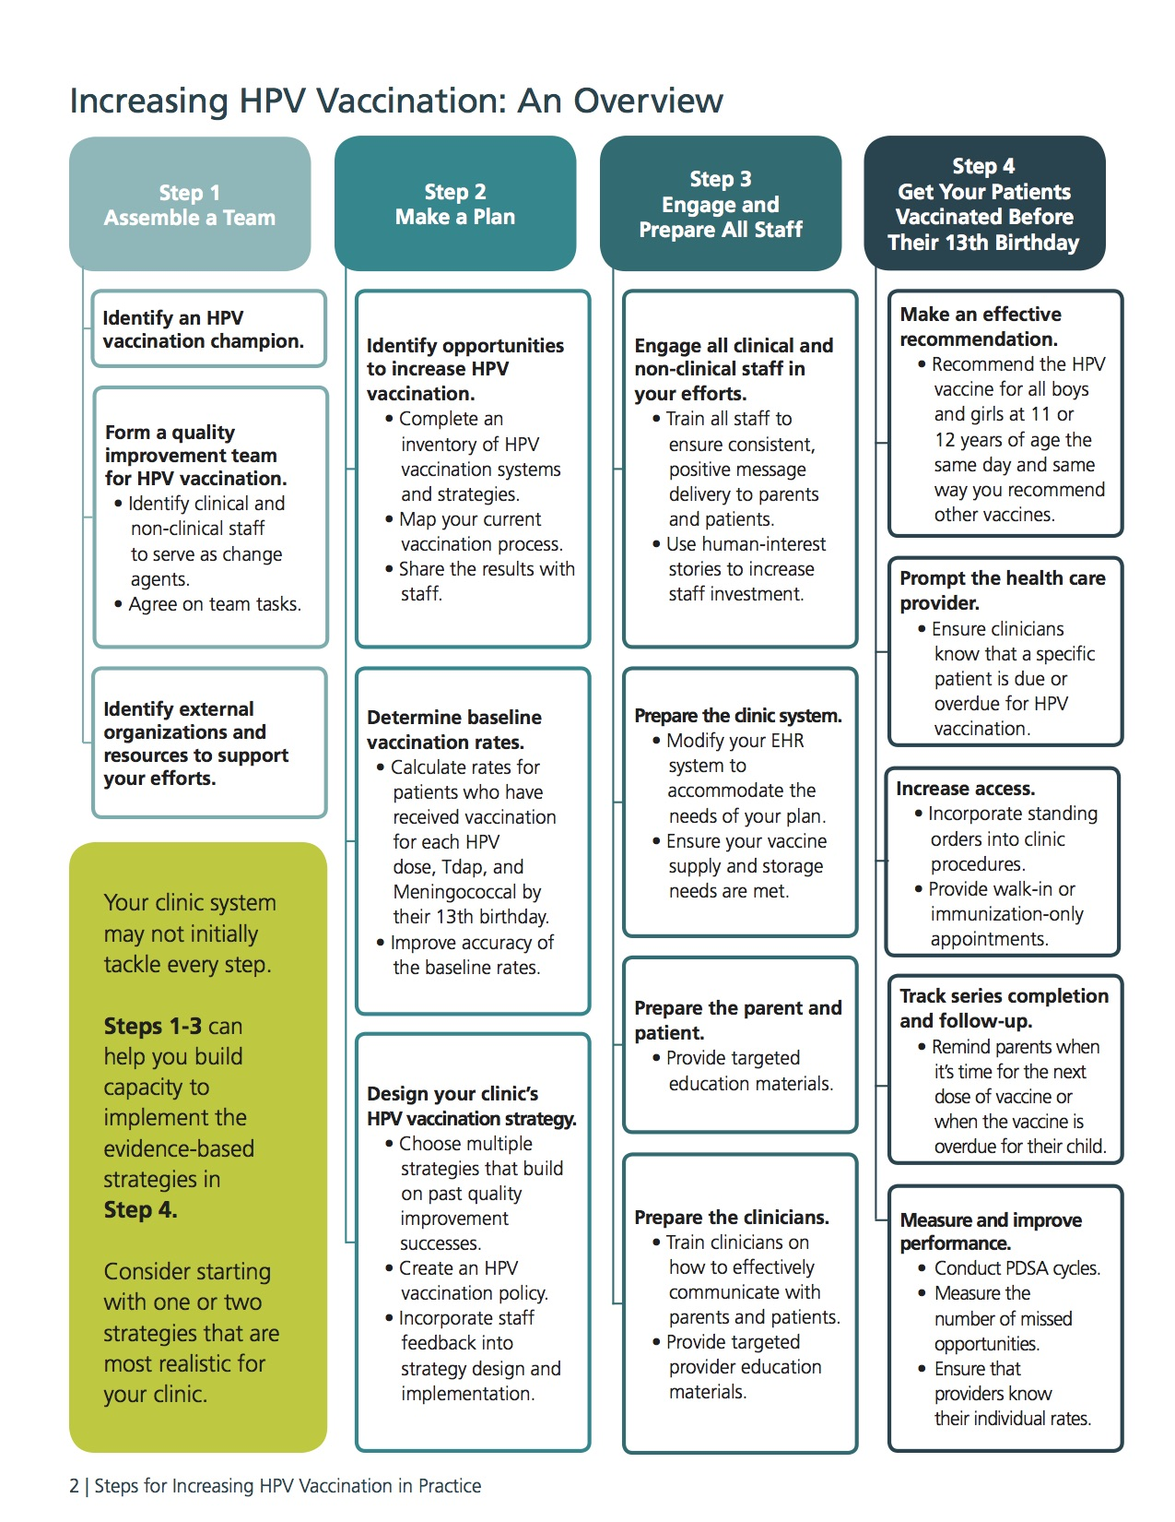
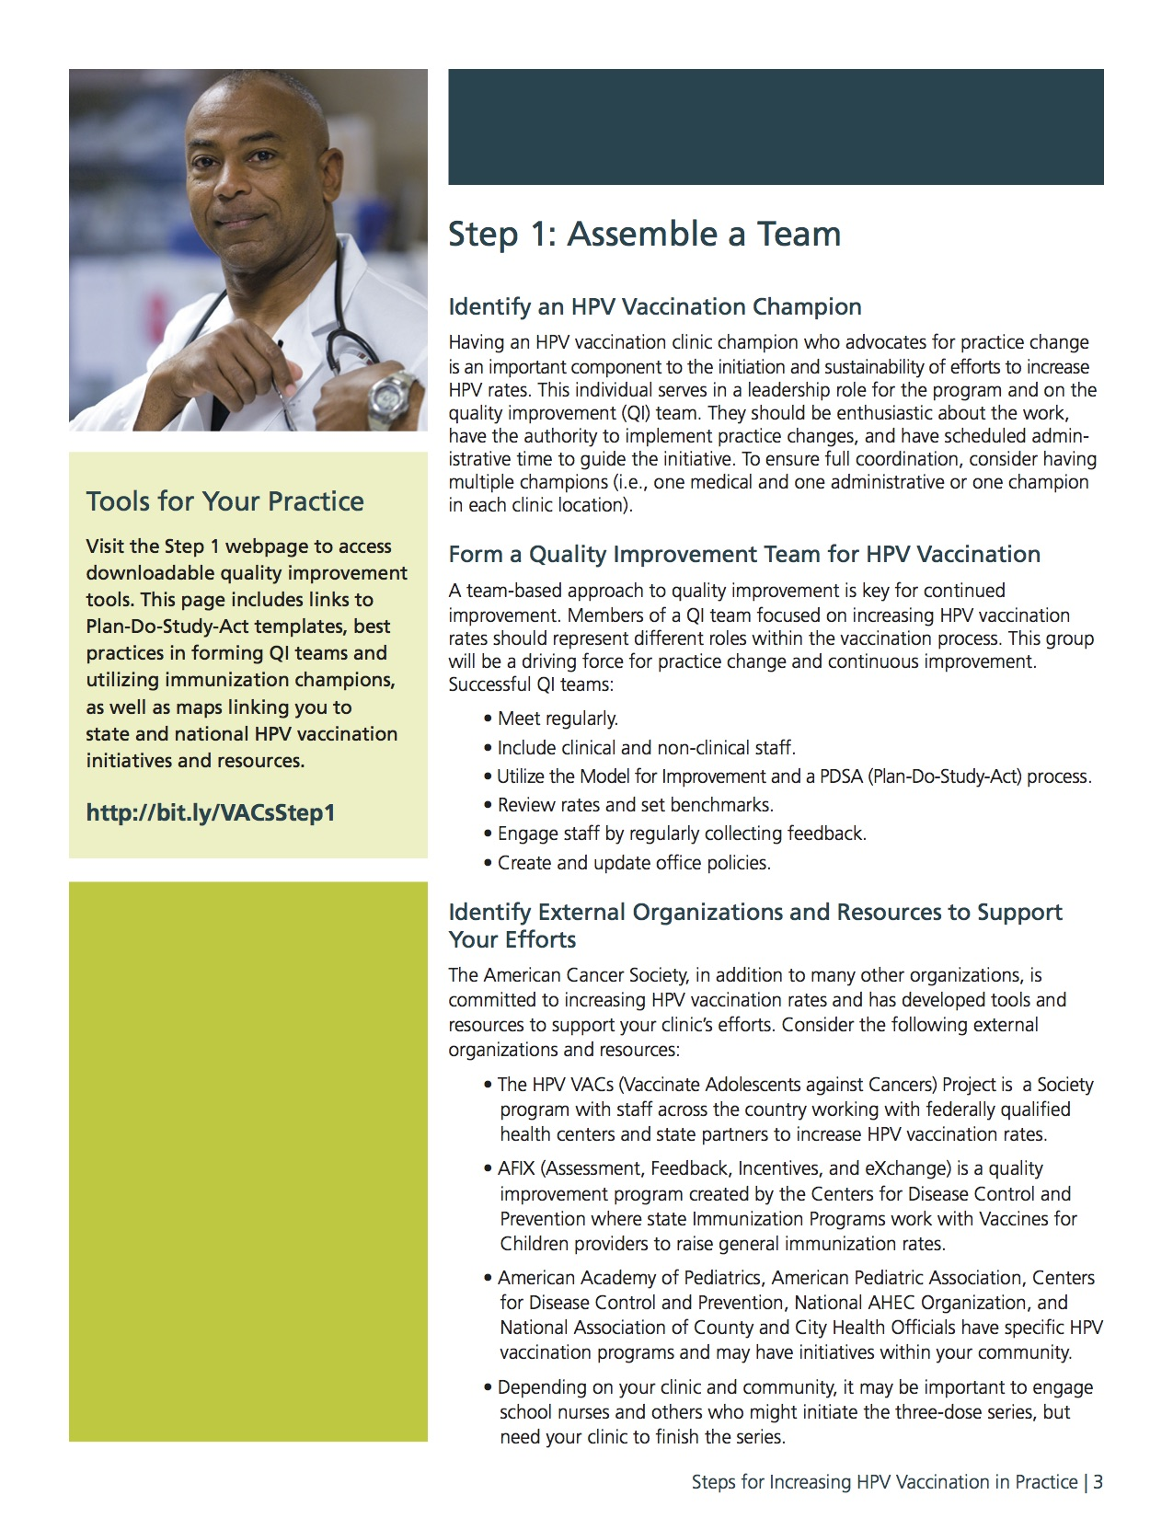
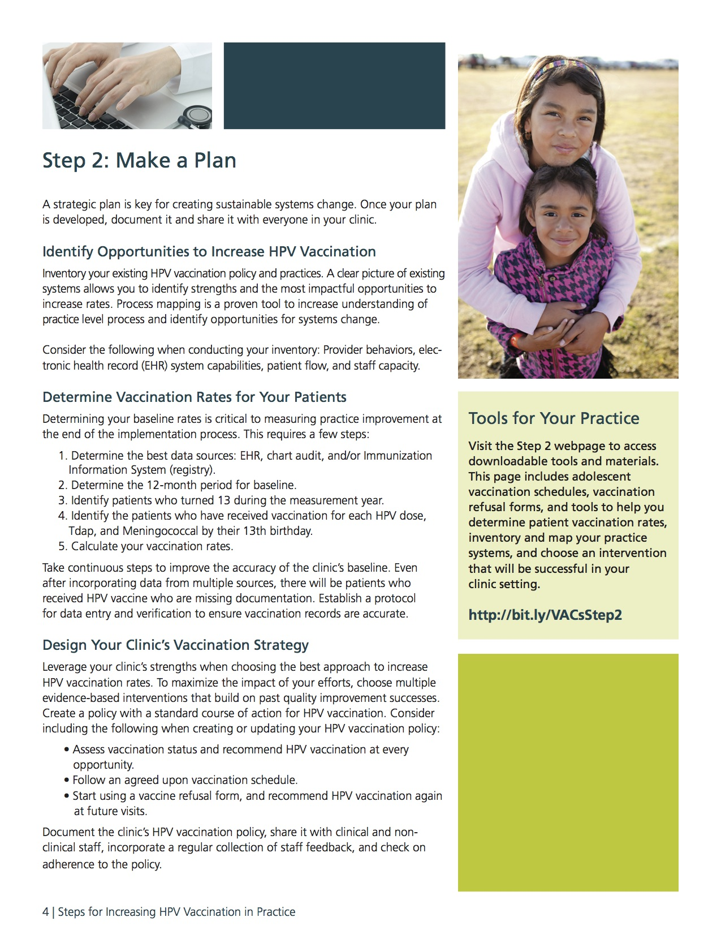
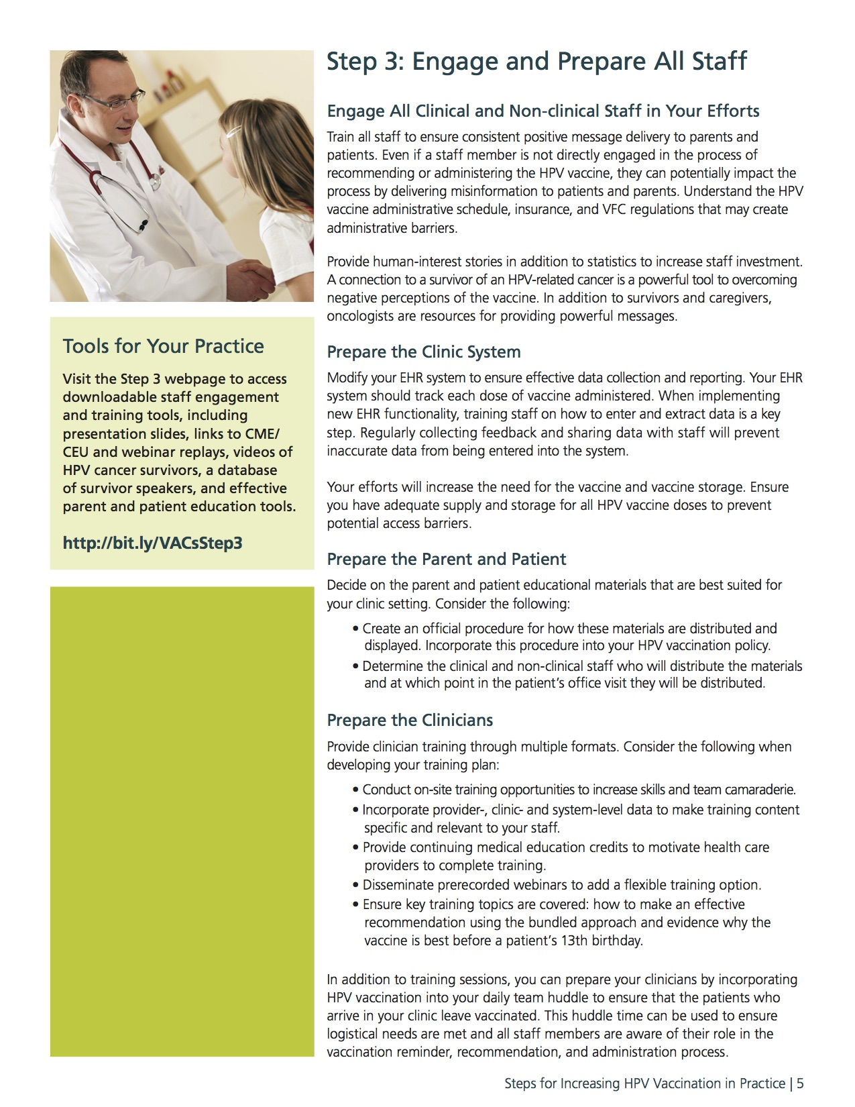
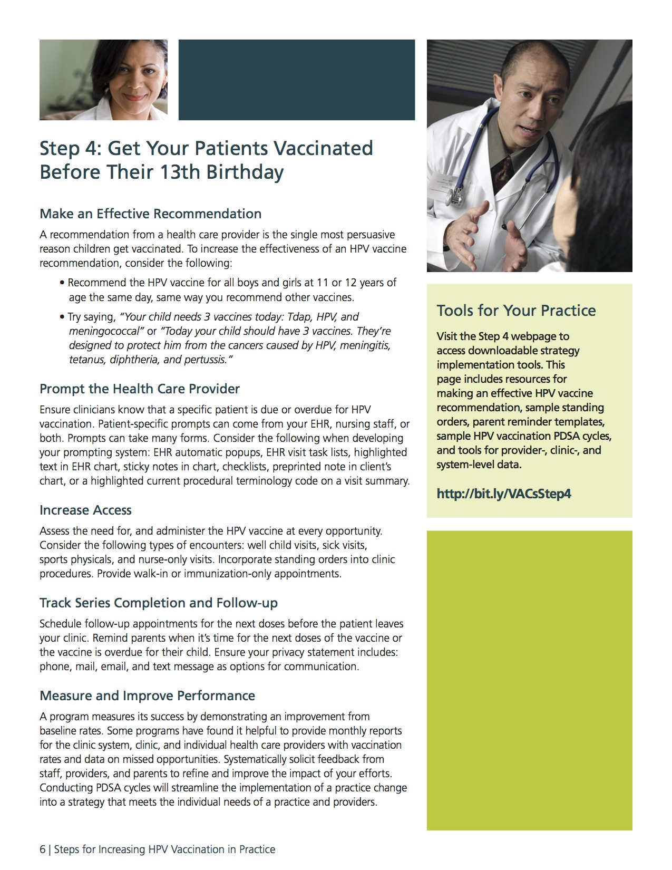
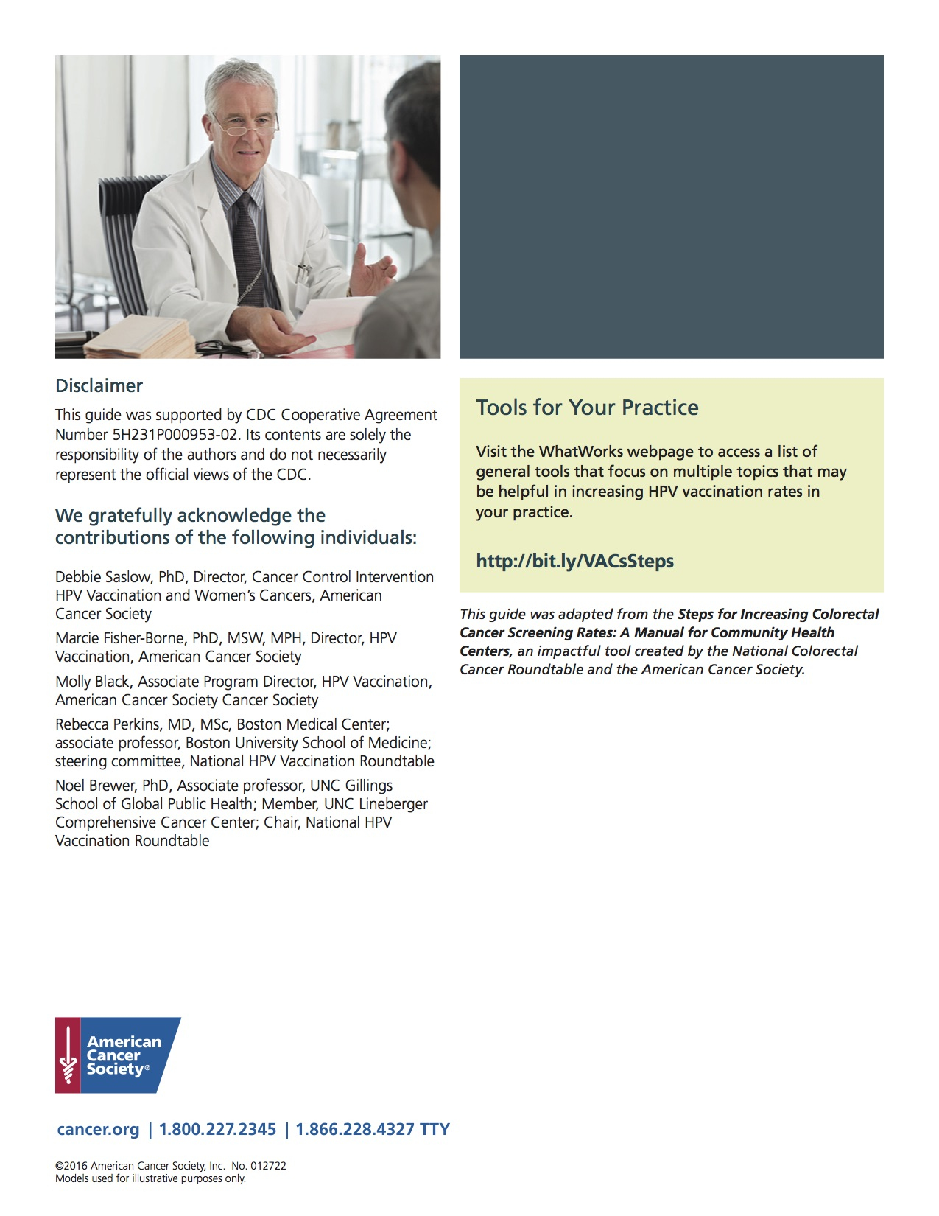

Appendix B
Project Timeline

Table 1. Timeline for Doctor of Nursing Project Capstone Project

Due Date | Task | Complete
March 13th 2017 | DNP Project Timeline | √
March 13th 2017 | Project Team Member Curriculum Vitae | √
March 13th 2017 | Project Site Contract | √
March 13th 2017 | DNP Project Proposal Approval
March 13th 2017 | Develop First Draft of Project Intervention | √
March 20th 2017 | DNP Journal Entry | √
March 27th 2017 | CITI Training Completed | √
April 3rd 2017 | First Draft of Paper (First 3 Chapters) | √
April 3rd 2017 | DNP Journal Entry | √
April 17th 2017 | DNP Journal Entry | √
April 26th 2017 | Final DNP Paper (First 3 Chapters) | √
April 28th 2017 | Time Log Submitted for DNP 1 | √
April 28th 2017 | DNP Project Progression Form | √
June 2017 | Literature Matrix | √
June 2017 | Expansion on budget/implementation | √
July 2017 | IRB Approval | √
July 2017 | Complete Written Implementation Plan | √
July 2017 | Time Log Submitted for DNP 2 | √
July 2017 | Final Paper for DNP 2 | √
August 2017 | Begin project implementation with 30 minute delivery of project intervention at provider lunch | √
August-November 2017 | Weekly updates with project champion via Qualtrics survey gathering feedback from providers and weekly vaccination rates. | √
October 11, 2017 | Draft Paper Due | √
October 16, 2017 | Mid-term Time Log | √
October 16, 2017 | Reflective Journal | √
October 30, 2017 | Reflective Journal | √
November 11, 2017 | Reflective Journal | √
November 22, 2017 | Project Implementation 90-Day Period Ends | √
November 27, 2017 | Final DNP III Paper Due | √
December 4, 2017 | Final Project Time Log Due | √
December 2017 | Final Paper Submitted for DNP 3 | √
January-February 2018 | Complete Final Paper DNP 4 | √
February 2018 | Presentation at Ardmore Family Practice with Findings | √
February 2018 | Create Poster Presentation | √
March 2018 | Upload final paper to ScholarShip | √
March 2018 | Close IRB Approvals | √
April 2018 | Time Log Submitted DNP 4 | √
April 2018 | Poster Presentation | √
May 2018 | GRADUATE!

Appendix C
Literature Matrix
Increasing HPV Vaccination Rates Through Provider Intervention

Author | Title | Name of Journal | Year | Purpose | Study Design | Sample | Data Source | Key Points | Level of Evidence
Allison et al. | Primary care physician’s perspectives about HPV vaccines | Pediatrics | 2016 | Describe self reported vaccine practices, estimate frequency of parental deferral of HPV vaccination and identify characteristics associated with not discussing it. | National survey with multivariable analysis | N=582 | National survey of family and pediatric physicians | Address physicians perception of parental acceptance and recommend discussing HPV along with other vaccinations | 2
ACS | Steps for increasing HPV vaccination in practice | N/A | 2016 | Guide to help providers increase HPV vaccination rates | N/A | N/A | N/A | Guide to help providers increase HPV vaccination rates | 5
Bean & Catania | Vaccine perceptions among Oregon health care providers | Qualitative Health Research | 2013 | Relationship between vaccinations and practice with HBM influence | Hour long interviews with HCP with thematic analysis | N=15 | Healthcare providers in Oregon | HBM constructs, perceived susceptibility and severity of illness helps explain HCP practices | 2
Bratic et al. | Update on barriers to HPV vaccination and effective strategies to promote vaccine acceptance | Current Opinion in Pediatrics | 2016 | Review of updated HPV vaccination barriers to vaccination | Literature review | N/A | N/A | HPV vaccines are safe but uptake is low. Lack of provider recommendation and lack of provider knowledge are important contributing factors. | 5
Brewer et al. | Announcements versus conversations to improve HPV vaccination coverage | Pediatrics | 2017 | Improving provider recommendation of HPV vaccine by studying announcements vs conversations with parents about vaccination. | Parallel group randomized clinical trial | N=30 | Pediatric and family clinics in central NC | Announcement recommendations by providers increase HPV vaccination uptake | 3
CDC | Basic information about HPV and cancer | N/A | 2013 | National and reputable source of HPV facts. | N/A | N/A | N/A | National and reputable source of basic HPV facts. | 1
CDC | HPV vaccine safety and effectiveness | N/A | 2016a | National and reputable source about the latest information on the HPV vaccine. | N/A | N/A | N/A | National and reputable source about the latest information on the HPV vaccine. | 1
CDC | Human papillomavirus | N/A | 2016b | National and reputable source of HPV facts. | N/A | N/A | N/A | National and reputable source of basic HPV facts. | 1
CDC | Genital HPV infection: Fact sheet | N/A | 2017a | National and reputable source of HPV facts. | N/A | N/A | N/A | National and reputable source of HPV facts. | 1
CDC | Who should not get vaccinated with these vaccines | N/A | 2017b | National and reputable source about who should and should not receive HPV vaccine. | N/A | N/A | N/A | National and reputable source about who should and should not receive HPV vaccine. | 1
Chesson et al. | Estimates of the annual direct medical costs of the prevention and treatment of disease associated with HPV in the US | Vaccine | 2012 | To determine the overall costs of HPV infection in the US. | Review of data used in National Health Interview Survey | US Population | National Health Interview Survey data | Overall annual economic burden of HPV is 8 billion. | 2
Gilkey et al. | Quality of physician communication about HPV: Findings from a national survey | Cancer epidemiology, biomarkers & prevention | 2015 | To determine the impact of provider communication style on HPV vaccination uptake. | National online survey | N=776 | National sample of US pediatricians and family physicians | A large amount of providers do not strongly endorse HPV vaccination and also use a risk based approach for determining who should be vaccinated. | 2
Guevenc et al. | HBM scale for HPV and its vaccination: Adaptation and psychometric testing | Journal of pediatric and adolescent gynecology | 2016 | To measure the utility of an HBM adapted instrument in determining HPV vaccination beliefs. | Adaptation of psychometric study into instrument | N=302 | Nursing students | The HBM is helpful in determining beliefs and attitudes towards HPV vaccination | 4
HRSA | Quality improvement | N/A | 2017 | Defining quality improvement | N/A | N/A | N/A | Defining Quality improvement | 7
Healthy People 2020 | Immunization and infectious diseases | N/A | 2017 | List of public health objectives for various infectious diseases | N/A | N/A | N/A | Goal for HPV vaccination is 80% | 5
Jones et al. | Evaluating the effectiveness of HBM interventions in improving adherence: A systematic review | Health Psychology | 2014 | To identify studies that utilize the HBM to design their intervention. | Systematic literature review | N=18 | Studies utilizing the HBM to design intervention | Use of HBM was inconsistent but showed significant improvements in adherence. | 5
Luque et al. | Recommendations and administration of the HPV vaccine to 11-12 year old girls and boys: A statewide survey of Georgia vaccines for children provider practices | Journal of Lower Genital Tract Disease | 2014 | Studies the prevalence of provider HPV vaccination recommendations and rates. | Cross sectional study | N=206 | Clinics that have patients who are 11 & 12 yo girls and boys in Georgia | Providers do not recommend HPV vaccinations as recommended in the national guidelines. | 3
Markowitz et al. | Reduction in HPV prevalence among young women following HPV vaccine introduction in the US, national health and nutrition examiniation surveys, 2003-2010 | The Journal of Infectious Diseases | 2013 | HPV prevalence data was compared before and after the implementation of HPV vaccination. | Review of survey data | N=8403 | US National Health and Nutrition Examination Survey | Within 4 years of the introduction of HPV vaccination, rates of infection declined regardless of low rate of vaccine uptake | 1
Marsh et al. | Mind the gaps: What’s missing from current economic evaluations of universal HPV vaccination? | Vaccine | 2014 | To examine the literature that attempts to quantify the economic impact of HPV vaccination | Literature review | N=8 | Published studies measuring economic impact of HPV vaccination | Most studies largely underestimate the economic impact of HPV vaccination. | 5
Meites et al. | Use of a 2-dose schedule for HPV vaccination: Updated recommendations of the advisory committee on immunization practices. | Morbidity and Mortality Weekly Report | 2016 | Update recommendations on HPV vaccination dosing schedule | Systematic review of studies who measured health incomes of HPV vaccination | N/A | N/A | Boys and girls who initiate HPV vaccination between 9-14 years old only need 2 doses instead of 3. Older patients will continue to receive 3 doses. | 1
Mergler et al. | Association of vaccine-related attitudes and beliefs between parents and healthcare providers | Vaccine | 2013 | To study the relationship between providers and parents on vaccination uptake | Survey utilizing 5 point likert scales | N=1918 | Primary care providers and parents in 4 states. | Similar beliefs between parents and their HCP exist. | 3
NCI | HPV vaccines | N/A | 2016 | Facts about HPV from the national cancer institute | N/A | N/A | N/A | Facts about HPV from the national cancer institute | 1
NFID | Call to action: HPV vaccination as a public health priority | N/A | 2014 | National facts about HPV, HPV vaccination and how to improve vaccination rates via provider interventions. | N/A | N/A | N/A | Facts about HPV, HPV vaccination and how to improve vaccination rates via provider interventions. | 5
Nichols et al. | Duty to advocate: HPV vaccination | Journal of Pediatric Pharmacological Therapy | 2017 | Reaffirm recommendations for HPV vaccination from pediatric pharmacy advocacy group | N/A | N/A | N/A | Pediatric pharmacy advocacy group recommends HPV vaccination because it is safe and effective | 5
Perkins et al. | Effectiveness of a provider focuses-intervention to improve HPV vaccination rates in boys and girls | Vaccine | 2015 | Provider focused intervention to increase HPV vaccination rates. | Experimental provider intervention | N=2 | Providers at 2 inner-city community health centers | Provider focused intervention for HPV vaccination increases vaccine uptake. | 3
Reagan-Steiner et al. | National, regional, state and selected local area vaccination coverage among adolescents aged 13-17 years: United states, 2015 | Morbidity and Mortality Weekly Report | 2016 | To determine rates of vaccination among adolescents 13-17 years of age in the US. | Analyzed collected data from National Immunization Survey-Teen | N/A | US adolescents aged 13-17 years | Although a modest increase in first dose HPV vaccination was seen the rates still remain much lower than other teen vaccinations. | 1
Rohrbach et al. | A survey of Wisconsin pediatrician’s knowledge and practices regarding HPV vaccine | Otolaryngology-Head and Neck Surgery | 2017 | To explore provider attitudes and practices about HPV vaccination, comparing males and females. | Cross-sectional descriptive survey research | N=412 | Wisconsin pediatricians | There is a discrepancy between providers in knowing the vaccine should be offered and actually recommending to eligible patients. | 3
Schuiling & Likis | Women’s gynecologic health (3rd ed) | Jones & Bartlett Learning | 2017 | Textbook used for HPV facts | N/A | N/A | N/A | Textbook | 5

Appendix D
Literature Search Table
Literature Search Table:
PubMed, February 2017
Search details: (HPV[All Fields] AND ("vaccination"[MeSH Terms] OR "vaccination"[All Fields])) AND providers[All Fields]
- Searched key words: HPV, vaccination, provider | 330 Articles Retrieved
- Excluded Articles published longer than 5 years ago excluded | 238 Articles Retrieved
- Excluded Article without full-text available | 223 Articles Retrieved
- Reviewed 223 potentially relevant articles via title | 95 Articles Retrieved
- Reviewed 95 abstracts in detail, excluded articles that did not focus on provider intervention. | 16 Articles Retrieved
- Excluded articles not completed in US | 10 Articles Retrieved
- 10 Articles included in analysis: National surveys, expert opinion, experimental, case controlled.

Appendix E
HPV Vaccination Provider Guide

Adapted from American Cancer Society’s Guide for Increasing HPV vaccination in Practice

HPV Facts Review
- Over 80% of people will be infected with HPV at some point in their lives.
- The highest rates of HPV infection are among 15-24 year olds.
- Most people do not have any symptoms.
- HPV causes cancers of the cervix, vagina, vulva, penis, anus, rectum and oropharynx.
- The number of oropharyngeal cancers caused by HPV are expected to surpass the number of HPV-related cervical cancers by 2020.

HPV Vaccination Updated Recommendation
- HPV vaccinations are safe and effective.
- Two-dose series is recommended for adolescents age 9-14. Older adolescents need the 3-dose series.
- Vaccinate all eligible adolescents at age 11 or 12.
  - Younger adolescents have 2-3-fold higher increase in antibodies as compared to older adolescents.
  - Vaccination should be completed well before first sexual contact.

Provider Actions to Increase Vaccination Uptake
- The biggest predictor of vaccination uptake is a strong provider recommendation.
- Recommend the vaccine with the same strength and at the same time as other adolescent vaccines, TDAP and meningitis vaccine.
- Communication with patient/family:
  - Announcement vs. shared-decision making recommendation.

Appendix F
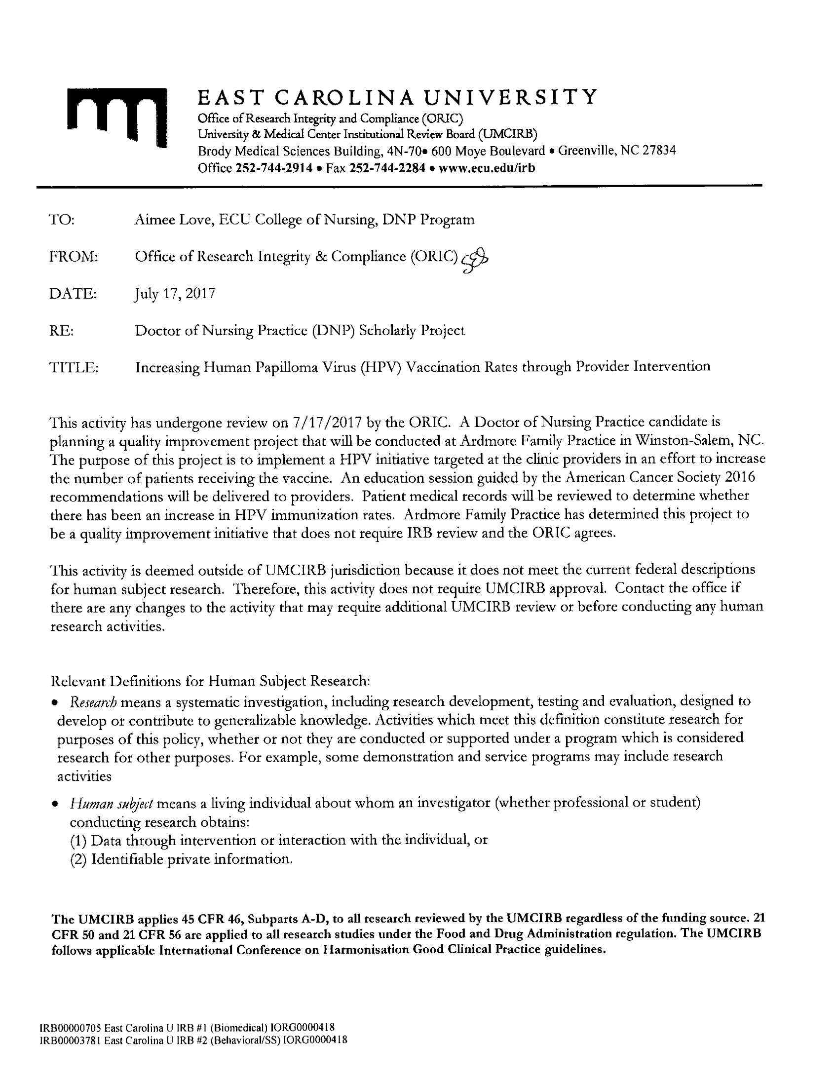
Appendix G
Weekly Provider Survey via Qualtrics
- Have you recommended the HPV vaccine this week? Yes/No forced response
- Did you have anyone decline the HPV vaccine this week? Yes/No forced response
- If applicable, what reasons were given for declining the HPV vaccine? Free text, optional response
- Is there any additional feedback you would like to add? Free text, optional response

Appendix H
Qualtrics Survey Results
Table 3

Question One: Have you recommended the HPV vaccine this week?
Week | Response Rate | Yes | No
1 | 50% | 100% | 0%
2 | 50% | 50% | 50%
3 | 25% | 100% | 0%
4 | 75% | 100% | 0%
5 | 25% | 100% | 0%
6 | 75% | 100% | 0%
7 | 75% | 100% | 0%
8 | 50% | 100% | 0%
9 | 75% | 100% | 0%
10 | 75% | 100% | 0%
11 | 100% | 50% | 50%
12 | 50% | 0% | 100%

Table 4

Question 2: Did you have anyone decline the HPV vaccine this week
Week | Response Rate | Yes | No
1 | 50% | 0% | 100%
2 | 50% | 0% | 100%
3 | 25% | 0% | 100%
4 | 75% | 100% | 0%
5 | 25% | 0% | 100%
6 | 75% | 33% | 67%
7 | 75% | 33% | 67%
8 | 50% | 50% | 50%
9 | 75% | 0% | 100%
10 | 75% | 0% | 100%
11 | 100% | 25% | 75%
12 | 50% | 0% | 100%

Table 5

Question 3: If applicable, what reasons were given for declining the HPV vaccine?
mom: "let's wait until next year"
Mom wanted to wait
child too young; wanted to wait until an older age
religious, or none
Didn't want to talk about it. Aknowledged understanding.
parent didnt think it was necessary
none
Mother unsure about safety felt it is experimental
Will think about it. Concerned about the "sexual" part.
wanted to wait until child was older
9 yo, wants to wait

Table 6

Question 4: Is there any additional feedback you would like to add?
Posters are up in my rooms
none
Brochure helpful with education
no
none
no
none

