THE HPV VACCINATION PROJECT: HPV VACCINATION FOLLOWING PEDIATRIC SEXUAL ABUSE

by

Elizabeth Arpe Goodman

Paper submitted in partial fulfillment of the

requirements for the degree of

Doctor of Nursing Practice

East Carolina University

College of Nursing

Date Finalized

Signature Faculty Coordinator Date

Signature Program Director Date

Acknowledgments

I would like to thank my family: My husband, JT, and two daughters, Jo, and Jill Goodman, whose patience, understanding and support allowed me to persevere through my lengthy academic journey. I would also like to recognize their willingness to take on an abundance of additional responsibilities and sacrifices to promote and ensure my successful outcome. They are the reasons why I raise my bar and strive for excellence. I would also like to extend my most sincere gratitude to my mentor, Dr. Meggan Goodpasture, for being the catalyst behind this project and serving as a quintessential example by faithfully serving this project’s population with unwavering passion and grace. Additionally, I am most grateful to Dr. Sally Bulla and Dr. Ann Bell, whose words of wisdom and steadfast encouragement provided much needed navigation, guidance, and support through this DNP project. Finally, I would like to recognize the enthusiastic and unyielding support of this important project by of the Child Protection Team and the Brenner Pediatric Specialty Clinic staff at Wake Forest Baptist Medical Center who patiently served as sounding boards, logistics experts, early project adopters, and “curbside” consults.

Dedication

“On a point of land, as though projecting into a domain beyond us, I found the star thrower. In the sweet rain-swept morning, that great many-hued rainbow still lurked and wavered tentatively beyond him. Silently I sought and picked up a still-living star, spinning it far out into the waves. I spoke once briefly. “I understand”, I said. “Call me another thrower”. Only then I allowed myself to think, He is not alone any longer. After us there will be others” (Eiseley, 1969, p. 89).

This work is dedicated to my amazing daughters, Joanna Thea and Jillian Tori Goodman. Always strive to be Star-Throwers.

Abstract

The nonavalent human papilloma virus (HPV) vaccination prophylactically contributes to the prevention of nine types of HPV associated with vaginal, anal, oropharyngeal, labial, cervical and penile cancers (Viens, et al, 2016). Rates of HPV vaccination remain significantly lower than the national Healthy People 2020 goal of 80% (Office of Disease Prevention and Health Promotion, 2014). The utilization of medical encounters outside of the well child evaluation as an opportunity to vaccinate has been cited in the literature as a possible method of positively impacting HPV vaccination rates (Farmar, et al., 2016; National Vaccine Advisory Committee, 2016). The purpose of this quality improvement project was to improve HPV vaccination rates in eligible children at the time of the medical evaluation following concerns for a history of pediatric sexual abuse by recommending, offering and administering HPV vaccination to this high risk population (Garland, Markowitz, et al., 2014; et al., 2015).

During the 60-day intervention, data was analyzed compared to similar information collected during a 60-day pre-intervention period. Project outcomes included acknowledgement of 22 missed opportunities to vaccinate during the pre-intervention period. Eight HPV vaccines were administered to NCIR eligible patients (N=21) during the 60-day intervention period. Sixty-two percent (n=5) of the vaccinations administered were initiated the HPV vaccine series and sixty-three percent were to younger adolescents, ages nine to 12 years of age (n=5). The primary barrier to vaccination during the intervention included appointment no-shows (n=8). Additional nursing implications guided by the eight American Association of Colleges of Nursing DNP essentials are explored and discussed.

*Key words*: *HPV vaccination and pediatric sexual abuse,* *HPV vaccination rates*, *HPV vaccination and missed opportunities*

**Table of Contents**

Acknowledgments 2

Dedication 3

Abstract 4

Chapter One: Overview of the Problem of Interest 10

Background Information 10

Significance of Clinical Problem 11

Question Guiding Inquiry (PICO) 12

Population 12

Intervention 12

Comparison 13

Outcomes 14

Summary 14

Chapter Two: Review of the Literature Evidence 15

Methodology of Literature Review 15

The HPV Vaccination………………………………………………………………16

HPV Vaccination Efficacy………………………………………………………….18

HPV Vaccination Rates…………………………………………………………….29

Possible Causes of Low HPV Vaccination Rates…………………………..............20

Recommendations to Address Low Vaccination Rates…………………………….21

HPV and Pediatric Sexual Abuse…………………………………………..............22

Limitations of the Literature Review Process 24

Discussion 25

Conclusions of findings 25

Advantages and disadvantages of findings 26

Utilization of findings in practice 27

Summary 28

Chapter Three: Theory and Concept Model for Evidence-based Practice 30

Pender’s Health Promotion Model 30

HPM and adolescents 31

Utilization of the situational influence modifier……………………………32

Summary 34

Chapter Four: Pre-implementation Plan 36

Project Purpose 36

Project Intervention in the CPT Clinic 38

Project Management………………………………………………………………...39

Organizational readiness for change 39

Inter-professional collaboration 40

Organizational approval process 41

Information technology: NCIR and VIS 42

Cost Analysis of Project Materials 43

Plans for Institutional Review Board Approval 44

Project Sampling Plan 45

Demographics 45

Inclusion Criteria 46

Exclusion Criteria 46

Recruitment 46

Implementation Plan 47

Plan for Project Evaluation 49

Demographic Comparison 49

Outcome Measurement 49

Evaluation Tool 50

Data analysis 51

Data management 52

Ongoing Project Evaluation 53

Summary 53

Chapter Five: Implementation Process 55

Setting 55

Project Participants 57

Inclusion and exclusion criteria in the CPT clinic 58

Project recruitment strategies 59

Overview of the Implementation Process 59

Plan for Variation 61

Summary 62

Chapter Six: Evaluation of the Practice Change Initiative 64

Participant Demographics 64

Pre-Intervention Missed Opportunities………………………………………….….65

Intended Outcomes 65

Findings 66

Age trend of vaccinations 66

No-shows 67

Missed vaccination during project intervention……………………...……. 68

Summary 68

Chapter Seven: Implications for Nursing Practice 70

Practice Implications 70

Essential I: Scientific underpinnings for practice 70

Essential II: Organization and systems leadership for quality

improvement and systems thinking 72

Essential III: Clinical scholarship and analytical methods for EBP 74

Essential IV: Information systems/technology and patient care

technology for the improvement and transformation of healthcare 74

Essential V: Healthcare policy for advocacy in healthcare 76

Essential VI: Interprofessional collaboration for improving patient

and population health outcomes 77

Essential VII: Clinical prevention and population health for

improving the nation’s health 78

Essential VIII: Advanced nursing practice 79

Summary 80

Chapter Eight: Final Conclusions 81

Significance of Findings 81

Project Strengths and Limitations 82

Project Benefits 84

Recommendations for Practice 85

Final Summary 87

References 89

Appendix A: HPV Vaccine Project Needs Assessment 98

Appendix B: Literature Review Evidence Matrix 99

Appendix C: Wake Forest Health Sciences IRB Ancillary Committee Approval 112

Appendix D: East Carolina University ORIC Project Approval 113

Appendix E: Vaccine Information Statement: Human Papilloma Virus 114

Appendix F: Pediatric Vaccines For Children (VFC) Vaccine Price 116

Appendix G: Average HPV Vaccination Cost for Project 117

Appendix H: Data Collection Tool 118

Appendix I: Pre-Intervention and Intervention Population Comparison 119

Appendix J: Pre-Intervention and Intervention HPV Vaccination Comparison 120

Appendix K: Pre-Intervention Missed Opportunities 121

Appendix L: HPV Vaccination Project Intervention Outcomes 122

Appendix M: HPV Vaccination Project Age Trends 124

Appendix N: HPV Vaccination Project No Show Rates and Project Outcomes 125

**Chapter One: Overview of the Problem of Interest**

The “herd effect” benefit of the human papilloma virus (HPV) vaccination can be described as the “indirect protection” in the reduction of the incidence of high risk oncogenic HPV associated infections or infectiousness in a target population, such as adolescents (Fine, Eames, & Heymann, 2011). Although calculations can assist in determining the vaccination threshold level required within a population to provide protection, low vaccination rates result in suboptimal outcomes (Fine, Eames, & Heymann, 2011). Over the past decade, low HPV vaccination rates have been a target for research and interventions that aim to increase the number of adolescents and young adults to improve health outcomes, including children with a history of concerns for sexual abuse (Farmer, et al., 2016; Rahman, et al., 2015; Kaufman, 2008; Oliver, Frawley, & Garland, 2016). Furthermore, the National Vaccine Advisory Committee on Immunization Practices (ACIP) (2016) and the Center for Disease Control and Prevention (CDC) (2015) have published statements in support for the provision of HPV vaccination outside of the medical home to eligible children and adolescents with a history of sexual abuse. Therefore, the purpose of this chapter is to provide some background information and a brief overview in support of a quality improvement project that could positively influence the rates of HPV vaccination series initiation and completion in children and adolescents following concerns for sexual abuse.

**Background Information**

Research has proven that the HPV vaccination prophylactically contributes to the prevention of vaginal, anal, oropharyngeal, labial, cervical and penile cancers (Internal Agency for Research on Cancer Working Group, 2012).  Coverage with initial vaccination in the HPV vaccine series has proven to provide some protective coverage against the development of HPV; however, vaccine series completion is ideal and is recommended prior to the onset of sexual activity (Kreimer, et al., 2011; Reagan-Steiner, et al., 2015). A 2015 national immunization survey revealed that, overall, there are low rates for series initiation and completion for both males and females, and that rates in North Carolina for series completion were 20.9 and 54 percent for males and females respectively (Reagan-Steiner, et al., 2015).   This rate is substantially lower than the Healthy People 2020 goals of HPV vaccine series completion of 80% (Office of Disease Prevention and Health Promotion, 2014).

**Significance of Clinical Problem**

Due to early sexual contact exposures and evidence of unsafe sexual activity at a younger age, victims of pediatric sexual abuse are at a higher risk for acquiring HPV and developing HPV related outcomes when compared to non-abused children (Abajobir, et al., 2017; Kaufman, 2008; Unger et al., 2011).  The ACIP and CDC address current recommendations for this high-risk population in recent publications. For example, a study byRahman, Laz, McGrath and Berenson (2015) suggested that the intention to initiate and complete the HPV vaccine series was benefited from provider based vaccine educational counseling and promotion to parents of adolescent patients in the primary care setting. Furthermore, more than one HPV research based recommendation included the provision of initial vaccination or completion of the HPV vaccine series to those eligible at the time of the sexual abuse evaluation or as soon as possible following the evaluation (Seña, et al., 2015; Petrosky, et al., 2015;Markowitz, et al., 2014).

Similarly, low rates of HPV vaccine series initiation and completion have been observed in a population of children evaluated following concerns for sexual abuse in a child protection team (CPT) clinic setting.  Prior to the project proposal, an informal needs assessment was conducted utilizing the CPT clinic schedule. One month revealed the percentage of male and female patients who were potentially eligible for HPV vaccination based on age at the time of their CPT evaluation (Owen, 2017). Overall (N=36), 44% (*n*=16) of these children fell between the ages of nine and 17 years of age and could have potentially received HPV vaccine series initiation or series completion (Appendix A).

**Question Guiding Inquiry (PICO)**

The purpose of this project was to initiate a process change that would improve the rates of HPV vaccination in eligible patients through provider recommendation and initiation of vaccination series or completion of vaccination series as a means to optimize HPV vaccination coverage in the high-risk population of sexually abused pediatric patients. This project aimed to answer the question: does vaccine recommendation and administration at the time of the medical examination for possible child sexual abuse improve the rates of HPV vaccination initiation and series completion in 9 to 17-year-old male and female victims of sexual abuse evaluated in a Northwestern North Carolina CPT clinic?

**Population**. Due to ethical considerations of exclusion from this project intervention, the population included all patients, ages 9 to 17 years old, evaluated in a CPT for concerns for a history of sexual abuse. This population selection directly reflected male and female children who were potentially eligible for HPV vaccination per ACIP and the CDC based upon age and history of concerns for sexual abuse (Markowitz, et al., 2014; Meites, et al., 2017; Seña, et al., 2015). As a result, the CPT clinic population provided ideal participants for this project’s goal of improving HPV vaccination rates in this high risk population.

**Intervention.** The HPV vaccination quality improvement project intervention involved providing the HPV vaccination to eligible patients at the time of their clinic evaluation. The reason that this intervention was selected for this project was, in part, due to research surrounding low HPV vaccination rates in the primary care setting highlighting that provider intention is not necessarily reflective of successful HPV vaccination rates (Feemster, et al., 2014). Furthermore, it has been suggested that difficult conversations occurring with caretakers in the primary care setting about young adolescents’ sexual debut and parental concerns related to the impact that vaccination has on sexual promiscuity have also contributed to low HPV vaccination rates (Jin, et al., 2013; Holman, et al., 2014). In contrast, these sexually focused conversations with caretakers in the CPT clinic routinely occur and are a standard component of the patient’s history, thus are less uncomfortable for both parents and patients alike.

Established inclusion and exclusion criteria determined intervention eligibility and reflected current practice standard recommendations for HPV vaccinations per the CDC and ACIP targeting children with concerns for a history of possible sexual abuse (Markowitz, et al., 2014; Meites, et al., 2017; Seña, et al., 2015). Based on this criteria, patients were determined to be potentially eligible for the project intervention as determined by their age and recommended national guidelines for HPV vaccination, and further delineation of eligibility status occurred via the use of a statewide vaccination registry (Markowitz, et al., 2014; Meites, et al., 2017; Petrosky, et al., 2015).

**Comparison.** Comparison of the HPV vaccination rates collected during the 60-day intervention period to those during the 60-day pre-intervention period revealed the impact that offering and providing the HPV vaccination had on this clinic population during the intervention. A demographic description of the CPT clinic population also provided insight into the pre-intervention and intervention groups. Ultimately, the comparison of these two groups highlighted the benefits achieved because of a process change (the intervention), and provided additional valuable information about the number of previous missed opportunities for HPV vaccination in the absence of the intervention.

**Outcomes.** Project outcomes included overall HPV vaccination rates, HPV initiation rates, and HPV series completion rates during the 60-day intervention. Process related rationale for not administering the HPV vaccination were also included as barriers to successful vaccination. Collection of these same data points also included the 60-day pre-intervention period for comparison purposes. Analysis of both vaccine series initiation and completion explored the age trends that were most impacted in this clinic setting. Additional data collected included a compilation of demographic data, such as age, sex, and ethnicity, to provide a more thorough description of the CPT clinic population during the project.

**Summary**

In summary, this chapter has provided a brief overview of the development of a quality improvement project that implemented practice recommendations of addressing eligible patient’s HPV vaccination status at the time of the evaluation for concerns for a history of sexual abuse. This was accomplished by identifying a clinical problem, thoughtfully determining eligibility for vaccination at the time of the clinic visit, and developing an intervention in which a provider recommends and administers the initial HPV vaccine or completing the HPV vaccine series. In conjunction, a brief needs assessment also provided evidence at the time that some children present for a medical evaluation for concerns for child sexual abuse, which identified the existence of an HPV vaccination gap. Demographic description also provided insight into the pre-intervention and intervention clinic population and the relevance of vaccinating for HPV as it directly relates to the identified project population.

**Chapter Two: Review of the Literature**

This chapter will provide the evidence to serve as the foundation for the HPV vaccination DNP quality improvement project in a northwestern North Carolina academic center based CPT clinic. There will be discussion regarding the barriers to HPV vaccination as noted in literature, in addition to research-based recommendations to address HPV vaccination rates. A brief overview of the project’s methodology, sampling strategies and evaluation criteria in the context of identified HPV vaccination barriers and recommendations will provide additional insight into the development of the project’s intervention and relevance to the selected population.

**Methodology for Literature Review**

A literature review was conducted to investigate and provide the foundation for this project's intervention was conducted.  PubMed, MedLine, and EBSCO were utilized to search for relevant information for the literature review of this paper. PubMed was queried using the key words [HPV vaccination recommendations], [HPV vaccination and sexual abuse], and [sexual abuse AND adolescent care recommendations] within the past ten years.  Exclusion criteria included studies involving adults, study subjects outside of the United States, and HPV vaccination recommendations prior to 2011. Fifty-five out of 480 total articles were selected.  Key words used for the MedLine search included, [HPV] and [HPV vaccination and barriers].  Information within the past 10 years was included for [HPV] and for the previous 5 years (since 2012) for [HPV vaccination and barriers]. Exclusion criteria included studies with adult subjects and studies with a focus on HPV and genetics. Of the initial 394 MedLine articles found, 51 of these were selected for further review. Key words used with the EBSCO search included [HPV AND adolescent AND sexual abuse] and [HPV vaccination AND adolescent AND barriers].  Again, articles identifying and addressing barriers were included within the past five years, and all other articles focusing on adolescents and vaccination barriers published within the past 5 years were included.  Exclusion criteria included repeat articles previously utilized, studies involving special populations such as human immunodeficiency virus (HIV), studies involving adults and studies involving populations outside of the United States. Overall, the EBSCO search provided 150 articles, seven of which were kept for additional review and possible inclusion for this paper (Appendix B).

The HPV vaccination.  Research shows that the presence of certain human papilloma viruses DNA is highly associated with specific cancers of the cervix, vulva, vagina, penis, anus, and oropharynx (International Agency for Research on Cancer, 2006).  Although there are known to be numerous types of HPV, archived tissues examined by the Centers for Disease Control and Prevention (CDC) concluded that 90.6% of cervical cancers (98.8% of cervical cancer insitu) contained HPV DNA, in addition to 91.1%, 75%, 70.1%, 68.8%, 63.3%, 32%, and 20.9% of cancers located in the anus, vagina, oropharynx, vulva, penis, mouth and larynx respectively (Saraiya, et al., 2015).

Certain types of HPV are more often associated with certain types of cancers.  For example, a multicenter case control study by Munoz, et al. (2004) that included 3,607 women with cervical cancer from 25 countries determined that HPV DNA was present in 96% of tissue specimens, and identified 15 of the most common HPV types are considered high-risk for the evolution of cervical cancer.  Conclusions suggested that a vaccine including protection against HPV types 16 and 18 alone could prevent 71% of cervical cancer worldwide, and vaccine inclusion of additional high-risk HPV types would increase the cancer prevention coverage (Munoz, et. al, 2004).  Another meta-analysis exploring HPV types in 115,789 HPV positive women revealed that HPV type 16 was associated with invasive cervical cancers in addition to both grades I and II of cervical intraepithelial neoplasia, while HPV types 16, 18 and 45 were associated with grade III cervical intraepithelial neoplasia and invasive cervical carcinomas (Guan, et al., 2012).  Lower oncogenic risk is associated with HPV types six and 11; however, these two HPV types are highly associated with genital warts, recurrent respiratory papillomatosis, and, on occasion, perianal and anal verrucous carcinomas (International Agency for Research on Cancer, 2006; Fortes, et. al, 2017; Donne, Hampson, Homer & Hampson, 2010; Cornall, et. all, 2013).

Favorably, the development of the most recent nonavalent human papilloma virus vaccine has resulted in an increase in HPV associated cancer protection due to inclusion of an additional five HPV types when compared to the bivalent and quadrivalent vaccines (Viens, et. al, 2016).  Not only does the nonavalent HPV vaccination protect against HPV types 16, 18, 6, and 11, it also provides prophylaxis for five additional high-risk HPV types: 31, 33, 45, 52, and 58, which have been associated with an additional 12% of HPV related cancers (Petrosky, et al., 2015; Viens, et al., 2016).

The most recent recommendations from the ACIP suggest a routine two-dose schedule for both 11 and 12 year-old males and females, with the second vaccine administered within a six to twelve-month interval, if the vaccine series has not been initiated prior to the child’s 15th birthday (Iverson, et. al, 2016; Meites, Kempe & Markowitz, 2017; Petrosky, et al., 2015).  Adolescents who have initiated the bivalent or quadrivalent series after the age of 15 can complete the three-dose schedule with the second vaccine administered at one to two months following the first, and the third vaccine administered after 6 months of the second vaccine (Meites, Kempe & Markowitz, 2017). In the three dose series, either the quadrivalent or the nonavalent vaccine is acceptable (Meites, Kempe & Markowitz, 2017).

**HPV vaccination efficacy.** Although recommendations suggest routine administration of the HPV vaccine at age 11 years, efficacy studies have included children as young as nine years of age (Meites, Kempe & Markowitz, 2017; Petrosky, et al., 2015).   Clinical trials cited by the World Health Organization (WHO) (2014) that have recently played an important role in HPV vaccine schedule recommendations concluded that the efficacy of receiving two HPV vaccinations in immune-competent younger adolescents was non-inferior to the receipt of three HPV vaccinations in older adolescents and women. Also, supporting the updated 2016 ACIP HPV vaccination recommendations, Meites, Kempe, & Markowitz’s (2016) systematic review included several clinical studies that all revealed non-inferior seroconversion with higher geometric mean titers (GMTs) and non-inferior immunogenicity in younger adolescent groups receiving two HPV vaccines when compared to older adolescents receiving three HPV vaccinations. This same study has served to promote the administration of the two dose nonavalent HPV vaccination in younger adolescents and recognized the value of the vaccine in special populations, such as young adolescents with a history of sexual abuse (Meites, Kempe, & Markowitz, 2016).

Additional clinical trials have also reported that there continues to be a positive impact from one or two HPV vaccinations. For example, one randomized single-center clinical trial that was originally designed to evaluate the immune efficacy of the singular or simultaneous administration of the HPV, hepatitis A (HAV), and hepatitis B (HBV) vaccinations, analyzed blood values in blood titers in 25 immunocompetent subjects following the administration of these vaccines concurrently and at different intervals (Glica, et al., 2014). Results revealed that, in the study group of nine and ten-year old girls at six months after initial HPV vaccination there was 94%, 96%, 99% and 100% of detectable antibodies for HPV types 6, 18, 16, and 11 respectively (Glica, et al., 2014). Furthermore, the same study group also displayed 87%, 86%, 99%, and 100% of anti-HPV titer values greater than or equal to 3 LU for the HPV types 6, 18, 16 at the same six-month mark following the first HPV vaccine yet prior to the second vaccination (Glica, et al., 2014). Conclusions noted that this data suggested potential singular vaccine effectiveness based upon these significantly high totals at 6 months after initial vaccination.

While this aforementioned study group of 25 was relatively small, a larger clinical trial involving 18 to 25-year-old women also compared the efficacy of one to two to three HPV quadrivalent vaccinations. Interestingly, the conclusion of this research also revealed promising vaccine efficacy following two doses and one dose of HPV vaccine, 84.1% and 100% respectively, regarding persistent HPV 16 or 18 infections lasting over a year after four years of monitoring (Kreimer, et al., 2011). As a result, while current guidelines endorse the completion of the recommended HPV vaccine series, there is good evidence of some protection against unexposed HPV types with one vaccine for both older and younger adolescents (Glica, et al., 2014; Kreimer, et al., 2011).

HPV vaccination rates. Results from the National Immunization Survey-Teen concluded that overall rates for HPV series completion for 13 to 17-year-old males and females being 57.8% and 69.3% in 2013 and 48.2% and 69.8% in 2014 respectively (Reagan-Steiner, et al., 2015).  This same survey revealed that North Carolina did show some increase in rates for HPV vaccination series completion for teens 13 to 17 years of age; however, the current rate for series completion in North Carolina males was 20.9 percent and 54 percent for females in 2014 (Reagan-Steiner, et al., 2015).  North Carolina HPV vaccine series initiation was higher than series completion in 2014 for 13 to 17-year-old males and females; however, the rate of the series completion substantially reduced with age.  Consequently, 2014 HPV vaccine series completion in North Carolina remains well below the Healthy People 2020 goal of 80% for both sexes by the age of 13 to 15 years and is currently 71.1%, with a rate of 45.2% for 13 to 17-year-old females and males (Reagan-Steiner, et al., 2015; Office of Disease Prevention and Health Promotion, 2014).

Possible causes of low HPV vaccination rates. Several studies in the literature were designed to target the identification and exploration of the potential causes of low vaccination rates and barriers to HPV vaccination. Some suggestions have promoted focused discussions for primary care providers of children and adolescents and caretakers about HPV vaccination, as caretakers are often routinely involved in the decision making process (Mullins, et al., 2013).  In contrast, other studies have concluded that provider intention to vaccinate does not necessarily result in successful vaccination initiation; therefore, high clinician intention does not translate into timely vaccination (Feemster, et al., 2014).  One systematic review conducted by Holman, et al. (2014) explored possible barriers contributing to low HPV vaccination rates after 2009 and discovered that parents of eligible adolescents perceived that they were lacking safety and efficacy information about the vaccine, as well as the absence of provider willingness to confidently recommend the HPV vaccination.  Identification of these same two barriers occurred in another study conducted by Jin, Lipold, Sikon, & Rome (2013) who investigated possible causes for low rates of bivalent and quadrivalent HPV vaccination.  Interestingly, both of these studies also identified parental concerns that becoming vaccinated for a virus that is largely associated with a sexually transmitted infection, such as HPV, could possibly promote sexual activity in teens (Holman, et al., 2014; Jin, Lipold, Sikon, & Rome, 2013); however, one small study was able to refute this argument.  In the rebuttal to this parental concern, researchers evaluating the study outcome of sexual activity following vaccination series completion in 499 females (mean age of 16 years) discovered that there was no statistically significant increase in sexual activity up to one year following HPV vaccination series completion (Al Romaih, Srinivas, Shahtahmasebi, & Omar 2011).

While additional studies have revealed that parental decisions to vaccinate their teen were influenced by a lack of knowledge regarding vaccine efficacy and safety, weak endorsement from their provider, and the difficulty of discussions related to their child’s sexual debut, the timing of other mandated adolescent vaccines has also been shown to play a role in the decision to vaccinate for HPV during the annual well child evaluation (Grandahl, et al., 2014; Perkins, et al., 2014).  In fact, additional recommended vaccinations typically administered in the primary care setting surrounding the time that young adolescents are eligible for HPV vaccination include the two dose meningococcal vaccine, the tetanus, diphtheria toxoids and acellular pertussis booster (TdaP), annual influenza vaccine, and any previously missed vaccines or vaccines are recommended for high-risk populations (AAP, 2017; CDC, 2018). Although suggestions that some vaccines, such as TdaP and the meningococcal vaccine, perform optimally if administered simultaneously at the annual check-up if the child is eligible, this practice is not required (CDC, 2018). As a result, the option to delay HPV vaccination could result from the need to acquire mandated vaccinations as a priority during the young adolescent years, as the HPV vaccination continues to remain optional (Perkins, et al., 2014).

**Recommendations to address low vaccination rates.** In response to identified HPV vaccination barriers, research-based interventions suggest that providers explain vaccine efficacy and safety with parents in conjunction with a knowledgeable and confident vaccination endorsement, in addition to provider and parental discussions to address parental concerns about HPV vaccination and future sexual activity (Holman, et al., 2014; Jin, Lipold, Sikon, & Rome, 2013; Kester, et al., 2013; Khan, 2017; Mullins, et al., 2013; Rahman, Laz, McGrath & Berenson, 2015).  One of the strongest evidence based suggestions to improve HPV vaccination rates is the recognition and capture of medical visits missed by clinicians that may be outside the annual primary care well child evaluation as an opportunity to discuss, endorse and administer HPV vaccination (Farmar, et al., 2016; National Vaccine Advisory Committee, 2016; Fiks, Luan, & Mayne, 2016; Seña, et al., 2015; Vadaparampil, et al., 2011).  Similarly, other research teams have strongly urged providers to avoid missed opportunities and encouraged normalizing vaccination discussions and administration as a means to increase rates (Markowitz, et al., 2014). For example, in a one-year study utilizing maintenance of certification requirements and plan-do-study-act (PDSA) cycles, clinician participants increased the captured opportunity to vaccinate for HPV through inclusion of the acute care visit (Fix, Luan & Mayne, 2016).  There was improvement of 5.7% in HPV vaccine dose one initiation at preventative visits and a 0.7 to 5.6% increase for doses two and three during acute visits among participating clinicians (Fiks, Luan & Mayne, 2016).  Additionally, a root-cause analysis designed to target barriers for low HPV vaccination rates, the National Vaccine Advisory Committee (2016) devised a goal to reduce the number of missed opportunities to discuss the importance of vaccination, and to support the decision to vaccinate with patients and caregivers, which could occur outside the child’s primary care medical home. The strategy of aiming to utilize missed opportunities to vaccinate has also been suggested in the research by Holman, et al. (2014) in the research team’s systematic review that identified common barriers to successful HPV vaccination in adolescents.

HPV vaccination in pediatric sexual abuse. In the past, discussion and considerations about HPV vaccination in special populations have targeted individuals with HIV, men who have sex with men, and immune compromised patients.  The recognition of the benefits of HPV vaccination has also occurred as a special consideration for the sexually abused pediatric and adolescent population and has been a new area of focus in relatively recent recommendations by the CDC, the ACIP, and the AAP.  Additionally, HPV vaccine related publications also encourage providers to inquire about the possibility of a history of sexual abuse and, if present, to promote HPV vaccination at the earliest age of eligibility due to the likely benefits (Markowitz, et al., 2014; Seña, et al., 2015). Currently, recommendations for child and adolescent victims of sexual abuse endorse the provision of the HPV vaccination at the time of the sexual abuse evaluation in children nine years of age and older, as well as children and young adults through the age of 26 for females and 21 for males in which there are concerns for a history of sexual abuse (Markowitz, et al., 2014; Meites, et al., 2017; Seña, et al., 2015). The evidence supports that a portion of the rationale behind these recommendations results from the HPV prevalence in children with a history of sexual abuse exposure and the potential for this population’s future risk taking behaviors (Seña, et al., 2015).  For example, one cross sectional study that included multiple centers of children between the ages of zero and 13 years being evaluated for concerns for sexual abuse, revealed a higher prevalence of HPV in the children who were suspected of being sexually abused (13.7%) in comparison to those who did not have evidence of abuse (1.3%) (Unger, et al., 2011).  Furthermore, there is an additional increase in the risk of HPV exposure due to a higher likelihood of future risky sexual behavior in survivors of child sexual abuse, particularly if sexual debut is at a young age (Abajobir, Kisley, Maravilla, Williams, & Najman, 2017; Lowry, Robin & Kann, 2017).

While HPV vaccination serves a prophylactic role and ideally should be administered prior to sexual contact, there is evidence that there is benefit to vaccination following sexual contact for coverage of HPV types that have not been yet exposed (Paavonen, et al., 2007; Seña, et al., 2015).  As a result, previous sexual contact, whether abusive or consensual, is not a contraindication to receive the HPV vaccine (American Academy of Pediatrics, 2012). This information is particularly valuable in light of a small study that concluded high immunogenicity and HPV antibodies for types 16, 18, 6, and 11 detection in 94-100 % of young adolescent females (ages 9 and 10 years) at six months following initial HPV vaccination (Gilca, et al., 2014). While this study also captured the positive immune response of the administration of the quadrivalent HPV vaccination with the hepatitis A and B vaccination, the outcomes of the HPV control group suggested that even one HPV vaccination is capable of providing some protection against the most oncogenic HPV types, 16 and 18, if child has not yet been previously exposed (Gilca, et al., 2014). Likewise, there is also good evidence that there are benefits of protection against un-exposed HPV types exclusively following initial vaccination in both younger and older adolescents, which supports this promising intervention following concerns for sexual abuse in this population (Glica, et al., 2014; Kreimer, et al., 2011).

**Limitations of the literature review process.**

Limitations of the literature review process included several studies that explored barriers to HPV vaccination at the time of the use of the quadrivalent vaccine in contrast to the current nonavalent vaccine. Due to the differing number of recommended injections between the two vaccines, research exploring the topic of barriers to series completion would likely show variance. In addition, another limitation to this literature review is simply the recent introduction of the nonavalent HPV vaccination. It is important to remember that, because the newest guidelines directed towards updated recommendations were originally published as recently as 2016, most practice related research involving the rates of the HPV vaccination in relation to the nonavalent vaccine remain in progress (Iverson, et. al, 2016; Meites, Kempe & Markowitz, 2017). Lastly, literature review studies selected for this paper were limited to the adolescent population in the United States due to vast population, cultural, medical care access and resource differences across the globe.

**Discussion**

**Conclusion of findings.** The most recent data reveals that HPV vaccination rates in North Carolina adolescents are substantially lower than the Healthy People 2020 goal (Reagan-Steiner, et al., 2015; Office of Disease Prevention and Health Promotion, 2014).This information is particularly alarming in the context of an increase in prevalence in children with a history of possible HPV exposure due to childhood sexual abuse (Unger, et al., 2011). A brief needs assessment in an academic medical center located CPT in northwestern North Carolina identified the potential for improvement in a specific northwestern CPT clinic population (Owen, 2017).

While there could be potential exposure prior to HPV vaccination due to a history of sexual abuse, there is strong evidence supporting vaccination at the earliest opportunity in eligible children following sexual abuse is recommended (Paavonen, et al., 2007; AAP, 2017). Additionally, research supports that a history of sexual abuse is not a contraindication for HPV vaccination and that there is potential benefit from protection after initial vaccination (AAP, 2012; Gilca, et al., 2014; Seña, et al., 2015). Identified barriers to HPV vaccination are numerous and included parental reports of not enough information about vaccine safety and efficacy (Holman, et al., 2014; Jin, Lipold, Sikon, & Rome, 2013). While it has been proven unfounded, there have been concerns voiced by parents regarding a negative association between HPV vaccination and an early sexual debut due to the transmission of HPV via sexual contact (Al Romaih, Srinivas, Shahtahmasebi, & Omar, 2011; Jin, Lipold, Sikon, & Rome, 2013).

Research suggests that promoting HPV vaccination in younger adolescents at a variety of medical encounters, would potentially promote HPV vaccination rates, particularly in younger teens (Vadaparampil, et al., 2011). Likewise, literature that addresses barriers clearly supports HPV vaccination outside of the primary care setting, and recommendations specifically state that HPV vaccination status is important to address at the time of the CPT evaluation when there are concerns for a history of sexual abuse (Markowitz, et al., 2014; Seña, et al., 2015). Recognizing and utilizing missed opportunities to vaccinate along with clinician recommendation to vaccinate is a suggestion to address the identified barriers (Holman, et al., 2014; National Vaccine Advisory Committee, 2016). In conclusion, a review of the literature resulted supported the decision to recommend and administer the HPV vaccination to eligible children at the time of their medical evaluation following concerns for child sexual abuse in a CPT clinic as the intervention for this quality improvement project (Appendix B).

**Advantages and disadvantages of findings.** The literature has suggested that multiple provider and patient encounters have served as missed opportunities to discuss, recommend and administer the HPV vaccination (Vadaparampil, et al., 2011). Thus, recommendations encouraged conversations and HPV vaccination outside of the primary care visit and potentially during acute care visits (Farmar, et al., 2016; National Vaccine Advisory Committee, 2016; Fiks, Luan, & Mayne, 2016; Seña, et al., 2015). One advantage of offering this intervention during the medical evaluation for concerns for child sexual abuse is utilizing a missed medical encounter as recommended to offer the vaccine outside of the primary care visit. Another advantage of providing HPV vaccination during this evaluation is capable of directly addressing the barrier of difficult conversations regarding sexual exposures in young adolescent children with caretakers, as these conversations routinely occur during this clinic visit. In fact, depending upon the exposure, testing for medical outcomes such as sexually transmitted infections and HIV, are a part of the comprehensive examination following child sexual abuse as recommended by the AAP’s Committee on Child Abuse and Neglect (Jenny, Crawford-Jakeubiak, & Committee on Child Abuse and Neglect, 2016).

One disadvantage of administering the HPV vaccination as the intervention in this quality improvement project would be the added discomfort to the child. While it the intention that the medical evaluation for concerns for child sexual abuse be painful or traumatizing, circumstances surrounding sexual abuse often require laboratory testing resulting in temporary physical discomfort, and a thorough genital examination that can be perceived as emotionally stressful. Although the rationale for both of these elements are fully supported as components of the comprehensive examination when there are concerns for sexual abuse in children, an intervention, such as HPV vaccination, that causes physical pain may be considered an additional stressor (Jenny, Crawford-Jakeubiak, & Committee on Child Abuse and Neglect, 2016). To quell these concerns, the scheduling of the evaluation process was strategic with the least invasive elements towards the beginning and the more physically uncomfortable recommendations at the end of the visit. Ultimately, the benefits of administering the initial HPV vaccination or completing the vaccination series at the time of the CPT clinic evaluation outweigh the risks of remaining unprotected against HPV.

**Utilization of findings in practice.**  One reason the CPT clinic evaluation following concerns for sexual abuse should include HPV vaccination recommendations and provision is in recognition that this visit poses as an opportunity outside of primary care that can be utilized to address HPV vaccination status (Seña, et al., 2015).  Of particular value is the knowledge that simple initiating the vaccination series with one dose can provide some protection against certain types of HPV, especially for younger teens (Glica, et al., 2014). This protection is important because, due to previous potential exposure to HPV, this pediatric population should be considered at a higher risk for the development of negative HPV related outcomes, thereby, warranting HPV vaccination initiation or series completion to optimize vaccination prevention (Seña, et al., 2015).  Ultimately, providing HPV vaccination to eligible children at the time of an evaluation for a history of sexual abuse could be a way to optimize protection in a high-risk population by utilizing the CPT clinic as an additional opportunity to vaccinate outside of the primary care setting (Vadaparampil, et al., 2011).

Importantly, concerns verbalized by parents regarding discussions about early sexual debut in younger adolescents can be a barrier for parents (Grandahl, et al., 2014; Perkins, et al., 2014). In the CPT clinic during the evaluation for concerns of a history of child sexual abuse, the topic of sexual debut and/or previous sexual contact is a routine discussion regardless of the age of the child. As a result, this evaluation could serve as an ideal time to pursuit HPV vaccination, as sexual transmitted disease tests are performed to address previous exposure to sexual contact, and conversations with focused guidance on potential future issues are routinely provided as components of the sexual abuse evaluation (Jenny, Crawford-Jakeubiak, & Committee on Child Abuse and Neglect, 2016).

**Summary**

Due to the presence of suboptimal HPV vaccination completion rates, research efforts have focused on identifying barriers and providing recommendations to improve these rates. One important barrier involved difficult discussions with caretakers of young adolescents surrounding a condition transmitted by sexual contact, which is routine conversation as a part of the comprehensive evaluation following concerns for child sexual abuse. Recommendations included utilizing medical encounters outside of the primary care well child exam to recommend and provide vaccination to eligible children. Likewise, the literature clearly supports clinicians addressing HPV vaccination status at the time of the evaluation following concerns for child sexual abuse. Thus, this chapter has concluded that addressing HPV vaccination status, recommending vaccination, and administering the HPV vaccine to eligible children in the CPT clinic, this medical encounter would be ideal to serve as another opportunity to vaccinate. Chapter three will involve the inclusion of the application of an appropriate nursing theoretical framework that can provide additional support and insight into the incorporation of vaccination in clinical practice as a project intervention to optimize patient outcomes.

**Chapter Three: Theory for Evidence-based Practice**

As previously mentioned, recommending and administering the human papilloma virus (HPV) vaccination to young adolescents can help protect against the development of HPV associated cancers of the cervix, anus, vagina, oropharynx, vulva, penis, mouth and larynx (Saraiya, et al., 2015).  While the HPV vaccine has been available to adolescents and young adults and is a recommendation to reduce the incidence of certain HPV related carcinomas, the national and rate for HPV vaccination series completion have been less than ideal. In fact, in North Carolina, HPV vaccine completion rates are trending well below the Healthy People 2020 goal of 80% for males and females ages 13-17 (Petrosky, et al., 2015; Iversen et al., 2016; Reagan-Steiner, et al., 2015; Office of Disease Prevention and Health Promotion, 2014). Barriers to HPV vaccination rates have been explored in the literature; however, the utilization of a nursing theoretical framework that adds insight into the promotion of healthy behaviors and decisions can further support measures to improve HPV vaccination rates. This chapter will identify and discuss why Pender’s Health Promotion Model is an appropriate framework for this DNP project as it relates to improving HPV vaccination rates in children being evaluated for concerns of a history of sexual abuse.

**Pender’s Health Promotion Model**

The theoretical framework chosen to provide a foundation for the HPV vaccination quality improvement project is a middle range theory, the Health Promotion Model (HPM), which was developed by Nola J. Pender.  This theoretical model is grounded in both social cognitive theory and expectancy-value theory, placing emphasis on goal directed behavior motivated by the belief in a beneficial or positive outcome (Pender, Murdaugh, & Parsons, 2002).  More specifically, the social cognitive theory construct of the HPM focuses on both cognitive-perceptive and modifying factors that impact health promotion behaviors, as well as analyzes biological, psychological, and social processes for reasons that people participate in health enhancing behaviors (Pender, Murdaugh, & Parsons, 2015; Pender, Murdaugh, & Parsons, 2011).  Although modified throughout its development, Pender's HPM has consistently included the individual’s perceived benefits of action, perceived self-efficacy, and situational influences as behavior-specific cognitions that impact health promotion behaviors (Pender, 2011).  These cognitive-perceptive factors of health status and self-efficacy perception, in addition to the HPM situational influencing modifier, make this model an ideal framework for this project.

Cognitive-perceptive factors include the definition and importance of health, in addition to several individual perceptions such as health status, control over one’s health, benefits and barriers to health, and self-efficacy towards healthy behaviors (Pender, 2011). The concept of health in HPM is defined as “the actualization of inherent and acquired human potential through goal-directed behavior, competent self-care, and satisfying relationships with others” (Pender, Murdaugh, & Parsons, 2011, p. 3). One contribution that an individual makes toward their own potential involves actively participating in decisions to achieve a beneficial health outcome (Pender, Murdaugh, & Parsons, 2011).  Perceived benefits of action of the HPM model emphasize an individual’s perception about positive outcomes resulting from certain health behaviors such that a change in the perception of an outcome can impact a change in behavior (Pender, Murdaugh, & Parsons, 2011).  Likewise, the HPM perception of self-efficacy also has an impact upon decision-making because it directly relates to the confidence that an individual has in successfully making health promotion behavior changes (Pender, Murdaugh, & Parsons, 2011).

HPM and Adolescents

Interestingly, Pender’s Health Promotion Model has been previously utilized to explore social cognitive theory as it relates to health promoting behavior in the adolescent population (Srof & Velsor-Friedrich, 2006; Montgomery, 2002).  A literature review that explored various theoretical perspectives models between 1990-2001 noted that Pender’s Health Promotion Model was consistently amongst the most frequently utilized theoretical frameworks in adolescent health promotion research (Montgomery, 2002).  One of the reasons for the successful use of this model in adolescent health behavior research has been noted by Montgomery (2002), recognizing the lower degree of life experiences of the adolescent population when compared to adults.  Montgomery (2002) also discusses how Pender's model highlights the impact that the absence of life experience in combination with personal resources has on the health promotion decisions of adolescents.   For example, optimal decisions about substance use, safe sex, and healthy lifestyle choices may not be easily actualized due to lack of knowledge and life experience (Montgomery, 2002).

Utilizing the Situational Influences Modifier

Health Promotion Model modifiers, such as situational influences, have the capability to facilitate or negatively impact behaviors that promote health (Pender, Murdaugh, & Parsons, 2015).  For example, discussions about sexual debut may not seem relevant to parents of younger adolescents and has been identified as one of the barriers of HPV vaccination in primary care (Perkins, et. al, 2014).  The medical evaluation for child sexual abuse includes considerations for a multitude of sexually transmitted infection exposures and testing is recommended based on the degree of risk of these potential exposures (Adams, et. al, 2016).  Due to the circumstance of a history of sexual abuse, the medical evaluation places focus on treatment of infections, yet sets the goal for also identifying conditions that cannot be eliminated, such as HIV and herpes simplex virus (HSV), but are able to be medically addressed if their presence is known.  Because difficult conversations with parents and adolescents regarding sexual activity are commonplace during the medical evaluation following sexual abuse, the approach to these discussions focuses on the standard of care. Thus, the circumstances surrounding the evaluation have the potential to serve as an opportunity to promote and administer HPV vaccination, and utilized to endorse series completion.  Furthermore, vaccine supportive evidence provided to parents and patients about the potential benefits following the administration of the HPV vaccine aligns with the expectancy-value theory component of the HPM. For example, the provision of research-based information supporting HPV vaccination sets a goal directed at a particular behavior aimed at preventing the transmission of vaccine covered HPV types to which the patient was not previously exposed. As a result, consent to vaccinate based upon the perceived positive outcome supports the application of the concern for a history of sexual abuse as a situational influence modifier to modify the patient’s goal-directed behavior utilizing the HPM (Pender, Murdaugh, & Parsons, 2002; Pender, Murdaugh, & Parsons, 2015).

Moreover, the same situational modifier of a concern for a history of child sexual abuse can be applied utilizing HPMs cognitive-perceptive variable, self-efficacy, which is derived from social cognitive theory (Pender, Murdaugh, & Parsons, 2002). Ultimately, the decision to initiate or complete the HPV vaccine series requires assent from the individual adolescent in conjunction with consent provided from the caregiver. While the goal of providing HPV vaccination is to optimize the current health status of the adolescent and ensure future prevention of HPV related disease processes, anxiety experienced during the child medical evaluation following abuse may contribute to declining or postponing vaccination.  As described in the HPM model, the role of health professionals as a part of the interpersonal environment exerts influence on individuals and can affect health promotion behaviors (Pender, Murdaugh, & Parsons, 2011).  For this reason, the CPT clinic providers will serve as the conduits of information that supports the health promotion behavior of HPV vaccination within the context of the HPM interpersonal environment, or the evaluation for possible child sexual abuse.  As a result, empowerment could result in willing participation in the HPV vaccine option due to an increase in perceived self-efficacy. This consent to vaccinate acquired by the adolescent further supports the evaluation following concerns for a history of child sexual abuse as a situational modifier for this DNP project. In addition, the cognitive-perceptive variable of HPMs self-efficacy aligns with behavior modification favoring health promoting behavior, defined as “health decision making or preparation for action”, made by the adolescent and their caregiver (Pender, Murdaugh, & Parsons, 2011, p. 4).  Consequently, the use of the patient’s circumstance and reason for the clinic evaluation as a situational modifier, in addition to the promotion of self-efficacious decisions promoting positive health outcomes, such as with consent to HPV vaccination, makes the HPM an ideal theoretical framework for this DNP project.

**Summary**

In summary, because HPV vaccination initiation and series completion encompass preventative care measures, the theoretical framework chosen to provide a foundation for this project is the middle range Pender Health Promotion Model (HPM) (Pender, Murdaugh & Parsons, 2011).  The HPM has also served as a nursing theory foundation in other adolescent research that explores adolescent health promotion behaviors (Montgomery, 2002).  This project could successfully utilize the clinic visit following concerns for a history of sexual as an HPM situational influence modifier, which could positively impact on healthy behavior choices in the form of HPV vaccination. In addition, the utilization of Pender’s HPM as a framework for this quality improvement project is also reflected in behavior choices of the adolescent that promote positive health outcomes. Choosing to vaccinate as a means to protect oneself from HPV allows young adolescents to control and optimize their health as represented by the self-efficacy variable and the expectancy-value theoretical foundation of the Health Promotion Model.  The following chapter will further discuss the pre-implementation of HPV vaccine administration as the intervention for this quality improvement project.

**Chapter Four: Pre-implementation Planning**

Project improvement planning is critical to pre-intervention development as facilitates a successful process and transformation that occurs before, during and after the intervention phase (Harris, Roussel, Dearman, & Thomas, 2016). This planning phase will be particularly important to reiterate the projected value of the intervention, to suggest methods of infusing the intervention of the human papilloma virus (HPV) vaccination project into practice where it is not currently being conducted, and to address suggested funding of the vaccine itself. As a result, chapter four’s aim is to state the purpose of this project, explore the selection of the intervention within the chosen setting, and further discuss vital components in the planning of this project’s intervention.

**Project Purpose**

Prior to project initiation, an informal chart review conducted to approximate the number of potential patients eligible by age to receive the HPV vaccination was conducted for children scheduled to receive evaluations at a Northwestern child protection team (CPT) clinic during a one-month period. The goal of this casual query was to discover whether there was potentially a large enough population of eligible children to begin providing HPV vaccination at the time of their evaluation for a history of sexual abuse as a way to substantiate providing the vaccine as a proposed intervention in this clinic population. Out of the 36 males and female patients on the schedule during a randomly selected pre-intervention month, 41.7% (n=15) met the age criteria for possible HPV vaccination at the time of the appointment (Owen, 2017). Consequently, this data revealed that approximately 15 children could conceivably receive the HPV vaccination by initiating or concluding their vaccine series if the vaccine were offered and provided in the CPT clinic (Appendix A). Interestingly, this substantial number represented the multiple missed opportunities to provide HPV vaccination intervention as an important and valuable nursing intervention and process change in the CPT clinic.

As elucidated in chapter two’s literature review, there have been multiple barriers and challenges to establishing solid HPV vaccination rates since the development of the vaccine. Evidence based ideas to address these barriers strongly support utilizing opportunities to vaccine outside of the routine well child evaluation as the risk of HPV exposure is perceived to be low by parents and conversations about sexual activity can be difficult for parents of young teens due to the near impossibility to predict sexual debut (Holman, et al., 2014; Perkins, et al., 2014). These factors are important because previous suggestions highlight the importance of the completion of the HPV vaccination series prior to sexual contact to optimize protection against the nine types of HPV in the nonavalent vaccine. Fortunately, the most recent publications about HPV vaccination recommendations include considerations for special populations and endorse providing the vaccine as soon as possible following concerns for a history of sexual abuse (AAP, 2017; Paavonen, et al., 2007; Seña, et al., 2015). In addition, research suggests that completing the vaccine series is ideal, yet also reveals evidence of the potential benefit in providing a single vaccine (Glica, et al., 2014; Meites, Kempe, & Markowitz, 2016). Based on this logic, providing HPV vaccination to eligible children not previous vaccinated at the time of their medical evaluation following concerns for a history of sexual abuse potentially optimizes their protection against HPV types 6, 11, 16, 18, 31, 33, 45, 52, and 58. Furthermore, based upon the known suboptimal HPV vaccination rates in North Carolina and the informally calculated number of children possibly eligible by age in the CPT clinic, utilizing the missed opportunities to offer and administer the HPV vaccine at the time of the evaluation could positively affect HPV protection and patient outcomes by improving vaccination rates in this population. As a result, the purpose of this DNP project is the formal evaluation of applying the intervention of recommending and administering the HPV vaccine to eligible children being evaluated following concerns for sexual abuse in a Northwestern CPT clinic by acknowledging pre-intervention missed opportunities and comparing vaccination rates. In short, this project aims to answer the question: Does HPV vaccine promotion and administration at the time of the medical examination improve the rates of HPV vaccination initiation and series completion in 9 to 17-year-old male and females evaluated for sexual abuse in this outpatient clinic population?

Project Intervention in the CPT Clinic

The CPT clinic is located in a northwestern tertiary medical center, approximately 20 surrounding counties, and provides medical evaluations following concerns and disclosures of child abuse and neglect, particularly child sexual and physical abuse.  In addition to providing a comprehensive assessment and plan of care by clinical experts, the clinic evaluations aim to align with published recommendations, abide by the established standards of care for the sexually abused child, and optimize health outcomes following concerns for pediatric sexual abuse (Adams, et al., 2016).  Practice recommendations for the care and treatment of sexually abused children and adolescents change over time, and recommendation updates occur routinely to incorporate new evidence from recent research and new scientific developments.  For example, early inclusion of considering HPV vaccination has evolved following questions that stimulated and promoted further discussion in this special population (Seña, et al. (2015). The outcome of this consideration has resulted in vaccination endorsement by the CDC (2016) at the time of the medical evaluation for concerns of sexual abuse in children as young as 9 years (Meites, Kempe, & Markowitz, 2016).

As aforementioned, although the evidence suggests that optimal benefit from HPV vaccination prophylaxis is prior to sexual exposure, recommendations that support vaccination following a history sexual contact argue the vaccination protection against HPV types not yet transmitted at the time of the abusive exposure (American Academy of Pediatrics, 2012; Seña, et al., 2015).  Conveniently, the CPT clinic evaluation routinely involves sexual exposure discussions as a part of the comprehensive examination that are otherwise difficult for caretakers in the young adolescent population. Thus, the medical evaluation for children following concerns for sexual abuse in CPT clinic could serve as an ideal opportunity to recommend and administer the HPV vaccination, thereby positively impacting HPV vaccination rates in this high-risk vulnerable population.

**Project Management**

**Organizational readiness for change**. In recent months, the CPT clinic has sustained multiple departmental changes influencing neighboring clinics that share the same space. Ultimately, these changes have affected the CPT clinic workspace and workflow on a continuous and ongoing basis. This consistent climate of change in the CPT has been ideal in that it has served as a foundation for the introduction of a new process change, such as the HPV vaccination project intervention. In addition, as an academic medical center, the initiation of a Center for Disease Control and Prevention and Advisory Committee on Immunization Practices (CDC and ACIP) clinical process change supporting the optimization of wellness in this clinic’s vulnerable population showed promise as one that would be embraced and fully supported by the CPT team, other clinic staff and administration. As a result, organizational support was acquired for this project through the promotion of these intervention benefits and as an institution serving academic and clinical practice leadership.

To further facilitate readiness and promote a smooth transition between the pre-implantation and intervention implementation phases, the HPV vaccination project administrator spent two hours each week during the three-month period prior to the intervention initiation to increase communication and become more familiar with CPT clinic staff. The goal of this additional interaction was to become better acquainted with those who would be potentially involved as a part of the project team and to introduce and reiterate administrative support in favor of the upcoming project intervention. Efforts taken included facilitating communication between staff and the project administrator through conversation and visibility, as establishing an effective transfer of information prior to project intervention implementation can optimize project flow (Harris, Roussel, Dearman, & Thomas, 2016).

**Inter-professional collaboration.** Prior to the project intervention, organizational inter-professional collaboration occurred with the institution’s project planning team members, the institutional review board (IRB), the project’s advanced practice nurse administrator, and physician expert serving as the community support faculty member. The project administrator was the responsible party in developing and gaining University approval of project protocol as well. The project administrator also served as the communications liaison and championed the intervention both in the CPT clinic setting and at the time of the IRB project application submission. Additional collaboration was conducted during this project planning period by the project administrator and included the CPT clinic physicians and nurses, clinic and departmental nurse-managers, and clinic certified medical assistants, as these same members would also be a part of the project’s intervention phase.

Project planning also involved the provision of pre-intervention calculations to the clinic nurse manager as a means of estimating an approximate number of vaccines to order for the project intervention phase. The number of estimated HPV vaccinations was relayed to the clinic nurse manager in person in a face-to-face meeting. This meeting between the nurse manager and project administrator was following discussions surrounding project purpose, design, intervention, and anticipated barriers with organizational research department representation, an organizational IRB board member, and the three other medical providers in the CPT clinic setting. This coordination effort amongst various professionals resulted in institutional support the intervention based on need and evidence based practice recommendations, and provided an anticipated cost estimate and suggested process for HPV vaccination ordering while avoiding excessive waste. Furthermore, the project administrator developed a plan to meet with relevant team members weekly during the intervention period to review and communicate project intervention successes and barriers. As a result, the exchange of this valuable information by the team was utilized to further facilitate intervention success throughout the duration of the project’s intervention phase.

**Organizational approval process**. Organizational approval began with communicating the project purpose, aim and anticipated proposal to the CPT team clinicians. Research based information was obtained via literature review by the project administrator and presented in support of the recommendation of introducing the HPV vaccination project intervention into the current medical evaluation work flow. After establishing intervention support from the three additional CPT providers, the department of Pediatrics chair, and the child abuse and neglect program director, an official proposal was developed and presented to the pediatric clinic management and administrative team. This proposal aimed to acquire project intervention support via the use of evidence based research, hypothesize an improvement in anticipated patient outcomes, and to detail project feasibility, cost and funding estimates. Clinic management and administrative stakeholders’ approval as a process change supported the project proposal submission to the IRB and ancillary committee for further consideration. Once institutional IRB support was achieved via the designation of the proposal as quality improvement (Appendix C), the same proposal submission process was repeated resulting in approval through the Office of Research Integrity and Compliance (ORIC) at East Carolina University (Appendix D). Ultimately, the HPV vaccination project was approved by both institutions as a quality improvement project that involved minimal risk to a select population that would be offered and receive this same vaccination in the primary care setting.

**Information technology: NCIR and VIS.** Utilization of the North Carolina Immunization Registry (NCIR) is an electronic effort to streamline, document, and communicate the acquisition of CDC and ACIP recommended vaccines for the state’s children through the duration of their childhood (North Carolina Department of Health and Human Services, 2017). While not for public use, the NCIR provides a secure electronic record for participating providers in the state to an efficient and timely review and document patient immunizations that were provided in North Carolina, in addition to facilitating compliance with both federal and state immunization reporting. In the context of this DNP project, the use of this electronic provider-based system could be used to review patient eligibility and current immunization status prior to CPT HPV vaccination intervention and, to close the communication loop, would document the successful completion of the intervention in a manner accessible to the patient’s primary care provider. Furthermore, current CPT practice involves the provision of certain immunizations to other high risk pediatric patients; therefore, clinic staff has pre-established access to this system and are familiar with its use. Consequently, because the NCIR is an effective communication tool with outside providers regarding immunization status and due to the CPT clinic staff familiarity with this electronic option, the HPV vaccination project administrator chose to take advantage of this pre-existing reliable resource as a part of the project intervention to perform both of these aforementioned tasks.

Another tool utilized to relay valuable vaccine related information to patients and their caregivers is the vaccine information statement (VIS), which is available for reproduction and distribution on the CDC website (Appendix E). Seven headings are listed on this two-page informational pamphlet that provides abridged bullet point evidence based knowledge about HPV and the vaccine. Headings include why vaccination is important, who should not get vaccinated, vaccine risks, and how to follow up if there is an adverse reaction after vaccination (CDC, 2016). Because the nature of the evaluation for child sexual abuse can be anxiety provoking for patients and caretakers, the decision was made to include an overview of the HPV vaccine, along with the VIS, at the beginning of the appointment. This process would allow caretakers and patients to look over the information provided and develop possible questions for providers that could be asked and answered prior to vaccine administration. Because the standard protocol for an evaluation following concerns for child sexual abuse can include blood testing to look for infections, it was decided to revisit the subject of vaccination in more depth toward the end of the visit at the time when blood would be collected if indicated. Following verbal consent, the patient was asked if they preferred the vaccine or the blood collection first, endorsing Pender’s Health Promotion Model’s cognitive-perceptive variable of self-efficacy and allowing for some degree of personal control over the events at the end of the clinic visit.

**Cost Analysis of Project Materials**

In 2016, a national and state cost effectiveness projection surrounding the nonavalent HPV vaccination in the United States was conducted by Durham, et.al, which quantified the use of the newest HPV vaccination in comparison to the bivalent and quadrivalent forms.  In fact, an estimated projection was calculated by Durham et al. (2016) concluded, that by the year 2050, the maximum achievable outcome of the nonavalent vaccine would reduce the incidence of HPV incidents by 88 percent and mortality by 65% nationally when compared to no vaccination. Ultimately, this would equal approximately a savings of between $.55 and $4.22 per capita per state as a result of a national switch from the quadrivalent and bivalent HPV vaccine to the nonavalent version (Durham, et.al, 2016).

The Vaccines For Children (VFC) program, which allows for HPV vaccine reimbursement through state funding, are currently a part of CDC recommended treatment protocols for many of the populations of high risk children who are evaluated in the CPT clinic (CDC, 2016).  At this time, one HPV vaccination is $15.43 for the CDC and $19.36 for the private sector (Appendix F).  An overview of the scheduled children during one month in the CPT clinic revealed that 15 patients met the age criteria for vaccination consideration (Owen, 2017).  Using these figures to estimate numbers of HPV vaccine eligible children during the 60-day intervention phase, approximate projected costs for the vaccinations would range between $462.90 and $580.80 for both the CDC cost and private sector costs respectively (Appendix G).  Ultimately, if this intervention were to be continued, a cost of between $2,777.40 and $3,484.80 would be the estimated vaccine cost for 180 children over a year to vaccinate all children who met criteria provided the monthly estimated number of eligible children remained constant.

**Plans for Institutional Review Board Approval**

Following the receipt of the CPT team and project setting environment management, all supporting information was submitted by the project team leader to the organization’s IRB ancillary committee along with a full IRB application (Appendix C). Due to the nature of this proposed intervention, institutional IRB deemed the work project improvement and did not require a full board review. The approved quality improvement project proposal and letter of approval from the intervention site was subsequently submitted to East Carolina University’s IRB, referred to as the Office of Research Integrity and Compliance (ORIC), with the same project approval results (Appendix D).

**Project Sampling Plan**

**Demographics.** Overall clinic demographics include any child that requires a medical evaluation for concerns related to abuse or neglect. The CPT clinic is located in a level 1 tertiary trauma center and services multiple surrounding counties, including locations in Virginia, South Carolina, and Tennessee. Patients can be referred for any type of abuse or neglect or polyvictimization, or multiple simultaneous forms of abuse; however, the majority of this clinic’s population are children who are evaluated for physical and/or sexual abuse.

Participants for the HPV vaccine project involved all patients in the CPT clinic who were nine years of age or older at the time of the clinic evaluation. Due to ethical principles that could potentially impact health outcomes in children who do not receive HPV vaccination protection, all children in the CPT clinic cohort that meet inclusion criteria during the 60-day intervention phase will be offered vaccination; however, the number of patients vaccinated who were not being evaluated for sexual abuse would not be included in the sexual abuse related data outcomes of this project.  As noted below, this project’s inclusion and exclusion criteria was carefully considered and established based upon current CDC guidelines and ACIP HPV vaccination recommendations.

**Inclusion criteria**. Project inclusion criteria primarily placed focus on children being evaluated for concerns related to a history of sexual abuse. Those considered eligible for the project intervention included patients being evaluated for sexual abuse in the CPT clinic between age nine and 15 years of age who had not initiated their HPV vaccine series or have received an initial vaccination at least six months prior.  In addition, children evaluated for sexual abuse in the CPT clinic 15 years of age and older who had initiated their three-injection series with a previous initial vaccination at least one month prior and a second vaccination 6 months prior to the clinic evaluation were also considered eligible.

**Exclusion criteria**.  Children evaluated in the CPT clinic who had allergies to the ingredients in the HPV vaccination or had had a previous reaction following administration, children evaluated in the CPT clinic for physical abuse, neglect, or medical child abuse, and children who did not assent or whose caretakers declined consent for vaccination at the time of the clinic visit were not included in the project intervention. As previously mentioned, ethical discussions involving the exclusion of age eligible children being evaluated exclusively for non-sexual abuse resulted in the decision to offer and administer the HPV vaccination to this population without utilizing the data in the project outcomes.

Strategies to accomplish outcomes included recommendation of the vaccination and provision of the CDC's Vaccination Information Sheet (VIS) to all patients and caretakers about the safety and efficacy of HPV vaccination in the context of a high-risk population (CDC, 2016).  Additionally, an opportunity to ask questions would be provided and all questions answered by the CPT provider or project administrator prior to verbal consent.

**Recruitment.** Sampling for the HPV Vaccine quality improvement project involved all patients in the CPT clinic who were nine years of age or older and who met inclusion criteria. Due to ethical principles that could potentially impact health outcomes in children who do not receive HPV vaccination protection, all children in the CPT clinic cohort that meet inclusion criteria during the 60-day intervention phase were offered vaccination. To parallel vaccination administration in the primary care setting, verbal consent was acquired from all eligible children’s caretakers and verbal assent was acquired from all eligible patients. If the legally appropriate caretaker was not present at the time of the evaluation and cannot be reached for consent, the child was not vaccinated. During these instances, it was decided to discuss HPV and recommend vaccination at the child’s primary care medical home.

**Implementation Plan**

Prior to the initiation of this project, a brief summation was reviewed with the project team, which included project aim, process, and outcome goals. The project was introduced by the project administrator during two clinic staff meetings held in the preceding two months prior to the project start date. In addition, suggestions were discussed to promote thoughtful thinking about potential nursing workflow modifications surrounding the intervention. These discussions allowed for clinic staff to be better prepared via addressing questions and troubleshooting issues throughout intervention implantation. The clinic manager was asked to forward a brief reminder to clinic nursing staff via email approximately two weeks prior to the initiating the intervention. This correspondence served as a reminder of the project’s start date and as an opportunity to answer any last minute questions.

Collaborative efforts with CPT providers were discussed in a team meeting prior to the beginning of the intervention as well. These discussions also included project aims and anticipated barriers during the intervention period. The suggested project workflow plan was relayed to the providers on the team and information was provided about the vaccine, recommendations, and instructions how to order the HPV vaccination for those eligible for vaccination as determined by the project administrator. The information provided to patients and caretakers would include the VIS along with the opportunity to ask questions about the importance of vaccination. It was determined that, if a patient was vaccinated in the clinic, the caretaker and patient would be informed about the need and timing for series completion if applicable.

During project implantation, the initial HPV vaccination series injection plan was offer and administer to patients who met inclusion criteria and who were eligible to vaccinate per the NCIR. These patients were to include those who had not been previously vaccinated and those with a history of HPV vaccination who were also eligible to complete their vaccine series. Previously vaccinated patients under the age of 15 years with an incomplete series were to be offered and would receive the second HPV vaccine dose in the two-injection series if the previous vaccination was at least six months prior.  For patients who are over the age of 15 years and had not completed a three-injection series, administration of HPV vaccination would be offered and provided if their previous vaccination was at least prior to the one to two month or six-month quadrivalent schedule recommendations (Meites, Kempe, & Markowitz, 2017; CDC, 2011; Markowitz, et al., 2014).  It was determined that all vaccination documentation would be entered into NCIR and the patient’s electronic medical record as a way to communicate the administration of the vaccine and for future reference by the primary care medical home.

In order to maintain a seamless workflow during the medical evaluation for a history of possible sexual abuse, it was decided that the intervention would best be provided toward the end of the appointment, prior to any blood collection for laboratory testing. The intervention timing decision resulted in the team’s agreement that the overall medical evaluation process should progress from being least invasive to more invasive so to best support the patient-provider relationship during critical aspects of the evaluation.

**Plan for Project Evaluation**

**Demographic comparison.** The HPV project proposal included the collection of basic demographic information to provide descriptive data for the clinic population prior to and during the intervention. Non-identifying information, such as age, sex, and ethnicity were documented to be able to accurately assess and compare the intervention group to the clinic population at large. Specifically, clinic population age would be documented as a range prior to and during the intervention. A percentage of males and females, as well as generalized ethnicities would also be calculated to assess whether the number of vaccines provided during the intervention was potentially impacted by the percentage of eligible patients present during the pre-intervention and intervention periods. It was anticipated that this information would be recorded on two separate pre-intervention and intervention tables as components of the project data collection tool (Appendix H). In addition, it was planned to collect and calculate a percentage of project eligible patients based exclusively upon their specific age both the pre-intervention and intervention groups. This number of eligible children by age divided into the number of children who are eligible based on their NCIR immunization records will provide a comparison percentage of teens in the project target age group during the intervention who are able to be vaccinated at the time of the clinic evaluation versus the pre-intervention group. It will also possibly be able to reveal the percentage of eligible children based on age and NCIR status in both groups compared to the overall CPT clinic population.

**Outcome measurement.** The primary project outcome measurements included HPV vaccination eligibility as determined using the NCIR during the 60-day intervention, and the number of administered HPV vaccinations during the intervention at the time of the CPT clinic medical evaluation. This information provided the rate of vaccines administered to the eligible population during the intervention. Furthermore, the NCIR eligibility of the children in the 60-day pre-intervention period was assessed, providing an estimate of the number of missed opportunities to vaccinate during this time frame for comparison.

Additional data collection in the project proposal included the number of patients vaccinated who were initiating the HPV vaccine series, completing the HPV series, and administering the HPV vaccine to a patient following the three-dose series recommendations. These HPV vaccination series details helped to determine what age group in the project intervention group received vaccination. Additionally, when comparing the same details from data collected during the 60-day pre-intervention period, further exploration of the differences in the percentage of vaccination and completion prior to and during the intervention could be revealed.

Lastly, the percentage of children who were eligible and decline HPV vaccination were also calculated and reported. While the rationale for eligible children declining HPV vaccination at the time of the clinic is not a component of the outcome data for this project, clinic workflow related reasons for not receiving vaccination, such as missed appointments, no caregiver consent, no documented history of vaccination status, and vaccine refusal were to be categorically documented and included in possible future discussions surrounding implications to practice.

**Evaluation tool.** A data collection tool was created for use prior to and during the intervention period (Appendix H). The data collection tool utilized prior to the intervention included non-identifiable demographics, pre-intervention patient vaccine eligibility, and, if eligible, which injection in the HPV vaccination series at the time of the CPT clinic visit. These pre-intervention data points served as a baseline for comparison for data collected during the project intervention.

The data collection tool utilized during the HPV vaccination project 60-day intervention included the same pre-intervention non-identifiable demographic data points, and the vaccine related outcome measures during the intervention. Additionally, patient vaccination eligibility, vaccine series initiation and completion, and project intervention decline were included in this data tool. The use of both of these data collection tools provided a demographic overview of the patient population in the CPT clinic prior to and during the time of the intervention. Moreover, utilizing the data points for HPV eligibility rates in the pre-intervention and intervention periods and comparing it to the rate of HPV vaccine administration during the intervention period could possibly revealed the number of missed opportunities to vaccinate as well as the potential impact on the rates that the administration of the HPV vaccine has in this northwestern CPT clinic.

**Data analysis.** Demographic data points included the age, ethnicity, sex for all CPT clinic patients during the 60-day intervention period and the 60-day pre-intervention period for comparative purposes. The use of the North Carolina Immunization Registry (NCIR) provided the vaccination status of children scheduled for evaluations in the CPT who met the age criteria for initial HPV vaccination and criteria for vaccination series completion. This registry also was used to determine whether patients were eligible to initiate the nonavalent HPV vaccine series, complete the nonavalent series, or provide the second vaccine in the three dose quadrivalent series. It was anticipated that these data points would be collected and totaled weekly through the project’s intervention and outcome measures calculated by hand after totaling up the values for the pre-intervention and intervention periods.

**Data management**. The project administrator was responsible for obtaining, recording, and securing all data throughout the project. All recorded data was via paper and pencil and secured in a secure file cabinet in the locked office of the project administrator. It was anticipated that North Carolina Immunization Registry status of all CPT clinic children who met age criteria would be compiled anonymously for weekly analysis at the beginning of each week and again at the conclusion of the respective week to ensure accuracy. Several data points were protected through anonymity and included the child’s age at the time of the clinic visit, whether the child was eligible for HPV vaccination based upon their age at the time of the clinic evaluation, if he child was eligible for HPV vaccination per the NCIR, what number vaccine in the HPV vaccine series that the child was eligible for, and whether the vaccine was administered or declined. Caretakers were not asked directly about the reasons for vaccine refusal; however, if the vaccine administration was impacted by a non-subjective process error, such as a patient missing the appointment, this was to be recorded on the data sheet. No identifiable information was collected, thus further securing patient anonymity.

A spreadsheet was filled out daily during the project intervention to clearly document the predetermined project outcome measures. A separate spreadsheet was used to collect basic demographic, age eligibility and NCIR eligibility data points during the 60-day pre-intervention period. All 60-day pre-intervention information collected retrospectively following project approval was utilized to synthesize baseline data. This data was secured in the same location as the intervention data for the duration of the project and with the plan to retain for a period of 3 years, where it will then be appropriately discarded as dictated by the project site institution’s policy.

**Ongoing project evaluation.** Planning for ongoing evaluation for the HPV vaccination project included a weekly CPT clinic team meeting with the child protection team members and site clinic staff through the 60-day intervention. While not a part of this project’s outcome measures, the ongoing meetings provided insight from team members about project intervention progress and allowed for intervention troubleshooting. This ongoing evaluation also yielded information about unanticipated barriers and facilitators to the project design and methodology, which were not previously known. As mentioned, this information was used to informally track project progress but was not included as a component of this project’s outcome data.

**Summary**

In summary, thoughtful and thorough project planning is vital to implementation success. Much consideration was made to match the clinic setting with a project intervention that could be reasonably implemented. As such, there were multiple reasons why the CPT clinic was an ideal setting to follow recommendations and utilize a missed medical encounter to initiate HPV vaccination in this vulnerable population, making it an ideal setting for this proposed project improvement intervention. In addition to this strong intervention and project site alignment, available research and associated recommendations provided the foundation of evidence upon which both organizational and IRB support for the HPV vaccination project intervention was obtained. Likewise, utilizing pre-existing tools, such as the NCIR and VIS, provided vaccine status queries and communication, and assisted in relaying valuable information to patients and caretakers. By providing the vaccination as an optional decision to promote self-wellness in the context of the evaluation following concerns for a history of child sexual abuse, Pender’s cognitive-perceptive variable of self-efficacy was demonstrated within the context of this situational modifier, thereby promoting patient empowerment through decision making about health-promotion behaviors.

The collection of basic demographic data points would provide a generalized description of the clinic population prior to and during the intervention for comparative purposes. Project outcome measures involved the calculation of vaccination rates in the CPT clinic, which was anticipated to represent the impact of offering and providing HPV vaccination on this specific target population. Additionally, it was expected that pre-intervention information would reveal the number of potentially missed opportunities in the CPT to vaccinate during the preceding 60-day period.

To protect patient confidentiality, all recorded data were to be kept anonymous or secured in a location with limited access for the duration of and until the conclusion of the project. At the end of the project’s intervention, the expected archival period and information destruction required for quality improvement project data was conducted as determined by organizational policy. In the following chapter, there will be details surrounding the implementation phase of the HPV vaccination project after its conclusion, including the results of anticipated project outcomes, as well as unanticipated roadblocks encountered as the HPV vaccination project intervention was infused into this practice setting.

**Chapter Five: Project Implementation Process**

Chapter five will provide insight into the human papilloma virus (HPV) vaccination project intervention phase and include details about project implementation process. Discussion will include the project setting, including the child protection team (CPT) clinic construct, staffing involvement and workflow. Second, information will be provided about the project participants that will provide greater insight into this project site population. Inclusion and exclusion criteria will be reviewed from the previous chapter, and the manner in which patients were recruited for the project will be provided. Finally, the intervention itself, ongoing monitoring or project progress, and variances to the plan will be revealed as a part of the implantation process discussion.

**Setting**

The site that served as the setting for this project was the outpatient CPT clinic that comprises one of several pediatric specialty practice clinics within an academic medical center. This child protection team clinic conducts medical evaluations following concerns for pediatric sexual abuse and is a component of a level one trauma and tertiary care center that receives referrals from Forsyth County and approximately 20 surrounding counties.  The abundance of referrals to the clinic supports the feasibility of this project and provided an adequate volume of patients for this project. The project site is located within an institution that is directly associated with a medical school and residency program. As an affiliate of the medical school and an academic medical leader in North Carolina, the CPT clinic was able to easily gain administrative support in favor of an intervention reflecting current recommendations optimizing pediatric patient outcomes.

Additional outpatient pediatric services offered in this same location include pulmonology, cardiology, gastroenterology, genetics, rheumatology, and, during a portion of this project, hematology and oncology. While these multiple specialties function paralleled to one another, there was individual staff, workspaces and patient rooms allocated to each practice such that each team was able to conduct business with a focus on the needs of their population. The CPT team itself is small, consisting of four medical providers, two social workers, and one nurse or assistant.  During the evaluation, there were typically one or two providers, one social worker, and one medical assistant involved in the process. The small size of this team promoted ongoing project communication and allowed it to occur sans a formal meeting format.

Conveniently, as busy as the pediatric specialty clinic appears on a daily basis, conversations that detailed child abuse and neglect remained confidential due to the construct of the clinic. For example, the CPT clinic had a designated private exam room, an interview room to conduct medical diagnostic interviews, and a workroom for team members to meet and privately discuss cases and watch interviews in real time. Additional CPT adjuncts and equipment, such as information sheets and recording devices, were located and stored within the team’s designated locations in the clinic; however, medications and laboratory testing items were stored in approved and monitored sites per institutional policy. As a result, clinic staff members were able to move freely within the clinic space with minimal disruptions to CPT clinic workflow, yet, at the same time, additional medical and ancillary staff could easily assist CPT patients due to their close proximity. Because of the ability to secure the confidentiality in this location, the CPT clinic made an ideal location to have lengthy discussions with patients and caretakers about HPV and the HPV vaccination in the context of a history of child sexual abuse.

During this project, the nurse manager ordered and stored the HPV vaccines in a regulated and monitored refrigerator within the larger pediatric clinic. When requested, nursing staff would obtain the vaccine, verify consent, administer the injection in the clinic room, and had space to allow for 15 minutes of recommended visualization prior to discharge to observe for reactions. Importantly, the capability of medication storage and the presence of a private exam room substantially contributed to the ease of pre-ordering, storage and administration of the HPV vaccine as this project intervention. In fact, these pre-existing elements were vital as the clinic space was limited and the nurse manager had a limited ability to take on new tasks because of her established responsibility for the oversight of the entire clinic’s workflow, nursing staffing, patient population clinic needs, and daily provider requests.

Lastly, it is important to acknowledge that the CPT clinic nursing staff was already familiar with providing vaccines for other patients in adjacent specialty clinics. This included the process of consent prior to and observation following all vaccinations and entry of the vaccine administration into the state’s database, the NCIR. Likewise, the act of administrating vaccines in this clinic setting was not outside of the normal workflow for staff and did not require any new billing processes outside of documenting and charging for the vaccine in the electronic medical record.  As a result, the only additional training required and provided was about HPV and the vaccine to the team’s designated medical staff, which was performed by the project administrator in two of the clinic staff’s monthly meetings prior to the intervention.

**Project Participants**

The primary population for this practice setting includes all children evaluated in the CPT clinic during the 60-day intervention period who were referred for a history of concerns for child sexual abuse, physical abuse and/or neglect. The patients involved in this project were local and also included referrals from several surrounding counties by any emergency department, child protection service (CPS) agency, law enforcement agency, or primary care physician. Additionally, the CPT clinic also evaluates a few children as self-referrals; however, this type of is typically uncommon as the medical evaluation process is generally conducted within the context of an open investigation.

While the CPT clinic evaluates children with a possible history of child physical abuse and sexual abuse, the children with an exclusive concern for a history of physical abuse were not included in the project intervention, as this population tends to be younger than the eligible age to initiate the HPV series. Due to the likely low yield of eligible patients by age in the clinic’s child physical abuse population and because research suggests that children with a possible history of child sexual abuse are at a higher risk for acquiring HPV, the target population for this project was determined to be children being evaluated for a possible history of child sexual abuse (Abajobir, et al., 2017; Lowry, Robin, & Kann, 2017).

**Inclusion criteria and exclusion criteria in the CPT clinic.** As previously stated in chapter four,children between age nine and 15 years being evaluated for sexual abuse in the CPT clinic for sexual abuse who had not initiated their HPV vaccine series or received an HPV vaccine at least six months prior were included in this project. Additionally, children 15 years of age and older who had initiated the three-injection series with an HPV vaccination at least one month prior and/or a second vaccination 6 months prior were also included. Excluded participants were children who had known allergies to the HPV vaccination ingredients, a history of a previous reaction after vaccine administration, children being evaluated for physical abuse, neglect or medical child abuse, and patients who did not present to the clinic visit with a legal guardian who could provide consent. Ethical discussions surrounding physical abuse eligibility resulted in the decision to recommend and administer HPV vaccination to any age and NCIR eligible child in the clinic; however, only the data outcomes for children being evaluated for sexual abuse would be included as a part of this project.

Utilizing this criteria, a retrospective chart review revealed that 24 % (n=22) of the patients out of the 90 being evaluated for a possible history of sexual abuse during the pre-intervention period were nine years of age or older and eligible to receive the HPV vaccination at the time of the clinic visit per the North Carolina Immunization Registry (NCIR). Further examination of the vaccine status of this eligible population revealed that 17 of these patients were eligible for series initiation and five could have received HPV vaccination series completion with either their second or third vaccine had the project intervention been offered and administered.

**Project recruitment strategies.** At the beginning of each week during the intervention period, the project administrator reviewed the clinic schedule for the following week and screen in potential project subjects by age. Basic demographic information was also manually recorded using a created data collection tool (Appendix H). The names and birthdays of the screened in children scheduled to be evaluated for a possible history of sexual abuse were entered into NCIR to determine HPV vaccine eligibility and, if eligible, the number vaccine in the HPV series that could be provided. This information was relayed to CPT team members via email and included which provider was scheduled to evaluate each patient. Team members were also reminded to notify the project administrator at the time of the appointments so that the administrator could discuss HPV and the vaccine with the patient and caretakers and arrange vaccine administration with nursing staff.

**Overview of the Implementation Process**

One month prior to project intervention, the pediatric clinic nurse manager an email request for the order of HPV vaccines was made as discussed in chapter four. This pre-order provided an estimated number of enough vaccines in preparation for the initial month of the intervention, allowing the project intervention to begin on a designated future date. Toward the end of each month during the intervention period, the project administrator reviewed the number of vaccines provided and made another request for purchase via email if necessary. In this project, the initial order of 15 vaccines, which was determined by the needs assessment, was enough vaccine stock for the duration of this project’s intervention period. It was decided by the team that the intervention would continue after the project end date, thereby utilizing the excess vaccines.

During each eligible evaluation for sexual abuse, information about HPV and vaccination were included in the routine discussions about sexually transmitted infection (STI) testing, human immunodeficiency virus (HIV), and hepatitis. Testing recommendations continued to be made based upon established protocol involving the degree of concern and witnessed or disclosed exposure, while HPV vaccination was recommended for all eligible patients during the clinic visit. The Center for Disease Control and Prevention (CDC) vaccine information sheet (VIS) was also provided to patients and caretakers and questions were answered (Appendix E). Following these discussions, verbal consent was acquired from the caretaker and the patient. Because the location of the clinic lab was close to the entrance and exit of the large waiting room, the patient was vaccinated at the conclusion of the visit and prior to having recommended laboratory testing collected.

At the conclusion of each week during the intervention period, the project administrator met with team members and discussed the project’s progress over the previous week. During this period, team members were thanked for their participation and asked about the presence of any specific concerns or roadblocks. During the intervention period there was some concern that another clinic experiencing a temporary relocation into the shared specialty clinic location due to renovations would utilize some of the CPT clinic space. This concern was short lived, however, as it was addressed by nursing in a timely manner during renovation planning and ultimately did not appear to have an impact on this project’s intervention.

**Plan for Variation**

Prior to the intervention implementation, it was decided that if there was no available information documented regarding HPV vaccination status, the patient would be deemed ineligible. This presented itself on two occasions where a patient’s vaccine record was not documented in the NCIR. One patient had been recently relocated to the local area from outside of North Carolina and the other patient did not have NCIR records due to transient housing in and out of multiple states. One patient was able to provide written documentation of vaccinations which were scanned into the electronic medical record and the other patient did not present to the appointment, thus no additional information was acquired and they were categorized as ineligible.

Patients who were Spanish speaking or were with caretakers who were Spanish speaking received a translated version of the VIS created by the CDC in addition to discussions about HPV and the vaccination translated by a trained interpreter employed at the institution. All questions were answered in person via the use of a language translator for accuracy; however, this additional information tended to extend an already lengthy appointment.

Lastly, two children presented on dates when the project administrator was not available to provide the project information to the patient and caretakers in clinic. Prior to these appointments, the project administrator reviewed the project information with providers scheduled on those dates and answered questions. Unfortunately, both of these occasions resulted in no vaccination of the patient. Upon inquiring about these misses, it was discovered that both evaluations were complex and time consuming thus the respective providers chose to not complicate the process with the intervention during the visit.

**Summary**

In this chapter, the details about the HPV vaccination project’s intervention implementation process were revealed. It was recognized that the academic medical center setting of the project site provided support for the HPV vaccination as an intervention. In addition, the current workflow and knowledge of nursing staff required minimal training and established work space and vaccine storage capacity allowed for vaccine discussions and administration while maintaining patient confidentiality. Vaccine stock pre-ordered prior to the intervention provided more than enough vaccines for the duration of the 60-day project implementation period.

Participants on the CPT clinic schedule were initially screened by age and then further screened utilizing the NCIR. A retrospective chart review included demographic information about the population during 60-days prior to the intervention. This data revealed that 22 patients could have been vaccinated if the HPV vaccine had been offered and administered.

The intervention process involved discussing HPV and the vaccine with the patient and caretaker, receiving verbal consent for the vaccine, and administering the vaccination. Nursing staff provided documentation in the NCIR per established clinic vaccine protocol. Due to the layout of the clinic, HPV vaccines were administered at the conclusion of the evaluation for possible child sexual abuse and prior to blood collection for recommended testing.

Project variations were considered and included not offering and administering the HPV vaccine to patients without documented evidence of vaccination status and by providing Spanish speaking patients and caretakers with translated materials along with discussions involving trained interpreters. There were two missed vaccinations for eligible patients during the project intervention. Both of these missed opportunities occurred when the project administrator was not available to participate in the intervention process and were reported to be related to case complexity and time duration of the appointment.

**Chapter Six: Evaluation of the Practice Change Initiative**

Chapter six reveals the project outcomes and discussion related to pre-intervention and intervention period data. This chapter provides an overview of child protection team (CPT) clinic demographic information from both periods during the human papilloma virus (HPV) vaccination project with additional insight into pre-intervention missed opportunities to vaccinate. Project outcomes discussed include the age breakdown of the patients vaccinated, appointment of no-shows, and considerations related to the missed opportunities to vaccinate during the intervention period.

**Participant Demographics**

The HPV vaccination project intervention period was 60 days in length and included basic demographic information about the CPT clinic population at large. Overall, the CPT clinic evaluated 99 patients during the intervention period which included 22% (n=22) of the children scheduled for possible physical abuse and 78% (n=77) for possible sexual abuse (Appendix I). Out of the total number of patients (N=99), 35% (n=35) were male and 64% (n-64) were female, 48% Caucasian, 29% African-American, and 22% Hispanic. This data was very similar in comparison to the 60-day pre-intervention demographic data, which included 111 patients total, 19% who were being evaluated for possible physical abuse (n=21) and 81% who were evaluated for possible sexual abuse (n=90). The pre-intervention clinic demographics were also comparable to the intervention period demographics in that 28% of the population were males (n=31), 72% females (n=80) and 50% (n=65), 22% (n=25), and 19% (n=21) of the patients were Caucasian, African-American, and Hispanic respectively. In addition, 32% (n=36) of the total clinic patients during the pre-intervention period were 9 years of age or older, and 40% (n=40) comprised the same age category during the intervention (Appendix J). As anticipated, there was only one child out of the 22 patients evaluated for a possible history of physical abuse and this child was not due for HPV vaccination at the time of the clinic visit. It was helpful to know that the general pre-intervention and intervention demographics were similar for consistency purposes during this project, and the information collected reflected some undeviating characteristics in the clinic population throughout these two periods.

**Pre-Intervention Missed Opportunities**

While 32% (n=36) of the 111 clinic patients were eligible by age for HPV vaccination during the pre-intervention period, or were age nine years or older. Out of this population, 22 of these patients were eligible for vaccination per the NCIR, which constituted well over half (61%) of those in the population eligible by age and represented the percentage of children nine years of age and older who could have potentially received HPV vaccination at the time of the clinic evaluation. Upon review of the patients who were eligible for HPV vaccination based upon available NCIR information, 18 of these patients, or 82%, presented for their evaluation in the CPT clinic (Appendix K). Overall, these 18 patients accounted for approximately 16% of the total number of CPT clinic patients during these 60-days. Importantly, there were no vaccinations administered during the pre-intervention period to those patients eligible to receive HPV vaccination because offering and administering HPV vaccination was not routine practice as a component of this medical evaluation during this time. As a result, 100% of the 18 patients eligible for vaccination represented the total number of missed opportunities to recommend and administer the HPV vaccination in the CPT clinic population during this pre-intervention period.

**Intended Outcomes**

During the 60-day HPV vaccination project intervention period, eight HPV vaccines were administered, which accounted for 38% of the population that was NCIR eligible for vaccination (n=21) at the time of the clinic evaluation. The number of vaccines administered represented 20% of the total number of patients who were nine years of age and older in the CPT clinic during the intervention period, 10% of the clinic’s total sexual abuse population, and 8% of the overall clinic population including all ages. Of these vaccines administered, 63% were HPV vaccination series initiations (n=5) and 37% (n=3) were series completion injections (Appendix L). There were no vaccines administered to complete a three-dose series as determined by current guidelines. Ultimately, by recommending and providing the HPV vaccination at the time of the medical evaluation following concerns for a history of sexual abuse, this project was able to vaccinate 38% of the patients eligible for vaccination during the intervention period. Rationale for those patients who were not vaccinated included appointment no-shows (n=8), absence of appropriate caretaker consent (n=2), missed opportunity to vaccinate (n=2), and caretaker refusal to vaccinate (n=1) (Appendix M)

**Findings**

**Age trend of vaccinations.** Of the eight patients that did receive the HPV vaccination during the intervention, 63% (n=5) were between nine to 12 years of age. Remaining vaccinated patients were aged 13 and 14, with one outlier who was 17 years old (Appendix M). As previously mentioned, series initiation also made up 63% of the vaccinations administered during the intervention. Because the project vaccination age trend tended to be toward the younger end of the adolescent spectrum and predominately consisted of HPV vaccination series initiations it was evident that the evaluation for a possible history of sexual abuse could potentially serve as an effective additional opportunity to vaccinate this population outside of the medical home, particularly for younger adolescents.

**No-shows.** Further review of the population of NCIR eligible patients at the time of the scheduled appointment revealed that the most common rationale for not recommending and providing the project intervention was because 38% (n=8) of these patients did not present for their appointment. Due to the noteworthy high rate of patients not presenting for their scheduled appointment during the intervention period, a brief review compared the no-show data of the patients in the nine years of age and older population with those scheduled during the pre-intervention. It was noted that 19% (n=7) of the children 9 years of age and older missed the clinic visit during the pre-intervention period, and four of the 22 patients (or 18%) who were HPV vaccination eligible per the NCIR did not receive their evaluation in the clinic. During the intervention, 30% (n=12) of the children in the same age category did not present for their clinic evaluation. In fact, 38% (n=8) of the 21 patients that were eligible for HPV vaccination per the NCIR did not come to their scheduled appointment during the intervention period, which was equivalent to the percentage of patients vaccinated during the same time frame. This information is valuable as it may highlight a potential target for measures that could promote and improve the attendance to the clinic evaluation following concerns for sexual abuse in this age population. Furthermore, because vaccinations cannot be administered to patients who do not keep their appointments, it was also important to look at the available project data sans patients who did not show for their evaluation. In consideration of this no-show rate, a re-calculation of the rate of HPV vaccination revealed that 62% of the patients eligible per the NCIR for vaccination who presented to their scheduled appointment (n=13) were vaccinated at the time of the clinic visit. Likewise, 82% of HPV vaccination eligible patients based on the NCIR also could have received vaccination had the intervention been in place during the pre-intervention period (Appendix N). In fact, HPV vaccination was accepted more often than not as only one patient’s caretaker declined vaccination when it was offered during this project. Thus, it is reasonable to conclude that more patients than not were agreeable to being vaccinated in the CPT clinic setting at the time of the evaluation for a possible history of child sexual abuse during this intervention period.

**Missed vaccination during project intervention.** It is important to note that the medical evaluation following a history of possible child sexual abuse can be timely, complicated and nuanced. Many of these children have complex social histories that must be considered in the context of sexual abuse in detailed conversations between investigators and medical providers at the time of the evaluation. As a result of this complexity, 10% of the patients eligible per the NCIR to receive the HPV vaccination were missed during this project’s intervention period even though the patient and caretaker attended their appointment. While it may not be possible to eliminate or even reduce these circumstances, it may be helpful to include additional nursing staff in the discussions surrounding HPV and the consent for the administration of the vaccine. By training and allowing these staff members to initiate discussions and provide the written VIS, it would be possible to streamline any questions from patients and caretakers about the vaccination and simultaneously maximize time as providers multitask other aspects of the evaluation process.

**Summary**

The medical evaluation for a history of possible child sexual abuse in a CPT clinic was successfully able to serve as an opportunity to discuss HPV and vaccinate outside of the primary care medical home during the HPV vaccination project. Both pre-intervention and intervention patient demographics served to be similar such that an adequate general description of the clinic population could be made. Data collected during the pre-intervention period concluded that 16% of the overall clinic population and 82% of the age-eligible clinic population who received their evaluation reflected the missed opportunities to vaccinate at the time of the CPT medical evaluation. Based upon the potential high-yield of project participants, there was ample justification to offer this project’s intervention in the CPT practice setting.

During the project’s 60-day intervention period, 38% of the patients who were NCIR eligible were vaccinated, representing 20% of the nine-year-old and older clinic population. Scheduled appointments that were not attended and missed vaccinations due to evaluation complexity and timeliness were identified as the most common barriers to vaccination in this population. In light of the high percentage of the clinic’s adolescent no-show population, recalculations revealed that the HPV vaccination project was able to provide vaccinations for 62% of the NCIR eligible patients who presented to the CPT clinic for their evaluation. Additionally, the age of the patients vaccinated during the project’s intervention tended to be toward the younger end of the adolescent spectrum. As a result, it was concluded that the medical evaluation following concerns for a possible history of sexual abuse in this CPT clinic is able to be an effective alternative opportunity to discuss and administer the HPV vaccination outside of the primary care medical home, particularly to younger eligible adolescents.

**Chapter Seven: Implications for Nursing Practice**

In 2005, the American Association of Colleges of Nursing (AACN) Board of Directors was challenged to assign a Doctorate of Nursing Practice (DNP) Essentials Taskforce to develop core competencies to serves as the foundation for the attainment of this practice focused terminal nursing degree (AACN, 2006). Currently, these eight DNP essentials serve as the expected outcomes resulting from the DNP education process and assist in the development and standardization of academic criteria for all DNP programs, regardless of the student’s entry point and program variation (AACN, 2006). Consequently, chapter seven utilizes the eight essentials to explore the implications of the outcomes from the human papilloma virus (HPV) Vaccination Project in advanced nursing practice.

**Practice Implications**

**Essential I: Scientific underpinnings for practice.** The initial DNP essential involves utilization of scientific and nursing theory as well as scientific evidence in efforts to improve practice (AACN, 2006). In addition, essential one also incorporates the scientific evaluation of outcomes in the context of healthcare delivery and health improvement (AACN, 2006). As a result, there were one clearly identified nursing theory-based implication to advanced practice contributed by this HPV vaccination project, which was the utilization of Nola Pender’s Health Promotion Model (HPM) as a nursing theory that can be adequately applied to the adolescent population in the context of promoting positive health behavior decisions even after possible disease exposure.

Nola Pender’s HPM has been successfully applied to adolescent health in the context of behavior decisions that promote health and reduce illness (Montgomery, 2002; Pender, Murdaugh, & Parsons, 2002). As a component of this nursing theory, personal beliefs about the susceptibility and seriousness of a particular disease process play a large role in behavior decisions made by patients (Pender, Murdaugh, & Parsons, 2002). In addition to these cognitive-perceptive variables, situational variables and the desire for self-efficacy also influence how health decisions are made by individuals (Pender, Murdaugh, & Parsons, 2011). Likewise, the HPM perspective focuses on the positive potential for health and endorsing healthy behaviors, which is a different motivation than a health protection approach in response to disease (Pender, Murdaugh, & Parsons, 2002).

The HPV vaccination project targeted the adolescent population following concerns for a history of sexual abuse. Adolescents and caretakers received information about HPV as well as other conditions and infections transmitted via sexual contact, thereby potentially influencing patient and caretaker perception of personal risk. Because of this project’s chosen intervention, providers were able to endorse vaccination as well as offer it at the time of the specialist medical evaluation. For example, during the intervention, the patient and caretaker were informed that the HPV vaccination did not prevent the transmission of HPV types that have already occurred or the transmission of other HPV types not included in the vaccination; however, it could assist in the optimization of health outcomes, albeit the full impact of vaccination was not able to be conclusively known or predicted. Furthermore, this DNP project placed a focus on endorsing the health promotion behavior of HPV vaccination by utilizing possible pre-existing exposures as motivators to maximize health potential and positive health outcomes (Pender, Murdaugh, & Parsons, 2002). Through choosing to vaccinate, patients and caretakers were not only making decisions to support health potential but were figuratively taking back the control of one’s health during a vulnerable period where this concept was challenged. Ultimately, it is believed that the decision to vaccinate for HPV was made by patients and caretakers as a means of both exercising self-efficacy and optimizing personal health status moving forward. In turn, there is good argument that, because of the positive project outcomes in this adolescent population, it could be implied that concepts such as pre-conceived cognitive-perceptive variables, the desire to strengthen and practice self-efficacy, and the situational modifier of a history of sexual abuse, were similarly impactful when the intervention approach was motivated by health promotion in conjunction with protection. As a result, it can reasonably be argued that Pender’s HPM has the potential to serve as a model for additional projects that promote health related behaviors in the adolescent population that support ideal health outcomes following possible disease exposure.

**Essential II: Organization and systems leadership for quality improvement and systems thinking.** DNP essential number two places focus on improving health from an organizational perspective, which includes care delivery that meets population needs that also addresses ethical dilemmas for vulnerable populations (AANC, 2006). In consideration of this concept, the HPV Vaccination Project highlighted the value of utilizing various opportunities to promote health outside of the primary care medical home. In fact, 62% of the North Carolina Immunization Registry (NCIR) eligible children who presented to their medical evaluation during the HPV Vaccination Project intervention received HPV vaccinations. While this project intervention benefited children with a possible history of sexual abuse, there were implications that support of the inclusion of other vulnerable populations in the child protection team (CPT) clinic setting, such as children evaluated for concerns related to physical abuse and neglect.

The decision to exclude the physical abuse population in this project’s target population occurred because of the historically low number of HPV vaccine eligible children who meet criteria in the CPT clinic. This scenario did not occur during the 60-day project intervention; however, the question to vaccinate a patient who was eligible via the NCIR without concerns for a history of sexual abuse arose during project planning. While one of this project’s supporting arguments cites the potential benefits of vaccinating children at higher risk due to possible exposure to HPV, one of the other supporting arguments endorses providing the vaccine outside of the primary care medical home. In addition, research reveals that older children are also at risk for other types of maltreatment such as physical maltreatment and/or neglect other than child sexual abuse. In fact, information submitted to the National Child Abuse and Neglect Data System (NCANDS) and published by the United States Children’s Bureau (2017) indicates that 58.2 per 1000 children are victims of various types of child maltreatment between the ages of 9 and 17 years. During the same 2015 federal fiscal year, national data also revealed that only 8.4% of the 683,487 victims of child maltreatment included concerns for sexual abuse (U.S. Children’s Bureau, 2017). Different types of child maltreatment can include physical abuse, emotional abuse, and various forms of neglect such as medical neglect and psychological maltreatment, all of which can occur independently, simultaneously, in multiple combinations or overlap U.S. Children’s Bureau, 2017). Likewise, the timing of the medical evaluation for child abuse and neglect generally occurs following concerns for abuse, but prior to investigative conclusions and case decisions. In other words, it is not always known whether or not abuse will be substantiated when the patient presents for the medical evaluation; however, the primary aim is to diligently protect these children throughout the investigation process. As a result, health related protection measures should include all forms of abuse during these evaluations. In turn, the feasibility and success of the HPV Vaccination Project in the CPT setting could provide ample support for the inclusion of all eligible adolescents regardless of the type of child abuse reported.

**Essential III: Clinical scholarship and analytical methods for EBP.** DNP essential number three incorporates the use of research methods and analysis in the improvement of practice and care delivery through the generation of new knowledge and evidence (AACN, 206). The ability to analyze and interpret project outcomes serves as an essential component of the quality improvement process. As it relates to essential three, the HPV Vaccination Project’s implication to nursing practice pertains to the utilization of outcomes in support of sustaining HPV vaccine recommendation and administration in the CPT clinic. In addition, the dissemination of this information via project outcome publication can possibly provide evidence that this intervention has the potential to be successful in other similar settings. For example, because the HPV decline rate in this particular medical setting during the project’s intervention period was only 8% (n=1), the project intervention in this specific high-risk and vulnerable population appeared to be a reasonable solution. Therefore, this project outcome aids in establishing the feasibility of vaccinating eligible patients for HPV outside of a primary care medical home at the time of the medical evaluation for concerns for a history of child sexual abuse, and is helpful in serving as a foundation for future similar projects in other clinical locations.

**Essential IV: Information systems/technology and patient care technology for the improvement and transformation of healthcare.** DNP essential number four pertains to the utilization of information technology resources to improve practice and communicate valuable information. One implication to practice related to essential four explores the value of utilizing a data bank such as the NCIR, and further expanding effective means of communicating important information such as best practice updates, to primary care providers.

During the HPV vaccination intervention period, the North Carolina Immunization Registry (NCIR) verified vaccine status prior to CPT appointments. This database was successfully able to provide current information about a patient’s vaccine status at the time of the evaluation in the CPT clinic. Following vaccination, primary care providers in the patient’s medical home did not directly receive notifications about changes in NCIR status due to stipulations placed on protected health information release during open child abuse investigations; however, utilization of the NCIR assisted in communicating that an update had occurred and prevented unnecessary vaccinations. As a result, the ability of multiple medical practices participating in and being able to utilize electronic information databases such as the NCIR is valuable and therefore, strongly recommended.

Although vaccine status was easily reported through NCIR, additional project team discussions included considerations to improve communication of relevant patient information while maintaining mandated confidentiality, as well as utilizing the opportunity to educate physicians and other medical providers about periodic changes in practice. For example, a brief notification of the patient consultation, relevant recommendations, and testing performed during the evaluation could accompany additional information about up to date practice standards. Due to the existence and use of multiple electronic medical records (EMR) that vary between organizations, the communication of health-related information between providers can be difficult. In fact, the most time consuming and occasionally unsuccessful communications during the HPV Vaccination Project occurred with providers from institutions outside of the CPT clinic organizational network. Ultimately, this challenge highlighted the potential value of establishing future communication networks between organizations. In addition, there is support for the need for the development or promotion of utilizing an effective integrated information system capable of relaying information while maintaining confidentiality to bridge the communication between various EMRs.

**Essential V: Healthcare policy for advocacy in healthcare.** DNP essential number five relates to nursing advocacy surrounding cost and delivery of healthcare through education and influence on health policies (AACN, 2006). The improvement in the quality and the cost of healthcare are vital components of this DNP essential as it relates to regulation and policies established by stakeholders. By focusing on these components, evidence-based proposals can promote practice change when health and wellness is optimized at a low cost burden.

In North Carolina, the Department of Social Services (DSS) can request medical evaluations following concerns for child abuse and neglect. These evaluations, funded by the state’s Child Medical Evaluation Program (CMEP), provide service reimbursement, training, and rostered provider oversight (UNC School of Medicine, 2008). Current policy reflects coverage under the 2015 Medicaid and Health Choice Clinical Coverage Policy and states that reimbursement for services occurs “if the service is medically necessary health care to correct of ameliorate a defect, physical or mental illness, or a condition [health problem] identified through a screening examination” (p.4). Unfortunately, these reimbursements only apply to services that diagnose and treat medical conditions, and do not include prevention services such as HPV vaccination.

Due to the cost-burden of disease and mortality related to the development of HPV related outcomes, there is evidence that services, such as vaccinating to prevent HPV is potentially a cost-effective option. In fact, state specific analysis suggests that policies aimed at extending nonavalent HPV vaccination coverage to establish herd immunity, has resulted in benefits to both health outcomes and state healthcare costs (Durham, et al., 2016). Furthermore, recent recommendations surrounding the administration of this DNP project’s intervention to the target population also provides support to policy change (CDC, 2011; Hilton, 2017; Meites, Kempe, & Markowitz, 2017; Markowitz, et al., 2014). As a result, additional research should be conducted in a variety of clinical settings where child sexual abuse medical evaluations are performed, as this evidence could potentially impact reimbursement policy and practice changes to improve patient outcomes at a lower financial cost.

**Essential VI: Interprofessional collaboration for improving patient and population health outcomes.** One HPV Vaccination Project implication that DNP essential number six highlights is the valuable role that the DNP can play as project leaders and on multidisciplinary teams (AACN, 2016). Project ownership was vital to the success of this DNP project and began several months prior to the intervention period and extended beyond the end of the project. For example, the project administrator completed all pre-intervention logistics and planning, including the development of projected project costs, funding options, and submitted formal project proposals to both organizational and academic institutional review boards. The establishment of a single, designated project advocate was essential, as they also served as a go-to for troubleshooting obstacles and meeting deadlines. As a result, the necessary role surrounding the leadership and knowledge of the project administrator as the content expert became increasingly apparent throughout the project.

Serving as project leadership and ownership was vital; however, the project administrator was also required to collaborate with clinic managers, nursing staff, and other members within the project clinical site’s organization. Some of the pre-intervention interactions included representatives from nursing research, organizational development and finance, and targeted specific project details such as cost and feasibility in the chosen clinical site. Others involved efforts to recruit stakeholders, inspire intervention participation, and encourage project momentum. Project Administrator collaboration continued throughout the intervention period with team updates on project progress, the reordering of additional vaccines, and the identification of intervention barriers. Consequently, the intricacies and nuances prior to and during the HPV Vaccination Project suggested that there is benefit when practice related project leadership is a person with both leadership training and experience on interdisciplinary teams, such as a DNP graduate.

**Essential VII: Clinical prevention and population health for improving the nation’s health.** HPV Vaccination Project implications related to DNP essential number seven is rooted in the Healthy People 2020 goal of meeting an 80% HPV vaccination rate nationwide (Office of Disease Prevention and Health Promotion, 2014). Recent research targeting barriers to HPV vaccination inspired by low national rates recommends the utilization of medical encounters outside the primary care medical home annual well-child evaluation as an opportunity to vaccinate (Farmar, et al., 2016; National Vaccine Advisory Committee, 2016). While the impact on national vaccination rates may be incidental, the HPV Vaccination Project successfully targeted a specific pediatric population at higher risk for the transmission of HPV and the development of HPV related outcomes in a setting outside of the medical home. Project outcomes revealed that the practice change of recommending and administering HPV vaccination was able to increase the rate of HPV vaccination in this population to 38%, or 62% when corrected for appointment no-shows. Because of not offering vaccination previously in the CPT clinic site, the rate of vaccinated children substantially increased during the intervention period. Ultimately, recommending and providing HPV vaccination in other clinic locations where similar medical evaluations occur could also prove to be an effective way to optimize and promote health and increase HPV vaccinations in this high-risk population.

**Essential VIII: Advanced nursing practice.** One project related nursing implication related to the DNP essential number eight endorses the necessity to disseminate outcomes and lessons learned via multiple modes, regardless of project size. For example, even though there was a small number of patients vaccinated during the HPV Vaccination Project intervention period (N=8), the evidence provided via the project outcomes as well as health promotion practice implications could be beneficial in other similar clinic settings.

While it is important to relay outcome data to other nurses and providers, it is just as important to participate in outcome discussions with those representing multiple platforms. The reason for doing so is that possible investors may be individuals or groups who are interested in vaccination rates or the health of the project’s population, which could include individuals not directly involved in health care. For instance, an evolution in policy related to funding or a change in clinical practice could be impacted from discussions between interdisciplinary stakeholders. As a result, changes could occur because of outcome dissemination to groups of individuals participating in policy development on various levels.

Lastly, leaders of practice related projects should utilize multiple methods of disseminating project outcomes that extend beyond the limitations of publication. Some of these methods could include poster presentations, lectures and structured meetings with victim advocates or state government representatives. Because not all disciplines have identical training, different perspectives of those from various disciplines could assist in identifying additional barriers or troubleshooting the implementation of the practice change in another setting. By using several different means of information distribution, basic project outcome data is readily accessible in addition to the opportunity to participate in valuable open discussions promoting quality and cost-effective healthcare changes.

**Summary**

In conclusion, the HPV Vaccination Project has resulted in multiple implications to nursing practice. All eight American Association of Colleges of Nursing DNP essentials have been utilized throughout the pre-intervention planning, project implementation, and outcome dissemination process. DNP essentials one and two supported the utilization of Nola Pender’s HPM as a foundation to promote health behaviors in this adolescent population, confirmed the feasibility of vaccinating for HPV outside of the primary care medical home, and supported vaccination in other vulnerable populations such as victims of child physical abuse. Additionally, DNP essentials three and four recognized the value of establishing and participating in system-wide health data networks to facilitate communication, and endorsed the utilization of quality improvement project evidence to justify intervention sustainability or practice change. Project implications that align with DNP essentials five and six center around the utilization of project outcomes to potentially influence or initiate changes in policy and funding to positively impact patient outcomes and quality of care, as well as the critical involvement of multiple disciplines on teams to gain perspective prior to, during and following project implementation, particularly when a DNP graduate is the team leader. Finally, application of DNP essentials seven and eight revealed that even small quality improvement projects have the ability to contribute to overall efforts on larger statewide or national scales, and that, regardless of project size or perceived success, project outcomes should be shared via multiple modes because of the potential insight provided.

**Chapter Eight: Final Conclusions**

Chapter eight will reiterate a summary of the knowledge gained from the human papilloma virus (HPV) project. Discussion will include final details about the significance of the project findings and outcomes, project strengths and limitations, and project benefits that were observed throughout the pre-implementation and implantation processes. Lastly, recommendations for future practice resulting from this project’s outcomes and lessons learned and an overall project summation will be provided at conclusion of this chapter.

**Significance of Findings**

First, the HPV Vaccination Project outcomes revealed that support to continue vaccination efforts in the project’s CPT clinic setting. Based upon project data, numerous missed opportunities to vaccinate in the CPT setting were recognized during the pre-intervention period in addition to identifying ample opportunity during the intervention period. On its own, this information highlighted the presence of a population base that would reasonably validate future vaccination efforts in this clinic setting. In turn, additional information further validated that the project intervention was able to successfully increase rates, 62% of which were initial vaccinations in younger adolescents. From a clinical perspective, this project outcome data will be utilized in measures to promote sustaining this project’s intervention in the CPT clinic setting.

Project findings also reflected the overall logistic feasibility and rationale of adding HPV discussions and vaccination to current workflow in the CPT clinic as a way to best meet new recommendations regarding the standard of care during the medical visit following concerns for a history of child sexual abuse. For example, during the project planning phase, it was established that the clinic was able to support the ordering, store and administer vaccinations. In addition, the utilization of a statewide database to confirm vaccination eligibility was easily conducted by staff at the beginning of each week and relayed to the various providers on this small child protection team. Furthermore, routine conversations with young patients and caretakers surrounding sexual exposures included the opportunity for providers to debunk myths, answer questions and address concerns using evidence-based information. As a result, discussions and the choice to vaccinate in this setting ultimately empowered patients and caretakers to make positive health protective decisions in real-time as a way to foster resilience moving forward.

**Project Strength and Limitations**

Project strengths included the presence of support for this project’s intervention and the established practice of administering vaccines in the pediatric specialty clinic project setting. Because of project underpinnings that focused on efforts to optimize health outcomes in a high-risk and vulnerable population, there was early organizational, team and clinic buy in to the proposed intervention. While it was not measured as an outcome, clinic staff appeared enthusiastic about their role and its impact on patient outcomes, and there was optimism and willingness to make a change in workflow to accommodate the project intervention. Department and team buy-in to the project intervention were pivotal in perpetuating forward movement, supporting workflow change, and communicating and troubleshooting issues. This open validation by organizational and team leaders firmly and clearly established HPV vaccination as an emerging new prescience and standard of care for this population. Furthermore, the development of an established protocol involving the ordering, storage and administration of vaccines was already in place in the pediatric specialty clinic setting. This protocol included previous completion of vaccine training completion by clinic staff and knowledge about vaccine storage monitoring mandated by the state’s Vaccines For Children (VFC) program, as well as established access and use of the statewide database, the North Carolina Immunization Registry (NCIR). As a result, the HPV Vaccination Project was able to begin quickly and did not require the project administrator to provide or endorse additional training and resources at the clinical site during the planning period. Also, project costs remained low as there was no additional training or supply purchase required outside of the HPV vaccination itself, which validated short term vaccination funding by the organization throughout the intervention. Subsequently, because of the overall buy-in from multiple organization tiers and the successful outcomes in this population at the end of the project, representatives from the institution’s financial department were willing to further explore ways to fund long-term project sustainability.

Limitations identified during this project included the project barriers to vaccination, such as the absence of consent and appointment no-shows. Pre-intervention data confirmed that appointment no-shows in this population was not uncommon and should be a future focus of improvement. Likewise, abuse investigations often displace children from legal caretakers, which poses to be an issue in the child abuse and neglect medical specialty due to the absence of appropriate caretaker consent. Pre-appointment attempts at gaining consent is often conducted; however, accessibility and knowledge about the whereabouts of consenting parties are not always known to the CPT members or investigators. This dilemma was apparent during this project as patient safety placement outside of the home contributed to not being able to conduct the medical evaluation or to vaccinate at the time of the appointment.

Another limitation noted was the small size of this project’s vaccinated group (n=8) and the small overall intervention eligible group (n=21). Due to the low degree of power related to small sample sizes, it is not possible to extrapolate this project’s conclusions and predict success in other pediatric settings or use project outcomes to generalize the degree of intervention effectiveness on a larger population. In addition, because this population was very specific to a small subset of children eligible for HPV vaccination presenting for a medical evaluation due concerns for a possible history of sexual abuse, it is impossible to know whether other pediatric specialty clinic populations would also have similar success vaccinating outside of the primary care medical home.

**Project Benefits**

One substantial benefit of the HPV Vaccination Project was that it provided evidence of the potential for a positive impact on vaccination rates when an opportunity outside of the primary care medical home is utilized, and that this recommendation could be exponentially beneficial when coupled with advocacy for high-risk and vulnerable populations (Advisory Committee on Immunization Practice, 2016). For example, as a high-risk population, children in this project had a history of concerns for sexual abuse and were considered vulnerable due to their age and victimization. Additionally, the project population are also considered at a higher risk of developing HPV and HPV related outcomes due to previous exposures (Abajobir, et al., 2017; Unger, et al., 2011). Consequently, this population is one that deserves special attention to specific health-related strategies to optimize health outcomes, which is one reason for the comprehensive medical evaluation following a history for concerns for sexual abuse (Adams, et al., 2016). Outside of the primary care medical home, the CPT clinic served as the project clinical site and serves as a specialty clinic providing recommended thorough medical evaluations for this high-risk and vulnerable population. Likewise, project outcome data proved that there was ample opportunity to utilize the CPT clinic setting to recommend and vaccinate outside of the medical home optimizing health through protective measures, regardless if the full impact of vaccination is not known at the time of the medical evaluation. As a result of the HPV Vaccination project intervention, there was an increase in the vaccination rates of the CPT clinic population. Ultimately, this project successfully initiated ACIP guidelines and recommendations to recommend and vaccinate outside of the primary care medical home as well as targeted a high-risk and vulnerable population with an aim of improving health outcomes.

**Recommendations for Practice**

Because of the positive impact on vaccination rates in the eligible CPT population resulting from the HPV Vaccination Project, one practice recommendation is to continue this intervention in this same setting moving forward. Of the 21 NCIR eligible patients scheduled in the CPT clinic over the 60-day period, eight were successfully vaccinated (38%) for HPV. Although there it is not possible to know at this time if vaccination prevented the development of HPV related conditions, these patients and their caretakers received optimal evidence-based efforts to promote their health and wellness. Because this project’s intervention period was short, it has been proposed to continue to provide recommendation, vaccination, and data collection for another three months. By doing so, there will be sufficient data to provide a more thorough look at the impact on vaccination rates, a better idea of the overall costs over time, and exploration of additional barriers to vaccination. As a result, there could be enough evidence to continue the project intervention as a standard of care with full funding.

The HPV Vaccination Project identified several barriers to vaccination that were specific to the CPT clinic setting, but that may also be a concern for other similar clinics. The single most significant barrier was the appointment no-show rate, which equaled the rate of successful vaccinations during the intervention period. It appeared that this rate was an issue in the adolescent population itself, which was also apparent in the CPT clinic during the pre-intervention period. As such, it is recommended that future projects explore strategies to address this no-show rate, particularly in this population. Efforts may include exploring published strategies in other settings or developing creative innovations that could work well in the CPT setting. Ultimately, it is arguable that, through the improvement of no-show rates, there may also be an improvement of HPV vaccination rates. In addition, there may be a new innovation to reduce adolescent appointment no-shows that could work in other clinic settings.

The final nursing practice related recommendation is centered around funding to provide vaccination in other clinic settings that perform these same medical examinations. Previous published discussions have included considerations regarding the HPV vaccination following sexual abuse, and have evolved over time resulting in a new recommended change in practice to vaccinate these children as soon as eligible. Because it is often the first comprehensive evaluation conducted when concerns arise, the medical evaluation for concerns of a history of child sexual abuse should include the HPV vaccination to optimize health outcomes. Doing so may require a change in policy at the state level and could include changes in general statute wording directed at reimbursement. Likewise, it is possible that this project, and other similar projects, could collectively serve as evidence in support of policy change with an aim to meet the Healthy People 2020 national goal for vaccination. In order to assemble like projects, it is necessary to share the outcome from quality improvement efforts, such as the HPV Vaccination Project. Currently, there are plans to share this project’s outcomes via publishing, state lecture at a conference for sexual assault nurse examiners, and possible poster presentation at national conference for child abuse specialists. It is anticipated that sharing of this information could initiate interest to vaccinate in other similar clinic settings or create collaborative efforts between leadership to promote funding through the evolution of policy. Whatever the end result, other nursing and medical leaders should be informed about this project and other strategic efforts that target the improvement of patient outcomes.

**Final Summary**

The HPV Vaccination Project was designed to identify and address a clinical problem by inserting evidence-based strategies into practice. The overall goal of this project was to potentially contribute to the improvement of population health outcomes with a focus on the positive impact on the selected vulnerable population. While the intervention population was small in size, there is still value in the HPV Vaccination Project’s outcomes. The most apparent conclusion centers around the feasibility of providing HPV vaccination during the medical evaluation following concerns for a history of pediatric sexual abuse. By going beyond simply recommending HPV vaccination and including the administration of the vaccine as a part of the typical workflow for the clinic evaluation, the rates of vaccination rose in this population. This rate increase was particularly true in the younger teens who were eligible by age but had not yet been vaccinated in their primary care medical home. In fact, these younger patients made up the largest group protected with the nonavalent vaccination in the intervention period. This information is important to know as it may also identify a way to meet current recommendations to vaccinate this population of children as soon as eligible for HPV following sexual abuse concerns, as well as validate the utilization of this opportunity to vaccinate outside of the medical home.

Many lessons about project processes were learned throughout this DNP project. Some were multifaceted and complex, such as how to utilize research to develop a practice change proposal, while other lessons were on a smaller scale as in the value recognition of multidisciplinary team collaborations and access to statewide databases. Overall, one of the most critical lessons deserves reiteration and is the importance of sharing project information using multiple platforms to various potential stakeholders. The dissemination of project outcomes, regardless of the overall scale, is vital to relaying the details of efforts that aim to improve patient and population outcomes. One reason is because successful project outcomes have the ability to provide evidence to initiate interventions in other locations as well as sustain current efforts. In other words, proving that research supports an idea that can be accomplished in one setting can further support the continuation of the idea in the same location. Likewise, positive and cost effective outcomes can also be fuel to attempt to initiate the idea in another similar site, even if it is uncertain which strategies will work in different settings. In fact, openly publicizing the challenges from individual projects can potentially help stakeholders and project administrators to effectively plan similar interventions in a variety of locations. Ultimately, through the willingness to share information and transparency, interventions that work to promote and optimize health and wellness can be potentially successful in various locations and become reasonably attainable standards of care.

References

Abajobir, A. A., Kisely, S., Maravilla, J. C., Williams, G., & Najman, J. M. (2017). Gender differences in the association between childhood sexual abuse and risky sexual behaviours: A systematic review and meta-analysis. Child Abuse & Neglect, 63, 249-260.

Adams, J.A., Kellogg, N.D., Farst, K.J., Harper, N.S., Palusci, V.J., Frasier, L.D., Levitt, C.J., Shapiro, R.A., Moles, R.L. and Starling, S.P. (2016). Updated guidelines for the medical assessment and care of children who may have been sexually abused. Journal of pediatric and adolescent gynecology, 29(2), p 81-87.

Al Romaih, W. R., Srinivas, A., Shahtahmasebi, S., & Omar, H. A. (2011). No significant change in sexual behavior in association with human papilloma virus vaccination in young girls. International Journal of Child and Adolescent Health, 4(4), 351.

American Academy of Pediatrics. (2012). HPV Vaccine Recommendations. Pediatrics. 129(3), 602-605.

American Academy of Pediatrics. (2017). Recommended immunization schedules for children and adolescents aged 18 or younger, United States. Retrieved from https://www.aap.org/en-us/advocacy-and-policy/aap-health-initiatives/immunizations/Pages/Immunization-Schedule.aspx

American Association of Colleges of Nursing (AACN) (2006). The Essentials of Doctoral Education for Advanced Nursing Practice. Retrieved from http://www.aacnnursing.org/Portals/42/Publications/DNPEssentials.pdf

Centers for Disease Control and Prevention (CDC). (2011). Recommendations on the use of quadrivalent human papillomavirus vaccine in males--Advisory Committee on Immunization Practices (ACIP), 2011. *MMWR. Morbidity and mortality weekly report*, *60*(50), 1705.

Centers for Disease Control and Prevention (CDC). (2016). HPV (Human Papillomavirus) VIS. Retrieve from <https://www.cdc.gov/vaccines/hcp/vis/vis-statements/hpv.pdf>

Centers for Disease Control and Prevention. (2018). Advisory Committee on Immunization Practices (ACIP) vaccine recommendations and guidelines. Retrieved from https://www.cdc.gov/vaccines/hcp/acip-recs/index.html

Cornall, A. M., Roberts, J. M., Garland, S. M., Hillman, R. J., Grulich, A. E., & Tabrizi, S. N. (2013). Anal and perianal squamous carcinomas and high‐grade intraepithelial lesions exclusively associated with “low‐risk” HPV genotypes 6 and 11. International Journal of Cancer, 133(9), 2253-2258.

Donne, A. J., Hampson, I. N., Hampson, L., & Homer, J. J. (2010). The role of HPV type in recurrent respiratory papillomatosis. International Journal of Pediatric Otorhinolaryngology, 74(1), 7-14.

Durham, D. P., Ndeffo-Mbah, M. L., Skrip, L. A., Jones, F. K., Bauch, C. T., & Galvani, A. P. (2016). National-and state-level impact and cost-effectiveness of nonavalent HPV vaccination in the United States. Proceedings of the National Academy of Sciences, 113(18), 5107-5112

Eiseley, L. (1969). The Star Thrower. William Cronon (Ed.), *The Unexpected Universe*. (pp. 66-91).

Farmar, A. M., Love-Osborne, K., Chichester, K., Breslin, K., Bronkan, K., & Hambidge, S. J. (2016). Achieving high adolescent HPV vaccination coverage. Pediatrics, 138(5),

Feemster, K. A., Middleton, M., Fiks, A. G., Winters, S., Kinsman, S. B., & Kahn, J. A. (2014). Does intention to recommend HPV vaccines impact HPV vaccination rates? Human Vaccines & Immunotherapeutics, 10(9), 2519-2526.

 Fiks, A. G., Luan, X., & Mayne, S. L. (2016). Improving HPV vaccination rates using maintenance-of-certification requirements. Pediatrics, 137(3), e20150675-e20150675.

Fine, P., Eames, K., & Heymann, D. L. (2011). “Herd immunity”: a rough guide. *Clinical infectious diseases*, *52*(7), 911-916.

Fortes, H.R., Felipe Mussi von Ranke, Escuissato, D.L., Cesar Augusto Araujo Neto, Zanetti, G., Hochhegger, B., Souza, C.A. & Marchiori, E. (2017). "Recurrent respiratory papillomatosis: A state-of-the-art review", Respiratory Medicine, vol. 126, 116

Grandahl, M., Oscarsson, M., Stenhammar, C., Nevéus, T., Westerling, R., & Tydén, T. (2014). Not the right time: why parents refuse to let their daughters have the human papillomavirus vaccination. *Acta Paediatrica*, 103(4), 436-441.

Gilca, V., Sauvageau, C., Boulianne, N., De Serres, G., Couillard, M., Krajden, M., Ouakki, M., Murphy, D., Trevisan, A., Dionne, M. (2014). Immunogenicity of quadrivalent HPV and combined hepatitis A and B vaccine when co-administered or administered one month apart to 9–10 year-old girls according to 0–6 month schedule. Human Vaccines & Immunotherapeutics, 10(8), 2438–2445. http://doi.org/10.4161/hv.29617.

Guan, P., Howell‐Jones, R., Li, N., Bruni, L., de Sanjosé, S., Franceschi, S., & Clifford, G. M. (2012). Human papillomavirus types in 115,789 HPV‐positive women: a meta‐analysis from cervical infection to cancer. *International journal of cancer*, *131*(10), 2349-2359.

Harris, J. L., Roussel, L., Dearman, C., & Thomas, P.L. (2016). *Project Planning & Management: A Guide for Nurses and Interprofessional Teams*. Jones & Bartlett Learning.

Hilton, L. (2017). CDC, AAP release 2017 pediatric vaccine recommendations. *Contemporary Pediatrics.* Retrieved from <http://contemporarypediatrics.modernmedicine.com/contemporary-pediatrics/news/cdc-aap-release-2017-pediatric-vaccine-recommendations>

Holman, D. M., Benard, V., Roland, K. B., Watson, M., Liddon, N., & Stokley, S. (2014). Barriers to human papillomavirus vaccination among US adolescents: a systematic review of the literature. JAMA pediatrics, 168(1), 76-82.

Internal Agency for Research on Cancer Working Group on the Evaluation of Carcinogenic Risks to Humans. (2012). Pharmaceuticals. Volume 100 A. A review of human carcinogens. *IARC monographs on the evaluation of carcinogenic risks to humans*, *100*(PT A), 1.

 Iversen OE, Miranda MJ, Ulied A, et al. Immunogenicity of the 9-valent HPV

vaccine using 2-dose regimens in girls and boys vs a 3-dose regimen in women. (2016). JAMA. 316(22):2411–2421

Jenny, C., Crawford-Jakubiak, J. E., & Committee on Child Abuse and Neglect. (2013). The evaluation of children in the primary care setting when sexual abuse is suspected. Pediatrics, 132(2), e558-e567.

Khan, L. (2017). Human Papillomavirus and the HPV Vaccine: Where Are We Today? *Pediatric annals*, *46*(1), e2-e5.

Kaufman, M. (2008). Care of the adolescent sexual assault victim. *Pediatrics*, *122*(2), 462-470.

Kester, L. M., Zimet, G. D., Fortenberry, J. D., Kahn, J. A., & Shew, M. L. (2013;2012;). A national study of HPV vaccination of adolescent girls: Rates, predictors, and reasons for non-vaccination. Maternal and Child Health Journal, 17(5), 879-885.

Kreimer, A.R., Rodriguez, A.C., Hildesheim, A., Herrero, R., Porras, C., Schiffman, M., González, P., Solomon, D., Jiménez, S., Schiller, J.T. and Lowy, D.R., (2011). Proof-of-principle evaluation of the efficacy of fewer than three doses of a bivalent HPV16/18 vaccine. *Journal of the National Cancer Institute*.

Lowry, R., Robin, L., & Kann, L. (2017). Effect of forced sexual intercourse on associations between early sexual debut and other health risk behaviors among US high school students. Journal of School Health, 87(6), 435-447.

Markowitz, L.E., Dunne, E.F., Saraiya, M., Chesson, H.W., Curtis, C.R., Gee, J., Bocchini Jr, J.A. and Unger, E.R., (2014). Human papillomavirus vaccination: recommendations of the Advisory Committee on Immunization Practices (ACIP). *MMWR Recomm Rep*, *63*(RR-05), 1-30.

Medicaid and Health Choice Clinical Coverage Policy No: 1A-5. (2015). NC Division of Medical Assistance Physician Participation in Case Conference for Sexually Abused Children. Retrieved from https://www.med.unc.edu/cmep/files/2018/03/Case-conference-sexually-abused-children.pdf

Meites, E., Kempe, A., & Markowitz, L. E. (2017). Use of a 2‐Dose Schedule for Human Papillomavirus Vaccination—Updated Recommendations of the Advisory Committee on Immunization Practices. *American Journal of Transplantation*, *17*(3), 834-837.

Montgomery, K. S. (2002). Health promotion with adolescents: examining theoretical perspectives to guide research. Research and theory for nursing practice, 16(2), 119-134.

Mullins, T. L. K., Griffioen, A. M., Glynn, S., Zimet, G. D., Rosenthal, S. L., Fortenberry, J. D., & Kahn, J. A. (2013). Human papillomavirus vaccine communication: Perspectives of 11-12 year-old girls, mothers, and clinicians. Vaccine, 31(42), 4894-4901.

Munoz, N., Bosch, F.X., Castellsagué, X., Díaz, M., de Sanjose, S., Hammouda, D., Shah, K.V. and Meijer, C.J., (2004). Against which human papillomavirus types shall we vaccinate and screen? The international perspective. International journal of cancer, 111(2), 278-285.

National Vaccine Advisory Committee. (2016). Overcoming barriers to low HPV vaccine uptake in the United States: recommendations from the National Vaccine Advisory Committee: approved by the National Vaccine Advisory Committee on June 9, 2015. Public Health Reports.

North Carolina Department of Health and Human Services (2017). NC Immunization Branch: North Carolina Immunization Registry. Retrieved from http://www.immunize.nc.gov/providers/ncir.htm

Office of Disease Prevention and Health Promotion. (2014).  Immunizations and Infectious Diseases, IID 11.4 and 11.5. Retrieved from <https://www.healthypeople.gov/2020/topics-objectives/topic/immunization-and-infectious-diseases/objectives>

Owen, L. (2017). CPT Clinic HPV vaccine eligibility by age for May 2017. Unpublished raw data.

Paavonen, J., Jenkins, D., Bosch, F.X., Naud, P., Salmerón, J., Wheeler, C.M., Chow, S.N., Apter, D.L., Kitchener, H.C., Castellsague, X. and de Carvalho, N.S., (2007). Efficacy of a prophylactic adjuvanted bivalent L1 virus-like-particle vaccine against infection with human papillomavirus types 16 and 18 in young women: an interim analysis of a phase III double-blind, randomized controlled trial. The Lancet, 369(9580), 2161-2170.

Pender, N. J., Murdaugh, C.L., Parsons, M.A. (2002). The health promotion model. In *Health promotion in nursing practice*. 4th ed. Upper Saddle River, NJ: Pearson Education, Inc. (pp. 59-78).

Pender, N. (2011). Health Promotion Model Manual. Retrieved from <https://deepblue.lib.umich.edu/bitstream/handle/2027.42/85350/HEALTH_PROMOTION_MANUAL_Rev_5-2011.pdf?sequence=1&isAllowed=y>

Pender, N.J., Murdaugh, C.L., & Parsons, M.A. (2011).  Health Promotion In Nursing Practice. 6th ed. Upper Saddle River, N.J. Pearson Publishing.

Pender, N. J., Murdaugh, C. L., & Parsons, M. A. (2015). Health promotion in nursing practice.  7th ed. Pearson Education, Inc.

Perkins, R.B., Clark, J.A., Apte, G., Vercruysse, J.L., Sumner, J.J., Wall-Haas, C.L., Rosenquist, A.W. and Pierre-Joseph, N. (2014). Missed opportunities for HPV vaccination in adolescent girls: a qualitative study. Pediatrics, peds-2014.

Petrosky, E., Bocchini Jr, J.A., Hariri, S., Chesson, H., Curtis, C.R., Saraiya, M., Unger, E.R., Markowitz, L.E. and Centers for Disease Control and Prevention (CDC), (2015). Use of 9-valent human papillomavirus (HPV) vaccine: updated HPV vaccination recommendations of the advisory committee on immunization practices. *MMWR Morbidity & Mortality Weekly Rep*, *64*(11), 300-304.

Rahman, M., Laz, T. H., McGrath, C. J., & Berenson, A. B. (2015). Provider recommendation mediates the relationship between parental human papillomavirus (HPV) vaccine awareness and HPV vaccine initiation and completion among 13-to 17-year-old US adolescent children. *Clinical pediatrics*, *54*(4), 371-375.

Reagan-Steiner, S., Yankey, D., Jeyarajah, J., Elam-Evans, L.D., Singleton, J.A., Curtis, C.R., MacNeil, J., Markowitz, L.E. and Stokley, S., (2015).  National, regional, state, and selected local area vaccination coverage among adolescents aged 13–17 years—United States, 2014. *MMWR Morbidity & Mortality Weekly Rep*, *64*(29), 784-792.

Saraiya, M., Unger, E.R., Thompson, T.D., Lynch, C.F., Hernandez, B.Y., Lyu, C.W., Steinau, M., Watson, M., Wilkinson, E.J., Hopenhayn, C. and Copeland, G. (2015). US assessment of HPV types in cancers: implications for current and 9-valent HPV vaccines. Journal of the National Cancer Institute, 107(6), djv086.

Seña, A.C., Hsu, K.K., Kellogg, N., Girardet, R., Christian, C.W., Linden, J., Griffith, W., Marchant, A., Jenny, C. and Hammerschlag, M.R., (2015). Sexual assault and sexually transmitted infections in adults, adolescents, and children. *Clinical infectious diseases*, *61*(8), S856-S864.

Srof, B. J., & Velsor-Friedrich, B. (2006). Health promotion in adolescents: A review of Pender’s health promotion model. Nursing Science Quarterly, 19(4), 366-373.

UNC School of Medicine. (2018). NC Child Medical Evaluation Program: Services. Retrieved from https://www.med.unc.edu/cmep/services/

Unger, E.R., Fajman, N.N., Maloney, E.M., Onyekwuluje, J., Swan, D.C., Howard, L., Beck-Sague, C.M., Sawyer, M.K., Girardet, R.G., Sautter, R.L., Hammerschlag, M.R. & Black, C.M. 2011, "Anogenital human papillomavirus in sexually abused and non-abused children: a multicenter study", Pediatrics, vol. 128, no. 3, pp. e658.

U.S. Children’s Bureau. (2017). Child Maltreatment 2015. Retrieved from https://www.acf.hhs.gov/cb/resource/child-maltreatment-2015

U.S. Department of Health and Human Services Health Resources and Services Administration. (2011). Testing for improvement.  Retrieved from https://www.hrsa.gov/quality/toolbox/methodology/testingforimprovement/

Vadaparampil, S.T., Kahn, J.A., Salmon, D., Lee, J.H., Quinn, G.P., Roetzheim, R., Bruder, K., Malo, T.L., Proveaux, T., Zhao, X. and Halsey, N. (2011). Missed clinical opportunities: provider recommendations for HPV vaccination for 11–12-year-old girls are limited. Vaccine, 29(47), 8634-8641.

Viens LJ, Henley SJ, Watson M, et al. Human papillomavirus-associated cancers—United States, 2008–2012. MMWR Morbidity & Mortality Weekly Rep 2016; 65: 661–666.

World Health Organization (2014). World Health Organization evidence based recommendations on Human Papillomavirus (HPV) vaccines schedules. Background paper for SAGE discussions. Retrieved from http://www.who.int/immunization/sage/meetings/2014/april/1_HPV_Evidence_based_recommendationsWHO_with_Appendices2_3.pdf

Appendix A

HPV Vaccine Project Needs Assessment

Prior to the project proposal, a needs assessment was conducted via a simple schedule query. The number of HPV eligible patients for the month of May in 2017 was 16 out of 36 total patients (44%).

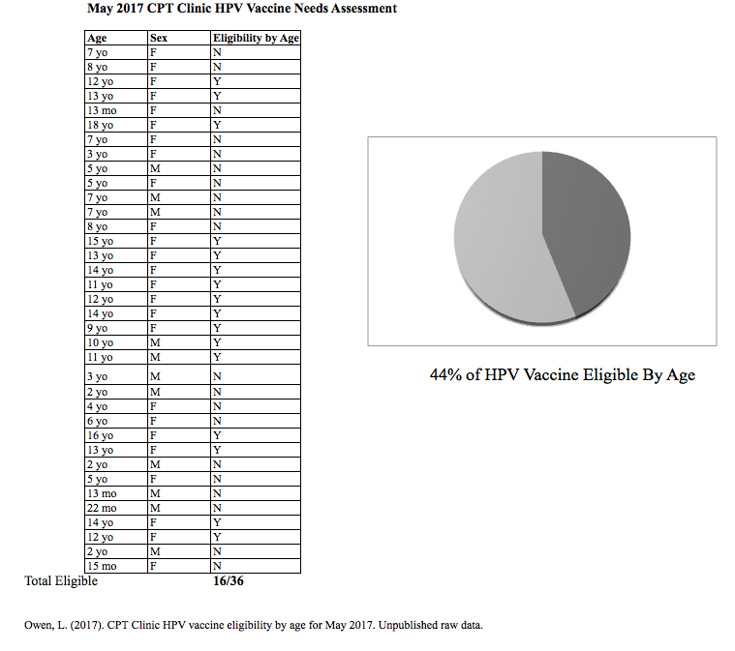

Appendix B

Literature Review Evidence Matrix

Background and Purpose



















Theoretical Framework





Cost



Barriers





Recommendations











Appendix C

Wake Forest Health Sciences IRB Ancillary Committee Approval



Appendix D

East Carolina University ORIC Project Approval

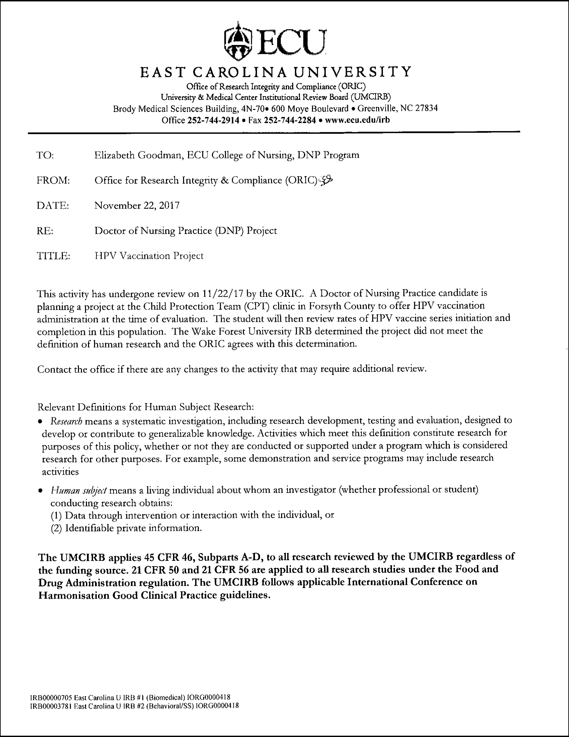

Appendix E

Vaccine Information Statement: Human Papilloma Virus

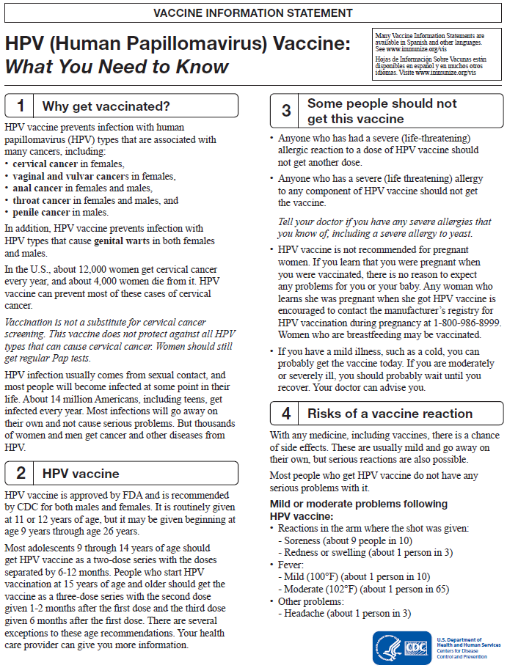

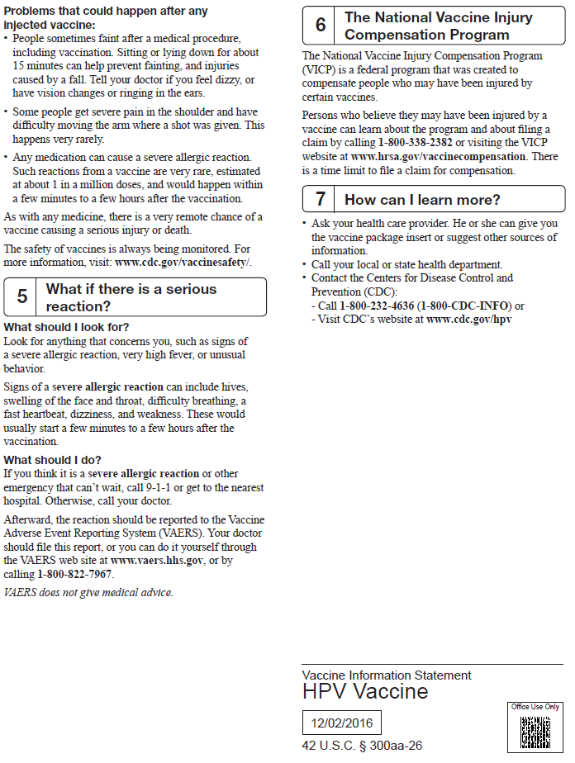

Appendix F

Pediatric Vaccines For Children (VFC) Vaccine Price

Private and CDC cost of HPV vaccination.  Adapted from the CDC Figure: Pediatric/VFC Price List (2017). Retrieved from https://www.cdc.gov/vaccines/programs/vfc/awardees/vaccine-management/price-list/index.html

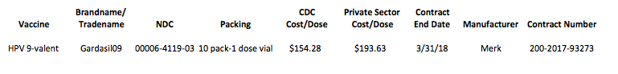

Appendix G

Approximate HPV Vaccination Cost

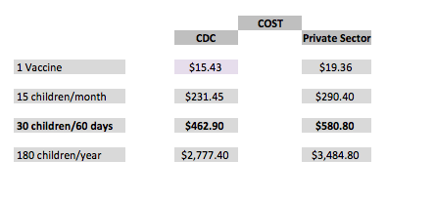Potential projected cost of HPV vaccination in the CPT for the project duration (60 days) and projected estimated cost for a year of vaccines. Figures based on costs adapted from the CDC Pediatric/VFC Price List (2017) retrieved from https://www.cdc.gov/vaccines/programs/vfc/awardees/vaccine-management/price-list/index.html.  Costs estimated using Owen, L. (2017). HPV vaccine eligibility by age for May 2017. Unpublished raw data.

Appendix H

Data Collection Tool

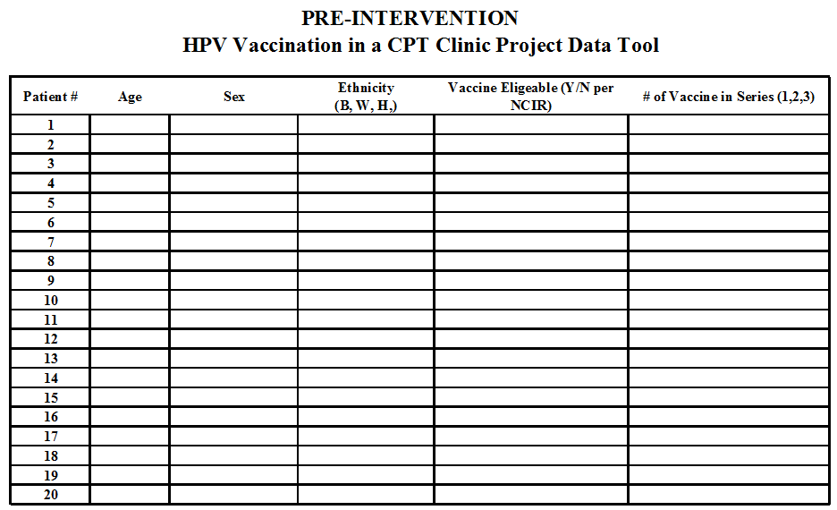

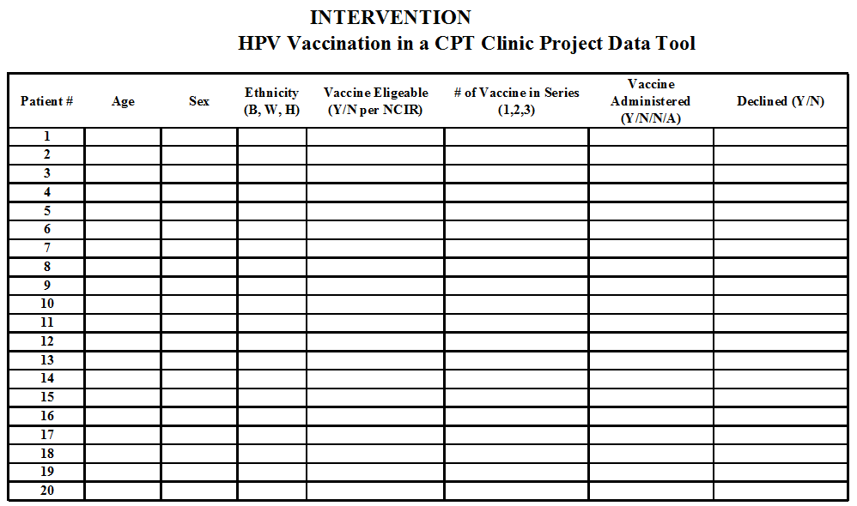

Appendix I

Pre-Intervention and Intervention Population Comparison

General Child Protection Team population demographics for the 60-day pre-intervention and intervention periods. The majority of patients during both periods were being evaluated for concerns for a history of sexual abuse, were white, and female.

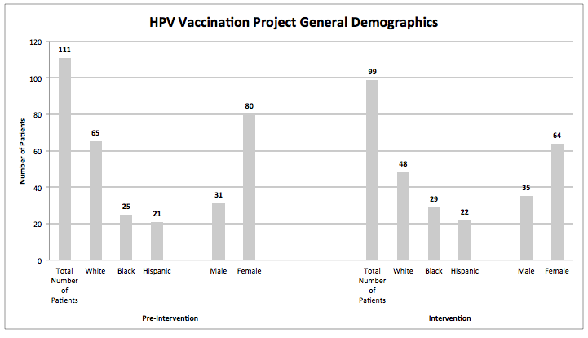

Appendix J

Pre-Intervention and Intervention HPV Vaccination Population Comparison

Similarly, during the pre-intervention period, 32% of the total clinic patients were eligible by age for HPV vaccination while 40% were eligible during the intervention period. Likewise, 61% of these age eligible children were also NCIR eligible during the pre-intervention and 53% during the intervention.

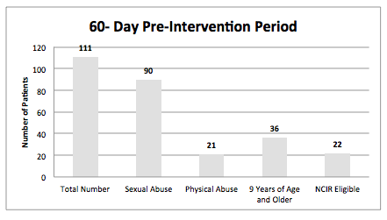

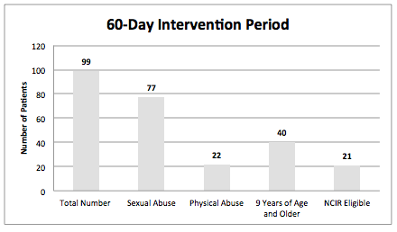

Appendix K

Pre-Intervention Missed Opportunities

During the pre-intervention period there were 22 missed opportunities to vaccinate for HPV. Four of these 22 patients did not attend their scheduled medical evaluation in the Child Protection Team clinic resulting in 82% of the total number of clinic patients who were North Carolina Immunization Registry eligible for the HPV vaccination.

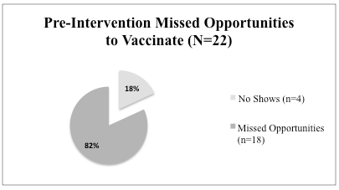

Appendix L

HPV Vaccination Project Intervention Outcomes

During the 60-day intervention period, there were 21 overall HPV vaccination eligible patients. The number of vaccinated patients equaled the number of appointment no-shows.

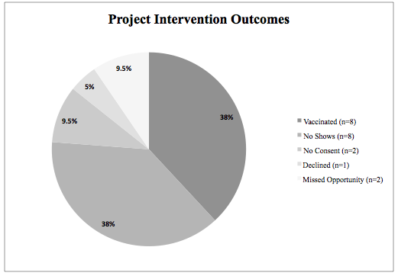

A larger percentage of vaccinations provided during the intervention (n=8) were to initiate the vaccine series.

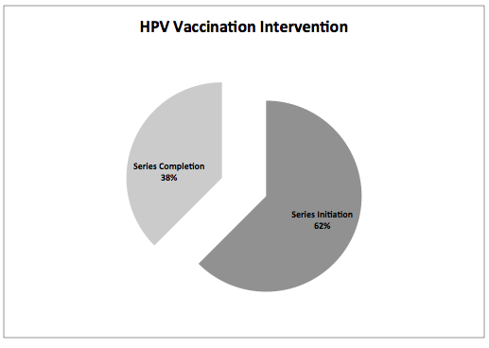

Appendix M

HPV Vaccination Project Age Trends

Those patients vaccinated during the intervention period (n=8) were mostly comprised of 9-12 year old patients (63%).

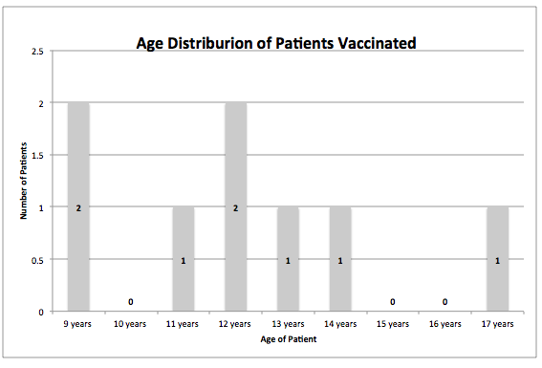

Appendix N

HPV Vaccination Project No Show Rates and Project Outcomes

Pre-intervention and intervention appointment no-show rates impacted the population eligible for HPV vaccination by age, which encompassed 30% and 19% of the nine year and older population during project period respectively.

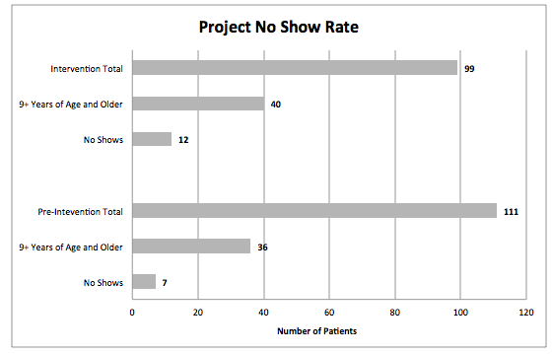

Correcting for the appointment no-show rates during the intervention period, 62% of the North Carolina Immunization Registry eligible patients that could receive the HPV vaccine at the time of the evaluation were vaccinated in the Child Protection Team clinic.

