TITLE PAGE – JOURNAL OF LEARNING SPACES SUBMISSION
Submission Type: Research manuscript
Author: Katy Kavanagh Webb, Director of Yale Access Services and Bass Library, Yale University
kathryn.webb@yale.edu
Title: Benchmarking Library Creative Spaces for Research Support and Faculty/Librarian Partnerships
Shortened Title (if applicable): Benchmarking Library Creative Spaces: The Scholar’s Lab
Abstract: During the course of this research, the author attempted to locate institutions and background information about spaces that would be similar in scope to a digital scholarship lab (or scholar’s lab) being proposed in a university library. The information is meant to serve as a guide for the space design project, but it will be an important benchmarking tool for existing spaces. A framework is provided as a planning document for other libraries that are considering the development of such a space in an academic library.
Keywords: Library creative space, benchmarking, scholar’s lab, digital humanities lab, data visualization lab, library, academic library

Benchmarking Library Creative Spaces for Research Support and Faculty/Librarian Partnerships

Introduction
This research was completed in October 2019 for the purposes of a Fulbright Specialist project wherein the University of Leiden’s Centre for Digital Scholarship acted as a host to a visiting librarian. During the course of this research, the author attempted to locate institutions and background information about spaces that would be similar in scope to the lab proposed at the University of Leiden. A Scholar’s Lab has been recommended to be built in the library in an existing space and will be aimed at the faculty of the university. The information is meant to serve as a guide for the space design project that will take place in a library in the Netherlands, but it will be an important benchmarking tool for existing spaces, as well as a planning document for other libraries that are considering the development of such a space in their university’s library.

Literature Review
In 2018, the book Development of Creative Spaces in Academic Libraries: A Decisionmaker’s Guide (Webb) was released. This book delved into the different models for library creative space, including three that will be important for the purposes of this study. A scholar’s lab is a space for faculty and advanced graduate students to receive assistance from trained librarians and IT experts in the use of digital research tools, software, and emerging methodologies, as well as to get guidance on the process of publication, including copyright, data management, data visualization, author’s rights, and more. Some scholar’s labs are combined wholly or in part with a digital humanities center or data visualization lab, or have features that are normally considered a part of these spaces. A digital humanities lab is a space set aside for high-tech research done by faculty in the humanities, and includes work on textual analysis, historical research using computing, and more. These spaces are sometimes located in a library and run by librarians and other trained staff. A data visualization lab is a space that is devoted to the design, creation, and analysis of data products. Each of these spaces will differ from the other in the way that they are designed, as well as the focus of their outreach, services, and technology. In the following sections, elements that distinguish these spaces have been researched and observed, and those elements are further defined.

In addition to drawing heavily from this prior work, the researcher conducted a literature review on scholar’s labs. The majority of the articles about digital scholarship are about beginning to offer services on campus, and not case studies about spaces. One standout article by Miller (2016) reports that Walter Library at Middle Tennessee State University evaluated the needs of the faculty in order to become the “hub of campus scholarship” in just under three years, although digital scholarship initiatives had been going on for at least 10 years. This article is a great case-study of one library’s path toward success for a digital scholarship lab; of note is their Steps to Digital Scholarship Success graphic (p. 85), which provides a model for creating partnerships. Another case study shows the path of University of North Carolina-Charlotte in their attempts to build scholarship services on campus and working toward the creation of a lab (McCullough, 2014). Interestingly, neither of these institutions came up during the course of the following research on scholar’s labs. Upon further digging, it appears that UNC-C did not build the lab they proposed in 2014 and the space at Middle Tennessee State was not included on the listings provided; additionally, relatively little information about the space is provided on their website. This dearth of case studies about scholar’s labs make it clear that more research about these spaces is needed.
During the course of conducting this research, a book called Open a GLAM Lab was released (Mahey, et. al, 2019). GLAM stands for galleries, libraries, archives and museums. Although the focus of the book on GLAM Labs is more on digital collections than the scholar’s lab model, a case study jumped out. “The Glucksman Library at the University of Limerick provides a Lab service. Included as part of a major building extension project concluded in 2018, the Glucksman Library opened up a physically based Lab built around collaborative spaces, highly specialised computers for working with collections and research data, and a large-scale data visualisation Lab. The Lab provides both a teaching function for post-graduates and researchers and a dedicated space for creativity and innovation. The Library Lab supports the strategic aims of the university around digital transformation and entrepreneurship” (p. 38). This space was not listed among those researched for this project; in fact, innovative new lab spaces are popping up all of the time.

Methodology
This new research took the form of a content analysis of the websites of digital scholarship labs in the US, EU, and Canada. The researcher visited the websites of each of the spaces identified in the initial screening to search for content related to the topics identified as important features and services for a digital scholarship lab. After reviewing the websites of the labs, the researcher emailed the coordinators of six additional spaces to set up interviews to determine information about funding models for digital scholarship labs.

Listing of Digital Scholarship Centers
In order to locate digital scholarship centers in the US, EU, and Canada, three listings were reviewed that are known to contain information about such spaces. ACRL is the Association for College and Research Libraries, which is the national listing for the US. The listing on centerNet is more aligned to digital humanities centers, but it contains a listing that is global in nature, and includes many centers without spaces. The websites reviewed are listed below.
- US Centers mainly came from this listing: https://acrl.ala.org/dh/registry/
- Located EU Centers and cross-checked US Centers with the centerNet listing: https://dhcenternet.org/centers
- Listing for Canada: https://guides.library.ubc.ca/c.php?g=447038&p=3050334

Additionally, the researcher added five additional centers that were not on either of these listings that were known from past research. This listing is not exhaustive, but a good faith attempt was made to locate centers that would be similar to the one that the University of Leiden was interested in creating.

The researcher then designated in the list whether the space was in the US Canada or the EU. This analysis did not explore labs in Asia, Australia, Russia and a few other countries, due to time.

First Review
US Centers: 61
EU Centers: 51
Canadian Centers: 14
(N=126)

Exclusion of Centers
The researcher reviewed each website to screen for places that did not fit the criteria for being included. The reasons that a center might be excluded are:
- They were not run at least in part by a university library;
- Their services did not line up with that of a scholar’s lab, digital humanities lab, or data visualization center/lab (e.g., they were only a makerspace or digital media center);
- They did not have a dedicated physical space included with their services;
- They were not located in the US, EU, or Canada;
- After further review, the space did not have enough information on their website.

Content Analysis: Final Website Selection
Forty-six spaces were selected for review for the content analysis. Upon further review, ten additional spaces were excluded (all for lack of content on their website), for a total of thirty-six (n=36) spaces under review.
- 19 of those spaces could be defined as scholar’s labs
- 12 of those spaces are digital humanities labs
- 5 are classified as “Other” and include hybrid spaces and data visualization labs

Of those spaces, the location of the spaces was broken down as such:
- US Centers: 30
- EU Centers: 3
- Canadian Centers: 3

Design of Data Collection Documents
A spreadsheet was created with 35 data points. These data points were based on research conducted on library creative spaces (Webb, 2018). The data description is in Appendix 4.

Data Collection
The researcher visited each website and sub-site of the selected digital scholarship space to find information about the services, offerings, and staffing models. For many data points (funding in particular), there may have been little to no information. In this case, the field was left blank.

Findings

Services Offered
Ten of the data points included services that would be offered in the space. The totals for these out of the 36 spaces surveyed in the content analysis follow, and are also broken down by services offered by scholar’s labs.

 |  | Data Services | Text Mining | Digital Humanities | Data Visualization | GIS | Copyright | IR | 3D Printing | Poster Printing
Scholar’s Labs |  | 13 | 11 | 17 | 16 | 15 | 8 | 7 | 8 | 1
Total |  | 19 | 23 | 31 | 30 | 28 | 11 | 8 | 11 | 2
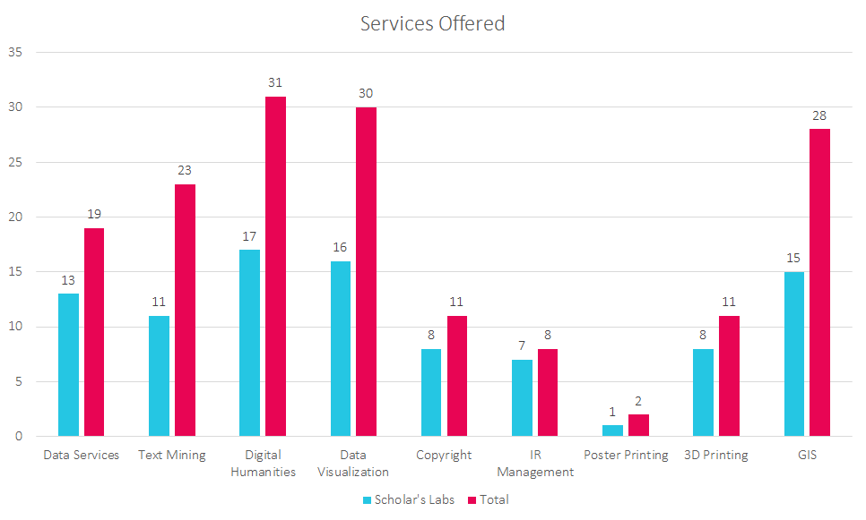

The most commonly found service in scholar’s labs, as well as from the total were the overarching services of digital humanities and data visualization. These are very broad and can have very different meanings for different academic institutions, but a generalization can be made that these are considered to be the important themes of the work being done in scholar’s labs. The less frequently mentioned services were copyright advice, 3D printing, poster printing, and IR Management. One-hundred percent of the spaces surveyed offered face-to-face workshops of some type, with many running the gamut of the services offered above.

Primary Level of Support
The primary level of support was defined in Webb’s book as the way that librarians or staff in the space interact with the researchers and faculty using the space. The methods include “doing it for people,” where the work is done as a project completed for faculty, “showing people how,” in which members of the staff of the scholar’s lab or creative space teach people to use tools and methods, and “doing it with people,” where scholars and librarians are partners to create a project. The model is shown below (Webb, 2018, p. 15).
Doing it with people

Doing it with people
Doing it for people
Showing people how

During the course of this research, the author found an emerging model, that of the community of practice, where interdisciplinary faculty teach each other about the work and complete it together. Since this is an emerging model and was not apparent at the time the data description was made, this was not included in the primary level of support. In both the total of the 36 spaces surveyed and in scholar’s labs, the model of showing researchers how to do the work seems to be the norm. A secondary model for support is partnering with faculty to do the work. A small number of spaces are doing the work for faculty (4 from the total and 2 defined as scholar’s labs, respectively).

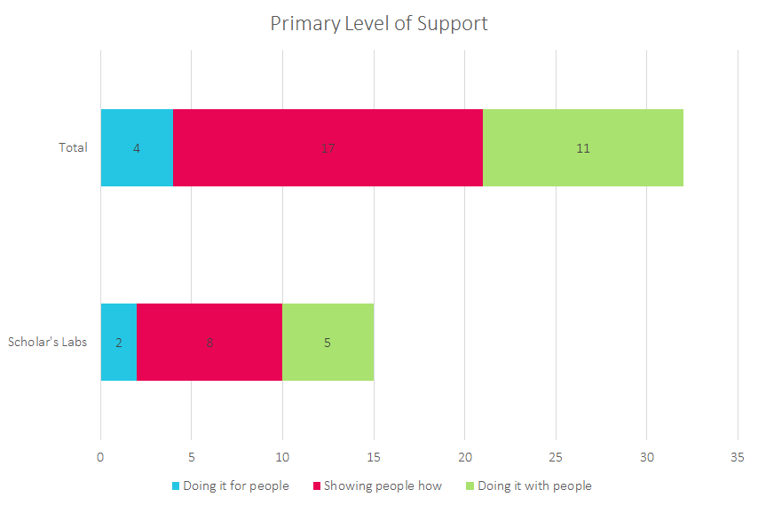

Primary Skills/Service Focus
The primary skills/service focus is a Venn diagram that shows the focus of the space (Webb, 2018, p. 13). The three types of models here are for course support, research, or technology skills. The space may be a combination of ---- two, or focus on all three.
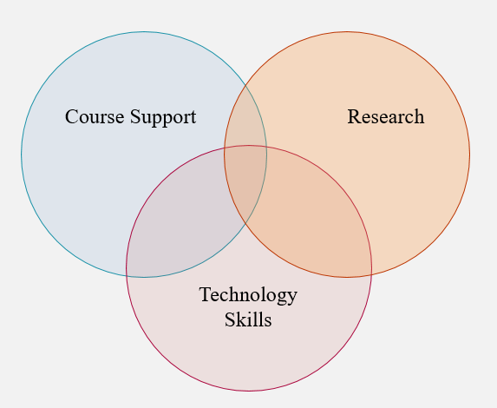

For the content analysis, the researcher noted a primary and secondary focus for each space. The application of the focus marker was based on information listed on the website, which overtly mentioned research, teaching, or technology skills, or it was inferred from a listing of workshops and other information on the site. The majority of spaces focus on research as their primary skills/service focus. This makes sense, as the audience for scholar’s labs are the university’s research faculty. This focus graph may look differently if makerspaces and digital media labs were considered alongside the scholar’s labs, digital humanities labs, and data visualization labs. These other spaces may be more focused on course support.

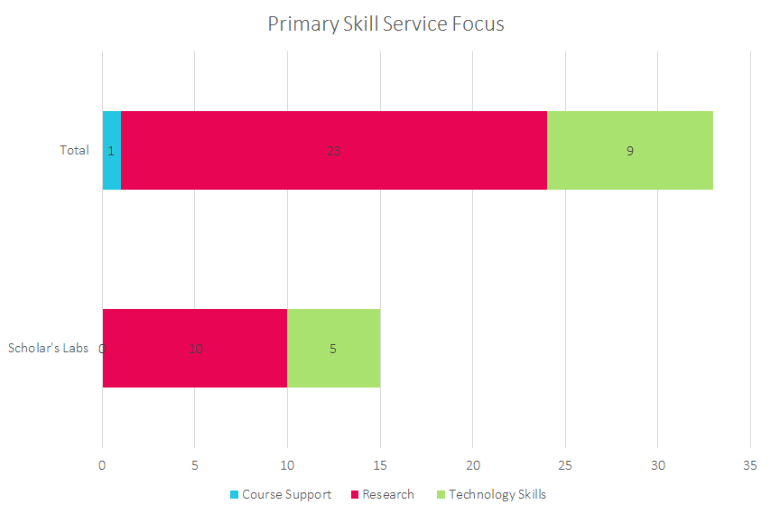

Secondary Skills/Service Focus

For the secondary skills/service focus, technology skills were prevalent in the findings. Course support was not as prevalent, but for the most part, course support includes working with faculty to train undergraduate students on a particular tool or methodology and the focus of scholar’s labs tends to be on the faculty or advanced graduate student’s own research.

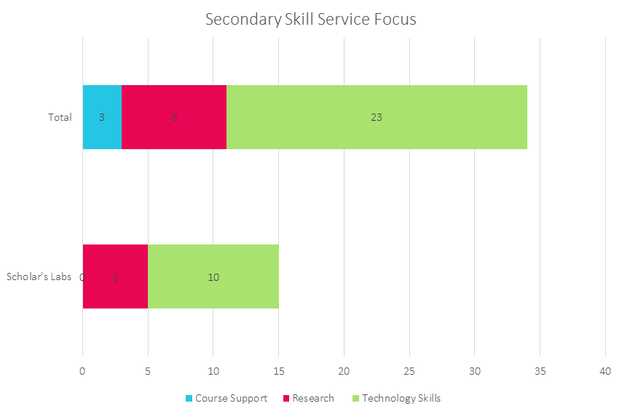

Features
Some additional features were noted during the course of the data collection. The researcher noted if there was a data visualization wall, such as a large, touch screen monitor. Other spaces had special terminals to visualize stock market data, and these were also counted. Only one space, that of Duke’s EDGE lab, had storage space available for faculty to store books, information, or other items that they may need during the course of their research. Six spaces out of the 36 had a service desk where people could receive assistance.

- Data Visualization Wall or Monitor: 12
(9 at scholar’s lab)
- Storage Space: 1
- Service desk: 6

Two spaces reviewed here had documentation of their visualization walls included in the library science literature. They were Brown University and the University of North Carolina-Chapel Hill. In his article about the Brown University library’s new lab (2012), Enis writes, “The centerpiece of the lab is a video visualization wall made from 12 55" LED screens, which can be used together to show a single 7' x 16' image or video at 24 megapixel resolution, or linked to individual touchscreen monitors for groups or classes working on collaborative projects. The wall is also set up for videoconferencing, which will facilitate events such as group meetings and long-distance lectures.” The Liquid Galaxy display at the Davis Library Research Hub is outlined in Tickner’s 2016 article, which also has background on other large displays being built around the same time. “The LG at UNC-CH is a series of seven screens which are run off of synchronized, parallel desktop computers which then display Google Earth and Google Street View as well as other web accessed .kml files. The user interacts with the display using a joystick…” (Tickner, 2016). There is additional information about the CURVE center’s wall at Georgia State in their planning documents.

Outreach
The spaces surveyed were also analyzed for the types of outreach that they engaged in. This included funding opportunities, such as fellowships and mini-grants. Nine of the 36 spaces surveyed had mini-grants, varying from $250 for travel to a conference up to $20,000 for a faculty project grant (Yale). There were also spaces that had student startup grants, such as Brandeis, which offers multiple $500 grants.

- Fellowships: 16 (44% of total)
- Fellowships in scholar’s labs: 7
- Mini-Grants: 9
Scholar’s labs with mini-grants: 5

- Website with Projects: 25
In scholar’s lab: 12
- Blog: 13
In scholar’s lab: 5

Some spaces had both a website with projects and a blog. The project sites tended to be links to projects that the center had helped with and the blogs included information about activities in the center, promotion for workshops, and statistics about the use of the space.

Staffing: Student Workers
Libraries in the United States are most likely to use student workers for staffing the space, or as technology experts that are able to help with projects. The majority of the spaces employing student workers were using graduate students, although some employed both graduate and undergraduate students. The numbers below refer to the total numbers out of the 36 spaces reviewed.

- Student workers: 11
- Graduate student workers: 7
- Undergraduate student workers: 5

Primary Staffing Model
The staffing models are, as follows:
- Single librarian: One librarian is responsible for the day-to-day running of the space;
- Team of librarians and staff: A team of people that includes both librarians and staff run the space;
- Decentralized: A team of curricular faculty, sometimes along with librarians, are responsible for the space;
- Community-led support: Prevalent in makerspaces and knowledge markets, a group of highly trained students or volunteers are in charge of running the space;
- Mixed Model: Some combination of these models (Webb, 2018, p.14).

The findings are that scholar’s labs are usually run by a team of librarians that may include staff. This is consistent with the model for the Centre for Digital Scholarship at the University of Leiden. Some are run with a decentralized model or a mixed model, depending on the institution and the way that the scholar’s lab got its start. There were no scholar’s labs that were run by a single librarian model. This model was found only in the digital humanities labs surveyed for this study.

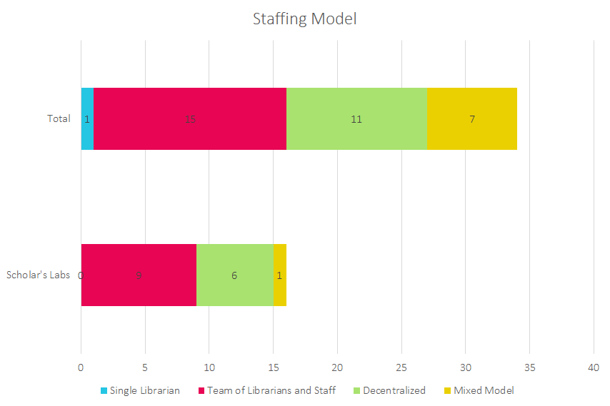

Space Size
Webb found in her book (2018, p. 11) that there are four sizes that are considered for the space size. They are:
- Mobile: a cart containing items is brought out when needed
- Small: One room or large office
- Medium: Multiple rooms
- Large: Established center, with multiple classrooms, meeting rooms, and staff space

Mobile
Robust Lab/Center

The findings of the content analysis were that there were no mobile labs. The majority of scholar’s labs are established centers (n=9), and the digital humanities labs that were reviewed are more likely to be small (n=6) or medium (n=4) in size.

[The total below (and in the bar graph) is 34, not the 35 that has appeared throughout.]
 | Small  One room | Medium  Multiple rooms | Large  Established Center
Scholar’s Labs | 4 | 5 | 9
Digital Humanities Labs | 6 | 4 | 1
Other | 0 | 2 | 3
Total | 10 | 11 | 13

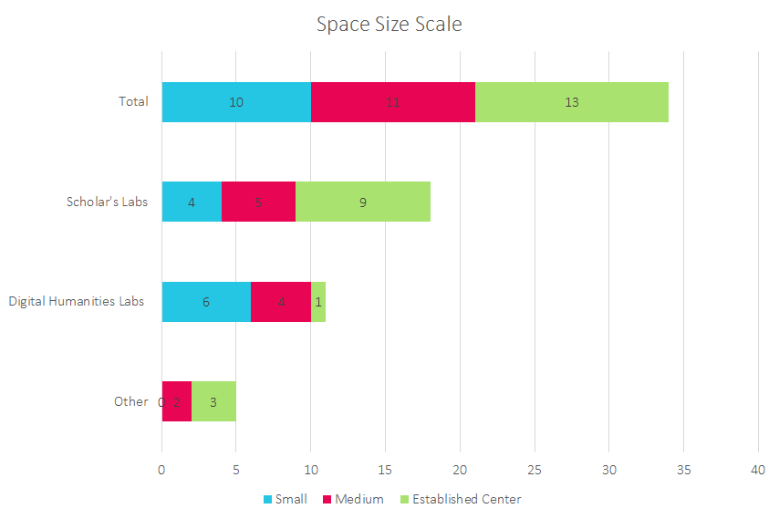

This research was conducted with FAIR data principles in mind, and a citation to the data can be found in Appendix 6.

Framework Document for Benchmarking
When the researcher visited the Centre for Digital Scholarship at Leiden University’s library, she presented on these results. Another step was to benchmark their current service and space offerings against those researched in this study. This led the researcher to create a handout that can serve as a planning and benchmarking document for different spaces and services. It can be used by libraries hoping to open a scholar’s lab, digital humanities lab, data visualization lab, or related space. In addition to the features listed, it was suggested by one member of the Centre for Digital Scholarship staff that spaces will differ based on their Innovation Culture. This slider shows the difference between spaces that are willing to act as innovators on campus and in their libraries, rather than those with a strict set of services that they may offer (such as in a digital media lab, where roles and services may be strictly defined). In a scholar’s lab, the innovation culture is likely to be quite high toward innovation, since the labs follow an agile methodology for project development and serve as kick starters for new projects on campus. The planning document is included for use at other institutions in Appendix 5.

Limitations and Future Research
The Community of Practice model for the Skills/Service Focus was unknown by the researcher before the content analysis. The graphic for this has been updated to be a Venn diagram that includes this model. Unfortunately, this was not known during the initial content analysis, so it was not included, however, it is included in the framework document in Appendix 5. Innovation Culture slider was also not developed at the time of the content analysis, so this was not researched at the time. It is also included on the framework document.
Future research will be undertaken by the researcher and the Centre for Digital Scholarship during the next visit to the Netherlands. This project could have been completed in part as a text analysis project of the websites of these spaces. The researcher worked with members of the Centre for Digital Scholarship staff to write Python code for this purpose. During the next visit, this text analysis code will be used to scrape the mission statements of lab spaces. This will be an important part of finding out the innovation culture of the lab spaces, as well as their scope. Lastly, new labs are being opened each year. This research will need to be updated in the future to include new and emerging labs and models for creative space.

Conclusion
The differences in space design and service selection for scholar’s labs tend to differ based on the impetus for the space being created, the funds available, staffing, and the focus of the university. These foci may also change over time as the space becomes more popular with faculty, or as funding increases for research-related activities. Universities with a research focus will have spaces that are focused on faculty needs, data, and smoothing the way for the progression towards publication. Other schools with an undergraduate focus on initiatives like student success will have spaces that are focused on students (Webb, 2018, p.11). Spaces will differ on a scale of how innovative they are. These scales and features have been developed as a framework that can be used by library administrators to start planning for the creation of a lab. Another use of the framework is for a center’s administration to set a course for growth or improvement upon an existing space. Although much of the literature has focused on case studies of these innovative spaces or descriptions of projects, this study focused on similarities between spaces at multiple institutions to better define the different types of library creative space. As new types of spaces are developed within libraries and universities, these definitions may expand or change.
The implications of this work on Leiden University’s Centre for Digital Scholarship have been that the staff have undertaken a self-study, which cites the framework from this article. Each of the different working groups within the CDS (Open Access, Open Science, copyright, digital data, etc.) will also look at the framework, apply it to their current work, and look for pathways for adding new services. Improvements upon the setup of the space within the CDS offices to welcome researchers into the lab to experiment with tools have been proposed, along with suggestions to guide those improvements. A final report was written by the researcher after the initial visit, which will serve as a guide for the second visit. During the second visit, the research team will better define the users of the services and apply user experience design (UX) using methods such as a survey and developing personas. A future article will report key findings of the University of Leiden’s entire two-visit project in their scholar’s lab, as well as the results of the research team’s activity on web scraping of mission statements.

The author thanks the administration of Joyner Library, East Carolina University, for their support during the first Fulbright trip to the Netherlands. Another important thanks is due to Leiden University Library’s Centre for Digital Scholarship’s staff, particularly the host, Dr. Laurents Sesink. The author thanks Kristina Hettne of the CDS, who first suggested the Innovation Scale for the framework.

References
Enis, M. (2012). Visualization wall centerpiece at Brown. Library Journal, 137(19), 12. Retrieved from http://search.ebscohost.com/login.aspx?direct=true&AuthType=ip,shib&db=llf&AN=83525895&site=ehost-live&scope=site&custid=s5822723
Kennan, M., Corrall, S., and Afzal, W. (2014). “Making space” in practice and education: research support services in academic libraries. Library Management, 35(8/9), 666–683. https://doi.org/10.1108/LM-03-2014-0037
McCollough, H. (2014). Developing digital scholarship services on a shoestring. College & Research Libraries News, 75(4), 187–190. https://doi.org/10.5860/crln.75.4.9103
Miller, A. (2016). DS/DH Start-Ups: A library model for advancing scholarship through collaboration. Journal of Web Librarianship, 10(2), 83–100. https://doi.org/10.1080/19322909.2016.1149544
Mahey, M., Al-Abdulla, A., Ames, S., Bray, P., Candela, G., Chambers, S., Derven, C., Dobreva-McPherson, M., Gasser, K., Karner, S., Kokegei, K., Laursen, D., Potter, A., Straube, A., Wagner, S-C. and Wilms, L., with forewords by: Al-Emadi, T. A., Broady-Preston, J., Landry, P. and Papaioannou, G. (2019) Open a GLAM Lab. Digital Cultural Heritage Innovation Labs, Book Sprint, Doha, Qatar, 23-27 September, 2019. Retrieved from: https://glam-labs.s3.amazonaws.com/media/dd/documents/Open_a_GLAM_Lab-10-screen.9c4c9c7.pdf

Tickner, A. (2016). The Liquid Galaxy in the library: A study of use and users of interactive digital display technology at UNC-CH, Library Hi Tech, Vol. 34 Issue: 4, pp.657-668, https://doi.org/10.1108/LHT-04-2016-0045

Webb, K.K. (2018). The development of creative spaces in academic libraries: A decisionmaker’s guide. Chandos: London.

Appendix 1: List of US Centers and Selection Reason

Lab Name | Lab School | Webpage | UsedYN
Center for Digital Scholarship | Brown | https://library.brown.edu/create/cds/about/ | Y
Digital Scholarship Group | Boston C | http://ds.bc.edu/ | Y
Research Technology Innovation | Brandeis University | https://www.brandeis.edu/library/rti.html | Y
Digital Scholarship Program, Carpenter Digital Media and Collaboration Lab | Bryn Mawr College | https://digitalscholarship.blogs.brynmawr.edu/ | N
Digital Pedagogy & Scholarship Department, Digital Scholarship Studio | Bucknell University | http://dps.bucknell.edu/, http://dps.bucknell.edu/digital-scholarship-at-bucknell/digital-scholarship-center/ | Y
Freedman Center for Digital Scholarship | Case Western Reserve | http://library.case.edu/ksl/freedmancenter/ | Y
Digital Humanities Center | Columbia | http://library.columbia.edu/locations/dhc.html | Y
GC Digital Scholarship Lab | CUNY | https://gcdsl.commons.gc.cuny.edu/home2/ | Y
Digital Humanities at Dartmouth | Dartmouth | http://digitalhumanities.dartmouth.edu/ | N
Richardson Library Scholar's Lab | DePaul | https://library.depaul.edu/technology/spaces/Pages/teaching-learning.aspx | Y
The Edge | Duke | https://library.duke.edu/edge | Y
Emory Center for Digital Scholarship | Emory | http://digitalscholarship.emory.edu/ | Y
Technology and Digital Scholarship at FSU, R&D Commons | Florida State | https://www.lib.fsu.edu/drs | Y
Digital Scholarship | Georgetown | https://www.library.georgetown.edu/digital-scholarship | N
CURVE | Georgia State | http://sites.gsu.edu/curve/tag/digital-scholarship/ | Y
The Digital Humanities Initiative (DHi) at Hamilton College | Hamilton College | https://www.hamilton.edu/academics/centers/digital-humanities-initiative/about | N
Scholars Commons | Indiana University-Bloomington | http://libraries.iub.edu/scholars-commons | Y
Center for Digital Scholarship | Indiana University-Purdue | https://www.ulib.iupui.edu/digitalscholarship | Y
Center for the Advancement of Digital Scholarship | Kansas State | http://www.lib.k-state.edu/digital-scholarship | N
Digital Scholarship Services | Lafayette College | https://dss.lafayette.edu/ | N
Digital Scholarship Projects/Center for Innovation in Teaching and Learning | Lehigh University | https://citl.lehigh.edu/ | N
Loyola Center for Textual Studies and Digital Humanities | Loyola University--Chicago | https://www.luc.edu/ctsdh/ | N
Digital Scholarship | Loyola University-New Orleans | http://researchguides.loyno.edu/digitalscholarship | N
Digital Humanities (MSU Libraries) | Michigan State | https://www.lib.msu.edu/dh/  http://digitalhumanities.msu.edu/digital-scholarship-lab/ | Y
DLA Digital Liberal Arts | Middlebury College | http://sites.middlebury.edu/dla/ | N
Digital Liberal Arts @ Mount Holyoke College | Mount Holyoke | http://commons.mtholyoke.edu/mhcdla/ | N
Digital Scholarship Services | New York University | https://library.nyu.edu/departments/digital-scholarship-services/ | N
Digital Scholarship Lab | New Jersey Institute of Technology | https://archlib.njit.edu/digitallab | N
Digital Scholarship Group, Digital Scholarship Commons | Northeastern | http://dsg.neu.edu/ | Y
Digital Scholarship Services | Northwestern | http://www.library.northwestern.edu/research/scholarly/index.html#digital | N
Research Commons | Ohio State | https://library.osu.edu/researchcommons/ | Y
Digital Humanities Studio | Purdue University-West Lafayette | https://www.lib.purdue.edu/libraries/hsse | N
Digital Scholarship Lab | Rochester | https://dslab.lib.rochester.edu/ | N
Digital Humanities Initiative | Rutgers | http://dh.rutgers.edu/ | Y
Department of Research and Digital Scholarship | Southwestern University | http://www.southwestern.edu/infoservices/departments/research/ | N
Ohio Five Digital Scholarship | The Five Colleges of Ohio | http://digitalscholarship.ohio5.org/ | N
Alabama Digital Humanities Center | University of Alabama | https://adhc.lib.ua.edu | Y
Digital Humanities @ Berkeley, D-Lab | University of California, Berkeley | http://digitalhumanities.berkeley.edu/  https://dlab.berkeley.edu/consulting | Y
Digital Scholarship Services | University of California, Irvine | http://lib.uci.edu/dss/ | N
Scholarly Services at the University of Idaho Library | University of Idaho | http://www.lib.uidaho.edu/services/scholarly/ | N
Institute for Digital Research in the Humanities | University of Kansas | http://idrh.ku.edu/  http://idrh.ku.edu/about | Y
Maryland Institute for Technology in the Humanities | University of Maryland | http://mith.umd.edu/ | Y
Digital Arts Sciences + Humanities (DASH) | University of Minnesota | https://www.lib.umn.edu/digital/dash | N
Institute for Advanced Study | University of Minnesota | https://ias.umn.edu/ | N
Center for Digital Research in the Humanities | University of Nebraska-Lincoln | http://cdrh.unl.edu/ | Y
Center for Southwest Research and Special Collections | University of New Mexico | http://library.unm.edu/cswr/index.php | N
Research Hub | University of North Carolina, Chapel Hill | http://library.unc.edu/hub/ | Y
Center for Digital Scholarship (CDS) | University of Notre Dame | http://cds.library.nd.edu | Y
University Libraries Digital Scholarship Lab | University of Oklahoma | https://libraries.ou.edu/dsl | N
Digital Scholarship Center, UO Libraries  New DREAM Lab | University of Oregon | http://library.uoregon.edu/digitalscholarship  https://around.uoregon.edu/content/new-dream-lab-offers-space-digital-scholarship-teaching | Y
UT Libraries Scholar's Lab | University of Tennessee-Knoxville | https://www.lib.utk.edu/scholar/ | N
Digital Writing and Research Lab | University of Texas at Austin | https://www.dwrl.utexas.edu/our-spaces/ | N
Digital Scholarship Unit | University of Toronto Scarborough | https://www.utsc.utoronto.ca/digitalscholarship/ | N
Digital Matters Lab | University of Utah | https://digitalmatters.utah.edu/ | Y
The Scholars' Lab | University of Virginia | http://scholarslab.org/ | Y
DH Lab | University of Wisconsin-Milwaukee | https://uwm.edu/libraries/dhlab/ | Y
Scholarly Communications | Vanderbilt University | http://www.library.vanderbilt.edu/scholarly/ | N
Digital Humanities and Digital Studies Research Group; Digital Pragmata; Innovative Media | Virginia Commonwealth University | http://humanitiescenter.vcu.edu/humanities-research-center-events/research-groups/ | N
EScience Studio | University of Washington | https://escience.washington.edu/wrf-data-science-studio/ | Y
Center for Digital Scholarship and Curation (CDSC) | Washington State University | http://libraries.wsu.edu/cdsc | Y
Whittier Digital Liberal Arts (DigLibArts) | Whittier College | http://diglibarts.whittier.edu/ | N

Interview with more information: https://www.hastac.org/blogs/rbkhsmall/2018/02/17/digital-scholarship-lab-thoughts-laboratories-and-libraries-msu

Appendix 2: List of EU Centers and Selection Reason

Lab Name | Lab School | Webpage | UsedYN
Library Lab at Faculty Library of Arts & Philosophy | Ghent University | http://www.flw.ugent.be/bibliotheek/librarylab | N
DH@TheLibrary | Queen’s University Belfast | http://digitalbedouin.com/ICRH/ | N
Department of Digital Humanities | King's College London, UK | https://www.kcl.ac.uk/ddh | N
Humanities Advanced Technology and Information Institute | University of Glasgow, Scotland | https://www.universitystory.gla.ac.uk/department/?id=1 | N
Sussex Humanities Lab | University of Sussex, UK | http://www.sussex.ac.uk/shl/about/digital_humanities_lab | Y
UCL Centre for Digital Humanities | University College London, UK | https://www.ucl.ac.uk/digital-humanities/ | N
Alfa Informatica | Groningen, Netherlands | http://www.let.rug.nl/alfa/ | N
British Academy | London, United Kingdom | https://www.thebritishacademy.ac.uk/tag/digital-research-humanities | N
Bereich Historische Fachinformatik | Berlin, Germany | https://www.geschichte.hu-berlin.de/de/bereiche-und-lehrstuehle/histfi | Y
Advanced Computing in the Humanities - ACO*HUM | Bergen, Norway | http://clu.uni.no/AcoHum/ | N
Computerlinguistik und Technologie | Bielefeld, Germany | https://www.uni-bielefeld.de/lili/studium/faecher/texttechnologie/ | N
Centre Informatique de Philosophie et Lettres | Liege, Belgium | http://web.philo.ulg.ac.be/cipl/ | N
Centre de traitement automatique du language | Louvain-la-Neuve, Belgium | https://uclouvain.be/fr/instituts-recherche/ilc/cental | N
Centre Virtuel de la Connaissance sur l'Europe (CVCE) | Sanem, Luxembourg | https://www.cvce.eu/ | N
Centre for Digital Humanities | Eötvös Loránd University | http://elte-dh.hu/the-centre/ | N
Centre d'etudes superieures de la renaissance | Tours, France | https://cesr.univ-tours.fr/centre-d-etudes-superieures-de-la-renaissance/centre-d-etudes-superieures-de-la-renaissance-50498.kjsp | N
Corso di laurea in Informatica umanistica | University of Pisa | https://www.unipi.it/index.php/lauree/corso/10456 | N
Cologne Center for eHumanities - CCeH | Universität Koeln | https://cceh.uni-koeln.de/ | N
Centre national pour la numérisation de sources visuelles | Paris | http://www.cn2sv.cnrs.fr/ | N
Centre for Research in Arts, Social Sciences and Humanities | Cambridge, United Kingdom | http://www.crassh.cam.ac.uk/gallery/ | N
Cultures Anglophones et Technologies de l'Information | Sorbonne | http://www.csti.paris-sorbonne.fr/ | N
DARIAH-DE | Göttingen, Germany | https://de.dariah.eu/ | N
Digital Humanities Lab | Utrecht, Netherlands | https://dig.hum.uu.nl/ | Y
Digital Humanities at The Open University | The Open University  Milton Keynes, UK | http://www.open.ac.uk/arts/research/digital-humanities/ | N
e-Humanities Group (KNAW) | Amsterdam, Netherlands | https://www.knaw.nl/en/institutes/ehumanities | N
Digitales | Madrid | https://digitalessummit.es/index.cfm?id_idioma=EN | N
digHUMlab | Aarhus, Denmark | https://dighumlab.org/learning-resources/vila-video-research-lab-aalborg/ | N
Göttingen Centre for Digital Humanities - GCDH | Göttingen, Germany | https://www.gcdh.de/en/campuslab/overview/ | Y
European Language Resources Association - ELRA | Paris, France | http://www.elra.info/en/about/ | N
Fondazione Rinascimento Digitale | Firenze, Italy | https://www.iit.cnr.it/node/21129 | N
Humanities Research Institute - HRI | Sheffield, United Kingdom | https://www.sheffield.ac.uk/hri/about | N
HUMlab | Umeå, Sweden | https://www.umu.se/en/humlab/ | Y
Humanities Computing at Leiden University | Leiden, Netherlands | https://www.universiteitleiden.nl/en/humanities/centre-for-digital-humanities/about | N
hist.net | Basel, Switzerland |  | N
Institut des Sciences Sociales - LaDHUL | Lausanne, Switzerland | https://www.unil.ch/iss/fr/home.html | N
Instituto de História Contemporânea (IHC) | Lisbon, Portugal |  | N
Laboratoire de recherche historique | Lyon, France |  | N
King's Digital Lab | King’s College, London |  | N
Koninklijke Academie voor Nederlandse Taal-en Letterkunde | Belgium |  | N
Le Laboratoire d’Analyse Statistique des Langues Anciennes | Liege, Belgium |  | N
Pegasus Data Project | Lausanne, Switzerland |  | N
OpenEdition | Marseille, France |  | N
Norwegian Social Science Data Services - NSD | Bergen, Norway | https://nsd.no/nsd/english/index.html | N
Office for Humanities Communication - OHC | London, United Kingdom |  | N
Oxford e-Research Centre | Oxford, United Kingdom |  | N
sotonDH | Southampton, Hampshire, United Kingdom | http://digitalhumanities.soton.ac.uk/ | N
UCL Centre for Digital Humanities | London, United Kingdom | https://www.ucl.ac.uk/digital-humanities/ | N
The Medici Archive Project | Firenze, Italy | http://www.medici.org/ | N
Würzburg Centre for Digital Editing | Würzburg, Germany |  | N
Institute for Corpus Linguistics and Text Technology - ICLTT | Vienna, Austria |  | N

Appendix 3: List of Canadian Centers and Selection Reason

Lab Name | Lab School | Webpage | UsedYN
CIRCA | University of Alberta | http://circa.ualberta.ca/ | N
CulturePlex Lab | Western University | http://www.cultureplex.ca/#about | N
Digital Research Centre | University of Saskatchewan | https://library.usask.ca/drc/#WhatWeDo | Y
Humanities Computing and Media Centre | University of Victoria | https://www.uvic.ca/humanities/hcmc/index.php | N
Humanities HyperMedia Centre | Acadia University | http://hhc.acadiau.ca/ | N
Hyperlab | Carleton | https://carleton.ca/hyperlab/ | N
McGill Digital Humanities | McGill | https://digihum.mcgill.ca/ | N
MeTA Digital Humanities Lab | Vancouver Island University | https://research.viu.ca/meta-digital-humanities-lab | N
Lewis & Ruth Sherman Centre for Digital Scholarship | McMaster | https://scds.ca | Y
MakerLab | University of Victoria | Website was broken  https://www.uvic.ca/news/topics/2016+maker-lab-and-dfl-in-visual-arts+ring | N
Digital Scholarship Commons | University of Victoria | https://onlineacademiccommunity.uvic.ca/dsc/ | Y
Centre for Digital Humanites | Ryerson University | https://www.ryerson.ca/cdh/about/ | N
Centre for Digital Humanities | Brock University | https://brocku.ca/humanities/digital-humanities/faculty-and-staff/ | N
Augmented Criticism Lab | University of Calgary | https://acriticismlab.org/#/ | N

Appendix 4: Data Description for Spreadsheet
ID
An identifier based on the name of the institution

Location
USA-American
EU-European Union
CAN-Canada

SpaceType
DH-Digital Humanities Lab
DV-Data Visualization Lab
SL-Scholar’s Lab
O-Other

Space and Funding

FundingModel
NA-Unknown
1-Grant
2-OperatingFunds
3-Donor

FundinginDollars
Amount of money available, if known, in dollars

YearOpened
If known, list year opened

SpaceSize
If known, list size in square feet, NA if no space is provided

SpaceSizeScale
0-No dedicated space
1-Mobile
2-Small (*single room)
3-Medium (*multiple rooms)
4-EstablishedCenter

DataVisWallMonitor
0-No
1-Yes

StorageSpace
0-No
1-Yes

WebsitewithProjects
0-No
1-Yes

Blog
0-No
1-Yes

Fellowships
0-No
1-Yes

MiniGrants
0-No
1-Yes

NumberofGrants
Number of mini-grants given per year, if known

GrantFunds
Amount of grant funding given per year, if known

Services

PrimarySkillServiceFocus
1-Course Support
2-Research
3-Technology Skills

SecondarySkillServiceFocus
1-Course Support
2-Research
3-Technology Skills

PrimaryLevelofSupport
1-Doing work for researchers
2-Showing people how
3-Doing projects with researchers

DataServices
0-No
1-Yes

TextMining
0-No
1-Yes

DigitalHumanities
0-No
1-Yes

GIS
0-No
1-Yes

DataVisServices
0-No
1-Yes

CopyrightSupport
0-No
1-Yes

3D Printing
0-No
1-Yes

InstitutionalRepositoryMgmt
0-No
1-Yes

PosterPrinting
0-No
1-Yes

Workshops
0-No
1-Yes

Staffing

PrimaryStaffingModel
1-Single Librarian
2-Team of Librarians and Staff
3-Decentralized
4-Community-led Support
5-Mixed Model

StudentServices
Whether students are welcomed to use services
0-No
1-Only Graduate students
2-Graduate and Undergraduate students

StudentWorkers
0-No
1-Yes

GraduateStudWorkers
0-No
1-Yes

UndergraduateStudWorkers
0-No
1-Yes

DeskServicePoint
0-No
1-Yes

HoursPerWeekOpen
List number of hours per week that a service desk is open, if known

Appendix 5: Framework for Developing Creative Spaces in Academic Libraries

See next two pages

Appendix 6: Citation of Data in Dataverse

Webb, Kathryn, 2019, "Benchmarking Library Creative Spaces for Research Support and Faculty/Librarian Partnerships", https://doi.org/10.15139/S3/CUOGQT, UNC Dataverse, V1
Framework for Developing Creative Spaces in Academic Libraries
Katy Kavanagh Webb

Impetus/Mission Statement

Funding

Researcher-focused

Audience

Student-focused
Researcher-focused

Innovation Culture
Innovators

Service Focus

Followers

Size of Space Dedicated

Mobile
Robust Lab/Center

Skills/Service Focus
Course Support
Research

Technology
Skills

Level of Support

Doing it for People

Doing it with People

Teaching People How

Community of Practice

Staffing Model

Initial Ideas for Assessment

