Table A2: The ionization potential (IP) values for UAAs. Optimization and frequency calculations were performed under no solvent and solvent conditions and are listed according to the respect environment.
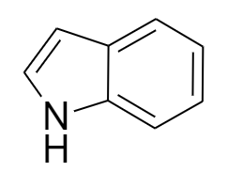 | No Solvent | Solvent | Opt Solvent | 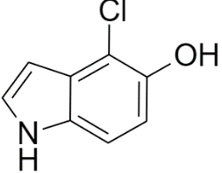 | No Solvent | Solvent | Opt Solvent
 | 7.51 | 5.61 | 5.62 |  | 7.38 | 5.62 | 5.62
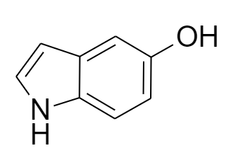 | 7.30 | 5.50 | 5.51 | 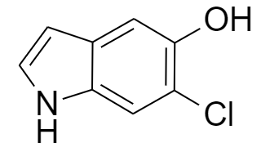 | 7.52 | 5.69 | 5.68
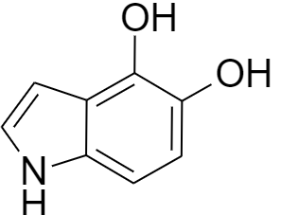 | 6.97 | 5.26 | 5.23 | 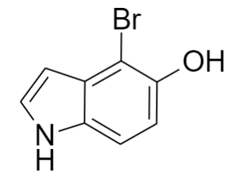 | 7.34 | 5.61 | 5.61
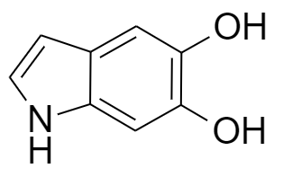 | 7.14 | 5.36 | 5.36 | 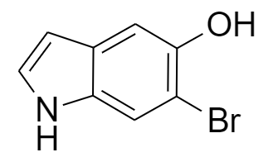 | 7.48 | 5.68 | 5.67
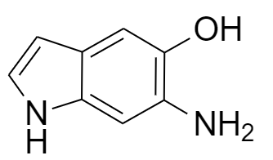 | 6.52 | 4.84 | 4.84 | 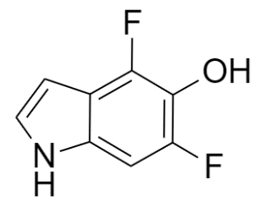 | 7.65 | 5.74 | 5.76
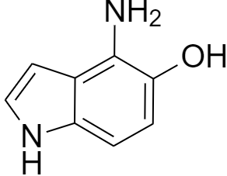 | 6.47 | 4.79 | 4.79 | 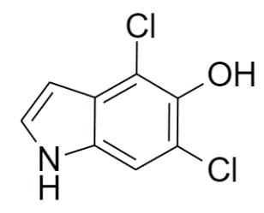 | 7.56 | 5.76 | 5.77
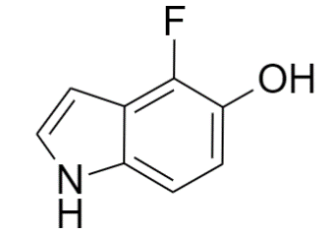 | 7.40 | 5.59 | 5.59 | 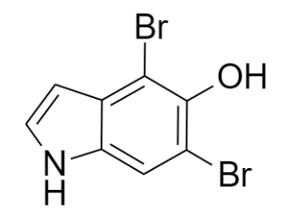 | 7.49 | 5.74 | 5.75
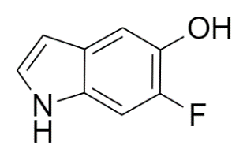 | 7.56 | 5.70 | 5.70

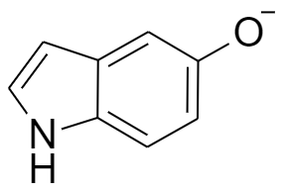 | No Solvent | Solvent | Opt Solvent | 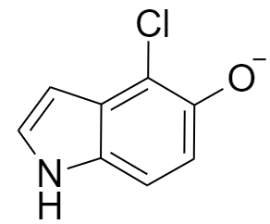 | No Solvent | Solvent | Opt Solvent
 | 1.76 | 3.98 | 3.99 |  | 2.06 | 4.18 | 4.19
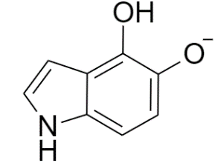 | 1.74 | 3.87 | 3.88 | 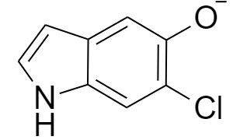 | 2.08 | 4.17 | 4.18
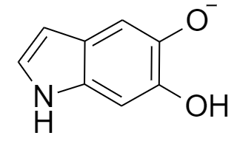 | 2.01 | 4.02 | 4.03 | 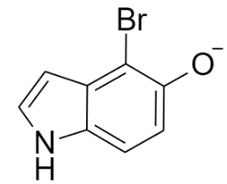 | 2.09 | 4.19 | 4.20
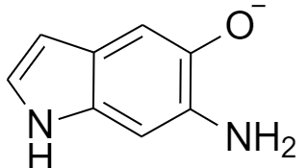 | 1.57 | 3.69 | 3.73 | 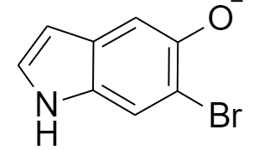 | 2.11 | 4.18 | 4.19
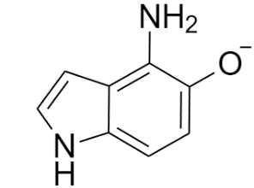 | 1.38 | 3.51 | 3.54 | 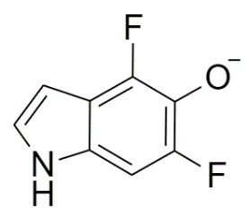 | 2.14 | 4.26 | 4.27
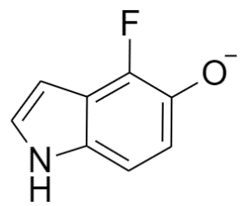 | 1.92 | 4.10 | 4.11 | 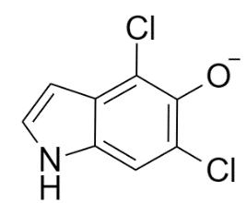 | 2.35 | 4.36 | 4.37
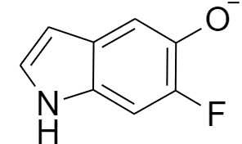 | 1.98 | 4.14 | 4.15 | 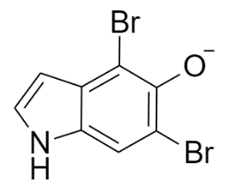 | 2.40 | 4.37 | 4.38

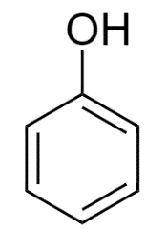 | No Solvent | Solvent | Opt Solvent | 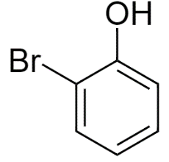 | No Solvent | Solvent | Opt Solvent
 | 8.26 | 6.20 | 6.20 |  | 8.24 | 6.30 | 6.30
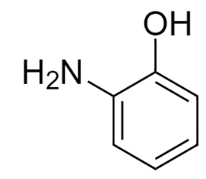 | 7.19 | 5.27 | 5.28 | 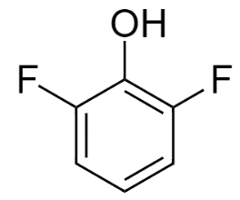 | 8.67 | 6.53 | 6.53
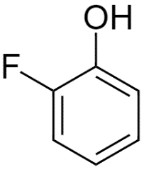 | 8.41 | 6.33 | 6.33 | 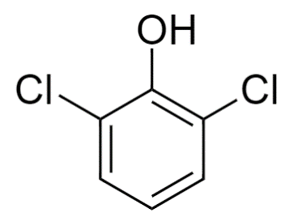 | 8.49 | 6.49 | 6.50
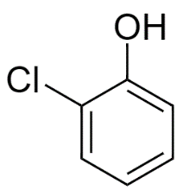 | 8.32 | 6.32 | 6.32 | 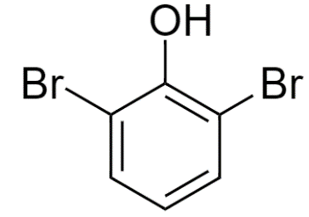 | 8.38 | 6.45 | 6.45

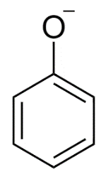 | No Solvent | Solvent | Opt Solvent | 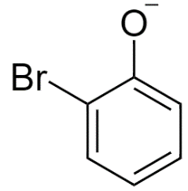 | No Solvent | Solvent | Opt Solvent
 | 2.17 | 4.40 | 4.41 |  | 2.52 | 4.61 | 4.62
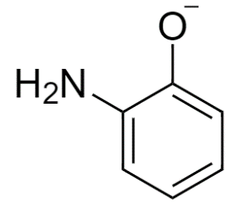 | 1.77 | 3.92 | 3.94 | 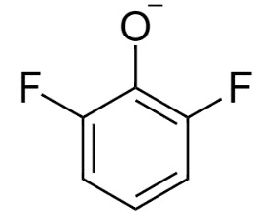 | 2.56 | 4.68 | 4.69
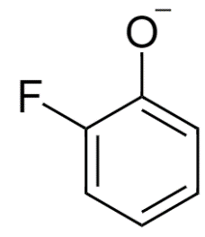 | 2.37 | 4.54 | 4.55 | 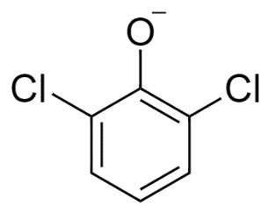 | 2.78 | 4.78 | 4.79
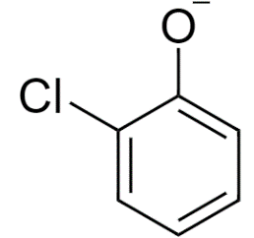 | 2.49 | 4.60 | 4.61 | 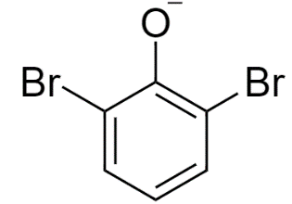 | 2.84 | 4.80 | 4.80

