A Practice Change Project to Decrease Heart Failure Readmission Rates

Kayla W. Johnson
College of Nursing, East Carolina University
Doctor of Nursing Practice Program
April 26, 2022

Acknowledgements from the Author
To my husband, thank you for giving me so much support and encouragement throughout this whole process. I cannot thank you enough for standing by my side and being my biggest cheerleader. To my family and friends, thank you for keeping me encouraged and contributing to my educational success. To my faith, thank you for never failing me. To Dr. A, thank you for allowing me to partner with you. Your leadership, expertise, and guidance were instrumental to my project's success. To the project site and project team, thank you for your patience, assistance, and guidance throughout my project. To Dr. C-O, thank you for leading me through this process. Your support and encouragement were invaluable. I am so grateful to have experienced this journey with all of you playing such instrumental parts to ensure this project was a success.

Abstract
Heart failure is a complex health condition that affects many individuals and families. This condition requires the implementation of self-management interventions after hospital discharge to reduce incidences of hospital readmission. The Hospital Readmissions Reduction Program was enacted by the Centers for Medicare & Medicaid Services in 2012 to financially penalize hospital organizations that exceeded the readmission benchmark for specific medical diagnoses such as heart failure. The purpose of this DNP project was to implement a practice change project within an organization to decrease 30-day hospital readmission rates for patients admitted with heart failure to prevent payment reduction. This project aimed to implement a standardized process of nurse-led patient education to inform patients and their families of self-care measures to manage heart failure and ensure an effective transition from hospital to home. This project demonstrated that face-to-face nurse-led education positively affected patient outcomes within the organization and reduced 30-day hospital readmission rates for patients with heart failure.
Keywords: heart failure, nurse-led education, education, readmission
Table of Contents
Acknowledgements from the Author ……..…….……………………………………………….. 2
Abstract .…………………………………………………………………………………………. 3
Section I: Introduction ...………………………………………………………………………… 6
Background………………………………………………………………………………. 6
Organizational Needs Statement…………………………………………………………. 6
Problem Statement……………………………………………………………………….. 8
Purpose Statement………………………………………………………………………... 8
Section II: Evidence…………………………………………………………………………….. 10
Literature Review……………………………………………………………………….. 10
Evidence-Based Practice Framework……………………………………………………14
Ethical Consideration and Protection of Human Subjects……………………………… 15
Section III: Project Design……………………………………………………………………… 16
Project Site and Population……………………………………………………………... 16
Project Team……………………………………………………………………………. 17
Project Goals and Outcomes Measures…………………………………………………. 17
Implementation Plan……………………………………………………………………. 19
Timeline………………………………………………………………………………… 20
Section IV: Results and Findings……………………………………………………………….. 21
Results……………………………………………………………………………………21
Discussion of Major Findings…………………………………………………………... 23
Section V: Interpretation and Implications………………………………………………………25
Costs and Resource Management...…………………………………………………….. 25
Implications of the Findings……………………………………………………………. 26
Sustainability …………………………………………………………………………… 28
Dissemination Plan …………………………………………………………………….. 29
Section VI: Conclusion…………………………………………………………………………. 30
Limitations and Facilitators………..…………………………………………………… 30
Recommendations for Others…………………………………………………………... 32
Recommendations for Further Study…………………………………………………… 33
Final Thoughts …………………………………………………………………………..33
References………………………………………………………………………………………. 35
Appendices………………………………. …………………………………………………….. 39
Appendix A: IRB Approval…..………………………………………………………… 39
Appendix B: Patient Education.………………………………………………………….42
Appendix C: Project Timeline...…………………………………………………………43
Appendix D: Heart Failure Pathway Utilization…………………………………………44
Appendix E: Pre-implementation and Post-implementation Readmission Rates…......... 45
Appendix F: Heart Failure Readmissions ……………………………….……………... 46
Appendix G: Project Budget…..…………………………………………………………47
Appendix H: Doctor of Nursing Practice Essentials ……………………………………48

Section I. Introduction
Background
Heart failure is a chronic heart condition that affects many individuals throughout the world. Within the United States, roughly 5.7 million individuals are currently diagnosed with heart failure (Nair et al., 2020). Approximately one million hospital admissions occur each year, attributing heart failure as a leading cause of hospital readmission for Medicare patients (Nair et al., 2020). Within 30 days, approximately one in four patients with heart failure are readmitted back into the hospital for heart failure complications such as dyspnea or edema (Di Palo et al., 2017). Roughly 30-40% of patients with heart failure survive up to one year after a previous hospitalization related to an exacerbation (Nair et al., 2020). The burden of heart failure events has led to an increase in annual healthcare costs, posing a significant resource and financial strain on healthcare systems. The average annual medical expense for heart failure is currently $30.7 billion; an increase to $70 billion by 2030 is expected (Lin et al., 2017). Reducing hospital readmissions for patients with heart failure has become a national priority for hospital organizations due to increased preventable hospitalization, cost, mortality, and poor quality of life (Lin et al., 2017).
Organizational Needs Statement
Hospital readmission prevention has become a primary concern for many hospital organizations due to the Hospital Readmissions Reduction Program (HRRP) initiation in 2012. The HRRP is a program enacted under the Centers for Medicare & Medicaid Services (CMS) to measure 30-day readmission rates for patients with heart failure to reduce avoidable readmissions (Centers for Medicare & Medicaid Services [CMS], 2020). The HRRP aims to increase quality care by financially penalizing hospital organizations with Medicare payment deductions of up to 3% for excessive readmission rates (CMS, 2020). The penalty calculation is determined by averaging the excess readmission ratio (ERR) for each health condition with other hospitals (Pandey et al., 2016). Hospital organizations have been challenged to prevent payment deduction by improving quality of care and reducing hospital readmission rates for Medicare patients within 30 days of discharge.
A hospital organization located within the southeastern region of the United States identified a need to develop a practice change process that encompasses care coordination to decrease 30-day readmission rates for patients with heart failure. The organization was currently falling below the CMS benchmark for heart failure readmission rates but had received payment deduction penalizations in the past. If the organization was able to reach the median cost of care for patients admitted with heart failure, there was a potential to save $3.8 million each year (C. B, personal communication, April 26, 2021). Despite many efforts to reduce hospital readmission rates for patients with heart failure, the organization had deemed it challenging to implement a change and recognize where the process had improved (M. H, personal communication, April 19, 2021). In the previous years, bedside nurses had been instructed to assess readiness for discharge and deliver discharge instructions to patients with heart failure prior to discharge. In some circumstances, the discharge information had either been missed, partially given, or poorly understood by the patient or patient caregiver (C. H, personal communication, May 21, 2021). The organization requested assistance in delivering an in-person patient education process for patients with heart failure utilizing an evidence-based transition of care model. This process began three days prior to expected patient discharge to ensure appropriate handoff and effective communication throughout the care continuum for patients with heart failure.
The need to reduce readmission rates for patients with heart failure intersects with the Triple Aim, developed by the Institute for Healthcare Improvement (IHI), and the Healthy People 2030 initiative to reduce hospitalizations for patients with heart failure and improve the quality of care and cost. The Triple Aim examines the performance of a healthcare system to improve the patient experience, population health, and cost-effective care (Institute for Healthcare Improvement [IHI], 2021). This practice change process targeted hospital readmission reduction within the heart failure population to enhance cost-effective and quality patient care. The goal was to reduce hospitalizations for patients with heart failure from 355.2 per 100,000 adults aged 18 years and older to 319.7 hospitalizations per 100,000 adults aged 18 years and older by 2030 (Office of Disease Prevention and Health Promotion [ODPHP], n.d.). This practice change process attempted to decrease hospitalizations for patients with heart failure to align with the Healthy People 2030 goal.
Problem Statement
Excessive readmission rates for patients with heart failure have caused costly financial penalties to hospital organizations. Due to this cost, this project attempted to reduce readmission rates within a 114-bed acute cardiovascular hospital located in the southeastern region of the United States by improving quality care for patients to ensure appropriate handoff, coordinated care, and communication throughout the care continuum.
Purpose Statement
The purpose of this practice change project was to decrease 30-day readmission rates for patients with heart failure. The reduction in readmission rates was attempted by delivering a face-to-face education plan for patients with heart failure beginning three days prior to patient discharge utilizing an evidence-based transition of care model. This face-to-face patient education delivery aimed to develop a standardized approach to improve quality care throughout the continuum for patients with heart failure, reduce hospital readmission rates, and cease payment deduction penalties.
Section II. Evidence
Literature Review
A literature review was performed with a search strategy related to the proposed plan to implement patient education to decrease 30-day readmission rates among adult patients with heart failure using the Cumulative Index to Nursing and Allied Health Literature (CINAHL) and PubMed databases. Keywords used in this literature review search process included: heart failure, education, and readmission. Following the initial literature review searches in CINAHL and PubMed, 803 articles were identified. Articles with levels of evidence described by Melnyk & Fineout-Overholt (2011) as levels I-IV were kept for review. The inclusion criteria included educational interventions for patients diagnosed with heart failure, publications with a publication date within the last five years, and English language. Exclusion criteria included studies with study participants younger than 18 years of age, patients who received a transplant, artificial device/medical intervention, patients discharged to a residential facility or nursing home, and patients who were not discharged directly home. After the inclusion criteria, exclusion criteria, levels of evidence, and duplicate articles were excluded, 49 articles were kept for final review. All remaining articles were read in their entirety, and 11 articles were appropriate for the project topic and were kept.
Current State of Knowledge
Thorough discharge planning has been associated with improved patient outcomes, self-care, and decreased organizational cost (American Heart Association Task Force, 2013). The current American Heart Association guidelines for patients with heart failure suggest a standardized process of 60 minutes of inpatient heart failure education within the hospital setting before patient discharge (American Heart Association, 2021). In addition, care coordination for patients with heart failure is implicated within hospital organizations due to the cost penalization associated with avoidable hospital readmissions implemented by the CMS (American Heart Association Task Force, 2013). The literature review provided evidence to support the implementation of patient education to decrease hospital readmission for patients with heart failure. Interventions intended to improve discharge education and care coordination demonstrated a reduction in heart failure readmission rates (Almkuist, 2017; Banerjee et al., 2017; Boyde et al., 2018; Chava et al., 2019; Cui et al., 2019; Deek et al., 2017; Rice et al., 2018; Wan et al., 2017).
Current Approaches to Solving Population Problem(s)
The implementation of patient and caregiver education for patients with heart failure has shown improvements in decreasing readmission when initiated early into hospitalization and before discharge (Almkuist, 2017; Boyde et al., 2018; Chava et al., 2019; Cui et al., 2019; Deek et al., 2017; Qui et al., 2019; Rhiantong et al., 2019; Wan et al., 2017). Many different educational approaches are utilized to decrease hospital readmission for patients with heart failure. These included nurse-led education sessions, multidisciplinary care, home visits, telephone calls, electronic medical record tracking, multimedia education, and the teach-back method. The method and timing of education vary between each approach.
The most common educational delivery approach within this literature review was nurse-led education. Active participation from the patient and caregiver during nurse-led education plays an important role in promoting self-care, goal-setting, and hospital readmission reduction (Deek et al., 2017; Rhiantong et al., 2019; Rice et al., 2018). The nurse-led education approach decreased rehospitalization, mortality rates, and organizational costs by providing education centered around the patient and family caregiver (Boyde et al., 2018; Cui et al., 2019; Qui et al., 2021; Rhiantong et al., 2019; Rice et al., 2018; Van Spall et al., 2019). Nurse-led education consists of independent educational sessions delivered by a trained nurse to the patient and family before discharge to evaluate self-care knowledge and educate on discharge planning, follow-up, symptom management, and additional resources (Cui et al., 2019; Deek et al., 2017; Qui et al., 2021; Rice et al., 2018; Van Spall et al., 2019; Wan et al., 2017). Similarly, an advanced practice nurse's 30-60 minute educational visit decreased the length of stay and the overall cost for patients admitted with heart failure (Rhiantong et al., 2019). Implementing a nurse-led intervention program can be a cost-effective and beneficial tool to decrease readmission and mortality in patients with heart failure.
The use of multidisciplinary care within hospital organizations has also shown effectiveness in decreasing hospital readmission rates for patients with heart failure (Banerjee et al., 2017; Boyde et al., 2018; Chava et al., 2019; Wan et al., 2017). Multidisciplinary care allows the patient and family to receive education with a care team of specialists to discuss home self-management interventions before patient discharge. This type of care can also potentially decrease medical costs and increase patient outcomes (Chava et al., 2019; Rice et al., 2018). The implementation of home visits delivered by a nurse or trained professional after patient discharge identified success in reducing the risk of hospital readmissions for patients with heart failure (Rhiantong et al., 2019; Wan et al., 2017). Telephone follow-up calls made to the patient and caregiver after discharge to request information regarding current clinical status, medication compliance, and adherence to self-monitoring recommendations also showed a reduction in heart failure readmission rates (Banerjee et al., 2017; Cui et al., 2019; Rice et al., 2018; Wan et al., 2017).
The implementation of an electronic medical record (EMR) dashboard within a hospital organization tracked patients with heart failure admission, interventions, patient education, and readmission rates. This organization sustained a decrease in heart failure readmission rates by utilizing the dashboard to determine gaps within the process of care for patients with heart failure (Banerjee et al., 2017). A multimedia educational approach that included a written manual and a DVD delivered to the patient and family prior to discharge showed effectiveness in improving knowledge through patient education and demonstrated a decrease in hospital readmission (Boyde et al., 2018). Incorporating the teach-back method approach to validate patient and family comprehension of discharge instruction, current health needs, and disease self-management also significantly reduced hospitalization for patients with heart failure (Almkuist, 2017; Banerjee et al., 2017; Boyde et al. 2018).
After identifying a variety of educational approaches used to assist with reducing hospital readmission for patients with heart failure through this literature review, these methods were shared with the partnering organization to determine an approach that would be efficient and cost-effective. It was determined that a face-to-face patient education process utilizing an evidence-based transition of care model beginning before expected patient discharge was the best approach to reduce readmission rates for patients with heart failure within the organization. This education was administered by the DNP student and trained nursing staff to consist of both written handouts and video material.
Evidence to Support the Intervention
Current literature suggested the importance of patient education within the hospital setting to assist the patient and family with the transition of care from the hospital to home (Almkuist, 2017; Rhiantong et al., 2019; Van Spall et al., 2019). A structured nurse-led educational approach during patient hospitalization improved self-care management, medication compliance, diet adherence, and social support (Cui et al., 2019). The literature demonstrated a reduction in readmissions for patients with heart failure when face-to-face nurse-led teaching sessions were incorporated for the patient and their family before hospital discharge (Boyde et al., 2018; Cui et al., 2019; Deek et al., 2017; Qui et al., 2021). Patient education regarding sodium restriction, weight observation, medication compliance, exercise, assessment of symptoms, and disease management improved patient knowledge, length of stay, and hospital readmission (American Heart Association Task Force, 2013). A nurse-led educational approach decreased hospital readmission and adverse patient outcomes when these educational components were taught (Cui et al., 2019; Deek et al., 2017; Qiu et al., 2021; Wan et al., 2017).
Evidence-Based Practice Framework
Identification of the Framework
The operational framework chosen to execute this project was the Revised Iowa Model of Evidence-based Practice by the Iowa Model Collaborative (2017). The Iowa Model has been used within many hospital organizations to promote evidence-based practice findings in clinical practice. The project was implemented by following the appropriate steps of the Iowa Model. The first step within the model is to identify an issue. If the issue is identified as a priority issue, the next step is to formulate a team and begin a search to synthesize evidence. If there is sufficient evidence to support the issue, the next step within the model is designing and piloting the practice change (Iowa Model Collaborative, 2017). After piloting the practice change, the next step is to identify if the change is appropriate for practice. Accordingly, if the change is deemed appropriate for adoption, the next step is implementing the change into practice hospital-wide (Iowa Model Collaborative, 2017). After sustaining change in practice, the final step is to analyze the process and disseminate the results. Suppose an issue arises at any time during the above steps. In that case, one must revisit the previous step to consider another issue, reassemble the evidenced literature, redesign the practice change, or consider additional alternatives (Iowa Model Collaborative, 2017). The organization understood the importance of following each step within this model to ensure a sustainable change in practice.
Ethical Consideration & Protection of Human Subjects
The formal approval process was prepared by first obtaining the partnership approval of this project with the project champion within the hospital organization via a letter of support. A project assessment tool was then completed to address the project's design, implementation, and evaluation. After approval, Collaborative Institutional Training Initiative (CITI) modules regarding social and behavioral research investigators and key personnel were completed to provide a foundation of knowledge about the responsible conduct of research and ethics. There were no ethical considerations for this project. The intervention of this project was equal and fair to all patients with heart failure admitted to the hospital organization. There was no potential harm to the heart failure population within this project. There was also no potential for any participant within this project to be taken advantage of during the project implementation. The institutional review board (IRB) was not necessary within the project organization as the organization recognizes Doctor of Nursing Practice (DNP) projects as quality improvement (QI) projects. The IRB approval for this project was only required from the university if necessary. This project did not require IRB review; exempt status was granted by East Carolina University for QI and/or program evaluation (See Appendix A).

Section III. Project Design
Project Site and Population
The project was completed within a hospital organization located within the southeastern region of the United States. The population within this QI project included adult patients admitted to the hospital with a diagnosis of heart failure. The families of the admitted patients were also encouraged to participate in the patient education if present. Barriers to implementation included accessibility of patient handouts and videos, time constraints, health literacy of patients, limited technology experience, skepticism using tablets and technology, refusal of patient education, and visitation limitations caused by the COVID-19 pandemic. Facilitators included a provider-driven order set that automatically triggered the patient education and the nurse-led intervention of patient education.
Description of the Setting
The setting where the implementation phase of this QI project occurred was within a 665-bed subsidiary non-profit community hospital owned by a health care system located within the southeastern region of the United States. This hospital’s 114-bed heart tower specialized in managing cardiovascular patients by offering cardiac catheterization, electrophysiology, interventional radiology, and cardiac rehabilitation. This hospital also consisted of intermediate and intensive care units to care for patients admitted with heart complications. Most of this project took place within the intermediate units of the heart tower. From July 1, 2016, to June 30, 2019, 1486 patients were discharged from the organization with a primary diagnosis of heart failure. Out of 1486 patients discharged, 325 were readmitted within 30 days (CMS, 2021).
Description of the Population
The target population included patients 18 years and older, of any race, admitted to the hospital with a diagnosis of heart failure and an active order for face-to-face patient education. This QI project included participants who were male, female, English speaking, and Spanish speaking. An interpreter was available for participants who were Spanish speaking, if necessary. Printed materials and videos were also provided in Spanish, if indicated. Family members of the patients with heart failure were also encouraged to attend and be actively present for patient education.
Project Team
The project team included the project leader, the faculty mentor, the project site champion, the heart failure team, and the care redesign team. The project leader implemented the QI project with oversight from the project site champion. The faculty mentor and project site champion provided guidance, encouragement, and support to the project leader throughout this project. The care redesign team followed each step of the project, communicated with Information Systems Design (ISD) for EMR assistance, and accepted feedback and recommendations to change any areas of the project to foster success. The heart failure and cardiology teams utilized the order set to initiate patient education for patients admitted with heart failure.
Project Goals and Outcome Measures
Before the implementation of this QI project, the IRB process was initiated. An IRB review within the project organization was not necessary because the organization recognized DNP projects as QI projects. An IRB review was conducted within the university and this QI project received exempt status for QI and/or program evaluation. The primary outcome measure for this project was to decrease 30-day readmission rates for patients hospitalized with a diagnosis of heart failure. The chosen delivery method for this project was the implementation of nurse-led education with provided printed handouts and videos. Aggregated pre- and post-implementation 30-day readmission data of de-identified patients was collected utilizing the organization’s software database.
Description of the Methods and Measurement
The patient education consisted of Day One, Day Two, and Discharge Day education with printed handouts and videos. Additional discharge instruction regarding heart failure was also attached to the patient’s after-visit summary (AVS) paperwork to take home upon discharge. The printed handouts and videos provided the patient with sodium and fluid restriction, weight observation, medication compliance, exercise, assessment of symptoms, and self-care management. There were three different methods to deliver video education. These methods included (a) using the organization’s electronic EMR app on the patient’s smartphone device to view the videos, (b) utilizing the nursing unit’s iPad to activate the EMR app to view the videos for patients who did not have a smartphone, (c) or viewing the educational videos on the television located within the patient’s hospital room. The methods were measured by examining the pre-implementation and post-implementation 30-day readmission data to assess if this project effectively decreased the overall readmission rate associated with the CMS's cost penalization for excessive readmission. The project compared the 30-day readmission rates of the patients that the DNP student delivered face-to-face education with to the 30-day readmission rates of the bedside nurse's educated patients. This comparison was utilized to identify if a nurse navigator may be necessary for the organization in the future.
Discussion of the Data Collection Process
Pre-implementation 30-day readmission data was first collected from January 2021 through March 2021 before implementing the nurse-led patient education to provide baseline 30-day readmission data during this timeframe. Readmission data was collected using software currently in the user acceptance testing phase to display 30-day readmission rates of all de-identified patients admitted to the hospital in Medicare Severity Diagnosis Related Groups (MS-DRGs) 291, 292, and 293. These MS-DRGs consisted of heart failure and shock with a major complication or comorbidity (MCC), heart failure and shock with a complication or comorbidity (CC), or heart failure and shock without MCC or CC. The results of this project compared pre-implementation and post-implementation 30-day readmission rates of de-identified patients with heart failure.
Implementation Plan
A multidisciplinary team created an inpatient heart failure pathway within the organization to initiate a heart failure order set that included patient education within the EMR for patients admitted with a diagnosis of heart failure. The EMR would automatically trigger the suggested heart failure order set to the patient's chart when two of the five criteria were met. The criteria included: (a) heart failure was active on the patient's problem list, (b) intravenous (IV) diuretic was administered during the admission, (c) elevated N-terminal prohormone brain natriuretic peptide was > 800 or brain natriuretic peptide was > 150, (d) ejection fraction < 50, or (e) the admitted patient was in the organization's heart failure registry. If criteria triggered the suggested order set, the provider would then choose whether to order the order set for patients admitted with heart failure or not.
After the provider ordered the order set, the heart failure education was activated within the patient's education plan to include three days of nurse-led education to be given by a trained nurse to the patient before hospital discharge. On discharge, additional heart failure education would also be attached to the patient's AVS paperwork. The nurses were educated on the educational delivery process by the staff management team. The patient education included printed handouts and video education to reinforce different learning modalities (See Appendix B). Each patient received printed handouts that provided health literacy appropriate written instruction. The education videos were delivered utilizing three different methods according to the patient's preference. The nurse would then chart the delivered day of education as completed in the patient’s chart. This QI project compared the pre-implementation and post-implementation 30-day heart failure readmission rates of de-identified patients after initiating this face-to-face nurse-led patient education process.
Timeline
On June 21, 2021, the pilot was launched to test the EMR and allow the providers to add the order set for patients admitted with heart failure. The implementation phase began on June 23, 2021, to begin face-to-face patient education with all eligible patients at the project site. The DNP student and nursing staff began receiving education about the new patient education by the project team and staff management. The patient handouts and different methods of video education were delivered according to the patient's preference. Meetings were conducted between the DNP student and the project team to evaluate successes and areas of improvement within the project. Potential project modification was also evaluated as necessary to align with the Iowa Model framework and the QI project. The implementation phase continued into August 23, 2021. See Appendix C for a visualization of the project timeline.

Section IV. Results and Findings
This project aimed to implement nurse-led education within the organization for eligible patients with heart failure to reduce 30-day readmission rates. Pre- and post-implementation data were collected during this process. The pre- and post-implementation data were compared with the number of 30-day readmissions after successful patient education upon discharge with the DNP student and nursing staff. During the pre-implementation period of June 23, 2020, through August 23, 2020, 133 patients were admitted to the organization with a diagnosis of heart failure with MS-DRGs 291, 292, and 293. Of the 133 patients admitted, 24 patients (18%) were readmitted to the hospital within 30 days of discharge.
During the implementation period of June 23, 2021, through August 23, 2021, 139 patients were eligible to be placed on the heart failure order set pathway with MS-DRGs 291, 292, and 293. Of these patients, 34 were manually placed on the order set pathway by a provider. Of the 34 patients with heart failure who met the criteria to receive face-to-face education, 29 patients received face-to-face education while admitted to the organization during this period. Of the 29 patients, 18 patients received face-to-face education from the DNP student, and 11 patients received face-to-face education from the nursing staff. See Appendix D for a visualization of the heart failure pathway utilization during the implementation period.
Results
During the implementation period of June 23, 2021, to August 23, 2021, 139 patients were admitted to the organization with a diagnosis of heart failure. Of these 139 patients, 20 (14.4%) patients were readmitted to the hospital within 30 days of discharge. The DNP student delivered face-to-face education to 18 patients during the implementation period. A total of two out of 18 (11.1%) patients with heart failure who received face-to-face education by the DNP student were readmitted back to the hospital within 30 days of discharge within this time frame. The two patients with heart failure who were readmitted back into the hospital within 30 days of discharge were discharged to a skilled nursing facility at the time of their first hospital discharge within this period. Seventeen out of 18 patients received patient education from printed handouts and educational videos on the television in the patient’s hospital room. One patient received patient education videos by utilizing the nursing unit’s iPad to activate the EMR app. The third method to use the organization’s electronic EMR app on the patient’s smartphone device to view the videos was not used during this implementation period.
There were 11 patients who received face-to-face education by nursing staff during this implementation period. Of the remaining 18 patients who were readmitted within 30 days of discharge, they either received face-to-face education by nursing staff during their hospital admission or were not educated. Although the following readmission data regarding who received face-to-face education by nursing staff was unable to be associated during this implementation period, the effect of the educated 11 patients was counteracted by the effect of not receiving education at all. After removing the 18 patients who received face-to-face education by the DNP student, 121 patients remained during this period who were admitted with a diagnosis of heart failure. Of the 18 out of 121 (14.9%) patients who were readmitted either received face-to-face education by nursing staff during their hospital admission stay or did not. To compare, 11.1% of patients were readmitted within 30 days of discharge after receiving face-to-face education by the DNP student compared to 14.9% of patients who either did or did not receive face-to-face education by nursing staff during this implementation period. See Appendix E for a visualization of the pre-implementation and post-implementation 30-day readmission rates.
Discussion of Major Findings
Nurse-led education was the most common type of educational approach found during the literature review process to reduce hospital readmission rates for patients with heart failure (Boyde et al., 2018; Cui et al., 2019; Qui et al., 2021; Rhiantong et al., 2019; Rice et al., 2018; Van Spall et al., 2019). The evidence within the literature supported the findings of implementing a nurse-led educational approach within the organization to decrease hospitalization and organizational costs when providing heart failure education to patients and their families. When nurse-led education was implemented within the organization by the DNP student, the readmission rate decreased from 18% to 11.1%. When patients with heart failure either received or did not receive face-to-face education by nursing staff, the readmission rate decreased to 14.9%. When comparing the 30-day readmission rate of the patients who received face-to-face education by the DNP student (11.1%) versus those who either received or did not receive face-to-face education by nursing staff (14.9%), there was an effective decrease in 30-day readmission when the DNP student gave nurse-led education during this implementation period. The nurse-led education given by the DNP student demonstrated the most success in reducing 30-day readmission rates for the organization.
It is important to note the discharge disposition of the two patients who received face-to-face education by the DNP student and were readmitted within 30 days of discharge. These two patients were discharged to a skilled nursing facility at their first hospital discharge within the implementation period. This information demonstrates that nurse-led education positively assisted patients and their families with transitioning from the hospital to home. There were no 30-day readmissions for patients who received education by the DNP student with a discharge disposition to home at the time of discharge. The evidence within the literature also suggested the importance of implementing a standardized process to improve patient outcomes (Boyde et al., 2018; Cui et al., 2019; Qui et al., 2021; Rhiantong et al., 2019; Rice et al., 2018; Van Spall et al., 2019). This practice change project demonstrated that implementing a standardized educational process during hospitalization for patients with heart failure improved patient outcomes by reducing 30-day readmission rates.

Section V. Interpretation and Implications
Costs and Resource Management
The average amount of hours spent on-site during the implementation period of the face-to-face patient education by the DNP student was 120 hours. The average cost of a heart nurse navigator within the hospital organization was $35/hour. If the total hours of on-site implementation are multiplied by the average salary of a nurse navigator, it would equal roughly $4,200. The organization utilized a care redesign team that focused on developing, implementing, and growing quality improvement throughout the organization. The care redesign team worked closely with the DNP student, the heart failure team, the ISD team, and the data collection team to ensure project success. The average hourly pay for a member of the care redesign team was $35/hour. There were approximately 100 hours spent working on this project by the care redesign team totaling $3,500. The organization had a system contract that supplied the educational videos located on the patient televisions within each hospital room of the heart hospital. There was no additional cost to add extra educational videos within the television system. An iPad was already located within each unit of the heart hospital. The app necessary for this project was already uploaded on the iPad. There was no additional cost to use the iPad for this project. The average cost to print one sheet of paper was two cents per page. The Day One, Day Two, Discharge Day printed handouts totaled 35 pages per patient, costing 70 cents per patient. The estimated cost of the project was calculated to be approximately $7720.30. See Appendix C for an itemized cost and resource project budget.
Cost reduction was an important outcome and goal for the organization to reduce payment penalties. It is estimated that the annual median medical cost per patient diagnosed with heart failure is $24,383 per patient (Urbich et al., 2020). The median cost per heart failure-specific hospitalization is $15,879 (Urbich et al., 2020). Within the implementation period, 16 patients with heart failure were not readmitted back to the hospital within 30 days after receiving face-to-face education by the DNP student. Utilizing the median cost per heart failure-specific hospitalization from Urbich et al. (2020), there was a potential savings of $254,064 (16 x $15,879) to $390,128 (16 x $24,383) during the implementation period for patients with heart failure who were not readmitted to the hospital within 30 days of discharge. The organization utilized nurse navigators for other disease and treatment processes, such as diabetes, oncology, and orthopedics (J. A, personal communication, January 5, 2022). Implementing a nurse navigator for patients with heart failure could assist the organization in reaching the goal of reducing annual heart failure costs.
Implications of the Findings
After reviewing the process and outcomes of this practice change project, the implications for patients, nursing practice, and the healthcare system were examined. The primary goal of this project was to decrease 30-day readmission rates for patients with heart failure to reduce financial penalties for the organization. The overarching goal was to improve patient outcomes, nursing practice, and the health care system through an effective transition of care for these patients throughout their care continuum.
Implications for Patients
Patient education is an essential component of heart failure care. Education for patients with heart failure has been shown to increase patient outcomes and self-care measures (Rice et al., 2018). While patient satisfaction was not measured during this project, many patients reported contentment with having this type of educational experience during their hospital stay. The inclusion of families and caregivers within this practice change project also assisted in supporting each individual in acquiring knowledge, skills, and strategies towards a successful transition from hospital to home. There was also an improvement in communication and care coordination for patients and caregivers during this process. Each educational experience allowed each individual to ask questions and feel more involved with their health care. This improvement helped achieve the IHI and Healthy People 2030 initiatives to improve the quality of care and patient experience (IHI, 2021; ODPHP, n.d.).
Implications for nursing practice.
The implementation of this project improved communication, care coordination, and discharge planning for nursing staff, providers, and the multidisciplinary team. There was an increased rapport and team cohesion when caring for patients with heart failure. This new standardized process to include educational topics within the handouts and videos created a new standard of care for the organization. The nurses no longer had to guess what education the patient should receive prior to discharge. There was also a well-defined set of expectations for both nurses and providers. The providers were expected to order the order set if the patient met the criteria, and the nurses were expected to deliver the patient education. There was also more confidence in the knowledge of the disease process as all nurses were educated on the same information to include evidence-based practice care. Nursing staff also received support from hospital leadership during implementation as there was ongoing goal-setting leadership engagement throughout this project.
Impact for Healthcare System(s)
Two (11.1%) patients with heart failure received face-to-face education by the DNP student and were readmitted back to the hospital within 30 days of discharge. The remaining 18 (14.9%) patients readmitted within 30 days of discharge either received face-to-face education by nursing staff during their hospital admission or did not. The pre-implementation readmission rate from June 23, 2020, to August 23, 2020, was 18%. Implementing a nurse-led educational approach demonstrated an effective decrease in 30-day hospital readmission for patients with heart failure. A decrease in 30-day hospital readmissions produced cost savings for the organization by reducing financial penalizations imposed by the Medicare HRRP program that the CMS enacted. This project aligned with Medicare’s HRRP program goal to decrease excessive hospital readmission for patients with heart failure by improving communication and care coordination throughout the health care team and organization. There was also a potential improvement of patient satisfaction scores for the organization as the quality of hospital care increased with implementing a more standardized educational approach for patients with heart failure.
Sustainability
Due to this type of practice change project being a new launch for the organization, considerations for improvement will need to be considered. Considerations include sustainability for staff nursing education regarding the order set and face-to-face education with the evolvement of the current COVID-19 pandemic. Although this practice change process continued within the organization despite the end of the implementation period, the COVID-19 pandemic has created unprecedented staff turnover, leading to a staffing crisis for many units. It became challenging to keep nursing staff educated on the heart failure pathway and the delivery of patient education. Many departments already utilized nurse navigators to deliver face-to-face education to patients within different specialties. This project could potentially evolve to focus on implementing a nurse navigator role as the hospital readmission rate for patients who received education by the DNP student was less than those who either received education by nursing staff or did not. A subsequent quality improvement project could assess the daily routine and process of nurse navigators who already work for the organization to compare a similar process for patients with heart failure for sustainability success.
Another consideration for this project was that it only focused on delivering nurse-led education to patients with heart failure who were admitted to the heart hospital during their hospital stay. There was no focus placed on patients with heart failure who were admitted to the remainder of the hospital. In the future, there could be a focus made on delivering nurse-led education to patients with heart failure within the whole hospital. This focus may aid in continuing to decrease the 30-day heart failure readmission rates for the organization since there were patients who met the criteria to be placed on the order set pathway and were placed outside of the heart hospital during the implementation period.
Dissemination Plan
This quality improvement project will be disseminated to the project site research council through an oral presentation at the project site. The DNP student will present the project’s implications, outcomes, and findings to the organization’s research council. The date of this dissemination presentation is on May 3, 2022. This project will also be disseminated through the university’s public online repository named “The ScholarShip,” An oral presentation was at the university’s College of Nursing DNP Project Presentation Day on April 5, 2022. The project site has requested an abstract or publication submission within the organization after the DNP student has graduated.

Section VI. Conclusion
Limitations and Facilitators
There were some areas identified within the project to be limitations. One limitation was the process required to identify patients placed on the order set by providers. An email was manually sent out by a member of the care redesign team during the weekday to provide a list of patients on the order set and required face-to-face education for that day. The list was not sent out on the weekends, limiting face-to-face education to some patients who may have been discharged prior to the next weekday. There was no automated process to notify the nurse or DNP student of newly identified patients placed on the order set. This project also only focused on implementing nurse-led education to patients with heart failure admitted within the heart hospital. Patients could be admitted anywhere in the hospital for any medical diagnosis, and there were eligible patients placed on the heart failure pathway admitted outside of the heart hospital.
The ongoing COVID-19 pandemic also created limitations during this project. Some patients were placed on the heart failure pathway with a current diagnosis of COVID-19. These patients did not receive education by the DNP student due to clinical regulations set forth by the university. Some family members were also not present at the time of the nurse-led education for this project due to the COVID-19 visitation policy within the hospital that limited the number of patient visitors per hospital stay. Staff turnover also caused limitations as it became difficult to keep nursing staff educated and up to date throughout the project.
Another limitation to this project was the inability to capture every patient admitted for heart failure within the organization. This project relied on providers to order the order set within the patient’s medical chart to place the patient on the heart failure pathway that would trigger the face-to-face patient education. There were 139 eligible patients for the heart failure pathway during the implementation period, and only 34 patients were placed on the pathway during this period by providers. Provider education may be warranted in the future to expand the number of patients being placed on the heart failure pathway.
The data collection software used within the project was also in the user acceptance testing phase. Software results needed to be verified for validity. When identifying patients who received face-to-face education by nursing staff during the implementation period, another limitation was that the organization’s EMR system would allow each day of education to be selected all at once. This created challenges in appropriately identifying if the patient had received each day of education prior to discharge. Some patients' charts displayed all education days as charted with the same timestamp and date of education. This obstacle was unable to be remedied during the implementation period to allow only one day of education to be chosen as completed within the EMR system each day. Another limitation was time constraints for nursing staff to deliver the education. Depending on the type of day, sometimes it was not always easy to spend 10 to 15 minutes educating a patient on the unit if there were other priorities for nursing staff to consider that day.
A facilitator for the project included a provider-driven order set that automatically triggered the patient education. With creating a provider-driven order set, there was no additional work required to identify patients who met the criteria to receive nurse-led patient education. The only premise was that the provider needed to manually order the triggered suggestion to place the patient on the education pathway. Another facilitator was that the project had multiple participants who acted as primary stakeholders to implement this type of project. The primary stakeholders included physicians, nurses, nurse managers, directors, and the care redesign team supporting this project's implementation. There was already an existing process to educate patients with heart failure. However, the organization requested assistance in implementing a practice change process to improve patient outcomes and decrease readmission rates. This project was created with the help of stakeholders who supported implementing a new practice change project.
The system contract that the organization already had in place that supplied the educational videos located on the patient televisions within each hospital room of the heart hospital was another facilitator for this project. There was no additional cost to add extra educational videos within the television system, which helped the project begin sooner. The utilization of the care redesign team was also very beneficial for this project. The care redesign team worked closely with the DNP student, heart failure team, ISD team, and data collection team to keep the project progressing. This care redesign team also ensured that each process aligned with the organization’s goal of improving patient outcomes, reducing hospital readmission, and expanding the continuum of care coordination across the organization.
Recommendations for Others
To anyone considering replicating this project, it will be essential to consider the current organizational goals, processes, protocols, and existing resources already available for the organization. The involvement and engagement of key stakeholders within the decision-making process of the project development phase are also essential. Key stakeholders know the organization's current processes, past successes, and failures, making the utilization of key stakeholders within this project pivotal in the success of this project. Developing a measurement strategy throughout the project is beneficial to assess the project for areas of improvement and success. The Revised Iowa Model of Evidence-based Practice by the Iowa Model Collaborative (2017) was utilized within this project to promote evidence-based practice findings in clinical practice and a sustainable change project.
Recommendations Further Study
The concept of this project could apply to many different discharge disposition settings, such as focusing on the transition of care from hospital to rehab, skilled nursing facility, or home with home health care. This project mainly focused on the transition of care from hospital to home, but there were two readmissions within 30-days of discharge to a skilled nursing facility. This project could also identify the transition of care from hospital to home, emphasizing family education instead of predominantly patient education. Five other conditions identified within the CMS HRRP program measure unplanned 30-day readmission rates for payment reduction penalties. These conditions include acute myocardial infarction, chronic obstructive pulmonary disease, pneumonia, coronary artery bypass graft surgery, and total hip arthroplasty or knee arthroplasty (CMS, 2020). This project could be expanded to focus on these other health conditions that may also require readmission rate reduction to save the organization from additional costly penalizations.
Final Thoughts
The CMS created the HRRP program to reduce excessive hospital readmissions and improve patient outcomes for specific health conditions. Heart failure is one of the health conditions prioritized under the HRRP. With the initiation of this program, hospital organizations are being financially penalized by Medicare payment reductions if the hospital is deemed to have excessive hospital readmissions for patients with heart failure. Reducing hospital readmission rates for patients with heart failure has become a priority for many hospitals to no longer receive payment reduction penalizations by the CMS. The literature revealed many different methods to reduce hospital readmissions for patients with heart failure. Face-to-face nurse-led patient and family education to patients with heart failure demonstrated success with 30-day hospital readmission rates within the literature review.
This practice change project aimed to decrease 30-day hospital readmission rates for patients admitted with heart failure by implementing a standardized process of nurse-led patient education. Utilizing a standardized process with a knowledgeable team within a hospital organization ensures appropriate handoff and effective communication throughout the care continuum for patients with heart failure. This project demonstrated that face-to-face nurse-led education positively affected patient outcomes within the organization. The development of this standardized process also demonstrated a reduction in 30-day hospital readmission rates for patients with heart failure. This practice change project revealed the importance of implementing a standardized process across an organization to provide evidence-based care, quality patient outcomes, and readmission reduction.

References
Almkuist, K. D. (2017). Using teach-back method to prevent 30-day readmissions in patients with heart failure: A systematic review. Medsurg Nursing, 26(5), 309-351.
American Heart Association. (2021). Get with the guidelines- Heart failure. https://www.heart.org/-/media/files/professional/quality-improvement/get-with-the-guidelines/get-with-the-guidelines-hf/educational-materials/hf-fact-sheetupdated-011119v2updated-3521km-002.pdf?la=en
American Heart Association Task Force. (2013). 2013 ACCF/AHA guideline for the management of heart failure: A report of the American College of Cardiology Foundation/American Heart Association task force on practice guidelines. Circulation, 128(16), e240-e327. https://doi.org/10.1161/CIR.0b013e31829e8776
Banerjee, D., Thompson, C., Kell, C., Shetty, R., Vetteth, Y., Grossman, H., DiBiase, A., & Fowler, M. (2017). An informatics-based approach to reducing heart failure all-cause readmissions: The Stanford heart failure dashboard. Journal of the American Medical Informatics Association, 24(3), 550-555. https://doi.org/10.1093/jamia/ocw150
Boyde, M., Peters, R., New, N., Hwang, R., Ha, T., & Korczyk, D. (2018). Self-care educational intervention to reduce hospitalisations in heart failure: A randomised controlled trial. European Journal of Cardiovascular Nursing: Journal of the Working Group on Cardiovascular Nursing of the European Society of Cardiology, 17(2), 178-185. https://doi.org/10.1177/1474515117727740
Centers for Medicare & Medicaid Services. (2020). Hospital readmissions reduction program (HRRP). https://www.cms.gov/Medicare/Medicare-Fee-for-Service-Payment/AcuteInpatientPPS/Readmissions-Reduction-Program
Centers for Medicare & Medicaid Services. (2021). Hospital readmissions reduction program.
https://data.cms.gov/provider-data/dataset/9n3s-kdb3
Chava, R., Karki, N., Ketlogetswe, K., & Ayala, T. (2019). Multidisciplinary rounds in prevention of 30-day readmissions and decreasing length of stay in heart failure patients: A community hospital based retrospective study. Medicine, 98(27), e16233-e16233. https://doi.org/10.1097/MD.0000000000016233
Cui, X., Zhou, X., Ma, L., Sun, T., Bishop, L., Gardiner, F. W., & Wang, L. (2019). A nurse-led structured education program improves self-management skills and reduces hospital readmissions in patients with chronic heart failure: A randomized and controlled trial in china. Rural and Remote Health, 19(2), 5270-5270. https://doi.org/10.22605/RRH5270
Deek, H., Chang, S., Newton, P. J., Noureddine, S., Inglis, S. C., Arab, G. A., Kabbani, S., Chalak, W., Timani, N., Macdonald, P. S., & Davidson, P. M. (2017). An evaluation of involving family caregivers in the self-care of heart failure patients on hospital readmission: Randomised controlled trial (the family study). International Journal of Nursing Studies, 75, 101-111. https://doi.org/10.1016/j.ijnurstu.2017.07.015
Di Palo, K. E., Patel, K., Assafin, M., & Piña, I. L. (2017). Implementation of a patient navigator program to reduce 30-day heart failure readmission rate. Progress in Cardiovascular Diseases, 60(2), 259-266. https://doi.org/10.1016/j.pcad.2017.07.004
Institute for Healthcare Improvement. (2021). The IHI Triple Aim. http://www.ihi.org/Engage/Initiatives/TripleAim/Pages/default.aspx
Iowa Model Collaborative. (2017). Iowa model of evidence-based practice: Revisions and validation. Worldviews on Evidence-Based Nursing, 14(3), 175-182. https://doi.org/10.1111/wvn.12223
Lin, A. H., Chin, J. C., Sicignano, N. M., & Evans, A. M. (2017). Repeat hospitalizations predict mortality in patients with heart failure. Military Medicine, 182(9), e1932-e1937. https://doi.org/10.7205/MILMED-D-17-00017
Melnyk, B. M., & Fineout-Overholt, E. (2011). Evidence-based practice in nursing & healthcare: A guide to best practice (Second ed.). Wolters Kluwer.
Nair, R., Lak, H., Hasan, S., Gunasekaran, D., Babar, A., & Gopalakrishna, K. V. (2020). Reducing all-cause 30-day hospital readmissions for patients presenting with acute heart failure exacerbations: A quality improvement initiative. Curēus, 12(3), e7420-e7420. https://doi.org/10.7759/cureus.7420
Office of Disease Prevention and Health Promotion. (n.d). Reduce heart failure hospitalizations in adults – HDS-09. Healthy People 2030. https://health.gov/healthypeople/objectives-and-data/browse-objectives/heart-disease-and-stroke/reduce-heart-failure-hospitalizations-adults-hds-09
Pandey, A., Golwala, H., Xu, H., DeVore, A. D., Matsouaka, R., Pencina, M., Kumbhani, D. J., Hernandez, A. F., Bhatt, D. L., Heidenreich, P. A., Yancy, C. W., De Lemos, J. A., & Fonarow, G. C. (2016). Association of 30-day readmission metric for heart failure under the Hospital Readmissions Reduction Program with quality of care and outcomes. JACC. Heart Failure, 4(12), 935-946. https://doi.org/10.1016/j.jchf.2016.07.003
Qiu, X., Lan, C., Li, J., Xiao, X., & Li, J. (2021). The effect of nurse-led interventions on re-admission and mortality for congestive heart failure: A meta-analysis. Medicine, 100(7), e24599-e24599. https://doi.org/10.1097/MD.0000000000024599
Rhiantong, J., Malathum, P., Monkong, S., McCauley, K., Viwatwongkasem, S. (2019). Outcomes of an advanced practice nurse-led continuing care program in people with heart failure. Pacific Rim International Journal of Nursing Research, 23(1), 32-46. https://he02.tci-thaijo.org/index.php/PRIJNR/article/view/119723
Rice, H., Say, R., & Betihavas, V. (2018). The effect of nurse-led education on hospitalisation, readmission, quality of life and cost in adults with heart failure. A systematic review. Patient Education and Counseling, 101(3), 363-374. https://doi.org/10.1016/j.pec.2017.10.002
Urbich, M., Globe, G., Pantiri, K., Heisen, M., Bennison, C., Wirtz, H. S., & Di Tanna, G. L. (2020). A systematic review of medical costs associated with heart failure in the USA (2014–2020). Pharmacoeconomics, 38(11), 1219-1236. https://doi.org/10.1007/s40273-020-00952-0
Van Spall, Harriette G. C, Lee, S. F., Xie, F., Oz, U. E., Perez, R., Mitoff, P. R., Maingi, M., Tjandrawidjaja, M. C., Heffernan, M., Zia, M. I., Porepa, L., Panju, M., Thabane, L., Graham, I. D., Haynes, R. B., Haughton, D., Simek, K. D., Ko, D. T., & Connolly, S. J. (2019). Effect of patient-centered transitional care services on clinical outcomes in patients hospitalized for heart failure: The PACT-HF randomized clinical trial. The Journal of the American Medical Association, 321(8), 753-761. https://doi.org/10.1001/jama.2019.0710
Wan, T. T. H., Terry, A., Cobb, E., McKee, B., Tregerman, R., & Barbaro, S. D. S. (2017). Strategies to modify the risk of heart failure readmission: A systematic review and meta-analysis. Health Services Research and Managerial Epidemiology, 4,1-16. https://doi.org/10.1177/2333392817701050

Appendix A
IRB Approval
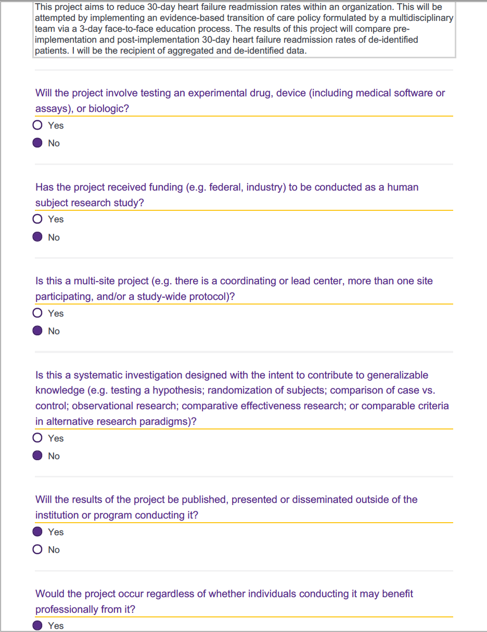

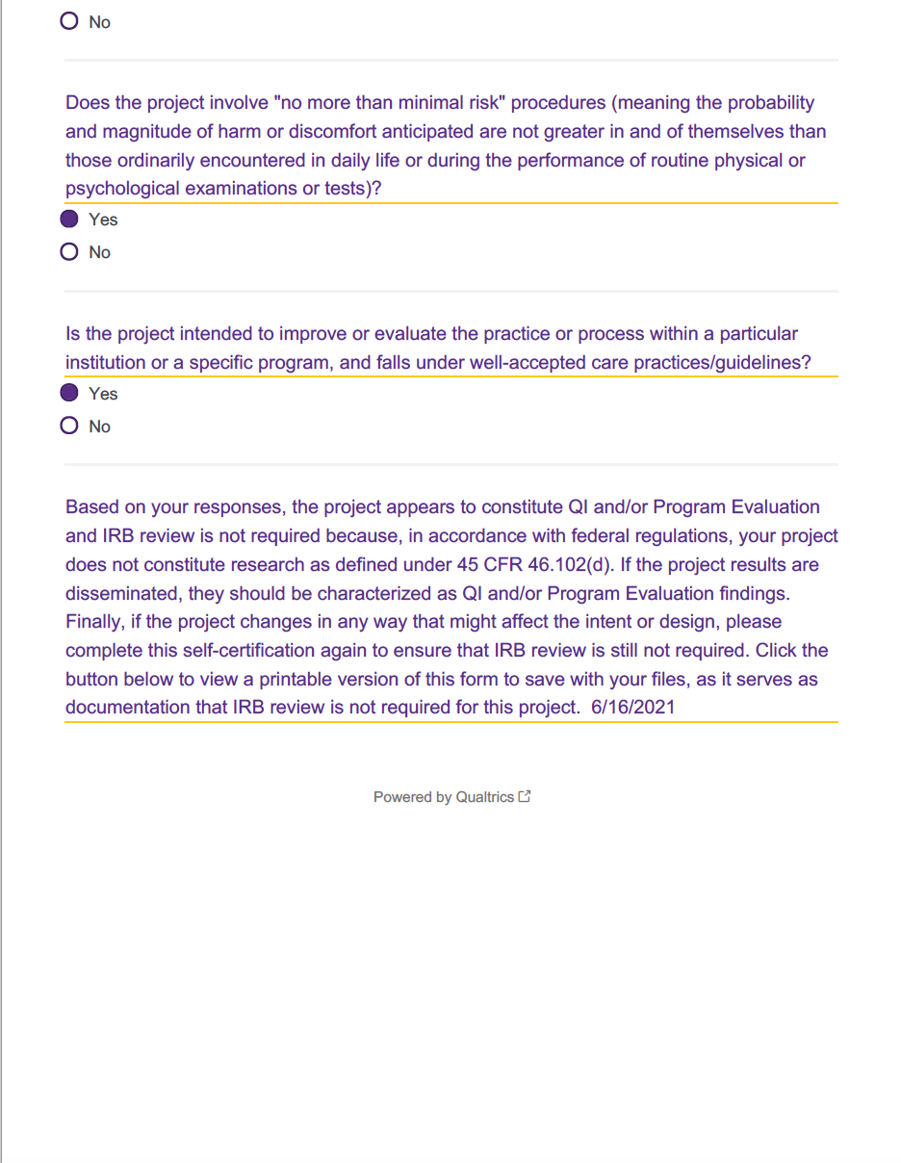
Appendix B
Patient Education
Format | Day 1 | Day 2 | Discharge/Day 3 | AVS
Written Instructions | 1. Learning About HF | 1. Avoiding Triggers with HF  2. Limiting Sodium with HF  3. Fluids Restrictions: Care Instructions | 1. Learning About HF Zones  2. HF: Care Instructions  3. Medicine for HF: Care Instructions | 1. Learning About HF Zones  2. HF: Care Instructions  3. Medicine for HF: Care Instructions
Videos | 1. Checking Your Weight Daily  2. Limiting Fluids  3. Limiting Sodium  4. Being Active  5. Learn to Recognize Symptoms | 1. Avoiding Triggers for CHF  2. Practice Tracking Sodium  3. Track Your Symptoms  4. Daily Symptom Check | 1. When to Act on Your Symptoms  2. Medicines to Avoid  3. Self-Care  4. When to Call for Help  5. Your Reason to be Active

Appendix C
Project Timeline
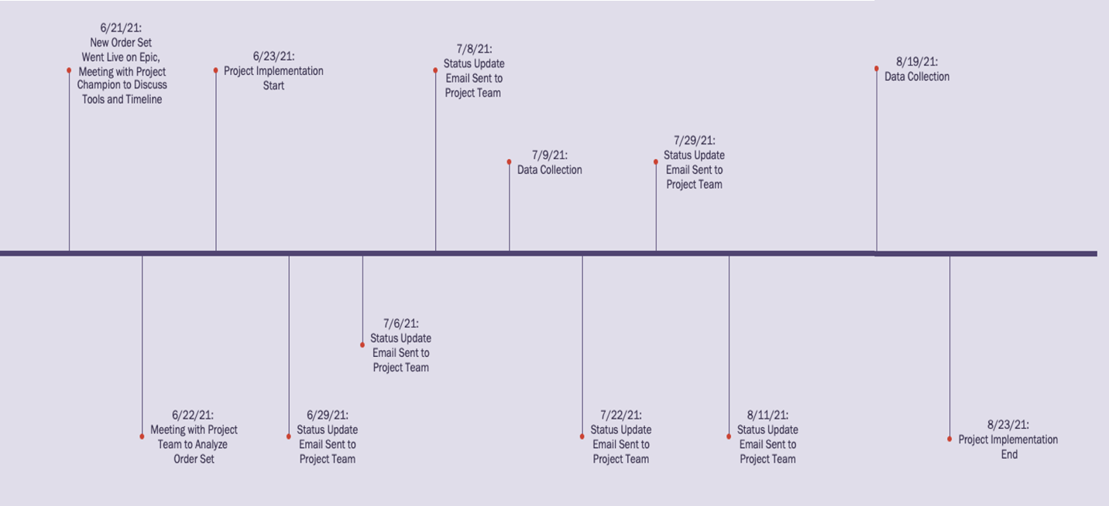
Appendix D
Heart Failure Pathway Utilization
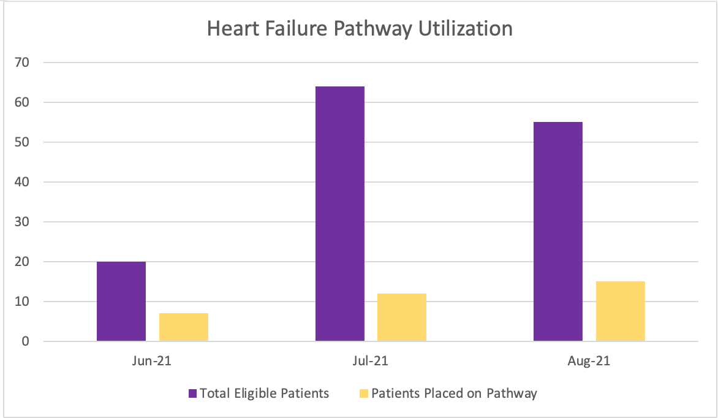

Appendix E
Pre-implementation and Post-implementation Readmission Rates

Appendix F
Heart Failure Readmissions

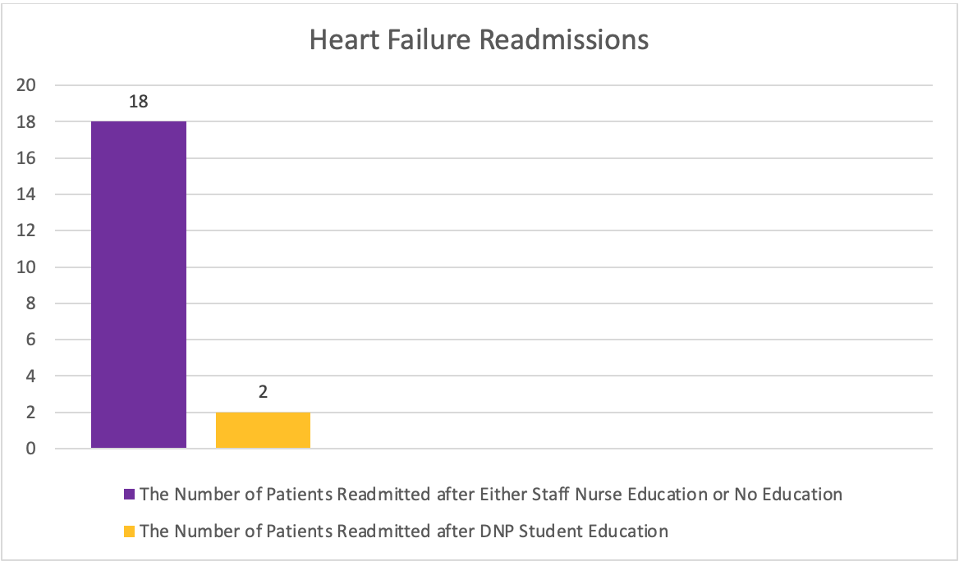

Appendix G

Project Budget

Heart Failure Nurse-led Education Project Budget

LABOR
 | Hours | Rate | Total $
Face-to-Face Education Completed by the DNP Student | 120 | $35/hour | $4,200
Care Redesign Team | 100 | $35/hour | $3,500
SUPPLIES
 | Quantity (per educated patient) | Rate | Total $
Paper | 29 | $0.70 | $20.30
PROJECT TOTAL = $7,720.30

Appendix H
Doctor of Nursing Practice Essentials
 | Description | Demonstration of Knowledge
Essential I  Scientific Underpinning for Practice | Competency – Analyzes and uses information to develop practice  Competency -Integrates knowledge from humanities and science into context of nursing  Competency -Translates research to improve practice  Competency -Integrates research, theory, and practice to develop new approaches toward improved practice and outcomes | - A literature review was completed and provided evidence to support the implementation of patient education to decrease 30-day hospital readmissions  - Results from the literature review were utilized to determine the project implementation process  - The Revised Iowa Model of Evidence-based Practice was utilized throughout the project
Essential II  Organizational & Systems Leadership for Quality Improvement & Systems Thinking | Competency –Develops and evaluates practice based on science and integrates policy and humanities  Competency –Assumes and ensures accountability for quality care and patient safety  Competency -Demonstrates critical and reflective thinking  Competency -Advocates for improved quality, access, and cost of health care; monitors costs and budgets  Competency -Develops and implements innovations incorporating principles of change  Competency - Effectively communicates practice knowledge in writing and orally to improve quality  Competency - Develops and evaluates strategies to manage ethical dilemmas in patient care and within health care delivery systems | - Developed a practice change project and incorporated evidence-based policies  - Ensured quality of care and positive patient safety outcomes during the DNP Project  - Quality of care, cost, and access to care were all reviewed and acknowledged during the DNP project  - Developed evidence-based strategies that were utilized within the DNP Project after completing a literature review  - Critical and reflective thinking were utilized throughout the project  - An oral poster presentation was completed to communicate practice knowledge
Essential III  Clinical Scholarship & Analytical Methods for Evidence-Based Practice | Competency - Critically analyzes literature to determine best practices  Competency - Implements evaluation processes to measure process and patient outcomes  Competency - Designs and implements quality improvement strategies to promote safety, efficiency, and equitable quality care for patients  Competency - Applies knowledge to develop practice guidelines  Competency - Uses informatics to identify, analyze, and predict best practice and patient outcomes  Competency - Collaborate in research and disseminate findings | - Utilized the literature review to determine best practices to decrease 30-day hospital readmission rates  - A data collection process was utilized using the organization’s software to measure process and patient outcomes  - Quality improvement strategies were implemented within the DNP Project  - Research findings were disseminated through the oral poster presentation
Essential IV  Information Systems – Technology & Patient Care Technology for the Improvement & Transformation of Health Care | Competency - Design/select and utilize software to analyze practice and consumer information systems that can improve the delivery & quality of care  Competency - Analyze and operationalize patient care technologies  Competency - Evaluate technology regarding ethics, efficiency and accuracy  Competency - Evaluates systems of care using health information technologies | - Utilized the organization’s EMR to implement printed handouts and video education  - Data were analyzed and compared using the organization’s data collection software  - Patient care technologies were created by implementing printed handouts and video education modalities within the DNP Project  - Data collection demonstrated efficiency and accuracy in decreasing hospital readmissions
 | Description | Demonstration of Knowledge
Essential V  Health Care Policy of Advocacy in Health Care | Competency- Analyzes health policy from the perspective of patients, nursing and other stakeholders  Competency – Provides leadership in developing and implementing health policy  Competency –Influences policymakers, formally and informally, in local and global settings  Competency – Educates stakeholders regarding policy  Competency – Advocates for nursing within the policy arena  Competency- Participates in policy agendas that assist with finance, regulation and health care delivery  Competency – Advocates for equitable and ethical health care | - Completed CITI modules pre-implementation  - The DNP project did not require IRB review; exempt status was granted by East Carolina University  - Advocated equitable and ethical health care to decrease excessive hospital readmissions  - Displayed the CMS HRRP intention and goals to educate stakeholders and influence policymakers  - A standardized process was achieved to advocate for patients, nursing, and other stakeholders  - Completed policy agenda meetings were accomplished during this DNP Project to address health care delivery
Essential VI  Interprofessional Collaboration for Improving Patient & Population Health Outcomes | Competency- Uses effective collaboration and communication to develop and implement practice, policy, standards of care, and scholarship  Competency – Provide leadership to interprofessional care teams  Competency – Consult intraprofessionally and interprofessionally to develop systems of care in complex settings | - Collaborated with a multidisciplinary team to develop, implement, and change standards of care and policies  - Provided leadership to interprofessional care teams by implementing the DNP Project and providing feedback and project recommendations  - Consulted with the multidisciplinary team to develop project sustainability
Essential VII  Clinical Prevention & Population Health for Improving the Nation’s Health | Competency- Integrates epidemiology, biostatistics, and data to facilitate individual and population health care delivery  Competency – Synthesizes information & cultural competency to develop & use health promotion/disease prevention strategies to address gaps in care  Competency – Evaluates and implements change strategies of models of health care delivery to improve quality and address diversity | - Integrated transition of care educational tools to decrease 30-day hospital readmissions  - Collected and compared data to synthesize prevention strategies, successes, and gaps in care  - Evaluated the DNP Project utilizing The Revised Iowa Model of Evidence-based Practice to improve strategies and quality of care
Essential VIII  Advanced Nursing Practice | Competency- Melds diversity & cultural sensitivity to conduct systematic assessment of health parameters in varied settings  Competency – Design, implement & evaluate nursing interventions to promote quality  Competency – Develop & maintain patient relationships  Competency –Demonstrate advanced clinical judgment and systematic thoughts to improve patient outcomes  Competency – Mentor and support fellow nurses  Competency- Provide support for individuals and systems experiencing change and transitions  Competency –Use systems analysis to evaluate practice efficiency, care delivery, fiscal responsibility, ethical responsibility, and quality outcomes measures | - Designed, implemented, and evaluated face-to-face patient education to promote quality of care and decrease 30-day readmission rates  - Provided patient education to patients and their families to foster successful transitions of care  - Demonstrated advanced clinical judgment to improve patient outcomes after implementing the DNP Project and achieving positive results  - Supported the multidisciplinary team and nurses by discussing successes and challenges during meetings  - Utilized the data collection software to analyze and evaluate practice efficiency, care delivery, and patient outcomes

