Implementation of the Target: Type 2 Diabetes - Heart Failure Initiative

Hannah Sherry D. Hillis
College of Nursing, East Carolina University
Doctor of Nursing Practice Program
Dr. Bradley Sherrod
July 27, 2022

Abstract
Heart failure is a serious, incurable medical condition affecting millions of adults in America. The risk for heart failure is increased by unhealthy behaviors such as smoking and a diet high in fat, salt, and cholesterol. Excessive alcohol intake and a sedentary lifestyle also increase heart failure risk. Some of the most common risk factors include medical conditions such as coronary artery disease, diabetes, hypertension, obesity, and valvular heart disease. The American Heart Association (AHA) and the American Diabetes Association (ADA) collaborated and developed the Target: Type 2 Diabetes℠ - Heart Failure (HF) initiative. The initiative aims to promote a targeted approach to implementing social change by providing patients and healthcare practitioners the evidence-based tools and resources to decrease morbidity and mortality due to cardiovascular diseases. The purpose of this evidence-based project was to implement the Target: Type 2 Diabetes℠ – HF initiative within the organization and improve compliance with the measures among the physician, nursing, and continuity of care (social workers and case managers). The project aimed to promote increased utilization of evidence-based assessment and medications and ensure appropriate patient education and post-discharge support. This project found that by having a structured quality improvement plan assists to ensure comprehensive implementation of and increased compliance with evidence-based care for diabetes patients hospitalized with heart failure.
Keywords: heart failure, diabetes, evidence-based care, initiative, quality improvement

Table of Contents
Abstract 2
Section I: Introduction
Background 5
Organizational Needs Statement 6
Problem Statement 7
Purpose Statement 7
Section II: Evidence
Literature Review 9
Evidence-Based Practice Framework 14
Ethical Consideration and Protection of Human Subjects 14
Section III: Project Design
Project Site and Population 16
Project Team 18
Project Goals and Outcomes Measures 19
Implementation Plan 20
Timeline 21
Section IV: Results and Findings
Results 22
Discussion of Major Findings 23
Section V: Interpretation and Implications
Costs and Resource Management 26
Implications of the Findings 27
Sustainability 29
Dissemination Plan 29
Section VI: Conclusion
Limitations and Facilitators 30
Recommendations for Others 31
Recommendations for Further Study 31
Final Thoughts 32
References 33
Appendices:
Appendix A: Literature Matrix 39
Appendix B: Relationship between Heart Failure and Type 2 Diabetes Mellitus 43
Appendix C: Classification of Recommendation and Level of Evidence 44
Appendix D: Algorithm for Initiating GDMT 45
Appendix E: Iowa Model of Evidence-Based Practice to Promote Quality Care 46
Appendix F: IRB Approval Letter 47
Appendix G: Table of Measures 48
Appendix H: Project Timeline 50
Appendix I: Project Budget 51
Appendix J: Project Site Partner Letter of Support 52

Implementation of the Target: Type 2 Diabetes - Heart Failure Initiative
Heart failure is a serious, incurable medical condition where the heart is either too weak or is unable to pump blood to adequately supply the needs of the body which can lead to complications and organ damage (National Heart, Lung, and Blood Institute, n.d). According to the Centers for Disease Control (CDC; 2020), some of the most common risk factors include medical conditions such as coronary artery disease, diabetes, hypertension, obesity, and valvular heart disease. The CDC (2020) further states that unhealthy behaviors such as smoking, diet high in fat, cholesterol and salt, excessive alcohol intake, and sedentary lifestyle also increase the risk for heart failure. Heart failure affected an estimated 6.2 million adults (20 years of age or older) in America between 2013 and 2016 (Virani et al., 2020).
Background
Studies have shown a high prevalence of diabetes among heart failure patients causing an increased risk for adverse cardiovascular outcomes (Rosano et al., 2017). To answer this critical need of this high-risk patient population, the American Heart Association (AHA) and the American Diabetes Association (ADA) collaborated and developed the Target: Type 2 Diabetes℠ - Heart Failure (Target: Type 2 Diabetes – HF), a component of the larger Know Diabetes by Heart initiative (AHA, 2021a). The Target: Type 2 Diabetes℠ – HF initiative helps healthcare facilities participating in the AHA Get With The Guidelines – Heart Failure (GWTG-HF) program promote a targeted approach to implementing social change by providing patients and healthcare practitioners the evidence-based tools and resources to decrease morbidity and mortality due to cardiovascular diseases (AHA, 2021a).
This evidence-based project focused on implementing the Target: Type 2 Diabetes℠ – HF initiative in a private, non-profit academic medical center located in southeastern North Carolina. The organization is one of the main employers in the region and is the preferred healthcare provider in the county and its surrounding cities and towns. The organization’s mission is to provide each patient with quality medical care and an exceptional patient experience (Cape Fear Valley Health, 2020a). The organization specializes in the care of patients requiring cardiac, cancer, neurology, pediatric, orthopedic, rehab, emergency, maternal, and neonatal care.

To demonstrate its commitment to quality patient care, the organization maintains its heart failure certification with The Joint Commission (TJC; Cape Fear Valley, 2020b). The organization also participates in the AHA GWTG-HF, a registry and an initiative that promotes in-hospital adherence to evidence-based guidelines to improve clinical outcomes (Ormseth et al., 2017). The organization’s Quality Department approved the implementation of this project to further the organization’s goal to provide quality heart failure care. Data abstractions through retrospective chart reviews were conducted to monitor compliance.

Organizational Needs Statement
Heart failure management remains to be a significant challenge to today’s healthcare environment with estimated hospitalizations of more than one million a year in the United States alone and having the highest readmission rate within 30 days among all diagnoses (Pollesello, 2020). There is a critical need to improve on programs geared at addressing the challenges to improve clinical outcomes and reduce the cost of care in heart failure management.
As an Accountable Care Organization (ACO) participant, the project’s partner organization needs to deliver cost-effective, high-quality care (Cape Fear Valley Health, 2020c). This need is also supported by the Institute for Healthcare Improvement’s (IHI; 2021) Triple Aim that seeks to promote health system performance optimization by improving patient care experience, improving population health, and reducing health care cost per capita. With an estimated $15,879 annual median total medical cost for heart failure specific hospitalization (Urbich et al., 2021), which can be compounded by decreased reimbursement due to penalties, the cost for heart failure care can significantly impact the organization’s financial status. Based on the July 21, 2021 report from Hospital Compare, the partner organization’s heart failure readmission rate was 23.4%, which was higher than the national heart failure readmission rate of 21.9% (Centers for Medicare & Medicaid Services [CMS], 2021). The high readmission rate, as well as the lack of a dedicated diabetes management program, further supported the need for targeted interventions for diabetic heart failure patients during their in-hospital stay to decrease negative clinical outcomes that can lead to increased length of stay, morbidity, and mortality.

Problem Statement
According to the AHA (2021b), heart failure increases the risk for developing diabetes, while diabetes increases the risk for developing cardiovascular diseases such as heart failure, heart attack, and stroke. Currently, the organization lacks a dedicated diabetes program and needs to provide diabetes support for heart failure patients. Because of this, there is a critical need for heart failure patients with diabetes to receive the most current evidenced-based care to reduce morbidity, mortality, length of stay, and readmissions.
Purpose Statement
The project aims to implement the Target: Type 2 Diabetes℠ – HF initiative within the organization and improve compliance with the measures among the physician, nursing, and continuity of care (social workers and case managers). The measures include the following evidence-based interventions for diabetic heart failure patients: smoking cessation advice or counseling, left-ventricular function assessment, post-discharge appointments, diabetes treatment, lipid-lowering medications, angiotensin-converting enzyme inhibitor (ACEI)/angiotensin receptor blocker (ARB) or angiotensin-receptor/neprilysin inhibitor (ARNI), evidence-based Beta-Blockers, and antihyperglycemic medication with proven cardiovascular disease benefit (AHA, 2021b). Compliance with the measures was evaluated using the Target: Type 2 Diabetes℠ – HF overall diabetes cardiovascular initiative composite score of 75% as the benchmark. The project involved the preparation of education materials, staff education sessions, and creation and implementation of action plans based on identified opportunities.

Section II. Evidence
Research on heart failure and diabetes are widely published as both conditions affect millions of people globally. With diabetes being a risk factor for heart failure and vise-versa, research on this bi-directional relationship has also increased over the years. A review of literature was conducted to synthesize the current knowledge on the subject, approaches to solving population problem, and evidence to support intervention.
Literature Review
Literature search was conducted using the Cumulative Index to Nursing and Allied Health Literature (CINAHL), MEDLINE, and PubMed databases. Keywords used in the search are: “guideline”, “medication”, “optimization”, “pathway”, “treatment”, “heart failure”, and “type 2 diabetes”. The search identified 2,055 titles. The titles were further filtered using the following criteria: scholarly and peer-reviewed, journals published in the last 5 years unless a hallmark title, and language used is English. The search identified 589 titles. The abstracts were reviewed, and titles were excluded for the following reasons: (1) focus on other cardiac conditions, (2) discussion specific to type 1 diabetes, (3) nursing home or ambulatory setting, (4) surgical or device focus, (5) involves cell studies, diagnostics, or laboratory tests, (6) clinical drug investigation studies, (7) specific to race or gender, and (8) duplication of topic or focus. Titles were further evaluated based on Melnyk & Fineout-Overholt (2019) levels of evidence. Priority was given to level 1 evidence to include clinical practice guidelines, systematic reviews, and randomly controlled trials. Other titles were included due to their applicability to the project. After reviewing the titles individually, 9 articles were selected. Please see Appendix A for the literature matrix.

Current State of Knowledge
The management of heart failure has provided a constant challenge to clinicians over the years. Majority of heart failure patients also suffer from multiple comorbidities making heart failure difficult to treat and manage in the long-term leading to frequent hospitalizations and readmissions. This challenge to manage heart failure has led to numerous studies conducted globally to improve outcomes in the various phases of care. In 2013, the American College of Cardiology (ACC) and the AHA developed clinical practice guidelines for the management of heart failure (Yancy et al., 2013). The guidelines were produced to assist clinicians in improving quality in heart failure care and promote the best outcomes for patients by using the most current evidence, strategies, and tools to guide care decisions. The recommendations, with their respective level of evidence, included clinical assessments, diagnostic tests, laboratory tests, imaging, medication management, and other therapies for the management of heart failure. A focused update of the guideline was released in 2017 (Yancy et al., 2017) to reflect current data and recent changes in the clinical environment. The update discussed novel heart failure medications such as the Angiotensin Receptor Blockers or ARNI, heart failure comorbidities such as anemia, hypertension, and sleep-disordered breathing, and use of cardiac biomarkers for heart failure prevention, diagnosis, and prognosis.
To reflect new data and evidence in care, the ACC Solution Set Oversight Committee released the 2021 Update to the 2017 ACC Expert Consensus Decision Pathway for Optimization of Heart Failure Treatment (Maddox et al., 2021). The update supported the cardiovascular benefits of sodium-glucose cotransporter 2 (SGLT-2) inhibitors, a diabetes medication, as one of the guideline directed medical therapy (GDMT). This greater understanding of the relationship between heart disease and diabetes led clinicians to consider therapies that were initially prescribed for glucose control (Das et al., 2018).
In a comprehensive review done by Butler et al. (2020), the pathophysiological overlap between heart failure and diabetes was discussed. In the review, diabetes was shown to increase the risk for heart failure due to several factors including metabolic changes that can lead to cardiac dysfunction. On the other hand, the impaired cardiac function associated with heart failure leads to delays in both compensatory responses and insulin signaling. The review also discussed the leading cardiovascular outcome trials (CVOTs) that investigated, or are still investigating, cardiovascular safety of anti-diabetic therapies for patients with type 2 diabetes (Butler et al., 2020). Please see Appendix B for the figure illustrating the relationship between heart failure and type 2 diabetes.
Current Approaches to Solving Population Problem(s)
There are multiple approaches that are appropriate to address the need to promote better outcomes for patients with heart failure and diabetes. Quality improvement programs have processes in place that monitor and evaluate events at various points of care, and if warranted, develop action plans to address opportunities. One of these methodologies for quality improvement is the Plan, Do, Study, Act (PDSA) by Deming (1986) which involve rapid cycles of small tests of change. PDSA is widely used by the project’s partner organization for existing programs.
However, this project being a new initiative and one which requires large-scale implementation, the approach selected must be able to provide a comprehensive multidisciplinary approach in addressing the complex population needs such as the following: medication management, cardiac imaging, care coordination, and patient education.
Medication Management: Initiation, Titration and Optimization. There are multiple evidence-based medications that are used in the management of heart failure as some are used to modify the disease while some are used for symptom control (Bolam et al., 2018). The initiation, titration, and optimization of these medications can be very complex and requires appropriate patient monitoring. The medications are referred to as guideline-directed medical therapies (GDMT). GDMTs are medications that are generally Class I recommendation with either an A or B level of evidence (Yancy et al., 2013). Please see Appendix C for Classification of Recommendation and Level of Evidence.
GDMTs are used in the management of heart failure play a very important role in promoting better outcomes for patients by preventing exacerbations, complications, and further loss of cardiac function. Some examples of GDMT are evidence-based beta-blockers (Carvedilol, Metoprolol Succinate, and Bisoprolol), angiotensin-converting enzyme inhibitors (ACEi)/angiotensin receptor blockers (ARB)/angiotensin receptor-neprilysin inhibitors (ARNi), and sodium glucose cotransporter-2 (SGLT2i). Randomized clinical trials (RCTs) have mainly focused on enrolling patients with reduced EF as therapies have a proven benefit particularly to those group of patients (Yancy et al., 2013). Please see Appendix D for algorithm for initiating GDMT.
Cardiac Imaging: Assessment of Left Ventricular Function. To determine the ejection fraction (EF), an echocardiogram can be performed (Yancy et al., 2013). Other imaging studies are also available to assess LVEF such as magnetic resonance imaging or radionuclide ventriculography. It is essential to assess the EF due to the differences in therapies, prognosis, and patient conditions or comorbidities associated with a preserved EF or a reduced EF (Yancy et al., 2013).
Care Coordination: Post-discharge Appointments. Yancy et al. (2013) and Maddox et al. (2021) stated that care coordination, involving inpatient and transitions of care, is essential in ensuring that patient is safely transitioned back to the community setting after an acute care hospitalization and prevent recurrent hospitalization. It was further stated by the authors that care coordination plays an important role in GDMT optimization, specialist referrals, post-discharge assessments, comorbidity assessments, laboratory tests to check renal response to medications, and reinforcement of patient education. Early post-discharge follow-up also enables clinicians to assess recently discharged patients for any decompensation which may be due to issues that were not addressed at discharge (Hollenberg et al., 2019).
Patient Education: Smoking Cessation Advice or Counseling. Patient engagement and activation are essential in changing patient motivation and behavior that can lead to self-management, improved health status, and decreased healthcare associated costs (Mirro et al., 2018). Educating patients on the increased cardiovascular risk that is caused by smoking is one of the non-pharmacological strategies that can improve positive prognosis (Cortes-Beringola et al., 2017). By providing patients who have history of smoking with smoking cessation advice or counseling during hospital stay can encourage behavior change to start during hospitalization and continue after discharge.
Evidence to Support the Intervention
The project partner organization participates in the AHA GWTG-HF program to manage and monitor its quality and program related data. GWTG also has other quality improvement initiatives that involve evidence-based interventions for specific cardiovascular health conditions such as heart failure, stroke, and atrial fibrillation. Recognition is given to participating organizations that meet the performance benchmarks under the specific initiative (AHA, 2021b).
Target: Type 2 Diabetes℠ – HF (AHA, 2021a) is one of the quality improvement initiatives under the AHA GWTG – HF program. Under this initiative, organizations are encouraged to provide evidence-based interventions to answer the complex needs of the heart failure and diabetes patients. This initiative developed by the AHA in partnership with the ADA was the most suitable approach as it appropriately addresses the needs of the heart failure and diabetes patient population through medication management, cardiac imaging, care coordination, and patient education.
Evidence-based Practice Framework
The framework that was utilized in the implementation of this project is the Iowa Model of Evidence-Based Practice to Promote Quality Care (Titler et al., 2001). The Iowa Model is a widely used model for evidence-based practice that was originally developed and used at the University of Iowa Hospitals and Clinics. This model was chosen as framework for this project due to the multiple triggering issues and opportunities in heart failure and diabetes care at the national, state, and organizational levels. The model’s multi-step process was considered appropriate to use in implementing a large-scale quality improvement initiative involving several disciplines in an acute care setting. The Iowa Model’s algorithmic approach provided guidance on whether there is sufficient evidence to move on to the next step of the process or if additional data or materials were needed. Please see Appendix E for the Iowa Model diagram.
Ethical Consideration & Protection of Human Subjects
This project was an implementation of an evidence-based quality improvement initiative designed to address the needs of the heart failure patients with diabetes. The interventions involved prescribing of medications, ordering cardiac imaging, scheduling of follow-up appointments, and providing patient education. Patient eligibility was based on the criteria set forth by the Target: Type 2 Diabetes℠ – Heart Failure initiative as each of the interventions is designed to benefit specific groups of patients based on their cardiac status, medical history, diabetes treatment/s, discharge disposition, or smoking status. Eligible patients were given the option to refuse any of the interventions. Physicians and providers were required to provide documentation if any of the physician-dependent interventions are not completed or ordered. Case managers/social workers scheduled patients for follow-up appointments except for the following reasons: patient refusal, existing follow-up appointment, planned transferred to another health care facility, discharged with home health services, discharged on home hospice/palliative care, or due to regulatory reasons.
The project partner’s Nursing Quality Department provided oversight to avoid any potential harm to any of the patients. Patient privacy was protected, and patient identifiers were kept confidential. In preparation for the project, the project leader completed the Collaborative Institutional Training Initiative (CITI) (n.d.) course modules through East Carolina University. The project was also presented to the project site’s Internal Review Board (IRB) for approval on October 29, 2021. The project was approved by the project partner’s IRB on November 18, 2021. Please see Appendix F for IRB approval letter.

Section III. Project Design
Project Site and Population

The project site is a 500+ bed teaching facility located in the Cape Fear region of southeastern North Carolina. The project site is the main campus of a health system composed of eight hospitals and several clinics and medical offices (Cape Fear Valley Health System, 2020a). The facility partnered with a nearby university for its medical residency program. The county where the hospital is located is home to one of the world’s largest United States Army bases (Cumberland County, 2019). As of 2021, the county has an approximate population of 319,431 (Cumberland County, 2021). The county’s population density is 489.7 persons per square mile, where 10.1% of the population is in the military, higher than the state’s where 1.0% of the total population is in the military (Cumberland County, 2019). This significant number of military residents correlate to the 19.8% veteran population in the county (Cumberland County, 2019).

According to the county’s 2019 community health assessment report, the proportion of the population by race or ethnicity are the following: White (51.8%), Black or African American (38.7%), American Indian or Alaska Native (1.8%), Asian (2.7%), Native Hawaiian & Other Pacific Islander (0.4%), Multiracial (4.6%), and Hispanic or Latino (11.3%) (Cumberland County, 2019). The report also mentioned that 49% of the population is male and 51% is female. The largest percentage of the population at 17% belongs to the 25-34 age group, 11.8% are in the 35-44 age group, and 11.4% are in the 45-54% age group. It was also indicated that between 2014-2016, heart disease was ranked #1 among the leading causes of mortality in the county (Cumberland County, 2019).
Barriers to the implementation of the project’s goals are physician resistance to change their practices, lack of leadership support, time constraints due to increased staff workload, patient refusal and cognitive limitations to receive health education and advice, unstable hemodynamics making it difficult to initiate GDMT, lack of staff awareness and education on the initiative’s measures, high turnover of staff, and lack of primary care physician availability to schedule follow-up appointments. On the other hand, the factors that facilitated the implementation are the following: critical need to support heart failure patients with diabetes, organizational culture to promote evidence-based care, and need to implement initiatives that can help decrease readmissions, mortality, and morbidity in this patient population.
Description of the Setting
The quality improvement (QI) project was implemented in an acute care setting. Although there are efforts to ensure that majority of heart failure patients are cohorted in two cardiac nursing units, there are still some heart failure patients that are admitted in the medical-surgical, step-down, nephrology, ICU, and observation units depending on bed availability at the time of admission. Each nursing unit is staffed by registered nurses, licensed practical nurses, nursing assistants, a clinical educator, unit secretaries, and a unit manager. Generally, the care team is led by physicians working alongside the advanced practice providers; however, in some cases, there are also medical residents assigned to patients. The medical residents work under the direct supervision of a physician who is also a faculty of the facility’s partner university. Each nursing unit also has assigned Coordination of Care staff, who are either nurses or social workers, to facilitate the social needs of the patients before and after discharge.
Description of the Population
The population for the QI project included adult patients admitted and treated for acute exacerbation of heart failure at the project site. Common reasons that lead to hospitalization are acute exacerbation of heart failure, fluid overload, and other conditions such as heart attack and COVID-19 infection that triggered cases of new onset of heart failure. It is important to note that patients with heart failure also suffer from multiple comorbidities such as hypertension, coronary artery disease, end-stage renal disease, diabetes, and chronic obstructive pulmonary disease, making diagnosis and treatment rather a complex process.
Outpatient, community, and family support are also significant considerations for these patients as most of them are discharged to and admitted from home. Patients typically arrive at the facility via the Emergency Medical Services (EMS) or by own transportation. Patients are primarily residents of the county or its nearby counties. There are also rare occasions where some travelers along the interstate are admitted due to urgent medical needs.
Project Team
The core members of the project team consisted of the DNP student who served as the project leader, the project site champion, the project site’s stroke coordinator, and the project site’s data analyst. The Heart Failure program’s medical director provided medical oversight over the initiative. The project team members have several years of experience in clinical care, quality improvement initiatives, and data management. The project site champion is a doctorally-prepared and specialty certified nurse with over 20 years of experience and currently works as the facility’s medical liaison/medical informatics analyst. The stroke coordinator has more than a decade of nursing experience in acute care, is specialty-certified in stroke care, and has several years of experience implementing quality improvement projects related to the AHA GWTG. The data analyst responsible for building the abstraction fields in the platform has been with the facility for almost 20 years and specializes in business intelligence.

Project Goals and Outcome Measures
The goal of this project was to promote better health outcomes among heart failure patients with diabetes. As indicated under the Target: Type 2 Diabetes℠ – Heart Failure, evidence-based interventions are implemented through a multidisciplinary approach to achieve this goal. Educational sessions and print materials were provided to the staff to introduce them to the initiative and the current evidence-based care related to heart failure and diabetes. Overall performance on the metrics was tracked monthly through retrospective chart reviews. Monthly data were utilized to trend compliance over time and guided the development of action plans to promote future compliance.
Description of the Methods and Measurement
Currently, the facility randomly selects charts for compliance reviews under the heart failure program. The selected charts amount to approximately 50% of the total number of discharged heart failure patients. The facility’s leadership decided on the sampling percentage years ago based on regulatory specifications (CMS, n.d.). Out of those sampled charts, the charts of heart failure patients with diabetes were selected for review for this project. To obtain baseline data, retrospective reviews of charts were conducted a month prior to project implementation in January 2022.
Discussion of the Data Collection Process
To prepare for data abstraction, fields were created in the organization’s MIDAS data management tool (IQVIA, 2022) by the data analyst using the guidelines provided by the Target: Type 2 Diabetes℠ program. Retrospective chart reviews of primary sources (i.e., the charts of discharged heart failure patients with diabetes) were conducted by the project lead. Data were entered into specific data fields in the MIDAS data management tool to allow easy generation of reports by the data analyst. The MIDAS data management tool is used by the facility in managing data for its quality programs. Monthly compliance with the measures was evaluated during the implementation period using the Target: Type 2 Diabetes℠ – HF performance target composite score of at least 75% as benchmark. Composite score is described as the “proportion of performance opportunities met among eligible opportunities for all the measures under the initiative” (AHA, 2021b, p. 2). Reports were generated monthly using de-identified information. Performance in the measures were evaluated, and fallouts were escalated to the appropriate parties. To illustrate the specific measures, criteria for inclusion and exclusion, and the staff responsible for the measure, please see Appendix G.
Implementation Plan
Prior to project implementation, the project lead obtained IRB approval. Once approval was obtained, educational sessions with the staff members were scheduled during December 2021 to discuss the initiative and answer questions and concerns regarding implementation. Handouts were provided to the staff to supplement the information provided during the education sessions. Staff education was started at the heart failure nursing unit and was later provided to the other nursing units to ensure widespread compliance. Further information regarding the initiative was sent to staff members upon request. Questions or comments from staff were communicated to the project lead in person or through internal email or other tools in Epic (the project site’s electronic medical record system).
To identify the target population, daily reports of admitted heart failure patients were generated using Epic. Using the lists, patients with diabetes were identified and the charts reviewed for compliance with the measures. Secure chats were sent to the provider, nurses, and COC to remind them of the evidence-based interventions that are applicable to the patients. Retrospective chart reviews and abstraction of data were conducted after the patient was discharged. The collected data was uploaded to the MIDAS data management tool. Monthly quality metrics data were tracked, monitored, and compared with the baseline performance rate and the initiative’s benchmark.
Timeline
The project timeline started in May 2021 with determining organization needs and reviewing potential areas that can benefit from a project. The decision to focus on heart failure is due to the high readmission rates of this patient population and the urgent need to provide support to patients with diabetes. A review of the Target: Type 2 Diabetes℠ – HF initiative and related literature was conducted. Organizational support for the project was obtained in July 2021. In August 2021, the research for supporting literature continued. During this time, the project design was developed in collaboration with the project team, faculty, and stakeholders. The request to conduct the project was subsequently submitted to the IRB for approval. Education activities were conducted after the IRB approval. Pre-implementation compliance data was obtained during the month of December 2021. Project implementation started on January 1, 2022 and continued until the end of April 30, 2022. The project results, findings, interpretation, and implications were reviewed and analyzed in May 2022. The project completion, approval, dissemination of results and findings, and presentation were completed during the June to July 2022 period. Please see Appendix H for the project timeline.

Section IV. Results and Findings
Results
This project aimed to implement the evidence-based measures under the Target: Type 2 Diabetes℠ – Heart Failure initiative for eligible patients admitted to the project site during the project period. The initiative promotes increased compliance with evidence-based care to improve outcomes related to the care of heart failure patients who have diabetes as a comorbidity. Pre-implementation data were collected as a baseline through retrospective reviews of patient charts between December 1 to 31, 2021. Data were obtained during the implementation period through retrospective chart reviews conducted monthly between January 1 to April 30, 2022.
The organization identifies heart failure cases through the Medicare Severity Diagnostic Related Groups (MS-DRG) of 291, 292, and 293 assigned to the patient chart. The sample for abstraction was selected using the project site's MIDAS data management tool, which was pre-programmed to choose the charts for its sample population randomly. From that sample, cases with diabetes as comorbidity were then selected for review under the initiative.
During the pre-implementation period of December 1 to 31, 2021, there were 74 heart failure charts selected by MIDAS as sample cases for abstraction. Out of those 74 heart failure charts, 29 cases had patients with diabetes as comorbidity, which qualified the patients to receive the evidence-based interventions under the initiative. On the other hand, a total of 147 qualified cases during the four-month implementation phase were reviewed for compliance with the initiative's measures. Please see Table 1 for the monthly number of heart failure sample cases and the number of cases from that sample that qualified under the initiative.

Table 1
Number of Cases per Month
Chart Type | Pre-implementation  2021 |  | Implementation  2022
Chart Type | December | January |  | February | March | April
Heart Failure sample cases | 74 | 71 |  | 66 | 79 | 71
Heart Failure with Diabetes cases | 29 | 36 |  | 31 | 40 | 40
Note. This table illustrates the number of heart failure cases and the qualified cases under the initiative monthly.
The monthly composite score was computed using the overall compliance with all the measures. Adherence to the abstraction guidelines set by the AHA GWTG hospital quality improvement program for the Target: Type 2 Diabetes℠ – HF initiative was observed to ensure reliability and accuracy of data. The data collected from each chart were entered in the MIDAS tool. An Excel spreadsheet was also created to serve as a secondary tool to which the data entered in Midas is compared to. Any discrepancy between the MIDAS and Excel generated reports merited further review of the chart to resolve any identified discrepancy.
Discussion of Major Findings
Evidence-based interventions for heart failure and those for noncardiac comorbidities such as diabetes can reduce the patient's risk for adverse clinical outcomes, cost of care, length of stay, readmissions, and death (Wiley et al., 2018). Under the initiative, several cardiovascular and diabetes evidence-based interventions were implemented. Through a multidisciplinary approach, patients received evidence-based heart failure and diabetes care throughout their hospitalization.
The pre-implementation composite score of 76.92% showed that the organization's performance for the month of December 2021 was above the required 75% composite score. However, there is still significant opportunity to improve care delivery to qualified patients who did not receive the evidence-based interventions during their hospitalization. The monthly composite score increased from 76.92% to 88.37% four months after implementing the initiative. Although there was a decrease in compliance in March, the compliance rates remained above the benchmark.
After an initial compliance rate of 96.55%, left ventricular assessment was done 100% of the time for all the qualified patients. There was a decrease in compliance during March for the ACEi/ARB or ARNi measure, where there is a 90% compliance rate compared to 100% compliance in January, February, and April. Compliance with the evidence-based beta-blocker measure was noted to vary from month to month. Prescribing lipid-lowering medications decreased during the first three months of the implementation period compared to the pre-implementation compliance rate. However, in April, 97.22% of the qualified patients were discharged with the lipid-lowering medication, which was an improvement compared to the pre-implementation compliance rate of 92.85%. Diabetes treatment or post-hospitalization follow-up for diabetes increased except for March. Smoking cessation advice or counseling improved and had 100% compliance during February, March, and April. Compliance was lowest on the measure involving prescribing the antihyperglycemic medication with proven CVD benefit (SGLT2 inhibitor). Despite the initial low number of physicians and providers prescribing the said medication to their patients, the compliance rate in April saw a significant increase from the pre-implementation compliance rate. Please see Table 2 for the monthly compliance data under each measure.
Table 2
Project Measures Compliance Data
Measures | Pre-implementation (%)  2021 | Implementation (%)  2022
Measures | December | January | February | March | April
Left ventricular assessment | 96.55 | 100 | 100 | 100 | 100
ACEi/ARB or ARNi | 75 | 100 | 100 | 90 | 100
Evidence-based Beta Blocker | 100 | 90 | 100 | 85.71 | 95
Lipid-lowering medication | 92.85 | 83.87 | 89.66 | 88.89 | 97.22
Follow-up appointment | 91.30 | 89.29 | 100 | 93.10 | 93.75
Diabetes treatment or post-hospitalization follow-up for Diabetes | 82.75 | 93.54 | 92 | 81.08 | 94.28
Smoking cessation advice | 91.67 | 87.50 | 100 | 100 | 100
Antihyperglycemic medication with proven CVD benefit (SGLT2 inhibitor) | 10.34 | 16.13 | 10.34 | 10.52 | 32.14
Composite per month | 76.92 | 79.23 | 80.86 | 76.74 | 88.37
Note. This table illustrates the monthly compliance under each measure and the monthly compliance composite score. The composite score was computed by dividing the number of cases that received the evidence-based care (numerator) with the number of qualified cases (denominator) for all the measures combined. Target composite score is ≥ 75%.

Section V. Interpretation and Implications
Costs and Resource Management
The cost incurred for this project was mostly related to the cost of human resources. The initiative's implementation was conducted hospital-wide, which required extensive planning, information dissemination, and follow-up. The total number of worker-hours used for the implementation of this project is approximately 182 hours, which included preparation of materials, meetings with team members, chart reviews for data abstraction, and patient and staff education. The salary of a junior nurse coordinator within the organization averages $35/hour, while a senior nurse coordinator averages $45/hour. By multiplying the total worker-hours spent by each team member with their average salary, the total salary cost would amount to $6,650. There were no startup, capital, or operational costs incurred as the Nursing Quality Department provided all the resources for the implementation. Please see Appendix I for the breakdown of the project expenses.
Considering the estimated $15,879 annual median total medical cost for heart failure-specific hospitalization (Urbich et al., 2021) and the decreased reimbursement due to penalties, heart failure care can significantly impact clinical outcomes and the financial state of the organization. Evidence-based care has been proven to promote better outcomes for patients and organizations through reduced mortality, morbidity, readmissions, and length of stay (Conway et al., 2019). The valuation of the other benefits related to clinical outcomes and penalties is complex and challenging to translate into specific dollar amounts. However, the cost associated with implementing this project is significantly lower compared to even just one heart failure-specific hospitalization.

Implications of the Findings
The project’s implications on patients, nursing practice, and healthcare and the project goals were evaluated after the implementation period. Doing so provides an opportunity to examine any gaps in the processes that can be further explored. By evaluating the pre-implementation performance, areas that need the most improvement and are potentially difficult to get stakeholder buy-in were identified. The project findings also provided data to analyze trends in compliance rates. Physician buy-in was identified as one of the significant barriers to implementation, as evidenced by the slow uptake in prescribing SGLT2 inhibitors for diabetic heart failure patients. This slow uptake is possibly due to physicians not immediately accepting information that affects their practice without extensively reading or consulting the specialists. The high cost of SGLT2 inhibitors may have also contributed to the hesitancy among physicians to prescribe the medication to their patients.
The project results also showed that some aspects of diabetes care were already being addressed through the other programs in the organization. Diabetes treatment and education are being provided to diabetic heart failure patients. However, it is not known whether this is consistently being done for patients not being monitored under the heart failure program. The results also showed that some patients do not have a clear post-hospitalization management plan or follow-up regarding their diabetes. Some physicians also fail to prescribe lipid-lowering medications for diabetic heart failure patients despite the increased risk for cardiovascular diseases among diabetic heart failure patients. In most cases, the cardiologists were the physicians who initiated the guideline-directed medical therapies for heart failure patients. Hospitalists generally relied on the cardiologist’s recommendations regarding the initiation and titration of the medications.
Implications for Patients
The project highlighted the importance of introducing novel therapies that will potentially have significant benefits on patient outcomes. Evidence-based practices promote improved quality of life, increase life expectancy, and decrease personal healthcare costs (Conway et al., 2019). Through health initiatives like this project, patients benefit from the most current evidence-based care. The patients are also ensured that the decisions regarding their care are strongly backed by research. Under this initiative, most of the patients received education on managing their heart failure and had diagnostic tests or assessments done by the physicians to assess their cardiac function properly. The patients also received evidence-based medications or treatments for heart failure and diabetes and had a follow-up scheduled after their hospitalization.
Implications for Nursing Practice
Through this project, nurses received education on the evidence-based care in heart failure and diabetes as specified under the initiative. The education provided focused on the relationship between diabetes and cardiovascular diseases and the evidence-based care that promote positive outcomes for patients with the said health conditions. Through an improved understanding of the relationship between heart failure and diabetes, nurses can enhance the nurse-patient relationship through well-informed interactions with patients, leading to increased patient engagement.
Impact for Healthcare System(s)
The implementation of this project provided the organization with an additional way to assess its current patient care processes affecting diabetic heart failure patients. By using the compliance data, the organization can identify opportunities to improve care delivery and decrease care costs through reduced readmissions and their associated penalties. The initiative will also help maintain current disease-specific certifications and improve public confidence in the care provided by the organization leading to stronger patronage and use of its health services.
Sustainability
In the absence of a dedicated diabetes program, the organization recognized the need to continue the project to support diabetic heart failure patients. Its Nursing Quality Department will continue the project under its heart failure program. The organization’s heart failure coordinator will continue to monitor and promote compliance with the measures for the next eight months to ensure that evidence-based measures are being provided to the patients and to be eligible for the 2022 GWTG quality award. The new measures have been made part of its monthly monitoring, and the organization will continue to develop action plans to maintain the target monthly composite performance.
Dissemination Plan
The quality improvement project's manuscript was submitted to the university's online repository called "The ScholarShip" on July 27, 2022. The results were presented and discussed during the project site's July 2022 heart failure council meeting. On July 12, 2022, the poster was presented to the faculty and DNP students at East Carolina University College of Nursing. The project results were also presented to the organization through the Heart Failure program's daily hospital-wide emails. Abstract submission to scholarly journals and poster presentation at national conferences were considered. As part of the organization's performance data, the project results were submitted to the American Heart Association's Get With The Guidelines program for consideration for the 2022 Heart Failure Quality Awards recognition.

Section VI. Conclusion
Limitations and Facilitators
The GWTG-HF initiative is limited only to inpatient health care facilities that participate in the GWTG-HF program and use the program's tools and registry. However, hospitals that are not GWTG-HF participants can develop their initiatives or subscribe to another registry or program that offers similar services. In contrast, GWTG-HF participant hospitals can implement the project by utilizing the tools provided by the program.
The competing priorities in the organization limited the impact of the project. The organization has been undergoing numerous changes brought about by the shift in leadership and shortage in staffing. Some organizational leaders have left the health system for various reasons causing realignments and hiring of new employees. The lack of additional staff in the heart failure program who can assist with the project also made it difficult for the heart failure coordinator to set aside sufficient time for additional project support. However, the Nursing Quality Department’s leadership’s strong support for the project made implementation possible.
A more extended implementation period would have also provided more data and opportunities to improve the current process and correlate the results with readmission rates, mortality and morbidity rates, length of stay, and patient experience. The support from the cardiology group (physicians and providers) was also instrumental in obtaining physician buy-in on the project initiative's measures. Due to the recent publication of the new heart failure guidelines supporting the measures under this project's initiative, there is a possibility that compliance will continue to increase.

Recommendations for Others
The project was developed specifically for hospitals participating in the AHA GWTG-HF hospital quality improvement program (AHA, 2021b). However, other hospitals can develop a similar initiative based on the current heart failure and diabetes management guidelines and customize their initiatives according to their organizational and patient population needs. It is also recommended that organizations that decide to implement this project should have a strong leadership commitment to managing the associated multidisciplinary challenges. According to Ursu et al. (2019), leadership buy-in is critical to quality improvement projects as it would ensure that resources and time will be provided for the project. It is also suggested that organizations continue to engage and educate staff on evidence-based care and promote an open line of communication for feedback as a strategy to improve clinical performance (Wagner et al., 2017).
Recommendations for Further Study
The project can be implemented by any acute care facility participating in GWTG-HF taking care of diabetic heart failure patients. As this initiative was developed by the AHA and the ADA, it is expected that there will be periodic updates on the measures as new guidelines are released. The project will evolve as new interventions, and new guidelines are developed.
Correlating compliance with the evidence-based measures with other quality measures will provide a more comprehensive assessment of the efficacy of this initiative. Initiatives focusing on measures not shared with other disease management programs, such as using SGLT2 inhibitors (Das et al., 2018) for diabetic heart failure patients, can also provide an in-depth singular analysis of its impact on quality performance metrics in an organization. The project’s methodology can also help guide initiatives aimed at other patient populations at risk for cardiovascular diseases.
Final Thoughts
The project aimed to implement evidence-based interventions as every patient deserves to receive the highest quality of care to address their medical conditions. For this to occur, organizations must have a culture that encourages innovation and supports quality initiatives to ensure that they provide the best care possible and remain competitive in the healthcare arena. The immediate benefits of quality initiatives are at times not immediately seen or felt due to the late adoption of evidence-based care among health care providers. However, as time goes by, evidence of the benefits of quality initiatives is more observable through improved patient outcomes such as decreased mortality and morbidity, decreased admissions, and reduced readmissions. Organizations also benefit from quality initiatives through lower financial costs of services, lower penalties, and higher reimbursement for services. By promoting evidence-based care, organizations are also recognized through certifications, accreditations, and quality awards that influence consumer patronage.
Having strong organizational commitment is one of the critical factors that helped this project possible. A team that works well together and where members complement each other’s strengths also helps the project stay on track and achieve its goals. By having these essential elements, the project was implemented, showed a gradual increase in compliance with the evidence-based care measures, and increased its sustainability.

References
American Heart Association. (2021a). Know diabetes by heart. https://www.heart.org/en/professional/quality-improvement/target-type-2-diabetes
American Heart Association. (2021b). Target: Type 2 diabetes. https://www.heart.org/-/media/files/professional/quality-improvement/target-type-2-diabetes/target-type-2--honor-roll-recognition-faq-2021.pdf?la=en
Bolam, H., Morton, G., & Kalra, P. R. (2018). Drug therapies in chronic heart failure: A focus on reduced ejection fraction. Clinical Medicine (London, England), 18(2), 138-145. https://doi.org/10.7861/clinmedicine.18-2-138
Butler, J., Januzzi, J. L., & Rosenstock, J. (2020). Management of heart failure and type 2 diabetes mellitus: Maximizing complementary drug therapy. Diabetes, Obesity & Metabolism, 22(8), 1243-1262. https://doi.org/10.1111/dom.14042

Cape Fear Valley Health System. (2020a). About Cape Fear Valley. https://www.capefearvalley.com/about/

Cape Fear Valley Health System. (2020b). Accreditations/certifications. https://www.capefearvalley.com/about/accreditations.html

Cape Fear Valley Health System. (2020c). Medicare shared savings ACO. https://www.capefearvalley.com/aco/home.html

Centers for Disease Control and Prevention (CDC). (2020). Heart disease: Heart failure. https://www.cdc.gov/heartdisease/heart_failure.htm

Centers for Medicare & Medicaid Services. (2021). Cape Fear Valley Medical Center. https://www.medicare.gov/care-compare/details/hospital/340028?city=Fayetteville&state=NC&zipcode=&measure=hospital-unplanned-readmissions#ProviderDetailsQualityIndicatorsContainer

Centers for Medicare & Medicaid Services. (n.d.). Hospital Inpatient Specifications Manuals. https://qualitynet.cms.gov/inpatient/specifications-manuals
CITI Program (n.d.). Get to know CITI program. https://about.citiprogram.org/get-to-know-citi-program/
Conway, R., Byrne, D., O'Riordan, D., & Silke, B. (2019). Outcomes in acute medicine - Evidence from extended observations on readmissions, hospital length of stay and mortality outcomes. European Journal of Internal Medicine, 66, 69-74. https://doi.org/10.1016/j.ejim.2019.06.001
Cortés-Beringola, A., Fitzsimons, D., Pelliccia, A., Moreno, G., Martín-Asenjo, R., & Bueno, H. (2017). Planning secondary prevention: Room for improvement. European Journal of Preventive Cardiology, 24(3_suppl), 22-28. https://doi.org/10.1177/2047487317704954
Cumberland County. (2019). 2019 Community Health Needs Assessment. https://www.cumberlandcountync.gov/docs/default-source/health-documents/reports/community-health-assessments/community_health_assessment-2019.pdf?sfvrsn=25042201_3
Cumberland County. (2021). County history. https://www.cumberlandcountync.gov/departments/non-departmental-group/countyhistory
Das, S. R., Everett, B. M., Birtcher, K. K., Brown, J. M., Cefalu, W. T., Januzzi, J., James L, Kalyani, R. R., Kosiborod, M., Magwire, M. L., Morris, P. B., & Sperling, L. S. (2018). 2018 ACC expert consensus decision pathway on novel therapies for cardiovascular risk reduction in patients with type 2 diabetes and atherosclerotic cardiovascular disease: A report of the American College of Cardiology task force on expert consensus decision pathways. Journal of the American College of Cardiology, 72(24), 3200-3223. https://doi.org/10.1016/j.jacc.2018.09.020
Deming, W. E. (1986). Out of the crisis. Massachusetts Institute of Technology, Center for Advanced Engineering Study.
Hollenberg, S. M., Warner Stevenson, L., Ahmad, T., Amin, V. J., Bozkurt, B., Butler, J., Davis, L. L., Drazner, M. H., Kirkpatrick, J. N., Peterson, P. N., Reed, B. N., Roy, C. L., & Storrow, A. B. (2019). 2019 ACC expert consensus decision pathway on risk assessment, management, and clinical trajectory of patients hospitalized with heart failure: A report of the American College of Cardiology solution set oversight committee. Journal of the American College of Cardiology, 74(15), 1966-2011. https://doi.org/10.1016/j.jacc.2019.08.001
Institute for Healthcare Improvement (IHI). (2021). The IHI triple aim. http://www.ihi.org/Engage/Initiatives/TripleAim/Pages/default.aspx
IQVIA. (2022). MIDAS. https://www.iqvia.com/solutions/commercialization/brand-strategy-and-management/market-measurement/midas
National Heart, Lung, and Blood Institute (n.d). Heart failure. https://www.nhlbi.nih.gov/health-topics/heart-failure
Ormseth, C. H., Sheth, K. N., Saver, J. L., Fonarow, G. C., & Schwamm, L. H. (2017). The American Heart Association's get with the guidelines (GWTG)-Stroke development and impact on stroke care. Stroke and Vascular Neurology, 2(2), 94–105. https://doi.org/10.1136/svn-2017-000092
Melnyk, B. M., & Fineout-Overholt, E. (2019). Evidence-based practice in nursing & healthcare: A guide to best practice (4th ed.). Wolters Kluwer.
Maddox, T. M., Januzzi, J., James L, Allen, L. A., Breathett, K., Butler, J., Davis, L. L., Fonarow, G. C., Ibrahim, N. E., Lindenfeld, J., Masoudi, F. A., Motiwala, S. R., Oliveros, E., Patterson, J. H., Walsh, M. N., Wasserman, A., Yancy, C. W., Youmans, Q. R., & Writing Committee. (2021). 2021 update to the 2017 ACC expert consensus decision pathway for optimization of heart failure treatment: Answers to 10 pivotal issues about heart failure with reduced ejection fraction: A report of the American College of Cardiology solution set oversight committee. Journal of the American College of Cardiology, 77(6), 772-810. https://doi.org/10.1016/j.jacc.2020.11.022
Mirro, M. J., Keltner, E. E., Roebuck, A. E., & Sears, S. F. (2018). Playing it close to the VEST and the clinical guidelines: Clinical guideline compliance in HFrEF patients—Role of WCD. Pacing and Clinical Electrophysiology, 41(10), 1314-1320. https://doi.org/10.1111/pace.13472
Pollesello, P. (2020), Facing up to the challenges of acute heart failure. European Heart Journal Supplements, 22(Issue Supplement D), D1–D2. https://doi.org/10.1093/eurheartj/suaa089
Rosano, G. M., Vitale, C., & Seferovic, P. (2017). Heart failure in patients with diabetes mellitus. Cardiac Failure Review, 3(1), 52–55. https://doi.org/10.15420/cfr.2016:20:2
Titler, M., Kleiber, C., Steelman, V., Rakel, B., Budreau, G., Everett, L., Buckwalter, K., Tripp-Reimer, T., & Goode, C. (2001). The Iowa model of evidence-based practice to promote quality care. Critical Care Nursing Clinics of North America, 13(4), pp. 497-509. https://doi.org/10.1016/S0899-5885(18)30017-0.
Urbich, M., Globe, G., Pantiri, K., Heisen, M., Bennison, C., Wirtz, H., & Di Tanna, G.L (2020). A systematic review of medical costs associated with heart failure in the USA (2014–2020). PharmacoEconomics 38, 1219–1236. https://doi.org/10.1007/s40273-020-00952-0
Ursu, A., Greenberg, G., & McKee, M. (2019). Continuous quality improvement methodology: A case study on multidisciplinary collaboration to improve chlamydia screening. Family Medicine and Community Health, 7(2). https://doi.org/10.1136/fmch-2018-000085
Virani, S. S., Alonso, A., Benjamin, E. J., Bittencourt, M. S., Callaway, C. W., Carson, A. P., Chamberlain, A. M., Chang, A. R., Cheng, S., Delling, F. N., Djousse, L., Elkind, M. S. V., Ferguson, J. F., Fornage, M., Khan, S. S., Kissela, B. M., Knutson, K. L., Kwan, T. W., Lackland, D. T., . . . On behalf of the American Heart Association Council on Epidemiology and Prevention Statistics Committee and Stroke Statistics Subcommittee. (2020). Heart disease and stroke statistics—2020 update: A report from the American Heart Association. Circulation, 141(9), e139-e151. https://doi.org/10.1161/CIR.0000000000000757
Wagner, D. J., Durbin, J., Barnsley, J., & Ivers, N. M. (2017). Beyond quality improvement: Exploring why primary care teams engage in a voluntary audit and feedback program. BMC Health Services Research, 17(1), 803-803. https://doi.org/10.1186/s12913-017-2765-3
Wiley, J. F., Chan, Y., Ahamed, Y., Ball, J., Carrington, M. J., Riegel, B., & Stewart, S. (2018). Multimorbidity and the risk of all-cause 30-day readmission in the setting of multidisciplinary management of chronic heart failure: A retrospective analysis of 830 hospitalized patients in Australia. The Journal of Cardiovascular Nursing, 33(5), 437-445. https://doi.org/10.1097/JCN.0000000000000391
Yancy, C. W., Jessup, M., Bozkurt, B., Butler, J., Casey, D. E., Drazner, M. H., Fonarow, G. C., Geraci, S. A., Horwich, T., Januzzi, J. L., Johnson, M. R., Kasper, E. K., Levy, W. C., Masoudi, F. A., McBride, P. E., McMurray, J. J. V., Mitchell, J. E., Peterson, P. N., Riegel, B., . . . Wilkoff, B. L. (2013). 2013 ACCF/AHA guideline for the management of heart failure: Executive summary: A report of the American College of Cardiology Foundation/American Heart Association Task Force on Practice Guidelines. Journal of the American College of Cardiology, 62(16), 1495-1539. https://doi.org/10.1016/j.jacc.2013.05.020
Yancy, C. W., Jessup, M., Bozkurt, B., Butler, J., Casey, J., Donald E, Colvin, M. M., Drazner, M. H., Filippatos, G. S., Fonarow, G. C., Givertz, M. M., Hollenberg, S. M., Lindenfeld, J., Masoudi, F. A., McBride, P. E., Peterson, P. N., Stevenson, L. W., & Westlake, C. (2017). 2017 ACC/AHA/HFSA focused update of the 2013 ACCF/AHA guideline for the management of heart failure: A report of the American College of Cardiology/American Heart Association task force on clinical practice guidelines and the Heart Failure Society of America. Journal of the American College of Cardiology, 70(6), 776-803. https://doi.org/10.1016/j.jacc.2017.04.025
Yancy, C. W., Januzzi, J., James L, Allen, L. A., Butler, J., Davis, L. L., Fonarow, G. C., Ibrahim, N. E., Jessup, M., Lindenfeld, J., Maddox, T. M., Masoudi, F. A., Motiwala, S. R., Patterson, J. H., Walsh, M. N., & Wasserman, A. (2018). 2017 ACC expert consensus decision pathway for optimization of heart failure treatment: Answers to 10 pivotal issues about heart failure with reduced ejection fraction: A report of the American College of Cardiology task force on expert consensus decision pathways. Journal of the American College of Cardiology, 71(2), 201-230. https://doi.org/10.1016/j.jacc.2017.11.025

Appendix A
Literature Review Spreadsheet

Authors | Year Pub | Article Title | Theory | Journal | Purpose and take-home message | Design/ Analysis/ Level of Evidence | IV DV or Themes concepts and categories | Instr. Used | Sample Size | Sample method | Subject Characteris-tics | Comments/critique of the article/methods GAPS
Butler, J., Januzzi, J. L., & Rosenstock, J. | 2020 | Management of heart failure and type 2 diabetes mellitus: Maximizing complementary drug therapy. | N/A | Diabetes, Obesity & Metabolism | Discuss the pathophysiologic overlap of heart failure and diabetes, current therapies, and identify areas that require further studies. | Level I Systematic review of randomized clinical trials for heart failure and diabetes | Pathophysiology Pharmacologic Therapies | N/A | Not provided | Clinical trials on HF and DM to date. No specific details mentioned. | Patients with Heart Failure and Type 2 Diabetes | Limitations: Need for further exploration on the safety and efficacy of combination therapies Usefulness: Identified current treatments and strategies for optimization of therapies and GDMT. Synthesis: The overlapping pathophysiology of heart failure and diabetes provides opportunities to explore therapies that can address both diseases.
Cortés-Beringola, A., Fitzsimons, D., Pelliccia, A., Moreno, G., Martín-Asenjo, R., & Bueno, H. | 2017 | Planning secondary prevention: Room for improvement. | N/A | European Journal of Preventive Cardiology | Review of pharmacological & non-pharmacological prevention strategies | Level I Systematic review of randomized clinical trials | Secondary prevention and its potential role in preventing cardiovascular events | N/A | Not provided | Literature review. Details of process not described. | Patients with diabetes at risk for cardiovascular events | Limitations: Interventions mentioned focused on the individual level and there is a need to explore interventions that are applicable at the population level. Usefulness: Discusses various secondary prevention strategies Synthesis: Secondary prevention strategies has the potential to improve and optimize current treatments to decrease cardiovascular risks for diabetes patients.
Bolam, H., Morton, G., & Kalra, P. R. | 2018 | Drug therapies in chronic heart failure: A focus on reduced ejection fraction. | N/A | Clinical Medicine (London) | Comprehensive review of and practical guidance in using contemporary pharmacological therapies in chronic heart failure. | Level I Systematic review of randomized clinical trials | Pharmacologic Therapies | N/A | Not provided | Review of results of clinical trials | Pharmacological therapies in chronic heart failure | Limitations: focus is on chronic heart failure management Usefulness: Provided a comprehensive review of current drug therapies used in the heart failure management Synthesis: It was suggested that specialist teams, in partnership with patients, should be formed to manage the complex drug regimens.
Hollenberg, S. M., Warner Stevenson, L., Ahmad, T., Amin, V. J., Bozkurt, B., Butler, J., Davis, L. L., Drazner, M. H., Kirkpatrick, J. N., Peterson, P. N., Reed, B. N., Roy, C. L., & Storrow, A. B. | 2019 | 2019 ACC Expert Consensus Decision Pathway on risk assessment, management, and clinical trajectory of patients hospitalized with Heart Failure: A report of the American College of Cardiology Solution Set Oversight Committee. | N/A | Journal of the American College of Cardiology | To improve clinical outcomes for patients with heart failure after hospitalization. | Level VII Decision Pathway | Clinical Decision pathway in assessing risk, management, and clinical trajectory of patients hospitalized with heart failure. Focuses on goals of therapy, assessments, comorbidities, and barriers to care. | N/A | Not provided | Conference/Teleconference calls of the writing committee members | Patients hospitalized with heart failure | Limitations: Care gaps will continue to exist as there is still lack of sufficient evidence on some areas of care. Usefulness: Made clinical information accessible and integrated useful data into solution sets Synthesis: The document is intended to complement current clinical practice guidelines and update clinicians on evolving evidence or need for evidence.
Yancy, C. W., Jessup, M., Bozkurt, B., Butler, J., Casey, D. E., Drazner, M. H., Fonarow, G. C., Geraci, S. A., Horwich, T., Januzzi, J. L., Johnson, M. R., Kasper, E. K., Levy, W. C., Masoudi, F. A., McBride, P. E., McMurray, J. J. V., Mitchell, J. E., Peterson, P. N., Riegel, B., . . . Wilkoff, B. L. | 2013 | 2013 ACCF/AHA Guideline for the Management of Heart Failure: Executive Summary: A Report of the American College of Cardiology Foundation/American Heart Association Task Force on Practice Guidelines | N/A | Journal of the American College of Cardiology | Guide clinical decision-making in heart failure management. | Level I Clinical Practice Guideline | Clinical Practice Guideline for the management of heart failure. | N/A | Not provided | Systematic review of studies between October 2011-April 2013 PubMed, EMBASE, Cochrane, Agency for Healthcare Research and Quality Reports | Not included: children with heart failure and adults with congenital heart lesions Addresses: Adult patients diagnosed with heart failure | Limitations: lack of sufficient data on some areas Usefulness: covers several issues in heart failure management Synthesis: The recommendations include guideline-directed medical therapy (GDMT) and lifestyle changes.
Yancy, C. W., Jessup, M., Bozkurt, B., Butler, J., Casey, J., Donald E, Colvin, M. M., Drazner, M. H., Filippatos, G. S., Fonarow, G. C., Givertz, M. M., Hollenberg, S. M., Lindenfeld, J., Masoudi, F. A., McBride, P. E., Peterson, P. N., Stevenson, L. W., & Westlake, C. | 2017 | 2017 ACC/AHA/HFSA focused update of the 2013 ACCF/AHA Guideline for the Management of Heart Failure: A Report of the American College of Cardiology/American Heart Association Task Force on Clinical Practice Guidelines and the Heart Failure Society of America. | N/A | Journal of the American College of Cardiology | Guide clinical decision-making in heart failure management. | Level I Clinical Practice Guideline | Focused update on the Clinical Practice Guideline to reflect new data affecting strategies in heart failure management. | N/A | Not provided | Randomized controlled trials (RCTs), registries, nonrandomized comparative and descriptive studies, case series, cohort studies, systematic reviews, and expert opinion. | Adult patients diagnosed with heart failure | Limitations: lack of sufficient data on some areas Usefulness: covers several issues in heart failure management Synthesis: The recommendations revisions to include cardiac biomarkers, new data on comorbidities and therapies, update on HFpEF management.
Das, S. R., Everett, B. M., Birtcher, K. K., Brown, J. M., Cefalu, W. T., Januzzi, J., James L, Kalyani, R. R., Kosiborod, M., Magwire, M. L., Morris, P. B., & Sperling, L. S. | 2018 | 2018 ACC Expert Consensus Decision Pathway on Novel Therapies for Cardiovascular Risk Reduction in Patients with Type 2 Diabetes and Atherosclerotic Cardiovascular Disease: A Report of the American College of Cardiology Task Force on Expert Consensus Decision Pathways. | N/A | Journal of the American College of Cardiology | Guide clinical decision-making in patients with type 2 diabetes and atherosclerotic disease. | Level VII Expert Report of the American College of Cardiology Task Force on Expert Consensus Decision Pathways Descriptive Retrospective | Clinical Decision Pathway aimed at cardiovascular risk reduction. | N/A | Not provided | Roundtable discussions, interactive sessions | Patients with type 2 diabetes and atherosclerotic cardiovascular disease | Limitations: Recommendations are not intended to replace good clinical judgement. Clinicians will need to incorporate more recent data. Usefulness: endorses the evidence-based recommendations Synthesis: Comprehensive approach in risk-reduction incorporation all recommended strategies by the AHA, ACC, and ADA.
Yancy, C. W., Januzzi, J., James L, Allen, L. A., Butler, J., Davis, L. L., Fonarow, G. C., Ibrahim, N. E., Jessup, M., Lindenfeld, J., Maddox, T. M., Masoudi, F. A., Motiwala, S. R., Patterson, J. H., Walsh, M. N., & Wasserman, A. | 2018 | 2017 ACC Expert Consensus Decision Pathway for Optimization of Heart Failure Treatment: Answers to 10 Pivotal Issues about Heart Failure with Reduced Ejection Fraction: A Report of the American College of Cardiology Task Force on Expert Consensus Decision Pathways. | N/A | Journal of the American College of Cardiology | Guide clinical decision-making in heart failure management. | Level VII Expert Report by the American College of Cardiology Task Force on Expert Consensus Decision Pathways Descriptive Retrospective | Clinical Decision Pathway: Involves the use of guideline-directed medical therapy initiation and optimization, referral to heart failure specialist, promoting patient adherence, needs of specific patient cohorts, managing cost of care, managing increasing complexity of heart failure care, managing comorbidities, and integration of palliative care and hospice care transition. | N/A | Not provided | Conference/Teleconference calls of the writing committee members | Patients diagnosed with heart failure with reduced ejection fraction (HFrEF). | Document provides guidance and addresses the gaps in current data regarding the implementation of various evidence-based strategies and interventions as provided in the 2017 ACC/AHA/HFSA Focused Update of the 2013 ACC/AHA Guideline for the Management of Heart Failure.
Maddox, T. M., Januzzi, J., James L, Allen, L. A., Breathett, K., Butler, J., Davis, L. L., Fonarow, G. C., Ibrahim, N. E., Lindenfeld, J., Masoudi, F. A., Motiwala, S. R., Oliveros, E., Patterson, J. H., Walsh, M. N., Wasserman, A., Yancy, C. W., Youmans, Q. R., & Writing Committee. | 2021 | 2021 Update to the 2017 ACC Expert Consensus Decision Pathway for Optimization of Heart Failure Treatment: Answers to 10 Pivotal Issues About Heart Failure with Reduced Ejection Fraction: A Report of the American College of Cardiology Solution Set Oversight Committee | N/A | Journal of the American College of Cardiology | Provide an update on the various interventions and modalities used in the management of heart failure. This document updates the 2017 ACC Expert Consensus Decision Pathway for Optimization of Heart Failure Treatment. | Level VII Expert Report by the American College of Cardiology and the Solution Set Oversight Committee Descriptive Retrospective | Clinical Decision Pathway: Guideline-directed medical therapy initiation and optimization to include new heart failure therapies & treatments such as the angiotensin receptor-neprilysin inhibitors (ARNIs), sodium-glucose cotransporter-2 (SGLT2) inhibitors, and percutaneous therapy for mitral regurgitation (MR). | N/A | Not provided | Multidisciplinary panel discussions, peer-review process, public comment period | Patients diagnosed with heart failure with reduced ejection fraction (HFrEF). | Document provides guidance for clinical decision-making based on the 2013 ACC/AHA heart failure guideline & the 2017 ACC/AHA/HFSA focused update.

Appendix B
Heart Failure and Type 2 Diabetes Mellitus

Note. The relationship between heart failure and type 2 diabetes mellitus. From Management of Heart Failure and Type 2 Diabetes Mellitus: Maximizing Complementary Drug Therapy, by Butler, et al., 2020, Diabetes, Obesity & Metabolism, 22(8), p. 1244 (https://doi.org/10.1111/dom.14042).

Appendix C
Classification of Recommendation and Level of Evidence
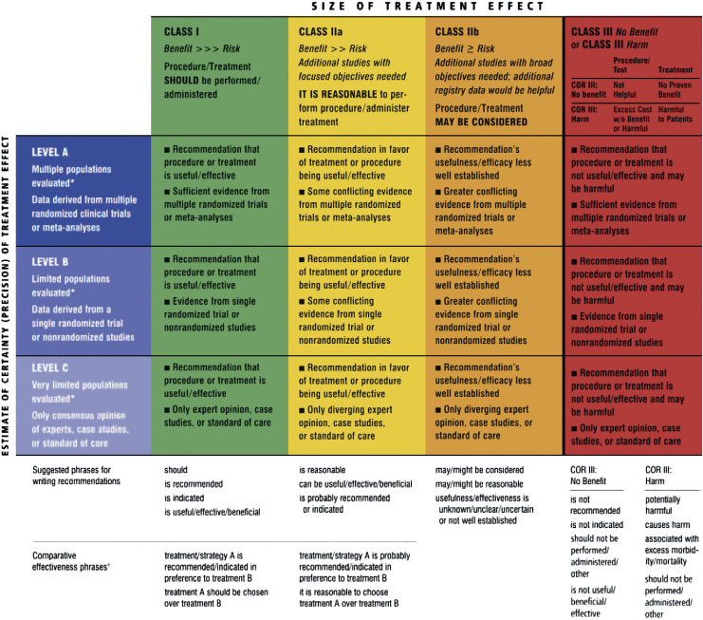
Note. Applying classification of recommendation and level of evidence. From 2013 ACCF/AHA Guideline for the Management of Heart Failure: Executive Summary: A Report of the American College of Cardiology Foundation/American Heart Association Task Force on Practice Guidelines, by Yancy, et al., 2013, Journal of the American College of Cardiology, 62(16), p. 1498 (https://doi.org/10.1016/j.jacc.2013.05.020).

Appendix D
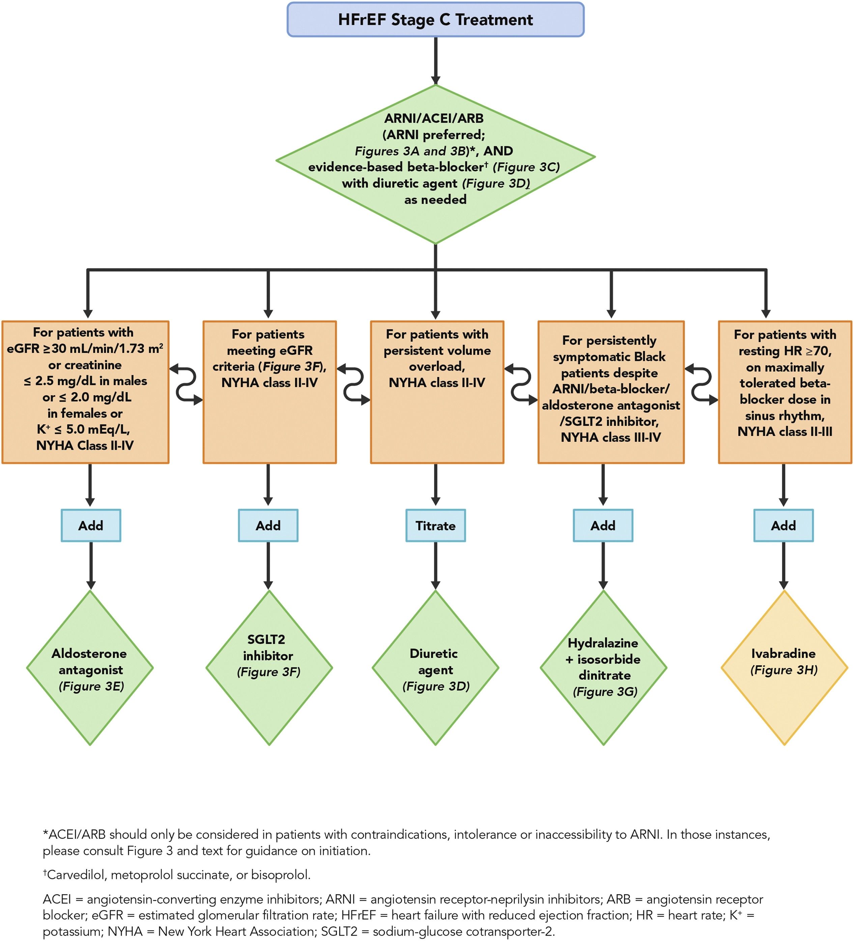
Algorithm for Initiating GDMT
Note. Guideline-directed medical therapy. From 2013 ACCF/AHA Guideline for the Management of Heart Failure: Executive Summary: A Report of the American College of Cardiology Foundation/American Heart Association Task Force on Practice Guidelines, by Yancy, et al., 2013, Journal of the American College of Cardiology, 62(16), p. 1507 (https://doi.org/10.1016/j.jacc.2013.05.020).
Appendix E
Iowa Model of Evidence-Based Practice to Promote Quality Care
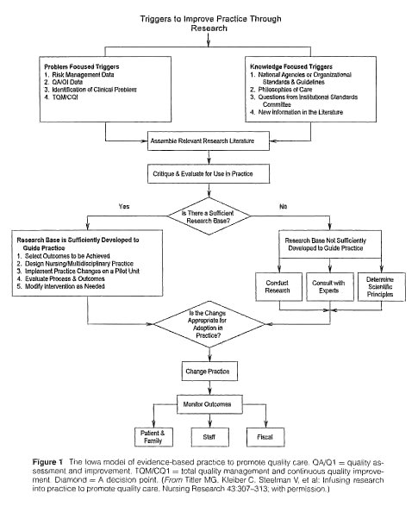

Note. The Iowa model of evidence-based practice to promote quality care. From The Iowa Model of Evidence-Based Practice to Promote Quality Care, by Titler, et al., 2001, Critical Care Nursing Clinics of North America, 13(4), pp. 499 (https://doi.org/10.1016/S0899-5885(18)30017-0).
Appendix F
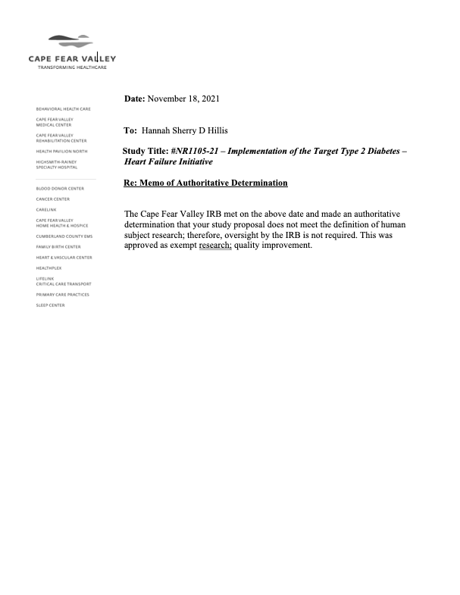
IRB Approval Letter

Appendix G
Target: Type 2 Diabetes – Heart Failure Measures
Measures | Inclusion Criteria | Exclusion Criteria | Staff Responsible
Documentation in the hospital record that left ventricular function was assessed before arrival, during hospitalization, or is planned after discharge | All heart failure patients with type 2 diabetes admitted in the hospital during the project time frame | Documented contraindication or criteria exclusion | - Physician  - Advance Practice Providers (Physician Assistant & Nurse Practitioner)  - Medical Residents
Percent of eligible patients who are prescribed with ACEI/ARB or ARNI at hospital discharge | All heart failure patients with type 2 diabetes and left ventricular systolic dysfunction (LVSD) admitted in the hospital during the project time frame | Documented contraindication or criteria exclusion | - Physician  - Advance Practice Providers (Physician Assistant & Nurse Practitioner)  - Medical Residents
Percent of eligible patients who are prescribed evidence-based Beta Blockers at hospital discharge | All heart failure patients with type 2 diabetes and ejection fraction less than or equal to 40% admitted in the hospital during the project time frame | Documented contraindication or criteria exclusion | - Physician  - Advance Practice Providers (Physician Assistant & Nurse Practitioner)  - Medical Residents
Percent of eligible patients who are prescribed lipid-lowering medications at hospital discharge | All heart failure patients with type 2 diabetes admitted in the hospital during the project time frame | Documented contraindication or criteria exclusion | - Physician  - Advance Practice Providers (Physician Assistant & Nurse Practitioner)  - Medical Residents
Percent of eligible patients who are receiving diabetes treatment or have follow-up appointments for diabetes management after hospital discharge | All heart failure patients with type 2 diabetes admitted in the hospital during the project time frame | Documented contraindication or criteria exclusion | - Physician  - Advance Practice Providers (Physician Assistant & Nurse Practitioner)  - Medical Residents
Percent of eligible patients who are prescribed an antihyperglycemic medication with proven cardiovascular disease (CVD) benefit (sodium glucose cotransporter-2 or SGLT-2 inhibitor) at hospital discharge | All heart failure patients with type 2 diabetes admitted in the hospital during the project time frame | Documented contraindication or criteria exclusion | - Physician  - Advance Practice Providers (Physician Assistant & Nurse Practitioner)  - Medical Residents
Percent of eligible patients who receive smoking cessation advice or counseling during the hospital stay | All heart failure patients with type 2 diabetes and history of smoking cigarettes admitted in the hospital during the project time frame | Documentation of patient’s inability/refusal or absence of any family member/ caregiver to receive advice or counseling or criteria exclusion | - Physician  - Advance Practice Providers (Physician Assistant & Nurse Practitioner)  - Medical Residents  - Nurses  - Continuity of Care (Case Managers & Social workers)
Percent of eligible patients who had follow-up appointments scheduled and documented | All heart failure patients with type 2 diabetes admitted in the hospital during the project time frame | Documented criteria exclusion | - Continuity of Care Staff (Case Managers & Social workers)
Overall composite compliance rate of 75% on the evidence-based measures (12 consecutive months). | All heart failure patients with type 2 diabetes admitted in the hospital during the project time frame | Documented criteria exclusion | - Physician  - Advance Practice Providers (Physician Assistant & Nurse Practitioner)  - Medical Residents  - Nurses  - Continuity of Care (Case Managers & Social workers)
Note. Recognition measures included in the Overall Diabetes Cardiovascular Initiative Composite Score for GWTG-HF. From Target: Type 2 Diabetes℠, by the AHA (2021b) (https://www.heart.org/-/media/files/professional/quality-improvement/target-type-2-diabetes/target-type-2--honor-roll-recognition-faq-2021.pdf?la=en).

Appendix H
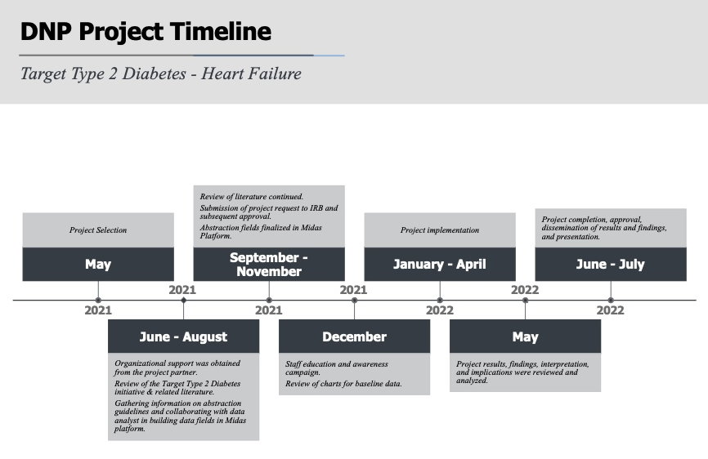
Project Timeline

Appendix I
Project Budget (Organization)

Team Member | Hourly Salary | Number of hours | Total Cost
DNP Student (Junior Coordinator) | $35 | 156 | $5,460
Stroke Coordinator (Senior Coordinator) | $45 | 8 | $360
Data Analyst | $45 | 14 | $630
Physician Liaison | $50 | 4 | $200
 |  | 182 | $6,650

Note. This table illustrates the number of hours spent by each team member and the corresponding hourly salary of each team member. The table provides the total cost of the human resources used in implementing the project. There are no startup, capital, or operational cost associated with the project implementation.

Appendix J
Project Site Partner Letter of Support
