Implementation of an Advance Directive Protocol among Hospitalized Patients
Lila K. Byrd
East Carolina University

East Carolina University
College of Nursing
Doctor of Nursing Practice
Final Project Approval

Student Name: ___________Lila K. Byrd________________________________

Project Title: __ Implementation of an Advance Directive Protocol among Hospitalized
Patients__________________________________________________________________

Private Review Completed on _____4/11/18______________________________________

Public Presentation Completed on _______April 5, 2018_______________________________

Final Project/Final Paper Approval:

As the Chair of this student’s Doctor of Nursing Practice Project Committee, I have reviewed and approved this student’s project and final paper and agree that he/she has met the project expectations, including the DNP Essentials, and has completed the project.

DNP Committee Chair Signature:_________________________________Date______________

Abstract
Background. Medical advancements have progressed considerably in recent decades, highlighting the necessity of advance care planning (ACP). Advance directives (ADs) help honor and promote patient preference, quality of life (QOL), and reduced health care costs. While Centers for Medicare and Medicaid Services (CMS) requires institutions to screen and educate all patients during admission on ADs, there is not a standardized process for agencies to follow.
Problem. Prior to project implementation, in a hospital network in southeastern North Carolina, initiatives were being done in the ambulatory setting to increase AD completion and having them located in the EHR. The aim of this project was to increase the number of ADs correctly located in the EHR on a progressive care unit (PCU) at a hospital in southeastern North Carolina.
Methodology. A DNP-led quality improvement project was implemented to increase the number of ADs located in the EHR. The intervention included the creation of an ACP navigator tab in the EHR to provide a standard location for AD admission screening and links to ADs scanned in to the EHR. Data collected included the number of patients with ADs and the number of them correctly located in the EHR. Data was gathered eight-weeks prior to implementation of the ACP navigator and eight-weeks post intervention.
Results. Before the ACP navigator, 26.2 percent of patients with ADs had them on file in the EHR. After the ACP navigator, 35.7 percent of patients with ADs had them correctly located in the EHR.
Conclusions. ADs are essential to patients receiving care consistent with their wishes. With the growing use of the EHR, ADs have the capability of being available across care settings. The addition of an ACP navigator in the EHR aids in standardizing the location of ADs and ensuring patients wishes are followed.
Acknowledgements
I would like to offer profound appreciation to my parents, Cam and Kim Byrd, for their encouragement and loving support as I pursued my Doctor of Nursing Practice. I would like to whole-heartedly thank Dr. Tracy Bell for mentoring me through this project and the numerous edits, feedback, and support over the past two years. Dr. Michelle Skipper and Dr. Janet Tillman, I want to thank you both for being exceptional mentors and educators throughout my DNP journey.

Table of Contents
I. Introduction................................................................................................................................ 6
II. Review of the Literature…………………………………………………...……………….... 11
III. Methodology……………………………………………………………..…………………. 23
IV. Results..………………………………………………………….….………………………. 27
V. Discussion………………………………………………….…….………………………….. 29
References………………………………………………………………..….………………….. 38
Appendix A: University IRB Approval………………………………..…………….……….… 45
Appendix B: Project Site IRB Approval………………………………………………...…...…. 46
Appendix C: Literature Review Matrix……………………………………………………….... 47
Appendix D: Literature Synthesis……………………………………………………………… 54
Appendix E: ACP Navigator Education Handout…………………………………………….... 61
Appendix F: Audit Methodology………………………………………………………………. 63
Appendix G: Project Site Letter of Support…………………………………………………..... 68
Appendix H: Weekly Audit Tool……………………………………………………………… 69

I. Introduction
Medical advancements have progressed considerably in recent decades, resulting in routine use of mechanical ventilation, hemodialysis, and artificial nutrition (Meghani, 2015). These advancements have blurred the lines between life-saving and death-prolonging interventions, highlighting the necessity of advanced care planning (ACP) (Vearrier, 2016). ACP involves the discussions regarding end-of-life (EOL) preferences and the creation of advance directives (ADs), the legal instructions prepared by individuals to ensure their wishes are followed by medical providers if they are unable to speak for themselves (Centers for Disease Control and Prevention [CDC], 2012). Completion of an AD has been associated with greater use of palliative care, decreased stress during end of life (EOL), shortened length of hospital stays, while decreasing healthcare costs without increasing mortality (Wu, Newman, Lasher, & Brody, 2013; Trustees of Dartmouth College, 2015). Despite the known benefits of ADs, only 21 to 32 percent of Americans have completed ADs (House & Lach, 2014).
Background and Significance
In response to medical advancements, United States (U.S.) Congress passed the Patient Self-Determination Act (PSDA) in 1991, which ensures the right for patients to engage in their own health care and to accept or refuse medical treatment (Patient Self-Determination Act [PSDA] of 1990, 1990). Under the PSDA, any institution providing care to Medicare or Medicaid patients must do the following: (1) comply with state laws for ADs, (2) provide written material to patients regarding state laws on ADs, (3) uphold written policies and procedures on ADs, (4) record if a patient does or does not have an AD, and (5) educate staff and community about ADs and ACP (PSDA of 1990, 1990). If an institution does not comply with these requirements they could lose funding from the Centers for Medicare and Medicaid Services (CMS) (Kossman, 2014). Despite regulations from CMS, there is not a universal procedure for these agencies to follow, and few hospital settings have developed standard processes to systematically address ACP (Bernacki & Block, 2014; Kossman, 2014).
According to Weiss, Berman, Howe, and Fleming (2012) over 39 million Americans age 65 and older are admitted to the hospital for medical or surgical treatment each year. This number is expected to grow to 71.2 million in the year 2030 (Weiss et al, 2012). Half of the annual deaths in the U.S. occur in the hospital, with 24 percent of Medicare dollars being spent in a patient’s final year of life (Gabler et al, 2016). Studies show Medicare is financially unsustainable (Harter, 2015).
In an effort to combat healthcare cost, the Institute for Health Improvement (IHI) established the “Triple Aim” framework. The “Triple Aim” initiatives include decreased healthcare cost, while improving patient experience and the health of populations (Berwick, Nolan, & Whittington, 2008). ACP and the creation of ADs supports Triple Aim initiatives by reducing medical spending in the last years of life, decreasing hospital length-of-stay, improving patient satisfaction, reducing death in the hospital, improving quality of life, and reducing discomfort and pain at end-of-life (Bernacki and Block, 2014).
According to Kossman (2014) if the AD is not properly documented in a designated location in the electronic health record (EHR), the patient’s wishes may not be followed. ACP documents must be easily accessible to medical providers in order to best honor patient wishes (Turley et al, 2016). Bernacki and Block (2014) conducted a narrative review of evidence to determine best practices and gaps in care for ACP, and found that there is often no standard location to document or retrieve ADs in the EHR. In the absence of accessible ADs, patients receive care that is inconsistent with their wishes, leading to increased health care cost, more aggressive treatment, and longer hospital stays (Weiss et al., 2012). While most ACP is done outpatient, ADs must be easily accessible across care settings (Wilson et al, 2013).
Problem Statement
While CMS requires institutions to screen and educate all patients during admission on ADs, there is not a standardized process for agencies to follow, or consistent locations for documentation of ACP in the EHR across health care settings (Bernacki & Block, 2014). In a hospital network in southeastern North Carolina, initiatives have been implemented to increase AD completion in the ambulatory setting, but no efforts have been started to increase inpatient AD completion or having AD documents easily retrievable across care settings.
Assumptions
One assumption of this project is that providing patient education on admission about AD will increase the number of patients with AD. The other assumption is that implementing an ACP navigator in the EHR will increase the number of patients with AD located in the EHR in an easily accessible location.
Purpose of the Project
The purpose of this project was to standardize the process to increase ADs located in the EHR in the inpatient setting on a progressive care unit (PCU). A standardized location was created for all ACP in the EHR, including admission screenings completed by the nurse, contact information for health care agent(s), links to completed ADs scanned in to the EHR, and links to provider notes that discuss ACP. A concurrent initiative implemented a standardized process beginning with AD screening of all adult patients, standardization of RN’s AD presentation to patients and family, a referral process to the spiritual care department who can notarize completed documents, and health unit clerk’s scanning documents into the EHR.
Theoretical Framework
Concepts, assumptions, and propositions from Imogene King’s Theory of Goal Attainment (TGA) will be used as the theoretical framework for this project. King’s TGA uses the nursing process through the role of nurse-patient interactions to help develop and attain patient’s goals for health (King, 1981).
Definition of Terms
Living Will: A legal document that defines treatment by establishing parameters under which patients want to be treated (Goede & Wheeler, 2015).
Healthcare Power of Attorney (durable power of attorney, healthcare proxy, medical power of attorney): A legal document that establishes a surrogate for patients if they are unable to make decisions for themselves (Goede & Wheeler, 2015).
Advance Health Care Directive (advance directive): legal and/or lay documents recognized under state law, such as a living will or durable power of attorney for health care, that tell how a person wishes to receive or not receive medical care if they are unable to make decisions for themselves (Musich, Wang, Hawkins, & Yeh, 2016).
Advance care planning (ACP): The discussions patients have with healthcare professionals, family members and loved ones, surrounding decisions of care a patient would and would not receive if they were unable to speak for themselves based on their values, goals, and preferences with family members and medical providers (Houben et al., 2014).
Patient Self-Determination Act (PSDA): A federal law passed in 1991 that requires adults to be provided in writing with their right to accept or refuse medical treatment and right to use an advance directive (Johnson, Zhao, Newby, Granger, & Granger, 2017).
Electronic Health Record (EHR): An electronic version of a patients medical history, that is maintained over time, and may include all of the key administrative clinical data relevant to that persons care under a particular provider, including demographics, progress notes, problems, medications, vital signs, past medical history, immunizations, laboratory data and radiology reports (Dillon et al., 2017).

II. Review of the Related Literature
Search Strategy
Information was extracted electronically for the literature review. Search methods included peer-reviewed, scholarly articles, and included the full text within the past five years among the following databases: CINAHL, PubMed, Medline, and Cochrane Library. Search terms included: ‘Advance directives’ OR ‘living will’ OR ‘durable power of attorney’ OR ‘advance care planning’ AND ‘electronic health record’ OR ‘medical records’ AND ‘documentation’. The search yielded 177 results. Inclusion criteria included articles written in the English language, among adult subjects, with primary sources being written between 2012 and 2017. Search results were manually selected based on relevance to the paper’s topic and the quality of the research study. Articles that were excluded were not in the inpatient setting, did not contain information relevant to the research topic or contained redundant information from more recent and higher quality studies.
From the initial yield of 177 results, Forty-one articles were excluded due to not including an inpatient population. Twenty-one articles were excluded due to not being relevant to the DNP projects objectives. This resulted in 115 relevant articles to be reviewed for the purpose of the DNP project.
Health Care Costs
On January 1, 2016, CMS released billing codes that allow for reimbursement to medical providers for ACP discussions (Kale, Ornstein, Smith, & Kelley, 2016). According to Harter (2015), increased Medicare spending at EOL does not correlate with improved quality of care or outcomes. Patients without ADs had higher Medicare expenditures than patients with ADs in the last month prior to death (Musich, Wang, Hawkins, & Yeh, 2016). A study by Nicholas, Langa, Iwashyna, and Weir (2011) used Medicare data from 2006, and found that beneficiaries with ADs in high-spending areas (regions of the country with large end-of-life expenditures) had an average of 5,585 dollars less in health care spending than those without ADs in the last 6 months of life. In the U.S., approximately half of the annual deaths occur in the hospital, with 25 percent of Medicare dollars being spent in a patient’s final year of life, leading to unsustainable costs to the U.S. health care system (Gabler et al, 2016; Meghani & Hinds, 2015). According to Harter (2015), ACP can be an effective way to control EOL Medicare costs.
Health Care Setting
According to Weiss et al. (2012) over 39 million Americans age 65 and older are admitted to the hospital for medical or surgical treatments each year. This number is expected to grow to 71.2 million in the year 2030 (Weiss et al, 2012). Approximately 25 percent of older adults die in the hospital, with 30 percent of these deaths being in the ICU (Meghani & Hinds, 2015). Medical costs are increased because of ICU admissions and aggressive treatments at EOL (Meghani & Hinds, 2015). According to Kossman (2014), AD discussions and completion results in lower hospital costs and the number of deaths in the hospital setting.
AD completion is crucial among older adult population due to the high mortality for unexpected acute illnesses, with 25 percent of hospitalized adult patients not able to make their own medical decisions (Gamertsfelder, Seaman, Tate, Buddadhumaruk, & Happ, 2016; Weiss, Berman, Howe, & Fleming, 2012). Among hospitalized patients that required mechanical ventilation, those with a good functional status before admission still had a mortality rate of 24 percent (Gamertsfelder, Seaman, Tate, Buddadhumaruk, & Happ, 2016.) A retrospective study examining EHR’s with ADs on file, found that emergency room and ICU providers have to make fast decisions regarding patient treatment and do not have time to search for ADs; however, if a standardized location for ADs were made, providers would be able to easily access and provide care consistent with patient’s wishes (Wilson et al, 2013). The study by Wilson et al (2013) also found that providers often document ACP discussions in their progress notes but do not properly sign the legal AD documents or properly label the notes for easy retrieval.
Rady and Johnson (2004) studied 252 patients who had died in a hospital over a 2-year period at Mayo Clinic Hospital, with 165 of these patients being in the ICU. The 165 patients that died in the ICU had higher medical costs and zero documentation in the EHR regarding EOL discussions or offered palliation, while 25 percent of patients on the medical floors did have documentation of EOL discussions (Rady & Johnson, 2004). Rady and Johson (2004) found that two-thirds of patient’s transferred from the medical floors to the ICU were treated by junior medical residents, and were more often not given treatment options or EOL discussions, as compared with general hospitalists; highlighting lack of experience and confidence as a deterrent to EOL conversations.
The months leading to the death of an older adult often consist of increased hospitalizations, ICU admissions, and skilled nursing facility admissions (Meghani & Hinds, 2015). While hospitalized, patients are often cared for by providers they do not know, or are unfamiliar with their health history (Meghani & Hinds, 2015). While many patients prefer comfort care at EOL, in the hospital setting, aggressive measures serve as default unless patient or family request otherwise (Meghani & Hinds, 2015). Without ACP discussions and completion of ADs, patients unable to speak for themselves will receive aggressive treatment despite their wishes.
A semi-structured, cross-sectional study among 505 adult patients in a cardiac ICU found that on admission, nurses asking if a patient has an AD or if they would like to complete an AD does not fully assess a patient’s knowledge and understanding of ADs (Johnson, Zhao, Newby, Granger, & Granger, 2012). The study by Johnson et al (2012) asked the required questions from the PSDA and then asked three open-ended questions to clarify the patient understood ADs and their purpose. The study found that 34 percent of patients did not originally understand what ADs were and therefore just said they did not have one (Johnson et al, 2012). By asking open-ended questions with the admission questions regarding AD understanding, increased communication between patients, families, and providers occurred (Johnson et al, 2012).
Barriers to Completion
Barriers to AD completion include lack of communication between providers, patients, and families, lack of understanding advance directives, difficulty in determining an appropriate healthcare agent, and the complexity of medical decisions (House & Lach, 2014; Kossman, 2014). Other barriers include nurses only asking if a patient has an AD but do not inquiring on patient’s knowledge of ADs, and shortened hospital stays that do not allow for follow-up discussions (Musich, Wang, Hawkins, & Yeh, 2016). The usual approach to ADs has been to complete the legal guidelines associated with the PSDA, and is usually consistent with yes or no questions about ADs at hospital admission (Rogne & McCune, 2014). Patients expect the medical provider to discuss ADs (Bernacki & Block, 2014). The more health care providers ask and inform patients about ADs the more open patients are to the idea of ADs (Kossman, 2014).
Few hospital settings have developed standard processes to systematically address ACP (Bernacki & Block, 2014). Lack of resources to help provide individualized assistance for AD completion also leads to decreased AD completion (Rogne & McCune, 2014). According to Kossman (2014), having an AD does not mean the patient’s wishes will be honored if not properly documented in a designated location in the EHR.
In a study by Dillon et al. (2017) ACP documentation rates were analyzed among 13 providers in primary care, pulmonology, cardiology, and oncology departments at a multispecialty practice, and then structured interviews were conducted among the 13 providers. Dillon et al (2017) found that primary care providers (PCPs) documented ACP more than specialists, with 88.6 percent of specialists having zero ACP documentations compared to only 29.1 percent of PCPs having zero. Providers reported issues with understanding how to enter or retrieve ACP documents (Dillon et al 2017). PCPs reported having standardized department workflows for ACP documentation; however, the specialists did not have standard workflows and reported more confusion and frustration with ACP (Dillon et al, 2017). The study also found that providers with low rates of ACP documentation described similar ACP discussion practices as those with high rates of ACP documentation; highlighting that while ACP discussions are occurring, standard process and variations in documentation locations in the EHR led to report discrepancies (Dillon et al, 2017). The study by Dillon et al. (2017) had limitations, including only studying one health care organization with one EHR system and only having interviewed a small number of providers. The sample size does not allow for generalizations, although it does highlight considerable variability in practice (Dillon et al, 2017).
Patient Outcomes
Many patients with chronic illness that are critically sick have not discussed EOL decisions with their surrogate decision maker or medical provider (Johnson, Zhao, Newby, Granger, & Granger, 2012). A study by Musich, Wang, Hawkins, and Yeh (2016) that examined AD prevalence among a Medicare Supplement population found that 72 percent of the 26,197 respondents had completed some form of ACP; however, only 13 percent of the respondents had discussed ADs with their health care provider.
While most Americans prefer to die at home, approximately 60 percent die in hospitals or SNFs (House & Lach, 2014). Around 80 percent of patients with a chronic illness have an acute exacerbation requiring hospitalization (Johnson, Zhao, Newby, Granger, & Granger, 2012). Higher quality-of-life (QOL) near EOL was associated with discussions about EOL care, limited aggressive medical treatments, and lower health care costs (Kale, Ornstein, Smith, & Kelly, 2016; Musich, Wang, Hawkins, & Yeh, 2016). A study by Musich, Wang, Hawkins and Yeh (2016) found, through interviews with patients prior to death, that less aggressive medical procedures and higher QOL were associated with AD completion and EOL discussions with providers. ADs are associated with decrease use of mechanical ventilation, feeding tubes, and hemodialysis, while increasing the use of hospice services (Gabler et al, 2016). Those that complete ADs are more likely to die outside of the hospital, have decreased cost of care, and have higher quality care (Gabler et al, 2016). Salmond and David (2005) found that communications about ADs led to higher rates of completion and improved thoughts regarding ADs.
EHR and Documentation
ACP documents must be easily accessible to medical providers (Turley et al, 2016). A narrative review of observational and interventional studies regarding ACP found there was no standard location to document or retrieve ADs exists in the EHR as ACP documentation was found in several different locations in the EHR. (Bernacki & Block, 2014; Wilson et al., 2013). Approximately 26 percent of patients that had an AD did not have their wishes followed during hospitalization (Wilson et al, 2013). Most ACP discussions occur outpatient with a health care provider familiar with the patient; however, if ADs are not easily accessible across care settings, patient wishes may go unrecognized, as there are multiple locations in the EHR to document ACP (Wilson et al, 2013). At a multispecialty ambulatory practice group, using one EHR, there are many places in the EHR for providers to document ACP, including the patient’s problem list, in progress notes, or in scanned documents (Wilson et al, 2013). After observing ACP documentation in an EHR among 60,105 patient charts, Wilson et al (2013) found ACP in the progress note 69 percent of the time, 43 percent in the scanned documents, and 34 percent in the problem lists. Wilson et al. (2013) theorize standard location of ACP and ADs will help with efficient retrieval in the inpatient setting when ACP was done among outpatient providers with a compatible EHR. A retrospective study examining EHR’s with ADs, found that in critical care settings urgent medical treatment is required; however, if a standardized location for ADs were made, providers would be able to quickly access ADs on file, and provide care consistent with patient’s wishes (Wilson et al, 2013). Wilson et al (2013) also found that providers often document ACP discussions in their progress notes but do not actually sign the legal AD documents or properly label the notes for easy retrieval later.
A study by Lindner (2007) found that reminders for AD in the EHR at a SNF increased AD discussions among 224 nursing home admissions from 4 to 63 percent. Through a narrative review of observational and interventional studies regarding ACP, Bernacki and Block (2014) concluded that a systematic intervention is needed to train medical staff on ACP, provide a documentation template in the EHR, apply “triggers” to remind staff of AD screening, and perform audits to ensure performance. Turley et al (2016) created and implemented a Care Directives Activity (CDA) tab in the EHR at a hospital in California, and compared documentation of ADs among 56,251 patients before, and 57,058 after implementation of the CDA. Statistically significant correlations were found between CDA usage and filed ADs, with CDA use having 1.7 to 5 times more likely to have an AD on file than before CDA was implemented (p < 0.001) (Turley et al, 2016). Linking advance directives to the EHR is the most efficient way to ensure easy access and provider compliance (Wood, D'Amore, Jones, & Sittig, 2014).Respecting Choices, an advance care program, examined through clinical trials, that electronic availability of standardized advance directives is essential to ensuring patient care is consistent with their wishes (Wood et al, 2014).
Respecting Choices
In 1991, Gundersen Health in La Crosse, Wisconsin, implemented a model for ACP, now known as Respecting Choices, a program that allows for ACP over the course of a person’s lifespan (Wilson, Kottke, & Schetlle, 2014). As a result of the intervention, from April 1995 to March 1996, 85 percent of La Crosse County adults who died had a written ADs, compared to the 25 percent average in the U.S.(Hammes, Rooney, & Gundrum, 2010). A second study was conducted between 2007 and 2008 among adults in La Crosse, Wisconsin and found that AD completion rates had increased from 85 percent in the first study to 90 percent (Hammes, Rooney, & Gundrum, 2010).
The Respecting Choices program provides standardized materials to patients across all of the health care settings in the community, and trains community member volunteers to help patients with ACP (Forlini & Goldberg, 2014). In the Respecting Choices program, ACP is viewed as an ongoing practice that is integrated into routine care, and is revised and assessed in conjunction with the individual’s health status and goals of care (Forlini & Goldberg, 2014). Under the Respecting Choices program, comprehensively defined, measurable goals are an important component to its success (Rogne & McCune, 2014). The Respecting Choices goals include assisting individuals in making informed health care decisions; assisting in the selection and preparation of a qualified health care power of attorney; and honoring informed decisions that are made (Rogne & McCune, 2014). The program design was also successful due to being systematically integrated into local practice across the continuum of care settings, as well as being integrated in to community settings where people socialize, receive services, and in religious settings (Rogne & McCune, 2014).
Respecting Choices incorporated ACP microsystems at the various settings of implementation, to focus on shaping professional behavior, patient satisfaction, effectiveness, safety, and medical cost (Rogne & McCune, 2014). The microsystems were hardwired into routine care across the community setting, and included uniform education and AD documents, a team approach for ACP referrals, and an efficient, standard, medical record system for inputting, storing, retrieving, and relocating documents and detailing ACP discussions (Rogne & McCune, 2014). In 2002, an application in the EHR was implemented among routine practices in LaCrosse, Wisconsin (Hammes, Rooney, & Gundrum, 2010). The Respecting Choices EHR application stores ADs electronically, has links to provider notes that discuss ACP, and code status information (Hammes, Rooney, & Gundrum, 2010). According to a study from 1995-1996 in La Crosse, Wisconsin, ADs were in the medical record 95 percent of the time (Hammes, Rooney, & Gundrum, 2010). In a follow-up study from 2007-2008 in LaCrosse, Wisconsin, and after the EHR application was implemented in 2002, ADs were located in patient charts 99.4 percent of the time (Hammes, Rooney, & Gundrum, 2010). Once an entire community implements standard and efficient ACP systems instead of at just one institution, widespread progress can be made (Rogne & McCune, 2014).
Respecting Choices has been replicated in several U.S. and international communities, and is supported by extensive, peer-reviewed research of the model (Forlini & Goldberg, 2014). It is currently being implemented in Minneapolis, Minnesota and St. Paul, Minnesota (Rogne & McCune, 2014). A Respecting Choices-based program was implemented in Australia, and centered on the La Crosse program (Rogne & McCune, 2014). Due to the success of the Australian program, the Respecting Choices-based model has become the national standard for all of Australia (Rogne & McCune, 2014). The Australian program published a randomized controlled trial among medical inpatients that were aged 80 years or older (Derling, Hancock, Reade, & Silvester, 2010). Patients who received the intervention were significantly more likely to have their wishes known, receive care consistent with their wishes, and increased satisfaction with their hospital experience when compared with the control group (Derling et al., 2010).
Gaps in Research
In a systematic review of qualitative and mixed method analyses, several studies highlight that there is insufficient high-level evidence that links ACP documentation to improved EOL communication with more studies being descriptive or qualitative in design (Lewis, Cardona-Morrell, Ong, Trankle, & Hillman, 2016). According to Korfage et al (2015), while ACP interventions have many benefits for patient outcomes, evidence for ACP in community dwelling older adults is scarce, with few randomized control trials (RCTs) available. The study by Bravo et al (2016) was a RCT, but was implemented in Canada, and it is unknown whether conclusions reflect the U.S. population. Weathers et al (2016) conducted a systematic review of RCTs regarding ACP and concluded that there is a need for RCTs to better examine the economic effect of ACP in hospitals and nursing homes.
Theoretical Framework
Imogene King’s Theory of Goal Attainment (TGA) examines how nurses interact with patients to help them achieve health goals (Alligood, 2010). King used the nursing process to help patients with goal-setting and goal-achievement through nurse-patient interactions (Alligood, 2010). King’s TGA contains three interacting systems: personal, interpersonal, and social, and the three systems each have their own concepts (Alligood, 2010). For the personal system, concepts include self, growth and development, perception, body image, space, and time (King, 1995). For the interpersonal system, concepts include interaction, transaction, communication, role, and stress (King, 1995). For the social system, concepts include organization, authority, power, status, and decision-making (King, 1995).
Assumptions. King (1981) gives the following assumptions for her TGA:
- Individuals are social, rational, reacting, purposeful, perceiving beings;

- The interaction process is influenced by the goals and values of the nurse and patient;
- Individuals have the right to be involved in decisions that affect their life, health, and community participation;
- HCP must share information with patients to help them make informed decisions regarding their care;
- Individuals have the right to accept or refuse medical treatment; and
- Patients and HCP may have different goals for the patient’s treatment (p. 143-144).
Propositions. King (1981) gives the following are propositions from the TGA:
- If perceptual accuracy is present in the nurse-client interaction, transaction will occur;
- If the nurse and patient make transactions, the goal(s) will be achieved;
- If goals are achieved, satisfaction will occur;
- If goals are achieved, effective nursing care will occur, and growth and development will be enhanced;
- If role expectations and performance as perceived by the nurse and patient are congruent, transaction will occur;
- If role conflict is experienced by the nurse or client, stress will occur; and
- If nurses with special knowledge and skills communicate appropriate information to clients, mutual goal setting and achievement will occur.
King’s TGA offers a framework for healthcare professionals to foster collaboration among the medical team, patients, and their families; and encourages patient-centered care. King’s TGA encourages patients to engage in open dialogue with providers, and encourages nurses to use their knowledge and skill set to help patients make goals that are consistent with their beliefs and disease processes.
King’s TGA stood as the framework for this project because ACP and ADs are individualized to each patient and based on the patient’s beliefs and choices. The patient’s wishes then guide medical treatment, placing patients at the center of their care. In this project, nurses engaged in dialogue with patients to obtain ADs and ensure they are available in the EHR for patient’s wishes to be known by the medical team.

III. Methodology

Project Design

This was a quality improvement project that was implemented over an 8-week period, with an aim to increase the number of patients with ADs located in a designated location in the EHR. The intervention included the addition of a designated, easily accessible, ACP section, or navigator in the EHR. The ACP navigator, in addition to a standardized AD protocol that was implemented simultaneously, measured the number of patients admitted to a single hospital unit with ADs and with ADs in the EHR at discharge. Data was gathered for 8 weeks prior to the project implementation and for 8 weeks after implementation. The implementation period was between September 2017 and November 2017. The East Carolina University DNP Committee approved this study in April 2017. Both East Carolina University and the project site exempt the study for Institutional Review Board (IRB) review.

Participants

This project was implemented on a Progressive Care Unit (PCU) that employees approximately 65 nurse sand a myriad of ancillary staff that work with patients on the PCU.

Sample

The sample of patients in this study was hospitalized patients admitted to the PCU over an eight-week pre-implementation period and eight-week post implementation period. PCU patients are age 18 and older, male and female, with varying socioeconomic and racial backgrounds.

Setting

This study was implemented on a 42 bed Progressive Care Unit, at an 855-bed community hospital in southeastern N.C. The PCU was chosen because it serves a wide variety of patients with various illnesses, bridging the gap between medical floors and the ICU. With various acuities and illnesses, the PCU provided a diverse sample of patients. The PCU has a nurse-patient ratio of 3 to 1.

Methods

The project lead and the Epic informatics department at the hospital created the ACP navigator tab. The navigator was located by clicking on a link in the top heading of the patient’s chart in the EHR. Screen shots of the navigator and its location were used in educational handouts for nurses, unit clerks, and medical providers. Once the ACP navigator link is selected, the navigator screen is arranged as follows:

A link, located at the top of the navigator screen, when selected, will bring users to all scanned AD documents for that patient in the EHR.

The patients code status and additional code instructions.

Admission screening completed by the nurse as required by PSDA legislation, including:

Do you have any advance directives? If so, are they on file?

Do you have a living will?

Do you have a health care agent?

Would you like information on ADs?

Do you have an existing, Do Not Resuscitate (DNR)?

If the patient answered yes to any of the above, the nurse was instructed to follow the Advance Care Planning Protocol that was implemented by a colleague that provided standard procedures when screening, educating, and creating ADs among PCU patients. PCU staff was simultaneously trained on the new ACP navigator and the new protocol for screening patients.

Health care agent contact information, for up to 3 contacts (if applicable) including (a) name, (b) phone number, (c) address, and (d) relationship to patient.

Physician screenings including if patient is capable to make decisions, family or visitors present during ACP, ACP discussions, if patient takes blood products, and any religious affiliations.

Links to provider notes that discuss ACP. The Epic EHR will be able to recognize specific phrases, known as smart phrases, or electronically recognizable programmed phrases, related to ACP in progress notes, and extract notes to the ACP navigator for easy accessibility to provider discussions and relevant information.

Advance directive screening is an admission requirement in the EHR. If a patient is not screened, a red dot will appear beside the patients name in the EHR census for the unit all admission screening is completed. When all screening is completed, including AD screening, a green dot will appear.

Protection of Human Subjects

The patient’s discretion and health information were kept private and protected by conducting audits from Epic’s “Dashboard” feature, which electronically gives daily audits of the number of ADs on file on each hospital unit, without disclosing any patient identifying characteristics. The project lead did not access patient charts and all patient identifiers were excluded from the Epic audits, as the EHR software conducts the audits without human intervention. The study was except from Institutional Review Board approval at the project site and East Carolina University because the project does not meet current federal descriptions for human subject research. See Appendix A.

Data Collection

The number of patients with ADs correctly charted in the EHR was collected by the project lead eight weeks (58 days) prior to the ACP navigator’s implementation. The data was obtained by the project lead through the “My Reports” audit feature in the Epic EHR. This audit feature enabled the project lead to back at patients that had been admitted to the PCU over the 58 days and obtain the number of patients with AD and the number with ADs on file in the EHR. Data was then placed in the weekly audit tool created by the project lead (see Appendix H).

The ACP Navigator was introduced on the PCU at a monthly staff meeting two weeks prior to implementation. The number of patients with ADs, and the number of ADs in the correct location in the EHR was compared between the eight weeks pre- intervention and eight weeks post-intervention. Patients who were transferred to the PCU from another hospital unit were excluded because they did not receive the standardized admission screening being implemented on the PCU. Throughout the implementation period, the researcher conducted weekly audits that were completed using the “My Reports” audit feature in the Epic EHR and filtered by admission date (See Appendix E). The audits were converted to a percentage and were posted on the daily huddle board in the staff break room so that staff was aware of the unit’s progress. Further staff education was completed based on these weekly audits.

Design Limitations

There are notable limitations for this quality improvement project. One limitation was the potential threat of selection bias. Because two different groups were used for comparison, there was a risk that the differences in the two samples, such as age and health status, could skew the results of the project. Another limitation was implementation bias because variations in how nurses screened patients for ADs could have potentially skew project outcomes.

IV. Results

Sample Characteristics

There were a total of 682 patient charts that were reviewed for this project. In the pre-implementation group, two of the charts were excluded because the patients were non-English speaking and one was excluded due to a physical barrier (intubation) and admission screening could not be done. In the post-implementation group, one chart was excluded because the patient was non-English speaking and two were excluded due to a physical barrier. The final sample included 676 patient charts. Of the 676 patient charts, 341 were reviewed over eight weeks prior to implementing the ACP navigator and 335 were reviewed over the eight weeks following the implementation of the ACP navigator. The sample included all patients admitted to the PCU but did not include patients transferred to the PCU from other hospital units. The mean age of the sample was 68.

Major Findings

The AD completion rates and number of ADs located in the EHR are reported in Table 1. Prior to implementing the ACP navigator, 35.8 percent (n= 341) of patients admitted to the PCU reported having an AD during admission screening. Of the pre-intervention group, 26.2 percent of patients with an AD had it correctly located in the EHR. After implementing the ACP navigator, 34.3 percent (n= 355) of patients admitted to the PCU reported having an AD. Of patient charts reviewed post- intervention, 35.7 percent of patients that reported having an AD had their AD correctly located in the EHR compared to 26.2 percent before the intervention was implemented.

Table 1. Comparing Documented AD Rates after Including an ACP Navigator in the EHR
 | Number of Weekly PCU Admissions (Admits) | PCU Admits that Report having an AD | Percentage (from total) | PCU admits with AD located in the EHR |  | Percentage (from those with an AD)
Pre-Implementation  7/2/1 7- 8/26/2017 | 341 | 122 | 35.8 % | 32 | 26.2 %
Post-Implementation  9/10/17 - 11/4/17 | 335 | 115 | 34.3 % | 41 | 35.7 %

Table 2. Weekly Post- Implementation Data
Week | Number of Weekly PCU Admits | PCU Admits that Report having an AD | PCU Admits with AD located in EHR
Week 1:  9/10/17 - 9/16/17 | 46 | 18 | 8
Week 2:  9/17/17 - 9/23/17 | 40 | 12 | 8
Week 3:  9/24/17 - 9/30/17 | 44 | 15 | 5
Week 4:  10/1/17 - 10/7/17 | 39 | 17 | 5
Week 5:  10/8/17 - 10/14/17 | 47 | 14 | 6
Week 6:  10/15/17 - 10/21/17 | 44 | 12 | 3
Week 7:  10/22/17 - 10/28/17 | 36 | 12 | 4
Week 8:  10/29/17 -1 1/4/17 | 39 | 15 | 2
TOTAL | 335 | 115 | 41

V. Discussion
As medical technology and treatment options continually expand, ADs help support patient autonomy and patient participation in their medical decisions (House & Lach, 2014). With the evolution of the EHR, ADs have the capability to be available across care settings in the patient’s chart (Dillion et al., 2017). The aim of this DNP-led, quality improvement project was to increase the number of patients with ADs correctly located in a standardized section of the EHR, using an ACP navigator. After the implementation of the ACP navigator, the number of patient’s with ADs located in the EHR, and in the correct location, increased. The increase in the number of ADs scanned in and located correctly in the EHR correlated with the addition of the ACP navigator.
Implications of Findings
In the age of the EHR, particularly in large hospital networks, standardization is essential for proficient and effective medical care at the direction of the patient. Standardizing the location of ACP documents and discussions is vital to ensuring patient’s rights and wishes are honored. The ACP navigator created through this project provides a consistent location for ACP documents and discussions that are available across care setting in this specific hospital network.
This project adds to the limited literature describing the use of a standardized location in an EHR for documenting ACP. Findings of this project were consistent with those by Turley et al. (2016) who found that use of a standard location feature in the EHR was associated with increases in filed AD rates in the EHR.
After process improvements are addressed, generalizability of the ACP navigator and its use to other hospital units has potential success. All medical units are required to do admission screening to all patients, including inquiring about ADs. The EHR is standard across the hospital and outpatient practices in the hospital network and will have access to the navigator.ACP and ADs completed in the outpatient setting will, in turn, be visible inpatient. Other outside hospitals and clinics with the same EHR software as this network will also be able to see the ACP navigator. Implementation of an ACP navigator among other hospital networks using a different EHR would have the challenge to determine a way implement an ACP navigator using their software.

Limitations
There are several limitations to this project that should be mentioned. First, this project was initiated on a single hospital unit, and is difficult to determine the success of the intervention among other patient populations, including the ICU and medical-surgical floors. Barriers on other units to admission screening may include physical barriers, such as intubation, altered level of consciousness, or staffing on other hospital units. Second, the data collected does not demonstrate if the new navigator and patient education at admission being implemented by a DNP counterpart increased the number of patients that asked for more information regarding ADs or plans to get them completed. Third, due to time constraints, project data could not be followed for a longer period of time to see if the project was sustained. The protocol and ACP navigator were introduced at one staff meeting prior to implementing the project. While most PCU staff had positive feedback regarding the interventions, several reported difficulty remembering the changes and incorporating them in their daily routines. Perhaps sustainability would be better observed if data was able to be gathered for a longer period of time than 8 weeks.

Since this study measured outcomes at two different time intervals, it is difficult to determine if the two different groups were exposed to any confounding external factors that could have contributed to variations in data outcomes. Examples of confounding factors include the EHR being down for maintenance, staff being floated to the PCU from other hospital units and not educated on the ACP navigator, and variation in nurse-patient ratios.

During the implementation phase of this project, other projects were also taking place on the unit. Multiple process changes being implemented on a single hospital unit may have led to slower rates of adoption among staff as they were all at the individual workflow level. In hindsight the inclusion of the PCU Nursing Congress, in addition to management to ensure all efforts are being made to a single process change on the unit and project overlap does not occur.

Delimitations
In the literature review, successful studies implemented electronic chart reminders to prompt the nurse to follow-up with admission screening and to obtain requested AD documents. EHR generated rules and triggers to make tasks and alerts for nursing staff are helpful methods of increasing staff adoption of new processes (Deokar & Sarnikar, 2014). Due to time constraints and workload to EHR personnel, electronic reminders were not able to be included in the ACP navigator. It can take time for staff to adopt new practices, and the pop-ups could help during transitions in practice.
Theoretical Framework
This findings from this project coincide with King’s Theory of Goal Attainment in that nurses with special knowledge and skills communicate appropriate information to clients, mutual goal setting and achievement will occur (King, 1981). By the nurse informing patients of the ability to have their ADs located in the EHR and obtaining and correctly getting the documents scanned in, both the health care team and the patient both achieve the goal of knowing and following the patient’s wishes.
DNP Essentials
Evidence gained through process improvement projects and various other forms of research guide practice implications. The American Association of Colleges of Nursing (AACN) (2006) has identified eight essential competencies that are used to guide the DNP curriculum. These essentials are outlined and then utilized to determine practice implications discerned from the DNP project.
Essential I: Scientific underpinnings for practice. This essential is the basis for any quality improvement project. Nursing science including knowledge in ethics, psychosocial, and biophysical sciences were essential to the planning and implementation of the DNP project. This DNP project utilized nursing science to explore King’s Theory of Goal Attainment and apply it to the goal of increasing AD completion for admitted patients.
Practice implications include the focus that the psychosocial dynamics of patients are extremely individual. A myriad of variables accumulate to determine a patients thoughts on ACP and end of life plans. There cannot be a pre-formed conversation that is applied to all patients when discussing AD completion. The RN must receive the training appropriate to be able to delicately approach this topic in a way that gives the patient autonomy in completing this goal. Not every approach will be successful for every patient. Moreover, an individualized tactic may be the most effective way to accomplish the goal of completing an AD.
Essential II: Organization and systems leadership for quality improvement and systems thinking. This essential identifies process improvement from a systems perspective that effects a broad population or community (AACN, 2006). This DNP project worked to implement process change on a large PCU within an even larger community-based hospital system. The goal to complete ADs at a patient-by-patient level was the initial step in creating a community of citizens with completed ADs that were accessible between specialties and amongst inpatient and outpatient settings.
This project as well as previous literature suggests that to be able to make a community wide change, a microstructure of change needs to be implemented first (Deokar & Sarnikar, 2014). This could start in the hospital setting or the primary care clinics or a combination of both. Once ADs are completed and documented in one setting the patients wishes would carry over to other settings, increasing communication and continuity of care amongst all health care providers (HCPs). This is considering if all settings within a community use the same EHR such as the community in the project. If all HCPs were dedicated to this goal, a community, system-wide change could be seen saving money, resources, and honoring patients’ wishes.
Essential III: Clinical scholarship and analytical methods for EBP.
This essential guided the DNP prepared Advanced Practice Registered Nurse (APRN) to review the evidence, analyze, synthesize, and evaluate the evidence, and lastly apply the evidence to improve clinical practice. This assisted with the design and implementation of the DNP project. Previous project methodologies were evaluated to gain insight into the proposed AD standardized protocol. Outcomes measured in other studies such as patient’s autonomy, family satisfaction, decreased intensive care admissions, and decreased healthcare costs at end of life were all synthesized and applied to the DNP project to better understand why this project was worth implementing. The practice implications include continuing to analyze current evidence to identify more efficient ways of having practice change be sustainable with clinical staff. Clearly, process and culture change is hard to evoke and the evidence needs to be utilized to identify ways to make this happen. Any further process improvement projects will encompass this essential to evaluate current evidence and how best to apply it to practice change.
Essential IV: Information systems/technology and patient care technology for the improvement and transformation of healthcare. Technology has transformed the ability of HCPs to communicate the care delivered to patients. This essential heavily influenced the design and implementation of this DNP project, as an ACP navigator was used to streamline and solidify the documentation of completed ADs in the EHR. This created one standard location to find the AD as opposed to the previous myriad of locations. This intervention increased in-hospital accessibility of ADs to HCPs. To ensure continuity of care in the outpatient setting, this navigator should be implemented across the healthcare spectrum to ensure homogeneity of AD documentation within the EHR, as it was done in the DNP project.
It is unclear if the AD protocol should be taught to outpatient RNs, as those RNs are not mandated to screen for ADs like the inpatient RNs. Perhaps in these settings, this should be HCP driven to screen and have ACP discussions with patients.
Essential V: Healthcare policy for advocacy in healthcare. The policies involved in regulating healthcare are vast and ever-changing depending on the current political platform. It is essential for DNP prepared APRNs to be in the policy arena, writing and guiding the discussion to be sure the best interest of both the APRN and the patient is protected. The U. S. Congress passing the Patient Self Determination Act (PSDA) of 1991 instigated healthcare systems across the country to design a policy for AD screening during the admission process. The hospital system in the DNP project had such a policy, however the focus of RNs pursuing AD completion and streamlining this process for patients and was nonexistent. There was also not a homogenous location for HCPs to document completed ADs and patients’ end of life wishes.
The practice implications from the project do not suggest that a policy including a standardized RN led AD protocol would increase AD completions. However, based on the feedback of the PCU staff, more education regarding ways to approach this topic with patients may see improved results in AD completion.
More importantly, a standard location for the documentation of these completed ADs should be included into the AD completion institutional policy. This would be easiest with an EHR but could also be implemented with paper chart systems, such as keeping the ADs on file within all areas of care that a patient needs. This leads to increase accessibility by HCPs, leading to increased awareness of patients’ wishes by HCPs in various practice settings.
Essential VI: Interprofessional collaboration for improving patient and population health outcomes. Interprofessional collaboration is imperative to providing high quality healthcare to patients. The expertise of various disciplines needs to come together in a fluid manner to design a holistic treatment plan. The DNP project utilized the skills of various roles including the RN to initially screen the patient for the AD, the spiritual care chaplain to complete and notarize the AD documents, and sometimes the HCP to answer disease specific questions. Future AD protocols should continue to utilize an interprofessional approach to AD completion. This could include various disciplines to fully assess all components that a patient possesses. Particularly in regards to end of life, patients may have spiritual questions best addressed to the chaplain. Other patients may have disease specific questions best addressed by the HCP while other patients could have legal questions addressed by social work.
Essential VII: Clinical prevention and population health for improving the nation’s health. The drive to improve population health ultimately starts at an individual level and then transfers into the community. With the hospital system in the DNP project being the only system within this particular Southeastern North Carolina County, a successful hospital-wide initiative could have profound effects on the health of the community.
Practice implications should include the importance of utilizing a community wide AD protocol in all practice settings that utilize the same EHR. It would also be important to utilize the ACP navigator to keep the location of the ADs exact amongst practices. This would increase continuity of care and increase patients’ autonomy. According to Wagner (2016), patient’s with ADs improves population health by helping patient’s become more engaged in their care and empowers patient’s to take charge of their own medical care. In the event that a patient with ADs is incapacitated to make their own medical decisions, they still have their decisions documented and made known, potentially preventing unwanted services and treatments (Wagner, 2016).
Essential VIII: Advanced nursing practice. With the increase in medical advancements and need for specialty care, nursing has progressed to necessitate advanced training in order to better care for complex patients. The DNP prepared APRN utilizes this training to provide therapeutic interventions to treat patients holistically. The intervention of the ACP navigator and creation of ADs provides holistic care for patients, as they encourage patient’s to receive individualized care consistent with their wishes. It is also essential to demonstrate systems thinking and design and deliver evidence-based care (AACN, 2006). This emphasizes the importance of the AD protocol to include a systems perspective including staff education amongst HCP and RNs and EHR adjustments and streamlining. Together these interventions improve the bigger system. For this project, The APRN assessed the needs in the local community and saw a gap in care among the inpatient population. By using the EHR, the APRN was able to serve a wide patient population and used evidence-based practice to guide the project.
This essential also promotes the DNP prepared APRN to guide individuals through complex health and situational issues (AACN, 2006). The transition to end of life or even the discussion can be extremely fear provoking for patients. This process needs to be approached empathetically in a manner so as not to translate the HCP feelings onto the patient. It is only in this way that a patient’s true autonomy can be maintained.
Summary
With the growing use of EHR technology in the inpatient and outpatient settings, there is increased capability of having easily retrievable patient information, including patient’s ADs. By having ADs in the EHR, patients do not have to bring them every time they go to the hospital, and providers are able to easily locate them and deliver care consistent with patient wishes if they are unable to speak for themselves.
This project adds to the current literature supporting that the addition of an ACP navigator in the EHR increases the number of patients with accessible ADs in their chart. Further research is needed to determine if having ADs in standardized locations in the EHR increases the utilization of ADs to provide patient care consistent with their wishes.
Recommendations
Before implemented on an organizational level, changes in process should include electronic pop-up reminders. According to Deokar and Sarnikar (2014) EHR generated rules and triggers to make tasks and alerts for nursing staff are helpful methods of increasing staff adoption of new processes. It would also be of benefit to include the PCU and organizational Nursing Congress and project leaders throughout the organization on every hospital unit. According to Deokar and Sarnikar (2014), clinical and administrative management support for process change is essential for an intervention to be successful.
References
Alligood, M. (2010). Family healthcare with king’s theory of goal attainment. Nursing Science
Quarterly, 23(2), 99-104.
American Association of Colleges of Nursing. (2006, October). The essentials of doctoral
education for advanced nursing practice. Retrieved from http://www.aacnnursing.org/Portals/42/Publications/DNPEssentials.pdf
Bernacki, R. E., Block, S. D., & American College of Physicians High Value Care Task Force. (2014). Communication about serious illness care goals: A review and synthesis of best
practices. JAMA Internal Medicine, 174(12), 1994-2003. doi:10.1001/jamainternmed.2014.5271
Berwick, D., Nolan, T., & Whittington J. (2008). The Triple Aim: Care, health, and cost. Health
Affairs, 27(3):759-769.
Bravo, G., Trottier, L., Arcand, M., Boire-Lavigne, A., Blanchette, D., Dubois, M., &
Bellemare,S. (2016). Promoting advance care planning among community-based older
adults: A randomized controlled trial. Patient Education and Counseling, 99(11), 1785-
1795. doi:10.1016/j.pec.2016.05.009
Centers for Disease Control and Prevention. (2012). Advanced care planning: Ensuring
your wishes are known and honored if you are unable to speak for yourself. Critical
Issues Brief. Retrieved from http://www.cdc.gov/aging/pdf/advanced-care-planning-
critical- issue-brief.pdf
Deokar, A., & Sarnikar, S. (2014). Understanding process change management in electronic
health record implementations. Information Systems E-Business Management, 14, 733-
766. doi:10.1007/s10257-014-0250-7
Derling, K., Hancock, A., Reade, M., & Silvester, W. (2010). The impact of advance care planning on end of life care in elderly patients: Randomized controlled trial. British Medical Journal, 340, 1-9.
Dillon, E., Chuang, J., Gupta, A., Tapper, S., Lai, S., Yu, P., Ritchie, C., & Tai-Seale, M. (2017).
Provider perspectives on advance care planning documentation in the electronic health
record: The experience of primary care providers and specialists using advance health-
care directives and physician orders for life sustaining treatment. American Journal of
Hospice & Palliative Medicine. doi: 10.1177/1049909117693578
Forlini, J., & Goldberg, L. (2014). Respecting Choices: A case study for incorporating advance
care planning into person and family-centered health care delivery. National Academy of
Social Insurance.
Gabler, N., Cooney, E., Small, D., Troxel, A., Arnold, R. M., White, D., Halpern, S. (2016).
Default options in advance directives: Study protocol for a randomised clinical trial. BMJ
Open, 6(6), e010628. doi:10.1136/bmjopen-2015-010628
Gamertsfelder, E. M., Seaman, J. B., Tate, J., Buddadhumaruk, P., & Happ, M. B. (2016).
Prevalence of advance directives among older adults admitted to intensive care units and
requiring mechanical ventilation. Journal of Gerontological Nursing, 42(4), 34.
doi:10.3928/00989134-20151124-02
Goede, M., & Wheeler, M. (2015). Advance directives, living wills, and futility in perioperative
care. The Surgical Clinics of North America, 95(2), 443-451. doi:10.1016/j.suc.2014.10.005
Gutierrez, K. M. (2012). Advance directives in an intensive care unit: Experiences and
recommendations of critical care nurses and physicians. Critical Care Nursing
Quarterly, 35(4), 396.
Hammes, B., Rooney, B., & Gundrum, J. (2010). A comparative, retrospective, observational study of the prevalence, availability, and specificity of advance care plans in a county that implemented an advance care planning microsystem. American Geriatric Society, 58(7), 1249-1255.
Harter, T. D. (2015). Why medicare should pay for advance care planning. Progress in Palliative
Care, 23(3), 148-152. doi:10.1179/1743291X14Y.0000000112
Houben, C., Spruit, M., Groenen, M., Wouters, E., & Janssen, D. (2014). Efficacy of advance
care planning: A systematic review and meta-analysis. Journal of the American Medical Directors Association, 15(7), 477-489. doi: 10.1016/j.jamda.2014.01.008.
House, T., & Lach, H. W. (2014). Advance directives in hospitalized patients: A retrospective
cohort study. The Journal for Nurse Practitioners, 10(7), 465-471.
doi:10.1016/j.nurpra.2014.04.007
Johnson, R. W., Zhao, Y., Newby, L. K., Granger, C. B., & Granger, B. B. (2012). Reasons for
noncompletion of advance directives in a cardiac intensive care unit. American Journal of
Critical Care : An Official Publication, American Association of Critical-Care Nurses,
21(5), 311-320. doi:10.4037/ajcc2012394
Kale, M. S., Ornstein, K. A., Smith, C. B., & Kelley, A. S. (2016). End‐of‐Life discussions with
older adults. Journal of the American Geriatrics Society, 64(10), 1962-1967.
doi:10.1111/jgs.14285
King, I.M. (1995). King’s theory of goal attainment. Nursing Science Quarterly, 5, 19-26.
King, I.M. (1981). A theory of goal attainment: General concepts of human behavior. New York,
NY: Wiley.
Korfage, I., Rietjens, J., Overbeek, A., Jabbarian, L., Billekens, P., Hammes, B., Hansen-van der
Meer, E., Polinder, S., Severijnen, J., Swart, S., Witkamp, F., & Heide, A. (2015). A
cluster randomized controlled trial on the effects and costs of advance care planning in
elderly care: study protocol. BMC Geriarics, 15:87. DOI 10.1186/s12877-015-0087-z
Kossman, D. A. (2014). Prevalence, views, and impact of advance directives among older adults.
Journal of Gerontological Nursing, 40(7), 44. doi:10.3928/00989134-20140310-0
Lewis, E., Cardona-Morrell, M., Ong, K., Trankle, S., & Hillmen, K. (2016). Evidence still
insufficient that advance care documentation leads to engagement of healthcare
professionals in end-of-life discussions: A systematic review. Palliative Medicine, 30(9),
807-824.
Lindner, S. (2007). An electronic medical record intervention increased nursing home advance
directive orders and documentation. J Am Geriatr Soc, 55(7), 1001-1006.
doi:10.1111/j.1532-5415.2007.01214.x
Meghani, S. H., & Hinds, P. S. (2015) Policy brief: The institute of medicine report dying
in America: Improving quality and honoring individual preferences near the end of life.
Nursing Outlook, 63(1), 51. doi:10.1016/j.outlook.2014.11.007
Musich, S., Wang, S. S., Hawkins, K., & Yeh, C. S. (2016). Disparities among those with
advance directives in a medicare supplement population. American Journal of Hospice
and Palliative Medicine, 33(5), 463-470. doi:10.1177/1049909115574837
Nicholas, L., Langa, K., Iwashyna, T., & Weir, D. (2011). Regional variation in the association
between advance directives and end-of-life medicare expenditures. JAMA, 306(13):1447-
1453. doi:10.1001/jama.2011.1410
Patient Self-Determination Act of 1990. (1990). H.R.4449.IH., 101st Congress.
Rady, M., & Johnson, D. (2004). "Admission to Intensive Care Unit at the End-of-Life: Is it an

Informed Decision?" Palliative Medicine 18 (8): 705-16.

Rogne, L., & McCune, S. L. (2014). Advance care planning: Communicating about matters of

life and death. New York, NY: Springer Publishing Company, LLC.

Salmond, S., & David, E. (2005). Attitudes towards advance directives and advance directive
completion rates. Orthopedic Nurse, 24(2), 117-126.
Trustees of Dartmouth College. (2015). The dartmouth atlas of health care. Retrieved from

http://www.dartmouthatlas.org

Turley, M., Wang, S., Meng, D., Kanter, M., & Garrido, T. (2016). Impact of a care directives

activity tab in the electronic health record on documentation of advance care planning.

The Permanente Journal, 20(2), 43. doi:10.7812/TPP/15-103

U.S. Department of Health and Human Services; Office of the Assistant Secretary for Planning

and Evaluation. (2008). Advance directives and advance care planning: Report to

Congress. Retrieved from https://aspe.hhs.gov/basic-report/advance-directives-and-

advance-care-planning-report-congress

Vearrier, L. (2016). Failure of current advance care planning paradigm: Advocating for a

community based approach. HEC Forum,28(4), 339-354. doi:10.1007/s10730-016-9305-0

Wagner, K. (2016). Activating patient engagement for population health. HFMA Learning

Solutions Inc.

Weathers, E., O’Caoimh, R., Cornally, N., Fitzgerald, C., Kearns, T., Coffey, A., Daly, E.,
O’Sullivan, R., McGlade, C., & Molloy, W (2016). Advance care planning: A systematic
review of randomized controlled trials conducted with older adults. Maturitas, 91,101-09.
Weiss, B., Berman, E., Howe, C., & Fleming, R. (2012). Medical decision-making for older

adults without family. The American Geriatrics Society.

Williams, R. (2016). Engaging patients to achieve the triple aim. Healthcare Financial
Management, 70(9), 72.
Wilson, K. S., Kottke, T. E., & Schettle, S. (2014). Honoring choices minnesota: Preliminary
data from a Community‐Wide advance care planning model. Journal of the American
Geriatrics Society, 62(12), 2420-2425. doi:10.1111/jgs.13136

Wilson, C. J., Newman, J., Tapper, S., Lai, S., Cheng, P. H., Wu, F. M., & Tai-Seale, M. (2013).

Multiple locations of advance care planning documentation in an electronic health record:

Are they easy to find? Journal of Palliative Medicine, 16(9), 189-1094.

doi:10.1089/jpm.2012.0472

Wood, N. M., D'Amore, J. D., Jones, S. L., & Sittig, D. F. (2014). Applied clinical
informatics: Death, taxes and advance directives. Applied Clinical Informatics, 5(2), 589-

593. http://doi.org/10.4338/ACI-2013-12-IE-0099

Wu, F.M., Newman, J.M., Lasher, A., & Brody, A.A. (2013). Effects of initiating palliative
care consultation in the emergency department on inpatient length of stay. Journal of Palliative Medicine, 16, 1362-1367. doi: 10.1089/jpm.2012.0352

Appendix A
IRB Approval: East Carolina University
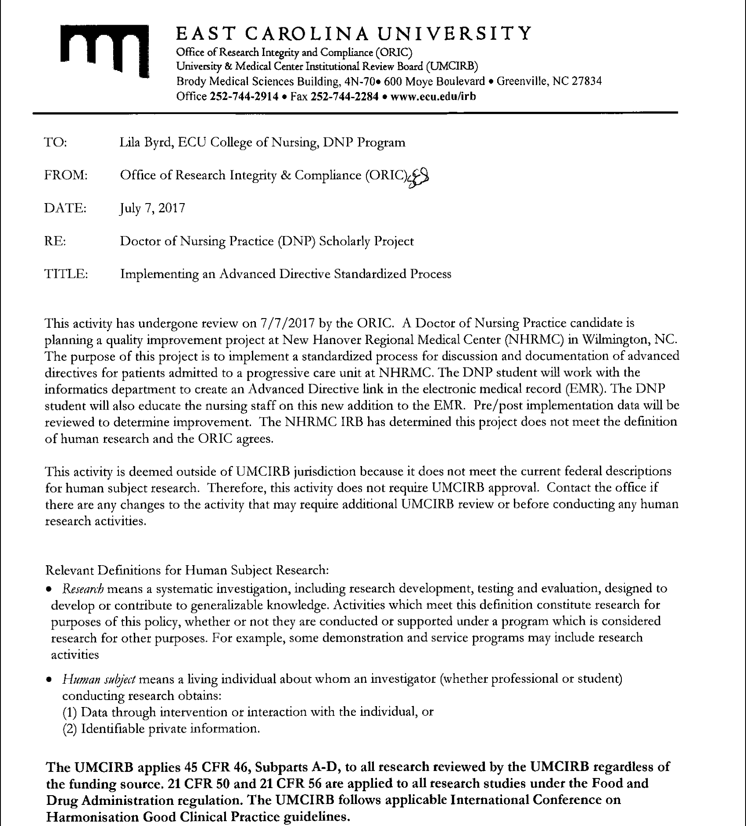

Appendix B
IRB Approval: Project Site

Appendix C
Literature Review Matrix
Article  Citation | Level of Evidence | Purpose and  Findings | Study  Conclusions | Use of Evidence in  Project Plan
Harter, T. D. (2015). Why medicare should pay for advance care planning. Progress in Palliative Care, 23(3), 148-152. | Level IV | Higher medical spending does not improve outcomes. ACP helps decrease cost and provide ethical care. | - ACP and proper ACP documentation helps decrease cost and provide ethical care. Medicare should provide ACP benefits.  - Decreased EOL costs are associated with ACP. | - Promote ACP through cost savings.
Kale, M. S., Ornstein, K. A., Smith, C. B., & Kelley, A. S. (2016). End‐of‐Life discussions with older adults. Journal of the American Geriatrics Society, 64(10), 1962-1967. | Level II: prospective, longitudinalsurvey | 61% of Medicare respondents had discussed ACP with someone. | 40% of a nationally representative sample of Medicare pts had discussed EOL treatments,. | - Promote discussions with the provider.  - Most patients desire comfort at EOL.
Musich, S., Wang, S. S., Hawkins, K., & Yeh, C. S. (2016). Disparities among those with advance directives in a medicare supplement population. American Journal of Hospice and Palliative Medicine, 33(5), 463-470. | Level II: Random sample of Medicare survey respondents. | - Pts without AD had higher medical costs in last 1 month of life than those with an AD.  - 72% of respondents had an AD. | - Those with an AD were more likely female, older high income, highly educated, and lived in in the Midwest.  - Only 13% had discussed with a provider.  - Lower medical costs with ADs. | - Communicating ADs with providers led to 36 % lower costs.  - Obstacles: lack of time talking with provider, lack of understanding, trouble identifying a proxy, complex forms, education level.  - Short hospital stays are harder to incorporate ACP and needs to occur inpatient and outpatient.
Houben, C., Spruit, M., Groenen, M., Wouters, E., & Janssen, D. (2014). Efficacy of advance care planning: A systematic review and meta-analysis. Journal of the American Medical Directors Association, 15(7), 477-489. | Level I: Meta-analysis of RCTs. | Interventins focusin on ADs increased completion and communication. | Patient outcomes consistent with wishes. Future studies need to show effective elements to structure a program. | - Increase communication among providers helps increase AD completion.
Bravo et al.(2016). Promoting advance care planning among community-based older adults: A randomized controlled trial. Patient Education and Counseling, 99(11), 1785-1795 | Level II: RCT | - 80% of older adults in the experimental group documented their wishes.  -Intervention to motivate community adults to document wishes through education and reflection, and help proxies through hypothetical situations. | - ACP interventions cause large increase in AD completion and desire for comfort care.  - Proxies not always choose what patient would. | - Older adults should be aware proxies often have different idea of their wishes and should be clearly communicated.
Johnson et al. (2012). Reasons for noncompletion of advance directives in a cardiac intensive care unit. American Journal of Critical Care : An Official Publication, American Association of Critical-Care Nurses, 21(5), 311-320 | Level III: cross-sectional study | Pts admitted to ICU were asked standard questions and 3 open-ended questions to assess AD understanding.  - Most did not have an AD before admission and most initially declined AD information because they were not familiar. | - Current practice meets PSDA requirements for documenting screening.  - Further assessment/inquiry needs to be done to better educate patients on ADs. | - General admission questions do not adequately educate patients on ADs and further discussion is needed.
Bernacki, R. E., Block, S. D., & American College of Physicians High Value Care Task Force.(2014). Communication about serious illness care goals: A review and synthesis of best practices. JAMA Internal Medicine, 174(12), 1994-2003. | Level II: narrative review of ACP and EBP in observational and high-quality studies. | - Evidence does not show distress with ACP discussions.  - Providers who do not know patient often do not do ACP. | - Best practices: sharing prognostic data, eliciting preferences, understanding fears/goals, exploring trade-offs and impaired function, and family involvement.  - No standard location in EHR for ACP.  - Decreased medical costs.  - EHR “triggers” help remind providers about ACP screening. | - Patients not distressed with ACP discussions, and expect provider to initiate.  - Best Practice recommendations: need standard location in EHR, initiate discussions.  -Palliative care patients had better QOL at EOL.
Hammes, B., Rooney, B., & Gundrum, J. (2010). A comparative, retrospective, observational study of the prevalence, availability, and specificity of advance care plans in a county that implemented an advance care planning microsystem. American Geriatric Society, 58(7), 1249-1255. | Level II: comparative, retrospective, observational study | - In La Crosse, WI to compare ADs from 1995-1996 and 2007 and 2008 after ACP intervention, Respecting Choices, applied in 1993 in the community.  - 95-96: 85% ADs, 07-08: 90%.  - 95-96: 95% in medical record, 07-08: 99.4%. | - ACP programs should be a continued process over time.  - Standard EHR location helps with documentation. | - program needs to be ongoing across the lifespan and improved over time.  - ADs should be in EHR across the care setting and easy to find.
Forlini, J., & Goldberg, L. (2014). Respecting Choices: A case study for incorporating advance care planning into person and family-centered health care delivery. National Academy of Social Insurance. | Level IV: Case Study | Wishes in intervention group for respecting choices had wishes followed 86% of time compared to 30% in control. | - Improved outcomes for patients and families. | - Patient choices change over time.  - ADs increase care with patient wishes.  - Families with better experience when ADs followed.
Weiss, B., Berman, E., Howe, C., & Fleming, R. (2012). Medical decision-making for older adults without family. The American Geriatrics Society. | Level III: Narrative Review | - 39.5 million older adults hospitalized, ¼ not able to make decisions. | - Many older adults hospitalized cannot make decisions and do not have surrogate or family present. | - Need for policy to cover gaps.
Meghani, S. H., & Hinds, P. S. (2015) Policy brief: The institute of medicine report dying in America: Improving quality and honoring individual preferences near the end of life. Nursing Outlook, 63(1), 51 | Policy Brief | Individuals at EOL with increased hospitalizations, ICU, aggressive treatment. | - Care not consistent with wishes | - Hospitalized patients not receiving care from a provider they know.
Kossman, D. A. (2014). Prevalence, views, and impact of advance directives among older adults. Journal of Gerontological Nursing, 40(7), 44. | Level II: Literature Review | - Pts with ADs less likely to have aggressive measures.  -Documentation and communication ensure adherence.  - lower hospital $ and deaths with ADs.  - ACP didn’t increase/hasten death. | - Need charting system with easy to find ADs.  - Better outcomes with AD. | - Increase discussions  - Standard documentation  _patient satisfaction.
House, T., & Lach, H. W. (2014). Advance directives in hospitalized patients: A retrospective cohort study. The Journal for Nurse Practitioners, 10(7), 465-471. | Level III: retrospective, cohort study | - Hospitalized patients: 63% were screened, 37% had AD, with only 14% in medical record. | - Not all patients screened.  - Having AD did not mean it was followed or wishes known. | - Need for process improvement and systematic process for AD documentation and filing.
Gamertsfelder, E. M., Seaman, J. B., Tate, J., Buddadhumaruk, P., & Happ, M. B. (2016). Prevalence of advance directives among older adults admitted to intensive care units and requiring mechanical ventilation. Journal of Gerontological Nursing, 42(4), 34. | Level II: data of random patients needing mechanical ventilation in ICU among 2 hospitals | - Most patients were in medical or CVICU.  - AD completion less than half.  - 24% of pts with high mortality rate had good functional status before admission. | - Generally healthy older adults are at risk for critical illness.  - Low rate of medicare recipients had documented ACP in PCP. | - Importance of AD completion even if generally healthy  - Despite federal regulation through CMS, Medicare still has low prevalence of ACP in PCP.
Gabler, N., Cooney, E., Small, D., Troxel, A., Arnold, R. M., White, D., Halpern, S. (2016). Default options in advance directives: Study protocol for a randomised clinical trial. BMJ Open, 6(6), e010628. | Level II: RCT protocol | N/A | N/A | - Most patients are not in the capacity at EOL to make decisions.  - ADs associated with lower cost, less aggressive care that is consistent with patient preferences of palliative measures.
Korfage, et al. (2015). A cluster randomized controlled trial on the effects and costs of advance care planning in elderly care: study protocol. BMC Geriarics, 15:87. | Level II: RCT protocol | N/A | N/A | - lack of RCTs for ACP protocol
Weathers, E., O’Caoimh, R., Cornally, N., Fitzgerald, C., Kearns, T., Coffey, A., Daly, E., O’Sullivan, R., McGlade, C., & Molloy, W (2016). Advance care planning: A systematic review of randomized controlled trials conducted with older adults. Maturitas, 91, 101-109. | Level I: Systematic review of RCTs | - Most studies did not implement a standard process or measurable QOL at EOL. | - Older adults had positive view and outcomes of ACP. | -- Need for more RCTs and measurable studies for ACP benefits and outcomes.
Wood, N. M., D’Amore, J. D., Jones, S. L., & Sittig, D. F. (2014). Applied clinical informatics: Death, taxes and advance directives. Applied Clinical Informatics, 5(2), 589-593. | Level IV: Expert Opinion | - ADs not adequately made available across care settings. |  | -EHR needs to link ADs on file.
Turley, M., Wang, S., Meng, D., Kanter, M., & Garrido, T. (2016). Impact of a care directives activity tab in the electronic health record on documentation of advance care planning. The Permanente Journal, 20(2), 43 | Level II: Retrospective pre and post analysis in inpatient and outpatient setting | - AD rates documented were 3.5 to 9.6 percentage points higher with the activity tab. | - Statistically significant differences in documentation rates between patients with and without an ACP activity tab in the chart shows standard location in EHR improves documentation. | standard location and specified ACP tab in EHR improves documentation.
Wilson, C. J., Newman, J., Tapper, S., Lai, S., Cheng, P. H., Wu, F. M., & Tai-Seale, M. (2013). Multiple locations of advance care planning documentation in an electronic health record: Are they easy to find? Journal of Palliative Medicine, 16(9), 189-1094. | Level III: Retrospective review of ACP documentation in EHRs | - 50% of older adults had at least 1 ACP documentation in EHR.  - 33.5% had a scanned in AD. | - only 33.5% had an AD somewhere in chart.  - Locations varied between progress notes, scanned documents and the problem list. | - standard location needed in EHR as there are multiple locations they can be located if not.
Dillon, E., Chuang, J., Gupta, A., Tapper, S., Lai, S., Yu, P., Ritchie, C., & Tai-Seale, M. (2017). Provider perspectives on advance care planning documentation in the electronic health record. American Journal of Hospice & Palliative Medicine | Level III: Structured Interviews | - 88.6% of 79 specialists had no ACP documentation.  - 29.1% of 358 PCPs had zero ACP documentation. | - Providers with ACP documentation and those with none followed similar methods of ACP discussions but had varying methods of documenting. | - Standardized processes and location of ACP in EHR leads to accurate ACP reporting.  - Medicare reimbursements of ACP should increase motivation to accurately measure ACP occurances and documentation.
Lewis, E., Cardona-Morrell, M., Ong, K., Trankle, S., & Hillmen, K. (2016). Evidence still insufficient that advance care documentation leads to engagement of healthcare professionals in end-of-life discussions: A systematic review. Palliative Medicine, 30(9), 807-824. | Level I: Systematic Review | - ACP documentation and initiation of EOL discussions were based on attitudes, beliefs, personal experiences rather than standard measures of triggering discussions. | - ACP documentation and EOL discussions is from low-level studies. | - Need for increased, high-quality evidence of ACP documentation and EOL discussions.
Vearrier, L. (2016). Failure of current advance care planning paradigm: Advocating for a community based approach. HEC Forum,28(4), 339-354. | Level I: Systematic Reviw | - Current legal framework does not make ADs the best EOL planning tool. | - Ongoing interactions are necessary between providers and patients to optimize EOL Care. | - Need for ongoing interactions.  - Medical advancements blur lines of life-saving to death prolongation.

Appendix D
Literature Synthesis by Category
Table 2.
Citation | Regulation | Cost | Process | Barriers | Hospital Setting | Outcomes | EHR | Gaps
Harter, T. D. (2015). Why medicare should pay for advance care planning. Progress in Palliative Care, 23(3), 148-152. | ✓ | ✓ |  |  |  | ✓
Kale, M. S., Ornstein, K. A., Smith, C. B., & Kelley, A. S. (2016). End‐of‐Life discussions with older adults. Journal of the American Geriatrics Society, 64(10), 1962-1967. | ✓ | ✓ | ✓ |  |  | ✓ |  | ✓
Musich, S., Wang, S. S., Hawkins, K., & Yeh, C. S. (2016). Disparities among those with advance directives in a medicare supplement population. American Journal of Hospice and Palliative Medicine, 33(5), 463-470. |  | ✓ | ✓ |  | ✓ | ✓ |  | ✓
Houben, C., Spruit, M., Groenen, M., Wouters, E., & Janssen, D. (2014). Efficacy of advance care planning: A systematic review and meta-analysis. Journal of the American Medical Directors Association, 15(7), 477-489. |  |  | ✓ | ✓ |  | ✓ |  | ✓
Bravo et al.(2016). Promoting advance care planning among community-based older adults: A randomized controlled trial. Patient Education and Counseling, 99(11), 1785-1795 |  |  | ✓ | ✓ |  | ✓
Johnson et al. (2012). Reasons for noncompletion of advance directives in a cardiac intensive care unit. American Journal of Critical Care : An Official Publication, American Association of Critical-Care Nurses, 21(5), 311-320 | ✓ |  | ✓ | ✓ | ✓
Hammes, B., Rooney, B., & Gundrum, J. (2010). A comparative, retrospective, observational study of the prevalence, availability, and specificity of advance care plans in a county that implemented an advance care planning microsystem. American Geriatric Society, 58(7), 1249-1255. |  |  | ✓ |  | ✓ | ✓ | ✓
Forlini, J., & Goldberg, L. (2014). Respecting Choices: A case study for incorporating advance care planning into person and family-centered health care delivery. National Academy of Social Insurance. |  |  | ✓ |  |  | ✓
Bernacki, R. E., Block, S. D., & American College of Physicians High Value Care Task Force.(2014). Communication about serious illness care goals: A review and synthesis of best practices. JAMA Internal Medicine, 174(12), 1994-2003. | ✓ | ✓ | ✓ | ✓ | ✓ | ✓ | ✓ | ✓
Weiss, B., Berman, E., Howe, C., & Fleming, R. (2012). Medical decision-making for older adults without family. The American Geriatrics Society. | ✓ |  |  | ✓
Meghani, S. H., & Hinds, P. S. (2015) Policy brief: The institute of medicine report dying in America: Improving quality and honoring individual preferences near the end of life. Nursing Outlook, 63(1), 51 | ✓ | ✓ | ✓ | ✓ | ✓ | ✓
Kossman, D. A. (2014). Prevalence, views, and impact of advance directives among older adults. Journal of Gerontological Nursing, 40(7), 44. | ✓ | ✓ | ✓ | ✓ | ✓ | ✓ | ✓
House, T., & Lach, H. W. (2014). Advance directives in hospitalized patients: A retrospective cohort study. The Journal for Nurse Practitioners, 10(7), 465-471. |  |  | ✓ | ✓ | ✓ | ✓ | ✓
Gamertsfelder, E. M., Seaman, J. B., Tate, J., Buddadhumaruk, P., & Happ, M. B. (2016). Prevalence of advance directives among older adults admitted to intensive care units and requiring mechanical ventilation. Journal of Gerontological Nursing, 42(4), 34. |  | ✓ | ✓ |  | ✓ | ✓ | ✓ | ✓
Gabler, N., Cooney, E., Small, D., Troxel, A., Arnold, R. M., White, D., Halpern, S. (2016). Default options in advance directives: Study protocol for a randomised clinical trial. BMJ Open, 6(6), e010628. |  | ✓ | ✓ |  |  | ✓
Korfage, et al. (2015). A cluster randomized controlled trial on the effects and costs of advance care planning in elderly care: study protocol. BMC Geriarics, 15:87. |  |  |  |  |  |  |  | ✓
Weathers, E., O’Caoimh, R., Cornally, N., Fitzgerald, C., Kearns, T., Coffey, A., Daly, E., O’Sullivan, R., McGlade, C., & Molloy, W (2016). Advance care planning: A systematic review of randomized controlled trials conducted with older adults. Maturitas, 91, 101-109. |  |  |  |  |  |  |  | ✓
Wood, N. M., D'Amore, J. D., Jones, S. L., & Sittig, D. F. (2014). Applied clinical informatics: Death, taxes and advance directives. Applied Clinical Informatics, 5(2), 589-593. |  |  |  |  |  | ✓ | ✓
Turley, M., Wang, S., Meng, D., Kanter, M., & Garrido, T. (2016). Impact of a care directives activity tab in the electronic health record on documentation of advance care planning. The Permanente Journal, 20(2), 43 |  |  | ✓ |  | ✓ | ✓ | ✓
Wilson, C. J., Newman, J., Tapper, S., Lai, S., Cheng, P. H., Wu, F. M., & Tai-Seale, M. (2013). Multiple locations of advance care planning documentation in an electronic health record: Are they easy to find? Journal of Palliative Medicine, 16(9), 189-1094. |  |  | ✓ |  |  | ✓ | ✓
Dillon, E., Chuang, J., Gupta, A., Tapper, S., Lai, S., Yu, P., Ritchie, C., & Tai-Seale, M. (2017). Provider perspectives on advance care planning documentation in the electronic health record. American Journal of Hospice & Palliative Medicine |  |  | ✓ | ✓ | ✓ | ✓ | ✓
Lewis, E., Cardona-Morrell, M., Ong, K., Trankle, S., & Hillmen, K. (2016). Evidence still insufficient that advance care documentation leads to engagement of healthcare professionals in end-of-life discussions: A systematic review. Palliative Medicine, 30(9), 807-824. |  |  |  |  |  |  | ✓ | ✓
Vearrier, L. (2016). Failure of current advance care planning paradigm: Advocating for a community based approach. HEC Forum,28(4), 339-354. |  |  | ✓ | ✓

Appendix E
Advance Care Plan Navigator Educational Handouts
Advance Care Plan Navigator
EPIC will now have a separate ACP navigator that will contain all patient information regarding advance care planning that may be accessed by clicking “Adv Dir on File” or the menu on the left-hand side of the patient chart.
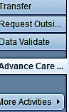
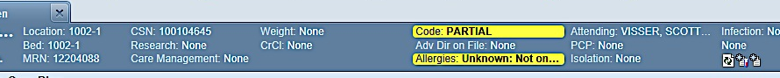

In the navigator the following will be easily accessed:
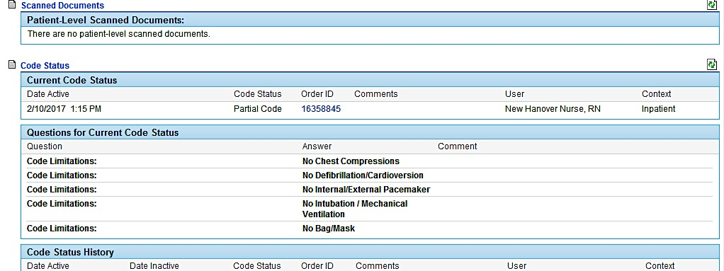
Advance directives scanned in to epic.
Code status details.

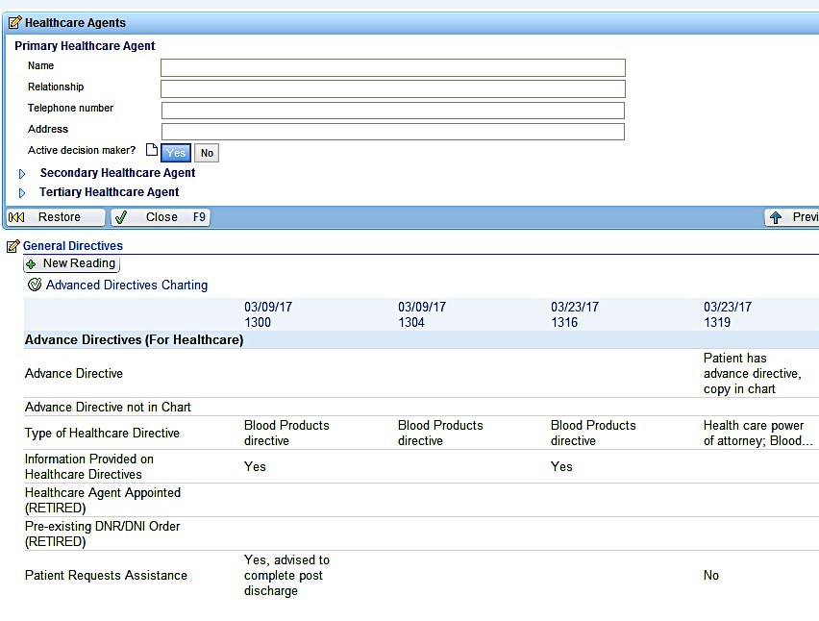

Provider
Screenings,

And links to provider notes containing ACP discussions.

Healthcare agent information for up to 3 contacts.

Advance directive screening completed on admission.
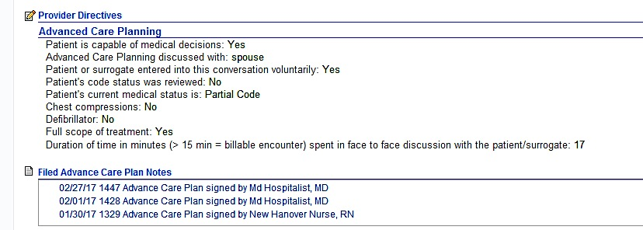

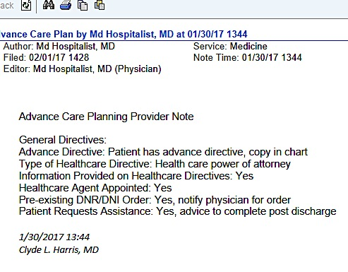
Appendix D
Screenshots to come of how audits were conducted.
Appendix F
AD Audit Methodology
Step 1. In EPIC EHR audits for ADs were conducted by going to “My Reports” in the top toolbar.
Step 3. Under “Clinical Monitoring” heading, select “Advance Directives on file” link.
Step 2. Select “NHRMC Nursing Dashboard link.
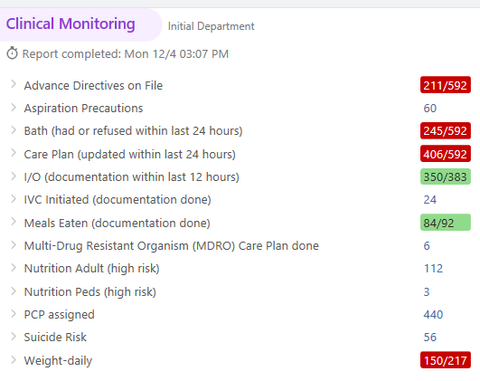
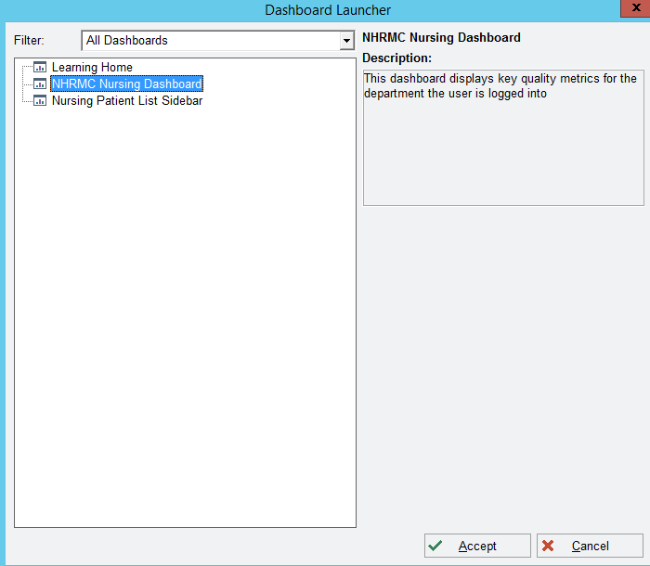

Step 4. Select “Options” link from the toolbar and then select “Report Settings” from the drop down menu.


Step 5. Select “Admitted patient by department” and then select “Progressive Care Unit” and “Run”.

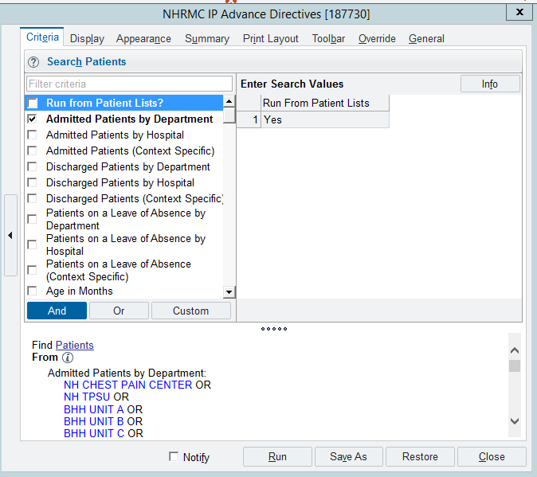

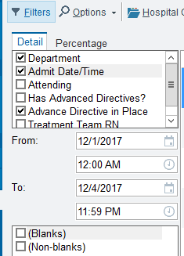
Step 6. After running the audit by department, select “admit date/time” on left side of screen and the associated dates being reviewed, and “Advance directive in place” to determine if AD is in the EHR.

Appendix G
Project Site Letter of Support
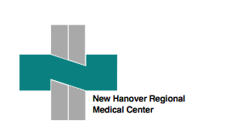
Date: March 23, 2017
To Whom It May Concern,
We at New Hanover Regional Medical Center have reviewed Lila Byrd and Daina Worcester’s DNP Project title “Implementing an Advance Directive Protocol among Hospitalized Patients” Lila Byrd and Daina Worcester have organizational support and approval to conduct their project within our institution. We understand that for Lila and Daina to achieve completion of the DNP program, dissemination of the project will be required by the University which will include a public presentation related to the project and a manuscript submission will be encouraged.
Our organization has deemed this project as an improvement initiative and not requiring institutional IRB review.

Thank you

James K. Adgent, MD
NHRMC Medical Director

Appendix H
Weekly Audit Tool
Advance Directive Audits Pre and Post Project Implementation
Pre-Intervention
 | Total # pts admitted | # of pts with copy of | # of the ADs on file
Week | to PCU | AD in chart | in correct location | Comments
1
2
3
4
5
6
7
8
Post-Intervention
 | Total # pts admitted | # of pts with copy of | # of the ADs on file
Week | to PCU | AD in chart | in correct location | Comments
1
2
3
4
5
6
7
8

