Screening for Risk Stratification of Cardiovascular Disease in Type 2 Diabetes

Victoria Bhardwaj
College of Nursing, East Carolina University
Doctor of Nursing Practice Program
Dr. Bradley Sherrod
07/25/2022

Acknowledgments
This quality improvement project was well supported by my hospital system and its leaders, and I sincerely appreciate everyone involved. I want to thank Dr. Krishna Mohindroo, MD, for his great depth of cardiology and electronic medical record knowledge. Thank you to the project site clinic and my colleagues for the incredible collaboration and momentum, even during trying times in the face of Covid-19. I would especially like to thank and appreciate Dr. Kimberly Blount, DNP, who was my site champion, mentor, generous supporter, gentle critic, and cheerleader. Thank you, Phyllis Justice, AVP, for your leadership, support, and guidance. Lastly, thank you to Dr. Bradley Sherrod, DNP who was my faculty advisor and never wavered from giving the needed, constructive feedback that always helped me see things a little clearer.
I dedicate my Doctor of Nursing Practice Project to my fantastic husband, ‘TC’ Aroon Bhardwaj, my wonderful son, Maxwell Rainey, my ever-supportive mother, Dorene Collum, and my dear cousin, Anna Prestridge. Your unconditional love, tolerance, and support helped me not falter along the sometimes-difficult path and push to the end. I love you all.

Abstract
An estimated 34 million Americans aged 18 and older have diabetes, with Type 2 Diabetes (T2DM) being the majority diagnosis and at a higher risk for cardiovascular disease. Less than 20% of diabetic patients meet or are below the Centers for Disease Control and Prevention risk levels, including for atherosclerotic cardiovascular disease (ASCVD). Evidence proves that early counseling and interventions in the ambulatory care setting help to reduce modifiable ASCVD risks. Initiating an ASCVD risk screening at primary care visits provides the opportunity for earlier detection, driving quicker and more effective healthcare decisions. Many ambulatory clinics serve lower socioeconomic and health literacy patients with poor self-management skills and miss an opportunity to address the risk of severe illness and death related to unmanaged or undiagnosed ASCVD. By using an embedded electronic medical record (EMR) tool, an ASCVD risk score screening populated into a provider visit note creates a visual reminder for providers to assess the risk level, educate, and engage patients in actively participating in their care. This evidence-based, quality improvement project aimed to increase the number of ASCVD risk score screenings in adult T2DM, ambulatory, EMR provider visit notes and help improve provider’s actions post-screening at the moderate and high-risk levels. The FADE model was used during each project team touchpoint and as needed for ongoing barriers such as EMR technical issues. The project led providers to collaborate with patients to improve their health and increase the number of screenings. An ASCVD risk score screening in a provider visit note is effective in aiding as a visual reminder for providers and will help to decrease the risk or severity of cardiovascular disease in the adult T2DM population.
Keywords: ASCVD, type 2 diabetes (t2dm), CVD and t2dm, CVD, ASCVD risk screening

Table of Contents
Acknowledgments 2
Abstract 3
Section I: Introduction 7
Background 7
Organizational Needs Statement 7
Problem Statement 8
Purpose Statement 8
Section II: Evidence 9
Literature Review 9
Evidence-Based Practice Framework 14
Ethical Consideration and Protection of Human Subjects 15
Section III: Project Design 17
Project Site 17
Project Team 19
Project Goals and Outcomes Measures 19
Implementation Plan 21
Timeline 23
Section IV: Results and Findings 23
Results 23 Discussion of Major Findings 22
Section V: Interpretation and Implications 25
Costs and Resource Management 25
Implications of the Findings 26
Sustainability 30
Dissemination Plan 30
Section VI: Conclusion 31
Limitations and Facilitators 31
Recommendations for Others 33 Recommendations for Further Study 34
Final Thoughts 35
References 37
Appendices 43
Appendix A: Literature Matrix 43
Appendix B: CITI Program modules 48
Appendix C: Hospital System Letter of Approval 47
Appendix D: Hospital System Internal Review Board QI Form of Approval 50 Appendix E: American Diabetes Association permissions 51
Appendix F: Project Management Strategy Form 52
Appendix G: Project Timeline 56
Appendix H: Gantt Chart Implementation Tracking Tool 57
Appendix I: Project Management Report #1 58
Appendix J: Project Management Report #2 60
Appendix K: Project Management Report #3 62
Appendix L: Project Management Report #4 64
Appendix M: Project Implementation Report Summary 67
Appendix N: Driver Diagram 71 Appendix O: DNP Project Poster 72
Tables 73
Table 1: Final Diabetes Registry Data for Provider Awareness 73
Table 2: Project Budget 74 Table 3: AACN DNP Essentials 75

Section I. Introduction
An estimated 13% or 34.1 million Americans aged eighteen and older have diabetes, with type 2 diabetes mellitus (T2DM) being the majority diagnosis. Only 19.2% of Americans with diabetes meet or are below the Centers for Disease Control and Prevention (Centers for Disease Control and Prevention, 2020) risk factor levels such as Hemoglobin A1c (A1c), blood pressure (BP), cholesterol, and smoking (Centers for Disease Control and Prevention [CDC], 2020). Primary care ambulatory providers are considered the first line of defense against serious health complications such as diabetes, cardiovascular disease (CVD), and atherosclerotic cardiovascular disease (ASCVD). Early detection in ambulatory care settings can drive more effective healthcare decisions with more positive outcomes (UHC2030, 2016, trickle-down effect, para 1).
Background
Many ambulatory clinics serve lower socioeconomic populations and missed CVD screenings can create lost opportunities to help decrease the risk of severe illness and death in disparate communities. The American College of Cardiology (ACC) presented findings from a Swedish study that noted that out of T2DM deaths totaling 19,105, almost 60% were heart disease-related and reported a 71-87% higher risk indicated for lower socioeconomic status population (CardioSmart, 2016). A partnership with a healthcare system whose mission and vision are to advance the health of communities through evidence-based practice (EBP), advancements in medicine, and emotional well-being support, can help focus on the need for CVD risk stratification in T2DM in an ambulatory clinic setting.
Organizational Needs Statement
Based on evidence that proves early counseling and interventions help reduce modifiable CVD risks associated with hypertension, heart attack, and stroke, the Agency for Healthcare Research and Quality (AHRQ) and Healthy People 2020 recommend consistent ambulatory CVD screenings in adults with T2DM (Ngo-Metzger, 2017). Based on diabetes outcome composite goals of blood pressure <140/90 (CDC, 2020) and non-high density lipoprotein cholesterol (HDL-C) levels of <115 mg/dl (Grundy et al., 2019), all targeted screenings for adults aged 20 – 79 need to increase using six assessment points within the ASCVD risk calculator, a 10-year risk assessment tool, recommended by the American Diabetes Association (ADA) in partnership with the American Heart Association (AHA) for the Know Diabetes by Heart™ program (Know Diabetes by Heart, n.d.), and the ACC (Goff et al., 2013). Compared to the ASCVD risk calculator criteria, the healthcare system's current ACO quality and safety metric targets only include diabetes outcomes with percentage targets for BP <140/90.
Problem Statement
Many diabetic patients at the low-income and low health literacy levels have poor self-management skills presenting a higher risk for undiagnosed CVD (Fritz, 2014). Based on hospital system benchmark targets, risk score screening for blood pressures of <140/90 is not consistently performed during every T2DM patient clinic visit. This often leads to missed risk stratification opportunities. Currently, the hospital system has no quality metric targets for the number of screenings and calculations for ASCVD risk. Initiating a new ASCVD screening target can help increase the opportunities for CVD risk stratification and help meet already established targets, along with guiding providers in improved treatment plans based on the 10-year risk score results.
Purpose Statement
The purpose of this evidence-based, quality improvement project was to increase ASCVD risk score screenings in the adult T2DM, ambulatory patient population. Clinician education and use of an already existing electronic medical record (EMR) risk score calculator, using evidence-based standards from the Know Diabetes by Heart™ program ASCVD risk screening, and 2013 ACC guidelines for cardiovascular risk assessment ASCVD pooled cohort equations risk calculator supported the purpose (Goff et al., 2013). This collaborative project provided evidence-based patient support in not only aiding to decrease ASCVD in the focused population, but in increasing the 10-year risk estimation to support long-term ASCVD reduction and improved disease management.
Section II. Evidence
Literature Review
A literature review was completed, and identified were expert opinion, peer-reviewed, and evidence-based literature regarding the important use of an ASCVD risk calculator for type 2 diabetics and included the need for primary care providers to complete the risk calculation during clinic visits. Literature searches were performed using PubMed, CIHAHL, East Carolina University (ECU) Joyner Library, and Diabetesjournals.org databases, along with an internet search. One phrase, 'using ASCVD risk calculator in type 2 diabetes was used, along with terms that included ASCVD, ASCVD calculator, ASCVD risk score, type 2 diabetes, t2dm, cardiovascular risk, risk stratification, and cardiovascular disease. The filters were then added to the Diabetesjournal.org database search for only those articles between 2017-2020 and a 5-year filter for all other searches.
To more precisely identify the relevant, peer-reviewed, evidence-based articles based on the intervention, levels of evidence taken into consideration were levels I through VI. Level VI was considered based on the qualitative nature of the project intervention and included level VII based on expert opinion found within guidelines development articles. Exclusion criteria included type 1 diabetes, neonates, children, adolescents, and any non-T2DM related interventions. The database searches produced 1,170 articles on ASCVD and T2DM, and the internet search produced over 12,000 articles. Duplicates were noted, and an exhaustive review of the internet articles was not completed. Once all filters were applied within the databases, the final number of articles was 91. After a review based on the appropriateness of the project, seventeen articles were kept. Of those seventeen, the internet search produced seven relevant articles, including one sentinel publication. The literature matrix (see Appendix A) emphasizes the pertinent evidence that supports the need for an ASCVD risk calculation screening for adult T2DM patients.
Current State of Knowledge
The ACC, AHA, and ADA have created recommended guidelines for a 10-year risk screening for ASCVD risk in adult T2DM patients. The ASCVD risk calculator was originally presented within the ACC/AHA 2013 assessment guidelines (Goff et al., 2013) to prevent cardiovascular disease and reduce comorbidity risks. Current literature presents a high level of evidence in the reduction of risk of mortality with the utilization of the ASCVD risk calculator in T2DM (Andari et al., 2020; Bertoluci & Rocha, 2017; Cobble, 2020; Simmons et al., 2017). Stratifying for ASCVD risk in T2DM using the risk calculator for low and high-risk buckets help guide providers in appropriate treatment options for improved patient outcomes (ADA, 2021; Andari et al., 2020; Bakhai et al., 2018; Bertoluci & Rocha, 2017; Goff et al., 2013; Grundy et al., 2018; Jellinger et al., 2017; Low Wang et al., 2016; Xiao et al., 2021; Zhang et al., 2020).
Hong et al. (2019) compared the ACC/AHA ASCVD risk calculator to the UK Prospective Diabetes Study risk engine utilizing a cross-sectional study, and measurable outcomes were presented in the published article. The outcomes supported that the ASCVD risk calculator was more appropriate for T2DM than the UK risk engine. Another cross-sectional study resulted in a more significant effect and accuracy in utilizing the ACC/AHA ASCVD risk calculator in T2DM rather than utilizing the China-PAR assessment (Yang et al., 2020). Andari et al. (2020) presented evidence through a systematic review of the literature and guided by the sentinel AHA/ACC 2013 guidelines (Goff et al., 2013) for T2DM patients, it was noted that the T2DM patient population was at a higher risk for CVD, with most of the patients presenting as non-symptomatic of CVD. Using the ASCVD risk calculator helped guide providers in earlier implemented treatments following the evidence-based standards for diabetes and CVD comorbidity care.
Common among the literature reviewed was the importance of ASCVD risk score calculations to be completed in the ambulatory, primary care setting as the first line of defense against untreated or poorly managed CVD in T2DM (Early, 2018; Jellinger et al., 2017; Rosenzweig et al., 2019; Simmons et al., 2017; Yang et al., 2020). Xiao et al. (2021) presented a study based on the ASCVD risk scoring international standard for T2DM in the primary setting. However, only the China-PAR ASCVD risk scoring tool was utilized. A takeaway from the study was the focus on using an ASCVD risk score tool in the primary setting for risk stratification, as CVD is a leading cause of T2DM mortality. Lippincott Nursing Center (2020) is a well-respected and credible nursing resource database for peer-reviewed journals and professional development, and a standard for nursing protocols. Included in their documents is a summary of the ACC/AHA 2019 guidelines for the primary prevention of cardiovascular disease and includes the importance of a team-based approach consisting of providers, nurses, and other clinicians in ensuring adult T2DM patients are screened for ASCVD risk. Key indicators include T2DM, tobacco use, dyslipidemia, and HTN as major risks for ASCVD, along with the importance of including the indicators in the ASCVD risk calculations (Lippincott Nursing Center, 2020).
An interesting cohort study called the Learnings with Experts to Advance Diabetic Dyslipidemia Management (LEADD) in India presented analyses of 199 primary clinic sites. The study assessed if the 2018 ADA T2DM guidelines and the ASCVD risk calculator were consistently used for risk scoring and appropriate treatment approaches. Based on missed stratification by uncompleted ASCVD risk calculations, the majority of T2DM patients were not appropriately prescribed any statin medications (Das et al., 2021).
Current Approaches to Solving Population Problem
Recommended guidelines currently being followed in the United States (U.S.) for CVD risk stratification in T2DM include using the ACC/AHA's 2013 ASCVD risk calculator in a primary care setting. The calculator, or estimator, has six assessment points, including smoking history and a diagnosis of T2DM. Labs included are the total cholesterol, high density lipoprotein (HDL), and systolic BP values that must fall within the set criterion values (Goff et al., 2013; Grundy et al., 2018; ADA, 2021).
The project site leadership and its information and analytics services (IAS) team were consulted, and the current standard is the ACC/AHA 2013 risk calculator for risk stratification in T2DM. The calculator is currently built into the current EMR with criteria generating an ASCVD risk score that can be pulled into a provider's clinic note through an auto-text containing a Smart Template. The template utilizes discrete data elements, such as a charted BP, diabetes listed as a problem, smoking status, and a resulted lipid panel from the patient's EMR flowsheet. A calculation is then automatically generated into the provider's office visit EMR note showing the calculation risk percentages for African American and non-African American patients.
This tool was built into the system's EMR in 2018 but was not made mandatory for providers to complete. One provider consulted for this project, who uses the EMR risk calculator, stated that if a patient is currently on a statin medication, he does not complete a risk assessment. Leadership understands that the lack of mandatory utilization of the tool, along with siloed provider decision making on when to complete a risk score assessment, create many missed stratification opportunities and increased risks of inappropriate, or lack of, treatments prescribed. This falls in line with Das et al.'s (2021) cohort study results that showed the lack of consistent ASDVD risk scores being calculated and missed treatment opportunities. Bakhai et al. (2018) implemented a quality improvement (QI) project with a sample size of n= 2565 that presented underutilization of the ASCVD risk score calculator in a primary care setting. Missed treatment opportunities for patients based on lack of use of the tool were also noted. Based on those results, the ASCVD risk scoring tool was later incorporated into daily workflows as a standard of care in primary care clinics (Bakhai et al., 2018).
Evidence to Support the Intervention
Das et al. (2021) presented evidence of missed treatment opportunities related to the underutilization of the ASCVD risk score calculator. Out of 89% of study participants that the team completed an ASCVD risk assessment, it was noted that over 99% had ASCVD risk factors. In patients less than 40 years of age, risk factors were present in over 66%. According to the 2018 ADA target metrics, low density lipoprotein (LDL) of less than 100mg/dl was noted in only 30% of all study patients. For the patients aged forty or over, 91.5% with ASCVD scoring considered at risk did not have an LDL resulted. For the ADA target metric of HDL equal to or greater than 40mg/dl in those less than 40 years of age, 64% of patients had not had a resulting lab noted in the EMR.
The Endocrine Society's clinical practice guidelines (Rosenzweig et al., 2019) are based on evidence-based, systematic reviews and meta-analyses that focus on RCTs. Although the study focused on the ASCVD risk screening in patients with no diagnosis of T2DM, it presented the fact that anyone with metabolic risks needs to be screened for T2DM and ASCVD. The article did provide evidence-based literature that presented the need for and importance of ASCVD risk screening using the ACC/AHA risk calculator in those patients already diagnosed with T2DM. It was noted that such risk factors as hypertension and abnormal lipids "tend to cluster together" (Rosenzweig et al., 2019, para. 2). The section summarizing changes in the 2008 guidelines noted that the ACC/AHA ASCVD risk calculator did not exist in 2008 and was unavailable, but has since become the evidence-based, standardized tool. The risk calculator includes the systolic blood pressure, which has been identified as a major target in early treatment and lifestyle changes to reduce ASCVD in T2DM (Rosenzweig et al., 2019).
Evidence-based Practice Framework
The FADE model, a framework created by the Duke University School of Medicine based on the need to develop a QI action plan, was used for the planning and implementation of this project. Assistance and support for the framework creation were from the Organizational Dynamics Institute in Massachusetts and created directly for the healthcare field (Josie King Foundation, n.d.). It is based on four distinct steps: Focus, which is defining the specific process improvement needed; Analyze by collecting data to create a baseline; Develop a plan of action that includes the implementation plan, along with monitoring and measuring success; Execute the improvement plan as a pilot program and continue to evaluate, monitor, and measure the success of the project (BHM Healthcare Solutions, n.d.; Josie King Foundation, n.d.).
Implementing a QI project at an ambulatory clinic pilot site is best supported by the FADE model and its consecutive steps of the model process. It closely resembles the PDSA model, which is also based on a cycle of four steps, but the FADE model includes focus and analysis within those four steps (Josie King Foundation, n.d.). Based on AHRQ's (n.d.a.) practice handbook, quality improvement by its very nature is a framework that guides systematic ways to improve the delivery of patient care. It "can be measured, analyzed, improved, and controlled…[with] continuous efforts to achieve stable and predictable results" (AHRQ, n.d.a., module four para. 1). The FADE model appropriately guides the QI process with succinct, cyclic steps to help achieve the proposed, measurable outcome of increasing ASCVD risk stratification in T2DM.
Ethical Consideration & Protection of Human Subjects
Consideration of ethical risk is imperative in any healthcare project design and implementation and includes published results that could contain patient identifiers. This quality improvement project focused on increasing ASCVD risk calculations on adult T2DM patients holds no risk, as it is an already established standard across the U.S. and in use internationally. For the project site's hospital system, the tool utilizes already existing discrete data found within a patient's EMR and was previously vetted by system leadership. The results automatically populate into a provider's EMR note, and the information found within the electronic chart remains confidential and HIPAA protocols were to be followed as with any EMR data.
The project focused on adults with new or existing T2DM and did not discriminate against patients based on sex, gender identification, race, ethnicity, type of insurance coverage, or income. There was no potential harm noted in using the ASCVD tool, as other hospital system providers had already used it in the past with no events or incidences based on scoring results. For patients with a lower literacy level, including health literacy, the scoring results were discussed by the provider and nursing staff with the patient in layman's terminology, along with a discussion of results with HIPAA release of information to family members, guardians, caretakers, or others deemed to have permission to discuss the risk percentages. Providers would drive any treatments based on the scoring results and be solely responsible for any possible injury, equity, or discrimination outside the DNP project scope of increased ASCVD risk calculation results. No personal health information (PHI) was involved in the project or within the baseline reports. Post-implementation information and analytical services (IAS) reports and manual chart audits were used to calculate measurable outcomes. Only the number of ASCVD risk screenings within the specified time periods were obtained from the manual chart audits.
Based on the required completion of modules related to human research, the Collaborative Institutional Training Initiative's (CITI) modules for Group 2 social/behavioral research investigators and key personnel basic course for East Carolina University were successfully completed (see Appendix B). This included assessing knowledge of regulatory requirements, ethics, and protection of human subjects historically (CITI Program, n.d.). The DNP project was submitted for approval to hospital facility nursing leadership on July 25, 2021 and was approved on July 26, 2021 (see Appendix C). Per the project site's hospital system policy, the project was presented to the system's DNP council before introduction to the facility's internal review board (IRB) on December 4, 2021. Once the project was formally deemed a quality improvement project, it continued to the IRB for internal vetting and was approved for implementation on December 6, 2021 (see Appendix D). The East Carolina University DNP project advisor then advised the next steps in the final IRB project implementation approval received on December 8, 2021. Permission for courtesy distribution of the ADA's "Where Do I Begin" booklets from their Living with Type 2 Diabetes program to the clinic and mention of the program within the DNP paper was obtained from the ADA on 11/15/2021. Permission to provide a provider decision cycle based on risk scores to the project site for courtesy awareness was obtained from ADA on January 28, 2022 (See Appendix E).
Section III. Project Design
Project Site
The quality improvement project was implemented in an ambulatory, primary care clinic connected to a healthcare system in North Carolina. The clinic's aim is to improve comprehensive healthcare, early disease risk assessment, and provide chronic disease management of populations served. Services provided are family medicine-oriented and include routine physicals, minor surgeries, and urgent care visits for all age groups (Project Site Clinic Manager, personal communication, November 1, 2021).
Description of the Setting
The targeted project setting was an ambulatory, primary care clinic connected to a not-for-profit healthcare system in western North Carolina. Four providers were onsite daily for patient clinic visits, as well as providing virtual visits when appropriate. Clinicians within the project site included a registered nurse, certified medical assistants, and a senior clinic manager. Patient demographics included neonates to adults and accepts a payer-mixed insurance coverage, including Medicaid. The clinic operating schedule is Monday through Friday, 8:00 am to 5:00 pm, with urgent after-hours on-call phone assistance available seven days a week. The community population serviced included the surrounding metro area, where the per capita income was approximately $38,000 (United States Census Bureau, n.d.).

Description of the Population
The project patient population included adults aged twenty and older with a diagnosis of T2DM visiting the clinic for a primary care visit. Based on conversations with the clinic providers, many project site patients were insured by Medicaid and were considered as low socioeconomic status. The two most prevalent health issues were hypertension and T2DM (Project Site providers, personal communication, November 1, 2021).
Project Team
The project team consisted of the project manager, the site champion who helped support the project manager and guide through the hospital system project and IRB approvals process, the ECU DNP faculty advisor, and a subject matter expert provider who helped support the project manager in the already established EMR ASCVD risk calculator background and process. The project partner was one ambulatory primary clinic with four providers consisting of one nurse practitioner and three doctors. Clinicians and ancillary staff who assisted the providers daily during patient clinic visits rounded out the project team. The senior clinic manager acted as the liaison between the project manager and the project partners.
Project Goals and Outcome Measures
The project goal was to increase the number of adult ASCVD assessment and risk screening rates within a provider note by 10% in the T2DM patient population in an ambulatory clinic setting. Specific goals were to increase providers' knowledge and consistent use of the already existing ASCVD risk calculator within the hospital system's EMR. The current recommendations were analyzed, and a majority standard noted was the ACC/AHA recommended guideline of using the ACC/AHA's 2013 ASCVD pooled cohort equations risk calculator (Goff et al., 2013) in a primary care setting on all adult T2DM patients. A provider auto-text function in the clinic provider visit note would capture risk screening scores and risk percentages with a goal to decrease the number of missed risk stratification opportunities. The outcome measure would be a 10% increase in the number of ASCVD risk screenings calculated for adult T2DM patients and pulled into the EMR provider visit note compared to the pre-implementation data.
Description of the Methods and Measurement
The focus, analyze, develop, and execute (FADE) model (Josie King Foundation, n.d.) was used for the planning and implementation of this project. Four distinct steps were followed based on the FADE acronym for focus, analyze, develop, and executive/evaluate (BHM Healthcare Solutions, n.d.; Josie King Foundation, n.d.). An ongoing Excel spreadsheet was used to visually map any weekly changes in the number of EMR provider note ASCVD risk score completions. Fifteen FADE model cycles were completed, with one at the beginning of each following week of implementation after manual chart audits were completed, and others during strategy planning when the project site clinic went live with a new EMR. Continued communication at least once per week between partner providers and the partner clinic manager was used to monitor progress or barriers, provide updates on the ongoing process, make needed changes to workflow, and continue to evaluate project progress.
For hospital system benchmarking purposes, IAS ran a 'current' total number of adult patients with a resulted HDL-C and ASCVD risk score calculation on September 30, 2021, as a baseline and continued to pull reports monthly until the end of implementation. A limitation to the report included ASCVD risk scores resulted for adult clinic patients, regardless of diagnosis. Manual chart audits were completed to filter T2DM patients. This report was used only to provide awareness and support in presenting the need to implement a mandatory EMR 10-year risk score calculation within the project patient population during a clinic visit for improved system benchmark target scores. It was understood by the project team that the number of ASCVD risk scores would need to be reviewed for at least six months post-implementation for an accurate measure of comparison, as the project time frame did not provide adequate time for more precise comparison of pre-and post-project scores.
Discussion of the Data Collection Process
The pre-implementation report for the number of ASCVD screenings resulted in the hospital system's EMR for the project site clinic within 12 weeks from July through August of 2021 was created by the hospital facility's IAS department and an application specialist team lead. This included the number of adult patients with a resulted HDL-C at the project site during the same time frame. A weekly IAS report was resulted throughout implementation for 10 weeks for ongoing review of measurable outcomes, and the resulting ASCVD count data was entered into an excel spreadsheet.
The excel spreadsheet containing the data was shared with the project team weekly and included courtesy data found within the weekly report for the hospital system’s diabetes registry metrics of ‘met’ or ‘unmet’ for BP <140/90, Hemoglobin (Hb) A1c <8%, HbA1c <9%, HbA1c monitoring met, nephropathy monitoring met, statin therapy met, and eye exam met. The IAS team also created a 10-week, post-implementation report for the number of ASCVD screenings resulting after the project implementation was completed and a report on the number of adult T2DM patients noted during implementation. A manual chart audit of adults 20 years and older with a diagnosis of T2DM seen in clinic during the implementation phase was completed for a count of ASCVD risk scores populated into a provider note. This data was compared to pre-implementation outcomes, of which the number of ASCVD risk scores populated into the provider note using the auto text feature was ‘zero’, as providers stated they were unaware of the EMR tool. The number of adult patients diagnosed with T2DM and the number of ASCVD risk screening rates pre-and post-implementation was compared and analyzed.
Implementation Plan
An implementation plan to increase the number of ASCVD risk calculations was developed that included involvement with and opinions of hospital facility leaders and providers. The project manager presented a PowerPoint presentation with discussion to the project partners during a lunch & learn virtual meeting on November 1, 2021, and a final proposed plan was agreed upon to begin the 10-week implementation starting the first week of May 2022 and a pre-implementation ‘transition phase’ beginning the last week of February 2022. A project strategy form was completed to detail the planned project and implementation strategies (see Appendix F). A virtual presentation format was chosen related to ongoing hospital facility Covid-19 restrictions and guidelines, and lunch was provided via delivery to the attendees at the project site. The attendees were three medical providers and the clinic senior manager who were educated on the EMR auto text workflow, which automatically pulled the ASCVD risk score into the visit note. Presentation attendees were provided with a copy of the PowerPoint presentation, which included the auto text feature steps, before the meeting for better streamlining and to be mindful of their time. The lunch and learn was recorded by the clinic senior manager for educational review by clinic staff such as Registered Nurses and certified medical assistants to understand the scope of the project and better support the providers with reminders to complete the risk score. Providers were encouraged to alert the project manager of any issues noted when attempting to pull in the risk score so that the hospital system's IAS team could address any possible break/fixes, a standard and time sensitive ad hoc EMR servicing need. Attendees were also encouraged to discuss the project with site clinicians to help support appropriate risk scoring for the inclusion population daily throughout implementation by giving providers reminders to pull the score into the visit note.
Project partners were informed of the pre-and post-implementation IAS reports. No patient personal health information, hospital system identification, or project site name would be used within the project final paper. The providers and project manager agreed that providers would be solely responsible for any treatment decisions or lack of outside the project scope. The ADA granted permission to the project manager for a courtesy distribution to the project site for its newly diagnosed T2DM patients of the ADA Living with Type 2 Diabetes program's 'Where Do I Begin?' booklet, which guides patients in evidence-based care, treatment options, and lifestyle changes (American Diabetes Association, n.d.) in English and Spanish. The project manager gave the complimentary copies of the booklet to the project site partners before implementation for patients to assist providers and clinicians in educating on not only T2DM disease, disease process, and healthier lifestyle choices, but also on why it was essential to complete an ASCVD risk score calculation with a subsequent discussion of the results.
An essential facilitator of implementing the project within the clinic was the project manager. The project manager had worked with the providers within a community health approach through care management and had already created a positive working relationship with clinic staff and providers. Another positive facilitator was that the ASCVD risk calculator was already built into the hospital system's EMR and there was no IAS build required. A possible barrier to the number of measurable outcomes was the possibility of four providers medically supporting a large population of patients and feeling that bandwidth would be decreased by populating an ASCVD risk score in the provider notes for all adult T2DM patients. Another possible barrier included a lack of education on using the auto text feature to populate the risk score. An added facilitator to break down that barrier was that the workflow education would be minimal and take approximately five minutes if needed.
Timeline
The timeline (see Appendix G) for the project began in May 2021 with biweekly faculty advisor meetings through December 2021. A Gantt chart was utilized to follow completion of implementation project tasks (see Appendix H) Due to a change of project site during the planning phase, a PowerPoint presentation to a new project site clinic manager and providers was presented on November 1, 2021. Project implementation was planned to begin January 25, 2022, but based on new Covid surges, it was pushed back to February 28, 2022, and continued until April 29, 2022. The post-implementation IAS report was scheduled for completion by the end of April 2022, when data analysis would have begun, but again based on Covid surges, the IAS last weekly report was pushed back to the first week of May 2022.
Section IV. Results and Findings
Results
The number of ASCVD risk score calculations for the project site resulted in the EMR ‘background’ per IAS monthly reports before project implementation was 317 (any lipid panel that results, regardless of diagnosis) risk stratification opportunities that could be pulled into a provider note for ASCVD risk stratification. The pre-implementation report could not discern between adult T2DM and non-T2DM patients; however, it is assumed that adult T2DM patients would fall within the 317 background scores. Data for October and November 2021 was reviewed, which was the last nine-week time frame of pre-implementation data. This time frame was based on having nine weeks of actual project implementation to keep an even number of weeks of ASCVD risk scores pulled into a provider note probabilities versus the actual number of risk scores pulled into a provider note throughout implementation.
The total number of ASCVD risk calculations pulled into a note during the project was 11. The number of adult T2DM patients seen either in clinic or during a virtual visit with a resulted lipid panel for the length of the project was 119 (see Table 1). Based on the projected 10% increase of ASCVD risk scores found within a provider note, the outcome percentage was slightly below expected at 9.24%. Secondary data found within the weekly IAS data reports was the total number of diabetes registries ‘met’ and ‘unmet’ for each metric (see Table 1). Throughout project implementation system ACO benchmark targets ‘met’ were collected for BP <140/90 with a weighted composite target set at 79.93% and Statin Therapy target set at 87.00%. The ACO diabetes registry target clinic performance percentages were below benchmark for both with an averaged performance score of 71.55% for and 53.21% respectfully. Outcomes were shared as a courtesy to the project site providers and for awareness of the hospital system metric target results. There were also four project management reports and an implementation report summary shared with the team during and post-implementation (see Appendices I, J, K, L, M).
Discussion of Major Findings
Current literature presents a high level of evidence in reducing the risk of mortality with the utilization of the ASCVD risk calculator in T2DM (Andari et al., 2020; Bertoluci & Rocha, 2017; Cobble, 2020; Simmons et al., 2017). Stratifying for ASCVD risk in T2DM using the risk calculator for low and high-risk buckets helps guide providers in appropriate treatment options for improved patient outcomes (ADA, 2021; Andari et al., 2020; Bakhai et al., 2018; Bertoluci & Rocha, 2017; Goff et al., 2013; Grundy et al., 2018; Jellinger et al., 2017; Low Wang et al., 2016; Xiao et al., 2021; Zhang et al., 2020). Such literature findings support the need for a visual indicator for ASCVD risk in a provider visit note. Based on conversations with one project provider during implementation, it was noted that she had become reignited in engaging with her adult T2DM patients in collaborating with them on the reduction of ASCVD risk, lifestyle changes, and medication decisions (project site provider, personal communication).
Also, based on literature findings, many hospital systems have previously adopted the ASCVD risk score assessment as mandatory, but it currently is not mandatory for the project site’s hospital system. Other earlier literature findings support the rationale for provider/patient discussions regarding the risk score results and improving patients’ health management. From a nursing standpoint, Lippincott Nursing Center (2020) felt ASCVD risk scores and resulting patient discussions were important enough to mention and include in their summary of the ACC/AHA 2019 guidelines (Lippincott Nursing Center, 2020), supporting this project, its drivers (see Appendix N), and nursing collaboration with interventional approaches. Regarding the unexpected secondary data included within the weekly IAS reports, the literature findings previously mentioned support a diabetes registry and the need to visualize metric target percentages for provider awareness for improvement in target measures.
Section V. Interpretation and Implications
Costs and Resource Management
The cost of project implementation was minimal, especially considering the impact made on patients with an ASCVD risk score pulled into a provider note with resulting discussions by providers with their patients on improving health management. The total monetary cost of the project came to $458.81 (see Table 2). It included three supplied lunches for the clinic, ADA/AHA handouts, gasoline to and from the project clinic site, the ASDVD embedded EMR tool, communication, and the IAS reports. Build time for the reports was incorporated into formal onsite requests (OSR) for the legacy EMR and final new EMR reports. Microsoft Teams meetings were conducted during lunch hour with lunch provided. Gas was calculated using miles per gallon of the project manager’s vehicle, gas prices during travel time, and the mileage to and from the clinic. The embedded ASCVD risk score tool was already embedded within the legacy and new EMRs, and there was no cost to the project. The ADA/AHA handouts were free, and only cost the time to email ADA to request the handouts and permission to give to site providers. Communication with the project team was utilized with email threads, Microsoft Teams chat, texts, and phone calls, with no cost to the project, especially since the project team was aware of the prospective communication timeline prior to implementation. It was agreed upon initially by the team that communication would be at the convenience of each teammate so that bandwidth was not decreased during business hours.
Time can be saved for future project or implementation attempts on a larger scale by having IAS run a test on the ASCVD risk score calculator in any legacy or new EMR. Also, evaluating the ability to data-mine reports in both EMRs would substantially decrease project time and improve outcomes related to improved preparation. QI committees based in nursing and providers already exist to review QI project ideas and lead implementations, and no direct cost would be incurred directly into the project. Education for any mandatory go-live can be disseminated by an IAS email communication system-wide to nursing and providers, as education time would be minimal.
Implications of the Findings
Based on informal conversations with the project site providers before implementation, the providers were unaware that an ASCVD risk score tool was already embedded within the EMR. Bringing awareness of the tool and the project purpose-initiated conversations in improving the health outcomes of their adult T2DM patients regarding the high risk of CVD. The IAS weekly reports contained the hospital system’s diabetes registry weekly ‘met’ or ‘unmet.’ The site providers were unaware of the results until the project manager added them to the weekly ASDVD risk score screening reports. The diabetes registry data was part of the hospital system’s ACO target metrics for ambulatory primary care clinics. During pre-implementation, further discussion was initiated with providers on the importance of visual awareness and efforts to improve the outcomes.
Another finding was related to what are called break/fixes (occasional breaks in EMR coding that may be viewed as a ‘quick fix’) in the EMR internet technology build related to the IAS smart template used to pull an ASCVD risk score into a provider visit note. If a provider attempted to pull in a risk score within a different EMR encounter than one the Lipid panel had resulted, the risk score would not populate into the note. The project team uncovered another issue where, if the Lipid panel had resulted further back than six months, the risk score was no longer applicable and would not populate into the note. The first break/fix was addressed with hospital system IAS specialists and was immediately corrected. The six-month issue was also addressed with IAS specialists, and the project team was informed that the build for the EMR tool had been approved for a six-month time limit to ensure accuracy and appropriateness of the risk score.
The project manager incorporated the FADE model early on in planning to address break/fixes, issues, or low ASDVD risk score screenings during implementation. FADE model findings each week presented the project team with unexpected barriers and initiated conversations to discuss the need for improvement in visible project and ACO metric target scores. This ignited interest in site providers for the project and reminded IAS and system provider leaders of the importance of utilizing built-in EMR tools for patient and siloed care improvement.
Implications for Patients
By utilizing the embedded EMR ASCVD risk score tool, providers were able to initiate conversations with patients and engage them in discussions. Providers shared decision-making to improve their health and well-being, especially regarding what risk level of either low, moderate, or high the score places the patient. Engaging the patients also supports improving their health self-management skills and improves outcomes such as reduction of cardiovascular risk. Initiating lifestyle changes such as healthier diets and exercise during initial discussions of the visual ASCVD risk score screening results early on does support a higher chance of engaging the patient and their family in healthier living initiatives and lifestyle changes, as well as not only improving the chances of decreasing patients’ future, out of pocket costs for managing their health but assist in decreasing the risks of morbidity and mortality from CVD and strokes.
Implications for Nursing Practice
The project and outcomes support a better understanding of the need for nurses and nursing leaders to help drive patient outcome improvements with interdisciplinary care team approaches. Also supported, was an advancement of collaboration between nurses and providers during patient clinic visits for improved patient education using the visible ASCVD risk score results. Utilizing external educational and guidance resources such as those provided by the ADA/AHA Know Diabetes by Heart™ Silver Certification program (KnowDiabetesbyHeart, n.d.) together with discussions on the ASCVD risk scores can help streamline lifestyle changes and goals between clinicians and patients. The project hospital system is already enrolled in the AHA’s Get with the Guidelines™ Gold Certification program, which the ADA/AHA program is designed to be appropriate to work in conjunction.
ADA’s booklet “Where Do I Begin?” (ADA, n.d.), which encourages healthier diets, increasing activities such as walking and exercise, medication consideration, and support resources, is an excellent example of not needing to reinvent the wheel to improve patient outcomes and increase patient engagement in their health. Historically, nurses are driven by provider direction on patient education. With providers initiating collaborations with their patients using the visible ASCVD risk score results, nurses can become more involved in patient education as part of the interdisciplinary care team.
Impact for Healthcare System
Based on the literature research for the project and evidence-based approaches, utilizing an EMR embedded ASCVD risk score tool and resulting provider collaboration with patients in lifestyle changes, healthcare systems can and will save time and money, along with improving CMS reimbursement by improving the ACO metric targets for primary care provider clinics. De-siloing health management by multiple providers can easily see the ASCVD risk screening results within the EMR has an even more significant impact on current and future ability to provide the best care for hospital system patients.
By implementing the project and adding outside resources such as subject matter expert providers and IAS specialists, the Know Diabetes by Heart™ (KnowDiabetesbyHeart, n.d.) introduced during implementation prompted leadership interest in the Silver Certification program, which could further positively impact CMS reimbursements. The project highlighted the need to utilize EMR embedded tools such as the ASCVD risk score and further highlighted how EMR tools can support metric target outcomes and improve reimbursements.
Sustainability
Based on long-term recommendations and guidelines by the ACC, continuing the use of an ASCVD risk score calculation for adult T2DM can improve patient outcomes, improve reimbursements, and create increased patient engagement with self-management of their health. The hospital system already absorbs the cost of an embedded tool in the legacy EMR and the new EMR currently in the final phases of go-live. Hospital administrators and cardiology provider leaders have vetted the risk score tool as a needed tool. Based on future build needs within the new EMR, if ACC/AHA releases new ASCVD risk score tool criteria, the EMR can be immediately updated by the EMR specialists, as indicated in the original build contract, providing accurate and appropriate information guidelines for CVD risk in adults.
Sustainability is also currently supported by buy-in from hospital system leaders. EMR tools such as the ASCVD risk score screening can be incorporated into EMR education for new clinicians during their orientation process. The resulting outcomes of mandatory use of the risk score will be a continued, positive impact on the project’s hospital system, its patients, and staff, creating self-sustainability within the hospital system.
Dissemination Plan
The project, outcomes, and abstract presentations began on July 12, 2022, with an onsite, formal poster presentation (see Appendix O) to the ECU College of Nursing for consideration of the Doctor of Nursing Practice – Leadership degree. The project paper was submitted to ECU’s “The Scholarship” for publication on or before July 30, 2022, as the final deliverable for the DNP degree. Plans for dissemination outside of ECU include abstract submissions to the project site’s hospital system leadership on or before July 30, 2022, to share the positive outcomes and future implications, along with recommendations for enterprise-wide consideration of mandatory ASCVD risk score screenings.
Submissions of the project paper abstract are also planned on or before July 30, 2022, to KnowDiabetesbyHeart.org and ADA’s DiabetesJournal.org, especially considering the importance of ADA’s and AHA’s initiatives and public recommendations that supported the basis of the DNP project. Included in the time frame is an abstract submission to AHA’s Circulation, which was an essential part of the literature review and included evidence-based articles that supported the foundation of the project’s problem, needs, and outcomes. In addition, the project paper abstract is planned to be submitted to the American Nurses Association’s NursingWorld.org journal on or before July 30, 2022, and the Nursing World Conference Abstract Final Round Submission, due by September 30, 2022. The importance of presenting the abstract to nursing is ingrained with the need for nurses to continue with quality improvement initiatives and help viably continue nursing’s involvement in full circle patient care, supporting positive patient outcomes. Submission to nursing and nursing faculty is imperative in presenting how the American Association of College of Nursing (AACN) DNP Essentials (see Table 3) are the foundation of any DNP program and project (AACN, 2006). The AACN essentials guide and lead DNP students to plan and implement quality improvements accurately and appropriately in healthcare settings.
Section VI. Conclusion
Limitations and Facilitators
As mentioned previously in the findings section, a break/fix in the EMR build with the IAS smart template used to pull an ASCVD risk score into a provider visit note was discovered during implementation, not allowing providers to pull in a risk score in their patient visit note. If a provider attempted to pull in a risk score within a different EMR encounter than the encounter in which the Lipid panel had resulted, the risk score would not populate into the note. During a subsequent virtual meeting, the providers stated they were unaware of why the score would not populate and verbalized frustration. The inability to appropriately utilize the EMR tool began to reverse buy-in by project site providers. The SME project provider was later able to explain the issue to the team during another subsequent meeting after he spoke with IAS specialists, who quickly corrected the issue. Another limitation was the six-month limit on resulted Lipid panels and the inability to pull a risk score into a provider note. Unfortunately, it was not a barrier that would be corrected, and workarounds like scheduling labs prior to a provider visit would need to be implemented. If a Lipid panel were drawn on the same day as the visit, providers would need to go back into their notes and pull in the risk score once the lab had resulted. This limited the use of the visual reminder during the patient’s visit and decreased opportunities to initiate conversations with the patients until a phone call was made to the patient or a future virtual or clinic visit. A significant barrier in resulting the outcomes within the last four weeks of weekly project reports was the clinic’s go-live with a new EMR. Data mining reports from the new EMR was substantially different in nature and process than from the legacy. IAS specialists had to create another type of reporting, which delayed obtaining the weekly data, thereby delaying the final number of ASCVD risk score screenings past the planned end of implementation by more than three weeks. Other limitations included residents within the project clinic site were residents who had completed their rotations and were placed at another clinic site immediately before and during the project time frame, leaving only the lead clinic provider and two residents on the original project team.
Facilitators included instant buy-in of the project by the project site champion and hospital leadership prior to presenting to the chosen clinic site. Long-standing relationships with the site champion and leaders made the DNP project and its importance quickly accepted and appreciated and helped ensure positive and supportive guidance throughout planning and implementation. Another one of the site clinic providers was a proponent of the ASCVD risk calculator and was the first to respond to the project lead regarding difficulties and barriers. Hospital system leaders were visible within the email threads and Microsoft Teams meetings, creating a reason for site providers to improve buy-in. The hospital system had already been participating in the Get with the Guidelines™ Gold Certification program and introducing the ADA/AHA’s diabetes Silver Certification program to hospital and project leaders ignited interest in the project and its focus. The visual risk score that would function as a reminder for providers to initiate health improvement conversations was also considered an essential facilitator in the project's progress, even with unexpected barriers and limitations.
Recommendations for Others
Barriers and gaps were noted during project implementation, such as EMR break/fixes, unknown limitations for pulling the ASCVD risk score into a provider note, and differences in reporting abilities between two EMRs. For others who may wish to implement the same type of project, especially within the same hospital system, it is highly recommended to utilize information from the initial implementation, such as PowerPoint slide decks for FADE model cycles during touchpoints with the project team. AHRQ (n.d.b.) recommends understanding the system’s technology by such processes as stringent testing of reporting abilities and EMR tools such as the ASCVD risk score before the start of any QI implementation. Especially during the time of a go-live from a legacy EMR to the new EMR, it is also recommended that strategic planning for mining viable and appropriate data be in place, as the need to understand barriers and gaps must be incorporated into the implementation plan for awareness in its workings by the project team for success and future scalability. Technology such as an EMR and EMR-embedded tools is fallible, creating barriers to implementing quality improvement projects and creating stakeholder pushback. It is imperative to be cognizant of the possibility of arising issues and plan for resulting project delays. Awareness of issues such as the pre-implementation reports and the inability to discern between T1DM and T2DM within the legacy EMR without manual chart audits as compared to the new EMR must be incorporated into strategic planning if the project is to be reinitiated before the final wave of go-lives (AHRQ, n.d.b.).
Understanding “what worked, what did not work, and what further or new interventions may be needed” (AHRQ, n.d.b., 4.B.4. Act: Expand implementation to reach sustainable improvement, para. 3) supports sustainability for not only the ASCVD risk stratification project, but any QI projects. Ensuring utilization of project visuals such as timelines and Gantt charts is also recommended. Tracking data collection, project team meetings, and performance-based on anticipated time frames can assist in not only remaining on track but also provide a visual hard stop to perform FADE model cycles for any barriers and gaps encountered throughout the project implementation (AHRQ, n.d.b.). QI projects with meager to no outcomes based on poor preparation not only expend necessary resources such as time and money but can reduce trust and decrease buy-in from stakeholders systemically with future QI projects.
Recommendations for Further Study
The future goal of using the ASCVD risk score screening tool is to make it mandatory enterprise wide for adult T2DM patients and any patients 40-75 years of age, regardless of diagnosis. The ACC and AHA recommend screening the latter population to complete a 10-year risk assessment to support the reduction of CVD risk and address moderate and high-risk levels (Goff et al., 2013; Grundy et al., 2018). For system ACO metric targets, it is recommended that the project be reinitiated to complete a minimum of six months of data collection to compare any improvements in the metrics, such as BP <140/90 and HbA1c <9%. AHRQ (n.d.b.) states that there should be no set time frame for FADE or PDSA model cycles. However, it is recommended that the project continue following the adult T2DM ambulatory patients with future consideration of expanding the project to all adults 40-75 years of age or older based on the ACC/AHA recommendations (Goff et al., 2013; Grundy et al., 2018).
Suppose the same project was introduced and launched in another hospital system. In that case, it is essential to test criteria discernment within reporting portals to reduce gaps and barriers and assure all needed data and outcomes for the appropriate patient population are available to the project team. Ensuring the EMR technical build includes the risk levels of low, moderate, and high populate within the ASCVD risk score within a provider note with the EMR build can assist providers in addressing the differing needs better and guide in potential recommendations of patients within the risk levels (AHRQ. n.d.b.). Publishing the project outcomes will also lend other hospital systems the knowledge of known barriers and gaps, helping to reduce the chances of reproducing the same issues during project implementation and guiding towards QI success (BMJ, n.d.).
Final Thoughts
QI projects are the cornerstone of continuously improving healthcare and patients' quality of life. Such is the reason for a QI project to increase the population of the ASCVD 10-year risk score screenings in a primary care provider patient visit note for improved risk stratification. Millions of American adults have T2DM yet do not meet risk factor targets such as BP and A1c. Primary care ambulatory providers are considered the first line of defense against serious health complications such as T2DM, CVD, and ASCVD. The DNP project team consisted of interdisciplinary teammates who worked collaboratively. Utilizing ongoing communication, the FADE model, and IAS weekly data-mined reports, the team increased the number of adult T2DM ASCVD risk scores populated into a provider note, as recommended by the ACC, AHA, and ADA during a virtual or clinic visit by 9.24%. Even though barriers and gaps were identified, the set time frame was unexpectedly extended, and the outcome percentage was slightly below the goal of 10%, the visual risk scores engaged the project providers in conversations with patients. These conversations helped initiate patient interest in the risk score meanings and created buy-in for positive recommendations by providers such as exercise, diet, and medications.
Final recommendations included mandatory ASCVD risk score screenings within the hospital system. Based on the ACC/AHA, any future ASCVD project should consist of adults 40-75 years of age, regardless of diagnosis. Utilizing the ASCVD EMR tool and other embedded EMR tools can guide providers and clinicians in more effective healthcare decisions. Discussing the risk score with patients for engagement and shared decision-making will decrease the risks of mortality and morbidity and reduce out-of-pocket healthcare costs to patients. A patient-provider collaboration will reduce long-term risks, increase reimbursements to hospitals, and align with worldwide initiatives and recommendations to continue improving the health of populations.

References
American Association of Colleges of Nursing (AACN). (2006). The essentials of Doctoral education for advanced nursing practice. https://www.aacnnursing.org/Portals/42/Publications/DNPEssentials.pdf
Agency for Healthcare Research and Quality (AHRQ). (n.d.). Module 4. Approaches to quality improvement. Practice facilitation handbook. https://www.ahrq.gov/ncepcr/tools/pf-handbook/mod4.html
Agency for Healthcare Research and Quality (AHRQ). (n.d.b). Section 4: Ways to approach the quality improvement process (Page 1 of 2). Agency for Healthcare Research and Quality. https://www.ahrq.gov/cahps/quality-improvement/improvement-guide/4-approach-qi-process/index.html
American Diabetes Association. (2021). Standards of medical care in diabetes - 2021 abridged for primary care providers. Clinical Diabetes: A publication of the American Diabetes Association, 39(1), 14–43. https://doi.org/10.2337/cd21-as01
American Diabetes Association. (n.d.). Living with type 2 diabetes. https://professional.diabetes.org/content/living-type-2-diabetes
Andari, E., Samir, A., Azar, S., Chammas, E., Jambart, S., Saleh, M., Nemr, R., & Sarkis, A. (2020). Diabetes without manifest cardiovascular disease: A novel approach in risk stratification and treatment selection. Current Diabetes Reviews, 16(8), 869–873. https://doi.org/10.2174/1573399816666200120122929
Bakhai, S., Bhardwaj, A., Sandhu, P., & Reynolds, J. (2018). Optimisation of lipids for prevention of cardiovascular disease in a primary care. BMJ Open Quality, 7(3), e000071. https://doi.org/10.1136/bmjoq-2017-000071
Bertoluci, M., & Rocha, V. (2017). Cardiovascular risk assessment in patients with diabetes. https://dmsjournal.biomedcentral.com/articles/10.1186/s13098-017-0225-1#citeas
BHM Healthcare Solutions. (n.d.). The drive for healthcare quality and pay for performance. https://bhmpc.com/2014/01/drive-healthcare-quality-pay-performance/#:~:text=Duke%20University%20has%20developed%20a%20QI%20%28quality%20improvement%29,identify%20root%20causes%2C%20and%20point%20toward%20possible%20solutions
BMJ. (2020). Quality improvement into practice. Practice. Clinical Updates. The BMJ. https://www.bmj.com/content/368/bmj.m865
CardioSmart. (2016). Diabetes outcomes strongly influenced by income and education. American College of Cardiology. https://www.cardiosmart.org/news/2016/8/diabetes-outcomes-strongly-influenced-by-income-and-education
Centers for Disease Control and Prevention (2020). National diabetes statistics report, 2020. Centers for Disease Control and Prevention. https://www.cdc.gov/diabetes/library/features/diabetes-stat-report.html
CITI Program. (n.d.). Human subjects research (HSR). https://about.citiprogram.org/series/human-subjects-research-hsr/?h=human%20subject
Cobble, M. (2020). Case studies in hyperlipidemia. The Journal of Family Practice, 69(7 Suppl), S21–S26
Das, A., Saboo, B., & Unnikrishnan, A. (2021). Current practices and gaps in management of dyslipidemia in type 2 diabetes mellitus (T2DM) in accordance with American Diabetes Association (ADA) guidelines: A subset analysis from a real-world, cross-sectional observational study (LEADD study). Diabetes, Metabolic Syndrome and Obesity: Targets and Therapy, 14, 2693–2700. https://doi.org/10.2147/DMSO.S294842
DNP Essentials. (2020). Master ECU DNP project log revised fall 2020. Tab 5. Documents. Modules. NURS8277.601.2022.50. East Carolina University. https://ecu.instructure.com/courses/92157/files/8088231?module_item_id=24289 73
Early, J. (2018). Discussing ASCVD risk score with patients: Quantifying treatment effect. https://www.ahrq.gov/sites/default/files/wysiwyg/evidencenow/heart-health/heart-health-ascvd-risk-score.pdf
Fritz, H. A. (2014). Challenges to developing diabetes self-management skills in a low-income sample in North Carolina, USA. Health & Social Care in the Community, 25(1), 26–34. https://doi.org/10.1111/hsc.12172
Goff, D. C., Lloyd-Jones, D. M., Bennett, G., Coady, S., D'Agostino, R. B., Gibbons, R., Greenland, P., Lackland, D. T., Levy, D., O'Donnell, C. J., Robinson, J. G., Schwartz, J. S., Shero, S. T., Smith, S. C., Sorlie, P., Stone, N. J., & Wilson, P. W. F. (2013). 2013 ACC/AHA Guideline on the Assessment of Cardiovascular Risk. Circulation, 129(25 suppl 2), S49–S73. https://doi.org/10.1161/01.cir.0000437741.48606.98
Grundy, S. M., Stone, N. J., Bailey, A. L., Beam, C., Birtcher, K. K., Blumenthal, R. S., Braun, L. T., de Ferranti, S., Faiella-Tommasino, J., Forman, D. E., Goldberg, R., Heidenreich, P. A., Hlatky, M. A., Jones, D. W., Lloyd-Jones, D., Lopez-Pajares, N., Ndumele, C. E., Orringer, C. E., Peralta, C. A., Saseen, J. J., … Yeboah, J. (2019). 2018 AHA/ACC/AACVPR/AAPA/ABC/ACPM/ADA/AGS/APhA/ASPC/NLA/PCNA Guideline on the management of blood cholesterol: Executive summary: A report of the American College of Cardiology/American Heart Association Task Force on clinical practice guidelines. Circulation, 139(25), e1046–e1081. https://doi.org/10.1161/CIR.0000000000000624
Hong, S., Choi, Y., & Hong, E. (2019). 436-P: Comparison of the ASCVD and UK prospective diabetes study risk engine with carotid intima media thickness and brachial-ankle pulse wave velocity. https://diabetes.diabetesjournals.org/content/68/Supplement_1/436-P
Jellinger, P., hendelsman, Y., Rosenblit, P., Smith, D., Wyne, K., & Davidson, M. (2017). American Association of Clinical Endocrinologists and American College of Endocrinology guidelines for management of dyslipidemia and prevention of cardiovascular disease. Endocrine Practice: Official Journal of the American College of Endocrinology and the American Association of Clinical Endocrinologists, 23(Suppl 2), 1–87. https://doi.org/10.4158/EP171764.APPGL
Josie King Foundation. (n.d.). FADE model in action. Patient safety – quality improvement. https://josieking.org/patientsafety/module_a/methods/fade_model_action.html
KnowDiabetesbyHeart. (n.d.). Clinical practice and health system change guide: Principles of diabetes and cardiovascular management for ambulatory care settings. The American Diabetes Association and the American Heart Association. https://www.knowdiabetesbyheart.org/wp-content/uploads/2021/01/KDBH-Clinical-Practice-Guide-Booklet_Ambulator.pdf
Lippincott Nursing Center. (2020). Primary prevention of cardiovascular disease. https://www.nursingcenter.com/getattachment/Clinical-Resources/Guideline-Summaries/Primary-Prevention-of-Cardiovascular-Disease/Guideline-Summary_Primary-Prevention-of-Heart-Disease_January-2020.pdf.aspx
Low Wang, C., Hess, C., Hiatt, W., & Goldfine, A. (2016). Clinical update: cardiovascular disease in diabetes mellitus, atherosclerotic cardiovascular disease, and heart failure in type 2 diabetes mellitus – Mechanisms, management, and clinical considerations. Circulation, 133(24), 2459–2502. https://doi.org/10.1161/CIRCULATIONAHA.116.022194
Ngo-Metzger, Q. (2017). U.S. preventive services task force abnormal blood glucose screening. Behavioral interventions. Agency for Healthcare Research and Quality. https://www.healthypeople.gov/sites/default/files/HP2020%20Spotlight%20on%20Health%20Diabetes%20Webinar.pdf
Rosenzweig, J., Bakris, G., Berglund, L., Hivert, M., Horton, E. Kalyani, R., Murad, M. & Verges, B. (2019). Primary Prevention of ASCVD and T2DM in patients at metabolic risk: An Endocrine Society clinical practice guideline. The Journal of Clinical Endocrinology and Metabolism, jc.2019-01338. Advance online publication. https://doi.org/10.1210/jc.2019-01338
‌ Simmons, R., Griffin, S., Lauritzen, T., & Sandbaek, A. (2017). Effect of screening for type 2 diabetes on risk of cardiovascular disease and mortality: A controlled trial among 139,075 individuals diagnosed with diabetes in Denmark between 2001 and 2009. Diabetologia, 60(11), 2192–2199. https://doi.org/10.1007/s00125-017-4299-y
UHC2030. (2016, May 25). Primary care: The first line of defense. UHC2030. https://www.uhc2030.org/blog-news-events/uhc2030-news/related-news/primary-care-the-first-line-of-defense-334625/.
United States Census Bureau. (n.d.) Quickfacts Charlotte city, North Carolina; United States.
https://www.census.gov/quickfacts/fact/map/charlottecitynorthcarolina,US/INC110219
Xiao, W., Xueming, H., Lei, W., Xinyi, H., & Quanzhong, Y. (2021). Analysis of factors of atherosclerotic cardiovascular disease risk in patients with type 2 diabetes based on community health screening. https://actamedicamediterranea.com/archive/2021/medica-3/analysis-of-factors-of-atherosclerotic-cardiovascular-disease-risk-in-patients-with-type-2-diabetes-based-on-community-health-screening/document
Yang, J., Zhao, Y., Ren, Y., Xu, L., Yin, J., Xu, Q. & Li, Y. (2020). 1486-P: Identification of undiagnosed diabetes mellitus and associated alternation of predicted ASCVD risk using Chinese and U.S. risk calculators. https://diabetes.diabetesjournals.org/content/69/Supplement_1/1486-P
Zhang, H., Li, Q., Chang-Sheng, S., Niu, Y., & Gu, H. (2020). ASCVD risk stratification modifies the effect of HbA1c on cardiovascular events among patients with type 2 diabetes mellitus with basic to moderate risk. BMJ Open Diabetes Research & Care, 8(1), e000810. https://doi.org/10.1136/bmjdrc-2019-000810

Appendices
Appendix A
Literature Matrix

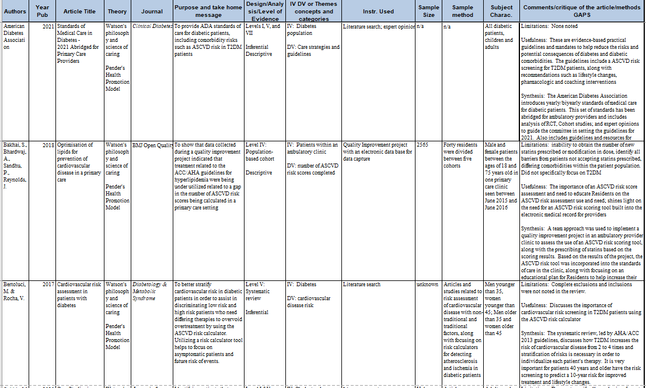
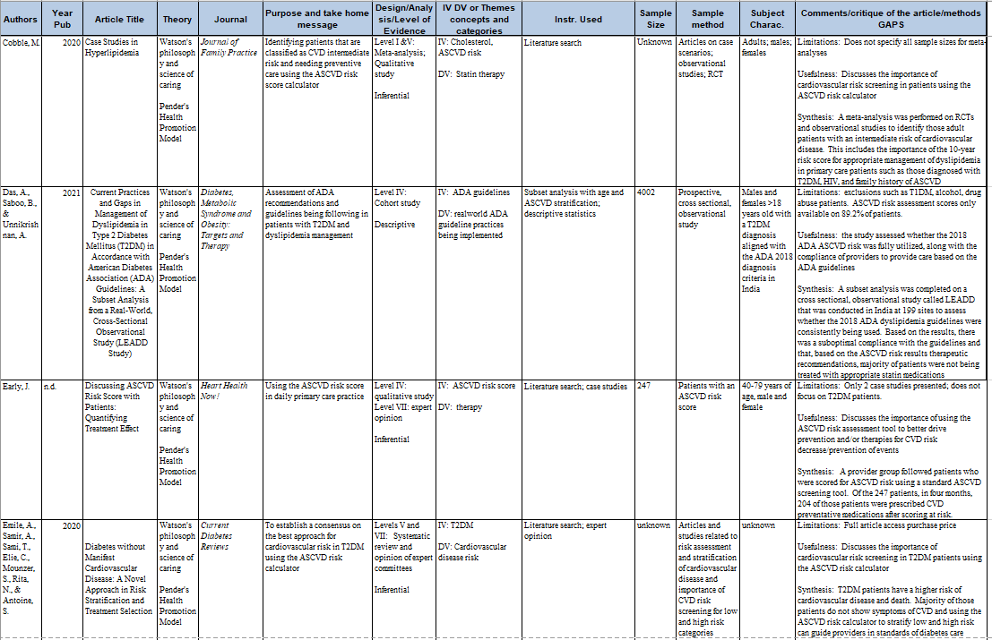
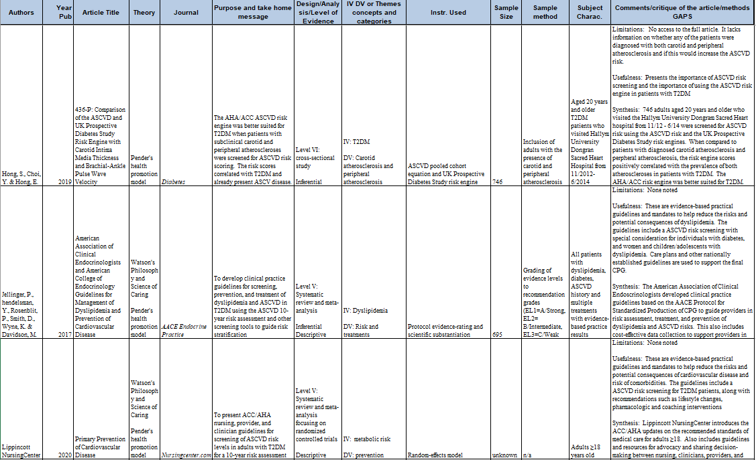
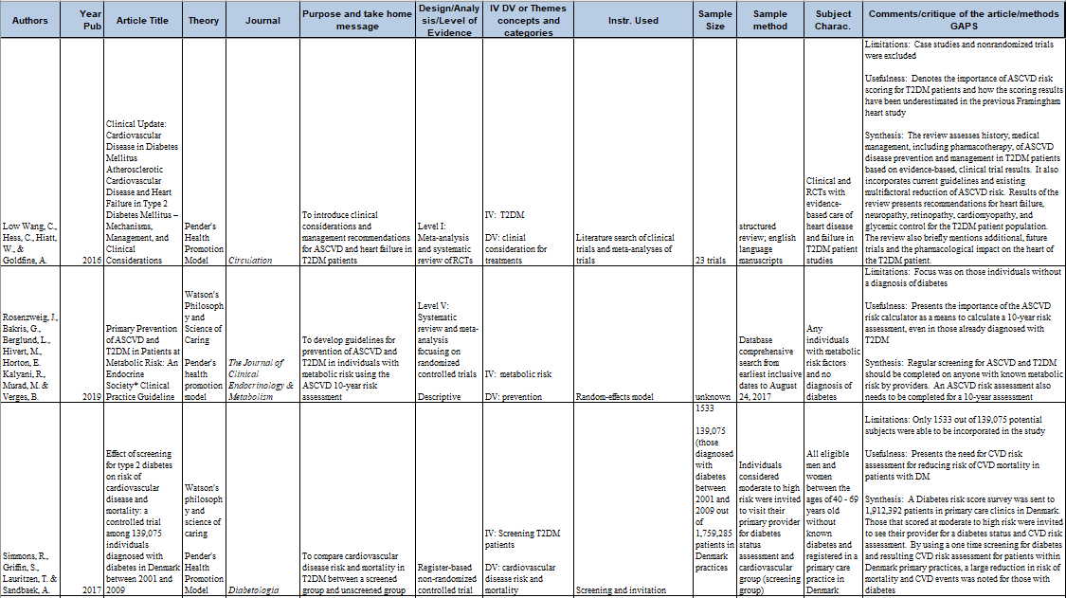
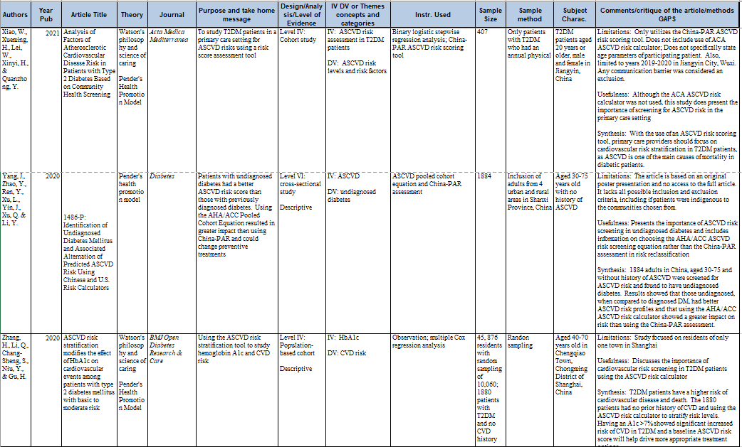

Appendix B
Collaborative Institutional Training Initiative (CITI Program) modules
as required by the project hospital system and/or ECU
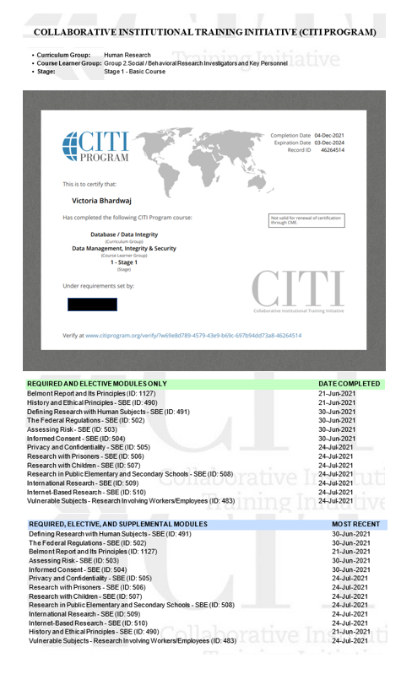
Appendix C
Hospital System Letter of Approval
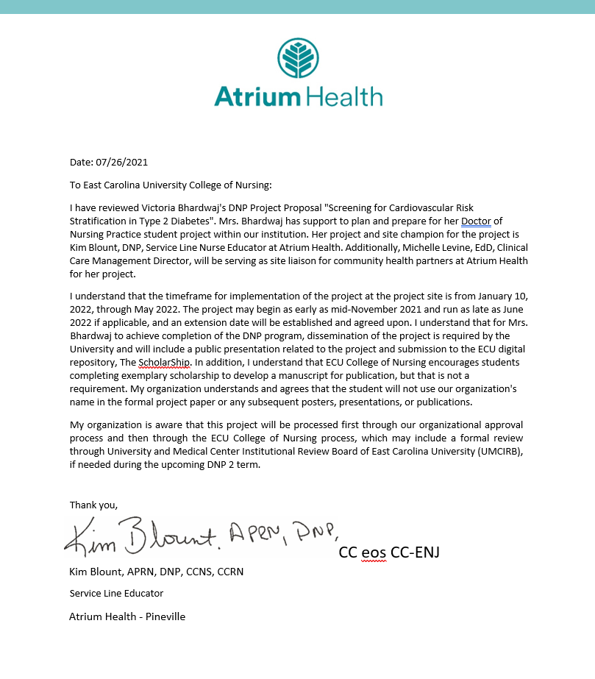

Appendix D
Hospital System Internal Review Board QI Form of Approval
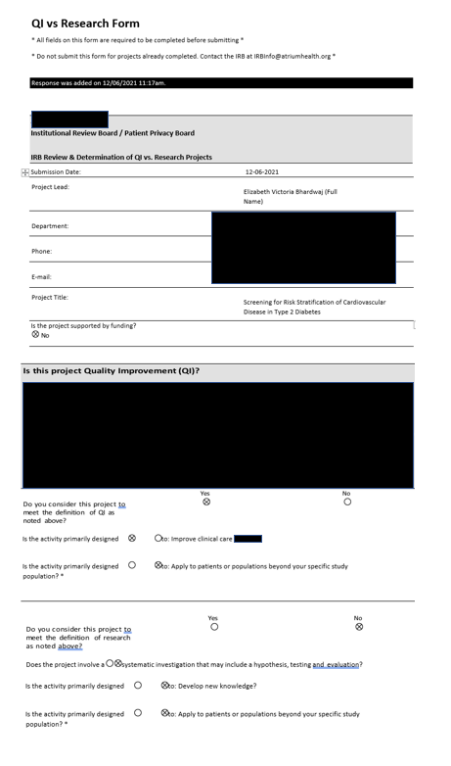
Appendix E
American Diabetes Association permissions
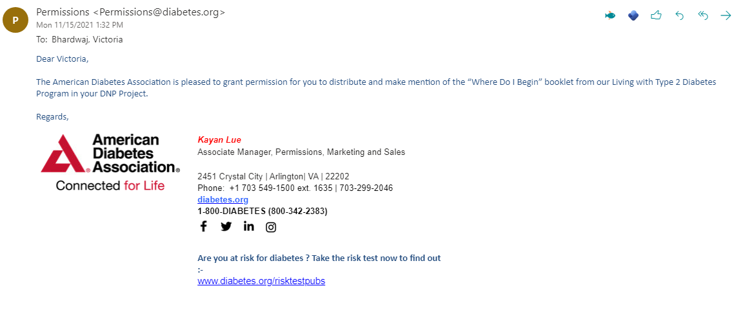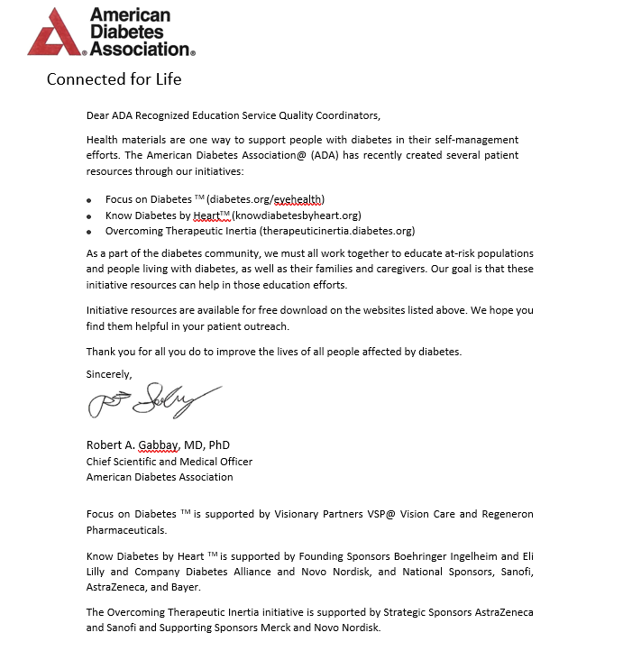
Appendix F
Project Management Strategy Form

FORM 8274.11
Project Management Strategy
Student’s Name Victoria Bhardwaj, MSN

Project Site Champion Dr. Kim Blount, DNP

Project Name Screening for Risk Stratification of Cardiovascular Disease in Type 2 Diabetes

What data will you be collecting?
Atherosclerotic cardiovascular disease (ASCVD) risk scores pulled into an adult type 2 diabetes mellitus (T2DM) patient clinic visit provider note seen in clinic during implementation time frame
Where will you get the data?
Manual chart audits of adult T2DM patients seen in clinic each week from IAS data pull reports
How often will you be at the project site?
Expected site visits will be 4 with phone calls, Teams meetings and email communications with the clinic manager and providers, based on current Covid surge and clinic bandwidth
How often will you meet with your site champion?
Weekly and as needed
What is the implementation methodology, theory, framework, etc. that you are using to guide you through the implementation phase of the project?
FADE (focus, analyze, develop, execute) model
______________________________________________________________________________
Why did you select this tool or method? Succinctly and thoroughly tell faculty why this seemed like the optimal tool/method.
The FADE model is based on four distinct steps for quality improvement (QI): Focus, which is defining the specific process improvement needed; Analyze by collecting data to create a baseline; Develop a plan of action that includes the implementation plan, along with monitoring and measuring success; Execute the improvement plan as a pilot program and continue to evaluate, monitor, and measure the success of the project (BHM Healthcare Solutions, n.d.; Josie King Foundation, n.d.). The FADE model appropriately guides the QI process with succinct, cyclic steps to help achieve the proposed, measurable outcome of increasing ASCVD risk stratification in T2DM. Each week, once the IAS data pull reports are published, I can easily compare the number of adult T2DM patients who were seen in clinic to the actual number of ASCVD risk scores for the patient population that were pulled into a provider note via manual chart audits. I can then quickly communicate with the site clinic via phone, email, Teams chat, or onsite visit to assess any barriers if the risk score numbers are low, evaluate what new processes the team feels may work better, and execute any changes.

What tools will you use to track implementation and data (SBAR, PDSA, Excel tracking form, etc)?
I will be using a Gantt Chart (see Appendix O) with FADE model phases and tasks (will add as implementation continues, and progress and processes are analyzed through measuring/monitoring).
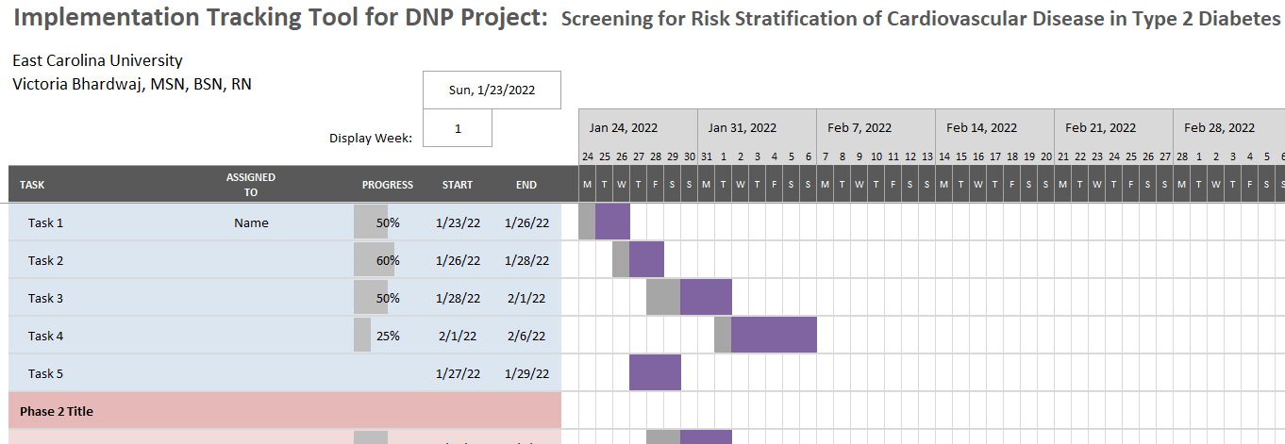 (Example only)
How will you communicate changes and project status to each member of your project team – academic and team members with the project site?
Changes and project status will be communicated to the team per the established timeline via onsite clinic visits, email, phone, or Teams meeting. For any urgent needs or issues, phone or email will be utilized. Updates as required or needed to ECU advisor Dr. Sherrod will be conducted via email with added request for phone communication when necessary. The Gantt chart will be shared with the clinic site team members and site champion via email for weekly updates on progress after the following week’s manual chart audit is completed.
Complete the following dates and map these on a timeline (Google “timeline” and construct your IMPLEMENTATION timeline using Word, PowerPoint, or Excel)
Date Implementation began or will begin on February 29, 2022
(See timeline in Appendix F)
Date for meeting with site champion to discuss your chosen tools and timeline is Monday, January 24, 2022
Discuss your plan(s) for meeting with the site champion (frequency, specific dates, phone vs face-to-face, etc). Be as specific as possible.
The plan to meet with my site champion to discuss and complete the project management reports is every Monday starting on January 24, 2022, each Monday during project implementation, and the final Monday after implementation is completed when the last IAS report is to be used for the final week’s manual chart audit. For needs outside of the scheduled meetings, email will be utilized for communication. Based on Covid surge causing Dr. Blount’s redeployment to bedside or barriers to meeting each Monday that may arise, meeting times/days will be moved to what we both are agreeable upon during that week. Microsoft Teams, email, or phone calls will be utilized depending upon the situation each week as well. Any face-to-face time will be on a situational basis and scheduled per Dr. Blount’s availability, again based on the ongoing Covid surge.

I have met with and discussed my tools and implementation plan with my site champion. We are in agreement to the tools, processes, and timeline.
Student Signature Victoria Bhardwaj, MSN Date 01/24/2022
Site Atrium Health / Primary Care Provider clinic
Site Champion Signature _____________________ Date __1/24/2022___
References
BHM Healthcare Solutions. (n.d.). The drive for healthcare quality and pay for performance. https://bhmpc.com/2014/01/drive-healthcare-quality-pay-performance/#:~:text=Duke%20University%20has%20developed%20a%20QI%20%28quality%20improvement%29,identify%20root%20causes%2C%20and%20point%20toward%20possible%20solutions
Josie King Foundation. (n.d.). FADE model in action. Patient safety – quality improvement. https://josieking.org/patientsafety/module_a/methods/fade_model_action.html

Appendix G
Project Timeline

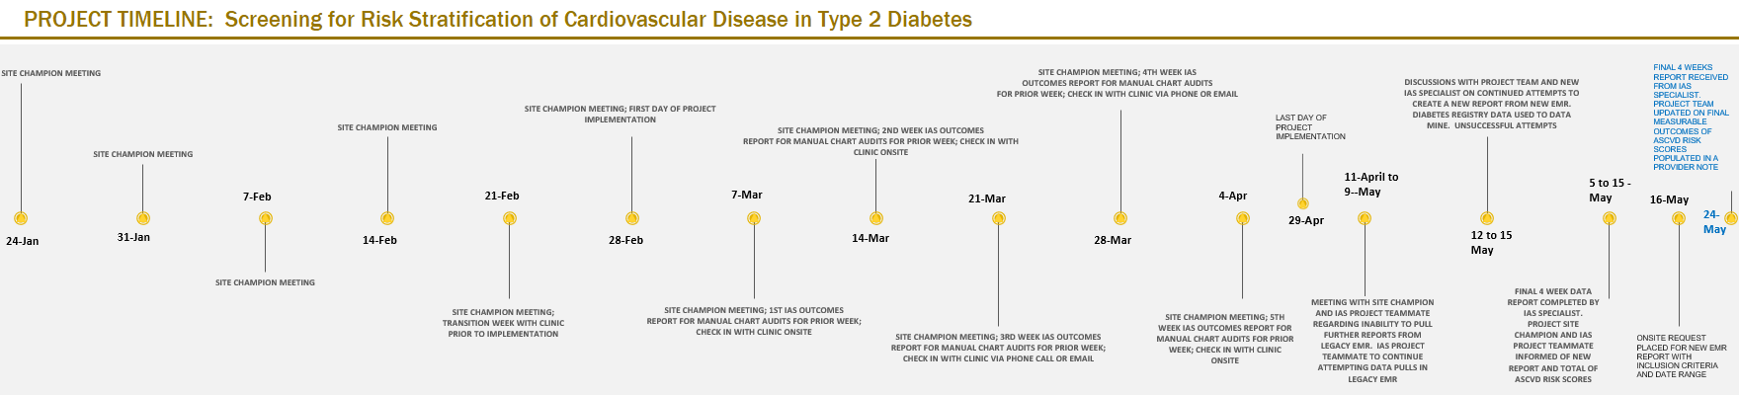

Appendix H
Gantt Chart Implementation Tracking Tool

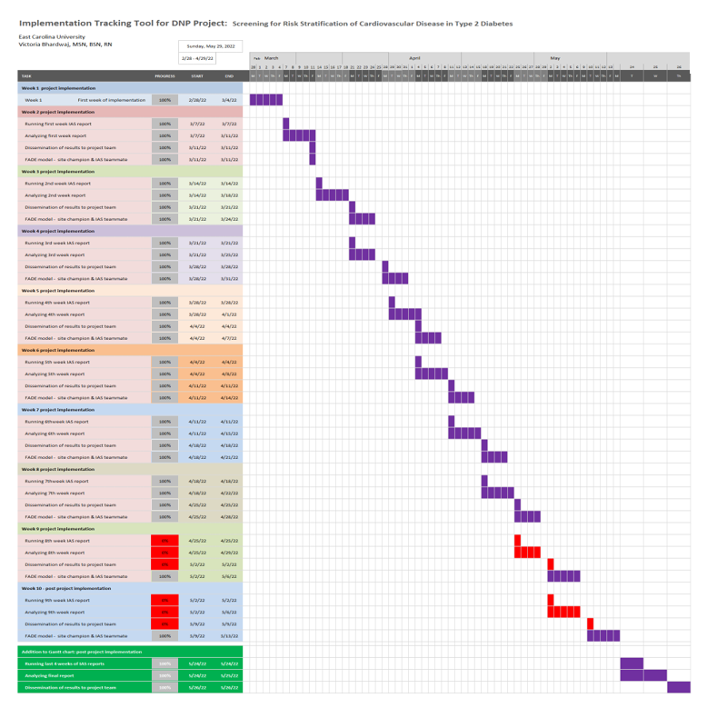

Appendix I
Project Management Report #1
FORM 8274.12
Project Management Report
Name Victoria Bhardwaj

Were you able to collect the data you thought you’d collect? Yes (based on test data pull of new report from one business week in January 2022)
If no, why not? Project implementation to begin 2/28/2022
Did you meet with your site champion on the date(s) you had planned to meet? Yes
If not, why not? ___________________________________________________________________________
Succinctly identify & discuss barriers to your implementation.
Did you update/revise your tools (PDSA, data collection tools, etc.)? Yes
If No, why not? ________________________________________________________________
______________________________________________________________________________
What date(s) were you at your project site during this implementation interval (face-to-face or virtually)? ______N/A
Succinctly identify 1-3 things you’ve learned during this implementation interval.
N/A
Statement of Collaboration
We have collaborated on the project process, needed revisions, and implementation strategies and agree that this project is on target with the timeline. As needed, provide additional comments on the following page.

Student Signature ____Victoria Bhardwaj, MSN Date __02/07/2022

Site Champion Signature ____________________________________ Date _______________

Comments
Please share addition thoughts/notes on progress, barriers, concerns, etc.

My thoughts are –
It remains unfortunate that the project implementation is still delayed due to Covid concerns verbalized previously by project site. However, the delay gave the IAS project team member time to create a much more detailed and comprehensive data pull report for weekly manual chart audits. Once implementation has begun, the project manager and IAS project team member will meet on a weekly basis to discuss data pull and outcomes, along with any possible barriers verbalized by project manager, site champion, and project site.

Appendix J
Project Management Report #2
FORM 8274.12
Project Management Report
Name Victoria Bhardwaj

Were you able to collect the data you thought you’d collect? N/A March 7 will be the first actual data pull report for manual chart audits
If no, why not? Project implementation to begin 2/28/2022
Did you meet with your site champion on the date(s) you had planned to meet? Yes
If not, why not? ___________________________________________________________________________
Succinctly identify & discuss barriers to your implementation.
N/A – This week is transition week prior to implementation. Complimentary AHA and ADA patient and provider handouts to be delivered to project site

Did you update/revise your tools (PDSA, data collection tools, etc.)? N/A
If No, why not? ________________________________________________________________
______________________________________________________________________________
What date(s) were you at your project site during this implementation interval (face-to-face or virtually)? N/A
Succinctly identify 1-3 things you’ve learned during this implementation interval.
N/A

Statement of Collaboration
We have collaborated on the project process, needed revisions, and implementation strategies and agree that this project is on target with the timeline. As needed, provide additional comments on the following page.

Student Signature ____Victoria Bhardwaj, MSN Date __02/21/2022
Site Champion Signature ______________ Date ____2/22/2022__

Comments
Please share addition thoughts/notes on progress, barriers, concerns, etc.

My thoughts are –
(It remains unfortunate that the project implementation is still delayed due to Covid concerns verbalized previously by project site. However, the delay gave the IAS project team member time to create a much more detailed and comprehensive data pull report for weekly manual chart audits. Once implementation has begun, the project manager and IAS project team member will meet on a weekly basis to discuss data pull and outcomes, along with any possible barriers verbalized by project manager, site champion, and project site.)
2/21/2022: IAS reporting is on track for target metric data pull report and awaiting completion of first week of implementation for the first completed report to begin collecting measurable outcomes data by project manager.

Appendix K
Project Management Report #3
FORM 8274.12
Project Management Report
Name Victoria Bhardwaj

Were you able to collect the data you thought you’d collect? N/A March 7 will be the first actual data pull report for manual chart audits
If no, why not? Project implementation begins today 2/28/2022
Did you meet with your site champion on the date(s) you had planned to meet? Yes
If not, why not? ___________________________________________________________________________
Succinctly identify & discuss barriers to your implementation.
This week is the beginning of the project implementation. AHA and AHA/ADA complimentary and approved patient handouts, along with provider decision cycles, were delivered to the site clinic on 2/25/2022. No barriers noted at this time, as all clinic providers are aware and prepared for implementation day #1

Did you update/revise your tools (PDSA, data collection tools, etc.)? N/A
If No, why not? ________________________________________________________________
______________________________________________________________________________
What date(s) were you at your project site during this implementation interval (face-to-face or virtually)? 2/25/2022 (Friday prior to implementation)
Succinctly identify 1-3 things you’ve learned during this implementation interval.
N/A
Statement of Collaboration
We have collaborated on the project process, needed revisions, and implementation strategies and agree that this project is on target with the timeline. As needed, provide additional comments on the following page.

Student Signature ____Victoria Bhardwaj, MSN Date __02/28/2022
Site Champion Signature Date __2/28/2022

Comments
Please share additional thoughts/notes on progress, barriers, concerns, etc.

My thoughts are –
(It remains unfortunate that the project implementation is still delayed due to Covid concerns verbalized previously by the project site. However, the delay gave the IAS project team member time to create a much more detailed and comprehensive data pull report for weekly manual chart audits. Once implementation has begun, the project manager and IAS project team member will meet on a weekly basis to discuss data pull and outcomes, along with any possible barriers verbalized by the project manager, site champion, and project site.)
2/21/2022: IAS reporting is on track for the target metric data pull report and awaiting completion of the first week of implementation for the first completed report to begin collecting measurable outcomes data by the project manager.
2/28/2022: Today is day 1 of the project implementation. Lunch has been provided for the clinic, and no barriers are noted at this time. The first day of the FADE model assessment will be via a project team email to the clinic project staff, IAS, and site champion on Friday, 3/4/2022, to ask about any barriers, issues, or concerns, and will be revisited the following Friday after manual chart audits of week one are completed.

Appendix L
Project Management Report #4
FORM 8274.12 #4
Project Management Report
Name Victoria Bhardwaj, MSN, BSN, RN

Were you able to collect the data you thought you’d collect? Yes. March 7 was the first actual data pull report for manual chart audits
If no, why not? n/a

Did you meet with your site champion on the date(s) you had planned to meet? Yes
If not, why not? ___________________________________________________________________________
Succinctly identify & discuss barriers to your implementation.
Barriers noted were the inability to filter T2DM, T1DM, and patients associated with the diabetes registry based on lipid panel results or prediabetes. Manual chart audits were able to filter for the correct patient population. The providers were unable to use the auto text feature to pull in an ASCVD risk score into some of their visit notes. There was some initial implementation push back by a few of the residents at the project site and they did not participate in the first two weeks of implementation.

Did you update/revise your tools (PDSA, data collection tools, etc.)? The FADE model was utilized to deep dive into why ASCVD risk scores were not always able to be auto populated into a provider note. After investigation, it was noted that the smart template created by IAS would only allow a provider to use the auto text feature appropriately if done within the same encounter the lipid panel resulted (such as a clinic visit a month prior, or an encounter created for the lab draw). The FADE model was appropriate for the project and no updates or revisions needed, as the processes within the model helped to identify the barriers. After a Microsoft Teams meeting with the project site providers and a hospital facility provider leader, IAS was able to identify the cause and
If No, why not? ________________________________________________________________
______________________________________________________________________________
What date(s) were you at your project site during this implementation interval (face-to-face or virtually)? 3/25/2022 virtual meeting
Succinctly identify 1-3 things you’ve learned during this implementation interval.
- There will more than likely be barriers that are either unknown initially or new barriers that arise during implementation. Succinct and quick communication with the project team will assist in identifying causes of the barriers, as well as quickly lead to corrective actions.
- Buy-in may seem to happen prior to the project, but upon initial implementation, it may not remain. Having streamlined communication and perseverance by the project manager can assist in redirecting push back and re-engage the project team
- Open communication, thankfulness, and utilizing an interdisciplinary type of approach consistently will help drive project team members to remain engaged and feel pride in the process and project itself.
Statement of Collaboration
We have collaborated on the project process, needed revisions, and implementation strategies and agree that this project is on target with the timeline. As needed, provide additional comments on the following page.

Student Signature ____Victoria Bhardwaj, MSN Date __03/28/2022
Site Champion Signature Date __03/28/2022

Comments
Please share additional thoughts/notes on progress, barriers, concerns, etc.

My thoughts are –
(It remains unfortunate that the project implementation is still delayed due to Covid concerns verbalized previously by the project site. However, the delay gave the IAS project team member time to create a much more detailed and comprehensive data pull report for weekly manual chart audits. Once implementation has begun, the project manager and IAS project team member will meet on a weekly basis to discuss data pull and outcomes, along with any possible barriers verbalized by the project manager, site champion, and project site.)
2/21/2022: IAS reporting is on track for the target metric data pull report and awaiting completion of the first week of implementation for the first completed report to begin collecting measurable outcomes data by the project manager.
2/28/2022: Today is day 1 of the project implementation. Lunch has been provided for the clinic, and no barriers are noted at this time. The first day of the FADE model assessment will be via a project team email to the clinic project staff, IAS, and site champion on Friday, 3/4/2022, to ask about any barriers, issues, or concerns, and will be revisited the following Friday after manual chart audits of week one are completed.
03/28/2022: The most recent Microsoft Teams meeting was extremely productive and buy-in by the site providers was much improved. The IAS team members were quickly involved in corrective action for a noted barrier, and these seemed to bring much more cohesiveness to the project team

Appendix M
Project Implementation Summary Report
FORM 8274.13
DNP Project Implementation Summary Report

- Did your project go as you felt it would during your Initial Project Implementation Plan? If so, what do you feel contributed to your “smooth sailing”? Did you have any problems along the way? If not, what were the barriers to implementing your project as you had anticipated? In retrospect, what would you have done differently?
The implementation plan presented in the Project Management Strategy form did not go as planned. The implementation start date was delayed due to a Covid-19 cluster in the clinic. Still, the delay gave the project information and analytics services (IAS) teammate time to create a more detailed and comprehensive data pull for the weekly manual chart audits. Four onsite clinic visits were initially planned, but only three were completed. Weekly emails and needed Teams meetings were utilized as expected.
Once implementation began, the weekly IAS reports were presented to the project manager every Monday morning, giving the project manager the week to complete detailed, manual chart audits of up to 120 patients weekly. Unfortunate barriers were the limitations of the atherosclerotic cardiovascular disease (ASCVD) risk score tool based on how the electronic medical record’s (EMR) smart template was created. A lipid panel had to have resulted within six months or no ASCVD risk score would populate. Another barrier noted by the team was the inability to pull in a risk score when a lipid panel had resulted within six months. After an emergency communication via Microsoft Teams using the FADE model with the project team and IAS staff, it was noted that the ASCVD risk score tool had to be utilized within the same EMR encounter that the lipid panel had resulted. Once this was reported, IAS was quickly involved in corrective action, and the ASCVD risk score could be pulled into a provider note within any encounter.
Another noted barrier was the eventual go-live to a new EMR from the legacy EMR approximately five weeks into the project. The subject matter expert (SME) provider project team member stepped up per the request of the project manager to support the site providers in utilizing a new smart phrase within a new EMR provider note, and providers were able to pull in ASCVD risk scores. Unfortunately, out of the four providers on the project team, two presented push-back by not utilizing the risk score tool at all. Fortunately, improved buy-in and measurable outcome data points were provided by the other two providers related to the emergency Microsoft Teams meeting.
In retrospect, I would have engaged more hospital system leaders in supporting the project to increase the use of the ASCVD risk score tool, as it was not mandatory related to the project. I would have also discussed the risk score tool with multiple IAS teammates to understand the implications and limitations better. However, the IAS team was not aware of the barriers and issues found during the project implementation until revealed by the project team.
- Complete the following information:
  - How often did you meet virtually with your project champion?
I met with the project champion at least once weekly. Multiple additions to an ongoing email thread and phone calls were also utilized. This number should increase as the project remains ongoing until April 29.
  - How often did you meet face-to-face with your project champion?
I met with the project champion face-to-face approximately five times, and this number should increase as the project remains ongoing until April 29.
  - What was the total number of meetings you had with your champion?
The total number of meetings thus far in the project has been 14, not including phone calls and an ongoing email thread. This number should increase as the project remains ongoing until April 29
  - Did you meet with other people at the project site? If so, what were their roles in your project?
I did not meet with other people/staff at the project site. The ancillary and clinical staff outside of the project team were alerted and educated in November 2021 via recorded initial Teams meeting and email communication by the project site clinic manager. Still, they were not included during implementation per the request of the clinic manager related to ongoing Covid-19 barriers and time constraints of staffing.
- Does the organization plan to continue your project past this semester?
The organization does have an informal plan to continue the project past this semester and end of project implementation on April 29. The SME provider supports the eventual mandatory status of an ASCVD risk score calculated on adult T2DM patients and any patient aged 40-75. Also, participation in the American Heart Association (AHA) and American Diabetes Association’s (ADA) Know Diabetes by Heart program coincides with the already established AHA’s Get with the Guidelines program. The hospital system is currently gold certified.
- Discuss, in detail, organizational changes that will be needed to continue the project past this semester?
Organizational executive leadership will need to discuss and approve a mandatory ASCVD risk score result on all patients, ambulatory, outpatient, and inpatient 40-75 years of age, emphasizing adult T2DM patients and their increased risk of cardiovascular disease. Adding the Know Diabetes by Heart program will need the initial vetting of leadership already involved in the Get with the Guidelines program. A project advisor/leader is already aware of the goal set by the project team, and communication and discussions will need to be in place and are planned for the late summer of 2022.
- Who benefitted from your project (patients, organizations, etc), and how were they benefitted?
I believe one of the most significant benefits was initially for the providers, as they were unaware of the existing ASCVD risk score tool within the legacy EMR. Also, increased awareness of the need for cardiovascular screening in adult T2DM was considered a benefit. For the patients who had an ASCVD risk score populated, the providers were able to discuss the risk score implications and need for either lifestyle changes or medication changes/additions with the patients. I believe this greatly benefitted the patients through awareness of the risks and improving their healthcare self-management. By bringing awareness of ASCVD risk for adult T2DM patients, the organization benefitted by reigniting cardiovascular provider leaders in a project initiated over three years ago when the ASCVD risk score tool was embedded in the legacy EMR. The tool may have been forgotten based on other tools available such as manual calculations, and Covid-19 changing the healthcare landscape for the past two years. Making the organization aware of the evidence-based support need for ASCVD risk scores benefitted it financially, as IAS build time for the tool seemed to have become a lost expense instead of a positive financial decision. Once the ASCVD risk score tool was re-presented, other providers became cognizant of it and began utilizing the tool. The ASCVD risk score calculator is currently embedded in the new EMR and was included in the original EMR build cost.
- Recommendations for other organizations who replicate this project
My recommendations would include a deep dive into the IAS EMR tool build. If not already embedded in their EMR, discussions for cost and build time implications would need to be at the forefront and acknowledge all possible stakeholders. Adopting the Know Diabetes by Heart program early on and utilizing the free tools, educational materials, and guidelines across the organization, especially if multiple facilities are included, will more easily guide nursing and organizational leadership to a smoother project implementation with fewer barriers. Another strong recommendation would be to include site clinic providers in early conversations with the project team and organizational leaders to improve buy-in. A soft, mandatory risk score would also improve the number of measurable outcome data points. Ongoing communication and the ability to pivot quickly when barriers or issues arise must be a quality the project manager needs to possess to decrease any siloed effects among the project team members. Another quality to also include is the ability of the project manager and team members to utilize constructive criticism as learning experiences for improved, quicker, corrective actions and increased success of the project. One last recommendation for other organizations would be to look closely at the barriers and resulting corrections, as these can be important items to communicate with organizational leadership. Many barriers can remain unnoticed and overlooked by the system, and awareness enterprise-wide may result in improved employee and patient satisfaction, along with improved patient outcomes.

Appendix N
Driver Diagram

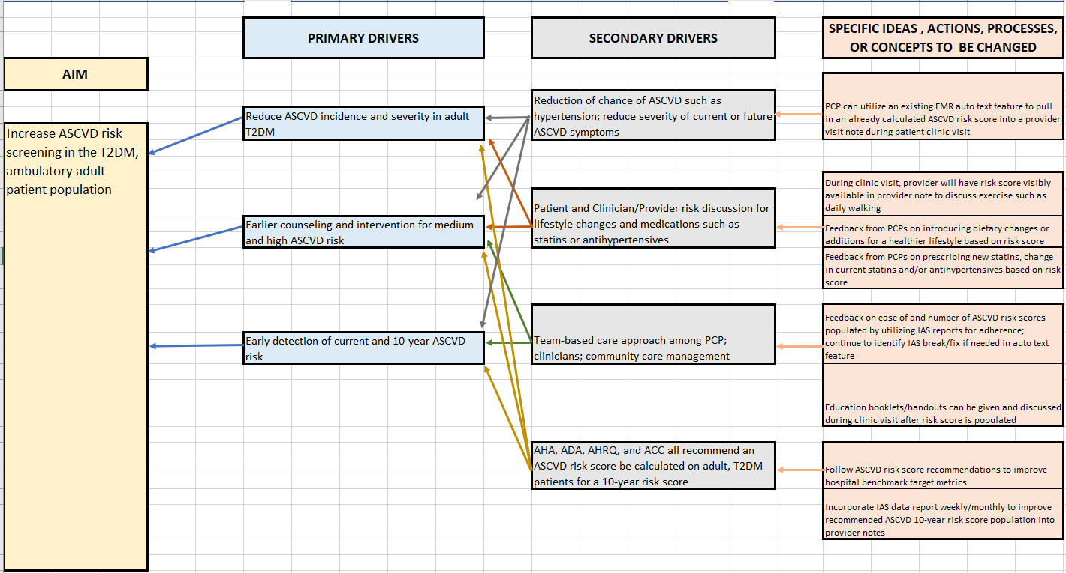

Appendix O
DNP Project Poster

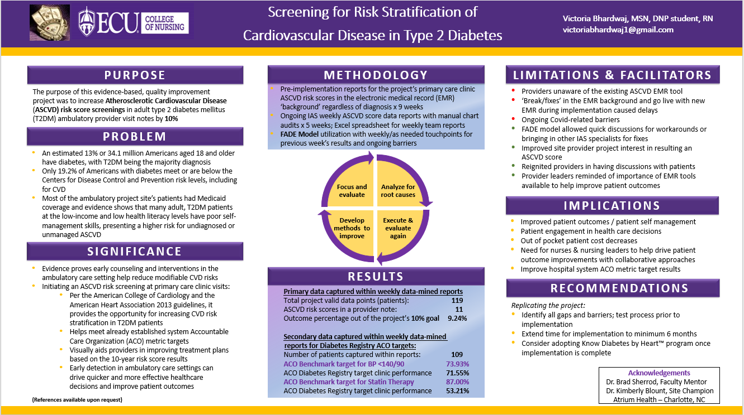

Table 1
Final Diabetes Registry Data for Provider Awareness

Table 2
Project Budget

Table 3
AACN DNP Essentials Table

Note. From Master ECU DNP project log revised Fall 2020, AACN DNP Essentials,
East Carolina University, 2020, Tab 5.

