Parental Response to Breeding Pool Water Level Change in Ranitomeya imitator
By
Michael Reynolds
July 2024

Director of Thesis: Kyle Summers
Major Department: Biology

ABSTRACT
For parental care behavior to be effective in providing benefit to offspring requires the accurate fulfillment of offspring needs. Environmental changes alter the stressors placed on offspring, and parental care must change to meet these altered needs. Parental care plasticity has been observed previously in amphibians, notably in males of the glass frog Hyalinobatrachium fleischmanni, which alter the lengths of time spent brooding eggs depending on ambient humidity and egg hydration levels. Dendrobatid frogs often lay their eggs terrestrially and transport tadpoles to adequate aquatic habitats. Previous research has shown that parental investment in offspring care tends to increase with smaller breeding pools. Among dendrobatids, the mimic poison dart frog Ranitomeya imitator is well known for raising its young in small phytotelmata, and for its unique reproductive system of monogamous biparental care of eggs and tadpoles. The pools R. imitator raise their offspring in are ephemeral and small in volume, making them vulnerable to desiccation. Although R. imitator provide trophic eggs as food for tadpoles, there is no evidence that they provide water to tadpoles.
To examine the behavioral responses of adults and the physiological responses of tadpoles of Ranitomeya imitator to water level changes in the breeding pool, we exposed 10 breeding pairs of frogs to three different treatment levels of water level change. Over the course of biweekly water changes, the fast treatment experienced a 5 ml water level decrease per week, the slow treatment decrease experienced a 2.5 ml water level decrease per week, and the control experienced no water level decrease. Adults were recorded attending to their tadpoles in artificial breeding pools, and the proportion of time each pair spent on different parental care behaviors was compared between groups. Soon after metamorphosis, metamorphs were weighed and measured. Parental care behaviors did not significantly differ in proportion between water level treatment groups. Significant differences were found between treatment groups in tadpole snout-vent length, weight in grams, and larval stage duration. The most significant differences between treatment groups were found between the fast and control treatment groups.
These results suggest that when exposed to rapidly decreasing water levels R. imitator tadpoles are selected to optimize the tradeoff between body mass and larval stage duration. Plasticity in growth exhibited in tadpoles may be an adaptation to the ephemerality of the phytotelm environment, enabling tadpoles to escape from the aquatic environment more quickly. Future research into this system should examine the impacts of the tradeoff between body mass and larval stage duration on post-metamorphosis life history. Such research could have implications for the persistence of this species and other dendrobatid frogs under climate change.

Parental Response to Breeding Pool Water Level Change in Ranitomeya imitator
A Thesis
Presented to the Faculty of the Department of Biology
East Carolina University
In Partial Fulfillment of the Requirements for the Degree
Master of Science in Biology
By
Michael Reynolds
July 2024
Director of Thesis: Kyle Summers, Ph.D.
Thesis Committee Members:
Susan McRae, Ph.D.
Jeffrey McKinnon, Ph.D.

© Michael Reynolds, 2024

TABLE OF CONTENTS
Title i
List of Tables iv
List of Figures v
Introduction 1
Methods 10
Recordings of Parental Behavior 10
Impact on Tadpoles 13
Statistical Analyses 13
Results 15
Time of Recordings 15
Parental Care Behaviors 15
Tadpole and Metamorph Dimensions 19
Discussion 24
References 31
Appendix: IACUC Animal Use Permissions 36

LIST OF TABLES
1. Means and Standard Deviations of Time Spent Engaged in Parental Care Behaviors 16
2. Linear Mixed Model Results for Tadpole Mass 19
3. Linear Mixed Model Results for Tadpole SVL 19
4. Linear Mixed Model Results for Larval Duration 20
5. Means and Standard Deviations of Metamorph Characteristics 20
6. Correlation Matrix of Treatment Level and Tadpole Characteristics 23

LIST OF FIGURES
1. Illustration of Location of Artificial Breeding Pools within Terraria 11
2. Proportion of Time Frogs Spent Contacting the Breeding Tube 17
3. Proportion of Time Frogs Spent Inside of the Breeding Tube 17
4. Proportion of Time Frogs Soaking in the Breeding Tube 18
5. Proportion of Time Pairs Spent Contacting the Breeding Tube 18
6. Tadpole Snout Vent Length 21
7. Tadpole Mass 21
8. Tadpole Larval Stage Duration 22

INTRODUCTION
Parental care is widespread throughout the animal kingdom and can be found in clades as disparate as passerine birds, teleost fishes, and vespid wasps. The amount of care that an animal provides to its offspring is an adaptation to help the offspring successfully pass a vulnerable life stage and survive in its environment. Parental care can take many forms, including protection from predators, shelter from environmental stressors, and the provisioning of offspring with food (Schulte et al., 2020)s. This care is often costly in terms of resources, effort, and time, and may be detrimental to the parent’s individual longevity and condition (Santos & Nakagawa, 2012; Steinhart et al., 2005; Zink, 2003). This costly investment is not without reward though, as it can bring significant benefits to offspring health and fitness. Parental care behaviors protect offspring from various sources of mortality, including predators, competitors, disease, and starvation, increasing offspring survival (Klug & Bonsall, 2014; Martins et al., 1998; Zink, 2003). Parental care can lead to improvements in offspring quality, such as increased body mass, decreased parasite load, and improved immune function (Eggert et al., 1998; Pryke & Griffith, 2010; Schürch & Taborsky, 2005). Parental care can also increase the developmental rate of offspring, limiting the time that offspring spend in dangerous developmental stages (Klug & Bonsall, 2014; Pryke & Griffith, 2010; Smiseth et al., 2003). The success of parental care in improving offspring survival is dependent on the ability of the provided resources to meet offspring needs. If the environment changes in such a way that offspring needs are intensified, then the usual amount of parental care will be insufficient to provide for the offspring. In an altered environment, parents may change the amount of care in response to maintain the desired benefits to offspring survival (Barbasch et al., 2020). This alteration of parental care to meet changes in offspring need is an example of behavioral plasticity.
Behavioral plasticity in parental care has been observed in many animal groups, including amphibians (Ringler et al., 2013). Males of the glass frog Hyalinobatrachium fleischmanni are known to brood terrestrial egg clutches, guarding them and providing the developing embryos with water. It has been found that the frogs will adjust the frequency of parental care to compensate for environmental variation, provisioning egg masses with more water in dry conditions that threaten embryos with dehydration (Delia et al., 2013). Parental care in amphibians often takes the form of nest site choice, egg guarding, and egg attendance (Schulte et al., 2020). Once the young emerge, they are usually left to their own devices. Dendrobatids are among those frogs that provide care for their larvae, with the males of many species attending the eggs and transporting newly-hatched tadpoles to adequate aquatic habitats (Schulte et al., 2020). Tadpole transport is widespread in this clade, and may provide benefits in allowing frogs to be more precise in choosing the aquatic habitats their tadpoles will develop in. Tadpole transport also allows dendrobatids to take advantage of ephemeral water bodies like pools in the axils of leaves and tree hollows, avoiding the high rates of competition and predation found in more permanent bodies of water (Mckeon and Summers, 2004). The adaptive significance of parental care behavior in dendrobatids becomes more evident when considering the volume of the environments chosen for tadpole development. Large breeding pools, while too small and ephemeral for fish to inhabit, are stocked with numerous species of insect larvae, crustaceans, and tadpoles. These environments are rich in nutrients, but highly competitive. Dendrobatids that deposit their young in these pools, like Ranitomeya variabilis, provide no further care for their offspring. The temporary pools formed in the leaf axils and hollows of plants, known as phytotelmata, tend to be small and ephemeral environments. As phytotelmata become smaller in volume, the aquatic habitat becomes poorer in nutrients and can support less biodiversity. Frogs that raise their tadpoles in these conditions cannot simply deposit their larvae and leave, as the tadpole would starve to death (Brown et al., 2010). Successful rearing of offspring in smaller phytotelmata requires the provisioning of food in the form of trophic eggs laid by the female. This form of parental care is an adaptation seen in dendrobatids that specialize in the resource-poor but comparatively competition-free environments to be found in small phytotelmata (Brown et al., 2008). The mimic poison dart frog Ranitomeya imitator raises its young in extremely small bodies of water and has appropriately high levels of parental investment in its offspring’s care. This frog is famous for its social and genetic monogamy, and for the dedicated biparental care that it provides to its young (Brown et al., 2010; Schulte et al., 2020).
Although biparental care had been observed in this species in captivity, it was only in 2008 that the parental care behavior of wild R. imitator was documented in detail. Ranitomeya imitator are small frogs, with males averaging at 17.4 ± 1.2 millimeters and females being around 18.2 ± 1.1 millimeters in total body length (Brown et al., 2008). This species is common in secondary and old-growth forests in Peru. These forests make for excellent R. imitator habitat because older forests are more abundant in the phytotelmata necessary for their reproduction. Reproduction in these frogs is monogamous, and a breeding pair will spend the season together raising and caring for their tadpoles (Brown et al., 2008). Like many tropical frogs, R. imitator lay their eggs in the terrestrial environment. This adaptation has appeared independently several times, and is thought to mitigate the danger to the egg clutch from aquatic predators and lack of oxygen (Delia et al., 2013). Ranitomeya imitator lay their fertilized eggs in thick foliage or leaf litter, and exhibit biparental brooding behavior. Both sexes brood the egg clutches, and spend approximately equal proportions of time guarding the developing embryos (Schulte & Summers, 2021). The parents are attentive to the clutches, sitting atop the eggs, guarding them from predators, and urinating over them to provide them with water (Schulte & Summers, 2021). Once the tadpoles are ready to hatch the male will assist in the hatching process, opening the egg sac using his back legs. Tadpoles are guided from the egg sac onto the parent’s back and usually transported singly. Tadpole transport is most often carried out by the male in this species, although females have been observed performing this task on occasion (Tumulty et al., 2014). Offspring are deposited into phytotelmata and raised individually in pools to avoid intraspecific competition. Ranitomeya imitator prefer to raise their young in small phytotelmata that average 24 milliliters in total volume (Brown et al., 2008). These pools offer little nutrition in the form of algal growth, detritus, or insect larvae. Without parental attendance and the provisioning of trophic eggs by the female, the tadpole would face starvation (Brown et al., 2010). In Ranitomeya imitator, parental provisioning is partitioned into roles, with the male traveling between nursery pools and monitoring tadpoles. Hungry tadpoles will beg for food by swimming at the water’s surface and wiggling vigorously. Males will emit calls and lead the female to the hungry tadpoles, continuing to vocalize as the female enters the nursery pools and releases an unfertilized trophic egg for the tadpole to eat (Tumulty et al., 2014). Females focus on the production of eggs, spending much of the time foraging for food. Female R. imitator often rely on their partners to monitor the needs of the offspring. Without the male’s encouragement, the female feeds tadpoles less frequently and may even neglect the offspring altogether. Previous research has demonstrated significant reduction in reproductive success when males were removed after tadpole deposition, establishing the importance of the male in coordinating feeding events (Tumulty et al., 2014). Investment from both parents is required for successful reproduction, and R. imitator exhibits both social and genetic monogamy (Brown et al., 2010). The evolution of the utilization of small phytotelmata as nurseries, increased parental care, and parental roles is closely linked in dendrobatids, and reaches its extreme in R. imitator (Brown et al., 2010).
In addition to provisioning behavior, parental R. imitator care for their offspring by protecting them from competitors. Adult frogs have well defined home ranges, and they defend these from conspecifics through territorial calls (Brown et al., 2009). Males territoriality is well documented, while female territorial disputes have been documented in captivity (Brown et al., 2009). In such cases, frogs will defend their home ranges from conspecific frogs of the same sex, calling and wrestling to drive away intruders. Territorial behavior has also been documented towards heterospecific frogs, specifically Ranitomeya variabilis (Brown et al., 2009). Ranitomeya imitator tadpoles are poor competitors when compared with R. variabilis tadpoles. In experimental trials where R. variabilis and R. imitator tadpoles are deposited in the same pool, the R. variabilis tadpoles attacked and ate the R. imitator tadpoles the overwhelming majority of the time (Brown et al., 2008). Considering the cannibalistic nature of dendrobatid tadpoles and the low-nutrient environments that R. imitator tadpoles develop in, this territoriality benefits offspring survival by preventing the introduction of a competitor’s tadpoles to a pair’s occupied nursery pools. The parents will guard and feed their young until it achieves metamorphosis into a froglet and climbs out of the phytotelma (Brown et al., 2008). In my research, I found the development period for an R. imitator tadpole in constant water conditions to take an average of 58.6 ± 3.76 days. However, considering that this species will continue to breed and raise offspring until the dry season begins, the breeding season is surely a busy time for these frogs (Brown et al., 2008)! Ranitomeya imitator thus provides its young with advanced care, even compared to closely related species, and can raise its offspring in a microhabitat that is relatively free of dangerous competitors and predators. However, the offspring are not safe from every danger.
Because Ranitomeya imitator breeds in the small bodies of water found in phytotelmata, its nurseries are at a greater risk of desiccation than larger bodies of water would be. Many organisms that use phytotelmata, like ostracods, mosquitos, and copepods, are adapted to make use of ephemeral water bodies, with strategies for traveling between phytotelmata before they dry up or spending the dry season as dormant eggs (Lopez & Rios, 2001). Phytotelmata may dry up during an extended period without rain, or run dry as the wet season comes to an end. These dry spells have the potential to become more common in the future, as global climate change alters the patterns of rainfall (Zevallos & Lavado-Casimiro, 2022). An effective behavioral response to environmental change requires accurate assessment of the environment. Previous studies on the bamboo internode breeding frog Ranitomeya biolat found that adults were aware of the volume of water contained in bamboo tubes when depositing their tadpoles. Bamboo nodes containing larger volumes of water were favored while those containing smaller water volumes were avoided (von May et al., 2009). Breeding pool choice studies with Ranitomeya imitator have shown parental preference towards small pool sizes over larger bodies of water (Brown et al., 2008). This genus is discerning when it comes to gauging volumes of water in potential breeding sites, and this ability may come into play when water levels run low in pools containing older tadpoles. While R. imitator are known to provision their eggs with water in the form of dilute urine, there is no current evidence that parental R.imitator supply water to their tadpoles (Schulte & Summers, 2021). Parents may not be able to respond to the risk of desiccation by providing their young with water, but they may be able to respond to this threat by providing young with food. Frogs, and amphibians in general, are well known for being developmentally plastic (Lent & Babbitt, 2020; Mogali et al., 2016; Petrović et al., 2021). This plasticity means that many species exhibit the ability to shorten or lengthen the larval stage in response to resource availability and environmental conditions. Experiments have shown that when exposed to drying water conditions, stream-breeding bronze frogs (Hylarana temporalis) can shorten their 80-day larval stage by nearly 10 days (Mogali et al., 2016). This alteration of the developmental process is stressful for the tadpole however, and taxing on the body’s resources (Gomez-Mestre et al., 2013). Parental R. imitator would be able to provide these necessary resources to their young by depositing more trophic eggs for them to feed on during this difficult developmental period. Ranitomeya imitator tadpoles exhibit significant plasticity in growth when provided with increased quantities of food, suggesting that tadpoles make effective use of additional food resources provided to them (Brooks et al., 2023). However, this response requires the parents to be able to recognize the risk of desiccation that their tadpole faces, the associated increased need for food, and to change the frequency of their parental care behaviors accordingly.
In addition to the parental rescue of distressed tadpoles through increased egg feeding to support accelerated tadpole development, tadpole transport provides another avenue by which larvae could escape an unsuitable aquatic environment. Tadpole transport is common in dendrobatids, but this usually takes the form of transportation of newly hatched tadpoles from the clutch site to the aquatic larval habitat. Little literature exists describing the transport of older tadpoles, and tadpoles observed being carried by adult frogs in the wild tend to be newly hatched offspring (Pašukonis et al., 2019; Ringler et al., 2013) In a study by Schulte and Mayer (2017), tadpoles of the poison frog Ranitomeya variabilis were found to seek parental escape if deposited in a pool with their cannibalistic siblings, attempting to climb onto the back of adults that entered the pool. Ranitomeya variabilis have also been observed to carry post-deposition tadpoles in field observations (Brown et al., 2008). This behavior from another Ranitomeya species suggests that the transport of tadpoles post-deposition is possible in R. imitator. If R. imitator adults continue to carry tadpoles of later developmental stages, then they may be able to transport tadpoles from phytotelmata at risk of desiccation to more stable water bodies nearby. This strategy would require that the parent recognizes the risk to the tadpole, that the tadpole is small enough to be transported by the parent, and that a suitable deposition site is nearby.
For my thesis I have studied how plastic, or adaptable, the biparental care behavior of Ranitomeya imitator is regarding water level decrease in tadpole nursery pools. I recorded the behavior of captive pairs of R.imitator as they cared for tadpoles subjected to varying rates of water level decrease. I watched video recordings of the frogs’ behavior, taking note of how often and for how long parental frogs attended to their tadpoles. I then used statistical methods including linear mixed models to compare the time pairs spent caring for their young when exposed to different levels of tadpole water scarcity. I also recorded the weight, size, and body length of tadpoles at birth and upon metamorphosis, as well as the duration of the larval period. Lastly, at Gosner stage 44-45 tadpoles were euthanized and preserved in ethanol for morphometric measurements (Gosner, 1960). Through these methods I tested the hypothesis that decreasing breeding pool water levels would result in an increased frequency of parental care behaviors, with the intensity of parental care increasing the more rapidly water level decreases. I also tested the hypothesis that tadpoles that are exposed to more rapidly decreasing water levels will achieve metamorphosis more quickly than conspecifics in more stable environments, and whether this involves tradeoffs in body size at metamorphosis. With this study we can gain insight into whether Ranitomeya imitator change their parental care behavior in response to water level decrease, and the consequences of water level decrease on tadpole development. This knowledge will help us to better understand the flexibility of the biparental care behavior in this unique species of frog, and to better respond to the risks that these amphibians may face as droughts become more frequent under climate change.

METHODS
Recordings of Parental Behavior
The Ranitomeya imitator used in this experiment were sourced from a captive colony at East Carolina University. The frogs in this colony descend from captive bred individuals of several color morphs originally provided by Understory Enterprises (Canada). Breeding pairs were housed in 5-gallon tanks, with each terrarium containing a male and female. Breeding pairs were assigned irrespective of color morph. While it has been suggested that color morph exerts some influence on mate choice in the wild, all frogs in the study were willing to breed irrespective of color morph, and there is no evidence for differences in parental care behavior between different color morphs of Ranitomeya imitator. The room that the frogs were housed in contained tanks situated on wire shelving along two opposing walls. All pairs used in this study were housed along the same shelf. The frog room was maintained at a steady temperature of 23-24℃, lights were maintained on a cycle of 12 hours light and 12 hours darkness, and daily misting of terraria with filtered water ensured that air within the terrariums remained near 100% humidity. Frogs were fed every other day on a diet of flightless Drosophila fruit flies dusted with Dendrocare multivitamin and calcium supplement. Tadpoles were fed and cared for by their parents, and no supplemental feeding was necessary. All animal care and use protocols were approved by the East Carolina University Animal Care and Use Committee (IACUC protocol #D381). The soil in the terrariums was made up of successive layers of rocks, charcoal, clay, and sphagnum moss, and live golden pothos (Epiprenum aureum) were planted within the tanks to provide shelter and climbing space. Transparent sided 50 mL volume centrifuge tubes served as breeding pools and were placed inside the tank to serve as a place for the frogs to deposit their tadpoles. A single centrifuge tube was provided to each experimental tank at the beginning of observation. The tubes were propped up in front of the glass for easy viewing of parental care behavior.

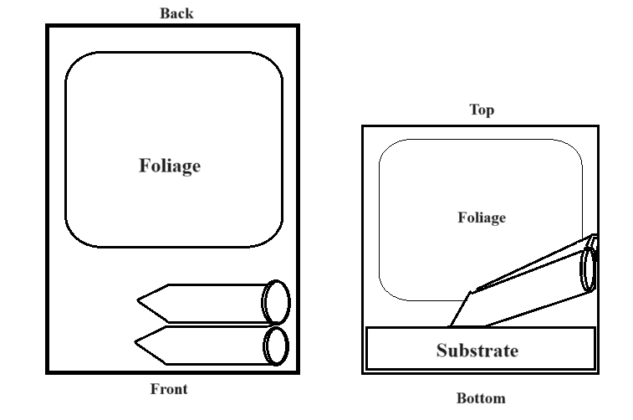
Figure 1. The placement of artificial breeding pools within terrariums, aerial (left) and front view (right). The centrifuge tube closest to the front is introduced to the tank first, followed by the second centrifuge tube a week later.

The water in the breeding pools was changed twice per week to maintain water quality. Water in the centrifuge tubes was removed and replaced with filtered water during the biweekly water changes. Breeding pairs of frogs raised tadpoles under three different water level change schedules. In the control treatment, levels remained at a constant 25 mL of water until the tadpole achieved metamorphosis. In the slow water level decrease treatment, water levels decreased by 1.25 mL during each water change for a 2.5 mL water level decrease per week. In the fast water level decrease treatment, water levels decreased by 2.5 mL during each water change for a weekly decrease of 5 mL. In decreasing water level treatments, water level would stop decreasing once 2.5 mL of water remained in the breeding pool. This volume was then held constant until the tadpole achieved metamorphosis. Breeding pairs were assigned to experimental treatments using the online list randomizer at RANDOM.org. The sequence of treatments was randomly assigned to groups using the same method. A week after a tadpole had been deposited into the breeding pool, a second centrifuge tube would be added to the terrarium. The second tube was maintained at a constant 25 mL water level regardless of the experimental treatment. This provided frogs with the option to transport young between breeding pools if they so desired. Once a breeding pair had successfully raised a tadpole under an experimental treatment, their next tadpole would be raised under the next experimental treatment in the sequence. This continued until every breeding pair had raised a tadpole under each experimental treatment.
Recording of parental care behaviors for a particular pair began once the pair deposited a tadpole into the centrifuge tube. Frogs were recorded daily using a tripod-mounted video camera situated in front of the terraria. Behavior was recorded from 7:00 am to 1:00 pm (0700-1300h) daily for a total of 6 hours of footage per active pair per day. Video footage from 4-day intervals was analyzed using BORIS behavioral analysis software to mark the duration and frequency of behavioral events. The behavioral events marked using BORIS were “contacting”, “inside”, “soaking”, and “calling”. A frog was considered to be “contacting” as long as it was in physical contact with the centrifuge tube containing the tadpole. A frog was considered to be “inside” if it was inside of the centrifuge tube containing the tadpole. A frog was considered to be “soaking” if it was making contact with the water in the tadpole’s centrifuge tube. Lastly, a frog was considered to be “calling” if it was vocalizing while contacting the centrifuge tube or the glass above the centrifuge tube. Additionally, the modifier “2frogs” was used to describe situations where two frogs were simultaneously engaged in the same activity. Because video recording quality and the nearly transparent appearance of trophic eggs made direct observation of egg laying difficult, a combination of behavioral states was used as a proxy for egg-feeding behavior. When both frogs were inside of the centrifuge tube, one was calling, and the other was soaking, these behaviors were used to suggest that egg feeding was occurring.
Impact on Tadpoles
Upon deposition into the breeding pools, each tadpole’s body length and surface area was measured. Tadpoles were photographed alongside a 30 cm ruler, and ImageJ image processing software was used to find the body length in centimeters. ImageJ was also used on the same photographs to find the tadpole dorsal surface area in square centimeters. Body length was measured from the snout to the base of the tail (Snout-Vent Length). Body surface area was measured as the surface as viewed from above of the tadpole’s body excluding the tail. Upon metamorphosis, froglet body length and body weight were measured. Froglets were photographed against a 30 cm ruler, and ImageJ was used to find body length in centimeters. Body weight was found by placing the frog onto an electronic precision balance.
Statistical Analyses
BORIS behavioral analysis software was used to determine the proportions of recorded time that frogs spent engaged in behaviors of interest. Analyses were performed using SPSS and R statistical analysis software. I began by comparing time budget percentages between treatment groups in R. I compared the proportion of time frogs spent “contacting”, “inside”, “soaking”, “calling”, as well as the proportion of time that two frogs were engaged in “contacting” or “inside” behaviors simultaneously. These comparisons were made visually using ggplot2 to generate box and scatter plots. Spearman correlations were tested between treatment groups, behavioral proportions, and tadpole dimensions. Treatment levels were translated into numbers for use in correlation tests. Zero represented the control treatment, -1 represented the slow water level decrease, and -2 represented the fast water level decrease. In SPSS, linear mixed models were used to compare the z-transformed proportions of parental care behavior between treatment groups. Comparisons were also carried out on tadpole measurements including SVL (Snout-Vent Length), body weight, and larval duration.

RESULTS
Time of Recordings
Recordings took place daily, beginning on 28 January 2023 and ending on 24 January 2024. A total of 395 videos were analyzed for behaviors. I observed the behavior of n=10 pairs of R.imitator, cataloging the behaviors of these pairs in four day intervals beginning when the tadpole is first deposited and ending when the metamorph emerges from the water of the breeding tube. At least 6 hours of video was recorded for each tank per day. In total, 2,291 hours, 33 minutes, and 46 seconds of video was analyzed for tadpole behaviors. No examples of tadpole transport from experimental breeding pools to stable breeding pools were observed.
Parental Care Behaviors
Linear mixed model tests on z-transformed proportions of recorded time frogs spent contacting the tube (Regression Coefficient = 0.393, df = 15.117, t = 0.829, p = .42, 95% CI lwr = -0.617, upr = 1.404), inside the tube (Regression Coefficient = -0.679, df = 16.165, t = -1.428, p = .172, 95% CI lwr = -1.686, upr = 0.328), soaking in the tube (Regression Coefficient = 0.113 , t = 0.256, df = 14.157 , p = .802, 95% CI lwr = -0.835 , upr = 1.062), calling (Regression Coefficient = 0.347, df = 12.441 , t = 0.789, p = .445, 95% CI lwr = -0.606, upr = 1.3), contacting the tube as a pair (Regression Coefficient = 0.212, df = 12.694, t = 0.493, p = .630, 95% CI lwr = -0.719, upr = 1.144), inside of the tube as a pair (Regression Coefficient = 0.355 , df =15.239, t = 0.799, p = .437, 95% CI lwr = -0.591, upr = 1.301), and inside of the tube as a pair while one of the parents soaks (Regression Coefficient = -0.22, df = 17.965, t = -0.945, p = .357, 95% CI lwr = -0.070, upr = 0.027) revealed no significant differences between treatment groups.
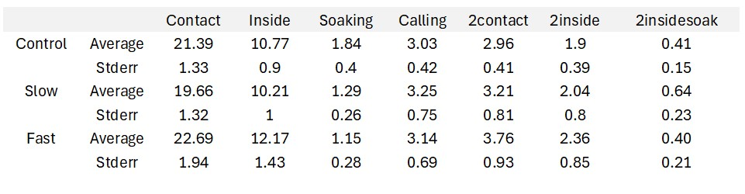
Table 1. Means and standard error for the percentage of recorded time spent engaged in parental care activities, separated by treatment group.

Spearman correlations tests carried out between parental care behaviors and treatment level did not reveal any strong correlations, and no correlations between behavior and treatment revealed a p-value of less than 0.09. The proportion of time adult frogs spent soaking seems to be positively correlated with the treatment level (rho = 0.33, p = .08537). All other correlations of behavior and treatment number had an absolute rho value of <0.15. Spearman correlation tests carried out between parental care behaviors revealed expected strong associations between parental behaviors which are prerequisites for each other. For example, at least one frog must be inside of the breeding tube for two frogs to be inside of the breeding tube. Thus, “inside” is strongly correlated (rho = 0.59, p = .0006282) with “2inside”. A strong correlation between “inside” and “2contact” (rho = 0.61, p = .000388), “soaking” and “2contact” (rho = 0.56, p = .001332), and “calling” and “2contact” (rho = 0.79, p = 2.122e-07) were found. Spearman correlations carried out between parental care behaviors and tadpole characteristics did not reveal any strong correlations. All correlations between parental care behaviors and tadpole development had p values of >0.05, with the strongest being a correlation between tadpole SVL and “contact” (rho = 0.35, p = .05746).

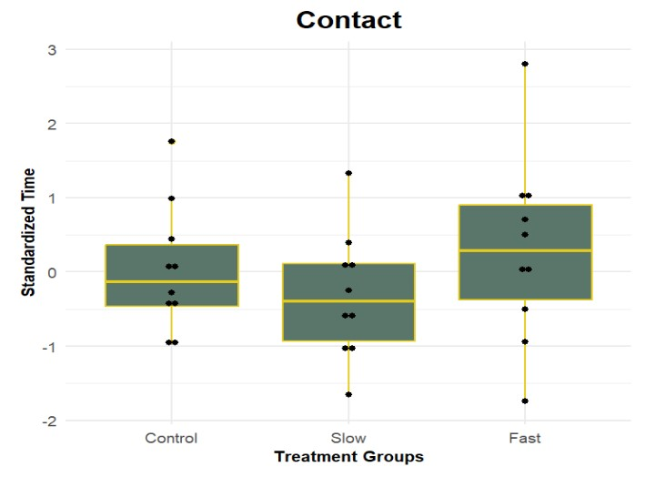
Figure 2. Standardized time that an adult was in contact with the centrifuge tube containing the tadpole, separated by treatment group.
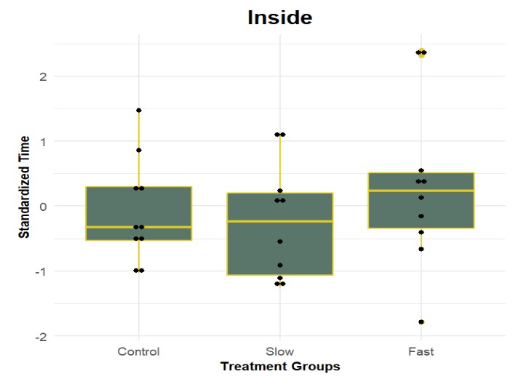
Figure 3. Standardized time that an adult was inside of the centrifuge tube containing the tadpole, separated by treatment group.

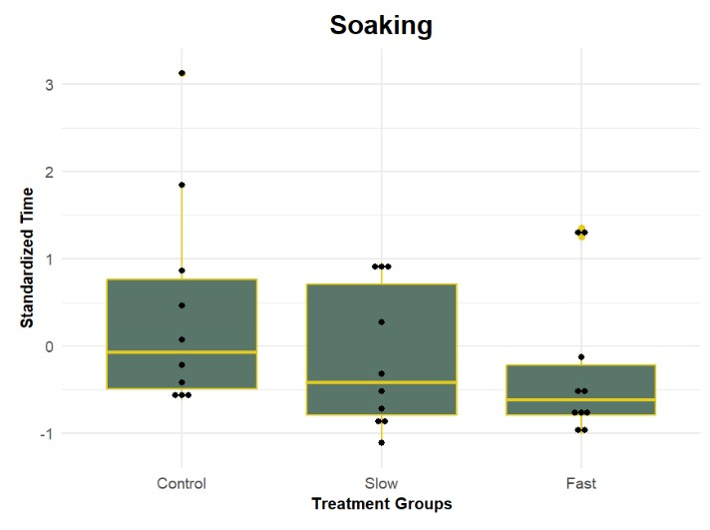
Figure 4. Standardized time that an adult was contacting water in the centrifuge tube containing the tadpole, separated by treatment group.
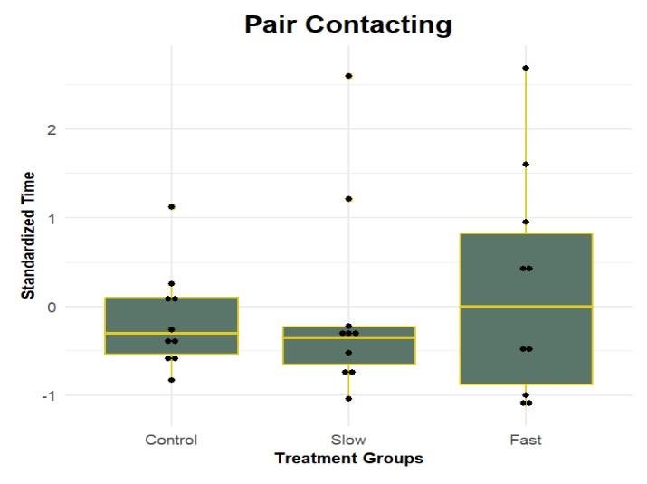
Figure 5. Standardized time that both adults were contacting the centrifuge tube containing the tadpole, separated by treatment group.
Tadpole and Metamorph Dimensions
Linear mixed model tests on tadpole mass revealed significant differences (See Table 2) between the control and the fast treatment level. Tests on tadpole SVL revealed significant differences (See Table 3) between the control and fast treatment levels. Tests on larval stage duration revealed significant differences (See Table 4) between the control and fast treatment levels.
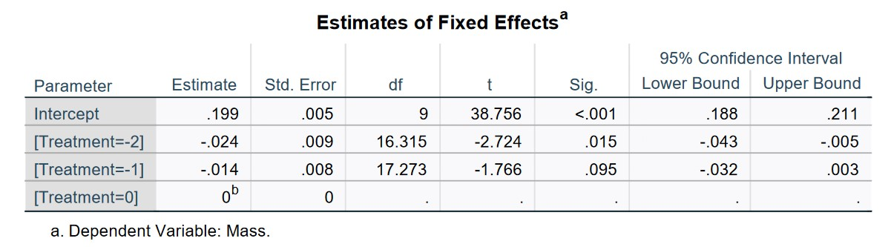Table 2. Linear mixed model test results for comparisons of tadpole mass in grams; treatment 0 is constant water level, treatment -1 is slow water level decrease, and treatment -2 is fast water level decrease.
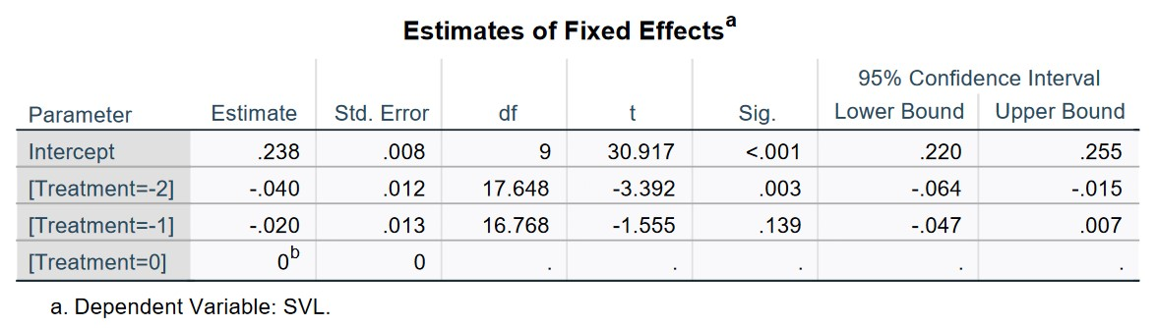Table 3. Linear mixed model test results for comparisons of tadpole SVL in cm; treatment 0 is constant water level, treatment -1 is slow water level decrease, and treatment -2 is fast water level decrease.
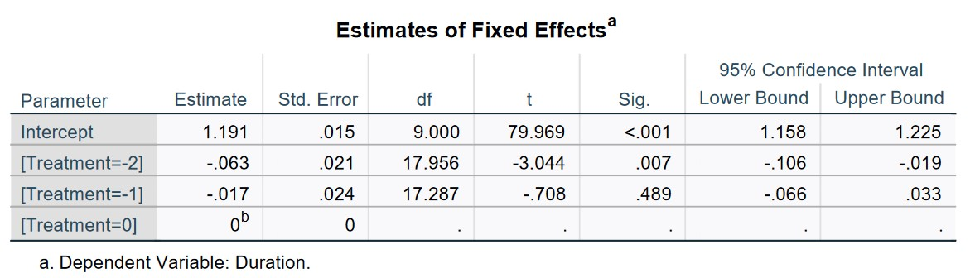Table 4. Linear mixed model test results for comparisons of larval stage duration; treatment 0 is constant water level, treatment -1 is slow water level decrease, and treatment -2 is fast water level decrease.

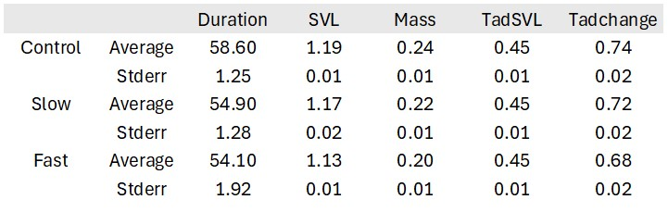
Table 5. Means and standard deviations for larval stage duration, metamorph body size, starting tadpole SVL, and change in mass, separated by treatment group.

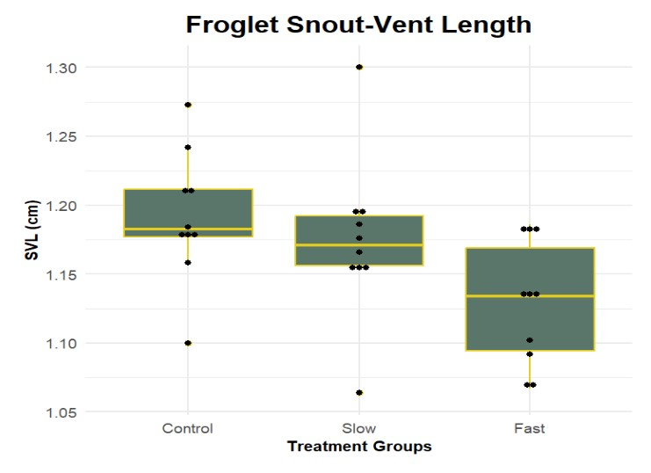
Figure 6. Metamorph snout-vent length in centimeters, separated by treatment group.

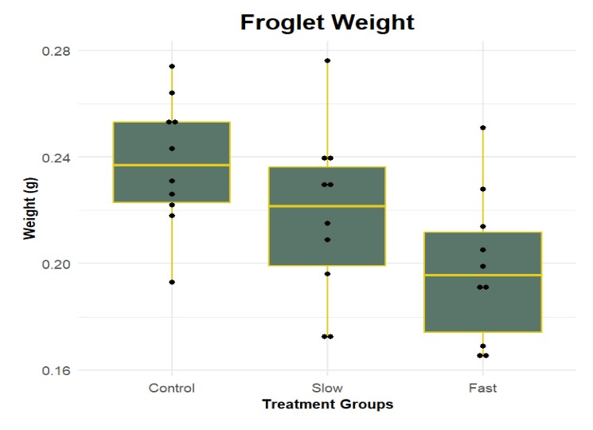
Figure 7. Metamorph wet weight in grams, separated by treatment group.

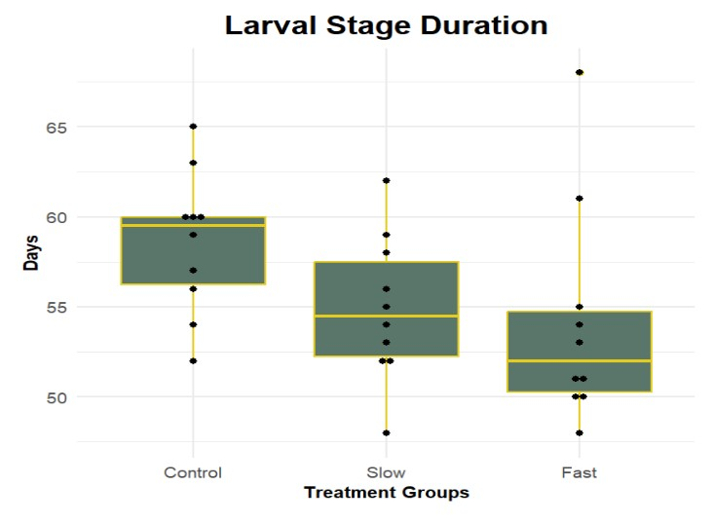
Figure 8. Duration of the tadpole larval stage, separated by treatment group.

Spearman correlation tests carried out between tadpole developmental characteristics and treatment level revealed strong correlations (See Figure 10). Treatment level was strongly positively correlated with mass (rho = 0.54, p = .002), and positively correlated with larval stage duration (rho = 0.44, p = .01), SVL (rho=0.48, p = 0.01), and change from tadpole SVL (rho=0.39, p = .03). Tadpole characteristics exhibited strong positive correlations with each other. Mass was strongly correlated with SVL (rho=0.8, p = 9.748e-08) and change from tadpole SVL (rho=0.73, p = 4.929e-06), and SVL (rho=0.78, p = 4.24e-07) was strongly correlated with the change from tadpole SVL. Duration exhibited no strong correlations with any of the other tadpole characteristics.

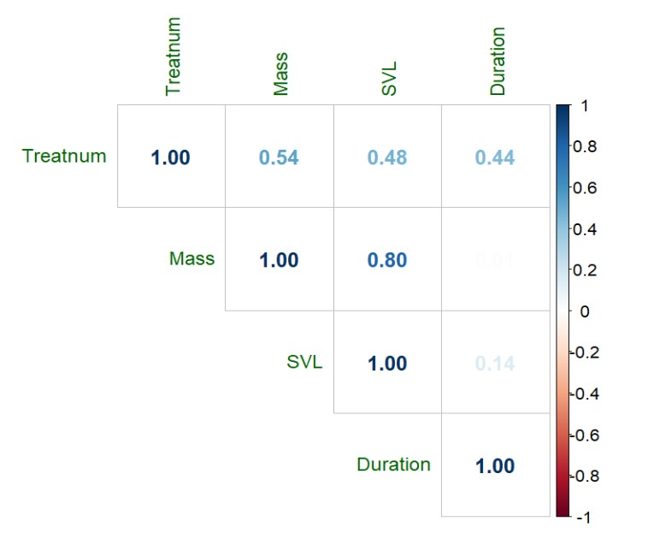
Table 6. Tadpole development variables compared against treatment level and each other in a spearman correlation matrix.

DISCUSSION
Parental care behavior can greatly improve the survival rate of offspring, as parental resources offset the stresses placed upon offspring by the environment. Yet this improvement of survival rate depends on the parents providing enough care to offset environmental stresses. If the intensity of the environmental stresses increase, parents may need to increase parental care to maintain the health of the offspring. I found no statistically significant differences between treatment groups in the proportion of time parents spent in contact with the breeding tube, inside the breeding tube, or in contact with the water of the breeding tube. Strong correlations were also not found between treatment groups and the proportion of time spent performing parental care behaviors, although a weakly significant positive correlation was found between the proportion of time that parents spent soaking in the breeding tube, and the duration of the larval stage. These data do not support the hypothesis that parental R. imitator increase the time spent on parental care behaviors when tadpoles are exposed to decreasing water levels.
It was found that offspring mass exhibited significant differences between treatment groups (see figure 7) and correlated strongly with water level treatment (rho = 0.54). It was also found that offspring SVL exhibited significant differences between treatment groups and though it did not correlate as strongly with treatment (rho = 0.48), it did strongly correlate with offspring mass (rho = 0.8). Duration of the tadpole stage correlated with treatment (rho = 0.44) and exhibited significant differences between the constant treatment group and the fast water level decrease treatment group. These data indicate that the water level decreases impacted tadpole growth and physiology, with the tadpoles in the more rapid water level change conditions emerging as metamorphs at a smaller body length and body weight than their counterparts in more stable water level conditions and spending less time in the larval stage. This suggests that tadpoles may be trading off size at metamorphosis to escape from rapidly drying pools.
A similar developmental tradeoff, where individuals under water level stress metamorphose and emerge more rapidly, but at smaller body sizes, has been previously documented in amphibians. Martha Crump (1989) examined the developmental plasticity of the tree frog Hyla pseudopuma by raising tadpoles under constant high, decreasing, and constant low water level conditions. It was found that tadpoles in the decreasing water level treatment developed forelimbs and emerged more quickly than tadpoles in the other two treatments but emerged at smaller average body weights. Tadpoles in the constant low water level conditions emerged at a slightly larger body weight than the tadpoles in the decreasing water level treatment, but at the cost of a development time longer than either other treatment group. Gomez-Mestre et. al (2013) examined the physiological effects of developmental acceleration in the spadefoot toad Pelobates cultripes. When raised under conditions of decreasing water level, tadpoles shortened their larval period by an average of 30% at the cost of lower body weights and proportionately shorter hind legs. This accelerated growth is metabolically intense, and was found to be costly in generating increased quantities of reactive oxygen species, which can prove damaging to biomolecules like DNA and proteins if not neutralized by increased production of antioxidants (Gomez-Mestre et al., 2013). Accelerated growth in response to water scarcity is an adaptation often seen in amphibians which complete their development in unpredictable aquatic larval sites like vernal pools, puddles, and temporary ponds (Crump, 1989). Many dendrobatids fit this description, developing as tadpoles in phytotelmata, tree hollows, and pools of water in large leaves. The ability to accelerate larval development in response to a shrinking nursery pool would be a beneficial adaptation in these habitats. Few studies exist describing the impacts of desiccation risk on larval stage duration in dendrobatid species, although papers exist that describe the effects of seasonal desiccation risk on tadpole deposition behavior in Ranitomeya variabilis. Similarly to R. imitator provisioning its young with trophic eggs, the approach of the dry season induces R. variabilis to deposit their newly hatched tadpoles in the pools of older cannibalistic siblings, potentially in an attempt to speed up offspring development (Poelman & Dicke, 2007; Schulte & Lötters, 2013) By accelerating development in response to water level decrease, tadpoles are able to escape desiccation and survive to reproduce. This metamorphic escape comes at a physiological cost however, as can be seen in the decreased SVL and body mass of R. imitator metamorphs raised under rapidly decreasing water level conditions. If the increased production of reactive oxygen species and associated production of protective antioxidants found in P. cultripes holds true for R. imitator, then this accelerated growth can prove to be metabolically expensive as well. Resources that are spent accelerating development and minimizing the harmful byproducts of this process are resources which would otherwise go into body mass. The metabolic costs of accelerated development and the production of antioxidants to neutralize reactive oxygen species are the likely cause of the decreased body mass forced to undergo early metamorphosis.
Amphibians must compromise between larval growth and time to maturity and will often time their metamorphosis to maximize the size they are able to achieve at metamorphosis while minimizing the time spent in the dangerous larval stage (Werner 1986). Amphibian larvae which are threatened with a diminishing aquatic habitat must sacrifice this ideal level of growth in order to survive desiccation. Even after metamorphosis, the smaller size of these individuals can have lasting consequences for life history. Prior research has shown that in frogs, smaller individuals exhibit lower fitness, produce fewer eggs, are less successful at attracting mates and defending territory, and are at greater risk of predation (Altwegg & Reyer, 2003; Chelgren et al., 2006; Székely et al., 2020) In an experimental dispersal study on green frogs Lithobates clamitans, the frequency and probability of dispersal to novel water bodies was positively correlated with body size, suggesting that larger frogs have greater dispersal abilities and are more able to take advantage of available habitats (Searcy et al., 2018). For frogs, increased body mass leads to a more successful life history. Although metamorphosing at a smaller size is an effective adaptation, and preferable to certain death, it is not an ideal situation for any frog. Previous studies have examined the ability of frogs that metamorphosed early to “catch up” their post-metamorphosis growth and development to match that of unaccelerated conspecifics, although this ability is currently unstudied in dendrobatid frogs (Székely et al., 2020).The physiological response to decreasing water level conditions exhibited by the tadpoles is better than desiccation, but is significantly taxing on the organism.
While R. imitator parents did not respond to water-stressed tadpoles with an increased frequency of parental care behaviors, it should be noted that all tadpoles in the study survived to achieve metamorphosis. The usual amount of parental care provided to offspring may be sufficient for the tadpole to accelerate its growth and escape from drying phytotelmata. Previous research has found that Ranitometa imitator tadpoles exhibit greater phenotypic plasticity than the closely related Ranitomeya variabilis when provided with trophic eggs as food, achieving greater growth in body size on the same resources. This plasticity persists even when provided with other food sources (Brooks et al., 2023). If this is the case, then the phenotypic plasticity exhibited by R. imitator tadpoles fed on trophic eggs may be an adaptation to the variable phytotelm environment. Tadpoles which must metamorphose and escape the phytotelm quickly are provided with enough energy to do so, while tadpoles in longer lived pools can devote parental resources to growing as large as possible before metamorphosis.
There is also the potential that the frogs altered their parental care in ways that were not recorded. Although soaking behavior and time spent by pairs inside of the breeding tube was used as a proxy for egg feeding behavior, the transparency of the egg made observation of egg feeding through recordings difficult. If frogs have the ability to alter their parental care behavior by laying more trophic eggs to provision water-stressed offspring without spending an increased duration of time inside of the breeding tube, then this plasticity would go unnoticed. Lastly, considering that wild R. imitator raise their young in small, ephemeral water bodies in phytotelmata, the rapid water level decrease to 5 ml experienced by tadpoles in the fast water level decrease treatment might not have been extreme enough to induce increased parental care in the frogs.
The lack of evidence for parental rescue of offspring threatened with desiccation has implications for the preservation of wild populations of Ranitomeya imitator under global climate changes. Changing weather patterns have the potential to decrease humidity and lengthen dry spells in the Peruvian Amazon (Zevallos & Lavado-Casimiro, 2022). Habitat fragmentation, deforestation, and land-use changes thin out the tree cover, allowing sunlight and dry air to enter deeper into the rainforest (Schlippe Justicia et al., 2023). Ranitomeya imitator might be well adapted to the current patterns of rainfall in their habitats, but population stability may be threatened if parental care behavior proves inflexible. Juvenile recruitment may be impacted as phytotelmata desiccate before tadpoles can achieve metamorphosis, even in their accelerated rate. Beyond direct mortality of larvae, water-stressed tadpoles develop into smaller metamorphs, with all of the life history challenges that accompany undersized amphibians. This has the potential to weaken populations of this species and increase susceptibility to secondary stressors like pollution and fungal disease (Burraco & Gomez-Mestre, 2016; Schlippe Justicia et al., 2023). Further research into this species is necessary to determine the extent of its reproductive plasticity, and its responsiveness to environmental changes.
This study lies at the intersection between behavior and physiological response in dendrobatids and provides numerous avenues for future research. This experiment could be replicated with a greater sample size of breeding pairs, diminishing the effect of outliers and making the parental care responses of these frogs more clearly seen. The scope of the study could be expanded to follow metamorphs through their life history. This research could examine the impacts of early metamorphosis on frog fitness, and the ability of small metamorphs to “catch up” to their peers in adult growth (Orizaola et al., 2014; Székely et al., 2020). Treatments could be altered to explore the behavioral plasticity of R.imitator when exposed to more rapid water level decreases, or when exposed to constant low water level conditions. Altogether, there is much left to uncover about the behavioral plasticity of these unique amphibians.

REFERENCES
Altwegg, R., & Reyer, H.-U. (2003). Patterns of Natural Selection on Size at Metamorphosis in Water Frogs. Evolution, 57(4), 872–882. https://doi.org/10.1111/j.0014-3820.2003.tb00298.x

Barbasch, T. A., Rueger, T., Srinivasan, M., Wong, M. Y. L., Jones, G. P., & Buston, P. M. (2020). Substantial plasticity of reproduction and parental care in response to local resource availability in a wild clownfish population. Oikos, 129(12), 1844–1855. https://doi.org/10.1111/oik.07674

Brooks, O. L., Talbott-Swain, E. N., Rimmele, B. N., & Dugas, M. B. (2023). Tadpole plasticity shapes the potential benefits of egg feeding to poison frog parents. Ethology, 129(4–5), 212–223. https://doi.org/10.1111/eth.13358

Brown, J. L., Morales, V., & Summers, K. (2008). Divergence in parental care, habitat selection and larval life history between two species of Peruvian poison frogs: An experimental analysis. Journal of Evolutionary Biology, 21(6), 1534–1543. https://doi.org/10.1111/j.1420-9101.2008.01609.x

Brown, J. L., Morales, V., & Summers, K. (2009). Home range size and location in relation to reproductive resources in poison frogs (Dendrobatidae): A Monte Carlo approach using GIS data. Animal Behaviour, 77(2), 547–554. https://doi.org/10.1016/j.anbehav.2008.10.002

Brown, J. L., Morales, V., & Summers, K. (2010). A Key Ecological Trait Drove the Evolution of Biparental Care and Monogamy in an Amphibian. The American Naturalist, 175(4), 436–446. https://doi.org/10.1086/650727

Brown, J., Twomey, E., Morales, V., & Summers, K. (2008). Phytotelm size in relation to parental care and mating strategies in two species of Peruvian poison frogs. Behaviour, 145(9), 1139–1165. https://doi.org/10.1163/156853908785387647

Burraco, P., & Gomez-Mestre, I. (2016). Physiological Stress Responses in Amphibian Larvae to Multiple Stressors Reveal Marked Anthropogenic Effects even below Lethal Levels. Physiological and Biochemical Zoology, 89(6), 462–472. https://doi.org/10.1086/688737

Chelgren, N. D., Rosenberg, D. K., Heppell, S. S., & Gitelman, A. I. (2006). Carryover Aquatic Effects On Survival Of Metamorphic Frogs During Pond Emigration. Ecological Applications, 16(1), 250–261. https://doi.org/10.1890/04-0329

Crump, M. L. (1989). Effect of Habitat Drying on Developmental Time and Size at Metamorphosis in Hyla pseudopuma. Copeia, 1989(3), 794–797. https://doi.org/10.2307/1445521

Delia, J. R. J., Ramírez-Bautista, A., & Summers, K. (2013). Parents adjust care in response to weather conditions and egg dehydration in a Neotropical glassfrog. Behavioral Ecology and Sociobiology, 67(4), 557–569. https://doi.org/10.1007/s00265-013-1475-z

Eggert, A.-K., Reinking, M., & Müller, J. K. (1998). Parental care improves offspring survival and growth in burying beetles. Animal Behaviour, 55(1), 97–107. https://doi.org/10.1006/anbe.1997.0588

Gomez-Mestre, I., Kulkarni, S., & Buchholz, D. R. (2013). Mechanisms and Consequences of Developmental Acceleration in Tadpoles Responding to Pond Drying. PLOS ONE, 8(12), e84266. https://doi.org/10.1371/journal.pone.0084266

Gosner, K. L. (1960). A Simplified Table for Staging Anuran Embryos and Larvae with Notes on Identification. Herpetologica, 16(3), 183–190.

Klug, H., & Bonsall, M. B. (2014). What are the benefits of parental care? The importance of parental effects on developmental rate. Ecology and Evolution, 4(12), 2330–2351. https://doi.org/10.1002/ece3.1083

Mckeon, C. Sea & Summers, Kyle. (2004). THE EVOLUTIONARY ECOLOGY OF PHYTOTELMATA USE IN NEOTROPICAL POISON FROGS. MISCELLANEOUS PUBLICATIONS, MUSEUM OF ZOOLOGY, UNIVERSITY OF MICHIGAN, 193: 55-73

Lent, E. M., & Babbitt, K. J. (2020). The effects of hydroperiod and predator density on growth, development, and morphology of wood frogs (Rana sylvatica). Aquatic Ecology, 54(1), 369–386. https://doi.org/10.1007/s10452-020-09748-y

Lopez, L. C. S., & Rios, R. I. (2001). Phytotelmata Faunal Communities in Sun-Exposed Versus Shaded Terrestrial Bromeliads from Southeastern Brazil. Selbyana, 22(2), 219–224.

Martins, M., Pombal, J. P., & Haddad, C. F. B. (1998). Escalated aggressive behaviour and facultative parental care in the nest building gladiator frog, Hyla faber. Amphibia-Reptilia, 19(1), 65–73. https://doi.org/10.1163/156853898X00331

Mogali, S., Saidapur, S., & Shanbhag, B. (2016). Influence of desiccation, predatory cues, and density on metamorphic traits of the bronze frog Hylarana temporalis. Amphibia-Reptilia, 37(2), 199–205. https://doi.org/10.1163/15685381-00003044

Orizaola, G., Dahl, E., & Laurila, A. (2014). Compensatory growth strategies are affected by the strength of environmental time constraints in anuran larvae. Oecologia, 174(1), 131–137. https://doi.org/10.1007/s00442-013-2754-0

Pašukonis, A., Loretto, M.-C., & Rojas, B. (2019). How far do tadpoles travel in the rainforest? Parent-assisted dispersal in poison frogs. Evolutionary Ecology, 33(4), 613–623. https://doi.org/10.1007/s10682-019-09994-z

Petrović, T. G., Kijanović, A., Kolarov Tomašević, N., Gavrić, J. P., Despotović, S. G., Gavrilović, B. R., Radovanović, T. B., Vukov, T., Faggio, C., & Prokić, M. D. (2021). Effects of Desiccation on Metamorphic Climax in Bombina variegata: Changes in Levels and Patterns of Oxidative Stress Parameters. Animals, 11(4), Article 4. https://doi.org/10.3390/ani11040953

Poelman, E. H., & Dicke, M. (2007). Offering offspring as food to cannibals: Oviposition strategies of Amazonian poison frogs (Dendrobates ventrimaculatus). Evolutionary Ecology, 21(2), 215–227. https://doi.org/10.1007/s10682-006-9000-8

Pryke, S. R., & Griffith, S. C. (2010). Maternal adjustment of parental effort in relation to mate compatibility affects offspring development. Behavioral Ecology, 21(2), 226–232. https://doi.org/10.1093/beheco/arp180

Ringler, E., Pašukonis, A., Hödl, W., & Ringler, M. (2013). Tadpole transport logistics in a Neotropical poison frog: Indications for strategic planning and adaptive plasticity in anuran parental care. Frontiers in Zoology, 10(1), 67. https://doi.org/10.1186/1742-9994-10-67

Santos, E. S. A., & Nakagawa, S. (2012). The costs of parental care: A meta‐analysis of the trade‐off between parental effort and survival in birds. Journal of Evolutionary Biology, 25(9), 1911–1917. https://doi.org/10.1111/j.1420-9101.2012.02569.x

Schlippe Justicia, L., Fouilloux, C. A., & Rojas, B. (2023). Poison frog social behaviour under global change: Potential impacts and future challenges. Acta Ethologica, 26(3), 151–166. https://doi.org/10.1007/s10211-022-00400-6

Schulte, L. M., & Lötters, S. (2013). The power of the seasons: Rainfall triggers parental care in poison frogs. Evolutionary Ecology, 27(4), 711–723. https://doi.org/10.1007/s10682-013-9637-z

Schulte, L. M., Ringler, E., Rojas, B., & Stynoski, J. L. (2020). Developments in Amphibian Parental Care Research: History, Present Advances, and Future Perspectives. Herpetological Monographs, 34(1), 71–97. https://doi.org/10.1655/HERPMONOGRAPHS-D-19-00002.1

Schulte, L. M., & Summers, K. (2021). Who cares for the eggs? Analysis of egg attendance behaviour in Ranitomeya imitator, a poison frog with biparental care. Behaviour, 159(7), 603–614. https://doi.org/10.1163/1568539X-bja10142

Schürch, R., & Taborsky, B. (2005). The functional significance of buccal feeding in the mouthbrooding cichlid Tropheus moorii. Behaviour, 142(3), 265–281. https://doi.org/10.1163/1568539053778274

Searcy, C. A., Gilbert, B., Krkošek, M., Rowe, L., & McCauley, S. J. (2018). Positive correlation between dispersal and body size in Green Frogs (Rana clamitans) naturally colonizing an experimental landscape. Canadian Journal of Zoology, 96(12), 1378–1384. https://doi.org/10.1139/cjz-2018-0069

Smiseth, P. T., Darwell, C. T., & Moore, A. J. (2003). Partial begging: An empirical model for the early evolution of offspring signalling. Proceedings of the Royal Society of London. Series B: Biological Sciences, 270(1526), 1773–1777. https://doi.org/10.1098/rspb.2003.2444

Steinhart, G. B., Sandrene, M. E., Weaver, S., Stein, R. A., & Marschall, E. A. (2005). Increased parental care cost for nest-guarding fish in a lake with hyperabundant nest predators. Behavioral Ecology, 16(2), 427–434. https://doi.org/10.1093/beheco/ari006

Székely, D., Cogălniceanu, D., Székely, P., Armijos-Ojeda, D., Espinosa-Mogrovejo, V., & Denoël, M. (2020). How to recover from a bad start: Size at metamorphosis affects growth and survival in a tropical amphibian. BMC Ecology, 20(1), 24. https://doi.org/10.1186/s12898-020-00291-w

Tumulty, J., Morales, V., & Summers, K. (2014). The biparental care hypothesis for the evolution of monogamy: Experimental evidence in an amphibian. Behavioral Ecology, 25(2), 262–270. https://doi.org/10.1093/beheco/art116

von May, R., Medina-Müller, M., Donnelly, M. A., & Summers, K. (2009). Breeding-site selection by the poison frog Ranitomeya biolat in Amazonian bamboo forests: An experimental approach. Canadian Journal of Zoology, 87(5), 453–464. https://doi.org/10.1139/Z09-026

Zevallos, J., & Lavado-Casimiro, W. (2022). Climate Change Impact on Peruvian Biomes. Forests, 13(2), Article 2. https://doi.org/10.3390/f13020238

Zink, A. G. (2003). Quantifying the costs and benefits of parental care in female treehoppers. Behavioral Ecology, 14(5), 687–693. https://doi.org/10.1093/beheco/arg044

APPENDIX: IACUC ANIMAL USE PERMISSIONS
