Implementing Substance Use Screening and Referral in Primary Care

Meagan McLean

East Carolina University

EAST CAROLINA UNIVERSITY

DOCTOR OF NURSING PRACTICE PROGRAM

In approval of the scholarly project of

Meagan B. McLean

Director of DNP Program
Michelle Skipper DNP, FNP-BC

_____________________________
Signature/Date

Lead Faculty
Ann Bell, DNP, FNP-C

_____________________________
Signature/Date

Team Member
Marcia Ballard, FNP

_____________________________
Signature/Date

Team Member
Utpal Patel, MD

_______________________________
Signature/Date

Team Member
Jerri Patterson, APRN-BC

________________________________
Signature/Date

Abstract

Primary care is the first step to screening and prevention, including the identification of substance use disorder (SUD). The number of patients with SUD has increased significantly in the past 10 years. It is estimated that 65% of patients with SUD are undetected in primary care (Barrett & Chang, 2016). Efforts to bring improvement to the IHI (2017) triple aim initiatives of improving the health of populations, improving the patient experience and decreasing the per capita cost of patient care are enhanced by community-based screening to identify SUD in primary care (IHI, 2017). To meet the need for increased screening and prevention of SUD, a scholarly project aimed at implementing Screening, Brief Intervention and Referral to Treatment (SBIRT) was performed at a primary care practice in a rural county of North Carolina. The primary objective of the project was to increase provider adherence to the screening and referral portions of the SBIRT guideline, developed by the Colorado Clinical Guideline Collaborative (CCGC, n.d.). SBIRT entails the use of evidence-based screening tools to detect SUD, brief educational interventions to halt or decrease SUD, and Referral to treatment programs. Providers were educated on the evidence supporting SBIRT in primary care, including the use of a single-question screening and the Drug Abuse Screening Tool (DAST-10). The single-question screening helped identify patients who may be at risk for SUD and the DAST-10 was then administered to all who answered in the affirmative. Patients who scored six or greater were referred to further, specialized treatment centers.
Keywords: Substance Use Disorder, triple aim initiative, SBIRT, DAST-10

Acknowledgements
The conception and construction of this scholarly project was made possible through the supportive efforts of Dr. Ann Bell, FNP-C of the ECU DNP program. Her patience and assistance were a vital asset to this work. I would like to recognize Dr. Dianne Marshburn, PhD, RN, NE-BC, whose expertise during construction and IRB review were much appreciated.
I am also indebted to Dr. Jan Tillman, DNP, MSN, RN, FNP-BC for her assistance with graphical data displays. Her support throughout my matriculation was outstanding.
Deserving special mention are Marcia Ballard, MSN, RN, FNP-BC, Leslie Purvis, MSN, RN, FNP-C and the staff of Carthage Family Care, as well as Jerri Patterson, MSN, RN, FNP-BC and Utpal Patel, MD of Integrated Pain Solutions. Without their flexibility and expertise, this project would not have been possible.

Contents
Approval…………………………………………………………………………………………..ii
Abstract…………………………………………………………………………………………...iii
Acknowledgements…………………………………………………………………….................iv
Table of Contents………………………………………………………………………………….v
Chapter One
Introduction to SBIRT for Substance Use Screening……………………………..9
Justification of the Study………………………………………………………...10
Problem Statement and Project Questions…....………………………………….12
Theoretical Framework…………………………………………………………..12
Assumptions……………………………………………………………………...14
Definition of Terms………………………………………………………………14
Summary…………………………………………………………………………15
Chapter Two
Theory and Concepts in the Identification of Substance Use Disorder in Primary Care-A Review of the Literature…………………………………………………………………16
Substance Use Disorder in Primary Care….……………………………….…....17
Theory Behind SBIRT …………………………………………………………..17
Nurse Practitioner Delivery of SBIRT…………………………………………..18
Single-Question Screening and DAST-10…….………………………………...19
Measurement of SBIRT Effectiveness..………………...……………………….20
Model Migration………………………………………………………………...20
Cost of SBIRT…………………………………………………………………...21
SBIRT Study Demographics…………………..………………………………...21
Limitations of SBIRT……………………………………………………………22
Summary……………………………………………………………………........23
Chapter Three
Methodology and Evaluation…………………………………………………………….24
Design……………………………………………………………………………24
Sample…………………………………………………………………………....25
Methods…………………………………………………………………………..25
Protection of Subject Rights……………………………………………………..29
Project Budget Analysis………………………………………………………….29
Summary………………………………………………………………………....29
Chapter Four
Findings………………………………………………………………………………….31
Participant Demographics………………………………………………………..31
Intended Outcomes……………………………………………………………....31
Results……………………………………………………………………………32 Summary..………………………………………………………………………..33
Chapter Five
Implications for Nursing Practice………………………………………………………..34
Doctor of Nursing Practice Essentials Met………………………………………34
Essential I: Scientific Underpinnings for Practice……………………………….35
Essential II: Organizational and Systems Leadership for Quality Improvement and Systems Thinking………………………………………………………………..35
Essential III: Clinical Scholarship and Analytical Methods for Evidence-Based Practice…………………………………………………………………………..36
Essential IV: Information Systems/Technology and Patient Care Technology for the Improvement and Transformation of Health Care…………………………...36
Essential V: Health Care Policy for Advocacy in Health Care………………….37
Essential VI: Interprofessional Collaboration for Improving Patient and Population Health Outcomes…………………………………………………….37
Essential VII: Clinical Prevention and Population Health for Improving the Nation’s Health…………………………………………………………………..38
Essential: VIII: Advanced Nursing Practice……………………………..............38
Summary……………………………………………………………....................39
Chapter Six
Discussion………………………………………………………………………………..40
Significance of Findings…………………………………………………………40
Project Strengths, Benefits and Limitations……………………………………...41
Integrated Behavioral Model and Provider Education…………………………...43
Recommendations for Practice…………………………………………………..43
Additional Work to be Continued………………………………………………..44
Final Summary…………………………………………………………………...44
Resources………………………………………………………………………………………...47
Appendices
Appendix A………………………………………………………………………………52
Appendix B………………………………………………………………………………54
Appendix C………………………………………………………………………………53
Appendix D………………………………………………………………………………54
Appendix E………………………………………………………………………………56
Appendix F……………………………………………………………………………….57
Appendix G………………………………………………………………………………58
Appendix H………………………………………………………………………………59
Appendix I……………………………………………………………………………….60

Appendix J……………………………………………………………………………….61

Appendix K………………………………………………………………………………62

Appendix L………………………………………………………………………………63

Appendix M……………………………………………………………………………...64

Appendix N………………………………………………………………………………67

Appendix O………………………………………………………………………………92

Appendix P……………………………………………………………………………….93

Chapter One: Overview of Substance Use Disorder Screening in Primary Care

Primary care is the first step to screening and prevention, including the identification of substance use disorder (SUD). Primary care providers (PCP) should be administering preventive screenings to detect, and treat or refer patients for SUD (Dowell, Haegerich & Chou, 2016). Screening, brief intervention and referral to treatment (SBIRT) is a validated method used to identify, reduce, and prevent problematic use of drugs and alcohol (Babor, Del Boca & Bray, 2017). SBIRT is recommended by the Substance Abuse and Mental Health Services Administration and the U.S. Department of Health and Human Services (SAMHSA-HRSA) to meet the Institute of Medicine (IOM) call for increased community-based screenings for health risks (SAMHSA-HRSA, n.d.). In fact, the Colorado Clinical Guidelines Collaborative (CCGC) (n.d.) created a guideline useful for implementing SBIRT within the primary care setting (Appendix A). Using this guideline, primary care providers (PCP) can increase the number of community-based screenings, reduce healthcare costs associated with drug overdose, and connect patients with behavioral health and treatment centers (Centers for Medicare and Medicaid Services, 2017); (SAMHSA-HRSA, n.d.).
To improve the use of evidence-based screening for SUD in primary care, a process improvement (PI) project was implemented at a small primary care clinic in a rural area of Southeast North Carolina, serving 35-50 patients per day. The project focus was to improve SUD screening through education of providers and staff. Specifically, the educational intervention included a review of SBIRT, guidelines for SUD and CPT coding for reimbursement. Also, to affect perceived norms held by providers and staff, recent grant-funded efforts to introduce SBIRT into local practices by Community Care of the Sandhills were shared. The in-service was finished with review of a proposed practice change of annual SUD screening using the tool devised specifically for this project, as well as a process flow map designed for the practice. By implementing a standardized process, the measurable outcomes of the project included increased screening and referral of patients detected to have SUD. Krupski et al. (2012) explains that primary care is the ideal setting to implement SBIRT, due to the high volume of patients who can be reached before a drug-related health incident occurs. This primary care site is a community “safe-haven”, where many local citizens receive both physical and mental/emotional attention from trusted providers. SUD was not a topic that was discussed unless an obvious symptom was exhibited or the patient broached the subject. There was no consistent, standard process for SUD screening and referral at this practice. Providers at the site supported the need for a PI project to increase detection of SUD, provide education or encouragement, and refer to treatment when necessary.
Justification of the Study
The number of patients with SUD involving alcohol and illicit drugs has increased significantly in the past 10 years (National Institute on Drug Abuse, 2015). Additionally, national concern has been raised over the opioid crisis (SAMHSA, 2017). On the national front, the Institution of Health Improvement (IHI) triple aim initiative seeks to bring improvement to the quality of healthcare delivered to patients while simultaneously reducing waste and cost. SBIRT meets the IHI (2017) triple aim initiative through improving the patient experience by offering SUD intervention in primary care. Likewise, SBIRT successfully reduces the per capita cost of patient care through avoiding emergency services for SUD and improves the health of populations by detecting and addressing undiagnosed SUD (SAMHSA-HRSA, n.d.).
Patients identified as having a SUD should be offered a treatment program, whether by medication-management, counseling or other methods (SAMHSA-HRSA, n.d.). The American Psychiatric Association (2017) defines addiction as a psychiatric disease, featuring substance use despite the harm it may cause. Physical evidence of addiction can be found in brain imaging studies showing detrimental alterations to the centers that control judgment, learning, and behavior control (APA, 2017). Moreover, because many patients with substance abuse disorder have co-occurring chronic illness, screening and treatment leads to better overall patient outcomes (SAMHSA-HRSA, n.d.; CCGC, n.d).
Substance abuse is increasing by alarming proportion and are becoming prevalent across different populations. Overdose death rates in urban areas have traditionally been higher than rural areas, but statistics of 2015 overdose deaths revealed rates to be higher in rural areas (Mack, Jones & Ballesteros, 2017). Also, National Vital Statistics reveal a 350% increase in reported illicit drug use among women in non-metropolitan areas from 1999-2015 (Mack, Jones & Ballesteros, 2017). Overall in 2014, 27 million Americans reported illegal substance use in the past month, 4.3 million of which reported using opioids outside of medical purposes (SAMHSA, 2014).
The condition of SUD significantly impacts health leading to decreased quality of life (QOL), according to Olfson, Wall, Lui, Schoenbaum and Blanco (2018). Olfsen et al. (2018) share that subjects age 18-24 had the greatest reported increase in substance use disorder from 2001-2013 (19.7%), followed by those age 25-44 whose percent increase was 16.3%. In this study, men and women had nearly equal increases in reported substance use disorder as a risk factor for decreased QOL (Olfson et al., 2018). Unfortunately, decreased health-related QOL isn’t the only outcome of national concern. The American Psychological Association (2017) reports a leading cause of preventable disease and premature death is drug and alcohol abuse.
Due to declining health, many patients with SUD require emergency services and inpatient stays, which are costly. As a result, healthcare utilization for misuse of opioids increased 150% since 1993, and outpatient opioid prescription expenses increased from $4.1 billion to $9 billion from 2002 to 2012 (U.S. Department of Health and Human Services, 2017). Though overprescribing and lack of patient education are major culprits, even well-informed patients with undiagnosed SUD may require emergency services due to overdose if the problem is not treated.
Problem Statement and Project Questions
Though SUD is a mental health disorder, screening should not be relegated to psychiatric and behavioral health settings alone (SAMHSA-HRSA, n.d.) Behavioral health providers are too few to handle the current volume of patients with SUD, and volume is expected to increase under the Affordable Care Act (Levit et al., 2013). PCPs must accept the challenge of integrating SUD screening and treatment into their practices to impact outcomes (SAMHSA-HRSA, n.d.).
The project question posed was: Does a PI project to educate providers and implement the CCGC SBIRT guideline result in increased screening and appropriate referrals when the DAST-10 score is six or above?” (Appendix B). An additional question posed was: “Did providers and staff indicate a reason of either ‘patient refused’ or ‘N/A’ for not referring patients who completed a DAST-10?”.
Theoretical Framework
Because improving the process of SUD detection and treatment requires provider behavior change, a strong theoretical underpinning was selected for structural support. The Integrated Behavioral Model (IBM) was chosen because of the ease with which it may be applied to provider behaviors and integration of a new practice. Attitude, perceived norm and personal agency are constructs of the IBM, which serve to define influences of behaviors (Blalock et al. n.d.). Attitude is broken further into “experiential attitude” consisting of the practitioner’s personal and emotional response to a behavior change and “instrumental attitude”, which pertains to what the provider believes about the behavior (Blalock et al., n.d.). The power of attitude can determine whether a behavior is performed or neglected, and therefore, provider education must be focused on harnessing a positive, enthusiastic attitude toward helping patients with SUD (Blalock et al., n.d.) (Appendix F).
Perceived norms within a professional setting have great influence on provider behaviors, as well. The IBM construct of perceived norm is defined as peer pressure surrounding a behavior (Blalock et al., n.d.). This is further delineated into “injunctive norm”, which addresses the provider’s beliefs about what is expected by their peers, and “descriptive norm”, which speaks to the healthy pressure imposed by peers when they make a practice change (Blalock et al., n.d.). To address injunctive and descriptive norms, information from a Community Care of North Carolina (CCNC) meeting about controlled substance prescribing was shared with providers. A list of practices utilizing SBIRT was presented to the providers at the site to encourage enthusiasm to act.
The final overarching construct of personal agency is of equal importance to changing provider behavior, and is delineated into “perceived control” and “self-efficacy”. While self-efficacy refers to the provider’s perception about their ability to carry out a task, perceived control refers to the provider’s beliefs about their level of control versus the environmental factors that may influence their performance of a behavior (Blalock et al., n.d.). A major limitation to introducing new practices in primary care is the time required to learn and solidify new behaviors at the systems level.
Another limitation is the lack of qualified behavioral health providers and SUD treatment sites available to handle the volume of patients requiring help. At the practice site, providers were assured that the method of implementation would solidify new practice behaviors over the course of eight weeks. Apprehension about time constraint was addressed by explaining the use of the single-question screening to cut down on unnecessary DAST-10 form completion. Finally, a compiled list of referral sites with contact information, insurance accepted and wait lists was given to the referral coordinator at the site to facilitate a smooth referral process.
Assumptions
Assumptions preceding implementation included that patients with SUD will answer honestly to the single-question screening and DAST-10 forms because they will be assured that their information will remain anonymous and safe for the purposes of the study. Patients will desire to seek help if they score six or higher on the DAST-10, because they show readiness for intervention, by admitting to having a problem. Finally, providers will adhere to the guideline and document accordingly, as it provides a time and cost-saving step to addressing the growing problem of SUD.
Definition of Terms

Process Improvement is action taken to review a current method and apply a systematic action that brings about measurable improvement (Agency for Healthcare Research and Quality, 2017). Substance Use Disorder is defined by the DSM-V as a pattern of substance use that is characterized by taking in larger amounts of the substance for longer than desired, a desire to stop use and multiple unsuccessful attempts to quit, spending large amounts of time obtaining the substance and revolving all other activities around using or obtaining the substance (APA, 2013). Screening is the process by which healthcare providers assess patients for high-risk substance use using validated screening tools such as the DAST-10 (SAMHSA, n.d.). DSM-V or the Diagnostic and Statistical Manual of Mental Disorders Fifth Edition is the latest edition of the text containing diagnostic criteria for all mental disorders.
Summary
In summary, the growing problems of substance misuse and abuse have developed into defined disorders based on criterion in the DSM-V. Such disorders are detectable and treatable with respect of the patient’s readiness and wishes. Primary care is an ideal setting to implement quality and process improvement, to bring about a streamlined system of screening, intervening and referring those who have a possible SUD (Krupski et al., 2012). Furthermore, SBIRT is a validated method of identifying, preventing or reducing SUD and referring patients to treatment (Borus, Parhami and Levy, 2016). With this information in mind, a PI project was introduced to a primary care site in a rural county of North Carolina to implement the CCGC SBIRT guidelines with minor exclusions. The project began with provider education using a process flow map (Appendix H), as well as the CCGC guideline and general information on coding for reimbursement. Data was collected and analyzed at the end of the eight-week project.

Chapter Two: Theory and Concepts in the Identification of Substance Use Disorder in Primary Care-Review of the Literature
The prevalence of substance use disorder (SUD) in the United States has increased steadily and significantly, warranting continued intentions to detect, treat and refer patients efficiently (SAMHSA, 2017). Research directed at devising methods of substance use disorder (SUD) detection and treatment have yielded various evidence-based tools for use across several healthcare settings. Screening, Brief Intervention and Referral to Treatment (SBIRT) is one method that is validated for use in primary care and increases access to SUD treatment (Babor, Del Boca & Bray, 2017).
The importance and usefulness of screening for SUD, as well as evidence-based and commonly used screening tools, were thoroughly researched to support the project. Search terms were derived from the clinical question: Does a process improvement (PI) project to educate providers and implement the Screening, Brief Intervention and Referral to Treatment (SBIRT) guideline result in completion of the single-question screening, the DAST-10 and referrals when the DAST-10 score is six or above? The search term, “SBIRT” was entered into PubMed search engine and filtered by “most relevant”, yielding 264 results. The Advanced feature was utilized to enter “primary care” and “substance abuse”, yielding 82 abstracts which were reviewed and 22 extractions were made. Additionally, “adult” was entered into “advanced search”, which yielded 474 articles and the “best match” sorter was applied. Twenty abstracts were reviewed for use in the literature search. The timeframe limited articles from the last 5 years. Exclusions included special populations including inmates and pregnant women, as well as adolescents and patients with HIV. Additional information was obtained using general search of “Substance Use Disorder” on the CDC Morbidity and Mortality Weekly Report (MMWR) website.
Substance Use Disorder in Primary Care
The Substance Abuse and Mental Health Services Administration (SAMHSA)(2015) now refers to the previously named “substance abuse” as “substance use disorder”, delineated as “mild”, “moderate” or “severe”, based on the DSM-V criteria. Substance use disorder and addiction exist on a continuum, as brain alterations lead to a physical, mental and emotional dependence on the abused substance, creating a destructive pattern of usage (American Psychiatric Association, 2017). Patients lose control of their substance use, leading to detrimental health effects, potential unemployment, loss of income, loss of driving privileges and family strife (SAMHSA, 2015). Primary care providers can address patients’ known symptoms and illnesses, as well as bring attention to health concerns that they may be less aware of. Furthermore, the PCP has a unique opportunity to build relationships with patients, affording them the rapport necessary to navigate problems as sensitive as substance abuse.
PCPs agree that screening for substance abuse is beneficial, but many are inconsistent with screening procedure, or are unsure of when to refer (Borus, Parhami & Levy, 2016). Borus, Parhami and Levy (2016) report from a study of PCPs in Massachusetts, that 89% screened for substance abuse but only 34% used an evidence-based tool. Only 34% of providers in Pennsylvania screened consistently on an annual basis (Borus, Parhami and Levy, 2016). Furthermore, an evidence-based screening tool was only employed 54% of the time in nationally recognized patient-centered medical homes (Kessler, Miller, Kelly, Graham, Kennedy and Littenberg, 2014). Using an evidence-based method to screen for SUD consistently offers a solution to identifying patients whose problem with substances may be inconspicuous (Aldridge, Linford & Bray, 2017). Utilizing the SBIRT model streamlines delivery of screening for SUD and offers a consistent approach to intervention, which may be helpful to providers in busy practices (SAMHSA, n.d.).
Theory Behind SBIRT
Though providers may influence patient actions, decisions about treatment after screening are dictated by the patient. A project sponsored by SAMHSA, identified the Transtheoretical model (TM) Stages of Change as the theoretical underpinning of SBIRT services (Bray, Kowalchuk and Waters, n.d.). The stages of “pre-contemplation”, “contemplation”, “preparation”, “action” and “maintenance” apply to patients across the continuum of behavior change. (Bray, Kowalchuk and Waters, n.d). Patients in the pre-contemplation stage do not show readiness to change and benefit from education (Bray, Kowalchuk and Waters, n.d.). Individuals in the contemplation stage show readiness to make a change within the next 6 months but those in the action stage are ready to make a change and should be placed on the waiting list with a behavioral health professional (Bray, Kowalchuk and Waters, n.d). Those in the maintenance stage have made changes and must be encouraged to continue their new behavior. The TM offers insight into the interaction providers can expect to have with patients they identify as having an SUD, as they offer referral services or attempt to educate.
Nurse Practitioner Delivery of SBIRT
Nurse practitioners (NP) are especially well-suited to deliver SBIRT services to patients in primary care (Mitchell, Hagle, Puskar, Kane, Lindsay & Talcott et al., 2015). Not only do NPs have patient outcomes equivalent to MDs, but the SBIRT model is an opportunity to exercise the full extent of practice including the core competencies of Quality Competency, Practice Inquiry, Health Delivery and Independent Practice (Mitchell et al., 2015). Unfortunately, many providers, including NPs, do not feel prepared to treat SUD (Harris & Yu, 2016). In one study, only 55% of non-physician providers surveyed felt comfortable with their knowledge on substance use problems (Harris & Yu, 2016). Harris & Yu (2016) suggest education geared toward increasing knowledge and improving the confidence of NPs about substance use disorder will improve the delivery of SBIRT.
Single-Question Screening and DAST-10
The CCGC involves using a single-question screening (SQS) to identify patients who require more intensive screening using the DAST-10. Per the CDC opioid guidelines (2016), using an SQS is 100% sensitive and 73.5% specific for detecting drug abuse. A study by McNeely et al. (2015) confirmed that single-item drug screening had sensitivity of 71.3 % (95 % CI 62.4–79.1) and specificity of 94.3 % (95 % CI 91.3–96.6) for detecting unhealthy drug use in the primary care adult population on the east coast. SQS has been found by Saitz, Cheng, Allensworth-Davies, Winter and Smith et al. (2014) to be more helpful than lengthier questionnaires at detecting substance abuse, because it offers high sensitivity and specificity for SUD detection without the barrier of a lengthy screen. Yudko, Lozkhina and Fouts (2007) evaluated the validity, reliability and internal consistency of the DAST-10, compared to the extended form, the DAST-28. The DAST-10 was found to be between 41-95% sensitive and between 68-99% specific (Yudko, Lozkhina and Fouts, 2007). In fact, Yudko, Lozkhina and Fouts (2007) report that several studies found a significant positive correlation between DAST score and frequency of drug abuse, with the highest correlations being between marijuana and barbiturates.
The DAST-10 takes 8 minutes to complete and provides a risk assessment of “low risk” (1-2 points), “intermediate risk” (3-5 points), “substantial risk” (6-8 points) or “severe risk” (9-10 points) (Skinner, 1982). These categories correlate with the CCGC guideline (n.d.) of “low”, “moderate”, “moderate-high” and “high” risk patients to whom interventions must be delivered respectively. CCGC guidelines (n.d.) suggest moderate-high and high-risk patients require intervention or referral to treatment. The DAST-10 and SBIRT guidelines are open to public use and no formal permission was needed, provided the sources are sited appropriately. Measurement of SBIRT Effectiveness
Efficacious methods of SUD detection and referral can make a large impact on patient outcomes. To elaborate, a study by Aldridge, Linford & Bray (2017) studied the effectiveness of SBIRT using the pre-post outcomes data at baseline, discharge and six months after the SAMHSA SBIRT grant concluded. Though the method of evaluation did not guarantee that SBIRT was the causal factor in substance abuse reductions, there was a statistically significant 75.8% reduction in illicit drug use (Aldrige, Linford & Bray, 2017). To address applicability, SAMHSA conducted studies to evaluate the use of SBIRT across various health settings. Within these studies, the SCORe protocol was developed to evaluate provider adherence to SBIRT guidelines (Vendetti et al.016). The SCORe protocol determined in the third cohort study, that SBIRT is applicable across many healthcare settings (Babor, Del Boca & Bray, 2017).
Model Migration
To individualize SBIRT delivery to the specific practice, model migration took place in one cohort of the SAMHSA SBIRT grant (Babor, Del Boca and Bray, 2017). An exemplary change was the shorter prescreens used instead of long versions of screening tools, allowing for quick administration in high volume practices (Babor, Del Boca and Bray, 2017). In addition, Babor, Del Boca and Bray (2017) discuss a study in which the first SAMHSA cohort migrated toward the use of contracted specialists to administer SBIRT services in effort to reduce the burden on generalists and staff. Admittedly, the authors relay that the deliverer of SBIRT services is site-specific because lower patient volumes may negate the need for SBIRT specialists (Babor, Del Boca & Bray, 2017). Successful model migration suggests that PCPs can take the principles of SBIRT and apply them to their specific setting. Theoretically, a small, rural practice with fewer resources could implement SBIRT relatively cheaply, by having medical assistants or nurses administer screenings. Further, brief intervention could simply consist of a short conversation about risk-mitigation regarding substance misuse.
Cost of SBIRT
SBIRT has the potential to be cost-effective for health care agencies. Billing for SBIRT services is covered well under Medicare and Medicaid, with reimbursement of $29.42 for Medicare and $48.00 for Medicaid (CMS, 2015). Commercial insurance covers 15-30-minute screening and brief intervention at an average of $33.41 per session (CMS, 2015). Medical doctors, nurse practitioners and physician assistants are among the providers eligible for reimbursement for SBIRT by CMS (CMS, 2015). Babor, Del Boca and Bray (2017) report findings from a study of the SAMHSA cohort study in which brief intervention was found to be more profitable than brief therapy. Interestingly, though it applies specifically to alcohol misuse, one study estimated brief intervention to cost about $205 and benefit providers about $1,151 (Mitchell et al., 2015). This potential savings could reduce costs of patient care in conjunction with goals of the IHI triple aim. Additionally, providers were enthused to learn that SBIRT could be a potential savings to the practice as it is also covered by multiple commercial insurers (Mitchell et al., 2015).
SBIRT Study Demographics
In the cohort study conducted under SAMHSA, SBIRT was used to screen more than one million patients, 33.5% of which screened positive (Babor, Del Boca & Bray, 2017). Approximately 56.2% of those treated were female, with most patients being approximately 40 years of age (Babor, Del Boca & Bray, 2017). Racial demographics of SBIRT participants included 47.7% and 65.6% white in the two cohorts respectively, and 26.2% and 23.3% black in the two cohorts, respectively (Babor, Del Boca & Bray, 2017). Between 41.8% and 45.8% of patients in cohort one used illicit substances, and between 30.0% and 32.1% used this type of substance in cohort three (Babor, Del Boca & Bray, 2017). These demographic statistics support the generalizability of SBIRT to multiple populations and use in the PI project to introduce SBIRT to a rural primary care practice.
Limitations of SBIRT
Babor, Del Boca and Bray (2017) suggest that successful implementation practices are those that harness an environment of good communication, collaboration, and committed leadership (Babor, Del Boca & Bray, 2017). Contextual factors to consider, include the patient population, staff training and monitoring and any requirements of the grant funding the implementation (Babor, Del Boca & Bray, 2017). These factors present opportunity for success if communication, collaboration and leadership are utilized appropriately, however if one area is lacking, implementation may fail. Another limitation to SBIRT in the literature includes the documented challenges of time constraint, knowing how to act on a positive screen and lack of knowledge about evidence-based screening tools (Borus, Parhami &Levy, 2016). Another limitation includes the delay in local and state government legislation that align with actions brought forth by the Affordable Care Act (ACA), including screening in community settings (Borus, Parhami & Levy, 2016); (SAMHSA-HRSA, n.d.). However, new controversial legislation in NC includes the Strengthen Opioid Misuse Prevention (STOP) act (H.B. 243, 2017), which promotes screening of drug abuse and prescribing behaviors that reflect the CDC guidelines.
A final limitation includes that primary care providers (PCPs) may not be fully-prepared to deliver SBIRT to their patients (Vendetti et al., 2017). Though primary care is a good setting to perform screening, contracted specialists were more suited to deliver SBIRT than general practitioners (Vendetti et al., 2017) This information suggests that PCPs may need to invest in further training to properly deliver SBIRT services, or else hire contractor specialists (Vendetti et al., 2017). An additional limitation of the DAST-10 includes that it effectively measures problem drug use, but may allow patients to “fake” a better score if they have intentions of hiding their substance use problem (Yudko, Lozkhina and Fouts, 2007).
Summary
Substance misuse and SUD are of increasing national concern. Many patients with SUD are seen in primary care, and an estimated 65% are undetected (Barret & Chang, 2016). Primary care providers have expressed concern that they are underprepared to properly identify and treat this population (Borus, Parhami & Levy, 2016). SBIRT guidelines were developed through grant-funded studies that revealed these methods are effective for patients in primary care with a variety of substance use problems (Babor, Del Boca & Bray, 2016). In addition, PI projects addressing SBIRT delivery can be tailored to the setting and patient population to create a program that fits the practice’s unique needs (Babor, Del Boca & Bray, 2016). Primary care NPs are well-suited to deliver SUD services, due to their outcomes that equal those of medical doctors and their focus on holistic delivery of care (Mitchell et al., 2015). The use of a single-question screening to identify patients in need of SUD services has been found effective, and shortened evidence-based screenings can help gather vital information that can lead to referral to treatment (McNeeley et al., 2015); (Ludko, Lozkhina & Fouts).

Chapter Three: Methodology and Evaluation
Patients with undetected substance use disorder (SUD) risk developing health complications related to his or her problem behaviors. Significant risk reduction can result from incorporating detection and referral into primary care practices (Babor et al., 2017). Site-specific quality improvement (QI) projects may impact provider confidence with use of SBIRT guidelines to impact SUD screening and treatment or referral in primary care (Babor et al., 2017). By targeting provider knowledge and attitude toward evidence-based methods of SUD detection, treatment and referral practices can improve the care and outcomes for patients with SUD.
This quality improvement project began with assessing the practice site for processes in need of improvement. The growing need for substance use screening in this community prompted a project focus of evidence-based SUD detection and referral at the project site. Prior to the PI project, substance misuse was not addressed unless patients initiated a conversation. Thus, no consisten screening tool or process was in place to detect SUD. There was a consensus among the providers about the need for a process improvement (PI) intervention to increase detection of SUD and refer for proper treatment.
Design
The Institute of Healthcare Improvement (IHI) Plan Do Study Act (PDSA) method was utilized to implement CCGC SBIRT guidelines into the practice site (IHI, 2017)(Appendix D). This method allowed for process change evaluation every two weeks throughout the project. Initially, SUD screening education was given to providers and staff in the form of an in-service at the beginning of the project. Specifically, the in-service was used to discuss rationale for consistent annual screenings for all adults in primary care, increasing patient access to SUD treatment and coding for SBIRT reimbursement. In addition, the plan-do-study-act (PDSA) method and worksheet were discussed as a method of introducing and tailoring the project to the unique needs of the practice. Following the first in-service, continued individual education and encouragement was given informally throughout the project. Weekly presence by the project administrator was maintained to answer questions and make note of stakeholder feedback for changes on the PDSA worksheets for each PDSA cycle. Rate of screening for SUD and number of referrals were tracked during each of the PDSA cycles to help visualize changes. Rate of screening and referral was shared with providers and staff at the midpoint and conclusion of the project.
Sample
A convenience sample of all providers and staff at the clinic participated in the project. The total number of paper screening forms were collected to compute patient screening statistics and education efficacy. Participants included two advanced practice registered nurses (APRNs) and a support staff made up of medical assistants, licensed practical nurses, lab staff and front office staff.
Methods
The rate of SUD preventive screening was zero, prior to the project implementation. SUD education of providers and staff took place during the initial in-service, and project components and delivery of the process improvement was discussed at that time. Over the course of the eight-week implementation, four PDSA cycles took place, allowing for evaluation and stakeholder feedback between each cycle. The PDSA worksheet was completed at the project commencement and conclusion of each of the four PDSA cycles. Worksheets were compared to evaluate the effectiveness of the PDSA method for implementing SBIRT in primary care. Throughout the project, IHI PDSA worksheets tracked changes and were used to adjust the method of delivery and prompt necessary questions throughout the project (Appendix M).
Providers and staff agreed to screen all patients 18 years and older who attended the clinic from August 28, 2017-October 19, 2017. Documentation of the interventions were completed using a paper form including the single-question screening, DAST-10 and referral question with a reason given if no referral was made. The responses were yes or no to the following question: “In the past year have you used or experimented with an illegal drug or a prescription drug for non-medical reasons?”. If the patient had a positive single-question screening test, they were then asked to complete the DAST-10 independently or with help from the nurse. If the DAST-10 form warranted referral due to a score of six or higher, and the patient agreed to seek further treatment, the administrator circled “Yes”. Likewise, if the patient did not warrant treatment or did not agree to further treatment, the administrator circled “No”. Finally, if the patient was not referred, the administrator circled either “refused” or “not applicable” in the case of a score of less than six. Forms were placed by staff in a paper folder and saved for evaluation. Confidentiality of protected health information (PHI) was ensured by refraining from the collection of any patient identifiers and destroying paper copies weekly after recording patient responses in a password-protected electronic file accessible only through East Carolina University virtual private network.
At the completion of each PDSA segment, paper forms were collected and transcribed to a data collection file, including the seven items:
- Date range
- Number of patients screened
- Number of patients seen weekly
- Screening rate per 1,000 patients
- Number of positive screens
- Number of referrals
- Number of refusals
This data collection excel file was secured on a university-owned, locked private drive (Appendix C). At the project conclusion, screening rates and number of referrals for each of the PDSA cycles were compared. A percentage of change from start to finish, and of each PDSA cycle was computed to determine if adherence to the CCGC SBIRT guideline increased after the educational in-service.
Though the CCGC SBIRT guideline (n.d.) suggest that provider actions include brief intervention and therapy, for the purposes of this PI, interventions referred only to general patient education about the risks associated with their DAST-10 score. No data was collected on brief interventions provided. As previously discussed the process intervention included:
- Adherence to the CCGC guideline through consistent completion of the single-question screening for substance abuse, followed by the DAST-10
- Referral of patients with moderate-high to high risk (score of six or above) to appropriate specialty treatment facilities
- Consistent documentation of a reason the patient was not referred
To positively influence the rate of screening at the clinic, the theoretical underpinnings of the project were referred to at the end of each PDSA cycle. Per the Integrated Behavioral Model (IBM), attitude, perceived norm and personal agency are strong influences of behavior (Blalock et al. n.d.). Provider and staff attitudes were assessed at the end of each PDSA cycle by holding brief, educational conversations to allow for feedback. Providers were encouraged and directed back to evidence that SBIRT can be effective in primary care to increase their personal agency (Babor et al., 2017). Data reporting to providers and staff to share the rate of screening was used to maintain awareness of the quality and frequency of screening.
During the planning stage, considerable attention was directed toward developing an effective educational intervention for providers and staff. The initial in-service was held to prepare providers with current, evidence-based education about CCGC SBIRT guidelines. Education included teaching providers and staff how to use the data collection sheet as well as coding for SBIRT and reimbursement from CMS versus commercial reimbursement. Consistent weekly education about the importance of screening all adults was used to positively impact compliance with behavior changes. Providers were also given a process flow sheet to ensure the process change was efficient (Appendix H). Finally, a list of referral sites was shared with staff and sent to the referral coordinator.
Providers were educated about the use of IHI PDSA Worksheet (n.d.) that would track any evolutions within the PDSA cycles. Theoretical underpinnings of the IBM, including attitude, personal agency and perceived norms played a role in the construction of the initial in-service by helping the student-implementer know how to appeal to providers and staff. In addition, throughout implementation of the project, the student-implementer was present on a weekly basis to assist with questions, collect feedback and give encouragement to providers and staff. During this time, information on how Community Care of the Sandhills (CCNCS) is working to improve community-based screening was shared with providers to influence their perceived norms and introduce positive peer-pressure. Further, screening rates and referral statistics at the site were shared with providers and staff after the first PDSA cycle and throughout the project.
Protection of Subject Rights
The data collected within this project was secured in a password-protected private drive accessible only through the university virtual private network. No patient information was collected at any time during the conduction of this project. Paper forms were collected by staff and placed in a folder in a locked file drawer housed within a locked office accessible only by the owner of the practice and office manager. After recording patient responses, paper copies were destroyed with a paper shredder each week. Providers and staff participated in all educational and project-oriented activities voluntarily. This project was reviewed by East Carolina University and Medical Center International Review Board (IRB) and deemed exempt (Appendix G).
Project Budget Analysis
The project was low-cost to implement and most expenses were made up of opportunity cost because of lost time in the workplace (Appendix E). Administering the DAST-10 form required ink cartridges and printer paper, and weekly refreshments were provided to thank the practice for participating in the project. Mileage was calculated using the standard $0.54 per mile from the project evaluator residence totaling $43.20in fuel expenses. The total cost of implementing the project was $233.91.
Summary
The process-change of implementing SBIRT guidelines at this rural primary care practice was completed by educating providers and offering encouragement and support after each two-week PDSA cycle. The IBM was used to structure the educational intervention to impact provider knowledge, attitude and personal agency. The data collection sheet was used to determine if an initial in-service and biweekly education impacted screening rates for SUD at the practice. The PDSA method allowed for ongoing alteration to the project as needed on a biweekly basis. Patients were protected from any exposure through use of the university private drive to protect data, and by avoiding the collection of any patient information.

Chapter Four: Findings
The efficacy of substance use screening, brief intervention and referral to treatment (SBIRT) for the detection, brief intervention and referral of patients with substance use disorder (SUD) has been documented in healthcare literature (Borus et al., 2016). Despite studies demonstrating SBIRT efficacy, more data is needed to understand how to influence provider attitudes toward using SBIRT and other screening methods (Kessler, Miller, Kelly, Graham, Kennedy and Littenberg, 2014). A process improvement (PI) was conducted using informal provider education to impact knowledge and behaviors about the use of SBIRT. Provider education and use of SBIRT guidelines for SUD screening and referral to treatment were implemented in rural primary care location. At regular intervals, the plan-do-study-act (PDSA) method was used to evaluate the process change to help tailor it to the unique needs of the project site.
Participant Demographics
Participants in the project included two APRN providers and staff including medical assistants, licensed practical nurses, lab personnel, front desk staff and a referral coordinator. The all-female, all-Caucasian staff ranged in age from twenty-three to sixty-three years of age. Education level ranged from high-school education to a master’s level nursing degree.
Intended Outcomes
The PI project targeted provider education to implement a consistent SUD screening and referral process in primary care. Thus, the measurable outcomes included routinely screening every adult seen for SUD and increased referral to specialty treatment if warranted. The baseline screening rate was undeterminable as the practice did not have a consistent method of screening and therefore the baseline measurement of screening and referral was zero.
Using the PDSA method of implementation, issues were identified at two-week intervals including problems with screening location and questions about who should be administering the screening form. Also, the IHI PDSA worksheet (2017) was useful for tracking these issues and making changes to tailor the project to the unique needs of the practice. In example, staff suggestions that the screening be self-administered by the patient. Was a change added using the PDSA method, which increased the efficiency of the process change.
Results
The practice site saw 957 adult patients during the 8-week implementation, with an average of about 120 patients per week. A total of 550 patients were screened for SUD during this timeframe (Appendix I). In the first two-week PDSA cycle, 48.6% of the patient population ages 18 and older were screened for SUD resulting in two positive screens, zero referrals and two refusals to be referred. In the second PDSA cycle, 68.2% of patients were screened, with two positive screens, one referral to treatment and one refusal to be referred. In the third PDSA cycle, 67.1% of patients were screened. One patient admitted to having a substance misuse problem and agreed to seek treatment. Unfortunately, this patient reported the abused substance to be alcohol, a substance not listed in the single-question screening (SQS). Therefore, this referral was excluded from the data set. In the fourth and final PDSA cycle, 43.6% of the patient population was screened for SUD with zero positive screens and zero referrals. The average of these percentages was taken for the full, 8-week implementation period and compared to pre-implementation SUD screening practices of the site. The mean screening rate for the eight-week process improvement period was 56.9%.
The incidence of referral was negligible throughout the four PDSA cycles. Out of the 550 patients, only five (0.01%) screened positive with one positive alcohol screen, a substance not named in the single-question screening. Though referral rates were not affected by the educational intervention, awareness was raised about the process of referral for both patients and staff. Staff showed compliance with the data collection form by indicating a reason for refusal to be referred 100% of the time.
Summary
Educating providers and staff about SBIRT guidelines using the initial in-service and additional support sought to improve screening and referral for SUD. These interventions were expected to result in improved knowledge and self-efficacy with employing a consistent, validated method of SUD screening and referral. To measure the success of the process change, rates of screening and referral were measured at the end of each PDSA cycle. The result of the project included a marked increase in screening rates from baseline. Due to the low number of screened patients answering in the affirmative to the SQS, few referrals resulted. Thus, the referral rate for the project was less than 1%.

Chapter Five: Implications for Nursing Practice
Screening for Substance Use Disorder (SUD) disorder with every adult patient is recommended in the primary care setting (CDC, 2016). Patients with an underlying SUD may be detected using evidence-based tools that are sensitive and specific to SUD, including, the SQS and the DAST-10. Nurse practitioners are among the best clinicians to administer SUD screening due to excellent patient outcomes and trusting relationships with patients (Mitchell et al.,2015). Unfortunately, physician and non-physician PCPs are not always readily prepared to screen or manage patients with known SUD, and increased education is needed to improve screening and referral to treatment (Borus, Parhami & Levy, 2016).
Furthermore, provider education is necessary and useful to improve screening and referral of patients with SUD to treatment. In addition, periodic data reporting to providers and stakeholders can improve adherence to processes that improve patient outcomes (Stith & Hirth, 2016). Using the PDSA model and the theoretical underpinnings of the IBM per to introduce SUD screening and implementation in primary care can improve screening and referral rates.
Doctor of Nursing Practice Essentials Met
Doctoral-prepared nurses are responsible for the improvement of healthcare at the systems level, as well as his/her individual practice. There are many settings in which a DNP may influence change for better healthcare outcomes, including the individual practice, hospital-based system, statewide and national public health arenas and the political arena. It is by the American Association of Colleges of Nursing (AACN) (2018) DNP Essentials that doctors of nursing practice (DNP) abide to create change. In the process improvement (PI) project to improve SUD screening and referral, provider knowledge, attitude, perceived norms and personal agency were altered using an educational intervention. The rate of SUD screening was increased using strategies guided by the DNP Essentials. Recommendations guided by each of the essentials were made the practice site and are applicable to all clinicians.
Essential I: Scientific underpinnings for practice
DNP Essential I encompasses the competencies of: analyzing information to develop practice, integrating knowledge from humanities and science into nursing practice, translating research, and integrating theory to develop new approaches toward improved practice and outcomes (AACN, 2018). Through conducting thorough literature review of nursing and medical science, evidence-based methods of SUD screening were discovered, as well as indications for use in primary care. Translating this research into a process improvement project was aided by using the Integrated Behavioral Model (IBM). Thus, using an interprofessional evidence-base to locate validated tools for process improvement and integrating these with a theory of behavior change was recommended for future PI initiatives at the practice site.
Essential II: Organization and systems leadership for quality improvement and systems thinking
DNP Essential II encompasses: demonstrating critical and reflective thinking, advocating for improved quality, access and cost of care using budgets, using principles of change to develop innovations, effectively communicating practice knowledge both orally and in writing, and developing strategies to manage ethical dilemmas (AACN, 2018). The PDSA method of process improvement is recommended as a useful aid to promote reflective thinking during project planning and implementation.
Furthermore, it is recommended to share potential revenue streams that may be realized during a PI project with stakeholders of the project site. This helps to garner support and demonstrate benefits of the PI to the practice. In addition, using a budget to estimate costs of implementation is indicated to anticipate any limitation to implementing the project, as well as in application for grant funding. Finally, it is recommended that in-person education of stakeholders take place before implementing a project, as this helps clarify the mission, strategies, benefits and risks posed to the project site. Oral presentation skills can also help garner much needed support from stakeholders and staff who are involved with the process change.
Essential III: Clinical scholarship and analytical methods for EBP
DNP Essential III encompasses: analyzing literature to determine best practices, evaluating process and patient outcomes, designing and implementing quality improvement strategies for quality care, applying knowledge to develop practice guidelines, using informatics to identify best practice and collaborating in research to disseminate findings (AACN, 2018). After the completion of the PI project to introduce SUD screening and referral, it is recommended that the practice adopt this evidence-based practice guideline into a practice protocol. In addition, it is recommended that the project site embed the protocol into the electronic medical record for ease of use and meaningful use data collection.
Essential IV: Information systems/technology and patient care technology for the improvement and transformation of healthcare
DNP Essential IV encompasses: creating or using software to analyze practice or patient information systems to improve care, analyzing patient care technology, evaluating technology for ethical care and efficiency and evaluating health care systems using technology (AACN, 2018). Using the EMR to evaluate care practices of a healthcare site is indicated prior to PI project implementation as it provides useful statistics that can justify the need for project, as well as provide a baseline. Post-project recommendations include building SBIRT screening tools into the EMR with automatic reminders to ensure annual screening for every adult. Additional possibilities include using technology to suit the needs and abilities of the practice. For instance, allowing patients to complete annual preventive screenings within a patient portal before arriving for their appointment, or using a tablet in the waiting room, could be indicated if a practice has access to such systems.
Essential V: Healthcare policy for advocacy in healthcare
DNP Essential V encompasses: analyzing health policy from stakeholder perspectives, leading in health policy, influencing policymakers, educating stakeholders about policy, advocating for the practice of nursing and for ethical care, and participating in the political agenda that affects quality care (AACN, 2018). It is recommended to consider health policy and public health initiatives involving SUD prevention within the practice site’s state and county. In addition, taking both the political agenda and the capabilities of a rural primary care office is recommended to tailor the PI to the unique needs and resources of the practice. Local rural health initiatives must be reviewed, as well as state and national health agendas that can help guide PI in primary care, prior to PI implementation. Demonstrating ways in which a PI project reflects a national health agenda could be helpful and necessary when seeking stakeholder support or petitioning for grant funding.
Essential VI: Interprofessional collaboration for improving patient and population health outcomes
DNP Essential VI encompasses: the use of effective collaboration to develop practice, policy and scholarship, leading in interprofessional care teams and consulting intraprofessionally and interprofessionally to develop systems of care (AACN, 2018). In health care settings, interprofessional collaboration may only occur through referral. Newer models support the employment of team-based care to bring an interprofessional perspective to patient cases. This PI project was conducted using the help of a medical doctor, APRNs, a social workers/referral coordinator and an LPN. Post-project recommendations include seeking the expertise of various health professionals, and building an interprofessional team prior to PI implementation.
Essential VII: Clinical prevention and population health for improving the nation’s health
DNP Essential VII encompasses: integrating epidemiology and biostatistics with patient data to influence population health care, addressing health care gaps by integrating cultural competency, and evaluating change strategies for health care models that need quality improvement or to better address diversity (AACN, 2018). To elaborate, cultural competence includes understanding and responding to the various presentations of diverse cultures in the professional setting (SAMHSA, 2016). In addition to researching the biostatistical profile of the community, it is recommended to elicit the expertise of staff who work directly with the population when tailoring interventions within the PDSA method. Understanding the values and beliefs of the population being served is indicated to ensure that PI interventions are effective and applicable.
Essential VIII: Advanced nursing practice
DNP Essential VIII encompasses: synthesizing diversity and cultural competence to evaluate health parameters in different settings, designing and implementing interventions to promote quality, developing patient relationships, demonstrating advanced clinical judgement that improves patient outcomes at a systems level, mentoring fellow nurses, and offering support to individuals and systems undergoing change (AACN, 2018). The national healthcare agenda includes plans to combat substance use disorder which is affecting change in North Carolina at the state and local level. Initiatives that promote quality care and help primary care practices align with state legislative action are recommended. Notably, stringent expectations during PI can create resistance from stakeholders or patients. It is recommended that incentivization and offering a supportive presence be the priority of project evaluators.
Summary
Doctoral-prepared NPs are responsible for abiding by and promoting the DNP Essentials to enhance healthcare delivery at a systems-level. Using these guiding principles, DNPs can affect change using PI initiatives that will improve the health of populations. Understanding knowledge translation, the role of theory in nursing, cultural competence and informatics, prepares DNPs to effectively improve processes. Recommendations for future PI initiatives includes the development of an interprofessional implementation team, using evidence-based practices and protocols, researching the culture of the community being served, understanding healthcare policy surrounding the change and using theory and technology to support the PI project.

Chapter 6: Discussion
Introducing screening, brief intervention and referral to treatment (SBIRT) for substance use disorder (SUD) in primary care was successfully achieved using a theoretically-based educational intervention. This simplistic process improvement (PI) project has implications spanning the spectrum of clinicians and in several health settings. The single-question screening and DAST-10 were fitting due to their succinct nature and sensitivity for detecting SUD. In addition, education guided by behavior theory was useful to garner support and raise the awareness of stakeholders. With attention to the strengths, limitations and benefits within this PI, duplication with improvement could yield a higher rate of screening and referral to treatment. In addition, repeating this project using a variety of the validated tools endorsed by the SBIRT method could be beneficial for screening and referral rates.
Significance of Findings
The introduction of an educational intervention targeting provider attitude, personal agency and perceived norm increased screening for substance use disorder (SUD) at the practice site over eight weeks. This contributed to the body of evidence that supports interventions which target providers using theoretical underpinnings and education. Further, the project demonstrates the effectiveness of the plan-do-study-act (PDSA) method of process improvement in primary care. Providers and staff were encouraged to share input and ideas that influenced modifications throughout each PDSA cycle. This created a new process over time that was uniquely designed to fit the needs of the primary care site. Input from providers and staff suggested that a brief questionnaire that included a single-question screening followed by the Drug Abuse Screening Tool (DAST-10) was efficient enough for use on every adult patient seen annually.

Project Strength, Benefits and Limitations
Introducing a process change at the systems level is often met with challenges including provider or staff resistance, time limitation and cost. Devising a process improvement project that was feasible for the environment was key to this successful implementation. Other areas of consideration included the setting of screening administration, the right professional to deliver the screening and whether the single-question screening should also be applicable to alcohol abuse. After consideration, the single-question screening was derived from the Colorado Clinical Guideline Collaborative (CCGC) clinical guideline and not changed to include alcohol abuse.
Strengths of the project design included a strong theoretical underpinning, simple design and ease of implementation. For instance, the educational in-service included a presentation equipped with SUD guidelines, evidence-based tools and national statistics on SUD severity. Additionally, including coding options helped providers and staff with reimbursement for services rendered. Another strength of the project design included a weekly presence at the practice to answer questions providers and staff may have had, and encourage consistency with screening every adult.
Benefits of the project included increased screening for SUD at the practice. Though it was not possible to calculate whether increased screening for SUD was directly caused by the educational intervention from the data collected, there was also a reported increase in awareness about SUD among the providers and staff at the project site. Finally, following project completion, stakeholders at the site were in consideration of a protocol involving the tools used with the PI project.
Limitations to this project include that findings were limited to the computed rate of screening from baseline to the end of each PDSA cycle. There was no ability to compare screening rates before the project to rates during and after the project because of limited access to the medical record. The baseline was thus established based on provider and staff reports that there was no consistent or standardized method of SUD screening. Another limitation includes that the SUD screening tool could not be added to the electronic medical record (EMR). Paper copies were used for data synthesis, which was more cumbersome and difficult to extract data for analysis than in electronic media.
Further limitations included that there was no pre- and post-intervention survey to determine if providers had increased positive attitude or increased efficacy toward SBIRT after the educational in-service and, thus, data collected on provider and staff attitude toward the behavior change was anecdotal and not scientific. Similarly, no data was collected on the provider and staff intentions of continuing the use of Screening, Brief Intervention and Referral to Treatment (SBIRT). As a secondary interest, the rate of referral in relation to the number of screens may have been limited by the exclusions of the single-question screening (SQS). Not specifically stating alcohol abuse in the SQS precluded patients who abuse alcohol from screening positive. This was made evident when the only patient who screened positive and accepted a treatment referral was a person admitting to an alcohol problem.
Finally, the varying rate of screening in each PDSA cycle may have been affected by the staff’s fear of offending patients by engaging them in SUD screening. Additionally, the level of intimacy in this small community may have influenced staff to avoid screening some patients based on perceptions and profiling. This assumption is based on screening behaviors prior to the process improvement (PI), which included staff using personal judgement to decide if screening was applicable for everyone.

Integrated Behavioral Model and Provider Education
Behavior change is influenced by attitude toward the new procedure (Blalock et al., n.d.). The Integrated Behavioral Model provided theoretical structure to the project by delineating items that influence attitudes toward a behavior, and defining various facets of attitude. Understanding that providers are influenced heavily by experiences with patients helped to tailor the educational intervention (Blalock et al, n.d.). Provider experiences were elicited to determine if they believed SUD is problematic in their community. Additionally, the IBM suggests that injunctive norms including peer behaviors can be influential on providers’ decision-making. This information was used to inform providers of practice changes in their community related to SBIRT initiatives. At the beginning of the project, provider input was elicited to help gather information on attitudes toward implementing SUD screening and referral for every adult patient at the practice. The educational in-service was then tailored to include local efforts to incorporate SBIRT or other SUD screening, as well as benefits to patients and practices. Providers expressed enthusiasm for the potential patients that may benefit from this process improvement as well as the potential revenue or cost savings. In addition, providers shared expectations that the screening would be efficient to implement and effective at identifying patients with SUD.
Recommendations for Practice
This PI project supports using SBIRT for the detection and referral of patients with undiagnosed SUD to specialty treatment. Future recommendations include the use of SBIRT in primary care practices delivered by providers. Also, practices could benefit from regular educational in-services focusing on updated SUD management guidelines. Another recommendation includes screening all adults in primary care for SUD annually. To track these screenings, it is recommended that SUD screening tools be embedded into the electronic medical record (EMR) to create a streamlined process that contributes to meaningful use (Ghitza et al., 2012). Finally, though referral was indicated for only a small number of patients within this PI project, having an updated queue of therapists and inpatient treatment programs on hand could have been helpful to the referral coordinator. It is recommended to keep an updated list of treatment programs in primary care offices.
Additional Work to be Continued
The results of this project to contribute to the literature in support of increased community-based screening for SUD through provider education. Next steps for this work include dissemination of the results at the East Carolina College of Nursing. This will entail creation of a formatted academic poster containing methods, results, implications and highlights, with presentation to faculty and colleagues. Following this presentation, a lunch-and-learn style presentation of the poster will take place at the project site. Pertinent information about the process of implementation as well as results will be highlighted for this group. Finally, the format required to submit to the Journal of the American Academy of Nurse Practitioners.
Final Summary
The increase of SUD in the United States is of national concern, with over 27 million patients reporting illicit substance use in 2014, contributing to hundreds of thousands of deaths (Dowell, Haegerich & Chou, 2016);(Mack, Jones & Ballesteros, 2017). There has been a national call for increased, community-based screening for SUD that helps identify these patients and improve access to specialty care as indicated. The practice of SBIRT in primary care has proven efficacy and generalizability across various health settings (Babor, Del Boca & Bray, 2017). Further, patients have improved access to these services when this method is used on an annual basis in primary care (Babor, Del Boca & Bray, 2017). Unfortunately, provider practices surrounding SUD detection and referral require improvement using a standardized process (Borus, Parhami & Levy, 2016). A PI project seeking to determine if an educational intervention to introduce a standardized, consistent method of SUD screening and referral was performed at a rural practice site in Southeast North Carolina. The SBIRT method was introduced to the practice based on the Colorado Clinical Guideline Collaborative (n.d.) version, including a single-question screening, followed by the DAST-10 if indicated. Patients scoring six or higher on the DAST-10 were referred to specialty treatment with their permission. The outcomes of the project suggest that process improvement using educational interventions can increase screening for SUD in primary care. Referral was not significantly increased.
Observations of the process of implementing a new standardized practice included that the PDSA method allows for tracking and continuous improvement, taking consideration of the valuable feedback stakeholders offered. An exemplar includes that using two-week PDSA cycles allowed for providers and staff at the project site to share concerns for the location of screening for patient privacy, as well as ways to increase screening efficiency through allowing patients to self-administer screenings. Additionally, the theoretical underpinnings give structure to process improvement interventions. The Integrated Behavioral Model gave insight as to what factors influence provider behaviors and practices. The educational intervention within this PI focused on attitude, perceived norm and self-efficacy as these were major influences over behavior, within the model (Blalock et al., n.d.). The resulting observation included that providers were receptive to the process change after the educational intervention.
Screening for SUD using a single-question screening, followed by the DAST-10 and referral to treatment has indications for primary care. The plan-do-study-act (PDSA) method of process improvement, coupled with provider education is a feasible means for gradually introducing this practice change in primary care. This process improvement project thus contributes to body of evidence supporting the use of educational intervention to influence provider attitude and behavior, as well as the use of SBIRT in primary care.

Resources
Aldridge, A., Linford, R. and Bray, J. (2017). Substance use outcomes of patients served by a large US implementation of screening, brief intervention and referral to treatment (SBIRT). Addiction 112(S2), 43-53. Doi:10.1111/add.13651
American Association of Colleges of Nursing (2018). DNP Essentials. Retrieved from http://www.aacnnursing.org/DNP/DNP-Essentials
Agency for Healthcare Research and Quality (2017). Ways to approach the quality improvement process. Retrieved from https://www.ahrq.gov/cahps/quality-improvement/improvement-guide/4-approach-qi-process/index.html
American Psychiatric Association (2013). Diagnostic and statistical manual of mental disorders.
Babor, T.F., Del Boca, J. and Bray, J.W. (2017). Screening, brief intervention and referral to treatment: implications of samhsa’s sbirt initiative for substance abuse policy and practice. Addiction 112(2), 110-117. Doi: 10.1111/add.13675.
Barbosa, C., Cowell, A., Landwher, J. Dowd, W. and Bray, J. (2015). Cost of screening, brief intervention and referral to treatment in healthcare settings. Journal of Substance Abuse Treatment, 60:54-61. Retrieved from https://doi.org/10.1016/j.jsat.2015.06.005
Barrett, K., and Chang, Y.P. (2016). Behavioral interventions targeting chronic pain, depression, and substance use disorder in primary care. Journal of Nursing Scholarship, 48(4), 345-353. doi:http://dx.doi.org.jproxy.lib.ecu.edu/10.1111/jnu.12213
Blalock, S., Bone, L., Brewer, N., Butterfoss, F.D., Champion, V., Epstein, R. et al. (n.d.). Integrated behavioral model. Retrieved from http://www.med.upenn.edu/hbhe4/part2-ch4-integrated-behavior-model.shtml
Borus, J., Parhami, I., & Levy, S. (2016). Screening, brief intervention, and referral to treatment. Child and Adolescent Psychiatric Clinics of North America, 25(4), 579-601. Retrieved from: https://doi.org/10.1016/j.chc.2016.05.001
Bray, J., Kowalchuk, A. and Waters, V. (n.d.) Brief intervention stages of change and motivational interviewing. Retrieved from https://www.bcm.edu/education/programs/sbirt/index.cfm?pmid=25042
Colorado Clinical Guideline Collaborative (n.d.) Guideline for alcohol and drug use screening, brief intervention, referral to treatment (SBIRT). Retrieved from http://improvinghealthcolorado.org/wp-content/uploads/2014/09/Substance-Use-Screening-and-Brief-Intervention-Clinical-Guideline-10-13-11.pdf
Dowell, D., Haegerich, T.M., Chou, R. (2016). CDC Guideline for Prescribing Opioids for Chronic pain. MMWR Recomm Rep 2016; 65 (No. RR-1): 1-49.
DOI: http://dx.doi.org/10.15585/mmwr.rr6501e1.
Ghitza, U., Gore-Langston, R.,Lindblad, R. Shide, D., Subramaniam, G. and Tai, B. (2012). Common data elements for substance use disorders in electronic health records: the nida clinical trials network experience. Addiction, 108(1), 1-230. Doi: 10.1111/j.1360-0443.2012.03876.x.
Institute of Healthcare Improvement. (2017). Initiatives. Retrieved from http://www.ihi.org/Engage/Initiatives/TripleAim/Pages/default.aspx
Institute for Healthcare Improvement (2017). Plan-do-study-act (PDSA) worksheet. Retrieved from http://www.ihi.org/resources/Pages/Tools/PlanDoStudyActWorksheet.aspx
Internal Revenue Service (2017). Retrieved from https://www.irs.gov/tax-professionals/standard-mileage-rates
Kessler, R., Miller, B., Kelly, M., Graham, D., Kennedy, A. and Littenberg, B. (2014). Mental health, substance abuse and health behavior services in patient-centered medical homes. Journal of the American Board of Family Medicine, 27(5): 637-644. doi:103122/jabfm.2014.05140021
Krupski, A., Joesch, J. M., Dunn, C., Donovan, D., Bumgardner, K., Lord, S. P., et al. (2012). Testing the effects of brief intervention in primary care for problem drug use in a randomized controlled trial: Rationale, design, and methods. Addiction Science & Clinical Practice, 7(1), 27-27
Levit, K. R., Stranges, E., Coffey, R. M., Kassed, C., Mark, T. L., Buck, J. A., et al. (2013). Current and future funding sources for specialty mental health and substance abuse treatment providers. Psychiatric Services, 64(6), 512-519.
Mack, K., Jones, C. and Ballesteros, M. (2017). Illicit drug use, illicit drug use disorders and drug overdose deaths in metropolitan and nonmetropolitan areas. MMWR Surveill Summ, 66(SS-19): 1-12. Doi: http://dx.doi.org/10.15585/mmwr.ss6619a1
McNeely, J., Cleland, C. M., Strauss, S. M., Palamar, J. J., Rotrosen, J., & Saitz, R. (2015). Validation of Self-Administered Single-Item Screening Questions (SISQs) for Unhealthy Alcohol and Drug Use in Primary Care Patients. Journal of General Internal Medicine, 30(12), 1757–1764. Retrieved from http://doi.org.jproxy.lib.ecu.edu/10.1007/s11606-015-3391-6
Mitchell, A.M., Hagle, H., Puskar, K., Kane, I., Lindsay, D. and Talcott, K. et al. (2014). Alcohol and other drug use screenings by nurse practitioners: policy implications. The Journal for Nurse Practitioners, 11(7), 730-732. Doi:http://dx.doi.org.jproxy.lib.ecu.edu/10.1016/j.nurpra.2014.11.025
N.C. Health and Human Services (n.d.) Substance Abuse. Retrieved from https://www.ncdhhs.gov/assistance/mental-health-substance-abuse/substance-abuse
National Institute on Drug Abuse (2015). Chart of evidence-based screening tools for Adults and Adolescents. Retrieved from https://www.drugabuse.gov/nidamed-medical-health-professionals/tool-resources-your-practice/screening-assessment-drug-testing-resources/chart-evidence-based-screening-tools-adults
Olfson, M., Wall, N., Liu,S., Schoenbaum, M. and Blanco, C. (2018). Declining health-related quality of life in the u.s. American Journal of Preventive Medicine, pii: S0749-3797(17)30700-6. doi: 10.1016/j.amepre.2017.11.012.
Saitz, R., Cheng, D. M., Allensworth-Davies, D., Winter, M. R., & Smith, P. C. (2014). The Ability of Single Screening Questions for Unhealthy Alcohol and Other Drug Use to Identify Substance Dependence in Primary Care. Journal of Studies on Alcohol and Drugs, 75(1), 153–157. Retrieved from https://doi-org.jproxy.lib.ecu.edu/10.15288/jsad.2014.75.153
SAMSHA-HRSA Center for Integrated Health Solutions (n.d.). Substance use. Retrieved from http://www.integration.samhsa.gov/clinical-practice/substance_use
SAMHSA (2014). Behavioral health trends in the united states: results from the 2014 national survey on drug use and health. Retrieved from https://www.samhsa.gov/data/sites/default/files/NSDUH-FRR1-2014/NSDUH-FRR1-2014.pdf
SAMHSA (2015). Substance use disorders. Retrieved from https://www.samhsa.gov/disorders/substance-use
SAMHSA (2017). Coding for screening and brief intervention reimbursement. Retrieved from https://www.samhsa.gov/sbirt/coding-reimbursement
treatment in health-care settings. Addiction 112(S2), 92-100. Doi:10.1111/add.13654
Strengthen Opioid Misuse and Prevention Act of 2017-18. H.B. 243. (2017).
The American Psychiatric Association (2017). Help with addiction and substance use disorders. Retrieved from https://www.psychiatry.org/patients-families/addiction?_ga=2.212799316.1304740908.1496359358-727936137.1496359358
U.S. Department of Health and Human Services (2017). Supporting HHS's opioid initiative. Retrieved from https://www.ahrq.gov/professionals/systems/primary-care/opioids/index.html
Vendetti, J., Gmyrek, A., Damon, D., Singh, M., McRee, B. and Del Boca, F. (2016). Screening, brief intervention and referral to treatment (SBIRT): implementation barriers, facilitators and model migration. Addiction Research Report 112 (S2) 23-33. doi:10.1111/add.136

Appendices
Appendix A
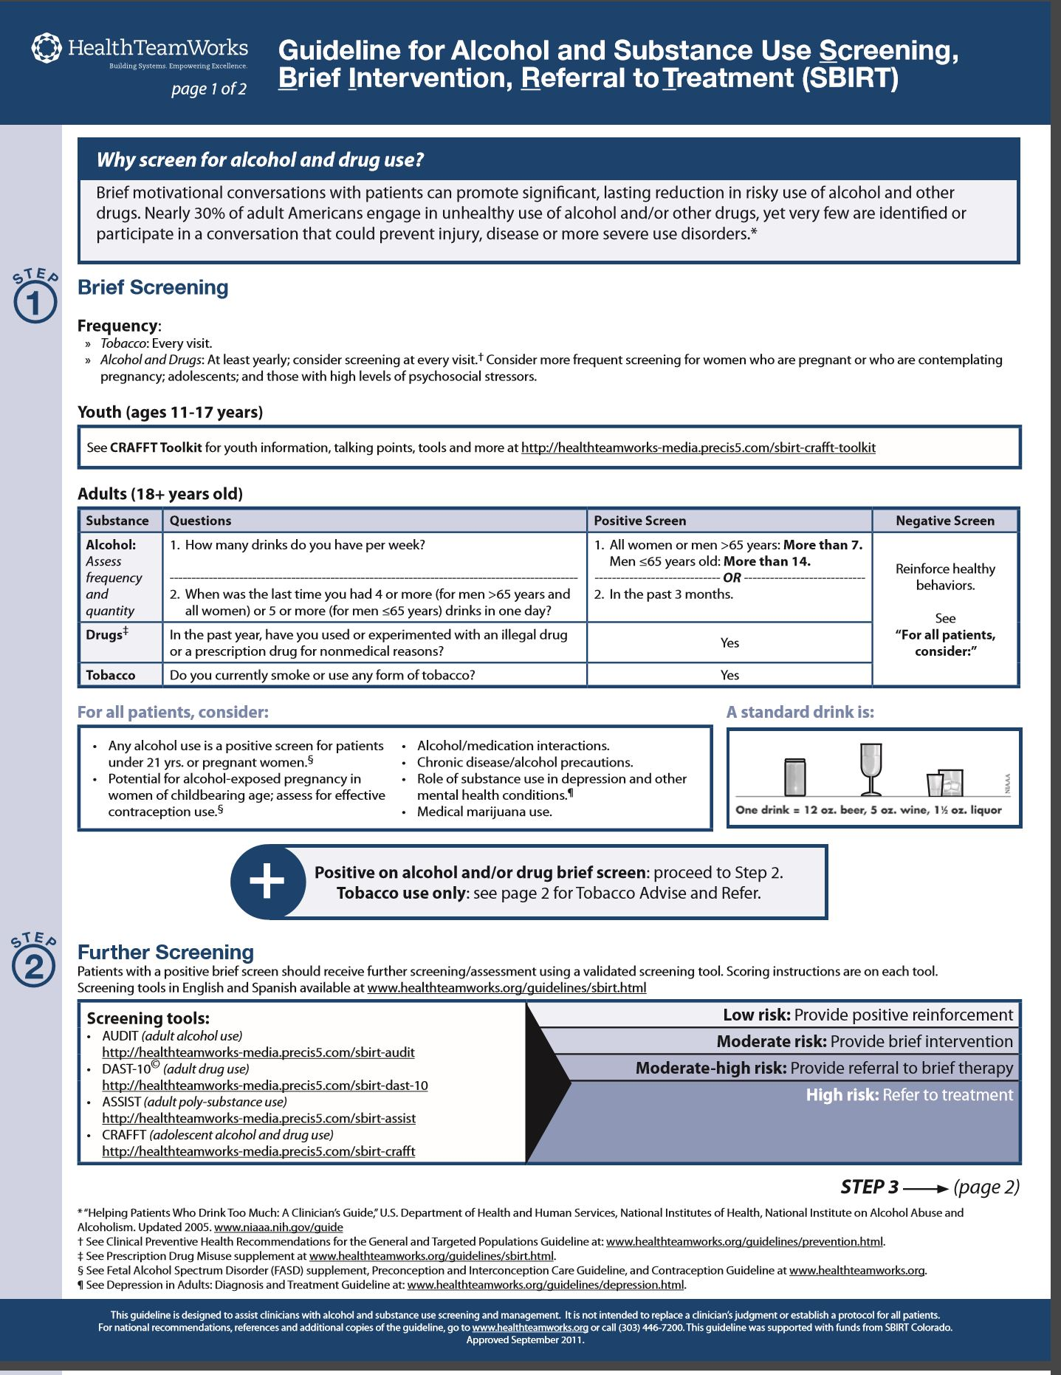
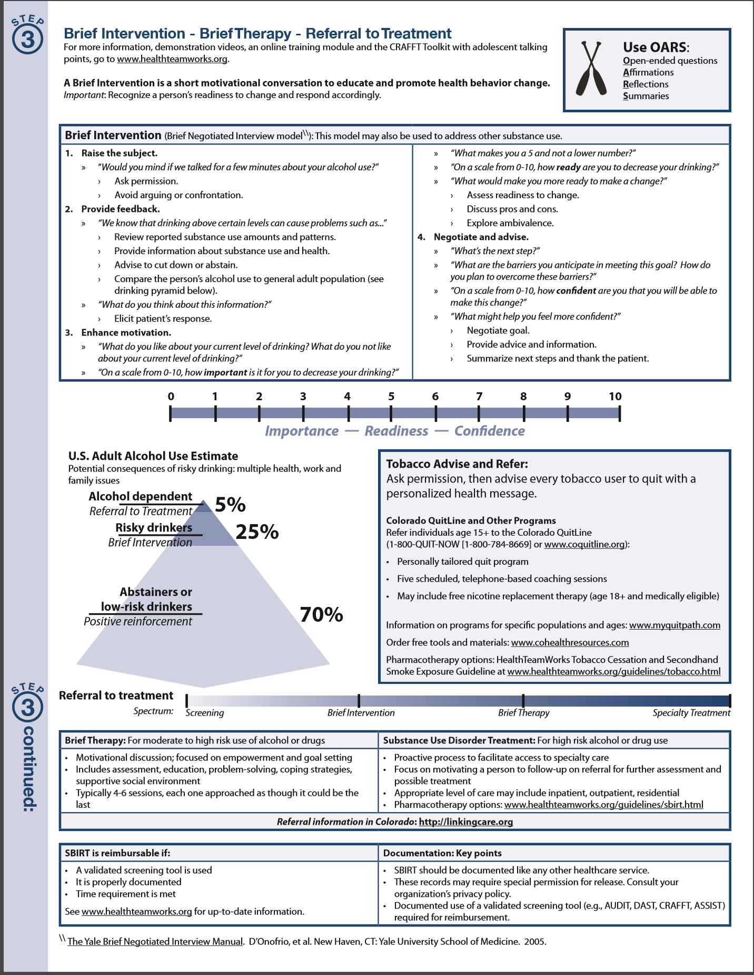

Appendix B
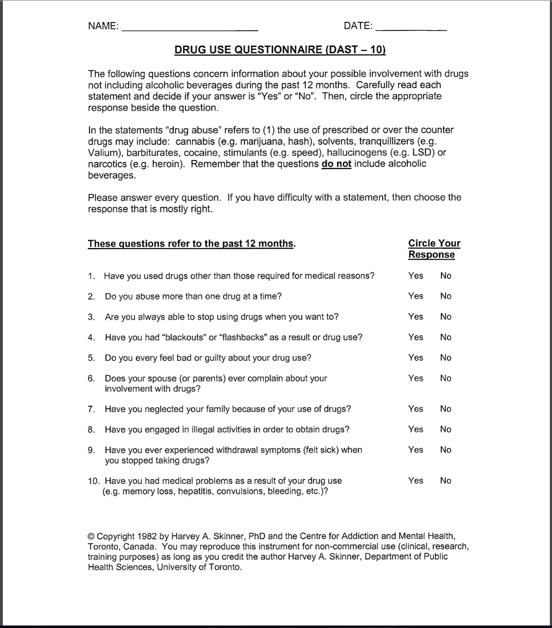

Appendix C
The outcomes data sheet was used to collect unidentifiable patient information from single-question screenings, DAST-10 forms and the referral note.
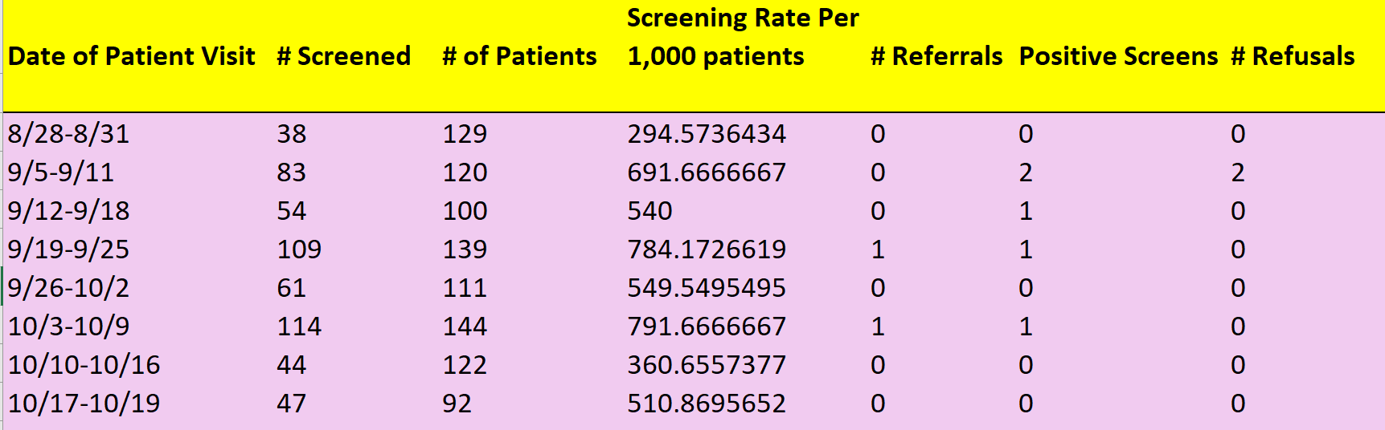
Figure 1. SBIRT Outcomes Data Sheet.

Appendix D
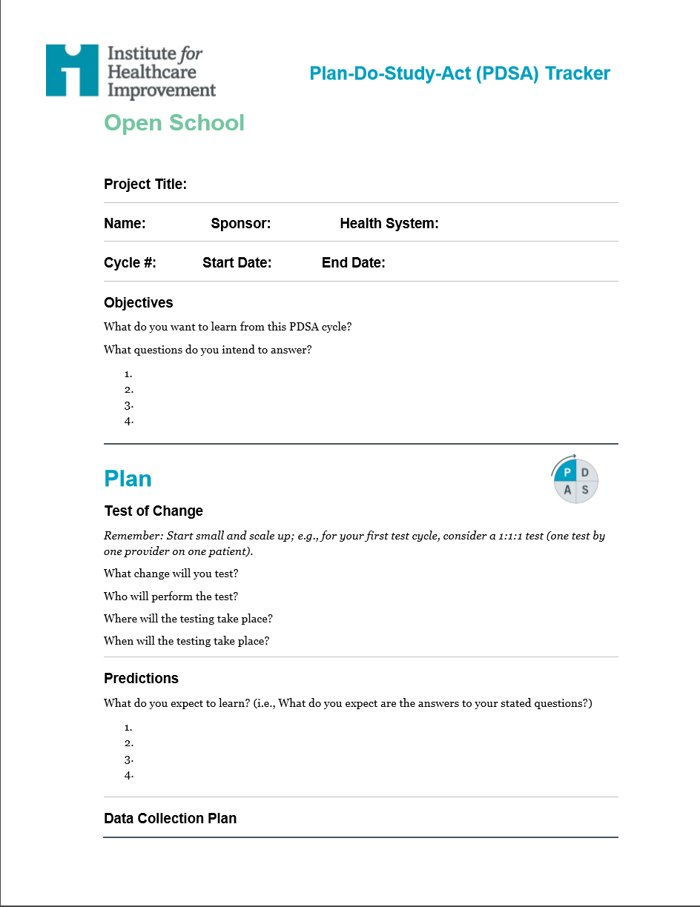
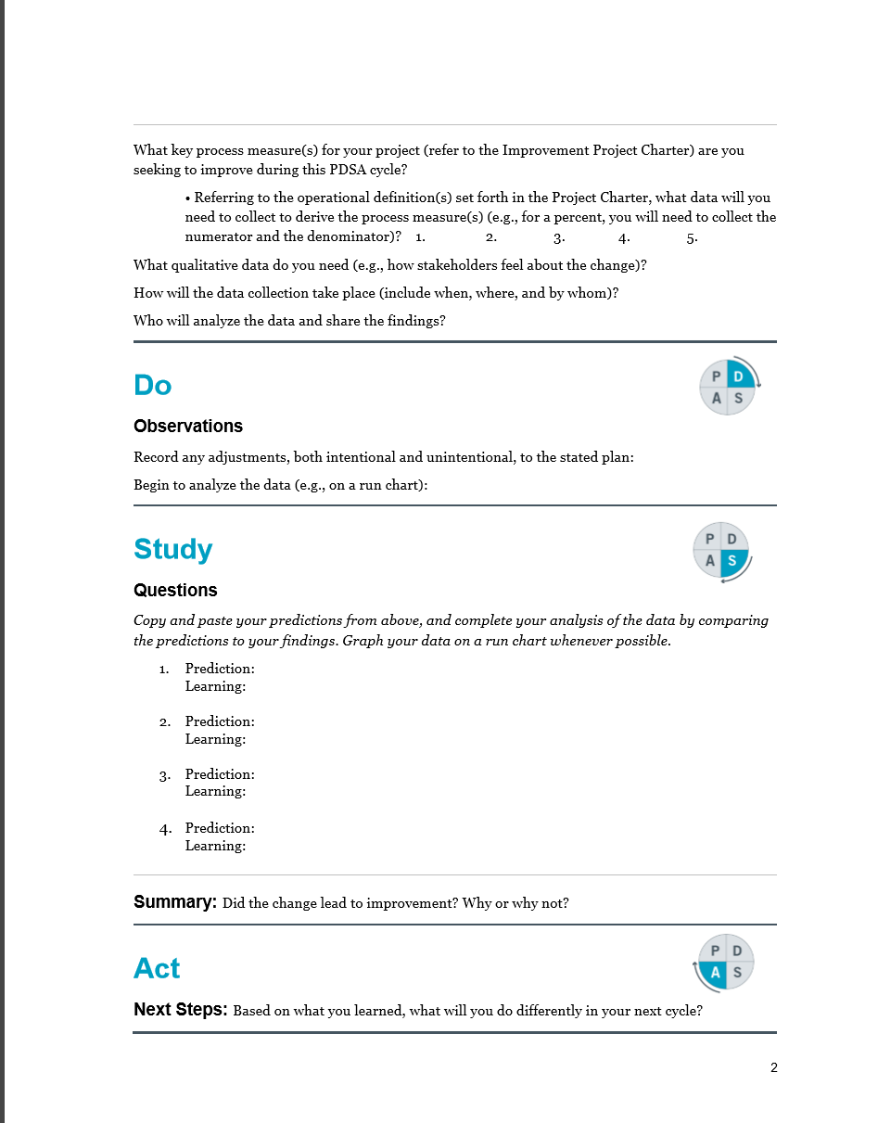
Appendix E
The SBIRT Cost Analysis included material and opportunity costs. Opportunity costs reflected the hourly rate of pay of the implementer in the workplace (see note). Mileage was also calculated based on the standard IRS mileage reimbursement rate (Internal Revenue Service, 2017).
Table 1
SBIRT Implementation Cost Analysis
Item |  |  | Cost Per Unit | # Units |  | Total (Dollars)
Printer paper |  |  | 12.07 | 1 |  | 12.07
Ink cartridge |  |  | 80.07 | 1 |  | 80.07
Pens |  |  | 4.07 | 2 |  | 8.07
Refreshments |  |  | 12.07 | 4 |  | 90.5
Mileage |  |  | 0.54 | 80 |  | 43.2
 |  |  |  |  | Total: 233.91
Note. Mileage is recorded by the standard "$0.54" per mile.
Table 1. SBIRT Implementation Cost Analysis

Appendix F
The IBM is useful for predicting and influencing provider behaviors, as each construct addresses possible barriers and facilitators of behavior change.
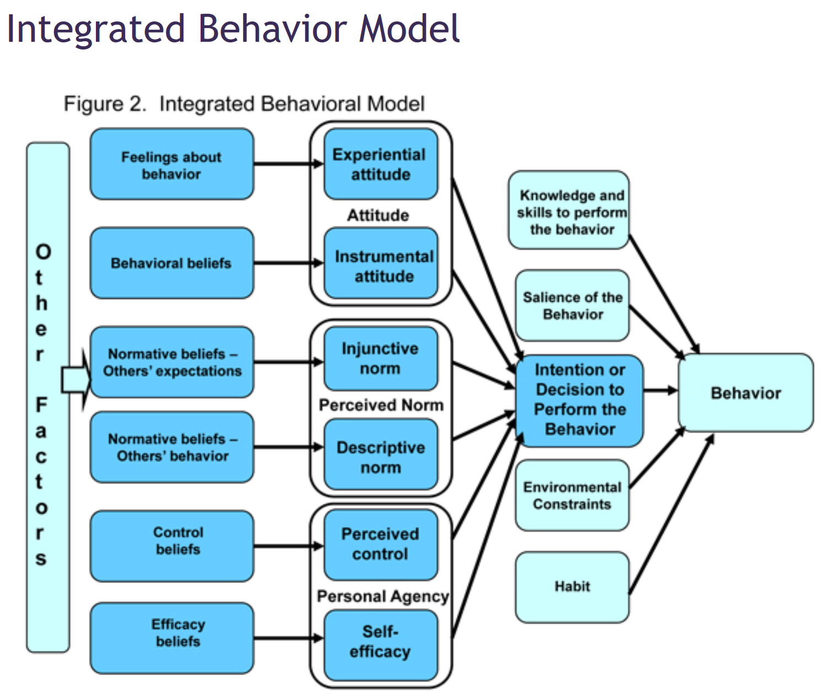

Appendix G
East Carolina University Office of Research Integrity and Compliance (ORIC) waiver of University & Medical Center Institutional Review Board (UMCIRB) review.
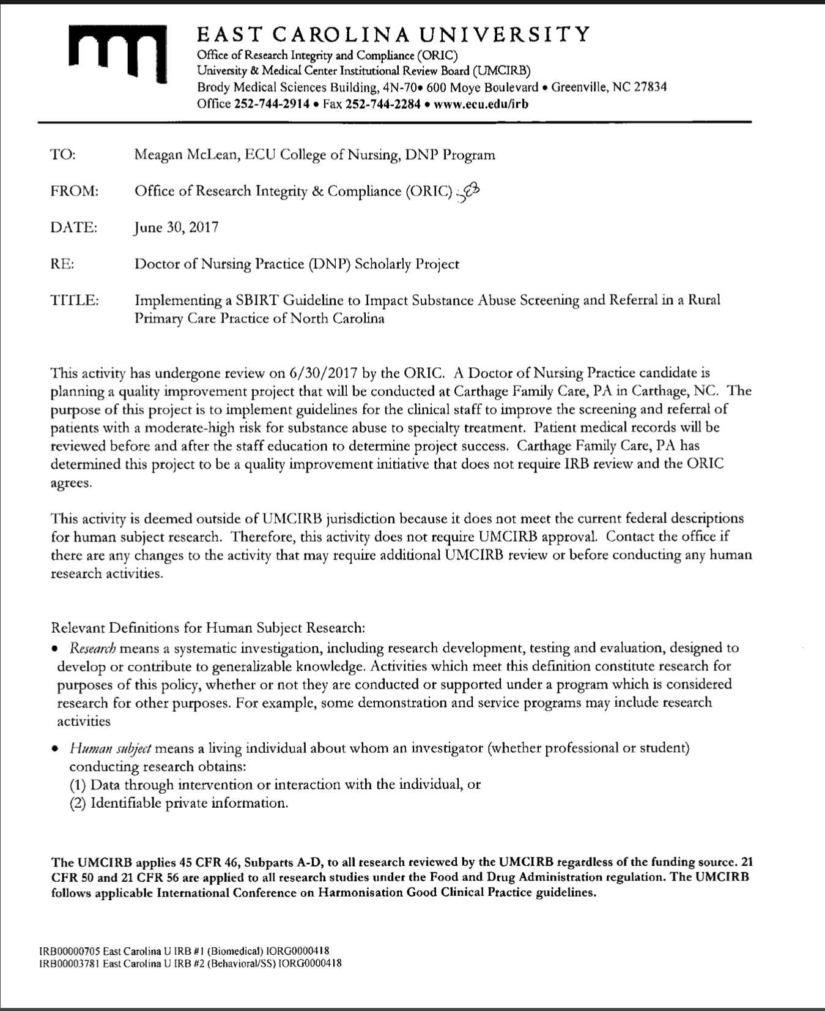
Appendix H
A map of the screening and referral process flow for use at the practice site.
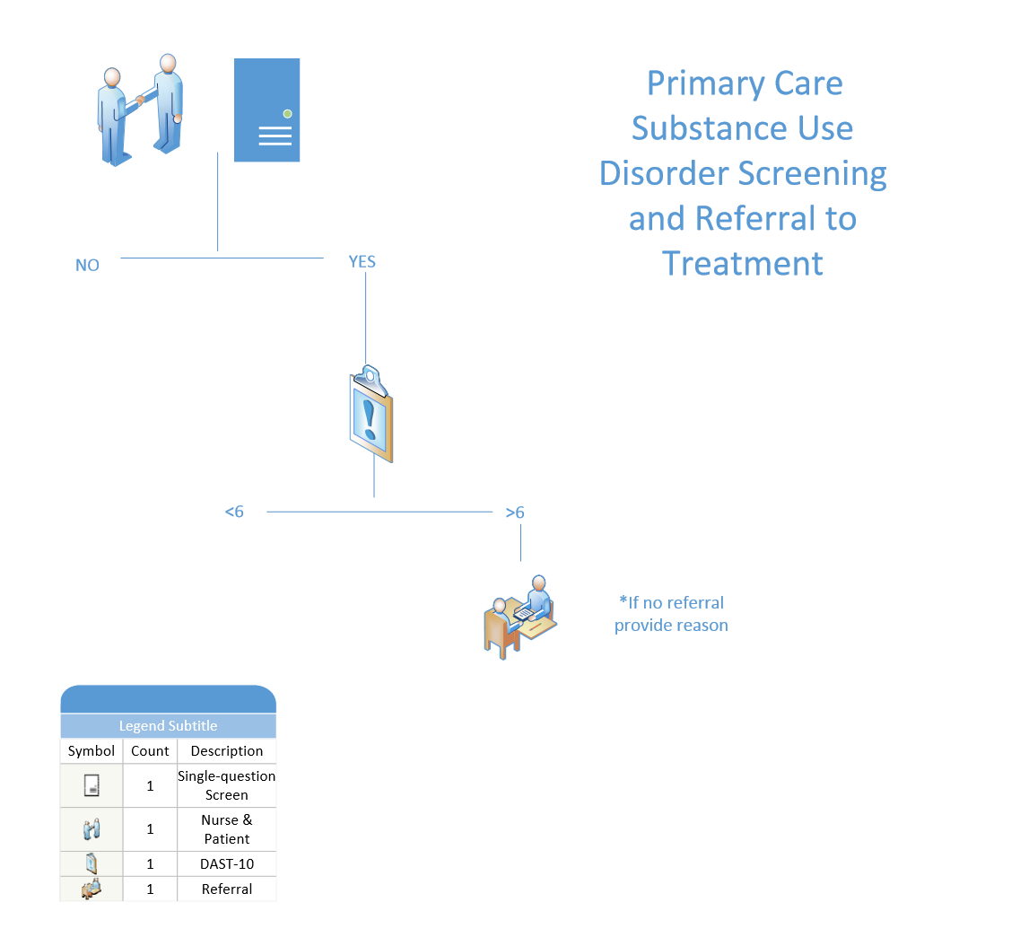

Appendix I
The results of the project are summarized in the table below. PDSA cycles refer to the two-week time segments in which implementation occurred. Cycles were modified every two weeks using the plan, do study, act method of process change. The rates of screening and referral were computed per 1,000 patients.
Table 2.
Rate of Screening for SUD N=957
PDSA Cycle | Patients Screened | Patients Seen | Rate of Screening | Positive Screens | Rate of Referral | Refusals
1 | 121 | 249 | 493.12 | 2 | 0 | 2
2 | 163 | 239 | 662.086 | 2 | 500 | 0
3 | 175 | 255 | 670.607 | 1 | 1000 | 0
4  Total  Average | 91  550  137.5 | 214  957  239.25 | 435.76  2261.57  565.393 | 0  5  1.25 | 0  1500  375 | 0  2  0.5
Table 2. Rate of Screening for SUD

Appendix J
Figure 2. Rate of Substance Use Disorder Across Four Plan Do Study Act Cycles

Appendix K

Table. 3
Cost-Benefit Analysis for Prescreen, Screen and Referral to Treatment for Patients with SUD
Screen Delivery | Clinician-Administered Screen |  | Patient-Administered Screen
Payer | CI and Medicaid | Medicare | CI and Medicaid | Medicare
Reimbursement | $33.41 | $29.42 | $33.41 | $29.42
Cost PS, FS, RT | $14.05 | $14.05 | $14.05 | $14.05
Unlicensed Clinician Time (10 minutes) | $4.22 | $4.22 | $0.00 | $0.00
Total Rev (per patient) | $15.14 | $11.15 | $19.36 | $15.37
Total for PI Project (4 patients) | $60.56 | $44.60 | $77.44 | $61.48
Total Rev (annual) | $393.64 | $289.90 | $503.36 | $399.62
Note: Reimbursement is based on American Medical Association approved CPT codes for SBIRT. Cost of pre-screen (PS), full-screen (FS) and Referral to Treatment (RT) were based on a study of cost-benefit analysis of SBIRT by Barbosa, C., Cowell, A., Landwehr, J., Dowd, W. & Bray, J. (2016). Unliscenced clinician time was based on average annual salary of a medical technician in Southeast North Carolina for 10 minutes of screening administration. The "Total for PI project" is based on the total revenue multiplied by 4 patients who's DAST-10 score indicated referral found within the study. Total annual revenue is based on the ratio of patients needing referral per two-week PDSA cycle, which was found to be one patient to every two weeks. This ratio was applied to 52 weeks of business at the clinic, multiplied by the total revenue.

Appendix L

Figure 3. Substance Use Disorder Prescreen, Screen and Referral Reimbursement Revenue

Appendix M
This table represents a summary of the four plan-do-study-act (PDSA) worksheets used to track change throughout the process improvement.
Table 4.
Summary of Plan Do Study Act Worksheets
PDSA Cycle | 1 | 2 | 3 | 4
Question 1 | Rate of screening up from 0? | Rate of screening up from 49.3%? | Rate of screening up from 66.2%? | Rate of screening up from 67.1%?
Question 2 | Referrals up from 0? | Referrals up from 0? | Referrals up from 0? | Referrals up from 0.01%?
Question 3 | Does SQS prompt DAST-10? | Does SQS prompt DAST-10? | Does SQS prompt DAST-10? | Does SQS prompt DAST-10?
Question 4 | Is screening efficient? | Is screening efficient? | Is screening efficient? | Is screening efficient?
PLAN
Prediction 1 | Rate of screening up from 0 | Rate of screening up from 49.3% | Rate of screening up from 66.2% | Rate of screening up from 67.1%
Prediction 2 | Rate of referral up from 0 | Rate of referral up from 0 | Rate of referral up from 0 | Rate of referral up from 0.01%
Prediction 3 | Single-question will prompt DAST-10 | Forms will be 100% completed | Forms will be 100% completed | Forms will be 100% completed
DO
Task 1 | Record rate of screening/referral | Record rate of screening/referral | Record rate of screening/referral | Record rate of screening/referral
Task 2 | Collect feedback from providers/staff | collect feedback | collect feedback | collect feedback
Task 3 | student present at the clinic 3x/week | remain present at the clinic 2x/week | remain present at the clinic 2x/week | remain present at the clinic 2x/week
STUDY
Finding 1 | screening increased from 0% to 49.3% | screening increased from to 66.2% | screening increased to 67.1% | screening decreased to 43.5%
Finding 2 | rate of referral did not increase | rate of referral did not increase | referral increased to 0.01% | referral decreased to 0
Finding 3 | staff administered screens | patient given screen | patient given screen | patient given screen
Finding 4 | staff report screening is efficient | staff report screening is more efficient | staff report screening is efficient | staff report screening efficient
ACT
Change 1 | Who administers: provider | Who administers: staff | Who administers: patient | patient self-administered screen
Change 2 | Location of screen: lobby | Location: patient room | Location: patient room | Location: patient room
Change 3 | continue track rate of screen/referral | continue track rate of screen/referral | continue track rate of screen/referral | finish track screen/referral
Change 4 | forms 100% complete | forms 100% complete | forms 100% complete | forms 100% complete
Note: table denotes changes made to each 2-week plan-do-study-act (PDSA) cycle and summarizes information recorded in the Institute of Health Improvement PDSA worksheet. Abbreviation "SQS" stands for single-question screening.

Appendix N
A literature review matrix housing articles, websites and other resources used in this project is included below.
Article Citation | Level of Evidence I-VII | Data/Evidence Findings | Conclusion | Use of Evidence in EBP Project Plan  (Include your evaluation, strengths/limitations, and relevance)
Addiction Technology Transfer Center Network (2015). ATTC white paper: integrating substance use disorder and health care services in an era of health care reform. Retrieved from http://www.attcnetwork.org/ATTC_WhitePaper-final-web.pdf | I | Guideline to integrating SUD treatment into primary care | The ATTCN white paper exists to emphasize the need for better integration of SUD and health care services and describe an array of effective models and interventions for various healthcare settings. | SAMSHA -HRSA center for integrated health solutions (CIHS) define "integrated care" as the "systematic coordination of general and behavioral health care. Integrating mental health, substance abuse and primary care services, that produce the best outcomes and proves the most effective approach to caring for people with multiple health care needs". 22.7 million Americans need SUD services, 11% of which actually receive them. 22% of all patients have a SUD in health care settings. 68 million Americans drink alcohol and use drugs in harmful ways but do not meet diagnostic criteria for SUD. These behaviors can change the circuitry of the brain's reward center, leading to SUD or worsening problems. Chronic and serious conditions such as arthritis, asthma, HTN, and ischemic heart disease are more than twice as prevalent among patients with SUD than the rest of the population. The director for SAMSHA's Center for Substance Abuse and Treatment suggests that use of SBIRT makes an invisible problem visible by providing tools to ID and address alcohol and drug abuse. SBIRT was not verified for use in drug abuse/misuse disorders.
Aldridge, A., Linford, R. and Bray, J. (2017). Substance use outcomes of patients served by a large US implementation of screening, brief intervention and referral to treatment (SBIRT). Addiction 112(S2), 43-53. Doi:10.1111/add.13651 | III | Retrospective study | Patients receiving SBIRT in SAMHSA cohort I had lower substance misuse following the intervention than those who did not receive SBIRT. | SBIRT is a validated method of screening and treatment/referral for patients in primary care. Patient outcomes were improved having received SBIRT.
American Association of Colleges of Nursing (2018). DNP Essentials. Retrieved from http://www.aacnnursing.org/DNP/DNP-Essentials | V | Expert opinion | The DNP Essentials guide advanced nursing practice by delineating actions within interprofessional groups, mentoring others within the healthcare field, use of EBP, use of technology for better patient outcomes, reducing cost and performing PI. | The DNP essentials are consulted when making recommendations for future PI, advanced nursing practice and the practices of PI project sites based on this PI project.
Babor, T.F., Del Boca, J. and Bray, J.W. (2017). Screening, brief intervention and referral to treatment: implications of samhsa’s sbirt initiative for substance abuse policy and practice. Addiction 112(2), 110-117. Doi: 10.1111/add.13675. | III | Retrospective cohort study | This paper discusses varying results between the SAMHSA SBIRT cohort studies and implications for practice/patient outcomes. | Repeat analysis of the large, grant-funded SAMHSA SBIRT results with the additon of a control yeilded different results than cohort I, however SBIRT is still beneficial and applicable in primary care. Sustainability depends on different factors, however and may require the addition of behavioral health contractors.
Barbosa, C., Cowell, A., Landwher, J. Dowd, W. and Bray, J. (2015). Cost of screening, brief intervention and referral to treatment in healthcare settings. Journal of Substance Abuse Treatment, 60:54-61. Retrieved from https://doi.org/10.1016/j.jsat.2015.06.005 | III | Retrospective study | 26 inpatient, outpatient, ED and 1 tribal site were analyzed for cost of SBIRT services. | Data collected can be used to practice sites to estimate the cost of delivering SBIRT services vs. reimbursement prior to PI.
Barrett, K., and Chang, Y.P. (2016). Behavioral interventions targeting chronic pain, depression, and substance use disorder in primary care. Journal of Nursing Scholarship, 48(4), 345-353. doi:http://dx.doi.org.jproxy.lib.ecu.edu/10.1111/jnu.12213 | I | Systematic Review | 50% of patients in primary care with depression and 65% of patients with SUD do not seek help. Mindfullness and motivational interviewing have indications in primary care. | This information encourages the use of consistent screening and a method of brief intervention in the context of primary care for those with SUD and behavioral health.
Benzon, H. T., Rathmell, J. P., Wu, C. L., Turk, D. C., Argoff, C. E., & Hurley, R. W. (2014; 2013). Practical management of pain (Fifth; 5 ed.). Philadelphia, PA: Elsevier/Saunders. | V | Text written by experts based on evidence of pain management strategies for inpatient/outpatient care. | Appraisal of evidence for guidelines of pain management in inpatient and outpatient settings | Information on inpatient/outpatient pain management from 2014 can be useful in understanding how differences between old and new contribute to the science of pain management as well as how old guidance may have left gaps contributing to the current state of opioid management.
Blake, H., Leighton, P., van der Walt, G., & Ravenscroft, A. (2015). Prescribing opioid analgesics for chronic non-malignant pain in general practice – a survey of attitudes and practice. British Journal of Pain, 9(4), 225-232. doi:10.1177/2049463715579284 | VI | a 57 item survey was distributed to PCPs and psychologists with a lot of opioid prescribing experience to determine if opioid prescribing had linkages to attitudes toward it. | General practitioners (GPs) need additional traning to build confidence in opioid prescribing capability. More research is needed to determine the attitudes of prescribers toward opioids, as the number of prescriptions continues to rise but concern for addiction continues to rise as well. | This evidence indicates a limitation in the evidence regarding provider perspective on opioid prescribing. It points to the need for more evidence to support provider attitudes toward opioid prescribing.
Blalock, S., Bone, L., Brewer, N., Butterfoss, F.D., Champion, V., Epstein, R. et al. (n.d.). Integrated behavioral model. Retrieved from http://www.med.upenn.edu/hbhe4/part2-ch4-integrated-behavior-model.shtml | VII | Website based on a textbook on health behavior and education from the University of Pennsylvania with expert opinion on a behavioral theory. | Integrated behavioral model is based on the theory of planned behavior (TPB) as well as the theory of reasoned action (TRA) and therefore combines many of the same pillars. | The IBM will be used to assess provider behaviors and details of interventions will be designed to encourage provider adherence to guidelines for opoid prescribing.
Borus, J., Parhami, I., & Levy, S. (2016). Screening, brief intervention, and referral to treatment. Child and Adolescent Psychiatric Clinics of North America, 25(4), 579-601. | I | Systematic Review | Examines the SBIRT implementation in adolescent and young adult care settings, including challenges to use and the feasibility of the PC setting | SBIRT is useful for adolescent and adult care settings, but challenges to use include lack of time, not knowing how to handle positive screens and lack of knowledge of validated tools. Use of the EMR and self-administered screens may increase use. PCPs in Mass. and Penn. believe screening should take place (92%) but only 34% used a validated tool and only 34% screened annually in Penn.
Bray, J., Kowalchuk, A. and Waters, V. (n.d.) Brief intervention stages of change and motivational interviewing. Retrieved from https://www.bcm.edu/education/programs/sbirt/index.cfm?pmid=25042 | VI | Expert opinion regarding change theory | SBIRT motivational interviewing and implementation information | The SBIRT uses motivational interviewing to deliver interventions and encourage patients to seek treatment. MI examples are given including reflecting the patient's surprise at results of their screen and showing genuine concern for their well-being.
Centers for Disease Control and Prevention (2016). CDC guideline for prescribing opioids for chronic pain-united states, 2016. Retrieved from https://www.cdc.gov/mmwr/volumes/65/rr/rr6501e1.htm | I | Up to date guidelines for opioid-prescribing practice. | CDC guidelines are a metanalysis of high levels of evidence pertaining to opioid prescribing. They should be referred to as the most current, most complete guideline. | CDC guidelines used to create a checklist for opioid-prescribing at the practice site
Centers for Disease Control and Prevention (2017). Calculating total daily dose of opioids for safer daily dosage. Retrieved from https://www.cdc.gov/drugoverdose/pdf/calculating_total_daily_dose-a.pdf | I | PDF for opioid risk mitigation using morphine milliequivalents (MME). Information for this PDF derived from CDC guideline. | Risk can be mitigated by calculating MME of the daily opioid dosage to determine risk of overdose and what patient is a candidate for naloxone prescription. | PDF will be used to educate providers at the practice site and guide a specific intervention.
Centers for Disease Control and Prevention (2017). Checklist for prescribing opioids for chronic pain. Retrieved from https://stacks.cdc.gov/view/cdc/38025 | I | PDF checklist for opioid prescribing based on CDC guideline. | Checklist provides steps to follow evidence-based protocol when prescribing opioids, including follow-up and use of MME for risk mitigation. | PDF will be used to educate providers at the practice site and guide a specific intervention.
Centers for Disease Control and Prevention (2017). Turn the tide prescribing opioids for chronic pain. Retrieved from https://www.cdc.gov/drugoverdose/pdf/turnthetide_pocketguide-a.pdf | I | PDF pocket guide for opioid prescribing adapted from CDC guideline | Pocket guide is a quick reference to follow evidence-based protocol when prescribing opioids. | PDF will be used to educate providers at the practice site and guide a specific intervention.
Chambers, J. E., Brooks, A. C., Medvin, R., Metzger, D. S., Lauby, J., Carpenedo, C. M., . . . Kirby, K. C. (2016). Examining multi-session brief intervention for substance use in primary care: Research methods of a randomized controlled trial. Addiction Science & Clinical Practice, 11doi:http://dx.doi.org.jproxy.lib.ecu.edu/10.1186/s13722-016-0057-6 | II | RCT | Patients were screened using the AUDIT and DAST forms in primary care centers, given a brief intervention and referred to treatment based on positive screens. | The potential is great for use of BI in the primary care setting but more systematic review is needed to confirm use with controlled substances.
Chelimsky, T. C., Fischer, R. L., Levin, J. B., Cheren, M. I., Marsh, S. K., & Janata, J. W. (2013). The primary practice physician program for chronic pain (© 4PCP): Outcomes of a primary Physician—Pain specialist collaboration for community-based training and support. The Clinical Journal of Pain, 29(12), 1036-1043. doi:10.1097/AJP.0b013e3182851584 | II | This is a prospective randomized controlled pilot study of 31 PCPs on which the 4PCP framework was implemented. This training involved the collaboration between chronic pain specialists and PCPs, based on the biopsychosocial pain model.This pilot study demonstrates the efficacy of the 4PCP training program in creating successful interdisciplinary chronic pain management by PCPs. Outcomes included improved patient outcomes, visit efficiency, and job satisfaction. 4PCP provides a promising framework to propel the national concept of PCP-specialist collaboration for chronic pain management. | PCPs receiving the intervention reported improvements in diagnosing and managing chronic pain (P=0.023), especially its functional consequences (P=0.008), in treatment satisfaction, and in involving other disciplines. Mean visit time dropped from 20 to 11 minutes (P<0.03) with improved patient outcomes, which correlated with 4PCP physician engagement. Significant benefit began at 10 continuing medical education hours and proved durable 1 year after trial. | Evidence in this study supports the use of an interdisciplinary collaboration between PCPs and chronic pain specialists. An educational intervention to address both disciplines improves patient outcomes. This can be applied to the primary care setting alone for the project.
Chen, J. H., Hom, J., Asch, S. M., & Richman, I. (2016). Effect of opioid prescribing guidelines in primary care. Medicine (Baltimore), 95(35), e4760; e4760 | III | This is a non-randomized controlled trial of provider documentation of opioid prescribing practices before and after dissemination of guidelines. A multidisciplinary team assembled guidelines of CNCP management and disseminated info to providers in the SF Bay area in internal med, primary care, pain specialty practices and others. Chart audit compared urine drug screens, opioid prescriptions, referrals for providers, and emergency room visits, primary care visits and opioid prescriptions for patients pre and post intervention. | The percentage of chronic opioid patients subject to urine drug screening increased 87% from 9.2% to 17.3% (P = 0.005), but the overall rates of screening and referrals to PT, psychiatry, and pain clinic remained relatively low both pre- and postintervention. No significant differences were detected in the number of patient visits to specialty referral clinics, emergency room encounters, or the overall quantity of opioids prescribed per patient. | This evidence directly supports the project, showing that urine drug screening increases with a guideline-directed educational intervention.
Colorado Clinical Guideline Collaborative (n.d.). Guideline for alcohol and drug use screening, brief intervention, referral to treatment (SBIRT). Retrieved from http://improvinghealthcolorado.org/wp-content/uploads/2014/09/Substance-Use-Screening-and-Brief-Intervention-Clinical-Guideline-10-13-11.pdf | II | Guideline | Guideline based on evidence supporting the use of single-question screening and one of several substance use disorder screning tools complete with algorithm for treatment | Single-question screening is validated and over 80% sensitive for detecting SUD and the DAST-10 was validated for primary care. These two tools were combined to create the project data collection tool.
Community Care of North Carolina (2017). Pain management tools. Retrieved from https://www.communitycarenc.org/pain-management/ | N/A | Opioid prescribing tools adapted from evidence-based resources by a community care organization for the state of NC . | Pain management tools include prescribing algorithms, a link to the NCCSRS, interpretation of urine toxicology and other useful tools | Tools adapted from guidelines and evidence-based resources will be put on a list of recommended resources for providers at the project site. The link to the NCCSRS and interpreting urine toxicology will be useful tools for project implementation.
County Health Rankings and Roadmaps (2017). North Carolina. Retrieved from http://www.countyhealthrankings.org/app/north-carolina/2017/measure/factors/138/data | V | Government website of health concerns by county including substance use disorder morbidity and mortality | Validates that SUD is a problem in county of concern in this PI project | Validates that 36 overdose deaths occurred in Moore county NC. Website up to date as of 2018
Dorflinger, L. M., Ruser, C., Sellinger, J., Edens, E. L., Kerns, R. D., & Becker, W. C. (2014). Integrating interdisciplinary pain management into primary care: Development and implementation of a novel clinical program. Pain Medicine, 15(12), 2046-2054. doi:10.1111/pme.12554 | VI | Descriptive study of a veteran primary care clinic and specialty pain clinic collaboration. The PDSA cycle was used to learn current process and discover gaps and areas for improvement. A 2 day collaborative conference was held between VA PCP and specialty pain practices to discuss implementation and ideas. | At the end of the study the cancellation of patients referred to pain specialty decreased from 42% to 34%. Patients and providers had higher satisfaction with the way pain was managed. | The study will be helpful as an example of the PDSA implementation of a project, as well feedback elicited from frustrated providers regarding pain management. This evidence supports the documented attitude of providers that pain management is frustrating and there is concern for addiction with opioid prescriptions.
Dowell D, Haegerich TM, Chou R. CDC Guideline for Prescribing Opioids for Chronic Pain — United States, 2016. MMWR Recomm Rep 2016;65(No. RR-1):1–49. DOI: http://dx.doi.org/10.15585/mmwr.rr6501e1. | I | CDC guideline with recommendations after metanalysis of current literature, intended for reference for providers who prescribe opioids. | Guideline should be referred to as the most current, most complete guideline. | This guideline serves as the gold standard for making policy for the study site.
Ghitza, U., Gore-Langston, R.,Lindblad, R. Shide, D., Subramaniam, G. and Tai, B. (2012). Common data elements for substance use disorders in electronic health records: the nida clinical trials network experience. Addiction, 108(1), 1-230. Doi: 10.1111/j.1360-0443.2012.03876.x. | VI | Case-control study | Screening and brief assessment was implemented in a system-wide fashion after the study took place, based on a survey of stakeholder input. | Screening and brief assessment are not unlike SBIRT, and both are helpful in detecting SUD. Screening is, at the very least necessary to detect SUD.
Hwang, C., Turner, L., Kruszewski, S., Kolodney, A. and Alexander, G. (2016). Primary care physicians’ knowledge and attitude regarding prescription opioid abuse and diversion. Clinical Journal of Pain 32(4): 279-84. doi: 10.1097/AJP.0000000000000268. | III | Case-control study | Providers feel underprepared to aid in the problem of opioid misuse. | Primary care providers require educational PI interventions to increase knowledge and improve attitude toward the behavior change of screening.
Institute of Healthcare Improvement. (2017). Initiatives. Retrieved from http://www.ihi.org/Engage/Initiatives/TripleAim/Pages/default.aspx | I | IHI website of health care initiatives | Triple Aim initiative includes reducing heatlhcare costs, improving the patient experience and improving the health of populations | Triple Aim initiative directs quality improvement initiatives on a smaller scale down to the single-practice level
Institute of Healthcare Improvement. (2017). Plan do study act (PDSA) worksheet. Retrieved from http://www.ihi.org/resources/Pages/Tools/PlanDoStudyActWorksheet.aspx | I | A summary educational worksheet for using the PDSA cycle in process improvement (PI). | The PDSA is useful in implementing PI projects in clinical settings because it allows for multiple cycles of implementation with adjustments. | The PDSA will guide implementation at the site.
Kessler, R., Miller, B., Kelly, M., Graham, D., Kennedy, A. and Littenberg, B. (2014). Mental health, substance abuse and health behavior services in patient-centered medical homes. Journal of the American Board of Family Medicine, 27(5): 637-644. doi:103122/jabfm.2014.05140021 | III | Cohort study | Nationally-recognized PCMH only screened using an EBP validated tool for SUD or behavioral health problems 54% of the time. | Screening for SUD and behavioral health problems is not consistently done using EBP.
Krupski, A., Joesch, J. M., Dunn, C., Donovan, D., Bumgardner, K., Lord, S. P., et al. (2012). Testing the effects of brief intervention in primary care for problem drug use in a randomized controlled trial: Rationale, design, and methods. Addiction Science & Clinical Practice, 7(1), 27-27. | II | RCT | This RCT examines SBIRT including MI for the ID and treatment of alcohol and drugs. MI techniques discussed. | SBIRT is effective for the ID and treatment of SBIRT in primary care.
Levit, K. R., Stranges, E., Coffey, R. M., Kassed, C., Mark, T. L., Buck, J. A., et al. (2013). Current and future funding sources for specialty mental health and substance abuse treatment providers. Psychiatric Services, 64(6), 512-519. | VII | Expert opinion | Review of funding and resources for mental health | There is a detrimental discrepancy in mental/behavioral health providers. This supports the need for integration of drug use disorder screening and treatment in primary care as there are not enough mental/bheavioral providers to handle the patient load if all patients with substance use disorder were referred after being screened positive.
Mack K.A, Jones C.M, Ballesteros M.F. Illicit Drug Use, Illicit Drug Use Disorders, and Drug Overdose Deaths in Metropolitan and Nonmetropolitan Areas — United States. MMWR Surveill Summ 2017;66(No. SS-19):1–12. DOI: http://dx.doi.org/10.15585/mmwr.ss6619a1. | I | Critically-appraised article using statistics gathered by a trusted government entity | SUD is increasing in urban and rural areas but rural areas were found to have higher SUD than urban areas for the first time in recent years. | Rural areas are beginning to suffer from higher rates of SUD, thus PI to introduce screening and referral is indicated to connect patients with treatment.
McNeely, J., Cleland, C. M., Strauss, S. M., Palamar, J. J., Rotrosen, J., & Saitz, R. (2015). Validation of Self-Administered Single-Item Screening Questions (SISQs) for Unhealthy Alcohol and Drug Use in Primary Care Patients. Journal of General Internal Medicine, 30(12), 1757–1764. http://doi.org.jproxy.lib.ecu.edu/10.1007/s11606-015-3391-6 | III | Cohort study | This study examined the use of a single-item screening for alcohol and drug problem use and SUD. Conclusions include that a SQS was valid and reliable for detecting SUD and problem use among adults under 65 on the east coast in 2 primary care safety net settings. | The use of a SQS has been validated for use in primary care in the adult population. It confirmed that single-item drug screening had sensitivity of 71.3 % (95 % CI 62.4–79.1) and specificity of 94.3 % (95 % CI 91.3–96.6) for detecting unhealthy drug use in the east coasts primary care adult population
Mitchell, A.M., Hagle, H., Puskar, K., Kane, I., Lindsay, D. and Talcott, K. et al. (2014). Alcohol and other drug use screenings by nurse practitioners: policy implications. The Journal for Nurse Practitioners, 11(7), 730-732. Doi:http://dx.doi.org.jproxy.lib.ecu.edu/10.1016/j.nurpra.2014.11.025 | VI | Report | NPs are excellent clinicians to deliver SBIRT due to good patient outcomes and holistic approach to care. SBIRT is economical for PCPs. | This information supports NPs deliving SBIRT in primary care. Reimbursement codes and amounts useful for implications of this PI and sustainability.
N.C. Health and Human Services (n.d.) Substance Abuse. Retrieved from https://www.ncdhhs.gov/assistance/mental-health-substance-abuse/substance-abuse | II | Government website with resources for substance misuse as well as definitions. | It is recommended by the NCHHS to offer substance abuse treatment resources to those with a know SUD. | This information supports the use of referral to treatment for those with SUD.
National Institute on Drug Abuse (2015). Chart of evidence-based screening tools for Adults and Adolescents. Retrieved from https://www.drugabuse.gov/nidamed-medical-health-professionals/tool-resources-your-practice/screening-assessment-drug-testing-resources/chart-evidence-based-screening-tools-adults | V | Evidence-based screening tools for drug use disorder in various settings | The NIH National Institute on Drug Addiction revised the chart of evidence-based tools to use for drug and alcohol addiction for adults and adolescents | The DAST-10 is validated for use on adults with addiction to drugs
NCSBIRT (n.d.) SBIRT clinical tools. Retrieved from http://ncsbirt.org/sbirt-clinical-tools/ | II | Government website listing drug abuse screening tools validated for use in various settings when implementing SBIRT | The DAST-10 is validated for SUD detection. | DAST-10 can be utilized in the PI project.
Olfson, M., Wall, N., Liu,S., Schoenbaum, M. and Blanco, C. (2018). Declining health-related quality of life in the U.S. American Journal of Preventive Medicine, pii: S0749-3797(17)30700-6. doi: 10.1016/j.amepre.2017.11.012. | III | Case-control study | Between 2001-2002 and 2012-2013 there was a decrease in QOL in part due to substance use disorder. | Patients with SUD will likely experience a decrease in health related quality of life.
Saitz, R., Cheng, D. M., Allensworth-Davies, D., Winter, M. R., & Smith, P. C. (2014). The Ability of Single Screening Questions for Unhealthy Alcohol and Other Drug Use to Identify Substance Dependence in Primary Care. Journal of Studies on Alcohol and Drugs, 75(1), 153–157. Retrieved from https://doi-org.jproxy.lib.ecu.edu/10.15288/jsad.2014.75.153 | III | Cross-sectional study | This cross-sectional study concluded that a single-question question (SSQ) is as or more useful than a longer questionairre in detecting substance use problems in primary care. | The use of a single-question screening is validated in this article, and will be used to detect SUD and then screen patients further using the DAST-10.
SAMHSA (2014). Behavioral health trends in the united states: results from the 2014 national survey on drug use and health. Retrieved from https://www.samhsa.gov/data/sites/default/files/NSDUH-FRR1-2014/NSDUH-FRR1-2014.pdf | V | Government website listing statistics and links concerning SUD statistics | Behavioral health and SUD often coexist. | Screening for SUD can lead to treatment for both SUD and underlying mental health problems.
SAMSHA-HRSA Center for Integrated Health Solutions (n.d.). Substance use. Retrieved from http://www.integration.samhsa.gov/clinical-practice/substance_use | I | Systematic Review of evidence surrounding substance abuse disorder | The SAMSHA-HRSA exists to provide evidence, resources and training support for the integration of behavioral and primary health care to improve patient outcomes. | Integration of behavioral health services including SUD services into primary care, improves patient outcomes.
Stanford Center for Continuing Medical Education (2015). Safe opioid prescribing and risk evaluation and mitigation strategies (REMS). Retrieved from https://med.stanford.edu/cme/courses/online/rems.html | NA | Continuing medical education (CME) course | This free CEU offered by Stanford University Center for Continuing Medical Education combines current evidence with expert opinion with the intent of educating providers about best opioid prescribing practices and pain management. | This CME/CEU is the educational intervention that providers at CFC will undergo in adjunct to and to prep them for the process improvement of pain management.
The American Psychiatric Association (2017). Help with addiction and substance use disorders. Retrieved from https://www.psychiatry.org/patients-families/addiction?_ga=2.212799316.1304740908.1496359358-727936137.1496359358 | VI | Expert opinion regarding SUD from the American Psychiatric Association | Definition of addiction shared. Also behavioral health and SUD often coexist. | Factors contributing to addiction and the definition of addiction are important for PCPs to know.
U.S. Department of Health and Human Services (2017). Supporting HHS's opioid initiative. Retrieved from https://www.ahrq.gov/professionals/systems/primary-care/opioids/index.html | V | Government website listing statistics and links concerning the Health and Human Services opioid initiative | Opioid prescription expenses rose from $4.1 billion to $9 billion since 1990's. SBIRT is recommended for primary care to detect SUD. | Validates use of SBIRT and gives support for the need for a PI project to introduce SBIRT in primary care.
Vendetti, J., Gmyrek, A., Damon, D., Singh, M., McRee, B. and Del Boca, F. (2016). Screening, brief intervention and referral to treatment (SBIRT): implementation barriers, facilitators and model migration. Addiction Research Report 112 (S2) 23-33. doi:10.1111/add.136 | VI | Cohort study (mixed methods) | A protocol called the SCORe was used to evaluate each of the SAMHSA SBIRT cohort studies. | The third cohort study demonstrated that SBIRT is applicable in primary care and other settings. PCPs may not be prepared to deliver SBIRT, and sustainability may be reached using contracted behavioral health specialists.
Woo, C., Schmidt, L., Krishnan, A., Jepma, M., Roy, M., Lindquist, M. A., et al. (2017). Quantifying cerebral contributions to pain beyond nociception. Nature Communications, 8, 14211. doi:10.1038/ncomms1421 | II | RCT | SIIPS 1, an MRI-based brain signature of pain experience was developed for 137 patients with 50 images each. The signature was predictive of perceived response regardless of increased intensity of a nociceptive, noxious stimulus. | MRI and machine learning were used to develop a "brain pain" signature, providing evidence that cerebral influences may be more significant than previously thought, and pain is not solely nociceptive.

Appendix O
The letter of approval of a process improvement project to implement substance use disorder screening and referral at the practice site is included below. The organization acting as the project site accepted the process improvement after IRB review.
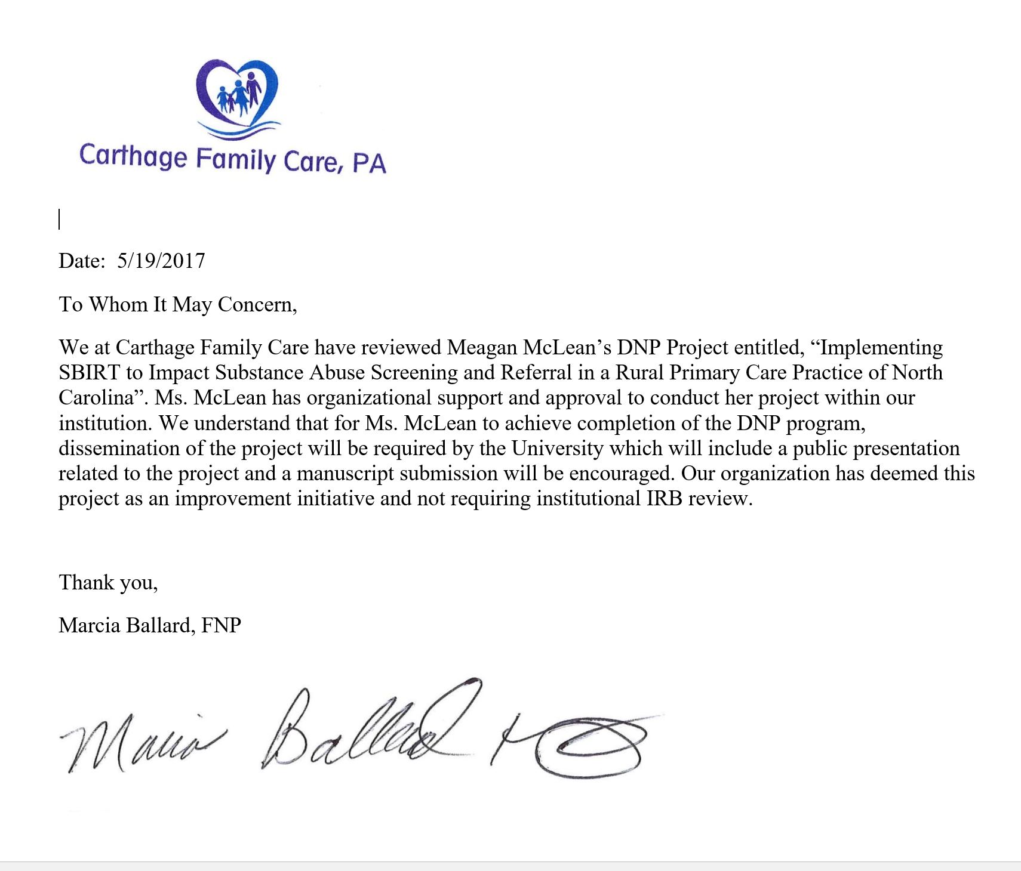

Appendix P
The first algorithm icon includes the initial literature review search yielding 22 articles. The second algorithm icon includes the second literature review yielding 20 articles. Additional search of trusted government websites was conducted using search engines including the key words “SBIRT”, “substance use disorder guideline”, “addiction”, “substance abuse statistics” and “substance abuse CDC”.

