Appendix IX

Orientation A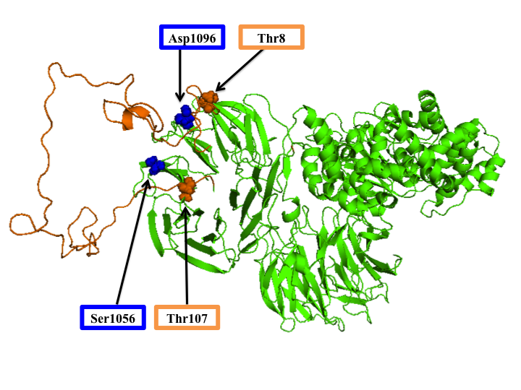
Figure 8.1: Orientation A: Final structure of prothymosin-α and apaf1 after 15 ns of molecular dynamics. Residues of interest for ProTα are outlined in orange and residues of interest for Apaf1 are outlines in blue.

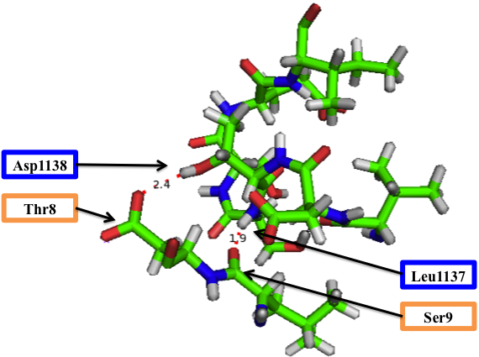
Figure 8.1a: Orientation A: Thr8 and all residues that are within 4 Å of it. A polar contact of 2.5 Å is present between Thr8 of ProTα and Asp1138 of Apaf1. There is also a polar contact of 1.9 Å between Ser9 of ProTα and Leu1137 of Apaf1.

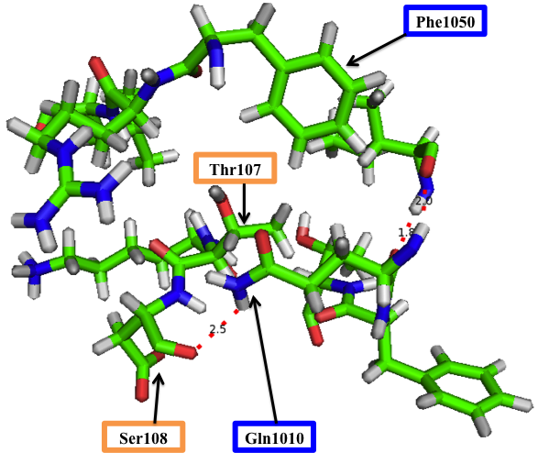
Figure 8.1b: Orientation A: Thr107 and all residues that are within 4 Å of it. A polar contact of 2.5 Å is present between Ser108 of ProTα and Gln1010 of Apaf1. Other polar contacts indicated are within Apaf1.

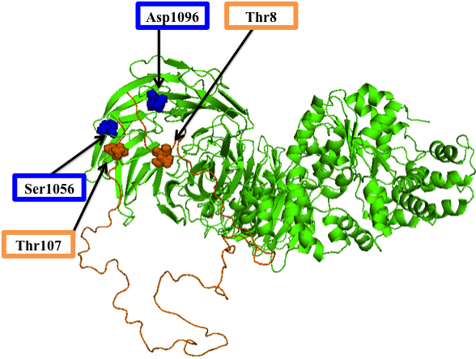
Figure 8.2: Orientation A,y: ProTα translated in the +y axis after 15 ns of molecular dynamics. Residues of interest for ProTα are outlined in orange and residues of interest for Apaf1 are outlines in blue.

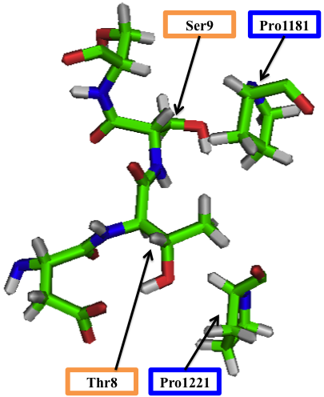
Figure 8.2a: Orientation A,y: Residues within 4 Å of Thr8. No polar contacts are present.

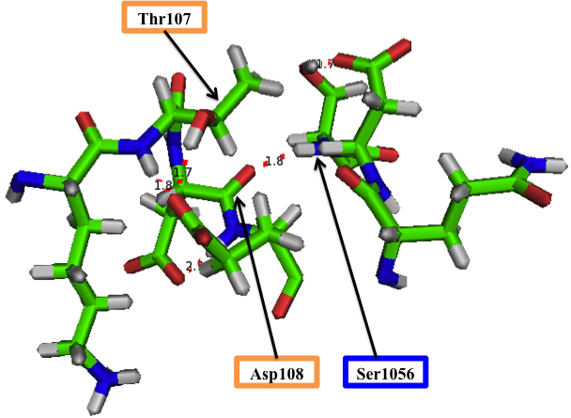
Figure 8.2b: Orienation A,y: Residues within 4 Å of Thr107. A polar contact of 1.8 Å is present between Asp108 of ProTα and Ser1056 of Apaf1.

Orientation B
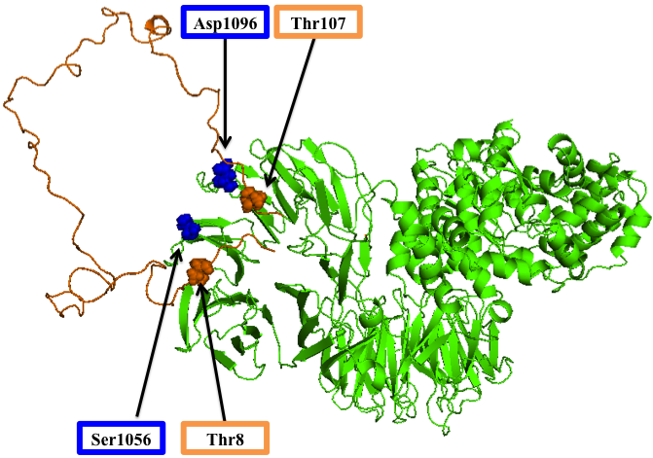
Figure 8.3: Orientation B: ProTα-Apaf1 after 15 ns of molecular dynamics. This orientation is the inverse of Orientation A. Residues of interest for ProTα are outlined in orange and residues of interest for Apaf1 are outlines in blue.

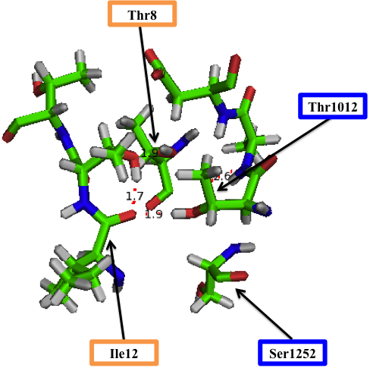
Figure 8.3a: Orientation B: Zoomed in view of Thr8 and all residues within 4 Å of it. A polar contact of 1.9 Å is present between Ile12 of ProTα and Thr1012 of Apaf1.

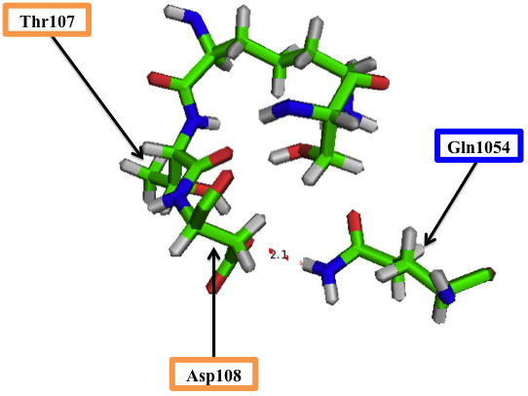
Figure 8.3b: Orientation B: Zoomed in view of Thr107 and all residues within 4 Å of it. A polar contact of 2.1 Å is present between Asp108 of ProTα and Gln1054 of Apaf1.

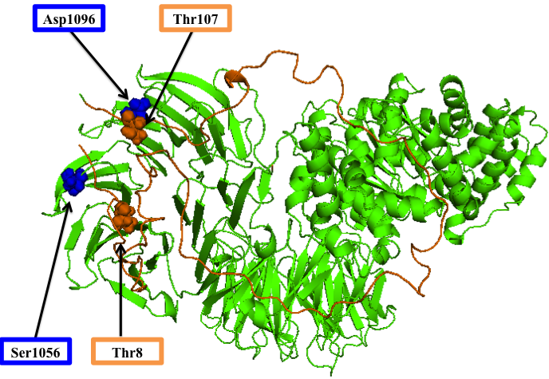
Figure 8.4: Orientation B,y: ProTα-Apaf1 after 15 ns of molecular dynamics. Thr107 of ProTα is placed within 10 Å of Asp1096 of Apaf1. This orientation is Orientation B translated in the y plane. Residues of interest for ProTα are outlined in orange and residues of interest for Apaf1 are outlines in blue.
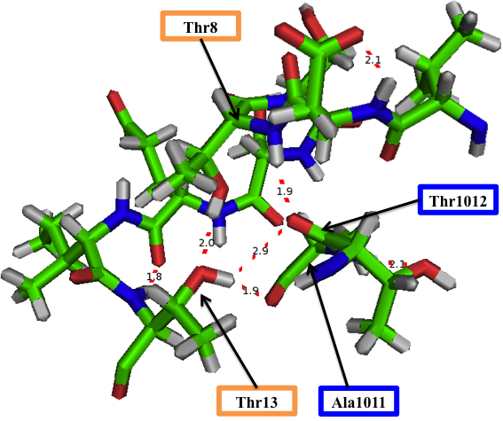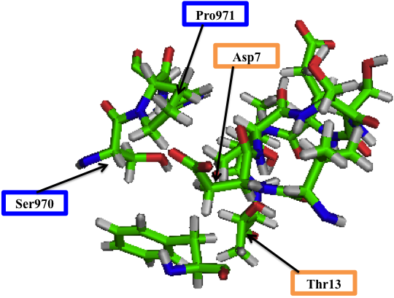
Figure 8.4a: Orientation B,y: Zoomed in view of Thr8 and all residues within 4 Å of it. A polar contact of 1.9 Å is present between Thr8 of ProTα and Thr1012 of Apaf1. Thr13 of ProTα has polar contacts of 1.9 Å with Ala1011 and 2.9 Å with Thr1012 of Apaf1. (TOP) All other contacts, only van der Waals forces are present. (BOTTOM).
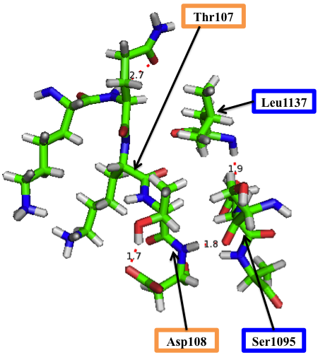
Figure 8.4b: Orientation B,y: Zoomed in view of Thr107 and all residues within 4 Å of it. A polar contact of 1.8 Å is present between Asp108 of ProTα and Ser1095 of Apaf1.

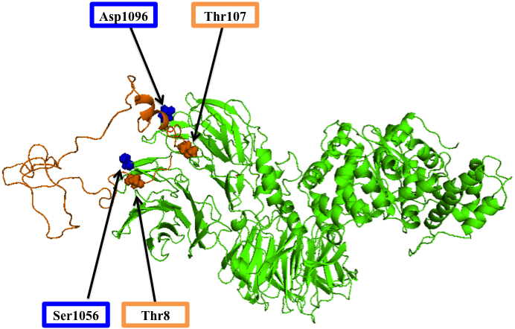
Figure 8.5: Orientation B,-y: ProTα-Apaf where ProTα is translated in the –y plane. Some alpha helical structure appears to be forming in ProTα. Residues of interest for ProTα are outlined in orange and residues of interest for Apaf1 are outlines in blue.

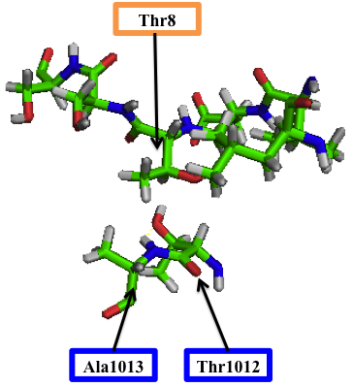
Figure 8.5a: Orientation B,-y: Zoomed in view of Thr8 and all residues within 4 Å of it. No polar contacts are present only van der Waals forces between Thr8 of ProTα and Ala1013 and Thr1012 of Apaf1.

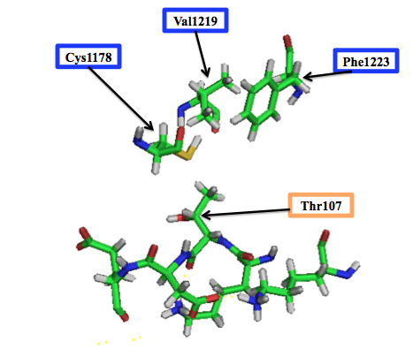
Figure 8.5b: Orientation B,-y: Zoomed in view of Thr107 and all residues within 4 Å of it. No polar contacts are present but van der Waals forces are present between Thr108 of ProTα and Cys1178, Val1219, and Phe1223 of Apaf1.

