Identification of Residual Neuromuscular Blockade in Post-Surgical Patients

Nicole Elaine Martin

East Carolina University

Abstract
Background: Many surgical procedures require administration of nondepolarizing neuromuscular blocking (NDNMB) agents. NDNMBs are typically reversed when surgery ends, allowing function to be restored. With more precise monitoring, it is now recognized that many patients arrive in Post Anesthesia Care Units (PACUs) with residual levels of neuromuscular blockade (RNMB), or TOF ratio < 0.90. RNMB is associated with poorer post-anesthesia outcomes. Currently, PACU nurses do not typically assess for RNMB and may benefit from guidelines, including use of objective monitoring.
Methods: This quality improvement project was based on Roger’s Diffusion of Innovation Theory and Deming’s model of Plan-Do-Study-Act (PDSA). A guideline was established and introduced for PACU nurses to use with patients who have received a NDNMB. A checklist was completed during admission and objective assessment of RNMB was performed. Nursing staff received instruction on proper use of the objective monitor prior to implementation. De-identified data was collected on a form created for this project.
Results: The sample included 912 patients, of these 6% (n=55) had RNMB. Five required additional treatment. Of the patients exhibiting RNMB, 62% had subjective or no neuromuscular monitoring recorded in the OR. Only 36% of patients with a TOF ≥ 0.90 had subjective monitoring used.
Conclusion: The implementation of the guideline was successful in identifying 55 patients with RNMB. Five required additional treatment. The use of this protocol supports early identification of RNMB and timely intervention. Use of an objective monitor was associated with a higher percentage of patients not exhibiting RNMB. There is an opportunity to implement the guideline and assessment on all patients in the future.
Keywords: neuromuscular blockade, neuromuscular blocking agents, post-operative complications, neostigmine, residual, and muscle weakness

Acknowledgements
I would like to express my gratitude to everyone who supported me throughout the course of obtaining my Doctorate of Nursing Practice. I am thankful for friends and family who reached out throughout this journey to offer advice and encouragement, as this accomplishment would not have been possible without their inspiration and faith over the past 18 months. I was encouraged to grow from my zone of comfort to amazing success.
I am sincerely thankful for Dr. McAuliffe for the encouragement to apply to the DNP program and for walking by me throughout the journey of work required to refine my project. Words cannot express what her guidance, invaluable constructive criticism, and friendly advice over this time have meant.
I would like to thank Dr. Marshburn. She guided me each semester with commitment to the DNP essentials while her encouragement challenged me to strive for success.

Table of Contents
Chapter One: Introduction…………………………...…………………………………......... 8-16
Justification of Study…………………………………………………………………… 10
Problem Statement…………………………………………………………………... 10-11
Theoretical Framework……………………………………………………………… 11-15
Purpose……………………………………………………………………………… 15-16
Summary………………………………………………………………………………… 16
Chapter Two: Research Based Evidence…………...……………………….……………… 17-24
Introduction……………………………………………………………………………... 17
Occurrence of Residual Neuromuscular Blockade in the PACU…………………… 17-19
Adverse Respiratory Events in the PACU…………………………………………... 19-20
Symptoms of Residual Neuromuscular Blockade in the PACU………………………... 20
Optimizing the Use of the Peripheral Nerve Stimulator………………………….......20-21
Sugammadex Administration in the PACU…………………………………………. 21-22
Current Challenges and Opportunities……………………………………………… 22-24
Summary………………………………………………………………………………... 24
Chapter Three: Methodology…………………………………………………………..…… 25-32
Design…………………………………………………………………………………... 25
Setting…………………………………………………………………………………... 25
Sample…………………………………………………………………………………... 25
Protection of Human Subjects………………………………………………………. 25-26
Implementation……………………………………………………………………… 26-27
Methods……………………………………………………………………………... 27-29
Instruments…………………………………………………………………….......... 29-30
Data Collection……………………………………………………………………… 30-31
Budget…………………………………………………………………………………... 31
Data Analysis…………………………………………………………………………… 31
Conclusion…………………………………………………………………………... 31-32
Chapter Four: Results………………….…………………………………………………… 33-36
Sample…………………………………………………………………………………... 33
Major Findings………………………………………………………………………. 33-35
Summary of Results…………………………………………………………………. 35-36
Chapter Five: Discussion……………………………............................................................ 37-41
Introduction……………………………………………………………………………... 37
Significance of Findings……………………………………….................................. 37-38
Implications…………………………………………………………………………. 38-40
Limitations……………………………………………………………………………… 40
Conclusions…………………………………………………………………………. 40-41
References………………………………………………………………………………… 42-45
Appendices…………………………………………........................................................... 46-76
Appendix A: Roger’s Diffusion of Innovation Theory Concept Map.………………... 46
Appendix B: Plan-Do-Study-Act Model for DNP Project.……………………………. 47
Appendix C: Process Map for Literature Review………………….......................... 48-51
Appendix D: DNP Literature Matrix...……………………………………………... 52-56
Appendix E: Duke University Health System IRB Approval…………………………. 57
Appendix F: East Carolina University IRB Approval…………………………………. 58
Appendix G: PACU NMT Educational Tool…………………………………………... 59
Appendix H: Guideline for Prevention of Post-Operative Residual Paralysis……... 60-61
Appendix I: GE Healthcare Carescape Monitor B450………………………………… 62
Appendix J: Electromyography Lead Placement……………………………………… 63
Appendix K: Starting Up the NMT Monitoring System………………………………. 64
Appendix L: Interpreting the Monitored Physiologic Signal………….......................... 65
Appendix M: Data Collection Tool……………………………………………………. 66
Appendix N: DNP Budget……………………………………………………………... 67
Appendix O: Neuromuscular Blocker Agent Administered to Patients…...................... 68
Appendix P: Neuromuscular Blocker Reversal Administered to Patients….................. 69
Appendix Q: Intraoperative Monitoring of Neuromuscular Blockade…...……………. 70
Appendix R: Table of Five Patients Requiring Pharmacological Intervention in PACU 71
Appendix S: DNP Essentials…………………………………………………………... 72
Appendix T: DNP Project Approval………………...…………………………………. 73
Appendix U: DNP Site Approval…………………...……………………...................... 74
Appendix V: DNP Timeline………………………...………………………………. 75-76

Identification of Residual Neuromuscular Blockade in Post-Surgical Patients

Chapter One: Introduction

Overview

Nondepolarizing neuromuscular blockers (NDNMB) are commonly used in surgery to provide optimal conditions for the anesthesia providers and surgeons. They work by blocking neurotransmission at the neuromuscular junction by competing with the neurotransmitter acetylcholine (the agonist) for its binding site on the acetylcholine receptor (AChR). When the nondepolarizing neuromuscular blocker (antagonist) occupies the receptor, neuromuscular blockade ensues (Miller, 2015). This competitive block is dependent upon the relative concentrations of agonists and antagonists as well as the binding properties of the drugs (Miller, 2015). At the end of surgical procedures, reversal agents called cholinesterase inhibitors are often administered to reverse the effects of the NDNMB. These agents work by inhibiting acetylcholinesterase, an enzyme that breaks down acetylcholine, thereby increasing the amount of acetylcholine available to compete for the binding site and effectively reversing the neuromuscular blockade (Miller, 2015).
When patients receive large doses of NDNMB it may become more difficult to reverse the effect of NDNMBs with acetylcholinesterase inhibitors (Miller, 2015). In 2016, another class of neuromuscular blocker reversal agents, the Selective Relaxant Binding Agents (SRBAs), were approved by the U.S. Food and Drug Administration (FDA). Sugammadex was the first drug in this class approved for use. In contrast to acetylcholinesterase inhibitors, sugammadex works by encapsulating steroid-based molecules, making them unable to compete for and subsequently have an effect at acetylcholine binding sites on AChRs. Since many NDNMBs are steroid-based drugs, the encapsulation by sugammadex results in reversal of any level of neuromuscular blockade (Miller, 2015). This has led some anesthesia providers in the U.S. to begin using sugammadex in lieu of a cholinesterase inhibitor or as a rescue drug to reverse residual levels of neuromuscular blockade (NMB) not fully reversed with anticholinesterase agents.
In typical practice, the level of neuromuscular block is monitored by the use of peripheral nerve stimulators (PNS). These work by emitting electrical impulses to a nerve and then observing the motor responses. Two stimulating electrodes are placed over a nerve and the nerve is stimulated with the electrical impulse. The ulnar nerve is frequently used as its neuromuscular blocking characteristics correspond well with other major nerves in the body. An impulse provided is in the form of a single-twitch, train of four (TOF) twitch, or tetanic stimulation (Miller, 2015). The electrical impulse transmitted is monophasic, with a rectangular waveform, and a pulse length of 0.2 to 0.3 millisecond (Miller, 2015). Using TOF electrical stimulation and observation of evoked muscle responses, anesthesia providers gain subjective assessments of the degree of neuromuscular blockade patients may be experiencing. If electrodes are placed incorrectly or current increased, providers may interpret the reading incorrectly which could result in unnecessary redosing of the NDNMB. Although it is common to redose neuromuscular blockers throughout the surgery, continuous redosing can lead accumulation of drug and a scenario where it could be difficult to reverse the neuromuscular blocking agent. This situation can also occur when anesthesia providers administer anticholinesterase drugs prior to measuring the TOF with a PNS. These two scenarios can result in patients experiencing residual neuromuscular blockade in Post Anesthesia Care Unit (PACU).
Recently, in attempt to prevent residual postoperative block, there has been a change in how anesthesia providers monitor levels of neuromuscular blockage. Practice is shifting from the use of subjective PNSs to more accurate objective monitors that are based upon electromyography (EMG). One objective monitor, the GE Healthcare Carescape B450, uses EMG to measure muscle contraction following electrical stimulation of a peripheral nerve. Two benefits of objective monitoring are that responses reflect factors influencing neuromuscular transmission, and they provide digital readouts that reflect the level of neuromuscular blockade.
Justification of Study
Patients who receive a NDNMB intraoperatively are at an increased risk for critical post anesthesia events. Currently when a postoperative patient suffers from an adverse respiratory event, it is common for providers to assume that the etiology may be the administration of opioids during the course of the anesthetic. Measuring the level of residual neuromuscular blockade (RNMB) in the PACU to determine if that could be the underlying etiology is not common practice. However, several studies including Murphy et al. (2008), Murphy et al. (2013), Stewart et al. (2016), McLean et al. (2015), and Brull & Kopman (2017) have demonstrated that the etiology of many postoperative respiratory adverse events is related to RNMB.
Problem Statement
The majority of the patients admitted to a PACU at a Medical Center in North Carolina receive a NDNMB as part of their anesthetic. There have been numerous postoperative respiratory events reported in the safety reporting system at the institution. It was not known if these were related to the fact that the patients received neuromuscular blockade as part of their anesthetic management. A review of the literature revealed that a common cause for postoperative respiratory events in PACUs is RNMB requiring additional reversal agents. However, because there has not been a ready means to identify the presence of RNMB in the PACU, the etiology is frequently misdiagnosed and patients are subsequently treated for other reversible conditions (opioid antagonism, benzodiazepine antagonism, blood glucose assessment, etc.), without the expected improvements in their condition.
The purpose of this project was to assess implementation of a guideline, called Guideline for Prevention of Post-Operative Residual Paralysis, in evaluating if patients admitted to PACU have RNMB. Implementation of the guideline allowed PACU nurses to assess, detect, and initiate interventions for patients arriving in the PACU with RNMB.
Theoretical Framework
Rogers’ Diffusion of Innovation Theory was used to provide the theoretical framework necessary to guide implementation of the postoperative guideline to detect RNMB in the recovery room. This is a commonly used theory to guide research in many different fields of study including history, economics, healthcare, communications, and technology. Rogers defines diffusion as “the process in which an innovation is communicated through certain channels over time among the members of a social system” (Rogers, 2003, p. 5).
To attain a greater understanding of the theory, it is important to have some insight into the life of the theorist. Everett Rogers was born on March 6, 1931 on the family farm in Carroll, Iowa (Singhal, 2012). He grew up on the farm during the Great Depression where he encountered many challenges throughout that period of life that influenced him as a person, scholar, mentor, and global intercultural citizen. He recalled frequently being told by his mother, “the purpose of life is to leave this world a better place than when we arrived” (Shefner-Rogers, 2006, p. 246). These influences steered him on the path to a very distinguished career as a professor in communication studies. This time was highlighted by his theory development and authorship of Diffusion of Innovation, which was originally published in 1962.
There are four fundamental elements to Rogers’ Diffusion of Innovation Theory that influence the degree of spread. The first is innovation, which he defined as “an idea, practice, or project that is perceived as new by an individual or other unit of adoption” (Rogers, 2003, p. 12). The second element of the Diffusion of Innovation is communication channels. This he defined as, “a process in which participants create and share information with one another in order to reach a mutual understanding” (Rogers, 2003, p. 5). Time dimension is the third element of the theory. He proposed that when time aspects are included in research it results in a stronger outcome. The last element of this theory is the social system, which he defined as “a set of interrelated units engaged in joint problem solving to accomplish a common goal” (Rogers, 2003, p. 15).
The next part in the Diffusion of Innovation theory is the innovation-decision process. This is “an information-seeking and information-processing activity, where an individual is motivated to reduce uncertainty about the advantages and disadvantages of an innovation” (Rogers, 2003, p. 172). There are five steps involved: 1) knowledge, 2) persuasion, 3) decision, 4) implementation, and 5) confirmation. Each of these steps are time-sensitive and function as a communication channel. Knowledge involves the characteristics of the decision-making unit including socioeconomic status, personality variables, and communication behavior. Persuasion involves perceived characteristics of the innovation, which involve relative change, compatibility, complexity, trialability, and observability. The decision to adopt or reject the innovation leads to the final steps in the innovation-decision process that are implementation and confirmation. (Appendix A)
The goal of any innovation is to be self-sustaining for long periods of time. To accomplish this there needs to be a period of adoption for those that are affected by the innovation. The fundamental elements leading from the innovation-decision process ultimately leads us to the adoption phase of the theory. The rate of adoption is defined by Rogers (2003) as, “the relative speed in which an innovation is adopted by members of a social system” (p. 221). During this phase of the diffusion process, adopter categories were developed by Rogers. Included in these categories are innovators, early adopters, early majority, late majority, and laggards. Each class is compared to its innovativeness, which is defined as, “the degree to which the individual or other unit of adoption is relatively earlier in adopting new ideas than other members of a system” (Rogers, 2003, p. 22). Of all the different divisions, the early adopters are the most influential in that they approve the innovation by adopting it into practice.
In any quality improvement (QI) initiative, using Rogers’ Diffusion of Innovation Theory can provide the framework to guide any new innovation to be successful. It allows the innovator to accurately be able to prepare an idea and plan out how it will diffuse into the work place. Focusing on the early adopters, late majority, and laggards to support the innovation is key to making it long lasting.
Having the proper flow in the diffusion of information in any network will ensure accuracy and success. Having leadership involved in the implementation of an innovation from the start will increase the success rate of it. Also, making sure that the information available to the early adopters is accurate and detailed will prevent work arounds and derailment of progress.
Motivation of the adopters plays a pivotal role in the success of the innovation. If the adopters are motivated for success and change, then work arounds will be made and the innovation will fail. Discovering motivational enticements to promote success is important for sustainability of the project. Education of the staff on how the change will improve work culture and the care of the patient will motivate the nurses to adopt this new process.
Technology will assist in the ease of adoption of the innovation. In order for early adoption and sustainability of the innovation to occur, the innovation should be integrated into technology that is used daily to ensure success. By having the checklist printed on a paper form will allow ease of use for the nurses and the advancement of the project will continue without allowing room for work arounds or failure.
Rogers’ Diffusion of Innovations Theory provides the framework necessary for many areas of the work environment. Throughout application of the project, the innovator is able to move from the fundamental elements of the issue to the innovation-decision process and then ending at the adoption phases. In healthcare there are many elements that can slow or halt the process of implementation. Therefore, it is important to recognize that making process changes take time. By applying Rogers’ Diffusion of Innovation Theory, the innovator is allowed to prepare and plan for each period of implementation with the goal of sustainability.
The Plan-Do-Study-Act (PDSA) model is based off the scientific method and uses a suggested hypothesis as a proponent of it. “The primary purpose of PDSA quality improvement research is to establish a functional relationship between process changes in systems of healthcare and variations of outcome” (Speroff & O’Connor, 2004, p. 17). The ultimate goal of all QI research is to show that the outcome sustained an improved result.
PDSA was made popular by Robert Deming, who is known as the father of QI. “Quality improvement involves understanding how the system works and sharing that knowledge within the organization” (Speroff & O’Connor, 2004, p. 20). In order to produce change, adjustment in the environment is key and this involves working with management, having teamwork, understanding the environment itself, as well as the psychology of change. Creative thinking and innovations help modify the structure and can lead to better outcomes (Speroff & O’Connor, 2004). PDSA QI requires research methodology to test theories that are driven by hypotheses and to change ideas about improving the process (Speroff & O’Connor, 2004).
Each step of Deming’s PDSA model guides a QI initiative from implementation through sustainability. In the “Plan” step, the purpose is identified and the plan is put into action. The purpose of this project was to implement the guideline on all patients that received a NDNMB in order to detect patients with RNMB on admission to the PACU. The next step is the “Do” step; this is where the plan is executed. The nurses were educated about the guideline and the checklist was printed on paper form and kept in the PACU. The “Study” step is where the outcomes are monitored and the results are studied. The results of the guideline were entered in an Excel Spreadsheet and the exact number of patients admitted to the PACU with RNMB was determined. The “Act” step, is where the cycle closes and action is taken to standardize the change. (Appendix B)
When Rogers’ Diffusion of Innovation Theory was combined with Deming’s PDSA model, the QI project had a well thought out design and one with potential sustainability. The PDSA model aided the overall process to ensure that the plan was executed with success. It helped the innovator prepare by getting key leadership involved from the start and then follows the initiative throughout implementation until the end.
Purpose

The purpose of this project was to implement a Guideline for Prevention of Post-Operative Residual Paralysis that promoted assessment of patients for detection of RNMB. Through the implementation of this guideline RNs in the PACU would then be able to identify patients experiencing RNMB by quantitatively assessing their levels of neuromuscular blockade recovery on admission to the PACU. The project was aimed at analyzing a process that allowed the nurses to assess patients upon admission to the PACU for RNMB, and refer those who fell below accepted national standards to the staff Anesthesiologist for further treatment. Currently, there are no national guidelines to guide practice in PACUs for detecting RNMB.
Summary
Patients are being admitted to the PACU with varying degrees of RNMB. RNMB can be misdiagnosed as opioid overdose, or simply undetected because nurses assume postoperative weakness is a normal post anesthetic condition. There are many overt and subclinical complications associated with RNMB. However, no practice guidelines exist for PACU nurses to assess patients for RNMB. By developing and implementing a Guideline for Prevention of Post-Operative Residual Paralysis, it was hoped that early detection would be possible and subsequent treatment initiated.

Chapter Two: Research Based Evidence
Introduction
Prolonged clinical recovery after a general anesthetic is becoming more frequently recognized as monitors improve and researchers focus studies in this area. Numerous studies have demonstrated that certain symptoms are present when patients are suffering from RNMB. A systematic search of the literature was conducted to analyze current knowledge and research about residual neuromuscular blockade in the PACU setting, as well as symptoms exhibited by patients suffering from this condition. A literature review was conducted using databases CINAHL and PubMed. The key words used were: neuromuscular blocking agents, neuromuscular blockade, post-operative complications, muscle weakness, residual, neostigmine, sugammadex, and finances. (Appendix C) In two separate searches, more than 500 articles were identified. Of those 27 were specific to neuromuscular blockade monitoring and RNMB in the PACU setting. (Appendix D)
Occurrence of Residual Neuromuscular Blockade in the PACU
Fortier et al. (2015) performed a prospective observational study, the Recite Study, in eight hospitals in Canada. They evaluated the amount of postoperative residual neuromuscular blockade (TOF ratio of < 0.90) at tracheal extubation and again in the PACU. To detect RNMB acceleromyography (AMG) was used on all patients who had received at least one dose of a NDNMB. Three hundred two patients were enrolled in the study and 207 had an AMG assessment upon arrival to PACU. In this study 99% of patients received rocuronium. While 72% of the patients were reversed using neostigmine, 56% still arrived to the PACU with some degree of RNMB. This study demonstrated that residual neuromuscular blockade is common despite intraoperative qualitative monitoring and reversal. The study concluded that better detection is needed to decrease risks associated with RNMB.
Yip, Hannam, Cameron, & Campbell (2010) conducted an observational study to document the occurrence of RNMB in the PACU at a tertiary hospital. This study included 102 patients. Anesthesia providers were unaware of the patients’ inclusion in the study, and administration of relaxants and reversal agents were at their discretion. A PACU TOF ratio was obtained on admission and every five minutes until the ratio was ≥ 0.90 using an electromyography NMT monitoring. These researchers documented that 31% of patients admitted to the PACU had some degree of RNMB. Because of this they recommended that the more sensitive quantitative monitor be used by all anesthesia providers to detect small amounts of RNMB.
A study conducted by Nemes et al. (2017) examined the impact of specific reversal agents on the incidence of postoperative residual neuromuscular blockade. An acceleromyography monitor was used in the PACU to determine if patients had RNMB. The patients were divided into four groups; those allowed to spontaneously recover, and those who received neostigmine, sugammadex, or placebo. Some patients in each group experienced RNMB. The highest occurrences of RNMB, however, were in those groups of patients who spontaneously recovered or were given the placebo.
Plaud, Debaene, Donati, & Marty (2010) determined that the incidence of RNMB in the PACU ranges from 4 to 50% depending on the diagnostic criteria. This wide range may also be related to the type of monitors used. Balliard et al. (2005) examined this over a ten-year period. At the start of the study in 1995, quantitative monitoring was used in 2% of cases and only 6% of patients received reversal agents. By 2005, 60% of cases were monitored with quantitative monitoring and 42% of patients received reversal agents. Over this period the frequency of RNMB decreased from 63% to 3%. This demonstrated that systematic application of simple measures (quantitative monitors) can reduce the incidence of RNMB. There was a positive association between the use of quantitative monitoring and administration of reversal agents.
Adverse Respiratory Events in the PACU
A study conducted by Stewart et al. (2016), examined the impact of residual neuromuscular blockade, oversedation, hypothermia, and Adverse Respiratory Events (ARE) in patients in the PACU. They reported the prevalence of RNMB in PACU patients was > 30% (Stewart et al., 2016). Patients at greatest risk were the elderly, those who had open abdominal surgeries, and those whose surgeries lasted < 90 minutes (Stewart et al., 2016). Those patients who had decreased levels of consciousness had the highest risk for AREs. These researchers also reported that most preventable AREs were associated with RNMB, hypothermia, and reduced levels of consciousness in PACU patients (Stewart et al., 2016).
A study conducted by McLean et al. (2015), explored the dose-dependent association between intermediate-acting neuromuscular-blocking agents and postoperative respiratory complications. These researchers examined the association between the duration of action with repeated administration of neuromuscular agents and the postoperative effects on patients. Their results confirmed that there is a dose dependent association between use of NDNMB and adverse postoperative respiratory events. They were able to demonstrate that through proper monitoring of neuromuscular blockade, neuromuscular blockers could be more appropriately titrated and the incidence of adverse postoperative events could be reduced (McLean et al., 2015).
Norton, Xará, Parente, Barbosa, & Abelha (2013) evaluated the incidence of RNMB in the PACU and its association with critical respiratory events. This prospective cohort study was conducted for three weeks in a PACU. A total of 202 adult patients were tested for residual neuromuscular blockade using an acceleromyograph. The results demonstrated that 29% of patients experienced RNMB, and of those 51% had more frequent Critical Respiratory Events (CRE). The CRE included airway obstruction, respiratory failure, inability to breathe deeply, and muscle weakness. They also found that RNMB was more common in high risk surgery (53%) and more often associated with postoperative hypoactive emergence (21%).
Symptoms of Residual Neuromuscular Blockade in the PACU
Murphy has performed many studies about the problem of RNMB in the Post Anesthesia Care Units. One sentinel study focused on the association between post-operative residual neuromuscular blockade and impaired clinical recovery (Murphy et al., 2013). Others focused on residual neuromuscular blockade and critical respiratory events in the PACU (Murphy et al., 2008). The first article, is one of the leading articles in the literature demonstrating that the incidence and severity of symptoms of muscle weakness are increased in PACU in patients who have a measured train of four (TOF) < 0.90 (Murphy et al., 2013). This researcher provided a subjective list of assessment questions for the providers to use to assist them is assessing patients for RNMB. Results from the second study demonstrated that incomplete neuromuscular recovery is an important contributing factor in the development of adverse respiratory events in the PACU (Murphy et al., 2008).
Optimizing the Use of the Peripheral Nerve Stimulator
A study conducted by Thilen & Bhananker (2016), examined optimal use of the peripheral nerve stimulator in reducing the risk of residual neuromuscular blockade. These researchers confirmed that a TOF count of 4 should be established prior to administration of a cholinesterase inhibitor (Thilen & Bhananker, 2016). Further, they recommend that extubation should not occur within ten minutes of administration of neostigmine to allow sufficient time for its full effect to occur (Thilen & Bhananker, 2016). A study conducted by Renew & Brull (2016) demonstrated that quantitative monitoring of a TOF provides an objective measure when assessing the level of neuromuscular blockade. Objective measures are more sensitive and thus can assist providers in selecting correct doses and in more accurate timing of administering neuromuscular blocking agents.
In this search of the literature no guideline was found that might assist providers in detecting and treating residual blockade in the PACU. Todd, Hindman, & King (2014) implemented quantitative electromyographic (EMG) neuromuscular monitoring assessment in the operating rooms with success, but did not carry it into the PACU. Therefore, implementation of a postoperative guideline to screen all patients for RNMB in the PACU may help identify patients with RNMB and allow for early intervention.
Sugammadex Administration in the PACU
Brueckmann et al. (2016), examined published studies about the association of sugammadex and RNMB. Results of their analysis were that intraoperative administration of sugammadex eliminates RNMB and is associated with decreased patient length of stay in the PACU. They also highlighted the importance of sugammadex as a rescue drug in PACU and provided dosing recommendations for PACU patients who have received neostigmine in the operating room.
The research on sugammadex is ongoing with relevant information continually being published. Naguib & Johnson (2017) compared the reversal effects of sugammadex, neostigmine, and edrophonium. They reported that the main advantages of sugammadex over neostigmine is its predictability and ability to extend the range of neuromuscular blockade reversal, as it can be administered to patients with very deep levels of neuromuscular block that is not possible with anticholinesterase agents. Additionally, since it is not an anticholinesterase there are no associated cholinergic side effects that normally require coadministration of an anticholinergic agent (Naguib & Johnson, 2017). Naguib and Johnson (2017) further recommended that neostigmine only be used in situations where patients have light or moderate neuromuscular blockade and that sugammadex be used to reverse deep blockade. Cost was identified as a factor that providers should consider when choosing the reversal agent. Edrophonium is the least expensive, followed by neostigmine and sugammadex. The cost of sugammadex is dose dependent with the least expensive dose of sugammadex equaling the cost of a full dose of neostigmine. The use of sugammadex is increasing as a routine reversal and this article highlights the advantages of its adoption into practice (Naguib & Johnson, 2017).
Current Challenges and Opportunities
Over the past few years there has been an increasing number of studies published related to residual paralysis in the PACU, monitoring techniques used in the operating room for neuromuscular blockers, and reversal agents. Brull & Kopman (2017) conducted an extensive review of literature and highlighted important factors that should be included in practice. One recommendation was that anesthesia providers should use peripheral nerve stimulators to manage perioperative neuromuscular blockade (Brull & Kopman, 2017). They discussed the limitations of subjective measurement in detection and prevention of residual paralysis, and pointed out how subjective clinical evaluations are insensitive for detecting neuromuscular weakness (Brull & Kopman, 2017). “Objective measurement (obtaining a train-of-four-ratio greater than 0.90) is the only method to determine appropriate timing of tracheal extubation and ensure normal muscle function and patient safety” (Brull & Kopman, 2017, p. 173). The valuable information gained in this article demonstrates the importance of objective measurement in neuromuscular assessment and the educational need that still exists for practitioners to incorporate its use in the operating room.
Naguib, Brull, & Johnson (2017) published a review article about the technical basis of neuromuscular monitoring. “Evidence indicates that current practice continues to perpetuate the status quo, in which 10-40% of patients experience postoperative residual weakness” (Naguib et al., 2017, p. 16). Core questions about neuromuscular blockers and how providers monitor the effects of drugs they administered were addressed. Detailed descriptions were provided about use of peripheral nerve stimulators (PNS) and the newer neuromuscular monitors that are available, including acceleromyography (AMG), mechanomyography (MMG), kinemyography (KMG), and electromyography (EMG). They concluded that accurately monitoring patients’ neuromuscular blockade in operating rooms can have an impactful result in preventing residual neuromuscular weakness.
Naguib et al. (2017) identified eight common mistakes providers make when using neuromuscular blocking drugs. These included: not using neuromuscular monitors, using the facial muscles for subjective monitoring, using five second tetanic stimulation for less than five seconds, using subjective evaluation of the TOF count, determining the onset of neuromuscular block by sustained tetany at one hertz, assessing neuromuscular function less than three minutes after tetanic stimulation, not maintaining monitored muscles at normothermia, and not ensuring good skin contact with electrodes (Naguib et al., 2017). If anesthesia providers and others who administer neuromuscular blocking drugs used objective neuromuscular monitoring most of these errors could be mitigated.
Naguib et al. (2010) conducted a survey about the management of neuromuscular blockade in the United States (U.S.) and Europe. In Europe neuromuscular blocking agents were still frequently administered without monitoring. An email survey was sent to all active members of the Anesthesia Patient Safety Foundation and European Society of Anaesthesiology. Of the 2636 replies, 64% were from Europe and 52% from the United States. The results demonstrated that routine pharmacologic reversal is less common in Europe (18%) than in U.S., quantitative monitors are less available in the U.S., and that 19% of European respondents and 9% of U.S. respondents do not use any type of neuromuscular blockade monitors. Surprisingly, most respondents also reported they do not think that qualitative or quantitative TOF should be a part of minimum anesthesia monitoring standards. These authors believe this reflects a need for enhanced awareness, and for establishing practice guidelines that include use of NMB monitors to improve care for patients receiving NMB.
Summary
Providing safe patient care is the goal of all members of the perianesthesia care team. Recognizing when patients experience residual neuromuscular blockade is key in providing timely treatment and preventing associated complications. Numerous studies have demonstrated the importance of using objective assessments of neuromuscular blockade. Two gaps were identified in the current literature. One is that an unknown number of patients experience residual block after surgery. The other is that there is an unknown number of patients with levels of RNMB requiring intervention.

Chapter Three: Methodology
Design
The goal of this project was to advance improvements in patient care by implementing a Guideline for Prevention of Post-Operative Residual Paralysis (GPPRP) designed to provide early detection of patients experiencing residual neuromuscular blockade (RNMB). Through the implementation of this guideline Registered Nurses (RNs) in the PACU would be able to identify patients experiencing RNMB by quantitatively assessing their levels of neuromuscular blockade recovery. The project was aimed at analyzing a process to allow nurses to screen patients upon admission to the PACU for RNMB, and refer those who fall below accepted national standards to the staff anesthesiologist for further treatment.
Setting
Participants for this project were the staff of a fifty-bed PACU in a central North Carolina tertiary Medical Center. These included all RNs and anesthesiologists that care for patients in this setting. The staff is responsible for all post-anesthesia, non-intubated patients admitted from the operating rooms and procedural suites throughout the hospital. This Medical Center serves patients from all parts of North Carolina and the surrounding states.
Sample
The target sample included all adult post-surgical patients who received nondepolarizing neuromuscular blocking agents in the operating room or procedural suites. Once institutional approval was obtained, data collection occurred for seven consecutive weeks between May and June 2017.
Protection of Human Subjects
In order to protect the rights of participants in this project a proposal was submitted to the Institutional Review Board (IRB) at the Medical Center. The Guideline for Prevention of Postoperative Residual Paralysis was reviewed and deemed as not meeting the definition for research. (Appendix E) The purpose was to implement a guideline that involves collection of intraoperative and postoperative neuromuscular blockade data and referral to a staff anesthesiologist should the PACU measurement fall below the commonly used standard for full recovery of neuromuscular function. The University Medical Center Institutional Review Board at East Carolina University also deemed the project as non-human subject research and no further review was required. (Appendix F)
Implementation
There have been numerous safety reporting system entries of patients who have experienced post-operative respiratory complications in the PACU where the project was implemented. A review of literature revealed that a common cause for this is RNMB that often requires administration of additional reversal agents. However, there has not been a ready means to identify the presence of RNMB in the PACU. As a result, the etiology has frequently been misdiagnosed and patients experiencing post-operative respiratory complications in the PACU have been treated for other reversible conditions (opioid antagonism, benzodiazepine antagonism, blood glucose assessment, etc.), without expected improvements in their conditions. The literature review that was conducted made evident that this is a national issue and not one exclusive to this Medical Center.
An investigation was performed into the current practice in the PACU and areas of possible change were identified. Key stakeholders were included such as the anesthesiologists, Certified Registered Nurse Anesthetists (CRNAs), residents, nurses in the PACU, and perioperative and PACU leadership. These stakeholders support was obtained as this project was being refined. The guideline was then developed from established recommendations in the medical literature. Prior to implementation, training in the use of the assessment tool for the PACU nurses was provided through in-services, and a laminated reference page was posted on each of the GE Healthcare Carescape Monitor B450 in the PACU as a visual resource. (Appendix G)
The Guideline for Prevention of Postoperative Residual Paralysis (Appendix H) contained the data collection tool for this project. De-identified data was collected on the GPPRP form by the nurses and placed in an envelope that was kept in a designated spot at the charge nurse desk in each PACU at this Medical Center. At the end of each day all completed GPPRP forms were secured in a locked box at the charge nurse desk in the project site. At the conclusion of the seven-week data collection period the data was entered by the project lead into a Microsoft Excel spreadsheet on a password protected computer to facilitate statistical analysis. This took place at the institution so the GPPRP forms stayed at the hospital. If the project data analysis demonstrated that implementation of the guideline was successful in identifying patients with RNMB, future discussions would occur with department and hospital leadership about the possibility of standardizing it for continued use in the PACU and purchasing NMT monitors specifically for the PACU to assess symptomatic patients upon arrival.
Methods
The Guideline for Prevention of Postoperative Residual Paralysis was developed based on information and recommendations from the literature review. The guideline, that included a checklist and data collection form, was implemented by PACU nurses upon patients’ admission. Printed copies of the GPPRP were accessible to nurses in the PACU. The GPPRP was completed as the nurses performed their admission assessment and received report from the anesthesia providers for the case. All patients who received a nondepolarizer neuromuscular blocker had an EMG TOF ratio (TOFR) assessed upon admission to the PACU. If the TOF ratio was < 0.90 the anesthesiologist was notified and the patient was monitored closely for signs and symptoms of RNMB until the TOF ratio exceeded 0.90. The anesthesiologist could have elected to order additional reversal agents. If these were ordered and administered the TOF was recorded every five minutes until the ratio exceeded 0.90.
Lunch and learn education sessions were conducted with the PACU RNs. These sessions occurred twice a week for two consecutive weeks and lasted two hours. Additional hour sessions were given for the weekend and night shift nurses. The main focus of these lunch and learns were to instruct the PACU RNs about the significance of residual neuromuscular blockade and how proper use of the guideline could assist in detecting it. They also received instruction on how to operate the neuromuscular monitoring device using correct electrode placement. Additional instruction focused on the significance of the TOFR and patient safety considerations for patients with RNMB defined as a TOFR < 0.90. Applying the PDSA model, at the monthly nurses meeting, specific feedback given by the nurses at the previous lunch and learn and first week of the project were addressed. The nurses were also given an opportunity to provide further feedback, voice concerns, or ask questions about the processes and guideline. One RN volunteered to be the liaison between the project lead and nurses in the PACU. Additionally, eight “super users” were chosen to be resources for the staff regarding the use of the guideline on a daily basis. The project lead provided additional training sessions for the “super users” that included detailed information about neuromuscular blockers, reversal, monitoring, and the GE Healthcare Carescape B450.
For the first two weeks of the project implementation, a daily analysis was conducted to ensure the nurses were not missing patients arriving from the operating room that had received a NDNMB. This required the project lead to be present each day for the first week in the PACU. During that time, the project lead ensured the monitors were working and assisted the nurses comfort level obtaining the EMG TOFR. The first couple weeks also required daily emails to the anesthesia and PACU nursing staff until they were better acquainted with the project. The nurse liaison and super users were valuable as a daily resource for all nurses in the PACU to ensure success of the project.
Instruments
Patients included in the project received a nondepolarizing neuromuscular blocker and had the GPPRP form and TOF assessment completed on admission to the PACU. The PACU had two quantitative GE Healthcare Carescape Monitor B450 available for this project. (Appendix I) This monitor has a neuromuscular transmission cable (NMT) that connects to the brown port of the module. For proper use of this monitor a five-lead EMG ElectronSensor recording sensor is used. This measures the evoked electrical activity (compound muscle action potential) of the adductor pollicis muscle with recording electrodes in response to stimulation of the ulnar nerve. It then quantifies the response to nerve stimulation. It is important to place the EMG leads in the correct location. The red electrode is placed on the index finger between the distal and middle phalanxes and records the muscle-contraction effect. The green electrode is placed in the web space between the first and second metacarpals overlying the adductor pollicis and also records the muscle-contraction effect. The black electrode, also known as the ground lead, is centered over the median nerve at the palmar crease. The brown and white electrodes are placed over the ulnar nerve and are the stimulating electrodes. The black and brown electrodes should not be touching while the white is the most proximal. (Appendix J)
After the provider connects the patient to the monitor, they press the “Start-Up” button. (Appendix K) At this time the monitor starts the measurement by setting the stimulus current automatically and by performing a reference measurement. In an unrelaxed patient, the TOF ratio is > 0.95. A non-depolarizing relaxant causes a fade in the responses, indicated by a lower TOF % and a slope in the bar graph. (Appendix L) In contrast, depolarizing relaxants result in an equal drop in all four responses without fade. During surgery, the TOF count is used to ensure optimal level of neuromuscular block. When a TOF count exceeds a level set by the user, the GE monitor will give a “block recovery” message. An antagonist, if used, will not be given until the TOF count rises to four. For safer extubation TOF ratio should be ≥ 0.90. Benefits of using the NMT Module include automatic and hands-free operation, ability to provide optimal dosing of neuromuscular blocking agents during anesthesia, optimized recovery, decreased PACU time, and integrated electronic monitoring (GE NMT Quick Guide, 2017).
Data Collection
Data collection began with implementation of the Guideline for Preventing Post-Operative Residual Paralysis. Upon arrival from the operating room, the nurses completed a data collection GPPRP form that documented type of neuromuscular blockade monitoring, as well as, dose and time of reversal agents administered. The GPPRP forms were located in the PACU areas for the duration of the project.
At the completion of the seven-week data collection period the project lead entered the data from the GPPRP forms into a Microsoft Excel spreadsheet. This was located at the institution on a password protected computer where data was analyzed and aggregated. The data collected for analysis included: total number of patients admitted to PACU that received NDNMBs, the time the last dose was administered, whether pharmacologic reversal was administered in the OR, the dose and time of reversal administration, the final operating room TOF, and documentation whether a subjective peripheral nerve stimulator or objective EMG monitor was used. Additional data included the number of patients whose EMG TOF ratio was < 0.90 upon admission to the PACU, any reversal drugs ordered and subsequently administered, and the time it took to obtain the final TOF ratio ≥ 0.90. (Appendix M)
Budget
The cost to perform this QI project for seven weeks was minimal. The two objective EMG monitors (GE Healthcare Carescape B450) used in the PACU were donated for the length of the project by GE Healthcare. The EMG cables came with the monitor and the electrodes were donated by the Medical Center. The GPPRP forms and the laminated reference page was printed on paper donated by the Medical Center and the data entry was performed by the project lead. The only cost was one meal provided for the PACU nurses at the conclusion of the project. (Appendix N)
Data Analysis
The goal of this analysis was to determine the effectiveness of implementing a guideline in the PACU that identified RNMB and provided treatment if indicated. Descriptive statistics were used to calculate the demographics, frequency, and percent of patients with RNMB who received treatment compared to those that did not, the type of NDNMB used, and the reversal given. A Chi Square Test was performed to determine statistical significance with a p value of 0.05 considered statistically significant.
Conclusions
This project was designed to demonstrate how initiation of a clinical guideline in PACU might improve patient safety through early detection and management of RNMB. Management included both pharmacologic reversal and/or increased patient monitoring for known associated risks of RNMB. The guideline was also designed to enable nurses to provide corrective treatment in a more timely manner.

Chapter Four: Results
The goal of the DNP Project was to perform a quality improvement initiative. The objective of this initiative was to determine whether a guideline available to the PACU nurses would enable the nursing staff to recognize residual neuromuscular blockade, consult the anesthesiologist, and quickly obtain corrective treatment as warranted.
Sample
Data collection for the project extended over a seven-week period (May – June, 2017). During that time 1,331 patients who had received a nondepolarizer neuromuscular blocker (NDNMB) intraoperatively were admitted to the PACU. Of those 912 (69%) were included in the project. Four hundred and nineteen (31%) patients were not included for several reasons. In most cases this was because the PACU nurse either did not complete the data collection form or did not conduct the admission TOF. In a few cases it was due to monitor malfunction. The average number of cases included in the project was consistent each week n=133 (range 108-159). Of the 912 patients included in the project 408 (46%) were male and 486 (54%) were female. Data was not reported for 18 patients. The median age was 59 years (range 18 to 93).
Major Findings
Patients included in this project had received a variety of nondepolarizing neuromuscular blocking agents intraoperatively. The selection of the drug was made by the anesthesia provider. Rocuronium was administered in 478 (52%) cases, vecuronium was administered in 362 (40%) and cisatracurium was administered in 66 (7%) cases. Both rocuronium and vecuronium was administered in five cases (1%), and both rocuronium and cisatracurium were administered in one case. For patients admitted with a TOF ratio ≥ 0.90 rocuronium was administered in 449 (52%) cases, vecuronium in 340 (40%) cases, cisatracurium in 63 (7%) cases, and both rocuronium and vecuronium in five (1%) cases. Those administered with a TOF ratio < 0.90 received rocuronium in 29 (53%) cases, vecuronium in 22 (40%) cases, cisatracurium in 3 cases (6%), and both rocuronium and cisatracurium in one (2%) case. (Appendix O)
The anesthesia providers selected the reversal agents. They used neostigmine, sugammadex, a combination of both, or administered none at all. Neostigmine was administered in 684 (75%) cases, sugammadex was administered in 99 (11%) cases, and both sugammadex and neostigmine were administered in 42 (5%) cases. In 87 cases (9%) no reversal drugs were administered. (Appendix P)
Selection of the type of intraoperative neuromuscular blockade monitoring used in the operating room was determined by the individual anesthesia providers. Both subjective and objective monitors were available for all cases. In 536 (59%) an objective monitor was used, in 336 (37%) cases a subjective monitor used, and 40 (4%) cases the type of monitor used was not recorded. The percentage per week of each monitor used remained consistent throughout the project.
There were 857 (94%) patients admitted to the PACU with a TOF ratio of ≥ 0.90, 305 (36%) were monitored in the operating room using a subjective monitor, 515 (60%) with an objective monitor, and 37 (4%) had no monitor recorded. Of the 55 (6%) patients admitted to the PACU with TOF ratio < 0.90, 31 (56%) were monitored with a subjective monitor, 21 (38%) monitored with an objective monitor, and three (6%) had no monitoring recorded. A Chi Square Test was performed demonstrating statistical significance (p = 0.005). Those who were monitored intraoperatively with objective monitors had a lower incidence of RNMB (TOF ratio ≥ 0.90). (Appendix Q)
Of the 912 patients included in the project, 55 (6%) had some degree of residual NMB as the TOF ratio was < 0.90 upon admission to PACU. The PACU RN notified the anesthesiologist when these patients were identified. The anesthesiologist then determined if an intervention was indicated for the patient.
Of the 55 patients admitted with a TOF ratio < 0.90 five required additional reversal agents. Three of these received sugammadex and two had neostigmine administered. Of the two who received neostigmine in the PACU, one had received vecuronium without any reversal agent in the operating room and the other received cisatracurium with incomplete reversal in the operating room. All five patients receiving reversal agents had a TOF ratio of ≥ 0.90 within 20 minutes. (Appendix R)
Of the 50 patients admitted to the PACU with a TOF ratio of < 0.90 and not subsequently receiving reversal agents by the anesthesiologist, 49 had uncomplicated recoveries. One patient had an extended length of stay (74 minutes out of a total 144 minutes) in the PACU until the TOF ratio exceeded 0.90. This patient had received the maximum dose of reversal agent in the OR (5mg neostigmine) yet had TOF ratio of 0.69 when leaving the OR and 0.75 upon arrival in the PACU.
All five patients who arrived with TOF ratio < 0.90 and subsequently receiving reversal agents had subjective monitors used in the operating room. Two had received intraoperative neostigmine and their PACU TOF ratio was 0.77 and 0.81. Two did not receive any intraoperative reversal agents and their PACU TOF ratios were 0.67 and 0.88. One patient received both neostigmine and sugammadex in the operating room and the PACU TOF ratio was 0.73 on arrival. (Appendix R)
Summary of Results
The results of the project demonstrated that 55 (6%) patients were admitted to the PACU with some degree of residual neuromuscular blockade. Five of these patients required an intervention with sugammadex or neostigmine. One of the fifty patients admitted with TOF ratio < 0.90 and not subsequently given an additional reversal agent had an extended length of stay.
Overall, this project demonstrated the use of this guideline aids PACU nurses to identify RNMB and institute timely interventions for patients. Residual neuromuscular blockade (defined as TOF ratio < 0.90) was evident in 6% of patients admitted to the PACU at this practice site. An additional finding was that a higher percentage of patients who had RNMB were monitored intraoperatively with subjective monitors when compared with those who had TOF ratio ≥ 0.90. This was statistically significant p = 0.005.

Chapter Five: Discussion

Introduction

In this QI project a guideline for early identification of RNMB in the PACU and subsequent corrective treatment was initiated at a large Medical Center in North Carolina. By using this guideline PACU nurses were able to identify that 55 (6%) of patients admitted had some degree of RNMB. Of the 55, five patients received treatment for RNMB with improvement as a result of this project. This guideline was effective because PACU nurses were trained to check an objective TOF ratio on each patient admitted to the PACU who received a nondepolarizing neuromuscular blocker.

Significance of Findings
The results of this QI project demonstrated that RNMB was evident in 6% of patients admitted to the PACU. Although the rate described in the literature greatly varies between studies, findings from this project were much lower than what has been observed in the literature. Many large-scale studies have identified the incidence between 10% to 50% of patients. One study identified a lower rate of 5.7% (Naguib, Kopman, & Ensor, 2007).

This Medical Center invested in providing objective monitors for every operating room and site where anesthesia is administered at the project site. Despite the availability of objective monitors, 37% of the anesthesia providers chose to use subjective monitoring in the operating room. There are differing opinions amongst anesthesia providers regarding the management of neuromuscular blockade and neuromuscular monitoring (Naguib et al., 2010). This has led to a variety of practices for dosing of neuromuscular blocking agents, reversal of agents, and monitoring of these agents. In the past, neuromuscular blockade was monitored using subjective monitoring and RNMB was defined as a TOF ratio of less than 0.70 (Fortier et al., 2015). National standards are currently changing and it is generally acknowledged that acceptable recovery from neuromuscular blockade is a TOF ratio of ≥ 0.90 when measured at the adductor pollicis (Miller, 2015). Quantitative neuromuscular monitoring is the only reliable method of assessing the recovery of muscular function at levels ≥ 0.90 (Miller, 2015). It has been demonstrated that patients who experience RNMB are at increased risk for adverse postoperative events in the PACU. One example is the association that has been established between patients with a TOF ratio < 0.90 and increased respiratory complications including, hypoxic events, impaired control of breathing during hypoxia, and airway obstruction (Brull, Naguib, & Miller, 2008).

This project identified patients with RNMB, made the anesthesiologist aware, and provided corrective treatment to five patients. Although the percentage of RNMB was small at 6% and only four patients received addition reversal in the PACU, a goal for the institution would be that no patients arrive in PACU with a TOF ratio < 0.90. An additional finding in this project was that all patients who had RNMB and received an intervention had subjective monitoring used in the operating room. (Appendix R) It has been recommended that objective monitors be the standard perioperative monitor (Yip et al., 2010). While this institution was an early adopter of this technology, providers still elected to use subjective monitoring in many of the cases.
Another finding was the change observed in the providers practice over the course of the project. There was an increase in sugammadex administration, especially the use of sugammadex as a rescue agent in the operating room after administration of an anticholinesterase agent to reverse neuromuscular blockade was inadequate.
Implications
Results from this project have several implications for practice. The difference in RNMB observed between subjective and objective monitoring was noteworthy. Patients monitored with objective monitors in the operating room had a lower incidence of RNMB when admitted to PACU. This is important due to the high acuity population undergoing surgery at this Medical Center. These patients often have multiple comorbidities placing them at higher risk for postoperative complications associated with RNMB. When objective monitoring is used, it is possible to recognize and treat residual neuromuscular block. Although this project did not evaluate the risk of surgery, it has been demonstrated in other studies that RNMB is more common in high risk surgery (Norton et al., 2013).
Fuchs-Buder & Schmartz (2017) demonstrated the importance of using neuromuscular monitors to assess adequate reversal as a key element in preventing post-operative residual blockade. This project was able to demonstrate the importance of using a neuromuscular blocking monitor for every patient receiving a neuromuscular blocking agent. Through objective monitoring RNMB was able to be detected in 6% and several patients required treatment prior to the patient leaving the operating room.
A financial consideration associated with this project concerns potential savings associated with patients being fully reversed on admission to PACU. Many studies have documented increased length of stay in the PACU associated with RNMB and this care is expensive. Patients that arrived with TOF ratio < 0.90 had varied lengths of stay in the project with one having 74 additional minutes in the PACU.
A second financial implication associated with this project revolves around the cost of medications used in reversing NMB. At this institution, the administration of the combination of neostigmine ($47) and glycopyrrolate ($25) is approximately $72. As the project progressed, sugammadex was given in addition to neostigmine and glycopyrrolate on 42 occasions. This additional treatment more than doubled the cost associated with reversal. Sugammadex cost $90 for a 200mg vial and $164 for the 500mg vial. If providers used objective monitoring and were able to keep the TOF at a level that required minimal amounts of reversal agents there could be significant cost savings for the institution.
Limitations
There were several limitations to this study. The first is that only 69% of eligible patients were included in the project. Although it was planned to include every patient that received a NDNMB in the project, 31% percent were not included due to a variety of factors. Despite education of the nurses and ensuring there were two functioning monitors available for the staff, the monitor at times malfunctioned, there were unexpected PACU holds in the OR which extended the time prior to testing patients, or the PACU nurses did not complete the data collection forms. It is possible that the overall incidence of RNMB could be higher or lower than was determined.
Conclusions
Overall, implementation of the Guideline for Prevention of Post-Operative Residual Paralysis was successful in identifying 55 patients and providing corrective treatment for five. Patients monitored with subjective monitors had a higher incidence of RNMB. Training of the anesthesia staff about the importance of objective monitoring for prevention of RNMB and treatment of it prior to leaving the OR may be beneficial. There will be discussions at the institution about continued use of this guideline in the PACU and purchase of a NMT monitor for PACU nurses to identify and treat patients who arrive with residual block. This QI initiative was able to provide the necessary information for the institution to identify patients with RNMB. A future project could look at initiating objective NMB monitoring as a part of all PACU admission assessments.

References
Balliard, C., Clec'h, C., Catineau, J., Salhi, F., Gehan, G., Cupa, M., & Samama, C. (2005). Postoperative Residual Neuromuscular Block: a survey of management. British Journal of Anaesthesia, 95(5), 622-626.
Brueckmann, B., Sasaki, N., Grobara, P., Li, M. K., Woo, T., Bie, J. D., . . . Eikermann, M. (2016). Effects of sugammadex on incidence of postoperative residual neuromuscular blockade. Survey of Anesthesiology, 60(4), 167-168. doi:10.1097/01.sa.0000484831.94219.dd
Brull, S. J., & Kopman, A. F. (2017). Current Status of Neuromuscular Reversal and Monitoring. Anesthesiology, 126(1), 173-190. doi:10.1097/aln.0000000000001409
Brull, S. J., Naguib, M., & Miller, R. D. (2008). Residual Neuromuscular Block: Rediscovering the Obvious. Anesthesia & Analgesia, 107(1), 11-14. doi:10.1213/ane.0b013e3181753266
Fortier, L., Mckeen, D., Turner, K., Médicis, É D., Warriner, B., Jones, P. M., . . . Galarneau, A. (2015). The RECITE Study: A Canadian Prospective, Multicenter Study of the Incidence and Severity of Residual Neuromuscular Blockade. Anesthesia Analgesia, 121(2), 366-372. doi:10.1213/ANE.0000000000000757
Fuchs-Buder, T., & Schmartz, D. (2017). Residual neuromuscular blockade. Anaesthesist, 66(6), 465-476. doi:10.1007/s00101-017-0325-1
GE Healthcare Quick Guide (2017). Neuromuscular transmission (NMT). Retrieved from https://www.anandic.com/bausteine.net/f/9663/QuickGuideneuromuscular.pdf?fd=2
Miller, R. D. (2015). Miller's anesthesia. New York, NY: Elsevier/Churchill Livingstone.
Mclean, D. J., Diaz-Gil, D., Farhan, H. N., Ladha, K. S., Kurth, T., & Eikermann, M. (2015). Dose-dependent association between intermediate-acting neuromuscular-blocking agents and postoperative respiratory complications. Anesthesiology, 122(6), 1201-1213. doi:10.1097/aln.0000000000000674
Murphy, G. S., Szokol, J. W., Marymont, J. H., Greenberg, S. B., Avram, M. J., & Vender, J. S. (2008). Residual neuromuscular blockade and critical respiratory events in the postanesthesia care unit. Anesthesia & Analgesia, 107(1), 130-137. doi:10.1213/ane.0b013e31816d1268
Murphy, G. S., Szokol, J. W., Avram, M. J., Greenberg, S. B., Shear, T., Vender, J. S., . . . Landry, E. (2013). Postoperative residual neuromuscular blockade is associated with impaired clinical recovery. Anesthesia & Analgesia, 117(1), 133-141. doi:10.1213/ane.0b013e3182742e75
Naguib, M., Brull, S. J., & Johnson, K. B. (2017). Conceptual and technical insights into the basis of neuromuscular monitoring. Anaesthesia, 72, 16-37. doi:10.1111/anae.13738
Naguib, M., & Johnson, K. B. (2017). Innovative Disruption in the World of Neuromuscular Blockade. Anesthesiology, 126(1), 12-15. doi:10.1097/aln.0000000000001410
Naguib, M., Kopman, A. F., & Ensor, J. E. (2007). Neuromuscular monitoring and postoperative residual curarisation: a meta-analysis. British Journal of Anaesthesia, 98(3), 302-316. doi:10.1093/bja/ael386
Naguib, M., Kopman, A., Lien, C., Hunter, J., Lopez, A., & Brull, S. (2010). A survey of current management of neuromuscular block in the United States and Europe. Anesthesia & Analgesia, 111(1), 110-119. doi:10.1213/ANE.0b013e3181c07428
Nemes, R., Fülesdi, B., Pongrácz, A., Asztalos, L., Szabó-Maák, Z., Lengyel, S., & Tassonyi, E. (2017). Impact of reversal strategies on the incidence of postoperative residual paralysis after rocuronium relaxation without neuromuscular monitoring. European Journal of Anaesthesiology, 34(9), 609-616. doi:10.1097/eja.0000000000000585
Norton, M., Xará, D., Parente, D., Barbosa, M., & Abelha, F. (2013). Residual neuromuscular block as a risk factor for critical respiratory events in the post anesthesia care unit. Revista Española de Anestesiología y Reanimación, 60(4), 190-196. doi:10.1016/j.redar.2012.12.011
Plaud, B., Debaene, B., Donati, F., & Marty, J. (2010). Residual Paralysis after Emergence from Anesthesia. Anesthesiology, 112(4), 1013-1022. doi:10.1097/aln.0b013e3181cded07
Renew, J. R., & Brull, S. J. (2016). The effect of quantitative neuromuscular monitoring on the incidence of residual neuromuscular blockade and clinical outcomes. Current Anesthesiology Reports, 6(2), 170-177. doi:10.1007/s40140-016-0156-7
Rogers, E. M. (2003). Diffusion of innovations (5th ed.). New York, NY: Free Press.
Shefner-Rogers, C. L. (2006). Everett Rogers’ personal journey: Iowa to Iowa. In A. Singhal & J.W. Dearing (Eds.), Communication of innovations: A journey with Everett Rogers (pp. 230-247). Thousand Oaks, CA: Sage.
Singhal, A. (2012). Everett M. Rogers, an intercultural life: From Iowa farm boy to global intellectual. International Journal of Intercultural Relations, 36(6), 848-856. doi:10.1016/j.ijintrel.2012.08.015
Speroff, T., & OʼConnor, G. T. (2004). Study designs for PDSA quality improvement research. Quality Management in Health Care, 13(1), 17-32.
doi:10.1097/00019514-200401000-00002
Stewart, P. A., Liang, S. S., Li, Q. S., Huang, M. L., Bilgin, A. B., Kim, D., & Phillips, S. (2016). The impact of residual neuromuscular blockade, oversedation, and hypothermia on adverse respiratory events in a postanesthetic care unit. Anesthesia & Analgesia, 123(4), 859-868. doi:10.1213/ane.0000000000001513
Thilen, S. R., & Bhananker, S. M. (2016). Qualitative neuromuscular monitoring: How to optimize the use of a peripheral nerve stimulator to reduce the risk of residual neuromuscular blockade. Current Anesthesiology Reports, 6(2), 164-169. doi:10.1007/s40140-016-0155-8
Todd, M. M., Hindman, B. J., & King, B. J. (2014). The implementation of quantitative electromyographic neuromuscular monitoring in an academic anesthesia department. Anesthesia & Analgesia, 119(2), 323-331. doi:10.1213/ane.0000000000000261
Yip, P. C., Hannam, J. A., Cameron, A. J. & Campbell D. (2010). Incidence of residual neuromuscular blockade in a post-anaesthetic care unit. Anaesthesia and Intensive Care 38, 91-95

Appendix A

Roger’s Diffusion of Innovations Theory Concept Map
Diffusion of Innovation
Knowledge
Persuasion
Implementation/ Confirmation
Decision
Personality Variables
Technology
Adoption
Rejection
Motivation
Adoption with Uncertainty
Felt Needs and Problems
Previous Practice
Relative Advantage
Compatibility/Complexity
Trainability
Observability

Appendix B
Plan-Do-Study-Act Model for DNP Project
ACT
Finalize education for sustainability
Implement education plan for new nurses
Continue to work with leadership of the PACU
Develop a spread team
Spread the guideline to the ICUs
PLAN
Problem
Innovation
Meeting with Anesthesia
Meeting with Leadership
Propose Guideline for Residual Neuromuscular Blockade
STUDY
Total patients that arrive in the PACU that received a nondepolarizer
The reversal agent used
All positive responses recorded on the checklist
Section
The results of the objective measurement of RNMB
If additional medications were given in the PACU
Duration of patients stay in the PACU
DO
Educate Post-Anesthesia Care Unit Nurses
Add Checklist to Electronic Health Record
Guideline is implemented
"Cheat-Sheet" is made to reference
Education plan is implemented for sustainability
Meet with Electronic Health Record to organize data extraction
Created by Unlicensed Version
Created by Unlicensed Version
Created by Unlicensed Version

Appendix C

Process Map for Literature Review
Postop
"postoperative complications"[MeSH Terms] OR "postoperative complications"[tiab] OR "postoperative" [tiab] OR "postop" [tiab] 712468
Neuromuscular blockade/blocking agents
(("neuromuscular blockade"[MeSH Terms] OR "neuromuscular blockade"[tiab])) OR ("neuromuscular blocking agents"[Pharmacological Action] OR "neuromuscular blocking agents"[MeSH Terms] OR "neuromuscular blocking agents"[tiab] OR "neuromuscular blocking agent"[tiab]) 27439

Search #1

AND

Combination between the two
(("postoperative complications"[MeSH Terms] OR "postoperative complications"[tiab] OR "postoperative" [tiab] OR "postop" [tiab])) AND ((("neuromuscular blockade"[MeSH Terms] OR "neuromuscular blockade"[tiab])) OR ("neuromuscular blocking agents"[Pharmacological Action] OR "neuromuscular blocking agents"[MeSH Terms] OR "neuromuscular blocking agents"[tiab] OR "neuromuscular blocking agent"[tiab])) 1770

Search #2

Residual
residual[tiab] 157223
Muscle weakness
Search "muscle weakness"[tiab] OR "muscle weakness"[MeSH Terms] OR "muscle weaknesses"[tiab] 16061

OR

Combination between the two
(("muscle weakness"[tiab] OR "muscle weakness"[MeSH Terms] OR "muscle weaknesses"[tiab])) OR residual[tiab] 172986

Neuromuscular blocking agents/Neuromuscular blockade AND Postoperative complications AND residual/muscular weakness
Search (((("muscle weakness"[tiab] OR "muscle weakness"[MeSH Terms] OR "muscle weaknesses"[tiab])) OR residual[tiab])) AND ((("postoperative complications"[MeSH Terms] OR "postoperative complications"[tiab] OR "postoperative" [tiab] OR "postop" [tiab])) AND ((("neuromuscular blockade"[MeSH Terms] OR "neuromuscular blockade"[tiab])) OR ("neuromuscular blocking agents"[Pharmacological Action] OR "neuromuscular blocking agents"[MeSH Terms] OR "neuromuscular blocking agents"[tiab] OR "neuromuscular blocking agent"[tiab]))) 275

Neuromuscular blocking agents/Neuromuscular blockade AND Postoperative complications AND residual/muscular weakness
Limited to 2010-2016
(((("muscle weakness"[tiab] OR "muscle weakness"[MeSH Terms] OR "muscle weaknesses"[tiab])) OR residual[tiab])) AND ((("postoperative complications"[MeSH Terms] OR "postoperative complications"[tiab] OR "postoperative" [tiab] OR "postop" [tiab])) AND ((("neuromuscular blockade"[MeSH Terms] OR "neuromuscular blockade"[tiab])) OR ("neuromuscular blocking agents"[Pharmacological Action] OR "neuromuscular blocking agents"[MeSH Terms] OR "neuromuscular blocking agents"[tiab] OR "neuromuscular blocking agent"[tiab]))) Filters: Publication date from 2010/01/01 to 2016/12/31 123
Neostigmine
("neostigmine"[MeSH Terms] OR "neostigmine"[tiab]) AND ("2010/01/01"[PDAT] : "2016/12/31"[PDAT]) 607

Neuromuscular blocking agents/Neuromuscular blockade AND Postoperative complications AND neostigmine
(((("postoperative complications"[MeSH Terms] OR "postoperative complications"[tiab] OR "postoperative" [tiab] OR "postop" [tiab])) AND ((("neuromuscular blockade"[MeSH Terms] OR "neuromuscular blockade"[tiab])) OR ("neuromuscular blocking agents"[Pharmacological Action] OR "neuromuscular blocking agents"[MeSH Terms] OR "neuromuscular blocking agents"[tiab] OR "neuromuscular blocking agent"[tiab])))) AND (("neostigmine"[MeSH Terms] OR "neostigmine"[tiab]) AND ("2010/01/01"[PDAT] : "2016/12/31"[PDAT])) Filters: English 64

Search #3
Neuromuscular blocking agents/Neuromuscular blockade AND residual english
(((("neuromuscular blockade"[MeSH Terms] OR "neuromuscular blockade"[tiab])) OR ("neuromuscular blocking agents"[Pharmacological Action] OR "neuromuscular blocking agents"[MeSH Terms] OR "neuromuscular blocking agents"[tiab] OR "neuromuscular blocking agent"[tiab]))) AND residual[tiab] Filters: English 612
Neuromuscular blocking agents/Neuromuscular blockade AND residual ñ 2016+ English
Search (((("neuromuscular blockade"[MeSH Terms] OR "neuromuscular blockade"[tiab])) OR ("neuromuscular blocking agents"[Pharmacological Action] OR "neuromuscular blocking agents"[MeSH Terms] OR "neuromuscular blocking agents"[tiab] OR "neuromuscular blocking agent"[tiab]))) AND residual[tiab] Filters: Publication date from 2016/01/01 to 2016/12/31; English 41

ALL 3 searches ORed together
(#30 OR #25 OR #20) Filters: English 152

Appendix D

DNP Literature Matrix

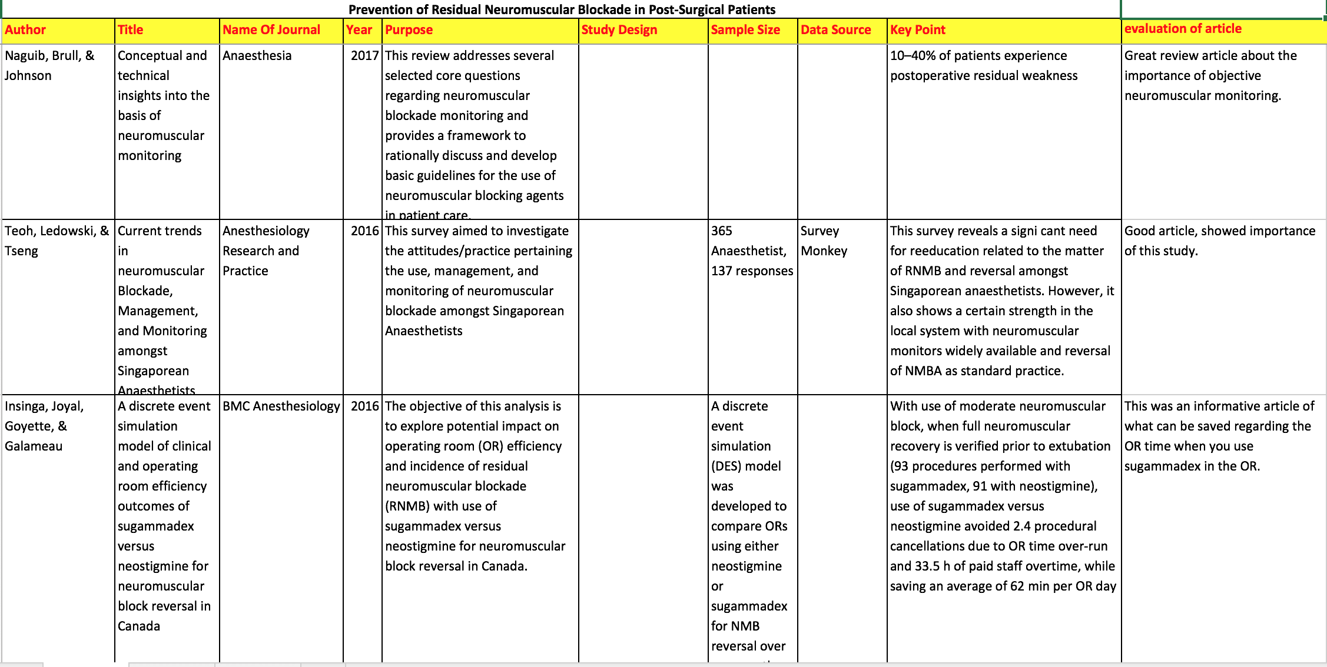
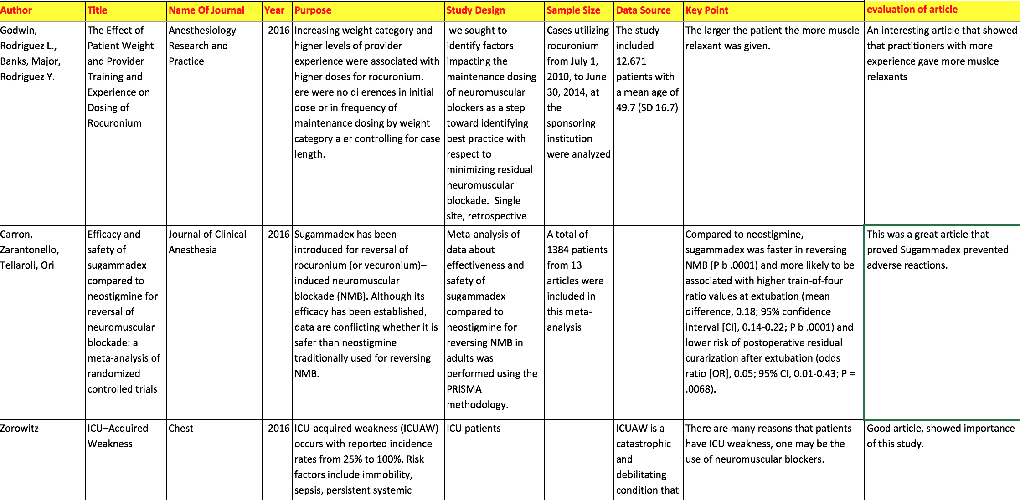
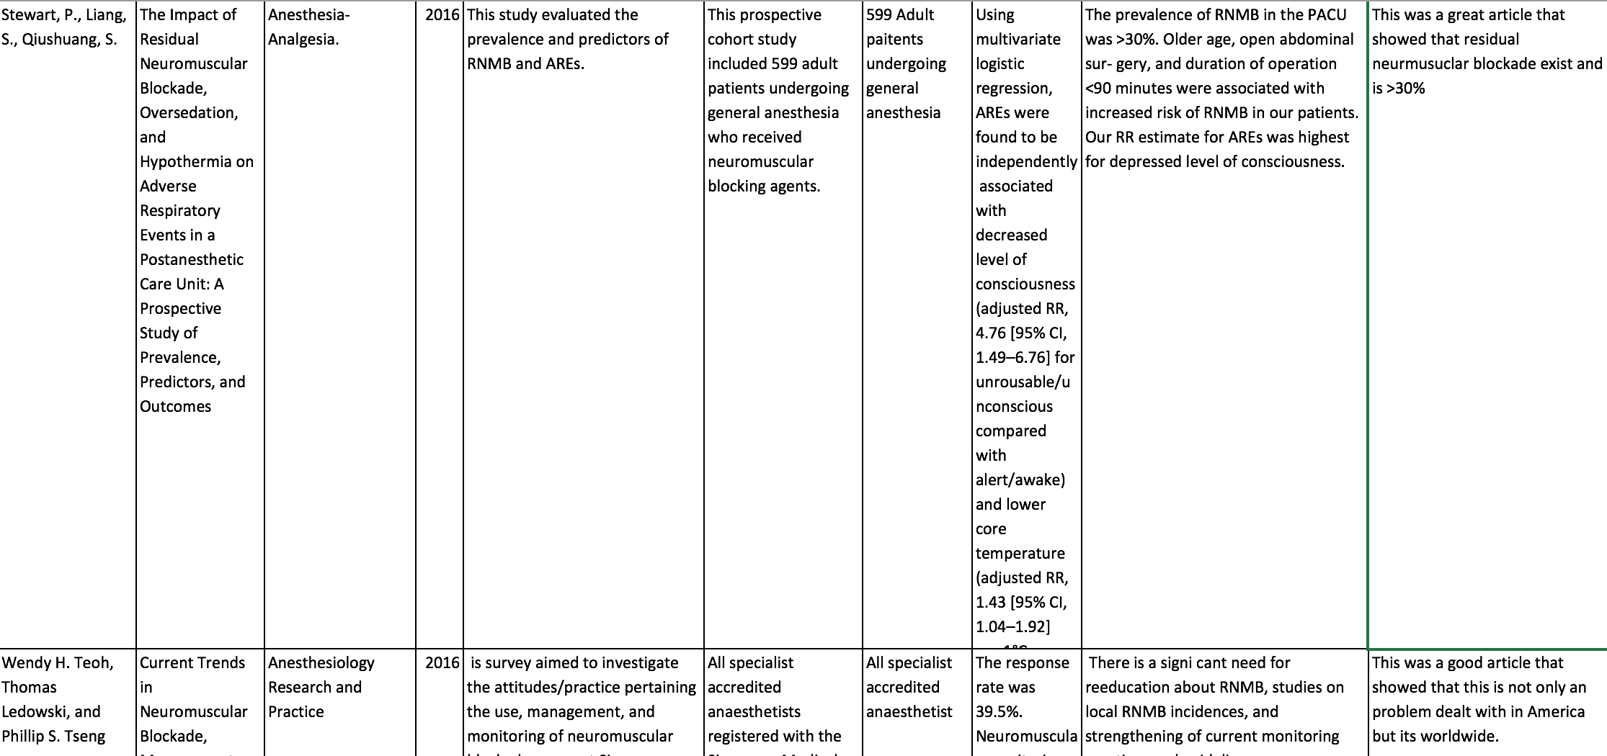
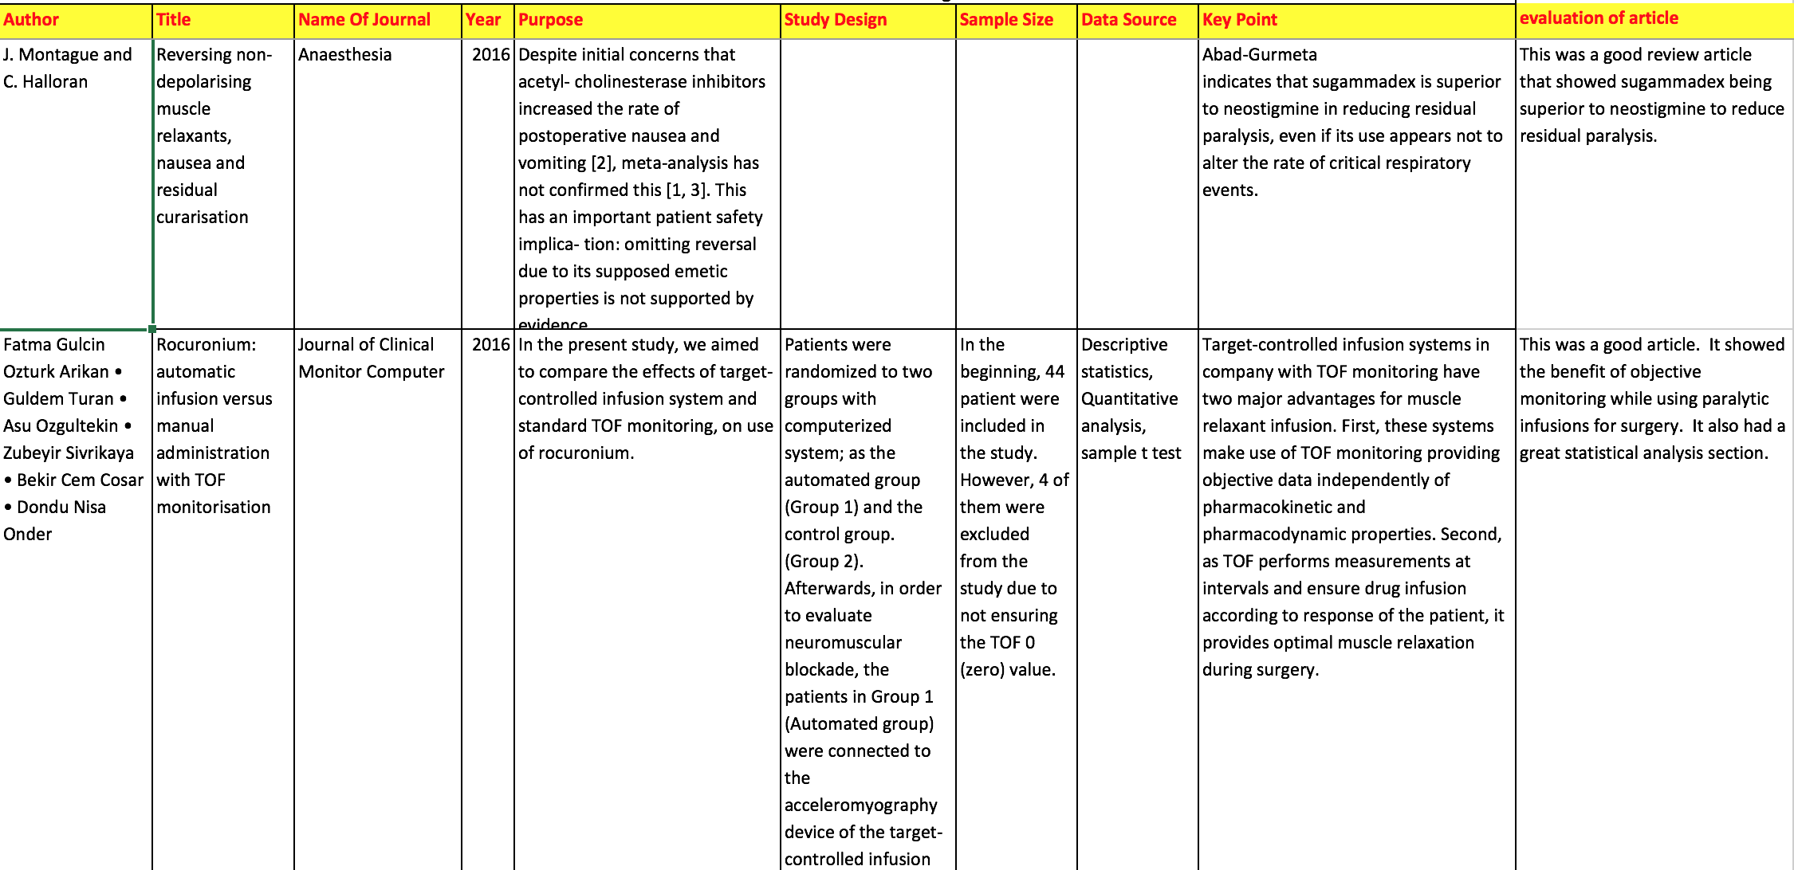
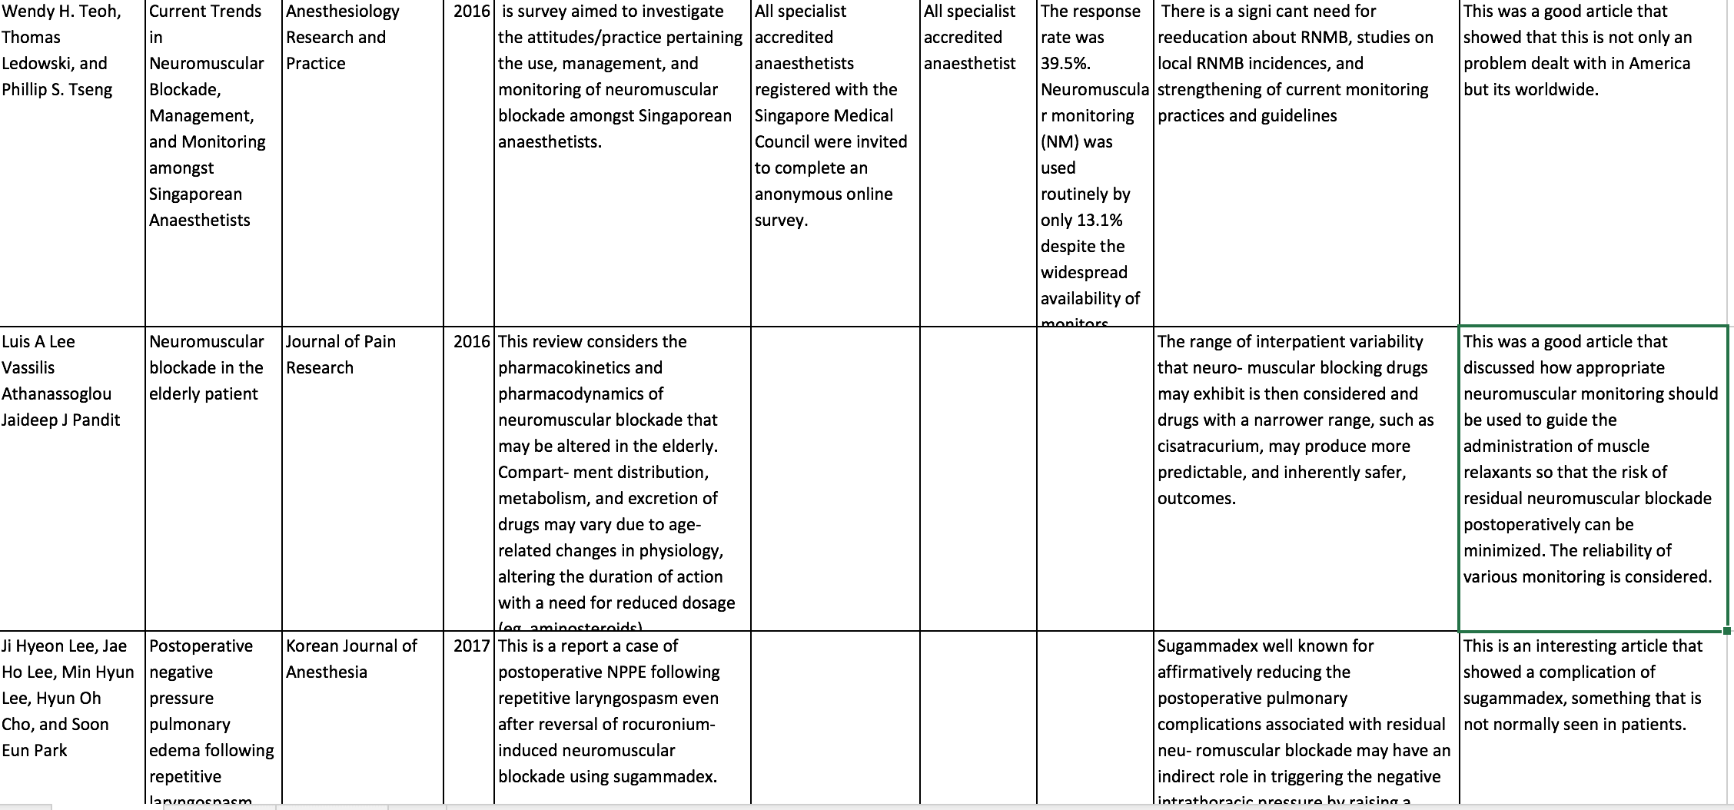
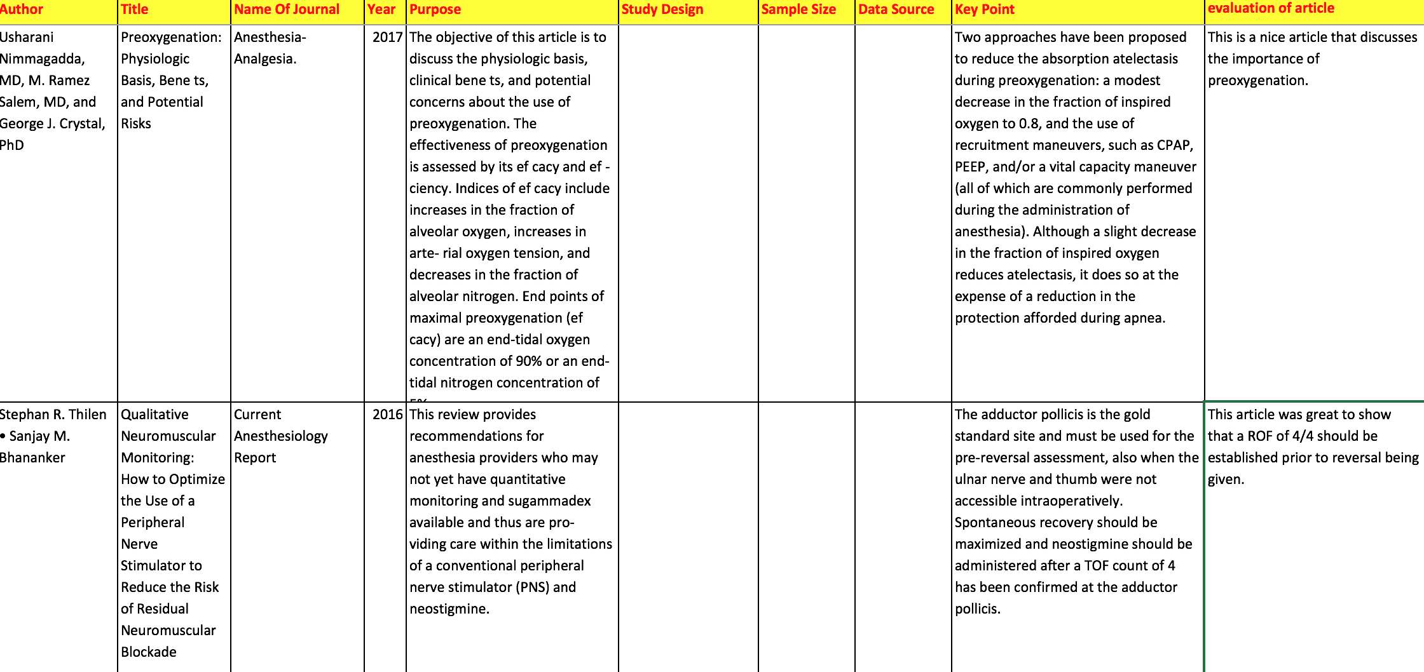
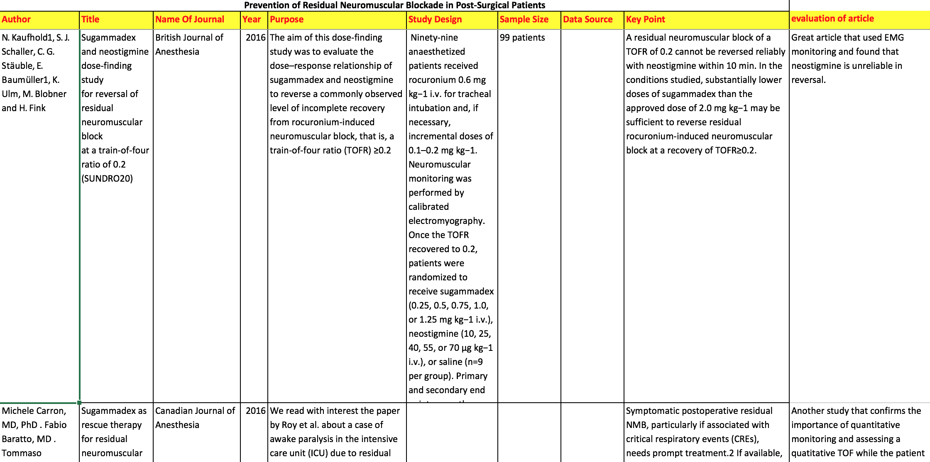
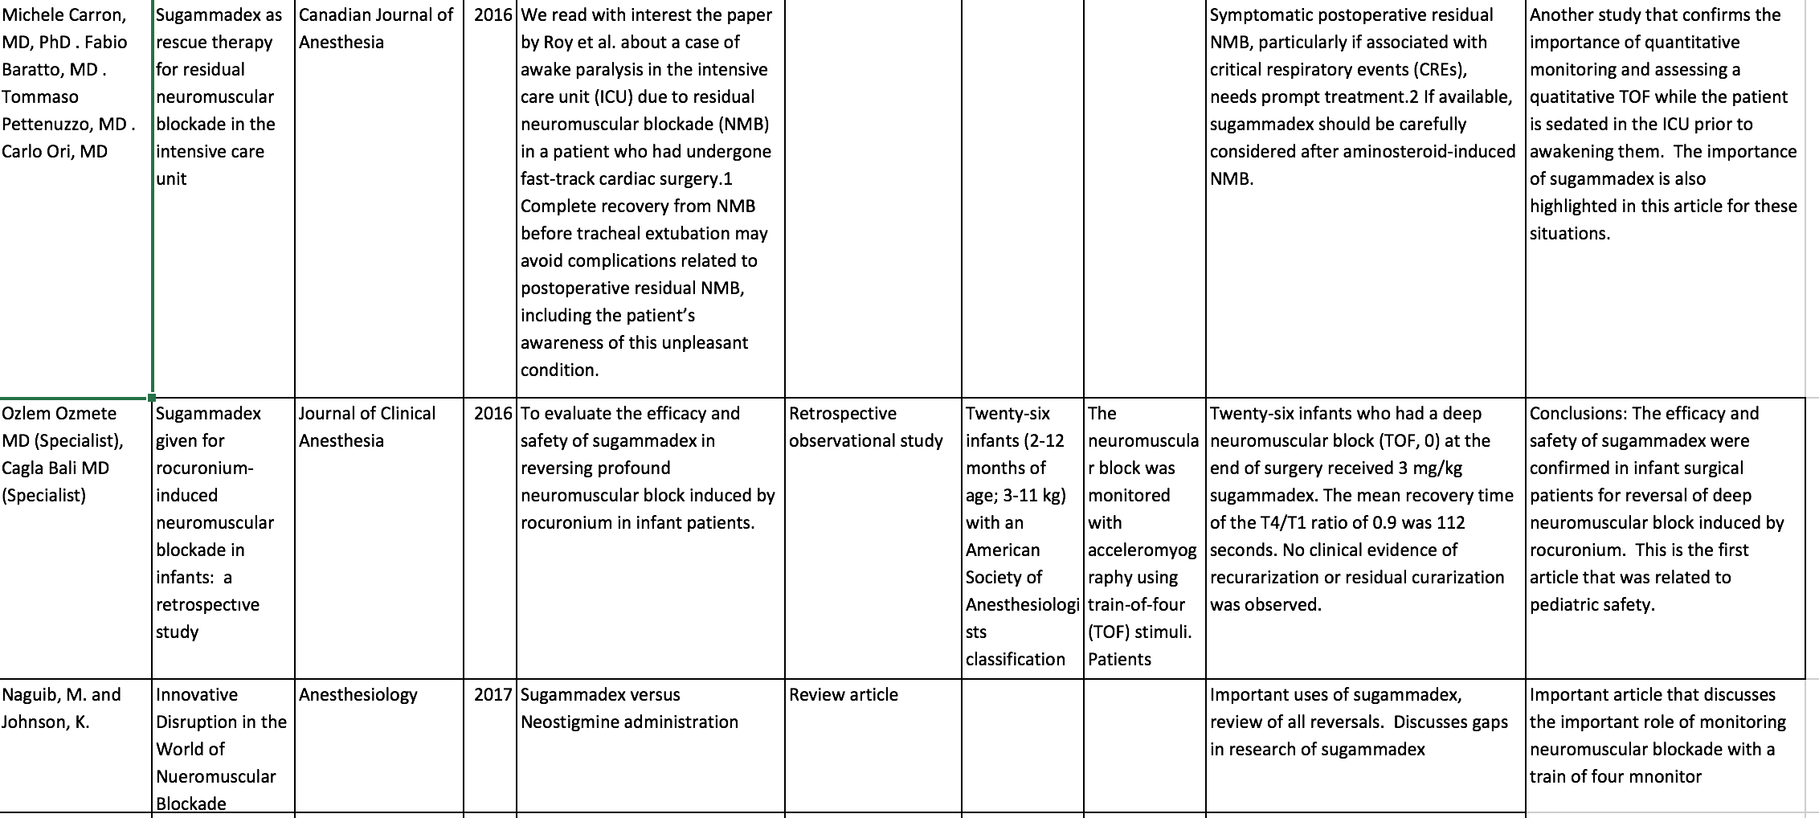
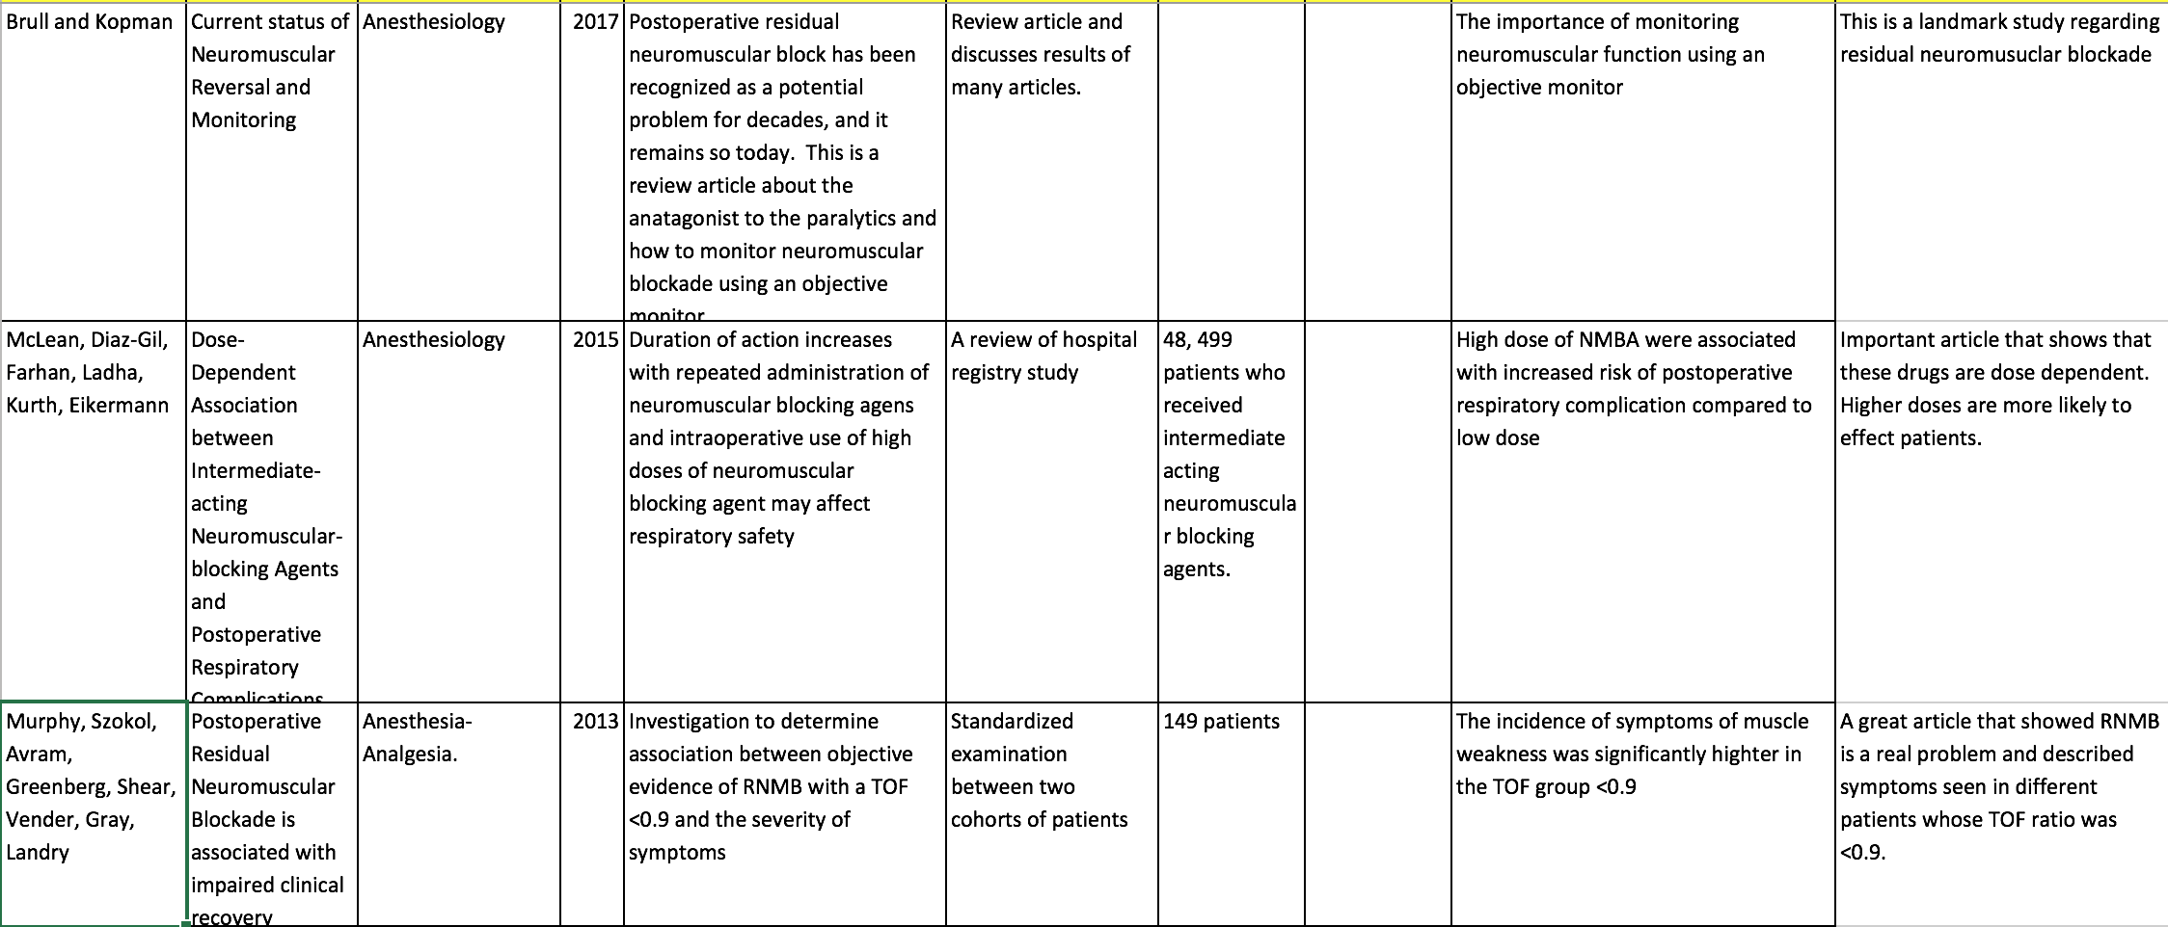
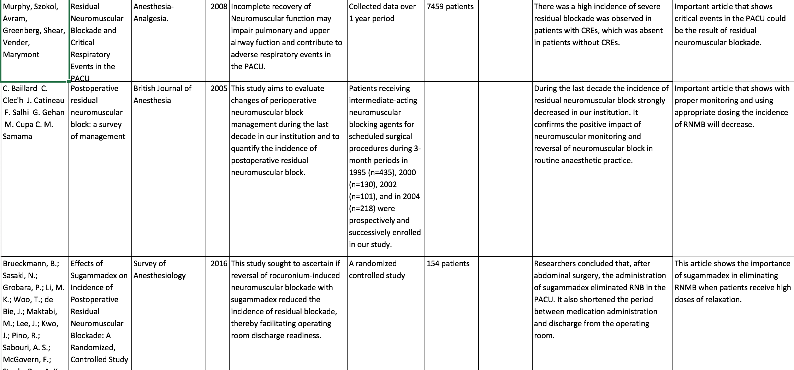
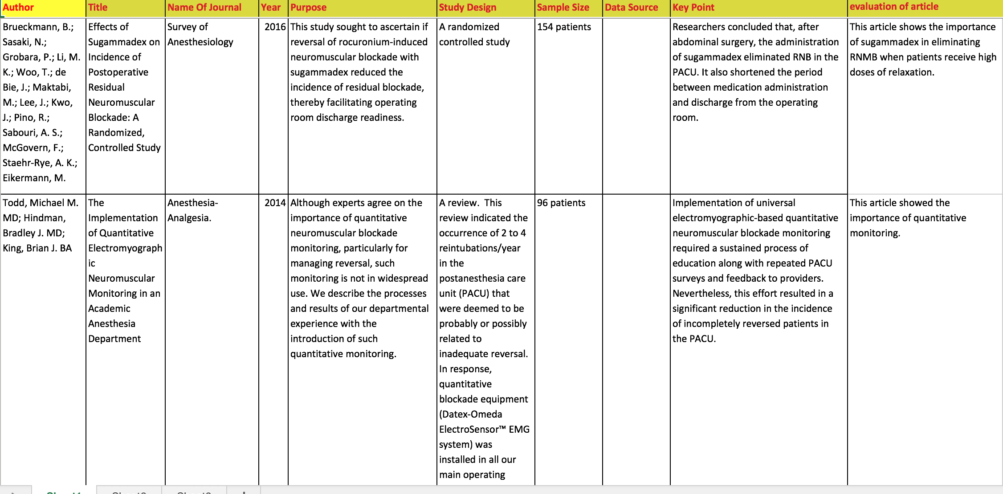

Appendix E
Duke University Health System IRB Approval
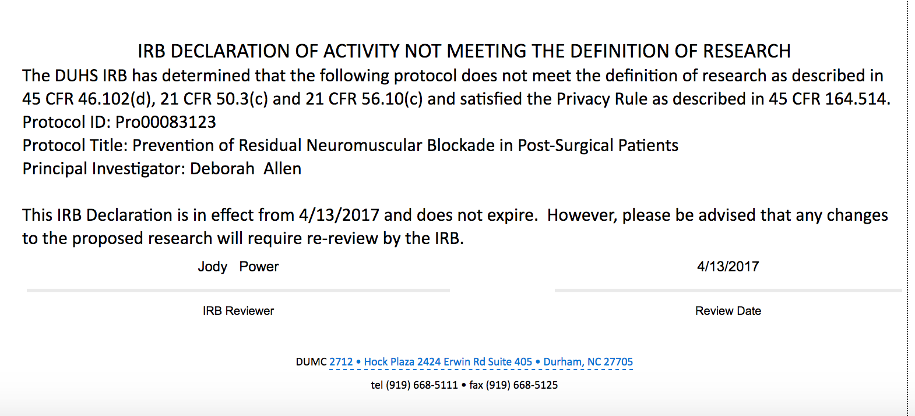

Appendix F

East Carolina University IRB Approval

Appendix G
PACU NMT Educational Tool
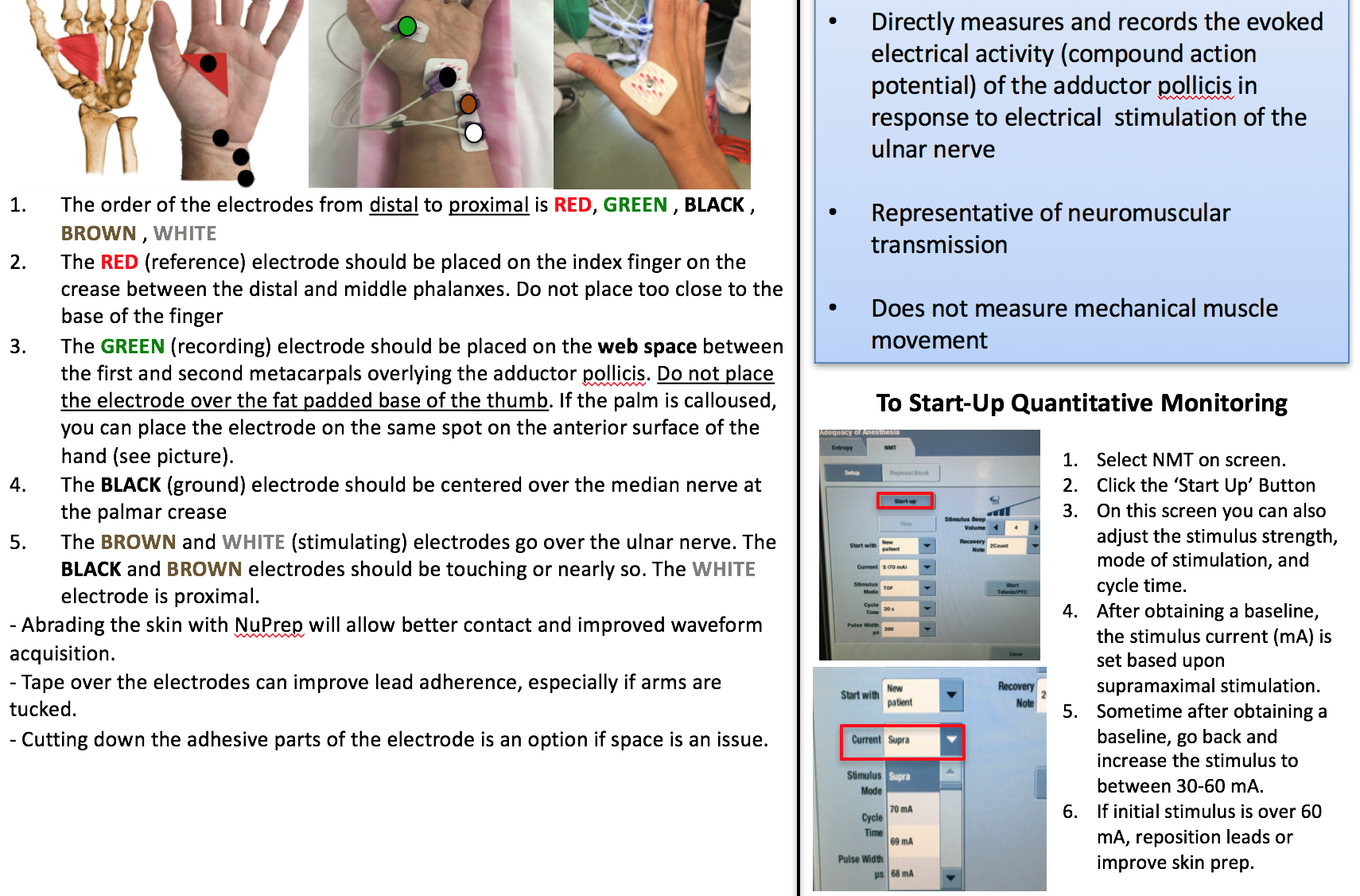
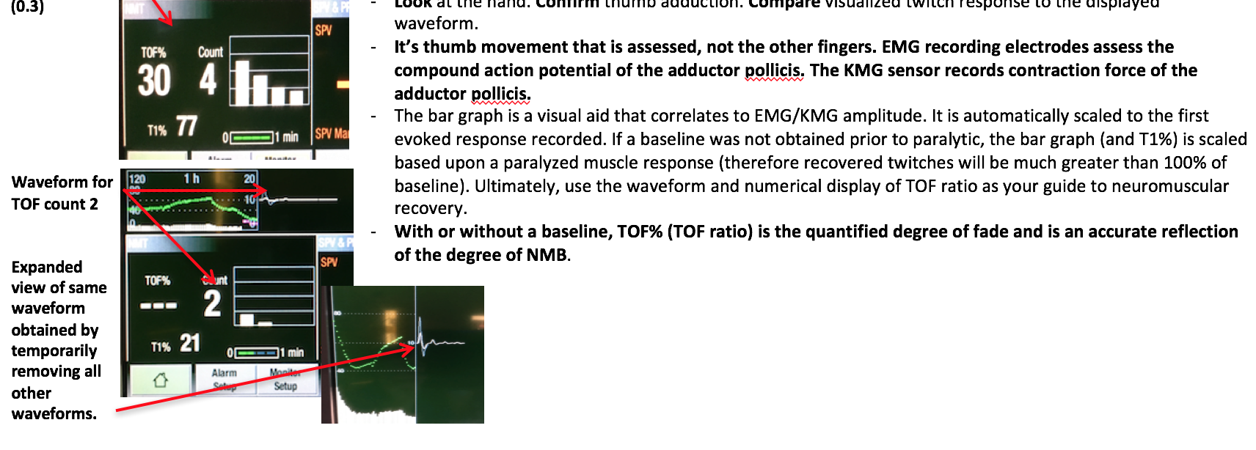

Appendix H
Guideline for Prevention of Post-Operative Residual Paralysis

- Patient admitted from operating room to the PACU space
- The anesthesia provider gives report, which includes whether a nondepolarizing neuromuscular blocker (rocuronium, vecuronium, cisatracurium) was given, the time of last dose, type of reversal, the time of the reversal dose, the type of monitor used to monitor the neuromuscular blockade (electromyography (EMG) or peripheral nerve stimulator (PNS)), and the last train of four ratio in the operating room
- The nurse completes his/her admission assessment, including the following:
PACU Screening for Residual Neuromuscular Block
Neuromuscular Blocking Agent Risk Factors
Did the patient receive a nondepolarizing neuromuscular blocking drug (circle)?  If yes, when was the last dose of NDNMB administered?  Did the patient receive pharmacologic reversal (circle)?  Type of nerve stimulator used to monitor patient (circle)?  What was the last Train of Four ratio in the Operating Room? | Yes No  Rocuronium, Vecuronium  Cisatracurium  Time:______________  Yes No  Neostigmine or Sugammadex  Time:______ Dose______  EMG PNS  EMG TOF %_______  PNS TOF____________
- If the patient received a nondepolarizing neuromuscular blocker an EMG train of four will be automatically performed.

  - The PACU nurse will use The GE Healthcare Carescape Monitor B450 to obtain the TOF
  - Record the patient’s EMG TOF ratio on admission to PACU here _________%

- If the TOF ratio is ≤ .90, was the anesthesiologist notified? __________

  - Continue to monitor TOF ratio every 5 minutes until TOF ratio exceeds 0.90

  - If the anesthesiologist orders an additional dose of a reversal agent based on the patient’s clinical assessment, assess the patient’s TOF five minutes after the dose is administered

Reversal drug administered (circle): Yes No
Dose administered:__________________________
TOF % 5 minutes after reversal administration:___________%

Appendix I
GE Healthcare Carescape Monitor B450

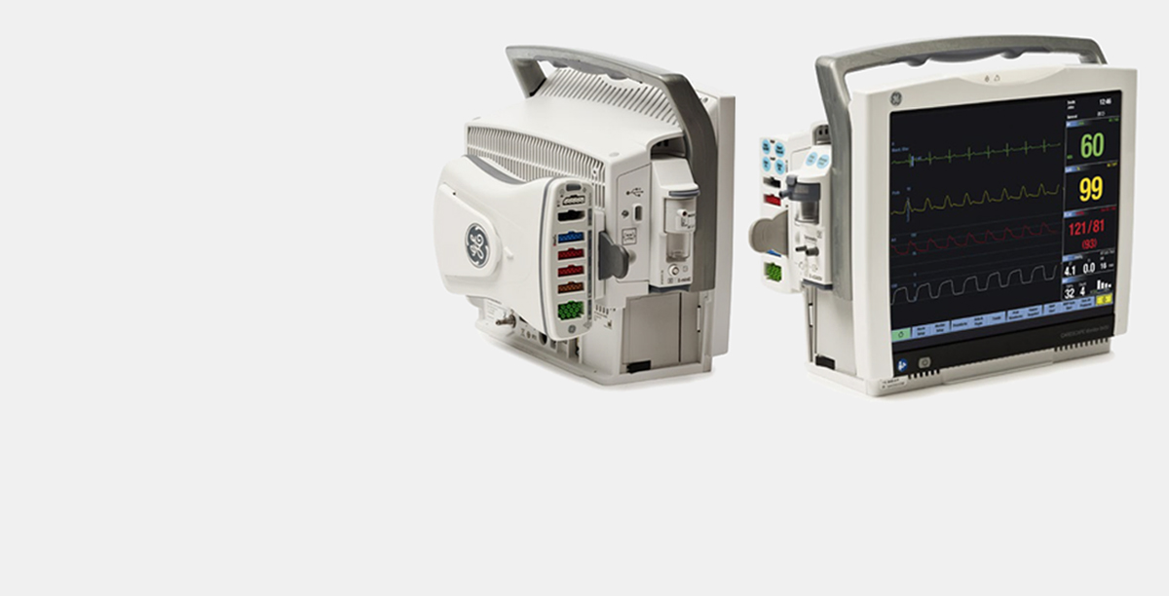

http://www3.gehealthcare.com/~/media/images/product/product-categories/patient-monitoring/patient-monitors/carescape-monitor-b450/carescape-monitor-b450-spotlight.jpg

Appendix J
Electromyography Lead Placement

Appendix K
Starting Up NMT Monitoring System

Appendix L

Interpreting the Monitoring Physiologic Signal

Appendix M

Data Collection Tool

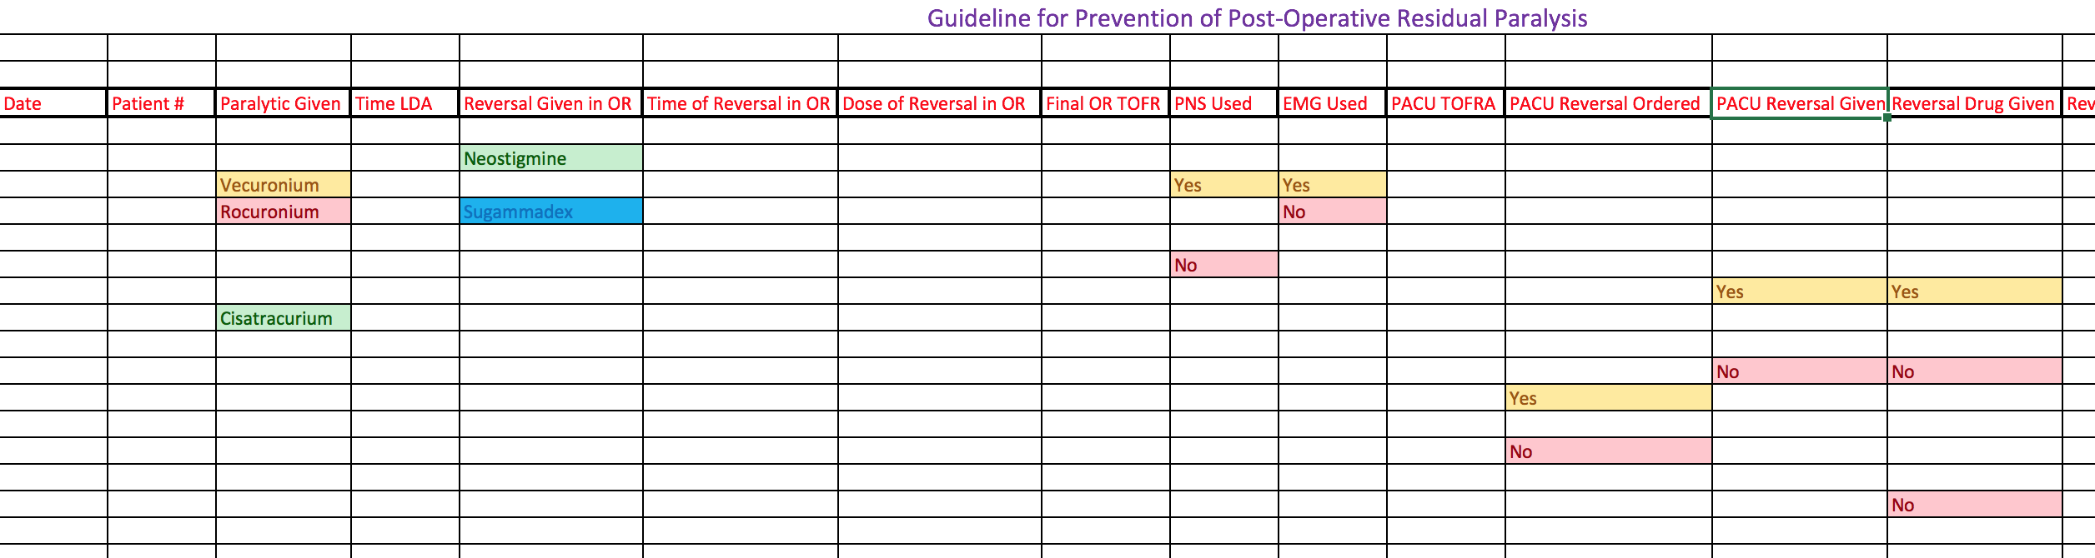
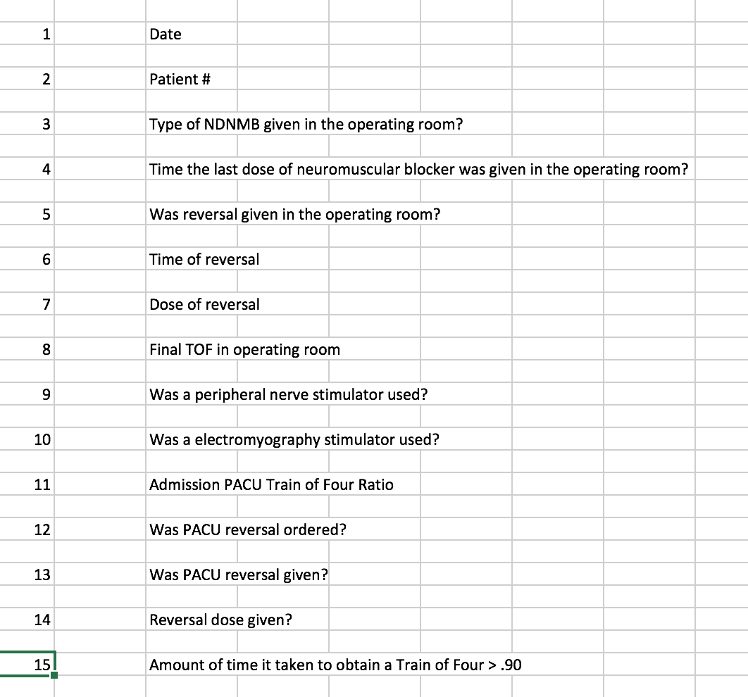

Appendix N

DNP Budget

- Office Supplies/Equipment | Total
GE Healthcare Carescape B450 Monitor | Donated by GE Healthcare
EMG Cables for Monitor | Came with Monitor
Electrodes | Donated by Medical Center
Paper | Donated by Medical Center
- Meetings/Workshop
Meal for PACU Nurses | $300

Appendix O

Neuromuscular Blocker Agent Administered to Patients

Appendix P

Neuromuscular Blocker Reversal Administered to Patients

Appendix Q

Intraoperative Monitoring of Neuromuscular Blockade

Appendix R

Table of Five Patients Requiring Pharmacological Intervention in PACU

Appendix S

DNP Essentials
DNP Essentials | Evidence
Essential I: Scientific Underpinnings for Practice | This project gave PACU nurses the skills necessary to determine if a patient had RNMB and enabled them to obtain the treatment needed for the patient. This had a benefit to the organization by providing increased quality of care to the patients.
Essential II: Organizational and Systems Leadership for Quality Improvement and Systems Thinking | Through the development of a guideline based on scientific findings to evaluate the current practice of regarding neuromuscular blockade delivery. It also was able to display scientific needs for future study in the anesthesia field in regard to dosing of medications and quantitative monitoring.
Essential III: Clinical Scholarship and Analytical Methods for Evidence-Based Practice | This project required critical appraisal of the literature to determine the evidence behind the guideline development. This also was impactful for the organization, it was able to evaluate the outcomes of NDNMB administration and monitoring, as well as, quantify the amount of RNMB at the institution.
Essential IV: Information Systems. Technology and Patient Care Technology for the Improvement and Transformation of Health Care | This project showed the importance of using advanced technology in objective monitoring and how the outcomes differed when subjective monitoring was used by the providers. It improved practice and transformed care at this institution.
Essential V: Health Care Policy for Advocacy in Health Care | A critical analysis that was done regarding patient outcomes at this Medical Center. Policy was evaluated, leadership and providers were educated on the policy and the plan for improvement of patient outcomes was made possible through implementation of the Guideline for Prevention of Postoperative Residual Paralysis.
Essential VI: Interprofessional Collaboration for Improving Patient and Population Health Outcomes | To complete this project, it took collaboration between the nursing and anesthesia staff to recognize patients with RNMB and get the necessary treatment. There was education of the nurses to employ the guideline and notification of the anesthesiologist elicited effective communication. Corrective treatment of the patients is pivotal to this essential.
Essential VII: Clinical Prevention and Population Health for Improving the Nation's Health | This essential was seen through understanding the cultural interactions of the nurses and patients and educating them on the benefit of this project. The importance of obtaining the EMG TOF ratio upon admission to the PACU was the highlight of this education.
Essential VIII: Advanced Nursing Practice | This QI initiative encompassed all of the DNP Essentials. The project was able to show there is a clinical difference in patients receiving neuromuscular blockade and the use of subjective or objective monitoring. It provided information about how important it is to reverse all neuromuscular blocking agents given to patients. Through the project, RNMB was detected in the PACU and patients were able to receive corrective treatment.

Appendix T
DNP Project Approval

Appendix U
DNP Site Approval

Appendix V

DNP Timeline

Timeline for Doctor of Nursing Project
Date | Task | Complete/Incomplete
September 2016 | Explore project topic | Complete
September 2016 – Present | Review the literature for topic of interest | Complete
September 2016 | Define project topic | Complete
September – November 2016 | Explore and define theoretical framework to guide project | Complete
September – October 2016 | Establish project committee | Complete
October 2016 | Establish how the project will be implemented | Complete
September – October 2016 | Search for validated guidelines that could be modified for project use | Complete
September 2016 | Complete DNP Project proposal | Complete
October 2016 | Initial guideline approval from Anesthesiologist at Duke | Complete
October 2016 | Complete CITI training | Complete
October 2016 | Letters of Support from Duke | Complete
October 2016 | First Draft of Paper | Complete
November 2016 | Signed project approval from Duke | Complete
April 2017 | Duke letter requiring no IRB | Complete
November 2016 | Abstract approved by Dr. McAuliffe and Dr. Skipper | Complete
November 2016 | Final Guideline approval from Anesthesiologist at Duke | Complete
November 2016 | Final draft of paper (chapters 1-3) | Complete
December 2016 | Signed project approval form | Complete
December 2016 | Time log completion 125hr (Fall) | Complete
March 2017 | Meeting with Perioperative Director and Post Anesthesia Care Unit (PACU) Manager about implementation of guideline | Complete
January 2017 | Completion of synthesis of the literature and literature matrix | Complete
January 2017 | Expansion of budget and implementation timeline | Complete
April-May 2017 | Educate PACU nurses about guideline/checklist implementation  (including EMG training) | Complete
March 2017 | Letter from Duke stating no IRB is necessary for project | Complete
January 2017 | ECU IRB review process | Complete
January – May 2017 | Complete design of project/intervention of program to be implemented including written permission to use any tools, all evaluation measures and complete description of project | Complete
May 2017 | Time log completion 125hr (Spring) | Complete
April 2017 | Final paper approved by project team and DNP course faculty | Complete
June 2017 | Further development of project paper | Complete
January – June 2017 | Education of the PACU nursing staff and  Collection of data (2 months) – describe steps in implementation process, identify barriers to implementation, and limitations of the project | Complete
July 2017 | Time log completion 125hr (Summer) | Complete
July-August 2017 | Statistical/data analysis | Complete
August 2017 | Evaluation of project outcomes including all final data analysis and conclusion | Complete
September 2017 | Strategies for further project implementation and evaluation | Complete
October 2017 | Dissemination plan | Complete
October 2017 | Present project outcomes at NCANA State Meeting – 30 min | Complete
November 2017 | Present project outcomes at Duke | Delayed
November 2017 | Create poster presentation of DNP project | Complete
November 2017 | Upload final paper into scholarship repository | Complete
December 2017 | Update closure or withdraw o of IRB | Complete
December 2017 | Time log completion 125hr(Fall) | Complete

