IMPROVING JAIL NAVIGATOR MENTAL HEALTH REFERRALS
by
Donna McLean

Paper submitted in partial fulfillment of the
requirements for the degree of

Doctor of Nursing Practice

East Carolina University
College of Nursing

Date Finalized: November 8, 2018

Acknowledgments

To my Doctor of Nursing Practice scholarly project faculty coordinator and community advisor I extend my gratitude and appreciation for their time, expertise and mentorship. Many thanks to the project team and clinic staff who gave thought and suggestions, as well as their time. To my family, I affirm my love for their support and patience while I endeavored to achieve this goal. Thank you to my colleagues and friends for their encouragement along the way.

Faculty Coordinator: Dr. Helene Reilly

Community Professional Advisor: Gary Leonhardt, M.D., DFAPA

Project Team: Venus Curry and Ray Faulkner, RN

Family: Scott, Brenden, Ian, and Evan McLean, Betty Hooks, Barbara and Dennis McLean

Abstract
Discharge planning links inmates with mental illness to community resources upon release. Jail navigators provide discharge planning services. A process was needed to improve referrals to jail navigators. The Doctor of Nursing Practice quality improvement project developed a systematic process guided by a policy and procedure for screening and identifying inmates with mental illness to increase jail navigator referrals. The plan-do-study-act method of evaluating change was the basis for the overall development, implementation, evaluation and sustainability of the systematic process. Rogers’s diffusion of innovation model was the framework for successful adoption of the new policy and procedure by clinic staff. There was a pre-intervention baseline of zero as no referrals were previously generated by the clinic staff. The Brief Jail Community Release Needs Assessment and algorithm generated eleven jail navigator referrals during the eight week implementation period. The criteria for receiving discharge planning assessments should be broadened to include all inmates reporting homelessness. Effective navigation of jail inmates with mental illness increases coordination with community services which is the most effective strategy to reduce recidivism. The project ensured evidence based quality improvement and an advancement of nursing practice for a vulnerable population.

Keywords: incarceration; jails; screening; mental health; discharge planning; needs assessment; community reentry
Term Definitions:
Jail / Detention Center: A county managed facility for individuals confined while awaiting trial or while serving short periods of time for minor offenses.
Prison: A state or federal managed facility for individuals confined after sentencing for a crime.
Recidivism: The recurrent cycle of release and arrest by the same individual.
Table of Contents
Acknowledgments …………………………………………………………………………………………………………………………......2
Abstract…………………………………………………………………………………………………………………………………………….....3
Chapter One: Introduction…………………………………………………………..………………………………………………………6
Overview…………………………………………………………………………………………………………………………………6
Problem………………………………………………………………………………………………………………………………..….7
Background and Significance…………………………………………………………………...…………………………….7
Project Question and Assumption…………………………………………………………………………………………..9
Summary……………………………………………………………………………………………………………………………........9
Chapter Two: Review of the Literature Evidence……………………………………………………….……………………10
Methodology……………………………………………………………………………………………………………………..…..10 Guidelines……………………………………………………..………………………………………………………………………10 Key Findings………………………………………………………………….……………………………………………………..11
Summary………………………………………………………………………………………………………………………….……13
Chapter Three: Concept Model for Evidence-based Practice Improvement…………………………………….14
Conceptual Framework…………………………………………………………………………………………………………14
DNP QI Project Adoption……………………………………………………………………………………………………..16
Summary……………………………………………………………………………………………………………………………….17
Chapter Four: Pre-Implementation…………………………………………………………………………………………………...18
Purpose…………………………………………………………………………………………………….……………………………18
Design……………………………………………………………………………………………………………………………….......18
Cause and Effect Problem Analysis……………………………………………………………………………………...18
PDSA Method……………………………………………………………………………………………………………………….20
Assessment Tool…………………………………………………………………………………………………………………...23
Data Collection and Measurement………………………………………………………………………………………..24
Financial Analysis………………………………………………………………………………………………………………...25
Summary……………………………………………………………………………………………………………………………….26
Chapter Five: Implementation Process……………………………………………………………………………………………..27
Setting……………………………………………………………………………………………………………………………….…..27
Participants……………………………………………………………………………………………………………………………28
Implementation Process………………………………………………………………………………………………………..28
Summary……………………………………………………………………………………………………………………………….29
Chapter Six: Evaluation of the Practice Change Initiative……………………………………………………………….30
Participation………………………………………………………………………………………………………………………......30
Outcomes………………………………………………………………………………………………………………………………30
Findings………………………………………………………………………………………………………………………………...30
Summary……………………………………………………………………………………………………………………………….31
Chapter Seven: Implications for Nursing Practice……………………………………………………………………………32
Practice Implications…………………………………………………………………………………………………………….32
Summary……………………………………………………………………………………………………………………………….36

Chapter Eight: Final Conclusions……………………………………………………………………………………………………..37
Significance of Findings……………………………………………………………………………………………………….37
Strengths and Limitations……………………………………………………………………………………………………..37
Project Benefits……………………………………………………………………………………………………………………..38
Sustainability………………………………………………………………………………………………………………………...38
Recommendations for Practice…………………………………………………………………………………………..…38
Final Summary………………………………………………………………………………………………………………...……38
References………………………………………………………………………………………………………………………………………....40
Appendix A: Literature Search Flow Diagram…………………………………………………………………………………44
Appendix B: Literature Matrix…………………………………………………………………………………………………………45
Appendix C: Diffusion of Policy and Procedure for Jail Navigator Referrals…………………………………52
Appendix D: Cause and Effect Diagram…………………………………………………………………………………………..53
Appendix E: Policy and Procedure…………………………………………………………………………………………………...54
Appendix F: Clinic Staff Training PowerPoint…………………………………………………………………………….…..56
Appendix G: Brief Jail Community Release Needs Assessment……………………………………………………...58
Appendix H: PDSA Project Model……………………………………………………………………………………………….…..60
Appendix I: Project Approval Form………………………………………………………………………………………………....61
Appendix J: Site Letter of Approval…………………………………………………………………………………………………65
Appendix K: Institutional Review Board Waiver Approval…………………………………………………………66
Appendix L: Jail Navigator Referral Data Collection Form…………………………………………………………….67
Appendix M: Data Table………………………………………………………………………………………………………………..…68
Appendix N: DNP Scholarly Project Timeline………………………………………………………………………………...69
Appendix O: Final Project Approval………………………………………………………………………………………….…… 73

Chapter One: Introduction
Overview
Approximately 12 million people are admitted to United States (US) jails annually and about 9 million are released. The jail incarceration rate increased 21% between 1999 and 2013, making correctional systems the second highest state budget cost behind Medicaid. About 40% of released inmates are arrested for another crime within one year of release (U.S. Department of Justice, 2015). In an effort to reduce the use of the justice system and the associated costs, the focus for intervention has turned to linking released inmates to community services to break the recidivism cycle.
Incarceration and Mental Illness. The 2012 national jail survey conducted by the US Department of Justice noted that nearly 45% of incarcerated US citizens reported a history of a mental health diagnosis (Bronson and Berzofsky, 2017). The rate of recidivism in this population is upward of 56%, which is a significantly higher rate than inmates that reported no mental health history. Greater numbers of mental health problems are reported in county jails and detention centers in comparison to prisons, particularly exposure to recent psychological distress (Gottfried & Christopher, 2017).
Jails Serving as Mental Health Facilities. Legal, health care, and economic leaders are discussing the need to improve mental health management during and after incarceration. In addition to ensuring evidence-based mental health treatment, it is imperative that jails no longer serve as mental health facilities. The US criminal justice system has become the largest provider of mental health services, yet criminal justice system employees have minimal to no mental health training (Ford, 2015).
Mental Health Management Guidelines. Legal mandates and mental health organization guidelines have required jails and prisons to develop a system of screening all offenders for mental illness at intake, referring for treatment, and planning for transition back into the community (Steadman, Morrissey, & Parker, 2016). Adequate screening tools that identify inmates with mental health diagnoses generate the opportunity to plan for a successful reentry back into the community with local services in place (Gottfried & Christopher, 2017). Once identified, inmates with high need for services can be referred to a jail navigator for discharge planning. Transitional care coordination should begin immediately with established community agency partnerships that can provide needed services upon release.
Problem
It is impractical to provide comprehensive mental health treatment during jail incarceration given the fiscal constraints of the facility and a primary mission of security (Steadman, Morrisey, & Parker, 2016). The average length of stay in jails is 11 to 21 days, making it difficult to initiate impactful services because of the constant inmate turnover (Ford, 2015). There is a small window of opportunity between arrest and release to develop a discharge plan for community reentry. A timely and efficient process is necessary to screen each inmate for current or past mental illness upon arrival to the jail facility. Those with a positive screen require further assessment for current symptomology, an immediate need for safety measures, and medication management during incarceration. Further, a needs assessment must be completed to begin discharge planning as soon as possible.
Background and Significance
Project site. An eastern North Carolina (NC) detention facility participated in a two-year mental health collaborative intended to improve the full legal process of citizens with mental health diagnoses from arrest to release. The collaborative team identified the need for a jail navigator within the detention center to advocate for discharge planning. The navigator enlists community mental health and social work services to coordinate continuity of mental health care, medication management, and housing after release.
Pre-project referral process. There was no formal referral process to the jail navigator at the detention center. The navigator identified inmates by electronically recoded notations in the jail system. The notations indicated that an inmate had current mental health symptoms and had been classified to a mental health jail block. Other inmates were identified by listening to their communication during first court appearance. Inherently, inmates could have been missed without a structured screening process. Screening for discharge needs during the booking process improves the opportunity to capture referrals to the jail navigator.
Pre-project assessment tools. The established assessment tools used at the detention center capture an inmate’s health history, providers’ information, and current mental status. These tools do not capture elements of discharge planning such as housing stability, income sources, supports, or insurance. According to Lamberti (2016), offenders who secure housing and financial resources upon release are more likely to use mental health services. In combination, stable housing, financial resources and mental health treatment reduce recidivism rates (Lamberti, 2016).
Expanding jail navigator services. Expanding jail navigator services addresses the Institute of Healthcare Improvement (IHI) triple aim initiative of improving the health of a population. The health needs of the mental health population are addressed when each inmate is assessed and an individualized plan of care is devised during incarceration. The addition of discharge planning is an improvement for this specialized population. The collaboration between the criminal justice system and community agencies for healthcare continuity and the provision of basic needs upon release is a relatively new evidence-based practice (EBP). MacDonald, Parsons, and Venters (2013) identify patient safety, population health, and human rights as specific aims for correctional health. The authors highlight the need for ensuring the safety of acutely symptomatic inmates and providing evidence-based mental health service with continuity upon release.

Project Question and Assumption
Will a systematic process guided by a policy and procedure for screening and identifying inmates with mental illness improve jail navigator referrals? Implementing a formal process to screen, identify, and refer inmates with mental health conditions will improve the utilization of jail navigator services based on inmate needs.
Summary
Employing evidence based practices in detention centers is essential to impact recidivism rates for inmates with mental illness. Given the short incarceration periods and budget constraints in detention centers, practical improvements must be considered. Jail navigation services facilitate connection to community resources when inmates are released. Discharge planning affords inmates the supports needed to stabilize their mental health and reduce the risks for recidivism. EBP guidelines for discharge planning in this population should be incorporated in the development of policy and procedure.

Chapter Two: Review of the Literature Evidence
Methodology
A journal literature review was conducted utilizing the keywords that included incarceration, jails, screening, mental health, discharge planning, needs assessment and community reentry. The Cumulative Index of Nursing and Allied Health (CINAHL), Medline, Proquest, Psychological Information Database (PsycINFO), and PubMed databases were accessed through East Carolina University’s library services. A search was performed between the years 2012-2017 with 62 journal articles reviewed. Sixteen articles were incorporated with inclusion of cited original publications dated before 2012 (see Appendix A and B). Additional current government publications and statistical resources were also included, as well as, an original book publication.
Guidelines
The Substance Abuse and Mental Health Services Administration (SAMHSA) is a division of the U.S. Department of Health and Human Services. In a coordinated effort with the U.S. Department of Justice’s Bureau of Justice Assistance, SAMHSA developed ten EBP guidelines that address mental health in the justice system. The focus is on management during incarceration and preparation for release. Adequate assessments for clinical and social needs should be conducted followed by planning for services that address identified deficits. Gaps in care should be avoided by aligning community resources prior to release (Blandford, A., Osher, F., 2013).
SAMHSA guidelines one and two pertain to this Doctor of Nursing Practice (DNP) quality improvement (QI) project. Number one is to screen all inmates early in the intake process and during the period of incarceration. Assessments should detect mental illness and substance abuse. Screening tools should be valid and reliable in the offender population. Guideline two is to provide a more comprehensive assessment for those inmates detected during the screening process. Full assessments should include basic demographics, clinical needs requiring intervention, and the social and community supports that will be needed upon release (Blandford, A., Osher, F., 2013).
Key Findings
Sequential Intercept Model. In collaboration with SAMHSA, Munetz and Griffin (2006) developed the sequential intercept model. The evidence base model holds two core objectives. The first is to reduce the use of the criminal justice system for individuals with mental illness. The second is to capitalize on the community for the management of such individuals. The model depicts five points when an individual with mental illness enters a stage of the criminal justice system from arrest to release. Each intercept is a chance for intervention that could alter the individual’s legal course. Instead, intercepts capitalize on behavioral health management.
The five sequential intercepts begin with law enforcement during arrest. When community options exist, officers could employ intercept one by promoting mental health evaluations rather than arrest for minor offenses such as trespassing. Likewise at intercept two, magistrates and judges could opt to release offenders to family or guardians during initial hearings with the stipulation of linkage to mental health services in lieu of incarceration. Intercept three incorporates the strategy of seeking mental health evaluations and linkage to community services by attorneys and defenders during pre-conviction hearings.
Intercept four occurs during incarceration by providing assessments for mental illness during the screening process. Provision of medication treatment can stabilize acute symptoms. Ensuring discharge planning needs are met for community reentry increases the likelihood of engaging in mental health management when stable housing, transportation, and income foundations are in place. The fifth intercept is a chance to interrupt the cycle of recidivism while residing in the community through linkage to ongoing monitoring, evaluation and treatment. Munetz and Griffin propose that at each level of deeper entry into the system, there should be fewer inmates if the preceding interception points are successfully designed.
Common literature threads. Three common threads found in the literature were the misuse of the justice system for mental health, the need for discharge planning, and the need for coordination of services upon release. There is common agreement among researchers that the key to reducing recidivism in the mental health population is risk factor identifications. Substance abuse, unemployment, limited social supports, unstable residency, being uninsured and having active mental health symptoms are identified risks (Pope, Smith, Wisdom, Easter, & Pollock, 2013; Lamberti, 2016; Harding & Roman, 2017). The vast majority of released inmates reported that the basic needs of stable housing, food, and money were needed before mental health services would be accessed (Wilson, 2013).
When surveyed, released inmates reported that unstable housing created the most distress which leads to a poor outlook and detrimental decision making. Experience of a therapeutic relationship with a mental health professional during incarceration improved the likelihood of using arranged services after release (Pope et al., 2013). Harding and Harmon (2017) discussed the realization that a housing first approach has become standard practice, as released offenders consistently reported that participation in arranged mental health services is not the priority when secure housing is still lacking.
Needs assessment tools. Needs assessment screening tools have been developed for discharge planning in the criminal justice system. Desmarais, Johnson and Singh (2016) reviewed literature from 1970-2012 looking at the predictive validity of nineteen assessment tools designed to capture recidivism risk factors in the incarcerated population. Each tool was evaluated for study quality, assessment content, the rigor of inter-rater reliability and validation of the predictors of recidivism risk. None of the instruments predicted recidivism risk reliably among all settings and populations. Elements of sexism, racial bias, and the inability to frame recidivism in the presence of mental illness were cited areas impacting tool validity.
Summary
As evidenced in the current literature, the prevalence of mental illness in the judiciary system is high. The recidivism rate of this population surpasses those without mental health disorders. The numbers will continue to rise without multi-faceted interventions from the point of arrest to the conditions of community release.
Discharge planning during incarceration is one interception point. Linking inmates to community services when released can reduce the risks of recidivism, but requires effective discharge planning. There is a need for an unbiased and valid discharge needs assessment tool that can be uniformly administered to all inmates in all settings. A policy and procedure to assess inmates with mental illness for discharge needs is now EBP. The absence of such a policy is an opportunity for quality practice improvement.

Chapter Three: Concept Model for Evidence-based Practice Improvement
Conceptual Framework
Diffusion of Innovation. The Diffusion of Innovation (DOI) model (Rogers, 2003) is the conceptual framework used to guide this DNP QI project. Rogers established four essential components of the model: innovation, communication, time, and the social system. Rogers classified participants of the innovative process based on the length of time and the amount of persuasion required for each participant to adopt an innovation. Furthermore, Rogers identified five stages of adoption that serve as a foundation for innovation development.
Innovation. An innovation is the introduction of any idea, practice, process, method or object introduced to a system or group that is perceived as new. Innovations are generally positive in nature and are solutions, enhancements, or novel discoveries. There are five elements of innovation. There must be a perceived advantage to the innovation. The innovation must be compatible with the norms, values, goals, and the needs of the group or system in which it is introduced. The complexity of an innovation can slow the rate of adoption if significant learning and skill acquisition is required. The observability of the intended results of an innovation will reinforce the significance and encourage its adoption. Providing trialability of a complicated innovation in increments allows gradual learning and attention to changes to the innovation as needed (Rogers, 2003).
Communication. Channels used to communicate information about an innovation impact understanding of its features. The method chosen also impacts how wide the communication spreads to the intended recipients. Mass media, internal communication systems, or personal contacts are some of the channels often used. Those persons involved with development of an innovation must clearly share information with potential adopters. The information conveyed requires elements of persuasion that promote adoption of the innovation (Rogers, 2003).
Time. Time frame is the length of time that transpires between introduction of an innovation to its adoption or rejection. This process incorporates five steps. The first step is to provide knowledge about the innovation. Next, is to persuade participants to form favorable opinions of the innovation. The system, group or individual must then make the decision to proceed with, modify, or reject the innovation trial. The innovation is then implemented. Finally, a confirmation is received that the innovation has either been adopted or rejected (Rogers, 2003).
Social system. Lastly, the social system in which the innovation is diffused should be united with the goal of the innovation. The members in the system may be individuals, groups, organizations, or subsystems of an organization. Diffusion of an innovation is affected by leaders’ opinions and influence, the power of the hierarchy of leadership, and informal networking among the components of the system (Rogers, 2003).
Participant adoption. Participant adoption varies based on perception of the innovative process and degrees of resistance to a change portrayed. Early adopters are receptive to innovative changes and join the persuasion phase with the innovators. The early majority network with each other and deliberate about changes together. The late majority is skeptical of change. They require peer pressure and evidence that their system is choosing the innovation as standard operating procedure. Laggards prefer to adhere to the past, are suspicious of change, and tend to interact in isolation from the larger system. When an innovation is mandated, there is little room for delayed adoption due to employed consequences for non-adherence.
Stage of adoption. Innovation adoption has five stages to include in planning, implementation and evaluation: Knowledge, persuasion, decision, implementation and confirmation. Pashaeypoor, Ashktorab, Rassouli, & Alavi-Majd (2016) examined shifts to EBP using Rogers DOI model. They focused on each stage of adoption for a new process or procedure. Knowledge of EBP has a direct impact on the likelihood of adopting recommendations. Ensuring change adoption requires persuasion with a clear vision of advantages or benefits. Decisions to move forward are based on positive or negative opinions of the innovation. New policies or procedures are more likely to meet staff resistance if complex. Breaking down complicated processes into sectional implementation trials enhances staff cooperation and efforts to learn. An ability to see outcomes of the change plan quickly increases success and sustainability, even in small increments. Cooperation, compliance, and participation confirm innovation adoption (Pashaeypoor, Ashktorab, Rassouli, & Alavi-Majd, 2016).
DNP QI Project Adoption
Project innovation (knowledge stage). The project innovation is the development and implementation of a discharge needs assessment to improve jail navigator mental health referrals. Successful adoption of the DNP QI innovation is dependent on addressing components of the DOI model (see Appendix C). The project aligns with the facility mental health improvement focus. Clinic staff must receive adequate training regarding the jail navigator role and perceive a valuable benefit for inmates. Staff needs to see their importance in conducting a thorough admission assessment. Detailed pertinent mental health and social factors will determine criteria for navigator referrals. Staff must find the new assessment tool straight forward and easy to administer with minimal impact on overall screening time. Likewise, the referral algorithm must be clear and user friendly, yet accurate for determining referral qualification.
Project communication (persuasion stage). In preparation for this DNP QI project, staff must understand what EBP is, and that a push for EBP is driven by healthcare, legal, financial and ethical forces. The most efficient channel for providing education and training is via email due to shift schedules. A voice-over PowerPoint presentation ensures that staff members receive identical education and training, including future hires. Staff can communicate clarification requests to the DNP student verbally or by email. This format is modifiable if changes are indicated by feedback or policy updates.
Project time (implementation stage). Policy and procedure adherence is non-negotiable by the administration of this facility. The project team must address all feedback during the implementation phase or staff cooperation could be delayed. Identified modifications should be made and implemented as they are discovered. Ongoing feedback, team discussions, and policy and procedure revisions should continue until the referral process is solidified and adopted. Project sustainability will improve through ongoing audits evaluating staff adherence.
Project social system (decision stage). The facility social system is united in efforts to improve the management of mental health issues during incarceration. Employer and facility leadership support has been obtained. The change team agreed on the need for this DNP QI project.
Project participant adoption (confirmation stage). There are several clinic staff members who will be early adopters and quickly adjust to incorporate the new policy and procedure without question. They will become mentors to staff who are the early majority and slower to adjust routines and add steps to processes currently in place. Clinic staff is accustomed to being held accountable for following policies and procedures. They are aware of the current system wide attention to inmates with mental illness. Given the mandate of policy and procedure adherence, late majority and laggard staff are not anticipated.
Summary
Rogers DOI serves as a framework for quality improvement implementation. The theory provides structure for answering the key questions of who, what, where, when and how, which are fundamental aspects that must be addressed. The anticipatory adoption guidance provides opportunity for preparatory education, attention to communication design, and potential manipulation of change projects to hasten the speed of adoption.
Chapter Four: Pre-Implementation
Purpose
The purpose of this Doctor of Nursing Practice quality improvement project was to develop a policy and procedure for screening and identifying inmate referrals to a jail navigator to increase the utilization of services. The objective was to generate referrals for discharge planning that could be feasibly managed during the time of incarceration.
Design
The DNP project was quality improvement that utilized the Plan-Do-Study-Act (PDSA) method of evaluation. A cause and effect analysis was completed to identify and specify an EBP practice improvement. The need for an assessment tool to identify inmates with mental illness needing discharge planning prior to release was determined. Promotion of project adoption was based on Rogers (2003) DOI model.
Cause and Effect Problem Analysis
An initial community mentor meeting took place to discuss a problem in need of improvement. Low utilization of jail navigator services was identified as a system deficit. A cause and effect analysis developed by the Institute for Health Improvement (IHI) in 2017 was used to determine four key factors and specific aspects contributing to the problem (see Appendix D).
Cause and effect process factor. Process factors are guidelines. No policy was in place requiring inmates to be screened for jail navigator referrals. There was no procedure to evaluate inmates for discharge planning needs. A process was needed to identify determinants that generate a navigator referral based on qualifying assessment responses.
Solution. A policy and procedure was written that delineates the process of assessment and referral for jail navigator services (see Appendix E). It was expected that all inmates would be assessed for the potential qualification for services based on discharge planning needs. When indicated by the general assessment and brief mental health screening form, a mental health discharge needs assessment was completed. Information collected was inserted into an algorithm that identified referrals based on need for services that could be accomplished within the timeframe between arrest and release.
Cause and effect clinic staff factor. People factors include perceptions, training, and knowledge. The clinic staff is responsible for completing a medical and psychological assessment for every inmate booked into the detention center. Training is provided to ensure adequate collection of information to maintain or improve an inmate’s state of health while incarcerated. Medical and psychiatric referrals are generated from this assessment based on established policies and procedures. There was no detention center announcement providing a jail navigator role description, so clinic staff was unfamiliar with the purpose of the position. Without guidance, the staff was not able to effectively assist with referrals for services.
Solution. Before project implementation, clinic staff was trained on the jail navigator role. Clinic staff either attended a training session provided by the DNP student or completed a voice over PowerPoint education session (see Appendix F). A description of EBP and the specific EBP goals for inmates with mental illness was discussed. Essential steps in discharge planning for release were highlighted. Examples of potential needs were provided. The jail navigator role was described. The clinic staff was made aware of their role in supporting the jail navigator.
Cause and effect inmate factor. Inmate factors incorporate receptiveness and cooperation of participants. Inmates may be intoxicated or experiencing acute mental health symptoms during the booking process and assessment. Inmates may not be able to provide the details of their current community supports to facilitate coordination. During the booking process, inmates are often agitated and uncooperative, impacting the ability to fully assess and collect adequate information.
Solution. Mental health information known by the arresting or probation officer was collected prior to change of custody to the detention center. Every effort was made to ensure privacy and a calm atmosphere. The inmates were reassured that information collected from the mental health needs assessment was useful for discharge planning. Guardian, parent, or family contact information was obtained for assistance in collecting additional information with permission of the inmate. If the inmate was not cooperative or coherent, the assessment was delayed until the inmate became sober or less agitated.
Cause and effect tool factor. Tool factors are the methods used to obtain needed data. The current screening tools do not collect demographic data pertinent to discharge planning. Housing stability, income sources, guardianship, or insurance are not assessed. Staff occasionally requires prompting to document clear and detailed answers regarding acute mental health symptoms, hospitalizations, medication management, and community providers.
Solution. The Brief Jail Community Release Needs Assessment (McLean, 2017) was formatted similarly to the Brief Jail Mental Health Screening form developed by Policy Research Associates, Inc. (2005) and used by the facility. The continuity of design and algorithm instructions allowed for ease of use by the staff due to familiarity. Copies of the new Brief Jail Community Release Needs Assessment tool accompanied the training slides (see Appendix G).
PDSA Method
The PDSA method was the base model for overall project development, implementation, evaluation and revision (see Appendix H). The PDSA is a unique model in that it guides continuous quality improvement as a process, not just an isolated solution. The simplicity is attractive, with a strong focus on planning. The PDSA cycle identifies inefficient or ineffective processes, formulates solutions, implements changes, and evaluates outcomes. The model also continuously monitors quality improvement to support sustainability (Taylor, 2014; Rudes, Viglione, & Porter, 2013).
Plan. In the planning phase, the team identifies what is not working well or meeting expectations. The desired goal for improvement is determined, and the objective or targeted outcome is defined. A state of the science review of the literature is conducted to be certain that the best EBP is incorporated in the study and the determined goal. The change plan is developed, with the essential questions of what, who, when, and where answered. The team makes predictions about outcomes resulting from an innovative change. It is important to obtain organizational or leadership support prior to proceeding.
Survey tools can be administered to staff to assess perceived barriers. Thus, educational needs can be addressed proactively. Guidelines, policies and protocols are drafted based on current and best evidence based practices. Rationales for change are included. Data collection and methods for evaluating and monitoring changes are developed.
DNP project Plan. During the planning phase, a team was established to identify a facility quality improvement need. This DNP QI project team included the advanced practice registered nurse DNP student, a consulting psychiatrist, a psychiatric nurse on staff, and the jail navigator. Low utilization of jail navigator services was identified as a system deficit. Improved utilization of jail navigator services for inmates with mental illness was a priority in an effort to reduce recidivism in this population. Faculty and organizational support for the DNP QI project was obtained (see Appendix I and J).
Following a literature review, a discharge needs assessment and navigator referral algorithm was developed based on key recidivism risk factors identified. A voice over PowerPoint was created for administration prior to project implementation. A data collection tool was prepared.
Protection of human subjects. No identifying demographic inmate or medical staff data was collected by the investigator. Clinic staff completed the developed tool and filed the Brief Jail Community Release Needs Assessment directly into the inmate clinic file. The investigator only had access to the data collection form that had no participant identifiers. Improving the referral system within the detention center was a quality improvement DNP project. The project was based on staff education, introduction of an assessment tool, and a referral algorithm. The project was presented to the university’s Institutional Review Board (IRB). An IRB not human subject waiver was approved on March 19, 2018 (see Appendix K).
Do. The innovation is then implemented using the delineated specific steps. Live workshops, video training, written materials and other educational forums can be provided to staff during this phase. Pre-determined data is collected as the implementation is in progress.
DNP project Do. Prior to project implementation, the majority of staff and administrators attended a live PowerPoint presentation by the DNP student. Those who could not attend were provided a voice over PowerPoint via email. Data was collected and tallied weekly for eight weeks. The project team communicated via email biweekly. A mid-point and final team meeting was held.
Study. Data is now analyzed. Outcome predictions are compared with actual results to determine whether the desired outcome was achieved. The team considers what was learned, the true outcome(s), and summarizes the findings. Post change survey tools can be administered to gather feedback from staff. The team addresses discovered barriers to implementation, as well as, key motivators that influenced participation in the project.
DNP project Study. Data was analyzed and presented as percentages. The total number of admission screenings, the number of discharge assessments, and the number of navigator referrals was reported. A baseline of zero formal navigator referrals was compared to referrals generated by the discharge needs assessment. An improved utilization of jail navigator services was anticipated as the result of a formalized system for referral.
Act. During the act phase of the PDSA model, the plan for change can either be fully adopted, adapted with modifications, or abandoned with no possibility of modification. The team identifies and devises any modifications necessary for the change to be successful. Individual components of the plan can be implemented if full project adoption cannot be accomplished. The PDSA cycle then restarts either for implementing a revised innovation, monitoring compliance, or detecting barriers to sustainability.
DNP project Act. Staff feedback was solicited biweekly via email. The project team discussed feedback and determined if project modifications were indicated. No significant changes were identified. The project team communicated monthly twice for post implementation sustainability monitoring.
Assessment Tool
Brief Jail Community Release Needs Assessment. Jail inmate discharge needs and recidivism risks were identified in the professional literature. Six questions were developed to determine discharge planning needs. Yes or no answers were formatted with space in the general comment column to explain a refusal or inability to answer a question. The screener was also asked to provide comments for all questions answered no. If the inmate indicated a guardian, case worker, or family member, that person was to be named to coordinate release.
Question One, Two and Three. Question one referred to housing available to the inmate on a daily basis. Housing should have had basic amenities such as running water, electricity and heat. Housing should have been considered physically and emotionally safe by the inmate. Question two addressed whether the inmate had a steady and reliable income to support housing, utilities, groceries, medications, medical care, and other essential items on a routine basis. Question three asked whether the inmate was covered by Medicaid, Medicare, Veteran Affairs (VA), or private health insurance benefits.
Question Four, Five and Six. Question four referred to steady and reliable transportation available to attend medical or mental health appointments, and to purchase groceries and medications. Question five addressed the physical, emotional and intellectual ability of the inmate to self- manage activities of daily living such as grooming, toileting, and nutrition. Question six asked about any person assigned to or willing to assist the inmate with any or all of the above needs. The presence of a guardian indicated that the inmate was a minor or had been determined to be incompetent to handle their own welfare without assistance.
Referral Criteria. The referral criteria identified high priority needs to ensure the physical safety of inmates at their release. Questions one and five were areas that impact basic human needs that needed to be addressed and generated an automatic referral. The algorithm helped screeners determine if a referral was needed based on concerns for inmate safety or judgment. The Brief Jail Community Release Needs Assessment was emailed to the Jail Navigator for all referred inmates. As per the current psychiatric referral procedure, the referral was documented in the jail electronic system mental health field. Brief Jail Community Release Needs Assessments were then filed in inmate clinic charts.
Data Collection and Measurement
A data collection form was to be provided in the medical intake room (see Appendix L). Each form included seven collection days. The forms were to be collected weekly once completed. Staff was instructed to place a slash mark in the appropriate box when a Brief Jail Community Release Needs Assessment was completed. An additional slash mark placed in the appropriate box identified when a navigator referral was generated.
Data was to be collected weekly during the eight-week project implementation time frame. Data collected would include the total number of inmates screened each week, and the number that met the criteria for a discharge planning assessment. The final number of inmates referred for jail navigator services would be tallied.
The total number of referrals generated by the medical staff would be reported. There was a pre-intervention baseline of zero as no referrals were currently being generated by the clinic staff. Numerical percentages would be utilized for data analysis and should include the number of completed assessments and referrals to the navigator.
Financial Analysis
DNP project costs. Direct costs for the DNP QI project included printer paper and copier toner estimated to total $110. The additional cost was absorbed by the facility as those are products currently supplied to the clinic for usual business. A project exclusive flash drive valued at $8 was purchased by the DNP student. There were no indirect costs associated with the DNP QI project as clinic staff, the DNP student, and all team members were employed at the facility. The project was implemented in conjunction with procedures currently in place during the intake and screening process, incurring little additional screening time for staff.
Direct costs per inmate per day. The direct cost per day to house one inmate at the facility was about $98 per day and was inclusive of all costs incurred by the county. Given the average length of stay per inmate is 11-21 days (Ford, 2015), the county savings to prevent one inmate from returning due to another arrest could be estimated to be $1,078 to $2,058. Those county monies would be better utilized funding community resources for basic need provision and mental health services for citizens with mental illness.
Indirect costs of incarceration. Baughman (2017) proposes that tangible indirect costs of incarceration include loss of income for the inmate, which may impact dependents of that inmate. Those dependents may then qualify for public assistance programs that provide food, shelter, and medical care. Increasing rates of incarceration force legislators with a limited budget to fund jails and prisons. This funding would benefit all citizens if invested in public assistance programs, mental health treatment, education, and vocational training programs.
Summary
Utilizing established models for the development and implementation of EBP QI projects ensures a systematic and inclusive process. Identifying the key factors that underlay a system deficit affords the opportunity to develop targeted solutions. Thorough preparation for the elimination of potential barriers to implementation improves the likelihood of achieving expected outcomes. An effective project design can positively impact the implementation process and ultimate achievement of desired outcomes.

Chapter Five: Implementation Process
Setting
County demographics. The project was implemented at an eastern NC county detention center that housed nearly 400 male and female inmates over age sixteen. The county had the14th largest population of 100 NC counties (NC Office of State Budget and Management, 2015). Based on the latest census, the 2016 estimated population was 177,220 residents (US Department of Commerce, 2016). The median age of the county residents was 31 years. Females were in majority. Over 85% of the residents held at least a high school degree. The median annual income was $40,000. Nearly 30% of the population was living below poverty level. A high unemployment rate surpassed several comparable counties and state reports. Food insecurity was high at a rate over 20% and 15% reported accessing food stamps. Nearly 16% were uninsured, with an additional 27% qualifying for public supported insurance programs (NC Health and Human Services, 2015). Approximately 130 people were without homes with 24 deemed homeless long term. Compared to statewide statistics, the county had a lower median household income and a higher percent of citizens that were unemployed or living in poverty (NC Health and Human Services, 2015).
County health care assets. The community had several assets including a level one trauma center with emergency and inpatient behavioral health management. The health department and a local university School of Medicine collaborated to assess and meet health needs as prominent representatives of the community. In addition, there were numerous medical, mental health, and dental practices. There was one federally qualified health center and three free clinics. Faith based organizations were diverse and had active health missions in the community.
The university played a large role in health care by serving the uninsured through the schools of medicine, psychology, and dentistry. Primary and specialty care, as well as dentistry were provided at reduced rates. Beyond the local federally qualified health center reduced cost services, free clinics in the area were staffed by students and local healthcare provider volunteers. Additional financial and healthcare service needs were accessed through the county Department of Social Services. Mental health services for the uninsured and Medicaid population were managed through the eastern NC local management entity-managed care organization.
Participants
Project participants included a convenience sample of all English speaking inmates booked into the detention facility during the eight week project implementation period. The facility housed male and female inmates age 16 and older. While the majority of inmates were residing in the same county as the facility, some were housed temporarily for charges in another county. Ultimately, only county residents qualified and were referred to the jail navigator.
Implementation Process
The DNP QI project was conducted over eight weeks, from May 14 to July 8, 2018. All inmates were assessed using the current medical intake form. All inmates were administered the current Brief Jail Mental Health Screen (Policy Research Associates, Inc., 2005). Inmates reporting the following within the past six months received a mental health discharge needs assessment: uncontrolled mental health symptoms, hospitalization for mental illness, medication management for mental health, or mental health treatment in the community. Jail navigator referrals were generated based on the provided algorithm.
Clinic staff feedback was elicited weekly by email or conversation. Inquiries included the feasibility of accomplishing the discharge planning tool during the booking process time frame. Staff was asked about difficulties eliciting information from inmates, and whether the algorithm was user friendly. Comments and suggestions were also solicited.
Team members communicated biweekly via email, text and phone to review process feedback from clinic staff and to discuss the referral data. A final discussion regarding the key objective of increasing referrals to the jail navigator was based on collected data. Monthly PDSA reviews for sustained implementation occurred for two months following the project completion.
Summary
The PDSA was an appropriate model for the DNP QI project. Much of the work lied with the planning and preparation as expected. During implementation, engaging in the PDSA process ensured continuous monitoring for unforeseen barriers to implementation. Allowing for the opportunity to make any timely modifications, increased the likelihood that the project design would ultimately yield the intended outcomes.
Understanding the fundamentals of Roger’s DOI created the opportunity to capitalize on early adopters to support the project. Setting the expectation of feedback from all staff, encouraged the engagement of laggards. Providing ongoing feedback regarding the data collection also promoted consistent staff participation. Staff participation and adherence to the project guidelines was essential for implementation and data collection.

Chapter Six: Evaluation of the Practice Change Initiative
Participation
During the eight week implementation, 1,046 inmates were booked into the detention center. Each inmate received the usual medical and mental health assessments. Clinic staff monitored for the project inclusion criteria of English speaking, county residents who reported uncontrolled mental health symptoms, hospitalization for mental illness, medication management, or community mental health treatment within the past six months. Inmates that met criteria were included as participants in the DNP QI project.
Of 1,046 inmates booked into the detention center, 35 (3.35%) inmates met criteria. These inmates were administered the Brief Jail Community Release Needs Assessment. Of the 35 inmates assessed, 11 (31.43%) indicated discharge planning needs and were referred to the jail navigator for services (see Appendix M).
Outcomes
Prior to the implementation of the DNP QI EBP project, there was no systematic process to assess inmates with mental illness for discharge planning needs during the booking process. Clinic staff were not identifying inmates or referring to the jail navigator. When compared to a zero baseline, 11 referrals are an increase for a standardized referral capture during the booking process.
Findings
There were no identified modifications of the policy or procedure suggested by the clinic staff or jail navigator through the end of the study. Comments from staff included “it’s straight forward”, “it’s clear”, “we’re used to using this kind of screen”, and “I thought inmates wouldn’t want to answer the questions, but they did when I told them it would help them when they leave”. The developed assessment tool was inclusive of information needed by the jail navigator.
No qualifying inmates were identified outside the referral process, with the exception of three inmates that did not complete the usual booking process. Those inmates were incapable of screening and assessment due to disease severity, but were referred based on observations of clinic staff. All referred inmates were deemed appropriate for discharge services.
Summary
The assessment tool proved useful for collecting relevant information and capturing appropriate referrals. Adoption of the EBP policy and procedure for discharge planning was rapid and inclusive of all staff. The DNP project yielded evidence of quality improvement via a systematic method of assessment and referral to the jail navigator. As anticipated, improved utilization of jail navigator services was evident.

Chapter Seven: Implications for Nursing Practice
Practice Implications
The American Association of Colleges of Nursing (2006) established eight essentials to serve as the foundational elements for the Doctor of Nursing Practice graduate education curriculum. Within the essentials, core competencies are set forth. The DNP graduate is expected to understand and utilize the fundamentals of each essential within the QI project and as structure for future evidence based practice improvements. Each essential and the implications for the advancement of nursing practice are delineated below.
Essential I: Scientific underpinnings for practice. Completing continuing education hours for active nursing licensure is required to ensure nursing practice remains current and evidence based. The scientific foundation affords the DNP student the ability to develop and evaluate EBP change. Scholarly QI work utilizes science based findings and theories from nursing and other disciplines. Understanding the fundamentals of a thorough and comprehensive literature review are key to ensuring that the most current evidenced based information is used as a platform for change. This skill is important for discovering relevant theories and models to frame and design future EBP quality improvements.
Drawing from nursing and other science and theory bases expands the tools for improving nursing practices, particularly in special populations like inmates. Nursing practice advancement and healthcare improvements for incarcerated individuals require incorporation of complimentary sciences like psychosocial, correctional, and mental health. Assisting inmates to maximize optimal health outcomes while restricted in a detention environment requires the ability to modify, adapt, and align science with the environment.
Essential II: Organization and systems leadership for quality improvement and systems thinking. The DNP has developed a population and systems perspective. Effective leaders understand the organizational politics, formal and social structures, philosophies and finances. Initiating collaborative discussions regarding improvement needs with key stakeholders and leaders is an acquired skill. The DNP can appraise the financial impact of a project. Identifying and developing solutions for health disparities is within the scope and knowledge foundation of the doctorate prepared nurse.
A broad view of the environment is essential for improving the healthcare of general and special populations like inmates. The healthcare needs of an incarcerated population must be assessed within the organizational setting in which they are detained. The DNP must understand that the primary mission of detention is security, and fiscal constraints will be in place. Ensuring quality, safe, and effective care of inmates within the culture of the justice system is of ethical and legal importance beyond the use of EBP. Nursing practice must acclimate to and appreciate the criminal justice and socioeconomic guidelines and regulations impacting the environment.
Essential III: Clinical scholarship and analytical methods for EBP. The recognition of practice problems, the integration of new and diverse sources of knowledge, and creative problem solving is characteristic of scholarly nursing practice. Once the healthcare improvement needs of a system or population are ascertained, the DNP can appraise existing literature, design and implement healthcare improvements, and analyze outcomes for practice relevance. Prominent guidelines and initiatives, current related data, and evidenced based practices serve as the foundation for the purpose, development, and subsequent evaluation of the implementation of an EBP quality improvement. The DNP can then disseminate the QI process and outcomes via presentations and publications to various audiences.
Employing EBP healthcare for incarcerated populations has gained legal, ethical and economic attention. Large gaps in knowledge exist that can be narrowed by DNP QI work. Traditionally, inmates have been considered vulnerable populations in terms of avoidance as research subjects. However, inmates must rely on the healthcare of the justice system when incarcerated. Implementing EBP QI initiatives in detention centers arguably addresses the health disparities of inmates while satisfying ethical concerns, economic burdens, and legal standards.
Essential IV: Information systems/technology and patient care technology for the improvement and transformation of healthcare. With the rapid advancement of technology and information systems, nurses must learn to enter, retrieve, analyze and protect data that is now available in healthcare. Accessible data can serve to evaluate and continuously monitor for quality improvement based outcomes. The DNP can assist patients with the overwhelming volume of health information available on the internet by evaluating popular websites for evidence based, non-biased, and current lay education.
Healthcare settings are expected to have electronic medical records (EMR), but some clinics are considered exempt from requirement. While detention centers would benefit from the ability to track and retrieve valuable data, the EMR is not required given there is no Medicare, Medicaid or private insurance billing for healthcare services provided to individuals while in county, state or federal judicial custody. Detention inmates have no access to computers, thus paper form education is still utilized. Staff education can be provided with online courses and PowerPoint presentations.
Essential V: Healthcare policy for advocacy in healthcare. The DNP has acquired the skills to evaluate, contribute to, develop, and employ healthcare policy in many arenas. Being aware of the agencies and foundations that influence healthcare is essential, as is developing a relationship with those entities when possible. Active participation in local, state and national political avenues to advocate for patients is strategic and necessary to influence sweeping policies that may positively or negatively influence access, quality or affordability of healthcare.
There will always be a need to advocate for inmate healthcare given the societal view of offenders. Justifying policy development based on EBP would seem straight forward, but alignment with extraneous agendas and established policy are necessary to move policy forward. Detention centers have administrative layers of authority and approval. State laws and county government parameters must be considered and abided by when proposing, developing, and implementing policies regarding inmate healthcare.
Essential VI: Interprofessional collaboration for improving patient and population health outcomes. The ability to lead and collaborate with interprofessional and intraprofessional colleagues is a proficiency the DNP can utilize in many settings. Effective oral, written, and electronic communications are essential leadership skills. Multi-disciplinary team composition broadens the base of knowledge, theory, skill and perspective to develop solutions for identified improvement needs. Eliciting and responding to contributed feedback from project participants positively impacts the implementation and eventual adoption and sustainability of initiatives.
Advocating for healthcare improvements within a detention setting requires consultation, collaboration, and an understanding of the dynamics of the justice system. The DNP can strategically position oneself on teams or boards that are influential regarding the health and overall welfare of inmates. Developing diverse professional relationships is strategic for gaining approval, cooperation, and support for QI initiatives that may rely on the influence, advice, or guidance of others. Detention centers have key administration and staff with whom the DNP would be well served to develop relations with.
Essential VII: Clinical prevention and population health for improving the nation’s health. The DNP has the ability to evaluate a population or community for healthcare gaps or disparities. Nurses are known for appreciating cultural diversity, and for holistic health promotion. Striving to reach government or expert aims with EBP QI capitalizes on the DNP skill set of health promotion and disease prevention within specialized population bases.
Engaging offenders in mental and chronic health management improves the well being of the population. Offering services such as HIV or TB testing while incarcerated is part of health promotion in a population often uninsured and lacking access to care. Linking or referring inmates to community resources prior to release impacts the health status of each individual long term by bridging access to care.
Essential VIII: Advanced nursing practice. The doctorate prepared nurse has acquired a population, systems, and community perspective. The DNP can serve in diverse settings as a leader, mentor, or educator among other roles. Through a conceptual and analytical view of systems, organizations, and populations, the DNP has a holistic perspective to launch assessments, strategic partnerships, and intervention designs.
There is a segmented, yet collective effort to reduce the use of jails as mental health facilities and to raise the standard of health care provided while citizens are incarcerated. Standardizing inmate screenings and assessments enforced by policy and procedure ensures a shared administrative and clinical emphasis on healthcare. Educating, motivating and incorporating staff in EBP QI initiatives broadens the collective efforts to improve outcomes for the incarcerated population who live under social stigmas.
Summary
The educational base and immersion experience in the EBP QI project captures the eight key essentials for the doctor of nursing practice degree set forth by the AACN. Continuing assessments of systems and population gaps or deficits in inmate healthcare affords the DNP an opportunity to continue ongoing EBP quality improvements within the detention setting. Incorporating aspects of each essential in future DNP project development and implementation ensures evidence based quality improvement and an advancement of nursing practice for a vulnerable population.
Chapter Eight: Final Conclusions
Significance of Findings
Policies serve as rules to reach a goal or outcome. Procedures provide specific steps or methods to meet the policy expectations. In the healthcare arena, policies and procedures set the foundation for achieving evidence based health improvements. The policy and procedure for screening all inmates for mental health, coupled with the policy and procedure for assessing identified inmates for discharge needs, established a standardized process for identifying, managing, and planning for discharge. Prior to the standardization, inmates potentially qualified but may not have been captured for jail navigator services. Ensuring equal opportunity for discharge planning and interception of the recidivism cycle is evidence based quality improvement.
Strengths and Limitations
Strengths. There was no cost burden for implementing the DNP QI project. Development of a voice over PowerPoint allowed consistent training for staff that is 24 hours a day and seven days per week with occasional staff turnover. The assessment tool was designed in a familiar format which reduced the need to educate staff regarding the algorithm. Directions for completing the assessment were reported to be clear. Time to administer the assessment had little impact on the overall assessment process. The referral process to the navigator was similar to the procedure already in place for referring to psychiatry.
Limitations. Initially there were staff members who were reluctant to ask assessment questions that were considered invasive of privacy. While those staff answered yes and no, they did not gather detailed information. This did not affect the referral criteria, but offered little assistance to the navigator to function from until meeting with the inmate. Limiting the inclusion criteria to mental health associated issues only for the past six months may have missed inmates in need of discharge planning.
Project Benefits
While there is daily discussion by clinic and detention staff regarding the return of the same inmates to custody repeatedly, there was little discussion regarding the role of detention to break the recidivism cycle. Administrators opened conversations through participation in the mental health collaborative and the hire of a jail navigator. This DNP QI project spurred staff level conversations regarding recidivism and the value of our interactions with these individuals.
Sustainability
The DNP QI project will sustain ultimately due to the presence of a policy and procedure. Staff compliance is expected and counseled if noncompliance is found to exist. Ongoing new clinic staff training will continue with the incorporation of the voice over PowerPoint in the hire module. Jail navigator feedback and communication with clinic staff solicited to reinforce the value of information gained by staff, and to report the service outcomes for inmates referred.
Recommendations for Practice
Future staff training should emphasize the relevance and need to include details of assessment responses. Reinforcing the importance and impact of assessments on discharge planning should be highlighted to promote ongoing staff thoroughness. It is evident that the jail navigator has the capacity to manage discharge planning efforts for additional inmates. The scope of the position was intended to focus on inmates with documented mental health. It is the impression of the project team that the inclusion criteria for discharge planning assessments should be broadened to include inmates that report homelessness without community interventions in place.
Final Summary
The DNP QI project intended to establish a systematic process guided by an evidence-based policy and procedure for screening and identifying inmates with mental illness to improve jail navigator referrals. This EBP initiative addressed the SAMSHA guidelines of screening all inmates for mental health early in the intake process and providing a more comprehensive assessment for those inmates detected during the screening process. In addition, discharge planning for community reentry is intercept four in the sequential intercept model for reducing recidivism in the mental health population.
Expanding jail navigator services addressed the IHI triple aim initiative of improving the health of a population. Systematic identification and referral for discharge planning services is an EBP improvement for this specialized population. Linking inmates to community services upon release, impacts recidivism and reduces the use of jails as mental health facilities.

References
American Association of Colleges of Nursing. (2006). The essentials of doctoral education for advanced practice nursing. Retrieved from http://www.aacnnursing.org/Portals/42/Publications/DNPEssentials.pdf
Baughman, S. (2017). Costs of pretrial detention. Boston University Law Review,97(1), 1-30. Retrieved from http://search.proquest.com.jproxy.lib.ecu.edu/
docview/1884767782?accountid=10639
Blandford, A., & Osher, F. (2013). Guidelines for the successful transition of people with behavioral health disorders from jail and prison. Council of State Governments Justice Center. Retrieved from https://csgjusticecenter.org/wp-content/uploads/2013/12/Guidelines-for- Successful-Transition.pdf
Bronson, J., & Berzofsky, M. (2017). Indicators of mental health problems reported by prisoners and jail inmates, 2011-12. U.S. Department of Justice Special Report NCJ 250612. Retrieved from https://www.bjs.gov/content/pub/pdf/imhprpji1112.pdf
Davis, M., Sheidow, A., & McCart, M. (2015). Reducing recidivism and symptoms in emerging adults with serious mental health conditions and justice system involvement. The Journal of Behavioral Health Sciences & Research, 42(2), 172-190. doi:10.1007/s11414-014-9425-8
Desmarais, S. L., Johnson, K. L., & Singh, J. P. (2016). Performance of recidivism risk assessment instruments in U.S. correctional settings. Psychological Services, 13(3), 206-222. doi:10.1037/ser0000075
Ford, E. (2015). First-episode psychosis in the criminal justice system” Identifying a critical intercept for early intervention. Harvard Review of Psychiatry, 23(3), 167-175.
doi:10.1097/HRP.0000000000000066
Gillam, S., & Siriwardena, A. N. (2013). Frameworks for improvement: Clinical audit, the plan-do- study-act cycle and significant event audit. Quality in Primary Care, 21(2), 123.
PMID: 23735693
Gottfried, E., & Christopher, S. (2017). Mental disorders among criminal offenders: A review of the literature. Journal of Correctional Health Care, 23(3), 336-346. doi:10.1177/1078345817716180
Harding, C. & Roman, C. (2017). Identifying discrete subgroups of chronically homeless frequent utilizers of jail and public mental health services. Criminal Justice and Behavior, 44(4),
511-530. doi:10.1177/0093854816680838
Institute of Healthcare Improvement. IHI Triple Aim Initiative. Retrieved from http://www.ihi.org/Engage/Initiatives/TripleAim/Pages/default.aspx
Institute for Healthcare Improvement. Quality Improvement Essentials Toolkit. Retrieved from http://www.ihi.org/resources/Pages/Tools/Quality-Improvement-Essentials-Toolkit.aspx
Lamberti, J. (2016). Preventing criminal recidivism through mental health and criminal justice collaboration. Psychiatric Services, 67(11), 1206-1212. doi:10.1176/appi.ps.201500384
MacDonald, R., Parsons, A., & Venters, H. (2013). The triple aims of correctional health: Patient safety, population health, and human rights. Journal of Health Care for the Poor and Underserved. 24(3), 1226-1234. doi:10.1353/hpu.2013.0142
McLean, D. (2017). Redesigning Jail Navigator Referrals to Improve Utilization of Services.
Unpublished paper, East Carolina University.
Munetz, M. R., & Griffin, P. A. (2006). Use of the sequential intercept model as an approach to decriminalization of people with serious mental illness. Psychiatric Services, 57(4), 544- 549. doi:10.1176/ps.2006.57.4.544
N.C. Health and Human Services, Division of Public Health. (2015). 2015 Pitt County community health assessment. Retrieved from http://publichealth.nc.gov/lhd/cha/docs/2015/2015-
PittCo-CHA.pdf
N. C. Office of State Budget and Management. (2015). 2015 Certified County Population Estimates- Ranked by Size. Retrieved from https://ncosbm.s3.amazonaws.com/s3fs- public/demog/countygrowth_bysize_2015.html
Pashaeypoor, S., Ashktorab, T., Rassouli, M., & Alavi-Majd, H. (2016). Predicting the adoption of evidence-based practice using “Rogers diffusion of innovation model”. Contemporary Nurse, 52(1), 85-94. doi:10.1080/10376178.2016.1188019
Policy Research Associates, Inc. (2005). Brief Jail Mental Health Screen. Retrieved from https://www.prainc.com/wp-content/uploads/2015/10/bjmhsform.pdf
Pope, L., Smith, T., Wisdom, J., Easter, A., &Pollock, M. (2013). Transitioning between systems of care: Missed opportunities for engaging adults with serious mental illness and criminal justice involvement. Behavioral Sciences and the Law, 31(4), 444-456.
doi: 10.1002/bsl.2074
Rogers, E. (2003). Diffusion of Innovations. New York: Free Press
Rudes, D. S., Viglione, J., & Porter, C. M. (2013). Using quality improvement models in correctional organizations. Federal Probation, 77(2), 69-75, 87-88. Retrieved from http://search.proquest.com.jproxy.lib.ecu.edu/docview/1459406035?accountid=10639
Steadman, H., Morrissey, J., & Parker, T. (2016). When political will is not enough: Jails, communities, and persons with mental health disorders. The Prison Journal, 96(1), 10-26.
doi: 10.1177/0032885515605466
Taylor, M., McNicholas, C., Nicolay, C., Darzi, A., Bell, D., & Reed, J. (2014). Systematic review of the application of the plan-do-study-act method to improve quality in
healthcare. British Medical Journal of Quality and Safety, 23, 290-298.
doi: 10.1136/bmjqs-2013-001862
U.S. Department of Commerce, Census Bureau. (2016). Quick facts. Retrieved from https://www.census.gov/quickfacts/fact/table/pittcountynorthcarolina,NC#viewtop
U.S. Department of Justice, Bureau of Justice Statistics (2015). Census of Jails: Population Changes, 1999–2013. Retrieved from https://www.bjs.gov/content/pub/pdf/cjpc9913.pdf
Wilson, A. (2013). How people with serious mental illness seek help after leaving jail. Qualitative Health Research, 23(12), 1575-1590. doi:10.1177/1049732313508476

Appendix A
Literature Search Flow Diagram

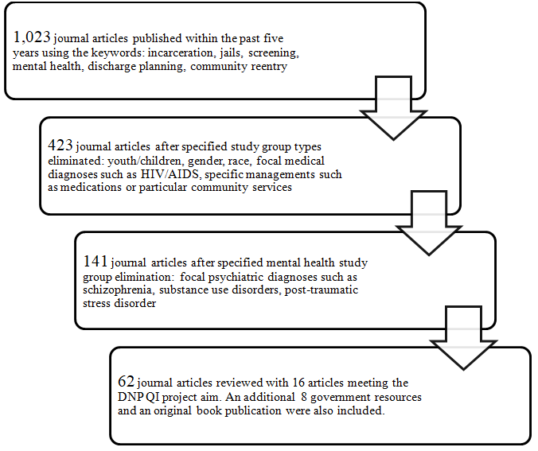

Appendix B
Literature Matrix
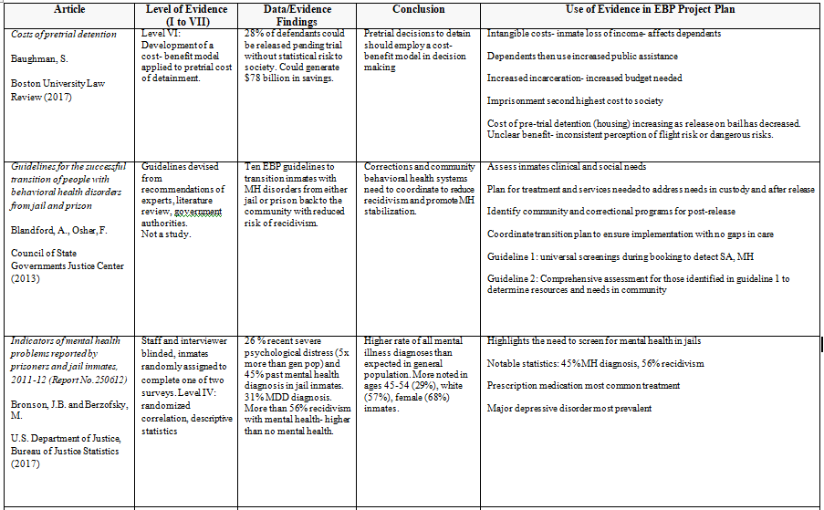

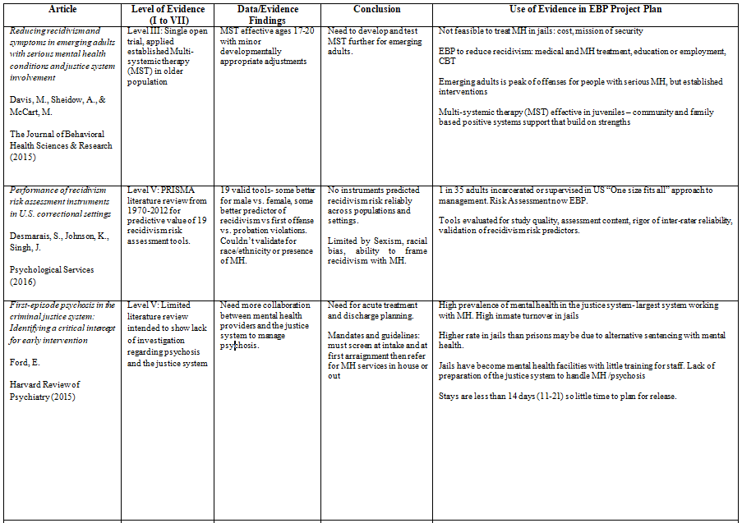

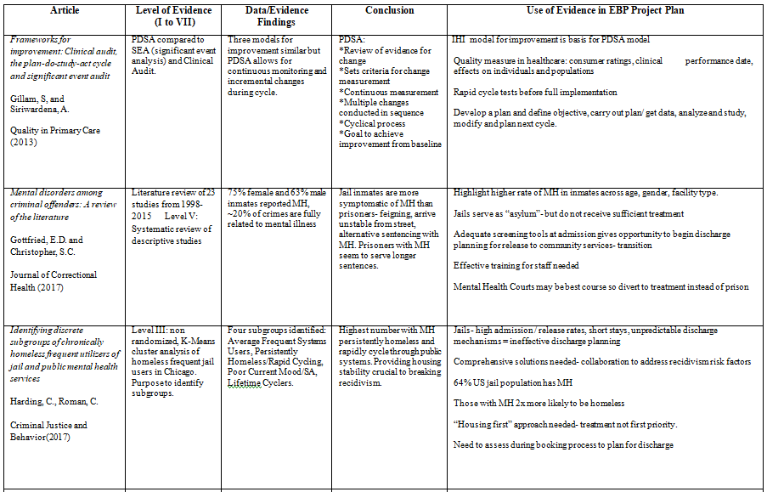

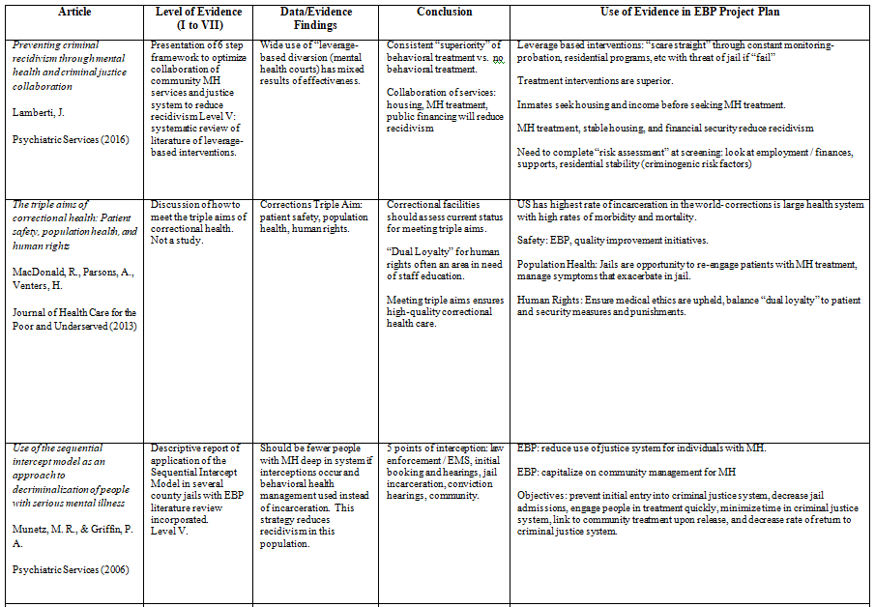

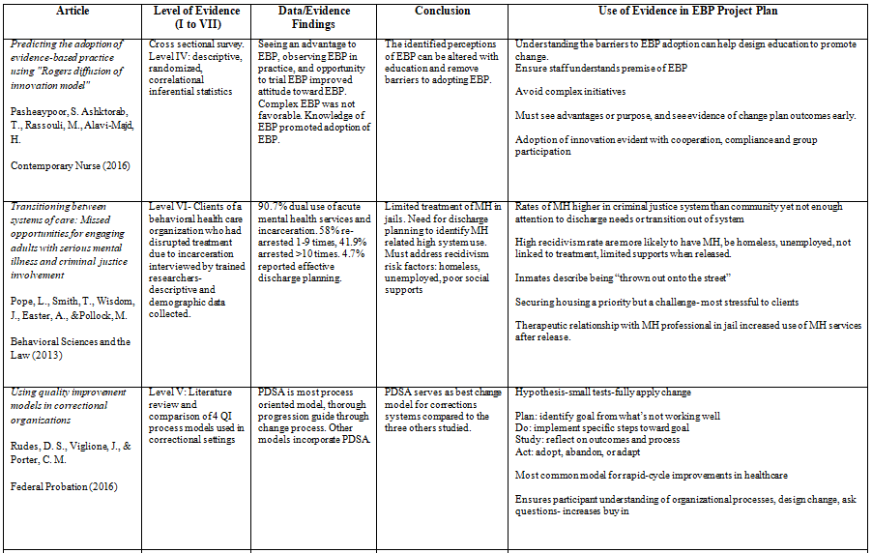

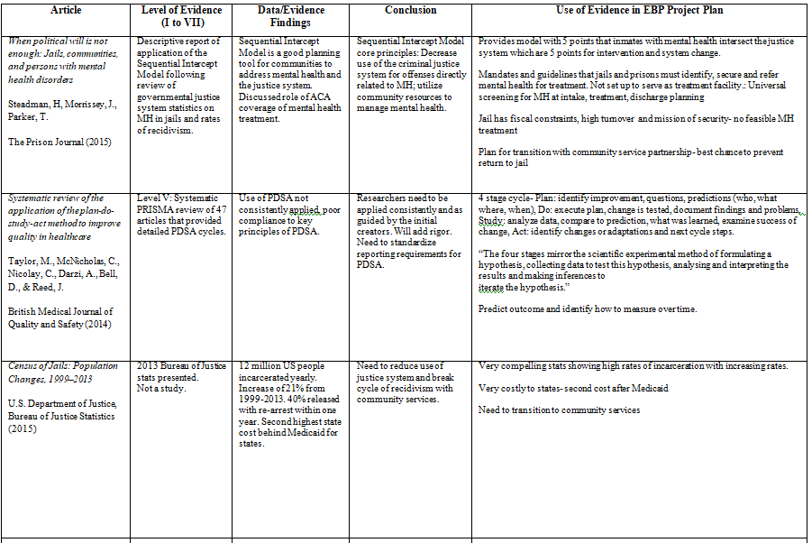

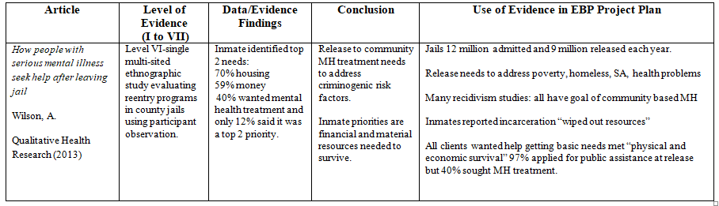

Appendix C
Diffusion of Policy and Procedure for Jail Navigator Referrals

Figure 1. Application of the four components of Rogers Diffusion of Innovation model (Rogers, 2003) to the implementation and adoption of the policy and procedure for jail navigator referrals.
(McLean, 2017)

Appendix D
Cause and Effect Diagram

Process
Clinic Staff

Who qualifies for services Unfamiliar with navigator role
Problem
Low utilization of jail navigator services
How do we prioritize referrals Unsure what data is needed
Inmate
Tools
What data is needed May not know specific data

Not capturing needed data May be intoxicated /acute symptoms

Figure 3. Cause and effect analysis of low utilization of jail navigator services
(McLean, 2017)

Appendix E
Policy and Procedure

Eastern Carolina Medical Services
Mental Health Community Release Needs Assessment and Referral

Policy:
All inmates taken into custody of PCDC will be screened during the booking process using the current medical intake form. All inmates will be administered the current Brief Jail Mental Health Screen. Inmates meeting the algorithm criteria shall be referred to the contracted psychiatric services for management.
Inmates reporting the following within the past six months will receive a Brief Jail Community Release Needs Assessment: Uncontrolled mental health symptoms, hospitalization for mental illness, medication management for mental health, or mental health treatment in the community. Inmates meeting the algorithm criteria shall be referred to the jail navigator for management.
Inmates, who are unable to complete the booking process upon entry, will be assessed when deemed capable.
Procedure:
Instructions for Completing the Brief Jail Community Release Needs Assessment:
General Information: This assessment was developed for the purpose of determining the discharge needs of detainees identified to have mental health issues during the general screening process. The assessment should be completed by clinic staff during the intake/booking process.
Instructions for Section 1:
Name: Enter detainees last name then first name
DOB: Enter detainees month, day and year of birth
Date: Enter today’s month, day and year
Time: Enter the current time and circle AM or PM

Instructions for Section 2:
For questions 1-6: Place a check mark in the appropriate column (for No or Yes response).
If the detainee does not know the answer or refuses to answer a question, Do Not Mark No. Instead, in the general comments section, indicate the reason (Doesn’t know / Refuses / etc.) for not
Question 1 refers to housing available on a daily basis to the detainee in the community. Housing should have basic amenities such as running water, electricity and the ability to heat. The detainee should consider it to be physically and emotionally safe with no fear of harm.
Question 2 refers to a steady and reliable income to support housing, utilities, groceries, medications, medical care, and other essential items on a routine basis.
Question 3 refers to Medicaid, Medicare, Veteran Affairs (VA), or private health insurance benefits.
Question 4 refers to steady and reliable transportation to attend medical or mental health appointments, and to purchase groceries and medications.
Question 5 refers to the physical, emotional and intellectual ability of the detainee to self- manage activities of daily living such as grooming, toileting, and nutrition.
Question 6 refers to any person assigned to or willing to assist the detainee with any or all of the above needs. Noting a name and contact number is helpful.
General Comments is the location to indicate any pertinent information related to the questions or overall response by the detainee. ALL NO answers require an explanatory comment.

Referral Instructions:
If the detainee answers NO to item 1, item 5, or 2 or more questions, the detainee should be referred to the Jail Navigator. “Other” is available if a referral is deemed appropriate for the detainee who does not meet the set criteria.

Referral Procedure:
Scan and email mental health needs assessment to Jail Navigator.
Document the referral in JMS mental health log.
File original assessment in inmate chart.

Policy Date: August 25, 2018

Appendix F
Clinic Staff Training PowerPoint with Voice Over

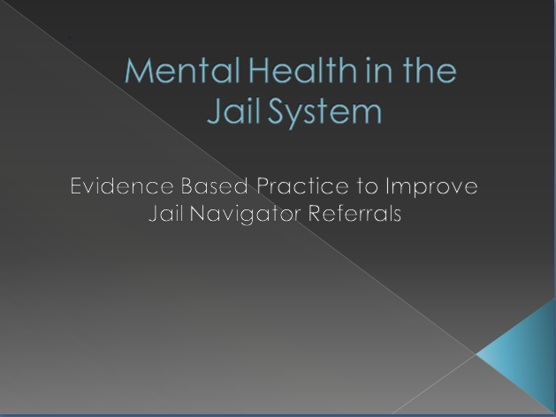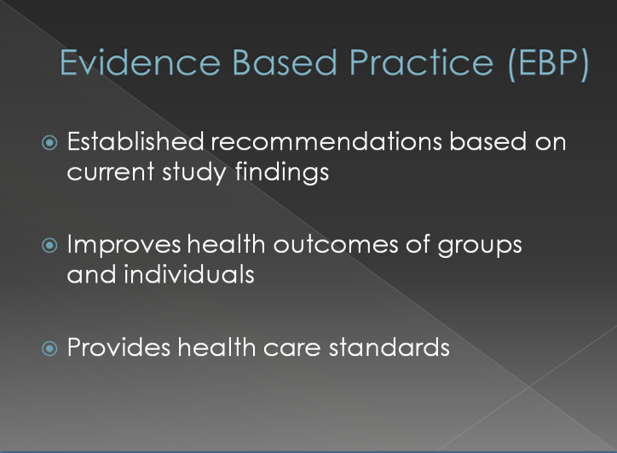
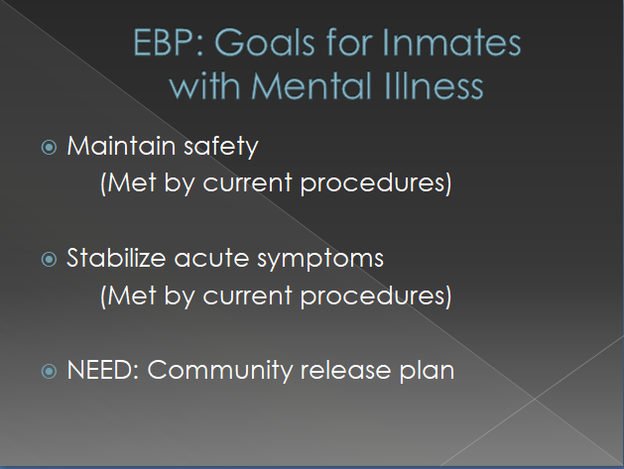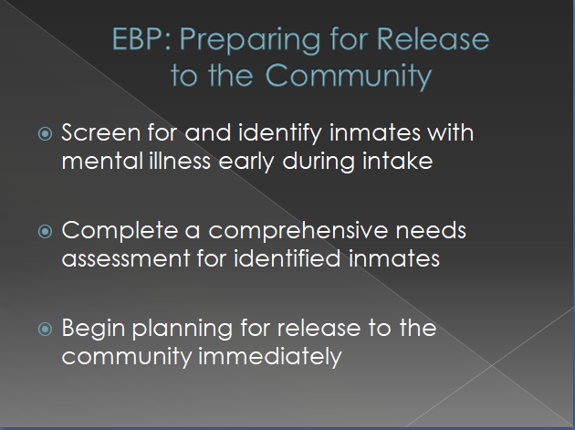
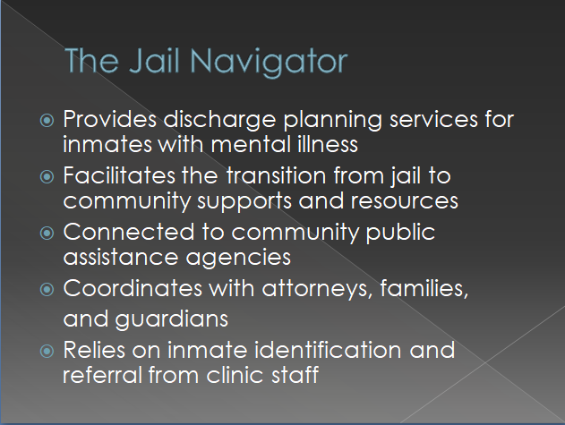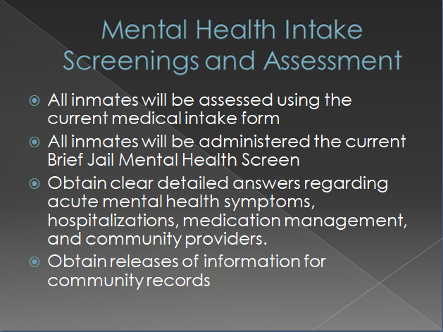
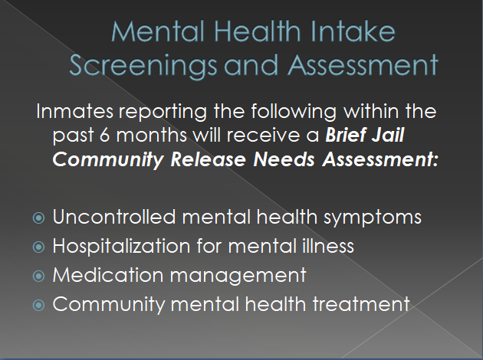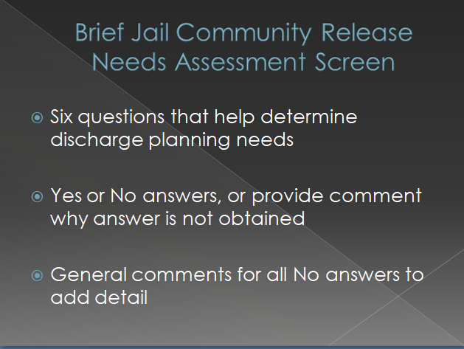
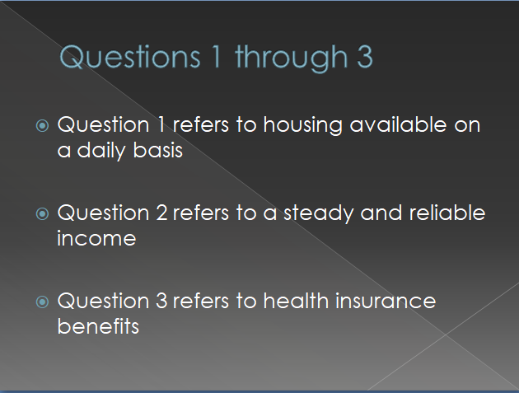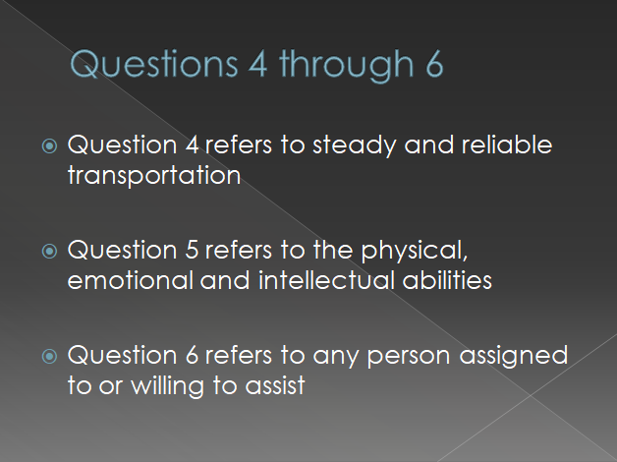
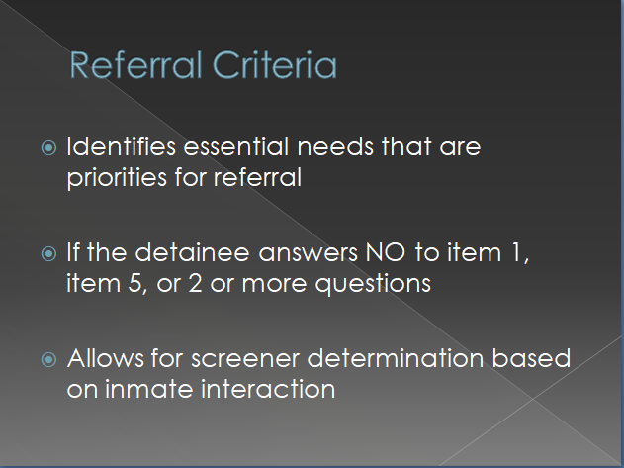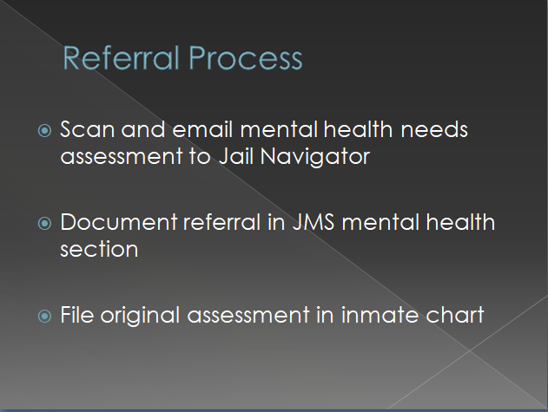
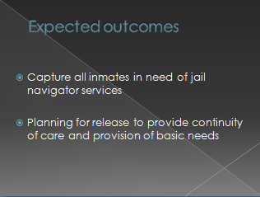 (McLean, 2017)
Appendix G
Brief Jail Community Release Needs Assessment
Section 1
Name:________________________________  Last First | DOB: ___/___/____ | Date: ___/___/____ | AM  Time:___:___ PM

Section 2
Questions | NO | YES | General Comments
- Do you currently have a permanent and safe place to live with running water and gas/electricity?
- Do you currently have steady money coming to you from the government, a job, a retirement fund, etc. to pay bills?
- Do you currently have health insurance government, job or your family to cover medical bills and medications?
- Do you currently have reliable transportation for groceries, medications, or health appointments?
- Are you currently able to take care of your own basic needs like bathing, using the restroom, getting food, etc.?
- Do you currently have family, a case worker or a guardian to help you with any of these issues?

Referral Instructions: This detainee should be referred to the Jail Navigator if he/she answered:
- NO to item 1; OR
- NO to item 5; OR
- NO to 2 or more of items 1-5;
- Other: ___________________________________________________________
- Not Referred
- Referred to Jail Navigator on ___/___/_____

Person completing screen:______________________________________________

Instructions for Completing the Brief Jail Community Release Needs Assessment
General Information: This assessment was developed for the purpose of determining the discharge needs of detainees identified to have mental health issues during the general screening process. The assessment should be completed by clinic staff during the intake/booking process.
Instructions for Section 1:
Name: Enter detainees last name then first name
DOB: Enter detainees month, day and year of birth
Date: Enter today’s month, day and year
Time: Enter the current time and circle AM or PM

Instructions for Section 2:
For questions 1-6: Place a check mark in the appropriate column (for No or Yes response).
If the detainee does not know the answer or refuses to answer a question, Do Not Mark No. Instead, in the general comments section, indicate the reason (Doesn’t know / Refuses / etc.) for not
Question 1 refers to housing available on a daily basis to the detainee in the community. Housing should have basic amenities such as running water, electricity and the ability to heat. The detainee should consider it to be physically and emotionally safe with no fear of harm.
Question 2 refers to a steady and reliable income to support housing, utilities, groceries, medications, medical care, and other essential items on a routine basis.
Question 3 refers to Medicaid, Medicare, Veteran Affairs (VA), or private health insurance benefits.
Question 4 refers to steady and reliable transportation to attend medical or mental health appointments, and to purchase groceries and medications.
Question 5 refers to the physical, emotional and intellectual ability of the detainee to self- manage activities of daily living such as grooming, toileting, and nutrition.
Question 6 refers to any person assigned to or willing to assist the detainee with any or all of the above needs. Noting a name and contact number is helpful.
General Comments is the location to indicate any pertinent information related to the questions or overall response by the detainee. ALL NO answers require an explanatory comment.

Referral Instructions:
If the detainee answers NO to item 1, item 5, or 2 or more questions, the detainee should be referred to the Jail Navigator. “Other” is available if a referral is deemed appropriate for the detainee who does not meet the set criteria.

(Format based on the Brief Jail Mental Health Screen developed by Policy Research Associates, Inc. currently utilized by this facility)

(McLean, 2017)
Appendix H
PDSA Project Model

Figure 2. Application of the PDSA model to the DNP QI project
(McLean, 2017)

Appendix I
Project Approval Form

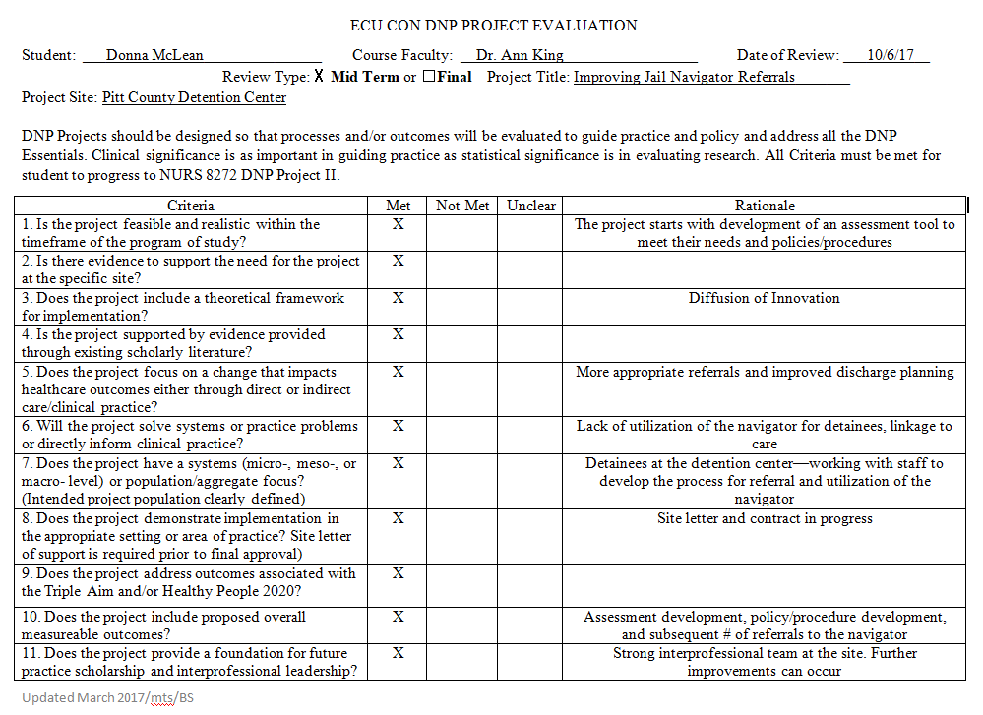

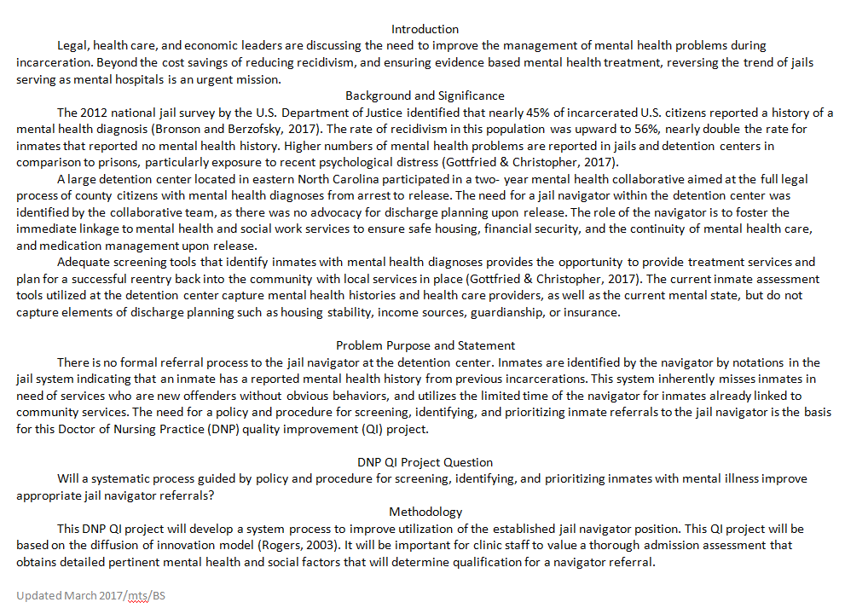

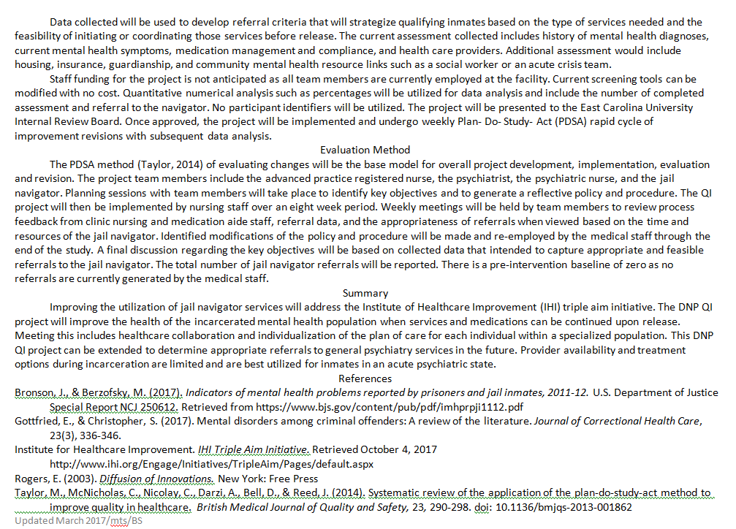

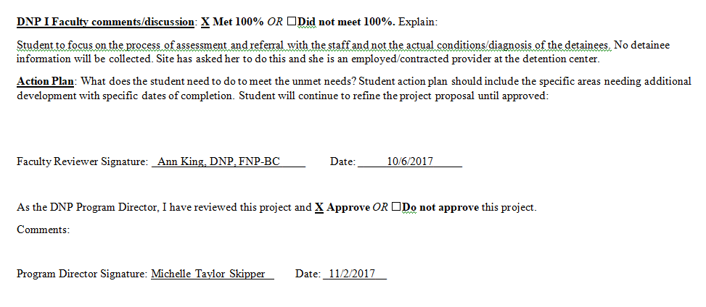

Appendix J
Site Letter of Approval

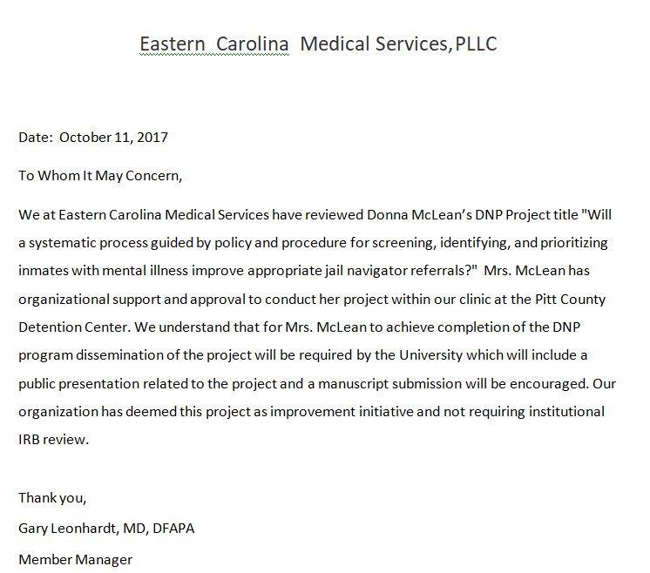

Appendix K
Institutional Review Board Waiver Approval

ORIC Staff Review: Suzanne Sparrow Date: March 19, 2018

Appendix L
Jail Navigator Referral Data Collection Form
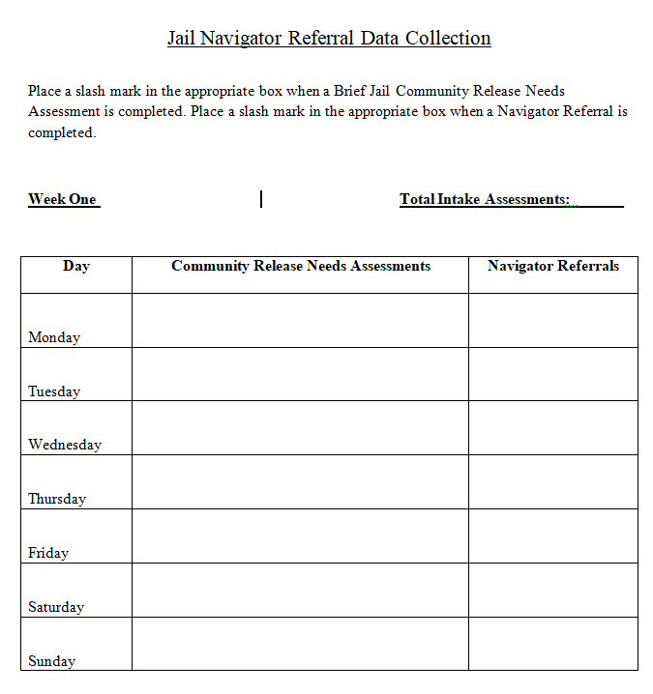
(McLean, 2018)

Appendix M
Data Table

Weekly Data Collection
 | Week 1 | Week 2 | Week 3 | Week 4 | Week 5 | Week 6 | Week 7 | Week 8 | Total | Percent
Total Screened | 156 | 123 | 120 | 132 | 127 | 137 | 125 | 126 | 1046 | 100%
Total Assessed | 3 | 4 | 0 | 14 | 0 | 4 | 7 | 3 | 35 | 3.35%
Total Referred | 1 | 1 | 0 | 3 | 0 | 1 | 3 | 2 | 11 | 31.43%

Appendix N
DNP Scholarly Project Timeline
Fall 2017 NURS 8269 DNP I

August 28: CITI IRB Training Completed
September 4: Project journal and time log Completed
7-9: DNP Intensives Completed
11: Project journal and time log Completed
15: DNP project proposal Completed
15: DNP project timeline Completed
20: Project team member CV Completed

20: Project team member signed agreement Completed
25: Project journal and time log Completed
October 9: Project journal and time log Completed
11: Site letter of support Completed
13: DNP project paper first draft Completed
16: Mid-term project time log Completed
23: Project journal and time log Completed
27: Project data collection tool, Staff training plan Completed
November 2: Approved DNP project proposal Completed
6: Final DNP project paper Completed
12: Project journal and time log Completed
17: Project site contract information Completed

20: Final DNP project log Completed

20: Project journal and time log Completed

Spring 2018 NURS 8272 DNP II

January 10: Revised project first draft paper from DNP I Completed

16: Project journal and time log Completed

22: Project site support letter Completed

29: Project journal and time log Completed

February 12: Quality and Research worksheet Completed

12: Data collection tools and project forms Completed

12: Project journal and time log Completed

20: DNP Intensives Completed

26: Project journal and time log Completed

March 12: Mid-term project time log Completed

12: Mid-term DNP project paper second draft Completed

12: Project journal and time log Completed

19: IRB review packet Completed

19: E-Pirate submission Completed

26: Project journal and time log Completed

April 9: Final DNP project paper Completed

9: Project journal and time log Completed

23: Project journal and time log Completed

24: Final DNP project log Completed

24: IRB approval submission Completed

Summer 2018 NURS 8274 DNP III

May 14: Begin project implementation Completed

17: Revised project first draft paper from DNP II Completed

21: Project journal and time log Completed

June 1: Continue project implementation Completed

4: Project journal and time log Completed

11: DNP Intensives Completed

18: Project journal and time log Completed

18: Mid-term project time log Completed

18: Mid-term DNP project paper second draft Completed

July 2: Project journal and time log Completed

16: Project journal and time log Completed

23: Final DNP project paper Completed

23: Final project journal and time log Completed

Fall 2018 NURS 8277 DNP IV

August 27: Project journal and time log Completed

DNP project paper first draft Completed

September 9: Dissemination plan Completed

10: Project journal and time log Completed

24: Project poster first draft Completed

24: Project journal and time log Completed

October 5: Mid-term DNP project paper Completed

Mid-term time log Completed

15: Project journal and time log Completed

Project poster second draft Completed
29: Project journal and time log Completed

November 5: Final copy poster Completed

8: Formal poster presentation Completed

12: Project journal and time log Completed

15: Final DNP project paper Completed

26: Project journal and time log Completed

27: Final DNP project paper and Approval form Completed

29: Withdraw IRB submission Completed

Final project time log Completed

Upload the final paper into scholarship repository Completed

Appendix O

Final Project Approval

