A Process Improvement Project to Increase Smoking Cessation Support Among Smoking Patients in an Outpatient Oncology Clinic
Allison R. West
DNP Scholarly Project
East Carolina University

Acknowledgements
I would like to acknowledge my husband, Brian, and daughters, Claire and Ava, who have supported and sacrificed so much for this achievement of mine. Brian, thank you for your unwavering support, love, and encouragement. You have always been my biggest fan. There are not enough words to express my gratitude and love to you. Thank you to my parents who have always given me support in all my endeavors and have taught me if I work hard enough, anything is possible. I thank God for his grace and giving me the abilities, skills, and experiences that have shaped me. A special thank you to my project chair, Dr. Ann Bell, and my project team, Dr. Birgit Arb, Alanna Iorio, RN, and Nora Landry for your enthusiasm and commitment to this project. Lastly, an acknowledgment to the oncology staff for the amazing patient care you provide every single day!

Abstract
The standard of practice among oncology patients who are current smokers is to assess their willingness to quit and offer cessation support for those interested tobacco cessation. The purpose of this DNP project was to improve tobacco assessment and cessation support offered to oncology patients who are current smokers in an outpatient oncology practice. A process change using the 5As of tobacco cessation tool was implemented to standardize tobacco use screening and cessation intervention. An electronic referral to the state quitline was incorporated as a cessation intervention approach. The goal of this project was to improve patient assessment of willingness to quit and to increase quitline referrals for those expressing readiness. The Health Promotion Model served as the project’s theoretical basis. A chart review was performed pre- and post-implementation to find a 66% increase in staff assessment of patient willingness to quit. Among patients expressing readiness, 32% were referred to the state quitline for cessation support. Standardizing tobacco screening with the 5As of tobacco cessation tool and incorporating an electronic quitline referral increased the number of patients assessed for willingness to quit and offered cessation counseling.
Key words: tobacco cessation, oncology, adverse effects, cessation intervention, quitline counseling, 5As of tobacco cessation, nursing.

Table of Contents
Acknowledgments 2
Abstract 3
Chapter One: Overview of the Problem of Interest 8
Purpose 8
Problem Statement and Assumptions 9
Background and Significance 9
Theoretical Framework 10
Justification of Study 10
Identified Practice and Problem 11
Chapter Two: Review of the Literature Evidence 12
Literature Review 12
Tobacco use and cancer 13
Mortality 13
Lung cancer 14
Head and neck cancer 14
Breast cancer 15
Colorectal, bladder, and kidney cancer 16
Cancer treatment and surgical outcomes 16
Chemotherapy and radiotherapy effectiveness 17
Surgical risks 18
Cancer reoccurrence 20
Tobacco cessation intervention 21
5As of tobacco cessation 22
Gaps in literature 24
Theoretical Framework 24
Perceived barriers 24
Perceived benefits 25
Plan of action 26
Chapter Three: Methodology 26
Design 26
Setting 27
Methods 27
Protection of Human Subjects 28
Tools 29
Data Collection 30
Chapter Four: Results 30
Sample 31
Table 1 31
Intended Outcome 31
Findings 31
Table 2 32
Table 3 33
Limitations 33
Chapter Five: Implications for Nursing Practice 34
Essential I: Scientific Underpinnings for Practice 34
Essential II: Organization and Systems Leadership for Quality
Improvement and Systems Thinking 35
Essential III: Clinical Scholarship and Analytical Methods for EBP 35
Essential IV: Information Systems/Technology and Patient Care
Technology for the Improvement and Transformation of Healthcare 36
Essential V: Healthcare Policy for Advocacy in Healthcare 36
Essential VI: Interprofessional Collaboration for Improving Patient
and Population Health Outcomes 37
Essential VII: Clinical Prevention and Population Health for
Improving the Nation’s Health 38
Essential VIII: Advanced Nursing Practice 38
Summary 39
Chapter Six: Discussion 39
Significance of Findings 40
Project Strengths and Limitations 40
Project Benefits 42
Recommendations for Practice 43
Final Summary 43
References 45
Appendix A: 5As of Tobacco Cessation Process 55
Appendix B: 5As Model Process Schema 56
Appendix C: 5As Model Process Integration into EMR 57
Appendix D: Staff Education 61
Appendix E: Data Table 63
Appendix F: New Hanover Regional Medical Center’s IRB Approval 64
Appendix G: East Carolina University’s IRB Approval 65
Appendix H: New Hanover Regional Medical Center Organizational Approval 66
Appendix I: World Health Organization Permission for 5As Tool 67
Appendix J: Literature Matrix 68

Chapter One: Overview of the Problem of Interest
Tobacco smoking is the most preventable cause of morbidity and mortality in the United States (Center for Disease Control and Prevention [CDC], 2017). Tobacco use is cancer- inducing and accounts for 30% of all cancer deaths (Office of Disease Prevention and Health Promotion [ODPHP], 2017; Hanna, Mulshine, Wollins, Tyne, & Dresler, 2013). A Healthy People 2020 goal is to reduce morbidity and mortality associated with tobacco use by increasing cessation approaches in clinical care (ODPHP, 2017). After all, cessation at any age and at any point in one's disease trajectory is health promoting (ODPHP, 2017). Not only will tobacco cessation lower cancer incidence, but also improve morbidity and mortality among active smokers with a malignancy (Department of Health and Human Services [DHHS], 2014).
Cancer patients who quit smoking after diagnosis have improved survival, response to cancer treatment, and quality of life (DHHS, 2014; Hanna et al., 2013). The American Society of Clinical Oncology (ASCO) recommends that tobacco assessment and cessation support be a component of standard oncology care (ASCO, 2012). Unfortunately, cessation support in this population has historically been lacking (Hanna et al., 2013; Warren et al., 2013). An ASCO led study among oncology providers found a leading perceived barrier to be lack of patient motivation for cessation (Hanna et al., 2013). This perception is a validated assumption as oncology patients who continue to smoke report not believing there is benefit in quitting (Li, Chan, & Lam, 2014). The purpose of this chapter is to validate the need to integrate tobacco assessment and cessation support into standard oncology care.

Purpose
The goal of this quality improvement project is to implement the 5As of tobacco cessation tool for standardization of tobacco screening and cessation support offered to oncology patients. An educational presentation was given to nursing and medical assistant staff to increase knowledge of tobacco cessation benefits in those with a cancer diagnosis and to overview the 5As tool. The expected outcome was an increased number of patients assessed for willingness to quit and for those willing to quit, an increased number who were offered a referral to the state quitline as a cessation intervention. The long-term goal of this initiative was to increase awareness of the negative impact of tobacco use after a cancer diagnosis and to decrease the number of oncology patients who smoke.

Problem Statement
Oncology-led tobacco cessation support is lacking. Patients who continue to smoke after a cancer diagnosis have a unique risk profile, yet tobacco cessation intervention initiated by the oncology team is often neglected. The project's primary assumption was that implementing a standardized clinical process would increase the number of patients asked about willingness to quit and offered a referral to the state quitline.

Background and Significance
The Surgeon General Report (2014) concluded that "cigarette smoking has caused an enormous avoidable public health tragedy" (p. 36). There is strong evidence linking tobacco smoking to a multitude of chronic diseases notably cancer, a leading cause of mortality among smokers (CDC, 2017; DHHS, 2014). Continual tobacco use among cancer patients subjects this population to unique health consequences including poorer prognosis and increased cancer-specific mortality (DHHS, 2014). This is partly explained by nicotine's ability to impede cancer treatment efficacy and increase treatment toxicity (CDC, 2017; DHHS, 2014). The mechanism of action of many chemotherapies is apoptosis by mitochondrial signaling, a pathway nicotine is capable of blocking (Conway, 2011; Lu et al., 2014). This results in reduced treatment effect and potential need for higher concentrations of drug (Conway, 2011). Prognosis and mortality data is also expounded by the increased risk of reoccurrence of the primary cancer as well as occurrence of a secondary tobacco-related cancer (CDC, 2017). These tobacco-related health consequences are specific to cancer patients and justify the need for population-specific intervention for improved cessation.

Theoretical Framework
Nola J. Pender’s Health Promotion Model (HPM) offers the framework needed to motivate tobacco cessation for the oncology population. Self-motivation initiates and maintains behavior and is described as the reason for our actions (Butts & Rich, 2011). A person must be motivated towards behavioral change to effectively change. Based on Pender's model, this can be accomplished by determining perceived barriers and benefits and creating a plan of action (Butts & Rich, 2011). Applying this model to motivate tobacco cessation for oncology patients will involve recognizing the challenges cancer creates towards cessation efforts, educating on the benefits of cessation after cancer, and offering individualized cessation interventions.

Justification of Study
The five-year cancer survival rate increased from 49% in 1980 to 67.2% in 2013 (National Cancer Institute [NCI], 2013). This increased longevity warrants a focus of health promotion among cancer survivors. Medicare’s meaningful use program and state tobacco control programs have prompted health providers to screen for smoking at every patient visit (CDC, 2014; CMS, 2014). However, tobacco cessation interventions have not been routinely adopted into standard oncology care (Sitas et al., 2014). Weaver et al. (2012) found health care providers frequently screened patients for smoking status, but upon patient report of being a current smoker, providers failed to intervene. Oncology providers are no different according to a survey by ASCO showing 90% of oncology providers asked patients about tobacco use, but only 39% offered cessation support to patients reporting use (Warren et al., 2013).
Unfortunately, cigarette smoking is commonly reported among cancer survivors despite having a tobacco-related disease (Shiels et al, 2014). Among cancer survivors, 12% continue to smoke (NCI, 2017). A review of smoking assessments among oncology patients within 30 days of diagnosis found over 25% of patients reported either current tobacco use or former use with a recent attempt to quit (Warren, Kasza, Reid, Cummings, & Marshall, 2013). Though many oncology patients are motivated towards smoking cessation upon diagnosis, the relapse rate is high occurring within six months (Toll, Brandon, Gritz, Warren, & Herbst, 2013). Cessation in this group offers specific advantageous including increased survival and quality of life (CDC, 2014; Underwood et al., 2012). Therefore, oncology-led tobacco cessation interventions are warranted for optimal prognosis in this population (Warren et al., 2013; Toll et al., 2013).

Identified Practice and Problem
A needs assessment was performed at an outpatient oncology practice in southeastern North Carolina to evaluate tobacco screening and cessation intervention compliance. The practice has two locations, seven board certified hematologists/oncologists, and two advanced practice nurse practitioners. Approximately 50 nursing and medical assistant staff rotate between the two locations to provide outpatient office-based, infusion, and laboratory care to hematology and oncology adult patients. A retrospective chart audit was performed on clinic patients at both locations who had a documented patient visit over a six-week period between October 19, 2016 and November 30, 2016. The audit showed 99% of patients were screened for smoking status by the medical assistant and/or nursing staff. Among patients who reported being active smokers, 92% were advised to quit by receiving an educational handout on smoking cessation. Unfortunately, only 13% of smokers were assessed of their desire to quit and there was no documentation of any cessation intervention on these patient encounters. For patients who are active smokers at this clinic, no cessation intervention efforts were offered beyond an educational handout.
Though this practice had remarkable compliance for tobacco screening and the majority of smokers were advised to quit by staff, there was failure in assessing patient willingness to quit and offering a cessation intervention, including cessation counseling referral. After this clinical problem was defined, evidence was needed to ascertain the issue and explore an appropriate solution.

Chapter Two: Review of the Literature Evidence
A comprehensive literature review was performed to analyze risks of continued smoking and benefits of cessation among smokers with a cancer diagnosis. In addition, a review of strategies to improve oncology-led cessation interventions for this population was examined. A literature search using PubMed yielded 472 articles utilizing key search terms tobacco cessation, oncology, adverse effects, and intervention. The search was limited to articles published in the last five years and in the English language. Articles with a focus on adult cigarette smoking after a cancer diagnosis were reviewed. After exclusions for smokeless tobacco, cigar smoking, electronic cigarette use, secondhand smoke, adolescence, and cancer prevention there were 31 remaining articles for this literature review.
Literature Review

Current literature evidence supports a correlation between continued tobacco smoking and increased morbidity and mortality, reduced treatment effectiveness, and cancer reoccurrence among patients with a malignancy (ASCO, 2012). The 5As of tobacco cessation tool and referral to the state quitline is a proven strategy to promote cessation (Sarna & Bialous, 2016, WHO, 2014). Pender’s Health Promotion Model offers a theoretical framework to effectively motivate cessation for this population (Butts & Rich, 2011).
Tobacco use and cancer.
The adverse effects of tobacco after a malignancy diagnosis was addressed in the 2014 U.S. Surgeon General Report affirming evidence of a causal effect between tobacco use and cancer patient prognosis, specifically that cigarette smoking increases all-cause and cancer-specific mortality (DHHS, 2014). Furthermore, there is suggestive evidence of a causal effect between cigarette smoking and the reoccurrence of cancer and response to treatment (DHHS, 2014).
Despite these consequences, there remains a population of oncology patients who continue to smoke tobacco. The National Health Interview Survey found 54.2% of Americans with a cancer diagnosis report a history of tobacco use and over 30% of those continue smoking after their cancer diagnosis (Ramaswamy, Toll, Chagpar, & Judson, 2016). Cessation motivation peaks for oncology patients at diagnosis; however, the rate of relapse is as high as 60% and those with a tobacco-related cancer are not more inclined to quit smoking compared to those with a tobacco-unrelated cancer (62.0% vs 69.9%) (Ramaswamy et al., 2016). Literature findings over the last five years strengthen these claims and support the need for cessation intervention in this population.

Mortality.
Premature death due to cigarette smoking is a consistent finding in the oncology population. The causality between smoking and increased mortality is multi-factorial as tobacco use induces cancer genotype alterations, hormone level changes, cellular proliferation, and metabolic modifications (Key et al., 2011; Varghese et al., 2013; Warren, Sobus, & Gritz, 2014). These effects have resulted in harmful outcomes in terms of survival. An increase in mortality rates is clearly evident among smokers with lung cancer and head and neck cancer. There is mounting evidence to support decreased survival rates among breast, colon, bladder, and kidney cancer patients who continue to smoke as well.

Lung cancer.
A causal relationship between lung cancer and smoking was initially identified in the 1964 Surgeon General Report with undisputable evidence since that time. Lung cancer compromises 27% of all cancer deaths and tobacco is to blame for nearly 90% of those deaths (Siegel, Miller, & Jemal, 2015). Continued cigarette smoking after the diagnosis of lung cancer contributes to worsening survival outcomes (Shiels et al., 2014). Shiels et al. (2014) found ongoing smokers with stage 1 lung cancer to have a significantly higher death rate than non-smokers (51.2% vs 25%). An increase in mutated KRAS, a proto-oncogene, has been discovered in lung cancer patients with a 15-pack year or more smoking history (Varghese et al., 2013). This is an important finding as this mutation in advanced lung cancer patients is associated with shorter survival times and therefore attributed to tobacco use (O’Malley, King, Conte, Ellingrod, & Ramnath, 2014; Varghese et al., 2013).

Head and neck cancer.
In addition to the lung cancer findings, Shiels et al. (2014) discovered head and neck cancer patients exhibit higher mortality among ongoing smokers compared to non-smokers (38.4% vs 30.0%). Head and neck carcinoma is another smoking-related cancer and involves malignancy of the oral cavity, larynx, pharynx, salivary gland, and nasal passages with a five-year survival rate of only 64% (NCI, 2013). Guo, Logan, Marks, & Shenkman (2015) studied the relationship between socioeconomic status and mortality among head and neck cancer patients and reported cigarette smoking to be associated with higher mortality independent of socioeconomic demographics, a finding consistent with other research in this cancer group (Guo et al., 201; Choi et al., 2016; Deutschmann, Sykes, Harbison, Cabrera-Muffly, & Shnayder, 2015).
Among those with oral cancer, Fang, Shi, Liu, & Sun (2014) found a five-fold increased risk of cancer-related death between current smokers compared to non-smokers. Higher mortality rates were also shown by Choi et al. (2016) who reported death rates to be nearly three times higher for continued smokers compared to non-smokers with head and neck cancer. In addition, Choi et al.’s (2016) study discovered cessation had a meaningful impact on mortality as smokers who quit upon diagnosis had a statistically significant improvement in their risk of dying (HR = 2.71, HR = 2.38 respectively). Cessation benefits were also apparent in a study on laryngeal cancer patients who quit smoking and found to have improved survival rates compared to those who continued cigarette use, 70% vs 36%, respectively (Al-Mamgani et al., 2014). For head and neck cancer patients, smoking increases mortality; however, cessation has proven survival advantageous even after diagnosis (Choi et al., 2016; Deutschmann et al., 2015).

Breast cancer.
Currently, there is only suggestive evidence of cigarette smoking predisposing to breast cancer; however, the biological mechanisms for a substantiating a causal effect exists (DHHS, 2014). Breast cancer risk is associated with circulating hormones of estrogen and androgens (Key et al., 2011). Key et al. (2011) discovered breast cancer patients smoking 15 or more cigarettes a day had higher levels of all hormones making it plausible that a correlation exists (Key et al., 2011). Though causality between tobacco use and breast cancer warrants additional research, there is evidence of increased mortality after a breast cancer diagnosis for ongoing smokers (Parker & Pierce, 2016).
Passarelli et al. (2016) analyzed data from the Collaborative Breast Cancer and Women’s Longevity Study to find women who continued to smoke after diagnosis had a 25% increase risk of death from breast cancer compared to non-smokers (Passarelli et al., 2016). Furthermore, smokers of this study who quit after diagnosis exhibited lower cancer-related and all-cause related mortality than those who continued to smoke (Passarelli et al., 2016). These findings are supported by a study of five-year cancer survivors with estrogen-receptor positive breast cancer as they experienced a 30% increased risk of cancer-related death among those who continued smoking (Nechuta et al., 2016). Smoking cessation promotion among breast cancer patients offers a mortality benefit at any point in the disease trajectory and is a warranted survivorship focus (Parker & Pierce, 2016).

Colorectal, bladder, and kidney cancer.
Additional research is needed to establish correlations between increased mortality and ongoing smoking in other cancers; however, there is relevant literature supporting a relationship. A study on colorectal cancer patients found tobacco use after diagnosis attributed to an increase in all-cause mortality, but not cancer-related mortality (Yang, Jacobs, Gapstur, Stevens, & Campbell, 2015). In contrast, cancer-related mortality was significantly higher among ongoing smokers compared to non-smokers with bladder cancer (26.0% vs 15.5%) and kidney cancer (42.2% vs 31.7%) (Rink et al., 2013; Shiels et al., 2014). Much of the harm is attributed to the detrimental actions of nicotine exposure, which alters cancer genotypes, cellular proliferation, apoptosis, and therapy actions (Warren et al., 2014).

Cancer treatment and surgical outcomes.
Increased mortality from cigarette smoking is multi-factorial and confounded by reduced treatment response due to nicotine's exposure to cancer cells (DHHS, 2014; Warren et al., 2014). Cancer treatment may require a multi-modal approach with chemotherapy, radiotherapy, and/or surgery. Cigarette smoking in cancer patients actively receiving these treatments are at risk of reduced therapy efficacy due to increased drug resistance and drug clearance, less response to radiotherapy, and heightened surgical risks with ongoing nicotine use (Al-Mamgani et al., 2014; O'Malley et al., 2014; Warren et al., 2014; Lau et al., 2012).

Chemotherapy and radiotherapy effectiveness.
The mechanism of action for many chemotherapy agents and radiotherapy is to halt cancer cell-cycle division and induce cancer cell death, apoptosis (Dinicola et al., 2013). However, nicotine has binding affinity to nicotinic acetylcholine receptors of lung cells which promote cell proliferation, counteracting the actions chemotherapy and radiotherapy in lung cancer (O'Malley et al., 2014). In addition, in vitro studies have shown that nicotine has the ability to block chemotherapy-induced apoptosis (Yang et al., 2015). Specifically, 5-fluorouracil and camptothecin are chemotherapy agents that had less "anti-proliferative and pro-apoptotic effects" when exposed to nicotine (Dinicola et al., 2013, p. 2263). For example, colorectal cancer patients who continued to smoke during cetuximab-based treatment have been found to have lower response to treatment in addition to experiencing cancer progression sooner than non-smokers (Yang et al., 2015).
In bladder cancer, nicotine promotes cancer cell resistance to chemotherapy agent, cisplatin, partly by disrupting mitochondrial membrane potential (Warren et al., 2014). Impaired treatment response from tobacco use was also observed in a study of head and neck cancer patients after radiotherapy who experienced worsening local control rates among ongoing smokers compared to those who quit (Al-Mamgani et al., 2014). Those who continued cigarette smoking had statistically significant less response to radiotherapy (81%) than those who stopped smoking (94 %) (Al-Mamgani et al., 2014). Furthermore, nicotine is metabolized in the liver by the P450 enzyme system (O'Malley et al., 2014). Nicotine's exposure to this metabolic pathway has been shown to expedite clearance of certain chemotherapy agents reducing systemic drug concentration (O'Malley et al., 2014). Nicotine not only promotes cancer growth and progression but has been shown to interfere with some anti-cancer treatments placing smokers at risk of receiving sub-optimal cancer-related therapy (O'Malley et al., 2014; Dinicola et al., 2013).

Surgical risks.
There is substantial evidence that proves smoking status impacts surgical risks (Lau et al., 2012). Post-operative morbidity is negatively affected for current smokers as evidenced by longer hospital stays, increased post-operative pulmonary complications, and increased intensive care admissions compared to non-smokers (Lugg et al., 2015; Yoshida et al., 2015). Interestingly, there is benefit in quitting smoking at the time of diagnosis, prior to surgical intervention (Jung et al., 2015; Lau et al., 2012).
Tobacco toxins of nicotine and carbon monoxide have relatively short half-lives; therefore, it is plausible that cessation, even for a short interval, can offer benefit in the oncology population (Jung et al., 2015). For example, gastric cancer patients undergoing surgical resection experienced a risk reduction for post-operative complications with only a two-week smoking cessation period (Jung et al., 2015). A study by Jung et al. (2015) found post-operative complications including pulmonary complications, surgical wound healing, leakage, and bleeding to be more prevalent in smokers (12.3%) compared to non-smokers (5.2%). Intriguingly, those who quit for two weeks prior to surgery reduced their incidence of complications, with the exception of bleeding, to nearly the same as non-smokers (5%) (Jung et al., 2015). This finding is encouraging as these patients often have a two-week lapse between diagnosis and surgery offering an opportune time for cessation motivation (Jung et al., 2015).
Cessation at any point in the disease course is advantageous to the cancer patient; however, the length of cessation time contributes to higher survival rates. This is evident in a study comparing cessation duration and post-operative morbidity in esophageal cancer patients undergoing esophagectomy (Yoshida et al., 2016). An inverse relationship between smoking cessation time and post-operative morbidity was observed (Yoshida et al., 2016). Unfortunately, the aggressive nature of some cancers, specifically lung cancer, often does not permit delaying surgery to allow for cessation time (Schmidt-Hansen, Page, & Hasler, 2013; Seok, Hong, & Lee 2014).
In a surprising finding, Mediratta & Poullis (2016) reported current smokers had lower 30-day mortality rates than former smokers in lung cancer patients undergoing curative resection. This was initially a counterintuitive discovery; however, upon analyzing population data, the authors found significant biological differences between current and former smokers as the current smoking group were younger with less cardiac disease and lower tumor stage at the time of surgery (Mediratta & Poullis, 2016). Post-operative mortality has multi-factorial influences beyond smoking status including age, cancer stage, pulmonary function, and body mass index (Mediratta & Poullis, 2016). Therefore, it is feasible to conclude these additional factors conjointly have more influence on mortality than smoking alone (Mediratta & Poullis, 2016). Nonetheless, smoking contributes to post-operative morbidity in lung cancer patients and cessation continues to be encouraged despite the complexities of cessation timing (Seok, Hong, & Lee 2014).
Finally, Lau et al. (2012) study showed significant post-operative mortality benefits in brain cancer patients requiring a craniotomy for tumor resection who quit smoking. In this population, smoking status was clearly associated with survival as non-smokers had a 15% increase in survival time over current smokers, 88.6% and 73.4% respectively (Lau et al., 2012). Smokers who quit prior to surgery improved their survival outcome by nearly 7% (81.8%) (Lau et al., 2012). The pre-operative period establishes an opportune time for oncology-led cessation intervention for preventing post-operative complications related to smoking (Yoshida et al., 2016).

Cancer reoccurrence.
Cancer reoccurrence is another detrimental adverse effect of tobacco use after a cancer diagnosis (DHHS, 2014). Shiels et al. (2014) discovered tobacco smoking prior to an initial cancer diagnosis of stage 1 lung, bladder, kidney, and head/neck cancer was associated with a higher incidence of developing a second smoking-related cancer in those who continued to smoke. Specific to head and neck cancer, Fang, Shi, Liu, & Sun (2014) observed a two-fold increase risk of cancer reoccurrence among smokers compared to non-smokers. A similar finding from a study of laryngeal cancer patients discovered those who continued to smoke nearly doubled their chance of developing a second primary tumor in comparison to those who quit (21% vs 12 %, p = 0.032) (Al-Mamgani et al., 2014).
Interestingly, the aforementioned Shiels et al (2014) study found the more time lapse from smoking cessation correlated with a lower risk of a second cancer development in all cancer sub-groups except stage 1 lung (Shiels et al., 2014). Specific to bladder cancer, the amount, duration, and cumulative exposure of cigarette smoking contributes to an increased risk of cancer reoccurrence and progression of disease (Rink et al., 2012). Cumulative exposure, in particular, was associated with a more aggressive cancer since heavy long-term smokers have increased risk of advanced staged cancer, metastatic disease, higher cancer reoccurrence, increased cancer-specific and overall mortality than light long-term, heavy short-term, and light short-term smokers (Rink et al., 2013). However, removing cigarette exposure for 10 years eliminated these risks (Rink et al., 2013). Cigarette smoking not only increases the risk for bladder cancer, but survival outcome is linked to smoking and appears to be dose-dependent (Rink et al., 2013).
Nicotine's ability to promote proliferation and angiogenesis predisposes new or residual cancer cells to growth and/or metastasis (Yang et al., 2015). Therefore, removing nicotine exposure early in the disease trajectory may limit cancer reoccurrence.

Tobacco cessation intervention.
The aforementioned adverse effects of tobacco in the oncology population is the basis of policy statements of two leading oncology professional organizations, the American Association of Cancer Research (AARC) and the American Society of Clinical Oncology (ASCO). The AARC (2013) policy statement is as follows:
- Patients with cancer from all clinical settings, participants in therapeutic cancer clinical trials, and cancer screening patients who use tobacco or have recently quit (past 30 days) should be provided with evidence-based tobacco cessation assistance. Ideally, that assistance capacity should be within or associated with the oncology practice. Even if the assistance is provided through an external service, the cancer patient’s oncology service provider should assume responsibility for ensuring that the patient receives appropriate care. That capacity can also be supplemented by telephone cessation quitlines in all 50 states that can be reached via a common toll-free telephone number (800-QUIT-NOW).
- Tobacco use should be comprehensively and repeatedly documented for all patients so that the confounding effects of tobacco on cancer treatment, disease progression, comorbid events, and survival can be evaluated in all oncology clinical trials, from registration to survival endpoints, and in all clinical cancer settings. (p.1945)
ASCO is in agreement as their tobacco control goal states "to develop an oncology workforce that effectively integrates tobacco cessation and control into its practices" (Hanna et al., 2013, p. 3147). AARC and ASCO recommend implementation of a specific tool, 5As of tobacco cessation, in an effort to provide a structured, comprehensive process to improve oncology-led tobacco cessation support (Hanna et al., 2013; Toll et al, 2013). These organizations recognize the lack of oncology focused cessation program existence and find external sourcing such as state quitlines as an appropriate supplement to intervention (Hanna et al., 2013; Toll et al, 2013). Lastly, there is organizational consensus that nurses have an integral role in assessing, educating, and providing these cessation approaches (Hanna et al., 2013; Toll et al, 2013).

5As of tobacco cessation.
The World Health Organization [WHO] (2014) published the 5As model for tobacco cessation to improve health care delivery of cessation interventions. This model has proven to be a cost-effective, efficient, evidenced-based approach for health care provider delivery of tobacco cessation support (Katz et al., 2012; Agency for Healthcare Research and Quality [AHRQ], 2014; Sarna & Bialous, 2016). The 5As is a five-step model, ask, advise, assess, assist, and arrange, designed to guide clinicians in screening and intervening for tobacco cessation (WHO, 2014). The tool, when applied systematically, offers reliability and validity as it improves tobacco cessation provider delivery and increased patient likelihood of engaging in cessation counseling (AHRQ, 2014; Kruger, O'Halloran, Rosenthal, Babb, & Fiore, 2016). In addition, the tool is applicable to a variety of patient populations (AHRQ, 2014).
Tobacco cessation often requires multiple attempts due to its addictive nature (Sarna & Bialous, 2016). Due to this relapsing course, the 5As process should be repeated with every patient encounter (WHO, 2014; Sarna & Bialous, 2016). For smokers, cessation support should include education about the harmful effects, benefits of quitting, and counseling services offered (WHO, 2014; Sarna & Bialous, 2016). Nurses are an integral, effective part of the oncology team to deliver the 5As (Sarna & Bialous, 2016). Unfortunately, many nurses feel they lack skills and confidence to offer cessation assistance to their patients (Sarna et al, 2015). Education and a standard process incorporating the 5As model into routine oncology care is an evidenced-based approach to empower nurses in offering cessation support to this population (Sarna & Bialous, 2016).
Cessation counseling by state quitlines are an effective strategy in assisting with patient quit attempts (Sarna & Bialous, 2016). State quitlines are a free service, available 24 hours a day offering individualized cessation coaching (North Carolina Tobacco Prevention and Control, 2017). Unfortunately, quitline referrals are underutilized due to clinician unawareness (Sarna, Bialous, Ong, Wells, & Kotlerman, 2012). Educating nurses and providers on the advantages of this service and implementation of an efficient referral system can increase patient referral to these programs and therefore progression in their cessation journey (Sarna et al., 2012; Katz et al., 2012). Katz et al. (2012) study reported a three-fold increase in the number of patients expressing willingness to quit smoking when the 5As model for tobacco cessation was implemented. These patients were assisted in their quit attempts by their state quitline who also provided follow up, a crucial step since follow up increases cessation success (Katz et al., 2012; Mendelsohn, 2015; Sarna & Bialous, 2016). Furthermore, the 5As model is well received by patients who report satisfaction with this cessation counseling approach (Persai, Panda, Venkatesan, Arora, & Ahluwalia, 2014).
Only 51.7% of cancer survivors who reported tobacco use recalled cessation counseling by a health care professional in the last 12 months (Ramaswamy et al., 2016). Offering patients tobacco cessation support is a responsibility of all health care providers and patient visits serve as an opportune time to intervene (Mendelsohn, 2015). Understanding the adverse effects of tobacco specific to the oncology population and the limited oncology-led cessation provision is a call to action.

Gaps in literature.
Although the health benefits of tobacco cessation after a cancer diagnosis are established, the impact of tobacco use in the oncology population remains under-researched. More work is needed to strengthen claims of increased mortality in all cancers. In addition, current tobacco cessation interventions are generalized and not targeted for those with cancer (Li et al., 2014). The oncology population carries unique challenges that must be addressed to develop an oncology-focused cessation plan of action for effective cessation intervention.

Theoretical Framework
Nola J. Pender’s Health Promotion Model (HPM) was applied for this quality improvement project because of its basis on motivational support for behavioral change. Based on Pender's model, effective change is motivated by determining perceived barriers and perceived benefits as well as creating a plan of action for the one embracing the behavioral change (Butts & Rich, 2011).

Perceived barriers.
As described by Pender, Murdaugh, & Parsons (2011), perceived barriers influence a person’s motivational strength and behavioral change ability. Interestingly, a diagnosis of cancer often is the perceived barrier to tobacco cessation because this disease and its treatments have known cognitive effects that can be temporarily counteracted by nicotine. For example, chemobrain is a documented cognitive side effect of chemotherapy that results in forgetfulness and an inability to focus (Dong, Crone, & Wise, 2014). In contrast, nicotine’s effect on the cholinergic system can induce temporary benefits of improved attention and concentration as well as less anxiety and depression (Aubin, Rollema, Svensson, & Winterer, 2012). Though these effects from nicotine are temporary, it is understandable how tobacco smoking could be a tempting maladaptive behavior to maintain for the oncology patient. Among cervical cancer patients undergoing radiotherapy, the stage of cancer was found to be a significant perceived barrier in motivating health promoting behavioral change (Taechaboonsermsak, Kaewkungwal, Singhasivanon, Fungladda, & Wilailak, 2005). These hurdles, if not addressed, can prevent health-promoting behavior change from occurring (Pender et al., 2011).

Perceived benefits.
A cancer diagnosis can serve as a perceived barrier for tobacco cessation; however, these barriers can be overcome by recognizing the benefits. Pender’s HPM proposes that if one values the benefit or fears the threat of a health-damaging action, they will be more likely to change it (Pender et al., 2011). Furthermore, benefits and fears that are personalized will have increased motivational effect (Pender et al., 2011). Nicotine’s ability to increase the risk of death and decrease treatment efficacy in this population can serve as influential fears and therefore motivate cessation efforts (DHHS, 2014). Once the cognitive perceptual factors are addressed, self-efficacy, the belief in one's ability to change, can be achieved and the health-promoting change can be propelled (Taechaboonsermsak et al, 2005).

Plan of action.
Commitment to an action plan is necessary for health promotion engagement (Butts & Rich, 2011). Part of the health promotion process is empowering patients to be in control of their health for the purpose of improving it. Application of Pender’s HPM can theoretically affect behavioral change to motivate oncology patients towards tobacco cessation by recognizing the challenges cancer creates towards cessation efforts, educating on the benefits of cessation after cancer, and offering cessation interventions in a structured manner. Pender's HPM is an effective framework to guide health care professionals to promote healthy behaviors, including tobacco cessation (Taechaboonsermsak, 2005).

Chapter Three: Methodology
Providing a standardized, evidenced-based intervention for tobacco cessation among patients attempting to quit was an identified problem in an outpatient oncology clinic. The 5As of tobacco cessation, ask, advise, assess, assist, and arrange, is an evidence-based tool created by the World Health Organization and was implemented to optimize tobacco screening and cessation intervention. For patients expressing willingness to quit smoking, a state quitline referral was offered as a cessation intervention. This referral was integrated into the electronic medical record (EMR) as an automated fax referral to provide an efficient, effective, and trackable approach to delivering cessation support.

Design
This quality improvement project allowed measurement of the 5As metrics pre- and post-implementation of the process change. The retrospective chart review found a clinic process in need of improvement. There were few patients queried on willingness to quit smoking and no patients offered tobacco cessation counseling. A process change using tool, 5As of tobacco cessation, was implemented at this practice upon organizational approval (Appendix H). An educational presentation, based upon ASCO’s Tobacco Cessation Guide for Oncology Providers (2012), was provided to nursing and medical assistant staff prior to this change. This guide overviews the details of implementing the 5As of tobacco cessation into an oncology-specific practice. The post-implementation data abstraction was performed after the initiation of the 5As process and served as a prospective outlook of the impact of the 5As tool for tobacco cessation support in practice.

Setting
The project setting was an outpatient oncology clinic serving hematology and/or oncology adult patients 18 years or older. The practice has two locations, seven board certified hematologists/oncologists, two advanced practice nurse practitioners, and 50 nursing and medical assistant staff. The clinic services patients in southern NC, a region who reports 19.5% of its population to be current smokers (North Carolina State Center for Health Statistics, 2015).

Methods
Prior to the process change to incorporate the 5As of tobacco cessation, the practice performed actions for ask and advise as seen in Appendix A; however, assess, assist, and arrange were new process components for this practice. The clinic uses electronic medical records system, EPIC. The process change was designed to integrate the 5As actions with EPIC documentation as outlined in Appendices A and B. An educational presentation, adapted from ASCO’s Tobacco Cessation Guide for Oncology Providers (2012), was given to nursing and medical assistant staff to overview the 5As of tobacco cessation tool, the process change, and the evidence supporting this implementation (see Appendix D). One on one sessions were performed for staff who missed the presentation and all staff were provided handouts seen in Appendix D.
Upon patient arrival for an office visit, the nurse or medical assistant assigned to room the patient initiated the 5As of tobacco cessation process with ask, questioning the patient regarding tobacco use. If the patient reported use, staff advise patient of the harmful effects of tobacco use, the benefits of quitting, and offered a cessation educational handout (Figure C5). This handout is housed within EPIC clinical references. Next, assess was accomplished with staff inquiring about the smoking patient's willingness to quit. If the patient expressed interest in quitting, staff proceeded to the next step, assist, by notifying the practice provider and making a referral to QuitlineNC via EPIC external referral system should patient comply (Figure C2 and C3). A QuitlineNC brochure was offered to these patients (Figure C4).
Modification was made to the electronic health record, EPIC, to designate "REF100" to serve as an automated fax referral to QuitlineNC upon provider signature (see Appendix C). Once referral received, QuitlineNC contacted the patient and established individualized cessation support and follow up. In addition, clinic staff completed the 5As process with arrange by scheduling a follow up appointment according to provider orders.
Biweekly rounding was made to assess for staff concerns and implementation barriers. Monthly monitoring of the 5As metrics was performed to validate staff compliance. Standard workflow expectation was the 5As process is performed for every patient office visit encounter to ensure comprehensive assessment of all patients including those attempting cessation.

Protection of Human Subjects
The human subjects of this project included staff members and patients whose medical record was reviewed. All identifiers and protected health information was removed from the collected data. This project was submitted for review to the Institutional Review Board (IRB) for both the project institutional setting and East Carolina University receiving approval as a quality improvement project and deemed not human subject research (Appendices F and G).

Tools
An educational presentation was given to nursing and medical assistant staff based upon material from ASCO’s Tobacco Cessation Guide for Oncology Providers (2012). This guide overviews the risks and benefits of tobacco cessation in the oncology population and is intended to empower oncology providers to offer cessation support to patients (ASCO, 2012).
The 5As tobacco cessation model, ask, advise, assess, assist, and arrange, was developed by the World Health Organization (WHO) as a toolkit for health care providers to implement tobacco cessation into standard patient care (2014). This process improvement project integrated the 5As model into existing EPIC documentation (Appendices A and C). Permission to use the 5As tool for this project was obtained from WHO (Appendix I).
A process schema of the 5As tobacco cessation tool, seen in Appendix B, was created for staff reference during practice operations and adapted from ASCO’s Tobacco Cessation Guide for Oncology Providers (2012). A staff educational handout that encompassed the aforementioned information and tools was presented to clinical staff during a scheduled meeting (Appendix D). A patient educational handout on success tips for tobacco cessation (Figure C5) was offered to patients reporting tobacco use and is a component of EPIC’s clinical references system (Elsevier Interactive Patient Education, 2016).
EPIC’s automated referral to QuitlineNC was designated as “REF100” for this practice (Figure C2 and C3). QuitlineNC provides free, individualized cessation resources and support to residents of North Carolina (NC) (NC Tobacco Prevention and Control, 2017; Sarna & Bialous, 2016). QuitlineNC brochure was offered to patients expressing willingness to quit tobacco use (Figure C4). This brochure, designed for patient use, overviews the importance of tobacco cessation, QuitlineNC services, and contact information.
The use of an electronic medical record in this process change permitted monitoring of compliance to the aforementioned metrics. This data was compiled from EPIC reporting capabilities and manually entered into the project’s data table to allow for a concise collection of aggregate data post-implementation of the 5As model (Appendix E).

Data Collection
EPIC reporting system was designed to abstract the patient sample and identified the smoking status of patients with an office visit during the designated six-week time frame. Among current smokers, filters were set to determine those who were advised to quit and assessed of willingness to quit. Next, EPIC’s outgoing referral queue identified patients who were assisted with cessation intervention with a QuitlineNC referral. Finally, return appointments in the patient’s EPIC chart was reviewed to evaluate if follow up was established.

Chapter Four: Results
Post-implementation data of the 5A metrics, ask, advise, assess, assist, and arrange, were compared to the retrospective data of the same metrics to determine if an improvement was found. Percent differences between pre-implementation data and post-implementation data (Table 2) were used to determine if improved compliance to these metrics was achieved, specifically among assess and assist as these measures were the focus of the project.

Sample
All clinic patients who had an office visit encounter over a six-week period between August 21, 2017 and September 30, 2017 served as the target group. The sample size (N= 2633) included all hematology and oncology patients over the age of 18 years and were classified by smoking status as seen in Table 1.

Table 1. Patient-reported Tobacco Use
Smoking Status | Pre-Implementation (N=2991) |  | Post-Implementation (N=2633)
Never Smoker |  | 1301 | 1144
Former Smoker |  | 1389 | 1231
Current Smoker |  | 280 | 250
Not asked or deferred |  | 21 | 8
Note. Number of patients divided by their response to tobacco screening question, “Do you use tobacco?”

Current smokers accounted for 10% of the total sample. Patients who reported prior tobacco use achieving cessation at the time of the office visit were labeled former smokers and accounted for 47% of the sample. Those who reported never using tobacco comprised 43% of the sample. All patients were accounted for including those who deferred reporting smoking status or were not asked by clinic staff. This group represented less than 0.01% of the sample.

Intended Outcome
The intention of this process improvement project was to improve assessment of tobacco use by determining patient readiness to quit and offering a cessation intervention to outpatient oncology patients who smoke. Measurement of success was based on an increased percentage of patients who were assessed for willingness to quit smoking and an increased percentage of patients who were offered cessation counseling, specifically a referral to QuitlineNC.

Findings
Improvement in all of the 5As metrics, ask, advise, assess, assist, and arrange, were seen after the 5As of tobacco cessation tool was implemented into practice. Measurement of the first metric, ask, was based on the total sample size and dependent on patient queried about tobacco use by clinic staff. Advise was determined by the number of current smokers who were or were not counseled to quit. Marginal percent differences were seen in categories ask and advise, 0.4% and 4.9% respectively (Table 3).
Assess involved staff to inquire about current smokers’ willingness to quit. A substantial percent difference (66.3%) was found among patients asked about readiness to quit post-implementation of the 5As process as highlighted in Table 3. Patient response, “yes, willing to quit” or “no, not willing to quit,” was also included in the data for this metric found in Table 2. Among patients asked, 38% reported desire to quit smoking. This subgroup of patients (n= 37) served as the sample for the next metric, assist, because the project’s intention was for this population to be offered a referral to QuitlineNC. Among patients interested in cessation (n= 37), 32% were offered a referral for cessation counseling and successfully referred to QuitlineNC through the electronic referral system. The final metric, arrange, had a minimal percent difference improvement (6%) post-implementation (Table 3). This measure was based on current smokers having a scheduled follow up appointment created the day of the patient encounter.
Table 2. 5As of Tobacco Cessation Data Pre- and Post-Implementation
 | Pre-Implementation (N=2991) |  |  | Post-Implementation  (N=2663)
5As | n | patients |  | n | patients
Ask | 2991 |  |  | 2663
Yes |  | 2970 |  |  | 2625
No |  | 21 |  |  | 8
Advise | 280 |  |  | 222
Yes |  | 258 |  |  | 242
No |  | 22 |  |  | 8
Assess | 280 |  |  | 222
Asked |  | 37 |  |  | 98
Yes, willing |  | 17 |  |  | 37
No, not willing |  | 20 |  |  | 61
Not asked |  | 243 |  |  | 152
Assist | 17 |  |  | 37
Yes |  | 0 |  |  | 12
No |  | 17 |  |  | 25
Arrange | 280 |  |  | 222
Yes |  | 254 |  |  | 241
No |  | 26 |  |  | 9
Note. Data from 5As metrics pre- and post-process implementation. 5As of tobacco cessation adapted from "Toolkit for delivering the 5A’s and 5R’s brief tobacco interventions in primary care," by WHO, retrieved from http://www.who.int/tobacco/publications/smoking_cessation/9789241506953/en. Copyright 2014 WHO.

Table 3. 5As of Tobacco Cessation Compliance Pre- and Post-Process Implementation
5As | Pre-Implementation (%) | Post-Implementation (%) | Difference (%)
Ask | 99.3 | 99.7 | 0.4
Advise | 92.1 | 96.8 | 4.9
Assess | 13.2 | 39.2 | 66.3
Assist | 0 | 32.4 | 100
Arrange | 90.7 | 96.4 | 5.9
Note. Percent of patients who were delivered 5As of tobacco cessation pre- and post-process implementation with percent difference between groups.

Limitations
The intended outcome was met for the project; however, limitations were discovered that potentially prohibited a greater metric improvement. There was an increase in referrals to QuitlineNC; however, the majority of patients (68%) who reported willingness to quit were not referred for cessation support. Unfortunately, there were no consequences to staff not referring applicable patients.
During biweekly rounding, the nurses and medical assistants reported feeling redundant when screening reoccurring patients. For patients who had clinic visits once a week or more frequently, staff admitted to avoiding some of the 5A steps in these patients. Also, it was discovered that QuitlineNC does not contact the referring provider after offering patient services. QuitlineNC is permitted to inform the referring provider if contact has been established with the mutual patient, but this information is only obtained upon provider-initiated contact. This created clinic inefficiency when validating patient receipt of services.
Chapter Five: Implications for Nursing Practice
The American Association of Colleges of Nursing (AACN) (2006) have established eight essentials for advanced practice nursing doctoral education. These foundational competencies were used to guide the development, implementation, analysis, sustainability, and practice implications of this Doctor of Nursing Practice (DNP) project. The correlation between the DNP essentials and this quality improvement project are discussed in this chapter.
Essential I: Scientific Underpinnings for Practice
The first DNP essential, scientific underpinnings for practice, establishes the need to integrate nursing science with ethical and psychosocial knowledge, concepts, and evidenced-based approaches for the purposes of improving health care delivery and health outcomes (AACN, 2006). These underpinnings were the basis of this DNP project’s problem identification and quality improvement process development.
Lack of oncology-led tobacco cessation support, the project’s identified problem, is an evidenced-based concern due to the increased morbidity and mortality among those with a malignancy who continue to smoke (ASCO, 2012). The 5As of tobacco cessation tool standardized screening and improved cessation intervention for this clinic. However, in retrospect, it is recommended that on-site cessation counseling with a trained clinician be offered to optimize cessation success. A person-to-person counseling approach offered on-demand when the patient is motivationally ready to quit is favorable (Mendelsohn, 2015). Referral to the state quitline remains an evidenced-based approach for cessation counseling, though this referral would better serve the patient as a supplement to on-site counseling.
Essential II: Organization and Systems Leadership for Quality Improvement and Systems Thinking
The next DNP essential incorporates organizational and systems leadership to effectively advocate for improved patient care. This DNP project employed a quality improvement process change to encourage tobacco cessation for the purposes of improving patient and population health. The project was cost-efficient, applicable in diverse health care settings, and supported by organizational and political initiatives. Unfortunately, there was lack of staff accountability.
Leadership recognized clinical staff members who implemented the new process, but there were no consequences or coaching given to staff members who failed to perform the 5A steps with their patients. The post-intervention project findings supported overall improvement in the 5A metrics; however, the majority of patients (68%) who reported willingness to quit were not referred for cessation support. It is possible that lack of consequence to staff members non-compliant to the 5As process led to suboptimal referrals. In an effort to overcome this limitation in the future, it is recommended that staff compliance to performing the 5As steps be monitored with leadership response to those who fail to complete.
Essential III: Clinical Scholarship and Analytical Methods for Evidenced-Based Practice
This DNP project’s goal was to improve a deficiency identified in an outpatient oncology clinic, lack of tobacco cessation support. The literature over the last five years validated tobacco use in this population to be a significant problem and identified the 5As of tobacco cessation and quitline referral to be evidenced-based solutions in promoting tobacco screening and cessation. The project was designed to implement the 5A steps; however, the 5As serve as only one part of the cessation tool. The World Health Organization (WHO) (2014) published “Toolkit for delivering the 5As and 5Rs brief tobacco cessation interventions in primary care” and addresses both the 5As, ask, advise, assess, assist, and arrange and the 5Rs, relevance, risks, rewards, roadblocks, and repetition. The 5Rs are designed to increase motivation towards cessation by addressing misconceptions, benefits, barriers, and expectations (ASCO, 2012). This project did not include the 5R steps which limited assessment of patient readiness for change. Tobacco cessation is a behavioral change that requires significant motivation to accomplish. It is recommended that the 5R steps be integrated into the process change to improve patient tobacco screening, cessation motivation, and cessation intervention.
Essential IV: Information Systems/Technology and Patient Care Technology for the Improvement and Transformation of Healthcare
Information systems are critical components in outcome evaluation of quality improvement initiatives (AACN, 2006). The electronic medical record (EMR) was utilized extensively in this DNP project. The 5As of tobacco cessation tool was integrated into the EMR documentation providing measurable data to monitor compliance and patient response to the 5A steps. The quitline referral was constructed within the EMR as an automated fax referral also contributing to the measurable data. The inclusion of technology in this project enhanced the efficiency and data tracking capabilities. It is recommended that practice sites implementing the 5As of tobacco cessation integrate the tool within their EMR to enhance staff compliance and measure data for ongoing sustainability.
Essential V: Healthcare Policy for Advocacy in Healthcare
Health policy is foundational to the delivery of health care and advocacy for improvement is essential to achieve optimal health outcomes (AACN, 2006). This DNP project endorsed policy improvements by revising the clinic’s documented procedure guidelines to include the 5As of tobacco cessation model as presented in this paper. The project’s organizational site is vast and includes multi-disciplinary health care settings. Ideally, the 5As model would be implemented across the organization to include all disciplines of clinical care rather than oncology alone. This institutional standardization would be valuable as tobacco use is a health concern across all populations and improvement in clinical screening and cessation intervention would promote improved outcomes across the organization.
Essential VI: Interprofessional Collaboration for Improving Patient and Population Health Outcomes
Patient-centered care is best accomplished with an interdisciplinary approach. The team must be skilled in their specialty and maintain communication with an emphasis on collaborative care (AACN, 2006). The success of this project was highly dependent on medical assistant and nursing staff because of their sole designation to perform the 5A steps with each patient. Relying on one group’s performance is not ideal; instead, the efforts from a multi-disciplinary team is more likely to improve patient tobacco cessation success. For example, a behavioral counselor would enhance cessation counseling using motivational skills and resources to serve patients on-site. In addition, increased involvement from practice leadership would augment the project’s success. Clinic administration and physicians were presented with the project’s proposal and notified of final findings as stakeholders of the practice; however, collaboration with the leadership team would increase staff compliance to the 5A metrics and help sustain the process change. Sustainability would be further complemented with the interdisciplinary inclusion of a billing and coding specialist to promote tobacco cessation coding entry for increased revenue. It is recommended that an interdisciplinary team approach would best achieve tobacco cessation support offered to patients and sustainability of the process change.
Essential VII: Clinical Prevention and Population Health for Improving the Nation’s Health
“The century-long epidemic of cigarette smoking has caused an enormous avoidable public health tragedy” (DHHS, 2014, p.36). In response, Medicare’s meaningful use program and state tobacco control programs have prompted health providers to screen for smoking at every patient visit (CDC, 2014; CMS, 2014). Furthermore, a Healthy People 2020 goal is to reduce morbidity and mortality associated with tobacco use by increasing cessation approaches in clinical care (ODPHP, 2017). These initiatives have enhanced tobacco screening and cessation intervention approaches in primary care but have not been routinely adopted in oncology-based care (ASCO, 2012). It is the intent of this project to bring awareness to the need for tobacco cessation intervention in all health care settings, including specialized medicine. Prior to this project implementation, there was a misperception among clinic staff that tobacco cessation intervention is the role of primary care. Instead, it is the responsibility of all health care providers to promote tobacco cessation for improved population health. Oncology-based clinics, as well as all specialized practices, must integrate smoking cessation support in the same vigor of primary care for improved population health.
Essential VIII: Advanced Nursing Practice
The role of an advanced practice nurse is dynamic. Comprehensive assessment of health issues incorporating the aforementioned DNP essentials is foundational, ongoing, and continuously developing (AACN, 2006). This DNP project addressed a population health concern, lack of tobacco cessation intervention in an oncology clinic. Intervention for tobacco cessation or any health promoting change requires the advanced practice nurse to establish a partnership with the patient for collaborative care. Tobacco cessation requires multiple attempts due to its addictive nature (Sarna & Bialous, 2016). This relapsing course warrants a therapeutic relationship between provider and patient to effectively assist patients through the complexities of quitting tobacco, especially with a coexisting cancer diagnosis. One way to enhance this relationship is direct, cessation-specific follow-up for patients attempting to quit rather than relying solely on the state quitline. The state quitline offers follow up phone calls to patients referred, however, not all patients accept this referral. For this group, ongoing motivation is needed and direct clinic follow up is an opportunity to provide this motivation while strengthening provider-patient partnership. It is recommended that clinics incorporate individualized cessation-specific patient follow up for those expressing willingness to quit as this is an invaluable motivational moment for change that should not be lost.
Summary
This project is an example of the design, implementation, and analysis of an evidenced-based intervention for the purpose of improved health. The 5As method successfully identified tobacco users and those ready to quit; however, in retrospect, collaboration with psychosocial and behavioral science with inclusion of the 5Rs would have likely improved patient motivation towards cessation and successful quit attempts. It is also anticipated that leadership involvement would improve adherence and sustainability to the process change moving forward. The implications gained from this project will direct ongoing process improvement change to improve health care delivery and promote population health outcomes.

Chapter Six: Discussion
The 5As of tobacco cessation tool was implemented into an outpatient oncology practice to improve cessation support offered to patients who reported to be current smokers. The pre-implementation data showed compliance to the 5A steps of ask, advise, and arrange, but poor compliance in assess for patient willingness to quit and no documentation for assist in cessation intervention. After the 5As process was implemented, data in all metrics increased, most notably for assess and assist.

Significance of Findings
The marginal percent increase in ask, advise, and arrange metrics post-implementation was not a surprising finding as the clinic was consistently screening patients for smoking status, advising against tobacco use in current smokers, and scheduling follow up appointments prior to this process change. The slight improvement evident in these metrics is likely accredited to process standardization. Simply having a step-by-step process encouraged compliance.
The substantial percent increase discovered in assess and assist were significant as these metrics were the focus of the project. There was a 66% increase in the number of smokers who were asked if they were willing to quit. Again, the standardized approach to this process likely prompted staff to inquire about readiness to quit when patients reported being a smoker. Furthermore, documenting patient response was efficient with the “yes” or “no” entry conveniently located in the electronic medical record (EMR) (Appendix C). This percent increase was of significance because without identifying patients who are ready to quit, measures to offer cessation support are irrelevant.
Once the subgroup of patients who smoke and expressed interest in quitting was identified, then the next metric, assist, could be met. Post-implementation results in this metric showed 32% of applicable patients, those willing to quit, were offered cessation counseling through QuitlineNC. This was a clinically significant finding as these 12 patients have initiated their journey towards cessation as a result of this process change.

Project Strengths and Limitations
The success of this project was multifactorial. Implementing an evidenced-based tool that was integrated into the EMR at a clinic site that valued quality improvement was the key to effective change. Additionally, the World Health Organization’s (2014) 5As tool for tobacco cessation is a model proven to enhance health care delivery of cessation interventions. The systematic approach of this tool offered consistency and reliability that ultimately improved the metrics for tobacco cessation intervention in this clinic.
The integration of the 5As model into the EMR was a critical component of the project’s success because this enhanced compliance and tracking capabilities. The patient history-taking screen in the EMR guided clinicians to perform the 5A steps and document patient response in an efficient manner. Furthermore, the electronic documentation produced measurable data to monitor compliance and track patient data. This data provided feedback to staff for encouragement and to stakeholders for updates giving a shared sense of system improvement.
Patient motivation is an important component of behavior change and the Health Promotion Model (HPM) provided a fundamental theoretical basis. Advising the patient of the harms of ongoing tobacco use and the benefits of cessation in addition to developing a plan to assist in cessation are congruent with the HPM to motivate towards health-promoting behavioral change (Butts & Rich, 2011).
Implementing this project in a setting that values quality improvement with engaged staff members and a leadership team supportive of change promoted much of the success. All stakeholders were made aware of the project and were supportive of the desired change. This led to revision of clinic policy and procedures to reflect the 5As process for ongoing improvement.
The project’s benefits contributed to its success but was not without limitations. Most notably was the majority of patients (68%) who reported willingness to quit were not offered a referral to QuitlineNC. This patient population expressed motivation for cessation yet no services were provided to assist this group. This is likely due to the newness of the process change and the lack of consequences to staff who did not offer quitline referral to applicable patients.
Another limitation was staff failure to complete the 5As for reoccurring patients. Additional education on the evidenced-based need to assess at every patient encounter for comprehensiveness and motivation may have improved this barrier. This repetitive screening approach has been found to increase patient likelihood of engaging in cessation counseling (Kruger, O'Halloran, Rosenthal, Babb, & Fiore, 2016). Increased staff rounding to remind, coach, and praise efforts could have improved compliance with this measure.
Finally, QuitlineNC does not contact the referring provider after offering patient services. This resulted in clinic inefficiency when validating patient receipt of services and led to missed opportunity for motivation. For example, staff awareness of patients actively receiving quitline support creates a favorable time to offer praise for cessation efforts, assess for barriers, and motivate for ongoing success.

Project Benefits
This project’s most notable benefit was that it made a change that impacts healthcare outcomes. Implementing the 5As tool for smoking cessation met a Healthy People 2020 goal of reducing morbidity and mortality associated with tobacco use by increasing cessation approaches in clinical care (ODPHP, 2017). This benefit is especially valuable to oncology patients who smoke because cessation can improve morbidity and mortality specific to this population (DHHS, 2014). Furthermore, the 5As model was an evidenced-based intervention that was feasible and efficient to implement.

Recommendations for Practice
The identified problem, lack of tobacco cessation support, at this outpatient oncology clinic is consistent with literature findings. Health care providers frequently screen patients for smoking status, but upon patient report of being a current smoker, providers fail to intervene (Weaver, 2012). Therefore, implementing the 5As of tobacco cessation and including referral to the state quitline for applicable patients is a potential solution as discovered with this project. For sustainability of success, leadership will need to continue promoting the change, track metric data to assess for compliance, and address limitations found in the implementation of the project. The Institute for Healthcare Improvement’s (2018) plan-do-study-act would be a valuable tool to test this change, assess barriers, and make modifications to include consequences for poor staff compliance to the 5A metrics. As time passes, additional challenges will arise and processes will need to be refined in order to spread (IHI, 2008). For optimal sustainability and change impact, the findings of this project should be disseminated. This project was selected for presentation at the 43rd annual Oncology Nursing Society Conference. The identified problem in this clinic is likely a shared issue for other oncology practices and it is the hope that the work performed in this project will aid in improvement of tobacco cessation support in other clinics.

Final Summary
Oncology-led tobacco cessation support has historically been lacking, but is a warranted survivorship focus for patients with cancer who continue tobacco use. The 5As of tobacco cessation is an evidenced-based tool that improved tobacco screening and cessation intervention in an outpatient oncology clinic after it was implemented into practice. In this process change, the state quitline offered an effective strategy for cessation counseling referral. Integration of the 5As model and quitline referral into the EMR supplied measurable data to monitor staff compliance and track patient data associated with the 5A metrics. The opportunity for improved health outcomes specific to the oncology population necessitates this quality improvement project and its sustainability.

References
Agency for Healthcare Research and Quality (AHRQ). (2014). Treating tobacco use and dependence. Retrieved from https://www.ahrq.gov/professionals/clinicians-providers/guidelines-recommendations/tobacco/clinicians/references/quickref/index.html
American Association of Colleges of Nursing (AACN). (2006). The Essentials of Doctoral Education for Advanced Nursing Practice. Retrieved from http://www.aacnnursing.org/DNP/DNP-Essentials
American Society of Clinical Oncology (ASCO). (2012). Tobacco Cessation Guide for Oncology Providers. Retrieved from https://www.asco.org/sites/new-www.asco.org/files/content-files/blog-release/documents/tobacco-cessation-guide.pdf
Al-Mamgani, A., van Rooij, P. H., Mehilal, R., Verduijn, G. M., Tans, L., & Kwa, S. L. S. (2014). Radiotherapy for T1a glottic cancer: The influence of smoking cessation and fractionation schedule of radiotherapy. European Archives of Oto-Rhino-Laryngology, 271(1), 125-132. doi:10.1007/s00405-013-2608-8
Aubin, H., Rollema, H., Svensson, T., & Winterer, G. (2012). Smoking, quitting, and psychiatric disease: A review. Neuroscience and Biobehavioral Reviews, 36(1), 271-284. doi: 10.1016/j.neubiorev.2011.06.007
Butts, J. B. & Rich, K. L. (2011). Philosophies and theories for advanced nursing practice. Sudbury, MA: Jones and Bartlett Publishers.
Conway, J. R. (2011). Smoking while on chemotherapy. Oncology Nurse Advisor, May-June 2011, 11.
Centers for Disease Control and Prevention (CDC). (2014). Best practices for comprehensive tobacco control programs. Retrieved from
https://www.cdc.gov/tobacco/stateandcommunity/best_practices/pdfs/2014/comprehensive.pdf
Centers for Disease Control and Prevention (CDC). (2017). Smoking and tobacco use. Retrieved from https://www.cdc.gov/tobacco/
Centers for Medicare and Medicaid Services (CMS). (2014). Meaningful use core measure 9 of 13: Record smoking status. Retrieved from https://www.cms.gov/Regulations-and-Guidance/Legislation/EHRIncentivePrograms/downloads/9_Record_Smoking_Status.pdf
Choi, S. H., Terrell, J. E., Bradford, C. R., Ghanem, T., Spector, M. E., Wolf, G. T., . . . Duffy, S. A. (2016). Does quitting smoking make a difference among newly diagnosed head and neck cancer patients? Nicotine & Tobacco Research, 18(12), 2216-2224. doi:10.1093/ntr/ntw189
Deutschmann, M. W., Sykes, K. J., Harbison, J., Cabrera-Muffly, C., & Shnayder, Y. (2015). The impact of compliance in posttreatment surveillance in head and neck squamous cell carcinoma. JAMA Otolaryngology-- Head & Neck Surgery, 141(6), 519. doi:10.1001/jamaoto.2015.0643
Dinicola, S., Morini, V., Coluccia, P., Proietti, S., D'Anselmi, F., Pasqualato, A., . . . Cucina, A. (2013). Nicotine increases survival in human colon cancer cells treated with chemotherapeutic drugs. Toxicology in Vitro, 27(8), 2256-2263. doi:10.1016/j.tiv.2013.09.020
Dong, Y., Crone, C., & Wise, T. (2014). Chemobrain. Psychiatric Annals, 44(7), 334-338.
doi:10.3928/00485713-20140707-07
Elsevier Interactive Patient Education. (2016). Smoking Cessation, tips for success. Retrieved from EPIC Clinical References for New Hanover Regional Medical Center.
Fang, Q., Shi, S., Liu, F., & Sun, C. (2014). Squamous cell carcinoma of the oral cavity in ever smokers: A matched-pair analysis of survival. The Journal of Craniofacial Surgery, 25(3), 934-937. doi:10.1097/SCS.0000000000000710
Guo, Y., Logan, H. L., Marks, J. G., & Shenkman, E. A. (2015). The relationships among individual and regional smoking, socioeconomic status, and oral and pharyngeal cancer survival: A mediation analysis. Cancer Medicine, 4(10), 1612-1619. doi:10.1002/cam4.509
Hanna, N., Mulshine, J., Wollins, D., Tyne, C., & Dresler, C. (2013). Tobacco cessation and control a decade later: American Society of Clinical Oncology policy statement update. Journal of Oncology Practice, 31(25), 3147-3157.
Institute for Healthcare Improvement (IHI). (2018). Plan-Do-Study-Act worksheet. Retrieved from http://www.ihi.org/resources/Pages/Tools/PlanDoStudyActWorksheet.aspx
Institute for Healthcare Improvement (IHI). (2008). Getting started kit: Sustainability and spread. Retrieved from http://www.ihi.org/resources/Pages/Tools/HowtoGuideSustainabilitySpread.aspx
Katz, D. A., Vander Weg, M. W., Holman, J., Nugent, A., Baker, L., Johnson, S., . . . Titler, M. (2012). The emergency department action in smoking cessation (EDASC) trial: Impact on delivery of smoking cessation counseling. Academic Emergency Medicine, 19(4), 409-420. doi:10.1111/j.1553-2712.2012.01331.x
Key, T. J., Appleby, P. N., Reeves, G. K., Roddam, A. W., Helzlsouer, K. J., Alberg, A. J., . . . Strickler, H. D. (2011). Circulating sex hormones and breast cancer risk factors in postmenopausal women: Reanalysis of 13 studies. The British Journal of Cancer, 105(5), 709-22. doi:10.1038/bjc.2011.254
Kruger, J., O'Halloran, A., Rosenthal, A. C., Babb, S. D., & Fiore, M. C. (2016). Receipt of evidence-based brief cessation interventions by health professionals and use of cessation assisted treatments among current adult cigarette-only smokers: National adult tobacco survey, 2009-2010. BMC Public Health, 16(1), 141. doi:10.1186/s12889-016-2798-2
Jung, K. H., Kim, S. M., Choi, M. G., Lee, J. H., Noh, J. H., Sohn, T. S., . . . Kim, S. (2015). Preoperative smoking cessation can reduce postoperative complications in gastric cancer surgery. Gastric Cancer, 18(4), 683-690. doi:10.1007/s10120-014-0415-6
Lau, D., Ziewacz, J. E., Siddiqi, H. K., Pelly, A., Sullivan, S. E., & El-Sayed, A. M. (2012). Cigarette smoking: A risk factor for postoperative morbidity and 1-year mortality following craniotomy for tumor resection. Journal of Neurosurgery, 116(6), 1204.
Li, W., Chan, S., & Lam, T. (2014). Helping cancer patients to quit smoking by understanding their risk perception, behavior, and attitudes related to smoking. Psycho‐oncology, 23(8), 870-877. doi:10.1002/pon.3486
Lu, B., Kwan, K., Levine, Y. A., Olofsson, P. S., Yang, H., Li, J., . . . Tracey, K. J. (2014). Alpha7 nicotinic acetylcholine receptor signaling inhibits inflammasome activation by preventing mitochondrial DNA release. Molecular Medicine, 20, 350-358. doi:10.2119/molmed.2013. 00117
Lugg, S., Tikka, T., Kerr, A., Agostini, P., Adamas, K., Bishay, E., . . . Naidu, B. (2015). Smoking at the time of curative-intent lung cancer surgery dramatically influences peri-operative complications. European Respiratory Journal, 46. doi: 10.1183/13993003.congress-2015.PA2518
Mediratta, N. & Poullis, M. (2016). Smoking status and 30-day mortality in patients undergoing pulmonary resections. Asian Cardiovascular and Thoracic Annals, 24(7), 663 - 669. doi:10.1177/0218492316657252
Mendelsohn, C. (2015). Managing nicotine dependence in NSW hospitals under the smoke-free health care policy. Public Health Research & Practice, 25(3), e2531533. doi:10.17061/phrp2531533
National Cancer Institute. (NCI). (2017). Cancer Trends Progress Report: Cancer survivors and smoking. Retrieved from https://progressreport.cancer.gov/after/smoking
National Cancer Institute (NCI). (2013). SEER Cancer Statistics Review 1975-2013. Retrieved from https://seer.cancer.gov/csr/1975_2013/results_merged/topic_survival.pdf
Nechuta, S., Chen, W. Y., Cai, H., Poole, E. M., Kwan, M. L., Flatt, S. W., . . . Ou Shu, X. (2016). A pooled analysis of post-diagnosis lifestyle factors in association with late estrogen-receptor-positive breast cancer prognosis: Lifestyle factors and breast cancer prognosis. International Journal of Cancer, 138(9), 2088-2097. doi:10.1002/ijc.29940
North Carolina Tobacco Prevention and Control. (2017). QuitlineNC. Retrieved from www.quitlinenc.com
North Carolina State Center for Health Statistics. (2015). BRFSS Survey Results: North Carolina Regions Tobacco Use. Retrieved from http://www.schs.state.nc.us/data/brfss/2015/nc/nccr/_rfsmok3.html
Office of Disease Prevention and Health Promotion. (ODPHP). (2017). Healthy People 2020: Tobacco use. Retrieved from https://www.healthypeople.gov/2020/topics-objectives/topic/tobacco-use
O’Malley, M., King, A. N., Conte, M., Ellingrod, V. L., & Ramnath, N. (2014). Effects of cigarette smoking on metabolism and effectiveness of systemic therapy for lung cancer. Journal of Thoracic Oncology, 9(7), 917-926. doi:10.1097/JTO.0000000000000191
Parker, B. A., & Pierce, J. P. (2016). Importance of smoking cessation to reduce breast cancer mortality. Journal of Clinical Oncology: Official Journal of the American Society of Clinical Oncology, 34(12), 1295-1296. doi:10.1200/JCO.2015.66.0910
Passarelli, M. N., Newcomb, P. A., Hampton, J. M., Trentham-Dietz, A., Titus, L. J., Egan, K. M., . . . Willett, W. C. (2016). Cigarette smoking before and after breast cancer diagnosis: Mortality from breast cancer and smoking-related diseases. Journal of Clinical Oncology, 34(12), 1315-1322. doi:10.1200/JCO.2015.63.9328
Pender, N. J., Murdaugh, C. L., & Parsons, M. A. (2011). Health promotion in nursing practice (6th ed.). Upper Saddle River, N.J: Pearson.
Persai, D., Panda, R., Venkatesan, S., Arora, M., & Ahluwalia, J. S. (2014). Does receipt of 5As services have implications for patients' satisfaction in India? BMC Family Practice, 15(1), 209-209. doi:10.1186/s12875-014-0209-2
Ramaswamy, A., Toll, B., Chagpar, A. & Judson, B. (2016). Smoking, cessation, and cessation counseling in patients with cancer: A population-based analysis. Cancer, 122, 1247–1253. doi:10.1002/cncr.29851
Rink, M., Xylinas, E., Babjuk, M., Hansen, J., Pycha, A., Comploj, E., . . . Shariat, S. F. (2012). Impact of smoking on outcomes of patients with a history of recurrent nonmuscle invasive bladder cancer. The Journal of Urology, 188(6), 2120-2128. doi: 10.1016/j.juro.2012.08.029
Rink, M., Zabor, E. C., Furberg, H., Xylinas, E., Ehdaie, B., Novara, G., . . . Shariat, S. F. (2013). Impact of smoking and smoking cessation on outcomes in bladder cancer patients treated with radical cystectomy. European Urology, 64(3), 456-464. doi: 10.1016/j.eururo.2012.11.039
Sarna, L. P., Bialous, S. A., Králíková, E., Kmetova, A., Felbrová, V., Kulovaná, S., . . . Brook, J. K. (2015). Tobacco cessation practices and attitudes among nurses in the Czech republic. Cancer Nursing, 38(6), E22-E29. doi:10.1097/NCC.0000000000000222
Sarna, L., Bialous, S. A., Ong, M. K., Wells, M., & Kotlerman, J. (2012). Increasing nursing referral to telephone quitlines for smoking cessation using a web-based program. Nursing Research, 61(6), 433-440. doi:10.1097/NNR.0b013e3182707237
Sarna, L., & Bialous, S. A. (2016). Implementation of tobacco dependence treatment programs in oncology settings. Seminars in Oncology Nursing, 32(3), 187-196. doi: 10.1016/j.soncn.2016.05.002
Schmidt-Hansen, M., Page, R., & Hasler, E. (2013). The effect of preoperative smoking cessation or preoperative pulmonary rehabilitation on outcomes after lung cancer surgery: A systematic review. Clinical Lung Cancer, 14(2), 96-102. doi:10.1016/j.cllc.2012.07.003
Seok, Y., Hong, N., & Lee, E. (2014). Impact of smoking history on postoperative pulmonary complications: A review of recent lung cancer patients. Annals of Thoracic and Cardiovascular Surgery, 20(2), 123-128. doi:10.5761/atcs.oa.12.02129
Shiels, M. S., Gibson, T., Sampson, J., Albanes, D., Andreotti, G., Beane Freeman, L., … Morton, L. M. (2014). Cigarette Smoking Prior to First Cancer and Risk of Second Smoking-Associated Cancers Among Survivors of Bladder, Kidney, Head and Neck, and Stage I Lung Cancers. Journal of Clinical Oncology, 32(35), 3989–3995. doi:10.1200/JCO.2014.56.8220
Siegel, R. L., Miller, K. D., & Jemal, A. (2015). Cancer statistics, 2015. CA: A Cancer Journal for Clinicians, 65(1), 5-29. doi:10.3322/caac.21254
Sitas, F., Weber, M.F., Egger, S., Yap, S, Chiew, M. & O'Connell, D. (2014). Smoking cessation after cancer. Journal of Clinical Oncology, 32, 3593-3595. doi:10.1200/JCO.2014.55.9666
Taechaboonsermsak, P., Kaewkungwal, J., Singhasivanon, P., Fungladda, W., & Wilailak, S. (2005). Causal relationship between health promoting behavior and quality of life in cervical cancer patients undergoing radiotherapy. The Southeast Asian Journal of Tropical Medicine and Public Health, 36(6), 1568.
Toll, B. A., Brandon, T. H., Gritz, E. R., Warren, G. W., & Herbst, R. S. (2013). Assessing tobacco use by cancer patients and facilitating cessation: An American Association for Cancer research policy statement. Clinical Cancer Research,19(8), 1941-1948. doi: 10.1158/1078-0432.CCR-13-0666
Underwood, J.M., Townsend, J. S., Tai, E., White, A., Davis, S. P., & Fairley, T. L. (2012). Persistent cigarette smoking and other tobacco use after a tobacco-related cancer diagnosis. Journal of Cancer Survivorship, 6(3), 333-344. doi:10.1007/s11764-012-0230-1
U.S. Department of Health and Human Services. (DHHS). (2010). How tobacco smoke causes disease: The biology and behavioral basis for smoking-attributable disease. Atlanta: National Center for Chronic Disease Prevention and Health Promotion, Office on Smoking and Health. Retrieved from https://www-ncbi-nlm-nih-gov.jproxy.lib.ecu.edu/books/NBK53017/
U.S. Department of Health and Human Services. (DHHS). (2014). The Health Consequences of Smoking—50 Years of Progress. A Report of the Surgeon General. Atlanta: National Center for Chronic Disease Prevention and Health Promotion, Office on Smoking and Health. Retrieved from https://www.surgeongeneral.gov/library/reports/50-years-of-progress/full-report.pdf
Varghese, A. M., Sima, C. S., Chaft, J. E., Johnson, M. L., Riely, G. J., Ladanyi, M., & Kris, M. G. (2013). Lungs don't forget: Comparison of the KRAS and EGFR mutation profile and survival of collegiate smokers and never smokers with advanced lung cancers. Journal of Thoracic Oncology: Official Publication of the International Association for the Study of Lung Cancer, 8(1), 123. doi:10.1097/JTO.0b013e31827914ea
Warren, G. W., Kasza, K. A., Reid, M. E., Cummings, K. M., & Marshall, J. R. (2013). Smoking at diagnosis and survival in cancer patients. International Journal of Cancer, 132(2), 401-410. doi:10.1002/ijc.27617
Warren, G., Marshall, J., Cummings, K., Toll, B., Gritz, E., Hutson, A., . . . Dresler, C. (2013). Addressing tobacco use in patients with cancer: A survey of American Society of Clinical Oncology members. Journal of Oncology Practice, 9(5), 258-262.
Warren, G. W., Sobus, S., & Gritz, E. R. (2014). The biological and clinical effects of smoking by patients with cancer and strategies to implement evidence-based tobacco cessation support. The Lancet Oncology, 15(12), 568-580. doi:10.1016/S1470-2045(14)70266-9
Weaver, K. E., Danhauer, S. C., Tooze, J. A., Blackstock, A. W., Spangler, J., Thomas, L., & Sutfin, E. L. (2012). Smoking cessation counseling beliefs and behaviors of outpatient oncology providers. The Oncologist, 17(3), 455-462. doi:10.1634/theoncologist.2011-0350
World Health Organization. (WHO). (2014). Toolkit for delivering the 5A’s and 5R’s brief tobacco interventions in primary care. Retrieved from http://www.who.int/tobacco/publications/smoking_cessation/9789241506953/en/
Yang, B., Jacobs, E., Gapstur, S., Stevens, V., & Campbell, P. (2015). Active smoking and mortality among colorectal cancer survivors: The Cancer Prevention Study II nutrition cohort. Journal of Clinical Oncology, 33(8), 885-893. doi:10.1200/JCO.2014.58.3831
Yoshida, N., Baba, Y., Hiyoshi, Y., Shigaki, H., Kurashige, J., Sakamoto, Y., . . . Baba, H. (2016). Duration of smoking cessation and postoperative morbidity after esophagectomy for esophageal cancer: How long should patients stop smoking before surgery? World Journal of Surgery, 40(1), 142-147. doi:10.1007/s00268-015-3236-9

Appendix A

5As of Tobacco Cessation Process
5As | Staff process | EPIC documentation terminology
ASK | "Do you use tobacco?" If current user, document and continue process. If former user, document quit date and go to ASSIST. If not a user, document and stop process. | "Smoking status"
ADVISE | Offer educational handout. If receptive, document and proceed in process. If not, document and stop process. | "Counseling given"
ASSESS | "Are you willing to quit?" If yes, document and continue process. If no, document and stop process. | "Ready to quit"
ASSIST | Notify practice provider, offer QuitlineNC brochure, and make referral to QuitlineNC if patient complies. If former user, document any patient concerns or barriers. | "REF100"
ARRANGE | Inform patient QuitlineNC will contact. Schedule return follow up according to provider orders. Re-start process, documenting cessation progress at every clinic visit. | "Comment"
Note. Adapted from "Toolkit for delivering the 5A’s and 5R’s brief tobacco interventions in primary care," by WHO, retrieved from http://www.who.int/tobacco/publications/smoking_cessation/9789241506953/en. Copyright 2014 WHO. Educational handout retrieved from EPIC Clinical References for New Hanover Regional Medical Center. QuitlineNC brochure retrieved from http://www.quitlinenc.com/docs/general-information/quitlinenc_brochure_3_11_14.pdf?sfvrsn=2

Appendix B

5As Model Process Schema

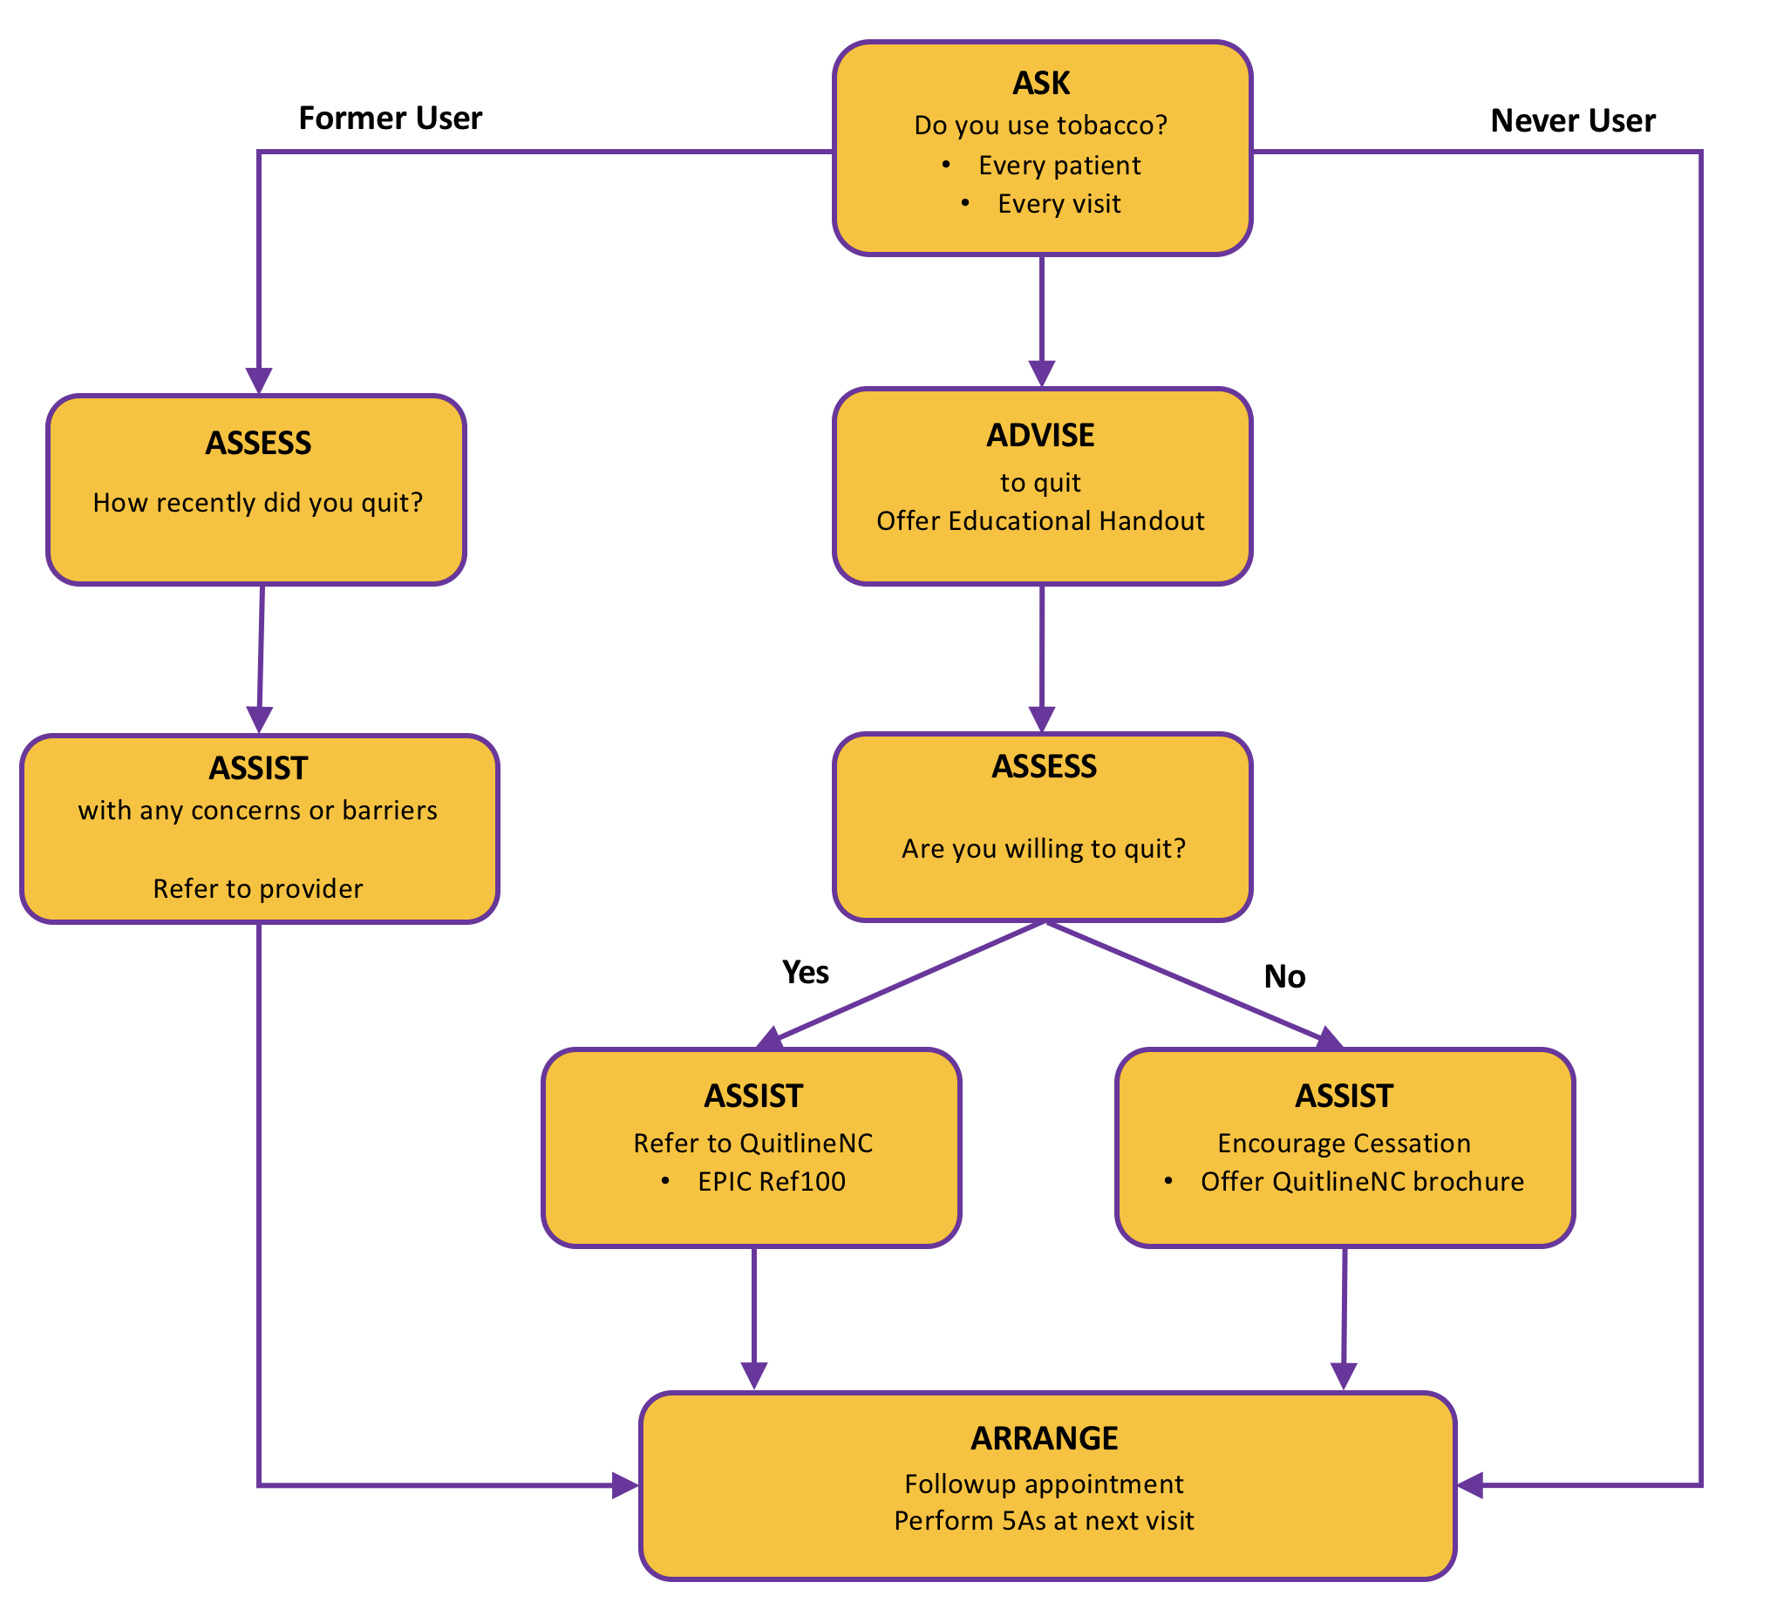

Figure B1. Nursing process schema for delivering 5As of tobacco cessation. Adapted from "Tobacco Cessation Guide for Oncology Providers," by ASCO, retrieved from
https://www.asco.org/sites/new-www.asco.org/files/content-files/blog-release/documents/ tobacco-cessation-guide.pdf. Copyright 2012 ASCO.

Appendix C

5As Model Process Integration into EMR

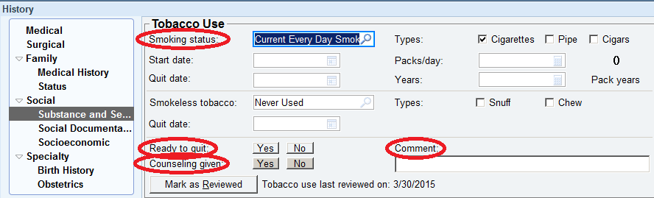
Figure C1. EPIC screenshot of tobacco use documentation sites that correlate with process change. Adapted from “Tobacco Use,” by EPIC electronic health record system for New Hanover Regional Medical Center. Copyright 2013 by EPIC Systems Corporation.

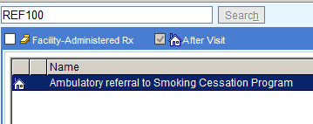
Figure C2. EPIC screenshot of "REF100," external referral to smoking cessation program. Adapted from “REF100,” by EPIC electronic health record system for New Hanover Regional Medical Center. Copyright 2013 by EPIC Systems Corporation.

Figure C3. QuitlineNC referral form. From "QuitlineNC: Fax Referral Form," by North Carolina Tobacco Prevention and Control, 2017. Retrieved from http://www.quitlinenc.com/docs/provider-resources/fax-referral-form_8-18-16.pdf?sfvrsn=0
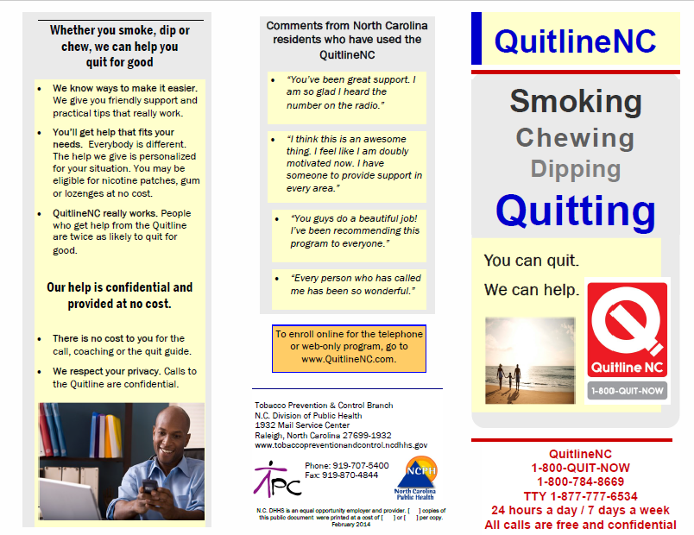Figure C4. QuitlineNC brochure. From "QuitlineNC: Brochure," by North Carolina Tobacco Prevention and Control, 2017. Retrieved from http://www.quitlinenc.com/docs/general-information/quitlinenc_brochure_3_11_14.pdf?sfvrsn=2
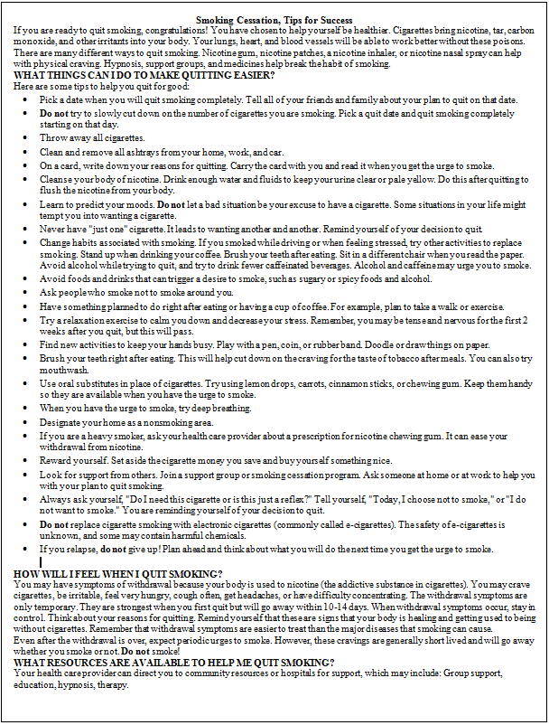
Figure C5. Smoking cessation patient educational handout. From “Smoking cessation, Tips for success,” by Elsevier Interactive Patient Education, 2016. Retrieved from EPIC Clinical References for New Hanover Regional Medical Center. Copyright 2016 Elsevier Inc.

Appendix D

Staff Education

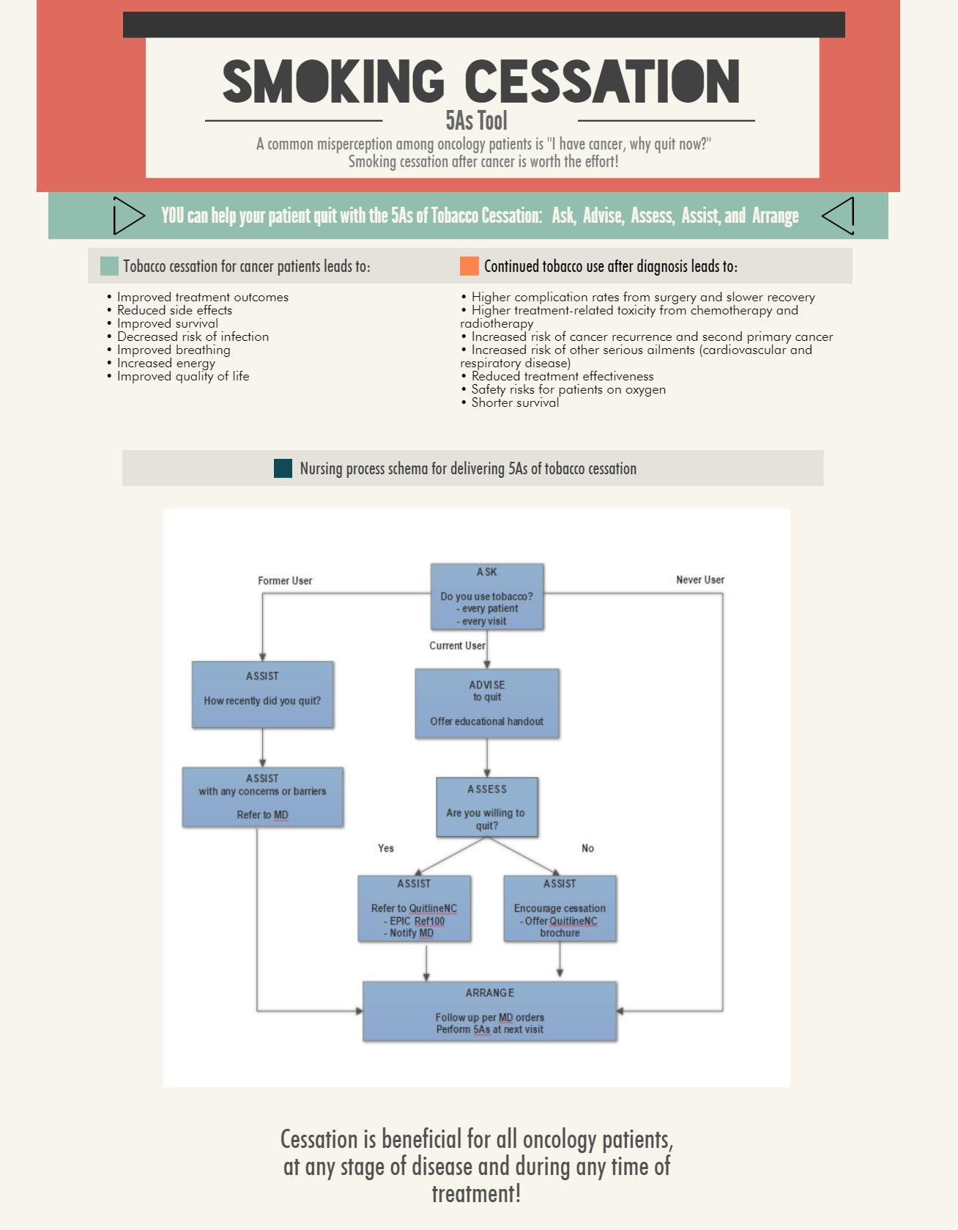

Figure D1. Staff education handout, page 1 of 2.

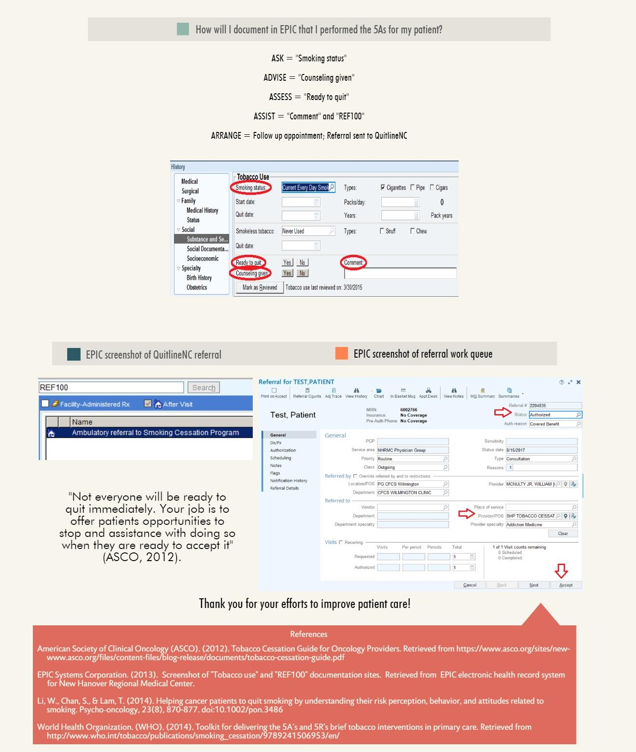

Figure D2. Staff education handout, page 2 of 2.

Appendix E

Data Table

5As of tobacco cessation post-implementation data table
Patient number | Date of encounter | ASK: | ADVISE: | ASSESS: | ASSIST: | ARRANGE:
 |  | “Smoking status” | “Counseling given” | “Ready to quit” | “REF100” | “Comment”
 |  |  |  |  |  | Follow up appointment within 1 month.
 |  | (Yes, No, Unknown, or Not asked) | (Yes, No, Unknown, or Not asked) | (Yes, No, Unknown, or Not asked) | (Yes, No, or Unknown) | (Yes, No, or Unknown)
001 | EXAMPLE | Yes | Yes | No | No | Yes
Note. Example template.

Appendix F
New Hanover Regional Medical Center’s Institutional Review Board Approval 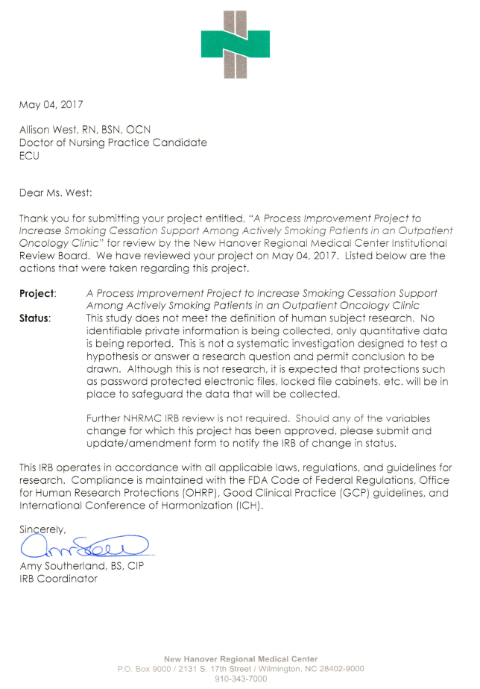

Appendix G

East Carolina University’s Institutional Review Board Approval
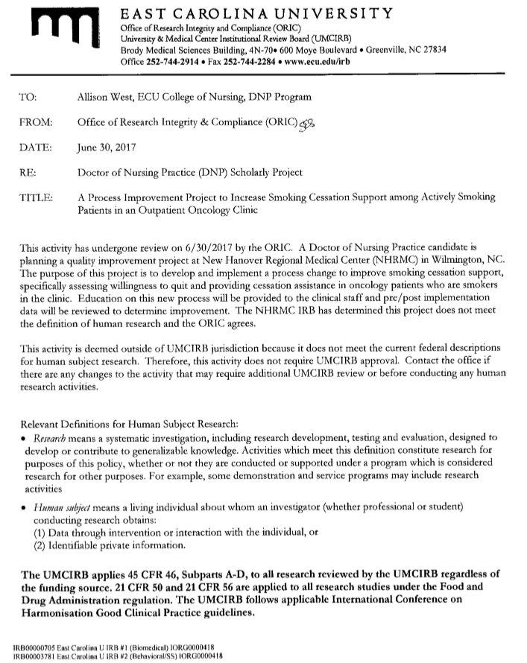

Appendix H

New Hanover Regional Medical Center Organizational Approval
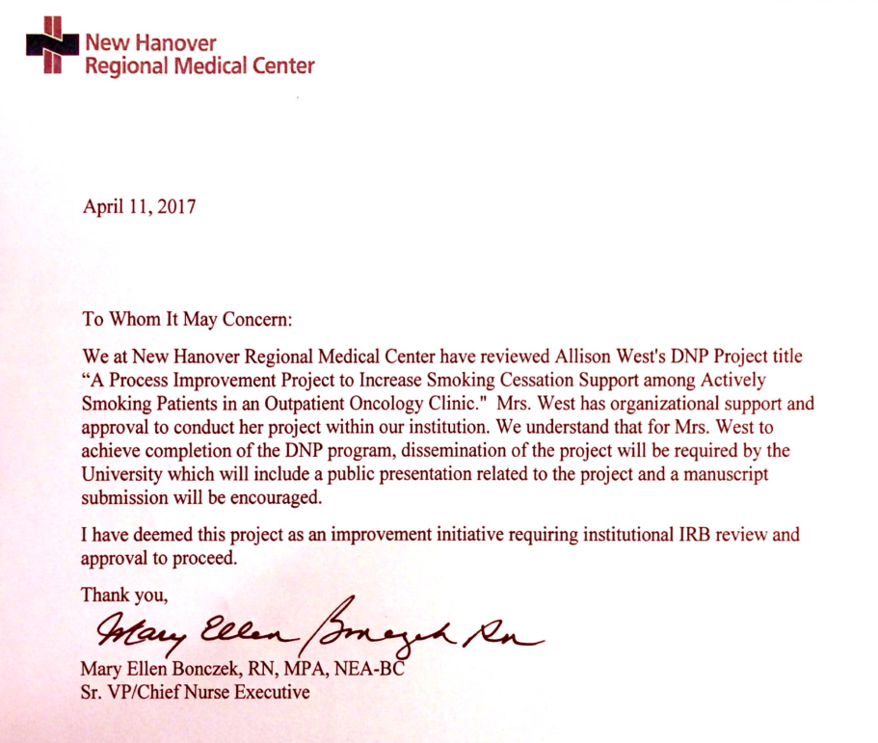

Appendix I

World Health Organization Permission for 5As Tool

From: permissions@who.int <permissions@who.int>
Sent: Thursday, June 15, 2017 09:25 AM
To: West, Allison Rivenbark
Cc: permissions@who.int
Subject: ID: 230420 Permission authorization for WHO copyrighted material

WORLD HEALTH ORGANIZATION (WHO)
Dear Mrs West
Thank you for your request for permission to reproduce, reprint or translate certain WHO copyrighted material.
On behalf of the World Health Organization, we are pleased to authorize your request to reproduce the WHO materials as detailed in the form below, subject to the terms and conditions of the non-exclusive licence below.
If you have questions regarding this authorization, please contact permissions@who.int.
We thank you for your interest in WHO published materials.
Kind regards,
WHO Permissions team
Form for requesting permission to reproduce, reprint or translate WHO copyrighted material
===================================================
ID: 230420
Section: Contact details
* Organization/affiliation
* East Carolina University
Section: Information about WHO material to be reproduced
* Full title of WHO material from which the reproduction is to be made
* Toolkit for delivering 5As and 5Rs brief tobacco interventions
* Website URL where WHO material is published
* http://www.who.int/tobacco/publications/smoking_cessation/9789241506953/en/
* For each item, please provide a reference and page number. If entire document, please state "Entire document".
* http://www.who.int/tobacco/publications/smoking_cessation/9789241506953/en/
The 5As Model Page 11-12
Section: Information about your publication
* Please provide the title of your publication that the above materials are to be published in
* A Process Improvement Project to Increase Smoking Cessation Support among Actively Smoking Patients in an Outpatient Oncology Clinic
* Target audience and planned distribution
* Nursing and medical assistant staff
* Planned publication/distribution date
* August 1, 2017
* If your publication or the material is to be sold, indicate the planned selling price or subscription fee
* NOT being sold
* Is your publication sponsored or funded by an organisation other than your own?
* No
* Will there be any advertising associated with your publication?
* No
* Additional information about your request
* In an effort to improve tobacco cessation support among oncology patients, a quality improvement process change is being implemented at an outpatient oncology practice. The 5As tobacco cessation model is the basis of this process. An educational presentation to staff will be provided to review this 5As model.

Appendix J

Literature Matrix
Student:  Allison R. West | Course:  DNP Project | Faculty Lead:  Dr. Ann Bell | Date:  04/01/2018 | Project:  A Process Improvement Project to Increase Smoking Cessation Support among Smoking Patients in an Outpatient Oncology Clinic
Article (APA Citation) | Level of Evidence  (I to VII) | Data/Evidence  Findings | Conclusion | Use of Evidence in EBP Project Plan  (Include your evaluation, strengths/limitations, and relevance)
American Society of Clinical Oncology (ASCO). (2012). Tobacco Cessation Guide for Oncology Providers. Retrieved from https://www.asco.org/sites/new-awww.asco.org/files/content-files/blog-release/documents/tobacco-cessation-guide.pdf | I | Benefits of cessation. Evidence for 5As and 5Rs as motivational tools. | Oncology providers must integrate smoking cessation into standard oncology care. Recommend applying 5As and 5Rs. | ASCO practice guideline. Supports project tool.
Al-Mamgani, A., van Rooij, P. H., Mehilal, R., Verduijn, G. M., Tans, L., & Kwa, S. L. S. (2014). Radiotherapy for T1a glottic cancer: The influence of smoking cessation and fractionation schedule of radiotherapy. European Archives of Oto-Rhino-Laryngology, 271(1), 125-132. doi:10.1007/s00405-013-2608-8 | IV | Laryngeal cancer patients (n=549) undergoing curative intent radiotherapy who continued to smoke compared to those who quit had less overall survival 36% vs 70% (p=0.001), less local control rates 81% vs 94% (p=.0001), and increased risk of secondary primary tumor, 21% vs 12% (p = 0.032). | Ongoing smoking increases risk of secondary primary cancer and decreases survival time as well as response to therapy. | Smoking cessation is valuable among laryngeal cancer patients undergoing curative intent radiotherapy in regards to response to therapy, survival time, and secondary cancer development risk.
Butts, J. B. & Rich, K. L. (2011). Philosophies and theories for advanced nursing practice. Sudbury, MA: Jones and Bartlett Publishers. | VII | Description of Nola J. Pender's Health Promotion Model (HPM). | Behavioral change is need for improved health. Pender's HPM is a useful theoretical framework for behavioral change motivation. | Using Pender's HPM as theoretical framework to guide behavioral change of smoking cessation with motivation using: perceived benefits, barriers, and plan of action.
Centers for Disease Control and Prevention (CDC). (2014). Best practices for comprehensive tobacco control programs. Retrieved from  https://www.cdc.gov/tobacco/stateandcommunity/best_practices/pdfs/2014/comprehensive.pdf | I | Best Practices for tobacco control:  Over 80% smokers see a physician every year with majority anticipating and receptive to HCP assessment and intervention for cessation.  Tobacco dependence treatment has been shown effective and reduces health care costs. Changing health care systems to incorporate cessation interventions consistently can substantially decrease smoking use. | HCP have opportune time to intervene for cessation and are advised to make this intervention part of standard, routine care.  Quitlines increase provider's likelihood to intervene. | Process change to assess and intervene for cessation at every patient encounter as well as benefits of quitline referrals.
Centers for Disease Control and Prevention (CDC). (2017). Smoking and tobacco use. Retrieved from https://www.cdc.gov/tobacco/ | I | Tobacco use damages almost every body organ and is the primary cause of preventable death. Furthermore, many adults prefer to quit. | Tobacco smoking is the most preventable cause of morbidity and mortality in the United States. | Negative consequences of smoking and that many may be willing to quit promote the need for smoking assessment and cessation intervention.
Centers for Medicare and Medicaid Services (CMS). (2014). Meaningful use core measure 9 of 13: Record smoking status. https://www.cms.gov/Regulations-and-Guidance/Legislation/EHRIncentivePrograms/downloads/9_Record_Smoking_Status.pdf | I | CMS Meaningful use core measure #9/13 "Record smoking status for patients 13 years old or older." | All patients should be screened for tobacco use with following coding criteria:  Current every day smoker, current some day smoker, former smoker, never smoker, smoker with current status unknown, unknown if ever smoked. heavy tobacco smoker, light tobacco smoker. | Medicare’s meaningful use program supports project process of screening for smoking at every patient office visit encounter.
Choi, S. H., Terrell, J. E., Bradford, C. R., Ghanem, T., Spector, M. E., Wolf, G. T., . . . Duffy, S. A. (2016). Does quitting smoking make a difference among newly diagnosed head and neck cancer patients? Nicotine & Tobacco Research, 18(12), 2216-2224. doi:10.1093/ntr/ntw189 | IV | Head and neck newly diagnosed cancer patients (n=590) who quit smoking upon diagnosis had improved overall mortality (HR = 2.38, 95% CI = 1.29–4.36) compared ongoing smokers. | Smoking status post cancer diagnosis is associated with overall mortality and cancer-specific mortality. | Smoking cessation is beneficial after a diagnosis of head and neck cancer.
Dinicola, S., Morini, V., Coluccia, P., Proietti, S., D'Anselmi, F., Pasqualato, A., . . . Cucina, A. (2013). Nicotine increases survival in human colon cancer cells treated with chemotherapeutic drugs. Toxicology in Vitro, 27(8), 2256-2263. doi: 10.1016/j.tiv.2013.09.020 | III | An in vitro study using human colorectal cancer cell lines Caco-2 and HCT-8 were used to evaluate nicotine's effect on cancer cells treated with chemotherapy agents, 5-Fluorouracil (5-FU) and Camptothecin (CPT). | Nicotine's exposure resulted in decreased anti-proliferative and pro-apoptotic effects from the chemotherapeutics on both cell lines. Nicotine disrupts colorectal cancer pharmacological treatment in vitro. | Ongoing smoking after diagnosis of colorectal cancer has the possibility of reducing treatment efficacy for patients treated with 5-FU and CPT.  Limitations: in vitro study
Deutschmann, M. W., Sykes, K. J., Harbison, J., Cabrera-Muffly, C., & Shnayder, Y. (2015). The impact of compliance in posttreatment surveillance in head and neck squamous cell carcinoma. JAMA Otolaryngology-- Head & Neck Surgery, 141(6), 519. doi:10.1001/jamaoto.2015.0643 | IV | Head and neck squamous cell carcinoma patients compliant with post-treatment surveillance (PTS) and increased rates of smoking cessation (P = .003). Among those who quit smoking and increase in survival time observed.  In regard to smoking cessation, PTS visits included frequent discussion of cessation, encouragement to quit, praise for efforts, review of harms of smoking, review of benefits of cessation. | Patients with head and neck squamous cell carcinoma more likely to quit smoking with PTS visits. Smoking cessation improves survival in this population. | Smoking cessation offers increase survival time. Health care smoking screening, education on harms/benefits, praise, encouragement, and follow up regarding cessation improves quit rates in this population.
Fang, Q., Shi, S., Liu, F., & Sun, C. (2014). Squamous cell carcinoma of the oral cavity in ever smokers: A matched-pair analysis of survival. The Journal of Craniofacial Surgery, 25(3), 934-937. doi:10.1097/SCS.0000000000000710 | IV | Squamous cell cancer of oral cavity who smoked had lower recurrence-free survival (P = 0.006) and disease-specific survival (P = 0.027) in smokers than nonsmokers. A matched-pair analysis  revealed smoking resulted in a 2-fold increase risk for recurrence and 5-fold increase risk for disease-related  death. | Smoking is directly associated with cancer reoccurrence and mortality in those with oral cancer.  There was no significant relationship between past and current smokers. | Smoking impacts cancer survival.
Guo, Y., Logan, H. L., Marks, J. G., & Shenkman, E. A. (2015). The relationships among individual and regional smoking, socioeconomic status, and oral and pharyngeal cancer survival: A mediation analysis. Cancer Medicine, 4(10), 1612-1619. doi:10.1002/cam4.509 | IV | Head and neck cancer patients who smoke, former or current, had significantly increase risk of overall (hazard ratios [HR] = 1.36, 95% CI = 1.30–1.42) and OPC- specific (HR = 1.48, 95% CI = 1.37–1.59) death than non-smokers independent of SES. | Current smokers with head and neck cancer are at risk of reduced survival time. | Smoking cessation in head and neck cancer patients is imperative to increase survival time.
Hanna, N., Mulshine, J., Wollins, D., Tyne, C., & Dresler, C. (2013). Tobacco cessation and control a decade later: American Society of Clinical Oncology policy statement update. Journal of Oncology Practice, 31(25), 3147-3157. | I | Tobacco cessation efforts are an expected part of quality oncology care. | Recommend cessation integration into care and to improve quality measurement. | Specifically addresses need for oncology practices to provide tobacco cessation support and to monitor and improve this metric. This supports this project’s process change by using performance tools with data that can be tracked, measured, and monitored accurately and efficiently.
Jung, K. H., Kim, S. M., Choi, M. G., Lee, J. H., Noh, J. H., Sohn, T. S., . . . Kim, S. (2015). Preoperative smoking cessation can reduce postoperative complications in gastric cancer surgery. Gastric Cancer, 18(4), 683-690. doi:10.1007/s10120-014-0415-6 | IV | Gastric cancer patients undergoing surgical resection (n=1335), smokers were found to have increased rates of postoperative complications than nonsmokers,  (12.3 vs 5.2 %, p=0.001, respectively). Adjusting for other risk factors, the odds  ratio (95 % CI) for postoperative complications in those who quit smoking <2 weeks, 2–4, 4–8, and >8 weeks preoperatively were  3.35 (1.92–5.83), 0.99 (0.22–4.38), 2.18 (1.00–4.76), and  1.32 (0.70–2.48), respectively, compared to non-smokers. | Smoking cessation for 2 weeks preoperatively in gastric cancer can decrease incidence of post-operative complications. | Cessation encouragement prior to this oncologic surgery is beneficial for post-operative complications and morbidity.
Katz, D. A., Vander Weg, M. W., Holman, J., Nugent, A., Baker, L., Johnson, S., . . . Titler, M. (2012). The emergency department action in smoking cessation (EDASC) trial: Impact on delivery of smoking cessation counseling. Academic Emergency Medicine, 19(4), 409-420. doi:10.1111/j.1553-2712.2012.01331.x | III | ED nurses applied 5As model as a framework to deliver tobacco cessation counseling. In addition, referral to the state quitline was incorporated for patients willing to quit.  ED nurse delivery of 5As framework increased the number of smokers (n=650) who were asked  about smoking (68% vs 53%, adjusted odds ratio [OR] = 2.0, 95% confidence interval  [CI] = 1.3 to 2.9), assessed for willingness to quit (31% vs 9%, adjusted OR= 4.9, 95% CI = 2.9 to 7.9), and assisted in quitting (23% vs 6%, adjusted OR = 5.1, 95% CI = 2.7 to 9.5) and had arrangements for  follow-up cessation counseling (7% vs 1%, adjusted OR = 7.1, 95% CI = 2.3 to 21) compared to baseline prior to 5A intervention. | Nurses are integral part of providing preventative health care. The 5As model is a time-efficient, effective approach to cessation counseling. Quitline referral was a successful intervention for assist in the 5As model. | This study supports 3 shared components of the current project: nurse delivery of cessation, use of 5As model for cessation, and incorporation of quitline referral for those motivated to quit.  Limitations: not specific to oncology.
Key, T. J., Appleby, P. N., Reeves, G. K., Roddam, A. W., Helzlsouer, K. J., Alberg, A. J., . . . Strickler, H. D. (2011). Circulating sex hormones and breast cancer risk factors in postmenopausal women: Reanalysis of 13 studies. The British Journal of Cancer, 105(5), 709-22. doi: 10.1038/bjc.2011.254 | IV | Smokers (15+ cigarettes/day) had higher levels of all hormones than non-smokers. Largest differences were for androstenedione, testosterone and calculated free testosterone, (18%, 20% and 19% respectively). | Breast cancer is positively associated with circulating hormones. This data suggests potential relationship between breast cancer and tobacco use. | This data supports Surgeon General Report (2014) of tobacco mechanisms having a potential to increase breast cancer risk.  Limitations: No definitive causal effect identified.
Lau, D., Ziewacz, J. E., Siddiqi, H. K., Pelly, A., Sullivan, S. E., & El-Sayed, A. M. (2012). Cigarette smoking: A risk factor for postoperative morbidity and 1-year mortality following craniotomy for tumor resection. Journal of Neurosurgery, 116(6), 1204. | IV | Brain cancer patients (n=453) undergoing craniotomy for tumor resection who were current smokers had higher postoperative complications (p= 0.03). Complication rates among current smokers were highest (31.5%) followed by those who quit (27.8%), then never smokers (21.9%).  Also, smoking status associated with 1-year survival (p <0.001). Never smokers had highest survival rate (88.6%) followed by those who quit (81.8%), then current smokers (73.4%). | Smoking increases postoperative complications and decreases survival time in this population. Those who quit can reduce complication incidence and improves survival time. | Smoking cessation prior to brain cancer surgical resection is improves outcomes.
Li, W., Chan, S., & Lam, T. (2014). Helping cancer patients to quit smoking by understanding their risk perception, behavior, and attitudes related to smoking. Psycho‐oncology, 23(8), 870-877. doi:10.1002/pon.3486 | VI | A structured interview of cancer patients who were smokers prior to diagnosis found the majority (86.3%) quit upon diagnosis. Those who continued to smoke reported perceived barriers to outweigh perceived benefits to cessation. | Awareness of perceived benefits and barriers specific to oncology patients must be incorporated when implementing cessation intervention. | Correlates with Pender's HPM regarding the need to alter perceived benefits and barriers so that benefits outweigh barriers. Supports cessation intervention project design.
Lugg, S., Tikka, T., Kerr, A., Agostini, P., Adamas, K., Bishay, E., . . . Naidu, B. (2015). Smoking at the time of curative-intent lung cancer surgery dramatically influences peri-operative complications. European Respiratory Journal, 46. doi: 10.1183/13993003.congress-2015.PA2518 | IV | Among curative-intent lung cancer patients undergoing surgical resection:  24% were current smokers  12% ex-smokers <6 weeks  53% ex-smokers >6 weeks  11% never smokers.  Current smokers had longer hospital LOS compared to never increased postop pulmonary complications and increased intensive care admissions. | 1 in 4 lung cancer patients undergoing surgical resection continue to smoke with significant impact on morbidity postoperatively. | Lung cancer patients should be offered smoking cessation interventions to improve post-operative morbidity.  Limitations: short follow up time.
Mediratta, N. & Poullis, M. (2016). Smoking status and 30-day mortality in patients undergoing pulmonary resections. Asian Cardiovascular and Thoracic Annals, 24(7), 663 - 669. doi: 10.1177/0218492316657252 | IV | Among non-small cell lung cancer patients undergoing surgical resection, the predicted 30-day mortality was higher in ex-smokers (2.9%) versus current smokers (1.2%). Life expectancy for current smokers was 18.1 years versus 14.1 years in ex-smokers (p < 0.0001). | Counter-intuitively, 30-day mortality rate was found to be higher among ex-smokers than current smokers. However, current smokers were younger, had less cardiac disease, and lower tumor stage at the time of surgery. Surgeon selection is another potential bias. The biological differences among the groups potential skews results. | Though findings that current smokers have less predictive mortality does not encourage cessation efforts, this study does acknowledge bias that exist among surgical candidates.
National Cancer Institute (NCI). (2013). SEER Cancer Statistics Review 1975-2013. Retrieved from https://seer.cancer.gov/csr/1975_2013/results_merged/topic_survival.pdf | I | "Age-Adjusted SEER Incidence and U.S. Death Rates and 5-Year Relative Survival (Percent) By Primary Cancer Site, Sex and Time Period." | Statistical comparison of 5-year mortality percentage from 1975 to 2013. | Data to support mortality incidence of specific cancers.  Limitation: Not specific to tobacco use.
National Cancer Institute. (NCI). (2017). Cancer Trends Progress Report: Cancer survivors and smoking. Retrieved from https://progressreport.cancer.gov/after/smoking | I | In 2015, 12% of cancer survivors were active smokers. Of those, the majority were aged 18-44yo. There is no Healthy People 2020 goal specifically related to cancer survivors and smoking cessation, though there is a goal to improve mental and physical health quality of life for cancer survivors. Smoking increases premature death in those with cancer. | Those who continue to smoke after a cancer diagnosis are at increased risk for impaired quality of life. Those under 40 are at increased need for motivation for healthy lifestyle to reduce cancer-related and noncancer-related morbidity. Efforts to assist with cessation among cancer survivors is imperative. Furthermore, monitoring these behaviors will help assess effect of cancer control efforts on mortality and morbidity. | Percentage of smokers in this project’s oncology clinic parallel with national statistics. Project provides evidenced-based tool to assist with cessation for oncology patients. In addition, documentation in EHR system will allow ongoing tracking and monitoring to improve this disparity.
Nechuta, S., Chen, W. Y., Cai, H., Poole, E. M., Kwan, M. L., Flatt, S. W., . . . Ou Shu, X. (2016). A pooled analysis of post-diagnosis lifestyle factors in association with late estrogen-receptor-positive breast cancer prognosis: Lifestyle factors and breast cancer prognosis. International Journal of Cancer, 138(9), 2088-2097. doi:10.1002/ijc.29940 | I | Among estrogen receptor-positive (ER+) breast cancer 5-year survivors, positive associations found for former smokers of ≥20 pack-years and current smokers and risk of late recurrence (HR: 1.32, 95% CI: 1.05–1.66 and HR: 1.30, 95% CI: 0.94–1.81, respectively). Strong positive associations found between former smokers and current smokers with late all-cause mortality. Former smokers and current smokers with increased risk of breast cancer-specific mortality, HRs (95% CIs): 1.27 (1.01–1.61) and 1.75 (1.30–2.35), respectively. | Current smoking in ER+ breast cancer is associated with late outcomes including increase breast cancer-specific mortality, all-cause mortality, and cancer reoccurrence. | Smoking cessation among ER+ breast cancer patients is a modifiable lifestyle change that can improve late outcomes of mortality and reoccurrence.
North Carolina Tobacco Prevention and Control. (2017). QuitlineNC. Retrieved from www.quitlinenc.com | VII | QuitlineNC offers free, personalized cessation services to NC residents in multiple forms: phone call, web based, quit coach, education, and resources. | A recommended, evidenced based intervention for cessation. | A fax referral will be made via EPIC EHR system for the assist and arrange process changes in the 5As model.
Office of Disease Prevention and Health Promotion. (ODPHP). (2017). Healthy People 2020: Tobacco use. Retrieved from https://www.healthypeople.gov/2020/topics-objectives/topic/tobacco-use | I | Tobacco use is cancer-inducing increasing the risk for 17 different cancers and accounting for 30% of all cancer deaths and 80% of lung cancer deaths. | A Healthy People 2020 goal is to reduce morbidity and mortality associated with tobacco use by increasing cessation approaches in clinical care among other strategies. | Project correlates with Health People 2020 goal of making health system changes to incorporate tobacco cessation approaches in clinical care.
Parker, B. A., & Pierce, J. P. (2016). Importance of smoking cessation to reduce breast cancer mortality. Journal of Clinical Oncology: Official Journal of the American Society of Clinical Oncology, 34(12), 1295-1296. doi:10.1200/JCO.2015.66.0910 | VII | Assessing recent evidence regarding relationship between ongoing smoking and breast cancer reveals there is statistically significant association between  smoking and increased breast cancer mortality.  Roughly 20,000 US women predicted to continue  smoking post breast cancer diagnosis. | Cessation promotion offers mortality benefit among others in this population and is a warranted survivorship focus. | Encourage and offer smoking  cessation at every oncology visit to limit treatment complications and  optimize breast cancer survival.
Passarelli, M. N., Newcomb, P. A., Hampton, J. M., Trentham-Dietz, A., Titus, L. J., Egan, K. M., . . . Willett, W. C. (2016). Cigarette smoking before and after breast cancer diagnosis: Mortality from breast cancer and smoking-related diseases. Journal of Clinical Oncology, 34(12), 1315-1322. doi:10.1200/JCO.2015.63.9328 | IV | Data from Collaborative Breast Cancer and Women’s Longevity Study used to compare mortality of women with breast cancer who were non-smokers, smokers, quit pre-diagnosis, quit post-diagnosis, and ongoing smokers. Active smokers more likely than never smokers to die of breast cancer (HR, 1.25; 95% CI, 1.13 to 1.37), respiratory cancer (HR, 14.48; 95% CI, 9.89 to 21.21), other respiratory disease (HR, 6.02; 95% CI, 4.55 to 7.97), and cardiovascular disease (HR, 2.08; 95% CI, 1.80 to 2.41).  10% of those continuing to smoke post-diagnosis more likely than never smokers to die of breast cancer (HR, 1.72; 95% CI, 1.13 to 2.60). Those who quit smoking after diagnosis had lower mortality from breast cancer (HR, 0.67; 95% CI, 0.38 to 1.19) and respiratory cancer (HR, 0.39; 95% CI, 0.16 to 0.95) compared to ongoing smokers. | Those who smoke pre- and post-diagnosis has higher mortality rates. In addition, those who quit post-diagnosis had lower breast cancer-related mortality than ongoing smokers. | Evidence supports need for those with breast cancer to be offered tobacco cessation interventions, even after diagnosis.
Pender, N. J., Murdaugh, C. L., & Parsons, M. A. (2011). Health promotion in nursing practice (6th ed.). Upper Saddle River, N.J: Pearson. | VII | Nola J. Pender Health Promotion Model (HPM). | Behavioral change is need for improved health. Pender's HPM is a useful theoretical framework for behavioral change motivation. | Using Pender's HPM as theoretical framework to guide behavioral change of smoking cessation with motivation using: perceived benefits, barriers, and plan of action.
Persai, D., Panda, R., Venkatesan, S., Arora, M., & Ahluwalia, J. S. (2014). Does receipt of 5As services have implications for patients' satisfaction in India? BMC Family Practice, 15(1), 209-209. doi:10.1186/s12875-014-0209-2 | II | 5As model given to primary care patients to assess patient satisfaction and success.  Patients who were advised to quit (OR: 9.56; 95% CI: 1.89-48.28), assessed for readiness  to quit (OR 2.1, 95% CI: 1.07-4.15) and offered cessation assistance (OR 2.2, 95% CI: 1.17–4.29) had higher satisfaction  with counseling services. Those reporting satisfaction were five times more likely to  have quit intention (OR: 5.45, 95% CI: 3.59 to 8.27) than other tobacco users. | Primary care patients who received 5As model were satisfied with this cessation counseling approach. | 5As is well received by patients who smoke.
Ramaswamy, A., Toll, B., Chagpar, A. & Judson, B. (2016). Smoking, cessation, and cessation counseling in patients with cancer: A population-based analysis. Cancer, 122, 1247–1253. doi:10.1002/cncr.29851 | V | The National Health Interview Survey (2010) was used to assess smoking behavior among cancer patients (N=27,157). Half (51.7%) of cancer patients who smoke reported their health care provider (HCP) counseled them to quit in the past 12 months. Smokers with a smoking-related cancer were not more inclined to quit than those with nonsmoking-related cancer diagnosis. | Tobacco-related cancer is not a motivating factor for cessation. HCP are only counseling for smoking cessation approximately half of the time for cancer patients. | Validates that all cancer patients are in need of motivational cessation support. Confirms the need to improve HCP cessation counseling.
Rink, M., Xylinas, E., Babjuk, M., Hansen, J., Pycha, A., Comploj, E., . . . Shariat, S. F. (2012). Impact of smoking on outcomes of patients with a history of recurrent nonmuscle invasive bladder cancer. The Journal of Urology, 188(6), 2120-2128. doi: 10.1016/j.juro.2012.08.029 | IV | This study of bladder cancer patients (n=390) found smoking intensity (p=0.015), duration (p=0.001), and cumulative exposure (p=0.001) to increase risk of disease recurrence and progression. | There is a dose-intensity relationship between smoking and aggressiveness of bladder cancer. | Smoking cessation, the earlier in disease trajectory, the better to reduce the risks of disease progression and reoccurrence among bladder cancer patients.
Rink, M., Zabor, E. C., Furberg, H., Xylinas, E., Ehdaie, B., Novara, G., . . . Shariat, S. F. (2013). Impact of smoking and smoking cessation on outcomes in bladder cancer patients treated with radical cystectomy. European Urology, 64(3), 456-464. doi: 10.1016/j.eururo.2012.11.039 | IV | Bladder cancer patients smoking status was  associated with increased disease recurrence (p = 0.004) and cancer-specific  mortality (p = 0.016). Cumulative exposure associated with advanced tumor stages (p < 0.001), node metastasis (p = 0.002),  disease recurrence (p < 0.001), cancer-specific mortality (p = 0.001), and overall mortality  (p = 0.037) with heavy long-term smokers having least favorable outcomes, followed by light long-term, heavy short-term, and light short-term smokers. Smoking cessation at 10 yrs. alleviated these risks (HR: 0.44; p < 0.001). | Smoking is associated with poor outcomes in bladder cancer and is dose-dependent. | Due to the dose-intensity relationship, cessation at any point may offer benefit, however at 10 years there is improved outcomes.
Sarna, L., Bialous, S. A., Ong, M. K., Wells, M., & Kotlerman, J. (2012). Increasing nursing referral to telephone quitlines for smoking cessation using a web-based program. Nursing Research, 61(6), 433-440. doi:10.1097/NNR.0b013e3182707237 | II | After education on value and use of quitlines, improvement in frequency and consistency of nursing implementation for  advise, assess, assist, arrange, and referral  to a quitline in smokers desiring cessation.  Consistent referral was most likely among those receiving education (OR = 1.74, 95% CI [1.11, 2.72). | Education, including printed material and/or webinars, are effective ways to inform nurses of quitline referral need. | Nursing staff and quitline referrals are imperative components of a successful patient cessation motivation process.
Sarna, L., & Bialous, S. A. (2016). Implementation of tobacco dependence treatment programs in oncology settings. Seminars in Oncology Nursing, 32(3), 187-196. doi: 10.1016/j.soncn.2016.05.002 | I | Review of clinical practice guidelines and published literature for tobacco cessation dependence strategies in oncology care.  With system changes, tobacco cessation can improve outcomes and is best accomplished with incorporating EHR, quitlines, resources for providers, and insurance coverage. | There is benefit in quitting smoking after a cancer diagnosis. Cessation support can be initiated by oncology nurses and will be most successful with a system change. | The system changes in this project including 5A process, use of quitline, use of EHR quitline referral, and use of EHR tracking will improve the success of tobacco cessation improvement project in this oncology practice.
Sarna, L. P., Bialous, S. A., Králíková, E., Kmetova, A., Felbrová, V., Kulovaná, S., . . . Brook, J. K. (2015). Tobacco cessation practices and attitudes among nurses in the Czech Republic. Cancer Nursing, 38(6), E22-E29. doi:10.1097/NCC.0000000000000222 | VI | A convenience sample of nurses (n=157) completed a survey to determine their attitudes and skills regarding tobacco cessation  Only 22% reported feeling nurses could have crucial role in helping patients quit and 65% felt their ability to assist with cessation as "fair/poor." | Nurses did not feel they had the ability to significantly impact motivation towards tobacco cessation for their patients. | Nurses need to feel empowered and be given skills to implement tobacco cessation support during their interaction with patients.
Schmidt-Hansen, M., Page, R., & Hasler, E. (2013). The effect of preoperative smoking cessation or preoperative pulmonary rehabilitation on outcomes after lung cancer surgery: A systematic review. Clinical Lung Cancer, 14(2), 96-102. doi:10.1016/j.cllc.2012.07.003
Seok, Y., Hong, N., & Lee, E. (2014). Impact of smoking history on postoperative pulmonary complications: A review of recent lung cancer patients. Annals of Thoracic and Cardiovascular Surgery, 20(2), 123-128. doi:10.5761/atcs.oa.12.02129 | IV | Smoking risk factors alone did not significantly increase post-operative pulmonary complications in lung cancer patients undergoing resection. | Though smoking is a known post-operative risk factor, there was not substantial evidence to show lung cancer resection should be delayed for cessation. | Smoking cessation remains recommended for lung cancer patients.
Shiels, M. S., Gibson, T., Sampson, J., Albanes, D., Andreotti, G., Beane Freeman, L., … Morton, L. M. (2014). Cigarette Smoking Prior to First Cancer and Risk of Second Smoking-Associated Cancers Among Survivors of Bladder, Kidney, Head and Neck, and Stage I Lung Cancers. Journal of Clinical Oncology, 32(35), 3989–3995. doi: 10.1200/JCO.2014.56.8220 | IV | Data obtained from 2,552 patients with stage I lung cancer, 6,386 with bladder cancer, 3,179 with kidney cancer, and 2,967 with head/neck cancer from ﬁve cohort studies  Current smokers had higher risk of developing second smoking-related cancer than never smokers among those with the following primary cancers: stage I lung (HR = 3.26; 95% CI, 0.92 to 11.6), bladder (HR = 3.67; 95% CI, 2.25 to 5.99), head/neck (HR = 4.45; 95% CI, 2.56 to 7.73), and kidney cancers (HR = 5.33; 95% CI, 2.55 to 11.1).  More time since cessation was associated with increased risk of second smoking-related cancer in survivors of bladder (P trend < .001), kidney (P trend = .002) and head/neck cancers (P trend < .001), but not stage I lung cancers (P trend = .99).  Also, current smokers compared to non-smokers had increased mortality among those with stage I lung (HR = 3.08; 95% CI, 2.18 to 4.33), bladder (HR = 2.48; 95% CI, 1.99 to 3.09), kidney (HR = 1.57; 95% CI, 1.18 to 2.08), and head/neck cancers (HR = 1.68; 95% CI, 1.34 to 2.10). | Those who smoke prior to primary cancer (stage 1 lung, bladder, head/neck, and kidney) are at higher risk of developing a second smoking-related cancer.  The length of time after quitting correlates with lower incidence of developing a second smoking-related cancer in all sub-groups except lung cancer.  Mortality rates were higher among current smokers than non-smokers in the mentioned cancer sub-groups. | Though the study found smoking prior to the primary cancer increased development of second cancer, the finding that early cessation is beneficial and the increased mortality among smokers in these cancer groups justifies the need for cessation intervention after a primary cancer diagnosis among those who continue to smoke.
Sitas, F., Weber, M.F., Egger, S., Yap, S, Chiew, M. & O'Connell, D. (2014). Smoking cessation after cancer. Journal of Clinical Oncology, 32, 3593-3595. doi: 10.1200/JCO.2014.55.9666 | VII | There is significant documented evidence to support smoking cessation to offer significant benefits to cancer survivor. In addition, the majority of oncology physicians do not offer cessation guidance. | Tobacco cessation is beneficial post cancer diagnosis. Unfortunately, cessation intervention has not been routinely adopted into standard oncology care. | Supports cessation benefit for oncology population and identifies oncology-based cessation intervention lacking.  Limitations: Large robust studies are lacking regarding correlation of smoking cessation on cancer survival.
Taechaboonsermsak, P., Kaewkungwal, J., Singhasivanon, P., Fungladda, W., & Wilailak, S. (2005). Causal relationship between health promoting behavior and quality of life in cervical cancer patients undergoing radiotherapy. The Southeast Asian Journal of Tropical Medicine and Public Health, 36(6), 1568. | VI | A study to evaluate causal relationships among age, education, family income, and stage of cancer, perceived benefits, perceived barriers, perceived self-efficacy, health promoting behavior and quality of life in patients with cervical cancer (N=488).  Health promoting behavior had a significant direct positive effect on quality of life (p < 0.01). Cognitive perceptual factors had a significant direct effect on health promoting behaviors (P = 0.69, p < 0.01). Social support had a significant direct effect on the cognitive perceptual factors (P = 0.64, p < 0.01), health promoting behavior (p < 0.01), and the quality of life (p < 0.01). The stage of cancer had a significant direct negative effect on cognitive perceptual factors (p < 0.05) and the quality of life (p < 0.01). | Pender's Health Promotion Model (HPM) was the conceptual framework of this study. | Pender's HPM is a beneficial framework in explaining and predicting health promoting behavior and quality of life.
Toll, B. A., Brandon, T. H., Gritz, E. R., Warren, G. W., & Herbst, R. S. (2013). Assessing tobacco use by cancer patients and facilitating cessation: An American Association for Cancer research policy statement. Clinical Cancer Research,19(8), 1941-1948. doi: 10.1158/1078-0432.CCR-13-0666 | VII | Ongoing smoking after cancer diagnosis negatively impacts outcomes. The specific impacts are discussed. There are no cessation tools specific to oncology. Finally, most oncology providers fail to move beyond ask and advise when using 5As model. | Policy statement recommendations:  (1) All smokers should be provided cessation support with internal or external intervention supplemented with quitline. (2) A thorough, routine, and repeated smoking assessment should be performed and documented. | Supports use of 5As model for oncology-based tobacco screening and cessation intervention until a focused oncology evidenced based tool is developed. Supports incorporation of quitline, however as a supplement to cessation intervention.
U.S. Department of Health and Human Services. (DHHS). (2014). The Health Consequences of Smoking—50 Years of Progress. A Report of the Surgeon General. Atlanta: National Center for Chronic Disease Prevention and Health Promotion, Office on Smoking and Health. Retrieved from https://www.surgeongeneral.gov/library/reports/50-years-of-progress/full-report.pdf | I | Sufficient evidence linking cigarette smoking to a multitude of chronic diseases, specifically cancer. Cigarette smoking increases all-cause and cancer-specific mortality. | "Cigarette smoking has caused an enormous avoidable public health tragedy" (p. 36). | Due to the detrimental health effect, specifically on cancer survivors, this project aims are supported by evidence and recommendations of this report.
Varghese, A. M., Sima, C. S., Chaft, J. E., Johnson, M. L., Riely, G. J., Ladanyi, M., & Kris, M. G. (2013). Lungs don't forget: Comparison of the KRAS and EGFR mutation profile and survival of collegiate smokers and never smokers with advanced lung cancers. Journal of Thoracic Oncology: Official Publication of the International Association for the Study of Lung Cancer, 8(1), 123. doi: 10.1097/JTO.0b013e31827914ea | IV | Those with heavier cigarette smoking had increased lung cancer KRAS mutations than never smokers. Heavier smoking history associated with less survival time among those with advanced-staged. Most changes in gene expression related to smoking reverts to normal with cessation except a subset of genes. | Cigarette smoking increases risk of lung cancer with KRAS mutation impacted survival time. Cessation returns many gene alterations to normal state with exception of KRAS. | Awareness of ongoing smoking and KRAS mutation regarding lung cancer prognostication and treatment is relevant. Cessation carries some benefit regarding genome mutations.
Warren, G., Marshall, J., Cummings, K., Toll, B., Gritz, E., Hutson, A., . . . Dresler, C. (2013). Addressing tobacco use in patients with cancer: A survey of American Society of Clinical Oncology members. Journal of Oncology Practice, 9(5), 258-262. | VI | A survey to oncology providers found 90% ask patient about smoking status, 80% ask patient to quit, 84% advise cessation, and 39% provide cessation support. Providers agreed cessation affects outcome for oncology patients and think it should be part of care (87%, 86% respectively). In addition, 74% felt lack of patient motivation main barrier. | Oncology providers assess smoking status, but do not routinely offer cessation intervention despite understanding value of cessation in this population. | Aligns with project site statistics.  Limitations: Study was limited to ASCO providers.
Weaver, K. E., Danhauer, S. C., Tooze, J. A., Blackstock, A. W., Spangler, J., Thomas, L., & Sutfin, E. L. (2012). Smoking Cessation Counseling Beliefs and Behaviors of Outpatient Oncology Providers. The Oncologist, 17(3), 455–462. doi: 10.1634/theoncologist.2011-0350 | VI | Survey issued to oncology providers (N=74) to find outpatient oncology tobacco screening offered to 82.4% of patients. Of those, 86.5% were advised to quit, less than 30% were offered cessation interventions, and only 30% received followed up. Only 18% of providers felt prepared to offer cessation support. | Beyond advising patients to quit, oncology providers are failing to provide tobacco cessation support. | Data parallels with project clinic site data and supports problem identified.  Limitations: Limited sample as survey results were of 74 oncology providers.
World Health Organization. (WHO). (2014). Toolkit for delivering the 5A’s and 5R’s brief tobacco interventions in primary care. Retrieved from http://www.who.int/tobacco/publications/smoking_cessation/9789241506953/en | VII | The 5As model for cessation intervention. | Ask: every visit, keep it simple  Advise: urge to quit, be clear, strong, and personalize  Assess: ask if willing to quit?  Assist: help with quit plan  Arrange: follow up | The basis of clinic process change for consistent, comprehensive, cessation intervention that can be monitored.
Yang, B., Jacobs, E., Gapstur, S., Stevens, V., & Campbell, P. (2015). Active Smoking and Mortality Among Colorectal Cancer Survivors: The Cancer Prevention Study II Nutrition Cohort. Journal of Clinical Oncology, 33(8), 885-893. doi: 10.1200/JCO.2014.58.3831 | IV | Smoking pre-diagnosis had higher all-cause mortality (RR], 2.12; 95% CI, 1.65 to 2.74) and CRC–specific mortality (RR, 2.14; 95% CI, 1.50 to 3.07). Former smoking had higher all-cause mortality (RR, 1.18; 95% CI, 1.02 to 1.36) but not higher CRC–specific mortality (RR, 0.89; 95% CI, 0.72 to 1.10). Smoking post-diagnosis had higher all-cause mortality (RR, 2.22; 95% CI, 1.58 to 3.13) and CRC mortality (RR, 1.92; 95% CI, 1.15 to 3.21). | Tobacco smoking pre- or post-CRC diagnosis is associated with all-cause mortality. Cancer stage had influence on mortality risk. Smokers who quit after diagnosis had lower all-cause and CRC-related mortality rates than those who continued to smoke, but the difference was not significant. | Smoking pre- or post-CRC diagnosis is correlated with increased all-cause mortality supporting cessation intervention need, however there was not a significant association between smoking status and CRC-related mortality.  Limitations: Limited research related to smoking post-CRC diagnosis.
Yoshida, N., Baba, Y., Hiyoshi, Y., Shigaki, H., Kurashige, J., Sakamoto, Y., . . . Baba, H. (2016). Duration of smoking cessation and postoperative morbidity after esophagectomy for esophageal cancer: How long should patients stop smoking before surgery? World Journal of Surgery, 40(1), 142-147. doi:10.1007/s00268-015-3236-9 | IV | Esophageal cancer patients (n=246) undergoing esophagectomy who continued smoking had higher rates of post-operative complications including pneumonia than those who quit smoking. An inverse relationship found between morbidity rates and smoking cessation duration. The no-cessation group (ongoing smokers) had the highest pulmonary morbidity (HR 3.68, 95 % CI 1.152–11.74; p = 0.028). Smoking cessation <30 days was risk factor for pneumonia (HR 2.89, 95 % CI 1.141–7.301; p = 0.025). Smoking cessation <90 days was risk factor for severe morbidities (HR 2.82, 95 % CI 1.072–7.427; p = 0.036). | Preoperative smoking cessation >90 days is ideal time to limit post-operative morbidity outcomes. However, any smoking cessation time shows reduction in post-operative morbidity.  There is a rise in patients receiving preoperative chemotherapy offering a 90day window for cessation without delays in treatment. | Smoking cessation, especially among those receiving pre-operative chemotherapy, is necessary to prevent post-operative complications in esophageal cancer patients receiving esophagectomy.
Note. Levels of Evidence: Level 1: Systematic review & meta-analysis of randomized controlled trials; clinical guidelines based on systematic reviews or meta-analyses. Level 2: One or more randomized controlled trials. Level 3: Controlled trial (no randomization). Level 4: Case-control or cohort study. Level 5: Systematic review of descriptive & qualitative studies. Level 6: Single descriptive or qualitative study. Level 7: Expert opinion. Source: Melnyk, B.M. & Fineout-Overholt, E. (2011). Evidence-based practice in nursing and healthcare: A guide to best practice. Philadelphia: Lippincott, Williams & Wilkins. Retrieved from http://guides.lib.umich.edu/c.php?g=282802&p=1888246

