Social Determinants of Health and Care Coordination for
Total Hip Arthroplasty Patients

Andrea Layton, MSN, RN, CDE, NEA-BC
College of Nursing, East Carolina University
Doctor of Nursing Practice Program
Dr. Bradley Sherrod
July 25, 2022

Notes from the Author
This evidence-based quality improvement project was supported by the Pre-Admission Testing Clinic team. I would like to personally thank each of the team members for embracing this project and their willingness to implement a new clinic workflow to address unmet social needs for our surgical patients. Additionally, I would like to thank Priscilla Ramseur, DNP, CNO for her leadership support and guidance throughout this project.
I would also like to thank Dr. Brad Sherrod for his ongoing support and wisdom throughout this project. His willingness to answer my many questions, provide guidance on my writings, and challenge me with questions regarding the nature of the project will always be appreciated.
I want to dedicate my Doctor of Nursing Practice Project to my family. To my husband Sonny, your support when I needed quiet time to study and your encouragement to take time out to enjoy our evening golf cart rides meant more than you will ever know. You’ve always believed in me and encouraged me to reach my goals. To my sons, Hunter and Chase, and daughter-in-law Julie, as well as my parents, Larry and Athalene, in-laws, Jimmy and Irene, and my “sisters” Tammy and Leigh, your encouragement during my DNP journey has been remarkable. I love each of you and will forever be grateful for your love, patience, and support as you walked this journey with me!

Abstract
The overall health and well-being of all patients is impacted by living and working conditions typically referred to as social determinants of health (SDOH). Recognizing the upstream impact these conditions may have on individual health care outcomes, the project organization utilizes a social care integration tool which connects the electronic health record (EHR) with local community partners and resources via the Unite Us platform. This evidence-based quality improvement project was designed to develop a clinical workflow to incorporate assessment of SDOH needs for patients scheduled to undergo a Total Hip Arthroplasty (THA) surgery and who are scheduled for a medical consult in the Pre-Admission Testing (PAT) Clinic. Patients who screened positive for unmet social needs including either food insecurities or transportation concerns were referred by the PAT Clinic Nurse Navigator to an appropriate community partner via the Unite Us dashboard utilizing the NCCARE360 platform. Chart reviews were conducted to confirm successful completion of the SDOH screening and documentation on the EHR flowsheet, with results visible on the patient storyboard for clinicians to easily view in the EHR. Findings identified 39 THA patients successfully screened, documented, and assessed for SDOH with five patients verbalizing unmet social needs. Referrals were successfully submitted and accepted by community partners for three patients. Although the number of patients with identified social needs was small, the PAT Clinic staff successfully implemented a screening and referral workflow that can be expanded to other surgical patent populations seen in the PAT Clinic.

Keywords: social determinants of health, social drivers, total joint surgery, total hip arthroplasty (THA), surgical outcomes, health outcomes, and electronic health record referrals
Table of Contents
Notes from the Author 2
Abstract 3
Section I: Introduction 6
Background 6
Organizational Needs Statement 7
Problem Statement 11
Purpose Statement 11
Section II: Evidence 12
Literature Review 12
Evidence-Based Practice Framework 20
Ethical Consideration and Protection of Human Subjects 21
Section III: Project Design 22
Project Site and Population 22
Project Team 23
Project Goals and Outcomes Measures 24
Implementation Plan 26
Timeline 28
Section IV: Results and Findings 29
Results…………………………………………………………………………………. 29
Discussion of Major Findings 30
Section V: Interpretation and Implications 31
Costs and Resource Management 31
Implications of the Findings 34
Sustainability 37
Dissemination Plan 38
Section VI: Conclusion 38
Limitations and Facilitators 38
Recommendations for Others 40
Recommendations for Further Study 42
Final Thoughts 42
References 44
Appendices 51
Appendix A: Literature Matrix 51
Appendix B: Nursing Research/Project Organizational Feasibility Form 53
Appendix C: Project Site IRB Approval 55

Appendix D: IRB QI Program Self-Certification Tool 56

Appendix E: Performance Services SDOH Dashboard 57

Appendix F: SDOH Screening Checklist 58

Appendix G: ROI Form in English 60

Appendix H: ROI Form in Spanish 61

Appendix I: Ambulatory Referral NCCARE360 62

Appendix J: Clinic Flow Diagram 63

Appendix K: Project Timeline 64

Section I. Introduction
Surgical Site Infections (SSIs), defined as an infection that occurred in relation to the surgical experience, are associated with an increased length of stay and elevated risk of readmission; thereby, negatively impacting the overall cost of medical care (Solomkin et al., 2017). Additionally, the risk of death associated with SSIs is up to 11 times higher than in patients without a SSI (Solomkin et al., 2017). Finally, Solomkin et al., (2007) noted that in 2007, there were approximately 500,000 SSIs contributing to an annual cost of $10 billion in the United States.
Background
The project site, a non-profit 186 bed community hospital, is part of a large, academic research health system. Serving residents from the northeast central region of North Carolina (NC) and surrounding rural counties, the hospital is a recognized leader in specialty care including orthopedic surgeries. The hospital mission, aimed at fostering wellbeing, through education and instilling confidence in healthcare, is evident in the community partnerships with various non-profit organizations.
The project site experienced unplanned hospital readmissions for SSIs for Total Hip Arthroscopy (THA) patients in Fiscal Year (FY) 2021. While these patients received a medical evaluation for surgery from the Pre-Admission Testing (PAT) Clinic, potential underlying social determinants of health (SDOH), which may impact post-operative surgical outcomes were not assessed nor addressed. It is important to note that there are many contributing factors to the development of an SSI, including external factors prior to the surgery, those that may occur in the operating room, and factors that are impactful after discharge. According to Kremers et al., (2015), social characteristics such as marital status, education level, social support, and coping skills contribute to positive patient outcomes. For example, patients who have higher education levels or are married and therefore have social support connections are more likely to have fewer post-operative complications (Kremers et al., 2015). Smoking status, on the other hand, is associated with increased risk of SSIs (Kremers et al., 2015). As Kremers et al., (2015) note, there is limited data on the relationship between “sociodemographic disparities” and surgical outcomes (p. 1853).
Organizational Needs Statement
The project site experienced four SSIs contributing to 75% of the hospital readmissions for THA patients from July 1, 2020, through June 30, 2021 (Medicare.gov, 2021). Additionally, when reviewing benchmark trends with the Duke Infection Control Outreach Network (DICON; n.d.), the comparison rate for THA infections is 0.61%, while the project site trending rate is 1.61%. Upon reviewing comparison data from the Centers for Medicare (CMS), complications for hip and knee replacement patients for the project site hospital from April 2017 to October 2019 are currently 2.6%, which is no different than the national rate of 2.4% (Medicare.gov, 2021). It is important to note that the CMS publicly reported data currently lags the project site data due to real time reporting.
As defined by the Office of Disease Prevention and Health Promotion (ODPHP; n.d.), SDOH are, “conditions in the environment where people are born, live, work, play, worship, and age that affect a wide range of health, functioning, and quality of life outcomes and risks”, (para. 1). Moreover, the effects of a person’s SDOH may impact one’s health and wellness in addition to access to healthcare along with the standard of care received (ODPHP, n.d.). SDOH are further classified into five categories which include the following: “Economic Stability; Education Access and Quality; Health Care Access and Quality; Neighborhood and Built Environment; and Social and Community Context” (ODPHP, n.d., para. 1). Specific examples of SDOH, such as the access to transportation for needed services, accessibility of nutritious food choices, access to exercise activities, and safe living communities, may improve one’s overall health and well-being, while inequities in these areas may lead to chronic diseases such as obesity and diabetes (ODPHP, n.d.). The SDOH work group, an initiative of Healthy People 2030 which is sponsored by the ODPHP (n.d.), acknowledges that although SDOH are not specific medical illnesses, these factors do impact patient outcomes. Several key goals from the SDOH work group include increasing referral communication between health care providers and community partners along with improving shared decision making between patients and providers (ODPHP, n.d.).
The Healthy NC 2030 initiative seeks to align with and further support the nationwide Healthy People 2030 campaign. Working with partners across NC to safeguard the “right of all North Carolinians to achieve health and wellness where they live, work, and play” is supported by this project (North Carolina Institute of Medicine [NCIOM], 2020, p 8). Acknowledging that health begins at home, and is further impacted by the community, available resources, and other financial and social factors, is imperative to achieve long-lasting improvements in a person’s health and well-being (NCIOM, 2020). Healthcare systems have an important role in accessing for a patient’s SDOH and should begin doing so by asking questions during clinical visits regarding food insecurities, transportation, and housing (NCIOM, 2020). The NC Department of Health and Human Services (NC DHHS) is now recommending that standardized screening questions assessing for SDOH be evaluated for all patients, regardless of payor status (NCIOM, 2020).
Of importance, the County Health Rankings (CHR) model, (Hood et al., 2016), acknowledges the relationship between various health care dynamics and health and wellness results. Care provided by the healthcare system, such as evidence-based practice (EBP), following recommended screening guidelines, and availability of resources such as primary care providers and specialists, only contributes 20% to health outcomes (Hood et al., 2016). By contrast, Hood et al, (2016) noted that 80% of the contributing factors affecting an individual’s health outcomes are directly related to SDOH such as tobacco and drug use, education level, jobs and unemployment levels, poverty, exposure to air and water pollution, lack of exercise, and limited access to healthy food choices or food insecurities. Therefore, it is imperative that clinicians recognize the impact many of these items may have one one’s access to healthcare, health literacy, and the ability to successfully manage the healing and recovery phase of illness.
Although many of the SDOH are not directly associated with the hospital delivery system, they are interconnected in that the consequences of one’s SDOH may negatively impact health care access, recovery, and outcomes (ODPHP, n.d.). For example, addressing food insecurities and access to healthy nutrition may impact the wound healing process, just as access to transportation for follow up appointments, and providing necessary discharge information such as physical therapy exercises and safe pain management during recovery, can affect optimal recovery (ODPHP, n.d.).
Addressing a patient’s SDOH is further supported by the Triple Aim, which was first developed in 2008 by The Institute for Healthcare Improvement (IHI). The Triple Aim provides a “framework for optimizing health system performance by simultaneously focusing on the health of a population, the experience of care for individuals within that population, and the per capita cost of providing that care” (Bachynsky, 2020, p 54). Within the scope of this project, the Triple Aim aligns in several ways. First, through assessing for a patient’s SDOH, the clinician will have the ability to advocate for the patient to potentially assist with obtaining needed resources. Assessing for food insecurities, in which there is an uncertainty of affordable or readily available healthy food choices, is one example of a SDOH, which currently affects 15.8 million families across the United States (American Hospital Association [AHA], 2017). The potential clinical effects of food insecurities can increase the risk developing diabetes or obesity, may lead to nutritional deficiencies, and can potentially increase the risk of hospital readmissions (AHA, 2017). Additionally, while addressing the cost associated with healthcare is another goal of the Triple Aim, the contributing effect of SDOH on poor surgical outcomes should be assessed. Patients returning to the hospital for readmission significantly increase the cost of medical care, both to the patient and the organization (AHA, 2017).
The Strong for Surgery Program, endorsed by the American College of Surgeons (ACS; n.d.), provides evidence-based guidelines for addressing potential risk factors prior to surgery to improve surgical outcomes. Recommended clinical guidelines for nutrition, diabetes management, and pain management are a few examples of the Strong for Surgery tools available for providers (ACS, n.d.). Fox, (2021), acknowledges the relationship between the Strong for Surgery guidelines and the overlap with a patient’s SDOH, noting that while a patient’s SDOH may not directly impact what happens during surgery, the effect of these items on a patient’s overall health and well-being may contribute to the surgical outcome, healing, and recovery process. For example, when following the recommended nutrition guidelines, access to healthy food is necessary for the surgical healing process and the prevention of SSIs (Fox, 2021). Assessing for food insecurities in the pre-operative setting may allow the provider to address nutritional deficiencies, thereby improving the post-operative healing process (Fox, 2021).
To address SDOH for all residents of N.C., a unique public-private partnership known as NCCARE360 was developed and implemented statewide beginning in 2020 (NCCARE360, 2021). Notably, NCCARE360 is “the first statewide network that unites health care and human services organizations with a shared technology that enables a coordinated, community-oriented, person-centered approach for delivering care in North Carolina” (NCCARE360, 2021, para 1). Linked with 100 counties and more than 2,200 community partners across NC, the NCCARE360 platform provides a closed-loop referral system within the electronic health record (EHR), improving handoff communication between the referring provider and receiving organization (NCCARE360, 2021). Providers within the PAT Clinic have the ability to assess and document a patient’s SDOH within the EHR, and based on identified needs, utilize the NCCARE360 resource to access appropriate community partners, and with shared decision making between the provider and patient, initial appropriate community referrals addressing pre-identified patient needs prior to the scheduled THA surgery.
Problem Statement
In FY21, 75% of readmissions for THA surgeries were due to SSI. Although 95% of these patients are evaluated in the PAT Clinic, the staff do not assess, nor address, the patient’s SDOH. To potentially impact readmissions related to SSIs, the PAT Clinic staff should assess, identify, and address SDOH using the NCCARE 360 referral tool prior to the surgical experience.
Purpose Statement
The purpose of this evidence-based project was to provide a tool for PAT Clinic staff to assess and identify SDOH needs prior to surgery thereby, improving hand-off communication, increasing referrals to community partners, and reducing readmissions related to SSIs. To address equity in healthcare, the project site utilized NCCARE360, a care coordination program aimed at connecting patients with community partners and resources. Additional project components include identifying a workflow and educating the PAT Clinic staff regarding how to efficiently use the NCCARE360 tool during the provider visit.
Section II. Evidence
Literature Review
Initially, a broad literature search was conducted using several databases including PubMed, Cumulative Index to Nursing and Allied Health Literature (CINHAL), and Ovid with a search date range of 2016 to 2021. Several key words and search terms were used including the following: social determinants of health, social drivers, total joint surgery, total hip arthroscopy (THA), surgical outcomes, health outcomes, and electronic health record (EHR), care coordination, and referrals. Multiple searches were conducted with various combinations of medical subject headings or MESH terms initially using OR to broaden the search and subsequently using AND to narrow the search.
The PubMed literature search initially returned 31,539 articles on SDOH. After narrowing down the search to include EHR integration, 75 articles were returned. Applying further criteria including care coordination resulted in eight articles. A subsequent search in CINAHL resulted in 15,804 articles. After applying MESH terms, three articles were returned. Inclusion criteria included a publication date of 2016 to 2021, articles in English, and evidence level of III or higher. Of significant importance, due to limited research on SDOH and EHR integration, most articles returned within the criteria timeframe were systematic reviews or Level I evidence.
In addition to the supporting articles for SDOH and EHR integration with care coordination, an additional search was conducted to identify relevant research for surgical outcomes for patients undergoing joint surgery or THA. Based on inclusion criteria previously identified, two articles were reviewed and summarized. Chosen articles that support the proposed intervention, which includes integrating the SDOH assessment into the EHR along with care coordination with community partners are referenced in Appendix A.
Current State of Knowledge
Social Determinants of Health. SDOH, which contribute to inequities in healthcare, have a profound and staggering effect on the overall health and wellbeing of individuals (Daniel, et al., 2018). Alarmingly, in 2000, the number of deaths due to inadequate support systems was comparable to the number of deaths from lung cancer (Galea et al., 2011). Likewise, approximately 133,000 deaths were directly related to poverty and 245,000 due to education status (Galea et al., 2011). Ubri and Artiga, (2016) note that $309 billion in economic losses annually are directly related to disparities in healthcare.
Though a variety of research on SDOH has been conducted, there is limited data on specific evidence-based recommendations to improve health outcomes (Taylor et al., 2016). The unanswered question is the financial impact coupled with focusing on SDOH needs. As Taylor et al. (2016) note, it is unknown if the increased cost in community resources needed to effectively address SDOH will result in lowering health care costs associated with improved health care outcomes.
Electronic Health Records Integration. As organizations have made the transition to EHRs, the Center for Medicare and Medicaid’s EHR Incentive Programs developed guidelines for meaningful use, aimed at creating criteria to utilize the EHR information so that it is useful to both the organization and the patient (Chen et al., 2020). In 2017, additional meaningful use criteria were implemented, requiring the incorporation of SDOH into the EHR, with an emphasis on achieving equity in healthcare while also focusing on quality improvement opportunities (Chen et al., 2020).
As Zhang et al. (2019) acknowledge, there are tremendous opportunities with leveraging the EHR to capture SDOH needs. These include the ability to aggregate patient data and communicate across a shared platform to improve collaboration and “shared decision-making” (Zhang, et al., 2019, p. S115). During the National Institute on Minority Health and Health Disparities meeting in 2017, several recommendations aimed at addressing SDOH through information technology (IT) were identified. First, it is imperative that different IT tools and the EHR can communicate between healthcare organizations and community partners (Zhang et al., 2019). The ability to connect electronically with various services across the community of patients served is necessary to connect patients with needed resources outside of the healthcare organization’s scope of service. Opportunities to include community data in the EHR, such as a patient’s ZIP code may also be beneficial as it might help identify patients who are potentially vulnerable based on the SDOH related to a person’s living conditions (Zhang et al., 2019). Finally, developing partnerships with those in both public and private businesses to address SDOH needs will be necessary to make lasting change in the community (Zhang et al., 2019).
Current Approaches to Solving Population Problem
Kreuter et al., (2021) acknowledges that healthcare organizations have utilized a variety of ways to assess an individual’s unmet social concerns. The simplest way is to utilize the patient to “self-report” social needs which yields to gaps in this process (Kreuter et al., 2021). First, there are a variety of assessment tools with different screening questions, variations in the social needs that are screened, and inconsistencies in screening the patient versus the household (Kreuter et al, 2021). Additionally, while it may be common practice to screen certain patient populations, such as pregnant women, children, or patients with diabetes, healthcare organizations may not broadly screen all patients seeking services within the organization (Kreuter et al., 2021). Current data estimates that across the U.S., only 30% of healthcare organizations have formal processes in place to assess for an individual’s SDOH needs and partner with community partners for resource support (Kreuter et al., 2021).
With regards to the surgical patient population, which this project focuses on, current approaches utilizing the integration of SDOH assessment and care coordination for THA patients were reviewed. While several articles identified the connection between SDOH and surgical outcomes, there is currently a gap with regards to connecting patients with appropriate community partners to address the individual’s social needs.
Total joint arthroplasty surgeries are the most common and THA surgeries account for an estimated 500,000 surgeries annually (Rubenstein et al., 2020). Unfortunately, for veterans undergoing a THA surgery, SDOH including financial status and race, have been recognized as negatively impacting multiple health outcomes, including increased lengths of stay, increased risk of discharge to a skilled facility rather than home, and increased risk of readmission due to postoperative complications (Rubenstein et al, 2020). While there are potential social drivers in the veteran population which should be considered, such as increased substance abuse and other comorbidities, additional research is needed to appreciate the relationship between care coordination based on the SDOH assessment for patients undergoing THA (Rubenstein et al., 2020).
When compared to a study by Okike et al., (2019), these disparities may be negated when there is equality with regards to access, insurance coverage, standardized treatment plans, and access to high volume surgeons. Although functional outcomes and complications between ethnic minorities and whites were comparable in this study, postoperative presentations to the emergency room were higher among minorities (Okike et al., 2019). According to Okike et al., (2019), the reasons for this may vary and are possibly due to various contributing SDOH factors such as “patient education, unmet medical needs, the strength of the patient-surgeon relationship, facility location relative to the patient residence, and or sociocultural factors” (p. 1165). Evidence to Support the Intervention
As healthcare organizations and providers recognize the fundamental relationship between an individual’s SDOH and personal health outcomes, developing mechanisms within the clinic, provider’s office, or hospital to address these concerns is imperative to begin making long-lasting changes in population health (Steiner et al., 2018). As Steiner et al, (2018) note, a care coordination model, which utilizes a multi-pronged approach for addressing SDOH needs is required. The following steps, according to Steiner et al., (2018), should be included. First, there should be a process for the provider to both assess and acknowledge a patient’s SDOH concerns. Second, a referral pathway to community partners should be established so that the patient’s identified SDOH needs can be addressed by the appropriate resource within the community. Finally, there should be a mechanism to track outcomes within the EHR to allow follow-up on intended referrals and tracking of healthcare outcomes (Steiner et al., 2018).
Currently, there is limited research identifying the impact such care coordination models have on sustainable lasting improvements affecting an individual’s SDOH (Gurewich et al., 2019). The Outcomes from Addressing SDOH in Systems (OASIS) framework, which was developed by Gurewich et al., (2019) is based on Maslow’s Hierarchy of Needs, which acknowledges that a person’s basic needs must be met before addressing other pressing needs. Applying this concept to an individual’s SDOH, addressing safe housing or food insecurity needs may be more important to the patient initially rather than focusing on postoperative physical therapy appointments after an elective THA surgery (Gurewich, et al., 2019). The OASIS framework provides a mechanism for providers to continuously assess for a patient’s unaddressed social concerns which may negatively impact one’s personal medical needs. Additionally, the framework provides a mechanism to initiate connections with community partners to address these concerns, which may in turn, impact health outcomes and improve health equity (Gurewich, et al., 2019).
As a result of the direct negative and harmful impact of unaddressed SDOH needs, both personally and to society, The American College of Physicians (ACP) issued a position statement in 2018 identifying several policy recommendations (Daniel et al., 2018). One key recommendation by ACP is the importance of “interprofessional communication and collaborative models that encourage a team-based approach to treating patients at risk to be negatively affected by social determinants of health” (Daniel et al., 2018, p 586). While this communication should be two-way and open between health care professionals and community partners, it should also be culturally sensitive and engaging with patients, acknowledging the importance of addressing SDOH needs while also providing support and avoiding bias or stigma (Daniel et al., 2018).
Leveraging current technology, such as using the EHR to assess and address SDOH needs, promote communication between professionals, and collect outcomes regarding the impact of various interventions on addressing SDOH needs, is another key policy recommendation by the ACP (Daniel et al., 2018). Using the EHR across the healthcare organization to communicate a patient’s SDOH needs may improve communication and shared decision making. As Cartier et al., (2020), also notes, while it is important to accurately document the SDOH needs, utilizing the EHR to communicate with the community partner to address these needs is essential. Several concerns, which may negatively impact this process, were identified, including a lack of knowledge regarding community partners and the services they provide, an inability to create electronic referrals to partners outside of the organization, and a lack of resources to follow up on referrals and verify outcomes (Cartier et al., 2020).
Through a detailed literature review, Chen et al., (2020) recognized the importance of integrating SDOH assessments into the EHR, supporting that an individual’s SDOH are associated with individual clinical health outcomes. Additionally, Cartier, et al., (2020) acknowledge that as health care organizations accept the relationship between social drivers and health outcomes, utilizing a referral process to appropriate community partners who can address these primary concerns is of upmost importance. With regards to population health management, amassed SDOH information within the EHR may also be useful in identifying disparities within a community, which can then be addressed by community partners and organizations in a shared care coordination model (Chen et al., 2020).
NCCARE360 Care Coordination Resource. One tool that is available at the project site health system is a social care integration model which relies on a clinical workflow to assess and identify a patient’s SDOH needs and create an electronic referral within the EHR to a community partner utilizing the NCCARE360-Unite Us platform. As Moore (2019) notes, to effectively address the SDOH needs and medical needs of the citizens in the community requires a multi-pronged approach involving the healthcare system, community partners, and leveraging informational technology systems. As healthcare organizations can assess for SDOH needs, successful implementation of this requires integrated screening tools within the EHR, adequate staff training to successfully screen for SDOH needs, along with a willingness to tailor the workflow so that it is efficiently incorporated into the clinical department patient assessment processes (Moore, 2019).
While community partners are tasked with addressing the SDOH needs for patients within the community setting, they are better equipped to answer questions regarding the financial cost of such programs and patient criteria for qualifying for these resources (Moore, 2019). An ability to communicate this information to healthcare organizations is beneficial to both as shared partners with a desired goal to improve patient outcomes (Moore, 2019). As Moore (2019) notes, “early, open, and ongoing communication between the health care sector and community-based organizations is critical to both identifying core issues, such as capacity and infrastructure needs, and developing cross-sector solutions to address capacity needs and create positive outcomes” (p 309).
Finally, the importance of a technology infrastructure which is integrated within the current EHR and is simple to use is vital to ensuring the adoption of the screening assessment by the clinical staff (Moore, 2019). Furthermore, the ability to connect community partners with patients via an electronic format can improve both operational efficiencies while adding value to the clinical workflow. As Moore (2019) states, identifying “a holistic view of an individual’s health and social needs” (p 310), in the EHR validates the referral request for community partner support. Additionally, the technology infrastructure should also provide a mechanism to improve communication between the health care organization and community partner, with an ability to follow up on the status of referrals as well as potential patient outcomes (Moore, 2019).
Evidence-based Practice Framework
Swanson's Caring Theory. This project was implemented using Swanson’s Caring Theory. This framework aligns well with this project for several reasons. The caring behaviors, as described by Swanson include the following: knowing, being with, doing for, enabling, and maintaining belief (Swanson, 1991). As a clinician implementing the project, when initially assessing a patient’s SDOH, there is a direct need to understand the patient’s work, home, and daily environment, all of which can impact one’s healthcare and wellness achievement. For example, the concept of knowing allows the clinician to approach the patient with compassion and nurturing, while also promoting respect for the individual while the concept of “being with” provides a mechanism for the clinician to actively listen to the patient and engage in problem solving, which will foster trust and shared decision making (Swanson, 1991). This level of connection and relationship building between the patient and provider will be imperative when discussing personal social drivers to limit the fear of potential stigma and bias. Finally, Swanson’s (1991) concept of “enabling” supports the clinician to openly assess a patient’s SDOH and subsequently follow up with appropriate referrals and other interventions to address the patient’s needs. Giving the patient reassurance to seek out and utilize needed resources, while also empowering the patient to make personal decisions about self-care and well-being are important aspects of enabling (Swanson, 1991).
Iowa Model of Evidence-based Practice. The project site currently uses the Iowa Model of Evidence-based Practice (EBP) to provide a framework for developing and implementing EBP. Initially developed in 1994 by Titler et al., the Iowa Model of Research in Practice focuses on identifying the problem statement based on the current data and evaluating the supportive research. Once confirmed, the framework supports identifying goal outcomes, designing and implementing the suggested EBP and evaluating the newly implemented processes and resulting outcomes to determine if a change in practice is warranted and supported by the evidence. If a change in practice is warranted, the recommendations should be shared and incorporated into ongoing practice across the organization as applicable (Titler et al., 1994).
Ethical Consideration & Protection of Human Subjects
This evidence-based project will be implemented within a hospital-based clinic located at the project site hospital. Patients who meet the project criteria shall have equal opportunity to participate in the project. The project site will maintain patient confidentiality and will obtain informed consent for participation. Adhering to the principles of justice, all patients who are scheduled for THA surgery and who self-identify SDOH needs will be offered an opportunity to participate in the NCCARE360 program. Additionally, patients have the right to refuse participation at any time during the program.
The project site champion and Chief Operating Officer initially reviewed and subsequently approved the project plan. Moreover, the project leader completed a series of social and behavioral training modules offered by the Collaborative Institutional Training Initiative (CITI), with topics focusing on ethics and research as well as the informed consent process, among others.
Prior to project implementation, the project site Nurse Researcher and health system nurse leadership committee reviewed and approved the Nursing Research/Project Organizational Feasibility Form (see Appendix B). These documents were submitted to East Carolina University (ECU) for review and consideration on October 28, 2021. IRB approval from the project site was officially received on November 16, 2021 (see Appendix C). Approval from ECU was received on November 30, 2021 (see Appendix D).
Section III. Project Design
Project Site and Population
The project site is a 186-bed non-profit hospital in an urban setting in the Piedmont region of North Carolina. Embedded in a rapidly growing county with multiple healthcare organizations, the hospital is part of a larger healthcare system. Offering a variety of both inpatient and outpatient services and specialties, the hospital specializes in orthopedic surgeries performed by surgeons affiliated with the organization as well as community surgeons.
Description of the Setting
The PAT Clinic is a busy hospital-based clinic that supports the surgical service line and anesthesia department by conducting medical assessment screenings and optimization prior to a patient’s surgical experience. Patients 18 years of age and older are referred to the PAT Clinic by their surgeon with appointments typically completed two weeks prior to the scheduled surgery date. The project site hospital performs approximately 17,000 surgeries annually with 3,500 of these patients seen in the PAT Clinic. THA surgeries account for approximately 250 surgeries each fiscal year, July 1 through June 30. The project site accepts all insurances, including Medicare, Medicaid, and private insurance. The PAT Clinic Financial Care Counselors (FCCs) are trained to offer financial counseling and an application for health system sponsored charity care to any patient who is uninsured or underinsured. The PAT medical consult appointment is considered a bundled charge and is included in the patient’s pre-operative surgical package.
Staffing in the PAT Clinic consists of a Program Coordinator, Medical Director, and Nurse Navigator along with FCCs, Certified Medical Assistants (CMAs), Advanced Practice Providers (APPs), and a pharmacy technician. Patient flow throughout the clinic requires that patients are checked in for their scheduled PAT medical consult by the FCC and placed in an exam room. The CMA completes an intake assessment which presently consists of obtaining vital signs, assessing for falls risk, and completing an electrocardiogram and labs as ordered by the APP. The pharmacy technician reviews and completes the medication reconciliation after which the APP performs the medical assessment, focused on optimizing patients for surgery and referring the patient to a specialist for further follow up care and medical clearance for surgery if applicable.
Description of the Population
Patient access for a PAT medical consult is dependent on the surgeon submitting a request for a PAT Clinic appointment when posting the operating room case request. From July 1, 2020, through June 30, 2021, the typical THA patient seen in the PAT Clinic ranged in age from 26 years to 87 years of age. The ethnicity of the THA population were majority non-Hispanic, 96%, with 4% Hispanic. Additionally, 69% were white, 27% African American and 49% were female, 51% male. With regards to discharge status, 85% were discharged home while 8% were discharged to a skilled nursing facility and 5% with home health services.
Project Team
The project team included the project leader along with the project site supervisor who was also the Chief Nursing Officer (CNO). The health system Nurse Researcher also played a supporting role in the project development by providing feedback regarding the initial problem statement development, offering suggestions regarding outcome metrics, and assisting with the IRB approval process for the project site hospital. Additional stakeholders in the success of the project included the PAT Medical Director and Program Coordinator along with the health system physician champion for the NCCARE360 partnership, the orthopedic surgeons who perform THA surgeries at the project site, as well as the Orthopedic Total Joint Patient Navigator, the Clinical Informatics Nurse Manager, and the Service Access Manager. The PAT Clinic staff implementing this project included an interdisciplinary team with various roles and responsibilities. Staff who were directly involved with providing care to THA patients in the PAT Clinic includes four FCCs, three CMAs, five APPs, as well as the Program Coordinator, Medical Director, and Nurse Navigator.
Project Goals and Outcome Measures
The aim of this project was to improve identifying SDOH needs of patients undergoing THA at the PAT Clinic to improve healthcare equity through community-based referrals. Following the development of the clinical workflow that incorporates SDOH assessment and documentation into the patient’s EHR and successful staff training to implement the new workflow, several outcome measures will be monitored and assessed. First, 85% of the THA patients seen in the PAT Clinic will have a SDOH assessment completed and documented within the EHR by the PAT Clinical staff. Subsequently, 85% of THA patients with identified SDOH needs, primarily focused on food insecurities and-or transportation needs, will have a referral to a community partner initiated by the PAT Navigator utilizing the NCCARE360 tool.
Description of the Methods and Measurement
A review of the surgical site infection data for the THA patient from July 1, 2020, through June 30, 2021, was reviewed for trends, opportunities, and potential gaps in care. Additionally, it was noted that the orthopedic surgeons and PAT Medical Director were inquiring about opportunities for the PAT Clinic to assist with addressing a patient’s SDOH needs prior to surgery utilizing the NCCARE360 resource. An initial review of the project site SDOH dashboard, which is supported by Performance Services, confirmed that a patient’s SDOH needs and subsequent documentation in the patient’s EHR during the PAT medical consult visit was not occurring. This project would monitor the assessment and documentation of a patient’s SDOH needs properly into the EHR along with appropriate referral to a community partner to address health equity prior to the scheduled THA surgery. Additionally, the target goal by the project healthcare system for referral uptake by the community partner is 65%. This is dependent on the inclusion of thorough details on the referral need as well as referring to the correct community partner based on eligibility guidelines.
Discussion of the Data Collection Process
Several methods and resources were utilized for the data collection process. Since this project required additional documentation utilizing the SDOH flowsheet, weekly chart reviews were conducted by the DNP Project Manager to review patients seen in the clinic for THA to confirm that staff were appropriately utilizing the documentation tool. This also allowed for real time follow up and additional training with staff for missing documentation. Weekly review of the health system Performance Services SDOH dashboard for the PAT Clinic was also utilized to identify staff compliance with assessing for SDOH within the clinic as well as the frequency of social needs identified within the THA surgical patient population (see Appendix E). Additionally, a monthly review of an individualized departmental report utilizing the slicer-dicer tool in the EHR provided a breakdown of the THA population seen in the PAT Clinic and assessed for SDOH needs. Subsequently, this tool also provided a breakdown of the patient population, zip code, and other demographic metrics.
The DNP Project Manager also conducted weekly reviews of the PAT Clinic ambulatory referral work queue to identify the number of outgoing NCCARE360 referrals to community partners. Additionally, an NCCARE360-UniteUS referral report embedded within the EHR was assessed bi-weekly to trend outgoing referrals to community partners and referral status such as accepted, pending, or denied. Monitoring referrals to ensure connections with appropriate community partners and developing a workflow to follow up on denied referrals was imperative to ensure engagement prior to the scheduled THA surgery.
Implementation Plan
The implementation plan for this project required multiple steps and several phases. Initially, preliminary discussions were held with the project site supervisor, patient quality manager, and PAT Medical Director to assist with identifying the problem. Narrowing the focus to the THA surgical patient offered an opportunity to align surgical outcomes with strategic goals of the surgeons and organization. Frequent meetings with the PAT Medical Director and Program Coordinator were necessary to further develop and outline the SDOH assessment and NCCARE360 referral workflow for the clinic. Successful day-to-day implementation relied on
both staff education to establish engagement and understanding of the importance of assessing for SDOH in addition to agreement and understanding of the newly defined clinical workflow for THA patients seen in the PAT Clinic.
Staff directly involved in the care of THA patients were invited to attend an educational session in December 2021 for an overview of the relationship between SDOH and patient clinical outcomes, how to document correctly on the flowsheet for improved care coordination, and the referral process to NCCARE360. Due to the small size of the PAT Clinic team, it was feasible to offer one educational session with ample time for an overview of the workflow and question and answer session. Although not directly involved in the day-to-day clinic flow, the Service Access Manager for the FCCs and the Orthopedic Patient Navigator were also offered an educational overview of the project workflow. Staff attendance in the education session introducing the clinic workflow was determined with the use of an attendance log.
Clinic Workflow. The clinic workflow is outlined as follows. Patients who are scheduled for a THA surgery, and who are scheduled for a PAT medical consult appointment will receive a SDOH screening questionnaire upon arrival for their appointment. The FCC will provide a paper copy of the form and provide instructions for completing the document. Utilizing a yes/no format, the form inquires if the patient would like help with any of the following needs: transportation or food insecurities (see Appendix F). Upon rooming the patient, the CMA will collect the form and transcribe the information into the SDOH flowsheet, which will pull pertinent information into the patient’s storyboard for other providers across the health system to easily review within the EHR. Patients who answer ‘yes’ are required to sign an NCCARE360-Unite US Authorization for Release of Information (ROI) form previously approved by the project site health system. Refer to Appendix G for the ROI form in English and Appendix H for the ROI form in Spanish. This form, which grants permission to submit a referral to an appropriate NCCARE360 community partner, is subsequently scanned into the EHR for future reference. The CMA will obtain the patient’s signature on the ROI form and forward the form to the PAT Clinic Nurse Navigator. The Nurse Navigator will enter an Ambulatory Referral to NCCARE360, identifying the patient’s need, reason for referral, and diagnosis code. See Appendix I for the NCCARE360 referral form. The referral, which is routed to the APP for review and cosign, flows to the PAT Clinic Ambulatory Referral work queue which is reviewed by the Nurse Navigator who then creates a referral to an appropriate NCCARE360 community partner. Both the Nurse Navigator and the project leader monitored the Unite Us referral database with follow up as needed for pending or declined referrals. Refer to Appendix J for an overview of the clinic workflow.
Timeline
Work on this project began in May 2021 with meetings with project site supervisor to discuss project ideas and strategic priorities of the organization. As ideas for the SDOH needs and the NCCARE360 tool began to formulate, follow up discussions with the PAT Medical Director, project site Quality Improvement Director and Performance Services Director occurred to identify the frequency of the problem. Concerns regarding the rate of SSIs for THA patients was identified and validated. Between May 2021 through July 2021, ongoing discussions with stakeholders, including the Orthopedic Joint Navigator, project site Chief Operating Officer, Case Management Director, and the health system Population Health ACNO occurred to further understand the concerns, gaps in care and potential opportunities. A review of the NCCARE360 website and literature search was initiated beginning in May 2021 and continuing into October 2021. Additional literature sources to support the problem statement included a review of the ODPHP definition of SDOH as well as the Healthy NC 2030 initiative along with the NC DHHS recommendations for SDOH screening within healthcare organizations. The Triple Aim and the Strong for Surgery Program recommendations were also reviewed between May 2021 through July 2021 which further support the importance of screening and care coordination for SDOH needs.
Refinement of the project continued in July 2021 through November 2021 with a thorough literature review conducted to identify EBP for SDOH screening, EHR integration and care coordination with community partners. Monthly participation in health system NCCARE360 meetings occurred between July 2021 through November 2021. Shadowing experiences with clinicians across the organization currently utilizing the NCCARE360 workflow within their respective clinics occurred between September 2021 through October 2021 leading to the proposed workflow development for the PAT Clinic. Ongoing meetings with the project site supervisor as well as PAT clinic leadership continued between August 2021 through November 2021 to develop and refine the proposed clinic workflow. Follow up with EHR team for development of referral work queue and integration of SDOH screening questions occurred in October 2021 and November 2021. Training for the CITI modules as identified by the university began in July 2021 with additional CITI modules required by the project site completed in October 2021 and IRB paperwork submitted for review. Project site IRB approval was received on November 16, 2021.
Staff education and training began in December 2021. Official program implementation began in January 2022 through April 2022. Ongoing monitoring, chart reviews to verify documentation in the SDOH Flowsheets and regular review of the NCCARE referral portal as well as weekly follow up with PAT Nurse Navigator and Orthopedic Nurse Navigator to identify readmissions also occurred during this timeframe. Data collection and summary outcomes were compiled and reviewed April 2022 through July 2022. See Appendix K for project timeline.
Section IV. Results and Findings
Results
The PAT Clinic staff participated in a training session in December 2021 where an overview of the SDOH screening tool and clinic workflow was reviewed. Additional training sessions were provided for the CMA staff, identifying the location of the SDOH flowsheet in the EHR and confirming documentation on the flowsheet successfully routing to the patient’s storyboard in the EHR which is viewable across the health system by all clinicians. Further one-on-one training sessions were provided to the PAT RN Navigator to learn and successfully traverse the NCCARE360 community partner platform.
This evidence-based project successfully implemented screening for SDOH, specifically food insecurities and transportation concerns, for patients scheduled for THA who were seen in the Pre-Admission Testing Clinic for medical consult prior to surgery. There was a total of 39 THA patients seen in the clinic between January 3, 2022, through April 29, 2022.
Discussion of Major Findings
The CMA successfully screened and documented the SDOH on the flowsheet in the EHR for 90% (n=35) of the THA patients seen in the PAT Clinic. The remaining 10% (n=4) of patients opted out as explained next. The SDOH paper screening tool provided an option for patients to identify if they would like help with any financial, food, or transportation concerns. If identified as “no”, the patient was not required to complete the screening questionnaire, thus the flowsheet was not updated. Upon reviewing the SDOH screening forms, two patients initially declined concerns and were not screened further for SDOH needs. In addition, two patients refused to participate in the screening process. Of those who completed the screening form in its entirety, 13% (n=5), screened positive for needs. Of these, three patients (60%) reported food insecurity, one patient (20%) identified transportation needs, and one patient (20%) reported having both food insecurity and transportation needs.
For those patients with identified either need, two patients (40%) declined interest in connecting with a community partner. Thus, an Ambulatory Referral to NCCARE360 was not submitted and the request for additional resources was not implemented. Successful referrals to NCCARE360 community partners were submitted for three patients (60%). Of these, 100% (n=3) of the referrals were initially accepted by the identified community partner and one transportation referral was later rejected by the patient due to reporting their personal situation changing and transportation services were no longer needed since the referral was initiated.
As Zhang et al. (2019) noted, the ability to connect patients seeking medical services within the healthcare system to community partners who can address social needs must rely on an EHR which can effectively communicate by transmitting external electronic referrals. As the PAT nurse navigator became familiar with the external referral process and workflow, the benefit of this integrated method was evident. Initially, there was a delay in the first patient referral submitted via the NCCARE360 platform, with the community partner not responding to the referral for five days due to an interface issue. Subsequent referrals submitted to various community partners via the NCCARE360 platform were either accepted or rejected within 48 hours of submitting via the EHR. Additionally, the status of the external referrals was easily visible via the Unite Us dashboard located in the EHR.
Section V. Interpretation and Implications
Costs and Resource Management
Costs
Staff training costs for this project were minimal. The project leader developed a PowerPoint presentation which provided an overview of the importance of assessing for SDOH, outlining the clinic workflow, and introducing the NCCARE360 platform. The 60-minute training session, which was held during the clinic workday, required staff to block six patient appointments. Training materials included copies of the presentation and reference materials for each participant. The cost of printing supplies was $15. Currently, the cost of the PAT medical consult visit is a bundled charge, included in the surgical experience. Although the patient is not billed for a professional charge by the APP, the CMA does bill for a venipuncture charge if applicable. Lost clinic charges for the blocked PAT medical consult visits are approximately $150. The cost associated with assessing for SDOH in the clinic includes the following: $10 for a package of 100 pre-printed SDOH questionnaires; $20 for the release of information (ROI) consent forms in both English and Spanish.
Resource Management
While the financial cost of implementation was minimal, the clinic operational efficiency was initially impacted as staff became familiar with openly discussing SDOH needs with patients and navigating the referral work queue. Additionally, by adding the SDOH assessment into the clinic workflow, an additional 10 minutes per visit for the CMA portion of the medical consult visit was initially required. Moreover, there was a learning curve for the PAT nurse navigator to become familiar with the NCCARE360 community partners, searching in the database and connecting patients with partners based on eligibility criteria. While this additional workload had the potential to impact other day-to-day priorities for the navigator, it improved as the navigator became more familiar with the NCCARE360 community partners. On average, approximately 30 minutes per patient was required to create the ambulatory referral to NCCARE360, search for an appropriate community partner, and create a referral within the NCCARE360 platform to the partner. Subsequent follow up to confirm if the referral was accepted or rejected was extremely efficient and could be completed within five minutes by referring to the Unite Us provider dashboard for a collective summary of referrals submitted by the provider. Thus, the overall impact to the PAT nurse navigator’s day-to-day work duties was minimal.
In the absence of the DNP project leader to provide initial training, NCCARE360 resources are available for the project site health system via a common share point site, which is accessible by all staff on the intranet. A series of five, 60-minute training modules with continuing medical education (CME) were available for staff to review. Additionally, staff who were incorporating NCCARE360 into their clinic workflow could participate in a monthly health system workgroup meeting where processes and best practices are reviewed, and updates are provided.
Most importantly, the costs associated with project implementation for both the patient and organization could be offset if an SSI is prevented. As noted by Premkumar et al. (2020), SSIs occur in approximately 2% of all total joint replacement surgeries performed annually in the United States (U.S.) and contribute to 15% of all revision hip surgeries. Alarmingly, there is a five-year mortality rate associated with SSI “higher than that of breast cancer, melanoma, Hodgkin’s lymphoma, and several other common malignancies” (Premkumar et al., 2020, p. 1484). Furthermore, an SSI may vary from superficial to complex, which may significantly impact the treatment plan (Rennert-May et al., 2018). While patients with superficial infections may simply require antibiotics and debridement, those with complex infections often require additional hospital resources which may include intravenous antibiotics and multiple surgeries for a complete joint revision (Rennert-May et al, 2018). While the average cost for a THA surgery is $18,500, the cost associated with an SSI increased to $32,100, based on a review of data from 2002 to 2017 (Premkumar et al., 2020). Of significant concern, based on estimates for 2030, SSIs for THA patients are expected to continue to increase nationally costing U.S. healthcare $753.4 million annually (Premkumar et al., 2020).
Although the cost associated with an SSI for the healthcare system is significant, the cost to the individual is also concerning. The individual patient must absorb additional medication costs for antibiotics, prolonged physical therapy treatments, potentially lost days at work, and travel expenses for medical appointments (Rennert-May et al., 2018). Patients may also experience costs associated with emergency room visits, surgeries for debridement or revision, and additional hospital days (Rennert-May et al., 2018).
Implications of the Findings
The findings from this study were reviewed to determine how assessing for SDOH impacted the patients, nursing practice, and the organization. While a small percentage of patients screened positive for SDOH needs, there are potential benefits for those involved in the screening process as well those who receive benefits. Furthermore, there are training implications and suggestions for engaging in the conversation to promote trust and transparency between the provider and patient.
Implications for Patients
Screening a patient for SDOH needs prior to elective THA surgery provided an opportunity to identify a patient’s potential vulnerabilities which may negatively impact surgical outcomes and the recovery process. To ensure successful screening, the patient’s perception of the reason and importance of screening should be considered (Rogers et al., 2019). Rogers et al., (2019) also acknowledge that patients who have previously experienced unmet needs, females, and minority groups are more likely to agree with completing SDOH needs assessments in various patient settings. Rather than making assumptions about this level of understanding and to better ensure screening success and acceptance, all patients undergoing an assessment should be provided with education regarding the importance of screening and the potential relationship between addressing social needs and healthcare outcomes (Rogers et al., 2019).
In a study by Kiles et al., (2022), there are several techniques, including the “rationale, relationship, and resources” (p. 829) that should be considered when framing communication with patients regarding social needs assessments. For example, patients should be provided with an understanding of the reason for the assessment along with the role of the provider or clinician in connecting the patient with resources (Kiles et al., 2022). Establishing an open, honest communication style, based on empathy, fosters a connection between the clinician and patient and is also an important step to encourage engagement in the screening process (Kiles et al, 2022). Finally, successfully connecting the patient with the community partner who can provide the needed resources to address the unmet social needs is crucial for long lasting benefits and improvements in health and well-being (Kiles et al., 2022).
Implications for Nursing Practice
Staff in the PAT Clinic who participated in the SDOH screening process were engaged and excited when given the opportunity to assist a patient by providing access to resources to address food insecurities and transportation needs. Recognizing that the patient’s health and well-being extends beyond the services offered within the clinic space is important to promote and improve health equity (Weinstein et al., 2017). Moreover, healthcare systems have an obligation to “recognize and address the behavioral, socio-economic and environmental factors that contribute to health” (AHA, 2017, p.4). As staff identified SDOH needs and submitted referrals to an appropriate community partner via the EHR, the benefit of a closed loop communication process was utilized, thereby impacting a patient’s care across the healthcare continuum. Finally, according to the American Nurses Association (ANA; 2015) Code of Ethics, nurses have an obligation to “advance the health, welfare, and safety” of patients (p. 48). This includes addressing a patient’s SDOH while working collaboratively with healthcare professionals and community partners to reduce health disparities (ANA, 2015).
In a recent study by Schickedanz et al., (2019), while it is assumed healthcare providers or clinicians will have the responsibility to assess for a patient’s SDOH needs, it is also important to recognize how this additional work is perceived and assimilated into the day-to-day work duties in the clinical setting. Eliminating barriers, such as additional time needed to conduct the assessment and document in the EHR, is important for successful integration into clinic priorities (Schickedanz et al., 2019). Additionally, opportunities exist to ensure that clinicians across the organization recognize that addressing unmet social needs can impact every aspect of health care, both inpatient and outpatient, and are therefore everyone’s responsibility to incorporate into the day-to-day care delivery workflow to successfully impact a patient’s unmet social needs (Schickedanz et al., 2019).
Impact for Healthcare System(s)
There are several implications related to assessing and addressing SDOH for the healthcare system. First, assessing for SDOH supports health equity initiatives and the strategic plan of the organization (Duke Health, 2022). In addition to promoting the organizations strategic goals, the project also supports several quality improvement initiatives for the project site orthopedic service line which focuses on addressing barriers to healthcare while improving health equity. Furthermore, healthcare organizations also have a responsibility to recognize the relationship between a patient’s unmet social needs and the potential impact on patient outcomes, access to care, and inequalities in care delivery (Drake, et al., 2021). Finally, it is imperative that healthcare systems begin to work closely with community partners to coordinate care through “community-based solutions” (Weinstein et al., 2017, p. 383). This is a critical requirement for success in improving health equity within the community.

Sustainability
The PAT Clinic staff have successfully created standard work for completing the SDOH assessment and have incorporated this into an efficient clinic workflow. Extending this assessment to other surgical patient groups will be conceivable. Likewise, the PAT nurse navigator has become more familiar with the NCCARE360 platform and has created a resource binder to assist with identifying appropriate community partners. Continuing to develop and refine the job description for the PAT nurse navigator to include coordinating referrals for NCCARE360 for surgical patients will be necessary for successful expansion to additional surgical patients.
Due to resource demands for both the screening and referral process, long-term sustainability may require the clinic to screen targeted populations of patients, such as all patients scheduled for total joint surgeries who require an overnight hospital stay. Other suggestions may include the use of student volunteers to assist with the referral process to appropriately identify community partners. In a recent study by Sandhu et al., (2021), utilizing a “student help desk” model may provide a mechanism for health students to engage with patients and provide the necessary follow up for the recommended referrals. Using a nurse navigator to oversee the work of the students, provide onboarding and training, and address any escalated concerns in a timely manner proved to be a sustainable model for a local health center (Sandhu et al., 2021).
As Drake et al., (2021) note, sustainability of both implementing and addressing a patient’s unmet social needs should include, identifying “sustainable staffing models or alternative delivery models that leverage existing technologies” (p. 13). This should involve both public and private partnerships and investments in an electronic platform which relies on a referral process within the EHR, closed-loop communication between community partners and healthcare providers, and the ability to monitor patient outcomes (Drake et al., 2021). Other recommendations acknowledge the importance of reviewing the outcomes data to identify zip-code level trends, identifying similar needs, gaps in care, or inadequate accessibility to community partners and resources in those communities, and using this information to individualize and target broad reaching community approaches (Drake et al., 2021). Finally, it is important to recognize the need for a method that breaks down political, structural, administrative, or economic barriers; eliminating silos between healthcare organizations and community partners (Drake et al., 2021).
Dissemination Plan
The results of this project were shared with various organizational leaders including the project site champion and the healthcare system nursing researcher. In July 2022, this project was also presented to the East Carolina University School of Nursing Doctoral Program leaders and will be submitted to the College of Nursing repository “The Scholarship”. In addition, the results were communicated with the orthopedic surgeons and other attendees during the monthly service line meeting in August 2022. Abstract proposal submission will be considered for the 2023 SPAQI Perioperative Medicine Summit along with the Medical Fitness Association annual conference in November 2023.
Section VI. Conclusion
Limitations
Screening patients for SDOH is a very humbling experience. Staff must first learn to ask these questions with sensitivity, while also respecting the patient’s right to admit to having needs yet denying help from NCCARE360 community partners. Patients frequently asked staff to explain the relationship between the SDOH screening questions and the scheduled surgery, wanting to understand why it was important to assess and address SDOH needs. Providing staff with education and scripting to facilitate answering these questions was important. As Andermann (2016) notes, staff should discuss social needs in a caring way while also displaying empathy, thereby building trust and rapport.
For patients who screened positive and requested help, navigating the NCCARE360 platform to identify appropriate community partners was challenging. Each partner had specific eligibility criteria such as age restrictions, disability, county of residence, or insurance status and it was not uncommon for partners to either be “out of funds” or “offline” and no longer accepting referrals. Additionally, the PAT nurse navigator was initially unfamiliar with many of the resources as this is often a function of Social Workers.
Another potential limiting factor was the timing of the PAT Clinic appointment with the date of surgery. On average, patients were seen in the clinic two weeks prior to surgery. For those with a referral submitted to NCCARE360, the turnaround time for the referral to be accepted by the community partner was two days. Additionally, there may be a delay between the referral acceptance date and successful contact and follow-up between the patient and the community partner.
Facilitators
Importantly, there were multiple facilitators which aided in the success of this project. The relationship between the PAT Clinic staff and the project leader was one of trust and mutual support. There was a willingness among team members to understand the importance of assessing for SDOH and to identify an efficient clinic workflow for this process. Furthermore, the PAT nurse navigator, which was a new position in the PAT Clinic, was open to the possibility of learning the NCCARE360 platform and incorporating this into the daily duties for the navigator role.
Leadership support across the project site was evident throughout the implementation process. The PAT Clinic Medical Director was inquisitive regarding the status of the project and was interested in extending the SDOH assessment to other surgical patients based on the project results. Likewise, other leaders, such as the project site Orthopedic Navigator and Quality Management Director, who were subsequently focused on readmission prevention efforts and the implementation of standardized order sets for the THA patient, were also supportive.
In addition to ongoing support from organizational leaders and those involved in the care of THA patients, the project leader also participated in a monthly health system NCCARE360 planning workgroup meeting. This was extremely helpful for ongoing support, problem solving, and identifying best practices. In addition to representatives across the health system who were in attendance, leaders from NCCARE360 along with local community partners regularly participated. The meeting provided a space to share educational updates to the platform as well as suggestions from front line users.
Recommendations for Others
There are several recommendations for others which will facilitate implementing SDOH screening with additional patient populations. As O’Gurek and Henke (2018) explain, screening patients for social needs must be a team effort. Resources such as nurse navigators, certified medical assistants, or community health workers may be extremely helpful explaining the reason for screening, conducting the screening, and coordinating the referral process to appropriate community partners (O’Gurek & Henke, 2018). Furthermore, leveraging technology to provide screening tools electronically to the patient prior to the clinic visit should be considered (O’Gurek & Henke, 2018). Most importantly, it is imperative that clinicians recognize that screening alone is not enough. Patients who are vulnerable and share their unmet social needs must be provided with connections to local community partners when and where possible (O’Gurek & Henke, 2018). Failure to address these needs after identifying them can erode trust between the patient and healthcare team and lead to defeat for the clinical staff (O’Gurek & Henke, 2018).
Becoming familiar with the referral platform as well as the various community partners is also essential (O’Gurek & Henke, 2018). One way to accomplish this is to work closely with the organization’s Community Affairs department, fostering and strengthening relationships between the healthcare organization and local community partners. Familiarity with the platform will also facilitate efficiencies in clinic workflow, and minimize the time spent searching for resources when placing referrals (O’Gurek & Henke, 2018).
It is also recommended to start small, screening a pre-identified set of patients or limiting the number of SDOH needs being assessed. As Sandhu et al., (2020) explain, “…targeted screening based on risks identified by the clinical staff, or screening based on risk stratification algorithms…are examples of screening approaches that may be appropriate in different settings” (p. 79). This will provide an opportunity to become familiar with the NCCARE360 platform and evaluate the clinic workflow. Likewise, it may help facilitate staff engagement and acceptance of additional documentation requirements.
Finally, having a dedicated staff member, such as a navigator, serve as the liaison between the patient and community partner, is vital (O’Gurek & Henke, 2018). While assessing and documenting SDOH on the flowsheet in the EHR was not time consuming, searching for a community partner based on qualifying inclusion criteria did require effort and research to successfully navigate the NCCARE360 platform. In the absence of this resource, staff must identify creative alternative ways to share this workload.
Recommendations Further Study
Based on the results of this project, there are several recommendations for further study. First, expanding SDOH screening to spinal surgery and other orthopedic surgical cases may be beneficial. As healthcare organizations seek to control or decrease costs while providing quality patient care, further exploration of the relationship between patients with identified social needs and surgical outcomes as compared to those with social needs, a referral to an NCCARE360 partner, and surgical outcomes would be helpful.
Moreover, exploring opportunities to strengthen the hand-off process between the healthcare organization and community partners via the EHR is essential. Other than the status of the referral, as accepted or rejected, limited details regarding the status of contact with the patient, the number of times the partner successfully connected with the patient, and resources provided or denied were available via the Unite Us patient dashboard after a referral was submitted. Continuing to refine the closed-loop communication between the EHR and community partners via the Unite Us dashboard will be essential to developing trust and transparency for all involved in improving the health and well-being of the patients.
Final Thoughts
Recognizing the synergistic relationship between healthcare organizations and community partners who also provide resources for patients to address SDOH needs, is imperative to both impact and improve the health and well-being for the community they serve. Unmet social needs, including access to healthy food and nutrition as well as transportation resources, have the potential to negatively affect a patient’s health outcomes. Although SDOH occur outside of the walls of the healthcare organization, they may significantly impact both preparation for surgery as well as surgical outcomes. With the increased risk of SSIs following joint surgeries, organizations have a responsibility to both screen patients for social vulnerabilities and submit an electronic referral to an appropriate community partner to effectively connect the patient with resources to address this need.

References
American College of Surgeons. (n.d.). Strong for surgery. https://www.facs.org/quality-programs/strong-for-surgery/about
American Hospital Association. (2017). Social determinants of health series: Food insecurity and the role of hospitals. http://www.hpoe.org/Reports-HPOE/2017/determinants-health-food-insecurity-role-of-hospitals.pdf
American Nurses Association. (2015). Code of ethics for nurses with interpretative statements https://www.nursingworld.org/coe-view-only
Andermann, A., (2016). Taking action on the social determinants of health in clinical practice: A framework for health professionals, Canadian Medial Association Journal, 188(17-18), E474-E483. https://doi.org/10.1503/cmaj.160177
Bachynsky N. (2020). Implications for policy: The triple aim, quadruple aim, and interprofessional collaboration. Nursing forum, 55(1), 54–64. https://doi.org/10.1111/nuf.12382
Cartier, Y., Fichtenberg, C., & Gottlieb, L., M., (2020). Implementing community resource referral technology: Facilitators and barriers described by early adopters. Health Affairs, 39(4), 662-669. DOI:10.1377/hlthaff.2019.01588
Chen, M., Tan, X., & Padman, R. (2020). Social determinants of health in electronic health records and their impact on analysis and risk prediction: A systematic review. Journal of the American Medical Informatics Association, 27(11), 1764-1773.
https://doi.org/10.1093/jamia/ocaa143
Daniel, H., Bornstein, S. S., & Kane, G. (2018). Addressing social determinants to improve patient care and promote health equity: An American College of Physicians position paper. Annals of Internal Medicine, 168(8), 577-594. doi:10.7326/M17-2441
Drake, C., Batchelder, H., Lian, T., Cannady, M., Weinberger, M., Eisenson, H., Esmaili, E., Lewinski, A., Zullig, L. H., Haley, A., Edelman, D., & Shea, C. M., (2021). Implementation of social needs screening in primary care: A qualitative study using the health equity implementation framework. BMC Health Services Research, 21(1), 2-16. https://doi.org/10.1186/s12913-021-06991-3
Duke Health. (2022). About our clinical enterprise strategic plan. https://corporate.dukehealth.org/about-our-clinical-enterprise-strategic-plan
Duke Infection Control Outreach Network (DICON), (n.d.). DICON remote surveillance program. https://dicon.medicine.duke.edu/dicon-remote-surveillance-program
Fox, M. (2021). Social determinants of health and surgery: An overview. Bulletin of The American College of Surgeons. https://bulletin.facs.org/2021/05/social-determinants-of-health-and-surgery-an-overview/
Galea, S., Tracy, M., Hoggatt, K., J., Dimaggio, C., & Karpati, A. (2011). Estimated deaths attributable to social factors in the United States. American Journal Public Health, 101, 1456-1465.
Gurewich, D., Garg, A., & Kressin, N., R. (2019). Addressing social determinants of health within healthcare delivery systems: A framework to ground and inform health outcomes. Journal of General Internal Medicine, 35(5), 1571-1575. https://dx.doi.org/10.1007%2Fs11606-020-05720-6
Hood, C. M., Gennuso, K. P., Swain, G. R., & Catlin, B. B. (2016). County health rankings: Relationships between determinant factors and health outcome. American Journal of Preventative Medicine, 50(2), 129-135. https://doi.org/10.1016/j.amepre.2015.08.024
Kiles, T. M., Cernasev, A., Leibold, C., & Hohmeier, K., (2022). Patient perspectives of discussing social determinants of health with community pharmacists. Journal of the American Pharmacists Association, 62(3), 826-833. https://doi.org/10.1016/j.japh.2022.01.007
Kremers, H. M., Kremers, W. K., Berry, D. J., & Lewallen, D. G. (2015). Social and behavioral factors in total knee and hip arthroplasty. The Journal of Arthroplasty, 30, 1852-1854. https://doi.org/10.1016/j.arth.2015.04.032
Kreuter, M., W, Thompson, T., McQueen, A., & Garg, R. (2021). Addressing social needs in health care settings: Evidence, challenges, and opportunities for public health. Annual Review of Public Health, 42, 329-344. https://doi.org/10.1146/annurev-publhealth-090419-102204
NCCARE360 (2021). About NCCARE 360. https://nccare360.org/about/
Medicare.gov. (2021). Duke Health Raleigh Hospital: Complications & deaths – Rate of complications for hip/knee replacements. https://www.medicare.gov/care-compare/details/hospital/340073?city=Raleigh&state=NC&zipcode=27609#ProviderDetailsQualityIndicatorsContainer
Moore, K., (2019). Social determinants of health: Addressing barriers through screening, referrals and care coordination. North Carolina Medical Journal, 80(5), 306-311. https://doi.org/10.18043/ncm.80.5.306
North Carolina Institute of Medicine. (2020). Healthy North Carolina 2030: A path toward health. https://nciom.org/wp-content/uploads/2020/01/HNC-REPORT-FINAL-Spread2.pdf
Office of Disease Prevention and Health Promotion (ODPHP) (n.d.). Healthy People 2030: Social determinants of health. https://health.gov/healthypeople/objectives-and-data/social-determinants-health
Okike, K., Chan, P. H., Prentice, H. A., Navarro, R. A., Hinman, A. D., & Paxton, E. W. (2019). Association of race and ethnicity with total hip arthroplasty outcomes in a universally insured population. The Journal of Bone and Joint Surgery, 101, 1160-1167. http://dx.doi.org/10.2106/JBJS.18.01316
O’Gurek, D. T., & Henke, C., (2018). A practical approach to screening for social determinants of health. Family Practice Management Journal, 25(3), 7-12. https://www.aafp.org/fpm/2018/0500/p7.html
Premkumar, A., Kokin, D., A., Farley, K., X., Wilson, J., M., McLawhorn, A., S., Cross, M., B., & Sculco, P., K., (2020). Projected economic burden of periprosthetic joint infection of the hip and knee in the United States. The Journal of Arthroplasty, 36, 1484-1489. https://doi.org/10.1016/j.arth.2020.12.005
Rennert-May, E. D., Conley, J., Smith, S., Puloski, S., Henderson, E., Au, F., & Manns, B., (2018). The cost of managing complex surgical site infections following primary hip and knee arthroplasty: A population-based cohort study in Alberta, Canada. Infection Control & Hospital Epidemiology, 39, 1183-1188. https://doi.org/10.1017/ice.2018.199
Rogers, A. J., Hamity, C., Sharp, A. L., Jackson, A. H., & Schickedanz, A. B., (2019). Patient’s attitudes and perceptions regarding social needs screening and navigation: Multi-site survey in a large integrated health system. Journal of General Internal Medicine, 35(5), 1389-1395. https://doi.org/10.1007/s11606-019-05588-1
Rubenstein, W. J., Harris, A. H. S., Hwang, K., M., Giori, N. J., & Kuo, A. C. (2020). Social determinants of health and patient-reported outcomes following total hip and knee arthroplasty in Veterans. The Journal of Arthroplasty, 35, 2357-2362. https://doi.org/10.1016/j.arth.2020.04.095
Sandhu, S., Lemmon, M. E., Eisenson, H., Crowder, C., & Bettgre, J. P., (2020). Addressing the social determinants of health during the COVID-19 pandemic: Ensuring equity, quality, & sustainability. Family & Community Health, 44(2), 78-80. https://doi.org/10.1097/fch.0000000000000290
Sandhu, S., Xu, J., Blanchard, L., Eisenson, H., Crowder, C., Munoz, V. S., Drake, C., & Bettger, J. P. (2021). A community resource navigator model: Utilizing student volunteers to integrate health and social care in a community health center setting. International Journal of Integrated Care, 21(1), 2. https://doi.org/10.5334/ijic.5501
Schickedanz, A., Hamity, C., Rogers, A., Sharp, A. L., & Jackson, A., (2019). Clinician experiences and attitudes regarding screening for social determinants of health in a large integrated health system. Medical Care, 57(6), S197-S201. http://dx.doi.org/10.1097/MLR.0000000000001051
Solomkin, J. S., Mazuski, J., Blanchard, J. C., Itani, K. M. F., Ricks, P., Dellinger, E. P., Allen, G., Kelz, R., Reinke, C. E., & Berrios-Torres, S. I. (2017). Introduction to the centers for disease control and prevention and the healthcare infection control practices advisory committee guideline for the prevention of surgical site infections. Surgical Infections, 18(4), 385-393. https://digitalcommons.wustl.edu/open_access_pubs/7743
Steiner, J. F., Bellows, J., Banegas, M. P., & Gottlieb, L. M. (2018). Interventions to address basic resource needs in Kaiser Permanente: A care continuum and an outcomes wheel. The Permanente Journal, 22(18), 53-57. https://doi.org/10.7812/TPP/18-130
Swanson, K., (1991). Empirical development of a middle range theory of caring. Nursing Research, 40(3), 161-165.
Taylor, L. A., Tan, A. X., Coyle, C. E., Ndumele, C., Rogan, E., Canavan, M., Curry, L., A., & Bradley, E., H., (2016). Leveraging the social determinants of health: What works? PLoS ONE, 11(8), 1-20. http://dx.doi.org.proxy.lib.duke.edu/10.1371/journal.pone.0160217
Titler, M. G., Kleiber, C., Steelman, V., Goode, C., Rakel, B., Barry-Walker, J., Small, S., & Buckwalter, K., (1994). Infusing research into practice to promote quality care. Nursing Research, 43(5), 307-313. Retrieved from: https://oce-ovid-com.proxy.lib.duke.edu/article/00006199-199409000-00009/HTML
Ubri, P., & Artiga, A. (2016). Disparities in health and health care: Five key questions. The Henry J. Kaiser Family Foundation. https://canvas.brown.edu/courses/1071292/files/60750267/download?wrap=1
Weinstein, J. N., Geller, A., Negussie, Y., & Baciu, A. (2017). Communities in action: Pathways to health equity. The National Academies Press Washington DC. http://www.nap.edu/24624
Zhang, X., Hailu, B., Tabor, D. C., Gold, R., Sayre, M. H., Sim, I., Jean-Francois, B., Casnoff, C. A., Cullen, T., Thomas Jr., V. A., Artiles, L, Williams, K., Le, P. T., Aklin, C. F., & James, R. (2019). Role of health information technology in addressing health disparities: Patient, clinician, and system perspectives. Medical Care, 57(6), S115-S120.
https://doi.org/10.1097/mlr.0000000000001092

Appendix A
Literature Matrix
Authors | Year Pub | Article Title | Journal | Purpose and take-home message | Level of Evidence | Comments/Critique of article/Gaps
Chen, Tan, & Padman | 2020 | Social determinants of health in electronic health records and their impact on analysis and risk prediction: A systematic review | Journal of American Medical Informatics Association | To conduct a literature review to study SDOH integration in the EHR and patient outcomes | I | Integrating SDOH into the EHR can assist in risk assessment and predicting healthcare “utilization” and health outcomes. National guidelines should be developed.  Gaps: additional studies are needed to assess patient outcomes and costs associated.  Limitations: A variety of articles, with varying outcomes and study designs were included
Daniel, Bornstein, Kane, & Public Policy Committee of the American College of Physicians | 2018 | Addressing social determinants to improve patient care and promote health equity: An American College of Physicians position paper | Annals of Internal Medicine | Recommendations to integrate SDOH data into the EHR | VII | Nine key policy recommendations identified. Focusing on SDOH and EHR integration, promoting healthcare “equity” and the development of public policy to address these issues as well as increased research to study these issues
Gurewich, Garg, & Kressin | 2019 | Addressing social determinants of health within healthcare delivery systems: A framework to ground and inform health outcomes | The Journal of General Internal Medicine | To better address an individual’s SDOH needs, a standardized framework should be utilized to facilitate SDOH assessment as well the referral pathway |  | The authors developed the Outcomes from Addressing SDOH in Systems (OASIS) Framework which provides standardized guidelines to assess for SDOH needs, identify ongoing needs, and develop evidence-based practice to address these needs.
Okike, Chan, Prentice, Navarro, Hinman, & Paxton | 2019 | Association of race and ethnicity with total hip arthroplasty outcomes in a universally insured population | The Journal of Bone and Joint Surgery | To review the relationship between race and ethnic disparities in THA outcomes | III | Minority patients who underwent THA surgery had similar postoperative outcomes as white patients.  Minority patients had higher rates of ER visits potentially associated with SDOH
Rubenstein, Harris, Hwang, Giori, & Kuo | 2020 | Social determinants of health and patient-reported outcomes following total hip and knee arthroplasty in veterans | The Journal of Arthroplasty | To identify the impact of SDOH on patient outcomes for Veterans undergoing THA or TKA | II | Racial and lower socioeconomic status have increased length of stay, risk of discharge to skilled nursing facility, and readmission rates.  Limitations: veteran patients may have additional SDOH needs than the general population (i.e. increased substance abuse, mental health problems) – can’t generalize to general population
Steiner, J., f., Bellows, J., Banegas, M., P., & Gottlieb, L., M. | 2018 | Interventions to address basic resource needs in Kaiser Permanente: A care continuum and an outcomes wheel | The Permanente Joul | To identify methods to assess a Kaiser Permanente member's SDOH needs, implement a mechanism to address these needs, and develop outcomes to assess the interventions |  | Limitations: complex process; relies on the patient to complete each step.  Gaps: the impact of health literacy; competing needs at the organization level; lack of funding for needed resources; and limited research on care coordination models addressing SDOH needs. Application to practice: Standardized framework to address SDOH needs, establish community partnerships, develop referral process, & collect health outcomes

Appendix B
Nursing Research/Project Organizational Feasibility Form
- Project Organization
- Are you a DUHS or DUSON employee?
☒ Yes: Indicate facility, department, and role _Duke Raleigh Hospital, Outpatient Specialty Clinics; Administrative Director
☐ No: Indicate facility, department, and role ___________________________________________

- Is the project or research outcome to be used to meet an educational requirement: ☒Yes ☐No
If, yes: Please indicate the program and degree you are obtaining:
☐ | DUSON MSN program | ☐ | BSN program (indicate school):
☐ | DUSON CRNA DNP | ☐ | MSN program (indicate school):
☐ | DUSON DNP | ☒ | DNP program (indicate school): | East Carolina University
☐ | DUSON PhD | ☐ | PhD program (indicate school):

- Project Overview and Research Questions or Hypotheses
Briefly (250-350 words) describe your project or research, including the primary goal and specific question to be addressed. Attach the IRB QI exempt summary or research summary (if DUSON, attach the DUSON project summary).
Project Lead: |  |  | Andrea Layton |  |  |  |  | Email: | Andrea.layton@duke.edu
If student, name of the faculty sponsor or chair: |  |  |  |  | Priscilla Ramseur
Project Title: |  |  | Pre-Surgical Screening of Social Determinants of Health (SDOH) Needs and Care Coordination for Total Hip Arthroplasty patients
Projects Overview or Description of the Protocol:
Background/Significance: In FY21, 75% of readmissions for Total Hip Arthroplasty (THA) surgeries were due to surgical site infections (SSI). Although 100% of these patients are evaluated in the Pre-Admission Testing (PAT) Clinic, the staff do not assess, nor address, the patient’s social determinants of health (SDOH). To potentially impact readmissions related to SSIs, the PAT Clinic staff should assess, identify, and address SDOH using the NCCARE 360 referral tool prior to the surgical experience.

Intervention: The purpose of this evidence-based project is to provide a tool for PAT Clinic staff to assess and identify SDOH needs prior to surgery thereby, improving hand-off communication, increasing referrals to community partners, and reducing readmissions related to SSIs. To address equity in healthcare, the project site will utilize NCCARE360, a care coordination program aimed at connecting patients with community partners and resources. Additional project components include identifying a workflow and educating the PAT Clinic staff regarding how to efficiently use the NCCARE360 tool during the provider visit.

Methods: Staff will attend an education session regarding the importance of screening for SDOH and the NCCARE360 referral process. Staff will complete the SDOH flowsheet located in the Electronic Health Record (EHR). This data will pull forward to the patient’s storyboard, viewable in the EHR to all providers. This data will also flow to the Performance Services (PS) website SDOH dashboard

Analysis Plan: Weekly chart review to confirm data entry into SDOH flowsheet; review of PS website SDOH dashboard for PAT Clinic data; review of Ambulatory Referral PAT Clinic NCCARE360 Workqueue to identify volume of NCCARE360 referrals; and review of Unite US data to monitor status of referrals (accepted, pending, declined). Review of Orthopedics dashboard to identify THA readmissions related to SSIs and discharge status (home vs. skilled facility)

Primary Aim/s, Research Question/s, or Hypotheses: Does screening and addressing SDOH needs for patients scheduled for elective THA surgery impact readmissions and discharge status

Are staff involved in subject screening, data collection, project implementation or evaluation: |  |  |  |  |  |  |  |  |  | ☒Yes | ☐No
 | If yes, complete the following:
 |  | Number of hospital or clinical staff required: |  |  |  |  | 8
 |  | Specific tasks staff will perform: |  | CMA staff will complete SDOH screening questionnaire (if patient didn’t complete pre-visit via MyChart; If needs are identified – enter Amb Referral NCCARE360 for PAT APP provider to cosign. PAT Navigator will referral Amb referral WQ and submit referrals to NCCARE360 community partners if applicable
 |  | Staff time required to complete each task: |  |  |  | Documentation SDOH questions on flowsheet – 10min; Create Amb Referral – 3 min; Provider cosign referral – 1 min; Navigator create referral NCCARE360 – 15-30 min (identify community partner, create referral).

- Administrative Approval
To consider the impact of your project/research within Duke University Health System, the DUHS Director of Nursing Research will assist you in identifying the DUHS nursing leadership best aligned with your project/research setting. Sign this form and send to Dr. Allen at hutch.allen@duke.edu to initiate the process to project implementation.
Project Lead / Date |  | DUHS Director Nursing Research / Date

Appendix C
Project Site IRB Approval
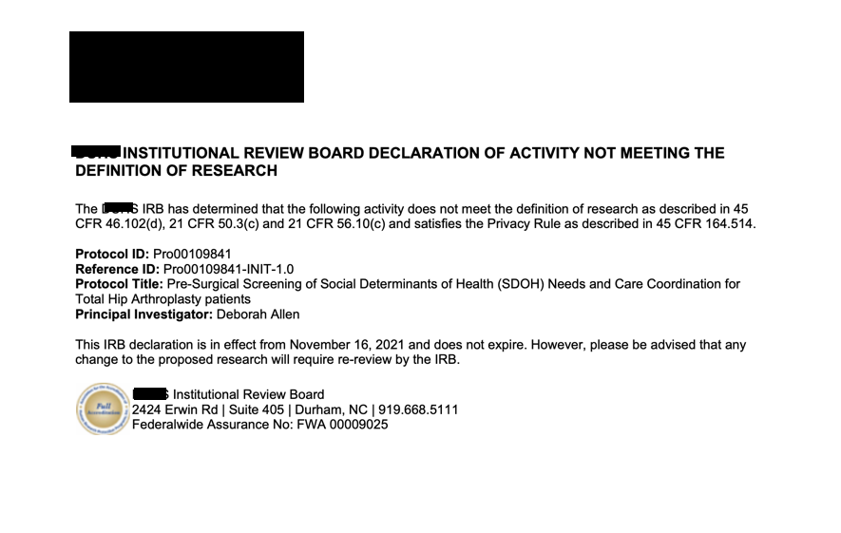

Appendix D
IRB QI Program Evaluation Self-Certification Tool
Project Information:
Name of Project Leader: Andrea Layton
Project Title: Social Determinants of Health and Surgical Outcomes
Brief Description of Project/Goals: The purpose of this evidence-based project is to provide a tool for PAT Clinic staff to assess and identify SDOH needs prior to surgery thereby, improving hand-off communication, increasing referrals to community partners, and reducing readmissions related to SSIs. To address equity in healthcare, the project site will utilize NCCARE360, a care coordination program aimed at connecting patients with community partners and resources. Additional project components include identifying a workflow and educating the PAT Clinic staff regarding how to efficiently use the NCCARE360 tool during the provider visit.

Based on your responses, the project appears to constitute QI and/or Program Evaluation and IRB review is not required because, in accordance with federal regulations, your project does not constitute research as defined under 45 CFR 46.102(d). If the project results are disseminated, they should be characterized as QI and/or Program Evaluation findings. Finally, if the project changes in any way that might affect the intent or design, please complete this self-certification again to ensure that IRB review is still not required. Click the button below to view a printable version of this form to save with your files, as it serves as documentation that IRB review is not required for this project. 11/30/2021

Appendix E
Performance Services SDOH Dashboard
Food Insecurities Screening – PAT Clinic
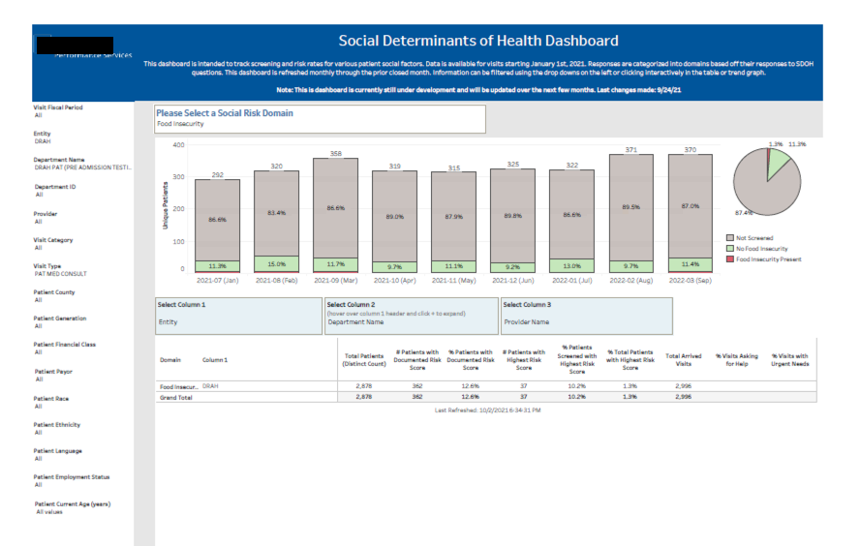

Transportation Screening – PAT Clinic
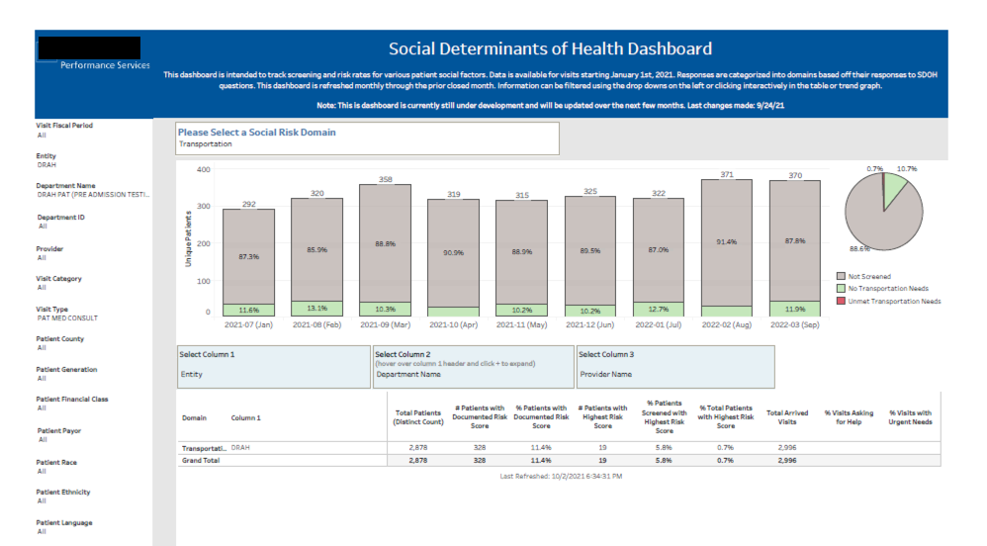

Appendix F
SDOH Screening Checklist
We believe everyone should be able to be healthy. Things like not having enough food or reliable transportation or a safe place to live can make it hard to be healthy.

Would you like help with any of the following needs: Financial Resources, Transportation, Food?
Yes No

If Yes: Please answer the following questions to help us better understand you and our current situation. We may not be able to find resources for all of your needs, but we will try an help as much as we can.

If No: Thank you for your reply. You do not need to answer the following questions.
____________________________________________________________________________________

Financial Resource Strain
How hard is it for you to pay for the very basics like food, housing, medical care, and heating?
Very Hard Hard Somewhat Hard Not Very Hard Not Hard at All
Transportation Needs
In the past 12 months, has lack of transportation kept you from medical appointments or from getting medications?
Yes No

In the past 12 months, has the lack of transportation kept you from meetings, work, or getting things needed for daily living?
Yes No

Food Insecurity
Within the past 12 months, have you worried that your food would run out before you got money to buy more?
Never True Sometimes True Often True

Within the past 12 months, the food you bought just didn’t last and you didn’t have money to get more?
Never True Sometimes True Often True

Additional Information
Are any of your needs urgent? For example: you don’t have food for today
Yes No

If you want someone to talk with you about your resources, please let your provider know during your visit. We can also call you at a later time if you prefer. We may not be able to find resources for all of your needs, but we will try and help as much as we can.

Appendix G
ROI in English
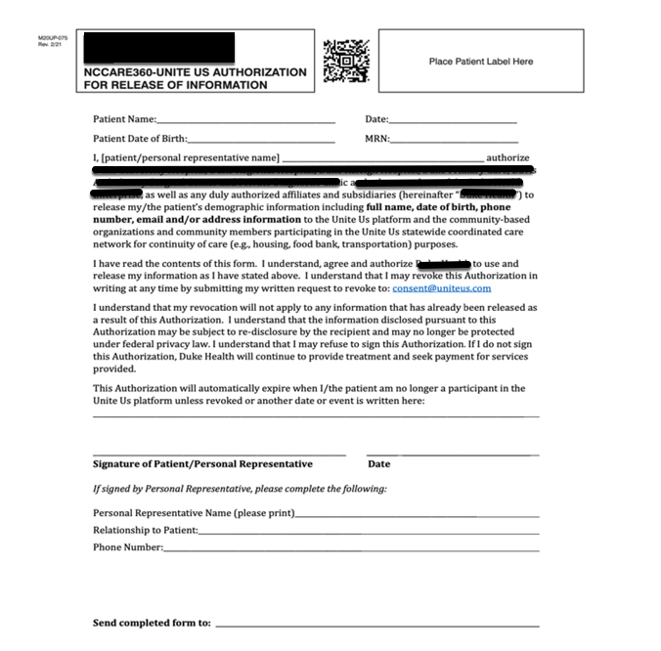

Appendix H
ROI in Spanish
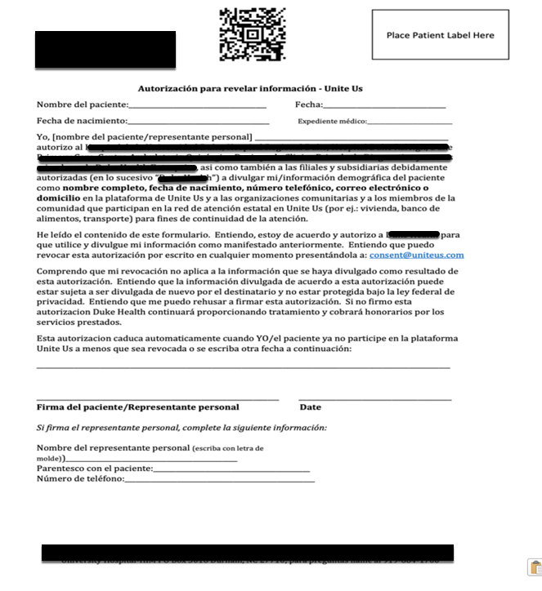

Appendix I
Ambulatory Referral NCCARE360
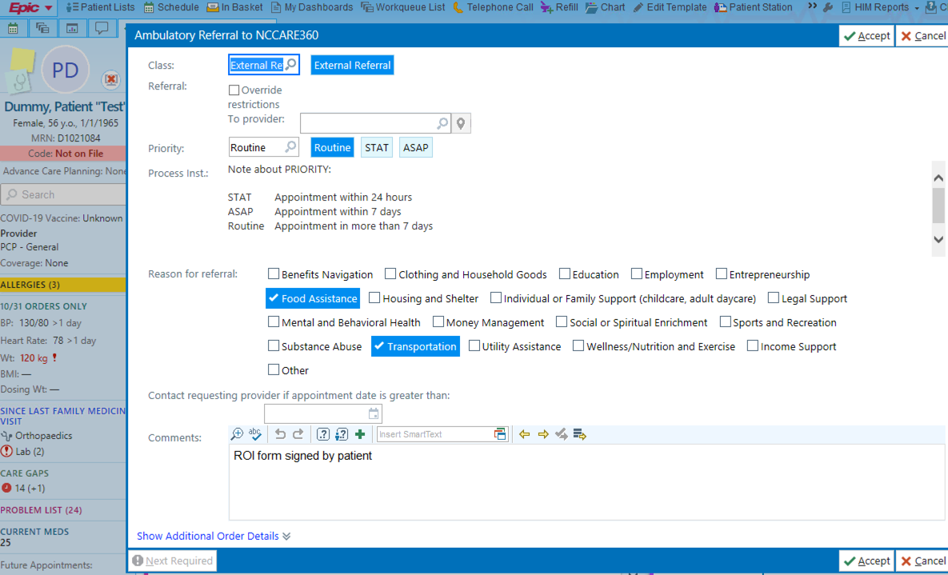
CPT Codes
SOCIAL DRIVER | REASON FOR REFERRAL | POSITIVE SCREEN VISIT DIAGNOSIS | ICD-10 CODE
Transportation Needs | Transportation | Assistance needed with transportation (i.e., to PT appointments, etc.) | Z74.8
Food Insecurity | Food Assistance | Food Insecurity | Z59.4

Appendix J
Clinic Flow Diagram
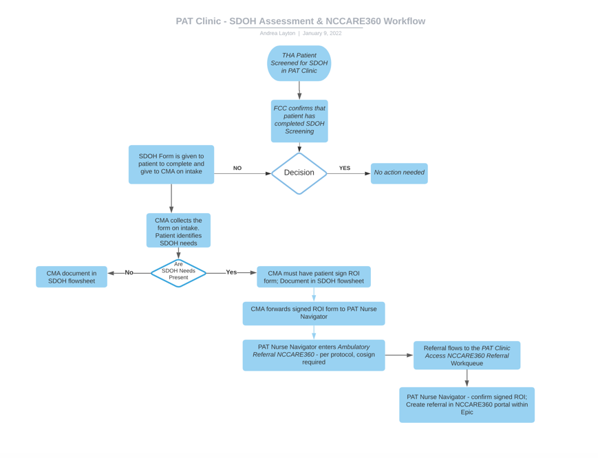

Appendix K
Project Timeline
Objectives | Timeline | Status
Identify problem | May 2021 - July 2021 | Completed
Identify project team and schedule recurring meetings with project site supervisor | May 2021 – July 2021 | Completed
Develop project statement and goals | May 2021 – July 2021 | Completed
Initial Literature Search: SDOH & NCCARE360; Healthy NC 2030; Triple Aim and Strong for Surgery program | May 2021 – July 2021 | Completed
Attendance at health system NCCARE360 planning meetings | June 2021 – July 2022 | Ongoing
CITI Training Modules for University | May 2021 – July 2021 | Completed
Detailed Literature Search: supporting evidence; best practice | July 2021 – September 2021 | Completed
CITI Training Modules for Project Site | October 2021 | Completed
IRB Worksheets | August 2021 – October 2021 | Completed
IRB Application Submission | August 2021 – October 2021 | Ongoing
IRB Project Site IRB | November 2021 | Completed
Epic Requests: NCCARE360 Referral workqueue for PAT Clinic; SDOH questionnaire for patient via MyChart | October 2021 - | Pending
Staff Education | November 2021 – December 2021 | Pending
Project Implementation | January 2022 – April 2022 | Pending
Data Collection | April 2022 – July 2022 | Pending

