Spelling Performance and Attitude:
Using digital word sorts as an extension of regular word sorts to impact spelling performance and attitude scores of 4th grade students with learning disabilities
Jo Shoemaker
East Carolina University

Abstract
The purpose of this single-subject design action research study was to determine how the use of digital word sorts as an extension to regular word study might impact the spelling performance and attitude of two 4th grade students with disabilities. The spelling test averages and attitude surveys scores were analyzed for an increase or decrease in performance of the participants who acted as their own control. An increase in correctly spelled words indicated a positive impact although the attitude survey provided insufficient data for determining change in attitude.
Keywords: digital word sorts, spelling strategies, spelling instruction, attitude

Spelling Performance and Attitude:
Using digital word sorts as an extension of regular word sorts to impact spelling performance and attitude scores of 4th grade students with learning disabilities.
According to the Common Core State Standards (National Governors Association Center for Best Practices (NGAC) & Council of Chief State School Officers (CCSSO), 2010), writing should be included as part of instruction in all content areas. In order to accomplish this task, students benefit from having sufficient knowledge about word spelling patterns and base word meaning (Goodwin, Lipsky, & Ahn, 2012). For children who have specific learning disabilities (SLD) and autism spectrum disorder (ASD), who are more likely to lack these skills and self-confidence, the assignment of composing a written essay can be especially difficult (Howard, Da Deppo, & De La Paz, 2008; Narkon, Wells, & Segal, 2011). Educators need to implement spelling instruction which enables students to feel more confident about themselves as spellers, and in turn increase each student’s desire to maintain proficiency when spelling.
The purpose of this paper is to present the results of an action research proposal which investigated how spelling performance and attitude scores were impacted by the use of digital word sorts when compared to conducting regular word sorts alone. Word sort activities such as developed by Words Their Way (WTW) (Bear, Invernizzi, Templeton, & Johnston, 2012) are accomplished by students manipulating or playing with words, during which they dissect the word to identify rime or spelling patterns, as well as base words and their meanings. A digital form of word sort may aid in bridging the learning gaps of students with SLD and ASD and improve students’ attitudes about spelling and confidence in their spelling skills (Kennedy & Deshler, 2010; Rhodes & Milby, 2007). A literature review that supports the research question follows.
Literature Review
Spelling accuracy is not a natural ability, but an acquired skill. In fact, one study has shown that spelling is more demanding than reading because it requires both the mental processes of retrieving phonemes and graphemes from memory and the physical demands of students such as holding the pencil, aligning the paper for writing, and forming letters (Shahar-Yames & Share, 2008). Students who struggle with spelling and experience frequent assessment failures lose sight of how important it is to build skills and use strategies, which will sustain them during future spellings assessments and attempts at composing written pieces (Sideridis, 2005). Teachers should help students understand why knowing how to spell and using spelling strategies are important. Inevitably, students who only focus on the short term goal of the weekly spelling test, instead of on how much they improved in spelling from the week before, are more likely to continue struggling because they are not maintaining the skills and strategies they already acquired (Alderman & Green, 2011).
Hopefully, as children build strategies and spelling skills, their performance in spelling and grammar will increase and greatly advance the quality of students’ written work. The progression in skills may also improve their attitudes about their own spelling abilities. Troia, Shankland, and Wolbers (2012) stressed the importance of teachers encouraging students to self-correct spelling words and assess their own handwriting, increasing self-confidence about themselves as spellers. In some cases, just being exposed to correctly spelled words is enough to enhance students’ ability to spell accurately. Unlike adults, most children use overt memory strategies to remember the correct spellings of words, which indicates another reason teachers should expose students to complex text when teaching in all content areas (Dixon & Kaminska, 2007). Regardless, some students such as those who have learning disabilities will still struggle with spelling and word recognition (Howard et al., 2008; Narkon et al., 2011).
Students with disabilities cannot rely on normally effective practices to help them to recall the spelling of unfamiliar words because they may not be proficient with the use of the required strategies. In addition, their spelling errors generally appear to be less thought out as those of their peers without disabilities (Howard et al., 2008). Even with the use of conventional spelling aids acquired through a program feature of word processors, which automatically checks for spelling errors, many students with disabilities are not able to identify the correct spelling from the given list of alternative choices (Howard et al., 2008). For this reason, teachers must establish routines of word study in order to enable students with disabilities to develop appropriate spelling skills and strategies in order for them to maintain proficiency. One such method of spelling instruction which has produced positive outcomes is word sorting (Bear, et al., 2012).
Word Sorts
The development of the spelling skills can be enhanced with the use of word sorts, a method of word study instruction recognized as being teacher-directed, yet student-centered (Williams, Phillips-Birdsong, Hufnagel, Hungler, & Lundstrom, 2009). Word study instruction breaks the process of developing the required skills into orthographic layers (e.g. alphabetic, pattern, and meaning) (Bear et al., 2011). As students develop knowledge and skills related to each layer, “print becomes a critical medium for conceptual development” (Bear et al., 2012, p. 1). Educators should promote the development of this knowledge through hands-on activities, such as word sorts, that can be designed specifically to the literacy needs of their students. During words sorts, students categorize a group of words based on self-selected guidelines, such as beginning sounds and vowel or spelling patterns.
As a means of enhancing spelling skill acquisition, teachers should present word sorts that challenge students to investigate words by looking at the context of letter patterns. This will help the students become familiar with letter patterns and determine how words are formed, both of which are integral to understanding the spelling of a word. The search for connections between words during sorts can also improve students’ morphological knowledge based on root words (Goodwin et al., 2012). Inevitably, word sorts can augment improvements in spelling strategies of students and improve how they are able to use the knowledge for correcting errors in written passages (Zutell, 2006).
As teachers conduct spelling instruction, it is important to consider how the type of instruction might impact the number of words students write, the complexity of words used, and the quality of the textual content. One important reason for using word sorts as a learning tool for increasing students’ list of spelling strategies is that the practice supports the forming of words and will likely transfer over to students’ writing assignments (Scott, 2014). Traditional spelling instruction approaches usually lead to the student preparing for a test, then completely forgetting those words and memorizing the new list. Word study models such as WTW (Bear et al., 2012) allow students to slowly learn spelling skills and strategies for optimum attainment. In addition, spelling skills and strategies can be developed from activities involving exposure to complex text, multiple opportunities for using familiar words in writing, as well as the chance to compare correct and incorrectly spelled versions of a word (Dixon & Kaminska, 2007; Evmenova, Graff, Jerome, & Behrmann, 2010; Sharp, Sinatra, & Reynolds, 2008). Furthermore, word recognition activities like word sorts, can strengthen students’ metacognitive skills for knowing how and when to use a variety of spelling strategies (Williams et al., 2009).
The confines of word sorts are not limited to the orthographic knowledge students acquire during the activities. Williams et al. (2009) stated that these study practices are viewed as a social manner of learning, such as when students discuss their reasoning for sorting words in a specific way. Teachers need to provide opportunities for students to share what they have learned because it gives the students a chance to be held accountable for their methods and strategies. Having the opportunity to take ownership for what was learned aids students in increasing self-confidence in spelling abilities as well as contributing to the acquisition of spelling skills of others by sharing the newly acquired knowledge.
Considerations for Students with Exceptional Needs
Studies have shown that some methods of spelling instruction, such as “explicit instruction, multiple practice opportunities, and immediate feedback regarding the accuracy of students’ spelling attempts” (Howard et al., 2008, p. 3) are not effective because of the difficulties students with disabilities have associated with their working memory (Narkon et al., 2008). Regardless, Maehler and Schuchardt (2011) purported that in some cases, these storage capacity deficits were concentrated within the phonological areas of processing.
When designing a spelling curriculum for students with disabilities, a more intense method of mnemonics spelling instruction can increase the chances of success for students with literacy difficulties (Shahar-Yames & Share, 2008). The physical or visual manipulation of words (e.g. word sorts), a type of mnemonics spelling activity, addresses students' diverse learning styles such as visual-spatial. As a result, students with literacy difficulties (e.g. SLD and ASD) are able to tap into the visual-spatial domain storage capacity for recalling the correct spelling of words even when phonological awareness is one of the students’ difficulties (Fischbach, Könen, Rietz, & Hasselhorn, 2014,). Fischbach et al. (2014) asserted “In the visual-spatial domain, storage capacity is mostly found to be not impaired in children with a literacy disorder” (p. 270).
Digital Technology
The integration of technology into English language arts instruction is not a new concept, especially when considering the importance put upon teachers to enable students to become 21st Century Learners. Presentation programs such as Microsoft PowerPoint software simplify the process for constructing student-created eSorts and “digital experience stories” (Zucker & Invernizzi, 2008, p. 655). Although not meant to replace the paper version of the traditional word sort exercises, using technology to extend word study might assist in reaching students with SLD and ASD by providing the option for digitally creating connections to words familiar to the student (Narkon, et al., 2011; Zucker & Invernizzi, 2008). Even more specifically, children with ASD benefit from mnemonic spelling instruction because of their positive response to visual representation through hands-on and digital illustrations as well as written text (Narkon et al., 2011). Narkon et al. (2011) reported an increase in the number of words utilized in writing when computer activities, such as eSorts, were at the center of instruction (Narkon, et al., 2011).
Fortunately, the integration of technology with word study instruction such as conducting eSorts and writing a personal digital experience story is conducive to students with disabilities building spelling strategies, as well as improving their self-confidence and attitudes about spelling (Alderman & Green, 2011; Evmenova, et al., 2010; Graham & Harris, 2005; Sylvester & Greenidge, 2009; Zucker & Invernizzi, 2008). The act of customizing the stories and eSorts provides the students with a personal vocabulary connection and accountability for misconceptions about the spelling of words. Misspelled words from a student-created story should be integrated into a word sort as a means of expanding the student’s word bank and familiarity of the words they included in their personal story (Zucker & Invernizzi, 2008). Another source for words could be the high-frequency words students encounter when reading, from activities outside of school, and words specific to an event the students might have studied (Alderman & Green, 2011).
Attitude and Motivation to Achieve
For many students, their attitude is what compels them to complete a particular task as well as maintaining the skills developed when performing similar tasks. Sideridis (2005) stated that when students find worth and rationale for learning a targeted skill, they are more likely to strive to achieve the skill. Even more specifically, he pointed out that “attitudes and perceived control are qualities that may cause intention and behavior, but goal importance is the variable that describes the quality of those relationships and successful goal attainment” (Sideridis, 2005, p. 89).
One belief called the “Achievement Goal Theory” (Alderman & Green, 2011, p. 599) is based on the concept of students having the motivation or self-confidence about their own skills to preserve newly acquired knowledge. Alderman and Green’s (2011) study focused on two concepts about why students put an effort into succeeding; (1) grade or performance and (2) learning or mastery of a task over time. The premise of the theory is that students who focus more on the short term goal of performance (e.g. the weekly spelling test), instead of the overall mastery of spelling (e.g. how many new words they learned over the previous week), are less likely to stay motivated to maintain the knowledge they had gain and apply it to their writing (Alderman & Green, 2011). Research suggests that students who perform well generally are more concerned about the grade and teacher approval, as well as enjoy challenging other students (Alderman & Green, 2011). On the other hand, students who struggle with spelling resign themselves to being incapable of getting a better grade than other students.
Alternatively, students who focus on the development of their own spelling skills are more apt to concentrate on acquiring the skills needed to continue improving (Alderman & Green, 2011). Teachers should support the students’ desire to master the skill of spelling by evaluating their spelling practices in all curriculum areas. By doing so, teachers will encourage students to appreciate the effort to spelling accurately in all content areas and not just for one good grade on a weekly assessment.
A positive attitude about spelling can also be increased by incorporating activities such as the introduction of word sorting exercises, in which students conduct open sorts as they study the words (Alderman & Green, 2011; Zucker & Invernizzi, 2008). Open sorts are student-centered sorts that demand the “highest level of independent effort and thought” (Bear et al., 2012, p. 63) from students because the students are not given any clues on how to sort the set of words. If the student is not recognizing the target spelling patterns, the teacher provides guidance to direct the student to the pattern and then gradually scaffolds control of the sort to the student. The shift in control encourages self-confidence and eagerness for learning as students build metacognitive skills (Rasinski, 2005).
Some responsibility for choosing what words to include in a word sort can be shifted to the students. Teachers should include students in the decision making process of selecting words by having them analyze the words misspelled on a test or in a written piece to see how it might fit into an existing word sort or to be the basis for a new sort (Alderman & Green, 2011). Ultimately, educators need to put more emphasis on the importance of spelling strategy use, such as with word study concepts, and how to apply the strategies to unfamiliar or more complex words the students may encounter.
In conclusion, a student being able to effectively apply spelling strategies when writing contributes to their ability to construct sentences and the improvement of spelling attitudes and motivation. Even more, ‘going digital’ with word sorts, can drive how creative and proficient the students are when composing written pieces and how well they maintain the newly acquired skills. Supported by the examination of the preceding literature review, the researcher investigated the following question: “How does the use of digital word sorts as an extension of regular word sorts impact the spelling performance and attitude scores of 4th grade students with disabilities?” The procedural details of the action research study conducted follow.
Methodology
This action research study was based on a single-subject design utilizing a baseline and intervention type of research with the participants. The independent variable was word sort instruction with the integration of technology for student activities and was characterized by instruction for using digital technology for word sorts. The dependent variables (see Figure 1) were the students’ spelling and attitude scores. The study was conducted in two parts: Treatment 1 and Treatment 2. Treatment 1 entailed the implementation of regular word study instruction and Treatment 2, the intervention phase, involved regular word study instruction in addition to the digital word sort extension. The scores on the pre and posttest spelling attitude survey (see Appendix A) defined the impact on the participants’ attitude toward spelling and their view of themselves as spellers. The scores on the teacher-created spelling tests were operationally defined by students’ spelling performance scores. The results from tests in Treatment 1 were used to establish baseline data points and scores from Treatment 2 were compared to the baseline scores to show the impact on student spelling performance.
 | Independent Variable: Instruction on Digital Word Sorts (eSorts)
Dependent Variable:  Spelling Attitude Scores | Spelling Attitude Survey (pre and posttests)  Researcher Journal observations
Dependent Variable:  Spelling Scores | Teacher-created spelling tests (baseline and intervention phase)  Researcher Journal observations
Figure 1: Independent Variable: Use of Digital Technology for Word Sort Activities

Participants and Setting
The action research study was conducted in a separate setting classroom at a rural elementary school in eastern North Carolina. At the pre-kindergarten through fifth grade school, which had an enrollment of approximately 532 students at the time of the study, over half of the students participated in the free or reduced-price lunch program. The participants were selected by the teacher/researcher because of their diagnosed disabilities and difficulties with spelling and because they were the researcher’s students. The teacher of record for the intervention group was also the researcher for the action research study. She had less than one year teaching experience in a classroom, but held a position as a Response to Intervention (RtI) tutor for two school years at the target school where the study took place.
The participants were two fourth grade boys, Shawn (pseudonym), a Caucasian student diagnosed with an SLD and Keith (pseudonym), an African American student who had ASD. Both students received Exceptional Children (EC) and related services in an EC separate setting classroom, in addition to resources (e.g. Art, Physical Education, and Music) in regular education settings. Shawn received Occupational Therapy and Speech Pathology services and Keith received Speech Pathology services at the time this study was completed.
Intervention
Per the Common Core State Standards (NGAC & CCSSO, 2010), writing is a skill students are expected to master and attend to in a variety of learning settings. As a result, students need proficient spelling skills that aid in easing some of the frustration they may feel when trying to compose a written piece. The intervention used for this action research study addressed spelling skills by extending regular word study to a digital version as a means of accommodating the disabilities of each participant. The action research study was conducted in two treatments. Treatment 1 ran from January 5 to January 30, 2015, while Treatment 2, the intervention phase, took place from February 2 to March 3, 2015.
Treatment 1
Dates | Instruction | Data
January 5 | Administered Pretest Survey | Pretest Spelling Attitude Survey
January 6 – 9 | Regular Word Study Instruction | Teacher-created Spelling Test
January 12 – 16 | Regular Word Study Instruction | Teacher-created Spelling Test
January 19 – 23 | Regular Word Study Instruction | Teacher-created Spelling Test
January 26 – 30 | Regular Word Study Instruction | Teacher-created Spelling Test
Treatment 2
Dates | Instruction | Data
February 2 – 6 | Week 1 of Digital Instruction | Teacher-created Spelling Test
February 8 – 13 | Week 2 of Digital Instruction | Teacher-created Spelling Test
February 16 – 20 | Week 3 of Digital Instruction | Teacher-created Spelling Test
February 23 – March 3 | Week 4 of Digital Instruction | Teacher-created Spelling Test  Posttest Spelling Attitude Survey
Figure 2: Action Research Study Timeline. The timeline shows the dates, types of instruction, and assessments conducted during the listed time frames.

The intervention in this action research study utilized digital word sort instruction as described by Zucker and Invernizzi (2008). They explained digital word sorts or “eSorts” (Zucker & Invernizzi, 2008, p. 654) can be used as extensions or enhancement to the regular or paper version of word sort instruction. Zucker and Invernizzi (2008) found eSorts to be especially effective with students in the primary grades who had poor attitudes about writing and spelling because of deficient spelling skills, as well as students who, in spite of being instructed on spelling patterns, had difficulties becoming proficient in using the spelling strategies.
Word sorting enables students to use kinesthetic learning to physically place word cards under the header card. For many students, this can be a very effective way of learning. On the other hand, students with SLD or ASD often have difficulty staying engaged in the sorts for lengths of time (Narkon et al., 2011). The digital eSort extends the sort to a process of manipulating the word cards on the computer screen, which can be a more supportive way of learning for children with the disabilities (Zucker & Invernizzi, 2008). For this action research study, the researcher used Microsoft PowerPoint software to create the students eSorts and digital experience stories (Zucker & Invernizzi, 2008). The software provided the option to insert photos of the participant and student-chosen clip art to personalize the contents of the story. This practice has been shown to aid in keeping children with ASD engaged in the activity, thus, increasing the chances for improvement of writing and spelling skills (Narkon et al., 2011).
Before gathering data for the baseline, the researcher utilized the WTW Primary Spelling Inventory (PSI) (see Appendix B) for determining which spelling patterns should be addressed in each student’s initial word sort (Bear et al., 2012). The results were used to help identify the participants’ understanding of orthographic features. The researcher used the accompanying feature guide (see Appendix C) to record errors. The PSI was considered to be a trustworthy measure of “developmental word knowledge” (Bear et al., 2012, p. 29). In addition, Sterbinsky (2007) recognized the validity of the PSI through the administration of the California Standards Test for English Language Arts.
The spelling inventory was conducted in the classroom with only the participants and researcher in attendance. The researcher supplied each student with a #2 sharpened pencil and a modified sheet of paper (see Appendix D), which was prescribed by the occupational therapist as a modification for Shawn’s writing assignments. The answer sheets were previously numbered with the lower portion of each line space highlighted in yellow. The PSI consisted of 26 words, which challenged the participants to spell words that started with CVC patterns that graduated in difficulty up to words with inflectional endings. The researcher followed the suggestions of the developer of the PSI by first stating the word, reading a sentence in which the word was used, and then repeating the word (Bear et al., 2012). The authors suggest continuing the assessment until the participants had misspelled five to six words of the inventory in order to have a sufficient amount of data to analyze for determining a student’s spelling feature skills (Bear et al., 2012). As per the authors’ recommendation, the researcher monitored the participants’ performance and suspended the assessment when the participants had attempted 16 of the 26 which included six words spelled incorrectly.
In order to have baseline data points for comparing data collected during the intervention phase, the research initiated Treatment 1, which entailed the continuation of regular word study instruction that was in place prior to the beginning of the research. A specific time each day was set for sorting words, defining base words, and word hunts. During this phase, the participants conducted paper word sorts using the WTW (Bear et al., 2012) method as part of their regular word study instruction. In addition, the researcher began to record pertinent information about the actions and comments of the students during instruction as well as assessments results.
The purpose for the digital extension version of word sorting, Treatment 2, was to add another dimension for the participants who may not have been able to become proficient using the paper version (Zucker & Invernizzi, 2008). The word sorts also comprised of word hunts, which entailed searching or ‘hunting’ for words with similar spelling patterns in texts as the students read independently and during guided reading. When encouraging students to expand on the words they are willing to attempt spelling for writing assignments, it is important to promote the use of student-selected topics (Graham & Harris, 2005; Narkon et al., 2011). This encouragement was extended to the eSorts in that some of the words for the sorts were drawn from the students’ personal experiences and previous paper word study activities
Due to the need for one-on-one instruction during Treatment 2, a daily 25-minute session was conducted with each participant. In order to accommodate holidays and teacher workdays, the days of intervention were listed as 1, 2, 3, 4, and 5 (see Figure 3). On Day 1 during Treatment 2, each student dictated a personal experience or event to the researcher, who typed the story into a teacher-created PowerPoint template. The story was then customized with digital photographs of the participants and student-selected clip art. The idea of starting with a digital experience story was to establish student accountability, building of self-confidence, and motivation for the development of the eSort (Zucker & Invernizzi, 2008).
Day of Intervention | Treatment 2
Day 1 | Creation of digital experience story: Researcher typed digital experience story into PowerPoint while student dictated. Photos of student were added by researcher (Zucker & Invernizzi, 2008).
Day 2 | Researcher and student reviewed previous word sort and construct eSort. Researcher typed words into eSort template as header cards (Zucker & Invernizzi, 2008).
Day 3 | Student and researcher finalized the eSort by adding words from the digital experience story, independent reading material, and the students’ previous word sorts (Zucker & Invernizzi, 2008).
Day 4 | Researcher and student practiced eSort until automaticity was achieved. Final touches were added in order to personalize the digital experience story (Zucker & Invernizzi, 2008).
Day 5 | Participant shared digital experience story with other participant and challenged him to complete the eSort (Zucker & Invernizzi, 2008). Researcher administered student-specific teacher-created spelling test.
Figure 3: Timeline for Days 1 to 5 Treatment 2 Sessions
Day 2 was dedicated to building and analyzing the students’ existing word sort header cards from the regular word study instruction words sorts. The header cards from the paper version were examined for spelling patterns with special attention to the sound and position of the pattern in the word. It was important to understand the significance of spelling patterns and terminology prior to incorporating new words into the sort (Zucker & Invernizzi, 2008). Next, the researcher opened the PowerPoint template and typed the selected headers into the eSort. The researcher then supported the student through a process of reasoning and synthesizing to construct a word list suitable for the word sort based on the headers. The researcher typed the words on digital word cards as the student dictated.
On Day 3, the student conducted a word hunt by examining the digital experience story more closely for words that fit into the eSort developed the previous day. The researcher provided questioning and modeling to enable the student to locate spelling pattern connections to ensure the student was “internalizing new concepts” (Zucker & Invernizzi, 2008, p. 656). The researcher and student also perused the student’s independent reading materials, as well as guided reading text. Any words appropriate for the sort were included in the eSort. The rationale for investigating multiple materials was to be certain the student was pulling words from all content areas to which he had been exposed (Zucker & Invernizzi, 2008). The researcher assisted the student with adding new words to the previously created word sort. Words were also represented in the story as clip art or a photograph providing additional personal connectivity for the student.
On Day 4 of the intervention week, the student reviewed and practiced the eSort which included 12-15 words until automaticity (95% - 100%) was achieved. The student conducted a self-evaluation of his story in order to develop accountability for successes and errors (Mo, Kopke, Hawkins, Troia, & Olinghouse, 2014). Speed or timed sorts were incorporated into the review of the eSort for an additional challenge. The digital experience story was finalized including editing and for personalization of student-preferred photos and clip art. Then, the student read the digital experience story multiple times to improve fluency in preparation for sharing the digital experience story with others.
To finish each rotation of days, the researcher administered a student-specific teacher-created spelling test to each participant. The tests consisted of 10 words drawn from each student’s personal word sorts. Next, the participants had a chance to demonstrate achievement of the newly acquired knowledge by sharing the digital experience story with his classmate. He challenged the other participant to conduct the student-created eSort (Zucker & Invernizzi, 2008).
Data Sources and Data Collection Procedures
There were three data sources used during the action research study: pre and posttest spelling attitude surveys, teacher-created spelling tests, and researcher reflection journal. Each is described in detail in the paragraphs that follow.
The first quantitative data source was a pre and posttest spelling attitude survey (see Appendix A) administered by the researcher, which was acquired from a Northern Michigan University thesis paper by Kleinpaste (2014), a teacher of first grade students at an elementary school in Michigan. Kleinpaste (2014) conducted research about how students’ involvement in the construction of student-created spelling lists and spelling assessments increased their motivation or attitude toward spelling and word study. She then examined if the process of participating in the tasks influenced how well they performed on spelling tests. Zucker and Invernizzi (2008) found students’ involvement in developing their own instructional tools not only boosted their self-confidence for word study, but also promoted a more positive attitude about literacy in general. The single page survey consisted of 14 questions that were directed towards students’ likes and dislikes of spelling, anxiety they had towards spelling, and how they felt about themselves as spellers. The completion of the attitude survey required the participants to circle the appropriate face (e.g. happy, straight-faced and sad) that depicted how they felt about the statement presented. The researcher introduced the directions and asked if the students understood. Because the participants struggled with reading the opinion statements, the researcher provided support by reading each statement for the students’ clarification.
The second quantitative data source was teacher-created spelling tests based on each student’s personalized word sort. During the baseline phase and intervention sessions of the action research study, the researcher administered a spelling test specific to the students’ word sorts every five days (see Figure 4) for a total of eight assessments for each student. The steps the researcher used for administering the test were the same as the PSI procedures in that each word was read aloud, the word was used in an appropriate sentence, and then the word was repeated. The students were given a sheet of adaptive highlighted lined paper (see Appendix D) for the spelling test. The tests were scored and results recorded on a graph. Data collected from the first four teacher-created spelling tests established the baseline data points. Each Treatment 1 spelling test consisted of ten words drawn from paper version word sorts and the results of the tests were recorded on individual participant graphs. During Treatment 2, the ten assessment words for each test were derived from student-created eSorts, a combination of words from the students’ digital experience story, the regular word sort, and word hunts. After the completion of
Treatment 1, each student’s scores were compared for change in the number of words spelled
Dates | Assessment
January 5 | Pretest Spelling Attitude Survey
January 9 | Teacher-created Spelling Test (baseline phase)
January 16 | Teacher-created Spelling Test (baseline phase)
January 27 | Teacher-created Spelling Test (baseline phase)
January 30 | Teacher-created Spelling Test (baseline phase)
February 6 | Teacher-created Spelling Test (intervention phase)
February 19 | Teacher-created Spelling Test (intervention phase)
February 27 | Teacher-created Spelling Test (intervention phase)
March 3 | Teacher-created Spelling Test (intervention phase)  Posttest Spelling Attitude Survey
correctly on Treatment 2 assessments.
Figure 4: Timeline for Assessment Data Collection
Throughout the action research study, the researcher collected anecdotal data during and after each session with the individual students and recorded it in a researcher reflection journal that served as a qualitative data source. The researcher commented on difficulties and successes the participants had during the lessons and how well they adjusted to using technology compared to the paper version of word sorts. She also recorded how well the participants stayed engaged during each phase of the study, as well as comments from the participants, which added insight into how motivated or discouraged the students were during the activities. In addition, the researcher noted any anxiety or lack thereof the participants had during the baseline and intervention phases of the study.

Data Analysis
The action research study conducted was single-subject research with an AB design meant to show how digital word sorts impacted the participants’ spelling performance and attitude towards spelling. Each participant was his own control and had quantitative measures exhibited in a graph illustrating the results of the spelling test scores for Treatment 1 and 2 and a table displaying the spelling attitude survey scores, as well as a qualitative measure based on entries in the researcher’s reflection journal.
Quantitative. The first quantitative measures were scores from the teacher-created spelling tests (see Figure 4). They were administered during the baseline, to establish baseline data points, and teacher-created spelling tests conducted during the Treatment 2. The number of words spelled correctly was plotted on a line graph, one for each treatment of the study. Upon completion of the action research study, the plotted scores were connected to show change during each treatment. Next, the graphs were analyzed to determine the impact the implementation of the digital word sort instruction had on students’ spelling performance.
The second quantitative source, a spelling attitude survey, was analyzed using a Likert-type scale from which the full-scale raw score was determined and then evaluated for its relationship to the total possible points, 42. The researcher assigned points to each face emotion (e.g. happy – 3, straight-faced – 2, and sad – 1). The responses were scored and analyzed by using a bar graph (see Figure 7) to compare before and after intervention results.
Qualitative. The researcher coded and analyzed the qualitative data in the form of researcher journal reflection notes for themes or trends which pertained to how the participants’ spelling skills improved pre and posttest. In order to accomplish this she first read the journal and noted any general themes in the margins of the hard copy of the paper. The researcher then reread the journal and recorded more specific trends or themes on separate sheets of paper in order to annotate any additional comments and allow for organization of the following themes: attitude and motivation to achieve, ease of learning, shared learning, and application of strategies. She also checked for how the students’ self-confidence for spelling increased or depleted, as well as the how the general motivation or attitude of the participants for conducting spelling, word sorts and hunts was impacted. Finally, the researcher considered how successful the findings of all data answered and/or supported the research question.
Validity and Reliability or Trustworthiness
This single-subject research was susceptible to several internal threats of validity, one of which was time constraints limiting the intended baseline data collected. Due to the demographic of the participants as students with disabilities, keeping the intervention block to four weeks was very important for staying aligned with specific requirements of instruction. The goal was to have enough data points to establish a baseline for adequate comparison to the intervention condition data points (Fraenkel, Wallen, & Hyun, 2012). The researcher intended to establish five baseline data points, but due to weather delays and an extended federal holiday weekend, the projected time frame for completing the research was compromised. As a result, the researcher analyzed the collected data and determined the trends evident in the results of four tests to be sufficient for establishing the baseline points for each student.
An additional internal threat was the degree and speed of change of the participants’ behavior after the intervention was implemented. This was partially controlled by assuring the participants had a good understanding of how to conduct the word sort digitally, which was meant to reduce anxiety and allow for their full engagement in the activity. The final internal threat considered was the testing and the use of constant terms during each phase of the action research study. This was controlled through the use of one researcher.
Lastly, an external validity threat to the study was the lack of ability to generalize results due to size of the group and uniqueness of students and location of the study. In order for the single-subject research study to be generalizable, the treatment must be replicated. Because of the need for one-on-one administration of instruction, the replication of the study should be best carried out with multiple individuals and not groups.
Findings
At the conclusion of the study, the results from the pre and posttest spelling attitude surveys and the teacher-created spelling tests were analyzed to find the difference in averages. Shawn’s Treatment 1 (baseline) spelling test average was 5 out of 10 words spelled correctly, while his Treatment 2 (intervention) tests had an average of 8 out of 10 words correct (see Table 1 and Figure 5). These results suggest the effect of incorporating eSorts as an extension to regular word study instruction had a significant influence on Shawn’s spelling ability since the increase in average of words spelled correctly from Treatment 1 to Treatment 2 improved by 3 words or 60%.
Table 1.

Treatment 1 and Treatment 2 Teacher-Created Spelling Tests Averages.

 | Treatment 1 | Treatment 2
Shawn | 5 | 8
Keith | 9 | 8.75

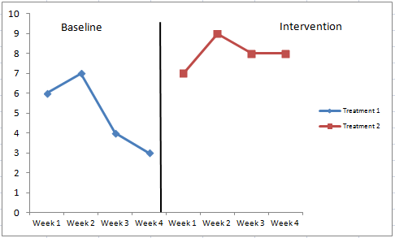

Figure 5. Line graph of Shawn’s spelling test data. This figure shows the results of the Treatment 1 and Treatment 2 spelling tests based on the number of words out of 10 spelled correctly.

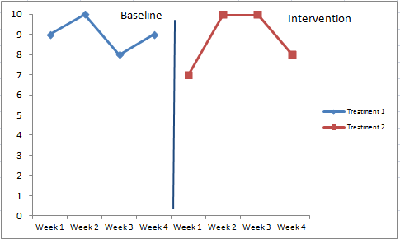
On the other hand, the data from Keith’s Treatment 1 and 2 assessments indicated a different outcome on his spelling ability from the execution of eSorts as an extension. Keith’s Treatment 1 spelling tests average was 9 words spelled correctly and the Treatment 2 spelling test average was 8.75 words correct (see Table 1 and Figure 6). The results show little to no impact on Keith’s spelling performance from the integration of eSorts as an extension. The scores Keith received on his tests were inconsistent in number of words spelled correctly (Treatment 1: 9, 10, 8, 9; Treatment 2: 7, 10, 10, 8) during Treatment 1 and 2, which could be attributed to Keith’s disability of autism and the amount of distractibility he experienced on specific days.

Figure 6. Line graph of Keith’s spelling test data. This line graph shows the results of the Treatment 1 and Treatment 2 spelling tests based on the number of words out of 10 spelled correctly.
The effect the intervention had on the participants’ attitude about spelling, words sorts, and how they viewed themselves as spellers had little to no impact. Keith’s pretest spelling attitude survey score of 98% remained the same on the posttest survey. Shawn’s pretest spelling attitude score was 100% and decreased by 7% to 93% on the posttest survey (see Table 2 and Figure 7).
Table 2.
Pre and Posttest Spelling Attitude Survey Percentages.
 | Pretest | Posttest
Shawn | 100 | 93
Keith | 98 | 98
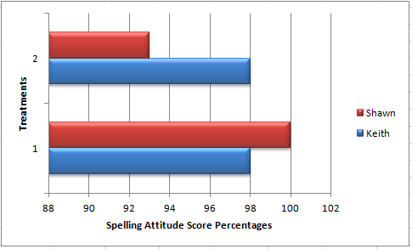

Figure 7. Pre and Posttest Spelling Attitude Survey Score Percentages. This bar graph shows the results of the Pre and Posttest Spelling Attitude Survey Scores.

During the eight weeks of the action research study, the researcher recorded detailed notes in a reflection journal about what was observed, heard, and implemented by the researcher and participants, based on happenings of Treatment 1 and 2. The qualitative data collected was then analyzed for themes or trends that indicated if the participants’ spelling skills increased or depleted. The researcher also analyzed the data for how the participants’ general attitude or motivation for spelling, conducting word sorts and hunts was impacted, as well as how the use of eSorts met participants’ learning needs. Finally, the researcher considered how successful the findings of the data answered and/or supported the research question.
Attitude and motivation to achieve. After only a few days of the implementation of Treatment 1, the researcher noted in her journal the frustration the participants displayed as they conducted word sorts and hunts based on unfamiliar spelling patterns or concepts. Keith expressed his disapproval by commenting, “We always have to do homework.” When the researcher asked to what he referred, he pointed to his word cards and notebook. Likewise, when Shawn conducted an initial word sort for a set of words, he began sorting the words by beginning sound, a very basic method of categorizing. The researcher then instructed him to look at the words more closely and sort them based on vowels sounds to which he replied, “This is hard.” Occasionally, the disappointment extended to the simple act of preparing words for the sort. In Shawn’s case, he struggled with cutting up the word cards and gluing them in his notebook due to difficulties with his fine motor skills. He dealt with the situation by gluing the words haphazardly in the book and stated an abrupt “I’m done!” Keith required regular prompting and encouragement in order to complete several of the sorts.
On the other hand, the researcher annotated the excitement the participants expressed after she explained the process of steps they would carry out during Treatment 2, especially when describing the students’ personal digital stories that would be created. Because the regular word study instruction was conducted simultaneously with Treatment 2, one student completed word sorts, blind writing sorts, and word hunts while the other worked alongside the researcher on the computer. Ultimately, the opportunity to conduct eSorts became an incentive for applying concentration when performing regular word study sorts, which were expected to be completed prior to moving onto the eSorts and digital story modifications. As the researcher worked with Keith, Shawn was to sort and write his target words in his word study notebook. In response to the direction of his beginning the task, Shawn indicated his enthusiasm for using the computers for eSorts by asking “Don’t we get to do it on the computer?”
The researcher also examined the difference in themes pertaining to the participants’ attitudes and motivation to expand on word sorts in Treatment 1 and eSorts in Treatment 2 through word hunts. As the researcher read articles to the participants during Treatment 1, the students struggled to stay focused and lacked confidence when stating a word they believed applied to the CVCe rule. The lack of confidence or good attitude about themselves as spellers might have affected how well they were able to recognize a new spelling pattern in a word. Conversely, readings of articles for a word hunt in Treatment 2 brought about the following acclamations from the participants as the students became more attentive to familiar and unfamiliar spelling patterns. Shawn proudly shouted, “I found one!” while Keith demanded “Wait, wait, I think this is one!”
Although Keith’s spelling test average in Treatment 1 was 9 correctly spelled words, Shawn averaged only 5 correctly spelled words. The researcher noted that the students’ lack of motivation and difficulties demonstrated during the regular word study sorts were reflected in their performance on spelling tests. Specifically, if they were not motivated or interested during the regular word study, they may not have scored as well on the assessments. Fortunately, this trend changed in Treatment 2 as noted by the researcher in her journal as the spelling tests scores and observed enthusiasm increased, which could be the result of creating and conducting eSorts on the computer. Shawn stated on several occasions as he maneuvered words across the screen as he sorted, “This is easy!”
Ease of learning. The researcher analyzed the qualitative data for themes which indicated how easy or difficult it was for the students to learn about spelling patterns during Treatment 1 and 2. The fact that the participants dictated the personal digital story to the researcher as she typed encouraged the students to compose a story which included words they normally used. The result was the participants’ use of words that they recognized by sound, which allowed for further examination of the spelling patterns. Keith demonstrated this by pointing out the words gave and have in his story about going to Chuck E. Cheese. He recognized the CVCe pattern in each, but noted “Have is an oddball word because the /a/ is short.” The researcher also recorded several instances of observing Keith’s good computer skills especially when conducting eSorts. He categorized the words with ease by moving the text boxes to the correct columns while enlarging font to better suit his needs.
For Shawn, the act of writing words for a sort was very frustrating. His difficulties with writing legibly in Treatment 1 became worse when frustrated and he responded by writing faster. As a result when Shawn tried to read some of the words back to the researcher, he was not able to interpret the text because they were illegible. With the use of the computer for eSorts, Shawn was able to type his new words in preexisting text boxes and read the words with no problem. Even so, Shawn struggled with maneuvering the text boxes and would occasionally enlarge a box or delete the box and the words entirely. In spite of his learning differences, Shawn continued the eSort and completed the task, to which he proudly proclaimed, “This is easy!” As a result of going digital, Shawn’s stress level may have been lowered allowing him to put more attention to identifying similar spelling patterns between words which aided in increasing his spelling abilities.
Shared Learning. On several occasions, the researcher observed that the boys were becoming more relaxed when working together or as they conducted eSorts and dictated personal digital stories. For example, the participants exhibited confidence in what they knew as they quizzed each other or when ‘playing teacher’ while determining which category to place words in their paper version sorts and eSorts. Shawn asked with assurance “What part of the word tells you if the /a/ is long or short.” The collaborative study the students conducted provided Shawn with the opportunity to take ownership for what he learned. As the confidence of each student increased the researcher noticed so did the overall amount of times (Treatment 1: 1 – 2 times; Treatment 2: 3 – 4 times) they interjected during the discussions with the reciting of spelling pattern rules.
The researcher also noted moments of humor and student imitations of the researcher when she directed the students to expand on their thoughts about spelling patterns. Shawn asked Keith “What do you need to look for when trying to figure out a new word?” On the same day, Keith began singing “What’s new pussycat? Whoa-oa-oa-oah!” as he sorted words. The relaxed antics of the students may have indicated an increase in self-confidence as they worked.
Applying strategies with confidence. The participants’ use of familiar and effective strategies was a common occurrence throughout the action research study. Shawn had developed his own strategies which included counting out phonemes on his fingers and specifically emphasizing the vowel sound to determine whether a short or long vowel sounded better in the word. Keith also sounded out words during the tests. Even so during Treatment 1, the participants were hesitant and confused about explaining word placement choices when the researcher asked them why they made the choices they did.
During Treatment 2, the researcher noted in her journal that the student’s tendency to being confused during word sort discussions subsided as the participants began to watch more closely how the words were formed in respect to CVCe, CVC, and CVVC spelling patterns. On one occasion when the researcher asked Shawn what he watched for or how he could tell which words would fit into his eSort, he exclaimed “I watch for Mama E” (Secret Stories CVCe spelling pattern) (Garner, 2015). He went on to explain how Mama E demands “Say your name.” Keith also relied on the CVCe pattern rule. In another Treatment 2 session, the researcher directed Keith to read the words in his eSort to ensure he understood their spelling pattern association. Keith started to pronounce lāne as lăn, when he suddenly stopped and shook his finger as he interjected “Wait! Oh, I know, ‘Say your name’!” He then asserted, “The word is lane.” The lessening of needed reassurance from the researcher about their choices in Treatment 2 could be because of the students’ acquisition of metacognitive skills and then the application of the strategies when spelling and sorting words.
When conducting eSorts on the computer, the students’ ability to recognize spelling pattern associations between the words was enhanced which enabled them to connect more easily with unfamiliar words to their commonly read and spelled vocabulary. During a Treatment 2 spelling test, Keith corrected himself when he spelled said as side. He began spelling “s-i-d…” then hesitated, “and e because it is long.” After a moment, Keith erased what he had written, changing it to the correct spelling of said. This is a student who on the first spelling test of Treatment 1, rarely thought twice about the words he sounded out as he wrote it on the test sheet. By the end of the intervention, he was remembering to apply the strategies he knew and utilize them to immediately fix his own errors demonstrating confidence in the new knowledge he had gained.
Discussion/Conclusions
The purpose of this study was to determine how the use of eSorts impacted the spelling performance and attitude scores of 4th grade students with disabilities. The researcher projected the data would support the theory that the participants’ pretest spelling assessment score average would increase over the time of the intervention and be overshadowed by the posttest spelling assessment score average due to improved spelling skills. She also anticipated that the participants’ spelling attitude would increase and be evident from pre and posttest survey scores. The increase in the spelling test score averages and spelling attitude survey scores would be attributed to the incorporation of conducting eSorts as an extension to the regular spelling instruction provided by the researcher. According to the quantitative data collected and evaluated, the results only partially support the researcher’s theories. Although the attitude survey scores proved insignificant for demonstrating an improvement in the participants’ attitudes about spelling, the qualitative data show that there was a positive impact from the integration of the digital eSorts on attitudes and motivation, as well as building spelling skills.
The effect the utilization of eSorts had on the participants’ spelling skills was most evident in Shawn’s increase in correctly spelled words. The data show he increased his average from 5 words spelled correctly in Treatment 1 to an average of 8 words correct in Treatment 2, which was a 60% increase in spelling performance. Research shows that the integration of technology with spelling instruction aids in enabling students with disabilities to build spelling strategies and improve spelling skills (Alderman & Green, 2011; Evmenova, et al., 2010; Graham & Harris, 2005; Sylvester & Greenidge, 2009; Zucker & Invernizzi, 2008).
On the other hand, Keith’s correctly spelled word average was 9 in Treatment 1 while his Treatment 2 scores averaged at 8.75 words spelled correctly, a slight decrease of 2.7%. Although he did not demonstrate an increase in spelling skills, Keith’s scores remained elevated throughout the intervention. Williams et al.’s (2009) study found word recognition activities like word sorts, can strengthen students’ metacognitive skills for knowing how and when to use a variety of spelling strategies therefore helping them to sustain accuracy in spelling.
Previously released research was reviewed by the researcher that supported the conclusions she found about which instructional methods aided students with disabilities in building spelling skills and augmenting attitudes about spelling. The researcher incorporated the use of research-based instruction when directing the students through composing personal digital stories and eSorts. The characteristics of the participants’ disabilities played into how well the digital extension aided in helping the students connect to the words they selected for the eSorts. Narkon, et al., (2011) and Zucker and Invernizzi (2008) found that the integration of technology to extend word study assists in reaching students with SLD and ASD by providing the option for creating connections to familiar words.
While observing the participants as they studied together and quizzed each other on targeted words, the researcher noted an increase in motivation to participate and be accountable for knowledge about spelling patterns. Williams et al. (2009) pointed out that study practices can be viewed as a social manner of learning, such as when the students conversed about their reasoning for sorting words in a specific way. The collaborative study the students conducted provided them with the opportunity to take ownership for what they learned. If the students are more confident about what they know, the result may be that they will apply the knowledge effectively when addressing more complex spelling pattern concepts. According to Williams et al. (2009), this type of opportunity augments the chances students have for improving self-confidence and their attitude about spelling abilities as well as contributing to the acquisition of spelling skills of others by sharing the newly acquired knowledge.
Spelling is a skill which demands more from the participants than simply mental recall, such as the physical aspect of writing the words (Sharar-Yames & Share, 2008). The difficulties Shawn had with writing the words for word hunts were counteracted by the option for typing and maintaining control of words to type. As Shawn built skills with the computer program, he began to become more confident and very eager to conduct eSorts including volunteering to be first, which is similar to what Sideridis found in his study (2005). Sideridis (2005) stated that a good attitude and control of learning can boost a student’s motivation. When referring to the students in his study, he added “the paths linking perceived control and intention were significantly stronger for the high spelling group” (Sideridis, 2005, p. 101).
During Treatment 1, Keith asked many questions of the researcher about where to place unfamiliar words in categories during word sorts. This practice changed in Treatment 2 as noted in qualitative data gathered by the researcher. The data show that Keith was very enthusiastic about creating personal digital stories and expanding on his eSorts. As a result, he increased his options of sources for familiar and unfamiliar words to be included in sorts. The inclusion of correctly (familiar) and incorrectly (unfamiliar) spelled words in his eSorts challenged Keith to question what he knew about the word patterns. When Keith applied the CVCe spelling pattern rule to his incorrect spelling of said, he may have recognized that the spelling could not be correct because when he repeated what he wrote, it did not sound like the pronunciation he heard from the researcher. This action is parallel to what was indicated in a study by Dixon and Kaminska (2007). The knowledge or strategy of using the CVCe spelling pattern rule as a baseline for analyzing his first attempt at spelling the word may have helped Keith realize the error and provoked him to consider another or correct spelling of the word. Studies have shown that given the chance to compare and analyze letter patterns of correctly and incorrectly spelled versions of a word provides opportunities for students to develop effective strategies and spelling skills (Dixon & Kaminska, 2007; Evmenova et al., 2010; Sharp et al., 2008).
Limitations
As a single-subject action research design, there were several limitations to the study. The first was a sample size of two students which restricted the generalization of population outside the study due to the number of students, uniqueness of their disabilities, and location of the study. Even though one of the participants made significant gains in spelling skills as projected by the researcher and supported her hypothesis, this might not be true for other samples. Replicated research should be conducted with more students so to effectively generalize the findings.
Despite the different disabilities of the students, another limitation would be the distractibility of each student. Although the triggers for this quality varied by student learning differences, the ‘lack of focus’ resulted in the same learning block for each student. Subsequently, the reading and phonemic awareness skills of the students were also similar which limited the investigation of other disability characteristics responsible for their learning difficulties.
A third limitation was the restricted length of time of four weeks for conducting the research. Inclement weather, field trips, and benchmark testing called for modifications to be made to the projected schedule. In addition, because students with disabilities have required amounts of time for service in the different content areas, the researcher could not deviate outside of the restricted service parameters when trying to gather additional information.
Implications for Educators
The results of this study revealed that using eSorts as an extension to regular word study positively impacted the spelling skills and attitudes of students with disabilities. Fortunately, this effect on students’ spelling performance and motivation for advancement is not restricted to children with disabilities. The integration of technology into word study expands the type of word study methods students may utilize and is generally a more enticing medium common to the 21st Century Learners of today. Regular education teachers might use this method to differentiate instruction for children with disabilities and children who have been taught spelling patterns but have difficulty mastering them (Zucker & Invernizzi, 2008). It could be incorporated as an incentive for those who have mastered the list of words, type of game for review, and as a home extension to promote parent involvement.
For special and regular education teachers, knowing and understanding the results of this study is beneficial because the research-based strategies provide the means for teachers to scaffold control of learning onto their students. The opportunity to create digital stories based on personal events provides ways for students to connect with and use words common to their general vocabulary, which encourages accountability, building of metacognitive skills, and improving students’ attitude about spelling (Rasinski, 2005; Williams et al, 2009).
Future Directions for Research
In this study, the results for one student with disabilities were significant in increasing his spelling performance. The second student’s spelling performance and attitude scores were constant even though his use of strategies improved. As a result, the recommendation for future study by the researcher is due to the small population and the need for examining spelling attitudes with a wider variety of students in regular and special education environments. The research was confined to the two students in an EC separate setting classroom. This is not typical of a regular education classroom and is another reason future research should be conducted in an inclusive environment where students with and with disabilities are learning together. For the participants, English was their native language, therefore, including students for whom English is a Second Language is recommended.
In respect to incorporating digital word study practices into lessons for children with autism such as Keith, the researcher found that when he became fixated on personal events that were disturbing or exciting, his learning during the study was hindered. After creating a digital story, Keith decreased his fascination with the event and was able to stay more focused. The researcher suggests future studies be conducted on the concept of using digital methods (e.g. composing digital personal stories as a resource for creating eSorts) when performing word study, which may result in helping students stay more engaged during a lesson.
Significance of Evidence-Based Research
Prior to conducting the study, the researcher reviewed literature and examined how what she summarized about various methods of word study could aid in enhancing her students’ learning. Previous research conducted by Zucker and Invernizzi (2008) utilized evidence-based word study methods for improving spelling skills, which the researcher had used for two previous case studies. The needs of the two students were different which required differentiated instruction. Williams et al. (2008) set the goal of differentiating instruction by enabling students to customize their own learning such as through the creation of digital personal events and learning-specific eSorts. As well, in Sideridis’ (2005) study, students who believed they were in control of their own learning were from the higher performing group of spellers.
As to be expected, how students view themselves as learners can drive how well they perform in any content area. Rasinski found that a shift in control of learning encourages self-confidence and eagerness for learning as students build metacognitive skills (Rasinski, 2005). The result was an increase in the motivation to stick with the task as well as ease learning by incorporating familiar vocabulary into the word sorts which is parallel to what the researcher found in her study.
Reflection
Conducting the action research project in the classroom with my own students reaffirmed that I am truly a person who needs ‘to do’ in order to learn, which I believe is a quality that is beneficial for a person who has committed to filling the role of teacher/researcher. While executing the action research assignment in my separate setting classroom, I discovered I was continually performing research as I differentiated instruction for my students’ individual needs in all content areas. The process I carry out on a daily basis even includes the recording of anecdotal notes and data about what my students are learning and where they need further instruction. The value of understanding action research and how it can help in the classroom will only further my desire to investigate how I can better my methods of determining the best instruction practices. As students begin to achieve the expectations put before them, a teacher/researcher must explore more complex methods of instruction which enable students to become independent learners. For this reason, the need for action research will continue because of the diverse learning needs of students and a teacher/researcher’s desire to meet those needs.
In an effort to help my students, I chose to conduct research about eSorts for spelling intervention because of the difficulties they had with spelling and writing on their own. As I first observed Shawn and Keith during writing assignments, I saw two boys who became frustrated while struggling to spell short 3-letter words. Fortunately, they began to build confidence in their skills, which is what I believe was the key to enabling them to use the strategies they already knew about spelling. The students not only benefitted from my one-on-one assistance but also the chance to share learning with each other in a new way. After considering each student’s learning differences, I chose two boys who were very laid back and generally eager to learn, so I knew it would be a good experience and hopefully favorable for me to obtain the information I needed.
I found from completing a literature review that the skills and strategies students need to become good spellers extend beyond being capable of memorizing the sequence of letters in each word on a spelling test. In order to maintain the skills, they need to understand how to use effective strategies with any word they may encounter in readings. Therefore, based on the research question of this action research study, “How does the use of digital word sorts as an extension of regular word sorts impact the spelling performance and attitude scores of 4th grade students with disabilities?,” the suspected outcomes of the intervention were an improvement in spelling performance and spelling attitude scores. As the researcher, I think the results of the integration of digital word sorts promoted a boost in the participants’ self-confidence as spellers. I also believe the participants will continue to utilize spelling strategies obtained through the construction and completion of word sorts in order to preserve the skills acquired.
As the research sessions transpired, the changes I noted in the students’ attitudes from Treatment 1 to Treatment 2 were significant enough for me to make using eSorts a regular part of weekly spelling activities. Even so, the spelling attitude survey turned out not to be a good piece of data. The results failed to reinforce what I noted in my qualitative data about the increase in the students’ motivation. In addition, as I read the questions to the students, Keith kept looking at Shawn’s survey for his response and Shawn stated “I am just going to circle all happy faces.” This led me to believe early on that I would have to depend on other data for confirmation of my hypothesis about spelling attitude.
When considering the research I conducted from an EC teacher aspect, I discovered an added benefit for Keith, a child with autism. The actual task of dictating stories to me as I typed them into PowerPoint and then seeing them in print seemed to enable Keith to let of out some pent up anxiety stemming from the events on which the stories were based. His fixation on them subsided and were rarely mentioned again allowing for him to better focus on the words to be drawn from the stories for future eSorts.
Ultimately, the task of conducting research and finding my way around a classroom as a beginning teacher while constructing a functional learning environment was stressful, enlightening, a bit crazy, and very funny thanks to the boys in my classroom. I am still not where I want to be, yet, I know I have acquired effective teaching strategies while completing this research that will help me provide effective instruction for my students’ diverse needs. I have no doubt it will continue to be an awesome experience!

References
Alderman, G. L., & Green, S. K. (2011) Fostering lifelong spellers through meaningful experiences. The Reading Teacher, 64(8), 599-605. doi: 10.1598/RT.64.8.5
Bear, D. R., Invernizzi, M., Templeton, S., & Johnston, F. (2012). Words Their Way: Word Study for Phonics, Vocabulary, and Spelling Instruction. Upper Saddle River, NJ: Pearson Education, Inc.
Dixon, M., & Kaminska, Z. (2007). Does exposure to orthography affect children’s spelling accuracy? Journal of Research in Reading, 30(2), 184-197. doi: 10.1111/j.1467-9817.2007.00337.x
Evmenova, A. S., Graff, H. J., Jerome, M. K., & Behrmann, M. M. (2010). Word prediction programs with phonetic spelling support: Performance comparisons and impact on journal writing for students with writing difficulties. Learning Disabilities Research & Practice, 25(4), 170-182. doi: 10.1111/j.1540-5826.2010.00315.x
Fischbach, A., Könen, T., Rietz, C., & Hasselhorn, M. (2014). What is not working in working memory of children with literacy disorders? Evidence from a three-year-longitudinal study. Reading & Writing, 27(2), 267-286. doi:10.1007/s11145-013-9444-5
Fraenkel, J. R., Wallen, N. E., & Hyun, H. H. (2012). How to Design and Evaluate Research in Education. New York, NY: McGraw Hill.
Garner, K. (2015). Secret stories. Retrieved from http://thesecretstories.com/
Goodwin, A., Lipsky, M., & Ahn, S. (2012). Word detectives: Using units of meaning to support literacy. The Reading Teacher, 65(7), 461-470. doi: 10.1002/TRTR.01069
Graham, S., & Harris, K. R. (2005). Improving the writing performance of young struggling writers: Theoretical and programmatic research from the center on accelerating student learning. The Journal of Special Education, 39(1), 19-33. doi: 10.1177/00224669050390010301
Howard, S., Da Deppo, L. M. W., & De La Paz, S. (2008). Getting the bugs out with PESTS: A mnemonic approach to spelling sight words for students with learning disabilities. TEACHING Exceptional Children Plus, 4(5), 1-12. Retrieved [date] from http://escholarship.bc.edu/education/tecplus/vol4/iss5/art3
Kennedy, M. J., & Deshler, D. D. (2010). Literacy instruction, technology, and students with learning disabilities: research we have, research we need. Learning Disability Quarterly, 33(4), 289-298. doi: 10.1177/073194871003300406
Kleinpaste, A. N. (2014). The effects of individualized, student-selected spelling lists on elementary student learning and motivation. The Commons: NMU Master's Theses. Paper 28. Retrieved from http://commons.nmu.edu/cgi/viewcontent.cgi?article=1025&context=theses
Maehler, C., & Schuchardt, K. (2011). Working memory in children with learning disabilities: Rethinking the criterion of discrepancy. International Journal of Disability, Development & Education, 58(1), 5-17. doi:10.1080/1034912X.2011.547335
Mo, Y., Kopke, R. A., Hawkins L. K, Troia, G. A., & Olinghouse, N. G. (2014). The neglected “r” in a time of Common Core. The Reading Teacher, 67(6), 445-453. doi:10.1002/TRTR.1227
Narkon, D. E., Wells, J. C., & Segal, L. S. (2011). E-word wall: An interactive vocabulary instruction tool, for students with learning disabilities and autism spectrum disorder. TEACHING Exceptional Children, 43(4), 38-45. doi: 10.1177/004005991104300404
National Governors Association Center for Best Practices (NGAC) & Council of Chief State School Officers (CCSSO). (2010). Common Core State Standards for English language arts and literacy in history/social studies, science, and technical subjects. Washington, DC: Authors. Retrieved from http://www.corestandards.org/
Rasinski, T. (2005). Making and writing words: Constructivist word learning in a second grade classroom. Reading & Writing Quarterly, 21(2), 151-163. doi: 10.1080/10573560590915950
Rhodes, J. A., & Milby, T. M. (2007). Teacher-created electronic books: Integrating technology to support readers with disabilities. The Reading Teacher, 61(3), 255-259. doi:10.1598/RT.61.3.6
Scott, R. M. (2014). Using digital technologies to support word study instruction. What Works? Research into Practice. Retrieved from http://www.edu.gov.on.ca/eng/literacynumeracy/inspire/research/WW_UsingDigitalTech.pdf
Shahar-Yames, D., & Share, D. L. (2008). Spelling as a self-teaching mechanism in orthographic learning. Journal of Research in Reading, 31(1), 22-39. doi: 10.1111/j.1467-9817.2007.00359.x
Sharp, A. C., Sinatra, G. M., & Reynolds, R. E. (2008). The development of children’s orthographic knowledge: A microgenetic perspective. Reading Research Quarterly, 43(3), 206-226. doi: org/10.1598/RRQ.43.3.1
Sideridis, G. D. (2005). Attitudes and motivation of poor and good spellers: Broadening planned behavior theory. Reading & Writing Quarterly: Overcoming Learning Difficulties, 21(1), 87-103. doi: 10.1080/10573560590523685
Sterbinsky, A., PhD. (2007). Words Their Way spelling inventories: Reliability and validity
analyses. Center for Research in Educational Policy
Sylvester, R., & Greenidge, W. (2009). Digital storytelling: Extending the potential for struggling writers. The Reading Teacher, 63(4), 284-295. doi:10.1598/RT.63.4.3
Troia, G. A., Shankland, R. K., & Wolbers, K. A. (2012). Motivation research in writing: Theoretical and empirical considerations. Reading and Writing Quarterly, 28 (1), 5-28. doi:10.1080/10573569.2012.632729
Williams, C., Phillips-Birdsong, C., Hufnagel, K., Hungler, D., & Lundstrom, R. P. (2009). Word study instruction in the K–2 classroom. The Reading Teacher, 62(7), 570-578. doi: 10.1598/RT.62.7.3
Zucker, T. A., & Invernizzi, M. (2008). My eSorts and digital extensions of word study. The Reading Teacher, 61(8), 654-658. doi: 10.1598/RT.61.8.7
Zutell, J. (2006). Word sorting: A developmental spelling approach to word study for delayed readers. Reading & Writing Quarterly: Overcoming Learning Difficulties, 14(2), 219-238. doi: 10.1080/1057356980140205

Appendix A
Spelling Attitude Survey

Name: ________________________________________________ Date: ____________________________

1. When I take a spelling test I feel happy because I know I will do well.
☺ 😐 ☹
2. I enjoy working with my spelling words.
☺ 😐 ☹
3. I am a smart spelling student.
☺ 😐 ☹
4. I like doing my spelling homework.
☺ 😐 ☹
5. I use spelling rules in my writing.
☺ 😐 ☹
6. It is important to me to do well in spelling.
☺ 😐 ☹
7. I feel nervous during a spelling test because I think I’ll get some wrong.
☺ 😐 ☹
8. I like learning about spelling.
☺ 😐 ☹
9. I often practice my spelling words at home.
☺ 😐 ☹
10. I enjoy doing word-work during daily 5.
☺ 😐 ☹
11. I practice my spelling words because I want to do well.
☺ 😐 ☹
12. I like getting good grades in spelling.
☺ 😐 ☹
13. I want to practice my spelling words.
☺ 😐 ☹
14. I feel like I have choice in spelling.
☺ 😐 ☹
Kleinpaste, A. N. (2014). The effects of individualized, student-selected spelling lists on elementary student learning and motivation. The Commons: NMU Master's Theses. Paper 28.
Appendix B
Appendix B
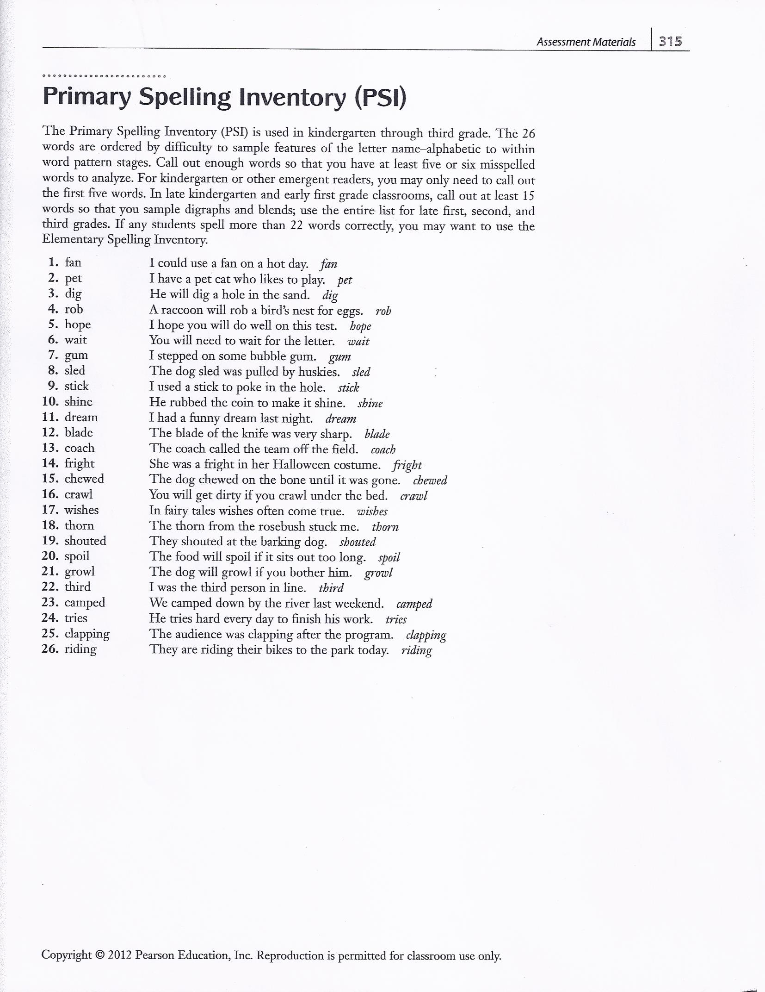
Words Their Way Primary Spelling Inventory Instructions
Appendix C
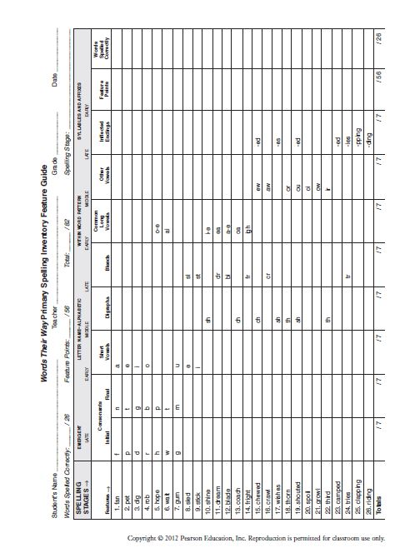
Words Their Way Primary Spelling Inventory Feature Guide
Appendix D
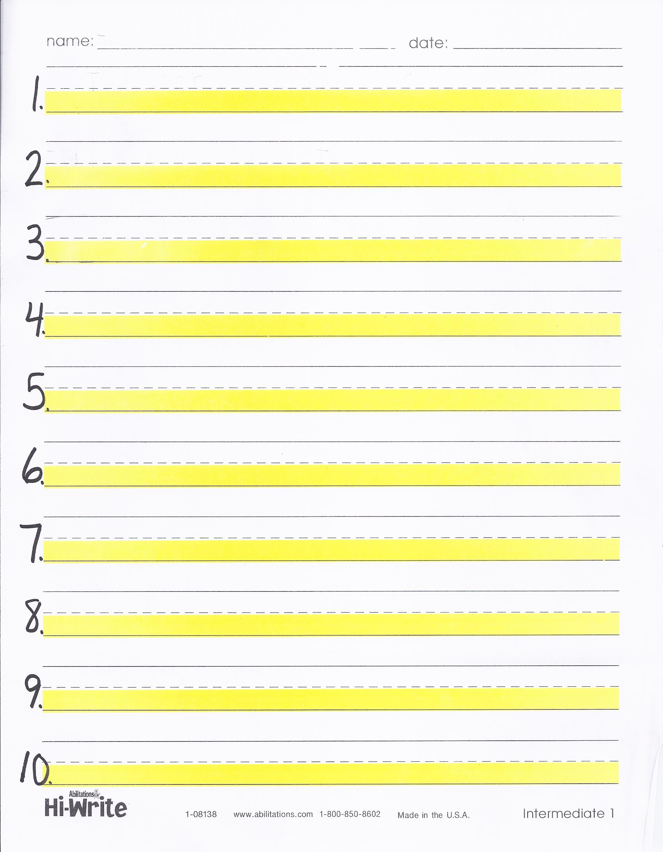
Highlighted Lined Paper for Spelling Tests
Appendix E
Parent Consent Form
Dear Parent/Guardian,

As part of my Master’s of Reading Education degree requirements at East Carolina University, I am planning an educational research project that will help me learn more about how to improve spelling instruction in my classroom.

The fundamental goal of this project is to improve spelling performance and students’ attitude about spelling. I have investigated an effective instructional practice, using digital word sorts as an extension to regular word study that I will be implementing during spelling instruction in January 2015. I am going to track student improvement during spelling instruction for 6 weeks. Pre and posttest student Spelling Attitude surveys and weekly spelling tests will allow me to track student progress.

This project has been approved by my instructor at ECU, Dr. Elizabeth Swaggerty, and the ECU Institutional Review Board.

I am asking permission to include your child’s progress in my project report. Your child will not be responsible for “extra” work as a result of this project. The decision to participate or not will not affect your child’s grade. I plan to share the results of this project with other educators through presentations and publications to help educators think about how they can improve reading instruction in their own classrooms. I will use pseudonyms to protect your child’s identity. The name of our school, your child, or any other identifying information will not be used in my final report. Please know that participation (agreeing to allow me to include your child’s data) is entirely voluntary and your child may withdraw from the study at any point without penalty.

If you have any questions or concerns, please feel free to contact me at school at 252-514-6420 or email me at jo.shoemaker@craven.k12.nc.us. You may also contact my supervising professor at ECU, Dr. Elizabeth Swaggerty, at swaggertye@ecu.edu, 252.328.4970. If you have questions about your child’s rights as someone taking part in research, you may call the Office of Research Integrity & Compliance (ORIC) at 252-744-2914 (days, 8:00 am-5:00 pm). If you would like to report a complaint or concern about this research study, you may call the Director of the OHRI, at 252-744-1971.

Please indicate your preference below and return the form by .

Your Partner in Education,

Jo Shoemaker
-------------------------------------------------------------------------------------------------

As the parent or guardian of ________________________________________, I grant permission for Jo Shoemaker to use my child’s data in the educational research project described above regarding vocabulary instruction. I voluntarily consent to Jo Shoemaker using data gathered about my child in her study. I fully understand that the data will not affect my child’s grade and will be kept completely confidential.

Signature of Parent/Guardian:______________________________________

Date____________________________

-OR-

As the parent or guardian of _______________________________, I do not grant permission for my child’s data to be included in the study.

Parent/Guardian: _______________________________________

Date____________________________

Appendix F

Student Assent Teacher Script and Assent Form– Intervention Participants
Student Assent Teacher Script - Intervention Participants

To be read by investigator (or another grade level teacher) to students who have turned in parent consent forms.

You are sitting here because your parent/guardian provided permission for you to participate in a study related to reading instruction. Now, I am wondering if you want to help me learn about how using the computer to complete word sorts can help you become a better speller.
As part of your spelling instruction, you will complete your regular word words and a digital version on the computer. You will do this beginning in January of 2015 after the holiday break for 4-5 weeks.
If you decide to take part in the research study, you can help me learn about what you think and what you’ve learned about spelling by letting me use your tests and assignments, for example, attitude survey, spelling tests, and notes I take.
Your decision to take part or not take part in the study won’t impact your grades at all. This project won’t require any “extra work” for you.
Results of the project will be shared with other teachers so they can get better at teaching reading. I won’t use your real name when I talk about the results of the project.
If, after we begin the project, you change your mind and decide you don’t want to take part, you can tell me and you can stop at any time.
I think this project will be fun and might help you be a better speller. If you have any questions, please ask me.
Since your parents have already agreed to let you participate, I just need your permission to participate now. If you agree, please sign the form.
Thanks!
-------------------------------------------------------------------------------------------------------------------------------
Spelling Performance and Attitude Action Research Study

Student Assent Form
After your teacher has described the project to you, if you decide it is ok for your teacher to use your results to see if the instruction works, please fill out the information below and give it to your teacher. Also, your teacher might want to share some of the results with other teachers, but she will not use your real name.
Print your name here: _____________________________________________
Sign your name here: _____________________________________________
Write the date here: _______________________________________________
Check here only if it is not ok with you that I use your results for my project. Saying no will not affect your grades in any way. __________
---------------------------------------------------------------------------------------------------------------------
Signature of Person Obtaining Assent: ________________________________
Printed Name of Person Obtaining Assent: _____________________________
Date: ____________________________________________________________

Appendix G
