Building a Staff Development Program for
Nursing Assistants in Long-Term Care

Natalie C. Sharpe
College of Nursing, East Carolina University
Doctor of Nursing Practice Program
Dr. Bradley Sherrod

Notes from the Author
I want to thank Dr. Bradley Sherrod for his guidance throughout this quality improvement project's development, implementation, and evaluation. I also wish to acknowledge and thank the project site, my project champion, Dr. Rajesh Khurana, the organizational lead, Ms. Sonya Rozier, LNHA, and core members of the DNP project team, Becky Baker, RN, Karen Booth, RN, Diana Gilmore, RN, and Tandera Carter, PhD. for their time and tireless support of this project. Lastly, I want to thank my family, especially my husband, Victor, for the prayers, patience, and encouragement while pursuing this academic endeavor.

Dedication
I would like to dedicate this work to the nursing assistants at the organizational site and throughout long-term care facilities, who provide invaluable service to our residents each and every day.

Abstract
Nursing assistant (NA) turnover was 88.9% for four long-term care facilities combined within the project organization. A staff development program was designed for NAs across all four facilities within the organization to reduce turnover. The staff development program included concepts of empowerment and discipline-specific education tailored to meet the organization's needs. The project team worked with facility leadership for 20 weeks to implement the program's NA meetings and educational modules in each facility, where 8.5 hours of in-service credit were offered and basic NA skills were validated. NA participation in program initiatives ranged between 85% to 88% per facility. Outcome measurements were obtained from the organization's payroll data and survey of NAs. Project findings included a 63.25% decrease in turnover, a 38.83% increase in retention, and an increase in job satisfaction by 37.14%. Recommendations for improvement include expanding empowerment concepts to include increased NA involvement in facility operations and specialized education to expand NA roles in long-term care.

Keywords: Long-term care; Skilled Nursing Facility; Certified Nursing Assistants; Nursing Assistants; Empowerment; Turnover; Retention; Job Satisfaction

Table of Contents
Notes from the Author …………………………………………………………………………..2
Dedication………………………………………………………………………………………..3
Abstract ………………………………………………………………………………………….4
Section I: Introduction ..………………………………………………………………………….8
Background…………………………..……………………………………………………8
Organizational Needs Statement……..……………………………………………………9
Problem Statement……………………………………………………………………….11
Purpose Statement……………….……………………………………………………….11
Section II: Evidence……………………………………………………………………………..12
Literature Review………………………………………………………………………..12
Evidence-Based Practice Framework……………………………………………………16
Ethical Consideration and Protection of Human Subjects……………………………….17
Section III: Project Design……………………………………………………………………….18
Project Site and Population……………………………………………………………....18
Project Team……………………………………………………………………………..18
Project Goals and Outcomes Measures…………………………………………………..19
Implementation Plan and Timeline..……………………………………………………..23
Section IV: Results and Findings………………………………………………………………...25
Results……………………………………………………………………………………25
Discussion of Major Findings……………………………………………………………25
Section V: Interpretation and Implications………………………………………………………35
Costs……………………………………………………………………………………..35
Resource Management…………………………………………………………………..35
Cost-Benefit Analysis…………………………………………………………………....35
Implications of the Findings……………….…………………………………………….36
Sustainability …………………………………………………………………………....40
Dissemination Plan ……………………………………………………………………...40
Section VI: Conclusion…………………………………………………………………………..41
Limitations and Facilitators…………..………………………………………………….41
Recommendations for Others……………………………………………………………43
Recommendations for Further Study…………………………………………………….45 Final Thoughts…………………………………………………………………………...45
References………………………………………………………………………………………..46
Appendices……………………………..………………………………………………………...51
Appendix A: Literature Matrix…………………………………………………………..51
Appendix B: University Medical Center Internal Review Board Approval …….………52
Appendix C: Nursing Assistant Survey Tool…………………………………………….53
Appendix D: Project Timeline…………………………………………………………...54
Appendix E: Nursing Assistant Monthly Education Calendar..…………………………55
Appendix F: Nursing Assistant Staff Development Binder Table of Contents………….56
Appendix G: Nursing Assistant In-service Participation………………………………...58
Appendix H: Nursing Assistant Meeting Guidelines…………………………………….59
Appendix I: Nursing Assistant Meeting Sample Agenda………………………………..61
Appendix J: Facility Tracker…………………………………………………………….62
Appendix K: Nurse Aide Education Data Collection Sheet……………………………..63
Appendix L: Nursing Assistant Skills Fair Outline……………………………………...64
Appendix M: Nursing Assistant Skills Fair Validation Tool………………………….....65
Appendix N: Turnover Data……………………………………………………………..67
Appendix O: Nursing Assistant Survey Results by Facility……………………………..68
Appendix P: Project Budget……………………………………………………………...73
Appendix Q: Project Key Deliverables………………………………………………..…74

Section I. Introduction
The long-term care industry has long since struggled to maintain a stable workforce. This issue has only been heightened with recent changes in managed care, value-based payment systems, and the Covid-19 global pandemic. Direct care workers, such as nursing assistants, have been the hardest hit as they provide physically demanding work with a high risk of injury and typically low compensation. This combination of elements has led to continuing workforce recruitment, retention, and turnover issues. (Scales, 2020). The Doctor of Nursing Practice (DNP) project discussed in this paper has been designed to address the workforce issues the project site has encountered with nursing assistants over the past year.
Background
Long-term care organizations cannot underestimate the impact of staff turnover. Turnover is measured in terms of dollars and cents, time, energy, and staffing struggles. These are all vitally important, but the most critical aspects of turnover are patient care and safety.
Temkin-Greener et al. (2020) explore the relationship between nursing home staff turnover and a well-developed Patient Safety Culture (PSC). Facilities with well-developed PSC exhibit a blame-free environment that encourages staff collaboration and organizational commitment to resources to seek safety issues without fear of reprimand or punishment. Temkin-Greener et al. expound that PSC shapes the staff's beliefs regarding acceptable behavior in the provision of daily care. Failure to act on unacceptable behaviors may result in increased complaints, accidents, poorer quality of care, and other adverse events. The Temkin-Greener et al. study suggests a direct correlation between high staff turnover and negative PSC.
Lerner et al. (2014) studied nursing home survey deficiencies related to nursing care, including Quality of Care (QOC), Quality of Life (QOL), and Resident Behavior (RB) categories, and compared turnover rates in 1174 nursing homes across the United States. Findings indicated that turnover, mainly nursing assistant turnover, was directly related to QOC issues such as activities of daily living, range of motion, pressure ulcers, and continence. Nursing assistant turnover was also linked to adverse outcomes in RB deficiencies, such as staff treatment of residents, restraints, and freedom from abuse (Lerner et al., 2014). Nursing assistant job satisfaction, absenteeism, and turnover have also been associated with decreased resident satisfaction in long-term care (Li et al., 2021).
Turnover rates in long-term care are some of the highest in the health care industry, and the discipline most drastically affected is that of the certified nursing assistant (CNA). National nursing home turnover rates have been estimated from 51-56.1% for nurses and 74.5% for CNAs (Donoghue, 2010). Recent studies using facility self-reported payroll journal data suggest that long-term care mean turnover rates may now be over 100% (Gandhi and Grabowski, 2021).
CNAs are described as the "backbone of the long-term care industry" and are vital to the daily care that a facility resident receives. CNAs build unique bonds with residents and families that make them feel good about their care (Blair and Glaister, 2005). CNAs provide almost 90% of all care provided in nursing homes to elderly and medically frail individuals (Pennington et al., 2003). Without this direct care, workforce facilities would find it impossible to function, and the workload for nurses would increase dramatically.
Organizational Needs Statement
A small chain of for-profit, skilled nursing facilities in Eastern North Carolina served as the designated site for this project. Each facility has between 90 to 155 beds and is committed to providing high-quality long-term care services to the residents and families they serve in a home-like environment. The organization has identified staff retention among CNAs as one of the organization's most significant needs. CNAs represent greater than 65% of the direct care workforce, yet the turnover rate for CNAs is 88.9% companywide and ranges between 55.3% - 120% per building. Hagerty and Buelow (2017) note CNA turnover as a national issue, with median rates reflecting greater than 50%.
The organization has been feeling the effects of this high turnover, as evidenced by staff frustration, increased dollars paid in bonuses, and elevated use of agency staff. Mukamel et al. (2009) provide insight into specific patient care costs associated with nursing assistant turnover in nursing homes. Mukamel et al. speak of staff working "short" due to an inability to fill vacated positions timely and note that time paid may be at a higher cost in bonuses and overtime pay. Staff may also be overworked, leading to QOC issues (Mukamel et al., 2009). It is easy to see how overworked staff and staff unfamiliar with residents and facility policies could be prone to make mistakes, causing decreased resident satisfaction and adverse resident outcomes. Researchers have consistently identified direct correlations between staff retention and the quality of care provided in skilled facilities throughout the years. Antwi and Bowblis (2018) link increases in nursing turnover, including CNAs, to increased survey deficiencies, worse outcomes in QOC indicators such as pressure ulcers, and even higher mortality rates. Agency leaders at the project site have not seen an increase in survey deficiencies. However, they note that survey activity has just begun to increase related to changes in Covid-19 visitation policies. Nursing home managers have also not been able to link any turnover rates to any specific adverse resident outcomes. Still, agency leaders acknowledge that residents are at risk for a breakdown in the quality of care related to turnover.
During the Covid-19 pandemic, the North Carolina Division of Health Service Regulation (DHSR) waived specific nurse aide training regulatory requirements to help facilities recruit nurse aides and meet staffing levels. The result of the waiver was the ability to hire and train temporary aides (TNAs) for longer than four months without meeting the Centers for Medicare and Medicaid Services (CMS) certification training requirements (NCDHSR April 26, 2021). The project site has experienced significant challenges recruiting certified nursing assistants, leading some of its facilities to utilize TNAs to fill vacancies that CNAs could not cover. Agency leaders acknowledge the risks associated with the hiring and use of TNAs.
Problem Statement
The project site has Nursing Assistant (NA) turnover rates in most facilities higher than the national median scores and is experiencing adverse effects related to this trend. This trend has only seemed to intensify with the progression of the Covid-19 pandemic. The project site has noted increased turnover, staffing, recruitment, and retention difficulties, especially for nursing assistants.
Purpose Statement
This project sought to decrease NA turnover by designing a staff development program geared to meet the needs of the NA population in the project facilities. The program was envisioned to be a deliverable that the project site could use companywide, easily adaptable to meet the unique needs of each facility and the nursing assistants for years to come. The project's staff development aspects were also geared towards developing the supervisory skills of those who supervise the nursing assistants in the skilled facilities. Choi and Johantgen (2012) cite supportive supervision as significantly linked to nursing assistant job satisfaction. This indicator ranks higher than pay and employee benefits when determining the NA's likelihood of staying on the job.

Section II. Evidence
Literature Review
A substantial review of literature for this project was conducted using databases Cumulative Index of Nursing and Allied Health Literature (CINAHL), PubMed, Ovid, and Medline. Key terms used were nursing assistants, NA, C.N.A., nursing homes, long-term care, recruitment, retention, turnover, turnover rates, staffing, and job satisfaction. Inclusion criteria were English language, online journals, and a date range from 2006 to 2021, focusing on the last five years. Initial searches yielded greater than 800 article abstracts that were narrowed based on dates, topic application, and evidence levels lower than three.
The review of literature produced 33 articles. Abstracts were read and considered for inclusion. Reference lists from these articles were also appraised to identify additional studies. Ultimately, eleven articles were relevant to the interventions and beneficial for inclusion in the literature matrix (see Appendix A). Further articles were considered for exploration and reference as the project progressed.
Current State of Knowledge
Non-licensed personnel spends more time with the residents in a nursing home than any other care provider; therefore, a CNAs' role cannot be overlooked as an overall part of quality care (Kusmaual & Bunting, 2016). The CNA is the backbone of the skilled facility. Much literature supports the importance of direct care workers, such as CNAs, in the long-term care arena. Blair and Glaister (2005) refer to the certified nursing assistant as the nursing home's number one resource and suggest that improving recruitment, retention, training, and education programs will improve life for the nursing assistant and the residents in nursing homes. Bethell et al. (2018) expound upon the importance of the personal support worker (PSW) by analyzing the relationship between the PSW and the supervisor. Bethell et al. suggest that by strengthening the relationship between the PSW and the supervisor, the quality of life for the residents will also be affected positively. Scales (2020) emphasizes the importance of the direct care worker by defining the workforce and discussing past and current challenges affecting the workforce in long-term care and its ability to provide high-quality services.
There is also much literature documenting the continued high turnover and low retention rates for nursing assistants in long-term care for decades (Mukamel et al., 2009). However, there is inconsistency noted in the literature when calculating these turnover rates. Gandhi et al. (2021) report a literature review with estimates of CNA turnover in nursing homes ranging from 14-346%. Many studies only included a small sampling of facilities or may have included only facilities in a specific region or state. Gandhi et al. (2021) utilized Payroll-Based Journal (PBJ) data from the CMS Nursing Home Compare provider files, which analyzed over 15,000 facilities. CNA turnover rates were noted as 129.1% and a mean of 98.8% (Gandhi et al., 2021). Even with the access to nationwide information, the authors note limitations to the use of PBJ data that may make these turnover rates challenging to utilize for comparison.
Although literature may conflict regarding the calculation of turnover, there are unmistakable messages about the effects of CNA turnover and its underlying cause. High CNA turnover is linked to lower quality of care, increased adverse resident events, and decreased resident satisfaction. Facilities with high CNA turnover rates are also noted to have lower Perceived Patient Safety Culture scores (Temkin-Greener et al., 2020). Reasons for CNA turnover have been cited as lack of supportive supervision, not feeling valued, pay, and work-related injury benefits (Choi & Johantgen, 2012).

Current Approaches to Solving the Problem
CNA retention strategies have been documented in the literature, including providing health benefits and fair wages and training to nurses and administrative staff in providing supportive supervision (Choi & Johantgen, 2012). Researchers agree that retention initiatives should include recognition, education, and empowerment strategies (Kennedy et al., 2020). Recognition initiatives may also come in the form of career ladders by which CNAs can progress and benefit themselves and the facility. Education initiatives should also address CNA needs, be designed for adult learners, and provide a hands-on demonstration. CNAs have also to be given the time and financial support to complete their education (Blair & Glaister, 2005)
Evidence to Support the Intervention
The project retention plan for nursing assistants focused on three key areas of empowerment, education, and supportive supervention.
Empowerment. Researchers agree that nursing home administrators and DONs must better understand the value of the nursing assistant and build paths to growth and development in their work. This growth and development will benefit the nursing assistant, the resident, and the organization (Li et al., 2021). Berridge et al. (2020) explore staff empowerment strategies and culture change with nursing assistant retention. Berridge et al. found that empowerment strategies such as participating in quality improvement teams, covering shifts, planning social events and participating in extra training positively impact CNA retention. Yeatts and Cready (2007) explore CNA empowered work teams and their impact on CNA work performance, work attitudes, absenteeism, and turnover. Yeatts and Cready revealed that the work teams did improve job performance and lower turnover but had little effect on absenteeism and work attitudes.
Education. Research supports the need for educational programs specifically designed for the certified nursing assistant. Blair and Glaister (2005) speak to the need for this education to be specifically designed for the CNA and to include interpersonal skills training and clinical skills teaching. Gion and Abitz (2019) describe a recruitment and retention plan that included nursing assistant-specific education based on learning needs assessment completed by the CNAs themselves. Many articles detail particular CNA training programs designed to give the nursing assistant training on specific specialty populations or skills. One such study is that of Malik and Chapman (2017), which explores End-of-Life Care for certified nursing assistants in long-term care. Malik and Chapman stress that nursing assistants deserve the same specialty training in end-of-life care that nurses or physicians receive and that this training should be designed to address the skills needed by the CNA. Marziali et al. (2015) delve into a specialty program using e-learning to assist CNAs in managing conflict resolution. Dreher et al. (2019) explore a program designed to teach compassion fatigue awareness and self-care to CNAs.
Supportive Supervision. Nursing assistants have the lowest control influence in the typical nursing home structure. Yet, they represent the largest employee group and spend more time with residents than other employees. Many CNAs take pride in their work but do not perceive it as valuable and think their place on the team is less significant than other teammates. CNAs in the study felt disconnected and unappreciated when managers did not recognize their work (Kusmaul & Bunting 2016). The Kusmaul and Bunting (2016) qualitative evaluation of certified nursing assistants' perceptions in caregiving speaks to the need for training of nurse managers in aspects of supervision such as communication and recognition. This theme is echoed in the literature. Bethell et al. (2018) examine the association between intent to turnover and supervisory support. Findings reiterate a direct correlation between the two and note that nurses need to be equipped with supervisory skills and competencies. Choi and Johantgen (2012) also found supportive supervision to be the leading factor over wages and benefits in CNA job satisfaction and retention. Blair and Glaister (2005) recognize that administrators, although not direct supervisors of nursing assistants, also have a role in evaluating care and providing feedback through policy development and direct observation.
Evidence-based Practice Framework
Change for an organization, even when planned, can be difficult. It requires much preparation for staff and management to receive the change process, take the steps needed to make the necessary adjustments, and ensure that the new processes become a part of everyday life. Lewin's Theory of Planned Change (TPC) is the change theory chosen for implementing this project.
Lewin's TPC comprises three stages, Unfreezing, Moving, and Re-Freezing. The first stage, unfreezing, involves getting the group or organization ready for the change. In this step, leaders may create a gap analysis to show the need for change or create a sense of urgency by addressing deficient practices and the need for change with staff members. Leaders will also seek to identify potential barriers to change and address them before change implementation (Shirey, 2013).
The next step is Moving or Transitioning, and it involves viewing change as a process rather than a single event. This second phase of Lewin's TPC calls for detailed action plans, coaching by leaders to combat the fear associated with change, and a constant assessment of where the organization is in relationship to the desired goal. Outcomes must be clearly defined and communicated for this stage to succeed (Shirey, 2013).
The final step in the TPC is Refreezing. This step is critical because it solidifies the change and seeks to embed it into the organization. Leaders must address policies, procedures, and standards of practice to ensure that new processes are clearly defined and the change is sustainable over time (Shirey, 2013).
Ethical Consideration & Protection of Human Subjects
This staff development program does not carry any implicit ethical considerations or need to protect human subjects. All aspects of the program were made equally available to all nursing assistants at all project sites. There was no chance that nursing assistants participating in the project could have been taken advantage of during project implementation as no data could specifically be traced back to any participants.
In preparation for the formal approval process, the project leader completed all modules outlined by the Collaborative Institutional Training Initiative (CITI) group, two introductory courses designed for Social/Behavioral Research Investigators and Key Personnel. These modules are designed to give the student basic information regarding ethical practices, federal regulations, and the formal approval processes surrounding research dealing with human subjects. Modules were completed from June 23 through July 9, 2021.
The project was evaluated by the University Medical Center Internal Review Board (UMCIRB) and deemed to be Quality Improvement and/or Program Evaluation, exempt from IRB review (see Appendix B). No ethical considerations or concerns were identified. No additional review was required.

Section III. Project Design
Project Site and Population
The project site was a network of six skilled nursing facilities and a corporate management entity. The facilities are family-owned, for-profit nursing homes that operate in local communities in Eastern North Carolina. Two of the nursing homes were under renovation. The population identified for the project was certified nursing assistants employed in the four operational skilled facilities.
Description of the Setting
Each skilled facility had between 90 and 150 beds and served a geriatric population primarily. Centralized functions, including human resources, billing, clinical and financial operations, were housed in the corporate office. The project mainly took place in the four skilled facilities; however, some work with human resources and finance/payroll was completed at the corporate office.
Description of the Population
Certified nursing assistants and temporary nursing assistants employed at each facility were the focus population for the project. Each facility had between 20 to 35 nursing assistants participate in the program. Most nursing assistants were certified; however, approximately 20 temporary nursing assistants were included between all sites. Although not specifically a part of the focus population, some interventions were geared towards the supervisors of the nursing assistants. This group included nurses, nurse managers, the Directors of Nursing, and facility administrators.
Project Team
The project team included representatives from all four facilities, employees from the organization's management company, the site champion, the organizational leader, and the faculty advisor. Core team members comprised the project leader (DNP student/Chief Nursing Officer), faculty advisor (ECU Leadership Program Coordinator), site champion (a facility Medical Director), organizational lead (Chief Operating Officer), four members from the organization's senior management team (Director of Infection Control/Staff Development, Director of Performance Improvement, Facility Nurse Consultant and Human Resources Specialist). Resource team members included five facility representatives (two CNAs, two Directors of Nursing, and one social worker) and corporate office finance personnel (Chief Finance Officer, Controller, Payroll Manager). A psychologist (Director of Counseling for Faculty and Staff) from Appalachian State University also served as a resource for management staff supportive supervision training.
Project Goals and Outcome Measures
The primary purpose of the evidence-based project was to develop a Nursing Assistant Staff Development program to decrease turnover in the organization's four facilities. The organization had an overall turnover rate of 88.9% in 2020. The project's primary goal was to reduce CNA turnover rates to less than the median national average (50%).
Description of the Methods and Measurement
Nursing assistant turnover and retention are the primary measures monitored for this project. Both measures give insight into the viability of the workforce, but they differ in what they tell us. Turnover measures the pace at which employees exit employment. Retention measures the consistency of the labor force (Kennedy et al., 2020). The project leader worked with the organization's CFO to develop a report table within the organization's payroll database to calculate turnover and retention rates. The formulas used will be described in the following sections.
Turnover and retention are often best analyzed over time. Because of this concern, a survey tool was also developed to assist in gauging organizational improvement. The project survey (Appendix C) was created using portions of the US Department of Health and Human Services' 2004 National Nursing Assistant Survey.
Turnover. Turnover was the primary measurement used for this project. It gave us insight into how fast nursing assistants were leaving the project site facilities. The formula used for turnover calculations included determining the number of NAs that left the workforce during a given period and dividing this by the average number of NAs employed during that same time. This calculation contained all departures from the organization, whether voluntary or involuntary. It also included both part and full-time workers.
Retention. Retention was also a vital measurement in this project. High retention rates in a facility with high turnover could be a sign of stability. In this case, retention rates showed that more experienced NAs stayed in the facility while newer, less experienced NAs left employment. Retention calculations for this project included a formula determining the number of NAs employed on the last payroll of a given time and dividing that by the number of the same NAs employed on the first payroll of the same time. By doing this, leadership can see the number of nursing assistants who stayed in the facility for that time.
Survey. The project survey was designed using sections of the 2004 National Nursing Assistant Survey (NNAS). The NNAS was conducted by the Assistant Secretary for Planning and Evaluation (ASPE) in the US Department of Health and Human Services and is the first national probability sample survey of nursing assistants in nursing homes. The survey's objectives were to learn more about nursing assistants' work conditions, wages, benefits, career growth, and what would make them leave the workforce. The content validity of the survey tool was verified using an advisory panel of experts with experience in survey design and long-term care workforce issues. The survey was designed to be administered via telephone and consisted of ten sections with questions formatted to be close-ended or in a checklist. (Squillace et al., 2007).
The DNP project nursing assistant survey was designed by pulling from portions of the NNAS relevant to the project interventions. Questions from three sections were used, Management/Supervision (10 questions), Workplace Environment (7 questions), and Organizational Commitment/Job Satisfaction (3 questions). All 20 questions were closed-ended using an interval scale. Each question was intended to stand alone as opposed to combining results to one composite score. Nursing assistants were instructed not to include their names on the survey to protect anonymity. The only identifiable information collected was the name of the specific facility where participants worked. The survey was administered twice during the project. Once early in the project implementation stage, before implementing project interventions and again after implementing all interventions. Survey results were analyzed at the facility and organizational level pre-implementation of interventions, at the project mid-point, and post-project interventions.
Data Collection Processes
Baseline turnover and retention rates were collected using secondary data from payroll reports from October 1, 2020, through October 1, 2021(see table 1). The project leader included the following data in the baseline report, the number of nursing assistants (NAs) employed at the beginning of the period, the number of NAs employed at the end of the period, the number of NAs leaving employment during the year, and the associated turnover and retention rates. The average days of employment were also included for NAs leaving employment to give some insight into the effectiveness of organizational onboarding practices. Calculations of turnover and retention rates were made at the facility and organizational levels.
Table 1
Organization Site Baseline Nursing Assistant Turnover and Retention Data 2020-2021
Baseline Nursing Assistant (N.A.) Turnover and Retention Data
October 1, 2020, through October 1, 2021
Facility | no. NAs 10/1/2020 | no. NAs 10/1/2021 | # NA Separations | 2020-2021 Turnover Rates | Average Days Employed | 2020-2021 Retention Rates
Facility 1 | 31 | 29 | 36 | 120.00% | 74.67 | 45%
Facility 2 | 49 | 33 | 33 | 80.49% | 100.64 | 59%
Facility 3 | 26 | 21 | 13 | 55.31% | 114.31 | 69%
Facility 4 | 37 | 22 | 30 | 101.69% | 80.30 | 54%
Companywide | 143 | 109 | 112 | 88.9% | 67.25 | 56.6%

Note. Companywide turnover and retention data are highlighted in bold.
Turnover. During the project implementation phase, turnover data were collected monthly from January through May 2022 via the organization's payroll database and reported quarterly. The payroll database captured the number of NAs employed at the beginning of each period as well as the number employed at the end of each period. Reports also included the specific number of days each terminated nursing assistant was employed at each facility.
Retention. Retention data was also collected from the organization's payroll database monthly from January through June 2022 and reported quarterly. Retention data included the number of NAs that stayed employed at each facility throughout the reporting periods. Special attention was paid to the NAs beginning employment after implementing the new onboarding and staff development initiatives to see if these employees were being retained.
Survey. The project survey was initially administered at the beginning of the project's implementation phase to provide baseline data related to supportive supervision, workplace environment, and overall job satisfaction. Participants were given a paper copy of the survey tool with an information sheet explaining the purpose of the survey and instructions on its completion. No identifying information was gathered regarding survey participants. Surveys were returned to a closed box after completion and picked up by the project leader. The project survey was administered at the project midpoint and again after implementing all interventions using the same procedures.
Implementation Plan and Timeline
The project implementation phase began on January 10, 2022, and concluded on May 31, 2022 (see Appendix D). The project began through formal UMCIRB approval. The program ran for five months and included monthly initiatives to be completed in each facility focused on two key areas, Staff Development and NA Empowerment.
Project implementation began with individual kick-off meetings held in each facility with the Director of Nursing and the Administrator. These meetings included a full program review, including a Project Timeline, Nursing Assistant Monthly Educational Calendar (see Appendix E), competency evaluation tools, and onboarding and orientation guidelines. Each facility was given a binder with the program with materials listed in the Table of Contents (see Appendix F). Nursing Assistant Surveys were also distributed to the facilities at this meeting to gather baseline data related to planned project initiatives. The project leader later picked up the survey after completion. Findings from the survey were discussed with facility leaders during the Supportive Supervision training for facility leaders held on January 31, 2022.
In February 2022, nursing assistant Meeting #1 and Educational Sessions #1 (Self-Care) and #2 (Effective Communication) were implemented. NA meetings were scheduled in a manner to be accessible to all shifts and facilitated by the Director of Nursing or Assistant Director of Nursing. NAs were encouraged to attend all meetings, and nurse leaders were urged to offer make-up sessions or one-on-one meetings for nursing assistants who missed the live training sessions. Directors of Nursing in each facility were asked to return the following information to the project leader after each meeting, complete attendance roster showing meetings for all three shifts, agenda, meeting minutes, and education session evaluations.
Nursing Assistant Meeting #2 and Educational Sessions #3 (End of Life Care) occurred in all of the organization's facilities in March. The mid-project survey was completed, and facility leaders continued to submit reports by the 5th of the following month to the project leader. This month also included a Skills Fair where project team members validated critical nursing assistant skills through NA return demonstration. First Quarter (January-March 2022) turnover and retention reports were analyzed and distributed to the project team and organizational leaders. The project team also reviewed evaluations of educational sessions and made adjustments as needed. NA Survey results were analyzed and compared to baseline survey results.
In April 2022, NA Meetings # 3 and Education Sessions # 4 (Professionalism) and #5 (Compliance & Ethics) occurred in all facilities as planned. Project Team members conducted site visits to facilities to monitor Supportive Supervision practices and assist in NA meetings. Feedback was given to facility leaders relative to their observations.
NA Meeting #4 and Education Sessions #6 (Dementia) and #7 (Resident Rights) were conducted in all facilities in May. Facility leaders were encouraged to plan for National CNA Week (June 16-22, 2022). Program participants took the final NA survey. Survey results were analyzed and compared to the previous survey results. Data regarding turnover and retention was pulled for review and final reporting.
Section IV. Results and Findings
Results
Nursing assistants in all four organizational facilities participated in the staff development program from January 10, 2022, through May 31, 2022. NA participation was monitored on a monthly basis from facility reports. Turnover and retention data was obtained from the organization's payroll system at the end of March 2022 (midpoint) and again at the end of May 2022 (endpoint) and compared to baseline turnover and retention data from October 1, 2020, through October 1, 2021. Qualitative data from NA surveys were obtained at the beginning of implementation in January 2022 (baseline), in March 2022 (midpoint), and in May 2022 (endpoint). The survey findings were compared over time to gauge NA job satisfaction and program effectiveness.
Discussion of Major Findings
Participation
The first training session for the staff development program was designed to teach supportive supervision skills to managers of nursing assistants in all four of the organization's facilities. Sixteen facility and organizational leaders attended this training session held on January 31, 2022. NA program initiatives were implemented in each facility by the Directors of Nursing with support from the DNP project team from January 10, 2022, through May 31, 2022, following the NA Monthly Education Calendar (see Appendix E). Fifty-nine to 94 NAs participated in each monthly activity organization-wide (see Appendix G; Table 5).
Monthly Meetings. Average participation percentages in monthly NA meetings for each facility ranged from 58% to 88% for NA monthly meetings and education modules (see Appendix G; Table 6). DONs in each facility were asked to follow the NA Meeting Guidelines (see Appendix H) and the sample agenda (see Appendix I) from the NA Staff Development Program Manual. Most DONs chose to follow the agenda format with one exception. Self-study packets were reviewed during the meetings with a group question and answer session instead of distributing the packets and having NAs return them once completed. DONs felt that this practice enhanced NA participation. NAs missing the monthly meetings were encouraged to complete self-study packets and return the completed tests to the DON.
The project leader managed the distribution of monthly in-service modules via email and in-person meetings. Using various resources, the project leader developed in-service module content for modules 1, 3, 4, and 6. These resources included DHSR North Carolina Department of Health and Human Services Division of Health Regulation State-approved Curriculum, Nurse Aide 1 Training Program, organization policies and procedures, Hartman's Nursing Assistant Care, Long-Term Care (5th ed.), and several journal articles. In-service module content for modules 2, 5, and 7 came from The Compliance Store, an online regulatory resource that the organization maintains an annual subscription.
DONs were responsible for turning in monthly agendas, sign-in sheets, in-service training reports, and meeting notes to the project leader by the 5th day of the month following the NA meeting. The project leader reviewed this information and documented individual NA attendance in facility trackers (see Appendix J) and Nurse Aide Education Data Collection Sheets (see Appendix K). Statistics relative to participation percentages were pulled from facility trackers. The project leader maintained the Excel workbook of Nurse Aide Education Data Collection Sheets for each NA in the facility and turned it over to the facility DON at the project end.
There were some deviations made to the monthly meeting plan for site four. This facility lost its DON just before project implementation. Due to the struggle to secure a DON and the lack of stable nursing leadership, the decision was made to hold NA meetings until a DON was placed. The project leader and facility administrator felt that the risk of having the meetings with little to no follow-up to NA expressed concerns was too high. The in-service education potions of the program were implemented while the NA meetings were on hold. A DON was hired in late March 2022, but the position was vacant again in May 2022.
The impact of the DON on NA retention cannot be understated. Literature shows a direct correlation between DON retention and CNA retention. Donoghue (2010) stated that nearly all dependent variables related to lower turnover and higher retention of CNAs in nursing homes related to DON tenure. Kenndy et al. (2020) also discuss the correlations between DON and CNA turnover, citing that facility investment in the DON pays off with CNA retention and staffing. Choi and Johantgen (2012) stress the importance of supportive supervision and CNA perception of being valued in overall CNA job satisfaction and intent to leave employment.
Skills Fairs. The skills validation fairs were the activities with the best attendance rates. Ninety-four NAs participated in the skills validation events, and the participation rates ranged from 88% to 100% per facility (see Appendix G). Skills fairs were conducted by the project leader and project team in each facility during March 2022 and the first week of April 2022. Each fair lasted between one and two days, depending on the number of NAs at the facility. The project leader set times for the fairs in collaboration with facility DONs to accommodate day, evening, and night shift NAs.
Each skills fair was conducted as outlined in the NA Skills Fair Outline (see Appendix J), with a few exceptions. The organization did not have personnel dedicated to staff development in each facility. Because of this, a regional staff development coordinator (RSDC) was hired in January of 2022 to assist with staff development functions for all four facilities. The RSDC was terminated in early February 2022 and was not in place at the time of the skills fairs. The project team leader managed planning, coordination, and scheduling with all facilities. The original design called for Covid vaccines to be given during the skills fairs. The vaccines were not given because each facility had processes in place to manage employee vaccines.
After each skills fair, the project leader met with the project team to evaluate the event's success and make the needed adjustments before the next event. One of these changes included revising the competency assessment tool used to check off NAs after successful task completion. During the skills fair, the team found the existing tool cumbersome and challenging to manage. The form was revised to better align with the flow of the event. Skills not being validated during this time were also removed, and a section was added to include the Dementia reality station (see Appendix K).
Turnover
This project was designed to decrease turnover by building an effective staff development program for the nursing assistants at the project site. Organization-wide NA turnover decreased by 56% during project implementation (See Table 2). All four facilities in the organization experienced a decrease in turnover during the course of this project.
Baseline. Baseline reports (October 1, 2020-October 1, 2021) revealed a turnover rate of 88.9% for the organization and rates ranging from 55.3% to 120% per facility (see Appendix L). During this baseline period, the organization lost 112 nursing assistants. The average days employed for the NAs exiting during this time was 67.25.
Midpoint. Midpoint turnover data (January 1, 2022- March 31, 2022) showed a drastic decline in turnover. The organization-wide rate had dropped to 28.00%, and facility-specific rates ranged between 11.11% to 33.85% (see Appendix L). The organization lost 28 nursing assistants by the project midpoint with average days employed of 112.70.
Endpoint. Endpoint turnover data (April 1, 2022 – May 31, 2022) was shy one month from a quarter due to project time constraints; however, the numbers show a very positive trend line. The organization-wide turnover rate for this period was 5.15%, with facility-specific rates ranging from 0% to 6.45% (see Appendix L). The organization lost 5 NAs during these two months with average days employed of 412.0.
Final. The final project turnover rate (January 1, 2022- May 31, 2022) was 32.67%. Thirty-three NAs departed employment during the project implementation phase. The average days of work were noted as 175.12.
Observations. This project did not address turnover associated with staffing agency use. When the project concluded on May 31, 2022, three facilities still depended heavily on contract staff to fill NA vacancies. The organization's payroll system showed 58 new contract profiles created for NAs in facility four alone during the span of this project. In comparison, the same facility had an average of 15 aides on its direct payroll.
High agency utilization is associated with lower quality of care, increased workloads, and lower job satisfaction for non-agency staff. Resident satisfaction is also affected by high NA turnover. Agency aides may be unfamiliar with the residents in the facility and practices and procedures in the building, causing frustration for both residents and non-agency staff (Castle et al., 2008).
Staffing agency use also drives up the cost of labor. The project site had several contracts in place to secure adequate staffing for the buildings. The average price for a staffing agency nursing assistant was $30 per hour. The average wage for a non-agency nursing assistant was
Retention
Nursing assistant retention increased by 22.5% during the project implementation. Baseline retention rates were noted to be 56.60%. Retention rates increased to 83.65% by the project midpoint and 94.90% by the endpoint (see Table 2). The final project retention rate (January 1, 2022- May 31, 2022) for NAs was 78.85%. Facility-specific rates are found in Appendix L.
Table 2
Organization Site Nursing Assistant Turnover and Retention Data Summary

Baseline Nursing Assistant (N.A.) Turnover and Retention Data

All Facilities | no. of NAs  Period Begin | no. of NAs  Period End | Turnover Rate | Average Days Employed | Retention  Rate
Baseline
10/1/20-10/1/21 | 143 | 109 | 88.9% | 67.25 | 56.60%
Midpoint
1/1/22-3/31/22 | 104 | 96 | 28.00% | 112.70 | 83.65%
Endpoint
4/1/22-5/31/22 | 96 | 98 | 5.15% | 412.00 | 94.90%
Final
1/1/22-5/31/22 | 104 | 98 | 32.67% | 175.12 | 78.85%

Note. The organization's baseline and project implementation turnover and retention rates are highlighted in bold.

Observations. While the turnover and retention rates have improved for all facilities within the organization for existing employees, it remains high within the first 100 days of employment. The organization hired 26 NAs between January 1 and May 31, 2022; 14 of the NAs left work during this same period. Facility 1 hired 10 NAs, and four left employment, with the average days employed being 4.75 days. Facility 2 hired 14 NAs, and eight left, average days employed of 15. Facility 3 hired 2 NAs, both terminated with the average days employed being 30.5. Negative trends in early employment turnover could indicate the need for further work with employee screening, hiring practices, and employee onboarding and orientation.
Survey
The NA survey was designed to gauge to project impact on supportive supervision, workplace environment, and overall NA job satisfaction. The survey was implemented three times during the project implementation. Survey findings were compared and shared with facility leaders and senior organizational leadership.
Baseline. Baseline surveys were implemented during early January in each facility. Administrators and Directors of nursing managed the survey distribution and collection at each facility location. Surveys were given to nursing assistants, and they were asked to return the surveys to a closed box by a specified date. Surveys were then collected by the project leader, who then completed data analysis. Data from these baseline surveys were shared with a psychologist, Tandrea Carter, Ph.D., to develop the supportive supervision training for NA managers. Survey findings were presented to organization and facility leaders on January 31, 2022, during the Supportive Supervision training for Managers of NAs. The group discussed the survey findings and agreed to focus on 11 questions in three categories to build upon supportive supervision interventions and gauge program effectiveness (see Table 3). Rating numbers grouped responses into the following categories; 5 and 4- Favorable, 3 and 2-Unfavorable, and 1- I Don't Know. The group also discussed increasing the 25% baseline survey return rate.
Table 3
Questions Chosen by Organizational Site

Nursing Assistant Survey
Category/Question
I. Supervision
- My supervisor treats all nursing assistants equally.
- My supervisor deals with the complaints and concerns of nursing assistants.
- My supervisor helps me with my job tasks when needed.
- My supervisor listens to me when I am worried about resident care.
- My supervisor tells me when I am doing a good job.
II. Workplace Environment
- I am appropriately respected or rewarded by my facility for my work?
- I have a chance to gain new skills and knowledge on the job?
- I am confident in my ability to do my job?
- How much do you think your supervisor values or appreciates the work you do?
- How important do you think your work is?
III. Job Satisfaction
- Overall, how satisfied are you with your job?

Note. This table shows questions and responses monitored by the organization.

Midpoint. The project leader and project team implemented midpoint surveys during the skills validation fair in each facility during the month of March and the first week of April 2022. NAs attending the skills validation event were asked to pick up a packet upon registering for the event. This packet included a competency assessment form, a quiz, and a copy of the NA survey tool. NAs were asked to complete the survey during the skills fair and place them in a closed box before leaving the event. Midpoint survey return rates were 84%.
Endpoint. Facility DONs implemented endpoint NA surveys during the monthly NA meetings in May 2022. NAs not attending the meetings were asked to complete the survey and return them to the DON along with the monthly education module quiz. The return rate for the endpoint surveys was 69%.
Observations. Ten of the 11 questions identified for follow-up by the organization and project team showed improvement throughout project implementation (see Table 4). The most significant gains:
- NAs feeling respected or rewarded by the facility for their work increased by 97%;
- Supervisors dealing with the complaints and concerns of NAs increased by 50%;
- NA job satisfaction increased by 37%; and
- NAs feeling that supervisors value or appreciate their work increased by 45%.
Nursing assistants feeling confident in their ability to do their jobs is the one question that showed a decrease in percentage. This question decreased by only 3%.
Nursing assistant survey response rates were 25% (Baseline), 84% (Midpoint), and 69% (Endpoint). The increase in survey participation for the midpoint and endpoint is attributed to the NAs being asked to complete the survey during a specified time instead of taking it and returning it at a later date. Midpoint surveys were also managed by the project leader and project team, who may have been more attentive to monitoring survey returns.

Table 4
Nursing Assistant Survey Results
All Facilities | Baseline | Midpoint | Final
Respondents (N) | 27 | 81 | 68
I. Supervision | Favorable (4-5) | Favorable (4-5) | Favorable (4-5)
I. Supervision | Percentage | Percentage | Percentage
My supervisor treats all nursing  assistants equally. | 62% | 74% | 78%
My supervisor deals with the complaints  and concerns of nursing assistants. | 52% | 74% | 78%
My supervisor helps me with my job  tasks when needed. | 70% | 72% | 78%
My supervisor listens to me when I am  worried about resident care. | 77% | 80% | 92%
My supervisor tells me when I am doing  a good job. | 55% | 78% | 72%
II. Workplace Environment | Favorable (4-5) | Favorable (4-5) | Favorable (4-5)
II. Workplace Environment | Percentage | Percentage | Percentage
I am appropriately respected or  rewarded by my facility for my work. | 33% | 73% | 65%
I have a chance to gain new skills and  knowledge on the job. | 59% | 79% | 76%
I am confident in my ability to do my  job. | 96% | 95% | 93%
How much do you think your supervisor  values or appreciates the work you  do? | 56% | 85% | 81%
How important do you think your work  is? | 88% | 91% | 99%
III. Job Satisfaction | Favorable (4-5) | Favorable (4-5) | Favorable (4-5)
III. Job Satisfaction | Percentage | Percentage | Percentage
Overall, how satisfied are you with your  job? | 70% | 86% | 96%

Note. Findings showing improvement through the project timeframe are highlighted in bold.
Section V. Interpretation and Implications
Cost
The project budget included the cost of supplies and training materials associated with the NA Staff Development Program (see Appendix K). The most considerable expense was associated with the skills validation fair. The organization purchased two manikins (one male and one female). The project team also used a dual-headed stethoscope and blood pressure cuff purchased by the organization. The second-highest expense category was related to the Supportive Supervision Training done by the project psychologist. The cost associated with the training included payment to the facilitator for class development and the training workbook. Expenses for NA meetings included candy grams that were given to coincide with survey collections. Other NA incentives included $25 gift cards given to NA of the month winners in each facility and NAs completing the first 100 days of employment.
Resource Management
The project leader and project team time were not factored into the financial budget. It is estimated that the project leader spent approximately 350 hours during the implementation phase alone on research, coordination, and project implementation. Activities included site visits, meetings with NAs and facility leaders, developing educational content, evaluation, and follow-up. Core project team members made site visits, assisted with training, and conducted the NA skills validation fairs in all facilities.
Cost-Benefit Analysis
The financial benefit of completing this project was positive for the organization and its facilities. This gain can easily be seen when comparing the cost of contract labor to retained employees. Cost savings related to eliminating the need for even one contract nursing assistant per facility for one month ($4,800.00 for one NA and $19,200.00 for one NA per facility) is less than the project's total cost of $3,649.99 (see Appendix N). Program benefits also notwithstanding the hidden cost associated with quality-of-care issues such as decreased patient and employee satisfaction and increased patient care issues, including pressure ulcers, accidents, and other adverse events that arise from increased turnover (Temkin-Greener et al., 2020).
Implications of the Findings
Implications for Nursing Assistants
Literature supports the positive correlations between NA training, empowerment, and supportive supervision on job satisfaction and retention. Nursing Assistants at the organizational site have significantly benefited from these aspects of the staff development program. Most NAs have taken advantage of the program and are on track to complete the federally required 12 hours of in-service credit before year-end. There has also been a stabilization of the NA workforce, evidenced by the decreased turnover (decreased by 63.25%) and increased retention rates (increased by 38.83%). NA monthly meetings have given the NAs a scheduled time devoted to communication and education specific to their needs, and the skills fair gave individualized instruction and skills validation.
NA ratings of the staff development program were also positive (see Table 5). Ninety-seven percent of NAs responding to the end-of-program survey rated the monthly meetings as important and had a favorable response to in-services being helpful. Ninety-four percent of NAs agreed that they had the opportunity to receive in-service education during the meetings, and 99% of NAs agreed that the skills validation fair was helpful.
The obvious advantages include gaining hours of in-service credit, a better work environment, and increased job satisfaction; however, the program implications go deeper. Nursing assistants at the project site have profited from an increased focus on the job by the organization and facility leadership. The organization engaged in a wage study outside of the parameters of this program. The purpose of the study was to review the salaries of all jobs in the company. As a result of an increased focus on the NA, including a review of literature detailing underlying causes of NA turnover, three of the four facilities have received substantial raises for certified nursing assistants. The fourth facility is scheduled to receive NA raises in the near future. Raises for all other employee categories have yet to be released.
Table 5
Nursing Assistant End of Program Survey
End of Program Survey
 | Strongly Agree | Agree | Disagree | Strongly Disagree | I Don't Know
I think the monthly NA meetings are important. | 68% | 29% | 1% | 1% | 0%
I think the monthly NA meetings are important. | 97% Agree |  |  |  | 0%
I have the opportunity to get in-service hours during the meetings. | 65% | 29% | 0% | 1% | 4%
 | 97% Agree |  |  |  | 4%
The in-services provided this year have been helpful to me. | 68% | 29% | 1% | 1% | 0%
The in-services provided this year have been helpful to me. | 97% Agree |  |  |  | 0%
The skills fair held this year was helpful to me. | 75% | 24% | 0% | 0% | 1%
The skills fair held this year was helpful to me. | 99% Agree |  |  |  | 1%

Note. Agreement percentages for each question are highlighted in bold
Implications for Patients
Many literary references speak to the adverse effects that NA turnover has on patient outcomes. One such study, Brown et al. (2013), showed that clinical outcomes such as reduced urinary tract infections, decreased falls, and lower infection rates were seen after facilitating a homegrown training program for nursing assistants. Other studies highlight the NA turnover as a major contributing factor impacting patient safety, decreased satisfaction, and lower quality outcomes (Antwi & Bowblis, 2018; Lerner et al., 2014; Temkin-Greener et al., 2020). Patient outcomes were not measured during this project. However, it is easy to see that improvements in NA turnover, training, and education can only make for better patient care.
Recent regulatory guidance also highlights the importance of nurse aide training and its implication for patient care. A memo issued by the Centers for Medicare and Medicaid Services (CMS) to State Survey Directors (April 7, 2022) speaks to the negative effect on patients of waiving nurse aide training requirements during the COVID 19 pandemic. CMS (2022) stated that surveys revealed increased problems with resident care, such as abuse, weight loss, and pressure ulcers. These problems have been attributed in part to relaxed NA training guidelines. One specific example in the memo mentioned that waiving training requirements for NAs may have contributed to increased malnutrition as aides may not have the training to recognize or prevent weight loss. The memo announces an end to several blanket waivers enacted during the pandemic. Two of the waivers speak specifically to nurse aide training. The first waiver termination related to nursing assistants includes In-Service Training for LTC facilities – 42 CFR §483.95(g)(1), which allowed long-term care facilities to waive the 12 hours of in-service for nursing assistants. The second is Training and Certification of Nurse Aides for SNF/NFs - 42 CFR §483.35(d), which allowed long-term care facilities to employ temporary nursing assistants for longer than four months without receiving the federally mandated training (CMS, 2022).
Implications for Nursing Practice
Nursing implications are the strongest for nursing leadership in long-term care. Nursing leadership at the facility level played an essential role in implementing program initiatives and provided increased support for NAs. DONs expanded their roles to take a more active role in staff development and were challenged to sharpen their supportive supervisory techniques. Senior nursing leadership at the organizational level played integral roles in project design and management. The organization's Chief Nursing Officer was also the project leader and guided the path to project buy-in.
It is no secret that NAs provide most of the direct care in a long-term care facility. They are the eyes and ears of the nurse and are usually among the lowest-paid and underrecognized staff in the facility. Studies show that feeling undervalued, overlooked, and underpaid are significant reasons for turnover in this population (Choi & Johantgen, 2012; Kennedy et al., 2020; Kennedy et al., 2021). Nursing leadership's responsibility is to reverse inequities and stabilize the workforce to provide better outcomes for both our patients and staff.
Impact for Healthcare System(s)
The project site has experienced issues with NA turnover since assuming management of the facilities in the fall of 2020. Staffing issues led to high labor costs, including increased contract labor, overtime, and bonuses. Three of the four facilities had resorted to hiring temporary NAs with little or no formal training to maintain adequate coverage for patient care. At the time of project implementation, none of the facilities had organized staff development programs, and all four positions were vacant. Much like the rest of healthcare, the organization had been in an "all hands-on deck" to fight Covid, manage vaccinations and keep adequate staffing in place. Pandemic waivers were in place that relaxed training and in-service standards to allow long-term care nursing facilities more flexible staffing and care coordination.
This project provided a framework for NA staff development by building an educational program with key deliverables (see Appendix Q) that the organization can use for years to come. Facility leaders and managers of NAs were trained in techniques designed to enhance their supportive supervision skills. The program emphasized NA recognition and empowerment with built-in monthly meetings led by DONs to facilitate increased communication and education.
Sustainability
The organization has plans to build and expand the current project. Organizational leadership recently secured a regional staff development coordinator (RSDC) to manage staff development functions, including general/corporate orientation, facility orientation, and continuing education plans for each facility. The RSDC will manage the NA staff development program, including maintaining the education calendar, general program oversite, and working with the organization's Chief Nursing Officer and corporate clinical team to develop program content. Facility DON will continue to conduct monthly NA meetings and facilitate the implementation of educational content.
Dissemination Plan
Findings relative to this project were shared with the organization's senior leadership team and the leaders in all four facilities. Results were also presented publicly at the East Carolina School of Nursing in partial fulfillment of the Doctor of Nursing Practice degree requirements. The final report was submitted to East Carolina University's Institutional Repository, The Scholarship. Conference poster presentations may be considered at a later date.

Section VI. Conclusion
Limitations and Facilitators
Limitations
Covid Outbreaks. Covid outbreaks in all four facilities caused early delays in program implementation. The supportive supervision class was initially scheduled to occur in early January 2022 but was moved to January 31, 2022, because all four facilities were in outbreak status with Covid-19. Outbreak status resulted in increased staff and resident Covid testing, limitations on the size of group meetings, staffing difficulties, and an overall shift in administrative focus. Due to the delayed supportive supervision class, the project leader also altered the schedule to begin monthly nursing assistant meetings and education sessions in February 2022 and decrease expected in-service hours from 10.5 to 8.5.
Personnel Changes. Changes in critical administrative staff also affected some of the facilities' engagement and participation. Facility 4 was without a DON January-March 2022 and again in May 2022. NA meetings were held until the DON was hired, but the education portion of the program remained intact. Facility 2 lost the administrator in February 2022, and the DON served as the temporary administrator from February to May 2022. The Assistant DON served as the interim DON. This change in the DON may have contributed to low NA meeting attendance for this facility.
There was no dedicated staff development personnel in any of the four facilities. The organization hired an RSDC in January 2022 to manage onboarding and orientation and assist with facility staff development. The RSDC vacated the position in early February 2022. The loss of dedicated staff development personnel may have contributed to a lack of follow-up with newly hired NAs resulting in high NA turnover within the first 100 days of employment.
Focus Shift. Increased survey activity and sentinel events caused shifts in administrative focus and periodic changes in scheduling. During program implementation, the facilities within the organization experienced 4 Myers & Stauffer remote surveys, two annual state surveys, two Life Safety surveys, two state complaint surveys, and one covid/infection control survey. The organization also had two patient-related sentinel events, and one major drug diversion occurred during this time.
Facilitators
Facility Specific Approach. Instead of large group meetings and conference calls, the project leader chose a facility-specific approach to dealing with each facility's nursing leadership. Kick-off meetings were conducted with the DON and administrator to present the NA Staff Development Manual, review the timeline and discuss essential program elements. Leaders asked questions specific to their facility and nursing assistant population. This approach allowed the project leader to address concerns and verify data for each facility. The project leader emailed facility leaders directly instead of in a group fashion to follow up on issues. Site visits were made to each facility by the project leader at least once a month and more frequently when needed.
Project Buy-In. Several factors led to the project leader's ability to get buy-in from this organization. The first was her position as the Chief Nursing Officer for the organization. Being a part of the senior leadership team allowed the project leader frequent access to the Chief Operating Officer (COO) and other senior leaders. She also had direct shared line authority with the COO for facility leadership and many members of the project team.
Buy-in was also fostered through focus groups with NAs within the organization. The project leader and COO listened to the concerns of nursing assistants in three of the organization's facilities. The project leader also met with NAs individually to review project plans and education content. These concerns were considered in the project design.
Recommendations for Others
This project's monthly NA meetings were just the beginning of what NA empowerment can look like in a long-term care facility. Early focus group meetings with NAs within the organization revealed this need for individualized focus, which is also heavily supported in the literature review. The goal of each meeting was to provide a regularly scheduled time devoted to the NA. The DONs devoted a portion of the meeting to listening to NA concerns and were challenged to respond to those concerns by the next meeting. Facility nursing leaders allowed NAs to decide the criteria for recognition, such as NA of the month and informed NAs of facility events, announcements, and information about newly admitted residents.
Berridge et al. (2018) encourage long-term care leaders to stretch empowerment practices to include NA involvement in planning facility events and participation in quality improvement teams. Other activities fostering NA empowerment are allowing NAs to participate in problem-solving when shifts need to be covered and rewarding them for extra education and training (Berridge et al. 2018). Kennedy et al. (2021) also emphasize the importance of empowerment but caution that empowerment without adequate wage compensation can be misplaced and have little effect on retention. Kenndey et al. found that retention scores were higher for employers who implemented the most NA empowerment activities and increased wages to the highest level.
Committee Involvement
The project organization is primed to take advantage of the newly implemented NA wage scale and NA staff development program to catapult NA empowerment. Recommendations include looking for ways in each facility to move beyond ensuring that NAs are informed to involving them in planning and problem-solving activities. Having NA involvement in the facility's monthly quality assessment and performance improvement (QAPI) team meetings is one way to meet this objective. Nursing assistants provide most of the hands-on care delivered by the facility, and their voice at the table would be valuable in solving patient-related problems.
Mentoring
Another recommendation is to utilize NAs more heavily in training new staff and compensate them for this involvement. Nursing assistants may not be able to validate competency, but they can act as mentors and show newly hired NAs and agency NAs facility practices and procedures. NAs working as mentors should be given the proper training and compensation. Programs using NAs as mentors have shown to be effective tools for NA retention and have positive results for the mentors and mentees (Edwards, 2013; Little & Clemens, 2005). The organization is encouraged to build on its staff development program by providing NA training specific to mentorship and compensating those NAs selected as mentors.
NA Specialization
Long-term care provides some opportunities for NAs to expand their roles beyond assistance with personal care. Allowing NAs to function at the top of their profession in jobs such as medication aides is another form of empowerment. Many of these expanded roles are jobs that a nurse may find mundane, but a NA would consider a badge of honor (Stulick, 2022). The organization is encouraged to add pathways to allow certified NAs to gain and maintain skills that will enable them to function in the facility using a higher skill level.

Recommendations Further Study
This project touched on some elements of supportive supervision for facility leaders, including the DON and Administrators. However, the focus was on the development and retention of NAs. Recommendations for further study include expanding focus to the nurses who provide the day-to-day direct supervision and oversite of these NAs.
Many RNs and LPNs providing direct supervision to unlicensed personnel have not had the training and did not feel adequately prepared to do so. According to Siegel et al. (2008), many front-line supervisors in long-term care were promoted because they showed clinical expertise but lacked supervisor experience and training. Long-term care regulations only specify that the DON be an RN. Many two-year Associate Degree programs do not have leadership training, and LPNs programs have fewer leadership components than the RN programs (Siegel et al., 2008)
Final Thoughts
This project focused on an employee population with the most direct patient contact and the least education and training. A staff development program was implemented using basic empowerment practices and discipline-specific education to decrease turnover in long-term care NAs. The principles learned here should be used to advance further the organization's efforts to provide quality care to its patients and enhance the quality of life for its employees.

References
Antwi, Y. A., & Bowblis, J. R. (2018). The impact of nurse turnover on quality of care and mortality in nursing homes: Evidence from the great recession. American Journal of Health Economics, 4(2), 131-163. https://doi.org/10.1162/ajhe_a_00096
Barbera, E. F. (2014, February 7). The keys to reducing turnover in long-term care. McKnight's. http://www.mcknights.com/the-world-according-to-dr-el/the-keysto-reducing-turnover-in-long-term-care/article/333071
Berridge, C., Tyler, D. A., & Miller, S. C. (2018). Staff empowerment practices and CNA retention: Findings from a nationally representative nursing home culture change survey. Journal of Applied Gerontology, 37(4), 419-434. https://doi.org/10.1177/0733464816665204
Bethell, J., Chu, C. H., Wodchis, W. P., Walker, K., Stewart, S. C., & McGilton, K. S. (2018). Supportive supervision and staff intent to turn over in long-term care homes. The Gerontologist, 58(5), 953-959. https://doi.org/10.1093/geront/gnx008
Blair, C. E., & Glaister, J. A. (2005). Making the most of nursing homes' number one resource. Health Care Management Review, 30(2), 110-115.
https://doi.org/10.1097/00004010-200504000-00005
Brown, M., Redfern, R. E., Bressler, K., Swicegood, T. M., & Molnar, M. (2013). Effects of an advanced nursing assistant education program on job satisfaction, turnover rate, assistant education program on and clinical outcomes. Journal of Gerontological Nursing, 39(10), 34-43. https://doi.org/10.3928/00989134-20130612-02
Castle, N. G., Engberg, J., & Men, A. (2008). Nurse aide agency staffing and quality of care in nursing homes. Medical Care Research and Review, 65(2), 232-252. https://doi.org/10.1177/1077558707312494
Choi, J., & Johantgen, M. (2012). The importance of supervision in retention of CNAs. Research in Nursing & Health, 35(2), 187-199. https://doi.org/10.1002/nur.21461
Centers for Medicare and Medicaid Services. (2022). Update to COVID-19 emergency declaration blanket waivers for specific providers. https://www.cms.gov/files/document/qso-22-15-nh-nltc-lsc.pdf
Donoghue, C. (2010). Nursing home staff turnover and retention: An analysis of national level data. Journal of Applied Gerontology, 29(1), 89-106.
https://doi.org/10.1177/0733464809334899
Dreher, M. M., Hughes, R. G., Handley, P. A., & Tavakoli, A. S. (2019). Improving retention among certified nursing assistants through compassion fatigue awareness and self-care skills education. Journal of Holistic Nursing, 37(3), 296-308. https://doi.org/10.1177/0898010119834180
Edwards, K. (2013). Triumph of teamwork: A scheme to give nursing assistants a role in student mentoring is proving its worth, says karen edwards. Nursing Standard, 27(51), 70. https://doi.org/10.7748/ns2013.08.27.51.70.s60
Fitzpatrick, P. G. (2002). Turnover of certified nursing assistants: A major problem for long-term care facilities. Hospital Topics, 80(2), 21-25. https://doi.org/10.1080/00185860209597991
Gandhi, A., Yu, H., & Grabowski, D. C. (2021). High nursing staff turnover in nursing homes offers important quality information: Study examines high turnover of nursing staff at US nursing homes. Health Affairs, 40(3), 384-391. https://doi.org/10.1377/hlthaff.2020.00957
Gion, T., & Abitz, T. (2019). An approach to recruitment and retention of certified nursing assistants using innovation and collaboration. The Journal of Nursing Administration, 49(7/8), 354-358. https://doi.org/10.1097/NNA.0000000000000767
Hagerty, D., & Buelow, J. R. (2017). Certified nursing assistants' perceptions and generational differences. American Journal of Health Sciences, 8(1), 1-6.
https://doi.org/http://dx.doi.org/10.19030/ajhs.v8i1.9898
Kennedy, K. A., Abbott, K. M., & Bowblis, J. R. (2021). The one-two punch of high wages and empowerment on CNA retention. Journal of Applied Gerontology, 41(2), 312-321. https://doi.org/10.1177/07334648211035659
Kennedy, K. A., Applebaum, R., & Bowblis, J. R. (2020). Facility-level factors associated with CNA turnover and retention: Lessons for the long-term services industry. The Gerontologist, 60(8), 1436-1444. https://doi.org/10.1093/geront/gnaa098
Kusmaul, N., & Bunting, M. (2017). Perspectives on caregiving: A qualitative evaluation of certified nursing assistants. Geriatric Nursing (New York), 38(2), 146-151. https://doi.org/10.1016/j.gerinurse.2016.09.004
Lerner, N. B., Johantgen, M., Trinkoff, A. M., Storr, C. L., & Han, K. (2014). Are nursing home survey deficiencies higher in facilities with greater staff turnover. Journal of the American Medical Directors Association, 15(2), 102-107. https://doi.org/10.1016/j.jamda.2013.09.003
Li, X., Dorstyn, D., Mpofu, E., O'Neill, L., Li, Q., Zhang, C., & Ingman, S. (2021). Nursing assistants and resident satisfaction in long-term care: A systematic review. Geriatric Nursing (New York), 42(6), 1323-1331. https://doi.org/10.1016/j.gerinurse.2021.08.006
Little, C. B., & Clemens, D. L. (2005). Certified nurse aides as mentors: A retention strategy. Geriatric Nursing (New York), 26(1), 50. https://doi.org/10.1016/j.gerinurse.2004.12.005
Malik, M., & Chapman, W. (2017). Education and training in end-of-life care for certified nursing assistants in long-term care. The Journal of Continuing Education in Nursing, 48(2), 81-85. https://doi.org/10.3928/00220124-20170119-09
Marziali, E., Mackenzie, C. S., & Tchernikov, I. (2015). Acceptability of an e-learning program to help nursing assistants manage relationship conflict in nursing homes. American Journal of Alzheimer's Disease and Other Dementias, 30(1), 55-60. https://doi.org/10.1177/1533317514551482
Mukamel, D., Spector, W., Limcangco, R., Wang, Y., Feng, Z., & Mor, V. (2009). The costs of turnover in nursing homes. Medical Care, 47(10), 1039-1045.
https://doi.org/10.1097/MLR.0b013e3181a3cc62
Pennington, K., Scott, J., & Magilvy, K. (2003). The role of certified nursing assistants in nursing homes. The Journal of Nursing Administration, 33(11), 578-584.
https://doi.org/10.1097/00005110-200311000-00007
Scales, K. (2021). It is time to resolve the direct care workforce crisis in long-term care. The Gerontologist, 61(4), 497-504. https://doi.org/10.1093/geront/gnaa116
Shirey, M. R. (2013). Lewin's theory of planned change as a strategic resource. The Journal of Nursing Administration, 43(2), 69-72. https://doi.org/10.1097/NNA.0b013e31827f20a9
Siegel, E. O., Young, H. M., Mitchell, P. H., & Shannon, S. E. (2008). Nurse preparation and organizational support for supervision of unlicensed assistive personnel in nursing homes: A qualitative exploration. The Gerontologist, 48(4), 453-463. https://doi.org/10.1093/geront/48.4.453
Stulick, A. (2022, April 13). Future of the CNA: Nursing home reform efforts, staffing crisis drive changes in key role. Skilled Nursing News. http://skillednursing news.com
Squillace, M. R., Remsburg, R. E., Bercovitz, A., Rosenoff, E., & Branden, L. (2007). An introduction to the national nursing assistant survey. Vital and Health Statistics.Series 1.Programs and Collection Procedures, (44), 1-54.
Temkin-Greener, H., Cen, X., & Li, Y. (2020). Nursing home staff turnover and perceived patient safety culture: Results from a national survey. The Gerontologist, 60(7), 1303-1311. https://doi.org/10.1093/geront/gnaa015
Yeatts, D. E., & Cready, C. M. (2007). Consequences of empowered CNA teams in nursing home settings: A longitudinal assessment. The Gerontologist, 47(3), 323-339. https://doi.org/10.1093/geront/47.3.323

Appendix A
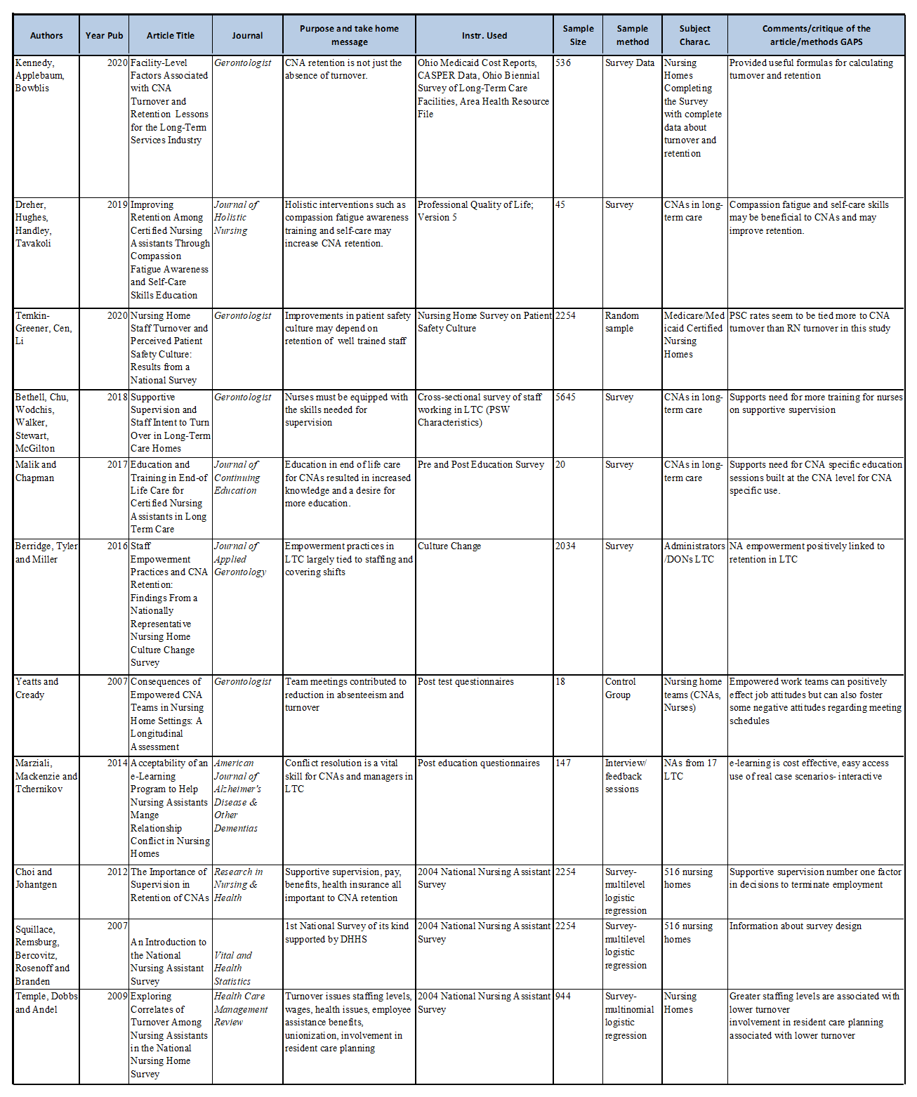
Literature Matrix

Appendix B
University Medical Center Internal Review Board Approval



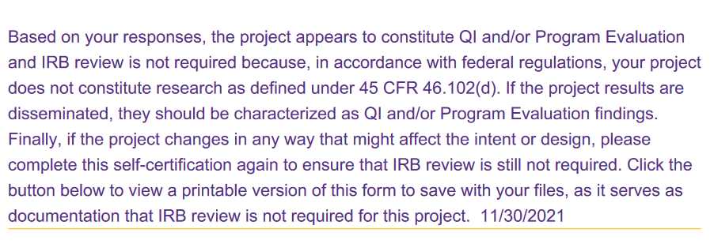

Appendix C
Project Survey Tool
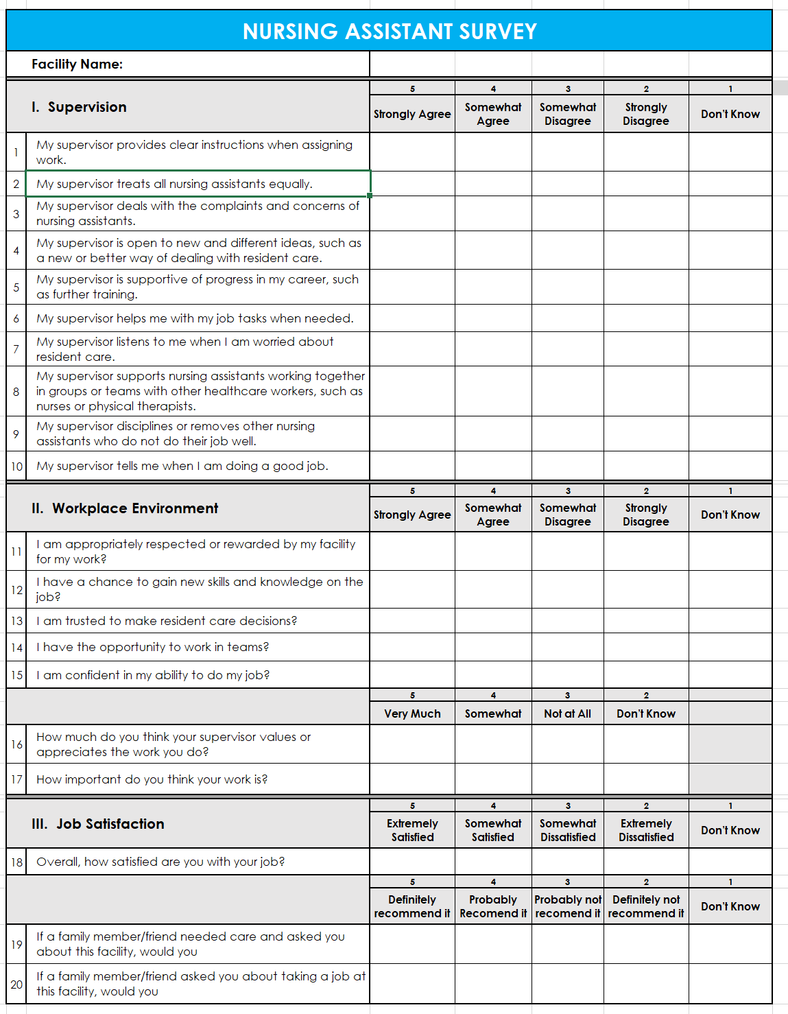

Appendix D

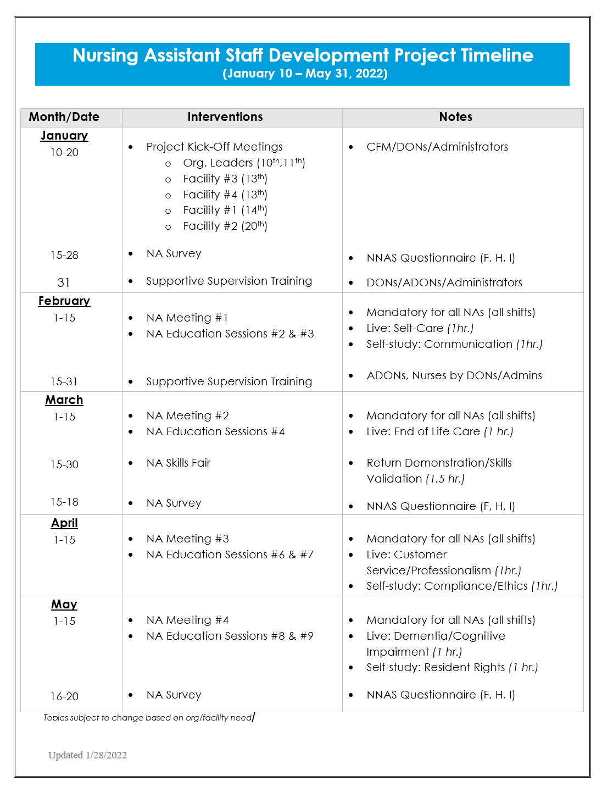
Project Timeline

Appendix E
Table 4
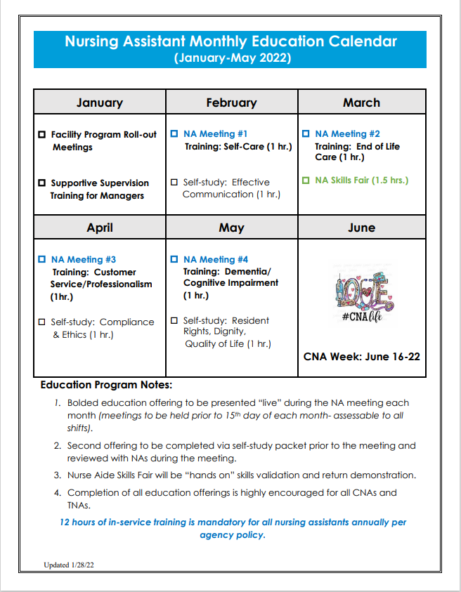
Nursing Assistant Monthly Educational Calendar

Appendix F
Nursing Assistant Staff Development Binder Table of Contents
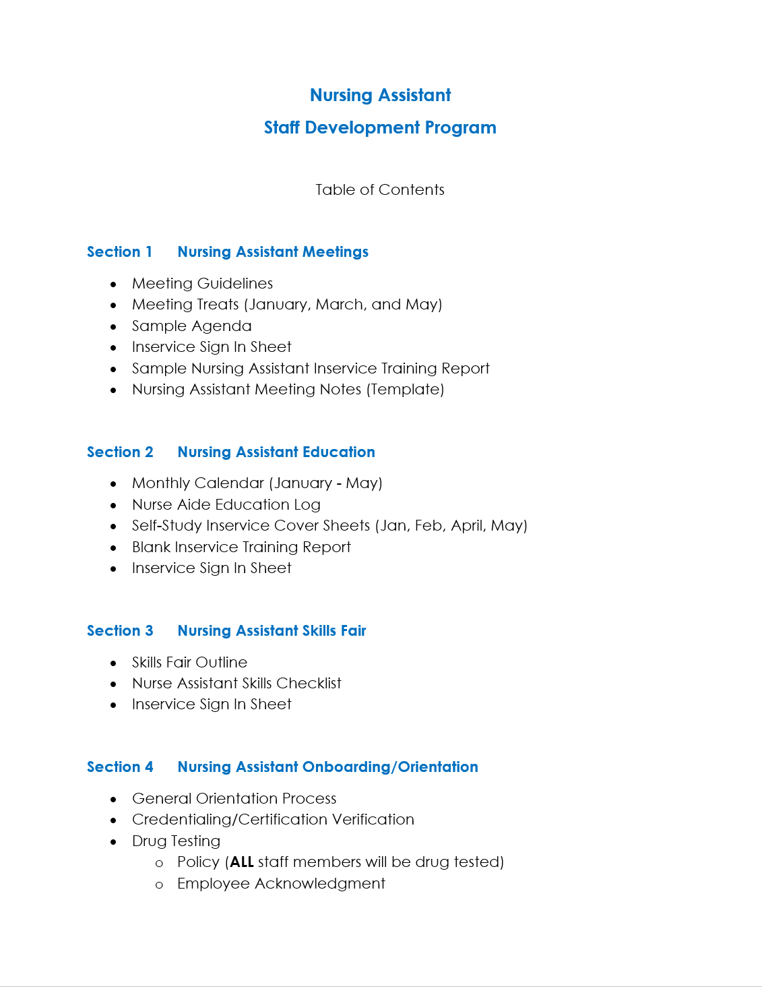

Appendix F (continued)

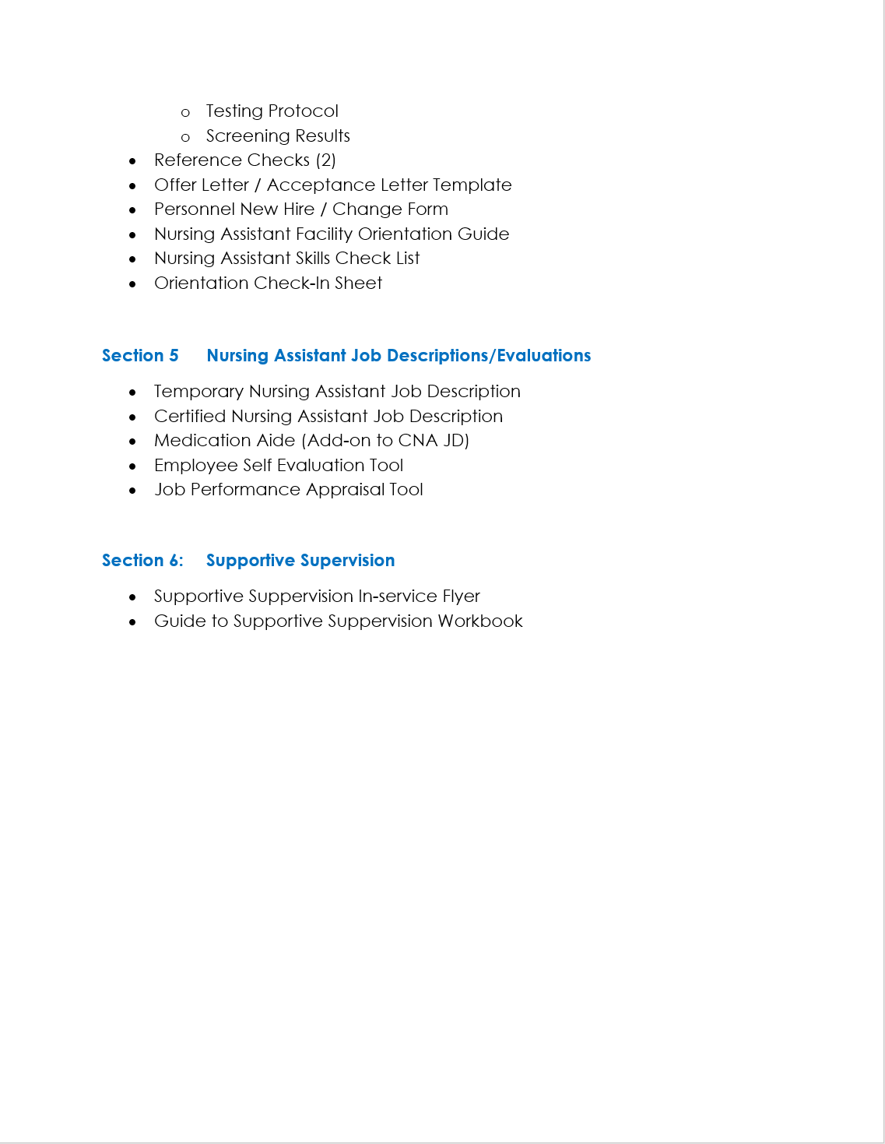
Binder Table of Contents (page 2)

Appendix G
Appendix G
Table 5
Nursing Assistant Inservice Participation by Month
Month | Training Activity | Hours | no. of Participants
January | Supportive Supervision Training for Facility Leaders | 3 | 16
February | Self-Care | 1 | 62
February | Communication | 1 | 62
March | End of Life Care | 1 | 59
March | Skills Fair | 1.5 | 94
April | Professionalism | 1 | 66
April | Compliance & Ethics | 1 | 66
May | Dementia | 1 | 69
May | Resident Rights | 1 | 69
Nursing Assistant Inservice Participation

Note. This table depicts the total number of nurse aides participating in each activity by month

Table 6
Nursing Assistant Inservice Participation
Nursing Assistant Inservice Participation by Facility
Facility | Feb | March | Skills Fair | April | May | Average
Facility 1 | 75% | 73% | 94% | 61% | 70% | 75%
Facility 2 | 37% | 50% | 88% | 56% | 57% | 58%
Facility 3 | 84% | 84% | 100% | 84% | 88% | 88%
Facility 4 | 73% | 29% | 94% | 87% | 93% | 75%

Note. This table depicts the percentage of nurse aide participation by facility
Appendix H
Nursing Assistant Meeting Guidelines
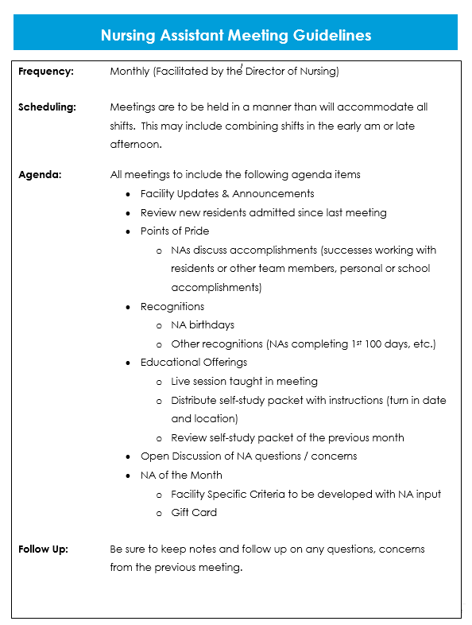

Appendix H (Continued)
Nursing Assistant Meeting Guidelines
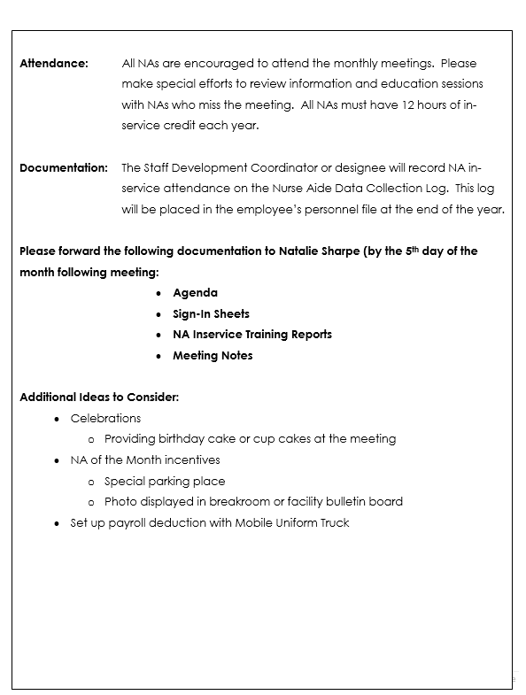

Appendix I
Nursing Assistant Meeting Sample Agenda

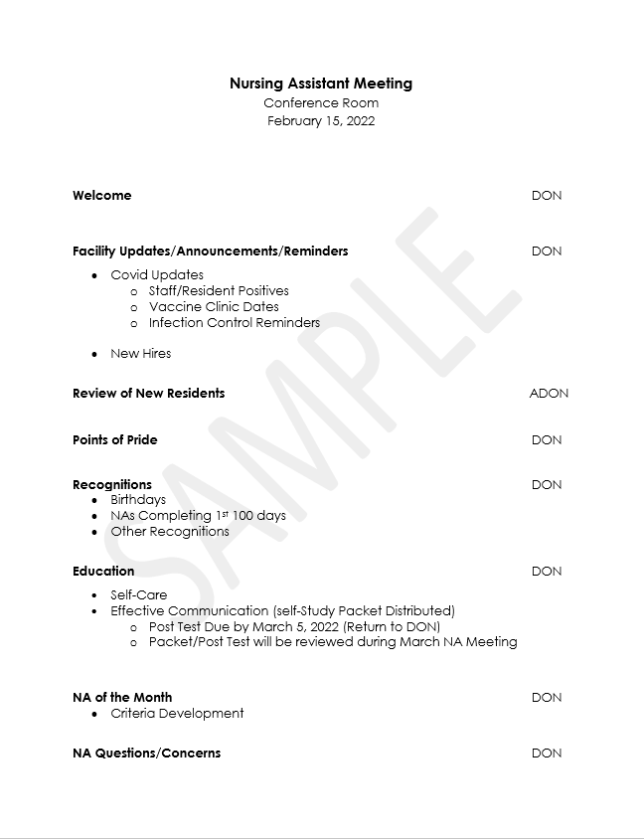

Appendix J

Table 7

Facility Tracker

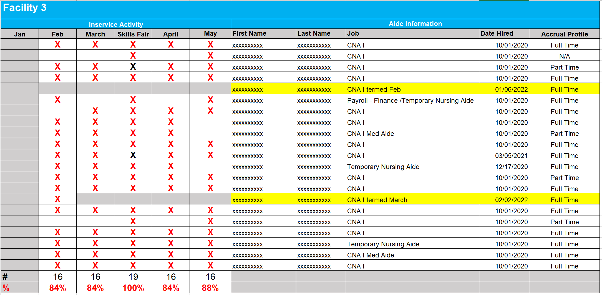

Appendix K

Nurse Aide Education Data Collection Tool

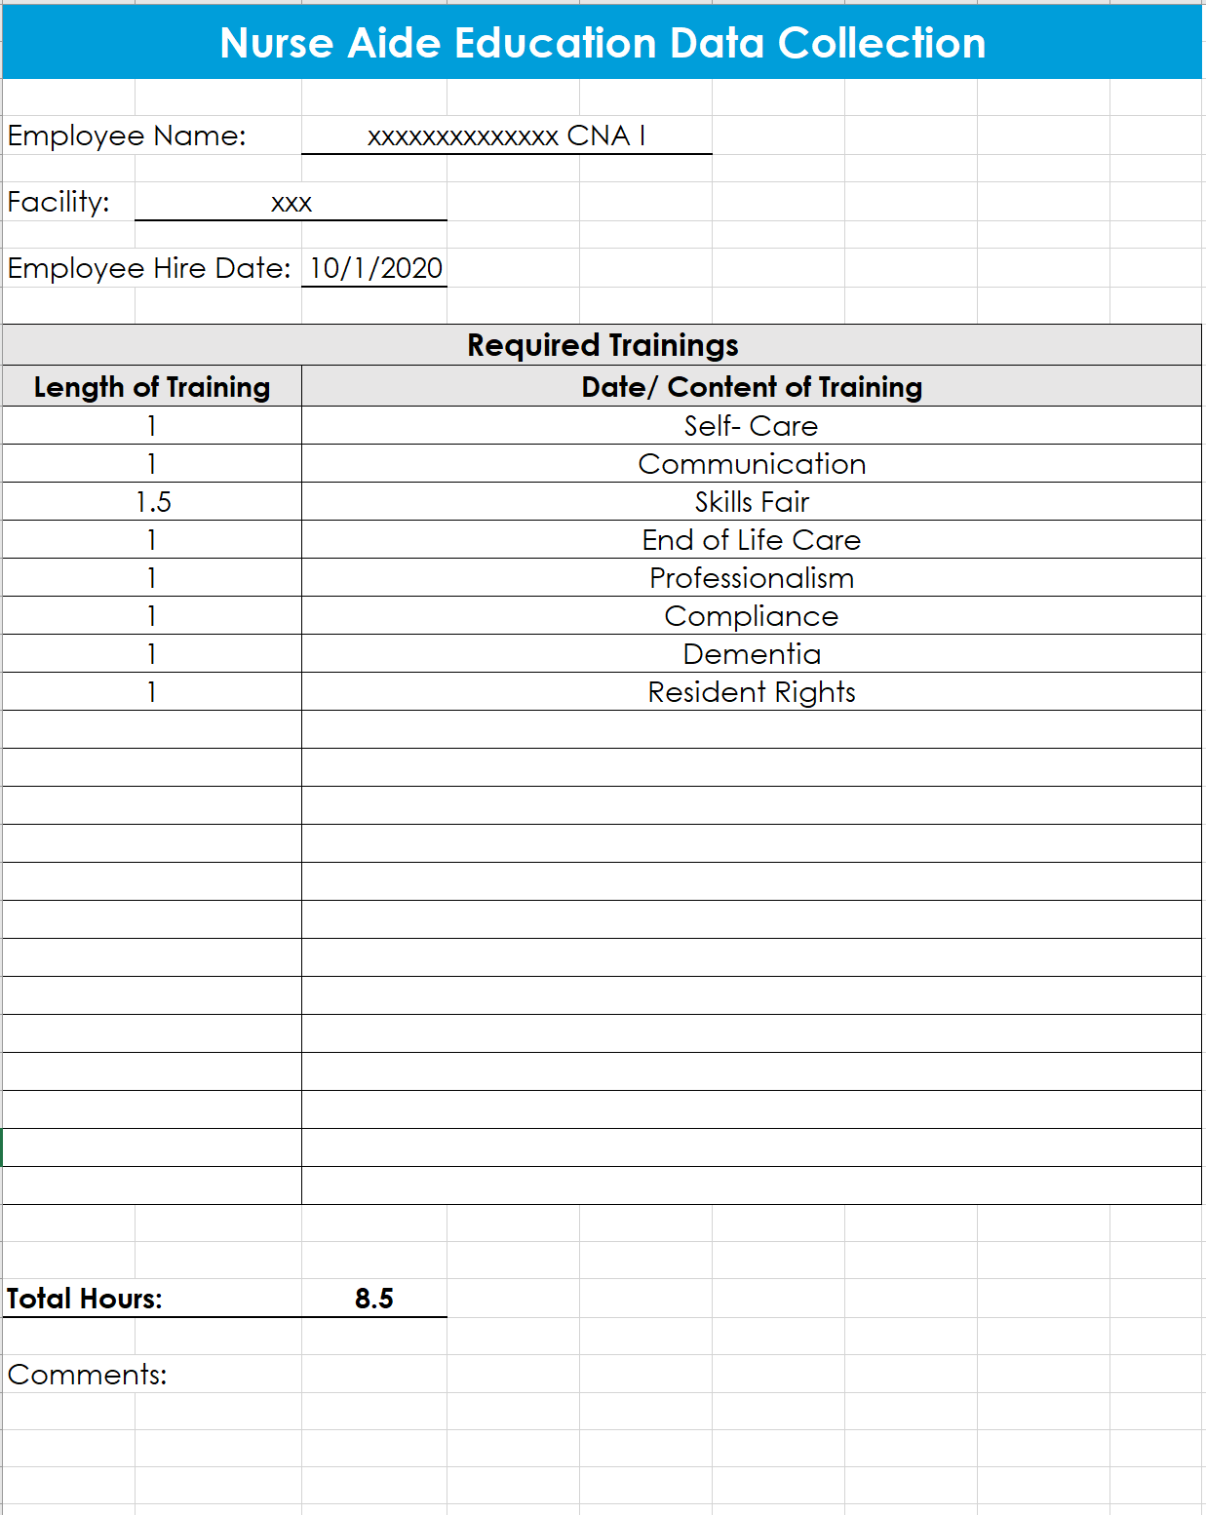

Appendix L

Appendix L
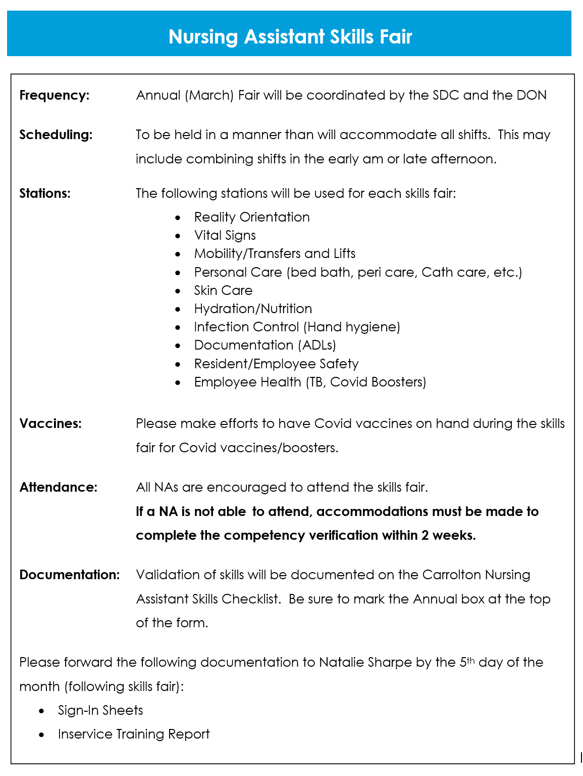
Nursing Assistant Skills Fair Outline

Appendix M
Nursing Assistant Skills Fair Competency Validation Tool
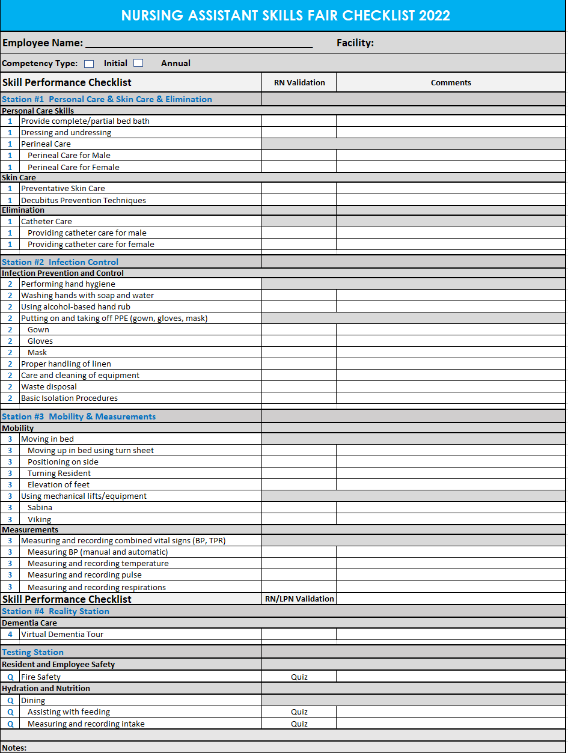

Appendix M (Continued)
Nursing Assistant Skills Fair Competency Validation Tool
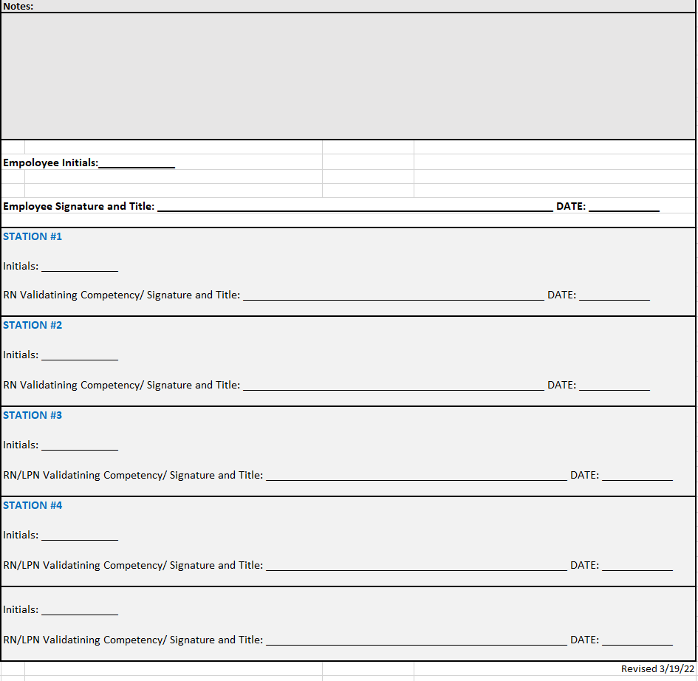

Appendix N
Turnover Data
Table 8
Baseline Turnover and Retention Data
Baseline Nursing Assistant (NA) Turnover and Retention Data
October 1, 2020, through October 1, 2021
Facility | no. NAs 10/1/2020 | no. NAs 10/1/2021 | no. NA Separations | 2020-2021 Turnover Rates | Average Days Employed | 2020-2021 Retention Rates
Facility 1 | 31 | 29 | 36 | 120% | 74.67 | 45%
Facility 2 | 49 | 33 | 33 | 80.49% | 100.64 | 59%
Facility 3 | 26 | 21 | 13 | 55.31% | 114.31 | 69%
Facility 4 | 37 | 22 | 30 | 101.69% | 80.30 | 54%
Companywide | 143 | 109 | 112 | 88.9% | 67.25 | 56.6%

Note. This table displays baseline nurse aide turnover and retention data

Table 9
Midpoint Turnover and Retention Data
Midpoint Nursing Assistant (NA) Turnover and Retention Data
January 1, 2022, through March 31, 2022
Facility | no. NAs 1/1/2022 | no. NAs 3/31/2022 | no. NA Separations | January - March Turnover Rates | Average Days Employed | January - March Retention Rates
Facility 1 | 34 | 31 | 11 | 33.85% | 75.27 | 76.47%
Facility 2 | 32 | 32 | 10 | 31.25% | 207.60 | 90.63%
Facility 3 | 18 | 18 | 2 | 11.11% | 30.50 | 100%
Facility 4 | 20 | 15 | 5 | 28.58% | 150.80 | 75%
Companywide | 104 | 98 | 33 | 25.74% | 112.70 | 83.65%

Note. This table displays midpoint nurse aide turnover and retention data
Appendix N (Continued)
Turnover Data
Table 10
Endpoint Turnover and Retention Data
Endpoint Nursing Assistant (NA) Turnover and Retention Data
April 1, 2022, through May 31, 2022
Facility | no. NAs 4/1/2022 | no. NAs 5/31/2022 | no. NA Separations | April - May Turnover Rates | Average Days Employed | April - May Retention Rates
Facility 1 | 31 | 31 | 2 | 6.45% | 175.5 | 77.42%
Facility 2 | 32 | 34 | 2 | 6.06% | 429 | 93.75%
Facility 3 | 18 | 18 | 1 | 5.56% | 851 | 94.44%
Facility 4 | 15 | 15 | 0 | 0% | n/a | 100%
Companywide | 96 | 98 | 5 | 5.15% | 412.0 | 94.90%

Note. This table displays endpoint nurse aide turnover and retention data

Table 11
Final Turnover and Retention Data
Final Nursing Assistant (NA) Turnover and Retention Data
January 1, 2022, through May 31, 2022
Facility | no. NAs 1/1/2022 | no. NAs 5/31/2022 | no. NA Separations | January - May Turnover Rates | Average Days Employed | January - May Retention Rates
Facility 1 | 34 | 31 | 13 | 40.00% | 90.69 | 73.53%
Facility 2 | 32 | 34 | 12 | 36.36% | 244.5 | 81.25%
Facility 3 | 18 | 18 | 3 | 16.66% | 304 | 94.44%
Facility 4 | 20 | 15 | 5 | 28.57% | 150.80 | 75%
Companywide | 104 | 98 | 33 | 32.67% | 175.12 | 78.85%

Note. This table displays final nurse aide turnover and retention data
Appendix O
Nursing Assistant Survey Results by Facility
Table 12
Nursing Assistant Survey Results Facility 1
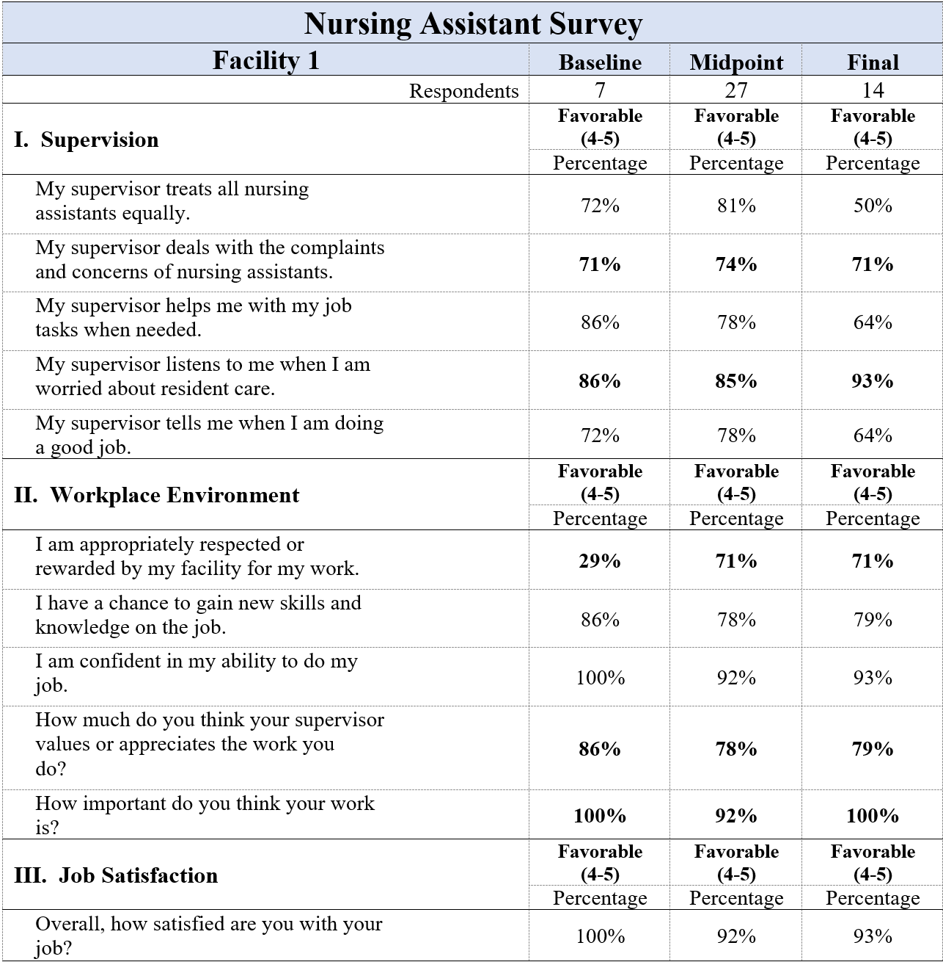
Note. Highlighted numbers indicate increase in this category from baseline to endpoint for for
facility #1.

Table 13
Nursing Assistant Survey Results Facility 2
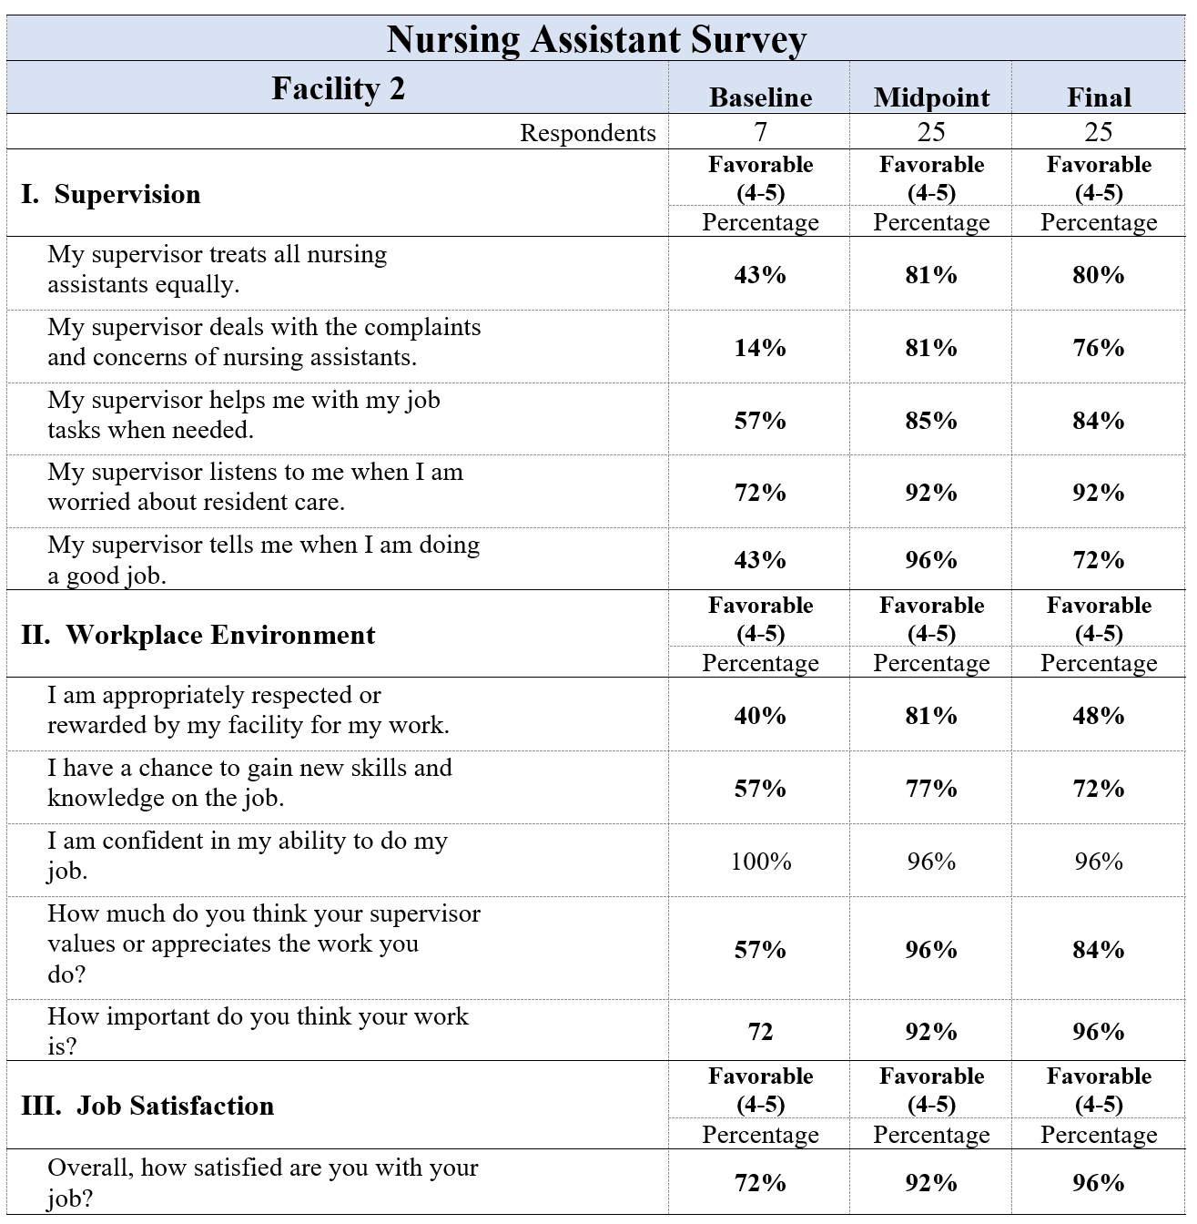

Note. Highlighted numbers indicate increase in this category from baseline to endpoint for
facility #2.
Table 14
Nursing Assistant Survey Results Facility 3

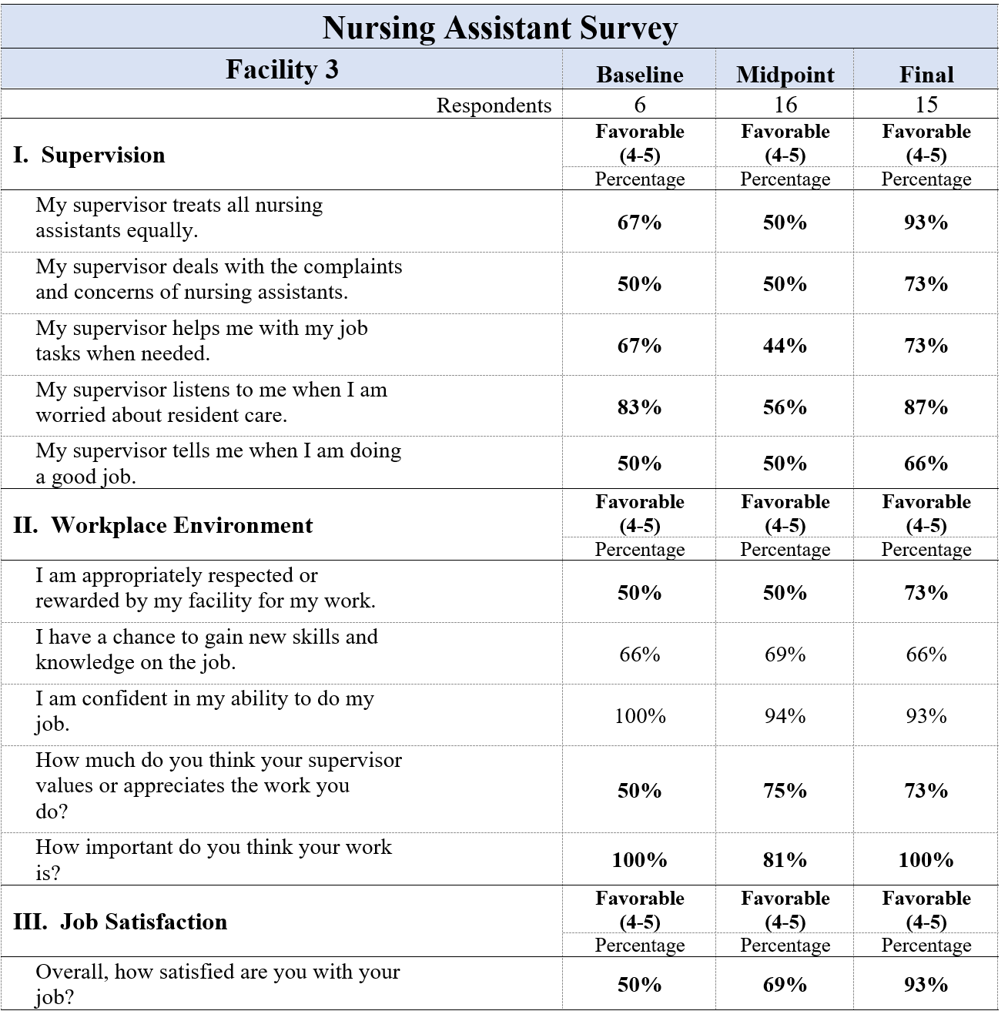

Note: Highlighted numbers indicate increase in this category from baseline to endpoint for
facility #3.

Table 15
Nursing Assistant Survey Results Facility 4
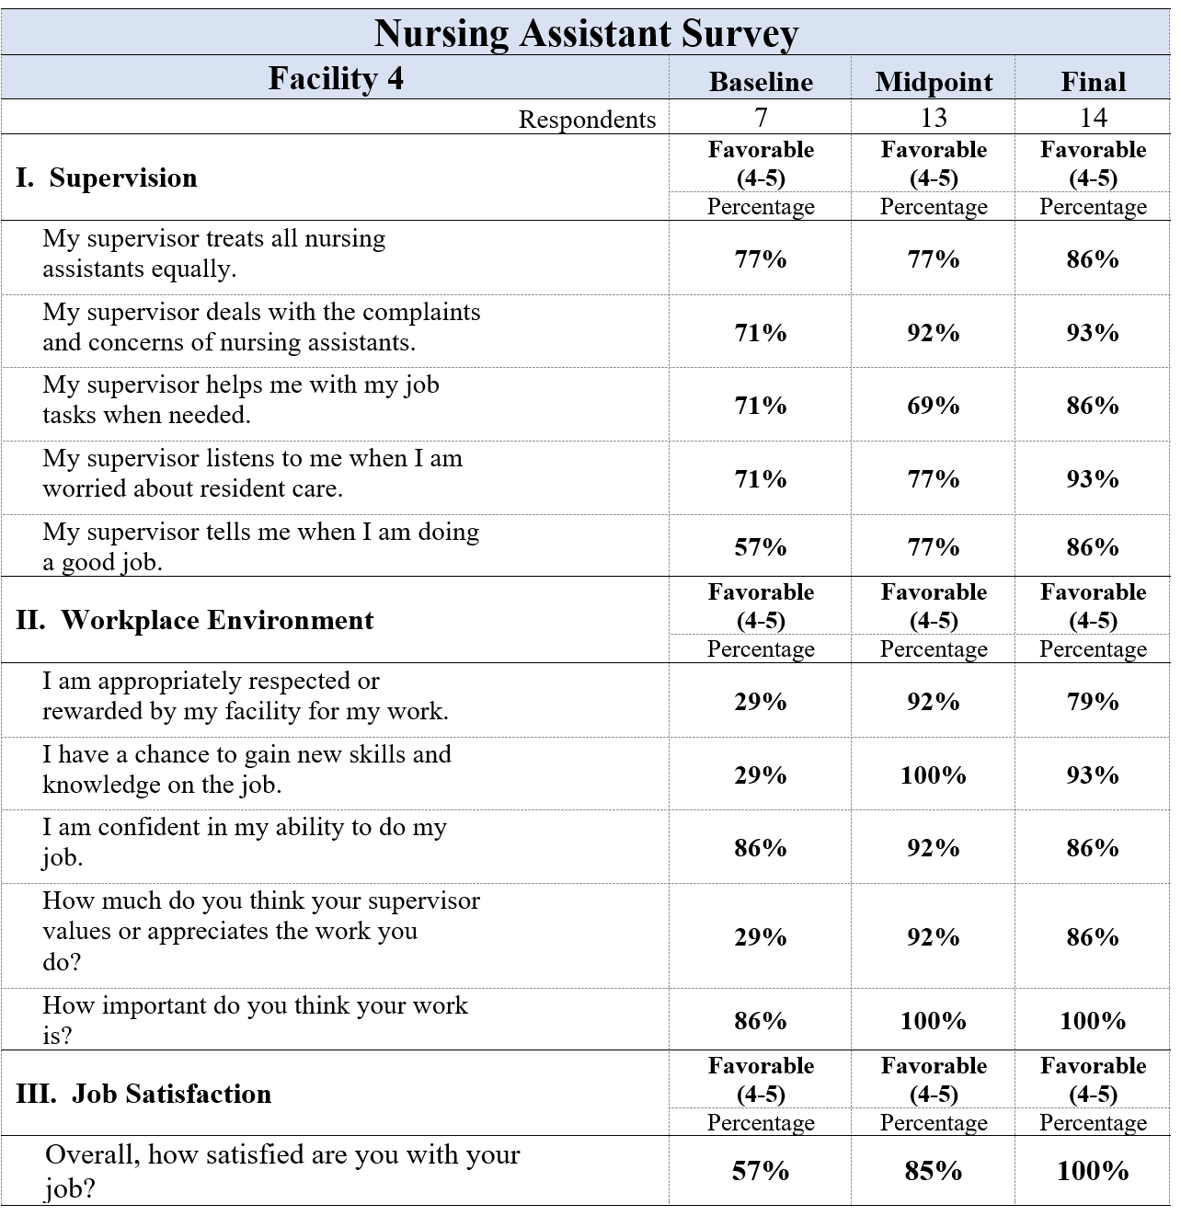
Note. Highlighted numbers indicate increase in this category from baseline to endpoint for
facility #4.
Appendix P
Project Budget
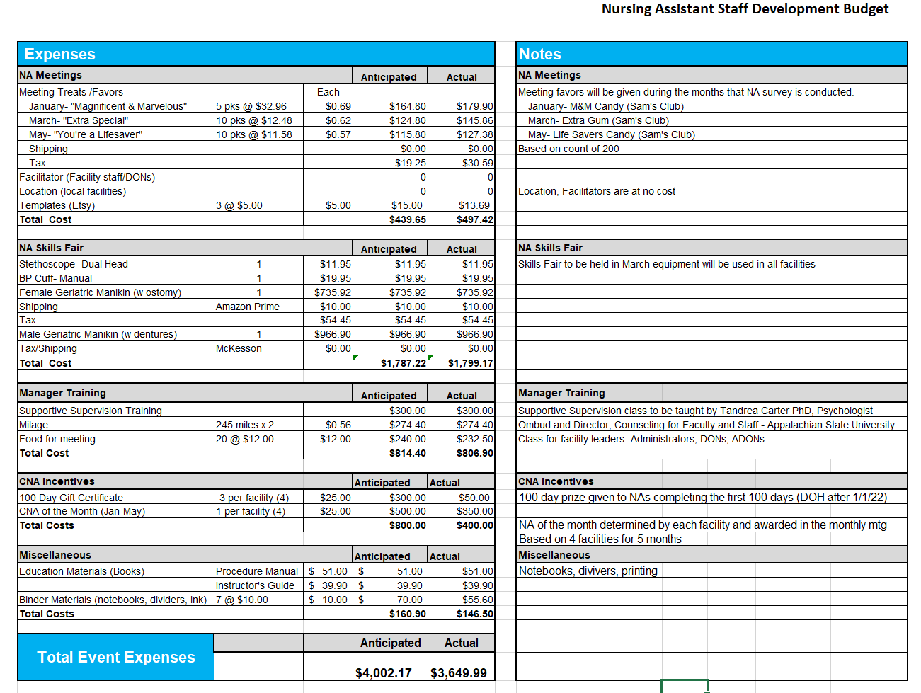
Table 16

Appendix Q
Key Deliverables

Appendix Q
Key Deliverables
