Evaluating the Effectiveness of QR Code in Expansion of Reach Out and Read Carolinas' Initiative to Increase Health Literacy on Oral Health and Vaccinations

Cierra Brown
College of Nursing, East Carolina University
Doctor of Nursing Practice Program
Dr. Lee Ann Long
7/22/2022

Abstract
Poor health literacy, or HL, is crucial in predicting less optimal health outcomes. Low HL can negatively affect informed decision-making in important healthcare decisions. Therefore, parental health literacy is of immeasurable value in ensuring the health of future generations. Technology has introduced new methods of information delivery and positively impacted the patient learning experience. In 2021, a pilot project between East Carolina University students and Reach Out and Read Carolinas successfully improved the parental health literacy of oral health and pediatric immunizations for ages zero to five years in counties in North Carolina by utilizing a Quick Response (QR) code. This DNP project focused on expanding the use of this QR code in new pediatric sites for ages zero to five years in Mecklenburg and Johnston counties. Like its predecessor, this DNP project collected data on website traffic and analyzed results from parental surveys to determine the effectiveness of learning materials on parental health literacy. This quality improvement project was completed in collaboration with ROR Carolinas, Eastern AHEC, and Charlotte AHEC.

Keywords: parental health literacy, QR code, quick-response code, eHealth tools, vaccine-preventable morbidity and mortality, healthcare technology, health informatics, immunizations, vaccines, oral health, health literacy

Table of Contents
Abstract.…………………………………………………………………………………………...2
Section I: Introduction....………………………………………………………………………….5
Background………………………………………………………………………………..5
Organizational Needs Statement…………………………………………………………..5
Problem Statement………………………………………………………………………...7
Purpose Statement…………………………………………………………………………7
Section II: Evidence…………………………………………………………………………….... 8
Literature Review……………………………………………………………………........ 8
Evidence-Based Practice Framework…………………………………………………....14
Ethical Consideration and Protection of Human Subjects…………………………….....16
Section III: Project Design.............................................................................................................18
Project Site and Population................................................................................................18
Project Team......................................................................................................................20
Project Goals and Outcomes Measures..............................................................................20
Implementation Plan..........................................................................................................22
Timeline.............................................................................................................................22
Section IV: Results and Findings……………………………………………………………...…24
Results…………………………………………………………………………………....24
Discussion of Major Findings…………………………………………………………....24
Section V: Interpretation and Implications……………………………………………………....27
Costs and Resource Management………………………………………………..………27
Implications of the Findings…………………………………………………………..…27
Sustainability.………………………………………………………………………..…...30
Dissemination Plan.……………………………………………………………..….……31
Section VI: Conclusion…………………………………………………………………..………32
Limitations and Facilitators…………..………………………………………………….32
Recommendations for Others…………………………………………………….……...33
Recommendations for Further Study………………………………………………….....34 Final Thoughts…………………………………………………………………………...34
References…………………………………………………………………………………..……36
Appendices ……………………………………………………………………………………....39
Appendix A: Literature Review……………………………………………………….…39
Appendix B: Project Timeline ……………………………………………………….….41
Appendix C: Project Management Form ………………………………………………..42
Appendix D: Actual Budget……………………………………………………………...49
Appendix E: Demographic Information………………………………………………....50
Appendix F: Project Poster……………………………………………………………....51
Appendix G: Project Bookmarks (English)………………………………………...……52
Appendix H: Project Bookmarks (Spanish)………………………………………...……53
Appendix I: QR Code Stickers…………………………………………………………..54
Appendix J: English Project Survey………………………………………………..……55
Appendix K: Survey Results.....………………………………………………………….57
Appendix L: Website Analytics....……………………………………………………….58
Appendix M: Provider Educational Pamphlet……..…………………………………….59

Section I: Introduction
Background
Early implementation of literacy-based learning has positive, long-lasting effects on families (Kim & Morrison, 2018). In fact, "a strong body of evidence suggests that such intervention programs improve early literacy outcomes" (Kim & Morrison, 2018). Reach Out and Read (ROR) is a national, non-profit organization that provides young children with a strong foundation for success by incorporating developmentally appropriate reading materials in the pediatric healthcare setting (Reach Out and Read, 2021a). Specifically, ROR Carolinas aims to provide a medically based literacy intervention for all children across North and South Carolina from birth to age five, starting with those in poverty (Reach Out and Read, 2021b). Through collaboration with doctors, nurse practitioners, and other healthcare providers, ROR Carolinas utilizes a three-part model to collaborate with and promote the lifelong success of the children and families they serve (Reach Out and Read, 2021b).
Organizational Needs Statement
ROR Carolinas needed to expand its initiative to increase health literacy on vaccinations and oral health for children five years old and younger in the other counties in North and South Carolina (T. Ramos-Hardy, July 7, 2021). The World Health Organization (WHO) listed vaccine hesitancy among parents as one of the ten leading threats to global health (Kempe et al., 2020). Throughout the COVID-19 pandemic, providing comprehensive education on the safety of vaccines was vital in ensuring the health of future populations. In addition, oral health in pediatric patients was an equally important topic. While preventative health care has been proven to improve oral health outcomes when introduced in early childhood, translation into practice remained a challenge (Quinonez et al., 2018). One of the most significant barriers to early implementation of preventative oral health interventions was low health literacy among parents and their lack of awareness of the significance of oral health in early childhood (Quinonez et al., 2018). To further support the initiative of ROR Carolinas, Healthy People 2030 listed oral health and vaccinations in childhood as top priorities in improving national health outcomes.
Like Healthy People 2020, the 2030 list of objectives included vaccinations, infectious diseases, and oral health as key topics in pediatric health-related goals. Healthy People 2030 aimed to increase the proportion of low-income youth who have preventive dental visits and use the oral health care system (United States Department of Health and Human Services, 2021a). In 2016-2017, 78.8% of children aged one through seventeen who lived in households with income less than 200% of the federal poverty level had a preventative dental service (United States Department of Health and Human Services, 2021a). Simultaneously, the focus on immunizations and preventing infectious diseases remained unwavering and had become an increasing concern in ensuring global health, particularly in young children. To illustrate, reducing the proportion of children who did not receive any recommended vaccines by age two was one of the main objectives of Healthy People 2030 (United States Department of Health and Human Services, 2021b). Nearly one in fifteen parents in the United States were hesitant about routine childhood vaccines, and one in eight were concerned about the safety of these vaccines (Kemp et al., 2020). Despite education on immunization safety in pediatric healthcare settings, overcoming barriers to early childhood vaccinations remained a significant issue.
Previously, ROR Carolinas collaborated with East Carolina University (ECU) Doctor of Nursing Practice (DNP) students to produce a QR code that routed parents to important educational links on early childhood oral health interventions and vaccinations (T. Hardy-Ramos, July 7, 2021). The study achieved many of its goals and received local recognition, igniting the need for further research on the topic, particularly upon expanding to new practices in the Mecklenburg and Johnston counties. In addition, a way to track the utilization of such educational methods is needed to evaluate the effectiveness of health literacy interventions. This DNP project addressed gaps in previous studies and analyzed utilization and information delivery methods.
Problem Statement
A deficit of evidence existed that supported increased utilization of resources available through ROR Carolinas following an expansion of their initiatives to improve health literacy regarding oral health and vaccinations in the Mecklenburg and Johnston counties. This lack of evidence created additional difficulties in understanding the community's educational needs and possibly resulted in poor outcomes in pediatric patients.
Purpose Statement
This DNP project aimed to evaluate barriers to information delivery of patient education regarding oral health and vaccinations in the Mecklenburg and Johnston counties after expanding ROR Carolinas' initiative to improve health literacy on these topics (Sharpe, 2021). This project aimed to address barriers to improving parental health literacy. This project also aimed to evaluate the effectiveness of digital media in information delivery of patient education.

Section II. Evidence
Literature Review
After a careful review of the available literature, it was evident that there was an overwhelming amount of information and a plethora of resources that could aid in the goals of this DNP project. As a result, various methods were used in the collection of data. Primarily, two databases were used in the literature search for this project, namely PubMed and CINAHL. The terms "health literacy in the United States AND pediatric care," "early oral health interventions," "health literacy in pediatric care," and "health literacy AND pediatric immunizations" were used as search terms for both databases.
Without applying any filters, the CINAHL Plus with full-text database yielded a total of 764 results for "early oral health interventions," 292 results for "health literacy in pediatric care," and zero results for both "health literacy in the United States and pediatric care and "health literacy and pediatric immunizations." Though fortunate, the immense number of resources available required extensive and detailed examination and evaluation for relativity and applicability in the project's target population. To further focus on the most useful information, inclusion criteria for CINAHL plus with text database included only those sources written in English, published within the last five years in a journal periodical, were peer-reviewed, and had the full-text and abstract readily available. When the criteria were further defined, ultimately, CINAHL plus with text database yielded three results for "early oral health interventions," for which zero were kept, and three for "health literacy in pediatric care," for which zero were kept. In addition, while zero results were yielded for both "health literacy in the United States and pediatric care and "health literacy and pediatric immunizations" in the initial search, two suggested articles were kept from the search for "health literacy in the United States and pediatric care."
Contrarily, a review of the PubMed database search without the application of any filters yielded a total of 183 results for "health literacy in the United States and pediatric care," 9,678 results for "early oral health interventions," 150 results for "health literacy in pediatric care," and 70 results for "health literacy and pediatric immunizations." The inclusion criteria for the PubMed search included sources written in English, published within the last five years in a journal periodical, were peer-reviewed and had the full-text and abstract readily available. However, inclusion criteria were further defined by those sources that were meta-analyses, randomized-controlled trials, reviews, or systematic reviews. With all criteria applied, the PubMed literature search yielded 2,543 results for "early oral health interventions," and eight were kept. There were ninety-one results for "health literacy in pediatric care," but none of the articles were kept. Also, the search yielded thirty-six results for "health literacy in the United States and pediatric care" and twenty for "health literacy and pediatric immunizations," with one result kept from each.
The highest level of evidence was sought in completing the literature review. While the most relevant and evidence-based data was a sought-out feature of each literary work, obtaining works of the highest-level evidence was not a significant determining factor in which data to use to complete the DNP project. As mentioned, the data collected focused on meta-analyses, randomized-controlled trials, and systematic reviews and included data from cohort studies. Articles ultimately utilized to complete this DNP project offered insight into attempted interventions to improve health literacy or discussed the importance of early oral health interventions and barriers to optimal oral health and up-to-date vaccination status in the pediatric population.
Current State of Knowledge
The literature offered evidence-based guidelines regarding health literacy in early oral health interventions and pediatric immunizations. The literature did not focus specifically on ages zero to five years old. However, the data collected did aid in understanding the overall status of health literacy of parents in the United States. This data also reviewed barriers to optimal health literacy among parents or guardians. Finally, the data discussed provided implications for future research to achieve the best patient outcomes.
Despite being an industrialized, well-educated nation, the United States has failed to meet imperative health literacy benchmarks. For example, in 2003, 88% of the United States' population lacked proficient health literacy (HL). This lack of proficiency has been overwhelmingly associated with adverse health outcomes, such as "poor access to medical care, increased hospitalizations, and fewer preventive visits" (Burgette et al., 2018). Furthermore, systemic reviews that have been conducted revealed varying levels of success of interventions in achieving desired outcomes targeted toward individuals and families at increased risk (Burgette et al., 2018). Additional research explored in this DNP project focused on exceeding the limitations of such studies by examining "the moderating effects of HL on the effectiveness of the health interventions," understanding the influence of HL on pediatric health outcomes, and how early preventive health intervention programs address low parent HL (Burgette et al., 2018).
Bridging the gaps in current literature required examining current modalities for communicating important healthcare information in pediatric settings, thereby exposing the strengths and weaknesses in the strategies employed. This examination would help circumvent poor pediatric patient outcomes resulting from poor health literacy and provider information delivery (Chi et al., 2018). Poor health literacy has also been associated with increased mortality and frequent hospitalizations, decreased use of preventive care, and efficient access to health services (Svendsen et al., 2020). Fortunately, available research offered various solutions to improving health literacy and encouraging preventative care practices in the pediatric population.
Current Approaches to Solving Population Problem(s)
Overwhelmingly demonstrated through the literature search, there are several ways to combat low parental health literacy and prevent less than optimal outcomes in the pediatric primary health care setting. Many of the discussed interventions in the list of chosen literature shared similar concepts and ideas and focused on the effectiveness of the information delivery technique. In addition, some studies included measurable metrics or deliverables to support the efficacy of the information provided, including monitoring of preventive oral health visits and verifying up-to-date immunization status. Analyzing the limitations and successes of previously attempted interventions to accomplish goals like this DNP project and ROR Carolinas' initiatives provided valuable insight in guiding future research development, implementation, and evaluation.
One study discussed the importance of collaborative, community-based care. It highlighted the importance of often overlooked but incredibly resourceful professionals of the healthcare team, such as social workers and community health workers (Edelstein, 2017). The role of the primary healthcare provider was highlighted in most literature. On the other hand, non-traditional helping professionals played a vital role in decreasing the risk of poor health outcomes. To illustrate, the healthcare provider (HCP) may have been able to efficiently provide patient education on preventative oral health interventions and pediatric immunizations. However, they may have lacked the knowledge or skill-base of other professionals, such as Certified Health Education Specialists (CHES), Registered Dietician Nutritionists (RDNs), and Medical Social Workers (MSWs) (Edelstein, 2017), in how to employ holistic care and meet any real or perceived gaps in care. Because low socioeconomic, or SEC, status and low HL were factors in poor health outcomes, the value of utilizing an inter-professional care approach to achieve the most optimal patient outcomes should not be disregarded as a possible and viable approach.
In contrast, patient education has traditionally been provided orally and reinforced via teaching-back methods and educational reading material. The primary advantage of distributing educational pamphlets is its' economic efficiency and feasibility in implementation. As a result, information delivered in this form is often able to reach a larger population regardless of frequency of visits, "socioeconomic status, possession of computers and internet network at their homes, and other technical problems related to using the website as an educational method to disseminate information" (Bardaweel & Dashash, 2018). Moreover, educational pamphlets, or leaflets, can be easily distributed at well-child checks and reviewed at the bedside to ensure proper understanding and address parental concerns. In addition, they provide a visual representation of appropriate oral health care strategies and pediatric immunization schedules. Educational pamphlets also serve as a visual reminder for essential milestones and preventive care information, especially for busy parents. While reliable and cost-effective, there has been an exponential increase in accessibility to new and old technology forms.
Constant and rapid technological advancements have become one of the most defining aspects of this age, particularly in a unique way for the current pediatric population and their parents. Children are exposed to technology, namely computers, cellular devices, and tablets, far earlier than possible or seen in the past, lending an exceptional opportunity to incorporate this omnipresent facet of everyday life, to improve the overall health care and outcomes of the pediatric population (Bardaweel & Dashash, 2018). Research "suggests that eHealth tools support patient-healthcare professional (HCP) interaction, patient self-management, and HCP-HCP interactions (through electronic health record integration)," which significantly and positively impacts patient outcomes (Ferrucci et al., 2021, p. 2). In addition, web-based applications, or eHealth tools, "promote patient self-management and co-responsibility" and encourage parental and patient empowerment (Ferrucci et al., 2021). Though many populations possess a proficient level of digital literacy, special consideration must be taken to prepare for the possibility of usability issues and disproportionate digital literacy of HCPs and families (Ferrucci et al., 2021).
Finally, the precedent to this DNP project, implemented by a previous cohort of East Carolina University students, implemented the use of a QR code via stickers, bookmarks, and posters to increase health literacy on oral health and immunizations in children ages zero to five years in four clinics in North Carolina (Sharpe, 2021). Like similar projects preceding it, the results of the intervention were favorable and even received recognition. The study found that the readability and accessibility of the educational material via the QR code was an effective, efficient, and budget-friendly intervention for parents to utilize. The QR code was also a quick intervention for healthcare providers and pediatric clinics to implement (Sharpe, 2021). Furthermore, the study reported an increase or "improvement in health literacy" (Sharpe, 2021). This study served as a quality improvement project. It offered guidance for future research, including identifying ways to "increase website traffic and completion of surveys" and partnering with Charlotte AHEC to expand to other pediatric clinics in North Carolina (Sharpe, 2021).
Evidence to Support the Intervention
Following careful evaluation of the collected literature and consideration of the project's goals, this DNP project worked with ROR Carolinas and Charlotte AHEC to increase the health literacy of oral health and pediatric immunizations in ages zero to five years. Evidence-based literature supported the need for increased health literacy on early oral health interventions and pediatric immunizations. In addition, it demonstrated technology-based health interventions' efficiency, accessibility, feasibility, and effectiveness in preventing negative patient outcomes (Office of Disease Prevention and Health Promotion, 2021). Not only did the continued use and expansion of the QR code allow for quick access to vital health information for parents despite their physical location, but this advantage became of particular and exponential importance during the COVID-19 pandemic (Office of Disease Prevention and Health Promotion, 2021). Implementation of the QR code also integrated technology-based health care modalities to increase parental health literacy and thus proved an innovative and valuable form of information delivery (Sharpe, 2021).
Evidence-Based Practice Framework
Identification of the Framework
This DNP project employed the Office of Disease Prevention and Health Promotion's (ODPHP) Health Literate Care Model (2021) to evaluate the impact of expanding the use of the QR code in clinics in the Mecklenburg and Johnston counties. In addition, per the goals of the Doctoral of Nursing Project, the Plan-Do-Study-Act (PDSA) model was utilized to direct the steps of the DNP project. Incorporating the Health Literate Care Model and the PDSA model helped to plan and execute the interventions reinforced by the goals of ROR Carolinas and evaluate the successes, applicability, limitations, and barriers of the proposed interventions.
ODPHP's Health Literate Care Model
Low health literacy in the United States has resulted in detrimental healthcare outcomes, calling upon researchers, scientists, healthcare professionals, and advocates to act. The ODPHP's Health Literate Care Model was created in response to the need to increase HL in the United States by increasing patient engagement in prevention, decision-making, and self-management (ODPHP, 2021). The model's defining principles are a conglomerate of "health literacy principles from the Universal Precautions Toolkit" and the Chronic Care Model (ODPHP, 2021). The Health Literate Care Model has three guiding principles for HCPs, including approaching all patients as if they are at risk of not understanding health information, employing a range of strategies for clear communication, and confirming that patients understand what providers are saying (ODPHP, 2021). Furthermore, the Health Literate Care Model provides a foundation for future research studies.
Integration of the Health Literate Care Model seamlessly incorporates health literacy into all aspects of care, "including self-management support, delivery system design, shared decision-making support, clinical information systems to track and plan patient care, and helping patients access community resources" (ODPHP, 2021). The model also addresses strategies for health organizations to inspire productive interactions that ultimately result in improved patient outcomes (ODPHP, 2021). To illustrate, the model suggests applying improvement methods, verbal exchange, and written communication, engaging patients as partners in care and improvement efforts, and serving as a vital link to supportive systems (ODPHP, 2021). The Health Literate Care Model is a comprehensive approach to care during a rapidly changing healthcare climate that aims to close the gap in poor health literacy in the United States.
Ethical Consideration & Protection of Human Subjects
With any study that involves human participation and observation, several details must be carefully examined and considered to determine the ethical implications of the study being conducted and ensure the appropriate steps are taken in the approval process of the study as an additional safeguard. Like its predecessor, this DNP project's intervention primarily targeted the parents or guardians of pediatric patients. Initially, there did not appear to be any immediate ethical considerations; however, upon deeper contemplation, the indirect involvement of pediatric patients via information obtained from parents was considered. In addition, this project served as an expansion of an initiative versus the creation of a new intervention. Therefore, if new metrics to measure the success of the interventions is employed, additional considerations would need to be considered. For example, one would need to re-evaluate obtaining informed consent and determining the project's role as a research project versus a quality improvement project.
After final approval, this expansion of ROR Carolinas' initiative to increase health literacy on oral health and pediatric immunizations in children equal to or younger than five years old was created through a previous collaboration with East Carolina University (ECU) College of Nursing Doctor of Nursing (DNP) students. This project implemented the QR code created by the previous cohort in four new clinics in North Carolina to increase overall health literacy on these topics statewide. The QR code guided parents to a website that discussed the importance of oral health and immunizations in ensuring a healthy childhood and optimal health outcomes later in life. The data continued to be collected anonymously. However, data from clinics previously involved in the initiative was compared to that of the clinics undergoing implementation in this DNP project. Because identifiable health information was not required to monitor this metric, there was no need to obtain informed consent from parents or patients. Furthermore, no potential harm existed to the target population, as the intervention and evaluation of its' effectiveness did not require vulnerable health data, have financial implications, involve excessively time-consuming efforts, or negatively affect the quality of care provided. Nevertheless, an extensive approval process was necessary to ensure beneficence and justice in care delivery during the conduction of the study.
In preparation for the DNP project, a structured and rigorous approval process was followed, including completing educational modules regarding human research and ethical implications via The Collaborative Institutional Training Initiative (CITI). The DNP project also required East Carolina University College of Nursing DNP faculty approval after a review of project components, goals, and qualifications as a DNP project. Under careful consideration, it was determined that review and approval from an Institutional Review Board (IRB) at ECU or ROR Carolinas' were not necessary to complete the DNP project.

Section III. Project Design
Project Site and Population
This DNP project was completed in collaboration with Reach Out and Read, a non-profit organization that works with numerous pediatric care offices across the United States. More specifically, this DNP project worked with the organization's Reach Out and Read Carolinas branch and another East Carolina University (ECU) Doctor of Nursing Practice (DNP) candidate. The Regional Director of Medical Engagement and Training served as the project site champion and assisted in assigning each student to specific clinics to expand the ROR Carolinas initiative. In addition, the Director of Communications at ROR Carolinas provided Google analytics of utilization of the QR code since the initial role out of the ROR Carolinas initiative in the fall of 2020 by the previous ECU cohort.
This project was a quality improvement project for ROR Carolinas; thus, it did not involve direct interaction with the patient or parent population of the individual clinics. The project involved the expansion of ROR Carolinas' initiative to eight new clinics, although data was tracked and collected for a total of fifteen clinics, including those involved in the pilot project. This project collaborated with ROR Carolinas' Regional Director of Medical Engagement and Training, Director of Communications, and pediatric healthcare clinics in Mecklenburg and Johnston counties to provide books, stickers, and bookmarks with the QR code. ECU DNP students were responsible for implementing the project in two clinics in Mecklenburg County, Clinics A and B, and two clinics in Johnston County, Clinics C and D. This project analyzed the utilization of the QR code in newly involved clinics and compared those rates with that of clinics involved in the initiative before the implementation of this DNP project. This DNP project aimed to improve the health literacy of oral health and immunizations in the Mecklenburg and Johnston counties to improve overall health literacy and pediatric patient outcomes in those communities. Barriers to this project include a smaller sample size than the project's predecessor and a lack of buy-in from providers and parents.
Description of the Setting
Reach out and Read (ROR) is a national, non-profit organization that provides young children with a strong foundation for success by incorporating developmentally appropriate reading materials in the pediatric healthcare setting. ROR Carolinas is a branch of ROR and aims to provide a medically based literacy intervention for all children across North and South Carolina from birth to age five. While ROR Carolinas does not have a physical office space, its initiatives are implemented across several pediatric clinics across North Carolina. ROR Carolinas has 2,424 trained ROR medical providers at 548 sites (2021a). This DNP project was implemented in pediatric healthcare clinics in Mecklenburg and Johnston counties in North Carolina.
Description of the Population
This DNP project did not involve direct contact with community stakeholders (i.e., providers, patients, parents) but aimed to impact the communities affected. Like its predecessor, this project focused on the parents of children zero months to five years old who brought their children to well-child visits. However, this project furthered the efforts of the previous DNP project by comparing utilization rates of the QR code in new clinics in North Carolina to that of clinics already involved in the initiative. This DNP project collected demographic data for the new clinics in Mecklenburg and Johnston counties, and the clinics already participating in this initiative were reviewed before implementation. Analyzing this data helped to discern the impact of implementing QR codes for parental and patient education on oral health and routine pediatric immunizations. It also determined the effectiveness of QR codes as a helpful tool in distributing important information about preventive health care and improving overall pediatric health outcomes.
Project Team
This DNP project team comprised a university faculty member and two facilitators. Additionally, two ECU DNP students worked together to implement the ROR Carolinas initiative at four new clinics in Mecklenburg and Johnston counties. The ECU College of Nursing faculty member served as a mentor throughout the DNP project and was responsible for periodically reviewing project elements to ensure they met requirements. The regional director of medical engagement and training fulfilled the role of project site champion, serving as the liaison and primary contact for ROR Carolinas. The liaison role encompassed connecting the ECU students with practice leaders at the participating clinics. ROR Carolinas' Director of Communications assisted in data collection by providing Google analytics to utilize the QR code.
Project Goals and Outcome Measures
This DNP project addressed barriers to information delivery and stakeholder buy-in that were limitations in the pilot DNP project. This project also implemented the use of the QR code attached to ROR Carolinas' books in new pediatric clinics in North Carolina. The previous ECU cohort developed a survey tool to evaluate the effectiveness of education delivered and included in this DNP project. ECU students delivered materials to their respective clinics and Google Analytics provided data on traffic to the website via scanning the QR code. Data from the survey tool and Google Analytics was synthesized and used to discern whether increased utilization of the QR code impacts health literacy in oral health and immunizations bi-monthly.
This project aimed to accomplish three goals. Primarily, this project aimed to increase the percentage of parents that agree to fluoride varnish and routine pediatric immunizations at well-child checks. In addition, this project aimed to determine the effectiveness of the QR code's website in increasing these metrics. Obtaining this information helped to discern whether a strong relationship exists between the modality of parental education and patient outcomes. Furthermore, inquiring about the efficacy of the QR code via a parental survey offered insight into the strengths and weaknesses of this project. In addition, the survey results helped to guide future research on similar topics. Finally, utilizing the parental survey that was developed and embedded in the QR code's webpage effectively measured the DNP project's success in increasing health literacy on oral health and pediatric immunizations.
Description of the Methods and Measurement
This DNP project was developed using the ODPHP's Health Literate Care Model and the PDSA model (ODPHP, 2021; Agency for Healthcare Research and Quality, 2021). The parental survey created during this project's pilot study was embedded into the QR code website and utilized to help determine the efficacy of provided education. The survey was available in Spanish and English. See Appendix J and Appendix K. Google Analytics continued to be of great use for this DNP project to monitor the frequency of use for the QR codes. Other proposed data measures included tracking the times parents agreed to the administration of fluoride varnish, chart records of a dental home, and administration of routine pediatric immunizations via CPT documentation. This data will be used to determine the efficiency in improving health literacy for oral health and immunizations in new clinics in North Carolina.
Discussion of the Data Collection Process
The data collection process started before the implementation of this DNP project. Data collected on the utilization of the QR code in clinics already involved in ROR Carolinas initiative were reviewed and analyzed. The data collected focused on the number of times the QR code was scanned after the initial implementation of the QR code on ROR Carolinas educational materials in 2020. An Excel spreadsheet was created containing that data. Additional data was collected during the implementation of this DNP project at each student's respective clinic sites and recorded in a separate Excel spreadsheet for comparison.
Implementation Plan
This DNP project was interdisciplinary and required careful planning and collaboration. Development of the project concept and design began in July 2021. Analyzation of previously collected data was performed to identify any limitations or barriers previously encountered. This analyzed data helped to ensure additional success in the ROR Carolinas initiative and close gaps not addressed in previous studies. Implementation began in November 2021, and evaluation of the project was ongoing until July 2022. Periodic and regular meetings were conducted between the project site champion and ECU students. ECU students were available and communicated regularly regarding implementation and data collection methods. Materials including QR code stickers, posters, and brochures were distributed to pediatric clinics in Mecklenburg and Johnston counties.
Timeline
This DNP project timeline started in July 2021 and ended in July 2022. Initial discussions about the project with ROR Carolinas and ECU faculty began in July 2021. Meetings between ECU DNP students and the project site champion were conducted monthly throughout the project period. Data from the previously completed DNP project with ROR Carolinas was analyzed in August 2021. Google analytics data for clinics already involved in ROR Carolinas initiative were reviewed in September 2021.
Implementation of this DNP project began in November 2021. The first implementation step began with distributing QR code posters, bookmarks, and stickers to ECU DNP students. See Appendices F through I. The students were responsible for distributing the materials to participating pediatric clinics in Mecklenburg and Johnston counties. Following the distribution of materials, an educational pamphlet outlining the DNP project goals and objectives was provided to providers at participating clinics. The pamphlet also further explained the role of ECU DNP students as collaborative partners with ROR Carolinas. After the dissemination of the pamphlet, a parental survey was created to determine the effectiveness of the education provided via the QR code website. Next, data was collected biweekly on utilization of the website and results from parental surveys. DNP project team meetings were held biweekly or triweekly to discuss any project needs and barriers.

Section IV. Results and Findings
Results
ECU students collaborated to implement this DNP project at four new pilot sites in Mecklenburg and Johnston counties. The project collected valuable data and information from fifteen participating clinics between November 2021 and April 2022. These clinics included ECU student implementation sites, other sites that were new to the initiative, and sites used in this project's inaugural pilot in 2020. In addition, data on parental survey results and the number of visits to the QR code's website were collected from January 2022 until April 2022. A total of nine surveys were completed during the implementation period. Of the nine surveys, eight were completed in English and one in Spanish. See Appendix K for individual results. The website had a total of fifty-two visits, with four visits in January, three in February, eleven in March, and thirty-four in April. See Appendix L. Additional outcome measures for clinics included the number of well-child check visits, percentage of book distribution, and insurance method. See Appendix E for demographic data.
There were 3,056 well-child visits for children ages zero to five between the two sites in Mecklenburg County from November 2021 through April 2022. Clinic A had 655 well-child visits for the targeted age demographic and a 100% distribution rate of ROR Carolinas' books. In addition, 40% of the patients at the clinic were insured by Medicaid, 40% had private insurance, and 15% were self-pay. Clinic B had 602 well-child checks with a 64% distribution rate. 45% of their patients had Medicaid, 37% had private insurance, and 12% were self-pay. It should be noted that it is unclear whether all distributed materials were distributed with ECU DNP project materials.
Discussion of Major Findings
This DNP project collected valuable information that will help provide insight into the benefits of technological advances in patient education delivery. Evidence found during the literature review supported the findings of the project. To illustrate, providing educational reading materials via a stickered QR code and bookmarks was an economically sound way to reach a large and diverse population. In addition, favorable book distribution rates in the pilot clinics demonstrate the feasibility of providing important education reading materials at visits. The DNP project also reflected how eHealth tools could positively impact patient outcomes by delivering information influencing parental health care decisions. Finally, though survey feedback remained low, it reflected important information. For example, it provided information on the likelihood of sharing the website with other parents and if any new information was learned after viewing it.
Historically, successful patient education modalities have included education provided orally and reinforced via the teach-back method. While many populations possess a proficient level of digital literacy, special consideration must be taken to prepare for the possibility of usability issues and disproportionate digital literacy of HCPs and families. Integrating oral education and the teach-back method with eHealth tools, such as QR codes, may help improve understandability. Furthermore, limited traffic to the QR code website and parental survey results made determining efficiency and effectiveness difficult. Finally, while this project's predecessor reported an "improvement in health literacy" (Sharpe, 2021), parental results collected in this study demonstrated varying responses in the amount of information learned. Parents that participated in the survey were only "somewhat likely" to recommend the website to other parents and did not change their immunization plans following education. Additional investigation into parental opinions on gaps in education provided would be useful to explore in future projects.

Section V. Interpretation and Implications
Costs and Resource Management
Charlotte AHEC and Eastern AHEC provided funding for this project. This DNP project was cost-effective and easily affordable to replicate. There were no significant changes to project materials used in the previous DNP project, which helped to limit costs. QR code stickers, posters, and bookmarks were reproduced from the previous year. SurveyMonkey and Google Analytics, free online services, were used for parental surveys and website analytics, respectively. ROR Carolinas' provided funding for website maintenance and associated costs. Overall, it cost $3,203.38 to expand ROR Carolinas' initiative. See itemized budget in Appendix D. In addition, approximately 200 student hours were dedicated to the literature review, development, collaboration, implementation, management, project revisions, and analysis of the findings.
If the organization were to conduct the project without the benefit of student labor and expertise, project costs would largely remain the same, varying if there is a change in the number of participating clinics or the implementation timeline. If the organization desired a cost reduction, they might consider only printing posters and bookmarks, saving labor, time, and money. It is otherwise a reasonably priced project to continue and expand upon, especially with the help and support of outside organizations such as Charlotte AHEC and Eastern AHEC. Furthermore, costs for preventative programs are less than the healthcare costs incurred from vaccine-preventable illnesses and morbidity and mortality related to poor oral health, making it a worthwhile investment.
Implications of the Findings
This project expanded accessibility to important health information regarding pediatric immunizations and oral health. Implementing the QR code's website in other clinics in Mecklenburg and Johnston counties promoted improved parental health literacy in new settings in the state. This provided information to a broader audience, which will help make results more generalizable as the number of participating clinics increases. Furthermore, this project helped to establish a relationship between ECU, ROR Carolinas, Eastern AHEC, and Charlotte AHEC. These partnerships can help further expand the project in other counties across the state. In addition, it may lead to exploring other important health topics for ages zero to five years. Finally, this project will serve as a guideline for similar studies that explore the use of technology in patient education and improving parental health literacy.
Implications for Patients
Constant technological advances and innovations in health informatics have played a pivotal role in changing how health information is delivered. Accessibility to such information makes it possible to provide patient education more cost-effectively and efficiently regardless of physical location. Improved accessibility also provides a new and unique opportunity to explore ways to help increase parental health literacy by using alternative modalities, such as QR codes. Furthermore, improving access helps decrease disparities in patient education, leading to higher quality patient outcomes. Providing patient education utilizing a QR code also reinforces information discussed during visits. Though parents are typically educated on the importance of maintaining pediatric oral health and staying up to date on pediatric vaccinations during visits, having a way of referring to the information later can help retain learned information. This project demonstrated the use of QR codes in improving parental health literacy patient outcomes. This project further supported the use of technology, specifically QR codes, in providing and reinforcing parental education for oral health and immunizations following evidence-based guidelines.
Implications for Nursing Practice
Rapid technological advances in healthcare have occurred in the last decade, foraging new and innovative ways to ensure quality patient outcomes. Additionally, informatics plays a vital and undeniable role in today's healthcare system, and its role continues to grow. The nursing role comprises several subsidiary roles, including educator, researcher, and patient advocate. The nursing profession will need to continue to adapt to the everchanging technological advances while assisting patients with understanding the use and benefits of these new modalities. This project illustrates the benefits of using technology, particularly QR codes, in successfully teaching patients about important health topics. Though recent technological interventions often come with a learning curve, the ability to provide quick, reliable patient health information and education has proven to be priceless. As a result, healthcare professionals must maintain steadfastness in their ability to accommodate these changes in the healthcare setting.
Impacts on Healthcare System(s)
Healthcare systems will need to fully embody their role as pioneers and instruments of change to promote quality patient outcomes. This includes assessing gaps and barriers in delivering efficacious, evidence-based health information. Interventions to tackle these challenges will also need to be cost-effective for the benefit of healthcare systems and consumers. Utilizing digital media to provide patient education is a budget-friendly teaching modality, decreases costs associated with traditional printed materials, and can be updated quickly if any changes are needed. Specifically, providing digital health education regarding vaccines and oral health can decrease healthcare costs. For example, it will help provide educational materials to promote healthy decision-making by parents when addressing their children's oral health and immunization needs. Providing evidence-based education on immunizations can help decrease vaccine hesitancy, thereby increasing compliance with routine pediatric immunizations. This will also help reduce healthcare costs associated with vaccine-preventable childhood morbidity and mortality. Education regarding appropriate oral health practices will help circumvent excessive healthcare costs associated with poor oral health. Budgetary pros and cons for individual clinics would need to be assessed to determine the sustainability of this project or similar projects.
Sustainability
This DNP project was an expansion of a previous collaborative project between ECU students and ROR Carolinas. Its predecessors' success with implementing the QR code promoted interest in expanding the project by Charlotte AHEC and was completed with the continued support of ROR Carolinas. Funding was provided via ROR Carolinas, Charlotte AHEC, and Eastern AHEC, making this project easily replicable and affordable. Materials from the preceding DNP project were printed without recreating the content, including posters, stickers, and bookmarks. The website and parental survey were also exempt from modifications by this DNP cohort. Continuing this project would be highly cost-effective for ROR Carolinas should they continue to avoid additional costs associated with website and content creation. While financially sustainable, it is important to consider other factors that may affect the success of this project in the future.
In contrast to its predecessor, this DNP project received less feedback from participating clinics. This made it difficult to discern the source of barriers to information delivery. One such barrier, the COVID 19 pandemic, affected many aspects of care delivery at the beginning of this project's implementation phase. However, many participating sites did return to normal operations toward the end of the implementation period as COVID 19 transmission rates decreased nationally. This might have contributed to an increase in website traffic in April 2022. To sustain this project and increase the likelihood of parental feedback, it would be useful to have project team members present in participating clinics at various points throughout the implementation process.
Dissemination Plan
This DNP project was presented during the East Carolina University's (ECU) College of Nursing poster presentation on July 12, 2022. The presentation was attended by ECU College of Nursing faculty and colleagues. This DNP project paper was also published on ECU's The Scholarship, a digital archive that houses the academic works of ECU faculty and students.

Section VI. Conclusion
Limitations and Facilitators
Limitations
This DNP project had far lower scanning and participation rates when compared to its predecessor. After evaluating possible causes, two major limitations were identified. First, like much of the world, this project was significantly impacted by the ongoing COVID 19 pandemic. The pandemic was approaching its third year at the beginning of implementation in January 2022. Consequently, pandemic-related fatigue was an omnipresent side effect of a longstanding healthcare crisis. As a result, many practices, healthcare providers, and personnel were overwhelmed and burnt out from the impact of the continued COVID 19 pandemic. Practices were understaffed after the effects of the pandemic and the introduction of a new COVID-19 strain at the beginning of the implementation period. This may have prevented staff and providers from promoting the use of and discussing project materials with parents. In addition, many pediatric practices restricted in-person visits, and parents were wary of bringing their children in for routine appointments, including well-child visits. This decrease in patient traffic further affected the number of opportunities available to distribute project materials.
Finally, there was little to no communication between the DNP project team and participating clinics after the distribution of materials. This communication breakdown made it difficult to receive feedback to help improve project outcomes. It also prevented analyzation of other metrics that were not explored in the previous ECU DNP study. This limited the ability of the project team to use different metrics to discern the effectiveness of teaching for those who scanned the QR code but did not complete a survey. Without this information, it is hard to determine whether the project had a direct correlation with patient outcomes.
Facilitators
Despite encountering some limitations, this project also had numerous facilitators. For example, many of the project materials were created by the previous ECU cohort and served as an excellent foundation for implementing this project. The previous ECU cohort also caught the attention of Charlotte AHEC, which ultimately secured funding for this project. DNP ECU faculty, clinic contacts and staff, ROR Carolinas team members, Eastern AHEC, and collaborating ECU students were also supportive of the goals of this DNP project. Establishing this network was of immense importance and service in completing this project. The interprofessional collaboration allowed for swift and efficient manipulation of project plans as needed to combat any barriers and contribute to the added success of the project.
Recommendations for Others
After carefully reviewing the project's limitations and facilitators, numerous recommendations exist for those wishing to create similar studies. In future studies, assessing barriers for all stakeholders before implementation will help create solutions that were not previously considered. Also, ensuring the parental survey is easily identifiable on the QR code's website's home page could help obtain additional teaching effectiveness information. Increasing the project team's physical presence in participating clinics throughout the implementation process to answer any staff questions or concerns and assist with promoting project goals would be beneficial. Future pioneers should also explore ways to encourage parents to scan the QR code during patient encounters. Implementing these changes may promote more traffic to the QR code website and encourage parental participation.
While some changes are necessary, it would be useful for those wishing to complete similar projects to continue networking with Charlotte AHEC and Eastern AHEC. Working with organizations such as Charlotte AHEC and Eastern AHEC helps secure funding for such projects and programs. This allows project information to reach a larger audience across North Carolina. This also ensures that those from other parts of the state reap the benefits of these studies. Increasing the project's scale also helps elicit additional data to make the project more generalizable for use in other places in the nation. Increased availability of educational materials across the state will lead to an increase in quality pediatric patient outcomes. It will also aim to decrease the mortality and morbidity related to poor oral health and failure to vaccinate against preventable diseases.
Recommendations for Further Study
Several pediatric practices in the state and within ROR's network across the country would benefit from the further expansion of this project. This presents a unique opportunity to improve health literacy in new settings to reach a broader audience. Focusing on additional topics identified by HealthyPeople2030 as leading causes of morbidity and mortality in children ages zero to five years would be useful in creating meaningful projects. In addition, the administration of a parental survey addressing concerns regarding their child's health could help identify gaps in care and opportunities for patient education. Finally, due to the project's targeted audience and age demographic, it may not be generalizable to a different population. Implementing such projects in family care clinics versus exclusively pediatric practices can help bypass this limitation.
Final Thoughts
This DNP project aimed to increase health literacy regarding oral health and immunizations in Mecklenburg and Johnston counties after expanding ROR Carolinas' initiative. The project also aimed to evaluate barriers to information delivery in pediatric settings, though limited communication with participating clinics made this difficult. Although there was little feedback from participating clinics, the project did have a positive impact. As evidenced by the survey results, parents could easily use the QR code and gain knowledge after reviewing website content. Other advantages throughout this project include a supportive and well-connected DNP project team and the completion of a pilot project for reference.
Future studies on similar topics are needed to generalize results due to the small sample size of this DNP project. Further studies should consider implementing a survey aimed at helping to identify gaps in parental understanding of provided education. Pioneers of the study might also consider developing a tool to accurately assess any barriers to information delivery of technology-based eHealth tools. As technology proves invaluable in today's healthcare climate, its use will continue to increase across various settings. Offering new and up-to-date modalities to deliver patient education can help promote autonomy in patient care while providing vital health information. This project served as an example of how eHealth tools, such as QR codes can effectively improve parental health literacy regarding pediatric oral health and immunizations for children aged zero to five years.

References
Agency for Healthcare Research and Quality. (2021). Plan-Do-Study-Act (PDSA) Directions
and Examples. Retrieved from
https://www.ahrq.gov/health-literacy/improve/precautions/tool2b.html
Al Bardaweel, S. & Dashash, M. (2018). E-learning or educational leaflet: does it make a
difference in oral health promotion? A clustered randomized trial. BMC Oral Health, 18(1), 81-81. https://doi.org/10.1186/s12903-018-0540-4
Burgette, J. M., Preisser, J. S., Weinberger, M., King, R. S., Lee, J. Y., & Rozier, R. G. (2018).
Absence of a moderating effect of parent health literacy on early head start enrollment and dental use. Journal of Public Health Dentistry, 78(3), 257-265. https://doi.org/10.1111/jphd.12269
Chi, D. L., Richman, J., Senturia, K., & Zahlis, E. (2018). Caregivers’ understanding of fluoride
varnish: Implications for future clinical strategies and research on preventive care decision making. Journal of Public Health Dentistry, 78(4), 282-286. https://doi.org/10.1111/jphd.12277
Edelstein, B. L. (2017). Pediatric dental-focused interprofessional interventions: Rethinking
early childhood oral health management. The Dental Clinics of North America, 61(3), 589-606. https://doi.org/10.1016/j.cden.2017.02.005
Ferrucci, F., Jorio, M., Marci, S., Bezenchek, A., Diella, G., Nulli, C., Miranda, F., & Castelli-
Gattinara, G. (2021). A web-based application for complex health care populations: User-centered design approach. JMIR Human Factors, 8(1), e18587-e18587. https://doi.org/10.2196/18587
Kempe, A., Saville, A.W., Albertin, C., Zimet, G., Breck, A., Helmkamp, L., Vangala, S.,
Dickinson, L.M. Rand, C., Humiston, S., & Szilagyi, P.G. (2020). Parental hesitancy about routine childhood and influenza vaccinations: A national survey. Pediatrics, 146(1), e20193852. https://doi.org/10.1542/peds.2019-3852
Kim, M.H. & Morrison, F.J. (2018). School effects on literacy skills during the transition to
school. AERA, 4 (3), 1-15. https://doi.org/10.1177/2332858418798793
Office of Disease Prevention and Health Promotion. (2021). Health Literate Care Model.
Retrieved from https://health.gov/our-work/national-health-initiatives/health-literacy/health-literate-care-model
Quinonez, R.B., Rozier, R.G., Mattison, K., Joshi, N., Preisser, J.S. (2018). Implementing an
early childhood oral health program in a federally qualified health center in North Carolina. Journal of Public Health Dentistry, 78(4), 329-336. https://doi.org/10.1111/jphd.12276
Reach Out and Read. (2021a). Our vision. Retrieved from https://reachoutandread.org/about/
Reach Out and Read. (2021b). Mission, vision, model. Retrieved from
https://www.rorcarolinas.org/about-us/vision-mission-model/
Sharpe, Sydney. (2021). Increasing Health Literacy of Parents of Children Aged 0 to 5
Regarding Oral Health and Immunizations (DNP Scholarly Project, East Carolina University). Retrieved from https://thescholarship.ecu.edu/handle/10342/9224
Svendsen, M. T., Bak, C. K., Sørensen, K., Pelikan, J., Riddersholm, S. J., Skals, R. K.,
Mortensen, R. N., Maindal, H. T., Bøggild, H., Nielsen, G., & Torp-Pedersen, C. (2020). Associations of health literacy with socioeconomic position, health risk behavior, and health status: a large national population-based survey among Danish adults. BMC public health, 20(1), 565. https://doi.org/10.1186/s12889-020-08498-8
United States Department of Health and Human Services. (2021a). Increase the proportion of
low-income youth who have a preventive dental visit. Retrieved from https://health.gov/healthypeople/objectives-and-data/browse-objectives/oral-conditions/increase-proportion-low-income-youth-who-have-preventive-dental-visit-oh-09
United States Department of Health and Human Services. (2021b). Reduce the proportion of
children who get no recommended vaccines by age 2 years. Retrieved from https://health.gov/healthypeople/objectives-and-data/browse-objectives/vaccination/reduce-proportion-children-who-get-no-recommended-vaccines-age-2-years-iid-02\

Appendix A
Literature Review

Appendix B
Project Timeline
May – August 2021 May 2022-July 2022

- Conceptualization and identification of project problem and purpose.
- Completion of CITI modules
- Identification of project site and DNP project team members

- Data collection and analyzation
- Biweekly team meetings
- Publishing of DNP paper to The ScholarShip
- Sharing of project findings with ROR Carolinas
- Project poster presentations in front of ECU faculty and colleagues

September 2021 – December 2021
- Literature search
- Evaluation of need for IRB
- Identification of participating clinics for DNP project
- Collaborated with Charlotte AHEC and Eastern AHEC
- Established contact with implementation sites
- Received bookmarks, stickers, and posters for project implementation
- Distribution of materials to and throughout participating sites marking the beginning of the implementation phase
- Data collection

January 2022 – April 2022

- Data collection and analyzation
- Biweekly team meetings

Appendix C
Project Management Form

Were you able to collect the data you thought you’d collect? Yes No
If no, why not?
- No, we were unable to collect some components of the data we sought. Namely, whether Providers were able to collect data regarding dental home visits or any other form of unidentifiable patient data as it relates to oral health or compliance with routine pediatric immunizations. We also did not have any participants for our parental survey, which could limit the qualitative information we receive to offer suggestions for future research. It also acts as a barrier to implementing the project in a way that is receptive to the targeted population.
- Update: No, we did not have any participants for our parental survey, which could limit the qualitative information we receive to offer suggestions for future research. We also had limited traffic to the QR code’s website. Both act as barriers to implementing the project in a way that is receptive to the targeted population.
- Update: No, we were unable to get responses regarding implementation barriers/challenges and successes from many of the participating clinics.
- Update: Yes, we were able to produce more analytics compared to our previous submission of the project management report.
Did you meet with your site champion on the date(s) you had planned to meet? Yes No

If not, why not?
- No, we have not scheduled our next meeting. We planned to meet at a minimum of once per month; however, biweekly meetings might be more beneficial and fall more in line with course deadlines. Ideally, we would have had the opportunity to schedule and conduct another meeting prior to the submission of this assignment to discuss the Google Analytics reports, possible barriers to implementation and solutions.
- Update: Yes, we were able to meet on Friday 2/18/2022.
- Update: Yes, we did not plan to meet via Teams, but we were in contact via email.
- Update: Yes, we did communicate with our site champion on the date we planned to meet virtually via Teams, as well as via email as needed to discuss any updates.
Succinctly identify & discuss barriers to your implementation.
- Need to reconnect with participating clinics regarding any insight they have on project implementation barriers and successes
- Need to identify if measuring an alternative metric would be more feasible than inquiring about dental home visits, or if other barriers exist, such as time
- Need to meet with project team to discuss lack of overall interest from the targeted audience and, consequently, lack of data to report
- Difficulty connecting with participating clinics regarding any insight they have on project implementation barriers and successes
- Difficulty identifying ways to increase traffic to the QR code’s website without stakeholder input
- Difficulty connecting with participating clinics regarding any insight they have on project implementation barriers and successes
- Difficulty identifying ways to increase traffic to the QR code’s website without stakeholder input
- One of the main barriers continues to be difficulty with connecting with participating clinics
- Though traffic to the QR code’s website has increased, we have not been able to identify the barriers in generating more traffic, which would be useful in discussing implications for future research
Did you update/revise your tools (PDSA, data collection tools, etc.)? Yes No

If No, why not?
- No, we have not updated or revised our tools. We will need to brainstorm ideas for new data collection tools or methods. We will also need to begin a new PDSA cycle as we re-evaluate barriers to achieving project goals.
- Yes, we are currently in a new PDSA cycle.
- No, we will need to conduct another meeting with the site champion to help discern the next steps in the project.
- No, due to limited communication with participating clinics, it was difficult to make any changes to the current PDSA cycle or any data collection tools. We did see an increase in website traffic, which we are unable to attribute specifically to chance or any changes within the participating clinics following emails from the project team.
What date(s) were you at your project site during this implementation interval (face-to-face or virtually)?
- We corresponded via email with our project site champion at ROR Carolinas on 1/12/22, 1/14/22, 1/18/22, 1/20/22, and 1/29/22. Additionally, we met with our project site champion via Microsoft Teams on 1/13. I was unable to contact my individual clinic sites during this implementation interval.
- We corresponded via email with our project site champion at ROR Carolinas on 2/7/22, 2/9/22, 2/10/22, 2/16/22. We met with our project site champion via Microsoft Teams on 2/18/22. I was unable to contact my individual clinic sites during this implementation interval.
- We corresponded via email with our project site champion at ROR Carolinas on 2/24/22 and 2/25/22. We did not meet with our project site champion via Microsoft Teams during this implementation period. An email was sent to individual participating clinics, Covenant Pediatrics and Ages and Stages, on 2/24/22, but a response has not yet been received.
- We corresponded via email with our project site champion at ROR Carolinas on 2/25/2022, 3/14/2022, 3/21/22, 3/23/22, 3/24/22, 3/25/22, 3/28/2022, and 3/29,2022. We did meet with our project site champion via Microsoft Teams during this implementation period on 3/15/2022. An email was sent to individual participating clinics, Covenant Pediatrics and Ages and Stages, on 2/24/22, but a response was never received.
Succinctly identify 1-3 things you’ve learned during this implementation interval.
- There may be multiple possible barriers to implementing a project, particularly when you are not able to be physically at the site, or do not have a personal, pre-existing relationship.
- It is important to consider and identify the motivating factors of Providers and staff at participating clinic to ensure stakeholder buy-in and desirable project goal outcomes.
- There may be unforeseen circumstances in any quality improvement project such as barriers to data collection.
- These circumstances may ultimately be outside of the control of the project team, but can still be discussed and limitations and discussed as implications for future research
- No new information has been gained within the last week of project implementation
- There may be unforeseen circumstances in any quality improvement project such as barriers to data collection
- These circumstances may ultimately be outside of the control of the project team, but can still be discussed and limitations and discussed as implications for future research
- The barriers and challenges encountered in the implementation of this project will serve as good discussion points in the limitations section of the DNP paper
- Limitations must be discussed in a way that addresses the perspectives of all involved in the project’s implementation
Statement of Collaboration
We have collaborated on the project process, needed revisions, and implementation strategies and agree that this project is on target with the timeline. As needed, provide additional comments on the following page.

My thoughts are –
It may be difficult to identify all the possible barriers to the lack of traffic to the QR code’s website, particularly because of the targeted population. Many parents are busy, or language barriers may exist that prevent them from utilizing the QR code. COVID may also be a factor in parental and Provider level of involvement. I am concerned we may not have a lot of data to report if we are unable to generate more traffic to the website. I am also concerned that we will not have a “new” metric that we are able to measure when compared to the previous ECU cohorts’ studies.

My thoughts are –
COVID may continue to be a barrier in parental and Provider level of involvement. Despite lack of desired traffic to QR website, we are hopeful that the project will still be a useful source of information for future studies to come. We are also looking forward to identifying some of the barriers that exist and addressing them with participating clinics.
Unchanged from the previous submission.

My thoughts are –
RE: COVID may continue to be a barrier in parental and Provider level of involvement. Despite lack of desired traffic to QR website, we are hopeful that the project will still be a useful source of information for future studies to come. We are also looking forward to identifying some of the barriers that exist and addressing them with participating clinics.

My thoughts are –
Though I would have liked to obtain more data during the implementation phase of this project, I am excited to synthesize the results we have received and translate them into use in the future projects. I believe that the barriers we faced will serve as great lessons and help create guidelines to recreating similar projects in the future. As before, I realized COVID may continue to be a barrier in parental and Provider level of involvement in quality improvement projects. This alone would also be a great basis for a new DNP project.

Appendix D
Actual Budget
Item Description | Quantity | Price
Spanish Posters “24x36” | 17 | $683
English Posters “24x36” | 23 | $893
Bookmarks 2.75” x 8.5” | 6540 | $926
QR stickers 1”x1” English | 3,950 | $424
QR stickers 1”x1” Spanish | 890 | $424
Packaging and Handling | 2 | $15
Shipping |  | $42.44
Tax |  | $216.55
TOTAL | $3,203.38

Appendix E
Demographic Information for Participating Sites in Mecklenburg County

Clinic | Medicaid | Private Pay | Self-Pay
A | 40% | 40% | 15%
B | 45% | 37% | 12%

Appendix F
Project Poster
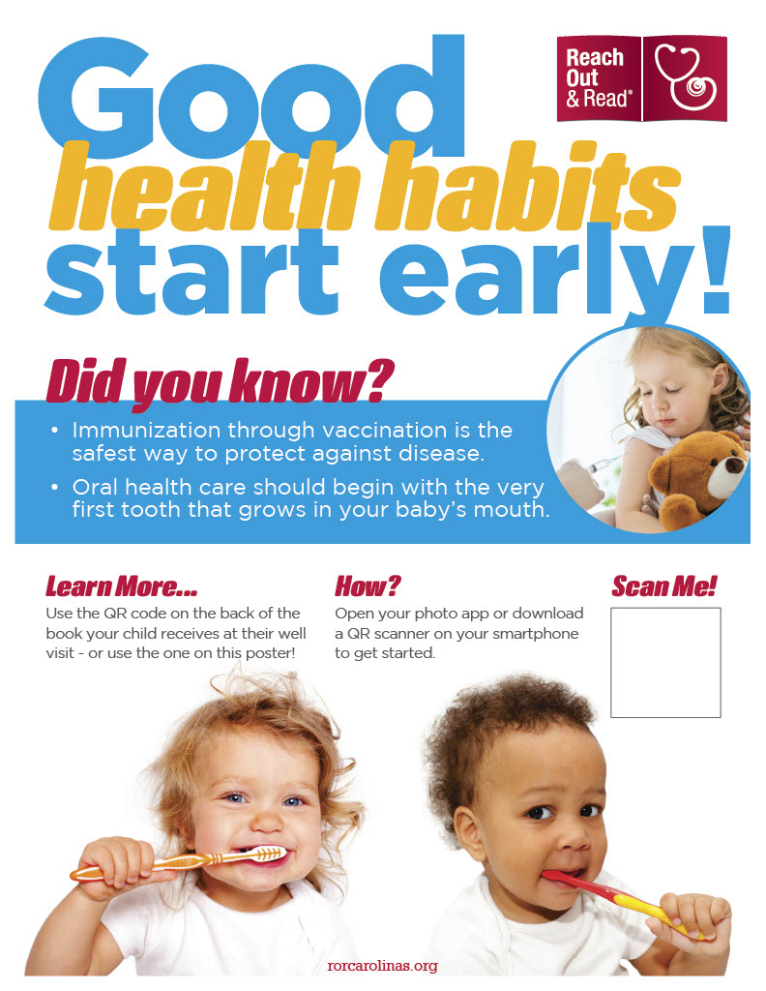

Appendix G
Project Bookmarks (English)

Appendix H
Project Bookmarks (Spanish)
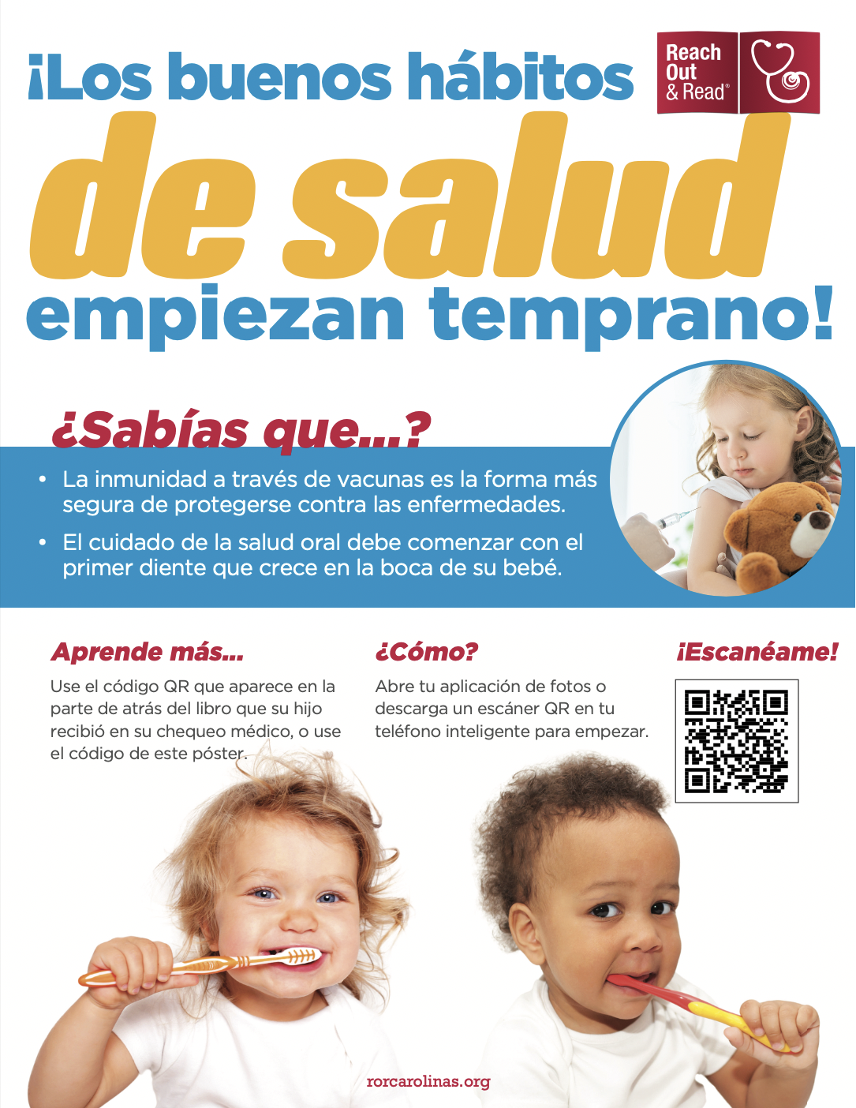

Appendix I
QR Code Stickers
English
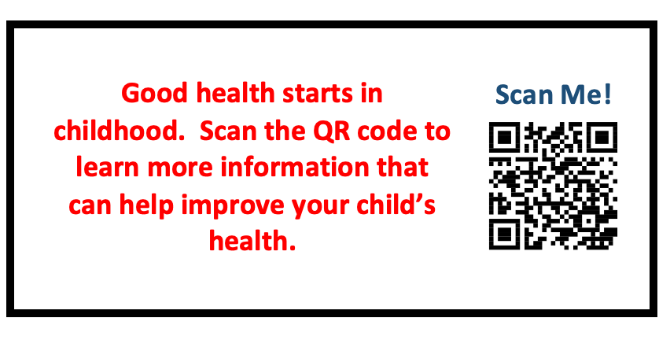

Spanish
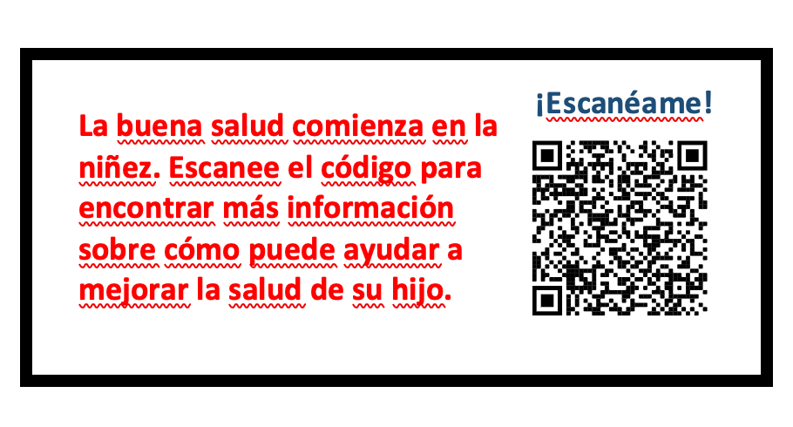

Appendix J
English Project Survey
https://www.surveymonkey.com/r/HSNXHCX

1. How old is your child who received the book at their recent visit?
0 – 5 months
6 – 11 months
12 – 17 months
18 – 23 months
24 – 35 months
3 – 5 years

2. Did you learn how to use the QR code during your child’s recent well-child visit?
Yes
No

3. How easy was the information on the website to understand?
Very hard
A little hard
Not hard or easy
A little easy
Very easy

4. How much did you learn from the website about oral care?
None
A little
Some
A lot

5. How much did you learn from the website about immunizations?
None
A little
Some
A lot

6. Will you change your plans for your child's oral health as a result of the information provided?
Yes
No

7. Will you change your plans for your child's immunization as a result of the information provided?
Yes
No

8. How likely are you to share the website with other parents?
Not likely
Somewhat likely
Very likely

9. We appreciate your time in taking this survey. If you have any comments, suggestions, or other child health areas you are interested in learning more about, please feel free to write them below. Thank you!

Appendix K
Survey Results
 | P. 1 | P. 2 | P. 3 | P. 4 | P. 5 | P. 6 | P. 7 | P. 8 | P. 9
Language of survey completed | English | Spanish | English | English | English | English | English | English | English
Age of Child | 12-17 months | 6-11 months | 6-11 months | 24-35 months | 6-11 months | 3-5 years | 24-35 months | 3-5 years | 0-5 months
Learned about QR code during visit? | Yes | Yes | Yes | Yes | Yes | Yes | Yes | Yes | Yes
Information easy to understand? | Not hard or easy | A little difficult | Very easy | Not hard or easy | Very easy | Very easy | Very easy | Very easy | Very easy
Amount of information learned about oral health | A lot | A little | A lot | A lot | A lot | A lot | A lot | A lot | A lot
Amount of information learned about  immunizations? | A lot | A little | A lot | A lot | A lot | A lot | A lot | A lot | A lot
Change oral health plans? | No | Yes | Yes | No | Yes | Yes | Yes | Yes | Yes
Change immunization plans? | No | No | Yes | No | Yes | No | Yes | Yes | Yes
Likelihood to recommend | Somewhat likely | Somewhat likely | Very likely | Somewhat likely | Somewhat likely | Very likely | Very likely | Very likely | Very likely
Additional Comments | N/A | N/A | N/A | N/A | N/A | N/A | Very informative. Thank you! | N/A | N/A

P = Participant

Appendix L
Website Analytics

Appendix M
Provider Educational Pamphlet
