MEMORIES MADE OF STONE
By
Emily Booker
May, 2024

Director of Thesis: Timothy Lazure
Major Department: School of Art and Design

Memories serve as an internal framework through which we structure our understanding of ourselves, others, and our past experiences, but they are not infallible. Memories distort over time and can be inaccurate artifacts—we can hyper-fixate, romanticize, take things out of context, and even forget. The experiences these memories are formed from are just as subjective, filtered through our own lenses of perception. This body of work is simultaneously an acknowledgement of both the subjectivity of perception and the natural distortion of memories, and a space to reflect on the existence of multiple perspectives.

Memories Made of Stone

A Thesis
Presented to the Faculty of the School of Art and Design
East Carolina University

In Partial Fulfillment of the Requirements for the Degree of
Master of Fine Arts

by
Emily Booker
May, 2024

Director of Thesis: Timothy Lazure, MFA
Thesis Committee Members:
Lisa Beth Robinson, MFA, MLIS
Angela Wells, MFA

© Emily Booker, 2024

DEDICATION

To Mom, who taught me how to lead a life full of creativity, empathy, and adventure.
In memory of Dad, who showed me how to strive for precision and find humor in the mistakes.
And to them both for their eternal love and support as I discover how much I am capable of.

ACKNOWLEDGEMENTS

I would like to express my deepest gratitude for the immeasurable generosity I experienced while working with my thesis committee. Thank you, Tim, for your continued guidance and willingness to help overcome any problem I managed to challenge myself with. Thank you, Lisa Beth, for your friendship, support, and curiosity that helped me find my way through a labyrinth of concepts and materials. And thank you, Angela, for your sincerity and humor that helped quell the overthinking and encouraged me to get out of my own way. I would also like to thank the School of Art and Design Director, Kate Bukoski, for your willingness to facilitate experiences and provide requested courses that had a direct influence on this body of work.
I am incredibly grateful for the extraordinary network of friends and family that have encouraged and supported me throughout my graduate studies. With your help I have learned more about myself and my creative practice than I could have ever imagined possible. Thank you.

TABLE OF CONTENTS

Dedication iii
Acknowledgements iv
List of Figures vi
List of Plates vii
INTRODUCTION 1
CHAPTER 1: Perception 3
CHAPTER 2: Memory 12
CHAPTER 3: Awareness 20
CONCLUSION 27
BIBLIOGRAPHY 28

LIST OF FIGURES

Figure 1: Weltenlinie, Alicja Kwade 6
Figure 2: Piercing process 7
Figure 3: Wheelbarrow and Shovels from Car Bombing, Cal Lane 18
Figure 4: Cold Dark Matter: An Exploded View, Cornelia Parker 21
Figure 5: Earthtime 1.8, Janet Echelman 22
Figure 6: Uncertain Journey, Chiharu Shiota 22

LIST OF PLATES

Plate 1: Bias, installation view 4
Plate 2: Bias 5
Plate 3: Myopic Perceptions 10
Plate 4: Interwoven 11
Plate 5: Interpretations 12
Plate 6: Subliminal Fragments, installation view 13
Plate 7: Subliminal Fragments, detail 13
Plate 8: Material Translations 17
Plate 9: Weightless, installation view 24
Plate 10: Weightless, detail 25
Plate 11: Memories Made of Stone, installation 26
INTRODUCTION

We often think of stone as static, unyielding, and unchanging. It is, and it is not. Over time stone will erode, change shape, reveal hidden secrets, and even transform into entirely new structures. None of these changes happen in a vacuum however, they are the result of external forces interacting with each rock. Heat, pressure, gravity, wind, and water will all leave their impact on stone. No one piece will undergo the same journey as another. In this way, people are a lot like rocks. We are constantly interacting with each other, abrading, smoothing, and chipping away at one another, with every interaction affecting each party uniquely. Memories are similarly akin to rocks. They are markers of place and time, subject to the transformations of external and internal forces that continue to tumble and shape them long after they are formed. Just like us, memories and stones are a continually evolving product of their internal structure interacting with their environment.
Memories also have weight; intangible and ever present. Some feel lighter than air, sources of inspiration that push us to ever greater heights. Others can be boulders, dragging us down and leaving us feeling unable to move forward. They are the foundation we build upon and the baggage we carry with us. But these memories are not as immutable as they may feel. We will all have different perceptions and memories formed from a shared experience. I have found that by recognizing and acknowledging that our experiences have countless alternative perspectives I can ease some of the weight of those memories that have become burdens. Maybe that person didn’t mean to cut me off on the highway. Perhaps that awkward encounter that’s been keeping me up for a week isn’t even remembered by the other person. While it does not change my experiences or invalidate my perspective, it changes the way I move forward: a little lighter.
Now, when overwhelmed and in need of a moment to reflect on alternative perspectives I find spaces with water and stone. The rhythmic shift of water and light over weathered stones becomes a tempo to match my breath and mind to. It seems inevitable that those moments would find their way back into my studio and work. In contrast to the overthinking that typically plagues my daily life, I collect stones with near reckless abandon. Less concerned with how I will haul around my new companions than I am excited by the unique textures, lines, and forms they offer. Each piece in this body of work is inspired by these collected stones: a simulacrum of the original that has its own unique material properties, both physical and those imposed by the viewer. The differences between each material representation illustrates the translation between perceived reality and remembered experience. This body of work is simultaneously an acknowledgement of both the subjectivity of perception and the natural distortion of memories, and a space to reflect on the existence of multiple perspectives.
CHAPTER 1
Perception

Let us begin with perception. Early in my research I was intrigued by what I felt was a distinct difference between experience and perception; a difference that is difficult to distinguish as they often happen simultaneously. We experience the external world through our senses—touch, taste, sight, sound, and smell—and that sensory information is filtered through our own unique lenses of perception, leaving each of us with our singular interpretation of the experience. This can explain why two people can look at the same object, listen to the same lecture, even be in the same conversation, and leave that experience with completely different understandings of the event. Whether we are aware of why those differences occur, or those reactions happen subconsciously, we are not passive in our perception of the external world. Our perspective, emotional state, and memories all influence how we perceive each new experience.
Maurice Merleau-Ponty (1908-1961), a French philosopher who was concerned with the human experience and perception, described this distinction in his essay Phenomenology of Perception (1945). He argued that “[the objective] scientific viewpoint, removed from any individual perspective, is neither autonomous nor complete since it fundamentally depends on the existence of a prior (and much neglected) human engagement with reality” (Quinn 39). The crux of this idea being that human engagement with reality is never a purely objective experience. What we expect to be objective information of the external world—regarding our sensory information of objects and interactions—are innately individualized and subjective experiences.
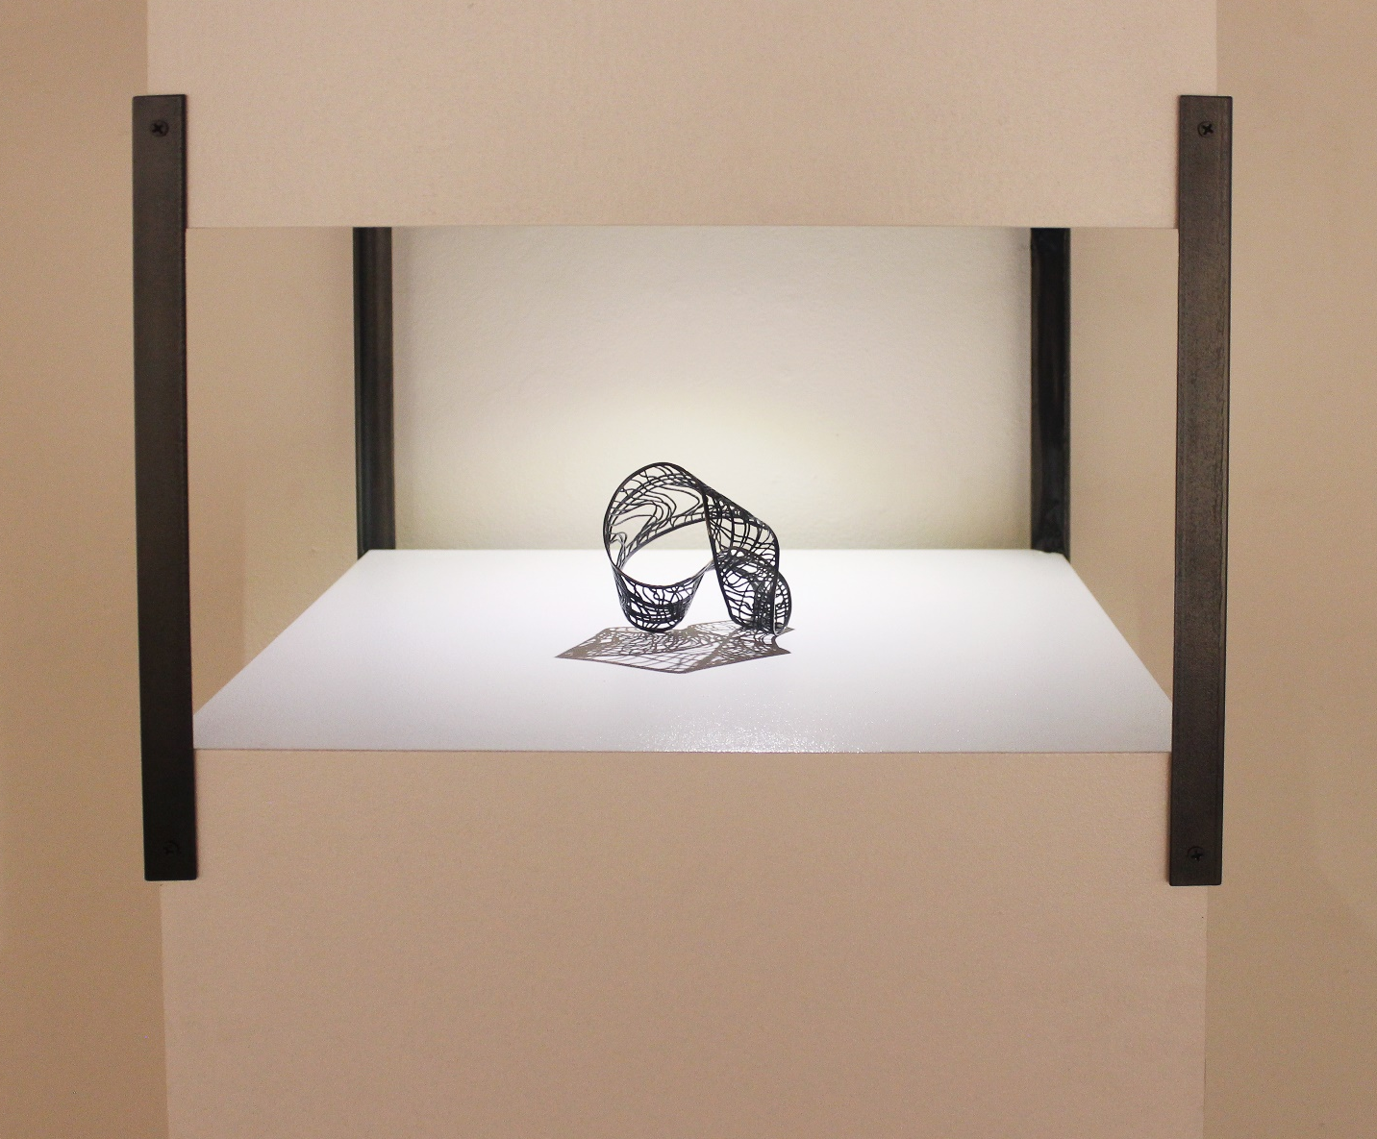
The first piece created in this body of work, Bias (Plate 2), is a means of exploring these lenses of perception. Bias is an intricately pierced sheet of brass twisted into a mobius band. A mobius band is a mathematically single-sided shape, which means one can reach every side without crossing over the edge. It is a form that if taken at a single point appears to have two sides but in reality has a single eternal side. I found this to be a compelling representation for the existence of multiple perspectives within a single experience. The areas of dense pattern create windows through the piece, both obscuring and revealing what lies behind. No matter what perspective the viewer takes, they will always be limited in how much they can perceive. Inspired by the multiple interpretations of illusion art and anamorphic installations, Bias is designed to briefly confuse the viewer’s sensory understanding of depth, movement, and space. Sitting on an eye-level pedestal the mobius band is lit by a rotating light that casts a continually moving shadow around the object. Contrasting the object and the eternally changing shadow creates a conversation within this piece about object and interpretation. The visual movement of the installation encourages a viewer to sit with the object, watching the passage of time. This creates an opportunity for the viewer to consider the various interpretations of the piece based on their own perspective and the current position of the light and shadow.
Plate 1. Bias, installation view
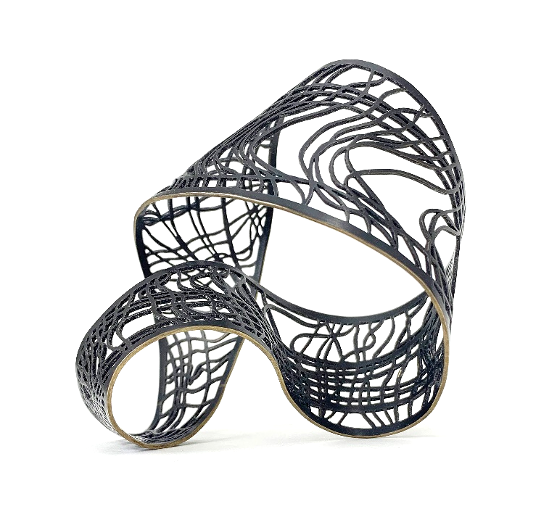
I pierced the brass sheet with a pattern created by the linear structure of woven thread. I was inspired by the visual phenomena of moiré patterns and distorted perspective grids. These patterns can be found in different types of textiles, which I drew upon to create a physical representation of a lens of perception: obscuring yet still permeable. Capturing a sense of movement in a static form was also necessary for achieving the visual illusion I desired. Recreating the movement of loosely woven thread in metal allows the form to feel as though it is undulating and flowing through space while maintaining its structural durability. The polished brass edge stands out from the black patina finish on the rest of the piece, guiding the viewer on a visual path through and around the piece.
Plate 2. Bias
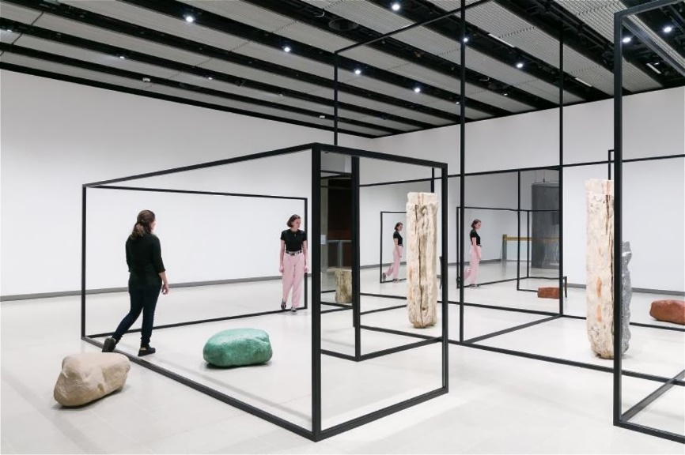
This strategy of using line as both a way to define space and a means to guide a viewer through the object is inspired by Alicja Kwade’s Weltenlinie series (Figure 1). Her installations and sculptures use line to create doorways and pockets of space that are unpredictable and entrancing. By using line, mirrors, and duplicate objects, the viewer is continually confronted with doubts about what is and is not. Objects, people, and spaces appear, reflect, disappear, or appear twice in different materials. As the viewer moves around and through the piece, Kwade intends “that it is more like a feeling or an experience than a solid sculpture. Phantasm rather than an object” (Berry).
Figure 1. Weltenlinie, Alicja Kwade, 2017

Incorporating space in my work has been a challenge. Not simply negative space in a pierced plane, or the space between layers, but pockets of space and a physical dimensionality. Kwade achieves this in her open-walled rooms, marking the corners and edges of the space and inviting the viewer to exist within the artwork and to be a part of the ideas contained there. I have always had a natural inclination towards working with line and flat planes, but the concepts I am trying to express consist of multiple perspectives and require a type of dimensionality with no “right” or “wrong” angle of viewing. My tendency towards working flat too often led to a “front” and “back” when I sought to create something that had neither. My first jewelry bench consisted of a bench pin, Dremel drill, and saw frame. I pierced my ideas out of sheet metal, adoring the ability to transfer the fragility of drawings into the durability of metal. I layered flat planes to create visual depth, believing the edges to be a mere byproduct of the of the sheeted material. In trying to achieve dimensional space with this body of work I believed I had to turn away from these earlier techniques to accomplish this new challenge I had set myself. I was wrong. I experimented with a wide variety of materials and processes, and learned to accept what engages me as a maker. Rather than abandoning my preferred methods, I learned how to push them beyond what I had previously imagined possible.
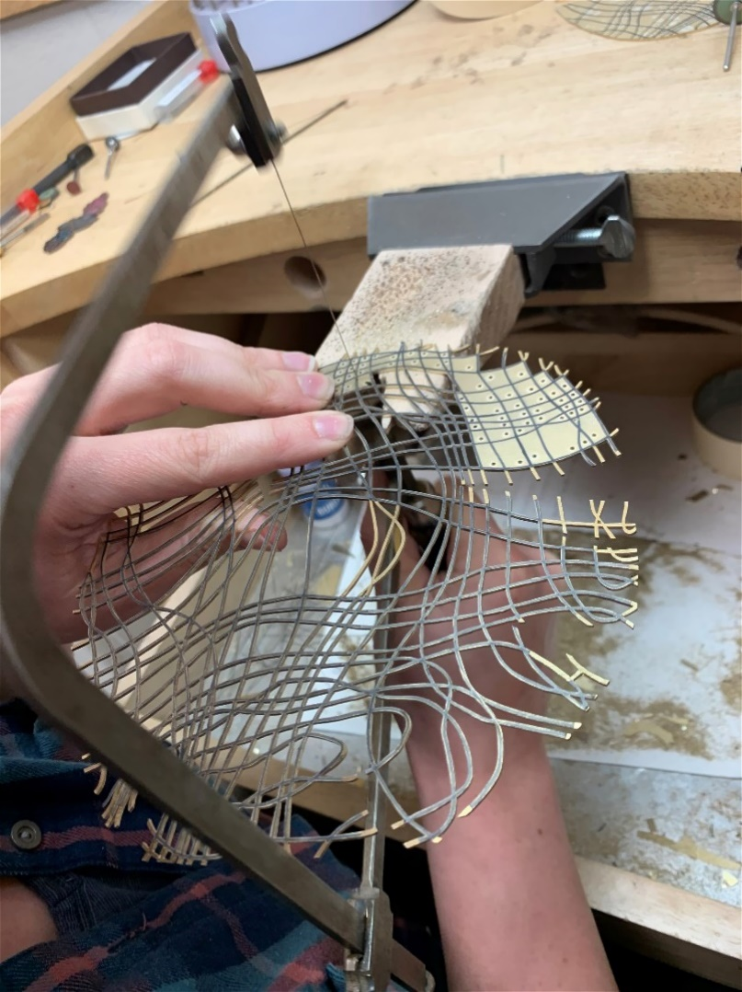
Piercing a sheet of metal is a meticulous and time-consuming process. Each piece of negative space starts with a drilled hole. The sawblade on a jeweler’s saw is then threaded through the hole and closed, before cutting around the edge of the shape to remove the desired metal from the plate. The sawblade is then unlatched, and threaded through the next drilled hole to repeat the process again and again until the design is revealed. I found a kindred spirit in Mirjam Hiller while listening to her describe her process in which she laboriously pierces powder-coated steel to create extravagant and exuberant fractal construction.
Figure 2. Piercing process
…the first look may give you the impression that it is just a technical and time-consuming process. But it is not about being diligent and hard working. It is not just about patience. I am not a very patient person. It is about something else. It is about the intensity that evolves from the simplicity. This might sound absurd. But this intensity arises out of the directness of the working process, out of its slowness, out of the time the piece has to grow. Bit by bit, cut by cut. The intensity emerges from the passion and the devotion invested in the piece. It arises from the calmness as well as the tension and the willingness to take on risks... It is a very meditative process. But at the same time, I am driven by curiosity and the desire to build something special (Hiller).

Hiller has found the perfect words for why piercing resonates so deeply with me. It is a process of continually balancing patience and impatience, driven by a determination to see the finished result of the work. At times it can be meditative and at other times it is painfully difficult. This technique—and others in this body of work—mirrors my experience with sitting in nature and acknowledging the vast array of alternative perspectives.
Myopic Perceptions (Plate 3) is a grouping of hollow river stones. Each deceptively lacy rock is made from two plates of pierced sheet metal, continuing the motif of loosely woven thread. Once both sheets of the pattern are pierced, each half of the shell is formed using its physical rock counterpart as a mold before being welded and soldered closed. The brass rocks are then patinated black and a single line is picked out and highlighted, revealing the material’s original golden hue. The golden thread contrasts those around it only in the attention it is given. It is representative of a single individual’s journey through a tapestry of interactions, with each intersecting thread on its own path. These pieces explore reality as we perceive it: with each of us at the center, too easily forgetting the intricacies of the lives of those around us.
sonder
n. the realization that each random passerby is living a life as vivid and complex as your own—populated with their own ambitions, friends, routines, worries and inherited craziness—an epic story that continues invisibly around you like an anthill sprawling deep underground, with elaborate passageways to thousands of other lives that you’ll never know existed, in which you might appear only once, as an extra sipping coffee in the background, as a blur of traffic passing on the highway, as a lighted window at dusk (Koenig).

The rocks in Myopic Perceptions represent the moment before that sense of sonder. They are displayed on a matte black pedestal top to further accentuate the highlighted thread and fade the patinated lines into the background. Myopic Perceptions is exhibited in contrast to Interwoven (Plate 4). While the former focuses on a solitary polished line in each rock, the latter focuses on the form of each rock constructed from a tapestry of individual golden threads. This second set of pierced brass rocks explores the reality of our interactions with every line polished, reflecting the truth of our experiences: that everyone is moving along their own individual path and the intersections with others creates a structure and community. Each pierced rock in these compositions is unique—reflecting the original river stones that had been shaped by their environments—yet each is made of the same material and process. The repeating similarities and differences emphasize the recurring nature of human perception. This contrast between perception and reality is a universal experience happening in different societies all over the world. We each lead a life full of aspirations, hopes, fears, and memories, and we bring our unique perspectives to each interaction. If we can learn to value those varied perspectives, to listen and learn from one another, we can gain new insight into our own experiences and see how we fit into the larger tapestry of society. I am not interested in arguing any specific side, only in illuminating others to the reality of multiple sides and perspectives to an issue or object – and the validity of each one.

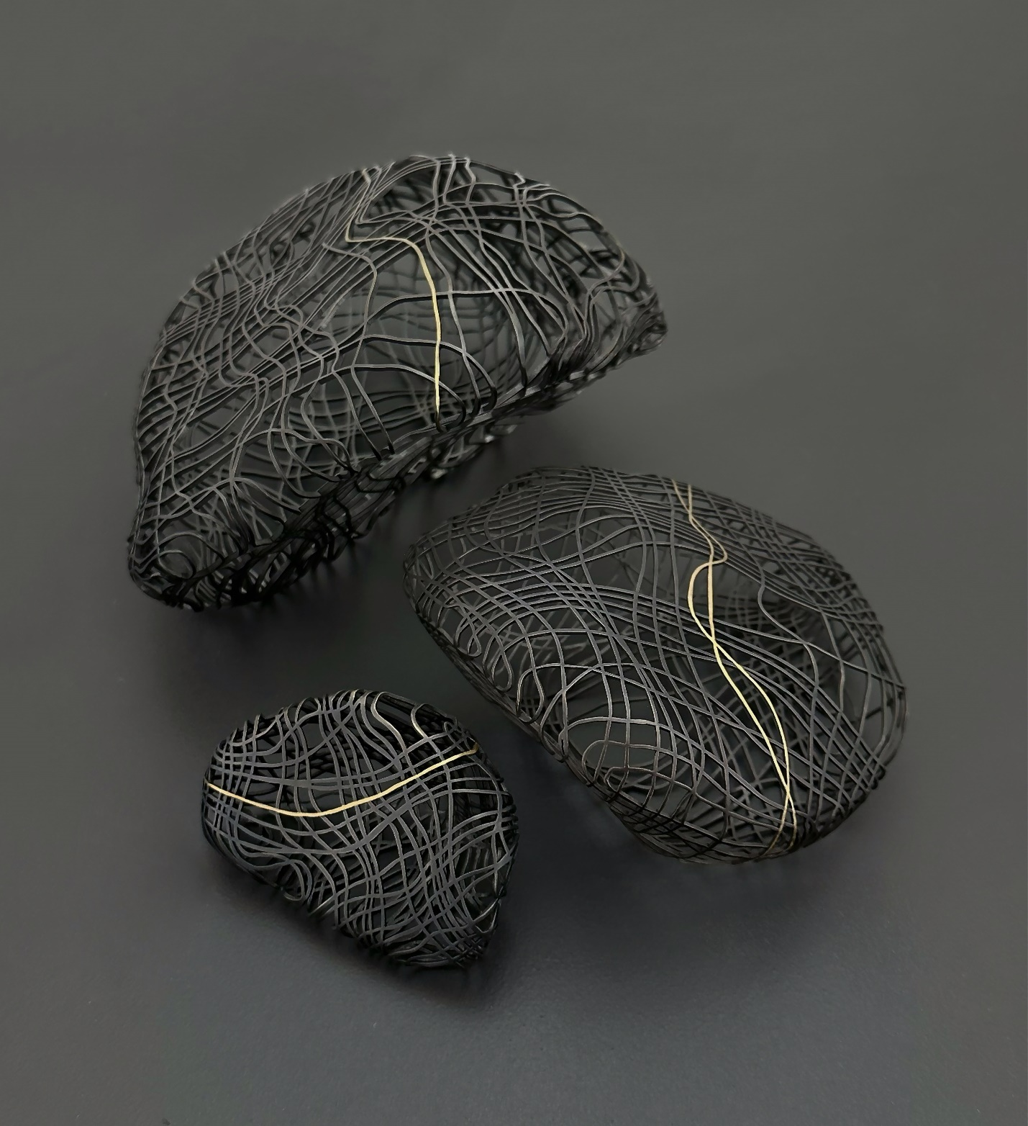
Plate 3. Myopic Perceptions

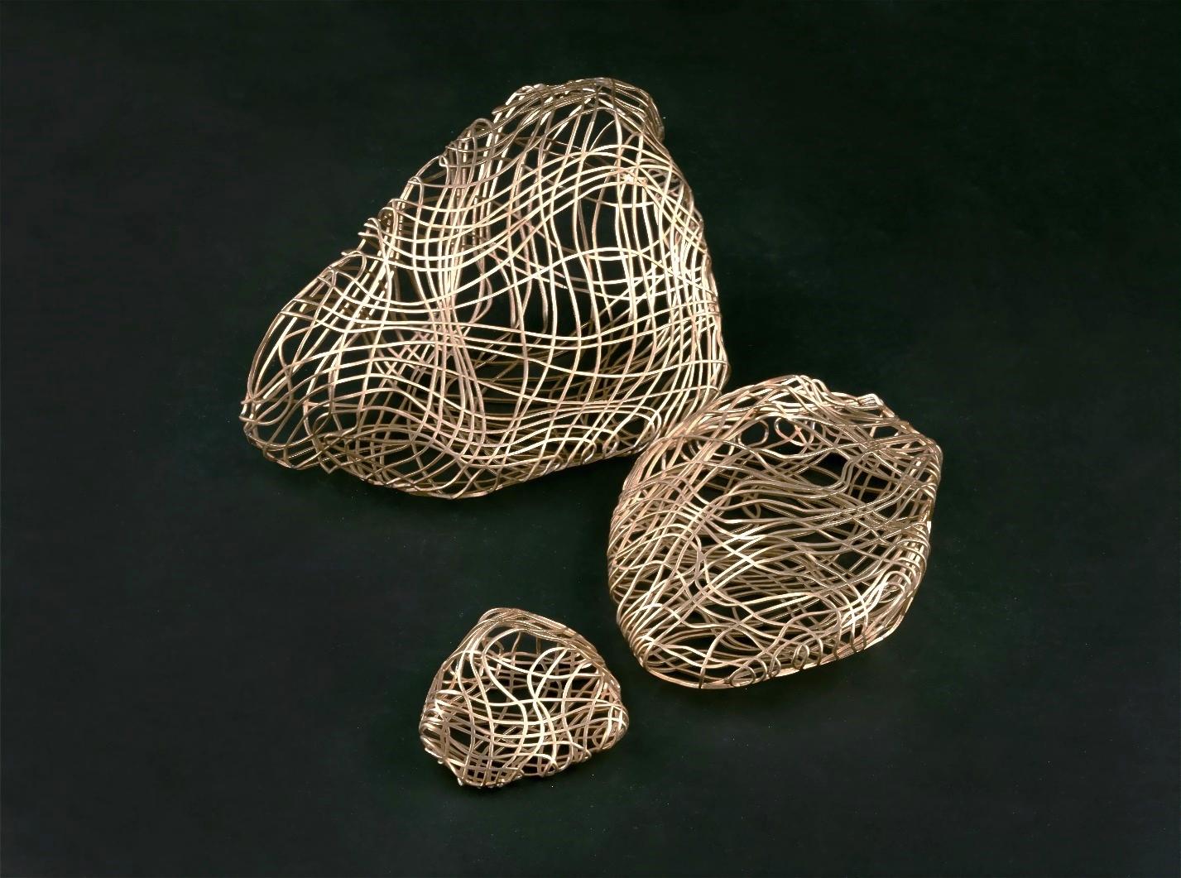
Plate 4. Interwoven

CHAPTER 2
Memory

“Memory is a selection of images – some elusive, others printed indelibly on the brain. Each image is like a thread. Each thread woven together to make a tapestry of intricate texture, and the tapestry tells a story, and the story is our past.”

– Eve’s Bayou

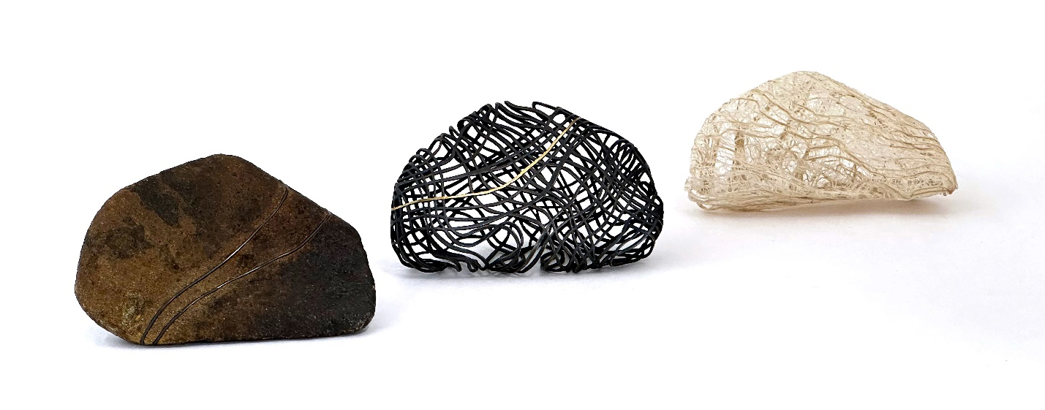
Experiences are the fleeting and ephemeral moments that our daily lives consist of. Memories are the impressions, markers, and remnants of those moments. Our memories become the context we bring to each new experience, filtering each new moment through our understanding of all the past ones—becoming a part of our lenses of perception. Not only are our memories formed from subjective experiences, but those memories distort over time. We can hyper-fixate, idealize, alter, take things out of context, and even forget—meaning those memories become inaccurate artifacts of our original experiences. There is no critique in this line of thought, only an attempt to understand why we so easily devolve into a binary system of right and wrong when discussing experience, belief, memory, and perspective.
Plate 5. Interpretations
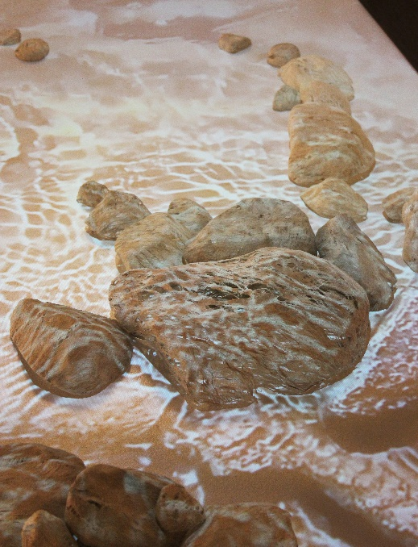
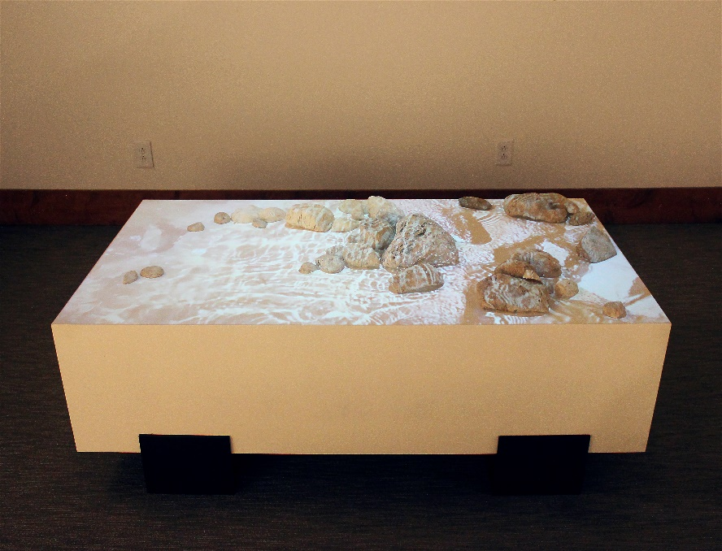
Two pieces in this body of work investigate the ways in which memories can be inaccurate depictions of past experiences. Interpretations (Plate 5) is a triptych of material explorations. Each material represents a different way that memories can be distorted. We can add things in, fitting them almost seamlessly into place until even we forget they are artificial addendums. We can reduce memories down to a shell, honing in on a single point while the rest fades away. And we can romanticize; creating hypothetical ideations that have no core, structure, or stability. In contrast to the physical materiality of Interpretations, Subliminal Perceptions (Plate 6) is a nearly intangible, dream-like composition exploring constructed memories. Many aspects of our experiences are processed subconsciously, becoming part of our implicit memory which is acquired and used unconsciously, but the memories are still formed. Subliminal Perceptions is an experience created by splicing and layering elements to fabricate a moment where it is not immediately clear what is real and what is not. A slow-motion video of the creek that inspired this body of work is projected over a scattering of rocks created with Kozo fiber. Kozo is the inner bark of the mulberry tree and takes on an airy and translucent quality when cooked with soda ash and stretched to reveal its natural cellular structure. The off-white color of the Kozo fiber allows the projected video to play over both the rocks and the pedestal base, obscuring which rocks are in the video and which are present in the space. The resulting experience is equal parts mesmerizing and mystifying; a space reflecting the slightly uncanny nature of subconscious memory.
Plate 6. Subliminal Fragments, installation view

Plate 7. Subliminal Fragments, detail

My continued research into memory and perception led me to discover Dr. Daniel Kahneman (1934-2024), a notable psychologist whose research primarily focuses on the psychology of decision-making. He won the Nobel Memorial Prize in Economic Sciences in 2002 for his work with prospect theory, which integrates psychological insights into economic science. His later research focuses on decision utility which distinguishes between experienced utility and remembered utility. Through a series of studies, he found that “people make wrong choices between experiences to which they may be exposed, because they are systematically wrong about their affective memories” (Kahneman).
Remembered utility turns out to be determined largely by the peak intensity of the pleasure or discomfort experienced during the episode, and by the intensity of pleasure or discomfort when the episode ended. The duration of the episode has almost no effect on its remembered utility. (Kahneman)

He continued this idea in a lecture by presenting the notion that there are two separate selves that make up our identities: the experiencing self and the remembering self. “There is an experiencing self, who lives in the present moment and… is capable of re-living the past… and there is a remembering self [who] keeps score, and maintains the story of our life.” (Kahneman 2:34). This way of looking at how we make choices provided new insights for how to understand memory as an interpretation, rather than an infallible record of events. It also posits a continued dialogue and translation between the experiencing self and the remembering self.
Material has become my way of representing the dialogue and translation between selves. Looking at translation in the literary world, it is not a one-to-one equation. There is intended meaning, rhythm, and underlying cultural context in language that influences how we speak and understand. Material can be read the same way. There are inherent societal understandings of material based on its structural limitations, historical and cultural context, economic factors, and environmental impacts. The social and cultural context I am working within has been shaped in part by the Aesthetic Theory developed during the 17th and 18th century Enlightenment in Europe. Led by thinkers such as Immanuel Kant, David Hume, and G.W.F. Hegel, these ideas have—and continue to—influence many Western civilizations. This aesthetic theory created a distinction and hierarchy between art and craft, largely based on political beliefs, material, and functionality. Textiles, which are historically associated with domestic work, were relegated to the realm of craft for their association with the feminine. Rocks and stone were some of our original tools, building materials, and weapons. We have carved great sculptures and built monuments out of stone, both of which exist in fields dominated by men, within the halls of fine art and architecture. Metal has become so integrated in all realms of life and art that specific metals have their own context. Steel is often associated with industrial and utilitarian functions, while non-ferrous metals such as brass, copper, silver, and gold all have different connotations depending on their economic value and use as sculptural object or personal adornment. These are just some of the societal understandings of material that may subconsciously influence our expectations and interpretations of new interactions or objects. I use this to my advantage, trusting the viewer’s innate categorization of material to exaggerate the differences between repeated forms.
Material Translations (Plate 8) is a collection of five rocks—each one a different material, each one a unique interpretation of the others. Steel, stone, brass, Kozo fiber, and porcelain all have a rich history of origin, development, and use—and viewed individually that would be the primary conversation around each piece. By instead grouping them together the conversation is focused on comparing and contrasting, creating an opportunity for the viewer to consider the similarities and differences of each stone. This piece is displayed in a line, referencing a linear system of reading from left to right. Doing so inherently creates a connection to literature and narrative—especially when considering the structure of comic strips and how the passage of time is portrayed through momentary snapshots. That notion of time is necessary to create a sense of story and transformation. The creation of narratives is the nature of the remembering self who “maintains the story of our life.” This piece illustrates how that narrative can distort over time, like a game of telephone.
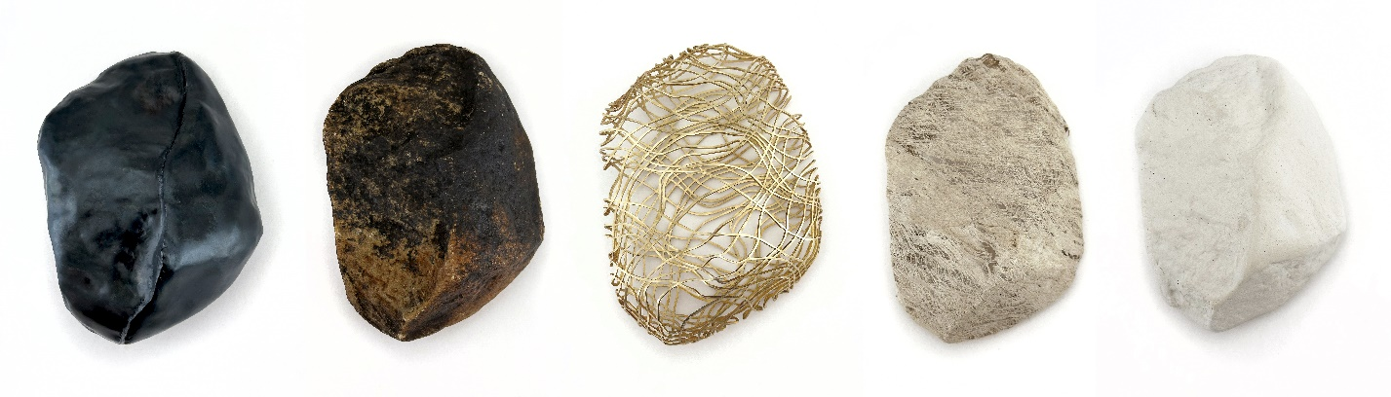
The narrative begins with the steel rock. I mapped out the pattern of the rock and hammered thin mild steel sheet using a variety of stakes and hammers into a representation of the original rock. While clearly a version of the original rock, the material qualities of steel show themselves. The weld lines are blended, but present, and in some cases lend themselves towards a representation of the stone texture. With its hollow fabrication and rich heat patina, this rock is unexpectedly light and comforting to hold. This steel rock represents the expectations we bring to each experience; a fabricated impression of what will be, based on our memories of what was. I include the original rock, unaltered, to represent the moment of the experiencing self. It is important to me that this moment is included as part of the narrative, rather than some unconnected and objective point of origin. The next rock is brass—beginning as a flat sheet that I intricately pierced to create a texture of woven thread before hammering each half around the original stone to capture its unique form. Welding and soldering the two halves together creates a three-dimensional tapestry, mapping out the story of the experience. This moment shows the logic, imposed structure, and neural pathways of memory. Appearing delicate and feeling deceptively lacy in the hand, this structure is incredibly durable and resistant to change. The next moment is the emotional or sensory aspect of the memory, represented with a Kozo fiber rock. The cooked Kozo fiber is stretched and molded around the original rock, revealing its abstracted impression as it dries. Delicate and malleable, this material holds its shape for the moment, always vulnerable to the influences of external forces. The final rock is made of porcelain—kept in a greenware stage to avoid the high shrinkage rate of porcelain. This is the memory we carry with us: a pale imitation, yet perceived as an unaltered interpretation of the original rock.
Plate 8. Material Translations
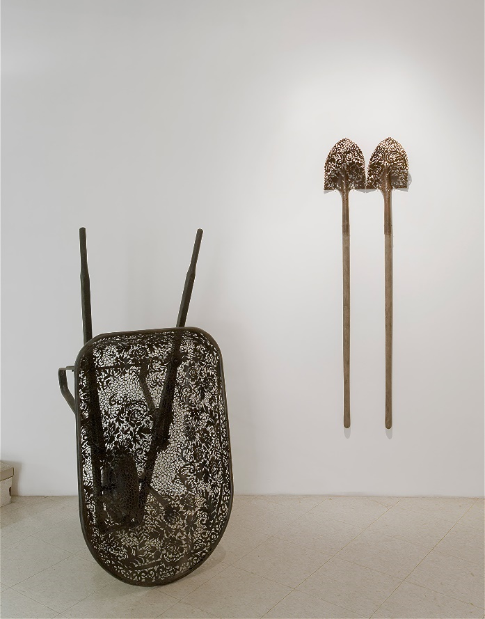
Choosing a material to work with based on its societal interpretations is a strategy that has been used before. One inspiration for this body of work is Cal Lane (b. 1968). Lane is a Canadian sculptor who—through a piercing process—transforms industrial steel and tools into delicately lacy objects. She combines materials that contextually clash to examine the dichotomies that exist in our perception of each material. “Like an illuminated manuscript, decoration overwhelms the surface. Ornamentation becomes one with the object, rendering it functionally useless yet aesthetically valued” (Apsey). Lane’s choice to infuse these steel objects with patterns and memories associated with her grandmother and the domestic realm is rebellion against both the masculine and feminine expectations she found herself balancing between. She is simultaneously leveraging the viewer’s interpretation of these materials and subverting their original function to convey the concepts behind her work. By taking recognizable objects—objects that are made or collected to accomplish a specific task—and removing the ability to fulfil their assigned task could lead one to assume that the function of the object is lost. However, just at the material is transformed, so is the purpose of the object. It becomes a tool for communication. The experience becomes purely about the form and material and how those two elements interact with each other and communicate with the viewer; and the audience’s pre-existing contextual understanding of form and material becomes an integral part of the conversation.
Figure 3: Wheelbarrow and Shovels, Cal Lane, 2007
Of the nearly limitless possibilities for material, I chose to primarily work with metal, textile, paper, and light. These choices are based on my own memories and perceptions of material meaning. Growing up with a mother who knits, quilts, and weaves, the structures of textile techniques have always been imbued with memories of familiarity and comfort. What is endlessly fascinating to me is that someone else will approach the same materials with entirely different memories and perspectives. My goal with this work is to create a sense of material ambiguity to avoid immediately understandable materials or structures. Where I see a silhouette of woven thread in the pierced brass, others may see 3D modeling scans, roadmaps, or circuit boards. Often, how someone interprets a material or form says more about their past experiences and lenses of perception than the work itself. If we can acknowledge and value those insights even if—and especially when—they counter our own perceptions, then we can examine more of our experiences from alternative perspectives. By being aware of alternative perspectives, we can challenge the narratives our remembering selves have created; easing some of the burden of those memories that weigh the heaviest
CHAPTER 3
Awareness

Reflecting on memories is not a passive experience; it is an interaction between the experiencing self and the remembering self. It is a process of interacting with the intangible and becoming aware of its weight, influence, and malleability. When thinking about how to represent the physical weight of memory I began by considering wearable objects. Partly due to my personal creative background, and partly due to the field of metal design and its overlap with contemporary jewelry. I created several brooches, intrigued by the sculptural freedom and the use of a wearer’s body as both installation site and conceptual component.
The space of the body complicates perception but activates objects in a transformative way… contemporary jewelry becomes something that is not merely an image or a three-dimensional sculpture but a conceptually driven artwork that can move fluidly between spaces and both carry and create meaning through such travels (Skinner 67)

While the ideas and processes are worthy of further investigation, the finished objects did not create enough of a physical imposition on the wearer. More importantly, the wearer became a mere play actor; part of the object rather than a point of entry for the viewer to imagine themselves in their place. This realization led me to broaden my understanding of the word “interactable” and to consider other ways interaction can occur between object and audience beyond observation.
I found my answer through my research into installation art. At its core, installation art is the use of three-dimensional work to transform the perception of an area. It activates the space around it, making it and the viewer a part of the artwork. Installation art began around the 1950’s with artists like Marcel Duchamp (1887-1968) and Allan Kaprow (1927-2006). At that time, they were referred to as “environments” and stemmed from the post-modernism and conceptual art movements. The early forays into this new field were an effort to expand the boundaries of what was, and could be, considered art. Artists in the 1970’s and 80’s began to use installation art as a tool for social and political commentary—using the viewer’s physical presence in the art to evoke more visceral reactions. The 2000’s saw a rise in digital work; Lights, sensors, computer coding, video, audio, and web-based installations. No matter the medium, the goal remained the same: to create a space or environment for the viewer to be immersed within. The physical objects are not nearly as important as the experience created by them and it “presupposes an ‘embodied’ and active encounter with the spectator” (Mosynska 167).
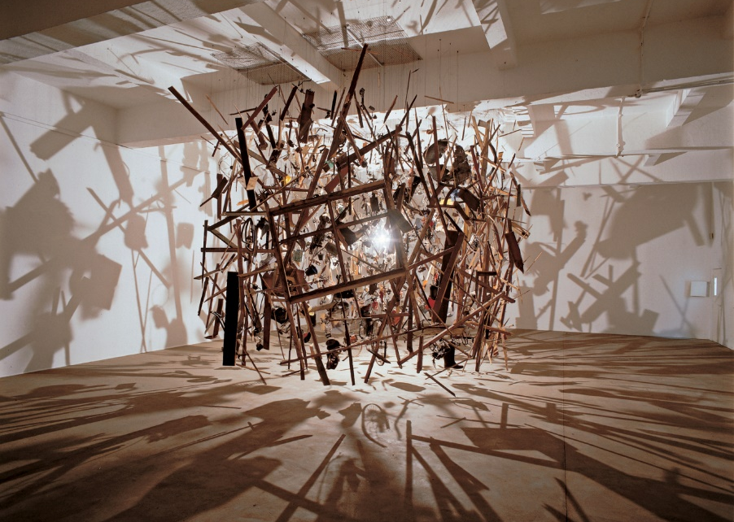
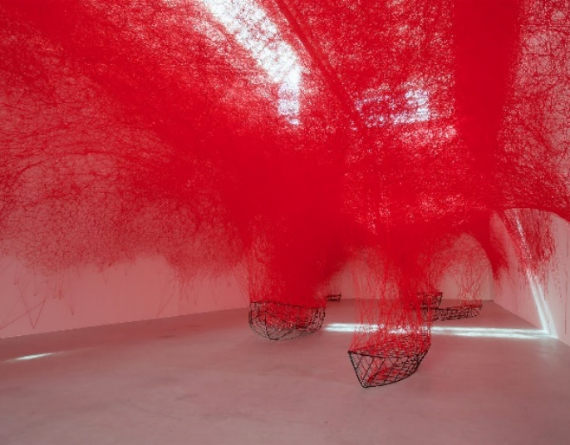
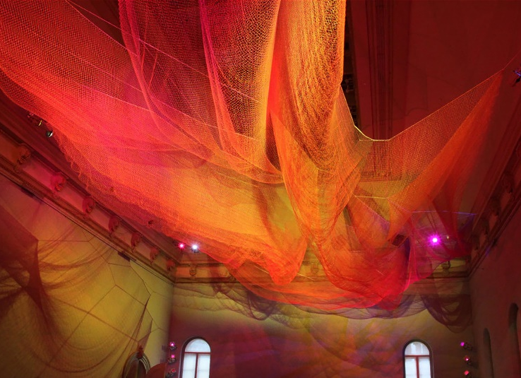
Several artists who create installation art have been inspirations and references for how this type of experience can be successfully created. Cornelia Parker (b. 1956) is an English artist known for her sculpture and installation art. She is best known for her installation Cold Dark Matter: An Exploded View (Figure 4) from 1991. Parker arranged to have a garden shed blown up by the British Army before arranging and suspending the remnants to appear mid-explosion—a moment captured in time and space. A light was placed at the center of the explosion, casting dramatic shadows on the surrounding walls, meaning that any viewer who enters the space becomes another shadow on the wall, a moving fragment in the space Parker had created. Janet Echelman (b. 1966) is an American sculptor who creates voluminous and flowing sculptures the size of buildings out of engineered netting. Suspended in cities all over the world, her installations respond to and transform architecture and space. Her work is in a constant state of transformation due to light and wind, shifting from “an object you look at, into an experience you can get lost in” (Echelman). This focus on the viewer’s experience as they interact with the work is what blurs the line between sculpture and installation art. Chiharu Shiota (b. 1972) is a Japanese artist known for her expansive and intricate installations exploring ideas of body, relationships, narrative, and memory. She creates dense networks of tangled thread to build volume and form in space and around objects. Her work overwhelms objects, spaces, and people; a single line showing the complexity and engulfing nature of memory and relationships. All three of these artists expertly alter space with deceptively simple materials, creating moments that evoke emotional responses and experiences. It is a model that I have followed closely while working to achieve a similar emotional interaction with my audience.
Figure 4. Cold Dark Matter: An Exploded View, Cornelia Parker, 1991

Figure 6. Uncertain Journey, Chiharu Shiota, 2016
Figure 5. Earthtime 1.8, Janet Echelman, 2015

My installation, Weightless (Plate 9), is a constructed environment that uses repeating forms and light to create an atmospheric experience for the viewer. I use an extremely lightweight, malleable material for this installation because our memories are surprisingly flexible and when we become aware of that we can see them for what they are: subjective interpretations that provide information, but are not absolute. Each rock in this arrangement is wispy and translucent, as ephemeral as our memories or perspectives. The knit structures are made from panels created on a knitting machine where each stitch is manipulated to build up an undulating texture in the material that mirrors the movement of the forms. Each knit panel is then dipped in an overbeaten flax paper pulp to create a translucent membrane before being stretched and dried over river stones to capture their forms. The paper forms are stitched onto wire frames and suspended to create depth between the layers. Lights hang intermittently behind the paper rocks to create a gentle shift of light and shadow through the layers. All these elements combine to build a space of quiet investigation, natural beauty, and peaceful separation from the external world. This space is both a representation of how it feels to become aware of multiple perspectives, and an environment reminiscent of the natural spaces where I find that awareness to be more attainable.
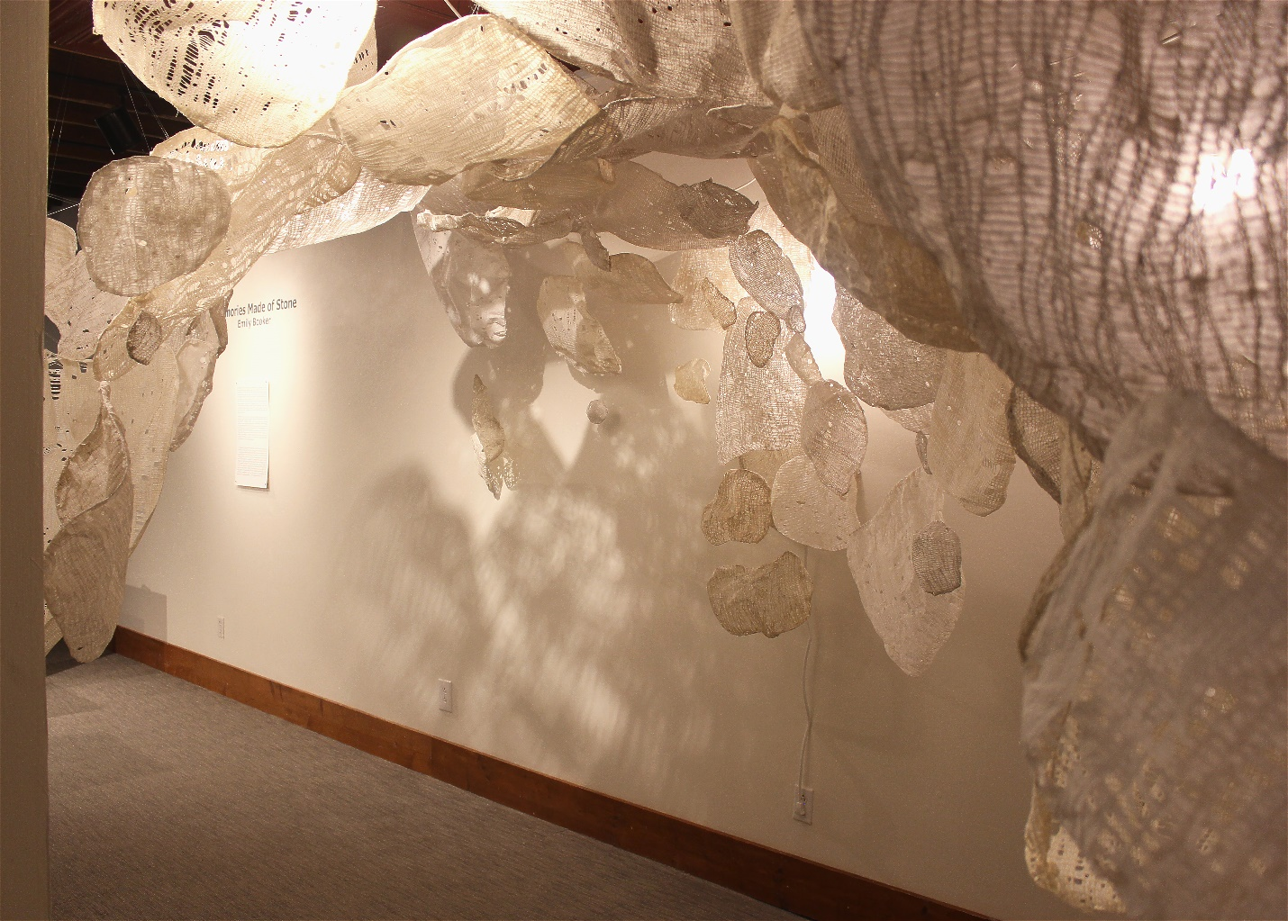
Within Weightless, I have captured the moment of awareness of all the alternative perspectives. It began as a way of recreating the space where I had found this sense of awareness: a simple creek in the woods behind my mom’s house. Nothing out of the ordinary—weathered stones, the movement of light, and a moment away from the incessant hum of society—but it was enough to create a dream-like encounter where I was secluded from the distractions and expectations of others. Nagging memories burbled up as they are inclined to do when it is quiet, and instead of listening to the same narrative, I challenged my interpretations. What if that interaction wasn’t as awkward as it seemed, it could even be remembered fondly by the other person. What if that rude comment was made out of ignorance instead of maliciousness. Rather than becoming an overwhelming flood of options, it felt like an expansive moment of broader perspective; as though a great weight had been taken off my mind. That awareness did not invalidate my experience or perspective up to that point, it only affected how much weight I gave to those perspectives. I realized that I have a conscious choice of how to carry memories and narratives forward, and how much I let them weigh me down. Weightless is my representation of that space and feeling, and a means of creating a space for a viewer to share that experience.
Plate 9. Weightless, installation view

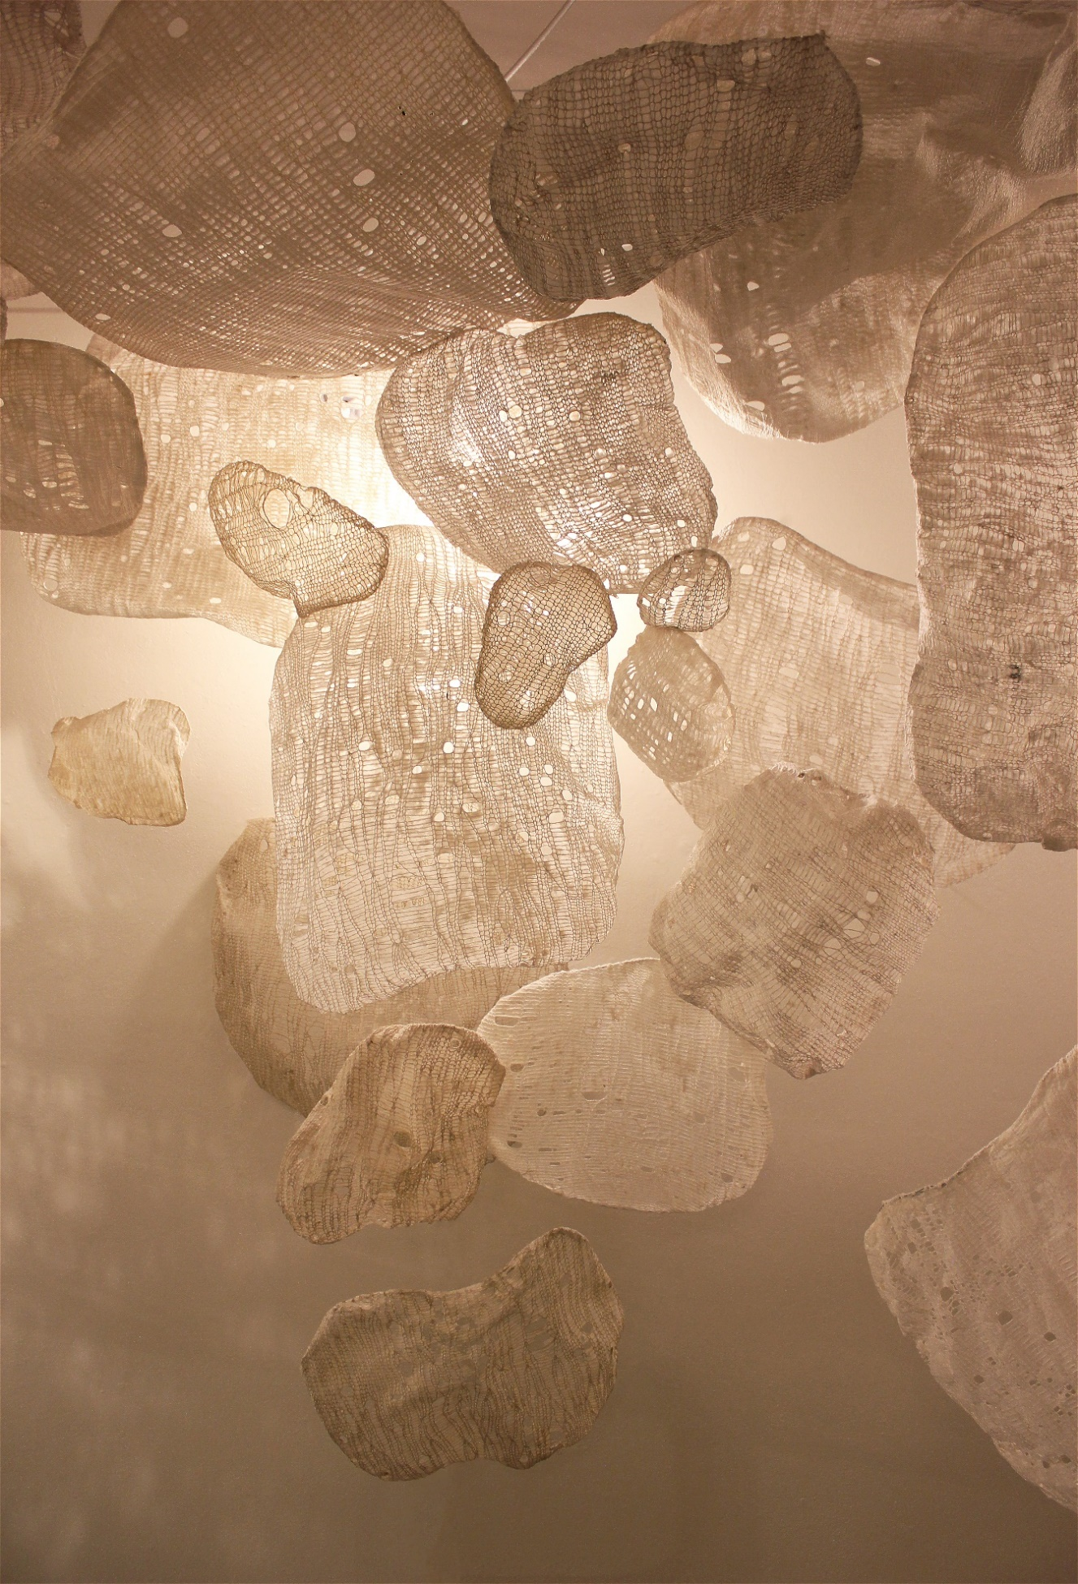
Plate 10. Weightless, detail

…No silken cocooning, no quiet emergence,
no mere cosmetic change, no, but a shift down to its very chemistry.
Atom by atom, the rock responds, its history rewritten
in its crystal lattice…

…And when you hold it in your hand,
and if you know how to read a rock,
then what you'll see is this: What it was. Where it's been. What fires it's seen…

- Andrea Friedman

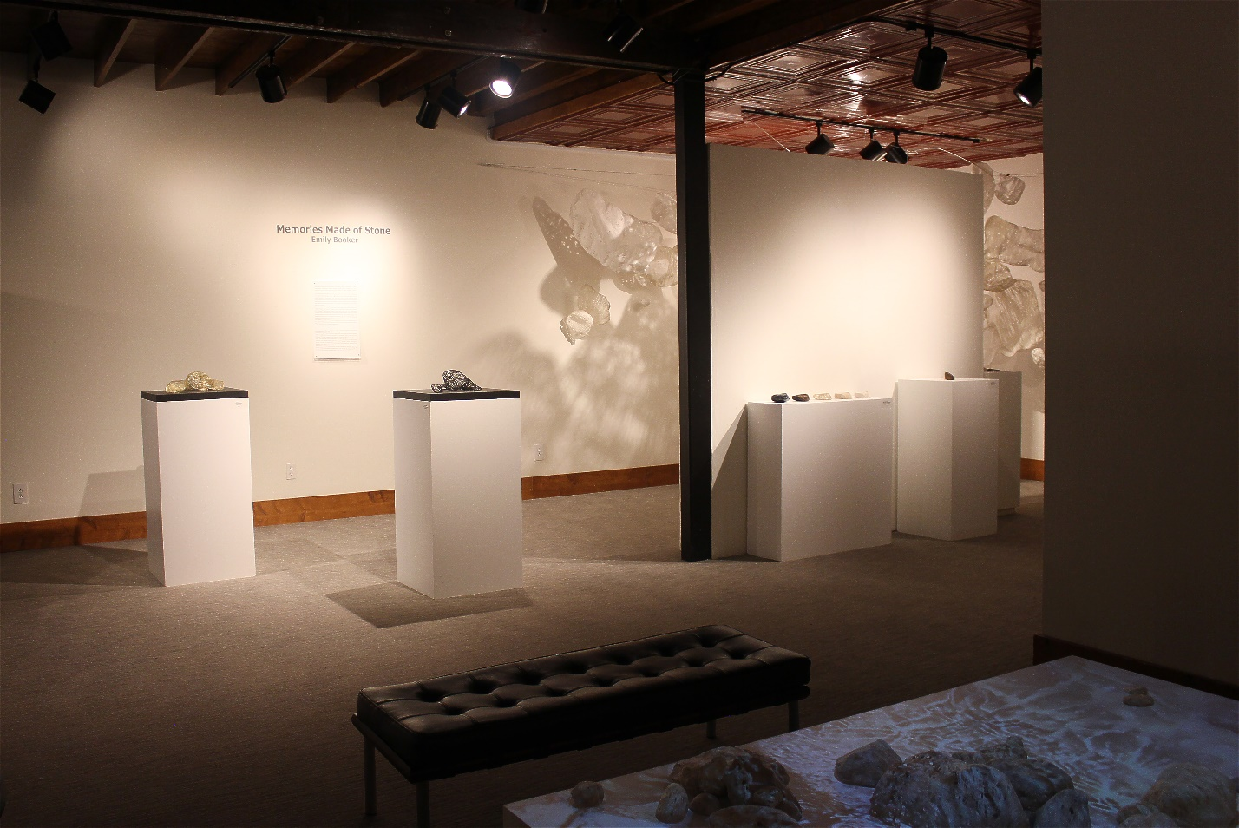
Plate 11. Memories Made of Stone, installation view. Emerge Gallery, Greenville, NC, 2024

CONCLUSION

Memories Made of Stone is an exploration of the subjective nature of perception and memory, a means of sparking conversation that can lead to an awareness of alterative perspectives, and a space to reflect on those insights. This body of work stemmed from a moment of frustration; a sense of resentment at both the weight and insubstantiality of memory. How can something so subjective and vulnerable maintain such control over the narrative of our lives? I remain unconcerned by the scientific explanations and entirely fascinated by the experience of memory. It is an experience we all share; a common thread beneath the discordant din of dissenting opinions.
Within this body of work I have endeavored to understand these intangible notions through a deep investigation of material. The natural properties of each material required patience and flexibility to appreciate its unique limitations and capabilities. I allowed myself to engage in the process of discovery, setting aside any narratives I had imposed on myself. This opportunity to infuse my studio practice with a sense of innovation has pushed my creative practice beyond what I had previously assumed possible. My work in Memories Made of Stone is an insight into my perspective, with all its accompanying vulnerabilities, frustrations, and hopes. It is an attempt to establish a dialogue with the viewer, creating a point of connection and perhaps a reminder that our memories are more malleable than they appear.
BIBLIOGRAPHY

Apsey, Katie. “Car Bombing.” Cal Lane, callane.com/portfolio_page/car-bombing/. Accessed 9 Mar. 2023.
Berry, Craig. “Space Shifters.” Medium, 24 Jan. 2019, craigberry93.medium.com/space-shifters-bd03c0ff6fd8.
Friedman, Andrea. “Two Poems.” Metamorphism, serendipstudio.org/sci_cult/bridges/friedman.html. Accessed 14 Oct. 2023.
Hiller, Mirjam. “Ride the Rainbow on Broken Sawblades.” ECU Material Topics Symposium: Shift in Values. ECU Material Topics Symposium: Shift in Values, 14 Jan. 2024, Greenville, East Carolina University.
Kahneman, Daniel. “The Riddle of Experience vs. Memory.” Daniel Kahneman: The Riddle of Experience vs. Memory | TED Talk, Feb. 2010, www.ted.com/talks/daniel_kahneman_the_riddle_of_experience_vs_memory?language=bo.
Kahneman, Daniel. “The Sveriges Riksbank Prize in Economic Sciences in Memory of Alfred Nobel 2002.” NobelPrize.Org, www.nobelprize.org/prizes/economic-sciences/2002/kahneman/biographical/. Accessed 21 Feb. 2024.
Koenig, John. The Dictionary of Obscure Sorrows. Simon & Schuster, 2021.
Koplos, Janet, and Bruce Metcalf. Makers: A History of American Studio Craft. University of North Carolina Press, 2010.
Lansroth, Bob. “What Is Installation Art and How Does It Transform Our Perception?” Widewalls, 19 Oct. 2016, www.widewalls.ch/magazine/installation-art.
Lemmons, Kasi. Eve’s Bayou. Trimark Pictures, 1997.
Moszynska, Anna. Sculpture Now. Thames & Hudson, 2013.
Quinn, Carolyne. “Perception and Painting in Merleau-Ponty’s Thought.” Perspectives: International Postgraduate Journal of Philosophy, vol. 2, autumn 2009, pp. 38–59.
Schmidt, Barbara. 350 Words for Jewellery. Barbara Schmidt, 2022.
Shiner, Larry. The Invention of Art a Cultural History. Univ. of Chicago Press, 2008.
Skinner, Damian. Contemporary Jewelry in Perspective. Lark Jewelry & Beading, 2013.

