DESIGN OF A FORCE BIOFEEDBACK TOOTH EXTRACTION EDUCATIONAL DEVICE

By

Rana Abdelsalam & Alex Bryan

A Senior Honors Project Presented to the

Honors College

East Carolina University

In Partial Fulfillment of the

Requirements for

Graduation with Honors
by

Alex Bryan & Rana Abdelsalam

Greenville, NC

May 2015

Approved by:

Dr. John Reis

Department of Engineering in the College of Engineering and Technology

DESIGN OF A FORCE BIOFEEDBACK TOOTH EXTRACTION EDUCATIONAL DEVICE

Mohamed A Abdelrahman, Rana T Abdelsalam, Alex C Bryan, Charles E Williams

ENGR 4020
Spring Semester 2015

i
DESIGN OF A FORCE BIOFEEDBACK TOOTH EXTRACTION EDUCATIONAL DEVICE

Project Team: Mohamed A Abdelrahman, Rana T Abdelsalam,
Alex C Bryan, Charles E Williams

Project Advisor: Dr. John Reis

Company Sponsor: East Carolina University School of Dental Medicine
Company Advisor: Dr. Stevan Thompson

ENGR 4020
Spring Semester 2015

Department of Engineering
East Carolina University
Executive Summary

The current jaw model used by students from the East Carolina School of Dental Medicine to practice tooth extractions does not accurately simulate the forces in a real human mouth. Originally multiple alternative designs were generated and divided into three different categories: tooth material, full or partial jaw, tooth attachment method, sensor type, and alert system. These alternatives were analyzed and the chosen ones were metal teeth for the tooth material, full jaw for the jaw type, fixed with pivot for the attachment method, strain gages on the forceps for the sensor type, and LED for the alarm system. After further analysis it was decided that the following changes would be made. Instead of having one full jaw, individual teeth were mounted on rectangular prism and cylindrical bases. Strain gages were placed on the side of the rectangular bases to determine bending moments and to the cylindrical bases to determine twisting moments applied to the teeth. The LED alarm system was used alert the user when certain moment thresholds are met. A prototype was built and tested and the design met the functional requirements of the engineering design specifications. Recommendations were provided to make the design more commercially feasible. Recommendations included assembling some of the electrical components in house, sending the models out to be manufactured by a third party, putting the LED lights closer to the model, and mounting the models in a way to better simulate a real extraction.

Table of Contents
List of Figures ...................................................................................................................................... vi

List of Tables ....................................................................................................................................... vi

1 Introduction ........................................................................................................................................ 1

2 Problem Description .......................................................................................................................... 2

2.1 Problem Description.................................................................................................................... 2

2.2 Problem Statement ...................................................................................................................... 2

2.3 Problem Definition ...................................................................................................................... 2

2.4 Scope of Work............................................................................................................................. 2

2.5 Deliverables................................................................................................................................. 2

2.6 Constraints................................................................................................................................... 2

3 Engineering Design Specifications .................................................................................................... 2

3.1 Introduction ................................................................................................................................. 2

3.2 Functional Performance .............................................................................................................. 2

3.3 Operating Environment ............................................................................................................... 3

3.4 Human Factors ............................................................................................................................ 3

3.5 Economic..................................................................................................................................... 3

3.6 Geometric Limitations................................................................................................................. 3

3.7 Design Integrity........................................................................................................................... 3

3.8 Safety........................................................................................................................................... 3

3.9 Ease of Use.................................................................................................................................. 3

4 Body ................................................................................................................................................... 3

4.1 Background ................................................................................................................................. 3

4.1.1 Tooth Anatomy..................................................................................................................... 3

4.1.2 Extraction Process ................................................................................................................ 5

4.1.3 Current Model....................................................................................................................... 7

4.1.4 Bending Moments Applied During Extraction..................................................................... 8

4.2 Alternative Designs ..................................................................................................................... 9

4.3 Technical Feasibility Analysis .................................................................................................. 10

4.4 Teeth Models............................................................................................................................. 11

4.5 Strain Gage on Forceps Implementation ................................................................................... 11
4.6 Altered Teeth Models................................................................................................................ 12

4.7 Material Analysis ...................................................................................................................... 12

4.8 LabVIEW Program ................................................................................................................... 13

4.9 Warning Lights.......................................................................................................................... 13

4.10 Prototype Summary................................................................................................................. 14

6 Conclusions .................................................................................................................................. 15

6.1 Introduction ............................................................................................................................... 15

6.2 Functional Performance ............................................................................................................ 15

6.3 Operating Environment ............................................................................................................. 16

6.4 Human Factors .......................................................................................................................... 16

6.5 Economic................................................................................................................................... 16

6.6 Geometric Limitations............................................................................................................... 16

6.7 Design Integrity......................................................................................................................... 16

6.8 Safety......................................................................................................................................... 16

6.9 Ease of Use................................................................................................................................ 16

7 Recommendations ........................................................................................................................ 16

7.1 Replacing the Strain Indicator and Analog to Digital Converter .............................................. 17

7.2 Model Manufacturing................................................................................................................ 17

7.3 Use of Real LED Lights ............................................................................................................ 17

7.4 Mounting the Models ................................................................................................................ 17

8 Acknowledgements ...................................................................................................................... 17

References ........................................................................................................................................... 18

Appendix A: Feasibility Analysis and Decision Matrices……………………………………….….A1

Appendix B: Teeth Models………………………………………………………………………….B1

Appendix C: Forceps and Diagrams………………………………………………………………...C1

Appendix D: Altered Teeth Models…………………………………………………………………D1

Appendix E: Calculations……………………………………………………………………………E1

Appendix F: Calibration for LabVIEW Program……………………………………………………F1

Appendix G: LabVIEW Output……………………………………………………………………..G1

Appendix H: Mechanical Drawings…………………………………………………………………H1
List of Figures
Figure 1 Dental Forceps……………………………………………...…………….……………..1

Figure 2 Typodent Mouth/Head………………………………………………….…..….………..1

Figure 3 The Anatomical Structure of the Tooth ……………………..……….………...………4

Figure 4 Tooth Anatomy ………………………………………………..…...…………………...4

Figure 5 Teeth in Jaw………………………………………….………..…...………………...….5

Figure 6 Root Attachment ……………………………..…...……………………………….……5

Figure 7 A Compete Set of Apical Forceps …………...…………………...…..……...………....6

Figure 8 Elevator Tool Applied to a Tooth ………………………………...…………………….6

Figure 9 Forceps Grip on a Tooth during an Extraction………………….…………………...….7

Figure 10 Final Step of the Extraction Process………..………….………………………..……..7

List of Tables
Table 1: Bending and Twisting Moments Applied During Maxillary Tooth Extractions …….....8

Table 2: Bending Moments Applied During Mandibular Tooth Extractions …............................8

Table 3: Light Thresholds for Incisors and Canines …..………………………………………...13

Table 4: Table 10: Light Thresholds for Premolars and Molars………………………………....13

1 Introduction
Tooth extraction is a common dental procedure used to remove teeth that cannot be restored using
other methods. Extractions are often prescribed to patients with extensively damaged or traumatized teeth that are not fixable, or for severely crowded teeth. Forceps (Figure 1) are the primary tools used to remove teeth. There are a variety of forceps types that are used to extract different teeth based on their size and location in the mouth [Dental, 2012].

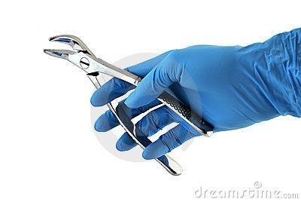

Figure 1: Dental Forceps [Dental, 2014]

A challenge dentists face with tooth extractions is being able to avoid generating too much force, which can result in the cracking of a tooth. Dental students are required to practice tooth extractions on a typodont head/mouth (Figure 2) before performing the procedure on live patients. However, the typodont head/mouth currently used does not accurately simulate the actual forces encountered in human mouths. The forces required to remove the teeth glued into the model are less than the forces required to extract human teeth. This results in students not having the proper proprioception of the procedure before their first live extraction and may result in unintentionally cracking teeth. If the students have a device that more closely simulates the forces in a real human mouth and provides biofeedback, they may be better prepared for the live extractions they will perform.

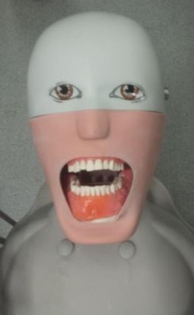

Figure 2: Typodont Mouth/Head
2 Problem Description

2.1 Problem Description
Design a device that provides force biofeedback for dental students to use while practicing forceps extraction.

2.2 Problem Statement
The current device used to practice forceps extraction of teeth does not accurately simulate the forces in a real human mouth or provide feedback when too much force is being applied.

2.3 Problem Definition
Dental students at East Carolina University School of Dental Medicine practice forceps extraction of teeth using a typodont mouth/head in a simulation laboratory. However, the typodont mouth/head does not accurately simulate the forces in a real human mouth. A design is required for a device that provides feedback on applied forces so that students know when they are applying excessive amounts of force that may result in cracking a tooth.

2.4 Scope of Work
• Analyze the current tools used to practice forceps extractions.
• Complete background research on the extraction process and the forces associated with it.
• Generate multiple design ideas.
• Analyze the design ideas using the project requirements and constraints.
• Develop a final design and present it to ECU SoDM faculty.

2.5 Deliverables
• Prototype of a device capable of providing biofeedback for forceps extractions.
• Video simulations demonstrating how the model works.

2.6 Constraints
• Time – device must be designed by the end of the Spring 2015 semester
• Does not cause harm to the user
• Feasible for commercialization – device has the ability to be manufactured in a way that provides a competitive cost compared to current products an could be mass produced
• Reliable – consistently performs accurately

3 Engineering Design Specifications

3.1 Introduction
• Design Problem: Design a forceps extraction practice tool that measures forces.
• Intended Purpose: Provide a teaching tool to dental students that will provide them with biofeedback during forceps extractions.

3.2 Functional Performance
• Incorporates strain gages
• Alerts user when forces exceed threshold value
3.3 Operating Environment
• Simulation laboratory in ECU SoDM.
• Contains 80 stations which include typodont mouth/head simulators and commonly used dental tools.

3.4 Human Factors
• Does not reduce current ergonomic conditions such as seating position and distance from student to model in the simulation laboratory.

3.5 Economic
• Cost must be competitive with current models
• The current model used by ECU SoDM costs $245
• 32 teeth cost $52 to replace

3.6 Geometric Limitations
• Device must be sized according to the dimensions of an average adult human mouth.
• Teeth must be similar in size and shape of an average adult human mouth.
• Sensor must not interfere with the extraction process.

3.7 Design Integrity
• Strength of tooth material greater than that of human teeth.
• Device must be able to withstand the forces associated with repeated tooth extractions.

3.8 Safety
• Device cannot have any pinch points, sharp edges, or electrical hazards that could potentially harm the user.

3.9 Ease of Use
• Feedback must be presented in a clear and concise manner that can be interpreted by the user.

4 Body
The background information on teeth, alternative designs, chosen tooth models, instrumentation analysis, and economic analysis will be discussed in the following sections.

4.1 Background
Research on tooth anatomy, the extraction process and the associated forces, and the material properties of teeth was conducted in order to gain insight on the problem and generate alternative designs.

4.1.1 Tooth Anatomy
Human teeth are comprised of two main sections: the crown and the root. The crown is exposed and the root is below the gums. The tooth is connected to bone via periodontal ligaments which are composed of fibrous tissue that surrounds the root of the tooth (Figure 3). The outer layer of the tooth is made of enamel which is only present in the crown. Encased within the enamel is the dentin. The enamel and dentin are separated by the dentin-enamel junction (DEJ). Encased within the dentin is the innervated and vascularized pulp. Figure 4 shows a diagram of the anatomy of a tooth [Dental,2014].

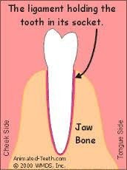

Figure 3: The Anatomical Structure of a Tooth [Animated, 2014]

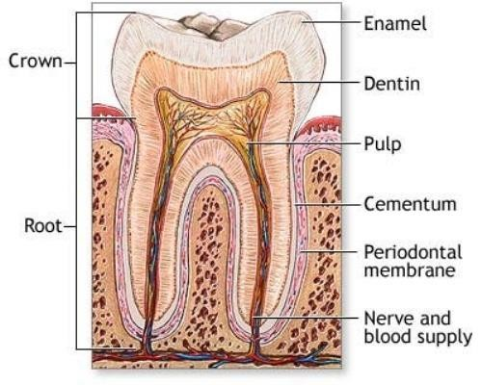

Figure 4: Tooth Anatomy [Dental, 2014]

An adult human jaw contains 32 teeth. Among these teeth are 8 incisors, 4 canines, 8 premolars, and 12 molars that include 4 wisdom teeth (Figure 5). Each tooth type varies in function, shape and attachment method (number of roots) (Figure 6). The incisors are single rooted teeth, with crowns that are arched. Their function is to cut food with their edges. The canines have one pointed cusp and are anchored with the longest root. Their function is to tear, grasp and hold food. Maxillary first premolars have a bifurcated root. All other premolars have one root and one prominent cusp with one or two lesser lingual cusps. Premolars have similar functions as canines. Molars can have bifurcated or trifurcated roots. They have broad chewing surfaces with four to five cusps. Their function is to grind food [Leeuw, 2015].

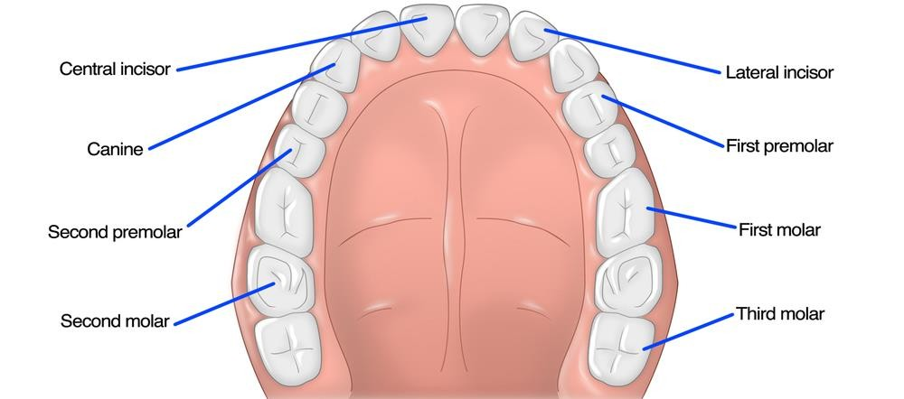
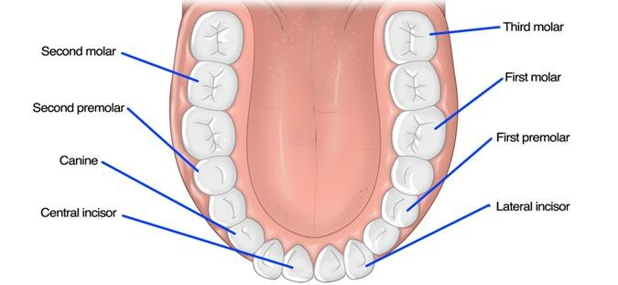

Figure 5: Teeth in the jaw [Impressions, 2015]

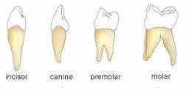

Figure 6: Root attachment [Different, 2015]

4.1.2 Extraction Process
Extractions are often used on patients with extensively damaged teeth that are not fixable or for patients with severely crowded teeth. The tooth extraction process involves the use of different types of specialized forceps depending on the location, condition, and type of tooth that is being extracted. There are forceps designed for maxillary (upper) and mandibular (lower) teeth (Figure 7). The handle shape puts the dentist’s hand and forceps beaks in a position to obtain optimal leverage based on whether the tooth is maxillary or mandibular. The beak shape varies depending on the shape of the tooth and the number of corresponding roots [Animated, 2014].

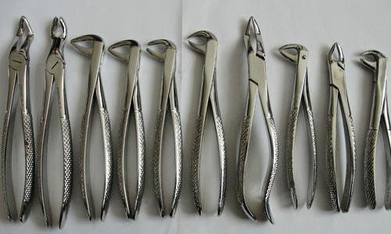

Figure 7: A Complete Set of Apical Forceps [Animated,2014]

During the extraction process the dentist first frees the surrounding periodontal ligaments using a tool called an elevator which loosens the tooth within the socket (Figure 8). The dentist seats the forceps onto the tooth and forces are applied in the apical (towards the root) and buccal-lingual (towards tongue-away from tongue) directions to break ligaments and expand the alveolus (socket) (Figure 9). For teeth with conical roots, rotational forces are also applied. During this process the dentist feels the gums with the opposite hand to ensure the tooth moves independently from the alveolus. After repeated application of pressure at multiple angles, these forces will eventually enlarge the socket, which will free the tooth from the alveolus. The dentist will then remove the tooth from the patient’s mouth [Animated, 2014] (Figure 10).

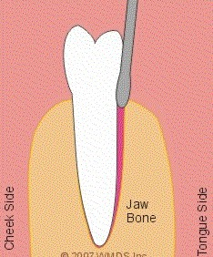

Figure 8: Elevator Tool Applied to a Tooth [Animated, 2014]
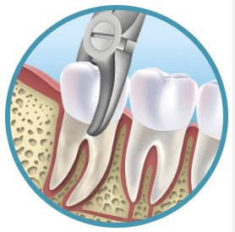

Figure 9: Forceps Grip on a Tooth during an Extraction [Animated, 2014]

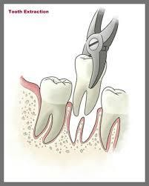

Figure 10: The Final Step of the Extraction Process [Animated, 2014]

A challenge faced by dentists is preventing teeth from fracturing during extraction. Fractures most often occur in the root of the tooth but can also occur on the crown, particularly when the crown has already been damaged due to cavities. When fractures occur, root tips remain in the alveolus which may require surgical removal [Animated, 2014]. The incidence of fractures depends on the forces applied and the strength of the teeth.

4.1.3 Current Model
The current model used by the dental students for practicing forceps extraction is the Adem Oral Surgery and Extraction Training Typodont made by Paradigm Dental Models. The model is of an adult human jaw containing a full set of removable teeth. The model can be placed into the typodont head for a more realistic simulation. The teeth are made of urethane and are held into the jaw with clear silicone glue. The model needs to be replaced approximately every five years. The model does not closely resemble the extraction of real human teeth. The forces required to remove the teeth are less than that of real human teeth. The teeth in the model often crack and require replacements. [Drennan,
2014]

4.1.4 Bending Moments Applied During Extraction
Ojala DDS, conducted vivo study to assess the bending and twisting moments applied to all types of teeth during forceps extractions. Moments were calculated using strain gages attached to forceps multiple times during the duration of each extraction. Buccal and lingual rocking (bending) moments were measured for all tooth types. In addition, twisting moments were measured for maxillary tooth extractions. The average and highest moment values for each individual extraction were recorded. Tables 1 and 2 show the mean and standard deviation of these values for each tooth and moment type. The bending and twisting moments applied during extraction varied with the type of tooth. The type of tooth that required the greatest bending moment to extract was maxillary canines which had a mean highest bending moment of 3.62 ft lbs. The type of tooth that required the smallest bending moment to extract was the mandibular incisors which had a mean highest bending moment of 1.03 ft lbs. The type of tooth with the highest twisting moment applied was maxillary first and second molars with a mean highest twisting moment of 1.00 ft lbs. The type of tooth with the lowest twisting moment applied was the maxillary incisors with a mean highest twisting moment of 0.52 ft lbs [Lehtinen ,1980] [Ojala, 1980].

Table 1: Bending and Twisting Moments Applied During Maxillary Tooth Extractions (ft lbs) [Lehtinen, 1980]

 | Incisors |  | Canines |  | Premolars |  | 1st & 2nd molars |  | 3rd molars
 | Mean | SD | Mean | SD | Mean | SD | Mean | SD | Mean | SD
Average buccal rocking | 0.95 | 0.40 | 1.42 | 0.78 | 0.72 | 0.26 | 1.03 | 0.52 | 0.80 | 0.38
Highest buccal rocking | 1.63 | 1.27 | 3.62 | 1.74 | 1.84 | 0.96 | 2.35 | 0.89 | 1.91 | 0.96
Average lingual rocking | 1.05 | 0.36 | 1.77 | 0.69 | 0.89 | 0.39 | 0.68 | 0.37 | 0.58 | 0.24
Highest lingual rocking | 1.55 | 0.62 | 2.69 | 0.97 | 1.95 | 0.87 | 2.06 | 1.05 | 1.14 | 0.68
Average twisting | 0.42 | 0.13 | 0.58 | 0.32 | 0.35 | 0.15 | 0.44 | 0.41 | 0.22 | 0.11
Highest twisting | 0.52 | 0.28 | 0.97 | 0.55 | 0.77 | 0.36 | 1.00 | 0.34 | 0.53 | 0.24

Table 2: Bending Moments Applied During Mandibular Tooth Extractions (ft lbs) [Ojala, 1980]

 | Incisors |  | Canines |  | Premolars |  | 1st & 2nd molars |  | 3rd molars
 | Mean | SD | Mean | SD | Mean | SD | Mean | SD | Mean | SD
Average buccal rocking | 1.10 | 0.55 | 1.67 | 0.80 | 0.92 | 0.55 | 1.53 | 0.83 | 1.17 | 0.63
Highest buccal rocking | 1.84 | 0.94 | 3.53 | 1.36 | 1.92 | 1.10 | 3.27 | 1.57 | 2.74 | 1.37
Average lingual rocking | 0.49 | 0.29 | 0.68 | 0.44 | 0.53 | 0.33 | 0.94 | 0.50 | 0.91 | 0.46
Highest lingual rocking | 1.03 | 0.58 | 1.50 | 1.07 | 1.18 | 0.74 | 2.06 | 1.16 | 2.05 | 1.15

4.2 Alternative Designs
In order to satisfy the problem statement the final solution was composed of three components, with those components being a jaw model, sensors, and an alert system. For the alternative analysis of this project, alternative categories were chosen to be analyzed rather than separate full alternative ideas. Those alternative categories were tooth material, full or partial jaw, tooth attachment method, sensor type, and alert system.

For the tooth material, two alternatives were analyzed. Those materials were metal and acrylic resin. An advantage of metal is high durability which allows it to have a long useful life. Some advantages of acrylic resin are affordability and its overall appearance, which more closely resembles actual tooth enamel.

Another set of alternatives that were analyzed were whether to use a full jaw model or partial jaw model focusing on specific teeth. An advantage of a full model is that it would allow for use with current typodont model. This model type would provide the closest experience to an actual extraction. The advantages of the partial model are that it would allow for select teeth to be replicated and would require less material than the full model.

For the attachment method, four alternatives were analyzed. Those alternatives were fixed with pivot, fixed with anchor, fully removable, and electromagnets. These alternatives were chosen for each of the specific features that they provide.

• The fixed with a pivot alternative has the teeth attached to the jaw model with a ball and socket joint. This will allow the tooth to exhibit buccal-lingual and rotational movement. This will simulate the breaking of the periodontal ligaments.
• The fixed with an anchor alternative has the teeth attached to the jaw using a metal jaw attached to the base of the model. This will make the teeth completely non-removable. This was chosen as alternative because it would remove the need to reattach the teeth to the model after every use. All of the forces exhibited on the model will be transferred to the attached sensors.
• The fully removable alternative has the teeth fixed in the jaw using a silicone adhesive, similarly to the current model. The silicone adhesive used in this alternative will be chosen based on the strength required to remove an actual tooth in order to better simulative a true extraction. Basic extraction techniques would be used to remove the teeth.
• The final attachment alternative was electromagnetic. This alternative has the teeth fixed in the jaw using electromagnets. This would allow the force required to remove the teeth to vary depending on the amount of current supplied. For this alternative the teeth will have to be made of a conductive material.

The second alternative category is sensor types and location. There were three alternatives in this category. Those alternatives were force sensor on the tooth, strain gages on the forceps, and strain gage on the tooth. The force sensor on the tooth would measure force over an area during the extraction. Those values could be used to determine bending moment. Strain gages on the forceps would measure the bending moment as the tooth is being extracted. A strain gage on the tooth would measure the tension in the tooth during extraction. Vertical gages would be used to measure tension from buccal-lingual applied forces and 45 degree mounted gages would be used to measure torsion applied forces. Tables 1-2 are provided above to show the ultimate strength of teeth and the bending moments of different teeth during an extraction.

The third alternative category is alert system type. The alternatives to choose from were LED and sound. The LED alternative would have a green LED representing when the optimal amount of force was applied and a red LED for when excessive force was applied. The sound alternative would have specific sounds to represent excessive and optimal force application.

4.3 Technical Feasibility Analysis
The process of choosing the preferred design alternative to be implemented began with a feasibility analysis of the various design alternatives based on the design requirements specified by the project sponsor. After the feasibility analysis was conducted, the design alternatives that were deemed feasible were ranked based on a number of performance parameters in decision matrices in order to reach the preferred design alternative.

The various design alternatives were evaluated based on the design requirements specified by the project sponsor. The various design alternatives were grouped into five categories: jaw type, tooth material, attachment method, sensor type and placement, and alert system. The feasibility matrix is included in Appendix A. After the feasibility analysis was conducted, the only design alternative deemed infeasible was the anchor tooth attachment method due to the fact that it did not meet the requirement of providing a repeatable method to practice the tooth extraction process.

Design alternatives were evaluated using a number of parameters chosen that depended on the functional requirements of each alternative category. The design alternatives were ranked based on the number of alternatives in each category, with the alternative receiving a ranking of 1 being the preferred alternative. After the decision matrices were completed, the preferred design alternatives were metal teeth for the tooth material, full jaw for the jaw type, fixed with pivot for the attachment method, strain gages on the forceps for the sensor type, and LED for the alarm system. The decision matrices can be seen in Appendix A.

In the preferred design alternative, the tooth attachment method of using a pivot was chosen due to the fact that it is the easiest to implement and it will provide the longest useful life. For the jaw type, the full jaw was chosen due to the fact that it is the most versatile, and it will provide the closest resemblance to live clinical extractions. For the tooth material, metal teeth were chosen because they provide the longest useful life, therefore saving the user the time and cost required to replace damaged teeth. For the sensor type and placement, the alternative of placing strain gages on the forceps was chosen due to the fact that it is the easiest to implement, the most cost effective, and the easiest alternative to use. For the alert system, the alternative of using LED lights was because of the cost efficiency and ease of use.

4.4 Teeth Models
The final design as described above consists of metal teeth attached using a ball and socket pivot system with strain gages attached to the forceps and an LED alert system. This design includes rubber bumpers between the teeth and the socket wall to simulate the periodontal ligaments. After the design was chosen, work began on modeling the teeth of the current typodont model, as shown above in Figure 2, provided by Dr. Stephen Thompson of the ECU SoDM. Calipers and rulers were used to measure the dimensions of the teeth. These measurements were used to annotate a rough sketch of the teeth for later use with the SolidWorks 3D modeling software. The teeth modeled are the central incisor, lateral incisor, and premolar. All of the modeled teeth are maxillary in position. The models were created in two parts, consisting of crown and root components. There are a total of four models, with the premolar consisting of two models to account for the single and double root versions. All of the models can be seen in the Appendix B. For the roots of each model the same basic setup was used. A profile of the bottom of the crown was lofted to meet a revolved base that is consistent between all models. In the case of the double root, the same method was applied but the profile was divided in half. The crowns were created by creating a sketch of the profile of the teeth and then extruding them the distance measured earlier for each tooth. The case of the lateral incisor was particularly complex due to the slope of the tooth.

4.5 Strain Gage on Forceps Implementation
Two different methods for measuring bending moment via strain gages on the forceps were considered. The first method involved attaching a slender rod to the forceps close to the pivoting point near the beaks. The rod would extend past the handles and have a ninety degree bend at the end with a forked attachment at the end. A strain gage would be placed on the rod close to the beaks of the forceps. The user would place a rigid object against the forked attachment during use so that the rod would push against the object when force was applied to teeth. It was decided that this method would not be used due to the bulkiness and the complexity of the mathematics required to solve for bending moment. A preliminary sketch of this method is included in Appendix C.

The second method was similar to a method used in an in vivo study where researchers measured the bending moments applied to teeth during live extractions. In the experiment, strain gages were attached to the handles of forceps in different orientations so that bending moment due to gripping, rocking, and twisting motions could be measured. Appendix C shows a picture and diagram of the forceps used in the study [Cicciu, 2013].

It was decided that the mathematics required to solve for bending moment due to gripping, rocking, and twisting was oversimplified and would require more in depth analysis than the scope of this project allows for. A free body diagram of the forceps used in the study is shown in Appendix C. To simplify the mathematics, a single strain gage was glued to forceps handles near the beaks with the intention of measuring bending moment due to rocking and gripping only.

The mathematics required to solve for bending moment directly from the strain gage measurements was also determined to be outside the scope of the project. Appendix C shows some of the attempted free body diagram and shear and moment diagram drawings. To simplify the problem, a decision was made to calibrate the measurements by applying several known moments to the forceps and relating the moments to the strain gage readings. The known moments would be applied by strapping the forceps into a cutout groove in a wooden block with zip ties and hanging weights from the beaks. However, it was decided that this method oversimplified the problem so much that it would not provide a useful prototype for dental students. The calculation of bending moment due to the hung weights simplified factors including the geometry of the forceps and reaction forces at the beaks and pivot joint. In addition, the method completely neglected twisting of the forceps which could potentially damage teeth during live extractions.

4.6 Altered Teeth Models
Due to the issues stated above, changes were made in order to allow completion of the project within the designated time frame. It was decided to attach strain gages to the models rather than the forceps and the models in Appendix D were produced. The models shown are altered versions of the models in Appendix B with the root components replaced with a solid base. Each tooth type was mounted on a rectangular prism and a cylindrical base. The rectangular bases are 1”x1”x1” and the cylindrical bases have a diameter of 1” and a height of 1”. These bases were attached to the crown components created previously with the crowns situated in the center of the base. The crown and base system was created as one solid component rather than in two parts, like the previous models. This setup allows for the strains present within the crowns to travel down into the base and be recorded by attached strain gages. Rectangular prism and cylindrical base central incisor models were 3D printed with 100% infill. Those models were then used to create molds for casting.

Because these models would not be part of a jaw or allow complete removal of teeth, they would be best used as an addition to the current models. The student could practice removing teeth with the current model and use this design to develop a perception of the amount of force required to remove a tooth.

4.7 Material Analysis
As stated above the altered final design for this project will be constructed using metal. The metals that will be compared are as follows: a nickel chrome alloy and aluminum alloy 6061. The nickel chrome alloy was considered because it is a common material used to make metal teeth for dental models and it has excellent material properties that ensure a long useful life. The aluminum alloy 6061 was considered for its ease of use and affordable pricing. After further analysis of the proposed model and the bending moments that will be acting on the model, it was found that the material properties will not play a key role in the models usefulness. The bending moments will not be large enough to cause plastic deformation of the models. This leads to ease of manufacturability and cost being the more desirable features. In this case aluminum alloy 6061 outperforms the nickel chrome alloy in both categories. Aluminum has a price of $0.80 per pound, which is much lower than that of the nickel chrome alloy [M. Vincent, 2015]. It is also easier to cast and mold due to the lower melting point. The melting point of aluminum is 588 oC and the melting point of the nickel chrome alloy is 1320 oC [Azo,2015].

4.8 LabVIEW Program
A LabVIEW program was used in order to analyze the strain gage measurements, compare the calculated bending moment and twisting moment values to the values obtained from previous published literature, and produce warning lights based on the range of the applied moment and torsion. Two LabVIEW programs were designed to analyze the obtained data. The first program is used to analyze the bending moment measurements and the second program is used to analyze the twisting moment measurements. The equations used to calculate each type of moment are in Appendix E. The LabVIEW programs compare the applied moments to the literature values and emit a warning light based on the range of the applied moments or torsion.

4.9 Warning Lights
The values from Tables 1 and 2 were used to determine the thresholds for the warning lights used in the LabVIEW program. Tables 3 and 4 show a summary of these values.

Table 3: Light Thresholds for Incisors and Canines

 | Incisors |  |  | Canines
Maxillary buccal rocking | 0.55-1.35 | 1.36-2.90 | >2.90 | 0.64-2.20 | 2.21-5.36 | >5.36
Maxillary lingual rocking | 0.69-1.41 | 1.42-2.17 | >2.17 | 1.08-2.46 | 2.47-3.66 | >3.66
Maxillary twisting | 0.29-0.55 | 0.56-0.80 | >0.80 | 0.26-0.90 | 0.91-1.52 | >1.52
Mandibular buccal rocking | 0.55-1.65 | 1.66-2.78 | >2.78 | 0.87-2.47 | 2.48-4.89 | >4.89
Mandibular lingual rocking | 0.20-1.39 | 1.40-1.61 | >1.61 | 0.24-1.12 | 1.13-2.57 | >2.57

Table 4: Light Thresholds for Premolars and Molars

 | Premolars |  |  | 1st & 2nd molars |  |  | 3rd molars
Maxillary buccal rocking | 0.46-0.98 | 0.99-2.80 | >2.80 | 0.51-1.55 | 1.56-3.24 | >3.24 | 0.42-1.18 | 1.19-2.87 | >2.87
Maxillary lingual rocking | 0.50-1.28 | 1.29-2.82 | >2.82 | 0.31-1.05 | 1.06-3.11 | >3.11 | 0.34-0.82 | 0.83-1.82 | >1.82
Maxillary twisting | 0.20-0.50 | 0.51-1.13 | >1.13 | 0.03-0.85 | 0.86-1.34 | >1.34 | 0.11-0.33 | 0.34-0.77 | >0.77
Mandibular buccal rocking | 0.37-1.47 | 1.48-3.02 | >3.02 | 0.70-2.36 | 2.37-4.84 | >4.84 | 0.54-1.80 | 1.81-4.11 | >4.11
Mandibular lingual rocking | 0.20-0.86 | 0.87-1.92 | >1.92 | 0.44-1.44 | 1.45-3.22 | >3.22 | 0.45-1.37 | 1.38-3.20 | >3.20

The purpose of the green warning light is to inform the user that they are applying approximately the average amount of moment for an extraction of that tooth type. Therefore, the threshold values chosen for the activation of a green warning light is plus or minus one standard deviation of the average moment. For example, the average buccal rocking moment applied during extractions of mandibular incisors was 1.10 ft-lbs with a standard deviation of 0.55 ft-lbs. For this tooth type, a green light will be displayed when buccal rocking moments between 0.55 and 1.65 ft-lbs are applied.

The purpose of the red warning light is to inform the user that they may be applying an excessive amount of moment. The threshold value chosen for the red warning light is greater than one standard deviation above the highest moment applied during extractions for that tooth type. Because all of the extraction data shown in Tables 1 and 2 was recorded from successful extractions with no damage to crowns or roots, it was determined that values below this threshold are to be considered generally safe for extractions under normal conditions. Successful extractions were observed with moments applied above this threshold. Therefore, the threshold value for the red warning light is to be used as a general conservative guideline, not an absolute limit on how much moment can be applied safely during extractions. In the case of buccal rocking for mandibular incisors, the mean and standard deviation of the highest moment applied was 1.84 and 0.94 ft lbs, respectively. For this tooth type, a red light will be displayed when buccal rocking moments above 2.78 ft lbs are applied.

Finally, yellow warning lights were added to the LabVIEW program to inform the user that they are applying between average and excessive moments to the tooth. For buccal rocking moments applied to mandibular incisors, a yellow light will be displayed when moments between 1.66 and 2.78 ft lbs are applied.

For the prototype created, the lights are displayed on a computer screen via a LabVIEW program. This setup is not optimal for practical use since the user will likely be focusing their eyes on the tooth model rather than a computer screen. To account for this issue, LED lights may be attached to the bottom of the models or mounted close enough to the model that the user would see the lights illuminate without having to look away from the tooth.

4.10 Prototype Summary
The prototype consists of several components including the aluminum models, strain gages, wiring, a strain indicator, an analog to digital converter, and the LabVIEW program. Two central incisor aluminum models were made: one with a rectangular prism base for bending moment and one with a cylinder base for twisting moment. A Vishay 250UN linear pattern general purpose strain gage was glued to the side of each base. On the rectangular prism base, the gage was glued in a vertical position in the center of the base below the buccal side of the tooth. On the cylindrical base, the gage was glued at a 45 degree angle with respect to the bottom of the base.

The gages were wired to a Vishay Model P3 Strain Indicator which measures strain as a function of voltage. The strain indicator was wired to a National Instruments myDAQ box which converted the analog output voltage from the indicator to a digital voltage. The myDAQ box was connected to a laptop with the LabVIEW program via a USB cable. Since the signal sent to the LabVIEW program is a voltage rather than a strain, a calibration of strain to voltage was performed. A detailed description of the calibration is included in Appendix F. The LabVIEW program is designed such that the voltage from the myDAQ box would be converted to moment and flashes warning lights based on the value. In addition to the lights, a waveform graph is included to show the applied moment in real time.

The two central incisor prototype models were tested individually with their respective LabVIEW program. The models were clamped to a desk using a c-clamp and connected electronically as previously described. The strain indicator was balanced so that the strain was set to zero when no moment was applied to the tooth. The “run continuously” button on the LabVIEW program was pressed so that constant measurements were taken at a rate of 10 per second. Dental forceps were used to apply buccal and lingual rocking moments to the rectangular prism base model and clockwise and counterclockwise twisting moments to the cylindrical base model. The LabVIEW program performed as expected. The appropriate warning lights turned on when moments were applied to the teeth and the waveform graph showed the applied moments in real time. Pictures of the LabVIEW program are shown in Appendix G.

5 Economic Analysis

The price of the current model used by East Carolina University dental students is $245 per model [Thompson, 2014]. There are currently seventeen models available for classes of eighty students. The teeth used for the models often crack and need to be replaced. The cost of replacement teeth is $1.60 per tooth [Paradigm, 2010]. New silicone glue must be used to insert the teeth back into the model after each use. The cost of silicone glue ranges from $0.10 to $7.23 per fluid ounce [Amazon, 2014].

A complete set of teeth would consist of a model with a rectangular base and a model with a cylindrical base for all sixteen tooth types for a total of thirty-two models. The approximate weight of thirty-two models cast in aluminum is 4.5 lbs. The total cost of 4.5 lbs of aluminum 6061 is $3.60 [M. Vincent,
2015]. The cost of one strain gage is $25.50 which would result in a total cost of $816 for a full set [T. Ryan, 2015]. The cost of the strain indicator is $2,565 [Digi-Key Electronics, 2015]. A myDAQ Box which is required to send the strain gage signal to LabVIEW costs approximately $180 [Studica, 2015]. A student Edition of LabVIEW costs approximately $20 [Studica, 2015]. This brings the total cost for one full set not including labor to approximately $3585.

One full set would be useful for a class of fifty dental students to use alongside the current models. However, with one strain indicator and one myDAQ Box, only one student would be able to use the device at a time. The cost could be significantly reduced by building a circuit that could replace the indicator and myDAQ box.

6 Conclusions
The conclusions address the requirements listed in the Engineering Design specifications.

6.1 Introduction
The device measures bending moments and twisting moments applied to teeth and flashes warning lights based on those values. In addition, a waveform graph shows the changes in moment in real time. The device could be used by dental students to practice forceps extractions.

6.2 Functional Performance
The models have strain gages which measure the strain on the side of the bases of the models as a result of moments applied to the teeth. The LabVIEW program calculates the appropriate moment type and flashes three types of warning lights to inform the user on how much moment they are applying.

6.3 Operating Environment
A different setup would have to be used than what is available in the SIM lab. The models could be used in the SIM lab but a separate mounting system would be required. The models are too big to fit inside the typodont heads.

6.4 Human Factors
The models do not have any limitations that would prevent current ergonomic conditions from being maintained. The models could be mounted in a way that retains the same seating position and distance from the student.

6.5 Economic
The estimated cost of one full set of the prototype is $3585. However, there are many ways that a manufacturer could reduce the cost. For example a circuit could be created to replace the strain indicator and analog to digital converter, which comprises the majority of the cost of the prototype. There are no design details that would prevent the product from being mass produced and sold at a competitive cost.

6.6 Geometric Limitations
The teeth were modeled after those of the current model used by ECU SoDM. Therefore, they are comparable in size and shape to those of a normal human adult. The sensors are attached to the base of the model. This puts them out of the way of the user and would not interfere with the extraction process.

6.7 Design Integrity
The models are made of aluminum 6061 alloy which is significantly stronger than human teeth and would not fail when forces associated with extractions are applied.

6.8 Safety
There are no sharp edges or pinch points present in the model that could be hazardous to the user. The electronics are encased in a coating gel and epoxy which prevents any risk of electric shock.

6.9 Ease of Use
Feedback values are displayed through the use of a waveform graph and colored lights and are accompanied by a table which states the threshold values for each light.

7 Recommendations
The recommendations provided are associated with using the provided design and prototype to make a commercialized product. In order to obtain the greatest benefit from this design, the following list of recommendations should be implemented. Using this design along with the typodont models currently used will provide a more thorough experience that will teach dental students not only the anatomy and techniques required to perform an extraction, but also the appropriate amount of force to apply.

7.1 Replacing the Strain Indicator and Analog to Digital Converter
The most expensive parts of the prototype are the strain indicator and analog to digital converter. Designing a circuit that could replace these items would significantly reduce the cost of the product.

7.2 Model Manufacturing
It is recommended that the models be manufactured by a third party company like GPI Prototyping and Manufacturing. This would reduce the costs associated with maintaining an in house facility to manufacture the models.

7.3 Use of Real LED Lights
To see the lights in LabVIEW, the user must look away from the tooth at a computer screen. This is not ideal for practicing extractions. LED lights should be either attached to the model or mounted close enough to the model that the user would not have to look away.

7.4 Mounting the Models
The models should be mounted in a way that closer resembles conditions during real extractions. One way this could be accomplished is by mounting the models inside of an apparatus that resembles an open mouth rather than mounting them to the top of a desk.

8 Acknowledgements
A special thanks to Dr. Teresa Ryan, Dr. William Howard, Mr. Hana Jubran, and Dr. John Reis for providing assistance. Dr. Ryan assisted with the LabVIEW program and gluing strain gages on the models. Dr. Howard also assisted with the strain gage implementation process. Mr. Jubran created the aluminum casts from the 3D printed tooth models. As the faculty advisor, Dr. Reis provided useful input to the group throughout the duration of the project.

References
Amazon.com (2014). Loctite 234323 Clear super flex silicon sealant. Retrieved from:
http://www.amazon.com/Loctite-234323-Silicone-Hardness-Strength/dp/B002BWF5PK

Amazon.com (2014). Devcon 12045 Premium Silicone Adhesive. Retrieved from:
http://www.amazon.com/Devcon-12045-Premium-Silicone-Adhesive/dp/B001005TX2

Amazon.com (2014). Dap 08641 Clear Silicone Sealant. Retrieved from: http://www.amazon.com/08641-Clear-Silicone-Sealant-9-8- Ounce/dp/B000BD0QAK/ref=sr_1_3?s=industrial&ie=UTF8&qid=1416847526&sr=1-
3&keywords=clear+silicone+glue

Amazon.com (2014). Permatex 80050 Clear RTV silicone adhesive sealant. Retrieved from: http://www.amazon.com/Permatex-80050-Silicone-Adhesive- Sealant/dp/B0002UEPVI/ref=sr_1_1?s=industrial&ie=UTF8&qid=1416847526&sr=1-
1&keywords=clear+silicone+glue

Animated-Teeth.com (2014). The Tooth Extraction Procedure. Retrieved from http://www.animated- teeth.com/tooth_extractions/t5_extracting_teeth.htm

Azo Materials (2015).Nickel Chrome Alloys. Retrieved from:
http://www.azom.com/properties.aspx?ArticleID=916

Azo Materials (2015). Aluminum 6061 Alloy. Retrieved from:
http://www.azom.com/article.aspx?ArticleID=6636
Cicciu, M., Bramanti, E., Signorino, F., Cicciu, A., & Sortino, F. (2013). Experimental Study on Strength Evaluation Applied for Teeth Extraction: An In Vivo Study.The Open Dentistry Journal, 7, pp.20-26.

Continuum Mechanics (2015). Beam Bending. Retrieved from:
http://www.continuummechanics.org/cm/beambending.html

Dentalcare.com (2014). Caries Process and Prevention Strategies: The Host. Retrieved from : http://www.dentalcare.com/en-US/dental-education/continuing- education/ce370/ce370.aspx?ModuleName=coursecontent&PartID=2&SectionID=0

Dentalcare.com. (2012, August 3). Maxillofacial Surgery Basics for the Dental Team: Part II. Retrieved from http://www.dentalcare.com/en-US/dental-education/continuing education/ce404/ce404.aspx?ModuleName=coursecontent&PartID=5&SectionID=-1

Digi-Key Electronics. (n.d.). MODEL P3 Micro-Measurements. Retrieved April 21, 2015, from http://www.digikey.com/product-detail/en/MODEL%20P3/1033-1023-ND/2503714

Different types of teeth (2015). Retrieved from: http://www.differencebetween.info/topics/human
Engineering Toolbox (2015). Area Moment of Inertia. Retrieved from:
http://www.engineeringtoolbox.com/area-moment-inertia-d_1328.html

Engineering Toolbox (2015). Stress. Retrieved from: http://www.engineeringtoolbox.com/stress- strain- d_950.html

Impressions (2015). Dental Care. Retrieved from:
https://impressdent.wordpress.com/category/dental-care/

Kyowa (2015). Torsional and Shearing Stress Measurement of Axis. Retrieved from:
http://www.kyowa-ei.com/eng/technical/notes/measurement/axis.html

Leeuw, Wilhemina (2015). Dental Anatomy: A review. Dentalcare.com

Lehtinen, R., & Ojala, T. (1980). Rocking and twisting moments in extraction of teeth in the upper jaw. International Journal of Oral Surgery, 5, 377-382.

M. Vincent & Associates Ltd. (2015). Price Data. Retrieved from:
http://www.vincentmetals.com/1Pricing/Price_Data/

Ojala, T, (1980). Rocking moments in extraction of teeth in the lower jaw. International Journal of
Oral Surgery. 9, pp.367-372

Paradigmmodels.com (2010). Replacement teeth. Retrieved from http://www.paradigmmodels.com/product.php?pid=213

R. Drennan (Personal communication, November 20, 2014)

S. Thompson (Personal communication, November 17, 2014) Studica (2015). NI LabVIEW Student Edition. Retrieved from:
http://www.studica.com/us/en/National-Instruments-students-ni-labview-mydaq/labview-student- edition.html

Studica (2015). NI myDAQ. Retrieved from: http://www.studica.com/us/en/National-Instruments- students-ni-labview-mydaq/ni-mydaq/781325-01.html

T. Ryan (Personal communication, April 14, 2015)
Appendix A: Feasibility Analysis and Decision Matrices

Table A.1: Feasibility Matrix with Legend

 | Jaw Type |  | Tooth Material |  | Tooth Attachment Method |  |  |  | Sensor Type and Placement |  |  | Alert System
 | Full | Partial | Metal | Plastic | Pivot | Anchor | Fully removable | Electromagnet | Force on tooth | Strain on teeth | Strain on forceps | LED | Sound
Functional Performance
Contains sensor that measures force, stress, or bending moment during extractions | Y | Y | N/A | N/A | Y | Y | Y | Y | Y | Y | Y | N/A | N/A
Can be used to practice forceps tooth extractions | Y | Y | Y | Y | Y | N | Y | Y | Y | Y | Y | Y | Y
Alerts user when forces exceed threshold value within 100 ms. | N/A | N/A | N/A | N/A | N/A | N/A | N/A | N/A | Y | Y | Y | Y | Y
Operating Environment
Usable in ECU SoDM Sim Lab | Y | Y | Y | Y | Y | N/A | Y | Y | Y | Y | Y | Y | Y
Human Factors
Does not reduce current ergonomic conditions in the SIM lab | Y | Y | Y | Y | Y | N/A | Y | Y | Y | Y | Y | Y | Y
Economic
Cost is competitive with current models | Y | Y | Y | Y | Y | N/A | Y | Y | Y | Y | Y | Y | Y
Geometric Limitations
Device is sized according to dimensions of average adult human mouth | Y | Y | Y | Y | Y | N/A | Y | Y | N/A | N/A | N/A | N/A | N/A
Teeth similar size and shape of average adult human teeth | Y | Y | Y | Y | Y | N/A | Y | Y | N/A | N/A | N/A | N/A | N/A
Sensor must not interfere with extraction process | N/A | N/A | N/A | N/A | N/A | N/A | N/A | N/A | Y | Y | Y | N/A | N/A
Maintenance, Repair, and Retirement
5 year minimum useful life | Y | Y | Y | Y | Y | N/A | Y | Y | Y | Y | Y | Y | Y
Replacement teeth easy to access | Y | Y | Y | Y | Y | N/A | Y | Y | N/A | N/A | N/A | N/A | N/A
Design Integrity
Must be able to withstand forces associated with repeated tooth extractions | Y | Y | Y | Y | Y | N/A | Y | Y | Y | Y | Y | N/A | N/A
Safety
Minimizes potential harm to users | Y | Y | Y | Y | Y | N/A | Y | Y | Y | Y | Y | Y | Y
Ease of Use
Feedback easy to understand for average dental student | N/A | N/A | N/A | N/A | N/A | N/A | N/A | N/A | Y | Y | Y | Y | Y
Not any more difficult than live extractions | Y | Y | Y | Y | Y | N/A | Y | Y | Y | Y | Y | N/A | N/A
Feasible? | Y | Y | Y | Y | Y | N | Y | Y | Y | Y | Y | Y | Y

Y | yes
N | no
N/A | not applicable

Table A.2: Tooth Material Decision Matrix

Tooth Material
 | Metal |  | Plastic
Parameters | Unweight | Weighted | Unweight | Weighted
Cost (30%) | 2 | 0.6 | 1 | 0.3
Durability (45%) | 1 | 0.45 | 2 | 0.9
Ease of Use (15%) | 1 | 0.15 | 1 | 0.15
Appearance (10%) | 2 | 0.2 | 1 | 0.1
Total |  | 1.4 |  | 1.45

Table A.3: Attachment Method Decision Matrix Table A.4: Sensor Type Decision Matrix Table A.5: Alarm System Decision Matrix
Attachment Method
 | Fixed with Pivot |  | Fully Removable |  | Electromagnetic
Parameters | Unweight | Weighted | Unweight | Weighted | Unweight | Weighted
Cost (10%) | 2 | 0.2 | 1 | 0.1 | 3 | 0.3
Resemblance to live extraction (45%) | 2 | 0.9 | 3 | 1.35 | 1 | 0.45
Ease of implementation (30%) | 1 | 0.3 | 2 | 0.6 | 3 | 0.9
Useful Life (15%) | 1 | 0.15 | 2 | 0.3 | 3 | 0.45
Total |  | 1.55 |  | 2.35 |  | 2.1

Sensor Type
 | Force Sensor on Tooth |  | Strain Gages on Teeth |  | Strain Gages on Forceps
Parameters | Unweight | Weighted | Unweight | Weighted | Unweight | Weighted
Cost (15%) | 3 | 0.45 | 2 | 0.3 | 1 | 0.15
Usefulness of data (40%) | 2 | 0.8 | 3 | 1.2 | 1 | 0.4
Ease of Use (25%) | 3 | 0.75 | 2 | 0.5 | 1 | 0.25
Number Required (20%) | 2 | 0.4 | 2 | 0.4 | 1 | 0.2
Total |  | 2.4 |  | 2.4 |  | 1

Alarm System Type
 |  | LED |  | Sound
Parameters |  | Unweight | Weighted | Unweight | Weighted
Cost (20%) |  | 1 | 0.2 | 2 | 0.4
Effectiveness (40%) |  | 1 | 0.4 | 2 | 0.8
Ease of Use (40%) |  | 1 | 0.4 | 2 | 0.8
Total |  |  | 1 |  | 2

Table A.6: Jaw Model Decision Matrix

Jaw Model
 | Full |  | Partial
Parameters | Unweight | Weighted | Unweight | Weighted
Cost (15%) | 2 | 0.3 | 1 | 0.15
Resemblance to live extraction (45%) | 1 | 0.45 | 2 | 0.9
Versatility (40%) | 1 | 0.4 | 2 | 0.8
Total |  | 1.15 |  | 1.85

A3
Appendix B: Teeth Models

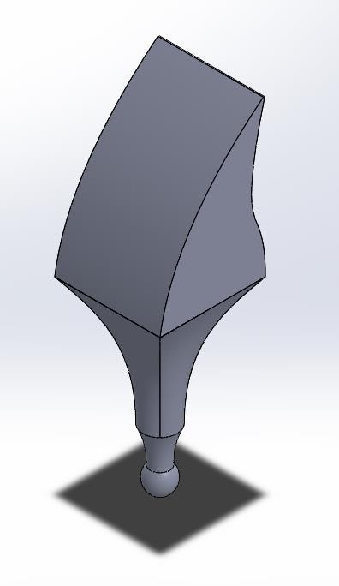

Figure B.1: Maxillary Central Incisor

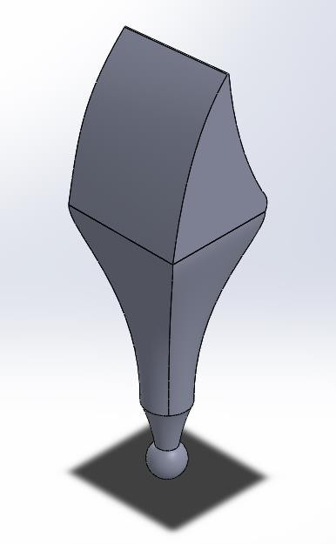

Figure B.2: Maxillary Lateral Incisor

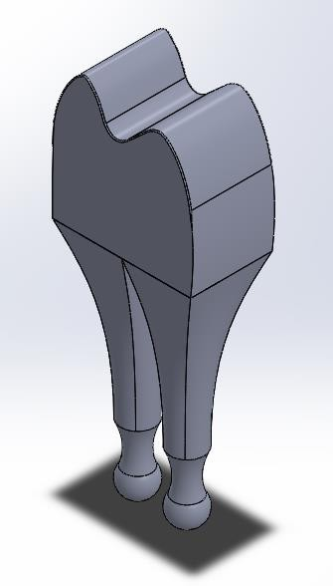

Figure B.3: Maxillary Premolar Double Root

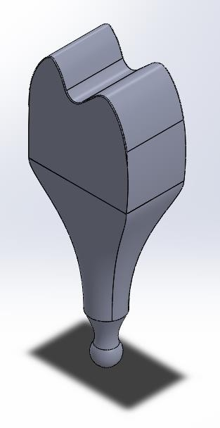

Figure B.4: Maxillary Premolar Single Root
Appendix C: Forceps and Diagrams

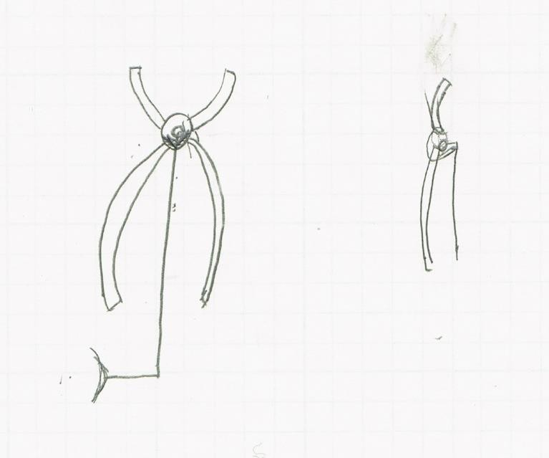

Figure C.1: Forceps Sketch 1

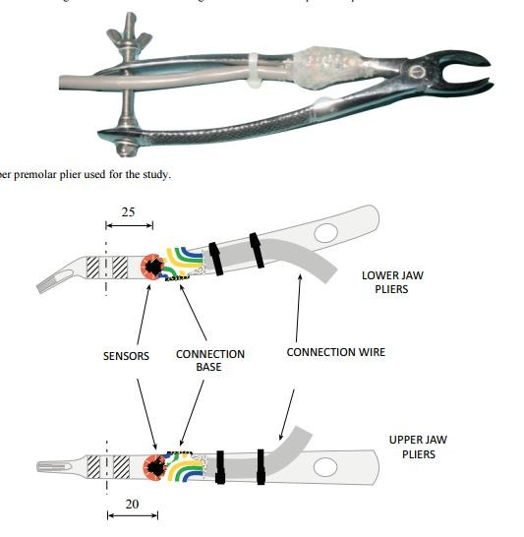

Figure C.2: Forceps In Vivo Study [Cicciu, 2013]
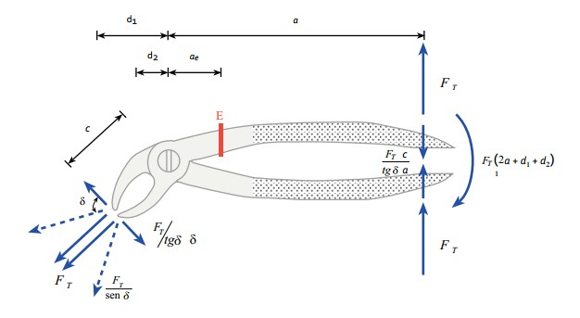

Figure C.3: Free Body Diagram In Vivo Study [Cicciu, 2013]

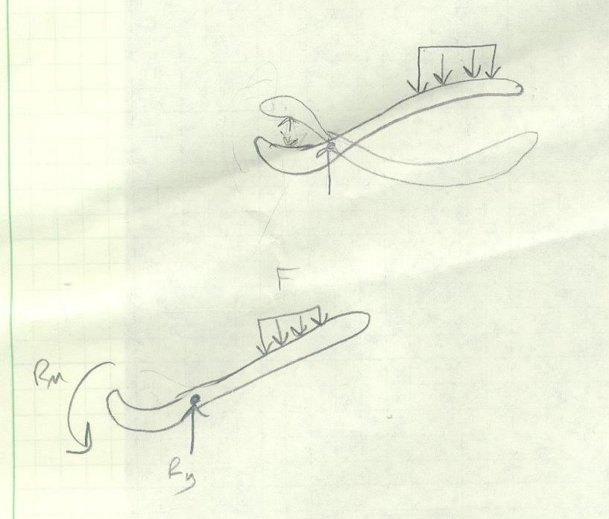

Figure C.4: Attempted FBD’s
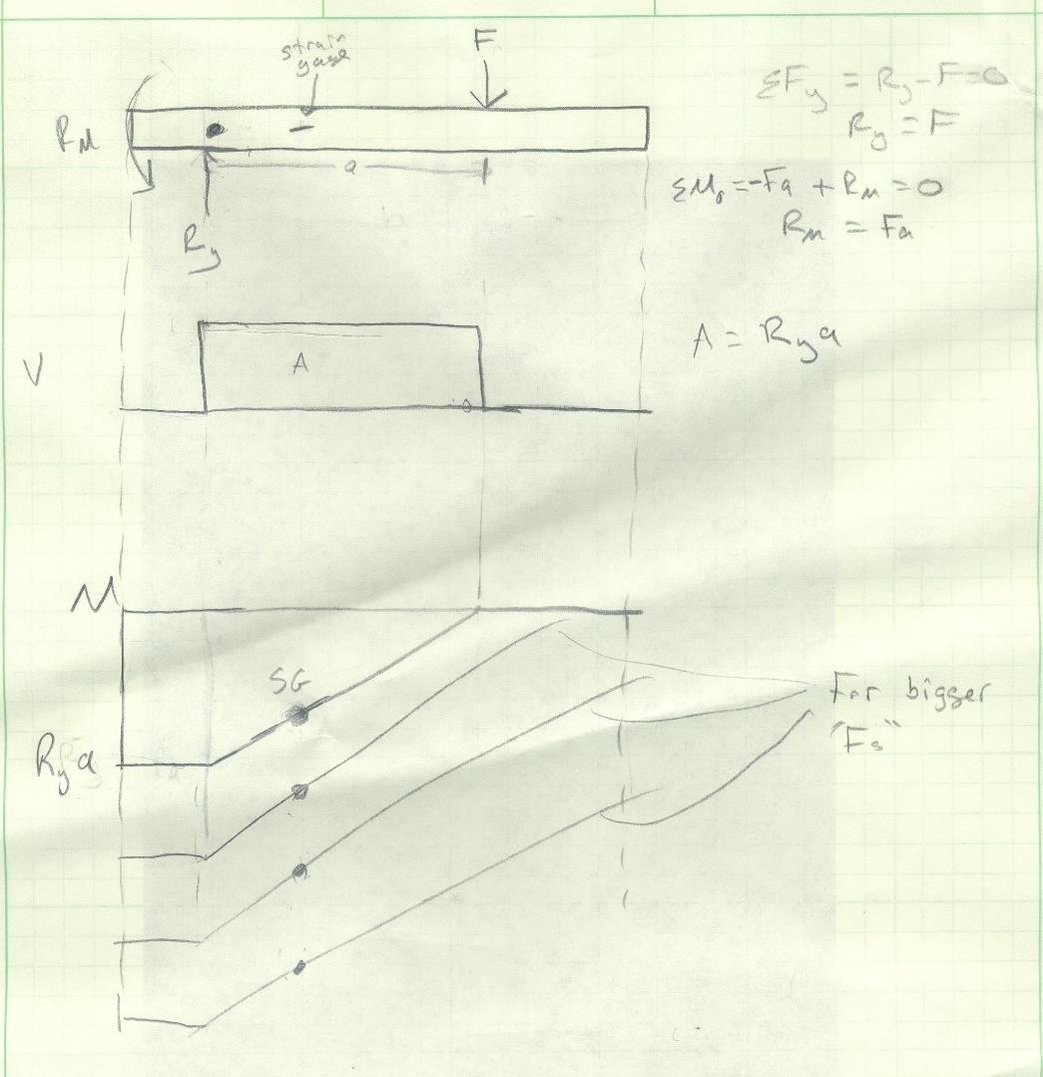

Figure C.5: Attempted Shear Moment Diagrams

C3
Appendix D: Alerted Teeth Models

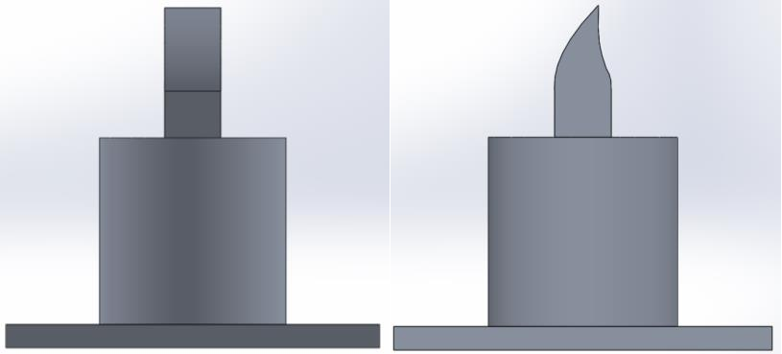

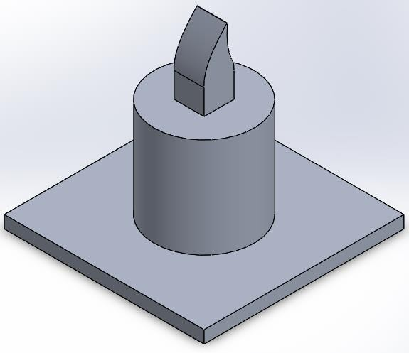

Figure D.1: Maxillary Central Incisor with Cylindrical Base

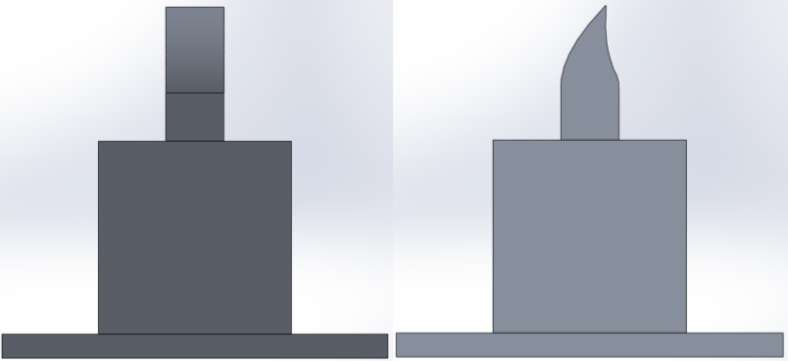

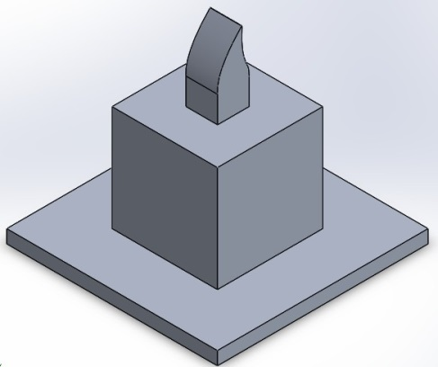

Figure D.2: Maxillary Central Incisor with Rectangular Base
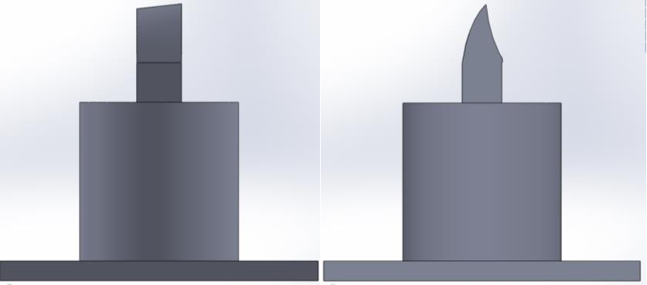

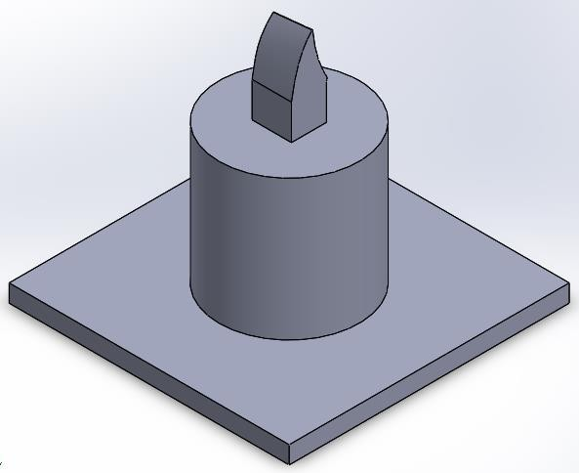

Figure D.3: Maxillary Lateral Incisor with Cylindrical Base

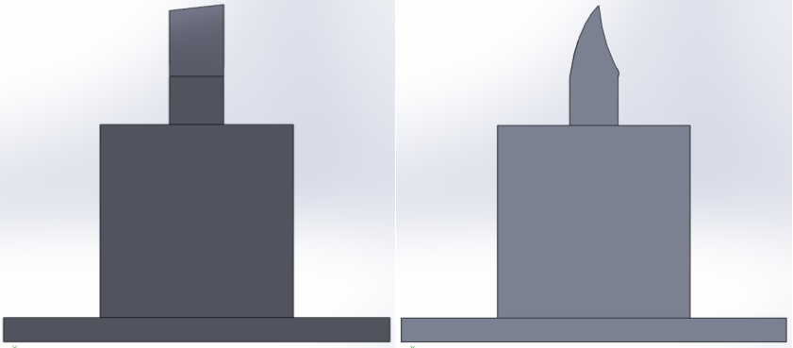

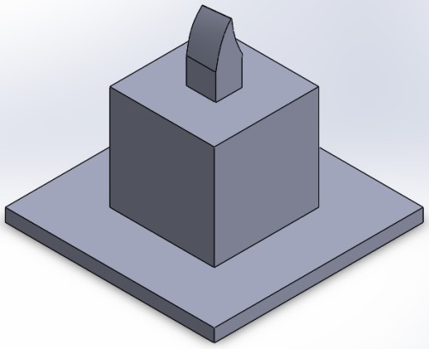

Figure D.4: Maxillary Lateral Incisor with Rectangular Base
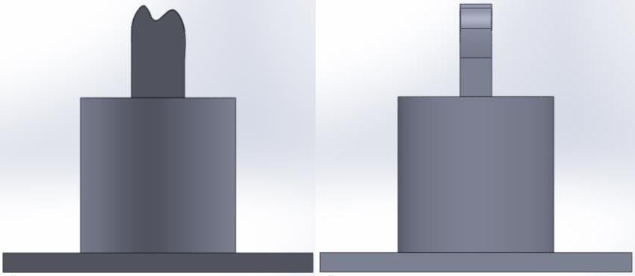

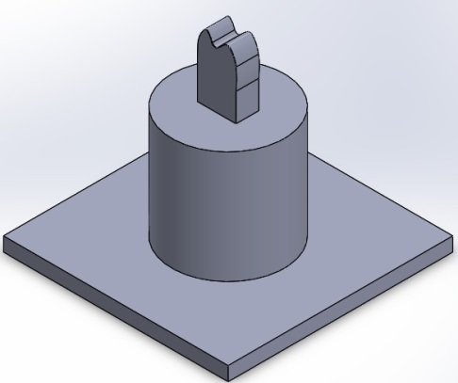

Figure D.5: Maxillary Premolar with Cylindrical Base

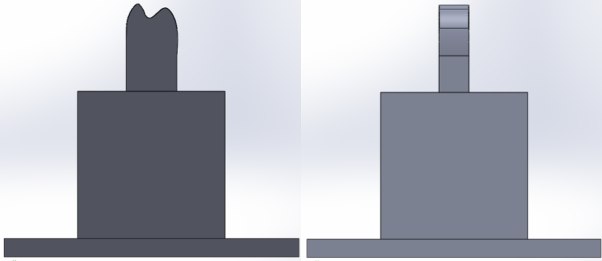

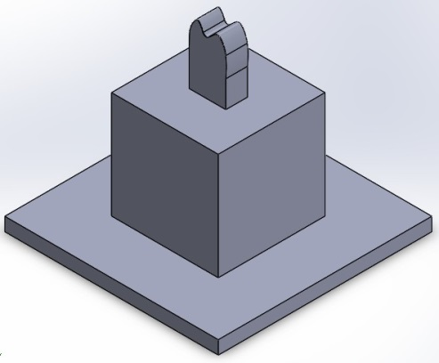

Figure D.6: Maxillary Premolar with Rectangular Base
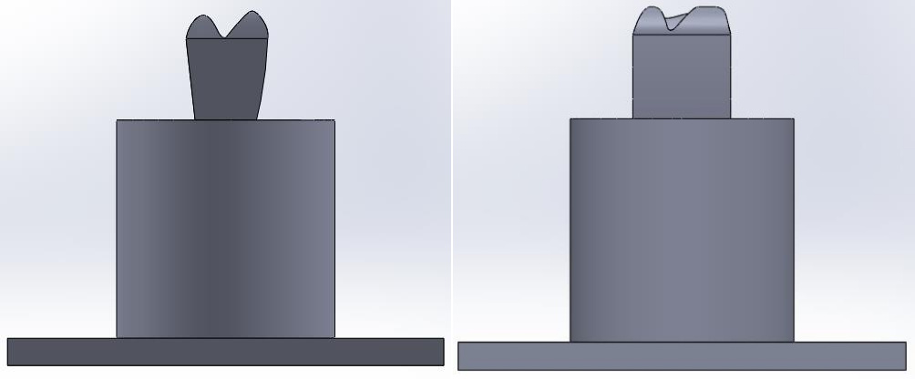

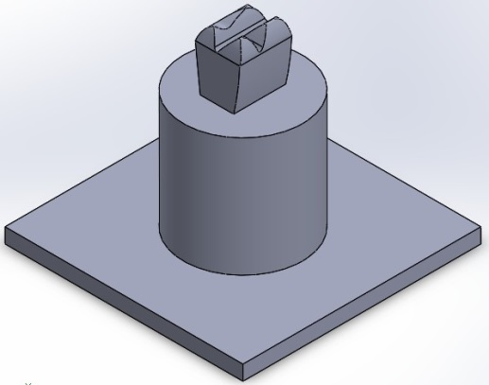

Figure D.7: Maxillary Molar with Cylindrical Base

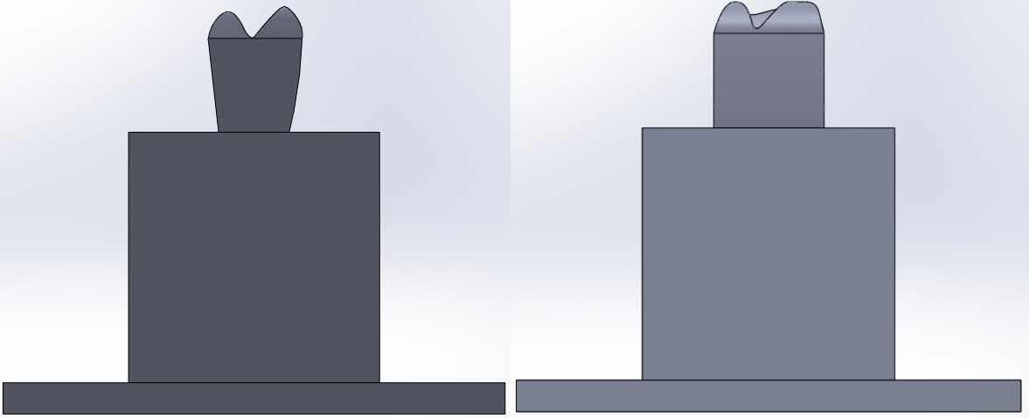

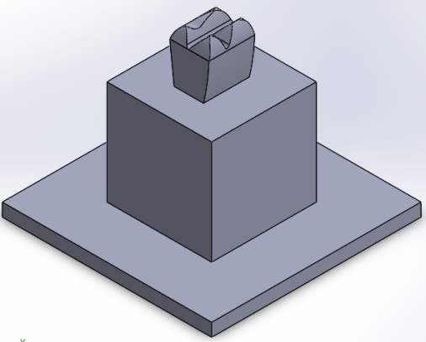

Figure D.8: Maxillary Molar with Rectangular Bas

Appendix E: Calculations

The bending stress can be calculated using Equation 1,
$σ=\frac{My}{I}$ (1)

where σ is the bending stress, M is the moment about the neutral axis, y is the perpendicular distance to the neutral axis, and I is the area moment of inertia about the neutral axis [Continuum Mechanics, 2015]

In order to calculate the bending stress using measured strain, Equation 2 can be used,

$σ=Eε$ (2)

where E is the modulus of elasticity of the material, and ε is the measured strain obtained from the strain gage [Engineering Toolbox, 2015]

The bending moment about the neutral axis (M) can be calculated by rearranging Equation 1 to form Equation 3.

$M=\frac{σI}{y}$ (3)

Substituting Equation 2 in Equation 3 yields Equation 4.

$M=\frac{EεI}{y}$ (4)

The moment of Inertia, I, can be calculated using Equation 5,

$I=\frac{1}{12}bh^{3}$ (5)

Where b is the base and h is the height of the model [Engineering Toolbox, 2015]

In order to obtain the twisting moment, T, values from the measured strain, Equation 6 was used,

$T=\frac{εEZ}{1+v}$ (6)

where v is the Poisson’s ratio of the material used to build the mode, Z is the polar modulus which can be calculated using Equation 7,

$Z=\frac{πd^{3}}{16}$ (7)

Where d is the diameter of the cross section [Kyowa, 2015].
Appendix F: Calibration for LabVIEW Program

In order to convert the output voltage from the strain indicator to moment, the output voltage first had to be converted to strain. Calibration of voltage to strain was necessary to accomplish this. An aluminum bar with the same type of gage used on the prototype glued to it was set on top of two supports in a similar fashion to a 3-point bending test. The gage on the aluminum bar was connected electronically as described in section… Prototype Summary. With the bar unloaded, the strain indicator was balanced so that the measured strain was zero. The strain displayed on the indicator and the measured voltage in LabVIEW were recorded. Weights of various magnitudes were placed on the bar and the strain and voltage were recorded under each condition. The bar was then flipped over and loaded so that data from positive and negative strains was collected.

The recorded values were loaded into an Excel file and a scatter plot of voltage vs. strain was created (Figure 28). A trendline was added to the plot with the equation and coefficient of determination displayed. The relationship was linear with a coefficient of determination of 0.9997. The equation of the line was y = -2.6142E-04x - 3.2824E-04. This equation was inputted into the LabVIEW
programs to convert voltage to strain.

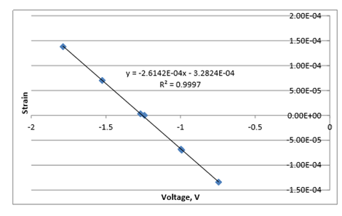

Figure F.1: Voltage vs Strain Scatter plot
Appendix G: LabVIEW Output

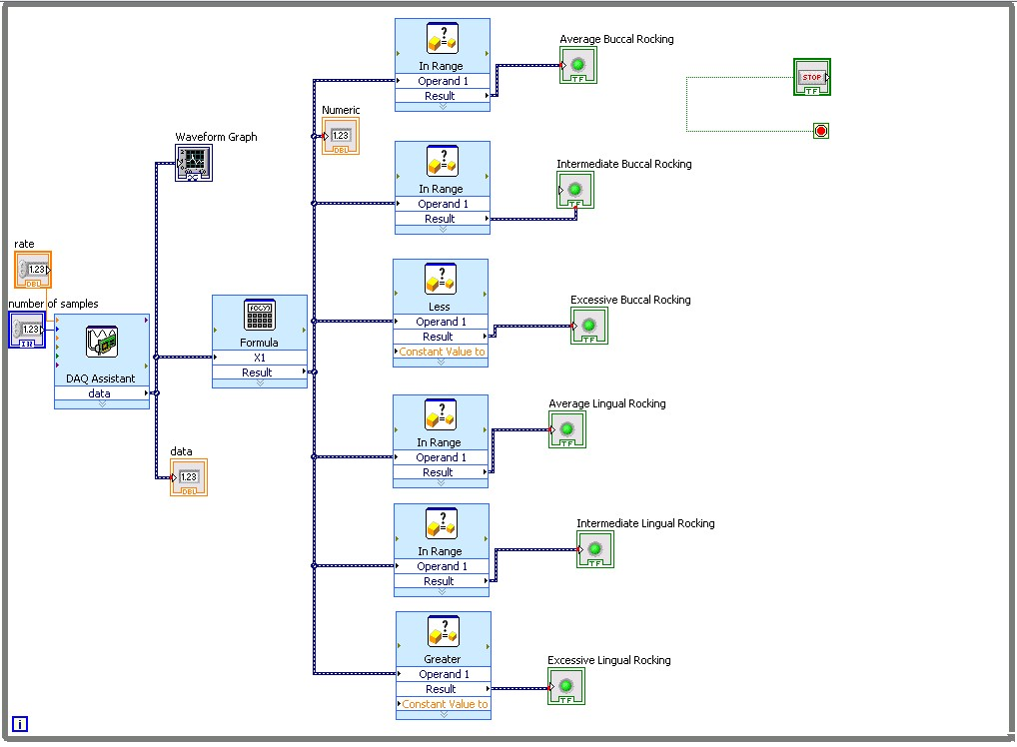

Figure G.1 Bending Moment Block Diagram

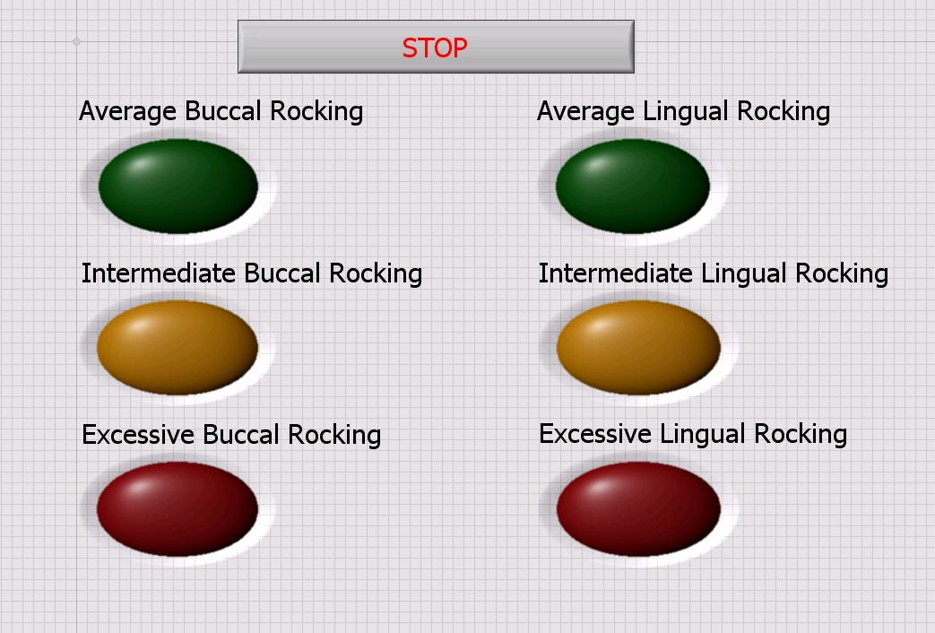

Figure G.2: Bending Moment Lights
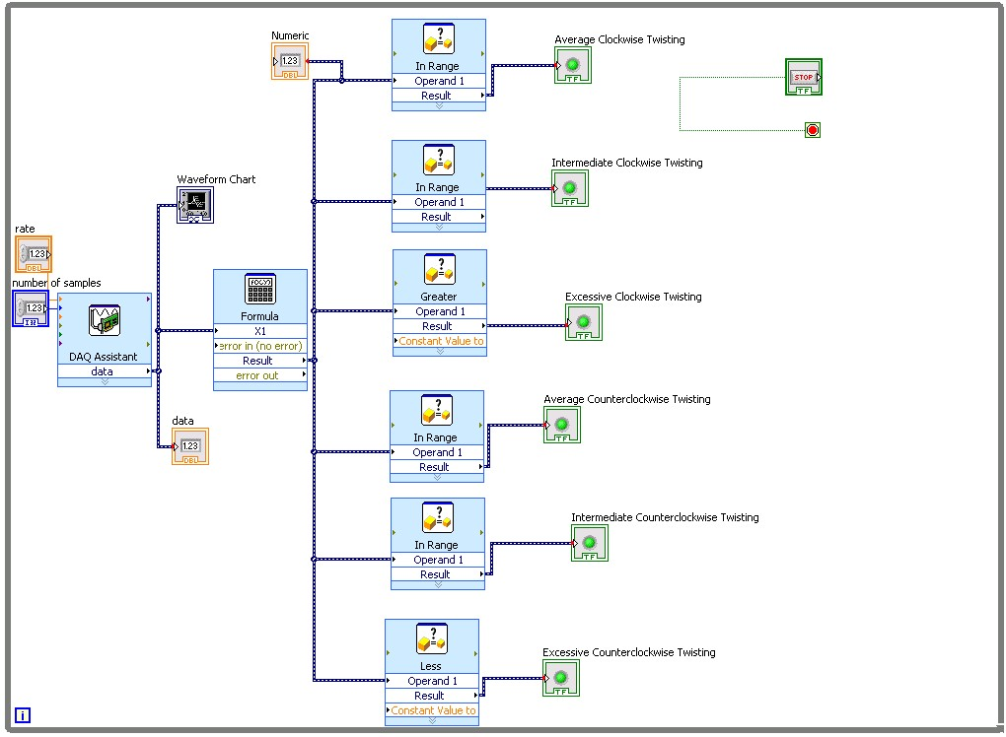

Figure G.3: Twisting Moment Block Diagram

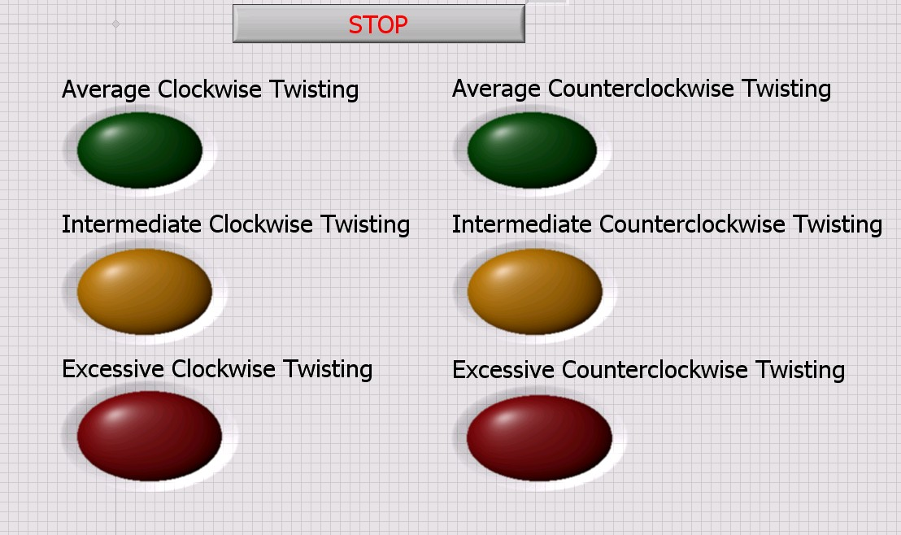

Figure G.4: Twisting Moment Lights
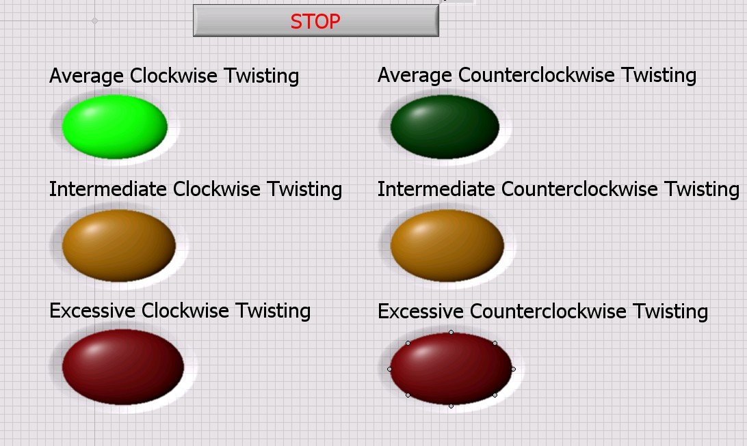

Figure G.5: Twisting Moment Lights with Green Light On

G3
Appendix H: Mechanical Drawings

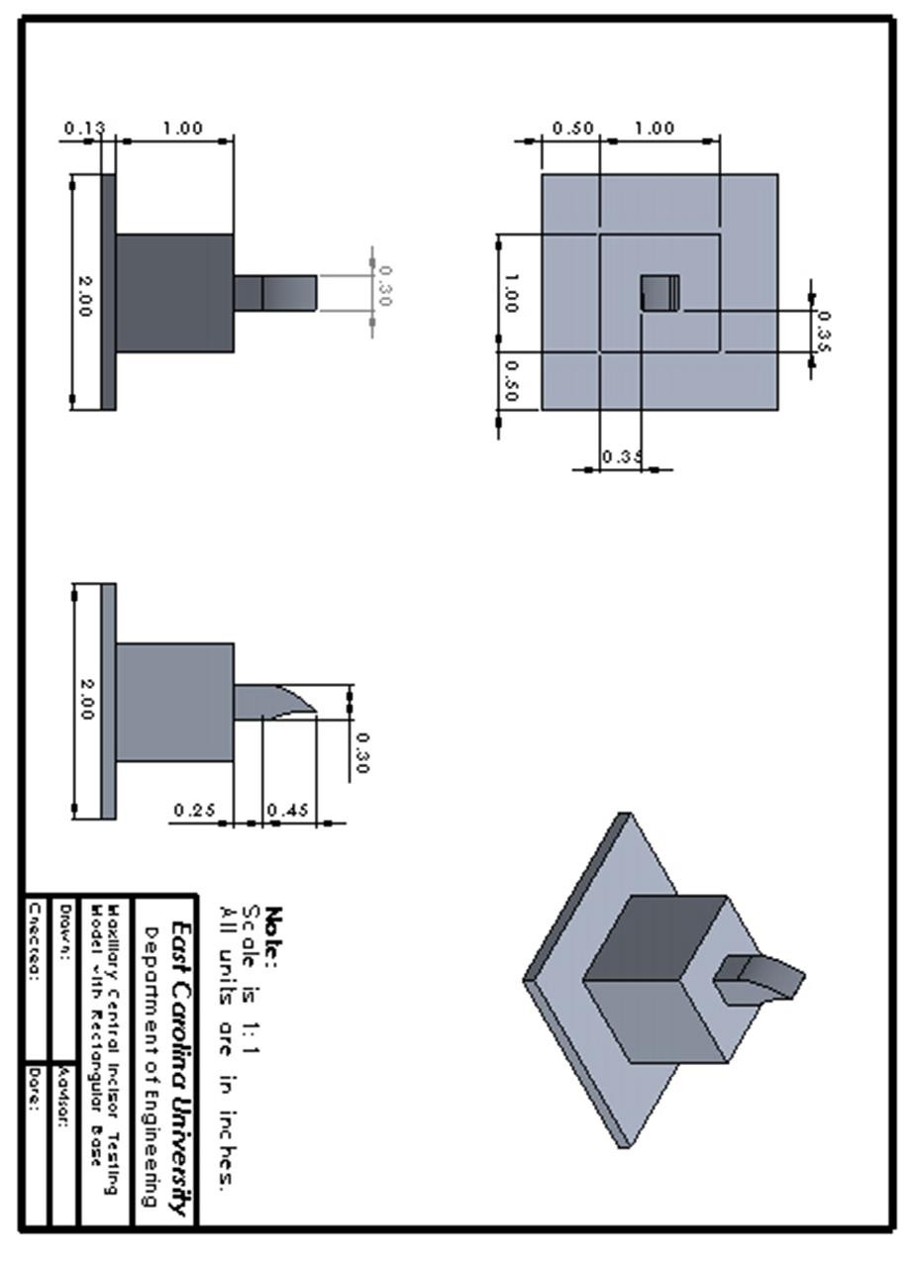

H1
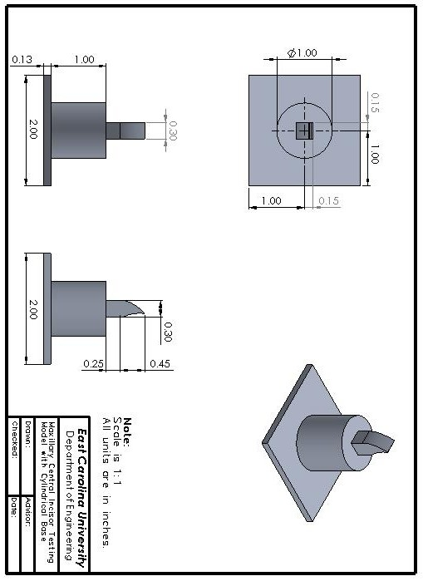

H2

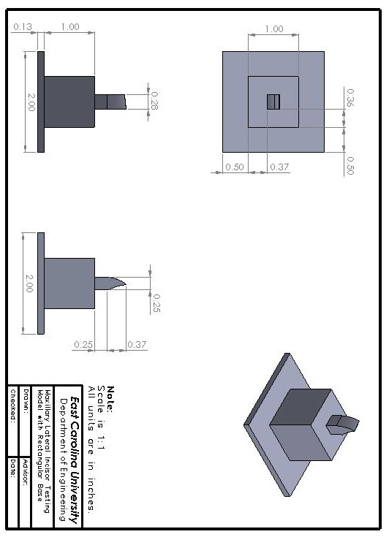

H3
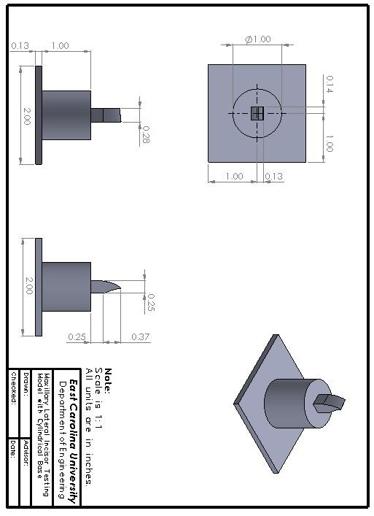

H4
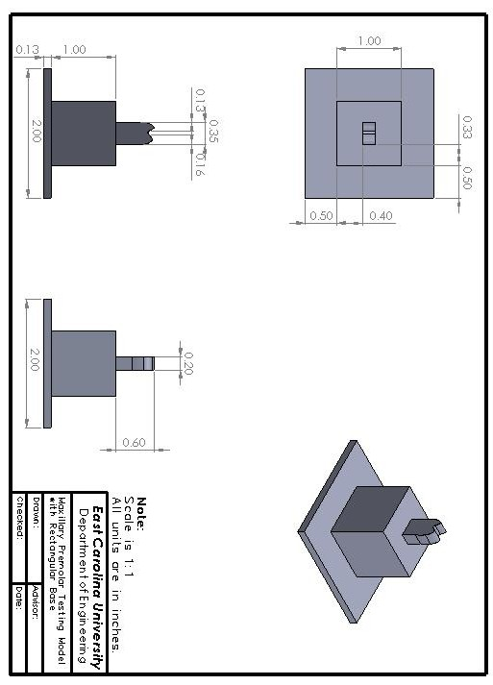

H5
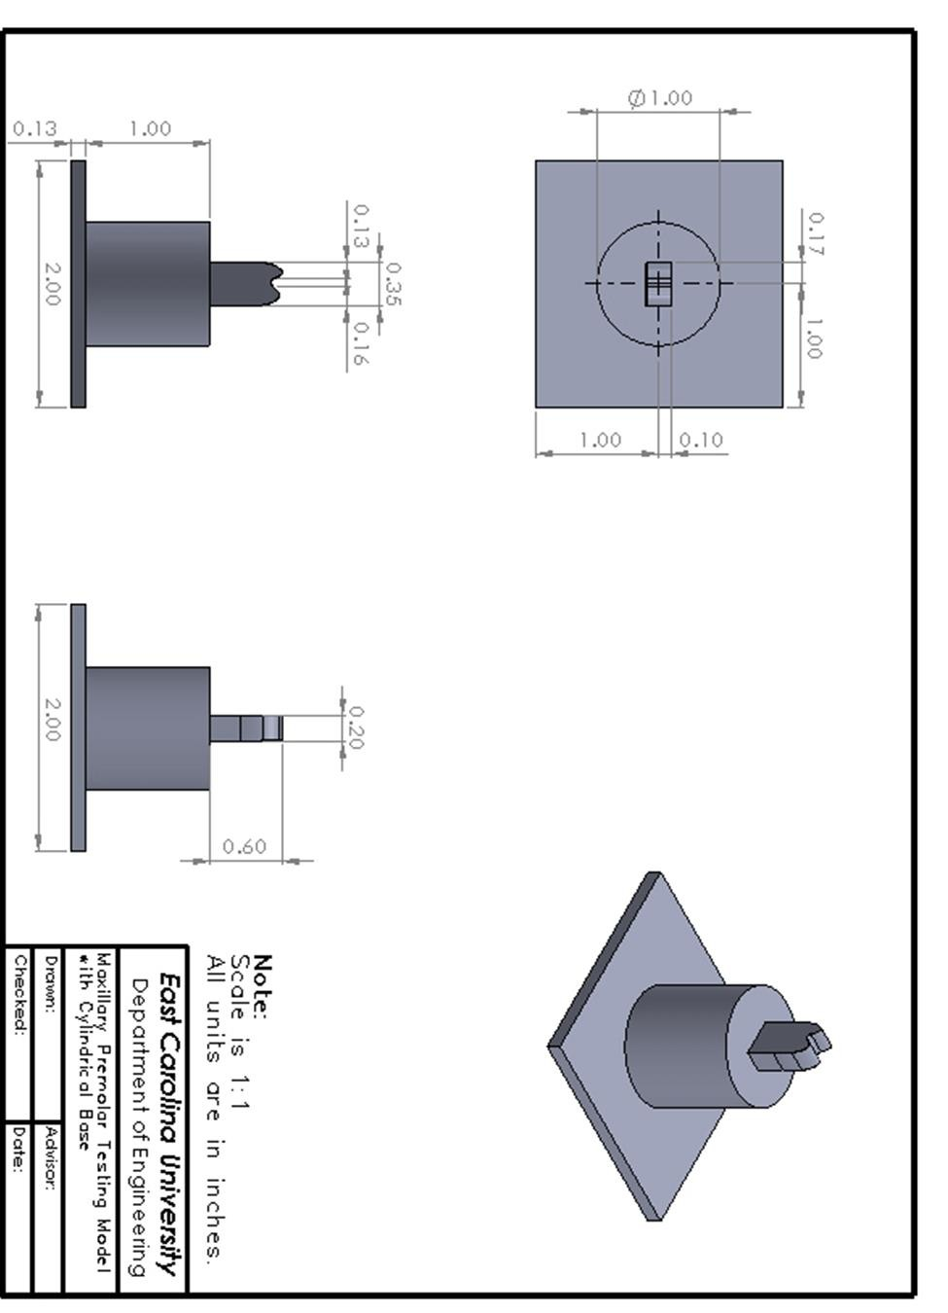

H6
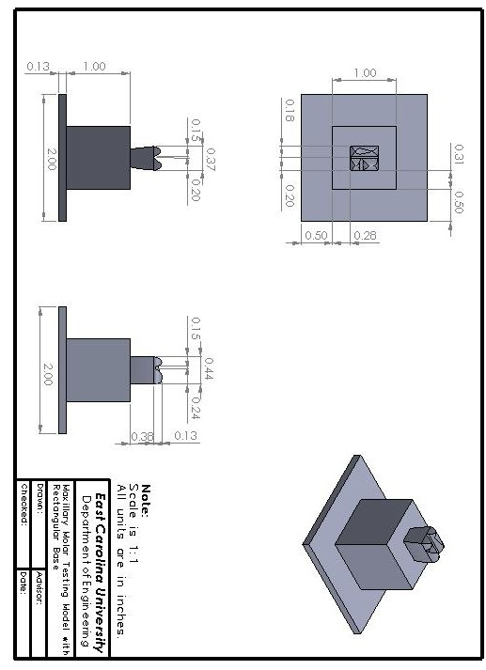

H7
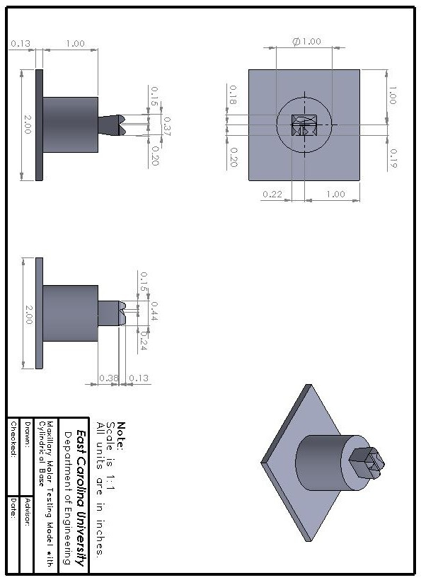

H8

