Assessing Shock Anxiety in Patients with ICDs

Dr. Taylor S. Hawkins, DNP, AGPCNP-C
College of Nursing, East Carolina University
Doctor of Nursing Practice Program

Abstract
Background
The Electrophysiology department at the collaborating institution for this DNP Project serves approximately 3,500 patients with implantable cardiac devices such as ICDs, pacemakers, and loop recorders. The site was identified as having no set metric to assess the patient's psychological response to the implantation of an ICD. Instead, the clinic intervenes with extensive education or a referral for Cardiac Psychology following an ICD shock based on patient history, clinical presentation, and shared decision-making.
Objective
The Florida Shock Assessment Scale (FSAS), created by Tripp et al. (2019), measures ICD-specific fears to target patients' psychological distress and the need for intervention. The objective is to prophylactically incorporate this tool at a patient's follow-up visit to identify patient-specific needs related to their ICD.
Methods
This project included 24 patients (n=24) with ICDs implanted (67% male, 33% female, 45% white, 54% African American, 25% previously shocked, and 75% never shocked). Patients were recruited at their routine follow-up ICD visits, where the clinic staff screened them for participation. The endpoint of the project was to identify patients with ICD-related anxiety and if cardiac psychology was indicated.
Results
Out of the sample, two patients who had been previously shocked were identified to have increased anxiety and were offered cardiac psychology. The female patient willingly accepted a referral to cardiac psychology. Each FSAS item was averaged, and two critical score items were identified to contribute to ICD-related anxiety: item 2 and item 8.
Conclusion
Knowledge of the clinic’s resources and education gave each patient a sense of safety and security in their ICD. In return, this improved quality of life and cardiac health.

Assessing Shock Anxiety in Patients with ICDs

Patients indicated for implantation of an Implantable Cardioverter Defibrillator (ICD) present with a frank, sudden cardiac arrest event or demonstrated significant risk for potentially fatal cardiac arrhythmias. Often, these patients experience considerable anxiety about their condition and ICD. These worries result in reduced physical activity, generalized stress, and cardiac-specific anxiety. Collectively, these psychological concerns may impair the overall health outcomes and interfere with achieving full benefit from the care process. According to Tripp et al. (2019), approximately 44% of patients with ICDs experience anxiety related to being defibrillated, which is associated with cardiac fear, physical inactivity, and increased morbidity and mortality. Incorporating metric tools to assess these concerns can improve a patient's quality of life.
An extensive literature review assessed the correlation between ICDs and anxiety and past and current strategies to alleviate the psychological distress associated with ICD shocks. It is identified in the literature that ICDs' effects on anxiety and quality of life are poorly understood (Perini et al., 2017). The Florida Shock Anxiety Scale (FSAS) is a widely used, reliable, and valid assessment tool to evaluate the clinical need for psychological support or psychoeducation for patients with ICDs (Tripp et al., 2019). Nationally representative data from Ford et al. (2012) suggests that a single score of the FSAS is an easy and appropriate assessment method to identify ICD-related stress. Cardiac Psychology is an underutilized intervention in patients with severe ICD-induced anxiety. Cardiac Psychology focuses on how ICD shocks facilitate rapid thinking, behavior, and self-perception changes. Therefore, interventions that have proven to solve this problem include cardiac health literacy and referral to cardiac psychology.
Hirsh et al. (2009) emphasized that symptoms of anxiousness and depression are frequently reported by ICD patients, demanding tailored psychological interventions to meet these needs. The project site for this DNP project does not employ the psychological screening tools and interventions for patients with ICDs necessary to improve their quality of life, thereby increasing the patient's risk for further cardiac decline. Instead, the project site assesses fear of shock as a tertiary prevention when the patient presents with extreme fear following a shock.
This quality improvement project aimed to engage with ICD patients by incorporating the FSAS tool at their follow-up visits. The outcome of the FSAS determines the patient's need for further education or Cardiac Psychology referral. This DNP project aimed to empower ICD patients by giving them the knowledge necessary to resume an active lifestyle without fear of being shocked, thereby increasing their confidence in maintaining a healthy, active lifestyle and overall improved health outcomes.
Methods
Modules were completed in the Collaborative Institutional Training Initiative (CITI) in preparation for the formal approval process of this project. The East Carolina University College of Nursing deemed the project a quality improvement (QI) project. The University's Self-Certification Qualtrics Survey was submitted and confirmed that IRB approval was optional. However, after a discussion with the site champion, an agreement to pursue IRB approval within the project site was reached to allow for future project expansion. IRB and implementation are currently ongoing with the clinic site.
Sample
Following IRB approval, 65 hours were spent at the project clinical site. The FSAS metric (Figure 1) was implemented for every ICD patient who met the criterion and was willing to participate in their regularly scheduled follow-up visit. The criteria for participation include ICD, mentally competent, and literate. Clinic staff would room the patient and perform their routine follow-up device interrogation. Following that visit, the clinic staff would then educate the patient on the project, allowing the patient to agree or refuse to participate. Informed patient consent was obtained before PHI access and implementation. A sample of 24 participants willingly participated. There were no incentives to participate in this project.
Instrument
The project implementor gave the FSAS tool to the patients, who then exited the room to allow for the patient to complete it. The patients were asked to individually fill out items 1-10 to measure the ICD-related anxiety regarding shock. Scores were then calculated, and results were reviewed with the patient; the project implementor educated the patient on their results. Data collected was stored in an Excel tracking sheet and kept in a private IRB-approved drive. Each patient was provided a peer-reviewed education sheet after participation, and those with FSAS scores greater than 30 indicating further needs were offered referral to Cardiac Psychology. At the end of the study, data was analyzed for results and conclusions.
Design
This DNP project execution aligns with the PRECEDE-PROCEED Model (PPM). PRECEDE stands for Predisposing, Reinforcing, and Enabling Constructs in Education/Environmental Diagnosis and Evaluation. PROCEED stands for Policy, Regulatory, and Organization Constructs in Educational and Environmental Development. PPM is an evidence-based health promotion approach that emphasizes planning and evaluation for successful interventions. The PPM is a method of making substantial progress in reducing morbidity and mortality at the community level through developing, implementing, and evaluating health promotion programs (Crosby & Noar, 2011). Health needs related to fear surrounding ICD shocks were identified within the clinical project site, the FSAS was implemented, and outcomes were evaluated.
Results
The findings indicate that out of the sample of participants (n=24), one male and one female patient met the criteria for referral to cardiac psychology, both of whom had previously experienced a shock. Of these two patients, the female patient willingly accepted the referral. The sample included an average age of 68; 67% were male, 33% were female, 45% were white, and 54% were African American. Shock history revealed that 25% of the sample had previously been shocked, while 75% had never been shocked, as seen in Figure 2. This is relevant as it aligns with previous evidence-based data showing that 1 in 4 patients with ICDs received a shock. FSAS results were separated by item, and the means were calculated as seen in Figure 3, revealing areas of most concern with the entire sample.
Discussion
Administration of the FSAS metric reveals the importance of continual assessment of ICD-related anxiety in patients with ICDs. Utilizing ICD-related anxiety assessment tools can
help prophylactically identify patients in need of further device knowledge or cardiac psychology. While the positive results of this study yielded only two patients in the sample, all patients acknowledged the benefits of education regarding their ICD. The female patient with positive results was more willing to seek help from Cardiac Psychology than the male patient. Patients who had never been shocked have less critical score items on their FSAS than those who had been shocked. However, each patient expressed security and safety with the knowledge of their implantable device and Cardiac Psychology as a resource.
The clinic site champion and his psychology student are currently continuing implementation. While the time spent at the clinic site provided relevant knowledge, more time and data will provide greater evidence to support the problem. In return, the hope is to provide patients with relevant knowledge and support for ICDs while exposing cardiac psychology as a relevant tool that can be used for patients with ICDs. Further knowledge and implementation can also provide more evidence of demographic-related differences in the patient population.
Conclusions
Incorporating and adopting the habit of measuring ICD-related anxiety in patients with ICDs can promote positive cardiac health outcomes. Screening all ICD patients at every visit can serve as a primary prevention strategy for the mental and physical sequelae of cardiovascular disease. Patients who know the clinic’s resources, such as cardiac psychology, are more likely to feel secure and safe with their care. Knowing these are available provides security at home and during shocks. Therefore, completing this quality improvement project made patients feel empowered and confident in their implantable device and the clinic that cares for them.

References
Crosby, R. & Noar, S.M. (2011). What is a planning model? An introduction to PRECEDE-PROCEED. Journal of Public Health Dentistry. 71(s1), S7-S15. https://doi.org/10.1111/j.1752-7325.2011.00235.x
Ford, J., Finch, J.F., Woodrow, L.K., Cutitta, K.E., Shea, J., Fischer, A., Hazelton, G., & Sears, S.F. (2012). The Florida Shock Anxiety Scale (FSAS) for Patients with Implantable Cardioverter Defibrillators: Testing Factor Structure, Reliability, and Validity of a Previously Established Measure. Pacing and Clinical Electrophysiology. 35(9), 1146–1153. https://doi.org/10.1111/j.1540-8159.2012.03455.x
Hirsh, A.T., Sears, S.F. & Conti, J.B. (2009). Cognitive and Behavioral Treatments for Anxiety and Depression in a Patient with an Implantable Cardioverter Defibrillator (ICD): A Case Report and Clinical Discussion. J Clin Psychol Med Settings 16, 270–279. https://doi.org/10.1007/s10880-009-9160-0
Perini, A.P., Kutyifa, V., Veazie, P., Daubert, J.P., Schuger, C., Zareba, W., McNitt, S., Rosero, S., Tompkins, C., Padeletti, L., & Moss, E.J. (2017). Effects of implantable cardioverter/defibrillator shock and anti-tachycardia pacing on anxiety and quality of life: A MADIT-RIT substudy. American Heart Journal. 189, 75–84. https://doi.org/10.1016/j.ahj.2017.03.009
Tripp, C., Huber, N. L., Kuhl, E. A., & Sears, S. F. (2019). Measuring ICD shock anxiety: Status update on the Florida Shock Anxiety Scale after over a decade of use. Pacing and Clinical Electrophysiology, 42(10), 1294–1301. https://doi.org/10.1111/pace.13793

Figure 1
Florida Shock Anxiety Scale
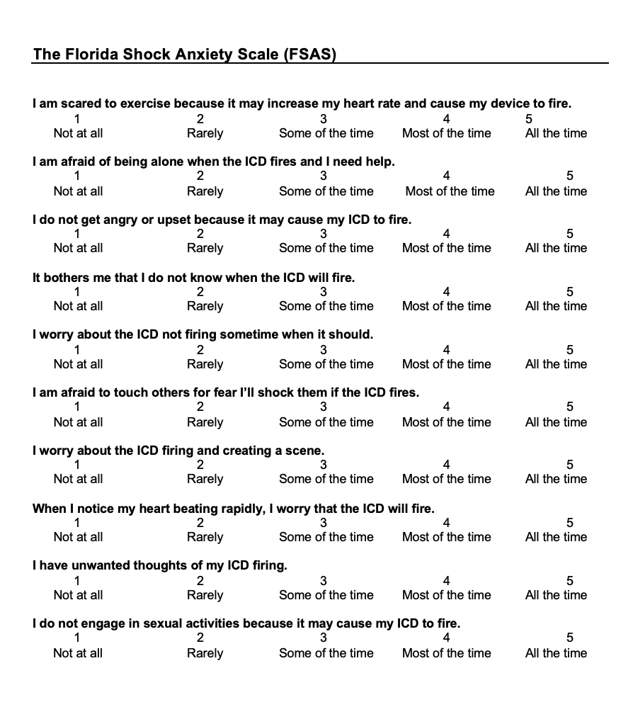
Note: This study provided patients with a replica of the FSAS metric above. Created by Tripp et al. (2019).
Figure 2
Pie Chart for Percentage of Population Shocked

Note: The pie chart above shows the percentage of patients within this study’s population (n=24) who have a history of being shocked and those who have never been shocked. This data aligns with evidence-based research showing that 1 in 4 ICD patients have previously been shocked (Perini et al., 2017).

Figure 3
FSAS Item Means

Note: This chart averages each patient’s scores from the sample on the items in the FSAS metric. This chart identifies two specific critical score items: items 2 and 8.

