Increase Advance Directives Knowledge among African Americans in the Faith-based Organization
Kotaya Griffith
East Carolina University

Abstract
Despite the passing of the Patient Self-Determination Act (PDSA) in 1990, advance directives (AD) remain underutilized. African Americans’ AD completion rates were found to be lower than rates of completion by white Americans. Lack of knowledge regarding the implications of AD was found to be one of the leading causes for the low rates. An evidence-based project targeting African American participants was conducted in three faith-based organizations. The participants were provided an evidence-based education session using Respecting Choices® along with written handouts. A customized readiness ruler (RR) was used by participants to self-report readiness levels toward completing AD before and after the education session. Participants were also asked to respond to a post-evaluation survey of the educational content that was presented. The project had a total of 74 participants (N =74) with 58 participants (n =58) completing the post-evaluation survey and the pre-and post RR. Aggregate data indicated a change in participants readiness to complete AD. The post-evaluation survey indicated that the use of Respecting Choices®, an evidence-based education program to raise participants’ awareness of AD, was beneficial in communicating with persons voluntarily attending one of three education sessions at the faith-based organizations.
Key words: advance directive, advanced care-planning, African Americans, Blacks, faith-based organization, education

Acknowledgments
Completing a doctoral program was not an easy task and required a lot of support from many individuals. First, I would like to thank God for this opportunity because without him this would not have been possible. I would like to thank my husband, Anthony, who have supported me in this endeavor with his love, prayers, and patience. I truly appreciate his understanding and willingness to take on more responsibility for our family during this time. I would like to thank my son, Justus, my little sunshine who have sat up with me many nights as I worked on this project. I would like to thank my church and family who have provided encouragement and prayers along this journey. I would like to thank my friend and sister, Veronica Rankin, who has been such a blessing during this entire process. We have traveled many miles together during this program and I’m forever grateful to God for allowing us to share in this experience. I would like to thank Catherine Hall, content expert for all her support during the project planning and implementation.
I would like to thank my committee chair, Dr. Tillman for her continued guidance and support throughout this entire process. Her wisdom and knowledge have been truly appreciated and I will never forget all I have gained from this program. Lastly, I would like to thank the entire DNP faculty and fellow classmates at East Carolina University for their support.
Table of Contents
Abstract 2
Acknowledgments 3
Chapter One: Problem Identification 7
Problem Statement 8
Justification of the Project 8
Purpose 10
Theoretical Framework 10
Assumptions 12
Project Questions 12
Definition of Terms 13
Summary 13
Chapter Two: Review of the Related Literature 15
Search Strategy 15
Literature Synthesis 15
Barriers to AD completion 15
AD Benefits 16
Education intervention effects on AD completion rates 18
Faith-based setting utilization for ACP discussions 21
Chapter Three: Methodology 23
Design 23
Setting 23
Participants 24
Methods 24
Protection of Human Subjects 25
Instruments 25
Data Collection 26
Data Analysis 26
Limitations 27
Chapter Four: Results 28
Sample Characteristics 28
Major Findings 30
Summary 33
Chapter Five: Discussion 35
Significance of Findings 35
Project Strengths 36
Project Limitations 37
Project Benefits 38
Recommendations for Practice 39
Final Summary 40
References 42
Appendices 50
Appendix A: Flowchart for article search 50
Appendix B: Evidence Matrix 51
Appendix C: Readiness Ruler 64
Appendix D: PowerPoint Presentation 65
Appendix E: Post Education Survey 75
Appendix F: Advance Directive Form 77
Appendix G: Event Flyer 85
Appendix H: Project Infromation Sheet 86
Appendix I: Project Timeline 87
Appendix J: Data Collection Tool 88
Appendix K: Doctor of Nursing Practice Essentials 89

Chapter One: Problem Identification
Advance care planning (ACP) is an important process which includes completing an advance directive (AD) based upon an individual's personal preferences (National Institute on Aging, 2014). Advance directives are legal paperwork, which allows an individual to select a healthcare agent to communicate decisions about end-of-life (EOL) care in the event that a person is unable to communicate his or her own wishes (National Library of Medicine, 2016). The Patient Self-Determination Act (PSDA) of 1990 was enacted to increase focus and guidance concerning AD and EOL discussions (Hinderer & Lee, 2014). Twenty-eight years after PSDA was passed, AD continue to be underutilized (Koss & Baker, 2017; Hinderer & Lee, 2014).
According to the Centers for Disease Control and Prevention [CDC] (2017), seventy percent of Americans lacked AD. Rao, Anderson, Lin, and Laux (2014) reported a survey of 7,946 participants in the United States (US), noting that approximately seventy-five percent did
not have AD. Lack of awareness was cited as the primary reason for lack of an AD (Rao, Anderson, Lin, & Laux, 2014).
According to the literature, African Americans (AAs) have a lower rate of completion of AD compared to whites (Ko & Lee, 2014). Rao et al. (2014) reported that 83% of AAs had not completed AD compared to 69.3% of whites. Ko and Lee (2014) found the rate of AD completion among whites (27.8%) was slightly higher when compared to blacks (21.4%). Koss and Baker (2017) also found rates of AD completion were significantly lower among blacks (38%) when compared to whites (74%). Portanova, Ailshire, Perez, Rahman, and Enguidanos (2017) reported that 15% of blacks’ decedents had completed AD compared to 51.7% of whites. The primary barriers identified included a lack of information, a mistrust of providers, and avoidance of discussing death (Huang et al., 2016). The completion of an AD is an important aspect of patient care and its absence can have a significant impact on the patient, family, healthcare outcomes, and EOL costs.

Problem Statement
Despite the passing of PSDA in 1990, which informed patient of their right to make EOL decisions (Hinderer & Lee, 2014) there is still a lack of EOL discussions and utilization of AD (Koss & Baker, 2017; IOM, 2015). However, when examining the various factors, race was noted to impact AD completion rates. Particularly, AAs’ completion rates are lower compared to whites (Ko & Lee, 2014; Koss & Baker, 2017; Portanova, Ailshire, Perez, Rahman, & Enguidanos, 2017; Rao et al., 2014). One of the top reasons for AAs decreased utilization of AD is lack of awareness (Rao et al., 2014). Consequently, this project provided an education session aimed at increasing AAs knowledge and awareness of AD.

Justification of the Project
Advance directives are important tools for communicating patients' EOL wishes and are associated with many benefits such as: reducing the burden for both the surrogate decision-makers and families, reducing EOL costs, stress and depression reduction, increasing quality of care, and higher patient satisfaction scores (Brinkman-Stoppelenburg, Rietjens, & Van, 2014; Detering, Silveira, Arnold, & Savarese, 2016; Wholihan & Pace, 2012). Despite these benefits, AAs completion rates remain low (Ko & Lee, 2014; Rao et al., 2014). Multiple studies have shown many factors impacting AD completion rates among AAs, but a lack of education was the main contributing factor (Huang et al., 2016; Pecanac, Repenshek, Tennenbaum, & Hammes, 2014; Rao et al., 2014).
According to Mecklenburg County Health Department, [MCHD] (2013) " African Americans have higher mortality rates than whites for nearly every type of cancer and die at higher rates from chronic diseases such as cardiovascular disease, stroke and diabetes" (p.2). Studies have also shown AAs have a higher rate of EOL treatments and deaths in the intensive care units (Chertoff, Olson, & Alnuaimat, 2017; Hanchate, Kronman, Young-Xu, Ash, & Emanuel, 2009; Johnson et al., 2010). African Americans tend to prefer more life-sustaining measures at EOL leading to higher EOL costs compared to their white counterparts (Barnato, Anthony, Skinner, Gallagher, & Fisher, 2009; Hanchate et al., 2009; Ladd, 2014; Portanova et al.,2017). The Institute of Medicine [IOM] (2015) "Dying in America" highlighted that EOL care in America was inadequate and costly, therefore called for healthcare organizations and policy reform to improve EOL care delivery. The Institute of Medicine (2015) stated that EOL care needed to be aligned with patient wishes and recommended improved ACP throughout the lifespan of all Americans.
The American population is growing more culturally diverse, with AAs accounting for 43.2 million people (13.3% of the population) in 2016 (United States Census Bureau, 2016). As this population continues to increase in number, the lack of EOL discussions and AD completion will likely increase and contribute to higher healthcare costs at EOL, aggressive treatment preferences, and prolonged hospital admissions. To curtail these outcomes, ACP discussions and documentation of EOL preferences is suggested. Findings have shown that ACP education has increased knowledge and AD completion rates (Huang et al., 2016; Pecanac et al., 2014). Wholihan and Pace (2012) found several innovative programs for ACP in the community linked to the earlier initiation of EOL decision-making leading to a reduction in hospital admissions.
An ACP program known as Respecting Choices® was implemented at Gundersen Lutheran Medical Center in LaCrosse in 1991 and has shown a reduction in costs in the last two years of life with only "13.6% of deaths associated with a stay in intensive care" (Wholihan & Pace, 2012, p. 174). In a study conducted by Pecanac, Repenshek, Tennenbaum, and Hammes (2014), the Respecting Choices® program was used when working among racial and ethnic populations showing an "increased prevalence of AD for racial and ethnic minorities from 25.8% to 38.45%" (p. 285). To help narrow the gap of AD completion rates among AAs they must first be made aware and educated. Given the documented reason such as the lack of knowledge and awareness regarding the importance of ACP in EOL care within the AA community this project was warranted in seeking to reduce racial disparities in AD knowledge and completion rates.

Purpose
The purpose of this project was to increase AD knowledge and completion rates among AA attendees participating in education sessions provided in faith-based organizations. The education sessions were intended to enhance knowledge and discussions regarding ACP and subsequently, completion of AD. The project goals were to increase awareness and percentage of AD completion among AA attendees.

Theoretical Framework
This project was guided by the Transtheoretical Model (TTM) of behavior change by Prochaska (2008). The TTM uses five stages to assess individual's readiness and willingness to make behavior changes (Prochaska, 2008). The five stages of change are precontemplation, contemplation, preparation, action, and maintenance (Prochaska, 2008). Applying the TTM to the phenomenon of deciding to complete an AD provided a better understanding of an individual's decision-making process regarding AD and helps to identify a reference point for their readiness for change. This model provides a framework to help assess individual's readiness for AD completion.
The first stage of TTM is precontemplation, which denotes that a person is not ready to take action in the near future (Prochaska, 2008). In this stage, an individual may not be aware of any behavior modification or that a change is warranted (Wilson, 2009). Prochaska, (2008) stated that individuals may be "uninformed or underinformed" (p.845). For this project, education sessions were provided to bring awareness and clarification regarding AD. At this stage, the education sessions were viewed as beneficial since studies have shown that AAs are not aware of AD.
The second stage of the theory is contemplation, which denotes a stage in which a person is planning to "take action in the next six months" (Prochaska, 2008, p. 845). In this stage, an individual realizes a behavior problem that requires change but may not be ready to act (Wilson, 2009). Providing this project did not only bring awareness to participants but also linked individuals at the contemplation stage with community resources such as an AD workshop for additional support. Preparation is the third stage of the theory and is where a person intends to take action in the near future and has a plan (Prochaska, 2008). Participants at this stage are ready to take action within 30 days. These individuals were provided an AD form to take to their primary care provider and information on other locations where an AD can be completed.
The fourth stage is action. In this phase, an individual has made some behavior modifications that is fewer than six months and is at risk for relapse (Prochaska, 2008). Participants that are at this stage are ready to complete an AD and have already taken steps toward the process of completing an AD. The individuals in this project were provided an opportunity to complete an AD at the project site with an ACP facilitator. Upon completion of the AD, facilitators recommended that individuals share a copy with the designated healthcare agent and primary care provider.
Lastly, is the maintenance stage of the TTM in which a person has had success in maintaining a change past six months but is working to avoid a relapse (Prochaska, 2008). At this point a person would have already completed an AD. For individuals in this stage it is important that the primary care provider have ongoing reviews of EOL preferences to ensure clients' wishes and care are aligned. Providers are encouraged to update the form with any changes. Individuals are encouraged to have ongoing communication with their designated healthcare agent and family members about their EOL wishes. The process of completing AD can be very complex. The TTM provided the necessary framework to assess a participant's readiness in moving forward with EOL planning with the goal of completing AD with AAs during the implementation phase of this project.

Assumptions
The primary assumption of this project was that AAs are not knowledgeable about AD. The main reason is thought to be due to a lack of ACP education. Therefore, it is assumed that a community education intervention regarding AD will increase awareness and ultimately completion of AD among AA attendees.

Project Questions
This project seeks to assess participants' readiness level to enact an AD by increasing their knowledge of EOL care and offering support for completion of the proper documentation. A post evaluation survey was administered to assess the effectiveness of the education sessions. Lastly, the impact of an AD education intervention within faith-based organizations among AA participants?

Definition of Terms
ACP is a process that involves making EOL decisions based on a person's preferences and the completion of an AD (National Institute on Aging, 2014). An AD is a legal document that provides written decisions regarding EOL medical care for the future in the event that a person is unable to speak on their behalf (North Carolina Department of Health and Human Services, 2009). The living will is a legal document that states a person wishes to die a natural death based upon specifying conditions (North Carolina Department of Health and Human Services, 2009). A healthcare power of attorney is a legal form that selects a decision maker for the patient's medical care known as the healthcare proxy, healthcare agent, or healthcare representative (North Carolina Department of Health and Human Services, 2009). A Medical Orders for Scope of Treatment (MOST) form is a medical order that depicts a patient's preference regarding resuscitation wishes, medical scope of treatment, antibiotic utilization, and tube feeding (North Carolina Division of Health Service Regulation, 2016). Do Not Resuscitate (DNR) orders, also called a "Golden Rod" form are legal forms completed by healthcare providers after a person communicates his or her wishes for no cardiopulmonary resuscitation (North Carolina Division of Health Service Regulation, 2016). Lastly, EOL care is the support and medical care around the time preceding a person's death (National Institute on Aging, 2016).

Summary
End-of-life care discussions and AD completion remain a complex issue and are neglected despite the benefits and the enactment of PSDA. This project seeks to narrow the racial disparity among AAs regarding AD completion rates through education sessions guided by TTM of behavior change by Prochaska (2008). It is well documented in the literature that AAs often prefer life-sustaining measures and have higher rates of hospital deaths (Chertoff et al., 2017; Hanchate et al., 2009; Johnson et al., 2010). The benefits associated with AD, as mentioned previously, are numerous including higher patient satisfaction and reduction of EOL care costs (Brinkman-Stoppelenburg et al., 2014; Detering et al., 2016; Wholihan & Pace, 2012). Improving AD completion rates among AAs would address the "Triple Aim" of the Institute for Healthcare Improvement by improving the patient care experience, health of a population, and a reduction in healthcare cost (Berwick, Nolan, & Whittington, 2008).

Chapter Two: Review of the Related Literature

Search Strategy
A literature review for this project was conducted using electronic databases: CINAHL, PUBMED, PsycINFO and a hand search of Journals. The key terms used were advance directives, advanced care-planning, living wills, healthcare power of attorney, healthcare proxy, Ulyssess contracts, African Americans, blacks, faith-based programs, church, end-of-life care, education, community, and do not resuscitate orders. The inclusion criteria were English language, online journals, and date range from 2006 to 2018 with a focus on the last five years. The search yielded 83 articles of which 21 were found to be specific, useful, and relevant to the chosen topic (see appendices A and B).

Literature Synthesis
Barriers to AD completion
African Americans have been found to have lower AD completion rates compared to whites (Ko & Lee, 2014; Koss & Baker, 2017; Portanova et al., 2017; Rao et al., 2014). The literature suggests several reasons for decreased use of AD among AAs (Huang et al., 2016; Rhodes, Batchelor, Lee, & Halm, 2015). Rhodes, Batchelor, Lee, and Halm (2015) examined provider experiences working with AA patients and families at the EOL. Barriers identified were: conflict with spiritual belief, family difficulties, desire for aggressive care, medical mistrust, “illness hastens death”, and lack of knowledge (Rhodes et al., 2015). Huang et al. (2016) reported similar barriers including mistrust of doctors, and avoidance of death discussions. Sanders, Robinson, and Block (2016) found similar barriers in their systematic review which added life sustaining treatment preferences and poor health literacy. However, Sanders et al. (2016) highlighted that these barriers were connected to the historical context of AAs in America. Belisomo (2017) wrote that racial barriers to ACP existed among AAs. Such barriers were acknowledged among some physicians as challenges when discussing EOL concerns. Additionally, Ramsey (2013) examined the attitudes of young AA adults toward AD. The researcher found that a lack of knowledge contributed to low AD.
Ladd (2014) found several explanations for AAs’ EOL preferences. Mistrust of healthcare providers, social structure and dynamics, religion, education and health literacy impacted AAs’ EOL preferences (Ladd, 2014). Ladd (2014) highlighted that education level had the strongest association with life-sustaining measures and use of hospice care. Koss (2017) examined religion as it influenced AD completion rates. The findings indicated no significant difference in religious practice between blacks and whites.
Even though the literature identified many compounding barriers, the lack of knowledge was the chief barriers in most studies (Ladd, 2014; Huang et al., 2016; Ramsey, 2013; Rao et al., 2014; Rhodes et al., 2016). Due to the knowledge deficit about AD, individuals are unaware of its benefits. Therefore, community-based ACP education programs are a strategy used to potentially increase AD awareness and to inform patients of their rights to make EOL decisions to guide their care.
AD Benefits
Several benefits are associated with completion of an AD. Main intentions are to (1) communicate patients' EOL preferences and (2) ensure their wishes are met (Brinkman-Stoppelenburg et al., 2014; Detering, et al., 2016; Wholihan & Pace, 2012). According to Detering, Silveira, Arnold, and Savarese (2016), benefits for completing ACP and AD include: (1) ensuring that care aligns with patient wishes, (2) improving communication among families and the healthcare team, (3) reducing hospital costs and (4) achieving "a higher satisfaction with the quality of care" (para. 10). Brinkman-Stoppelenburg, Rietjens, and Van (2014) conducted a systematic review on ACP’s impact on EOL care. Advanced care-planning was associated with an increased compliance with patients' wishes and an increased satisfaction with quality of patient care (Brinkman-Stoppelenburg et al., 2014). Several studies showed hospitalization reduction rates associated with having Do Not Hospitalize (DNH) orders (Brinkman-Stoppelenburg et al., 2014). Advanced care-planning discussions were found to reduce stress, depression, and anxiety (Brinkman-Stoppelenburg et al., 2014). Rocque et al. (2017) found that patients who had started or completed an ACP conversation had a significantly lower hospitalization rates than patients who had not (46% vs. 56%, p = 0.02).
Multiple components associated with EOL care are expensive for patients and their family from direct and indirect costs. Rao et al. (2014), stated that "healthcare costs are greatest during the final years of life" (p. 66). Evidence suggests that ACP and AD have significant impacts on reducing patient health care spending during EOL (Wholihan, & Pace, 2012; Rao et al., 2014). Rao et al. (2014) stated evidence have shown "advance directives were associated with significantly lower levels of Medicare spending and lower in-hospital deaths" (p. 66). Klinger, In der Schmitten, and Marckmann (2016) conducted a systematic review on care costs with ACP compared to standard without ACP costs. Six studies demonstrated a “cost saving ranging from $1,041 to $64,830 per patient" (Klinger, In der Schmitten, & Marckmann, 2016, p.429). Wholihan and Pace (2012) highlighted an ACP program Respecting Choices®, which showed costs reduction during the final two years of life with "13.6% of deaths associated with a stay in intensive care" (p. 174).

Education intervention effects on AD completion rates
Advanced care planning is a complex topic that warrants public education. Lack of education is one of the main barriers to ACP (Ladd, 2014; Huang et al., 2016; Ramsey, 2013; Rao et al., 2014; Rhodes et al., 2015). Rao et al. (2014) identified racial and education disparities about AD completion. The researcher noted the need for ACP education. Findings indicated that education interventions increased AAs participants' knowledge and completion of AD (Huang et al., 2016; Pecanac et al., 2014).
Hinderer and Lee (2014) assessed a nurse-led AD and ACP community seminar using Fives Wishes. There were 82.6 % of participants (n = 71) found the seminar practical and 97.7% (n =84) reported an increased likelihood to complete an AD and ACP participation (Hinderer & Lee, 2014). Although this study did not measure AD completion rates, it found that participants were willing to engage in the ACP process. The evidence suggests that education interventions may facilitate ACP conversations in the community. In a similar study, a nurse practitioner led a community-based Five Wishes workshop that resulted in ACP discussions with 15 of 22 participants completing AD one-month post workshop (Splendore & Grant, 2017). Bonner et al. (2014) created an education intervention, ACT-Plan (Advance Care Treatment Plan) using group sessions to improve self-efficacy of ACP among AA caregivers. The intervention group showed a significant improvement in self-efficacy to make EOL decisions when compared to control group (p =0.02) (Bonner et al., 2014).
Bullock (2006) used a faith -based model to promote AD among AA participants in North Carolina. The intervention was an AD education module based upon Emmanuel's medical directive for focus groups (Bullock, 2006). Emmanuel's medical directive is a comprehensive advance care document that outlines four paradigmatic scenarios, proxy of designation, organ donation, and a personal statement to communicate EOL care decisions (Emanuel & Emanuel, 1989). Bullock (2006) reported that only 25% of participants were willing to complete AD following the intervention. She concluded that the education intervention had minimal impact. Although this study found only a small percentage of participants completed AD, dissemination of ACP education increased AD awareness among the AA populations.
Litzelman et al. (2017) conducted a study using lay community health workers care coordinators to initiate ACP discussions with patients and to document the discussion in the electronic medical record. The care coordinators received ACP training workshops, simulation sessions, and clinical decision support tools. ACP documentations were measured pre-and post-intervention. The results showed that 392 / 818 patients had an ACP discussion, in which 64% participants signed the health care designee form, 22.7% recorded their goals of living, and 18.4% completed a Living Will (Litzelman et al., 2017). The study findings indicated ACP discussions could lead to AD completion.
Hamayoshi (2014) developed an education program using the situation of EOL care to facilitate AD completion among persons with dementia. A quasi-experimental design was used with 81 participants in the intervention group and 60 participants in the control group. The education intervention consisted of lectures on EOL combined with an AD booklet explaining how to complete an AD (Hamayoshi, 2014). Fourteen participants completed AD in the intervention group and two participants in the control group post-intervention.
Markham, Levi, Green, and Schubart (2015) conducted a study of AA participant’s usage of a computer program on ACP. The education intervention was a computer-based decision aid of complex problems about EOL medical decisions (Markham, Levi, Green, & Schubart, 2015). Eighteen participants completed the program. The findings revealed significantly increased knowledge with ACP scores increasing from 44.9% to 61.3% (p = 0.0004). Follow-up interviews found that 88% of participants had shared the AD with their family (Markham et al., 2015). The findings in this study suggested an interactive computer program may increase knowledge of AD and its completion rates.
An ACP evidence-based program, Respecting Choices®, received national recognition for ACP initiatives increasing community awareness of AD and a reducing hospital costs (Wholihan & Pace, 2012). The Respecting Choices® program was used among racial and ethnic populations showing “increased prevalence of AD for racial and ethnic minorities from 25.8% to 38.45%" (Pecanac et al., 2014, p. 285). Pecanac et al. (2014) stated that the Respecting Choices® program "provided the means to alleviate barriers for racial and ethnic minorities to complete advance directives" (p. 285). Huang et al. (2016) included the Respecting Choices® in a multi-component ACP intervention among 30 AAs participants. Findings showed a significant increase in knowledge about AD among the participants in the intervention group (p = 0.01) (Huang et al., 2016). An increase in participants completing an AD post- intervention was also reported (Huang et al., 2016). Additionally, Mackenzie, Smith-Howell, Bomba, and Meghani (2017) conducted a systematic review on Respecting Choices® and related models. The researchers reported a high level of evidence of AD completion among the Caucasians with a lower level of evidence among African Americans.
The studies included in this literature review used qualitative or quantitative methods and represent a range of levels of evidence (see Appendix B). A commonality found in multiple studies was education interventions used in community settings. The evidence suggests education intervention increases knowledge about AD.

Faith-based setting utilization for ACP discussions
Churches have always served as one of the primary places for education among AAs, dating back to Dr. Martin Luther King's work during the Civil Rights Movement. During King's era, churches were the primary platforms for dissemination of information. Rowland and Isaac-Savage (2014) discussed the role of the black church in promoting health and fighting disparities, stating that the "black church has been the epicenter and have served as the education institution and a vehicle for healthcare and health promotion" (p. 19). Rowland and Isaac-Savage (2014) advocated for adult educators to create healthcare programs with the black churches to reduce the impact of disparities. Due to the social, racial, and historical context of AAs in America, there remains a level of distrust of healthcare systems and healthcare providers. Therefore, ACP is a sensitive topic of discussion for this population and as a result, conversation must start in a familiar environment that is non-threatening.
The IOM report "Dying in America" (2015) strongly recommended ACP in community settings among minority populations. Literature suggests community settings, such as a churches or clinics, are less threatening environments than acute settings for AAs and are suitable places for ACP discussions (Belisomo, 2017; Bonner et al., 2014; Bullock, 2006; Hendricks Sloan et al., 2016; Ramsey, 2013). Hinderer and Lee (2014) stated that community settings were ideal for addressing AD because individuals had more time to discuss EOL wishes. Splendore and Grant (2017) found community-based workshops prompted participants to be proactive in ACP discussions and completion. Rhodes et al. (2016) emphasized collaborating with faith-based organizations to provide ACP education to equip AAs with making EOL decisions.
Hendricks Sloan et al. (2016) surveyed blacks’ parishioners about ACP and received 930 responses of 2500 attendees with a 30% response rate. Hendricks Sloan et al. (2016) reported 93% (n= 865) of the respondents welcomed " church-based information on ACP and believes that good EOL care is important" (p. 192). There were 40% (n= 372) of parishioners that had never completed an ACP. Therefore, Hendricks Sloan et al. (2016) pointed out the need for a church-based program providing education on ACP and suggested involving clergy in the implementation of ACP programs.
Bullock (2006) reported 74% of participants in the study "believed that a faith-based promotion of ACP was an effective method of mobilizing community members to come together to learn about ACP" (p.191). Bullock (2006) wrote that participants were unwilling to receive EOL information if the church didn’t support the program. Johnson et al. (2016) partnered with AA churches to conducted seven focus groups on EOL care and decision-making from spiritual perspectives. Faith beliefs were found to influence African Americans decision making about EOL, palliative and hospice care (Johnson et al., 2016). However, Johnson et al. (2016) urged health providers to welcome faith beliefs of AA patients and view it as an asset, not a barrier. In these studies, the church was identified as a venue for increasing awareness and knowledge among AAs and called for new models to prepare church members and clergy in overcoming communication challenges about EOL care (Bullock, 2006; Johnson et al., 2016).

Chapter Three: Methodology

Design
This quality improvement (QI) project was guided by the Transtheoretical Model (TTM) (Prochaska, 2008). The TTM has five stages of change: precontemplation, contemplation, preparation, action, and maintenance (Prochaska, 2008). The five stages of change were used to identify a reference point for participants' self-reported readiness level for completing an AD. The Readiness Ruler (RR) was developed by Stephen Rollnick based on the TTM stages of change. The RR assesses an individual’s readiness or willingness to change a specific behavior (Rollnick, Heather, & Bell, 1992). A customized RR assessed participant’s self-reported readiness levels about completing an AD before and after attending an education session (see Appendix C). The education session incorporated handouts from Respecting Choices® and a PowerPoint presentation about AD (see Appendix D). Additionally, a post-survey evaluating the effectiveness of the education session, required as part of Respecting Choices® (see Appendix E), was administered following the education session. Participants were then provided an opportunity to voluntarily complete AD.

Setting
This project took place in Charlotte, North Carolina (NC) at three different faith-based organizations. Charlotte is the largest NC city and is suburban with some urban areas. The population in Charlotte was 842,051 in 2016 (United States Census Bureau, 2016). African Americans accounted for 35% of the population in 2010 (United States Census Bureau, 2016). Approximately 17% of the population in Charlotte lives below poverty level, and over 88.4% of residents aged 25 and above have a high school diploma or greater (United States Census Bureau, 2016). There was no data available for the AD completion rate in Charlotte or the state.

Participants
The participants for this project voluntarily self-elected to attend one of three education sessions conducted in the three faith-based organizations. Target population was the community engaged in the three faith-based organizations, inclusion criteria was AAs adults aged 21 or older.

Methods
This project included an education intervention by the project leader during which AD were discussed using handouts written and provided by Respecting Choices® and a PowerPoint presentation. In preparation, the project leader received a coaching session regarding the PowerPoint presentation by the Respecting Choices® educator. A RR was prepared to assess the participants’ self-perceived readiness to complete AD pre-and post-education, as well as to document participants ‘self-reported readiness level to complete AD. An anonymous post- evaluation survey, required by Respecting Choices®, was administered after the education session. The post-survey asked participants to provide feedback about the education session. Handouts were provided to participants, including an AD information sheet, AD forms, and a listing of the various workshops in Charlotte, NC about AD education or assistance with completing the formal paperwork (see Appendix F). The total time for the education intervention, RR administration pre-and post-education, and an anonymous post- evaluation survey took approximately 90 minutes to complete at each of the three venues. The project was implemented in three faith-based organizations in Charlotte, NC. The duration of the project spanned over a four-month period with potential make-up dates pre-selected in the event of bad weather. The recruitment process consisted of announcements, via a flyer, along with an information sheet (see Appendices G and H, respectively). Participants’ attendance implied consent. The project leader collaborated with other certified ACP facilitators who assisted to provide one-on-one discussions with participants interested in completing AD. Notaries were available for those interested in completing AD on site. Only the data captured from the post-surveys and RRs were analyzed and reported. To facilitate ongoing conversations within the community, leaders within the faith-based organizations were provided information to attend a future AD workshop to help guide individuals in completing AD. Please see Appendix I for project timeline details.

Protection of Human Subjects
The project proposal was first approved by Doctor of Nursing Practice program director at the East Carolina University (ECU) and then was submitted to both Carolinas Healthcare System Institutional Review Board and the East Carolina University Medical Institutional Review Board. Both entities deemed the project exempt, as there was no human subject research in the project proposal. An organizational letter of support was received and approval from the Nursing Scientific Advisory Committee at Carolinas Healthcare System. All participants in this project were adults ages 21 or older who attended the education sessions voluntarily. Participants’ attendance implied consent. Participant's identification was not included on the RR or post-survey to minimize risks to human subjects.

Instruments
Upon completion of the education session, each participant received a post-evaluation survey. The post-evaluation survey was developed by Respecting Choices® to be used to capture participants’ perceptions related to the content and proceedings of the session. Permission was granted to the project leader, who is a Respecting Choices® certified ACP facilitator, to use both the AD education PowerPoint presentation and post-evaluation survey. The post-evaluation survey has six questions with one optional demographics question added by project leader. A RR created by the project leader to assess the participants' readiness level toward completing AD was provided for participants to record pre-and post-education scores. The RR used a rating scale from zero to ten included only one question "are you ready to complete an advance directive?" Participants reflected their personal readiness by selecting one value on the scale: “not ready" valued as zero to three, "thinking about it" valued from four to six and "ready to complete" valued from seven to ten. The estimated time needed for completion of the tools was 2-3 minutes for the RR and 5-7 minutes post-survey.

Data Collection
The three educational sessions were conducted over a timespan of four months. Data was collected from participants by the project leader. A data collection tool was created in Microsoft Excel© (see Appendix J) which was used to document participants’ responses to the RR and post-evaluation survey. A sealed box was used by participants to return the completed RR and post-surveys.

Data Analysis
Data analysis included the tabulation of each response from the RR and post-survey completed by the participants. Descriptive statistics, frequencies, percentages, means, and standard deviations were calculated using the data. Calculations of the data were recorded as site-specific, allowing comparisons of data, as well as aggregates of all responses, using SPSS version 25 software.

Limitations
One limitation of this project was that participation was from a convenience sample of AAs ages 21 years and older in three faith-based organizations. Due to this narrow sample, the findings cannot be generalized to other populations or settings. During the project implementation period, two of the three sites changed the dates of the education session. The first project site date was changed due to inclement weather and the second site was changed because an unexpected death impacted the organization. Date changes could have impacted the number of participants in attendance. One of the project sites did not have technology available for participants to view the PowerPoint presentation. The project leader was unable to use the slide presentation as outlined in the Respecting Choices® protocol. At this site, participants followed the presentation with the handouts printed from the PowerPoint slide deck (see Appendix D). As a result, the small print of the presentation slides could have imposed an unexpected difficulty for participants with vision impairment.

Chapter Four: Results
Advance directives continue to be underutilized among AAs, with the lack of knowledge being one of the top reasons according to the literature (Ladd, 2014; Huang et al., 2016; Ramsey, 2013; Rao et al., 2014; Rhodes et al., 2015). The purpose of this project was to increase participants’ knowledge of AD, potentiating completion by AA attendees who participated in education sessions provided at faith-based organizations. Studies suggested that the use of an education intervention could increase knowledge regarding AD (Hamayoshi, 2014; Hinderer & Lee, 2014; Huang et al., 2016; Markham, Levi, Green, & Schubart, 2015; Pecanac et al., 2014; Splendore & Grant, 2017; Wholihan & Pace, 2012). Respecting Choices®, an evidenced based curriculum providing education on advance care planning is nationally recognized; it was used as educational content for this project (Wholihan & Pace, 2012). Microsoft Excel© was used to document data (see Appendix J) and SPSS version 25 software provided analysis and displays of the captured data. Information and knowledge gleaned from this process and data analysis is shared in this chapter.

Sample Characteristics
A total of 74 participants (N = 74) completed the education sessions; with site A having 23 (n = 23) participants, site B having 10 (n = 10) participants, and site C having 41participants (n = 41). Of those, 58 participants completed the post surveys and the pre-post RRs. Four participants did not complete some portion of the demographics section of the survey, though project analyses included the partial data they provided.
Age was identified by 57 respondents, and ranged from 21 to 84, with the mean being 57.6 years of age (SD = 15.13). From the 56 surveys completed, 44 participants (78.5%) were females and 12 participants (21.4%) were males. Education was identified by 54 surveys, with many of the participants having a college degree, with 27.8% (n = 15) having a master’s degree, 22.2% (n = 12) having either an associate’s or bachelor’s degree, and 1.9% (n = 1) had a doctoral degree. Other participants represented in the sample included 27.8% (n = 15) with some college, 16.7% (n = 9) with a high school diploma and 3.8% (n =2) with less than a high school education or GED. Table 1& 2 highlights demographic characteristics of the participants by each site.
Table 1

Participants Age and Gender by each site
Characteristics |  |  | Site A |  |  | Site B |  | Site C | Cumulative
Age
18 - 24 0 (0.0%) 0 (0.0%) 1 (3.4%) 1 (1.8%)
25 - 35 2 (10%) 0 (0.0%) 0 (0.0%) 2 (3.5%)
36 - 45 3 (15%) 2 (25%) 2 (6.9%) 7 (12.5%)
46 - 55 0 (0.0%) 1 (12.5%) 7 (24.1%) 8 (14 %)
56 – 64 8 (40%) 2 (25%) 6 (20.7%) 16 (28 %)
65 and above 7 (35%) 3 (37.5%) 13 (44.8%) 23 (40 %)

Gender
Male 4 (20 %) 2 (25%) 6 (21 %) 12 (21.4 %)
Female 15 (75 %) 6 (75%) 23 (79 %) 44 (78.5 %)
_____________________________________________________________________________
Note. The table shows the age and gender of the 57 participants by each site; % = percent of participants.

Table 2

Participants Education Level by each site
Characteristics |  |  | Site A |  |  | Site B |  | Site C | Cumulative
Education
GED 0 (0.0%) 0 (0.0%) 1 (3.7%) 1 (1.9%)
Less than high school 0 (0.0%) 1 (12.5%) 0 (0.0%) 1 (1.9%)
High school graduate 2 (10.5%) 2 (25%) 5 (18.5%) 9 (16.7%)
Some college 5 (26.3%) 2 (25%) 8 (29.6%) 15 (27.8%)
Associate’s degree 2 (10.5%) 1 (12.5%) 3 (11.1%) 6 (11.1%)
Bachelor’s degree 3 (15.8%) 0 (0.0%) 3 (11.1%) 6 (11.1%)
Master’s degree 6 (31.6%) 2 (25%) 7 (25.9%) 15 (27.8%)
Doctoral degree 1 (5.3%) 0 (0.0%) 0 (0.0%) 1 (1.9%)

Note. The table shows education level of the 54 participants by each site; % = percent of participants.

Major Findings
All 58 (100%) participants selected either strongly agreed or agreed that the ACP education sessions were useful and would help them to plan for their future healthcare choices, with 91.4% (n=53) indicating strongly agreed, and 8.6% (n=5) agreeing. Fifty of the 58 participants (82.8%) did not have an AD, and eight participants (13.8%) already had an AD completed. Two (25%) of those participants with AD answered “yes” they had shared a copy with their provider and seven of the eight participants (87.5%) answered “yes” that they had shared their healthcare choices with their chosen healthcare agents.
All 58 (100%) participants completed the pre-and post-RRs, which asked Are you ready to complete an AD?”. Readiness Rulers (RRs) were excluded for participants who had completed AD prior to the education sessions. Detailed RR responses, by site, are available in Table 3. Site A had 20 pre-RRs completed with four RRs excluded due to respondents’ prior AD completion. Site A respondents’ post-RRs indicated, 14 participants (88 %) responded that “they were ready to complete an AD. There was one exclusion at Site B with eight RRs completed. Six participants (75%) self-reported, “they were ready to complete an AD” on the post-session RR. Site C had 29 participants with three of RRs excluded due to respondents’ prior AD completion. Of the post-session RRs completed, 23 participants (88 %) self-reported, “they were ready to complete an AD”. It was notable that each site showed an increased mean score on the post-session RR. Four participants (site B [n=2]; site C [n=2]) completed an AD after the education session. Table 3 highlights the levels of changes from the pre- and post-RRs.

Table 3
Group Pre- and Post-Readiness Ruler Levels of Change
 | Site A  n (%) |  |  |  |  |  | Site B  n (%) |  |  |  |  | Site C  n (%)
Scale | Pre-RR Post-RR |  |  |  |  |  | Pre-RR Post-RR |  |  |  |  | Pre-RR Post-RR
0-3  Not ready | 3 (18%) |  | 2 (13%) |  |  |  | 0.0 |  |  | 0.0 |  | 4 (15%) | 0.0
4-6  thinking  about it | 9 (56%) |  | 0 (0%) |  |  | 5 |  | (63%) | 2 (25%) |  |  | 15 (58 %) | 3 (12 %)
7-10  ready to complete | 4 (25%) | 14 (88%) |  |  |  | 3 |  | (38 %) | 6 (75%) |  |  | 7 (27 %) | 23 (88%)
Total | 16 (100%) |  | 16 (100%) |  |  | 8 |  | (100%) | 8 (100%) |  |  | 26 (100%) | 26 (100%)
Mean | 5.5 |  | 8.4 |  |  |  | 6.8 |  | 7.9 |  |  | 5.5 | 8.6
SD | 3.07 |  | 2.42 |  |  |  | 2.12 |  | 1.80 |  |  | 2.23 | 1.62
Note. The table shows the group pre-and post-Readiness Ruler responses for each site; n = number of participants; % = percent of participants; RR= readiness ruler.

All 58 (100%) participants answered question number 2c on the post-survey. Participants were able to select multiple responses to reflect the reasons for not completing an AD. It was noted that eight participants of the 58 respondents (14%) had previously completed AD. The responses of the remaining 50 respondents were varied, with 68% selecting, “I just haven’t taken time to do it”. Please see completed responses by each site in Table 4.

Table 4
Participants selection of multiple responses for post- survey question number 2c
 |  | Site A |  | Site B |  | Site C |  | Cumulative
Scale |  | n (%) |  | n (%) |  | n (%) |  | n (%)
It’s hard to talk about and I don’t know how to start the conversation |  | 4 (25%) |  | 1 (12%) |  | 1 (4%) |  | 6 (12%)
I don’t want to upset my loved ones by talking about this |  | 1(6%) |  | 1 (12%) |  | (0.0%) |  | 2 (4%)
I trust my loved ones to make choices for me |  | 2 (13%) |  | 2 (25%) |  | 4 (15%) |  | 8 (16%)
I don’t know who to choose as my healthcare agent |  | 1 (6%) |  | 0.0% |  | 3 (12%) |  | 4 (8%)
I just haven’t taken time to do it |  | 11 (68%) |  | 3 (38%) |  | 20 (77%) |  | 34 (68%)
Other |  | 3 (18%) |  | 1 (12%) |  | 0.0% |  | 4 (8%)
Note. The table shows individuals selection of multiple responses by each site; n = number of participants; site A (n =16), site B (n = 8), site C (n = 26); % = percent of participants.

All 58 (100%) participants answered post-survey question number 3 with multiple responses to reflect what actions they are likely to take after education session. It is notable that 49 respondents (98%) selected, “I will talk about this topic with my loved ones” with 34 respondents (68%) selected “I will write down my medical choices using an advance directive”. There were no participants who selected “I don’t plan to do anything” or “other”. The remaining responses are found in Table 5 highlights by each site.

Table 5

Participants selection of multiple responses for post-survey question number 3.
 |  | Site A |  | Site B |  | Site C |  | Cumulative
Scale |  | n (%) |  | n (%) |  | n (%) |  | n (%)
I will think about this topic more. |  | 11 (69 %) |  | 4 (50 %) |  | 11 (42%) |  | 26 (52 %)
I will talk about this topic with my doctor |  | 7 (44 %) |  | 2 (25 %) |  | 11 (42%) |  | 20 (40 %)
I will talk about this topic with my loved ones |  | 14 (88 %) |  | 8 (100 %) |  | 26 (100 %) |  | 49 (98 %)
I will talk about this topic with my healthcare agent |  | 10 (63 %) |  | 2 (25%) |  | 13 (50 %) |  | 25 (50 %)
I will write down my medical choices using an advance directive |  | 13 (81%) |  | 4 (50%) |  | 17 (65 %) |  | 34 (68 %)
I will review and/or update my advance directive |  | 8 (50 %) |  | 1 (13%) |  | 8 (50 %) |  | 17 (34 %)
I don’t plan to do anything |  | 0.0% |  | 0.0% |  | 0.0% |  | 0.0%
Other |  | 0.0% |  | 0.0% |  | 0.0% |  | 0.0%
Note. The table shows individuals selection of multiple responses by each site; n = number of participants; site A (n =16), site B (n = 8), site C (n = 26); % = percent of participants.

Summary
The project had a total of 74 participants (N =74) with 58 participants (n =58) completing the post-evaluation survey and the pre- and post-RRs. The post-evaluation survey indicated that the use of Respecting Choices®, an evidence-based education program to raise participants’ awareness of AD was beneficial in communicating with persons voluntarily attending one of three education sessions at AA faith-based organizations. The RR showed the participants' readiness levels toward completing AD prior to and after they attended an education session. Aggregate data indicated a change in participants readiness to complete AD. Pre-education session responses of the 50 participants, it was noted that seven participants (14 %) were not ready to complete AD, 29 participants (58 %) were thinking about completing an AD, and 14 participants (28 %) were ready to complete AD. The Participants responses post-education session noted that 43 participants (86 %) were ready to complete AD, five participants (10%) were thinking about it, and two participants were not ready. There was an increase of 58 % for participants who self-reported readiness to complete an AD.
Overall, the goal of increasing participants’ knowledge related to AD was met, with 91.4% (n=53) indicating that they strongly agreed that the ACP education sessions were useful and would help them to plan for their future healthcare choices. Thirty-four participants (68 %) self-selected, “I will write down my medical choices using an advance directive” after completing the education session. However, the AD completion rates were found to be low with only four of the 50 participants (8%) completing an AD onsite. After the education session, many of the participants shared their desire to complete an AD. But as highlighted during the presentation, their prioritized need to identify a health care agent stymied their ability to complete the AD at that time. This was an important point provided during the session. Therefore, although 68% of the participants self-reported their readiness to complete an AD, they were not prepared to do without more preparation of sharing their wishes with their loved ones or and established health agent.

Chapter Five: Discussion
Advance directive (AD) remains a national topic of discussion due to poor utilization since the passing of PSDA in 1990. African Americans were found to have lower AD completion rates compared to whites. The absence of AD utilization is associated with prolonged hospitalization and increased economic burden for both the patient and the healthcare system at the EOL. After completing a thorough literature review on AD barriers, benefits, and educational intervention effects on completion rates, it was determined to use Respecting Choices® to increase AD awareness and completion rates among the AA population.
This evidence-based project provided AD education sessions to participants in three faith-based organizations in Charlotte, North Carolina. Participants completed RR to self-assess readiness to complete an AD pre-and post-education session and a post-survey. Aggregate data indicated a change in participants readiness to complete AD. Post-evaluation survey results showed the use of the Respecting Choices® evidence-based program was successful in increasing participants awareness of AD. This project has the potential to increase AD awareness and improve completion rates. This chapter describes the significance of findings, project strength and barriers, project benefits, and recommendations for practice.

Significance of Findings
Studies have shown many factors impacting AD completion rates among AAs, but a lack of education was the main contributing factor (Huang et al., 2016; Pecanac, Repenshek, Tennenbaum, & Hammes, 2014; Rao et al., 2014). The project targeted AA participants in three faith-based organizations; the project goal was to increase knowledge and awareness of AD. The project findings showed all participants selected either strongly agreed or agreed that the ACP education sessions were useful and would help them to plan for their future healthcare choices. There were four participants who completed AD after attending an education session with over 50% of the participants selected, “I will write down my medical choices using an advance directive”. Implementation of an AD education session in a faith-based organization helped to increase knowledge and awareness regarding ACP. The faith-based organization provide a non-threaten environment for AD discussion and promote an open dialogue regarding the misconceptions and benefits of AD. Although there were only four participants to complete an AD immediately following the education session, most of the participants self-reported on the post-session RR, “they were ready to complete an AD”. Until AAs are provided AD education in a non-threatening environment, AD completion rates will remain low. The first step to improving AD rates among AAs must begin with increasing their awareness and knowledge about AD. The project provided AD education to AA participants and guided open discussions about AD. It is vital that AD education initiatives are implemented to help improve knowledge of AD and, ultimately, increase the completion rates among the AA population.

Project Strengths
For this evidence-based project, there were many strengths identified, one of which was that project leader was AA and very passionate about increasing AD knowledge among the AA population. The participants were able to connect with the project leader to engage in discussions concerning the social, racial, and historical context of AAs in America, and how that context impacts the level of distrust of healthcare systems and healthcare providers. Many of the participants commented on the project leader’s passion and all three sites have requested that the project leader return for a follow-up session. The content expert attended all three-education sessions and stated that she found the project leader to be passionate about the completion of AD and impressed concerning the participants’ levels of engagement in the educational content.
Another strength of this project was support from the project partnering organization and the content expert. The content expert was a licensed social worker who was a Respecting Choices® certified educator employed by supporting organization. The content expert was instrumental in coaching the project leader throughout the entire process of project planning and implementation, including attending all three education sessions. She also served as a notary for participants completing an AD.
Another strength was the project leader was a certified ACP facilitator by Respecting Choices® prior to planning and implementation of the project. Permission was granted to the project leader to use both the AD education PowerPoint presentation and post-evaluation survey created by Respecting Choices®. As an ACP facilitator, the project leader was trained in facilitating the conversations about AD that was necessary for this project.
The last notable strength identified was the support received from the leaders of the three faith-based organizations. The leaders helped to promote the importance of attending the AD education sessions within their congregations. This was critical for engaging participants in this project. The leaders also participated in AD education session which demonstrated their support for the project and provided the foundation of trust needed between the project leader and the participants.

Project Limitations
There were several limitations identified through the implementation of the project. The time of the year the project was implemented was a limitation. The education sessions occurred during the winter when inclement weather forced changes in scheduling within the faith-based organizations, as well as alterations in participants’ access to transportation services. As a result, it was difficult securing another date given the competing demands of the faith-based organization. For this project, the date was changed once due to inclement weather.
Another limitation identified was the limited time span at each project site. The project leader had originally requested 90 minutes total time for each session to allow time for the educational intervention, completion of pre-and post-education RR, and completion of an anonymous post-education evaluation survey. During the implementation period each project site had participants who wanted to continue ongoing discussions after the education session, but given the limited time constraints, additional time for discussion might have been beneficial.

Project Benefits
The results of the project showed an increase in AD awareness, four participants completing an AD, and 34 respondents (68%) selecting “I will write down my medical choices using an advance directive” on the post-education session. Improving participants’ knowledge of AD can influence them to complete AD. Improved awareness of AD potentially addresses the Triple Aim of the Institute for Healthcare Improvement by improving the patient care experience, health of a population, and a reduction in healthcare cost (Berwick, Nolan, & Whittington, 2008). This project targeted AA participants to help increase AD awareness, improve AD completion rates and EOL care, to reduce hospital costs and racial disparity. Additionally, the participants were able to discuss AD in a non-threatening environment. Many participants commented that they found the education session beneficial. At the completion of the education session, 98% of the participants selected, “I will talk about this topic with my loved ones” which is an important part of ACP and will potentially help reduce the burdens and stresses associated with EOL care for both the patient and family.
The financial impact of this project could be beneficial for those who completed an AD. Studies have shown patients with documented AD have higher satisfaction related to care and lower EOL costs (Brinkman-Stoppelenburg et al., 2014; Klinger, In der Schmitten, & Marckmann, 2016). It is estimated that the cost saving of a completed AD ranges from $1,041 to $64,830 per patient (Klinger, In der Schmitten, & Marckmann, 2016). Therefore, the four participants in this project who completed an AD would likely avoid higher EOL costs and unnecessary hospitalizations. Additionally, patients with documented AD reported increased satisfaction with the shared-decision making with the healthcare team and an increased quality of life (Brinkman-Stoppelenburg et al., 2014).

Recommendations for Practice
The project was successful in raising participants awareness of AD and creating a non-threatening environment for engaging in discussions about AD. The recommended change to practice would be to continue an ongoing partnership with the leaders within the faith-based organizations and to offer future AD education sessions for the congregation. In addition, partnering with faith-based organizations should be considered for future AD projects. The IOM report "Dying in America" (2015) strongly advocated for providing ACP for minority populations within community-based settings. Literature suggests community settings, such as a churches or clinics, are less threatening environments for AAs and are suitable places for ACP discussions (Belisomo, 2017; Bonner et al., 2014; Bullock 2006; Hendricks Sloan et al., 2016; Ramsey, 2013).
A recommendation for practice change would be to have a smaller group for future AD education sessions. Smaller groups allow more time for open discussion and time for participants to reflect on previous experiences surrounding EOL care. Advance care planning is a process and additional follow-up is suggested. If this AD project is replicated, a recommended change to practice would be to arrange a follow-up meeting 2-3 weeks post-education session focusing on AD completion.
The findings from this project were used as data to apply for a grant to provide AD education in an underserved community to engage in ACP discussion. The grant was awarded, and there are plans underway to offer AD education sessions within the African American community in Charlotte, North Carolina. The education intervention will consist of a game called Hello that was developed by the Philadelphia-based company, Common Practice, and has been found to promote meaningful EOL discussions among participants. The goal of this initiative is to increase AD conversations among AA participants.
Another recommendation for practice change would be the dissemination of project findings to other professionals and organizations. Discussing project results could serve as a baseline for future AD educational projects for other DNP students and within other community settings. Dissemination of findings can be beneficial for future project development and improve health outcomes for the vulnerable population. This project could be ongoing in Charlotte, North Carolina and replicated in other states focusing on improving AD education among AAs. Other minority populations such as the Hispanic could benefit from having AD education sessions within the community settings.

Final Summary
Advance directives are essential tools for communicating patients' EOL wishes. According to the PSDA ACT passed in 1990, patients have the right to self-determination in health care decisions. Therefore, every patient should be informed of this right provided with education about AD in a favorable environment. Studies have shown many associated benefits with the utilization of AD (Brinkman-Stoppelenburg, Rietjens, & Van, 2014; Detering, Silveira, Arnold, & Savarese, 2016; Wholihan & Pace, 2012). Despite these benefits and the enactment of the PDSA ACT, literature has shown AAs completion of AD are at rates considerably lower when compared to the rates of completion by whites. One of the main reasons for the low completion rates was due to the lack of knowledge about AD. This project targeted AA participants in faith-based organizations to help increase AD knowledge and completion rates. Use of education sessions within faith-based organizations has shown to be an effective platform for dissemination of information for AAs and was found to be true for the success of this project.
Lastly, this project utilized the Doctor of Nursing Practice eight essentials written by the American Association of Colleges of Nursing (AACN; 2006). The eight essentials are the foundational building blocks used to guide conceptualization, planning, and implementation of DNP projects, scholarship, and practice for advanced nurses. The eight essentials used to guide this project are in Appendix K.

References
American Association of Colleges of Nursing (2006). The essentials of doctoral education for advanced nursing practice. Retrieved from http://www.aacnnursing.org/Portals/42/Publications/DNPEssentials.pdf
Barnato, A. E., Anthony, D. L., Skinner, J., Gallagher, P. M., & Fisher, E. S. (2009). Racial and ethnic differences in preferences for end-of-life treatment. Journal of General Internal Medicine, 24(6), 695-701. http://dx.doi.org/doi:10.1007/s11606-009-0952-6
Belisomo, R. (2017). Reversing racial inequities at the end of life: A call for health systems to create culturally competent advance care planning programs within African American communities. Journal of Racial and Ethnic Health Disparities, 1-8. https://doi.org/10.1007/s40615-017-0360-2
Berwick, D. M., Nolan, T. W., & Whittington, J. (2008). The triple aim: Care, health, and cost. Health Affairs, 27(3), 759-769. http://dx.doi.org/10.1377/hlthaff.27.3.759
Bonner, G. J., Wang, E., Wilkie, D. J., Ferrans, C. E., Dancy, B., & Watkins, W. (2014). Advance care treatment plan (ACT-plan) for African American family caregivers: A pilot study. . Dementia, 13(1), 79-95. http://dx.doi.org/doi:10.1177/1471301212449408
Brinkman-Stoppelenburg, A., Rietjens, J. A., & Van, D. H. (2014). The effects of advance care planning on the end of life care: A systematic review. Palliative Medicine, 28(8), 1000-1025. http://dx.doi.org/10.1177/0269216314526272
Bullock, K. (2006). Promoting advance directives among African Americans: A faith-based model. Journal of Palliative Medicine, 9(1), 183-195. http://dx.doi.org/doi:10.1089/jpm.2006.9.183
Centers for Disease Control and Prevention (2017). Advance care planning and chronic disease management. Retrieved from https://www.cdc.gov/aging/advancecareplanning/
Chertoff, J., Olson, A., & Alnuaimat, H. (2017). Does admission to the icu prevent African American disparities in withdrawal of life-sustaining treatment? Critical Care of Medicine. http://dx.doi.org/doi:10.1097/CCM.0000000000002478
Detering, K., Silveira, M., Arnold, R., & Savarese, D. (2016). Advance care planning and advance directives. UpToDate. Retrieved from http://www.uptodate.com/contents/advance-care-planning-and-advance-directives
Emanuel, L. L., & Emanuel, E. J. (1989). The medical directive: A new comprehensive advance care document. Jama, 261(22), 3288-3293. http://dx.doi.org/10.1001/jama.1989.03420220102036
Hamayoshi, M. (2014). Effects of an education program to promote advance directive completion in local residents. General Medicine, 15(2), 91-99. http://dx.doi.org/doi:10.14442/general.15.91
Hanchate, A., Kronman, A., Young-Xu, Y., Ash, A., & Emanuel, E. (2009). Racial and ethnic differences in end-of-life costs: Why do minorities cost more than whites? Archives of Internal Medicine, 169(5), 493-501. http://dx.doi.org/doi:10.1001/archinternmed.2008.616
Hendricks Sloan, D., Peters, T., Johnson, K. S., Bowie, J. V., Ting, Y., & Aslakson, R. (2016). Church-based health promotion focused on advance care planning and end-of-life care at black baptist churches: A cross-sectional survey. Journal of Palliative Medicine, 19(2), 190-194. http://dx.doi.org/doi:10.1089/jpm.2015.0319
Hinderer, K., & Lee, L. C. (2014). Assessing a nurse-led advance directive and advance care planning seminar. Applied Nursing Research, 27(1), 84-86. http://dx.doi.org/doi:10.1016/j.apnr.2013.10.004
Huang, C. S., Crowther, M., Allen, R. S., DeCoster, J., Kim, G., Azuero, C., ... Kvale, E. (2016). A pilot feasibility intervention to increase advance care planning among African Americans in the deep south. Journal of Palliative Medicine, 19(2), 164-173. http://dx.doi.org/10.1089/jpm.2015.0334
Institute for Healthcare Improvement (n.d.). The ihi triple aim. Retrieved June 25, 2017, from http://www.ihi.org/Engage/Initiatives/TripleAim/Pages/default.aspx
Institute of Medicine [IOM] (2015). Dying in America: Improving quality and honoring individual preferences near the end of life. Washington, DC: The National Academics Press.
Johnson, J., Hayden, T., True, J., Simkin, D., Colbert, L., Thompson, B., ... Martin, L. (2016). The impact of faith beliefs on perceptions of end-of-life care and decision making among African American church members. Journal of Palliative Medicine, 19(2), 143-148. http://dx.doi.org/doi:10.1089/jpm.2015.0238
Johnson, R. W., Newby, K., Granger, C. B., Cook, W. A., Peterson, E. D., Echols, M., ... Granger, B. B. (2010). Differences in level of care at the end of life according to race. American Journal of Critical Care, 19(4), 335-343. http://dx.doi.org/doi: 10.4037/ajcc2010161
Klingler, C., In der Schmitten, J., & Marckman, G. (2016). Does facilitated advance care planning reduce the costs of care near the end of life? Systematic review and ethical considerations. Palliative Medicine, 30(5), 423-433. http://dx.doi.org/doi:10.1177/0269216315601346
Ko, E., & Lee, J. (2014). Completion of advance directives among low-income older adults does race/ethnicity matter? American Journal of Hospice & Palliative Medicine, 31(3), 247-253. http://dx.doi.org/10.1177/1049909113486170
Koss, C. S. (2017). Does religiosity account for lower rates of advance care planning by older African Americans?The Journals of Gerontology: Series B, 1-9. http://dx.doi.org/doi:10.1093/geronb/gbw155
Koss, C. S., & Baker, T. A. (2017). Race differences in advance directive completion: The narrowing gap between white and African American older adults. Journal of Aging and Health, 29(2), 324-342. http://dx.doi.org/10.1177/0898264316635568
Ladd, S. C. (2014). Systematic review of research literature on African Americans’ end-of-life healthcare preferences. Journal of African American Studies, 18(4), 373-397. http://dx.doi.org/doi:10.1007/s12111-013-9276-z
Litzelman, D. K., Inui, T. S., Griffin, W. J., Perkins, A., Cottingham, A. H., Schmitt-Wendholt, K. M., & Ivy, S. S. (2017). Impact of community health workers on elderly patients’ advance care planning and health care utilization: Moving the dial. Medical Care, 55(4), 319-326. https://doi.org/10.1097/MLR.0000000000000675
MacKenzie, M. A., Smith-Howell, E., Bomba, P. A., & Meghani, S. H. (2017). Respecting choices and related models of advance care planning: A systematic review of published evidence. American Journal of Hospice & Palliative Medicine, 1-11. https://doi.org/10.1177/1049909117745789
Markham, S. A., Levi, B. H., Green, M. J., & Schubart, J. R. (2015). Use of a computer program for advance care planning with Africans American participants. Journal of the National Medical Association, 107(1), 26-32. http://dx.doi.org/doi:10.1016/S0027-9684(15)30006-7
Mecklenburg County Health Department, Epidemiology Program (2013). 2013 Mecklenburg Community Health Assessment. Retrieved from http://publichealth.nc.gov/lhd/cha/docs/chareports/2013/Mecklenburg-2013-CHA.pdf
National Institute on Aging (2014). Advance care planning: Tips from the national institute on aging. Retrieved from https://www.nia.nih.gov/health/publication/advance-care-planning
National Institute on Aging (2016). End of life: Helping with comfort and care. Retrieved from https://www.nia.nih.gov/health/publication/end-life-helping-comfort-and-care/introduction
National Library of Medicine (2016). Advanced directives. Retrieved from https://medlineplus.gov/advancedirectives.html
North Carolina Department of Health and Human Services (2009). Medical care decisions and advance directives: What you should know. Retrieved from http://www.ncmedsoc.org/wp-content/uploAD/2014/02/MedicalCareDecisions-AdvanceDirectives.pdf
North Carolina Division of Health Service Regulation (2016). Do not resuscitate (DNR) & medical orders for scope of treatment forms. Retrieved from https://www2.ncdhhs.gov/dhsr/EMS/dnrmost.html
Oczkowsk, S. J., Chung, H., Hanvey, L., Mbuagbaw, L., & You, J. J. (2016). Communication tools for end-of-life decision-making in ambulatory care settings: A systematic review and meta-analysis. PloS One, 11(4). http://dx.doi.org/doi:10.1371/journal.pone.0150671
Pecanac, K. E., Repenshek, M. F., Tennenbaum, D., & Hammes, B. (2014). Respecting choices® and advance directives in a diverse community. Journal of Palliative Medicine, 17(), 282-287. http://dx.doi.org/10.1089/jpm.2013.0047
Portanova, J., Ailshire, J., Perez, C., Rahman, A., & Enguidanos, S. (2017). Ethnic differences in advance directive completion and care preferences: What has changed in a decade? Journal of the American Geriatrics Society, 65(6), 1352-1357. https://doi.org/doi:10.1111/jgs.14800
Prochaska, J. (2008). Decision making in the transtheoretical model of behavior change. Medical Decision Making, 28(), 845-849. http://dx.doi.org/10
Ramsey, C. (2013). Young adult African Americans family matters’ perceptions, knowledge, attitudes, and utilization toward advance directives. The ABNF Journal: Official Journal of the Association of Black Nursing Faculty in Higher Education, Inc, 24(2), 51-59.
Rao, J. K., Anderson, L. A., Lin, F. C., & Laux, J. (2014). Completion of advance directives among U.S. consumers. American Journal of Preventive Medicine, 46(1), 65-70. http://dx.doi.org/doi: 10.1016/j.amepre.2013.09.008.
Rhodes, R. L., Batchelor, K., Lee, S. C., & Halm, E. A. (2015). Barriers to end-of-life care for African Americans from the providers’ perspective: Opportunity for intervention development. American Journal of Hospice and Palliative Medicine, 32(2), 137-143. http://dx.doi.org/doi:10.1177/1049909113507127
Rhodes, R. L., Elwood, B., Lee, S. C., Trio, J. A., Halm, E. A., & Skinner, C. S. (2016). The desires of their hearts: The multidisciplinary perspectives of African Americans on end-of-life care in the African American community. American Journal of Hospice and Palliative Medicine, 34(6), 510-517. http://dx.doi.org/ doi:10.1177/1049909116631776
Rocque, G. B., Dionne-Odom, J. N., Sylvia Huang, C., Niranjan, S. J., Williams, C. P., Jackson, B., ... Kvale, E. A. (2017). Implementation and impact of patient lay navigator-led advance care planning conversations. Journal of Pain and Symptom Management, 53(4), 682-692. https://doi.org/10.1016/j.jpainsymman.2016.11.012
Rollnick, S., Heather, N., & Bell, A. (1992). Negotiating behaviour change in medical settings: The development of brief motivational interviewing. Journal of Mental Health, 1(1), 25-37. Retrieved from https://phe512.files.wordpress.com/2011/03/04-rollnick.pdf
Rowland, M. L., & Isaac-Savage, E. P. (2014). The black church: Promoting health, fighting disparities. New Directions for Adult and Continuing Education, 142, 15-24. http://dx.doi.org/doi:10.1002/ace.20091
Sanders, J. J., Robinson, M. T., & Block, S. D. (2016). Factors impacting advance care planning among African Americans: Results of a systematic integrated review. Journal of Palliative Medicine, 19, 202-227. http://dx.doi.org/doi:10.1089/jpm.2015.0325
Splendore, E., & Grant, C. (2017). A nurse practitioner-led community workshop: Increasing adult participation in advance care planning. Journal of the American Association of Nurse Practitioners, 1-8. http://dx.doi.org/doi:10.1002/2327-6924.12467
United States Census Bureau (2016). Quick facts Mecklenburg County, North Carolina; Charlotte, North Carolina; United States. Retrieved from https://www.census.gov/quickfacts/fact/table/mecklenburgcountynorthcarolina,charlottecitynorthcarolina,US/PST045216
United States Census Bureau (2016). Quick facts United States. Retrieved from https://www.census.gov/quickfacts/fact/table/charlottecitynorthcarolina,US/PST045216
Wholihan, D. J., & Pace, J. C. (2012). Community discussions: A vision for cutting the costs of end-of-life care. Nursing Economics, 30(3), 170-176. Retrieved from http://go.galegroup.com.jproxy.lib.ecu.edu/ps/i.do?p=HRCA&u=gree96177&id=GALE|A291496702&v=2.1&it=r&sid=summon
Wilson, B. R. (2009). Transtheoretical model. In N. Piotrowski (Ed.), Psychology and Mental Health. [Adobe E]. Retrieved from http://online.salempress.com.jproxy.lib.ecu.edu

Appendix A
Articles identified through database (CINAHL, PUBMED, & PsycINFO)
(n=83)

Full-texted articles assessed for eligibility
(n=36)
Articles excluded
Not relevant to AD topic
(n=47)
Articles screened (title & abstract)
(n=83

Full-texted articles excluded
with reasons
(n=15)

Reasons for exclusion:
No ACP intervention
Not relevant to AD topic
Duplicates
Not completed in the community settings
Studies included
(n=21)

Figure 1. Flow chart depicting search screening and inclusion process

Appendix B
Evidence matrix of selected articles

East Carolina University
College of Nursing DNP Program Evidence Matrix

Student _________Kotaya Griffith_________________________ Course _______NURS8269____________________________

Databases Used for Literature Search ___PUBMED, CINHAL, and PsycINFO_________________________________________

Terms searched: Advance directives, advance care planning, living wills, Do-Not-Resuscitate orders, end-of-life care, health care power of attorney, health care proxy, Ulysses contracts, African Americans, Blacks, education, community, faith-based programs and church_________________________________________________________________________________________

MESH Terms Searched Advance directives OR living wills, African Americans OR blacks_____________________________

Filters Applied to Searches _____limited to 10 years_______________________________________________________________

Number of Articles Retrieved (unique, cumulative) __83____________________________________________________________

Number of Article Abstracts Read ____83________________________________________________________________________

Number of Full Articles Read ____21____________________________________________________________________________

What were the rationales for excluding articles? _no utilization of an advance directive education intervention_____________

OR ___ not relevant to AD topic_______________________________________________________________________________

OR__ not completed in a community setting __________________________________________________________

Article  (APA Citation) | Level of Evidence  (I to VII) | Data/Evidence  Findings | Conclusion | Use of Evidence in EBP Project Plan  (Include your evaluation, strengths/limitations, and relevance)
Bonner, G. J., Wang, E., Wilkie, D. J., Ferrans, C. E., Dancy, B., & Watkins, W. (2014). Advance care treatment plan (ACT-plan) for African American family caregivers: A pilot study. . Dementia, 13(1), 79-95. http://dx.doi.org/doi:10.1177/1471301212449408 | III | An education intervention called ACT-Plan (Advance Care Treatment Plan) was used for groups sessions to improve knowledge, self-efficacy, and skills of ACP among AA caregivers. For intervention group the findings showed a significant improvement in self-efficacy to make EOL decisions (p=0.02) | Evidence suggests education intervention increased self-efficacy. | For intervention group the findings showed a significant improvement in self-efficacy to make EOL decisions (p=0.02)
Bullock, K. (2006). Promoting advance directives among African Americans: A faith-based model. Journal of Palliative Medicine, 9(1), 183-195. http://dx.doi.org/doi:10.1089/jpm.2006.9.183 | V | A faith -based model was used to promote AD among African American participants in NC. The intervention used was an AD education module based upon medical directive. There were 25% of participants willing to complete AD compared to three fourths who had refused. | A faith -based model suggests minimal effects upon AD completion rates. | The education intervention did not show a statistically significant increase in AD completion. However, there were 25% of participants willing to complete AD post intervention.  74% of participants believed that a faith-based promotion of ACP was an effective method of mobilizing community members to come together to learn about ACP.
Hamayoshi, M. (2014). Effects of an education program to promote advance directive completion in local residents. General Medicine, 15(2), 91-99. http://dx.doi.org/doi:10.14442/general.15.91 | III | A quasi-experimental design was used to examine effects of an education program to promote (advance directive) AD completion in local residents. Of the 141 participants 81 were included in the intervention group and 60 were in the control. 14 of 60 participants completed an AD (p=0.04). | The intervention group showed a statistically significant increase in participants completed AD from baseline assessment from 0% to 17%. The results also showed an increase in both the AD attitude scale and dementia knowledge scale among the intervention group. | The evidence suggests that an education program may increase AD completion rates.  The limitations of this study were the participants which were local welfare officers in Japan and the AD completion rate was based upon self-reports.
Hendricks Sloan, D., Peters, T., Johnson, K. S., Bowie, J. V., Ting, Y., & Aslakson, R. (2016). Church-based health promotions focused on advance care planning and end-of-life care at black baptist churches: A cross-sectional survey. Journal of Palliative Medicine, 19(2), 190-194. http://dx.doi.org/doi:10.1089/jpm.2015.0319 | VI | A cross-sectional survey was conducted of blacks’ parishioners concerning ACP. There were 97% of parishioners favored church-based program regarding information on ACP. There were 40% of parishioners that have never completed ACP | Majority of the participants favored church-based program regarding information on ACP | Findings showed 97% of parishioners favored church-based program regarding information on ACP.  Findings also were consisted with the literature regarding the lack of AD completion among African Americans. There were 40% of parishioners that have never completed ACP.  The sample was a convenience sample from two local Baptist churches.
Hinderer, K., & Lee, L. C. (2014). Assessing a nurse-led advance directive and advance care planning seminar. Applied Nursing Research, 27(1), 84-86. http://dx.doi.org/doi:10.1016/j.apnr.2013.10.004 | III | Assessed a nurse led AD and ACP seminar in the community using Fives Wishes. 82.6 % of participants (n= 71) found the seminar practical and 97.7% (n=84) reported an increased likelihood to complete AD and ACP participation | Education ACP seminar conducted in a community setting may facilitate ACP conversations and engagement. | The evidence suggests that education interventions may facilitate ACP conversations in the community.  Majority of the participants reported intent to complete an AD and engage in ACP conversations.  The limitation of this study was the sample that were majority whites women (n=57)
Huang, C. S., Crowther, M., Allen, R. S., DeCoster, J., Kim, G., Azuero, C., ... Kvale, E. (2016). A pilot feasibility intervention to increase advance care planning among African Americans in the deep south. Journal of Palliative Medicine, 19(2), 164173.http://dx.doi.org/10.1089/jpm.2015.0334 | II | Advance care planning (ACP) education intervention using multicomponent was shown to have a significant increase in knowledge on advance directive (AD) post intervention (p=0.01) | ACP Education intervention incorporating motivational interviewing, Respecting choices®, and Health literacy was effective in increasing AD knowledge among African Americans (AAs). | Respecting choices® First Steps was used as AD education intervention and evidence suggest an increase in AD knowledge post intervention.  The limitations of this study include the small sample size (30 participants), and geographic location.
Johnson, J., Hayden, T., True, J., Simkin, D., Colbert, L., Thompson, B., ... Martin, L. (2016). The impact of faith beliefs on perceptions of end-of-life care and decision making among African American church members. Journal of Palliative Medicine, 19(2), 143-148. http://dx.doi.org/doi:10.1089/jpm.2015.0238 | VI | Seven focus groups of members from African American churches cultural and spiritual perspectives on EOL care and decision making was examined. Faith beliefs were found to influence AAs decision making regarding EOL, palliative and hospice care. | Faith beliefs were found to influence African Americans decision making regarding EOL, palliative, and hospice care. | In this study the church was identified as a venue to increasing awareness and knowledge among African Americans.  Faith beliefs influence EOL decision among African Americans.  The sample was a convenience sample from two local Baptist church.
Klingler, C., In der Schmitten, J., & Marckman, G. (2016). Does facilitated advance care planning reduce the costs of care near the end of life? systematic review and ethical considerations. Palliative Medicine, 30(5), 423-433. http://dx.doi.org/doi:10.1177/0269216315601346 | I | Conducted a systematic review that included multiple randomized controlled trails (RCTs) regarding costs of care with ACP compared to standard costs. There were six studies that demonstrated a cost saving ranging from USD1041 to USD64,830 per patient | Evidence suggests ACP reduce cost at the EOL. | 6 of 7 studies demonstrated cost savings with use of ACP compared to standard costs.  The limitation was the lack of a comprehensive cost-effectiveness analysis of ACP found in the studies.
Ko, E., & Lee, J. (2014). Completion of advance directives among low-income older adults does race/ethnicity matter? American Journal of Hospice & Palliative Medicine, 31(3), 247-253. http://dx.doi.org/10.1177/1049909113486170 | VI | Cross-sectional study examined the prevalence of completed AD. Of 256 participants only 20% completed AD. whites (27.8% were more likely to complete AD compared to Blacks (21.4%). Factors associated with completion of AD were also examined and knowledge about AD was found to  vbe statistically significant in the prediction of AD completion (p=0.01) | Lack of utilization of AD however Blacks rate are much lower compared to whites.  AD knowledge is a factor associated with completion of AD. | Blacks have lower AD completion rates compared to whites  Knowledge about AD was found to be associated with AD completion.
Ladd, S. C. (2014). Systematic review of research literature on African Americans’ end-of-life healthcare preferences. Journal of African American Studies, 18(4), 373-397. http://dx.doi.org/doi:10.1007/s12111-013-9276-z | V | Systematic review of African Americans end-of-life healthcare preferences. | Mistrust of healthcare provider, social structure and dynamics, religion, education and health literacy were found to be factors impacting African Americans EOL preferences | Education level was shown to have the strongest correlation with life-sustaining measures and use of hospice care  30 articles (24 quantitative and 6 qualitative) included in a detailed table explaining the sample method and results.
Litzelman, D. K., Inui, T. S., Griffin, W. J., Perkins, A., Cottingham, A. H., Schmitt-Wendholt, K. M., & Ivy, S. S. (2017). Impact of community health workers on elderly patients’ advance care planning and health care utilization: Moving the dial. Medical Care, 55(4), 319-326. https://doi.org/10.1097/MLR.0000000000000675 | III | Pre-post ACP intervention using lay community health workers to document ACP conversation. Results showed an increased documentation post intervention from 3.4% to 47.9%, 64% had signed the health care designee form, 22.7% goals of living were recorded, and 18.4% completed a Living Will. | The results suggest ACP discussion increase completion of AD. | The study showed ACP discussion can lead to completion of AD. Limitations were the study design used was not randomized and the population was subset of elderly patients.
MacKenzie, M. A., Smith-Howell, E., Bomba, P. A., & Meghani, S. H. (2017). Respecting choices and related models of advance care planning: A systematic review of published evidence. American Journal of Hospice & Palliative Medicine, 1-11. https://doi.org/10.1177/1049909117745789 | I | A systematic review was conducted about Respecting Choices and related models regarding ACP; 16 studies were selected which included 9 randomized controlled trails (RCTs), 6 observational, and 1 pretest-posttest study. | There is mixed level of evidence regarding the effectiveness of Respecting Choices model regarding ACP. | Studies using Respecting Choices model have a high level of evidence found among the Caucasian populations and low level of evidence among African Americans.
Markham, S. A., Levi, B.H., Green, M.J., & Schubart, J.R. (2015). Use of a computer program for advance planning with African American participants. Journal of the National Medical Association, 107(1), 26-32. doi:10.1016/S0027-9684(15)30006-7 | VI | ACP knowledge significantly increased after the computer intervention; from 44.9% to 61.3% (p=0.01) | Make Your Wishes Known: Planning Your Medical Future (MYWK) computer intervention was effective in increasing ACP knowledge among African Americans. | The study provided evidence concerning the effect of an interactive ACP computer program among the African Americans population.  Limitations were the same sample size of 18 participants with the majority being women (85%).
Oczkowsk, S. J., Chung, H., Hanvey, L., Mbuagbaw, L., & You, J. J. (2016). Communication tools for end-of-life decision-making in ambulatory care settings: A systematic review and meta-analysis. PloS One, 11(4). http://dx.doi.org/doi:10.1371/journal.pone.0150671 | I | The use of structured communication tools for end of life increased AD discussion and completion. Seven randomized controlled trails (RCTs) reported that "communication tools reduced patient's stated desire for life supporting treatment (p=0.02). Findings also showed a reduction in the number of hospitalizations 27% vs 48% (p=0.001) and total health care costs $3490 vs $5239. | The use of structured communication tools for end of life shown to have numerous benefits; increasing AD discussions, reduction in hospitalization and costs. | Use of a structured communication tools for end of life have shown to increased AD discussion and completion.  Systematic review & meta-analysis: Of the 67 studies 46 were RCTs.
Pecanac, K. E., Repenshek, M. F., Tennenbaum, D., & Hammes, B. (2014). Respecting choices® and advance directives in a diverse community. Journal of Palliative Medicine, 17(3), 282-287. http://dx.doi.org/10.1089/jpm.2013.0047 | IV | Post implementation of Respecting choices® program showed the prevalence of increase AD knowledge among racial and ethnic minorities; from 25.8% to 38.4% (p=0.01) | Respecting choices® program showed an increase prevalence of AD knowledge among ethnic minorities. | Use Respecting choices® program as education intervention shown an increase prevalence of AD in racial/ethnic minority.  The limitation was the study design, a retrospective design that included sample of decedents that differ pre and post implementation period of Respecting choices® program. Therefore, other factors could have possibly influenced the results.
Ramsey, C. (2013). Young adult African Americans family matters’ perceptions, knowledge, attitudes, and utilization toward advance directives. The ABNF Journal: Official Journal of the Association of Black Nursing Faculty in Higher Education, Inc, 24(2), 51-59. | VI | A descriptive study examining the perceptions, knowledge, attitudes among young adult African Americans. 112 participants were surveyed. | There were no significant relationships among the variables except the relationship between the genders except for the participants feeling of being treated differently for having a living will. | A lack of knowledge was found to be a factor impacting AD completion among African American participants.  The author stated that most participants did not have an AD but did not provide detail of how this was measured.  The convenience sample method was a limitation in this study.
Rao, J. K., Anderson, L. A., Lin, F. C., & Laux, J. (2014). Completion of advance directives among U.S. consumers. American Journal of Preventive Medicine, 46(1), 65-70. http://dx.doi.org/doi: 10.1016/j.amepre.2013.09.008. | VI | A HealthStyles Survey was mailed to examine the associations between AD completion and demographic and socioeconomic variables. Of the 7,946-completed survey 26.3% had an AD and 74.7% did not have an AD. | Findings suggest there is a lack of utilization of AD. | Approximately75% of participants did not have AD. There were 83% of African Americans that had not completed AD compared to 69.3% of whites. A lack of awareness was found to be the top reason for not having an AD.  The mailed survey was a limitation in this study which may pose selection bias.
Rhodes, R. L., Batchelor, K., Lee, S. C., & Halm, E. A. (2015). Barriers to end-of-life care for African Americans from the providers’ perspective: Opportunity for intervention development. American Journal of Hospice and Palliative Medicine, 32(2), 137-143. http://dx.doi.org/doi:10.1177/1049909113507127 | IV | A qualitative study that examined provider experiences working with African American patients and families at the end-of life (EOL). The barriers identified were conflict with spiritual belief, family barriers, desire for aggressive care, medical mistrust, a misconception of that illness hastens death, and lack of knowledge. | There are multiple barriers to completion of AD found among African Americans | Several barriers were identified to EOL for African Americans. The barriers were conflict with spiritual belief, among family, desire for aggressive care, medical mistrust, a misconception of that illness hastens death, and lack of knowledge.  The small sample size of 12 participants was a limitation in this study
Rhodes, R. L., Elwood, B., Lee, S. C., Trio, J. A., Halm, E. A., & Skinner, C. S. (2016). The desires of their hearts: The multidisciplinary perspectives of African Americans on end-of-life care in the African American community. American Journal of Hospice and Palliative Medicine, 34(6), 510-517. http://dx.doi.org/ doi:10.1177/1049909116631776 | VI | A qualitative study that examined the African Americans perceptions of advance care planning. Semi structured interviews were conducted with several barriers identified to completion of AD identified. | There are multiple barriers to completion of AD found among African Americans | Several barriers to completion of AD were identified from the participants that were consisted with the literature. The barriers were the lack of knowledge, medical mistrust, and conflict with spirituality.  Establishment with faith-based communities for education was recommended.  The limitation was the small sample size of 17.
Sanders, J. J., Robinson, M. T., & Block, S. D. (2016). Factors impacting advance care planning among African Americans: Results of a systematic integrated review. Journal of Palliative Medicine, 19(202-227), . http://dx.doi.org/doi:10.1089/jpm.2015.0325 | I | Systematic integrated review examining factors impacting advance care planning among African Americans. 38 quantitative studies and 14 qualitative studies were included. | Multiple factors impacting ACP among African Americans were suggested to be related to the historical context of African Americans in America. | Findings suggest African Americans prefer informal ACP discussions versus formal discussions.  Several barriers to completion of ACP were found to be consisted with the literature.
Splendore, E., & Grant, C. (2017). A nurse practitioner-led community workshop: Increasing adult participation in advance care planning. Journal of the American Association of Nurse Practitioners, 1-8. http://dx.doi.org/doi:10.1002/2327-6924.12467 | III | Pre-post repeated measures design was used to evaluate participants understanding of AD. One-month post intervention 15 of 22 participants completed AD | A nurse practitioner led AD workshop demonstrated an increase in ACP discussion and AD completion in the community | One-month post AD community workshop intervention 15 of 22 participants completed AD.  Limitations were the instrument and sampling method. A convenience sample, small sample size (n=40) therefore limited generalizability. The instruments used was created by author and have not been validated

Appendix C
Readiness Ruler

Are you ready to complete an advance directive?

0 1 2 3 4 5 6 7 8 9 10

__________________________________________________________________________________________________________________

Not ready Thinking about it Ready to complete

For more information regarding advance directive please contact

704-512-4714

http://www.carolinashealthcare.org/YourCareYourChoice
Figure 3. Readiness Ruler was created by project leader to assess participants' readiness level toward completing an advance directive. On the back of the Readiness Ruler a website for Your Care Your Choice and telephone number is provided for information regarding advance directive.

Appendix D

Power Point Presentation by Respecting Choices

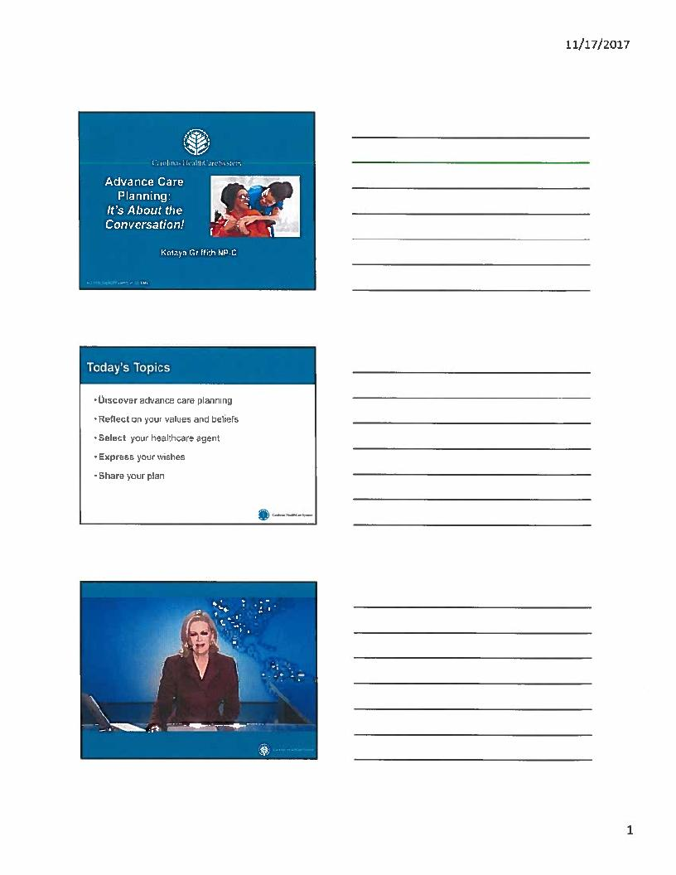
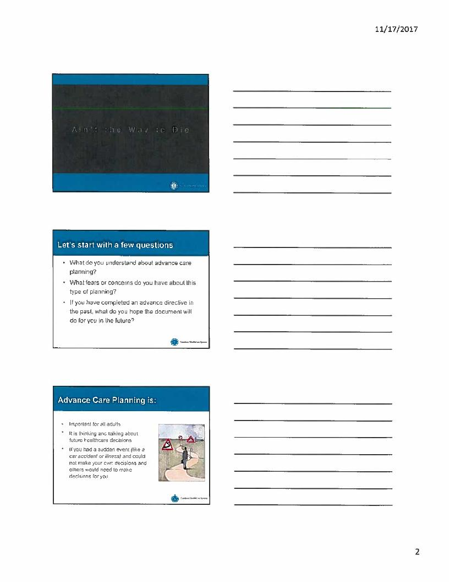
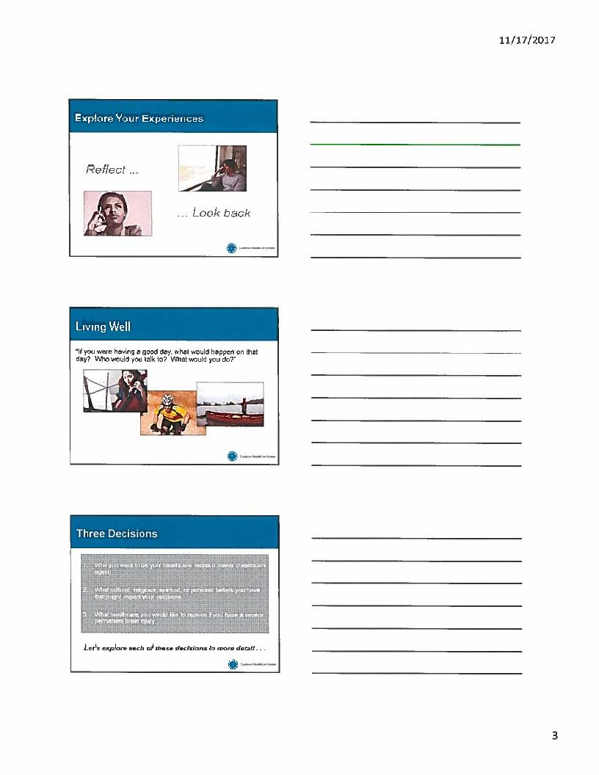

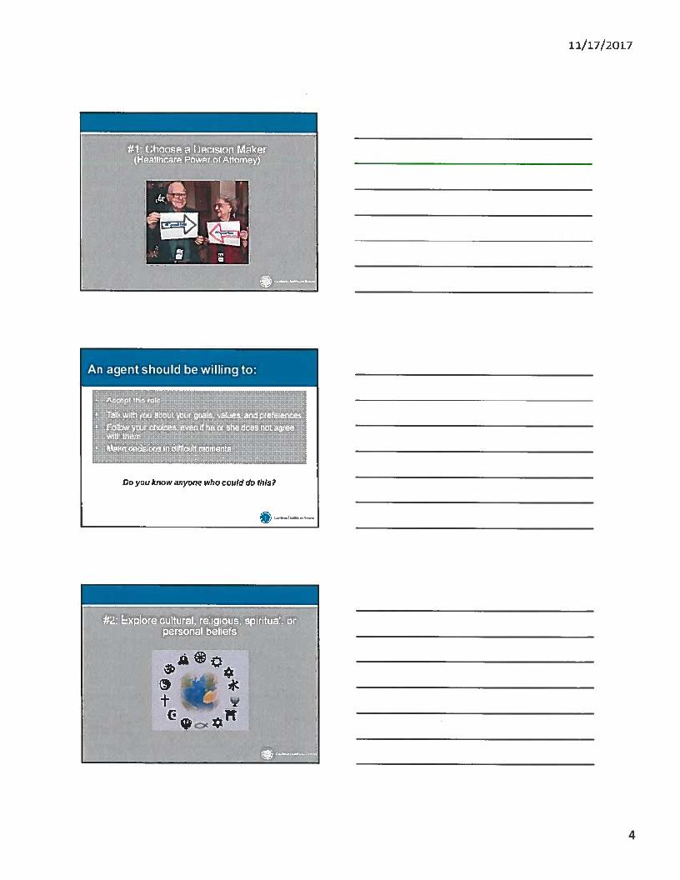
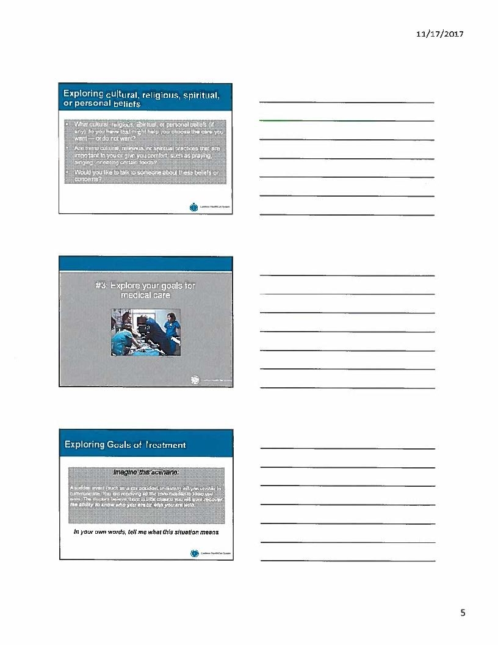

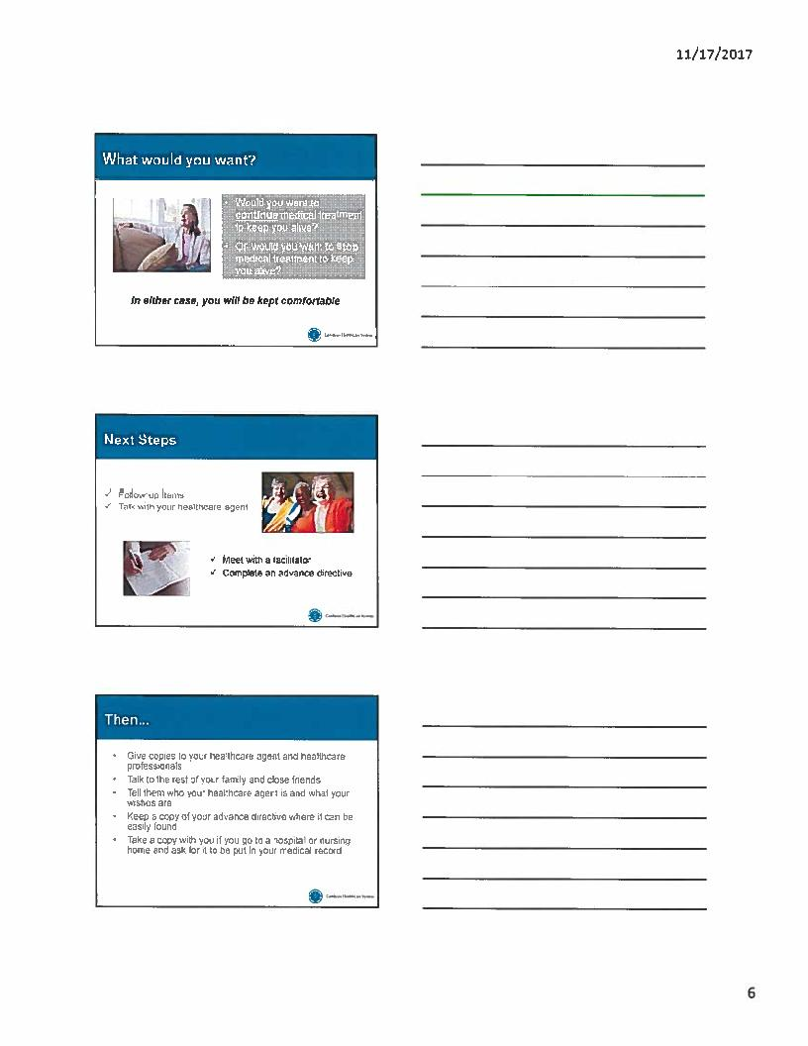

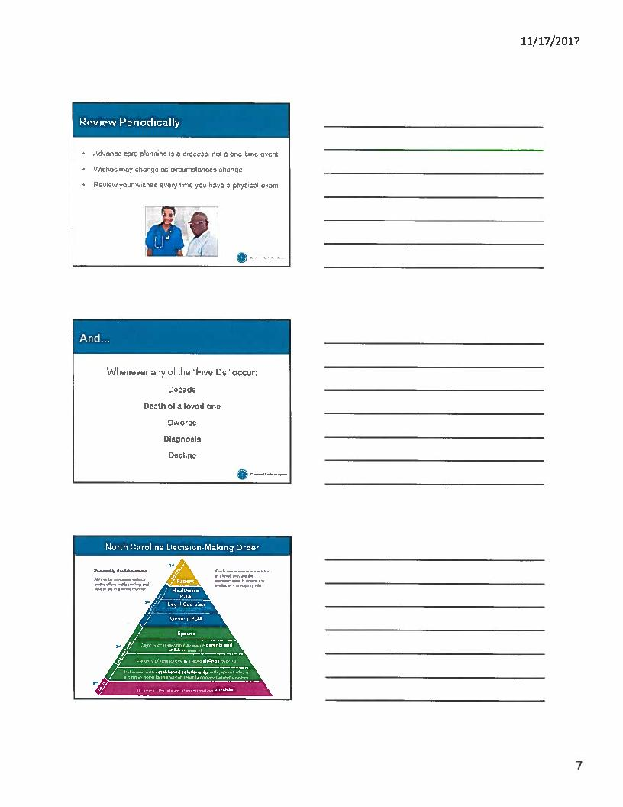

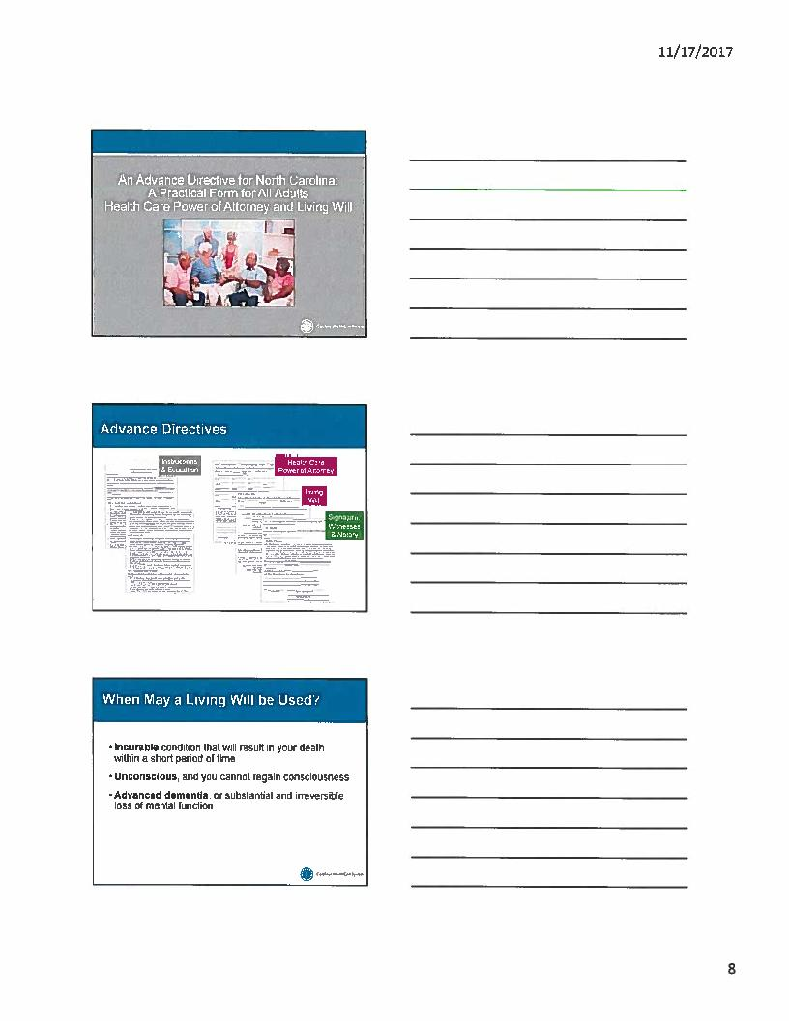
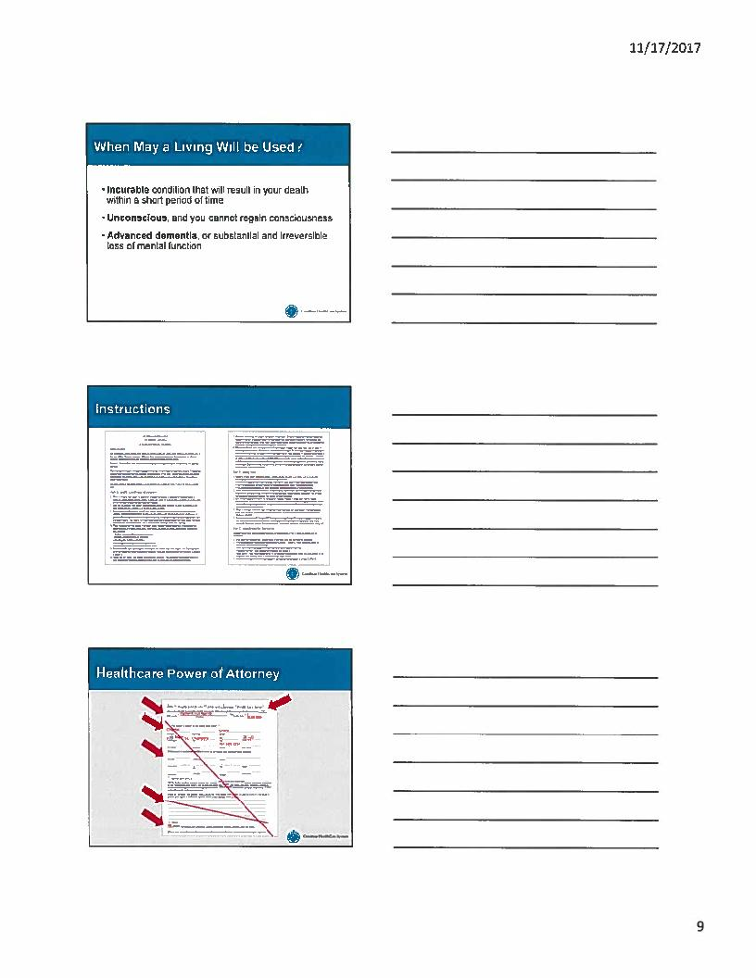

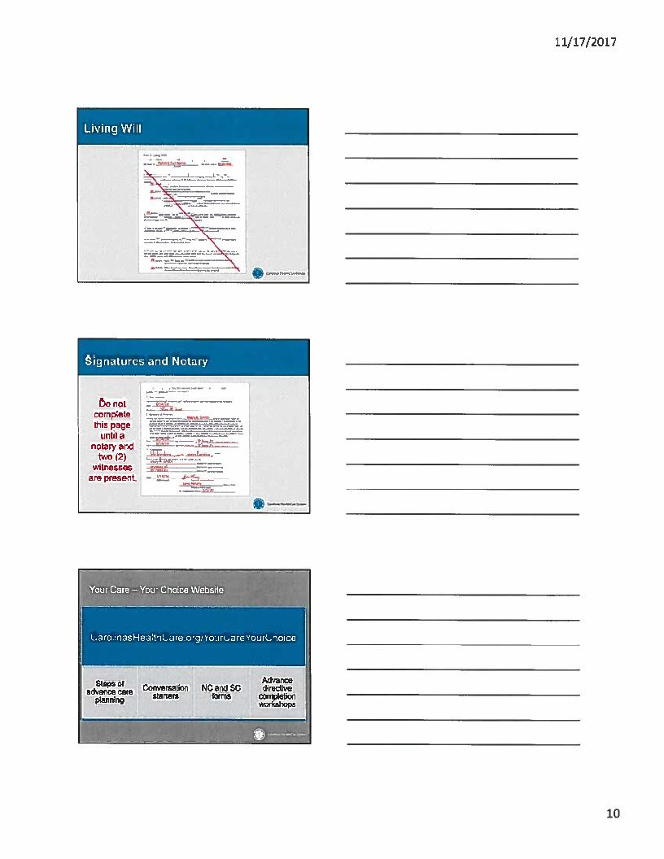

Appendix E

Post Education Survey

Advance Care Planning Community Education Session Survey
Thank you for participating in today’s conversation. We hope you will help us by completing this short survey.

- I believe today’s presentation was useful and will help me to plan for my future healthcare choices.

Strongly Agree Agree Neutral Disagree Strongly Disagree

- Do you have an advance directive already? Yes No

If yes, please answer the following questions:
  - Does your doctor have a copy of your advance directive? Yes No

  - Does your healthcare agent know what choices you have made? Yes No

If no, please answer the following question:
  - What are the reasons you have not completed an advance directive? (check all that apply)

It’s hard to talk about and I don’t know how to start the conversation.
I don’t want to upset my loved ones by talking about this.
I trust my loved ones to make choices for me.
I don’t know who to choose as my healthcare agent.
I just haven’t taken the time to do it.
Other: ____________________________________________

- Because of what you heard today, what are you most likely to do? (check all that apply)

I will think about this topic more.
I will talk about this topic with my doctor.
I will talk about this topic with my loved ones.
I will talk about this topic with my healthcare agent.
I will write down my medical choices using an advance directive.
I will review and/or update my advance directive.
I don’t plan to do anything.
Other: ____________________________________________

Please share the following information to help us customize our future presentations for different audiences.

Age: ____________________________________
Gender: _________________________________
Race/Ethnicity: ____________________________
Education Level ____________________________

Is there anything else you would like to share with us about today’s session?
________________________________________________________________________________________________________________________________________________________________________________________________________________________________________________________________________________________________________________________________________________________________________________________________________________________________________________________________________________________________________________________________________________________________________________________________________________________________________________________________________________________________

Appendix F
Advance Directive Handouts (AD information sheet)



AD Handouts (NC Advance directive)

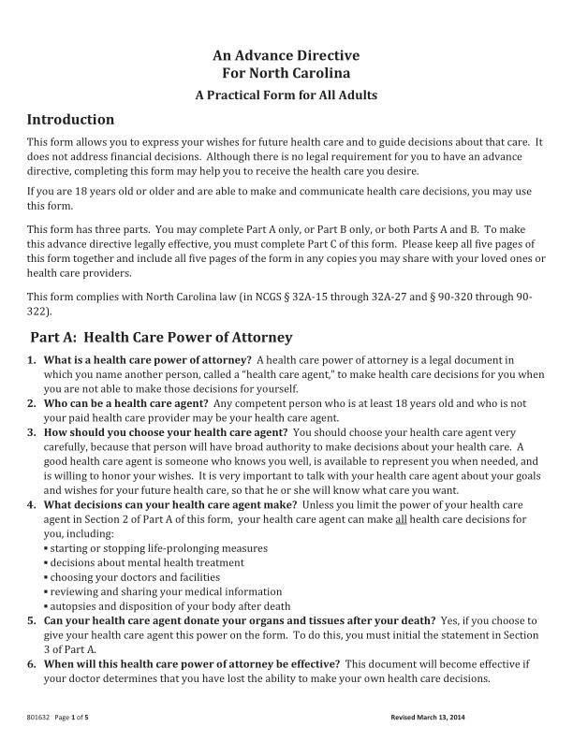

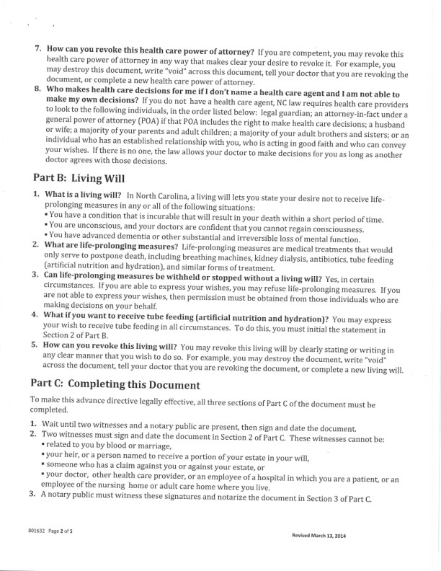

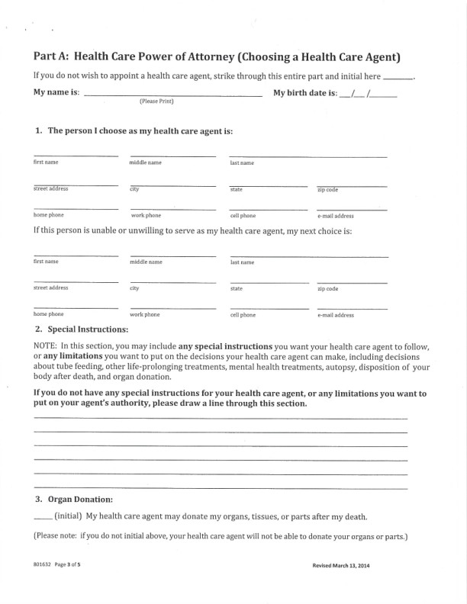

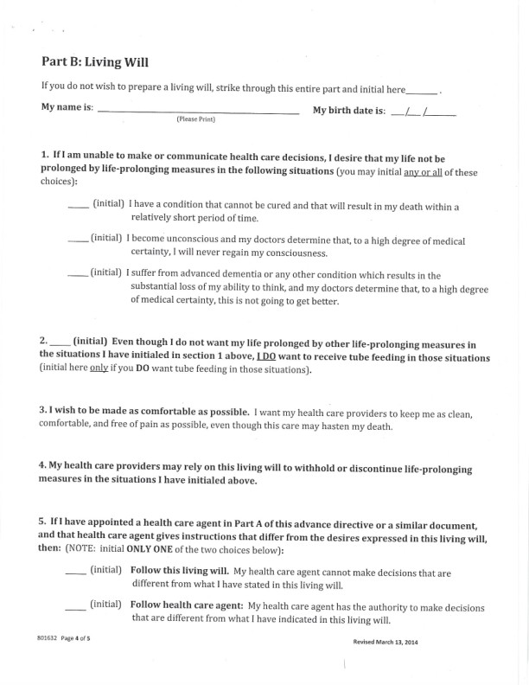

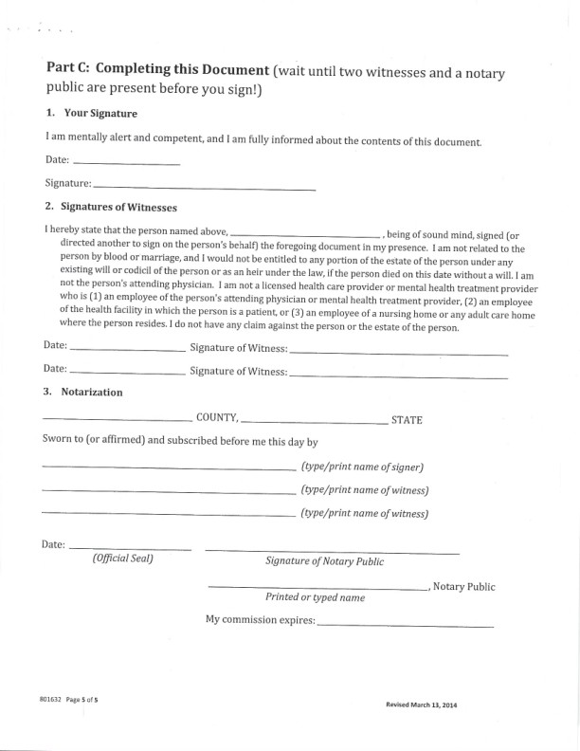

AD handouts (workshops location 2018)

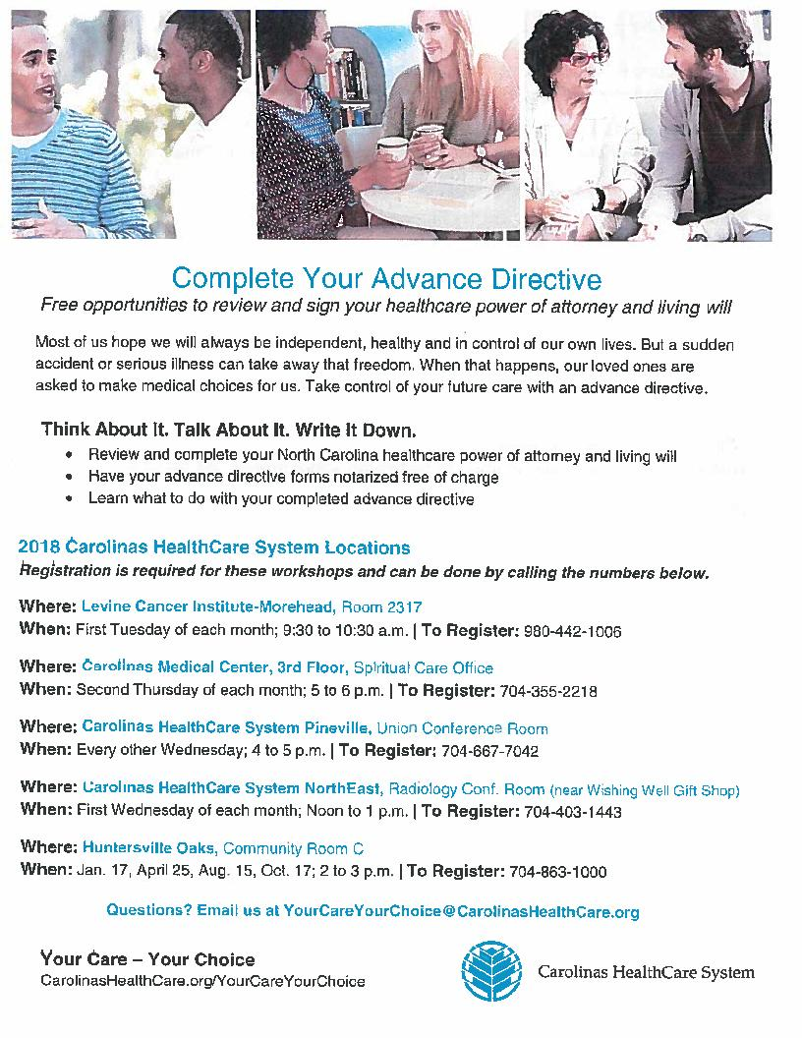

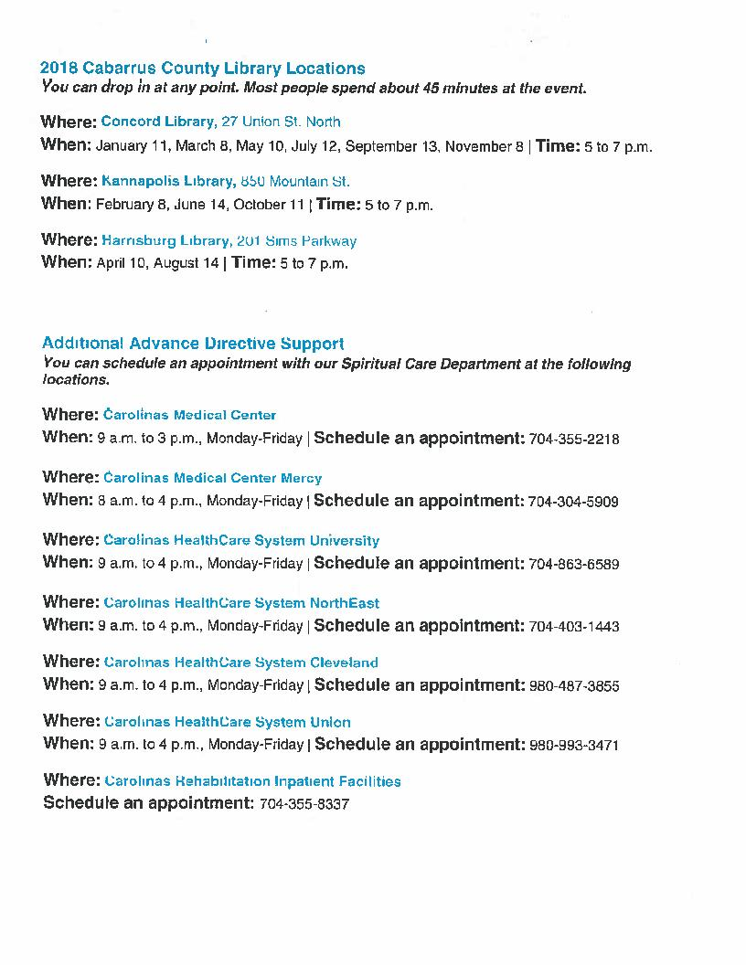

Appendix G

Event Flyer

Appendix H

Appendix I
Project Timeline

Timeline for Doctor of Nursing Practice Project
Date | Task | Complete/Incomplete
August 2016-May 2017 | Explore project topic | complete
August 2016-Present | Review the literature for topic of interest | ongoing
May 2017 | CITI Training | complete
May 2017 | Define project topic | complete
May 2017 | Theoretical framework selected | complete
June 2017 | Establish project committee | complete
June 2017 | Project Proposal form | ongoing
July 2017 | Final draft of Project Proposal | complete
July 2017 | Project team member approval form | complete
July 2017 | Project site approval letter | complete
August 2017 | Finalize project design | complete
August 2017 | Site authorization letters | complete
August 2017 | Create project budget | complete
August 2017 | Draft of first seminar paper Chp. 1, 2 &3 | complete
September 2017 | Submit project for CMC IRB | complete
October 2017 | Received CMC IRB approval | complete
October 2017 | Submit project for ECU IRB | complete
November 2017 | Received ECU IRB approval | complete
December 2017 | Confirm project sites | complete
December 2017 | Final first seminar paper Chp. 1, 2 &3 | complete
January-April 2018 | Project Implementation | complete
April 2018 | Final first seminar paper Chp. 4 | complete
May 2018 | Final data analysis/Discussion Chp.5 | complete
May 2018 | Final first seminar paper Chp. 1-5 | complete
May 2018 | Create Dissemination plan | complete
June 2018 | Create project poster | complete
June 2018 | Present project outcomes in the partnering agency | complete
July 2018 | Present project outcomes on ECU Campus | complete
July 2018 | Final paper into scholarship repository | complete
July 2018 | Close appropriate IRB approval | complete
July 2018 | Disseminate Project Information | ongoing

Appendix J
Data Collection Tool

Anonymous Site Participants  (Site labels A, B, C... AA etc...) | Q #1 | Q #2 | Q#2A | Q#2B | Q#2C | Q#3 | Pre-RR | Post-RR | Age | Gender | Race/Ethnicity | Education level

Appendix K
Doctor of Nursing Practice Essentials

Essential Number | Essential Title | Demonstration of Knowledge
I | Scientific Underpinnings for Practice | - Prochaska’s Transtheoretical Model (TTM) of behavior change was used as the theoretical framework to guide this quality improvement project.  - This project utilized a readiness ruler developed by Stephen Rollnick based upon the stages of changes to assess the participants’ self-perceived readiness to complete advance directive pre-and post-education.
II | Organizational and Systems Leadership for Quality Improvement and System Thinking | - The project leader conducted a quality improvement project in the faith-based community designed to increase advance directive knowledge among African Americans aimed to improved advance directive completion rates.  - Literature has shown that the benefit of an advance directive is decreased hospital costs, increased patient satisfaction concerning the quality of care and the ability to ensure that care is aligned with patient wishes due to improved communication among families and the healthcare team.
III | Clinical Scholarship and Analytical Methods for Evidence-Based Practice | - The project leader conducted a literature review and synthesis of evidence. This project used Respecting Choices, an advance care planning (ACP) evidence-based program that received national recognition for increasing awareness of advanced directives in the community.  - The project leader utilized faith-based organizations for ACP education sessions for project implementation. Literature suggests community settings such as churches or clinics are less threatening settings to discuss advance directives.  - The findings were disseminated at the project site, a nursing research symposium and at East Carolina University’s Poster Presentation Day.
IV | Information Systems/Technology and Patient Care Technology for the Improvement and Transformation of Health Care | - The DNP project was submitted to both Carolinas Healthcare System Institutional Review Board and the East Carolina University Medical Institutional Board. Both entities deemed the project as exempt. Additionally, the project was reviewed and approved by the Nursing Scientific Advisory Committee.  - SPSS version 25 software and Microsoft Excel© were used for data collection and analysis of this project.
V | Health Care Policy for Advocacy in Health Care | - Participants were provided education about advance directive and the Patient Self-Determination Act (PSDA) of 1990. The PSDA is a federal law that mandates that a patient is provided information about an advance directive at the time of admission.
VI | Interprofessional Collaboration for Improving Patient and Population Health Outcomes | - The project leader collaborated with a clinical social worker and an advance directive educator from the healthcare organization to obtain guidance regarding a project implementation plan targeting African Americans in the faith-based organizations.  - The project leader selected three faith-based organizations within the community to implement the project. The project leader communicated with the three pastors to discuss the project’s purpose and goals of targeting African Americans. The project consisted of 74 participants.
VII | Clinical Prevention and Population Health for Improving the Nation’s Health | - Increasing advance directive knowledge among African Americans, ultimately leads to increase advance directive completion rates which addresses the "Triple Aim" of the Institute for Healthcare Improvement by improving the patient care experience and health of a population while decreasing healthcare costs.  - The project aimed to decrease racial disparity among the African American population.
VIII | Advanced Nursing Practice | - The project leader an APRN and certified ACP facilitator designed, implemented, and evaluated advance directive education sessions which were aimed to increase advance directive knowledge and completion rates.  - The project focused on cultural sensitivity among African Americans due to the social, racial, and historical context in America. The project also provided education from the literature relaying that a level of distrust remains prevalent in the African American population concerning healthcare systems and healthcare providers. This information was used in the decision to select the faith-based organization as project site due to its non-threatening environment.

