The Impact of the Repeated Reading of Poetry on Struggling Second Grade Students’ Oral Reading Prosody and Reading Attitudes

LaQuitta Hinton
East Carolina University

Abstract
The purpose of this research paper is to share the results of action research that aimed to explore the impact of the repeated readings of poetry on struggling second grade students’ oral reading prosody and reading attitudes. The impact of the repeated readings of poetry on the reading attitudes of the participants was analyzed as well. The results of this study show that the participants showed improvement in reading fluency as well as improvement in reading attitudes.
Keywords: Repeated reading, poetry, oral reading fluency, reading prosody reading attitudes, elementary

The Impact of the Repeated Reading of Poetry on Struggling Second Grade Students’ Oral Reading Prosody and Reading Attitudes
Fluency, the ability to read a text quickly, accurately, and with proper expression, has previously been described as the most neglected reading skill (Allington, 1983); however, fluency has also been noted as one of the several critical factors necessary for reading comprehension (National Institute of Child Health and Human Development, 2000). It has been implied that if a student struggles to read with appropriate expression and also struggles with segmenting text into meaning chunks and phrases, a sufficient level of reading comprehension may be difficult to achieve (Arcand et al., 2014). These findings suggest that one must not encourage speed and accuracy of word recognition at the expense of reading prosody as prosodic reading is a crucial component of fluent reading. Fortunately, current literacy trends support the need for explicit reading fluency instruction and practice as being essential to developing more fluent and prosodic reading. The purpose of this research paper is to report the results of a research study that examined the impact of the repeated readings of poetry on struggling second grade students’ oral reading prosody while also considering the impact of the use and the recital of poetry on students’ reading attitudes. A literature review that supports theories about this topic follows.
Literature Review
This literature review reflects upon three specific reoccurring themes that were found within several scholarly resources that specifically addressed the topic selected for this research. The following themes will be addressed in the next section of this literature review: the important dimensions of oral reading fluency, previous studies involving reading fluency, and promoting positive reading attitudes.
The Important Dimensions of Oral Reading Fluency
According to Rasinski (2004), reading fluency has three important dimensions. The first of these dimensions is known as decoding. Decoding occurs when a student has the ability to utilize semantic, syntactic, or visual cues to make meaning from words and sentences. Decoding must become automatic, freeing the reader their cognitive resources to comprehend the text immediately upon reading it (Laberge & Samuels, 1974). Readers who are classified as being fluent are able to automatically decode text without giving much attention to decoding efforts. Students who lack sufficient decoding skills when reading also most likely lack appropriate levels of oral reading prosody. Those readers who are not as fluent in reading may also spend such a great amount of time on the decoding of a text that there is often a negative impact on their ability to make meaning of the text. This theory supports the belief that oral reading fluency has a direct relationship with a student’s comprehension level. This leads to the second element of fluency, automatic processing.
Automatic processing involves a reader’s ability to automatically process a text as they are using their cognitive resources for meaning making instead of putting too much emphasis on the decoding of words (LaBerge & Samuels, 1974). Based on these ideas of LaBerge and Samuels, some researchers have suggested that once these cognitive resources become available for use then the attention and focus that was once exhausted by basic word recognition can be used towards boosting the readers comprehension of the text (Hudson, Lane & Pullen, 2005; NICHD, 2000). Research has also suggested that it is important to note that reading fluency consists of more than just decoded text and the rate of speed in which text is read. In reality, the simple interpretation of fluency as speeded decoding does not offer a complete reflection of students’ comprehensive reading ability.
In a 2009 study conducted by Applegate, Molda & Applegate, 171 students who were identified as established and fluent readers were assessed to determine if there was a relationship between the participants’ level of reading fluency and level of reading comprehension. The foundation of this study was based on the theory that if a student is a fluent reader then the student must have a higher level of reading comprehension. The students were assessed using the Critical Reading Inventory-2 (CRI-2). The CRI-2 includes passages that range from the pre-primer reading level to a 12th grade reading level. The CRI-2 utilizes both narrative and informational texts to assess the reader’s oral reading rate, retelling ability, and the reader’s ability to correctly answer both explicit and implicit comprehension questions that are based on the passage that had been read. The results of the study indicated that thirty percent of strong fluent readers were noted as having a higher comprehension level when asked both appropriate grade level explicit and implicit comprehension questions. Thirty-six percent of the readers received a score that implies that they were found to be proficient in the area of oral reading fluency, but could have benefited from explicit instruction in the area of reading comprehension. The researchers reported that the most astonishing result of the study was that one third of the readers that had been identified as being a solid and fluent reader had problems when completing the reading comprehension portion of the assessment.
The final component of oral reading fluency is prosodic reading. Fluency involves using expressions, intonation, and appropriate phrasing (Guerin & Murphy, 2015). Prosodic readers are able to alter the pitch, rhythm, volume, and tone of the voice as they read a text. For example, these readers tend to fluently use a higher voice at the beginning of a sentence and they may use a lower voice towards the conclusion of a sentence, unless there is an exclamation point or a question mark. Changes in pitch may help students to feel their way through a text as they seek to determine where ideas start and conclude. Prosodic reading also involves segmenting texts into syntactically and semantically correct chunks. Expressive readers are able to appropriately use speed as they read, taking care to pause at commas and are able to portray feelings and emotions through a text as they read. If readers read quickly and accurately, but with none of the prosodic elements previously mentioned, then these readers are unlikely to fully comprehend any text that has been read (Schreiber, 1980, 1991; Schreiber & Read, 1980). When a student has demonstrated the need for explicit reading fluency instruction, there are many approaches and interventions have been used in the educational setting. The following section of this literature review will share the findings of existing studies and classroom practices on reading fluency interventions.
Previous Studies Involving Reading Fluency
Reading fluency has been noted as an essential component to the overall process of reading. Educators utilize many different programs and resources to provide meaningful reading instruction to students on a daily basis. All of these available programs and resources provide freedom for educators to decide what fluency intervention approach would best meet the educational demands of their students.
The fluency intervention of repeated readings is a well-known intervention that has been used for decades. The method of repeated readings involves rereading a short, meaningful passage several times until a satisfactory level of fluency is reached (Samuels, 1979). The rereading method emerged from the teaching implications of the theory of automatic information processing in reading (LaBerge & Samuels, 1974). Texts that are to be used for repeated readings are suggested to be no more than 50-200 words in length and can be read with or without audio support (Samuels, 1979).
Stanley (2004) states "reading and performing poetry provides numerous opportunities for children to practice with pleasure the essential skills of phonemic awareness, phonics, fluency, vocabulary and comprehension.” (Stanley, 2004, p. 56-57). In the past, there have been a small number of studies conducted in which the goal was to improve reading fluency or comprehension while implementing the repeated readings of poetry as the primary reading intervention strategy. Such studies as a study conducted by Wilfong in 2008 have sought to collect data about the effectiveness of the integration of a repeated reading intervention of poetry and a performance component that provides students with the opportunity to recite or to perform the poems that have been used for intervention in front of an audience.
In this particular study, Wilfong created the Poetry Academy, an intervention program in which struggling third grade students were able to participate in if they demonstrated a need for explicit fluency instruction. This results of this study found that the use of repeated readings will most likely help students to make gains in their reading fluency and comprehension and that integrating poetry into repeated readings is a fun and exciting way to get students to be excited about the repeated readings. Students who participated in this program and who received the intervention of the repeated readings of poetry showed improvement in the areas of fluency, word recognition, retell, and reading attitudes. The students’ reading attitudes and reading motivation levels were also reported to have showed positive growth or change as well.
Faver (2008) also supports the use of poetry during the repeated readings intervention. In a published practitioner-based article, Faver discusses the text choices for repeated readings and then shares how she supports the use of poetry for repeated readings in her own classroom. Faver’s basis for using the repeated readings of poetry comes from the belief that the use of poetry during repeated readings may prove to be more entertaining than the traditional narrative-based passages as poetry naturally encourages children to want to read and to have fun while reading. Faver (2008) suggests that her students have shown a boost in fluency and comprehension as the result of using poetry-based reading interventions.
It has been a concern to some educators that using the repeated readings intervention may cause the student to develop feelings of boredom or punishment (Wilfong, 2008). The fear is that students may begin to feel as though repeatedly reading the same text is a tedious, meaningless, and relentless activity. In an attempt to combat any feeling of student boredom or punishment, some researchers have explored the idea of using poetry for repeated readings compared to the standard narrative text selection that has been previously used. The basis for this idea is due to the fact that poetry tends to be shorter in context than narrative literary pieces, which may increase engagement and motivation levels for students. One may argue that if a student is completely engaged in learning and also has a genuine reason to be motivated to complete a reading assignment that has been given, then that student should also have a positive attitude towards reading. The final section of this literature review discusses reading attitudes and the key motivators that have been found to have a direct effect on reading motivation and engagement.
Promoting Positive Reading Attitudes
Naturally, students who struggle with prosodic reading can possibly develop a negative attitudes towards reading. Gambrell and Marrow (2011) define reading motivation as the values, beliefs, and behaviors surrounding reading. They identify three key motivators that have a direct relationship with an individual’s level of reading motivation and reading attitude. Those motivators consist of interest, confidence, and dedication. In short, it is implied that students must possess some innate interest in a text in order to want to truly engage themselves in the particular text. Students must also be provided with literary texts and scenarios that will help to boost their confidence levels. By theory, once students are truly confident in their ability to successfully read and comprehend a text that that are truly interested in they will dedicate themselves to that text.
Research has suggested that the implementation of the element of poetry recital and performance may boost students’ reading motivation, confidence, and attitude. The foundation for this suggestion is due to the belief that if students are aware that they will be held responsible for recitals and a live performance of the poetry that has been introduced to them, then they will have a purpose for reading the text. The development of this purpose then creates a genuine interest in the poems being used for recital. The inclusion of the repeated reading intervention gives students repetitive opportunities to build their level of comfortability with the text. As the student becomes more comfortable with the text and repeatedly experiences success with the text, the student’s level of confidence is lifted. Students may become dedicated to the idea of the continuous performance opportunities presented which then provides the student with a true reason to become dedicated to the texts that are being read.
In conclusion, the information presented in this literature review suggests that reading fluency is recognized as an important element in the process of reading. There are numerous educators who are aware of the importance of explicit fluency instruction in the classroom environment as research suggests that students who have to spend abundant amounts of energy on reading decoding often have little energy left over for comprehending what has been read. There are several approaches that one may use when incorporating fluency instruction into the educational setting. Repeated readings is one of these well-known reading fluency interventions that are used for boosting levels of reading fluency and prosody. However, there are precautions and flaws that may occur when using this method of intervention. Some researchers have stated that the repetitiveness of the readings may become tiring and boring for students. In an attempt to combat this issue, the use of poetry while using the repeated readings intervention has been recommended as a method increasing students’ attitudes towards reading.
The research shared throughout this literature review shows that the use of repeated readings have been effective in previous small studies in terms of improving elements of reading fluency such as oral reading rate and expression; however, there have been few studies conducted that have analyzed the link between the use and performance of poetry on the reading attitudes of students. The purpose of this paper is to present the findings of an action research study that investigates the question: What is the impact of the repeated reading of poetry on struggling second grade students’ oral reading prosody and reading attitudes? The methodological details of this proposed action research study follow.
Methodology
This action research study is a case study that utilized a single group pre-test/post-test design that was used to track data collected from the same group of participants over a specific time frame. The independent variable is the repeated reading fluency intervention. There are two dependent variables that were examined during this action research: oral reading prosody and attitudes towards reading. The first of these variables, oral reading prosody, is operationally defined as the score earned on a Multidimensional Fluency Rubric and reading attitude is operationally defined as the score earned on the Elementary Reading Attitude Survey (ERAS).
 | Independent Variable: Type of reading fluency intervention (repeated readings of poetry)
Intervention Students:
Repeated reading intervention
Dependent Variable:  Oral reading prosody | 1. Multidimensional Fluency Rubric (pretest/posttest)  2. Researcher Log Observations
Dependent Variable:  Student reading attitudes | 1. Elementary Reading Attitude Survey (pretest/posttest)  2. Researcher Log Observations
Figure 1. Research Variables. This figures states the variables within this action research.

Participants
The participants in this study consisted of six second grade students whose ages range from seven to eight years old and who are in the same self-contained classroom. Three students are African American and three students are Caucasian. There were two male participants and four female participants in the sample group. The participants in this study were selected based on mClass: Reading 3-D scores. The assessment tool, mClass: Reading 3-D, is used to assess students at the beginning (BOY), middle (MOY), and end (EOY) of the school year. During the BOY assessment, the students were assessed on their ability to decode nonsense words (NWF), their oral reading rate (DORF), their reading accuracy rate, and their reading retell ability. The participants for this study scored an oral reading rate of eleven words per minute to fifty-four words per minute and thus were selected for this study. Additionally, the range of scores for reading accuracy ranged from fifty-two to ninety-six percent correct. Parental consent was obtained from the parent or guardian of each participant in the sample group through the use of a parental consent form that was reviewed and approved by an Institutional Review Board (see Appendix E). Student assent was also obtained from each student prior to the start of this study through the use of a student assent form that was reviewed and approved by an Institutional Review Board. There was no comparison group used in this study.
LaQuitta Hinton was the teacher of record for the intervention group and was also the researcher conducting the action research study described in this action research paper. Ms. Hinton is a third year teacher in a rural county in northeastern North Carolina and is currently a self-contained, regular education second grade teacher. This current academic year is Ms. Hinton’s first year teaching second grade curriculum as she taught third grade curriculum for the two previous years of her career. Ms. Hinton currently holds a Bachelor of Science degree in Elementary Education with a concentration in Mathematics and is actively pursuing a Master of Arts in Reading Education. In preparation to conduct this action research study, Ms. Hinton was required to draft a research proposal that was reviewed and approved by an Institutional Review Board (see Appendix D).
Setting
The setting of this study was in a grades PreK-5 elementary school in a rural county in northeastern North Carolina that serves just over 500 students daily. The population in which the school predominantly serves is considered as being high poverty. The school is classified as a NC A+ Creative Arts school and is also a Title I school in which seventy-nine percent of all students receive free or reduced lunch. The school is split into two main sections with construction being completed on the older section in the 1940s. The newer section’s construction was completed in the late 1980s, after a fire destroyed the previous building in 1986. The school was not originally built as an elementary school as one section of the school has three levels. The school also proves to be unique as the school houses the districts only full-sized auditorium with a full-sized stage for performances. Students who attend this school mostly live within the appropriate zoning area for attendance; however, some students who attend the school live within a different zoning area as the parents of students throughout the district have the opportunity to apply for their child’s admittance to this NC A+ arts school.
The school has a variety of support staff available such as one administrator, one school counselor, one school nurse, one instructional coach, one speech therapist, and special education staff. Even with these supports being available, the school does experience a shortage of technological and educational resources at times. The intervention classroom is located on the second floor of the school. There are a total of nineteen students in the classroom and one teacher as there are no instructional aides available during the day to provide assistance in the classroom. The students sit in table groups that range from three to six students. There are two students in the classroom who sit in individual desks. There are three computers available for student use, a SMARTBoard, and a document camera located in the classroom. The classroom also includes a kidney shaped table that is primarily used for small group instruction.
Intervention and Research Procedures
The intervention used during this study was the repeated reading of poetry. This intervention was used to help students to develop appropriate phrasing and expression while developing reading fluency. The intervention treatment used was based on previous interventions conducted by (Kuhn, 2004) and (Guerin & Murphy, 2015). The design of each session incorporated a modified version of the fluency-oriented oral reading strategy while providing students with the intervention of the repeated reading of poetry. The data collection process prior to the intervention treatment started on January 26, 2016. The intervention began on January 27, 2016 and lasted until March 4, 2016, a duration of five weeks. Intervention sessions were randomly held three times per week for twenty minutes per session. The following figure displays the weekly events that occurred during this action research:

Date: | Event Occurring:
January 25-January 29 | Pretest Data Collection-Multidimensional Fluency Rubric and Elementary Reading Attitude Survey
February 1-February 5 | Week One: Explicit Fluency Instruction-Expression
February 8-February 12 | Week Two: Explicit Fluency Instruction-Expression
February 15-February 19 | Week Three: Explicit Fluency Instruction: Phrasing
February 22-February 26 | Week Four: Explicit Fluency Instruction: Phrasing
February 29-March 4 | Week Five: Explicit Fluency Instruction: Intonation and Smoothness
March 7-March 11 | Posttest Data Collection-Multidimensional Fluency Rubric and Elementary Reading Attitude Survey
Figure 2. Action Research Timeframe. This figure shows the weekly events that occurred during this action research study.

As previously noted, there were a total of three weekly sessions in which the modified use of the Fluency Oriented Reading Instruction (FORI) framework was utilized as the repeated readings fluency intervention was provided to the participants in the intervention group. FORI was used as a supplemental guide to organize the activities that occurred during each of the three daily sessions per week during this research study (see Appendix A). The following figure shares the format of each daily session during a week’s intervention.
Weekly Session 1 | - Teacher introduces the poem (activates prior knowledge, vocabulary, etc.)  - Teacher reads selection aloud while explicitly modeling fluency expectations (students follow with their own copy of the poem)  - Students echo-read the same selection (teacher reads and students repeat)
Weekly Session 2 | - Teacher reads selection aloud while explicitly modeling fluency expectations (students follow with their own copy)  - Teacher and students choral read the poem  - Students begin to partner read the poem
Weekly Session 3 | - Students partner read the poem  - Students recite/perform the poem for audience  - Students complete one extension activity is time permits
Figure 3. Weekly Session Format. This figure shows the format that was utilized during weekly sessions during this action research study.

During the first session of the week, the teacher engaged students in an activity that would activate the prior knowledge of the students. The activity changed based on the theme of the poem that was being used for the week. The teacher also used this first session of the week to introduce the students to any new vocabulary terms prior to reading the poem. After these activities were completed, the teacher would provide a copy of the weekly poem to the students. The teacher read the poem aloud while being careful to explicitly model what fluency skill the intervention group was focusing on during the week. During this time, the students were to follow along on their own copies as they tracked the teacher’s reading. The last activity of the session, echo reading, occurred when the teacher would reread the poem with the students repeating what was read afterwards.
During the second session of the week, the teacher began by reading the text aloud while continuing to explicitly model the fluency skill being taught for the week. During this time, the student participants were expected to follow along on their own copies of the poem. The next activity, choral reading, is an activity in which the teacher and students were to read the text together while focusing on the target skill of the week. The final activity of the session consisted of the students engaging in partner reading. During this time the participants engaged in the repeated reading of the poem with a partner as they practiced incorporating the target skill of the week in their reading. The researcher used this vital time to work with individual students and partner groups who were in need of skill reinforcement.
The last session of the week was primarily dedicated to the performance component of the intervention. The students began by partner reading with their group partner. The teacher of record used this time to provide skill reinforcement to students. During the second half of the session, the students performed their poem for the audience. The audience usually consisted of classroom peers.
The intervention required the use of one poem per week. Copies of the poem had to be made in order to ensure that all students received a personal copy of the poem to use during echo reading, choral reading, partner reading, and performances. There were no costs associated with the preparation of the poems. The teacher of record downloaded the poems from an online educator subscription that had been purchased prior to the beginning of this research study. There was no special training required for the intervention.
Data Sources and Data Collection Procedures
Three data sources were collected: a Multidimensional Fluency Rubric, an Elementary Reading Attitudes Survey, and anecdotal notes were collected from a researcher’s log. Triangulation was utilized as a means to establish validity of the results of this study as data sources were collected and analyzed. These sources are described in the paragraphs below.
The first of the three data sources was a Multidimensional Fluency Rubric based on the ideology of Tim Rasinski (see Appendix B). The multidimensional fluency rubric measured participants reading expression, phrasing, smoothness and pace. The participants could earn a score of 1-4 in each of these areas, with a score of 1 being the lowest and a 4 being the highest. The score from each of the areas is then added together to determine a final total score. A score of 10 or more indicates that the student is making good progress in fluency; however, a score below 10 indicates that the student needs additional fluency instruction. Data was collected from this source during week one and week five of this study and served as pre-test and post-test data. During the collection of this data, the participants were given a short poem in which they were instructed to read. The text that was provided to the students was new and unfamiliar in context. As the participants completed the initial reading of the text in a one-on-one setting, the researcher completed the Multidimensional Fluency Rubric and provided a score based on the pre-determined criteria set on the rubric.
The second data source that was used during this study was an Elementary Reading Attitude Survey created by McKenna and Kear in 1990 (see Appendix C). The Elementary Reading Attitude Survey consists of twenty items in which each item presents a brief, simply worded statement about reading, followed by four pictures of Garfield. Each picture of Garfield is designed to display a different emotional state ranging from positive to very negative (McKenna & Kear, 1990). Specifically, the attitudes presented by the pictures of Garfield are noted as very happy, a little happy, a little upset, and very upset. This reading attitude survey measured participants attitudes toward reading during week one and week five of the study and served as pre-test and post-test data. The directions of the survey were read aloud to participants followed by the administration of the survey in a small group setting of no more than four individuals. The researcher collected student data and analyzed the data to determine if there was a positive relationship between the repeated readings of poetry and the participants’ attitudes towards reading once pre-test and post-test data was analyzed.
The final data source was a researcher’s log. This data source was completed on a daily basis and kept record of daily observations noted as sessions were held with participants. The qualitative data collected from the researcher’s log was analyzed to note successes and challenges that occurred during this action research study. The thoughts, ideas, and actions of the researcher and participants were also recorded and analyzed so that the overall progress of the study was continuously reflected upon throughout the duration of this research study.
Data Analysis
Due to the small number of participants who were involved in this study, no statistical tests were used to analyze data. Instead, a one group pre-test/post-test design was used and the average scores of the pre-test and post-test were analyzed. In this study, pre-test and post-test data collected for data analysis consists of oral reading prosody data based on the Multidimensional Fluency Rubric by Tim Rasinski (see Appendix B) and the Elementary Reading Attitude Survey by McKenna and Kear (see Appendix C).
The Multidimensional Fluency Rubric was designed to measure participants reading expression, phrasing, smoothness and pace as participants complete the initial reading of a text in a one-on-one setting. The researcher completed the Multidimensional Fluency Rubric and provided a score based on the pre-determined criteria set on the rubric. The ERAS measured each participant’s attitude towards reading before and after the intervention of repeated readings and the performance of poetry was used. All pre-test data was collected during week one of the study, while all post-test data was collected during week five of the study. The researcher collected student data and analyzed the data to determine if there was a positive relationship between the repeated readings of poetry and the participants’ attitudes towards reading.
Qualitative data was also analyzed from the researcher’s log associated with this study. During the entire duration of this action research study, anecdotal notes and the researcher’s thoughts were recorded. The researcher’s daily observations were recorded as well. The initial researcher’s log was formatted in a spiral notebook. This notebook was locked into a file cabinet at the end of each session and was destroyed after the final version of the researcher’s log was completed. The final version of the researcher’s log was formatted electronically using Microsoft Word on a personal, password protected computer. There were no names or aliases used in either researcher’s log. Instead, the participants were assigned random numbers that were only known by the researcher to protect their identities. The final researcher’s log was analyzed to determine if any reoccurring themes, ideas, and issues were noted during the duration of the research. There were a total of three reoccurring themes noted as a result of analyzing the researcher’s log.
Validity and Reliability or Trustworthiness
Despite all measures taken, there were threats to the validity of this study or trustworthiness issues that occurred during this study. It is important to note that these occurrences could have impacted the results of this study. First, the geographic location of our school and workload of the data collector proved to cause an issue that could have jeopardized the validity and reliability of this study due to inclement weather and a delayed start of the intervention. There were winter weather patterns in the northeastern region of North Carolina that caused school delays and early releases which caused a delay in the completion of this action research. During the beginning of the intervention, there were also times in which the teacher of record and data collector had state and local assessment deadlines to meet which prevented the sessions from occurring. While all efforts were made to have each of the three weekly sessions on three consecutive days of the week, there were weeks in which this was not possible. Due to this, there were occasions in which the time in between sessions were not consistent and students may have struggled to retain information from the previous session. To address this issue, the researcher was sure to incorporate a quick review of the prior session into the beginning of each of weekly session.
Secondly, there could have also been a potential issue that impacts validity and reliability or trustworthiness due to the dual role of the teacher of record being both the regular education teacher of all participants involved and the data collector of the research study. While the use of the Multidimensional Fluency Rubric to assess students’ prosodic reading ability may have greatly minimize these concerns due to the incorporation of a built in rubric, the Elementary Reading Survey did not have such a level of built-in protection. Students may have felt the need to indicate all positive responses on this survey to avoid altercation with the teacher of record and data collector. In an attempt to diminish this concern, the teacher of record and data collector repeatedly reminded students that they were to answer all questions truthfully and also repeatedly ensured students that there was no right or wrong answer as the participants completed the survey.
Similarly, researcher bias could have potentially altered the results gathered while using the Multidimensional Fluency Rubric. Subjective thoughts and opinions of the participants reading ability could have unintentionally caused the researcher to utilize personal or independent feelings that are not a part of the evaluation protocol presented on the rubric when evaluating students’ oral reading prosody. In order to minimize this validity issue, the teacher of record and data collector closely followed the pre-determined rubric closely and utilized objective findings to complete the rubric for each student participant.
As previously mentioned, due to the small sample size of the intervention group, no statistical tests were used to analyze data. Although triangulation was used, the results of this study may only provide little insight to the area of fluency instruction and should not be used as a universal data source.
Findings and Results
Mutidimensional Fluency Rubric
The Multidimensional Fluency Rubric was designed to measure participants reading expression, phrasing, smoothness and pace before and after receiving the intervention of repeated readings along with explicit fluency instruction. On average, the individual growth in pre-test vs. post-test scores using the multidimentsional fluency rubric was found to be positive 2.0 points. All participants were noted as showing growth in the area of reading prosody. The change between the pre-test and post-test scores of each participant using the multidimensional fluency rubric was calculated and recorded in the table below. A corresponding graph that displays the same data in a different format can be found following this table.

Participant | Pre-test score | Post-test score | Growth (-/+) Points
Lucy | 9 | 11 | 2
Adam | 6 | 7 | 1
Caroline | 8 | 11 | 3
Sandra | 10 | 12 | 2
Ava | 8 | 10 | 2
Connor | 6 | 8 | 2
Figure 4. Change in Pre-test vs Post-test scores. Table that shows the change between pre-test and post-test scores of each participant.

Figure 5. Change in Pre-test vs. Post-test scores. Graph that shows the change between pre-test and post-test scores of each participant.

Upon further analysis of the pre-test and post-test data gathered from the multidimensional fluency rubric, the greatest gain was found in the area of expression. All six participants showed growth on this area of the fluency rubric. Smaller gains were also noted in the other areas tested assessed using the Multidimensional Fluency Rubric. Additionally, Lucy, Caroline, Sandra, and Ava proved to be making good process with their fluency and reading prosody based on their post-test scores. Adam and Connor did make gains in their scores; however, the scores received by these students indicates that they are in need of additional fluency instruction.
Elementary Reading Attitudes Survey
The Elementary Reading Attitudes Survey (ERAS) measured each participant’s attitude towards reading before and after the intervention of repeated readings and the performance of poetry was used. Data collected from the pre-test and post-test surveys was categorized by participant and then by the total number of responses given for the happy attitude vs. upset attitude on the pre-test and post-test. There were four attitudes that the participants could select from during this study: very happy, a little happy, a little upset, and very upset. The recorded number of responses for happy attitudes vs. upset attitudes for each participant using the ERAS survey was calculated and recorded in the table below.
Participant | Number of Very Happy Responses (Pre/Post) | Number of A Little Happy Responses (Pre/Post) | Number of A Little Upset Responses (Pre/Post) | Number of Very Upset Responses (Pre/Post)
Lucy | (6/8) | (8/10) | (5/1) | (1/1)
Adam | (4/4) | (6/9) | (7/5) | (3/2)
Caroline | (6/9) | (9/9) | (4/1) | (1/1)
Sandra | (5/9) | (7/8) | (5/3) | (3/0)
Ava | (7/6) | (4/7) | (4/4) | (5/3)
Connor | (6/6) | (5/9) | (5/2) | (4/3)
Figure 6. ERAS Data Table. This table shows the change between the number of recorded responses per attitude for each participant during pre-test and post-test data collection.

Figure 7. ERAS Data Graph. This graph shows the number of recorded happy attitude responses for each participant during pre-test and post-test data collection.

The data recorded in the table above indicates that there was an overall improvement in the reading attitudes of the participants. Each participant was noted as showing an overall increase in the number of happy attitude responses that were recorded on the post-test as compared the number of positive responses recorded on the pre-test. There were some instances in which the number of upset responses did not improve on the post-test when compared to the pre-test, but these occurrences did not affect the overall trend of the positive improvement of reading attitudes that the participants’ responses indicated. A graph that displays the difference in the number of happy attitude responses recorded pre-test and the number of happy attitude responses recorded post-test per participant can be found below.

Researcher’s Log
During the duration of the research study, the researcher maintained a researcher’s log that documented the successes and challenges that occurred as the intervention was being implemented. The thoughts, ideas, and actions of the researcher and participants were also recorded and analyzed so that the overall progress of the study was continuously reflected upon throughout the duration of this research study. These successes, challenges, and other observations noted in the researcher’s log can be categorized into three main themes: the importance of explicit modeling, using repetition to promote an increase in confidence, and the significance of peer support for struggling readers.
The first reoccurring theme that was noted after analyzing the final researcher’s log was the teacher’s realization about the importance of and frequency of explicit modeling. Explicit modeling was repeatedly used during each session of the intervention. During the initial sessions, explicit modeling was used to correctly model the expectations for each of the components of fluency that were addressed during this study. As time progressed, the researcher began to notice that the participants were either struggling with retaining information that had been taught during the previous session or having a hard time processing and understanding newly presented information. After reflecting, the researcher decided to incorporate additional opportunities for explicit modeling into the intervention sessions. In addition to providing additional explicit modeling exposures to the participants, the researcher also incorporated examples that were relatable for the students into the sessions. Before incorporating the additional explicit modeling opportunities into the sessions, one student was overheard stating that she “doesn’t read with expression the right way”. After the additional modeling and examples were provided, this same student was overheard stating that “she was ready to read with expression now”. A combination of these elements began to boost the students’ understanding of the material and information being presented in the intervention sessions.
The next reoccurring theme that was documented during this session was using repetition to promote an increase in confidence. The use of repetition was present during the majority of the intervention sessions through the incorporation of echo reading, repeated opportunities for partner reading activities, and the recital and performance of poetry each week. As the sessions progressed, students were observed making comments such as “reading with expression is getting easy”. One female student was also observed stating that she “is doing good at reading with expression”. In general, it was evident that the student’s level of confidence continued to improve as the number of exposures to the content within the intervention increased.
The last theme that was noted was the significance of peer support for struggling readers. This theme continuously resurfaced throughout the notes and observations of the daily researcher’s log. The significance of peer support was initially noted during week one of the intervention. There was an observation noted by the researcher in which one student was helping a partner to sound out the words in a poem. One other prominent occurrence that supports this theme occurred during a poetry recital piece in which three students were observed smiling as their peer filled audience applauded after their performances of poetry. The participants never declined to read for their peers. In fact, during the last performance a student was observed commenting that she “wanted to do her best reading since this was the last time she had to read”.

Discussion and Conclusions
The purpose of this study was to determine if the use of the repeated reading of poetry would have an impact on struggling second grade students’ oral reading prosody and reading attitudes. After conducting a literature review on the topic of interest, the researcher expected to see gains in the areas of reading fluency and reading attitudes after concluding the intervention. The participants in this study received explicit modeling instruction in the area of reading prosody three times per week for five consecutive weeks. During this five week span, the students received explicit instruction in the areas of expression, phrasing, intonation, and smoothness while engaging in the repeated reading of poetry. Elements of pace were also integrated within the intervention sessions at multiple points.
The integration of the repeated readings intervention into this action research study was influenced by the ideology of Samuels. The method of repeated readings involves rereading a short, meaningful passage several times until a satisfactory level of fluency is reached (Samuels, 1979). The intervention of repeated readings is a well-known intervention that has been used for decades. During this study, poetry was chosen as the text type that was to be used during each intervention session.
The integration of poetry into this intervention was influenced by previous studies in which the performance of poetry was reported to improve the reading performance and attitudes of student participants. Stanley (2004) states "reading and performing poetry provides numerous opportunities for children to practice with pleasure the essential skills of phonemic awareness, phonics, fluency, vocabulary and comprehension.” (Stanley, 2004, p. 56-57). Researchers such as Wilfong have also experimented with the incorporation of poetry into reading interventions and have reported improvements in the overall reading attitude of student participants as well.
The overall results of the quantitative data collected during this study supports the research reviewed as the data showed that the participants did make gains in the areas of reading prosody and reading attitude. All participants showed growth on the Multidimensional Fluency Rubric when comparing the pre-test data collected to the post-test data collected. The average growth in points was determine to be +2.0 points. The reading attitude survey results for each participant were analyzed and categorized into the number of happy attitude responses vs. the number of upset attitude responses. The data collected showed that the number of happy attitude responses improved for all participants on the ERAS post-test as compared to the ERAS pre-test. Qualitative data collected during this study provides notes and observations that support the idea that the students attitudes towards reading began to improve as the studied continued. During some of the earlier intervention sessions, students were observed making comments such as “I don’t read with expression the correct way”; however, as the sessions continued those comments shifted into comments such as “it (reading with expression and phrasing) was hard, but I will try to get better”.
Due to these gains, it could be implied that the gains in reading prosody and reading attitude were due to using the intervention of repeated readings in conjunction with the performance of poetry.
Limitations
There were limitations of this study that prevents the final results and findings from being applicable to the general population. During this study, the results imply that the intervention that was used was successful for this group of participants. Yet, it is important to consider the fact that the sample size of this study was limited to six participants. A larger sample size would be needed in order to conclude that the findings of this study could be generalized for a universal population.
Another limitation of this study that prevents the results from being generalized for a large population is that the intervention sessions that were held lacked consistency at times. Initially, there was a delay with the start of the intervention due to the researcher’s dual role as teacher and researcher. The intervention was scheduled to start during the timeframe that district and local student assessments were to take place which sometimes meant that assessments had to be completed in place of the intervention times. While all efforts were made to schedule intervention on consecutive days of the week, this sometimes was not an obtainable goal. There were also instances in which delays and early releases of school due to weather prevented the sessions from being held consistently as well. Using consistent scheduling while implementing the intervention sessions may have altered the final results of this study.
The third limitation of this study involves the text type that was selected for use during the repeated reading intervention. During one session, the participants expressed their boredom with using poetry during every session. No other text type was used during the intervention sessions. This peaks the curiosity of whether similar growth in reading prosody and reading attitude would have been obtained if the repeated readings had been used during this intervention, but with other text types besides poetry.
Implications of Research for Educators
This action research study aimed to explore the impact of the repeated readings of poetry on struggling second grade students’ oral reading prosody and reading attitudes. This study provides classroom teachers or other educators with important implications about the effectiveness of using poetry during the use of the repeated reading intervention and measured the development of more prosodic reading of struggling second grade readers. This study also sought to provide implications of the impact of the repeated reading of poetry on the reading attitudes of struggling second grade readers as well.
All student participants were found to have positive gains in reading prosody as well as an overall improvement in reading attitude. The results of this study imply that repeated readings and the recital of poetry are indeed an effective means to boost fluency rates and to promote more prosodic reading and positive reading attitudes in struggling readers; however, due to limitations noted during this study, caution should be exercised before attempting to apply the results of this study to a larger student population.
Future Directions for Research
While this study did produce positive growth in struggling readers’ reading prosody and reading attitudes, additional research is recommended before the results are universalized. A study which consists of a larger sample size would be needed in order to generalize the findings of this study. Also, a study in which a more consistent and lengthy intervention schedule was used would help to reduce the limitations of the results of this study. Additionally, the researcher who conducted this study was responsible for the dual role of the teacher of the student participants and conductor of the research in this study. While precautions were taken to prevent any validity issues that could occur due to the assignment of the dual role, it would be suggested to assign a researcher who has no prior relationship to the student participants.
Reflection
As I reflect upon the conceptualization, planning, implementation, and outcomes of this research project, I realized that I have learned how to persevere, even when it may not have been easy to do so. Completing this research project has pushed me to reach new limits that I had not known I could reach. I have permanently been changed as a student, teacher, and researcher as the result of completing this action research and corresponding action research paper.
During the conceptualization of this project, I was introduced to the action research process. As I progressed through the steps of this process, I often felt feelings of frustration and defeat. Despite these feelings, I continued to push myself to embrace the positive aspects of this project. I often reminded myself that I would be completing this project to improve my practices as an educator. This in turn would create a more positive learning environment for my students, which in turn would promote a positive difference in my school.
When deciding to choose to focus on the area of reading fluency and prosody, I knew that it would be important to research an intervention that would be useful when applied in the current classroom learning environment. Throughout all of my years of teaching, I have continuously encountered students who struggle with reading fluency. Before beginning this project, I had only viewed fluency as the rate of reading per minute; however, this project has allowed me to comprehend what fluent reading truly encompasses. Fluent readers are able to read with appropriate speed, volume, accuracy, and expression. In all honesty, at times I have been unsure as to how I should provide assistance to my students who were in need of explicit fluency instruction. Completing this assignment has provided me with the knowledge needed to provide proper assistance to my students in the future.
The role of a teacher researcher is one of significant importance. The usage of the repeated readings intervention provided me an opportunity to incorporate a research-based intervention into my reading instruction in hope that I could make a positive difference for my students. The incorporation of the performance of poetry was an added bonus because I would also be able to determine if there were ways in which I could confidently influence the reading attitudes of my students. My school wholeheartedly believes in using data to drive all small group instruction, and this project was able to help me to do just that.
As a final point, I would like to emphasize the fact that undergoing the action research process has proved to be valuable in many ways. Prior to completing this research, I had not had extensive knowledge of the process of action research other than completing one course that addressed research during a previous semester. As previously mentioned, I have certainly grown as researcher. I now have a better understanding of the importance of incorporating research-based practices into my classroom instruction. I find myself wondering “what the research says” when I am contemplating introducing a new learning strategy or intervention to my students. I have also learned of the significance of documenting the events that occur during student learning. I believe that this insight came from having to complete the researcher’s log during this research study. After analyzing the researcher’s log, I was able to determine patterns that were occurring during the instruction. These patterns helped me to further internalize what the research that I had conducted truly meant for my students’ learning and what I could improve upon to make learning meaningful to them.
As a current elementary teacher and a prospective reading specialist, the content knowledge that I have gained from the completion of this action research has been invaluable. Before beginning this project, I had hoped to learn more about the process of developing reading fluency as I had noticed that many students that I have encountered at my school struggle in this area. I sought to find a method of instruction to use in my classroom that would promote a positive change for my current students and I was able to successfully do just that. As mentioned, I have learned additional information about strategies, techniques, and resources such rubrics and surveys that I can utilize in the future to provide instructional assistance to my students. I plan to continue to utilize information learned from this action research study during my forthcoming years as an educator.

References
Allington, R. L. (1983). Fluency: The neglected reading goal in reading instruction. The
Reading Teacher, 36, 556-561.
Arcand, M.-S., Dion, E., Lemire-Théberge, L., Guay, M.-H., Barrette, A., Gagnon, V., …Fuchs,
D. (2014). Segmenting texts into meaningful word groups: Beginning readers’ prosody and comprehension. Scientific Studies of Reading, 18(3), 208-223. http://doi.org/10.1080/10888438.2013.864658
Faver, S. (2008). Repeated reading of poetry can enhance reading fluency. The Reading
Teacher, 62(4), 350-352. http://doi.org/10.1598.RT.62.4.8
Guerin, A., & Murphy, B. (2015). Repeated readings as a method to improve reading fluency
for struggling adolescent readers. Journal of Adolescent & Adult Literacy, 58(7), 551-560. http://doi.org/10.1002/jaal.395
Gambrell, L. B. & Marrow, L. M. (2011). Best practices in literacy instruction, fourth edition (4th ed., pp. 177–198). New York, NY: The Guilford Press.
Hudson, R.F., Lane, H.B., & Pullen, P.C. (2005). Reading fluency assessment and instruction: What, why, and how? The Reading Teacher, 58(8), 702-714. http://doi:10.1598/RT.58.8.1
Kuhn, M. (2004). Helping students become accurate, expressive readers: Fluency instruction
for small groups. The Reading Teacher, 58(4), 338-344. http://doi.org/10.1598/RT.58.4.3
Laberge, D., & Samuels, S. J. (1974). Toward a theory of automatic information processing in
reading. Cognitive Psychology, 6(2), 293-323.
McKenna, M. C. & Kear, D. (1990). Measuring attitude toward reading: A new tool for
teachers. The Reading Teacher, 43(9), 626-639. Retrieved from
http://www.leadtoreadkc.org/wp-content/uploads/2012/12/Professor-Garfield-reading-survey-used-by-Lead-to-Read-KC.pdf
National Institute of Child Health and Human Development. (2000). The report of the
National Reading Panel. Teaching children to read: An evidence based assessment of the scientific research literature on reading and its implications for reading instruction. Retrieved from http://www.nichd.nih.gov/publications/pubs/nrp/Pages/findings.aspx
Rasinski, T. V. (2004). Creating fluent readers. Educational Leadership, 61(6), 46-51.

Samuels, S. J. (1979). The method of repeated reading. The Reading Teacher, 32, 403-408.
Schreiber, P. A. (1980). On the acquisition of reading fluency. Journal of Reading Behavior, 12,
17–186.
Schreiber, P. A. (1991). Understanding prosody's role in reading acquisition. Theory Into
Practice, 30, 158–164.
Schreiber, P. A., & Read, C. (1980). Children's use of phonetic cues in spelling, parsing, and—
maybe—reading. Bulletin of the Orton Society, 30, 209–224.
Stanley, N. (2004). A celebration of words. Teaching Pre K-8, 34(7), 56-57.
Wilfong, L.G. (2008). Building fluency, word-recognition ability, and confidence in struggling
readers: The poetry academy. The Reading Teacher, 62(1), 4-13.
http://doi.org/10.1598/RT.62.1.1

Appendix A
FORI: Fluency Oriented Instruction
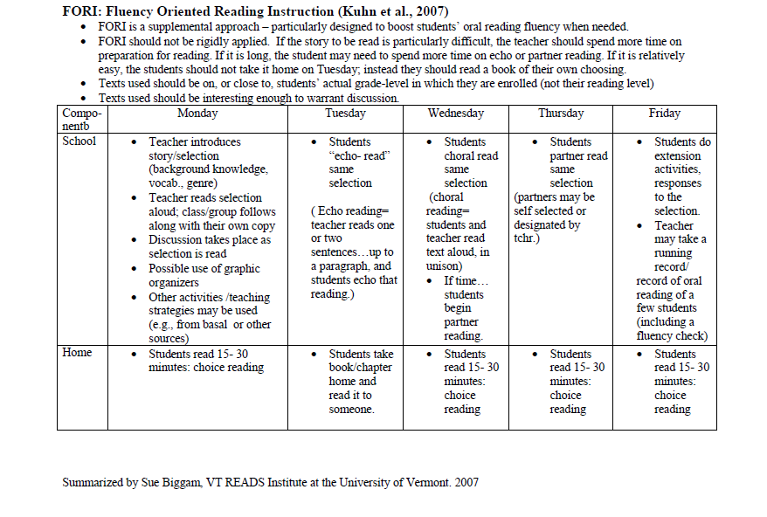

Appendix B
Multidimensional Fluency Rubric designed by Tim Rasinski

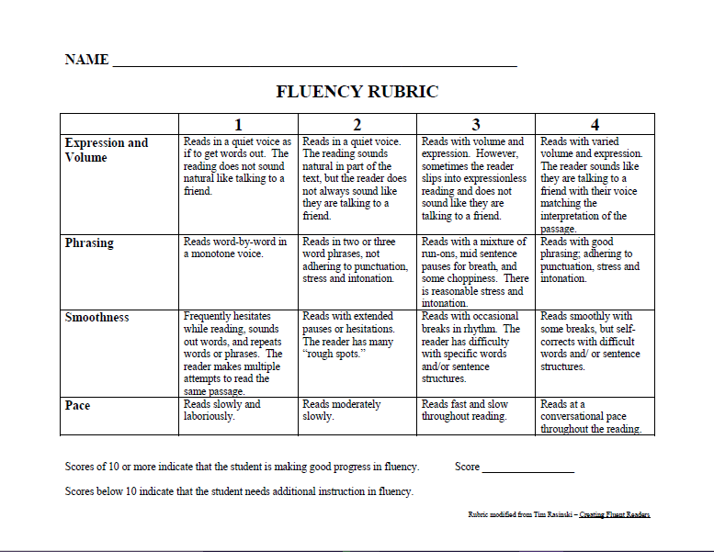

Appendix C
Elementary Reading Attitude Survey designed by McKenna and Kear

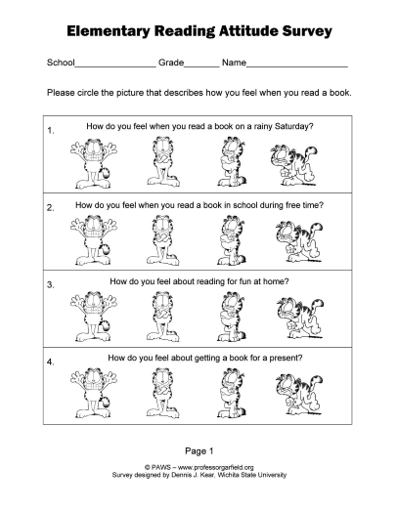
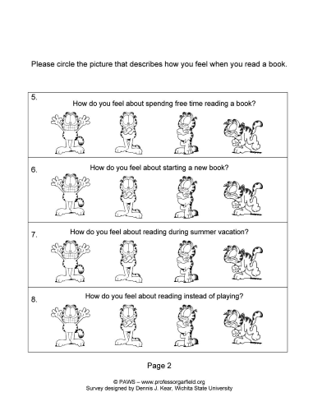

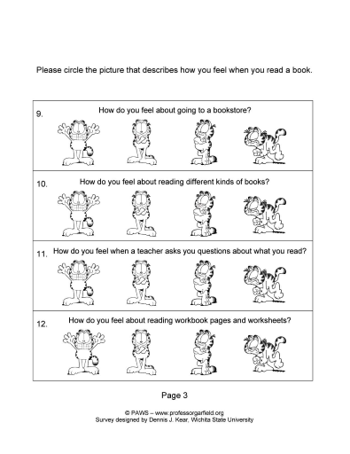
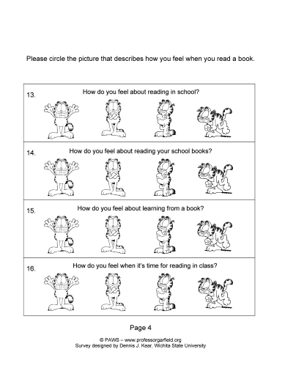
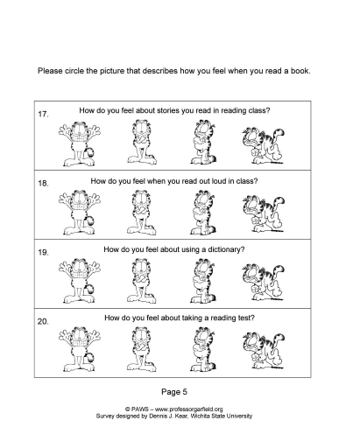

Appendix D
IRB Exempt Approval


Appendix E
Intervention Group Consent Form

College of Education
Department of Literacy Studies, English Education and History Education
East Carolina University
Speight Building Greenville, NC 27858-4353
252-328-6181 office 252-328-2585 fax
www.coe.ecu.edu

Dear Parent/Guardian,

As part of my Master’s of Reading Education degree requirements at East Carolina University, I am planning an educational research project that will help me to learn more about how using the repeated reading of poetry can improve your child’s reading skills and feelings about reading.

The fundamental goal of this project is to improve your child’s reading skills and to learn more about how your child views the importance of reading in their life. I have investigated an effective instructional practice, repeated readings, that I will be implementing during reading instruction in January 2016. I am going to track student improvement during reading instruction for 5 weeks. A reading rubric that allows me to score your child’s reading skills and a reading attitudes survey that tells about how your child feels about reading will allow me to track student progress.

This project has been approved by my instructor at ECU, Dr. Elizabeth Swaggerty, and the ECU Institutional Review Board.

I am asking permission to include your child’s progress in my project report. Your child will not be responsible for “extra” work as a result of this project. The decision to participate or not will not affect your child’s grade. I plan to share the results of this project with other educators through presentations and publications to help educators think about how they can improve reading instruction in their own classrooms. I will use pseudonyms to protect your child’s identity. The name of our school, your child, or any other identifying information will not be used in my final report. Please know that participation (agreeing to allow me to include your child’s data) is entirely voluntary and your child may withdraw from the study at any point without penalty.

If you have any questions or concerns, please feel free to contact me at school at 252-335-4303 ext. 263 or email me at lhinton@ecpps.k12.nc.us. You may also contact my supervising professor at ECU, Dr. Elizabeth Swaggerty, at swaggertye@ecu.edu, 252.328.4970. If you have questions about your child’s rights as someone taking part in research, you may call the Office of Research Integrity & Compliance (ORIC) at 252-744-2914 (days, 8:00 am-5:00 pm). If you would like to report a complaint or concern about this research study, you may call the Director of the OHRI, at 252-744-1971.

Please indicate your preference below and return the form by _____________________.

Thank you,

LaQuitta R. Hinton

-------------------------------------------------------------------------------------------------

As the parent or guardian of ________________________________________, I grant permission for ______________________________ to use my child’s data in the educational research project described above regarding fluency instruction. I voluntarily consent to_________________________________ using data gathered about my child in her study. I fully understand that the data will not affect my child’s grade and will be kept completely confidential.

Signature of Parent/Guardian: ______________________________________

Date____________________________

-OR-

As the parent or guardian of _______________________________, I do not grant permission for my child’s data to be included in the study.

Parent/Guardian: _______________________________________

