Pediatric Two-Dose Influenza Vaccination Series:
Impact of Text Message Reminders on Adherence to Second Dose
Allison Nelson
East Carolina University

Abstract
Introduction: The Centers for Disease Control and Prevention (CDC) recommends that children 6 months to 9 years of age receive a two-dose series of the influenza immunization in the same influenza season. A quality improvement project was performed at a pediatric office in eastern North Carolina that had a low rate of adherence for the second influenza vaccine.
Methodology: The project focused on children from age 6 months to 24 months who had not received a two-dose series of the influenza immunization. Text message reminders were used to improve adherence rates. Data from the same eight-week period in 2016 and 2017 was collected and compared to determine if there was improvement in the adherence rates.
Results: Out of the patients reviewed during the eight-week period in 2016, 85 patients were eligible for the second dose of the influenza immunization and 9 returned for the second dose. In 2017, out of the patients reviewed, 91 patients were eligible for the second dose of the influenza immunization and 35 returned. Of those that returned, 28 had received the text message reminder.
Discussion: From 2016 to 2017 there was an improvement in adherence to the two-dose influenza immunization series. The rate of adherence went from 10.6% to 38.5% respectively. The biggest problem with non-adherence was related to staff compliance with the text message reminders.
Conclusion: Text message reminders improved the rate of adherence to the two-dose series of influenza immunization. Improved staff education is needed with future projects.

Table of Contents
Abstract 2
Chapter I: Introduction 5
Background 5
Problem Statement 6
Justification 6
Assumptions 7
Proposed Clinical Improvement 7
Definition of Terms 7
Summary 8
Chapter II: Research-Based Evidence 9
Overview 9
Literature Search Strategy 9
Review of the Literature 9
Theoretical Framework 16
Summary 18
Chapter III: Methodology 19
Protection of Human Subjects 19
Design 19
Setting 22
Sample 23
Data Collection 23
Data Analysis 23
Chapter IV: Results 25
Preliminary Analysis 25
Sample Characteristics 25
Major Findings 26
Chapter V: Discussion 28
Implications of Findings 28
Limitations 30
Delimitations 30
Recommendations 31
Conclusion 31
Chapter VI: Doctor of Nursing Practice (DNP) Essentials 32
References 34
Appendix A 39
Appendix B 41
Appendix C 52
Appendix D 54
Appendix E 55
Appendix F 56
Appendix G 57
Appendix H 59

Chapter I: Introduction

Background
Influenza is preventable; however, child mortality continues to be an issue because children are under vaccinated (Flannery et al., 2017). Flannery et al. (2017) looked at national surveillance data and case cohort studies from the influenza seasons ranging from 2010 to 2014. This review found that out of 291 pediatric deaths due to laboratory-confirmed influenza, only one out of every four children had been vaccinated. All children starting at six months of age up to nine years should receive a one-time, two-dose series of the influenza immunization to have sufficient antibodies against influenza (Grohskopf et al., 2016). This two-dose series should occur within the same influenza season and a minimum of 28 days apart (Grohskopf et al., 2016). However, if two influenza immunizations have been given in previous years, only one annual influenza immunization is needed (Grohskopf et al., 2017). The U.S. Department of Health and Human Services (USDHHS) reports that if a child does not receive the second dose of influenza immunization, the first vaccine does not produce enough antibodies to be protective. Starting at nine years of age, children are safe to start receiving one annual influenza immunization because studies have shown by this age there are enough antibodies produced with one vaccine (USDHHS, 2017).
The original Healthy People 2020 objective 12.1 was to achieve 80% adherence with influenza vaccination for children ages 6-23 months. Due to policy changes in 2013, objectives 12.1-12.4 were consolidated into objective 12.11. This objective was to increase the rate of influenza immunization for ages 6 months to 17 years to 70%. Children under 24 months of age can develop serious complications such as pneumonia, cardiac issues, and multi-organ failure due to influenza. Addressing the influenza immunization rate will improve protection for those individuals (USDHHS, 2017).

Problem Statement
The project site was a pediatric office in eastern North Carolina that had a low rate of adherence for the second influenza vaccine, which is needed to complete the two-dose series for children 6 months to 23 months of age.

Justification
FluView (2017), developed by the USDHHS, showed an increase in influenza vaccination coverage in the United States (US) for children ages 6 months to 17 years. The national percentage of vaccinated children increased from 43.7% in 2009-2010 to 59.3% in 2015-2016. This data may not consider the under vaccination in children ages six months to nine years who are eligible for the second seasonal influenza immunization (FluView, 2017). Children ages six months to nine years who are receiving their initial lifetime influenza immunizations should receive the two-dose regimen, and those who do not receive two doses are at higher risk for complications if they contract the virus (Grohskopf et al., 2016). Communications with the office manager (personal communication, March 2017) at the project site reflected the belief that only around 20% of patients under the age of nine years old were properly vaccinated for influenza.
The project focused on patients whose ages range from 6 months to 23 months. Children under 5 years of age need more medical care related to influenza complications, but children 23 months or younger have the highest risk of influenza-related complications (USDHHS, 2017).

Assumptions
Due to the 28-day minimum wait period for two-dose administration, influenza vaccine was in adequate supply when implementing the project.
Caregivers had a text message operational phone number recorded in the office’s system and agreed with participation in text message reminders.

Proposed Clinical Improvement
Implementing a text message reminder for the second-dose influenza immunization will increase the rate of children between 6 and 23 months of age receiving the recommended two-dose regimen during their inaugural influenza seasons.

Definition of Terms
For the purpose of this Quality Improvement (QI) project the following are defined:
- Project population: children ages 6 months through 23 months
- Two-dose series: The first and second dose of a quadrivalent influenza immunization required during the first influenza vaccination season for children ages six months to nine years to provide appropriate antibodies.
- Healthy People 2020: Set of 10-year objectives developed based on evidence to give benchmarks for achievement and to monitor progress in healthcare (Healthy People, 2017).
- Peak flu season: Peak influenza season falls between December and February annually, reflective of when the most cases of influenza are typically seen based on previous years (USDHHS, 2017).
- FADE model: FADE stands for Focus, Analyze, Develop, and Execute. FADE is a quality improvement method used to help explore complex issues and develop a plan to improve outcomes for the complex issue (Moran, Burson, &Conrad, 2017).
- Quadrivalent vaccine: Influenza vaccine that protects against two influenza A viruses and two influenza B viruses (USDHHS, 2016).

Summary
Children aged six months to nine years follow a different clinical standard than individuals of other ages (USDHHS, 2017). Failure to receive the second dose of influenza immunization can lead to decreased resistance to influenza, resulting in serious complications and even death (Flannery, et. al, 2017). A computer report developed by the office manager at the pediatric office found that the project site had low rates of second dose influenza immunization adherence for the 2016-2017 influenza season (personal communication, March 2017). A text message reminder, sent to parents or parental surrogates, was implemented at the project site as a strategy for increasing rates of receiving the two-dose immunization regimen, when indicated.

Chapter II: Research-Based Evidence

Overview
The literature review for this project included the value of the influenza vaccine for ages 6 months to 23 months, the two-dose influenza immunization series, and reminder systems for increasing vaccine uptake. The review of the literature addresses the utilization of Pender’s Health Promotion Model (HPM) and how it guided this quality improvement project.

Literature Search Strategy
This review of literature covered a 10-year period ranging from 2007-2017. The search included the use of electronic databases PubMed and OVID, Google Scholar, and the CDC Website. Over 200 articles and websites were reviewed, and 37 were incorporated in this project (see Appendix A for literature search log).
Articles and other relevant information were chosen based on relevance to the project and were searched for using key words such as “health promotion, Pender’s health promotion model, influenza immunization, two-dose vaccine, and reminder systems.” Information that was based on pediatric research, and more specifically children age 6 months to 23 months, was saved and incorporated. If the information related to adults, it was discarded unless it included statistics relevant to the project.

Review of the Literature
FADE model. The FADE model stands for Focus, Analyze, Develop, and Execute/Evaluate (Moran et al., 2017). It is a method used in quality improvement projects to focus on complex issues and guide development of a project by breaking the project down into different sections to be completed one at a time (Moran et al., 2017). The model was developed by Organizational Dynamics Institute as a tool for organizations to use to guide quality improvement (Hickey & Brosnan, 2017). The first step, Focus, is used to define the problem that needs to be improved. Analyze is the second step, which involves collecting and establishing baseline data on methods of improvement that would be appropriate for the problem. The third step is Develop, which requires the ability to use the baseline data and produce an action plan for improvement. Finally, the fourth step, Execute, is utilized when the plan is implemented and evaluated for effectiveness (Hickey & Brosnan, 2017). This four-step method, seen in Figure 1, was used to shape this quality improvement project.

Figure 1. FADE model
Value of influenza immunization. Literature shows the importance of the influenza immunization for improving personal and population health outcomes for patients by decreasing serious complications caused by influenza. Multiple studies also referenced the fact that individuals aged 6 months to 23 months who were not appropriately vaccinated had higher risks of complications related to influenza. Influenza immunizations have improved health outcomes for all patients, including influenza and 870,000 respiratory-related hospitalizations annually in children less than five years of age (Bramley, Bresee, & Finelli, 2009; Lanfond et al., 2016). Respiratory complications are one among many problems that can be associated with influenza virus.
Flannery et al. (2017) analyzed relationships between the influenza immunization and pediatric death and found that receiving the influenza vaccination was associated with decreased risk of laboratory confirmed, influenza-associated pediatric death. From July 2010 through June 2014, a total of 291 deaths occurred in children between the ages of 6 months and 17 years in the US with known vaccination status. Only 75 of those 291 children were fully vaccinated before the onset of the disease (Flannery et al., 2017). It is not known if this means that children were vaccinated late in the season or if they were exempt from the vaccine due to health risks. It also cannot be determined if the children who were eligible for the two-dose vaccine did not receive it. Flannery et al. (2017) looked at pediatric deaths of patients who tested positive for influenza. There was no specific cause of death provided; however, issues such as respiratory problems, cardiovascular problems, or other specific diagnoses or complications were cited.
It is important for all children to receive the influenza immunization, although children under 24 months are at higher risk of influenza-related complications. Appiah et al. (2015) reviewed influenza activity in the US from 2014 through 2015, ascertaining that out of 141 confirmed pediatric deaths, 23 deaths were children 6 to 23 months of age, but no vaccination status was reviewed. Gill et al. (2015) performed a systematic review that focused on children presenting with complications from influenza and noted that children under two years of age had a greater percentage of hospitalization from complications related to influenza than did the chronic diseases of asthma and obesity in children. Esposito and Principi (2009) found that children under 23 months have the highest rate of emergency room visits related to influenza than individuals of other age groups.
Geographic impact of influenza morbidity and mortality. In the US during the 2016-2017 flu season, there were 107 documented pediatric deaths under 18 years of age where patients tested positive for influenza. Data from the 2016-2017 influenza season indicated that 24 of those 107 pediatric influenza deaths were found in Region 4, which covers Alabama, Florida, Georgia, Kentucky, Mississippi, North Carolina, South Carolina, and Tennessee (FluView, 2017). The rate of pediatric influenza associated death in Region 4 increased from 1.3/1,000,000 in 2015-2016 to 1.8/1,000,000 in 2016-2017 (FluView, 2017).
During the 2015-2016 flu season there were 60 influenza-associated deaths compared to the 2016-2017 North Carolina flu season, when 219 deaths occurred, including all ages (“About influenza,” 2017). This shows the overall increase in deaths associated with influenza in North Carolina. In comparison, South Carolina had 94 influenza-related deaths in the 2016-2017 influenza season (FluView, 2017). When looking at the North Carolina data for the 2016-2017 influenza season there were between 30 and 60 hospital admissions weekly due to acute respiratory illness and two pediatric deaths from ages 0 years to 4 years (“About influenza”, 2017). The data was not broken out specifically for children in the age range of 6 months to 23 months. North Carolina had an increased number of deaths from one influenza season to the next and had higher rates than South Carolina for the same timeframe.
Timing of influenza vaccine administration. The USDHHS (2013) documented that during the 2012-2013 flu season, approximately 90% of children under the age of 18 years who died from influenza were not vaccinated at all during the season. Not being vaccinated left those individuals at higher risk for complications related to influenza. The CDC found that influenza immunization would have decreased the risk of going to the doctor for flu-related problems by 60% (USDHHS, 2013). Giving the two-dose influenza vaccines as close to the 28-day interval as possible is recommended because without the two doses, the individual is left without proper vaccination coverage for the influenza season (Hu, Chen, & Zhang, 2017).
Receiving the full influenza immunization coverage before the onset of influenza in the community is important to give the appropriate coverage. The immunization should be offered by the end of October if possible; further, children that need two doses should receive the first dose as soon as available and the second dose as close to the 28-day interval as possible to provide adequate coverage (Grohskopf et al., 2016).
Two-dose influenza immunization series. The USDHHS (2017) recommends children between six months and nine years receiving their first lifetime, or inaugural, influenza vaccine obtain a one time, two-dose series during the same influenza season. The two vaccines should be given a minimum of 28 days apart. This recommendation was concluded after several studies proved that one dose of the vaccine did not provide appropriate antibodies to be protective but rather served as a primer for the subsequent dose (USDHHS, 2017). Failure to receive both doses during the same season leaves children under-protected (USDHHS, 2017). Grohskopf et al. (2016) noted that 80-90% of the children older than six months who had received the two doses of 2009 A (H1N1) had protective antibodies. In that same season, the response for children aged 6 months to 35 months who had only received one influenza vaccine in their first vaccination year was only 50%, while 75% of children three to nine years of age developed protective antibodies (Grohskopf et al., 2016). This shows the importance of receiving the two-dose influenza immunization series as early in a child’s life as possible to provide appropriate coverage.
This quality improvement project considers only the quadrivalent influenza vaccine, which was used at the project site. This vaccine was developed to protect against four different types of influenza viruses; two influenza A viruses and two influenza B viruses. The quadrivalent vaccine used in the project site was approved for children six months and older (USDHHS, 2016).
Reminder strategies. Schneiderman, Kennedy, and Sayegh (2017), performed a qualitative study where 28 foster caregivers were interviewed after return appointments. This occurred for any return appointment for the low-income population to try and improve return adherence. It was found that 19 caregivers returned to the clinic, while 9 caregivers missed appointments (Schneiderman et al., 2017). After the return appointment, the 28 caregivers were called and surveyed to determine if appointment reminders would be helpful for future visits. Multiple options were allowed during the interview, during which 22 caregivers responded that a telephone reminder would be effective, 19 responded that a text message would be effective, 6 responded that e-mail messages would be effective, and 3 responded that postal mail correspondence would be effective (Schneiderman et al., 2017).
Lin, Fiebelkorn, and Pabst (2016) studied trends in compliance with the two-dose influenza vaccination from 2010 to 2015. Between the seasons, two-dose compliance for children ages 6 months to 23 months ranged from 63.3-67.6%. This leaves room for improvement. There was no specific cause for the poor vaccination rates, but it was recommended that reminder systems be utilized to improve adherence. Ahlers-Schmidt et al. (2012) surveyed 50 mostly female, white non-Hispanic parents between the ages of 20 and 41 years about their preferences on their children’s immunization reminders. All parents had face-to-face interaction with the provider, and 74% had telephone contact. Of those parents, almost all were satisfied with face-to-face and telephone interaction, but 98% were interested in receiving immunization text message reminders, and 100% were interested in appointment text message reminders (Ahlers-Schmidt et al., 2012).
Stockwell et al. (2012), performed a study to determine if the number of patients that return for follow up appointments would increase when patients received reminder letters or text message reminders. Of the original patients, 21.8% returned with text messages and 9.2% returned with letters (Stockwell et al., 2012). Morris et al. (2015) tested several reminder systems such as phone calls, letters, text message reminders, etc. and found that, with text message reminders, 32.1% of patients returned to complete scheduled immunizations. This was the highest rate of return when compared to the rate of return for postcard (23.0%), e-mail (20.8%), and phone call (12.4%) recipients.
Aigbogun, Hawker, and Stewart (2015) reviewed 18 studies, which covered many reminder systems in different settings for different conditions. It was found that reminder letters improved influenza immunization adherence in children with chronic health conditions. It is not specific to age or dosage number for the influenza immunization but for the reminder systems only. Phone call reminders were also evaluated, but the results showed greater increase with letter reminder systems.
Cost-burden due to nonadherence. Improving the adherence of adequate vaccination will improve health care costs (Nichol, 2011). Nichol (2011) noted that the total annual economic burden for the United States in 2003 related to seasonal influenza for individuals less than 18 years of age was $3.8 billion. Of the total cost, $2.2 billion, or 58%, was due to costs incurred to care for children under the age of 5 years. This cost includes resources used to care for children with complications related to influenza such as otitis media, pneumonia, antibiotics, emergency department visits, and hospitalization. This cost analysis does not consider if children received the influenza vaccine two-dose series. However, a MEDLINE review was also completed for economic evaluation of the influenza vaccination in young children. Nine articles were reviewed, with six of them showing cost-saving conclusions (Nichol, 2011). Ensuring that the appropriate number of vaccines is given at the times indicated in evidence-based guidelines can reduce costs associated with complications.

Theoretical Framework
Pender’s HPM provided the framework for this QI project. The focus of this model is changing behaviors of individuals to improve quality of health and promote healthy interventions (Pender, 2011). HPM was first used in nursing literature in 1982 to promote counseling of healthy lifestyles. Its purpose is to help individuals look at their previous behaviors and ways that they can adjust such behaviors to improve overall health outcomes (Pender, 2011). The HPM was founded in two theories: the expectancy value theory and the social cognitive theory. The expectancy value theory is based on an individual’s beliefs or expectations about outcomes of actions and the perceived value of the goal trying to be obtained. The social cognitive theory is based on observing others and making changes to reduce health risks based on observed behaviors. Both theories focused on individuals altering behaviors to result in the best outcomes (Pender, 2011). Discussing the benefits and consequences of personal behaviors on health and explaining possible interventions may enhance individuals’ interests in desirable health goals. This desire may increase individuals’ value of improved health outcomes, making the behavior change worth the individuals’ time and effort.
The framework of Pender’s (2011) HPM has three major concepts. The first concept is individual characteristics and experiences, which means prior behaviors or ideas that affect care. Second, the framework considers behavior-specific cognitions, which are thoughts about different behaviors, and their effect relating to what a person perceives about benefits, self-ability, and how it influences the plan. This relates to what a person believes can and will happen. The third concept in Pender’s HPM is that health-promoting behaviors should improve health outcomes (Pender, 2011). As seen in Figure 2, the three components of the HPM have been used as the framework for this quality improvement project.

Figure 2. Pender’s Health Promotion Model. Example of current project using three components of Pender’s health promotion model.

Heydari and Khorashadizedeh (2014) performed a systematic review to explore ways in which Pender’s health promotion model can be used in medical research. After a systematic review of 74 articles relevant to the topic being studied, it was found that promoting healthy choices generated better outcomes for patients (Heydari & Khorashadizadeh, 2014). This may relate to Pender’s HPM as it intersects with this QI project. Pender’s HPM is used to promote interventions to improve patient behaviors. Improving adherence of the two-dose influenza immunizations for children 6 months to 23 months of age potentiates improved health outcomes for this patient population. Based on Pender’s HPM, sending these text messages may be a communication intervention that will teach parents about the importance of the second dose of influenza vaccine.

Summary
Increasing influenza immunization rates by completing the two-dose vaccine regimen potentially decreases serious complications related to influenza. These complications include otitis media, pneumonia, emergency room visits, hospitalizations, and respiratory distress (Nichol, 2011). Both doses should be given within the same influenza season, yet no closer than 28 days apart, for the series to be considered complete. Specifically, children under two years of age are at higher risk for hospitalization related to influenza complications (Gill et al., 2015). Improving the rates of the two-dose series is important to yield adequate antibody production, hence providing coverage against four types of influenza virus.
The literature review for this project found that different reminder systems, such as text message, phone calls, emails, or letters, have been used to improve return rates for appointments. Stockwell et al. (2012) found that 21.8% of patients returned for immunizations when text message reminders were used compared to reminder letters, which only resulted in 9.2% of patients returning. There are many reminder systems available, but research did show that text message reminders could be beneficial in improving rates of immunization adherence.

Chapter III: Methodology

Protection of Human Subjects
This project was reviewed by the University and Medical Center Institutional Review Board (UMCIRB) and was deemed not to be human subjects’ research, but quality improvement (see Appendix H). Aggregate data, which did not include personal identifying information, was extracted from the electronic medical record (EMR) by the immunization nurse employed at the project site and the project lead. The text message reminder developed for this project was only used to contact patients and caregivers regarding their appointment through the EMR. The text message reminder system was stored on a password-protected computer.

Design
The FADE method is used by researchers to guide the development of projects. In this case, it was used to guide this quality improvement project. The first step of the FADE model is focus. Discussions were held with the office manager about the project and any perceived quality or process problems in the practice. After running a computer-generated report, the office manager noted that only about 20% of eligible pediatric patients ages six months to nine years were receiving the appropriate influenza immunization coverage. This included patients needing either one or two doses of the influenza immunization, depending on eligibility. It was also determined that no reminder system had been utilized in the 2016-2017 influenza season to prompt eligible patients to return for their second dose of the influenza vaccine.
The second step of the FADE model is analyzing. After analyzing the options for intervention with the office manager, information technology nurse, immunization nurse, community champion, and team lead, it was decided that a text message reminder would be used to improve the adherence to the second influenza immunization. The project site had an existing text message reminder system in place that was not being utilized for the second influenza immunization. In the literature it was found that text message reminders were an effective option to increase patient return to appointments.
Development of the implementation plan is the third step of the FADE model. The office staff, along with the project lead, worked together to perform this development. Implementing the text message reminder meant scheduling an appointment for the patient to return to the clinic. The immunization nurse had to determine if the patient would be eligible for the second dose of the influenza immunization. A new appointment option and text reminder for the second dose appointment was developed. The text reminder was sent to parents and caregivers of patients that received their first influenza immunization and were eligible for the second dose. Parents and caregivers had the option of declining text message services. It was documented in the EMR if the text message service was accepted or declined.
An in-service training was conducted for all staff and providers to provide education on the text message reminder before implementation of the QI project. Clinical information about the importance of the two-vaccine series for influenza was addressed, and the new reminder system was described. Written instructions describing steps of the project (see Appendix D) and the CDC algorithm for choosing eligible patients (see Appendix E) were posted in the nursing office and immunization room.
Execution and evaluation is the last and fourth step of the FADE model. In this project, this step involved implementing the project at the pediatric office and then evaluating its effectiveness. This quality improvement project was conducted over two months. Figure 2 shows each step in the implementation process. When a patient aged 6 months to 23 months received their first influenza vaccine of the season, the immunization nurse determined if the patient was eligible for the second vaccine. This was decided using the algorithm provided by the CDC (see Appendix E). If the patient was eligible for the two-dose series, the immunization nurse sent an e-task to the receptionist to schedule a follow-up appointment. The practice also provided weekly influenza clinics in the lobby. If a child received the first influenza immunization at the influenza clinic and was eligible for the second, then an appointment was made by the staff involved with the clinic and no task was sent to the receptionist. At the time the child received the initial influenza immunization, the nurse informed the parent or caregiver that a second influenza immunization was needed and that an appointment would be scheduled at checkout.
The receptionist checking the patient out was responsible for scheduling eligible patients for their second dose 28 days after the initial dose. If the 28th day fell on a day that the practice was closed, the appointment was made for the next day the practice was open. The scheduling of the appointment would prompt a single text message that was sent to the parents and caregivers two days prior to the return appointment. If they did not respond to the text message, the parents or caregivers would also receive a phone call one day prior to the appointment. After completion of the eight-week implementation of the QI project, data related to the second influenza immunization was compiled. This compiled data was compared to data from the previous influenza immunization season to determine if changes in adherence occurred from one year to the next.

Figure 3. Steps of implementation of project

Setting
This quality improvement project was implemented at an eastern North Carolina pediatric office. The patient population was made up of approximately 7,000 active patients. Of the total active patients, approximately 1,000 were ages 6 to 23 months. The practice sees approximately 480 patients a month, depending on the season. Providers included three physicians, one pediatric nurse practitioner, one family nurse practitioner, six registered nurses, two licensed practical nurses, one certified medical assistant, and three certified nursing assistants. The front office included five receptionists and one practice administrator. Registered nurses and licensed practical nurses administered immunizations and provided education about immunizations to patients, parents, and caregivers.

Sample
The patient population for this quality improvement project was a convenience sample of children ages 6 months to 23 months in one pediatric practice who had never received the two-dose influenza immunization series and received the first dose.

Data Collection
At the end of the project, data was extracted from the pediatric office EMR. This query identified all patients aged 6 months to 23 months that received influenza immunization from September 25, 2017 to November 17, 2017 and were eligible for the second dose during the eight weeks that the project was implemented. It was then determined how many children returned for their appointment to obtain the second influenza immunization dose. Of those who received a second influenza vaccine, the number that received the text reminder was determined. Information was also extracted from a similar eight-week period in 2016. The dates of this data were September 26, 2016 to November 18, 2016. After the quantitative data was collected the reports were shredded and not used during the presentation of the information.

Data Analysis
This quality improvement project captured the number of patients aged 6 months to 23 months who received influenza vaccine between September 26, 2016 to November 18, 2016 and were eligible for the second influenza vaccine and compared that number to those with the same demographic and eligibility between September 25, 2017 to November 17, 2017. Children that were within the age range for the first vaccine but out of the age range for the second vaccine were still included in the collected data. This data was used to determine the percentage of eligible patients that received the second influenza immunization dose. This analysis determined if there was an increase in adherence in receiving the second influenza dose between the 2016 influenza immunization season and the 2017 season. The data gathered was used to determine if a text message intervention increased the number of children who returned to complete their two-dose influenza vaccine series. This information will improve the process at the practice and provide information for future influenza seasons.

Chapter IV: Results
This chapter presents the results of the data analysis from the quality improvement project. Data results demonstrate the effect that the text message reminder intervention had on improvement of adherence to the recommendation for the second influenza immunization for children 6 months to 23 months who were receiving their inaugural dose of the vaccine.

Preliminary Analysis
Two eight-week periods were analyzed to determine the rate of the two-dose influenza adherence. The first eight-week period was from September 26, 2016 to November 18, 2016. In that timeframe there were 117 patients in the 6 months to 23 months age range. Of those, 30 patients had completed the vaccine series the previous year, and two had received the first vaccine before the eight-week window, resulting in 85 patients in the correct age range during the eligible timeframe.
The second eight-week period was from September 25, 2017 to November 17, 2017. In this timeframe there were 119 patients in the 6 months to 23 months age range. Of those patients, 28 completed the influenza immunization the previous year. This left 91 patients who were eligible for the two-dose influenza vaccination series in the appropriate timeframe.

Sample Characteristics
The final sample sizes from the two years consisted of 85 patients for 2016 and 91 patients for 2017. This sample consisted of patients aged 6 months to 23 months who were eligible for the two-dose influenza immunization series during that influenza season. Children of all ethnicities, financial backgrounds, and medical conditions were included in the sample.

Major Findings
Out of the 85 eligible patients in 2016, nine (10.58%) returned within the eight-week window and 76 (89.41%) did not. This only considered the eight-week window and did not look further into the influenza season. No reminder systems were used, so there are no further variables to determine influencers for patients returning for the second influenza immunization. Patients may have returned later in the season to receive the second influenza immunization, but that was not determined during this QI project. In the 2017 influenza season, out of 91 patients, 35 (38.46%) returned within the eight-week window, and 56 (61.54%) did not return. Again, this does not consider patients that returned outside of the eight-week timeframe. Figure 4 shows the comparison between the 2016 and 2017 influenza season.

Figure 4. Comparison of the percentage of patients that returned and did not return in the 2016 and 2017 influenza immunization season.

Further analysis was performed to determine if text message reminders improved the return rate of adherence during the 2017 influenza season. Out of the 91 patients that were eligible during the 2017, 35 patients returned. Of the 35 patients that returned, 28 (80%) had received text messages. Figure 5 shows a comparison of return rates with no intervention in 2016 compared to text message reminder return rates in 2017. Of those 56 patients that did not return, 36 that did not return had no appointments made, 10 had a text message sent but did not return, four appointments were canceled, and six appointments were made outside of the timeframe.

Figure 5. Comparison of return rate in 2016 with no intervention versus return rate in 2017 with a text message intervention.

When comparing the 2016 and 2017 influenza seasons the rate of adherence to the second influenza vaccine during the specified timeframe increased from 10.58% to 38.46%, respectively. In the 2017 influenza season, out of the 35 patients that returned, 28 of them had received text message reminders for the appointments. Of the patients that returned, 80% of them had received text messages. This data shows the significant impact of text message reminders on improving two-dose influenza immunizations.

Chapter V: Discussion
The problem that was addressed in this project was a low rate of adherence to the two-dose influenza vaccination series in children 6 months through 23 months at a pediatric clinic in eastern North Carolina. In 2016, during a specific eight-week period, only 10.58% of eligible patients returned for the second influenza immunization without any reminder system in place. The data collected in a similar eight-week period in 2017, after the implementation of a text message reminder, resulted in a return rate of 38.46%. Of those that returned in 2017, 80% had received a text message reminder.

Implications of Findings
The results from this QI project support the use of text message reminders for improving patient return for two-dose influenza immunizations. Pender’s HPM, which was the theoretical framework implemented, is supported by the outcomes of this QI project. A previous behavior was identified, in this case the decreased adherence to two-dose influenza immunization series. An intervention or health promotion concept was implemented when the text message reminder system was developed and started at the pediatric clinic. Lastly, the outcome resulted in an improved rate of return and completion of the two-dose influenza immunization series, which is an improved health outcome for the patient population.
Healthy People 2020 is a national initiative that has developed objectives to improve health outcomes for the nation. The group has developed many health objectives that are trying to be achieved by the year 2020. In the case of influenza immunizations, the objective changed from a specific age group to a broader population. Immunization and Infectious Disease (IID) objective 12.11 reports one of their goals is to improve the percentage of children from 6 months through 17 years of age who receive the influenza immunization annually. The percentage of completion in the 2010-2011 influenza season was only 46.9%, with a target percentage of 70% (Healthy People, 2017). This objective supports the importance of improving adequate immunization coverage. The QI project completed provides one intervention that would be beneficial in improving the adherence for children age 6 months through 23 months who need the two-dose series completed. Without the completion of the two-dose series, patients would not be adequately covered and could not count towards the goal of 70%.
Findings from the project do support change in the current pediatric practice regarding how patients are brought back for the second influenza immunization. The text message reminder system that was implemented in 2017 did result in improved adherence to the two-dose series, compared to no reminder system being in place in 2016. However, this one small project will not be enough to determine if this is the best intervention that could be used. It did show improvement, but it only reviewed the effect of one intervention. Other studies also support the use of text message reminders, but other reminder systems such as phone calls were slightly more acceptable to the caregivers being interviewed (Schneiderman et al., 2017). Other studies suggested much interest in text message reminder systems, but few specifically focus on immunization follow up. Further information should be gathered at this practice before major practice changes are made.
The biggest gap in education that was found was between the staff completing the steps of implementation and the facilitator of the project. Staff was provided an in-service training and several surveys throughout the eight-week period. No questions were asked, and further education was denied by staff. However, after the data analysis was completed it was found that of the 56 patients that did not return for their second influenza immunization, 36 appointments were never made, which in turn means no text message reminder was sent.
Further projects should be performed to determine if the text message reminder intervention should be implemented into the practice permanently or not. Limitations to the project such as staff education, sample size, and length of implementation period need to be addressed, and a new project should be performed to give a better understanding of the impact of the text message reminder. Another part of the influenza vaccine that could be further investigated would be the effectiveness. This information could be beneficial in promoting health outcomes, and convincing others that the change in practice would be worth the effort.

Limitations
In the QI project 56 patients did not return. Of those patients, 36 never had an appointment made to trigger the text message reminder. In future projects it would be beneficial to have onsite training with staff and not only a one-time in-service training. Weekly surveys for the first four weeks, followed by biweekly surveys for the last month were completed, but staff never expressed any concerns while the project was being implemented.

Delimitations
The time frame for the project only consisted of an eight-week period. From the administration of first vaccine to the second, there must be a minimum of 28 days. This was known before the project started, but it did limit the number of patients that could be included in the project. The small age group of 6 months through 23 months also limited the sample size. This age group was decided upon due to the increased risk for complications in this age group. In future projects it would be beneficial to expand the time frame for the duration of the influenza season to capture all vaccinations provided without regard to the eight-week time limit.

Recommendations
In future projects it would be recommended to start implementation at the beginning of influenza season and stop collecting data only at the end of the season. This would provide a larger sample size. The age range should remain the same so that the focus can remain on patients who are in a high-risk population for influenza-related complications. Another recommendation would be to perform chart checks early after implementation of the project to ensure participation by the staff and completion of the process.

Conclusion
The outcomes of this project indicate that text message reminders can improve the adherence rate for the two-dose influenza immunization series. Influenza is a disease that can cause complications such as cardiac issues, multi-organ failure, and respiratory distress. These complications can lead to hospitalization or death. Children under two years of age are at higher risk for complications compared to some other populations.
Improving influenza immunization coverage is an important step to improving patient health outcomes. The text message reminder system in this project did show improved rates of adherence. However, even with some improvement there were still places where changes could be made to the process to produce better outcomes. More staff education, confirmation of understanding from staff, and longer periods of implementation would benefit future projects.
Healthcare professionals need to strive to provide the highest quality of care for their patients. Constant evaluations of current practices needed to be performed to ensure quality standards are being met.

Chapter VI: Doctor of Nursing Practice (DNP) Essentials
DNP Essentials were developed to provide individuals completing this degree with a set of guidelines. There are eight Essentials that should be utilized while completing the requirements of the degree. They are the foundational competencies that are at the base of the advanced nursing practice profession and curriculum. Table 1 shows each DNP Essential and how the QI project met that essential.
DNP Essential | How QI Project Met Essential
Essential 1: Scientific Underpinnings for Practice | Background information was found regarding influenza and the importance of improving adherence rates to the two-dose influenza immunization series. Pender’s Health Promotion Model was used to guide the project.
Essential 2: Organizational and Systems Leadership for Quality Improvement and Systems Thinking | A problem was identified at the pediatric practice, and a plan for added intervention was put into place.
Essential 3: Clinical Scholarship and Analytical Methods for Evidence- Based Practice | An extensive literature review was completed to learn about influenza immunizations and possibilities for improving adherence rates in a specific population.
Essential 4: Information Systems/Technology and Patient Care Technology for Improvement and Transformation of Health Care | This QI project used evaluation of an EMR and text message reminders. These pieces of technology were used to improve patient outcomes and adherence to recommended guidelines for practice.
Essential 5: Health Care Policy for Advocacy in Health Care | The QI project focused on working with the staff at the pediatric office and educating them about the roles of an APRN, specifically what the Doctor of Nursing Practice degree consists of. Policies within the practice were changed regarding the reminder systems used for two-dose influenza immunizations.
Essential 6: Intraprofessional Collaboration for Improving Patient and Population Health Outcomes | During this project there was collaboration between Registered Nurses, Licensed Practical Nurses, Medical Doctors, Advanced Practice Registered Nurses, and Reception staff.
Essential 7: Clinical Prevention and Population Health for Improving the Nation’s Health | Improving adherence to the recommended dosing for the influenza immunization is a health promotion project.
Essential 8: Advanced Nursing Practice | This project used Advanced Nursing Practice regarding the way that staff interaction occurred and in the way the project was conducted.
Table 1. DNP Essentials and how the QI project met each essential
Each DNP Essential was met during the project and at times different steps of the project could overlap and cover more than one Essential. Completing these components shows that the expectations for the DNP program were met and that the best quality of care was being provided for the patient. It is important to make sure that we are thinking about these advanced nurse practice guidelines anytime we are making a change.

References
About influenza (Flu) viruses. (May 13, 2017). Retrieved from http://www.flu.nc.gov/
Ahlers-Schmidt, C., Chesser, A., Paschal, A., Hart, T., Williams, K., Yaghmai, B., & Shah-Hague, S. (2012). Parent opinions about use of text messaging for immunization reminders. Journal of Medical Internet Research, 14(3). doi: 10.2196/jmir.1976
Aigbogun, H., Hawker, J., & Stewart, A. (2015). Interventions to increase influenza vaccination rates in children with high-risk conditions—a systematic review. Vaccine, 33(6), 759-770. doi: 10.1016/j.vaccine.2014.12.013
Appiah, G., Blanton, L., D’Mello, T., Kniss, K., Smith, S., Mustaquim, D., ... Brammer, L. (2015). Influenza activity-United States, 2014-2015 season and composition of the 2015-2016 influenza vaccine. MMWR, 64(21), 583-590. Retrieved from https://www.ncbi.nlm.nih.gov/pubmed/26042650
Bradbury-Golas, K. (2013). Health promotion and prevention strategies. Nursing Clinics of North America, 48(3), 469-483. doi: 10.1016/j.cnur.2013.04.003. Epub 2013 Jul 22
Bramley, A., Bresee, J., & Finelli, L. (2009). Pediatric influenza. Pediatric Nursing, 35(6), 335-345. Retrieved from https://www.ncbi.nlm.nih.gov/pubmed/20166462
Esposito, S. & Principi, N. (2009). The rational use of influenza vaccines in healthy children and children with underlying conditions. Current opinion of infectious diseases, 22(3), 244-249. doi: 10.1097/QCO.0b013e32832a58e4.
Flannery, B., Reynolds, S., Blanton, L., Santibanez, T., O’Halloran, A., Lu, P., ... Fry, A. (2017). Influenza vaccine effectiveness against pediatric deaths: 2010-2014. Pediatrics, 139(5). doi: 10.1542/peds.2016-4244. Epub 2017 Apr 3.
FluView. (May 13, 2017). Retrieved from https://www.cdc.gov/flu/weekly/
Ghadieh, A., Hamadeh, G., Mahmassani, D., & Lakkis, N. (2015). The effect of various types of patients’ reminders on the uptake of pneumococcal vaccine in adults: A randomized controlled trial. Vaccine, 33(43), 5868-5872. doi: 10.1016/j.vaccine.2015.07.050. Epub 2015 Jul 29.
Gill, P., Ashdown, H., Wang, K., Heneghan, C., Roberts, N., Harnden, A., & Mallett, S. (2015). Identification of children at risk of influenza-related complications in primary and ambulatory care: a systematic review and meta-analysis. The Lancet Respiratory Medicine, 3(2), doi: 10.1016/S2213-2600(14)70252-8
Grohskopf, L., Sokolow, L., Broder, K., Olsen, S., Karron, R., Jernigan, D., & Bresee, J. (2016). Prevention and control of seasonal influenza with vaccines. MMWR Recommendations and Reports, 65(5), 1-54. doi: 10.15585/mmwr.rr6505a1
Grohskopf, L., Sokolow, L., Broder, K., Walter, E., Bresee, J., Fry, A., & Jernigan, D. (2017). Prevention and control of seasonal influenza with vaccines: Recommendations of the advisory committee on immunization practices- United States, 2017-18 influenza season. Recommendations and Reports, 66(2), 1-20. doi: 10.15585/mmwr.rr6602a1
Healthy People. (2017). Immunization and infectious diseases. Retrieved from https://www.healthypeople.gov
Heydari, A., & Khorashadizadeh, F. (2014). Pender’s health promotion model in medical research. Journal of Pakistan Medical Association, 64(9), 1067-1074. Retrieved from https://www.ncbi.nlm.nih.gov/pubmed/25823190
Hickey, J. & Brosnan, C. (2017). Evaluation of health care quality for DNPs [Google Books version]. Retrieved from https://books.google.com/
Hofstetter, A., Durivage, N., Vargas, C., Camargo, S., Vawdrey, D., Fisher, A., & Stockwell, M. (2015). Text message reminders for timely routine MMR vaccination: A randomized controlled trial. Vaccine, 33(43). doi: 10.1016/j.vaccine.2015.09.042
Hofstetter, A., Vargas, C., Kennedy, A., Kitayama, K., & Stockwell, M. (2013). Parental and provider preferences and concerns regarding text message reminder/recall for early childhood vaccinations. Preventive Medicine, 57(2), 75-80. doi: 10.1016/j.ypmed.2013.04.007
Hu, Y., Chen, Y., & Zhang, B. (2017). Two-dose seasonal influenza vaccine coverage and timeliness among children aged 6 months through 3 years: An evidence from the 2010-11 to the 2014-15 seasons. Human Vaccines and Immunotherapeutics, 13(1), 75-80. doi: 10.1080/21645515.2016.1225640
Kirby, J., Archibeque, L., Confer, L., & Baird, D. (2016). Workplace formative assessment: faculty members’ beliefs. Clinical Teacher, 13(1), 33-37. doi:10.1111/tct.12348
Lanfond, K., Nair, H., Rasooly, M., Valente, F., Booy, R., Rahman, M.,…Widdowson, M. (2016). Global role and burden of influenza in pediatric respiratory hospitalizations, 1982-2012: A systematic analysis. Public Library of Science Medicine, 13(3). doi: 10.1371/journal.pmed.1001977. eCollection 2016 Mar.
Li, C. & Freedman, M. (2009). Seasonal influenza: an overview. The Journal of School Nursing, 1, 4S-12S. doi: 10.1177/1059840508330066
Lin, X., Fiebelkorn, A., & Pabst, L. (2016). Trends in compliance with two-dose influenza vaccine recommendations in children aged 6 months through 8 years, 2010-2015. Vaccine, 34(46), doi: 10.1016/j.vaccine.2016.09.037
Livingston, R. & Bernstein, H. (2015). Preventing of influenza in children. Infectious Disease Clinics of North America, 29(4), 597-615. doi: 10.1016/j.idc.2015.07.008
Moran, K., Burson, R., & Conrad, D. (2017). The doctor of nursing practice scholarly project: A framework for success (2nd ed.). Burlington, MA: Jones & Bartlett Learning.
Morris, J., Wang, W., Lawrence. W., Peddecord, M., & Sawyer, M. (2015). Comparison of reminder methods in selected adolescents with records in an immunization registry. Journal of Adolescent Health, 56(5), 27-32. doi: http://dx.doi.org/10.1016/j.jadohealth.2015.01.010
Nichol, K. (2011). Cost-effectiveness and socio-economic aspects of childhood influenza vaccine. Vaccine, 29(43), 7554-7558. doi: 10.1016/j.vaccine.2011.08.015
Pender, N. (2011). Health promotion model manual. Deep Blue, 1(5), 110-123. doi: 10.12691/ajphr-1-5-2
Plennevaux, E., Blatter, M., Cornish, M., Go, K., Kirby, D., Wali, M.,…Denis, M. (2011). Influenza a (H1N1) 2009 two-dose immunization of US children: An observer-blinded, randomized, placebo-controlled trial. Vaccine, 29(8), 1569-1575. doi: 10.1016/j.vaccine.2010.12.116
Schneiderman, J., Kennedy, A., & Sayegh, C. (2017). Qualitative study for foster caregivers views on adherence to pediatric appointments. Journal of Pediatric Health Care, 31(1), 104-110. doi: 10.1016/j.pedhc.2016.05.001
Snydman, L., Chandler, D., Rencic, J., & Sung, Y. (2013). Peer observation and feedback of resident teaching. Clinical Teacher, 10(1), 9-14. doi:10.1111/j.1743-498X.2012.00591.x
Stockwell, M., Kharbanda, E., Martinez, R., Lara, M., Vawdrey, D., Natarajan, K., & Rickert, V. (2012). Text4Health: Impact of text message reminder-recalls for pediatric and adolescent immunizations. American Journal of Public Health, 102(2), e12-21. http://dx.doi.org/10.2105/AJPH.2011.300331
U.S. Department of Health and Human Services, Centers for Disease Control and Prevention. (2013). CDC reports about 90% of children who died from flu this season not vaccinated. Retrieved from https://www.cdc.gov/flu/spotlights/children-flu-deaths.htm
U.S. Department of Health and Human Services, Centers for Disease Control and Prevention. (2016). Quadrivalent Influenza Vaccine. Retrieved from https://www.cdc.gov/flu/protect/vaccine/quadrivalent.htm
Whitt, L. (March 2017). Personal communications
U.S. Department of Health and Human Services, Centers for Disease Control and Prevention. (2017). Children, the flu, and the flu vaccine. Retrieved from https://www.cdc.gov/flu/protect/children.htm

Appendix A
Literature Search Log
Database | Key Word  Searches | Limits | # of Citations  Found / Kept | Rationale for Inclusion / Exclusion (include rationale for excluding articles as well as for inclusion)
PubMed | Pender health promotion | 10 years | 66 items found, 2 kept | Focused on articles related to project framework.
Google Scholar | “health promotion” manual | 5 years | 1 manual kept | Kept original health promotion document by Pender.
PubMed | (((("influenza, human"[MeSH Terms] OR ("influenza"[All Fields] AND "human"[All Fields]) OR "human influenza"[All Fields] OR "influenza"[All Fields]) AND ("vaccination"[MeSH Terms] OR "vaccination"[All Fields])) AND ("influenza, human"[MeSH Terms] OR ("influenza"[All Fields] AND "human"[All Fields]) OR "human influenza"[All Fields] OR "influenza"[All Fields])) AND (("influenza, human"[MeSH Terms] OR ("influenza"[All Fields] AND "human"[All Fields]) OR "human influenza"[All Fields] OR "influenza"[All Fields]) AND ("immunisation"[All Fields] OR "vaccination"[MeSH Terms] OR "vaccination"[All Fields] OR "immunization"[All Fields] OR "immunization"[MeSH Terms]))) AND "child"[MeSH Terms] AND (Review[ptyp] AND "2007/05/28"[PDat] : "2017/05/24"[PDat] AND "infant"[MeSH Terms]) | Included in search. | 88 citations found, 6 articles kept | Articles were limited to the last 10 years, many removed due to out of date information; articles kept related specifically to influenza or influenza immunization.
PubMed | (("influenza, human"[MeSH Terms] OR ("influenza"[All Fields] AND "human"[All Fields]) OR "human influenza"[All Fields] OR "influenza"[All Fields]) AND ("complications"[Subheading] OR "complications"[All Fields])) AND (Review[ptyp] AND "2012/05/26"[PDat] : "2017/05/24"[PDat] AND "humans"[MeSH Terms] AND "infant"[MeSH Terms]) | Included in search | 40 citations found, 2 kept | Articles had information that was out of date, one was a repeat, and two that were kept discussed prevention of influenza.
Other | Google search for NC Statistics influenza | 10 years | 2 government websites used for statistics | Used government websites.
CDC Website | Looked at influenza information on CDC website. Also used supporting articles from one of the sources on the CDC to support two-dose influenza vaccination. | 10 years | 6 articles and documents used from CDC website | Found information relevant to topic within the last 10 years.
PubMed | (("influenza, human"[MeSH Terms] OR ("influenza"[All Fields] AND "human"[All Fields]) OR "human influenza"[All Fields] OR "influenza"[All Fields]) AND two-dose[All Fields] AND ("immunisation"[All Fields] OR "vaccination"[MeSH Terms] OR "vaccination"[All Fields] OR "immunization"[All Fields] OR "immunization"[MeSH Terms])) AND ("2012/05/26"[PDat] : "2017/05/24"[PDat]) | Included in search | 38 articles found, 2 articles kept | Some articles were repeats, some were based out of country, some had outdated information.
PubMed | (((reminder system) AND appointment) AND pediatric AND "last 5 years"[PDat]) | Included in search | 15 items found, 4 items kept | One article focused on HPV vaccines, one article focused on mothers and infants, one article focused on opinions, and five articles were not related to topic; one article was out of country, two articles were repetitive; kept articles talking about pediatric population, reminder systems and their effectiveness.
OVID and Textbook | Focus Analyze Develop Execute and quality improvement | No limitations | Three articles found, one kept  One textbook used | Only one article was specific for FADE method.  FADE method chosen out of textbook for project.
Other Google Scholar and Web Searches for Scholarly articles | Two-dose influenza vaccine  Text Message reminders | 10 years | Four articles kept | Kept articles that were relevant to topic and provided adequate evidence of research.
PubMed | Employee survey AND  Feedback | 5 years  Humans | 32 articles found, 2 kept | Two articles kept, which related to staff survey and feedback. Excluded articles dealing with evaluations.
PubMed | Email reminder system and immunization | 5 years  Humans | 10 articles found, 2 kept | Kept articles relevant to topic and reminder systems.
Web Search | Influenza Immunization 2017-2018 guidelines | Current year | One article used | Found current influenza immunization guidelines for this influenza season.

Appendix B
Literature Evidence Matrix
Article (APA Citation) | Level of Evidence  (I to VII) |  | Data/Evidence  Findings | Conclusion | Use of Evidence in EBP Project Plan  (Include your evaluation, strengths/limitations, and relevance)
Heydari, A., & Khorashadizadeh,  F. (2014). Pender’s health  promotion model in medical  research. Journal of Pakistan  Medical Association, 64(9),  1067-1074. Retrieved from  https://www.ncbi.nlm.nih.gov/p  ubmed/25823190 | Level V | The study showed that Pender’s health promotion model can be used for conducting studies that predict barriers in health-promotion, and detects impacts of intervention. |  | Health promoting behaviors integrated to healthy lifestyle allows improvement of health and generation of better quality of life. | Authors found: 74 articles that were relevant for the review.  Evaluation: The review included all articles that use Pender’s health promotion for theoretical framework. If articles were not guided by the model they were excluded.  Synthesis: Nine goals were found. from the synthesis
Bradbury-Golas, K. (2013). Health promotion and prevention strategies. Nursing Clinics of North America, 48(3), 469-483. doi: 10.1016/j.cnur.2013.04.003. Epub 2013 Jul 22 | Level VI | Other health promoting behaviors increased chances of recover or sobriety for opiate-dependent drug users. |  | Primary care providers are the forefront to provide healthy behaviors and give options for individuals experiencing opiate dependence. | Authors found: there were significant differences in health promoting behaviors depending on the person and also how it affects the person.  Evaluation: 79 subjects, 5 excluded, 74 total participants. Two questions were asked.  Limitations:  The participants were from only one region from the state of New Jersey. High percentage of one ethnic group. Convenience sampling and snowball sampling also limited the study.
Pender, N. (2011). Health promotion model manual. Deep Blue, 1(5), 110-123. doi: 10.12691/ajphr-1-5-2 | Level VII | Discussion of Pender’s Health promotion model |  | Pender’s Health Promotion model manual | This is a manual by Nola Pender explaining the aspects and concepts of the Health Promotion Model.  Limitations: N/A.
Lanfond, K., Nair, H., Rasooly, M., Valente, F., Booy, R., Rahman, M.,…Widdowson, M. (2016). Global role and burden of influenza in pediatric respiratory hospitalizations, 1982-2012: A systematic analysis. Public Library of Science Medicine, 13(3). doi: 10.1371/journal.pmed.1001977. eCollection 2016 Mar. | Level V | Influenza responsible for about 374,000 respiratory hospitalizations in children <6 months and around 870,000 respiratory hospitalizations in children <5 years old annually. |  | Influenza is a major contributor to respiratory hospitalizations. Giving vaccinations to young children could decrease this rate. | Evaluation: 38,006 records from nine scientific literature databases; 957 full text articles reviewed; 108 included in the descriptive analysis.  Limitations: Differences in hospital practices; applications of case definitions; influenza testing practices.
Aigbogun, H., Hawker, J., & Stewart, A. (2015). Interventions to increase influenza vaccination rates in children with high-risk conditions—a systematic review. Vaccine, 33(6), 759-770. doi: 10.1016/j.vaccine.2014.12.013 | Level I | Interventions used were multi-component strategies, letters, telephone recalls, letters plus telephone recalls, education tools, and year-round influenza vaccination scheduling. |  | Reminder letters showed improvement in influenza vaccination uptake. Telephone recall and telephone recall plus letter was weak. Further research is needed to determine number of letters needed. | Evaluation: 18 studies reviewed, 1 specifically for asthma, 7 RCTs, 6 before and after studies, 1 non-randomized controlled trial, 1 retrospective cohort study, 1 quasi-experimental post-test study, 1 letter to editor.  Limitations: some children may have received reminders from health plans or other providers during the study period. Some immunizations may not have been documented in the computer. Only included children between 2 and 5 years, which makes it hard to apply to children of other ages.  Synthesis: Reminder letters can improve influenza immunization uptake in children with HRC’s. Weak evidence of telephone recall.
Nichol, K. (2011). Cost-effectiveness and socio-economic aspects of childhood influenza vaccine. Vaccine, 29(43), 7554-7558. doi: 10.1016/j.vaccine.2011.08.015 | Level V | Children have high rates of healthcare. utilization due to influenza. |  | Vaccination is either cost saving or cost effective. | Evaluation: Review of data related to influenza and associated complications.  Synthesis: Children have high influenza rates and high rates of health care use due to influenza.  Weakness: Does not list how many sources or method through which information was obtained.
Bramley, A., Bresee, J., & Finelli, L. (2009). Pediatric influenza. Pediatric Nursing, 35(6), 335-345. Retrieved from https://www.ncbi.nlm.nih.gov/pubmed/20166462 | Level V | Gives description of many types of influenza. |  | Vaccination is the most effective way to prevent influenza. | Evaluation: Information was gathered by professionals in the healthcare field. No mention of method of information gathering.
Esposito, S. & Principi, N. (2009). The rational use of influenza vaccines in healthy children and children with underlying conditions. Current opinion of infectious diseases, 22(3), 244-249. doi: 10.1097/QCO.0b013e32832a58e4. | Level V | Children with underlying diseases along with healthy children suffer severe clinical problems with influenza. The greatest clinical problems in the first 23 months of life. |  | Vaccines are available and appear to be clinical and socioeconomic advantages in pediatric population. | Evaluation:  Review of information by professionals in the healthcare field regarding influenza vaccines.
Li, C. & Freedman, M. (2009). Seasonal influenza: an overview. The Journal of School Nursing, 1, 4S-12S. doi: 10.1177/1059840508330066 | Level VII | Season influenza is a major cause of morbidity and mortality in US. |  | It is hoped that increasing vaccination decreases serious side effects. | Evaluation: Information was gathered to review and include in an overview.  Limitations: No mention of how large the search was for the information.
Livingston, R. & Bernstein, H. (2015). Preventing of influenza in children. Infectious Disease Clinics of North America, 29(4), 597-615. doi: 10.1016/j.idc.2015.07.008 | Level VII | On average 100 pediatric deaths per influenza season. |  | Vaccination is best preventable measure to take. | Evaluation: Information gathered by medical professionals to use in influenza prevention.  Synthesis: Influenza spreads person to person, Early identification is key.
Gill, P., Ashdown, H., Wang, K., Heneghan, C., Roberts, N., Harnden, A., & Mallett, S. (2015). Identification of children at risk of influenza-related complications in primary and ambulatory care: a systematic review and meta-analysis. The Lancet Respiratory Medicine, 3(2), doi: 10.1016/S2213-2600(14)70252-8 | Level I | Risk of hospital admission higher in children. Age younger than 2 years old was a risk factor. |  | Children under 2 years old should be a concept taken into consideration for risk factor for influenza. | Evaluation: 28 articles that reported data from 27 studies including a total of 14,086 children.  Synthesis: Being younger than 2 years old increases risk for contracting influenza.  Limitations: N/A
About influenza (Flu) viruses. (May 13, 2017). Retrieved from http://www.flu.nc.gov/ | Level VII | 210 deaths in NC related to Influenza starting 2016-2017.  2015-2016 NC influenza summary  60 flu associated deaths. |  | Gives basic information about influenza and tallies weekly influenza deaths and total number in NC. | Evaluation: Based on reporting statistic in the nation and per state.  Limitations: N/A. Immunizations could be left out of the computer system.
FluView. (May 13, 2017). Retrieved from https://www.cdc.gov/flu/weekly/ | Level VII | 92 pediatric flu related deaths in the nation;  Region 2, which included Carteret county, had 6 pediatric influenza-related deaths. |  | Website shows weekly changes in influenza year round and changes frequently. | Evaluation: National and state statistics gathered and presented by the Centers of Disease Control and Prevention.
U.S. Department of Health and Human Services, Centers for Disease Control and Prevention. (2013). CDC reports about 90% of children who died from flu this season not vaccinated. Retrieved from https://www.cdc.gov/flu/spotlights/children-flu-deaths.htm | Level VII | Influenza rates for children have improved slightly but still remain low. About 40% received vaccine in 2012-2013. Total influenza associated pediatric deaths 2012-2013 was 105. |  | Annual flu vaccine be the best first step to preventing influenza. | Evaluation: Review of statistics from 2012-2013 influenza season and how it relates to previous seasons. Information gathered and presented by the Centers for Disease Control and Prevention.
U.S. Department of Health and Human Services, Centers for Disease Control and Prevention. (2017). Children, the flu, and the flu vaccine. Retrieved from https://www.cdc.gov/flu/protect/children.htm | Level VII | First dose primes the system and second provides immune protection. |  | Both vaccines are needed one time to receive appropriate coverage against influenza. | Evaluation: Clinical standards developed by the Centers for Disease Control and prevention.
Grohskopf, L., Sokolow, L., Broder, K., Olsen, S., Karron, R., Jernigan, D., & Bresee, J. (2016). Prevention and control of seasonal influenza with vaccines. MMWR Recommendations and Reports, 65(5), 1-54. doi: 10.15585/mmwr.rr6505a1 | Level VII | Vaccinated children older than 6 months had 80-90% protective antibodies after 2 doses of 2009 A(H1N1) and only 50% age 6-35 months had antibodies after 1 dose. |  | Two doses of influenza vaccine are needed for children younger than 9 years old to achieve effective antibodies. | Evaluation: Vaccine recommendations developed by the Advisory Committee on Immunization Practices within the Centers for Disease Control and Prevention.
Grohskopf, L., Sokolow, L., Broder, K., Walter, E., Bresee, J., Fry, A., & Jernigan, D. (2017). Prevention and control of seasonal influenza with vaccines: Recommendations of the advisory committee on immunization practices- United States, 2017-18 influenza season. Recommendations and Reports, 66(2), 1-20. doi: 10.15585/mmwr.rr6602a1 | Level VII | Children 6 months to 9 years old need two influenza immunizations to receive appropriate coverage. |  | If a child between 6 months and 9 years has received two influenza immunizations in past years, then only one influenza immunization is needed during the current season. | Evaluation: Vaccine recommendations developed by the Advisory Committee on Immunization Practices within the Centers for Disease Control and Prevention.
Plennevaux, E., Blatter, M., Cornish, M., Go, K., Kirby, D., Wali, M.,…Denis, M. (2011). Influenza a (H1N1) 2009 two-dose immunization of US children: An observer-blinded, randomized, placebo-controlled trial. Vaccine, 29(8), 1569-1575. doi: 10.1016/j.vaccine.2010.12.116 | Level II | In children under 10 years old, the same seroprotection rates were seen after two doses as seen in adults after one. |  | The results of this study showed the benefits of receiving the second dose of the vaccine. | Authors found: for vaccine to be effective from age 6 months to 9 years, patients need two doses of the influenza immunization.  Evaluation: Random group of 229 children, aged 6-35 months and 245 children, aged 3-9 years received two injections of either H1N1 vaccine or placebo to determine binding potential. 474 received initial and 460 received a second and 458 returned for follow up visit.
Appiah, G., Blanton, L., D’Mello, T., Kniss, K., Smith, S., Mustaquim, D., ... Brammer, L. (2015). Influenza activity-United States, 2014-2015 season and composition of the 2015-2016 influenza vaccine. MMWR, 64(21), 583-590. Retrieved from https://www.ncbi.nlm.nih.gov/pubmed/26042650 | Level VII | 141 lab confirmed total pediatric deaths and of those children  6-23 months there were 22 deaths. |  | Moderately severe influenza season and vaccine not as effective as previous seasons. | Evaluation: Influenza activity gathered and presented by several medical professionals and educational professionals. Information gathered from the U.S. Department of Health and Human Services.
Hu, Y., Chen, Y., & Zhang, B. (2017). Two-dose seasonal influenza vaccine coverage and timeliness among children aged 6 months through 3 years: An evidence from the 2010-11 to the 2014-15 seasons. Human Vaccines and Immunotherapeutics, 13(1), 75-80. doi: 10.1080/21645515.2016.1225640 | Level VI | Less than 1% of children received their two doses by December 1st. |  | Majority of children aged 6 months to 3 years remained at risk of incomplete vaccination. | Evaluation: Study performed in China. 8,551,791 children filled the 2 eligibility criteria from 2010-2011 to the 2014-2015 seasons. First evaluation to cover 2-dose schedule of influenza.  Limitations: N/A
Lin, X., Fiebelkorn, A., & Pabst, L. (2016). Trends in compliance with two-dose influenza vaccine recommendations in children aged 6 months through 8 years, 2010-2015. Vaccine, 34(46), doi: 10.1016/j.vaccine.2016.09.037 | Level V | First dose of influenza increased, but the second dose had poor adherence and improvement. |  | Improved messaging about the two-dose influenza vaccine recommend-ations is needed for providers and parents. | Evaluation: Greater than 2.6 million children were analyzed for each immunization season.  Limitations: Data from the six sentinel sites may not show the entire U.S. population.
Schneiderman, J., Kennedy, A., & Sayegh, C. (2017). Qualitative study for foster caregivers views on adherence to pediatric appointments. Journal of Pediatric Health Care, 31(1), 104-110. doi: 10.1016/j.pedhc.2016.05.001 | Level VI | Caregivers reported that they wanted to provide quality care for their children but had a hard time remembering to reschedule an appointment in their hectic life. After reminder 19 of 40 caregivers returned for an appointment. |  | Some type of reminder system may be helpful with improving quality of care. | Evaluation: 77 foster caregivers contacted about participating in the survey, and 40 agreed.  Limitations: Caregivers from highly Latino and urban areas, which may affect the type of ethnicity reviewed.
Hofstetter, A., Durivage, N., Vargas, C., Camargo, S., Vawdrey, D., Fisher, A., & Stockwell, M. (2015). Text message reminders for timely routine MMR vaccination: A randomized controlled trial. Vaccine, 33(43). doi: 10.1016/j.vaccine.2015.09.042 | Level II | 71.9% parents using text message reminder system followed up, compared to 67.4% that did not adhere to plan as well. |  | Text message reminder improved timely MMR vaccination of high-risk children. | Evaluation: 2,054 randomized patients sent appointment reminders by text message  Limitations: May have used inactive patients. Patients may have encountered unforeseen scheduling problems. Performed in one care network of predominately low-income patients, so may not be useful at other facilities.
Hofstetter, A., Vargas, C., Kennedy, A., Kitayama, K., & Stockwell, M. (2013). Parental and provider preferences and concerns regarding text message reminder/recall for early childhood vaccinations. Preventive Medicine, 57(2), 75-80. doi: 10.1016/j.ypmed.2013.04.007 | Level VI | 38% caregivers concerned about incorrect numbers; only 6% were concerned about cost. |  | Text message system is widely supported but need to consider barriers. | Evaluation: Study conducted in four academically-affiliated pediatric clinics in New York City.  Limitations: Convenience sampling was used so opinions may not represent the entire population.
Ahlers-Schmidt, C., Chesser, A., Paschal, A., Hart, T., Williams, K., Yaghmai, B., & Shah-Hague, S. (2012). Parent opinions about use of text messaging for immunization reminders. Journal of Medical Internet Research, 14(3). doi: 10.2196/jmir.1976 | Level VI | 98% of parents surveyed wanted to use the text message reminders; 100% willing to receive text appointment reminders. |  | Most parents were happy with face to face and telephone but still showed unanimous interest in receiving text message appointment reminders. | Limitations: Socially desirable responses may have impacted results because of self-reported interview questions. Small sample size. Further study in larger samples and more diverse population needed. Usefulness: Gives basis for further research on text message interventions Synthesis: This study shows overwhelming support for text message immunization reminders from parents who use text-messaging.
Flannery, B., Reynolds, S., Blanton, L., Santibanez, T., O’Halloran, A., Lu, P., ... Fry, A. (2017). Influenza vaccine effectiveness against pediatric deaths: 2010-2014. Pediatrics, 139(5). doi: 10.1542/peds.2016-4244. Epub 2017 Apr 3 | Level IV | 358 lab-confirmed pediatric deaths 2010-2014; of this,  vaccination status for 291 was established, and only 75 received vaccine before illness onset.  Vaccine effectiveness against death was 65%. |  | Influenza was associated with reduced risk of lab confirmed influenza associated pediatric death. | Evaluation: Comparison of vaccination uptake among laboratory confirmed influenza associated pediatric deaths with vaccination coverage. Used national surveillance data.  Limitations: Coverage estimates rely on parental report of influenza vaccination. Excluded death of infants that became eligible for vaccination after November 1.  Synthesis: Vaccination reduced risk of influenza-associated deaths by half in children with high-risk conditions and by two-thirds in children without high-risk conditions.  Usefulness: First study that showed laboratory-confirmed outcomes related to vaccination status, showing importance of vaccination.
Healthy People. (2017). Immunization and infectious diseases . Retrieved from https://www.healthypeople.gov | Level VII | Goal: Increase immunization rates and reduce preventable infectious diseases. |  | HealthyPeople2020 wants to improve child survival by decreasing mortality due to reduced immunization. | Goal developed by Health People to improve immunization rates.
Stockwell, M., Kharbanda, E., Martinez, R., Lara, M., Vawdrey, D., Natarajan, K., & Rickert, V. (2012). Text4Health: Impact of text message reminder-recalls for pediatric and adolescent immunizations. American Journal of Public Health, 102(2), e12-21. http://dx.doi.org/10.2105/AJPH.2011.300331 | Level II | Letters and text messages were used to recall patients. 21.8% of families who received a text message returned, compared to 9.2% who just received a letter. |  | Studies suggest that text messaging can be successfully used to deliver immunization- related reminders. | Limitations: Receipt of undocumented vaccines can skew results. Low number of recorded cell phones plays a role in parent participation. Low income minority populations are important community for interventions, but further research with increased racial diversity should be used. Usefulness: Text messaging can be useful in reminding parents of immunizations Synthesis: Study shows how technology can be used to benefit public health issues.
Moran, K., Burson, R., & Conrad, D. (2017). The doctor of nursing practice scholarly project: A framework for success (2nd ed.). Burlington, MA: Jones & Bartlett Learning. | Level VII | Discuss many aspects of the Doctor of Nursing Practice Project |  | Discusses FADE method | This book developed to help guide the doctor of nursing practice scholarly project.
Barton, A., Danek, G., Johns, P., & Coons, M. (1998). Improving patient outcomes through CQI: Vascular access planning. Journal of Nursing Care Quality, 13(2), 77-85. Retrieved from https://www.ncbi.nlm.nih.gov/pubmed/9842178 | Level VI | Improved IV attainability with less starts and less stress using algorithm. |  | Education with staff on algorithm was effective in changing practice. | Evaluation: FADE model used to guide the development of a QI project.  Synthesis: Project broken down into the four steps: Focus, analysis, develop, and execute.  Usefulness: Shows how others have used FADE model and how it may be relevant for other QI projects.
Snydman, L., Chandler, D., Rencic, J., & Sung, Y. (2013). Peer observation and feedback of resident teaching. Clinical Teacher, 10(1), 9-14. doi:10.1111/j.1743-498X.2012.00591.x | Level VI | Twenty-one residents responded to survey to evaluate peer observation. This showed that residents liked receiving feedback. |  | It was found that residents liked receiving feedback but had a hard time giving feedback. | Evaluation: 24 medical residents observed teaching during work rounds and completed a survey at the end of the year to determine how giving feedback to and receiving feedback from peers was tolerated.  Limitations: Small study in single, urban academic medical center limits ability to find statistically significant results. Did not distinguish attending physician feedback from peer feedback. Social desirability bias and recall bias from pre/post survey could have played a role in results.  Synthesis: Peer feedback is beneficial in improving self-reported behaviors and may enhance teaching and clinical performance.  Usefulness: Support use of surveys for project and getting feedback from participants.
Kirby, J., Archibeque, L., Confer, L., & Baird, D. (2016). Workplace formative assessment: faculty members’ beliefs. Clinical Teacher, 13(1), 33-37. doi:10.1111/tct.12348 | Level VI | Forty-three percent of US dermatology programs responded to a survey about workplace-based formative assessment (WFA). Half of respondents used WFA. Barriers were time and interest. |  | WFA shown to stimulate learning through exchange of feedback with learner about gaps in practice. | Evaluation: Electronic survey used in all US dermatology programs to assess teaching, gaps, and to encourage feedback. 56 schools out of 131 responded to the survey.  Limitations: Response rate was 43% after several invitations. Further information from non-respondents was not received, so unsure of differences in practice. Some questions on survey were skipped.  Synthesis: Workplace-based formative assessment could be a beneficial tool if more widely implemented.  Usefulness: Shows that workplace assessment could be beneficial to the quality of work being performed and determining areas that need improvement.
Morris, J., Wang, W., Lawrence. W., Peddecord, M., & Sawyer, M. (2015). Comparison of reminder methods in selected adolescents with records in an immunization registry. Journal of Adolescent Health, 56(5), 27-32. doi: http://dx.doi.org/10.1016/j.jadohealth.2015.01.010 | Level II | A total of:  23% postcard,  32.1% text message,  20.8% email,  12.4% phone call,  patients became up to date with immunizations. |  | In this study text messages were most effective form of reminder. | Strengths: Participants were recruited randomly from registry database. Limitations: Registry only represents a subset of the adolescent population. Limit of three calls per household, which limited opportunity to talk with patients. Usefulness: Using a registry with text messaging could help public health departments. Synthesis: Using a reminder intervention would be beneficial for patients and practices to improve vaccination rates.
Ghadieh, A., Hamadeh, G., Mahmassani, D., & Lakkis, N. (2015). The effect of various types of patients’ reminders on the uptake of pneumococcal vaccine in adults: A randomized controlled trial. Vaccine, 33(43), 5868-5872. doi: 10.1016/j.vaccine.2015.07.050. Epub 2015 Jul 29. | Level II | Reminder systems increased vaccination rate. 16.5% for short phone calls, 7.2% of SMS-text group, and 5.7% of email group. |  | Electronic methods seem to be easy to use. | Evaluation: Randomized controlled prospective study targeting unvaccinated patients. Sample size of 1,380,  Limitations: Limited information on e-mail reminders.  Synthesis: randomized controlled trial revealed automated text reminders are effective in improving vaccination uptake.  Usefulness: Supports use of text message reminders as an intervention.

Appendix C
Timeline
Table 1. Timeline for Doctor of Nursing Practice Capstone Project
Date | Task | Complete/Incomplete/Ongoing
August 2016-April 2017 | Explore topics for project | Complete
March 2017 | Finalize Project Proposal | Complete
March 2017 | Establish site champion | Complete
April-May 2017 | Complete first draft of three chapters of project | Complete
July 2017 | Complete synthesis of the literature and literature matrix to be attached to final paper | Complete
July 2017 | Expansion of implementation timeline | Complete
July 2017 | IRB approval | Submitted and approved
July 2017 | Site Authorization Letter | Complete
May-July 2017 | Finalize with site plan for implementation of project starting in September and plan to use survey each week during project | Complete
July 2017 | 125 hour Time Log complete | Complete
July 2017 | Final Paper in correct format approved by project team and DNP faculty | Complete
August 2017 | Set up appointment for text-reminder system | Complete
September 19, 2017 | Hold in-service trainings at pediatric clinic | Complete
September 19, 2017 | Ensure written instructions and algorithm included at clinic | Complete
September 25, 2017 | Start new practice guidelines with patients | Complete
November 2017 | Run query with data from September 26, 2016 - November 18, 2016 | Complete
November 2017 | Run query with data from September 2017-November 2017 | Complete
December 2017 | Update paper to include steps of implementation, barriers, limitations, statistical/data analysis, and lessons learned | Complete
November 2017- April 2018 | Compile results of project and effectiveness of intervention | Complete
April 2018 | 125 hour Time Log complete | Complete
April 2018 | Final Paper in correct format approved by project team and DNP III faculty | Complete
April 2018- July 2018 | Develop project information in a way that can be explained to others | Complete
July 11, 2018 | Present project outcomes in DNP Project site | Complete
May 2018- July 2018 | Create poster presentation of DNP Project and present to DNP faculty. | Complete
July 2018 | 125 hour Time Log complete | Complete

Appendix D
Instructions for Text message Reminder Second Dose Influenza Immunization Implementation

Purpose: Text message reminder will be implemented to improve rates of return for second influenza vaccine.

- Patient chart reviewed by immunization nurse to determine:
  - If the child has ever received the two-dose series of the influenza immunization; and
  - The uses the CDC algorithm to determine if second dose is needed.

- When immunization nurse administers first influenza vaccine of the season, if the patient is eligible then parent(s) or caregiver(s) will be told that a second dose is needed, and a task will be sent to clinic receptionist to schedule the patient to return for an immunization-only visit 28 days later.

- Reception will make sure appointment is scheduled and text message reminder is chosen in patient’s electronic medical record. If office is closed on 28th day, then patient will be scheduled for next open visit.

Appendix E
Influenza vaccine dosing for children 6 months through 8 years
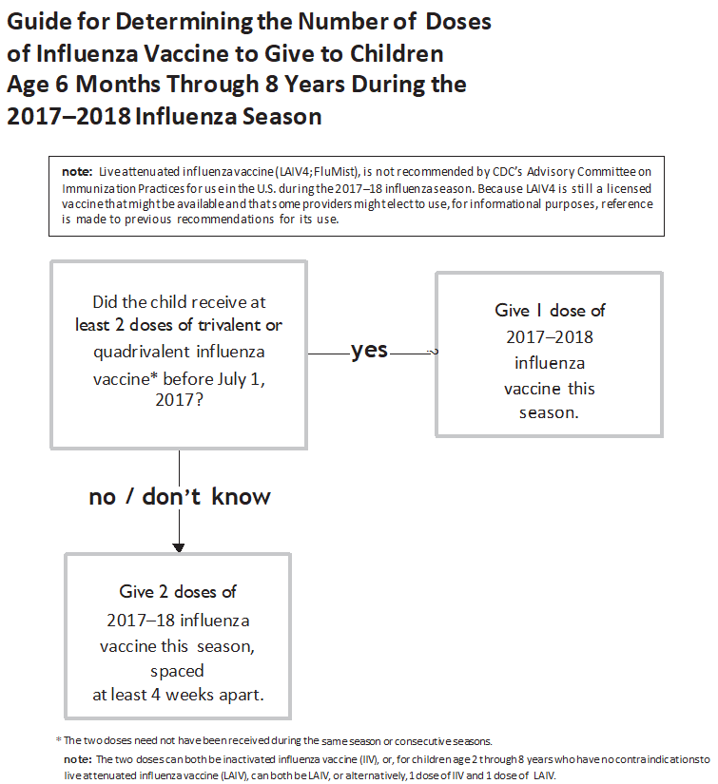
Figure 4. 2017-2018 Influenza immunization recommendations for children aged 6 to 23 months in algorithm form.

Appendix F
ORIC Approval Letter
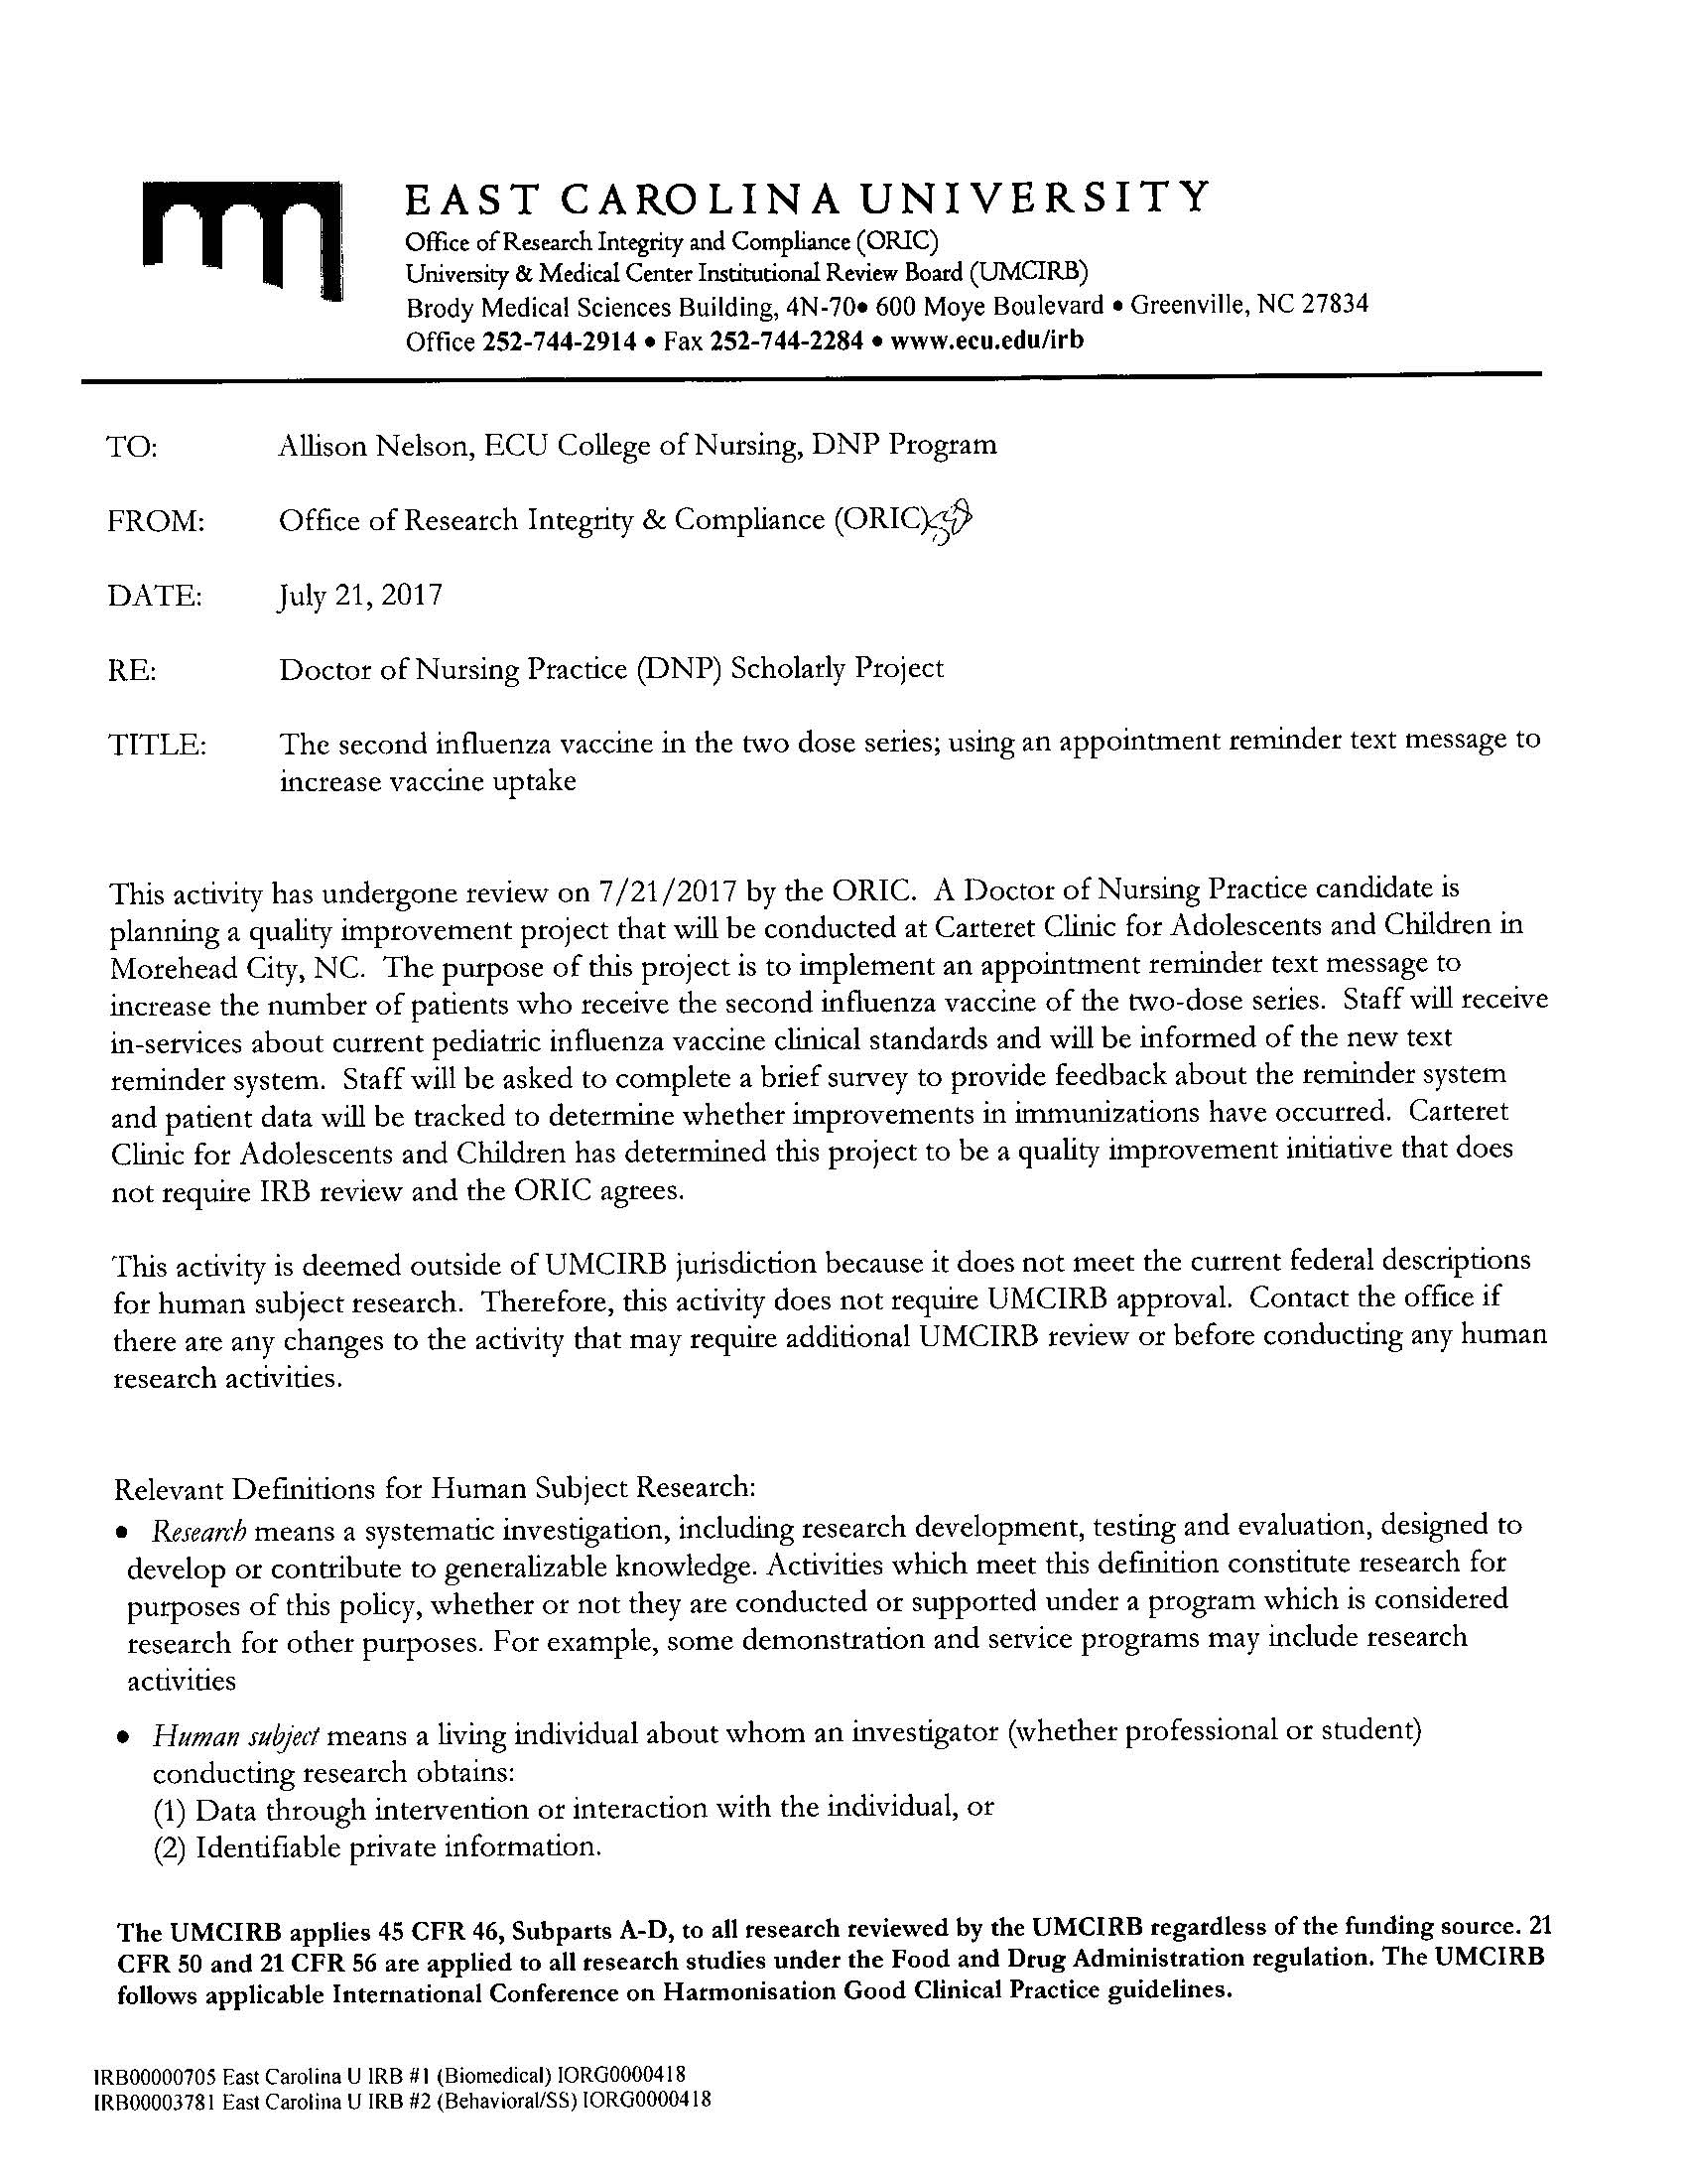

Appendix G
ECU Staff Project Proposal Acceptance
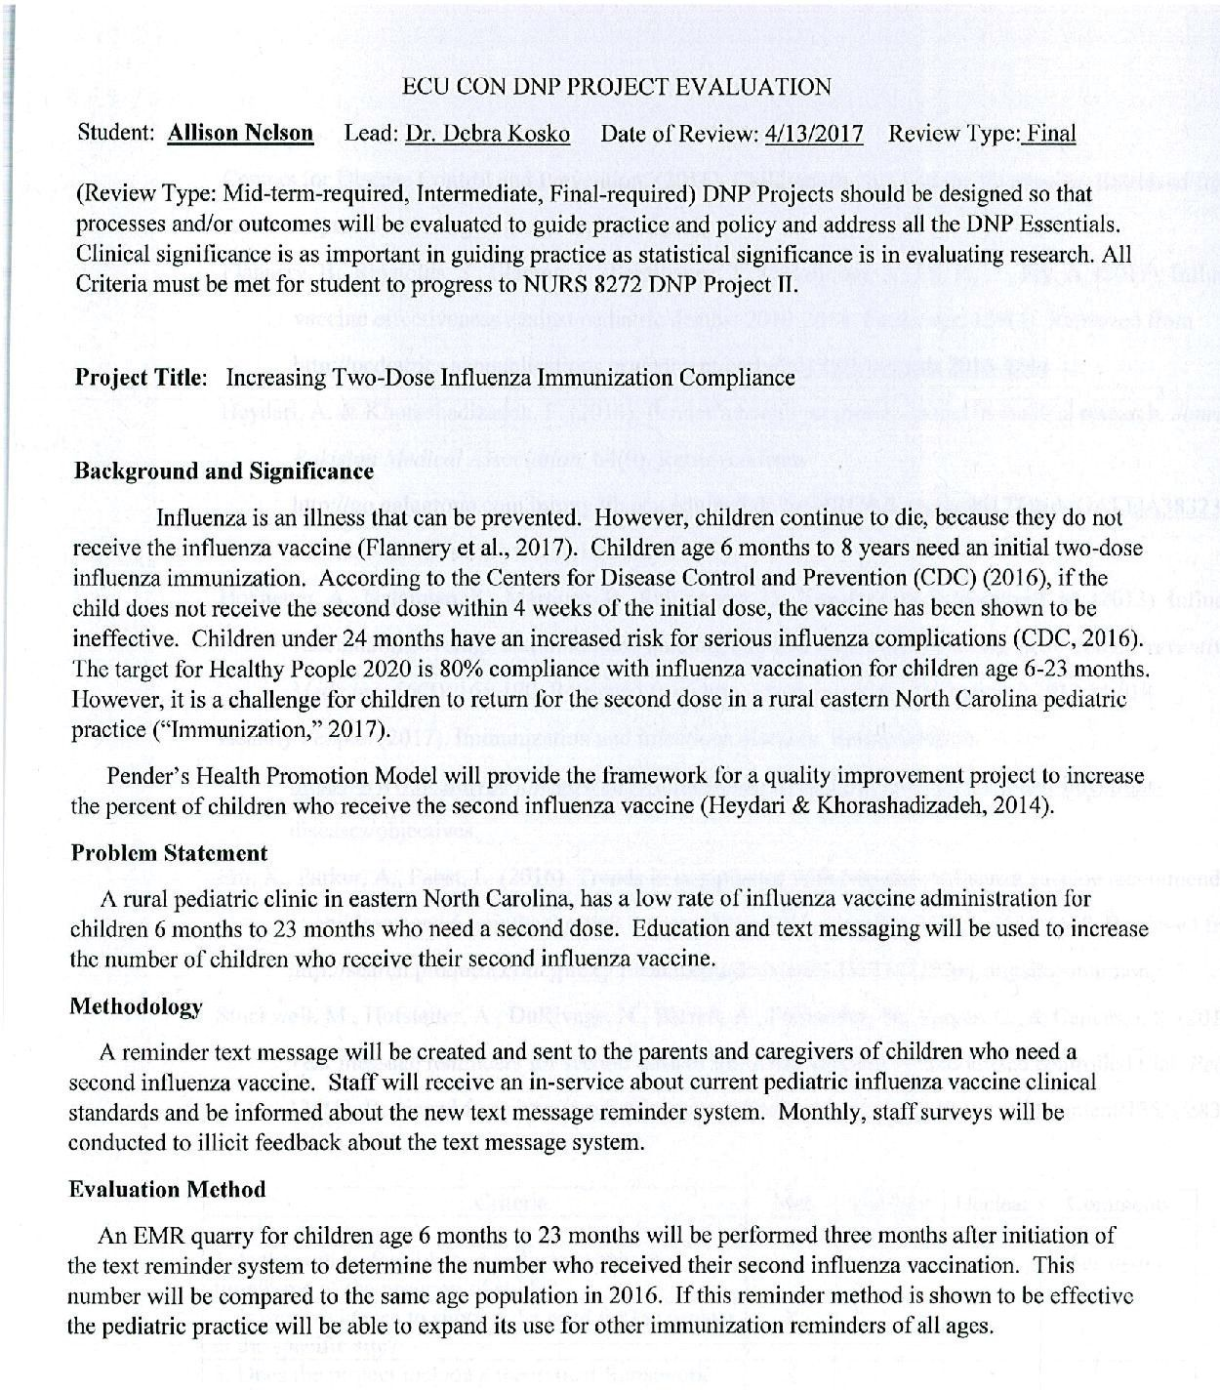

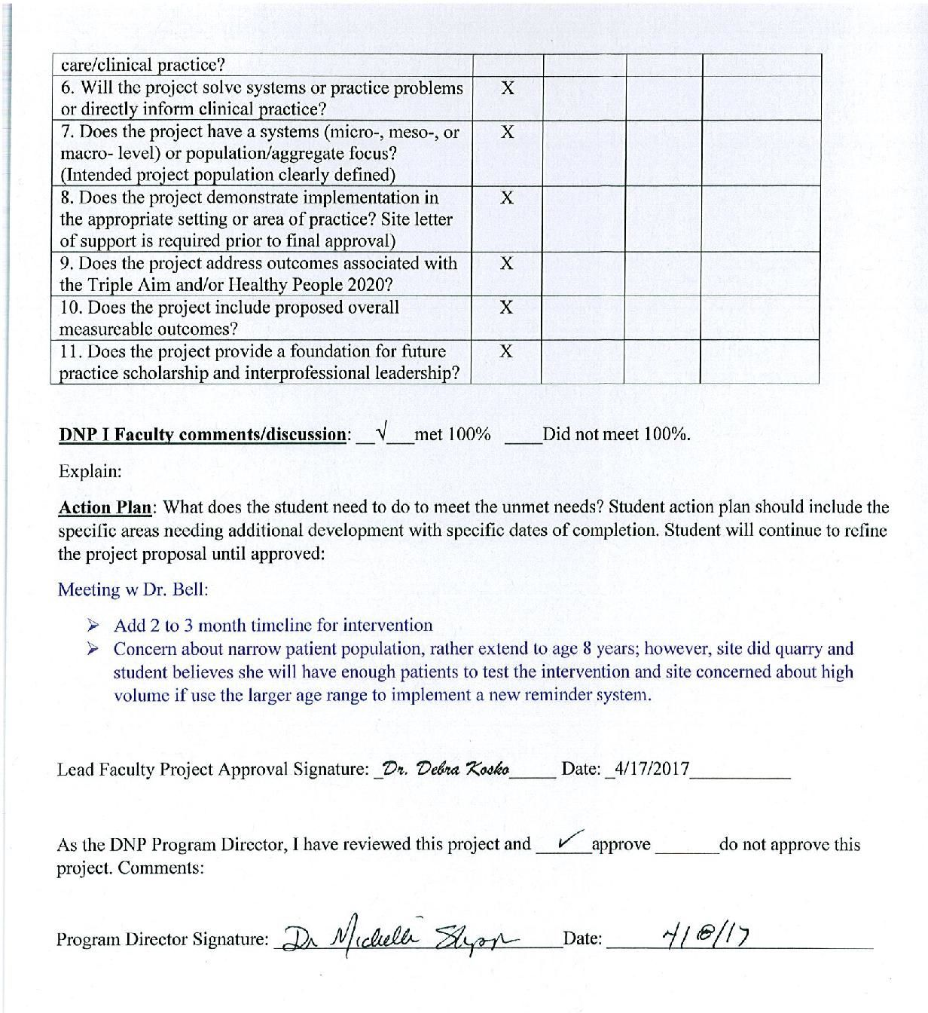

Appendix H
Site Support Letter