Dare County Quality Improvement Project for the Overweight and Obese Adult Patient
by
Michelle Paris Petty

Paper submitted in partial fulfillment of the
requirements for the degree of

Doctor of Nursing Practice

East Carolina University
College of Nursing

April 15, 2019

Signature Faculty Coordinator Date

Signature Program Director Date

Acknowledgments
This quality improvement project was partially supported by The College of Nursing TD Scholarship. I would like to thank all the generous donors for their support.
I would like to thank Debbie Dutton the Community and Clinical Services Nursing Director at the Dare County Department of Health and Human Services for her generous spirt and ongoing assistance in executing this quality improvement project.
I would also like to show my gratitude to Carol Ann King, DNP, MSN, FNP-BC, APRN for sharing her pearls of wisdom and insight with me during this project. I am immensely grateful, thank you.

Dedication
I dedicate my Doctor of Nursing Practice Project to my family. A special feeling of gratitude to my parents, Victor and Bonnie Paris who supported me in my early educational pursuits. My sister Vicki, who inspired me to return to further my education and has kept me laughing along the way. My brother Greg, for challenging me to become a better human being. My beloved husband Rob, who is my wingman in life and my greatest cheerleader, always encouraging me to chase my bliss. To my beautiful daughter Kendelle, my muse, who embodies all the wonderful qualities of who I aspire to be. And my son Brodyn, whose sunny disposition and unconditional love keeps me focused on what is most important in life. I love you all. Thank you for supporting me in everything that I do.
Abstract
Obesity is a serious disease that has tripled in prevalence since the 1980s, it affects all Americans either directly or indirectly, and attributes to several serious comorbidities and premature death. While guidelines do currently exist, provider weight management counseling is inconsistent and far from ideal. After educating the staff in a primary care setting on the importance of identifying patients with BMIs > 25 and providing those identified with weight management counseling, the staff showed a sitewide improvement in the identification of abnormal BMIs with a 37% increase in the use of corresponding overweight and obesity diagnosis codes, an 8% increase in patient weight management counseling, and an 88% increase in the use of weight management counseling billing codes.

Key words: Adult, Obesity, Overweight, BMI, Health Department, Dare County, America, United States, North Carolina, East Carolina University, Reimbursement, Weight Management, Education

Table of Contents
Acknowledgments 2
Dedication 3
Abstract 4
Chapter One: Adult Obesity in the United States of America
Overview of the Problem of Interest 10
Background Information 10
Significance of Clinical Problem 12
Question Guiding Inquiry (PICO) 12
Population 12
Intervention 13
Comparison 13
Outcomes 13
Summary 13
Chapter Two: Review of the Literature Evidence on Adult Obesity 14
Methodology 14
Sampling strategies 14
Evaluation criteria 14
Literature Review Findings 14
Guidelines 14
Indications for Improvement 16
Identifying Patients 17
Role of Health Care Providers 18
Interventions 19
Reimbursement 20
Limitations of Literature Review Process 20
Discussion 20
Conclusions of findings 21
Advantages and disadvantages of findings 21
Utilization of findings in practice 21
Summary 21
Chapter Three: Theory and Concept Model for Evidence-based Practice 22
Concept Analysis 22
Theoretical Framework 22
Application to practice change 23
Evidence-Based Practice Change Theory 23
Application to practice change 24
Summary 24
Chapter Four: Pre-implementation Plan 26
Project Purpose 26
Project Management 26
Organizational readiness for change 26
Inter-professional collaboration 26
Risk management assessment 27
Organizational approval process 27
Information technology 27
Cost Analysis of Materials Needed for Project 27
Plans for Institutional Review Board Approval 28
Plan for Project Evaluation 29
Demographics 29
Outcome measurement 29
Evaluation tool 30
Data analysis 30
Data management 30
Summary 30
Chapter Five: Implementation Process 32
Setting 32
Participants 33
Recruitment 33
Implementation Process 34
Plan Variation 41
Summary 42
Chapter Six: Evaluation of the Practice Change Initiative 43
Participant Demographics 43
Table 1 - DCDHHS Post-Adult Obesity QI Project Participants 43
Intended Outcomes 43
Findings 44
Table 2 - DCDHHS Pre-Adult Obesity QI Project Data 45
Table 3 - DCDHHS Post-Adult Obesity QI Project Data 46
Figure 1 – Data Comparison Pre- vs Post- QI Adult Obesity Project 47
Summary 47
Chapter Seven: Implications for Nursing Practice 48
Practice Implications 48
Essential I: Scientific underpinnings for practice 48
Essential II: Organization and systems leadership for quality
improvement and systems thinking 50
Essential III: Clinical scholarship and analytical methods for EBP 51
Essential IV: Information systems/technology and patient care
technology for the improvement and transformation of healthcare 51
Essential V: Healthcare policy for advocacy in healthcare 52
Essential VI: Interprofessional collaboration for improving patient
and population health outcomes 52
Essential VII: Clinical prevention and population health for
improving the nation’s health 53
Essential VIII: Advanced nursing practice 53
Summary 53
Chapter Eight: Final Conclusions 55
Significance of Findings 55
Project Strengths and Limitations 56
Project Benefits 57
Recommendations for Practice 58
Final Summary 58
References 60
Appendix A: Literature Review Log 64
Appendix B: ECU IRB Worksheet 72
Appendix C: Pre- and Post-Data Collection Tool 74
Appendix D: Contract Agreement – DCHHS and ECU 75
Appendix E: DCHHS Letter of Support 76
Appendix F: ECU CON DNP Project Evaluation 77
Appendix G: Provider Handouts 80
Appendix H: Patient Handouts - English 83
Appendix I: Patient Handouts - Spanish 92
Appendix J: Staff PowerPoint Presentation 103
Appendix K: Copyright Policy Health.gov 116
Appendix L: Pre- QI Project-Measurement Tool 117
Appendix M: Post-QI Project Measurement Tool 118
Appendix N: Outcome Evaluation Tool 119
Appendix O: Free Weight Management Apps – English 120
Appendix P: Free Weight Management Apps – Spanish 121
Appendix Q: Provider Weight Management BMI Billing Codes 122
Appendix R: Provider Weight Management Counseling Billing Information 123

Dare County Quality Improvement Project for the Overweight and Obese Adult Patient
Chapter One: Adult Obesity in the United States of America
Overview of the Problem of Interest
Obesity is a prevalent disease that is associated with several serious comorbidities (Center for Disease Control and Prevention [CDC], 2018). Therefore, it is important that providers identify patients who are overweight or obese, take the time to educate them, and provide them with information on how to access resources that will support their future weight loss efforts. The purpose of this chapter is to evaluate the significance of the obesity epidemic, to take a close look at Dare County, North Carolina, which was the location of this project site, and to give a brief overview of this quality improvement (QI) project on adult obesity.
Background Information
Obesity is a serious disease that affects all Americans, directly or indirectly. Obesity attributes to premature death and several serious comorbidities including: diabetes, hyperlipidemia, hypertension, sleep apnea, stroke, heart disease, arthritis, gallbladder disease, mental illness, and cancer (endometrial, breast, colon, kidney, gallbladder, and liver) (CDC, 2018; Shepherd, 2014; Wang, Pamplin, Long, Ward, Gortmaker, & Andreyeva, 2015). Obesity has been on the rise, having tripled in prevalence since the 1980s (Wang, Pamplin, Long, Ward, Gortmaker, & Andreyeva, 2015). According to the CDC (2018) over 93 million Americans are currently obese. This equates to more than one-third obese adult Americans and this number is projected to rise to one-half by the year 2030 (Sampath, Dinani, & Rothstein, 2016). These statistics are staggering and what’s more staggering is that some suggest the statistics from the CDC are on the low side since state estimates from the CDC use self-reported weights and heights, which results in data underestimates of about 16-23% (Wang, Pamplin, Long, Ward, Gortmaker, & Andreyeva, 2015; Ward, Long, Resch, Gortmaker, Cradock, Giles, Hsiao, & Wang, 2016).
Obesity is not only costly to one’s health but also to their wallet. The estimated annual cost of obesity-related health care in the United States (US) is about 200 billion dollars and this figure is only on the rise, by 2030 the cost of obesity-related health care is projected to increase between 48-66 billion dollars (CDC, 2018; Sampath, Dinani, & Rothstein, 2016; Voelker, 2012). In addition, individual obese Americans are estimated to pay $1,429 more per year in medical cost, as compared to those Americans who are of normal weight (CDC, 2018).
However, there is hope. A population-wide decrease in body mass index (BMI) would in turn decrease the prevalence of obesity’s many comorbidities, which would result in significant health care savings for Americans that could reach into the billions of dollars (Voelker, 2012). In addition, primary care visits in conjunction with patient education can yield positive weight loss results (Stevens, Jackson, Howes, & Morgan, 2013; Tsai, Wadden, Volger, Sarwer, Vetter, Kumanyika, Berkowitz, Diewald, Perez, Lavenberg, Panigrahi, & Glick, 2013).
Unfortunately, many health care providers do not take the time to counsel their overweight or obese patients. According to Lorts and Ohri-Vachaspati (2016), rates of counseling for obese and overweight patients by health care providers range from 25% to 67%, leaving plenty of room for improvement. They propose that providers can make a significant difference in the lives of overweight and obese patients since 82% of U.S. adults will see their health care provider this year. To achieve consistent patient education, providers must address barriers to weight loss and nutrition counseling, which include the lack of time, inadequate reimbursement, and lack of knowledge of accessible resources (Lorts, & Ohri-Vachaspati, 2016).
Dare County was selected for the location of this QI project because of geographic convenience. Dare County is a coastal area that borders the Atlantic Ocean and is the furthest easternmost county in the state of North Carolina covering an area of over 1,000 square miles (Healthy Carolinians of the Outer Banks [HSCB], 2016). The population of Dare County is around 35,000 people and is evenly divided among males and females (HSCB, 2016; United States Census Bureau [USCB], 2016). Dare County is not racially or ethnically diverse, Whites make up 87.8% of the population as compared to the state’s 71%, Blacks make up 2.7% of the population as compared to the state’s 22%, and Hispanics made up 7.1% of the population as compared to 9.2% of the state’s population (HSCB, 2016). In addition, Dare County has about 14.7% of its population who are without health insurance (USCB, 2016).
Significance of Clinical Problem
Obesity is a national health crisis and needs to be addressed as such. Currently 39.8 % of adult Americans are obese and another 31.8% are overweight (CDC, 2018). The prevalence of adult obesity in America is such that overweight and obese individuals outnumber normal weight individuals 2:1 and by the year 2030 it is projected that 85% of American adults will be overweight or obese (Smith & Smith, 2016). And in Dare County obesity rates closely reflect the national percentages currently 32.8% of Dare County residence are reportedly obese (HSCB, 2016).
Question Guiding Inquiry (PICO)
Population. Adults (individuals eighteen years of age or older) who are overweight (BMI > 25) or obese (BMI > 30) and seek care in the Dare County Department of Health and Human Services’ (DCDHHS) patient clinic.
Intervention. Clinical staff will document the patient’s height and weight, which will populate a corresponding BMI in the patient’s electronic medical record. Clinical staff will provide all individuals who meet the population criteria with a resource packet and document that the packet was given in the patient’s chart to flag the provider. The provider will then address the patient’s educational needs related to their BMI status and bill accordingly.
Comparison. Comparisons of BMI documentation, use of appropriate BMI diagnostic codes, patient weight management education, and provider billing codes were made pre- and post-QI initiative.
Outcomes. Anticipated outcomes include appropriate BMI identification with a corresponding diagnosis code, consistent documentation of patient weight management education for all adults 18 years of age and older who have a BMI at or above 25, and the use of appropriate billing codes for provider weight management education.
Summary
Obesity is a serious health crisis that affects us all. It has become increasingly important that we as a nation take steps to stop this growing epidemic and prioritize initiatives to improve health outcomes for those at risk. By implementing a QI project to target overweight and obese individuals who seek care in Dare County, North Carolina, we will be setting systems in place that have the potential to impact the obesity epidemic both directly and indirectly, and may improve health outcomes for individuals who seek care at the Dare County Department of Health and Human Services’ outpatient clinic.

Chapter Two: Review of the Literature on Adult Obesity
An extensive literature review was performed using search engines including East Carolina University’s Lampus Library, Cumulative Index of Nursing and Allied Health Literature (CINAHL), and PubMed. Research included the topics of adult obesity and literature on current guidelines for the management of overweight and obese adults.
Methodology. Literature review was implemented using several online search engines including PubMed, CINHAL, East Carolina University’s (ECU) Lampus Library, and Google Chrome. In addition, supplemental content was used from several government websites including CDC, Office of Disease Prevention and Health Promotion (ODPHP), and the Centers for Medicare and Medicaid services.
Sampling strategies. Search strategies used key terms including adult, obesity, education, primary care, guidelines, interventions, United States, public health, obesity management, apps and obesity, free weight management apps, billing codes for overweight and obese patients, weight management counseling, and obese patient education materials.
Evaluation criteria. Literature was evaluated on content to include the adult population (18 years of age and older), obese and overweight patients (BMI at or above 25), the primary care setting, weight management counseling, provider reimbursement, and billing codes. See Appendix A.
Literature Review Findings
Guidelines. In 2000, a National Institutes of Health panel described obesity as a chronic disease, which led to the American Medical Association adopting a policy in 2013, which recognized obesity as a disease (Brunton, 2014). Since the mention of obesity as a chronic disease in 2000, there have been several national recommendations and policies implemented to improve the management of obese patients (Fitzpatrick & Stevens, 2017). The U.S. Preventive Services Task Force (USPSTF), the American Heart Association, American College of Cardiology, and the Obesity Society have all recommended that providers screen for overweight and obese patients in their practices and provide patients identified with risk factors for cardiovascular disease additional intensive behavioral counseling (Fitzpatrick & Stevens, 2017).
In 2011, the Centers for Medicare & Medicaid Services (CMS) supported a policy to reimburse primary care providers for taking the time to provide intensive behavioral therapy for obese patients (Brunton, 2014; Fitzpatrick & Stevens, 2017). This policy supported the reimbursement of primary care providers providing intensive behavioral therapy for obesity as a stand-alone billable service, so long as the care was for Medicare beneficiaries, using the 5 A’s of counseling framework, and within a 10-15-minute period of face to face counseling (Brunton, 2014; Fitzpatrick & Stevens, 2017). The CMS also implemented the Electronic Health Record (EHR) Meaningful Use Incentive Program, this program gave providers financial incentives for the use of EHR to document QI measures including: BMI, treatment, follow-ups, and/or referrals for patients identified with a BMI > 25 (Brunton, 2014; Fitzpatrick & Stevens, 2017).
The 2013 Report of the American College of Cardiology/American Heart Association Task Force on Practice Guidelines and The Obesity Society released recommended guidelines and an algorithm for the management of overweight and obese adults, which included: the assessment of risks associated with obesity and overweight individuals, benefits of subsequent weight loss, and treatments for weight loss (Brunton, 2014; Jensen, et al, 2013). The treatment suggestions for weight loss included dietary changes, lifestyle changes, and for some bariatric surgery (Jensen, et al., 2013).
Indications for Improvement. Despite the recent practice recommendations and clinical practice guidelines for the management of overweight and obese patients, obesity management in the primary care setting is less than optimal. Studies indicate that most patients would like the opportunity to discuss weight loss with their provider however, diagnosis and treatment rates for obesity remain low (Barnes, Theeke, & Mallow, 2015; Fitzpatrick & Stevens, 2017; Kushner & Ryan, 2014).
Relatively few patients receive obesity counseling consistent with the current recommended guidelines despite providers’ access to guidelines and patients’ desire for counseling. It has been noted that more than two-thirds of patients with obesity in the United States are not being offered or referred for appropriate treatment of their obesity by their primary health care provider (Fitzpatrick, Dickens, Avery, Ventrelle, Shultz, Kishen, & Rothchild, 2017).
This inconsistency in care can be attributed to both patient and provider factors. Patients have several barriers to care that may include feeling judged by providers, feeling a lack of desire from the provider to assist them with their weight loss, the lack of proper education and awareness of the chronic nature of being overweight or obese, compromised socio-economic status, time constraints, lack of social support systems, other co-morbidities, medications, and/or substance abuse problems (Barnes, Theeke, & Mallow, 2015).
In addition to patient barriers to care of the overweight and obese patient, there are also provider barriers of care to consider. Provider contributing factors and barriers to optimal care of the overweight and obese patient include the lack of provider confidence in obesity management, concerns about the efficacy of treatment, frustrations with prior attempts and perceived failures, negative attitudes toward obese patients, thoughts that obese patients are lazy, thoughts that obese patients should be able to manage their own weight, perceptions that obese patients lack time for exercise, and/or the perception that obese patients lack self-control (Barnes, Theeke, & Mallow, 2015; Petrin, Kahan, Turner, Gallagher, & Dietz, 2016). In addition, the lack of the use of objective screening tools by providers contributes to the subpar treatment of overweight and obese patients resulting in an increase in negative health outcomes for the overweight and obese individual (Barnes, Theeke, & Mallow, 2015).
Identifying Patients. The current standard of care in both identifying and quantifying the overweight and obese patient is the use the patient’s body mass index (BMI) (Barnes, Theeke, & Mallow, 2015). A persons BMI is the measurement of body fat and is calculated using the individual’s height and weight. Therefore, the evaluation of patients should include a current height, weight, and calculated BMI at each clinical visit (Millen, Wolongevicz, Nonas, & Lichtenstein, 2014). BMI’s should be further categorized to include the overweight population (BMI greater than 25 to 29.9) and the obese (BMI greater than or equal to 30) (Millen, Wolongevicz, Nonas, & Lichtenstein, 2014).
It is important to note that there are some issues with using the BMI solely to assess a patient’s health status. For some BMI’s are too general and do not consider the individual’s gender, build, age, or ethnicity. George (2017) reported that professional athletes who are often very healthy are considered overweight or obese when using their BMI because their build is so dense secondary to muscle tissue, which weighs more than fat and conversely, individuals loose density in their bone mass as they age, which may result in the calculation of a normal BMI when in fact they may be more accurately classified as overweight or obese. These additional variables should be considered by providers during their assessment and physical exam in addition to the calculated BMI.
Role of Health Care Providers. The U.S. Preventative Service Task Force (USPSTF) (2012) recommends all adults be screened for obesity. The USPSTF guidelines recommend that individuals who are identified as having a BMI greater than 30 should receive intensive, multicomponent behavioral interventions. The USPSTF recommendations are based on evidence that showed counseling obese patients resulted in a 6% body weight loss, which in turn improved serious comorbidities and cardiovascular disease risk factors such as hypertension and/or hyperlipidemia, compared with those individuals’ who did not receive weight management counseling from their provider (Petrin, Kahan, Turner, Gallagher, & Dietz, 2016).
Patients who have been counseled by their health care providers regarding weight management have shown a consistent increase in odds of clinically significant weight loss of at least 5% (Petrin, Kahan, Turner, Gallagher, & Dietz, 2016). Weight management counseling from providers has also been shown to substantially affect a variety of health outcomes, in addition to weight, and these educated patients are in turn more likely to perceive themselves as overweight or obese, and are more likely to report a readiness to start attempting weight loss efforts (Petrin, Kahan, Turner, Gallagher, & Dietz, 2016).
The role of the primary health care provider is key for patients who are overweight or obese. Brunton’s (2014) systematic review and meta-analysis of over 207 thousand individuals in the United States, showed the positive impact of advice given by primary care providers regarding patient’s weight loss efforts. It concluded, that the greater the support provided by the primary healthcare provider, and the better the perceived provider communication, the greater the overall weight loss (Brunton, 2014).
Appropriate management of overweight and obese patients should include provider documentation of the diagnosis of overweight or obesity. Appropriate provider documentation and corresponding diagnosis codes positively correlate with documentation and implementation of treatment for the overweight and obese patient (Barnes, Theeke, & Mallow, 2015). The 2013 guidelines recommend recording patients’ height, weight, and BMI annually, and more frequently depending on the individuals risk factors (Jensen, et al., 2013).
Interventions. Kushner and Ryan (2014) suggest the management of the overweight and obese adult patient should start with the screening of all adult patients. In addition to height, weight, and BMI a thorough medical history should be obtained and include the patient’s diet, physical activity habits, psychosocial factors, weight gaining medications, and family history (Kushner & Ryan, 2014).
Once the overweight and obese adult patients are identified, their level of readiness for change should be assessed, and a thorough health history taken. The health care provider should then assist their overweight and obese patients with their weight loss efforts through patient counseling and proper interventions (Goldkamp, Anderson, Lifits‐Podorozhansky, & Gavard, 2015; Kushner & Ryan, 2014). Interventions should include weight loss through lifestyle changes, which may include a reduced calorie diet, aerobic activity, and structure to support their efforts (Goldkamp, Anderson, Lifits‐Podorozhansky, & Gavard, 2015). Treatment counseling efforts can be implemented in the health care provider’s office, through a referral to a registered dietician, or weight loss program (Kushner & Ryan, 2014). The initial goal should be a weight reduction of 5% to 10% to achieve significant health benefits (Barnes, Theeke, & Mallow, 2015; Kushner & Ryan, 2014).
Kushner and Ryan (2014) suggest is not necessary for patients to reach a BMI of less than 25 to see clinically significant results. They report there is strong evidence that a weight loss of 5% - 15% can greatly reduce the risk of several comorbidities including: cardiovascular disease, type 2 diabetes, and sleep apnea. In addition, they state any sustained weight loss of as little as 3% - 5% may result in clinically significant improvement of high triglycerides and elevated blood sugars, and greater levels of weight loss may further reduce blood pressure, blood sugar, and cholesterol levels resulting in the reduction or even the elimination of medications to control these chronic conditions.
Reimbursement. Insurance companies have responded to recent guideline updates for the management of overweight and obese adults in America and have expanded their coverage of care to include obesity screening and counseling (Wang, Pamplin, Long, Ward, Gortmaker, & Andreyeva, 2015).
Limitations of Literature Review Process
The literature review yielded large results. Search terms used were easily linked to a variety of comorbidities and subjects that were outside the scope of this QI project. Search terms used included adult obesity with the inclusion of current statistics, United States, English, comorbidities, treatment, prevention, resources, diet, exercise, BMI criteria, billing codes, reimbursement, primary care, and current guidelines. Exclusion criteria during the literature review included pediatrics and adolescents.
Discussion
Overall the literature review was compelling and supported the following ideas:
- obesity is currently a major health concern
- individuals should be screened and counseled by their health care providers
- use of patients’ BMI was an appropriate screening method for identifying and classifying overweight and obese patients
- interventions for weight loss and patient education should focus on lifestyle changes through calorie reduction, activity, and support of patient efforts
- reimbursement is available for health care providers through insurance companies for their time used to counsel overweight and obese adult patients
Conclusion of findings. The literature review provided a large body of evidence, which supports the clinical importance and efficacy of treatment for the overweight and obese adult.
Advantages and disadvantages of findings. Advantages included the support of BMI screening at all visits with the health care provider, supportive national guidelines, data to support clinical efficacy for treatment efforts, and reimbursement support for providers.
Disadvantages were that most successful outcomes relied heavily on the patient’s motivation and less on the provider’s specific interventions, and incentives of reimbursement for health care providers were rarely addressed.
Utilization of findings in practice. Fortunately, the interventions set forth by the USPSTF to manage the overweight and obese population in America can be implemented in any care setting. Therefore, a QI intervention at the Dare County Department of Health and Human Services that is backed by current reliable research and aligns with the current governmental guidelines can be seamlessly apply.
Summary
A comprehensive literature review was implemented to search for viable interventions for the overweight and obese adult. There was a considerable amount of research to support the need for BMI screenings, counsel from health care providers, patient lifestyle changes in the form of diet and exercise, and patient support systems.

Chapter Three: Theory and Concept Model for Evidence-based Practice
Rogers theory, Diffusion of Innovations, relies on social systems and human capital to spread new ideas, which supports the concept of QI and was the theoretical framework used to guide this project (Rogers, 2003). The purpose of this chapter is to analyze concepts used in Rogers’ theory, to look at the framework of the Diffusion of Innovations Theory, and to explain how this theory may be used to carry out changes within the health care system.
Concept Analysis
Roger (2003) explains that his Diffusion of Innovations Theory is based on three major concepts: diffusion, communication, and innovation. Roger describes diffusion is as the process in which innovation is communicated through human interaction such as conversation, documentation, education, and role modeling, over time, among those individuals who are part of the same social system. He defines communication as the process in which individuals within the same social system, create and share information, with one another, to reach a mutual understanding, and innovation is an idea, practice, or object that is perceived as new to an individual or social system for adoption (Rogers, 2003).
Theoretical Framework
Rogers’ Diffusion of Innovations Theory explains how new ways of thinking or practice ideas can be translated and adopted by and into social systems. Roger (2003) bases his theory on four main elements innovation, communication, time, and social systems. Rogers defines innovation as the perception of a new idea or concept, communication as the process by which the individuals in a social system share information or concepts with one another, time as the amount of time or rate at which the innovation is adopted, and social systems as the interrelated units made up of individuals, groups, organizations, or subsystems that share ideas to accomplish a common goal (Rogers, 2003).
Application to practice change. The QI initiative at the Dare County Department of Health and Human Services relied heavily on Rogers’s theory and concepts to translate innovation into practice among staff members. The innovation of new practice ideas was implemented during an initial staff meeting that included mutual goal setting to increase the number of patient’s being identified as overweight or obese using their BMI’s, receiving patient education packets and related counsel, and to communicate appropriate and easy access to billing codes to increase reimbursement rates and to provide financial incentives to the organization. Communication efforts relied on the daily interaction between staff members and the adoption of QI efforts through behavior, new expectations, and dialog. Time was an organic variable and adoption rates were facilitated by financial incentives, initial mutual goal settings, and the quality of the relationships that existed among staff members before the QI project. Social systems were already in place and included all clinical staff and providers that participated in adult patient care and triage at the Dare County Department of Health and Human Services’ Clinic.
EBP Change Theory
Roger’s Diffusion of Innovation Theory was used to guide this QI project because of its seamless systematic approach on how to spread a new idea. Rogers’ theory easily explains how over time a new idea can gain momentum and spread through the social network or in this case the clinical setting (Rogers, 2003). In the end, the result of diffusion is the adoption of the new idea and new way of doing things. It is the perception of the idea or intervention as new that makes it appealing and diffusion possible (Rogers, 2003).
The adoption of the new idea or intervention does not usually happen simultaneously, but rather systematically, starting with those who are innovative thinkers (Rogers, 2003). Innovative thinkers are those individuals who are venturesome and like to try new things (Rogers, 2003). The idea continues systematically through the path of least resistance based on the individual’s personality traits. Next, one would expect to see conversion by the early adopters. The early adopters are generally those in leadership roles and are already aware that change is needed (Rogers, 2003). This trend of diffusion would continue sequentially to the early majority (those who convert sooner based on supportive evidence), the late majority (those who are the skeptical and who will only adopt change once it has been adopted by the majority), and finally the laggards (these tend to be conservative individuals that are bound by tradition) (Rogers, 2003).
Application to practice change. The innovation for this QI project was initiated after an educational staff wide meeting that introduced the concept to consistently classify each adult’s weight status based on their BMI. The adoption of this idea relied on the Diffusion of Innovation Theory to use their clinical social system to naturally disseminate or diffuse this new way of classifying patients throughout the clinic. The acceptance of this change set in motion seamless identification of overweight and obese adult patients with BMIs >25, which flagged the staff to provide a resource packet, subsequent provider weight management counseling, and the use of billing codes for reimbursement of the weight management counseling provided.
Summary
Rogers Diffusion of Innovation Theory provided a solid framework to guide this QI project. By understanding the concepts of innovation, communication, diffusion, and social systems one was able to foster a new idea founded by evidence-based practice, communicate it effectively in an established social system that provides care to this population of interests, and to anticipate and allow time for diffusion to occur.

Chapter Four: Pre-implementation Planning
The pre-implementation phase of this QI initiative focused on collaborating with staff at the DCDHHS to identify a viable project site, one that would be both ready and able to assist QI efforts for their adult overweight and obese patients. In addition, collaboration with fellow student and faculty colleagues generated input and feedback that aided decision making efforts on which outcomes should be evaluated. The purpose of this chapter is to identify the process of this QI initiative, discuss components of project management, identify cost, IRB approval, and the plan for project evaluation.
Project Purpose
The purpose of this project was to improve identification, diagnosis, patient education, and the use of subsequent billing codes for all overweight and obese adult patients who sought care at the DCDHHS clinic.
Project Management
Organizational readiness for change. When the DCDHHS was approached as a possible clinical site to perform a QI project related to adult obesity, their Clinical and Community Services Nursing Director acknowledged that they had both a need and desire to address the obesity epidemic in their adult population. Hence, the DCDHHS’s readiness for change was clearly communicated.
Inter-professional collaboration. The Clinical and Community Services Nursing Director at the DCDHHS facilitated efforts to carry out the obesity QI project at the DCDHHS Manteo site, served as a main point of contact for project approvals, identified staff members who were interested in educating the overweight and obese adult population at their facility, and identified a viable site champion for the project.
Risk management assessment. A risk assessment of the DCDHHS was done using a SWOT analysis. Strengths identified through the assessment included the staff’s readiness to change, encouragement of new ideas and policy initiatives, professional and consistent communication efforts, staff’s awareness of the current obesity crisis, and a preexisting commitment to serving the community. Weaknesses identified included the lack of a consistent site wide approach to the overweight and obese adult patient and the lack of a policy to address management of these patients. Opportunities noted included a high percent of obese adults living in Dare County, access to free weight management apps for patients who use a smart phone or have a home computer; the ability to bill for provider weight management education; and free community transportation. Lastly, threats found using the SWAT analysis included possible coverage changes and discrepancies, access to care, access to healthy food, and potential knowledge deficits.
Organizational approval process. The DCDHHS had an existing contract with East Carolina University (ECU), which facilitated a seamless partnership. The DCDHHS did not require an IRB review and the IRB review board at ECU determined the QI project did not qualify as human research, and subsequently did not need to go through a formal IRB process. See appendix B.
Information technology. Information technology was used to randomly audit charts pre- and post-project implementation from the DCDHHS’s computer charting system. The use of technology enabled, the automatic calculation of patient BMI’s, calculation of patients’ current age based on date of birth data entry, quick access to diagnosis codes, documentation within the provider’s notes, and use of billing codes.
Cost Analysis of Materials Needed for Project
Table 1
DNP Obesity Project Budget

Line Item | Quantity | Cost Per Unit  (Dollars) | Total  (Dollars)
Travel
Gallons of Gas | 24 | 2.85 | 68.40
Food
Mini Scones Platter | 1 | 16.99 | 16.99
Loaf Cake Platter | 1 | 20.99 | 20.99
Fresh Fruit Tart Platter | 2 | 30.99 | 61.98
Fresh Fruit Platter | 1 | 24.50 | 24.50
Combo Breakfast Platter | 1 | 18.99 | 18.99
Mini Croissant and Bagels Platter | 1 | 15.99 | 15.99
Wraps Platter | 1 | 59.99 | 59.99
Fresh Fruit Display | 1 | 29.99 | 29.99
Pot Roast Sliders Platter | 1 | 19.99 | 19.99
Vegetables and Dip Platter | 1 | 49.99 | 49.99
Tea Cakes Platter | 1 | 23.99 | 23.99
Beverages
Bottle Water (24) | 3 | 4.49 | 13.20
Low Fat Milk (Gallon) | 1 | 4.49 | 4.49
Plant Based Milk | 2 | 4.50 | 9.00
Serving Supplies
Cups (16) | 2 | 1.00 | 2.00
Napkins (20) | 4 | 1.00 | 4.00
Paper Plates (10) | 8 | 1.00 | 8.00
Cutlery (48) | 3 | 2.99 | 8.97
Tongs | 9 | 1.00 | 9.00
Office Supplies
Pocket Folders Box (25) | 8 | 7.50 | 60.00
Folder Labels | 175 | .50 | 87.50
Color Copies per Sheet | 2,500 | .09 | 225.00
Laminator | 1 | 21.99 | 21.99
Thermal Laminating Pouches (50) | 1 | 12.91 | 12.91
Total |  |  | $877.85
Plans for Institutional Review Board Approval
IRB approval was initiated through ECU. Submission for project approval included a worksheet (Projects Requiring IRB Review vs. Quality Improvement, Quality Assessment, or Quality Assurance: A Worksheet to Assist in Determining When IRB Review is Required) to determine the need for IRB review. In addition, all project information was submitted to the IRB board, which included: an IRB worksheet, project data collection and outcome tools for pre- and post-project implementation, existing contract agreement between the DCDHHS and ECU, a letter of support from the DCDHHS project site, project proposal approval from the Project Team Faculty Lead, hand out for providers, each handout for patients in both English and Spanish, staff PowerPoint presentation, and the copyright policy giving permission to use handouts and PowerPoint from health.gov. After reviewing the IRB worksheet and project materials ECU concluded that the obesity QI project did not directly involve human subjects and therefore, did not require a formal IRB review. See Appendixes B & F.
Plan for Project Evaluation
Demographics. Demographic information collected included: patient’s age (reported as 18 years of age and older) and patient’s BMI (reported as equal to or greater than 25). Each patient had a BMI, which was automatically calculated in the electronic chart once the patient’s height and weight was entered at triage. In addition, each chart had an associated age with entry of their date of birth. The pre- and post-data collection tool was used to identify those individuals who met the inclusion criteria from the 100 randomly audited charts. See data collection tool in Appendix C.
Project Outcomes. The project looked at whether (yes or no) a diagnosis code was associated in each adult patient’s chart who had a BMI > 25, whether (yes or no) weight management education was provided to the overweight adult patient and documented in the chart, and whether (yes or no) a weight management counseling billing code was used. The outcomes were measured before and after the QI initiative and one PDSA cycle, which was used to make changes based on the staffs’ verbal input. The pre- and post-data collection was done using two random chart audits. The number of yes answers for each outcome were compared from the chart audit prior to the QI initiative and the chart audit after the QI initiative, to see if there was any improvement in the use of BMI associated diagnoses codes, the frequency of patient weight management education, and/or an increase in the use of weight management counseling billing codes.
Evaluation tool. The evaluation tool provided a comparison of the number of charts that had a diagnosis code associated with a BMI > 25, documentation of weight management counseling, and the use of a weight management counseling billing code. This collection tool was used both before and after the implementation of the QI project initiative to evaluate if there was an increase in the number of yes responses, for each outcome, after the QI effort. See Appendix F.
Data analysis. Data analysis was used to evaluate whether the QI efforts increased the overall number of yes answers, for each outcome measure. The pre- and post-data collection tools were compared to determine if the improvement efforts showed an increase in yes answers for: the use of BMI diagnosis codes, documentation of patient weight management education, and the use of provider weight management counseling billing codes.
Data management. Tools used to document data were on paper and void of patient identifiers. Tools used were kept secure in an unidentified folder until it was manually entered onto a personal desktop, again without any patient identifiers.
Summary
The pre-implementation phase of this adult obesity QI project led to a viable project site at the DCDHHS. The SWOT analysis provided a risk assessment, which aided the identification of potential opportunities for the DCDHHS to use in this QI effort. In addition, a project budget was created along with several outcome tools. Lastly, the IRB process was seamless secondary to the preexisting contract between ECU and the DCDHHS and because data collected was void of any individual patient identifiers.

Chapter Five: Implementation Process
The implementation of this adult overweight and obesity QI initiative took place over a 12 week period, during the Fall of 2018, at the DCDHHS. Initially there was a meeting with the DCDHHS’s Community and Clinical Services Nursing Director to discuss the implementation plan, data that would need to be collected, parameters for pre- and post-implementation chart audits, content of a staff educational meeting, the number of patient education packets needed, the population’s language barriers, and the scheduling of dates for chart audits, staff educational lunch, and subsequent meetings.
The overall QI initiative focused on educating the staff at the DCDHHS on the importance of weight management education for their overweight and obese adult population. The staff was encouraged to identify adult patients consistently and appropriately who have a BMI >25, to provide those identified with a weight management education packet in their preferred language during rooming so they could have an opportunity to review the information while waiting for the provider. Providers would then discuss weight management efforts with the patient, give needed weight management counseling, and document that weight management counseling had been given in the patients’ EMR. Lastly, providers were educated on how to code BMI’s and how to bill for weight management education services to ensure provider compensation and to present an additional financial incentive.
Setting
The DCDHHS clinic is located on Roanoke Island in Manteo, North Carolina. The DCDHHS clinic includes a Community and Clinical Services unit, which provides many services to the area including: adult health, prenatal care and management, maternal health, family planning, newborn and post-partum assessments, child health, immunizations, preventative screenings, physicals, laboratory testing, school and dental health and disease surveillance (Dare County North Carolina, 2018).
Participants
The DCDHHS Community and Clinical Services unit had three providers during the time of this QI project implementation phase which included a full time midwife, physician’s assistant, and a part-time medical doctor. For this QI initiative, the entire staff including all providers, nurses, social workers, dieticians, and clerical staff were involved. Although actualizing clinical changes and patient education deferred to providers and their nurses, further patient education needs had the potential to transfer to the dietitians, necessary patient resources to the social workers, and billing changes and coding efforts to the clerical staff. Therefore, education regarding the overweight and obese adult QI initiative was provided to all the Manteo staff at the DCDHHS Community and Clinical Services unit.
Each of these providers saw a wide range of clinical cases on any given day therefore, the focus was limited to those individuals seeking adult health or family planning care with one of the providers and who were 18 years of age or older. In addition, individuals seeking family care specifically for prenatal care were omitted. Next, patient education efforts were limited to all those individuals who met the above mentioned criteria and who had an abnormal BMI > 25.
Recruitment
Recruitment of providers and staff was facilitated by the DCDHHS’s Community and Clinical Services Nursing Director who invited them to participate in an educational luncheon that included an overview of the adult overweight and obesity QI initiative. Staff participation thereafter was voluntary and widely accepted. In addition, patient charts used in the pre- and post-QI initiative audit were selected based on pre-implementation and post-implementation dates and ages of the individuals. In addition, no patient identifiers were collected.
Implementation Process
The implementation process focused on QI through a team process and quantitative data collection using patient health records. The team process was important because it acknowledged that the inclusion of each member of the staff would enable a collective knowledge with varying insights, skills, experience, and perspectives. In addition, the team process challenged the entire staff to collectively reach common goals, identify potential barriers, carry out sustainable changes, and ultimately improve the quality of care provided to their patients.
The collection of quantitative data from the EMR was also an important inclusion in the implementation process. Pre-QI data collected through an initial chart audit deemed useful in establishing a baseline of the care being given at the DCDHHS for the overweight and obese adult patient. This baseline data enabled us to determine the effectiveness of current practice approaches, coding, and billing efforts and to validate that a team wide improvement effort would be useful. In addition, data collected post-QI efforts when compared to initial baseline data validated that the team process approach and QI efforts were both successful in rendering improvements in the overall quality of care for the overweight and obese adult patients at the DCHHS clinic.
The implementation process itself was systematic and started with a meeting with the DCDHHS’s Community and Clinical Services Nursing Director to discuss the proposed implementation plan. During this meeting there was detailed discussion of data that would need to be collected both pre- and post-QI project. The Nursing Director was informed that data collected would include whether the patient was 18 years of age or older and if they had a BMI of 25 or greater. If the answer was yes to both inclusion criteria, further data collection would look at whether a BMI diagnosis code was assigned to the patient, whether weight management education was provided and documented in the EMR, and whether a billing code was used for the weight management counseling provided. The nursing director was then provided with supportive documents outlining a proposed data collection tool and reassurance that no patient identifiers would be included. See Appendix C.
The initial meeting also included a discussion of the need for two chart audits. It was agreed upon that the responsibility of providing a list of charts for auditing would fall back on the Nursing Director. It was then decided that the parameters for pre- and post-QI implementation chart audits would be based on the dates of the patient visit for pre- and post-QI change and the age of the patient to include those individuals seen in the given timeframe who were 18 years of age or older.
The Nursing Director was also provided with the content of a staff educational PowerPoint that would be used to educate the staff on the current state of obesity in America and the need for QI efforts in the primary care setting. This PowerPoint presentation was retrieved from health.gov and shortened to accommodate the timeframe of a subsequent one hour educational luncheon for the staff. See Appendix J.
After outlining the QI initiative and providing the DCDHHS’s Community and Clinical Services Nursing Director with project materials, the remainder of time of the initial meeting was used to gather information. It was important to inquire about the number of patient education packets that would be required since these would be prepared beforehand. Also, prior research of the site indicated that there was a large Hispanic population indicating potential language barriers. Therefore, information regarding the number of patient weight management education packets in Spanish was also important to render. Lastly, the scheduling of dates for chart audits, the initial staff education luncheon, project implementation timeline, and subsequent meetings were finalized.
At the pre-QI project implementation chart audit the Nursing Director provided a list of names of potential charts for auditing. The EMR was used by the Nursing Director to pull together a list of all patients that were seen at the DCDHHS clinic from January 1, 2018 through June 30, 2018 at an adult health or family planning visit, who were between the ages of 18 through 150 years old, and of any gender. The Obesity QI Project Data Collection Tool (see Appendix C) was then used to collect data on the first 100 individuals from the provided list of automated names who were seen by a provider and who were not seen for a prenatal visit. The number of 100 charts was chosen for inclusion. Data collected included whether the patient was 18 years of age or older and whether they had a BMI > 25. If the answer was yes to both initial questions, follow up data collection then included whether a diagnosis code was assigned to the abnormal BMI, whether patient weight management education had been given and documented in the chart, and whether a subsequent weight management counseling billing code had been used.
The pre-QI project chart audit was followed by an hour long clinic-wide luncheon during which a PowerPoint presentation was presented along with supplemental patient information packets. See Appendixes H, I, & J. Patient weight management information packets were preassembled for both English and Spanish speaking individuals. Initially, the staff was provided with 100 English patient weight management packets and 25 Spanish patient weight management packets. Later, 25 additional Spanish patient weight management packets were provided upon request form the Nursing Director.
Each patient weight management packet included handouts retrieved from health.gov. These handouts simply and colorfully outlined information on how to build healthy eating patterns, how to shift to healthier food and beverage choices, how to cut down on saturated fats, and how to cut down on sodium. In addition, each patient weight management packet included a simple flyer with basic information on free weight management applications for smartphones or tablets. See Appendixes O & P.
During the initial staff luncheon all providers were presented with an additional packet, in addition to the patient weight management packets. These provider packets included a copy of the PowerPoint presentation, handouts retrieved from health.gov on how to speak to patients, all the content from the patient weight management packets, and a two sided laminated coding sheet, which included BMI diagnostic and billing codes. See Appendixes G, Q, & R.
The initial lunch was an hour long. The content was presented in an informal and open manner to allow room for plenty of discussion and support of the group process. The food was catered by a local grocery store chain and included a variety of healthy options as well as some vegan choices. Beverages were limited to bottles of water and dessert was also included which, prompted a lot of discussion in leu of the project’s topic of obesity. This open discussion allowed for easy transition into several of the topics covered in the patient handouts and the ability to reinforce the idea that only small changes are needed in weight management efforts to render significant results over time.
On the first day of the clinical portion of the QI implementation plan, clear and labeled bins of pre-assembled patient weight management information packets were left at the nursing station. Nurses were encouraged to give the patient weight management packets to individuals in their native language, during all adult and non-prenatal family planning visits when those patients met the criteria of being both 18 years of age or older and had an abnormal BMI > 25.
The rationale was that during triage each patient was already being weighed before seeing their scheduled provider and the BMI was calculated automatically in the EMR using the patient’s height and current weight. Therefore, nurses could easily identify patients who met the QI criteria and provide those patients with the preassembled weight management packets, which were readily accessible at the nursing station.
Additionally, patients who received weight management packets by the nurses before seeing the provider, would then have time to review weight management information and potentially form questions to ask the provider during their visit. Another thought was that providers might be visually alerted to the need for patient weight management education upon entering the patient room and seeing the weight management packet which, would be a good reminder to providers in addition to having the patient’s current BMI available in the EMR.
After entering the patient room and seeing that a weight management packet had been provided to the patient by the nurse during triage, providers then had the opportunity to discuss weight management issues with the patient. The patient weight management packets were used to assist the initial weight management conversation with the provider, to supplement the provider’s weight management education efforts, and to serve as an educational tool and future reference for the patient. The providers were then encouraged to document that weight management counseling had been provided to the patient in the EMR, assign a designated diagnosis code to reflect the patient’s BMI, and to bill for the weight management counseling provided.
After two weeks into the weight management QI initiative, there was a site wide breakfast meeting which, again included the entire staff of the DCDHHS Community and Clinical Services unit of Manteo. This was an open forum meeting intended to get feedback from the staff on how the QI implementation process was going, to perform a Plan Study Do Act (PDSA) cycle, and to make any necessary changes to the current implementation plan.
During the breakfast meeting, the staff provided verbal feedback to the daily clinical functioning with the original implementation plan in place. Overall, the staff felt that the weight management packets were helpful in supplementing weight management education for the patients. Nurses reported that the patients took packets home with them and did not leave them behind in the rooms after the office visit with the provider was over. Providers reported that by bringing new awareness to BMIs and the subject of obesity, they found that their attention to the subject of obesity had been enhanced. In addition, providers reported that this heightened awareness facilitated a new habit of looking at BMIs during all visits. Providers also initially had been reporting BMIs not just by a general E66 diagnostic code which, simply denotes an overweight diagnosis or the diagnosis by the type of obesity but they were now also using Z68 diagnostic codes which, classify the range the patient’s current BMI. Providers liked that by using the additional Z68 diagnostic codes they as well as insurers could have the ability to track changes in BMI’s for each patient over time. See Appendix Q & R.
The breakfast meeting also allowed the staff to voice some concerns regarding the effectiveness of the current QI plan. Nurses had observed that they often failed to remember to provide patients who met the criteria with patient weight management packets and that is was often the providers who would supply the patient weight management packets during the patient’s visit. Provider also didn’t like that they would have to leave the patient’s room to get the weight management packets from the nursing station. Other concerns from providers included: the sensitivity of the subject of weight, not wanting to stress out already stressed patients, the BMI range was too small and unforgiving to body types such as athletes, older patients may benefit from having some extra weight to help sustain them during times of illness, they didn’t want to hurt feelings, individuals may take the conversation well but never return, patients get defensive once weight is brought up and shut down to any further efforts in care, some women and their husbands think extra weight is more attractive, Hispanic patients culturally have diets very high in carbohydrates, and they have observed little success in their careers of individuals who have lost weight and have been able to maintain that weight loss over time.
After contemplating staff feedback it was decided to make some changes in the original QI implementation plan. The patient weight management packets were moved into the providers exam rooms. By moving patient weight management packets into the exam rooms the weight management packets could be incorporated more naturally into the natural progression of conversation during the patient’s visit, and some may assume that all patients get a packet and therefore, be less likely to feel defensive, singled out, and/or to have hurt feelings.
The implementation process ended with a post-chart audit. As with the pre-implementation audit the Nursing Director provided a list of names as potentials for a chart review. The EMR was used by the Nursing Director to render a list of all patients that were seen at the DCDHHS clinic from September 24, 2018 through November 6, 2018 (which was during the time of the QI project’s implementation phase) at an adult or family planning visit, who were between the ages of 18 through 150 years old, and of any gender. The Obesity QI Project Data Collection Tool (see Appendix C) was then intended to be used to collect data on the first 100 individuals from the provided list of names audited who were seen by a provider and were not scheduled for a prenatal visit. However, due to the smaller period of the post-QI audit, only 98 charts met the criteria needed for a chart review and therefore, all 98 charts that met the criteria during auditing and who were seen by a provider and who were not scheduled for a prenatal visit were used for the post-QI chart audit. The goal of 100 charts to audit was closely met with the inclusion of all 98 charts that met the criteria in the post-QI audit. Of the 98 patients who were identified, 57 of them met the inclusion criteria of being 18 years of age or older and having a BMI > 25. Further data collection for all of those who met the inclusion criteria included whether a diagnosis code was assigned to the abnormal BMI, whether patient weight management education had been given and documented in the chart, and whether a subsequent weight management counseling billing code had been used.
Plan Variation
The two week post-implementation open forum breakfast meeting with the DCDHHS Community and Clinical Services unit staff provided useful feedback of the initial adult overweight and obesity QI initiative implementation plan. Staff found that it was mostly the providers who would present the weight management patient packets to patients who met the adult BMI criteria. Although, the providers agreed that the subject of weight management was important to address with their patients, they also felt that the topic was a very sensitive one and they were often met with resistance and sometimes hurt feelings from the patients that they were trying to manage. One of the providers simply stated, “I just don’t want patients to leave here feeling bad about themselves.” With the staff’s and provider’s given feedback it was decided that a change in the systematic approach of the adult overweight and obesity QI initiative was needed. By keeping the weight management patient education packets in the exam rooms, in clear view of the patients, that way they could discover the information on their own accord during their wait, and/or if the provider presented them with a weight management packet and started weight management counseling during the visit patients could assume that it was part of all visits and may be less likely to feel singled out regarding their weight.
Summary
The implementation process of this adult overweight and obesity QI initiative focused on QI through a team process and quantitative data collection using patient health records. The project was systematically implemented at the DCDHHS Community and Clinical Services unit of Manteo, North Carolina, over a 12 week period with 6 weeks of clinical weight management education changes. The collection of quantitative data through pre- and post-QI implementation patient chart audits was used to establish baseline effectiveness of practice approaches, make improvements to the system, and provided data for final comparisons which, validated out QI efforts. Initiation of QI changes were placed on the nursing staff and providers to achieve more consistent and appropriate identification, education, coding and billing for all the adult overweight and obese patients seen in their clinic. In addition, an opportunity for staff feedback and a PDSA cycle was presented during an open forum staff meeting which, led to changes in the initial implementation process.

Chapter Six: Evaluation of the Practice Change Initiative
This chapter presents the results of the data analysis for both the pre- and post-QI initiative for the overweight and obese adult patient. Demographics are discussed and key findings noted.
Participant Demographics
The post-QI chart audit rendered a total of 98 patients who met the criteria of adult patients (18 years of age and older), who were seen by a provider at the DCDHHS primary care clinic for either an adult health or family planning visit, during the time of our overweight adult and obesity QI implementation phase (September 24, 2018 through November 6, 2018). Of these 98 patients we determined that 57 (58.2%) of the individuals met the additional inclusion criteria of being either overweight or obese as reflected by a BMI > 25 on the day of their visit.
Table 1
DCDHHS Post-Adult Obesity QI Project Participants (N = 98)
Question | Yes | No
Age 18+ | 98 | 0
BMI > 25 | 57 | 41

Intended Outcomes
The intention of this project was to determine whether taking the time to educate the staff and providers of a primary care clinic on the:
- severity of America’s current obesity epidemic
- importance of identifying overweight and obese patients
- current recommendations for providing overweight and obese individuals with weight management education and support
- ability to receive reimbursement for their efforts
would in turn increase their rates of:
- identifying their adult patients with BMIs > 25 and assigning corresponding diagnosis codes
- providing their overweight and obese patients with weight management education and documenting the education given in the EMR
- using subsequent billing codes for their time spent on patient weight management education
The intended outcomes for this QI project are important because by increasing the rates of diagnosis for the overweight and obese adult, increasing the consistency and efforts of provider-driven weight management education for patients, and improving provider billing efforts with subsequent reimbursement in the primary care setting, an evidence-based foundation is being laid for initiating positive shifts in America’s current obesity epidemic.
Findings
The pre-QI project implementation chart audit included a list of all patients that were seen at the DCDHHS clinic from January 1, 2018 through June 30, 2018 at an adult health or family planning visit, who were between the ages of 18 through 150 years old, and of any gender. Data was collected on the first 100 individuals from the provided list of automated names who were seen by a provider and who were not seen for a prenatal visit. Data collected showed all 100 patients were 18 years of age or older and of these 61 patients had a BMI > 25. The charts of the 61 individuals who met both the criteria of being an adult and overweight were then further evaluated. Of these 61 patients 34 (55.7%) had been assigned an overweight or obese diagnosis code, 54 (88.5%) had documentation in their EMR record that patient weight management education had been given by the provider, and none (0%) of the time providers had billed for weight management counseling.
Table 2
DCDHHS Pre-Adult Obesity QI Project Data (N = 100)
Question | Yes | No | % Yes
*Age 18+ | 100 | 0 | 100
*BMI > 25 | 61 | 39 | 61
Diagnosis code | 34 (n = 61) | 27 (n = 61) | 55.7
Education | 54 (n = 61) | 7 (n = 61) | 88.5
Billing code | 0 (n = 61) | 61 (n = 61) | 0
Note Percentages are rounded up to the tenths place
*Inclusion criteria
The post-adult overweight and obese QI project chart audit included a list of all the patients that were seen at an adult or family planning visit, who were not scheduled for a prenatal visit, who were between the ages of 18 through 150 years old, of any gender, and seen during the time of the QI project’s implementation phase at the DCDHHS clinic, which was from September 24, 2018 through November 6, 2018. Only 98 charts met the criteria needed for a chart review and therefore, data was collected form all 98 charts. Data collected showed all 98 patients were 18 years of age or older and of these 57 (58.2%) patients had a BMI > 25. The charts of the 57 individuals who met both the criteria of being an adult and overweight were then further evaluated. Of these 57 patients 53 (93%) had been assigned an overweight or obese diagnosis code, 55 (96.5%) had documentation in their EMR record that patient weight management education had been given by the provider, and 50 (87.7%) of the time providers had billed for weight management counseling.
Table 3
DCDHHS Post-Adult Obesity QI Project Data (N = 98)
Question | Yes | No | % Yes
*Age 18+ | 98 | 0 | 100
*BMI > 25 | 57 | 41 | 58.2
Diagnosis code | 53 (n = 57) | 4 (n = 57) | 93
Education | 55 (n = 57) | 2 (n = 57) | 96.5
Billing code | 50 (n = 57) | 7 (n = 57) | 87.7
Note Percentages are rounded up to the tenths place
*Inclusion criteria

Findings from the data analysis supported the intended outcomes and showed an increase in the rates of adult patients identified with BMIs > 25 with a corresponding diagnosis code, an increase in providers providing weight management education to their overweight and obese adult patients and documentation it in the EMR, and an increase in the rates of provider billing codes for their time spent on patient weight management education when compared to pre-QI implementation data.

Summary
The data from this adult overweight and obesity QI project supports the idea that taking the time to educate and support the staff and providers of a primary care clinic on the severity of America’s current obesity epidemic, the importance of identifying overweight and obese patients, the current recommendations for providing overweight and obese individuals with weight management education and support, and the ability to receive reimbursement for their efforts in turn can render an increase in the rates of identifying adult patients with BMIs > 25 with corresponding diagnosis codes, an increase the rates of overweight and obese patient weight management counseling and documentation in the EMR, and an increase the rates of provider billing codes used for time spent on patient weight management education.

Chapter Seven: Implications for Nursing Practice
This chapter will introduce and define the American Association of Colleges of Nursing (AACN) Doctor of Nursing Practice (DNP) Essentials I through VIII for nursing practice and discuss how each one relates to this overweight and obese adult QI project in the primary care setting. In addition, this chapter will discuss implications for nursing practice based on information and outcomes gathered form this overweight and obese adult QI project including lessons that can be gathered and applied for the advancement of nursing.
Practice Implications
The AANC DNP Essentials I through VIII are foundational outcome competencies that are core to all advanced nursing practice roles, which have been deemed essential for graduates of DNP programs (American Association of Colleges of Nursing (AACN), 2019). The practice implications that can be gathered from this overweight and obese adult QI project in the primary care setting are many and include positive evidence-based outcomes, which support the need for provider education on the current obesity epidemic and the importance of at risk patient identification, education, and provider billing incentives as well as the effectiveness of the quality improvement process and systems thinking, scholarly clinical application and analysis of evidence-based practice method, the use of EMR technology to improve health care practices and effectively compare and evaluate clinical process changes, data analysis to consider when implementing current policy and considering future policy changes, open and inclusive forums, which support interprofessional collaboration with the intention of improving patient and population health outcomes, and overall advancement in nursing practices.
Essential I: Scientific underpinnings for practice. Preparation for this QI project used scientific underpinnings for practice, which included an extensive literature review using search engines including East Carolina University’s Lampus Library, Cumulative Index of Nursing and Allied Health Literature (CINAHL), and PubMed. Research included the topics of adult obesity and literature on current guidelines for the management of overweight and obese adults. The literature review supported several fundamental foundational concepts used to inform this overweight and obese adult QI project. Research that informed the development of this QI project, included the ideas that obesity is currently a major health concern, individuals should be screened for elevated BMI’s and counseled about weight management by their primary health care providers, the use of patients’ BMI is an appropriate screening method for identifying and classifying overweight and obese patients, interventions for weight loss and patient education should focus on lifestyle changes through calorie reduction, activity, and support for patients’ efforts, and reimbursement availability for health care providers through insurance companies for time used to counsel overweight and obese adult patients. Scientific underpinnings for practice were also used in this QI project with the use of Rogers theory, Diffusion of Innovations, which supports the concept of QI and was the theoretical framework used to guide this project.
Looking forward to future scientific study based on current available research for the topic of adult obesity, it would be helpful to incorporate technological advancements for aiding in one aspect of the solution to the obesity epidemic. Future studies that inform a medical weight management application that could track individuals weight management progress, provide individualized meal plans, individualized exercise plans, social support, be tailored to the individual’s education level, and cost effective would be useful. In addition, further projects focusing on long-term success of provider weight management education in the primary care setting could better inform current practice standards and future policies.
Essential II: Organization and systems leadership for quality improvement and systems thinking. The adult overweight and obese QI project highlighted the importance of including the input and efforts of the entire staff to maximize QI efforts. It would have been easy to limit the focus of this QI initiative to the triage staff and providers however, everyone in the system played a role in maximizing outcomes and providing insight for maximizing QI efforts. The front staff easily identified language barriers that would need to be overcome during the visit, triage staff ensured appropriate and current data was entered in the EMR to calculate patient BMI’s, providers and nurses used EMR data to identify individuals who would benefit from weight management education, dietitians offered insight and support for approaching patient weight management education, billing staff reinforced provider reimbursement efforts and answered questions for the staff, and the nursing director organized chart audits and staff meetings to facilitate QI efforts, data collection, and organizational communication.
The QI project included pre-QI meetings with the staff, which allowed us to identify the need for bilingual patient literature, specific diet education that would need to be inclusive for the Hispanic culture and differences in current provider weigh management approaches and beliefs. The information gathered from the pre-QI meetings guided staff education and discussion, which enabled productive staff collaboration and goal setting. During the pre-QI staff meetings, it was agreed upon that providers were aware of the obesity epidemic and often addressed the topic during patient office visits, although not consistently, and they were unanimously unaware that they could bill for the weight management education they had been providing. Provider billing education along with easy access billing sheets were given to providers, which added a cost-incentive for the providers all while promoting improved patient outcomes.
Essential III: Clinical scholarship and analytical methods for EBP. The literature review provided a wealth of information, which informed the adult obesity QI initiative and included current adult obesity statistics, guidelines for treatment and management of overweight and obese adult patients, the pros and cons of using BMI’s to monitor patients and make clinical judgments, the importance of the role of primary care providers, as well as current provider reimbursement initiatives. The research collected was used to formulate a system, which would enable the staff to consistently and accurately identify patients with an elevated BMI, alert providers to the need of weight management education, and allow providers to be compensated for their efforts.
The initial system for improving the identification and care of those individuals with an elevated BMI was then analyzed and adjusted through a PDSA cycle and staff input. Collaboration included all providers, nurses, social workers, dieticians, and clerical staff all of whom provided feedback and input for ways of improving the initial system and subsequent changes were made to improve the system accordingly. Future PDSA cycles were not included due to time constraints however, they would have been beneficial. The staff was gathered for a final meeting to disseminate the overweight and obese adult weight management QI project results, which provided evidence that supported the system changes implemented and validated their efforts.
Essential IV: Information systems/technology and patient care technology for the improvement and transformation of healthcare. Use and access to the project site’s EMR provided up to date technology, which allowed for quick and accurate chart audits, automatic BMI output for triage staff, legible provider documentation, and clear and consistent BMI diagnosis and weight manamgent billing codes. The system could be improved by allowing providers to pull in the preprinted weight management education packets in the EMR when formulating the patient’s after visit summary (AVS), which is a printout handed to them in their native language before they leave and is a highlight of their visit. The addition of the weight management handouts to the EMR would save providers and staff from having to have the printouts ready, available, and collated prior to their arrival, which would safe on time.
Essential V: Healthcare policy for advocacy in healthcare. The discussion and implementation of this overweight and obese adult weight management QI project was able to highlight for that staff that they did not currently have a practice policy in place for addressing BMI’s. Initially, the staff suggested they should come up with a practice wide policy to address BMI’s however, due to the time constraints of this QI project I was not able to see through a BMI policy outcome. Although, the idea was initiated and may be executed by the staff in the future.
As previously mentioned the USPSTF (2012) recommends all adults be screened for obesity and individuals identified who are identified as having a BMI greater than 30 should receive intensive, multicomponent behavioral interventions. The USPSTF recommendations provide a good foundation for guiding policy that would have the potential to positively improve the healthcare outcomes for those identified.
Essential VI: Interprofessional collaboration for improving patient and population health outcomes. Based on the findings of this overweight and obese adult QI project, quality improvement efforts that promote open and inclusive interprofessional collaboration can prove useful when initiating a system change and gathering ideas for system improvement. In addition, the advanced practices nurse is a well prepared and proven resource in providing effective leadership and promoting improvements in interprofessional collaboration.
Essential VII: Clinical prevention and population health for improving the nation’s health. This overweight and obese adult QI project’s literature review successfully underscored the current obesity health crisis in America. In addition, it highlighted the recent increase in the prevalence of obesity and predictions that obesity in American is only going to get worse. Knowing that obesity attributes to several disease states and is costly to individuals and the population, presents us with vital information that promotes the need to prioritize our populations weight management efforts to correct this ominous trend. The overall goal of a population-wide decrease in BMI would be beneficial to improving the nation’s health and result in significant health care savings for Americans. This QI project introduces potential systems that can support positive outcomes when initiating provider and staff education, patient weight support, and appropriate reimbursement.
Essential VIII: Advanced nursing practice. This overweight and adult obesity QI project can provide guidance to other primary care practices who wish to improve their current system to potentially improve patient outcomes for those who have an elevated BMI. Providers may find that special attention and individualized weight management education to those who need it may improve the overall doctor patient relationship. In addition, improving individual patient care and weight management over time has the potential to benefit the health of the population, which in turn can decrease the per capita cost of healthcare.
Summary
The AACN DNP Essentials I through VIII are foundational outcome competencies that are core to all advanced nursing practice roles, which have been outlined to show how each essential can be applied to this overweight and obese adult QI project in the primary care setting. The project QI outcomes support the need for provider education, the importance of BMI collection and identification, education, and provider billing incentives. In addition, the AANC DNP Essentials can be applied to the QI process to show the effectiveness of the quality improvement process and systems thinking, scholarly clinical application and analysis of evidence-based practice methods, the use of EMR technology to improve health care practices and effectively compare and evaluate clinical process changes, data analysis to consider when implementing current policy and considering future policy changes, open and inclusive forums, which support interprofessional collaboration with the intention of improving patient and population health outcomes, and the overall advancement in nursing practices.

Chapter Eight: Final Conclusions
This final chapter will highlight the clinical significance of this overweight and obese adult QI project. It will present an overview of the strengths and limitations, which were identified while conducting this project as well as highlight the overall benefits found. Lastly, it will discuss future recommendations for practice improvement based on the project findings as well as potential future data analysis.
Significance of Findings
The clinical significance found from performing this project were derived from the outcomes observed, which included improved BMI identification and classification, improved rate of patient weight management education, improved consistency in system wide approach to BMI’s and potential increased practice revenue by encouraging the use of appropriate provider weight management billing codes.
Improving BMI identification in the clinical setting is the first step in supporting the USPSTF recommendations that all adults be screened for obesity. The BMI provides a quick and easy way for providers to identify those individuals who would benefit from subsequent weight management counseling. Once individuals have been identified to have an elevated BMI > 25 then a diagnosis code can be assigned to their current BMI range that can easily be monitored through the EMR over time to gauge future weight management trends and data analysis.
Improving provider weight management education supports the USPSTF recommendations that obese patients should receive intensive, multicomponent behavioral interventions. The recommendations are in place to support evidence that provider based counseling can improve weight loss in obese patients and improve clinical outcomes by reducing the occurrence and/or severity of obesity related comorbidities such as hypertension and hyperlipidemia (Petrin, Kahan, Turner, Gallagher, & Dietz, 2016). By improving the consistency of the system-wide approach to BMI’s and the consistency of provider weight manamgent education, this QI initiative can potentially improve individual patient weight loss.
Also, by improving the use of provider weight management education billing codes and increasing practice revenue this QI initiative can provide additional incentive for the practice and the providers to continue their system wide overweight and obese adult patient quality improvement efforts. And in turn these efforts, over time, can improve patient clinical outcomes.
Project Strength and Limitations
Project strengths included:
- Site leader with effective organizational skills
- Staff willingness to communicate
- Site wide motivation to implement QI changes
- In place and functioning EMR system
- Pre-established culturally sensitive environment
- Comprehensive and supportive literature review
- Preexisting awareness of current obesity epidemic
Project limitations included:
- Limited time to implement QI
- Limited time to implement subsequent PDSA cycles
- Provider concerns regarding the sensitivity of the subject
- Staff fear of hurting patient’s feelings
- Cost of multiple staff meetings
- Cost of patient education packets and supplies
Project Benefits
The benefits of the overweight and obese adult quality improvement project at the DCDHHS are many. For starters the project opened lines of communication with the staff. The open forum meetings encouraged positive interprofessional collaboration, which provided a proven foundation for site wide quality improvement efforts. These established lines of communication have the potential to aid future improvement efforts as well as continued quality improvement for their overweight and obese adult population.
The project benefited the provides at the project site by ensuring support staff entered the patient current height and weight so BMI’s were consistently up to date and available in the EMR, which helped streamline data collection. The QI project also benefited the providers by providing evidenced based, language appropriate, patient weight management information packets, which quickly and effectively supplemented provider weight management education efforts.
The QI project also benefited the site. The project included a staff wide educational luncheon which, focused on educating providers on, and encouraging reimbursement for, provider weight management counseling. After the provider educational luncheon, the site showed an 88% increase in billing code use for their weight management counseling when compared to their rates of billing code use for weight manamgent counseling prior to the QI initiative. This is beneficial to the site because the increase use of billing codes has the potential to increase their revenue. In addition, after educating the staff on the importance of identifying patients with BMIs > 25 and providing those identified with weight management counseling, the staff showed a sitewide improvement in the identification of abnormal BMIs with a 37% increase in the use of corresponding overweight and obese diagnosis codes. In addition, an 8% increase in weight management counseling was seen when comparing pre- and post-QI initiative data. The site’s improved rates of BMI identification and weight management counseling is also beneficial because it more closely aligns them with current recommendations that, providers should screen for overweight and obese patients in their practices and provide patients identified with behavioral weight management counseling (Fitzpatrick & Stevens, 2017).
Recommendations for Practice
Future recommendations for practice include data analysis of patient outcomes comparing BMI’s pre- and post-QI efforts, data comparing site wide reimbursement after improving provider weight management education and coding, more demographic data specifically looking at BMI changes by age group, culture, and gender, and specific patient satisfaction feedback as it relates to the population’s self-identified weight management needs and overall patient satisfaction.
In addition, recommendations to improve future research and practice would include dissemination of this overweight and obese adult QI project to journals that focus on primary care, public health, obesity, weight management, diabetes, stroke, hypertension, and hyperlipidemia just to name a few. Dissemination should also include nursing conferences, primary care offices, and educational institutions.
Final Summary
Obesity affects us all and is known to be a prevalent disease associated with several serious and costly comorbidities. It has become increasingly important that we as a nation take steps to stop this growing epidemic and prioritize proven initiatives to improve weight management education in the primary care setting, with the intention of improving patient outcomes and our population’s health. Therefore, it is important that primary care providers identify patients who are overweight or obese, take the time to educate them, and provide them with information that will support their weight loss efforts.
The implementation of this overweight and obese adult QI project set systems into place in a primary care setting that rendered positive measurable outcomes. The data rendered from this adult overweight and obesity QI project supported the concepts that taking the time to educate and support the staff and providers of a primary care clinic on the severity of America’s current obesity epidemic, the importance of identifying overweight and obese patients, the current recommendations for providing overweight and obese individuals with weight management education and support, and the ability to receive reimbursement for their efforts in turn increased the rates of identifying adult patients with BMIs > 25 and assigning corresponding diagnosis codes, increased the rates of overweight and obese patient weight management counseling and documentation in the EMR, and increased the rates of provider billing codes for time spent on patient weight management education. The outcomes and lessons rendered from this overweight and adult obesity QI project has the potential to improve the current obesity epidemic both directly and indirectly and can be easily replicated in any primary care setting.

References
American Association of Colleges of Nursing (AACN). (2019). AACN Essentials. Retrieved from https://www.aacnnursing.org/Portals/42/Publications/DNPEssentials.pdf
Barnes, E. R., Theeke, L. A., & Mallow, J. (2015). Impact of the provider and healthcare team adherence to treatment guidelines (PHAT‐G) intervention on adherence to national obesity clinical practice guidelines in a primary care centre. Journal of Evaluation in Clinical Practice, 21(2), 300-306. doi:10.1111/jep.12308
Brunton, S. A. (2014). Management of obesity in adults. Journal of Family Practice, 63(7), S1.
Center for Disease Control and Prevention. (2018). Adult Obesity Facts. Retrieved from https://www.cdc.gov/obesity/data/adult.html
Dare County North Carolina. (2018). Community & Clinical Services. Retrieved from https://www.darenc.com/departments/health-human-services-/our-units/community-clinical-services
Fitzpatrick, S. L., Dickins, K., Avery, E., Ventrelle, J., Shultz, A., Kishen, E., & Rothschild, S. (2017). Effect of an obesity best practice alert on physician documentation and referral practices. Translational Behavioral Medicine, 7(4), 881-890. doi:10.1007/s13142-017-0514-0
Fitzpatrick, S. L., & Stevens, V. J. (2017). Adult obesity management in primary care, 2008–2013. Preventive Medicine, 99, 128-133. doi:10.1016/j.ypmed.2017.02.020
George, R. (2017, January 23). How to Calculate Your BMI. The Calculator Site. Retrieved from https://www.thecalculatorsite.com/articles/health/bmi-formula-for-bmi-calculations.php
Goldkamp, J., Anderson, S., Lifits‐Podorozhansky, Y., & Gavard, J. A. (2015). Women's perceptions regarding obesity and comorbidities and provider interaction. Journal of Obstetric, Gynecologic, & Neonatal Nursing, 44(6), 784-792. 10.1111/1552-6909.1275
Healthy Carolinians of the Outer Banks. (2016). 2016 Community health needs assessment. Retrieved from https://www.vidanthealth.com/VidantHealth/media/Documents/Health%20Needs%20and%20Assessment%20PDF's/2016-DARE-CHA.pdf
Jensen, M. D., Ryan, D. H., Apovian, C. M., Ard, J. D., Comuzzie, A. G., Donato, K. A., et al. American College of Cardiology/American Heart Association Task Force on Practice Guidelines. (2014). 2013 AHA/ACC/TOS guideline for the management of overweight and obesity in adults: A report of the American college of Cardiology/American heart association task force on practice guidelines and the obesity society. Circulation, 129(25_suppl_2 Suppl 1), S102-S138. 10.1161/01.cir.0000437739.71477.ee
Kushner, R. F., & Ryan, D. H. (2014). Assessment and lifestyle management of patients with obesity: Clinical recommendations from systematic reviews. Jama, 312(9), 943-952. doi:10.1001/jama.2014.10432
Lorts, C., & Ohri-Vachaspati, P. (2016). Eating behaviors among low-income obese adults in the united states: Does health care provider's advice carry any weight. Preventive Medicine, 87, 89-94. 10.1016/j.ypmed.2016.02.015
Millen, Barbara E., Dr. PH, RD, LDN, FADA, Wolongevicz, Dolores M., PhD, RD, LDN, Nonas, Cathy A., MS, RD, & Lichtenstein, A. H., DSc. (2014). 2013 American heart Association/American college of Cardiology/The obesity society guideline for the management of overweight and obesity in adults: Implications and New Opportunities for registered dietitian nutritionists. Journal of the Academy of Nutrition and Dietetics, 114(11), 1730-1735. doi:10.1016/j.jand.2014.07.033
Petrin, C., Kahan, S., Turner, M., Gallagher, C., & Dietz, W. H. (2016). Current attitudes and practices of obesity counselling by health care providers. Obesity Research & Clinical Practice. doi:10.1016/j.orcp.2016.08.005
Rogers, E. M. (2003). Diffusion of innovations (5th ed.). New York: Free Press.
Sampath, K., Dinani, A. M., & Rothstein, R. I. (2016). Endoscopic devices for obesity. Current Obesity Reports, 5(2), 251-261. 10.1007/s13679-016-0217-8
Shepherd, A. B. (2014). Improving treatments for obesity: The concept of self-management. Nurse Prescribing, 12(6), 302-306. doi: 10.12968/npre.2014.12.6.302
Smith, K. B., & Smith, M. S. (2016). Obesity statistics. Primary Care: Clinics in Office Practice, 43(1), 121-135. 10.1016/j.pop.2015.10.001
Stevens, D. J., Jackson, J. A., Howes, N., & Morgan, J. (2014;2013). Obesity surgery smartphone apps: A review. Obesity Surgery, 24(1), 32-36. doi:10.1007/s11695-013-1010-3
Tsai, A. G., Wadden, T. A., Volger, S., Sarwer, D. B., Vetter, M., Kumanyika, S., Berkowitz, R. I. Diewald, L. K., Perez, J., Panigrahi, E. R., & Glick, H. A. (2013). Cost-effectiveness of a primary care intervention to treat obesity. International Journal of Obesity (2005), 37 Supplement 1(8), S31. doi:10.1038/ijo.2013.94
United States Census Bureau (2016). Quick Facts: Dare County, North Carolina. Retrieved from https://www.census.gov/quickfacts/fact/table/darecountynorthcarolina/PST045216
U. S. Preventative Services Task Force [USPSTF]. (2012). Obesity in Adults: Screening and Management. Retrieved from https://www.uspreventiveservicestaskforce.org/Page/Document/UpdateSummaryFinal/obesity-in-adults-screening-and-management
Voelker, R. (2012). Escalating obesity rates pose health, budget threats. Jama, 308(15), 1514-1514. doi:10.1001/jama.2012.13712
Wang, Y. C., Pamplin, J., Long, M. W., Ward, Z. J., Gortmaker, S. L., & Andreyeva, T. (2015). Severe obesity in adults cost state Medicaid programs nearly $8 billion in 2013. Health Affairs, 34(11), 1923-1931. 10.1377/hlthaff.2015.0633
Ward, Z. J., Long, M. W., Resch, S. C., Gortmaker, S. L., Cradock, A. L., Giles, C., Hsiao, A., & Wang, Y. C. (2016). Redrawing the US obesity landscape: Bias-corrected estimates of state-specific adult obesity prevalence: E0150735. PLoS One. 11(3). doi:10.1371/journal.pone.0150735

Appendix A
Literature Review Log

Student:  Michelle Petty | Course:  DNP 1 - 4 | Faculty Lead:  Dr. King | Date:  2018-2019 | Project:  Dare County Quality Improvement Project for the Overweight and Obese Adult Patient
Database | Key Word  Searches | Limits | # of Citations  Found / Kept | Rationale for Inclusion / Exclusion (include rationale for excluding articles as well as for inclusion)
Lampus Library | Adult Obesity Dare County North Carolina | Past 4 years, Full Text Online, Journal Articles | 5 found 0 Kept | 0 articles related to specific population; May return to one article:  Courtemanche, C., Heutel, G., & McAlvanah, P. (2015). Impatience, incentives and obesity. The Economic Journal, 125(582), 1-31. 10.1111/ecoj.12124
Lampus Library | Obesity AND Adult AND United States AND Screening | +Government Documents; +Journal Articles; +Items with Full Online Text; Past 4 years | 0 Found
Lampus Library | Adult Obesity in the United States | Full Text Online; Journal Article; Past 4 years; Government; Adult | 9 Found 0 Kept
Lampus Library | United States Adult Obesity Statistics | Full Text Online; Journal Article; Past 4 years; Medicine; United-States; Public Health; English | 3350 Found 2 Kept | Large Search Result; Kept 2 of interest:  Smith, K. B., MD, & Smith, Michael Seth, MD, CAQ-SM, PharmD. (2016). Obesity statistics. Primary Care: Clinics in Office Practice, 43(1), 121-135. 10.1016/j.pop.2015.10.001;  Glauser, T. A., Roepke, N., Stevenin, B., Dubois, A. M., & Ahn, S. M. (2015). Physician knowledge about and perceptions of obesity management. Obesity Research & Clinical Practice, 9(6), 573-583. 10.1016/j.orcp.2015.02.011
Lampus Library | Annual Medical Spending Attributable to Obesity: Payer-And Service-Specific Estimates | Full Text Online; Journal Article; Past 5 years; United-States; United States - US | 260 Found 3 Kept | Wang, Y. C., Pamplin, J., Long, M. W., Ward, Z. J., Gortmaker, S. L., & Andreyeva, T. (2015). Severe obesity in adults cost state Medicaid programs nearly $8 billion in 2013. Health Affairs, 34(11), 1923-1931. 10.1377/hlthaff.2015.0633  Ward, Z. J., Long, M. W., Resch, S. C., Gortmaker, S. L., Cradock, A. L., Giles, C., . . . Wang, Y. C. (2016). Redrawing the US obesity landscape: Bias-corrected estimates of state-specific adult obesity prevalence: E0150735. PLoS One, 11(3)10.1371/journal.pone.0150735  Tsai, A. G., Wadden, T. A., Volger, S., Sarwer, D. B., Vetter, M., Kumanyika, S., . . . Glick, H. A. (2013). Cost-effectiveness of a primary care intervention to treat obesity. International Journal of Obesity (2005), 37 Suppl 1(8), S31. 10.1038/ijo.2013.94
Lampus Library | effective provider interventions for Obese adults | Full Text Online; Journal Article; Past 4 years; Medicine; Nursing; Adults; Public Health; Primary Care; Interventions; English | 951 Found 1 Kept | Lorts, C., & Ohri-Vachaspati, P. (2016). Eating behaviors among low-income obese adults in the united states: Does health care provider's advice carry any weight. Preventive Medicine, 87, 89-94. 10.1016/j.ypmed.2016.02.015
PubMed | Significance and obesity and adult and United States | Past 4 years; Humans | 205 Found 0 Kept
Lampus Library | (Rogers Theory Diffusion of innovations) AND (Author Combined:(Rogers)) | All | 668 Found 1 Kept | Book Request: 712746 Diffusion of innovations, Everett M. Rogers ; Awaiting Request Processing from Library  (Rogers, E. M. (1995). Diffusion of innovations (4th ed.). New York: Free Press.)
Lampus Library | (Rogers Theory Diffusion of innovations) AND (Author Combined:(Rogers)) | Full Text Online; Journal Article; Public Health; English | 17 Found 2 Kept | Rogers EM, Peterson JC. Diffusion of Clean Indoor Air Ordinances in the Southwestern United States. Health Education & Behavior. 2008; 35:683-697.  May, C., Finch, T., Mair, F., Ballini, L., Dowrick, C., Eccles, M., . . . Heaven, B. (2007). Understanding the implementation of complex interventions in health care: The normalization process model. BMC Health Services Research, 7(1), 148-148. 10.1186/1472-6963-7-148
CINAHL | "Diffusion of Innovations Theory" | OR (MH "Diffusion of Innovation") OR (MH "Systems Theory") OR (MH "Social Learning Theory") OR (MH "Nursing Theory") | 6 Found 2 Kept
PubMed | Adult Obesity Patient Education | (((obesity) AND Adult) AND America) AND patient education; Past 5 years | 79 Found 13 Kept
Author & Year | Title | Model | Purpose | Citation | Rating (1-5)
Avery  (2012) | Managing obesity in young adults.Practice Nursing |  | Obesity Statistics and Data | Avery, A. (2012). Managing obesity in young adults. Practice Nursing, 23(6), 291-294. doi:10.12968/pnur.2012.23.6.291 | 5
Erickson, Monsen, Attleson, Radosevich, Oftedahl, Neely & Thorson(2015) | Translation of obesity practice guidelines: Measurement and evaluation |  | Study to evaluate guideline translation across organizations and data outcomes | Erickson, K. J., Monsen, K. A., Attleson, I. S., Radosevich, D. M., Oftedahl, G., Neely, C., & Thorson, D. R. (2015). Translation of obesity practice guidelines: Measurement and evaluation. Public Health Nursing, 32(3), 222-231. doi:10.1111/phn.12169 | 3
Sargent, Forrest, & Parker (2012) | Nurse delivered lifestyle interventions in primary health care to treat chronic disease risk factors associated with obesity: A systematic review |  | Data review and analysis of obesity studies | Sargent, G. M., Forrest, L. E., & Parker, R. M. (2012). Nurse delivered lifestyle interventions in primary health care to treat chronic disease risk factors associated with obesity: A systematic review. Obesity Reviews, 13(12), 1148-1171. doi:10.1111/j.1467-789X.2012.01029.x | 3
Cha, E., Akazawa, M. K., Kim, K. H., Dawkins, C. R., Lerner, H. M., Umpierrez, G., & Dunbar, S. B. (2015) | Lifestyle habits and obesity progression in overweight and obese American young adults: Lessons for promoting cardiometabolic health. |  | Cross-sectional study to assess prevalence of obesity in young adults | Cha, E., Akazawa, M. K., Kim, K. H., Dawkins, C. R., Lerner, H. M., Umpierrez, G., & Dunbar, S. B. (2015). Lifestyle habits and obesity progression in overweight and obese american young adults: Lessons for promoting cardiometabolic health. Nursing & Health Sciences, 17(4), 467-475. doi:10.1111/nhs.12218 | 4
Buchholz, S. W., Wilbur, J., Ingram, D., & Fogg, L. (2013) | Physical activity text messaging interventions in adults: A systematic review. |  | Literature review of regarding the use of text messaging interventions | Buchholz, S. W., Wilbur, J., Ingram, D., & Fogg, L. (2013). Physical activity text messaging interventions in adults: A systematic review. Worldviews on Evidence‐Based Nursing,10(3), 163-173. doi:10.1111/wvn.12002 | 3
Watkins, I., & Xie, B. (2015) | Older adults' perceptions of using iPads for improving fruit and vegetable intake: An exploratory study |  | Small study to assess older adults view and ability to use technology regarding diet | Watkins, I., & Xie, B. (2015). Older adults' perceptions of using iPads for improving fruit and vegetable intake: An exploratory study. Care Management Journals : Journal of Case Management ; the Journal of Long Term Home Health Care, 16(1), 2-13. doi:10.1891/1521-0987.16.1.2 | 2
Shaw, R., & Bosworth, H. (2012) | Short message service (SMS) text messaging as an intervention medium for weight loss: A literature review |  | Literature review of text messaging and weight loss | Shaw, R., & Bosworth, H. (2012). Short message service (SMS) text messaging as an intervention medium for weight loss: A literature review. Health Informatics Journal, 18(4), 235-250. doi:10.1177/1460458212442422 | 5
Hindle, L., & Mills, S. (2012) | Obesity: Self-care and illness prevention |  | Management of obesity data | Hindle, L., & Mills, S. (2012). Obesity: Self-care and illness prevention. Practice Nursing, 23(3), 130-134. doi:10.12968/pnur.2012.23.3.130 | 3
Shepherd, A. B. (2014) | Improving treatments for obesity: The concept of self-management | Concept of Self-Management | Self-management strategies for obesity treatment | Shepherd, A. B. (2014). Improving treatments for obesity: The concept of self-management. Nurse Prescribing, 12(6), 302-306. doi:10.12968/npre.2014.12.6.302 | 3
Anonymous. (2010) | Obesity data paint bleak future for adults |  | Adult obesity data | Anonymous. (2010). Obesity data paint bleak future for adults. Practice Nurse, 39(4), 8. | 2
Sabol, V. K., Hammersla, M., & Idzik, S. R. (2012) | Incorporating obesity education into adult primary and acute care nurse practitioner programs |  | Obesity prevention strategies for education NP | Sabol, V. K., Hammersla, M., & Idzik, S. R. (2012). Incorporating obesity education into adult primary and acute care nurse practitioner programs. Bariatric Nursing and Surgical Patient Care, 7(2), 62-69. doi:10.1089/bar.2012.9979 | 3
Ryan, P., Weiss, M., Traxel, N., & Brondino, M. (2011) | Testing the integrated theory of health behaviour change for postpartum weight management | Integrated Theory of Health Behavior Change | Correlation study and post-partum weight management | Ryan, P., Weiss, M., Traxel, N., & Brondino, M. (2011). Testing the integrated theory of health behaviour change for postpartum weight management. Journal of Advanced Nursing, 67(9), 2047-2059. doi:10.1111/j.1365-2648.2011.05648.x | 4
Lombardo, S. L., & Roof, M. (2005) | A case study applying the modeling and role-modeling theory to morbid obesity | Modeling and Role-Modeling Theory | Study homebound morbidly obese clients | Lombardo, S. L., & Roof, M. (2005). A case study applying the modeling and role-modeling theory to morbid obesity. Home Healthcare Nurse, 23(7), 425-428. doi:10.1097/00004045-200507000-00005 | 3
Schroeder, K., Kulage, K. M., & Lucero, R. (2015) | Beyond positivism: Understanding and addressing childhood obesity disparities through a critical theory perspective | Critical Theory | Menu labeling review | Schroeder, K., Kulage, K. M., & Lucero, R. (2015). Beyond positivism: Understanding and addressing childhood obesity disparities through a critical theory perspective. Journal for Specialists in Pediatric Nursing, 20(4), 259-270. doi:10.1111/jspn.12122 | 2
RYAN, P. (2009) | Integrated theory of health behavior change: Background and intervention development | Integrated Theory of Health Behavior Change | Health management and behavior modification | RYAN, P. (2009). Integrated theory of health behavior change: Background and intervention development. Clinical Nurse Specialist, 23(3), 161-170. doi:10.1097/NUR.0b013e3181a42373 | 2
Beckman, H., Hawley, S., & Bishop, T. (2006) | Application of theory-based health behavior change techniques to the prevention of obesity in children | Behavior Change Theory | Behavior and readiness for change in childhood obesity | Beckman, H., Hawley, S., & Bishop, T. (2006). Application of theory-based health behavior change techniques to the prevention of obesity in children. Journal of Pediatric Nursing, 21(4), 266-275. doi:10.1016/j.pedn.2006.02.012 | 2
Conn, V. S. (2009) | Editorial: Are theory-driven behavior change interventions truly theory driven? | Behavior Change Theory | Review of theory and its application | Conn, V. S. (2009). Editorial: Are theory-driven behavior change interventions truly theory driven? Western Journal of Nursing Research, 31(3), 287-288. | 2
Sappington, J., & Kelley, J. H. (1996) | Modeling and role-modeling theory: A case study of holistic care | Modeling and Role-Modeling | Applying Theory to nursing and case study review | Sappington, J., & Kelley, J. H. (1996). Modeling and role-modeling theory: A case study of holistic care. Journal of Holistic Nursing, 14(2), 130-141. doi:10.1177/089801019601400205 | 5
Cody, W. K. (1998) | Critical theory and nursing science: Freedom in theory and practice | Critical Theory | Review of theory | Cody, W. K. (1998). Critical theory and nursing science: Freedom in theory and practice. Nursing Science Quarterly,11(2), 44-46. doi:10.1177/089431849801100202 | 4
Swartz, M. K. (2014) | Critical theory as a framework for academic nursing practice | Critical Theory | Application of theory for educators | Swartz, M. K. (2014). Critical theory as a framework for academic nursing practice. The Journal of Nursing Education, 53(5), 271. doi:10.3928/01484834-20140408-01 | 2
 | Nurses could soon be 'prescribing' mobile phone apps to help patients keep themselves healthy, according to the department of health |  | Unable to locate article4 | Nurses could soon be 'prescribing' mobile phone apps to help patients keep themselves healthy, according to the department of health. (2012). Nursing Standard, 26(26), 11. | 1
Randolph, S. A. (2013) | Selecting health-related apps |  | Data on healthy apps | Randolph, S. A. (2013). Selecting health-related apps: 1.Workplace Health & Safety, 61(4), 184. doi:10.3928/21650799-20130327-79 | 4
Evans, N. (2014) | Diet assistant - weight loss app |  | Review of healthy app | Evans, N. (2014). Diet assistant - weight loss app. Nursing Standard (Royal College of Nursing (Great Britain) : 1987),28(52), 31-31. doi:10.7748/ns.28.52.31.s34 | 4
Hamel, L. M., & Robbins, L. B. (2013) | Computer‐ and web‐based interventions to promote healthy eating among children and adolescents: A systematic review |  | Literature Review determine if computer and web interventions promote healthy eating in children | Hamel, L. M., & Robbins, L. B. (2013). Computer‐ and web‐based interventions to promote healthy eating among children and adolescents: A systematic review. Journal of Advanced Nursing, 69(1), 16-30. doi:10.1111/j.1365-2648.2012.06086.x | 3
 | Obesity Stats USA |  |  | CDC Website http://www.cdc.gov/obesity/data/adult.html | 4
Ogden CL, Carroll MD, Kit BK, Flegal KM (2014) | Prevalence of Childhood and Adult Obesity in the United States, 2011-2012 |  | National statistics of obesity | Ogden CL, Carroll MD, Kit BK, Flegal KM. Prevalence of Childhood and Adult Obesity in the United States, 2011-2012. JAMA. 2014;311(8):806-814. doi:10.1001/jama.2014.732. | 4
RYAN, P. (2009) | Integrated theory of health behavior change: Background and intervention development | Integrated Theory of Health Behavior Change | Using theory to manage chronic conditions for NP | RYAN, P. (2009). Integrated theory of health behavior change: Background and intervention development. Clinical Nurse Specialist, 23(3), 161-170. doi:10.1097/NUR.0b013e3181a42373 | 5
Moore, J. (2010) | Nursing theory as the foundation for interdisciplinary success |  |  | Moore, J. (2010). Nursing theory as the foundation for interdisciplinary success. Research and Theory for Nursing Practice, 24(3), 149.
Butts, J. B. & Rich, K. L. (Eds.). (2015) | Philosophies and Theories for  Advanced Nursing Practice (2nd ed) |  |  | Butts, J. B. & Rich, K. L. (Eds.). (2015). Philosophies and Theories for Advanced Nursing Practice (2nd ed). Burlington, MA: Jones & Bartlett Learning.
Chesney, M. & Anderson, B. A. (2016) | Caring for the Vulnerable: Perspectives  in Nursing Theory, Practice, and Research (4th ed) |  |  | Chesney, M. & Anderson, B. A. (2016). Caring for the Vulnerable: Perspectives  in Nursing Theory, Practice, and Research (4th ed). Burlington, MA: Jones & Bartlett Learning.
Fawcett, J. (2012) | Thoughts on concept analysis: Multiple approaches, one result |  |  | Fawcett, J. (2012). Thoughts on concept analysis: Multiple approaches, one result. Nursing  Science Quarterly, 25(3), 285-287. doi: 10.1177/0894318412447545
Gigliotti, E. & Manister, N. N. (2012) | A beginner’s guide to writing the nursing conceptual  model-based theoretical rationale |  |  | Gigliotti, E. & Manister, N. N. (2012). A beginner’s guide to writing the nursing conceptual  model-based theoretical rationale. Nursing Science Quarterly, 25(4), 301-306.  doi: 10.1177/0894318412457060
Horne, C. (2012) | Transparency: A concept analysis |  |  | Horne, C. (2012). Transparency: A concept analysis. Nursing Science Quarterly, 25(4), 326-331.  doi: 10.1177/0894318412457070
Cobb, R.K.(2012) | How well does spirituality predict health status in adults living with HIV-disease: A Neuman Systems Model study | Neuman Systems Model |  | Cobb, R.K.(2012). How well does spirituality predict health status in adults living with HIV-disease: A Neuman Systems Model study. Nursing Science Quarterly,25(4), 347-355.  doi: 10.1177/0894318412457051
Neuman, B. (2012) | Thoughts about the Neuman Systems Model: A dialogue | Neuman Systems Model |  | Neuman, B. (2012). Thoughts about the Neuman Systems Model: A dialogue. Nursing Science  Quarterly,25(4), 374-376. doi: 10.1177/0894318412457055
Seah, W.Y., & Xiang, C.T.(2015) | Management of bulimia nervosa: A case study with the Roy Adaptation Model | Roy Adaption Model |  | Seah, W.Y., & Xiang, C.T.(2015). Management of bulimia nervosa: A case study with the Roy Adaptation Model. Nursing Science Quarterly,28(2), 135-141.  doi: 10.1177/0894318415571599
Banfield, B.E. (2011) | Environment: A perspective of the self-care deficit nursing theory |  |  | Banfield, B.E. (2011). Environment: A perspective of the self-care deficit nursing theory. Nursing Science Quarterly, 24(2), 96-100. doi: 10.1177/0894318411399457
Florczak, K., Poradzisz, M., & Hampson, S. (2012) | Nursing in a complex world: A case for  grand theory |  |  | Florczak, K., Poradzisz, M., & Hampson, S. (2012). Nursing in a complex world: A case for  grand theory. Nursing Science Quarterly, 25(4), 307-312.  doi: 10.1177/0894318412457069
Labrague, L.J., McEnroe-Petitte, D.M., Papathanasiou, I.V., Edet, O.B., & Arulappan, J. (2015) | Impact of instructor caring on students’ perceptions of their own caring behaviors |  |  | Labrague, L.J., McEnroe-Petitte, D.M., Papathanasiou, I.V., Edet, O.B., & Arulappan, J. (2015).  Impact of instructor caring on students’ perceptions of their own caring behaviors. Journal of Nursing Scholarship, 47(4), 338-346.
Valek, R.M., Greenwald, B.J., & Lewis, C.C. (2015) | Psychological factors associated with weight loss maintenance: Theory-driven practice for nurse practitioners |  |  | Valek, R.M., Greenwald, B.J., & Lewis, C.C. (2015). Psychological factors associated with weight loss maintenance: Theory-driven practice for nurse practitioners. Nursing Science Quarterly, 28(2), 129-135. doi: 10.1177/0894318415571598
Nguyen, V.H. (2014) | As assessment of osteoporosis health beliefs based on the health belief model | Health Belief Model |  | Nguyen, V.H. (2014). As assessment of osteoporosis health beliefs based on the health belief model. International Journal of Health Promotion and Education, 52(2), 105-115. doi: 10.1080/14635240.2014.893138

Appendix B
ECU IRB Work Sheet
(IRB Signature Page has been removed)

Appendix C
Pre- and Post-Data Collection Tool

Appendix D
Contract Agreement – DCHHS and ECU
(Signed Contract Agreement Page has been removed)

Appendix E
DCDHHS Letter of Support
(Dare County Department of Health and Human Services Signed Letter of Support has been removed)

Appendix F
ECU CON DNP Project Evaluation
(ECU CON DNP Project Evaluation Signature Page has been removed)

Appendix G
Provider Handouts
Appendix H
Patient Handouts - English
Appendix I
Patient Handouts – Spanish
Appendix J
Staff PowerPoint Presentation

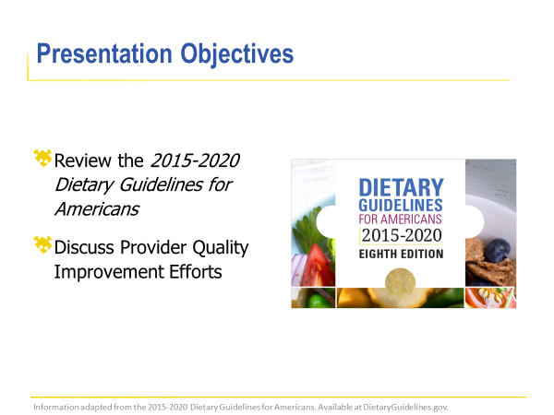
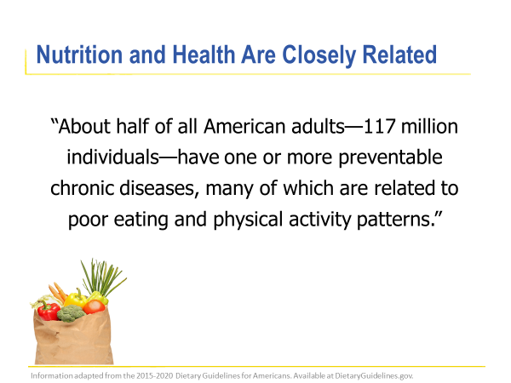
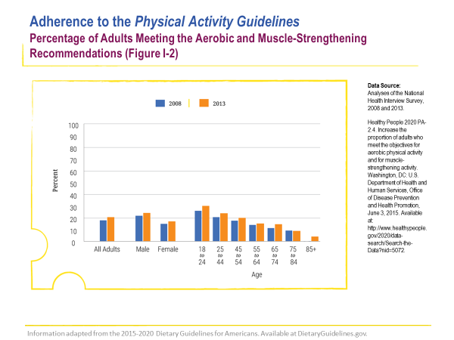

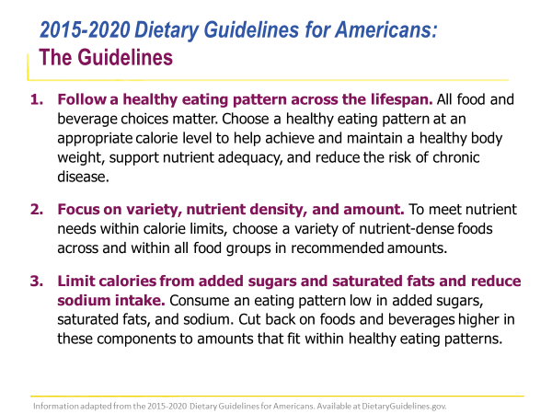
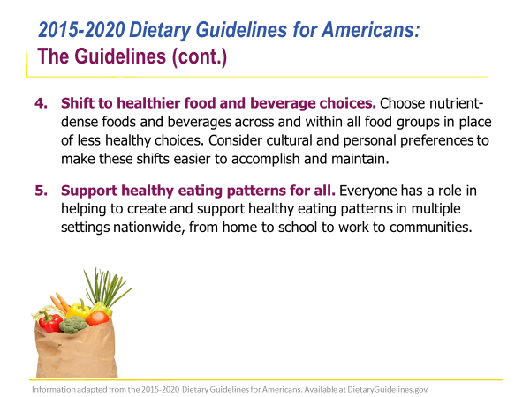
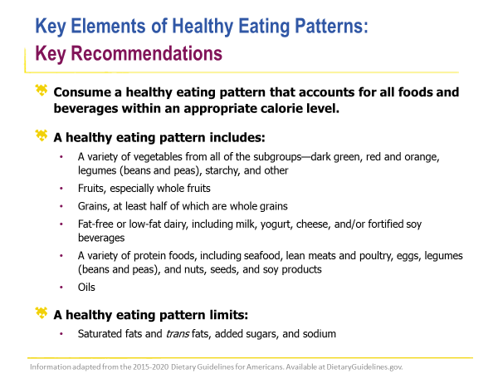
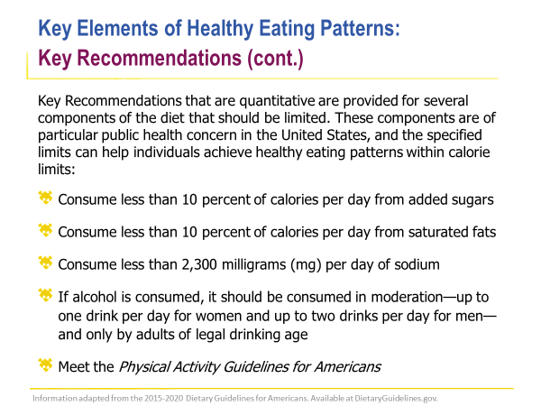
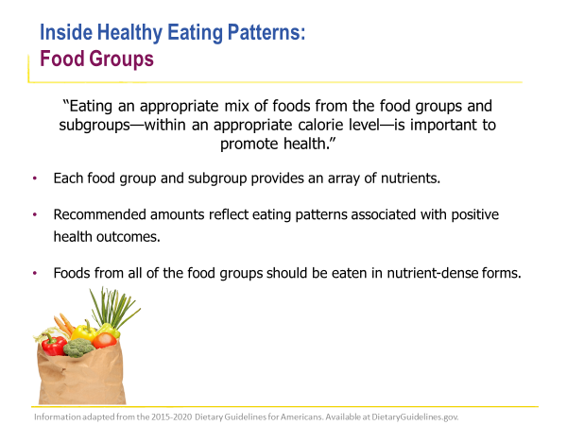
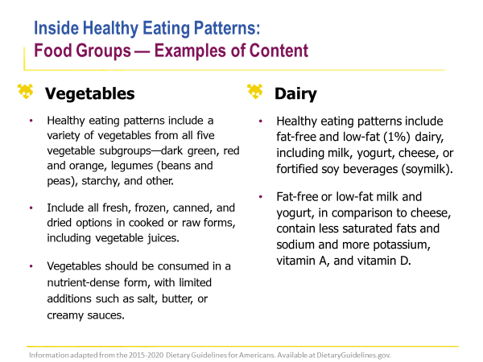
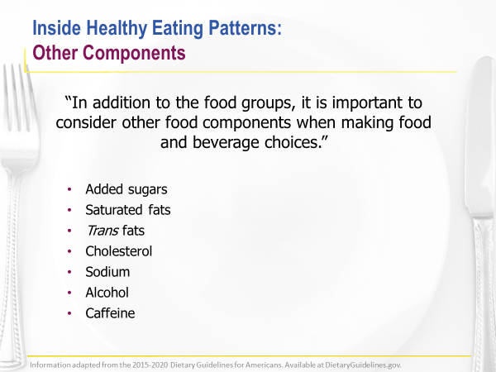
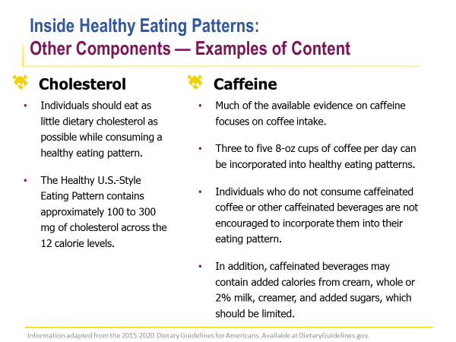
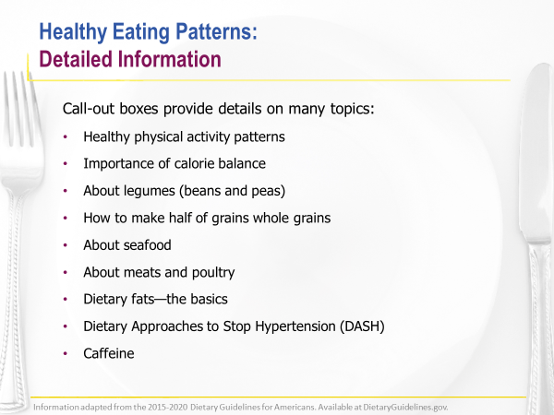
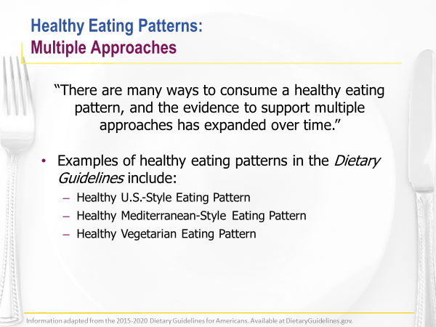

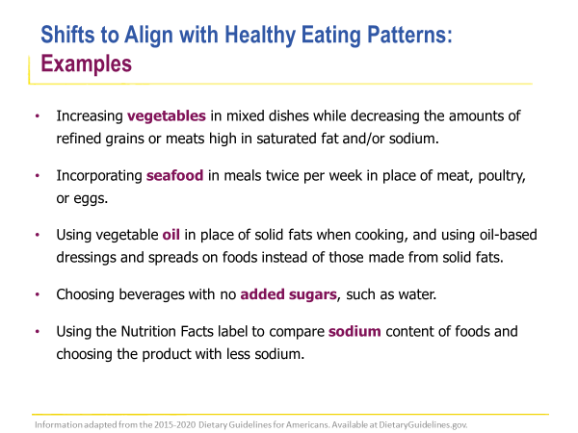
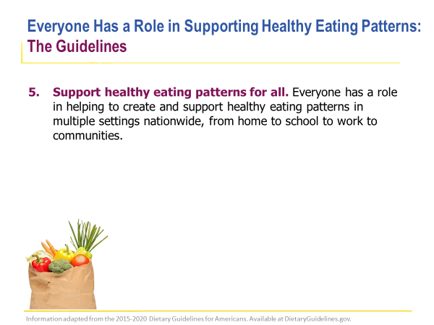
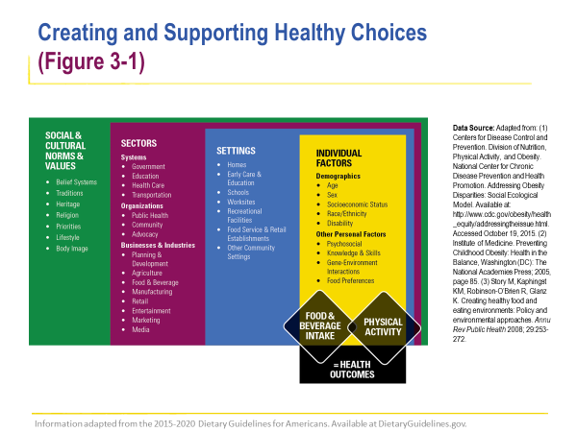
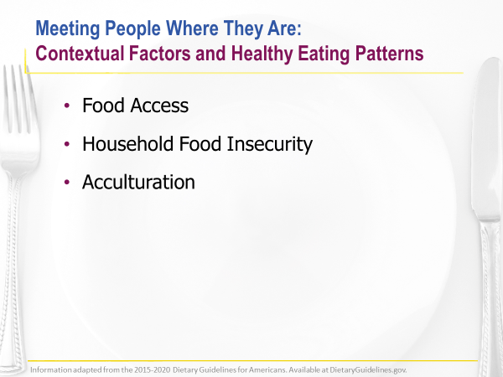
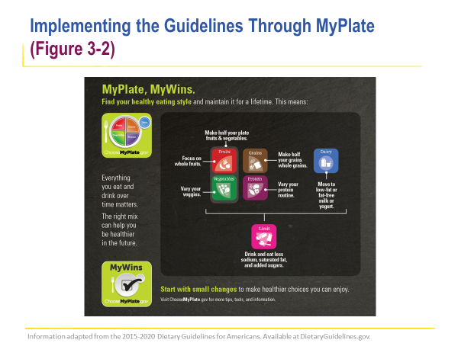
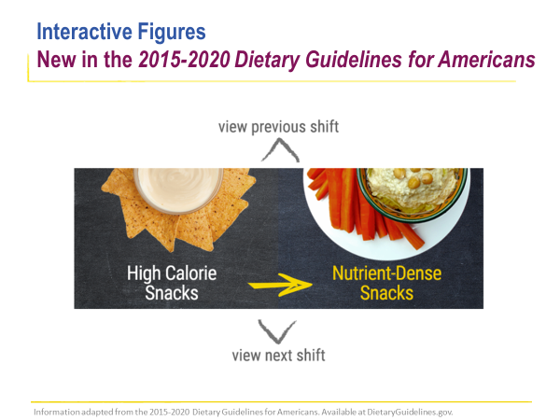
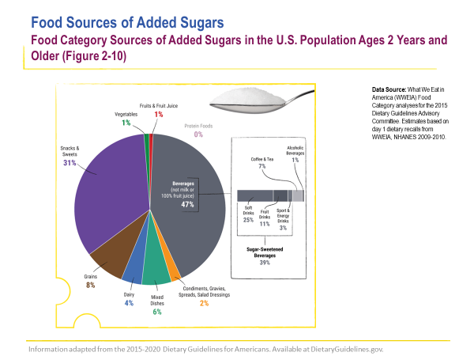
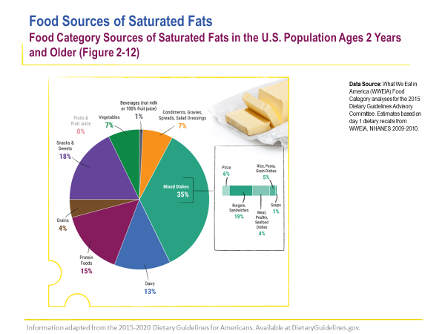
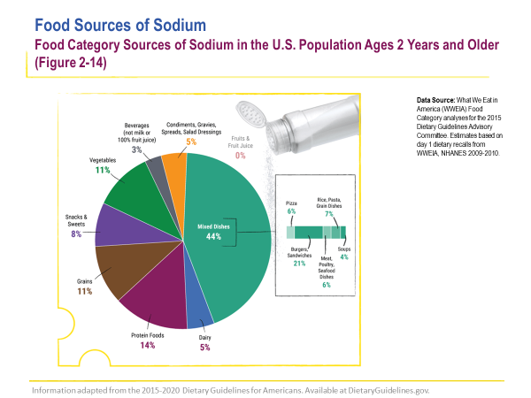


Appendix K
Copyright Policy Health.gov

Appendix L
Pre-QI Project-Measurement Tool
Pre-Project Implementation Measurement Tool

Audit of 100 Random Charts – Pre-QI Project
Criteria Met: Adult (18 +) and Overweight or Obese Patients (BMI 25 +)

Outcome #1: Was a BMI diagnosis code assigned to patient in the chart?
Associated BMI Diagnosis Code?
Total Number = Yes
Total Number = No

Outcome #2: Was weight management education provided to the patient and documented in the chart?
Pt. education provided and documented?
Total Number = Yes
Total Number = No

Outcome #3: Was a billing code used for weight management education?
Wt. education billing code used?
Total Number = Yes
Total Number = No

Appendix M
Post-QI Project Measurement Tool
Outcome Measurement Tool

Audit of 100 Random Charts – Post-Project Implantation
Criteria Met: Adult (18 +) and Overweight or Obese Patients (BMI 25 +)

Outcome #1: Was a BMI diagnosis code assigned to patient in the chart?
Associated BMI Diagnosis Code?
Total Number = Yes
Total Number = No

Outcome #2: Was weight management education provided to the patient and documented in the chart?
Pt. education provided and documented?
Total Number = Yes
Total Number = No

Outcome #3: Was a billing code used for weight management education?
Wt. education billing code used?
Total Number = Yes
Total Number = No

Appendix N
Outcome Evaluation Tool
Outcome Evaluation Tool

Outcome #1: Was a BMI diagnosis code assigned to patient in the chart?
 | Associated BMI Diagnosis Code Pre-QI Implementation? | Associated BMI Diagnosis Code Post-QI Implementation?
Total Number = Yes
Total Number = No

Outcome #2: Was weight management education provided to the patient and documented in the chart?
 | Pt. education provided and documented Pre-QI Implementation? | Pt. education provided and documented Post-QI Implementation?
Total Number = Yes
Total Number = No

Outcome #3: Was a billing code used for weight management education?
 | Wt. education billing code used Pre-QI Implementation? | Wt. education billing code used Post-QI Implementation?
Total Number = Yes
Total Number = No

Was there an increase in yes answers from Pre-QI and Post-QI Outcomes for:
Outcome #1
Outcome #2
Outcome #3

Appendix O
Free Weight Management Apps – English

Appendix P
Free Weight Management Apps – Spanish

Appendix Q
Provider Weight Management BMI Billing Codes
Appendix R
Provider Weight Management Counseling Billing Information

