Implementation of an Opioid Overdose Prevention Program in a Health

Department

by

Rachel M. McInerney

Paper submitted in partial fulfillment of the requirements for the degree of

Doctor of Nursing Practice

East Carolina University
College of Nursing

November 2018

Abstract
Opioid overdose is pandemic in the United States. North Carolinians are not exempt from hazardous health behavior. Opioid overdose prevention programs are one method of providing naloxone to laypersons in the community. Public health departments in North Carolina are able to dispense naloxone to members of the community through a state-wide standing order. The purpose of this project was to implement a naloxone dispensing program by using the state standing orders for naloxone dispensing in a health department located in central North Carolina. A rural health department in North Carolina had standing orders in place to dispense naloxone, but did not have the naloxone available to dispense and was not screening for opioid use. Within the rural health department, standing orders for dispensing naloxone were implemented when high risk clients, friends and family were identified. Clients identified at risk for witnessing an overdose were instructed in indication and administration of naloxone. Over nine weeks, every client seen at the clinic was screened for opioid use or knowledge of opioid user(s). If the screen was positive, the client was offered naloxone training and take-home naloxone. The number of completed screening forms was compared to the number of clients seen in the clinic. Of the 307 clients that were screened over a nine week period, 4.2% (13) of clients received a naloxone kit.
Keywords: opioid overdose, naloxone, overdose prevention, laypersons naloxone

Table of Contents
Chapter One: Introduction 5
Overdose Prevention Laws 6
Significance of the Problem 7
Problem Statement 8
Needs Assessment 8
Justification of the Project 8
Project Outcomes and Strategies 9
Theoretical Framework 10
Force Field Analysis 10
Phases 10
Assumptions 11
Project Question 12
Definition of Terms 12
Summary 14

Chapter Two: Review of Literature 15
Opioid Overdose Prevention Program 15
Public Health Interventions and Naloxone Training 18
Cost Effectiveness of Naloxone Dispensing Programs 19
Barriers to Naloxone Dispensing 20
Family and Friend Use of Naloxone 21
Intramuscular versus Intranasal Naloxone 22
Screening Tools 23
Gaps in Literature 23
Summary 24

Chapter Three: Methodology 25
Design 25
Setting 25
Sample 25
Methods 26
Protection to Human Subjects 27
Instruments 27
Data Collection 28
Data Analysis 28
Budget 28
Summary 29

Chapter Four: Results 30
Introduction 30
Demographic Characteristics of Clinic Staff 30
Intended Outcomes 30
Findings 30
Summary 32

Chapter Five: Implications for Nursing Practice 33
Practice Implications 33
DNP Essentials 33
Essential I 33
Essential II 33
Essential III 34
Essential IV 35
Essential V 35
Essential VI 36
Essential VII 36
Essential VIII 37
Summary 37

Chapter Six: Final Conclusions 38
Significance of Findings 38
Project Strengths/Limitations 38
Project Benefits 39
Recommendations for Practice 41
Recommendations for Future Projects 42
Final Summary 42

References 43

Appendix A: Theory Framework Flowchart 50
Appendix B: Good Samaritan Handout 51
Appendix C: Literature Review Matrix 52
Appendix D: Flowchart 80
Appendix E: Standing Order for Naloxone 81
Appendix F: Opioid Use Screening Tool 85
Appendix G: Outline of Naloxone Training Webinar 86
Appendix H: Naloxone Kit Contents 87
Appendix I: Data Collection Tool 88
Appendix J: Project Budget 89
Appendix K: PDSA Cycle 90
Appendix L: Institutional Review Board Approval 91
Appendix M: Project Site Approval 94

Chapter One: Introduction
Unintentional poisoning, primarily due to drug overdose, is now the leading cause of injury-related death among Americans aged 25 to 64 years, having surpassed motor vehicle accidents in 2009 (Centers for Disease Control and Prevention, 2013). Although Americans represent less than 5% of the world’s population, they use 80% of the world’s opioid supply (Manchikanti, Fellows, Ailinani, & Pampati, 2010). In 2014, the CDC reported 259 million prescriptions were written for opioids, which is enough to supply every American with a bottle (Opioid Painkiller Prescribing, 2014).
Healthy People 2020 objectives identify substance abuse as a priority. One of the 2020 objectives is to reduce drug-induced deaths from 12.6/100,000 population to 11.3/100,000 population (Healthy People 2020, 2017). From 2000 to 2016 more than half a million people died from drug overdoses and 115 Americans die every day from opioid overdose (CDC, 2017). In 2015, data pooled from North Carolina demonstrated that there were 16.9 drug-induced deaths per 100,000 population, up from 13.4 in 2013 (Healthy People 2020, 2017).
The Institute of Healthcare Improvement advocates and supports a framework known as Triple Aims (“Institute of Healthcare Improvement,” 2018). Triple Aims work in improving the patient’s experience and health, and reduces the costs of healthcare (“Institute of Healthcare Improvement,” 2018). In order for changes to be met in communities, the Institute of Healthcare Improvement recommends that a project’s process includes the identification of a targeted group, definition of measures, development of a project, and testing that is conformed to the specific needs or conditions (“Institute of Healthcare Improvement,” 2018). Opioid overdose prevention programs target opioid users and their friends by giving them the education and tools to reverse overdose in the community (Winstanley, Clark, Feinberg & Wilder, 2016). These programs can reduce the numbers of people visiting the hospital for overdose management, thus, decreasing the costs of healthcare.
The Department of Health and Human Services has stated that expansion of naloxone programs is one of the most important initiatives that may reduce the mortality associated with opioid overdose (Department of Health and Human Services, 2015). In attempts to prevent opioid overdoses, states are changing legislation to make naloxone, an approved opioid antagonist, available to friends and family of persons at risk for overdose (Calas, Wilkin & Oliphant, 2016). As of July 2016, North Carolina law permits pharmacies to dispense naloxone without a prescription (“New law expands access”, 2016). North Carolina’s Strengthen Opioid Misuse Prevention (STOP) Act allows for community distribution of naloxone by organizations with a standing order to do so (“New law expands access”, 2016). Since 2013, the North Carolina Harm Reduction Coalition has dispensed 50,000 naloxone kits to organizations and community members in North Carolina and there have been 7,932 reversals with laypersons administering the drug (Naloxone and OD Prevention, 2017).
Overdose Prevention Laws
North Carolina has passed many overdose prevention laws since 2013, one of which includes SB20/911 Good Samaritan/Naloxone Access Law (Senate Bill 20, 2013). The 911 Good Samaritan Law protects individuals who overdose or who witness an overdose when they call for help (Senate Bill 20, 2013). If someone calls for help, they cannot be prosecuted for having small amounts of drugs, having drug paraphernalia, and/or underage drinking (Senate Bill 20, 2013). With enactment of this law, there is less fear of being prosecuted and more effort placed on getting life-saving assistance (Senate Bill 20, 2013). As part of this law, the caller needs to provide their full name when calling 911 to report the overdose (Senate Bill 20, 2013). Additionally, neither the caller, nor the victim, will be in consideration of violating their parole (Senate Bill 20, 2013). North Carolina’s overdose prevention law removes civil liabilities from the naloxone prescriber and the naloxone administrators (Senate Bill 20, 2013). Under the protections of this law, community based organizations can dispense naloxone under a medical provider and pharmacist without civil liabilities (Senate Bill 20, 2013). Prior to passing of overdose prevention law, naloxone was not on the list of medications that nurses could dispense at health departments. In 2014, the North Carolina Pharmacy Board approved the addition of naloxone to the nursing formulary, making it legal for a nurse to dispense naloxone (North Carolina Department of Health and Human Services a Division of Public Health, 2016). Of note, only 36 of the 100 counties in North Carolina dispense naloxone under the state standing order (“Where to Find Naloxone,” 2017).
Significance of the Problem
Between the years of 1999 to 2016, North Carolina saw over 12,000 people die from opioid related overdoses (“Opioid Crisis,” 2017). North Carolina has developed an Opioid Action Plan 2017-2021 in attempts to reduce the numbers of opioid overdose deaths by 20% by the year 2021 (“Opioid Crisis,” 2017). One of the strategies is to increase awareness and prevention amongst community members and make naloxone readily available (“Opioid Crisis,” 2017). North Carolina’s Department of Health and Human Services has identified local health departments as a lead in community naloxone distribution, as local health departments can participate in increasing availability of naloxone rescue kits to laypersons in the community (“Opioid Crisis,” 2017).

Problem Statement
A review of literature (Albert et al., 2011; MacDonald & Strang, 2016; Wheeler, Jones, Gilbert, & Davidson, 2015) indicates providing an opioid overdose prevention program to lay persons is beneficial. The purpose of this project was to implement a naloxone dispensing program by using the state standing orders for naloxone dispensing in a health department located in central North Carolina.
Needs Assessment
Ideally, in the state of North Carolina, naloxone is available to members of the community without a prescription. It is possible for someone to go to the pharmacy and ask for naloxone to take home with them, but this can be costly. It is unknown how much a dose of naloxone would cost if purchased without insurance. Having the opportunity for a community member to come to the health department for a free dose of naloxone is essential. It is also unknown as to what training for the use of naloxone is given to someone who is given a dose of naloxone from the pharmacy. The naloxone dispensing program in a health department setting provides the client with not only the tools for opioid reversal, but also the knowledge on how to use the tool.
Justification of Project
All races, ethnicities, social, and economical demographics are vulnerable to the opioid epidemic. According to Nolan & Amico (2016), White and Native Americans (267% and 236%, respectively) have seen the greatest increase in opioid overdose deaths between 2010 and 2014, than that of African American and Latinos (213% and 137% respectively). According to Lee et al. (2017), in a 2015 national survey on drug use and health, it was found that over 40% of people who misused opioids, obtained them for free from a friend or family member. More than 40% of all overdose deaths are due to a prescription opioid (CDC, 2017). In May of 2017, new information released from North Carolina indicated a 73% increase of opioid related deaths from 2005 to 2015 (“County-by-County Figure”, 2017). The project site is located in a predominately rural county, with only 20% of its residents living in incorporated towns (United States Census Bureau, 2015). A majority of residents are White (71.2%), 22.1% are Black, and 9.1% identified as Hispanic or Latino (United States Census Bureau, 2015). The percentage of people without health insurance under the age of 65 is 13.1% and 16.4% live in poverty (United States Census Bureau, 2015). In 2015 there was one opioid overdose death in the county (County-by-County Figures, 2017). According to the Department of Health and Human Services, there was a 20 percent increase in the numbers of opioid related deaths in NC from 2015 to 2016, and by 2021 the state could expect 1,200 overdoses a year (NC Governor Roy Cooper, 2017). The health department in which the project was conducted did not have a naloxone dispensing program in place.
Project Outcomes and Strategies
The purpose of this project is to establish an opioid overdose prevention program in a small rural county in central North Carolina. As part of this program, nurses who had been trained in naloxone education and dispensing gave the clients the naloxone to take home. All clients that came into the county health department for child health, family planning, and sexually transmitted disease clinic were screened for substance abuse. Every client was asked if they used opioids or if they knew of a friend or loved one that used opioids. If they were at risk for opioid overdose with admission to using opioids, or knew someone who is at risk for opioid overdose due to use of opioids, then naloxone education was provided. Afterward, a naloxone kit was dispensed. There were no established estimates on how many clients would be interested in obtaining take-home naloxone. Secondarily, this project would provide data to create an estimate on the communities need for naloxone.
Theoretical Framework
Kurt Lewin’s Theory of Planned Change is frequently used to guide implementation of a planned change processes (Shirey, 2013). This framework guided development of the opioid overdose prevention program for the health department (Appendix A). Additionally, this framework was utilized to evaluate how the nursing staff adapts to the implementation of the standing order in dispensing naloxone.
Force field analysis. Force field analysis can identify driving and restraining forces that are influencing a behavioral or interventional change (Lewin, 1948). With identification of driving and restraining forces before implementation of the naloxone standing order, predictions could be made in regards to how the nursing staff would respond to the intervention. It was also possible to determine which of the forces needed to be strengthened and which needed to be diminished (Lewin, 1948). The balance of these forces helps to bring about change (Lewin, 1948).
Phases. Theory of Planned Change has three phases: unfreezing, moving, and refreezing (Shirey, 2013). The first step involves unfreezing which occurs when the problem is identified and the change is initiated (Shirey, 2013). Lewin (1947) describes unfreezing as a deliberate “stir up” that works to break up complacency and self-righteousness in the beginning stages of change. North Carolina developed standing orders for health departments to dispense naloxone in 2014, but the current project site did not have a standing order in place. Unfreezing started when the issue was discussed with the Health Director and the Director of Nursing. Unfreezing continued with nurses learning the specifics of the standing order and their role in the process.
Moving, the second step of the process, occurred when the project was assimilated into the clinic flow. Moving is the phase in which projects typically meet fear and uncertainty (Shirey, 2013). As fear and uncertainty were met within project site, coaching and retraining were given to promote further change. Coaching and retraining included revisiting the standing order to clarify policies and procedures and retraining nurses on how clients are educated prior to dispensing naloxone.
Refreezing happens as the change becomes part of the practices’ culture and policy (Shirey, 2013). Once the change becomes part of an institution’s practices, the change will become part of the institutions policy over time (Shirey, 2013). The opioid overdose prevention program with dispensing of naloxone and education on its use will become a part of the nurses’ standing orders manual.
Assumptions
It can be surmised that there is a need in the project’s community for take-home naloxone. With development of standing orders for naloxone dispensing, there will be care taken to assure that the orders are easily interpreted by the nursing staff, as the orders will be reviewed with the nurses that will be dispensing the drug. With adequate and extensive education on the use and dispensing of naloxone, nursing staff will find that when having to dispense the drug, they will feel comfortable. It is assumed that clients will not always be truthful when asked about opioid use, and therefore, will not receive a naloxone kit. With this assumption, and in an effort to reach all clients, every client will receive a handout about naloxone and the Good Samaritan Law (Appendix B).

Project Question
With a standardized process, in implementing a standing order, will nursing staff appropriately screen clients for substance abuse risk? When the screening process indicates a client uses opioids or knows of someone who uses opioids, they are identified at risk for opioid overdose. Will the nursing staff provide education and dispense a naloxone kit as detailed in the standing order? It is hypothesized that with standardization of naloxone dispensing, clients will be appropriately screened and they will receive a naloxone training and a naloxone overdose kit, as specified within the standing orders.
Definition of Terms
Layperson. A layperson is someone who does not have knowledge in a particular subject (Layperson [Def 1.1], 2018).
Opioids. Opioids work on the central nervous system by binding to mu receptors (Calas, Wilkin & Oliphant, 2016). There are many changes to the body when an opioid binds to mu receptors: pain relief, mood changes, drowsiness, pupil restriction, feelings of highs and lows, decreased respiratory rates, and cough (Calas et al., 2016). Common opioids include: buprenophrine, codeine, fentanyl, hydrocodone, hydromorphone, meperidine, methadone, morphine, oxycodone, oxymorphone, and heroin (Calas et al., 2016).
Overdose. Overdose occurs when there is an intake of too much of something, most often a drug (Overdose, 2018). Opioids can cause respiratory depression and apnea (World Health Organization, 2014). This respiratory depression and apnea limits oxygen from getting to the brain and may cause a person to become unconscious (World Health Organization, 2014). Cardiac arrest may result from respiratory depression and apnea (World Health Organization, 2014). When the brain goes for long periods without oxygen and the heart stops beating, death may result (World Health Organization, 2014). Some signs of overdose are decreased respiratory rate, dysfunctional breathing (snoring/gurgling), pupil constriction, decreased consciousness, or pale or blue skin (Lim, Bratberg, Davis, Green & Walley, 2016).
Naloxone. Since 1971, naloxone, an opioid antagonist, has been approved to be used in drug overdose (Calas et al., 2016). This drug binds to the mu receptors in the brain (Calas et al., 2016). This chemical replaces the opioid on the mu receptor and reverses the effects of the opioids; the symptoms of respiratory depression are reversed (Calas et al., 2016). Naloxone does not work in removal of the opioid from the blood and it only has a half-life of 30-90 minutes (Calas et al., 2016). When the naloxone wears off, the opioid again has the chance to bind to the mu receptors, potentially causing another overdose situation (Calas et al., 2016). There are three forms of naloxone, intramuscular (IM) injection, intranasal (IN) spray, and auto-injector (Calas et al., 2016). Naloxone does not work orally (Calas et al., 2016).
Naloxone kits. Naloxone take home kits contain two doses of naloxone (0.4 mLs/dose) (Kumar & Rosenberg, 2017). Additionally, naloxone kits contain alcohol swabs, non-latex gloves, and a rescue breathing device (Kumar & Rosenberg, 2017).
Standing Orders for Medication Dispensing. Nurses working in public health departments have the ability to dispense medications based on standing orders that have been signed by the department’s Medical Director (North Carolina Department of Health and Human Services, 2016). These medications are dispensed based on the client meeting specific criteria (North Carolina Department of Health and Human Services, 2016).
Quality-adjusted life year. A health outcome measurement unit that takes into account both life expectancy and quality of life is known as a quality-adjusted life year, but is also known as a health status index (Sassi, 2006).
Summary
Naloxone can save the life of a person who is overdosing after use of opioids. There were no standing orders for naloxone dispensing being utilized in a rural health department in central North Carolina. As the numbers of opioid-related overdoses are expected to rise across North Carolina, it would be beneficial for this county to utilize the standing order for dispensing naloxone. This action supports the recommendation of the North Carolina Action Plan for local health departments getting involved with the community dispensing of naloxone. The purpose of this project was to implement standing orders for naloxone dispensing. With implementation of Lewin’s Theory of Planned Change, nurses were trained on how to educate clients on use of naloxone and dispensing of naloxone kits.

Chapter 2. Review of Literature
A comprehensive literature review was conducted to identify and evaluate interventions related to dispensing naloxone to laypersons in the community (Appendix C). The following search engines and databases were used: One Search, CINAHL, PubMed, and Google Scholar. Key terms utilized were “naloxone and overdose”, “opioid overdose prevention programs”, and “laypersons naloxone.” Inclusion criteria encompassed scholarly information regarding opioid overdose, overdose prevention programs, and giving naloxone to laypersons. Articles were also included that explored successful opioid overdose prevention programs where naloxone was given to a member of the community. In total, there were over 62,000 articles found using the above mentioned search terms. Included in the review were full text articles written in English. References were excluded that were older than 10 years, being limited from 2007 to 2017. Further limits on the search involved including only articles that were in the nursing, medical, and public health disciplines. This brought the number of articles down to approximately 2,600. Two applicable meta-analysis articles and fifteen qualitative articles were reviewed in the literature review process (Appendix D). During the review of the literature, contradicting opinions and gaps in the literature were identified in relation to opioid overdose prevention programs.
Opioid Overdose Prevention Programs
Opioid overdose prevention programs typically involve getting take-home naloxone into the hands of people most likely to overdose or witness an overdose. These prevention programs also work to inform the user, family member, or peers on what an overdose looks like, how to manage an overdose in an emergent situation, and how to use the naloxone (MacDonald & Strang, 2016). It is important to get knowledge about the signs of overdose and information about how to use naloxone into the hands of people who use opioids or people who know of someone who abuses opioids. In 2014, in response to the increase in opioid overdoses, the World Health Organization published recommendations to get naloxone in the hands of the people most likely to witness an overdose (MacDonald & Strang, 2016). Furthermore, Albert et al. (2011) found that more than half of all overdoses occurred in the home and emergency personnel were not called because laypersons did not recognize the symptoms of overdose.
In a meta-analysis, Giglio, Li, & Dimaggio (2015) synthesized literature that examined the effectiveness of naloxone programs with bystander administration. Giglio et al. (2015) reviewed four studies and found with a 95% confidence interval that when naloxone was given by a bystander to someone who was overdosing, the person overdosing recovered better than if they were not given naloxone. In review of five studies, Giglio et al. (2015) found a 95% confidence interval where overdose education programs give bystanders a better understanding of what an overdose looks like.
In July of 2014, the Harm Reduction Coalition distributed a survey across the nation to 140 managers of programs that gave out naloxone to laypersons (Wheeler, Jones, Gilbert, Davidson, 2015). In the survey which asked about the amounts of naloxone that was distributed and the number of documented overdose reversals from 1996 to 2014, there were 136 managers that responded (Wheeler et al., 2015). Of the program managers that responded, 152,283 naloxone overdose kits were documented as dispensed and there were 26,463 overdose reversals. Ninety-three of the respondents provided information on the characteristics of the laypersons receiving naloxone, 81.6% were opioid abusers and 11.6% were friends and family (Wheeler et al., 2015). Just over 50% provided intramuscular naloxone, 37% offered intranasal naloxone, and the remainder of the respondents reported offering both versions (Wheeler et al., 2015). The number of opioid overdose reversals were discussed across various studies. A systematic review of 17 studies related to the evaluation of the safety and efficacy of take-home naloxone was conducted (MacDonald & Strang, 2016). A total of 2,336 take-home naloxone administrations were documented and an estimated 2,249 overdose reversals were noted (MacDonald & Strang, 2016).
In support of opioid overdose prevention programs and distribution of take-home naloxone, Clark, Wilder & Winstanley (2014) reviewed characteristics and outcomes of opioid overdose prevention programs within current peer-reviewed literature. They found that if opioid and non-opioid users are properly trained, they can and will use naloxone when witnessing an overdose (Clark et al., 2014). Further evidence demonstrated that understanding and confidence in how and when to use naloxone increases with educational programs and training (Ashrafioun, Gamble, Herrman & Baciewicz, 2016).
In a systemic review and descriptive meta-analysis of take home naloxone programs, McAuley, Aucott & Matheson (2015) reported on 25 programs that dispensed naloxone for use in the home. When reviewing take home naloxone programs, studies that were reviewed included programs that were very similar in the training technique and the length of time spent with each person trained (McAuley et al., 2015). In review of these programs, McAuley et al. (2015) determined that if 100 people were trained in peer-administration of naloxone, 9% of the overdose prevention kits would be used in the first three months. In review of the programs, there was no mention of what was included within the take home naloxone kits.
Opioid overdose prevention programs are shown to be successful across the world. Mitchell & Higgins (2016) evaluated 38 research reports on opioid overdose prevention programs. In their review of the programs, many aspects were examined: global trends, United States overdose education programs with naloxone distribution, barriers to public access, political opposition and support, financial impact, and gaps in the literature (Mitchell & Higgins, 2016). In evaluating global trends, there were multiple countries, such as, Scotland, England, and Canada, that discussed successful reversal rates with the use of take-home naloxone (Mitchell & Higgins, 2016). Evaluating implementation and effectiveness of naloxone distribution programs in the U.S., Mitchell & Higgins (2016) found that most opioid education programs produced positive overdose reversal outcomes. According to Mitchell & Higgins (2016) many of the articles’ authors recommended standings orders or protocols for naloxone distribution to be initiated at health departments and pharmacies.
Community opioid overdose prevention programs have improved patient outcomes. In instances where naloxone was used in an overdose, many positives were highlighted: the victim lived, the victim was not in a coma, and the victim did not suffer brain damage (Bennett, Bell, Tomedi, Hulsey, & Kral, 2011). Conversely, when opioid overdose programs are implemented in drug-using communities there were very few negative consequences, namely death (Bennett et al., 2011). In a review of 17 studies there were 20 overdose deaths in which naloxone did not reverse the effects of opioids (MacDonald & Strang, 2016). Bennett et al. (2011) found that bystanders trained in the administration of naloxone continued to be reluctant to call 911 after administering naloxone.
Public Health Interventions and Naloxone Training
North Carolina started opioid overdose prevention programs led by coalitions in 2011, under the name of Project Lazarus (Alexandridis, Dasgupta, Ringwalt, Sanford & McCort, 2017). Alexandritis et al. (2017) found in counties with local health department opioid overdose coalitions, there were 27% less opioid-related emergency department visits. In counties that had overdose coalitions that were not county supported, the rates of opioid overdose related visits to the emergency department only decreased by 6% (Alexandritis et al., 2017).
Leece et al. (2013) discusses Toronto’s Public Health Department’s program that provided naloxone training and naloxone kits. As a result of this program, clients reported that they felt empowered after the training (Leece et al., 2013). Additionally, with completion of the training, these clients reported that they told their friends about the program (Leece et al., 2013).
Cost Effectiveness of Naloxone Dispensing Programs
Coffin & Sullivan (2013) and Leece et al. (2013) analyzed the cost-effectiveness of distributing naloxone to the public. Coffin & Sullivan (2013) discussed that distribution of naloxone to laypersons results in fewer overdoses and emergency medical service activations. Under probabilistic analysis it was found that for every 227 naloxone kits distributed, 6% of overdose deaths would be prevented (Coffin & Sullivan, 2013). Coffin & Sullivan (2013) estimated that each naloxone kit would cost about $25 per kit, this would include two doses of IM naloxone, supplies to inject the medication, and $10 for staff time. Coffin & Sullivan (2013) based their cost-effectiveness calculations on costs, quality-adjusted life years, and incremental costs per quality-adjusted life years gained. Policymakers typically base incremental costs of less than $50,000 per quality-adjusted life year gained to be cost effective (Coffin & Sullivan, 2013). Coffin & Sullivan (2013) found that distribution of naloxone increased quality-adjusted life year by 0.119, with a calculated lifetime cost of the naloxone kit at $53. In their calculations it was found that there was an incremental cost-effectiveness ratio of $438, which is less than the $50,000 cutoff for incremental costs per quality-adjusted life years gained (Coffin & Sullivan, 2013).
Similarly, Leece et al. (2013) reported on the cost-effectiveness of a naloxone distribution program in Toronto, Canada. The overall reported cost of obtaining 209 naloxone kits was $5000 (Leece et al., 2013). It was determined that if one life was saved in every 17 kits dispensed, there would be $30,890-$46,334 per quality-adjusted life year gained (Leece et al., 2013).
Opioid overdose prevention programs have been cost-effective and beneficial across the nation. In 2006, Rhode Island started a pilot program called Preventing Overdose and Naloxone Intervention (Yokell, Green, Bowman, McKenzie, & Rich, 2011). Yokell et al. (2011) found that when providing a naloxone kit that contained a multi-dose vial of naloxone, the cost was $15. They estimated that hospital costs of treating an overdose to be estimated around $88,000 with an additional cost of over $800,000 if the patient was admitted (Yokell et al., 2011). When taking into account the hospital costs of an overdose, it was estimated that over 61,000 naloxone overdose kits could be purchased (Yokell et al., 2011).
Barriers to Naloxone Dispensing
There are barriers to naloxone dispensing and with further awareness of barriers, there are increased chances for successful opioid overdose prevention programs. As the need for public support for naloxone distribution programs increases, there will be more implementation of these programs (Bachhuber, McGinty, Kennedy-Hendricks, Niederdeppe & Barry, 2015). One way to increase public support of naloxone dispensing programs is to provide factual information along with description account of how naloxone is used (Bachhuber et al., 2015). Programs that dispense naloxone to the public are stigmatized, possibly due to the negative opinion of drug users (Bachhuber et al., 2015). Lack of public awareness and compassion of consequences associated with naloxone distribution may lead to low support to drug users obtaining naloxone (Bachhuber et al., 2015).
Some in the medical community may have the perception that giving medical naloxone to the opioid abusers will increase the number of overdoses in a community (Schuman-Olivier et al., 2013). Wilson, Spicyn, Matson, Alvanzo, & Feldman (2016) found that when interviewing 97 hospital residents, 52% reported that they did not feel confident in assessing clients for risk of opioid overdose. It was found that if there was to be an increase in the number of naloxone prescriptions given, there would need to be better overdose risk guidelines for providers, so that once identified, the client can be offered naloxone (Wilson et al., 2016).
Friends and Family Use of Naloxone
With the emergence of opioid overdose prevention programs that target the education of family members of opioid users, Bagley et al. (2015) sought to describe the motivations of the individuals attending these programs. Bagley et al. (2015) surveyed attendees of opioid overdose prevention programs and inquired about their relationship to the opioid user, their experiences with overdose, and their motivations for obtaining naloxone take-home kits. According to their study, Bagley et al. (2015) found that parents, individuals who provided financial support, individuals that were ordered to participate in treatment, or had witnessed an overdose were motivated to learn how to use naloxone to ensure that they were prepared in case of emergency. Lewis et al. (2016) found when they examined the self-efficacy of participants in an opioid overdose training, 72% of the participants were friends and family members of opioid users. Additionally, it was found that friends and family that had participated in the program were participating because they were fearful that their loved one would overdose (Lewis et al., 2016).
A study was conducted by Ashrafioun et al. (2016) to compare the confidence levels of friends and family, providers, and those identified as others (firefighters/first responders) after receiving opioid overdose prevention training and naloxone. Ashrafioun et al. (2016) found that when delivering education and naloxone to friends and family, the friends and family reported more confidence after the training than both the providers and others. It was found that knowledge on how and when to use naloxone increases if the person in the training had overdosed in the past (Ashrafioun et al., 2016).
Katzman et al. (2017) provided opioid overdose prevention education and take-home naloxone to 244 participants of an opioid treatment program. They found that 31 of the 244 participants used the kits to reverse overdose in members of the community (Katzman et al., 2017). Of the trainees who used a kit, 87% of those who overdosed were friends or family of the study participant (Katzman et al., 2017).
Of note, Rowe et al. (2015) evaluated the demographics of community members that used naloxone for opioid reversals. Of the 2500 registered naloxone program participants, Rowe et al. (2015) found that active heroin and methamphetamine users were most likely to obtain a naloxone kit and report a reversal.
Intramuscular versus Intranasal Naloxone
There are many different forms of naloxone. Some opioid overdose prevention programs dispense intramuscular naloxone and some dispense intranasal naloxone. Ashrafioun et al. (2016) found participants in opioid overdose prevention programs may have more confidence in using naloxone depending on the type of naloxone dispensed. In attempts to determine if there was a difference in the level of confidence after completing the training when comparing the route of administration, one cohort of participants were shown how to use intramuscular naloxone and a second cohort shown how to use intranasal naloxone (Ashrafioun et al., 2016). Results from the study indicated no difference in the knowledge and confidence in using intranasal naloxone compared to intramuscular naloxone (Ashrafioun et al., 2016).
Screening Tools
There are various ways in which clients can be screened for risk factors in a clinic. Shakil et al. (2014) evaluated the efficacy of verbal versus written screening forms when screening for intimate partner violence and found that the responses to both types of screening were the same, as both tools had 83% return on positive screenings. In contrast, MacMillan et al. (2006) studied women’s preference for intimate partner violence screening and discovered when administering the screening, women preferred to complete written screening on their own in contrast to verbal questioning. The written screening tools had the least amount of missing data (MacMillan et al., 2006).
A screening for eating disorders called SCOFF (Sick, Control, One stone, Fat, and Food) had been validated to be delivered verbally, but many practices were administering the screening in an invalidated written form (Perry et al., 2002). In attempts to determine validity for a written version of the screening, Perry et al. (2002) conducted the screening both verbally and in written form. Of the 178 participants, 82 were given the verbal questionnaire first followed by the written questionnaire. The kappa statistic was reported at 0.752 (Perry et al., 2002). For 96 participants, the written questionnaire was administered before the verbal and the kappa statistic was 0.862. Perry et al. (2002) found that written tools to be more concise and reliable.
Gaps in Literature
From the review of literature, no randomly controlled trials evaluating the effectiveness of take home naloxone were found. MacDonald & Strang (2016) discuss that conducting a trial in evaluating a take home naloxone program could be viewed as unethical. Most of the studies published discussed characteristics and distribution of naloxone to heroin users and not to oral opioid users (Mitchell & Higgins, 2016). Many of the opioid overdose prevention programs evaluated had given naloxone out in conjunction with a needle exchange program, making IV drug users the main population evaluated, thus eliminating evaluation of oral opioid abusers (Mitchell & Higgins, 2016).
When searching for how opioid overdose programs made the public aware of their existence, the only information found dealt with prison release or needle exchange programs. No standardized questionnaires were found to support screening individuals on opioid use or knowing someone who uses opioids.
Summary
Opioid overdose prevention programs are effective; they happen to be most effective when local health departments are providing the education and dispensing the naloxone. These programs have shown that when take-home naloxone is given out to the community, laypersons are capable of administering the life-saving naloxone dose to the overdosing individual. Both intranasal and intramuscular doses are effective and laypersons are capable of providing either. These programs have shown to be cost-effective and increase quality-adjusted life years. While there are provider barriers to giving naloxone to laypersons for take-home use, providing adequate education helps to overcome these barriers.

Chapter Three. Methodology
Design
In order to implement an overdose prevention program in a rural health department, clients were screened for opioid use or knowledge of friends or family that use opioids. In this quality improvement project, clients were screened for personal opioid use or knowledge of friends or family that are opioid users. If a client screens positively and would like to receive a naloxone kit, nursing staff will provide training on how to use naloxone in an overdose situation.
The goal of this project was to evaluate the effectiveness of implementing standing orders for dispensing naloxone. The effectiveness was determined by comparing the number of education opportunities met with the total number of clients seen in the clinic for the week to the number of opportunities possible as depicted with the number of screening forms collected. Furthermore, the number of naloxone kits dispensed was collected.
Setting
The project took place at a health department clinic in rural NC. This clinic serves family planners, child health, and STD screening. An average of 15 clients visit the health department clinic on a daily basis.
Sample
There were five nurses, four administrative staff, two lab techs, one medical doctor, and one nurse practitioner that work in the health department clinic. The nursing staff was responsible for screening every client that visits the clinic. Every client over the age of 18 that visited family planning, child health, and STD clinics were screened for opioid usage or knowledge of someone that used opioids. There were no exclusions based on race or sex.

Methods
Standing orders developed for dispensing naloxone within a health department setting were based upon the North Carolina Department of Health and Human Services toolkit (North Carolina Department of Health and Human Services a Division of Public Health, 2016). The standing orders, listed as Standing Order for Naloxone (Narcan) (Appendix E), was incorporated into the existing nurses’ standing orders manual. Within these standing orders there were guidelines for the nursing staff in dispensing naloxone to health department clients that requested naloxone.
A naloxone dispensing training program was made available to any nurse that was responsible for checking in clients. This training was scheduled during a staff meeting and consisted of watching a state-provided webinar on naloxone dispensing (Appendix G). The nursing staff was trained on the contents of the Standing Order for Naloxone, how to administer the opioid use screening form and was instructed to place the completed screening forms on a shelf in the locked medical records office.
Nurses checked the client into their scheduled clinic and administered and reviewed the opioid use screening form in the waiting area or in the nurse triage room. If the client used opioids or knew of someone who used opioids and were interested in being trained on how to use naloxone, the nurse provided the naloxone training to the client based on the standing order.
For the layperson naloxone training, the client was asked to review an eight minute DVD on opioid overdose. The DVD covered information on: how to administer the naloxone, how to place the overdosing person in a rescue position, and to call 911 to alert emergency personnel of the overdose. After the client training was completed, the nurse dispensed the kit to the client. Documentation of the dispensed naloxone kit was recorded on the paper pharmacy dispensing log (found in the clinic pharmacy) by the nurse who provided the training and dispensed the drug.
The opioid overdose prevention kit included: an eye glass case to hold the supplies, two doses of IN naloxone, two pairs of gloves, a CPR mask, and an insert reminding the user on how to use the naloxone. As there was no data to suggest how many kits would be needed, only ten kits were assembled for initial implementation (Appendix H).
In review of the weekly process, the Institute of Healthcare Improvement’s (IHI) Plan, Do, Study, Act (PDSA) cycle was implemented. With implementation of the PDSA cycle, it was easier to evaluate the weekly process and review what needed to be changed and areas that could be improved. By following the PDSA cycle (Appendix K), staff education on the use of standing orders could be reinforced or a process that was found to be not working could be modified.
Protection to Human Subjects
The project was reviewed by the University Institutional Review Board (IRB) and deemed as non-human subject research (Appendix L). No identifying names were assigned to the client screening forms. Screening forms and data collection sheets were stored in the locked medical records area of the office building within a locked file cabinet.
Instruments
The opioid use screening tool was developed with the assistance of the clinical supervisor and the site champion. A written screening tool with two questions that assesses the client for the need for naloxone training was developed for each client who visit the clinic to complete (Appendix F). If the client used opioids or knew of someone who used opioids, then they were offered education on how to use naloxone and provided a kit. As this was a pilot, the questionnaire was not uploaded into the electronic medical record for the nurse to ask the client.
Data Collection
On a weekly basis, screening forms were evaluated and audited to ensure that clients were being screened, which made it possible to make changes to the standing order, ensuring ease for the nursing staff and the clients. An excel data collection tool was used to evaluate numbers of clients seen in the clinic to the numbers of client screened. Additionally, the numbers of education sessions in a given week was collected and recorded on the data collection tool (Appendix I). Every week the pharmacy dispensing log was assessed to collect the numbers of naloxone kits dispensed.
Data Analysis
The number of actual screening tools completed was compared to the number of opportunities for administration of the screening tool. Descriptive statistics, specifically frequencies and percentages, was used to evaluate the success of the intervention, specifically, the number of screenings possible compared to completed and the number of doses dispensed compared to the number of doses possible for dispensing.
Budget
Nursing staff completed the training for naloxone dispensing during working hours at the health department. They screened clients for opioid use during clinic hours at the time of the client’s scheduled appointment. The clients received opioid overdose training during the clinic visit. The items for the naloxone kit was purchased through various vendors with money specifically budgeted for by the health department for this project. The cost of one kit was $83.59, and includes two doses of nasal naloxone, non-latex gloves, and CPR mask within an eyeglass case. Additional cost associated with the project included: paper and copier toner (Appendix J).
Summary
The naloxone dispensing program, a quality process improvement project, includes screening clients for opioid use, training the client on naloxone use, and dispensing naloxone. Costs were minimal, as the health department already had many of the needed supplies and personnel. Results were collected and analyzed weekly and use of a PDSA cycle was implemented to evaluate the process. Results were placed in an excel spreadsheet for data analysis.

Chapter Four: Results
Introduction
The purpose of this project was to implement a naloxone dispensing program by using the state standing orders for naloxone dispensing in a health department located in central North Carolina. Project implementation started May 14, 2018 and ended July 13, 2018. Family planning, child health and sexually transmitted disease clients were screened and naloxone kits were dispensed during the nine weeks project period.
Demographic Characteristics of Clinic Staff
In total, seven registered nurses were trained in the opioid use screening process and in dispensing naloxone. Four administrative staff were trained on how to ensure the screening forms were stapled to each client’s encounter. Two providers were trained on how to screen clients for opioid overdose risk; one medical doctor and one nurse practitioner.
Intended Outcomes
The intended outcome for this project was to screen clients for risk for opioid overdose and to provide those at risk with a naloxone kit. The outcome included training nursing staff on screening clients and providing clients with naloxone kits. The intention of this project was to provide this clinic with a standardized process for screening clients and implementation of a standing order for dispensing naloxone. Throughout project implementation, the PDSA review cycle was utilized as changes were made to the screening process.
Findings
Education of the nursing staff, providers, and administrative staff was the initial step of this quality improvement process with a 100% participation. One nurse was out on maternity leave in the first few weeks of implementation. As part of PDSA, the process of screening and dispensing the naloxone were reviewed with the nurses and administrative staff at the beginning of each week. When the first dose of naloxone was dispensed to the client there were additional reinforcement of the standing order in regards to how the client education was accomplished, how the documentation was entered into the client’s encounter, and how the medication was dispensed. This process was reviewed with the nurse that was involved in the implementation of the standing order and with the other staff nurses.
Of note, during the course of the implementation phase, there were two holidays. This led to a decrease the number of clinic days during these weeks. Additionally, for two weeks, the full time provider was not in the clinic, reducing the numbers of clients seen in the clinic during this time. In attempts to prepare the administrative and nursing staff for these breaks, project objectives and plan for screening for opioid use and dispensing naloxone were reviewed.
A total of 410 clients visited the clinic and had the opportunity to be screened. Of the 410 clients, a total of 307 (74.9%) clients were screened. Of the 307 clients screened, 4.2% (13) of clients received a naloxone kit over the course of the nine weeks. (Table 1).

Table 1. Project Weekly Data
 | Total # number of clients seen in the clinic | Total # of clients screened  n (%) | Total number of trainings/kits dispensed
Week 1 | 34 | 32 (94) | 1
Week 2 | 55 | 28 (51) | 2
Week 3 | 55 | 38 (69) | 2
Week 4 | 44 | 34 (72) | 2
Week 5 | 40 | 28 (70) | 0
Week 6 | 49 | 39 (80) | 1
Week 7 | 47 | 38 (81) | 1
Week 8 | 28 | 25 (89) | 2
Week 9 | 58 | 45 (78) | 2
Totals | 410 | 307 (75) | 13 (4)

In reviewing the weekly data, week two saw a significant drop in the number of clients screened, this was the week when the pregnant nurse returned off her maternity leave. As per PDSA process, the screening process and standing order were reviewed with this nurse prior to week three. There were less clients schedule during week four and five due to the full time provider not being available in the clinic. Less clients were seen during week eight as it was the Fourth of July.
Summary
Administrative staff, nurses and providers were all trained in the implementation of this quality improvement project. Of the 75% of clients that were screened, 13 (4%) of the clients left with a naloxone kit. As per PDSA review, many factors influenced the implementation of this project. These factors included the need for reinforcement of the project goals with clinical staff and the numerous days in which there were less clients seen in the clinic.
Chapter Five: Implications for Nursing Practice
Introduction
The American Association of Colleges of Nursing (AACN) (2018) has identified eight essential competencies that are used to guide the DNP curriculum. These essentials were implemented during the course of this project to improve healthcare at the system level, thus improving patient care at the individual practice level. The eight essentials were used to help guide the project improvement at every step ensuring that the project was evidenced-based, approved by organizational leaders, and that the project implications were disseminated with stakeholders.
Practice Implications
Essential I: Scientific underpinnings for practice. This essential incorporates the use of science, ethics, and theories in nursing to develop and evaluate innovative practices (AACN, 2018). Through the process of conducting a literature review, evidenced-based methods for opioid overdose prevention programs were identified. Translation of Lewin’s Theory of Planned Change made it possible to incorporate the knowledge acquired during the literature review to develop a process improvement project. Research was done through an intensive review of literature to determine the best strategies to get naloxone into the hands of those most at risk for overdose.
Essential II: Organization and systems leadership for quality improvement and systems thinking. Understanding of organization and leadership is the foundation for nurses to eliminate disparities and promote patient safety (AACN, 2018). In promotion of residents’ safety in this rural county, this project was discussed thoroughly with the Health Director, Nursing Supervisor, and Board of Health. Knowledge of who the stakeholders were in this organization and their participation were necessary for this project and future practice improvement projects to be successful. In the future, there should be more involvement of the Board of Health and the health director, as this could assist to further promote the program and have more buy-in. Implementation of this essential means that there is understanding of models that can be implemented to promote organizations’ cultures and economic perspectives (AACN, 2018). With use of the PDSA method during the project implementation, there were the opportunity for promotion of reflective thinking. This essential assumes that DNP prepared nurses can develop and evaluate care delivery approaches, while implementing strategies that account for ethical issues that are inherent to health care systems (AACN, 2018). Furthermore, this essential encourages the DNP prepared nurse to share impacts of revenue with stakeholders of the organization (AACN, 2018). Prior to project, the project costs were discussed and shared with the clinical supervisor and the county Health Director. Transparency of the project’s budget and the plan lead to the overall success of the project’s implementation.
Essential III: Clinical scholarship and analytical methods for EBP. Essential III prepares the DNP nurse with the skills of using information technology to perform in-depth literature searches to determine the best practices for implementation within systems (AACN, 2018). This essential highlights the DNP-prepared nurse to use evidenced based literature to design and evaluate projects that are effective and focused on bettering patient care practices (AACN, 2018). The project was made possible through internet access to Laupus Health Sciences Library. Since the project was based on evidence found in the health care literature, it is recommended that the project site continue to implement use of the standing order to dispense naloxone to opioid users and/or their family members.
Essential IV: Information systems/technology and patient care technology for the improvement and transformation of healthcare. Application of DNP Essential IV ensures that the nurse is able to create or use software to analyze practice or patient information systems to improve care, apply patient care technology, evaluate technology for ethical care and efficiency and evaluate health care systems using technology (AACN, 2018). DNP prepared nurses are trained in using information technology to improve patient care and health care systems (AACN, 2018). Advanced practice nurses can use information systems and technology to audit client records to determine if naloxone kits were offered to those at risk for opioid overdose. The client’s history should include whether or not the client reports having used opioids and incorporated into the electronic medical record (EMR). The clinic utilizes a pharmacy inventory feature within the system. This feature was used to dispense the medication and to keep inventory of the naloxone supply.
Essential V: Healthcare policy for advocacy in healthcare. The DNP-prepared nurse is able to disseminate health care policies to become leaders in health care systems as they are able to educate others on the underpinnings of these policies (AACN, 2018). With application of Essential V, the DNP-prepared nurse has the ability to influence policymakers, educate stakeholders about policy, advocate for nursing, and participate in policy agendas that influence healthcare (AACN, 2018). In application of this essential for implementation of the naloxone standing order, application of a state-wide policy to promote patient safety in regards to opioid overdose was used. An important component in the support of this essential is that staff were trained on the policy standards and the implications could have on the community. With the training, came the internal motivation for this project to be successful as it meant that the clients who needed naloxone were given naloxone. Additionally, with implementation of this project within the health department, there was a request that a representative from the clinic be present at the Sheriff’s drug abuse and overdose coalition.
Essential VI: Interprofessional collaboration for improving patient and population
health outcomes. This application encompasses the capability of the DNP-prepared nurse use of effective collaboration to develop practice, policy and scholarship, lead inter-professional care teams, and consult with inter-professional care teams to develop care systems. In implementation of improvement projects, DNP prepared nurses are able to work effectively in inter-professional team collaborations to create change in healthcare systems (AACN, 2018). Working closely with the administrative staff, nurses, the health director, and nursing supervisor, ensured that each member of the health care team worked closely together to complete the goal of implementing a standing order to dispense naloxone that ultimately protects those at risk for opioid overdose. As stakeholders, such as the Health Director and Clinic Manager, were invested in implementation of this project, nurses were able to see the importance of this project and the impact it had on the community. With implementation of this project, nurses were able to see how many clients needed naloxone and were more apt to adhere to the standard in providing naloxone to those in need.
Essential VII: Clinical prevention and population health for improving the nation’s health. This essential ensures that the nation’s health is improved with demonstration of population health and clinical prevention (AACN, 2018). With implementation of DNP essentials, DNP-prepared nurses can have an influence in improving the health status of populations in the United States (AACN, 2018). DNP-prepared nurses are able to evaluate and synthesize scientific data in implementation of care models related to various dimensions of health (AACN, 2018). Application of this essential helps to meet Triple Aims in reducing costs of health care and fulfills the Healthy People 2020 goal of reducing deaths related to substance abuse. Nurse practitioners adhering to prescribing guidelines for naloxone can be instrumental in improving the health status of populations.
Essential VIII: Advanced nursing practice. Essential VIII supports DNP-prepared nurses in using their skills in assessment to design and implement interventions based on science, while mentoring other nurses in achieving excellence (AACN, 2018). Additionally, this essential is the foundation for nurse practitioners skills in assessment and evaluation (AACN, 2018). DNP essentials help to ensure that the DNP-prepared nurse will continue to research for evidenced-based interventions that will decrease adverse patient outcomes. Evidence-based practice is ever-changing and with these changes the DNP-prepared nurse needs to ensure that their practices are current and most up to date. Application of this essential in the public health community allows the nurse practitioner to use their assessment skills to ensure and lead initiatives that may benefit the community. Nurses in the health department clinic have proven that they can assess a client for need of a naloxone kit and training, which further reduces overdose in their communities.
Summary
Throughout this project’s planning, implementation, and dissemination the DNP practice essentials influenced the trajectory of success. The DNP essentials provided the foundation, framework, and guidelines to better ensure the project’s success in addressing a health care issue. Incorporating the DNP essentials, nurse assessment, use of technology, interdisciplinary collaboration, patient advocacy, and policies were used to ensure that clients in need of naloxone received the training and medication based on the implementation of best practice standing order.

Chapter Six: Final Conclusions
This quality improvement project began a screening process for opioid use. More importantly, there was implementation of a state-wide standing order to dispense naloxone in a health department. This chapter will describe the significance of the findings, the project strengths and limitations, and future recommendations for opioid overdose prevention program in the community.
Significance of Findings
Evidenced based measures to screen for opioid use and to provide naloxone for at-risk clients is essential for good quality community care. Specifically, screening for opioid use in clinical practice identifies clients at risk for opioid overdose. Implementing the statewide standing order that health departments may dispense naloxone recently provided thirteen people with naloxone in case of at-home overdose.
Using concepts from Lewin’s Theory of Planned Change, the clinic went through unfreezing, moving, and refreezing during project implementation. The clinic staff moved from clients not being screening for opioid use and non-provision of naloxone towards this projects practices. The QI project led to the clinic adopting a standard check-in process. The PDSA was successfully used during the project which led to changes in processes that needed revision. Implementing the Theory of Planned Change and PDSA may increase the possibility of another public health department clinic using the same processes to implement the state standing order to dispense naloxone.
Project Strengths and Limitations
There were many strengths observed during the project implementation. One strength was the staff’s willingness in taking on a new project. All clinic staff members participated in the training. Staff were involved in developing the order and had opportunity to voice their opinions in the project implementation. Staff were open to learning about the new nursing standing order and opioid screening even though health department visits already had multiple required screenings to implement. The clinic staff were eager to provide naloxone to community members that would need it. Clients were receptive to the new screening process. This receptivity meant the nursing staff had better opportunities to teach patients the risks associated with opioid use, including overdose.
The project was affected by several limitations during implementation. First, the project was implemented over a nine week period when staff typically take vacations. When staff are away for vacation, the clinic schedule is restricted. For example, one full-time provider was away for two weeks which led to fewer scheduled clinic visits. Additionally, two holidays during the nine-week period further reduced the number of scheduled clinic visits.
Maternity leave among nursing staff during the project’s first weeks was another project limitation. Because the nurse had completed the staff training, she was aware of the purposes of screening and naloxone provision. As a result of her absence, she had not practiced the screening process as much as the other nurses had. During project implementation, it became clear that reinforcement and additional training was necessary. With minor reinforcement and training, this nurse was regularly screening clients and offering naloxone kits as per standing order.
Project Benefits
Implementing an opioid overdose prevention program in this health department setting resulted in several benefits. There were benefits to both the community and clinic staff. With establishment of an opioid overdose prevention program in this community there is now an increase in the community’s awareness of naloxone and how it can benefit the community.
The main benefit of this project concerns the community. There is now more naloxone in the hands of people that may benefit from overdose reversal. More patients and families in the community are now aware of where they can obtain naloxone and why and how it is used. As a result of this project more patients and families are more knowledgeable about the Good Samaritan Law and how it can protect someone if they call to report an overdose.
With the implementation of this project there are benefits to the clinical staff. They are more aware of when, how, and why to use naloxone. The staff are more apt to screen the clients for opioid use and more aware of when there is a need to offer naloxone. With having dispensed naloxone to a variety of clients, nursing staff are now able to recognize that many different patient populations are interested in having naloxone on hand, it is not only those that use opioids.
Implementation of this project influences the local government. With promotion of this program there are added costs to the county’s budget. However with the overall cost of one kit, there could be lives saved. It is possible that with the local health department dispensing naloxone that there will be less overdose deaths reported in the community. Potentially with more naloxone getting into the hands of those in need, there will be less visits to the county’s emergency room. With promotion of this program, the community may see more people putting the Good Samaritan Law into use, meaning less people being abandoned while overdosing. Furthermore, there is more awareness of the importance of getting naloxone into the community from key stakeholders in the county.
During this project, I had the opportunity to become involved with the Sheriff’s Prevention Partnership on Controlled Substances. I was invited to discuss ways in which the health department can reduce overdose deaths. This invitation resulted in more people among the community realizing that naloxone is available at the county health department without additional fees. This is important because some recovery clinics regularly run out of naloxone to give to their clients (that may be prescribed methadone or suboxone). Furthermore, the health department has a spokesperson to describe methods that appear to reduce opioid overdose.
Recommendations for Practice
It is recommended that this project continue in the county so that naloxone is provided to community members at- risk for opioid overdose. To provide support for this project to continue, the initial project findings and success will be presented at a county Board of Health meeting. In sharing the success, one hopes for more buy-in from these stakeholders’ members in providing more support for the clinic capabilities of providing naloxone to members of the community who need it. The naloxone kits are costly, so discussions of project benefits will be conveyed to outweigh the costs. The emergency cost of one overdose reversal is over $80,000, so $75 for the kit is a much lower price for the community to pay than for an overdose.
For this project, only clients of certain clinics were offered opioid use screening. It is recommend that screening clients for opioid use be offered to every client of the health department, because opioid users come into every clinic that the health department offers. With the screening of every client, there will likely be an increase in the numbers of people identified who are in need of the reversal agent. Additionally, with screening every client for opioid use, more clients will become aware of the Good Samaritan Law pertinent to naloxone use.
Recommendations for Future Projects
This project could be developed further to reach those in the community that could benefit from having naloxone in their home. To illustrate, clients came to the clinic who either used opioids or knew someone who did, but refused naloxone. More screening could determine why they refused it. Perhaps the client believed they would get into trouble if they admitted to drug use. This belief indicates that not all individuals are aware of the Good Samaritan Law. More community education about this law may direct people in seeking out naloxone kits and using them in an emergency situation.
Final Summary
This quality improvement project aided a NC county health department to make naloxone available to community members at risk for opioid overdose. This project helped clinic staff and community stakeholders recognize the importance of opioid use screening and increasing awareness of the Good Samaritan Law. The project’s best results is that the community knows they may obtain free naloxone at the clinic.
With the success of the project in implementing the state-wide nurse standing order to dispense naloxone, other health departments may follow to ensure their clinics provide the same service to their clients. If a PDSA model and Lewin’s Theory of Change model are used as a framework, NC health clinics can be successful in providing naloxone to clients that need it.

References

Albert, S., Brason II Chaplain, F. W., Sanford, C. K., Dasgupta, N., Graham, J., & Lovette, B.
(2011). Project Lazarus: Community-based overdose prevention in rural North Carolina.
Pain Medicine, 12(2), S77-S85. doi:10.1111/j.1526-4637.2011.01128.x
Alexandridis, A. A., Dasgupta, N., Ringwalt, C., Sanford, C., McCort, A. (2017). Effect of local
health department leadership on community overdose prevention coalitions. Drug and
Alcohol Dependence, 171, e5-e6.
American Association of Colleges of Nursing (2018). DNP Essentials. Retrieved from http://www.aacnnursing.org/DNP/DNP-Essentials
Ashrafioun, L., Gamble, S., Herrmann, M., & Baciewicz, G. (2016). Evaluation of knowledge
and confidence following opioid overdose prevention training: A comparison of types of training participants and naloxone administration methods. Substance Abuse, 37(1), 76-81. doi:10.1080/08897077.2015.1110550
Bagley, S., Peterson, J., Cheng, D. M., Jose, C., O’Connor, P. G., & Walley, A. Y. (2015).
Overdose education and naloxone rescue kits for family members of opioid users:
Characteristics, motivations and naloxone use. Drug and Alcohol Dependence, 146, e213.
doi:10.1016/j.drugalcdep.2014.09.048
Bachhuber, M. A., McGinty, E. E., Kennedy-Hendricks, A., Niederdeppe, J., & Barry, C. L.
(2015). Messaging to increase public support for naloxone distribution policies in the
United States: Results from a randomized survey experiment. PLoS ONE, 10(7), e0130050. http://doi.org.jproxy.lib.ecu.edu/10.1371/journal.pone.0130050
Bennett, A. S., Bell, A., Tomedi, L., Hulsey, E. G., & Kral, A. H. (2011). Characteristics of an
overdose prevention, response, and naloxone distribution program in Pittsburgh and
Allegheny County, Pennsylvania. Journal of Urban Health, 88(6), 1020-1030.
doi:10.1007/s11524-011-9600-7
Calas, T., Wilkin, M. & Oliphant, C. (2016). Naloxone: An opportunity for another chance. The
Journal for Nurse Practitioners, 12(3), p. 154-160.
Centers for Disease Control and Prevention. (2017). CDC review Opioid Overdose:
Understanding an epidemic. Last updated August 30, 2017. Retrieved from
https://www.cdc.gov/drugoverdose/epidemic/index.html

Centers for Disease Control and Prevention. National Center for Injury Prevention and Control:

Data and Statistics. Web-based injury statistics query and reporting system 2005. (2013).

Available at: http://www.cdc.gov/injury/wisqars/LeadingCauses.html

Clark, A.K., Wilder, C. M. & Winstanley, E.L. (2014). A systemic review of community opioid

overdose prevention and naloxone distribution programs. Journal of Addiction Medicine,

8(3), p. 153-163.

Coffin, P. O., & Sullivan, S. D. (2013). Cost-effectiveness of distributing naloxone to heroin

users for lay overdose reversal. Annals of Internal Medicine, 158(1), 1.

County-by-County Figures. (May, 16, 2017). Retrieved from:

https://governor.nc.gov/news/county-county-figures-opioid-crisis-north-carolina

Department of Health and Human Services (2015). Opioid abuse in the U.S. and HHS actions to

Address opioid-drug related overdose and death. Retrieved from

https://aspe.hhs.gov/basic-report/opioid-abuse-us-and-hhs-actions-address-opioid-drug-

related-overdoses-and-deaths

Giglio, R. E., Li, G., & Dimaggio, C. J. (2015). Effectiveness of bystander naloxone

administration and overdose education programs: A meta-analysis. Injury Epidemiology,

2(1), 1-9. doi:http://dx.doi.org.jproxy.lib.ecu.edu/10.1186/s40621-015-0041-8

Healthy People 2020 (2017). State level data: Drug induced deaths. Retrieved from
https://www.healthypeople.gov/2020/data/map/5197?year=2015

Institute of Healthcare Improvement Triple Aim Initiatives. (2018). Retrieved from

http://www.ihi.org/Engage/Initiatives/TripleAim/Pages/default.aspx

Katzman, J. G., Takeda, M. Y., Bhatt, S. R., Moya Balasch, M., Greenberg, N., & Yonas, H.

(2017). An innovative model for naloxone use within an OTP setting: A prospective

cohort study. Journal of Addiction Medicine, 10.1097/ADM.0000000000000374

Kumar, T., & Rosenberg, H. (2017). Take-home naloxone. CMAJ: Canadian Medical

Association Journal, 189(37), E1192. doi:10.1503/cmaj.170600

Layperson [Def 1.1]. (2018). In English Oxford Living Dictionaries, Retrieved January 24, 2018,

from https://en.oxforddictionaries.com/definition/us/layperson

Lee, J., Han, B., Blanco, C., Jones, C. M., Compton, W. M., & Crane, E. (2017). Prescription

opioid use, misuse, and use disorders in U.S. adults: 2015 national survey on drug use

and health. Annals of Internal Medicine, 167(5), 293.

doi:10.7326/M17-0865

Leece, P. N., Hopkins, S., Marshall, C., Orkin, A., Gassanov, M. A., & Shahin, R. M. (2013).

Development and implementation of an opioid overdose prevention and response

program in Toronto, Ontario. Canadian Journal of Public Health = Revue Canadienne

De Santé Publique, 104(3), e200.

Lewin, K. (1947). Frontiers in Group Dynamics: Concept, Method and Reality in Social

Science; Social Equilibria and Social Change. Human Relations, 1(1), 5-41.

Lewin, K. (1948). Resolving Social Conflicts and Field Theory in Social Sciences. Washington,

DC: American Psychological Association.

Lewis, D. A., Park, J. N., Vail, L., Sine, M., Welsh, C., & Sherman, S. G. (2016). Evaluation of

the overdose education and naloxone distribution program of the Baltimore Student Harm

Reduction Coalition. American Journal of Public Health, 106(7), 1243-1246.

doi:10.2105/AJPH.2016.303141

Lim, J. K., Bratberg, J. P., Davis, C. S., Green, T. C., & Walley, A. Y. (2016). Prescribe to

prevent: Overdose prevention and naloxone rescue kits for prescribers and pharmacists.

Journal of Addiction Medicine, 10(5), 300-308. doi:10.1097/ADM.0000000000000223
MacMillan, H. L., Wathen, C. N., Jamieson, E., Boyle, M., McNutt, L., Worster, A., . . . McMaster Violence Against Women Research Group. (2006). Approaches to screening for intimate partner violence in health care settings: A randomized trial. Jama, 296(5), 530-536. doi:10.1001/jama.296.5.530
Manchikanti, L., Fellows, B., Ailinani, H., & Pampati, V. (2010). Therapeutic use, abuse, and nonmedical use of opioids: a ten-year perspective. Pain Physician, 13(5), 401-435.
McAuley, A., Aucott, L., & Matheson, C. (2015). Exploring the life-saving potential of naloxone: A systematic review and descriptive meta-analysis of take home naloxone (THN) programmes for opioid users. The International Journal on Drug Policy, 26(12), 1183-1188. doi:10.1016/j.drugpo.2015.09.011
McDonald, R., & Strang, J. (2016). Are take‐home naloxone programmes effective? Systematic review utilizing application of the Bradford Hill criteria. Addiction, 111(7), 1177-1187. doi:10.1111/add.13326
Mitchell, K. D., & Higgins, L. J. (2016). Combating opioid overdose with public access to naloxone. Journal of Addictions Nursing, 27(3), 160-179.
Naloxone and OD Prevention (2017). NCHRC’s Community Based Overdose Prevention Project. Retrieved from http://www.nchrc.org/programs-and-services/
New law expands access to overdose rescue drug. (2016, June 30). Retrieved from https://www.ncmedboard.org/resources-information/professional resources/publication/forum-newsletter/notice/new-law-expands-access-to-overdose-rescue-drug
NC Governor Roy Cooper. (2017). Governor Cooper announces bold action plan to turn the tide
of the opioid epidemic in North Carolina. (2017, June 27). Retrieved from https://governor.nc.gov/news/governor-cooper-announces-bold-action-plan-turn-tide-opioid-epidemic-north-carolina
Nolan, D. & Amico, C. (2016) How bad is the opioid epidemic? Frontline. Retrieved from http://pbs.org/wgbh/frontline/article/how-bad-is-the-opioid-epidemic/
North Carolina Department of Health and Human Services a Division of Public Health. (2016).

Adopting naloxone standing orders: Toolkit for North Carolina Local Health

Departments (Version 2).
Opioid Crisis. (August, 2017). Retrieved from

https://files.nc.gov/ncdhhs/NC%20Opioid%20Action%20Plan%208-22-2017.pdf

Opioid Painkiller Prescribing. (July, 2014). Retrieved from

http://www.cdc.gov/vitalsigns/opioid-prescribing/

Overdose. (2018). In Medline Plus, Retrieved July 23, 2018,

from https://medlineplus.gov/ency/article/007287.htm

Perry, L., Morgan, J., Reid, F., Brunton, J., O'Brien, A., Luck, A., & Lacey, H. (2002). Screening

for symptoms of eating disorders: Reliability of the SCOFF screening tool with written

compared to oral delivery. International Journal of Eating Disorders, 32(4), 466-472.

doi:10.1002/eat.10093

Rowe, C., Santos, G., Vittinghoff, E., Wheeler, E., Davidson, P., & Coffin, P. O. (2015).

Predictors of participant engagement and naloxone utilization in a community-based

naloxone distribution program. Addiction, 110(8), 1301-1310. doi:10.1111/add.12961

Sassi, F. (2006). Calculating QALYs, comparing QALY and DALY calculations. Health Policy

and Planning, 21(5), 402-408. doi:10.1093/heapol/czl018

Senate Bill 20 (2013). Retrieved from

https://www.ncga.state.nc.us/Sessions/2013/Bills/Senate/HTML/S20v7.html

Shakil, A., Bardwell, J., Sherin, K., Sinacore, J. M., Zitter, R., & Kindratt, T. B. (2014).

Development of verbal HITS for intimate partner violence screening in family medicine.

Family Medicine, 46(3), 180.

Shirey, M. R. (2013). Lewin's theory of planned change as a strategic resource. The Journal of

Nursing Administration, 43(2), 69.

Schuman‐Olivier, Z., Connery, H., Griffin, M. L., Wyatt, S. A., Wartenberg, A. A.,

Borodovsky, J., …Weiss, R. D. (2013). Clinician beliefs and attitudes about

buprenorphine/naloxone diversion. The American Journal on Addictions, 22(6), 574-580.

doi:10.1111/j.1521-0391.2013.12024.x

United States Census Bureau. (2015). Quick Facts: United States. Retrieved from:

http://www.census.gov/quickfacts/table/PST045215/00

Wheeler, E., Jones, T. S., Gilbert, M. K., & Davidson, P. J. (2015). Centers for Disease Control

and Prevention (CDC).Opioid overdose prevention programs providing naloxone to

laypersons – United States, 2014. Morbidity and Mortality Weekly Report, 64(23), 631.

Where to find naloxone. (May, 2017). Retrieved from https://www.naloxonesaves.org/n-c-

health-departments-with-standing-ordersprotocols/

Winstanley, E. L., Clark, A., Feinberg, J., & Wilder, C. M. (2016). Barriers to implementation of

opioid overdose prevention programs in Ohio. Substance Abuse, 37(1), 42-46.

doi:10.1080/08897077.2015.1132294

Wilson, J. D., Spicyn, N., Matson, P., Alvanzo, A., & Feldman, L. (2016). Internal medicine

resident knowledge, attitudes, and barriers to naloxone prescription in hospital and clinic

settings. Substance Abuse, 37(3), 480-487. doi:10.1080/08897077.2016.1142921

World Health Organization. (2014). Community Management of Opioid Overdose. Retrieved

from https://www-ncbi-nlm-nih-gov.jproxy.lib.ecu.edu/books/NBK264311/

Yokell, M. A., Green, T., Bowman, S., McKenzie, M., & Rich, J. (2011). Opioid overdose

prevention and naloxone distribution in Rhode Island. Medicine and Health Rhode

Island, 94(8), 240-2. Retrieved from

http://search.proquest.com.jproxy.lib.ecu.edu/docview/920321774?accountid=10639

Appendix A
Theory Framework Flowchart
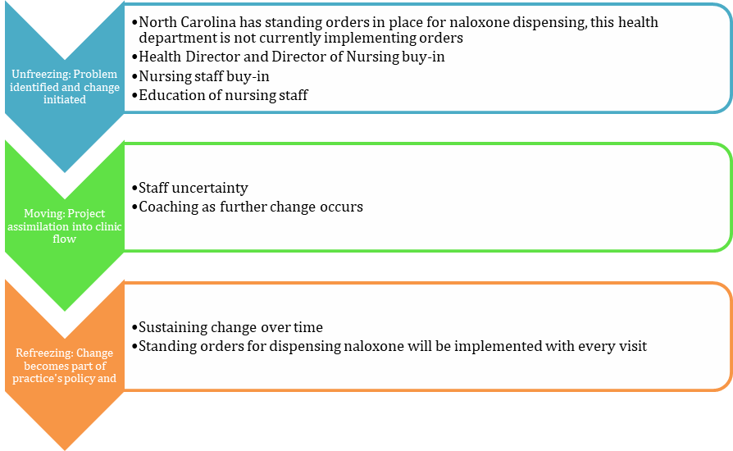

Appendix B
Good Samaritan Handout
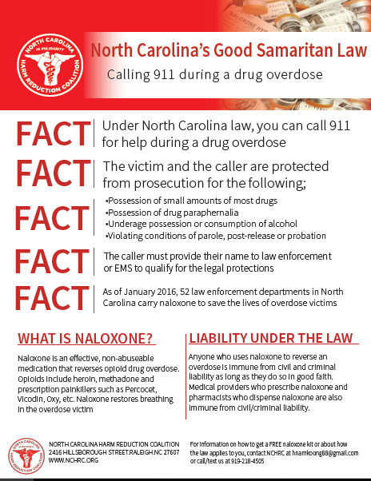

Appendix C
Literature Review Matrix

Article | APA Citation | Level of Evidence | Data/ Evidence Findings | Conclusion
Project Lazarus: Community-based overdose prevention in rural North Carolina | Albert, S., Brason II Chaplain, F. W., Sanford, C. K., Dasgupta, N., Graham, J., & Lovette, B. (2011). Project Lazarus: Community-based overdose prevention in rural North Carolina. Pain Medicine, 12(suppl 2), S77-S85. doi:10.1111/j.1526-4637.2011.01128.x | Level 7 | Wilkes County unintentional poisoning mortality rate is quadruple that of NC's ( 46.6 vs 11.0 state mortality rate per 100,000 population in 2009) and due almost exclusively to prescription opioid pain relievers. Top opioids implicated in deaths are fentanyl, hydrocodone, methadone, and oxycodone. The average age of death is late 30s. Preliminary unadjusted data from Wilkes County suggests that overdose death rate has dropped from 43 per 100,000 in 2008 to 29 per 100,000 in 2010. Wilkes county did not see an increase in overdose deaths that other NC counties experienced. | The project Lazarus take home naloxone provisional model addresses the need for rescue and works as follows: a resident sees a physician for routine medical care, the physician identifies the patient as a naloxone priority patient based on criteria for overdose risk, when the patient agree to participate, they watch a 20 minute DVD in the office, they then go to a prearranged community pharmacy to pick up the free kit. The message doesn’t dwell on differences between legitimate and illicit users of opioids. According to the Agency for Health Care Research and Quality, the average cost of inpatient hospitalization for opioid poisoning in NC in 2008 was $16,970. Development of a community based overdose prevention program in Wilkes County. Project Lazarus created a model for preventing prescription opioid overdose deaths that includes the following five components: community activation and coalition building; monitoring and surveillance data; prevention of overdoses; use of rescue medications for reversing overdoses by community members; and evaluating project components. Center of project assumes that communities are responsible for their own health.
Effect of local health department on community overdose prevention coalitions. | Alexandridis, A. A., Dasgupta, N., Ringwalt, C., Sanford, C., McCort, A. (2017) Effect of local health  department leadership on community overdose prevention coalitions. Drug and Alcohol  Dependence, 171, e5-e6. | Level 3 | In 2013 there were 19,103 opioid-related hospital ED visits in NC, and 7.45 M outpatient prescriptions for OA were dispensed. Compared to non-funded counties, those receiving funding for community coalitions had a 6% lower rate of opioid related ED visits per OA script dispensed. In counties where the coalition was led by the LHD, the rate of opioid related ED visits was 27 % lower than all the counties. | NC counties with funded coalitions had marginally lower rates of opioid related ED visits, and leadership of community coalitions by local health departments led to a further reduction. Community coalitions focused on prescription opioid overdose prevention have shown promise in reducing overdose death.
Evaluation of knowledge and confidence following opioid overdose prevention training: A comparison of types of training participants and naloxone administration methods. | Ashrafioun, L., Gamble, S., Herrmann, M., & Baciewicz, G. (2016). Evaluation of knowledge and confidence following opioid overdose prevention training: A comparison of types of training participants and naloxone administration methods. Substance Abuse, 37(1), 76-81. doi:10.1080/08897077.2015.1110550 | Level 3 | Number of knowledge questions answered correctly by the participants significantly increased from pre-training to post training. Also an increase in confidence pre- and post-training. Effect of knowledge on participant type: Patient, provider, family member/friend, or other: Knowledge and confidence scores did not differ. | The purpose of the study was to assess the effect of overdose prevention training on participant’s knowledge about opioid overdose and confidence to recognize and respond to situations as a function of naloxone administration and participant type. Used pre and post knowledge scores. Opioid overdose trainings are effective in increasing knowledge and confidence related to overdose situations. Trainees are more confident administering nasal narcan compared to injection.
Overdose education and naloxone rescue kits for family members of opioid users: Characteristics, motivations and naloxone use. | Bagley, S., Peterson, J., Cheng, D. M., Jose, C., O’Connor, P. G., & Walley, A. Y. (2015). Overdose education and naloxone rescue kits for family members of opioid users: Characteristics, motivations and naloxone use. Drug and Alcohol Dependence, 146, e213. doi:10.1016/j.drugalcdep.2014.09.048 | Level 6 | Of 126 surveys completed at 8 sites, 99 attendees had received OEN training and 27 had not. The trainees were likely to be parents, provide financial support, utilize court mandated treatment, and to have witnessed an overdose. The major motivations to receive training were: wanting a kit in case there was an overdose in their home, encouragement at the beginning of support group meeting and having heard about the benefits. Nine used a naloxone kit on a family member. | Most family member support group attendees received OEN training, motivated by wanting to be prepared in case of an overdose, peer encouragement and prior knowledge of naloxone. Several had used naloxone to rescue family members who overdosed. Cross- sectional multisite study to survey attendees of community support groups for family members of opioid users where OEN training was offered. Development of a 42 item self-administered survey that included demographics relationship to the user, experience with overdose, motivations to receive OEN, and naloxone rescue kit use.
Characteristics of an overdose prevention, response, and naloxone distribution program in Pittsburgh and Allegheny County, Pennsylvania. | Bennett, A. S., Bell, A., Tomedi, L., Hulsey, E. G., & Kral, A. H. (2011). Characteristics of an overdose prevention, response, and naloxone distribution program in Pittsburgh and Allegheny county, Pennsylvania. Journal of Urban Health, 88(6), 1020-1030. doi:10.1007/s11524-011-9600-7 | Level 6 | Describe the experiences of 426 individuals who participated in the OPP between 2005 and 2008. Of these 89 individuals reported administering naloxone in response to an overdose in a total of 249 separate overdose episodes. Of these 249 overdose episodes in which naloxone was administered, participants reported 96% were reversed. | Community based opioid overdose prevention programs that equip drug users with skills to identify and respond to an overdose and prescribe naloxone can help users with skills to identify and respond to an overdose and prescribe naloxone can help users and their peers prevent and reverse potentially fatal overdoses without significant adverse consequences. Intervention was started at sites with needle exchange programs. During visit participants received verbal explanation of the overdose prevention trainings. On subsequent visits participants were offered training and naloxone, trainings lasted 25 minutes. Naloxone was prescribed, no cost for naloxone, following training.
Naloxone: An opportunity for another chance. | Calas, T., Wilkin, M. & Oliphant, C. (2016). Naloxone: An opportunity for another chance. The Journal Calas, T., Wilkin, M. & Oliphant, C. (2016). Naloxone: An opportunity for another chance. The Journal  for Nurse Practitioners, 12(3), p. 154-160. | Level 7 | Discussion of the need for naloxone, how opioids and naloxone work in the body, what an overdose looks like, the forms of naloxone and directions for use, and what needs to be done in an overdose. | Narcan provides a second chance for survival and can be first step towards opioid overdose recovery.
A systemic review of community opioid overdose prevention and naloxone distribution programs. | Clark, A.K., Wilder, C. M. & Winstanley, E.L. (2014). A systemic review of community opioid overdose  prevention and naloxone distribution programs. Journal of Addiction Medicine, 8(3), p. 153-163. | Level 5 | No randomized studies were found. There were 19 published studies. Overall studies were descriptive. | Current literature suggests that nonmedical bystanders trained by OOPP are able to administer naloxone effectively and use additional recommended and non-recommended strategies in response to an overdose. None of 17 studies used randomization, all were reliant on participant self-reports. Heroin was identified as the drug most frequently reported used in overdose. The demographics of the participant’s reviewed in the studies may not have accurately represented the persons at high risk for overdose, most respondents were men and studies show that women are more at risk than men for overdose. There was evidence that people show improvement in knowledge right after training, but nothing about retention for months after. Including only reviewed studies, nearly 2000 overdoses were reversed by lay bystanders who had received training. All but one study indicated that the participants used and refilled their prescriptions. Individuals that use naloxone effectively also use appropriate and inappropriate strategies in response to overdose, suggesting that different training programs may be more or less effective. Most participants do not call EMS. Participants feared negative consequences, and although there were few cases of EMS harassment, most people reported positive experiences. OOPP participation is associated with overdose reversals, increased knowledge and ability to respond appropriately in an overdose situation, and the ability of nonmedical bystanders to safely administer naloxone.
Overdose education and naloxone rescue kits for family members of opioid users: Characteristics, motivations and naloxone use. | Coffin, P. O., & Sullivan, S. D. (2013). Cost-effectiveness of distributing naloxone to heroin users for lay overdose reversal. Annals of Internal Medicine, 158(1), 1. | Level 5 | Principle risk factor for heroin overdose is prior heroin overdose. 10-25% of heroin users overdose annually and 33-70% overdose in a lifetime. Mean age of overdose death is in the fourth decade of life. The risk for repeat overdose increased after the first overdose and again after second overdose. Naloxone is obtained through contractual agreements with programs generally paying $6 per dose, $15 per kit of injectable, $30 per kit of intranasal. Naloxone distribution increased costs by $53 and QALY by 0.119 for an ICER of $438 | Naloxone distribution to heroin users is likely to reduce overdose deaths and is cost-effective.
Development and implementation of an opioid overdose prevention and response program in Toronto, Ontario. | Leece, P. N., Hopkins, S., Marshall, C., Orkin, A., Gassanov, M. A., & Shahin, R. M. (2013). Development and implementation of an opioid overdose prevention and response program in Toronto, Ontario. Canadian Journal of Public Health = Revue Canadienne De Santé Publique, 104(3), e200. | Level 3 | In the first 8 months of the program, 209 clients were trained. Clients have reported 17 administrations of naloxone, and all overdose victims have reportedly survived. Client demand for POINT training has been high, and Toronto Public Health has expanded its capacity to provide training. Overall, reception to the program has been overwhelmingly positive. | This intervention may be cost-effective: if the provision of 209 kits represented approximately $5000 in capital cost and saved one life out of the 17 who received naloxone during the program, it would meet the National Institute for Health and Clinical Excellence (NICE) cost-effectiveness threshold of £20,000-£30,000 (roughly CAD $30,890-$46,335) per quality adjusted life year (QALY) gained. However, more research on cost-effectiveness is needed.
Evaluation of the overdose education and naloxone distribution program of the Baltimore student harm reduction coalition. | Lewis, D. A., Park, J. N., Vail, L., Sine, M., Welsh, C., & Sherman, S. G. (2016). Evaluation of the overdose education and naloxone distribution program of the Baltimore student harm reduction coalition. American Journal of Public Health, 106(7), 1243-1246. doi:10.2105/AJPH.2016.303141 | Level 3 | BSHRC obtained naloxone through contractual agreements, and approximate cost per kit was $15.84, which is similar to other cost estimates of injectable naloxone kits and lower than for intranasal kits. 3 Total materials came to $20.01 per kit. Of 263 eligible trainees, 50% consented to participate (n = 132) in the evaluation of the program, of whom 86% completed both initial pre- and posttest surveys (n = 113). Most individuals (72%) were at the training because they were concerned about somebody they knew overdosing, such as a family member, friend, or colleague. | In an 8-month pilot period, 250 free naloxone kits were distributed, and 3 overdose reversals were reported to BSHRC. Trainings were effective in increasing self-efficacy surrounding overdose prevention and response, which appears to persist at up to 12 months following the training.
Rapid widespread distribution of intranasal naloxone for overdose prevention. | Madah-Amiri, D., Clausen, T., & Lobmaier, P. (2017). Rapid widespread distribution of intranasal naloxone for overdose prevention. Drug and Alcohol Dependence, 173, 17-23. doi:10.1016/j.drugalcdep.2016.12.013 | Level 3 | Staff from multiple low threshold facilities trained clients on how to use naloxone. There were 2056 naloxone sprays distributed from one of the 20 participating facilities with 227 reports of successful reversals. | A government supported multisite naloxone initiative appears to achieve rapid high volume distribution of naloxone at an at risk population.
Exploring the life-saving potential of naloxone: A systematic review and descriptive meta-analysis of take home naloxone (THN) programmes for opioid users. | McAuley, A., Aucott, L., & Matheson, C. (2015). Exploring the life-saving potential of naloxone: A systematic review and descriptive meta-analysis of take home naloxone (THN) programmes for opioid users. The International Journal on Drug Policy, 26(12), 1183-1188. doi:10.1016/j.drugpo.2015.09.011 | Level 1 | From 25 identified THN evaluations, 9 studies allowed a PoU (proportion of use) to be determined. Overall the model shows a range of 5.2-13.2 naloxone uses every three months for every100 PWUD trained. 9% of naloxone kits distributed are likely to be used for peer administration within the first three months of supply for every 100 PWUD trained. | Although the evidence base for THN is limited by evaluation design, the number of successful reversals and the lack of reported adverse events make a strong case for increasing delivery worldwide. Our model estimates that around 9% of naloxone kits distributed are likely to be used for peer administration within the first three months of supply for every 100 PWUD (People who use drugs) trained.
Are take‐home naloxone programmes effective? Systematic review utilizing application of the Bradford Hill criteria | McDonald, R., & Strang, J. (2016). Are take‐home naloxone programmes effective? Systematic review utilizing application of the Bradford Hill criteria. Addiction, 111(7), 1177-1187. doi:10.1111/add.13326 | Level 5 | A total of 1397 records (1164 after removal of duplicates) were retrieved, with 22 observational studies meeting eligibility criteria. Due to variability in size and quality of the included studies, meta-analysis was dismissed in favor of narrative synthesis. From eligible studies, we found take-home naloxone met all nine Bradford Hill criteria. The additional five World Health Organization criteria were all either met partially (two) or fully (three). Even with take-home naloxone administration, fatal outcome was reported in one in 123 overdose cases (0.8%; 95% confidence interval = 0.4, 1.2). | Take-home naloxone programs are found to reduce overdose mortality among program participants and in the community and have a low rate of adverse events. In 2014, the World Health Organization (WHO) launched guidelines on the community management of opioid overdose, recommending that ‘people likely to witness an opioid overdose should have access to naloxone and be instructed in its administration.
Combating opioid overdose with public access to naloxone. | Mitchell, K. D., & Higgins, L. J. (2016). Combating opioid overdose with public access to naloxone. Journal of Addictions Nursing, 27(3), 160. | Level 5 | Wheeler et al. (2015) calculated detailed statistics from 644 OEPs and naloxone distribution sites across the United States. According to their survey results, approximately 152,283 naloxone kits with overdose training were provided to laypersons, which resulted in 26,463 reversals from 1996 to 2014. Through San Francisco’s Drug Overdose Prevention and Education Project, Enteen et al. (2010) found that 399 of 1,942 program participants used naloxone to reverse an overdose with 89% success rate. | In the 38 articles selected for the final review, six categories were discussed: global trends, U.S. overdose education programs with naloxone distribution, barriers to public access of naloxone, political opposition and support, financial impact, and recommendations. After reviewing the findings, gaps in the literature were examined, and nursing implications were acknowledged.
Messaging to Increase Public Support for Naloxone Distribution Policies in the United States: Results from a Randomized Survey Experiment | Bachhuber, M. A., McGinty, E. E., Kennedy-Hendricks, A., Niederdeppe, J., & Barry, C. L. (2015). Messaging to Increase Public Support for Naloxone Distribution Policies in the United States: Results from a Randomized Survey Experiment. PLoS ONE, 10(7), e0130050. http://doi.org.jproxy.lib.ecu.edu/10.1371/journal.pone.0130050 | Level 5 | The final sample consisted of 1,598 participants (completion rate: 72.6%). Factual information and the sympathetic narrative alone each led to higher support for training first responders to use naloxone, providing naloxone to friends and family members of people using opioids, and passing laws to protect people who administer naloxone. Participants receiving the combination of the sympathetic narrative and factual information, compared to factual information alone, were more likely to support all policies: providing naloxone to friends and family members (OR: 2.0 [95% CI: 1.4 to 2.9]), training first responders to use naloxone (OR: 2.0 [95% CI: 1.2 to 3.4]), passing laws to protect people if they administer naloxone (OR: 1.5 [95% CI: 1.04 to 2.2]), and passing laws to protect people if they call for medical help for an overdose (OR: 1.7 [95% CI: 1.2 to 2.5]). | All messages increased public support, but combining factual information and the sympathetic narrative was most effective. Public support for naloxone distribution can be improved through education and sympathetic portrayals of the population who stands to benefit from these policies. Barriers to public support for naloxone distribution include lack of knowledge, concerns about potential unintended consequences, and lack of sympathy for people at risk of overdose.
Opioid overdose and naloxone education in a substance use disorder treatment program. | Lott, D. C., & Rhodes, J. (2016). Opioid overdose and naloxone education in a substance use disorder treatment program. The American Journal On Addictions, 25(3), 221-226. doi:10.1111/ajad.12364 | Level 3 | Total score on the OOKS increased significantly from pre-to post-education, and improvement was maintained at follow-up (p<.0001). OOKS subdomains of actions and naloxone use also had significant increases (p<.0001). Four subjects reported possessing naloxone in the past, and only one subject who did not already have  naloxone at the time of treatment had obtained it at follow-up. | Education about opioid overdose and naloxone use in a community treatment program increases overdose knowledge, providing support for the idea of  making OE a routine part of substance use disorder treatment. However, the rate of follow through on accessing naloxone was low  with this education-only intervention
Overdose rescues by trained and untrained participants and change in opioid use among substance-using participants in overdose education and naloxone distribution programs: A retrospective cohort study. | Doe-Simkins, M., Quinn, E., Xuan, Z., Sorensen-Alawad, A., Hackman, H., Ozonoff, A., & Walley, A. Y. (2014). Overdose rescues by trained and untrained participants and change in opioid use among substance-using participants in overdose education and naloxone distribution programs: A retrospective cohort study. BMC Public Health, 14, 297. doi:http://dx.doi.org.jproxy.lib.ecu.edu/10.1186/1471-2458-14-297 | Level 3 | Among 4,926 substance-using participants, 295 trained and 78 untrained participants reported one or more rescues, resulting in 599 rescue reports. We found no statistically significant differences in help-seeking (p = 0.41), rescue breathing (p = 0.54), staying with the victim (p = 0.84) or in the success of naloxone administration (p = 0.69) by trained  versus untrained rescuers. 325 OEND participants identified who had drug use information collected more than once. There was no significant overall change in the number of days using heroin in past 30 days (decreased 38%, increased 35%, did not change 21%). | Among 4926 substance users who participated in OEND, 373(7.6%) reported administering naloxone during an overdose rescue. We found few differences in behavior between trained and untrained overdose rescuers. Prospective studies will be needed to determine the optimal level of training and whether naloxone rescue kits can meet an over-the-counter standard. With no clear evidence of increased heroin use, this concern should not impede expansion of OEND programs or policies that support them.
Cost-effectiveness of distributing naloxone to heroin users for lay overdose reversal. | Coffin, P. O., & Sullivan, S. D. (2013). Cost-effectiveness of distributing naloxone to heroin users for lay overdose reversal. Annals of Internal Medicine, 158(1), 1. | Level 3 | In the probabilistic analysis, 6% of overdose deaths were prevented with naloxone distribution; 1 death was prevented for every 227 naloxone kits distributed (95% CI, 71 to 716). Naloxone distribution increased costs by $53 (CI, $3 to $156) and quality-adjusted life-years by 0.119 (CI, 0.017 to 0.378) for an ICER of $438 (CI, $48 to $1706). Naloxone distribution was cost-effective in all deterministic and probabilistic sensitivity and scenario analyses, and it was cost-saving if it resulted in fewer overdoses or emergency medical service activations. In a “worst-case scenario” where overdose was rarely witnessed and naloxone was rarely used, minimally effective, and expensive, the ICER was $14 000. If national drug-related expenditures were applied to heroin users, the ICER was $2429. | In summary, this analysis of naloxone distribution to heroin users for lay overdose reversal suggests that the intervention would increase QALYs and be highly cost-effective, even under markedly conservative assumptions.
Overdose prevention and naloxone prescription for opioid users in San Francisco. | Enteen, L., Bauer, J., McLean, R., Wheeler, E., Huriaux, E., Kral, A. H., & Bamberger, J. D. (2010). Overdose prevention and naloxone prescription for opioid users in san Francisco. Journal of Urban Health, 87(6), 931-941. doi:10.1007/s11524-010-9495-8 | Level 3 | The Drug Overdose Prevention and Education (DOPE) Project was the first naloxone prescription program (NPP) established in partnership with a county health department (San Francisco Department of Public Health), and is one of the longest running NPPs in the USA. From September 2003 to December 2009, 1,942 individuals were trained and prescribed naloxone through the DOPE Project, of whom 24% returned to receive a naloxone refill, and 11% reported using naloxone during an overdose event. Of 399 overdose events where naloxone was used, participants reported that 89% were reversed. In addition, 83% of participants who reported overdose reversal attributed the reversal to their administration of naloxone, and less than 1% reported serious adverse effects. We found that the majority of individuals who used naloxone during an overdose event also indicated that they used other revival methods taught during DOPE trainings. However, a minority reported contacting EMS. An earlier survey of IDUs in San Francisco found that 62% reported they would be “less inclined” to contact EMS if they had naloxone. That 84% of participants who used naloxone reported successful reversal without EMS intervention may suggest that IDUs did not call EMS because they did not deem it necessary, given successful reversal. | Participants are usually recruited and trained while waiting to receive services at clinics, dropping off syringes at SEPs, or in group trainings in SROs and treatment programs. Trainings typically last between 10 and 30 minutes and focus on overdose symptom identification, revival strategies, calling EMS, and administering naloxone. After DOPE Project staff train participants, SFDPH medical providers initiate a medical record (clinical registration) and assign each participant a unique identifier. Providers prescribe and dispense naloxone in two 0.4-mg/mL vials and two 3-cm3/mL 22-gauge 1-in muscling syringes along with a rescue breathing mask. All trained participants with unique identifiers and clinical registrations may receive refills of two pre-filled syringes at any subsequent dispensation—when participants use naloxone, lose, or have naloxone confiscated. SFDPH providers do not limit the number of refills trained participants may receive. Of the 1,942 participants who receive naloxone prescriptions, 24% returned to receive at least one naloxone refill, of whom half returned on more than one occasion to receive multiple refills. Participants requested refills for a variety of reasons, including having naloxone stolen on the street, confiscated in a shelter, or destroyed during unstable housing transition. Of 1,020 refills dispensed, 399 (40%) were provided after participants reported using naloxone during an overdose event, while 49% were provided after participants reported a loss of naloxone, and 12% were provided after participants reported confiscation by police, DPW, or sheriff’s department (upon admission to jail). Of participants who lost naloxone, 27% reported that they also used naloxone in response to a subsequent overdose event.
Effectiveness of bystander naloxone administration and overdose education programs: A meta-analysis. | Giglio, R. E., Li, G., & Dimaggio, C. J. (2015). Effectiveness of bystander naloxone administration and overdose education programs: A meta-analysis. Injury Epidemiology, 2(1), 1-9. doi:http://dx.doi.org.jproxy.lib.ecu.edu/10.1186/s40621-015-0041-8 | Level 1 | Data from five studies of overdose education indicated that average scores were significantly higher for trained participants than untrained participants for tests on naloxone administration, overdose recognition, and overdose response (standardized mean difference=1.35, 95% CI=0.92 to 1.77). | Bystander naloxone administration and overdose education programs are associated with increased odds of recovery and with improved knowledge of overdose recognition and management in non-clinical settings.
Barriers to medical provider support for prescription naloxone as overdose antidote for lay responders. | Green, T. C., Bowman, S. E., Zaller, N. D., Ray, M., Case, P., & Heimer, R. (2013). Barriers to medical provider support for prescription naloxone as overdose antidote for lay responders. Substance Use & Misuse, 48(7), 558-567. doi:10.3109/10826084.2013.787099 | Level 3 | This analysis focuses on the 24 interviews  with emergency department providers, substance use  treatment providers, pain specialists, and generalist/family medicine practitioners. | Identified concerns included that naloxone not be treated as a safety net to support more risk taking among drug users, that it be prescribed to those at risk  or likely to administer it, concerns about naloxone’s appropriateness when reversing long-acting opioid-involved overdoses, and that naloxone prescription not be treated as  a stand-alone safety measure for providers nor as a single response step for lay overdose responders. The majority of providers did not  express concern that naloxone itself could do harm to patients.
Reducing Fatal Opioid Overdose: Prevention, treatment and harm reduction strategies. | Hawk, K. F., Vaca, F. E., & D’Onofrio, G. (2015). Reducing Fatal Opioid Overdose: Prevention, Treatment and Harm Reduction Strategies. The Yale Journal of Biology and Medicine, 88(3), 235–245. |  | The first naloxone distribution program in the United States began in Chicago. In 1996, the Chicago Recovery Alliance program started distributing naloxone through a mobile van-based harm reduction program and in the subsequent decade delivered naloxone to 10,211 people with 1,011 reported overdoses reversals. | Types of opioid abuse, increased opioid prescribing, biology of an opioid overdose, elevated risk for fatal overdose.
Expanded access to naloxone: Options for critical response to the epidemic of opioid overdose mortality. | Kim, D., M.P.H., Irwin, K. S., M.A., & Khoshnood, K., PhD. (2009). Expanded access to naloxone: Options for critical response to the epidemic of opioid overdose mortality. American Journal of Public Health, 99(3), 402-7. Retrieved from http://search.proquest.com.jproxy.lib.ecu.edu/docview/215086476?accountid=10639 | Level 3 | For those in attendance, calling 911 is often a last resort, occurring only an estimated 10% to 56% of the time,14,20,27 because, in the United States, the police are usually notified of a 911 call reporting an overdose and frequently appear at the scene.18,22,28 Because many of those who misuse opioids are on parole, have outstanding arrest warrants,18,20 or otherwise don't want to be identified | Peers (at the scene) often attempt to revive victims themselves, sometimes employing such dubious strategies as injecting them with salt, milk, or stimulants like cocaine; immersing them in a cold bath; massaging their hearts; or deliberately inflicting pain. Such interventions are generally ineffective and potentially dangerous to the victim, but peers, even those who call 911, almost always first attempt these methods. Others may initiate cardiopulmonary resuscitation but, because few are adequately trained, their attempts are often unsuccessful. Thus, although peers are often on the scene and willing to help, one time can rapidly run out for those in need of urgent intervention. Three policies capable of increasing access to naloxone should be considered. First, physician prescriptions of naloxone to at-risk patients should be increased, and second, distribution programs should be expanded; both could be accomplished within current regulatory structures. Third, naloxone could be relabeled as an over-the-counter drug, which may be an important alternative that could supplement the limited reach of the first two options, although further studies may be necessary.
Awareness and attitudes toward intranasal naloxone rescue for opioid overdose prevention. | Kirane, H., Ketteringham, M., Bereket, S., Dima, R., Basta, A., Mendoza, S., & Hansen, H. (2016). Awareness and attitudes toward intranasal naloxone rescue for opioid overdose prevention. Journal of Substance Abuse Treatment, 69, 44-49. doi:10.1016/j.jsat.2016.07.005 |  | 100 patients and 101 providers completed questionnaires between August, 2014 and January, 2015. Patient participants were primarily Caucasian males with a mean age of 37.7 years, of which 65% accurately identified naloxone for opioid overdose, but only 21% knew more specific clinical features. 68% of patients had previously witnessed a drug overdose. Notably, 58% of patients anticipated their behavior would change if provided access to an intranasal naloxone rescue kit, of which 83% predicted an increase in opioid use. Prior overdose was significantly correlated with anticipating no change in subsequent opioid use pattern (p = 0.02). 99% of patients reported that their rapport with their health-care provider would be enhanced if offered an intranasal naloxone rescue kit. As for providers, 24% had completed naloxone rescue kit training, and 96% were able to properly identify its clinical application. 50% of providers felt naloxone access would decrease the likelihood of an overdose occurring, and 58% felt it would not contribute to high-risk behavior. Among providers, completion of naloxone training was correlated with increased awareness of where to access kits for patients (p < 0.001).
Predictors of participant engagement and naloxone utilization in a community-based naloxone distribution program. | Rowe, C., Santos, G., Vittinghoff, E., Wheeler, E., Davidson, P., & Coffin, P. O. (2015). Predictors of participant engagement and naloxone utilization in a community-based naloxone distribution program. Addiction, 110(8), 1301-1310. doi:10.1111/add.12961 | Level 3 | A total of 2500 participants were registered and 702 reversals were reported from 2010 to 2013. Participants who had witnessed an overdose [adjusted odds ratio (AOR)=2.02, 95% confidence interval (CI)= 1.53–2.66; AOR=2.73, 95% CI=1.73–4.30] or used heroin (AOR=1.85, 95% CI= 1.44–2.37; AOR=2.19, 95% CI=1.54–3.13) or methamphetamine (AOR=1.71, 95% CI=1.37–2.15; AOR=1.61, 95% CI=1.18–2.19) had higher odds of obtaining a refill and reporting a reversal, respectively. African American (AOR=0.63, 95%  CI=0.45–0.88) and Latino (AOR=0.65, 95% CI= 0.43–1.00) participants had lower odds of obtaining a naloxone refill, whereas Latino participants who obtained at least one re  fill reported a higher number of refills [incidence rate ratio (IRR) = 1.33 (1.05–1.69)]. | Community naloxone distribution programs are capable of reaching sizeable populations of high-risk individuals and facilitating large numbers of overdose reversals. Community member most likely to engage with a naloxone program and use naloxone to reverse an overdose are active drug users.
Family carers and the prevention of heroin overdose deaths: Unmet training need and overlooked intervention opportunity of resuscitation training and supply of naloxone. | Strang, J., Manning, V., Mayet, S., Titherington, E., Offor, L., Semmler, C., & Williams, A. (2008). Family carers and the prevention of heroin overdose deaths: Unmet training need and overlooked intervention opportunity of resuscitation training and supply of naloxone. Drugs: Education, Prevention & Policy, 15(2), 211-218. | Level 3 | Carers were usually parents (80%); 89% were currently caring for a heroin  user of whom 49% had already had an overdose (93% involving opiates). One third had  witnessed heroin being used, and 31 had witnessed an overdose. For eight caretakers, there  had already been a death from drug overdose. There was poor knowledge of how  to manage an overdose. Only a quarter had received advice on overdose management (26%) and only one third knew of the opiate antagonist naloxone (33%). The majority(88%) wanted training in overdose management, especially in emergency naloxone administration (88%). Interest in training did not differ according to caretaker type nor previous overdose experience. | We found evidence of an extensively overlooked carer population, many of  whom have already been faced with an overdose situation and yet have received minimal  training. We also found high levels of interest in receiving overdose training, in particular,  in emergency naloxone administration.
Barriers to implementation of opioid overdose prevention programs in Ohio. | Winstanley, E. L., Clark, A., Feinberg, J., & Wilder, C. M. (2016). Barriers to implementation of opioid overdose prevention programs in Ohio. Substance Abuse, 37(1), 42-46. doi:10.1080/08897077.2015.1132294 | Level 3 | The first Ohio OOPP opened in August 2012, a second program opened in 2013, and the remaining programs began in 2014. All of the programs distribute nasal naloxone and provide overdose prevention education, and 89% provide overdose kits for free. Six OOPPs are funded by the Ohio Department of Health, 3 programs are funded by a local health foundation, and several other public and  private funding sources were reported. The OOPPs have funding to distribute a combined total of 8,670  overdose kits and had distributed 1998 kits by October 2014. The OOPPs reported 149 overdose reversals.  Fifteen programs (83%) reported implementation barriers that were categorized as stigma-, cost-, staffing legal, regulatory, and client-related problems. Legislative changes aimed at removing some of the obstacles to distribution and lay administration of naloxone have recently been enacted in Ohio. | OOPPs have rapidly expanded in Ohio during the past 3 years. Although recent legislative  changes have addressed some of the reported implementation barriers, stigma and the cost of naloxone remain significant problems

Appendix D
Flowchart

Eligibility
Studies included in quantitative synthesis (meta-analysis)
(n =2 )

Included

Studies included in qualitative synthesis
(n = 15 )
Records identified through database searching
(n = 62,805 )

Identification

Records after eliminating all but journal articles
(n = 5,427 )

Screening
Articles from 2007-2018
(n = 45 )

Full Text Medical, Nursing, Public Health articles
(n = 2603 )

Appendix E

Standing Order for Naloxone

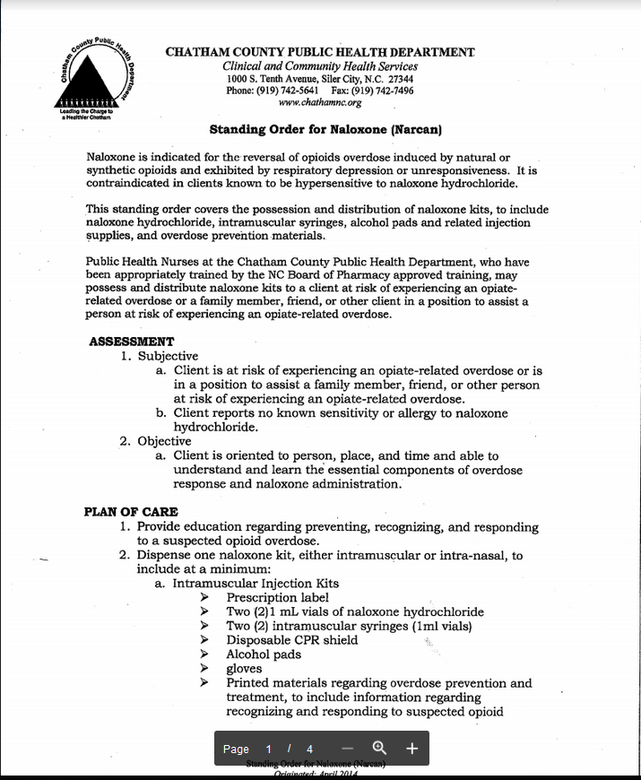
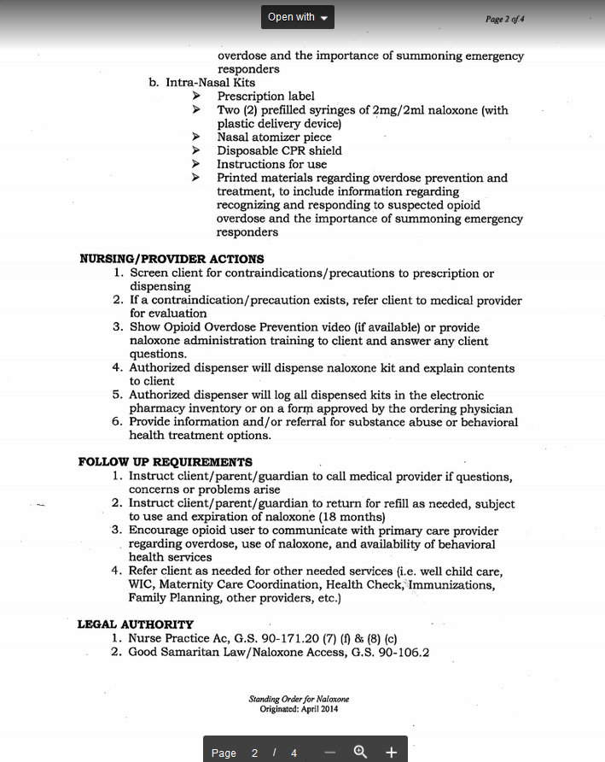

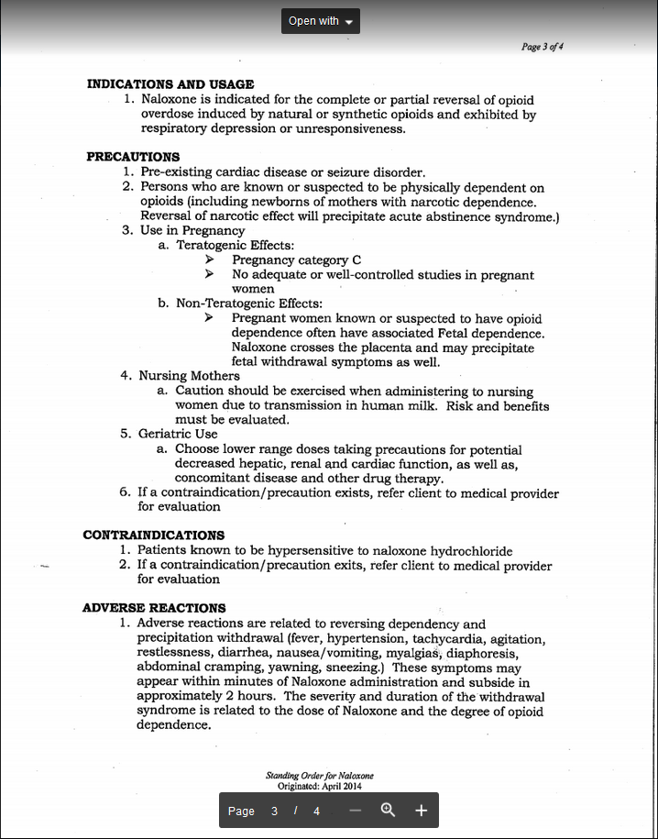

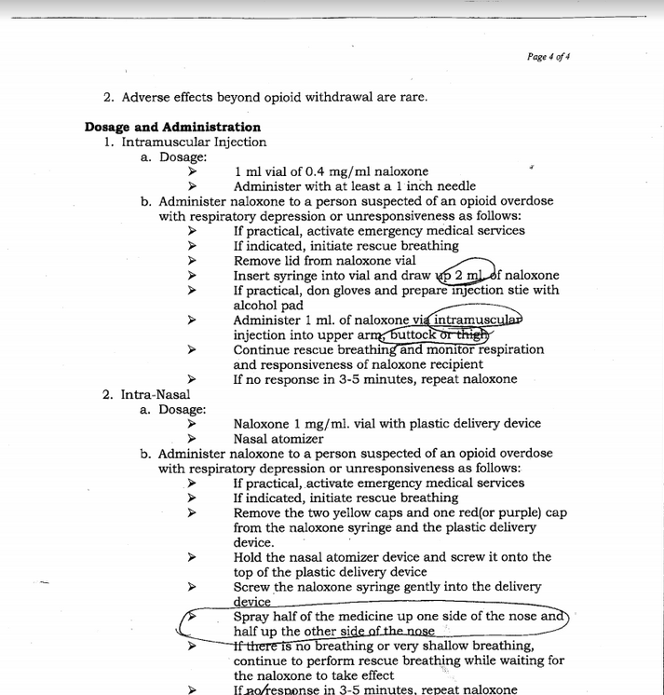

Appendix F
Opioid Use Screening Tool
Opioids are drugs available by prescription, such as, Fentanyl, Vicodin/hydrocodone, Percocet, Dilaudid/hydromorphone, oxycodone, codeine, morphine, methadone, Suboxone, and many others. The illegal drug, Heroin, is also an opioid.

When too much of an opioid is taken, there is a risk for overdose that may lead to death. Naloxone or narcan can reverse the effects of an opioid on the system and save a life.

- Do you use opioids or know of a friend or family member who uses opioids?
YES NO

- Are you interested in receiving a naloxone kit to take home today?
YES NO

Appendix G
Outline of Naloxone Training Webinar
Dispensing of Drugs by Public Health Nurses: Part I Addendum Naloxone Dispensing
I: Introduction: The need
- The Response
- What are opioids
- The role of naloxone
- How to recognize an opioid overdose and what to do
- The signs of opioid overdose (what to look for)
- How to respond to an opioid overdose
- If the individual does not respond to stimulation it is important to:
  - Calling 911-What to say
  - Perform rescue breathing
  - Administer naloxone
- How to dispense naloxone kits

Appendix H
Naloxone Kit Contents
One eyeglass case holding the contents of the kit
Two doses of Narcan Nasal Spray
One CPR mask
One drug insert with reminder of how to use drug and perform rescue breathing

Appendix I
Data Collection Tool

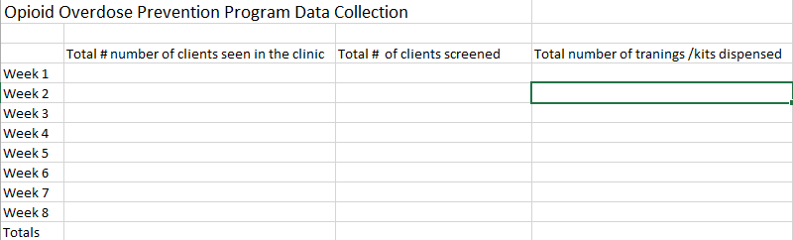

Appendix J

Project Budget

Appendix K
PDSA Cycle

Appendix L
Institutional Review Board Approval

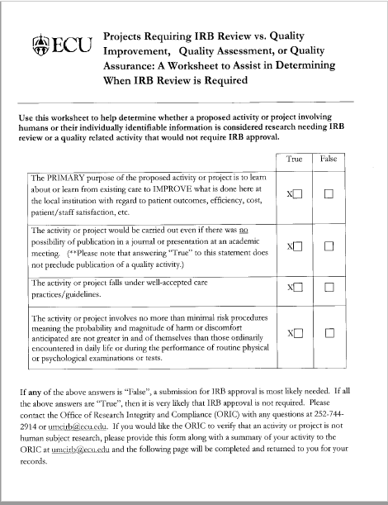

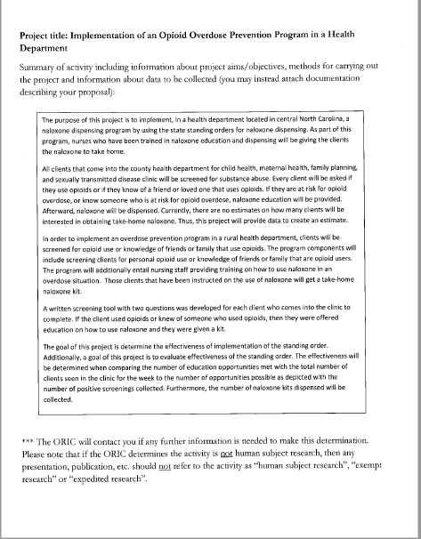

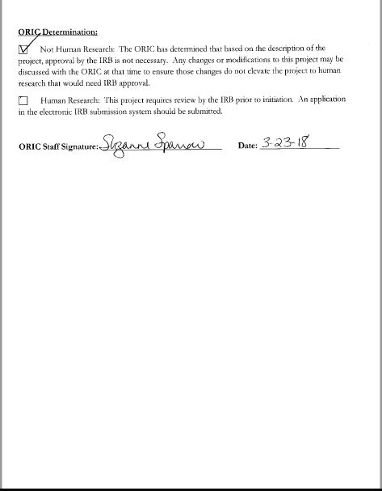

Appendix M
Project Site Approval

