Epigenetic Effect of Modified Diet and Exercise on Drosophila Metabolic Phenotype and Cardiovascular Health

Ajay Ajmera

A thesis submitted to the Department of Biology, East Carolina University, in partial fulfillment of the requirements for Biology Honors Thesis

Advisor: Alexander K. Murashov, M.D, Ph.D.
Brody School of Medicine
Department of Physiology

April 24th, 2015

Approved by:
Alexander K. Murashov, M. D, Ph.D.
Brody School of Medicine
Department of Physiology

I hereby declare I am the sole author of this thesis. It is the result of my own work and is not the outcome of work done in collaboration, nor has it been submitted elsewhere as coursework for this or another degree.

Signed: Ajay Ajmera Date: April 24, 2015

Acknowledgments

I would sincerely like to thank the people who made this study possible:
Elena Pak who helped with the lab techniques through the duration of the project, Henry Alarco, Oksana Williams, Michelle Pike, Lee Hoff, Sean Ross, and Daniel Ramos, the Department of Physiology at the Brody School of Medicine, and East Carolina University. I am especially grateful to my project advisor, Dr. Alexander K. Murashov, for his knowledge and guidance. If not for his unwavering support and patience, this thesis would not have been possible. Funding was received from an East Carolina University Undergraduate Research and Creativity Award.

Epigenetic Effect of Modified Diet and Exercise on Drosophila Metabolic Phenotype and Cardiovascular Health
Ajay Ajmera
Department of Biology, East Carolina University, Greenville N.C. 27858

ABSTRACT - Obesity is a growing world-wide epidemic. Overweight populations are prone to a variety of morbid conditions including diabetes type 2, cardiovascular diseases, and cancers. The catastrophic increase in obesity rates, which can later present as cardiovascular disease, is largely attributed to sedentary life style and a poor diet. Epigenetic studies show maternal obesity as a risk factor for metabolic syndromes in offspring. Furthermore, evidence suggests obese and diabetic fathers may also contribute to offspring metabolic phenotype. Experiments were designed to answer the question: does modified paternal diet and exercise produce transgenerational effects on offspring metabolic phenotype and cardiovascular health? Drosophila Melanogaster was used as a model because of its well-known genetics and short life cycle, making it ideal for transgenerational studies. Specifically, this research sought to look at the effects of high-fat and high sucrose diets and exercise on whole body composition, and particularly effects on cardiovascular health in Drosophila F0, and F1 generations. To test the effects of diet and exercise, male flies were exposed to either 14 days of high-fat, high-sucrose, exercise or control diet and then mated with control virgin females. Offspring were collected after hatching and subjected to a normal or modified diet for 14 days. After 14 days, animals were analyzed for triglyceride and trehalose/glucose levels in F0 and F1 generations. Fruit flies were also subjected to exercise for 14 days to measure the effects on phenotype. A vertical test was done before and after exercise to measure the effect of exercise on motor activity. Height climbed was measured in centimeters after vials were tapped down and flies were allowed to climb up for 5 seconds. Cardiovascular health was measured by beats per minute and was recorded at various time points throughout the 14 day diet. Results indicate a significant increase in amount of triglycerides and trehalose in exercise father offspring flies on a high-fat diet challenge than fat father offspring flies on a high-fat diet challenge. There was also a significantly increased heart rate for F0 flies on a high sucrose diet, and on an exercise regimen than flies on a high-fat diet. Fat father offspring on an exercise regimen had a significantly higher heart rate than control father offspring and exercise father offspring on an exercise regimen. Vertical test data showed a significantly higher level of motor activity from the exercise group than the control group through day 7, but then locomotor activity decreased post day 7 in the exercise group compared to the control. The combined data suggest paternal experience due to diet and exercise induces transgenerational effects in F1 male flies due to diet and exercise in the metabolic phenotype and cardiovascular health.

Table of Contents

Acknowledgments 3

Abstract 4

Table of Contents 6

List of Figures 8

Introduction 9

Methods 11

Animals 11

Breeding 12

Exercise 12

Vertical Test 12

Sample Collection/ Weight Monitoring 13

Sample Preparation 13

Triglycerides Assay 14

Glucose Assay 14

Trehalose Assay 15

Cardiovascular Health 15

Results 17

Vertical Test 17

Weight Monitoring 19

Triglyceride Assay 21
Glucose Assay 23

Table of Contents (continued)

Trehalose Assay 25

Cardiovascular Health 27

Discussion 29

Conclusions 29

Study Limitations 32

Future Studies 33

Literature cited 34

List of Figures

Figure 1: Experimental Design 11

Figure 2: Power Tower 13

Figure 3: 14 Day Vertical Test 18

Figure 4a: Weight F0 WT 19

Figure 4b: Weight F0 (Control) vs F1 (Control) WT 19

Figure 4c: Weight F0 (30%) vs F1 (30%) WT 20

Figure 5a: Triglycerides F0 WT 21

Figure 5b: Triglycerides F0 (Control) vs F1 (Control) WT 21

Figure 5c: Triglycerides F0 (30%) vs F1 (30%) WT 22

Figure 6a: Glucose F0 WT 23

Figure 6b: Glucose F0 (Control) vs F1 (Control) WT 23

Figure 6c: Glucose F0 (30%) vs F1 (30%) WT 24

Figure 7a: Trehalose F0 WT 25

Figure 7b: Trehalose F0 (Control) vs F1 (Control) WT 25

Figure 7c: Trehalose F0 (30%) vs F1 (30%) WT 26

Figure 8a: Heart Rate F0 WT 27

Figure 8b: Heart Rate F0 (Control) vs F1 (Control) WT 27

Figure 8c: Heart Rate F0 (Exercise) vs F1 (Exercise) WT 27

Introduction
Obesity is an important global public health problem (Seidell, 2000) and is a risk factor for morbidity and mortality (Pemberton et al., 2010). National statistics demonstrate continued increases in overweight and obesity among young adults and children over the past three decades (Loomba et al., 2008). Additionally, the obesity epidemic is linked to a startling rise in the incidence of type II diabetes among children. Both obesity and type II diabetes are heritable traits with obesity estimates of >0.70 (Walley et al., 2006), and diabetes heritability estimates ranging from 0.21 to 0.72 (Mathias et al., 2009). Increased rates of obesity not only have high correlations to diabetes but can also increase pre-disposition to cardiovascular diseases later in life (Hu 2011). Moreover, these adverse effects of obesity from sedentary lifestyle and improper diet increase the rate of cardiovascular disease (Van Gaal 2006). Although observations suggest both genetic and environmental components may play equally important roles in the etiology of obesity, type II diabetes, and cardiovascular disease changes in the gene pool of the population over this time frame are not sufficient to explain the recent increase of childhood obesity, type II diabetes in adolescents, and further cardiovascular disease presentation in younger and younger adults. Rather, such rapid increases in heritable traits are likely due to epigenetic modification of the genome (Permutt et al., 2005) by environment factors such as high fat intake, or physical inactivity. Of particular interest is whether modifications to the genome induced by the environment may be passed to offspring. Growing bodies of literature have demonstrated epigenetic programming in the maternal and paternal lineage (Vidal 2014). However, there is much elucidation needed in regards to what can be affected across multiple generations and to what extent. Drosophila melanogaster is an attractive model organism for transgenerational studies because it offers unique opportunities to study the impact of diet and exercise on metabolism and cardiovascular health (Buescher 2013). For example, Drosophila melanogaster contain many conserved metabolic and cardiac functions with vertebrates, and particularly humans (Baker 2007). Drosophila have similar and analogous insulin, insulin-like-growth factors, energy storage and target of rapamycin (TOR) signaling pathways (Schlegel 2007). Although Drosophila contain no chambers in their heart, with their heart tube running from the bottom of the thorax to the bottom of the abdomen, they still remain a model organism to study cardiomyopathies in humans due to the shared genetic similarities (Wolf 2006). Advances in Drosophila understanding have led to insight in the complex interactions between the nutritional environment, metabolism, and cardiovascular health (Musselman 2009, Raud 2011, Sieber 2009) Transgenerational effects of nutrition on metabolism have been reported on the maternal lineage, where maternal flies exhibit poor metabolic homeostasis when subjected to a caloric excess (Buescher 2013). However, little is known of the paternal transgenerational effect (Ost 2013). Thus, the goal of the study is to determine whether there is a transgenerational effect of diet or exercise on metabolism and cardiovascular health of male offspring due to paternal programming. Based on experimental evidence, it was hypothesized there would be a transgenerational effect from diet and exercise due to paternal exposures.

Methods
Animals
All experimentation was completed using the Canton-S wild type strain of Drosophila melanogaster. To reduce the confounding effects of environment from different laboratories, multiple generations of Drosophila were bred in order to create the F0 group. All experimental flies were placed in the same incubator containing constant conditions of temperature (21.5°C), 50% humidity, and a 12-hour light/dark cycle to simulate natural conditions. Male Drosophila were placed together in cohorts of 15 per vial with unlimited access to food. Vials were oriented horizontally in the incubator to prevent flies from sticking to food. Drosophila were given either control food (Cat # 66-112, Genesee Scientific, Bloomington, Indiana), 30% coconut oil, or 1M sucrose diet. 50% of Drosophila given a control diet were also supplemented with an exercise regimen. Experimental design is shown in figure 1. Cardiovascular Health was measured for the first 5 days of diet after eclosion. Triglyceride, Trehalose, and Glucose levels were measured at day 14 when flies were either sacrificed or set for breeding.

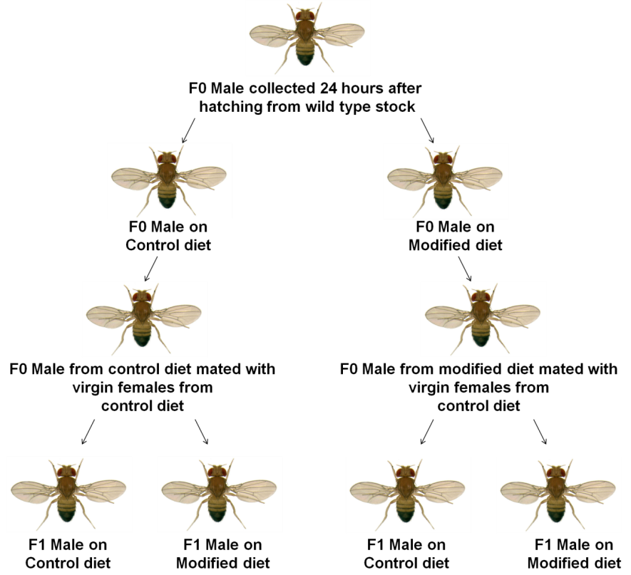
Figure 1: Experimental Design. F0 males were placed on diets. 14 days after diet they were either collected for assays or placed with control virgin females for breeding. Offspring produced were then placed on all diets.

Breeding
The F1 generation was produced through mating of F0 males of all groups and control virgin females. Groups of 5 males from each diet were placed in control diet vials with groups of 5 females for 4 days. After 4 days, males and females were removed from all mating vials and eggs were given time to develop. Upon eclosion, F1 flies from fathers on each diet group were separated into every diet group. Experiments were ran on control fathers (CF), 30% coconut oil fathers (FF), 1M sucrose fathers (SF), and exercise fathers (EF) along with their respective offspring control father offspring (CFO), 30% coconut oil fathers (FFO), 1M sucrose father offspring (SFO) and exercise father offspring (EFO). Data was compared among offspring and father groups.
Exercise
Some Drosophila on the control diet were subjected to an exercise regimen consisting of 1 hour of exercise for 6 consecutive days, starting on the day after eclosion. They were exercised using a power tower device, which works by taking advantage of Drosophila’s negative geotaxis (fig. 2). As soon as the flies climb to the top of their vials, the power tower exerts a force allowing the flies to be shaken down, giving them the opportunity to climb again. This process was continued until time of exercise was complete. On average, Drosophila climbed ~0.5 miles a day due to the exercise machine in addition to their normal climbing habits.
Vertical Test
Vertical test was completed every day for 14 days starting one day after eclosion, and was performed on control flies as well as exercise flies before and after exercise. Flies were transferred to empty vials plugged with cotton at the same mark. The vial was tapped down to shake all flies to the bottom of the vial. A photograph was taken after 5 seconds to capture fly distribution within the vial to measure motor activity. Height climbed was measured in centimeters. A total of three images were taken of each vial. The average score (based on the ratio of height climbed over total height) per vial was calculated from each image. The average score of the three images per each vial was used for statistical analysis.
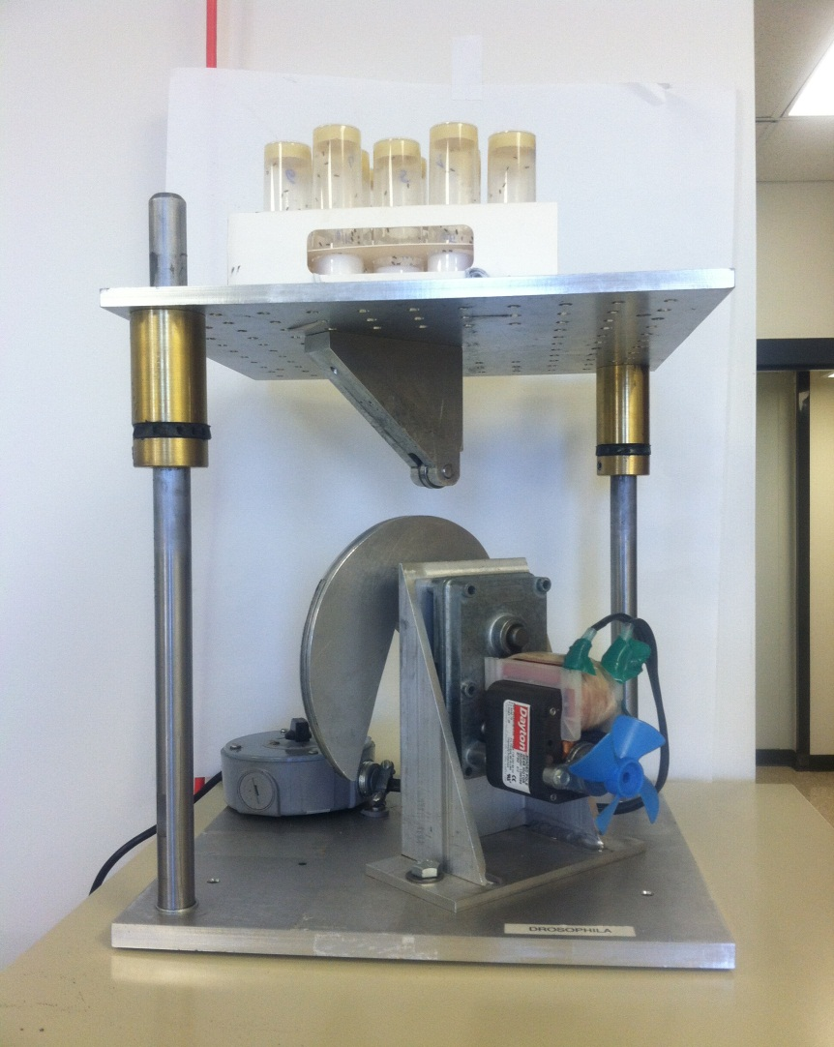
Figure 2: Power Tower. This power tower works using Drosophila’s negative geotaxis. The time it took for them to climb to the top of the vial was measured and the wheel was set to drop every 6 seconds for the duration of exercise.

Sample collection/ Weight Monitoring
Flies were collected after 14 days of diet or exercise. Empty Eppendorf tubes were weighed and 5-15 flies anesthetized with CO₂ were placed in the tube and then weighed to determine the average weight of the group of flies. Weight was recorded in mg/fly. Immediately after weighing flies they were frozen in liquid nitrogen and stored in -80 °C.
Sample preparation
5 flies were homogenized using a Tissue Tearer hand-held homogenizer in 0.5mL of PBS 0.05% Triton Buffer. The homogenization consisted of 30 seconds pulse at 25000RPM, followed by a 5 second break, and then a repetition by 10 seconds pulses with 5 second breaks for a total period of 1 min. After homogenization, the samples were centrifuged at 4500RPM, 4 ºC for 15 minutes. The clear fraction of homogenate (supernatant) was transferred to clean Eppendorf tubes and was either immediately used for biochemical assays, or stored in -80 °C for no longer than a week before use in biochemical assays.
Triglyceride Assay
The Thermo Scientific Infinity Triglycerides kit (Cat # TR-22421, Fisher Scientific, Waltham, MA) was used for triglycerides assays. Each sample was prepared in duplicates and each averaged value was used for statistical analysis.100µl of diluted supernatant was then added to 900 µl of triglyceride reagent (1:10 dilution) and incubated for 10 minutes at 37 ºC in a water bath. The spectrophotometry readings were taken at 550 nm. Standards were prepared using triglyceride standard at concentrations 0.5 mg/mL, 0.25 mg/mL, 0.125 mg/mL, and 0.0625 mg/mL. The linear regression was used to calculate triglyceride concentration in mg/mL, and results were calculated to reflect triglycerides concentration in µg / fly.
Glucose Assay
Pointe Scientific Glucose Oxidase Reagent (Cat # G7521, Pointe Scientific INC, Canton, MI) set was used for glucose assays. Each sample was prepared in duplicates and averaged values were used for statistical analysis. 10µl of undiluted supernatant was added to 100 µl of glucose reagent and incubated for 5 minutes at 37 ºC on water bath. The spectrophotometry readings were taken at 500 nm. Standards were prepared using glucose at concentrations 0.5 mg/mL, 0.25 mg/mL, 0.125mg/mL, and 0.0625 mg/mL. The linear regression was used to calculate glucose concentration in mg/ml, and results were calculated to reflect glucose concentration in µg / fly.
Trehalose Assay
Trehalase from porcine kidney from Sigma Life Sciences (Cat # 9025-52-9, Sigma, Aldrich, St. Louis, MO) and Pointe Scientific INC. Glucose Oxidase Reagent set was used for trehalose assays. Each sample was prepared in duplicates and averaged values were used for statistical analysis.100µl of supernatant was added to 100 µl of PBS 0.05% triton buffer with added trehalase (3.33 µl /mL) and incubated for 1 hour at 37 °C in a water bath. After 1 hour of incubation, 10µl of sample was added to 1000 µl of glucose reagent and was incubated for 5 minutes at 37 ºC in a water bath. The spectrophotometry readings were taken at 500 nm. Standards were prepared using glucose at concentrations 0.5 mg/mL, 0.25 mg/mL, 0.125mg/mL, and 0.0625 mg/mL. The linear regression was used to calculate trehalose concentration in mg/ml, and results were calculated to reflect trehalose concentration in µg / fly (GraphPad Prism 6, GraphPad, La Jolla, CA).
Cardiovascular Health
Drosophila melanogaster were assessed for cardiovascular health on days 2-4 of diet and/or exercise (1 hour) to measure heart rate. Exercised flies were given an hour to rest to readjust to normal homeostatic conditions before their heart tube was isolated. The procedure used to isolate the beating heart tube in Drosophila and to prepare AH followed previously established protocol (Vogler 2009). Flies were observed under (480x magnification) a dissecting microscope (SMZ800, Nikon Instruments Inc., Melville, NY) utilizing a constant amount of light. Heart preparations were performed at room temperatures ranging from 21-23 °C. Before heart preparations were performed artificial hemolymph (AH) was oxygenated for 15 minutes prior and was the oxygen bubbler was allowed to stay on for the duration of the isolations to ensure the heart tubes had a sufficient supply of oxygenation. AH solution contains 108mM Na⁺, 5mM K+, 2mM Ca²⁺, 8mM MgCl₂, 1mM NaH₂PO₄, 4mM NaHCO₃, 10mM sucrose, 5mM trehalose, 5mM HEPES at pH 7.1. The sucrose and trehalose were kept refrigerated and added to the AH prior to use to prevent bacterial contamination. Flies were placed on ice for 1 minute to induce a hypothermic shock. They were then placed wings down, on a Petri dish smeared with Vaseline in order to remain fastened. A cut was made to remove the head and legs and then oxygenated AH was placed in the dish to maintain the beating heart. The lower abdomen was then cut and cuts made diagonally along the sides of the upper abdomen were made to expose the inside of the fly. The organs and tissues were then removed to expose the heart. Once the heart tube was exposed, AH was then replaced with fresh AH and the heart tube was recorded in beats per minute for one minute.

Results
Vertical Test
The motility index for groups of 15 flies was calculated using the vertical test from day 2-14 on diet. Flies were given sufficient time (5 seconds) to climb up the vial. Measurements were taken from the exact distance the fly climbed using Image J software. Figure 3 compares the motility index of EF before and after exercise against CF taken as a baseline to account for the effects of aging. Motility index was measured as the ratio of length climbed over total length of the vial.
A significant increase in before exercise motility index was found compared to after exercise and baseline control on day 2 which is indicative of endurance gained through exercise after 2 days of training. Before and after exercise on day 8 through day 14 had significantly lower motility indexes compared to baseline control, which suggest occurrence of fatigue due to prolonged exercise (fig. 3).

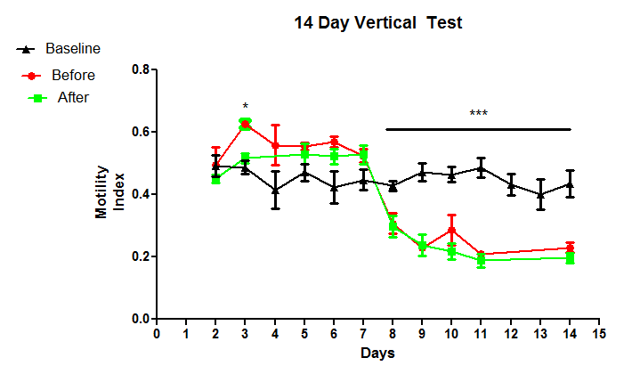
Figure 3: 14 Day Vertical Test. The before EF group had a significantly higher motility index than baseline on day 2 (p<0.05). There was a significantly lowered motility index for before and after EF groups from day 7-14 than baseline (p<0.05) which could be due to fatigue from exercise. The bars show mean ± SEM (n=298).

Weight Monitoring
Average whole body weight was measured in cohorts of 15 flies per tube after 14 days of diet. Weight was monitored to determine effect of diet and exercise on obesity susceptibility in fly groups. EF displayed a significantly lower body weight than all F0 groups. CF was also significantly lower in weight than FF and SF (fig. 4a). This highlights the pivotal role of exercise coupled with a caloric restriction in the reduction of body weight.
SFO exhibited decreased body weight compared to other F1 control groups (fig. 4b).
However when challenged on a 30% coconut diet, there was a pronounced effect which increased the body weight of challenged EFO making it higher than all challenged groups, and significantly higher than challenged CFO (fig. 4c). This body weight increase in challenged EFO is a sign of paternal programming occurring due to diet and exercise.

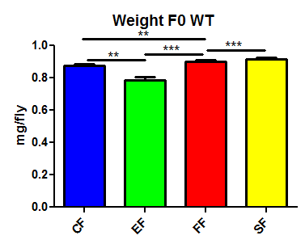
Figure 4a: Body weight of F0 flies. EF had a significantly lower body weight in mg/ fly than all F0 groups (p< 0.01). FF and SF had a significantly higher body weight in mg/ fly compared to CF (p<0.01). **=p<0.01, ***=p<0.001. The bars show mean ± SEM (n =98). This indicates exercise overtime has a role in decreasing bodyweight

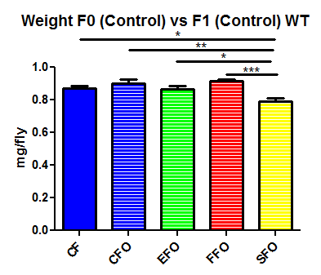

Figure 4b: Body weights of F1 offspring on control diet. SFO had a significantly lower body weight in mg/ fly than all other groups (p<0.05). No other groups showed significant differences in body weight. *= p<0.05, **=p<0.01, ***=p<0.001. The bars show mean ± SEM (n=78).

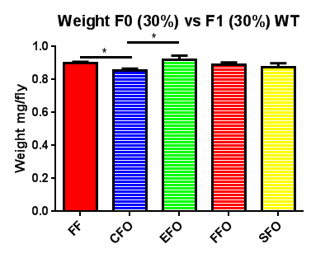

Figure 4c: Body weights of F1 flies challenged with high fat diet. CFO had a significantly lower body weight in mg/ fly than FF (p<0.01). EFO had a significantly higher body weight in mg/ fly than CFO (p<0.05). No other groups showed significant differences in body weight. *= p<0.05. The bars show mean ± SEM (n=74). Challenged EFO exhibit the highest body weight due to diet-induced paternal programming.

Triglyceride Assay
Whole body Triglyceride concentration was measured from groups of 5 flies after 14 days of diet. Triglycerides were measured because they are the major storage form of energy in Drosophila (Katewa 2012). There were no differences among levels of triglyceride concentration in F0 (fig. 5a).
There were also no differences among levels of triglycerides among F1 non-challenged control flies (fig. 5b).
Challenged EFO had a significantly pronounced increase in whole body triglyceride concentration in comparison to challenged FFO. This elevated level of triglycerides by challenged EFO could be a result of epigenetic programming due to their respective father’s diet (fig. 5c). There was a noticeable trend where challenged EFO were acquiring the most unfavorable phenotype among all challenged groups.

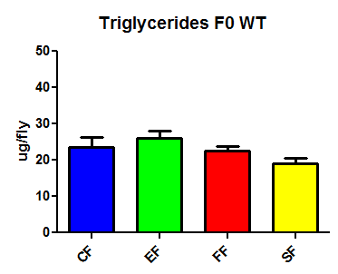
Figure 5a: Whole body triglyceride level in F0 flies. There were no significant differences between F0 groups in triglyceride content in ug/ fly. The bars show mean ± SEM (n=59).
This showed there were no major changes in cellular lipid storage among F0 flies.

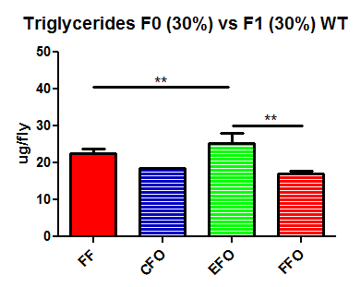

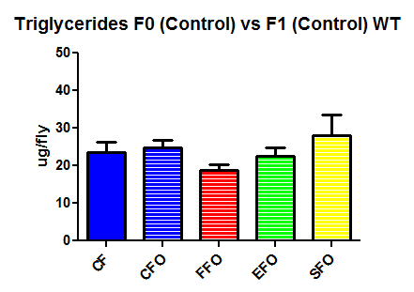
Figure 5b: Whole body triglyceride level in F1 flies on control diet. There were no significant differences in triglyceride content in ug/ fly among CF and offspring on a control diet. The bars show mean ± SEM (n=35). This revealed lipid storage remained the same for F1 flies on a control diet.

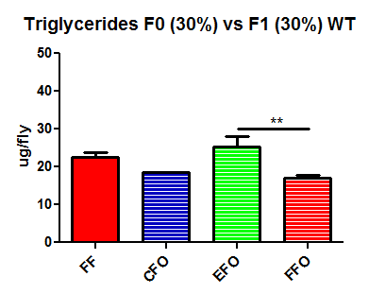
Figure 5c: Whole body triglyceride level in F1 flies challenged with high fat diet. EFO had significantly higher triglyceride content in ug/ fly than FFO (p<0.005). There were no other significant differences among other groups. **=p<0.01. The bars show mean ± SEM (n=30). Elevated triglyceride levels in challenged EFO illustrated paternal programming due to diet.

Glucose Assay

Glucose concentration was measured from groups of 5 flies after 14 days of diet. Glucose is one of the two major sugars in Drosophila, and its concentration can demonstrate diabetes susceptibility or insulin resistivity in flies (Dus 2011). EF had a significantly higher glucose concentration than CF and FF. SF also had a significantly lower glucose concentration than FF (fig. 6a).
There were no considerable differences in glucose concentration among F1 flies on control diet (fig. 6b) or any differences in glucose concentration in challenged F1 offspring (fig. 6c).

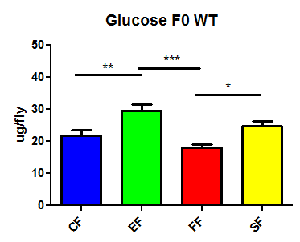

Figure 6a: Total body glucose in F0 flies. EF had a significantly higher glucose level in ug/ fly than CF and FF (p<0.05) FF also had a significantly lower glucose level in ug/ fly than SF (p<0.05). There were no other significant differences among groups. *= p<0.05, **=p<0.01, ***=p<0.001. EF were unable to use glucose as efficiently as other groups. The bars show mean ± SEM (n=43).

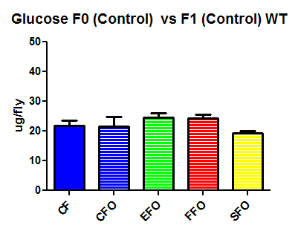

Figure 6b: Total body glucose in F1 flies on control diet. There were no significant differences in glucose concentration in ug/ fly among CF and offspring on a control diet. All F1 groups on control diet utilized glucose equally efficiently. The bars show mean ± SEM (n=50).

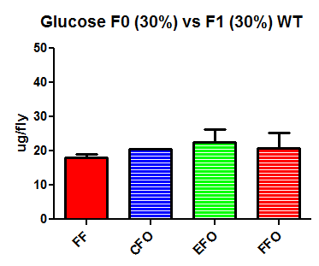

Figure 6c: Total body glucose in F1 flies challenged with high fat diet. There were no significant differences in glucose concentration in ug/ fly among FF and offspring on a fat diet. However not significant, challenged EFO were least efficient in using their glucose. The bars show mean ± SEM (n=19).

Trehalose Assay
Trehalose level was measured from groups of 5 flies per tube after 14 days of diet. Trehalose is the other sugar component, which largely makes up total sugar concentration in Drosophila (Dus 2011). SF had significantly higher trehalose content than FF and EF. CF also had significantly higher trehalose content than FF (fig. 7a). The significantly reduced level of trehalose in EF compared to control suggests exercise protects against insulin resistance and allows efficient trehalose storage.
There was no significant difference in trehalose concentration between CF and offspring on a control diet (fig. 7b).
An increased level of trehalose was found in challenged EFO, which was significantly higher than FF and challenged FFO (fig. 7c). Decreased levels of trehalose in challenged FFO signify the paternal programming occurring providing a protective effect in trehalose efficiency in offspring. This pattern has remained constant through all assays.

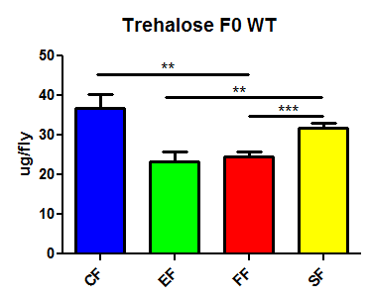

Figure 7a: Level of trehalose in F0 flies. SF had significantly higher trehalose content in ug/ fly than EF and FF (p<0.05). CF had significantly higher trehalose content than FF (p<0.005). There were no other significant differences among groups. **=p<0.01, ***=p<0.001. Decreased trehalose levels in EF signify their ability to use trehalose more efficiently than other F0 groups. The bars show mean ± SEM (n=29).

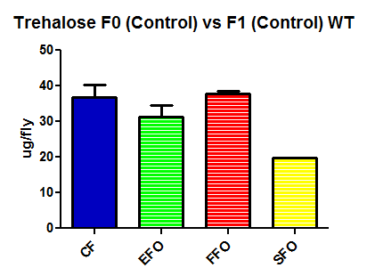
Figure 7b: Level of trehalose in F1 flies on control diet. There were no significant differences in trehalose concentration in ug/ fly among CF and offspring on a control diet. Trehalose was used equally efficiently in all F1 flies on control diet. The bars show mean ± SEM (n=23).

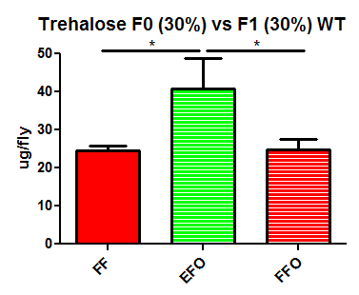

Figure 7c: Level of trehalose in F1 flies challenged with high fat diet. EFO had significantly higher trehalose content in ug/ fly than FF and FFO (p<0.05). There were no other significant differences among groups. *= p<0.05. The bars show mean ± SEM (n=24).

Cardiovascular Health
Cardiovascular health was measured for individual flies on day 2-4 on diet after eclosion. Upon completion of 4 days of diet, SF and EF were found to have significantly higher heart rate than FF (fig. 8a).
There were no significant differences in heart rate among F1 control flies from day 2-4 (fig. 8b).
On day 2 and 3, exercise challenged EFO displayed a significantly higher heart rate than exercise challenged CFO. Exercise challenged FFO also had a significantly higher heart rate than exercise challenged CFO and exercise challenged EFO on day 4 (fig. 8c).

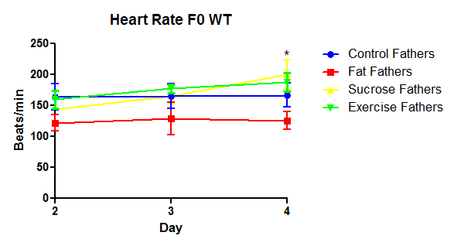

Figure 8a: Heart Rate in F0 flies. SF and EF had significantly higher heart rate in beats/ min than FF on day 4 after eclosion (p<0.05). There were no other significant differences among groups. *= p<0.05. Low heart rate in FF indicates the negative effect of high-fat diet on the group. The bars show mean ± SEM (n=108).

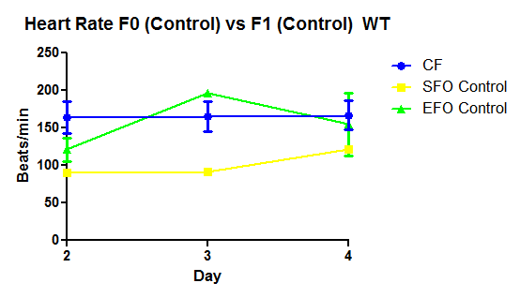
Figure 8b: Heart rate in F1 flies on control diet. There were no significant differences in heart rate in beats/ min on days 2-4 between CF and offspring on control diet. The bars show mean ± SEM (n=56)

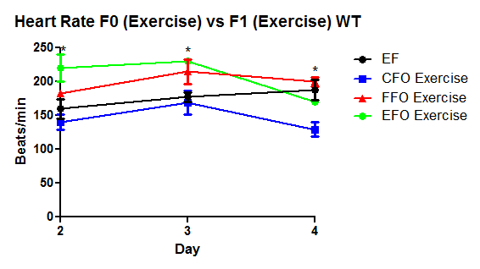

Figure 8c: Heart rate in F1 after exercise challenge. EFO had a significantly higher heart rate in beats/ min than CFO on day 2 and 3. FFO had a significantly higher heart rate in beats/ min than CFO and EFO on day 4. Challenged FFO were tachycardic and predisposed to cardiomyopathies than EFO or CFO. There were no other significant differences. *= p<0.05. The bars show mean ± SEM (n=69).

Discussion
Conclusions
The main purpose of the study was to deepen the understanding of transgenerational effects of diet and exercise on metabolic phenotype and cardiovascular health in Drosophila melanogaster. Particularly this project sought to look at the differences through programming of the paternal lineage. It has been shown increased sucrose in a 2-day diet can program offspring adiposity via the paternal lineage (Ost 2013). Therefore, maintaining proper diet and exercise are necessary for the organism to achieve optimum metabolic functioning and prevent cardiovascular disease (Mobasseri 2015). There was a significantly lower motility index in the before and after exercise group in comparison to the baseline control group when looking at the results of the 14 day vertical test. Excessive exercise can reduce fitness and leave the body susceptible to disease (Lakier 2003).
Results for whole body weight analysis showed significantly decreased weight for EF compared to all other F0 groups. Exercise is shown to increase levels of gas exchange and increase lipid storage efficiency in organisms such as mice, which thereby reduce whole body weight (Marinho 2012). Individuals with consistently higher levels of activity can also induce and sustain weight loss over time (Maruthur 2014). Western-like fat diet fed to male and female mice has been shown to cause enhanced fat mass over time in 4 successive generations given a regular diet emulating the effect of increasing prevalence of obesity in humans (Massiera 2010). EFO given a high fat challenge exhibited a significantly higher weight than CFO on a high-fat challenge which could signify a disadvantage being placed on the EFO on a challenge because they are not predisposed to a high-fat diet. Since the FF were exposed to high levels of resources their offspring’s metabolism was prepared to for the consumption of larger fat quantity of resources. However, EF were exposed to lower fat quantity of diet, and exercise which caused them to be metabolically efficient, so when offspring of EF were challenged their metabolism was unprepared for the overload in resources coupled with the lack of activity thus giving them an increased body weight. This same trend is exhibited with the level of triglycerides, glucose and trehalose. EFO on a challenged diet had significantly higher levels of triglycerides than FFO on a challenged diet. Although there is no significant difference in glucose concentration between EFO and FFO on a challenged diet, EFO still has higher levels of glucose than FFO. Challenged EFO had significantly higher trehalose levels than challenged FFO. There is possibly some paternal programming occurring causing the offspring to be more susceptible to metabolic changes due to early environmental diet. Paternal programming has also been shown with flies challenged for 2 days of diet. One such study shows in later development high sucrose challenged males produced offspring having significantly elevated induced responses in triglyceride levels relative to those offspring produced from males fed a sucrose diet (Ost 2014). Transgenerational effects have been shown in other organisms such as mice. Offspring of males fed a low protein diet developed elevated expression of genes involved in regulation of lipid and cholesterol synthesis relative to offspring of males fed a control diet (Carone 2010). Another study investigated the effect of high-fat diet (HFD) and control diet (CD) on offspring placed on CD. Males from HFD fathers developed insulin resistance and impaired glucose homeostasis, which suggests the importance of paternal influence (Fullston 2013). HFD fed rats were also shown to produce female offspring with early impaired insulin secretion and glucose tolerance which worsened over time compared to female offspring from CD rats (Ng 2010). HFD compared to CD was shown to reduce reproductive fitness of offspring due to diminished gametic function transmitted through the paternal lineage (Fullston 2012).
EF and SF had significantly higher heart rates than FF on day 4. High sucrose diet in Drosophila has been shown to elevate heart rate and result in structural defects (Na 2013). This leads to arrhythmic dysfunction and cardiac fibrosis which are cardiac complications commonly emerging from diabetic patients (Na 2013). EFO with an exercise regimen exhibited a significantly higher heart rate than CFO with an exercise regimen on day 2 and 3. FFO on an exercise regimen also had a significantly higher heart rate than CFO and EFO on an exercise regimen on day 4. In this case, exercise is the challenge instead of the diet, which is causing FFO to remain tachycardic with a higher resting heart rate. Overall, these biochemical assays and cardiovascular health data suggest there is a paternal programming occurring. This is causing diet-challenged FFO to be more advantageous than diet-challenged EFO because of the comparatively poorer diet FFO’s father received compared to EFO. Also, it allows for exercise-challenged EFO to be more energy efficient than exercise-challenged FFO allowing for a lower resting heart rate in EFO. Evolutionarily, this was known as the thrifty phenotype hypothesis. This theory suggests early environment plays an important role in the progression of metabolic diseases and cardiovascular diseases later in life (Hales 2001). Historically, hunter-gather populations with seasons of famine would pass down thrifty genes enabling offspring to store fats for longer periods of time. However, in modern populations when famine does not and individuals are exposed early to obesogenic environments they develop obesity, diabetes type 2, and cardiovascular disease (Genne-Bacon 2014). In our population of flies there is no famine, however they eat ad libitum coupled with exercise which predisposes offspring to metabolic problems in high-fat dietary conditions. It was also found in populations where consumption of resources was high, offspring developed some resistance to diet-induced obesity (Prentice 2008). However, changes in interactions between the paternal metabolic phenotype, and the environment can alter the interactions occurring between offspring and their environment, affirming the correlation between environmental change due to diet and exercise. In order to prime the offspring for optimum lifestyle, it would be necessary to determine in what environment the offspring would thrive. Knowing this information through testing of the fetus during the last three months of pregnancy would give insight into how the metabolism of the child would develop in the later stages of life (Barteson 2001). Essentially these combined findings imply with altered nutrient uptake and variation in activity level, epigenetic modification can occur for at least one generation through the paternal lineage. The offspring at risk need calorie restricted early diet and sustained exercise to maintain proper health.
Study Limitations
There were study limitations present in the investigation. These limitations primarily occurred with the cardiovascular health aspect of the study. Many offspring groups were not analyzed for heart rate, which left a large part of the study unclear. In order to understand the full effects of diet and exercise on heart rate, analysis of all offspring groups would have been necessary.
Heart rate is a decent indicator of heart health; however, it is not the best indicator of cardiovascular disease health (Kurths 1995). The cardiovascular part of this study focused solely at the heart rate comparison among F0 and F1 male Drosophila. Furthermore, recent studies have shown visualization of the beating heart in vivo and while the Drosophila is alive using real-time optical coherence tomography is possible (Chroma 2006). However our study did not use these sophisticated forms of equipment to look at m-mode, which is considered a more appropriate measure of heart analysis comparing vibrations of the aorta and heart tube (Ocorr 2007). By looking solely at the heart rate we were unable to measure true arrhythmic nature of the heart due to diet or exercise and were unable to measure heart defects accurately.
Future Studies
Due to the study limitations, the next step would to fill in the missing offspring groups to first determine how the cardiovascular data would play a role in larger picture of paternal transgenerational effects due to diet and exercise. The next step would be beginning analyzing arrhythmic dysfunction due to improper diet and sedentary lifestyle. This would clear up any ambiguous results with cardiovascular health data. Another vital step to take would be identifying the genes being up regulated or down regulated in Drosophila melanogaster because of diet or exercise and then pinpoint the mechanisms involved in the regulation. With a better understanding of the mechanisms, and pathways involved in the regulation of key metabolic and cardiac genes, it will become easier to determine how to adjust lifestyles for future generations. Therapeutic approaches can be studied to then offer alternatives to individuals prone to obesity, and cardiovascular diseases to ensure these diseases are reduced in the population.

Literature Cited
Baker, K. D., and C. S. Thummel. "Diabetic Larvae and Obese Flies-Emerging Studies of Metabolism in Drosophila." Cell metabolism 6.4 (2007): 257-66.
Baschetti, R. "Diabetes Epidemic in Newly Westernized Populations: Is it due to Thrifty Genes Or to Genetically Unknown Foods?" Journal of the Royal Society of Medicine 91.12 (1998): 622-5.
Bateson, P. "Fetal Experience and Good Adult Design." International journal of epidemiology 30.5 (2001): 928-34.
Buescher, J. L., et al. "Evidence for Transgenerational Metabolic Programming in Drosophila." Disease models & mechanisms 6.5 (2013): 1123-32.
Carone, B. R., et al. "Paternally Induced Transgenerational Environmental Reprogramming of Metabolic Gene Expression in Mammals." Cell 143.7 (2010): 1084-96.
Choma, M. A., et al. "Images in Cardiovascular Medicine: In Vivo Imaging of the Adult Drosophila Melanogaster Heart with Real-Time Optical Coherence Tomography." Circulation 114.2 (2006): e35-6.
Dus, M., et al. "Taste-Independent Detection of the Caloric Content of Sugar in Drosophila." Proceedings of the National Academy of Sciences of the United States of America 108.28 (2011): 11644-9.
Fullston, T., et al. "Paternal Obesity Initiates Metabolic Disturbances in Two Generations of Mice with Incomplete Penetrance to the F2 Generation and Alters the Transcriptional Profile of Testis and Sperm microRNA Content." FASEB journal : official publication of the Federation of American Societies for Experimental Biology 27.10 (2013): 4226-43.
Fullston, T., et al. "Diet-Induced Paternal Obesity in the Absence of Diabetes Diminishes the Reproductive Health of Two Subsequent Generations of Mice." Human reproduction (Oxford, England) 27.5 (2012): 1391-400.
Genne-Bacon, E. A. "Thinking Evolutionarily about Obesity." The Yale journal of biology and medicine 87.2 (2014): 99-112.
Hales, C. N., and D. J. Barker. "The Thrifty Phenotype Hypothesis." British medical bulletin 60 (2001): 5-20.
Hu, F. B. "Globalization of Diabetes: The Role of Diet, Lifestyle, and Genes." Diabetes care 34.6 (2011): 1249-57.
Katewa, S. D., et al. "Intramyocellular Fatty-Acid Metabolism Plays a Critical Role in Mediating Responses to Dietary Restriction in Drosophila Melanogaster." Cell metabolism 16.1 (2012): 97-103.
Kurths, J., et al. "Quantitative Analysis of Heart Rate Variability." Chaos (Woodbury, N.Y.) 5.1 (1995): 88-94.
Lakier Smith, L. "Overtraining, Excessive Exercise, and Altered Immunity: Is this a T Helper-1 Versus T Helper-2 Lymphocyte Response?" Sports medicine (Auckland, N.Z.) 33.5 (2003): 347-64.
Loomba, R., et al. "Parental Obesity and Offspring Serum Alanine and Aspartate Aminotransferase Levels: The Framingham Heart Study." Gastroenterology 134.4 (2008): 953-9.
Marinho, R., et al. "Endurance Exercise Training Increases APPL1 Expression and Improves Insulin Signaling in the Hepatic Tissue of Diet-Induced Obese Mice, Independently of Weight Loss." Journal of cellular physiology 227.7 (2012): 2917-26.
Maruthur, N. M., et al. "Avoiding Weight Gain in Cardiometabolic Disease: A Systematic Review." Journal of obesity 2014 (2014): 358919.
Massiera, F., et al. "A Western-Like Fat Diet is Sufficient to Induce a Gradual Enhancement in Fat Mass Over Generations." Journal of lipid research 51.8 (2010): 2352-61.
Mathias, R. A., et al. "Heritability of Quantitative Traits Associated with Type 2 Diabetes Mellitus in Large Multiplex Families from South India." Metabolism: clinical and experimental 58.10 (2009): 1439-45.
Mobasseri, M., et al. "Effect of a Long-Term Regular Physical Activity on Hypertension and Body Mass Index in Type 2 Diabetes Patients." The Journal of sports medicine and physical fitness 55.1-2 (2015): 84-90.
Musselman, L. P., et al. "A High-Sugar Diet Produces Obesity and Insulin Resistance in Wild-Type Drosophila." Disease models & mechanisms 4.6 (2011): 842-9.
Na, J., et al. "A Drosophila Model of High Sugar Diet-Induced Cardiomyopathy." PLoS genetics 9.1 (2013): e1003175.
Ng, S. F., et al. "Chronic High-Fat Diet in Fathers Programs Beta-Cell Dysfunction in Female Rat Offspring." Nature 467.7318 (2010): 963-6.
Ocorr, K., et al. "Genetic Control of Heart Function and Aging in Drosophila." Trends in cardiovascular medicine 17.5 (2007): 177-82.
Ocorr, K., G. Vogler, and R. Bodmer. "Methods to Assess Drosophila Heart Development, Function and Aging." Methods (San Diego, Calif.) 68.1 (2014): 265-72.
Ost, A., et al. "Paternal Diet Defines Offspring Chromatin State and Intergenerational Obesity." Cell 159.6 (2014): 1352-64.
Pemberton, V. L., et al. "Report of the National Heart, Lung, and Blood Institute's Working Group on Obesity and Other Cardiovascular Risk Factors in Congenital Heart Disease." Circulation 121.9 (2010): 1153-9.
Permutt, M. A., J. Wasson, and N. Cox. "Genetic Epidemiology of Diabetes." The Journal of clinical investigation 115.6 (2005): 1431-9.
Prentice, A. M., B. J. Hennig, and A. J. Fulford. "Evolutionary Origins of the Obesity Epidemic: Natural Selection of Thrifty Genes Or Genetic Drift Following Predation Release?" International journal of obesity (2005) 32.11 (2008): 1607-10.
Ruaud, A. F., G. Lam, and C. S. Thummel. "The Drosophila NR4A Nuclear Receptor DHR38 Regulates Carbohydrate Metabolism and Glycogen Storage." Molecular endocrinology (Baltimore, Md.) 25.1 (2011): 83-91.
Schlegel, A., and D. Y. Stainier. "Lessons from "Lower" Organisms: What Worms, Flies, and Zebrafish can Teach Us about Human Energy Metabolism." PLoS genetics 3.11 (2007): e199.
Seidell, J. C. "Obesity and Weight Control: The Evidence." The Proceedings of the Nutrition Society 59.3 (2000): 419-20.
Sieber, M. H., and C. S. Thummel. "The DHR96 Nuclear Receptor Controls Triacylglycerol Homeostasis in Drosophila." Cell metabolism 10.6 (2009): 481-90.
Van Gaal, L. F., I. L. Mertens, and C. E. De Block. "Mechanisms Linking Obesity with Cardiovascular Disease." Nature 444.7121 (2006): 875-80.
Vidal, A. C., et al. "Maternal Stress, Preterm Birth, and DNA Methylation at Imprint Regulatory Sequences in Humans." Genetics & epigenetics 6 (2014): 37-44.
Vogler, G., and K. Ocorr. "Visualizing the Beating Heart in Drosophila." Journal of visualized experiments : JoVE (31). pii: 1425. doi.31 (2009): 10.3791/1425.
Walley, A. J., A. I. Blakemore, and P. Froguel. "Genetics of Obesity and the Prediction of Risk for Health." Human molecular genetics 15 Spec No 2 (2006): R124-30.
Wolf, M. J., et al. "Drosophila as a Model for the Identification of Genes Causing Adult Human Heart Disease." Proceedings of the National Academy of Sciences of the United States of America 103.5 (2006): 1394-9.
Xue, C., et al. "Smaller Genetic Risk in Catabolic Process Explains Lower Energy Expenditure, More Athletic Capability and Higher Prevalence of Obesity in Africans." PloS one 6.10 (2011): e26027.

