Reach out and Read: Expanding Child Immunization and Oral Health Literacy Using Quick Response Codes in Pediatric Clinics in North Carolina.

Tabitha W. Akuoko
College of Nursing, East Carolina University
Doctor of Nursing Practice Program
Dr. Lee Ann Long
07/18/2022

Notes from the Author
I would like to extend my sincere gratitude to my entire DNP project team. Thank you to the Reach Out and Read site champion, DNP project faculty, student colleague, and clinic liaisons. Thank you for the teamwork, feedback, and effort made to achieve the success of this project. Lastly, thank you to my loving family. My husband, Nana Akuoko, thank you for being my confidant and mentor. My children Gabriel and Imani, for your patience and understanding. Thank you to my parents, Jackson Ratemo Omoi and Esther Muthoni Ratemo, for your love, support, and sacrifice. Thank you to my siblings; Allan, Becky, and Gracie, for their never-ending confidence in me. I owe my success to you all.

Abstract
Health literacy is essential for positive patient health outcomes. Low literacy among parents, guardians, and patients negatively affects health choices that impact overall health. Reach out and Read (ROR) partners with primary care and pediatric clinics to enhance early literacy by providing age-appropriate books to patients ages zero to five during well-child visits. Child oral health and immunizations were established as two areas of low literacy within North Carolina with the potential to explore ways of increasing knowledge and education for parents and guardians. This project utilized a Quick Response (QR) code placed on the books provided by ROR within participating clinics. Once scanned, the QR code would lead to an educational webpage with evidence-based information on child oral health and immunizations among children aged zero to five arranged per age group and a parental feedback survey. This project was implemented in four clinics within Johnston County and Mecklenburg County as an expansion of the pilot project initiated from November 2020 to April 2021. Web page visits and parental survey responses were monitored every three weeks and analyzed to synthesize and evaluate project impact and goals.
Keywords: health literacy, parents, guardians, pediatric patients, QR codes, Reach Out and Read, immunizations, child oral health, education

Table of Contents
Notes from the Author …………………………………………………………………………. .2
Abstract …………………………………………………………………………………………. 3
Section I: Introduction.………………………………………………………………………….. 6
Background……………………………………………………………………………… 6
Organizational Needs Statement………………………………………………………….7
Problem Statement………………………………………………………………………..8
Purpose Statement………………………………………………………………………...8
Section II: Evidence……………………………………………………………………………....9
Literature Review…………………………………………………………………………9
Evidence-Based Practice Framework……………………………………………………13
Ethical Consideration and Protection of Human Subjects……………………………….14
Section III: Project Design……………………………………………………………………….15
Project Site and Population………………………………………………………………15
Project Team………………………………………………………………………….….16
Project Goals and Outcomes Measures………………………………………………….17
Implementation Plan…………………………………………………………………..…19
Timeline………………………………………………………………………………….19
Section IV: Results and Findings……………………………………………………………..….19
Results……………………………………………………………………………….…...21
Discussion of Major Findings……………………………………………………………22
Section V: Interpretation and Implications………………………………………………………23
Costs and Resource Management………………………………………………………..23
Implications of the Findings……………………………………………………………24
Sustainability …………………………………………………………………………..26
Dissemination Plan ………………………………………………………………….…27
Section VI: Conclusion…………………………………………………………………………28
Limitations and Facilitators…………..…………………………………………………29
Recommendations for Others…………………………………………………………...29
Suggestions for Further Study……………………………………………………...…...30
Final Thoughts…………………………………………………………………………..30
References……………………………………………………………………………………….32
Appendices………………………………………………………………………………...….…35
Appendix A: Literature Matrix………………………………………………………....35
Appendix B: Parent Survey ………………..………………………………………..…37
Appendix C: QR Code Book Stickers……………………………………………….…39
Appendix D: QR Code Project Bookmark English ……………………………………40
Appendix E: QR Code Project Bookmark Spanish ………………………………….…41
Appendix F: Project Timeline……………………………………………………………….42
Appendix G: Webpage Visits………………………………………………………...…43
Appendix H: Survey Responses…………..…………………………………..…………44
Appendix I: Project Budget and Cost Breakdown…………………………………….…45

Section I. Introduction
Background
Literacy is an essential factor and social determinant of health. Literacy components are established in the infant stage of life and depend on various factors, including genetic, environmental, and medical aspects (Hutton et al., 2021). The majority of children from minority and underserved populations experience difficulty in school due to a lack of preparedness to learn and read by the time they begin kindergarten. The American Academy of Pediatrics (AAP) encourages pediatricians to endorse early literacy to ensure school readiness, developmental observation, relational health, and brain development.
Reach out and Read (ROR) is a United States (US) non-profit organization founded in 1989 that collaborates with pediatric and primary care clinics to promote early literacy and meaningful family interactions for children five years and younger (Reach Out and Read, 2021). The new chapter agenda by ROR recognizes a need for significant change through relational health, which encompasses early interpersonal relationships between families, physicians, and children. This initiative strives to achieve positive health and social outcomes by equipping physicians with skills to execute relational health strategies effectively and establishing funding for advanced best practice approaches.
Health literacy is defined by the ability that individuals have to obtain, process, comprehend uncomplicated health information and recognize available services to make suitable health decisions (Morrison et al., 2019). ROR Carolinas identified a lack of health literacy on child immunization and oral health as barriers to quality healthcare. A quality improvement project was initiated that incorporated quick response (QR) codes that families could scan and obtain information on guidelines and recommendations for child oral health and immunization. Pediatrician clinics recognized a continued need to expand this project within many counties, including Wake and Mecklenburg counties in North Carolina (NC), as an opportunity to provide informed care and make an impactful move in the adaptation of relational health strategies.
Organizational Needs Statement
Health outcomes are affected directly by income, affecting access to needed resources, including health services and treatment (North Carolina Institute of Medicine & North Carolina Department of Health and Human Services, 2020). Reports show uneven distribution of positive oral health outcomes throughout NC, with most cases of poor oral health among children from rural counties. Healthy North Carolina (HNC) 2030 notes the current number of people living in poverty at 36.8% of the total population. The risks of insufficient oral health increase among low-income, uninsured, minority, immigrant populations, and individuals with low literacy. Approximately one-third of states do not have a comprehensive public oral health monitoring data system (Office of Disease Prevention and Health Promotion [ODPHP], n.d.). Healthy People 2030 incorporates goals that seek to increase health literacy among populations by improving health care access and utilizing health technology which promotes exploration of modern ways of providing information or education.
Vaccine spacing and gaps are typical in North Carolina due to vaccine hesitancy (Vasudevan et al., 2021). Statistics from the National Immunization Survey noted that roughly 20% of parents and guardians in North Carolina have vaccine uncertainties. Vaccine hesitancy can result from misleading information, cultural practices and beliefs, friends and family influence, and previous experiences. Healthy People 2030 seeks to address the lack of immunization by providing strategies to address parent and guardian concerns (Office of Disease Prevention and Health Promotion [ODPHP], n.d.). Providing clear, easily accessible, evidence-based information to parents is crucial to establishing immunization literacy.
Problem Statement
Low health literacy affects the ability of health systems to facilitate the needs of patients. Many providers lack strategies to incorporate informed health literacy communication methods with patient encounters (Morrison et al., 2019). Most minority and disadvantaged populations are at high risk of experiencing social disparities, including low health literacy. Families and children from rural, low-income, minority, and immigrant families within NC are at risk of low health literacy, poor oral health, and a lack of informed health practices regarding immunization.
Purpose Statement
This project aimed to expand health literacy on immunization and oral health for parents or guardians of children five years and younger by utilizing QR codes in participating primary care and pediatric clinics within North Carolina while promoting relational health through patient participation and improving the provider and family relationship.

Section II. Evidence
Literature Review
A comprehensive literature search was conducted utilizing PubMed and CINAHL databases. The initial literature search through PubMed using the MESH terms; child, health literacy, and parents. The initial search yielded 223 articles. Additional measures were implemented to narrow the search. Inclusion criteria incorporated; systematic reviews, meta-analysis, randomized controlled trial articles, and peer-reviewed journal articles in English performed in the United States that were full-text articles written within the last five years. After incorporating inclusion criteria, the literature search yielded 110 articles. A total of three pieces were chosen after evaluating titles and reading literature based on the topic context.
A further search was done using PubMed with the search terms; family-centered care yielding 337 articles. With inclusion criteria, only one piece was chosen after reading. A third search was done utilizing PubMed using the words; vaccine hesitancy, pediatrics. This search yielded 383 results utilizing inclusion criteria; only one article was chosen. Further inquiries utilizing ECU Laupus Health Science Library resource with filters to generate literature from PubMed, CINHAL, and MEDLINE using quick response codes in healthcare yielded 1842 results. Only one source was chosen after utilizing the same inclusion criteria. A second search using the terms; parents, technology, and health yielded 70,982 results. Only one source was selected after incorporating the same inclusion criteria. See Appendix A.
Current State of Knowledge
Literature has shown that illness, and disease processes, occur as a result of multifactorial causes. These factors include non-modifiable determinants like age, genetics, ethnicity, and modifiable factors, including social determinants. Social determinants of health (SDOH) include; income and social status, the neighborhood and physical environment, economic security, education and literacy, access to health care systems, food security, community safety, and social context. SDOH influences a child’s immediate and future risk for disease (Gottlieb et al., 2016). Childhood exposures to social adversities increase the probability of adverse health outcomes and earlier mortality in life.
Education and literacy are critical components of health and patient outcomes. Research has shown that one in four parents have low health literacy, which leads to an inability to make informed decisions and participate in health plans affecting child health outcomes through prevention, acute care, and chronic disease management (Morrison et al., 2019). The effects of low literacy among pediatric populations lead to decreased use of preventative services, medication errors, frequent emergency department visits, and higher obesity rates.
Pediatric and primary care practices face many barriers to vaccination administration due to vaccine hesitancy and lack of vaccine literacy (Mohanty et al., 2018). Health care professionals play a role in the education of parents and guardians regarding vaccination. Communicating vaccination information requires certain levels of literacy which can pose a challenge for caregivers or patients with low health literacy leading to seeking alternate sources of information from possible inaccurate sources. Approximately 20% of parents and guardians in North Carolina have vaccine uncertainties. Many parents in North Carolina choose to space out vaccines resulting in altered vaccine schedules and lower vaccination rates for children by the age of two (Vasudevan et al., 2021).
The most common chronic disease in the United States among adults and children is tooth decay (Office of Disease Prevention and Health Promotion [ODPHP], n.d.). Regular preventative care can reduce tooth decay risks and improve overall oral health. Oral health is an element and indicator of overall health in childhood and adult life (Dudovitz et al., 2020). Oral disease is linked to low school performance and an increased likelihood of chronic illnesses. Parents have a great responsibility for the health of their children. Lack of oral health literacy is related to children having an increased rate of dental caries, fillings, and other health disparities.
Current Approaches to Solving Population Problem
Achieving quality standards of healthcare and positive patient health outcomes is a crucial component among health agencies across the federal, state, and community levels. Health literacy is a significant factor in the delivery of high-quality health. Providers can improve health knowledge and patient outcomes by implementing strategies established through evidence-based research. Some systems include: simplifying the information, providing basic language instruction, utilizing demonstration, utilizing show-back and teach-back methods, multimedia instruction that incorporates pictographic or video instruction, and verbal or text instruction (Morrison et al., 2019).
Increasing patient engagement is a foundational factor in providing quality care (Bombard et al., 2018). Family-centered care approaches incorporate the needs of the parent and family. This model of care offers a mutual relationship between the family and providers, including the family, through all care processes (Kokorelias et al., 2019). Within pediatric populations, provider-parent/guardian relationships allow collaboration to provide individualized care that addresses the child’s needs and goals (Small, 2021).
Relational health strategies within primary care and pediatrician offices recognize that children need multiple relationships for effective development and positive child health outcomes. This approach incorporates providers, caregivers, family members, and the community to identify patient and family needs and provide treatment or support plans relative to their needs (Frosch et al., 2019).
As established in the literature, effective communication strategies are essential to patient engagement and participation and provide alternative ways to provide patient education. While demonstration, show-back, and teach-back methods can be effective for patient education, Healthy People 2030 identifies the significance of incorporating health information technology in health information exchange (Office of Disease Prevention and Health Promotion [ODPHP], n.d.). Patients able to access electronic health information can participate in their healthcare more effectively. Establishing strategies that streamline health information could result in enhanced health outcomes.
The use of digital devices is standard across all populations and social realms. Cell phones are a necessity in modern society and day-to-day experiences. Patients engage in digital devices in healthcare facilities, including texting, web browsing, and social media. Literature has shown that approximately half of the caregivers utilize the internet to obtain health information. Technological approaches to communication have advanced positive pediatric health outcomes (Meyers et al., 2020).
The use of quick response (QR) codes has become increasingly utilized among diverse industries within society. QR codes can be created easily via web links or apps. The ability of QR codes to contain bulk information and the ease and versatility of use has increased interest in usage within healthcare settings. Patients can scan the code and obtain a variety of health information topics (Karia et al., 2019). This mode of technology was established as an appropriate model for this quality improvement project with ROR to enhance relational health and improve oral and immunization health literacy among pediatric practices within North Carolina.
Evidence to Support the Intervention
QR codes are various technological applications and visual materials available for learning and education (Karia et al., 2019). QR codes are easy to establish, and patients only need to obtain a QR code app that is easily downloadable on most smartphones or tablets. Utilizing QR codes provides a method of engaging learners by delivering quick, just-in-time access to health information.
Evidence-Based Practice Framework
This research project utilized the Nielsen Bohlman, Panzer, & Kindig model of health literacy. Health literacy is influenced by many factors, including the interaction between health care systems, educational systems, social, and cultural systems where all these three sectors must share improvement in health literacy, (Nielsen Bohlman, Panzer, & Kindig, 2004).
Culture provides meaning to health communication. Therefore, health literacy should be acknowledged and addressed concerning culture and language. Culture is learned from society and the environment. While culture evolves, it may cause differences in healthcare perceptions, affecting how people interact with healthcare systems.
Childhood literacy and education provide a foundation for literacy in adulthood. Health literacy is essential for quality care. The model suggests that healthcare systems incorporate creative approaches to communicate health information. Using straightforward language, relevant translations, and printed, electronic, and media materials are recommended.

Ethical Consideration & Protection of Human Subjects
The Collaborative Institutional Training Initiative (CITI) modules were completed to prepare for formal project approval. The modules provided in-depth education and testing on the research process and ethical considerations in research. This project expanded on an initiated project in collaboration with ROR that utilized QR code stickers with information on childhood immunization and oral health care embedded in books available to families of children aged newborn to five years at the well-child visits within pediatric offices in Johnston and Mecklenburg counties in North Carolina.
The QR code links would anonymously generate health information from accredited national health organizations on child immunization and oral health. The project did not have any personal or health information generated; consequently, no consent was necessary. The analytics were anonymously generated based on the usage of QR codes. This DNP project was acknowledged as a quality improvement project, not a research project; thus, no IRB review and approval was needed.

Section III. Project Design
Project Site and Population
This DNP project was associated with Reach Out and Read, a national non-profit organization that partners with pediatric and primary care offices to provide books for children between zero to five years at each well-child visit. This initiative aimed to provide a foundation for positive family interaction, early literacy, and future school readiness and success. Reach Out and Read Carolinas’ new chapter goals include increasing provider and family relations through a model of relational care that aims to reduce gaps and intervene in the health or social needs of families. In line with this initiative, ROR participated in an initiated quality improvement project set by East Carolina University (ECU) Doctor of Nursing Practice (DNP) students to increase health literacy among parents, caregivers, and family members. This project was implemented in four pilot clinics. The project involved using QR codes placed in books for children between the age of zero to five provided at well-child checks with information on child oral health and immunization.
As part of an expansion for this project, ROR Carolinas identified four clinics within Johnson and Mecklenburg counties to expand the pilot project. Four clinics participated in the project expansion, and metrics were tracked and evaluated within eight clinics, including the four clinics that supported the pilot project. This student implemented the project in one pediatric clinic and one primary care clinic within Johnson County. Associated potential barriers to the project included poor participation, state, county, or organizational protocols and restrictions, such as the possibility of small sample sizes and data collection delays, COVID 19 pandemic consequences and regulations, and clinic staff participation.

Description of the Setting
Reach Out and Read organization serves more than four million children a year nationwide (Reach Out and Read, 2021). ROR Carolina’s reach network includes more than 548 participating clinics and hospitals. Age-appropriate books were provided to affiliate pediatric and family medicine clinics in addition to community centers, regional county health departments, and private health facilities to increase literacy and improve school readiness. Each clinic location for this project participates as an affiliate for ROR Carolinas. The two clinics in Johnson County included; Clinic A, a pediatric clinic, and Clinic B, a primary care clinic. The clinics in Mecklenburg County included two pediatric clinics.
Description of the Population
The target population included family, caregivers or guardians, and children between zero to five. Parents and caregivers had access to age-appropriate books provided at well-child visits. At all four clinics, the patient population utilized English and Spanish languages for communication. Additional demographic information for each participating clinic was added with data collection at the culmination of implementation.
Project Team
The project was executed in collaboration with an ECU DNP student who implemented the project in two clinics within Mecklenburg County. An ECU DNP clinical professor served as the project’s faculty member and as a resource and guide, ensuring DNP project standards and requirements were met through all project stages, including; the project formulation, the approval process, implementation needs, and project paper interpretation.
The regional director of medical engagement and training for ROR in NC and Virginia served as the project site champion and liaison resource between students and the participating clinics. The project site champion communicated inquiries and expectations and provided information on clinic contact. Additionally, the site champion ensured materials were available and ready when needed for implementation. The director of communication for ROR Carolinas served as part of the project team and participated by producing and attaining materials required for project implementation and establishing and providing data collection tools.
Project Goals and Outcome Measures (Methods, Tool(s), Procedure, Data Analysis, IRB)
This project aimed to increase oral health and child immunization health literacy among parents, guardians, and caregivers in clinics within Johnston County and improve patient-provider engagement and relationships, promoting ROR’s goals of fostering relational health. The process included placing bookmarks and posters in consultation and exam rooms. The posters and bookmarks detailed the project and had the QR codes embedded. QR code stickers were placed in all the available ROR books within participating clinics.
With QR code scanning, parents were directed to a web page with immunization information based on CDC guidelines per their child’s age group, and oral health education and care recommendations based on age group. The project was an expansion of the pilot project implemented from November 2020 through July 2021. Additional considerations included the new chapter ROR goals of increasing patient-provider relations and promoting relational health through increasing patient-provider interaction, patient participation, and knowledge on preventative health among pediatric patient populations.
Other purposes within the promotion of relational health included encouraging clinical staff participation in identifying vaccine hesitancy, identifying patient inquiries, areas of gaps in health care, increasing opportunities for interaction and education, identifying barriers to care, and ensuring access to dental providers. Additionally, with these considerations in place, providing resources as needed and providing fluoride treatments as required.
With the pilot project, QR codes proved to be an effective way of increasing health literacy and providing just-in-time health information as easy as a scan away. The QR code provided a link to a webpage with information on oral health and immunization categorized in age groups and a parental survey. Outcome measures were evaluated utilizing the parental survey developed and embedded in the web page to assess health literacy and the impact of acquired webpage educational information (see Appendix B).
The Description of the Methods and Measurement
As noted, with the pilot project, QR codes in English and Spanish were created that, when scanned, would lead to a webpage with educational evidence-based information on oral health and immunization and what to expect per age, see Appendix C. Bookmarks in English see Appendix D and Spanish see Appendix E was created for distribution to parents and for viewing in consultation rooms. Additionally, a parental survey link created through Survey Monkey was available for parents embedded within the educational webpage in English and Spanish, see Appendix B. This survey link was used to establish education impact, ease of QR code use, and willingness to participate in better health choices. Other data measures included; evidence of a chart record of a dental home, demographic information, utilization of webpage, survey response analytics, and website traffic measured through Google Analytics.
The Discussion of the Data Collection Process
Data collection began during implementation, obtaining information from the individual clinics supporting the project expansion. Each week, data generated from analytics was recorded by the ROR communications director and sent via email to students every three weeks depending on website traffic. The data trends were further monitored and stored for further review using Microsoft Excel Spreadsheet software.
Implementation Plan
This DNP project expanded a pilot project that implemented the project from November 2020 to April 2020. All project elements utilized in the pilot project were used with the expansion project to be implemented between November 2021 to April 2022. Project fundamentals included; identifying funding partners through ROR, Eastern AHEC, and Charlotte AHEC, identifying partnering clinics willing to participate in project expansion, staff education on project information, and obtaining materials for each participating clinic. Materials for implementation included; QR stickers printed according to individual clinic needs and averaged well-child visits, which were placed in the books provided to parents and guardians of children zero to five at each well-child visit. See Appendix C. Additional materials included; promotional posters with replicated bookmarks with information on QR code sticker use and the website printed, laminated, and placed in exam rooms in each participating clinic.
Each student participated in project implementation, acquiring and analyzing data trends as needed throughout the implementation phase. Project team members met every two weeks to identify needs, assess progress, communicate inquiries or concerns to be addressed, identify conditions or barriers, and ways to improve or mitigate where able.
Timeline
The timeline for the DNP project began in August 2021 and through July 2022. Materials for the project were provided to the students between November 2021 and December 2021. The QR code stickers were placed on all ROR books in participating clinics between November 2021 and January 2022. Additionally, all other project materials were delivered to clinics, including bookmarks and posters hung in examination rooms. Data collection began when project implementation was initiated, and all available QR stickers were placed in the books of participating clinics. Data was collected every two to three weeks. As the data was received, the analysis was used to identify needs or potential barriers. PDSA cycles were performed periodically with analysis of data. Team meetings were held every two to three weeks or as needed. See Appendix F.

Section IV. Results and Findings
Results
Before initiation of implementation, all QR stickers were placed on the ROR books available in participating clinics. All materials were delivered to participating clinics by the end of December 2021. Implementation began on January 11, 2022, and ended on the last day of April 2022. Four clinics participated in expanding this parental literacy project—two clinics in Mecklenburg County and two clinics in Johnson County. Additionally, data was tracked among the four clinics that participated in the pilot project that continue to participate in the project to date. Primary languages utilized for materials and surveys among the four clinics participating in the project expansion included English and Spanish.
There were 2,307 well-child visits within the implementation timeline among all participating clinics. Clinic A had 1,651 well-child visits where books were distributed with a 100% distribution rate. The primary languages for this clinic were English and Spanish. Two percent of the patients were uninsured, 40% had Medicaid insurance, 10% used Tricare, and 48% utilized private insurance and HMO/PPO plans. Clinic B had 656 well-child visits with a 100% book distribution rate. Forty-five percent of patients used HMO/PPO insurance, 48% had Medicaid insurance, and 0% were uninsured.
Webpage traffic was tracked throughout the implementation phase, with seven visitors in January and February and 11 visitors in March, and 34 visitors in April. See appendix G for webpage visitor data breakdown. Survey responses received were eight, seven English and one Spanish. See Appendix H for the survey response breakdown. Clinics A and B reported 100% dental home for all patients seen for well-child checks within the implementation timeframe.

Discussion of Major Findings
At the time of implementation initiation, there was an ongoing global pandemic (SARS COVID 19) and a wave of a new viral strain of the disease affecting the United States. Clinic participation was limited due to the influx of COVID-19 cases within the community. Therefore, it markedly reduced the clinic’s well-child visits from January-February. Staff changes and shifts were affected, including parental and guardian participation, which was minimal and not as expected at the initiation of project expansion. Increased participation would have allowed for a broader perspective from received feedback. There were nine parental survey responses.
Data from the survey responses revealed that 90% of parents learned a lot, and 10% indicated learning a little about oral health and vaccines. Ninety percent of parents noted the information was easy to understand, and 100% were somewhat likely to recommend the website to other parents. Eighty percent indicated they intended to change their child’s oral health habits from learned information, and 50% noted they would change immunization practices. Website page visit data showed a low number of visits in January (four) and February (three). Website traffic increased in March (11) and the month of April (34) see Appendix G.

Section V. Interpretation and Implications
Costs and Resource Management
Area Health Education Center (AHEC) Charlotte and Eastern AHEC provided funding for expansion. The cost for this expansion project was manageable because most charges were incurred at the initiation of the pilot project. The budget was not extensive because the main costs included, reprinting the material utilized in the pilot project. These materials included QR code stickers, posters, and bookmarks. SurveyMonkey that was used for the parent surveys was free. Google analytics which served as the primary data collection medium, was also a free service.
The same literacy website was utilized as with the pilot project with website hosting and website domain maintained by ROR Carolinas. The total time dedicated to completing the project was approximately 188 hours, including clinic visits, team member collaborations, communication, and placement of QR code stickers on available books within participating clinics. The total costs for expansion were $3,203.38. For budget breakdown, see appendix I.
Future expansion can effectively progress if the materials and website content remain the same. Future costs to expand this project would include the budget for printing materials, website domain, sustainment fees, and QR code subscriptions. If other health topics could be explored, the costs may increase even though the model of implementation is maintained. Costs could possibly include web and domain hosting, web development, QR code designing, content translation to other languages, posters, and bookmark development and printing. Overall, funding and expenses could shift depending on the project implementation timelines, funding agencies, and the number of participating clinics.

Implications of the Findings
This project provided a significant step in exploring the use of new technological advances in providing health information. Using QR codes, parents and guardians had quick access to information on child oral health and vaccinations. Webpage visit data showed page visitors could navigate through the webpage. Survey participants indicated ease of navigation through the web page, revealing how to be incorporated and used for information dissemination.
Evidence of parental webpage visits shows the convenience of having quick access information available to the parents for reference. Ninety percent of survey respondents noted the ease of webpage use, and 90% indicated they learned a lot from the web page information. These project findings lean positively to fulfill the project goals of increasing parental literacy on child oral health and immunizations. Other project goals included improving patient-provider relationships and promoting relational health. This was accomplished by documentation of dental homes, which allowed for the identification of health needs, and provision of referrals if needed.
Implications for Patients
Health information and guidelines are constantly evolving thanks to continuous health research. Quality healthcare utilizing evidence-based guidelines remains the goal for all best patient outcomes. With growing studies, technology has also increased, and patients and families can easily access healthcare topics through the web. QR codes provided a way to condense information accessed by a single click. Parents could access information on child immunizations and oral health information per their child’s age group. Parents and caregivers can overlook oral child health. While families may know the basics of dental hygiene, establishing a dental home and having scheduled checkups is essential for overall health and set precedence for future practices. Patients also learned vaccination schedules according to age and guidelines and had the opportunity to reference information when desired. Improving health literacy is essential for patient outcomes. This project showed that utilizing evidence-based information and providing quick methods to access this information, in this case through QR codes, can help increase health literacy and provide accurate health information to patients and families.
Implications for nursing practice.
The nursing role encompasses many aspects aside from clinical roles. Nursing practice entails teaching, advocacy, leadership, and research. Patient education is essential for compliance and positive patient outcomes. Utilizing various ways to promote health education and literacy is crucial to providing quality care. In order to ensure growth in patient literacy, it is important to incorporate different teaching methods. Simple methods commonly used include; teach-back techniques, visual demonstrations, and technological approaches to provide easy-to-understand patient information.
Utilizing QR codes to provide access to patient education was an innovative and easy way to provide patient education. The majority of patients and families worldwide utilize mobile phone devices to consume web-based information, including health information. Taking advantage of inventive and modern forms of engaging patients can improve patient participation in their care. This project highlighted the ease of QR codes in implementing patient education—survey responses confirmed learned concepts validating educational consumption.
Impact on Healthcare System(s)
Improving health literacy is essential for patient health outcomes. Cost-effective methods of delivering health education can effectively be utilized in healthcare settings. Digital forms of health information are more straightforward and cost-effective because they eliminate the paper burden and conserve costs. Healthcare systems should incorporate necessary steps to provide improved quality healthcare while identifying gaps and needs in care. More people use digital platforms for information consumption in this modern age. Tapping to these methods can provide an array of venues for providing accurate patient information. Patients and families may have access to information on preventive care, as in this project that focused on oral health and immunizations. Other information that could be provided is; common illness danger signs, discharge information, and patient instructions.
Sustainability
As an expansion of the pilot project initiated with a previous DNP cohort between November 2020 and July 2022, the project expansion was embarked upon based on the pilot project’s success. Logistics related to the project’s development were sustainable because funding was provided, and most materials were reprinted with no changes to content, including webpage content. The expansion was successfully implemented among four additional clinics. The project is easily replicable in other ROR settings intending to maintain the same educational content or expand and explore different healthcare topics. It is important to note that while implementation was incorporated within four clinics, previous data from the pilot clinics were intended to be monitored and included in data reports.
This expansion project showed considerably lower participation from all participating clinics. Consequently, it was hard to tell if this data could predict possible future involvement or if results solely reflected the situation based on the current world state at the implementation phase under the COVID SARS pandemic. Sustainability could be highly likely considering lower infection rates and a noted uptake in data responses seen through March and April when the pandemic infection rates had significantly reduced. There was a return to normalcy for the majority of participating clinics.
Dissemination Plan
This DNP project was completed and presented at the East Carolina University’s
(ECU) College of Nursing project poster and presentation day on July 12, 2022. The ECU College of Nursing faculty, family, ROR site champion, and colleagues attended. Additionally, this scholarly paper was published on East Carolina University’s digital platform, The Scholarship, an archive platform that preserves the academic work of ECU faculty, staff, and students.

Section VI. Conclusion
Limitations and Facilitators
Limitations
The main limitation that impacted this project expansion was the ongoing global COVID 19 pandemic. At the start of project implementation, the pandemic had already continued since November 2019. The pilot project was also implemented during the ongoing pandemic. The significant consideration for this project is that implementation was initiated in January 2022. However, implementation materials were provided to clinics through November and December 2021. During this period, a new strain of the virus spread at alarming rates throughout the United States, impacting all participating clinics.
To limit the spread of the disease, clinics limited office traffic, including restricting office visits and in-person appointments. Another limitation was that possible staff fatigue and burnout caused staff shortages that reportedly affected participating clinics. Project promotion was lower. Moreover, parental and guardian participation was impacted as there was not much physical interaction in the clinics. Inability to reinforce follow through with scanning of QR codes resulted in significantly low participating rates compared to the previous cohort.
One last limitation was limited communication feedback from clinic contacts from the pilot project clinics. The intent was to monitor data trends from the pilot clinics as a way to predict the sustainability of the project. Decreased communication from the pilot clinics made it difficult to know of any possible barriers that perhaps could have been mitigated during the implementation phase of the expansion project.

Facilitators
Despite many limitations, project implementation was enabled with the coordination and participation of involved team members. Facilitators of the project included all research team members, including the DNP project ECU faculty, clinic contacts, participating staff members, ROR team members and site champion, Eastern AHEC and Charlotte AHEC representatives, and collaborating ECU students. Through this collaboration, PDSA cycles were reviewed periodically with identified barriers, and discussions were made on how to mitigate hurdles or implement any further interventions and facilitate the project’s success. Data analytics were provided every three weeks allowing for timely review and follow-up.
Recommendations for Others
Recommendations for the future would be to identify better ways of engaging parents in participation and following through with code scanning. This engagement could include a change in information delivery strategy, including having parents scan QR codes while in waiting rooms or after well-child visits before leaving the clinic. Another consideration would be including a prescreening questionnaire. Incorporating a prescreening questionnaire, among other noted ways, would ensure participation, boost website traffic and enhance learning.
Another recommendation would be to further make provision for other languages that participating clinics may utilize. Based on community needs, material content can be created to reflect the included languages. Expanding language options would enhance knowledge spread among different cultures, communities, and language groups and not limited to only a few common languages.
Other recommendations would include establishing ways to promote or incentivize participation among clinic staff. Complete set-based incentives and continued education on shared patient outcome goals could be done.
Recommendations Further Study
Further information to consider for future study would be establishing other literacy needs among communities of participating clinics and catering education to specific areas of educational need. With QR codes, this project can expand to all participating ROR clinics with various clinical information and not just report on child vaccines and oral health. Other topics to explore could include discharge information, medication use information, safe sleep, healthy food options and recommendations, common danger signs of certain childhood illnesses, safe home remedies, and information on community health resources for different sectors, including mental health and other support groups.
Final Thoughts
This DNP project explored critical healthcare and health literacy growth through modern technology to enhance learning and provide just-in-time information for parents and guardians of children between zero to five years. While there was notably lower participation from parents with the second rollout and expansion of the project initiated in November 2020, the project goals were achieved, as noted from survey responses of parents reporting an increase in knowledge and ease of use of QR code scanning and webpage information.
As noted, future topics could be explored for educational purposes, and this model of health literacy provision can be replicated in other healthcare settings. With continued growth in healthcare informatics, technology, and research, it is essential to note that healthcare providers need to enhance patient education to avoid unnecessary health costs, low patient health outcomes, and mortality rates to ensure the quality of care. Engaging patients in different forms of learning can improve patient participation and provide opportunities for identifying patient needs, and improve patient-provider relationships. Overall, the project successfully enhanced parental literacy on child oral health and immunizations for children aged zero to five.

References
Bombard, Y., Baker, G. R., Orlando, E., Fancott, C., Bhatia, P., Casalino, S., Onate, K., Denis, J. L., & Pomey, M. P. (2018). Engaging patients to improve quality of care: a systematic review. Implementation Science, 13(1). https://doi.org/10.1186/s13012-018-0784-z
Dudovitz, R., Teutsch, C., Holt, K., & Herman, A. (2020). Improving parent oral health literacy in head start programs. Journal of Public Health Dentistry, 80(2), 150–158. https://doi.org/10.1111/jphd.12361
Frosch, C. A., Schoppe-Sullivan, S. J., & O’Banion, D. D. (2019). Parenting and child development: A relational health perspective. American Journal of Lifestyle Medicine, 15(1), 45–59. https://doi.org/10.1177/1559827619849028
Gottlieb, L. M., Hessler, D., Long, D., Laves, E., Burns, A. R., Amaya, A., Sweeney, P., Schudel, C., & Adler, N. E. (2016). Effects of social needs screening and in-person service navigation on child health. JAMA Pediatrics, 170(11), e162521. https://doi.org/10.1001/jamapediatrics.2016.2521
Hutton, J. S., DeWitt, T., Hoffman, L., Horowitz-Kraus, T., & Klass, P. (2021). Development of an eco-developmental model of emergent literacy before kindergarten. JAMA Pediatrics. Published. https://doi.org/10.1001/jamapediatrics.2020.6709
Karia, C. T., Hughes, A., & Carr, S. (2019). Uses of quick response codes in healthcare education: a scoping review. BMC Medical Education, 19(1). https://doi.org/10.1186/s12909-019-1876-4
Kokorelias, K. M., Gignac, M. A. M., Naglie, G., & Cameron, J. I. (2019). Towards a universal model of family-centered care: a scoping review. BMC Health Services Research, 19(1). https://doi.org/10.1186/s12913-019-4394-5
Meyers, N., Glick, A. F., Mendelsohn, A. L., Parker, R. M., Sanders, L. M., Wolf, M. S., Bailey, S., Dreyer, B. P., Velazquez, J. J., & Yin, H. S. (2020). Parents’ use of technologies for health management: A health literacy perspective. Academic Pediatrics, 20(1), 23–30. https://doi.org/10.1016/j.acap.2019.01.008
Mohanty, S., Carroll-Scott, A., Wheeler, M., Davis-Hayes, C., Turchi, R., Feemster, K., Yudell, M., & Buttenheim, A. M. (2018). Vaccine hesitancy in pediatric primary care practices. Qualitative Health Research, 28(13), 2071–2080. https://doi.org/10.1177/1049732318782164
Morrison, A. K., Glick, A., & Yin, H. S. (2019). Health literacy: Implications for child health. Pediatrics in Review, 40(6), 263–277. https://doi.org/10.1542/pir.2018-0027
Nielsen-Bohlman, L., Panzer, A. M., & Kindig, D. A. (Eds.). (2004). Health literacy. A prescription to end confusion (2004). Published. https://doi.org/10.17226/10883
North Carolina Institute of Medicine & North Carolina Department of Health and Human Services. (2020, January). Healthy North Carolina 2030: A path toward health. North Carolina Institute of Medicine. https://nciom.org/wp-content/uploads/2020/01/HNC-REPORT-FINAL-Spread2.pdf
Office of Disease Prevention and Health Promotion. (n.d.). Help health care providers and patients use health information technology to access and exchange health information. Healthy People 2030. US Department of Health and Human Services. https://health.gov/healthypeople/objectives-and-data/browse-objectives/health-it
Office of Disease Prevention and Health Promotion. (n.d.). Improve oral health by increasing access to oral health care, including preventive services. Healthy People 2030. US Department of Health and Human Services. https://health.gov/healthypeople/objectives-and-data/browse-objectives/oral-conditions
Office of Disease Prevention and Health Promotion. (n.d.). Reduce the proportion of children who get no recommended vaccines by age two years. Healthy People 2030. US Department of Health and Human Services. https://health.gov/healthypeople/objectives-and-data/browse-objectives/vaccination/reduce-proportion-children-who-get-no-recommended-vaccines-age-2-years-iid-02
Reach Out and Read. (2021, June 23). What We Do. https://reachoutandread.org/what-we-do/
Small, P. M. (2021). Doing the right thing: Aligning plans with goals and values for pediatric patients. AACN Advanced Critical Care, 32(3), 351–355. https://doi.org/10.4037/aacnacc2021410
Vasudevan, L., Walter, E., & Swamy, G. (2021). Vaccine hesitancy in North Carolina: The elephant in the room? North Carolina Medical Journal, 82(2), 130–137. https://doi.org/10.18043/ncm.82.2.130

Appendix A
Literature Matrix

Appendix B
Parent Survey
https://www.surveymonkey.com/r/HSNXHCX

1. How old is your child who received the book at their recent visit?
0 – 5 months
6 – 11 months
12 – 17 months
18 – 23 months
24 – 35 months
3 – 5 years
2. Did you learn how to use the QR code during your child’s recent well-child visit?
Yes
No
3. How easy was the information on the website to understand?
Very hard
A little hard
Not hard or easy
A little easy
Very easy
4. How much did you learn from the website about oral care?
None
A little
Some
A lot
5. How much did you learn from the website about immunizations?
None
A little
Some
A lot
6. Will you change your plans for your child’s oral health due to the information provided?
Yes
No
7. Will you change your plans for your child’s immunization due to the information provided?
Yes
No
8. How likely are you to share the website with other parents?
Not likely
Somewhat likely
Very likely
9. We appreciate your time in taking this survey. If you have any comments, suggestions, or other child health areas you are interested in learning more about, please feel free to write them below. Thank you!

Appendix C

QR Code Book Stickers

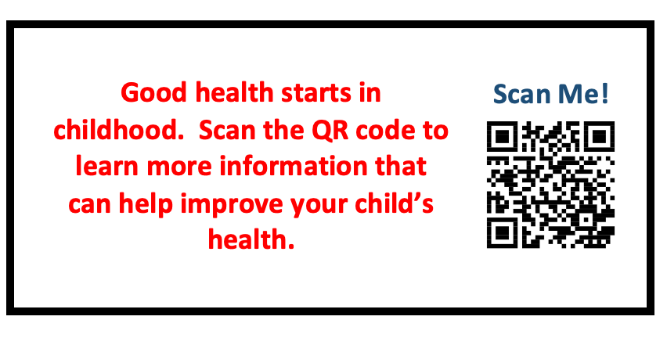

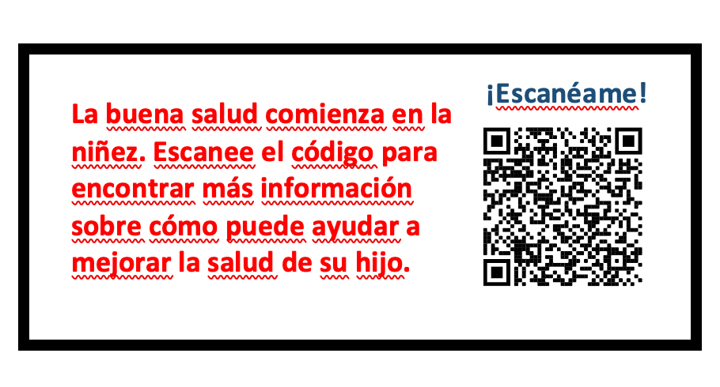

Appendix D

QR Code Project Bookmark English

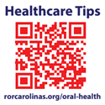
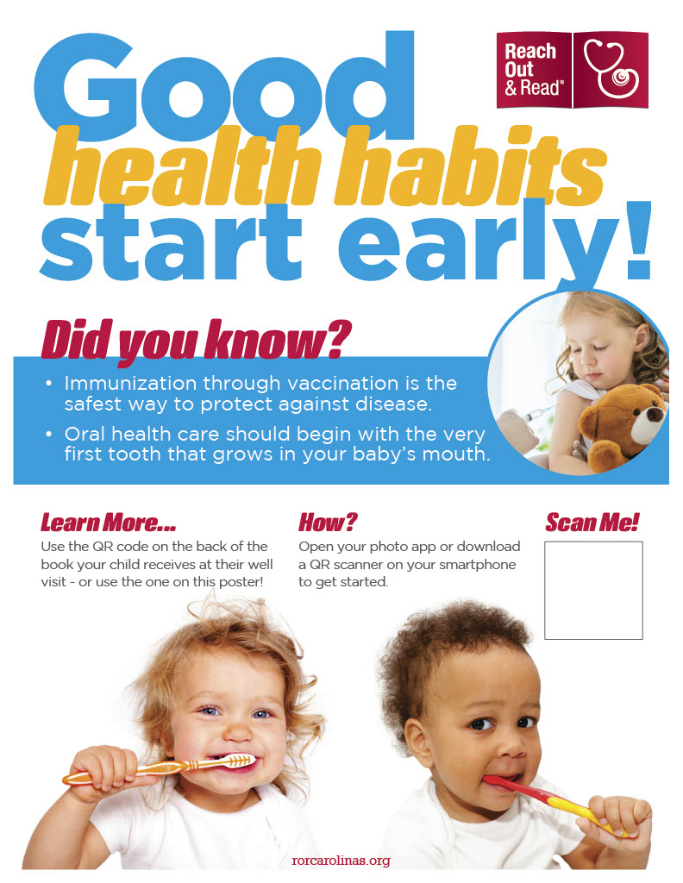

Appendix E

QR Code Project Bookmark Spanish

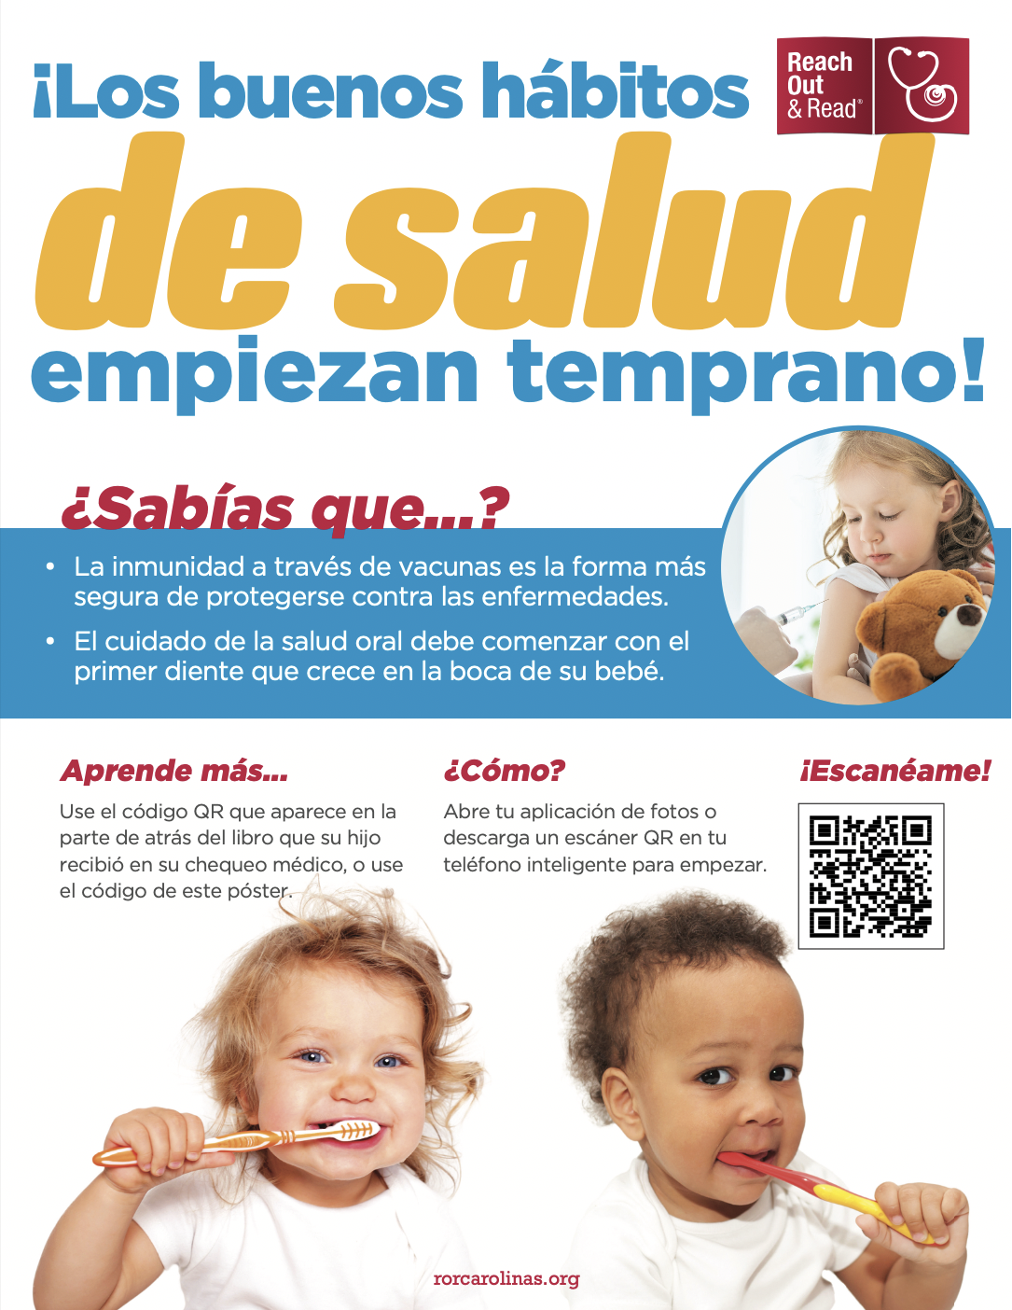

Appendix F

Project Timeline
 | May-August 2021 | August-December 2021 | January -April 2022 | May-July 2022
Project conceptualization, identification of project components, problem, purpose, and goals. | X
CITI Modules completed | X
The project site, site champion, and other team stakeholders were identified. | X | X
Literature search and documentation |  | X
IRB tools worksheet and survey |  | X
Identified participating clinics for project expansion. |  | X
Established communication with Eastern AHEC and Charlotte AHEC, who showed funding for project expansion and implementation materials. |  | X
Obtained contacts for participating clinics. |  | X
Obtained materials for implementing the project, including bookmarks, posters, and QR stickers from funding agencies. |  | X
Students met with clinic partners and AHEC representatives. Student-provided staff project education. Provided information on resources available for the project. Education on the website provided. |  | X
Implementation began, including sticking QR codes in books and hanging promotional posters in participating clinics. |  | X
Clinical staff to provide ROR books with included QR code stickers and website. |  | X
Data collection to begin. Demographic information, number of well-child visits, number of books distributed, distribution rates among staff, website use, and survey data. |  | X | X | X
Data is collected, reviewed, and analyzed weekly. |  | X | X | X
Biweekly project team meetings |  | X | X | X
Publishing process initiation |  |  |  | X
Distribution of project results to supporting organization |  |  |  | X
Distribution of project results to ECU faculty and fellow students at CON, Project poster presentations, and publicization on scholarly. |  |  |  | X

Appendix G

Webpage visits

Appendix H

Survey Responses

English: Very Likely (5)
Spanish: Somewhat Likely (1)
English: Somewhat Likely (3)

Appendix I

Project Budget and Cost Breakdown

Item Description | Quantity | Price
Spanish Posters “24x36” | 17 | $683
English Posters “24x36” | 23 | $893
Bookmarks 2.75” x 8.5” | 6540 | $926
QR stickers 1”x1” English | 3,950 | $424
QR stickers 1”x1” Spanish | 890 | $424
Packaging and Handling | 2 | $15
Shipping |  | $42.44
Tax |  | $216.55
TOTAL | $3,203.38

