Table of Contents
Introduction | 4
Literature Review  Summary | 5  10
Capstone Plan and Process | 12
Needs Assessment (Findings and Results) | 12
Capstone Setting and Site  Population/Participants  Model of Practice  Project Focus Area  Capstone Experience Objectives  Planning and Development  Development Process  Capstone Project Description  Steps to Implement Capstone Project  Evaluation Plan | 13  13  13  15  16  17  17  19  26  30
Outcomes | 31
Project Summary | 31
Project Outcome and Analysis | 33
Discussion | 35
Interpretation of Results | 35
Plan for Sustainability  Dissemination | 35  36
Limitations | 37
Implications for Profession | 38
Future Directions | 40
Conclusion | 41
References | 43
Appendices | 55
Appendix A | 55
Appendix B | 60
Appendix C | 65
Appendix D | 66
Appendix E  Appendix F  Appendix G  Appendix H  Appendix I  Appendix J | 68  77  78  79  80  81

Music is an art form that is interwoven in almost every aspect of human culture, comprising tens of thousands of years of cultivation and evolution to become what we experience today. Universally recognized as a powerful medium for self-expression, connection, and personal identity (Bachiev et al., 2024; Bonneville-Roussy & Vallerand, 2020; Guptill, 2014; Halsted, 2024; Villas, 2020), music plays a pivotal role in the lives of those who dedicate themselves to its mastery. Despite its ubiquity across cultures and environments, the deeper significance of engaging in music, particularly for those pursuing it at the collegiate level and beyond, is often disregarded. Musicians experience a profound bond with their craft (Guptill, 2014; Halsted, 2024), one that extends beyond performance to influence their identity, social interactions, and overall well-being. The literature affirms that engagement in music is not merely a career choice but a fundamental component of musicians’ lives, driven by both passion and purpose (Bonneville-Roussy & Vallerand, 2020).
While the pursuit of musical excellence can positively influence well-being, it often comes as a double-edged sword. Advanced performance and the rigorous training required to meet expectations place significant physical and psychological demands on musicians (Halsted, 2024), often leading to performance-related musculoskeletal disorders with serious implications (Baadjou et al. 2018; Bachiev et al., 2024; Guptill, 2012). The literature consistently highlights the risk factors associated with intensive musical training including repetitive movements, prolonged static postures, and high stress levels (Bachiev et al., 2024, Schaefer & Speier, 2012; Zaza & Farewell, 1997).
Despite the high prevalence of these injuries, rehabilitative and preventative approaches that are musician-centered remain underdeveloped compared to other career-focused counterparts, such as sports medicine (Bachiev, 2024; Yang, Fufa, & Wolff, 2021). This literature review serves to examine the common themes of musicians’ connection to their craft, the occupational risks they face, and the effectiveness of injury prevention strategies for pianists to ensure positive long-term health outcomes and sustainable occupational engagement. These findings ultimately informed the development of an injury prevention program for college students studying piano.

Literature Review

Musicians’ Deep Connection to Their Craft
Music has been an integral component of human culture for millennia, often referred to as a universal language that transcends cultural, racial, and generational boundaries (Gottlieb, 2019). Its omnipresence in daily life often renders its significance overlooked until it is absent. According to the National Endowment for the Arts (2022), over half of adults aged 18 and older engage in artistic creation or performance, with musical participation on the rise. Despite its ubiquity, the value of music and musicianship is frequently undervalued in professional and academic discourse. However, occupational science asserts that engagement in meaningful occupation is a fundamental human need (Wilcock, 1993; Yerxa, 1998).
For musicians pursuing post-secondary education, interaction with their instrument is as habitual and essential as other daily activities. In one phenomenological study, a participant noted, “I couldn’t imagine not having music in my life every day because it had been for [years]” (Park et al., 2007, p. 91). This reflects the deep-rooted connection between musicians and their craft, with instruments often described as an extension of the body (Guptill, 2012). Music not only constitutes a core component of personal identity but also fosters social connection, spiritual engagement, self-efficacy, autonomy, and emotional expression (Bonneville-Roussy & Vallerand, 2020; Guptill, 2012; Halsted et al., 2024; Schoeb & Zosso, 2012). Musicians often experience profound fulfillment and purpose through their artistic pursuits, driven by both intrinsic and extrinsic motivations and a relentless commitment to excellence (Bonneville-Roussy & Vallerand, 2020; Evans, 2015). However, the intense dedication necessary to pursue musical studies to the professional level presents players with a host of variables to navigate away from the spotlight of the concert hall.

Implications of Advanced Performance
While musicianship can greatly enhance well-being, identity, and social belonging, it often entails significant physical and occupational challenges. Professional musicians frequently encounter precarious working conditions such as inconsistent income, blurred professional-personal relationships, and limited access to healthcare (Chafe & Kaida, 2019; Musgrave, 2023). One of the most pressing concerns in the literature is the high prevalence of performance-related musculoskeletal disorders (PRMDs), defined as “pain, weakness, numbness, tingling, or other symptoms that interfere with [a musician’s] ability to play [their] instrument at the level [they] are accustomed to” (Zaza & Farewell, 1997, p. 293).
PRMDs result from repetitive strain, overuse, prolonged non-ergonomic postures, and extended practice durations (Bachiev et al., 2024; Schaefer & Speier, 2012; Zaza & Farewell, 1997). Spahn et al. (2017) found that the prevalence of PRMDs among first-year university music students was already at 29%, increasing to 42% in the second year. These risks are compounded by factors such as the physical demands of different instruments, repertoire complexity, sudden practice schedule changes, technical inefficiencies, and performance-related stress (Bragge et al., 2006; Hildebrandt et al., 2012; Revak, 1989).
The World Health Organization (2022) identifies musculoskeletal conditions as the leading cause of disability globally. Literature on workplace injuries highlights strong correlations between repetitive physical tasks, psychosocial stress, and the development of such conditions (Cruder et al., 2020; Fan et al., 2024; Roos et al., 2024). These findings are highly applicable to the musical profession, where daily practice routines and performance pressures mirror the occupational demands seen in other high-risk vocations (Berezutsky & Berezutska, 2020).
There is a growing consensus that musicians should be viewed similarly to athletes in terms of physical health risks (Niarchou et al., 2021; Yang et al., 2021). Just as sports medicine has developed specialized frameworks for injury prevention and rehabilitation, musicians require tailored approaches that acknowledge the biomechanical and psychosocial demands of their craft (Niarchou et al., 2021; Yang et al., 2021). Despite this need, most clinicians lack the specialized knowledge to effectively treat musicians, contributing to a gap in care that persists decades after the initial identification of PRMDs in the literature (Bastepe-Gray et al., 2021; Villas et al., 2020).

Injury Prevention
While advances have been made to address the high prevalence of PRMDs in musicians, limited knowledge about how to address and treat these disorders remains a common obstacle to navigate for musicians and general medical personnel alike (Bachiev et al., 2024; Bastepe-Gray et al., 2021; Kok et al., 2016; Rotter et al., 2020). The literature consistently reiterates that prevention of these injuries poses the best outcomes for musicians (Yang et al., 2021) and emphasizes the importance of taking what has been gathered from studies on etiology of PRMDs to target prevention strategies in a focused way (Baadjou, et al., 2018; Kaufman-Cohen et al., 2018; Spahn et al., 2017; Yang et al., 2021).
Within the last decade, multiple studies have explored which prevention measures achieve the most positive outcomes in terms of reduction in pain symptoms experienced, improved endurance while playing, perceived feelings of stress, and performance quality, with promising results shown from a variety of approaches aimed at improving health behaviors in musicians (Baadjou, et al., 2018; Kaufman-Cohen, 2018; Savvidou, et al., 2017; Wolff et al., 2021). Additionally, musicians do not experience an off season similar to athletes, so the need for effective injury prevention is imperative for continued participation and healthy engagement in music making. Contrary to athletes that participate in various sports, musicians’ training is often rooted in tradition passed down from teacher to pupil rather than scientific principles (Bachiev, 2024). This poses both a challenge and an opportunity to implement injury prevention strategies within the process of traditional pedagogy.

Injury and Prevention Strategies Specific to Pianists

Injuries
Due to the varying repertoire, postures, and biomechanical demands of each instrument, focusing on instrument-specific injury prevention is requisite. Accordingly, this literature review is focused on the piano keyboard. The many hours spent learning the piano to achieve the performance level is a unique paradox. On one hand, extensive practice allows for an individual to excel in skill, musicality, and performance ability, but conversely, the demands of playing the piano at this level directly correlate with increased risk and prevalence of injuries (Baadjou et al. 2018; Bachiev et al., 2024; Guptill, 2012; Niarchou et al., 2021; Yang et al., 2021).
First, literature strongly attests that formal instruction and education in proper technique, health, safety, and injury prevention strategies is imperative to address the staggering statistics of PRMDs in musicians, especially music students (Matei et al., 2018; Wolff & Robbins, 2021). Multiple studies have displayed success in reducing perceived physical tension while playing by implementing relaxed technical concepts, such as the Alexander Technique, to positively influence reduction in onset or perseverance of playing-related injuries. This method focuses on improving kinesthetic body awareness such as tension and adjusting postural habits and breathing to promote healthy playing (American Society for the Alexander Technique, 2025; Davies, 2020; Madapatha & Perera, 2023; Wong et al., 2024).

Prevention Strategies
The importance of sustaining optimal posture and kinematics to promote biomechanical health and maximize mechanical efficiency in piano performance is well-documented in the literature (Bachiev et al., 2024; Shoebridge, Shields, & Webster, 2017; Steinmetz, Seidel, & Muche, 2010; Tominaga et al., 2016; Wong et al., 2024). Evidence supports that engaging in therapeutic exercise to build proper muscle tone and balance between agonists and antagonists for upper extremity movements at the keyboard as well as core musculature reduces the risk of injury and can improve playing endurance (Bachiev et al., 2024; Iglesias-Carrasco et al., 2024; Jeong et al., 2024; Kava et al., 2010; Santoro, 2022; Steinmetz et al., 2010). Postural stabilization systems were found to be weak or defective in 93% of the 84 musicians attending a specialized clinic discussed in one cohort study (Steinmetz et al., 2010). Similarly, over half of students at one music conservatory showed maladaptive postures when sitting and standing in another literature review (Blanco-Pineiro et al., 2015).
Addressing sources of psychological stress has additionally been documented throughout the literature (Passarotto et al., 2023; Santoro, 2022). Such stress is closely intertwined with experiences of physical tension that correlate with an increase in performance-related injury risk. Thus, interventions targeted at reducing mental and emotional stress surrounding playing and performance are an essential component of a holistic injury-prevention approach (Kenny & Osborne, 2006; Kok et al., 2017; Passarotto et al., 2023; Ting & Rocker, 2019). Lastly, solutions that provide guidance on how to practice more effectively show promise in directly targeting the risk factors of overuse to promote injury prevention caused by excessive load and stress in multiple studies (Bastepe-Gray et al., 2021; Guptill, 2014; Matei et al., 2018; Pozennato, 2020; Stambaugh, 2011).

Summary
Music is a universal and enduring human occupation that plays a vital role in the development of identity, social connectedness, spiritual engagement, and personal expression (Gottlieb, 2019; Villas et al., 2020; Wilcock, 1993; Yerxa, 1998). The literature emphasizes that musical practice and performance not only fosters a sense of purpose and fulfillment, but also supports autonomy, self-efficacy, and community belonging (Bonneville-Roussy & Vallerand, 2020; Halsted et al., 2024; Schoeb & Zosso, 2012). Despite these benefits, musicians face disproportionately higher risks of performance-related musculoskeletal disorders (PRMDs), which are associated with repetitive strain, poor ergonomics, prolonged practice, and high psychosocial stress (Bachiev et al., 2024; Schaefer & Speier, 2012; Zaza & Farewell, 1997). Literature consistently demonstrates a concerning prevalence of PRMDs among university-level musicians, with early onset occurring during the first years of study (Allsop & Ackland, 2010; Correa et al., 2018; Kaufman-Cohen & Ratzon, 2011; Kok et al., 2016; Savvidou et al., 2017; Spahn et al., 2017; Yang et al., 2021). These conditions, if unaddressed, have far-reaching repercussions including chronic pain and career-threatening limitations; therefore, a client-centered approach to injury prevention is needed for this population.
Comparative frameworks have increasingly drawn parallels between musicians and athletes, noting shared patterns of overuse injuries and physical demands unique to their respective crafts (Niarchou et al., 2021; Yang et al., 2021). However, many healthcare providers lack the specialized knowledge required to treat musicians effectively, highlighting the need for a more targeted, occupation-centered approach to preventative and rehabilitative care (Bastepe-Gray et al., 2021).
Occupational therapy is uniquely positioned to address this need through its holistic lens and scope of practice, as defined in the Occupational Therapy Practice Framework-4 (American Occupational Therapy Association [AOTA], 2020; Guptill, 2014). Accordingly, this capstone project was developed to advance this aim (Ting & Rocker, 2019; Halsted, Biggins, & Davis, 2024). Historically, leaders in occupational therapy have voiced the importance for clients to “live, not merely exist, (Cardwell, 1966), [and to be] engaged in activities that are meaningful to them (Shimeld, 1971)” as cited in (Polatajko et al., 2013, p. 16). With an evidence-based program, informed occupational therapists can be pivotal team members in addressing PRMDs in musicians through use of a holistic lens and utilization of occupational analysis. Ultimately, this profession is built upon the central belief in supporting participation in life through engagement in occupation, and this can be directly applied to the performing arts population that is at risk for PRMDs. Therefore, this capstone project was undertaken to provide a framework for addressing the foundational skills supported by evidence to promote healthy piano performance and practice through addressing principles of ergonomics, kinesthetic awareness, and the development of positive practice habits.

Capstone Plan and Process

Needs Assessment (Findings and Results)
A needs assessment was conducted at the capstone site on February 6, 2025, with piano students of Dr. Keiko Sekino. An anonymous Qualtrics survey was completed by five students and their professor to gather data on the needs of relevant stakeholders. Sixty percent (n=5) of student respondents answered that they were unfamiliar with injury prevention strategies, highlighting a stark need to define injury prevention clearly as well as educate on its importance within piano playing. The most striking findings from the gathered responses were students’ mean of 49.8 regarding their body awareness, with a range of 22.0 to 70.0 (scale 0-100). This statistic indicated that more than half of the students surveyed were not attuned to physiological signs of tension, pain, or stress in their bodies. Additionally, out of seven injury prevention topics, the professor selected improved kinesthetic body awareness as the highest priority for her students to receive during this capstone project. These results highlighted the gap in both piano student understanding and educational opportunities regarding improved body awareness, which further supported the critical need for injury prevention education within this population.
Furthermore, 80% of student respondents reported a history of hand, wrist, arm, or shoulder performance-related injuries, either with or without a formal diagnosis. Only 20% of respondents reported an absence of any current or previous upper extremity injuries stemming from playing piano. The data regarding psychological stress and physical manifestations also identified potential needs, as 80% of student respondents had experienced mental stress and/or physical pain and tension at the piano during both practice and performance. Students responded that they were playing for a range of 1-6 hours per day, with the majority reporting they played 3-4 hours per day. The importance of implementing stress reduction techniques throughout practice and performance emerged as a critical focus of this capstone experience to best address the students' current routines. Please refer to Appendices A, B and C to view the questions, results, and a summarizing infographic of the administered needs assessment.

Capstone Setting and Site
This capstone project was implemented at the East Carolina University School of Music located in the A.J. Fletcher Music Center in Greenville, North Carolina. The ECU School of Music is comprised of approximately two hundred undergraduate, fifty graduate students, and over seventy faculty/staff members (East Carolina University, 2026). It is a program dedicated entirely to music with more than fifty practice rooms, two large rehearsal halls, and a two hundred twenty-seat recital hall. The ECU School of Music is one of the premier recognized and comprehensive music schools in the Southeast United States (East Carolina University, 2026).

Population/Participants
The target population and participants of this Capstone Experience were undergraduate and graduate piano students studying at the ECU School of Music. The piano students at this site were between the ages of 18-25 years old with various concentrations including performance and pedagogy, music therapy, and music education. Their occupational demands include performing solo and ensemble repertoire; performing with large ensembles such as the orchestra, bands, choirs, and the Opera Theater; competing in the school’s annual concerto competition if desired; performances in weekly studio classes; performing in master classes with visiting guest artists; and participating in weekly individual one hour lessons with their applied instructor.

Model of Practice
The occupational therapy Model of Practice that informed the development and implementation of this capstone project was Person-Environment-Occupation-Performance (PEOP), developed by Baum and Christiansen. PEOP analyzes how a person interacts with and is influenced by their environment, the occupations they engage in, and their occupational performance of a given task in a continuous, reciprocal way (Baum & Christiansen, 2015).
The person in PEOP involves factors within an individual including physiological, cognitive, spiritual, neuro-behavioral, and psychological attributes (Baum & Christiansen, 2015). Applying this to pianists, specific factors in this domain could include as follows: any PRMDs the individual may experience or be at risk of experiencing; the postures they display at the piano; sensations they may feel when playing such as pain, fatigue, tension, or ease; their kinesthetic awareness to their own bodies and movements; their understanding of how different piano techniques may support health and longevity through playing; the spiritual connection and sense of identity/purpose they feel in their craft; how they approach making adjustments to how they play the instrument; or their attitudes towards considering new ways of approaching practice, performance, and learning music in general.
The environment domain as defined in this theory includes social support and economic systems, culture and values, the built environment and technology, and the natural environment the pianist finds themself in (Baum & Christiansen, 2015). The environmental factors that may affect piano students could include: the temperature of the room/space they are playing in; the lighting; seating (adjustable bench vs. hydraulic bench vs. chair with a back); the social environment of playing in a large ensemble, as an accompanist, as a soloist, or as a chamber musician; playing in the practice room versus a performance hall; the attitudes of professors and colleagues around them towards injury prevention/awareness; and playing a paid gig/job as a means for financial support versus music chosen simply for the joy of playing.
Occupation refers to any meaningful activity an individual chooses to engage in, structured as tasks within an endeavor. For piano students, occupation is playing their instrument and this can include the touch weight of the piano keys (how much force is necessary to depress the keys down), the structure and material the piano is made out of, the repertoire they are playing (baroque, classical, romantic, impressionistic, 20th century, prepared piano), and the work demands placed on them by academic expectations or jobs that requires their playing to be completed.
Performance is defined as the doing of meaningful activities. For musicians this would include the act of playing their instrument and how well they can do so, including their own mastery of repertoire, keyboard skill proficiency in various styles and techniques, and their ability to meet their playing-related work or school demands. By using occupational analysis to look at how individuals approach playing the piano through the informed lens of PEOP, areas within each domain of this model can be targeted by the therapist in a strategic way to support healthy occupational engagement.

Project Focus Area
The primary focus area of this capstone experience was the development of an injury prevention program for piano students at East Carolina University. Titled “Preventing Injuries among Piano Students” (PIPS), the program encompassed three online learning modules including the importance of injury prevention for career longevity and occupational engagement, development of body awareness, and guidance for how to structure practice and performance routines that support healthy and continued engagement in playing the piano. These modules were strategically chosen to meet the unique needs of the capstone site identified in the needs assessment, and with the intent to scaffold learning throughout the duration of the course. A secondary focus of this project was education, as this program was developed as a noncurricular Canvas Learning Management System course for current and future piano students to complete, with the intent to facilitate sustainable injury prevention.

Capstone Experience Objectives
The goals of this capstone experience were as follows: (1) The PIPS program materials will be fully developed and integrated in Canvas by week 6 of the capstone experience, (2) A pilot implementation of the PIPS program will be conducted with two piano students by the conclusion of the capstone experience, and (3) The perceived usefulness and effectiveness of the PIPS program within ECU’s School of Music will be evaluated upon completion of the capstone experience.
The objectives necessary for successful completion of goal one were encompassed as follows: developing one module related to the importance of injury prevention, creating one module related to developing body awareness, and developing one module of guidelines for structuring a healthy practice and performance routine, integrating these modules into a noncurricular course format to include information presentations, learning activities, and a knowledge quiz.
The objectives necessary for completion of goal two were encompassed as follows: recruiting one piano student who is experiencing PRMD symptoms and one piano student who is not experiencing PRMD symptoms to pilot the PIPS program and implementation of the three modules of the PIPS program. Information gained from these individual assessments was later incorporated into the modules as appropriate. Furthermore, administration of pre- and post-test surveys to the students piloting the PIPS program contributed to this goal’s completion.

The objectives to meet goal three included building a Qualtrics survey for the piloting students to gather final opinions on the utility and effectiveness of the PIPS program, a review of the outcome data gathered between the capstone student, the site mentor, and content expert, and agreement on a plan of continuation with the PIPS program at the ECU School of Music contingent on appropriate changes made to the program to refine it.

Planning and Development

Development Process
Developed and refined from Fall 2024 through Fall 2025, this capstone project implemented a targeted, evidence-based approach to address an identified gap within this population at a site with identified risks and history of PRMD occurrence. The idea for this capstone first began in 2017 during the author’s undergraduate studies pursuing a Bachelor of Music Performance with a concentration in Piano. The author underwent bilateral wrist surgeries to address DeQuervain’s tenosynovitis after sustaining cumulative injuries related to playing during her first year of music school. The firsthand experience gained by navigating a healthcare system that has very little evidence to inform an approach to musicians’ playing and the associated demands proved to be difficult. After completing her degree, she went on to sing professionally with the North Carolina Master Chorale and NC Symphony, worked as a church pianist, and taught a full private piano studio for two years before returning to school for occupational therapy. She frequently encountered colleagues in need of healthcare for playing-related disorders in each of these spaces, and the breadth of how large this gap existed within the music profession truly solidified her passion for seeking to work towards a solution during her doctoral studies.
Upon acceptance to the Doctor of Occupational Therapy program at ECU, the capstone student researched occupational therapy’s role in musicians’ healthcare from a two-pronged approach that examined both injury prevention and injury rehabilitation specific to musicians. After analyzing the literature and having discussions with her content expert, Dr. Lynne Murphy, the decision was made to focus on injury prevention. The strength of the literature highlighting the staggering prevalence of PRMDs within this population supported the need for knowledge and application of injury prevention. In fact, prevalence of PMRDs in pianists has not decreased since the 1997 seminal article by Zaza and Farewell on this topic (Zaza & Farewell, 1997). Program development to address this gap emerged and was ultimately selected for this capstone project.
Using the author’s professional knowledge as a musician and having completed the didactic coursework of the Doctor of Occupational Therapy degree, the options for topics to address within the umbrella of injury prevention were endless. Topics for inclusion that were considered included addressing attitudes within the music field towards injuries and injury prevention, basic human anatomy applicable to musicians, guidelines for specific keyboard skills practice and acquisition, and recommendations of avoiding strain on the wrist and hands in consideration of repertoire. These topics were considered from a dual lens of piano pedagogy and musicality, combined with ergonomics/kinematics knowledge from occupational therapy.
To determine the most important aspects of injury prevention to include in the project, professionals with expertise in music and healthcare were consulted. Interviews with professionals in the field included Mr. Kwan Yi, BM, Dr. Keiko Sekino, DMA, and Dr. Christine Guptill, PhD, MSc(OT), BMus, which provided perspectives of both professional pianists that perform globally and an occupational therapist who specialized in working with injured musicians for over twenty years. Dr. Keiko Sekino completed a Doctor of Musical Arts degree at the Peabody Conservatory of Johns Hopkins University and holds additional degrees from Yale University in economics and music. She actively performs as a solo recitalist and chamber musician in the United States and abroad, serving as Associate Professor of Piano and Director of Applied Piano Studies at the East Carolina University School of Music (East Carolina University, 2026). Mr. Kwan Yi is a graduate of the Curtis Institute, Juilliard School, and the Peabody Institute where he studied piano. He enjoys an active career as a chamber musician and piano soloist, frequently performing with world-class musicians at esteemed venues across the United States and abroad (East Carolina University, 2026). Dr. Christine Guptill holds a Bachelor of Music in Oboe Performance from Western University, Master of Science in Occupational Therapy from Western Michigan University, PhD in Health and Rehabilitation Sciences from Western University and completed a post-doctoral fellowship in work disability prevention at the University of Toronto. She currently serves as an Associate Professor of Occupational Therapy at the University of Ottawa, co-director of the Canadian Network for Musicians Health and Wellness, and vice-chair of research for the Performing Arts Medical Association (University of Ottawa, 2026). Upon completion of stakeholder interviews, a needs assessment was developed for the piano students and faculty to address various aspects of PRMDs such as baseline knowledge of injury prevention, self-appraisal of body awareness, history of PRMDs, and occupational demands. Please refer to Appendix D to view a summary of the various stakeholder meetings that informed the development of this project.

Capstone Project Description
Each module of the PIPS program directly correlated with the findings of the needs assessment and addressed the critical gaps identified between injury prevention and daily piano playing at the capstone site. The importance of injury prevention was selected as the first module of the course to elicit buy-in from participants by explaining the risks associated with certain playing behaviors and why injury prevention was relevant to their piano playing. The literature supports that formal instruction and education in injury prevention strategies is imperative to address the staggering statistics of PRMDs in music students (Wolff & Robbins, 2021; Matei et al., 2018). By approaching the piano students with the intent to help them understand the purpose of the recommendations presented in the successive modules, the course allowed them to take autonomy over their health behaviors related to playing and supported positive outcomes (Krist, et al., 2017). Please refer to Appendix E to view the module 1 PowerPoint for a detailed look into the content covered throughout the course.
The second module, development of body awareness, included information for the students on how to check in with their bodies before, during, and after playing. Directly related to addressing the piano professor’s top priority and the piano student’s self-reported high uncertainty in this area, the content educated and challenged students to incorporate kinesthetic awareness techniques throughout their daily playing and performance routines. The importance of displaying optimal postures and kinematics to promote biomechanical health and maximize mechanical efficiency in piano performance is well-documented in the literature (Shoebridge, Shields, & Webster, 2017; Steinmetz, Seidel, & Muche, 2010; Tominaga et al., 2016; Wong et al., 2024; Bachiev et al., 2024). By guiding the piano students in their awareness of body postures and positioning, perceived tension, and pain throughout the body, the module presented them with the opportunity to address those potential problems in a preemptive manner before cumulative stress and trauma began to affect their daily occupational performance and self-efficacy. To view a handout from this module covering terminology to use when completing body mapping exercises, please refer to Appendix F. Upon the conclusion of the online module on this topic area, two students engaged in one-on-one ergonomic assessments conducted by the capstone student, which included filming them playing the piano from the side, rear, and close-up hand perspectives. The videos were edited with superimposed lines to highlight healthy and maladaptive positioning of the spine, hips, shoulders, neck, and forearms/hands. Additionally, the videos included a voiceover provided by the capstone student explaining the key ergonomic considerations displayed throughout filming, with consideration of repertoire and musicality. The edited ergonomic assessments were added as a supplement to module two content for students to review and write a brief reflection on, remaining available for future students to view. The visual and auditory elements of the ergonomic assessments embedded in the course provided students with a multimodal approach to the information, which enhanced understanding and carryover of the strategies presented. Furthermore, one recommendation in this module encouraged students to film themselves while practicing or performing as an objective way to examine their playing postures and habits while actively engaging with the instrument. The inclusion of the capstone student’s ergonomic analysis videos in the module further served as a template for students’ own analysis of their playing after the experience was complete. Growth in kinesthetic awareness was recognized as a skill that took time to foster, and this module provided a clear foundation from which piano students could build in their practice to support positive changes in body positioning and posture at the piano. Photos taken from the ergonomic assessment videos included in the course are included below in Figure 1.
Figure 1
Photo Capture from Ergonomic Analysis Video with Body Positioning Indicator
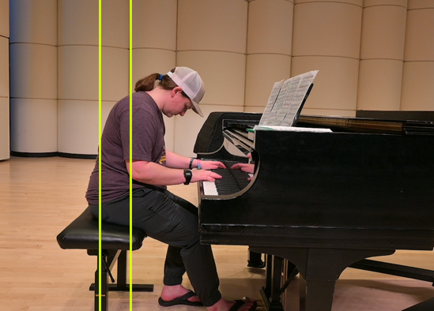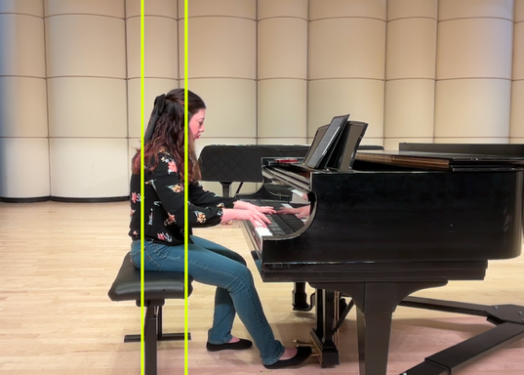
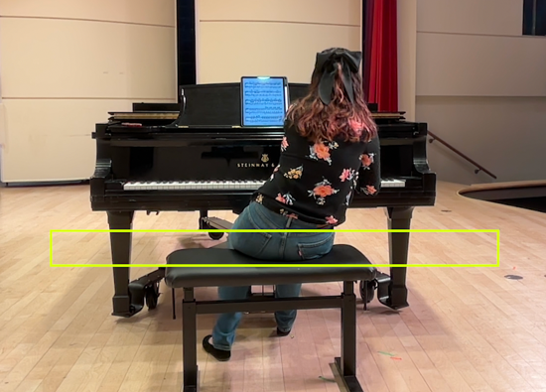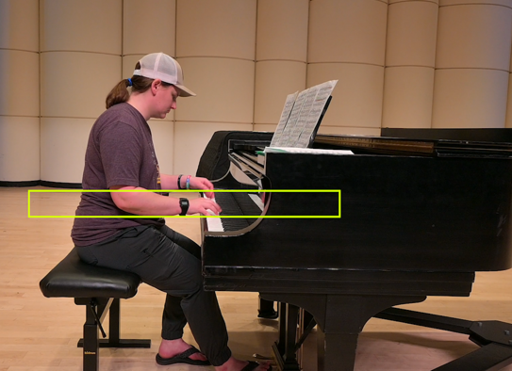
Note: Top row of photos indicates center of gravity markings, bottom left photo indicates weight distribution, and bottom right photo indicates neutral upper extremity distal joint positioning.
Following each assessment, participants received individualized written feedback outlining recommended postural adjustments and injury prevention strategies, specific guidance for enhanced musicality within ergonomic guidelines across varied repertoire, and personalized practice recommendations intended to support long-term healthy playing habits and occupational engagement. Please refer to Figure 2 below for a detailed look at written feedback provided to participating students.

Figure 2
Individual Ergonomic Assessment Feedback
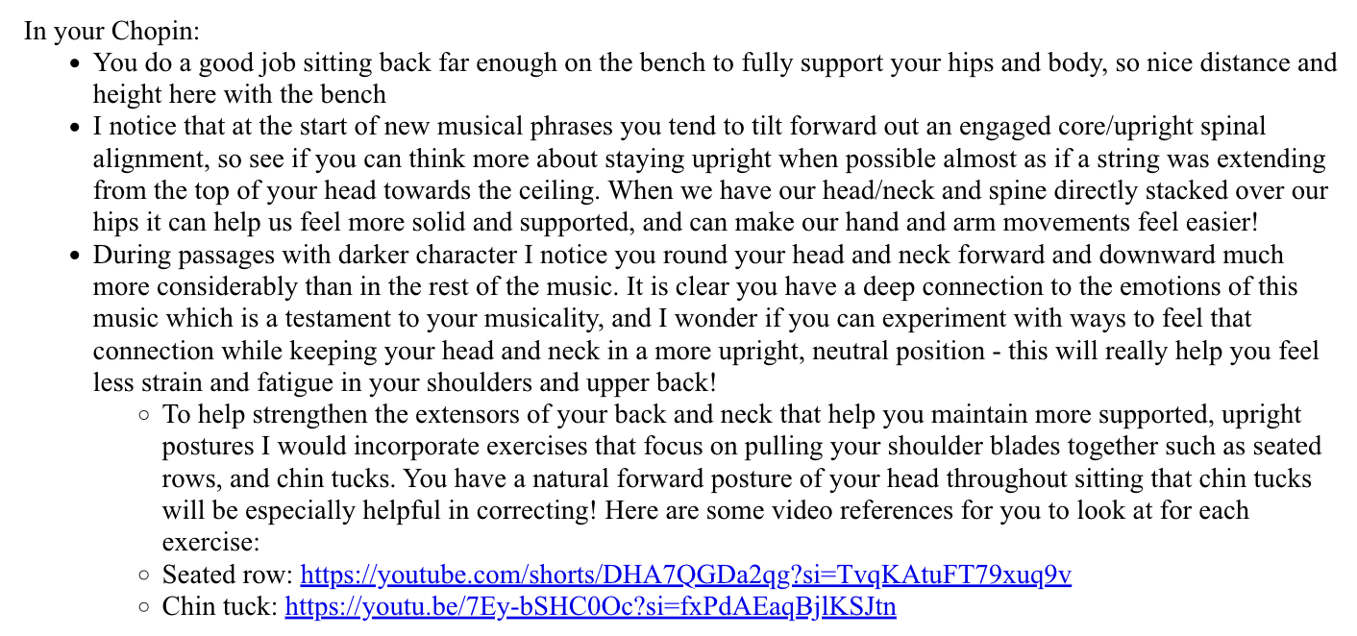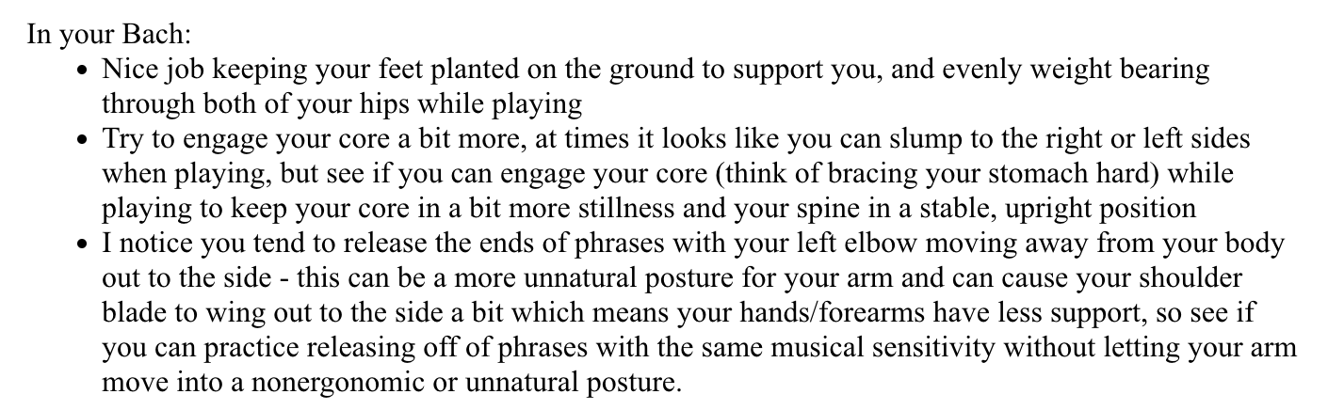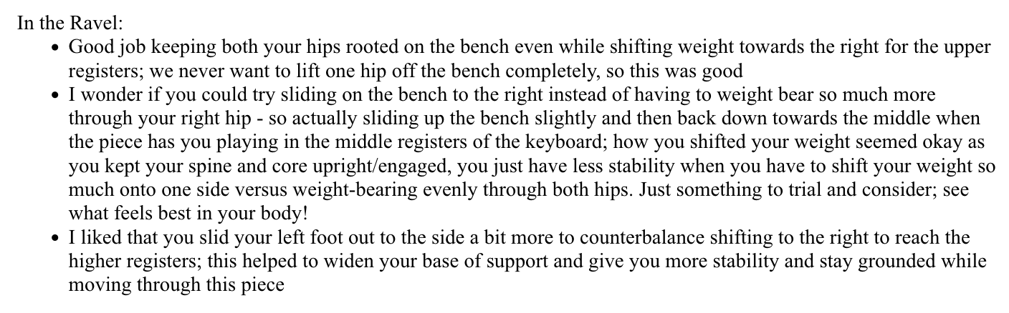
Module three provided students with specific methods for integrating the injury prevention principles learned thus far into their daily routines and presented additional considerations for healthy practice and performance habits. The literature indicated that intentional practice and scheduled breaks showed promise in directly targeting risk factors of overuse to promote injury prevention caused by excessive load and stress (Matei et al., 2018; Guptill, 2014; Bastepe-Gray et al., 2021; Pozennato, 2020; Stambaugh, 2011). Accordingly, this module included recommendations that students could use before, during, and after playing to support their autonomy in selecting strategies that fit each piano student’s unique needs.
The module addressed several specific topics, including appropriate times to utilize the kinesthetic check-ins introduced in module two and recommended playing-to-rest ratios grounded in best practices. Additional content focused on stress-reduction techniques, cognitive strategies for structuring practice sessions, and broader health behaviors that promote longevity. An example of a practice journal template provided to students in this module can be found in Appendix G. The students who participated in filming the ergonomic assessments also received an additional individualized practice routine based on their scheduled rehearsals, lesson times, and studio performances. The practice routines consisted of a written schedule of when to warm up and cool down before/after playing, suggestions for when to nutritionally fuel based on their schedules, as well as types of exercise to engage in (aerobic vs. anaerobic) to support their overall health. The individual practice routines given to both film participants can be seen in Figure 3 below. The primary intention was to introduce practical changes that could be incorporated into the students’ everyday lives to support sustained carryover after the course concluded.

Figure 3
Individual Practice Routines for Student Participants
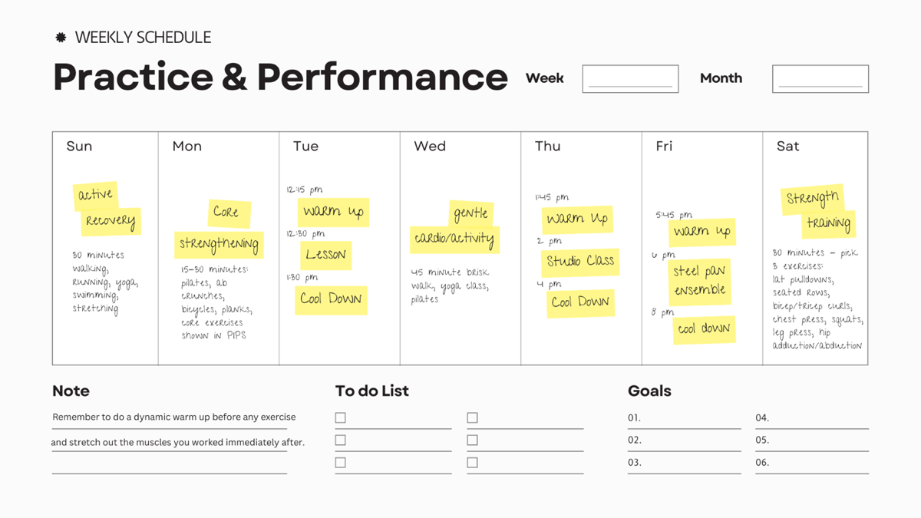
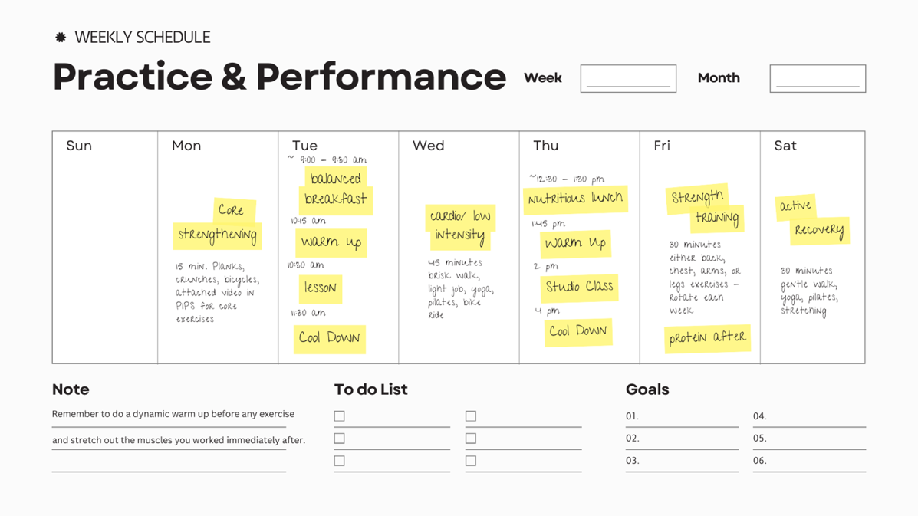
Note: Top practice routine omits nutritional fueling recommendations, while bottom practice routine includes nutritional fueling suggestions alongside warm up/cool down, and anaerobic and aerobic recommendations.

Steps to Implement Capstone Project
To implement the goals and objectives of this capstone project, efforts were divided into three phases: content development, pilot, and dissemination. To develop the content of the course, one week per module was allotted to gather evidence-based information from the literature and one week per module was allotted to present it through various multimodal formats within the noncurricular course. These formats included PowerPoint presentations, videos, photos, and text to provide a robust learning experience for the piano students to work through. After uploading the contents of each module, the completed work was sent to both the content expert and site mentor for review as the student began gathering information for the next module. This method facilitated a process for continual feedback and improvement throughout the creation of the course. During week three of the capstone experience, the capstone student met with the site mentor to determine the students that would pilot the course in the next phase. Module content was fully developed by the end of week six. Week seven allocated time to complete final edits of the course, to trial of the course from start to finish, and to create and administer the pre-course knowledge test for the piloting students.
Week eight marked the beginning of the pilot phase, where four piano students at the site began working through Module One of the PIPS program. The students were allotted one week to work through the content of module one, and two weeks each to work through modules two and three in a self-paced, asynchronous schedule. This self-paced format was intentional in accommodating the piano students’ busy demands within the school of music. An individual ergonomic assessment was conducted with two of the participants from the pilot at the beginning of module two which included video media to supplement and expand the initial module. While students worked through module three, the capstone student created and shared specific ergonomic recommendations based on the ergonomic analyses completed in module two. By utilizing the unique approach of occupational analysis paired with an ergonomic lens when reviewing the students’ playing, the participants were empowered with multiple tools and knowledge to support injury prevention. The participants completed the same knowledge test they were given before piloting the course, and their results were analyzed for areas of improvement. Additionally, a separate survey gathering opinions on utility and effectiveness of the course was administered to gather final feedback from the piloting students. Information gathered from this survey directly informed any final necessary course adjustments to ensure the most relevant content remained in the course moving forward.
Dissemination of findings was the final phase of the capstone experience. This consisted of (1) an analysis of pre-test, post-test scores that was shared with the content expert and site mentor, (2) a summary of feedback gathered from the survey of utility and effectiveness, and (3) necessary changes to the course for successful continuity. This capstone project was presented as a poster at AOTA’s National Conference in Anaheim, CA in April 2026, and was orally presented at Research Day at East Carolina University’s College of Allied Health Sciences the following week. Please refer to Figure4 below for a detailed timeline of the Capstone Experience, and Appendix H to view an infographic timeline of the Capstone Experience.
Figure 4
Timeline of Capstone Project
Week | Action Steps, Experiences, Activities
1 | - Gathered evidence on the importance of injury prevention for career longevity and positive health, organizing it into a module outline.
2 | - Put the essential information on the importance of injury prevention module into its final format as a draft to be reviewed in the subsequent week, including any videos, photos, presentation, or text.
3 | - Sent the completed module on the importance of injury prevention to my content expert for review/feedback and made necessary changes  - Gathered evidence on the importance of body awareness and ways to improve it relevant to approaching the piano, organizing information into a module outline.  - Created presentation to recruit piano students to participate in pilot, sending to content expert for feedback; made necessary adjustments to presentation.  - Presented to piano students of Dr. Keiko Sekino during a studio class explaining what my project was.
4 | - Put the essential information on body awareness and how to practice it at the piano into its final format as a draft to be reviewed in the subsequent week, including all videos, photos, presentations, and text.  - Finalized 2 student volunteers (one experiencing PRMD symptoms and one without symptoms) who would pilot the course and complete individualized ergonomic assessments, as well as 2 additional students who would pilot the course.
5 | - Sent the completed module on body awareness to content expert for review and made necessary changes to improve it.  - Gathered evidence on how to structure an effective practice session and healthy practice schedule, organizing it into a module outline.
6 | - Put the essential information on practice habits and routines into its final format as a draft to be reviewed in the subsequent week, including videos, photos, presentations, and text.
7 | - Sent the completed module on body awareness to content expert for review and made necessary changes to improve it.  - Completed a run-through of the course from start to finish to ensure continuity  - Created a pre-test and post-test of outcome data to collect.  - Sent pre-test to content expert to review.  - Sent pre-test to the students piloting the course to complete.  - Upon completion of pre-test, the modules of the PIPS program were unlocked for piloting students to begin working through.
8 | - Piano students worked through module 1 of the PIPS program  - Collected data from pre-test responses and analyzed  - Shared pre-test findings with content expert  - Made hypotheses on outcomes measured that the course should improve  - Piano students completed module 1 by the end of the week  - Coordinated and scheduled times to complete individual ergonomic assessments in following week with both participants, reserving necessary performance space and securing film equipment.
9 | - Module 2 content opened to piano students  - Conducted one-on-one ergonomic assessment sessions with two students piloting the PIPS program.  - Created and distributed media consent forms to each piloting student.  - Ergonomic assessment included videotaping students playing different repertoire to assess posture and kinematics in a variety of musical styles and techniques at the piano.
10 | - Edited videos in Adobe Premier Rush to superimpose lines to show center of gravity, weight distribution through the hips, and joint neutrality in the upper extremities.  - Highlighted areas of tension, added voice over to the videos, and addressed other ergonomic considerations as appropriate for each student.  - Added individual ergonomic assessments into module 2 of PIPS program, publishing for students to review and complete a brief reflection due by the end of the pilot.  - Emailed individualized feedback on each student’s specific ergonomic patterns and considerations at the piano to promote health. These were sent to the piloting students and site mentor.  - Ensured piano students completed module 2 of the PIPS program by Monday 3/16.
11 | - Piano students began module 3 of the PIPS program  - Built individualized routines for piloting students to implement before, during, and after practice based on their individual ergonomic assessments as appropriate.  - Routines included exercises to complete relative to each students’ performance load in their weekly routine (strength training vs. aerobic), suggestions for nutrition and timing of meals in preparation for performances based on sports nutrition literature, and allotted time to warm up and cool down before and after lessons, weekly performances, and rehearsals according to each students personal schedules.
12 | - Finalized individual student routine drafts  - Emailed piloting students their individualized routine plans, offering times to meet if piloting students had questions.  - Ensured piano students completed module 3 of the PIPS program by the end of the week  - Administered post-test knowledge quiz to students piloting upon completion of Module 3.  - Built separate Qualtrics survey to gather final opinions on utility and effectiveness of the PIPS program, administering it to all piloting students.  - Administered survey of final opinions to students and site mentor to be completed by the end of the week.
13 | - Gathered the data/feedback from the students and site mentor surveys and highlighted important feedback.  - Graphed outcome data of pre-and-post-knowledge scores to analyze change in knowledge of ergonomics as they pertain to piano playing.  - Scheduled a meeting with content expert and site mentor to review final outcomes gathered by the end of module assessments for the following week.
14 | - Met with content expert and site mentor to review final outcomes and discuss plan for sustainability.  - Shared the feedback data gathered with content expert and site mentor to discuss its continued use within the music program moving forward  - Agreed upon a plan for continuation and made necessary changes to the program to support its continued use at the capstone site.

Evaluation Plan
The evaluation plan utilized both formative and summative methods throughout the course of the capstone experience. Formative evaluation occurred throughout the content development phase, with the capstone student eliciting feedback from the content expert and site mentor on a weekly basis. Feedback was provided and further discussed via email or virtual meetings. This information informed continual improvements of the program content, ultimately leaving piloting students with a high quality and effective injury prevention program.
Summative methods for evaluation consisted of three processes, (1) embedded knowledge checks at the end of each module in the piloting process, (2) a pre- and post-course knowledge test, and (3) a survey gathering opinions on the utility and effectiveness of the program. Evaluation of knowledge acquisition was addressed by the capstone student through the embedded knowledge checks, presented at the conclusion of each module in Canvas.
Additionally, pre-and post-course knowledge test scores were compared to look for change in knowledge of injury prevention principles related to piano playing upon completion of the PIPS program. A survey gathering perceptions of utility and effectiveness of the course further provided piloting students with opportunities to share feedback on the course upon completion. Participants rated their agreement with statements regarding utility and effectiveness of the course on a 5-point Likert scale to inform the intended outcomes of the program. Additionally, free-response questions asked participants to share things they felt were most helpful to them within the PIPS program as well as considerations that would improve the course for future students. After collecting the data from the methods detailed above, the capstone student summarized the key findings to be presented to the site mentor and content expert. Together, a collaborative process to determine necessary changes for continuity was utilized amongst the team, and adjustments were implemented to support continuation of the PIPS program at the ECU School of Music.

Outcomes

Project Summary
The “Preventing Injuries among Piano Students” (PIPS) program was conceptualized during the author’s undergraduate studies in Piano Performance and developed during the Doctor of Occupational Therapy program through a comprehensive literature review, interviews with stakeholders in both the classical music and occupational therapy fields, and a needs assessment conducted at the implementation site. The program was designed to address the need for accessible and evidence-based injury prevention education for pianists, particularly related to performance-related musculoskeletal disorders (PRMDs).
The PIPS program consisted of two primary components: asynchronous online educational modules and individualized ergonomic assessments. Educational content was delivered through an asynchronous, noncurricular course hosted via the Canvas Learning Management System within East Carolina University’s domain. Four piano students participated in the pilot implementation of educational course modules and two participants completed the individual ergonomic assessments. To enhance the generalizability of preliminary findings, one participating student had a confirmed history of PRMDs while the other reported no prior history, allowing for preliminary comparison across differing injury backgrounds.
Individual ergonomic assessments were conducted with both participants. Students were filmed performing piano repertoire within their natural performance environment from multiple camera angles. The capstone student strategically chose to film the pilot participants from a lateral view to assess center of gravity and joint neutrality of the upper extremities, while a rear-view recording was chosen to analyze weight distribution through the hips while the students played. The recorded footage was subsequently edited to include visual overlays highlighting key ergonomic variables to include center of gravity while seated, weight distribution through the hips, and upper extremity joint positioning during performance. Voiceover commentary was incorporated to emphasize ergonomic principles and support students’ ability to identify both healthy and maladaptive movement patterns when reviewing recordings of their own playing.
Participants received individual written feedback detailing recommended postural adjustments and injury prevention strategies, specific guidance to enhance musicality within ergonomic guidelines across varied repertoire, and individual practice recommendations intended to support long-term healthy playing habits. The edited videos were integrated into the Canvas course to promote sustained carryover of ergonomic strategies and to serve as instructional resources for future cohorts.
The objectives of the PIPS program included the successful development of course content, pilot implementation with a minimum of two students, and collection of preliminary data regarding knowledge acquisition related to injury prevention as well as participant perceptions of the program’s utility and effectiveness. All objectives were successfully achieved. Qualitative feedback gathered from student participants through a post-test survey was overwhelmingly positive, with the individual ergonomic assessments highlighted as the most valued component of the course. Additionally, quantitative data collected through pre-and-post knowledge test scores displayed a notable increase in ergonomic knowledge related to piano playing for all four participants.

Project Outcome and Analysis
Final outcomes targeted analyzing knowledge acquisition regarding injury prevention strategies and opinions on the utility and effectiveness of the program. Knowledge acquisition data gathered in the form of post-module knowledge quizzes showed high scores across all student participants, with scores averaging 80% or higher on every module across all participants. Knowledge acquisition data gathered in the form of pre- and post-course knowledge tests showed an increased in ergonomic knowledge related to piano playing in all participants following completion of the course. Participants were not permitted to see their scores or correct/incorrect answers for either test to support test-retest reliability. Please refer to Figures 5 and 6 below for a complete view of the post module quiz scores and pre-and-post test data results.
Figure 5
PIPS Post-Module Knowledge Scores
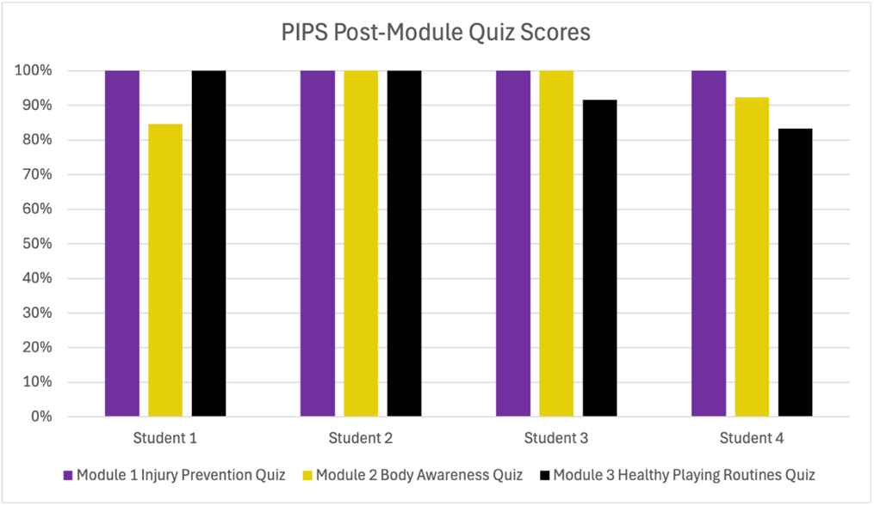

Figure 6
Pre-and-Post PIPS Program Ergonomic Knowledge Scores
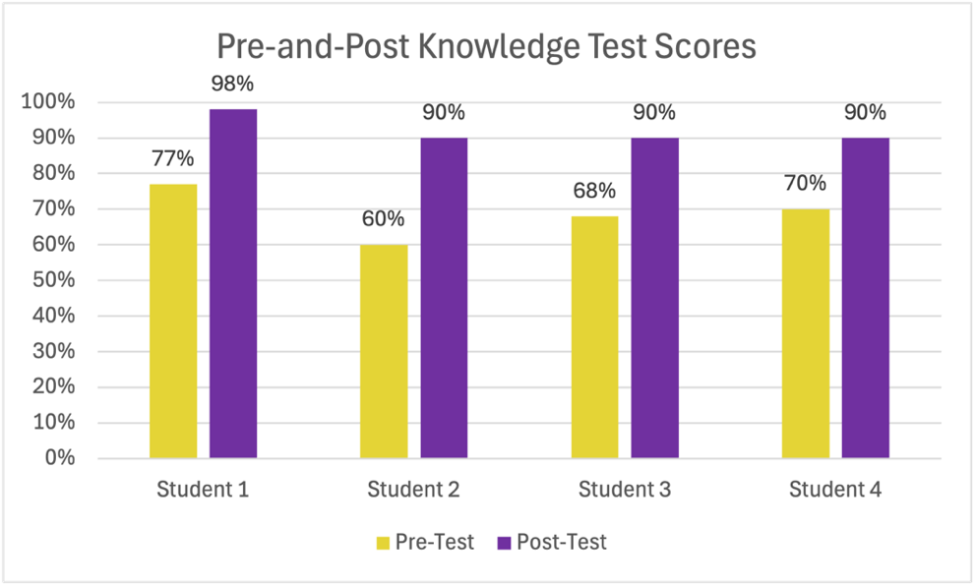
An anonymous Qualtrics survey was administered to gather participant perspectives on the utility and effectiveness of the course, consisting of a combination of Likert-scale and free response questions which can be viewed in Appendix I. A data collection issue within the Qualtrics survey prevented the Likert responses from being accurately collected, and no meaningful outcomes could be concluded from those specific questions. However, qualitative data from the free-response questions in the survey strongly displayed participant opinions that the individual ergonomic assessments were perceived to be the most helpful component of the PIPS, with some students specifying that the assessments helped them to form connections between concepts covered in the course and enhanced their understanding of proper ergonomic positioning while playing the piano to prevent injuries. Qualitative participant responses can be viewed in Appendix J.

Discussion

Interpretation of Results
Final outcomes targeted analyzing knowledge acquisition regarding injury prevention strategies and opinions on the utility and effectiveness of the program. Knowledge acquisition data gathered in the form of pre- and post-course knowledge tests showed an increased in ergonomic knowledge related to piano playing in all four participants following completion of the course. Participants were not permitted to see their scores or correct/incorrect answers for either test to support test-retest reliability. An anonymous Qualtrics survey was administered to gather participant perspectives on the utility and effectiveness of the course, consisting of a combination of Likert-scale and free response questions. Almost every single participant responded that they felt the ergonomic assessments were the most helpful component of the PIPS course in the free response section, specifying that the assessments helped them to form connections between concepts covered in the course as well as enhanced their understanding of proper positioning while playing the piano to prevent injuries. These results affirm that the client-centered approach to piano playing through occupational analysis taken in the PIPS program yielded strong benefits to participants. Additionally, this feedback further supports the need for specialized care and approach for this greatly underserved population, consistent with findings from Bastepe-Gray et al., (2021), Niarchou et al., (2021), and Yang et al., (2021).

Plan for Sustainability
The sustainability plan proposed that the PIPS program, developed as a noncurricular Canvas Learning Management course, remained accessible to the site mentor for future use. The site mentor can publish the course for piano students at East Carolina University to complete at their own pace in subsequent semesters following the capstone experience. A key, unique benefit of the PIPS program is the accessible nature of its design. Not only can occupational therapists administer it directly to their clients, but musicians can independently utilize it as a framework for identifying potential need for further referrals or additional care. It is important to note that while this program format provides an excellent means of gaining knowledge acquisition related to ergonomic principles of piano playing, skilled ergonomic assessment provided by an occupational therapy practitioner is necessary for full, effective implementation of the PIPS program.

Dissemination
Dissemination of capstone results occurred at both the university and national levels following completion of the fourteen-week Capstone Experience. At the university level, the capstone student delivered an oral presentation to an interdisciplinary audience of peers, faculty, and healthcare stakeholders at the East Carolina University College of Allied Health Sciences Research Day hosted on April 29, 2026. The presentation highlighted existing gaps in healthcare services for musicians, particularly related to prevention and management of performance-related musculoskeletal disorders (PRMDs). The capstone student introduced the Preventing Injuries among Piano Students (PIPS) program and described its targeted interventions designed to address these gaps. Preliminary pilot outcomes demonstrating increased participant knowledge and awareness of injury prevention strategies were presented. The presentation also emphasized the program’s structured format, which allows healthcare providers who encounter musicians experiencing PRMDs to utilize the program as an educational resource and preliminary screening tool to determine whether referral for specialized care may be warranted if symptoms persist following program completion.
Dissemination at the national level occurred at the AOTA Inspire Annual Conference and Expo hosted by the American Occupational Therapy Association from April 23-25, 2026, in Anaheim, CA. The capstone student presented a poster outlining gaps in care for the musician population, the evidence-based strategies incorporated within the PIPS program to address these needs, and key implications for occupational therapy practice. The poster also summarized pilot data demonstrating increased awareness of ergonomic knowledge related to injury prevention among participants and highlighted the potential role of occupational therapists in promoting injury prevention and health promotion among musicians in an emerging area of practice.

Limitations
While preliminary outcomes of the PIPS program pilot demonstrate promise, it is important to acknowledge several limitations of the capstone project. The first limitation is the small sample size. The PIPS program was piloted with a total of four piano students (n=4) enrolled in the East Carolina University School of Music. This limited sample restricts the generalizability of findings to broader populations of musicians and piano students. Implementation of the PIPS program with a larger and more diverse participant pool would strengthen the reliability of the findings and improve the generalizability of outcomes related to injury prevention knowledge and program usability.
A second limitation is that participants were recruited from a single university music program. Participants were recruited exclusively from piano students studying in one studio at the East Carolina University School of Music, which may limit the transferability of findings to broader populations of musicians. Institutional culture, curriculum expectations, faculty teaching styles, and practice demands can vary considerably across music programs, potentially influencing both the prevalence of PRMDs and students’ engagement with injury prevention strategies. As a result, the perspectives and outcomes observed among participants in this pilot may not fully reflect the experiences of musicians training in other university programs, conservatories, or community-based music settings. Future implementation of the PIPS program across multiple institutions and diverse training environments would strengthen the external validity of findings and provide a more comprehensive understanding of the programs’ applicability to different musician populations. Expanding recruitment to include students from additional universities, conservatories, and potentially professional music ensembles may also help identify contextual factors that influence the effectiveness and adoption of injury prevention education among musicians.
Additionally, the absence of post-pilot data collection following completion of the fourteen-week Capstone Experience to evaluate sustained outcomes over time is a limitation. Primary outcome measures for the PIPS program focused on knowledge acquisition, perceived relevance, and functional utility of the program delivered through a noncurricular Canvas Learning Management System course. Although these measures provide insight into the program’s immediate educational impact, the pilot did not assess longer-term behavioral outcomes related to the implementation of injury prevention strategies. Future research should examine whether increased knowledge gained through the PIPS program translates into sustained behavior change, including the consistent use of prevention strategies such as structured warm-up routines, scheduled practice breaks, and other health-promoting practices among musicians.

Implications for Profession
This capstone project presents a potential avenue for occupational therapists who may encounter musicians in clinical practice, particularly those working in hand and upper extremity rehabilitation settings. The literature consistently demonstrates that musicians experience a high prevalence of performance-related musculoskeletal disorders (PRMDs) (Baadjou et al. 2018; Bachiev et al., 2024; Guptill, 2012). Despite this prevalence, musicians’ trust in health care practitioners is often limited. This mistrust may stem from experiences in which the necessity of continued playing to meet professional, academic, and personal demands as meaningful occupation has been minimized or dismissed (Bonneville-Roussy & Vallerand, 2020; Guptill, 2012; Wilson et al., 2014)
For occupational therapists who may be unfamiliar with the specific physical and occupational demands of playing instruments such as the piano, the PIPS program can serve as a preliminary guide to key aspects of occupational performance and health behaviors that should be addressed at the initiation of care. The PIPS program emphasizes the importance of injury prevention and provides users with a variety of evidence-informed strategies designed to promote healthy playing behaviors.
When used alongside occupational analysis and consideration of the client’s unique contexts and performance demands, occupational therapists can support patients in implementing strategies introduced in the PIPS program. These strategies include taking frequent practice breaks, engaging in appropriate warm-up and cool-down exercises, and maintaining adequate sleep routines as foundational components of home carryover outside of the clinical setting to support improved health outcomes.
Furthermore, if a client has completed the PIPS course and continues to experience persistent PRMD symptoms, referral to an occupational therapist with specialized expertise in musicians’ health and performance-related injuries may be warranted. The PIPS program was intentionally designed so that occupational therapists are not required to administer the asynchronous components of the course directly for musicians to benefit from its content. In this capacity, the program may function as a preventative education and screening tool that musicians can access independently, with the goal of reducing injury risk or limiting the progression of PRMD symptoms they may be experiencing. However, skilled ergonomic analysis delivered by an occupational therapy practitioner is required for comprehensive, effective implementation of the program. Based on the strong feedback about the value the ergonomic assessments provided by the student participants who piloted the PIPS program, the ergonomic assessment component of PIPS demonstrates the unique value of occupational therapy in this emerging area of practice.

Future Directions
The preliminary findings gathered from the pilot implementation of the PIPS program show strong potential for effectiveness with piano students studying at the collegiate level. Potential for extension to other instruments and varied proficiency levels in music performance presents another avenue forward as well. The pilot was helpful in showing what components of the program were effective in achieving their intended outcomes, as well as areas to improve our methods in future iterations of the program. With the successful completion of the pilot and positive reception to the program at the capstone site, if the program is utilized with successive cohorts of piano students this would provide more data over time which could then be analyzed to draw more meaningful results. Two promising opportunities were identified while reviewing the program’s outcomes at the end of the pilot implementation that would further bolster the program’s credibility. The first proposes adding a pre-module and post-module quiz in for each of the three modules to collect more specific insights into the effectiveness of resources and delivery of each content area covered in the modules. This would increase the quantitative data collected by participants throughout the course to potentially identify more meaningful relationships and more accurately appraise the quality of each module for its intended content area. The second improvement that became apparent towards the end of the pilot implementation involves identifying an improved method for gathering opinions at the completion of the program. It was difficult to get follow-up data from participants, partly due to issues with the Qualtrics survey administered and partly due to getting participants to complete the survey. The pilot implementation was instrumental in identifying areas that were successful and areas for improvement within the program, and successful program continuity will depend on collaboration between faculty and students between the departments of music and occupational therapy in the future.

Conclusion
Musicians face significant physical and psychological challenges that influence occupational performance and threaten career sustainability. Approximately 90% of pianists endure performance-related musculoskeletal disorders (PRMDs) during training. Although occupational therapy practitioners have expertise in ergonomic approaches for other occupations, our role in preventing injuries has not been fully developed. Due to the unique physical demands of different instruments, the PIPS program was created with the intention to provide ergonomic education and training for pianists. Partnership with East Carolina University’s School of Music faculty and students revealed low self-perceived body awareness, high rates of PRMD symptoms, and frequent experiences of physical and psychological stress during practice and performance for piano students. The PIPS program was delivered as an online, self-paced course in ergonomics and injury prevention, paired with individual ergonomic assessments and recommendations for four piloting piano students. The ergonomic assessments were completed with two of the four student participants and involved video analysis of the students playing a variety of standard repertoire for the collegiate level. Ergonomic analysis of center of gravity, weight distribution through the hips, and neutral joint position in the upper extremities were the primary focus areas of the videos. In addition to superimposed lines to highlight each ergonomic principle in the videos, participants received voiceover explanation of positioning recommendations, written suggestions for healthy piano playing behaviors, specific guidance for musicality within ergonomic guidelines, and personalized practice recommendations in consideration of their unique academic and performance demands in music. The PIPS program was evaluated through both qualitative and quantitative measures. Subjective feedback was overwhelmingly positive and highlighted the ergonomic assessments as the most helpful component of the course. Quantitative data of pre-and-post knowledge tests revealed an increase in ergonomic knowledge related to the occupation of playing piano in all four participants. Informed by the need established in the literature and at the capstone site for a specialized, occupation-centered approach for musicians, the preliminary findings of the PIPS program pave a foundation to build from in future practice not just at the capstone site but in the occupational therapy profession as an emerging area of practice.

References
Allsop, L., & Ackland, T. (2010). The prevalence of playing‐related musculoskeletal disorders in relation to piano players' playing techniques and practicing strategies. Music Performance Research, 3(1), 61–88. https://www.proquest.com/scholarly-journals/prevalence-playing-related-musculoskeletal/docview/2082950789/se-2
American Occupational Therapy Association. (2020). Occupational therapy practice framework: Domain and process (4th ed). American Journal of Occupational Therapy (74) (Suppl. 2). 7412410010p1–7412410010p87. https://doi.org/10.5014/ajot.2020.74S2001
American Society for the Alexander Technique. (2025). What is the Alexander Technique? https://alexandertechniqueusa.org/what-is-alexander/#:~:text=The%20Alexander%20Technique%20is%20a,and%20comfortable%20in%20their%20roles.
Baadjou, V. A. E., Verbunt, J. A. M. C. F., van Eijsden-Besseling, M. D. F., de Bie, R. A., Girard, O., Twisk, J. W. R., & Smeets, R. J. E. M. (2018). Preventing musculoskeletal complaints in music students: A randomized controlled trial. Occupational Medicine 68(7), 469–477. https://doi.org/10.1093/occmed/kqy105
Bachiev, L., Bastepe-Gray, S., Mueller, D., Watson, M.D., Chiang, C.C., Emam, M., & Lasner, A.N. (2024). Updates in performing arts medicine: A clinical overview for instrumental musicians and dancers. Current Physical Medicine and Rehabilitation Reports, 12, 223-233. https://doi.org/10.1007/s40141-024-00450-w
Bastepe-Gray, S., Riley, M. A., Klotchkov, N., Supnekar, J., Filippi, L., & Raghavan, P. (2021). Ecology of musical performance as a model for evaluation and treatment of a musician with a playing related musculoskeletal disorder: A case report. Journal of Hand Therapy, 34(2), 330–337. https://doi.org/10.1016/j.jht.2021.04.025
Baum, C. M., Christiansen, C. H., & Bass, J. D. (2015). The person-environment-occupation- performance (PEOP) model. In C. H. Christiansen, C. M. Baum, & J. D. Bass (Eds.), Occupational therapy: Performance, participation, and well-being (4th ed., pp. 49-56). Thorofare, NJ: SLACK Incorporated.
Berezutsky, V.I., & Berezutska, M.S. (2020). Overuse injuries in musicians as an interdisciplinary problem: Yesterday, today, tomorrow: Part I. Pain, Joints, Spine, 10(2), 81-89. https://doi.org/10.22141/2224-1507.10.2.2020.206944
Blanco-Pineiro, P., Diaz-Pereira, M.P., & Martinez, A. (2017). Musicians, postural quality and musculoskeletal health: A literature’s review. Journal of Bodywork & Movement Therapies, 21, 157-172. https://doi.org/10.1016/j.jbmt.2016.06.018
Bonneville-Roussy, A., & Vallerand, R.J. (2020). Passion at the heart of musicians’ well-being. Psychology of Music, 48(2), 266-282. https://doi.org/10.1177/0305735618797180
Bragge, P., Bialocerkowski, A., & McMeeken, J. (2006). A systematic review of prevalence and risk factors associated with playing-related musculoskeletal disorders in pianists. Occupational Medicine 56, 28-38. https://doi.org/10.1093/occmed/kqi177
Branscheidt, M., Kassavetis, P., Anaya, M., Rogers, D., Huang, H. D., Lindquist, M. A., & Celnik, P. (2019). Fatigue induces long-lasting detrimental changes in motor-skill learning. eLife Sciences Publications Ltd. https://doi.org/10.7554/eLife.40578
Cardoso, M., Morgado, E., & Leonido, L. (2019). From incidence to strategy: A systematic review in playing-related musculoskeletal disorders. Healthy Living and Well-Being: Contributions to the Collective Health of the XXI Century 15,4. https://doi.org/10.6063/motricidade.20061
Chafe, D. & Kaida, L. (2020). Harmonic dissonance: Coping with employment precarity among professional musicians in St John’s, Canada. Work, Employment, and Society 34(3), 407-423. https://doi.org/10.1177/0950017019865877
Chan, C., Driscoll, T., Ackermann, B. (2014). Exercise DVD effect on musculoskeletal disorders in professional orchestral musicians. Occupational Medicine, 64, 23-30. https://doi.org/10.1093/occmed/kqt117
Chi, J., Halaki, M., & Ackermann, B. J. (2020). Ergonomics in violin and piano playing: A systematic review. Applied Ergonomics, 88, 103143. https://doi.org/10.1016/j.apergo.2020.103143
Corrêa, A. L., Teixeira Dos Santos, L., Nogueira Paranhos, E. N., Jr, Minetti Albertini, A. I., do Carmo Silva Parreira, P., & Calazans Nogueira, L. A. (2018). Prevalence and risk factors for musculoskeletal pain in keyboard musicians: A systematic review. PM & R: The Journal of Injury, Function, and Rehabilitation, 10(9), 942–950. https://doi.org/10.1016/j.pmrj.2018.04.001
Cruder, C., Barbero, M., Koufaki, P., Soldini, E., & Gleeson, N. (2020). Prevalence and associated factors of playing-related musculoskeletal disorders among music students in Europe. Baseline findings from the Risk of Music Students (RISMUS) longitudinal multicentre study. PLoS ONE 15(12): e0242660. https://doi.org/10.1371/journal.pone.0258608
Davies, J. (2020). Alexander Technique classes improve pain and performance factors in tertiary music students. Journal of Bodywork & Movement Therapies, 24, 1-7. https://doi.org/10.1016/j.jbmt.2019.04.006
East Carolina University. (2026, February). About the school of music. https://music.ecu.edu/about-us/
East Carolina University. (2026, February). Keiko Sekino. East Carolina University School of Music. https://music.ecu.edu/about-us/faculty-staff-information/keiko-sekino/
East Carolina University. (2026, February). Kwan Yi. East Carolina University School of Music. https://music.ecu.edu/about-us/faculty-staff-information/kwan-yi/
Evans, P. (2015). Self-determination theory: An approach to motivation in music education. Musicae Scientiae, 19(1): 65-83. https://doi.org/10.1177/1029864914568044
Fan, J., Xiaotong, T., Smith, A.P., & Wang, J. (2024). Work-related musculoskeletal disorders, fatigue and stress among gas station workers in China: A cross-sectional study. BMJ Open, 14(7), e081853. https://doi.org/10.1136/bmjopen-2023-081853
Foxman, I., Burgel, B.J. (2006). Musician health and safety: Preventing playing-related musculoskeletal disorders. AAOHN Journal, 54(7), 309-316. Retrieved from https://www.proquest.com/scholarly-journals/musician-health-safety-preventing-playing-related/docview/219334506/se-2
Gottlieb, J. (2019, November 21). Music everywhere: Comprehensive study explains that it is universal and that some songs sound ‘right’ in different social contexts, all over the world. The Harvard Gazette. https://news.harvard.edu/gazette/story/2019/11/new-harvard-study-establishes-music-is-universal/
Guptill, C. (2012). Injured professional musicians and the complex relationship between occupation and health. Journal of Occupational Science, 19(3), 258-270. https://doi.org/10.1080/14427591.2012.670901
Guptill, C. (2014). Musicians’ health: A developing role for occupational therapists. Occupational Therapy Now 16: 29-31.
Halsted, K. S., Biggins, K., & Davis, K. (2024). When music becomes me: Occupational therapy’s role in caring for upper extremity disorders in musicians. The Open Journal of Occupational Therapy, 12(1), 1. https://doi.org/10.15453/2168-6408.2064
Hildebrandt, H., Nubling, M., Candia, V. (2012). Increment of fatigue, depression, and stage fright during the first year of high-level education in music students. Medical Problems of Performing Artists, 27, 43-48. https://doi.org/10.21091/mppa.2012.1008
Iglesias-Carrasco, C., de-la-Casa-Almeida, M., Suarez-Serrano, C., Benitez-Lugo, M.L., & Medrano-Sanchez, E.M. (2024). Efficacy of therapeutic exercise in reducing pain in instrumental musicians: Systematic review and meta-analysis. Healthcare, 12, 1340. https://doi.org/10.3390/healthcare12131340
Jeong, S., Kim, S. H., & Park, K. N. (2024). Effects of core stability and feedback music on upper body mediolateral movements during cycling. BMC Sports Science, Medicine & Rehabilitation, 16(1), 29. https://doi.org/10.1186/s13102-024-00822-8
Kaufman-Cohen, Y., Portnoy, S., Sopher, R., Mashiach, L., Baruch-Halaf, L., & Ratzon, N.Z. (2018). The correlation between upper extremity musculoskeletal symptoms and joint kinematics, playing habits and hand span during playing among piano students. PLoS ONE, 13(12): e0208788. https://doi.org/10.1371/journal.pone.0208788
Kaufman-Cohen Y. & Ratzon, N.Z. (2011). Correlation between risk factors and musculoskeletal disorders among classical musicians. Occupational Medicine 61: 90-95. https://doi.org/10.1093/occmed/kqq196
Kava, K. S., Larson, C. A., Stiller, C. H., & Maher, S. F. (2010). Trunk endurance exercise and the effect on instrumental performance: A preliminary study comparing Pilates exercise and a trunk and proximal upper extremity endurance exercise program. Music Performance Research, Suppl.Special Issue: Music and Health, 3(1), 1-30. https://www.proquest.com/scholarly-journals/trunk-endurance-exercise-effect-on-instrumental/docview/2082955199/se-2
Kenny, D., & Osborne, M.S. (2006). Music performance anxiety: New insights from young musicians. Advances in Cognitive Psychology, 2(2-3), 103-112. https://doi.org/10.2478/v10053-008-0049-5
Kok, L.M., Huissteded, B.M., Douglas, T.J., & Nelissen, R.G. (2017). Association of arm position and playing time with prevalence and complaints of the arm, neck, and/or shoulder (CANS) in amateur musicians: A cross-sectional pilot study among university students. Medical Problems of Performing Artists, 32(1), 8-12. https://doi.org/10.21091/mppa.2017.1003
Krist, A. H., Tong, S. T., Aycock, R. A., & Longo, D. R. (2017). Engaging patients in decision-making and behavior change to promote prevention. Studies in Health Technology and Informatics, 240, 284–302.
Madapatha, P.M., & Perera, P.P. (2023). A study on how relaxed technical approaches affect perceived tension and performance in pianists. Journal of Research in Music, 1(1), 19-27. https://doi.org/10.4038/jrm.v1i1.3
Matei, R., Broad, S., Goldbart, J., Ginsborg, J. (2018). Health education for musicians. Frontiers in Psychology 9, 1137. https://doi.org/10.3389/fpsyg.2018.01137
McCrary, J.M., Ackermann, B.J., & Halaki, M. (2015). A systematic review of the effects of upper body warm-up on performance and injury. British Journal of Sports Medicine, 49, 935-942. https://doi.org/10.1136/bjsports-2014-094228
Musgrave, G. (2023). Musicians, their relationships, and their wellbeing: Creative labour, relational work. Poetics, 96. https://doi.org/10.1016/j.poetic.2023.101762
National Endowment for the Arts. (n.d.). Arts Participants. https://www.arts.gov/impact/research/NASERC/arts-participants
Niarchou, M., Lin, G. T., Lense, M. D., Gordon, R. L., & Davis, L. K. (2021). Medical phenome of musicians: an investigation of health records collected on 9803 musically active individuals. Annals of the New York Academy of Sciences, 1505(1), 156–168. https://doi.org/10.1111/nyas.14671
Park, A., Guptill, C., & Sumsion, T. (2007). Why music majors pursue music despite the risk of playing-related injuries. Medical Problems of Performing Artists, 22, 89-96. https://doi.org/10.21091/mppa.2007.3021
Passarotto, E., Worschech, F., & Altenmuller, E. (2023). The effects of anxiety on practice behaviors and performance quality in expert pianists. Frontiers in Psychology, 14.1152900. https://doi.org/10.3389/fpsygg.2023.1152900
Polatajko, H. J., Davis, J., Stewart, D., Cantin, N., Amoroso, B., Purdie, L., & Zimmerman, D. (2013). Specifying the domain of concern: Occupation as core. In E. A. Townsend & H. J. Polatajko, Enabling Occupation II: Advancing an Occupational Therapy Vision for Health, Well-being, & Justice through Occupation (pp. 13-36). Ottawa, ON: CAOT Publications ACE.
Pozenatto, R. (2020). Working memory in musicians: A review of literature. Research Perspectives in Music Education, 21(1), 48-63.
Revak J.M. (1989). Incidence of upper extremity discomfort among piano students. American Journal of Occupational Therapy, 43,149–154. https://doi.org/10.5014/ajot.43.3.149
Roos, M., Lamontagne, M.E., Desmeules, F., Dionne, C., Savard, I., Pinard, A.M., Lafrance, S., Tanguay, M., & Roy, J.S. (2024). Workplace injury prevention and wellness program for orchestra musicians: A randomized controlled trial. Journal of Orthopaedic & Sports Physical Therapy, 54(9), 584-593. https://doi.org/10.2519/jospt.2024.12277
Santoro, S. (2022). Understanding the muscles of the shoulders, back, and core: Injury prevention for pianists. [Doctoral dissertation, The University of Alabama]. University of Alabama Libraries. https://ir.ua.edu/items/2d3c5269-92c9-449a-92bc-742071ccef67#:~:text=https%3A//ir.ua.edu/handle/123456789/9573
Sataloff, R.T., Brandfonbrener, A.G., Lederman, R.J. (2010). Preface. In: Sataloff, R.T., Brandfonbrener, A.G., Lederman R.J., editors. Performing Arts Medicine. 3rd ed. Narberth, PA: Science and Medicine; 2010. P. xi-xii.
Savvidou, P., N.C.T.M., Willis, B., Li, M., & Skubic, M. (2017). Assessing injury risk in pianists: Using objective measures to promote self-awareness. Music Teacher’s National Assocation (MTNA e – Journal), 9(1), 3-17. https://www.proquest.com/scholarly-journals/assessing-injury-risk-pianists-using-objective/docview/2033253137/se-2
Schaefer P.T., & Speier J. (2012). Common medical problems of instrumental athletes. Current Sports Medicine Reports, 11(6), 316-322. https://doi.org/10.1249/JSR.0b013e318272c8ae
Schoeb, V., & Zosso, A. (2012). “You cannot perform music without taking care of your body”: A qualitative study on musicians’ representation of body and health. Medical Problems of Performing Artists, 27(3), 129-136. https://doi.org/10.21091/mppa.2012.3024
Shoebridge, A., Shields, N., & Webster, K.E. (2017). Minding the body: An interdisciplinary theory of optimal posture for musicians. Psychology of Music, 45(6), 821-838. https://doi.org/10.1177/0305735617691593
Spahn, C., Voltmer, E., Mornell, A., & Nusseck, M. (2017). Health status and preventative health behavior of music students during university education: Merging prior results with new insights from a German multicenter study. Musicae Scientiae, 21, 213-229. https://doi.org/10.1177/1029864917698197
Stambaugh, L.A. (2011). When repetition isn’t the best practice strategy: Effects of blocked and random practice schedules. Journal of Research in Music Education, 58(4), 368-383. https://doi.org/10.1177/0022429410385945
Steinmetz, A., Seidel, W., & Muche, B. (2010). Impairment of postural stabilization systems in musicians with playing-related musculoskeletal disorders. Journal of Manipulative and Physiological Therapeutics, 33(8), 603-611. https://doi.org/10.1016/j.jmpt.2010.08.006
Ting, A., & Rocker, J. (2019). Evaluation and treatment of musicians from a holistic perspective. The Open Journal of Occupational Therapy, 7(4), 1-10. https://doi.org/10.15453/2168-6408.1581
Tominaga, K., Lee, A., Altenmuller, E., Miyazaki, F., Furuya, S. (2016). Kinematic origins of motor inconsistency in expert pianists. PLoS ONE, 11(8): e0161324. https://doi.org/10.1371/journal.pone.0161324
University of Ottawa. (2026, February). Christine Guptill. University of Ottawa. https://www.uottawa.ca/faculty-health-sciences/rehabilitation/our-professors/christine-guptill
Villas, B., Duarte Wisnesky, U., Campbell, S., Slavik, L., Mevawala, A. S., Handl, M. N., & Guptill, C. (2020). Role of occupational therapy in musicians’ health: A scoping review protocol. BMJ Open, 10(12), e040922. https://doi.org/10.1136/bmjopen-2020-040922
Wilcox, A. (1993). A theory of the human need for occupation. Journal of Occupational Science: Australia, 1(1), 17-24.
Wilson, I.M., Doherty, L., & McKeown, L. (2014). Perceptions of playing-related musculoskeletal disorders (PRMDs) in Irish traditional musicians: A focus group study. Work, 49(4), 679-688. https://doi.org/10.3233/WOR-131737
Wolff, A.L., Ling, D.I., Casey, E.K., Toresdahl, B.G., & Gellhorn, A.C. (2021). Feasibility and impact of a musculoskeletal health for musicians (MHM) program for music students: A randomized controlled pilot study. Journal of Hand Therapy, 34, 159-165. https://doi.org/10.1016/j.jht.2021.04.001
Wolff, A.L., & Robbins, L. (2021). Leveraging implementation science to prevent and reduce musculoskeletal overuse injury in musicians: A proposal for the study of a conceptual framework. Journal of Hand Therapy, 34, 315-322. https://doi.org/10.1016/j.jht.2021.05.008
Wong, G.K., Comeau, G., Russell, D., & Huta, V. (2024). The effect of lessons in the Alexander Technique on pianists’ posture during performance. Musicae Scientiae, 28(1), 159-173. https://doi.org/10.1177/10298649231172928
World Health Organization. (2022, July 14). Musculoskeletal health. https://www.who.int/news-room/fact-sheets/detail/musculoskeletal-conditions
Yang, N., Fufa, D.T., Wolff, A.L. (2021). A musician-centered approach to the management of performance-related upper musculoskeletal injuries. Journal of Hand Therapy, 34(2): 208–216. https://doi.org/10.1016/j.jht.2021.04.006
Yerxa, E. (1998). Health and the spirit of occupation. American Journal of Occupational Therapy, 52, 412-418. https://doi.org/10.5014/ajot.52.6.412
Zander, M.F., Voltmer, E., Spahn, C. (2010). Health promotion and prevention in higher music education: Results of a longitudinal study. Medical Problems of Performing Artists, 25, 54-65. https://doi.org/10.21091/mppa.2010.2012
Zaza, C., & Farewell, V. T. (1997). Musicians' playing-related musculoskeletal disorders: An examination of risk factors. American Journal of Industrial Medicine, 32(3), 292–300. https://doi.org/10.1002/(SICI)1097-0274(199709)32:3<292::AID-AJIM16>3.0.CO;2-Q

Appendix A
Results of Piano Student Survey Needs Assessment
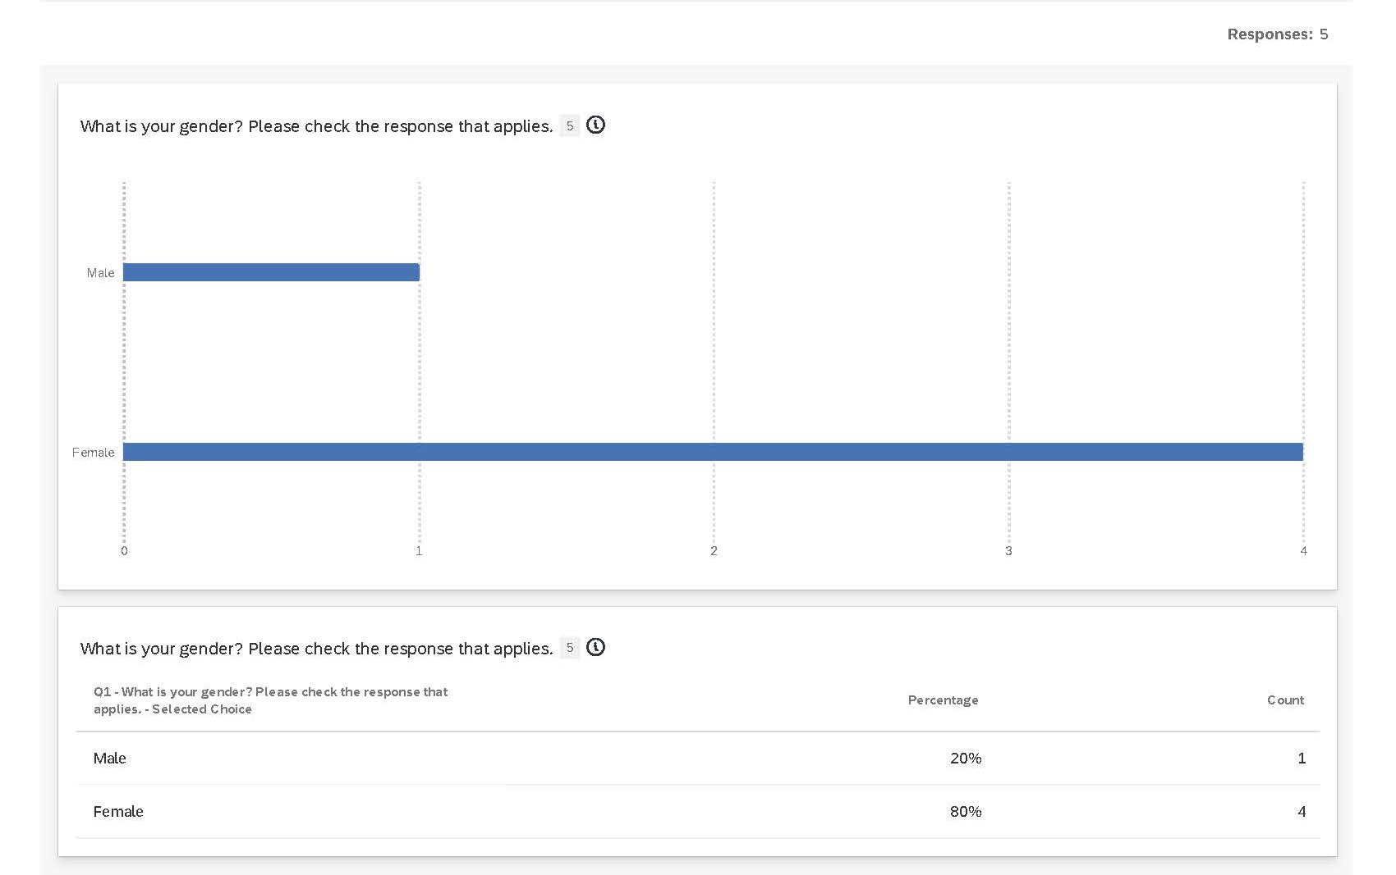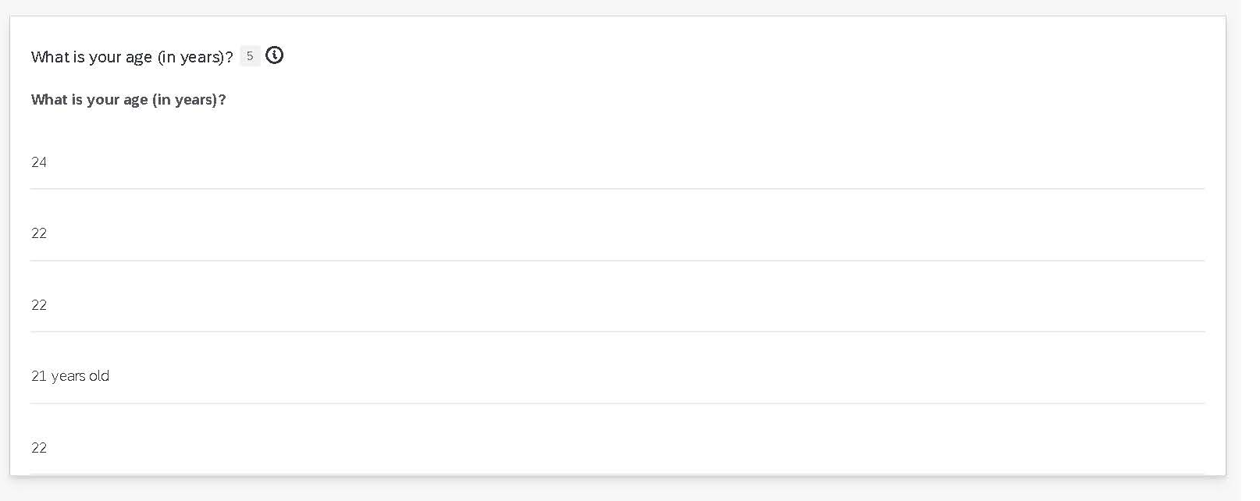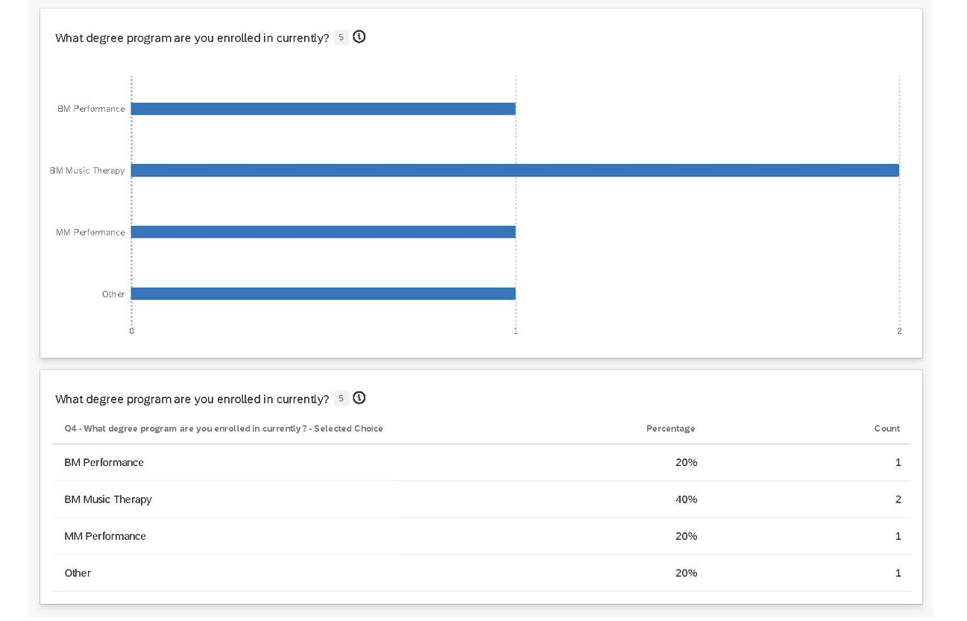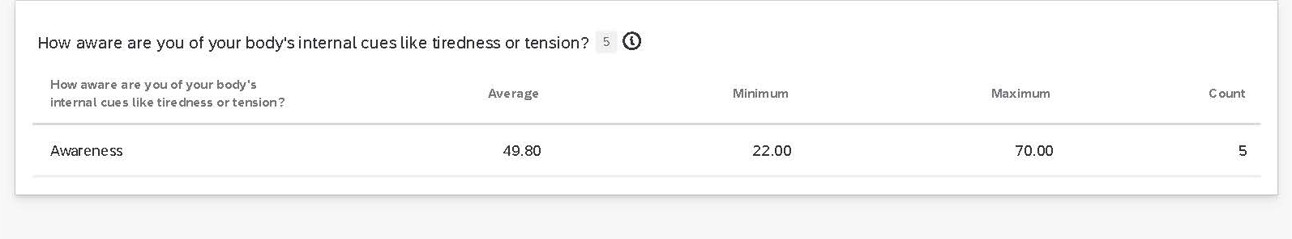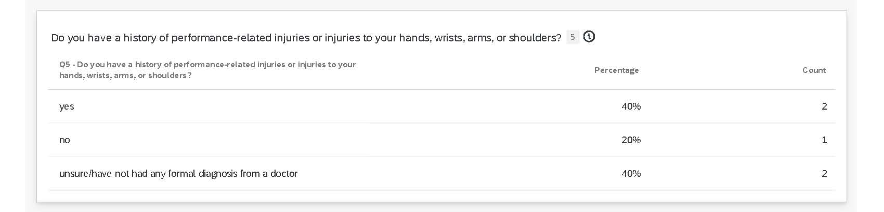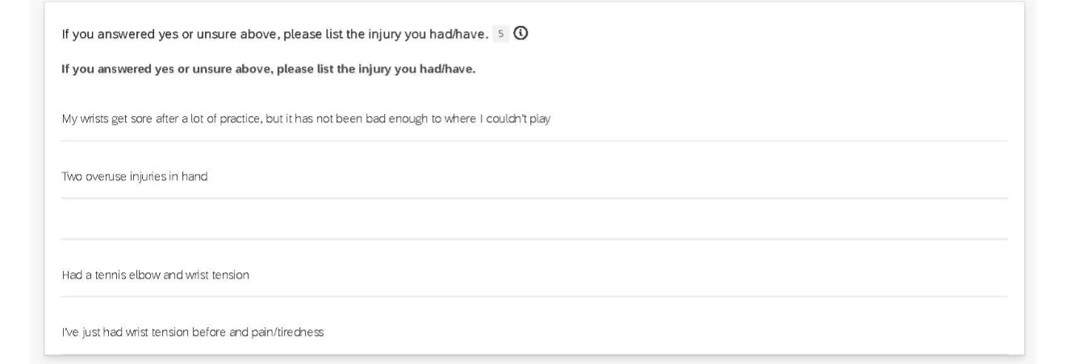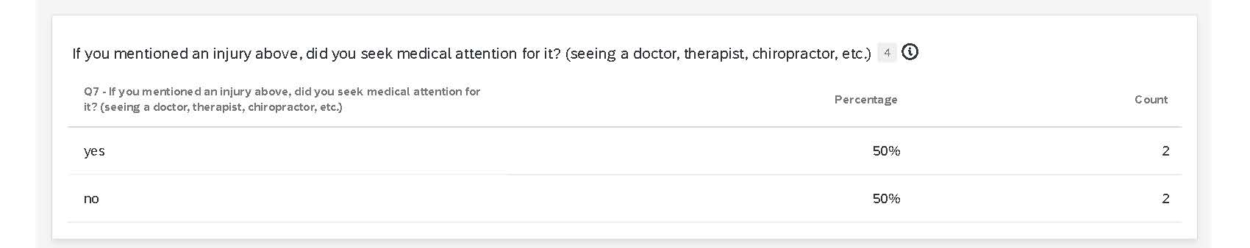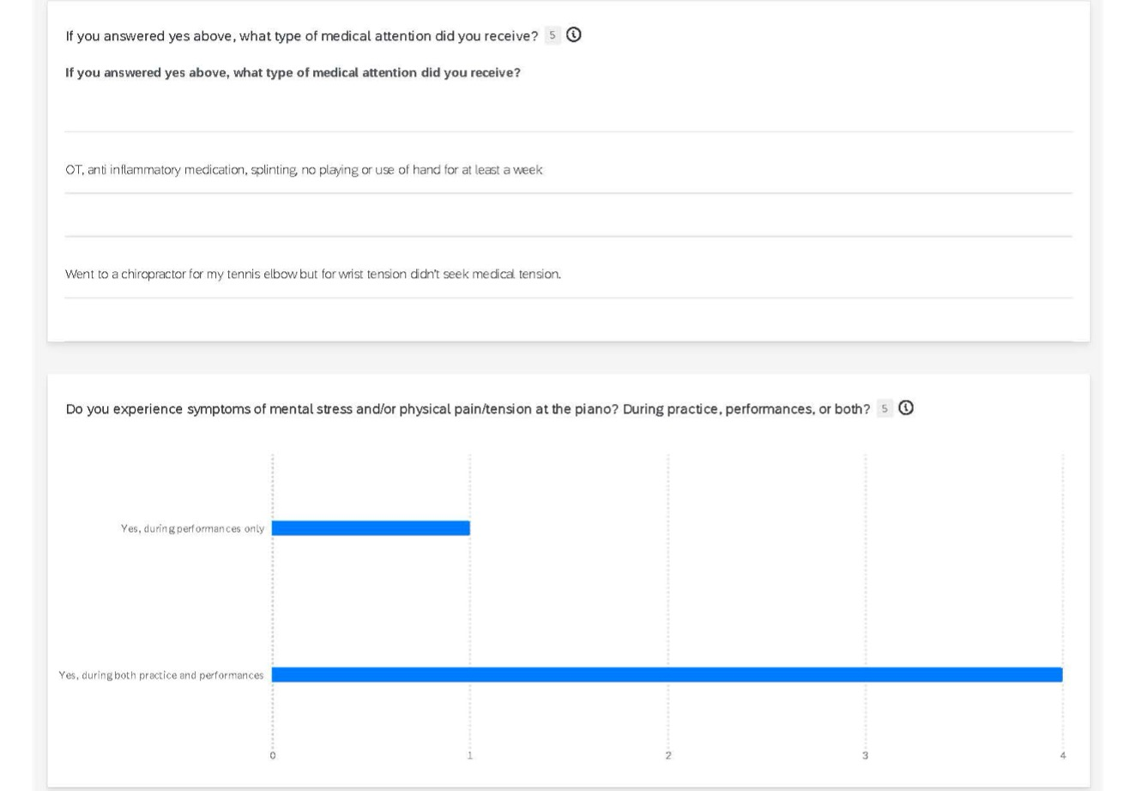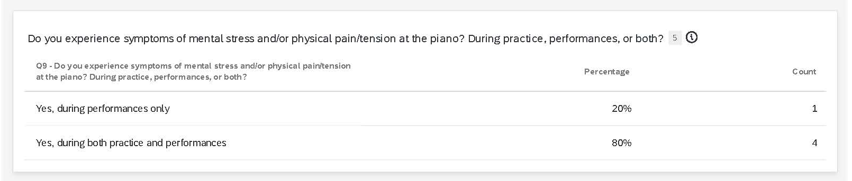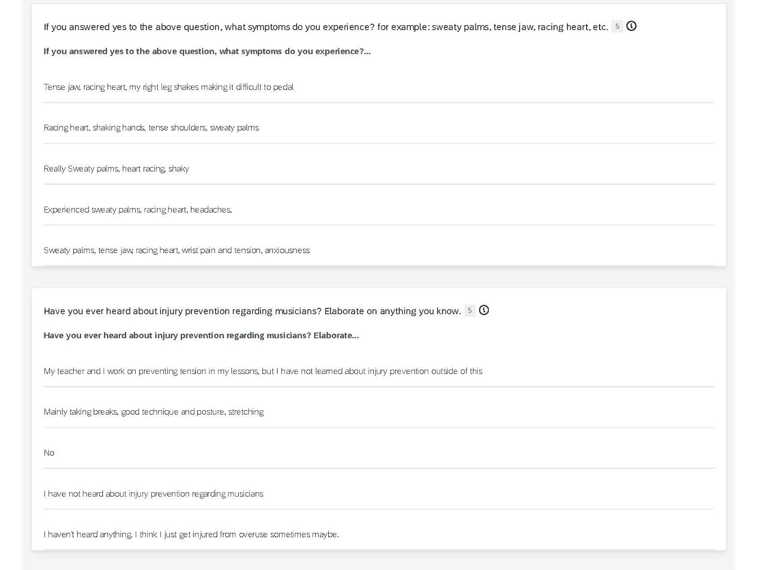
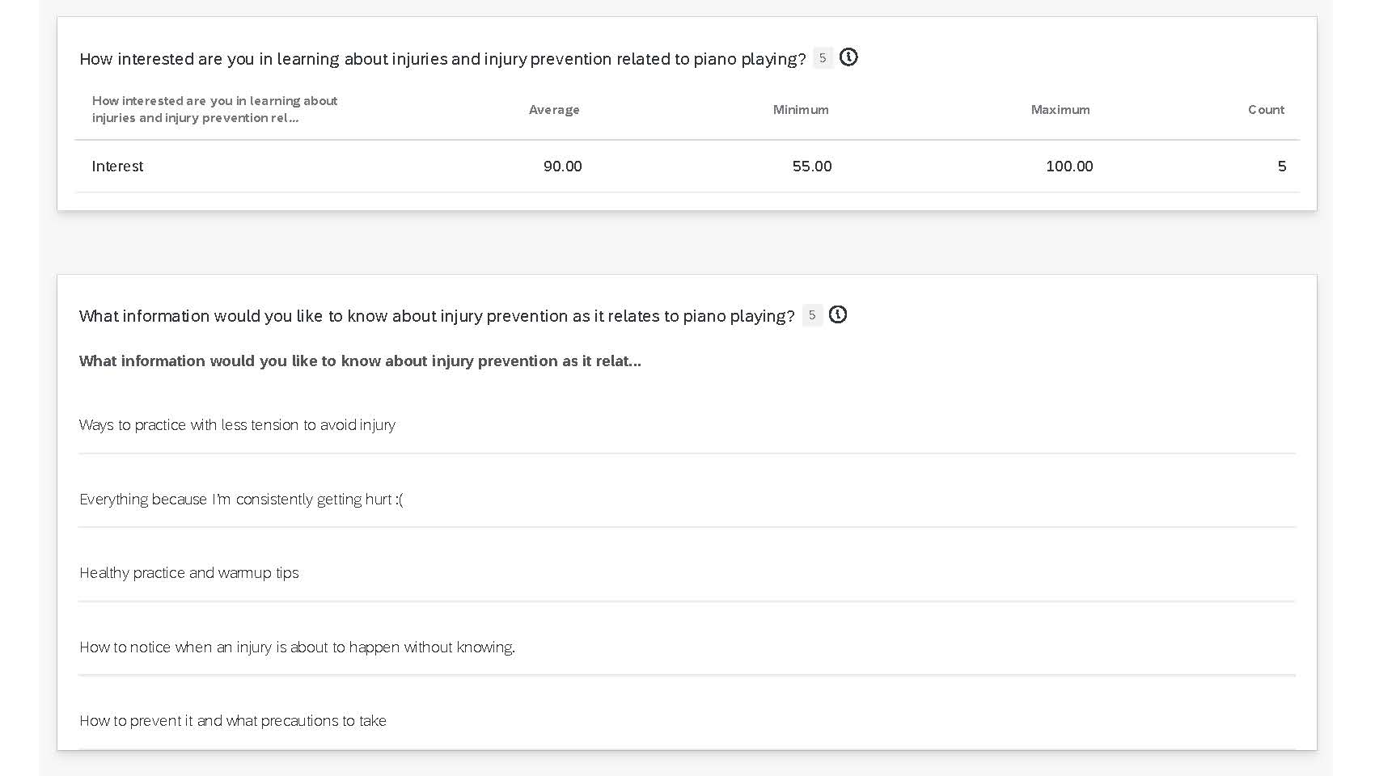

Appendix B
Piano Professor Survey Results
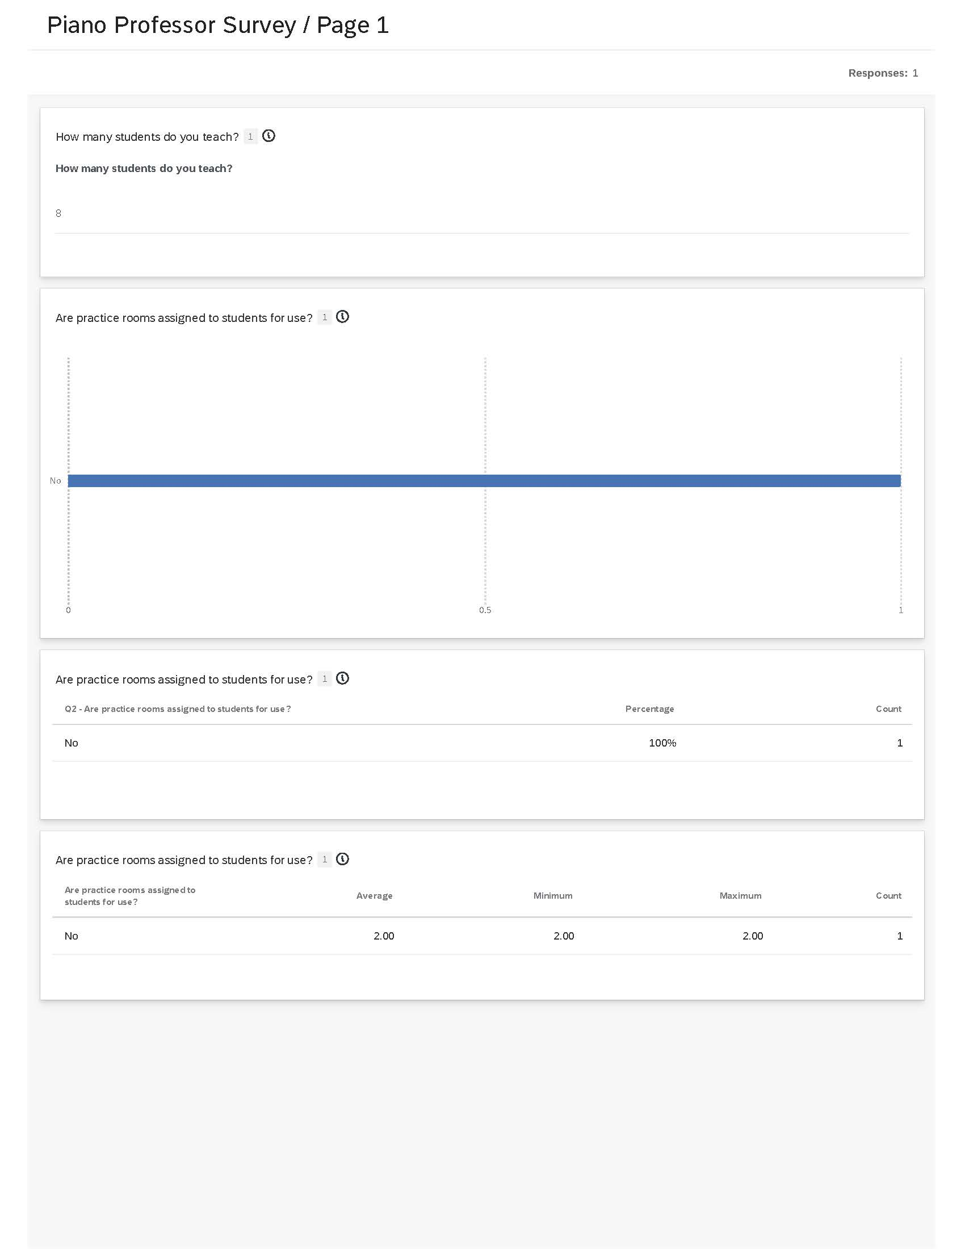
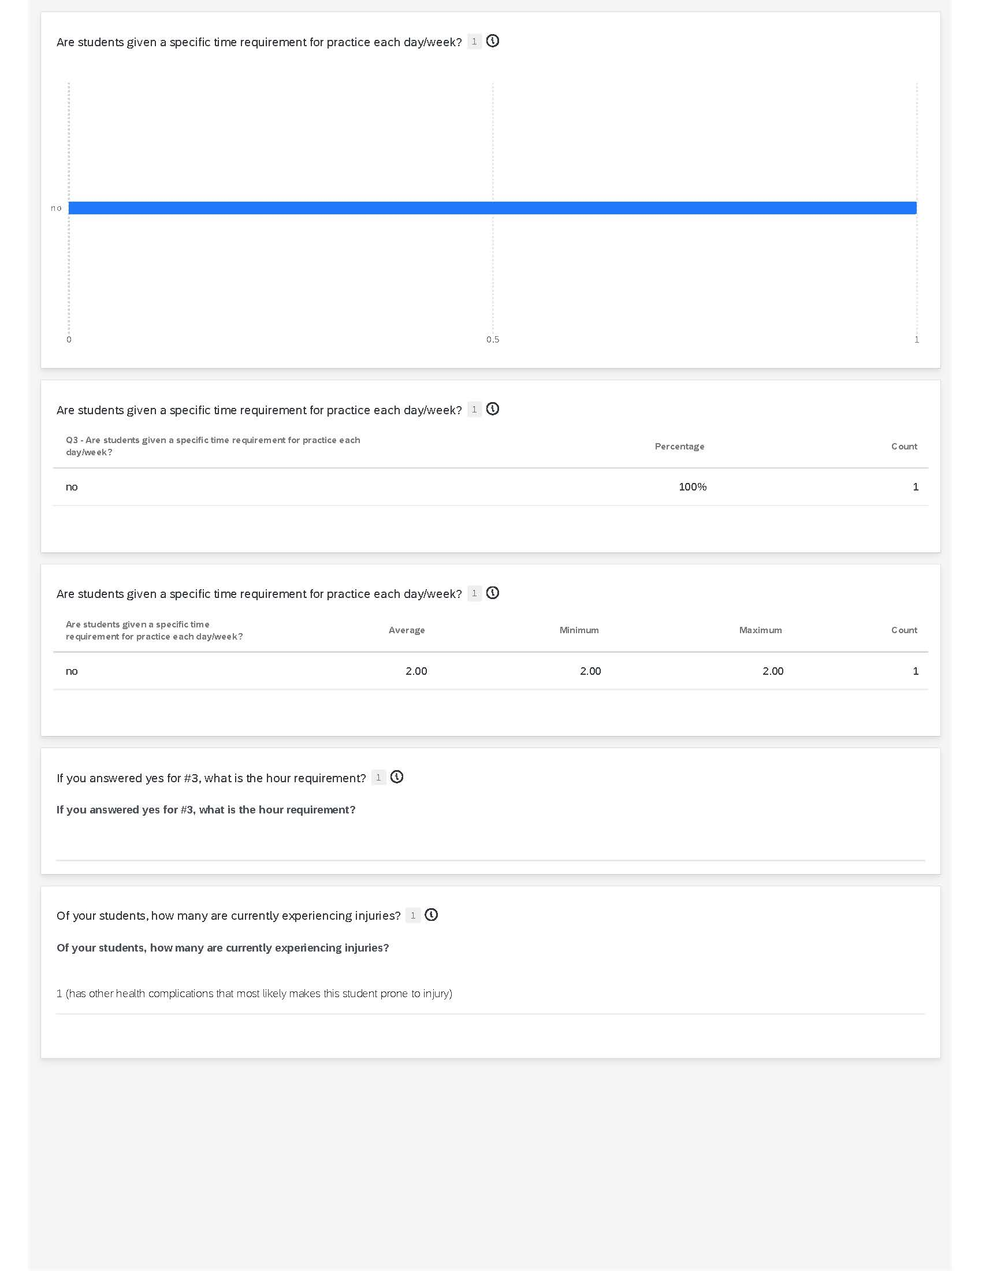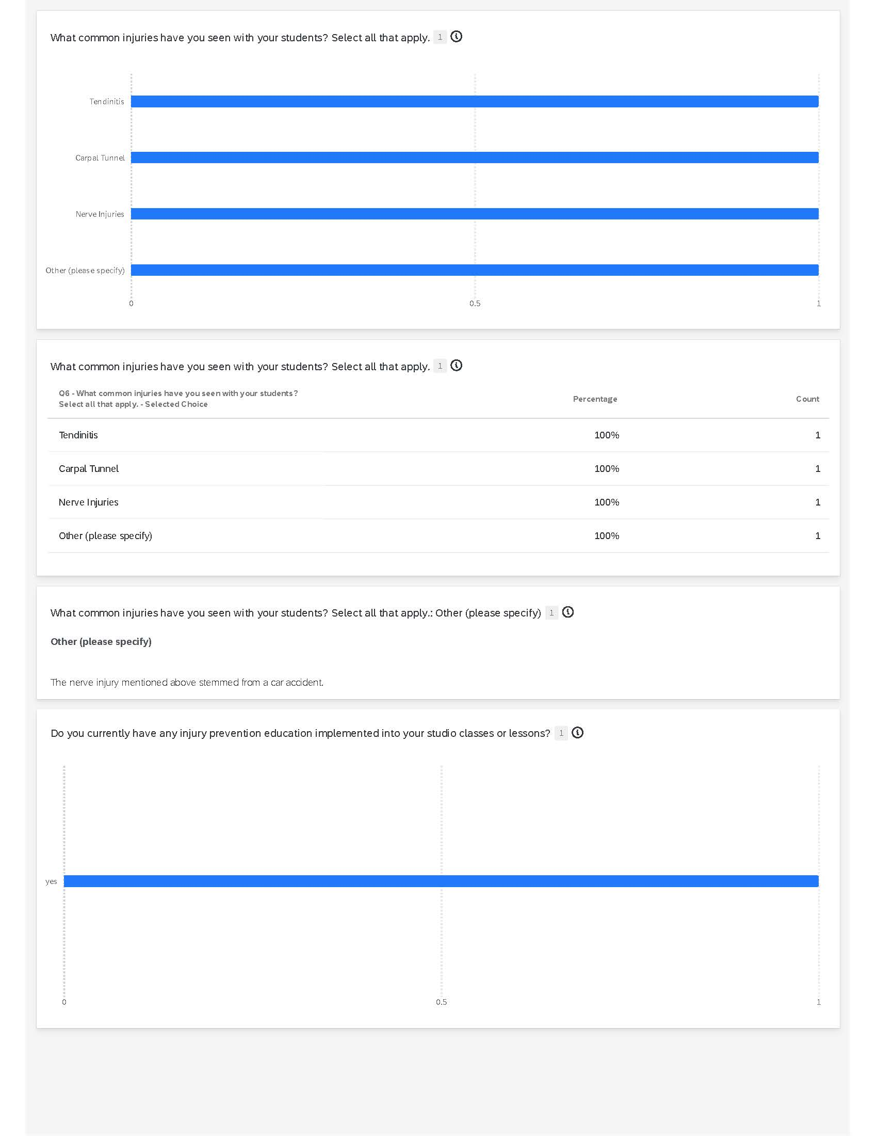

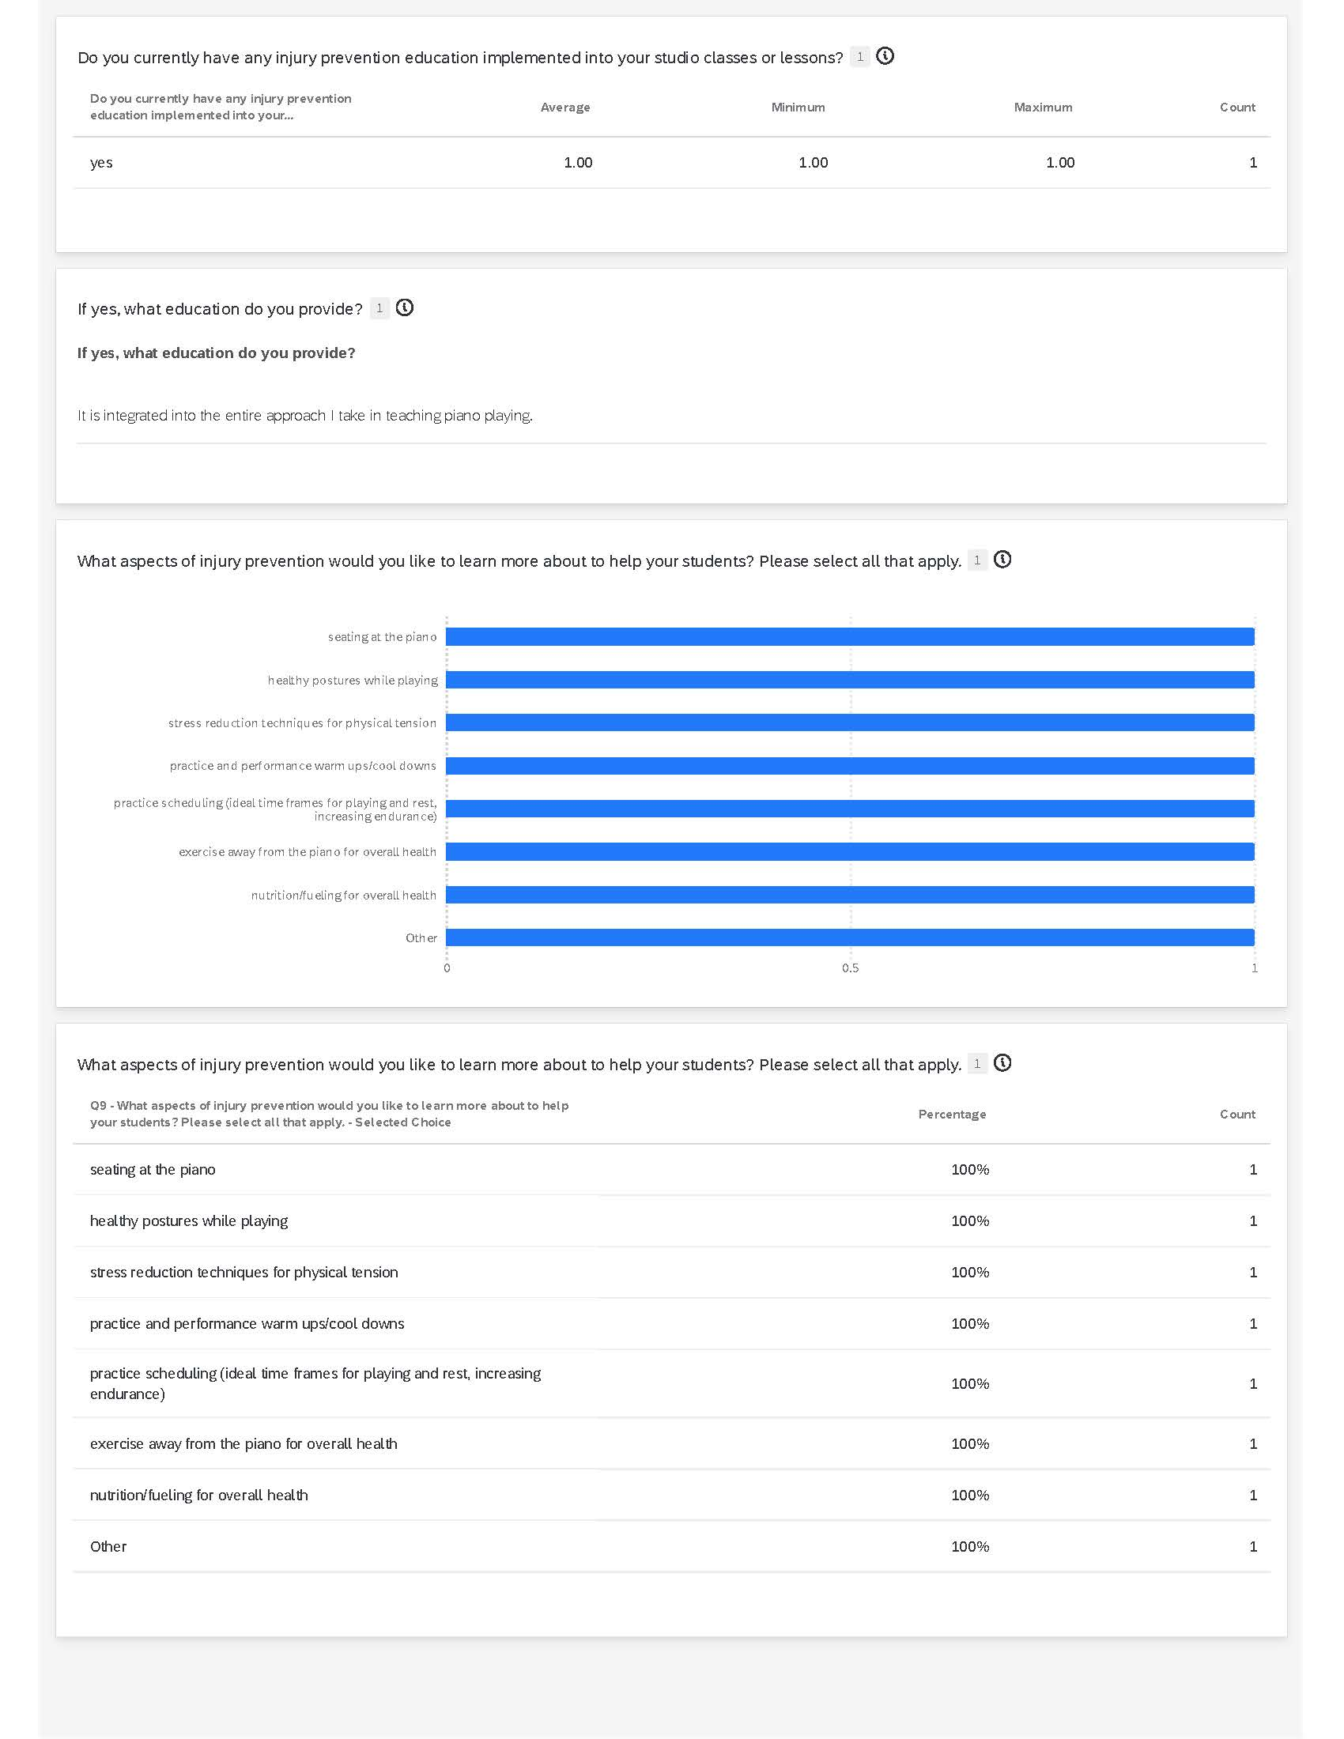

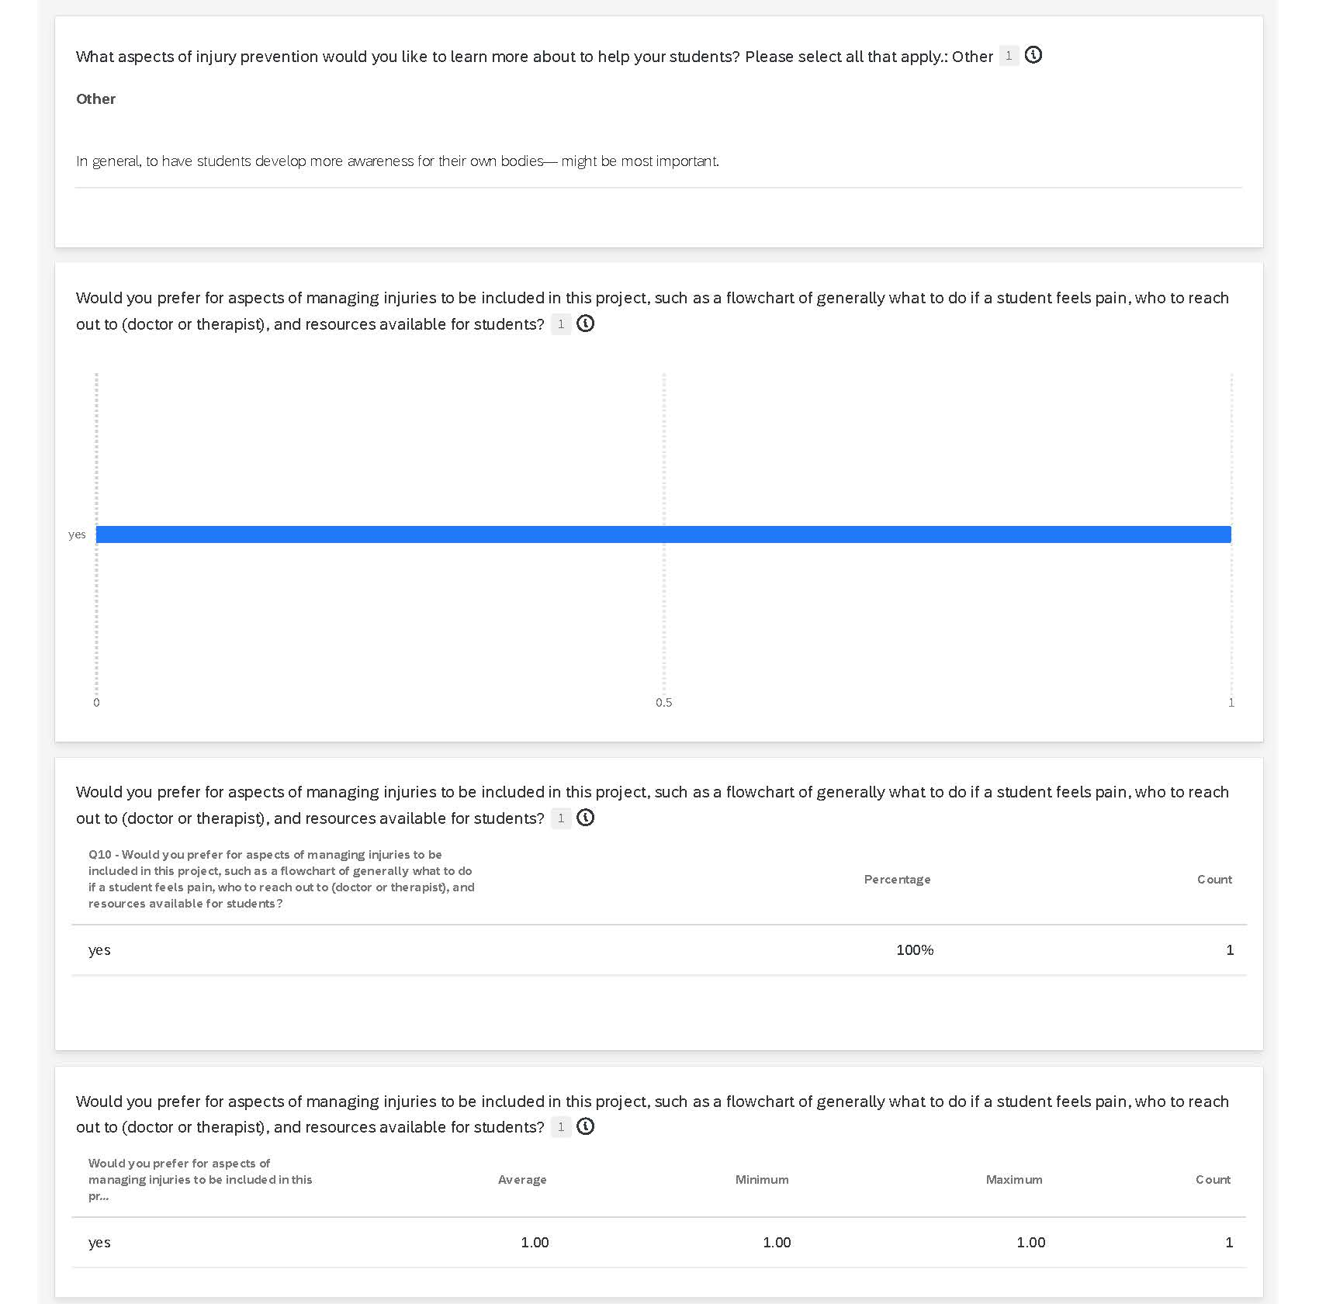

Appendix C
Needs Assessment Infographic

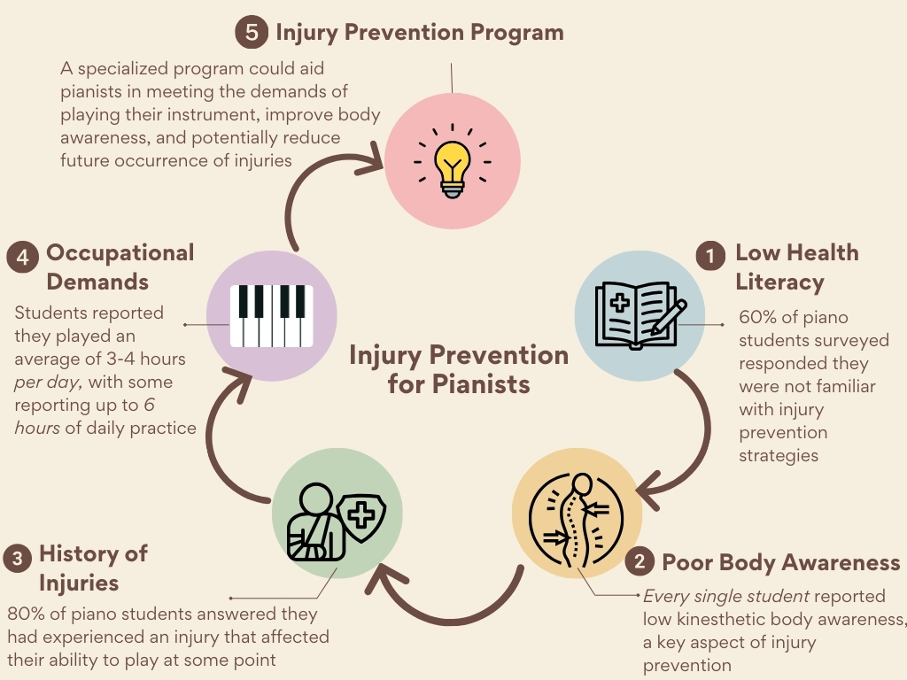

Appendix D
Table of Data Collection Strategies During Needs Assessment
Data Collection Format & Context | Who | Date(s) | Summary of Data Collected
Semi-structured interview; open-ended questions; Virtual meeting through Teams | Kwan Yi, Piano Faculty | 9/24/2024 | - Observed lack of medical professionals with knowledge of pianist's occupational demands  - Discussion of career altering injuries for his former teacher, Leon Fleisher with focal dystonia – a need for treatment but also prevention of injuries to halt progression to this end stage of injury is imperative for musicians to have  - He expressed he has observed musicians who if they develop injuries, likely must deal with them on and off or leave the field as they progress through their careers  - Expressed serious need for therapists who understand musicians to work with students earlier on in careers and knowledge to be shared
Microsoft Teams Meeting Guided Interview w/ Dr. Lynne Murphy attending | Dr. Christine Guptill, PhD, MSc(OT), BSc, BMus | 12/12/2024 | - Many recommendations for pianists and injury prevention can be taken from evidence within work disability prevention literature and sports medicine.  - Importance of cardio exercise, taking microbreaks, chunking practice time, and warmups/cool downs before and after playing is essential for injury prevention recommendations.  - Kinesthetic awareness is important, especially to forearm tension since most hand movements are the result of extrinsic muscles working  - A dynamic pelvis on the piano bench is good for our support and for freedom to move while we play.  - Rule of thumb is to rest for 15 minutes for every 45 minutes you play so that within each hour of time you have appropriate rest.
Qualtrics survey; open-ended, checkbox, and Likert scale questions | Piano students of Keiko Sekino | 2/6/2025 | - Students have decreased sense of body awareness when playing as noted by professor & students – this is a priority to address  - More than half of students have history of PRMD  - Students have limited knowledge of injury prevention strategies, but strong desire to gain knowledge  - Students expressed desire to learn how to practice in a healthy way – another area to address
Active observation of piano students in private lesson | Laura, junior undergrad; Melissa,1st year graduate student | 4/2/2025 | -Students appear to have correct body position at bench including distance from keys, bench height, and general posturing with elbows at 90, wrists neutral when they begin to play, but as play continues sometimes technique slips – could potentially be attributed to flow or mental focus on music, taking focus away from body positioning?  -Some students struggle with body awareness during lessons  -Professor emphasizes body awareness check-ins throughout lesson, but unclear how often this carries into practice room – strategies for self-checks should be addressed in PIPS to meet this need  -Aesthetic sound production is where value is placed, but finding solutions to body movements that elicit those sounds in a healthy way requires constant exploration  -Constant neuromotor control being challenged in lessons – reliant on what student listens for and constant kinesthetic adjustments made in the moment  -Students display signs of fatigue towards ends of lessons; rubbing proximal forearm, cracking wrists/fingers, shaking out hands – approaching the 1-hour mark on
Direct observation of piano students performing in studio recital | Students within Dr. Sekino’s Piano Studio | 4/17/2025 | - Students displayed physical signs of stress breathing heavier before and while playing onstage  - Rigidity/tension observed in neck, shoulders, and arms of some students while playing

Appendix E
PIPS Module 1 PowerPoint Presentation Slides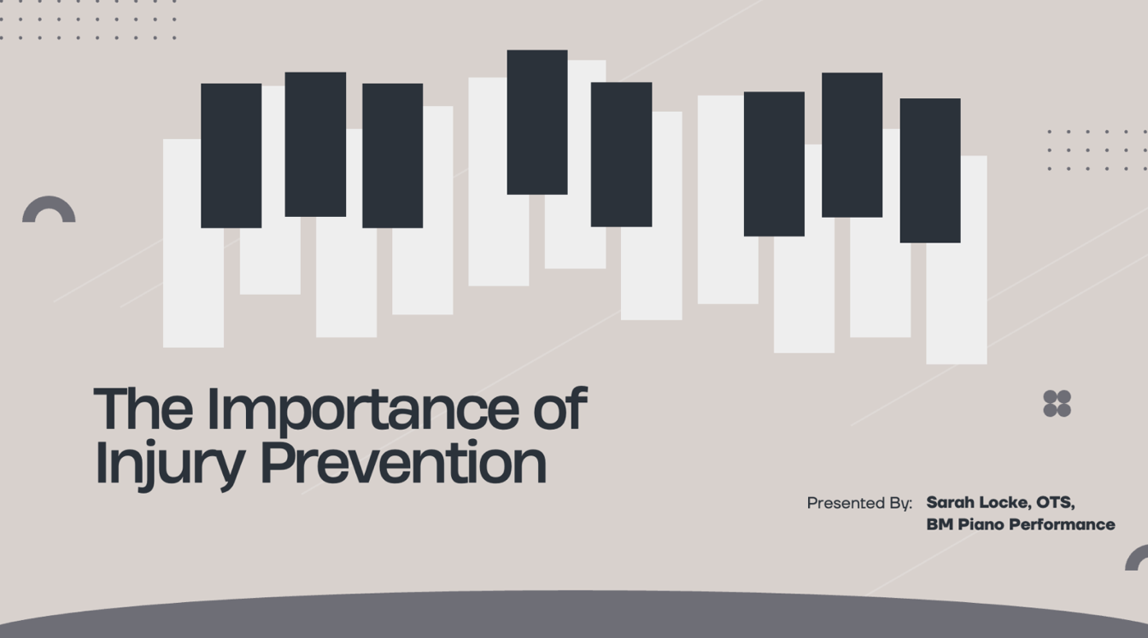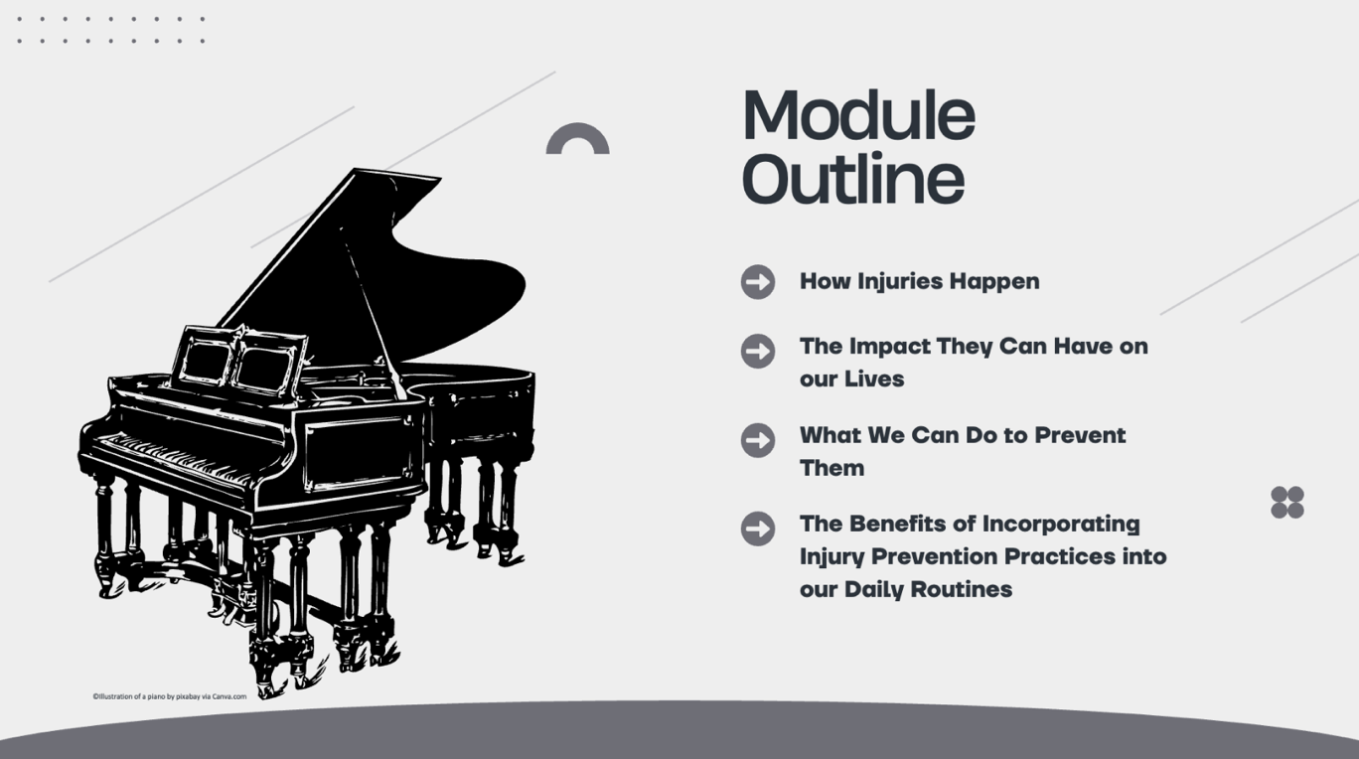
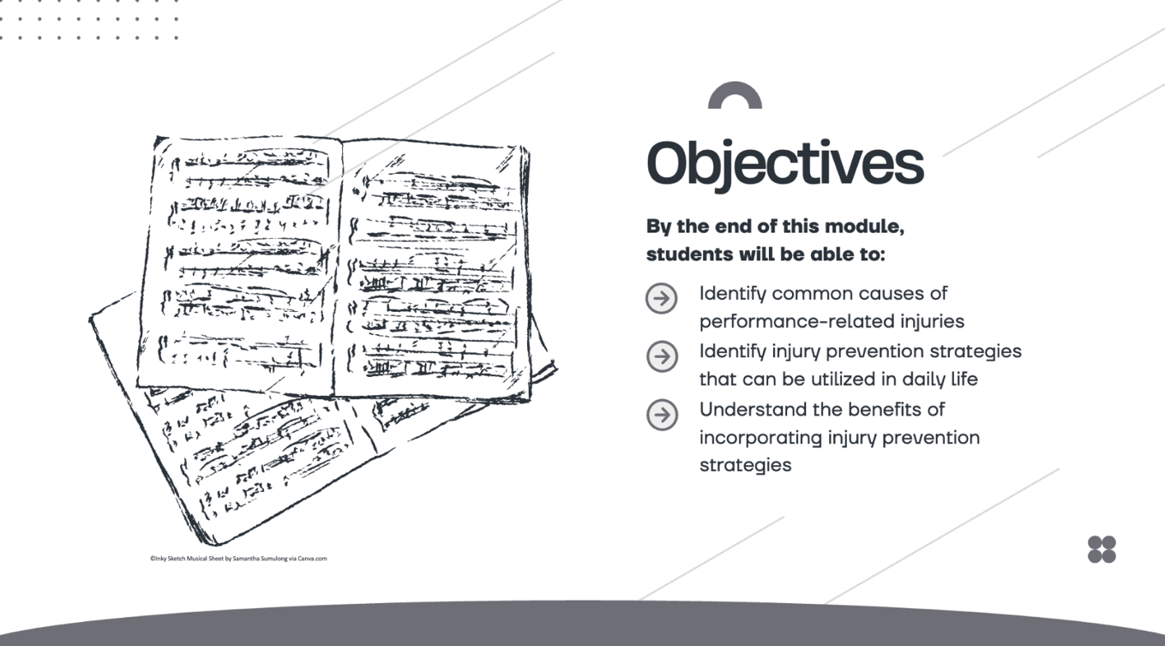

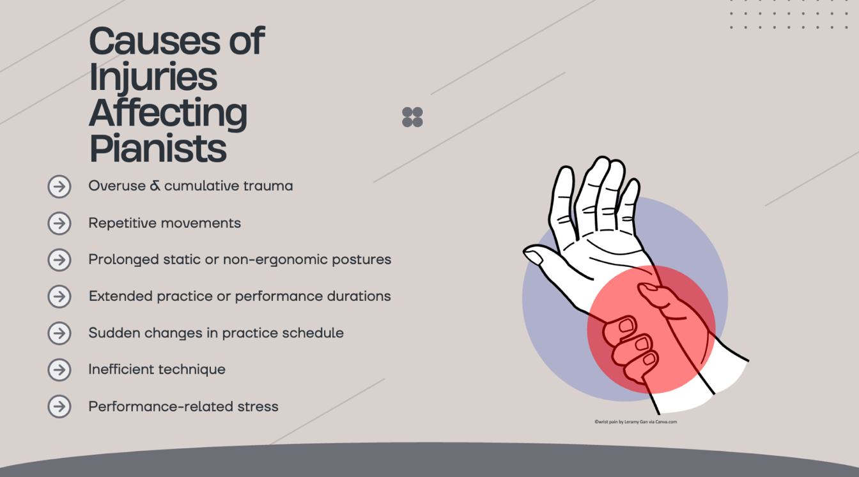
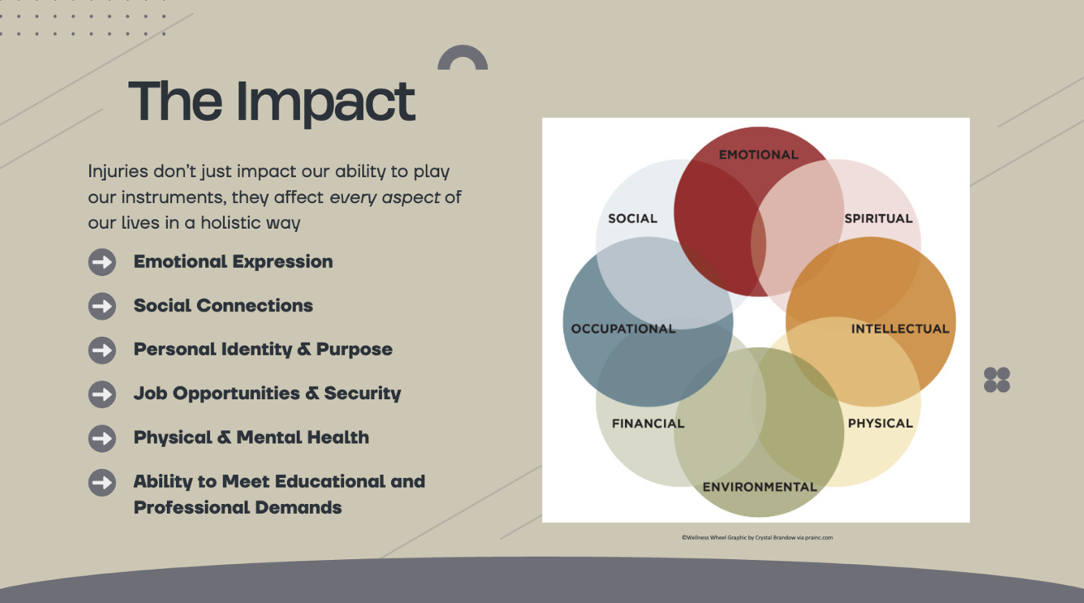
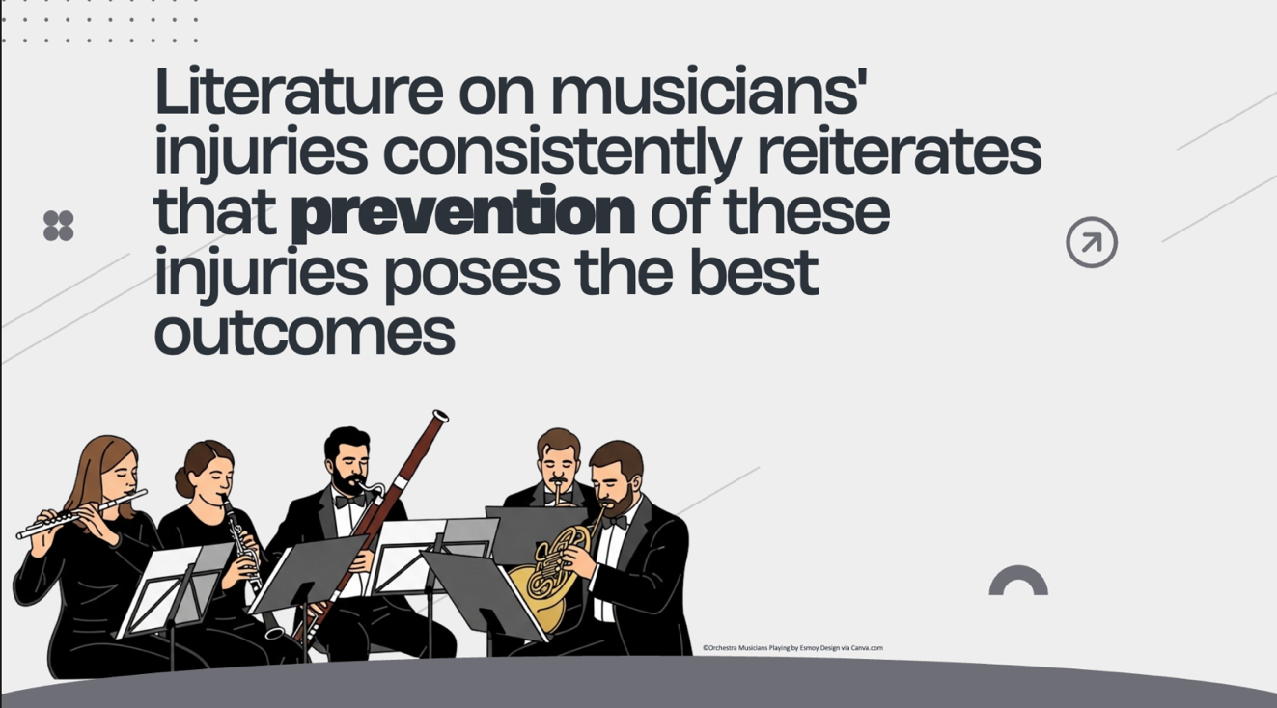
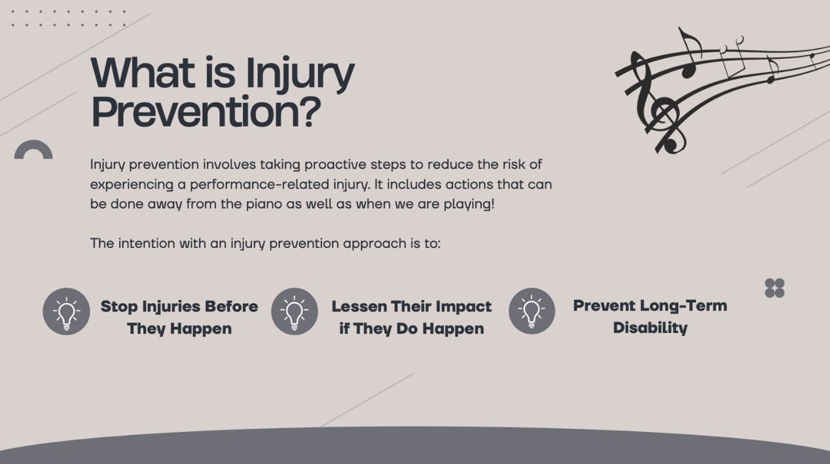
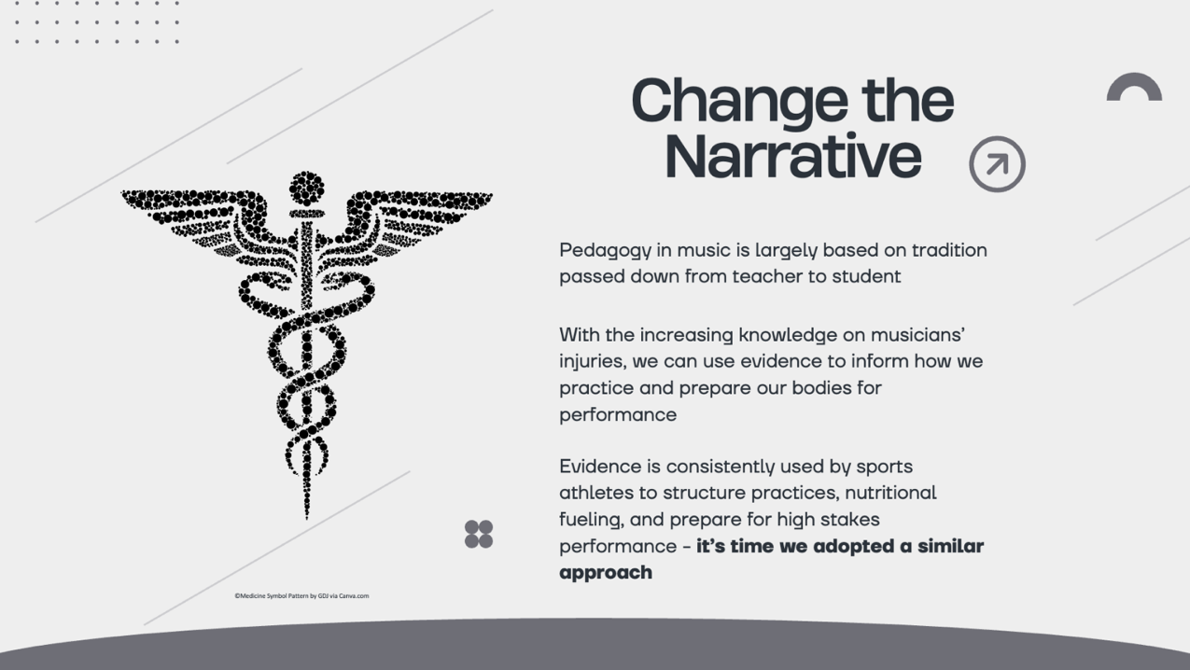
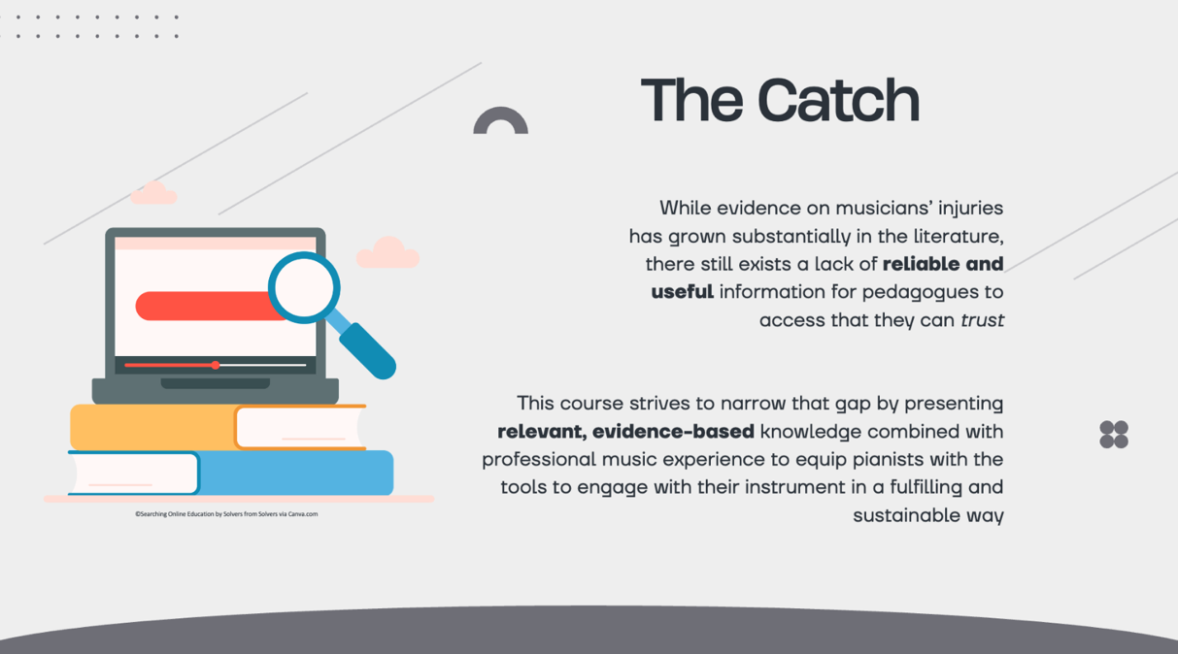

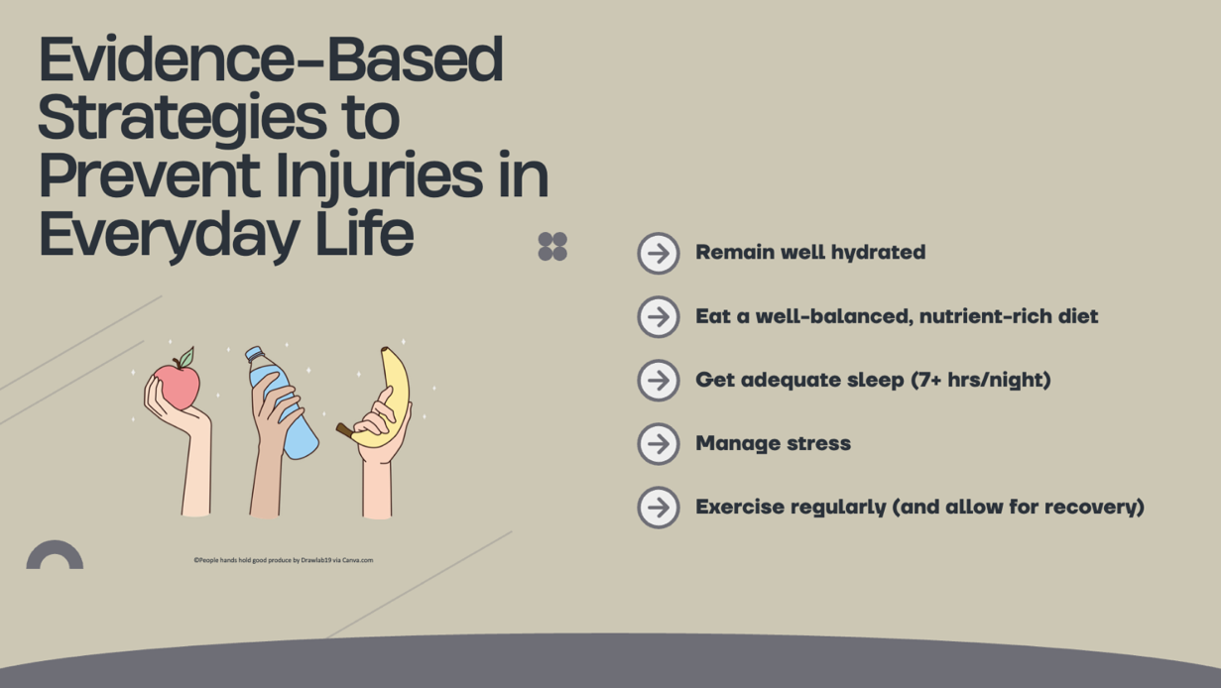
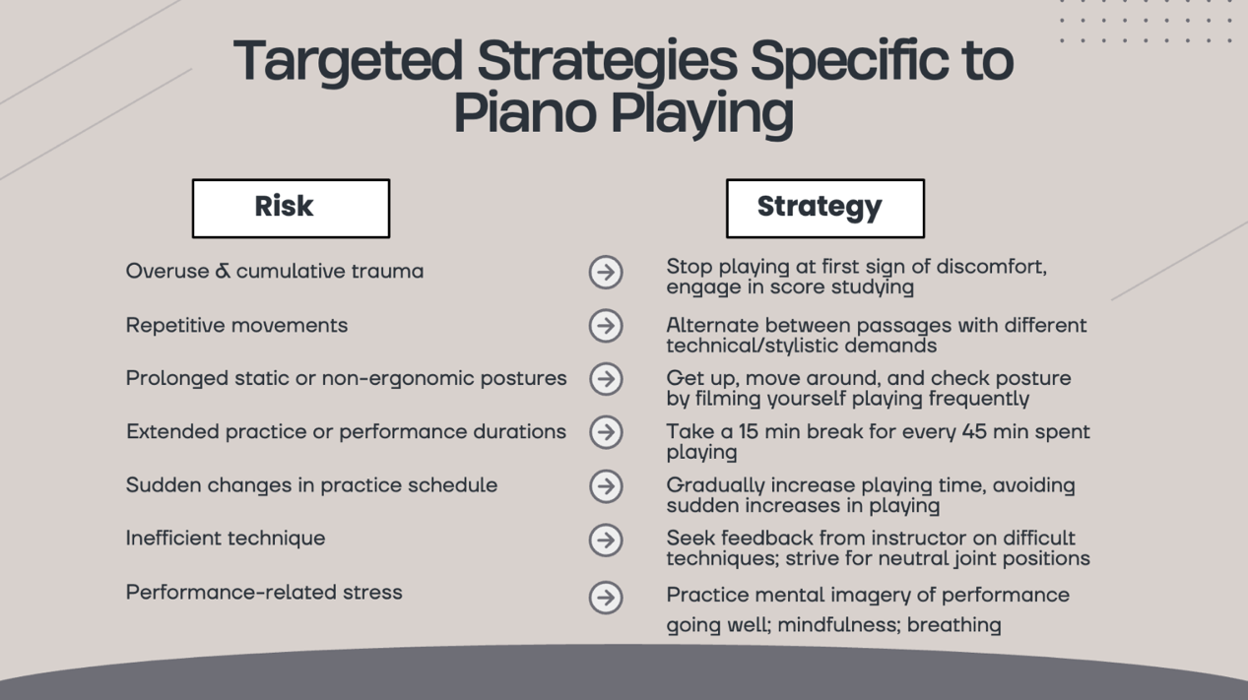

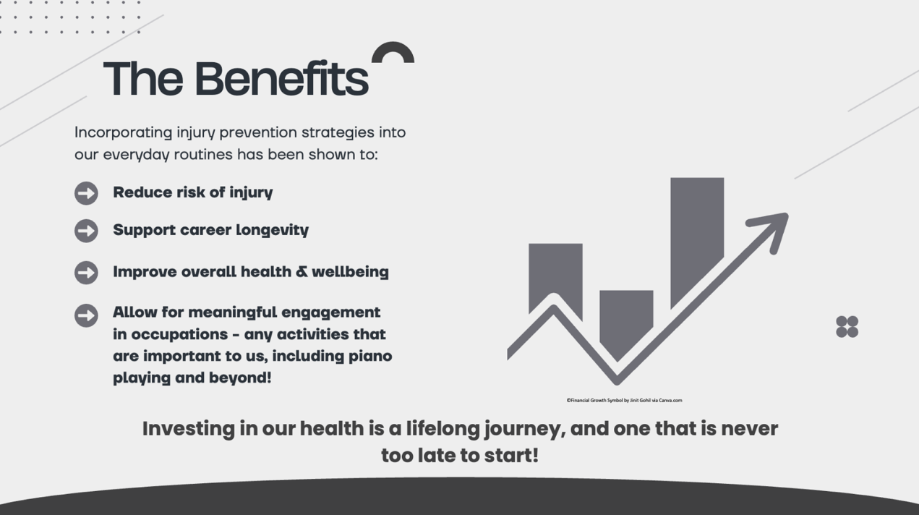
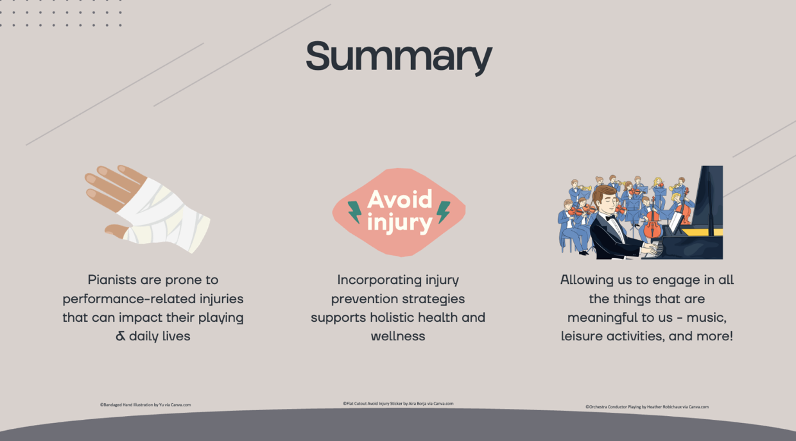

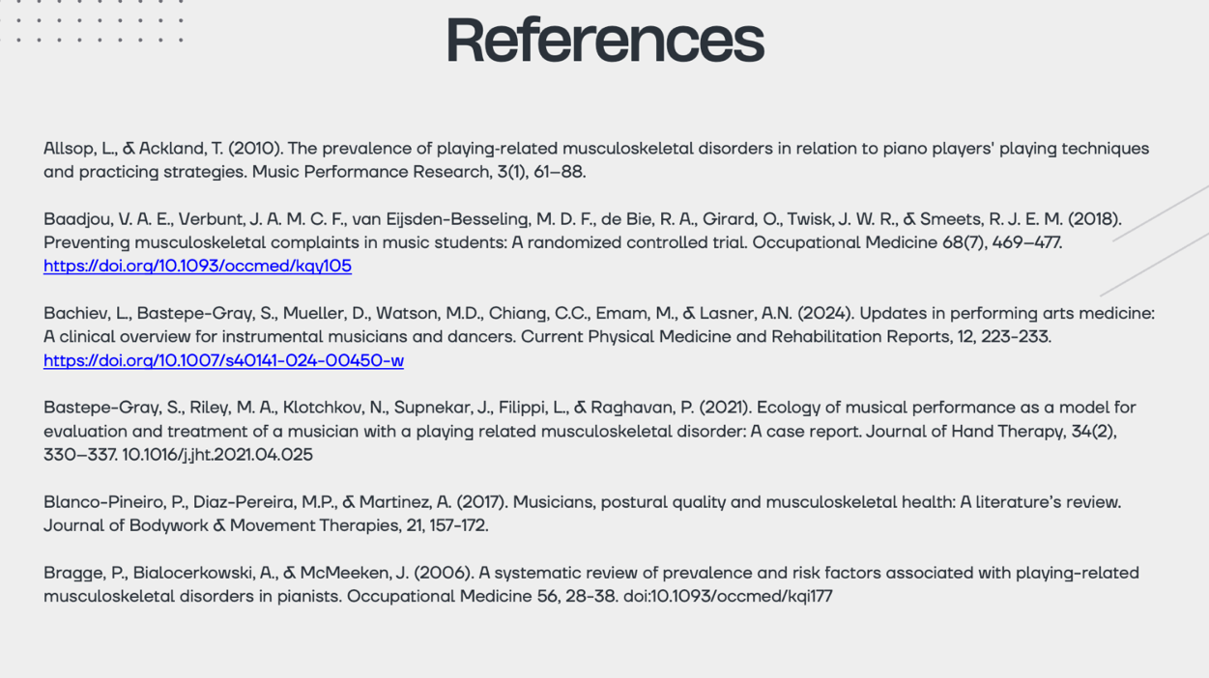
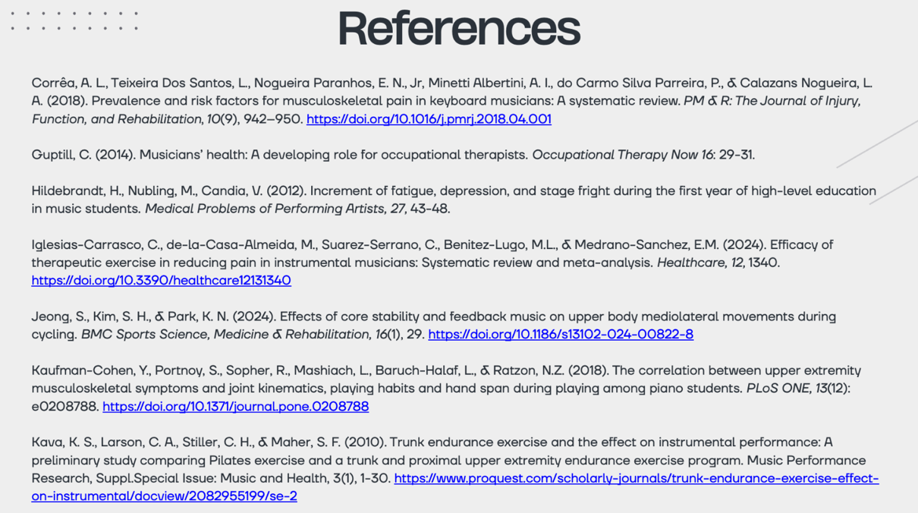
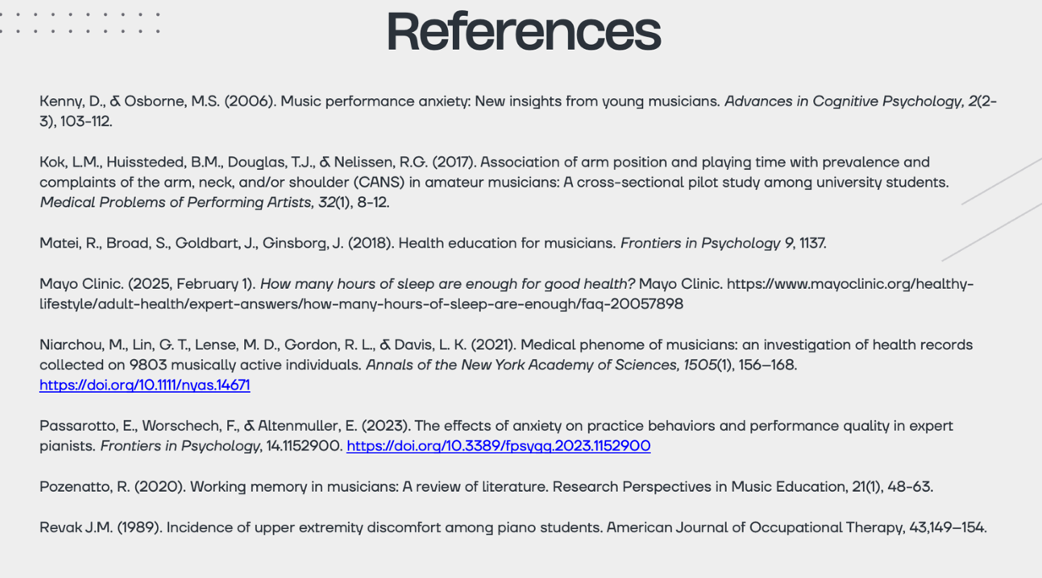
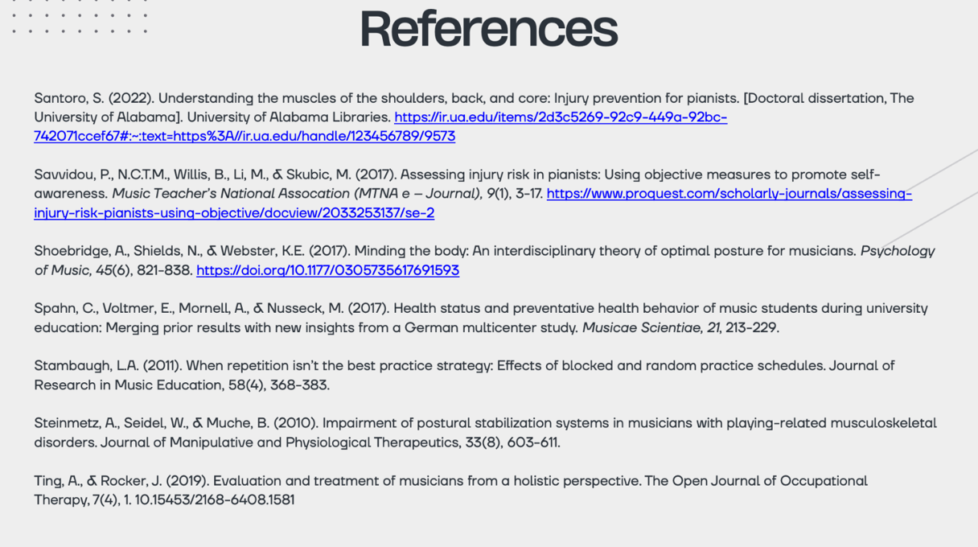

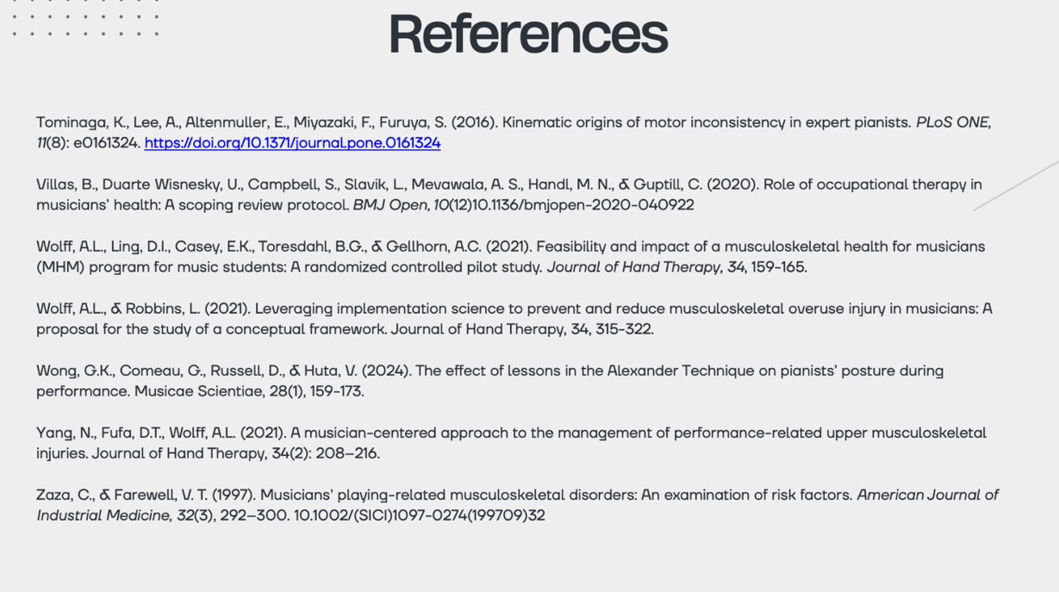

Appendix F
PIPS Body Map Word Bank Module 2

Appendix G
Daily Practice Journal Example Resource Module 3

Appendix H
Timeline Infographic

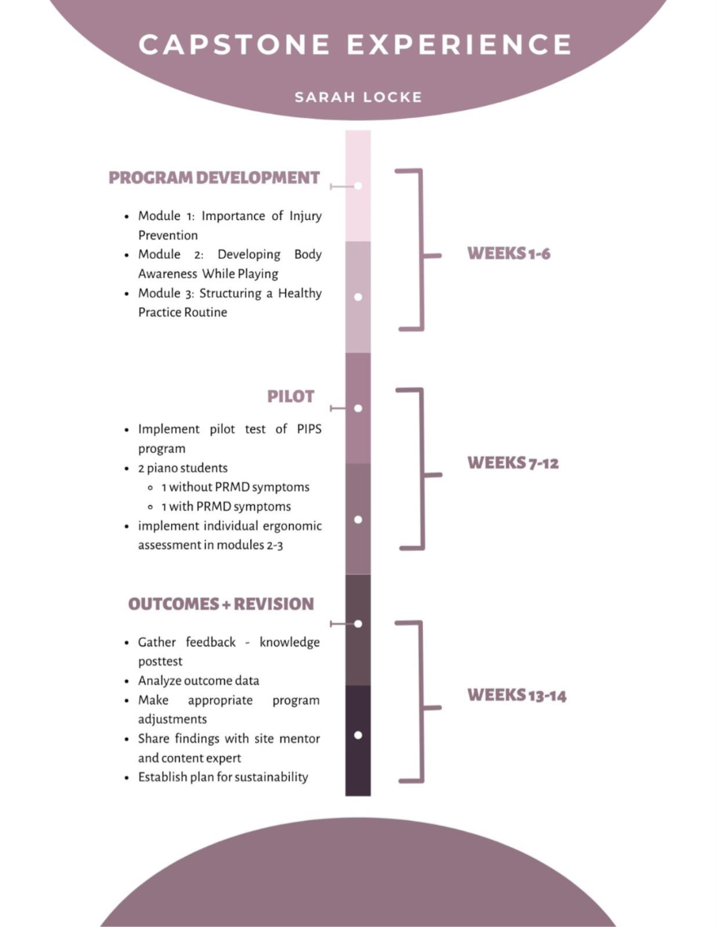

Appendix I
Final Survey of Opinions Questionnaire

Appendix J
Final Survey of Opinions Qualitative Results
