Implementation of Evidence-Based Blood Pressure Management Guideline to Improve Blood Pressure in Control
Anderson Williamson
East Carolina University

Acknowledgements
It is easy to see how this quality improvement project has impacted my education and life over the past year. Even though this was important to complete the project and improve my self-awareness, it doesn’t show the impact it had on others around me. That is why I would like to acknowledge a few people that have endured my dedication to obtaining my Doctor of Nursing Practice.
First and foremost, I want to thank my loving wife for supporting me through this process. She is my rock and I know I would not be here without her. I love her more than she can possible imagine. I want to include my children, who routinely observed my work ethic knowing I could not participate in many of their activities. I love you! I would like to thank my editor for her guidance. Finally, I would like to thank my professor for staying on me, demanding more when I thought it was not possible to discover anymore supporting research and leading me out of the “forest to see the details of a single tree”.

Abstract
One in every three adults in the United States are diagnosed with hypertension and only half of this population has their blood pressure in control. The rate of uncontrolled hypertension in North Carolina is 35% and at least 26% of this population expire each year. With the added responsibility from the CMS benchmark goals, family practices are searching for innovated ways to manage blood pressure in control. While effective blood pressure guidelines exist, a family practice site in eastern North Carolina currently uses no standard guideline interventions to control blood pressure, therefore a quality improvement project that included a modified version of the Heart Health Now guideline was implemented over a 12-week interval. The purpose of the project was to evaluate staff guideline compliance, modifying steps for blood pressure measurements, and referrals for continuous follow-up. The guideline included standardized steps in blood pressure measurements, use of an educational hypertension brochure, and Telehealth referrals. Of the 17 patients, 11 (65%) met the modified HHN guideline and Telehealth referral criteria. Improvement was noted in staff compliance in blood pressure measurement adequacy and increase in the number of Telehealth referrals. The organization blood pressure in control improved to 61% compared to 52% prior to the project implementation. This was an improvement by 9%. This evidence-based quality improvement project did improve staff and provider compliance and changed the family practice cultural behavior without increasing the workload for the staff thereby improving delivery of care.

Keywords: normal blood pressure, prehypertension, hypertension, blood pressure in control, DASH diet, Telehealth, Centers for Medicare & Medicaid Services, Accountable Care Organization, Patient Centered Medical Home
Table of Contents
Abstract……………………………………………………………………………3
Chapter One: Introduction………………………………………………...8
Significance of Problem……………………………………………… 9
Justification of Project………………………………………………...12
Theoretical Framework…………………………………………….....12
Assumptions…………………………………………………………..14
Definition of Key Concepts…………………………………………...14
Summary………………………… …………………………………16
Chapter Two: Review of Literature………………………………………17
Heart Health Now……………………………………………………..17
Education of the Providers and Staff………………………………….19
Patient Education……………………………………………………...19
Improvements to the Delivery of Care………………………………...21
Theory of Goal Attainment Utilization………………………………..22
Limitations…………………………………………………………….24
Summary……………………………………………………………....24
Chapter Three: Methodology……………………………………………..26
Design………………………………………………………………….26
Setting………………………………………………………………….27
Sample………………………………………………………………....27
Methods………………………………………………………………..28
Human Subject Protection……………………………………………..29
Data Collection………………………………………………………..30
Data Analysis………………………………………………………….30
Budget…………………………………………………………………31
Chapter Four: Results Introduction……………………………………….32
Participant Demographics……………………………………………..32
Intended Outcomes…………………………………………………….32
Findings………………………………………………………………..33
Summary…………………………………………………………........36
Chapter Five: Implications for Nursing Practice………………………….37
Practice Implications…………………………………………………..37
Essential I: Scientific underpinnings for practice……………....38
Essential II: Organization and systems leadership for quality
improvement and systems thinking………….………………….38
Essential III: Clinical scholarship and analytical methods for
evidence-based practice…………………………………...…….39
Essential IV: Information systems/technology and patient care
technology for improvement and transformation of healthcare....40
Essential V: Healthcare policy for advocacy in healthcare...…...40
Essential VI: Interprofessional collaboration for improving
patient and population health outcomes…………………………41
Essential VII: Clinical prevention and population health for
improving the nation’s health…………………………….……...42
Essential VIII: Advance nursing practice……………………….42
Summary……………………………………………………………….43
Chapter Six: Final Conclusion…………………………………………….45
Significance of Findings……………………………………………….45
Project Strengths……………………………………………………….47
Project Limitations……………………………………………………..47
Project Benefits………………………………………………………...48
Recommendation for Practice………………………………………….59
Final Summary…………………………………………………………50
References………………………………………………………………………….52
Appendix A: Heart Health Now Blood Pressure Measurement Workflow……….60
Appendix B: Modified Heart Health Now Blood Pressure Guideline.………....... 61
Appendix C: King’s Theory of Goal Attainment…………………………………62
Appendix D: Literature Flow Chart………………………………………………63
Appendix E: Literature Matrix……………………………………………………64
Appendix F: Blood Pressure Management Education Brochure………………....77
Appendix G: Telehealth ………………………………………………………….87
Appendix H: Excel Spreadsheet Analysis (Dept. of Quality) ……………………89
Appendix I: PDSA Worksheet……………………………………………………90
Appendix J: BP Project Data Collection (Dept. of Quality) ……………………..91
Appendix K: Project Manager’s Staff Compliance Tool………………………....92
Appendix L: Site Approval Letter…………………………………………….......93
Appendix M: IRB…………………………………………………………………94
Appendix N: Budget Spreadsheet…………….…………………………………..95
Appendix O: PDSA Week 4....................................................................................96
Appendix P: PDSA Week 9……………………………………………………….97
Appendix Q: Telehealth Patient Result…………………………………………….98

Chapter One: Introduction
In 2010, the passage of the Affordable Care Act (ACA) changed the fee-for-service model to a compensation model based on value and quality of care, especially within the delivery of Medicare reimbursement. These reimbursements were developed by Health and Human Services (HHS) and included a blended payment system with bonuses when meeting or exceeding benchmarks for hospitals and family practices (Davis, Guterman, & Bandeali, 2015). Healthcare organization has the opportunity to receive an extra 5% reimbursement payment by participating in the Shared Savings Program developed by the Accountable Care Organization (ACO) which is an incentive so providers work together with hospitals to provide value and quality care (Accountable Care Organizations: What Providers Need to Know, 2016). The HHS has set benchmarks of 90% so that all Medicare payments will be tied to value or quality of care by the end of 2018 (Davis et al., 2015). The Centers for Medicare and Medicaid Services (CMS), an agency within HHS, is responsible for developing evidence-based, value-based, and provider cost-reducing benchmark guidelines for hospitals and primary care clinics to reach its overall goal (Centers for Medicare and Medicaid Services [CMS], n.d.). Core benchmark measurements encompass various chronic health conditions, such as myocardial infarction, heart failure, pneumonia, chronic obstructive pulmonary disease (COPD) and uncontrolled hypertension (Davis et al., 2015). Ultimately, the benchmarks support the Institute for Healthcare Improvements (IHI) Triple Aim framework by improving the patient experience, improving the health of populations, and reducing the per capita cost of health care (IHI Triple Aim, 2017). The results are a high-quality healthcare system that ensures better care, access to coverage and improved health outcomes (Fontinelle, 2016). This project in particular focuses on improved health outcomes desired for uncontrolled hypertension by meeting or exceeding the CMS blood pressure in control benchmark.
Significance of Problem
In the United States, approximately one of every three adults has hypertension and only half of this population has their hypertension under control (High Blood Pressure Facts, 2016; Moran, Odden, Thanataveerat, & Tzong, 2015). Uncontrolled hypertension increases risk for heart disease and stroke which are the two leading causes of death in the United States (High Blood Pressure Facts, 2016; Moran et al., 2015). The effects of uncontrolled hypertension over time slowly damage blood vessels throughout the body without any warning or symptoms (Fortuna, Nagel, Rose, McCann, & Teeters, 2015). This continued damage to the blood vessels increases the risk of kidney failure, vision loss, heart disease, and stroke (Fortuna et al., 2015). Hypertension is a treatable disease and even with the known benefits of treatment only about half of hypertensive patients reach blood pressure control (Fortuna et al., 2015). With the increased rate of uncontrolled hypertension, there is an enormous potential for improving the health of the population by expanding treatment and improving control (Moran et al., 2015). Therefore, recognition and treatment in the primary care setting is important to reduce risk factors and improve the quality of life for patients with this disease.
In North Carolina, 35% of the population has been diagnosed with hypertension by their provider and at least 26% of this population expire each year (America’s health rankings, 2015). The mortality rate from hypertension in the county is approximately 23% (230 deaths per 100,000) in which the family practice setting for the project resides and twice the national average (100 deaths per 100,000) or 10% (High Blood Pressure Facts, 2016).
At a family practice in eastern North Carolina, routine screening and management of hypertension are performed but the actual blood pressure in control was not being achieved (P. Lockamy, personal communication, May 8, 2017). As of March 2017, blood pressure control was 52% at the practice which, was above the CMS benchmark of 50%, but lower than the organization overall goal of 80% (P. Lockamy, personal communication, May 8, 2017).
Achieving blood pressure in control is potentially related to numerous factors at every level of care including patient, clinician, and systems related factors (Fortuna et al., 2015). Even with patients’ frequent follow-up appointments with their primary care provider, blood pressure control is not guaranteed (Glynn, Murphy, Smith, Schroeder, & Fahey, 2010). For this reason, family practices are implementing evidence-based quality improvement guidelines to assist with the management of blood pressure in control. One such guideline is the Heart Health Now (HHN) Blood Pressure Measurement Workflow Guideline (Appendix A).
Heart Health Now (HHN) is a stepped wedge, stratified, cluster randomized trial quality improvement project to evaluate the effect of primary care practice support, dissemination and implementation of evidence-based guidelines for cardiovascular disease prevention in primary care practices as an effective strategy to reduce cardiovascular risk factors (Weiner et al., 2015). Achieving this includes properly diagnosing and treating high blood pressure; however, clinics lack blood pressure measurement standards and the clinics that institute a blood pressure guideline in their practice tend to be limited to posture, cuff size, left arm and both feet on the floor (Kallioinen, Hill, Horswill, Ward, & Watson, 2017). Kallioinen et al., (2017) conducted a systematic review of 329 studies to assess and identify blood pressure measurement inadequacies. Findings in the review of potential inadequacies were categorized related to patient, device, procedure and observer. Few studies were found directly assessing the effects of a rest period (time between blood pressure measurements). However, two studies included rest periods of more than 5 minutes which found resting 10 to 16 minutes could decrease systolic and diastolic blood pressures by small to moderate amount (Nikolic, Abhayaratna, Leano, Stowasser, & Sharman, 2013; Sala, Santin, Rescaldani, & Magrini, 2006). Kallioinen et al. (2017), recommends that no single blood pressure outside the expected range should lead to medical interventions without other supporting evidence. They suggest blood pressure values should be reported graphically rather than numerically which can reduce the impact of some sources of inaccuracy. This graphical format provides the user the ability to interpret the information quicker to communicate with others (Brewer, Gilkey, Lillie, Hesse, & Sheridan, 2013). In the aforementioned family practice, no blood pressure management guideline was currently being utilized. In contrast, other family practices that are part of project site hospital system have implemented HHN guideline to assist with uncontrolled blood pressures. Therefore, a modified version of the HHN blood pressure measurement guideline for implementation at this family practice was created (Appendix B).
The modified version of the HHN blood pressure measurement guideline includes a Telehealth referral and a patient education brochure that discusses the disease process, DASH diet, and lifestyle changes. Even though Telehealth is a free service offered by the hospital organization, the providers at this family practice rarely utilize this service for their patients with uncontrolled hypertension. This service incorporates home blood pressure measurements, which may be the most effective method for diagnosing hypertension (Nikolic et al., 2013). Telehealth provides home blood pressure monitoring and adds an instant link via cellular communication to specially trained nurses who can evaluate uncontrolled blood pressures. It provides communication with the provider for medication changes limiting the need for routine follow-up visits.
The purpose of this project was to implement an evidence-based blood pressure management guideline to improve blood pressure in control for a family practice in eastern North Carolina. The modified HHN guideline included a pathway for prehypertension and hypertension patient interventions with a focus on patient education and telehealth referral.
Justification of Project
There is limited evidence as to how care for hypertensive patients should be delivered in the community to help control high blood pressure in the primary care setting (Glynn et al., 2010). Strategies and interventions that have shown to improve blood pressure control include self-monitoring, education directed to the patient, education directed to the health professional, and improvements in the delivery care (Glynn et al., 2010). Family practices need to have an organized system to review and manage hypertensive patients (Glynn et al., 2010).
Costs of hypertension in the United States have been estimated at $90 billion; this includes health care services, medications, and missed work days (Halladay et al., 2017). With the passage and implementation of the Affordable Care Act, primary care clinics have shifted their focus toward managing patient populations to improve patient’s health with underlying chronic illnesses (Halladay et al., 2017).
Theoretical Framework
King’s Theory of Goal Attainment and her concepts can be implemented to provide improved quality of care by using health as a goal (King, 1997). The Theory of Goal Attainment can be used to improve the communication and decision-making process between the nurse and patient (Caceres, 2015). This concept of integration of process and outcome is consistent with evolving approaches of quality and supports an open system view in which a systematic and objective methods that measures the effectiveness of nursing care (King, 1997). With communication and assessment of concerns, problems, and disturbances regarding their health, it can assist patients and their families to move toward quality health improvements (King, 2007) (Figure 1)

Theory of Goal Attainment
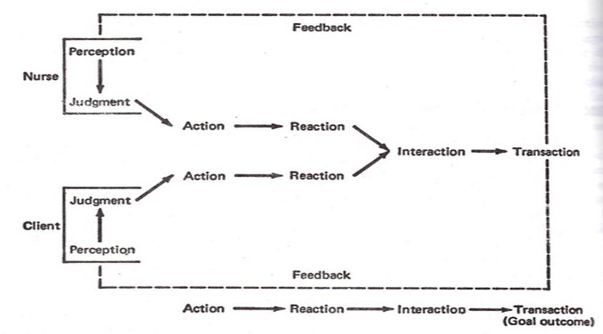
Figure 1 Retrieved on 09/01/2017, from http:googl/NRaZr
With the movement of healthcare to a patient-family centered care or a Patient Centered Medical Home (PCMH) approach to care, King’s theory can provide an increased emphasis on the patient needs and the delivery of primary health care (Defining the PCMH, 2017). A PCMH includes a team of care providers which may consist of a physician, advance practice nurses, physician assistants, nurses, pharmacists, nutritionists, social workers, educators and care coordinators (Defining the PCMH, 2017). This comprehensive group can provide health care oriented toward the person as a whole. Both patient and family centered care and PCMH healthcare concept includes patients and their families as members of the care team (Defining the PCMH, 2017). The PCMH provides the health care team an understanding of the patients’ functional clarity. It incorporates the health of the individual, the health of the group, and the health of the society, which is the same as King’s conceptual view of three dynamic interacting systems; the personal, interpersonal, and social system (King, 1997). This evidence-based blood pressure guideline provides the opportunity for an interactive dyad (Appendix C) with the patient by providing them with specific education for uncontrolled hypertension and encourages them to participate in the decision process concerning their health. Providing the patients with the best interventions to attain their optimum health requires a collaborating plan to meet this goal and King’s theory-based can deliver quality care to all individuals in hospitals, primary care, and in families (King, 1997).
Assumptions
The implementation of an evidence-based blood pressure management guideline has the assumption of decreasing blood pressure for better control. Other assumptions include: providers ordering Telehealth for patients with uncontrolled hypertension, clinical lead nurse identifying pre-hypertensive and hypertensive patients to provide education and Telehealth referral, and all others involved with care following the guideline to obtain accurate blood pressure measurements. Patient assumption includes the ability to follow the education brochure to lower blood pressure, read at an 8th grade level, and be free from a mental health disorder.

Definition of Key Concepts
Normal blood pressure. A blood pressure measurement of less than 120/80 mm Hg is an optimal normal range (American Heart Association, 2016).
Prehypertension. Prehypertension is when blood pressure remains consistently in the range from 120-139/80-89 mm Hg (American Heart Association, 2016).
Hypertension. Hypertension (stage 1) is when blood pressure measurements remain consistently from 140-159/90-99 mm Hg and (stage 2) blood pressure measurements remain consistently greater than 160/100 mm Hg (American Heart Association, 2016).
Blood pressure in control. Blood pressure in control is when blood pressure measurements remain consistently below 140/90 mmHg (American Heart Association, 2016).
DASH diet. The Dietary Approaches to Stop Hypertension (DASH) is a lifelong approach to healthy eating designed to treat or prevent high blood pressure (Mayo Clinic, 2016, para. 1).
Telehealth. Telehealth or Telemedicine is a program to help rural communities use the capabilities of telecommunications to connect to each other and the world, overcoming the effects of remoteness, education, and health care which are keys to economic and community development (Distance learning and telemedicine grants, 2017).
Centers for Medicare & Medicaid Services (CMS). This is a federal agency that runs the Medicare and Medicaid programs and is responsible for the oversight of HIPPA administrative simplification transaction, code sets, health identifiers, and security standards. It works to make sure that the beneficiaries in these programs receive the highest quality of health care (CMS, n.d.).
Accountable Care Organization (ACO). A group of health care providers, potentially including doctors, hospitals, health plans and other health care constituents, who voluntarily come together to provide coordinated high-quality care to populations of patients (RTI International, 2016).
Patient Centered Medical Home (PCMH). This is a care delivery model where the patient’s treatment is coordinated through their primary care provider to ensure they receive comprehensible reasons and the necessary care when and where they need it (Defining the PCMH, 2017).
Summary
With the passage of the Affordable Care Act, family practices are closely following and managing patients with poorly controlled chronic diseases. If this is not demanding enough, family practices engaging in the CMS quality improvement take on a new task to satisfy requirements for maximum reimbursements. The CMS requires family practices to meet established set benchmarks to be eligible for these reimbursements. One quality improvement benchmark associated with the cardiovascular core measure is blood pressure in control. With the mortality rate, twice the national average in the county where the project is being implemented, patients managed at family practices would benefit from a blood pressure management guideline based on research evidence.
Implementing an evidence-based blood pressure management guideline includes more than one intervention to maintain blood pressure in control. One intervention alone may have a limited effect on controlling blood pressure but when multiple interventions are implemented, blood pressure control can have better results (Glynn et al., 2010). The working hypothesis by implementing a blood pressure management guideline including key interventions will assist in maintaining blood pressure in control for patients. This approach allows for more opportunity for patient engagement and to assist with controlling hypertension with office staff and at home (Kravetz & Walsh, 2016).

Chapter Two: Review of the Literature
A literature search was performed using the search engine PubMed (Appendix D). The search terms utilized included “primary health care”, “primary care”, “hypertension”, “hypertensive”, “high blood pressure”, “blood pressure”, “blood pressure control”, and “monitoring”. Initial results were 4066 research articles. Key words added separately to the initial search included “North Carolina” (109 results), “rural health” (209 results), and “quality improvement” (265 results). The information was limited to adults, printed in the English language and covered a period from January 2012 to the present. The topics excluded were; pregnancy induced hypertension, ocular hypertension, intracranial hypertension, pulmonary hypertension, and portal hypertension. Supportive searches were utilized using Health Information Technology (Healthit.gov), American Heart Association (AHA), and Vidant Medical Center. A total of 400 research articles were reviewed and a final total of 15 research articles were used (Appendix E).
A theoretical research review was performed using the search engine PubMed. The search terms utilized included “Imogene King Theory of Goal Attainment”, “Theory of Goal Attainment”, “Telehealth”, and “education”. This search period covered the past ten years. Four research studies were similar to the concepts presented in this project which include; education, collaboration, Telehealth, and hypertension.
Heart Health Now
In 2011, the US Department of Health and Human Services launched an ongoing campaign called the Million Hearts to prevent one million heart attacks and strokes by 2017 (UNC Health Care and UNC School of Medicine Newsroom, 2015). The Heart Health Now project was initiated four years later to support the campaign by evaluating the effect of primary care on practice-level delivery of evidence-based cardiovascular disease, patient-level health outcomes, implementation of clinical changes that support evidence-based preventions, and clinic-level capacity to implement future evidence-based clinical guidelines (Weiner et al., 2015). The Heart Health Now (HHN) is a University of North Carolina (UNC) primary care project for advancing heart health in North Carolina by using the latest evidence to improve heart health of millions of Americans (UNC Health Care and UNC School of Medicine Newsroom, 2015). With a $15 million grant from the Agency for Healthcare Research and Quality (AHRQ), HHN project is part of the AHRQ initiative called Evidence Now. This initiative focuses on advancing heart health and supports the HHS effort for better care, smarter spending, and is aligned with the Million Heart national initiative to prevent heart attacks and strokes (UNC Health Care and UNC School of Medicine Newsroom, 2015). HHN is designed to target smaller family practices and provide quality improvement services typically not available to them due to their size.
The “Million Hearts” and “Heart Health Now” project focuses on the management of the “ABC-S” of cardiovascular prevention. Aspirin use in high-risk individuals, Blood pressure control, Cholesterol management and Smoking sensation interventions (Weiner et al., 2015). HHN has implemented a blood pressure measurement workflow (Appendix A) allowing a 10-minute interval between the first and second blood pressure measurement. This is an ongoing research study that includes 300 small to medium sized primary care practices in seven states, covering over an estimated 900,000 adult patients with no published results nor has there been a practice facilitation control trial attempted at this scale (Weiner et al., 2015).

Education of the Providers and Staff
An educational intervention that will improve control of blood pressure in patients requires successful identification of increased blood pressures as the first step to diagnosing hypertension (Handler et al., 2015). Obtaining accurate blood pressures in the office setting is imperative to diagnosing high blood pressure or “normal” blood pressures (Handler et al., 2015). In a recent study of primary care clinics in rural Utah, blood pressures of diabetic patients were not controlled (Woolsey, 2014). Clinical teams were not accurately measuring blood pressures and the reports were entered with inaccurate results leading to poor blood pressure control benchmarks (Woolsey, 2014). Standardized blood pressure measurements focused on correctly positioning their patients, making sure their patients did not talk during the measurements, waited five minutes or more for first blood pressure, for second measurement waited two minutes or more and used proper cuff size (Handler et al., 2015; Woolsey, 2014). These steps were implemented and the staff were trained according to the standards with results indicating improved blood pressure readings and control by 10% (Woolsey, 2014). Implementing a blood pressure guideline as a primary intervention can assist in blood pressure control and combined with a multidisciplinary approach can further improve blood pressure control (Fortuna et al., 2015).
Patient Education
Research is limited when education is the primary modifier for blood pressure control but when the educational interventions are focused on self-management, it can be beneficial in the treatment of long-term diseases (Ho et al., 2016). In a quasi-experimental multi-center study on the patients’ knowledge of hypertension, Ho et al. (2016) suggested approximately half of the participants correctly knew the definition of hypertension, that it was a chronic disease, and if they had received any explanation about hypertension. A pre-and post-questionnaire tool and an education teaching intervention were used prior to the post test results. Prior to patients receiving the educational teaching intervention, 48% correctly identified hypertension was greater than 140/90 mm Hg and only 68% knew it was a chronic disease (Ho et al., 2016). After receiving the education teaching intervention, these results increased to 99% and 98% respectively (Ho et al., 2016). These results indicate educating patients about hypertension was beneficial for their overall compliance for hypertension management (Ho et al., 2016). Therefore, educating patients about their disease can have a positive impact on the patients’ level of knowledge and should be incorporated in primary care for patients with hypertension or any chronic disease (Ho et al., 2016).
The DASH-Sodium trial study combined the DASH (Dietary Approaches to Stop Hypertension) diet and included low Sodium intake (American Heart Association [AHA], 2016). The DASH and low Sodium diet trial revealed patients with hypertension achieved the greatest blood pressure reduction, in comparison to other diets, and it also reduced blood pressure in patients with no history of hypertension (AHA, 2016). A recent study conducted in eastern North Carolina, patients indicated an unhealthy diet and lack of understanding about the disease process as barriers to understanding the importance of blood pressure control (Donahue et al., 2014). Some barriers to educational interventions are the socioeconomic disparities in health, where they fail to address environmental factors, which are associated with patients with lower education status and lack of access to fresh fruits and vegetables (Zhang, Eastwood, Ertl, & Whittle, 2016). Lack of communication and education emerged from this study as the common issue patients described when needing help with their blood pressure control (Donahue et al., 2014).
Improvements to the Delivery of Care
An alternative to home blood pressure monitoring is Telehealth. Telehealth presents another alternative for changing the physician-patient relationship with controlling hypertension (Cobos, Haszkard-Zoinierek, & Howard, 2015). Past research has demonstrated the use of telemedicine can improve medication adherence and blood pressure control (Cobos et al., 2015). This technology initially had its beginnings for monitoring blood glucose levels for better control in diabetic patients and has expanded to include oxygen saturation and uncontrolled hypertension (Cobos et al., 2015). A major advantage for patients receiving Telehealth provided by this hospital organization is that it’s a free service for their patient. This service is a cost-saving program for small-rural family practices within this hospital organization. In a randomized controlled trial, McKinstry et al., (2013) wanted to determine if an intervention consisting of telemonitoring would lower daytime blood pressures in patients with uncontrolled hypertension. Half of the participants received telemonitoring and half received the usual care from the primary care clinic. The usual treatment group had a decrease of 2.3 mm Hg (95% confidence interval 0.9 to 3.6; P=0.001) and the telemonitoring group decrease was 4.3 mm Hg (2.0 to 6.5; P=0.0002). Even though the usual group did have a reduction in blood pressure, their conclusion suggests telemonitoring can significantly reduce blood pressure in those with uncontrolled hypertension compared to the usual treatment group (McKinstry et al., 2013).
A one year randomized controlled trial (RCT) use of telemonitoring was conducted in Canada on 110 hypertensive patients. The results indicated a blood pressure reduction of 7.1/3.9 (systolic/diastolic) mm Hg (p<0.005), and the proportion of controlled blood pressure increased by 20% (Wood, Boulanger, & Padwal, 2017). Wood et al., (2017), conducted a meta-analysis of 23 RCTs that enrolled 7037 patients using telemonitoring and found systolic blood pressure was reduced by 4.7 mm Hg (95% CI, 1.6-3.3).
Telehealth adds a safety net for patients who use home blood pressure monitoring to enable self-management by the action communicated by the provider with high or low blood pressure readings (Abdullah et al., 2016). The software has been proven to improve blood pressure control and medication adherence in patients with uncontrolled hypertension (Cobos et al., 2015; McKinstry et al., 2013). In a qualitative study, the researchers found the lack of communication between the provider and patient decreases the motivation for continued use (Abdullah et al., 2016). They found when patients and providers discussed their blood pressure results, patients were more inclined to become self-motivated to continue with the telehealth program (Abdullah et al., 2016). Patients did find telehealth easy to use, indicated the need for communication with their provider influenced their acceptance and for understanding blood pressure reading but questioned the usefulness over an extended period of time (Abdullah et al., 2016). It is important to have effective communication with their doctors and nurses to keep their blood pressure under control (Donahue et al., 2014). According to Cobos et al., (2015) patients participating in telemedicine can be diagnosed earlier in the disease progression and it can improve medication adherence and blood pressure control. The goal of telemedicine is to increase access to care and home remote monitoring, and its aim is to improve clinical outcomes and improve patient care (Telehealth, 2012).
Theory of Goal Attainment Utilization
Incorporating King’s Theory of Goal Attainment is a study of interactions, for setting goals, agreeing on how to achieve these goals between the nurse and patient, and how communication can lead to transaction or goal outcome (De Leon-Demare, MacDonald, Gregory, Katz, & Halas, 2015). De-Leon-Demare et al. (2015) studied the evolution of relationship building and goal setting between nurse practitioners and their patients over three consecutive visits in one year. This longitudinal study included seven hours of audiotaped sessions. Their findings suggest interpersonal skills of the nurse practitioner were crucial in building a strong relationship with the patient. This relationship identified areas of decision-making related to the needs of the patients and for agreeing with the goals needed to achieve transaction.
A goal-attainment-theory-based educational program on cardiovascular risks, behavioral modification, and quality of life indicators among patients presenting with acute myocardial infarction was implemented by Park, Song, & Jeong, (2017). A convenience sample of 64 patients were randomly assigned to either an education group or control group for a 6-month period. Findings revealed patients who received the goal-oriented education showed better glucose control, overall health behaviors, and the mental component of quality of life over the patients who received usual care. A nurse-led education program with individualized goal-oriented approach can easily be integrated in current medical treatment systems to increase effective lifestyle modifications (Park et al., 2017).
Integrating King’s theory with healthcare technologies can facilitate better patient outcomes. Through the work of Fronczek, Rouhana, & Kitchin, (2017), telehealth content and resources were infused into nursing school’s undergraduate and graduate curricula using King’s conceptual system and theory of goal attainment as a guide. The graduate level nurse must demonstrate competencies in technology to collect, manage, and analyze data (Fronczek et al., 2017). Technological advances can be applied to quality improvement projects to assist in modifying a clinical practice information system to improve efficiency and related patient outcomes, therefore, King’s theory along with collaborations in the personal, interpersonal, and social systems provides the framework to develop educational innovations to meet goals and be current in telehealth technologies (Fronczek et al., 2017).
Limitations
Limitations extrapolated from the research studies reviewed for this quality improvement project revealed some common factors. A limited time frame and smallness of the sample can lead to difficulties identifying the difference in the outcome of the variables used with education, diet, and lifestyle modifications. These findings could be considered suggestive due to potential bias. With technology constantly changing, Telehealth will never be static but patients will continue to refuse to participate or will drop out of the study. Related studies using King’s theory of goal attainment were utilized in the aforementioned studies. Even with years of utilizing King’s theory in nurse and patient communications, there are limitations when incorporating this conceptual framework in quality improvement projects. These include difficulties with forming positive relationships, developing trust and satisfaction when the nurse-patient interactions never progress from the action to transaction feedback. Although, none of the research studies were the same as this project, the conceptual framework included important aspects related to the interventions implemented in the quality improvement project.
Summary
When reviewing the literature, a majority of studies focused on one aspect of blood pressure control. Woolsey, (2014) discovered inaccurate blood pressure measurements in diabetics with hypertension and introduced blood pressure measurement standards to staff. Staff was retrained which improved measurement accuracy in hypertensive patients. This intervention of standardizing blood pressure measurements resulted in improved blood pressure readings and control by 10% in their practice.
When educational tools such as; disease progression education, changing one’s diet, and modifying lifestyle has been shown to assist with blood pressure control when it is focused on self-management, it can be beneficial in the treatment of chronic diseases. According to Halladay et al. (2017), patients receiving education interventions increase disease knowledge, provider-patient communication and should be incorporated in the family practice for patients with hypertension or any chronic disease.
Although, home blood pressure monitoring may be the most effective method for diagnosing hypertension compared to office measurements, the cost associated with implementing this intervention can be expensive for the primary care practice. Any additional overhead costs for a small family practice is difficult to maintain and absorb. Therefore, an alternative to home blood pressure monitoring is Telehealth. It provides home blood pressure monitoring but adds an experienced trained nurse to follow patients via a cellular link communication. Patients with hypertension participating in telehealth are able to be diagnosed earlier in the disease progression and can improve medication adherence and blood pressure control.

Chapter Three: Methodology
Design
This quality improvement (QI) project implemented a modified version of the Heart Health Now blood pressure guideline at a family practice in eastern North Carolina. The purpose of this project was to modify the family practice culture by implementing an evidence-based guideline for managing uncontrolled hypertension, increase blood pressure in control, and to educate patients on healthier lifestyle choices. The project had three objectives: to standardize blood pressure measurements; to identify uncontrolled hypertension sooner; and to provide education where needed.
Prior research has shown that the consistent use of standard guidelines is key to increasing the accuracy of blood pressure measurements (Woolsey, 2014), however, a review of this family practice revealed a lack of such standards in blood pressure measurements. Therefore, the introduction of standardizing blood pressure guideline will provide clear interventions for this family practice to follow.
The family practice utilized Telehealth, a home monitoring communication system that provides blood pressure measurements over a secure cellular network to a trained nurse for evaluation, to quicken the identification and treatment of uncontrolled hypertension. A major advantage for patients at this project site is that Telehealth is provided at no additional cost to the patient by the hospital. Telehealth referral was incorporated in the modified HHN guideline.
A key modification to the HHN guideline at the project site include an education component. Patients were provided education information about the impact of uncontrolled hypertension, dietary changes incorporating the DASH and Sodium restricted diet, and moderate exercise have on the body.
Finally, the implementation of this goal-oriented project was guided by Imogene King’s Theory of Goal Attainment, which states that quality of care can improve the communication and decision-making process between the nurse and patient (De Leon-Demare, et al., 2015). A key component of this project was a nurse-patient relationship working together to manage uncontrolled hypertension with goal oriented education.

Setting

The project site was a family practice located in eastern North Carolina that participates in the ACO and the Shared Savings Program, which provides reimbursements when meeting or exceeding HHS and CMS benchmarks. This family practice provides care for patients 19 years and older. This practice manages 45 to 60 patients a day with various medical problems. Although not designated as a Patient Centered Medical Home (PCMH) it does provide a similar treatment model comparable to a PCMH.
Sample
The staff targeted for the blood pressure management guideline education include: one physician, a physician assistant, one nurse practitioner, four nurses, two nurse’s assistants, two lab technicians, and four clerical staff. The accounting staff had no patient interaction therefore were excluded. The clinical lead nurse is responsible for patient flow through the practice providing teaching to the staff and patient education. Weekly huddles with the clinical lead nurse included implementation of the modified guideline and educational information to be incorporated in daily patient education sessions.

Methods

A non-staff project manager and the family practice’s lead clinical nurse were responsible for the communication and education of this 12-week project. On days one and two, the project manager described the implementation of a modified HHN guideline to providers, nurses and ancillary staff during the morning staff huddles. The project manager, in collaboration with the clinical lead nurse oversaw the implementation of the project by selecting three staff nurses to assist with educating patients and ensuring staff were compliant with the guidelines.

The clinical lead nurse and selected staff nurses were educated on the use of the guideline with an emphasis on steps in proper blood pressures measurements, utilizing a blood pressure management brochure in patient education, and referring patients identified with uncontrolled hypertension to Telehealth. They reinforced the modified HHN guideline (Appendix B) by ensuring staff implemented blood pressure measurement standards and by providing education and/or a Telehealth referral as appropriate.
Staff used a manual or sphygmomanometer blood pressure cuff to take patient blood pressures as they sat upright in a chair with feet flat on the floor. The left arm was the preferred choice, but the right arm could be used. The initial blood pressure measurement and arm of the patient where obtained were documented in the Electronic Health Record (EHR). If the first blood pressure measurement was > 140/90 mm Hg, a second measurement was performed approximately 10 minutes apart and documented in the EHR.
The second blood pressure determined the next steps to be taken by the staff. When the second blood pressure measurement was > 120/80 mm Hg but < 140/90 mm Hg, the patients were described as prehypertensive and received a free (English only) Hypertension Control Blood Pressure Management brochure (Appendix F). These patients were educated by the clinical lead nurse about the negative effects of hypertension disease, the DASH and sodium-restricted diet, and lifestyle changes needed to lower blood pressure. When the second blood pressure measurement was > 140/90 mm Hg, the patients were diagnosed with uncontrolled hypertension and received the Hypertension Control Blood Pressure Management brochure, a Telehealth pamphlet (Appendix G), and were referred to Telehealth by their providers. The clinical lead nurse provided general information about Telehealth’s services while Telehealth services provided more in-depth information. Patients who agreed to Telehealth were prescribed 30-day monitoring. When patients refused, Telehealth informed the clinical lead nurse at the family practice.
Each Wednesday, utilizing the plan-do-study-act (PDSA) cycle, the project manager reviewed the overall guidelines compliance with the clinical lead nurse. The review entailed: blood pressure measurements, the number of patients being educated according to the guideline, and the number of Telehealth referrals ordered. No patient identifiers were recorded during this review process. The plan-do-study-act (PDSA) tool (Appendix I) was used to obtain staff’s feedback on areas of improvement to maintain guideline compliance.
Human Subject Protection
Organizational site approval was obtained prior to implementation (Appendix L). The project was reviewed by the University Institutional Review Board and deemed as non-human subject research (Appendix M). The clinical lead nurse and Quality Department representative reviewed the patient records for blood pressure measurement compliance, progress notes for documentation of educational teaching, and Telehealth referrals. No patient information or identification was collected. Only blood pressure results were collected by the project manager and were stored on a password protected laptop computer. Aggregate blood pressure in control data was provided by the quality director.

Data Collection

The clinical lead nurse and the organizations Quality Department representative collected the data for this project in order to ensure HIPPA compliance. Patient name, medical record number, two blood pressure measurements, whether patient education were provided and Telehealth referrals were recorded on the Project Data Collection Sheet (Appendix J). Information collected on patients who met the guideline was sent weekly or biweekly by the clinical lead nurse via secure e-mail to the Quality Department representative. At the end of 12 weeks and the end of Telehealth’s 30-day blood pressure monitoring, the representative processed the 30-day results from Telehealth, then returned the blood pressure in control data loaded into the Excel Spreadsheet Analysis program (Appendix H) to the project manager for evaluation.

The project manager utilized the Staff Compliance Tool (Appendix K) to record whether staff was adhering to guideline compliance during weekly huddles with the clinical lead nurse. Patients who met the modified guideline were reviewed by the clinical lead nurse prior to being emailed to the Quality Department representative. Data collected included: two blood pressure measurement compliance, education brochure teaching, and telehealth referrals. The PDSA cycle was utilized to evaluate compliance of the modified HHN guideline.
Data Analysis
The data collected on the Staff Compliance Tool was compiled to create a weekly graph of compliance over the course of 12-week project. A positive trend indicated staff compliance and probability of blood pressure in control. Following the 12-week and 30-day Telehealth monitoring, data was entered into an Excel Spreadsheet (Appendix H) for data analysis and provided by the Quality Department representative. Descriptive statistics including frequency and percentages were used to display data results to evaluate staff and provider compliance.
Budget
The estimated cost to implement the evidence-based blood pressure management guideline to improve blood pressure control was as follows: 20 educational pamphlets totaling $200, miscellaneous office supplies totaling $50, transportation (vehicle/gas) totaling $150, and food (doughnuts and drinks) totaling $100. Added to the budget was work missed by the project manager (two days per week at $32.00/hour for 12 weeks) totaling $9,216. The comprehensive total equals $9,716 (Appendix N).
Financial cost for the practice site for project implementation included the use of the Hypertension Control pamphlet at $10 dollars per person. Telehealth is free for patients who are treated at this primary care practice. The primary practice extra 5% incentive for meeting and exceeding CMS benchmarks is unknown to the Department of Quality at this time and is contingent on the hospital organization as a whole.

Chapter Four: Results
Introduction
The introduction of a modified evidence-based blood pressure measurement guideline to improve blood pressure in control was implemented at a family practice in eastern North Carolina. Prior to the guideline implementation, the family practice had no standardized method in measuring blood pressures, educating patients with hypertension, or managing blood pressures in a structured manner. The overall goal was to improve blood pressure in control by implementing a guideline to provide standards for blood pressure measurements, provide patients with hypertension education, and Telehealth referrals for continuous blood pressure monitoring.
Participant Demographics
There were a total of four nurses and three providers (MD, PA, and FNP) directly responsible at the practice for adhering to the modified evidence-based guideline. Each provider utilized a staff nurse to initiate the pre-interview vital signs including the initial blood pressure measurement and the second blood pressure measurement for patients who met the guideline.
Initially, there were 17 patients identified who met the guideline criteria, but only 11 (65%) met the modified Heart Health guideline. Three of the seventeen (18%) did not meet the age criteria (19-65), one (0.06%) failed to participate and one (0.06%) fell outside the project period. One patient (0.06%) was identified with pre-hypertension and was rescheduled for an office visit in three months which was outside the project time frame.
Intended Outcomes
The first intended outcome was staff compliance in utilizing the guideline. The staff was tracked by random observations performed by the clinical lead nurse and each week by the project manager. In addition to observations, each staff nurse recorded blood pressure measurements on the data collection tool (Appendix J) on patients who met guideline criteria. The second intended outcome was staff compliant with providing patients the education brochure for information on the disease process, DASH diet, and lifestyle changes including exercise. The third intended outcome was provider compliance referring patients who met the eligibility criteria of two blood pressure measurements greater than 140/90mm Hg to Telehealth.
Findings
After applying the projects criteria for inclusion, there were a total of 11 patients followed through the modified HHN guideline. The sample size was small considering this busy family practice and the aforementioned hypertension rate of 33% for this community.
Guideline compliance findings for staff and providers will be discussed separately. First, staff guideline compliance was in obtaining blood pressure management. This consisted of sitting the patient, following the steps provided by the guideline, having a delay of at least 10 minutes between blood pressure measurements, and educating the patient with the Hypertension brochure. Staff nurse compliance was evaluated weekly utilizing the PDSA review cycle. The staff nurses were compliant with all 11 patients. The summary for staff guideline compliance is illustrated in Table 1.
Table 1
Modified Heart Health Guideline Compliance

Modified Heart Health Guideline  Compliance Summary | Nurse A | Nurse B | Nurse C | Eligible #  of pts. | Total #  of pts. | Total # of Brochures
Initial 4 weeks | 4 | 2 | 4 | 7 | 7 | 7
Weeks 5-8 | 2 | 3 | 1 | 4 | 4 | 4
Weeks 9-12 | 0 | 1 | 0 | 0 | 0 | 0
TOTAL Compliance |  |  |  |  | 11 | 11

Patients who met the guideline and were determined eligible for inclusion during the initial four weeks of the project began with promising results. Gradually, the sample size trended lower in weeks five thru eight and by weeks nine thru twelve, only one patient met the guideline criteria. A plausible reason for the downward trend was the family practice utilizing appointment times for influenza shots for their patient population.
During the weekly PDSA review, an unexpected finding occurred during week 4. Prior to discharge, one patient refused the Telehealth referral. A PDSA cycle worksheet was implemented with the staff (Appendix O) to address future patient refusals during the discharge process. A collaborative decision was made to continue with the Telehealth generalized description by the providers but explain to the patient that further detail of services would be provided by the Telehealth staff. Once patients communicated with a Telehealth representative, they could then decide to continue or refuse service. Telehealth would inform the practice of the patient’s decision. If the patient refused, the providers would reschedule them for a repeat blood pressure measurement beginning the fifth week of the project.
The provider section of the modified HHN guideline included whether a Telehealth referral was ordered. To support guideline compliance, a Telehealth referral was initiated when two blood pressure measurements where greater than 140/90mm Hg and each patient received the hypertension educational brochure provided by the nurse. Table 2 illustrates provider compliance and patients’ eligibility for Telehealth referrals. Each provider were compliant by referring all of eligible patients (11) for Telehealth monitoring.

Table 2
Telehealth Referrals
Telehealth Referral  Compliance | Provider A | Provider B | Provider C | Pt eligible  for  Telehealth | Total  Referrals
Initial 4 weeks | 4 | 2 | 4 | 7 | 7
Weeks 5-8 | 2 | 3 | 1 | 4 | 4
Weeks 9-12 | 0 | 1 | 0 | 0 | 0
Total Meeting  Guideline Criteria |  |  |  | 11  eligible | 11  referrals

During weeks eight and nine, a provider identified that follow-up results for Telehealth were either delayed or the information was not communicated appropriately. The lead nurse reviewed several charts from Telehealth finding no recorded results. The project manager, clinical lead nurse, and Telehealth manager engaged in telephone conference call to find a solution for potential delays. A PDSA cycle worksheet (Appendix P) was created for developing a plan to provide patients results in a timely manner. During this interdepartmental collaboration, a computer system communication problem was identified as being responsible for the delays. The computer system used by Telehealth did not interface with the vital sign section of the family practice electronic health record. The blood pressure measurement results relied heavily on the Telehealth staff to send information by a note system instead of actual email. These Telehealth generated notes were difficult to find in the providers charting system resulting in delayed or missed information. A tentative plan was devised that included telephone communications between Telehealth and the clinical lead nurse for reporting abnormally high blood pressures and daily email communication with results provided to the clinical lead nurse. Telehealth began sending blood pressure results on patients (Appendix Q).
Prior to implementing the modified evidence-based guideline, blood pressure in control benchmark scores at the project site were 52%. At the end of the twelve-week project, the blood pressure in control score had increased to 61%. Although there was a 9.0% improvement in blood pressure control, this result remains below the 80% benchmark target set by the hospital organization.
Summary
The purpose of implementing the modified HHN guideline was to improve the family practice blood pressure in control scores by standardizing steps for blood pressure measurements, provide patient education, and Telehealth referrals. Although, staff and providers adhered to the guideline as instructed, interdepartmental communication between the family practice and Telehealth delayed follow-up evaluations to determine if Telehealth would be an appropriate alternative compared to office appointments.
The implementation of a modified HHN evidence-based blood pressure measurement guideline could lead to an increase blood pressure in control. There was a change in the practice culture at this project site without compromising work flow or patient care during the twelve-week project period.

Chapter Five: Implications for Nursing Practice
Since 2010, hospitals and primary care clinics have been working to implement new policies and standardizing procedures to meet or exceed requirements to receive compensation for their services. Hospital organization are measured by set benchmarks which is tied to value and quality which follows the recommendations of the CMS. To meet these benchmarks, hospital organizations are implementing evidence-based guidelines to deliver higher quality care for their patients.
An important measured benchmark is blood pressure in control. Complications from uncontrolled hypertension include renal and cardiovascular diseases. These comorbidities increase the risk for stroke, renal failure, and myocardial infarcts that can impact the mortality and morbidity which can increase the rate of hospitalizations for this patient population.
Practice Implications
This major shift in healthcare provided opportunities for universities to broaden their curriculum and develop advance knowledge for practice in this complex healthcare environment. Research focused nursing schools have been the mainstay for years but with the introduction of the Doctor of Nursing Practice (DNP), it is primarily focused on practice. With the development of curriculum standards by the American Association of Colleges of Nurses (AACN) the Advance Practice Nurse (APN) can promote evidence-based knowledge in the practice environment (AACN, 2006). The AACN developed the Essentials of the Doctorate of Nursing (DNP) to guide doctoral students on the implications for nursing practice. These essentials are required competencies that allow the DNP prepared nurse to utilized and apply evidence-based research into practice (AACN, 2006). Each essential will be discussed.
Essential I: Scientific underpinning for practice. Posing any change in policy or a patients’ healthcare, a solid scientific underpinning is needed to implement these changes. Nursing theories have evolved over the years to provide a framework to introduce these changes in the healthcare environment. This project utilized King’s Theory of Goal Attainment due to its fundamental premise of patients communicating and decision making with the nurse or provider toward an established goal. Development of middle range theories and concepts is needed to guide and evaluate new practice approaches based on these theories (AACN, 2006).
The goal for this project was to improve blood pressure in control by introducing an evidence-based guideline which was modified from the Heart Health Now guideline. The process included; standardizing the sitting process during the office visit, obtaining two blood pressure measurements ten minutes apart, providing a diet and lifestyle education brochure for patients and using Telehealth for uncontrolled hypertension. These steps provided a clearer process and changed how the providers and nurses manage uncontrolled hypertension in this office. The implementation of this modified guideline was a needed change for this family practice because no standardized guideline was being used at the time.
Essential II: Organization and systems leadership for quality improvement and system thinking. The DNP graduate must be skilled at developing and evaluating the delivery of patient care that meets current and future needs of the community based on evidenced-based research, ensuring a high quality of health care and safety for their patient population (AACN, 2006). This includes research, design, implementation and evaluation of quality improvement evidence-based projects for small or large healthcare organization by evaluating patient needs (AACN, 2006).
After evaluating this organizations current practice policies and standards, a plan was developed to increase patient blood pressure in control. Therefore, an evidence-based guideline modified from the Heart Heath Now guideline was created and implemented. Challenges identified included guideline compliance, communication between the nurses and providers, following blood pressure measurements to provide the best accurate reading, and Telehealth referral compliance. Weekly collaboration with the clinical lead nurse were conducted to evaluate staff guideline compliance or problems related to the modified HHN guideline. These weekly huddles identified guideline and communication deficiencies. Patient refusal and communication between Telehealth were addressed by utilizing a PDSA cycle. Adjusting these deficiencies assisted overall guideline compliance. Future deficiencies may require additional PDSA cycles to maintain compliance.
Essential III: Clinical scholarship and analytical methods for evidence-based practice. The DNP graduates induce corroboration from their practice to improve practice and care outcomes (AACN, 2006). This includes drafting and implementing a process to evaluate practice outcomes from prior benchmarks related to blood pressure in control and apply existing evidence-based literature to improve benchmark scores in this family practice (AACN, 2006).
Prior to implementing this quality improvement project, the use of analytical methods to review existing literature and discovering applicable research to provide a basis for a workable hypothesis for maintaining blood pressure in control was done. The modified HHN guideline was developed and designed from evidence-based research for the primary practice to incorporate into their daily routine. Findings revealed overall compliance from the staff and providers had a positive impact on blood pressure in control. Although the impact was small, an opportunity for continued improvement can be achieved if the modified HHN guideline is fully adopted to provide the change needed to control blood pressures.
Essential IV: Information systems/technology and patient care technology for the improvement and transformation of healthcare. Incorporating technology for the improvement of patient care can be a beneficial tool in a complex healthcare environment. Identifying means for improvement through data, information, technology, and sharing are important concept for nurses to understand in the practice setting. The DNP graduate should be able to analyze and communicate critical health information when selecting and evaluating health care information systems and patient technology for patient care (AACN, 2006). Collectively, the process of identifying data, information, technology and sharing of information can lead to increase in knowledge and positive changes in health care delivery.
Overall provider and staff guideline compliance in use of the modified Heart Health Now guideline was the goal for the project. Although provider compliance for Telehealth referrals were maintained, differences in computer software communication between Telehealth and the practice led to unexpected delays in reporting results. Utilizing the PDSA cycle provided opportunities to identify strategies to improve communication between the providers at the practice site and Telehealth.
Implications for improvement included problem sharing with the family practice, Telehealth, and the department of quality. A recommendation to improve blood pressure results in a timely manner is to facilitate a computer software update for Telehealth to be able to access the EHR to load blood pressures measurements for easy access for each provider. This change is schedule to occur during the summer of 2018. Telehealth has the potential to be a valuable tool for each provider for transforming patient care delivery (Wood et al., 2017).
Essential V: Health care policy for advocacy in health care. Advocating for improved health care delivery for the hospital, community, and patients is a responsibility of the nursing profession. With the development of the Doctor of Nursing Practice (DNP), advance practice nurses now have a leadership role in advocating for health policies, equality, and patient care outcomes. DNP graduates have a valuable role in practice, research and policy (AACN, 2006).
This project provided the opportunity to address the family practice policies, their overall compliance, and how this project could have an impact on this patient population. Nursing leadership requires the development of policies that can change the view of healthcare by providing cost saving interventions such as utilizing Telehealth, a free service provided by this hospital organization, implementing a guideline to provide better outcomes for patients with uncontrolled hypertension, and by incorporating new policies changes throughout the organization. DNP leadership is essential to lead, deliver and present findings through educating and sharing patient outcomes data to hospital leadership committee members for review.
Essential VI: Interprofessional collaboration for improving patient and population health outcomes. The DNP graduate is prepared in interprofessional collaboration within healthcare providing leadership skills to implement evidence-based initiatives to improve communication and patient care (AACN, 2006). Effective team leadership can identify obstacles in healthcare or highlight interventions that could change the delivery system to improve health care, reduce patient follow-up care which in turn can decrease cost to the patient and hospital organization. During implementation of the project, collaboration between department of quality, Telehealth leadership, and the medical director of the family practice were engaged in the delivery of care for patients meeting the modified HHN guideline. The interdisciplinary collaboration between the individual team leaders concerning organizational issues provided the best way to improve coordination for improving patient care and appropriate changes needed to facilitate patients’ results efficiently.
Essential VII: Clinical prevention and population health for improving the nation’s health. With the healthcare industry in a constant transition, DNP graduates have a clinical foundation in prevention and health promotion. They are able to analyze healthcare organizations and social problems within different populations by designing improvements in delivery of care and by evaluating results to prevent illness and disease progression (AACN, 2006). This foundation provides a skill set and clinical knowledge for improving patient outcomes by focusing on interprofessional collaboration between other medical professions.
The concept of the Triple Aim, developed by the Institute for Healthcare Improvement (IHI), includes; improving the quality of care, improving the health of the population, and reducing the cost of healthcare (IHI, 2017). The DNP graduate has the skill set and clinical knowledge to support initiatives to improve the Triple Aim.
During this quality improvement project, interprofessional collaboration was imperative with implementation of the guideline. This was accomplished by utilizing the PDSA review process in evaluating and sharing ideas that led to a change in the office culture, empowered patient’s knowledge by providing hypertension education, and improving blood pressure control with referrals to Telehealth.
Essential VIII: Advanced nursing practice. The DNP graduate have specialized training that encompass multiple specialties in healthcare (AACN, 2006). Not only does the DNP graduate demonstrate assessment skills to manage and treat patients in a primary or hospital setting, with their advanced knowledge they are able to design and implement evidenced-base programs to screen for chronic diseases and promote wellness for better outcomes. While the DNP graduate gains experience in their practice, they increase their awareness when patients are functioning at their highest capacity based on their chronic disease (Caceres, 2015). To transform healthcare, the DNP graduate will need an understanding of their population demographics, gathering and analyzing data, incorporating intra-professional collaborative discussion in sharing ideas to implement a care delivery approach to decrease morbidity and mortality in the community.
During this quality improvement project, the DNP advance practice nursing student collaborated with quality leadership team to identify low benchmark scores for blood pressure in control for the practice site. Literature was reviewed for best practices in improving blood pressure in control. Data was collected and analyzed to develop a collaborative plan to improve blood pressure in control score at the practice. The development of a modified evidenced-based guideline from the Heart Health Now research initiative was presented to quality interdisciplinary leadership and the family practice. The project manager provided guideline education to all the staff prior to implementation, utilized the PDSA review process to evaluate the process and staff compliance. Data was collected and synthesized in collaboration with the quality team leadership to evaluate for: 1) staff compliance in utilizing the guideline, 2) improvement in blood pressure in control and 3) recommended changes in the process.
Summary
With the development of AACN DNP competencies and the knowledge gained via advanced practice experiences, the DNP graduate is positioned to identify inequalities within the healthcare organization and patient populations. Collecting and synthesizing data, incorporating research, implementing a plan, and measure the outcome are the foundation for improving the delivery of care for patients and the community. After evaluating the impact of this quality improvement project several trends were identified. The family practice staff, quality department leadership, and project manager through interdisciplinary collaboration discussed the positive and negative project impact had on the staff, organization, and patient. Evaluating these trends will impact future decisions made by the quality department whether or not this initiative would be viable to distribute and implement in other practices in the hospital organization.

Chapter Six: Final Conclusion
In the primary care setting, family practice is the frontline of healthcare when providing patient education, treatment, and chronic disease management. Considering family practices responsibilities, the passage of the Affordable Care Act implemented new standards to follow to receive monetary reimbursements caring for patients enrolled in Medicare. These new quality standards or benchmarks were established by the Centers for Medicare and Medicaid Services (CMS) and are used to improve the delivery of care to Medicare recipients. In response to these new CMS benchmarks, family practices are now faced with finding innovative ideas to improve their delivery of care for their patient population to meet and increase monetary reimbursements. The purpose of this chapter is to summarize the significance of project findings, strengths, limitations, and recommendations for practice.
Significance of Findings
About one in every three adults in the United States have high blood pressure and total costs in 2011 were estimated at $46 billion (High Blood Pressure Facts, 2016; Moran et al., 2015). Information collected during the literature review identified a range of strategies to assist in blood pressure in control, but there was limited evidence-based research combining different therapies into a usable guideline within a family practices for maintaining blood pressure in control. One ongoing evidence-based research study identified was Heart Health Now being implemented at numerous sites in North Carolina.
A modified Heath Health Now guideline quality improvement project was implemented at the project site for staff and providers to follow to improve blood pressure in control. The modified guideline provided steps in blood pressure measurement, use of patient educational brochure and process for telehealth referrals for providers. Significance findings identified at the conclusion of the project were improved blood pressure in control CMS benchmark scores, provider and staff adherence to the guideline and telehealth referrals, improved blood pressure measurement, and an alternative for providers to have ongoing blood pressure measurements outside of the office.
At the projects 12-week conclusion, blood pressure in control benchmark results improved by 9% which decreases costs for the practice, the organization and improves patient outcomes. Physician and staff compliance while incorporating patient education enhanced patient knowledge about the disease process, provided information about the DASH diet with lifestyle changes to improve blood pressure in control. The significance of this finding relates to improving health by preventing follow-up visits, reducing readmissions and improving patients’ experiences during the office visit by self-management of their blood pressure measurements (Wood et al., 2017). Physician Telehealth referral compliance can lead to reduced costs, improved patients’ experiences and the care of the population.
Although, blood pressure in control is one of the benchmarks listed within the chronic cardiovascular diseases core measurements developed by the CMS, overall 9% improvement in blood pressure in control over 12-weeks would not be a guaranteed full reimbursement unless all of the cardiovascular disease core measurements were greater than 50%. However, it did contribute toward an improvement in the overall goal. This CMS benchmark goal will change to 90% by the end of 2018. This project site does participate in the ACOs and Shared Savings Program which creates incentives for providers working with hospitals providing value and high-quality care. Organizations can be eligible for a five percent bonus and additional funding when meeting or exceeding benchmark core measures (P. Lockamy, personal communication, May 8, 2017). This could be very significant for the practice and hospital organization related to the quality improvements results identified from the project. Correcting the interdepartmental computer programs, implementing the modified HHN guideline at this practice could possibly improve benchmark core measure scores and contribute towards full reimbursements.
Project Strengths
At the project site, the family practice blood pressure in control benchmark score (52%) was below the hospital organizations goal of 80%. Introducing the modified HHN guideline provided structured and easy-to-follow steps for staff in obtaining blood pressure measurements. The ten-minute delay between blood pressure measurements did not hinder the staff’s ability to continue with their daily work schedule and it provided a more accurate blood pressure measurement during the office visit. Staff and providers preferred the blood pressure educational brochure format for introducing disease, diet, and lifestyle information. An important strength with the modified HHN guideline was increasing the staff and providers awareness of existing resources such as the availability of Telehealth services offered as a free service for patients treated by the hospital organization.
Project Limitations
Project limitations included a small sample size, delayed communication between departments, the inability to evaluate the qualitative portions of the modified Heart Health Now guideline and time constraints. The small sample size did produce some favorable results, but communication delays between departments hindered follow-up care with some patients. The sample size of Telehealth referral results were too small to draw concrete conclusions about the efficacy of the modified Heart Health Now guideline. There was the possibility of patients with transient episodes of hypertension having not been identified during the sitting process.
The random observation of the staff during project implementation did produce favorable compliance, but the project manager did not observe the staff with every patient. All staff compliance was observed one day each week by the project manager. This may contribute to the staff reverting to their prior behavior when not being observed. This behavior could introduce blood pressure measurement bias when identifying uncontrolled hypertension in patients.
The collaboration and communication between Telehealth and the primary care office resulted in delays in follow-up care. Providers referred patients to Telehealth for 30-day follow-up. As part of the PDSA review process, a limitation identified was that blood pressure results were overlooked due to computer technology delays. Telehealth results were uploaded as notes which made it difficult for providers to find. Although Telehealth results were sent, Telehealth staff did not inform the family practice of abnormal results via e-mail or telephone communication in a timely manner. These communication failures resulted in project manager having direct collaboration with organizations quality department and Telehealth resulting in a tentative solution for providing results for abnormal blood pressure measurements. As a result, providers may return to rescheduling their patients for office visits after the project conclusion.
Project Benefits
The benefits of this project provided organizational change when controlling hypertension. The modified guideline enables staff and providers to incorporate structural and process changes where needed. These benefits included: standardizing the blood pressure measurement process, incorporating existing resources such as patient educational brochure and Telehealth referrals in a practice site to improve the management of hypertensive patients. Prior to the project, this practice had no blood pressure measurement standards. Available Telehealth services were not being utilized to its fullest potential and the available patient educational information was not organized for easy access.
Recommendations for Practice
Primary care offices should implement a standardized blood pressure management guideline into their practice specifically, one which incorporates multiple blood pressure readings to identify uncontrolled hypertension trends. Standards have been set with success in use of practice guidelines with diabetes and heart failure management to simplify procedural steps to improve productivity and patient quality of care.
Staff education is a key factor to continue proper blood pressure management techniques. Developing continuing education classes or computer based learning activities can provide structured clinical based knowledge for healthcare providers and ease of access related to patient information. Future policy should include standardized blood pressure measurements as part of the practice at this site and other organizational family practices. Maintaining blood pressure consistency should be a priority in patient care management.
For improved blood pressure in control, Telehealth referrals can give the providers a clearer picture of blood pressure measurements on a daily or weekly basis. This data can provide quicker treatment options for providers to assist with blood pressure control and costs related to treatment delays with uncontrolled hypertension. Incorporating Telehealth as a tool for providers to assist with and management of blood pressure in control has the potential to diagnose uncontrolled hypertension quicker and medically treat them without office follow-up appointments. This service can assist with other chronic diseases such as diabetes and pulmonary management. Finger stick blood glucose and pulse oximetry can be monitored at home improving patient compliance and management. Family practices can benefit from ongoing results outside of the practice and providing improved management for these patient populations. It is recommended that the organization primary care practices in eastern North Carolina incorporate Telehealth into its policy for managing blood pressure in control to meet or exceed benchmark scores. Another important recommendation is that practice sites have a computer system that can integrate software programs that can provide transparency in communicating patient care. Technology can be beneficial for providers and patients. The use of technology can improve the communication between departments to improve the delivery of care and patient outcomes.
Patient education should continue to be the mainstay of treatment with other interventions to manage blood pressure in control. Future recommendations for the practice site would be an alert or flagged system to remind staff to provide patient education. The education can be provided during the discharge process to include the disease process, DASH diet, and lifestyle changes for each patient meeting the modified HHN guideline. Glen et al., (2010) suggest strategies and interventions that have improved blood pressure in control include self-monitoring, education directed to the patient, education directed to the health professional, and improvements in the delivery of care. Empowering patients understanding of the disease process can assist the patient and provider with the overall management of this disease.
Summary
Identifying, researching, implementing, and evaluating the problem during this quality improvement project was insightful. Being available during the week provided a sense of caring to the staff and provided an open line of communication between the staff and the project manager. This communication emphasized the importance for increasing benchmark scores for this family practice. The collaboration provided the opportunity to include staff in the PDSA evaluation process to identify opportunities to improve the process and use the guidelines.
The process of modifying existing tools based on best practices to improve blood pressure in control enhanced staff awareness of existing resources based on hypertension education and Telehealth technologies. Incorporating these tools enhanced the staff education and ability for managing patients with hypertension. Introducing an educational tool for patients can improve and empower the patient to make changes in their life to assist with blood pressure in control.
Developing a guideline that incorporates best practices in blood pressure management, patient education and Telehealth can lead to improvement in patient care and organization outcomes. Technology can assist with managing care, improve the delivery of care for patients, and reduce treatment times to improve blood pressure in control. Standardizing a guideline for staff to utilize in the management of patients with an elevated blood pressure can improve practice work-flow and reduce cost associated with hypertension. Overall, incorporating evidenced-based interventions can promote practice changes, improved healthcare delivery, and promote cost saving which supports the Triple Aim initiatives.

References
Abdullah, A., Liew, S., Hanafi, N. S., Ng, C. J., Lai, P. S., Chia, Y. C., & Loo, C. K. (2016, January 27). What influences patients’ acceptance of a blood pressure telemonitoring service in primary care? A qualitative study. Dove Medical Press, 10, 99-106. http://dx.doi.org/10.2147/PPA.S94687
Accountable care organization: What providers need to know [Fact Sheet]. (2016). Retrieved from https://www.cms.gov/Medicare/Medicare-Fee-for-Service-Payment/sharedsavingsprogram/Downloads/ACO-Providers-Factsheet-ICN907406TextOnly.pdf
Accountable Care Organizations: What Providers Need to Know. (2016). Retrieved from https://www.cms.gov/medicare/medicare-fee-for-service-payment/sharedsavingsprogram/downloads/aco_providers_factsheet_icn907406.pdf
American Association of Colleges of Nursing. (2006). The essentials of doctoral education for advanced nursing practice. Washington D. C. Retrieved from http://www.aacnnursing.org/DNP/DNP-Essentials
American Heart Association. (2016, November 29). Recommended dietary pattern to achieve adherence to the American Heart Association/American College of Cardiology (AHA/ACC) guidelines. Journal of Circulation, 134, e505-e529. http://dx.doi.org/10.1161/CIR.0000000000000462
America’s health ranking. (2015). Retrieved from http://www.americashealthrankings.org/explore/2015-annual-report/measure/Hypertension/state/NC
Armstrong, C. (2014, October 1). JNC 8 guidelines for the management of hypertension in adults. American Family Physician, 90(7), 503-504. Retrieved from http://www.aafp.org/afp/2014/1001/p503.html
Brewer, N. T., Gilkey, M. B., Lillie, S. E., Hesse, B. W., & Sheridan, S. L. (2013, September 11). Tables or bar graphs? Presenting test results in electronic medical records. Medical Decision Making, 32(4), 545-553. https://doi.org/Retrieved from
Caceres, B. A. (2015). King’s theory of goal attainment: Exploring functional status. Nursing Science Quarterly, 28(2), 151-155. http://dx.doi.org/10.1177/0894318415571601
Centers for Medicare and Medicaid Services [CMS]. (n.d.). Retrieved from https://www.cms.gov/About-CMS/About-CMS/
Cobos, B., Haskard-Zoinierek, K., & Howard, K. (2015). White coat hypertension: improving the patient-health care practitioner relationship. Psychology Research and Behavior Management, 8, 133-141. http://dx.doi.org/10.2142/PRBM.S61192
Davis, K., Guterman, S., & Bandeali, F. (2015). The affordable care act and Medicare. Retrieved May 5, 2017, from http://www.commonwealthfund.org/~/media/files/publications/fund-report/2015/jun/1821_davis_aca_and_medicare_v2.pdf
De Leon-Demare, K., MacDonald, J., Gregory, D. M., Katz, A., & Halas, G. (2015, March 5). Articulating nurse practitioner practice using King’s theory of goal attainment. Journal of the American Association of Nurse Practitioners, 27(11), 631-636. https://doi.org/10.1002/2327-6924.12218
Defining the PCMH. (2017). Retrieved from https://pcmh.ahrq.gov/page/defining-pcmh
Distance learning and telemedicine grants. (2017). Retrieved from https://www.rd.usda.gov/programs-services/distance-learning-telemedicine-grants
Donahue, K. E., Vu, M. B., Halladay, J. R., Miller, C., Garcia, B. A., & Cummings, D. M. (2014, April 24). Patient and Practice Perspectives on Strategies for Controlling Blood Pressure, North Carolina, 2010-2012. Preventing Chronic Disease, 11. http://dx.doi.org/http://dx.doi.org.jproxy.lib.ecu.edu/10.5888/pcd11.130157
Fact sheet for patients and families [Fact sheet]. (2013). Retrieved from https://intermountainhealthcare.org/ext/Dcmnt?ncid=522591328
Final recommendation statement: High blood pressures in adults: Screening. (2016). Retrieved March 3, 2017, from https://www.uspreventiveservicestaskforce.org/Page/Document/RecommendationStatementFinal/high-blood-pressure-in-adults-screening
Fontinelle, A. (2016). U.S. Centers for Medicare and Medicaid Services (CMS). Retrieved May 5, 2017, from http://www.investopedia.com/terms/u/us-centers-medicare-and-medicaid-services-cms.asp
Fortuna, R. J., Nagel, A. K., Rose, E., McCann, R., & Teeters, J. C. (2015, October 5, 2015). Effectiveness of a multidisciplinary intervention to improve hypertension control in an urban underserved practice. Journal of the American Society of Hypertension, 9, 966-974. http://dx.doi.org/10.1016/j.jash.2015.10.004
Fronczek, A. E., Rouhana, N. A., & Kitchin, J. M. (2017, June 21). Enhancing Telehealth Education in Nursing: Applying King’s Conceptual Framework and Theory of Goal Attainment. Nursing Science Quarterly, 3(3). https://doi.org/10.1177/0894318417708418

Glynn, L. G., Murphy, A. W., Smith, S. M., Schroeder, K., & Fahey, T. (2010). Interventions used to improve control of blood pressure in patients with hypertension. Cochrane Database of Systematic Reviews 2010, 3(3), 1-111. http://dx.doi.org/10.1002/14651858.CD005182.pub4.
Halladay, J. R., Tillman, J., Hinderliter, A., Cummings, D. M., Donahue, K. E., Cene, C., ... Garcia, B. (2017, March/April). Practice level costs of office-based hypertension performance improvement: The heart healthy lenoir study. Journal of Healthcare Management/American College of Healthcare Executives, 62(2), 136-150. http://dx.doi.org/10.1097/JHM-D-17-00010
Handler, J., Mohan, Y., Kanter, M. H., Reynolds, K., Li, X., Nguyen, M., ... Koebnik, C. (2015, June). Screening for high blood pressure in adults during ambulatory nonprimary care visits: Opportunities to improve hypertension recognition. Journal of Clinical Hypertension, 17(6), 431-439. http://dx.doi.org/10.1111/jch.12517
High Blood Pressure Facts. (2016). Retrieved from https://www.cdc.gov/bloodpressure/facts.htm
Ho, T. M., Estrada, D., Agudo, J., Arias, P., Capillas, R., Gilbert, E., ... Sole, J. (2016, July 26). Assessing the impact of educational interventions in patients with hypertension. Journal of Renal Care, 42(4), 205-211. http://dx.doi.org/10.1111/jorc.12165
How to improve. (2017). Retrieved from http://www.ihi.org/resources/Pages/HowtoImprove/default.aspx
IHI triple aim initiatives. (2017). Retrieved from http://www.ihi.org/Engage/Initiatives/TripleAim/Pages/default.aspx
Interactive atlas of heart disease and stroke. (2015). Retrieved from CDC: https://nccd.cdc.gov/DHDSPAtlas/reports.aspx?geographyType=county&state=NC&themeSubClassId=17&filterIds=9,2,3,4,7&filterOptions=1,1,1,5,1#report
Kallioinen, N., Hill, A., Horswill, M. S., Ward, H. E., & Watson, M. O. (2017, March). Sources of inaccuracy in the measurement of adult patients’ resting blood pressure in clinical settings: A systematic review. Journal of Hypertension, 35. https://doi.org/10.1097/HJH.0000000000001197
King, I. (1997). King’s theory of goal attainment in practice. Nursing Science Quarterly, 10, 181-185. http://dx.doi.org/10.1177/089431849701000411
King, I. (2007, April). King’s conceptual system, theory of goal attainment, and transaction process in the 21st century. Nursing Science Quarterly, 20(2), 109-111. http://dx.doi.org/10.177/08944318407299846
Kravetz, J. D., & Walsh, R. F. (2016). Team-based hypertension management to improve blood pressure control. Journal of Primary Care and Community Health, 7(4), 272-275. http://dx.doi.org/10.1177/2150131916645580
Mayo Clinic. (2016). Mayo clinic healthy lifestyles; Nutrition and healthy eating. Retrieved from http://www.mayoclinic.org/healthy-lifestyle/nutrition-and-healthy-eating/in-depth/dash-diet/art-20048456
McKinstry, B., Hanley, J., Wild, S., Pagliari, C., Paterson, M., Lewis, S., ... Krishan, A. (2013, May 24). Telemonitoring based service redesign for the management of uncontrolled hypertension: Multicenter randomized controlled trial. British Medical Journal, 346(f3030), 1-25. http://dx.doi.org/10.1136/bmj.f3030
Moran, A. E., Odden, M. C., Thanataveerat, A., & Tzong, K. Y. (2015, January 29). Cost-Effective of hypertension therapy according to 2014 guidelines. New England Journal of Medicine, 372, 447-455. http://dx.doi.org/10.1056/NEJMsa1406751
Nikolic, S., Abhayaratna, W., Leano, R., Stowasser, M., & Sharman, J. (2013, May 30). Waiting a few extra minutes before measuring blood pressures has potentially important clinical and research ramifications. Journal of Human Hypertension, 28, 56-61. http://dx.doi.org/10.1038/jhh.2013.38
Park, M., Song, R., & Jeong, J. (2017, June). Effect of goal attainment theory based education program on cardiovascular risks, behavioral modification, and quality of life among patients with first episode of acute myocardial infarction: Randomized study. International Journal of Nursing Studies, 71, 8-16. https://doi.org/10.1016/j.ijnurstu.2017.02.019
Perna, G. (2014). Healthcare informatics. Retrieved from https://www.healthcare-informatics.com/news-item/cms-expands-telehealth-reimbursement-new-rule-says-ata
Powers, B. J., Olsen, M. K., Smith, V. A., Woolson, R. F., Bosworth, H. B., & Oddone, E. Z. (2011, June 21). Measuring blood pressure for decision making and quality reporting: Where and how many measures? Annuals of Internal Medicine, 154(12), 781-788. Retrieved from www.annals.org
RTI International. (2016). Accountable Care Organization 2016 Program Quality Measures Narrative Specifications. Retrieved from https://www.cms.gov/Medicare/Medicare-Fee-for-Service-Payment/sharedsavingsprogram/Downloads/2016-ACO-NarrativeMeasures-Specs.pdf
Sala, C., Santin, E., Rescaldani, M., & Magrini, F. (2006, July). How long shall the patient rest before clinic blood pressure measurement? Journal of Human Hypertension, 19, 713-717. https://doi.org/10.1016/j.amjhyper.2005.08.021
Sheppard, J. P., Stevens, R., Gill, P., Martin, U., Godwin, M., Hanley, J., ... Hobbs, R. (2016, May). Predicting out-of-office blood pressure in the clinic (PROOF-BP). Journal of Hypertension, 67, 941-950. http://dx.doi.org/10.1161/hypertensionaha.115.07108
Solak, Y., Kario, K., Covic, A., Bertelsen, N., & Afsar, B. (2015, October 22). Clinical value of ambulatory blood pressure: Is it time to recommend for all patients with hypertension? Japanese Society of Nephrology, 20, 14-22. http://dx.doi.org/10.1007/s10157-015-1184-1
Telehealth: Collaborating with patients to improve their health [Fact sheet]. (2012). Vidant Medical Center: Vidant Medical Center.
The IHI Triple Aim. (2017). Retrieved from http://www.ihi.org/Engage/Initiatives/TripleAim/Pages/default.aspx
UNC receives $15M AHRQ award to advance heart health in NC primary care [News brief]. (2015). Retrieved from UNC Health Care and UNC School of Medicine Newsroom: http://news.unchealthcare.org/news/2015/may/unc-receives-15m-ahrq-award-to-advance-heart-health-in-nc-primary-care
Understanding blood pressure readings. (2016). Retrieved from http://www.heart.org/HEARTORG/Conditions/HighBloodPressure/KnowYourNumbers/Understanding-Blood-Pressure-Readings_UCM_301764_Article.jsp#.WUXo1mgrLIU

Weiner, B. J., Pignone, M. P., Dubard, C. A., Lefebvre, A., Suttie, J. L., Freburger, J. K., & Cykert, S. (2015). Advancing heart health in North Carolina primary care: The Heart Health Now study protocol. Implementation Science, 10:160(160), 1-12. http://dx.doi.org/10.1186/s13012-015-0348-4
Wood, P. W., Boulanger, P., & Padwal, R. S. (2017, May). Home blood pressure telemonitoring: Rationale for use, required elements, and barriers to implementation in Canada. Canadian Journal of Cardiology, 33(5), 619-625. https://doi.org/10.1016/j.cjca.2016.12.018
Woolsey, S. (2014). Health IT Success Stories. Retrieved from http://www.healthit.gov/providers-professionals/dr-sara-woolsey uses health it to improve blood pressure control
Zhang, K., Eastwood, D., Ertl, K., & Whittle, J. (2016). Education attainment does not modify the effect of educational interventions on blood pressure control: A secondary analysis of data from a randomized trial. The Royal Society of Medicine, 7(8), 1-8. http://dx.doi.org/10.1177/2054270416654359
Appendix A

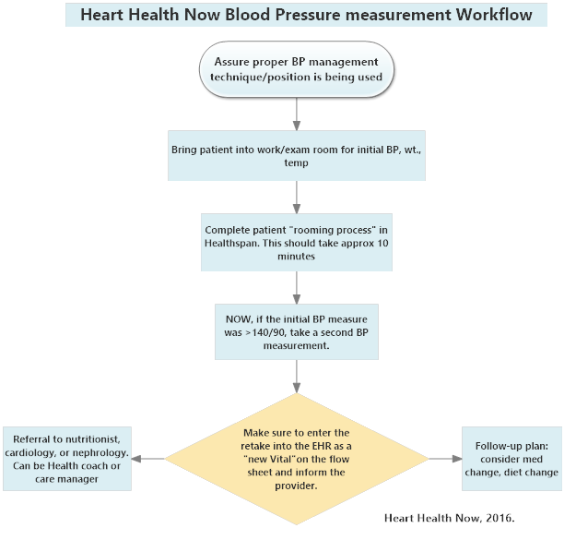

Appendix: B

MODIFIED HEART HEALTH NOW BLOOD PRESSURE GUIDELINE
If BP is < 140/90;
Implement patient education brochure. This includes disease, diet, and lifestyle modification
If BP is > 140/90;
Referral to Telehealth and include the patient education brochure
MODIFICATION

Make sure to enter the retake into the EHR as a “New Vital” on the flow sheet and inform the provider.
NOW, if the initial BP measure was > 140/90, take a second BP measurement.
Complete patient “rooming process” in Healthspan. This should take approx. 10 minutes
Bring patient into work/exam room for initial BP, wt., temp
Assure proper BP management technique/position is being used

Appendix C
King’s Theory of Goal Attainment

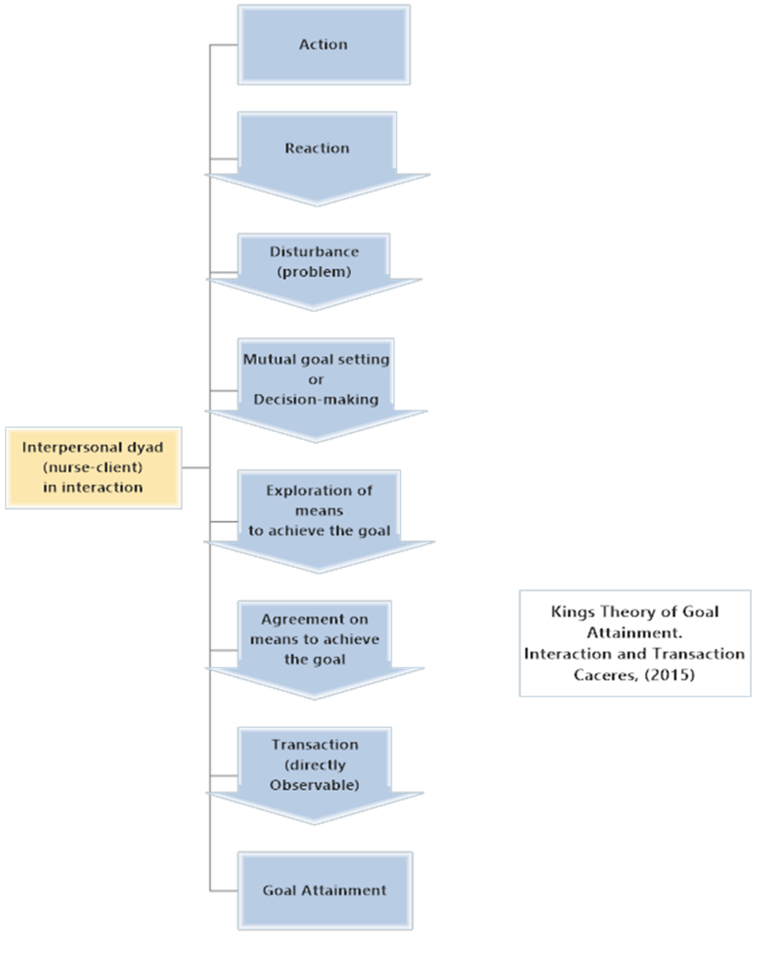
Appendix D
Literature Flow Chart
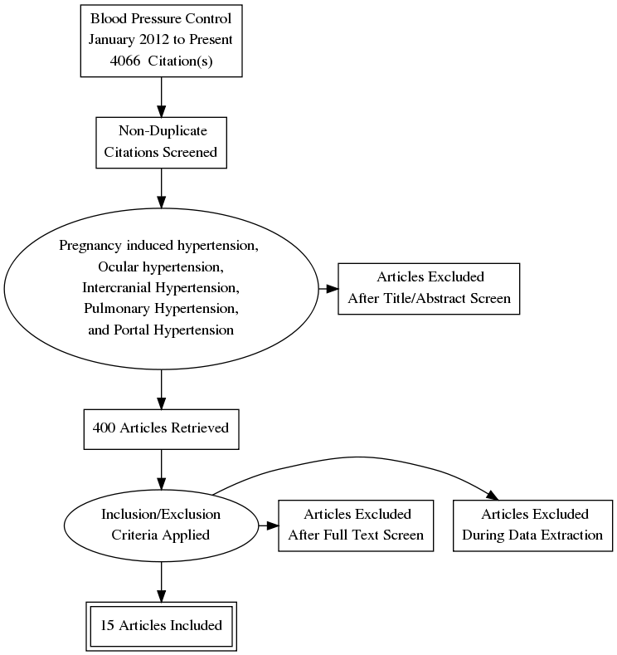

Appendix E
Literature Matrix
Student: | Course: | Faculty  Lead: | Date: | Project:
Article | Level of Evidence  (I to VII) | Data/  Evidence  Finding | Conclusion | Use of Evidence in EBP Project Plan  (Include your evaluation, strengths/Limitations, and  Relevance)
PubMed  Zhang, K., Eastwood, D., Ertl, K., & Whittle, J. (2016). Education attainment does not modify the effect of educational interventions on blood pressure control: A secondary analysis of data from a randomized trial. The Royal Society of Medicine, 7(8), 1-8. http://dx.doi.org/10.1177/2054270416654359 | Level 2 | Changes in blood pressure, weight, and physical activity were similar across education levels | Education interventions delivered by peers or professionals improved chronic disease management | Educational attainment does not modify the effect of educational interventions on blood pressure control.
Supplemental Evidence  Telehealth: Collaborating with patients to improve their health [Fact sheet]. (2012). Vidant Medical Center: Vidant Medical Center. | Level 7 | Telehealth provides a instant link to specially trained nurses who evaluate key information like your blood pressure, heart rate, weight and blood oxygen level | For blood pressure control, Telehealth is easy to use and information is evaluated by nurses to assist in the management of uncontrolled blood pressure | This program is a free service for provided by Vidant Health and the equipment is loaned to patients seen in a Vidant Health facility who need service.
PubMed  McKinstry, B., Hanley, J., Wild, S., Pagliari, C., Paterson, M., Lewis, S., ... Krishan, A. (2013, May 24). Telemonitoring based service redesign for the management of uncontrolled hypertension: Multicenter randomized controlled trial. British Medical Journal, 346(f3030), 1-25. http://dx.doi.org/10.1136/bmj.f3030  ed | Level 1 | Supported self-monitoring by telemonitoring is an effective method for achieving clinically important reduction in blood pressure | Can achieve a reduction in blood pressure with uncontrolled blood pressures in the primary care setting | Telemonitoring is a useful tool to assist patients with controlling blood pressure but is it cost effective for the primary care setting
PubMed  American Heart Association. (2016, November 29). Recommended dietary pattern to achieve adherence to the American Heart Association/American College of Cardiology (AHA/ACC) guidelines. Journal of Circulation, 134, e505-e529. http://dx.doi.org/10.1161/CIR.0000000000000462 | Level 1 | The AHA/ACC  Guideline on lifestyle management to reduce cardiovascular risks. | Patient/client tailored interventions that encourage self-monitoring of diet and physical activity levels is an effective strategy. | Adopting evidence-based diet and lifestyle behaviors to achieve cardiovascular health promotion and disease reduction goals
PubMed  Cobos, B., Haskard-Zoinierek, K., & Howard, K. (2015). White coat hypertension: improving the patient-health care practitioner relationship. Psychology Research and Behavior Management, 8, 133-141. http://dx.doi.org/10.2142/PRBM.S61192 | Level 5 | Ambulatory/Home  Blood pressuring monitoring may be the most effective method to diagnosing persistent increased blood pressures. | Home blood pressure monitoring is an effective way to diagnose uncontrolled HTN earlier. | Home blood pressure monitoring can diagnose uncontrolled blood pressure earlier and is an effective method in diagnosing HTN
PubMed  Donahue, K. E., Vu, M. B., Halladay, J. R., Miller, C., Garcia, B. A., & Cummings, D. M. (2014, April 24). Patient and Practice Perspectives on Strategies for Controlling Blood Pressure, North Carolina, 2010-2012. Preventing Chronic Disease, 11(130157). http://dx.doi.org/http://dx.doi.org.jproxy.lib.ecu.edu/10.5888/pcd11.130157 | Level 3 | Provider strategies to optimize blood pressure control should include regular visits, medication adjustment, side-effects, and behavioral counseling. | Regular visits, medication adjustments, medication side-effects and behavioral counseling can optimize blood pressure control | Developing a team approach to HTN treatment, patients value high quality communication and not losing their primary relationships with their provider
PubMed  Fortuna, R. J., Nagel, A. K., Rose, E., McCann, R., & Teeters, J. C. (2015, October 5, 2015). Effectiveness of a multidisciplinary intervention to improve hypertension control in an urban underserved practice. Journal of the American Society of Hypertension, 9, 966-974. http://dx.doi.org/10.1016/j.jash.2015.10.004 | Level 1 | Patient-centered multidisciplinary interventions offer one of the most promising strategies to improve blood pressure control | These findings are similar to findings in randomized control trails and large well-resourced systems | The use of a multidisciplinary team approach with theses clinical interventions resulted in a 30% improvement in HTN control.
PubMed  Halladay, J. R., Tillman, J., Hinderliter, A., Cummings, D. M., Donahue, K. E., Cene, C., ... Garcia, B. (2017, March/April). Practice level costs of office-based hypertension performance improvement: The heart healthy lenoir study. Journal of Healthcare Management/American College of Healthcare Executives, 62(2), 136-150. http://dx.doi.org/10.1097/JHM-D-17-00010 | Level 1 | Increased expenses for the family practice for home blood pressure measurements, can identify Hypertension or white coat hypertension | Family practices have limited funds. Home blood pressure measurements may be the “Gold Standard” but it is expensive for primary family practices. | This may be the “Gold Standard” for diagnosing HTN, but the costs associated with implementation, many family practices cannot afford.
PubMed  Handler, J., Mohan, Y., Kanter, M. H., Reynolds, K., Li, X., Nguyen, M., ... Koebnik, C. (2015, June). Screening for high blood pressure in adults during ambulatory nonprimary care visits: Opportunities to improve hypertension recognition. Journal of Clinical Hypertension, 17(6), 431-439. http://dx.doi.org/10.1111/jch.12517 | Level 1 | Because HTN is asymptomatic, expanding screening for HTN to non-primary care settings may improve HTN control | Identifying increased or normal blood pressures in the primary care office by accurate measurements is important | This study suggest that many patients identified with an initial high BP in primary care or in nonprimary care cannot be confirmed as patients with high BP in subsequent visits. Due to the increased portions of false positives by training staff BP standards to follow
PubMed  Ho, T. M., Estrada, D., Agudo, J., Arias, P., Capillas, R., Gilbert, E., ... Sole, J. (2016, July 26). Assessing the impact of educational interventions in patients with hypertension. Journal of Renal Care, 42(4), 205-211. http://dx.doi.org/10.1111/jorc.12165 | Level 3 | Patient education can be beneficial in the treatment of chronic diseases which showed a positive impact of educational interventions to improve the patient’s knowledge of HTN | Oral and written education interventions included the definition of HTN, causes of cardiovascular risk factors and means of control | This study did show a positive impact but further studies are needed to assess if these educational interventions will produce long term changes.
PubMed  Kravetz, J. D., & Walsh, R. F. (2016). Team-based hypertension management to improve blood pressure control. Journal of Primary Care and Community Health, 7(4), 272-275. http://dx.doi.org/10.1177/2150131916645580 | Level 3 | Proactive team-based care of hypertension including dietary changes, weight loss, exercise, smoking sensation, reduced alcohol consumption | Sixty-two percent of patients in the intervention group had lower SBP post interventions | Team effectiveness interventions approach management for the control of blood pressure
PubMed  Nikolic, S., Abhayaratna, W., Leano, R., Stowasser, M., & Sharman, J. (2013, May 30). Waiting a few extra minutes before measuring blood pressures has potentially important clinical and research ramifications. Journal of Human Hypertension, 28, 56-61. http://dx.doi.org/10.1038/jhh.2013.38 | Level 5 | Office BP measurements are recommended to be measured after 5 min of a seated rest, but may decrease for 10min of seated rest. | Waiting 10min compared to 5min is more representative of true BP control | This study showed if the BP after 5 min rest was considered, more participants would be classified as having uncontrolled BP, compared to 10 mi BP would be reclassified as in control BP
PubMed  Woolsey, S. (2014). Health IT Success Stories. Retrieved from http://www.healthit.gov/providers-professionals/dr-sara-woolsey uses health it to improve blood pressure control | Level 6/7 | Implementation of a blood pressure measurement standard for patients for controlling blood pressure | Three strategies used increased blood pressure in control | The percentage of the Community Health Center’s patients with diabetes with uncontrolled BP increased from 63% to 73% in one year.
PubMed  Fronczek, A. E., Rouhana, N. A., & Kitchin, J. M. (2017, June 21). Enhancing Telehealth Education in Nursing: Applying King’s Conceptual Framework and Theory of Goal Attainment. Nursing Science Quarterly, 3(3). https://doi.org/10.1177/0894318417708418 | Level 5 | Demonstrate skill using patient care technology, use of Telecommunication, and apply these technologies to the patient population. | King’s system based approach along with multiple collaboration in the personal, interpersonal, and social systems provide the strongest framework to develop educational innovations. | Technology is an increasing essential element of healthcare, it should not replace the nurse-patient relationship.
PubMed  Abdullah, A., Liew, S., Hanafi, N. S., Ng, C. J., Lai, P. S., Chia, Y. C., & Loo, C. K. (2016, January 27). What influences patients’ acceptance of a blood pressure telemonitoring service in primary care? A qualitative study. Dove Medical Press, 10, 99-106. http://dx.doi.org/10.2147/PPA.S94687 | Level 6 | Telemonitoring of home blood pressure is found to have a positive effect on BP control in offices of primary care | Patients found BP telemonitoring easy to use and found their home readings lower than the office readings | Patients found Telemonitoring easy to use, but did have some problems with the technical side of the device. Telemonitoring services in a primary care would need a well laid out plan for Telemonitoring
PubMed  De Leon-Demare, K., MacDonald, J., Gregory, DM., Katz, A., & Halas, G. (2015, March 5). Articulating nurse practitioner practice using King’s theory of goal attainment. Journal of the American Association of Nurse Practitioners, 27(11), 631-636. | Level 5 | Dyads of NP’s and their patients were video/audio taped for the purpose to study the interactions by using King’s theory | King’s theory was applicable to describe NP practice. | NP’s as practitioners need to be reflective of their own practice, embrace disturbances in the clinical encounter, and attend to these as opportunities for mutual goal setting.
PubMed  Park, M., Song, R., & Jeong, J. (2017, June). Effect of goal attainment theory based education program on cardiovascular risks, behavioral modification, and quality of life among patients with first episode of acute myocardial infarction: Randomized study. International Journal of Nursing Studies, 71, 8-16. https://doi.org/10.1016/j.ijnurstu.2017.02.019 | Level 5 | Behavioral modification strategies should be explored at the time of admission to lead the maximum effect of cardiovascular risk management, 2-year risk of cardiovascular disease was significantly reduced (p=0.142) | Applying a goal oriented education program at an early stage of hospital management improved and maintained healthy behaviors | Behavioral modification can reduce morbidity and mortality of cardiovascular disease. These strategies can be implemented by health professionals and should be explored further to maximize the effects of risk management.

Appendix F

Hypertension
Control
BLOOD PRESSURE MANAGEMENT EDUCATION


WHAT IS HIGH BLOOD PRESSURE?
High blood pressure (also called hypertension) is known as the "silent killer." This is because most of the time it doesn't cause symptoms. In fact, many people don't know they have it until other problems develop. In most cases, high blood pressure can't be cured. It's a disease that often requires lifelong treatment. The good news is that it can be managed.

UNDERSTANDING BLOOD PRESSURE
The circulatory system is made up of the heart and blood vessels that carry blood through the body. Your heart is the pump for this system. With each heartbeat (contraction), the heart sends blood out through large blood vessels called arteries. Blood pressure is a measure of how hard the moving blood pushes against the walls of the arteries.

HIGH BLOOD PRESSURE CAN HARM YOUR HEALTH
In a healthy blood vessel, the blood moves smoothly through the vessel and puts normal pressure on the vessel walls.
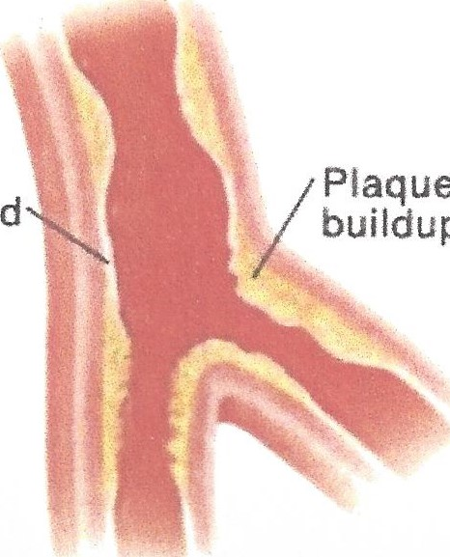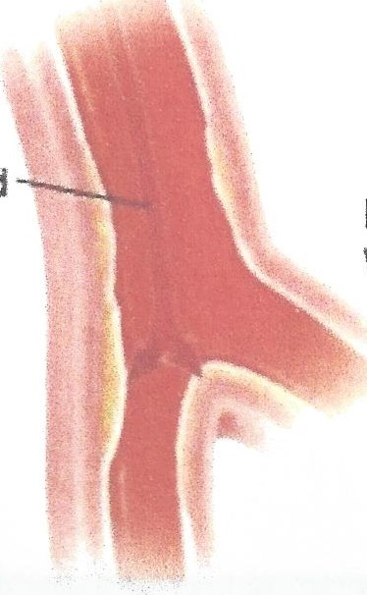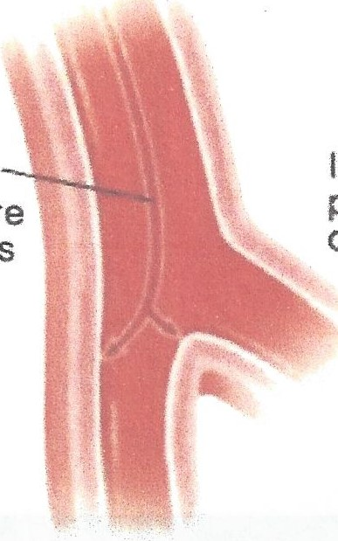Normal Pressure Increased pressure on wall Damaged wall and Plaque buildup
Plaque

High blood pressure occurs when blood pushes too hard against artery walls. This causes damage to the artery walls and then the formation of scar tissue as it heals. This makes the arteries stiff and weak. Plaque sticks to the scarred tissue narrowing and hardening the arteries. High blood pressure also causes your heart to work harder to get blood out to the body. High blood pressure raises your risk of heart attack, also known as acute myocardial infarction, or AMI, and stroke. I can also lead to kidney disease, and blindness.

RISK FACTORS YOU CAN CONTROL
There are plenty of risk factors for high blood pressure that you can control. Learn what these risk factors are and then find out how to reduce your risk. Check the ones that apply to you.

WHAT YOU EAT
Do you eat a lot of salty, fatty, fried, or greasy foods? Do you go to restaurants or eat out frequently?

[] ALCOHOL CONSUMPTION
Do you drink more than 1 drink a day if you are a female or more than 2 drinks a day if you male?

 IF YOU SMOKE OR SOMEONE CLOSE TO YOU SMOKES
Do you smoke cigarettes or cigars, chew tobacco, or dip snuff? Are you exposed to second-hand smoke on a regular basis?

HOW ACTIVE YOU ARE
Are you inactive most of the time at work and at home? Do you go weeks without exercising?
 YOUR WEIGHT
Has your doctor said that you are 15 or more pounds' overweight?

 YOUR STRESS LEVEL
Do you often feel anxious, nervous, and stressed? Do you feel that you don't have a supportive environment?
known as acute myocardial infarction, or AMI, and stroke. It can also lead to kidney disease, and blindness.

MEASURING BLOOD PRESSURE
An example of a blood pressure measurement is 120/70 (120 over 70). The top number is the pressure of blood against the artery walls during a heartbeat (systolic). The bottom number is the pressure of blood against artery walls between heartbeats (diastolic). Talk with your healthcare provider to find out what your blood pressure goals should be.
YOUR HIGH BLOOD
PRESSURE RISK FACTORS
Risk factors are things that make you more likely to have a disease or condition. Do you know your risk factors for high blood pressure? You can't do anything about some risk factors. But other risk factors are things that can be changed. Know what high blood pressure risk factors you have. Then find out what changes you can make to help control your risk for high blood pressure. Start with the change that you think will be easiest for you.

RISK FACTORS YOU CAN'T CONTROL
Though you can't change any of the things listed below, check off the ones that apply to you. The more boxes you check, the greater your risk for high blood pressure.

FAMILY HISTORY
 One or both of your parents or grandparents has had high blood pressure or heart disease.

GENDER AND AGE
 You're a man over age 55 or a postmenopausal woman.

CONTROLLING BLOOD PRESSURE
If your blood pressure is too high, work with your doctor on a plan for lowering it. Below are steps you can take that will help lower your blood pressure.
Choose heart-healthy foods, Eating healthier meals helps you control your blood pressure. Ask your doctor about the DASH eating plan. This plan helps reduce blood pressure by limiting the amount of sodium (salt) you have in your diet. DASH also encourages eating plenty of fruits and vegetables, low-fat or non-fat dairy, wholegrains, and foods high in fiber, and low in fat.
Reduce sodium. Reducing sodium in your diet reduces fluid retention. Fluid retention caused by too much salt increases blood volume and blood pressure. The American Heart Association's (AHA) "ideal" sodium intake recommendation is 1 ,500 milligrams per day. However, since American's eat so much salt, the AHA says a positive change can occur by cutting back to even 2,400 milligrams of sodium a day.
 Maintain a healthy weight. Being overweight makes you more likely to have high blood pressure. Losing excess weight helps lower blood pressure.
, Exercise regularly. Daily exercise helps your heart and blood vessels work better and stay healthier. It can help lower your blood pressure.
Stop smoking. Smoking increases blood pressure and damages blood vessels.
Limit alcohol. Drinking too much alcohol can raise blood pressure. Men should have no more than 2 drinks a day. Women should have no more than 1. (A drink is equal to 1 beer, or a small glass of wine, or a shot of liquor.)
Control stress. Stress makes your heart work harder and beat faster. Controlling stress helps you control your blood pressure.

EATING HEART-HEALTHY
FOOD: USING THE DASH PLAN

Eating for your heart doesn't have to be hard or boring. You just need to know how to make healthier choices. The DASH eating plan has been developed to help you do just that. DASH stands for Dietary Approaches to Stop Hypertension. It is a plan that has been proven to be healthier for your heart and to lower your risk for high blood pressure. It can also help lower your risk for cancer, heart disease, osteoporosis, and diabetes.

CHOOSING FROM EACH FOOD GROUP
Choose foods from each of the food groups below each day. Try to get the recommended number of servings for each food group. The serving numbers are based on a diet of 2,000 calories a day. Talk to your doctor if you're unsure about your calorie needs. Along with getting the correct servings, the DASH plan also recommends a sodium intake less than 2,300 mg per day.

GRAINS
Servings: 6 to 8 a day
A serving is:
I slice bread
1 ounce dry cereal
Half a cup cooked rice, pasta or cereal
Best choices: Whole grains and any grains high in fiber.

VEGETABLES
Servings: 4 to 5 a day A serving is:
I cup raw leafy vegetable
Half a cup cut-up raw or cooked vegetable
Half a cup vegetable juice
Best choices: Fresh or frozen vegetables prepared without added salt or fat.

FRUITS
Servings: 4 to 5 a day
A serving is:
I medium fruit
One-quarter cup dried fruit
Half a cup fresh, frozen, or canned fruit
Half a cup of 100% fruit juices
Best choices: A variety of fresh fruits of different colors. Whole fruits are a better choice than fruit juices.
LEAN MEATS,

POULTRY, FISH
Servings: 6 or fewer a day
A serving is:
I ounce cooked meats, poultry, or fish
I egg
Best choices: Lean poultry and fish. Trim away visible fat. Broil, grill, roast, or boil instead of frying. Remove skin from poultry before eating. Limit how much red meat you eat.

FATS AND OILS
Servings: 2 to 3 a day A serving is:
I teaspoon soft margarine
I tablespoon mayonnaise
2 tablespoons salad dressing
Best choices: Nut and vegetable oils (non-tropical vegetable oils), such as olive and canola oil.
—For more on the DASH eating plan, visit:
www.nhlbi.nih.gov/health/health-topics/topics/dash

LOW-FAT OR FAT-FREE DAIRY
Servings: 2 to 3 a day
A serving is:
I cup milk
I cup yogurt
One and a half ounces' cheese
Best choices: Skim or 1% milk, low-fat or fat-free yogurt or buttermilk, and low-fat cheeses.

NUTS, SEEDS, BEANS
Servings: 4 to 5 a week
A serving is:
One-third cup nuts (one and a half ounces)
2 tablespoons nut butter or seeds
Half a cup cooked dry beans or legumes
Best choices: Dry roasted nuts with no salt added, lentils, kidney beans, garbanzo beans, and whole pinto beans.

SWEETS
Servings: 5 a week or fewer
A serving is:
I tablespoon sugar, maple syrup, or honey I tablespoon jam or jelly
I half-ounce jelly beans (about 1 5)
I cup lemonade
Best choices: Dried fruit can be a satisfying sweet.
Choose low-fat sweets. And watch your serving sizes!

MANAGING HIGH BLOOD

PRESSURE WITH THE DASH DIET
What you eat can help lower your blood pressure and reduce your risk for stroke and heart disease.
One such diet, the Dietary Approaches to Stop Hypertension (DASH) diet, has been shown to reduce blood pressure. This diet is low in saturated fat, cholesterol, and total fat. The diet emphasizes fruits, vegetables, and low-fat dairy products.
According to the National Heart, Lung, and Blood Institute (NHLBI), your blood pressure can be unhealthy even if it stays only slightly above 120/80 mm Hg. The higher above that level, the greater your health risk. Over time, high blood pressure makes your heart work too hard. This can cause stroke, heart disease, kidney disease, and even blindness.

WHY THIS DIET WORKS
Why is the DASH diet so effective at reducing blood pressure? It combines many nutrients that have been shown to help reduce blood pressure. Those nutrients include calcium, potassium, magnesium, protein, and fiber, as well as lower total fat and saturated fat.
The DASH diet is naturally low in salt. The DASH diet recommends menus containing 2,300 mg of sodium. The lower sodium DASH diet contains up to 1 ,500 mg of sodium a day. (One teaspoon of salt contains 2,300 mg of sodium.)
Further, following the DASH diet may delay your need to take blood pressure lowering medicine, and may even keep you from needing to take it at all. And if you ^{t}re already on medicine, it may help you reduce the amount you take.

DOING THE DASH
The DASH diet is a 2,000-calorie diet that includes:
Six to 8 daily servings of grains and grain products, such as whole wheat bread, cereal, oatmeal, crackers, unsalted pretzels, and popcorn. A serving size is 1 slice of bread, 1 cup of ready-to-eat cereal, or a half-cup of rice, pasta, or cereal.
Four to 5 daily servings of vegetables — the darker in color, the better. A serving size is 1 cup of raw leafy vegetables, a half-cup of cooked vegetables, or 6 ounces of vegetable juice.
- Four to 5 daily servings of fruit. A serving is 1 medium fruit, quarter-cup of dried fruit, half-cup of fresh, frozen or canned fruit, or 6 ounces of fruit juice.
Two or 3 daily servings of low-fat or fat-free dairy products. A serving is 8 ounces of milk, 1 cup of yogurt, or 1% ounces of cheese.
- Six or fewer daily servings of lean meat, poultry, or fish. A serving is 1 ounce of cooked meats, skinless poultry, or fish.
Four to 5 servings per week of nuts, seeds, and dry beans. A serving is one-third cup or 1% ounces of nuts, 1 tablespoon or half-ounce of seeds, or half-cup cooked dried beans.
Two to 3 small daily servings of fats and oils like olive oil and low-fat salad dressing. A serving is 1 teaspoon soft margarine, 1 tablespoon low-fat mayonnaise, 2 tablespoons light salad dressing, or 1 teaspoon vegetable oil.
- Five or fewer servings per week of sweets like maple syrup, sorbet, or gelatin. A serving is 1 tablespoon sugar, 1 tablespoon jelly or jam, half-ounce jellybeans, or 8 ounces of lemonade.
Although the DASH diet isn't designed for weight loss, it can promote it if you reduce the number of servings you eat. Most of the food the diet features is big on volume and low in calories.
Still, there are parts of the DASH diet that may not be easy to follow. For one, it's packed with dark-colored fruits and vegetables, so be prepared to be choosier at the supermarket. Also, if it's very different from what you normally eat, it may be hard to adjust.
If you're serious about following the diet, it's a good idea to work with a registered dietitian (R.D.) for support and guidance. (For the names of R.D.s in your area who know about the DASH diet, visit the Academ of Nutrition and Dietetics.)

MOVING FORWARD
If you decide to go it alone, adopt the DASH diet gradually. By doing so, you'll be more likely to stick to it long-term. For example, add 1 more serving of vegetables at lunch and dinner if you eat only 1 or 2 servings a day now. You might also add fruit to meals and snacks if you now only have juice for breakfast. In addition, slowly increase your dairy products to 3 servings per day. Try drinking skim milk with lunch or dinner, instead of soda, alcohol, or tea.
To get the most out of the DASH, lose weight if you need to and exercise regularly. Thirty to 40 minutes of moderate to vigorous intensity aerobic exercise 4 to 5 days a week is recommended.

MORE DISH ON THE DASH
"The DASH Eating Plan" is a 24-page online guide published by the NHLBI. It offers a reader-friendly explanation of high blood pressure, detailed daily servings charts to help you plan your menus, a week of suggested DASH menus, plus tips to reduce sodium.
For more information about diet and other lifestyle factors to reduce hypertension, visit Your Guide to Lowering Blood Pressure.

EXERCISE FOR A HEALTHIER HEART
You may wonder how you can improve the health of your heart. If you're thinking about exercise, you're on the right track. You don't need to become an athlete, but you do need a certain amount of brisk exercise to help strengthen your heart. If you have been diagnosed with a heart condition, your doctor may recommend exercise to help stabilize your condition. To help make exercise a habit, choose safe, fun activities.
Exercise with a friend. When activity is fun, you're more likely to stick with it.
Be sure to check with your healthcare provider before starting an exercise program.
WHY EXERCISE?
Exercising regularly offers many healthy rewards. It can help you do all the following:
Improve your blood cholesterol level to help prevent further heart trouble
Lower your blood pressure to help prevent a stroke or heart attack
Control diabetes, or reduce your risk of getting this disease Improve your heart and lung function
, Reach and maintain a healthy weight
Make your muscles stronger and more limber so you can stay active
Prevent falls and fractures by slowing the loss of bone mass (osteoporosis)
Manage stress better
Reduce your blood pressure
Improve your sense of self and your body image

EXERCISE TIPS
Ease into your routines. Set small goals. Then build on them.
Exercise on most days. Aim for a total of 150 or more minutes-of moderate to vigorous intensity activity each week. Consider 40 minutes, 3 to 4 times a week. For best results, activity should last for 40 minutes on average. It is OK to work up to the 40-minute period over time. Examples of moderate-intensity activity is walking 1 mile in 15 minutes or 30 to 45 minutes of yard work.
Step up your daily activity level. Along with your exercise program, try being more active throughout the day. Walk instead of drive. Do more household tasks or yard work.
Choose one or more activities you enjoy. Walking is one of the easiest things you can do. You can also try swimming, riding a bike, dancing, or taking an exercise class,
STOP EXERCISING AND CALL YOUR DOCTOR IF YOU:
Have chest pain or feel dizzy or lightheaded
Feel burning, tightness, pressure, or heaviness in your chest, neck, shoulders, back, or arms
Have unusual shortness of breath
Have increased joint or muscle pain
Have palpitations or an irregular heartbeat

Approved by the Quality Oversight Committee
September 2016
Revised: April 2016
Copyright 2000-2017 The StayWell Company, LLC

Appendix G
Telehealth
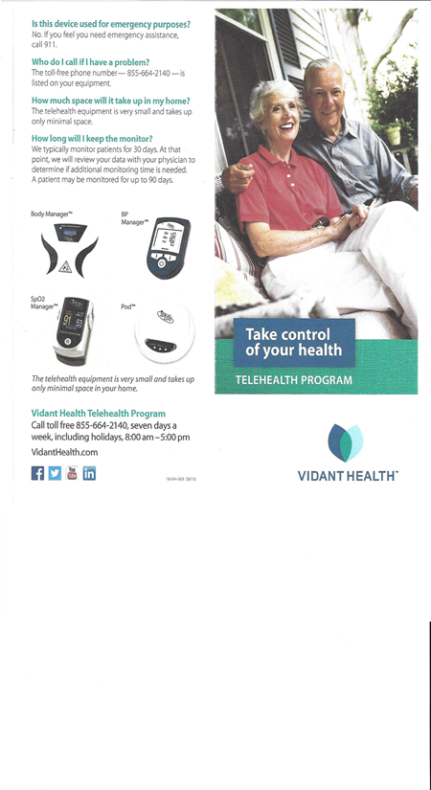

Appendix G

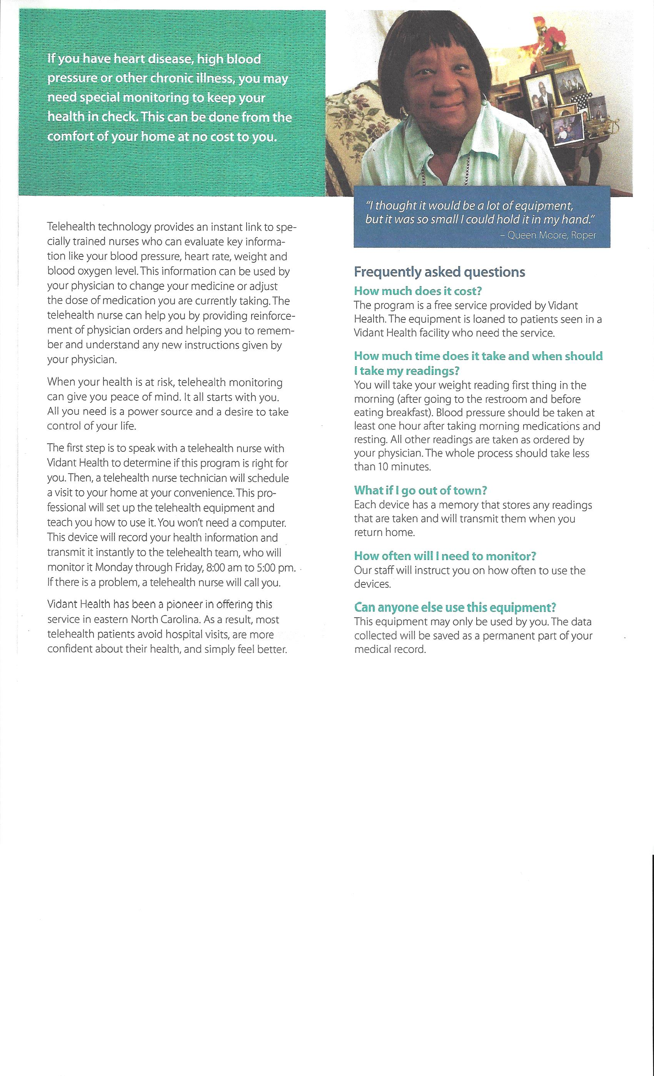

Appendix H
Excel Spreadsheet Analysis
Department of Quality

Appendix I
Template: PDSA Worksheet
Objective:_______________________________________________________________________________________________________________________________________________________________________________________________________________
- Plan: Plan the test, including a plan for collecting data. Questions and predictions:
•___________________________________________________________________________________________________________________________________________________________________________________________________________
Who, what, where, when: ____________________________________________________________________________________________________________________________________________________________________________________________________________
Plan for collecting data:
___________________________________________________________________________________________________________________________________________________________________________________________________________
2. Do: Run the test on a small scale.
Describe what happened. What data did you collect? What observations did you make? __________________________________________________________________________________________________________________________________________________________________________________________________________
3. Study: Analyze the results and compare them to your predictions.
Summarize and reflect on what you learned: __________________________________________________________________________________________________________________________________________________________________________________________________________
4. Act: Based on what you learned from the test, make a plan for your next step.
Determine what modifications you should make — adapt, adopt, or abandon:
____________________________________________________________________________________________________________________________________________________________________________________________________________

Appendix J

Appendix K
Project Manager’s Staff Compliance Tool

Appendix M
IRB

EAST CAROLINA UNIVERSITY
Office of Research Integrity and Compliance (ORIC)
University & Medical Center Institutional Review Board (UMCIRB)
Brody Medical Sciences Building, 4N-70• 600 Moye Boulevard • Greenville, NC 27834
Office 252-744-2914, Fax 252-744-2284 www.ecu.edu/irb
TO: | Anderson Williamson, ECU College of Nursing, DNP Program
FROM: | Office of Research Integrity & Compliance
DATE: | July 20, 2017  Doctor of Nursing Practice (DNP) Scholarly Project
TITLE: | Implementation of Evidence-Base Blood Pressure Management Program to Improve Blood Pressure
in Control

This activity has undergone review on 7/20/2017 by the ORIC. A Doctor of Nursing Practice candidate is planning a quality improvement project that will be conducted at Vidant Family Medicine in Washington, NC. The purpose of this project is to implement an evidence based guideline to improve blood pressure control at this site. Staff will be educated on the new guidelines for standardizing blood pressure measurements, patient education and referral to Telehealth program. Patient data will be tracked to determine whether improvements in blood pressure control and other benchmarks have occurred. Vidant Medical Group has determined this project to be a quality improvement initiative that does not require IRB review and the ORIC agrees.
This activity is deemed outside of UMCIRB jurisdiction because it does not meet the current federal descriptions for human subject research. Therefore, this activity does not require UMCIRB approval. Contact the office if there are any changes to the activity that may require additional UMCIRB review or before conducting any human research activities.
Relevant Definitions for Human Subject Research:
- Research means a systematic investigation, including research development, testing and evaluation, designed to develop or contribute to generalizable knowledge. Activities which meet this definition constitute research for purposes of this policy, whether or not they are conducted or supported under a program which is considered research for other purposes. For example, some demonstration and service programs may include research activities
- Human subject means a living individual about whom an investigator (whether professional or student) conducting research obtains:
- Data through intervention or interaction with the individual, or
- Identifiable private information.
The UMCIRB applies 45 CFR 46, Subparts A-D, to all research reviewed by the UMCIRB regardless of the funding source. 21 CFR 50 and 21 CFR 56 are applied to all research studies under the Food and Drug Administration regulation. The UMCIRB follows applicable International Conference on Harmonization Good Clinical Practice guidelines.
IRB00000705 East Carolina U IRB (Biomedical) IORG0000418
IRB00003781 East Carolina U IRB #2 (BehavioraVSS) IORG0000418

Appendix N
Budget Spreadsheet

Appendix O
Template: PDSA Worksheet (Week 4)
Objective: When patients are referred to Telehealth during the office discharge process and with general education was provided on the Telehealth service. Continue the referral and give Telehealth the opportunity to explain their detailed services and how it works for a more comprehensible informed decision. If they continue to refuse the service, Telehealth will inform the practice of the refusal to allow the practice to schedule a follow-up appointment in the office.
- Plan: Plan the test, including a plan for collecting data. Questions and predictions:
The clinical lead nurse and the providers will continue to educate patients about their disease and offer Telehealth to monitor their blood pressures at home, reiterating that the service is free. Also, will inform the patient that Telehealth can offer a better understanding of their service.
Who, what, where, when:
This information will be shared by the provider during the office discharge process.
Plan for collecting data:
Telehealth will be informed of patient reluctance to use Telehealth. Telehealth will email or call if patient refuses services.
2. Do: Run the test on a small scale.
Describe what happened. What data did you collect? What observations did you make?
One patient was reluctant to use Telehealth, but when Telehealth explained their services, to patient decided to use Telehealth for blood pressure monitoring
3. Study: Analyze the results and compare them to your predictions.
Summarize and reflect on what you learned:
Patient should have all the information about their care interventions to make an informed consent. The more a patient is involved with their care, improvements to their disease can be accomplished.
4. Act: Based on what you learned from the test, make a plan for your next step.
Determine what modifications you should make — adapt, adopt, or abandon:
Providers and the clinical lead nurse will continue to provide the best possible plan to assist patients in blood pressure control. Patients will be given the opportunity to refuse after Telehealth has explained their services.

Appendix P
Template: PDSA Worksheet (Week 9)
Objective: Blood Pressure results sent by Telehealth are being missed by the providers. There were no communication standards utilized between the departments. Blood pressure results sent by Telehealth were in the patient health record but providers were having problems finding this information to evaluate and treat uncontrolled hypertensive patients. This communication problem led to delays in patient care. The overall objective was to provide a standard to communicate these results from Telehealth.
- Plan: Plan the test, including a plan for collecting data. Questions and predictions:
The plan involved telephone communication between the clinical lead nurse and Telehealth to discuss ways to send this information to the providers for evaluation. The plan was for Telehealth to call the office if they see an increased blood pressure trend with no provider intervention. This phone call will alert the provider of the patients increased blood pressure. Telehealth would send this information via email to the clinical lead nurse for a second follow-up method.
Who, what, where, when:
Involved in this process was the clinical lead nurse, project manager, Telehealth representative, and the organization department of quality. Telephone, and email communication was the primary intervention.
Plan for collecting data:
Weekly meetings with the clinical lead nurse was initiated to review how the process was working.
2. Do: Run the test on a small scale. Describe what happened. What data did you collect? What observations did you make?
Weekly meetings with the clinical lead nurse indicated Telehealth blood pressure results were being sent via email to the clinical lead nurse and she had received phone calls from Telehealth for information verification. The providers began to receive blood pressure results in a timely manner.
3. Study: Analyze the results and compare them to your predictions.
Summarize and reflect on what you learned:
System failures can be problem when departments cannot communicate. Not having control when patient care is involved is frustrating for both departments. Providing a plan assisted both departments.
4. Act: Based on what you learned from the test, make a plan for your next step.
Determine what modifications you should make — adapt, adopt, or abandon:
This plan was adopted during the 12-week implementation. Information from the organization department of quality indicated a plan for computer interface in the summer. This plan developed will continue to as a standard until the interface in done. Telehealth will continue to send results to the clinical lead nurse via email and telephone communication will continue between departments.

Appendix Q
Telehealth Patient Result

