The Effect of an Orientation Video in the Pediatric Emergency Department

Mackenzie Hauser-Crews
College of Nursing, East Carolina University
Doctor of Nursing Practice Program
Dr. Megan Dillon
July 30, 2023

Table of Contents
Abstract…………….....………………………………………………….…………………….… 4
Section I: Introduction..………………………………………………….…………………….… 5
Background………………………………………………………………………….…… 5
Organizational Needs Statement……………………………………………………….….5
Problem Statement………………………………………………………………………...8
Purpose Statement…………………………………………………………………………8
Section II: Evidence……………………………………………………………………………….9
Literature Review………………………………………………………………….………9
Evidence-Based Practice Framework……………………………………………………15
Ethical Consideration and Protection of Human Subjects……………………………….16
Section III. Project Design……………………………………………………………………….18
Project Site and Population………………………………………………………………18
Project Team……………………………………………………………………………..20
Project Goals and Outcome Measures…………………………………………...………21
Implementation Plan…………………………………………………………………..…22
Timeline………………………………………………………………………………….24
Section IV. Results and Findings………………………………………………………………...24
Results……………………………………………………………………………………25
Discussion of Major Findings……………………………………………………………25
Section V. Interpretation and Implications………………………………………………………26
Costs and Resource Management………………………………………………………..26
Implications of the Findings……………………………………………………………..27
Sustainability……………………………………………………………………………..29
Dissemination Plan………………………………………………………………………30
Section VI. Conclusion…………………………………………………………………………..30
Limitations and Facilitators……………………………………………………………...30
Recommendations for Others……………………………………………………………33
Recommendations for Further Study……………………...……………………………..33
Final Thoughts…………………………………………………………………………...34
References……………………………………………………………………………….……....35
Appendices………………………………………………………………………………………40
Appendix A: Literature Search Log…………...………………………………………...40
Appendix B: Literature Matrix.……………………………………………….…………41
Appendix C: Orientation Video Script….……………………………………….………43
Appendix D: Microsoft Teams Survey……………………...…………………………...45
Appendix E: Orientation Video Flyer …………………………………………….……..46
Appendix F: Staff Email………………………………………...……………………….47
Appendix G: Itemized Budget……………………………………….…………………..48
Appendix H: Monthly Patient Satisfaction Scores…………………..……………….….49

Abstract
Health systems’ reimbursement funding is highly influenced by patient satisfaction scores. Communication and availability of information are two of the common themes contributing to lower than optimal patient satisfaction scores in this organization’s pediatric emergency department. Up to date research recommends the use of an orientation video to aid in increasing communication and patient satisfaction during emergency department visits. The aim of the orientation video is to provide parents and caregivers with information and expectations during the visit while showcasing the functionality of the department and roles of various personnel in an academic medical center. The goal was to improve patient satisfaction scores with the implementation of the orientation video in the waiting room, triage rooms, and exam rooms.
Keywords: patient satisfaction, orientation video, communication, emergency department, parents/caregivers

Section I. Introduction
Background
Improving patient experiences contributes to an array of benefits for patients and healthcare systems, such as enhanced health outcomes, greater employee satisfaction, reduced medical malpractice risk, and higher reimbursement funding (Agency for Healthcare Research and Quality [AHRQ], 2020a). A large academic medical center in the central piedmont of North Carolina has prioritized the need to improve patient satisfaction scores in the pediatric emergency department. The health system is among the largest non-profit healthcare organizations in the United States. The organization’s mission is to achieve patient expectations and provide a safe environment for care through a patient- and family-centered approach (Atrium Health Wake Forest Baptist, n.d.-a). The pediatric emergency department is a 24-bed level I trauma center with access to 120 pediatric specialists. The department is committed to providing high-quality care and includes specialized staff caring for children with emergent medical needs (Brenner Children’s, n.d.).
Organizational Needs Statement
In October 2020, another renowned system invested $3.4 billion in this organization, including the prestigious medical school to join as a single enterprise with a mission to create a new era of healthcare (Atrium Health, 2020). This new healthcare system prioritizes high-quality patient care, medical education opportunities, and innovative research. Approximately 7 million people across the region benefit from this investment and the positive impact on clinical, research, and educational capabilities. The new enterprise plans to revolutionize healthcare by establishing the next generation of clinical excellence, growing the medical education program, and developing patient-centered research and innovation (Atrium Health, 2020).
Since the two organizations combined, there has been a big push to improve satisfaction scores (Assistant Nurse Manager, personal communication, June 29, 2022). Patient satisfaction scores significantly influence hospital reimbursement through the Hospital-Value Based Purchasing Program. According to Centers for Medicare & Medicaid Services [CMS] (2015), in 2016, an estimated $1.5 billion in value-based incentive payments was available to hospitals. Among other key factors, those with higher scores received higher reimbursement amounts, while those with lower scores were penalized. Therefore, low satisfaction scores can enormously hinder Medicare reimbursement funding and the organization’s reputation among consumers (Centers for Medicare & Medicaid Services [CMS], 2021b). Mandates require the organization to publicly report patient satisfaction scores measured by The Hospital Consumer Assessment of Health Providers and Systems (HCAHPS) surveys (CMS, 2021a). This organization utilizes a patient experience company, National Research Corporation (NRC) Health, to administer HCAHP surveys by contacting patients and gathering consumer satisfaction data (Assistant Nurse Manager, personal communication, June 29, 2022).
NRC Health is available through a subscription service to health systems and is one of the largest healthcare market insight databases to assess patient satisfaction. In 3 years, the benchmark database surveyed “more than two million consumer voices from 300,000 American households, which were sources from more than 580 healthcare organizations across the United States” (NRC Health, 2021, para 2). As a result, NRC real-time benchmarking is valuable for comparing patient satisfaction scores of similar subscribing organizations. NRC Health uses a metric called Net Promoter Score (NPS) to measure patient experience. The organization’s NPS score maintained state and national averages of 72 in 2020. In 2021, NPS scores increased above the state average and achieved the national average with a score of 73 (Atrium Health Wake Forest Baptist, 2022; CMS, 2022). According to NRC Health’s real-time analysis (2022), the organization’s pediatric emergency department’s annual NPS score from July 2021 to July 2022 was 70.7. This rating compares NRC Health’s state benchmark for pediatric emergency departments with an annual NPS score of 69.4. However, the organization’s pediatric emergency department’s NPS score dropped to 53.7 between May 2022 and July 2022 (NRC Health, 2022b). Significantly reduced NPS scores during this time frame raise concern about implementing change and improving patient satisfaction.
The need to improve patient experience intersects directly with the Institute for Healthcare Improvement’s (IHI) Triple Aim. The Triple Aim is an approach to achieving successful health system performance by optimizing the health of the population served, reducing per capita cost, and delivering high-quality patient care. Therefore, patient experience is among the highest priorities for top-performing hospitals and health organizations (Institute for Healthcare Improvement [IHI], 2022a). Similarly, Healthy People 2030’s goal to improve health care coincides with the organization’s need to improve patient satisfaction. Healthy People 2030 (2022) states that effective communication between patients and healthcare providers benefits healthcare delivery and patients’ overall health and well-being. In addition, the organization’s need to improve patient satisfaction aims to achieve Healthy North Carolina 2030’s goals of attaining health literacy and promoting statewide leadership to improve access, delivery, and achievement of optimal health (Colville, 2021).
Recent studies indicate various benefits of incorporating videos into healthcare settings. According to Abass et al. (2021), low-cost interventions that improve patient interactions and communication, such as videos, facilitate understanding of wait times and help clarify certain perceptions, ultimately improving patient satisfaction. Lavaerts et al. (2021) add that videos presented in a radiology department waiting room helped increase patient knowledge about the department and process while clarifying misconceptions, reducing anxiety, and positively impacting the overall experience. Although informational videos in a tertiary pediatric emergency department lacked significant effects on patient satisfaction, there was a great improvement in new patient perceived knowledge (Baskwill & Sumpton, 2015). Another study found that 75% of the participants preferred a video rather than written information, while all participants encouraged informative videos in the waiting room of the pediatric emergency room (Fissler & Ryan, 2016). Papa et al. (2008) state that using a video in an emergency department’s waiting room to discuss the process and prepare patients for their experience ultimately improves patient satisfaction. However, there is a need for further research on implementing introductory videos in the waiting room of emergency departments.
Problem Statement
The pediatric emergency department patient satisfaction scores, as reported by NRC Health, consistently indicate a need for improvement. Two criteria that consistently score low are the availability of information and communication.
Purpose Statement
The purpose of this project is to develop a Pediatric Emergency Department introduction video to provide patients and families with information and expectations of the visit. This will include the functionality of the emergency department and the roles of the various personnel in an academic medical center.

Section II. Evidence
Literature Review
Patient satisfaction scores are complex and multifaceted measurements of healthcare quality. Multiple intrinsic and extrinsic factors influence individuals’ overall healthcare experiences. In addition, patient satisfaction scores heavily influence a health system’s reputation, health outcomes, and eligibility for government reimbursements. Therefore, health organizations are becoming more active and innovative in improving patient satisfaction scores. This section of the paper focuses on analyzing literature to mitigate patient satisfaction and discusses the initial steps to implementing an introduction video in an urban pediatric emergency department.
The search process started by utilizing the university’s health sciences search database, One Search (see Appendix A). Narrow search terms such as pediatric, emergency departments, introduction, video, and waiting room were originally explored. This search yielded five results: one innovative article aiming to improve patient satisfaction in an emergency department using an orientation video. This article created the foundation for future searches. The additional four articles addressed patient satisfaction using informative videos in various healthcare waiting rooms. However, two of the sources were not limited to five years.
Next, the literature search was enhanced by the Scopus database. This database further showcased relevant articles with the use of forward-searching. This technique was used to identify articles that cited the sentinel article during publication. The search produced 37 findings that were then reduced to 8 articles by a five-year limitation. In addition, two valuable articles discussed various interventions geared towards enhancing patient or parent experiences and knowledge. The Cumulative Index to Nursing and Allied Health Literature (CINAHL) database was also utilized. However, no articles met the search criteria of a five-year limitation and diverse word combinations such as “emergency department “waiting room,” “pediatric emergency” “patient satisfaction,” and “academic medical center” “patient satisfaction.” Fortunately, five-year limitations and diverse Boolean phrases aided in a precise and productive search in the PubMed database. Many phrases yielded minimal or no results. However, phrases specific to patient satisfaction and emergency departments with a five-year limitation generated five beneficial research articles showcasing the most common patient satisfaction influences, prompting the need for intervention. The majority of articles’ levels of evidence ranged from I-IV with one level VII article. For instance, most studies were cross sectional, observational, quasi-experimental, retrospective cohort, or randomized control trials. The results from the literature search were combined into an Excel spreadsheet to gather useful information and reference during the literature review process (see Appendix B).
Current State of Knowledge
There is no gold standard to address patient satisfaction in healthcare as each patient experience is unique and influenced by many factors within the visit. Therefore, no literature outlines practice guidelines to meet patient satisfaction expectations in any healthcare setting. The development of guidelines is even more limited for pediatric emergency departments. Emerson et al. (2021) explain that patient satisfaction in emergency departments is complex due to unforeseen circumstances, overcrowding, and unestablished relationships between staff and patients. Therefore, patient satisfaction scores in pediatric emergency departments are more challenging to account for patient and caregiver perspectives (Emerson et al., 2021).
However, research suggests implementing interventions to optimize communication as it significantly influences patient satisfaction in emergency departments, including the pediatric population. According to Villalona et al. (2020), effectiveness and communication approaches largely influence patient satisfaction ratings. For instance, negative patient experience ratings strongly correlate with a lack of understanding of emergency department procedures and functionality (Villalona et al., 2020). The gap in communication raises great opportunities and demand for interventions.
Current Approaches to Solving Population Problem
According to Abass et al. (2021), the patient’s outlook on healthcare and individual experience significantly improves when staff develops strong interpersonal communication with patients and parents. Analyzing patient satisfaction scores in the emergency department is crucial, as 28% of the United States population’s acute care needs are conducted in that setting (Abass et al., 2021). Therefore, multiple intervention modalities are studied to compact the multifactorial approach to patient satisfaction in emergency departments.
An emergency department in an academic military hospital incorporated hourly rounding by nurses to increase communication and improve low satisfaction scores (Brosinski & Riddell, 2020). The study occurred over 23 months and was divided into four phases. A 5-point Likert scale was used to measure patient satisfaction, perception of staff attitude, and whether patient questions and concerns were adequately addressed. The Likert scale used 5-point answer choice, ranging from ‘not at all’ to ‘very helpful.’ The range of answer choices helped gauge the strength of the respondent’s answer. The project required weekly meetings, 5-minute customer service training sessions, and daily self-reporting of rounding. However, the study struggled to reach staff buy-in, was limited by staffing shortages, and competed with nurses’ time performing clinical tasks. Project coordinators reported difficulty measuring and determining the accuracy of rounding compliance. Brosinski & Riddell (2020) report that hourly rounding compliance was limited to 39%-51% during both intervention phases. The study reported 1,046 patient satisfaction responses, representing less than 0.01% of the population served by this emergency department during the period. The low response rate was attributed to limited nurse compliance and engagement, extensive construction in the department during the study, and failure to refill bins with response forms and keep response kiosks in service. Nonetheless, according to Brosinski & Riddell (2020), hourly rounding yielded an estimated 20% increase in patient satisfaction despite poor study participation. In addition, the perception of staff attitude and reports of appropriately answered questions improved with hourly rounding. However, future research must explore a reliable method to monitor staff compliance consistently and accurately.
Recent research findings support using technology to communicate and provide patients with information in emergency departments. One study evaluated the application of a queue management system designed to improve patient satisfaction in the waiting room of an academic emergency department (Bidari et al., 2021). The study consisted of 236 parents of pediatric patients presenting with low-acuity conditions. The study showed that perceived wait times were significantly lower compared to the actual wait times for those subject to the queue management system. Bidari et al. (2020) report that the intervention group showed higher satisfaction ratings than the control group. Additionally, Reid et al. (2017) aimed to understand parental awareness and response to informative presentations showcased in the waiting room of a pediatric emergency department in Canada. The presentation included information regarding existing wait times, the triage process, and common health concerns such as fever, earache, abdominal pain, and head injury. Although nearly 70% of parents were aware of the presentation, only 33% could watch the full 20-minute video. Overall, most parents reported improvement in satisfaction due in part to the presentation (Reid et al., 2017).
Ultimately, patient experience has proven to be an important indicator of patient outcomes. For example, an urban pediatric emergency department within an academic medical center with nearly 40,000 annual level 1 trauma patients implemented a quality improvement project to improve patient satisfaction (Emerson et al., 2021). As a result, the department leaders created a multidisciplinary team that identified the need to incorporate nine interventions: staff huddles, multidisciplinary improvement group, leadership rounding, updated communication boards, regular waiting room rounding, standardized communication approaches, development of mentors, standardized scripts, and follow-up feedback emails. Emerson et al. (2021) conclude that a multidisciplinary approach can improve patient experience in pediatric emergency departments as ratings increased from 86.1% to 89.8%.
Similarly, Fissler & Ryan (2016) conducted a small study in a pediatric emergency department using a series of informative videos. The videos aimed to educate parents on managing common pediatric illnesses in the home to reduce emergency department visits. Study feedback included responses from both patients and parents. Results showed that 75% of respondents prefer video information over written options and the use of a website or mobile phone application. Additionally, 100% of the 24 participants support informative videos in the pediatric emergency department, and 83% encourage adding videos to the series. Suggestions were also made to include options for sign language and other languages (Fissler & Ryan, 2016).
Furthermore, informative videos have also been used in other areas of healthcare to enhance patient experiences. For example, an older study used an informational video to educate patients on treatment expectations for healthcare-related massage therapy. The study produced increased patient knowledge but did not achieve increased satisfaction ratings (Baskwill & Sumpton, 2015). Another study evaluated the implementation of a 2-minute video with patient instructions during magnetic resonance imaging (MRI) to reduce procedural anxiety (Alghamdi et al., 2022). The video was shown to the patients in the waiting room approximately 30 minutes before the scan. Unfortunately, Alghamdi et al. (2022) state that the information video increased anxiety for some female patients, patients with higher education levels, and patients with a history of a previous MRI.
Evidence to Support the Intervention
According to Hassan et al. (2016), healthcare waiting rooms operate as an opportunistic setting to educate and involve patients. Many patients are unaware of how the emergency department functions and are interested in learning the processes. Although a study performed in an academic emergency department in Saudi Arabia did not implement an orientation video, Alhabdan et al. (2019) report that nearly 60% of patients responded wanting to know how the emergency department functions, and 50% specifically requested a video played in the waiting room explaining the process. Similarly, an urban pediatric emergency department with 68,000 annual visits implemented a 20-minute instructional video in the waiting room leading to 79.9% of respondents reporting that the informational video improved the healthcare experience and successfully described the ED’s functionality (Reid et al., 2017). Though only 33.7% of viewers could watch the entire video suggests shorter video length or broadened access to the video throughout the department.
Additionally, a hallmark study published by Paul et al. (2008) incorporated an instructional video in the waiting room of a pediatric emergency department to determine if providing patients and parents with emergency department-specific instruction and expectations would improve patient satisfaction. Surveys were physically distributed and collected upon discharge for feedback and marked improvement in patient satisfaction scores from 58.1% to 65%. However, the study suggests using randomization rather than a convenience sample in future studies (Paul et al., 2008). In Belgium, a similar animated video was implemented in a radiology department to explain the radiology process to the patients while waiting in the waiting room (Lavearts et al., 2021). The purpose of the study was to educate patients on the radiology process and ensure the patients understand the roles of each healthcare worker. Lavaerts et al. (2021) report that the animated video successfully clarified staff roles and enhanced the visit but significantly decreased anxiety and increased appreciation for the professions.
The organization encouraged and supported the orientation video as the intervention is low-cost and feasible to implement. The department’s management team agrees that the video can reach nearly the whole population in the pediatric emergency department at any given time, regardless of department census (Assistant Nurse Manager, personal communication, July 28, 2022). Also, the video was created in collaboration with the organization’s marketing and production team, permitting the video to be edited and uploaded to other modalities if indicated by the study results. Additionally, the organization favors implementing an orientation video as the intervention does not interfere with patient care or add tasks and responsibilities to department staff. Using an orientation video is not a process change but an enhancement to current processes. Although department processes may change in the future, the orientation video can continue to be used in conjunction to improve communication and patient and caregiver knowledge if successful in this study.
Evidence-Based Practice Framework
The Iowa Implementation for Sustainability Framework served as a guide during the DNP project process. According to Cullen et al. (2022), the Iowa Model was developed to guide and ensure successful and sustainable implementation of evidence-based practice to improve patient care. The Iowa Model includes seven steps: identifying an issue or opportunity, stating the purpose, forming a team, assembling, appraising, and synthesizing the body of evidence, designing and piloting the practice change, integrating and sustaining the practice change, and dissemination (Cullen et al., 2022). Initially, the organization identified an opportunity for improvement in NRC patient satisfaction scores and deemed necessary as patient satisfaction scores influence the organization’s reputation and federal reimbursements. An interdisciplinary team within the department was created and appraised various evidence-based approaches to successfully and feasibly improve patient satisfaction scores. The project team collectively decided on producing an orientation video to provide patients and families with expectations and insight in the pediatric emergency department to improve patient experience and overall satisfaction. The video was designed, created, and produced then used during a 12-week implementation period. The feedback results via the Microsoft Teams survey, NRC patient satisfaction surveys, and staff shift huddles were gathered and disseminated for future practice change recommendations.
Ethical Consideration & Protection of Human Subjects
The orientation video was available to patients and families who presented to the pediatric emergency department. The video was viewed voluntarily and anonymously using personal smartphone devices. The NRC Health patient satisfaction feedback surveys that were reviewed allow responses to be submitted with patient information, parent information, or anonymously. However, no patient identifiers such as name, medical record number (MRN), date of birth, address, or phone number were used in evaluating patient satisfaction. Additionally, access to the NRC database is only granted to authorized personnel in the department. The database was viewed using the organization’s password-protected computer and a private server to protect against breaches of confidentiality.
The orientation video was accessible via quick response (QR) code flyers posted throughout the pediatric emergency department, including the registration desk, waiting room, triage rooms, and exam rooms. The various locations of the QR code flyers were to accommodate all patients regardless of the mode of arrival, wait times, bed location, and triage process. The QR code can be scanned with any smartphone device with a camera to access the video. Step-by-step instructions in Spanish and English were provided on the flyer to assist viewers unfamiliar with the process. Once the QR code was scanned and the webpage was launched, the viewer was given the option to either view the video in English or to watch the video with Spanish subtitles. Subtitles were also provided for the English version to include those who are hard of hearing.
There was no risk of potential harm to the target population. The orientation video aimed to enhance patient and caregiver knowledge and experience related to the visit. Viewing the orientation video was voluntary and anonymous, and lack of participation did not influence the quality of care the patient received. Unfortunately, individuals without a smartphone or tablet were unable to watch the video during the visit. If the orientation video positively correlates with improved patient satisfaction after the 12-week implementation phase, the project team can consider additional ways to incorporate the video onto the televisions.
Approval was granted by both the partnering organization and the university before implementing the orientation video. Initially, the project was discussed with the department’s nurse manager and approved. The organization required authorization from the pediatric emergency department’s medical director by letter of support. Collaborative Institutional Training Initiative (CITI) modules and study team training were completed to guarantee that ethical standards were clear and followed (CITI Program, n.d.). The purpose of completing the training was to learn the researcher’s responsibilities when conducting research, such as abiding by ethical standards, investigating human subjects, and permitting research funding. Thorough information on the study process was provided to the organization’s clinical research team, along with proof of approval from the university. The DNP program required additional CITI modules and a letter of support for proof of authorization by the organization. Approval Process and Self-Certification Quality/Research forms were submitted for faculty and university review and approval. Both institutions considered the DNP project a Quality Improvement (QI) project and did not require formal Institutional Review Board (IRB) approval.
Section III. Project Design
Project Site and Population
The project site is a level I pediatric trauma emergency department within a large academic medical center in the piedmont of North Carolina. The medical center employs nearly 14,000 people and is the county’s largest employer (Atrium Health Wake Forest Baptist, n.d.-b.). The pediatric emergency department serves a diverse population ranging from newborns to 17 years of age. Patients seeking medical care present from within the county and surrounding areas in North Carolina and Virginia.
Description of the Setting
The pediatric emergency department is one of three pediatric level 1 trauma centers in North Carolina, providing the most comprehensive and highest level of medical care to critically ill and injured patients. The department is comprised of one waiting room, two triage rooms, 22 exam rooms, two trauma bays, four hallway beds, and three express-intake rooms. Staffing in the emergency department is strategic to accommodate the predicted patterns of a high and low patient census. Census reports show the least number of patients in the early to mid-morning hours, with the most significant number of patients during the mid-day to evening hours. Physicians work 8-hour shifts, nursing staff work 12-hour shifts, and nurse practitioners are scheduled for 10 hours starting around noon. Therefore, the department has a day and night shift, with two additional mid-shift positions for nursing staff to accommodate the increase in the census. The unit staff includes 33 full-time nurses, ten full-time nursing assistants, one attending physician per eight hours, and an additional attending physician every evening for six hours.
Description of the Population
The organization’s pediatric emergency department serves approximately 33,000 patients annually and cared for nearly 41,000 pediatric patients in 2022 (Nurse Manager, personal communication, January 2, 2023). At least one caregiver accompanies each pediatric patient. The most recent visitor policy allows two visitors in the room at a time that can switch out with other family members during the visit. The department serves as a healthcare facility for patients to seek emergency and trauma care and is also utilized by patients for less urgent needs when unable to schedule appointments at primary care offices due to lack of insurance or available appointment times or need after-hours care. This organization offers over one-hundred pediatric specialists with around-the-clock access to specialists. Outside hospitals and primary care offices also refer patients to this emergency department for specialized pediatric care and further evaluation. Commonly utilized specialty services include trauma, burns, orthopedics, plastic surgery, general pediatric surgery, and child abuse.

Project Team
The project team consisted of several members, including the project team lead, project site champion, patient experience advisor, and the university’s DNP faculty. The organization’s medical direction, marketing team, interpreting services, and clinical research team also assisted in executing the project. The department’s medical director approved the project and provided continued support while working full-time in the department as an attending physician. The project also gained approval from the organization’s nursing research team.
The project site champion was the department’s nurse manager. The nurse manager has decades of nursing and management experience in emergency care. The project site champion presented the project lead with the need for the department to improve patient satisfaction scores. The site champion and project lead frequently met with assisting disciplines throughout the planning and implementation phase to discuss video script information, video production, and survey and webpage creation. The project team lead conducted the literature review, created the video script and flyer with the assistance of the marketing team. The project team lead also informed department staff of the project, promoted the project throughout the implementation period, gathered staff feedback, and scheduled bi-weekly meetings with other team members. For instance, bi-weekly meetings occurred throughout implementation to review NRC scores and feedback from staff, patients, and families. These meetings included the project team lead, site champion, and patient experience advisor. The patient experience advisor contributed to the project team by provided additional NRC data trends, connecting the project team with the marketing and communications department, and ensuring project funds were spent by the deadline.
In addition, the marketing and interpreting services teams collaborated with the project lead in creating an orientation video with an additional option for Spanish-speaking patients and families. DNP faculty were also part of the project team serving as mentors, approving the project, providing suggestions, and guiding the project process. Lastly, the implementation phase includes the department’s registration and nursing staff encouraging patients and families to watch the video.
Project Goals and Outcome Measures
This project aimed to improve patient satisfaction scores by increasing communication and availability of information by implementing an orientation video in the pediatric emergency department. The video addressed specific functionalities of an emergency department and the roles of various personnel in an academic medical center. Following the Iowa Model, the project lead met with the site champion bi-weekly to gather and evaluate NRC scores and feedback comments to determine the effectiveness of the orientation video on improving patient satisfaction.
Description of the Methods and Measurement
The orientation video briefly described the functionality of the pediatric emergency department and the roles of various staff. After viewing the video, viewers were prompted to complete a 5-question Microsoft Teams survey to assess the effectiveness of the video addressing specific topics. Survey questions inquired whether the information provided in the video was accurate and helpful and if the information was effective in addressing the functionality of the department and staff roles. The survey also assessed if the video improved patient experience. The data from the survey tool was tracked every two weeks in addition to NRC patient satisfaction scores. NRC patient satisfaction surveys are used regularly to track patient satisfaction for all patients who received care in the pediatric emergency department. The NRC surveys are sent via email or phone. The NRC data included the patient’s score to recommend the facility, and optional comments provided by the parent. The project lead also gained feedback from nursing staff during morning and evening huddles weekly throughout the 12-week implementation period.
Discussion of the Data Collection Process
Initially, pre-implementation patient satisfaction data was retrieved from the NRC database. Then, video and project information were sent to department staff one week before the implementation period. The email included the link to watch the video, a description of the project goals, and the project timeline. Once the 12-week implementation period began, the project lead and site champion accessed the NRC patient satisfaction data from the secured database and Microsoft post-video survey feedback bi-weekly. The survey results, patient satisfaction scores, and feedback comments from parents and staff were collected and stored in a secure Excel spreadsheet throughout the implementation phase. The spreadsheet did not include patient identifiers, only NRC scores and themes identified by survey feedback. Additionally, the spreadsheet was saved on the site champion’s work computer, protected by the organization’s locked down server. Following the 12-week implementation period, the data was extensively reviewed and evaluated for effectiveness in improving patient satisfaction.
Implementation Plan
Initially, pre-implementation NRC scores were collected and reviewed. The project lead created the video script in October and requested feedback from the organization’s advisory committee and multiple lead physicians in the department. A budget was created for the video by the patient experience department and a videographer contracted with the organization assisted with video production. Video production began in December 2022. The project lead read the video script from a teleprompter and was filmed showcasing a patient and parents entering the department, checking in at the registration desk, completing the triage process, walking to the exam room, meeting the nurse, being assessed by the nurse, and then discharged. The video also showcased the radiology room and various staff members. The video was completed in early January 2022. The project lead, site champion, and patient experience team met to finalize Microsoft Forms post-video survey questions. One of the organization’s digital creators then created a hidden webpage for the video to be accessible via QR code. The webpage provided the option to choose the English or Spanish version of the video and prompted a Microsoft Forms feedback survey following the video. The post-video survey can be found in Appendix D.
The video link was emailed to all department staff members one week before implementation, with a summary discussing the purpose of the video and project. Staff were encouraged to advertise and view the video in case the patients or family members had specific questions. Flyers advertising the video with a scannable QR code (see Appendix E) were visible in many areas throughout the pediatric emergency department. From January 2023 through April 2023, the orientation video QR code was available for viewers to scan via smart devices in the waiting room, both triage rooms, and each exam room. The Iowa Model continued to serve as a guide during the implementation period. Staff members such as nurses, residents, and greeters were encouraged to engage patients and families to view the video and provide feedback via post-visit NRC patient satisfaction surveys, post-video surveys, and weekly shift huddles. The organization plans to incorporate the orientation video into the adult emergency department and other units across the enterprise if the video is effective in improving patient satisfaction results after the implementation period.
Timeline
The project was introduced in May 2022 when the site champion approached the project lead with the idea of implementing an intervention to address suboptimal patient satisfaction scores in the pediatric emergency department. In July 2022, the project lead conducted a literature search to determine the most effective, evidence-based approaches to improving patient satisfaction in pediatric emergency settings. The idea of an orientation video gained support from the department’s medical director in August 2022. Further research was conducted producing a literature review in September 2022. Upon completion of the literature review and during the planning phase, the university and organization deemed the project a quality improvement project.
In November 2022, the project lead and site champion met weekly to discuss the logistics of producing the orientation video. The patient experience department was contacted for assistance on creating a budget and hiring a videographer to create the video. The script was finalized in the beginning of December and interpreting services provided translated documents for a Spanish version of the video. The video script can be found in Appendix C. Production then started in mid-December. The video was finalized in January 2023. A final meeting was conducted with the patient experience department, site champion, and project lead in mid-January to collaborate on post-video survey questions and discuss webpage creation. An email discussing the project and showcasing the video was sent to the department staff one week before implementation (see Appendix F). The video was implemented the first week of March 2023 for 12 weeks ending in May 2023. Finally, dissemination of the project occurred from May 2023 to July 2023.
Section IV. Results and Findings
Results
The DNP project was implemented over a 12-week period ranging from the first week in March 2023 to the final week in May 2023. The orientation video was available for all parents and caregivers to view during the visits and NRC patient satisfaction surveys were evaluated via an online database. A Microsoft Forms post-video survey was also available for viewers to complete to determine the effectiveness of the video in providing beneficial information regarding pediatric emergency department visits. During the three months before implementation, 621 NRC patient satisfaction surveys were completed with an average Likelihood to Recommend the facility score of 68 compared to the organization’s benchmark of 70.6. Similarly, 746 NRC surveys were completed during the implementation period. The first month of implementation resulted in a slight decrease in NRC scores from 61.2 in February 2023 to 60.6 in March 2023. However, NRC scores dramatically increased over the following four weeks, with patient satisfaction scores rising to 73.7 compared to the 71.1 benchmark target. During the final month of implementation, scores slightly decreased to 70.9 from the previous month, but remained two points above the benchmark of 68.6. The NRC patient satisfaction scores can be found in Table 2. The marketing department was not able to determine the number of video views. Also, no Microsoft Forms post-video surveys were completed to determine the video’s effectiveness.
Discussion of Major Findings
Overall, patient satisfaction scores increased during the implementation period, with improvement above the organization’s benchmark scores. However, a couple of weeks into implementation, the video was not getting viewed as much as the project team anticipated, evidenced by no post-video survey responses. The video was also not regularly promoted during the registration process, rooming of the patient, or triage per caregiver and staff verbal feedback. Brosinski & Riddell (2020) also experienced similar limitations with low staff compliance and engagement when working to improve communication and patient experience scores. Additional studies supported the use of an informational video in the waiting room describing the functionality of the emergency department to improve healthcare experiences (Reid et al., 2017). However, without post-video survey responses and unknown view counts, there was no way to receive feedback and determine the effectiveness of the video itself or the information presented by the video. Therefore, determining the correlation strength between increased patient satisfaction scores and orientation video implementation was a challenge.
Section V. Interpretation and Implications
Costs and Resource Management
There were costs associated with the DNP quality improvement project, including video production and editing, flyer printouts, and the DNP student’s time spent executing the project, as represented in Table 1. The initial project budget and approval for additional costs throughout the planning phase were approved by the department’s director and patient satisfaction advisor. The DNP student created the video script and supplied the video actors for free. A contracted videographer was hired for $2,000.00 to produce and edit the orientation video. The organization required a contracted videographer to follow branding and privacy policies. Once the video was complete, there was an additional cost of $300.00 to add Spanish subtitles to a second version. Additionally, three large, laminated flyers and 20 small flyers were printed by a contracted company for $90.00.
Costs were avoided by allowing the DNP student to work as a registered nurse on the unit while conducting the DNP project. The extensive time spent working on the project was either during scheduled time on the unit or during unpaid days off. Therefore, the student’s expertise and labor warranted no additional cost. If a registered nurse that is not a student were managing a similar project, the employee would be paid hourly for 100 on-site hours, estimating $3,800.00. Additionally, the organization regularly incentivizes nurses to initiate quality improvement projects with $3,500.00 bonuses if all requirements are met. The DNP student missed the deadline to qualify for this bonus and, therefore, avoided additional costs for the organization. While the DNP student was working, meetings were scheduled during lunch breaks or when other staff could cover the patient assignments. Also, the DNP student’s nursing assignment was often in triage or the waiting room to increase the promotion of the orientation video. Meetings with the site champion, patient experience advisor, medical director, and other project team members occurred during paid work hours of salary positions preventing overtime costs.
In future studies, printing costs can be avoided by looping the video into the televisions throughout the department rather than using flyers to access the QR code. Another option is to use a freelance videographer agreeable to donate time if the organization permits. Adding a Spanish version of the video resulted in additional costs; therefore, future studies could initiate the project with one version and wait to produce more languages until the video is deemed effective. Future costs could include creating department-specific orientation videos for multiple emergency departments and other specialty units across the enterprise. Future health system mergers could warrant more editing and branding alterations resulting in further costs.
Implications of the Findings
The pediatric emergency department orientation video is beneficial in improving patient satisfaction. The video is a visual aid that serves as an additional line of communication between the department’s staff and caregivers/guardians during emergency department visits. The video provides viewers with insight into the functionality of the department, the purpose of an academic medical center, the triage process, staff roles, and laboratory testing. The project benefits nursing practice and the health system by improving patient experience and increasing hospital reimbursements. Overall, the DNP project video has yielded positive results, and continuing the video post-implementation is supported by management.
Implications for Patients
The project’s main focus was to improve communication and information availability for the patients’ caregivers and guardians. Most patients present during emergent situations and are unaware of how an emergency department functions. Processes can be confusing concerning the triage process, obtaining laboratory results, and factors affecting wait times. The triage process is explained to help caregivers understand why patients are called back to a room based on a combination of clinical presentation and medical history rather than on a first-come, first-serve basis. Additionally, the caregivers are given estimated time frames for the admissions process and laboratory test results to allow caregivers time to take care of other issues such as siblings’ childcare arrangements. This can also give the caregiver peace of mind and make the process less stressful. Therefore, the video was developed as a patient-centered approach to address these gaps in care and enhance the patient experience.
Implications for nursing practice.
The orientation video influences nursing practice by setting the stage for the department’s standards of care. All medical team members are advised to introduce themselves and their roles in the child’s care upon entry into the exam room. The concept of an academic medical center confuses many caregivers when multiple doctors, students, and other interdisciplinary team members are involved in each patient’s care. Proper introductions and clear lines of communication can lead to more informed decisions and positive patient outcomes. In addition, the orientation video showcases the organization’s dedication to providing high-quality and time-sensitive patient care by highlighting alternative spaces and beds in the hallway to decrease wait times and accommodate patient acuity during times of high census.
Impact for Healthcare System(s)
Implementation of the orientation can significantly impact the healthcare system in many ways. Higher patient satisfaction scores increase eligibility for Medicare reimbursement funding and generate superior reputation ratings among consumers. An orientation video ensures caregivers are informed of the pediatric emergency department process and have a better understanding of the visit. The orientation video could be utilized on a larger scale in various departments across the enterprise to enhance communication and patient experience. Other departments that could benefit from the project video include adult emergency departments and surgical and radiology services.
Sustainability
The DNP project will continue to be used in the pediatric emergency department after completing the implementation period. The flyers will remain showcased in the waiting room, triage rooms, and patient exam rooms for caregivers to scan the video’s QR code. The video does not require changes as the information provided still applies to the current processes in the department. The QR code on the flyers does not expire, and the video webpage continues to be protected on the organization’s server. Fortunately, video production was a one-time cost eliminating additional costs associated with continued use of the video. Also, the flyer will continue to be posted on the daily shift huddle board to remind nursing staff, including new hires and travel nurses, of the orientation video.
Dissemination Plan
In May 2023, the 12-week implementation phase of the pediatric emergency department orientation video was completed. The project outcomes were provided to the site champion, nursing staff, and patient experience team, who were recognized as key stakeholders. In July 2023, the DNP student presented a poster presentation to the university’s faculty before the final DNP project paper was submitted to the university’s scholarship website. There are ongoing discussions with the management and patient experience teams to disseminate further within the organization. However, the organization does not permit conferences outside the organization or university without extensive IRB approval.
Section VI. Conclusion
Limitations and Facilitators
There were several barriers faced during the planning phase of the DNP project. Initially, the department’s assistant manager acted as the site champion. After conducting much of the literature review, the original site champion accepted a position in another department. This forced a change in site champion from the assistant nurse manager to the nurse manager. Shortly after this adjustment, the DNP student was advised that the department did not have the funds to produce an orientation video. To further complicate the process, the DNP student could not find a freelance videographer to donate time and meet marketing requirements for nearly four months, delaying implementation.
Once a budget was finally established, the funds had to be spent by the end of the 2022 year. Video production was scheduled two weeks before the deadline, and editing took another four to five weeks before the initial video was produced for stakeholder review. There were a series of four editing meetings requiring multiple schedules to align each time. In addition, editing was complicated by recent branding changes and Spanish subtitle typing errors. Once the final videos were submitted to the marketing department for upload to a hidden webpage, the review process lasted approximately ten business days before implementation could begin. Also, the marketing team had to recreate the DNP’s flyer due to branding restrictions leading to additional delays to the original implementation schedule.
Changes to the location of the Microsoft Forms post-video survey served as a significant barrier to survey responses. The survey was originally going to populate at the end of the orientation video. However, marketing suggested adding a QR to the flyer to reach the survey. Unfortunately, there were no survey responses, perhaps due to the unlikelihood of viewers revisiting the flyer to provide feedback. Marketing also made adjustments by adding another QR code on the flyer for the Spanish version, rather than scanning one QR code and then selecting the language of choice on the webpage. As a result, three QR codes on the flyer and Spanish and English translations prevented space for visual aids.
Furthermore, low staff buy-in and participation were among some limitations recognized during the implementation phase. Nursing and registration staff were encouraged to point out the flyers while checking in, triaging, and rooming patients. However, with multiple shifts, new travel nurses, and no incentives, the flyers were rarely promoted during the DNP student’s interactions on the unit. When the DNP student would advertise the video, caregivers of frequently seen patients would not be interested in watching the video due to familiarity with the department. Therefore, views were nearly limited to the caregivers who noticed the flyer, had time to scan the QR code, and started playing the video. Also, as previously mentioned, there were no Microsoft Forms post-video survey results. The absence of responses on the Microsoft Forms post-video survey limits the ability to determine the effectiveness of the video in presenting information to caregivers. The marketing information technology department was also unable to quantify the number of times the video was viewed. More importantly, there was no way to establish if the caregivers who completed the NRC patient satisfaction surveys also viewed the video.
Before the planning phase, the department’s nurse manager, later designated as the site champion, was eager to help facilitate a project to improve patient satisfaction. The site champion has decades of experience networking and working with interdisciplinary teams to generate change. Consequently, the site champion accelerated the creation of a budget, approved some additional expenses, and arranged several meetings with other project team members. Emails sent to managers of other disciplines by the DNP student were often missed or overlooked. However, copying the site champion into emails often produced quicker response rates. The nurse manager was also supportive of the project and DNP student’s work throughout the project process while being available for scheduled meetings and on an as-needed basis to discuss barriers and changes. When the DNP student was not on the unit, the site champion continued to promote the flyers in shift huddles and inform staff members about the project. The site champion was a mentor for the DNP student in conducting the project, but also when making decisions as a member of an interdisciplinary team of a large academic medical institution.
The patient experience advisor largely facilitated the DNP project by collaborating with the department’s management team, DNP student, and patient experience team to create a budget for the orientation video. The advisor discovered the approved videographer and set up the initial meetings to ensure the funding was spent by the end of the fiscal year. The advisor also served as the liaison between the DNP student and the marketing team to create the flyers, finalize the orientation videos, and upload the videos to a hidden webpage. Lastly, most of the NRC patient experience scores were supplied by the patient experience advisor for the DNP student to evaluate. Finally, despite low staff buy-in, many department staff members encouraged caregivers to scan the QR code and watch the video throughout their shifts and during shift huddles.
Recommendations for Others
In future studies, staff buy-in can be incentivized with gift cards, pizza or ice cream parties, and special recognition boards to enhance flyer advertisements from department staff. In addition, a checklist could be added to the triage questions to ensure the video is mentioned to prompt parents to scan the QR code before leaving the room. Due to the video’s limited visibility to caregivers in the department using a flyer and QR code, recommendations also include looping the video onto the televisions. Eliminating the flyers would decrease the burden on staff to continually promote the video and increase visibility regardless of location in the department or time of day. While the Microsoft Teams post-video survey was listed at the bottom of the flyer, the survey should be more accessible through a pop-up link at the end of the video. Additionally, tracking the video views allows the project team to know if the video is being watched and can indicate if changes need to be made throughout the implementation phase to increase accessibility.
Recommendations Further Study
Developing ways to measure staff participation, video views, and video effectiveness would be beneficial in determining the specific role each variable has in improving patient satisfaction scores. Also, further studies should develop a system to determine if the NRC survey respondent did or did not view the video during the emergency department visit. In addition, determining the relationship between views and the scores would further determine the impact the orientation video has on patient satisfaction scores. Finally, additional orientation video studies should be conducted in similar departments, such as adult emergency departments and surgical and radiology services.
Final Thoughts
The DNP project improved NRC patient satisfaction scores in the pediatric emergency department, consistent with recent research findings. Research has suggested that providing patients and caregivers with information enhances the patient experience. Furthermore, video information is more effective than written pamphlets or other forms. Views were dependent on staff buy-in and promotion of the video, along with the visibility of the flyers in the waiting room, triage room, and exam rooms. However, these variables were not explicitly measured and are recommendations for future studies.

References
Abass, G., Asery, A., Al Badr, A., AlMaghlouth, A., AlOtaiby, S., & Heena, H. (2021). Patient satisfaction with the emergency department services at an academic teaching hospital. Journal of Family Medicine and Primary Care, 10(4), 1718-1725. doi:10.4103/jfmpc.jfmpc_8_20
Alhabdan, N., Alhusain, F., Alharbi, A., Alsadhan, M., Hakami, M., & Masuadi, E. (2019). Exploring emergency department visits: Factors influencing individuals’ decisions, knowledge of triage systems and waiting times, and experiences during visits to a tertiary hospital in Saudi Arabia. International Journal of Emergency Medicine, 12(1). Doi:10.1186/s12245-019-0254-7
Agency for Healthcare Research and Quality. (2020a). Section 2: Why improve patient experience? https://www.ahrq.gov/cahps/quality-improvement/improvement-guide/2-why-improve/index.html
Agency for Healthcare Research and Quality (2020b). Emergency severity index (ESI): A triage tool for emergency departments. https://www.ahrq.gov/patient-safety/settings/emergency-dept/esi.html
Atrium Health. (2020). Atrium Health announces $3.4 billion in investments into Wake Forest Baptist Health and its communities. https://atriumhealth.org/about-us/newsroom/news/2020/10/atrium-health-announces-34-billion-in-investments-for-winston-salem-area
Atrium Health Wake Forest Baptist. (n.d.-a.). Patient experience. https://www.wakehealth.edu/about-us/quality-and-awards/quality-and-safety-measures/patient-experience
Atrium Health Wake Forest Baptist. (n.d.-b.). Our history. https://www.wakehealth.edu/about-us/history#:~:text=Today%2C%20Wake%20Forest%20Baptist%20Medical,care%2C%20psychiatric%20and%20rehabilitation%20beds.
Baskwill, A., & Sumpton, B. (2015). The use of an informational video to improve patient satisfaction, preparedness, mood, and empowerment. International Journal of Therapeutic Massage & Bodywork, 8(4), 12-18. https://doi.org/10.3822/ijtmb.v8i4.259
Brenner Children’s. (n.d.). Brenner Children’s Emergency Department. https://www.wakehealth.edu/locations/emergency-departments/brenner-childrens-emergency-department
Brosinski, C., & Riddell, A. (2020). Incorporating hourly rounding to increase emergency department patient satisfaction: A quality improvement approach. Journal of Emergency Nursing, 46(4), 511-517. https://doi.org/10.1016/j.jen.2019.08.004
Centers for Medicare & Medicaid Services. (2015). Fiscal year (FY) 2016 results for the CMS hospital value-based purchasing program. https://www.cms.gov/newsroom/fact-sheets/fiscal-year-fy-2016-results-cms-hospital-value-based-purchasing-program
Centers for Medicare & Medicaid Services. (2021a). HCAHPS: Patients’ perspectives of care survey. https://www.cms.gov/Medicare/Quality-Initiatives-Patient-Assessment-Instruments/HospitalQualityInits/HospitalHCAHPS
Centers for Medicare & Medicaid Services. (2021b). The hospital value-based purchasing (VBP) program. https://www.cms.gov/Medicare/Quality-Initiatives-Patient-Assessment-Instruments/Value-Based-Programs/HVBP/Hospital-Value-Based-Purchasing
Centers for Medicare & Medicaid. (2022). Patient survey rating. https://www.medicare.gov/care-compare/details/hospital/340047?city=Winston-Salem&state=NC&zipcode=27105&measure=hospital-patient-surveys
CITI Program (n.d.). Get to know CITI program. https://about.citiprogram.org/get-to-know-citi-program/
Colville, K. (2021). Healthy North Carolina 2030: Introduction and overview. https://www.ncmedsoc.org/wp-content/uploads/2021/10/1-NCMS-Lifestyle-Medicine-Summit-NCIOM-Healthy-NC-2030-9-24-21.pdf
Cullen, L., Hanrahan, K., Edmonds, S., W., Reisinger, H. S., & Wagner, M. (2022). Iowa implementation for sustainability framework. Implementation science: IS, 17(1), 1. https://doi.org/10.1186/s13012-021-01157-5
Emerson, B. L., Setzer, E., Bechtel, K., & Grossman, M. (2021). Improving patient experience scores in a pediatric emergency department. Pediatric Quality and Safety, 6(4), doi:10.1097/pq9.0000000000000417
Fissler, S. & Ryan, M. (2016). Information videos for use within the pediatric emergency department. Archives of Disease in Childhood, 101(1). http://dx.doi.org/10.1136/archdischild-2016-310863.217
Hassan, R., Twyman, N., Nah, F. F., & Siau, K. (2016). Patient engagement in the medical facility waiting room using gamified healthcare information delivery. Lecture Notes in Computer Science, 9752, 412-423. Doi:10.1007/978-3-319-39399-5_39
Institute for Healthcare Improvement. (2022a). Triple aim for populations. http://www.ihi.org/Topics/TripleAim/Pages/Overview.aspx
Institute for Healthcare Improvement. (2022b). Science of improvement: How to improve. https://www.ihi.org/resources/Pages/HowtoImprove/ScienceofImprovementHowtoImprove.aspx
Lavaerts, M., Vandenhout, H., Oyen, R., & Van Ongeval, C. (2021). Getting rid of patient’s misconceptions about the radiology department using animated video in the waiting room. Journal of the Belgian Society of Radiology, 105(1), 41. http://doi.or/10.5334/jbsr.2405
National Research Corporation Health. (2021). New directions for healthcare consumerism. https://nrchealth.com/new-directions-for-healthcare-consumerism/
National Research Corporation Health. (2022a). Department summary. https://nrchealth.com/solutions/real-time-feedback/
National Research Corporation Health. (2022b). Real-time analysis. https://nrchealth.com/solutions/real-time-feedback/
Papa, L., Seaberg, D., Rees, E., Ferguson, K., Stair, R., Goldfeder, B., & Meurer, D. (2008). Does a waiting room video about what to expect during an emergency department visit improve patient satisfaction? Canadian Journal of Emergency Medicine, 10(4), 347-354. https://doi.org/10.1017/S1481803500010356
Reid, S., Neto., G., Tse, S., Farion, K. J., Marvizi, A., Smith, L., Clarkin, C., & Rhode, K., & Moreau, K. (2017). Education in the waiting room: Description of a pediatric emergency department educational initiative. Pediatric Emergency Care, 33(10), 87-91. doi:10.1097/PEC.0000000000001140
Villalona, S., Boxtha, C., Webb, W. A., Cervantes, C., & Wilson, J. W. (2020). “If at least the patient could not be forgotten about”: Communication in the emergency department as a predictor of patient satisfaction. Journal of patient experience, 7(6), 1015-1021.

Appendix A
Literature Search Log
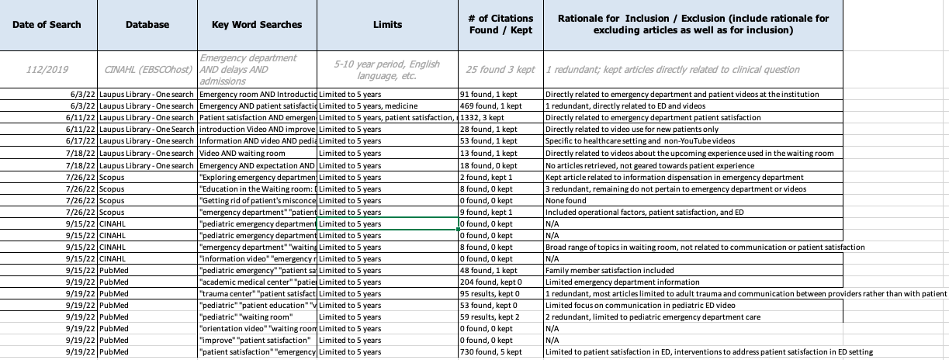

Appendix B
Literature Matrix
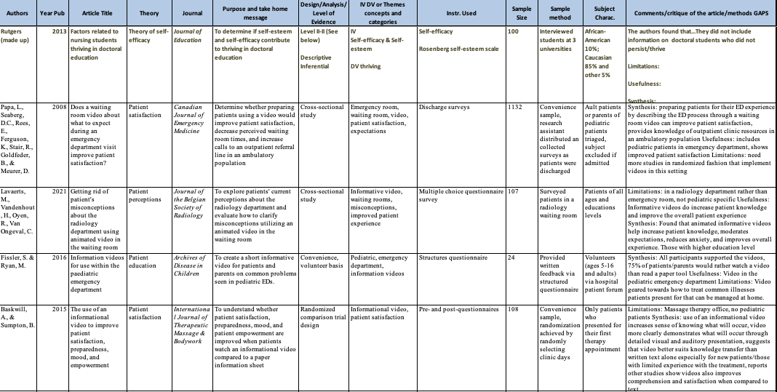
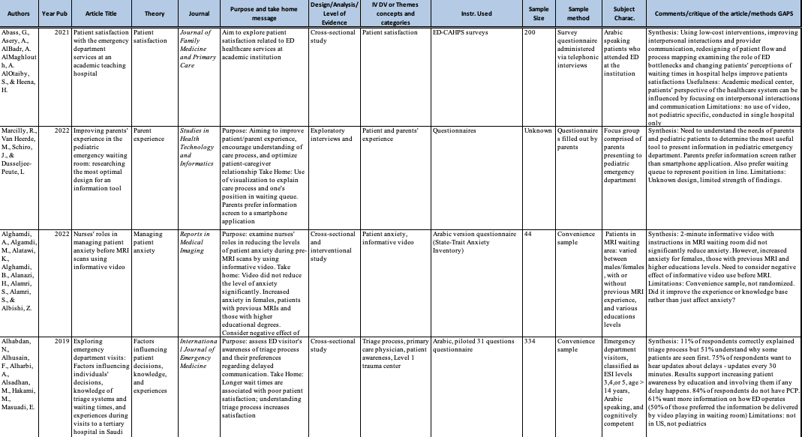

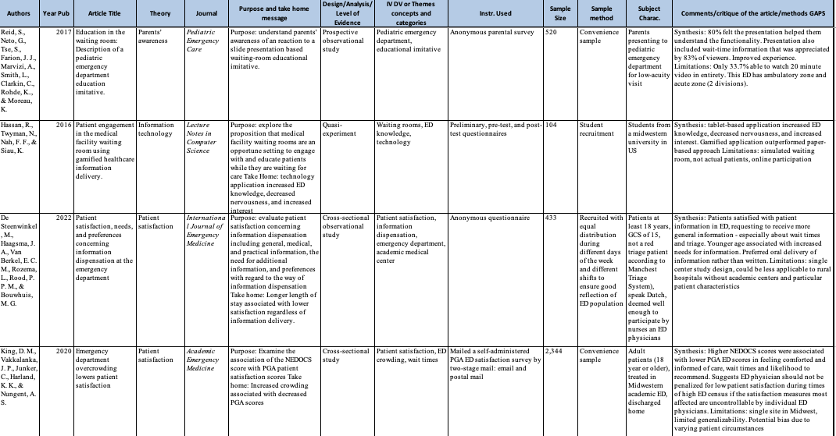
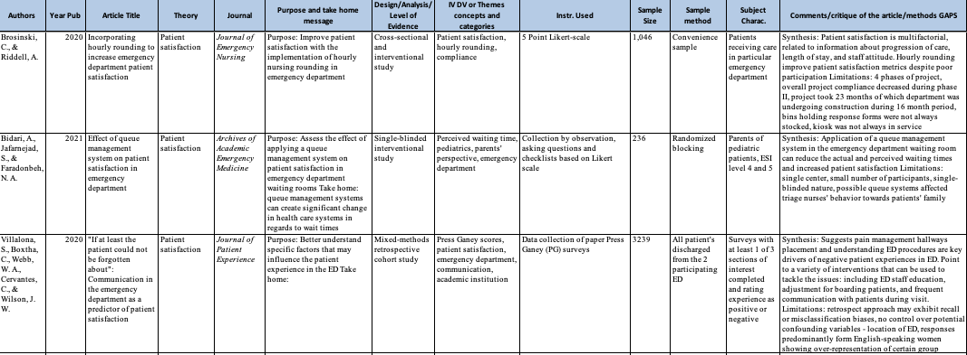

Appendix C
Orientation Video Script
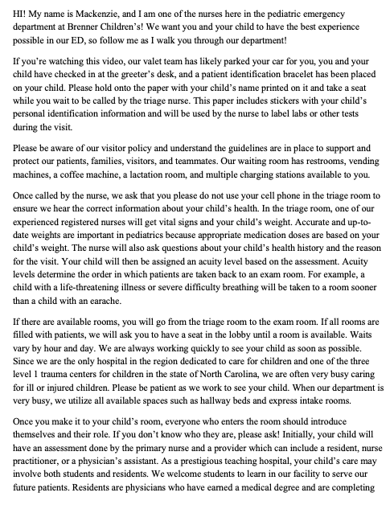
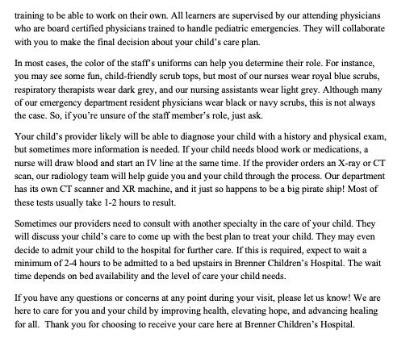

Appendix D
Microsoft Teams Survey
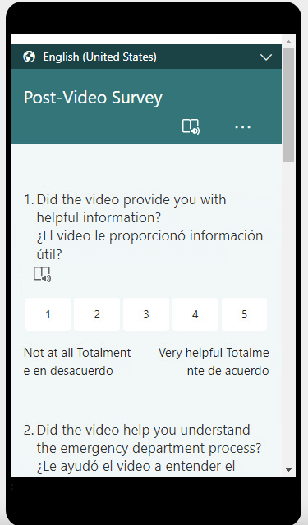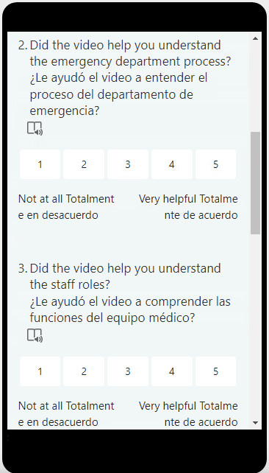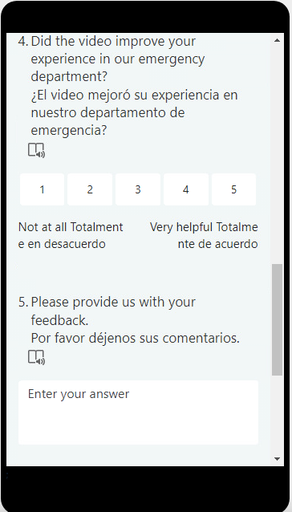

Appendix E
Orientation Video Flyer
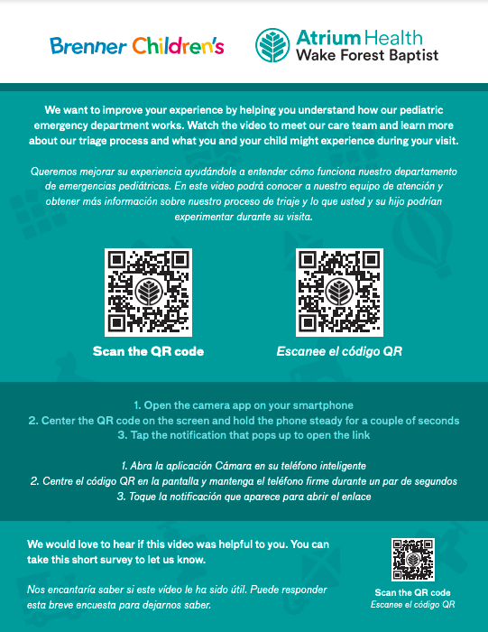

Appendix F
Staff Email
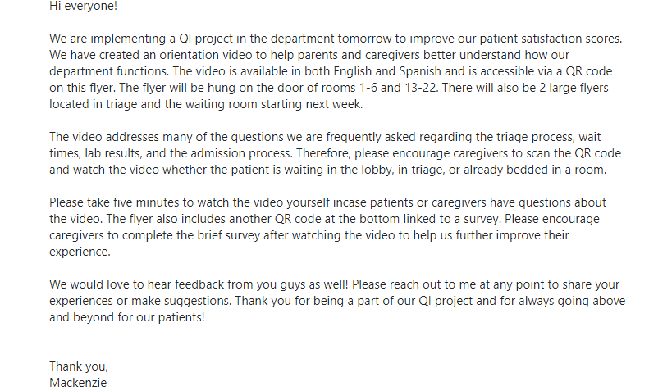

Appendix G
Table 1
Itemized Budget for Project Development and Implementation
Item | Cost
Video Production | $2,000.00
Video Editing | $300.00
Flyer Printing | $90.00
RN/DNP Student Time ($38/hr.) x 100 hrs. | $3,800.00
 | Total: $6,190.00

Appendix H
Table 2
Monthly Patient Satisfaction Scores Pre-Implementation and During Implementation
 | Pediatric Emergency Department | Benchmark
Pre-Implementation
December 2022 | 67.1 | 74.0
January 2023 | 74.8 | 72.0
February 2023 | 61.2 | 72.0
Implementation
March 2023 | 60.6 | 69.9
April 2023 | 73.7 | 71.1
May 2023 | 70.9 | 68.6

