Initiating Practice Guidelines for Postpartum Depression Screening at Well-Child Visits
Andrea D. Sessoms
East Carolina University

Abstract
Purpose: This project examined the process of initiating a postpartum depression (PPD) screening protocol at the 2 month well-child visit in four pediatric/family practice offices in a rural North Carolina. The goal is to foster organization improvements to integrate maternal PPD screening into routine pediatric practice.
Study Design and Methods: The design is a prospective analysis of the process of initiating a PPD protocol into clinical practice. This protocol was developed based on information and recommendations gathered from the literature review. Mothers were administered the Edinburgh Postnatal Depression Scale (EPDS) at the two month well-child visit. Women who scored 10 or greater were identified as at risk for PPD and were counseled by the pediatric provider, provided two educational handouts and given a referral appointment with their obstetrician.
Results: Out of the fourteen PPD screens performed, one woman was identified as at risk and referred to her obstetrician. Overall, initiating PPD screens in these pediatric offices was reported as easy, cost effective and causing no increase in workload of the providers or nurses.
Clinical Implications: Well-child visits can be examined as an alternative health care setting where screening, identification and referral for mothers with PPD can occur as an additional opportunity to screen mothers. Increasing the detection rates for postpartum depression is imperative to improve the health of not only the mother, but also of the infant and family (AAP, 2010).
Key Words: postpartum depression, Edinburgh Postnatal Depression Scale, well-child visits,

Acknowledgements
I would like to thank my Committee Chairperson, Dr. Becky Bagley and Committee Member, Dr. Robin Webb Corbett. Your guidance, knowledge, patience and support made this project possible. I would also like to express my appreciation to my other Committee Member, Dr. Steven Spruill.
Many people and agencies participated in the research project. I would like to thank the providers and nurses at each agency, for without their willingness and participation, this research would have never been possible. There have been several colleagues, including Mr. Bob Green, MSN, CNM that served as a sounding board and provided much needed support and encouragement to me throughout this journey. I am also extremely grateful for my special group of friends that were always in my corner, cheering me on and even provided me with much needed quiet time to finish my assignments.
Most importantly, I would like to thank my family, my husband, David, my children, Jacob, Anderson and Carter and my parents. Their unwavering love and faith in me means more than they will ever know. Each of them have all made many sacrifices to allow me this chance for personal and professional growth. Without their love and support, this journey would not have been possible or even worth it. I hope I have made each of you proud.

Andrea D. Sessoms
©

Table of Contents

Chapter I: Introduction 8-9
Problem Statement 9
Justification of Study 9-10
Theoretical Framework 10-11
Project Hypothesis 11
Definition of Terms 11-12
Summary 12-13

Chapter II: Research Based Evidence
Introduction 14
Literature Review 14-15
Barriers of Screening in the Pediatric Setting 16-17
Mother’s Perspective on Screening 17-18

Chapter III: Methodology
Design 19
Participants & Setting 19
Protection of Human Subjects 19-20
Implementation 21
Methods 21-23
Instruments 23-24
Data Collection 25

Chapter IV: Results
Sample Characteristics 26
Findings 26-27
Limitations 28
Timeline & Budget 28-29
Summary 29

Chapter V: Discussion
Introduction 30
Application to Theoretical Framework 30-31
Clinical Implications 31-32
Summary 33-34
References 35-39

Appendices
Appendix A: Letter of Support 40
Appendix B: IRB Approval 41
Appendix C: PPD Screening Protocol 42
Appendix D: Edinburgh Postnatal Depression Screen (EDPS) 43
Appendix E: Data Collection Form 44
Appendix F: Procedural Flow Chart 45
Appendix G: Understanding PPD handout 46
Appendix H: Eastpointe pamphlet 47
Appendix I: Suicide Action Plan 48
Appendix J: Follow-up Appointments 49
Appendix K: PPD poster 50
Appendix L: Plan, Do, Study Act Model (PDSA) 51
Appendix M: Compliance Survey 52

Chapter I: Introduction

Introduction
The March of Dimes (2012) asserts that postpartum depression (PPD) is the most common complication after childbirth, affecting as many as one out of every eight women. Anywhere from 10-22% of women within the first year after childbirth will experience PPD (Farr, Denk, Dahms, & Dietz, 2014; Gjerdingen, Crow, McGovern, Miner & Center, 2011; Horowitz, Murphy, Gregory, Wojcik, 2010; Liberto, 2012; Walker, Im, & Tyler, 2013) Given that there were just under 4 million births in the United States in 2013 (Hamilton, Martin, Osterman, & Curtin 2014), PPD could potentially affect 400,000-800,000 women, infants and families in the United States. Fourteen to twenty three percent of all pregnant women will experience depression during pregnancy according to the American College of Obstetricians and Gynecologists (ACOG, 2010). Depression costs the United States approximately $30 to $50 billion in lost productivity and direct medical costs each year (Gjerdingen & Yawn, 2007). Exacerbating the issue of PPD is inconsistent screening of women during their postpartum follow-up visits with the obstetrical or women’s health provider Delatte, Cao, Meltzer-Brody, & Menard (2009) found that providers at the University of North Carolina documented the Edinburgh Postnatal Depression Scale (EDPS) score in 39% of visits and counseled their patients on their score and/or PPD in only 35% of visits. According to ACOG in a Committee Opinion published in 2010, reaffirmed in 2012, there is a lack of sufficient evidence to recommend universal screening or the frequency of antenatal and postpartum depression screening, nor is there a consensus for a recommended screening tool. They do however, acknowledge that PPD screening has potential benefits and should strongly be considered during antenatal and postpartum visits (ACOG, 2010). Despite this recommendation to the obstetrical community, there is also a failure by many mothers to return for at least one postpartum visit with their obstetrical provider where the PPD screening often takes place. The Health Employer Data and Information Set (HEDIS) of 2012 reported that only 63% of women with Medicaid insurance and 80% of women covered by private insurance returned for their postpartum checkups (National Committee for Quality Assurance, 2013) . Therefore, Sriraman (2012) states that low income women have an increased risk of undiagnosed and untreated PPD due to the decreased rates of returning for their routine postpartum follow-up visits.

Problem Statement
The AAP estimates there are over 400,000 infants annually born to mothers who are depressed, making PPD the most underdiagnosed obstetric complication in the United States. (Sriraman, 2012). Due to inconsistent screening for PPD at postpartum visits, as well as the failure of women to return for their PP exams visits, many women are not identified, diagnosed and treated for PPD. Numerous studies (Byatt, Biebel, Friedman, Debordes-Jackson, & Ziedonis, 2013; Walker, Im, & Tyler, 2013; Liberto, 2012; Chaudron et al., 2010; Sheeder, Kabir, & Stafford , 2009; Gjerdingen, Crow, McGovern, Miner & Center, 2009; Gjerdingen & Yawn, 2007) list the benefits of screening for PPD at pediatric well-child visits; however, there is a need for further study to discuss how to integrate PPD screening at well-child visits via a PPD protocol.

Justification of Study
Pediatric practices provide an opportunity to implement PPD screening at well-child visits, identify community resources that can be used for the treatment and referral and help support the mother-child relationship (AAP, 2010). These visits, scheduled at regular intervals throughout the first year of the infant’s life, allow for increased detection of PPD during the period when depression most frequently occurs. Pediatricians are able to play an active role in screening for PPD by using a standardized screening instrument that will identify women who need referral (Chaudron, Szilagyi, Kitzman, Wadkins, & Conwell, 2004). In a clinical report by the American Academy of Pediatrics (AAP) and the Committee on Psychosocial Aspects of Child and Family Health (2010) integrating PPD screening into the routine well-child care visits is recommended. This screening provides a supportive atmosphere for the mother-child relationship and referral to community services when the screen is positive. Sriraman (2012) states the nature of the relationship between pediatric providers and the mothers, coupled with the longevity of this relationship and frequency of the visits allows the mother time to develop trust with these pediatric providers. This trusting relationship provides mothers with the opportunity to be more apt to discuss other issues that may be affecting the child’s environment, health and well-being.

Theoretical Framework
The Diffusion of Innovation Theory by Rogers was used as the theoretical framework for this investigation. Rogers (2003) describes innovation as an idea that an individual recognizes as new. He defines diffusion as the process in which an innovation is conveyed through specific channels over time among members of a social system. It is through the sharing of these ideas, behaviors or products that individuals perceive as new, that the society can then adopt them as their own. It is then that diffusion happens.
Rogers (2002) stated the four main components of diffusion of new ideas are innovation, communication channels, time and social system. Innovation is the idea perceived as new. The communication channels are defined as the mode in which the new idea is disseminated. Time is considered the rate of adoption or how long it takes an individual to adopt the behavior. The social system refers to a group of individuals that come together to problem solve for a unified goal.
Rogers (1995) established five adopter categories and each of them play a different role in determining the success or failure of adopting an innovation. First, are the innovators. These are people who are willing to take risks and be the first one to try the innovation. Second are the early adopters who are the leaders and may have already identified the need for change and are willing to adopt these new ideas. Third, the early majority category are people that are willing to adopt change, however, they need to see evidence that this idea is valid before they agree to this change. Roger’s fourth category is the late majority, people who are skeptical of the change and only willing to adopt the innovation after it has been tried by the majority. Lastly, the fifth category is the laggards who tend to be very conservative. These people are the most unwilling to adopt the innovation and must be convinced of its success before agreeing to adopt it.

Project Hypothesis
The purpose of this project is to examine the process of initiating these practice guidelines for PPD screening at well-child visits. Currently, there are no practice guidelines available for PPD screening.

Definition of Terms
The American Psychological Association (APA) (n.d.) states that “postpartum depression is a serious mental health problem characterized by a prolonged period of emotional disturbance, occurring at a time of major life change and increased responsibilities in the care of a newborn infant.” The Diagnostic and Statistical Manual of Mental Disorders (DSM-V), (2013) does not list postpartum depression as a separate entity, but lists it under the mood disorder diagnoses. According to the American Psychiatric Association (2013) depression is defined as:
Depressed mood most of the day, diminished interest or pleasure in all or most activities, significant unintentional weight loss or gain, insomnia or sleeping too much, agitation or psychomotor retardation noticed by others, fatigue or loss of energy, feelings of worthlessness or excessive guilt, diminished ability to think or concentrate, or indecisiveness, and recurrent thoughts of death (p.186).
To positively diagnose postpartum depression, at least five of these symptoms should be present over a two week period and they should cause clinically significant impairment in social, work, or other important areas of functioning almost every day (APA, 2013). The time period in which these symptoms occur is what differentiates postpartum depression from general depression. The symptoms of PPD can be identified up to one year after childbirth, but symptoms frequently appear as early as three to four weeks after giving birth (ACOG, 2013).

Summary
Since PPD screening is not a standard of care at the postpartum visits and there are no practice guidelines available for this screening, exploring other health care visits or providers to meet this maternal health need is essential. An already established setting is the pediatric practice providing newborn care. The goal would be to engage pediatric providers to initiate PPD screening to the mother as part of the well-child visits. This topic is of particular interest due to the prevalence and implications that PPD has on the child’s health and development (Walker, Im, & Tyler, 2013). Through the earlier identification of PPD, there can be referral and more prompt treatment putting these mothers in a better place to care for themselves and their infant as well as enhancing the maternal child bonding experience during that first year of life.

Chapter II: Researched Based Evidence

Introduction
A literature review was conducted using the databases OVID and CINAHL. The key words, postpartum depression, postpartum depression screening, well-child visits, pediatric visits, and Edinburgh Postnatal Depression Screen were used. This detailed search was conducted to explore the current knowledge and research on PPD screening at well-child visits and nine articles were found.

Effects of Postpartum Depression
PPD has an effect on early maternal/infant bonding and affects the family as a whole. According to the American Academy of Pediatrics (AAP) and the Committee on Psychosocial Aspects of Child and Family Health (2010) “PPD leads to increased costs of medical care, inappropriate medical care, child abuse and neglect, discontinuation of breastfeeding, and family dysfunction and adversely affects early brain development” (p. 1032). Pediatric practices provide an opportunity to implement PPD screening at the well-child visits and to identify community resources that can be used for the treatment and referral of the depressed mother and help support for the mother-child relationship (AAP, 2010).

Review of the Literature
Although ACOG (2010) acknowledges the benefits from PPD screening and strongly encourages this screening at the regular postpartum visits, they do not have clinical guidelines that address the frequency of the PPD screening or a recommended screening tool. Without these recommendations, other health care sites should be identified to provide PPD screening for new mothers to meet these health needs.
Although PPD screening is the first step for the pediatric providers to identify mothers at risk for PPD, alone, it is insufficient to improve outcomes (Kuehn, 2011). The AAP (2010) proposes screening for PPD and observing for signs and symptoms of maternal depression should be included as part of the family-centered well-child care. Outcomes improved when a system with protocols was used to provide these women with collaborative care (Kuehn, 2011). Prior to initiating PPD screening in a pediatric setting, systems must be in place for appropriate referral, case management, and follow-up. According to Sriraman (2012), prior to initiating postpartum depression screening as a standard of care, office based policies and guidelines must be created to ensure an efficient and adequate triage for the mothers being screened. A referral process should then be in place for those mothers with a positive PPD screen. There needs to be extensive training of both the pediatric providers and nursing staff on the process of screening, making referring and management of the mother with suicidal thoughts. When a mother has a positive PPD screen, a referral to a mental health professional, primary care provider, or their obstetrical/gynecology (Ob-gyn) provider should be initiated. Written pamphlets explaining PPD and the mental health services available in their area should be shared with these mothers. For those mothers who are experiencing suicidal ideations, immediate referral or transfer to the nearest emergency room for further evaluation should be made while maintaining a safe environment for the child (Sriraman, 2012).

Barriers to Screening in the Pediatric Setting
In an effort to examine the purpose of PPD screening at pediatric well-child visits, one also has to assess the barriers preventing pediatric providers from conducting PPD screening in their practice. Cauldron et al. (2007) states the primary reason for not providing this screening is related to a combination of ethical and legal considerations. The pediatric providers express concern regarding the legal ramifications in dealing with these mothers who are not technically their patients. They also do not want the mothers to feel that the questions are intrusive potentially causing them to limit the care their children receive at that practice. Gjerdingen and Yawn (2007) cite other barriers as lack of education and training for pediatric providers in regards to postpartum depression, the lack of time to educate and counsel these mothers adequately during the well-child visits, and their limited ability to manage adult mental health issues and referrals. However, even with these barriers, parents and providers agree that recognizing and dealing with PPD is an important aspect of the primary care of the infant (Gjerdingen & Yawn, 2007).

Mother’s Perspective on Screening
In order to address the barriers to identification and treatment of PPD, the perspective of the mother needs to be addressed. Byattm, Biebel, Friedman, Debordes-Jackson, & Ziedonis (2013) examined the mother’s view on PPD screening in the pediatric setting. Twenty-seven mothers participated in a 90-minute focus group and several barriers to getting care were identified. Some of the barriers identified were related to fear of the stigma associated with PPD, concerns about losing their parental rights, and feeling like the mothers were being judged by the provider. Another barrier dealt with the mother’s uncertainty regarding the role of the provider. Some participants did not feel comfortable talking to their pediatric providers about their personal feeling while others felt like the provider did not have the motivation or time to deal with these issues. Some acknowledged that when the provider helped the mothers, in turn they were helping the child. The last barrier identified was the lack of training of the pediatric provider to screen or discuss PPD. The participants felt like the provider disregarded the importance of discussing the results of the PPD screen and responded non-emphatically when the mothers verbalized genuine concerns about their crying or distressed infant. One participant stated that screening and identification was ineffective without referrals and other resources for the mother. Since PPD affects not only the mother but also the infant and the maternal/infant relationship, the pediatric setting offers a frequently missed opportunity to detect and discuss PPD (Byattm Biebel, Friedman, Debordes-Jackson, & Ziedonis, 2013). Counseling new mothers on the signs and symptoms of PPD prior to these symptoms occurring has the potential to increase the mother’s ability to identify these symptoms and seek care before these symptoms become more severe (Farr, Denk, Dahms, & Dietz, 2014).
In a clinical report by the American Academy of Pediatrics & the Committee on Psychosocial Aspects of Child and Family Health entitled “Incorporating recognition and management of perinatal and postpartum depression into pediatric practice” (2010) it identifies the role of the pediatric provider is not to treat the mother, but to support the mother and facilitate the referral to community resources in order to create a healthy environment for the infant and family. This report recommended pediatric providers incorporate PPD screening at the one, two, four and sixth month well-child visits. Screening for PPD at pediatric well-child visits has been identified by Bright Futures (2008) and the AAP Mental Health Task Force (2010) as best practice in caring for infants and their families
It was suggested that when a mother had a positive PPD screen, the provider’s responses should include verbal reassurance, supportive strategies and referral for interventions. If mild depression is noted, the mother may need something as simple as reassurance that she is not alone, she is not to blame and she will get better. If moderate to severe depression is noted, the mother will need to be referred for therapy and medication (AAP, 2010). This referral and follow-up care can be scheduled with the mother’s obstetrician, primary care or mental health provider. Communication from the pediatric provider to the referring primary care or mental health provider as well as the mother’s obstetrical provider is essential in order for the mother to get the best outcome possible.

Chapter III: Methodology

Design
The goal of this project was to foster organization improvements to integrate maternal postpartum depression screening into routine pediatric practice. The design was a prospective analysis of the process of initiating a PPD screening protocol in pediatric practices.

Participants & Setting
The participants chosen for this project are the staff in each of four pediatric and/or family practice offices. They include the physicians, family nurse practitioners (FNPs), registered nurses (RN) and licensed practical nurses (LPNs) from each of these offices. These four offices are located in a small rural county serving approximately 55,000 people. With the exception of a county health department, these four offices include all the pediatric providers in the county. There is only one Ob-gyn practice in the county which was the practice where the women with positive screens of 10 or greater on the EDPS were referred.

Protection of Human Subjects
Prior to submitting to the IRB Committee at a southeastern university, a letter of support (see Appendix A) was obtained from the large medical group with whom these four practices are affiliated. After submitting all of the necessary documents to the IRB Committee and making the necessary changes, an exempt certification was given on May 9, 2014 (see Appendix B).
In order to protect the rights of all participants, informed consent was obtained. In this project, the participants were the nurses and providers at each of the four participating offices. At the initial introduction meeting and orientation to the project, the consent process was explained to each participant and a verbal consent was obtained. Their participation in the research was strictly voluntary. They could choose not to answer any or all questions, and they could withdraw at any time. There was no penalty for not taking part in this research study. This project did not affect their current role in the office and did not affect their employment in anyway. No protected health information from the mothers was accessed, used or generated in this study. This project only examined the strategies for implementing a PPD screen at this visit in a pediatric/family practice office.

Implementation
Prior to beginning this project, the problem was identified and a literature search was conducted. An investigation of a pediatric practice currently conducting PPD screening was done. The key stakeholders included each of the participating pediatric providers, the obstetricians, and the large medical group that operates each of these practices. Written approval from these stakeholders was obtained. The PPD protocol, the suicide action plan and the educational materials were developed. All of this information was submitted to the IRB committee of a southeastern university. After the IRB committee granted exempt approval, the educational sessions were scheduled. Educational sessions and start-up packets were provided. Data collection lasted 6 weeks with phone or face to face meetings with the participants to evaluate the process. At the conclusion of the project, a final meeting was conducted for the participants to complete the compliance survey and obtain their final recommendations.

Methods
A PPD screening protocol (see Appendix C) was developed based on information and recommendations gathered from the literature review. The Edinburgh Postnatal Depression Scale (EPDS) was offered to all mothers at the two month well-child visit. Women who scored a 10 or greater would be identified as at risk for PPD and would be counseled by the pediatric provider about PPD. This counseling was individualized by each provider but included how PPD can affect the newborn and the bonding process. These mothers were also provided with two educational pamphlets and referred to their obstetrician within three to five days for further evaluation. The obstetricians were chosen to provide continuity of care for these mothers and to provide follow-up care if needed.
This project analysis examined the process of implementing these guidelines and provided information on strategies for implementing a PPD screen at the two month well-child visit in a rural pediatric/family practice office setting. Early identification would allow these women to receive the help they need, putting them in the best possible position to begin a healthy life with their new baby.
The protocol was initiated by the nursing staff in each of the participating offices as a standard of practice for mothers who attended their infant’s two month well-child visit in each of the participating offices. The protocol began with the nurse explaining the purpose of the Edinburgh Postnatal Depression Scale (EPDS) (see Appendix D) in screening for PPD. The nurses reminded the mothers to answer the questions based on their feelings over the last seven days. The screening was provided to all mothers who brought in their infant for the two month well-child visit at any of the four participating practices. After the screen was scored by the nursing staff, they informed the provider of the score, recorded the score in the infant’s chart and completed the data collection form (see Appendix E) coded with a pre-assigned letter that corresponded to each practice. A procedural flow chart (see Appendix F) demonstrated the steps of the project in more detail. Mothers who scored less than 10 on the EDPS received no further screening or counseling as part of the protocol.
If the mother scored 10 or greater, the nursing staff documented this on the data collection form and then continued to the subsequent steps of the protocol. First, the provider counseled the mother on the effects of postpartum depression and resources available in the community. Next, the mothers were provided with two informational handouts. The first informational handout from Childbirth Graphics entitled “Understanding Postpartum Depression” (see Appendix G), is double sided with English on one side and Spanish on the other. The second pamphlet is provided from a behavioral health managed care organization, (see Appendix H) and addresses the services they provide. These two handouts are also given to any woman in the county receiving their postpartum care from the health department or ob-gyn office as part of the Pregnancy Medical Home program. Making the mother a referral appointment with her obstetrician was the last step of the protocol.
This behavior health managed care organization that serves this county and 11 other counties in eastern North Carolina. It provides an array of services to people dealing with behavioral health and substance abuse concerns via 24 hours a day toll free telephone hot line number. Eastpointe does not provide inpatient services however, they contract with mental health providers to offer mental health and substance abuse services in an office setting. These providers accept Medicaid and other state monies to cover their services. This organization provides two additional serves, a walk-in clinic and a mobile crisis unit. The walk-in clinic is located in a larger town 15-25 minutes away providing mental health care for both insured and uninsured populations. The mobile crisis unit is available on-site for limited behavioral health issues and can be called in the event of an immediate crisis.
Due to the nature of the study, a suicide action plan (see Appendix I) was also created. Question 10 on the Edinburgh Postnatal Depression Scale (EDPS) addresses suicidal ideations stating “the thought of harming myself has occurred to me….” If in the past 7 days a mother answers question 10 as “yes, quite often” or “sometimes,” the suicide action plan would be initiated. The mother would be referred for a same day appointment with the obstetrician or to the emergency room at the local hospital.
After the protocol was developed and the proper approvals were obtained, staff education and training sessions were scheduled with the nursing staff and providers from each practice as their schedule allowed. Each participant received an orientation packet that contained all of the necessary information to familiarize themselves with the project and a sample of the forms. Each packet included a sample of the PPD protocol, suicide action plan, instructions on making the follow-up appointments (see Appendix J), scoring instructions for the EDPS, a poster about PPD (see Appendix K) and the importance of the screening as well as a sample data collection form and the two informational handouts. Each office was provided with twenty-five copies of the EDPS screen and the two handouts.
Instruments
There is no universally accepted screening tool for PPD. Various tools are used, with the Edinburgh Postnatal Depression Scale (EDPS) being the most studied. In addition, it is endorsed by the US Preventive Services Task Force (Sriraman, 2012). This tool has an overall reliability (Cronbach's alpha) ranging from 0.81- 0.87, sensitivity 61- 85% and specificity 77%-93% in past studies (Cox, Holden, & Sagovsky, 1987; Horowitz et al., 2001; Chaudron et al., 2010). The positive predictive value ranges from 73-83% (Cox, Holden & Sagovsky, 1987).
This self-assessment tool is meant to examine the feelings a woman has had during the past seven days. Each of the ten questions has four possible options. The questions are scored 0-3 in increasing severity based on the response given by the mother. The overall score can range from 0 to 30. The cutoff scores are either greater than or equal to 10 or greater than or equal to 13. A score of greater than 10 indicates possible depression while a score above 13, identifies mothers likely to be suffering from a depressive illness (Cox, Holden, & Sagovsky, 1987). In order to reduce the failed detection rate to less than 10%, the authors of the tool recommend the cutoff score of greater than or equal to ten (Cox, Holden, & Sagovsky, 1987). For the purposes of this project, a cutoff score of greater than or equal to 10 was used. Screens were provided to the offices in both English and Spanish.
According to Logsdon and Hutti (2006), the EDPS is written on a third grade reading level which improves the mother’s ability to understand and answer each question accurately. This screen takes approximately five minutes and is in the public domain, available in many languages and has cross-cultural validity (Sriraman, 2012).

Data Collection
The project began with the educational sessions while the data collection portion continued for six weeks. Originally, the follow-up meetings were scheduled weekly either being face to face or by phone. After the first week, many of the practices had not had the opportunity to perform any screens, so the follow-up meetings changed to every two weeks. These meetings were held informally using the Plan, Do, Study, Act (PDSA) format (see Appendix L) to elicit feedback regarding the implementation of the project. This feedback was documented and used to refine the protocol. At the conclusion of the data collection, there were meetings with the study participants to discuss their comments and final recommendations. At this time a compliance survey (see Appendix M) was given to all of the participants to evaluate their compliance to the protocol and elicit demographic information, further suggestions and comments.

Chapter IV: Results

Sample Characteristics
The sample included four physicians, one FNP and four nurses from four different offices that provided pediatric services. Forty percent of the providers were male and 60% percent female, with 40% of the female providers identified as minorities. Although nurse practitioners (NP) were originally identified as participants, they did not have any two month well-child visits scheduled during the project time period.
Seventy-five percent of the nurses were LPNs and 25% percent were RNs. Seventy-five percent of the nurses were African American and 25% percent Caucasian. The four offices participating represent the majority of the pediatric providers in this rural county in eastern North Carolina. Of the practices, 25% was family practice, 50% pediatrics, and 25% internal medicine/pediatrics. All subjects participated in the project and there were no withdrawals.

Findings
A total of 14 PPD screenings were performed out of a total of 23 infants who presented for their two month well-child visit over a six week period in all four offices. There were no mothers in any of the practices that refused the screening, however not all of the two month well-child visits were not attended by the mother. Of the 14 screens, one was referred to the obstetrical providers for follow-up due to an EDPS score greater than or equal to 10, making the referral rate 7%.
Office A screened one mother. Although this office sees pediatric patients, they are primarily an internal medicine practice. Office B screened six mothers of their eleven infants that attended the two month well-child visit, for a 54.5% screening rate. Office C screened five of the seven mothers, making their screening rate of 71.4%. Office D screened two of the four mothers, for a 50% screening rate.
The EPDS scores were recorded by the nurse and documented in the infant’s electronic medical record or on the nursing notes pages and the physicians would dictate the score into their progress note in the infant’s electronic medical record. Comments and recommendations were collected regarding the protocol and the ease of use from each of the four practices during the follow-up meetings every two weeks and at the final meeting at the conclusion of the project. Table 1 is a summary of the nurse’s feedback in all four offices and table 2 addresses physician’s feedback.
Table 1

Summary of Nurse Feedback on Postpartum Depression Screening Protocol
Protocol easy to follow
Did not cause an increase in workload (no referrals involved)
No problems identified with the referral process
Reminder in the electronic health record (EHR) would be helpful to prompt EDPS screening
Thinks screen is especially important for younger mother
Easy to follow and explain to nurses who fill in
Table 2

Summary of Physician Feedback on Postpartum Depression Screening Protocol
Comfortable with counseling mothers regarding PPD
Consider initiating EDPS at the 2 week visit as well
Uncomfortable with counseling due to being unsure of what to say
Handouts for the mother made the counseling easier
Considered initiating the screen at the 4 month well-child visit to space it out from the 4-6 weeks screen performed at the OB office
Worried at pediatric parents get survey overload and this may affect the responses or elicit inaccurate feedback

Limitations
There were several limitations to this project. One limitation was the low number of screens, as only one mother was referred for a score of 10 or greater. Identifying barriers with the referral process was difficult to make with only one referral. Another possible limitation would be the provider’s comfort level with the counseling. This has the potential to increase their workload depending on how in-depth the counseling is that they provide to the mother.

Timeline and Budget
Timeline | Objectives | Budget
Fall 2013 | - Select project topic and research question  - Select committee chair and committee members  - Obtain approval for the project | - No actual costs were incurred
Spring 2014 | - Develop PPD protocol  - Create educational documents  - Securing letters of support from the physicians and the medical group that all four offices belong to  - Obtain ECU IRB approval | - No actual costs were incurred
Summer 2014 | - Begin education and training sessions with participants  - Project began  - Follow-up meeting to obtain feedback  - Project concluded | - Approximate cost of copies, folders, laminated materials, thank you cards $50  - Behavioral health brochures were free of charge from the agency  - Understanding PPD handouts costs $17.14/100 sheets + shipping
Fall 2014 | - Analyze findings  - Complete final paper and journal article for submission | - No actual costs were incurred

Summary
In summary, 14 PPD screens were performed at four pediatric providers’ offices out of a potential of 23 infants who attended the two month well-child visit. One was referred for a score greater than or equal to 10. The protocol was followed by all participants in each of the offices and no mothers refused the screening. Practice A had the best screening rate of 100%, while practice D had the lowest of 50%. These numbers also take into account the number of well-child visits that the mother did not attend, so therefore no screening was performed. Feedback was received from all nurses and providers that participated in the screening.

Chapter V: Discussion

Introduction
Initiating practice guidelines for PPD screening at pediatric well-child visits appears to have increased the identification of new mothers who are suffering from PPD. Through the evaluation of this process, one can gain a greater understanding of how this can be replicated in any pediatric or family practice setting.

Application to Theoretical Framework
Using Roger’s Diffusion of Innovation theory, initiating the PPD screening protocol into these pediatric provider’s offices was the innovation. Many of the providers, as well as the nursing staff were unfamiliar with not only the EDPS tool, but the effect that PPD has on the maternal-infant relationship. In order for the concept of PPD screening to be adopted, the communication channels had to remain open. Through staff education and training sessions with the nurses and providers from each office, the idea of PPD screening was presented with supporting evidence and their role in this screening was explained. The time or the rate of adoption was fairly swift. Since the majority of the screening and data collection fell on the shoulders of the nursing staff, they had to be the early adopters. After being presented with the evidence based literature in combination with the knowledge that almost half of the mothers in this county do not return for their postpartum visit, which is where the PPD screening occurs, the nurses promptly bought into the project. At least two of the providers were in the early majority to late majority categories for adopting the innovation. They were somewhat persuaded by the evidence but still not totally convinced on what difference the screening would truly make in their practice and community.
As with any new program implementation, there can be barriers to its success. Some of the potential barriers to implementing the PPD screening in the pediatric setting include the likelihood of the nurses to administer the PPD screens and document the information on the data collection form. If the nurses view the PPD protocol and the referral process to the obstetrical provider, as difficult or increasing their overall work load, this will limit the PPD screening that is performed. Another potential barrier is to assess the comfort level of each provider regarding their ability to counsel the mothers, who had a positive EDPS, on the effects of PPD. There were providers who were more comfortable counseling these mothers than others. At least two providers were slightly uncomfortable with this topic, as it was considered an innovation for them. Rogers’ Diffusion of Innovation theory provided the theoretical framework for this project.
By understanding the Diffusion of Innovation theory, one can better anticipate the successes and barriers to initiating a new program. It is through this knowledge that initiating PPD screening at well-child visits will become successful.

Clinical Implications
Overall, the nursing staff agreed that this screening protocol was easy to follow and the screening itself was easy for the patient to complete. Initiating this screening protocol into their routine practice did not cause an increase in their daily workload. It was agreed that documenting the score was easy. Depending on the provider, the PPD screening score was recorded in the infant’s electronic medical record by the nurse or by the physician in the progress note. Several nurses recommended a prompt for the EDPS score in the electronic medical record to providing the screens. The nurses expressed the importance of the screening in the identification and referral process for these mothers. One nurse commented that the protocol was easy to explain and for other nurses to follow in the case that it primary nurse is not in the office. In regards to the one practice that made a referral for a score greater than or equal to 10, the nurse stated that the referral process was easy and the obstetrical practice handled the follow-up appointment in a timely manner.
The feedback received from the providers provided differing opinions. Some providers reported being uncomfortable talking with the mothers about PPD, while one stated that this project increased his awareness of the potential for PPD. He was more comfortable with counseling all mothers about the signs and symptoms of PPD and their effects. Two providers stated they would rather initiate the screening at the four month well-child visit to space it out from the postpartum screening completed at 4-6 weeks by the obstetrical provider. Another provider stated that he would like to initiate the screening beginning with the two week well-child visit to identify mothers with PPD earlier. One provider expressed concern over the mothers becoming overloaded with surveys at these well-child visits and was worried about how this might affect the accuracy of the results. Some of these additional surveys include asthma or developmental screening. For the provider who referred a mother with a positive screen, there was a sense of “feeling uncomfortable and not quite sure what to say” during the counseling time but the handouts provided this physician with talking points making this discussion easier. This provider also felt the discussion would become easier and more routine with time and experience.
Through the course of this project, it was also discovered that reimbursement can be obtained for the EDPS at the well-child visits. This coding falls under primary screening so the providers can be reimbursed $8.14/screen for conducting this screening at the well-child visits.
One thing that would need to be considered in a larger study would be the lack of insurance, preventing the women from being financially able to participate in follow up care with the obstetrician. Although this problem was not encountered during the course of this project once this protocol was implemented into practice. Many of these mothers, who are covered under Medicaid, are no longer covered after six weeks postpartum. Since this screening takes place at approximately eight weeks postpartum, this may affect the pediatric provider’s ability to refer women to their obstetrical provider and the mother’s likelihood to follow-up.
Another point to take into consideration is the referral process. Although this part of the protocol is essential, this author is unsure of the implication of this process when multiple pediatric and obstetrical/primary care/mental health practices are involved.
Summary
Overall, initiating PPD screens in these pediatric practices was easy, cost effective and did not cause an increased in the workload of the providers or nurses. When there was a referral, there was only a minor increase in workload due to the counseling by the providers and making the follow-up referrals for the nurses.
In an effort to increase the screening, identification and referrals for mothers with PPD, one has to examine other health care settings where this screening can take place. This is especially important since the Health Employer Data and Information Set (HEDIS) found that 37% of women with Medicaid and 20% of women with private insurance did not return for their postpartum checkups. Based upon those numbers, potentially 57% of women may not be screened for PPD.
Although this project was on a small scale, the clinical implications are significant. The referral rate for this project was 7 %. If we examine the referral rate to the nearly 4 million live births in the United States in 2013, it can be postulated that over 250,000 women would potentially screen positive for PPD at visits with providers other than their primary obstetrical provider. If PPD screens were conducted in pediatric providers’ offices, providers could potentially intervene and treat PPD that may go undetected.
Initiating the screening at the pediatric well-child visits provides another opportunity to screen these mothers. By the nature of the relationship between the pediatric provider and the family, it provides a unique possibility to identify PPD and help prevent the adverse effects that PPD can have on the family as a whole (AAP, 2010). Increasing the detection rates for postpartum depression is imperative to improve the health of not only the mother, but also of the infant and family. Incorporating PPD screening as part of the well-child visits is not only a recommendation from Bright Futures (2008), but also the AAP Mental Health Task Force as part of best practice for providers caring for infants and their families (AAP, 2010). Early identification and referral will allow these women to receive the help they need, putting them in the best position possible to begin a healthy life with their new baby.

References

American Academy of Pediatrics (AAP) & the Committee on Psychosocial Aspects of Child and
Family Health. (2010). Clinical report-Incorporating recognition and management of
perinatal and postpartum depression into pediatric practice. Pediatrics, 126(5), 1032-
1039. doi: 0.1542/peds.2010-2348.
American Congress of Obstetrics and Gynecologists. (2010). Ob Gyns encouraged to screen
women for depression during and after pregnancy. Retrieved from
http://www.acog.org/About_ACOG/News_Room/News_Releases/2010/Ob_Gyns_Encou
raged_to_Screen_Women_for_Depression_During_and_After_Pregnancy
American Congress of Obstetrics and Gynecologists. (2010). Screening for depression during
and after pregnancy. (Committee Opinion No. 453) Obstetrics and Gynecology, 115,
394–395.
American Psychiatric Association (2013). Diagnostic and statistical manual of mental disorders.
(5th Text Revision ed.) Washington, DC: American Psychiatric Association.
Beck, C.T. & Gable, R. K. (2001). Compartive analysis of the performance of the postpartum
Depression screening scale with two other depression instruments. Nursing Research,
50(4), 242-250.
Byatt, N., Biebel, K., Friedman, L., Debordes-Jackson, G., Ziedonis, D. (2013). Women’s
perspectives on postpartum depression screening in pediatric setting: a preliminary study.
Archives of Women’s Mental Health, 16, 429-432. doi:10.1007/s00737-013-0369-4.
Chaudron, L. H., Szilagyi, P. G., Campbell, A. T., Mounts, K. O., & McInerny, T. K. (2007).
Legal and ethical considerations: Risks and benefits of postpartum depression screening at well-child visits. Pediatrics, 119(1), 123-128. doi: 10.1542/peds.2006-2122
Chaudron, L. H., Szilagyi, P. G., Kitzman, H. J., Wadkins, H. I., & Conwell, Y. (2004).
Detection of postpartum depressive symptoms by screening at well-child visits.
Pediatrics, 113(3 Pt 1), 551-558.
Chaudron, L.H., Szilagyi, P.G., Tang, W., Anson, E., Talbot, N.L., Wadkins, H.I., Tu, X., and
Wisner, K.L. (2010). Accuracy of depression screening tools for identifying postpartum depression among urban mothers. Pediatrics, 125(3), e609-e617. doi: 10.1542/peds.2008-3261.
Cox, J.L., Holden, J.M., & Sagovsky, R. (1987). Detection of postnatal depression: Development
of the 10-item Edinburgh Postnatal Depression Scale. British Journal of Psychiatry, 150,
782-786.
Delatte, R., Cao, H., Meltzer-Brody, S., & Menard, M.K. (2009). Universal screening for
postpartum depression; an inquiry into provider attitudes and practice. American Journal
of Obstetrics and Gynecologists, 200(5), e63-64. doi: 10.1016/j/ajog.2008.12.022.
Farr, S.L., Denk, C.E., Dahms, E.W., & Dietz, P.M. (2014). Evaluating universal education and
screening for postpartum depression using population-based data. Journal of Women’s
Health, 23(8), 657-663. doi: 10.1089/jwh.2013.4586.
Gjerdingen, D., Crow, S., McGovern, P., Miner, M., Center, B. (2011). Changes in depressive
symptoms over 0-9 months postpartum. Journal of Women’s Health, 20(3), 381-386.
doi: 10.1089/jwh.2010.2355
Gjerdingen, D. K., & Yawn, B. P. (2007). Postpartum depression screening: Importance,
methods, barriers, and recommendations for practice. Journal of the American Board of
Family Medicine: JABFM, 20(3), 280-288.
Kuehn, B. M. (2011). Report promotes depression screening for mother during pediatric visits.
The Journal of the American Medical Association, 305(1), 26-27.
Hamilton, B.E., Martin, J.A., Osterman, M. J.K., Curtin, S.C. (2014). Births: Preliminary data for

2013. National Vital Statistics Reports, 63(2), 1-19. Retrieved from
http://www.cdc.gov/nchs/data/nvsr/nvsr63/nvsr63_02.pdf
Hagan, J.F., Shaw, J.S., Duncan , P., eds. 2008. Bright Futures: Guidelines for Health
Supervision of Infants, Children, and. Adolescents, Third Edition.
Heneghan, A.M., Silver, E.J., Bauman, L.J. & Stein, R.K. (2000). Do pediatrician recognize
mothers with depressive symptoms? Pediatrics, 106, 1367-1373.
Horowitz, J.A., Bell, M. Trybulski, J.A, Munro, B.H., Moser, D., Hartz, S.A., et al. (2001).
Promoting responsiveness between mother with depression symptoms and their infants.
Journal of Nursing Scholarship, 33(4), 323-329. doi: 10.1111/j.1547-5069.2001.00323.x
Horowitz, J.A., Murphy, C.A., Gregory, K.E., & Wojcik, J. (2011). A community-based
screening initiative to identify mothers at risk for postpartum depression. Journal of
Obstetric, Gynecologic, and Neonatal Nursing, 40(1), 52-61. doi: 10.1111/j.1552-

6909.2010.01199.x
Leddy, M., Haaga, D., Gray, J., & Schulkin, J. (2011). Postpartum mental health screening and
diagnosis by obstetrician-gynecologists. Journal of Psychosomatic Obstetrics &

Gynecology, 32(1), 27-34. doi: 10.3109/0167482X.2010.547639
Liberto, T. (2012). Screening for depression and help-seeking in postpartum women during well-
baby pediatric visits: An integrated review. Journal of Pediatric Health Care, 26(2), 109-

117. doi:10.1016/j.pedhc.2010.06.012
Logsdon, M.C. & Hutti, M.H. (2006). Readability: An important issue impacting healthcare for
women with postpartum depression. American Journal of Maternal Child Nursing, 31(6),
350-355.
National Committee for Quality Assurance. The state of health care quality 2013. National

Committee for Quality Assurance; Washington, DC: 2013. Retrieved from
http://www.ncqa.org/Portals/0/Newsroom/SOHC/2013/SOHC-web_version_report.pdf

Postpartum depression. (2012). March of Dimes.com. Retrieved from
http://www.marchofdimes.com/pregnancy/postpartum-depression.aspx
Postpartum depression. (n.d.). American Psychological Association.org. Retrieved from
http://www.apa.org/pi/women/programs/depression/postpartum.aspx
Rogers, E.M. (1995). The Diffusion of Innovations. Fourth Edition. New York: Free Press
Rogers, E.M. (2003). The Diffusion of Innovations. Fifth Edition. New York: Free Press.
Rogers, E.M. (2002). Diffusion of preventive innovations. Addictive Behaviors, 27(6), 989-993.
doi: 10.1016/S0306-4603(02)00300-3
Sheeder, J., Kabir, K., and Stafford, B. (2009). Screening for postpartum depression at well-child
visits: Is once enough during the first six months of life? Pediatrics, 123, e982-e988. doi:

10.1542/peds.2008-1160
Sriraman, N. (2012). Postpartum depression why pediatricians should screen new moms.
Contemporary Pediatrics, 29(6), 40-46.
Walker, L.O., Im, E.O., & Tyler, D. (2013). Maternal health needs and interest in screening for
depression and health behaviors during pediatric visits. Journal of Pediatric Health
Care, 27(4), 267-277.

Appendix A
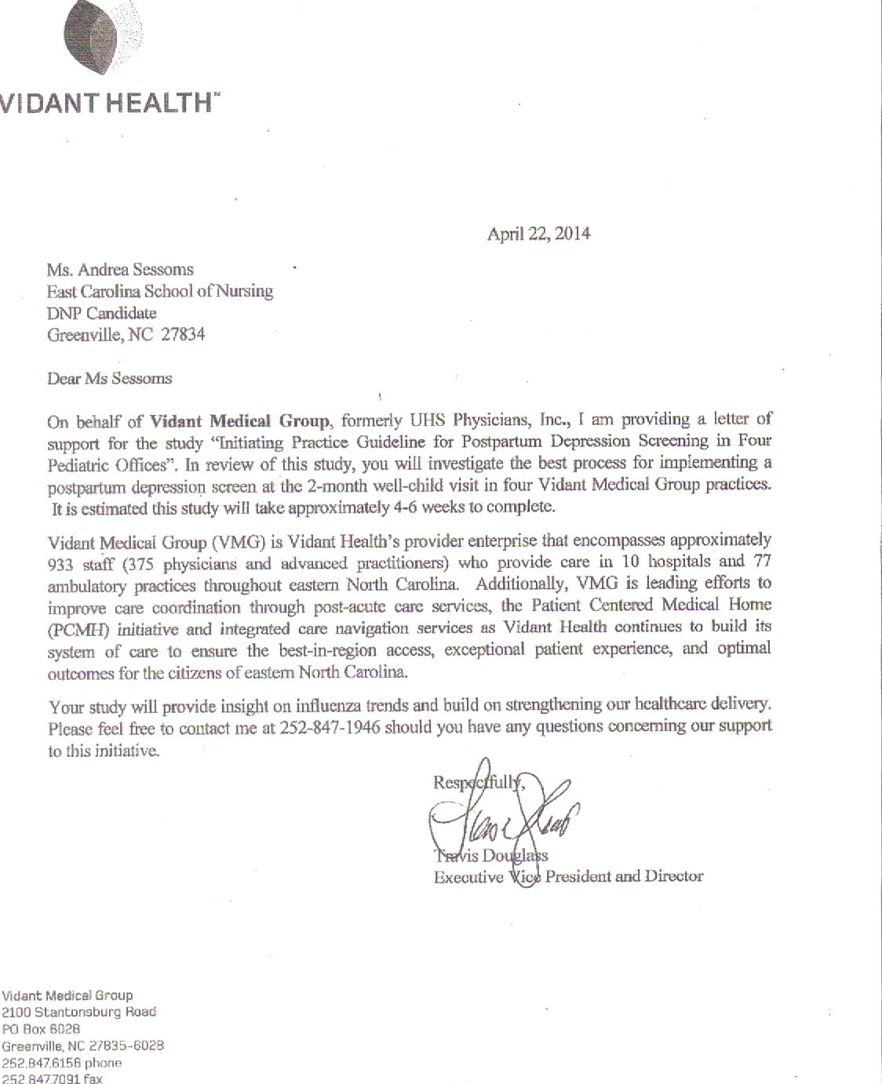

Appendix B
EAST CAROLINA UNIVERSITY
University & Medical Center Institutional Review Board Office
4N-70 Brody Medical Sciences Building· Mail Stop 682
600 Moye Boulevard · Greenville, NC 27834
Office 252-744-2914 · Fax252-744-2284 · www.ecu.edu/irb
Notification of Exempt Certification

From: | Biomedical IRB
To: | Andrea Sessoms
CC: | Rebecca Bagley
Date: | 5/9/2014
Re: | UMCIRB 14-000392  Initiating Practice Guidelines for Postpartum Depression Screening in Four Pediatric Offices
I am pleased to inform you that your research submission has been certified as exempt on 5/9/2014 . This study is eligible for Exempt Certification under category #2 .

It is your responsibility to ensure that this research is conducted in the manner reported in your application and/or protocol, as well as being consistent with the ethical principles of the Belmont Report and your profession.
This research study does not require any additional interaction with the UMCIRB unless there are proposed changes to this study. Any change, prior to implementing that change, must be submitted to the UMCIRB for review and approval. The UMCIRB will determine if the change impacts the eligibility of the research for exempt status. If more substantive review is required, you will be notified within five business days.
The UMCIRB office will hold your exemption application for a period of five years from the date of this letter. If you wish to continue this protocol beyond this period, you will need to submit an Exemption Certification request at least 30 days before the end of the five year period.
The Chairperson (or designee) does not have a potential for conflict of interest on this study.

IRB00000705 East Carolina U IRB #1 (Biomedical) IORG0000418
IRB00003781 East Carolina U IRB #2 (Behavioral/SS) IORG0000418

Appendix C
Postpartum Depression Screening Protocol
Provide to all mothers who are scheduled for a
well-child visit at:
2 months
Score the screening tool per the instructions.

If score is 10 or greater then:
- Inform the provider
- Encourage provider to counsel mom on PPD
- Provide mom with 2 handouts
  - (Eastpointe & Understanding PPD)
- Schedule a follow-up appointment with their delivering obstetrician’s office within 3-5 days.
Record the date and answer questions regarding the protocol on the data collection form provided.

Appendix D
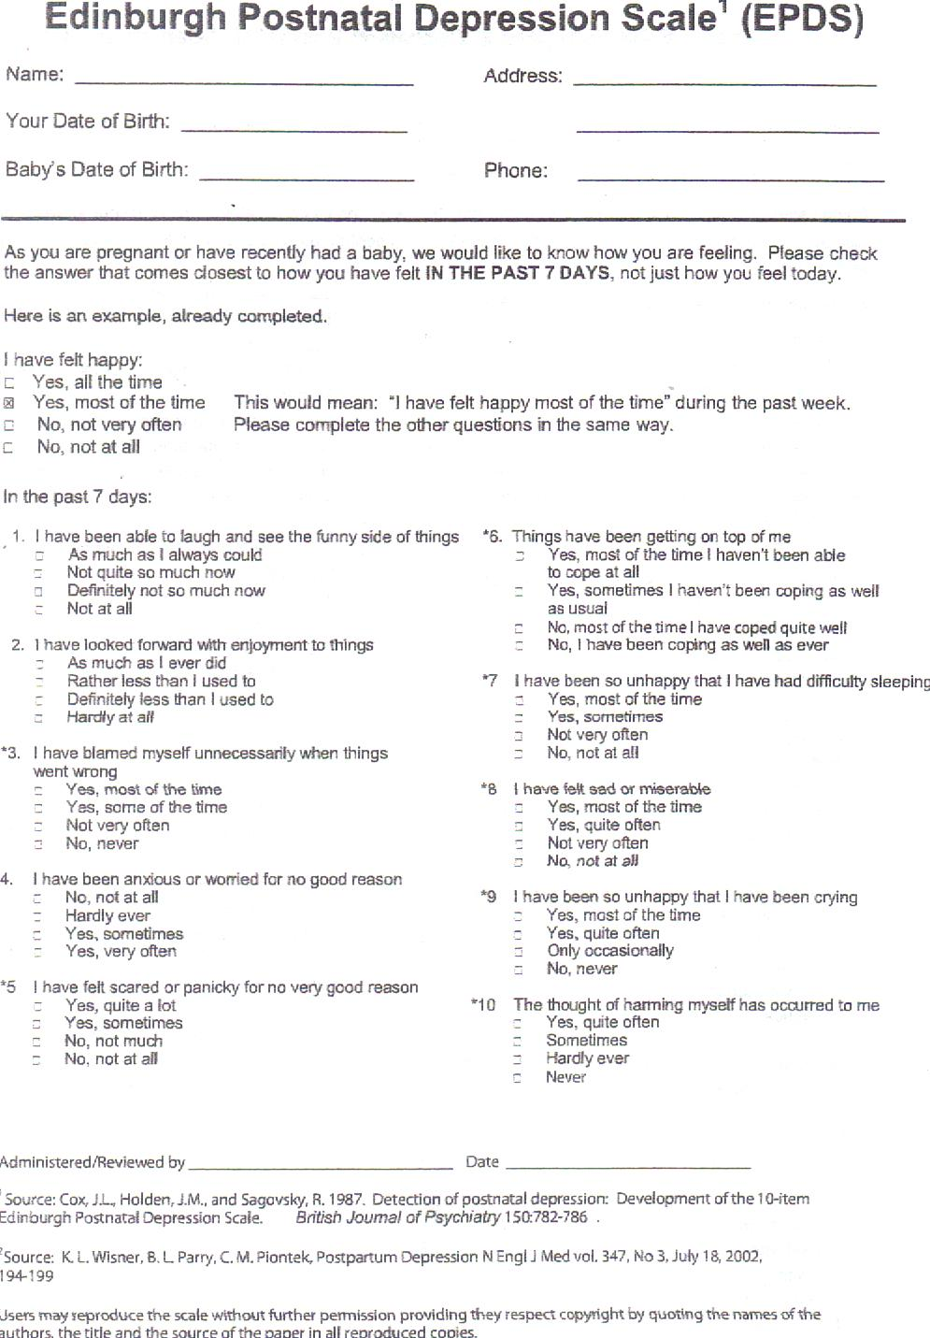
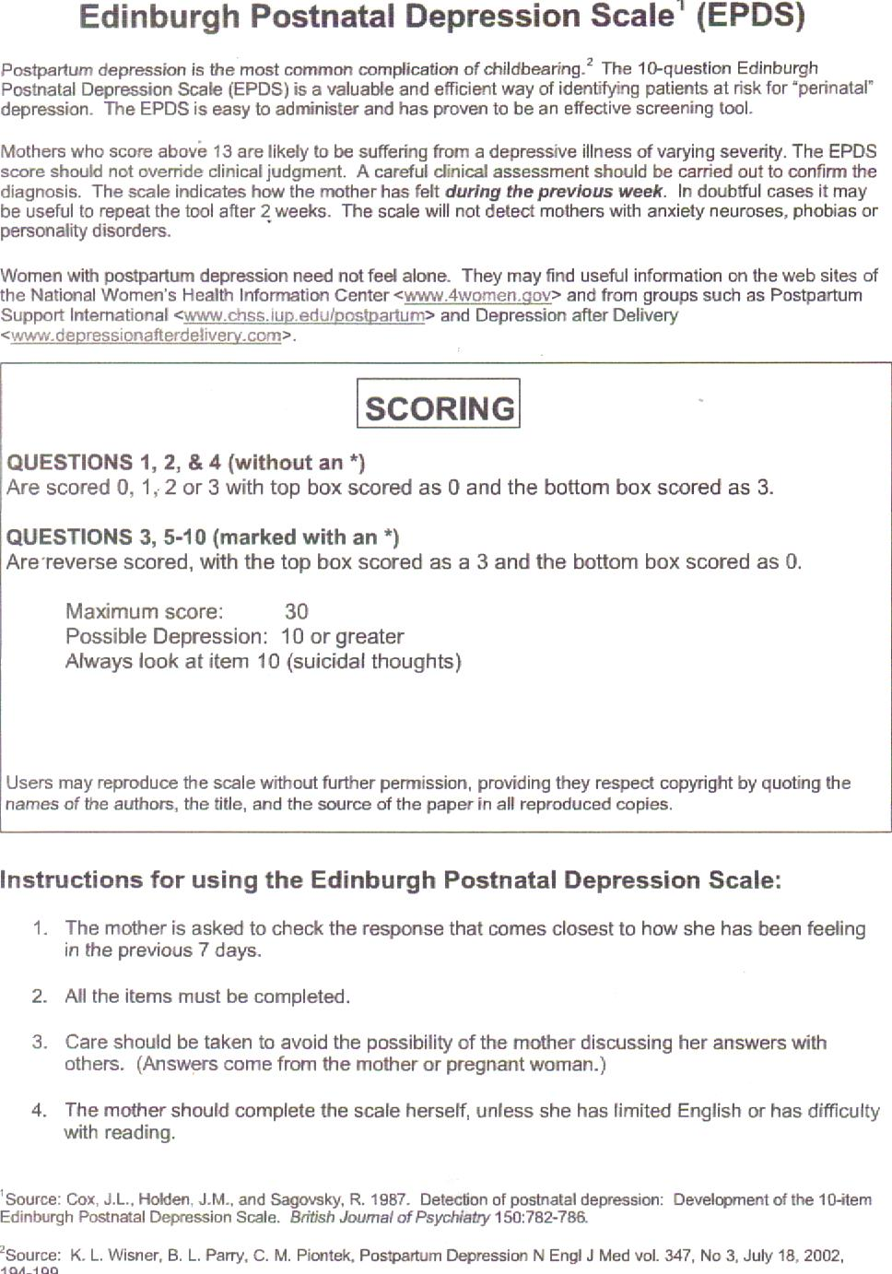

Appendix E
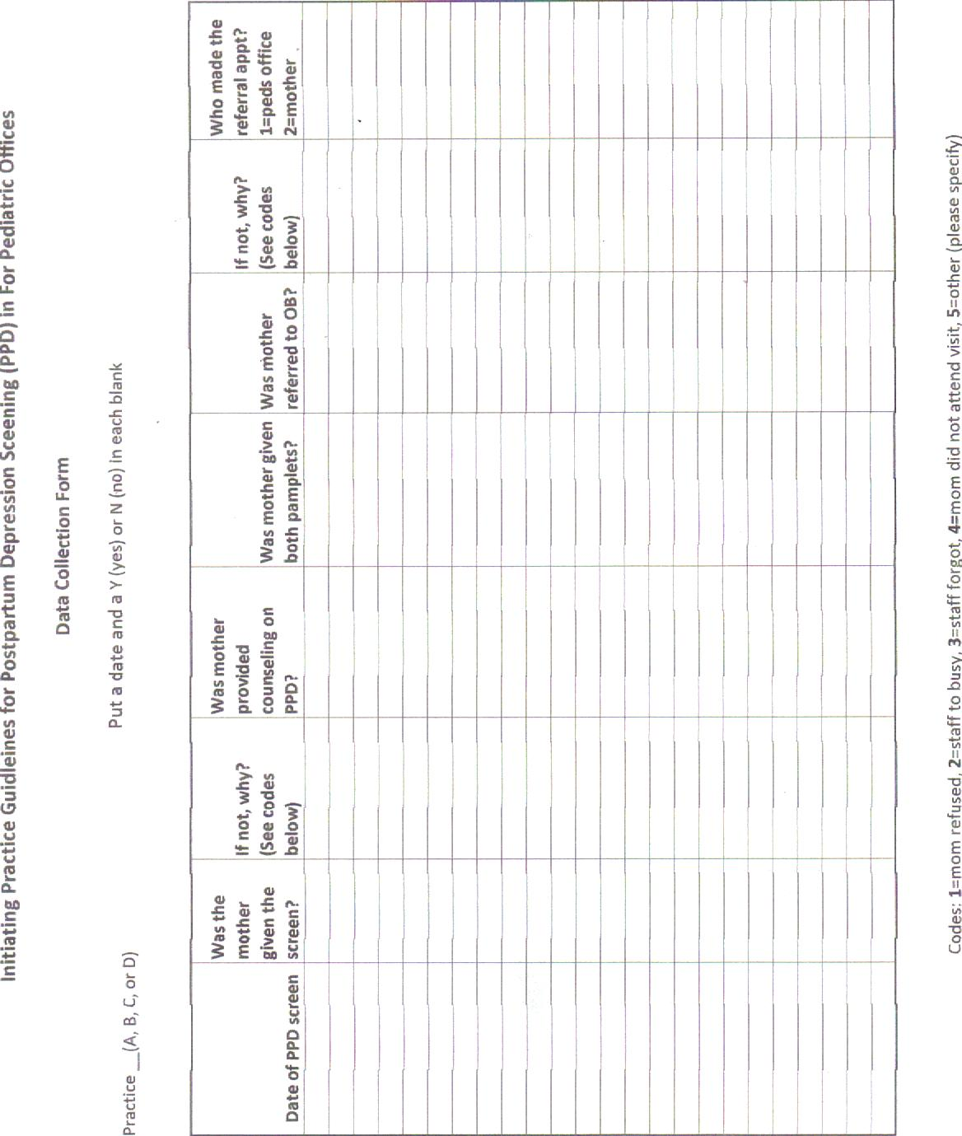

Appendix F
Procedural Flow Chart
Step 1
Develop PPD Screening protocol and all of the staff educational documents and providers agree to adopt this protocol as a standard of practice for the purposes of this project

Step 2
Obtain letter of support from large medical group and received exempt approval from the IRB Committee

Step 3
Schedule and hold participant education and training classes

Step 4
Screening for PPD for all mothers at the 2 month well-child visits

Step 5
Follow-up every other week by phone or in person with the nursing staff regarding their feedback related to the screening process

Step 6
Schedule and hold final meeting where all participants provide their final recommendations and complete the Compliance Survey

Appendix G
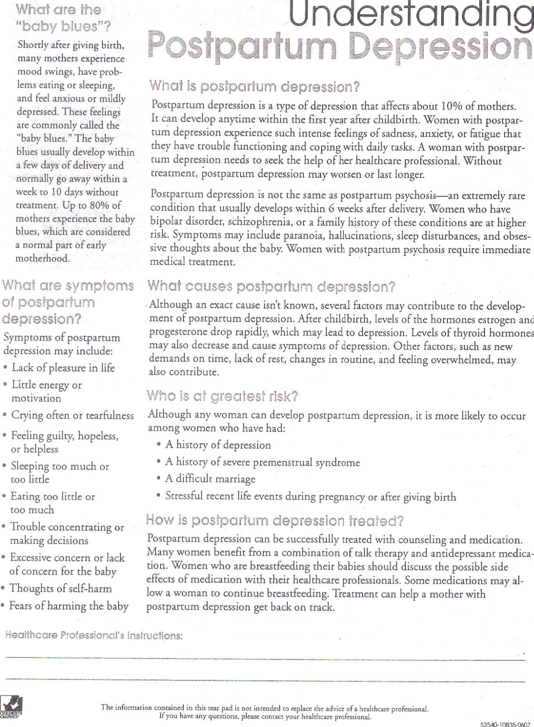

Appendix H



Appendix I
Suicide Action Plan
This protocol will be put into place as part of the project initiation guidelines. This information has been given to all of the pediatric providers for their understanding and agreement.
Question 10 on the Edinburgh Postnatal Depression Screen (EDPS) addresses suicidal ideations and states “the thought of harming myself has occurred to me….” If in the past 7 days a mother answers question 10 as “yes, quite often” or “sometimes” the following steps will be taken by the nurse and/or provider:
1. Make the mother an appointment to be seen the same day with an obstetrician’s office further evaluation
2. Make a referral to Eastpointe’s behavioral health 24-hr call center 1-800-913-6109 for assessment, crisis care and/or referrals
3. Refer the mother to the emergency room at the local hospital for further evaluation

Appendix J
Postpartum Depression Screening
Follow-up Appointments
All mothers who score 10 or greater on the Postpartum Depression Screen, will be given an appointment to follow-up with their delivering obstetrician’s office
Please complete the following steps:
- Email the receptionists, to get an appointment scheduled.
- Put PPD Protocol in the subject line.
- The email should include the following information:
- Mother’s Name
- DOB
- Delivering provider
- Telephone number

- The receptionists at the obstetrician’s office will make that appointment within the 3-5 day time frame and call the mother back with the appointment within 24 hours.
- In the event that the suicide action plan is needed, the pediatric nurse and/or provider will call the receptionists at obstetrician’s office for an appointment the same day.

Appendix K
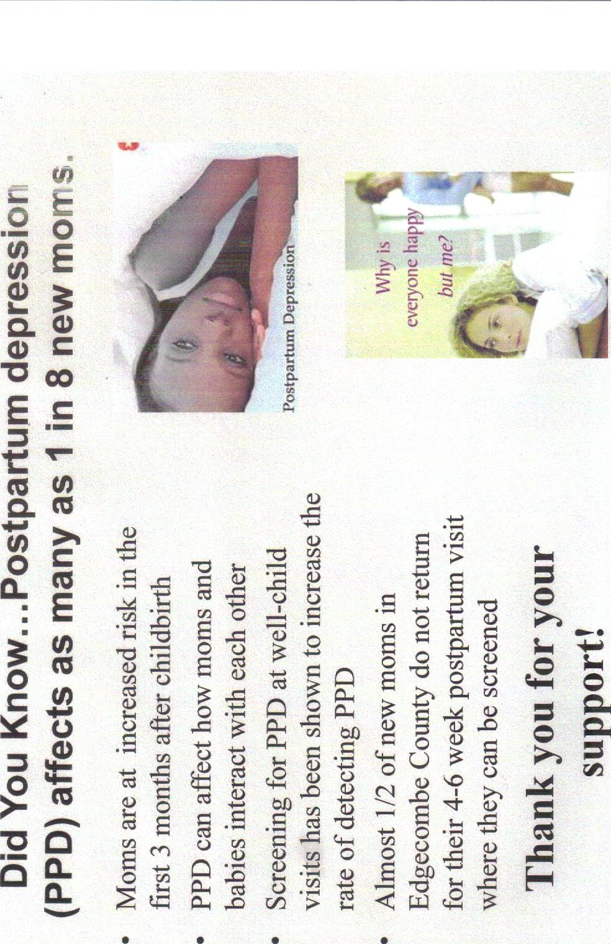

Appendix L
PDSA Directions

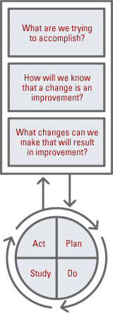The Plan-Do-Study-Act method is a way to test a change that is implemented. By going through the prescribed four steps, it guides the thinking process into breaking down the task into steps and then evaluating the outcome, improving on it, and testing again. Most of us go through some or all of these steps when we implement change in our lives, and we don’t even think about it. Having them written down often helps people focus and learn more.
For more information on the Plan-Do-Study-Act, go to the IHI (Institute for Healthcare Improvement) Web site or this PowerPoint presentation on Model for Improvement.
Keep the following in mind when using the PDSA cycles to implement the health literacy tools:
- Single Step - Each PDSA often contains only a segment or single step of the entire tool implementation.
- Short Duration - Each PDSA cycle should be as brief as possible for you to gain knowledge that it is working or not (some can be as short as 1 hour).
- Small Sample Size - A PDSA will likely involve only a portion of the practice (maybe 1 or 2 doctors). Once that feedback is obtained and the process refined, the implementation can be broadened to include the whole practice.

Filling out the worksheet
Tool: Fill in the tool name you are implementing.
Step: Fill in the smaller step within that tool you are trying to implement.
Cycle: Fill in the cycle number of this PDSA. As you work though a strategy for implementation, you will often go back and adjust something and want to test if the change you made is better or not. Each time you make an adjustment and test it again, you will do another cycle.

PLAN
I plan to: Here you will write a concise statement of what you plan to do in this testing. This will be much more focused and smaller than the implementation of the tool. It will be a small portion of the implementation of the tool.
I hope this produces: Here you can put a measurement or an outcome that you hope to achieve. You may have quantitative data like a certain number of doctors performed teach-back, or qualitative data such as nurses noticed less congestion in the lobby.
Steps to execute: Here is where you will write the steps that you are going to take in this cycle. You will want to include the following:
- The population you are working with – are you going to study the doctors’ behavior or the patients’ or the nurses’?
- The time limit that you are going to do this study – remember, it does not have to be long, just long enough to get your results. And, you may set a time limit of 1 week but find out after 4 hours that it doesn’t work. You can terminate the cycle at that point because you got your results.

DO
After you have your plan, you will execute it or set it in motion. During this implementation, you will be keen to watch what happens once you do this.
What did you observe? Here you will write down observations you have during your implementation. This may include how the patients react, how the doctors react, how the nurses react, how it fit in with your system or flow of the patient visit. You will ask, “Did everything go as planned?” “Did I have to modify the plan?”

STUDY
After implementation you will study the results.
What did you learn? Did you meet your measurement goal? Here you will record how well it worked, if you meet your goal.

ACT
What did you conclude from this cycle? Here you will write what you came away with for this implementation, if it worked or not. And if it did not work, what can you do differently in your next cycle to address that. If it did work, are you ready to spread it across your entire practice?

PDSA (plan-do-study-act) worksheet

TOOL: PPD Screening STEP: Project implementation CYCLE: 1st try

PLAN
I plan to: Evaluate the protocol/process of providing mothers PPD screening at the 2 month well child visit

I hope this produces: I hope the PPD screening is being provided to all mothers at the 2 months well-child visit & the data collection sheet is being completed

Steps to execute:
- Provide & explain screening to moms, ONLY using emotions experienced in the last 7 days
- Score the screening
- If score is > or = 10, follow the PPD protocol
- Complete the data collection form

DO

What did you observe?

STUDY

What did you learn? Did you meet your measurement goal?

ACT

What did you conclude from this cycle?

Appendix M

Compliance Survey for Pediatric Office Staff
You are being invited to participate in a study titled, “Initiating Practice Guidelines for Postpartum Depression Screening in Four Pediatric Offices” being conducted by Andrea Sessoms, RN, CNM and Doctorate of Nursing Practice Student at East Carolina University College of Nursing. The goal is to survey the office staff at Vidant Multi-Specialty Clinic-Tarboro and Vidant Family Practice-Pinetops, specifically the providers, nursing staff and receptionists if applicable in the following offices: Dr. Williams-Wooten, Dr. Alligood and Dr. Stark. The question being examined is what is the best process for implementing a depression screen at the 2 month well-child visit in a pediatric office?
This survey will take approximately 5-7 minutes to complete. The hope is that this information will assist us to better understand how to foster organization improvements through the integration of maternal postpartum depression screening into routine pediatric practice.
The survey is anonymous, so please do not write your name. Your participation in the research is voluntary. You may choose not to answer any or all questions, and you may stop at any time. There is no penalty for not taking part in this research study and it will not affect your employment in anyway. Please call Andrea Sessoms at 252-813-6839 for any research related questions or the UMCIRB at 252-744-2914 for questions about your rights as a research participant. Thank you in advance for you participation!
- What is your age?
- 20-30
- 31-40
- 41-50
- 51-60
- 60+

- What is your gender?
- Male
- Female

- What is your position?
- Receptionist
- NA I or NA II
- LPN
- RN
- FNP
- MD
- Which educational session presented by Andrea Sessoms, CNM did you attend?
- Staff/Office Meeting
- Provider meeting
- Did not attend any presentation

- The educational session provided by Andrea Sessoms, CNM was informative and helpful.
- Strongly Disagree
- Disagree
- Neutral
- Agree
- Strongly Agree

- The posters placed in nurse’s station and exam rooms were informative and helpful reminders.
- Strongly Disagree
- Disagree
- Neutral
- Agree
- Strongly Agree

- The laminated cards given to the providers and nursing staff were informative and helpful reminders.
- Strongly Disagree
- Disagree
- Neutral
- Agree
- Strongly Agree

- Since the implementation of the postpartum depression screening, have you participated or been involved with the screening, scoring, and referral of the patients identified as high risk?
- Never
- Rarely
- Sometimes
- Frequently
- Always

- If you have not participated in the PPD screening since the implementation process, which of the following best describes your reason?
- Unaware of the evidence supporting the need for this evaluation
- Was not convinced of the need for this practice
- Time or work load limited the ability to implement this screening into the daily routine
- Did not provide care to these patients
- Other

- In general, how did you feel about initiating and scoring the PPD screening?
- Very uncomfortable
- Slightly uncomfortable
- Comfortable
- Very comfortable

- In general, how did you feel about referral process put in place for the purposes of this study?
- Very uncomfortable
- Slightly uncomfortable
- Comfortable
- Very comfortable

- Do you have any suggestions that would make initiating and scoring the postpartum
depression screening a smoother procedure? Please list.

- Do you have any suggestions that would make the referral process easier? Please list.

These last questions are directed at your standard practice during this project for those patients who scored a 10 or greater on the EPDS. These questions are regarding referral, counseling and making the follow-up appointments with the OB providers. Please answer according to how you handled the majority of these patients.

- Did you counsel the mother scoring 10 or greater on the EPDS regarding postpartum depression?
- Never
- Rarely
- Sometimes
- Frequently
- Always
- Not applicable

- Did you give the mothers the handout entitled “Understanding Postpartum Depression?
- Never
- Rarely
- Sometimes
- Frequently
- Always
- Not applicable

- Did you give these mothers the handout that describes EastPointe’s behavioral health services?
- Never
- Rarely
- Sometimes
- Frequently
- Always
- Not applicable

- Were there problems in scheduling these patients with a follow-up appointment with the OB provider within 3-5 business days?
- Never
- Rarely
- Sometimes
- Frequently
- Always
- Not applicable

