Neurodevelopmentally Based Care Training for International Healthcare Volunteers

Rachel Frances Roberts

College of Nursing, East Carolina University
Doctor of Nursing Practice Program
Dr. Lee Ann Long
May 20, 2022

Notes from the Author
A special thanks to Dr. Lee Ann Long for her valuable insight and feedback, propelling me forward to completion of this project and graduation. Thank you to the support of the parents and patients in Antigua that gave generously of their trust and love. My deep gratitude is owed to Casa Jackson and director Vicany Sanchez for opening their life saving operation to this training project. All my love and thanks to Hunter, Sariah, and Liliana who have spent the last three years with a mama working three full time jobs and striving to be the best parent they deserve. You inspire me.

Abstract
International medical volunteerism is a global force that has posed complex issues for hosting organizations and volunteers. Nonprofit medical organizations that rely on international volunteers for donations, volunteer hours, and publicity can face significant challenges. In addition, medical training, education, and volunteers' preconceptions of the host community and country can be formidable challenges. The subject hospital of this project was a nonprofit hospital that expressed a need for a volunteer training program for health care workers. A hospital and rehabilitation center for malnourished children in Antigua, Guatemala, was a nonprofit specialized facility serving infants and children. The 24-bed hospital treats 100-150 patients in the inpatient and over 1000 in the outpatient program each year. In Guatemala, over 47% of children suffer from malnutrition, specifically undernutrition identified as wasting, stunting, and being underweight. The impacts of malnutrition are extensive and long-lasting, including significant developmental, economic, social, and medical challenges. The project implemented neurodevelopmentally based care training for international healthcare volunteers through video-based training. Participant perceptions of readiness and knowledge of neurodevelopmentally based care were measured before and after the training and results were compared.

Table of Contents
Notes from the Author………………………….……………………………………………….. 2
Abstract …………………………………………………………………………………………. 3
Section I: Introduction ..………………………………………………………………………… 6
Background……………………………………………………………………………… 6
Organizational Needs Statement………………………………………………….………7
Problem Statement…………………………………………………………………..……8
Purpose Statement……………………………………………………………………...…9
Section II: Evidence……………………………………………………………………………...10
Literature Review………………………………………………………………………...13
Evidence-Based Practice Framework…………………………………………………....14
Ethical Consideration and Protection of Human Subjects……………………………….14
Section III: Project Design……………………………………………………………………….15
Project Site and Population……………………………………………………………....15
Project Team……………………………………………………………………………..15
Project Goals and Outcomes Measures…………………………………………………..16
Implementation Plan……………………………………………………………………..17
Timeline………………………………………………………………………………….18
Section IV: Results and Findings………………………………………………………………...19
Results……………………………………………………………………………………19
Discussion of Major Findings……………………………………………………………20
Section V: Interpretation and Implications………………………………………………………22
Costs and Resource Management………………………………………………………..22
Implications of the Findings……………………………………………………………..22
Dissemination Plan …………………………………………………….………………..25
Section VI: Conclusion…………………………………………………………………………..26
Limitations and Facilitators…………..………………………………………………….26
Recommendations for Others……………………………………………………………27
Recommendations for Further Study…………………………………………………….28 Final Thoughts………………………………………………………………………...…29
References……………………………………………………………………………….……….30
Appendices………………………………………………...………………………………….….34
Appendix A: Literature Review Spreadsheet……………………………………………34
Appendix B: Project Timeline. ………………………………………………………….36
Appendix C: Budget……………………………………………………………………..37
Appendix D: Volunteer Training Video……………………………………...………….38
Appendix E: PowerPoint Presentation Volunteer Training………………….……….….44
Appendix F: Project Implementation Worksheet…………………………….………….48
Appendix G: Project Implementation Report...………………………………………….51
Appendix H: DNP Essentials Table...…………………………………………...……….53
Appendix I. DNP Project Poster...……………………………………………………….58

Section I. Introduction
Background
International medical volunteerism is a global force that has posed complex issues for hosting organizations and volunteers. International trends suggest that global medical volunteerism is increasing (United Nations, 2021). Nonprofit medical organizations that rely on international volunteers for donations, volunteer hours, and publicity can face significant challenges. In addition, medical training, education, and volunteers' preconceptions of the host community and country can be formidable challenges. The subject hospital of this project was a nonprofit hospital that expressed a need for a volunteer training program.
A hospital and rehabilitation center for malnourished children in Antigua, Guatemala, was a nonprofit specialized facility serving infants and children. The 24-bed hospital treats 100-150 patients in the inpatient and over 1000 in the outpatient program each year (Director, personal communication, August 8, 2021). In Guatemala, over 47% of children suffer from malnutrition, specifically undernutrition identified as wasting, stunting, and being underweight (WHO, 2021). The impacts of malnutrition are extensive and long-lasting, including significant developmental, economic, social, and medical challenges (Mazariegos et al., 2020). The hospital served the neediest of cases with residential intensive care, medical interventions, outpatient services, and long-term recovery care.
Organizational Needs Statement
The hospital relied on volunteers for approximately 30% of its daily operational infrastructure, including feeding, medication administration, assessment, and caring for infants (Director, personal communication, August 8, 2021). The hospital encouraged volunteers to "…donate their time and love, to help the children get the care they need to recover from malnutrition and starvation." Volunteers also educated families in health, hygiene, and nutrition to prevent further malnutrition and childhood mortality. Volunteers came from abroad for a period of one week to six months. Volunteers came with varying levels of training, experience, and comfort levels in caring for infants. The organization needed efficient and effective training tools to ensure volunteer competency who served this vulnerable patient population. This DNP project developed evidence-based best practice protocols and a volunteer training program for short-term volunteers.
Problem Statement
The hospital needed a comprehensive training program for volunteers who care for infants recovering from malnutrition. Evidence-based training programs can improve patient and family outcomes and volunteer experiences (IHI, 2020). With adequate training, patient outcomes would improve, the overall population of infants recovering from malnutrition in Guatemala would improve, and trained volunteers would help alleviate some of the financial burdens of care for patients for the nonprofit hospital.
The hospital served only a tiny fraction of the forty-seven percent of children five and under in Guatemala who suffered from malnutrition (WHO, 2021). Still, they served the neediest (Director, personal communication, August 8, 2021). The hospital served patients in a residential hospital setting with the help of volunteers. However, the hospital lacked a comprehensive set of evidence-based best practice protocols and staff and volunteer training programs to facilitate patients' care. Newborn Infant Developmental Care and Assessment Program (NIDCAP) is an internationally recognized approach to neonatal and infant care in the hospital setting (Als, 2021). Utilizing a modified NIDCAP program to create an individualized training program, the hospital provided volunteers with evidence-based practice training. The burdens were significant, but the organization and staff were resourceful. Providing the hospital with better prepared and trained staff and volunteers would improve the hospital's outcomes (Director, personal communication, August 8, 2021).
Purpose Statement
The purpose of this DNP quality improvement project was to develop an evidence-based volunteer training program based on the Newborn Individualized Developmental Care and Assessment Program for a hospital for malnourished children in Antigua, Guatemala. It was a collaborative effort with the hospital, NIDCAP Southeast, USA, Family and Infant Neurodevelopmental Education (FINE), and BirthLink to provide evidence-based volunteer training for staff and short-term healthcare volunteers serving infants recovering from malnutrition in Antigua, Guatemala (Director, personal communication, August 8, 2021). In addition, this project provided an opportunity to address training barriers for volunteers at the hospital with partnerships with international organizations focused on neurodevelopmentally based care for infants.

Section II: Evidence
Literature Review
Chapter two describes a literature review on the significance of volunteer training programs in the neonatal and pediatric settings. Neonatal was defined as "infants four weeks after birth or four weeks for corrected age." Neonatal Individualized Developmental Care Assessment Program (NIDCAP) Federation International was defined as the internationally recognized comprehensive, family-centered, evidence-based approach to developmental care for newborns and infants in intensive care nurseries (Als, 2021). Finally, a volunteer was defined as a person who freely offers to participate in a task or endeavor instead of paid health care providers (Dionigi et al., 2020).
Methodology
Sampling Strategies
CINAHL and PubMed were the search databases. CINAHL was first searched from 2016 to present for neonatal volunteer training, yielding 1791 articles. The search was narrowed down with the following terms in articles within the last five years: (1) volunteer + infant + trainings (1791 results), NIDCAP volunteer (19 results), (3) NIDCAP (143), (4) NIDCAP volunteer training (19). PubMed was searched 2016 to present for volunteer training infant, yielding 721 articles. To narrow down the search, the following terms were used to search all within the last five years: (1) NICU + Volunteer + Training (20 hits), (2) NIDCAP + training (42 results), (3) NIDCAP + volunteer + training (27 results), (4) ethical ­+ international + volunteer (987 results) (See Appendix I).

Evaluation Criteria
Inclusion criteria included articles with keywords for training for volunteers with infants, NIDCAP program outcomes, and ethical questions about international volunteerism. Exclusion criteria included: (1) articles in which volunteer training was not specific to the target population of infants and pediatric patients; (2) duplicate articles; and (3) articles in languages other than English.
After inclusion and exclusion criteria were applied, articles were further investigated by title. After selecting an article for inclusion, the abstract and results sections were assessed for relevancy. Articles with relevant information on training for volunteers with infants, ethics of international healthcare volunteerism, and NIDCAP were retained for potential use as a reference. Seventy-two articles were selected and reviewed in this Quality Improvement project. Eight articles were selected for use, and a literature matrix was created to summarize each article's findings (See Appendix A).
Current State of Knowledge
Literature review findings described training for healthcare volunteers working with infants and ethical considerations for international healthcare volunteers. Volunteer training programs were discussed as an individual giving freely of their time and expertise in a healthcare setting. Populations served through the volunteer training program were volunteers working with infants and pediatric patients in a healthcare setting. Many articles discussed training volunteers without professional medical training to care for infant and pediatric patients in hospital and outpatient settings. Ethical considerations for international healthcare volunteerism were discussed as considerations for volunteers before, during, and after volunteer experiences.
Training for volunteers in NIDCAP was a comprehensive, family-oriented, evidence-based approach to neonatal newborn developmental care in the hospital setting (Als, 2021). NICU nurseries utilizing NIDCAP were found to increase parental satisfaction, minimize developmental delays, and decrease the length of stay, thus reducing overall costs per patient (Moody et al., 2017). In addition, volunteers trained in the NICAP method were perceived by staff and patients' families to provide comfort to a neonatal patient, reducing periods of crying and distress for babies, and allowing staff to complete other tasks (James-Nunez et al., 2019). One hundred percent of families surveyed identified that they would recommend the program to other families.
International medical volunteerism is a global force that poses complex issues for hosting organizations and volunteers. International trends suggest that global medical volunteerism is increasing (Unknown, 2021). Ethical consideration in international volunteerism explores the moral principles that influence a person's behavior or activity. In 2019 the American Nurses Association (ANA) published guidelines and considerations for healthcare providers who volunteer in a healthcare capacity in an international setting (ANA, 2019). The ANA expresses affirmation for short-term volunteerism as a positive response to challenges and inequities in access to care around the world. When providing care in foreign countries, social perspectives that emphasize respect for the host communities' culture, religion, and beliefs should be considered. Collaboration with host communities should make special consideration for resiliency and continuity of health care to empower the host communities while providing opportunities for cultural and intellectual exchange between the host and guest parties.
Volunteerism training and management can positively contribute to nonprofit healthcare organizations' economic, logistical, and delivery of care capacities (Albuquerque et al., 2018). Volunteers can be considered capital for an organization because of the financial benefits of reduced burden in paying employees (Wu et al., 2016). Volunteers benefit from their experiences primarily through increased social interaction, personal fulfillment, and health improvement (Burr et al., 2016, Principe et al., 2016). Secondary benefits of volunteerism include improved community health, increased access for vulnerable populations to healthcare, reduced rates of homeless, and reductions in healthcare disparities (Birs et al., 2016).
Limitations of Literature Review Process
Study design, limited sample size, study methods, study date, and study location were all challenges and limitations posed in studies in the literature review process. This project was a Quality Improvement study and a descriptive study. Therefore, a randomized control trial (RTC) was not necessary for this level of study. The sample size was limited to staff and volunteers at the hospital and their response rate.
The literature review supported the quality improvement project for volunteer training in an inpatient facility for infants recovering from severe malnutrition. However, disadvantages included a lack of studies that assessed the specific role of volunteer training for international episodic volunteering. In addition, no research was available on improved outcomes for infant patients with improved volunteer training.
Utilization of Findings in Practice
Literature findings support the implementation of volunteer training programs for global healthcare experiences. The retrospective survey of volunteers and staff on training is an accessible and valuable tool for analyzing the effects of a new training program. Improved outcomes for patients, volunteers, staff, and patients' families can be facilitated with volunteer training.
Evidence to Support the Intervention.
Literature review findings supported the need for high-quality volunteer training programs for global health care experiences. Literature supported the efficacy of NICDAP for reducing hospital length of stay, neurodevelopmental delays, and nurse, doctor, and family satisfaction with the NIDCAP methods. Special considerations for ethical global volunteerism are necessary to facilitate hosts' and volunteers' positive and productive experiences.
Evidence-Based Practice Framework
Health care quality can be directly correlated between improved health services and the health outcomes of individuals and populations. The nursing theory of Cultural Care is foundational in the implementation of this project (Blake, 2019). The focus on the human care phenomena while making intentional space for patient and family autonomy in the care paradigm. The interplay between scientific care discipline and care phenomena guides the actions of nurses at the hospital and this project.
Plan-Do-Study-Act (PDSA) cycle is a systematic approach to Quality Improvement. The planning phase of the cycle is an opportunity to utilize assessment data, clinical workflow, and established metrics to enable progress towards a goal or goals. The "Do" component of the cycle is where the plan is in action. The process or procedure can commence for a time interval or number of subjects. In the study portion of the cycle, researchers examine and analyze the results collected in the "Do" step (see Appendix B). The "Act" part of the series is the culmination of the three other series with implementation and incorporation of changes established as quality improvement with the plan, collection of data from "do," and analysis of outcomes in the study (Deming, 1993).
Ethical Consideration & Protection of Human Subjects
The Collaborative Institutional Training Initiative (CITI) program certified integrity and professionalism in research and advanced learning (Longaray, 2017). The CITI training modules for Behavioral Research Investigators and Key Personnel were completed to avoid ethical dilemmas in research. The Institutional Review Board is a group of professionals designated to review and monitor the protection of human subjects in clinical trials (East Carolina University, 2021). This project is not subject to IRB review because patients are not the subject of the intervention being measured (Longaray, 2017).
Summary
The literature review demonstrated the clinical significance of volunteer training for improved outcomes for patients, volunteers, staff, and patients' families. Literature indicated that volunteers trained in NIDCAP could help to alleviate staff workload, facilitate patient family empowerment and education, and improve outcomes for infants in an inpatient setting (Moody et al., 2017). The literature supported this Quality Improvement project's premise of implementing evidence-based volunteer training for neurodevelopmental care to improve volunteer readiness and patient outcomes.

Section III. Project Design
Project Site and Population
According to UNICEF (2020), one in every two children in Guatemala are chronically malnourished. The global SARS-CoV-2 pandemic has more than doubled acute malnutrition cases in children under the age of five in the country (Kragel et al., 2020). In 2019 the World Food Programme estimated that 40% of Guatemalans spend more than 65% of their income solely on buying sustenance food (WFP, 2020). Reductions in remittances from families abroad and decreased employment opportunities in formal and informal employment have led to reduced income and money for food. Short-term effects of chronic and acute malnutrition lead to higher incidents of infectious and chronic diseases, infant mortality, and cognitive and neurological deficits (Black, 2017). Long-term effects of malnutrition include loss of academic learning, reduced economic contributions, and increased life-long health disparities.
The hospital for malnourished children in Antigua, Guatemala, was a unique inpatient facility that served severely malnourished children from throughout Guatemala. Staff and volunteers helped care for infants in their recovery from malnutrition and starvation. Hand feeding, hygiene, and nursing assistants were roles that volunteers participated in at the hospital. Appropriate training, volunteer readiness, and increased engagement helped facilitate effective care for infants at the hospital. In addition, increased volunteer engagement could lead to increase financial gifts, volunteer hours, return trips, and word-of-mouth support for the program.
Description of the Setting
Before the pandemic began in 2020, the hospital in Antigua, Guatemala, relied on international volunteers for 25% of the operational budget and 30% of the human hours necessary for infant care (with significant variability in the time of year) (Director, personal communication, August 8, 2021). Volunteers prepared for their experience caring for infants in the inpatient hospital setting with self-study and an informational packet outlining the hospital's function. Staff at the hospital provided in-person guidance as volunteers provided care for patients in Spanish. For this reason, the leadership at the hospital identified a volunteer training program as a priority for preparing volunteers, offering them a more meaningful experience during their short-term volunteer experience.
Description of the Population
Nursing groups, church-based mission groups, and individuals find the hospital an international volunteer destination through national media recognition (Kristoff, 2019), online searches, and word-of-mouth. In the recent past, international volunteers at the hospital were predominately from Canada and the United States (Director, personal communication, August 8, 2021). The organization's headquarters in the US is in Golden Valley, Minnesota, and approximately 25% of volunteer groups come from the state. About 50- 75% of the volunteers came from Canada, where churches and community organizations have a long-standing relationship with the hospital and the parent nonprofit organization in Golden Valley, Minnesota.
Project Team
The project team consisted of a Doctor of Nursing Practice-Family Nurse Practitioner student at East Carolina University, project advisor and Adjunct Professor of Nursing at East Carolina University, Doctor of Nursing Practice Project manager and Professor of Nursing at East Carolina University, National Director of nonprofit in Guatemala, Program and Sponsorship Coordinator, Former Director of Carolina NIDCAP (Newborn Individualized Developmental Care and Assessment Program) Training Center, and the director of BirthLink.
Project Goals and Outcome Measures
This project aimed to increase volunteers' readiness by training volunteers in neurodevelopmentally-based care before their experience at the hospital. Perceptions of readiness and knowledge were evidenced by increases in positive responses on post-training surveys compared to pre-training responses. Increased understanding of neurodevelopmentally based infant care was demonstrated in knowledge recall questions. Volunteers' perception of readiness was measured before and after training with Likert scale questions. The development of a NIDCAP-based training program was the expressed goal of the hospital's director and the service of this project. The project objective was to implement effective NICAP-based training to increase volunteer readiness and engagement in meaningful care. The collection of volunteers' perceptions of preparedness and knowledge was the measurable outcome of this DNP project. Narrative feedback from staff at the hospital was included in the project outcomes.
Description of the Methods and Measurement
Participants in the project were volunteers who worked at the hospital within six months of the project initiation. Participants filled out a Likert scale survey before participation in training. Video and written training were provided to volunteers educating them on the NICAP techniques for infant care. Depending on the volunteers' timeline, participants were surveyed on their perceptions of readiness after the training program. A Likert scale survey was utilized to analyze interval data with mean, standard deviation, and narrative responses to the volunteers' perception of the effectiveness of the volunteer training program.
Discussion of the Data Collection Process
Qualtrics XM through ECU was the primary method for data collection (see Appendix E and F). The hospital provided a list of volunteers scheduled for the past six months with contact information. Email, phone, and in-person communication (while in Guatemala) were utilized to recruit participants in the training program.
Implementation Plan
August - December 2021 Development of project plan and training materials.
December - January 2021-2022 Three-week trip to Guatemala to meet with staff and administration to solicit feedback on the effectiveness of the training program.
January - May 2022- Implementation of the training program and data collection on the effectiveness. Data analysis and paper completion.
May - June 2022- Presentation of the training program (with modifications based on data analysis) to the hospital's volunteer coordinators and administration.
Timeline
Background for this DNP project began in April- May 2018 during a visit to Guatemala and the hospital. Development of the specific project plan started in 2019 with brainstorming positive impact projects for the hospital. The project began in the fall of 2020 as the hospital's director expressed a specific need for volunteer training and readiness. In summer 2021, the former director of the Carolina NIDCAP training center agreed to serve as a project advisor and lend NIDCAP expertise to the project. The project was implemented in the winter and spring of 2021-2022. Project analysis took place in the spring and summer of 2022.

Section IV. Results and Findings
Results
Quantitative Results Pre-Training
Eleven volunteers and six staff members participated in the training and the pre and post-survey. The average age of participants was between 25-34 years old. Participants reported education level to be 56% (n. 9) with no formal education, 31% (n. 5) nurses, and 13% (n. 2) medical assistant. Three respondents were from Guatemala, two from Mexico, seven from the USA, one from Canada, and one from Denmark. Of the respondents, 66% (n. 10) had volunteered at least once before at the hospital, while 33% (n. 5) volunteered for the first time. Two respondents failed to answer this question.
Qualitative Results Pre-Training
Respondents reported knowledge of Neurodevelopmental based care for infants as follows: 31% (n. 5) strongly disagree, 63% (n. 10) disagree, 6% (n. 1) strongly agree, with a mean of 3.06 or neutral, and a standard deviation of 0.97. In addition, participants reported their readiness to care for patients at the hospital as follows: agree 44% (n. 7), neutral 25% (n. 4), disagree 25% (n. 4), strongly disagree 6% (n. 1), average 3.06 or neutral and standard deviation of 0.96.
Qualitative Results Post-Training
Respondents reported feeling more prepared to volunteer after the training: agree, 44% (n. 7), strongly agree, 56% (n. 9). Compared to pre-training survey data, there was a 56% increase from neutral, disagree, or strongly disagree to strongly agree. When comparing the pre and post-training data, the mean of people who felt more prepared increased by more than 30%. When asked about their understanding of the training objectives, participants indicated that 19% agreed (n. 3), and 81% strongly agreed (n.13). All participants agreed with an average of 4.81/5 that concepts were defined. Of the sixteen participants who responded to the survey, 4.88/5 was the average score agreeing with the statement, "Relevant content was delivered." Participants agreed with 4.75/5 that relevant application examples were provided.
One emphasis of the training was Family-Centered Care. After the training, participants were asked to rate their understanding of the importance of Family-Centered Care from "Strongly Disagree" to "Strongly Agree." One respondent or 6% responded "Agree," while 94% or 15 responded, "Strongly Agree."
In conclusion, participants were asked to rate their agreement with "I would recommend this training to other volunteers." Of 16 participants who completed the pre nd post-training survey, 6% responded: "Agree." Ninety-four percent (n. 15) responded: "Strongly Agree."
Discussion of Major Findings
Literature supported training for international health care volunteerism to improve patient outcomes. Neurodevelopmental-based care for infants provided the framework for best practices for trained and inexperienced healthcare volunteers. In addition, volunteers were educated about respecting their role as guests and volunteers in a foreign country. The volunteer training emphasized the importance of supporting and respecting Family-Centered Care. Overall, volunteers expressed a positive experience with the pre-volunteer training.
Figure 1 represents survey respondents' data on the changes in perceptions of preparedness for volunteering compared before and after the training. The ordinal data collected through the Likert-scale questionnaires supports volunteer growth in perceptions of preparedness from pre- to post-volunteer training. When asked, "I am prepared to care for patients at Casa Jackson Hospital for Malnourished Children." and given the options "Strongly Disagree, Disagree, Neutral, Agree, and Strongly Agree," participants answered: 61.25% positive pre-training and 91.25% positive post-training. There was an increase of 30% in perceptions of preparedness after the training.

Figure 1
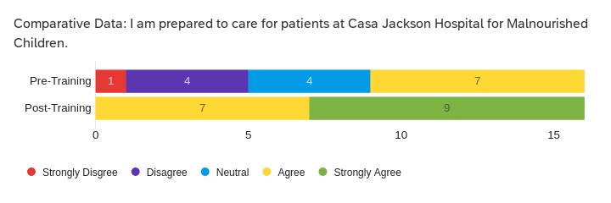
In figure two, survey participants' data is compared in the knowledge of Neurodevelopmental Care pre and post-training. The majority of participants had little or no prior knowledge of neurodevelopmental-based care. Therefore, there was a significant opportunity for growth before the training volunteers responded with 37.5% positivity regarding knowledge of neurodevelopmental-based care. After the training, participants responded with 92.5% positivity, an increase of 55%.

Figure 2
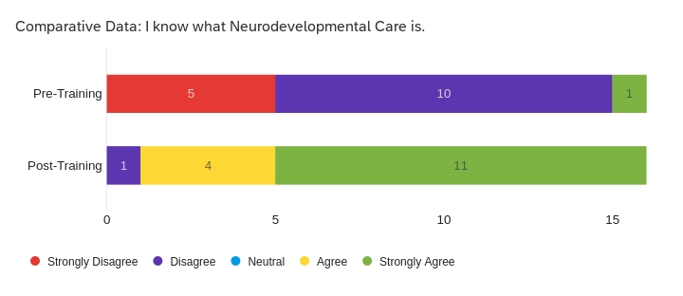

The original goals of the project did not include staff training. However, the director of the hospital asked that staff be included. Staff participated in pre and post-training surveys. The data collected indicated that staff benefited from the training by expanding their understanding of neurodevelopmental-based care, systems, and protocols for volunteers to participate in patient care, and language translation tools to help them communicate with English-speaking staff. Staff survey data was not separated from volunteer data which in the future could contribute to a better understanding of staff perceptions independent of volunteer perceptions.

Section V. Interpretation and Implications
Costs and Resource Management
Financial
Research and collaboration on NIDCAP training (150 hrs) presented to the hospital volunteer and staff required significant contributions from international organizations supporting infant neurodevelopmental-based care. This project was enabled by generous support from nonprofits around the world as noted in Appendix C. The director of Carolina NIDCAP Training Center and member of the Board of Directors of NIDCAP International, collaborated on the project offering his expertise and global connections with face-to-face meetings, zoom conferencing, and emails with approximately 40 hours of donated time. The director provided networking with two international non-governmental organizations that specialize in neurodevelopmental training for low-resource hospitals, including BirthLink (25 hrs.) based out of London and Kinshasa and Family and Infant Neurodevelopmental Education (FINE) (25 hrs.) based out of Birmingham, United Kingdom. Collectively, more than 90 hours was a donation of greater than $3,600. The hospital's parent organization, contributed staff and facilities for the training delivery. With 80 hours of donated time from the director and staff and 50 hours of facility time, the hospital and parent organization donated 130 hours at greater than $5,200. Development and dissemination of the PowerPoint training took 125 hrs. ($4,000). Further research would be needed to justify the financial benefits of the project in comparison with the financial savings of decreased time for recovery, growth, and development of patients.
Implications of the Findings
Narrative and anecdotal evidence collected from staff support increased perceptions of readiness of volunteers after participation in pre-volunteer training. A foundational understanding of Family-Centered Care and neurodevelopmentally-based care for infants facilitated volunteers' ability to provide care that relieved the burden on the limited staff. Volunteers exhibited curiosity and sought an understanding of patients' physiological and neurological developmental stages before engaging with patients. For example, a volunteer inquired about a twenty-two-month-old patient's ability to walk, stand independently, and general physiological milestones before encouraging the patient to walk independently on the hospital's ceramic tile floors. Neurodevelopmentally informed care improved the safety and care the patient received while at the same time relieving the staff of intensive oversight of volunteers who would otherwise be unfamiliar with each patient's developmental state. Soliciting input from staff before volunteers provided care for patients to understand patients' developmental delays and associated appropriateness of care was highlighted by staff to be a necessary topic of training. For the safety of patients, volunteers needed to be aware of acute and chronic malnourishment, which left many patients with significant physical and mental development delays
Volunteers expressed increased readiness and improved care for patients after the volunteer training. A foundational understanding of neurodevelopmentally appropriate care served as the foundation for volunteers' care delivery to patients. Volunteers expressed increased empowerment in caring for patients increasing the hours of touch, play, individualized feeding, and care patients received. These increased contact hours helped alleviate staff with the burden of staff to high patient ratios. Without volunteers, staff typically cared for six to nine patients. Volunteer support could be brought down to two or three patients per adult caregiver.
There are significant implications for nursing practice when well-trained volunteers provide neurodevelopmental-based care. Decreasing the caregiver to patient ratio supports increased individualized care for high acuity fragile patients suffering from acute and chronic malnutrition. Individualized care based on developmental stages can lead to decreased length of stay and increased weight gain, as indicated by staff. The care provided by volunteers was a small step in addressing healthcare inequities for the most vulnerable populations.
The impact on the hospital's health care systems is significant. The hospital depends on volunteers. Having well-trained volunteers can increase patient outcomes and alleviate the work burden on nurses. The nursing care for patients increased when volunteers could competently complete caregiving tasks for patients, including feeding, bathing, changing, and putting to sleep. The alleviation of work burden allowed nurses to focus more time and energy on medication administration, assessments, documentation, and other higher-skilled tasks. The redistribution of care provided more time and attention for patients, thus increasing their quality of care.
Sustainability was a central goal of the program from its inception. The program was delivered digitally through a free video streaming service available globally without an account (see Appendix D). The survey was created and distributed using a university service that enabled participants to respond with an internet connection and link. On-going technical support maintenance would be minimal and provided by a volunteer.
Dissemination Plan
The dissemination plan for the project involved the hospital staff and is incorporated into their work responsibilities when orienting new volunteers and staff to the hospital. When volunteers apply to work at the hospital, the response includes a link to the orientation video, digital access to the orientation document, and a volunteer contract to be signed and returned to the hospital before volunteering. The current workflow identified the director as the responsible party for orienting volunteers. However, if needed, this could be delegated to other staff or long-term volunteers.
Dissemination of the project and paper will continue through East Carolina University's digital archive of scholarly work called the ScholarShip. The digital repository of academic work provides indefinite storage of the paper. In addition, a URL of the work will be provided by the storehouse for improved distribution to other journals and publications.

Section VI. Conclusion
Limitations and Facilitators
Working in any country foreign to the student requires flexibility with different cultural concepts of time, timeliness, and timelines for project completion. For example, in Guatemala, the Mayan understanding of time is circular compared to the Eurocentric linear concept of time. Therefore, rushing or expediting a project for implementation and completion seems extraneous. Communicating needs and expectations continually during the project planning and implementation phases is essential to success. Working in a country foreign to the project coordinator requires flexibility to meet the stated needs of the organization. During this project implementation, the hospital and parent not-for-profit acquired new directors. The hospital patient population shifted in response to community needs to serve primarily six months to two years instead of newborn to one-year-old patients. Flexibility in the project vision and goals was essential to the successful implementation and outcomes of the project.
Significant challenges are present when conducting an international Quality Improvement project. The language barrier, cultural differences between parents, volunteers, and staff, international research amid a pandemic, and changes to the primary patient population were just a few of the specific challenges of this project. All of the participants, excluding the hospital director, spoke a primary language other than Spanish. Staff and parents each spoke one of over 28 Mayan languages as their native language and Spanish as their second language. Volunteers spoke English as their native language and Spanish as a second language. Spanish was a common tongue; therefore, much may have been lost in translation. However, all parties were patient and understanding in striving to communicate clearly. Many volunteers expressed challenges with their insufficient language skills in communicating with staff and parents of patients. In response, the project created a dictionary of common phrases and laminated sheets with vocabulary essential to caring for patients in the hospital in English and Spanish.
International research amid a pandemic was a challenge common to all projects conducted during these last two years. Because of the changing nature of poverty and malnutrition during the pandemic, the hospital changed the primary population that they serve. In response, this project adapted the original goals and volunteer training to apply to the hospital's needs. While the training was first intended for volunteers, the hospital director expressed that staff would also benefit. Therefore a modified Spanish version of the training was created. In addition, staff identified further needs for a more generalized training on the facility, volunteerism in a foreign country, and an introduction to Guatemalan history and culture.
Facilitators
The Quality Improvement project would not have been possible without the generous support of the project's facilitators. Program Director provided an international lens for the challenges of international volunteerism. They were knowledgeable of the specific form and function of a nonprofit hospital. Hospital Director V. S. generously offered intimate knowledge of the particular needs of patients and families at the hospital, specific requirements for volunteers to be trained, and ideas for addressing those in documents and videos. NIDCAP trainer Dr. J. H. helped network with international NGOs for specific training content and an overview of the application of neurodevelopmental-based care. BirthLink provided the raw material for training content delivered in an international limited resources setting. The hospital's enthusiastic nurses were patient and generous in welcoming short- and long-term volunteers and sharing their passion for the children. Parents opened their hearts, and families let volunteers help care for their children. Enthusiastic volunteers gave generously of their time, talents, and resources with a deep desire to conscientiously share their privilege and gifts with others.
Recommendations for Others
A few recommendations for those perpetuating this project should keep an open heart and flexible mind and schedule. Never assume that what you have to give is what others asking. LISTEN first, act second, and ask for confirmation of perceptions of need without assumptions. The project is scalable in this specific hospital and the application of neurodevelopmental-based care. The project can be expanded to other low-resource hospitals serving acutely and chronically malnourished children.
Recommendations Further Study
Recommendations for further study include examining parents' perception of training in nurses and volunteers. Gaining insights into nurses' perception of training in volunteers would be valuable for the sustainability of the volunteer program. Training parents in Neurodevelopmentally based care would serve patients in the hospital and as they transition to the home setting upon discharge. More information could be gathered about the understanding of parents' perceptions of the value of training staff, volunteers, and themselves in neurodevelopmentally-based care. NIDCAP's worldwide efforts could be linked to this project, supporting a broader networking effort. Customization and tailoring could serve other hospitals that utilize volunteers for infant care. Exploring gaps in service to patients, such as overworked nurses with a lack of resources and unable to serve all their patients with best practices, is a significant possibility for further study.
Final Thoughts
In Guatemala, where one in two children are chronically malnourished and malnutrition is the underlying cause of as many as 45% of child deaths, the hospital serves the most vulnerable patient population. The hospital's essential role in offering residential family-centered care for the patients was an evidence-based, best practice model. Neurodevelopmentally based care provides a framework of care for infants that is responsive and neurodevelopmentally appropriate, individually tailoring care to the developmental state of infant patients. Infant patients benefited when volunteers and staff were trained and could provide care through a neurodevelopmental lens. Volunteers and staff trained in neurodevelopmentally based care for infants perceive their readiness to service this unique and vulnerable population increased after training. In addition, patients benefit from well-trained caregivers with improved rates of recovery and lower developmental discrepancies based on their age.

References
Albuquerque, S., Eriksson, A., & Alvesson, H. M. (2018). The rite of passage of becoming a
humanitarian health worker: Experiences of retention in Sweden. Global Health Action, 11(1), 1. https://doi.org/10.1080/16549716.2017.1417522
Als, H. (2021). Newborn Individualized Developmental Care and Assessment
Program. https://nidcap.org/.
ANA Ethics Advisory Board (2019). ANA Position Statement: Ethical
Considerations for Local and Global Volunteerism. OJIN: The Online Journal of Issues in Nursing, 25(1).
Berwick, D. M., Nolan, T. W., & Whittington, J. (n.d.). The triple aim: Care, health, and
cost. Institute for Healthcare Improvement. http://www.ihi.org/resources/Pages/Publications/TripleAimCareHealthandCost.asp.
Birs, A., Liu, X., Sullivan, S., Garris, S., Hardy, M., Lee, M., . . . Pasarica, M. (2016). Medical
care in a free clinic: A comprehensive evaluation of patient experience, incentives, and barriers to optimal medical care with consideration of a facility fee. Cureus, 8(2), E500. doi:10.7759/cureus.500
Black, R. E. 2017. "Patterns of Growth in Early Childhood and Infectious Disease and
Nutritional Determinants." In Complementary Feeding: Building the Foundations for a Healthy Life. Vol. 87, 63–72. Basel: Karger Publishers.
Blake, J. (2019). Cultural Heritage Care and Management: Theory and Practice ed. by Cecilia
Lizama Salvatore]. The Public Historian 41(1), 167-169. https://www.muse.jhu.edu/article/737453.
Burr, J., Han, S., & Tavares, J. (2016). Volunteering and cardiovascular disease risk: Does
helping others get "under the skin?". The Gerontologist, 5(1), 937-945. doi:https://doiorg.ezproxy.bradley.edu/10.1093/geront/gnv032
Casa Jackson Hospital for Malnourished Children. (2019). The GODS CHILD Project.
https://godschild.org/casajackson.
East Carolina University and Medical Center Institutional Review Board (2021). UMCIRB.
https://rede.ecu.edu
Deming, W.E. (1993). The New Economics. MIT Press: Cambridge, MA.
Dionigi, A., Casu, G., & Gremigni, P. (2020). Associations of self-efficacy, optimism, and
empathy with psychological health in healthcare volunteers. International Journal of Environmental Research and Public Health, 17(16), 6001.
James-Nunez, K., Griffiths, N., and Gittany, H. (2019, October 5-7). Supporting families in the
neonatal setting its time to get creative! [Conference presentation]. 30th Annual NIDCAP Trainers Meeting. Portsmouth, NH
Kragel, E. A., Merz, A., Flood, D. M. N., & Haven, K. E. (2020). Risk factors for stunting in
children under the age of 5 in rural Guatemalan highlands. Annals of Global Health, 86(1), 8-8. https://doi.org/10.5334/aogh.2433
Lasker, J. N. (2016). Hoping to help: The promises and pitfalls of global health volunteering.
Ithaca, NY: Cornell University Press.
Lasker, J. N., Aldrink, M., Balasubramaniam, R., Caldron, P., Compton, B., Evert, J.,...Siegel, S.
(2018). Guidelines for responsible short-term global health activities: Developing common principles. Globalization and Health, 14(18). doi:10.1186/s12992-018-0330-4
Loiseau, B., Sibbald, R., Raman, S.A., Darren, B., Loh, L., & Dimaras, H. (2016). Perceptions
of the role of short-term volunteerism in international development: Views from
volunteers, local hosts, and community members. Journal of Tropical Medicine. http://dx.doi.org/10.1155/2016/2569732
Longaray, R. (2017). Research, ethics, and compliance training. CITI Program. Retrieved
September 22, 2021. www.citiprogram.org.
Mazariegos, M., Kroker-Lobos, M. F., & Ramírez-Zea, M. (2020). Socio-economic and ethnic
disparities of malnutrition in all its forms in Guatemala. Public Health Nutrition, 23(S1), s68-s76. https://doi.org/10.1017/S1368980019002738
Moody, C., Callahan, T. J., Aldrich, H., Gance-Cleveland, B., & Sables-Baus, S. (2017). Early
Initiation of Newborn Individualized Developmental Care and Assessment Program
(NIDCAP) Reduces Length of Stay: A Quality Improvement Project. Journal of pediatric
nursing, 32, 59–63. https://doi.org/10.1016/j.pedn.2016.11.001
Principi, A., Schippers, J., Naegele, G., Di Rosa, M., & Lamura, G. (2016). Understanding the
link between older volunteers' resources and motivation to volunteer. Educational Gerontology, 42(2), 144-158. doi:http://dx.doi.org/10.1080/03601277.2015.1083391
Rivero Jiménez, B., Conde Caballero, D., Pedret Massanet, C., López-Lago Ortiz, L., García
Arias, M. A., & Mariano Juárez, L. (2021). Malnutrition, stunting, development, and evidence generation in Guatemala: A systematic review. Journal of Development Effectiveness, https://doi.org/10.1080/19439342.2021.1953567
UNICEF (Ed.). (2020). In Guatemala, the search for cases of child malnutrition are
hidden by the pandemic. UNICEF Latin America and Caribbean. Retrieved October 13, 2021, from https://www.unicef.org/lac/en/stories/guatemala-search-cases-
child-malnutrition-are-hidden-pandemic.
Unite for Sight. (2018). Cultural competency online course. Retrieved
from http://www.uniteforsight.org/cultural-competency/
Unknown. (2021). Priority areas for rapid deployment and profiles in demand. United
National Volunteers. https://www.unv.org/volunteer-abroad/volunteer-abroad-profiles-demand.
World Health Organization (2021). Malnutrition: Key facts.
https://www.who.int/news-room/fact-sheets/detail/malnutrition
Wu, Y., Li, C., & Khoo, S. (2016). Predicting future volunteering intentions through a self-
determination theory perspective. Voluntas (Manchester, England), 27(3), 1266-1279. https://doi.org/10.1007/s11266-015-9570-6

Appendix
Appendix A

Appendix A. Literature Review Spreadsheet
Authors | Year Pub | Article Title | Theory | Journal | Purpose and take home message | Design/Analysis/Level of Evidence | IV DV or Themes concepts and categories | Instr. Used | Sample Size | Sample method | Subject Charac.
Albuquerque, S., Eriksson, A., & Alvesson, H. M.https://doi.org/10.1080/16549716.2017. 1417522 | 2018 | The rite of passage of becoming a humanitarian health worker. | Gennep's Theory "Rites of Passage" | Global Health Action | Social supports are important to facilitate rites of passage during humanitarian missions. | Design: Semistructured interviews. Research Tools Used: methodology of content analysis Sample Size:10 HVs in 3 missions Data Analysis: Social dimensions of transformation . Evidence/Gra de: Level II-B | To find what motivates and supports experienced humanitaria n health workers to remain engaged. The experience  and assistance  during  deployment and  after having a  great impact on  the long-term  commitment of a  volunteer.  Strengthen  strategies to  facilitate longterm  commitment.
Als, H. | 2021 | Newborn Individualized Developmental Care and Assessment Program |  |  | Introductory website for organization |  | NIDCAP, volunteers, families, neonates, newborn
ANA Ethics Advisory Board | 2019 | ANA Position Statement: Ethical Considerations for Local and Global Volunteerism |  | OJIN: The Online Journal of Issues in Nursing, 25(1)
Bailey,Cate; Tawia,Susan and McGuire,Elizabeth | 2020 | Breastfeeding Duration and Infant Sleep Location in a Cohort of Volunteer Breastfeeding Counselors |  | Journal of human lactation | Breastfeeding targets have been difficult to achieve across the western world, with breastfeeding outcomes consistently failing to meet WHO guidelines. In this paper we provide new insights into the association between breastfeeding duration and the proximity of the mother at night. If breastfeeding outcomes are significantly improved by the mother sleeping near the infant at night, this information needs to be carefully considered when developing public health messaging to increase breastfeeding outcomes. | cross-sectional, one-group survey design | Volunteers in Australian Breastfeeding association can help to identify and provide subjects of study.
Birs, A., Liu, X., Sullivan, S., Garris, S., Hardy , M., Lee , M., . . . Pasarica, M. | 2016 | Medical care in a free clinic: A comprehensive evaluation of patient experience, incentives, and barriers to optimal medical care with consideration of a facility fee. | Cureus
Burr, J., Han, S., & Tavares, J. | 2016 | Volunteering and cardiovascular disease risk: Does  helping others get "under the skin?" | The Gerontologist
Clubbs,Brooke Hildebrand; Barnette,Alan R.; Gray,Natallia; Weiner,Lauren; Bond,April; Harden,Jane and Pineda,Roberta | 2019 | A Community Hospital NICU Developmental Care Partner Program: Feasibility and Association With Decreased Nurse Burnout Without Increased Infant Infection Rates |  | Advances in neonatal care | Volunteers trained in Developmental Care Partner (DCP) program at level III NICU decrease nurse emotional and depersonalization, burnout. Volunteers can provide staff-directed sensory inputs to infants hospitalized in the NICU, but research on volunteer programs is limited. To evaluate the feasibility of a developmental care partner (DCP) program in a level III NICU and determine its relationship with provider burnout and infant infection rates. To determine whether the volunteers increased NICU staff stress, burnout was measured using the Maslach Burnout Inventory Human Services Survey. | Mixed methods: quantitative and qualitative | Volunteers decrease nurse burnout without increasing infetion rates
Cunningham,Kenda; Singh,Akriti; Menon,Purnima; Avula,Rasmi; Rana,Pooja Pandey; Oyloe,Peter and Alayon,Silvia | 2016 | Improving Nepal's Female Community Health Volunteers' (FCHV) Infant and Young Child Feeding (IYCF) Exposure and Knowledge: Results from Implementation Research on the Suaahara Program |  | The FASEB journal |  | Mixed methods: quantitative and qualitative
Deming, W. E. | 1993 | The new economics | PDSA | MIT Press | Quality improvement through Plan-Do-Study-Act | Theory
Hignell,Amanda; Carlyle,Karen; Bishop,Catherine; Murphy,Mary; Valenzano,Teresa; Turner,Suzanne and Sgro,Michael | 2019 | The Infant Cuddler Study: Evaluating the effectiveness of volunteer cuddling in infants with neonatal abstinence syndrome |  | Paediatrics & child health | Infants diagnosed with NAS experienced a 6.36 LOS reduction when involved in volunteer cuddle program. Volunteers only cuddle when family is not avilable to be present. Four hours shifts. Training in infant dirven cues and overstimulation. Holding while sitting or standing, or hand holding if in incubator. | Mixed methods: quantitative and qualitative | Volunteers improve LOS and volunteer and perceptions of programs success and challenges. |  | 23 |  | Control N=14, Intervention N=9
James-Nunez, K., Griffiths, N., and Gittany, H. | 2019 | Supporting families in the  neonatal setting its time to get creative! |  | 30th Annual NIDCAP Trainers Meeting. Portsmouth, NH | Family perceptions of volunteer trained in NIDCAP | Survey
Lasker, J. N. | 2016 | Hoping to help: The promises and pitfalls of global health volunteering |  | Cornell Univeristy Press | Ethical considerations for volunteering globally, international health care
Lasker, J. N., Aldrink, M., Balasubramaniam, R., Caldron, P., Compton, B., Evert, J.,...Siegel, S. |  | Guidelines for responsible short-term global health activities: Developing common principles. |  | Globalization and Health | Ethical considerations for volunteering globally, international health care
Loiseau, B., Sibbald, R., Raman, S.A., Darren, B., Loh, L., & Dimaras, H. | 2016 | Perceptions of the role of short-term volunteerism in international development: Views from  volunteers, local hosts, and community members. |  | Journal of Tropical Medicine. | Host community perceptions of volunteers
Moody, C., Callahan, T. J., Aldrich, H., Gance-Cleveland, B., & Sables-Baus, S. | 2017 | Early initiation of newbor individualizedDevelopmental Care and Assessment Program  (NIDCAP) Reduces Length of Stay: A Quality Improvement Project |  | Journal of of pediatric nursing | Measuring the LOS for patients with NIDCAP or w/o | QI | LOS, NICDAP
Neupane,Dinesh; Dawson,Penny; Houston,Robin; Dhakal,Liladhar; Sharma,Jaganath; Gargi,K C.; Lagos,Christina; Khanal,Vishnu; Mishra,Shiva Raj and Kallestrup,Per | 2017 | Lower mortality is observed among low birth weight young infants who have received home-based care by female community health volunteers in rural Nepal |  | BMC pregnancy and childbirth | Out of 51,853 newborn infants recorded in the MINI database, 2229 LBW neonates were included in the analysis. The proportion of deaths among those who received FCHV follow up visit and those who did not receive were 2% (95% CI: 1%; 2%) and 11% (95% CI: 6%; 18%) respectively(P < 0.001). The relative risk of death in LBW infants who received FCHV follow up visit was 84% less as compared to LBW infants who did not receive (RR = 0·16; 95% CI: 0·09, 0·29). Conclusion The current study indicates that to save the lives of LBW young infants simple home-based measures implemented through trained health volunteers within the existing government health system may be effective when technically more sophisticated measures such as tertiary health centers, pediatricians, and expensive technology are limited. |  | Volunteers can increase survival for low birthweight babies in Napal.
Ngoma-Hazemba,Alice; Ncama,Busisiwe P. | 2018 | The role of community volunteers in PMTCT programme : lessons from selected sites in Zambia to strengthen health education on infant feeding and follow-up of HIV-positive mother-infant pair |  | African journal of primary health care & family medicine | The role of community volunteers was to support and teach mothers on infant feeding in relation to HIV, the known cultural norms and practices had a bearing on how they tailored their information on breastfeeding to mothers. However, their link of the community to the health facilities cannot be overemphasised in these settings. Conclusion: The role of community volunteers in PMTCT interventions can be strengthened by improving their training through use of appropriate educational materials and support of required resources. Lessons from these sites can inform future research to design communitybased interventions and develop health education materials that are sensitive to cultural norms and practices in this and similar settings. | Exploratory descriptive qualitative study with focus groups | Educating volunteers to overcome some cultural norms that are not medically or scientifically based. Low-income countries depend on volunteers to serve as healthcare advocates and educators when poverty leads to a lack of healthcare professionals.
Principi, A., Schippers, J., Naegele, G., Di Rosa, M., & Lamura, G. | 2016 | Understanding the link between  older volunteers' resources and motivation to volunteer |  | Educational Gerontology
Serlachius,Anna; Hames,Jessica; Juth,Vanessa; Garton,Dale; Rowley,Simon and Petrie,Keith J. | 2018 | Parental experiences of family‐centred care from admission to discharge in the neonatal intensive care unit |  | J.Paediatr.Child Health | Examination of the parental experience of Family Centered Care at admission and discharge based on interviews. Key themes: disempowerment (lacking control, ownership, and proximity to baby), hierarchy (Feeling like a burden, staff as gatekeepers, role of parent), and father's peripheral role (fathers as secondary, fathers as primary support person). Significant obstacles to FCC were reported. No significant changes in perceptions from admissions and discharge in FCC.  The challenges reported by parents did not noticeably differ between admission and discharge nor between the level of care.  This suggests that parental needs for FCC stay relatively consistent during the entire neonatal intensive care unit stay. | Descriptive Cross Sectional/Survey | Significant/same challenges at admission and discharge for parents of infants in NICU in Family Centered Care |  |  |  |  | Volunteers will need comprehensive education in the experience of the parent and how to facilitate empowerment of patient family as most important and long term care giver.
Unknown. | 2021 | Priority areas for rapid deployment and profiles in demand. |  | United Nations Volunteers
Wu, Y., Li, C., & Khoo, S. | 2016 | Predicting future volunteering intentions through a self- |  | Vountas | Volunteer loyalty, engagement, and self-determination |  | Volunteer satisfaction, training

Appendix B
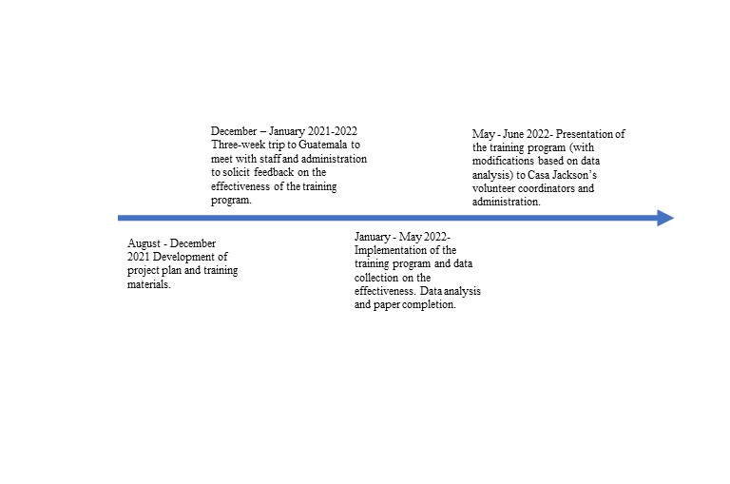
Appendix B. Project Timeline

Appendix C
Appendix C. Itemized Budget
 | Hours Contributed |  | Hourly Rate | Total
Dr. J. H. |  | 40 | $40.00 | $1,600.00
BirthLink |  | 25 | $40.00 | $1,000.00
FINE |  | 25 | $40.00 | $1,000.00
Neustra Ahijados |  | 80 | $40.00 | $3,200.00
Facility |  | 50 | $40.00 | $2,000.00
Student |  | 125 | $40.00 | $5,000.00
 |  |  |  | $13,800.00

Appendix D
Appendix D. Tools Created for Project- Qualtrics Survey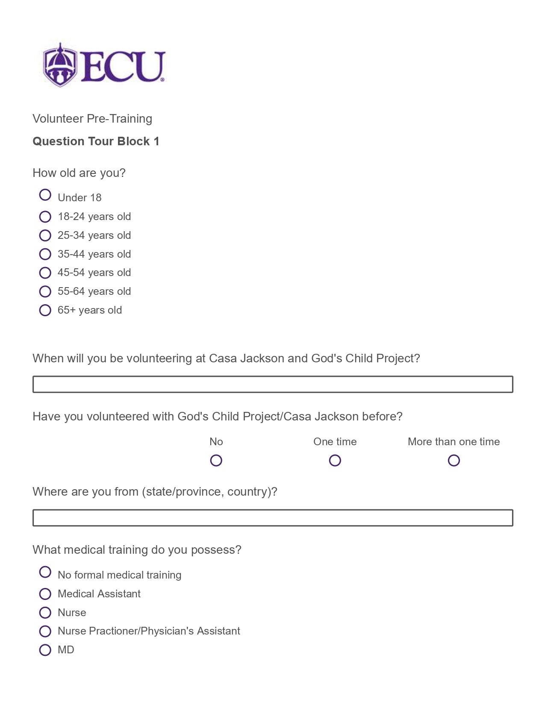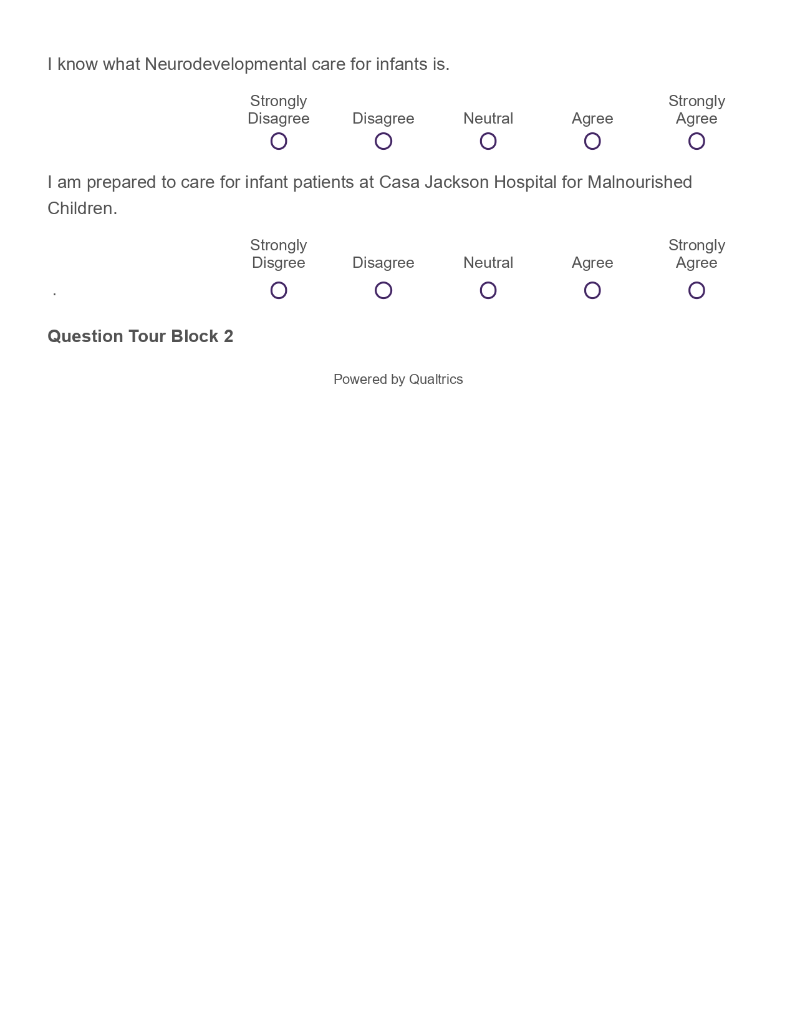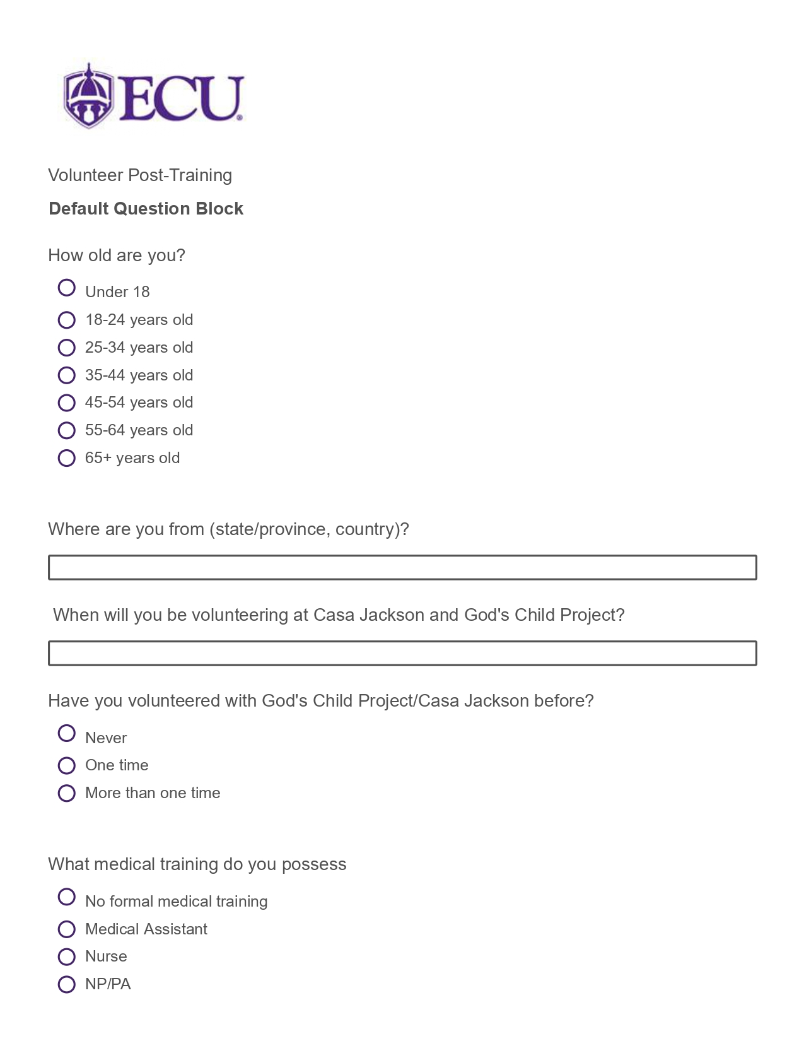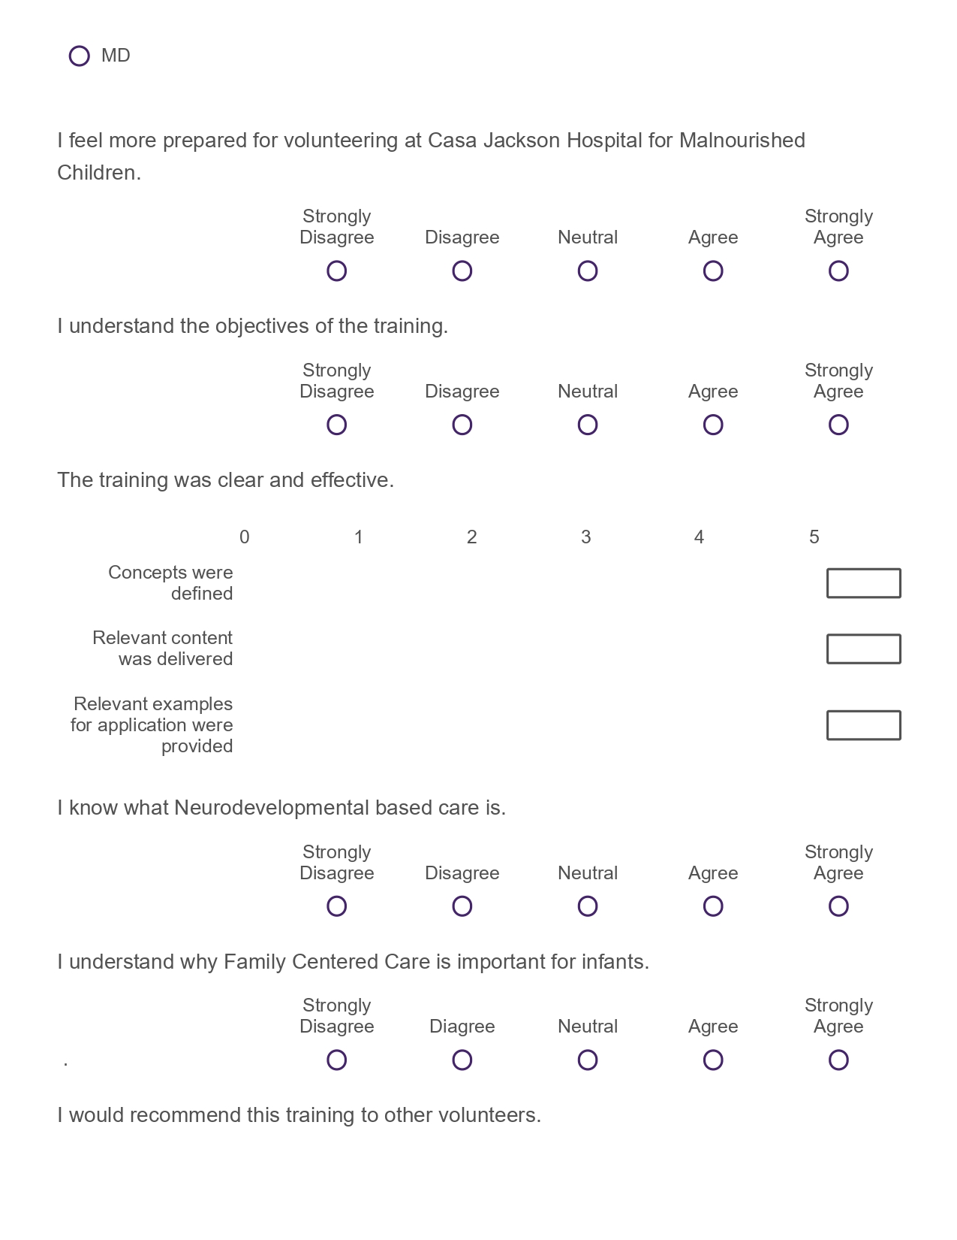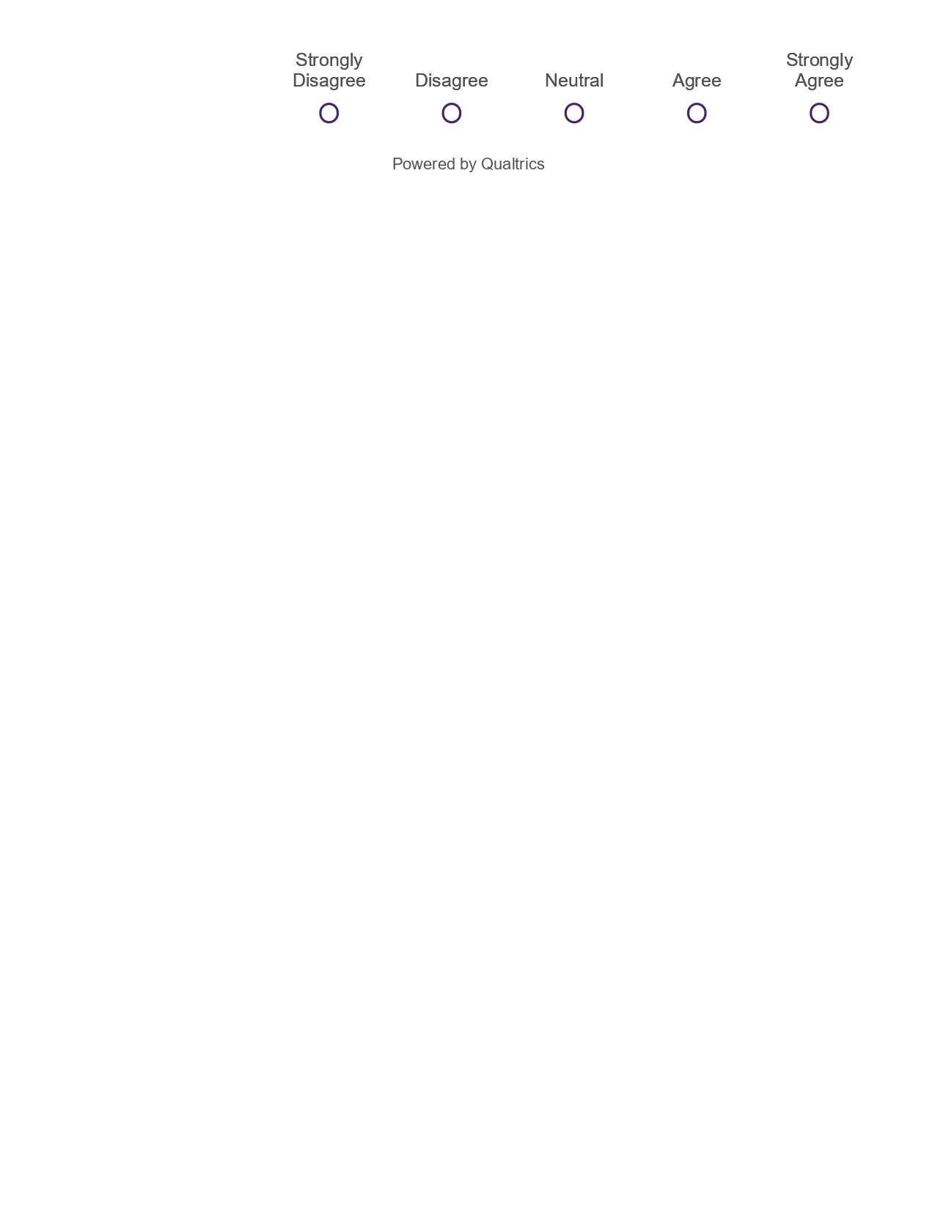

Appendix E
Appendix E. Volunteer Training Video Link
https://youtu.be/ki-OOnr7IHE

Appendix F
Appendix F. PowerPoint Presentation- Volunteer Training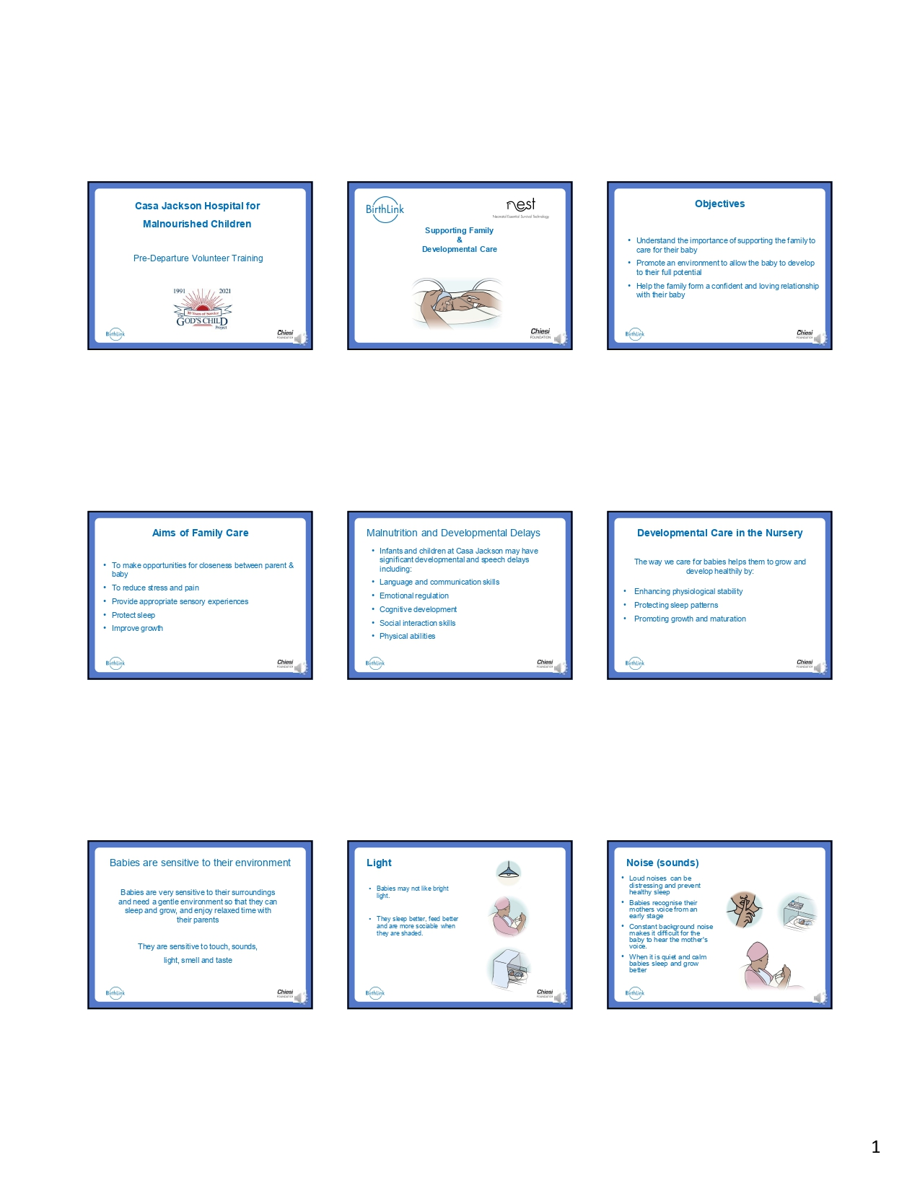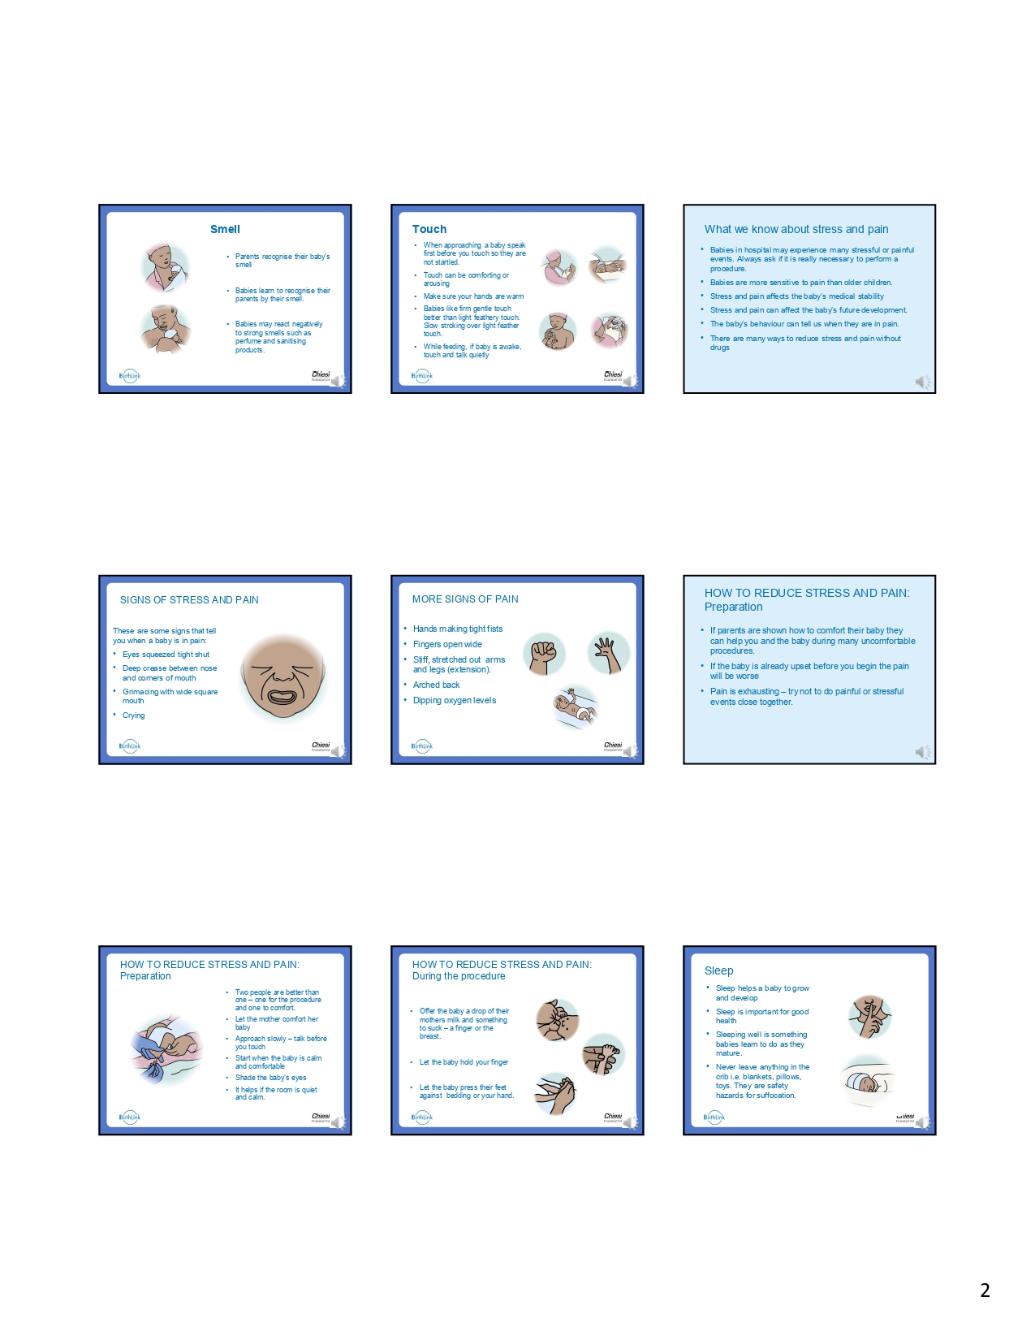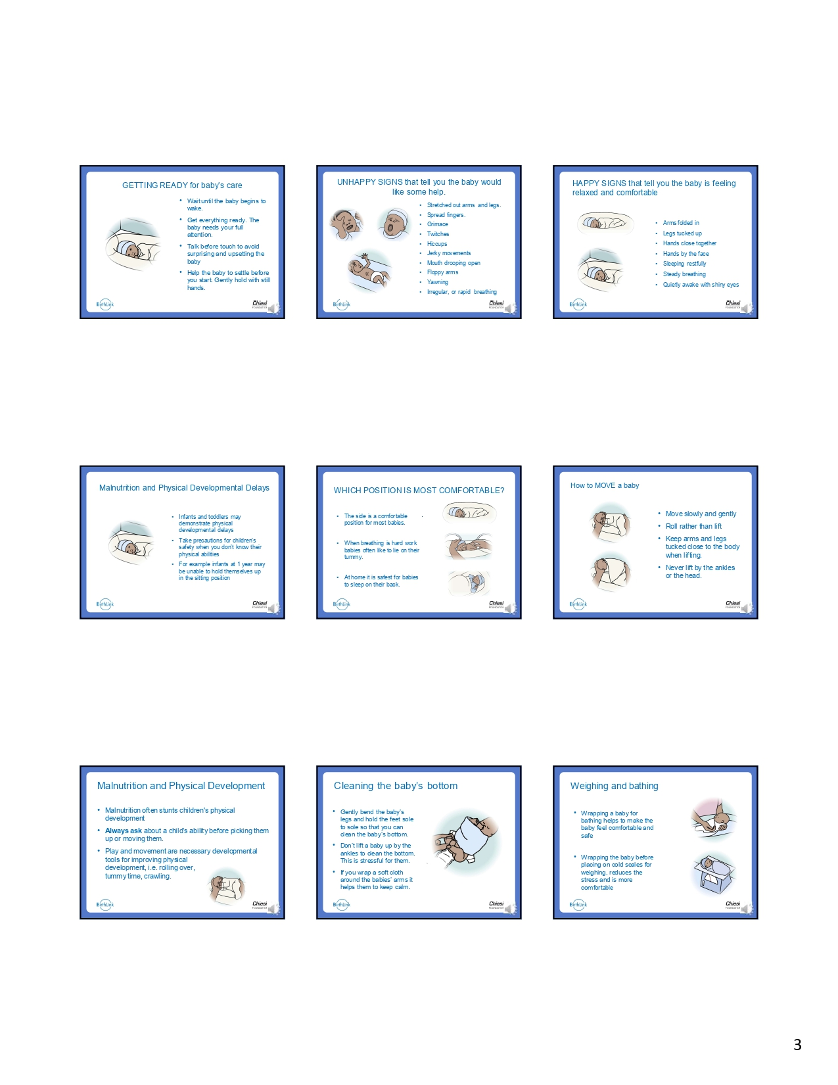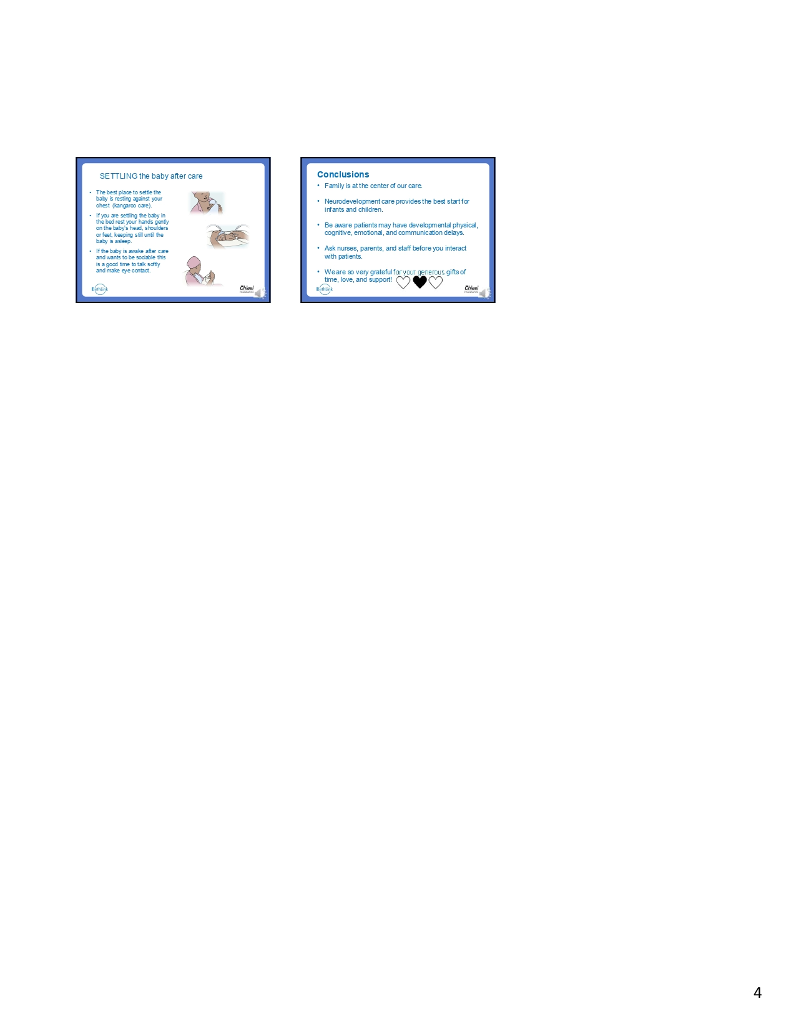
Appendix G
Appendix G. DNP Project Poster
