Fostering Self-Efficacy in Diabetic Patients in Primary Care

Amanda Baynard

Paper submitted in partial fulfillment of the
requirements for the degree of

Doctor of Nursing Practice

East Carolina University

College of Nursing

April 19, 2020

Acknowledgements

I would first like to thank Dr. Dianne Marshburn for guiding me through this process and creating a far better writer in myself than I could have ever imagined. Your dedication to your students is impeccable and is something to be admired.

To Dr. Nicki Vogel, my site champion, as well as all the staff at my implementation site, thank you for your willingness to accept me with open arms. Your guidance and support throughout this project were invaluable.

Thank you to Nicki and Jess for being my rocks through this program. There is no way I would have made it through without you two alongside me. Also, thank you to the rest of my fellow DNP students for inspiring me to keep going along this journey.

Finally, I would not be in the position I am today were it not for my amazing family. Brandon, thank you for loving no matter what and being my continuous point of encouragement. I can never thank you enough for loving me so well. To my parents and my sister who have watched me go through both struggle and celebration time and time again throughout this process, thank you for never giving up on me and helping me to become the woman I am today.

Dedication
I dedicate this to my amazing family and support system. Everything I do is to make you proud.

Abstract

Diabetes Mellitus Type II (DM II) is one of the most commonly diagnosed and managed diseases in primary care in the United States, and has been identified as a national health concern. Due to the commonality and frequency of this diagnosis, much research has been conducted in attempt to identify the most effective method to tighten diabetic patients glycemic control. Fostering self-efficacy among diabetic patients has been shown to improve their overall health and reduce their HgB A1C levels. A quality improvement project was implemented in a rural primary care setting in North Carolina. This project introduced an educational packet, offered to patients from their providers, that promoted self-efficacy among diabetic patients with a HgB A1C of 7.0% or greater. Information provided within the educational packet focused on lifestyle interventions (LSI), such as diet and exercise. As a result of this project, 85% of eligible patients in the office received education and 61% of those patients chose to implement a LSI. This project offered the potential for improved provider-patient relationships, tighter glycemic control for patients, and a decrease in financial burden for the healthcare organization as well as the patient.

Key words: Type 2 DM; HgB A1C; glycemic control; self-efficacy; lifestyle interventions;
quality improvement

Table of Contents
Acknowledgments 2
Dedication 3
Abstract 4
Chapter One: Overview of the Problem of Interest 10
Background Information 10
Significance of Clinical Problem 12

Question Guiding Inquiry (PICO) 13
Population 13
Intervention 13
Comparison 14
Outcome(s) 14
Summary 15
Chapter Two: Review of the Literature Evidence 17
Literature Appraisal Methodology 17
Sampling strategies 17
Evaluation criteria 18
Literature Review Findings 18
Lifestyle Interventions 19
Self-Efficacy 19
Implementation 20
Limitations of Literature Review Process 22
Discussion 22
Conclusions of findings 22
Advantages and disadvantages of findings 23
Utilization of findings in practice change 23
Summary 24
Chapter Three: Theory and Concept Model for Evidence-based Practice 26
Concept Analysis 26
Theoretical Framework 28
Naming the theory 28
Application to practice change 30
Evidence-Based Practice Change Theory 31
Naming the change model 31
Application to practice change 32
Summary 33
Chapter Four: Pre-implementation Plan 34
Project Purpose 34
Project Management 34
Organizational readiness for change 34
Inter-professional collaboration 34
Risk management assessment 35
Organizational approval process 35
Information technology 36
Cost Analysis of Materials Needed for Project 36
Plans for Institutional Review Board Approval 36
Plan for Project Evaluation 37
Demographics 37
Outcome measurement 37
Evaluation tool 37
Data analysis 37
Data management 38
Summary 38
Chapter Five: Implementation Process 40
Setting 40
Participants 40
Recruitment 40
Implementation Process 41
Plan Variation 42
Summary 43
Chapter Six: Evaluation of the Practice Change Initiative 44
Participant Demographics 44
Intended Outcome(s) 44
Findings 45
Graph 1: Lifestyle interventions chosen by patients 45
Summary 46
Chapter Seven: Implications for Nursing Practice 47
Practice Implications 47
Essential I: Scientific underpinnings for practice 47
Essential II: Organization and systems leadership for quality
improvement and systems thinking 48
Essential III: Clinical scholarship and analytical methods for EBP 49
Essential IV: Information systems/technology and patient care
technology for the improvement and transformation of healthcare 49
Essential V: Healthcare policy for advocacy in healthcare 50
Essential VI: Interprofessional collaboration for improving patient
and population health outcomes 51

Essential VII: Clinical prevention and population health for
improving the nation’s health 51
Essential VIII: Advanced nursing practice 52
Summary 53
Chapter Eight: Final Conclusions 55
Significance of Findings 55
Project Strengths and Weaknesses 56
Project Limitations 56
Project Benefits 57
Practice Recommendations 57
Final Summary 58
References 59
Appendix A: PRISMA 63
Appendix B: Literature Matrix 64
Appendix C: ADA DSME/DSMS Algorithm 71
Appendix D: Permission to use Iowa Model 72
Appendix E: Iowa Model 2015 73
Appendix F: Official Letter of Project Support 74
Appendix G: Project Budget 75
Appendix H: IRB Approval 76
Appendix I: Provider Checklist 77
Appendix J: Patient Education Survey 78
Appendix K: ADA A1C Educational Handout 79
Appendix L: ADA Aerobic, Resistance, Balance, and Flexibility Exercises Education 80
Appendix M: ADA Physical Activity Education 82
Appendix N: ADA Starter Walking Plan Education 84
Appendix O: ADA What Can I Eat? Education 85
Appendix P: USDA Diabetes MyPlate Education 87
Appendix Q: Results of Patient Surveys 88

Chapter One: Overview of the Problem of Interest
When individuals feel they have the power to make a positive change, they often will. This chapter will focus on the background of type 2 Diabetes Mellitus, as well as pitfalls in the management of patients living with this disease. Emphasis is placed on lifestyle interventions and problems facing the implementation of these interventions in a primary care setting. This project is centered on provider education regarding beneficial lifestyle interventions for patients diagnosed with type 2 Diabetes Mellitus, and methods to improve patient access to diabetic management resources.

Background Information
Diabetes is one of the most commonly managed diseases in the primary care setting. “In 2015, 30.3 million people in the United States had diabetes,” with 90% to 95% of all these diabetics being classified as type 2 diabetics (National Diabetes Statistics Report, 2017, p.2). It is projected that diabetes will be the seventh leading cause of death by 2030 (Becic, Studenik, & Hoffmann, 2018). Type 2 diabetics either do not produce enough insulin or their bodies are resistant to insulin; therefore, the glucose levels in their body remain elevated. Uncontrolled diabetes can lead to other health conditions, including cardiovascular disease, stroke, arterial diseases, as well as amputation of limbs (National Diabetes Statistics Report, 2017).
There are two commonly used screening methods for those with type 2 diabetes or suspected diabetes. These are a serum fasting glucose level and glycosylated hemoglobin, or hemoglobin A1C. An elevated serum fasting glucose, greater than 100, is indicative of diabetes (American Diabetes Association, 2014). A hemoglobin A1C level is frequently obtained in people with diabetes to assess glucose trends in the body over three months. According to the National Institute of Health, a hemoglobin A1C greater than 6.5% indicates diabetes in a patient (NIH, n.d.).
The American Diabetes Association (ADA) recognizes the following as risk factors for type 2 diabetes: physical inactivity, having a first degree relative with diabetes, hypertension, personal history of cardiovascular disease, an HDL of less than 35 and/or a triglyceride level higher than 250, and severe obesity (Martinez, Sherling, & Holley, 2019). It is crucial to screen people with diabetes regularly to prevent adverse effects related to the diseases from occurring. Without regular screening, gradual hyperglycemia can lead to severe micro- and macrovascular changes (Martinez et al., 2019).
Heredity has been proven to be a factor for type 2 diabetes. However, obesity and a sedentary lifestyle have been shown to play an even more significant role in the disease process (Martinez, Sherling, & Holley, 2019). Lifestyle interventions, such as exercise and weight loss that decrease the rates of obesity and sedentary lifestyles have been shown to slow the progression of type 2 diabetes (Martinez et al., 2019). Studies have shown that diabetic patients participating in a low-calorie diet have reported a reduction in blood glucose levels in just one week and have maintained their glycemic control for up to two months (Kolb & Martin, 2017). While diet is essential in controlling glucose levels and weight loss, regular exercise has proven to be just as equally vital. A systematic review and meta-analysis of twenty-two trials involving 2,996 individuals revealed that physical exercise, specifically aerobic exercise, leads to improved glycemic control (Becic, Studenik, & Hoffmann, 2018). Aerobic exercise includes activities such as walking, biking, and jogging. Even moderate exercise, when done regularly, has shown a reduction in hemoglobin A1C levels (Becic et al., 2018).
The success of individual lifestyle interventions relies heavily on the utilization of existing resources in practice, as well as the adequate training of practitioners to deliver information to patients. (Dintsios, Chernyak, Grehl, & Icks, 2018). When providers are adequately trained to educate patients on successful lifestyle interventions, patients are likely to feel empowered regarding their health. Patient self-efficacy related to diabetes self-management has been shown to have a direct correlation with health education on diabetic care, and elevated confidence levels were associated with stronger glycemic control and an increase in self-care activities (Amer, Mohamed, Elbur, Abdelaziz, & Elrayah, 2018). Many providers attempt to educate their patients regarding positive lifestyle interventions related to diabetic self-care during routine exams. However, it is often grouped with other information regarding comorbidities and can be quickly forgotten by overwhelmed patients (Institute for Healthcare Improvement, 2019). Without concrete information for patients to review related to lifestyle interventions, much of the information they receive at their visit is subject to be misconstrued, poorly implemented, or unused.

Significance of Clinical Problem
Diabetes is a disease that is plaguing the nation, and the rates of diagnosis are projected to increase (Healthy People 2020, n.d.). Individuals diagnosed with type 2 diabetes are at risk for multiple other comorbidities, such as cardiovascular disease and renal insufficiency. Primary care providers, even though they may attempt to educate their patients regarding lifestyle interventions that help slow disease progression, are not able to foster as much self-efficacy in their patients as is needed to promote better glycemic control. This is, in large part, due to the rapidly rising rates of individuals with diabetes, which results in a decrease in resources and available time for provider attention per person to help combat the disease (Healthy People 2020, n.d.).
Self-management is the center of care for diabetics and consists of healthy dietary habits, physical exercise, blood glucose monitoring, medication adherence, good coping and problem-solving skills, and a reduction in risky behaviors (Amer, Mohamed, Elbur, Abdelaziz, & Elrayah, 2018). Providers are the spearheads of diabetic care, but it is the role of the patient to take responsibility for their health on a day-to-day basis. By fostering increased self-efficacy and providing patients with tools and resources to use as references at home, providers are allowing them to obtain tighter glycemic control and advocate for their health. According to the Institute for Healthcare Improvement (IHI), better patient outcomes can be achieved through activities that involve collaboration between provider and patient and patient empowerment (2019).

Question Guiding Inquiry (PICO)
The goal at a primary care office in rural Western North Carolina (NC) is to improve the care that diabetic patients receive and offer them resources and materials to foster self-efficacy in diabetic self-care. This goal will be achieved through provider education regarding resource material and how to convey the information most effectively to diabetic patients.
Population. The population being evaluated is a group of providers in a rural North Carolina primary care office involved in the direct patient care of diabetic patients. This area has limited access to specialists, including endocrinologists; therefore, primary care providers assume responsibility for the majority of chronic disease care.
Intervention. The intervention will be to educate providers on materials included in an educational packet to be reviewed and sent home with patients who have a hemoglobin A1C of 7.0% or higher. The aim is to create a standardized, evidence-based diabetic education program using resources found on the American Diabetes Association website and using resources such as the Diabetes MyPlate poster (Learning ZoneXpress, n.d.) for diabetes management in the clinic. The Diabetes MyPlate poster does come at a cost that will be covered by the project lead. There will be weekly follow up with providers and staff to assess the positives and negatives of the intervention at various intervals, and adjustments will be made accordingly to suit the practice and their patients better.
Comparison. There is currently no defined practice in place at the primary care office that fosters self-efficacy among diabetic patients or provides resources to be sent home with patients to aid in patient-directed glycemic control. Providers were previously charting that they educated patients on lifestyle interventions, but no documentation indicated that materials related to lifestyle interventions were sent home with patients for review. Therefore, there is no guideline for comparison. The organizations' goal is for 100% of all individuals with a hemoglobin A1C greater than 7.0% to receive patient educational materials. This will be assessed through the collection of checklists placed on each chart that the provider will complete stating whether or not eligible patients received the material and associated education.
Outcome(s). The outcomes being evaluated are compliance in the implementation of a standardized patient educational tool for diabetics, patient satisfaction related to educational materials received, and the real-life potential for implementation of lifestyle interventions. Questionnaires regarding the education being given, as well as provider checklists, will be collected by front office staff. Whether or not eligible patients, those with a hemoglobin A1C of 7.0% or greater, received the educational packets will be evaluated based on response to “yes” or “no” option on the checklist. It will be the role of providers to review educational materials and resources in the packets with patients, as well as to circle the correct option on checklists. The role of the nurse will be to review the checklist and confirm that the provider documented accurately. This will function on an honor system, and providers will be encouraged to report honestly to assist in ensuring the success of the intervention. When patients receive these educational materials, they will also receive a patient satisfaction survey regarding their impression of the materials given to them. This short survey will be completed in the office and given to the front desk staff following the patients' appointment. Questions on the satisfaction survey will focus on the patients’ satisfaction of the provider education, materials received, if questions were answered, and any plan of lifestyle changes.

Summary
Diabetes is not a self-limiting disease and, if uncontrolled, can increase a patients’ risk for heart attack, stroke, or limb amputation. The percentage of individuals diagnosed with diabetes in the United States is on the rise, and provider management can only reach so far. It is crucial for patients to feel empowered to play a role in the management of their diabetic care.
Primary care providers offer education to their patients regarding lifestyle interventions that lower the risk of disease progression and blood glucose levels, but it is not ensured that this information is always understood. Providing patients with proper education regarding lifestyle interventions in conjunction with take-home educational materials that help to foster self-efficacy among diabetic patients is necessary in a world with a rapidly growing diabetic population.
This project works on multiple levels to achieve improved patient care for diabetic patients in a primary care office in rural North Carolina. Through provider and nursing education regarding the importance of self-efficacy, documentation of educational review of materials with patients, and allowing patients to be involved in their diabetic self-care, this project will work to improve the overall health of people with diabetes involved in the implementation.

Chapter Two: Review of the Literature
The following discussion will focus on the review of literature related to diabetes patient education, self-efficacy, and implementation of patient education strategies. Due to the increasing prevalence of diabetes, there is extensive discussion surrounding the topics. Through careful evaluation, inclusion, and exclusion, the reviewed literature is compiled to support the importance of the proposed project in a rural primary care setting.

Literature Appraisal Methodology
Sampling strategies. The literature review is composed of articles from multiple sources, including PubMed, CINAHL, and One Search. Several short phrases, including “diabetes education,” “self-efficacy diabetes,” “diabetes lifestyle interventions,” “diabetes patient education,” and “diabetes self-management education in primary care” were used in the review of literature. Using the PubMed database, the search term “self-efficacy diabetes” yielded 450 results, and the search for “diabetes lifestyle interventions” resulted in 633 articles, four total articles were utilized from these results. CINAHL revealed 9,461 articles related to “diabetes education,” two of which are included in the literature review. The search term, “diabetes patient education,” yielded 618 total results in the PubMed database, of which four are present in the literature review. Finally, “diabetes self-management education in primary care” was searched using One Search and yielded 11,938 articles, one of which was utilized in this review. Each literature search was limited to peer-reviewed journal articles from the last five years with full text available online. Other inclusion criteria included adults aged eighteen or older, and studies involving English-speaking individuals.
Since the topic of diabetes and issues surrounding the disease are increasing in their prevalence and popularity, search terms yield a large variety of scholarly articles. Many articles were excluded from this literature review due to the sheer fact of duplicity of results or similarity in study composition. Therefore, the articles most relevant to this project implementation were selected (Appendix A).
Evaluation criteria. Articles identified were initially included or excluded based on whether or not they focused on clinically diagnosed diabetics. Any articles that only included information on prediabetes or preventing diabetes in non-diabetics were excluded. Information related to diabetes or diabetic patients in an inpatient setting were also excluded from the literature review. Articles were narrowed to include only studies or research that involved an English-speaking population since the intervention is being implemented in an English-speaking location. Articles that included patients with heart failure as an additional comorbidity were not excluded since the two diagnoses often coincide with one another.

Literature Review Findings
A review of the current literature surrounding the proposed intervention revealed a plethora of evidence-based practice guidelines regarding diabetic patient education and self-efficacy. Articles included in the literature review are from varying levels of evidence. These include systematic reviews and meta-analyses of randomized controlled trials, randomized controlled trials, systematic reviews of descriptive and qualitative studies, descriptive and qualitative studies, and expert opinions (Appendix B). While evidence related to the proposed intervention dates back several decades, only the most recent and relevant data from the last five years were included in the review of the literature.
It is projected that by the year 2050, one out of every three individuals in the United States will develop type 2 diabetes (Powers, Bardsley, & Cypress, 2017). Through review of the literature and evidence-based practice, patient education and an increase in self-efficacy are necessary to aid in glycemic control for patients with diabetes and can lower healthcare costs related to diabetic care (Amer, Mohamed, Elbur, Abdelaziz, & Elrayah, 2018).
Lifestyle Interventions. There are several methods of diabetes self-management that have the potential to benefit patient outcomes. Lifestyle interventions (LSI), including dietary management, weight loss, and exercise, are becoming more critical with the increasing prevalence of type 2 diabetes (Alberti, Zimmet, & Shaw, 2007). A meta-analysis of twenty-two trials, with 2,996 participants, showed that aerobic exercise can positively affect adipokines, such as leptin and adiponectin, in the body, which leads to tighter glycemic control (Becic, Studenik, & Hoffman, 2018). While exercise is important in controlling blood glucose, it can prove to be difficult for patients who may be in less than optimal physical health. Therefore, it is essential to stress the need for dietary management. Diabetic patients who practice a low-calorie diet have a better chance of maintaining normal blood glucose levels than those who do not (Kolb & Martin, 2017). The glycemic index (GI) of food helps to predict how quickly a dietary carbohydrate will raise blood glucose levels (Avedzi, Storey, Johnson, & Johnson, 2019). Type 2 diabetics should be encouraged to consume foods with a low GI to aid in improving glycemic control (Avedzi et al., 2019).
Self-Efficacy. The American Association of Diabetes Educators (AADE) clearly defines seven self-management behaviors that education surrounding diabetes should address. These include healthy eating, physical activity, blood glucose monitoring, medication use, risk reduction, problem-solving, and healthy coping mechanisms (Chatterjee et al., 2018). All these components of diabetes education, when utilized properly, play a role in improving self-efficacy among diabetic patients. The method of communicating information to patients is equally as important as the specific content that is offered. For example, a qualitative focus group of 20 British diabetics revealed they were “graded” as a “pass or fail” based on how their lab results changed after they received education from their primary care providers (Arana, Valderas, & Solomon, 2019). Instead of feeling as though they were working with their provider in achieving a healthier lifestyle, these patients felt as though they were being judged based on their success or failure. Fostering an environment of positive change instead of one of probable failure will likely result in inherently happier and healthier patients.
When constructing an educational program, different learning styles must be accommodated. Learning materials should be specific to the general patient population (Fink, Fach, & Schröder, 2019). For example, introducing dietary suggestions that include a large quantity of fresh seafood to individuals who live in the Western part of the state will inevitably fail due to the lack of resources that provide fresh seafood (Fink et al., 2019). Overcoming obstacles such as this is vital to the success of diabetes patient education programs.
Self-efficacy includes providing patients materials about diabetic care that equips the patient with the education and support systems to foster confidence in their ability to manage their health. Diabetes Self-Management Support (DSMS) helps patients acquire skills, knowledge, and ability to self-manage diabetes, while DSMS allows patients to develop coping skills and behaviors (Coppola, Sasso, Bagnasco, Glustina, & Gazzaruso, 2016).
Implementation. The research supports the need to foster self-efficacy in diabetic patients through education and lifestyle interventions; however, the gap in knowledge surrounds the topics of how to implement the interventions and which information is most important to convey to patients (Chatterjee et al., 2018). The American Diabetes Association (ADA) has developed a provider's diabetes education algorithm. This algorithm includes the ADA Standards of Medical Care in Diabetes recommendations. (American Diabetes Association, 2016). These recommendations include four critical times to assess, provide valuable information, and adjust Diabetes Self-Management Education (DSME) and Diabetes Self-Management Support (DSMS). (See Appendix C). These critical times include at diagnosis, annually, with the introduction of new factors, and when transitions in care occur (Powers, Bardsley, & Cypress, 2017). Although not an exclusive list of methods and timing to provide patient diabetes education, it organizes provider education. This algorithm will be used as a template to guide self-management and educational interventions in the project at different stages of the diabetic disease process.
Information related to diabetes self-management is essential for tighter glycemic control and healthier lifestyle for diabetic patients; however, method and timing may overwhelm patients. Introducing information tailored to a specific population's level of education achieves successful patient educational programs (Coppola, Sasso, Bagnasco, Glustina, & Gazzaruso, 2016).
Evidence suggests that education explicitly tailored to individual patients is more efficacious than generalized materials. However tailored interventions are rarely feasible in primary care due to time and monetary constraints (Dintsios, Chernyak, Grehl, & Icks, 2018). Generalized education plans applicable to a large subset of patients are more sustainable in primary care. There are no clear standards from any health care organization stating how much contact time, what specific content, and which methods of delivery are the most likely to achieve desired patient outcomes and increased self-efficacy in diabetic self-management (Chatterjee et al., 2018). Therefore, providers must address such concerns independently with each varying delivery.

Limitations of Literature Review Process
Although there is substantial literature on diabetes self-management and self-efficacy, gaps in the literature persist. Limitations in the studies reviewed included the variation in contact time between provider and patient, content delivered, and method of delivery. More research is available with the aim to prevent diabetes rather than to reduce hemoglobin A1C. Due to the lack of comparability between trials, there is no official educational guideline set forth by any leading organizations in healthcare, such as the ADA or AADE (Chatterjee et al., 2018). These organizations offer recommendations of various modes of education delivery and content, but no concrete plans. This has the potential to cause ambiguity between providers and can lead to conflicting information delivered to patients, which can cause confusion and misuse of information. Mode of content, delivery, interaction with healthcare providers, blood sugar testing, and life applications are five additional barriers to successful diabetes education and lifestyle interventions (Arana et al., 2019).

Discussion
Conclusion of findings. The most efficient way to improve glycemic control in diabetic patients with a hemoglobin A1C of greater than 7.0% is to increase their self-efficacy through provider education on lifestyle interventions and diabetes self-management techniques. Ideally, the information would be tailored to specific patient needs, but this is often difficult to implement in the primary care setting. However, to progress towards better patient education and increased self-efficacy, educational material needs to be as specifically tailored to the target patient population as possible. By using ADA recommendations on critical components of self-care behaviors, a program can be implemented to provide resources to diabetics in a primary care office.
Advantages and disadvantages of findings. Support for the proposed intervention includes standardizing a diabetes self-management education program and ensuring providers are aware of educational interventions that foster self-efficacy. Evidence supports the fact that DSME and DSMS programs benefit patient outcomes and reduce healthcare costs for the clinical practice as well as the patients.
Disadvantages of the proposed intervention include a lack of nationwide standardization of educational materials or modes of delivery. Lack of standardization makes it more challenging to ensure the most beneficial information for patients is given by their provider. The literature also supports individualized interventions on a patient to patient basis, which is not feasible in the construction of educational materials. The materials will be specific to the target population of a rural community in Western North Carolina. However, this idea can be implemented through one-on-one interaction between provider and patient. While reviewing the educational materials, the provider can individualize instructions for each patient.
Utilization of findings in practice change. The intervention is designed for patients with a hemoglobin A1C of 7.0% or higher. This includes those who already have a diagnosis of diabetes, and those just presenting with elevated hemoglobin A1C levels who have not been formally diagnosed. Patients receiving this education fall in at least one of the three categories listed in the DSME and DSMS algorithm of care (Appendix C). Providers will use this algorithm to help guide the education they give to their patients. Providers will be educated about the importance of adequate and effective education to help ensure self-efficacy and success in tightening glycemic control, as well as improving patient quality of life. The literature supports educating providers to assure proper delivery of education and support of patients. This has been shown to increase patient confidence and self-efficacy. Literature also provides support for standardizing diabetes self-management care in primary settings, even though it does not offer direct guidelines for precisely what materials and how often these materials should be delivered.
The materials for the educational packet were developed through evaluation of the most successful interventions and evidence-based practice. The packet included information regarding appropriate dietary choices, exercise routines to fit patients at various levels of fitness, and links to resources that provide information on self-management of type 2 diabetes.

Summary
Diabetes is a rapidly increasing disease. By implementing standardized educational packets for patients, the goal is to achieve tighter glycemic control and improve patients’ attitudes towards their diabetic management. Healthy People 2020 (n.d.) has several objectives that align with this intervention. These include reducing the diabetes death rate by 10%, improving glycemic control among people with diabetes by tracking trends of individuals with a hemoglobin A1C of less than 7.0%, and aiming to reduce the number of individuals with a hemoglobin A1C of 9.0% or higher by 10% (Healthy People 2020, n.d.). Implementing education regarding lifestyle interventions for patients, as well as encouraging healthy eating and weight loss, are interventions for the proposed intervention that are supported by Healthy People 2020 (n.d.).
Literature suggests that patients feel more confident about their health care management when they receive adequate education and support from providers and their healthcare staff. This implementation should improve the health of the patients involved, lowering their hemoglobin A1C levels as well as improving their overall quality of life through weight loss interventions and exercise strategies. Finally, by obtaining tighter glycemic control, health care costs will be reduced for the patients who will, ideally, not have to progress to further medications or suffer from side effects associated with uncontrolled diabetes. Costs of health care per capita will also be reduced by preventing hospitalizations and expensive treatments related to diabetes. All these benefits of the intervention are congruent with the Triple Aim objectives of “improving the patient experience of care, improving the health of populations, and reducing the per capita cost of healthcare” (IHI, 2019, p.1).
The proposed intervention is aligning with both Healthy People 2020 and Triple Aim objectives. It is supported by evidence-based and peer-reviewed literature and will benefit both patients and the primary care office involved in the implementation.

Chapter Three: Theory and Concept Model for Evidence-based Practice
Concepts surrounding project implementation, as well as the theoretical framework, and evidence-based practice model supporting the intervention will be reviewed in this chapter. Concepts included are: hemoglobin A1C, self-efficacy, self-care, provider education, and lifestyle interventions. Dorothea Orem’s Self-Care Deficit Theory will provide the theoretical basis for the project, while the Iowa Model of Evidence Based-Practice will act as the conceptual framework.

Concept Analysis

Hemoglobin A1C. A hemoglobin A1C serum level is a screening tool to aid in the screening, diagnosis, and monitoring of diabetes (ADA, 2014). It gives providers and patients an average of glucose levels in the blood over three months. For this project, hemoglobin A1C levels were used as the trigger for implementation. Individuals with a hemoglobin A1C of 7.0% or higher were eligible to receive the educational packets and associated education.
Self-Care. Having the ability to take the initiative and provide self-initiated care to improve one's health and wellbeing is an appropriate way to define the concept of self-care (Amer et al., 2018). Self-care can be utilized as a tool for promoting wellbeing in a variety of healthcare areas, including mental health, physical health, emotional health, as well as in the management of chronic diseases (Powers et al., 2017). This intervention focused on promoting self-care among patients with the diagnosis of diabetes who have a hemoglobin A1C of 7.0% or higher. Care activities included in the intervention included ways to improve diet, exercise recommendations, and connections to diabetic resources.
Lifestyle interventions. Lifestyle interventions include any intervention of care that works to improve a patients' health status. Usually, lifestyle interventions include some aspect of dietary recommendations, exercise plans, and another element of care specific to the disease process that is being improved (Dintsios et al., 2018). An educational packet consisting of dietary recommendations, exercise routines applicable to all skill levels, ways to reduce blood sugar, and links to relevant resources for people with diabetes constituted the lifestyle interventions highlighted by this project. The ultimate goal of these interventions was to improve the overall health of patients who receive the information, as well as assist them in obtaining tighter glycemic control.
Provider education. The concept of adequate provider training regarding educational materials, as well as how they present this information to their patients is essential to the success of any healthcare intervention (Coppola et al., 2016). For this project, providers were educated on the importance of the information and interventions contained within the educational packets. The concept of providing personalized and thorough guidance to the patients receiving the educational materials was conveyed to providers. The role of the provider was to review the packet information with eligible patients and individualize specific information and recommendations for the patient. A significant theme from the literature review related to the pitfalls of lifestyle intervention implementation was that providers do not do an adequate job of discussing interventions with patients or listening to concerns and questions that the patient may express (Arana et al., 2019). This project worked to address this issue by educating providers regarding the various aspects of effective patient communication and relay of information.
Self-Efficacy. For an individual to be successful in the implementation of lifestyle interventions and in implementing self-care behaviors, they must believe in their innate ability to achieve the goals at hand. Fostering self-efficacy involves the utilization of effective provider/patient communication as well as encouraging the patient to take the initiative in their health care (Amer et al., 2018). For an individual to be willing to play a role in their health, they need to believe that there is a need for personal improvement in the area of health and that by changing their habits regarding the issue, there will be a reward to be reaped (Amer et al., 2018). In relation to this project, fostering self-efficacy in diabetic patients may instill the belief that they can make a positive change in their glycemic control through self-care activities, lifestyle intervention, and communication with their primary care provider.
Project outcome. There are several components of this project that work together to help achieve the goal of all eligible patients receiving the educational packets with personalized education and guidance from providers. The intervention focused on equipping patients with the tools necessary to improve their glycemic control and overall health through available educational materials and individualized provider education. The project outcome was measured through checklists identifying whether eligible patients received the educational materials or not and evaluation of patient satisfaction regarding education provided. There was also an additional assessment of patient’s perception on lifestyle changes based on education.

Theoretical Framework
Naming the Theory. Dorothea Orem spent a large portion of her adult life constructing her theory of self-care. Orem believed theories that could be applied to practical sciences, such as nursing, should not only focus on the "What" and "Why," but also on the "Who" and "How" behind the model (Smith & Parker, 2015). Her theory has been applied in the implementation of numerous studies, interventions, and research articles (Smith & Parker, 2015). Orem’s theory focuses on the concept of overcoming the deficits individuals face surrounding self-care. This theory relies heavily on the individual assessment and personalization of care for each patient (Mohammadpour, Shargi, Khosravan, Alami, & Akhond, 2015).
There are five main concepts identified by Orem in her theory. These include the idea that patients should be responsible for their own care, patients are distinct individuals, nursing constitutes an interaction between two or more people, successfully meeting universal self-care requisites is vital to primary care prevention and health, and that a persons' knowledge of potential health problems helps to promote self-care behaviors (Petiprin, 2016).
Self-care agency is a concept of Orem’s theory, and is defined as the capability of an individual to practice self-care (Kumar, 2007). Identifying the structure of an individual’s self-care agency involves identifying their capabilities for self-care operations, enabling these capabilities, and analyzing their foundational capabilities (Smith & Parker, 2015). The success of the model relies on identifying clients’ unmet needs and selecting which methods best assist the client in compensating for their deficits (Wagnild, Rodriguez, & Pritchett, 1987). A patient is identified as having a self-care deficit when their self-care demand is greater than that of their self-care agency (Kumar, 2007).
Orem's model is not one-sided and cannot be adequately utilized if the effort is not put forth by the patients as well as the providers. Individuals must be willing to engage in self-care activities. Providers alone cannot ensure patient success and must rely on patient motivation (Kumar, 2007).
There are three systems identified in Orem’s theory that help guide its application. These include the wholly compensatory system, the partially compensatory system, and the supportive-education system (Smith & Parker, 2015). These three systems offer a variety of tactics and frameworks based on the self-care ability of the individuals affected by a particular intervention. Individuals with limited or no self-care agency are grouped under the wholly compensatory system (Smith & Parker, 2015). Those with some ability and willingness to perform self-care are considered a part of the partially compensatory system, while those with a strong sense of self-care agency can utilize the supportive-education system (Smith & Parker, 2015).
Application to practice change. Orem’s Self-Care Deficit theory strongly embodies the ideals that this project represents. Individuals affected by this project were suspected of having a self-care deficit in relation to diabetes self-management. This is because their A1C was 7.0% or higher, which demonstrated uncontrolled type 2 diabetes (ADA, 2014). Ideally, if they did not have a deficit, then their hemoglobin A1C levels would be more controlled.
The goal of this project was to increase the self-care agency of those with elevated hemoglobin A1C levels through provider education. By acting on behalf of others, guiding patients, supporting their needs, providing an environment that promotes personal development, and providing proper education, this project embodied what Dorothea Orem's theory is based upon (Petiprin, 2016).
This project focused on the supportive-educative system identified in Orem’s theory. Based on the theory, the role of the healthcare provider was to regulate the exercise and development of an individual’s self-care agency (Smith & Parker, 2015). This was accomplished through use of educational materials that were provided to them, and through open communication and individualized education from providers. The role of the patient in this system was to begin working towards the goal of accomplishing self-care by increasing their self-care agency (Smith & Parker, 2015).
According to Orem, the success of a conceptual model or theory is dependent on whether or not it can be adapted into specific settings (Wagnild et al., 1987). Using this idea as a guide, her theory has proven to be a success based on its widespread implementation throughout the years (Smith & Parker, 2015). Using Orem’s theory as a theoretical blueprint for this project allowed for the implementation to focus on the need to increase the self-care agency and abilities through provider based educational methods. In a healthcare field where providers are doing all they can to ensure the wellbeing of their patients, a tool that will increase the ability for the patients to aid in their own success and healthfulness is needed.

EBP Change Theory
Naming the change model. Using evidence-based practice models, such as the Iowa Model, has been shown to aid in the success of health care related implementations for decades (Buckwalter et al., 2017). Permission to utilize this model for this project and paper were obtained (Appendix D). The Iowa Model has recently been revised to maintain relevance with the changes that have been made in healthcare over the last decade (Buckwalter et al., 2017) (Appendix E).
The first step in the utilization of the Iowa Model is identifying whether or not a need for the project is present (Iowa Model Collaborative, 2017). Determining the necessity of a project is site specific and should focus on identifying opportunities for patient improvement. After assessing the need for a particular project, the next step is creating a formal statement identifying the purpose of the proposed intervention (Iowa Model Collaborative, 2017). This statement offers a concise identification of what the intervention's goal will be in relation to the specific site being targeted. If the proposed intervention is identified as a priority, then a team needs to be formed to work towards the implementation of the project (Iowa Model Collaborative, 2017).
Before implementation, a systematic review and synthesis of literature related to the proposed intervention must be conducted to ensure that there is enough evidence to support the intervention (Iowa Model Collaborative, 2017). Recent literature should be relevant to the specific intervention and from reputable and reliable resources. Once enough evidence is found to support the intervention, a pilot of the project should be performed to assess the efficacy of the implementation (Iowa Model Collaborative, 2017). This is done to assist in attaining baseline data, developing and editing protocols, promoting the adoption of a specific intervention, and ensuring that materials and planning are designed to the highest level possible (Iowa Model Collaborative, 2017). Finally, if the success of a project is determined after pilot implementation, and the organization would like to continue the utilization of a project, it is then appropriate to begin formal adoption of a project into practice (Iowa Model Collaborative, 2017).
The Iowa Model is evidence that the successful implementation of an idea or project into practice is not done lightly. There are several steps involved in the process, many of which have the potential to set a project back. While linear progression is the goal, factors such as not having enough evidence to support an implementation or a lack of resources in an organization, have the potential to produce regression. However, even with potential setbacks, the Iowa Model offers step-by-step guidelines on how to implement ideas and methods regarding how to rebound from complications.
Application to practice change. The steps outlined in the Iowa Model coincided well with the proposed implementation plan for this project. The opportunity that this project presented was creating an evidence-based educational intervention for patients that did not exist in the clinical practice. It offered an opportunity to ensure that the organization was meeting national initiatives to provide better quality care for people with diabetes through methods that work to tighten their glycemic control (Healthy People 2020, n.d.). The purpose of the project was to ensure providers were equipped with the appropriate materials and skills to offer education to their diabetic patients that foster self-efficacy and self-management of the disease. This topic has been deemed as a priority by national standards, such as Healthy People 2020 and Triple Aims, as well as by the clinic where it will be implemented.
The team for this project involved all individuals at the clinic, including providers and nurses, who were included in the implementation and review process. Enough evidence to support this intervention was found in the recent and relevant literature. The project pilot was implemented over twelve weeks. During this time, baseline data was compared to weekly and bi-weekly reports, and regular discussions with the implementation team were held to evaluate methods to improve the interventions. If, after the twelve-week implementation, the post-pilot data were to show an improvement in the number of diabetics who received the educational materials and patient questionnaires result in positive patient perception of selected lifestyle interventions, there is an opportunity for sustainability at the clinical practice.

Summary
Each of the key concepts identified in this project played an essential role in its successful implementation. Alone, they each possess merit, but when utilized together, they create a project with the potential to positively impact healthcare. Dorothea Orem's Self-Care Deficit Theory offers a guide for how to increase self-agency and self-efficacy of both the patients and providers in relation to the identified key concepts. Identifying areas where individuals are lacking and providing resources and tools to assist their growth decreases their self-care deficit and allows for improving self-confidence
The goal of utilizing the Iowa Model during implementation is to ensure that evidence-based practice guidelines are being followed. By evaluating the process, even as complications arose, a tool was available to provide recommendations on the most appropriate next developments.
Chapter Four: Pre-implementation Plan
Before implementing this quality improvement (QI) project, several steps were taken to evaluate for appropriateness and feasibility of proposed project. Project received approval from project site and faculty lead. From there, a detailed implementation and evaluation plan was created. This chapter describes this QI project's pre-implementation plan.
Project Purpose
Project purpose was for providers to educate diabetic patients with elevated (i.e., 7% or higher) hemoglobin A1C levels about the importance of lifestyle interventions, such as diet and exercise, to control the disease. Providers reviewed and gave educational packets during patient encounters to assist patients in better understanding of lifestyle interventions to lower blood glucose levels.
Project Management
Organizational readiness for change. Discussions with the project's site champion and office manager demonstrated that this organization was ready to participate in this project. The organization supported improving care that their diabetic patients receive; particularly tighter glycemic control to achieve better overall health. Key participants' support enforced implementation among office staff and contribute to the project's success.
Interprofessional collaboration. This project team consisted of several team members. Team members included a DNP student who was the project lead, DNP faculty, a DNP site champion, an on-site office manager, and a staff of providers, nurses, and ancillary personnel. DNP faculty and site champion contributed expert advice on public health practice and made project improvement recommendations. The on-site office manager controlled logistical areas of implementation, i.e., specific paperwork, and gave official approval for project implementation. Office staff and personnel were central to the project in performing project implementation at clinical entry level. Feedback from these individuals ensured the best practices are provided for patients.
Risk management assessment. A SWOT analysis was conducted to evaluate the strengths, weakness, opportunities and threat of project implementations. Several strengths were identified of this project. There was minimal risk of patient harm. Project implementation was feasible within the allotted time frame. Key stakeholders supported the project, and minimal time burden was added to provider workload.
A weakness identified was that patients may not adhere to lifestyle interventions or behaviors to lower their blood glucose levels. Individuals who failed to adopt lifestyle interventions may also be unreceptive to education. This would make evaluation of the intervention somewhat difficult.
Potential opportunities of this project included tighter glycemic control for the patients in this practice through education. Patients also had the opportunity to experience improved levels of self-efficacy concerning diabetes care. Better overall health for patients and enhanced provider-patient communication were both possible opportunities of this project.
Threats for this project included the potential for patients to refuse education and lifestyle interventions. Providers might also have been resistant to implementation perceiving as increase to workload. Their resistance would result in education not being delivered to patients.
Organizational approval process. Project approval began during discussion between the project lead and project site champion about quality improvement ideas that pertained to the clinical setting. The project lead met with the on-site office manager, the final topic was selected, and approved by the manager. Email and telephone correspondence between the DNP faculty, project lead, project site champion, and on-site office manager were exchanged on the proposed intervention. The final project plan outline was sent to and approved by the office manager at the organization (Appendix F).
Information technology. The project lead collected patient survey data and provider checklists bi-weekly. Data was displayed using Microsoft® Excel and Pages®. The number of (1) patients eligible to receive education, (2) patients who received instruction, and (3) patient survey results were collected and entered on an Excel spreadsheet. Microsoft® Word was used to create the provider checklist and patient survey. The electronic health record was not accessed and no personal health information was collected.
Data from Excel® and Pages® were used to aid the DNP graduate in reporting findings and demographics of project. Microsoft® PowerPoint was used to create a poster for dissemination of final results and discussion surrounding project implementation.
Cost Analysis of Materials Needed for Project
The costs related to this project were minimal (Appendix G). Production of each educational packet cost were estimated at $1.45. Additional costs included staff lunch provision during a pre-implementation informative session. Both data collection and PowerPoint presentations were created by the project lead and, therefore, did not create additional costs.
Plans for Institutional Review Board Approval
Formal approval from the site was obtained from the on-site office manager in the official letter of support (Appendix F). The project site did not have an IRB; therefore, the University IRB verification process was completed. The first step was completing the IRB QI/Program Evaluation Self-Certification Tool. After obtaining approval from the faculty lead, the tool was submitted online. The project was deemed QI and an immediate response was received stating that IRB review was not required (Appendix H).
Plan for Project Evaluation
Demographics. All patients involved in this project have a hemoglobin A1C of 7.0% or higher. This, along with gender, was the only demographic information specific to project evaluation. Gender was voluntarily provided by patients during educational sessions and was communicated to the project lead.
Outcome measurement. The project's primary outcomes were lowered blood glucose and decreased hemoglobin A1C levels post provider-patient education. For the purpose of this project, outcomes measured included increasing the number of patients receiving provider education and receiving a formal education packet. An additional outcome was assessing patient perception in making a lifestyle change following provider education.
Evaluation tool. Two evaluation tools were used for this project. The first was a checklist for providers asking whether or not patients received the education and educational packet (Appendix I). Providers marked "yes" or "no" on the checklist. If they mark "no," indicating that an eligible patient did not receive the education, they were asked to elaborate why. The second evaluation tool was a patient questionnaire about their perceptions of the education and materials provided, and if they plan to begin one of the lifestyle interventions (Appendix J). These evaluation tools, created by the project lead, were approved by the site champion and on-site practice office manager.
Data analysis. The provider checklist and patient questionnaires were analyzed using Microsoft® Excel. Data collected from the provider checklists was quantitative. All data was measured at the nominal level. Descriptive statistics was used to analyze the results using frequencies and percentages. Patient answers to questionnaires were presented in a table, displaying which answer choices or satisfaction scores were most common. Provider checklist data were presented in a table highlighting how many patients received the intervention versus how many were eligible.
Quantitative results of the patient questionnaire were additionally measured at the nominal level. Questions regarding patients’ perception of the education they received were assessed using a Likert scale. Descriptive statistics were used to analyze the results using frequencies and percentages. There are no organizational benchmarks currently in place for comparison.
Data management. No personal or identifying patient health information were collected for this project. Patients surveys and provider checklist were stored in a locked file cabinet within a locked office. Project lead reviewed the surveys and checklists, and entered data on an excel spreadsheet for data analysis. Data on excel spreadsheet was stored on a password protected computer in a locked office. Aggregate data was shared confidentially with DNP faculty, site champion, and the office manager via email during and post-implementation. Once the project was completed, data was deleted from the project lead’s computer and paper tools were shredded.
Summary
The proposed quality improvement project aimed to improve glycemic control among patients in a rural, primary care practice in North Carolina. This goal was achieved through provider patient education about lifestyle interventions. Organizational readiness for change was determined, and a SWOT analysis was performed to identify potential strengths, weaknesses, opportunities, and threats in the pre-implementation phase. Collaboration between several healthcare professionals throughout this phase helped to create a well-planned project.
This quality improvement project earned approval from DNP faculty, the office manager, the site champion, and was deemed a quality improvement project by a University IRB review, and no further IRB review was required. The project presents minimal risk of patient harm and minimum time burden added to clinical site staff.
Data from this project were gathered and reviewed weekly throughout its implementation. Final data were analyzed to determine if results support the project’s goal: increased number of diabetic patients that received education from providers and the anticipated outcome to improve glycemic control.

Chapter Five: Implementation Process
Following pre-implementation planning, QI project implementation was ready to begin. Project implementation was scheduled for twelve weeks, with a staff educational luncheon occurring prior to implementation. This chapter discusses project setting, participants in the project, the recruitment process, implementation process, and variations made to the project during implementation.
Setting
This project took place in a privately-owned primary care practice in Western, NC that serves members within the small community. Providers treat patients with multiple comorbidities and chronic disease processes. The practice accepts a wide variety of health insurances, but not Medicaid. The organizations interest in this project stemmed from their desire to improve patient care for their diabetic patients.
Participants
Participants in the QI project included all office staff and providers employed by the project site. The role of providers in the QI project was to provide education and standardized education materials to patients. Other staff, including nurses, ensured that providers are aware of which patients were eligible to receive the intervention and were responsible for collecting hard copies of questionnaires from patients and providers. Beneficiaries of the QI project initiative were those patients with a hemoglobin A1C of 7.0% or greater.
Recruitment
All participants employed at the project site were expected to participate in the project. Prior to approval from the project partner, educational materials and data tools were reviewed and approved by providers in office. A luncheon session was held a week before implementation began for all staff. The office manager communicated the time and date of the luncheon to staff members prior to the date. This session included an overview of all educational materials, checklists, and questionnaires. Any staff questions and concerns were addressed at this luncheon.
Based on participants approval of materials for this intervention and their willingness to accept the QI project at their practice site, the office staff were excited for implementation to take place. Providers in the office reviewed educational materials and expressed agreeance with their importance to improving glycemic control.
Implementation Process
The QI project was implemented over a 12-week period at the primary practice site. Prior to implementation, a luncheon was held that included an overview of the project plan and review of educational materials and the implementation process. Providers received a copy of the ADA DSME and DSMS algorithm (Appendix C), to review which stage in the process their patients may be and the importance of self-efficacy at each of these stages. The algorithm was used to guide patient education.
Prior to the implementation, a patient educational packet was compiled by the project lead for use by the providers that included: ADA A1C Educational Handout (Appendix K), ADA Aerobic, Resistance, Balance and Flexibility Exercise handout (Appendix L); ADA Physical Activity Handout (Appendix M); ADA Starter Walking Plan (Appendix N); ADA What Can I Eat Educational Handout (Appendix O); and USDA Diabetes MyPlate Educational Handout (Appendix P). Each packet included the provider checklist (Appendix I) and patient education survey (Appendix J). Patient educational packets were stored at a central location within the office so that all staff had access to them. When adult patients came in for an appointment, nurses followed their normal patient onboarding process, with the addition of reviewing the patients most recent hemoglobin A1C value. If a patient had a value of 7.0% or higher, the nurse placed an educational booklet in the room for the provider to review with the patient.
After the provider reviewed this information with the patient, providers were to complete the provider checklist by indicating: “yes” or “no” on whether or not the eligible patient received the education. Providers were to return the checklist to the front desk at completion of patient visit.
At the completion of the review of the education, providers asked patients to complete the patient education satisfaction survey located in the booklet (Appendix J). Patients were asked to complete the survey, insert in attached envelope and return the envelope to the front desk. Front desk staff were to store the provider checklists and patient surveys in a sealed envelope for the project lead.
Biweekly, the project lead collected and reviewed the hard copies of both the patient questionnaire and provider checklist. The project lead met informally with providers and staff members once every other week to receive their feedback on project implementation. Adjustments were made based on provider and staff input to improve flow of the project. A PDSA review cycle was completed biweekly based on results of deliverables gathered and feedback from providers and staff. Alterations to the project were made based on the outcome of the PDSA cycle and were implemented in the weeks following.
Plan Variation
As with any project, some complications arose and changes were made throughout implementation. After the first week of implementation, providers found that having patients complete the survey in office was cumbersome for their practice and asked the project lead to follow-up with the patients to conduct a telephone survey. From that point forward, phone calls were made to patients in the office by the project lead and surveys were completed by proxy. No identifying patient information was collected during these phone encounters. The on-site office manager supplied the project lead with patient phone numbers, that were only used in office and returned after the completion of phone calls. Due to time constraints of the project lead, data was gathered from the office site bi-weekly instead of the initial plan of weekly collection.
The original on-site office manager unexpectedly resigned from the practice after week six of project implementation. For two weeks, an interim office manager aided the DNP project champion with implementation. During this time, educational packets were misplaced and the project fell to the wayside. The new on-site office manager entered the role during week nine of implementation, and the project lead met with staff again to reinforce project goals and strategies. After this meeting, the project continued with some success, but not all momentum was recovered.
Summary
Several setbacks occurred throughout implementation that hindered some of the potential for success of this project. Provider buy-in with in-office patient survey completion, change in management, time constraints, and a decrease in office momentum were all factors that limited progress. Biweekly evaluation of the project by the project lead was performed. Increased project lead presence in the office during the last few weeks of the project aided in raising staff awareness and remembrance of the project. Though there was some success, the project was unable to reach its maximum potential due to the aforementioned obstacles.

Chapter Six: Evaluation of the Practice Change Initiative
The purpose of this DNP project was to increase self-efficacy in diabetic patients at a primary care clinic through standardized provider education. The intent of this chapter is to review findings and discuss implications for practice change.
Participant Demographics
Participants in this project included providers, clinical nursing staff, and an on-site office manager at a rural primary care office in Western North Carolina. Providers consisted of two physicians and three nurse practitioners. Additional demographic information was not collected due to lack of relevancy to project implementation. These participants worked closely with the project lead to ensure successful implementation of the project.
The population directly affected by implementation were diabetic patients at the primary care clinic who had a hemoglobin A1C of 7.0% or greater. During the 12-week implementation, twenty-seven patients, 10 (37%) male and 17 (63%) female, were identified as eligible by providers to receive education.
Intended Outcome(s)
Prior to initiation of this project, the site did not have a standardized educational regime for their diabetic patients. The intended outcome was for provider compliance in educating and distributing materials to all patients who visited the office with HgB A1C levels of 7.0% or greater.
A short-term outcome was for providers to incorporate standardized educational materials into their daily practice. An intermediate outcome was for eligible patients to receive provider education and take-home packets. A long-term outcome was for all eligible patients at the clinic who received education to adopt a lifestyle intervention and implement it into their daily lives. An additional long-term outcome that was not able to be measured in the time allotted for the DNP project was for tighter glycemic control and improved HgB A1C level for patients who received education.
Findings
A total of twenty-seven eligible patients were identified during the 12-week period. Of these patients, twenty-three (85%) received education from providers and four (15%) declined. Fourteen of the 23 patients (61%) who received materials and education completed the survey and indicated a lifestyle intervention they were going to adopt into their lives. Of the 23 patients who received education, nine (39%) did not complete the patient survey.
During the first four weeks, 14 patients were identified as eligible for education, however during week five and six no patients were identified. Further evaluation revealed lack of follow-up due to an abrupt change in office management. During week seven and eight, six patients were identified, and in the final four weeks, seven were identified as eligible. (See Appendix Q)
Patients who completed the survey, selected between diet, exercise, or diet and exercise for their implemented lifestyle intervention. Of these 14 patients, 42% (6) chose diet alone, 29% (4) indicated exercise alone, and 29% (4) chose to implement diet and exercise together. (see Graph1).
Graph1. Lifestyle Interventions chosen by patients.

Summary
The intended outcome of this project was to increase self-efficacy of diabetic patients in the primary care setting through standardized provider education. Of all eligible patients, 85% received education from providers during the 12-week period. Over half of the patients who received education reported a lifestyle intervention they planned to implement. Though provider compliance regarding distribution of educational materials wavered in weeks five and six due to organizational changes; there was an overall increase in patients who received education and support regarding self-efficacious behaviors related to diabetes management during the 12-week implementation period.

Chapter 7: Implications for Nursing Practice
There are eight essentials, known as the DNP Essentials, that are required for the completion of a Doctorate of Nursing Practice (DNP) degree. These essentials represent skills and knowledge central to all advance nursing practice roles. In this chapter, each essential will be defined and its relation to the DNP project will be discussed.
Practice Implications
According to the Cambridge Dictionary, implication is best defined as “the effect than an action or decision will have on something else in the future” (Implication, 2019, p.1). Using this definition as a basis, practice implications can further be defined as the result of current actions on future nursing practice. The American Association of Colleges of Nursing (AACN), has published eight DNP essentials that must be incorporated into DNP programs throughout the country (AACN, 2006). These essentials outline core competencies and work as a guide in evaluating the implications of a DNP project on overall nursing practice.
Essential I: Scientific underpinnings for practice. This essential address science and theory as one of the foundations of nursing practice and outlines how the DNP student should use these foundations in advanced nursing practice. The DNP student should focus on the integration of natural and social sciences, as well as theory, biology, and the science of therapeutics within their project (AACN, 2006).
Biological science was utilized in defining the patient population that providers were to educate for the DNP project. The next step was to use previously researched theoretical and behavioral science to identify the most effective methods to educate those with elevated hemoglobin A1C levels. Literature reviews yielded a great deal of information regarding the success of utilizing self-efficacy in education for diabetic patients.
Dorothea Orem’s Self-Care Deficit theory was utilized as the theoretical framework to guide the DNP project. The PDSA cycles were conducted to evaluate the bi-weekly outcomes. Run charts as well as bar graphs were used to display information gathered from the project. Information gathered from patient surveys indicated that patients were accepting and willing to change their habits and behaviors based on the education they received from their provider. Many patients expressed that they had already begun implementing diet, exercise, or diet and exercise changes into their daily lives.
Essential II: Organization and systems leadership for quality improvement. The second DNP essential defines the DNP students’ ability to target a specific population or set of populations using care delivery models that are applicable within current organizational, political, cultural, and economic perspectives (AACN, 2006). The DNP student must be able to demonstrate balance between the provision of patient care with productivity and financial limitations in their area of implementation (AACN, 2006).
Two of the main concepts of this project were empowerment of patients and education of providers. Patients received evidence-based education regarding their diabetic care, and had the potential to increase their self-care agency to better control their health. This project was cost-effective for the organization, and was restructured to remove more time burden from office staff. Educational packet materials consideration included the potential financial constraints for patients, and offered guidance on low-cost ways to improve health.
With continued organizational commitment to providing the best patient care possible, this project has the potential to be continued at the implementation site. The continued use of the educational materials, as well as provider education resources will allow for the continued promotion of increased patient outcomes. Benefits to the patients include a stronger sense of self-efficacy regarding their diabetes and the potential for a healthier and improved lifestyle.
Essential III: Clinical scholarship and analytical methods for EBP. According to the AACN, DNP students should be able to appropriately analyze existing literature, design and implement systems of care based on literature review, convey findings to a team of individuals, and examine and report on outcomes (AACN, 2006). The ability to understand and appropriately use information technology (IT) is vital for each of the aforementioned responsibilities of the DNP student.
The DNP student utilized IT to review the literature and analyze findings that led to defining the target population for this QI project. Various levels of evidence, including multiple randomized controlled trials (RCTs), meta-analyses of RCTs, and case-controlled studies, were included in literature analysis for this project (Appendix B). Only data from peer-reviewed journals written in the last five years were utilized. From there, educational materials and tools were developed and disseminated to patients through trained providers at the organization. The literature review techniques used for this QI project ensured that patients and providers received the highest level of information and education possible. Effective dissemination of patient education information was made possible through an interdisciplinary team approach consisting of the DNP graduate, DNP project site champion, on-site office manager, providers in the office, and nursing staff.
Essential IV: Information systems/technology and patient care technology for the improvement and transformation of healthcare. Knowledge surrounding information systems/technology allows the DNP student to improve patient care (AACN, 2006). The DNP student should be able to evaluate outcomes of care and care systems, evaluate the execution of a plan or system, and provider leadership in the resolution of IT related ethical and legal issues within a healthcare system (AACN, 2006).
Information systems/technology was used to collect data, evaluate and implement a system, collaborate with an interdisciplinary team, and present findings. Literature reviews using search engines produced the basis for why the project was needed and how to most effectively implement the project. Collaboration with the interdisciplinary team via email and through sharing of PDSA cycles, run charts, and bar graphs allowed for continuous evaluation of the project. Microsoft Excel and Microsoft Word were used to display bi-weekly outcome reports. In the future, patient education information could be better disseminated to patients through online patient portals. This would allow for patients to continue to benefit from provider education through continual access to materials online.
Essential V: Healthcare policy for advocacy in healthcare. This essential state that DNP prepared graduates assume leadership roles in regard to analyzing and developing healthcare policy, as well as implementing policy at all governmental levels (AACN, 2006). According to the AACN (2006), DNP students should be prepared and willing to influence and educate nursing practice policy makers on current events and best practices for patients.
The organization for this DNP project did not have a process in place to promote self-efficacy among diabetic patients through provider education. Giving these patients access to materials and resources to promote their self-efficacy in relation to their diabetes, falls under the realm of health equality for all patients. The potential for continuation of this project through standardization of the process after the initial twelve-week implementation, could mean additional healthcare equality for patients in this practice.
Essential VI: Interprofessional collaboration for improving patient and population health outcomes. Collaboration amongst healthcare professionals is vital in addressing need of patients and improving patient outcomes. The DNP graduate must be able to not only be a part of a team, but have the capability to accept leadership when necessary (AACN, 2006). Through effective communication, the DNP student can create change in healthcare (AACN, 2006).
Collaboration between a variety of professionals was integral to this DNP project. Both the DNP project champion as well as on site office manager were vital in distributing educational materials to patients and encouraging other providers to participate. Nursing staff and other providers in the organization gave feedback that aided in ensuring the project was more time-efficient, which led to more widespread adoption. The DNP graduate served as the project lead and was available to receive feedback, make necessary changes to implementation strategies, and follow up with patients who received education. Collaboration between intraprofessional team members has helped to ensure better outcomes for diabetic patients in this practice.
Having a DNP prepared nurse leading interdisciplinary collaborative initiatives has the potential to improve patient outcomes on several levels in a rural setting. The DNP prepared nurse has the ability to critically analyze relevant literature to ensure pertinent material is disseminated, as well as the skillset required to unite a subset of individuals for a common goal. These abilities of the DNP nurse create an individual capable of leading others in the implementation of a successful project. The presence of a DNP prepared nurse during implementation, has the potential to lead to increased success.
Essential VII: Clinical prevention and population health for improving the nation’s health. Promoting healthy behaviors and reducing illnesses and risky behaviors among specific groups of people, or aggregates, are the key components to this DNP essential (AACN, 2006). Aggregates are defined as groups of individuals who share a similar characteristic, either age, diagnosis, gender, etc. (AACN, 2006). The DNP prepared graduate has the capability to analyze global data on a larger scale, and synthesize it so similar concepts are applicable within a specific community (AACN, 2006).
Secondary clinical prevention in relation to the diabetic population in rural North Carolina (NC) was the focus of this project. An intensive literature review revealed data on a global scale reporting the benefits of increasing patient self-efficacy through education. The DNP student synthesized this data and applied it to an aggregate of providers and patients in rural NC. Providing evidence-based educational materials to providers to distribute to patients supports an increase in self-efficacy among the patients in this community, and an increase in overall positive health outcomes supporting the Healthy People 2020 guidelines. The project specifically addresses the Healthy People 2020 initiatives of increasing the proportion of diabetics who receive formal diabetes education, and increasing the number of diabetics who are implementing healthy lifestyle interventions, such as diet and exercise (Healthy People 2020, n.d.).
Essential VIII: Advanced nursing practice. DNP programs are designed to prepare students as experts in one field, however, the domain of advanced nursing practice encompasses a wide variety of specializations (AACN, 2006). It is the role of the DNP student to prepare themselves to competently address patient care issues in a multitude of settings. Through the use of therapeutic interventions, culturally sensitive care, and relationship development and sustainability, the DNP student is able to maintain progressive patient and professional relationships (AACN, 2006).
This project was performed in an outpatient, community health setting. However, it maintains applicability to a wide variety of care settings that treat diabetic patients. Discussions amongst the interprofessional care team regarding outcomes of this project, could be further disseminated to private offices, health departments, as well as inpatient settings. Providing patients the ability to gain confidence and control over their own health care choices through direct education is not restricted to a particular realm of healthcare.
Ensuring that providers are giving consistent and comprehensible education to the patients helps to ensure that understanding of information is occurring and promotes likelihood of adoption of behaviors. Therapeutically communicating with patients and leaving the door open for questions and concerns further strengthens the provider-patient relationship, which improves patient outcomes. The role of the advanced practice nurse in leading a quality improvement initiative such as this one is to improve patient outcomes through direct patient care and advocacy.
Summary
The eight DNP essentials discussed above outline a program of study for DNP prepared graduate nurses. To be eligible to confer a degree, the DNP graduate must meet all of these goals. However, these essentials carry more weight than just a degree. Accomplishing all of these essentials allows the public eye to recognize the DNP graduates’ contributions in advancing nursing practice and patient care outside of an education institution. Using these essentials in practice as an advanced practice nurse allows for a greater impact on community and population health. DNP students are poised to enter the advanced practice world and make positive change. By working with their peers to ensure improved outcomes, DNP graduates are changing the way society looks at healthcare and nursing but also can have an impact on patient outcomes through implementing evidence-based practice change.

Chapter Eight: Final Conclusions
This QI project focused on promoting self-efficacy among diabetic patients in the primary care setting. With diabetes diagnoses on the rise in the U.S., it is imperative to work towards standardizing a method that encourages diabetics to take ownership in their own healthcare needs. This final chapter will summarize significance of findings, strengths, weaknesses, limitations, and recommendations of the QI project.
Significance of Findings
There was an increase in diabetic patients receiving standardized educational interventions promoting self-efficacy as a result of the DNP Project. Prior to the intervention, there was no standardized tool promoting self-efficacy for patients at the clinic. Over the twelve-week implementation period, 85% (23) of eligible patients received the educational intervention, and 61% (14) of those patients stated that they planned on implementing a lifestyle intervention gleaned from materials given.
Self-efficacy is a concept that has the potential for application in various areas of healthcare. Promoting autonomous health behaviors among patients with various comorbidities affords them the opportunity to improve their overall health status. Having a systematic program in place surrounding self-efficacious behaviors can potentially improve patient outcomes across the board.
The information provided to diabetic patients throughout the course of this project implementation was aimed specifically at increasing their self-efficacy in relation to their disease. Counseling and providing resources related to dietary changes and exercise regimens gave these patients the opportunity to impact their own healthcare and work towards improving their overall health and tightening their glycemic index.
Project Strengths and Weaknesses
Strengths of this project included willingness of providers and staff to adopt the initiative, as well as offer suggestions for change throughout implementation. Clinical staff played an important role in the project in their diligence by placing questionnaires on patients charts prior to provider review. Conducting bi-weekly PDSA cycles strengthened the project through the process of continual revision and improvement of the implementation. Another strength of the project was the minimal cost burden to the office. As mentioned in Chapter Four, the cost of organizing educational packets for patients was $1.45 with the majority of the educational materials readily available for healthcare providers on the American Diabetes Association website.
One weakness of the project was the lack of efficiency in completing patient surveys. Due to limited time of staff in the clinic, patient surveys had to be completed via telephone, which introduced another weakness of patient compliance with survey completion. Many patients did not answer phone calls from the project lead, and therefore were not available to provide feedback related to the education they received; leading to no follow-up or feedback from these patients.
Project Limitations
Organizational leadership change midway through the 12-week implementation limited the potential success of the project. There was a lapse in communication between providers and clinical staff during this time, and no educational materials were provided to patients for a two-week time span. As mentioned in Chapter One, the purpose behind the project was to improve glycemic management, but due to the limited time frame of the project, further evaluation of HgB A1C was beyond the scope of the project. In reference to the survey completion process, not having a dedicated personnel member to complete telephone surveys with patients is a potential future limitation for continuance of the implementation.
Project Benefits
Benefits of the project included offering the option for a standardized diabetes education program related to self-efficacy at the office. Being able to identify eligible patients in the practice made providers and staff more aware of the individual needs of the patient. Actual cost-savings were not quantifiable in the time span allotted for implementation. However, according to the American Diabetes Association (2018), the average healthcare costs per person with diabetes is estimated to be around $16,570 per year. Additionally, it is estimated that the annual cost of diabetic healthcare in America is around 327 billion dollars (American Diabetes Association, 2018). Physician visits account for around 13% of the medical expenditures related to diabetic care (American Diabetes Association, 2018). Therefore, if the project is continued at the site, potential healthcare expenditures could be reduced for both the patient as well as the institution. The minimal cost of implementation in relation to potential cost savings for both patient and organization is potentially the largest benefit of the project.
Practice Recommendations
This QI project resulted in increased patient self-efficacy regarding lifestyle interventions to increase their glycemic control. As a result of providers spending time with patients educating them on methods to improve their glycemic control, provider-patient relationships were strengthened. Continuing this project at the clinic site has the potential for overall healthier and improved lifestyle for diabetic patients. Increasing patients’ willingness for self-care and disease management allows for a strengthened team-centered approach to care. Collaboration within the interprofessional team aimed at providing patients with the educational information necessary to help them manage their diabetes and glucose level is vital toward sustainability.
To support further replications of this project, there are recommended changes that could lead to improvement. Having the survey integrated into the patient portal and automatically sending it via the portal for patients to complete has the potential to increase the amount of feedback related to educational materials. For those who are not enrolled in the portal or do not have access to the internet, designating a staff member to call and follow-up regarding their care and integrating the survey into this follow up would be a viable option. Additionally, the adoption of a flagging system in the electronic medical record (EMR) to alert providers of eligible patients has the potential to allow providers to identify those at increased need for education on self-care and management of their diabetes and ensure they are receiving the assistance needed, as well as decrease burden on clinical staff.
Final Summary
Diabetes is a chronic disease that is rapidly increasing in prevalence across the United States. This QI project addressed the concept of strengthening diabetic patients’ self-efficacy through a standardized provider-led educational program in a primary care clinic. The goal of increasing documented rates of patient self-efficacy related to their diabetes management was met in this clinic. Revision of the project during the 12-week implementation period through PDSA cycles allowed for changes in workflow that increased benefit to providers and patients. Promoting self-efficacy among patients as it relates to diabetes and other chronic health conditions has the potential to improve patient outcomes and reduce individual as well as organizational healthcare costs.

References:
Alberti, K.G., Zimmet, P., & Shaw, J. (2007). International Diabetes Federation: a consensus of Type 2 Diabetes prevention. Diabetic Medicine, 24(5), 451-463. doi: 10.1111/j.1464-5491.2007.02157.x.
Amer, F.A., Mohamed, M.S., Elbur, A.I., Abdelaziz, S.I., & Elrayah, Z.A. (2018). Influence of self-efficacy management on adherence to self-care activities and treatment outcome among diabetes mellitus type 2. Pharmacy Practice (Granada), 16(4), 1274. doi: 10.18549/PharmPract.2018.04.1274
American Association of Colleges of Nursing. (2006). The essentials of doctoral education for advanced nursing practice. Washington, DC.
American Diabetes Association. (2016). Diabetes Self-Management Education and Support for Adults with Type 2 Diabetes: Algorithm of Care. Retrieved from: https://www.diabeteseducator.org/docs/default-source/practice/practice-resources/algorithm-of-care.pdf?sfvrsn=0
American Diabetes Association. (2014). Diagnosis and classification of Diabetes Mellitus. Diabetes Care, 37(1), doi: 10.2337/dc14-S081.
American Diabetes Association. (2018). Economic Costs of Diabetes in the U.S. in 2017. Diabetes Care, 43(2), doi: 10.2337/dci18-0007.
Arana, M.A. Valderas, J.M., & Solomon, J. (2019). Being tested but not educated - a qualitative focus group study exploring patients' perceptions of diabetic dietary advice. BMC Family Practice,20(1), 1-7. doi: 10.1186/s12875-018-0892-5.
Avedzi, H.M., Storey, K., Johnson, J.A., & Johnson, S.T. (2019). Healthy eating and active living for Diabetes-Glycemic Index (HEALD-GI): Protocol for a pragmatic randomized controlled trial. JMIR Research Protocols, 8(3), 1-12. doi: 10.2196/11707.
Becic, T., Studenik, C., & Hoffmann, G. (2018). Exercise increases adiponectin and reduces leptin levels in prediabetic and diabetic individuals: Systematic review and meta-analysis of randomized controlled trials. Medical Sciences, 6(4), 97. doi: 10.3390/medsci6040097.
Buckwalter, K.C., Cullen, L., Hanrahan, K., Kleiber, C., McCarthy, A.M., Rakel, B, Steelman, V., et al. (2017). Iowa Model of Evidence-Based Practice: Revisions and validation. Worldviews on Evidence-Based Nursing, 14(3), 175-182. doi: 10.1111/wvn.12223.
Chatterjee, S., Davies, M.J., Heller, S., Speight, J., Snoek, F.J., & Khunti, K. (2018). Diabetes structured self-management education programmes: a narrative review and current innovations. The Lancet Diabetes & Endocrinology, 6(2), 130-142. doi: 10.1016/S2213-8587(17)30239-5.
Coppola, A., Sasso, L., Bagnasco, A., Giustina, A., & Gazzaruso, C. (2016). The role of patient education in the prevention and management of type 2 diabetes: an overview. Endocrine, 53(1), 18-27. doi: 10.1007/s12020-015-0775-7.
Dintsios, C.M., Chernyak, N., Grehl, B., & Icks, A. (2018). Quantified patient preferences for lifestyle intervention programs for diabetes prevention-a protocol for a systematic review. Systematic Reviews, 7(214), 1-9. doi: 0.1186/s13643-018-0884-5.
Fink, A., Fach, E., & Schröder, S.L. (2019). 'Learning to shape life'- a qualitative study on the challenges posed by a diagnosis of diabetes mellitus type 2. International Journal for Equity in Health, 18(19), 1-11. doi: 10.1186/s12939-019-0924-3.
Health People 2020. (n.d.). Diabetes. Retrieved from: https://www.healthypeople.gov/2020/topics-objectives/topic/diabetes
Implication. (2019). In online Cambridge Dictionary. Retrieved from: https://dictionary.cambridge.org/us/dictionary/english/implication

Institute for Healthcare Improvement. (2019). Chronic Care Management. Retrieved from: http://www.ihi.org/Topics/ChronicCare/Pages/default.aspx
Iowa Model Collaborative. (2017). Iowa model of evidence-based practice: Revisions and validation. Worldviews on Evidence-Based Nursing, 14(3), 175-182. doi:10.1111/wvn.12223
Used/reprinted with permission from the University of Iowa Hospitals and Clinics, copyright 2015. For permission to use or reproduce, please contact the University of Iowa Hospitals and Clinics at 319-384-9098.
Kolb, H., & Martin, S. (2017). Environmental/lifestyle factors in the pathogenesis and prevention of type 2 diabetes. BMC Medicine, 15(131), 1-11. doi: 10.1186/s12916-017-0901-x.
Kumar, C.P. (2007). Application of Orem’s Self-Care Deficit Theory and Standardized Nursing Languages in a case study of a woman with diabetes. International Journal of Nursing Knowledge, 18(3), 103-110. doi: 10.1111/j.1744-618X.2007.00058.x.
Learning ZoneXpress. (n.d.). Diabetes MyPlate Poster. Retrieved from: https://www.learningzonexpress.com/diabetes-myplate-poster.html
Martinez, L.C., Sherling, D., & Holley, A. (2019). The screening and prevention of Diabetes Mellitus. Primary Care: Clinics in Office Practice, 46(1), 41-52. doi: 10.1016/j.pop.2018.10.006.
Mohammadpour, A., Sharghi, N.R., Khosravan, S., Alami, A., & Akhond, M. (2015). The effect of a supportive educational intervention developed based on the Orem’s Self-Care Theory on the self-care ability of patients with myocardial infarction: a randomized controlled trial. Journal of Clinical Nursing, 24(11-12), 1686-1692. doi: 10.1111/jocn.12775.
National Diabetes Statistics Report, 2017. (n.d.) National Center for Chronic Disease Prevention and Health Promotion: Division of Diabetes Translation. Retrieved from: http://www.diabetes.org/assets/pdfs/basics/cdc-statistics-report-2017.pdf.
NIH: National Institute of Diabetes and Digestive and Kidney Disease. (n.d.). The A1C Test & Diabetes. Retrieved from: https://www.niddk.nih.gov/health-information/diabetes/overview/tests-diagnosis/a1c-test
Petiprin, A. (2016). Self-Care Deficit Theory. Retrieved from: http://www.nursing-theory.org/theories-and-models/orem-self-care-deficit-theory.php
Powers, M.A., Bardsley, J., & Cypress, M. (2017). Diabetes self-management education and support in Type 2 Diabetes: A joint position statement of the American Diabetes Association, the American Association of Diabetes Educators, and the Academy of Nutrition and Dietetics. The Diabetes Educator, 43(1), 40-53. doi: 10.1177/0145721716689694
Smith, M. & Parker, M. (2015). Nursing Theories and Nursing Practice (4th ed.) Philadelphia, PA: F.A. Davis Company.
Wagnild, G., Rodriguez, W., & Pritchett, G. (1987). Orem’s Self-Care Theory: A tool for Education and Practice. Journal of Nursing Education, 26(8), 342-343.

Appendix A
PRISMA
Records identified through database searching
Search Terms: “diabetes education,” “self-efficacy diabetes,” “diabetes lifestyle interventions,” “diabetes patient education,” and “diabetes self-management education in primary care”
PubMed, CINAHL, ONESEARCH
(n= 106,378)

Identification

Screening

Records after inclusion/exclusion criteria applied
Published within last 5 years, Peer reviewed journal articles, Full-text available online.
Subjects – 18 or older
Language – English
(n = 23,100)

Eligibility

Records eliminated after screening for duplicity and relevance to project implementation
(n = 23,089)

Included
Number of articles included after duplicates and articles with similar results and study methods used
(n = 11)

Appendix B
Literature Matrix
NURS 8269: DNP Project I Literature Review Matrix
Student: Amanda Baynard |  |  | Date of Submission:
Faculty: Dr. Marshburn
Project Title: Fostering Self-Efficacy in Diabetic Patients in Primary Care
Article (APA Citation) | Level of Evidence (I to VII) | Data/Evidence Findings | Conclusion or Summary | Use of Evidence in EBP Project Plan (Include your evaluation, strengths/limitations, and relevance to your project and other information that you would like to make note of)
Martinez, L.C., Sherling, D., & Holley, A. (2019). The screening and prevention of Diabetes Mellitus. Primary Care: Clinics in Office Practice, 46(1), 41-52. doi: 10.1016/j.pop.2018.10.006. | Level V | search term - diabetes education ---obesity and sedentary lifestyle play a larger role than ethnicity and heredity in type 2 DM diagnosis. Diet and/or exercise can help lower risk of developing type 2 DM | Obesity, sedentary lifestyle plays a large role in type 2 DM and by working to correct these issues with diet and exercise, one can help lower overall blood glucose and in turn A1C levels | Include diet and exercise plans in packets for patient education
Dintsios, C.M., Chernyak, N., Grehl, B., & Icks, A. (2018). Quantified patient preferences for lifestyle intervention programs for diabetes prevention-a protocol for a systematic review. Systematic Reviews, 7(214), 1-9. doi: 10.1186/s13643-018-0884-5. | Level I | search term: diabetes education --- LSI have been shown to decrease obesity rate and in turn lower HbA1C and disease progression Specifically tailored interventions work better for patients | Specifically, tailored LSI work well to aid in lowering A1C levels by reducing rates of obesity, BP, and disease progression. 14 electronic databases searched to find eligible studies. | While tailored LSI have been shown to be more effective than generalized LSI, they are not always feasible and can be unrealistic to implement. I plan to make as inclusive of an educational intervention as possible while maintaining ease of implementation for staff.
Amer, F.A., Mohamed, M.S., Elbur, A.I., Abdelaziz, S.I., & Elrayah, Z.A. (2018). Influence of self-efficacy management on adherence to self-care activities and treatment outcome among diabetes mellitus type 2. Pharmacy Practice (Granada), 16(4), 1274. doi: 10.18549/PharmPract.2018.04.1274 | Level VI | search term: self-efficacy diabetes---Elevated self-efficacy is directly correlated with an increase in diabetes self-management, stronger glycemic control, and lower HbA1C | Educating diabetics and giving them the confidence to play a role in their own care is directly related to stronger glycemic control. Qualitative study of 392 patients at two health-care facilities | Ensure that through educating the patients, they become more empowered to take charge of their own care and hopefully will result in stronger glycemic control.
Becic, T., Studenik, C., & Hoffmann, G. (2018). Exercises increases adiponectin and reduces leptin levels in prediabetic and diabetic individuals: Systematic review and meta-analysis of randomized controlled trials. Medical Sciences (Basel), 6(4), 97. doi: 10.3390/medsci6040097 | Level I | search term: diabetic lifestyle interventions---Exercises, specifically aerobic exercise increases adiponectin and decreases leptin levels. Both of these works to help lower HbA1C levels | Review of several articles showed that aerobic exercise can positively affect adipokines, adiponectin and leptin, which leads to tighter glycemic control. 22 trials with 2,996 patients involved in the systematic review | Ensure that there are exercise ideas and regimens included for people at all levels of physical activity in the educational packet to help aid them in reduction of A1C-- Providers will be educated to assess patient functional status before recommending physical exercise.
Kolb, H., & Martin,S. (2017). Environmental/lifestyle factors in the pathogenesis and prevention of type 2 diabetes. BMC Medicine, 15(131), 1-11. doi: 10.1186/s12916-017-0901-x. | Level II | search term: diabetic lifestyle interventions ---Low calorie diets reduce blood glucose quickly and maintain their control | Diabetic patients who practice a low-calorie diet have a better chance of maintaining normal blood glucose levels | As one of the dietary options, will include a low-calorie diet plan that is easy for patients to follow.
Coppola, A., Sasso, L., Bagnasco, A., Giustina, A., & Gazzaruso, C. (2016). The role of patient education in the prevention and management of type 2 diabetes: an overview. Endocrine, 53(1), 18-27. doi: 10.1007/s12020-015-0775-7. | Level II | search term - diabetes patient education --- TPE is effective way of training patients how to acquire and maintain the skills necessary to best manage their chronic disease | TPE is effective in helping diabetics become efficient in self-management. However, there is research that needs to be done regarding which information is most important and how frequently educational sessions should occur | Will ensure individualized education and try to ensure that the most relevant and helpful information is in the packets.
Chatterjee, S., Davies, M.J., Heller, S., Speight, J., Snoek, F.J., & Khunti, K. (2018). Diabetes structured self-management education programmes: a narrative review and current innovations. The Lancet Diabetes & Endocrinology, 6(2), 130-142. doi: 10.1016/S2213-8587(17)30239-5. | Level V | search term - diabetes patient education--- Diabetic self-education is important because diabetics are responsible for making most of the choices that affect their disease process. There are 7 key aspects that should be addressed in diabetes education: healthy eating, physical activity, monitoring glucose, medication use, risk reduction, problem solving, and healthy coping | There are 7 identified key aspects that should be included in diabetes patient education. These should be addressed in each form of education and should be tailored to the specific population at hand. | All 7 key aspects identified in this article will be included in the educational materials given to patients
Fink, A., Fach, E., & Schröder, S.L. (2019). 'Learning to shape life'- a qualitative study on the challenges posed by a diagnosis of diabetes mellitus type 2. International Journal for Equity in Health, 18(19), 1-11. doi: 10.1186/s12939-019-0924-3. | Level VI | search term - diabetes patient education--- one main reason patients struggle to adapt to the diagnosis of DM II is learning how to live a new life with new changes | TPE is effective in helping diabetics become efficient in self-management. However, there is research that needs to be done regarding which information is most important and how frequently RCT of 600 patients | Provide resources on how to cope with new changes related to diabetes and ways to incorporate slow changes into current lifestyle.
Arana, M.A. Valderas, J.M., & Solomon, J. (2019). Being tested but not educated - a qualitative focus group study exploring patients' perceptions of diabetic dietary advice. BMC Family Practice,20(1), 1-7. doi: 10.1186/s12875-018-0892-5. | Level VI | search term - diabetes patient education ------- Guidelines for patient education regarding dietary changes for diabetics are not being met by providers | Patients feel that the education they receive from providers regarding dietary changes is insufficient, generic, lacking in individualization, or perceived as "pass or fail" | Ensure that the material that is included in educational packets regarding dietary changes is relevant, applicable to various situations, and is personally reviewed with patients individually.
Powers, M.A., Bardsley, J., & Cypress, M. (2017). Diabetes self-management education and support in Type 2 Diabetes: A joint position statement of the American Diabetes Association, the American Association of Diabetes Educators, and the Academy of Nutrition and Dietetics. The Diabetes Educator, 43(1), 40-53. doi: 10.1177/0145721716689694 | Level VII | search term: diabetes self-management education in primary care ---- DSME/S programs are recommended by the ADA, AADE, and in primary care practices to benefit diabetic patients and improve self-efficacy | DSME and DSMS programs have been proven to lower healthcare cost, decrease A1C levels, and improve patient’s perception of their self. These programs are recommended in primary care settings by national diabetes organizations | This entire project centers around implementing a DSME/S system. So, this will be in line with the ADA and other organizations
Avanza, H.M., Storey, K., Johnson, J.A., & Johnson, S.T. (2019). Healthy eating and active living for Diabetes-Glycemic Index (HEALD-GI): Protocol for a pragmatic randomized controlled trial. JMIR Research Protocols, 8(3), 1-12. doi: 10.2196/11707. | Level II | search term: self-efficacy diabetes -- Randomized controlled trial that compared a group who received standardized glycemic index food information, and one who received standardized material plus web-based interventions | While all data has not been analyzed yet, early reports show an improvement in glycemic control and improvement in the choice of lower GI foods in the focus group | Will investigate what online interventions are offered in US for healthful eating tips and exercise tips and include that in the intervention.
Alberti, K.G., Zimmet, P., & Shaw, J. (2007). International Diabetes Federation: a consensus of Type 2 Diabetes prevention. Diabetic Medicine, 24(5), 451-463. doi: 10.1111/j.1464-5491.2007.02157.x. | Level 1 | IDF focused on reviewing previous studies to come up with a plan to help prevent Type 2 DM in the entire population | LSI should be the primary goal for prevention and management of Type 2 DM and should be delivered in a stepwise fashion and tailored based on local situation | LSI will be a large focus of the implementation of the project at hand.
Buckwalter, K.C., Cullen, L., Hanrahan, K., Kleiber, C., McCarthy, A.M., Rakel, B, Steelman, V., et al. (2017). Iowa Model of Evidence-Based Practice: Revisions and validation. Worldviews on Evidence-Based Nursing, 14(3), 175-182. doi: 10.1111/wvn.12223. | Level VII | review of the revised Iowa Model of Evidence-Based Practice | The new and revised Iowa Model has been updated to keep up with changes in healthcare | The Iowa Model will be used at the evidence-based model for project implementation
Kumar, C.P. (2007). Application of Orem’s Self-Care Deficit Theory and Standardized Nursing Languages in a case study of a woman with diabetes. International Journal of Nursing Knowledge, 18(3), 103-110. doi: 10.1111/j.1744-618X.2007.00058.x. | Level VI | Orem's self-care deficit theory is appropriate in the implementation of care of a diabetic patient. | A case study where Orem's theory is applied to the care of a woman with diabetes and shown to be efficacious | Orem's theory will be used as the theoretical framework for this project
Mohammadpour, A., Sharghi, N.R., Khosravan, S., Alami, A., & Akhond, M. (2015). The effect of a supportive educational intervention developed based on the Orem’s Self-Care Theory on the self-care ability of patients with myocardial infarction: a randomized controlled trial. Journal of Clinical Nursing, 24(11-12), 1686-1692. doi: 10.1111/jocn.12775. | Level II | Orem's theory is applicable to the management of individuals with a variety of chronic diseases, including cardiac disease | Orem's theory has been proven to be applicable across a variety of disease and healthcare fields | Orem’s theory will be used as the theoretical framework for this project
Smith, M. & Parker, M. (2015). Nursing Theories and Nursing Practice (4th ed.) Philadelphia, PA: F.A. Davis Company. | Level VII | This is a book reviewing several different theorists and their nursing theories. I focused on the chapter regarding Orem and her SCDT | The chapter regarding her theory gave a review of the theory and areas of healthcare in which it has the potential to be implemented | Orem’s theory will be used as the theoretical framework for this project
Wagnild, G., Rodriguez, W., & Pritchett, G. (1987). Orem’s Self-Care Theory: A tool for Education and Practice. Journal of Nursing Education, 26(8), 342-343. | Level VII | This review showed how Orem's theory can be implemented in clinical practice | The success of a theory depends on how it can be adapted into specific settings, which is what makes Orem’s theory so successful | Orem’s theory will be used as the theoretical framework for this project

Appendix C
ADA DSME/DSMS Algorithm
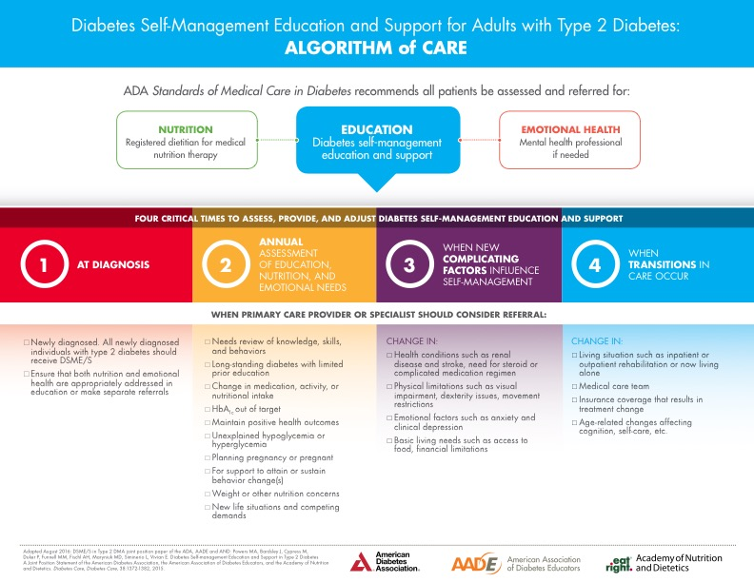
Appendix D
Permission to use Iowa Model
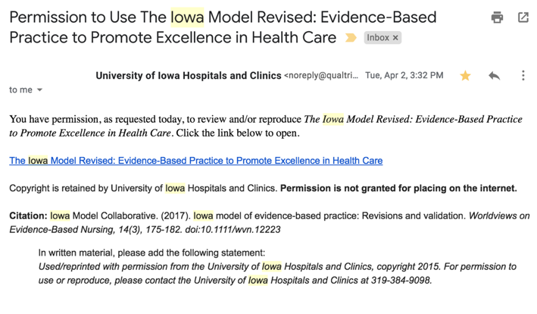

Appendix E
Iowa Model 2015
Appendix F
Official Letter of Project Support
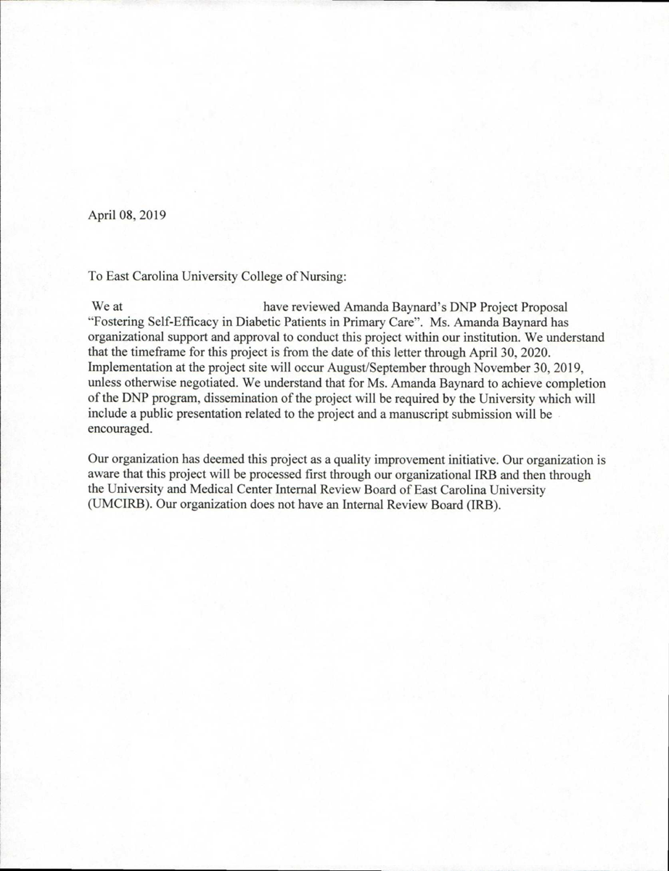
Appendix G
Project Budget
DNP Project Budget
Item | Individual Cost | Total Cost
Education Folders | 0.34 | 34.08
MyPlate Handout | 0.35 | 34.85
Printing per page | 0.04 | 76.00
Staff Lunch | 9.50 | 228
Total Project Budget |  | 372.93

Appendix H
IRB Approval
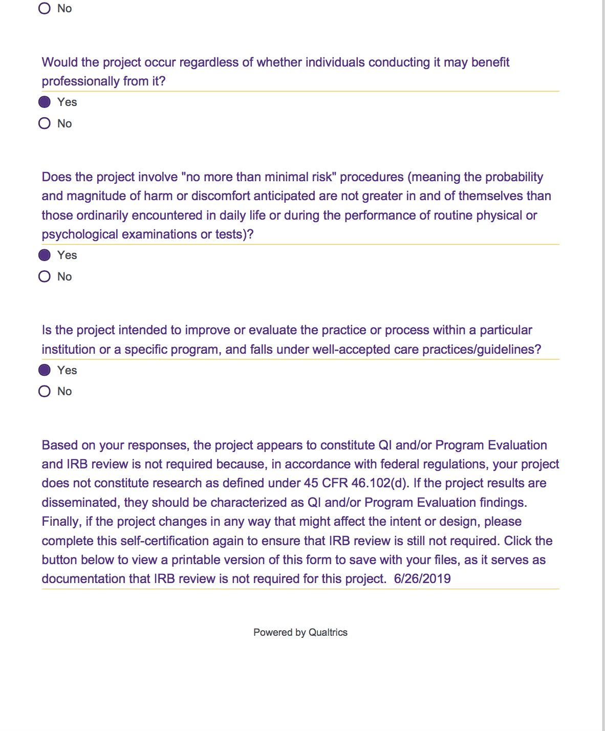
Appendix I
Provider Checklist
Provider Checklist on Diabetic Education
(Please circle the correct response)

- Was the patient eligible to receive provider education and educational packet?
  - Yes b. No

If you circled “No” for question #1, you may stop here. If you circled, “Yes,” please answer the following questions.

- Did the patient receive the provider education and educational packet?
  - Yes b. No

- If you circled no to question #2, please elaborate on why did the patient not receive the provider education and educational packet?

  - Patient refused
  - Not enough time
  - Unaware that the patient qualified for the education
  - Other ___________________________________

Appendix J
Patient Education Survey
Diabetes Education and Materials
Patient Satisfaction Survey

We would like to know how you feel about the education you received from your provider today regarding the diabetes educational materials you were given. Please take the time to complete this short survey so that we may better care for you. All responses are kept confidential and anonymous. Thank you for your time.

Please mark how satisfied you were in the following areas: | Very unsatisfied  1 | Unsatisfied  2 | Indifferent  3 | Satisfied  4 | Highly Satisfied  5
The provider education given to you
The materials provided to you in the booklet
How the provider answered any questions you may have had

Overall, were you satisfied with the diabetes education and materials you received today?
- Yes b. No

What, if any, lifestyle intervention do you plan on incorporating into your life?

- Improving your diet b. Trying to exercise more c. Diet & Exercise

d. I don’t plan on implementing any lifestyle changes

Please circle your gender below

- Male b. Female c. Other d. Prefer not to answer

Appendix K
ADA A1C Educational Handout
Appendix L
ADA Aerobic, Resistance, Balance, and Flexibility Exercises Education
Appendix M
ADA Physical Activity Education
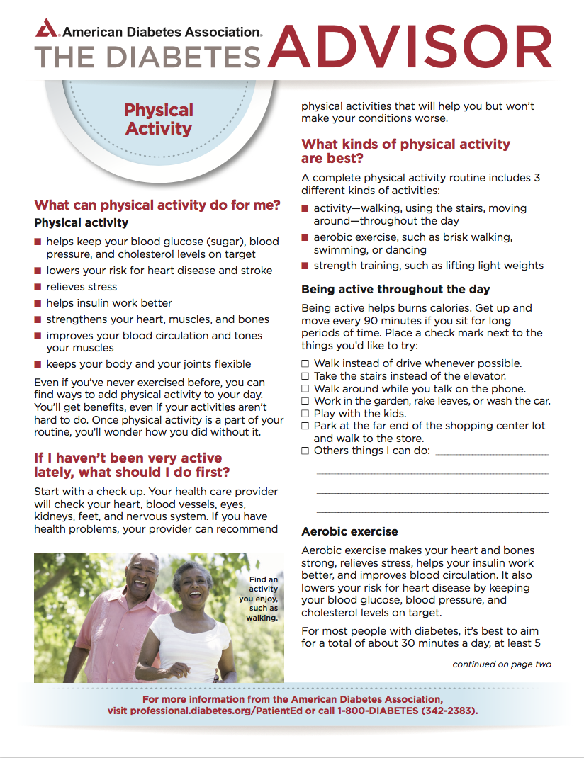

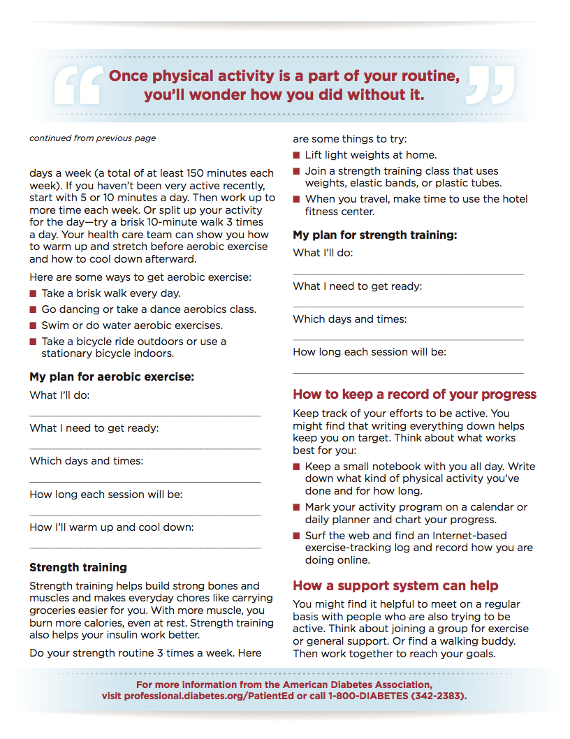

Appendix N
ADA Starter Walking Plan Education

Appendix O
ADA What Can I Eat? Education
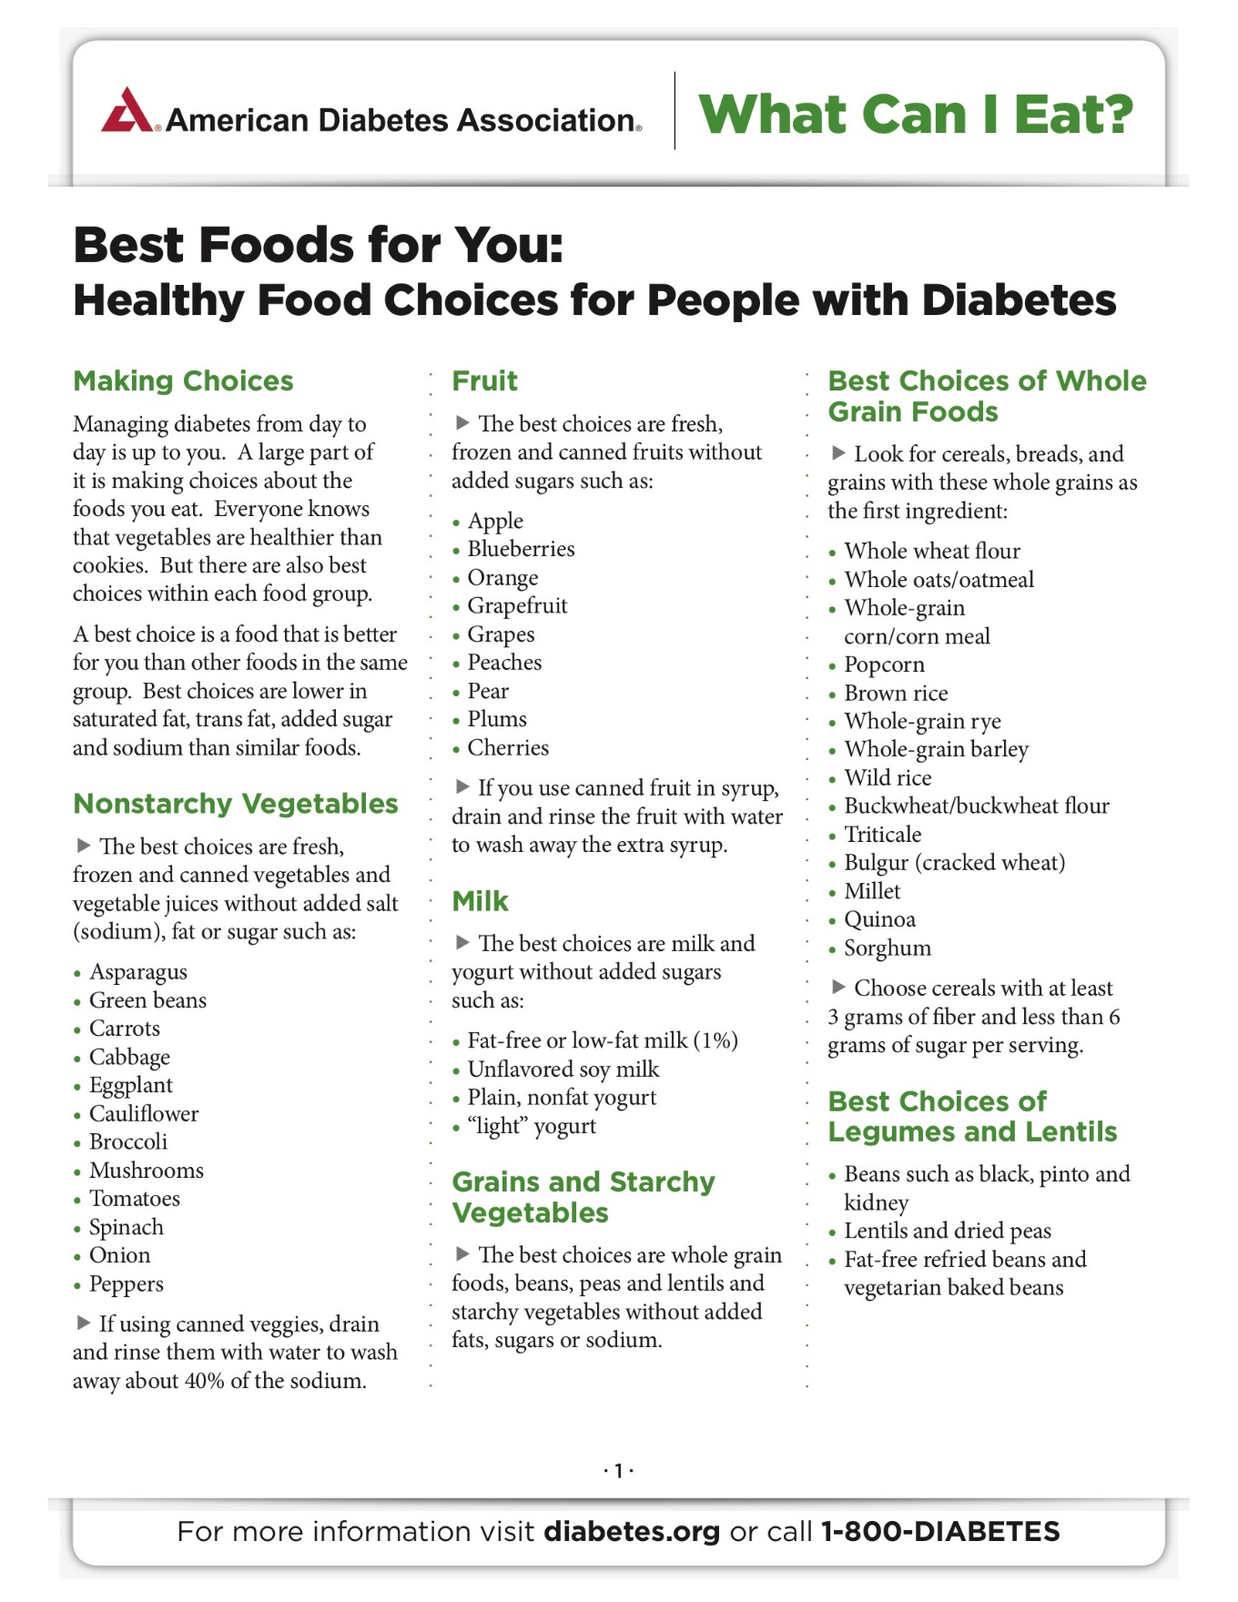


Appendix P
USDA Diabetes MyPlate Education
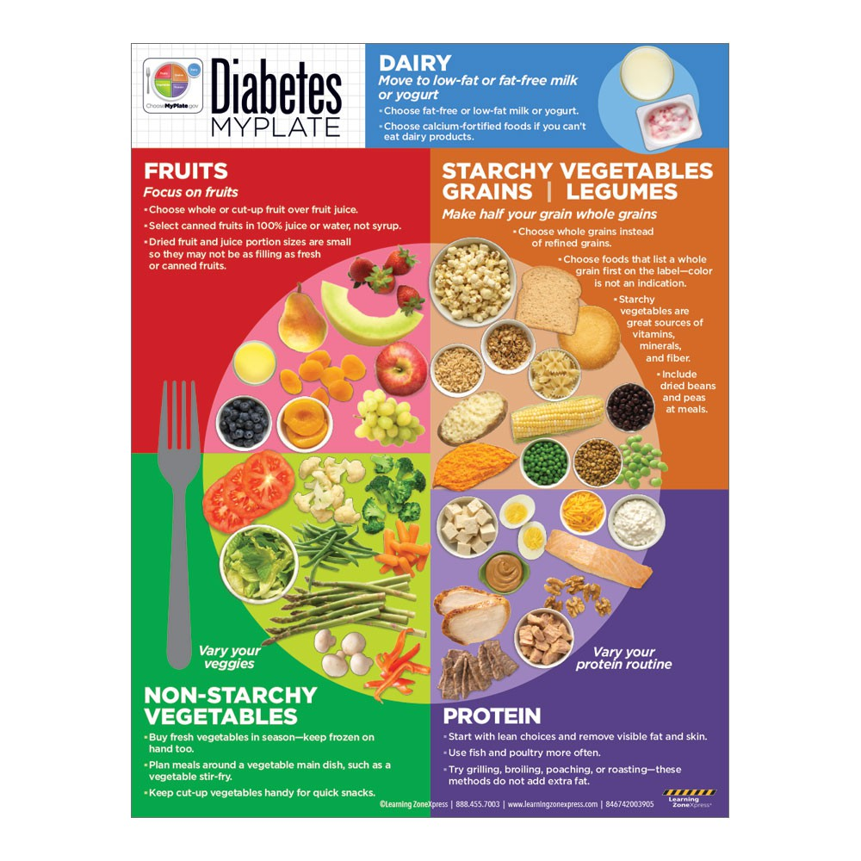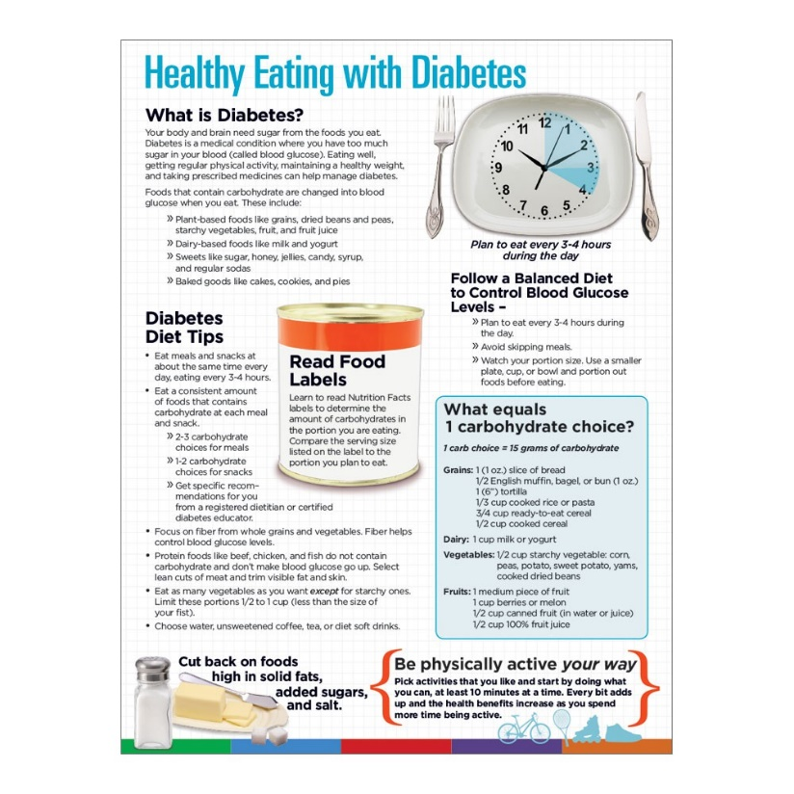
Appendix Q
Results of Patient Surveys
WEEKLY RESULT OF PATIENT EDUCATION SURVEYS
 | DIET | EXERCISE | DIET & EXERCISE | NO ANSWER | DECLINED EDUCATION | TOTAL NUMBER OF ELIGIBLE PATIENTS
WEEK 1 | 1 |  |  | 1 |  | 2
WEEK 2 |  |  |  |  |  | 0
WEEK 3 | 1 | 1 |  | 1 | 1 | 4
WEEK 4 | 2 |  |  | 4 | 2 | 8
WEEK 5 |  |  |  |  |  | 0
WEEK 6 |  |  |  |  |  | 0
WEEK 7 | 1 |  | 1 | 2 |  | 4
WEEK 8 | 1 | 1 |  |  |  | 2
WEEK 9 |  | 2 | 1 |  |  | 3
WEEK 10 |  |  |  |  | 1 | 1
WEEK 11 |  |  | 1 |  |  | 1
WEEK 12 |  |  | 1 | 1 |  | 2

