Increasing Provider Education to Improve HPV Vaccination Rates in Female Veterans

Deidre Murphy
College of Nursing, East Carolina University
Doctor of Nursing Practice Program
Dr. Victoria Conway
July 18, 2022

Notes from the Author
First and foremost, I want to give all the honor, glory, and praise to God who has shown me grace and mercy day after day. Without him, I would be nothing. Second, I would like to thank my family. To my husband John, and my children Jayden and Zariah, thank you for being my biggest supporters and for pushing me to continue and not give up. John, you have been by voice of reason and my strong tower. I know it has not been easy of the years while on this journey, but you remained by my side. Jayden, you were always using my words against me to encourage me to do my work. Zariah, my night “ride or die”; you would struggle to stay up with me at night while I was finishing my papers. As late as it may have been, you never went to bed without me. To my babies, I apologize for the events you had to miss because I had assignments to complete. I want you both to know that I could not have completed this journey without you both, as I did this for you as well as myself.
To my parents, you have instilled in me that I can dream big and reach those dreams. I would not be who I am or what I am if it wasn’t for you. I will forever be grateful to you both. To my grandfather, Lib Murphy aka Smokey, I wish you were present on earth to witness this. I was listening to you, even when you thought I wasn’t. I can only hope and pray that I have made you proud.
Thank you to Dr. Conway and Dr. Tillman for your constant support and encouragement. You both have left a lasting impression on me personally and professionally. Last but not least, I would like to thank my co-workers at the Fayetteville VAMC Women’s clinic.

Abstract
Human papillomavirus (HPV) is a common sexually transmitted disease that affects more than 75% of people. It has been identified for being responsible for over 10,000 cases of cervical cancers annually, in addition to other cancers and diseases. Gardasil 9 is a vaccine that protects against several strands of HPV, including the strands responsible for cervical cancer. HPV vaccination rates are considerably low for adults. A lack of provider knowledge regarding the HPV vaccine, Gardasil 9, has been attributed to the cause. This project aimed to enhance provider knowledge, thus improving the rate of vaccination. Ten providers in a women’s clinic participated in an education session, in addition to being invited to participate in pre- and post-surveys regarding the education, their knowledge, and comfort level regarding discussing and ordering the vaccine. There was a significant increase in the vaccination rates at the end of the project.

Table of Contents
Notes from the Author ………………………………………………………………………….. 2
Abstract …………………………………………………………………………………………. 3
Section I: Introduction ..………………………………………………………………………… 6
Background……………………………………………………………………………… 6
Organizational Needs Statement……………………………………………………….…7
Problem Statement…………………………………………………………………….….8
Purpose Statement………………………………………………………………….……..8
Section II: Evidence……………………………………………………………………………..10
Literature Review………………………………………………………………………..10
Evidence-Based Practice Framework……………………………………………………13
Ethical Consideration and Protection of Human Subjects……………………………….14
Section III: Project Design……………………………………………………………………….15
Project Site and Population………………………………………………………………15
Project Team……………………………………………………………………………..16
Project Goals and Outcomes Measures………………………………………………….16
Implementation Plan……………………………………………………………………..18
Timeline………………………………………………………………………………….19
Section IV: Results and Findings………………………………………………………………...20
Results……………………………………………………………………………………20
Discussion of Major Findings……………………………………………………………20

Section V: Interpretation and Implications………………………………………………………22
Costs and Resource Management………………………………………………………..22
Implications of the Findings……………………………………………………………..22
Sustainability …………………………………………………………………………….24
Dissemination Plan ……………………………………………………………………...25
Section VI: Conclusion…………………………………………………………………………..26
Limitations and Facilitators…………..………………………………………………….26
Recommendations for Others……………………………………………………………27
Recommendations for Further Study…………………………………………………….27 Final Thoughts…………………………………………………………………………...28
References………………………………………………………………………………………..29
Appendices (include as many as you need)………………………………………………………
Appendix A: Pre-implementation Survey……………………………………………….33
Appendix B: PowerPoint Presentation……………………………………...……………35
Appendix C: Post-implementation Survey………..…………………………...………. .42
Appendix D: Project Budget……………………………………………………………..44

Section I. Introduction
Background
The Veterans Affairs Medical Center (VAMC) is a federally funded healthcare organization that provides veterans with various services and treatments. This facility provides medical services to more than 74,000 veterans within a 19-county area in eastern North Carolina (U.S. Department of Veterans Affairs, 2018). Their mission statement is “to care for him who shall have borne the battle, and for his widow, and his orphan by serving and honoring the men and women who are America’s veterans” (U.S. Department of Veterans Affairs, 2018). The eastern NC Women’s Clinic where this project was conducted has 10 female providers who are physicians and advanced practice registered nurses (APRNs). These providers administer both comprehensive and gender-specific care to over 3,500 veterans.
Human papillomavirus (HPV) is a common sexually transmitted infection, often asymptomatic. HPV affects more than 75% of people over their lifespan. There are more than 100 different types of HPV. However, strands 16 & 18 are considered high-risk and are responsible for most HPV-related cancers. More than 33,000 cancers are caused by HPV annually, including over 12,000 oropharyngeal cancers, over 10,000 cervical cancers, and close to 6,000 anal cancers. Other types of cancers associated with HPV include vaginal and vulvar in women (Meites et al., 2019).
Gardasil 9 is a vaccine that protects against multiple types of HPV, including high-risk strands. It also protects against HPV 6 & 11, which are responsible for over 80% of genital warts. It has a strong prevention rate of greater than 90% when administered before HPV exposure (Cheng et al., 2020).
The goal of this quality improvement project is to increase provider education regarding HPV vaccinations so that the number of vaccinations will increase. The intended outcome is that the number of HPV vaccinations will increase by at least 10% by the end of the project.
Organizational Needs Statement
Based on CDC guidelines, the aforementioned veterans’ healthcare organization currently offers the HPV vaccine to female veterans up to the age of 26 (Center for Disease Control and Prevention, 2020). However, it is available to veterans ages 27-45 if requested and accompanied by a medical order. The clinic does not currently have any initiatives aimed at increasing HPV vaccination rates.
The clinic uses Healthcare Effectiveness Data and Information Set (HEDIS) measures to track HPV vaccination rates for veterans. A notification appears in the electronic health record (EHR) for all females up to age 26 on their first visit and requires input on whether they have received the HPV vaccine in the past and if so, when. It also automatically prompts offering the vaccine to those who qualify and have not been previously immunized.
The problem arises as the clinic uses Thin Prep as the testing source for pap smears or cervical cytology. Thin prep does not check for HPV until the female reaches 30 years old unless it is detected on the cervical sample. Pap smears detect abnormal cells in the cervix, whereas the HPV test checks specifically for an HPV infection, which can lead to the development of cervical cancer. If the HPV results are positive, it can indicate that precancerous cells are present. Both cervical cytology and HPV testing are performed utilizing the same specimen.
Increasing HPV vaccinations would decrease future treatment costs and reduce veterans' pain and discomfort. When active HPV infections are detected, female veterans may require invasive procedures such as a colposcopy or loop electrical excision procedure (LEEP). At this facility for 2021, 55.9% of the abnormal pap smears required a colposcopy or LEEP procedure (Fayetteville VAMC, 2022). According to Zullig et al., (2019), gynecological cancers accounted for 12% of all cancers in female veterans in 2010. These cancers included uterine, cervical, and ovarian. A study conducted using veterans in south Florida indicated that 14% of their patients were positive for high-risk HPV. Age groups 30-39 and 20-29 had the highest percentages at 32.4% and 24.5%, respectively (Syler et al., 2021).
By increasing the administration rates of the HPV vaccine, especially in women who have not yet been exposed to HPV, the number of abnormal pap smear results, cervical biopsies/colposcopies, and cervical cancer diagnoses should decrease. These anticipated outcomes address the Triple Aim by improving female veterans' health and enhancing the care experience for the female veteran population as less invasive procedures may be required. Closson et al. (2020) indicated that the HPV vaccination rate for the United States was 66%-70% in 2019, which is below the goal of 80% per Healthy People 2020.
Problem Statement
The HPV virus is a sexually transmitted infection directly associated with causing numerous gynecological cancers. The HPV vaccination rate for the women’s clinic where this quality improvement project was conducted was 43.6% for 2021, which is significantly low. By increasing provider knowledge regarding HPV and the vaccine, the aim is to increase the number of vaccinations administered, thereby decreasing the number of severe health conditions related to HPV infections. Treatment of HPV-associated cancers costs an average of 13 billion dollars. Increasing vaccinations would reduce costs significantly (Chesson et al., 2019).
Purpose Statement
This quality improvement project aimed to increase HPV vaccinations in female veterans by improving provider knowledge of the infection and vaccination. Increasing veterans’ knowledge and access to the vaccine can decrease the incidence of serious health outcomes related to HPV.

Section II. Evidence
Literature Review
An extensive literature review was conducted to examine existing literature available on the topic of HPV vaccinations. Multiple search engines were used via Google and the university library. PubMed, Clinical Key, CINAHL, and ProQuest were the search engines utilized in addition to Google Scholar. Using key terms such as HPV, HPV vaccines, provider recommendations for the HPV vaccine, and HPV vaccination guidelines yielded more than 500 articles. Exclusion criteria included articles published before 2016, articles that did not contain keywords, and duplicates. Inclusion criteria included articles with keywords printed in English, restricted to the United States, published within the past five years, and full-text available. After applying inclusion and exclusion criteria, 28 articles were yielded.
A detailed review of the articles was performed, of which 17 were deemed applicable to this DNP project. These relevant articles were assessed for their level of evidence, in which 11 articles were used.
Current State of Knowledge
HPV vaccination is routinely recommended between the ages of 9 and 12 years. However, catch-up vaccination is recommended for people up to age 26 who have not been previously vaccinated or have not completed the series. The Advisory Committee on Immunization Practices (ACIP) recommends catch-up HPV vaccination for adults up to the age of 45. However, the American Cancer Society (ACS) does not currently endorse this due to the low effectiveness and decreased potential to lower cancer in this age group (Saslow et al., 2020).
The American Cancer Society (ACS) issued its first guideline for routine use of the HPV vaccine in 2007 in conjunction with the ACIP and has issued updated guidelines with the last update in 2020. The current guideline is routine HPV vaccination starting at age 11 or 12 with catch-up vaccinations up to age 26 for those who have not previously been vaccinated. However, it can be administered starting as early as age 9. For ages 27-45, shared decision-making should be discussed with the patient and provider. Although the vaccine is most effective when administered before exposure to HPV infections, it can be administered regardless of abnormal HPV results (Workowski et al., 2021).
Currently, there are 3 HPV vaccines licensed in the United States. Ceravix HPV vaccine offers protection against HPV 16 & 18, Gardasil vaccine offers protection against HPV types 6, 11, 16, & 18, and Gardasil-9 offers protection against HPV types 6, 11, 16, 18, 31, 33, 45, 52, & 58. Gardasil-9 is the only HPV vaccine currently available in the United States. The HPV vaccine should be administered in a 2-dose schedule: 0 month and 6–12-month interval if started before age 15. A 3-dose schedule, 0, 1-2 months, and 6-month intervals should be utilized if the vaccination series was administered after age 15 or for all immunocompromised persons, regardless of age (Workowski et al., 2021).
A study performed by Nobel et al., (2019) indicated that the HPV vaccination initiation rate was less than 22%, and an average of 10% of veterans have received at least one HPV vaccine prior to receiving care at the VA. This study indicates plenty of missed opportunities to discuss, encourage, and offer the HPV vaccine (Nobel et al., 2019).
From the timeframe of January 2021 to December 2021, there were approximately 110 HPV vaccines administered throughout the Fayetteville VAMC. However, only 48 of those vaccines were ordered and administered in the women’s clinic (Fayetteville VAMC, 2021). Although there is no specific measure or benchmark for HPV vaccine administration within the VA organization, this scholarly project aims to increase HPV vaccinations by at least 10%.
Current Approaches to Solving Population Problem(s)
Several barriers have been identified as direct influences on low HPV vaccinations in women. Lack of provider knowledge, missed opportunities, provider attitude, and lack of access to the vaccine are indications of why the vaccines are not being administered. By eliminating these barriers, we can increase the HPV vaccinations, which will decrease the number of HPV-related cancers (Shelal et al., 2020).
The lack of provider recommendations can be attributed to a lack of knowledge regarding the vaccine. A study performed indicated that a structured presentation for healthcare providers improved provider knowledge regarding the prevalence of HPV, guidelines for immunization, and incidence of cervical cancer. After the presentation, the rate of HPV vaccines increased by nearly 20%, with providers reporting an increase in HPV knowledge and patient interactions regarding HPV prevention (Leung et al., 2019).
Provider attitude plays a vital role in HPV vaccinations. Leung et al. (2019) note the most influential factor in HPV vaccinations is the providers’ attitude. Suppose the provider has a positive attitude and recognizes the vaccine's impact on decreasing the incidence of cervical cancer in women. In that case, they are more inclined to discuss and offer the HPV vaccine.
Lack of access has been noted as a reason for decreased vaccination rates. This is not a problem for female veterans as they can easily obtain their vaccine with or without an appointment with their provider as vaccinations can be ordered and administered during appointments with registered nurses (RN). However, many veterans are not aware of the vaccine or their eligibility to receive it.
Evidence to Support the Intervention
Improving the providers' knowledge would significantly impact increasing HPV vaccination rates. A total of 1396 pap smears were collected for the year 2021. 1159 were normal, and 237 were abnormal. 75.5% of the abnormal results were HPV positive, and 55.9% of the HPV positive results required an invasive procedure as part of treatment (Fayetteville VAMC, 2022). The results reviewed included veterans whose ages ranged from 21 to 74 years old. Improving providers’ attitudes and increasing their knowledge regarding the vaccine is key to increasing administration.
Leung et al. (2019) indicate that healthcare providers are a huge factor in administering the vaccine, and recommendations by providers can increase the HPV vaccination and the initiation and completion of the series. The most influential factor in increasing the HPV vaccination rate was noted to be the positive attitude of the provider regarding the vaccine and the positive impacts it has on reducing cervical cancer (Leung et al., 2019).
Provider-focused interventions include meetings with providers every 4-6 weeks, focused education, individual feedback, and the provision of CME credits. Other interventions performed in Leung et al. (2019) study include electronic health records (EHR) based vaccine alerts, educational presentations, audit and feedback, and automated telephone reminder calls to patients. This project will consist of focused education and meetings with providers.
Evidence-Based Practice Framework
The Health Belief Model has been widely used regarding immunizations. This framework is based upon the elements of perceived susceptibility, severity, and benefits. Information and awareness of the HPV and Gardasil 9, the HPV vaccine, are essential factors to one’s element of perceived susceptibility (Blount et al., 2020).
Perceived susceptibility is one’s idea of developing the disease. The Center for Disease Control and Prevention (CDC) notes that from 2012 to 2016, over 34,000 cancers were directly related to HPV infections and that 92% of those cases were caused by the type of HPV infections that are targeted by the Gardasil-9 HPV vaccine. Perceived severity is the thought of how severe one’s condition will be if one were to get the illness. Perceived benefits describe the concept of effectiveness of actions that can be taken to prevent the disease. For this project, the perceived benefit would be to get the HPV vaccine as studies have proven it to provide protection against 90% of cervical cancers (Blount et al., 2020).
Ethical Consideration & Protection of Human Subjects
The interventions are equal and impartial for this project as it is aimed at all providers in work in the Women’s Clinic at this project site. There are no ethical considerations and no potential harm as education is being provided to increase vaccination rates for HPV. No indication is noted that would allow anyone to be taken advantage of during implementation.
Collaborative Institutional Training Initiative (CITI) modules were used to prepare for the formal process, encompassing research, ethics, and compliance training. This project was deemed quality improvement through the project site and the quality self-assessment form from East Carolina University (ECU). No formal IRB is needed. HIPPA and security and privacy modules were required and completed per project site.

Section III. Project Design
Project Site and Population
The project was conducted at a veteran’s healthcare organization located in eastern North Carolina. This clinic is one of more than 20 North Carolina clinics that provide care to armed forces veterans. It served as the project site offers as it offers services to females and transgender persons who require gender-specific care. The population focus of this DNP project was the medical providers that work within the women’s clinic.
Description of the Setting
The project site was a women’s clinic within a veteran’s healthcare organization. This clinic has approximately 10 female providers who provide primary care and comprehensive women’s services such as routine pap smears. The women’s clinic at this facility serves an average of 3,500 female veterans annually, increasing each year (Fayetteville VAMC, 2021).
Description of the Population
The population focus of this quality improvement project was the medical providers within the clinic. There are four physicians, eight nurse practitioners, and one midwife. One provider performs procedures that include biopsies, colposcopies, IUD insertions and removals, Nexplanon insertion and removals, and polyp and genital wart removals. Each provider in the women’s clinic has three nurses, two licensed practical nurses (LPNs), and one registered nurse (RN). The RN has two appointment slots daily, which are utilized for immunizations and care management, focusing on chronic disease management. RNs occupy a significant role in patient care as they provide education to patients regarding disease prevention and disease management.
The women’s clinic also has two pharmacists known as PharmD providers, two Primary Care Integrated Mental Health (PCMHI) providers, and two social workers. The PharmD providers can also order medications and immunizations.
Project Team
The partner organization for this quality improvement project is the veterans’ healthcare organization. The women’s clinic will be the only clinic utilized within this organization for this project. Project team members consist of the chief of the women’s clinic, who serves as the manager of this project location, and myself as the project lead. There are two faculty members for this project and the project site champion, who all serve as mentors.
Project Goals and Outcome Measures
This quality improvement project had a two-fold goal. The goals were to increase the knowledge regarding HPV and the HPV vaccine amongst providers to increase HPV vaccination rates in accordance with Healthy People 2020 initiatives. The targeted goal for vaccination was 80%. Prior to implementation, limited information and resources were readily available at the site.
IRB approval was not required as this project was deemed quality improvement by a self-assessment process. Provider knowledge was assessed by administering a pre-and post-project implementation survey using the Likert scale. The pre-implementation survey assessed their knowledge of HPV infections and HPV vaccines. The post-implementation surveys evaluated provider knowledge, comfort with discussing and ordering the vaccine, and determining patient eligibility. HEDIS measures, in conjunction with information from the clinic pharmacist, will be used to analyze data related to HPV vaccines.
Description of the Methods and Measurement
The implementation framework used for this project was the Practical Robust Implementation Sustainability Model (PRISM). This model was adopted to be a practical, actionable model that could be used to plan, guide interventions, implementation strategies, transformations, and components related to sustainability. According to PRISM components, crucial factors to improve the implementation of a project include fostering an encouraging environment, sharing best practices, observing results, modifying actions, promoting intervention, and establishing sustainability. The PRISM model was applied as this quality improvement project aims to integrate existing concepts into a sustainable practice (McCreight et al., 2019).
Provider knowledge was assessed via digital surveys. The Likert scale utilized pre-and post-intervention surveys related to their understanding of HPV and HPV vaccinations. Providers were questioned regarding comfort level with knowledge of HPV, discussing and ordering the vaccination, and whether they felt barriers to ordering and administering the vaccine. The data from the surveys were gathered, organized, and reviewed.
Discussion of the Data Collection Process
Data collection occurred at two intervals: before the educational session and at the end of the project. Two days prior to the educational session, the providers received an email informing them of this project and requesting their participation. The pre-implementation survey was emailed as a link to the SurveyMonkey website. At the end of the project, a post-intervention survey was emailed to providers. This data regarding provider knowledge was compiled and reviewed.
The data regarding HPV vaccinations were collected and analyzed beginning with the date the email was sent requesting participation and closing at the end of the project. A total of seven providers participated in the survey. Data was assessed using the number of vaccinations ordered from the pharmacy department and HEDIS measures.
Implementation Plan
Implementation and support for sustainability are critical when planning, evaluating, and broadcasting programs. Engaging feedback from the providers at different stages of the program is correlated with the PRISM model for improved implementation success (McCreight et al., 2019)
Prior to implementation, information was obtained and placed into a PowerPoint presentation, and surveys were created. The program was designed and discussed with the site champion.
The pre-intervention survey was emailed in February 2022 and consisted of ten questions regarding knowledge of HPV infections and HPV vaccines (see Appendix A). After completing the pre-intervention survey, an educational session was performed via PowerPoint presentation during the morning departmental huddle. The PowerPoint contained information regarding HPV infections and HPV vaccines (see Appendix B). This PowerPoint was also emailed after the educational session. Weekly emails with information on HPV vaccines were sent to providers to reinforce their knowledge.
Several clinical days were utilized to support the clinic providers, nurses, and veterans. Questions were answered, and education was provided, which concluded with several veterans obtaining their HPV vaccine during their clinic visit. The post-intervention survey was emailed at the end of the project. The post-intervention survey included questions regarding knowledge of HPV vaccine and comfort level regarding ordering and administration (see Appendix C).

Timeline
The project idea was envisioned in August 2021. Shortly afterward, the project team was developed. Collection and clarification of information occurred from August 2021 to December 2021. The timeframe for implementation will be February 2022 until April 2022.
The educational session occurred on February 18, 2022, at a morning huddle with all providers in the women’s clinic. Further informational sessions were conducted one-on-one with providers.

Section IV. Results and Findings
This project aimed to improve providers' knowledge regarding the HPV vaccine, with an end goal of increasing vaccination rates. The vaccination rate for the clinic in the year 2021 was 43.6%. The projected outcome of this quality improvement project was to increase provider knowledge and raise the vaccination rate by at least 10%, which is still well below the Healthy People 2020 goal of 80%.
Results
The pre-implementation survey indicated a lack of provider knowledge regarding HPV infections and vaccinations. Seven out of ten providers, one midwife, two doctors, and four nurse practitioners completed the pre-implementation survey, which yielded a participation rate of 70%. Two questions regarding HPV vaccine dosing yielded a response of 85%, two questions regarding the effectiveness of the vaccine yielded a response of 57%, and one question about the annual number of HPV infections yielded a response of 28%. Only four questions were answered correctly by all seven participants.
The total number of HPV vaccines (Gardasil 9) was obtained from PharmD. Their report included the name of the ordering provider or nurse, ordering clinic, and the name of the receiving veteran. The HPV vaccination rates for January to March 2022 for the women’s clinic increased to 81% for eligible veterans as there was a total of 37 vaccines ordered throughout the entire facility with 30 of those vaccines ordered and administered in the women’s clinic. The remaining seven vaccines were administered in the primary care clinics.
Discussion of Major Findings
The results of this project determined that providers had a knowledge deficit regarding HPV infections and the HPV vaccine. Three providers stated that they were unaware that the vaccine could be given up to age 45, and four providers did not know that the vaccination series consists of three doses. This knowledge gap could be directly linked to the low vaccination rates. Hurley et al. (2021) report that shared clinical decision-making conversations presents a challenge for providers with knowledge deficits. Research has indicated that face to face conversations between patients and providers with the goal to educate about vaccinations are effective. When healthcare providers discuss and agree with their colleagues, other providers, and professional organizations, they tend to vaccinate at a higher rate (Leung et al., 2019). The weekly emails that were sent to the providers include information from the CDC and ACIP regarding the HPV vaccine Gardasil 9. The weekly educational emails, along with the face-to-face conversations between the provider and the veteran helped increase the number of HPV vaccine administered.
The DNP project also revealed that veterans have a knowledge deficit related to the HPV vaccine. Although veterans were not surveyed, while in clinic for face-to-face educational encounters with the providers, the vaccine was discussed by the provider during their appointment with the veterans. Several veterans were unaware of the vaccine or their eligibility. Questions asked and answered included why this is needed and what it prevents. Perceived benefit has been associated with increased rates of vaccination. Once informed about the vaccine and its benefit in decreasing the incidence of cervical cancer and genital warts, the population of interest became more interested in the vaccine. A study performed by Thompson et al. (2021) indicates that perceived effectiveness regarding future HPV infections was directly linked to increased HPV vaccinations over the following six months. This study also notes that cancer prevention, a perceived benefit of the vaccine, increased one’s acceptability, intentions, and vaccine uptake (Thompson et al., 2019).
Section V. Interpretation and Implications
Costs and Resource Management
Costs related to this project included travel and mileage by the project lead. Travel to the clinic occurred seven times over the implementation period. The distance to the clinic is 67 miles one way, a total of 134 miles roundtrips. With the current government mileage rate of 58.5 cents per mile the total cost for travel totaled $590.94 for a total of 938 miles. Survey monkey was also used for survey development at no additional cost. Numerous hours were spent with research, development, collaboration, implementation, and management. Student research/labor in addition to time contributed by the project site champion and other clinic providers for the PowerPoint presentation and completing both surveys were essential, however, did not yield a monetary cost. (See Appendix D).
This project would likely incur more costs if implemented on a larger scale. Expenses associated with visual aids such as posters and pamphlets would be incurred. Also, incorporating social media could potentially reach a more significant number of people.
The potential budget costs would greatly increase if this project was completed by a paid employee as hourly wages would have to be paid. The project would remain beneficial despite the current budget costs or potential costs if completed by a paid employee, Every HPV vaccine administered in the clinic has the potential to reduce cervical cancer and other HPV associated cancers and diseases.
Implications of the Findings
This quality improvement project indicated that providers did verbalize an increase in knowledge of the HPV vaccine following their education session. Results demonstrate a positive correlation between provider knowledge and vaccination rates. The post-implementation survey indicated that the providers tend to increase conversations with veterans regarding the HPV vaccine which can lead to increase vaccinations.
Implications for Patients
A decreased risk of cervical cancer and other HPV-associated infections are the major long-term implications for patients. Gardasil 9 has been proven to prevent HPV infections, precancerous lesions, and vulvar and vaginal diseases. Out-of-pocket costs and other expenses associated with HPV-associated diseases and cancers can be a burden to patients. Obtaining the HPV vaccine can reduce those burdens.
Decreasing the need for invasive treatments and procedures while minimizing the healthcare burden are also associated implications of this project. As the number of HPV vaccinations increase, the number of these painful and potentially costly procedures decrease.
Improving patient outcomes and decreasing HPV related cancers and other associated diseases through vaccinations can have a major impact on health and wellness for years to come. This project made a difference not only in the increase knowledge of the providers but also in the increased number of needed vaccinations,
Implications for Nursing Practice.
Nurses play an essential role in disease prevention and health promotion. With more than 14 million new cases of HPV diagnosed each year, increasing the administration of the HPV vaccine can decrease the prevalence and minimize the burden on the healthcare system. Nurses are essential stakeholders in the prevention of HPV and directly impact vaccination rates. Having a working knowledge of HPV and the vaccine and maintaining a positive attitude towards vaccination correlate with discussing, recommending, and administering the HPV vaccine (Ebu et al., 2021).
Impact for Healthcare System(s)
HPV-associated diseases account for more than 190,000 cervical precancers and more than 35,000 HPV-attributable cancers each year. A study by Chesson et al. (2019) reported that costs associated with cervical cancer amount to around $82,000. Vaginal cancer related to HPV has an estimated medical cost of about $145,000. The financial burden on the healthcare systems can be eased through increased vaccinations for HPV.
This quality improvement project can continue to make an impact on health. The vaccine is available to veterans at no cost to them. As the vaccination numbers increase, the expected outcome is that invasive procedures and cervical cancers will decrease. The decrease in these numbers affects the healthcare system in several ways, such as the decrease in need for specialized and expensive equipment.
Sustainability
Developing a HPV vaccine protocol that provides continuing education to both providers and veterans can lead to a continued increased rate of HPV vaccinations. Adding EHR alerts for all female veterans up to age 45 to assess their eligibility, in conjunction with an electronic patient reminder system, would identify a more significant number of female veterans that could potentially receive the Gardasil 9 HPV vaccine.
This project should be continued in the women’s clinic and implemented in all primary care clinics as the HPV vaccine is for men and women. Just as there is emphasis on influenza vaccines and the COVID 19 vaccine, the same could be done for HPV. Increasing visibility of the Gardasil 9 vaccine creates advertisement which could yield an increase in vaccinations. Annual training for providers should also be implemented to keep them up to date with current information.
The Associate Deputy Chief of nursing has reached out regarding implementing this initiative in primary care. A meeting is to be scheduled to determine and develop implementation guidelines.

Dissemination Plan
This project will be presented to the primary care providers at the VAMC facility before the end of 2022 to increase vaccinations for all eligible veterans, both male and female. It will also be submitted to ECU’s ScholarShip after presenting to the College of Nursing on July 12, 2022.

Section VI. Conclusion
Limitations and Facilitators
The limitations of this project were time, nursing support, and competing priorities. The setting for this project was a busy clinic. The appointments are structured so that the nurse gets
the veteran for the first 15 minutes of the 30-minute appointment to clear reminders. This leaves the provider with the remaining15 minutes to complete their visit. Due to time constraints, the nurses are reluctant to discuss or offer HPV vaccines, whether the HEDIS reminder alerts are active or not.
The duration of this project could also be considered a limitation. The duration of this project was four months. Due to the short duration, the number of vaccinations reported were limited. It also does not allow the monitoring of pap results to correlate any changes related to the increased number of vaccinations.
Another limitation are the competing priorities in the clinic each day. Competing priorities are a critical factor with the providers attempting to complete a visit in 15 minutes. Other provider responsibilities include reviewing and addressing multiple alerts related to ordered labs, tests, and consults and answering secure messages.
Facilitators of this project include the ability to engage with both providers and veterans. Questions were able to be asked and answered promptly due to in person availability. The utilization of weekly emails also contributed as education was constantly being provided. The PharmD providers had a significant impact on this project as they could run HPV vaccine reports and separate them by ordering providers and clinics in order to gauge the effect of ongoing education of HPV vaccination rates.

Recommendations for Others
Although this project was successful at increasing the vaccination rates of HPV, the duration was relatively short. Extending this project to yield more concrete results for several months to at least a year would be highly beneficial. Also, hanging posters throughout the clinic and facility and placing pamphlets in each exam room would increase awareness of HPV prevention.
Regarding scalability, this project could be expanded to primary care clinics at this facility and others to promote awareness and increase HPV vaccinations for both male and female veterans. This project is not limited to HPV vaccines and could be utilized for other vaccinations.
This project could easily be sustained with no projected end date as it could be implemented on a continuous basis.
Recommendations Further Study
Several additional projects could be launched from this one. Monitoring the HPV vaccination series completion rates, monitoring cervical cytology/pap smear results of those who have not received the vaccine, and tracking abnormal cervical cytology/pap smear in correlation with one’s HPV vaccination series are just a few.
This project is not strictly limited to women or the women's clinic. It could be replicated in a pediatric clinic, as the HPV vaccine is available for ages 11-45. It is recommended that children receive the first dose of the HPV vaccine at age 11. However, some children receive it as young as nine years old. Research has indicated that younger children who receive the vaccine tend to complete the series. And it is well documented that the HPV vaccine is most efficient when administered before becoming sexually active.
Because the vaccination of males has the advantage of decreasing the risk of HPV transmission, nurses and providers should have a gender-neutral approach. The HPV vaccine should be offered to both males and females. By vaccinating both sexes, the risk of HPV infections, cancers, and transmission is significantly reduced (Lee & Garland, 2017).

Final Thoughts
HPV is one of the most common sexually transmitted diseases directly linked to cervical cancer. It is also a vaccine preventable disease. HPV is responsible for an average of 10,000 new cervical cancer cases yearly. HPV vaccine is essential in the prevention of cervical cancer. Gardasil 9, the HPV vaccine has proven to prevent more than 90% of cancers caused by HPV from ever occurring. The HPV vaccination rate for female veterans in the VAMC women’s clinic was relatively low. This low rate was likely due to a lack of provider knowledge. The vaccination rate increased nearly 40% in a relatively short timeframe by providing increased education to the providers and female veterans. Project findings yielded an increase of HPV vaccines from 43.6% to 81%.
The purpose and goal of this project was to address and improve provider knowledge deficits regarding HPV infections and vaccines to increase HPV vaccination rates. Barriers such as lack of provider knowledge and encouragement, nursing support, time, and competing priorities must be addressed. This project was a success through collaboration with the women’s clinic providers, nurses, PharmD, and department chief.

References
Blount, C.A., Jackson, J. C., & Sasser, J. T. (2020). An HPV vaccination protocol to increase rates. I-managers Journal on Nursing, 10(3).
Centers for Disease Control and Prevention (2020). HPV Vaccine Recommendations. https://www.cdc.gov/vaccines/vpd/hpv/hcp/recommendations.html
Cheng, L., Wang, Y., & Du., J. (2020). Human papillomavirus vaccines: an updated review. Vaccines, 8(3). http://doi:10.3390/vaccines8030391
Chesson, H. W., Meites, E., Ekwueme, D. U., Saraiya, M. & Markowitz, L.E. (2019) Updated medical care cost estimates for HPV-associated cancers: implications for cost- effectiveness analyses of HPV vaccination in the United States. Human Vaccines & Immunotherapeutics, 15, 1942-1948. http://doi:10.1080/21645515.2019.1603562
Closson, K., Karim, M.E., Sadarangani, M., Naus, M., Ogilvie, G.S., & Donken, R. (2020). Association between human papillomavirus vaccine status and sexually transmitted infection outcomes among females aged 18-35 with a history of sexual activity in the United States: A population survey-based cross-sectional analysis. Vaccine, 38, 8396- 8404. https://doi.org/10.1016/j.vaccine.2020.10.033
Ebu, N.I., Abotsi-Foli, G.E., & Gakpo, D.F. (2021). Nurses’ and midwives’ knowledge, attitudes, and acceptance regarding human papillomavirus vaccination in Ghana: a cross- sectional study. BMC, 20(11). https://doi.org/10.1186/s12912-020-00530-x
Fayetteville VAMC (2021). Women’s health statistics
Hurley, L.P., O’Leary, S.T., Markowitz, L.E., Crane, L.A., Cataldi, J.R., Brtnikova, M., Beaty, B.L., Gorman, C., Meites, E., Lindley, M.C., & Kempe, A. (2021). US primary care physicians’ viewpoints on HPV vaccination for adults 27 to 45 years. Journal of the American Board of Family Medicine, 34(1), 162-170. https://doi.org/10.3122/jabfm.2021.01.200408
Lee, L., & Garland, S.M. (2017). Human papillomavirus vaccination: the population impact [version 1; referees: 3 approved]. F1000Research 2017, 6(F1000 Faculty Rev):866. doi: 10.12688/f1000research.10691.1
Leung, S., Akinwunmi, B., Elias, K. M., & Feldman, S. (2019). Educating healthcare providers to increase Human Papillomavirus (HPV) vaccination rates: A Qualitative Systematic Review. Vaccine: X, 3, 100037. https://doi.org/10.1016/j.jvacx.2019.100037
McCreight, M.S., Rabin, B., Glasgow, R.E., Ayele, R.A., Leonard, C.A., Gilmartin, H.M., Frank, J.W., Hess, P.L, Burke, R.E., & Battaglia, C.T. (2019). Using the Practical, Robust Implementation and Sustainability Model (PRISM) to qualitatively assess multilevel contextual factors to help plan, implement, evaluate, and disseminate health services programs. Translational Behavioral Medicine, 9(6), 1002-1011. https://doi.org/10.1093/tbm/ibz085
Meites, E., Szilagyi, P. G., Chesson, H. W., Unger, E. R., Romero, J. R., & Markowitz, L. E. (2019). Human papillomavirus vaccination for adults: updated recommendations of the advisory committee on immunization practices. Morbidity and Mortality Weekly Report,68(32), 698-702.
Nobel, T., Rajupet, S., Sigel, K., & Olier, K. (2019). Using Veterans Affairs Medical Center (VAMC) data to identify missed opportunities for HPV vaccination. Human Vaccines & Immunotherapeutics, 15, 1878-1883. doi: 10.1080/21645515.2018.1559684
Saslow, D., Andrews, K. S., Mannassaram-Baptiste, D., Smith, R. A., & Fontham, E. T. H. (2020). Human papillomavirus vaccination 2020 guideline update: American cancer society guideline adaptation. CA: A Cancer Journal for Clinicians, 70, 274-280. doi: 10.3322/caac.21616
Shelal, Z., Cho, D., Urbauer, D. L., Lu, Q., Ma, B. Y., Rohrer, A. M., Kurian, S., Sturgis, E. M., & Ramondetta, L. M. (2020). Knowledge matters and empowers: HPV vaccine advocacy among HPV-related cancer survivors. Supportive Care in Cancer, 28(5), 2407-2413. https://doi:org/10.1007/s00520-019-05035-1
Syler, L. B., Stobaugh, C. L., Foulis, P. R., Carlton, G. T., DeLand, L. A., & Borkowski, A. A. (2021). Cervical cancer screening in South Florida veteran population, 2014 to 2020: cytology and high-risk human papillomavirus correlation and epidemiology. Cureus, 13(8). doi:10.7759/cureus.17247
Thompson, E.L., Garg, A., Galvin, A.M., Moore, J.D., Kasting, M.L., & Wheldon, C.W. (2021). Correlates of HPV vaccination intentions among adults ages 27-45 years old in the U.S. Journal of Community Health, 46, 893-902. https: doi.org?10.1007/s10900-021-00968-3
U.S. Department of Veterans Affairs (2018). Fayetteville VA Coastal Health Care System. https://www.fayettevillenc.va.gov/about/index.asp
Workowski, K. A., Bachmann, L. H., Chan, P. A., Johnston, C. M., Muzny, C. A., Park, I., Reno, H., Zenilman, J. M., & Bolan, G. A. (2021). Sexually Transmitted Infections Treatment Guidelines, 2021. MMWR Recommendations & Reports, 70(4), 1-187. https://doi.org/10.115585/mmwr.rr7004a1
Zullig, L. L., Goldstein, K. M., Sims, K. J., Williams, C. D., Chang, M., Provenzale, D., & Kelley, M. J. (2019). Cancer among women treated in the veterans affairs healthcare system. Journal of Women’s Health, 28(2), 268-275. https//doi.org/10.1089/jwh.2018.6936

Appendix A
Pre-implementation Survey

Human Papillomavirus (HPV).

Top of Form

1. When is the best time to vaccinate against HPV?
- At birth
- Before becoming sexually active
- After being exposed to HPV
- None of the above
Bottom of Form

2. How many types of HPV?
- 40
- 5
- More than 100
- 10

3. Does the HPV vaccine provide protection against all types of HPV?
- No
- Yes
- Not sure

4. Can you administer HPV vaccine to a person if they had HPV infection?
- Yes
- No

5. Can HPV vaccine be given with other vaccines?
- Yes
- No

6. How many new HPV infections occur each year in the United States?
- 1 million
- 14 million
- 7 million
- 500,000

7. The HPV vaccine is how effective if administered prior to HPV infection?
- 50%-60%
- 70%-80%
- 80%-90%
- 90%-100%

8. HPV vaccine is administered in how many doses if started after age 15?
- 3
- 2
- 1
- 4

9. Does HPV vaccine series have to be restarted if interrupted?
- Yes
- No

10. Can the HPV vaccine be administered in a female with active high risk HPV infection? If so, is it effective?
- Yes; Yes against other strands of HPV
- Yes; No against other strands of HPV
- No; No against other strands of HPV
- No; Yes against other strands of HPV

Appendix B
PowerPoint Presentation

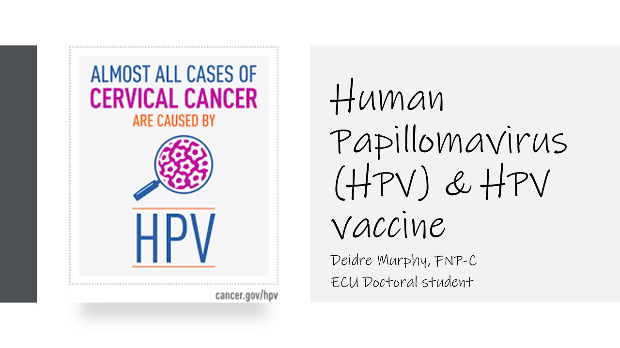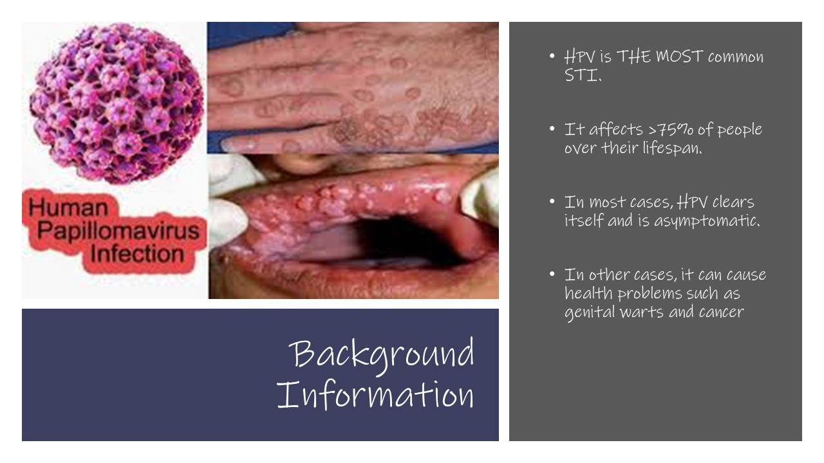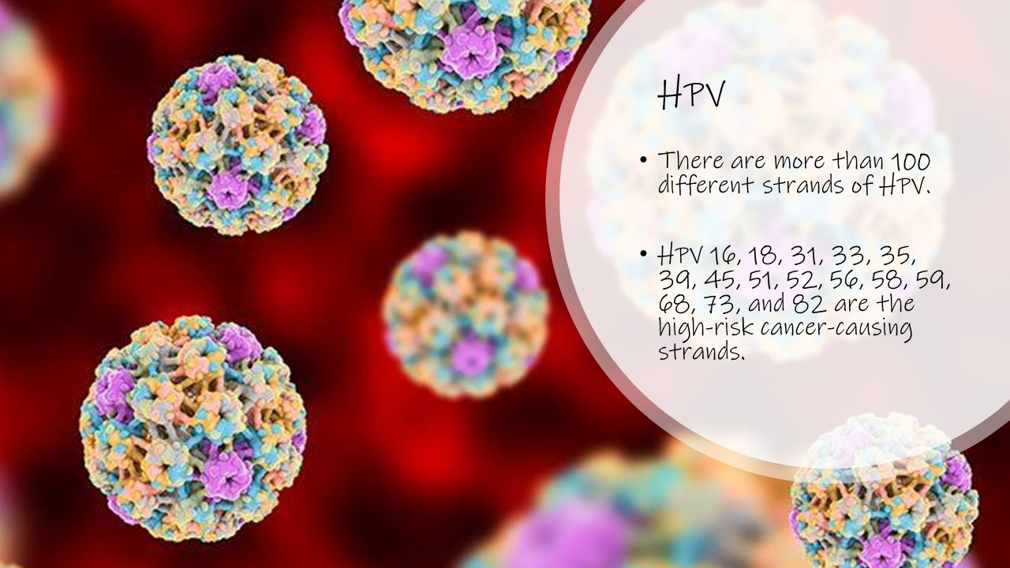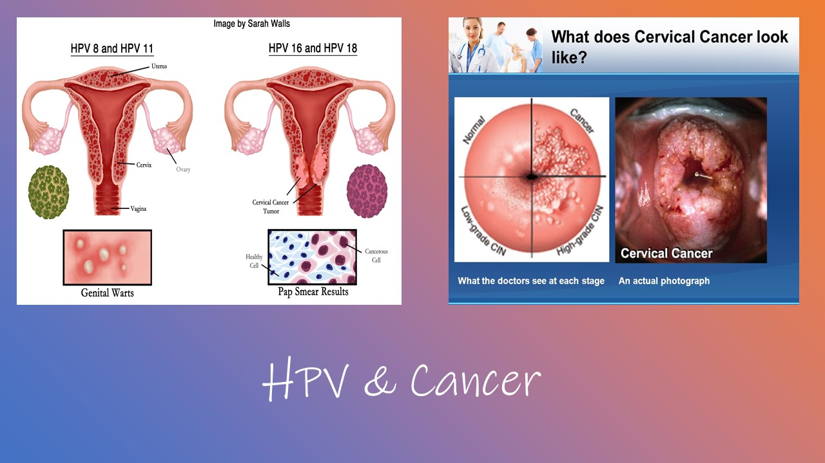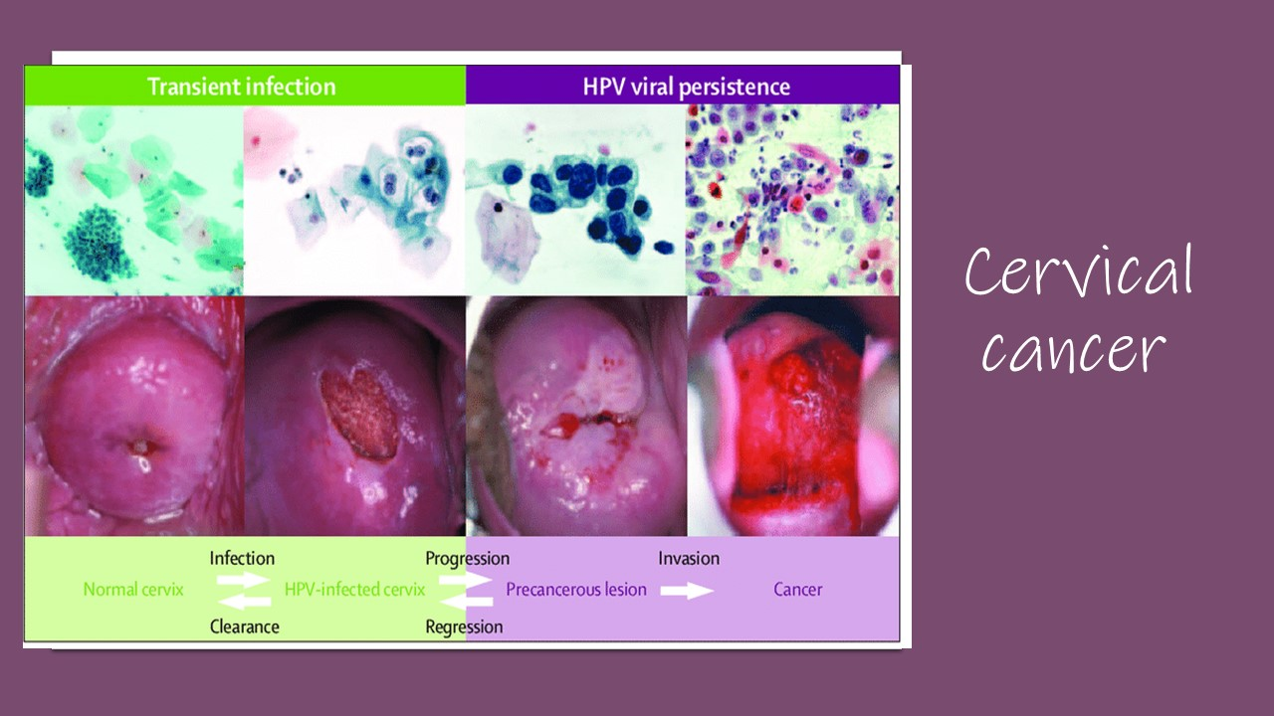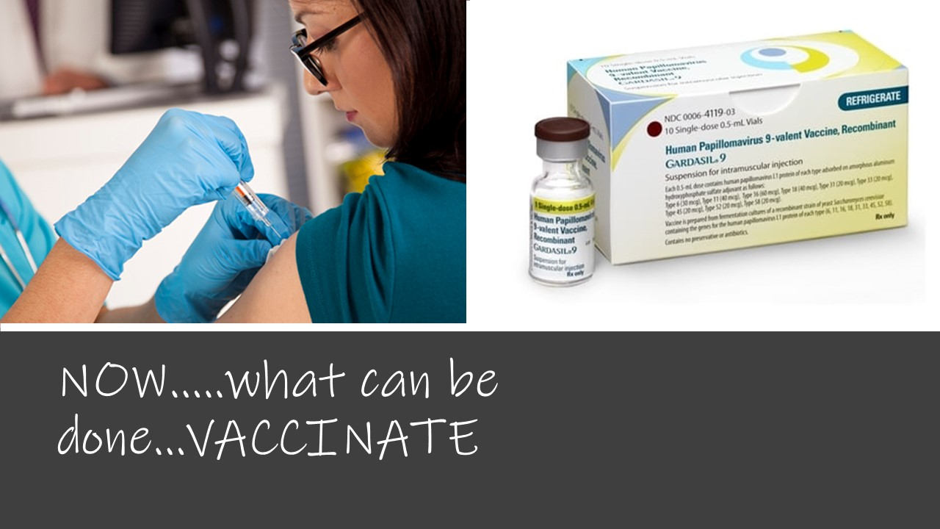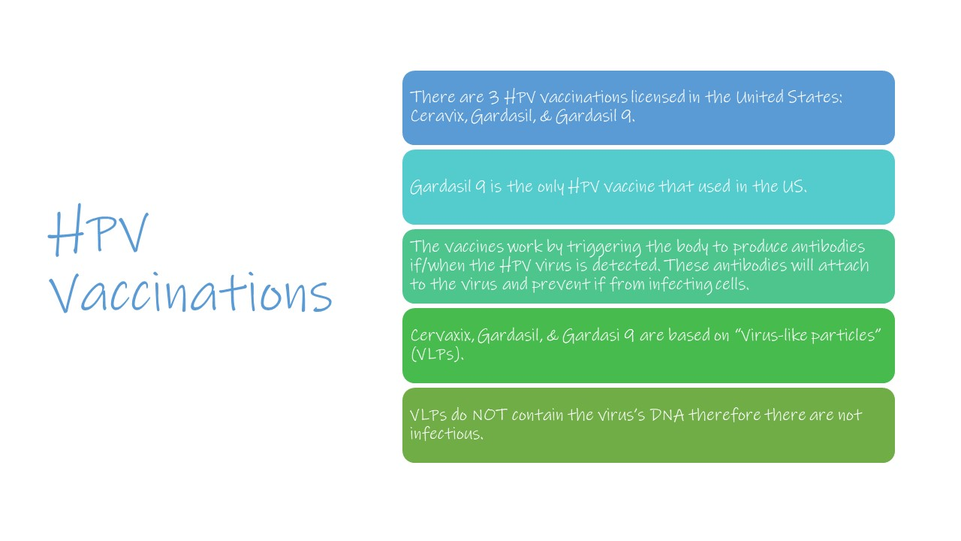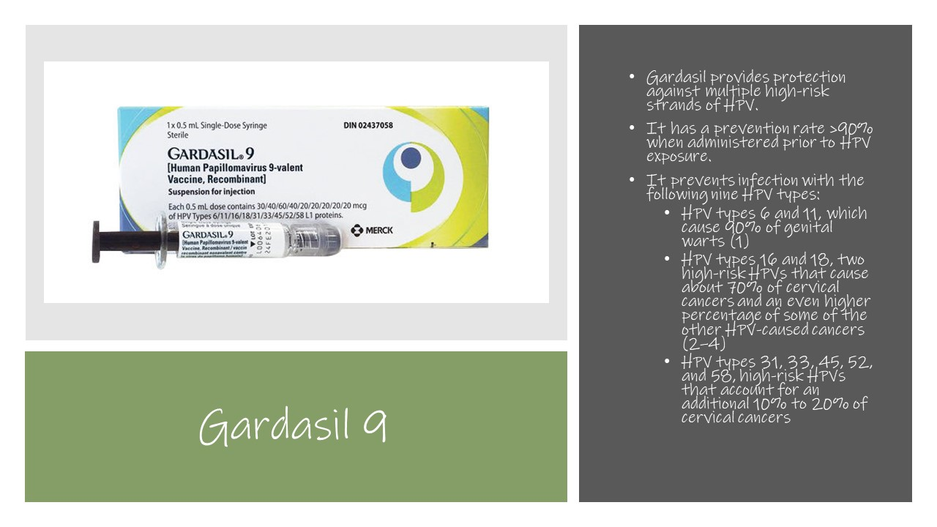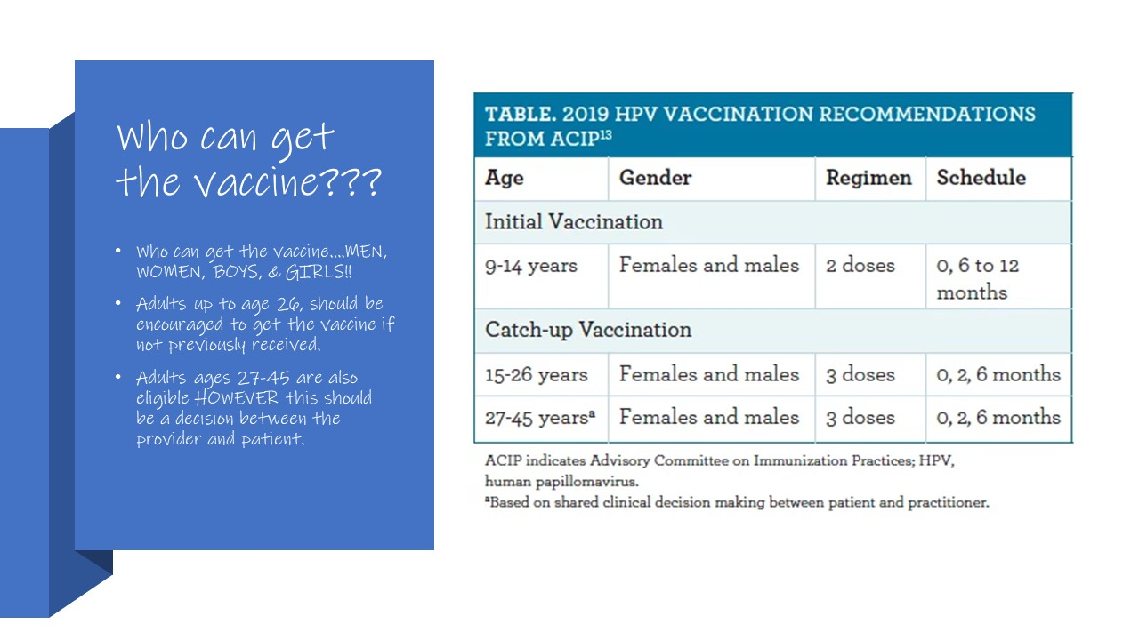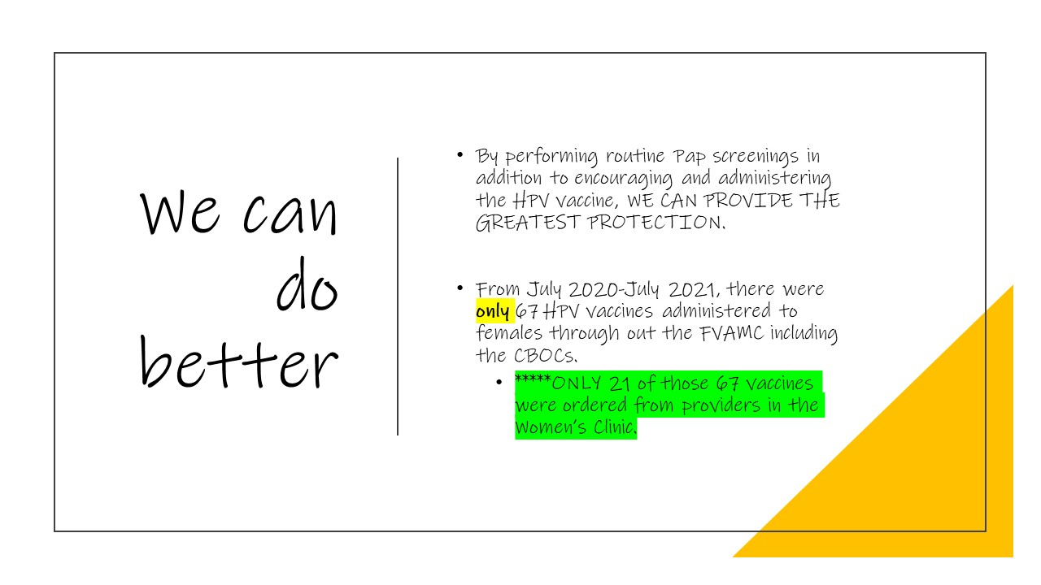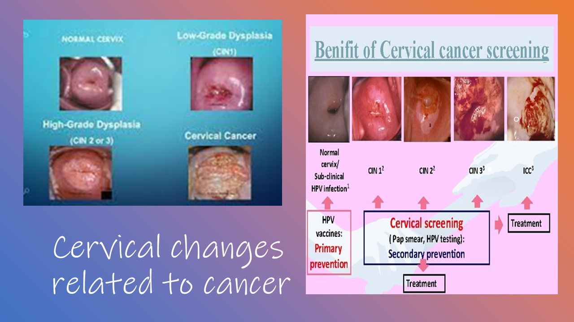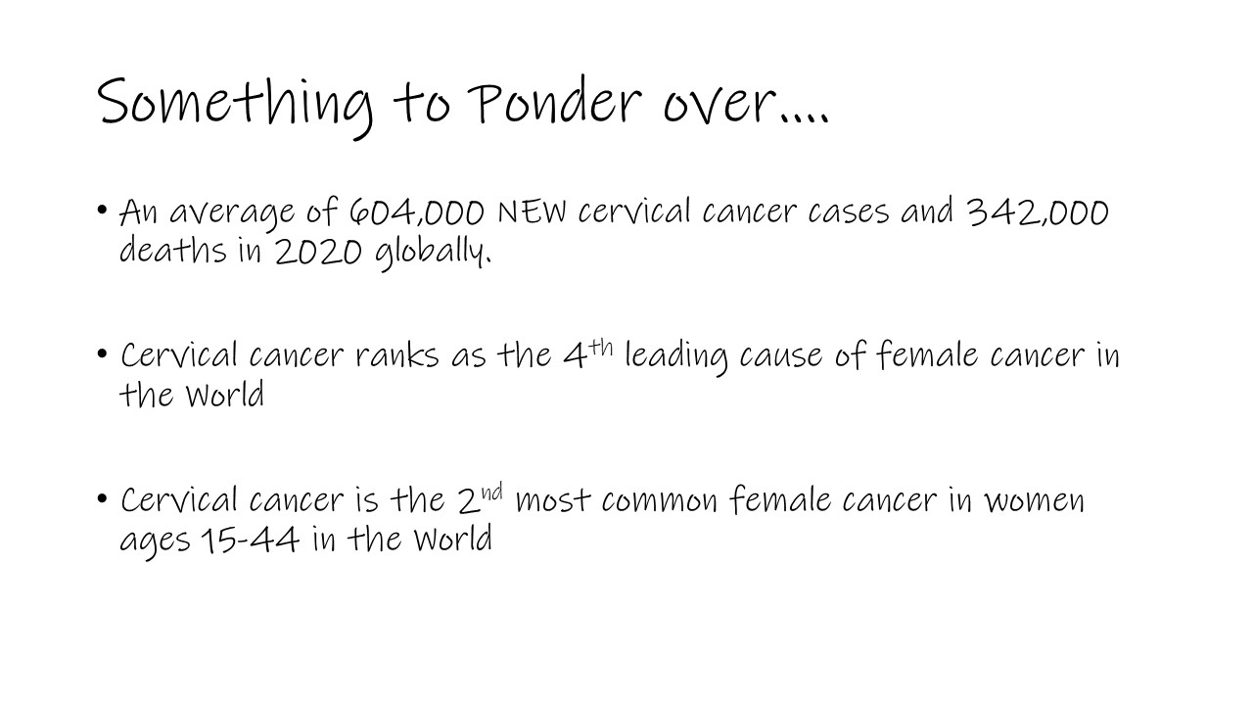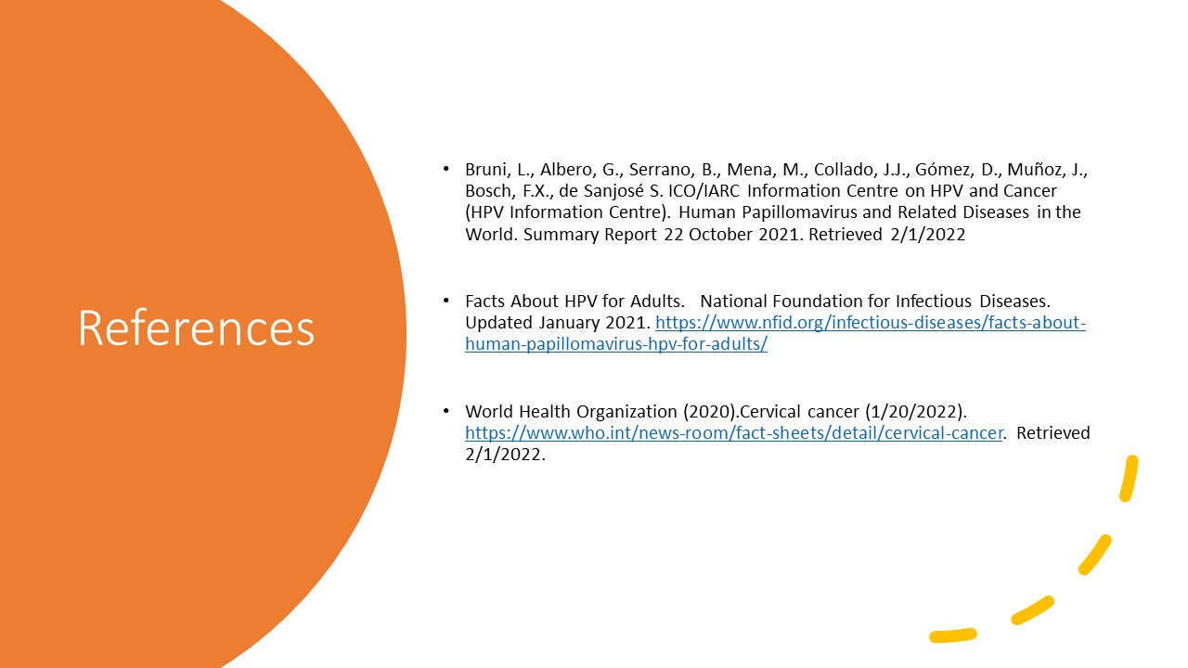

APPENDIX C
Post-Implementation Survey

HPV Post-Implementation Survey

1. Do you feel the HPV vaccine is safe & effective?
( ) Yes
( ) No

2. Do you feel you have enough time during your visits to discuss the HPV vaccine?
( ) Yes
( ) No

3. Do you feel knowledgable about the HPV vaccine?
( ) Yes
( ) No

4. Do you plan to increase discussions regarding the HPV vaccine?
( ) Yes
( ) No

5. Do you feel comfortable discussing the HPV vaccine with your patients?
( ) Yes
( ) No

6. Are you concerned about the side effects of the HPV vaccine?
( ) Yes
( ) No

7. Do you feel you have enough information regarding the HPV vaccine?
( ) Yes
( ) No

8. Do you think increasing posters and pamphlets on the HPV vaccine with increase awareness?
( ) Yes
( ) No

9. Do you think the female veterans will be open to receiving the HPV vaccine if they are informed of the benefits?
( ) Yes
( ) No

10. Do you feel the presentation on HPV helped increased your knowledge on HPV vaccines?
( ) Yes
( ) No

Appendix D
Project Budget

Project Item | Unit Cost | # Units | Total Cost
Travel (Mileage) | 58.5 cent per mile | 134 miles roundtrip with total of 7 trips made | $590.94
Survey Monkey | Free | 1 | $0
Total Project Costs |  |  | $590.94

