Intensive Care Unit Joint Commission Remediation Plan 2021

Chelsea Tilley
College of Nursing, East Carolina University
Doctor of Nursing Practice Program
Dr. Jan Tillman, DNP, RN, FNP-BC
7/22/22

Notes from the Author
This DNP project would not have been possible without the overwhelming support of many friends and family members. To Dr. Tillman, DNP, RN, FNP-BC, this project was made possible thanks to your flexibility, support, and inspiration to forge a new path. To Moe Edmonds, MSN, RN, your mentorship and guidance motivated me to achieve a potential I did not realize was possible in myself. Lastly, to my husband, Jonathan, your support has been my foundation throughout this process, and I could not have done it without you.

Abstract
Background: Nurses in the intensive care unit (ICU) are tasked with caring for patients who are mechanically ventilated and require medications to induce sedation and/or pain relief. Sedation assists to prevent agitation that can cause disruptions to care, promote patient safety, and reduce mortality (Aragón et al., 2019). Using a standardized and validated tool such as Richmond Agitation-Sedation Scale (RASS) for sedation and Critical-Care Pain Observation Tool (CPOT) for pain can assist nurses in ensuring that the patient’s level of sedation and/or pain relief is optimal and safe. Problem: This Doctor of Nursing Practice (DNP) project addressed the lack of accurate nursing sedation and analgesia medication drip assessment, titration, and documentation in the ICU as cited by The Joint Commission in June 2021. Methods: Interventions included a comprehensive education program for new ICU nurses, education for the current staff, an annual in-service, a written policy, order set revisions, and electronic medical record (EMR) modifications. Results: Accurate titrations vs. titration opportunities were 80.1% in September 2021 as compared to 80.7% in April 2022. Accurate documentation versus documentation opportunities were 70.8% in September 2021 as compared to 96.4% in April 2022. Recommendations: Engaging the multidisciplinary team provided an environment that allowed for widespread interventions and system-wide input to improve patient outcomes. Further studies are needed to determine what interventions could be successfully utilized to improve titration accuracy with sedation/analgesia medications in the ICU setting.
Keywords: Richmond Agitation-Sedation Scale (RASS), Critical-Care Pain Observation Tool (CPOT), nursing assessment, sedation/analgesia, medication titration, nursing documentation, nursing education.

Table of Contents
Notes from the Author ……………………………………………………………………….…. 2
Abstract …………………………………………………………………………………………. 3
Section I: Introduction...………………………………………………………………………… 6
Background……………………………………………………………………………… 6
Organizational Needs Statement………………………………………………………….6
Problem Statement……………………………………………………….……………….8
Purpose Statement ……….……………………………………………………………….8
Section II: Evidence………………………………………………………………………………9
Literature Review…………………………………………………………………………9
Evidence-Based Practice Framework……………………………………………………12
Ethical Consideration and Protection of Human Subjects……………………………….13
Section III: Project Design……………………………………………………………………… 15
Project Site and Population………………………………………………………………15
Project Team ...………………….……………………………………………………….16
Project Goals and Outcome Measures ….……………………………………………….16
Implementation Plan …………………………………………………………………….18
Timeline………………………………………………………………………………….18
Section IV: Results and Findings………………………………………………………..…….…20
Results……………………………………………………………………………………20
Outcomes Data…………………………………………………………………………...20
Discussion of Major Findings……………………………………………………………21
Section V: Interpretation and Implications………………………………………………………22
Cost Benefit Analysis…………..………………………………………………….…….22
Resource Management…………………………………………………………………..22
Implications of the Findings……………………………………………………..….…...23
Sustainability ………………………………………………………………..…….….…24
Dissemination Plan ……………………………………………………………...………24
Section VI: Conclusion…………………………………………………………………………..25
Limitations………………..…………..…………………………………………….……25
Recommendations for Others……………………………………………………………25
Recommendations for Further Study…………………………………………………….26
References………………………………………………………………………………………..27
Appendices ………………………………………………………………………………………30
Appendix A: Literature Search..…………………………………………………………30
Appendix B: Self-Certification Tool..…………………………………………………...31
Appendix C: Audit Tool…………………………………………………………………33
Appendix D: Project Timeline.…………………………………………………………..34

Section I. Introduction
Background
Nurses in the intensive care unit (ICU) setting are tasked with caring for patients who are seriously ill. Mechanically ventilated ICU patients often require medications that induce sedation to prevent agitation that can cause disruptions to care. Agitation among ICU patients can have lasting adverse effects including increased time on the ventilator, increased ICU and hospital stay, delirium, and even increased mortality (Aragón et al., 2019). Using a standardized and validated tool can assist nurses in ensuring that the patient’s level of sedation is optimal. Barr et al. (2013) recommend utilizing either the Richmond Agitation-Sedation Scale (RASS) or the Sedation-Agitation Scale (SAS) for assessment of sedation in the ICU patient.
Organizational Needs Statement
The project site ICU recognized the need for intervention when The Joint Commission (TJC) cited findings related to improper medication titration in June 2021. The citation included failure to appropriately titrate medication per order, failure to complete appropriate assessment of patient status using ordered sedation scale, and failure to document interventions. The Joint Commission lists in medication management chapter, beginning at MM.01.01.01, requirements for medication titration (The Joint Commission, 2018). The Joint Commission (2018) defines medication titration as “titrating orders: orders in which the dose is either progressively increased or decreased in response to the patient’s status” (p. 7). In The Joint Commission (2018) Nursing Chapter, NR.02.01.01, requirements for nursing are defined including ensuring that “the development of hospital-wide programs, policies, and procedures that address how nursing care needs of the patient population are assessed, met, and evaluated” (p. 29). The ICU recognized that action was needed due to failure to remain compliant with The Joint Commission’s regulations (Nurse Manager, personal communication, June 24, 2021).
The North Carolina General Assembly’s (1981) Nursing Practice Act sets minimum standards for nurses in this state. The Nursing Practice Act defines two key areas, including “implementing the treatment and pharmaceutical regimen prescribed by any person authorized by State law to prescribe the regimen” and “reporting and recording the plan for care, nursing care given, and the patient's response to that care” (North Carolina General Assembly, 1981, “90-171.20. Definitions” section). The Joint Commission’s citations included not following the prescribed titration order, failure to assess the patient’s status using ordered sedation scale, and failure to appropriately document nursing care provided and the patient’s response. These findings are all included in the nursing licensure requirements. Failure to properly perform these acts are not only related to The Joint Commission’s hospital accreditation permitting these services, but are also reportable to the North Carolina Board of Nursing for practicing outside of the scope of nursing.
The Institute for Healthcare Improvement (2021) established a triple aim initiative that focuses on three topics, “improving the patient experience of care (including quality and satisfaction), improving the health of populations, and reducing the per capita cost of health care” (“The IHI Triple Aim” section). Increasing nurse knowledge related to accurate medication titration, proper and timely sedation assessments, and documentation satisfies all three of these aims by ensuring the patient is within parameters for sedation, reduces costs by avoiding adverse effects of under- or over-sedation, and works to improve the overall health and wellbeing of any person admitted to the ICU.
The Healthy People 2030 (Office of Disease Prevention and Health Promotion, n.d.) foundational principles are used to provide a framework for establishing nationwide goals by encouraging the utilization of shared decision making and creating policies that can positively reform population health. Ensuring the accuracy of sedation scoring, titration, and documentation through nursing education and ICU policy changes follow the Healthy People 2030 foundational principles. This DNP project also worked to improve the ICU patient population’s outcomes by avoiding the consequences of excess or improper sedation.
Problem Statement
The problem that was addressed by the DNP project was lack of accurate nursing sedation and analgesia medication drip titration and documentation in the ICU.
Purpose Statement
The purpose of this DNP project was to create a comprehensive education program that included education for new ICU nurses, education for the current staff to correct the problem, and an annual in-service to serve as a refresher. This DNP project also aimed to create a written policy that provided guidelines for clear nursing responsibilities. This project also worked with providers to reduce ambiguity and improve provider/nurse communication with written orders. EMR changes also occurred to improve the interaction nurses have with documentation that had allowed for discrepancies in charting sedation scores, titrations, and worked to overall facilitate simpler pain and sedation documentation.

Section II. Evidence
Literature Review
This literature review is unique in that it was performed post-intervention due to the expeditious nature in which this project had to be performed to meet TJC deadlines. Databases utilized include PubMed and CINAHL. The search terms utilized include (a) reducing medication errors, (b) nursing, (c) education, (d) medication errors, (e) order sets, (f) electronic medical record, (g) documentation, (h) continuing nursing education, (i) patient safety, (j) ICU, (k) agitation/sedation, (l) medication errors, (m) sedation scoring, and (n) intensive care nurses. Inclusion criteria were articles within the past five years and full text. With CINAHL database, academic journal was an additional part of inclusion criteria. With the database PubMed, additional limits were set for the level of evidence including clinical trials, controlled clinical trials, meta-analysis, practice guidelines, randomized controlled trial, and systematic review. A total of 264 articles were found. 10 articles were kept and were read entirely to determine if applicable to this DNP project; see Appendix A for the literature search. The most common reasons for exclusion were articles that could not be transferred to another setting or intervention, and not being relevant to this DNP project.
Current State of Knowledge
This DNP project was already implemented at the time of this review; however, literature was examined to evaluate the implementation choices made and were utilized in assisting with further recommendations for future implementation. Little literature was found regarding specific recommendations for this DNP project; however, information was found that could be transferred, including recommendations for nursing education, EMR, and written policy.
Continuing nursing education is a pivotal component in improving patient safety and quality of care. There are many considerations to make when creating a program aimed at increasing nursing knowledge that can increase the likelihood of a successful program. Walter and Terry (2021) found that when organizations and managers are supportive of continuing education programs, nursing motivation and engagement are higher. Walter and Terry (2021) also discourage the requirement of nurses using personal resources such as personal time off or finances as this can negatively impact motivation and engagement. Krespani et al. (2021) examined the nursing motivation to pursue learning or education opportunities and found that topics such as maintaining skills, improving quality of care, maintaining professional identity, and building a positive professional image were top reasons nurses pursued continuing education. Additionally, Ramoo et al. (2017) used case studies in their nursing education and found that this method improved sedation scoring even several months post-intervention. Nurses have a profound impact on healthcare organizations and nursing education is crucial to improving patient safety data.
Utilization of an EMR in healthcare can have many advantages, but must also be assessed and modified as needed to improve care delivery and documentation of that care. Shafiee et al. (2022) emphasized that qualities of a successful EMR include ease of usability, positive impact on quality care, and reduced overall time spent on documentation. Wells and Loshak (2019) found in a systematic review that creating standardized order sets can have many benefits on patient quality of care and safety, including reduced length of stay and reduced medication errors. While this study examined the physician’s experience with EMRs, they found that post-education intervention, physicians reported a significant increase in satisfaction and performance and improvements in patient safety and care (Robinson and Kersey, 2018). Keyworth et al. (2018) emphasize that reminders and alerts as well as feedback can be successful EMR interventions. This literature review has demonstrated that while the EMR is important and can be very useful, health care facilities must continually assess for areas in need of improvement and make those changes to improve patient safety, quality of care, and user satisfaction.
Current Approaches to Solving Population Problem(s), Evidence to Support the Intervention
The literature review provided reinforcement that the interventions performed were supported by research and best practice. The first intervention utilized to target the problem was nursing education. This was both a requirement of the organization and recommended in literature to improve the accuracy of sedation scoring by nurses (Ramoo et al., 2017). Collaborating with the site champion, the decision was made that 1:1 remediation education would be provided to each ICU nurse (Nurse Manager, personal communication, 6/29/21). This education would then be available for future onboarding education, as well as annual nursing competency/review in a power point presentation.
Modifying the EMR was a top priority for the site champion and nurse manager of the ICU (Nurse Manager, personal communication, 6/29/21). Modifications were needed to facilitate a simpler workload by creating a less complicated means of documentation for the ICU nurses. Building prompts and reminders into the EMR helped to reduce medication errors and improve documentation (Keyworth et al., 2018). Another area of concern was within the language of already established order sets for sedation and analgesia drips in the ICU. Order review found that the language was confusing, and order sets provided conflicting information such as “titrate to a SAS of a RASS score”, indicating two different methods of sedation scoring. Computerized order entry for physicians by means of creating standardized order sets with consistent verbiage can help reduce medication errors (Manias et al., 2020; Wells & Loshak, 2019).
Prior to this intervention, the DNP project site did not have a standardized policy guiding nursing practice for managing sedation or analgesia medication drips in the ICU. After collaborating with the site champion, the decision was made to write a policy specific to the ICU to guide the nurses when managing sedation or analgesia drips (Nurse Manager, personal communication, 6/29/21). Due to DNP project site regulations, and after corroborating practice guidelines with nursing leadership and ICU providers, the decision was made to make RASS the scale for assessing sedation and CPOT the scale for assessing analgesia (Nurse Manager, personal communication, 6/29/21; Devlin et al., 2018).
Evidence-Based Practice Framework
This DNP project was executed using the Plan-Do-Study-Act (PDSA) model. This model was originated with Walter Shewhart in the 1920’s to guide improvement changes in a factory (Best and Neuhauser, 2006) and has grown to become one of the most popular quality improvement models in healthcare (Chen et al., 2021). The Plan component consisted of establishing a reason why an intervention was necessary and identifying processes contributing to the current outcome, including staff, stakeholders, EMR, and policies. The Plan phase also was important in establishing a relationship with the site and ensuring all requirements were defined and met. Additionally, working closely with the site champion to manifest a plan specific to the needs of this site was part of this initial step. An objective necessary for project approval was to complete a quality improvement plan for the education department at the project site to review and approve. The Do phase consisted of the implementation period, which for this project was initially 12 weeks. Due to unavoidable circumstances involving COVID-19, delays in implementation occurred necessitating an additional five week “make-up” period. The Study phase was utilized post-intervention and required auditing of implementation goals to monitor the degree of intervention success. The Act phase was the final phase and was utilized to summarize and conclude the DNP project. This occurred with a final meeting with the site champion to determine which parts of the implementation were successful. In this phase, and during the final meeting, recommendations were made for future practice, as needed, per assessment during the PDSA phases.
Ethical Consideration and Protection of Human Subjects
Although this DNP project focused on quality improvement, ethical considerations should always be made to ensure the target population will not incur any risk of or actual harm. In this DNP project, there was minimal to no risk for the target population. The target population in this project were the ICU nurses and the intervention aimed to be distributed evenly to all nurses without bias. The potential for harm is negligible, as this was a quality improvement project.
The formal approval process was a multi-step process involving both East Carolina’s School of Nursing and the DNP project site. The School of Nursing required Collaborative Institutional Training Initiative (CITI) modules be completed and submitted prior to project implementation so that the DNP candidate had a foundation of knowledge regarding the Institutional Review Board (IRB) prior to implementation. The School of Nursing also required a statement from the project site specifying that this was only a quality improvement project and that they did not require IRB approval for implementation. East Carolina University did provide approval once the Quality Improvement/Program Evaluation Self-Certification Tool was completed, see Appendix B. The DNP project site required a detailed plan with the project explained. Once this was provided, the project was granted approval for implementation initiation.

Section III. Project Design
Project Site and Population
The project site setting is a small, six-bed ICU housed within a suburban hospital with a total capacity of 46 inpatient beds. During this intervention, increased bed demands due to COVID-19 required the ICU to expand to 10 beds; staffing was supplemented with the assistance of float staff and travel nurses. The target population for intervention were the 18 permanent ICU nurses.
A major facilitator for this project site and population was that the ICU is small and staffed by 18 permanent ICU nurses. This allowed educational opportunities and other strategies to be quickly implemented.
COVID-19 proved to be a major barrier during project implementation. The ICU had to expand to 10 beds during the implementation period to allow for the increased patient census. Staffing was made possible with permanent ICU nurses performing overtime shifts, as well as adding travel nurses and float nurses from other patient-care areas. The non-permanent staff were not included in the implementation per request of the site (Nurse Manager, personal communication, 7/29/21), due to the high census, workload demands, and time-related implementation concerns.
Description of the Setting
This setting is a small, 46-bed hospital located in south-eastern United States. This suburban hospital serves a specific population and is a teaching hospital. This ICU has a nurse manager who reports to the Assistant Chief Nurse of Acute Care, who then reports to the Chief Nurse of Acute Care. There are no nursing assistants or technicians employed in this ICU. There is no designated charge nurse; each nurse rotates through this role equitably. The RN to patient ratio is generally 1:2 unless there is a high acuity patient, at which time the ratio is 1:1.
Description of the Population
The target population for this DNP project included all of the ICU nurses. For project purposes, their participation was voluntary, but due to the concerning nature of TJC findings, site management required participation by all ICU nurses (Nurse Manager, personal communication, 6/29/21). The ICU nurse population has a wide range of years of experience, with the mean years of day shift nurses was 14 years and mean years of night shift nurses was 16 years. The nurses have a wide variety of background knowledge. This included time spent in management, post-anesthesia care units, other ICUs, and medical-surgical telemetry floors. The ICU nurses had a range of 2 and 23 years, with the mean of 7.5 years, of experience at the project site.
Project Team
The project team consisted of the ECU DNP candidate, ICU nurse manager/site champion, ECU project liaison, Assistant Chief Nurse of Acute Care, and Chief Nurse of Acute care. All the permanent ICU nursing staff participated in this project. Other important contributors included members of pharmacy, nursing informatics, and multiple providers, all of whom assisted with the implementation strategies.
Project Goals and Outcome Measures
The project goal that was addressed by the DNP project was to improve the accuracy of nursing sedation and analgesia assessment, medication titration, and documentation. Per facility requirements for TJC, the audits must demonstrate 90% or greater accuracy for three consecutive months (Nurse Manager, personal communication, 6/29/21). Post-intervention audits were performed monthly to determine if outcome measures were met per facility requirements. See Appendix C for the auditing tool utilized to measure outcomes. PDSA meetings were planned after the initial implementation phase, which were followed by monthly meetings with the site champion.
Description of the Methods and Measurement
The major focus of this DNP project was based on TJC survey findings, which included failure to appropriately titrate medication per order, failure to complete appropriate assessment of patient status using the ordered sedation scale, and failure to document interventions. The medication cited in the survey was propofol. After collaborating with the site champion/ICU nurse manager, a quality improvement-based implementation plan was developed to remediate these findings (Nurse Manager, personal communication, 6/29/21). While propofol was the medication originally cited in TJC report, this medication was part of a larger order set that included medications prescribed as a continuous drip to promote sedation and/or analgesia for ICU patients. This DNP project incorporated all of the medications in the order set in the remediation plan, per request of the site champion/ICU nurse manager (Nurse Manager, personal communication, 6/29/21). Medications in the sedation/analgesia order set included propofol, midazolam, dexmedetomidine, morphine, and fentanyl. The two areas of measurement included medication titration accuracy and sedation/analgesia documentation accuracy. Charts for any patient who was prescribed a continuous medication drip for sedation or analgesia were then examined in entirety for medication titration accuracy as compared to the provider order, and for documentation accuracy of the sedation/analgesia score.
Discussion of the Data Collection Process
Data collection began once the initial implementation phase was completed by the DNP candidate. This was achieved by systematically reviewing the EMR of each patient who was admitted to the ICU. Medications and documentation entries were then cross-referenced to determine accuracy and ensure completeness. The results were recorded using an auditing tool created for this project, see Appendix C. The results were then reported monthly to the project site’s upper management.
Implementation Plan
This DNP project’s implementation plan took a multimodal, multidisciplinary approach. In the initial implementation phase, the goals of implementation were to provide individualized ICU RN education, construct EMR changes to improve documentation consistency, develop a written policy for nursing sedation/analgesia assessment and documentation, and modify the propofol order with clarified and cohesive language. Once this first phase was complete, PDSA meetings with the site champion, as well as chart auditing, commenced monthly. Following the first phase of implementation, order set revisions were made to the remaining medications, including midazolam, fentanyl, dexmedetomidine, and morphine. Additionally, the order sets were divided into “sedation” and “analgesia” with corresponding “RASS” or “CPOT” score to add further clarification for both prescribers and ICU nurses. At a PDSA meeting with the site champion, suggestions to improve documentation, including further charting options and physical reminders for RASS and CPOT scoring, were determined to be of added benefit (Nurse Manager, personal communication, 9/24/21).
Timeline
This DNP project was unique due to the expeditious nature by which the initial implementation phase was requested to be completed by the project site. The Joint Commission surveyed the ICU and issued citations in June 2021. Collaboration and project planning began immediately and preliminary project approval occurred in June 2021. Official approval occurred on August 5th, 2021 and implementation began immediately. The project sites’ initial implementation phase was to be completed by August 20th, 2021. The next phase of the implementation plan was to occur after the August 20th deadline, for a total of 12 weeks. Due to unavoidable circumstances surrounding COVID-19, this timeline was extended to an implementation end date of December 2nd, 2021, see Appendix D for the project timeline.

Section IV. Results and Findings
Results
For this project, results were reported on a monthly basis beginning in September 2021 and ending in April 2022. After April 2022, the auditing portion was discontinued for the DNP project and transferred to the ICU staff to maintain continued sustainability. See the table below for detailed data.
Table 1
Date | September 2021 | October 2021 | November 2021 | December 2021 | January 2022 | February 2022 | March 2022 | April 2022
Accurate titrations | 243 | 247 | 122 | 121 | 127 | 17 | 33 | 21
Titration opportunities | 303 | 289 | 146 | 137 | 155 | 24 | 37 | 26
Percentage accuracy | 80.1% | 85.4% | 83.5% | 88.3% | 81.9% | 70.8% | 89.1% | 80.7%
Accurate documentation | 410 | 621 | 319 | 277 | 273 | 47 | 50 | 54
Documentation opportunities | 579 | 756 | 372 | 320 | 346 | 50 | 52 | 56
Percentage accuracy | 70.8% | 82.1% | 85.7% | 86.5% | 78.9% | 94% | 96.1% | 96.4%
ICU Audit data from September 2021 to April 2022

Outcomes Data
When examining the data for accurate titrations versus titration opportunities, the results over this 8-month span did not significantly improve. In September 2021, the percentage accurate was 80.1% as compared to April 2022, the percentage accurate was 80.7%. When examining the data for accurate documentation versus documentation opportunities, there was a much greater significance over the 8-month span. In September 2021, the percentage of accurate documentation was 70.8% as compared to April 2022, the percentage accurate was 96.4%.
Discussion of Major Findings
The data obtained over the eight-month collection period for accurate titration versus titration opportunities were very different than accurate documentation versus documentation opportunities. This project’s interventions successfully implemented positive changes that improved sedation/analgesia drip documentation for patients in the ICU.
More information is needed to determine why this intervention did not influence titration data more. Further studies could investigate different interventions and how they could impact titration accuracy. A notable difference from September 2021 to April 2022 is the volume of titrations and documentation being performed. Titrations and documentation went from the triple digits in September 2021 to double digits by April 2022. Emphasis was placed during the educational intervention, as well as modifying the EMR, on ensuring that documentation was simple and easily accessible. Again, more information is required to determine why these interventions did not have the desired effect on titration numbers, and what interventions could be useful in creating a positive impact in this small ICU setting.

Section V. Interpretation and Implications
Cost Benefit Analysis
The cost of medication errors can range from little to no reaction and can be as serious as patient death. Tariq et al. (2021) indicate that there are between 7,000 and 9,000 patient deaths annually due to medication errors and that over $40 billion dollars is spent caring for patients who suffer an adverse event as a result of a medication error. According to the U.S. Bureau of Labor Statistics (2022), the average hourly wage for a Registered Nurse in North Carolina as of May 2022 is $34.23. The project implementation period was from August 5th, 2021, until December 2nd, 2021, and lasted 125 hours. The average cost of a Registered Nurse in North Carolina to do this implementation over 125 hours would be $4,278.75. Because TJC provided a citation in June 2021 for improper medication titration and documentation (Nurse Manager, personal communication, June 24, 2021), it became a necessity that the facility provided follow-up interventions to demonstrate positive improvements to stay accredited and/or to maintain a program in the ICU that allowed for sedation/analgesia drips. Based on the findings of this project, the benefits of improving medication titration and documentation within the ICU outweighed the financial cost.
Resource Management (not financial)
Another important consideration was resource allocation and availability. If a facility were to recruit a Registered Nurse from their site to implement this project, it would take up to 125 out of 480 hours (40 hours x 12-week implementation) to accomplish. If this nurse were pulled out of the unit’s staffing, this could provide a significant burden on the unit. This project was implemented using electronic resources such as EMR and order set modifications and PowerPoint educational presentation. If the facility already has these programs, then there are no further expenditures that would be accrued.
Implications of the Findings
The project findings provided insight into a future project starting point. Although the titration results did not improve as well as expected, there was a significant improvement in documentation compliance. Facilities confronted with similar issues can examine the interventions employed by this project and apply them to the needs identified within their sites. Another useful consideration is the impact that barriers, such as the COVID-19 pandemic, had on this project’s implementation and outcomes.
Implications for Patients
The findings demonstrated a positive impact on patient care by building a supportive network of interventions aimed at reducing safety events, and therefore potential harm, to patients. Improving the accuracy of sedation and analgesia medication titration and documentation was paramount in the reduction of medication errors that could cause detrimental effects to a patient in the ICU. Having created a sustainable framework of interventions, patients will continue to be positively impacted by this project’s efforts.
Implications for Nursing Practice
The findings suggest that nurses are at the forefront of patient safety and harm reduction. Nurses must take responsibility for their practice by engaging in continuing education and speaking up when identifying areas that need improvement. Additionally, utilizing a standardized framework for change, such as the PDSA model, can guide nurses to have profound impacts on the unit, facility, patients, and community where they work.

Impact for Healthcare System(s)
The findings strongly suggest that patient safety is an organizational issue and must be addressed as such to create meaningful change. By taking a multidisciplinary, multimodal approach, this project’s findings demonstrate the necessity of engaging an entire system in an effort to address the problem. Healthcare systems that encourage this type of problem-solving and team-based approach will positively impact patients, as well as the staff committed to the safety and well-being of the patient.
Sustainability
Sustainability of this project was accomplished with close collaboration with the facility’s site champion and administration. EMR and order set revisions occurred and are permanently a part of the ordering and documentation process. Individualized ICU-based education was performed during implementation and later forwarded to the unit educator to be part of an annual education competency as well as an onboarding training for new ICU nurses. By utilizing the PDSA model, this project encouraged sustainability through standardized changes and collaborative effort among the multidisciplinary team. Additionally, at the project’s audit conclusion in April 2022, the responsibility of auditing was passed to the ICU team to continue sustainable monitoring of progress and the ability to continue with future interventions as needed.
Dissemination Plan
This project will be submitted through East Carolina for publication with site-specific information redacted. This allows for other sites to examine and accommodate any implementation pieces applicable for utilization in their facility.

Section VI. Conclusion
Limitations
The COVID-19 pandemic had a significant impact on this project. The ICU unit where project implementation occurred was quickly expanded from six to ten beds due to the rapid influx of patients with COVID-19 who required ICU-level care. Staffing for the expanded unit occurred with the assistance of travel nurses and nurses from other units that had temporarily closed, such as primary care. These nurses were not included in the education intervention due to their temporary status in the ICU unit, per request of the site champion (Nurse Manager, personal communication, 6/29/21). During the implementation period, and in the months immediately following, the titration and documentation data did not show a significant improvement. In Spring 2022, when the unit was permanently returned back to six beds and all of the travel and temporary nurses were removed from the unit, that the data showed significant improvement. Another major limitation was a small sample size of the ICU nurses with N=18 which limits generalizability especially to facilities with significantly larger ICUs.
Recommendations for Others
Taking a multidisciplinary, multimodal approach was crucial for the success of this project’s implementation. Implementing only one part of the project, for example, nursing education, would not address the systemic flaws allowing and contributing to error. By engaging the multidisciplinary team that included nursing, providers, pharmacy, nursing informatics, and administration, participation and investment in the project’s successful implementation and positive outcome remained heavily supported. Additionally, taking a multimodal approach allowed for thorough examination and application of various interventions that promoted successful change within the ICU, as well as system-wide.
Recommendations for Further Study
More research would be useful to provide further recommendation and ability to generalize this project to other settings. Due to the small sample size, further study should include a larger sample size including ICU bed count and nurses. Another important factor is the EMR software utilized within the project site facility. Some of the specific changes may not be transferrable to other facilities so examining this implementation with other EMRs would be useful in future studies. Software in each facility can have its’ own barriers in accurate titration and documentation. Software utilized in the ICU was examined and changes were made as they related to the project. Further studies could be conducted examining various EMR types and specific recommendations based on that particular software.

References
Aragón, R. E., Proaño, A., Mongilardi, N., de Ferrari, A., Herrera, P., Roldan, R., Paz, E., Jaymez, A. A., Chirinos, E., Portugal, J., Quispe, R., Brower, R. G., & Checkley, W. (2019). Sedation practices and clinical outcomes in mechanically ventilated patients in a prospective multicenter cohort. Critical Care, 23(1), 130-130. https://doi.org/10.1186/s13054-019-2394-9
Barr, J., Fraser, G. L., Coursin, D. B., Herr, D. L., Tung, A., Robinson, B. R. H., Fontaine, D. K., Ramsay, M. A., Riker, R. R., Sessler, C. N., Pun, B., Skrobik, Y., Puntillo, K., Jaeschke, R., Wesley Ely, E., Gelinas, C., Dasta, J. F., Davidson, J. E., Delvin, J. W. (2013). Clinical practice guidelines for the management of pain, agitation, and delirium in adult patients in the intensive care unit. Critical Care Medicine, 41(1), 263-306. https://doi.org/10.1097/CCM.0b013e3182783b72
Best, M., & Neuhauser, D. (2006). Walter A Shewhart, 1924, and the Hawthorne factory. Quality & Safety in Health Care, 15(2), 142–143. https://doi.org/10.1136/qshc.2006.018093
Chen, Y., VanderLaan, P. A., & Heher, Y. K. (2021). Using the model for improvement and plan-do-study-act to effect SMART change and advance quality. Cancer Cytopathology, 129(1), 9-14. https://doi.org/10.1002/cncy.22319
Devlin, J. W., Skrobik, Y., Gelinas, C., Needham, D. M., Slooter, A. J., Pandharipande, P. P., Watson, P. L., Weinhouse, G. L., Nunnally, M. E., Rochwerg, B., Balas, M. C., Boogaard, M. v. d., Bosma, K. J., Brummel, N. E., Chanques, G., Denehy, L., uot, X., Fraser, G. L., Harris, J. E., . . . Alhazzani, W. (2018). Executive summary: Clinical practice guidelines for the prevention and management of pain, Agitation/Sedation, delirium, immobility, and sleep disruption in adult patients in the ICU. Critical Care Medicine, 46(9), 1532-1548. https://doi.org/10.1097/CCM.0000000000003259
Institute for Healthcare Improvement. (2021). Initiatives: IHI triple aim initiative. http://www.ihi.org/Engage/Initiatives/TripleAim/Pages/default.aspx
Keyworth, C., Hart, J., Armitage, C. J., & Tully, M. P. (2018). What maximizes the effectiveness and implementation of technology-based interventions to support healthcare professional practice? A systematic literature review. BMC Medical Informatics and Decision Making, 18(1), 93-93. https://doi.org/10.1186/s12911-018-0661-3
Krespani, M., Tsaloglidou, A., Koukourikos, K., Ouzounakis, P., Iliadis, C., Krepia, V., Kaptanoglu, A. Y., & Lambrini, K. (2021). Educational Needs and Motivations for Lifelong Learning of Nurses. International Journal of Caring Sciences, 14(3), 1686– 1696.
Manias, E., Kusljic, S., & Wu, A. (2020). Interventions to reduce medication errors in adult medical and surgical settings: A systematic review. SAGE Publications. https://doi.org/10.1177/2042098620968309
North Carolina General Assembly. (1981). Article 9A: Nursing Practice Act. https://www.ncleg.net/enactedlegislation/statutes/html/byarticle/chapter_90/article _9a.html
Office of Disease Prevention and Health Promotion. (n.d.). Healthy people 2030 framework: What is the healthy people 2030 framework? http://www.health.gov/healthypeople/about/healthy-people-2030-framework
Ramoo, V., Abdullah, K. L., Tan, P. S., Wong, L. P., Chua, Y. P., & Tang, L. Y. (2017). Sedation scoring and managing abilities of intensive care nurses post educational intervention: Sedation assessment and management abilities. Nursing in Critical Care, 22(3), 141-149. https://doi.org/10.1111/nicc.12180
Robinson, K. E., & Kersey, J. A. (2018). Novel electronic health record (EHR) education intervention in large healthcare organization improves quality, efficiency, time, and impact on burnout. Medicine (Baltimore), 97(38), e12319. https://doi.org/10.1097/MD.0000000000012319
Shafiee, M., Shanbehzadeh, M., Nassari, Z., & Kazemi-Arpanahi, H. (2022). Development and evaluation of an electronic nursing documentation system. BMC Nursing, 21(1), 15- 15. https://doi.org/10.1186/s12912-021-00790-1
Tariq, R. A., Vashisht, R., Sinha, A., & Scherbak, Y. (2021). Medication dispensing errors and prevention. https://www.ncbi.nlm.nih.gov/books/NBK519065/
The Joint Commission. (2018). Revisions related to EP review phase IV: Hospital (HAP) accreditation program. https://www.jointcommission.org//media/tjc/newsletters/prepub_hap_ep_review_ mm_nr_pcpdf.pdf?db=web&hash=21541FB2FBD278B4563D034956B365A2
U.S. Bureau of Labor Statistics. (2022). Occupational employment and wage statistics. https://www.bls.gov/oes/current/oes291141.htm
Walter, J. K., & Terry, L. M. (2021). Factors influencing nurses' engagement with CPD activities: A systematic review. British Journal of Nursing (Mark Allen Publishing), 30(1), 60-68. https://doi.org/10.12968/bjon.2021.30.1.60
Wells, C., & Loshak, H. (2019). Standardized hospital order sets in acute care: A review of clinical evidence, cost-effectiveness, and guidelines. Canadian Agency for Drugs and Technologies in Health.
Appendix A: Literature Search
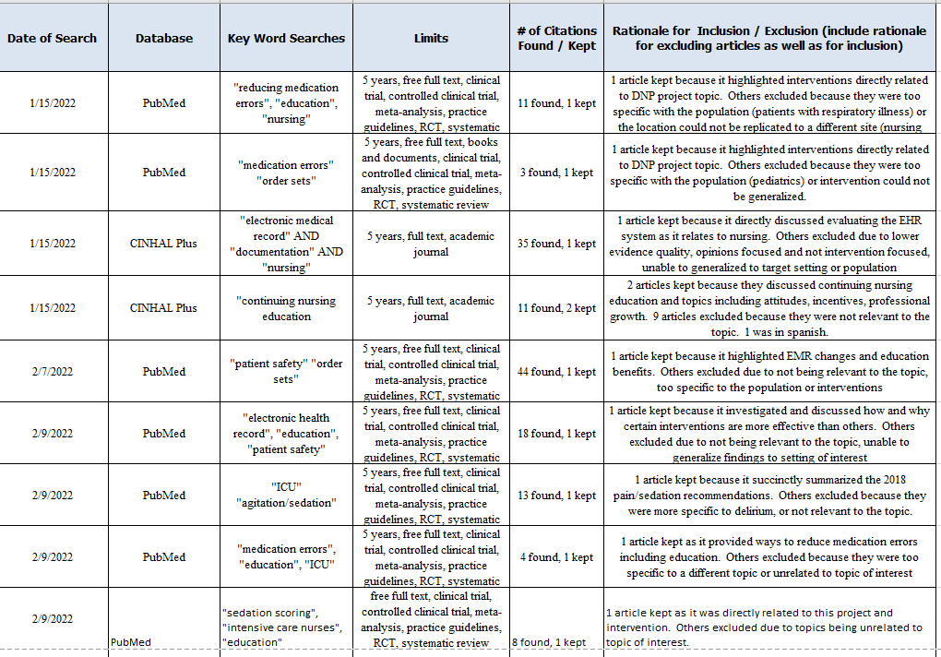

Appendix B: Self-Certification Tool
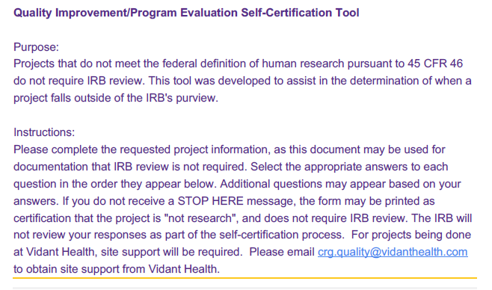

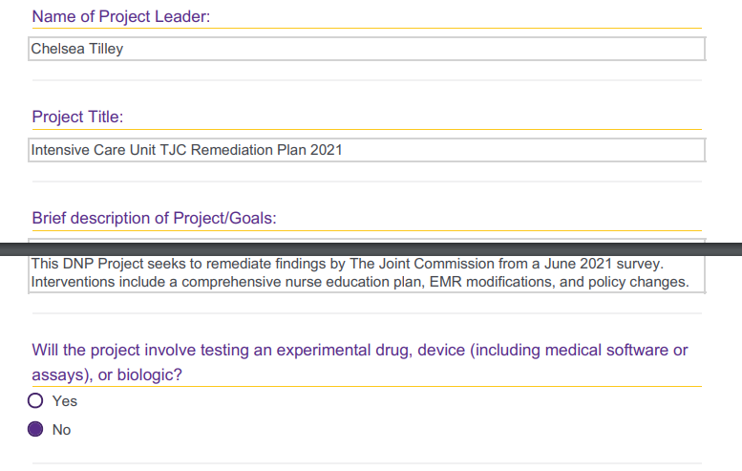
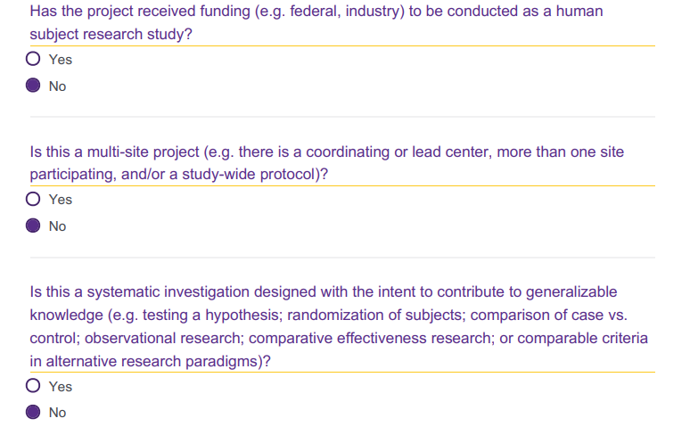

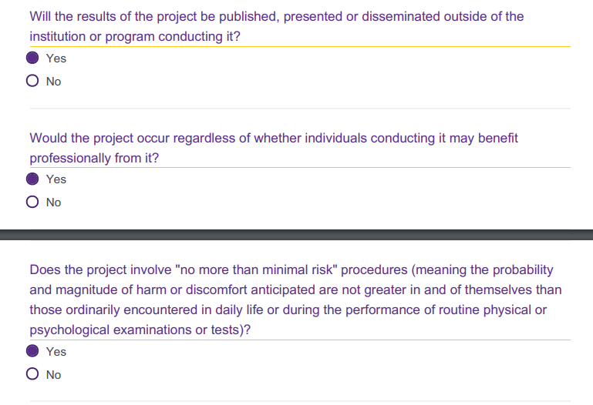
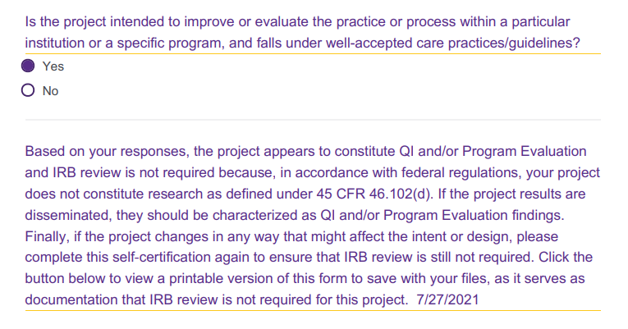
Appendix C: Audit Tool
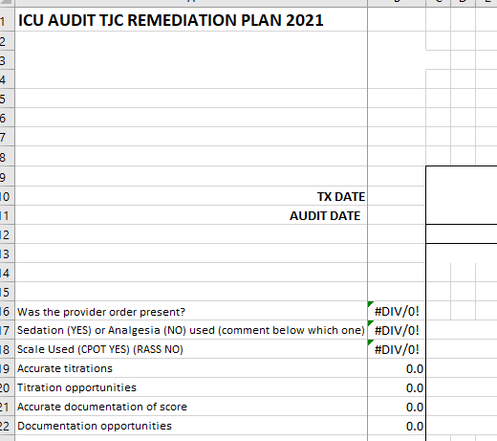

Appendix D: Project Timeline
Date | Activity
June 2021 | TJC survey of ICU with citations.
June 29th, 2021 | Initial project planning with site champion and preliminary approval by ECU liaison.
July 12, 2021 | Project proposal sent to site for approval.
August 5th, 2021 | Official approval granted for project; first phase of implementation begins.
September 7th, 2021 | PDSA meeting with site champion.
September 10th, 2021 | Revised proposal submitted with plans for additional medication order set modifications. Second phase of implementation commences.
September 24th, 2021 | PDSA meeting with site champion.
October 12th, 2021 | PDSA meeting with site champion.
November 4th, 2021 | PDSA meeting with site champion.
December 2nd, 2021 | Project implementation completion, final PDSA meeting with site champion.
April 2022 | Auditing ended for the purposes of this DNP project, responsibility transferred to ICU staff.

