Improving Successful Intubations in the Neonatal Intensive Care Unit
Lisa N. Clevenger
College of Nursing, East Carolina University
Levine Children's Hospital Neonatal Intensive Care Unit

Author Note
I have no conflicts of interest.
Correspondence concerning this article should be addressed to Lisa Clevenger, 2108 Deer Meadows Drive, Waxhaw, NC 28173, United States. Email: lisanicoleross@gmail.com

Abstract
Background: Neonatal intubation is challenging due to an infant’s size, anatomy, and tolerance to the procedure. Utilizing rapid sequence intubation (RSI) improves outcomes for neonates and decreases adverse events (Johnston et al., 2021; Sing et al., 2022).
Local Problem: A level IV NICU does not currently provide RSI prior to intubations and the current first-attempt success rate is 37%.
Methods: PDSAs were used to improve first-attempt success rates from 37% to 95%. Following an analysis of a Pareto chart, the team directed their effort toward developing a Rapid Sequence Intubation (RSI) protocol and education for team members.
Results: After the creation and implementation of the RSI protocol, first-attempt intubation success improved from 37% to 60%. Following the initiation of additional interventions, the success rate continued to improve.
Conclusion: Neonatal RSI is instrumental in improving intubation processes and outcomes.

Keywords: neonatal intubation, rapid sequence intubation, adverse events with intubation, neonatal airway
Improving Successful Intubations in the Neonatal Intensive Care Unit
Intubations are a common procedure in the Neonatal Intensive Care Unit (NICU) with 1-6% of all NICU patients requiring this potentially dangerous procedure (National Emergency Airway Registry for Neonates [NEAR4NEOs], n.d.). The American Academy of Pediatrics (AAP) released a statement in 2010 suggesting that pre-medicating infants before intubation attempts increases success and decreases adverse outcomes (Kumar et al., 2010). Adverse outcomes have been identified but not limited to desaturations, bradycardia, bleeding of mouth/gums, esophageal intubation, emesis, increased intracranial pressure, and hemodynamic instability (Singh et al., 2022). A reduction in intubation attempts correlates to an improvement in the safety and quality of care for patients.
Introduction
Rapid sequence intubation is a prevalent, safe, and effective practice in many NICUs. Using RSI prior to intubation decreases discomfort, limits interference during the intubation process, improves success rates, and decreases required attempts. With each attempt to pass an endotracheal tube through a small delicate airway, the risk of vocal cord damage, tracheal stenosis, and bleeding is compounded; therefore, intubation complications correlate with the number of intubation attempts (Folgia et al., 2019).
Following the AAP’s recommendations in 2010, subsequent research has continued to align with the original findings. The low success of first-attempt intubation prompted the initiation of a quality improvement (QI) project at a level IV, 85-bed NICU. Their current process involves intubating the infant without providers administering medication. During baseline data collection, the first-time intubation success was 37% and the goal was to increase the rates to 95% in six months (see Figure 1), therefore improving the first-attempt success and improving outcomes.
Methods
The patient population included in the project were all patients requiring intubation in a level IV NICU and the labor and delivery room. A pre/post-implementation design and a multistep approach were used to implement portions of the project using Plan-Do-Study-Acts (PDSA). Key stakeholders were identified to lead the project including nurses, respiratory therapists, neonatologists, and the quality nurse. The Standards for Quality Improvement (SQUIRE) guidelines were used to develop this manuscript (Ogrinc et al., 2015).
Following initial baseline data collection, recognition of the desired change led to creation of a working group comprising a quality improvement nurse and nurse practitioner, neonatologists, advanced practice providers (APPs), nurses, respiratory therapists, and a pharmacist. The team used quality improvement tools including key driver diagrams (see Figure 2), failure mode and effect analysis (see Figure 3), and Pareto charts (see Figure 4) in planning the project.
The first step in the process was deciding the combination of medications to include for RSI. In reviewing the literature and the pediatric pharmacist’s recommendations, atropine, fentanyl, and rocuronium were incorporated into the protocol, and guidelines were developed. The guideline included indications for intubation, medications, doses, patient exclusions, and reversal agents for fentanyl (see Figure 5).
Following the creation of the guideline, the team created a checklist for patients requiring intubation (figure 6). The checklist indentified the reason for intubation, providers who were present, equipment checks, preferred pre-medications, recommended doses, medication order time, medication administration time, the number of intubation attempts, and adverse events experienced by the patient. The checklist was intended to help the staff transition to using RSI and aid in data collection. The next steps then included implementing an order set for providers.
The pediatric pharmacist constructed an order set using the electronic medical record (EMR) to improve the ordering process and ensure the correct medications and doses were prescribed. Following those steps, a button was created in the automated medication dispensing cabinet (Omnicell) to allow quick and easy access to the RSI medications to improve efficiency. Located on the Omnicell was a laminated worksheet with details about RSI providing nurses one last education tool to familiarize themselves with the process and medication dosage checks. Following the implementation of these interventions, education ensued.
Education for all disciplines rolled out two months after the initiative was launched. Education via email, printed material, and staff meetings consisted of information about medications, protocols, checklists, and administering RSI to a patient. All staff was instructed that the first two medications, Atropine and Fentanyl, require the APP at the bedside. The third medication, Rocuronium, requires the neonatologist and APP to be present at the bedside for safety due to the paralyzing effect. Prior to the formal rollout of the process, discussions and demonstrations occurred daily, question and answer sessions were held, and daily announcements were included in education provided to nursing staff. Once the rollout occurred, every patient was a learning opportunity, and debriefs were completed after each intubation.
PDSA cycles were used to fine-tune the intubation process and gather data for outcomes. The quality improvement lead observed the process from identifying the need for intubation, placing RSI orders, nurses obtaining the RSI kits, documenting on the checklists and dosing sheets, giving the medications, and the intubation. Debriefs were completed with the team to review the feedback from the staff and make adjustments to the process as needed.
A retrospective chart review of the metrics obtained from the electronic medical record (EMR) documentation of intubation notes from providers was completed two months before implementation to gain baseline data. Following implementation, chart reviews of the metrics were obtained from the intubation checklists and EMR documentation of intubation notes. Data analysts created a weekly report providing EMR documentation of the number of attempts per intubation and the medical record numbers of patients who required intubation. The electronic documentation provided tracking for a process measure of the percentage of checklists used prior to intubation. This was helpful information for identifying failures. Multiple methods of data collection were utilized in this project.
Approval from the institutional review board for implementing RSI was obtained through Atrium Health during the planning phase. No protected health information was used in the project. There are no conflicts of interest for this project.
Results
This project aimed to implement interventions to improve intubation success and decrease adverse patient events. Although the goal of a 95% first-attempt success rate was not achieved in six months, the data indicates intubation success is improving with a success rate of 53%.
Characteristics of Infants
Over six months, 168 intubations were performed at the level IV NICU site. The intubations occurred in both the delivery room and the NICU. Table 1 demonstrates the number of intubations performed in each location. There were 112 intubations in the NICU and 56 in labor and delivery. The gestational age of infants intubated ranged from 23 weeks to 41 6/7 weeks, with the average gestational age (GA) of neonates intubated being 30 6/7 weeks (see Table 2). Of the 168 infants intubated, 37% were Caucasian, 34% African American, 15.8% declined identification, 9.7% Hispanic, 2.4% Asian, and 1.2% Arab.
Successful Intubation Attempts
Pre-implementation, a retrospective chart review was completed including infants from the NICU and labor and delivery room revealing they were seldom pre-medicated before intubation. Baseline data demonstrated that the first-attempt success rate was 37% (see Figure 1). Following the implementation of RSI and the intubation checklist, staff were presented with an illustrated control chart describing the results including the first-attempt intubation success rate improved to 53% by six months post-implementation. After data was obtained, it was dissected further and by the seventh month, providers were successful 60% of the time on the first attempt, 67% by the second attempt, and 80% by the third attempt. The number of provider intubation attempts decreased. However, there were several outliers of patients requiring up to eight attempts. After investigation, two of those infants had critical airways and could be excluded from the data. Three intubations were attempted by learners on the first attempts before an experienced provider attempted. Overall, successes were celebrated for decreasing intubation attempts.
Adverse Events
Baseline data for adverse events was difficult to obtain because of poor documentation tools for intubations and outcomes. The intubation checklist offers a place to document adverse events but very few were recorded. Of the checklists received, nine reports of bradycardia and desaturations occurred and only four out of the nine patients received RSI. One infant was observed to have chest wall rigidity, a known complication of fentanyl being given too quickly and the infant’s chest wall stiffens requiring further life-saving interventions. Following the incident of the adverse event, a debrief was completed and resulted in identifying the protocol and medication administration were properly completed per protocol and this was an event that we would continue to monitor for in future RSI administration. Following this adverse event, education was reinforced to nurses on giving fentanyl per the protocol to reduce adverse events from the medications. To date, no other reports of chest wall rigidity have been documented in this project. Follow-up education has been completed, however, documentation on adverse events continues to be a barrier. Future work includes identifying ways to improve documentation.
Intubation Checklists
A process measure for this project included collecting data on completed checklists. To provide consistency for a new process, record actions of the process, and minimize errors, a checklist was created. The intubation checklists were completed for 73% of NICU intubations. The current checklists are not relevant in the delivery room, but future work can include an intubation checklist for that area.
Discussion
Summary
The education of the interdisciplinary team was vital for success. Providing different forms of education such as individual communication, simulation, worksheets for nurses to complete, laminated copies of the protocol in common areas, and debriefs after RSI helped to promote a successful project.
Monitoring the time from ordering medications to administration was a barrier and a balancing measure in this project. Data collected from December 1, 2022, through January 31, 2023, showed this process took a mean of 3.58 minutes. Several incidents took more than three minutes to approve, and three orders took 10 minutes for the infant to get the first medication thus delaying care. Following this data, order sets were changed to STAT priority. In the following two weeks, data collected showed it took a mean of 4.58 minutes from ordering to administration of the first medication. This increased the timing for medications to get to the patient. Due to the unexpected results, a dive into the data suggested a recent reduction of pharmacy staff may have skewed the data and will be monitored closely during and following this project.
Atropine was the first medication administered for RSI and the clinical results were comparable with those reported by Wilmott et al. (2018). Atropine decreases bradycardia as it blocks the effects of vagal activity with intubations. Limitations of pre-implementation data and minimal intubation checklists note bradycardia as an adverse event post-implementation; therefore, these findings were not statistically significant.
Pre-intubation checklists were developed and placed with the intubation boxes per nursing and respiratory therapists. Nurses previously used a recorder thus they assumed the role of completing the checklist. During a PDSA, nurses were observed pre-checking the checklist before the procedure. Nursing educators provided rationales and education to the nurses in daily nursing huddles surrounding the importance of the checklist to provide consistency for the procedure and to identify problem areas. Clinically this has been proven to improve our intubation process by identifying missing or failing equipment before intubation has begun. Clinical significance for this is noted amongst staff.
Several gaps in the data were identified two months after the project was started. Intubations were not being captured through the EMR properly. The quality improvement nurse assisted the EMR leads in developing a data form that pulls all intubation charges and notes from the EMR. Education on proper note-writing for easy data extraction was communicated to the neonatologists and APPs via email and staff meetings. Overall, this project was an effective communication builder between the disciplines and improvements were identified quickly. Staff appreciated individual teaching with RSI and successful intubations are increasing.
Relation to Evidence
Several publications such as Diego et al. (2023) have shown improvement in first-attempt intubation success rates as well as decreased overall attempts and increased trainee success with implementing RSI. Similarly, Diego et al. also noted the checklist improved interdisciplinary communication and assisted in role definition during the procedure. Sawyer and Johnson (2020) describe the process using an intubation checklist, premedication, and a standardized order set led to a 10% sustained reduction of adverse events. The research and evidence are overwhelming to support RSI, intubation checklists, and an EMR order set and this quality improvement project reflects comparable results.
Interpretation
The results illustrate RSI, an order set, and an intubation checklist may decrease the number of intubations required for neonates. Continuance of the PDSA cycles following new interventions will provide staff the opportunities to review the processes and adapt, adopt, or abandon the intervention (Langley et al., 2009). Quarterly staff updates will promote communication and increase sustainability. Implementing RSI in the NICU has the potential to decrease intubation attempts and improve patient care.
Limitations
Limitations to the project comprise several factors. Prior to the project, the hospital had recently changed EMRs, and data collection was difficult to procure electronically. Data was initially collected manually from paper checklists completed by nurses and providers. Though helpful when completed, the checklists were not completed for every intubation and vital information may have been missing. By month five, the EMR technicians had developed a way to extract the data, however, this too had its limitations. The data was only available if a specific template was used to write the note for the intubation and this had not been standard procedure for the providers. This led to a PDSA resulting in a provider in-service on documentation.
The lack of intravenous access for patients who require intubation posed a limitation in the early stages of the project. RSI was not an option for these patients until an intranasal option was available halfway through the project. The original planning of preferred medications identified the intranasal option, however, an atomizer which is used for the administration of intranasal medications was not in stock until month four—the lack of availability for intranasal sedation potentially skewed data.
Other limitations included the distribution of educational material for nursing and providers was difficult to disseminate to every staff member. A lack of understanding and hesitancy to use RSI by the staff was challenging to overcome. Measuring adherence to all the interventions was difficult to capture because of a lack of EMR data. This project included data from the NICU and labor and delivery intubations; limiting the data to the NICU intubations may be helpful in the future to review only the patient’s eligibility for RSI administration.
Conclusion and Potential Nursing Implications
RSI before intubation increases successful intubations and decreases adverse events. The outcomes of the project support evidence-based interventions including RSI before intubation, using an intubation checklist, and using intubation order sets. This quality improvement project’s success results from the interdisciplinary work in the NICU. Using several QI tools such as key driver diagrams, Pareto charts, simplified failure mode effect analysis, and PDSAs provides working illustrations to identify the problem, define success, and address key elements of the project. Providers and nurses were adherent to the new protocol.
Readily available intubation checklists proved helpful in identifying concerns in real time. Nurses and respiratory therapists provided feedback and acknowledged the tool creates a closed loop of communication among the team. An unintended benefit to the checklist was developing a process for calling a “time out” before the procedure. This is a standard intervention prior to any procedure, however, the checklist provided standardization.
Practice recommendations include creating a protocol for RSI in which an intubation checklist and EMR order sets accompany the intubation. The next steps include spreading RSI to other NICUs within our system and spreading it for transport for neonatal patients. Due to the limited scope of the population, these results are limited to neonatal intensive care patients, though the learnings can benefit other populations.
References
Diego, E. K., Malloy, K., Cox, T., Broomall, A., Orr, L., Baxter, C., Meany, S., Baker, N., Fraser, J., Corbin, K. S., Gregoski, M. J., Wagner, C., & Ross, J. R. (2023). Implementation of a standardized premedication bundle to improve procedure success for nonemergent neonatal intubations. Pediatric Quality & Safety, 8(1), e622–e622. https://doi.org/10.1097/pq9.0000000000000622
Foglia, E. E., Ades, A., Sawyer, T., Glass, K. M., Singh, N., Jung, P., Quek, B. H., Johnston, L. C., Barry, J., Zenge, J., Moussa, A., Kim, J. H., DeMeo, S. D., Napolitano, N., Nadkarni, V., Nishisaki, A., & NEAR4NEOS Investigators. (2019). Neonatal intubation practice and outcomes: An international registry study. Pediatrics, 143(1), 1. https://doi.org/10.1542/peds.2018-0902
Hatch, L. D., Grubb, P. H., Lea, A. S., Walsh, W. F., Markham, M. H., Whitney, G. M., Slaughter, J. C., Stark, A. R., & Ely, E. W. (2016). Endotracheal intubation in neonates: A prospective study of adverse safety events in 162 infants. The Journal of Pediatrics, 168, 62–66. https://doi.org/10.1016/j.jpeds.2015.09.077
Johnston, L., Sawyer, T., Andes, A., Moussa, A., Zenge, J., DeMeo, S., Glass, K., Sing, N., Howlett, A., Shults, J., Brei, B., Foglia, E., Nishisaki, A., & NEAR4NEOS Investigators. (2021). Impact of physician training level on neonatal tracheal intubation success rates and adverse events: A report from national emergency airway registry for neonates. Neonatology, 118(4), 434–442. https://doi.org/10.1159/000516372
Kumar, P., Denson, S. E., Mancuso, T. J., & Committee on Fetus and Newborn, Section on Anesthesiology and Pain Medicine. (2010). Premedication for nonemergency endotracheal intubation in the neonate. Pediatrics, 125(3), 608–615. https://doi.org/10.1542/peds.2009-2863
Langley, G. J., Moen, R. D., Nolan, K. M., Norman, C. L., & Provost, L. P. (2009). The improvement guide (2nd ed.). Jossey-Bass Wiley.
National Emergency Airway Registry for Neonates. (n.d.). Making intubation safer, together. http://www.Near4neos.Org/
Ogrinc, G., Davies, L., Goodman, D., Batalden, P., Davidoff, F., & Stevens, D. (2015). SQUIRE 2.0 (Standards for Quality Improvement Reporting Excellence): Revised publication guidelines from a detailed consensus process. American Journal of Critical Care, 24(6), 466–473. https://doi.org/10.4037/ajcc2015455
Sawyer, T., & Johnson, K. (2020). Neonatal intubations: Past, present and future. Neoreviews, 21(5), 335–341. https://doi.org/10.1542/neo.21-5-e335
Singh, N., Sawyer, T., Johnston, L. C., Herrick, H. M., Moussa, A., Zenge, J., Jung, P., DeMeo, S., Glass, K., Howlett, A., Shults, J., Barry, J., Brei, B. K., Kim, J. H., Quek, B. H., Tingay, D., Mehrem, A. A., Napolitano, N., Nishisaki, A., … National Emergency Airway Registry for Neonates (NEAR4NEOS). (2022). impact of multiple intubation attempts on adverse tracheal intubation associated events in neonates: A report from the NEAR4NEOS. Journal of Perinatology, 42(9), 1221–1227. https://doi.org/10.1038/s41372-022-01484-5
Wilmott, A. R., Thompson, G., Lang, E., Powelson, S., Wakai, A. A., Vandermeer, B. B., & O’Sullivan, R. R. (2018). atropine therapy versus no atropine therapy for the prevention of adverse events in paediatric patients undergoing intubation. Cochrane Database of Systematic Reviews, 2018(1), 1. https://doi.org/10.1002/14651858.CD010898.pub2

Figure 1
Run Chart of Baseline to Identify First Attempt Intubation Success Rate
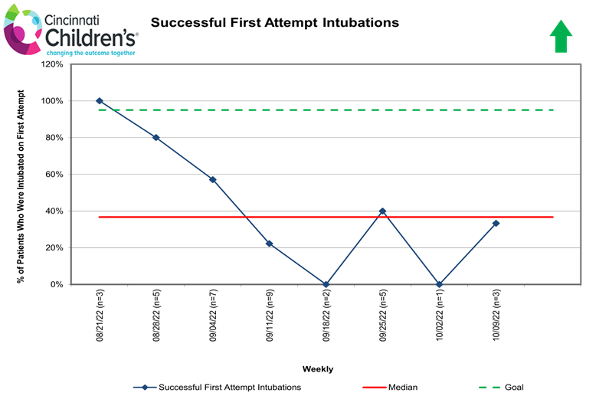

Figure 2
Key Driver Diagram to Identify Primary and Secondary Drivers and Associated Interventions
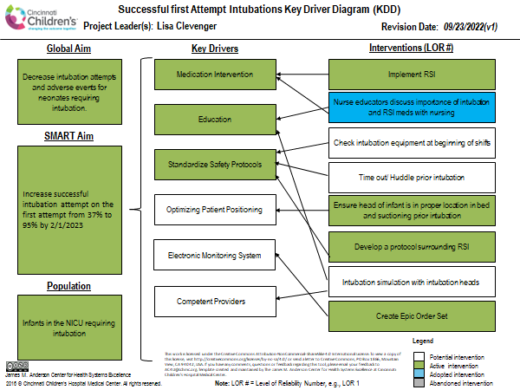

Figure 3
Failure and Mode Effect Analysis
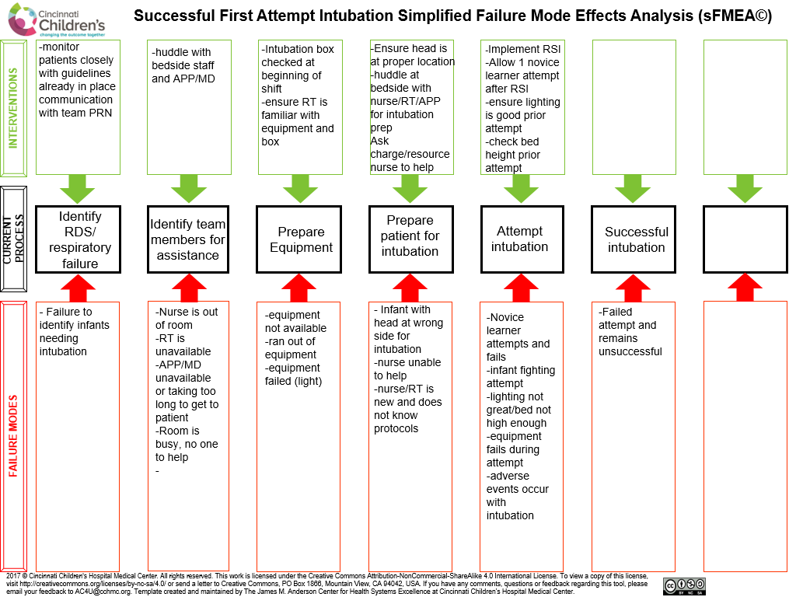

Figure 4
Pareto Chart to Identify Barriers to Successful Intubation
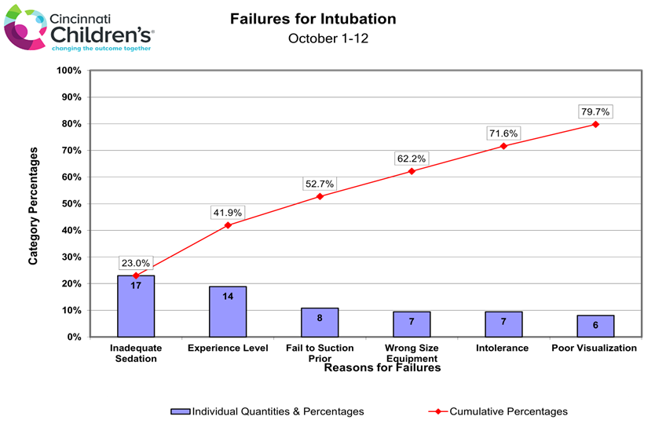

Figure 5

RSI Protocol

RSI Protocol
- Determine need for intubation and RSI
- Provider to use RSI order set in EPIC
- Nurses will obtain RSI meds from RSI kit in Omnicell and will draw up correct doses per order; once medications are approved by pharmacy, nurses will notify providers to ensure they are at bedside then give meds in order listed below
- Intubation checklist should be completed by recording RN at bedside and provider should document intubation, number of attempts, and adverse events in EPIC after intubation completed

In and out Surfactant: All GA
Atropine: 0.02 mg/kg IV push
Fentanyl: 1 mcg/kg/dose IV over 5 min

Intubation for <32 weeks GA:
Atropine: 0.02 mg/kg IV push
Fentanyl: 2 mcg/kg IV over 5 min
Rocuronium: 0.6 mg/kg IV push

Intubation for >32 weeks GA:
Atropine: 0.02 mg/kg IV push
Fentanyl: 2 mcg/kg IV over 5 min
Rocuronium: 0.6 mg/kg IV push
* May need 2 doses of rocuronium for desired effect

RSI Intubation for infants without IV access:
Fentanyl: 1.5mcg/kg intranasal with an atomizer (if greater than 0.15 ml per nare,
consider dividing doses further)

RSI Exclusions:
*Consider fentanyl and atropine for craniofacial anomalies (*no Rocuronium)
* Emergent and Labor & Delivery Intubations

Figure 6

Intubation Checklist

INTUBATION ASSESSMENT:  Indication for intubation:  __ emergent  __ respiratory failure/distress  __ prior surgical procedure  __ in and out surf  __ other ________  Notified: RT__ APP__ RN__  TEAM MEMBER CHECK:  __ Bedside RN  __ RT  __ APP/Resident/Neo  __ Recorder  __ Med Nurse 1  __ Med Nurse 2 | EQUIPMENT CHECK:  __ Stethoscope  __ Appropriate size mask  __ NeoPIP (settings 20/5 preterm and 25/5 term)  __ Working Suction catheter 8fr  __ Laryngoscope  __ Correct Size Blade  __ Correct Size ETT with stylet available  __ Pedi Cap  __ Aspirate NG/OG if one is in place (Feeds Stopped)  __ Ventilator Checked and Ready  __ RSI medications prescribed and at bedside  (Atropine, Fentanyl, and Rocuronium)  __ Consider turning on volume of QRS on monitor  for audible HR  __ Consider the use of video laryngoscope(C-MAC)
PREMEDICATIONS:
Order time of meds: __________________Start time of meds: ________________
Start time of intubation: _______________Time Intubation Completed: _________

___None ___Atropine (0.02 mg/kg) ___ Fentanyl (1-2mcg/kg)
___ Rocuronium (0.06mg/kg) ___ Intranasal Fentanyl (1.5mcg/kg)

NUMBER OF ATTEMPTS: ______________Successfully Intubated by____________
*(includes “looking” with blade in mouth)

ADVERSE EVENTS:
____ bleeding of gums or oropharynx
____ chest wall rigidity
____ bradycardia during intubation attempt
____ prolonged bradycardia/desaturation requiring escalation (ex: chest compressions)
____ other (please specify)

Table 1
Number of Patients Intubated by Location
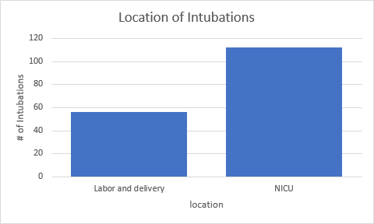

Table 2

Gestational Age at Birth by Gender and Intubation Location

