Surgical Oncology APP Productivity: wRVUS and Continuity of Care Measures

Kara Threatt RN, MSN, ANP, AOCNP
College of Nursing, East Carolina University
Doctor of Nursing Practice Program
Dr. Bradley Sherrod
July 25, 2022

Abstract
With the evolution of the electronic health records (EHR), the volume of non-billable work including direct patient emails, order entry, and numerous notifications has potential to affect provider productivity, well-being, and in some cases quality of patient care. Non-billable care coordination tasks, described as Service Value Activities (SVAs), is often not considered when evaluating productivity of providers despite the significant time spent on these tasks. This workflow redesign project evaluated the impact of a Team-Based Model of Care implementation focused on delegation of SVAs to the appropriate health care team member based on the optimal scope of practice in a Gastrointestinal (GI) Surgical Oncology clinic. Role specific outcomes were evaluated including time spent on SVAs and change in work Relative Value Units (wRVU) and clinic visit productivity for surgical Advanced Practice Providers (APPs). The project goals were to decrease APP time spent on SVAs and increase billable activities by implementing an “In Basket” Management workflow redesign based on a Team-Based Care Model. Before implementation, GI Surgical Oncology APPs spent 55.4 minutes per day in “In-Basket” management and saw 46.3 patients per month. Following implementation of the Team-Based Care Model, the GI Surgical Oncology APPs spent 38.5 minutes per day in “In Basket” management and saw 50.2 patients per month. The wRVUs for the APPs increased by 58% which increases potential for increased revenue. Through scope of practice role delineation and task delegation, health systems can improve patient access, patient care, staff utilization, and well-being.

Keywords: Service Value Activities, Advanced Practice Providers, Productivity, Team Based Care, work Relative Value Units
Table of Contents
Abstract 2
Section I: Introduction 5
Background 5
Organizational Needs Statement 6
Problem Statement 8
Purpose Statement 9
Section II: Evidence 9
Literature Review 9
Evidence-Based Practice Framework 13
Ethical Consideration and Protection of Human Subjects 13
Section III: Project Design 14
Description of the Setting 14
Description of the Population 14
Project Team 16
Project Goals and Outcomes Measures 16
Description of the Methods and Measurements 17
Discussion of the Data Collection Process 17
Implementation Plan 18
Timeline 22
Section IV: Results and Findings 22
Results 22
Discussion of Major Findings 28
Section V: Interpretation and Implications 29
Costs and Resource Management 29
Implications of the Findings 30
Sustainability 34
Dissemination Plan 34
Section VI: Conclusion 35
Limitations and Facilitators 35
Recommendations for Others 36
Recommendations for Further Study 36
Final Thoughts 37
References 39
Appendices 43
Appendix A: Evidence Matrix 43
Appendix B: Project Site IRB Approval 47
Appendix C: ECU IRB Site Approval 48
Appendix D: Project Timeline 49
Appendix E: Itemized Budget 50

Section I. Introduction
Advanced Practice Providers (APPs) are the “glue” that fill the gaps in clinical care by promoting continuity of care (Winter et al., 2020a). Martsolf et al. (2018) reported an increase in APP employment in surgical specialty practices by 15.8% and in general surgery by 24% from 2008 to 2016. APPs are recruited to help achieve the organizational mission by providing quality, efficient care, improved clinic throughput, reduction of hospital readmissions and promoting continuity of care (Winter et al., 2020a). The work of APPs and physicians is most often measured by face-to-face patient care which translates into revenue for the practices. With the evolution of the Electronic Health Records (EHR), the volume of non-billable work including direct patient emails, order entry, and numerous notifications had potential to affect provider productivity, well-being, and in some cases quality of patient care. Non-billable work, described as Service Value Activities (SVAs), is often not considered when evaluating productivity of providers despite the significant time spent on these tasks.
Background
As healthcare shifts to value-based care, there is more focus on non-billable work, also known as SVAs, contributing to the quality of care (Ogunfiditimi et al., 2013). SVAs include telephone calls, patient emails, review of diagnostics, care coordination, and team conferences (Ogunfiditimi et al., 2013). The Medicare Access and Chip Reauthorization Act (MACRA), passed in 2015, sets benchmarks for quality of care, electronic medical record use, quality improvement, and cost. As a result of MACRA, it is essential for health systems to evaluate SVAs and performers of this work specifically related to the scope of practice and cost-benefit. This work can be performed by APPs and other clinical staff, including Registered Nurses (RNs), Certified Medical Assistants (CMAs), and Administrative Assistants. Buerhaus et al. (2017) predicted a shortage of 1.1 million nurses in 2022 due to an aging workforce. As a result of the nursing shortage created by an aging workforce and exacerbated by the COVID-19 pandemic, APPs perform more SVAs, than nurses have historically performed.
Organizational Needs Statement
The project site is an 800-bed academic medical center located in central North Carolina that felt the impact of the COVID-19 pandemic. In March 2020, the COVID-19 pandemic led to reduced clinics, postponement of elective surgeries, and decreased nursing workforce resulting in reduced revenue. In response to the financial impact, site leadership set APP targets for work Relative Value Units (wRVUs) and number of independent clinics to improve surgical patient access, provider productivity, and revenue. The fiscal year (FY) 2022 APP productivity targets included minimum of six clinic sessions per week and 50th percentile of annual wRVUs appointed by the Medical Group Management Association (MGMA; 2021). In FY21, only three of 19 Surgical Oncology APPs met the 50th percentile benchmark, and the remaining APPs productivity fell below the 25th percentile of wRVUs. The time impact of non-billable work secondary to the nursing shortage is not reflected in the wRVU measurement. As a result of the additional non-billable work, APPs struggle to meet productivity metrics, staff independent clinics, and function at the top of the license. There are conflicting goals of “doing more with less,” which has led to increased APP burnout and turnover.
The Institute for Healthcare Improvement’s (IHI) Triple Aim model focuses on improvement of patient care, cost of care reduction, and health of the population. The work performed to meet the goals of the Triple Aim has led to the evolution of the Fourth Aim of provider well-being as a priority. The Triple Aim brought with it higher rates of burnout which contributes to decrease in quality of care and higher care costs (Bodenheimer & Sinsky, 2014).
A Work Culture Survey of Surgical Oncology APPs was performed in September 2020 related to work culture, job satisfaction, and burnout. When the Gastrointestinal (GI) Surgical Oncology APPs were asked if practicing at top of license, only 14% reported “most of the time”, 57% “some of the time”, and none were practicing at scope “all of the time”. When asked how satisfied they are with their current roles, 58% were “dissatisfied” or “very dissatisfied.” When asked in a typical workday how often APPs feel stressed, 86% reported “about half the time” or “most of the time.” A staggering 86% of GI Surgical Oncology APPs reported burnout lasting greater than three months. Contributing factors described included lack of scope of practice, the volume of non-billable (SVA) work, and appreciation and recognition of APP work (i.e. note preparation, split share work).
There is limited literature related to SVA measurements and how this is considered when evaluating staffing needs. Winter et al. (2020b) utilized a time-based coding system to assess specialty time spent on non-billable time. Surgical APPs were found to spend 6.22 hours per month on SVAs. Similar studies found physicians spend up to 45 minutes per session up to 20% of all time on non-revenue generating tasks (Chen et al., 2011; Farber et al., 2007). Ogunfiditimi et al. (2013) demonstrated APPs spend 36.7% of their time on nonbillable SVA activities and 60.3% on billable work. SVAs performed by GI Surgical Oncology APPs at the project site include surgeon clinic preparation (i.e. requesting/reviewing records and images, prepopulating clinic notes), order entry, and management of operating room (OR) schedules. Other activities include triage telephone calls, direct patient emails, care coordination among disciplines, lab and imaging review, medical form completion, appointment scheduling, and team conference attendance.
Time spent on these SVAs at the project site was estimated for telephone calls and electronic patient advice requests as 10 minutes per message, care coordination (lab and imaging review) as 10 minutes per incident, OR scheduling per case as 15 minutes, and new patient note preparation as 30 minutes per chart. Using this estimation, the time spent on SVAs weekly per APP include: 3.6 hours for new patient chart preparation, 10.2 hours for telephone calls and patient advice requests, 12.3 hours for care coordination, and 2.1 hours on surgical case scheduling. The GI Surgical Oncology APPs are spending 28.2 hours per week on SVA tasks. When added to the 24 hours per week of clinics, APPs may work up to 52.2 hours per week to meet their productivity targets.
In summary, the GI Surgical Oncology APPs are spending 70.2% of their work week performing SVA work compared to benchmark of 36.7% (Ogunfiditimi et al., 2013). Given this, there is an opportunity to evaluate the roles and responsibilities of the APP, RN, CMA, and administrative assistants in relation to the delegation of SVAs. The desired result would be clinical staff practicing at the top of the license, fostering continuity of care across the patient continuum, increased provider productivity, and higher revenue.
Problem Statement
The GI Surgical Oncology APPs have much higher amount of time spent on SVAs compared to literature benchmarks. The GI Surgical Oncology APPs are not functioning to the full scope of practice due to a lack of role and responsibility for non-billable work leading to burnout and dissatisfaction with their work. As a result, Surgical Oncology APPs cannot meet wRVU productivity metrics due in part to high non-billable workload secondary to insufficient clinical staff support.

Purpose Statement
The purpose of this project was to evaluate the impact of implementing a Team-Based Model of Care focused on delegation of SVAs to the appropriate health care team member based on the optimal scope of practice in a GI Surgical Oncology clinic. Role specific outcomes were evaluated including time spent on SVAs and change in wRVU and clinic visit productivity for surgical APPs.
Section II. Evidence
Literature Review
A systematic search of PubMed and Cumulative Index to Nursing and Allied Health Literature (CINAHL) databases from Duke University Medical Library was performed related to Team-Based Care and productivity. The project leader (PL) explored keywords including team-based care model, productivity, interprofessional collaboration, and electronic health record (EHR). Articles were included in the English language, full text, and published from 2016 to 2021 unless sentinel literature. Articles were excluded if related to inpatient or hospital setting, ancillary staff including pharmacy, nutrition. Most of the literature retrieved were descriptive studies and subjective survey data. Each article was reviewed in its entirety, and ultimately 26 articles were included related to the intervention (see Appendix A).
Current State of Knowledge
The IHI’s Triple Aim is focused on improving patient health and experience while reducing overall healthcare costs (Berwick et al., 2008). The Triple Aim has led to various practice sites developing and utilizing new models of care to achieve these goals. The common theme focuses on high-performance healthcare teams. Bodenheimer et al. (2014) developed a framework of 10 building blocks of high-performing primary care practices to guide to meeting IHI’s Triple Aim objectives. The building blocks arose from observation and direct interaction with process improvement work in the Primary Care practice sites. The building blocks relevant to this project included engaged leadership, data-driven improvement, empanelment, comprehensive care coordination, continuity of care, and team-based care (Bodenheimer et al., 2014). The building blocks support a practice model that requires the engagement of all staffing levels, a connection between the patient and the care team, which fosters continuity of care and care coordination (Bodenheimer et al., 2014). Team-based care is an encompassing building block that supports all components needed for a successful high-performance primary care practice. This framework could be considered for implementation in specialty ambulatory care clinics.
Current Approaches to Solving Population Problem(s)
Team-based care. The Institute of Medicine (IOM) defines Team-Based Care as the “provision of health services to individuals, families, and communities by at least two health care providers who work collaboratively with patients and caregivers—to the extent preferred by each patient—to accomplish shared goals within and across settings to achieve coordinated high-quality care” (Mitchell et al., 2012, p.5). The IHI has included the Team-Based Care model in many of its initiatives dating back to the Chronic Care Model developed by E.H. Wagner in 1998 and the more recent Transforming the Primary Care Practice program (Hupke, 2014; Wagner, 1998).
Szafran et al. (2018) evaluated patients’ perceptions of a Team-Based Model and found a higher sense of knowledge of their medical conditions, improved access to care, and reduced emergency room visits. Much of the current literature related to Team-based Care revolves around implementation in primary care settings, but very little is related to ambulatory specialty practices.
Interprofessional Collaboration. Interprofessional collaboration is another model very similar to Team-based care. The Robert Wood Johnson Foundation defined interprofessional collaboration as “active participation of each discipline inpatient care,” “fully engaging patients and those that support them, and leadership on the team adapts to the patient needs” (CFAR, Inc., et al., 2015, p.1). The RWJF (CFAR, Inc., et al., 2015) described principles of interprofessional collaboration, which include recognition of slow process, building relationships, identification of areas of best collaborative practice, starting in small clinical areas and building to the organization, and creation of a culture with reinforcement to maintain success.
Advanced Team Care with In-Room Support. Sinsky and Bodenheimer (2019) describe a methodology to “power up” a primary care team. This model’s staffing ratios are two to three trained medical assistants or nurses classified as Care Team Coordinators (CTC) to each clinical provider. The CTC and the clinical provider complete the visit as a team, with the CTC performing brief symptom-targeted histories, identifying and closing care gaps like immunizations and medication reconciliation. The CTC remains in the room with the provider to document portions of the visit and plan and enter orders. The provider completes a more detailed history, performs a physical examination, and formulates the care plan. The CTC remains in the room after the provider leaves to move on to the next patient with the 2nd CTC (Sinsky & Bodenheimer, 2019). Early data suggests that the “power-up” model allows for larger patient panels per provider and improved patient and clinical staff satisfaction (Sinsky & Bodenheimer, 2019). The model appears to be financially sustainable as funding for additional staff is covered by the increased patient volume, improved direct patient management, and decreased hospital admissions (Sinsky & Bodenheimer, 2019). It is limited in this current site due to staffing shortages and few applicants seeking positions.
Other Models. Several different models are briefly discussed in the literature related to improving healthcare workflow. The retail clinic model involves Nurse Practitioner led same-day access clinics for minor medical issues (Cassel, 2018). However, these types of clinics are limited in chronic care conditions. The direct primary care model necessitates a smaller patient panel that impacts practice revenue and propagates the existing primary care provider shortage (Huff, 2015).
Evidence to Support the Intervention
To transform the GI Surgical Oncology team into a high-performance team, a Team-Based care model, also known as interprofessional collaboration, would foster management of complex postoperative patients to provide efficient quality care. The GI Surgical team has Quality Improvement (QI) metrics, including Emergency department visits, hospital readmissions, as well as value-based care metrics of patient satisfaction and overall costs. Team-based care models are built on principles of shared goals among the clinical staff, patients, and family, clear roles and expectations of each care team member, trust within the team, effective communication, and measurable outcomes and processes (Mitchell et al., 2012).
In 2014, the Robert Wood Johnson Foundation published Lessons from the Field: Promising Interprofessional Collaboration Practices which evaluated 16 health systems with interprofessional care models. Themes noted across sites include making patients the priority, leadership commitment, enabling team members to practice at the top of their scope, knowing their roles and feeling valued, ensuring organizational structure support, and fostering team communication (CFAR, Inc., et al., 2015).
Haj-Ali et al. (2020) compared Team-based and non-Team-based care primary care practices on outcomes of avoidable hospitalizations and readmissions. They found no difference in hospital admissions and hospitalizations between the two groups. The researchers attributed the results to the need to collaborate with other aspects necessary to Team-based care, including access, coordination within the team, and overall continuity (Haj-Ali et al., 2020).
Evidence-based Practice Framework
The Lean framework used in healthcare is described as “an organization’s cultural commitment to applying the scientific method to designing, performing, and continuously improving the work delivered by teams of people, leading to measurably better value for patients and other stakeholders” (Toussaint & Berry, 2013, p.75). The Lean framework has six guiding principles, including 1) continuing improvement using the Deming cycle, specifically Plan-Do-Study-Act (PDSA), 2) improving value for patients, 3) prioritizing goals based on most benefits to the organization, 4) empowering front line staff to share innovations for improvement, 5) visual tracking boards to share metrics and foster communication of areas of need, 6) flexibility of innovations through continuous evaluation and changes to facilitate additional improvement (Toussaint & Berry, 2013). Lean fosters leaders and front-line staff to work together to identify and solve issues in a continuous improvement cycle. This project will utilize the Lean framework and, specifically, the PDSA cycle for continuous improvement.
Ethical Consideration & Protection of Human Subjects
There are no ethical considerations for this project. The implementation of the Team-Based care model is equal and equitable to the clinical care team and GI surgical patients as all received the same level of care. The results of this project would be shared with colleagues at the project site to facilitate optimization if applicable to other disease groups.
The project proposal was drafted using a project site exempt study submission template and submitted to the project site Institutional Review Board (IRB) for approval before implementation. IRB approval was obtained by the PL two weeks after submission for final approval (see Appendix B). CITI modules were completed by the PL per ECU School of Nursing and project site requirements. The project proposal was also submitted and approved by East Carolina University IRB (see Appendix C).
Section III. Project Design
Description of the Setting
The project site was an outpatient gastrointestinal (GI) oncology clinic within a National Comprehensive Cancer Center Network (NCCN)-designated Cancer Center located in central North Carolina. The GI Oncology clinic is multidisciplinary with medical oncology, surgical oncology, and radiation oncology specialists. Approximately 21 physicians and 8 Advanced Practice Providers have clinical practices within this clinic. There are 10 nurses and 6 Certified Medical Assistants who provide clinical support within GI Oncology.
Facilitators for the project include a strong desire by team members to practice at the top of their license. The clinical team is also very engaged in maintaining efficient quality care in the challenging setting of staffing shortages. The most critical barrier is short staffing and high turnover at all levels of clinical and administrative support. Other barriers include multiple specialties within the practice site with different existing care model needs. Role definition was a barrier but has improved with recent role delineation work.
Description of the Population
The project population is the GI Surgical Oncology clinical teams which include APPs (n=6, clinic nurses (n=3), CMAs (n=2), and administrative staff that support 9 surgeon (8 full time, 1 part time) practices. The clinical team provides care to cancer and non-cancer patients with GI illnesses that require surgical management. The GI surgical team sees approximately 400 new patients and performs around 150 surgeries per month. Almost all of SVAs occur within the Providers “In Basket” folders within the EMR. The project focused SVAs within the In Basket include Telephone Calls, Patient Advice Requests, and Refill Requests. The team receives approximately 6,500 In Basket notifications per month, of which 20% are Telephone Calls and Patient Advice Requests. These messages do not include other In Basket activities such as care coordination (labs, imaging review), staff messages, clinical note completion, OR case coordination, scheduling, or communication with outside providers. In the pre-intervention state, management of these SVAs is completed primarily by the APP with partial support of a clinic nurse. CMAs and administrative staff are not involved in In Basket management (see Figure 1).
Figure 1
In Basket Clinical Care Team Message Workflow: Pre-Intervention
Note. This flowchart depicts the current state of how patient portal messages by subject and by the clinical care team.
Project Team
The project team was made up of the following: the site DNP prepared Nurse Practitioner sponsor, Division Chief of Surgical Oncology, APP Director, GI Surgical Oncology RN Manager, GI Surgical Oncology RN Team Lead, GI Surgery APPs, Colorectal Surgery RNs, Hepatobiliary RNs, GI Surgical Oncology CMAs, and Doctoral prepared Nurse Practitioner as Project Leader who was required for the site-specific IRB submission.
Project Goals and Outcome Measures
This project is a workflow redesign using a Lean framework to implement a Team-Based Care Model for managing EMR “In Basket” work by the clinical team. The project goals are to decrease APP time spent on SVAs and increase billable activities by implementing an “In Basket” Management workflow redesign based on a Team-Based Care model. Before implementation, GI Surgical Oncology APPS spent 55.4 minutes per day in “In-Basket” management and saw 1.87 patients per day compared to 31 minutes and 5.5 patients respectively for their Oncology APP colleagues.
Outcome measures included the following:
- Implement standardized Team-Based workflows for management of “In Basket” messages
- Reduce time spent in In Basket per day by 25% for GI Surgical Oncology APPs
- Increase in the number of independent clinic visits per month by 25% for GI Surgical Oncology APPs.
The number of wRVUs was collected to demonstrate the financial impact of the workflow redesign.
Description of the Methods and Measurement
Time spent on SVAs by APPs was measured by minutes per day spent within In Basket. “Time in In Basket per Day” was calculated as a total number of minutes spent by a provider in In Basket activity or navigator section divided by the total number of days logged in and worked during the reported period. The mean and range of Time in In Basket per Day was reported.
APP productivity measures collected include number of independent clinic visits (billable and post-op non-billable) and wRVUs monthly. The wRVU volume was collected to provide the financial impact of the workflow redesign. The number of wRVUs for each APP was collected monthly from the project site Revenue Manager. The mean and range wRVUs for the GI Surgical APPs were reported.
Discussion of the Data Collection Process
Baseline outcome measure data were collected from the project site-specific EPIC Signal Dashboard and the revenue manager. “Time in In Basket per Day” and number of independent clinic visits were collected monthly for each GI Surgical Oncology APP provider by specialty of CRS and HPB for comparison. The wRVU volume for each APP was collected monthly. Baseline data for all metrics were collected from October 3, 2021, to December 26, 2021.
To evaluate the impact of workflow redesign on other clinical roles, the percentage of In Basket messages managed by the APP and the Clinical Care Team (RN and CMA) was collected. Baseline and post intervention data was collected monthly from the EPIC In Basket Pool Workload dashboard within the EPIC EMR system used at the Project Site. Baseline data was collected from October 2021 through December 2021 and post intervention from December 27, 2021, through April 30, 2022. Finally, APP productivity metrics, including the number of patient visits and wRVUs, were collected, and means and ranges were reported. All data was collected by the project lead and logged in an Excel database.
Implementation Plan
In Basket Clinical Pools. Prior to the intervention, patient Telephone Calls and Patient Advice Requests were routed directly to the MD or APP provider for initial management. The MD or APP would forward tasks to the appropriate staff for assistance. Provider specific clinical team message pools were created to centralize electronic and telephone triage messages from patients to allow implementation of Team-Based workflows. In a Clinical Care Team Pool model, the patient messages are automatically routed to a centralized message pool that is staffed by the Clinical Care Team which can include the MD, APP, RN, and CMA. This method allows all team members to address the work within the scope of their license. It is recommended that the APP, RN, and CMA be permanently “checked in” to the pools while the MD can “check-in” periodically to manage messages.
Clinical Care Team Standard Work. The most common In Basket patient message types include symptom management, scheduling questions, medication refills, form completion, medication prior authorizations, and medical record requests. Roles and responsibilities related to message types for each Clinical Care Team member were defined (see Table 1). The APP, RN, and CMA tend to the messages within their scope and communicate with the MD or APP for those that require higher scope input.
Table 1
Clinical Care Team Roles and Responsibilities for In Basket Patient Messages
Clinical Care Team Roles | Responsibilities
Physician/APP | - Symptom management  - Triage phone calls
RN | - Symptom management  - Triage phone calls  - Patient education
CMA | - Appointment and/or surgery scheduling questions  - Forms/Letters  - Patient questionnaires
Pharmacy | - Medication prior authorizations
Scheduling Team | - Appointment scheduling  - Appointment questions
Administrative Assistant | - Forms/Letters  - Medical Record Requests

Clinical Care Team pools were created on September 29, 2021 and included only the APP and the RN to allow both staff and patients to adjust to the communication model. In October 2021, the clinical teams participated in an EPIC concierge education session related to In Basket communication, including tips to streamline how to address and take ownership of messages based on top of scope. Baseline data of percent of messages managed by APP and RN only before implementation of Clinical Care Team-based model with addition of the CMA was collected from September 29 through December 31, 2021.
In Basket Message Workflows. Workflows related to In-Basket management did not exist before project implementation. In Basket Workflows were created for specific message types and who would manage them based on scope of practice. Workflows will foster involvement of all team members, promote autonomy of clinical staff, and improve efficiency.
On January 1, 2022, the CMAs were checked in to the clinical provider team pools in addition to the RNs and APPs to foster Team-Based Care. The RN and CMA would address patient messages as appropriate to the top of their license (see Figure 2). Clinic RNs were given scheduled administrative time without direct “in clinic” duties to focus on In Basket management, follow-up phone calls, and patient education calls. The CMA continued to manage both In Basket work and clinic throughput.
Figure 2
In Basket Clinical Care Team Message Workflow: Intervention
Note. This flowchart depicts the intervention workflow of how patient portal messages by subject and by the clinical care team.
After implementation of the provider specific pools, the Colorectal Surgery Clinical Care Team raised concern of inefficient workflow with multiple people in the pool. After PDSA review, the Colorectal Surgery APPs were removed from their provider pools on March 20, 2022. A Colorectal Surgery APP pool was created and the In Basket workflow was revised. The RN and CMA served as first line management for patient messages. If the message required beyond scope of practice assessment, the message would be sent to the Colorectal Surgery APP pool to be managed by the APPs (see Figure 3). This revision of pool workflow could not be initiated in the Hepatobiliary Surgery team due to staffing limitations.
Figure 3
In Basket Clinical Care Team Message Workflow: Intervention with Care Coordinator
Note. This flowchart depicts the impact of a Care Coordinator role on the workflow of how patient portal messages by subject and by the clinical care team
Co-Location of Teams. Team-based care models also emphasize the co-location of clinical staff with the providers. Before this project, the primary RN was located adjacent to clinical exam rooms, which does not foster communication. On January 1, 2022, the primary RN was co-located to the provider workroom to facilitate communication related to In Basket messages and other clinical activities. The administrative assistants were closely available in the clinical space or electronically to support Operating Room scheduling, clerical tasks like faxing, and time-sensitive scheduling needs.
Telemedicine Nurse Visits. Telemedicine visits to provide surgical teaching, post-visit calls, and post-discharge calls for complex patients were implemented as part of the Team-Based Model. Nurses were assigned one office day per week to complete telemedicine visits and focus on In Basket management. The office day assignment allowed the RN to focus on “out of clinic” work. The telemedicine nurse visits provide patients with teaching closer to surgical dates to foster retention of information and possibly reduce the number of follow-up calls and electronic messages.
Timeline
The project was submitted to the project site IRB on November 8, 2021 and was approved on November 16, 2021. Baseline pre-intervention data were collected retrospectively from September 29, 2021, through December 26, 2021. Implementation of the project was from December 27, 2021, through April 30, 2022. Data were collected from December 27, 2021, through April 30, 2022. Data analysis was performed in May and June 2022. The complete timeline is detailed in Appendix D.
Section IV. Results and Findings

Results
Baseline data were collected from October 3, 2021, to December 26, 2021, before an In-Basket workflow intervention was implemented. APPs spent an average of 38.4 minutes per day (range 25 to 60) performing tasks within In Basket. APPs received an average of 6.4 (range 3.1 to 17.2) patient advice requests and calls per day. During the baseline period, each APP performed an average of 47.6 visits (range 6 to 127) and generated an average of 37.4 wRVUs (range 1 to 99) monthly.
The intervention In Basket workflows was implemented from 12/27/21 through 4/30/22. Post-intervention, APPs spent an average of 38.5 minutes per day (range 24 to 59) performing tasks within In Basket (see Figure 4). APPs received an average of 6.6 patient-related messages (range 2.8 to 11.5) per day (see Figure 5). During the baseline period, APPs performed an average of 46.3 visits (range 18-127) and generated 36.2 wRVUs (range 2 to 144) monthly (see Figures 6 & 7).
Figure 4
APP Time Spent in In Basket (min/day) by Sub-Specialty and Total

Note. Pre and post workflow implementation data for APP time spent in In Basket per day is represented for all GI APPs (N=6) and broken down into each specific disease group of Colorectal Surgery (CRS) and Hepatico-pancreaticobiliary (HPB).
Figure 5
APP Patient Messages & Calls/Day (excludes pool messages)

Note. Pre and post workflow implementation data is represented for volume of patient messages and calls for all GI APPs (N=6) and broken down into each specific disease group of Colorectal Surgery (CRS) and Hepatico-Pancreaticobiliary (HPB).
Figure 6
APP Independent Visits per APP per Month

Note. Pre and post workflow implementation data is represented for number of independent APP clinic visits for all GI APPs (N=6) and broken down into each specific disease group of Colorectal Surgery (CRS) and Hepatico-Pancreaticobiliary (HPB).
Figure 7
APP wRVUs per Month

Note. Pre and post workflow implementation data is represented for volume of patient messages and calls for all GI APPs (N=6) and broken down into each specific disease group of Colorectal Surgery (CRS) and Hepatico-Pancreaticobiliary (HPB).
The In Basket provider specific pools were managed initially by the RN and the CMA, who would escalate the messages to the MD or APP based on scope of practice. During the implementation period, the HPB Clinical Care Team received 3,260 patient advice request messages and the CRS team received 1777 messages. The percentage of messages completed by the GI Clinical Care Team (RN/CMA) RN was 48.9% (n=2463), by the APP was 41.3% (n=2080.3), and by the MD was 9.9% (n=498.7; see Figure 8). The HPB Clinical Care Team message completion was 18.9% by MD (n=616), 42.6% by APP (n=1388), and 37.6% by RN/CMA (n=1225.8) (see Figure 9). The CRS Clinical Care Team message completion was 0% by MD, 40% by APP (n=710.8), and 60% by RN/CMA (n=1066.2) (see Figure 10).

Figure 8
Pool Messages Completed by Role (percent) - All GI
Note. Each column represents the breakdown of patient message management by MD, APP, and the Clinical Team to demonstrate stratification of work by role for the GI Surgery Team (both CRS and HPB).
Figure 9
Pool Messages Completed by Role (percent) – Hepato-pancreaticobiliary (HPB) Surgery

Note. Each column represents the breakdown of patient message management by MD, APP, and the Clinical Team to demonstrate stratification of work by role for the HPB surgery team.
Figure 10
Pool Messages Completed by Role (percent) – Colorectal Surgery (CRS)

Note. Each column represents the breakdown of patient message management by MD, APP, and the Clinical Team to demonstrate stratification of work by role for the CRS surgery team.
Discussion of Major Findings
Trust and Communication within Team Based Care Model
Team-based care models have been demonstrated to foster top of license practice and enhance team communication to achieve the mutual goal of efficient, quality patient care. Honeyman et al. (2005) evaluated patient feedback on the impact of open access, and 75% of survey respondents felt access to their notes would foster confidence and communication with their providers. The creation of a provider team based In Basket pools and associated workflow involving all clinical staff roles was completed. The GI surgical team quickly demonstrated top of license practice as evidenced by co-management of many messages. Team communication was crucial to its success. A gap not initially recognized was the assessment of interprofessional collaboration and the inherent trust needed to be successful. The pilot team embraced the pool model, but there were initial hesitations around change and trust within the teams. The providers had always been involved with patient messages from the time of message receipt. In this pilot model, their RN and CMA team became responsible for the messages upon initial receipt. The providers had to trust that their team recognized appropriate escalation to the providers, would provide efficient and appropriate responses, and maintain communication with them about the needs of the patients. Interestingly, there was also some mild conflict between the Triage Nurses, who lacked trust in prompt management and response by the Clinical Care Team.
APP and MD Measures
An APP’s role is to provide efficient quality care, promote continuity of care, and reduce hospital admissions. The MD’s role, particularly in surgical practice, is to provide efficient quality patient care through medically indicated and appropriate surgical interventions. Surgeons spend several hours per day in the operating room and require APP support for the care continuity of their patients. The data in this project demonstrates that the surgeons have significantly lower time in non-face-to-face work while the APPs manage more of that work. The Provider based In Basket pools has enhanced the Team-Based Model as the RNs, and the CMAs are supporting the non-face-to-face work and the APPs. Post-intervention data suggests that neither the APP time nor the message volume did not dramatically decrease. The MD time remained the same, demonstrating the pool’s impact on their work to be minimal. The minimal surgeon impact is not an unexpected finding as the APP primarily manages the surgical In Basket work.
APP time in In Basket and message volume did not decrease by the goal of 25% and remained stable. For each HPB APPs, independent visits and wRVUs increased by 34% and 150%, respectively, demonstrating the impact of workflows on revenue-producing work. For CRS APPs, independent visits decreased by 9%, and wRVUs increased by 11.7%. For all GI APPs combined, independent visits and wRVUs increased by 8% and 58% for each APP. The revenue conversion of one wRVU is $32.4085. The GI APP group generated an additional $4102 per month which can support 1.5 additional CMAs for the clinic ($49,234 annually).
Skill Mix
Several workload assessment tools for ambulatory nursing models are discussed in the literature (Swan & Griffin, 2005). Most models are based on workload assessment based on practice scope. Ambulator work includes visits, assessments, care coordination, patient support, and triage. There are no clear guidelines of roles and workload expectations for ambulatory clinical care teams, which can lead to practicing out of license scope, confusion of responsibilities, staff conflict, and increased healthcare system costs (Deeken et al., 2017).
Section V. Interpretation and Implications
Costs and Resource Management
The In-Basket workflow project required the collaboration of multiple clinical staff, including site leads, nursing leadership, physicians, APPs, and EPIC concierge. Costs were primarily related to training, creation of provider-specific pools, development of workflows, and weekly huddles as part of the PDSA. These costs are further detailed in Appendix H.
As work was delegated to other roles, a change in skill mix need was identified. The RN needed dedicated administrative time to perform care coordination tasks, affecting staffing for daily clinic flow. A second clinic RN was moved to the GI Surgery team to accommodate the model change. A clinic CMA was transitioned to a more direct Care Coordinator role within the In Basket Pools. An additional CMA was added to the team to assist with daily clinic flow. The staff skill mix needed for the ideal Clinical Care Team model to manage in-clinic and out-of-clinic flow for GI Surgery would require four nurses and 4 CMAs. Additional analysis is needed to be related to the volume of CMA and RN work. Surgical specialty clinic needs additional CMA support for clinic flow and RN care coordination.
Implications of the Findings
Impact on “Top of Scope” Practice
The In-Basket workflows required standard work based on within-scope roles and responsibilities for each Clinical Care Team member. The everyday work of care coordination supports the top-of-scope practice by APPs, RNs, and CMAs. There was the engagement of the entire care team and improved well-being. The themes of subjective feedback included improved patient satisfaction, better communication with the co-location of the team, and the ability to function at the top of the practice scope (see Table 12). APPs and MDs had more time to focus on complex patient issues and in-person care provision. The time in In Basket for the APPs did not significantly change, indicating that time spent was more valuable and focused on complex patients. The volume of clinic visits increased, which may lead to increased revenue. The revenue for the additional visits per month was approximately $53,000, which can help offset additional staffing costs.
Table 2
Clinical Care Team Feedback on Intervention
- More organized structure and flow of clinic
- Decreased patient wait time
- Improved patient satisfaction
- Workroom co-location improved communication and care coordination
- Telemedicine patient education visits provide more time for patients to ask questions
- Improved utilization of APP and RN to an extent within the full scope of practice.

Clinical Care Team Composition
The Clinical Care Team composition of MD, APP, RN, and CMA can better manage care coordination work within In Basket. The findings revealed an increased value of In Basket work by the RN and CMA. However, the team reported similar challenges in managing this non-face-to-face work while managing in-person clinic flow. Additional work is needed to clarify the skill mix and staffing levels to help support the model’s success. During the implementation, it was apparent that a different skill mix of RN and CMAs in the care team may be critical to success. We quickly recognized that the In Basket work done by the CMA and RN limited their bandwidth to manage in-person clinic throughput. The CMAs were redirected to rooming and assisting in procedures in clinics, reducing their dedicated time to managing the non-face-to-face work. RNs were also redirected to in-person patient education, assisting providers with in-person clinic flow, which decreased their bandwidth to manage out-of-clinic urgent messages. This assessment was evident in the first month of intervention which led to a change in flow to have a dedicated CMA in In Basket as a Care Coordinator.
Development of formal role titles of Care Coordinator (CMA), Nurse Coordinator (RN), Procedural CMA, and Clinic CMA to fill the gaps in care may help with role delineation. The project team recognized quickly that the In-Basket management is a very labor-intensive role that cannot be effectively done by a CMA while also managing clinic throughput such as rooming. It will require additional CMA and RN staff; however, it is expected to increase the time spent by billing providers performing revenue-generating work to offset additional staff costs. The Clinical Care Team noted improved team satisfaction as they became more embedded in the clinical team. The pilot team described an increased feeling of worth. APPs reported a higher sense of worth with increased face-to-face independent practice. They also felt more supported by their colleagues in providing care to their patient panels.
Implications for Patients
The Team-based care model for managing patient triage messages facilitates proper navigation of messages to the right team member who can respond at an appropriate time. Patients will have care coordination by a consistent team throughout their care journey. In theory, with appropriate staffing, patient needs would be managed more efficiently and conveniently. Sawin and O’Connor (2019) described primary care transformation as focused on developing care teams that help build patient trust, provide the appropriate amount of care at the right time, and expand team roles. In value-based care systems, practice must lean on the entire clinical team to create higher team function. Adding roles such as Care Team Coordinators (CTCs) fosters relationships with patients and sharing work with providers, allowing improved processes (Bodenheimer et al., 2014).
Lyon et al. (2018) created the Ambulatory Process Excellence or Awesome Patient Experience (APEX) model to expand the assistant medical roles within patient visits. The staff ratio was increased to 2.5 CMAs to 1 MD. The CMA tasks include history collection, documentation of visit assistance, clinical tasks based on the protocol, care coordination, and coaching (Lyon et al., 2018).
Implications for Nursing Practice
Care coordination performed by a clinical care team that includes schedulers, CMAs, RNs, and providers allows the ability to route messages to the right staff member to enhance the utilization of staff better. By creating more efficient workflows, RNs and CMAs can optimize their scope of practice to meet their professional and well-being goals.
From a cost standpoint, it may lead to increased revenue, lower labor costs, and increased clinic throughput.
Defined patient management workflows are a component of standard work that translates to improved efficiency and decreased errors. Standard work is one of the core principles of the Lean framework that has been described within healthcare systems as a way to achieve Zero Harm. For CMA role definition, standard work processes provide the needed guardrails to facilitate top-of-scope responsibilities and guide the CMA in their work goals. CMAs in other clinical areas of the project site have different work responsibilities, including rooming, medication reconciliation, assistance with procedures, and form completion. Team-Based CMAs can review patient charts for care gaps, perform direct patient care tasks, coordinate patient care between visits, and even lead the Clinical Care team communications (Ladden et al., 2013). Creating standard work for each role within the care team can lead to defined roles which leads to improved collaboration and communication.
Impact on Healthcare System
In the setting of value-based care, patient satisfaction through the delivery of patient-centric care is critical. By reducing the burden of non-face-to-face work for billing providers, well-being is expected to improve, given that it is the top dissatisfier in Work Culture surveys at the project site. Billing providers can transition the time saved on the service value activities to more clinic visits, improved patient access, and increased revenue. The RN and CMA time spent on out-of-clinic care coordination may lead to increased staffing or an alternate staffing mix. The APP time remained the same, but clinic visits increased, resulting in increased revenue for the health system. The time spent in In Basket by each provider demonstrates improved cost-effectiveness of most of the work being done by CMA and RN. APPs can spend more time on complex patient care and improve patient access to care.
Sustainability
The In-Basket workflows can serve as standard work for all team members based on each role. The metrics identified for care coordination within the EMR may help with staffing workload standards. The non-face-to-face care tasks can be quantified to measure the needed skill mix and the number of team members to complete the work. Standard work processes can more easily be disseminated to other clinics within the project site to sustain success further. This project may facilitate the creation of a staffing prediction tool that includes both in and out of clinic work. Such tools can help determine the amount and type of staff needed for individual care teams, such as when new physicians are hired. The workload can be monitored closely to adjust staffing as needed.
Dissemination Plan
This project was disseminated to the East Carolina College of Nursing on July 12, 2022. Project site presentation was at the Advanced Practice Provider Grand Rounds in August 2022 and Oncology APP Grand Rounds in October 2022. Abstract submission was considered for Oncology Nursing Society Congress 2023 (due in February 2023) for presentation at a national conference. Manuscript submissions being considered include the Journal of Advanced Practitioner in Oncology (JADPRO) or the Journal of The American Association of Nurse Practitioners (JAANP). This document was published in the ECU ScholarShip.

Section VI. Conclusion
Limitations and Facilitators
Before the Care Team creation, clinical staff was task-oriented in their daily work without optimizing their scope-specific skills. The standard work based on roles necessitated a change in work culture and team building. Change management can be classified as both a limitation and a facilitator. There was team engagement with common goals to improve care coordination, utilization of clinical staff resources, and clinic throughput. Unfortunately, the Covid pandemic and the Great Resignation have exacerbated the nursing shortage and reduced staffing in non-nursing roles. As a result, frequent staff turnover and temporary staff limit formal work training and consistency. The CMAs and RNs expressed uncertainty around their “new” defined roles and possible increased tension between each other. There was hesitancy to participate in the team out of fears of limited knowledge of the work, making mistakes, and ultimate failure. Further development of clinical care coordination protocols for RNs and CMAs can help facilitate everyday work within and at the top of the practice scope.
The project site executive leadership was very supportive of redesigning the In-Basket management workflows within the Clinical Care Teams. The leadership shared similar goals of improvement of well-being, retention of staff, and efficient patient-centric care. The Clinical Care Team workflow intervention was implemented in a small provider group within an extensive academic health system. The group was selected from a convenience sample based on staffing and experience level. The results of the quality improvement intervention may have been affected more positively given the team’s level of experience. As value-based care models continue to become mainstream, patients utilize electronic communication with care teams more often due to convenience and ease of use. Patients need education on the appropriateness of electronic messaging for symptom reporting and management. Additional work is needed in converting electronic messaging into visits due to a higher level of care and reimbursement of care.
Recommendations for Others
The success of Clinical Care Team redesign and associated In Basket workflows is strongly associated with the engagement of executive leadership. The model requires the support of creative methods of staffing as well as openness to change the staffing mix. Local leadership support is also essential to support the nursing model as it does involve a change of roles that the team may not well receive.
The initial use of a small pilot group allowed the project team to navigate the roadblocks of the workflows before expanding to larger groups at the project site. Starting small, it enhances the option of scalability and sustainability as it moves to a more systematic and comprehensive approach. Starting big with a model change can be risky if the potential pitfalls are not addressed at a smaller level. There is an additional opportunity to clarify the workflows further to increase efficiency, include ancillary staff, including scheduling teams to manage work directly, and create additional standard work for other roles.
Recommendations Further Study
There is an opportunity to develop more formal roles of Care Coordinator (CMA), Nurse Coordinator (RN), Procedural CMA, and Clinic CMA to fill the gaps in care. The project team recognized quickly that the In-Basket management is a very labor-intensive role that cannot be effectively done by a CMA while also managing clinic throughput such as rooming. It will require additional CMA and RN staff; however, it is expected to increase the time spent by billing providers performing revenue-generating work to offset additional staff costs.
There is a need for labor-management standards for APPs that include visit volumes, wRVUs, and care coordination tasks. This preparation includes ensuring all records are available, reviewing the records to formulate the patient history, reviewing imaging and diagnostic tests, and formulating a preliminary plan of care before the visit. The preliminary care plan may include additional diagnostic studies, biopsies or procedures, and additional multidisciplinary evaluations like medical oncology. This work in the current state does not generate wRVUs or billing opportunities, but it does facilitate clinic throughput and access. The physicians can see twice as many new patients daily, which may convert to surgical cases for the health system. The APP’s work also increases patient safety, efficiency, and care coordination. There is an opportunity to evaluate how this work is captured or other workflows to accomplish this work by the “right” team member, i.e., nurse navigator, resident/fellow, or nurse coordinator.
Final Thoughts
The COVID pandemic not only impacted the general health of the population but also greatly affected the health and well-being of the health care providers taking care of the sick. In addition, an economic impact led to the Great Resignation resulting in decreased staffing in healthcare and other business areas. It brought about a sense of self-evaluation of everyone on the value of life and happiness during the time of solitude of COVID isolation. Healthcare staff is now even more aware of their worth when we are all doing much more with much less. The Lean framework is becoming necessary for the survival of health systems as we do not expect the staffing shortages to resolve soon. This project is a small intervention to optimize the standard work that fits the scope of practice for each clinical team member while also embracing value-based care principles of patient-centric efficient, cost-effective, quality care. There is also an overarching theme of improving well-being while reducing burnout from filling all the roles over the past few years. This intervention does not make the team “less” busy; however, it makes them equally busy doing the tasks each was trained to do. We did not have to teach compassion or desire for patient-centered care; we merely had to remind our tired and burned-out teams of why we were here. A recent ad campaign by the project site shared the theme of “You are Why.” The “you” includes our patients, colleagues, community, and ourselves.

References

Berwick, D. M., Nolan, T. W., & Whittington, J. (2008). The triple aim: Care, health, and cost. Health affairs (Project Hope), 27(3), 759–769. https://doi.org/10.1377/hlthaff.27.3.759
Bodenheimer, T., Ghorob, A., Willard-Grace, R., & Grumbach, K. (2014). The 10 building blocks of high-performing primary care. Annals of family medicine, 12(2), 166–171. https://doi.org/10.1370/afm.1616
Bodenheimer, T., & Sinsky, C. (2014). From triple to quadruple aim: Care of the patient requires care of the provider. The Annals of Family Medicine, 12(6), 573-576. https://doi.org/10.1370/afm.1713
Brooks, P. B., & Fulton, M. E. (2019). Demonstrating advanced practice provider value: Implementing a new advanced practice provider billing algorithm. JAAPA: Official Journal of the American Academy of Physician Assistants, 32(2), 1–10. https://doi.org/10.1097/01.JAA.0000550293.01522.01
Brooks, P. B., & Fulton, M. E. (2020). Driving high-functioning clinical teams: An advanced practice registered nurse and PA optimization initiative. JAAPA: Official Journal of the American Academy of Physician Assistants, 33(6), 1–12. https://doi.org/10.1097/01.JAA.0000662400.04961.45
Buerhaus, P. I., Skinner, L. E., Auerbach, D. I., & Staiger, D. O. (2017). Four challenges facing the nursing workforce in the United States. Journal of Nursing Regulation, 8(2), 40-46. https://doi.org/10/ggcht5
Cassel, C. K. (2018). Can retail clinics transform health care? JAMA, 319(18), 1855–1856. https://doi.org/10.1001/jama.2018.2172
CFAR, Inc., Tomasik, J., & Fleming, C. (2015). Lessons from the field: Promising interprofessional collaboration practices. White Paper. The Robert Wood Johnson Foundation. https://www.rwjf.org/en/library/research/2015/03/lessons-from-the-field.html
Chen, M. A., Hollenberg, J. P., Michelen, W., Peterson, J. C., & Casalino, L. P. (2011). Patient care outside of office visits: A primary care physician time study. Journal of General Internal Medicine, 26(1), 58–63. https://doi.org/10.1007/s11606-010-1494-7
Deeken, D. J., Wakefield, D., Kite, C., Linebaugh, J., Mitchell, B., Parkinson, D., & Misra, M. (2017). Development, validation, and implementation of a clinic nurse staffing guideline. The Journal of Nursing Administration, 47(10), 515–521. https://doi.org/10.1097/NNA.0000000000000524
Farber, J., Siu, A., & Bloom, P. (2007). How much time do physicians spend providing care outside of office visits? Annals of Internal Medicine, 147(10), 693–698. https://doi.org/10.7326/0003-4819-147-10-200711200-00005
Haj-Ali, W., Moineddin, R., Hutchison, B., Wodchis, W.P., & Glazier, Richard. (2020). Role of interprofessional primary care teams in preventing avoidable hospitalizations and hospital readmissions in Ontario, Canada: A retrospective cohort study. BMC Health Services Research, 20, 782-780. https://doi.org/10.1186/s12913-020-05658-9
Honeyman, A., Cox, B., & Fisher, B. (2005). Potential impacts of patient access to their electronic care records. Informatics In Primary Care, 13(1), 55-60. https://doi.org/10.14236/jhi.v13i1.579
Huff, C. (2015). Direct primary care: Concierge care for the masses. Health affairs (Project Hope), 34(12), 2016–2019. https://doi.org/10.1377/hlthaff.2015.1281
Hupke, C. (2014). Team-based care: Optimizing primary care for patients and providers. Institute of Healthcare Improvement. http://www.ihi.org/communities/blogs/team-based-care-optimizing-primary-care-for-patients-and-providers-
Ladden, M. D., Bodenheimer, T., Fishman, N. W., Flinter, M., Hsu, C., Parchman, M., & Wagner, E. H. (2013). The emerging primary care workforce: Preliminary observations from the primary care team: Learning from effective ambulatory practices project. Academic Medicine: Journal of the Association of American Medical Colleges, 88(12), 1830–1834. https://doi.org/10.1097/ACM.0000000000000027
Lyon, C., English, A. F., & Chabot Smith, P. (2018). A team-based care model that improves job satisfaction. Family Practice Management, 25(2), 6–11.
Martsolf, G. R., Barnes, H., Richards, M. R., Ray, K. N., Brom, H. M., & McHugh, M. D. (2018). Employment of advanced practice clinicians in physician practices. JAMA Internal Medicine, 178(7), 988–990. https://doi.org/10.1001/jamainternmed.2018.1515
Medical Group Management Association. (2021). MGMA DataDive provider compensation. https://www.mgma.com/data/benchmarking-data/provider-compensation-data
Mitchell, P., Wynia, M., Golden, R., McNellis, B., Okun, S., Webb, C.E, Rohrbach, V., & Von Kohorn, I. (2012). Core principles & values of effective team-based healthcare. NAM Perspectives. Discussion Paper, National Academy of Medicine, Washington, D.C. https://doi.org/10.31478/01210c
Ogunfiditimi, F., Takis, L., Paige, V. J., Wyman, J. F., & Marlow, E. (2013). Assessing the productivity of advanced practice providers using a time and motion study. Journal of Healthcare Management / American College of Healthcare Executives, 58(3), 173–186.

Sawin, G., & O'Connor, N. (2019). Primary care transformation. Primary Care, 46(4), 549–560.
https://doi.org/10.1016/j.pop.2019.07.006
Sinsky, C. A., & Bodenheimer, T. (2019). Powering-up primary care teams: Advanced team care with in-room support. Annals of Family Medicine, 17(4), 367–371. https://doi.org/10.1370/afm.2422
Swan, B. A., & Griffin, K. F. (2005). Measuring nursing workload in ambulatory care. Nursing Economic$, 23(5), 253–260.
Szafran, O., Kennett, M. N., Bell, N. R., & Green, L. (2018). Patients’ perceptions of team-based care in family practice: Access, benefits and team roles. Journal of Primary Healthcare, 10(3), 248-257.
Toussaint, J. S., & Berry, L. L. (2013). The promise of lean in health care. Mayo Clinic proceedings, 88(1), 74–82. https://doi.org/10.1016/j.mayocp.2012.07.025
Wagner, E. H. (1998). Chronic disease management: What will it take to improve care for chronic illness? Effective Clinical Practice: ECP, 1(1), 2–4.
Winter, S. G., Duderstadt, K., Chan, G. K., Spetz, J., Stephan, L. M., Matsuda, E., & Chapman, S. A. (2020a). Service value activities by nurse practitioners in ambulatory specialty care. Policy, Politics & Nursing Practice, 21(2), 95-104. https://doi.org/10.1177/1527154420927689
Winter, S., Chan, G. K., Kuriakose, C., Duderstadt, K., Spetz, J., Hsieh, D., Platon, C., & Chapman, S. A. (2020b. Measurement of nonbillable service value activities by nurse practitioners, physician assistants, and clinical nurse specialists in ambulatory specialty care. Journal of the American Association of Nurse Practitioners, 33(3), 211–219. https://doi.org/10.1097/JXX.0000000000000439

Appendix A
Evidence Matrix
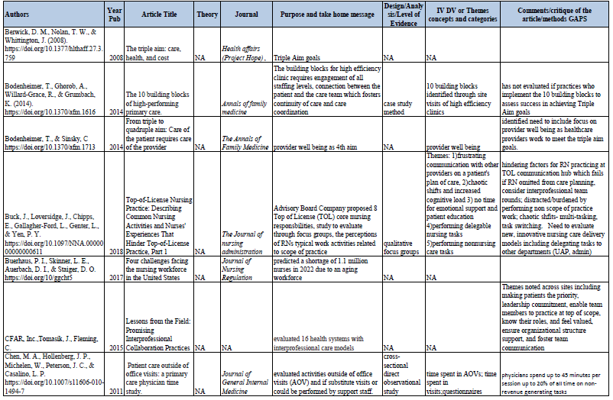
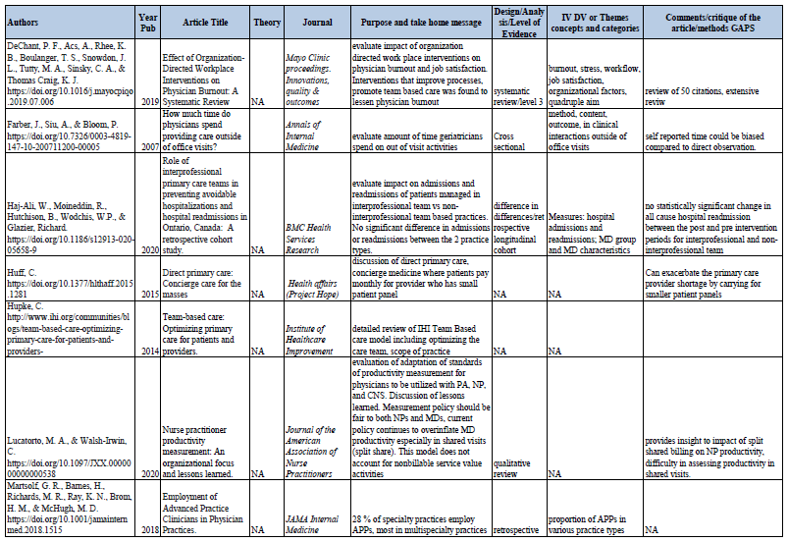
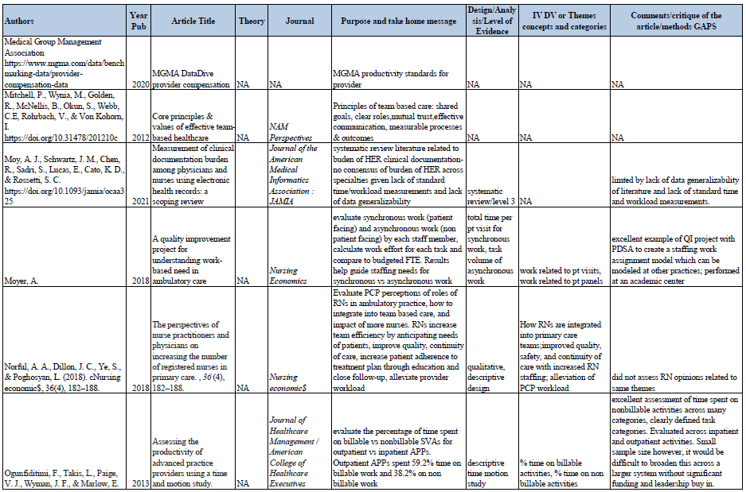

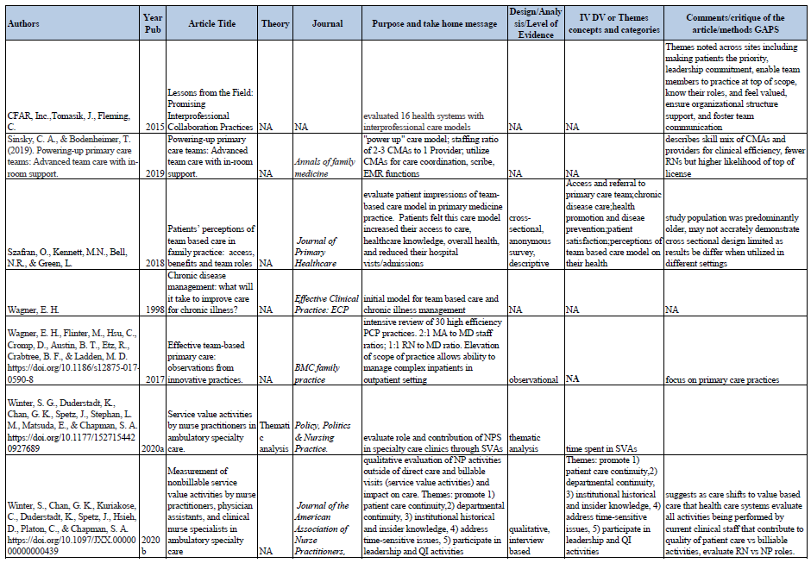

Appendix B
Project Site IRB Submission


DUHS INSTITUTIONAL REVIEW BOARD DECLARATION OF ACTIVITY NOT MEETING THE DEFINITION OF RESEARCH

The DUHS IRB has determined that the following activity does not meet the definition of research as described in 45 CFR 46.102(d), 21 CFR 50.3(c) and 21 CFR 56.10(c) and satisfies the Privacy Rule as described in 45 CFR 164.514.

Protocol ID: Pro00109820
Reference ID: Pro00109820-INIT-1.0
Protocol Title: Surgical Oncology APP Productivity: wRVUS and Continuity of Care Measures

Principal Investigator: Deborah Allen

This IRB declaration is in effect from November 16, 2021 and does not expire. However, please be advised that any change to the proposed research will require re-review by the IRB.


DUHS Institutional Review Board
2424 Erwin Rd | Suite 405 | Durham, NC | 919.668.5111 Federalwide Assurance No: FWA 000090

Appendix C
ECU IRB Submission

Appendix D
Project Timeline

Appendix E
Itemized Budget
 | Time/hour | # Staff | Time | Total Expense
Project Team Meetings
APP | $55 | 1 | 12 | $660.00
RN Manager | $40 | 1 | 12 | $480.00
RN | $28 | 1 | 12 | $336.00
CMA | $22 | 1 | 12 | $264.00
IT Manager | $27 | 1 | 12 | $324.00
 |  |  |  | $2,064.00 | $2,064.00
Epic Concierge
 | $25 | 1 | 2 | $50.00
 |  |  |  | $50.00 | $50.00
Workflow Training
APP | $55 | 6 | 2 | $660.00
RN Manager | $40 | 1 | 2 | $80.00
RN | $28 | 4 | 2 | $224.00
CMA | $22 | 3 | 2 | $132.00
 |  |  |  | $1,096.00 | $1,096.00
 |  |  |  |  | $3,210.00

