Teaching & Mentoring Motivational Interviewing with Clinical Staff Working within a Sexually
Transmitted Infection Clinic
Arnold McLendon
East Carolina University

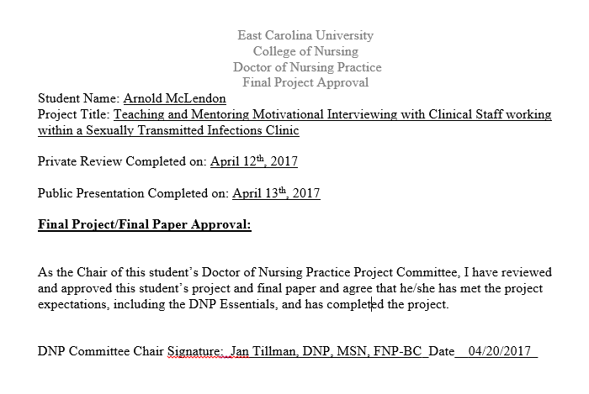
Abstract
Sexually Transmitted Infections (STI) continue to be alarming issues in the United States, costing billions of dollars to treat. The current model of STI treatment begins when a patient presents for STI screening. If treatment is indicated, clinical staff provide the treatment but may not utilize effective communication strategies to assist the patient to understand the consequences of their high-risk sexual behaviors. Motivational interviewing (MI) is a well-known counseling method that has been used to effectively create change in patient behavior. As such, the potential benefit of utilizing MI to improve clinical staff communication could result in an impactful change to a patient’s high-risk sexual behavior. This project investigated if training and mentoring in MI techniques could increase a clinical staff’s willingness to implement MI. The target population was clinical staff working in an eastern North Carolina rural county health department’s sexually transmitted infections clinic. Clinicians exposed to brief targeted MI training sessions demonstrated an increase in their confidence levels with utilizing MI during patient interactions.
Keywords: motivational interviewing, sexually transmitted infections

Acknowledgments
First, I would like to thank God for allowing me to achieve this blessing. I owe everything I am and have, to Him. I would like to thank my wife and children for enduring this school process with me. I know it has not been easy with me working full-time, school full-time, completing clinical hours, and staying up late studying, to be there for them. I was present at home, but my mind was often preoccupied with school work. Yet, all of you let me stay focused and complete my coursework. I am indebted to all of you eternally. I am truly blessed to have such a wonderful and understanding family.
I am grateful for the support, wisdom, and guidance Dr. Janet Tillman provided me throughout this project. I owe special thanks to Dr. Jim Tillman for assisting with training, and for his support and prayers. The two of you are a dynamic team, and I am so thankful for your talents and inspiration.
I would like to thank the organization where I implemented the project. The staff is truly wonderful, and I am proud of the work each and every one of them accomplished by embracing motivational interviewing. All of you were able to see the importance of motivational interviewing, and how it can potentially be beneficial to your patient population.
Lastly, I would like to thank my committee members—Dr. Tracey Robertson-Bell and Dr. Ann Bell—for their support and guidance through this process. It has been a pleasure to work with and learn from both of you.

TABLE OF CONTENTS
CHAPTER 1: INTRODUCTION
Introduction ……………………………………………………………………………….9
Problem Statement………………………………………………………………………...9
Justification of Project..…………………………………………………………………...9
Theoretical Framework…………………………………………………………………..11
Assumptions……………………………………………………………………………...12
Project Question………………………………………………………………………….14
Definition of Terms………………………………………………………………………14
Summary…………………………………………………………………………………15
CHAPTER 2: REVIEW OF LITERATURE
Review of Literature……………………………………………………………………..15
Gaps in Literature………………………………………………………………………..24
Strengths and Weaknesses of Literature…………………………………………………24
CHAPTER 3: PROJECT DESIGN
Project Design……………………………………………………………………………25
Length of Project…………………………………………………………………………25
Evaluation………………………………………………………………………………..26
CHAPTER 4: RESULTS
Results……………………………………………………………………………………27
CHAPTER 5: DISCUSSION
Discussion………………………………………………………………………………..31
Implications of Findings…………………………………………………………………32
Limitations……………………………………………………………………………….33
Recommendations………………………………………………………………………..33
Conclusions………………………………………………………………………………34
REFERENCES…………………………………………………………………………………..35
APPENDICES…………………………………………………………………………………...39

CHAPTER 1
Introduction
One of the primary goals of the Healthy People 2020 initiative is to promote healthy sexual behavior (Office of Disease Prevention and Health Promotion, 2014). Millions are affected each year by sexually transmitted infections (STIs), with the true rate of all STIs not being known due to only cases of chlamydia, gonorrhea, and syphilis being reported to the CDC (Office of Disease Prevention and Health Promotion, 2014). In addition to these STIs, North Carolina requires conditions such as HIV, pelvic inflammatory disease, and AIDS to be reported to state officials.
The costs of treating STIs are estimated to be as much as $15 billion annually (Office of Disease Prevention and Health Promotion, 2014). Biological, social, economic, and behavioral factors contribute to the spread of STIs (Office of Disease Prevention and Health Promotion, 2014). Public health departments are the foundational institutions where many individuals seek treatment for STIs (Brackbill, Sternberg, & Fishbein, 1999). It is these same public health departments that aid in evaluating infection patterns in high risk groups and executing control processes (Brackbill et al., 1999). The treatment model at most health departments is the “old” treatment model, in which: (a) the patient presents with a chief complaint of STIs, (b) treatment is provided along with advice, and (c) the patient is handed educational material and leaves.
At the project site, utilization of evidence-based therapeutic communication strategies were not being performed. “MI, developed by Miller and Rollnick in 1983, is a well-known, scientifically tested method of counseling clients and viewed as a useful intervention strategy in the treatment of lifestyle problems and disease” (Rubak, Sandboek, Lauritzen, & Christensen, 2005, p. 305). Likewise, Motivational Interviewing is evidence based, and has been beneficial in helping patients adhere to treatment and change behavior (Levensky, Forcehimes, O’Donohue, & Beitz, 2007).
Problem Statement
The current model of counseling in the STI clinic begins with the patient presenting for STI screening and treatment. Treatment is provided without clinical staff utilizing a communication style that can effectively help patients to understand the consequences of their high-risk behaviors. Research has shown that the use of MI has been beneficial in helping patients change behavior (Ross et al., 2007), and the potential benefits of utilizing MI to improve clinical staff communication in the STI clinic could be impactful in changing a patient’s high-risk sexual behavior. This project investigated if training and mentoring MI would increase a clinical staff’s willingness to implement MI.
Justification of Project
In the United States, STIs are on the rise for the first time in 10 years (U.S. Department of Health and Human Services, 2015). In 2013, 1.4 million cases of Chlamydia Trachomatis were reported, up 2.8% since 2006. (U.S. Department of Health and Human Services, 2015). Treponeum pallidum (Syphilis) and Neisseria Gonorrhoeae have both increased since 2013, increasing 15.1% and 5.1% respectively (U.S. Department of Health and Human Services, 2015). Rates are increasing among heterosexual men, gay men, and bisexual men, which has contributed to the overall increased rate in STIs (U.S. Department of Health and Human Services, 2015). Adolescents between the ages of 15 and 24 exhibit the highest rates of acquiring STIs, and account for half of the 20 million new cases of STIs each year (U.S. Department of Health and Human Services, 2015). In 2010, almost half of high school students were sexually active and re-infection was common in this age group (In-Iw, Braverman, Bates, & Biro, F., 2015). “Fourteen percent are re-infected within 1 year, with a median time of 4 to 7 months for females and 6 to 10 months for males, with the highest recidivism rates belonging to 15 to 19 year olds” (In-Iw, et al., 2015).
Motivational interviewing (MI) is a counseling approach that provides positive outcomes in behavior changes (Miller & Rollnick, 2013). Initially, MI was primarily focused on behavioral changes with regards to substance abuse (Miller & Rollnick, 2013). MI has been shown to provide better outcomes than when clinicians provided traditional advice giving to patients (Britt, Hudson, & Blampied, 2004). Traditional clinical communication as advice is only one of several types of communication typically used. Evidence suggests that the effectiveness of traditional advice giving is not strong, with success rates as low as 5–10 % in terms of achieving behavioral change among patients (Britt et al., 2003). The primary goal of MI is to assist in behavioral change by helping patients explore and resolve their conflicting feelings about the behavioral change (Britt et al., 2003). The principles of MI are expressing empathy, identifying discrepancy, avoiding argumentation, rolling with resistance, and supporting self-efficacy (Britt et al., 2003). Miller and Rollnick describe empathy as the ability of the clinician to understand the patient’s internal perspective (Miller & Rollnick, 2013). Once the clinician understands the patient’s perspective, then he or she can better assist the patient identify any discrepancies between their behaviors and goals, so that it appears the patient presents the argument for change, rather than the clinician offering the patient advice (Britt et al., 2003). Avoiding argumentation with patients is critical (Britt et al., 2003), as the patient may become defensive and resistant to change (Britt et al., 2003). Instead, clinicians are to create a collaborative partnership with patients via communication that strengthens the patient’s own commitment and motivation to change (Britt et al., 2003). Rolling with resistance simply means exploring with the patient to help them understand their conflicting feelings toward change (Britt et al., 2003). To support self-efficacy, clinicians help patients discovery that they possess the inner strength and tools needed for change, and that they must have faith in themselves (Britt et al., 2003). When change is hard, it is often because of ambivalence, and MI is an effective way of engaging individuals about change. MI helps patients resolve uncertain feelings and can be used as a guide by clinicians to assist patients in sorting through their feelings and discovering their own reasons for change (Miller & Rollnick, 2013).
Theoretical Framework
Bandura’s Social Cognitive Theory (SCT) was chosen to assist in the implementation of this quality improvement project as it was put into practice. Bandura’s theory explains how people are motivated by external factors, and that these factors include the interaction of behaviors, personal factors, and their environments (The World Bank). In SCT, situational influences and the environments in which the behavior is preformed represent the environmental factors (The World Bank). Personal factors are characterized instincts, drives, traits, and other individual motivational forces (The World Bank). However, there are also variables that influence human learning and behavior change (The World Bank). These variables may also compete in the process of changing behavior, and include self-efficacy, outcome expectation, self-control, reinforcements, emotional coping, and observational learning (The World Bank).
Bandura’s SCT says that, in order for any change to be effective, self-efficacy had to be improved and incentives had to be placed into effect to keep individuals motivated to continue the behavior change (The World Bank). Therefore, to increase self-efficacy, two half-day onsite training sessions with an MI expert were provided to clinicians who worked in the STI clinic. The clinical staff received ongoing support from leadership to continue practicing and using MI techniques with patients. The project stipulated that staff members were expected to complete yearly trainings, such as online modules related to MI, to improve their confidence and empower them to continue using MI techniques daily. Once the health department’s leadership had gauged staff members fully embracing and utilizing MI techniques, special incentives were enacted to keep the staff motivated to continue using MI techniques. With this higher level of education, staff in STI clinic will feel more comfortable incorporating MI into their patient interactions.
To assist in shaping the environment to encourage behavioral change, it was made clear from leadership that utilizing MI techniques would be an expectation. Staff members were encouraged to utilize MI when interacting with patients. It was anticipated that interviews would run longer during initial MI implementation, but over time, encounter length would decrease as the staff became more familiar and comfortable with MI techniques. Using the social cognitive theory as a framework, the clinical staff worked to improve their communication skills by using MI when interviewing patients. This communication increased staff members’ self-confidence and helped them develop a therapeutic rapport with patients (personal factors), improved their MI skills and self-regulating practices (behavior), and altered the clinic processes by practicing MI on a routine basis making it more familiar for everyone working in the clinic (environmental factors) (Pajares, 2002).
Assumptions
Bandura’s Social Cognitive Theory has several assumptions. One assumption is that learning occurs in a social context, and much of what is learned is gained through observation (Denler, Wolter, & Benzon, 2013). As such, training was provided in a social context with a MI trainer leading and guiding the group sessions. Another assumption relates to the relationship and interactions of how personal, behavioral, and environmental factors influence each other (Denler et al., 2013). This simply means that an individual’s ongoing functioning is created by an endless collaboration between cognitive, behavioral, and contextual factors (Denler et al., 2013). Another assumption of SCT is that individuals have the ability to control and direct one’s own behaviors and environment in a meaningful way; and via planning, self-reflection, and self-regulatory processes, individuals can exercise considerable control over their own conclusions and their environment (Denler et al., 2013). At the end of each training session, clinical staff were asked to reflect upon the day to identify favorable and unfavorable aspects of the training. One last assumption of SCT that was helpful for this project was that SCT assumes learning requires more than attainment of new behaviors, but also requires new knowledge, cognitive skills, concepts, abstract rules, and values (Denler et al., 2013).
Core concepts in SCT include observational learning and modeling, outcome expectation, perceived self-efficacy, goal setting, and self-regulation (Denler et al., 2013). The primary premise of SCT is that people learn through observation and modeling. This was accomplished during the onsite training sessions with the MI expert. The MI expert incorporated role-play with the clinical staff as a means of teaching and modeling MI techniques. Outcomes expectation is the second core concept of SCT, and depicts an individual’s belief about what ramifications can be anticipated when a behavior is performed. Clinicians were trained to perceive that more therapeutic relationships with patients as a result of increased engagement in communication with the patient, would result in better strategies that could be implemented to avoid STI re-infections.
Self-efficacy refers to an individual’s own belief in being successful at a task (Denler et al., 2013). Education, support, and reassurance from leadership offered to the clinical staff were monumental in increasing the staff members’ self-efficacy. Goal setting was important because it helped individuals set achievement points to reach. In the beginning, the clinical staff decided to use MI techniques with a limited number of patients, and then gradually increased that number as he or she gained more confidence with using the communication techniques. Self-regulation involves the three processes of self-observation, self-judgment, and self-reaction (Denler et al., 2013). Self-observation represents one’s ability to monitor one’s own behaviors. Self-judgment is the evaluation of whether one’s own actions are effective. Finally, self-reaction is when and how one responds to the evaluations made—either revising the behavior, continuing it, or terminating the behavior (Denler et al., 2013).
Project Question
The question this project aimed to answer was: Will training and mentoring MI increase a clinical staff’s willingness to implement MI? To measure the effectiveness of the question, two half-day onsite MI training sessions were provided by a MI trainer, and each trainee was evaluated on how effectively they used MI techniques during a simulated patient encounter by the MI trainer using a validated MI toll. Feedback from the MI trainer was offered to clinical staff after observation was completed.
Definition of Terms
For the project, the terms “sexually transmitted diseases” and “sexually transmitted infections” were used interchangeably. The two terms are herein used synonymously; however it should be noted that, in the world of health sciences, infections are called diseases when patients are symptomatic (Davis, 2016). Individuals are more familiar with the term sexually transmitted diseases, but for the purposes of this paper, sexually transmitted infections will be used. “Self-efficacy” refers to an individual’s own belief that he or she can be successful at a task (Denler et al., 2013). “Self-regulation” refers to the ability of an individual to monitor his or her own behaviors and alter behaviors that are not beneficial to teach (Denler et al., 2013).
Summary
The current state of counseling in the STI clinic is that patients’ present for STIs screening and treatment, if indicated. Treatment is provided without clinical staff utilizing a communication style that assists in helping patients understand the consequences of their high-risk behaviors. The current treatment model of traditional provider-patient communication is being utilized because staff is familiar and comfortable with it. MI training and mentoring could be beneficial to staff feeling comfortable with implementing MI techniques into individualized patient interactions and interviews. When clinical staff are taught and mentored in MI, effective communication is potentiated, and there is increased potential to motivate behavior change in patients with high risk sexual behavior.
Chapter 2
Review of Literature
A literature review was conducted by searching various databases and search engines. Using the key words of “motivational interviewing”, “sexually transmitted infections”, and “sexually transmitted diseases”, a search was conducted using PubMed, Cumulative Index to Nursing, and Allied Health Literature (CINAHL), and ProQuest Nursing & Allied Health Source databases. A total of 141 potential articles were obtained. An emphasis was placed on articles from the last five years, with some articles preceding the five-year date in order to provide a historical record of motivational interviewing. The list of 141 potential articles was decreased to 48 articles. By reading article abstracts, 93 articles were eliminated as they were not related to using motivational interviewing as an intervention by clinicians. Of the 48 remaining articles, one article was a Cochrane Review of theory-based interventions for contraception (Lopez, Tolley, Grimes, Chen, & Stockton, 2013). The review included 17 trials. Of the 17 trials, four were based primarily on motivational interviewing; Floyd 2007, Ingersoll 2011, Petersen 2007, and Kirby 2010 (Lopez et al., 2013). Since Cochrane reviews are systematic reviews that are recognized as high in evidence and scientific objectivity, a decision was made to include these four articles in the literature review. These articles dealt directly with the efficacy of training clinicians to use motivational interviewing and/or using motivational interviewing in a clinic setting. The four articles, Floyd et al. (2007), Ingersoll et al. (2011), Petersen et al. (2007), and Kirby et al. (2010), will be discussed later in this paper. The Consolidated Standards of Reporting Trials (CONSORT) was utilized to assess the quality of reporting of these four articles. In addition, a study that utilized motivational interviewing in brief training with an endocrinology practice will be discussed (Bean, Biskobing, Francis, & Wickham, 2012).
Floyd et al. (2007) published data from a study conducted from 2002–2006 which was a randomized controlled trial on preventing alcohol exposure during pregnancy. Floyd et al. (2007) focused on using motivational interviewing techniques during four counseling sessions to reduce the risk of an alcohol exposed pregnancy in women by concentrating on risk drinking and ineffective contraception use (Floyd et al., 2007). The study was called project CHOICES (Floyd et al., 2007). The motivational intervention consisted of four counseling sessions and one contraception consultation and services visit (Floyd et al., 2007). The main strategy of the intervention was to empower women to change one or both behaviors of risky drinking and ineffective contraception use (Floyd et al., 2007).
The counseling session intervention was conducted by 21 trained counselors holding a minimum education level of Master’s degree or above (Floyd et al., 2007). The intervention focused on discussing the subject’s commitment to change using motivational interviewing, and while the intervention was aimed at both high-risk behaviors, counselors could target and discuss either of the two topics the participants felt was more important (Floyd et al., 2007). The counseling sessions and the contraception consultation visit were each 45 to 60-minutes long and subjects were contacted at three, six, and nine months for follow-up assessments, with a contraception visit occurring between the second and third counseling session (Floyd et al., 2007).
The primary outcomes for the study were to reduce risky drinking, ineffective contraception, and risk for alcohol exposed pregnancy (Floyd et al., 2007). The primary study outcomes were assessed using the timeline follow back (TLFB) method (Floyd et al., 2007). TLFB has been used heavily in clinical and non-clinical populations, and has been shown to be effective with assisting patients with memory recall of events (Floyd et al., 2007).
Analysis of the data revealed statistically significant benefits of project CHOICES. The data suggested that across all three phases of follow-up (three, six, and nine months), the odds of being at reduced risk for an alcohol exposed pregnancy was doubled in the intervention group compared to the control group (Floyd et al., 2007). Overall, the odds ratios of being at reduced risk for an alcohol exposed pregnancy were more favorable for the intervention group than the control group; thus indicating that a brief motivational intervention targeting high risk behaviors of risky drinking and ineffective contraception use reduced the risk of an alcohol exposed pregnancy (Floyd et al., 2007).
A randomized control trial conducted by Ingersoll et al. published in 2011 applied a descriptive study using motivational interviewing and a feedback intervention aimed at reducing the risk of alcohol exposed pregnancy among college women who participated in binge drinking. The premise of the study was that binge drinking combined with pregnancy risk due to absent, sporadic, or unsuccessful contraception among fertile, sexually active women increased their potential of having an alcohol-exposed pregnancy. Using studies, such as Hickey (2009), Ingersoll et al. identified that for every 15 out of 100 college women that had ever been pregnant, more than half reported their pregnancies were unplanned (Ingersoll & Ceperich, 2011). Sawyer et al. (1998) revealed that more than one third of college women requesting pregnancy testing reported using no contraception, while 60% had contraception methods available but did not use the methods on a consistent basis (Ingersoll & Ceperich, 2011). Ni Riain (1998) found that college women were more apt to use contraceptive methods after a scare, but Kusseling et al. (1995) found that the women eventually fell back into old habits and did not maintain effective contraceptive measures (Ingersoll & Ceperich., 2011). Ingersoll and Ceperich (2011) decided to model their study after Floyd et al. (2007) CHOICES, discussed previously. Ingersoll and Ceperich (2011) wanted to determine whether reducing the number of counseling sessions by one would be as effective as the alcohol exposed pregnancy risk reduction intervention by Floyd et al. (2007) (Ingersoll & Ceperich, 2011).
Ingersoll and Ceperich (2011) conducted one session of motivational interviewing plus a personalized feedback intervention to see if it would reduce the risk of alcohol exposed pregnancy due to alcohol consumption and ineffective contraception usage among college women who are sexually active (Ingersoll & Ceperich, 2011). They called the study BALANCE. An assessment tool was designed to assess study participants’ behaviors and other influences that could potentially relate to treatment response (Ingersoll & Ceperich, 2011). The BALANCE assessment tool was administered prior to randomization, with follow-up assessments at one and four months (Ingersoll & Ceperich, 2011). The tool, consisting of 41 questions, was administered by a study counselor and covered topics such as demographic characteristics, sexual behaviors, obstetric history, alcohol and illicit drug use, health behaviors and knowledge, and attitudes (Ingersoll & Ceperich, 2011).
The BALANCE counseling intervention consisted of a 60 to 75-minute Motivational Interviewing session and a personalized feedback session that followed a semi-structured counseling manual (Ingersoll & Ceperich, 2011). Counselors used motivational interviewing techniques during intervention activities, followed by the participants being asked to record her data for drinking, sexual intercourse, and contraceptive behaviors (Ingersoll & Ceperich, 2011). Counselors computed each intervention subject’s data and provided individualized feedback of risks using a printed BALANCE Feedback Form.
Results of the study indicated that the BALANCE intervention with Motivational Interviewing plus feedback that targeted drinking and contraceptive behavior showed that the rate of alcohol-exposed pregnancy risk in the intervention group was 20.2% versus the control group at 34.9% (p-value < .02) (Ingersoll & Ceperich, 2011). One can see from these results that not receiving the intervention almost doubled the control group’s chances of experiencing an alcohol exposed pregnancy (Ingersoll & Ceperich, 2011). While the outcomes of both the CHOICES and BALANCE studies are similar, CHOICES improvements continued over time and did not diminish significantly, whereas with BALANCE, there was a decline in the statistical differences between the groups for risk drinking and pregnancy risk over time (Ingersoll & Ceperich, 2011). However, this does not diminish neither the importance nor the significance of demonstrating the impact motivational interviewing can have on changing high risk behaviors, which both studies indicated.
A randomized controlled trial conducted by Petersen et al. (2007) investigated pregnancy and STI prevention counseling using an adaptation of motivational interviewing. Petersen et al. (2007) hypothesized that since more than half of all pregnancies in the United States are unplanned, an effective counseling intervention would improve women’s consistent use of effective prevention methods (Petersen, Albright, Garrett, & Curtis, 2007). Petersen et al. (2007) supported the need for the study arguing that half of all pregnancies in the United States were unintended, and these same pregnancies were at higher risk for low-birth weight infants, late initiation of prenatal care, use of harmful substances during pregnancy, and contraction of STI’s (Petersen et al., 2007).
Providers are in the ideal environment to provide patients with counseling for behaviors that place them at risk for unintended pregnancies and STI’s, and Petersen et al. (2007) contend that their counsel should focus on reducing risky behavior for sexually active women. Few providers counsel women on their contraceptive needs, sexual risk taking behaviors, or the need for pregnancy or disease prevention (Petersen et al., 2007). In primary care settings, there is no validated instrument noted to be effective in behavior change that could potentially lead to a decrease in unintended pregnancies and STIs (Petersen et al., 2007). The interventions that have been used and found successful in other areas of health promotion have been implemented with targeted high-risk individuals outside of the primary care setting, such as individuals in drug treatment, ones who live in high-risk communities, or incarcerated individuals (Petersen et al., 2007).
Petersen et al. (2007) conducted their study at three primary care facilities affiliated with the Department of Family Medicine of the University of North Carolina at Chapel Hill (Petersen et al., 2007). During the trial, the intervention group received pregnancy and STI prevention counseling at enrollment and two months later in a follow-up session (Petersen et al., 2007). At the time of enrollment, the control group received one brief, general counseling session related to preventive health care, such as smoking cessation, diet, exercise (Petersen et al., 2007).
The intervention was based on the concepts of MI and emphasized three elements: (1) exploring discrepancies between pregnancy intention and contraceptive use, and between STD risk and condom use, (2) sharing information with participants, and (3) promoting behaviors to reduce risk (Petersen et al., 2007). The researchers found that the percentage of women maintaining a high level or improving their level of contraceptive use between baseline measurement and the 12-month follow-up was slightly higher among the intervention group (Petersen et al., 2007). A possible reason why the intervention group numbers were slightly higher could be attributed to the study limitations, i.e. reliance on self-reporting for contraceptive use and barriers to use, and counseling inconsistencies among health educators (Petersen et al., 2007). The researchers concluded that repeated counseling may be beneficial to improve contraceptive decision-making and to reduce the risk of unintended pregnancy and STIs, thus again emphasizing the potential significance of motivational interviewing (Petersen et al., 2007).
A study conducted by Kirby et al. (2010) researched the impact of an intervention to improve contraceptive use through follow-up phone calls to female adolescent clinic patients. The study was a randomized, controlled study (RCT) and the participants received follow-up phone calls that integrated the concepts of motivational interviewing to improve contraceptive use (Kirby et al., 2010). The researchers hypothesized that the intervention would increase condom and hormonal contraceptive use, thus reducing the pregnancy rate, enhancing patient relationships with the clinic and its services, and, ultimately, change patients’ high risk sexual behaviors (Kirby et al., 2010).
For the intervention, follow-up phone calls were made to participants during a 12-month period: one call per month for the first six months, and one call every two months for the next six months (Kirby et al., 2010). During the calls, counselors utilized the intent and techniques of motivational interviewing to engage participants in conversations about their current relationship statuses, pregnancy desires, condom use, and contraceptive use (Kirby et al., 2010). The counselors assessed the participants’ perceptions of high risk behaviors and helped them identify the discrepancies between the patients’ high risk behaviors and their goals (Kirby et al., 2010). Although the analysis of the data revealed it may not be reasonable to utilize follow-up phone calls to achieve behavior change, the data clearly demonstrated that during follow-up, women in both the intervention and control groups increased their use of contraceptives and reduced their frequency of unprotected intercourse (Kirby et al., 2010). The counselors performing the follow-up phone calls received little motivational interviewing training, and the researchers concluded that a phone intervention utilizing motivational interviewing could potentially be more successful if implemented by counselors with advanced motivational interviewing training (Kirby et al., 2010).
The last study that will be discussed focused on motivational interviewing and the results of a brief training in endocrinology. The study was conducted by Bean, Biskobing, Francis & Wickham (2012), and was conducted with endocrinology providers (Bean et al., 2012). The researchers found that even though MI has been proven to be effective, an insufficient amount of published reports about MI training in graduate medical education exists (Bean et al., 2012). The goal of the study was to demonstrate the viability and efficacy of a brief MI training intervention for endocrinology fellows and other providers (Bean et al., 2012).
The researchers utilized a pretest/posttest design to evaluate the effectiveness of a brief MI training for a small group of providers that consisted of endocrinology fellows, nurse practitioners, dietitians, attending endocrinologists, and pharmacists at a large Virginia urban academic medical center (Bean et al., 2012). Study participants completed a pre and post survey prior to and after MI training (Bean et al., 2012). Their patient encounters were then recorded for a two to three-week period prior to and after MI training, and were also evaluated and coded for MI compliance (Bean et al., 2012). Six hours of training was conducted during a four weekly 1.5-hour training sessions (Bean et al., 2012). The training consisted of didactics, group discussions, practice activities, and video vignettes (Bean et al., 2012). Course materials included a text, journal articles, training DVD’s, and Motivational Interviewing Network Trainers (MINT) training exercises, including role play (Bean et al., 2012).
Session one focused on defining MI and the spirit of MI, session two focused on teaching the concepts of open-ended questions, affirmations, reflections, and summary statements (Bean, et al., 2012). During session three, participants had the opportunity to practice MI and learn strategies for implementing MI in patient encounters (Bean et al., 2012). During the final session, participants were given more opportunities to practice MI, and were provided with a review of previously discussed material (Bean et al., 2012). For evaluation purposes, participants’ patient encounters were coded using the Motivational Interviewing Treatment Integrity (MITI) version 3, which is a validated rating system for determining MI conformity (Bean et al., 2012).
The study findings revealed that the MI training intervention was practical, and that at post-test, participants showed (a) an increase in utilization of MI and (b) an increased confidence in MI skills (Bean et al., 2012). The researchers concluded that although more training is needed for individuals to become proficient or confident with using MI, the results revealed that even brief, targeted MI training had short-term benefits and was well received by providers (Bean et al., 2012).
Gaps in Literature
A review of literature resulted in 141 articles, which revealed a gap in the use of interventions, such as motivational interviewing. Motivational interviewing is a noninvasive intervention that has been used to address high-risk health behaviors in patients with substance abuse, HIV, and risky sexual behaviors in gay and bisexual men. The literature failed to yield substantial research evaluating the use of motivational interviewing by clinicians working in clinics that diagnose and treat sexually transmitted infections. The literature also revealed that there is not a standardized curriculum for teaching MI, and, although numerous methods have been described, a limited number of studies have examined MI training for specialists (Bean et al., 2012).
Strengths and Weaknesses of Literature
The literature review demonstrated that motivational interviewing is an effective evidenced-based communication strategy that can potentially create positive behavioral change. Numerous research studies in the literature review appeared to focus on the behaviors of females, regardless of whether the study was related to sexual behaviors or not. The majority of the papers were related to the use of motivational interviewing and HIV treatment, and three articles out of 141 directly related to clinicians working in sexually transmitted infections clinics using motivational interviewing to address patients’ high risk sexual behavior.

Chapter 3
Project Design
A literature search was conducted and remained ongoing, extensive, and assembled throughout the project to ensure the latest research regarding MI was included in the training. The clinical staff that participated in the training were identified for the two half-day training sessions and one half-day follow-up evaluation via one-on-one phone calls with the MI trainer. Clinical staff performing direct patient care in the STI clinic were required to attend all training sessions. The MI trainer was contacted and negotiations were conducted with the MI trainer to provide training, coaching, and mentoring sessions to the clinical staff.
Length of the Project
The project consisted of four phases. The initial phase started spring 2016 with the project proposal, literature review, projected project timeline, and obtaining a letter of organizational support. The second phase of the project occurred during the summer 2016, and included the institutional review board process to determine if permission was needed to use the MITI tool. The project was implemented during phase three, which occurred during fall 2016, and data analysis occurred during phase four of the project, in spring 2017.
Implementation of onsite training started in fall 2016. Training consisted of two half-day training sessions lasting four hours each and one half day follow-up evaluation session, where the trainer performed an assessment of each participant’s use of MI. Follow-up coaching and mentoring sessions provided by the MI trainer was negotiated between the MI trainer and site director. Total training for the two half day sessions was eight hours. Three hours of time was dedicated to follow-up coaching and mentoring sessions provided by the MI trainer. Therefore, the health department invested a total of 11 hours for the MI training. Onsite training was completed in fall 2016 so that a final analysis of the project could be performed by the project leader. Findings were presented to project committee members and at the East Carolina University College of Nursing’s spring 2017 Poster Day.
Evaluation
The total number of clinical staff that participated in training was identified for two half-day training sessions and one half-day follow-up evaluation session. Six employees were identified for the training. The six employees consisted of two family nurse practitioners and four enhanced-role registered nurses. After completion of training, the MI trainer conducted one-on-one phone sessions with the participants to evaluate retention of MI concept and practices. It is important to note that the evaluation of learning was performed during simulated phone calls and not with actual patients. The MI trainer met with the participants to conduct a 20-minute interview utilizing the spirit of MI with an emphasis on the aspects covered in the initial training. Each trainee was provided a patient scenario by the trainer. The employee used the patient scenario to demonstrate retention of MI knowledge from the training sessions. The MI trainer evaluated each trainee’s interview using the MITI tool and then provided feedback during a brief 5 to 10-minute session with each trainee. The MITI tool is a widely used validated MI assessment tool (McMaster & Resnicow, 2015). A study by Pierson et al. examined the reliability of the MITI tool. The researchers audiotaped interactions between substance abuse counselors, with one role playing as the patient (Pierson et al., 2007). The audiotaped encounters were scored using the MITI tool by trained undergraduate and graduate students (Pierson et al., 2007). Their MITI scorecards were compared and found to produce the same reliability and integrity results (Pierson et al., 2007). Finally, there were discussions held with the health director regarding follow-up sessions, mentoring staff, and identifying a staff champion for MI. Additional discussions were held with the health director regarding yearly implementation of MI modules as a mandatory learning assignment for clinical staff to ensure ongoing expectations and competency in MI techniques. The MITI tool and all other project-related documents were submitted for IRB approval. In addition, permission for use was obtained for any documents not in the public domain.
Chapter 4
Results
The purpose of this project was to see if training and mentoring MI would increase clinical staff’s willingness to utilize MI when talking with patients in the sexually transmitted infection clinic at one rural health department. Clinical staff (n=6) participated in the project. The participants included two family nurse practitioners (FNP), and four enhanced-role registered nurses providing patient services in the STI clinic. All project participants were women and ranged in age from 30-years-old to 63-years-old. One FNP was African-American, and the other was Asian-American. Three of the enhanced role nurses were Caucasian and one was Latina.
After completing two half-days of training, the MI trainer followed up one week later with individual phone sessions to evaluate how well each participant retained the concepts of MI. The evaluation of learning was conducted via simulation and not with actual patients. The MI trainer met with the participants one-on-one via phone, and conducted a 20-minute interview. The trainer provided the participants with a patient scenario and they utilized MI concepts with an emphasis on the aspects covered during trainings to address individual scenarios. For evaluation purposes, the participants’ simulated patient encounters were coded using the Motivational Interviewing Treatment Integrity (MITI) version 3, which is a validated rating system for determining MI conformity (Bean et al., 2012).
The MITI tool is comprised of two components: global scores and behavior counts (Miller & Rollnick, 2013). The global scores required the trainer to assign a number 1-5 to describe the interview (Miller & Rollnick, 2013). These scores were meant to capture the rater’s overall impression about how well the participant utilized the spirit of MI, as far as evocation, collaboration, autonomy/support, direction, and empathy (Miller & Rollnick, 2013). These terms herein are defined as follows: Evocation is the belief the client already possess internal attributes for successful behavioral change (Miller & Rollnick, 2013). Collaboration means the clinician works with the patient to identify the internal tools they already have, instead of the clinical taking on the traditional advice giving role (Miller & Rollnick, 2013). Autonomy and support is respecting individual’s right for self-direction (Miller & Rollnick, 2013). It is important to note that global scores reflect the overall evaluation of the participant, with a spirit global rating parsed into three global ratings: evocation, collaboration, and autonomy/support (Miller & Rollnick, 2013). Individual rating scores for evocation, collaboration, and autonomy/support were averaged together to produce a spirit global (Miller & Rollnick, 2013). Participants at the highest end of the spirit global rating displayed a high degree of collaboration, evocation, and autonomy/support, while participants who scored lower on the scale exhibited low levels of collaboration, evocation, and support for autonomy.
Participants who scored high in MI Spirit demonstrated collaboration in the one-on-one patient simulation and displayed that they could avoid taking on the traditional provider expert role. As such, the successful participant partnered with their patient to develop a therapeutic treatment plan. They demonstrated evocation by showing they could assist their patient in helping them self-identify the resources they already possessed to be successful at change. The participants also demonstrated support for autonomy by offering support for their patient, regardless of the decisions the simulated patient made.
The trainer evaluated each trainee’s interview and then provided feedback during a brief 10-minute session after the interview. To assess pre and post comfort level with regards to using MI, the trainer added a question to the MITI tool asking each participant to rate their pre and post confidence level with 1 being “not at all” and 10 being “extremely confident”, regarding their confidence in using MI. Table 1 shows the participants global ratings and MI spirit. Table 2 provides the results of self-identified Pre and Post-MI Training Confidence Levels for all participants.
Table 1
Participant Global Ratings & MI Spirit
Participant | Evocation | Collaboration | Autonomy/Support | Direction | Empathy | MI Spirit
1 | 2 | 2 | 2 | 5 | 3 | 2
2 | 2 | 2 | 2 | 5 | 4 | 2
3 | 3 | 3 | 3 | 5 | 3 | 3
4 | 4 | 4 | 4 | 5 | 3 | 4
5 | 4 | 4 | 4 | 5 | 4 | 4
6 | 4 | 4 | 3 | 4 | 4 | 4

Table 2
Pre/Post MI Training Confidence Level
Participant | How confident were you with using MI at the beginning of the workshops? | How confident are you with using MI after the completion of the workshops?
1 | 1 | 2
2 | 1 | 4
3 | 1 | 5
4 | 1 | 6
5 | 1 | 5
6 | 2 | 7

Figure 1 shows the total pre/post training MI confidence level with the average. MI confidence level was measured on a scale of one to ten. The pre-training level was 1.17 (averaged) and the post-training level was 4.83 (averaged), which indicated by self-report an improvement of 73%.
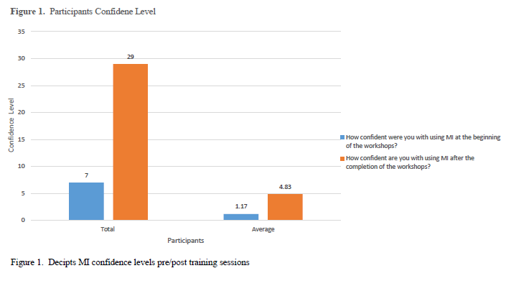
Chapter 5
Discussion
This purpose of this project was to determine if training and mentoring MI would increase clinical staff members’ willingness to implement MI. MI is an evidence-based way of providing counseling to clients to create behavioral change. A potential benefit of staff feeling more confident with utilizing MI to improve communication with their patients could be a change in their patient’s high-risk sexual behavior. After the training, participants demonstrated increased confidence level with utilizing the concepts of MI after the brief targeted training session. The results of a study completed by Bean et al. in 2012 demonstrated similar results, showing that brief targeted MI training resulted in short-term efficacy. This is important, because MI success is about exemplifying the spirit of MI. More extensive MI training completed on a yearly basis could potentially yield more positive results. After training was complete, the clinical staff members’ self-efficacy confidence level regarding the use of MI increased.
Bandura’s SCT assisted in the implementation of this quality improvement project as put into practice. According to Bandura’s SCT, for change to be effective, participants’ self-efficacy had to be improved and incentivized to keep individuals motivated to continue the behavior change (The World Bank). Training occurred in a social context with group role playing and classroom discussions. Learning in a social context is vital component of Bandura’s SCT. Discussions with clinic leadership, training participants, and the MI trainer will remain ongoing to develop incentives to centime MI momentum. The clinic leadership demonstrated full buy-in of continued MI training, and discussions have begun to provide additional MI training during the upcoming fiscal year. Budget development includes annual MI training and evaluation of MI competencies for clinic staff.
Implications of Findings
The findings of the project indicated that brief targeted training of basic concepts of MI with providers increased their confidence levels with regards to implementing MI into their daily interactions with patients. Data received from post training tests and conversations with the clinical staff showed that the staff members were more confident with MI concepts and interviewing techniques. Data from the post training surveys indicated that staff members would be more willing to use MI when talking with their patients to create change or modify patients’ sexually risky behaviors. It is important for the clinic leadership to continue supporting the staff with learning MI techniques and include training on a yearly basis. Potential outcomes on participants increased confidence level with using MI include improving the patient’s experience of care, improving the health of the population, and reducing the cost of healthcare—all of which are directly related to the Triple Aim (Institute for Healthcare Improvement, 2017). The clinic was encouraged to incorporate more robust tracking methods related to STI recidivism rates.
In order for staff to improve their MI skills, Bandura’s SCT indicates it is imperative for the concepts to be practiced, and for training to be conducted in a social context in order to continue improvement of communication skills. Participants reported the training was helpful and that they would utilize the knowledge gained to implement MI in their daily interactions with patients. Participants reported feeling more comfortable and confident with MI concepts after being exposed to the brief targeted MI training sessions.
Limitations
Project limitations included a small sample size of participants, thus limiting generalizability, and that an MI knowledge assessment questionnaire was not administered to examine participants’ existing knowledge of MI prior to training. This pre-examination/survey could have identified if there were any existing biases regarding training, use, or content of MI. Generalizability is limited because of the small clinic size and number of participants. Therefore, caution is recommended in generalizing the results to larger clinics. Readers cannot presume similar result in larger clinics or non-public health settings.
Recommendations
Future research studies could include a larger sample size of participants and include clinical staff caring for patients in other clinical settings, such as family planning. In addition, the project could investigate the actual effectiveness of MI techniques on patient behavior within the STI clinic. In addition, retrospective chart reviews over one year could indicate the successes and challenges with using MI communication strategies in the STI clinic with special attention given to reduced STI recidivism rates following implementation of MI. A reduction in recidivism rates may be a potentially observed outcome of MI implementation.
Conclusion
MI training was well received and increased confidence levels when using MI among clinical staff working in the STI clinic. During a round table discussion, all participants voiced that they enjoyed the training and desired additional training. A post training survey was conducted, and indicated that participants were willing to use the MI techniques with their patients within the STI clinic setting. Continued mentoring and more intensive training are recommended. To sustain a high confidence level for utilization of MI, yearly training is also recommended to ensure clinical staff’s sustained self-confidence in using MI skills.

References
Bean, M. K., Biskobing, D., Francis, G. L. ,& Wickham, E. (2012). Motivational interviewing in health care: results of a brief training in endocrinology. Journal of Graduate Medical Education, 4(3), 357-361. Retrieved from http://doi.org/10.4300/JGME-D-11-00166.1
Brackbill, R., Sternberg, M., & Fishbein, M. (1999). Where do people go for treatment of sexually transmitted diseases? Family Planning Perspectives, 31(1), 10-15. doi:10.2307/2991551
Britt, E., Hudson, S. M., & Blampied, N. M. (2004). Motivational interviewing in health setting: a review. Patient Education and Counseling, 53(2), 147-155. Retrieved from http://doi.org/10.1016/S0738-3991(03)00141-1
Davis, J. M. (2016, April). STD vs STI – What’s the difference? Retrieved from http://www.thestdproject.com/std-vs-sti-whats-the-difference/
Denler, H., Wolter, C., & Benzon, M. (2013). Social Cognitive Theory. Retrieved from http://project542.weebly.com/uploads/1/7/1/0/17108470/social_cognitive_theory__education.com.pdf
Floyd, R., Sobell, M., Velaaquez, M., Ingersoll, K., Nettleman, M., Sobell, L., . . . Nagaraja, J. (2007). Preventing alcohol-exposed pregnancies: a randomized controlled trial. American Journal of Preventive Medicine, 32(4), 1-10. Retrieved from http://doi.org/10.1016/j.amepre.2006.08.028
Ingersoll, K.S., & Ceperich, S.D. (2011). Motivational interviewing & feedback intervention to reduce alcohol-exposed pregnancy risk among college binge drinkers: determinants and patterns of response. Journal of Behavioral Medicine, 34(5), 381-395. doi:10.1007/s10865-010-9308-2
In-Iw, S., Braverman, P., Bates, J., & Biro, F. (2015). The impact of health education counseling on rate of recurrent sexually transmitted infections in adolescents. Journal of Pediatric and Adolescent Gynecology, 28(6), 481-485. Retrieved from http://doi.org/10.1016/j.jpag.2015.02.001
Institute for Healthcare Improvement. (2017). IHI triple aim initiative. Retrieved from http://www.ihi.org/Engage/Initiatives/TripleAim/Pages/default.aspx
Kirby, D., Raine, T., Thrush, G., Yuen, C., Sokoloff, A., & Potter, S. (2010). Impact of an intervention to improve contraceptive use through follow-up phone calls to female adolescent clinic patients. Perspectives on Sexual and Reproductive Health, 42(4), 251-257. doi:10.1362/4225110
Levensky, E., Forcehimes, A., O'Donohue, W., Beitz, K. (2007). Motivational interviewing: An evidence-based approach to counseling helps patients follow treatment recommendations. American Journal of Nursing, 107(10), 50-58. doi:10.1097/01
Lopez, L. M., Tolley, E.E., Grimes, D. A., Chen, M., Stockton, L. L. (2013). Theory-based interventions for contraception (Review). Cochrane Database of Systematic Reviews (8). doi:10.1002/14651858.CD007249.pub4
McMaster, F., & Resnicow, K. (2015). Validation of the one pass measure for motivational interviewing competence. Patient Education and Counseling, 98(4), 499-505. Retrieved from http://doi.org/10.1016/j.pec.2014.12.014
Miller, W.R., & Rollnick, S. (2013). Motivational interviewing: helping people change (3rd. ed.). New York, NY: The Guilford Press.
Office of Disease Prevention and Health Promotion. (2014). Retrieved from https://www.healthypeople.gov/2020/topics-objectives/topic/sexually-transmitted-diseases
Pajares, F. (2002). Overview of social cognitive theory and of self-efficacy. Retrieved from http://www.uky.edu/~eushe2/Pajares/eff.html
Petersen, R., Albright, J., Garrett, J., Curtis, K. (2007). Pregnancy and STD prevention counseling using an adaptation of motivational interviewing: A randomized controlled trial. Perspectives on Sexual and Reproductive Health, 39(1), 21-28. Retrieved from https://doi.org/10.1363/3902107
Pierson, H., Hayes, S., Gifford, E., Roget, N., Padilla, M., Bissett, R., Berry, K., Kohlenberg, B., Rhode, R., & Fisher, G. (2007). An examination of the motivational interviewing treatment integrity code. Journal of Substance Abuse Treatment, 32(1), 11-17. Retrieved from http://doi.org/10.1016/j.jsat.2006.07.001
Rubak, S., Sandboek, A., Lauritzen, T., & Christensen, B. (2005). Motivational interviewing: a systematic review and meta-analysis. British Journal of General Practice, 55(513), 305-312. Retrieved from https://www.ncbi.nlm.nih.gov/pmc/articles/PMC1463134/
The World Bank. (n.d.). Theories of behavioral change. Retrieved 2016, from http://siteresources.worldbank.org/EXTGOVACC/Resources/BehaviorChangeweb.pdf
U.S. Department of Health & Human Services, Centers for Disease Control and Prevention. (2015). 2014 Sexually transmitted diseases surviellance. Retrieved from https://www.cdc.gov/std/stats14/syphilis.htm
U.S. Department of Health and Human Services, Centers for Disease Control and Prevention. (2015). 2015 Sexually transmitted disease treatment guidelines. Retrieved from http://www.cdc.gov/std/tg2015/gonorrhea.htm
U.S. Department of Health and Human Services, Centers for Disease Control and Prevention. (2015). Reported cases of STDs on the rise in the U.S. Retrieved from http://www.cdc.gov/nchhstp/newsroom/2015/std-surveillance-report-press-release.html
U.S. Department of Health and Human Services, Centers for Disease Control and Prevention. (2016). Chlamydia - CDC fact sheet (detail). Retrieved from http://www.cdc.gov/std/chlamydia/stdfact-chlamydia-detailed.htm

Appendix A
IRB Waiver Letter

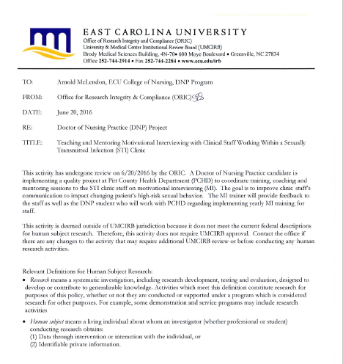

Appendix B
Organizational Approval Letter

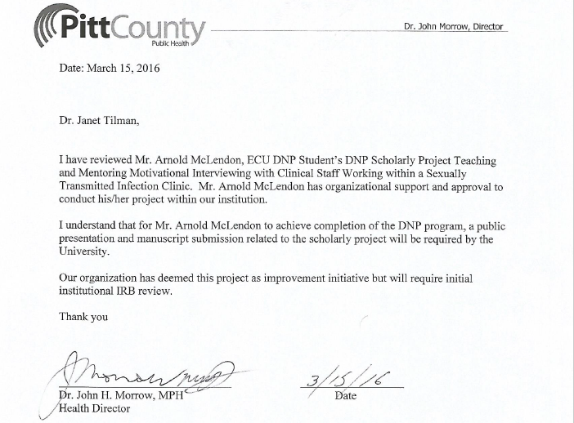

Appendix C
Health Department Email

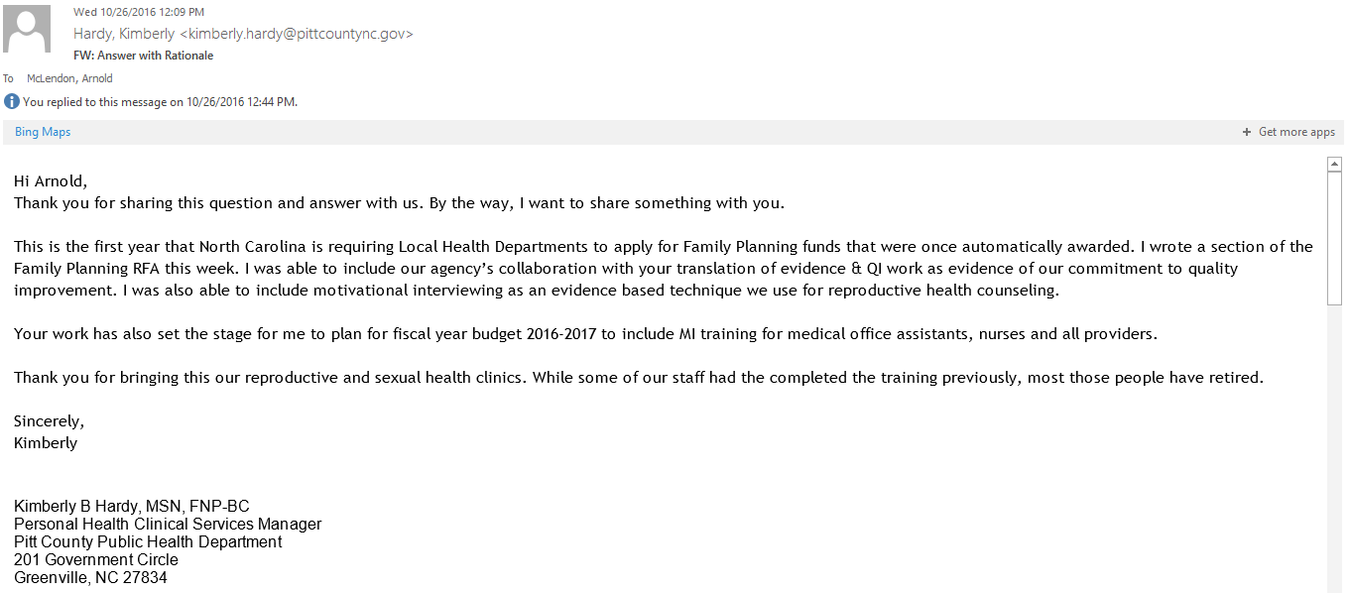
Note. Permission to use email was obtained from Mrs. Kimberly Hardy, MSN, FNP-BC
Appendix D
Health Department Email

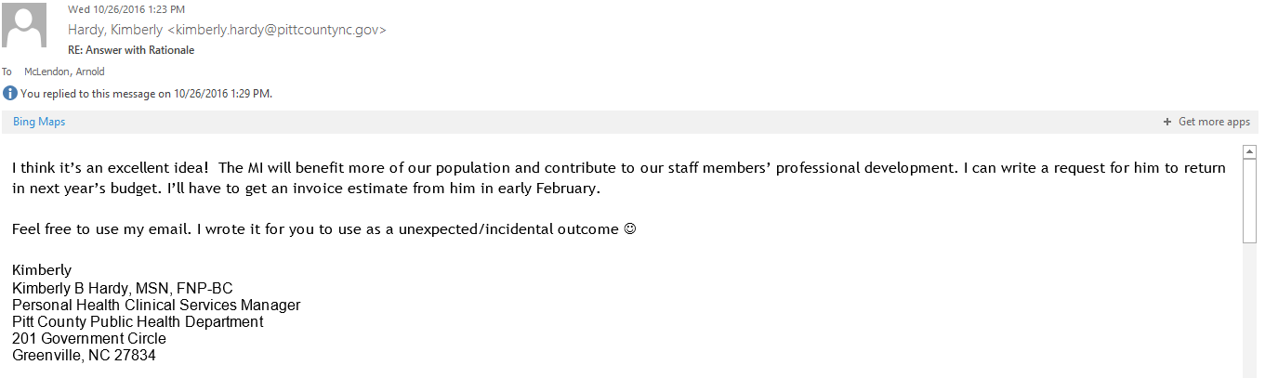
Note. Permission to use email was obtained from Mrs. Kimberly Hardy, MSN, FNP-BC

Appendix E
Timeline

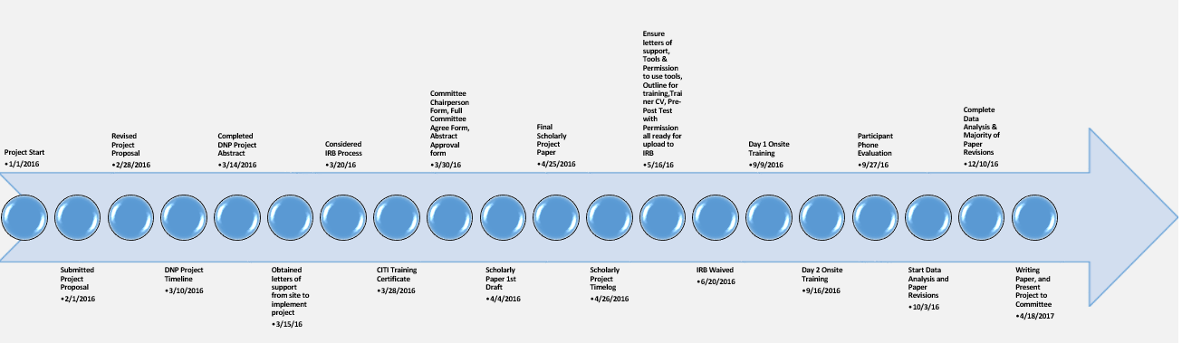

Appendix F
MITI Tool

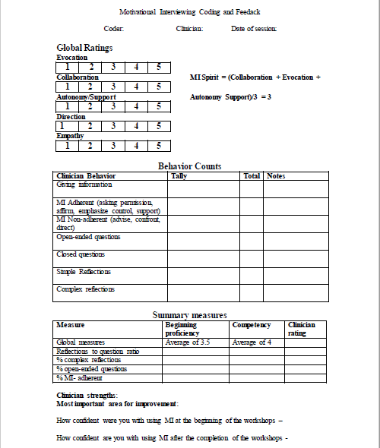
Appendix G
Project Poster

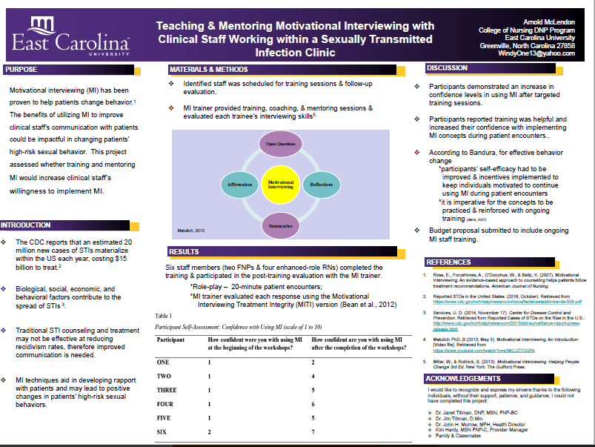
Appendix H
Doctor of Nursing Practice Essentials

DNP Essentials | Demonstration of Knowledge
- Scientific Underpinnings for Practice | Literature Review  IRB Submission  Community Assessment  Theory/Statistics Course-provided foundation for understanding nursing theory, research, and how to advance nursing practice
- Organizational and Systems Leadership for Quality Improvement and Systems Thinking | Diffusion of Innovations Paper  Virtual Clinic Cases  Leadership Self-Assessment  PDSA and SWOT Analysis Self-Assessment  Volunteer Leadership Opportunity  PDSA on residency site location
- Clinical Scholarship and Analytical Methods for Evidence-Based Practice | Literature Review  Application of CONSORT / PRISMA guidelines
- Information Systems/Technology and Patient Care Technology for the Improvement and Transformation of Health Care | Qualtrics Survey-ATHCTS  SPSS Utilization  Consumer Health Website Evaluation  Virtual Clinic Cases  Diffusion of Innovation Paper  EHR MU Evaluation  NC Health Information Portal – Data Mining Analysis
- Health Care Policy for Advocacy in Heath Care | Policy Analysis Paper  Policy Process Presentation  Letter to elected official Dan Blue  Policy discussion boards  Strategic Plan Analysis Paper  Service Learning Project – Day at NC legislature building
- Interprofessional Collaboration for Improving Patient and Population Health Outcomes | Interprofessional OSCE’s  Scholarly Project Dissemination Plan  Virtual Clinic Case Building  Finance Case Studies  Discussion Boards
- Clinical Prevention and Population Health for Improving the Nation’s Health | Community Assessment  Cultural Competency Certification  SWOT Analysis  Diffusion of Innovation Paper
- Advance Nursing Practice | SWOT Analysis  Innovation Analysis Paper  Diffusion of Innovation Paper  Cultural Competency Certification  Finance Assignments

