Abstract
FtrABCD is a four-component iron uptake system found in several Gram-negative bacteria, including Brucella spp. This four-component transporter consists of two soluble periplasmic subunits (FtrA and FtrB), a putative membrane embedded terminal electron acceptor (FtrD), and a membrane spanning iron permease (FtrC). Based on the evolutionary relationship and sequence homology between FtrC and eukaryotic Ftr1p, this bacterial permease is predicted to be an oxidase dependent Fe²⁺ transporter. Unlike the eukaryotic Ftr1p permease, which can only function when co-expressed with the multicopper oxidase Fet3p, FtrC does not co-express homologs of any known ferrous oxidase. However, based on its evolutionary relationship with cupredoxins and ferroxidases, periplasmic FtrB is proposed to bind and oxidize Fe²⁺ during its transport through FtrC. This oxidase property of FtrB is predicted to take palce if it binds a single copper ion using conserved D118 and H121 residues. Cu²⁺ binding using these non-classical copper ion binding ligands in FtrB, its ability to form the active enzyme substrate complex (Cu²⁺-FtrB-Fe²⁺), and producing the ferrous oxidase function have not been verified experimentally, creating a knowledge gap in the bacterial iron uptake and redox enzyme literature.
Data presented in this thesis demonstrates that a) recombinant wild-type Brucella FtrB can form a predominantly β-sheet containing structure (like all other cupredoxins); b) the ability of this protein to form this expected native secondary structure and coordinate Cu²⁺ (K_{d} = 3.0 ± 1.0 μM in 50 mM bis-tris, 100 mM NaCl, pH 7.3) is dependent on the presence of the conserved residue D118; and c) the recombinant wild-type FtrB can effectively oxidize Fe²⁺ at pH 7.3 under in vitro conditions. The results described in this thesis are significant as they demonstrate FtrB as a novel ferrous oxidase and open future research opportunities to investigate the importance of this Fe²⁺ oxidation during iron transport through FtrABCD under in vivo conditions.

Brucella spp. FtrB copper binding thermodynamics and iron oxidase activity

A Thesis
Presented to the Faculty of the Department of Biology
East Carolina University

In Partial Fulfillment of the Requirements for the Degree
Master’s of Science - Biology

By
Kai Hart
July, 2024

Director of Thesis: Eric Anderson, PhD; Sambuddha Banerjee, PhD
Thesis Committee Members:
Roy Martin Roop, PhD
Alice Haddy, PhD
Adam Offenbacher, PhD

© Kai Hart, 2024

TABLE OF CONTENTS
LIST OF TABLES vi
LIST OF FIGURES vii
CHAPTER 1: Background
1.1: Biological Relevance of Iron 10
1.2: Bacterial iron uptake systems 12 1.3: The novel Ftr permeases 14
1.4: Literature review on FtrABCD proteins
1.4.1: ftrABCD is a conserved iron regulated gene sequence found in several Gram-negative bacteria 17
1.4.2: Brucella FtrABCD copper binding proteins 18
1.4.3: Proposed mechanism of FtrABCD 24
1.5: Research objectives 25
CHAPTER 2: Methods and Experimental Theory
2.1: Cloning Recombinant FtrB 28
2.2: Protein Expression 28
2.3: Protein Purification 28 2.4.1: Circular Dichroism (CD) Method & Data Analysis 29 2.4.2: CD Experimental Theory 30 2.5.1: Electron Paramagnetic Resonance (EPR) Spectroscopy Method 31 2.5.2: EPR Experimental Theory & Data Analysis 32 2.6.1: Isothermal Titration Calorimetry (ITC) Method 35 2.6.2: ITC Experimental Theory & Data Analysis 36 2.7.1 : Cyclic Voltammetry (CV) Method 39 2.7.2: CV Experimental Theory & Data Analysis 40
2.8.1: Cu²⁺-EDTA Assay 42
2.8.2: Cu²⁺-EDTA Experimental Theory 44
2.9.1: Ferrozine Assay Methods 45
2.9.2: Ferrozine Assay Experimental Theory & Data Analysis 46
Chapter 3: Results & Discussion
3.1: Brucella FtrB requires D118 to form a predominantly β-sheet secondary structure in solution 48
3.2: Recombinant wild-type as isolated FtrB and H121A mutant purify with Cu²⁺ bound 50
3.3.1: Cu²⁺ binding to wild-type apo-FtrB is pH dependent and this protein can only recognize a mimic of its substrate, Fe²⁺, when Cu²⁺ is bound to the protein 52

3.3.2: H121A and D118A FtrB Cu²⁺ binding 57
3.4: EPR signal from Cu²⁺ reconstituted wild-type and H121A mutant FtrB suggest different binding pockets 58
3.5: Wild-type FtrB can bind to both Cu²⁺ and a Cu⁺ mimic and the FtrB-Cu²⁺ ⬄ FtrB-Cu⁺ redox reaction does not significantly alter the apo-enzyme 61
3.6: Wild-type FtrB can oxidize Fe2+ in a pH dependent manner 65
Chapter 4: Conclusions 69
Chapter 5: Broader Impacts 73
REFERENCES 74

LIST OF TABLES
1: Spectrophotometric data showing cupric cation content in as isolated FtrB (50 µM) 51
2. Thermodynamic parameters obtained from ITC of metal ion (Cu²⁺, Mn²⁺, and Ag⁺) binding to wild-type and mutant Brucella FtrB protein. 54
3. Wild type FtrB CV data... 63

LIST OF FIGURES
1. Aqueous iron reactions, redox potential, and uptake 11
2. Cartoon diagram showing iron cargo (Fe³⁺-siderophore, Fe³⁺ bound to transferrin or lactoferrin, heme, Fe²⁺) translocation in (left) Gram positive and (right) Gram negative bacteria 14
3. A diagram illustrating the uptake of Fe²⁺ mediated by yeast Fet3p-Ftr1p 16
4. Evolutionary relationship of bacterial Ftr permeases with eukaryotic Ftr1p 18
5. MCO iron oxidation compared to single copper site iron oxidation 20
6. The phylogenetic relationship of Cup-I, Cup-II, and Cup-III proteins 21
7. Structural prediction for Brucella FtrB (wild-type) predicts a cupredoxin like fold formation and its ability to bind Cu²⁺ using the conserved Cup-II residues, D118 and H121. 23
8. A schematic representation of the proposed mechanism of Fe²⁺ utilization by FtrABCD as proposed by Armstrong et al. and Elhassanny et al 24
9. The hypothesized reaction of FtrB in this system. 26
10. How CD works 31
11. How EPR works 33
12. An example EPR spectra. 34
13. The standard ITC cell 37
14. A standard ITC thermogram 38
15. Standard CV setup 41
16. A typical potential Vs current response expected from an electroactive analyte 42
17. The method used to collect as-isolated FtrB Cu2+ concentrations 44
18. Ferrozine Experimental setup 46
19. Representative CD spectra of recombinant FtrB and its mutants. 49
20. ITC thermograms for wild-type apo-FtrB binding to Cu²⁺ 53
21. A qualitative thermochemical cycle showing some of the different steps that are involved during Cu²⁺ transfer from a buffer bound state to protein bound state 55
22. ITC thermograms for wild-type apo-FtrB and Cu²⁺-FtrB binding to Mn²⁺. 56
23. H121A FtrB thermodynamic parameters and binding thermogram 58
24. ITC thermograms for wild-type apo-FtrB and Cu²⁺-FtrB binding to Mn²⁺ 60
25. Wild type FtrB copper signal before and after acidification 61
26. Voltammograms of wild-type and H121A FtrB 63
27. ITC thermograms for FtrB binding to Ag⁺ (a Cu⁺ mimic). 64
28. Trendline of iron loss (Au) in solutions of wild type FtrB, iron, and copper at pH 7.3, 6.8, and 6.5 over 5 minutes. 67
29. Trendline of iron loss (Au) in solutions of D118A FtrB at pH 7.3 68
30. Proposed enzymatic cycle for Fe²⁺ oxidation by Cu²⁺-FtrB showing different intermediate species in solution 70
Background
  - Biological relevance of iron
Iron plays crucial roles in biology and is an essential micronutrient for nearly all living organisms. Due to its high abundance, stable redox states, and versatile coordination chemistry, it has been utilized ubiquitously throughout nature. This iron requires tight regulation during its uptake, transport, and utilization (Crichton, 2001). Despite these positive properties, this micronutrient is highly regulated by organisms growing in contact with molecular oxygen and close to neutral pH. This iron regululation arises due to a) the ability of Fe²⁺ and Fe³⁺ to interconvert non-enzymatically, producing toxic levels of reactive oxygen species (ROS), and b) extreme insolubility of aqueous Fe³⁺ ions (Figure 1).A common strategy organisms use in iron regulation is to keep this metal ion sequestered by biological ligands (proteins, peptides, metabolites), making the concentration of the “dangerous” inorganic iron very low (Crichton, 2001). Although beneficial, this low labile iron pool (where iron is not bound to biological ligands) makes it difficult for host dependent pathogens to survive inside host systems (Crichton, 2001). For mammalian pathogens, the situation is more complex as mammalian hosts further drop the labile iron pool by a series of innate immunity processes (Ong, Shan, & Ding, 2006). Because iron is required for survival and replication, the bacteria respond to iron starvation by upregulating dedicated iron sequestering systems, often causing infection inside hosts (Krewulak, 2008; Figure 1C).
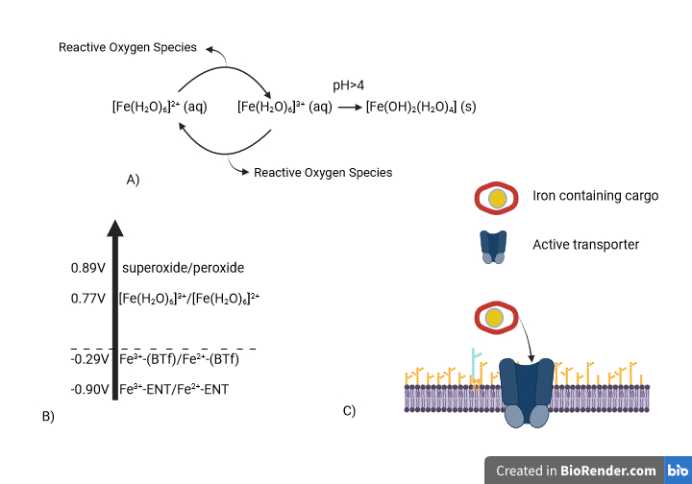
Figure 1. Aqueous iron reactions, redox potential, and uptake. A) Non-enzymatic cyclical interconversion between Fe²⁺ and Fe³⁺ in aqueous solution producing reactive oxygen species. This figure also shows precipitation of aqueous Fe³⁺ at pH greater than or equal to 4 making it biologically unavailable. B) Reduction potentials of various Fe^{3+/2+} species in comparison to superoxide/peroxide couple (BTf stands for bacterial transferrin and ENT stands for enterobactin). This shows binding of iron with biological molecules takes it outside of the redox reaction with reactive oxygen species (ROS). C) A cartoon representation of iron uptake by living system, requiring the expression of dedicated active transporters.
This has made understanding bacterial iron uptake systems integral to understanding the pathogenesis of infectious organisms (Williams, 1993). Given that the infection/survival strategy is specific to each microbial environment, it follows that there would be a large variability in how these organisms persist in their niche.

  - Bacterial iron uptake systems
In iron-scarce conditions, it is imperative that a find a consistent source of iron so that iron-dependent biological functions do not cease. This necessity has provided a selective pressure, causing bacteria to evolve iron uptake systems that can effectively sequester iron for biological use. Inside of larger eukaryotes, such as humans who have evolved ways to keep free-iron concentration low, iron availability can be very scarce. Additionally, upon infection, hosts lower their available iron concentration even further. Living in this niche requires competition with the host for iron; and such, systems have evolved to do this in several ways. These bacterial iron uptake systems, expressed under iron-starvation conditions, can be classified by the form of iron (also referred to as “cargo”) they carry (Krewulak, 2008). The known “cargos” are heme, siderophore-bound iron, and protein-bound ferrous or ferric iron. Though, despite the variability in “cargo”, all Gram-negative bacterial iron uptake systems studied, to date, require an outer membrane transporter that uses proton motive force derived energy, harvested by TonB, and an inner membrane ATP dependent permease (Figure 2; Krewulak, 2008). Additionally, Fe2+ transporters (like FeO) do not require an outer membrane receptor (as Fe2+ is more soluble than Fe³⁺) and get translocated through the inner membrane without requiring oxidation or use of an ATP dependent permease (Lau, 2015).
Heme, a planar porphyrin ring with Fe²⁺ bound at its center, is the primary oxygen transport and storage molecule as well as an electron transport molecule used for cellular respiration (Poulos, 2014). Extracellular heme is captured by bacteria either by using a heme-binding molecule (a hemophore) or free floating in their environment and is taken into the cell through a heme-specific receptor. After translocation into the cell, the porphyrin ring is degraded, and the iron is free to be used in other metabolic processes (Contreras, 2014). This process is similar for both Gram-positive and Gram-negative bacteria though movement through the periplasm requires extra steps and energy.
Siderophores are small, high affinity iron-chelating molecules synthesized and secreted by bacteria for the sole purpose of accumulating ferric iron. These molecules, once bound to iron, are recognized by a receptor in the cell surface and transported into the cell. These siderophores can be recycled or degraded to release the iron (depending on how tightly the iron is chelated) and the iron is used for metabolic processes (Chu, 2010). This process is similar for both Gram-positive and Gram-negative bacteria though movement through the periplasm requires extra steps and energy.
Protein-bound iron, such as Fe³⁺ bound to transferrin, utilize host iron storage proteins as an iron source for the bacteria. Some Gram-negative bacteria express TonB dependent receptors (TbpA) that can directly interact with host Fe³⁺ transport proteins (like transferrin or lactoferin) and steal Fe³⁺ for transport through the periplasm. In the periplasm, Fe³⁺ is captured by FbpA, the soluble component of an ABC-type transporter and the cargo is translocated to the cytosol (Cornelissen, 2022).
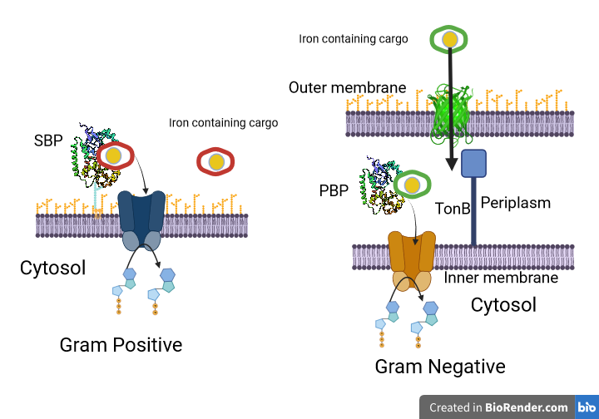
Figure 2. Cartoon diagram showing iron cargo (Fe³⁺-siderophore, Fe³⁺ bound to transferrin or lactoferrin, heme, Fe²⁺) translocation in (left) Gram positive and (right) Gram negative bacteria. In both, translocation of the iron cargo through the cytosolic/inner membrane is dependent on an ABC-type (ATP binding cassette) transporter where the hydrolysis of ATP into ADP provides the energy for translocation. For Gram negative bacteria, the iron cargo is translocated using TonB derived proton motive energy through a β-barrel transporter.
  - The novel Ftr permeases
The Ftr (ferrous transport receptor) family of permeases are found in both prokaryotes and eukaryotes but remain mostly uncharacterized. This family of proteins are iron-inducible and are predicted to form seven trans-membrane α-helices. Presently, the only characterized member of this family is Ftr1p from yeast and this system does not
require ATP hydrolysis to function. Instead, this system is suspected to use the energy generated from oxidation to power iron translocation in this system (Stearman et al. 1996). In yeast, Fe²⁺ is first sequestered by Fre which ensures Fe²⁺ is entering the system. Next, iron is transferred to Fet3p, a multicopper oxidase (MCO). This protein has four bound coppers that serve to oxidize Fe²⁺ and provide the energy for iron translocation through Ftr1p. Experimental and computational work has confirmed that Ftr1p can only translocate Fe³⁺ produced by Fet3p during this transition metal ions passage through the permease and that co-expression of the MCO Fet3p is required for this system to function. (Kosman et al. 2004, Kosman et al. 2006, Severance et al. 2006). Notably, Fre is not required for this system to function Severance et al. 2006). The Ftr1p system, as seen in Figure 3, has many homologous proteins in bacteria (EfeU, FetM, cFtr, FtrC) (Stearman, 1996; Askwith, 1994; De Silva, 1995; Severance, 2006)
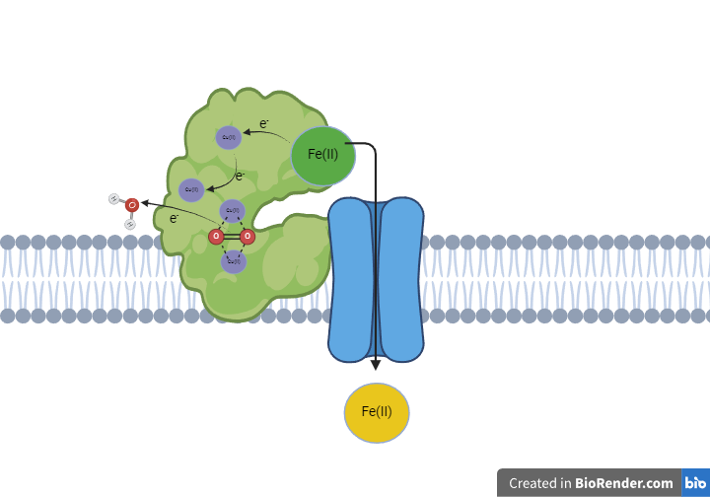
Figure 3. A diagram illustrating the uptake of Fe²⁺ mediated by yeast Fet3p-Ftr1p. Ftr1p (depicted in orange) functions as an integral membrane transporter protein, while Fet3p is a multi-domain multicopper oxidase (MCO) with one domain shown here featuring three distinct Cu²⁺-binding sites. Fe²⁺ ions (shown in green) are captured by the MCO Fet3p near its type-1 electron transfer (ET) site, characterized by Cu²⁺ bound to conserved HHC residues. Fet3p oxidizes Fe²⁺ to Fe³⁺ (depicted in yellow), which is subsequently transported through Ftr1p. The reduced type-1 Cu site is regenerated by transferring electrons via type-2 (mononuclear) and type-3 (binuclear) Cu²⁺ ions, ultimately reducing O₂ to water.

  - Literature review on FtrABC.D proteins
    - ftrABCD is a conserved iron regulated gene sequence found in several Gram-negative bacteria
The evolutionary relationship and homology between the eukaryotic and bacterial Ftr permease containing transporters has been identified in the last two decades (Armstrong et al. 2012, Elhassanny et al. 2013, Chan et al., 2010, Koch et al. 2011). A recent bioinformatics work by Banerjee et al. demonstrated that of the bacterial Ftr permease, FtrC from Brucella, is among the most closely related to the yeast Ftr1p (Figure 4) (Banerjee et al., 2022). Of the bacterial Ftr1p homolog containing systems, FtrABCD is the only four-component transporter and is expressed by several Gram-negative pathogens, including Brucella, Bordetella, and Burkholderia spp. (Armstrong et al. 2012, Elhassanny et al. 2013, Thomas et al. 2017). The genetic locus organization for genes encoding these proteins in Bordetella and Brucella spp. are conserved (Armstrong et al. 2012, Elhassanny et al. 2013). In Bordetella, expression of all four protein subunits are essential for Ftr function, indicating that each protein has a unique (and non-redundant) property (Armstrong et al. 2012). In both organisms, all four proteins are found on an open reading frame and experiments described in these works confirm that these genes are upregulated by acidic pH and low iron concentration. Additionally, data reported by Elhassanny et al. also showed that the transcription of the ftrABCD genes is also regulated by binding of the Irr transcriptional factor directly upstream to ftrA gene (Elhassanny et al. 2013).

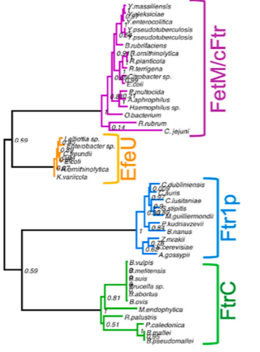
Figure 4. Evolutionary relationship of bacterial Ftr permeases with eukaryotic Ftr1p. A phylogenetic tree of bacterial permeases. All Ftr homologs share a common ancestry with Ftr1p. FtrC proteins from Brucell and Bordetella spp. show closer evolutionary relationship with this yeast permease than the other bacterial Ftr homolog containing proteins (Figure adopted from Banerjee et al. 2022).
1.4.2 Brucella FtrABCD copper binding proteins
The co-expression of an MCO is required for iron oxidation and translocation through Ftr1p (Kosman et al. 2004). Notably, Fet3p utilizes the copper binding sites found in Figure 5. Conversely, FtrABCD, and all other known bacterial Ftr systems, do not express a known ferrous oxidase or ferroxidase enzyme. These copper binding proteins (falling under the Cup-III classification) traditionally bind copper in three ways, known as Type-1, Type-2, and Type-3 copper sites. Type-1 copper sites bind copper with HisHisCys residues. Type-2 copper sites bind copper with mainly His residues and lack the notable Cys residue from Type-1 copper sites. Type-3 copper sites bind two coppers in His rich coordination environments and reduce molecular oxygen to water. In MCOs, these sites act to shuttle electrons from iron (with the electron going from the Type-1 site, to the Type-2 site, and lastly the Type-3 site), having molecular oxygen act as the terminal electron acceptor. In enzymes that are only a singular type of copper site (usually a Type-1 site), this electron is passed to another enzyme instead of being removed through reduction of oxygen (Solomon, 2014). Fe²⁺ oxidation can be done by multidomain or single domain cupredoxins. In single domain cupredoxins, there is a single Cu²⁺ in a Type-1 site and it can oxidize Fe²⁺ to Fe³⁺. However, to regenerate the active enzyme, these systems also contain a redox protein partner (in general a cytochrome) that accepts an electron from the single domain cupredoxin and resetting the function. Representations of the three types of copper sites and single proteins with a Type-1 copper site can be seen in Figure 5. These copper binding environments and ferroxidase activity are not found in Brucella FtrABCD.
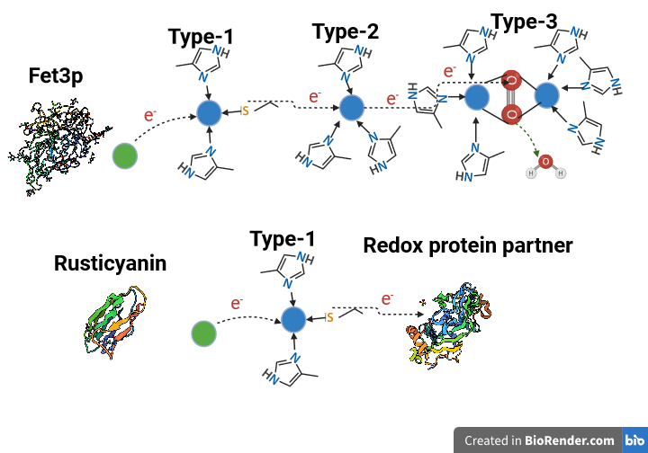
Figure 5. MCO iron oxidation compared to single copper site iron oxidation. Fet3p, from yeast, is shown above oxidizing Fe²⁺ (brown) using Cu²⁺ (blue). The electron is transferred from iron to the Type-1 copper site, then transferred to the Type-2 copper site. The electron is then given to the Type-3 copper site where it is used to reduce molecular oxygen to water, resetting the system. Rusticynin, a known copper binding protein, is shown below oxidizing Fe²⁺ (brown) using a Type-1 copper site. The electron is passed to Cu²⁺ (blue) and then transferred to another protein, resetting the system.
Cup-III proteins, being the traditional copper binding proteins, are but one of three types of copper binding proteins. Cup-III proteins encompass the three traditional copper binding sites described above. Cup-I and Cup-II proteins, called the novel cupredoxins, show an evolutionary relationship with Cup-III proteins, all being within the same clad (Figure 6)( Rajasekaran, 2010). Though there is a shared evolutionary relationship between the Cup proteins, Cup-I and Cup-II proteins do not conserve any known copper binding sites (types I – III). Notably, there are no characterized Cup-II proteins. FtrB, a part of FtrABCD from Brucella, belongs to the Cup-II class of proteins but FtrABCD has no known ferrous oxidase or ferroxidase.
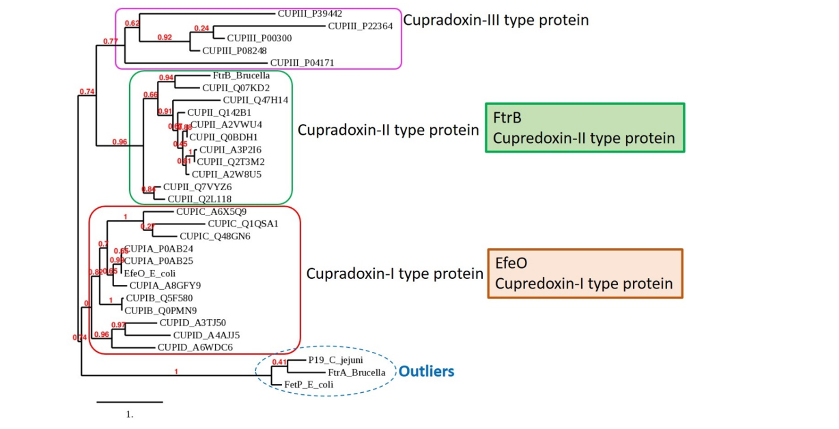
Figure 6. The phylogenetic relationship of Cup-I, Cup-II, and Cup-III proteins. Cup-III proteins, classical cupredoxin proteins, are usually MCOs and are well documented. Cup-I and Cup-II proteins remain mostly characterized but there are no, yet, characterized Cup-II proteins. All Cup protein belongs to the same clad. Figure adopted from Banerjee et al., 2022.
Evolutionary bioinformatics done by Rajasekaran et al. in 2010 also showed all known Cup-II proteins have two conserved residues (D118 and H121) and Brucella FtrB is expected to fold in the typical cupredoxin fold. The reported homology model of FtrB (Figure 7), showing a cupredoxin like fold rich in β-sheet secondary structure. Structural superposition of this FtrB model on the crystal structures of a known cupredoxin (azurin) and with a single Cu²⁺ coordinated in the typical Type-I site (described by HHC residues). The superimposition shows that Brucella FtrB has two residues (D118 and H121) in favorable positions that are co-structural to a histidine found in azurin’s binding copper site and an aspartic acid identified in type-0 mutant azurin (Banerjee et al., 2022; Grey et al., 2010). These conserved Cup-II residues (D118 and H121) are suggested as putative Cu²⁺ binding residues from Brucella FtrB (Figure 7)(Banerjee, 2022).

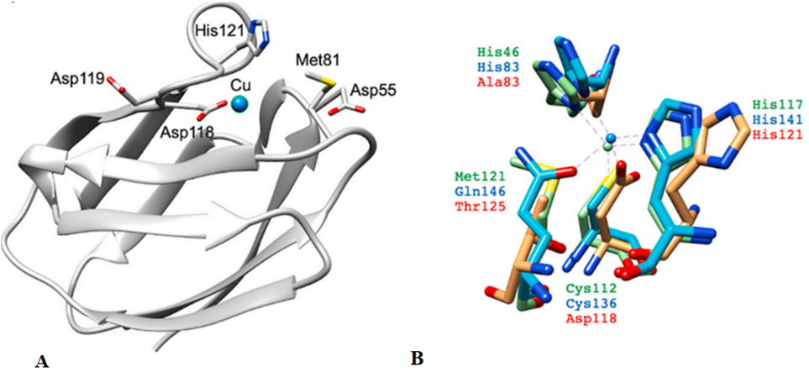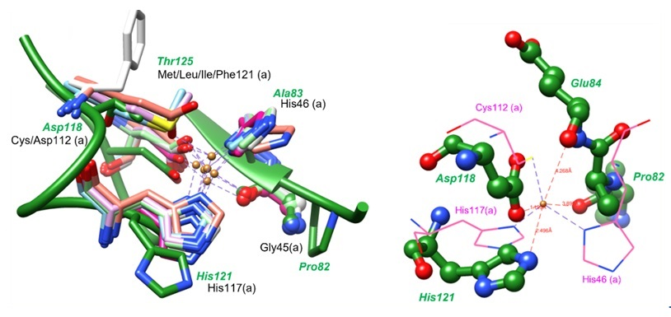
Figure 7. Structural prediction for Brucella FtrB (wild-type) predicts a cupredoxin like fold formation and its ability to bind Cu²⁺ using the conserved Cup-II residues, D118 and H121. A) Homology model of mature FtrB (Templet: 4HCF, GQMP: 0.64, RMSDa: 0.84, Cov.: 0.978). B Left) Structural superimposition of the Brucella wild-type FtrB homology model (green) with the Cu2+ binding site of different azurin mutants (PDB Id 1XB6, 3FQY, 3FQ1, 3FQ2, 3FPY, and 3NP4) identifying H121, D118, A83, T125, and P82 as isostructural with H117, D/C112, H46, M/L/I/F121, and G45, respectively from the mutant azurin crystal structures. B Right) Distances between coordinating atoms from H121(imidazole N), D118 (carboxylate O), A83 (backbone carbonyl O), and E84 (backbone carbonyl O) residues from the FtrB homology structure with the Cu2+ in the crystal structure of azurin (1XB6) are shown as dotted red lines.)
    - Proposed mechanism of FtrABCD
Elhassanny et al showed that Brucella abortus FtrABCD is the sole ferrous iron uptake system. Additionally, it concluded that all four proteins play some essential and non-redundant function in this transport, all subunits being required. Armstrong et al. and Elhassanny et al. proposed a functional model for Fe²⁺ utilization using FtrABCD proteins and a schematic representation of it has been presented in Figure 8. According to this model, passively transported Fe²⁺ binds with FtrA upon its entry into the periplasmic space and is handed over to the proposed cupredoxin protein, FtrB. FtrB then oxidizes Fe²⁺ to Fe³⁺ during its transport through FtrC and is itself reduced to inactive state. Inactive FtrB is then oxidized and activated by transferring an electron to the proposed polyferredoxin, FtrD, resetting the transport system.
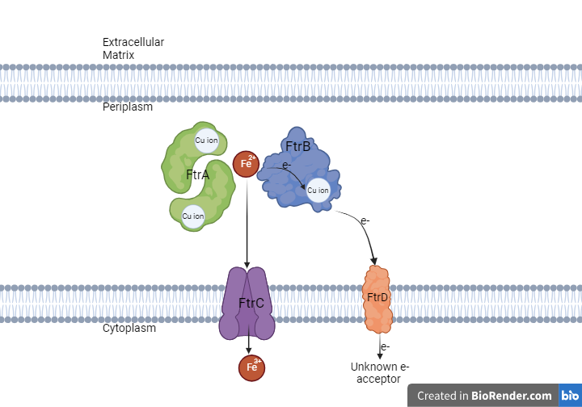
Figure 8. A schematic representation of the proposed mechanism of Fe²⁺ utilization by FtrABCD as proposed by Armstrong et al. and Elhassanny et al. FtrC is a trans-membrane protein with seven α-helical components. FtrD is an integral membrane protein that acts as the terminal electron acceptor for periplasmic electron transfer. FtrA is a dimer that can bind one Cu in each monomeric unit as well as one Fe²⁺ and FtrB is a monomer which can bind only one copper (Armstrong et al. 2012, Elhassanny et al. 2013).

  - Research objectives
Though the detailed mechanism of Fe2+ transport through FtrABCD and the roles of the periplasmic subunits remain uncharacterized, this work hypothesizes that FtrB is the main transportation and oxidative periplasmic protein. In this hypothesis, FtrB is a metalloenzyme that can coordinate copper and oxidize Fe²⁺. Here, the active enzyme (FtrB-Cu²⁺) coordinates the substrate (Fe²⁺) forming the enzyme-substrate complex (Cu²⁺-FtrB-Fe²⁺). The enzyme substrate complex then reduces the substrate, forming the reduced enzyme (FtrB-Cu⁺) and the product (Fe³⁺). This hypothesis of iron utilization can be written as follows:
Cu²⁺-FtrB_{(aq)} + Fe²⁺_{(aq)} ⇌ Cu²⁺-FtrB_{(aq)}-Fe²⁺_{(aq)} → Cu⁺-FtrB_{(aq)} + Fe³⁺_{(aq)}
Via this mechanism, an FtrB-bound cupric ion acts as the electron acceptor for ferrous iron oxidation. This proposed mechanism would see the ferric ion passed to FtrC and FtrB’s cuprous ion oxidized by FtrD to enable further oxidation of other ferrous iron atoms in the periplasm. A detailed enzymatic pathway based on the hypothesized mechanism is shown in Figure 9.
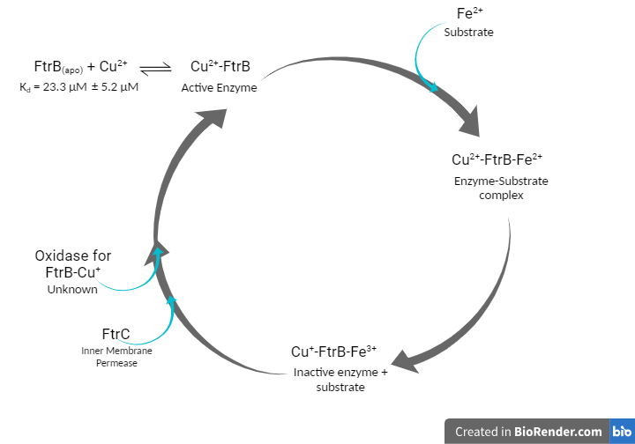
Figure 9. The hypothesized reaction of FtrB in this system. FtrB is the metalloenzyme and becomes active once Cu²⁺ is bound. This enzyme binds the substrate, Fe²⁺, and the substrate is oxidized. The substrate is then released, and the inactive enzyme is regenerated to the active version.
Although FtrB does not conserve the Type-I copper residues, the predicted copper binding site in FtrB created by D118 and H121 gets indirect support from a similar system reported by Grey et al. (Grey et al. 2010). These researchers created a so-called Type-0 copper site by mutating C112 to D in azurin where the mutant retained its three-dimensional fold, Cu²⁺ binding affinity, and electron transfer property (Grey et al. 2010).
This study aims to contextualize the biological relevance of novel copper binding by FtrB and determine if it can act to mediate ferric oxidation within FtrABCD (a system very similar to one seen in eukaryotes). To do this, looking at the importance of FtrB’s two conserved copper binding residues (D118, H121) is imperative. The hypothesis of this work is: D118 is essential for copper binding, and copper binding and bound copper is necessary for iron oxidation to occur. To address this hypothesis, the following questions are proposed:
- Question 1: Does recombinant FtrB contain copper when purified/isolated? This is important for determining whether recombinant FtrB forms the active holoenzyme with a Cu²⁺ cofactor. This will be determined though UV-visible spectroscopy using Cu²⁺ as the target for the reporter molecule.
- Question 2: Are H121 and D118 necessary for FtrB Cu²⁺ binding? This gives insight into the importance of one specific residue of interest. This will be determined through isothermal titration calorimetry (ITC), and UV-visible spectroscopy.
- Question 3: Does recombinant FtrB bind iron and does recombinant FtrB oxidize this iron when copper is bound? This shows whether the substrate-enzyme complex forms and determines if it can perform oxidation. To assess iron binding, ITC will be used. To evaluate oxidation, UV/visible spectroscopy will be done with Fe²⁺ as the target for the reporter molecule.

- Methods and Experimental Theory

  - Cloning Recombinant FtrB
The ftrB open reading frame (from Brucella abortus 2308) was translated and analyzed using SignalP 5.0 to predict the cleavage site of the Sec-dependent amino terminal signal sequence. The mature secreted protein was expected to initiate at residue 45 relative to the first amino acid. The sequence, spanning from codon 45 to codon 133 (the stop codon), was used to construct the protein expression clone in pET-28a (+)-TEV, resulting in the creation of pET28-FtrB. GenScript USA, Inc. generated the expression construct. An NdeI site was introduced upstream of the 5'OH of ftrB (codon 45) and an XhoI site was introduced downstream of the 3'OH (codon 133). This fragment was assembled into pET-28a (+)-TEV at the NdeI and XhoI sites, ensuring that the His tag and TEV cleavage sites align correctly with the mature ftrB coding sequence.
  - Protein Expression
E. coli BL21 cells containing pET28(a)-TEV plasmid for mature ftrB were cultured at 37°C in Terrific broth supplemented with 40 μg/mL kanamycin with shaking. Induction was initiated upon reaching an OD₆₀₀ of 1.2 by adding 2 mM isopropyl-β-D-thiogalactoside (IPTG). After 4 hours of induction, cells were harvested by centrifugation at 10,000 ×g for 20 minutes at 4°C, and the cell pellet was stored at -80°C overnight.
  - Protein Purification
Cells were thawed on ice then resuspended in Histidine-Wash (His-wash) buffer (50 mM sodium phosphate, 300 mM sodium chloride, 10 mM imidazole, pH 7.4) at a ratio of 50 mL buffer per liter of culture. Cell lysis was performed using French pressing (3X). The resulting lysate was centrifuged at 25,000 ×g for 20 minutes at 4°C, and the supernatant was collected. Supernatant containing His-tagged FtrB proteins (wild-type or mutants D118A and H121A respectively) were purified via affinity chromatography using a HisPur cobalt-column (Thermo Scientific) employing gravity flow. Initially, the column was washed with 3 column volumes of Histidine-recharge buffer (100 mM MES, 100mM NaCl, pH 5), followed by equilibration with Histidine-wash buffer before application of the crude lysate. The His-tagged proteins were eluted from the column using 10 column volumes of Histidine-Elution Buffer (50 mM sodium phosphate, 300 mM sodium chloride, 100 mM imidazole, pH 7.4). The elution fraction containing the His-tagged protein was dialyzed overnight (3X) at 4°C in His-wash buffer to remove excess imidazole. The next morning, 50 µL of TEV protease and 5 µL of β-mercaptoethanol were added to the dialyzed sample to digest the His-tag overnight. Tag-free protein was subsequently applied to an equilibrated HisPur Resin in a gravity flow Cobalt-column (Thermo Scientific). The tag-free wild-type FtrB was collected in the flow-through, while the free-tag remained bound to the column. Crude tag-free wild-type FtrB was further purified using a Hi-Load Superdex 75/200 PG column, and the purity of the protein was assessed by 16.5% SDS-PAGE analysis of FtrB fractions.
2.4.1 Circular Dichroism (CD) Method & Data Analysis
All circular dichroism (CD) experiments were conducted using a JASCO J-815 CD spectrometer maintained at 25ºC. Spectroscopic data was acquired using 1 mm quartz cuvettes in the wavelength range of 190-300 nm and averages of 8 consecutive scans. This was recorded as the raw CD signal. Protein samples (10-20 µM) were prepared by buffer exchange into 10 mM phosphate buffer at pH 7.3 or 6.8 for all experiments. Buffer and protein concentrations were adjusted to ensure that the high tension (HT) voltage remained below 600 V across the entire scan range. Raw CD data were processed by subtracting the buffer baseline and normalizing to derive θ values using a standard formula from previous studies (Greenfield, 2006). CD analysis of wild-type apo-FtrB, the protein in its as-isolated state was initially dialyzed against a 5 mM EDTA solution in phosphate buffer, followed by three rounds of extensive buffer exchange with EDTA-free phosphate buffer.
    - Circular Dichroism Experimental Theory
Circular dichroism (CD) is a spectroscopic method that shines light through optically active (chiral) substances and determines the global secondary structure based on the amount of left-handed polarized and right-hand polarized light that is received. When this light is received by the instrument, an absorbance spectrum of the difference of left-handed and right-handed absorbance is generated. Standardized peak maximums for the primary secondary structures (α-helix, β-sheet, and random loop) are used to compare the global secondary structure of the protein. It is important to note that local changes to structure cannot be perceived through CD so another method will be required to achieve this. Additionally, there is software available to determine what percentage of each of the secondary structures a protein may consist of but the generated model may not reflect reality (Greenfield, 2006). Figure 10 shows how CD data is generated.
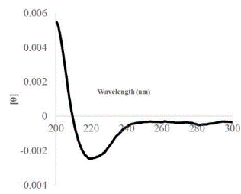
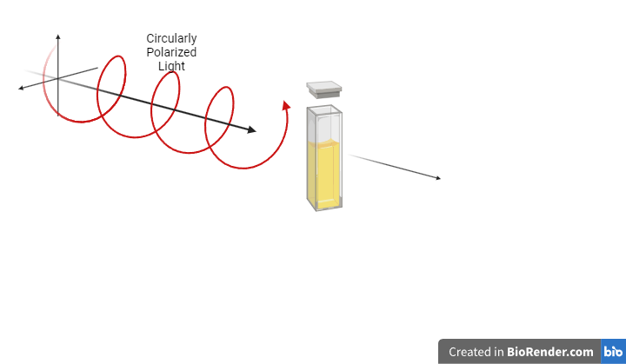
Figure 10. How CD works. CD uses circularly polarized light to generate the global structure of proteins by how the different angles of light interact with the sample.
    - Electron Paramagnetic Resonance (EPR) Spectroscopy Method
Wild-type FtrB samples were initially dialyzed against sodium azide to remove any bound copper, followed by three rounds of extensive dialysis against 100 mM phosphate buffer at pH 7.3. Cu²⁺-FtrB (1:1) samples were prepared by adding the required amount of Cu²⁺ stock solution, derived from atomic absorption grade copper nitrate, and incubating overnight. For Cu²⁺-FtrB EPR samples, clear fused quartz EPR tubes were used. The samples were frozen in liquid nitrogen, and EPR spectra were recorded. To denature the Cu²⁺-FtrB, samples were thawed, and approximately 10% volume of concentrated HCl was added directly to the EPR tube before refreezing the sample. EPR spectra were acquired using a Bruker Instruments 10/12 EMX model EPR spectrometer equipped with an ER4116DM cavity. The temperature was maintained at 77 K using a Wilmad (Buena, NJ) liquid nitrogen finger dewar. Spectra were recorded at a microwave frequency of 9.6 GHz, with a microwave power of 3.2 mW, modulation frequency of 100 kHz, and modulation amplitude of 1 G.
    - EPR Experimental Theory and Data Analysis
Electron spin, referred to by the spin quantum number s, falls into two categories: spin up and spin down. These states are numerically referred to as +½ and –½. This spin is further representative of the electron’s magnetic moment, a measure of strength and orientation of the magnetic field generated by a spinning electron. As charged particles, electrons are susceptible to change from an outside magnetic field. This factor is how electron paramagnetic resonance (EPR), a spectroscopic method, is used to study molecules/complexes that have unpaired electrons. This technique is, fundamentally, like nuclear magnetic resonance (NMR) but instead uses the interactions of electrons in a scanning external magnetic field. Because this method depends on the electron splitting of a paramagnetic material, each substance, or atom, being studied will give a unique signal. For example, copper and manganese will have different signals from each other. Analysis works best on fine powders, of which ice is one such material. Samples are cooled to liquid nitrogen temperature (77K) inside of a glass tube. This cooling step not only reduces the thermal contributions in the system but also reduces the variability in predominant spin state of the sample, making it so that either spin up or spin down is the dominant spin state. Because there is one spin state predominant, it is easier to visualize electron conditions when microwaves are applied from the EPR’s magnets. As the microwaves change, the frequency applied changes and this frequency approaches the energy separation between the electronic spin states, a resonance state occurs. At resonance, energy is absorbed by the electron and causes a spin state transition (Roessler & Salvadori, 2018). This can be seen in Figure 11.
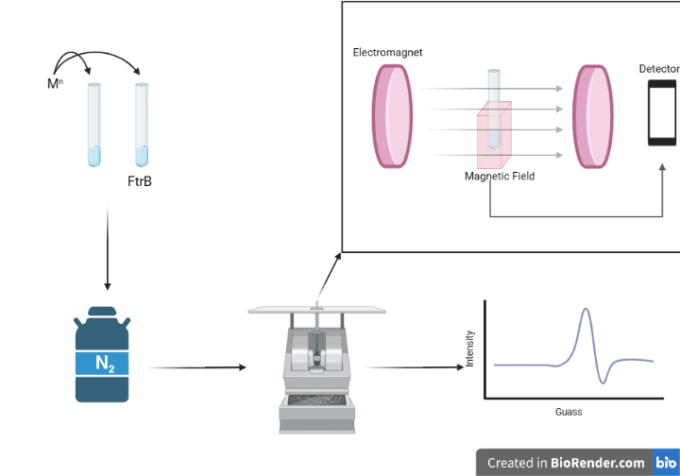
Figure 11. How EPR works. apo-EPR samples are incubated with metal, frozen to liquid nitrogen temperature, and scanned over a range of 2000 to 4000 MHz. This yields a spectrum that can be analyzed.
This transition is detected as a difference in applied and received microwaves signal by the instrument and gives a standard absorbance graph. This raw data is then analyzed though its first derivative. This increases peak resolution and decreases the amount of detail obscured by overlapping signals. This derivative spectroscopy contains a lot of useful information. When analyzing the spectra, several pieces of information can be gathered from the spacing and size of the peaks. For instance, the g-value (a dimensionless parameter that is influenced by the ligand’s coordination environment and is determined by the electron splitting pattern of the spectra) is equal to $\frac{hν}{βBo}$ where $h$ is Plank’s Constant (4.135x10⁻¹⁵ eV), $ν$ is microwave X-band frequency, β is the Bohr magneton (5.788x10⁻⁵ eV T⁻¹), and B₀ is the applied magnetic field of the EPR (Khan et al., 2020). EPR can also tell us what the coordination geometry from atoms sufficiently close to the ligand, known as hyperfine splitting. Because all these factors are determined by the physical state of the complex being analyzed, changes in coordination geometry yield distinctly visible information. Changes in buffer, pH, and binding ligands are all testable though side chains that bind cannot be determined specifically from an EPR spectra so use alongside a model is recommended.

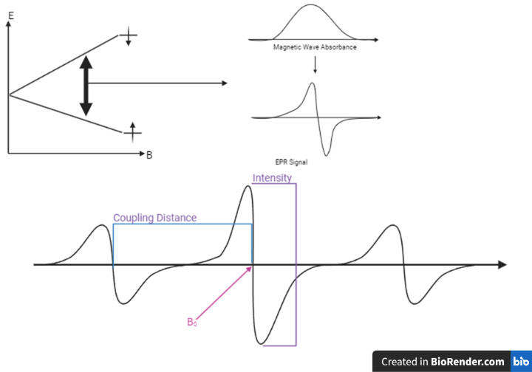
Figure 12. An example EPR spectra. How EPR spectra are derived and where some of the specific components are found in the spectra.

    - Isothermal Titration Calorimetry (ITC) Method
Samples for ITC were prepared following previously published methods (Wilcox, 2019; Colette, 2010; Wilcox, 2008). As-isolated wild-type/mutant proteins underwent dialysis against 5 mM EDTA, followed by three rounds of extensive dialysis against appropriate buffer and pH conditions (100 mM HEPES, 100 mM NaCl, pH 7.3; 50 mM Bis-tris, 100 mM NaCl, pH 7.3; 100 mM sodium acetate, pH 4). The complete removal of Cu²⁺ from the isolated proteins was confirmed by the absence of the Cu²⁺ -EDTA band at 732 nm (Bermejo-Barrera, 1986). Cu²⁺ and Mn²⁺ solutions were prepared by diluting atomic absorption standards (Ricca Chemicals) into the third dialysate from the apo-protein preparation. To prevent silver ion (Ag⁺) precipitation, ITC experiments involving this metal ion were conducted in degassed deionized water without any buffer present. Prior to injection into the ITC instrument, protein and peptides were degassed by centrifuging the sample solution for 1 minute. All ITC experiments were carried out using a Nano-ITC instrument (TA Instruments), and the raw data were analyzed using Nano-analyze software. The analysis of ITC data was based on the 1:1 binding reaction of Cu²⁺ or Ag⁺ (a Cu⁺ mimic) with wild-type apo-FtrB, as predicted by a homology model (Banerjee, 2022):
M^{n+}_{(aq)} + apo-FtrB_{(aq)} ⇌ M^{n+}-FtrB_{(aq)}, K_{d} = ([M^{n+}][FtrB])/[M^{n+}-FtrB])
Where M^{n+} = Cu²⁺ or Ag⁺. The concentration of wild-type apo-FtrB (and H121A mutant) used for Cu²⁺ titration was 100 µM, while for Ag⁺ titrations it was 50 µM. In each experiment, the protein solution was placed in the sample cell of the Nano ITC instrument, and the metal solution was loaded into the injector. All experiments were conducted at 25°C by incrementally titrating the metal solution into a well-stirred (320 rpm) protein solution. Raw heat data, after subtracting the heat of dilution of the metal ion into solvent, were fitted using an independent model (Nano Analyze, TA Instruments) to obtain thermodynamic parameters (K_{d}, N, ΔH_{ITC}, and ΔS).

    - ITC Experimental Theory & Data Analysis
Isothermal titration calorimetry (ITC) is an analytical technique used, in this study, to measure binding affinity, stoichiometry, and thermodynamics of copper to FtrB. ITC works by measuring the heat generated/ absorbed during a titration, where the titrant (copper) is incrementally added to the analyte (FtrB) in a controlled manner while keeping the temperature constant. ITC consists of several parts, namely the calorimeter. This system consists of two cells (one with analyte and the other titrant) which are maintained at the same temperature and constantly heated/cooled to eliminate fluctuations. Next is the syringe. Microliter amounts of titrant are added to the analyte at regular intervals and the heat change is collected by the instrument. The titrant concentration in the syringe should be 10x that of the analyte. Lastly, the thermometer is incredibly sensitive and detects changes in heat of up to 5 x10^{-6 O}C (Saponaro, 2019). The ITC system can be seen in Figure 13.

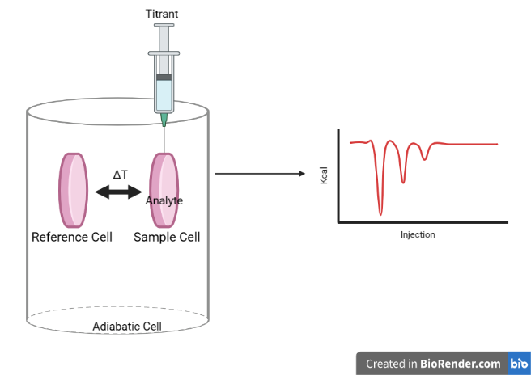
Figure 13. The standard ITC cell. ITC titrates a titrant into the analyte and uses the reference cell to determine the amount of energy generated/absorbed. The resulting thermogram is then output as heat generated against the number injections that have occurred.
The measurements taken by this instrument is in the form of a thermogram (seen in Figure 14). Initially, this measurement is a flat line, as the system is a homogenous mixture at a known temperature, thus no temperature fluctuations occur. Upon the first titration, the instrument records the heat change, as a unit of power removed/added to the system to correct the temperature shift caused by a given titration, causing an injection peak to form. Each peak can be seen as an equilibrium being achieved between the current ratio of titrant and analyte. After any given peak returns to baseline, another specified volume of titrant is added, and the same process occurs. This is referred to as the pre-transition baseline. As injections take place, these peaks will become smaller, in a sigmoidal fashion, until each equilibrium is consistent in size. This is known as the system reaching saturation, or the post-transition baseline, and denotes that all the analyte’s binding sites and occupied by the titrant. Any further titration results in no further binding, leaving only the heat of the titrant’s dilution into the system (Freyer & Lewis, 2008).
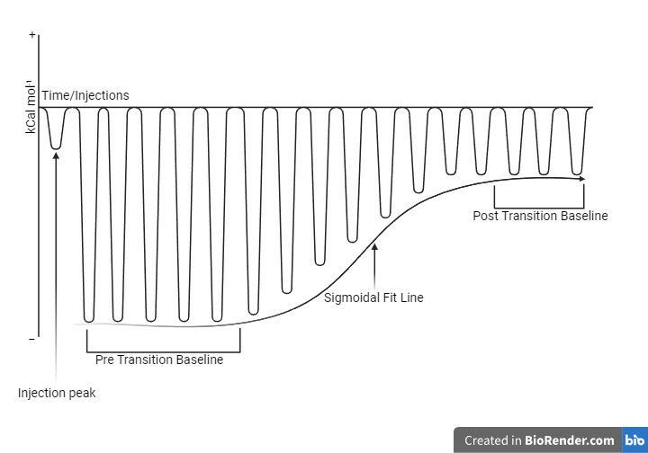
Figure 14. A standard ITC thermogram. This shows the pre transition baseline approaching the post transition baseline (where all binding occurs). The sigmoidal fit line is how one would get the Kd, n, and other relevant information about the binding kinetics of the species.
Mathematically, this heat exchange is directly related to the binding or chemical reaction occurring between the two substances by the expression:
ΔU = q+w
Where ΔU is the change in internal energy of the system, q Heat exchanged, and w is the work done by the system. Additionally, this can be further expanded to determine the enthalpy of the system using the equation.
ΔH = q_{total} ÷ q_{titrant}
In a typical ITC experiment, the following reaction is observed:
[A] + [B] ↔ [AB]
This reaction is used to construct the ratio [A][B]/[AB] = K_{d}. This is the power of ITC and allows us to show not only if different species are binding but how strongly the two are attracted to each other. Interpreting ITC data can yield information about ΔH (enthalpy change associated with the reaction), ΔS (entropy change/ disorder in the system), K_{d} (dissociation constant for the reaction), and n (stoichiometry/ number of binding sites available) (Misra, 2019). This is done by fitting data; for this system, we expect a 1:1 binding stoichiometry and thus an independent binding model.
    - Cyclic Voltammetry (CV) Method
Experiments were conducted on wild-type Cu²⁺-FtrB and Cu²⁺-H121A mutant of FtrB in 100 mM phosphate buffer at pH 7.3 using a BASi MF-2114 gold working electrode, a BASi MF-2052 Ag/AgCl reference electrode, and a platinum wire counter electrode. The Ag/AgCl reference electrode underwent calibration with a [Fe(CN)6]³⁻/ [Fe(CN)6]⁴⁻ solution according to a previously published method (Kolthoff, 1936). Potential sweeps were carried out using an Epsilon potentiostat connected to a BASi three-electrode system. Self-assembled monolayers (SAM) of the proteins (12 mg/mL) were prepared following a previously described protocol (González-Arribas, 2018). The gold electrode was initially polished and subjected to electrochemical acid cleaning to ensure the reliability of SAM formation. Subsequently, the cleaned electrode was immersed overnight in an ethanolic solution containing 10 mM mercaptopropionic acid (MPA). The following morning, the MPA-modified electrode was gently rinsed with ethanol and air-dried. A drop of the respective protein solution was then applied to the electrode surface and dried under constant N2 purging. Adherence of the protein to the electrode surface was confirmed by conducting CV experiments sequentially with the cleaned bare electrode, the electrode soaked overnight in MPA solution, and the electrode with the protein drop cast before each experiment. No redox signal was observed from either the bare gold electrode or the gold electrode soaked in MPA within the scanned potential range. Prior to each potential sweep, the buffer solution underwent a 10-minute N2 purging, followed by argon purging to blanket the buffer solution during the potential sweep.
    - Cyclic Voltammetry (CV) Experimental Theory & Data Analysis
Cyclic voltammetry (CV) is an electrochemical analytical technique used to probe the electroactivity of a species. This technique utilizes three electrodes: the working electrode (what shifts the electrical potential), the reference electrode (what the working electrode shifts with respect to), and the counter electrode (an electron sink so that potential can change) as seen in Figure 15. During the first half of this cycle, the potential is ramped in the negative direction, initially causing the salts ions in the solution to migrate producing a current (baseline). As the potential of the working electrode (WE) reached a characteristic value (indicated by E_{p}^{C}), the analyte starts getting reduced by accepting electrons from the electrode surface, producing reduction current (I_{p}^{C}). The potential then stops increasing in the negative direction and, reaching the swing potential, ramping begins in the positive direction. The working electrode reached another characteristic value (indicated by E_{p}^{A}) and the analyte starts getting oxidized by giving electrons to the electrode surface, producing oxidation current (I_{p}^{A}). Additionally, using these notable points, it is possible to determine the reversibility of a redox process (E_{p}^{A}-E_{p}^{C}) and how much analyte is lost due to the redox process (I_{p}^{C}/I_{p}^{A}).
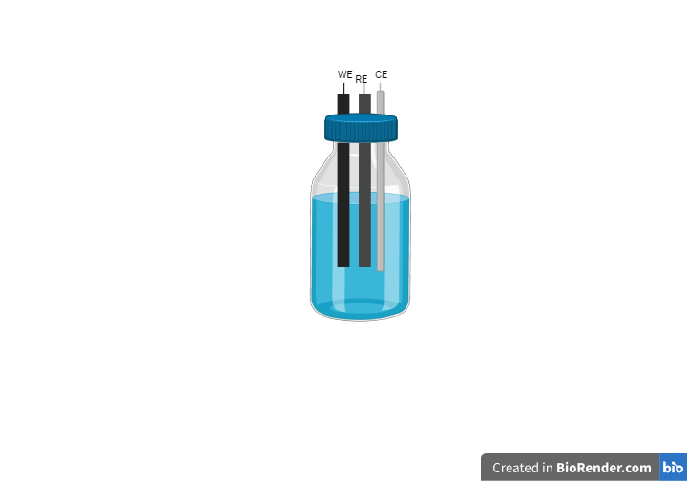
Figure 15. Standard CV setup. The working electrode (WE), reference electrode (RE), and counter electrode (CE) work together to oxidize and reduce the analyte of interest.
In this set up, the protein of interest is chemically linked to the surface of the working electrode with 3-mercaptopropionic acid (MPA) (Cheng, 2003). This forms a disulfide bridge to the protein and anchors so that signal is not dependent on protein coming sufficiently close to the electrode. After the protein is fixed to the electrode, the potential shifts. This change in potential serves to oxidize or reduce the protein of interest (Elgrishi, 2017). A standard CV voltammogram can be seen in Figure 16.
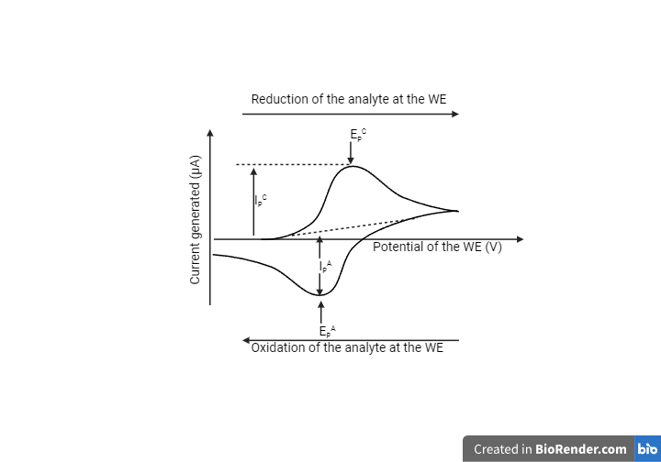
Figure 16. A typical potential Vs current response expected from an electroactive analyte. The height of the current peak is dependent on the concentration of the analyte in solution and the rate of diffusion of the oxidized and reduced analyte at the working electrode (WE). Once the potential ramping direction was switched (-0.2 to 0.2 V), the reduced analyte started diffusing towards the progressively positive potential electrode and when the potential reached a certain value (EpA), the reduced analyte lost electron to the electrode surface.
The maximum oxidation/potential and location of the currents demonstrate whether the redox reaction is reversible. The more symmetrical a voltammogram is, the more reversible the process is. If one of the peaks is not present, that process does not occur.
    - Cu²⁺-EDTA Assay Method
Ethylenediamine tetraacetic acid (EDTA) is a widely used chelator known for forming strong 1:1 complexes with various divalent metal ions. The Cu²⁺ complex of EDTA exhibits a distinct absorption peak at 732 nm, with a documented molar extinction coefficient (ε732 = 90.7 M⁻¹cm⁻¹) (Bermejo-Barrera, 1986). Other divalent cations like Co²⁺ and Ni²⁺ absorb at 490 nm and 335 nm, respectively, which allows for the specific detection of Cu²⁺ in a sample using spectrophotometric methods based on the 732 nm absorption maximum of the Cu²⁺-EDTA complex. We utilized this characteristic absorption value to determine the concentration of Cu²⁺ in the as-isolated wild-type FtrB protein using the following method:
EDTA_{(aq)} + Cu²⁺-FtrB_{(aq)} ↔ Cu²⁺-EDTA_{(aq)} + apo-FtrB_{(aq)}
To ensure complete removal of Cu²⁺ from the as-isolated protein, the final concentration of EDTA in the reaction mixture was maintained at 20 times higher than that of the protein concentration. Because the efficacy of this reaction depends on the presence of other chelators in solution (such as the conjugate base from buffer molecules) and the pH of the solution, we conducted spectrophotometric detection of Cu²⁺ under two different buffer conditions: 100 mM MES, 100 mM NaCl at pH 6.5, and 10 mM imidazole, 50 mM sodium phosphate, 300 mM NaCl at pH 7.4. As-isolated wild-type FtrB (50 μM), obtained after passing the tag-free protein through a size exclusion column, was extensively dialyzed against the specified buffers. Subsequently, an excess EDTA solution was added to the protein solution and incubated overnight at room temperature. The following morning, spectrophotometric measurements were taken on these samples. The protein samples (containing EDTA) were analyzed using a Shimadzu double-beam spectrophotometer in spectrophotometric mode. Absorbance readings from three independent protein solutions (with EDTA) were taken for each buffer condition to determine the standard deviation. Calibration curves were constructed using known concentrations of Cu²⁺ (prepared by diluting a standard Cu²⁺-nitrate solution from atomic absorption) to assess EDTA's capacity for binding Cu²⁺ quantitatively under these experimental conditions. The extinction coefficient (ε732 = 90.9 M⁻¹cm⁻¹) determined from this study in both buffers closely matched the reported value. The experimental setup can be seen in Figure 17.
Bottom of Form

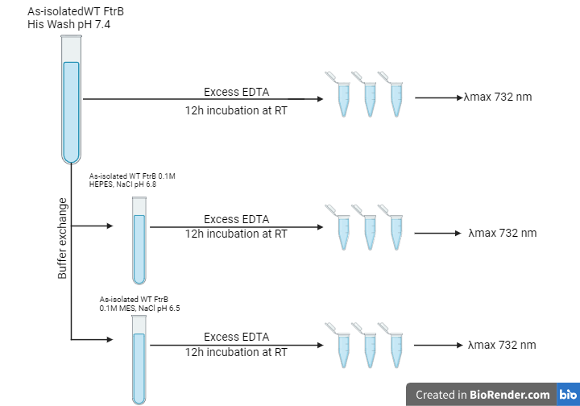
Figure 17. The method used to collect as-isolated FtrB Cu2+ concentrations. As-isolated FtrB used was 50µM and was allowed to incubate at room temperature for 12 hours. Samples were then scanned at 732 nm.
    - Cu²⁺-EDTA Experimental Theory & Analysis
The Cu²⁺-EDTA assay relies on the fact that different divalent metal ions (Ni²⁺, Co²⁺, Cu²⁺, etc.) can be bound by EDTA and absorb light at different maxima. Ni2+-EDTA and Co²⁺-EDTA absorb at 335 and 490 nm, respectively, whereas the λ_{max} for Cu²⁺-EDTA is at 732 nm. Due to the differences in the λ_{max} positions for these three transition metal ions, it is possible to selectively determine the concentration of each divalent ion from a mixture by adding a large excess of EDTA. The expected reaction taking place is:
Cu²⁺-FtrB (aq) + EDTA (aq) ↔ Cu²⁺-EDTA (aq) + apo-FtrB
The UV-visible spectra of the isolated protein did not show any absorption in the 800-400 nm range, allowing us to use the Cu²⁺-EDTA band at 732 nm to investigate the presence of any bound Cu²⁺ in the isolated protein (Bermejo-Barrera, 1986).

    - Ferrozine Assay Method
As isolated wild-type FtrB (2.5 μM) obtained after running the tag free protein through size exclusion column was extensively dialyzed against the desired buffer. A final concentration of 48 μM Fe²⁺ from an atomic absorption standard of Fe²⁺-chloride was added into a sample of 2.5 μM as isolated FtrB. Aliquots of this Fe²⁺-FtrB-Cu²⁺ solution were removed and added to an equal volume of ferrozine solution (at least 10x excess of Fe²⁺) after 5 seconds of the addition of iron and then every thirty seconds for a total of five minutes. Each aliquot was mixed thoroughly and performed in triplicate. This reaction was performed three times 1) 2.5 μM as isolated-FtrB + 48 μM Fe²⁺, 2) 2.5 μM Cu²⁺ + 48 μM Fe²⁺, and 3) 48 μM Fe²⁺. Spectrophotometric data on these protein samples were recorded on a Shimadzu double-beam instrument in spectrophotometric mode. Absorbance from three independent protein solutions were recorded for each buffer condition to obtain standard deviation value. This experimental setup can be seen in Figure 18.

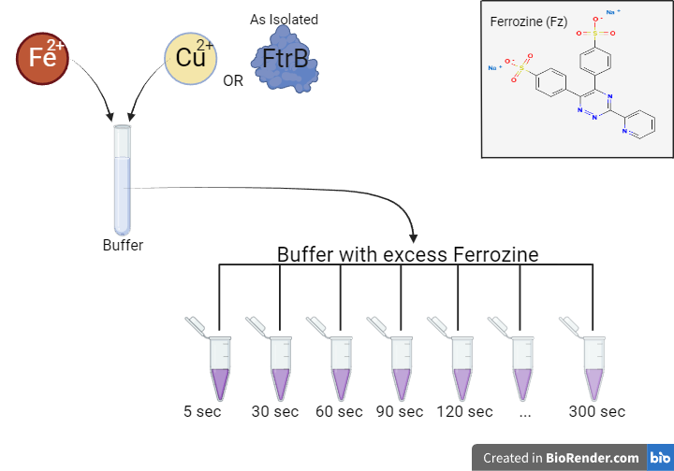
Figure 18. Ferrozine Experimental setup. As-isolated protein/copper solutions are inoculated with Fe²⁺ and aliquots are added to solutions with at least 10x Ferrozine. An aliquot is taken at 5 seconds and then every 30 seconds for 5 minutes.
    - Ferrozine Assay Experimental Theory & Data Analysis
3-(2-Pyridyl)-5,6-diphenyl-1,2,4-triazine-p,p′-disulfonic acid (Ferrozine or Fz, MF: C₂₀H₁₃N₄NaO₆S₂ , MW: 492.5 g/mol, ε= 27,900 M⁻¹ cm⁻¹) is a widely used chelator known for forming strong 3:1 complexes specifically with Fe²⁺. The complex of Fe²⁺-Fz exhibits a distinct absorption peak at 562 nm, with a documented molar extinction coefficient (ε562 = 27900 M⁻¹cm⁻¹) (Thomas, 2014). We utilized this characteristic absorption value to determine the amount of iron oxidized by as-isolated wild-type FtrB protein using the following method:
Fz_{(aq)} + Cu²⁺-FtrB-Fe²⁺_{(aq)} ↔ Cu²⁺-FtrB_{(aq)} + Fz₃-Fe²⁺
As the above reaction is dependent on the present pH of the solution, spectrophotometric detection of Fe²⁺ at three different buffer conditions (100 mM MES, 100 mM NaCl pH 6.8, 100 mM HEPES, 100 mM NaCl, pH 7.3, and 100 mM sodium acetate pH 6.5). Calibration curves were created with known Fe²⁺ concentrations (prepared by diluting an atomic absorption standard Fe²⁺-chloride solution) to determine the ability of ferrozine to quantitatively bind Fe²⁺ (E Viollier, 2000; Jeitner, 2014).
- Results & Discussion

  - Brucella FtrB requires D118 to form a predominantly β-sheet secondary structure in solution
As a predicted cupredoxin, Brucella FtrB is expected to fold as a conserved Greek key structure (Figure 19), consisting of β-sheets (Davidson et al. 2011). Although the homology modeling for wild-type FtrB predicted this structural fold (Figure 19) (Banerjee et al. 2022), no experimental data was available to confirm this predominantly β-sheeted structure in solution or the effects of pH and mutations on this structural fold. Circular dichroism (CD), a well-established spectroscopic tool to determine average solution structures of proteins, was used this spectroscopic method to experimentally determine the solution secondary structure of wild-type FtrB and two of its putative Cu²⁺ binding mutants, D118A and H121A (some of these CD experiments were performed prior to my time in our labs by Alexa Kerkan). I also conducted CD experiments under two pH conditions to determine the effect of pH change on the secondary structures of these proteins. Finally, I conducted Cu²⁺ titration into wild-type FtrB CD experiments to determine any structural effects due to metal ion addition. All CD experiments were performed in 10 mM phosphate buffer with no added salt and raw CD data were buffer subtracted and normalized (See Chapter 2 for more details on CD methods).
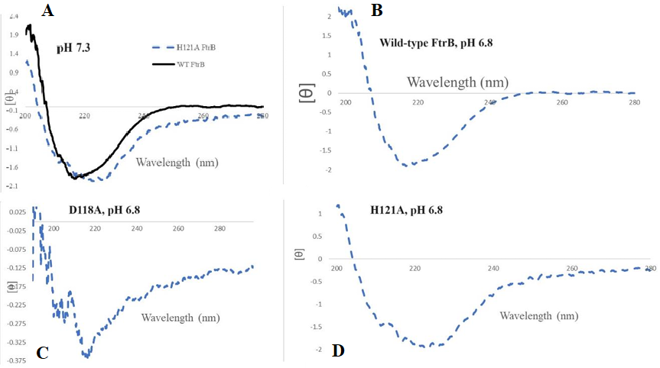
Figure 19. Representative CD spectra of recombinant FtrB and its mutants. A) wild-type FtrB and H121A FtrB at pH 7.3, B) wild-type FtrB at pH 6.8, C) D118A FtrB in 10mM phosphate buffer at pH 6.8, and D) H121A FtrB at pH 6.8. All proteins are in 10mM phosphate buffer at 25 ºC. Experiments were conducted on JASCO J-815 CD spectrometer using 1 mm quartz cuvette in the 190-280 nm range.
Representative CD spectra are presented in Figure 19, and the normalized data were compared with standard CD signals from standard proteins (Greenfield, 2006), indicating that wild-type FtrB folds in a global β-sheet secondary stucture (single negative band centered ~217 nm) under both pH 7.3 and 6.8 conditions but H121A FtrB shows a slight shift (single negative band centered at ~222). This is interpreted as a pH causing no variability in the global secondary structural fold of wild-type FtrB but the H121A mutation altering global secondary structure slightly, showing potential loss of β-sheet character. In contrast, an identical experiment with solutions of D118A FtrB shows (Figure 19C) an altered signal with two negative peaks (~220 and ~210 nm, pH 6.8). Additionally, there is a large change in intensity of ellipticity in the negative direction. This is interpreted as a changed global secondary structural fold resulting from mutating this putative Cu²⁺ binding residue (D118) with a significant loss of the β-sheet fold. CD data presented here confirms that wild-type FtrB folds in the correct secondary structure and that H121A FtrB has a slight alteration in secondary structure, but suggests that D118A might also be a structurally necessary residue as well as a cofactor binding residue.
Cu²⁺ titration into a solution of wild-type apo-FtrB did not show any significant change in the position or intensity of the original CD band. This is interpreted as either a) Cu²⁺ binding to this protein did not alter the global secondary structure of the protein significantly (although local structural changes cannot be ruled out), or b) Cu²⁺ did not bind to wild-type FtrB under these experimental conditions. Crystal structures of characterized apo- and holo-cupredoxins (such as azurin, rusticyanin, plastocyanin, etc.) show very low Cα RMSD deviation (Davidson et al. 2011), indicating little global structural changes upon metal binding to these proteins in the solid state, and the CD data obtained by me is congruent with X-ray crystal structure data.
  - Recombinant wild-type as isolated FtrB and H121A mutant purify with Cu²⁺ bound
FtrB is proposed to acquire copper in the periplasm and utilize this copper for enzymatic activities. With this in mind, it is relevant to see if FtrB is capable of chelating copper during its expression and keeping this copper bound during purification. UV-visible data indicates that wild-type and H121A FtrB isolate/ are purified with bound copper between pH 6.5 and 7.4. D118A FtrB does not isolate with copper at any pH tested. These values (seen in Table 1) are consistent with the presented ITC data (see next section and Table 2) about the pH ranges at which FtrB and mutants bind copper.

Table 1. Spectrophotometric data showing cupric cation content in as isolated FtrB (50 µM). All experiments were performed at 25ºC and standard error, of Cu²⁺ content in as isolated wild type FtrB, values were collected from individual trials done in triplicate.
Buffer condition | Protein name | [Protein]: [Cu²⁺]
100 mM MES, 100 mM NaCl, pH 6.5 | Wild-type FtrB | 1:2.0± 0.50
His wash buffer (10 mM imidazole, 50 mM sodium phosphate, 300 mM NaCl, pH 7.4) | Wild-type FtrB | 1:1.6 ± 0.38
His wash buffer (10 mM imidazole, 50 mM sodium phosphate, 300 mM NaCl, pH 7.4) | H121A | 1:1.48 ± 0.29
His wash buffer (10 mM imidazole, 50 mM sodium phosphate, 300 mM NaCl, pH 7.4) | D118A | No Cu²⁺ detected

The Cu²⁺-EDTA assay strongly supports recombinant D118A having no copper binding function. Additionally, this data supports recombinant wild type and H121A FtrB binding copper and maintaining this copper throughout the purification process. This rationalizes using as-isolated proteins as they purify with copper bound.

3.3.1 Cu²⁺ binding to wild-type apo-FtrB is pH dependent and this protein can only recognize a mimic of its substrate, Fe²⁺, when Cu²⁺ is bound to the protein
A recent study used differential scanning calorimetry (DSC) to determine if Cu²⁺ addition to recombinant wild-type FtrB from R. gelatinous altered its protein folding stability and found that presence of Cu²⁺ did not have any effect on melting temperature of this protein but addition of Fe²⁺ changed the unfolding temperature (Steunou et al. 2022). Given the CD data described in this thesis (Section 3.1) showed no significant secondary structural alterations by adding Cu²⁺ to wild-type FtrB, we argue that protein unfolding data is not conclusive in determining its Cu²⁺ binding ability. I conducted ITC metal titration experiments with recombinant wild-type and mutant Brucella FtrB under different pH and buffer conditions for more direct evidence of Cu²⁺ affinity of these proteins.
Representative thermograms obtained by myself and a former undergraduate student, Alexa Kerkan, are shown in Figure 20 and binding parameters are provided in Table 2. Titrating Cu²⁺ into apo-FtrB (wild-type) in different buffer and pH conditions showed exothermic binding heats (Figure 20). At pH 7.3 condition, Cu²⁺ showed stronger affinity towards the wild-type protein when both the metal and the proteins were dissolved in Bis-Tris buffer (Figure 20 A and B) than in HEPES buffer (Table 2).
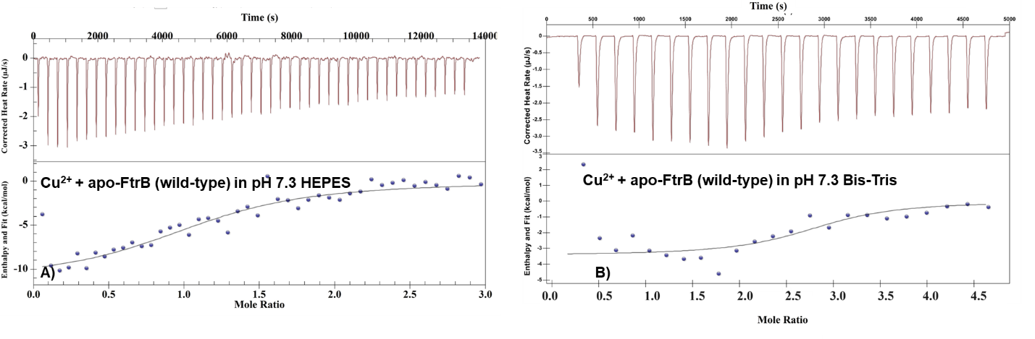
Figure 20. ITC thermograms for wild-type apo-FtrB binding to Cu²⁺. Representative ITC thermograms for A) Cu²⁺ titrated into wild-type apo-FtrB in 100 mM HEPES, 100 mM NaCl, pH 7.3; B) Cu²⁺ into H121A apo-FtrB in 100 mM HEPES, 100 mM NaCl buffer, pH 7.3. In all experiments, the concentration of the protein was 50 μM and the sample and reference cells were maintained at 25ﹾC. The upper part of each thermogram shows the heat generated during incremental ligand addition and the lower half shows the integrated heat data (as dots) with the best fit shown with thin lines. The raw exothermic heat data was integrated, and the best fit of this data was obtained by using an independent single site binding model.
The higher Cu²⁺ affinity towards wild-type FtrB at pH 7.3 can be attributed to a stronger affinity of Cu²⁺ towards Bis-Tris at this pH, making more Cu²⁺ available in solution for the binding reaction. Although HEPES (and other Good’s buffers) are expected to show minimal binding to metal ions, several recent experimental works have shown small to significant affinity of HEPES and MES towards Cu²⁺ (Bal et al. 2005), allowing ITC Cu²⁺ titration to be performed in these buffers. As a result of these buffer affinities towards Cu²⁺, proteins designed to bind this metal ion have to compete against the buffer and this competition depends on the availability of Cu²⁺ in the solution as well as the ability of proteins to sequester Cu²⁺ from the buffer. This latter point can be explained qualitatively using the scheme shown in Figure 21.

Table 2. Thermodynamic parameters obtained from ITC of metal ion (Cu²⁺, Mn²⁺, and Ag⁺) binding to wild-type and mutant Brucella FtrB protein. ª In100mM HEPES, 100 mM NaCl, pH 7.3; ^{b} in 50 mM Bis-tris, 100 mM NaCl, pH 7.3; ^{c} degassed DI water, pH 6.8.
Protein | Titrated metal | K_{d} (µM) | ΔH_{ITC} (kcal/mol) | ΔS (cal/Kmol) | n
Wild-type apo-FtrB^{b} | Cu²⁺ | 3.0 ± 1.0 | -3.64 ± 0.43 | 13.99 ± 1.5 | 2.15 ±0.50
Wild-type apo-FtrBª | Cu²⁺ | 23.3 ± 5.1 | -11.82 ± 1.01 | -18.38±3.76 | 1.24 ± 0.08
Wild-type apo-FtrB^{c} | Ag⁺ | 3.47 ± 0.7 | -105. ±30 | 73.2 | 1.10±0.30
Wild-type apo-FtrB^{d} | Cu²⁺ | No binding | No binding | --- | ---
Wild-type apo-FtrBª | Mn²⁺ | No binding | No binding | --- | ---
Wild-type Cu²⁺-FtrBª | Mn²⁺ | 2.13±0.46 | -63.0 ±0.05 | -188± 0.03 | 2.33±0.41
Apo-H121Aª | Cu²⁺ | 24.2 ± 11.5 | -8.001 ± 4.47 | -5.6 ±14.30 | 1.75 ± 0.57
Apo-D118Aª | Cu²⁺ | No binding | No binding | --- | ---

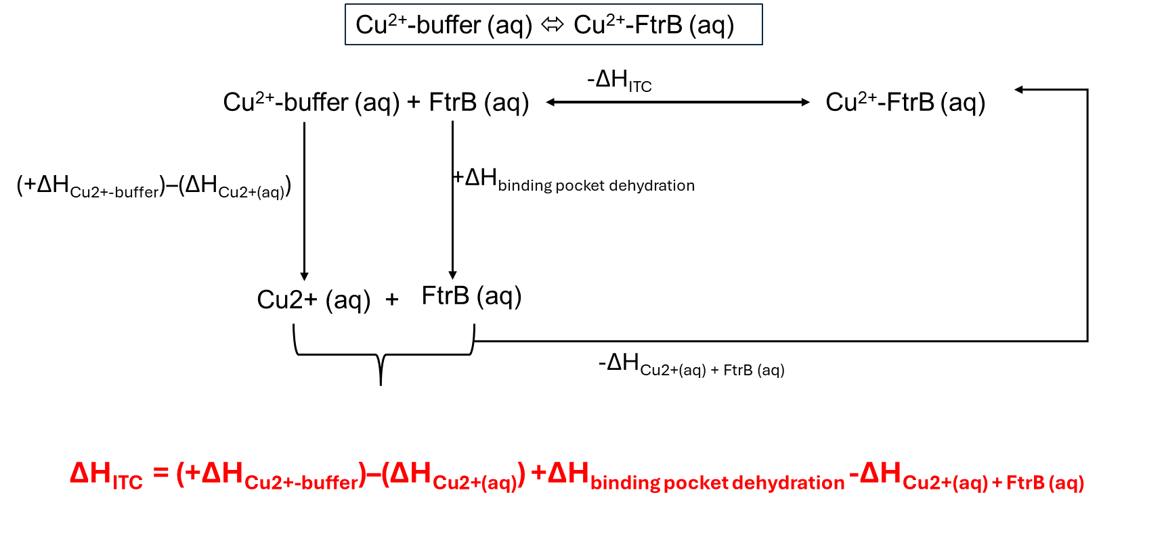
Figure 21. A qualitative thermochemical cycle showing some of the different steps that are involved during Cu²⁺ transfer from a buffer bound state to protein bound state. ITC experiments can follow the overall reaction shown at the top (enclosed in the box) and allow us to determine the net enthalpic change (ΔH_{ITC}) during a process which has contributions from breaking of Cu²⁺-buffer interaction (+ΔH_{Cu2+-buffer}), aquation of the Cu²⁺ ion (-ΔH_{Cu2+(aq)}), dehydration of the Cu²⁺ binding pocket in the protein (+ΔH_{binding pocket dehydration}), and finally, the binding of Cu²⁺ to FtrB (ΔH_{Cu2+-FtrB}). For clarity, as the experiment was performed at 25 ^{O}C, deprotonation of buffer was not included as a possible step in this scheme and for clarity (pKa for HEPES at 25 ◦C is 7.48), Cu²⁺ dehydration enthalpy before binding to FtrB and rehydration of the Cu²⁺-bound FtrB binding pocket are not shown.
Wild-type FtrB shows not only the ability to bind Cu²⁺ but also Cu⁺ at pH 7.3. This supports wild-type FtrB being able to for the active and inactive enzyme, required steps for performing iron oxidative activity. H121A FtrB shows comparable copper binding to the wild-type protein under the same buffer and pH conditions. D118A FtrB showed no copper binding activity but CD supports a significant loss of secondary structure, supporting that the fold is important to copper binding activity with a potential for D118 also being a copper binding residue.
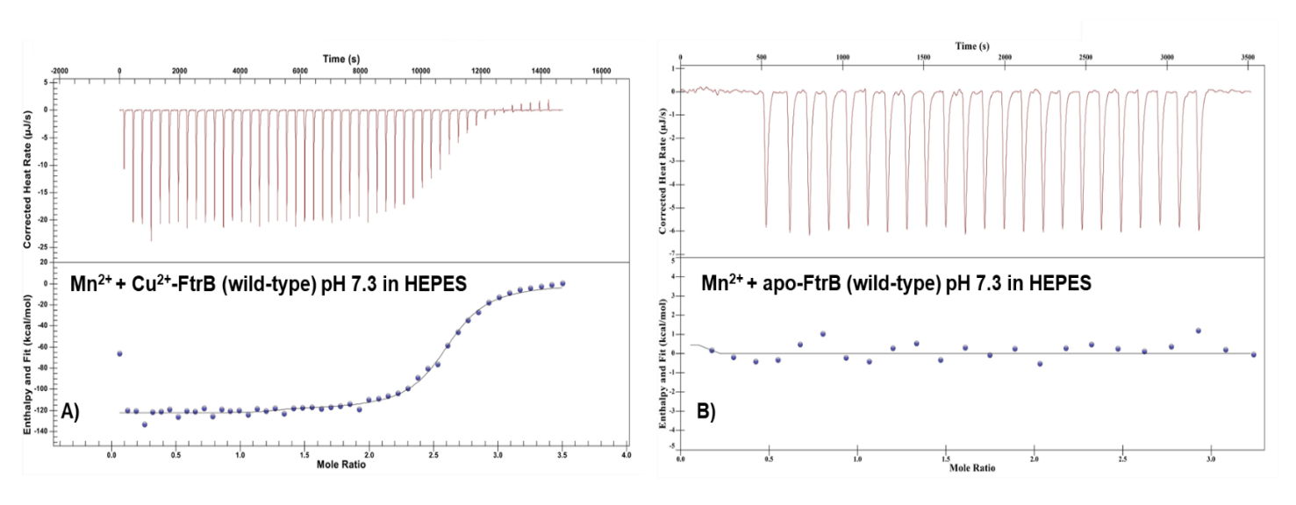
Figure 22A shows representative ITC thermogram for Mn²⁺ (a Fe²⁺ mimic) titrated into a solution of Cu²⁺-FtrB (wild-type) in HEPES buffer at pH 7.3. Binding parameters on Table 2 indicate that Mn²⁺ (an Fe²⁺ mimic) showed enthalpy-driven low μM affinity for the protein at this pH. On the other hand, Mn²⁺ titrations with apo-FtrB (wild-type) did not show any binding heat (Figure 22B), indicating that the presence of Cu²⁺ in the wild-type protein is necessary for the Fe²⁺ mimic recognition. Similar observations were also made for FtrA-Mn²⁺ interaction (Chanakira et al. 2022) and taking Mn²⁺ binding data from FtrB and FtrA together, it can be concluded that Cu²⁺ might play a crucial role in substrate recognition by these periplasmic proteins.
Figure 22. ITC thermograms for wild-type apo-FtrB and Cu²⁺-FtrB binding to Mn²⁺. Representative ITC thermograms A) Mn²⁺ titrated into wild-type Cu²⁺-FtrB in 100 mM HEPES, 100 mM NaCl, pH 7.3; B) Mn²⁺ into wild-type apo-FtrB in 100 mM HEPES, 100 mM NaCl buffer, pH 7.3. In all experiments, the concentration of the protein was 50 μM and the sample and reference cells were maintained at 25ﹾC. The upper part of each thermogram shows the heat generated during incremental ligand addition and the lower half shows the integrated heat data (as dots) with the best fit shown with thin lines. The raw exothermic heat data was integrated, and the best fit of this data was obtained by using an independent single site binding model.
Lastly, when similar Cu²⁺ binding experiments at pH 5 showed that the wild-type apo-FtrB did not show any binding heat, indicating the ability of the wild-type protein to bind Cu²⁺ is dependent on the pH of the environment. Given that one of the putative Cu²⁺ binding residue from FtrB is from a His sidechain (H121), this lack of affinity of wild-type apo-FtrB towards Cu²⁺ at pH 5 can be attributed to protonation of the His side chain (pKa of His sidechain ~ 6.2) creating repulsion between the metal ion and the binding site from the protein.
3.3.2 H121A and D118A FtrB Cu²⁺ binding
Wild-type and H121A FtrB both show copper binding ability with comparable binding affinity but H121A shows a difference in the thermodynamic contributions of enthalpy and entropy (Figure 23B). D118A FtrB was tested under these same conditions but showed no copper binding between pH 7.3-6.5. Cu²⁺ binding to wild-type and H121A was also tested at pH 6.8 and 6.5 and suggest binding but more work needs to be done to come to a definitive conclusion. This shows that D118 is essential for protein folding and may hold a significance for copper binding by wild-type FtrB. (Section 3.1).

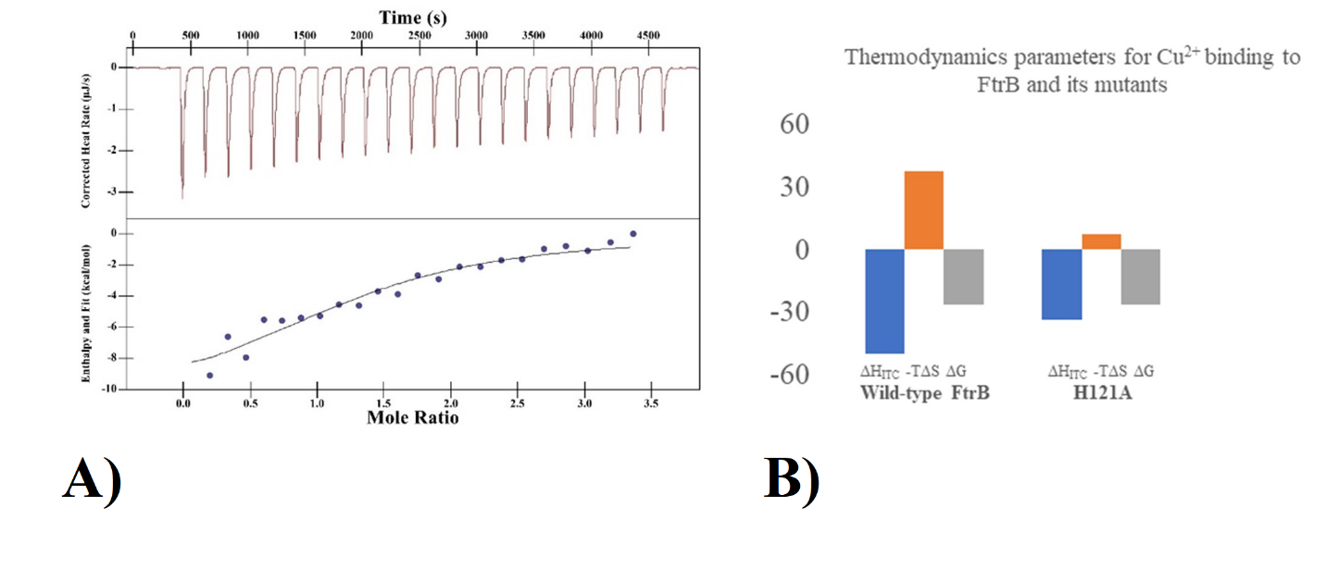
Figure 23. H121A FtrB thermodynamic parameters and binding thermogram. A) a representative ITC binding thermogram for H121A FtrB and B) a bar graph generated from the thermodynamic analysis of ΔHITC, ΔG (obtained from the K_{d}), and ΔS of Cu²⁺ binding to wild-type and H121A mutant FtrB. This graph shows ΔHITC as blue bar, -T ΔS as orange bar, and ΔG as gray bar. The ΔHITC contribution for Cu²⁺ binding to H121A is much smaller and the ΔG has greater contribution from the -TΔS term. This analysis was done using binding data of wild-type and H121A FtrB in 100 mM HEPES, 100 mM NaCl, pH 7.3. Table 2 provides the standard deviations for ΔH, ΔG, and ΔS.
3.4 EPR signal from Cu²⁺ reconstituted wild-type and H121A mutant FtrB suggest different binding pockets
As described in section 3.2, both the wild-type and H121A FtrB showed Cu²⁺ affinity. ITC data analysis indicated that Cu²⁺ binding to H121A takes places with different enthalpy-entropy parameters than with the wild-type apo-protein (Table 2, Figure 24). EPR experiments were performed on Cu²⁺ reconstituted wild-type and H121A mutant FtrB to investigate if this altered thermodynamics results from Cu²⁺ binding in a different ligand environment in the mutant protein.
Preliminary Cu²⁺ EPR spectra obtained from a single EPR trial (non-reproducible) of Cu²⁺-H121A (Figure 24) show a copper signal that differs from wild-type. The intensity of the Cu²⁺ signal from H121A-Cu²⁺ was also not reduced when compared to Cu²⁺ in buffer solution. As a whole, the EPR is inconclusive. The single trail Cu²⁺ signal from Cu²⁺-FtrB (wild-type, no HCl added) when compared with the Cu²⁺-H121A signal (blue and red curves from Figure 24), shows that the Cu²⁺ environment in the wild-type protein is different than in the mutant. This difference in spectra could suggest a difference in the g-factor of these species, presenting as a split peak. binding coordination than that of wild type FtrB (seen in Figure 24). Comparing the signal from Cu²⁺-H121A with Cu²⁺ alone in the buffer (red and black curves from Figure 24), it can be suggested that this paramagnetic metal ion exists in a different coordination environment in the presence of H121A FtrB but more spectra would been to be collected before concluding anything more. Further investigation needs to be done.

Figure 24. H121A FtrB EPR spectra compared to wild type FtrB. Cu²⁺ is black. Cu²⁺-FtrB H121A is red. Cu²⁺-FtrB wild-type is blue. (Frequency: 9.634 GHz, Power: 3.181 mW, Modulation amplitude:15.00 G)
Figure 25 shows the single trial of Cu²⁺ EPR signal (at pH 7.4) for the wild-type protein showed a reduction in intensity compared to aqueous copper (Figure 25). To investigate if this reduced Cu²⁺ signal from the wild-type protein sample was due to copper ion precipitation (before it could bind to the protein at the experimental pH) or due to partial reduction of the FtrB bound Cu²⁺ to the EPR inactive Cu⁺ form, 12 N HCl was added to EPR samples (the control was performed by adding the same amount of acid to a tube containing only Cu²⁺ and the buffer). The EPR data presented in Figure 25 shows that by adding HCl to the protein-copper solution, there is a recovery of Cu²⁺ signal (seen in purple). This EPR signal recovery can be because HCl denatured the protein, releasing any copper ion bound to it (as Cu²⁺ and Cu⁺) and due to the aerial oxidation of any Cu⁺ in the solution to Cu²⁺.

Figure 25. Wild type FtrB copper signal before and after acidification. The EPR signal from Cu²⁺ by itself in the buffer is shown using the black curve. EPR signal from Cu²⁺-FtrB (wild-type) is shown in blue and Cu²⁺-FtrB (wild-type) + 12N HCl is shown in purple. The concentration of Cu²⁺ in all samples was 100 µM. A comparison of the intensities due to paramagnetic Cu²⁺ in solution indicates loss of signal in the presence of the wild-type protein which was recovered by adding HCl, which denatured the protein releasing Cu²⁺ in solution. (Frequency: 9.632 GHz, Power: 3.196 mW, Modulation amplitude:15.00 G)
This EPR data is, as a whole, inconclusive as there is only a single run to go from and these data were non-reproducible. There are several things that could be suggested from the data above but there is not enough information to make any definitive claims other than more experiments need to be done.
  - Wild-type FtrB can bind to both Cu²⁺ and a Cu⁺ mimic and the FtrB-Cu²⁺ ⬄ FtrB-Cu⁺ redox reaction does not significantly alter the apo-enzyme
EPR data on Cu²⁺ reconstituted wild-type FtrB indicates that some of the bound Cu²⁺ is reduced to Cu⁺ state (Figure 25). As Cu²⁺-FtrB ⬄ Cu⁺-FtrB is an expected step during the proposed ferroxidase mechanism, the reduction potential for this reaction and the stability of the Cu⁺-FtrB were investigated using CV and ITC experiments, respectively.
CV data (Figure 26) on Cu²⁺-FtrB (wild-type) and Cu²⁺-H121A are shown below, and the oxidation/reduction potential data is presented in Table 3. These show that Cu²⁺-FtrB ⬄ Cu+-FtrB is a reversible process (ΔE = 46 mV, Table 3). As reversibility of a redox reaction requires small to no alteration to the overall energy levels of the reduced and oxidized state, this data indicates that FtrB bound to copper ion is relatively invariant in its molecular structure, irrespective of the oxidation state of the bound copper ion. The reduction potential for Cu²⁺ reduction (bound to wild-type FtrB) is 500 mV (vs NHE) and is comparable to the reduction potential obtained for known cupredoxins (Davidson et al. 2011). This reduction potential is also within the stability of water region, indicating that FtrB can act as a biological redox system without causing redox reaction to this biological solvent.

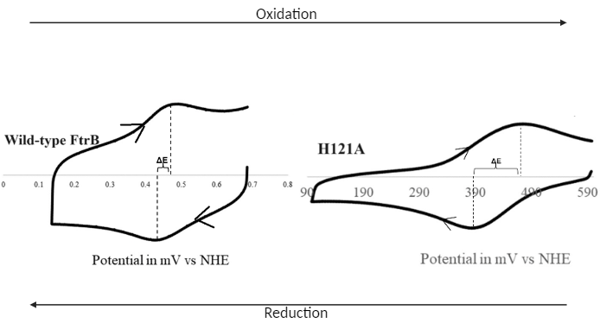
Figure 26. Voltammograms of wild-type and H121A FtrB. The thick black line shows the raw data. The difference between wild-type FtrB oxidation and reduction potentials (ΔE ~75 mV) falls within the quasi-reversible redox process, indicating the molecular orbital energy levels in the oxidized and reduced species are not altered appreciably due to the one-electron redox process. The difference between H121A FtrB oxidation and reduction potentials (ΔE >100 mV) is irreversible, indicating the energy levels of the oxidized and the reduced species differ appreciably. The ratios of oxidation and reduction current are close to 1, indicating the mutant can also bind with both Cu2+ and Cu+ ions.
Table 3. Wild type FtrB CV data. The CV data collected supports wild-type and H121A FtrB binding both Cu⁺ and Cu²⁺ but only wild-type FtrB can biologically perform oxidation and could accept an electron from iron. This would suggest that H121 contributes to the stabilization of both Cu⁺ and Cu²⁺ binding.
Protein | E_{R} (mV) | E_{O} (mV) | ΔE (mV) | E_{1/2} (mV)
FtrB (as-isolated) | 477 | 523 | 46.0 | 500
H121A (as-isolated) | 376 | 473 | 97.0 | ---

CV experiments on Cu²⁺-FtrB (wild-type) showed that the ratio of currents (I_{reduction/}I_{oxidation)} at all scan speeds remained close to 1. As this current ratio is a measure of the relative concentration of the species that can get oxidized and reduced in solution during an experiment, this indicates that Cu⁺ was not lost from wild-type FtrB. The ability of wild-type FtrB to bind Cu⁺ was also confirmed using ITC (Figure 27). In the ITC experiment, performed by Bridget Aidoo (an undergraduate researcher from our lab), Ag⁺ was used as a Cu⁺ mimic and was titrated in apo-FtrB (wild-type) solution. Figure 27 shows exothermic binding heat for Ag⁺ towards FtrB and a μM affinity very similar to Cu²⁺ (Table 2).
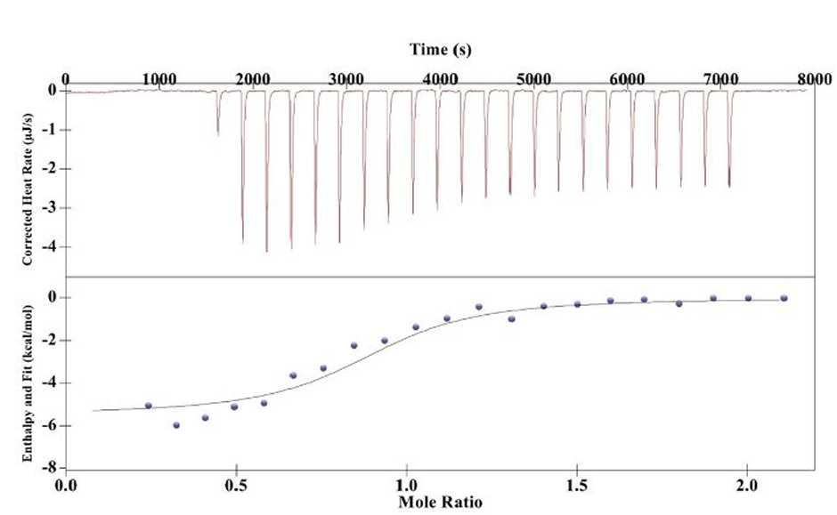
Figure 27. ITC thermograms for FtrB binding to Ag⁺ (a Cu⁺ mimic). A representative Ag+_{(aq)} titrated into wild-type apo-FtrB in 100 mM HEPES, 100 mM NaCl, pH 7.3. The concentration of the protein was 50 μM and the sample and reference cells were maintained at 25ﹾC. The upper part of each thermogram shows the heat generated during incremental ligand addition and the lower half shows the integrated heat data (as dots) with the best fit shown with thin lines. The raw exothermic heat data was integrated, and the best fit of this data was obtained by using an independent single site binding model.
In contrast, the CV data obtained from Cu²⁺-H121A showed irreversible redox reaction (ΔE= 99 mV), indicating alteration in the electronic energy levels of Cu²⁺-H121A upon reduction.
3.6 Wild-type FtrB can oxidize Fe²⁺ in a pH dependent manner
The data presented above confirms that wild-type FtrB can bind Cu²⁺ and a Fe²⁺ mimic (Mn²⁺), forming an active holoenzyme (Cu²⁺-FtrB) and an active holoenzyme-substrate complex (Cu²⁺-FtrB-Mn²⁺). As the proposed Fe²⁺ oxidase, the function of this active holoenzyme is to oxidize the bound substrate, forming the substrate (Fe³⁺) for its transport through FtrC following the reaction shown below—
- Cu²⁺ (aq) + apo-FtrB (aq) Cu²⁺-FtrB (aq) Active holoenzyme
- Cu²⁺-FtrB (aq) + Fe²⁺ (aq) Cu²⁺-FtrB-Fe²⁺ (aq) Active holoenzyme-substrate
- Cu²⁺-FtrB-Fe²⁺ (aq) Cu⁺-FtrB-Fe³⁺ (aq)
A spectrophotometric assay was used to investigate if the last reaction above takes place spontaneously in vitro. In short, the proposed ferrous oxidase reaction was “quenched” by adding excess ferrozine, a Fe²⁺ specific chelator, to a solution containing as isolated FtrB (active holoenzyme)-Fe²⁺ at different time points. The experimental assumption was that ferrozine having a high affinity for Fe²⁺, coordinated with the left-over Fe2+ that did not get oxidized to Fe³⁺. Absorbance due to the characteristic [Fe(ferrozine)3]⁴⁻ complex at 562 nm (ε₅₆₂ = 27,900 M⁻¹cm⁻¹) quenched at different time points were recorded and converted into concentration of Fe²⁺ left over at that time point. Graphs were generated by plotting concentration of Fe²⁺ left vs the time when the reaction was quenched. Control experiments were performed to compare the rate of autooxidation of Fe²⁺, and oxidation of Fe²⁺ by free Cu²⁺ in solution in separate experiments and the analyzed data plotted on the same graph for comparison. Figure 28 shows the analyzed ferrozine assay data at three different pH conditions. As can be noted, the rate of Fe²⁺ loss is most pronounced at pH 7.3 (Figure 28), and least at pH 6.5 (Figure 28). The orange trend line in Figure 28 shows the loss of Fe²⁺ when as isolated FtrB (wild-type) was present in solution, and when this is compared with the green (Fe²⁺ alone in solution) and blue (Fe²⁺ with free Cu²⁺) trend lines show Fe²⁺ loss due to autooxidation and oxidation due to free Cu2+ in solution. The ferrozine assay strongly suggests that wild type FtrB can oxidize iron and that this oxidation is not due to free copper in solution. As seen in Figure 28, Cu²⁺ alone shows increased iron loss compared to autoxidation in solution but wild type FtrB heavily reduces the amount of iron (II) in solution compared to both. Oxidation by wild type FtrB also seems to be pH dependent as wild type FtrB at pH 6.5 shows a negligible difference in iron oxidation compared to the rate of autoxidation (as seen in Figure 28).

Figure 28. Trendline of iron loss (Au) in solutions of wild type FtrB, iron, and copper at pH 7.3, 6.8, and 6.5 over 5 minutes. A) 0.1M HEPES, 0.1M NaCl pH 7.3 oxidation of Fe²⁺. B) 0.1M MES, 0.1M NaCl pH 6.8 oxidation of Fe²⁺. C) 0.1M Sodium acetate buffer pH 6.5.
D118A FtrB shows no oxidative activity at pH 7.3 and follows the same trend as iron autoxidation instead of Fe²⁺ + Cu²⁺, supporting that there is no copper bound to D118A FtrB (Figure 29).

Figure 29. Trendline of iron loss (Au) in solutions of D118A FtrB at pH 7.3. Oxidation of Fe²⁺ over a span of 5 minutes in 0.1M HEPES, 0.1M NaCl, pH 7.3. Orange is D118A FtrB (2.5µM). Purple is the autoxidation of iron (II). Blue is Cu²⁺(2.5µM) with Fe²⁺(48µM). D118A follows the trend of autoxidation closely.
This strongly supports D118 as a required residue for copper binding and that recombinant as-isolated wild type FtrB requires a copper cofactor to oxidize iron. Oxidation also occurs in a pH dependent fashion.
- Conclusion
As was mentioned in Chapter 1, the main aim of this thesis work was to determine a) if wild-type FtrB can bind Cu²⁺ and Mn²⁺ (Fe²⁺ mimic), b) identifying the roles of the conserved Cup-II residues, D118 and H121 in forming the native structure and metal ion binding property of FtrB/ if Cu²⁺ and Fe²⁺ are bound, and c) determining if wild-type FtrB can perform the predicted Fe2⁺ oxidase activity. The experimental techniques utilized to answer these questions and the theories behind these methods are outlined in Chapter 2. Figure 30 reiterates the experimental methods in identifying—
- If wild-type FtrB can bind to Cu²⁺ and Cu⁺. This is an important question as if FtrB does perform as a redox enzyme, it cannot lose its metal cofactor (Cu ion) during its enzymatic reaction.
- If wild-type FtrB can recognize Fe²⁺ (or its mimic, Mn²⁺). This is important as to be able to act as a ferrous oxidase, FtrB should form an enzyme-substrate complex.
As shown in Figure 30 below, the Cu²⁺, Cu⁺, and a Fe²⁺ binding abilities were investigated using ITC experiments. The feasibility of the Cu²⁺-FtrB ⬄ Cu⁺-FtrB reaction under biological conditions was investigated using CV experiments. Integrity of the solution structures for wild-type and mutant FtrB were investigated using CD experiments and the ability of the mutants to bind Cu²⁺ and Fe²⁺ were investigated using ITC and/or EPR experiments. The data obtained from these experiments are described in the following sections. Data and their analyses presented in this thesis show that—
- Wild-type FtrB forms predominantly β-sheet structure in the pH interval 7.3-6.8
- FtrB purifies bound to Cu²⁺ and wild-type apo-FtrB can be reconstituted with Cu²⁺ (at pH 7.3 but not at pH 5), a Cu⁺ mimic
- The wild-type protein can form the proposed enzyme-substrate complex (Fe²⁺-FtrB-Cu²⁺)
- The conserved Cup-II residue, D118, is required for the native structure formation and Cu²⁺ recognition
- The wild-type enzyme substrate complex (Fe²⁺-FtrB-Cu²⁺) loses Fe²⁺ in a time dependent manner most efficiently at pH 7.3 and 6.8 but not at pH 6.5
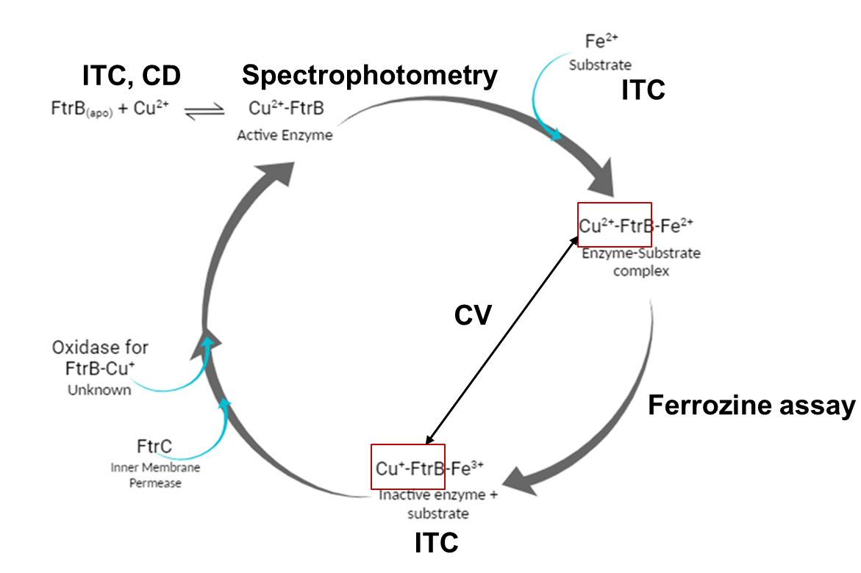
Figure 30. Proposed enzymatic cycle for Fe²⁺ oxidation by Cu²⁺-FtrB showing different intermediate species in solution. This Figure also shows experimental methods used to determine the presence of various intermediate species. The CV experiment was conducted on Cu²⁺-FtrB (wild-type) in absence of any added Fe²⁺ to avoid overlapping redox signals and that is indicated by enclosing the Cu²⁺-FtrB and Cu⁺-FtrB in red boxes.

The CD data generated confirms that wild-type FtrB fold in a β-sheet secondary structure, which was previously only a model prediction. This also supports the functional relation of FtrB to known cupredoxin proteins that share a similar secondary structure to this protein. Mutants H121A and D118A showed differences in secondary structure with H121A showing a slight shift in character and D118A showing almost complete loss of secondary structure. This suggests that these residues are important to the correct folding of wild-type FtrB in vitro.
FtrB is proposed to bind copper for redox activity. If FtrB can be purified with copper bound, this gives an indication towards whether copper binding is occurring by this protein. Wild-type and H121A FtrB both showed copper binding after purification, indicating that H121 is not essential for copper binding to occur. This residue does play some role in global structure of the wild-type protein. D118A FtrB shows no copper bound during isolation and suggests that the fold is required for wild-type FtrB to bind copper. This makes biological sense considering that cupredoxins all fold in a global β-sheet structure.
The ITC and CV data gathered shows that not only can wild-type FtrB form all of the required complexes for the proposed ferrous oxidase enzymatic activity, but that copper is not lost during oxidation or reduction. Additionally, manganese, an iron mimic, can only bind when copper is previously bound. This is very biologically relevant as it supports that FtrB’s function is copper dependent, like a ferroxidase or ferrous oxidase. H121A did not show a difference in binding affinity for copper but instead in the enthalpy-entropy contribution of the binding, suggesting that there is a difference in the coordination environment of the complex.
The ferrozine assay results assert that FtrB can oxidize iron efficiently at pH 7.3. This data not only supports the model assumption that FtrB is a novel ferrous oxidase enzyme and also indicates that this oxidation is pH dependent with lower pH values (like pH 6.8 or pH 6.5) being less efficient. This result is interesting in vitro and addressed weather FtrB is a redox active enzyme but does not fit well into the biologically context of the system. FtrABCD is a system that is expressed under low pH/ acidic conditions. Additionally, the habitat of Brucella is within the macrophage which is, largely, acidic. With FtrB working better at higher pH values, it does not make biological sense for FtrB to function worse closer to the pH that the host organism will be living at. With this in mind, it is relevant to mention that FtrA could be supplementing this role as the low pH iron oxidation enzyme, but further research would need to be done on this topic.
This investigation into metal binding and thermodynamic properties of recombinant wild-type FtrB from Brucella spp. serves to demonstrate that FtrB binds copper in a novel fashion and oxidizes iron in a pH dependent fashion. Additionally, copper is required for oxidative activity and is therefore biologically relevant for FtrB’s function. To our knowledge, this study presents the first biochemical characterization of Cu²⁺ binding by any Cup-II protein, utilizing conserved residues D118 and H121. This is significant as it challenges the traditional understanding of copper binding by proteins with cupredoxin folds. These findings enhance our comprehension of possible metal coordination within Cup-II proteins and offer avenues for exploring the functional significance of FtrB within the FtrABCD system. Lastly, these findings emphasize the need for more research into copper binding by biological molecules and using this binding to understand bacterial iron transport.

- Broader impact
Brucella spp. are equipped with a unique and, presently, mostly unexplored iron acquisition system. Determining how this system’s other subunits work together could give us insight into similar systems in other organisms and potentially expand on how we understand copper chemistry in living systems. Additionally, Brucella spp. live in inhospitable niches, mainly the macrophage of the lymph nodes, spleen, and liver. Because of the nature of their niche in the mammalian system, it is very difficult to treat the organism directly. These pathogens are highly contagious, with some species requiring as little as one organism to cause infection. Understanding what makes this organism’s biology function not only serves to fill in a crucial gap in our knowledge but could also give some clue to the virulence and gleam at a potentially specific way to target Brucella as a whole. Additionally, given that FtrB’s functions are now known, there is more reason to investigate FtrA’s iron oxidase function and the combined functions of FtrA and FtrB in solution together. Lastly, looking at how these proteins functions in vivo would not only contextualize the activity of the proteins but also the mechanism of iron oxidation and translocation.

REFERENCES
Askwith, C., Eide, D., Van Ho, A., Bernard, P. S., Li, L., Davis-Kaplan, S., Sipe, D. M., & Kaplan, J. (1994). The FET3 gene of S. cerevisiae encodes a multicopper oxidase required for ferrous iron uptake. Cell, 76(2), 403–410. https://doi.org/10.1016/0092-8674(94)90346-8
Banerjee, S., Chanakira, M. N., Hall, J., Kerkan, A., Dasgupta, S., & Martin, D. W. (2022). A review on bacterial redox dependent iron transporters and their evolutionary relationship. Journal of Inorganic Biochemistry, 229, 111721. https://doi.org/10.1016/j.jinorgbio.2022.111721
Banerjee, S., Garrigues, R. J., Chanakira, M. N., Negron-Olivo, J. J., Odeh, Y. H., Spuches, A. M., Martin Roop, R., Pitzer, J. E., Martin, D. W., & Dasgupta, S. (2020). Investigating the roles of the conserved cu2+-binding residues on Brucella ftra in producing conformational stability and functionality. Journal of Inorganic Biochemistry, 210, 111162. https://doi.org/10.1016/j.jinorgbio.2020.111162
Bermejo-Barrera, A., Guisasola-Escudero, M., & Bermejo-Martinez, F. (1986). Spectrophotometric determination of copper with EDTA and NTA by derivative spectrometry. Microchemical Journal, 33(1), 52–61. https://doi.org/10.1016/0026-265x(86)90079-2
Brickman, T. J., & Armstrong, S. K. (2012). Iron and ph‐responsive ftrabcd ferrous iron utilization system of bordetella species. Molecular Microbiology, 86(3), 580–593. https://doi.org/10.1111/mmi.12003
Butt, A. T., & Thomas, M. S. (2017). Iron acquisition mechanisms and their role in the virulence of burkholderia species. Frontiers in Cellular and Infection Microbiology, 7. https://doi.org/10.3389/fcimb.2017.00460
Chan, A. C. K., Doukov, T. I., Scofield, M., Tom-Yew, S. A. L., Ramin, A. B., MacKichan, J. K., Gaynor, E. C., & Murphy, M. E. P. (2010). Structure and function of p19, a high-affinity iron transporter of the human pathogen campylobacter jejuni. Journal of Molecular Biology, 401(4), 590–604. https://doi.org/10.1016/j.jmb.2010.06.038
Cheng, W., Dong, S., & Wang, E. (2003). Site-selective self-assembly of MPA-bridged CuHCF multilayers on APTMS-supported gold colloid electrodes. Chemistry of Materials, 15(13), 2495–2501. https://doi.org/10.1021/cm021052l
Choi, M., & Davidson, V. L. (2011). Cupredoxins—a study of how proteins may evolve to use metals for bioenergetic processes. Metallomics, 3(2), 140. https://doi.org/10.1039/c0mt00061b
Chu, B. C., Garcia-Herrero, A., Johanson, T. H., Krewulak, K. D., Lau, C. K., Peacock, R. S., Slavinskaya, Z., & Vogel, H. J. (2010). Siderophore uptake in bacteria and the battle for iron with the host; a bird’s Eye View. BioMetals, 23(4), 601–611. https://doi.org/10.1007/s10534-010-9361-x
Contreras, H., Chim, N., Credali, A., & Goulding, C. W. (2014). Heme uptake in bacterial pathogens. Current Opinion in Chemical Biology, 19, 34–41. https://doi.org/10.1016/j.cbpa.2013.12.014
Crichton, R. R., Wilmet, S., Legssyer, R., & Ward, R. J. (2002). Molecular and cellular mechanisms of iron homeostasis and toxicity in mammalian cells. Journal of Inorganic Biochemistry, 91(1), 9–18. https://doi.org/10.1016/s0162-0134(02)00461-0
Stoudenmire, J. L., Greenawalt, A. N., & Cornelissen, C. N. (2022). Stealthy microbes: How neisseria gonorrhoeae hijacks bulwarked iron during infection. Frontiers in Cellular and Infection Microbiology, 12. https://doi.org/10.3389/fcimb.2022.1017348
De Silva, D. M., Askwith, C. C., Eide, D., & Kaplan, J. (1995). The FET3 gene product required for high affinity iron transport in yeast is a cell surface ferroxidase. Journal of Biological Chemistry, 270(3), 1098–1101. https://doi.org/10.1074/jbc.270.3.1098
E Viollier, P.W Inglett, K Hunter, A.N Roychoudhury, P Van Cappellen, The ferrozine method revisited: Fe(II)/Fe(III) determination in natural waters, Applied Geochemistry, Volume 15, Issue 6, 2000, Pages 785-790, ISSN 0883-2927, https://doi.org/10.1016/S0883-2927(99)00097-9.
E. González -Arribas, M. Falk, M. O. Aleksejeva, S. Bushnev, S. P. Sebastián, J. M. Feliu and S. Shleev, J. Electroanal. Chem. (2018), 816, 253.
Edward I. Solomon, David E. Heppner, Esther M. Johnston, Jake W. Ginsbach, Jordi Cirera, Munzarin Qayyum, Matthew T. Kieber-Emmons, Christian H. Kjaergaard, Ryan G. Hadt, and Li TianChemical Reviews 2014 114 (7), 3659-3853. DOI: 10.1021/cr400327t
Edwards, A. A., & Alexander, B. D. (2017). UV-visible absorption spectroscopy, organic applications. Encyclopedia of Spectroscopy and Spectrometry, 511–519. https://doi.org/10.1016/b978-0-12-803224-4.00013-3
Elgrishi, N., Rountree, K. J., McCarthy, B. D., Rountree, E. S., Eisenhart, T. T., & Dempsey, J. L. (2017). A practical beginner’s guide to cyclic voltammetry. Journal of Chemical Education, 95(2), 197–206. https://doi.org/10.1021/acs.jchemed.7b00361
Elhassanny, A. E., Anderson, E. S., Menscher, E. A., & Roop, R. M. (2013). The ferrous iron transporter ftrabcd is required for the virulence of bRucella Abortus 2308 in mice. Molecular Microbiology, 88(6), 1070–1082. https://doi.org/10.1111/mmi.12242
Freyer, M. W., & Lewis, E. A. (2008). Isothermal titration calorimetry: Experimental Design, Data Analysis, and probing macromolecule/ligand binding and kinetic interactions. Biophysical Tools for Biologists, Volume One: In Vitro Techniques, 79–113. https://doi.org/10.1016/s0091-679x(07)84004-0
Greenfield, N. J. (2006). Using circular dichroism spectra to estimate protein secondary structure. Nature Protocols, 1(6), 2876–2890. https://doi.org/10.1038/nprot.2006.202
Guerinot, M. L. (1994). Microbial Iron Transport. Annual Review of Microbiology, 48(1), 743– 772. https://doi.org/10.1146/annurev.mi.48.100194.003523
Hasanjani Roushan MR, Kazemi S, Fallah Rostami F, Ebrahimpour S. A Study of Brucella Infection in Humans. Crescent J Med & Biol Sci 2014; 1(3): 69-75.
Khan, A., Hussain, R., Toufiq, A. M., Shah, A., Khan, B. A., Niaz, Z., & Rahman, S. ur. (2020). Fabrication of cryptomelane FEXMN1-XO2 with enhanced antibacterial activity and specific heat capacity. Materials Characterization, 169, 110661. https://doi.org/10.1016/j.matchar.2020.110661
Koch, D., Chan, A. C. K., Murphy, M. E. P., Lilie, H., Grass, G., & Nies, D. H. (2011). Characterization of a dipartite iron uptake system from uropathogenic escherichia coli strain F11. Journal of Biological Chemistry, 286(28), 25317–25330. https://doi.org/10.1074/jbc.m111.222745
Kolthoff, I. M., & Tomsicek, Wm. J. (1936). The oxidation potential of the system potassium molybdocyanide–potassium molybdicyanide, and the effect of neutral salts on the potential. The Journal of Physical Chemistry, 40(2), 247–255. https://doi.org/10.1021/j150371a011
Krewulak, K. D., & Vogel, H. J. (2008). Structural Biology of Bacterial Iron Uptake. Biochimica et Biophysica Acta (BBA) - Biomembranes, 1778(9), 1781–1804. https://doi.org/10.1016/j.bbamem.2007.07.026
Kwok, E. Y., Severance, S., & Kosman, D. J. (2006). Evidence for iron channeling in the fet3p−ftr1p high-affinity iron uptake complex in the yeast plasma membrane. Biochemistry, 45(20), 6317–6327. https://doi.org/10.1021/bi052173c
Lau, C. K., Krewulak, K. D., & Vogel, H. J. (2015). Bacterial ferrous iron transport: The feo system. FEMS Microbiology Reviews, 40(2), 273–298. https://doi.org/10.1093/femsre/fuv049
Mathew, A., Eberl, L., & Carlier, A. L. (2014). A novel siderophore‐independent strategy of iron uptake in the genus burkholderia. Molecular Microbiology, 91(4), 805–820. https://doi.org/10.1111/mmi.12499
Misra, G. (2019). Chapter 9 - Isothermal titration calorimetry. In Data Processing Handbook for Complex Biological Data Sources. essay, Elsevier Science.
Ong, S. T., Shan Ho, J. Z., Ho, B., & Ding, J. L. (2006). Iron-withholding strategy in innate immunity. Immunobiology, 211(4), 295–314. https://doi.org/10.1016/j.imbio.2006.02.004
Poulos, T. L. (2014). Heme enzyme structure and function. Chemical Reviews, 114(7), 3919–3962. https://doi.org/10.1021/cr400415k
Q. F. Colette. TA Instruments Application Note, 2010, 1.
Quintanar, L., Gebhard, M., Wang, T.-P., Kosman, D. J., & Solomon, E. I. (2004). Ferrous binding to the multicopper oxidases saccharomyces cerevisiae fet3p and human ceruloplasmin: contributions to ferroxidase activity. Journal of the American Chemical Society, 126(21), 6579–6589. https://doi.org/10.1021/ja049220t
Rajasekaran, M. B., Nilapwar, S., Andrews, S. C., & Watson, K. A. (2009). Efeo-cupredoxins: Major new members of the cupredoxin superfamily with roles in bacterial Iron Transport. BioMetals, 23(1), 1–17. https://doi.org/10.1007/s10534-009-9262-z
Rizvi, M. A., Mane, M., Khuroo, M. A., & Peerzada, G. M. (2016). Computational survey of ligand properties on iron(iii)–iron(ii) redox potential: Exploring natural attenuation of nitroaromatic compounds. Monatshefte Für Chemie - Chemical Monthly, 148(4), 655–668. https://doi.org/10.1007/s00706-016-1813-8
Roessler, M. M., & Salvadori, E. (2018). Principles and applications of EPR spectroscopy in the chemical sciences. Chemical Society Reviews, 47(8), 2534–2553. https://doi.org/10.1039/c6cs00565a
Saponaro, A. (2018). Isothermal titration calorimetry: A biophysical method to characterize the interaction between label-free biomolecules in solution. BIO-PROTOCOL, 8(15). https://doi.org/10.21769/bioprotoc.2957
SEVERANCE, S., CHAKRABORTY, S., & KOSMAN, D. J. (2004). The ftr1p Iron Permease in the yeast plasma membrane: Orientation, topology and structure-function relationships. Biochemical Journal, 380(2), 487–496. https://doi.org/10.1042/bj20031921
Sokołowska, M., & Bal, W. (2005). Cu(II) complexation by “non-coordinating” N-2-hydroxyethylpiperazine-N′-2-ethanesulfonic acid (HEPES buffer)☆. Journal of Inorganic Biochemistry, 99(8), 1653–1660. https://doi.org/10.1016/j.jinorgbio.2005.05.007
Solomon, E. I., Heppner, D. E., Johnston, E. M., Ginsbach, J. W., Cirera, J., Qayyum, M., Kieber-Emmons, M. T., Kjaergaard, C. H., Hadt, R. G., & Tian, L. (2014). Copper active sites in biology. Chemical Reviews, 114(7), 3659–3853. https://doi.org/10.1021/cr400327t
Stearman, R., Yuan, D. S., Yamaguchi-Iwai, Y., Klausner, R. D., & Dancis, A. (1996). A permease-oxidase complex involved in high-affinity iron uptake in yeast. Science, 271(5255), 1552–1557. https://doi.org/10.1126/science.271.5255.1552
Steunou, A. S., Vigouroux, A., Aumont‐Nicaise, M., Plancqueel, S., Boussac, A., Ouchane, S., & Moréra, S. (2022). New insights into the mechanism of iron transport through the bacterial FTR system present in pathogens. The FEBS Journal, 289(20), 6286–6307. https://doi.org/10.1111/febs.16476
Stoj, C. S., Augustine, A. J., Zeigler, L., Solomon, E. I., & Kosman, D. J. (2006). Structural basis of the ferrous iron specificity of the yeast ferroxidase, Fet3p. Biochemistry, 45(42), 12741–12749. https://doi.org/https://doi.org/10.1021/bi061543+
Thomas M. Jeitner, Optimized ferrozine-based assay for dissolved iron, Analytical Biochemistry, Volume 454, 2014, Pages 36-37, ISSN 0003-2697, https://doi.org/10.1016/j.ab.2014.02.026.
Welch, K. D., Davis, T. Z., & Aust, S. D. (2002). Iron Autoxidation and free radical generation: Effects of buffers, ligands, and chelators. Archives of Biochemistry and Biophysics, 397(2), 360–369. https://doi.org/10.1006/abbi.2001.2694
Wilcox, D. E. (2008). Isothermal titration calorimetry of metal ions binding to proteins: An overview of recent studies. Inorganica Chimica Acta, 361(4), 857–867. https://doi.org/10.1016/j.ica.2007.10.032
Wilcox, D. E., Porras, A. G., Hwang, Y. T., Lerch, K., Winkler, M. E., & Solomon, E. I. (1985). Substrate analog binding to the coupled binuclear copper active site in tyrosinase. Journal of the American Chemical Society, 107(13), 4015–4027. https://doi.org/10.1021/ja00299a043
Williams, P., & Griffiths, E. (1992). Bacterial transferrin receptors ? structure, function and contribution to virulence. Medical Microbiology and Immunology, 181(6). https://doi.org/10.1007/bf00191543
Wooldridge, K. G., & Williams, P. H. (1993). Iron uptake mechanisms of pathogenic bacteria. FEMS Microbiology Reviews, 12(4), 325–348. https://doi.org/10.1111/j.1574-6976.1993.tb00026.x
Wooldridge, K., Williams, P. H. (1993). Iron uptake mechanisms of pathogenic bacteria. FEMS Microbiology Reviews, 12(4), 325–348. https://doi.org/10.1016/0168-6445(93)90011-w

