ABSTRACT
Danielle M. Colbert-Lewis, THE TRIPLE BOTTOM LINE: USING LIBRARY PROGRAMMING TO INCREASE SUSTAINABILITY LEARNING AT AN HBCU
(Under the direction of Dr. David Siegel). Department of Educational Leadership, May, 2024.

The purpose of this study was to determine how the North Carolina Central University’s James E. Shepard Memorial Library's Marketing Committee programs and events can provide opportunities for the university community to learn about sustainability issues pertaining to the triple bottom line: equity, economics, and the environment. To understand current issues related to sustainability on campus, an inventory and interviews were conducted. The inventory focused on how Shepard Library programs and events in previous years conceptualized sustainability. Interviews with students focused on their engagement with sustainability issues on campus and how Shepard Library programs and events can benefit students by including sustainability as a focus to inspire them to change their behavior or continue to benefit them as a result of the program or service. The study produced a resource guide for academic libraries and the university community to utilize and engage in learning about sustainability from multiple resources.

THE TRIPLE BOTTOM LINE: USING LIBRARY PROGRAMMING TO INCREASE SUSTAINABILITY LEARNING AT AN HBCU

A Dissertation
Presented to the faculty of the Department of Educational Leadership
East Carolina University

In Partial Fulfillment of the Requirements for the Degree
Doctor of Education in Educational Leadership

by
Danielle M. Colbert-Lewis
May, 2024

Director of Dissertation: David Siegel, PhD
Dissertation Committee Members:
Crystal Chambers, PhD
Heather Vance-Chalcraft, PhD
Theodosia T. Shields, PhD

©Copyright 2024
Danielle M. Colbert-Lewis

DEDICATION

For this dissertation, I have many to whom I owe a tremendous debt of gratitude for helping me mentally, physically, and spiritually accomplish this academic milestone. First, I thank my Lord and Savior Jesus Christ for blessing me with the spiritual strength to endure and succeed in this scholarly endeavor. Secondly, I thank and dedicate this dissertation to significant family members who stood by me, supported me, and never ceased to remind me that I would succeed in completing my research and accomplishing my goal of earning my doctoral degree. My husband Sean...I will always appreciate you for your love and constant support. You stood by me and reminded me during the earlier stages of my research when I felt the urge to throw the towel to not give up and you gave me so much constructive criticism through your edits and guidance based on your own past experiences as a doctoral student. I consider you one of the best writers I know. My son, Sean Jr... I love you more than life itself. You represent my greatest pride and joy. Thank you, my beloved son, for your love, support, patience, and encouragement throughout my entire doctoral experience. Your youthful energy and the many hit songs we have sung together in fun have helped sustain me throughout these three intense years of research and writing! My beloved mother, Felecia... I would not have become the successful woman that I have become without the tireless sacrifices you have made throughout my life. I love you more than you will ever know, and I will forever have gratitude for you throughout my entire life! I also wish to express my deep appreciation for my many cousins, aunts, and uncles who have given me love and support throughout my life. To my sister, Ratasha, I love you and your beautiful family very much. Thank you for all your love and support throughout my life. To my late sister, Dara, I love and miss you very much. To my late father, Richard and my late stepmother Evaughn, I love you and miss you very much. I look forward to the day when we will all meet again in the glory of God’s presence in heaven.
To all my friends and colleagues in the academy, I owe much to you. Rebekkah Smith Aldrich, your keynote address, The Just Transition: How Libraries Can Help Build Community Resilience, at the 2021 NC Live Annual Conference inspired me to look at libraries and their efforts in promoting sustainability awareness. Thank you, members of the James E. Shepard Memorial Library Marketing Committee, for your dedicated service to all the academic and public patrons who enter our library for sources of research and new knowledge. Your example of service and leadership served as a role model for me every day on how to carry on as an academic librarian. To my colleagues at the James E. Shepard Memorial Library, I want to express my gratitude to each of you, I am grateful for your friendship and constant encouragement of me during this academic endeavor. To Dr. Theodosia Shields, Director of the James E. Shepard Memorial Library, my boss, and a member of my dissertation committee... I will forever have gratitude to you for your constant support of my academic and professional development endeavors as an academic librarian and higher educational leader. My dissertation committee chair, Dr. David Siegel... thank you for never giving up on me and for your detailed constructive criticisms that have allowed me to create this important scholarship for the academy of higher educational leadership. Dr. Crystal Chambers, my third dissertation committee member.... Thank you for your constant encouragement and constructive criticism as I worked on this dissertation. I consider you an amazing educator and scholar. Dr. Heather Vance-Chalcraft, my fourth dissertation committee member...Thank you as well for your support, and constructive criticism, and for helping me reach this academic and personal milestone in my life! To Dr. Carressa Gerald, thank you for allowing me to be the sustainability librarian for your Environmental Education and Outreach class. It was truly a pleasure to learn about environmental education. To Dr. Jamillah Scott Branch, my fellow academic librarian, research and collaboration partner, former boss, and fellow doctoral classmate in the EdD program in Higher Education Administration, and one of my closest friends in life...Thank you for motivating me to apply to East Carolina University’s program in Educational Leadership and for continuing to be such a great friend and classmate with me for our entire time together. I look forward to continuing our many scholarly collaborations in the future but now as two Doctors of Education!
Lastly, I want to thank all my closest friends in life who have been so supportive of me for over three decades. Some of you I have known since my middle school and high school years. I have been blessed to have accumulated many friends during my entire collegiate years and from beyond my time as a student in the academy. I will forever appreciate your love, humor, undying support, and deep friendship. Your energy has helped sustain me during my happy times and challenging times as well. To my classmates, in the Higher Education Administration program, I am thankful to you all for your constant encouragement and inspiration. Furthermore, this dissertation is dedicated to those who are interested in learning more about sustainability and how to impact the community around them.
“Unless someone like you cares a whole awful lot, nothing is going to get better.
It’s not.” -Dr. Seuss

TABLE OF CONTENTS

Page

TITLE………………………………………………………………………………… |  | i
COPYRIGHT………………………………………………………………………... |  | ii
DEDICATION……………………………………………………………………….. |  | iii
LIST OF TABLES…………………………………………………………………… |  | xi
LIST OF FIGURES………………………………………………………………….. |  | xii
CHAPTER 1: INTRODUCTION……………………………………………………. |  | 1
Purpose of the Study…………………………………………………………… |  | 6
Context of the Study…………………………………………………………… |  | 7
Focus of the Problem of Practice…………………………………………........ |  | 11
Naming and Framing the Problem of Practice………………………………… |  | 11
Study Questions……………………………………………………………….. |  | 12
Overview of Inquiry Method………………………………………………….. |  | 16
Inquiry Partners………………………………………………………………... |  | 18
Theoretical or Conceptual Framework………………………………………… |  | 19
Defining Key Terms…………………………………………………………… |  | 21
Assumptions…………………........…………………………………………… |  | 22
Scope and Delimitations……………………………………………………….. |  | 22
Limitations……………………………………………………………………... |  | 23
Significance of Inquiry………………………………………………………… |  | 23
Advances in Practice…………………………………………………………... |  | 24
Summary……………………………………………………………………….. |  | 24
CHAPTER 2: REVIEW OF LITERATURE………………………………………… |  | 25
The Concept of Sustainability………………………………..………………... |  | 26
Institutional Sustainability at Historically Black Colleges and Universities…... |  | 28
Libraries, Partnerships, and Programming…………………………………….. |  | 29
Sustainability and Academic Libraries Literature...………………………….... |  | 32
History of Sustainability in Libraries……..………………………………….... |  | 34
Libraries and the Triple Bottom Line………………………………………….. |  | 37
Engaging Students in the Library .…………………………………………….. |  | 38
Engaging Students in Sustainability Issues…...……………………………….. |  | 39
Engagement of Academic Libraries in Sustainability-Related Programming…. |  | 41
Summary……………………………..………………………………………… |  | 42
CHAPTER 3: METHODS OF INQUIRY………………………………………….... |  | 44
Focus of Practice Guiding Questions.…………………………………………. |  | 45
Design of Study and Rationale ………………..………………………………. |  | 46
Context of the Study………….………………………………………………... |  | 50
Inquiry Partners Description of Participation, and Recruitment Strategies……. |  | 52
Ethical Considerations…………………………………………………………. |  | 53
Pilot Study……………………………………………………………………... |  | 54
Wrapping Up……………………………………………………………. |  | 56
Data Analysis of the Pilot Study……………………………………… |  | 56
Phase 1 Inventory of Shepard Library Programs and Events…………… |  | 58
Phase 2 Interviewing Students…………………………………………... |  | 59
Phase 3 Creating Programming Model………………………………….. |  | 60
Analysis of Approach…………………………………………………… |  | 60
Inquiry Design Rigor…………………………………………………………... |  | 62
Delimitations, Limitations, and Assumptions…………………………………. |  | 62
Role of Scholarly Practitioner…………………………………………………. |  | 63
Summary……………………………………………………………………….. |  | 64
CHAPTER 4: RESULTS…………………………………………………………….. |  | 65
Research Questions……………..…………………………………………… |  | 66
Demographics of the Study……………………………………………………. |  | 67
Data Collection………………………………………………………………… |  | 69
Data Analysis of Research Questions………………………………………….. |  | 72
Research Question 1: Sustainability Programming Presented Offered…. |  | 72
Research Question 2: Student Responses……………………………….. |  | 78
Research Question 2: Staff Responses………………………………….. |  | 86
Research Question 3: Student Responses……………………………….. |  | 88
Research Question 3: Staff Responses………………………………….. |  | 93
Themes………………………………………………………………….. |  | 96
Theme 1: Sustainability is Represented in Diverse Forms Across  the Campus……………………………………………………….. |  | 96
Theme 2: Programs and Events Encourage Communication,  Engagement, and Collaboration………………………………….. |  | 98
Theme 3: Additional Resources will Enhance Understanding  Sustainability……………………………………………………... |  | 99
Intervention……………………………………………………………… |  | 101
Assessment of the Intervention…………………………………………. |  | 106
Summary……………………………………………………………………….. |  | 111
CHAPTER 5: SUMMARY, CONCLUSIONS, AND RECOMMENDATIONS…… |  | 114
Discussion…………..………………………………………………………….. |  | 114
Interpretations of Research Question 1.………………………………… |  | 115
Interpretations of Research Question 2…………………………………. |  | 116
Interpretations of Research Question 3…………………………………. |  | 121
Implications……………………………………………………………………. |  | 122
Recommendations for Practice………………………………………………… |  | 125
Recommendations for Future Research………………………………………... |  | 129
Summary and Conclusion……………………………………………………… |  | 130
REFERENCES………………………………………………………………………. |  | 132
APPENDIX A: INSTITUTIONAL REVIEW BOARD APPROVAL………………. |  | 147
APPENDIX B: ASSOCIATION OF COLLEGE AND RESEARCH LIBRARIES (ACRL)……………………………………………………………………………….. |  | 150
APPENDIX C: INSTITUTIONAL REVIEW BOARD APPLICATION SAMPLE… |  | 151
APPENDIX D: INTERVIEW PROTOCOL…………………………………………. |  | 153
APPENDIX E: ENGAGING STUDENTS IN REFLECTION TO INCREASE KNOWLEDGE AND APPLICATION OF SUSTAINABILITY ISSUES AT A HISTORY BLACK UNIVERSITY ACADEMIC LIBRARY………………………. |  | 154
APPENDIX F: INSITUTIONAL REVIEW BOARD APPROVAL LETTER: NORTH CAROLINA CENTRAL UNIVERSITY…………………………………... |  | 156
APPENDIX G: UNITED NATIONS SUSTAINABILITY DEVELOPMENT GOALS (SDGS)……………………………………………………………………… |  | 157
APPENDIX H: ACRL PROGRAM OUTCOME EVENTS SURVEY……………… |  | 158
APPENDIX I: OVERVIEW OF PHASES IN THE STUDY………………………... |  | 159
APPENDIX J: PROGRAM FLYERS………………………………………………... |  | 160
APPENDIX K: ADAM HARRIS PRESS RELEASE……………………………….. |  | 162
APPENDIX L: SOCIAL MEDIA ANNOUNCEMENT…………………………….. |  | 168
APPENDIX M: CAMPUS ANNOUNCEMENTS MESSAGES……………………. |  | 169
APPENDIX N: ACRL PROJECT OUTCOMES SURVEYS FOR SHEPARD LIBRARY PROGRAMS 2019-2022………………………………………………… |  | 170
APPENDIX O: SUSTAINABILITY AND ENVIRONMENTAL RESOURCES SURVEY……………………………………………………………………………... |  | 171
APPENDIX P: SURVEY RESULTS FROM SUSTAINABILITY AND ENVIRONMENTAL RESOURCES LIBGUIDE…………………………………… |  | 173
APPENDIX Q: CHATGPT EXAMPLES……………………………………………. |  | 174
APPENDIX R: THE SUSTAINABLE VALUE FRAMEWORK……………………  APPENDIX S: MAKING THE CONNECTION TO SUSTAINABILITY PROGRAMMING……………………………………………………………………. |  | 176  177

LIST OF TABLES
1. Shephard Library Program Inventory…….……………………………………….. |  | 13
2. Categories for Students and Shepard Library Staff......…..………………………... |  | 82

LIST OF FIGURES
- Students’ classification…………………………………………………………… |  | 68
- Students’ majors….………………………………………………………………. |  | 70
- Campus living……………………………………………………………………. |  | 71
- Campus announcements…………………………………………………………. |  | 79
- Sustainability and environmental resource guide………………………………… |  | 104

CHAPTER 1: INTRODUCTION
In 2019, the American Library Association added sustainability as a core value of librarianship. Sustainability in this context is defined as “meeting the needs of the present without compromising the ability of future generations to meet their own needs” (United Nations, 1987, p. 54). Consequently, libraries (public and academic) have in the past traditionally served as the places for patrons to learn through programs and information literacy instruction to find and conduct research, obtain expert research assistance, and locate books, magazines, and other media on a multitude of topics that must now include sustainability awareness among its missions to serving patrons. Within the last twenty years, innovations in computer technology, the Internet, wi-fi technology, research databases, e-books, e-journals, and a plethora of online resources (magazines, newspapers) have led to “[l]ibraries [being] able to add more value addition to their services” (i.e., adding more technology and services) (Mohammadi & Yegane, 2021, p. 75). As a result of these transformations, libraries have become innovative places that allow the public to access the latest technology and information. This access to technology and information makes the academic library an ideal place for its main patrons (students, faculty, and staff) to learn more about contemporary issues facing humanity, such as sustainability. This study centers on an academic library at a public Historically Black University, the James E. Shepard Memorial Library (Shepard Library) at North Carolina Central University, and it examines the extent to which its library programs and events help students and library staff make connections and both informed and engaged decisions that address campuswide issues stemming from the various levels of sustainability as outlined through the Triple Bottom Line Theory (Elkington, 1998).
The majority of literature on sustainability programs and initiatives in academic librarianship focuses on environmental issues versus social equity and economics (Hauke et al., 2014). Moreover, sustainability efforts in higher education tend to focus on the management and operations aspect rather than on teaching and curriculum changes (Mintz & Tal, 2018, p. 208). This includes focusing on building maintenance issues instead of focusing on how to add sustainability to the general education curriculum. There is little research on the efforts of academic libraries at HBCUs to educate their patrons about sustainability. The existing literature that examines the interconnections among sustainability, HBCUs, and academic librarianship relates to topics such as (1) Predominantly White Institutions (PWIs) collaborating with HBCUs in the hiring of diverse library staff at PWI academic libraries and maintaining environments that (2) promote diversity, equity, and inclusion, (3) utilizing resources, (4) maintaining student retention (5) underfunded endowments and (6) funding challenges (Andrews et al., 2016; Gasman, 2013; Ndumu & Rollins, 2020). The present research helps fill a void in the literature involving the intersectionality of HBCU libraries and their approaches to engaging the university community in sustainability efforts, such as sustainability-centered programs hosted by Shepard Library or in collaboration with other departments or Earth Day programs and activities.
I work as an academic librarian at a HBCU with a diverse staff but with limited resources. The American Library Association’s (ALA) recent inclusion of sustainability as a core value of librarianship has brought new challenges to implementing sustainability programs and events (American Library Association, 2019). Thus, a core problem of practice is how I, along with the Shepard Library Marketing Committee team that I am a member of, engage the university community in understanding sustainability outside of institutional sustainability. Will our patrons understand, through our sustainability-themed programs, concepts such as environmental stewardship or social justice as sustainability? In the past, we served our patrons through information literacy and programs that highlight the other core values of librarianship. Will programs the Marketing Committee develops for the university community that addresses sustainability lead to their environmental stewardship or social justice issues awareness? These are the issues this study aims to address.
Many definitions of sustainability exist. For this study, I used the ALA’s adoption of John Elkington’s definition of sustainability as outlined in his Triple Bottom Line Theory (TBL) sustainability for business as the standard for exploring sustainability throughout this study (Elkington, 1998). Consisting of social, environmental, and economic factors, sustainability plays out via the TBL when “... an organization acts responsibly in all three aspects – social equity, environmental stewardship, and economic feasibility” (Tanner et al., 2019, p. 366). A helpful way to understand these concepts for social, environmental, and economic sustainability are as follows: social equity is achieved when all members of society share the same rights, benefits, and decision-making power; environmental sustainability refers to sustainability principles that can be applied to ecosystems of any size; and economic sustainability is economic activity that takes into account social and ecological consequences (University of Maine, 2017). Another way to understand sustainability comes from the United Nations Sustainability Development Goals: “to improve human lives and protect the environment” (United Nations, 2022a). These notions of sustainability, when considered in conjunction with the historic mission of HBCUs to educate and uplift Black students and communities, present a unique opportunity to integrate sustainability goals with the education and empowerment that HBCUs are known for (Ricad & Brown, 2023).
On August 16, 2022, United States President Joseph Biden, Jr. signed into law the Inflation Reduction Act, also known as the Climate Bill. This bill has been considered, by some, a landmark health and energy bill and the largest investment in climate action in U.S. history (Hill & Babin, 2022; Tankersley, 2022). Biden ran on climate change as a signature issue. Upon signing the bill, President Biden remarked that this was “the biggest step forward on climate ever” (Tankersley, 2022). The bill calls for the spending of nearly $370 billion over the next decade for the purpose of increasing avenues of renewable energy and mitigating greenhouse gas emissions (Hill & Babin, 2022). Through tax credits, this new law will also help electric utilities switch to lower-emission sources of energy (Tankersley, 2022).
Sustainability addresses these issues of economics and renewable energy; the law’s passage gives institutions of higher education a way to start a conversation about sustainability and an opportunity to explore and develop sustainability initiatives. For example, in 2022, Stanford University announced the opening of the Doerr School of Sustainability, named after John Doerr, who donated $1.1 billion, the largest in Stanford’s history. The Doerr School of Sustainability is committed to tackling areas such as “climate and sustainability challenges facing all people” (Stanford University, 2022). This type of commitment from institutions is needed to create and maintain sustainability opportunities in higher education.
Beyond efforts at elite institutions, more broadly academic libraries communicate research development and new information to their patrons through information literacy instruction and programs and events. The American Library Association (ALA) defines information literacy as “a set of abilities requiring individuals to recognize when information is needed and have the ability to locate, evaluate, and use effectively the needed information” (American Library Association, 2019). Consequently, for a person to achieve the status of being information literate, “one needs skills not only in research but in critical thinking” (American Library Association, 2019, para. 1). Libraries support literacy and critical thinking development through their programming.
Libraries create formal and informal instruction opportunities to connect people to the library's numerous resources to be critical thinkers. Formal instruction tends to take place in traditional classroom settings during information literacy sessions with students, faculty, and staff. Informal instruction takes place through programs and other campus-wide events. Kasten-Mutkus (2020) states:
Programming in academic libraries takes many different forms, including workshops, speaker events, orientations, social gatherings, wellness presentations, film screenings, and other forms of outreach and engagement. These events are an opportunity to invite people into the library and to encourage them to see library faculty and staff as partners in their research and learning, whether or not the program in question has an overtly pedagogical emphasis. Such offerings, while not inherently instructional, are, nevertheless, intrinsically related to the library’s mission of supporting student success. Programming seeks to give the library an accessible public face (p. 425).
Within the context of the present study, the James E. Shepard Memorial Library, through its Marketing Committee, incorporated a sustainability focus into programs and events to align more with ALA’s core values and also to contribute to NCCU’s focus on student learning outcomes. This includes direct topics pertaining to equity, economics, and the environment, or indirect topics such as book talks with authors whose works contain sustainability-related topics.

Purpose of the Study
The purpose of this study was to determine how the North Carolina Central University’s James E. Shepard Memorial Library's Marketing Committee programs and events can provide opportunities for the university community to learn about sustainability issues pertaining to the triple bottom line: equity, economics, and the environment. James E. Shepard Memorial Library’s (Shepard Library) Marketing Committee provides educational opportunities centered on sustainability. These educational opportunities are focused on student learning outcomes (SLOs) discussed further below. This purpose connects the ALA’s sustainability core values with the mission of the “libraries at North Carolina Central University, which is to provide resources and services that support the University's educational, research, cultural and public service objectives” (James E. Shepard Memorial Library, 2021). In this study, I used student learning outcomes associated with sustainability to connect with the university’s strategic plan.
Student learning outcomes are “statements that specify what students will know, be able to do, or be able to demonstrate when they have completed or participated in a course or program,” and these outcomes are measurable and observable (Oxnard College, n.d.). Learning outcomes or student learning outcomes promote student learning by creating goals for the learning experiences which, in this study, are Shepard Library programs and events. Student learning outcomes (SLOs) are in the planning and development of the Marketing Committee’s programs in events. Accreditation standards highlighted throughout the study are from the Southern Association of Colleges and School Commission on Colleges (SACSCOC), the accreditation organization upon which North Carolina Central University bases all of its academic policies (SACSCOC, 2020). SACSCOC standard 8.2 states, “The institution identifies expected outcomes, assesses the extent to which it achieves these outcomes, and provides evidence of seeking improvement based on analysis...” (SACSCOC, 2020, p. 66). The value of SLOs is to have definable measures by which learning, or growth in knowledge, can be assessed as a function of understanding instructional efficacy. By learning outcomes being tied to accreditation, they help accreditation agencies access whether goals are being met by the program and indicate program success. Furthermore, learning outcomes, when articulated to learners, make it clear to the participants what they are expected to learn in a course or program (Mahajan & Singh, 2017).
Authors across the disciplines of the humanities, the professions, and in science (social and natural sciences), technology, engineering, and mathematics (STEM) suggest a wide range of SLOs for sustainability. For example, Kioupi and Voulvoulis (2022) suggest that the United Nations Sustainability Development Goals (SDGs) play a key role in program learning outcomes. SDGs are a way to tie in directly what students are learning to global outcomes. Another example from Wang (2019) describes how universities use the SDGs as their core curriculum and in their strategic plan. These suggestions are further explored in Chapter 2. In Chapter 3, I discuss a process for distilling a measurable set of SLOs to assess what content students are learning with respect to sustainability. SLOs in this FoP were aggregated to create a sustainability programming model. This model tied ogether institutional sustainability programming, allowing for the library to access student learning in the areas of equity, economics, and the environment.
Context of the Study
The library staff of the James E. Shepard Memorial Library, the central academic library of North Carolina Central University (NCCU), established the Marketing Committee in 2007 to engage the campus community with programs and events that support NCCU’s educational goals. I am a member of the Shepard Library Marketing Committee and have been a member for a number of years. The Marketing Committee on average hosts between six and eight events each year. Over 200 to 300 participants attend events at the James E. Shepard Memorial Library (Shepard Library) annually. Shepard Library hosts programs and events for faculty, students, staff, and community. Notable programs include the James E. Shepard Memorial Library Authors Club, James E. Shepard Memorial Library Alumni Series, International Game Night, Poetry and Spoken Word, and National Library Week events. These programs and events seek to create an environment in which the library may serve as an outreach, research, and instructional partner within the university community and as a “vital conduit for informational awareness” (Kasten-Mutkus, 2020, p. 426). Events such as International Game Night, Poetry and Spoken Word and, others that have a “social tone [that] can help to make the library more accessible and raise its profile on campus” (Kasten-Mutkus, 2020, p. 426). Programming in Shepard Library also focuses on academics, such as workshops that instruct students, faculty, and staff about research databases, research techniques, and online research tools (citation management tools, library guides, etc.). This form of engagement focuses on the curricular and co-curricular and allows students, faculty, and staff within the context of information literacy to connect with information and research in a hands-on approach.
The Shepard Library Marketing Committee assesses most of the programs and events it hosts. The Shepard Library staff uses the survey assessment tool known as the Association of College and Research Libraries (ACRL) Project Outcome tool (see Appendix H). The assessment tool measures knowledge, confidence, application, and awareness. The survey's data from academic year 2021-2022 revealed positive outcomes from the events and programs held at Shepard Library. Participants stated they “learned something new, feel more confident about what they learned, intend to discuss and share what was learned at events, and are more aware of programs and services by the library” (see Appendix H). The survey does not measure what students are learning. The present study, by using SLOs, created opportunities to measure what students are learning in relation to sustainability.
The Marketing Committee plans programs according to current trends in librarianship, national and international current events, and trends within the campus community. These programs help foster partnerships and collaborations within the university community (including alumni). In many situations, programs and events are spontaneous and not strategically planned in advance (prior to the academic year) and do not directly correlate to accreditation standards or directly to university strategic goals. An example of this spontaneity includes authors (alumni and faculty) coming to the Marketing Committee and pitching their newly-published book. The resulting collaborative program is often successful despite its going beyond the initial goals of the Marketing Committee plans that led to the program’s implementation. Even when they are not sought after, programs often succeed, according to survey data collected. The Marketing Committee implements a program if it feels that it would complement the university’s and library's mission. The design of a sustainability-focused programming framework that integrates student learning outcomes helped the Marketing Committee assist Shepard Library in supporting the university’s strategic goals and maintaining its compliance with the SACSCOC accreditation process.
This study established a programming focus for an academic library at an HBCU that helped to advance a university’s long-term sustainability goals along with the sustainability goals articulated by the ALA. In the NCCU Strategic Plan Goal Four (out of four goals) is Institutional Sustainability: “NCCU will increase and sustain university-wide resources to support and advance institutional priorities” (North Carolina Central University, 2019). Planning programs with a direct focus and theme of sustainability helps to increase students’ knowledge and applications of issues involving equity, economics, and the environment.
Sustainability is a major national trend and a core value of librarianship (American Library Association, 2018b, p. 19). Having sustainability as a programming focus also prepares students to think about life after college. Kruger et al. (2020) state that “[c]olleges and universities are uniquely positioned to help ensure graduates obtain high levels of knowledge related to all components of sustainability – social, economic and environmental” (p. 514).
North Carolina Central University, where the study was conducted, is a Historically Black University. Historically Black Colleges and Universities (HBCUs) were founded prior to 1964 to educate America’s black citizens. These colleges and universities were “founded and developed in an environment of legal segregation and, by providing access to higher education, they contributed substantially to the progress of Black Americans" and to the landscape of higher education (National Center for Education Statistics, n.d.). Educating 279,000 students, HBCUs are located in 19 states, the District of Columbia, and the Virgin Islands, accounting for 101 HBCUs in 2020 (52 were public institutions and 49 were private nonprofit institutions). Many HBCUs were established during the Reconstruction Era, starting in 1865 and continuing up to 1935 with assistance from missionary philanthropy, white and black religious philanthropy, and industrial philanthropy (wealthy individuals) (Anderson, 1997, p. 432). Many institutions started off as private teacher colleges (Anderson, 1997, p. 432). However, funding for both public and private higher education was uneven across historically Black and historically White institutional contexts, leading to gross underinvestment in Black colleges and universities (Brown & Burnette, 2014; Chambers, 2013). Given uneven financing and the greater risk of accreditation challenges, institutional fiscal sustainability is much of the sustainability focus for HBCUs (Burnet, 2020).
Focus of the Problem of Practice
The purpose of this study is to focus Shepard Library’s Marketing Committee planning towards providing educational opportunities centered on sustainability, particularly topics pertaining to equity, economics, and the environment. The focus of my study led to creating a sustainability-focused programming model for the Shepard Library Marketing Committee. This model has the potential to connect programs and events at Shepard Library to the university’s strategic plan and accreditation goals.
This study examined an HBCU’s academic library as it incorporated sustainability efforts following the development of ALA’s recent addition of sustainability as a core value of librarianship, along with assisting the institution in its pursuit of sustainability goals. Past research has not explored sustainability initiatives at an HBCU academic library. The study is a catalyst to providing new literature involving an HBCU academic library’s efforts at promoting social equity, economics, and environmental stewardship through sustainability programs and events. The current literature centering around sustainability and HBCU academic libraries relates to the recruitment and retention of diverse librarians in all sectors of academic librarianship and institutional longevity (Schexnider & Nelms, 2022).
Naming and Framing the Problem of Practice
Sustainability in higher education is well-accounted for in research, but little literature exists when it comes to sustainability and library practices (Jankowska et al., 2014, p. 46). The extant literature related to higher education incorporates an environmental focus. This is especially true within the context of HBCUs. The library practices documented have involved some sustainability activities but tend to lack focus (Jankowska et al., 2014, p. 53). These activities may include programs and events that are related to sustainability, but they do not state that directly. Research focused on the Green Library Movement and Green Libraries that started in 2000s explain how to make library practices more “green” in terms of sustainable building design and services (Hauke et al., 2014). Due to the multi-disciplinary nature of sustainability topics, the library, which serves all disciplines, has the potential to become the optimal campus partner to drive change. Creating a specific programming model for sustainability in academic libraries represents the challenge addressed in this study. This study highlights how the Shepard Library Marketing Committee and I (as a member of the Marketing Committee) created a programming model that includes sustainability issues relating to social equity, environmental stewardship, and economics. The outcomes from this study offer academic libraries and librarians a guide and strategies to follow when planning programs and events with a sustainability focus.
Study Questions
The purpose of this study is to focus the James E. Shepard Memorial Library’s Marketing Committee planning towards providing educational opportunities centered on sustainability, particularly topics pertaining to equity, economics, and the environment. The study questions are:
- What educational opportunities in the area of sustainability are presently offered?
This question was assessed through an inventory of Shepard Library’s programming from 2019 to 2022. I compiled events during this period into a table (see Table 1). I used a tripartite taxonomy to sort programs in which sustainability is central, ancillary, or absent (or silent). Furthermore, programs were sorted into categories based on their relation to social equity,
Table 1

Shepard Library Program Inventory

Program Title | Sustainability Present | Environment Related | Economics Related | Social Equity Related
November 2022 Ultimate Homecoming Exhibit featuring NCCU’s historic images | No
October 2022 Zelda Lockhart Writers’ Worshop | Yes |  |  | Yes  SDG 3  SDG 5
April 6, 2022  A Winner In Spite Of book talk | Yes |  |  | Yes  SDG 8
March 26, 2022  Unscripted, a fireside chat | Yes |  |  | Yes  SDG 3
February 22, 2022  Book Talk with School of Law with Jonothan Augustine | Yes |  |  | Yes  SDG 10
February 24, 2022  Ready for Love | Yes |  |  | Yes  SDG 3
February 3, 2022  Geeta Kupur Drink from the Well author | Yes |  |  | Yes  SDG 4  SDG 10
November 9, 2021  Book Talk with Adam Harris | Yes |  | Yes  SDG 4 | Yes  SDG 16
October 2021  911 Exhibit | Yes | Yes  SDG 15 |  | Yes  SDG 11
June 17, 2021  Juneteenth program | Yes |  |  | Yes  SDG 10
April 9, 2021  Alumni Series with Kebreeva Lewis | Yes |  | Yes  SDG 2
Table 1 (continued)

Program Title | Sustainability Present | Environment Related | Economics Related | Social Equity Related
April 7, 2021  Author’s Club Dr.  Kesha Reed | Yes |  |  | Yes  SDG 3
November 11, 2020  Author’s club  Barbara Peacock | Yes |  |  | Yes  SDG 3
October 15, 2020  Virtual Talent Show | No
April 20, 2020  National Library Week Virtual Tours/Information | No
February 27, 2020  Faculty and Staff Publication Showcase at Shepard Library | Yes |  |  | Yes  SDG 4
November 1, 2019  International Game Night | No
April 25, 2019  HomeFree-USA Homebuyer Seminar | Yes |  | Yes  SDG 11
April 17, 2019  Participated in the NCCU International Festival | Yes |  |  | Yes  SDG 11
April 12, 2019  National Library Week Ice Cream Social to celebrate National Library Worker Day | No
April 11, 2019  Throw Back Thursday, 10:40a.m. break in the Library Bowl | No
Table 1 (continued)

Program Title | Sustainability Present | Environment Related | Economics Related | Social Equity Related
April 2, 2019  Money Smart Week Event GeoCache for College Cash Scavenger Hunt | Yes |  | Yes  SDG 8
April 2, 2019  Money Smart Week Event: Being an Entrepreneur and Personal Finance Presented by Kimberly V. Williams from Right Time Realty | Yes |  | Yes  SDG 8
March 5, 2019  Mr. Bryan Collier, Award – Winning Illustrator, visited Shepard Library | No
February 11-15, 2019  Library orientation sessions for the Facilities Operations staff | Yes |  |  | Yes  SDG 4
February 7, 2019  Visited R.N. Harris Elementary School for The Great American read. We read Martin’s Big Words | Yes |  |  | Yes  SDG 4

environment stewardship, and economics. I broadly used the United Nations Sustainability Development Goals (SDG) descriptions of the 17 goals to aid in this process. I also interviewed library staff to gain their perspective on programs and events at Shepard Library.
- How do students experience content offered through programs and events that relate to the triple bottom line (equity, economics and the environment) when participating in programs and events on campus, including Shepard Library events?
The purpose of question two is to assess student learning about sustainability across the three domains of sustainability in relation to previous programming at Shepard Library.
- What is a strategy Shepard Library can adopt to focus programming to enhance sustainability student learning outcomes?
To answer this question, I designed a sustainability programming model derived from SLOs in the literature review. Student learning outcomes (SLOs) were created for the Shepard Library Marketing Committee sustainability programming model. To ensure these SLOs were effective, I debriefed with peers and inquiry partners. The programming model was also explored and evaluated for its effectiveness by using a survey (see Appendix P). These inquiry questions parallel the three-phase inquiry design.
Overview of Inquiry Method
To answer these FoP guiding questions, I used a three-phase inquiry design in order to investigate students’ awareness of sustainability related issues. The first phase of inquiry was an inventory of past programs from 2019-2022 hosted by the Shepard Library in order to establish how many programs pertained to topics relating to sustainability. By doing so, I established a baseline of the types of programs implemented by the Shepard Library Marketing Committee. This inventory was based on past flyers, interviewing library staff members, and use of other marketing materials from programs and events during 2019-2022. I compiled events during this period into a spreadsheet and sorted programming according to whether the sustainability was central, ancillary, or absent. I used the interviews with staff to complement the information from the inventory. I used semi-structured interviews for the second phase of inquiry. Students were interviewed to gain the students' perspective on sustainability practices on campus and at Shepard Library programs and events. Eleven student participants were recruited based upon a convenience sample and selected on the basis of the research inquiry criterion. Students were recruited from a multitude of areas. In order to participate in the study, they were required to be undergraduate students, and they had to have familiarity with or had to have attented programs and events sponsored by the Shepard Library or on-campus with departments across the university. Students were recruited from the classroom setting, including library instruction sessions and invitations from professors. Students were recruited who volunteered at the library and from student affairs offices (i.e Women’s Center, Office of Diversity and Inclusion, and Men’s Achievement Center) and academic departments (i.e. Department of Language and Literature and Environmental, Earth and Geospatial Sciences). A diverse student population was recruited from across the university.
Participants were asked open-ended questions that were based upon the research questions for this study. These open-ended questions were designed to “elicit views and opinions from the participants” (Creswell & Creswell, 2018, p. 187). I codified the qualitative data to find and identify emergent themes that appeared from the interviews with students. These themes became the basis of the creation of the sustainability programming model and will help to improve programming efforts at Shepard Library over the long term.
The third phase of the inquiry consisted of formulating a sustainability-centered programming model based on the emerging themes from the student interviews. In the fall semester of 2023, the model was created and presented to students in an Environmental Education and Outreach class. The programming model was also reviewed by debriefing with peers on the Marketing Committee and with inquiry partners. The sustainability model will be used to guide sustainability programming efforts for future programming at Shepard Library.
Inquiry Partners
The inquiry partners and stakeholders for this study included Shepard Library administrators and library staff (librarians and staff members who work at Shepard Library), NCCU faculty members, and NCCU program directors who frequently interact with the library. Diverse units on campus are involved in issues of sustainability. Units include, but are not limited to, the Facilities Management Department and the Department of Environmental, Earth and Geospatial Sciences. Within the Department of Environmental, Earth, and Geospatial Sciences, there is a program called GEOPATHS-IMPACT: Growing Geoscience Enrollment through Academic Partnership with NC Community Colleges (GGETAP with NCCC). The research priority of this program is social justice and environmental sciences. The program enables a sustainable and lasting partnership between NCCU and two North Carolina community colleges (North Carolina Central University, 2022). These inquiry partners were ideal for this study for their focus on sustainability. At NCCU, the Facilities Management Department is responsible for long-term sustainability efforts on campus, including policies, procedures, and actions… “in support of a better physical and academic environment for our students” (North Carolina Central University, 2022). On the NCCU Facilities Management Department website, the Sustainability section states:
These policies also provide leadership for our students and staff in promoting
environmental awareness and best practices that improve the environment of the University and society as a whole. An important focus of the mission of North Carolina Central University has always been to prepare our students academically and professionally as leaders not only in their chosen professions but also in advancing social responsibility in an increasing diverse global society. Being environmentally responsible is now a vital aspect of acting in a socially responsible manner. It is our hope that by implementing long-term sustainability best practices, we will help nurture our core values. (North Carolina Central University, 2022)
Participants were invited to be involved in the study and recruited through the aforementioned programs and departments. Beyond participant recruitment, inquiry partners’ engagment included being thought partners and advocates and assisting in the evaluation process of the sustainability program model created from this study. Moreover, inquiry partners served as peer debriefers, defined as someone “who reviews and asks questions about the qualitative study so that the account will resonate with people other than the researcher” (Creswell & Creswell, 2018, p. 201).
Theoretical or Conceptual Framework
The theoretical framework used for this study is Kolb’s Experiential Learning theory. Kolb stated that “[l]earning is the process whereby knowledge is created through the transformation of experience” (Kolb, 1984, p. 38). Learning happens for students at the university level via curriculum in the classroom and co-curriculum outside of the classroom. When students attend programs and events on campus, it is the goal that students will be engaged and informed and will reflect on the information learned at programs and events about the topic at hand. Kolb (1984) references Paulo Freire’s (1974) work to describe the process of learning. Freire states that praxis (nature of learning and adaption) is “reflection and action upon the world in order to transform it” (Freire, 1974, p. 36). By attending programs and events, I hope students are reflecting upon their experiences.
Kolb’s Experiential Learning Theory has four cycles: (1) concrete experience (CE): having a learning experience, (2) reflective experience (RO): a reviewing aspect, (3) abstract conceptualization (AC): a contemplative aspect, and (4) active experimentation (AE): taking action from what is learned (Evans et al., 1998, p. 209). Kolb’s Experiential Learning Theory has students as the focus and learning effectiveness being based on the "abilities represented by each of the four components of the learning cycle" (Evans et al., 1998, p. 209). In Kolb’s model, learners choose the learning ability (CE, AC, AE, or RO) they will use when encountering new learning conditions (Evans et al., 1998, p. 209). Four individual learning styles occur based on the learner’s ability, and the preference is driven by “polar opposites” of the aforementioned learning cycle (Evans et al., 1998, p. 210). Those with the learning abilities AC and AE represent the Convergers (AC and AE), and they have great ability in solving problems and making decisions. Those with the learning abilities CE and RO represent the Divergers (CE and RO), and they have great ability at being imaginative and making meaning and awareness of values. Learners possessing abilities represented by the Assimilators (AC and RO) is great skill at inductive reasoning. The Accommodators (CE and AE) represent those action-driven learners (Evans et al., 1998, p. 210). When students encounter a new learning experience such as attending programs and events, they engage in Kolb’s cycle of learning and decide how they will make sense out of the new information learned from their experiences. This study asked students about their experiences and had them reflect upon their participation to facilitate the learning process.
Defining Key Terms
Academic Library – an Academic Library is defined as the library associated with a degree-granting institution of higher education. Academic libraries are identified by the post-secondary institution of which they are a part and provide all of the following: an organized collection, trained staff, schedule of services, and physical facilities to support collection, staff, and schedule (National Center for Education Statistics, 2010).
ALA – American Library Association, the oldest and largest professional organization for libraries and librarians created to provide “leadership for the development, promotion, and improvement of library and information services and the profession of librarianship in order to enhance learning and ensure access to information for all” (American Library Association, 2017). ALA also serves as an accreditation body for master’s programs in library science schools (American Library Association, 2022).
Economic Sustainability – The concept of economic sustainability encompasses much more than the sustainable development of resources and profit margins. In order to be sustainable, economic activity must take into account the social and ecological consequences (University of Maine, 2017).
Event – Events are planned public or social occasions that happen as an occurrence (Butler, 2017).
Environmental Sustainability - Includes clean air and water, as well as energy and raw materials for construction and transportation that come from our environment. To meet human needs in the future, environmental sustainability is essential. A broad definition of environmental sustainability includes the entire global ecosystem (oceans, freshwater systems, land, and atmosphere) and sustainability principles can be applied to ecosystems of any size (University of Maine, 2017).
Program - a series of related measures or activities with a particular long-term aim designed to meet goals and objectives (Shock et al., 2010).
Social equity (social sustainability) - In a sustainable society, all members share the same rights, benefits, and decision-making power. Furthermore, societies cannot sustain themselves if they consume resources faster than natural systems can renew them, discharge more waste than nature can handle, or rely upon distant sources of energy (University of Maine, 2017).
Sustainability – Sustainability is thought of as having three core concepts: economic, environmental, and equity (Aldrich, 2018). Also, sustainability in its broadest sense is the capacity to endure or maintain (Aldrich, 2018).
Assumptions
It was assumed that students being interviewed for the study had attended events on campus. Furthermore, it was assumed that students were aware of sustainability and topics that relate to economics, environment, and equity. It was also assumed that programs and events at Shepard Library included topics broadly related to sustainability.
Scope and Delimitations
This study focused on the James E. Shepard Memorial Library at North Carolina Central University, located in Durham, North Carolina. North Carolina Central University is the first state-supported liberal arts college for Black students (North Carolina Central University, n.d.). North Carolina Central University has a diverse population of students, faculty, and staff. Like the university, the James E. Shepard Memorial Library has a diverse staff to support the university. My inquiry engaged those students who have attended events on campus.
Limitations
This study only engaged undergraduate students. The criterion for selection was that students must have have attended events on campus, including, but not limited to, Shepard Library events. Shepard Library’s Marketing Committee plans a limited number of programs and events (six to eight) per academic year. These events are typically offered during the work day before 5:00 p.m., and the time of the programs and events limit the amount of student participation.
Significance of Inquiry
This study explored how the Shepard Library’s Marketing Committee’s plan to provide educational opportunities centered on sustainability, particularly topics pertaining to equity, economics, and the environment. Through this study, a programming model was developed. Shepard Library is located at North Carolina Central University, a History Black College and University (HBCU). There is scant research on academic libraries at HBCUs and their efforts in providing sustainability educational opportunities. Among the desired outcomes of this study are further conversations at the administration level about extending the work that is already happening with institutional sustainability and continuing to make sustainability a priority at NCCU in pursuit of previously articulated institutional goals. Information from this study will be shared at different levels of administration (library administration, academic affairs administration, student affairs administration). Furthermore, shared research findings nationally can support discussions regarding sustainability atHBCUs and HCBUs academic libraries more broadly. Another potential outcome is that the programming model derived from this study becomes a programming resource and example nationally for academic libraries.
Advances in Practice
This study created a programming model that can be used for programs at Shepard Library and potentially other programs at the university outside of the library. This study will provide opportunities for Shepard Library to create relationships with other departments. The research benefits academic libraries at HBCUs that wish to start providing sustainability related programs and events on their campuses.
Summary
Higher education institutions should take the lead on issues relating to sustainability. The library, with its vast resources, is a great please to start at colleges and universities. Academic libraries such as Shepard Library have an opportunity to take the lead at NCCU and bring sustainability issues to the forefront. This research benefits academic libraries at universities and colleges and in particular HBCUs. Chapter 2 presents relevant literature for the study. This chapter includes information about the chosen theoretical framework, provides a history of sustainability and libraries, and explores the partnerships and collaborations libraries create with programs and events. It also examines the conceptual framework used for sustainability. Chapter 3 includes the study design and methodology. Additional details are provided in that chapter regarding the inventory and student interviews and a more extensive version of the data collection technique. Chapter 3 also provides information as to the data analysis methods utilized in the study. Chapter 4 shares the results from the study, and Chapter 5 provides discussion on the results of the study.
CHAPTER 2: REVIEW OF LITERATURE
Librarians want to engage with and reach out to the university community on current events, the latest technologies, and current trends. When appropriate, they will invite experts to present to the public on a particular topic through instructional sessions. These instructional sessions usually take the form of workshops, programs, or events. This literature review discusses the alignment of an academic library’s programming to support the institutional priority of sustainability. The first section of this literature review includes an introduction to the concept of sustainability, the United National Brundtland Report, and the concept of the triple bottom line. The second section states how sustainability is typically depicted in literature with Historically Black Colleges and Universities (HBCUs). The third section includes the importance of programming, events, and partnerships in the library, as well as the significance of these programs and events to the library's mission, the university's mission, strategic planning, and accreditation. The fourth section of the literature review describes the history and importance of sustainability in libraries. Major topics this section covers include the history of green libraries and the sustainability movement. The fifth section of this literature review discusses the main framework that forms the basis of sustainability, the triple bottom line, and its importance in libraries, which includes social equity, environmental stewardship, and economic feasibility. The sixth section and the final section of the literature review discuss the theoretical framework of the triple bottom line and how to explore sustainability practices using Kolb's Experiential Learning theory. The final section also explores how libraries and universities can engage students in applying sustainability issues. This study explores how an academic library at an HBCU can address sustainability issues and impact the institution in which it is located.

The Concept of Sustainability
According to Kuhlman and Farrington (2010), the concept of sustainability has its roots in forestry, where it means “never harvesting more than the forest yields in new growth” (p. 3,437). As early as 1713, the German term Nachhatigkeit was used as a term for sustainability (Kuhlman & Farrington, 2010, p. 3,437). Other areas such as economics use the term sustainability indirectly by focusing on the scarcity of resources (Kuhlman & Farrington, 2010, p. 3,437). The idea of preserving and focusing on natural resources for future generations is one of the mostly widely used concepts in sustainability.
In 1987 the United Nations World Commission on Environment and Development published the Brundtland Report, also known as Our Common Future. The report states that “[h]umanity has the ability to make development sustainable - to ensure that it meets the needs of the present without compromising the ability of future generations to meet their own needs” (United Nations, 1987, p. 24). The report is directed at governments, private enterprise, multinational companies, and people, “whose well-being is the ultimate goal of all environment and development policies” (United Nations, 1987, p. 16). Thinking about future generations in terms of “inter-generational equity” is an essential concept in sustainability (Elkington, 1998, p. 71). In Our Common Future, sustainable development is identified as a process of change (United Nations, 1987, pp. 16, 25). This includes change related to decisions made by people, governments, institutions, businesses, and policies. The report also explains how those responsible for the environment are separated from those responsible for managing the economy (United Nations, 1987, p. 25). The environment and the economy are intertwined, and policies and institutions must change in order to impact sustainable development (United Nations, 1987).
Sustainability’s connection to the environment, the economy (institutions, government, businesses, policies), and people is a concept that is detailed in Our Common Future. This concept is also discussed in John Elkington’s (1998) book Cannibals with Forks: The Triple Bottom Line of 21st Century Business. In his book, Elkington details sustainable capitalism using the analogy “cannibalism with a fork,” and the three prongs of the fork constitute “sustainability’s triple bottom line,” which is “economic prosperity, environmental quality, and social justice” (Elkington, 1998, p. ix). The sustainability agenda “is an attempt to harmonize the traditional financial bottom line with the emerging thinking about the environmental bottom line” (Elkington, 1998, p. 2).
Elkington states that “[s]ociety depends on the economy – and the economy depends on the global ecosystems, whose health represents the ultimate bottom line” (Elkington, 1998, p. 73). In traditional business models, the bottom line is an accounting practice used in the earning per share statement (Elkington, 1998, p. 74). To determine a company’s bottom line, accountants analyze a wide range of data. This type of analysis is used in environmental and social accounting (Elkington, 1998, p. 74). The triple bottom entails thinking about economic capital, human capital, natural capital, and social capital (Elkington, 1998, p. 75). The triple bottom line allows businesses, governments, non-profits, and other organizations to set their agenda for sustainability in a way that puts people, planet, and profit – in that order – at the forefront of their goals.
In his book Capitalism at the Crossroads, Stuart Hart details how sustainability and business can co-exist and how capitalism can thrive. Hart describes the challenges that are faced by businesses and the environment. He states, “[f[ailure to address the challenges we face – from global-scale environmental change, to mass poverty, to international terrorism – could produce catastrophe on an even greater scale than that experienced in the first half of the twentieth century...” (Hart, 2007 p. xxxix). Hart (2007) goes on to explain how addressing these challenges will be key to how capitalism can thrive (p. xxxix). To advance the idea that businesses can create strategies to be successful in area of sustainability, Hart and Milstein (2003) developed the Sustainable Value Framework. The Sustainable Value Framework connects global sustainability to a firm’s shareholder value (Hart, 2007, p. 60). The Sustainable Value Framework details sustainability opportunities organized in a quadrant format for businesses. Quadrants are labeled building tomorrow’s opportunity, managing today’s business, nurturing internal capabilities and engaging external constituencies ( Hart, 2011; see Appendix R). The framework shows how firms must do well in all quadrants to provide shareholder value over time and create profits (Hart, 2007, p. 64). Becoming a sustainability-focused company focusing on stewardship and lowering environmental impact also creates alignment overall with business, the earth, and humanity. This type of alignment and example from business makes the triple bottom line a model for sustainability across disciplines such as higher education and libraries.
Institutional Sustainability at Historically Black Colleges and Universities
Historically Black Colleges and Universities (HBCUs) are recognized for graduating notable alumni, and there are a few that are noted for graduating students in certain fields such as engineering and STEM preparation (Schexnider & Nelms, 2022, p. 10). Since Kamala Harris, the first woman in history to serve as Vice President of the United States, also graduated from an HBCU, Howard University, HBCUs have enjoyed increased exposure in recent years. Extant literature that addresses sustainability in HBCUs tends to focus on the longevity and viability of HBCUs as successful institutions. For example, Schexnider and Nelms (2022), past chancellors of HBCUs, state that alliances and partnerships will be imperative for the sustainability of HBCUs in the future. Other literature relates to the sustainability of “town-gown relationships on the sustainability of the community” surrounding HBCUs (Gallo & Davis, 2009, p. 509), while other scholars focus on “institutional survival and sustainability” (Andrews et al., 2016, p. 150). These discussions of institutional sustainability derive from debates about the relevance of HBCUs in higher education. Moreover, particularly within state systems, steep budget cuts and constraining budgeting models plague HBCUs, given past inequities in funding and failure to remedy those constitutional infractions (Boland & Gasman, 2014; Brown & Burnette, 2014; Chambers, 2013) even as state systems of higher education reduce their investments in higher education (Alexander, 2020; Sav, 2016). These actions leave HBCUs more vulnerable to negative accreditation actions (Burnett, 2020). At HBCUs, institutional sustainability is a priority due to the dire need for institutions to sustain themselves, their history, their funding, their leadership, and their students. This often means institutional sustainability may supersede environmental sustainability as a top priority. For example, North Carolina Central University states in the 2019-2024 strategic plan that institutional sustainability is a priority (North Carolina Central University, 2022). Due to the aforementioned reasons, this study is crucial to starting the conversation about TBL sustainability at HBCUs, beginning with its library.
Libraries, Partnerships, and Programming
Both public and academic libraries offer programs and events to educate the public and members of a university community on a myriad of subjects. These subjects may include trends, current affairs, institutional matters relating to the mission and the vision, the strategic plan, and issues relating to sustainability. To better serve their communities, libraries have expanded their outreach activities (Gomes et al., 2011). The librarian staff at academic libraries must understand the imperativeness of being effective through successful outreach to students and creating meaningful partnerships. Gomes et al. (2011) state: "A key factor in developing partnerships across any institution is increasing the visibility of the librarians and the library, and then creating connections in order to help others achieve their professional goals and objectives” (p. 166). Blackburn (2016) and Hooey et al. (2017) believe that “[c]ross-sector initiatives such as these [programs] require groups to adopt new approaches to achieve their objectives and to increase the level of interaction with other units across campus” (Hooey et al., 2017, p. 284). Librarian staff might establish partnerships with other units, academic departments, student affairs units, facilities management, and alumni affairs. Moreover, programming and partnerships create visibility on campus for librarians. Lyon et al. (2006) argue that “the ability of the librarian to make internal connections in the organization is vital ... and ... visibility appears to be the key to developing collaborative relationships” (pp. 131, 133). For example, in 2013, the librarians at Shepard Library developed a partnership with the Lesbian, Gay, Bisexual, Transgender, and Ally (LGBTA) Resource Center to become Safe Zone trained. Safe Zone trainings “are opportunities to learn about LGBTQ+ identities, gender and sexuality, and examine prejudice, assumptions, and privilege” (Safe Zone Project, 2016). Partnerships may also include access to information. Public and academic libraries provide access to online government materials. Some libraries (1,150), both public and academic, are partners with the United States Government Publishing Office (GPO) in the Federal Depository Library Program (FDLP) to provide access to government resources that are printed and electronic historical and current Federal Government resources (Federal Depository Library Program, 2021; Government Publishing Office, n.d.). The availability of internet access and librarians to assist the public makes this partnership between libraries and the FDLP ideal for the communities and people libraries serve. In the 21st century, the library’s new normal with space and technology has become a place “of collaborative learning and community interaction” (Montgomery & Miller, 2011, p. 229).
Programming in the library allows students and the community to actively participate in learning new information. Partnerships allow students and the community to engage with the library and each other. Furthermore, creating successful programs builds an atmosphere on campus where the library serves as a hub for collaboration and learning about sustainability. Programming and events allow members of the academic community to see accessibility as part of the library’s mission and to view the librarians in them as research partners and facilitators of student success on campus. Programming and creating campus partnerships represents an “essential building block for libraries interested in providing holistic campus-wide engagement” (Scott-Branch et al., 2018, p. 12).
Partnerships in academic libraries have an impact on the university community. When library leadership was asked in a study, “What types of data more effectively demonstrate the contribution or impact of the library when shared with other senior academic leadership,” the highest-rated response was feedback from users (e.g. satisfaction data, evaluation of library program) (Frederick & Wolff-Eisenberg, 2020, p. 66). Positive responses from students can include survey feedback and also attendance at programs. F example, during a final exam week, the librarians will collaborate with different departments on campus to provide study breaks for students who spend long hours in the library. Programming during finals week brings hundreds of students to the library to study and for the programming. Librarians have an opportunity to use these study breaks as an opportunity to educate students about sustainability issues. Scanlon et al. (2014) describe how the academic librarians at Wake Forest University’s Z. Smith Reynolds Library (ZSR) created their Sustainability Committee to engage staff in sustainable practices within the library. ZSR’s Sustainability Committee in turn created a partnership with the Office of Sustainability on campus. The Office of Sustainability brought to the library several sustainability items such as recycle containers and water bottle filling stations, and also co-sponsored programming with ZSR’s librarians around sustainability education. Having partnerships such as this one allows for educational and experiential learning engagement for students as they practice sustainability habits.
This study is based on the programming that the Shepard Library Marketing Committee hosts. Programs that tend to have more participants in attendance are the ones that include partnerships and collaborations with other departments or academic units within the university. These partnerships and collaborations are imperative to Shepard Library’s mission to provide resources and services that support the “University's educational, research, cultural and public service objectives” (James E. Shepard Memorial Library, 2021).
Sustainability and Academic Libraries Literature
Sustainability in library literature has two foci, the first having to do with what John Elkington (1998) calls the triple bottom line and the second centered on library impact and advocacy. Regarding library impact, institutional sustainability, and advocacy, Cottrill et al. (2015) describe sustainability in public libraries utilizing the Bill and Melinda Gates Foundation’s Global Libraries (GL) definition:
GL defines advocacy as the actions individuals or organizations undertake to influence decision-making at the local, regional, state, national, and international levels that help create the desired policy or funding change in support of public libraries. This definition is based on the principle that when government decision-makers understand the impact that libraries have on people’s lives. Libraries will receive the support they need to sustain the results they have achieved when the grant ends” (p. 160).
This definition also relates to academic libraries and the budget and staffing support they receive from their respective institution of higher education. Academic libraries have a better chance of meeting the needs of the campus community when decision-makers understand the impact of an academic library and library staff on campus.
Our Common Future presented sustainability as a “balance between social equity, economic growth and ecological concerns” (Jankowska & Marcum, 2010, p. 161). This report sought to engage international perspectives and communities on institutional sustainability practices, including legal principles. There was a strong focus on the environment, including a statement that “the ‘environment’ is where we all live; and 'development' is what we all do in attempting to improve our lot within that abode" (United Nations, 1987, p. 14). Our Common Future also outlines how the international community may come together to form a “global agenda for change” and contains several recommendations on global sustainability strategies to address governments, private enterprises, and individuals (United Nations, 1987, pp. 12, 16).
A few years later, in 1990, university leaders across the United States and beyond became involved in the sustainability movement through the signing of the Talloires Declaration by the academic group University Leaders for a Sustainable Future (ULSF), a consortium of university leaders from across the world (Jankowska, 2014, p. 1; University Leaders for a Sustainable Future, 1990). This document contains the declaration that universities “... bear [a] profound responsibility to increase the awareness, knowledge, technologies, and tools to create an environmentally sustainable future" (Jankowska, 2014, p. 1). The Talloires Declaration also led academic libraries toward sustainability research and education (Jankowska, 2014, p. 2). The declaration reinforces the concept that sustainability includes everyone in an organization, not just a few individuals.
In 2015, the 2030 Agenda for Sustainable Development was adopted by the United Nations Member States (United Nations, 2022b). There are 17 Sustainability Development Goals (SDGs) that “...recognize that action in one area will affect outcomes in others, and that development must balance social, economic and environmental sustainability” (United Nations, 2022a). The goals are interrelated, comprehensive, and global. The SDGs are as follows: 1), No poverty, 2), Zero hunger, 3), Good health and well-being, 4), Quality education, 5), Gender equality, 6), Clean water and sanitation, 7), Affordable and clean energy, 8), Decent work and economic growth, 9), Industry, innovation and infrastructure, 10), Reduced inequalities, 11) Sustainable cities and communities, 12), Responsible consumption and production, 13), Climate action, 14), Life below water, 15), Life on land, 16), Peace, justice and strong institutions, and 17), Partnerships for the goals (see Appendix G). When planning programs and events, the Sustainable Development Goals of the United States are viewed as a catalyst for sustainability action. The historical perspective provided by the Talloires Declaration, Our Common Future, and United Nations Sustainability Development Goals is key in understanding why sustainability discourse is important in higher education.
History of Sustainability in Libraries
The discussion of sustainability in libraries as a concept has been around for a long time. The earliest mention of sustainability and libraries appeared in the 1990s. At the time, these discussions centered around the “Green Library Movement” (Antonelli, 2008). Antonelli (2008) provides the following definitions of “green” and “sustainability” to ensure clarity about interpretation: green is defined as “pertaining to, or supporting environmentalism,” and sustainable “relates to forms of human economic activity and culture that do not lead to environmental degradation, esp. avoiding the long-term depletion of natural resources” (Oxford English Dictionary Online, 2008; Oxford English Dictionary, 1989, p. 811). One of the earliest published articles centering on a library climate study centers on the teaching and incorporation of environmental education and curricula to help students develop ecologically sound attitudes (Armstrong, 1971).
Limited scholarship existed during the early years of the Green Library Movement in the 1990s (Antonelli, 2008). A noteworthy publication of the time, the Wilson Library Bulletin (1991), consisted of articles relating to how one may engage in “green” practices at home and at the library, environmental issues surrounding Earth Day, and how to preserve nature and the library space (Antonelli, 2008; LeRue & LeRue, 1991). In 1992, The American Library Association created The Green Library Journal: Environmental Topics in the Information World (GLJ) to promote environmental literacy. Shortly afterwards, the association also created the American Library Association’s Task Force on the Environment (TFOE), and TFOE contributed articles to promote environmental literacy (Antonelli, 2008). In 1994, TFOE’s publication became the Electronic Green Journal, one of the first to exist as open access, and one of the first open access journals published by an academic library to create a space for “sustainable research and publication” practices (Jankowska, 2014, p. 2). Scholarly publications about libraries being "green" and “sustainable” have increased since then. During the period of the early Green Libraries movement, librarians began to focus more on the environment (i.e., building design) and climate change (Antonelli, 2008). Consequently, sustainability now incorporates the themes of social justice, economic equality, environment, and climate change.
In 2018, the American Library Association created a special report titled The State of America’s Libraries, which describes sustainability as one of the national issues and identifiable trends for that year (p. 19). In 2019, the American Library Association (ALA), the oldest and largest association for libraries, librarians, and library staff, identified sustainability as a core value of librarianship (American Library Association, 2019). ALA began enhancing its national focus on sustainability and libraries after its 2015 annual conference in San Francisco. At that conference, members passed a resolution highlighting “... the importance of sustainable libraries” (Tanner et al., 2019, p. 365). In 2017, ALA created a Task Force on Sustainability (Task Force) to address the resolution and sustainability in libraries.
The Task Force sought to define sustainability and offer recommendations and themes for ALA, its members, and libraries. The Task Force identified three roles for ALA, libraries, and librarians: (1) inspiration and catalyst, (2) conveners and connectors, and (3) contributors to community resilience (Tanner et al., 2019, p. 366). Each role, as defined by the ALA, describes how libraries may contribute to their community with sustainability practices, programs, policies, and initiatives. For example, the inspiration and catalyst role has four directions: (1) “modeling sustainable practices,” (2) “providing proactive education...on topics related to the environment, economics and social equity,” (3) “advocating for new policies and grassroots organizing,” and (4) “innovating through the creation of tools, techniques and programs...that help “other organizations operate sustainably and the “community’s ability to share resources” (Tanner et al., 2019, p. 366). Both conveners and connectors in libraries have a second role of linking up with individuals, groups, and initiatives which include building partnerships and teams (Tanner et al., 2019, p. 366). Moreover, they have a third role as contributors to community resilience by directing libraries with the “presence, engagement, and commitment” to work with the community (disaster preparedness and recovery) and by creating a “community in which people respected, understood and empathized with each other” (Tanner et al., 2019, p. 366). These recommendations give examples of how libraries can contribute to sustainable practices.
Libraries and the Tripe Bottom Line
Currently, academic libraries use the sustainability framework model known as the triple bottom line (Elkington, 1998) that came from Elkington’s book Cannibals with Forks: The Triple Bottom Line of 21st Century Business (Aldrich, 2018; Elkington, 1998). The triple bottom line (TBL) “broadens the focus of an entity’s responsibility beyond shareholders to stakeholders (i.e. individuals impacted by the business) (Aldrich, 2018, p. 81). The triple bottom line encourages sustainable thinking regarding being socially equitable, economically feasible, and environmentally sound (Aldrich, 2018, p. 81). The Task Force cited 52 recommendations in accordance with the TBL framework. The recommendations ranged from sustainability practices in the library profession to the “wise use of resources in libraries” (Tanner et al., 2019, p. 369). For libraries and librarianship, sustainability should represent a way of thinking and acting (Aldrich, 2018; Tanner et al., 2019). Advocates of sustainability as a core value and a new mindset believe that “we can embed sustainability into the association and libraries from the very beginning of an individual’s career” (Tanner et al., 2019, p. 370).
The Task Force recommendations also included programming examples that are easy to locate and follow. For example, websites such as ProgrammingLibrarian.org focus on topics related to sustainability and the Triple Bottom Line (American Library Association, 2018). Moreover, the recommendations also include having a sustainability programming track at conferences (American Library Association, 2018a, p. 10). The recommendations also call for more opportunities to expand “core skill development for “sustainable thinking” at professional conferences and at ALA Divisions and Roundtables (American Library Association, 2018a, p. 10). These examples are helpful for libraries as they commence sustainability-related programming.
Engaging Students in the Library
Programming, events, and partnerships in the library allow students to engage in learning opportunities and experiences. It is the goal of this study that students learn sustainability issues from the experiences of participating in a program or an event. Kolb’s Experiential Learning theory is the theoretical framework for this study. Kolb (1984) describes learning “as the process whereby knowledge is created through the transformation of experience.” Experiential learning opportunities become available for students during their engagement in activities on campus such as attending events and participating in programs. Learning is essential to personal development. Kolb (1981) stated that “[h]ow one learns becomes a major determinant of the course of personal development (Evans et al., 1998, p. 212).
An example of using experiential learning to engage students with sustainability is a Sustainability Leadership Certification (SLC) that launched in 2012 at Dalhousie University in Halifax, Canada (Savage et al., 2015). The goal of this certification is to develop participants' self-awareness and leadership skills as they explore tools to take action on sustainability issues and lead change (Savage et al., 2015, p. 693). The learning design used to engage students in this certification program comes from feedback from students' desire for experiential learning opportunities. The learning and leadership opportunities allowed students to be introspective with reflection assignments using a teams model to build community, training modules, and completion of learning projects to “introduc[e] interdisciplinary learning using multi-dimensional perspectives on complex sustainability issues” (Savage et al., 2015, p. 693). The SLC is an example of how universities are engaging students in sustainability awareness and creating opportunities for students to experience, reflect, think, and act (Kolb, 1984).
Academic libraries also engage students and the university community with sustainability efforts. Embree and Gillman (2020) sought to turn their campus’s science library into a Campus Sustainability Hub. The definition of hub used in this article was “center of activity” (Embree & Gillman, 2020, p. 30). Their efforts included establishing relationships with student organizations on campus that have a sustainability focus; making the library available for meeting spaces for undergraduate sustainability clubs; and collaborating with faculty and students on sustainability research. To create opportunities for the science library to become a Campus Sustainability Hub, sustainability-related programs needed to increase (Embree & Gilman, 2020, p. 32). Due to the pandemic, programming was virtual. Embree and Gilman implemented programs such as an Earth Day-themed Virtual Reality event and a 50 Years of Earth Day Sustainability Panel in 2020, and sustainability poster sessions were planned to be held in the science library. These types of programs create opportunities for the library to encourage campus sustainability practices and also for the library to become a sustainability leader on campus.
Engaging Students in Sustainability Issues
Students who attend colleges and universities provide an ideal audience for educators to introduce sustainability issues (social, economic, and environmental). A study (Kruger et al., 2020) conducted between Fall 2015 and 2017 sought to explore college students’ understanding of sustainability issues and their relation to social justice (Kruger et al., 2020). Furthermore, the researchers wanted to access students’ understanding of sustainability and how it encompasses
“more than just the environment including but not limited to food distribution and production” (Kruger et al., 2020, p. 518). The researchers wanted to capture students’ conception of sustainability and its “multifaceted nature” (Kruger et al., 2020, p. 518). The researchers of the study ultimately concluded that college students have "limited sustainability literacy, gender differences in conceptualization of sustainability and a lack of understanding of the relation of food systems to sustainability, highlighting the need for education aimed at enhancing sustainability literacy" (Kruger et al., 2020, p. 522). It is the goal of this current study that students understand the multifaceted nature of sustainability and how it applies to their worldview.
Sustainability literacy represents "the knowledge, skills and mindsets that allow individuals to become deeply committed to building a sustainable future and assisting in making informed and effective decisions to this end” (United Nations, 2017). The three areas or pillars for sustainability (social equity, economics, and the environment) exist in the literature as singularities, but little research exists about their interconnectedness such as looking at, for example, how social equity and/or social justice issues connect with environmental and economic issues (Kruger et al., 2020; Mosier et al., 2022). Academic libraries have the potential to become the beacons of sustainability literacy due to the vast amount of research they have available. Focusing on sustainability literacy also serves as an opportunity for the librarians and other campus departments to create partnerships and collaborations to share knowledge from different disciplines. Programs and events in academic libraries provide a way for students, faculty, and staff to interact and create partnerships for sustainability.

Engagement of Academic Libraries in Sustainability-Related Programming
In 2014, a study took place to assess the levels of engagement with sustainability in academic libraries and library science schools, including curricular initiatives and activities (Jankowska et al., 2014). This study utilized the Sustainability Tracking, Assessment & Rating System (STARS) created by the Association for the Advancement of Sustainability in Higher Education (AASHE). The mission of AASHE is “[t]o inspire and catalyze higher education to lead the global sustainability transformation” (The Association for the Advancement of Sustainability in Higher Education, 2019). The study used five research questions about how academic libraries and library school schools teach sustainability and engage in curricular activities. This study also asked about engagement across the curriculum, what sustainability activities academic libraries are involved in, how academic libraries market sustainability resources, and the sustainability-related area's libraries collaborations with other departments on campus (Jankowska et al., 2014, p. 46). Participants in the study included 247 academic library employees, library school employees, and students. The study concluded that academic libraries engage in a variety of activities that both support and enhance sustainability curricular efforts at their institutions, and 75% of the academic libraries respondents said that they had participated in some sustainability activity or initiative (Jankowska et al., 2014, pp. 49-50). More than 35% of respondents indicated how their libraries had been involved in environmental initiatives and green environmentalism such as “recycling, reducing paper waster, green printing, using filtered tab water, and composting in the library kitchen” (Jankowska et al., 2014, p. 51). A participant in the study shared how libraries should play a significant role in the campus community:
Libraries are the hub of campus and ought to take the lead in sustainability issues; We are positioned perfectly to be an integral player to sit at the table along with other faculty and administrators deciding campus-wide sustainability initiatives, programs, and philosophies. (Jankowska et al., 2014, p. 50).
Overall the study found that academic libraries have engaged their respective institutions of higher education with a multitude of sustainability activities that support “institutional sustainability research and curricular functions” (Jankowska et al., 2014, p. 53). The study also highlights the need for a sustainability action plan that allows academic libraries to “respond more quickly to the needs of university sustainability initiatives” (Jankowska et al., 2014, pp. 53-54). This study also asked participants about library collaborations on “sustainability-related content” with other departments on campus (Jankowska et al., 2014, p. 53). In response to that question, 32% participants indicated teaching with academic units on campus, while only 18% referenced organizing speakers with academic units on campus (Jankowska et al., 2014, p. 53). Like the aforementioned study, this current study seeks to address the need for a targeted focus on sustainability using programs, events, and initiatives with other departments on campus. With Shepard Library focusing on sustainability and bringing issues related to sustainability to the forefront, it will create opportunities on campus to further the institution’s sustainability goals.
Summary
Student engagement is a priority for programming in higher education. The purpose of programming and events is to expose students to new ideas and new information and to broaden students’ worldview. Sustainability related programs and events have the impact to do this for participants due to its multifaceted and multidisciplinary areas of social equity, economics and the environment. Given that news and legislation have focused on sustainability issues, such as climate change, this is a propitious time for students to learn what sustainability is and to reflect on what they are learning on campus. By participating in this study, students will have an opportunity to reflect on their experiences with sustainability related programs and events on campus.
CHAPTER 3: METHODS OF INQUIRY

This study sought to determine how the James E. Shepard Memorial Library (Shepard Library) Marketing Committee can successfully implement programs and events that provide opportunities for the university community to learn about sustainability issues. I conducted interviews as the primary means to understand the impact that events and programs have on the university community and to understand how students and staff define sustainability. This study included three phases of data collection. During Phase 1, I created an inventory of Shepard Library programs and events. The inventory captured and categorized program and event marketing materials for evidence of sustainability. The inventory answered the first research question: What educational opportunities in the area of sustainability are presently offered? During Phase 2, I interviewed students and library staff for their viewpoint to gain an understanding of sustainability issues presented in campus and Shepard Library programming. During the interview process, students and library staff reflected on their experiences with programs and events on campus. As part of the interview process, I spoke with staff who are not affiliated with Shepard Library's Marketing Committee.
Reflection is a key part of how students can engage in the Kolb’s cycle of learning and decide how they will make sense of the new information learned from their experiences at programs and events. Additionally, students commented on how Shepard Library can integrate sustainability into its programs and events. As part of Phase 3, from the data gathered during Phase 1 and Phase 2, I developed a sustainability model that will be used for sustainability programming at Shepard Library and shared with inquiry partners.

Focus of Practice Guiding Questions
The purpose of this study is to orient the James E. Shepard Memorial Library’s Marketing Committee planning toward providing educational opportunities centered on sustainability. The study questions are:
- What educational opportunities in the area of sustainability are presently offered?
This question was assessed through an inventory of Shepard Library’s programming from 2019 to 2022. I compiled events during this period into a spreadsheet listed in chronological order. I uses a tripartite taxonomy to sort programs according to whether their sustainability focus was central, ancillary, or absent. I also interviewed library staff to gain their perspectives on program and event design, services offered, methods utilized (speakers, authors, websites, databases, exhibits, etc.), and other areas. These interviews generated qualitative data for analysis. These data can be used to inform or expand services that the library has to offer.
- How do students experience content offered through programs and events that relate to the triple bottom line (equity, economics, and the environment) when participating in programs and events on campus, including Shepard Library events?
The purpose of question two was to learn about students’ experiences with sustainability-related programs and events on campus and at Shepard Library. I also interviewed library staff to gain their perspectives.
3. What is a strategy Shepard Library can adopt to enhance students’ experiences of
sustainability-related programs and events using student learning outcomes as a
guide?
To answer this question, I created (along with the input of my inquiry partners) a programming model derived from the qualitative data analysis from the interviews in Phase 2 and created programming SLOs. This programming model can be used to plan more sustainability-related programs on campus. Student learning outcomes (SLOs) were created for the Shepard LibraryMarketing Committee sustainability programming model. To ensure these SLOs were effective, I debriefed with peers and inquiry partners.
Design of Study and Rationale
The research philosophy for this study centers on a constructionist worldview. This study sought to “rely as much as possible on the participants’ views of the situation being studied” (Creswell & Creswell, 2018, p. 8). The semi-structured interviews yielded qualitative data for this study to make sense of participants’ worldviews. The inventory included examining Shepard Library marketing materials for programs and events, as well as interviewing library staff for their insights on how sustainability is incorporated into library programs and events. Student and staff interview responses and the program inventory were examined critically by inquiry partners.
During this study, I discovered students' perspectives on sustainability issues as they reflected upon their participation in events and programs on NCCU's campus and at the Shepard Library. Sustainability issues included, but were not limited to, environmental racism, social justice, environmental justice, peace, poverty, human rights, and financial literacy. One of the main areas of student participation that I focused on and discussed in this study concerns how the students make connections to sustainability through issues raised during campus programs and Shepard Library programs. I hope that students construct meaning “as they engage with the world they are interpreting” when they attend programs and events on campus (Creswell & Creswell, 2018, p. 8).
Through the exploratory interview design, I examined how both the library and NCCU addressed sustainability. After the inventory, the second phase of data collection consisted of interviewing students who had attended events on campus and had familiarity with or attended Shepard Library events to determine their viewpoint relating to issues of sustainability on campus and in Shepard Library programs and events. The interview questions that I employed for the study stem from the central aforementioned research questions for this study, and the questions “resemble[d] guided conversations rather than structured queries” (Yin, 2018, p. 118). Interview questions for students were as follows:
- Tell me about your experiences as a student, attending programs and events at Shepard Library or on campus.
- How do you define sustainability?
- How do you experience issues relating to social equity, economics, the environment, when participating in Shepard Library events?
- How does attending Shepard Library events influence you to learn more to do more about issues relating to sustainability?
- What is a strategy(ies) Shepard Library can adopt to enhance sustainability programs and events?
Student interviews produced detailed qualitative data about their impressions of sustainability on campus. Using this qualitative method allowed me to collect and analyze data for the population being interviewed. I obtained data via the inventory and the interview transcripts. Interviewing participants also helped me gain insight and determine how Shepard Library programs and events are perceived to incorporate sustainability issues and how the library can support the university’s sustainability efforts. Student involvement in this study is a way to actively engage library users and non-library users in the program creation process, which is key to enhancing library services for the university community. For this study, 14 participants answered open-ended questions “to elicit views and opinions from the participants” (Creswell & Creswell, 2018, p. 187). The interview questions were based on the research questions presented in this study. The sample size of 14 participants was based on the concept of Creswell’s (2013) purposeful sampling, which entails obtaining “different perspectives on the problem, process, or event I want to portray” (p. 100). Creswell (2013) states that individuals being interviewed can “purposely inform an understanding of the research problem and central phenomenon in the study” (p. 156). Furthermore, to improve validity, data were collected from multiple sources, including interviews, documents, surveys, and social media (Creswell, 2013, p. 200). As a result of the opinions gathered by participants, I was able to determine how the library can engage students and provide opportunities relating to sustainability issues at library programs and events.
Next, I codified the qualitative data to find and identify patterns and themes emerging from the interviews with students. From the transcripts of the interviews, I utilized line by line coding to look for patterns and themes. This process made use of a “one word capitalized code” for a descriptive code or a few words for coding, including decoding (meaning making) and encoding (labeling) (Saldaña, 2021, pp. 7-8). Once the coding was complete, I was able to make assertions during the data analysis process. The goal of these interviews was to obtain students’ perspectives and views of how they learn about sustainability. The coding structure developed during the process of reading through the qualitative data obtained during the interviews so as not to introduce any preconceived biases.
In this study, student participants answered questions in a semi-structured interview format, which included five (5) main open-ended questions with three (3) follow-up questions and three (3) wrap-up questions (see Appendix E). The interviews lasted approximately 20 minutes. Participants selected for the study came from a convenience sample and were selected on the basis of students being undergraduates and having the familiarity with programming and events on campus and at Shepard Library. The interviews were on-site, at Shepard Library; two interviews were virtual (WebEx). Interviews were conducted during the Spring semester of the 2022-2023 academic year. Participants were informed that participation in the study was completely voluntary. An informed consent form and interview protocol were created to ensure consistency between interviewees. The informed consent form detailed the reason for the study. Participants received a copy of the questions asked in the interviews through the informed consent form they chose to sign prior to the interviews. I recorded all interviews with participants' permission and transcribed all interviews.The inventory explored programs and events at Shepard Library from 2019-2022 and captured and organized the subject of the program or event into one of three areas:
- sustainability featured directly,
- sustainability featured indirectly, or
- sustainability not at all featured.
This provided a baseline of Shepard Library’s current state of sustainability-related programs and events. The inventory included looking at marketing materials for programs and events.
Further, the study included interviews with library staff to understand existing perspectives about sustainability programming at Shepard Library from a different vantage point. Interview questions asked of staff mirrored those asked of students when appropriate. Interview questions for staff were the following:
- Tell me about your experiences as a staff member with programs and events at Shepard Library.
- How do you define sustainability?
- How do you experience issues relating to social equity, economics, the environment, when learning about or participating in Shepard Library events?
- How does learning about Shepard Library events influence you to learn more to do more about issues relating to sustainability?
- What is a strategy(ies) Shepard Library can adopt to enhance sustainability programs and events?
Context of the Study
Located in Durham, North Carolina, Dr. James E. Shepard founded North Carolina Central University (NCCU) in 1910 as the nation’s first state-supported liberal arts college for African American students (North Carolina Central University, 2022; Wadelington, 2006). It initially started as a private institution in 1909 and opened its doors to students in July 1910. The university’s original name, the National Religious Training School and Chautauqua for the Colored Race, started as a part of the Chautauqua movement. The Chautauqua movement from 1874 to the mid-1920s consisted of “adult education, offering a range of cultural, religious, and recreational activities” (Editors of the American Heritage Dictionaries, 2016). Dr. Shepard believed that “[i]ndustrial education alone will never solve the race problem” and that education also needs to develop the “spiritual and moral life” of people (Shepard, 1907). In the document True Solution, Dr. Shepard (1907) conveys his view of the significance of religious education. Dr. Shepard originally wanted to establish a Bible school. He believed that a school that sends out “one practical Christian, moral man or woman, is doing more to bring about a solution of the race problem than the school that sends out one hundred men and women fully equipped in any trade or profession” (Shepard, 1907). Dr. Shepard also served as its first president until his death in 1947. During the present study, Dr. Johnson O. Akinleye serves as the 12th chancellor of NCCU.
Currently, NCCU holds the Carnegie Classification of Master’s College and University: Larger Programs (M1). NCCU has nearly 100 undergraduate programs and more than 40 graduate programs. NCCU’s Master of Library Science degree program, offered through its School of Library and Information Science (SLIS), exists as one of NCCU’s oldest graduate programs since its establishment in 1939 (North Carolina Central University, 2021b). Despite other historically black colleges and universities (HBCU) having had library science programs in the past, NCCU currently has the only program within an HBCU accredited by the ALA. Shepard Library houses the nationally-recognized SLIS program, and this has led to many scholarly and programmatic interactions between the Shepard Library staff and the SLIS faculty. The long cherished history of NCCU’s SLIS library science program and its location within the confines of Shepard Library serve as a good example of institutional sustainability.
Shepard Library contains 500,597 volumes and 140,200 federal and state documents. Periodical subscriptions total 1,928. The library also contains several microform collections and an extensive inventory of full-text electronic databases as the library’s non-print resources. Patrons may access over 400 electronic databases remotely. Shepard Library has an overall staff of 16 staff members serving nearly 8,000 students. The Shepard Library exists as a part of the Division of Academic Affairs at NCCU, and the Director of Library Services reports to the Associate Provost for Academic Programs and Research.
“I serve” was one of the first mottos for NCCU (Durham State Normal School, 1926). The university’s motto has since changed to the altruistic motto of “Truth and Service.” Furthermore, the Eagle Promise, the university’s motto, and outcomes agenda for all of NCCU’s active students serve as the ideological bases for the Shepard Library Marketing Committee’s programmatic themes (North Carolina Central University, 2021a). Whenever the librarians plan programs or events at Shepard Library, they incorporate the university’s motto, the Eagle Promise, and the NCCU Strategic Plan. The successful implementation of the Eagle Promise means that (1) Students will graduate in four years, (2) Students can and will engage with people and programs both nationally and internationally; Students will have opportunities to travel aboard, (3) Students will gain leadership skills by engaging in activities in and outside the classroom (project-based learning, internships, community service etc.), and (4) Upon graduation students will be job-ready for employment or ready to apply to graduate or professional school (North Carolina Central University, 2021a). All of Shepard Library’s staff understand that as a part of the Division of Academic Affairs, its events and programs need to relate to service, the Eagle Promise, institutional sustainability, and the NCCU Strategic Plan in order to gain support from key stakeholders such as the Chancellor, Provost, Associate Provost, alumni, and other members of the university community. Furthermore, NCCU’s Strategic Plan includes a section on Institutional Sustainability highlighting the university's goal to “prepare students to become global leaders and practitioners who transform communities” (North Carolina Central University, 2019). Universities and colleges have the unique position to ensure that graduates become familiar with all the components of sustainability: social, economic, and environmental (Kruger et al., 2020, p. 514; Wals & Jickling, 2002).
Inquiry Partners, Description of Participation, and Recruitment Strategies
The inquiry partners and stakeholders for this study include Shepard Library administrators and library staff (librarians and staff members who work at Shepard Library), NCCU faculty members, and NCCU program directors who frequently interact with the library. These departments and programs include, but are not limited to, the Women’s Center, Men’s Achievement Center, Office of Department of Diversity and Inclusion, Facilities Management, Office of Faculty Professional Development, and the Department of Environmental, Earth, and Geospatial Sciences. I recruited students through these programs and departments. I approached students who are frequent library users by asking them how often they interact with the library, including library student workers and volunteers. I contacted faculty who have requested information literacy classes during the previous academic year or faculty who consistently request classes and have a familiarity with Shepard Library services and asked if I may communicate with their class. Beyond participant recruitment, inquiry partners engaged as thought partners and advocates in exploring sustainability issues on campus and creating future collaborations and partnership opportunities with Shepard Library. Inquiry partners were also asked to review and assess the programming model for effectiveness and clarity.
Ethical Considerations
According to Creswell and Creswell (2018), qualitative approaches such as interviews are intended to “elicit views and opinions from the participants” (p. 187). The interviews conducted for this study were designed to elicit students’ views of sustainability on campus and how Shepard Library can implement sustainability topics into programs or events. The questions asked of the students during the interviews mirrored the research questions. The aim of interviewing students was for me to understand how sustainability is addressed on campus and in Shepard Library through the viewpoint of students. This includes how sustainability is manifested in different forms and formats such as a campus cleanup, a campus recycling program, or a speaker who talks about social justice issues.
Due to the nature of this study involving human participants (students and faculty), Institutional Review Board (IRB) approval was required. I received IRB approval prior to the study (see Appendix C).
Pilot Study
During the Spring 2022 semester, I initiated a pilot study to interview students within a classroom setting. For this cycle of research, “convenience, access and geographic proximity [were the] main criteria for selecting [this] pilot case” (Yin, 2018, p. 107). A recruited faculty member who taught a world societies history class permitted me to visit their classroom and talk to the students about sustainability. The faculty member and I let the students know of the voluntary nature of their participation in this focus group and received permission from all to record the pilot session. I provided the students with a definition of sustainability and introduced it in the context of their world societies class.
I used the pilot study as an opportunity to refine the interview questions for clarity. The pilot study was recorded to gain insight when later reviewing the recording. I followed the pilot questions and interview protocols as closely as possible (see Appendix C for interview protocol). The conclusion of the pilot study helped me to determine the redundancy of initial interview questions, and this information helped in the final research design of revising the questions for single person interviews. The following interview questions were used in the Pilot Study:

Tell me about your experiences as a student attending programs and events at Shepard Library or on campus.
- Do you attend events because of the speaker, location, or topic?
- From attending events at Shepard Library, did you tell anyone about the information you learned?

- Did you utilize the information/resources learned (if any) in your personal life?
- In regards to issues relating to sustainability:
- How do you experience issues relating to social equity when participating in Shepard Library events?
- How do you experience issues relating to economics, environment when participating in Shepard Library events?
- How do you experience issues relating to the environment when participating in Shepard Library events?
- How does attending Shepard Library events influence you to learn more to do more about issues relating to sustainability?
- Do you feel like your actions have changed by attending Shepard Library events?
- Have you experienced any challenges when attending Shepard Library events?
- Do you ever consult with your peers (friends or family) about what you have learned after attending Shepard Library events?
- Are there any supports that could help you implement what you have learned at Shepard Library events in regards to issues relating to sustainability?
- In regards to issues relating to sustainability:
- How do you experience issues relating to social equity when participating in campus events?
- How do you experience issues relating to economics, environment when participating in campus events?
- How do you experience issues relating to the environment when participating in campus events?
Wrapping Up
Other areas that were not mentioned:
- If there was a magic wand that could help with sustainability issues, what would you ask it to do for you?
- Are there any ways that library or others on campus can help you with understanding issues related to sustainability?
- Are there any issues relating to your experiences that you think that librarians and/or others on campus who support you and your peers should we be aware of that have not yet come up in our discussion?
Data Analysis of the Pilot Study
I transcribed the responses from the students to the aforementioned pilot study questions to analyze the data gained from the pilot study focus group session. I placed the transcriptions into a digital file for future accessibility. Twenty-eight students consented and participated in the pilot study. Of the 28 students, six students spoke consistently during the classroom focus group discussion. I conducted a qualitative analysis of the pilot focus group interviews. I employed a line-by-line manual coding process to code the interview transcript. Further analyses were conducted to find emergent themes found from the responses from the interview. I manually placed the themes that emerged into categories to “eliminate redundancy and overlap” and grouped them “into themes that represent a common idea” (Creswell & Creswell, 2018, p. 197). I utilized Creswell and Creswell’s (2018) data analysis step 6 to assign the codes to groups and to ensure “qualitative findings [would] represent diverse perspectives” (p. 197).
Expected themes that came out of the pilot study were program attendance and actions after programming. Students discussed their inability to attend many programs on campus due to time and schedule commitments. When asked if participants attended events because of the speaker, location, or topic, participants said they participated in programs based on the topic and not necessarily the program presenter (speaker). Students indicated that they remembered the programs they attended because they received certificates or incentives such as gift cards. For example, a recent campus program held in the library, an escape room, gave out certificates to the participating students. Students remembered the certificate almost a year later.
During the pilot study, participants were asked Are there any issues relating to your experiences that you think that librarians and/or others on campus who support you and your peers should we be aware of that have not yet come up in our discussion? Surprising themes that arose from this question included campus infrastructure and city planning. For campus infrastructure, students remarked that they did not know the times that campus buses ran, due to a lack of signage and information. Students also mentioned the difficulty in finding suitable parking on campus, and one student mentioned having a car towed. Another surprising theme that came up was city planning, centered around the discussion of the slowing down of campus construction in the area. Students also noticed in the part of Durham where they resided how the city has new buildings being constructed throughout the region. Unusual themes mentioned by the students included the price of unleaded gas and road conditions. Students also mentioned how the gas prices brought financial challenges for them. One student boldly stated that economics had been a factor for the condition of roads on one side of Durham versus another side of town. This student also stated that the “fancier side” of Durham had better roads.
Results from this pilot study suggested that students do not connect sustainability topics to triple bottom line topics, as shown in the literature. Furthermore, the pilot study’s results indicate that further research needs to be conducted in this area. Finally, conducting this pilot study led me to subscribe to interviewing students individually versus using a focus group, and an inventory was conducted to understand how sustainability was presented in programs and events at Shepard Library.
Phase 1: Inventory of Shepard Library Programs and Events
The first phase of the study consisted of an inventory of Shepard Library programs and events that were hosted from 2019-2022. I compiled events during this period into a spreadsheet and clustered programs by topics. I then used a tripartite taxonomy to sort programs into levels of sustainability: central, ancillary, and absent. Programs and events were further segmented into categories relating to the area of sustainability: economic, environment, or equity. I also interviewed library staff to gain their perspective and observations on sustainability and library programming. I gathered information for the inventory internally through marketing and promotional materials associated with library programs and events. Survey data from events were also used for the inventory for this study. The inventory of Shepard Library helped to reflect upon past programs and events with the potential to make changes to programs and events creation and implementation in the future.
The inventory also included interviews with library staff concerning programming and events. The library staff were asked about the extent to which sustainability is aligned with Shepard Library programs and events and organizational performance. I defined sustainability during the interview process to ensure all participants had the same understanding of terminology. The interview questions looked at the participants' knowledge of the programs and events offered by Shepard Library and their perception of sustainability and related issues in these programs. Due to fact that I work with staff in the library, I attempted to mitigate perceived bias by interviewing staff I do not supervise directly and who are not in my department. I emphasized to library staff that their participation was entirely voluntary. Interviewing library staff allowed me to gain an internal perspective of Shepard Library programs and events. The data received from the library staff interviews, marketing materials, and surveys were used as a way to triangulate sources in order to determine accuracy (Creswell & Creswell, 2018, p. 200).
Phase 2: Interviewing Students
The second phase of the research involved interviewing students to gather their views about sustainability at campus events. The following questions served as the basis for interviews for me to understand students' viewpoints related to sustainability on campus and with Shepard Library events:
- Tell me about your experiences as a student attending programs and events at Shepard Library or on campus?
- How do you define sustainability?
- How do you experience issues relating to social equity, economics, the environment, when participating in Shepard Library events?
- How does attending Shepard Library events influence you to learn more to do more about issues relating to sustainability?
- What is a strategy(ies) Shepard Library can adopt to enhance sustainability programs and events?
During the interviews, I asked the aforementioned questions of students. I recorded all interview sessions and obtained permission from each student to participate in the recorded sessions. The qualitative data from these interviews were imperative to understand knowledge of sustainability on campus.

Phase 3: Creating Programming Model
The third phase of research for this study consisted of creating a programming model. This model includes student learning outcomes, suggested policies, and evaluation measures. Inquiry partners evaluated this model to see how it applied to their respective areas. This model provides an overview of ways to implement sustainability programming in an academic library. The model supports the mission of NCCU Libraries and the university’s mission. The university’s mission statement states the institution will “prepare students to become global leaders and practitioners who transform communities” (North Carolina Central University, 2019). To ensure students are global leaders, exposing them to global issues such as sustainability will provide that opportunity. An overview of the phases in the study is provided in Appendix I.
Analysis of Approach
The model that was created from the data in Phase 1 and Phase 2 was evaluated by inquiry partners. Inquiry partners reviewed the model, served as peer debriefers, and offered comments and suggestions to assess the qualitative data of the model. The evaluation and feedback from inquiry partners about the qualitative study and model were essential in creating an effective model that can be used in academic libraries for programming and also used broadly in other departments at the university interested in implementing sustainability programming.
Every time the Marketing Committee hosts a program or event, a survey is administered and collected. This survey is included as an evaluation tool to determine whether students learn anything new at programs and events that are sustainability focused. These events have SLOs clearly defined for students to be aware of when they are participating in Shepard Library programs and events and when they are taking the survey. An ACRL project outcome measurement tool specific to events will be used for the survey.
The ACRL project outcome survey is designed specifically to measure the outcomes of programs and events (see Appendix H). The survey is pre-populated with the questions below. Open-ended questions specific to Shepard Library programs and student learning outcomes can be added to the survey. The ACRL Program Outcome survey data gives insight as to what students learned, felt, discussed, are aware of, liked, or want to suggest as a result of attending a program or event. By giving the same survey at each program and event, data collection, gathering, and analysis of Shepard Library programs will be maintained consistently. These survey data may be incorporated to improve future sustainability-focused programs and events as well as in the implementation of other programs and events in general that the Marketing Committee may host. Questions asked on the survey are:
As a result of participating in this event / program...
- I learned something new from this event or program.
- I feel more confident about using what I just learned.
- I intend to discuss or share with others what I just learned.
- I am more aware of the library's programs and services.
- What did you like most about this event / program?
- What other types of events or programs would you be interested in attending?
Added open ended questions for learning outcomes:
- Please identify a sustainability related issue you learned about because of attending today's program?
- Please describe a sustainability related issue you learned about because of attending today's program?
Inquiry Design Rigor
Rigor was addressed this study by the triangulation of qualitative data obtained from the interviews with library staff, the inventory of the Marketing Committee’s program from 2019-2022, and the interviews with students. The inventory was organized in a spreadsheet and presented in a table format (see Table 1). The interview questions with students were closely based on the research questions. The interview questions were asked of participants in the same order each time an interview was conducted. Moreover, the program model created from this study was evaluated by peer debriefing with the Marketing Committee and inquiry partners.
Inquiry partners were able to view the codes and emerging themes from the interviews to determine level of agreement, which helped to ensure the study’s reliability. Utilizing inquiry partners during the evaluation stage will also ensure credibility.
Delimitations, Limitations, and Assumptions
Delimitations of this study include location. This study is based on students and staff at North Carolina Central University (NCCU), and the findings of this study may not be applicable to other universities. This study is based on a specific library, the NCCU James E. Shepard Memorial Library. This study is unique to this library, and some findings of this study may not be applicable to other academic libraries.
Limitations include the choice of methodology. The methodology chosen for this study is the qualitative research method. This methodology is broadly based on qualitative interviews to engage participants in a discussion about their views and opinions (Creswell & Creswell, 2018, p. 187). These views and opinions are limited to the students and staff who participated in the study. These views may or may not represent the general population of university students, faculty, and staff.
It is assumed that students have positive experiences when they participate in programs and events on campus, including those sponsored by Shepard Library, and will give an honest appraisal of their experiences. It is also assumed that staff at Shepard Library are aware of the programs and events that the Marketing Committee hosts at Shepard Library. Other assumptions included that inquiry partners would be amenable to evaluate and review study data and the programming model that was created from the findings of this study.
Role of Scholarly Practitioner
My role in this study is as an "insider collaborating with other insiders" (Perry et al., 2020, p. 112). I am a member of the Marketing Committee. My primary job is as a department head within the organization that the Marketing Committee supports, the James E. Shepard Memorial Library (Shepard Library). As a department head, I have administrative duties in Shepard Library. As a member of the Marketing Committee, I play a role along with other members of the committee in the implementation and execution of the events and programs this dissertation seeks to study. I am rarely the subject of any of the programs and events. During events and programs, audience members are introduced to members of the Marketing Committee. Staff at Shepard Library are familiar with my work on the Marketing Committee.
The university where this research is based is an HBCU. I identify as a Black American woman. Programs and events at the library may relate to the Black or African American experience. Shepard Library, where I conducted this research, is a diverse work environment. A range of ethnicities, nationalities, and perspectives is represented.
The research conducted on sustainability is a national trend, a core professional value of librarianship, an institutional priority (NCCU), and also a priority for elected leaders (American Library Association, 2018b, p. 19; American Library Association, 2019; North Carolina Central University, 2019; Priorities, 2021). I recognize that sustainability is an important issue around which to engage students, faculty, and staff at library programs and events. Previous programs and events at the library included issues relating to sustainability (social equity, economic, and environmental) but were not intentionally called or referred to as sustainability. Programming and planning have been a part of my work in higher education and libraries. I am not an expert on sustainability issues, but I identify the parallels in programming and events at the library related to sustainability goals and the need to engage the university community on sustainability issues.
Summary
This study details how students experience issues relating to sustainability from events and programs on campus and also in Shepard Library. Library staff opinions of Marketing Committee programs and events are also included in this study. The data from this study can impact future programming at Shepard Library and future conversations and collaborations with other departments on campus in hopes of stimulating a broader conversation on campus about sustainability goals. The model created with the data and information captured in this study will inform Shepard Library Marketing Committee programming practices.
CHAPTER 4: RESULTS
​​This study sought to determine how the North Carolina Central University’s James E. Shepard Memorial Library's Marketing Committee programs and events can provide opportunities for the university community to learn about sustainability issues pertaining to the triple bottom line: equity, economics, and the environment. The study incorporated an inventory of Shepard Library programs, interviews with students, and interviews with Shepard Library staff to collect qualitative data surrounding issues related to sustainability at Shepard Library and on campus. The qualitative data collected from the inventory and during interviews provide responses to the research questions guiding the study.
This chapter presents the findings of the study. I collected data from semi-structured interviews, and I conducted these interviews with undergraduate students (11) and Shepard Library staff (3) from April 2023 to May 2023. I conducted most of the interviews in-person in a conference room located in Shepard Library, while for one student and one staff member, I conducted those two interviews virtually on Webex. Each of the interviews, both virtual and in-person, lasted about 20 minutes each on average. I have attributed the sub-hour lengths of the interviews to the participants’ unfamiliarity with the subject of sustainability; consequently, the participants’ responses to my interview questions were brief by qualitative research standards. This limitation with the interviews falls in line with the research explained by Mosier et al. (2022) that “the malleability of the term [sustainability] has stretched the utility of the concept and perhaps led to significant confusion over how to integrate the concept into real-world applications” (p. 112). Realizing that most of the interviewees had very little knowledge about sustainability, I asked students and staff to attempt to define sustainability themselves, and then I provided the definition of sustainability as stated by the United
Nations Brundtland Commission in 1987 as “meeting the needs of the present without compromising the ability of future generations to meet their own needs” in order to preemptively combat any confusion that they may experience before I exposed them to the questions presented in the interview that relate to the research questions for this study (United Nations, 1987).
When I asked questions that related to each area of sustainability (equity, economics, and the environment), I gave examples of events or programs that highlight each area of sustainability. For instance, when I asked students and staff about events and programs that relate to economics, I also added more details to assist participants with understanding the question. I added: “This includes programs with a financial literacy angle, financial education, anything related to economics.” I added details like this to all questions when I asked participants about the triple bottom line concepts of sustainability. I also restated the question if I saw that participants became confused or unsure in an effort to gain more detailed responses from students and staff. I audio-recorded and transcribed all interviews. I initially coded the transcripts using structural coding methods, applying “a content-based or conceptual phrase representing a topic of inquiry to a larger segment of data that relates to a specific research question used to frame the interview” (MacQueen et al., 2008, p. 124; Saldaña, 2021, p. 130). Moreover, the initial coding consisted of in vivo coding, or “terms used by [participants] themselves” (Saldaña, 2021, p. 137; Strauss, 1987, p. 33).
Research Questions
This chapter addresses the findings discovered through data analysis of qualitative research collected during the study in order to answer the following research questions:
- RQ1: What educational opportunities in the area of sustainability are presently offered?
- RQ2: How do students experience content offered through programs and events that relate to the triple bottom line (equity, economics and the environment) when participating in programs and events on campus, including Shepard Library events?
- RQ3: What is a strategy Shepard Library can adopt to enhance students’ experiences of sustainability related programs and events using student learning outcomes as a guide?
Demographics of the Study
I personally recruited all study participants in person, via email, and through invitations during library instruction classes. I found my pool of interviewees from members of the University Honors Program, Shepard Library student volunteers, and Shepard Library student workers who worked in the Research and Instructional Services Department. Due to the academic year ending soon, I had to conduct interviews with students within a period of seven business days. I had more flexibility in time with the library staff interviewees, as Shepard Library operates on a year-round schedule. I conducted the interviews with the Shepard Library staff within a period of sixteen business days. For the program inventory, I reviewed flyers, campus announcements, and Shepard Library social media posts to determine the sustainability status of each program. I present the program inventory in Table 1 of this chapter.
The eleven undergraduate participants of the study ranged in classification status: freshmen (one), sophomore (two), junior (three), and senior (five) (see Figure 1). Students lived on campus (five) and off campus (six) and had various majors: Psychology (three), Business Administration (three), Behavior and Social Science (one), Behavior Health Sciences (one), Human Behavior Science (one), Business: Human Resources (one), and Family Consumer
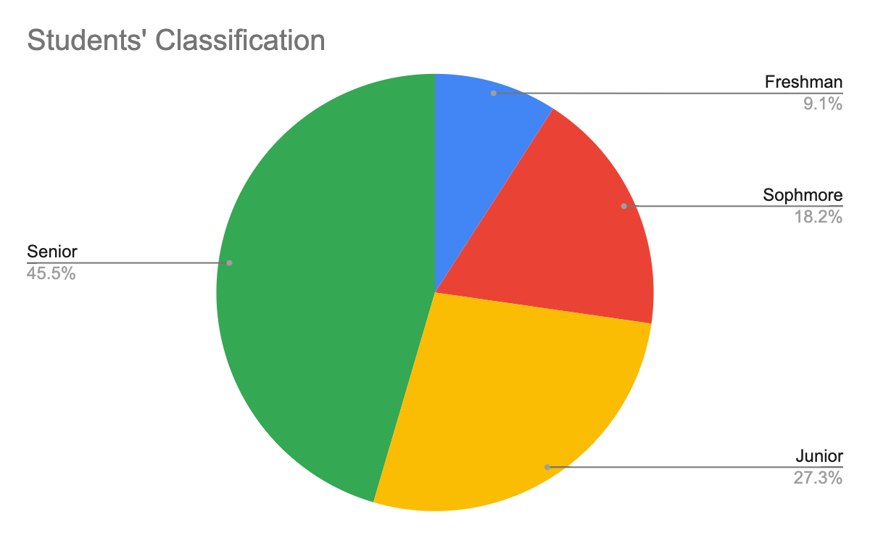
Figure 1. Students’ classification.

Science: Nutrition and Dietetics (one) (see Figures 2 and 3). Of the student participants, three identify as male, and eight identify as female.
The three library staff participants have years of service at Shepard Library ranging from three to twenty-three years. Among the Shepard Library staff members interviewed, one identified himself as male, and two identified themselves as female. The library staff members who were interviewed came from different departments within Shepard Library: Access Services, Technical Services, and the Curriculum Materials Center. I will now provide a broad description of the aforementioned departments. The Access Services department focuses on the circulating book collection (checking in and out books; maintaining the circulating book collection), course reserves, and interlibrary loan services. The Technical Services department at Shepard Library focuses on preparing materials for use by patrons, including acquisition of new materials, cataloging materials (adding to the library’s online catalog), and processing materials. The Curriculum Materials Center (CMC) serves as the official library for the NCCU School of Education, and it possesses media that cover various topics related to education (North Carolina Central University, 2024). Two University Library Technicians and a department head/librarian represented the job titles for the Shepard Library staff participants.
Data Collection
On April 6, 2023, I received Institutional Review Board (IRB) approval to begin interviewing participants and commence with this study. I conversed with potential participants about the research study and about interviewing them upon obtaining IRB approval. I began scheduling appointment times with students for interviews. After identifying the students, I interviewed the first student on April 17, 2023. The participants I recruited include student library workers, student library volunteers, students from library instruction classes, and students

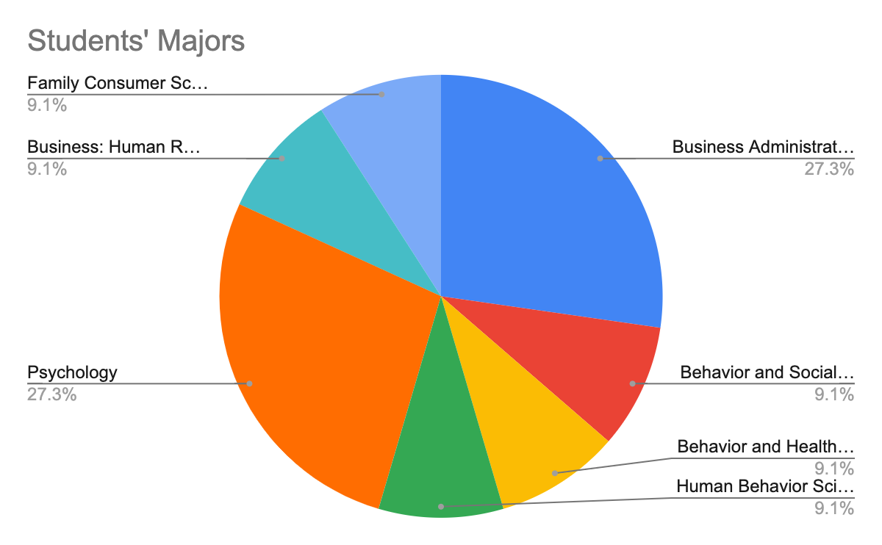

Figure 2. Students’ majors.

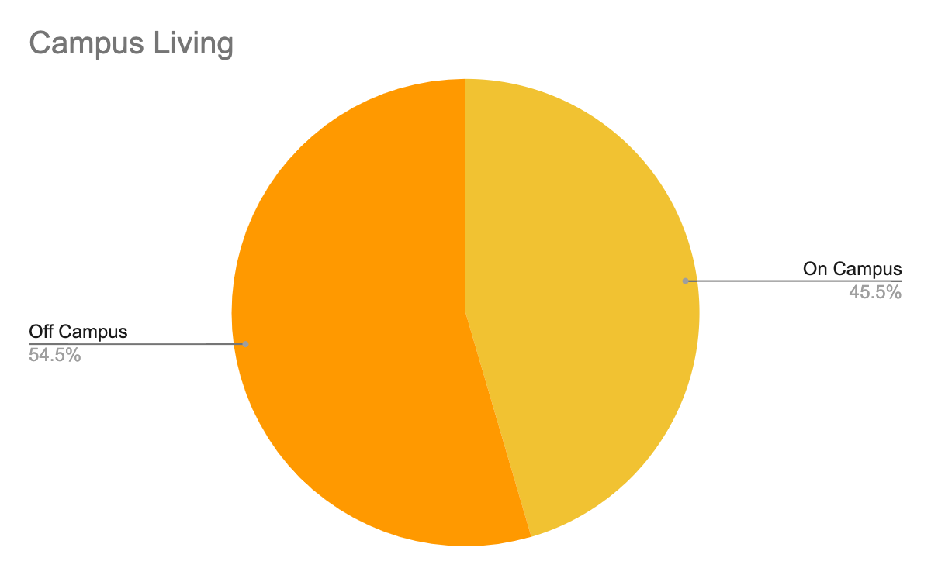
Figure 3. Campus living.

from the University Honors Program. The academic year ended within one week of interviewing students on April 24, 2023. I completed the interviews with students by April 25, 2023. I interviewed students first due to time constraints with the end of the semester approaching. I initially wanted to interview 6-8 students. Despite the time constraints relating to the ending of the academic year, I succeeded in interviewing eleven (11) students. Of the eleven (11) students interviewed, five (5) represented graduating seniors.
Once I completed the student interviews, I moved on to interviewing Shepard Library staff members starting on May 4, 2023. I completed the Shepard Library staff interviews by May 15, 2023. I used the same Shepard Library conference room to conduct most of my interviews with both the students and library staff participants, and I interviewed two participants (one student, one Shepard Library staff member) virtually using Webex. I conducted one interview with each participant. During each interview, I asked open-ended questions aimed to elicit participants' opinions and views (Creswell & Cresswell, 2018). Due to time constraints because of the impending end of the academic year, I had only time to interview each person once, and the one interview per participant serves as the research design for this study. During each interview, the consent form was signed by every participant. I expressed to each student and Shepard Library staff member that participation in the research study was voluntary. The interviews with each participant were audio recorded with their permission.
Data Analysis of Research Questions
Research Question 1: Sustainability Programming Presented Offered
What educational opportunities in the area of sustainability are presently offered? To address this research question, I conducted an inventory of Shepard Library programs that commenced from 2019 to 2022 to determine whether sustainability had been included as a focus and, if so, which aspect of sustainability the particular focus addressed: environmental, economic, or social equity (see Table 1). The inventory included 26 programs and events. I used the definitions of economic sustainability, environmental sustainability, and social equity from the Defining Key Terms. The inventory consisted of looking at previous program materials. Program materials consisted of digital copies of flyers sent out to the university community by the Marketing Committee, campus announcements posted on the university’s events page, and Shepard Library social media posts (see Appendix L). I reviewed the Shepard Library’s Facebook, Instagram, and Twitter pages to determine any level of demonstration regarding sustainability by looking at the program description detailed in the posts, campus announcements, and program flyers (see Appendix J). Many times, Shepard Library's social media posts contained the same information on each platform.
During the inventory, I looked for keywords that related to sustainability topics, including equity, economics, and the environment. To aid in this process, I broadly used the United Nations Sustainability Development Goals (SDG) descriptions of the 17 goals to determine any presence of sustainability within Shepard Library’s programming and events, and I determined which area of sustainability and SDG had been presented (equity, economics, and environment) (see Appendix G). The 17 United Nations Sustainability Development Goals “also known as the Global Goals, were adopted by the United Nations in 2015 as a universal call to action to end poverty, protect the planet, and ensure that by 2030 all people enjoy peace and prosperity” (United Nations Development Programme, 2023). I also utilized the following definitions to assist me in making determinations about the inventory: social equity, economic sustainability, and environmental sustainability.
I utilized the definition of social equity as “all members share the same rights, benefits, and decision-making power” (University of Maine, 2017). If a program contained a description or mention of social justice issues (race, gender, sexual orientation, religion, or ability), I rated it as a social equity-related program. If a program’s details contained any mention of finances, economics, or financial literacy, I rated it as an economic sustainability-related program. Economic sustainability describes any economic activity that takes into account social and ecological consequences (University of Maine, 2017). If a program contained any mention of issues relating to the environment, I rated it as an environmental sustainability-related program. Environmental sustainability involves the entire global ecosystem (oceans, freshwater systems, land, and atmosphere) and the application of sustainability principles to ecosystems of any size (University of Maine, 2017). Additionally, I included the codes of environmental and environmental exposure for the environmental sustainability-related programs. Furthermore, societies that (1) consume resources faster than their natural system’s ability to renew them, (2) discharge more waste than nature’s ability to handle such waste, or (3) have a reliance upon distant resources of energy will not have the ability to sustain themselves (University of Maine, 2017). During the timeframe of these programs from 2019-2022, I served as a member of the Marketing Committee, and I assisted in the planning and/or attended each of these programs. Campus announcements, students, faculty, staff, and the greater Durham community served as the means to advertise all these events and programs. The Marketing Committee sends out emails to librarians at Shepard Library, and then the librarians send out emails to academic departments across campus. Attendance at events and programs varied from 10 participants to over 100 participants, depending on the particular event or program. The Marketing Committee promoted all Shepard Library events towards students, faculty, staff, and the campus community.
During the years 2021-2022 (during COVID-19), most events and programs had been recorded. At times, completing the inventory or assessing a program's sustainability status was not always straightforward. I focused on keywords in the program description and personal experience from attending events and programs to complete the inventory. Regarding how programs and events at libraries relate to sustainability, Silk (2022) states:
Library programs are often aimed at improving the quality of life at the local level by delivering programs and services that support literacy, numeracy, lifelong learning, and civic engagement. These same local initiatives also contribute to making global economic progress. The SDG framework provides an excellent way to document your efforts, measure progress toward targets, and achieve goals that are relevant to your local stakeholders, as well as help accomplish national and international objectives. (p. 4)
Upon reviewing Shepard Library programs during the inventory, I determined that most programs featured aspects of sustainability. In 2021, OCLC Global Council conducted a survey of library staff about how they use and consider the United Nations Sustainable Development Goals (SDGs) to inform their strategic directions (OCLC, 2021). The results of their survey led them to conclude that “[w]hether explicitly or implicitly, libraries are contributing to all 17 of the SDGs. Some SDGs, however, see greater levels of library involvement” (OCLC, 2021). For instance, I provide below an example of a book talk related to funding Historically Black Colleges and Universities (HBCUs). I used the information from campus announcements (see below) and a press release (see Appendix K) to make a determination:
Please join Shepard Library as we host a book talk with author and journalist, Adam Harris. Mr. Harris is a staff writer at The Atlantic where he has covered education and national politics since 2018. He was previously a reporter at the Chronicle of Higher Education and a 2021 New America Fellow and the recipient of the Rising Star Award by the News Media Alliance. Harris will discuss his book, The State Must Provide: Why America’s Colleges Have Always Been Unequal – And How To Set Them Right. This event will be moderated by Dr. Shauntae White, NCCU professor, Women’s Gender Studies Coordinator, and author. The James E. Shepard Memorial Library’s Authors Club book talk will be held November 9th, 2021 at 2:00 p.m. and will be virtual.
Due to the topics and discussion raised during this book discussion, I rated this event as both an economic sustainability-related and social equity-related program. Book discussion topics covered systemic funding disparities among HBCUs and how the disparities force HBCUs to do more with fewer resources. Moreover, the author discusses the unequal funding of HBCUs at the state level and how states must take corrective measures to provide more equal funding practices to support HBCUs. This program related to SDG Goal 4: Ensure inclusive and equitable quality education and promote lifelong learning opportunities for all; and SDG Goal 16: Promote peaceful and inclusive societies for sustainable development, provide access to justice for all and build effective, accountable and inclusive institutions at all levels (United Nations, 2023). The Marketing Committee recorded this moderated program for future accessibility.
Another example includes a book talk with an author/professor, speaking about relationships:
Dr. Jennifer Rounds-Bryant is an NCCU Psychology Professor and experienced licensed clinical psychologist. She has enjoyed over 30 years of clinical and research experience with the full continuum of human behavior. Dr. Rounds-Bryant’s passion has been to translate research on common challenges that people talk about in therapy into plain language that everyday people can understand and use. Her book “The Honeymoon Won’t Last Forever!” Is part of that passion and presents the science of developing and maintaining great relationships. Dr. Rounds-Bryant is proud to be the mother of two college students, who help her to center the student viewpoint in her work. Learn more about Dr. Rounds-Bryant and her books at www.drjennmovedmeforward.com.
This program was held on February 24, 2022. This program referred to human behavior and maintaining relationships; therefore, I rated this program as social equity-related. Additionally, this program relates to SDG 3: Ensure healthy lives and promote well-being for all at all ages. During this program, the author/professor spoke about equitable communication between partners in relationships. Also, the author/professor talked about the importance of therapy for mental health and well-being. I continued this way of taxonmizing Shepard Library programs for the years 2019-2022 (see Table 1). The Marketing Committee recorded this program for future accessibility.
The descriptions below highlight a few examples of Shepard Library programming that NCCU sent out through campus announcements, including financial literacy for Money Smart Week in 2019. These programs were intentionally geared toward financial literacy for Money Smart Week in April of 2019. Money Smart Week (2019) “is a national public education campaign coordinated by the Federal Reserve Bank of Chicago and delivered by a network of several thousand partners.” Shepard Library participates in Money Smart Week annually. Therefore, I rated these programs as economic-related for the inventory. I used some of the descriptive words in the campus announcements to make the following descriptions: personal finance, financial literacy, budgeting, credit scores, paychecks, small business ownership, and entrepreneurship. These events also refer to entrepreneurship, small business ownership, and personal finance and additionally relate to SDG 8: Promote sustained, inclusive, and sustainable
economic growth, full and productive employment, and decent work for all (see Figure 4, campus announcements).
Following my completion of the inventory, I found that most of the programs at Shepard Library comprised some aspects of sustainability. Most programs and events relate to the social equity aspect of sustainability. Shepard Library hosted five programs related to economics and one program related to environmental sustainability. Events and programs do not directly refer to sustainability but include aspects of sustainability (equity, economics, and the environment). Due to social responsibility being a core value of librarianship, events and programs tend to focus on social equity issues. The American Library Association, the premier professional development organization for librarians, defines social responsibilities for the organization “in terms of the contribution that librarianship can make in ameliorating or solving the critical problems of society...” (American Library Association, 2023). With this inventory data, the Marketing Committee may continue to diversify its programming to become more intentional about sustainability in the future.
Research Question 2: Student Responses
How do students experience content offered through programs and events that relate to the triple bottom line (equity, economics and the environment) when participating in programs and events on campus, including Shepard Library events? To answer this research question, I addressed the following series of interview questions to students and similar questions to Shepard Library staff, which incorporated each aspect of sustainability as it relates to the triple bottom line: equity, economics, and the environment. I incorporated the following sustainability-themed interview questions for the students listed next.

Money Smart Week March 30-April 6, 2019
The James E. Shepard Memorial Library invite you to attend Money Smart Week events. Money Smart Week was created by the Federal Reserve Bank of Chicago in 2002, and is a public awareness campaign designed to help consumers better manage their personal finances. The James E. Shepard Memorial Library will have helpful material about personal finances, at each desk for you to grab throughout the week.

When: April 1, 2019 at 9:00 AM
Where: James E. Shepard Memorial Library

GeoCache for College Ca$h
GeoCache for College Cash, play a scavenger-hunt game (2 hours allotted), and instead of taking objects, leave proof you saw them by following the directions on 7 posters located throughout the library. While you are playing learn about topics such as budgeting, credit scores, paychecks, identify theft and more. Prizes will be awarded to students that complete the scavenger hunt.
When: April 2, 2019 at 11:00 AM
Where: James E. Shepard Memorial Library, Information Desk

Being and Entrepreneur and Personal Finance Presented by Kimberly V. Williams of Right Time Realty and NC Central University alumna will present financial literacy tips and entrepreneurship principles. Discussion topics include personal finance and valuable information to help you handle your finances and small business ownership.
When: April 2, 2019 at 2:00 PM Where: James E. Shepard Memorial Library, Room 212

Figure 4. Campus announcements.
- How do you experience issues relating to social equity when participating in Shepard Library events or on campus?
- How do you experience issues relating to economics, when participating in Shepard Library events or on campus?
- How do you experience issues relating to the environment when participating in Shepard Library events or on campus or on campus?
- How are you more aware of sustainability issues by attending Shepard Library or on campus events and programs?
For these questions, I analyzed all qualitative data from the interviews. I uploaded transcripts into Delve. Delve (n.d.), a qualitative coding software technology used to analyze qualitative data, allowed me to code each interview. I coded line by line, looking at themes as they emerged and using participants' language with in vivo coding. I also incorporated the interview questions as a theoretical framework to categorize data with structural coding. The incorporation of the interview questions allowed me to “examine comparable segments’ commonalities, differences, and relationships” (Saldaña, 2021, p. 130). Looking at each interview transcript resulted in 81 codes using Delve. The 11 student interview transcripts represent the first completed coding of data. The three Shepard Library staff interview transcripts represent the second set of interviews coded, and I based the coding for the staff interviews on the interview questions and structural coding. I labeled the coding for staff with the word "Staff" next to it to avoid confusing it with the students' interview codes. Utilizing this delineation in this manner allowed me to quickly separate out staff interview codes from student interview codes. Of the 81 codes, 59 represented initial codes for student interviews, while the remaining 22 initial codes highlighted the staff interviews. Moreover, from the initial 81 codes, I placed the 59 student interview codes into five categories based on similar attributes, and I placed the 22 staff interview codes into five categories based on similar attributes (see Table 2). For the initial student codes, the Delve qualitative analysis tool created a comma-separated values CSV file of all the codes for exporting and analysis. I exported the (CSV) file into an Excel spreadsheet. I placed the initial codes based on order of entry. Once exported to Excel, I sorted the codes into alphabetical order. Placing the codes in alphabetical order allowed me to see any duplicates and patterns in the codes (Saldaña, 2021, p. 102).
I used Focused Coding: “cutting and pasting together the codes into clusters of what ‘looks alike’ and ‘feels alike’” for the second cycle of coding (Saldaña, 2021, p.103). During Focused Coding, I created 8 clusters from the codes. I developed the following categories: programs, awareness and understanding, campus related, resources, library related, students actions, sustainability-related, and students from the 8 clusters. Furthermore, from these categories I combined the 8 clusters to create the 5 major categories: programming, student engagement and development, campus life and resources, library services, and sustainability.
For the initial staff codes, I reviewed the 21 codes I created while reading the staff interview transcripts. I found that I had to engage in more structural coding with the staff codes by using the question to identify and organize the codes. For example, the code "Staff: sustainability defined" was the code used when staff defined sustainability. I created an Excel file with the 21 codes. I sorted the codes into alphabetical order. This allowed me to see whether there were duplicates or patterns (Saldaña, 2021, p. 102). I clustered the 21 codes into five categories: library services, sustainability, programming, personal awareness and actions, and campus issues. I created five categories for both student and staff codes. Similarities exist
Table 2

Categories for Students and Shepard Library Staff

Categories: Students | Categories: Staff
Campus Life and Resources | Campus Issues
Library Services | Library Services
Programming | Personal Awareness and Actions
Student Engagement and Development | Programming
Sustainability | Sustainability

between both the student and staff categories. Looking at the categories for students and staff led me to identify the following overarching categories: library and campus resources, sustainability, personal development and engagement, and programming.
The responses to the interview questions from students about the triple bottom line ranged from being specific to Shepard Library programs, specific to campus programs, the university/campus community, or the learning environment. The student interview questions focused on the programming at Shepard Library and the greater NCCU campus. Some of the students who did not attend Shepard Library or campus programs tended to refer to the university in general. For example, a student commented about the university when asked about the existence of social equity programs on campus: “Well, I would say, you know, being at an HBCU, there's a lot of social equity for people of color because it is a school for, you know, their niche.” Also, considering the social equity question, another student stated the following relating to the university:
But in terms of respectability and inclusivity, definitely, the events offer, offer that often. Things of that nature. Everybody's respectful and, you know, no one gets turned down or excluded from such events. So I appreciate that.
The majority of students interviewed did not attend or did not see specific programs relating to social equity at Shepard Library or on campus that they could recount. A student commented that they saw a few events on campus, and another student did recall attending a program at the NCCU School of Law about globalization and understanding its importance. Some students saw social equity relating to economics or the environment within the university. For example, students' comments indicated they planned or hosted programs on campus. Planning events made them more aware of sustainability issues. These programs included campus clean-ups, financial
literacy workshops, and campus involvement (i.e. sorority and student organization involvement).
Students' experiences included the economic aspect of sustainability. To understand how students acquired economic sustainability knowledge on campus and at Shepard Library events and programs, I analyzed each student's response relating to economics. Experiences included hosting financial literacy workshops and presentations within the campus community and to a nearby high school, as well as attending a university financial aid/scholarship presentation. Most of the students interviewed attended programs on campus that related to financial literacy. Other students related to economics in a more personal way, stating, “First, I recognize that everyone's economics are not the same, I realized that everyone doesn't have the same resources as far as economics.” Students learned about the economic aspect of sustainability by participating in financial literacy workshops or presentations. One student responded that they “started investing in the stock market after attending an event.” By attending workshops and presentations, students became aware of financial and economic issues.
In relation to the environment, students referred to the learning environment/university (surroundings), and the environment (triple bottom line) during their interviews. Students mentioned specific environment-related events such as campus clean-ups, a tree planting event on campus, and programming during the 10:40 a.m. common hour. The tree planting event was hosted with the community organization Keep Durham Beautiful, where a student described the event when they “seek out the campus area and like maybe two miles, or two-mile radius of the campus and a group of students from here (NCCU) and Duke planted trees around the designated areas that they feel is scarce.” When asked about the environment, another student referred to the learning environment/university and commented, “Honestly, I’ve never had to deal with issues with the environment here.” During the interview, students commented about the learning environment, as opposed to the natural environment (triple bottom line). Other students did not know of or did not see any programming relating to the environment at Shepard Library or on campus.
Most of the students who were interviewed participated in programs or events that related to the environment (triple bottom line). Students engaged with the environment through programming such as clean-ups, and students spoke about the learning environment. Students' understanding and usage of the term, environment, represents a future area of research for further study. Most students during the interview responded that they gained more of an awareness of sustainability issues after attending the programs. One student responded that “through libraries and library services, I am able to, if I want, research some good events in the area…I am easily able to access, you know, online information about related topics and organizations that, you know, affect this area and people in this area.” This student’s remark gives an indication that they have the ability to find the information needed. Another student remarked that being at the in-person events made them more aware of issues: “If I’m in the environment (on campus), and I see what people are talking about, like, Oh, this is a problem. And here's an example of it right here. That makes it a lot more relevant and digestible. And I realized, like, it's a real issue.” A student commented that they became more aware of sustainability issues due to being in a sorority: “Since I've joined a sorority, I think I see it like from a wider like prospective view of, like, you actually have to take care of certain things and you're held up to a different pedestal than others.” By attending these events on campus, students gained an awareness of the sustainability issues pertaining to equity, economics, and the environment on campus and beyond. Students became more aware of available campus resources to promote sustainability at NCCU, and their attendance in these programs allowed them to understand the issues to a greater extent.
Research Question 2: Staff Responses
I posed similar interview questions to the Shepard Library staff as I had asked of the students in order to provide background information to research question 2: How do students experience content offered through programs and events that relate to the triple bottom line (equity, economics and the environment) when participating in programs and events on campus, including Shepard Library events?
The Shepard Library staff’s interview responses help clarify their understanding of sustainability as they participate in Shepard Library programs. In interviewing the staff, I incorporated the following interview questions pertaining to sustainability:
- How do you experience issues relating to social equity when participating in Shepard Library events?
- How do you experience issues relating to economics, when participating in Shepard Library events?
- How do you experience issues relating to the environment when participating in Shepard Library events?
- How are you more aware of sustainability issues by attending Shepard Library events and programs?
I found each of the Shepard Library staff’s responses to these questions to be consistent with one another when asked about the programming at Shepard Library. All staff members who were interviewed said they did not experience issues relating to social equity when attending Shepard Library programs. Shepard Library staff participants indicated that they either did not attend any programs or events pertaining to social equity or could not recall attending programs or events at Shepard Library that pertained to social equity. I found their responses essential in order to understand their experiences from the perspective of what to consider in future program planning. If the staff feels that they did not experience social equity elements in Shepard Library programs and events, what might the student participants think regarding these Shepard Library programs with respect to perceiving social equity?
During their interviews, I discussed other aspects of the triple bottom line that pertain to economics with Shepard Library staff members. One staff member did not recall participating in any Shepard Library events pertaining to economics. Another staff member remembered that one program did highlight financial literacy speakers and emails hosted by Shepard Library. In addition, another staff member commented about hearing students raise issues about economics through a reading of poetry during a “Poetry Jam” program hosted by Shepard Library. The staff member mentioned, “To be honest with you, that last poem… is on economics, it kind of fits even to social justice, the way those …young adults presented themselves.” A third Shepard Library staff member directly experienced economics-related programming at Shepard Library that emphasized financial literacy programs and also through the subjects brought up at other events.
Shepard Library taff were also asked about issues relating to the environment during the interview. When asked about the environment, staff members said that “they did not think or could not recall Shepard Library having anything relating to the environment,” but one staff member recalled some Shepard Library staff being involved with the NCCU Food Pantry and also building recycling. Another staff member recalled the “Poetry Jam” event and how students brought up a variety of issues including the environment with their poetry during the event. Upon asking staff members the question about the environment, they said they could not initially recall programs that related to the environment at Shepard Library, but upon reflecting more on the questions, staff members did recall some engagement opportunities at Shepard Library. The interviews with the Shepard Library staff helped me realize that the environment had been a sustainability theme that staff did not have many experiences with at Shepard Library programs and events.
In terms of awareness, one library staff member said, “I don’t know that my awareness is heightened necessarily by the events themselves.” Another library staff member mentioned that they gained an awareness of X because of “the way the marketing team markets information, yeah, I wouldn't be aware of any of it if they did not send out the emails and you know mentioned it to us in passing.” Overall, library staff members have an awareness of just library programming, but not necessarily a greater awareness of sustainability issues.
Research Question 3: Student Responses
What is a strategy Shepard Library can adopt to enhance students’ experiences of
sustainability related programs and events using student learning outcomes as a guide? To answer this research question as a means to promote some transformative interventions that may allow students to experience sustainability-related issues and themes, I asked both the students and Shepard Library staff the following questions:
- What is a strategy(ies) Shepard Library can adopt to enhance sustainability programs and events?
- Are there any specific programs or events you want to attend relating to sustainability?

- Are there any specific resources you want to learn more about relating to sustainability?
- Are there any specific resources Shepard Library can provide relating to sustainability?
I found the students' replies to these questions to be practical through the specific examples they shared on how they think the Shepard Library Marketing Committee may address bringing an awareness about sustainability through its programs. For instance, one student replied, “Surveys!...maybe you could ask everybody that’s in the library what they are interested in…and come up with strategies of what people like.” This student relayed the need to gather data and the opinions of fellow students to make informed decisions. Another student told me in an interview that the library should “broadcast a little bit” through the use of more social media. A third student commented that “getting feedback is really important” and then went on to remark:
“Sometimes people don’t make adjustments based off their audience. But sometimes you
have to make adjustments based on who you’re talking to. So being adaptable is
important. Even if you have your own vision in mind, like being able to adapt to your
your audience, because it matters. If they don't receive it, then it doesn't even matter what you have to say. So I would say, being adaptable, and also asking for feedback. So,
you can make improvements.”
These first three students relayed the importance of getting feedback and also making adjustments and improvements to programming and events based on the feedback received. A fourth student became very analytical during our interview and relayed to me the need for these programs to have “more fun, interactive events…that really, like, grabs their eyes, grabs their attention to be more focused and willing to participate” as a means to enhance both programming and the experiences of students during these events with respect to promoting sustainability awareness. Additionally, these students remarked that for specific programs and events, the Shepard Library Marketing Committee should consider pop-up cleanups more often (weekly) and the sharing of more details regarding global warming, a major environmental sustainability issue.
My interviews with additional students led to the sharing of more original ideas (examples) on how the Shepard Library Marketing Committee may enhance future sustainability programs and events. During their interview, one student stated that Shepard Library may adopt a strategy: “Market the events more so people can come out because a lot of people are interested in stuff like that…they just don’t know how to get into it.” Another student recommended “posting more visuals around campus to let people know about events well in advance of them happening.” Also, a student specifically pointed out that there should be an Earth Day event. I found these insights about marketing and promoting sustainability resources imperative to me as a member of the Shepard Library Marketing Committee. The Marketing Committee currently uses flyers, the university’s announcements page for events, and social media to advertise programs and events. Given the data provided by these interviews, my committee members and I feel encouraged to investigate and try new approaches on additional ways to advertise to students.
Another interview helped me come to the realization of the advantages in relating sustainability to students through real-life examples within the scope of programming and events. During an interview, a student stated that "educating people on what sustainability is, that can be beneficial, and then also kind of relating it to like real-world issues that they're going through.” Some students also identified specific programs, events, or opportunities for involvement. One student replied, “I would attend an event to explain what sustainability is to people.” This student then went on to say,
“...because some words may be daunting to people, they may not necessarily know what it is, they may they may just think it's an initiative for recycling, because that's what I thought of for a little bit. So events that raise awareness that allow people to know how they, and what they can do in their day to day lives to contribute just little small things. Not, like anything big like, and more ways to get involved, if their curious and how they can educate others once they know more.”
The students’ responses reflect their ability to understand the concept of sustainability. Students also mentioned the importance of resources in their responses when asked about specific programs or events. When asked about specific programs or events they said, “Meet the library crew…because it's important to know your resources…” Shepard Library staff and librarians (including the Marketing Committee members) need to understand that students want to know more about available library resources and interact with the librarians.
Students’ perspectives about resources varied. Students described that they wanted to learn more about renewable energy, clean water, and gas. Additionally, students wanted to become more involved in the campus garden, learn more about the impact of sustainability, and learn about the Environmental Protection Agency (EPA) and other government agencies that pertain to sustainability. One student even commented on wanting to learn more about how our government and school systems incorporate sustainability by remarking:
[A]nd how jobs relate to sustainability? Are there things that we can do with our degrees that may not necessarily be like a direct, you know, a direct comparison of it, but things that we can do from whatever we've learned through our matriculation to see how we can better help sustainability across the campus across the state and across the world.
This student's perspective shows how they are looking at sustainability from a broader perspective, relating it to the government, school systems, and beyond to the
world around them. Another student related sustainability to their experience and how it
relates to their future professions, saying that sustainability...
“relates to every area of life. So I will definitely want to learn more about how to make
just anything more sustainable than I'm going to be doing. Like when I'm trying to [go] in grad school, and being a counselor and being a teacher later, like, I want to learn more
about sustainability in those environments specifically.”
Students provided valuable suggestions for specific resources that Shepard Library may incorporate to help promote sustainability awareness. One student stated “...just have the information out there because they already have the information here. It's really just a means of putting it out there for you to see.” Another student mentioned, “You can make it easier to find the sustainability books.” I found this response helpful as it serves as a mandate for the Shepard Library Marketing Committee and other librarians to attempt to understand students’ needs for more library information and making Shepard Library resources and various forms of information readily available in multiple formats: (e.g., signage, advertisements, marketing, social media). Other students commented on additional resources, saying “[m]aybe more films, like hardcopy films...or hard hardcopy, maybe magazines pertaining to nature versus sustainability...things, things like that.” Again, these student comments reveal a theme about the Shepard Library Marketing Committee and other librarians needing to provide more visible sustainability resources that students may readily obtain and in multiple formats. In the area of
mental health, a student suggested collaborating with other campus offices to help promote sustainability awareness.
“I feel like we should collaborate with the Counseling Center a little bit more as well. I
feel like everyone should collaborate with them more because I don't think a lot of
people know about the resources we have at the Counseling Center. And knowing that
you can get free therapy as well.”
In conclusion, the students’ comments provide concrete examples and specific recommendations for how the Shepard Library Marketing Committee and others may provide resources and support for sustainability for students. By taking these steps, Shepard Library will better understand what proactive steps (actionable ideas) they need to take in order to promote sustainability awareness on campus as well as in the community at large. I believe that this understanding from the perspectives of these students will lead the Shepard Library librarians and staff to create programs that foster student learning, awareness, and success with respect to sustainability.
Research Question 3: Staff Responses
Similar to students, when asked about the strategies they believe the Shepard Library Marketing Committee should adopt in developing sustainability awareness programs, the Shepard Library staff members mentioned the importance of collaboration with other libraries, such as public libraries, and “...looking at what other schools are doing or libraries to see what they are doing that will help a lot.” Other Shepard Library staff members commented about having additional funding for programs and events and hiring more staff. The strategies detailed
by staff members included establishing partnerships, looking at other examples, and acquiring additional resources such as additional funding and hiring additional staff.
Also, when asked about any specific programs or events that they wanted to attend relating to sustainability, one Shepard Library staff member said, “Maybe if they have some more community involvement or something as far as libraries are concerned…”. Another Shepard Library staff member expressed concern about a lack of human resources at the library and mentioned a “a job fair for the library.” I found the staff members’ replies as indicative of the different perspectives represented in the library with respect to sustainability. The latter Shepard Library staff member also expressed a concern about the job retention of some of the staff, and the first staff member who was interviewed expressed a concern over the need for increasing community engagement.
I also interviewed the Shepard Library staff about specific resources they would want to learn more about relating to sustainability. Of the three staff members interviewed, two had specific answers to this question. One staff member wanted to know more about the “practices and policies within the libraries,” while the other staff member stated, “For us, it's not so much a question of ,you know, are we contributing to a problem or are we having a problem? It's just that we know what the problem is and we don't seem to be able to implement a solution.” This staff member’s comments were in reference to Shepard Library’s attempt at retaining current librarian staff and hiring new librarian staff. From the perspective of the Shepard Library staff participants, specific resources related to Shepard Library directly impact it as an organization.
The Shepard Library staff members stated specific resources they believe the library has the ability to provide relating to sustainability. The Shepard Library staff identified the need for the library to invest in digital resources such as accessible ebooks for use by the university community of students, faculty, and staff. The staff members also made mention of the need to create a sustainability hub, a place where the university community may find readily available sustainability resources (online and in print). Moreover, the staff held the belief that it is essential to hire new personnel as a means (1) to provide the necessary human resources to help in the continued growth of Shepard Library and (2) to support sustainability programs and events in the future. By implementing these strategies, the Shepard Library Marketing Committee and the other librarians will contribute to providing resources and support for sustainability-focused programs and events.
In conclusion, the iShepard Library staff members who participated in the study offered several strategies for enhancing the library's role in sustainability. I consider these strategies as themes that represent the suggestions that the interviewees recommended in order for the Shepard Library Marketing Committee to create programs centering on sustainability awareness. Collaboration emerged as a key theme, with staff suggesting partnerships with public libraries and a focus on learning from the practices of other institutions. They also identified additional funding and hiring more staff as crucial steps to support sustainability-related programs and events. Incorporating diverse perspectives within the library became an additional theme when discussing specific programs or events related to sustainability. One staff member emphasized community involvement, while another expressed concerns about human resources and proposed a library job fair. When it came to learning about sustainability resources, staff members had specific interests, such as understanding library practices and policies or addressing staffing challenges. In terms of providing resources, investing in digital resources like ebooks and establishing a sustainability hub were highlighted. The library staff viewed these initiatives, alongside increased human resources, as essential for Shepard Library's continued growth and support for sustainability-focused initiatives. I will explore these in more detail in the next section.
Themes
Theme 1: Sustainability is Represented in Diverse Forms Across the Campus
From looking at interview data, one would find that the students experienced sustainability in different ways on campus and in their lives. I base this perspective on the evidence stemming from the interviews when I asked the students about their experiences with sustainability (equity, economics, and the environment) on campus and at Shepard Library. When I asked the students during their interview to define sustainability, their answers about sustainability consisted of being specific to the environment (planet), resources, personal definitions, or campus events. For example, when asked to define sustainability, one student answered, “Being able to do things on your own, like for me, I use my own sustainable deodorant made from this book called Sustainable Living.” I consider this a more personal definition of sustainability because it directly relates to this student’s experience and how they take care of themselves using the knowledge gained by learning about sustainability. Other definitions given by students included the environment, campus resources, and events. Below, I provide an example of a student incorporating the environment in their definition of sustainability:
[E]nvironmental sustainability, I would assume it means to make use with the resources we already have today and try, and you know, not to overuse it or abuse it, but to use it to micromanage it basically, you know, bringing to life the environmental issues that we currently face, like global warming and you know, pollution and stuff. So, I would say you know, by just making our environment clean and being friendly to our environment, to prolong it and to keep it healthy, so that the next generation would be able to make use of it.
Other students mentioned campus events as a part of their definition of sustainability as highlighted in this statement:
“... I want to say the way we participate in events, going to basically even to seminars, things of that sort, how they affect us staying on campus or going to school, or just
participating in anything.”
Students recalled sustainability in their personal life, in their campus life (campus programming, including Shepard Library programs and resources), and in their surroundings (environmental sustainability). Similarly, the library staff participants would also have their own diverse definitions of sustainability.
Shepard Library staff observed sustainability differently than students regarding the programs offered at Shepard Library. For example, Shepard Library staff members did not recall social equity issues presented in Shepard Library programs. However, Shepard Library staff members recognized issues pertaining to sustainability such as economics and the environment presented in programs and in staff engagement opportunities. Shepard Library staff members defined sustainability in terms of access that “sustainability is being able to provide access to resources continuously” and the environment (including the work environment). Staff members defined sustainability with the environment in mind by saying “the ability to be maintained at a certain rate or level… [w]hen I think of it I think of like the environment.” Sustainability for one staff member meant staff retention in job positions at the Shepard Library and at the university.
Sustainability for students and for staff included elements of the triple bottom line (equity, economics, and the environment). Most of the students interviewed saw sustainability represented on campus in some format or from their involvement in campus life (student organizations, fraternities, and sororities). The Shepard Library staff I interviewed saw sustainability in terms of economics with Shepard Library financial literacy programs and environmental issues detailed in programs or with staff engagement activities such as donating to the food pantry on campus. In a 2022 study, Mosier et al. state that, “If the elite-driven discourse has not provided a clear conception of sustainability, then what hope do we have for the public to understand its application and significance?” (p. 112). The current study focuses on how students view sustainability within campus programming at both Shepard Library and throughout NCCU’s campus, and I also asked the Shepard Library staff how they viewed sustainability programming in order to get another perspective on sustainability in Shepard Library programming. This study found that even though sustainability awareness comes in diverse forms through programs at Shepard Library and across campus, participants might have viewed the content of the programs as not addressing sustainability and the issues directly related to sustainability. These findings represent an opportunity for the Marketing Committee to engage the campus community in programs and resources that more directly address sustainability and sustainability-related themes.
Theme 2: Programs and Events Encourage Communication, Engagement, and Collaboration
Based on the students' interview responses, participating in programs and events encouraged students to take action and promote the engagement and awareness of sustainability issues. For instance, one of my interviewees, after attending a financial literacy workshop, started to invest money. Other students wanted to become more involved with NCCU’s campus clean-up programs and the campus garden. As a result of attending these Shepard Library programs and events, students became more aware of the library's resources, and they began to understand the importance of communicating information about Shepard Library resources to the university community frequently and effectively.
I assessed from their comments that both students and staff possessed a need for additional resources. Students suggested materials such as films, magazines, and more resources about renewable energy, clean water, and gas. Staff members suggested additional ebooks, additional funding, and additional staff for programs and events. In their interviews, students also communicated that they wanted to see more real-world examples that would assist them in learning about sustainability issues. The theme of collaboration also emerged during interviews with both the students and staff. For students, they considered collaboration with offices on campus, such as the Counseling Center, to be important. For the staff, they valued opportunities to collaborate with the local public libraries and other academic libraries in order to see examples of sustainability in a different environment. Both the students and the staff understood the need to collaborate internally with other departments on campus and externally with other universities and libraries.
During the interviews, students stated that they wanted to learn about the impact of sustainability through major organizations’ involvement in sustainability like the Environmental Protection Agency. Students also mentioned their desire to involve themselves in activities that relate to sustainability. Students currently involve themselves in sustainability efforts such as campus cleanups and planning programs. One student said, “The more people are informed, the greater of an impact, you know, is being made, you know, no matter how small.” Students wanted to learn more about sustainability and become more involved with sustainability-related activities.
Theme 3: Additional Resources will Enhance Understanding Sustainability
Both the students and Shepard Library staff members expressed their desire for additional resources when asked about learning more about sustainability. Students mentioned that they wanted to become more involved and learn more about the impact of sustainability. Shepard Library staff mentioned subscribing to additional online sustainability resources because it “provides greater accessibility to students ....” Shepard Library staff also stated the importance of knowing more about sustainability policies and practices of libraries. Hicks and Sadler (2022) explain that “[e]ducation for sustainability...depends on cultivating environmental knowledge and attitudes equal to the environmental challenge that today’s university students face” (p. 39). Additional resources that facilitate collaboration and partnerships have the potential to facilitate organizational change and “increased student learning and skill development in sustainability” (Hicks & Sadler, 2022, p. 40). Similarly, academic libraries have the potential to create new partnerships and collaborations across the campus to foster a culture of sustainability. For example, Jankowska and Marcum (2010) suggest that “the role of libraries in supporting global sustainability by promoting and disseminating literature on this topic and providing environmental information literacy needs to be institutionalized so that libraries can themselves become sustainable organizations adopting a model of economic progress that recognizes users’ equity and shrinks libraries’ ‘ecological footprint’” (p. 166). The Shepard Library Marketing Committee may continue to cultivate sustainability education by facilitating partnerships with the inquiry partners of this study and with other offices and departments on NCCU’s campus. Research confirms the need for more information and resources regarding sustainability. Kamińska et al. (2021) indicate that “[a]s a consequence, the role of information professionals is to develop and inform a knowledge base, people’s information literacy, and technical infrastructure, which are required to support truly sustainable information practices that would meet present and future needs” (p. 11).
The findings stemming from the interviews represent my attempt, as the researcher of this study, to create an intervention to the problem of how to cultivate learning spaces that actively engage both the students and library staff in learning about sustainability, its diverse dimensions, and issues related to it. However, the interviewees’ involvement in learning about sustainability must not represent the primary intervention in addressing the problem. As the researcher of the study, I must utilize the interviewees’ novice actions in learning about sustainability to create a substantial intervention tool that will build upon the information literacy the students and staff gained from the interviews and their actions following the interviews. I consider the creation of a LibGuide, stemming from the statements compiled from the interviews articulated by both the students and library staff, on sustainability as the substantial intervention tool that will build upon the interviewees’ newfound experiences with sustainability. I now address the LibGuide as my major intervention tool.
Intervention
From the data obtained during the interviews, I created an online library research guide (guide) titled Sustainability and Environmental Resources to incorporate the recommendations of students and Shepard Library staff from this study. This online library research guide be useful for future programs and events at Shepard Library. I utilized the students' responses to research question 3 to develop learning outcomes associated with the guide. I will also apply these learning outcomes to programs and events that the Shepard Library Marketing Committee hosts and to the Sustainability and Environmental Resources online research guide as the major intervention for this study. The online research guide will highlight the following learning outcomes:
- Students will be able to identify sustainability concepts (equity, economics, environment) by reviewing the Sustainability and Environmental Resources Guide.
- Students will be able to recognize sustainability-related campus resources by reviewing the Sustainability and Environmental Resources Guide.
- Students will be able to locate sustainability-related resources beyond campus by reviewing the Sustainability and Environmental Resource Guide.
Student learning outcomes that relate to programs and events:
- Students will be able to identify sustainability concepts (equity, economics, environment) by attending Shepard Library events and programs.
- Students will be able to recognize sustainability-related campus resources by attending Shepard Library events and programs.
- Students will be able to locate sustainability related resources beyond campus by attending Shepard Library events and programs.
I used the Springshare platform called LibGuides to create the library online research guide. As a “flexible platform for creating and sharing guides,” many librarians consider LibGuides as “[t]he most popular, most flexible content management & curation platform for libraries” (Springshare, 2023). LibGuides have become a standard for libraries to disseminate information about a subject, topic, or collection. Librarians create LibGuides in order to organize library resources and information in a way that researchers can easily understand and access online. Previously, when the Shepard Library Marketing Committee presented workshops for faculty, they would create a research guide in order to make information from the workshop accessible to participants. I incorporate this model with this particular LibGuide. I incorporated a survey
component to the LibGuide to obtain feedback from the university community in order to see the degree of effectiveness of the guide as a medium to present information about sustainability.
I organized the Sustainability and Environmental Resources LibGuide into seven navigation tabs at the top of the LibGuide (see Figure 5). The seven tabs are as follows: Home, Sustainability Journals, Earth and Environmental and Sciences Journals, Other Resources, Helpful Websites/Careers, NCCU Resources, and Please Give Your Feedback. The Home tab defines sustainability and includes the U.N. Sustainability Development Goals and also links to 16 Shepard Library databases and collections. The Sustainability Journals tab directs users to over 100 Shepard Library Sustainability-related journals. The Earth and Environmental Sciences Journals tab directs users to over 1,000 Shepard Library Earth and Environmental Sciences- related journals. The Other Resources tab contains six TED Talks about climate change and four resources about globalization and sustainable workplaces and businesses. The Helpful Websites/Careers tab contains 20 links and descriptions to organizations, websites, and four websites and links to careers that are focused on sustainability. The NCCU Resources tab list six resources available on campus that will help researchers relate to sustainability. Moreover, the NCCU Resources tab includes the following: Environmental Science concentration for Environmental and Geographic Sciences (BS), NCCU Facilities Management, NCCU Hospitality by Aramark, NCCU Counseling Center and Career and Professional Development Center (per the suggestions from students in this study). The last tab, Please Give Your Feedback, consists of a survey that launches in the page for users to give their feedback about the guide.
I have used and designed LibGuides for research, programs, and events for over a decade in my career as an academic librarian. For this study, I developed the research guide based on what students and staff said they wanted to see or use as a resource for sustainability. I researched the Shepard Library collection of online resources to create the list of databases on 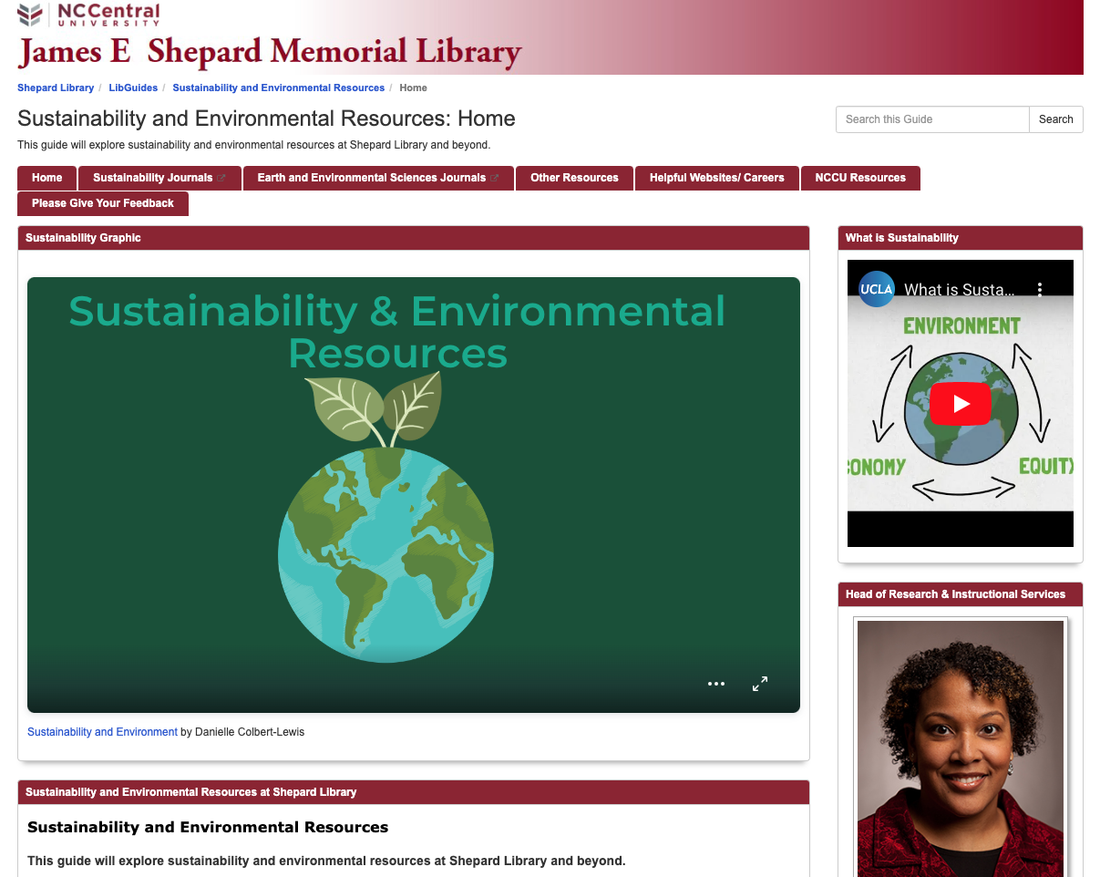

Figure 5. Sustainability and environmental resources guide.

the research guide Home tab. The tabs to Sustainability and Earth and Environmental Sciences ensure users of the guide know of the availability of select Shepard Library journals for research. The Other Resources tab includes resources that were inspired from students stating they wanted more real-world examples of sustainability (TED Talks, climate change resources). The Helpful Websites/Careers tab stems entirely from the recommendations of inquiry partners and students during their interviews. During their interviews, the students stated that they wanted to learn more about resources, and, consequently, I created the NCCU Resources tab based on suggestions from the students. For example, during an interview, a student described the NCCU Counseling Center as a resource for collaboration, information, and mental health, and, subsequently, I added this resource to the LibGuide. I also added other departments such as the NCCU Career and Professional Development Center to the NCCU Resources tab based on the students mentioning during their interview that they wanted to know how and what jobs relate to sustainability.
I shared the research guide with many inquiry partners. I worked with the inquiry partners to promote both the LibGuide and the survey to the diverse student populations across campus. I presented the LibGuide to students during an Environmental Education and Outreach course on October 16, 2023. During this course, two students in the class chose to participate in the survey. The professor of the course served as an inquiry partner in the Environmental, Earth, and Geospatial Sciences department. I utilized the ACRL Project Outcome survey template for Digital & Special Collections in order to have consistency with other Shepard Library surveys. The title of the research guide includes both sustainability and environment due to working
with the Environmental, Earth, and Geospatial Sciences Department, one of the inquiry partners for this study.
The survey asked students whether they Strongly Disagree, Disagree, Neither, Agree, Strongly Agree, or N/A in response to questions 1-4 (see Appendix O):
      - I feel more knowledgeable about the topic supported by the resource I used.
      - I feel more confident about my ability to use this resource or collection.
- I intend to apply what I just learned from the resource I used.
- I am more aware of the library's resources and collections.
Questions 5-9 were open-ended:
- What did you like most about this resource or collection?
- What else could the library do to help you better use its resources and collections?
- What is a strategy(ies) Shepard Library can adopt to enhance sustainability programs and events?
- Are there any specific programs or events you want to attend relating to sustainability?
- Are there any specific resources you want to learn more about relating to sustainability?
Assessment of the Intervention
The Sustainability and Environmental Resources library online research guide (LibGuide) received survey feedback from seven respondents (see Appendix P). When asked, 71% of respondents selected “strongly agree” in response to whether they feel more knowledgeable about topics due to the resources used (in the guide). Also, 86% of respondents selected “strongly agree” that they intend to use what they learned. The majority (57%) of respondents strongly agree that they feel more confident about their ability to use the resource, and 83% strongly agree that they are more aware of the library's resources and collections.
Additionally, survey respondents answered open-ended questions about the Sustainability and Environmental Resources guide. Respondents stated that they would like to learn more about holistic approaches to sustainability and “how sustainability affects African American families specifically.” The LibGuide contains many aspects of the guide that the respondents liked. For example, one response stated, “It’s well put together and gives me resources, I wouldn’t be able to find easily.” Another respondent noted, “I like the fact that it was up to date. It also provided different viewpoints of environmental sustainability such as a holistic database.” It is important to understand what users liked about the database to ensure future changes are made accordingly. The survey also included examples of strategies that the Shepard Library Marketing Committee could adopt. These examples include “[m]aking students more aware of the benefits of sustainability may make the students more interested” and “connect with business owners and ask them what sustainability means to them.” These responses provide insight into other areas of sustainability that the university community may find interesting. The participants in this survey are not a representative sample of the university population. The LibGuides platform collects statistics on how many times users viewed the guides. Since its creation on September 23, 2023, the Sustainability and Environmental Resources guide has received 138 views. The information gained from the surveys represents a starting point on how to make improvements to the Sustainability and Environmental Resources LibGuide in the future. Further research on the guide’s effectiveness will represent a future study that I will conduct at a later time.
During the course of implementing the intervention, NCCU experienced a cyberintrusion on November 12, 2023, and this intrusion affected all of the technology systems, including the Wi-Fi network, phone network, and the university’s internal online systems (North Carolina Central University, 2023). The entire campus had no internet for almost an entire work week. The University of North Carolina Systems Office, the North Carolina Department of Information Technology, The Joint Communications Task Force, The United States Federal Bureau of Investigations, the United States Secret Service, and other organizations helped in investigating the source/perpetrators of the intrusion (North Carolina Central University, 2023). The university had to reimage and erase all of the university desktops and laptops in order to control the threat. The process of getting technology systems back up and running to full capacity continued into the Spring 2024 semester. Some technology systems remained shut down for months after the cyberintrusion. A week before the cyberintrusion, I communicated with inquiry partners and students to review the Sustainability and Environmental Resources guide and encouraged them to take the survey. The cyberintrusion caused both the inquiry partners and students’ attention to sway elsewhere, and this impacted the survey numbers for the intervention. Students did not have access to the Internet for almost a week, many students and staff had the Thanksgiving Holiday and break to look forward to, and students would start their final exams the week they returned to campus following Thanksgiving. The cyberintrusion represents an unforeseen environmental factor that negatively affected the full execution of the intervention with inquiry partners and student participation.
Beyond this study, I will continue to update the Sustainability and Environmental Resources guide with new resources including campus, national, and international resources. I will continue to utilize the feedback survey posted on the resource guide in order for me to continuously assess the guide and make the appropriate adjustments. Moreover, I will continue to review statistics, such as how many times the guide receives viewership per month. I will find and create opportunities to share the guide on campus, regionally and nationally. For example, I will share the guide with the American Library Association’s Sustainability Roundtable (SustainRT). The American Library Association established SustainRT in 2014 to serve as a national resource and a “venue in which members exchange ideas and opportunities regarding sustainability in order to move toward a more equitable, healthy and economically viable society” (Sustainability Round Table, 2023). SustainRT hosts a Zotero Library, an online bibliography that includes books, articles, websites, blogs, and projects that fall under the auspices of sustainable libraries (Sustainability Round Table, 2023). One of my future career/research goals involves my recommending SustainRT to add the Sustainability and Environmental Resources LibGuide to the SustainRT Zotero Library.
I will also present my LibGuide to campus departments such as NCCU’s Career and Professional Development Center. I hope to collaborate with the Career and Professional Development Center staff and encourage more relationships with sustainability-related employment opportunities locally and nationally. This includes sustainability-related internships and recruitment/career fairs that the Career and Professional Development Center hosts every semester. The purpose of Career and Professional Development Center is to “collaborate with student organizations, faculty and campus departments to offer transformative career and professional development events” (Career and professional development center, 2024). Moreover, I will present this guide to NCCU’s Office of Faculty Professional Development (OFPD). The OFPD works with faculty “to improve the quality of instruction for undergraduate and graduate student success” (Office of Faculty Professional Development, 2024). My goal in working with OFPD involves collaborating with its personnel to host faculty workshops that create course-based interventions to improve knowledge of sustainability issues across disciplines using the Sustainability Development Goals (SDGs) as a guide. For example, this may include looking at SDG 3: Ensure healthy lives and promote wellbeing for all at all ages, and collaborating with the Department of Nursing faculty to determine what type of sustainability interventions and knowledge would benefit nursing students.
To enhance online engagement, gain feedback, and continue to update resources for the guide, I may contact local universities to understand their sustainability initiatives. Duke University serves as the closest university to examine its sustainability initiatives. Like NCCU, the city of Durham, North Carolina, serves as the home to Duke University, and Duke has an office, The Office of Sustainable Duke, dedicated to launching sustainability initiatives on its campus. The Office of Sustainable Duke has as its mission “reducing the environmental impact of Duke University, strategic planning for sustainability, educating the campus community regarding sustainability on campus, and developing programs to positively influence campus sustainability behavior and operations” (Office of Sustainable Duke, 2023). Through interaction with offices such as the Office of Sustainable Duke, I will learn about the sustainability resources available at these other institutions and update my LibGuide accordingly. The city of Durham, North Carolina, also has a Sustainability Office of Durham County, with the mission to “provide guidance, resources, and programs to County employees, businesses, and residents to protect and improve the environment in a just and equitable way” (Durham County Sustainability Office, n.d.). I believe opportunities to create future partnerships and collaborations exist because of the local proximity of these two offices to NCCU. These partnerships and collaborations will also allow me to learn about the existence of new resources that I will add to the LibGuide.
In order to present the results of this study and the LibGuide to a national academic audience, I will submit proposals to present my research to the Black Caucus of the American Library Association (BCALA) National Conference of African American Librarians (NCAAL). The mission and members of BCALA work to “serve as an advocate for the development, promotion, and improvement of library services and resources to the nation’s African American community; and to provide leadership for the recruitment and professional development of African American librarians” (Black Caucus American Library Association, 2021). Because this study involves an HBCU and African American students, BCALA will serve as an interactive platform for sharing and exchanging information with librarians nationwide.
Summary
This chapter has highlighted the results of my interviews with both the students and Shepard Library Staff on their knowledge of sustainability and issues pertaining to sustainability. I collected data from my semi-structured interviews. The data were provided by 11 students and 3 Shepard Library staff members I interviewed to assist my colleagues in North Carolina Central University’s James E. Shepard Memorial Library’s Marketing Committee in determining how to develop programs and events that introduce the university community to sustainability and issues pertaining to it through the triple bottom line: equity, economics, and the environment. All of the student participants represented baccalaureate degree-seeking students at North Carolina Central University ranging from freshmen to senior, and staff participants in the study worked at the James E. Shepard Memorial Library with years of service ranging from three to twenty-three years. I initially coded the transcripts using structural coding methods and applying “a content-based or conceptual phrase representing a topic of inquiry to a larger segment of data that relates to a specific research question used to frame the interview” (MacQueen et al., 2008, p. 124; Saldaña, 2021, p. 130). From my examination of all the interview transcripts, 81 codes emerged. From the initial 81 codes, I placed the 59 student interview codes into five categories based on similar attributes. I also placed the 22 staff interview codes into five categories based on similar attributes (see Table 2). Based on the interviews of students and Shepard Library staff members, and my interpretation of the qualitative data gathered, three themes emerged: (1) Sustainability is represented in diverse forms across the campus; (2) Programs and events encourage communication, engagement, and collaboration; and (3) Additional resources will enhance understanding sustainability. I found that from these 3 major themes, an overarching theme of communication, engagement, collaboration, and resources emerged.
To communicate sustainability resources at Shepard Library more readily to the university community, my major intervention introduced sustainability and sustainability-related issues to the community. I created an online research guide called a LibGuide. I designed my LibGuide and incorporated resources into it from the proactive suggestions (recommendations) given to me by the students and Shepard Library staff I interviewed for this study. Students engaged with the LibGuide by viewing the resources presented and providing their feedback about the guide. The Shepard Library Marketing Committee uses the LibGuides platform as a resource when planning programs and events, and the committee will take into account that sustainability is presented in programming and event planning. My LibGuide, the Sustainability and Environmental Resources LibGuide, contains over 70 links to sustainability-related resources. As part of this study, I asked viewers of the LibGuide to participate in a survey to garner feedback about the guide. When asked about the effectiveness of the LibGuide, 71% of the respondents strongly agreed that they felt more knowledgeable about topics due to the resources presented in the guide. Also, 86% of the survey respondents selected strongly agree to indicate the degree that they intend to use what they learned. The majority (57%) of the respondents strongly agree that they feel more confident about their ability to use the resource, and 83% strongly agree that they have a better awareness of the library's resources and collections. Both this research study and the LibGuide emphasize the importance of making sustainability a priority on campus, in its academic library, and with campus programs and events to increase understanding of sustainability issues.
CHAPTER 5: SUMMARY, CONCLUSIONS, AND RECOMMENDATIONS
This final chapter discusses additional insights into the three research questions posed in this study. I will comment on the data provided by the inventory completed and from interviews conducted with students and Shepard Library staff. At the end of this chapter, I present implications and recommendations for further and future research.
Discussion
This study aimed to determine how the North Carolina Central University’s James E. Shepard Memorial Library's Marketing Committee programs and events can provide opportunities for the university community to learn about sustainability issues pertaining to the triple bottom line: equity, economics, and the environment. To understand current issues related to sustainability on campus, an inventory and interviews with undergraduate students and Shepard Library staff were conducted. The inventory focused on how Shepard Library programs and events in previous years conceptualized sustainability. Semi-structured interviews with students focused on their engagement with sustainability issues on campus and how Shepard Library programs and events can benefit by including sustainability as a focus to inspire them to change their behavior or continue to benefit them as a result of the program or service (ACRL Project Outcome, 2019). Students were recruited based on a convenience sample and selected on the basis of the research inquiry criterion. The eleven undergraduate participants in the study ranged in classification status: freshmen (one), sophomore (two), junior (three), and senior (five). The three library staff participants have years of service at Shepard Library ranging from three to twenty-three years.

Interpretations of Research Question 1
What educational opportunities in the area of sustainability are presently offered? I addressed this question by conducting an inventory of 26 Shepard Library programs hosted by the Shepard Library Marketing Committee from 2019 to 2022 to determine whether sustainability was a focus and, if so, which aspect of sustainability was addressed: equity, economics, and the environment. For the program inventory, I reviewed flyers, campus announcements, and Shepard Library social media posts to determine the sustainability status of each program. Upon reviewing Shepard Library programs during the inventory, I determined most programs featured some aspect of sustainability. Events and programs do not directly refer to sustainability but include aspects of sustainability (triple bottom line: equity, economics, and the environment). Additionally, most programs and events related to the social equity aspect of sustainability “because of the social and cultural nature of libraries as institutes, i.e., agencies, that are meant to provide their communities with opportunities to learn, develop, and increase access to various types of information” (Kamińska et al., 2021, p. 11). In addition to financial literacy programs, one program presented environmental issues. All three areas of sustainability were represented in Shepard Library programming during 2019-2022. Before I conducted this inventory, I understood that Shepard Library programs focused on aspects of sustainability. It can be concluded from this inventory that more aspects of sustainability, such as economic sustainability and environmental sustainability, can be incorporated into Shepard Library's programs. The Marketing Committee can use the data gathered from this inventory to strategically diversify its future programming to be more intentional about sustainability topics.

Interpretations of Research Question 2
How do students experience content offered through programs and events that relate to the triple bottom line (equity, economics and the environment) when participating in programs and events on campus, including Shepard Library events? To answer this question, I asked the following series of interview questions to students and similar questions to Shepard Library staff:
- How do you experience issues relating to social equity when participating in Shepard Library events or on campus?
- How do you experience issues relating to economics, when participating in Shepard Library events or on campus?
- How do you experience issues relating to the environment when participating in Shepard Library events or on campus or on campus?
- How are you more aware of sustainability issues by attending Shepard Library or on campus events and programs?
During the interviews, I asked students and staff questions about each aspect of sustainability as it relates to the triple bottom line of equity, economics, and the environment to ensure coverage of the topic. For these questions, I analyzed all qualitative data from the interviews using Delve, a qualitative coding software used to analyze data (Delve, n.d.). Delve allowed me to code each interview. Looking at each interview transcript resulted in 81 codes using Delve. Coding resulted in 59 student interview codes and 22 staff interview codes. The students and staff codes were placed into five categories based on similar attributes. For students, categories included campus life and resources, library services, programming, student engagement and development, and sustainability. The Shepard Library staff codes included campus issues, library services, personal awareness and actions, programming, and sustainability.
During the interview with students, I asked about programming at Shepard Library and on campus. Some students generally referred to the university in their replies rather than Shepard Library or specific campus programs. When asked about social equity events or programs on campus and at Shepard Library, most students interviewed did not attend or did not experience specific events or programs relating to social equity at Shepard Library or with campus programs. When asked about economics, students commented that they experienced economic sustainability by participating in financial literacy workshops or presentations. When asked about the environment during interviews, students referred to the learning environment/university (surroundings) and the environment more globally. Students mentioned specific environment-related events on campus that they attended.
Shepard Library staff were also asked similar questions to students about each aspect of sustainability as it relates to the triple bottom line of equity, economics, and the environment. All three of the Shepard Library staff members interviewed said that they did not experience issues relating to social equity when attending Shepard Library programs. Program planning requires a thorough understanding of this information. We cannot expect students to see social equity elements in Shepard Library programs and events if staff do not see them presented. Other aspects of the triple bottom line that pertain to economics were discussed with Shepard Library staff members. During the staff interviews, Shepard Library staff members discussed their experience with economics-related programming at the library, both directly in financial literacy programs and through events. Staff were also asked about issues relating to the triple bottom line in relation to the environment. During the interview, staff members were initially unable to recall anything relating to the environmental programs and events at Shepard Library, but upon reflecting more on the question, staff members did recall engagement opportunities at Shepard Library. The environment is another area where staff did not have much experience with Shepard Library programs and events.
Sustainability for students and staff included aspects of the triple bottom line. Most of the students interviewed experienced sustainability represented on campus, at campus programs, or from their involvement on campus. The Shepard Library staff who were interviewed saw sustainability in terms of economics with Shepard Library financial literacy programs and environmental issues detailed in programs or staff engagement.Overall, from these qualitative interviews with students and Shepard Library staff, sustainability can be interpreted differently by each person. Defining sustainability and all aspects of the triple bottom line is necessary for all parties to understand sustainability-related issues in programs and events on campus. This study also revealed a noticeable gap that both students and staff reported a lack of experience, or even recollection of, social equity programs associated with on campus programs or with Shepard Library programs. Highlighting the link between social equity issues and sustainability becomes imperative, and understanding this connection will be crucial in shaping the direction of future of library programs and events, ensuring they are more impactful (see Appendix S). This interpretation aligns with the research. Mosier et al. (2022) state that “[s]ustainability is a complex and elusive concept to define” and that the “malleability of the term has stretched the utility of the concept in practice, which has led to significant confusion in how to apply the concept in practice” (p. 112). This study revealed that sustainability is represented in a variety of ways across the campus. As a result, the concept of sustainability is complex in practice. The first theme presented in this study is that students perceive sustainability in diverse ways, both on campus and in their personal lives. Students presented various definitions of sustainability when questioned about their experience with sustainability (equity, economics, and environment) on campus and at Shepard Library programs and events. Responses ranged from personal definitions to broader interpretations encompassing the environment, campus resources, and campus events. The incorporation of personal experiences highlights the diverse nature of sustainability as students relate it to their own well-being and the environment.
Conversely, Shepard Library staff members exhibited a distinct perspective on sustainability compared to students. While staff acknowledged economic and environmental issues in library programs, they did not experience or perceive experiencing social equity issues presented in programs and events. This may be because as librarians, they are professionals with a reasonable income as related to the regional cost of living. Additionally, they work on a historically Black campus, a relatively racism-free environment (Cole, 2011). Further priming may be warranted to determine whether and to what extent staff experience sexism, heterosexism, ableism, or other discriminations, as these issues are not discussed as much in Black communities (Cole & Guy-Sheftall, 2003). Shepard Library staff defined sustainability in terms of providing continuous access to resources and emphasized the importance of maintaining balance in the work environment. For staff, sustainability extends to staff retention and ensures stability in job positions at Shepard Library and the university. The difference in perspectives between students and staff highlights the complexity of sustainability, with students experiencing all aspects of the triple bottom line (equity, economics, and the environment), whereas staff emphasized access, environment, and economic aspects, demonstrating how sustainability is represented in diverse forms across the campus and in different populations.
The second theme presented in this study is that programs and events encourage communication, engagement, and collaboration. In their interview responses, students indicated that participation in programs and events helped foster engagement and sustainability awareness. It was clear from students and Shepard Library staff that additional sustainability resources were needed. Materials suggested by students included films, magazines, and more resources on renewable energy, clean water, and gas. Shepard Library staff suggested additional ebooks, additional funding, and additional staff for programs and events. Furthermore, students expressed their desire to see more real-world examples that would help them learn about sustainability. Both students and staff understood the need to collaborate internally, with other departments on campus, and externally with other universities and libraries. Overall, students and Shepard Library staff indicated that sustainability is an issue with which they are engaging in different ways. This includes participation in activities and/or communicating what types of resources they are interested in learning about or what the library can provide or make easily accessible.
The final theme presented is that additional resources will enhance understanding of sustainability. Learning more about sustainability resources was a topic that students and Shepard Library staff were interested in exploring. Both students and Shepard Library staff recognized the need for additional resources about sustainability to have a thorough understanding of sustainability as a topic for themselves and for others in the university community. Comments from students and Shepard Library staff included wanting to learn about local (community and university) resources and national resources (U.S. government). Understanding the types of resources the university community needs to better understand sustainability can inform library resource acquisition, program and event planning, and departmental partnerships in the future.
Interpretations of Research Question 3
What is a strategy Shepard Library can adopt to enhance students’ experiences of
sustainability related programs and events using student learning outcomes as a guide?
To address this research question, I asked the following series of questions:
- What is a strategy(ies) Shepard Library can adopt to enhance sustainability programs and events?
- Are there any specific programs or events you want to attend relating to sustainability?
- Are there any specific resources you want to learn more about relating to sustainability?
- Are there any specific resources Shepard Library can provide relating to sustainability
Responses from students and Shepard Library staff provided engaging examples of how Shepard Library can enhance students’ experience of sustainability-related programs and events. Students expressed the need for Shepard Library to obtain feedback to understand the needs of students to make improvements, to provide more details about sustainability issues such as global warming, and to host pop-up cleanup events. Students also mentioned that Shepard Library should use more visuals (i.e., flyers, social media) and should be more interactive to increase attendance at programs and events. Marketing events to students in an engaging way with flyers and social media was important to students.
During the interviews, students expressed that it is crucial for them to comprehend sustainability concerns and establish a clear definition of sustainability. Connecting sustainability to real-life instances during programming and events can offer valuable advantages. In a study by Hicks and Sadler (2022), the authors state that “[e]ducation for sustainability…depends on cultivating environmental knowledge and attitudes equal to the environmental challenge that today’s university students face” (p. 39). From this study, students showed interest in wanting to learn more about sustainability, especially in “real-life,” and based on the findings of this study, it is evident that students have demonstrated an interest in expanding their knowledge of sustainability. The data from this study suggest that students have a genuine curiosity and eagerness to understand the complexities of sustainability, emphasizing the importance of incorporating practical, real-world scenarios into programs and events.
Shepard Library staff members, when asked about specific strategies, programs, or resources, suggested institutional level practices. Suggestions included collaborations and partnerships with other libraries, obtaining additional funding, and hiring additional staff.
One staff member emphasized a desire for increased community involvement. Another staff member voiced concerns about human resources within the library. Shepard Library staff members also suggested sustainability resources such as ebooks, library practices and policies, and creating a sustainability hub on campus. These responses highlight the varied perspectives within Shepard Library regarding sustainability. While one staff member focused on community engagement, the other underscored the importance of sustaining and strengthening the library's internal human resources.
Implications
From this study, I determined how the North Carolina Central University’s James E. Shepard Memorial Library's Marketing Committee programs and events can provide opportunities for the university community to learn about sustainability issues pertaining to the triple bottom line. The study provided valuable insights used to create a Sustainability and Environmental Resources online guide intended to be shared with the campus community. Also, this guide has the potential to connect programs and events at Shepard Library to the university’s strategic plan and accreditation goals.
Interviews with students and Shepard Library staff allowed participants to reflect on how they experienced sustainability issues in Shepard Library and on-campus programs and events. Students remarked that upon attending programs, they were more aware of sustainability issues. In some cases, students stated that after attending programs, they became more involved in sustainability-related initiatives such as financial literacy programs and presentations, investing in the stock market, and campus clean-ups.
This study used Kolb's (1984) Experiential Learning theory as a theoretical framework. This theory holds that learning is the result of transforming experiences into knowledge (p. 38). In interviews, students explained that participating in campus programs and events heightened their engagement and knowledge regarding sustainability. This increased their awareness, prompting them to act based on insights gained from these activities. Additionally, the interviews provided both students and staff with a chance to reflect on the information learned during sustainability related programs and events. The students' interview responses demonstrate how Kolb's Experiential Learning theory can be applied to understand how experience can lead to action, especially with the topic of sustainability.
Students and Shepard Library staff viewed social equity-related programming and events similarly. For instance, most students interviewed did not attend or see specific programs relating to social equity at Shepard Library or on campus that they could recount. Also, Shepard Library staff did not attend any events pertaining to social equity, or they could not recall events at Shepard Library that pertained to social equity. This is a significant finding because, upon completing the inventory of programs and events at Shepard Library, I determined that most of the programs and events implemented presented social equity topics. This finding suggests that social equity topics in programs and events are not easily associated with sustainability. Moreover, because sustainability is a core value of librarianship, it is imperative that we present sustainability in as many formats as possible. From the perspective of program planning, it is critical to understand this information so that the Marketing Committee can be intentional when presenting social equity and sustainability topics in Shepard Library programs and events.
If sustainability is a priority, there needs to be greater awareness about what sustainability is and what aspect of sustainability (equity, economics, and environment) is a priority and/or is being presented in programs and events on campus. To increase awareness among the campus community members, it is imperative for different departments to collaborate and work together toward a common goal. For example, this may include having a librarian attend class sessions in environmental sciences to introduce students to sustainability-related library resources. Also, a librarian being embedded in the class to learn more about what students are learning in the classroom regarding sustainability can be effective. Franzen and Sharkey (2021) stated that, according to Blake et al., 84% of students would consult the librarian about future projects after the embedded experience, and when the instructor publicly supports the authority of the embedded librarian, students better understand their full scope of expertise and recognize the librarian's legitimacy (Blake et al., 2016; Franzen & Sharkey, 2021, p. 312). By understanding what students are learning in the classroom, Shepard Library can publicize the resources it maintains related to sustainability and obtain resources that faculty and students may request.
For HBCUs, this research is important, as it implies that sustainability is a concept where students and faculty want more engagement. There are HBCUs that are at the forefront of leading in climate and sustainability practices. In February 2024, the United Negro College Fund’s (UNCF) Institute for Capacity Building released a report on current and future initiatives in climate change, sustainability, and environmental justice at HBCUs titled The HBCU Climate Action Blueprint: Sustainable Campuses, Empowered Communities (UNCF Institute for Capacity Building, 2024). This report includes an eight-part framework that develops an understanding of current climate and sustainability practices at HBCUs (UNCF Institute for Capacity Building, 2024). UNCF President Michael L. Lomax stated that “HBCUs are positioned to lead the nation and world in a just transition to a greener and more equitable future for all” (UNCF Institute for Capacity Building, 2024). The research conducted in this study and the aforementioned report are the catalysts needed to create buy-in to start sustainability initiatives at other academic libraries at HBCUs.
Recommendations for Practice
The findings from this study will be shared with appropriate departments on campus, such as the inquiry partners in this study. The Sustainability and Environmental Resources online guide will be shared widely on campus and updated with new information as it is made available. As stated, earlier collaboration and partnerships will be essential in establishing how sustainability will be promoted across campus. Collaboration and partnerships is one of the goals in the NCCU Strategic Plan. Aligning with the current Strategic Plan and future strategic plans will be beneficial for sustainability education. Future partnerships may include the Office of Faculty Professional Development to assist with disseminating sustainability education goals and competencies to faculty and to the classroom. Other collaborations and partnerships within the same county as NCCU (Durham County) may include communicating with the Office of Sustainable Duke and the Sustainability Office of Durham County. These collaborations and partnerships can establish city-wide communication and engagement for sustainability. Furthermore, collaboration and communication with other HBCUs about their sustainability practices will inform continued research, resource sharing, and the addition of resources to the Sustainability and Environmental Resources LibGuide.
From this study, it can be concluded that being intentional in explaining and educating about sustainability will be necessary for the university community to understand the triple bottom line concept of sustainability. To increase knowledge of sustainability issues, programs and events that include sustainability-related topics must make that association clear for participants to connect. As noted by scholars, sustainability is a challenge to define and operationalize (Mosier et al., 2022; Purvis et al., 2019). Future endeavors will require a deliberate effort to establish a shared understanding of sustainability, ensuring consistency and inclusivity across campus.
The study did not encompass a full portrayal of the campus due to the limited number of students and staff participating. Future studies can involve surveying and interviewing more students, faculty, and staff about their experience with sustainability on campus and their knowledge of sustainability topics and issues that pertain to the triple bottom line. In a future study, more demographic data can be collected to better understand the needs and attitudes of different populations (students, faculty, staff) on campus. Future research may also entail using student learning outcomes combined with the United Nations Sustainability Development Goals (SDGs) and the NCCU Strategic Plan. Kamińska et al. (2021) and Nolin (2010) state that sustainable development “should be therefore translated into an imperative of social and ethical issues, and ought to become a part of university curricula” (p. 14). Once sustainability is a part of the university curriculum, it can be applied to many different subject areas and majors.
The research from this study and resource guide led to the development of the following student learning outcomes:
- Students will be able to identify sustainability concepts (equity, economics, environment) by attending Shepard Library events and programs.
- Students will be able to recognize sustainability-related campus resources by attending Shepard Library events and programs.
- Students will be able to locate sustainability related resources beyond campus by attending Shepard Library events and programs.
From this study, I conclude that when students are involved in sustainability programs and events, they are more engaged with sustainability issues and topics.
Engagement is a part of the NCCU Strategic Plan 2019-2024: Objective 1.2 – Create a campus-wide Student Success Plan which integrates students’ overall campus engagement to increase degree attainment. Getting students involved and engaged early with programs and events on campus that relate to sustainability will enhance understanding of sustainability issues, will help with campus overall engagement, and may help with degree attainment. Tinto (1975) explains that ‘‘... it is the individual’s integration into the academic and social systems of the college that most directly related to his continuance in that college’’ and “[o]ther things being equal, the higher the degree of integration of the individual into the college systems, the greater will be his commitment to the specific institution and to the goal of college completion” (p. 96). This perspective underscores the benefit of incorporating sustainability programs and events early and often in an undergraduate student’s tenure to get students engaged in campus life.
This study may provide a future opportunity to collaborate with organizations such as the Sustainable Library Initiative (SLI). SLI’s mission is “empowering library leaders to advance environmentally sound, socially equitable, and economically feasible practices to intentionally address climate change and co-create thriving communities” (Sustainable Libraries Initiative, n.d.a.). The SLI has a certification program, the Sustainable Libraries Certification Program (SLCP), which offers library leaders a proven, structured approach to enhance their library's dedication to environmental stewardship, economic viability, and social equity (Sustainable Libraries Initiative, n.d.b.). This certificate demonstrates that a library and campus is committed to triple bottom line sustainability. Such collaborations could pave the way for shared initiatives and resources aimed at advancing sustainability efforts within the library and campus community.
There are also opportunities for people to learn sustainability-related topics and information using generative artificial intelligence (AI) platforms. Generative AI is defined as “deep-learning models that can generate high-quality text, images, and other content based on the data they were trained on” (Martineau, 2023). Models such as ChatGPT, developed by OpenAI, and other AI platforms are large language models (LLM) pre-trained on large amounts of data. Other AI platforms such as Gemini from Google and Copilot from Microsoft are also popular LLM for people to access information quickly (see Appendix Q). AI can be an effective learning tool, but there are a few things to be cautious about. There is bias in AI due to machine learning bias or algorithm bias. IBM Data and AI Team (2023) state that “this bias refers to AI systems that produce biased results that reflect and perpetuate human biases within a society, including historical and current social inequality. Bias can be found in the initial training data, the algorithm, or the predictions the algorithm produces.” This bias can be found in AI responses which could result in false information, also known as AI hallucination (IBM, n.d.; Metz, 2023). Critical thinking skills are imperative when using AI technology, but the benefits of learning sustainability practices and having sustainability-related information within seconds through AI platforms may outweigh the negatives.
Recommendations for Future Research
Future research can build upon the findings presented in this study. This includes research conducted on a wider scale at the university, such as interviewing a more representative population of students and staff for their perspectives on sustainability. Campus-wide quantitative surveys can also be conducted to assess students knowledge of sustainability. The assessment of sustainability knowledge (ASK) is a 16-question survey (Zwickle et al., 2014) that can be administered for future research. The ASK survey measures knowledge of all three areas of sustainability: equity, economics and the environment. This assessment can be given at multiple points during the academic year. To obtain a baseline of how knowledgeable students are of sustainability issues, the ASK can be conducted in the Fall and again in the Spring for comparison data. During the time between surveys, Shepard Library and/or the university may work to present intentional campus-wide sustainability programming and compare survey data to see whether there is a difference, similar to conducting a pre- and post-survey.
In the library profession and in library and information science schools, future research may continue to include a focus on the ALA Core Values of Librarianship. Recently, in January 2024, ALA updated the Core Value of Librarianship to the following: access, equity, intellectual freedom and privacy, and sustainability. Sustainability continues to be a core value of librarianship (American Library Association, 2023). More information about sustainability and how libraries make an impact in their communities must continue to be embedded into more curricula emphasizing sustainability. In the library profession, sustainability is also an area that should be considered early and engaged in often in a librarian’s career.
Summary and Conclusion
This study emphasizes the significant role academic libraries in higher education play in promoting sustainability efforts. This research emphasizes the importance of libraries in bringing sustainability to the forefront in academic settings through its focus on The James E. Shepard Memorial Library (Shepard Library) at North Carolina Central University (NCCU). The findings are relevant to academic libraries in universities and colleges, especially Historically Black Colleges and Universities (HBCUs). Higher education institutions are essential in promoting sustainability, and academic libraries, with their many resources, are uniquely positioned to lead these efforts. Shepard Library represents a model of how libraries can lead sustainability efforts on campus. Through this study, academic libraries will gain insights into how to integrate sustainability into library programs and events.
Findings from the study reveal the experiences of students and library staff with sustainability-related programs and events at Shepard Library and NCCU. Through the analysis of interviews with 11 students and 3 Shepard Library staff members, the study uncovers three main themes: sustainability is represented in diverse forms across the campus; programs and events encourage communication, engagement, and collaboration; and additional resources will enhance understanding sustainability. This study led to the creation of a LibGuide to communicate sustainability resources effectively to the university community. This online research guide consists of over 70 links to sustainability-related resources, including library, career, and government resources, based on the recommendations of students and staff interviewed for the study. The LibGuide is an effective tool for raising awareness and understanding of sustainability issues among students, with positive feedback from users stating its impact on their knowledge and confidence in using sustainability resources. Libraries can significantly contribute to creating a sustainability-conscious campus culture by actively promoting sustainability through programs, events, and resources like the LibGuide. The research from this study will influence future programming at Shepard Library and future conversations and collaborations with other university departments and similar organizations in Durham, NC, in the hopes of beginning a dialogue about sustainability on campus and beyond.
REFERENCES

ACRL Project Outcome. (2019). ACRL Project Outcome Resources.
https://acrl.projectoutcome.org/surveys-resources
Aldrich, R. S. (2018). Sustainable thinking: Ensuring your library’s future in an uncertain
world. American Library Association.
Alexander, B. (2020). Academia next: The futures of higher education. Johns Hopkins University Press.
American Library Association. (2017, July 18). Mission & history. About ALA. https://www.ala.org/aboutala/mission-history#:~:text=Founded%20on%20October%206%2C%201876,learning%20and%20ensure%20access%20to
American Library Association. (2018a). Report of the ALA special task force on sustainability. Sustainability Round Table. https://www.ala.org/rt/sustainrt/Report-of-the-ALA-Special-Task-Force-on-Sustainability
American Library Association. (2018b, April 9). State of America's Libraries 2018, Issues and Trends. American Libraries Magazine, 12-19.
https://americanlibrariesmagazine.org/blogs/the-scoop/state-of-americas-libraries-2018/
American Library Association. (2019, May 14). ALA adding sustainability as a core value of librarianship. News and Press Center. https://www.ala.org/news/press-releases/2019/05/ala-adding-sustainability-core-value-librarianship
American Library Association. (2022, September 29). Directory of ALA-accredited and candidate programs in library and information studies. Education & Careers. https://www.ala.org/educationcareers/accreditedprograms/directory
American Library Association. (2023, May 25). Core values of librarianship. Advocacy, Legislation & Issues. https://www.ala.org/advocacy/advocacy/intfreedom/corevalues
Anderson, J. D. (1997). Training the apostles of liberal culture: Black higher education, 1900-
1935. The History of Higher Education, 2, 432-458.
Andrews, D. R., No, S., Powell, K. K., Rey, M. P., & Yigletu, A. (2016). Historically Black
colleges and universities’ institutional survival and sustainability: A view from the
HBCU business deans’ perspective. Journal of Black Studies, 47(2), 150–168.
https://doi.org/10.1177/0021934715622220
Antonelli, M. (2008). The green library movement: An overview and beyond. Electronic Green
Journal, 1(27). https://doi.org/10.5070/G312710757
Armstrong, H. (1971). The role of the library in environmental education. Sedro-Woolley
Project Report No. 4. https://files.eric.ed.gov/fulltext/ED102047.pdf
Blackburn, W. R. (2016). The practice of sustainability at colleges and
universities. Environmental Law Reporter. News & Analysis, 46, 10394-10415.
Black Caucus American Library Association. (2021, April 20). About BCALA. https://www.bcala.org/about-bcala
Blake, L., Ballance, D., Davies, K., Gaines, J. K., Mears, K., Shipman, P., ... & Burchfield, V.
(2016). Patron perception and utilization of an embedded librarian program. Journal of
the Medical Library Association: JMLA, 104(3), 226.
Boland, W., & Gasman, M. (2014). America's public HBCUs: A four state comparison of
institutional capacity and state funding priorities. Penn Center for Minority Serving
Institutions, (340).

Brown, W. A., & Burnette, D. (2014). Public HBCUs’ financial resource distribution disparities
in capital spending. The Journal of Negro Education, 83(2), 173-182.
Burnett, C. A. (2020). Diversity under review: HBCUs and regional accreditation
actions. Innovative Higher Education, 45(1), 3-15.

Butler, S. (Ed.). (2017). Event. In The Macquarie Dictionary (7th ed.). Macquarie Dictionary
Publishers.
https://search.credoreference.com/articles/Qm9va0FydGljbGU6NDYzOTkxOA==? aid=103461
Carnegie Foundation for the Advancement of Teaching. (n.d.). The six core
principles of improvement.
https://www.carnegiefoundation.org/our-ideas/six-core-principles-improvement/
Carnegie Foundation for the Advancement of Teaching. (2020, May 13). Improvement discipline in practice. https://www.carnegiefoundation.org/blog/improvement-discipline-in-p ractice/
Career and professional development center. (2024). North Carolina Central University. https://www.nccu.edu/dsa/student-support/cpdc
Chambers, C. R. (2013). Rawlsian justice and the Ayers settlement. Educational Policy, 27(6), 898-922.
Chautauqua Lake. (2016). In Editors of the American Heritage Dictionaries (Ed.), The American Heritage (R) Dictionary of the English language (6th ed.). Houghton Mifflin. Credo Reference: https://search.credorefernce.com/
Cole, J. B. (2011). Conversations: Straight talk with America's sister president. Anchor.
Cole, J. B., & Guy-Sheftall, B. (2003). Gender talk: The struggle for women's equality in African American communities. One World.
Cottrill, J., Letelier, F., Blanco, P. A., García, H., Chiranov, M., Tkachuk, Y., Liubyva, T.,
Crocker, R., Vanderwerff, M., Cistoviene, G., Krauls-Ward, I., Stratilatovas, E., Mount, D., Kurutyte, A., & Triyono. (2015). From impact to advocacy: Working together toward public library sustainability. Performance Measurement and Metrics, 16(2), 159. http://dx.doi.org.ezproxy.nccu.edu/10.1108/PMM-04-2015-0008
Creswell, J. W. (2013). Qualitative inquiry and research design: Choosing among five approaches (3rd ed.). SAGE Publications.
Creswell, J. W., & Creswell, J. D. (2018). Research design: Qualitative, quantitative, and mixed methods approaches. SAGE Publications.
Delve. (n.d.). https://delvetool.com/
Durham County Sustainability Office. (n.d.). Durham County.
https://www.dconc.gov/county-departments/departments-a-e/engineering-and-environmental-services/sustainability-office
Durham State Normal School. (1926). Catalog, 1926-27.
Editors of the American Heritage Dictionaries. (2016). Chautauqua Lake. The American
Heritage(R) Dictionary of the English Language. Houghton Mifflin.
Elkington, J. (1998). Cannibals with forks: The triple bottom line of 21st century business. New
Society Pub. American Library Association.
Embree, J., & Gilman, N. (2020). The library as a campus sustainability hub: A case study in
increasing community engagement & collaboration in sustainability through academic libraries. International Journal of Librarianship, 5(2), 26-44.
Evans, N. J., Forney, D. S., & Guido-DiBrito, F. (1998). Student development in college:
Theory, research, and practice. Jossey-Bass.
Collins Dictionaries (Ed.). (2014). Event. In Collins English Dictionary (12th ed.). Collins. Federal Depository Library Program. (2021, November 9). FDLP Basics.
https://www.fdlp.gov/basics
Franzen, S. R., & Sharkey, J. (2021). Impact of embedded librarianship on undergraduate
nursing students' information skills. Journal of the Medical Library Association:
(JMLA), 109(2), 311–316. https://doi.org/10.5195/jmla.2021.913
Frederick, J. K., & Wolff-Eisenberg, C. (2020, April 2). Ithaka S+R US Library Survey 2019. https://doi.org/10.18665/sr.312977
Freire, P. (1974). Pedagogy of the oppressed. PUBLISHER?
Gallo, R., & Davis, R. (2009). The impact of town–gown relationships on the sustainability of African American communities: An examination of the role of HBCUs. Journal of
African American Studies, 13(4), 509–523. https://doi.org/10.1007/s12111-008-9052-7
Gasman, M. (2013). The changing face of historically Black colleges and universities.
Gomes, A., Palena-Hall, E., Abate, L., Sullo, E., Levett, P., & Wilcoxson, M. (2011).
Connecting to our community: Extending librarians' roles through collaboration. Journal of Hospital Librarianship, 11(2), 165-174.
Government Publishing Office. (n.d.). Federal depository library program. U.S. Government
Publishing Office. https://www.gpo.gov/how-to-work-with-us/agency/services-for- agencies/federal-depository-library-program
Hart, S. L. (2007). Capitalism at the crossroads. Pearson Education Incorporated.

Hart, S. L., & Milstein, M. B. (2003). Creating sustainable value. Academy of Management
Perspectives, 17(2), 56-67.
Hauke, P., Grunwald, M., & Wilde, A. (2014). Green libraries coming up! National and
international initiatives fostering environmental sustainable libraries and library
services. BOBCATSSS 2014 Proceedings, 1(1), 65-72.
Hicks, S., & Sadler, O. (2022). A survey of environmental attitudes and knowledge of university undergraduate students for the purpose of faculty development in teaching and learning for sustainability. Sustainability and Climate Change, 15(1), 38-49.
Hill, A., & Babin, M. (2022, August 10). What the historic U.S. climate bill gets right and gets
wrong. Council on Foreign Relations. https://www.cfr.org/in-brief/us-climate-bill-
inflation-reduction-act-gets-right-wrong-emissions
Hooey, C., Mason, A., & Triplett, J. (2017). Beyond greening: Challenges to adopting
sustainability in institutions of higher education. The Midwest Quarterly, 58(3), 280.
IBM. (n.d.). What are AI hallucinations? IBM - United States. https://www.ibm.com/topics/ai-
hallucinations
IBM Data and AI Team. (2023, October 16). Shedding light on AI bias with real world examples. IBM Blog. https://www.ibm.com/blog/shedding-light-on-ai-bias-with-real-world- examples/
James E. Shepard Memorial Library. (2021). James E. Shepard Memorial Library. North
Carolina Central University. https://www.nccu.edu/james-e-shepard-memorial-library
Jankowska, M. A. (2014). Focus on educating for sustainability: Toolkit for academic libraries.
Jankowska, M. A., & Marcum, J. W. (2010). Sustainability challenge for academic libraries:
Planning for the future. College & Research Libraries, 71(2), 160-170.
Jankowska, M. A., Smith, B. J., & Buehler, M. A. (2014). Engagement of academic libraries
and information science schools in creating curriculum for sustainability: An exploratory
study. The Journal of Academic Librarianship, 40(1), 45-54.
Kamińska, A. M., Opaliński, Ł., & Wyciślik, Ł. (2021). The landscapes of sustainability in the
library and information science: Systematic literature review. Sustainability, 14(1), 441.
Kasten-Mutkus, K. (2020). Programming as pedagogy in the academic library. portal: Libraries
and the Academy, 20(3), 425-434.
Kioupi, V., & Voulvoulis, N. (2022). The contribution of higher education to sustainability: The development and assessment of sustainability competenices in a university case study. Education Sciences, 12(6), 406.
Kolb, D. A. (1981). Learning styles and disciplinary differences (pp. 232-255). In A. W. Chickering & Associates, The modern American college: Responding to the new realities of diverse students and a changing society .Jossey-Bass.
Kolb, D. A. (1984). Experiential learning: Experience as the source of learning and
development. Prentice Hall.
Kruger, T. M., McCreary, N., Verhoff, B. L., Sheets, V., Speer, J. H., & Aldrich, S. P. (2020).
College students’ understanding of social justice as sustainability. International Journal of Sustainability in Higher Education, 21(3), 513-530.
Kuhlman, T., & Farrington, J. (2010). What is sustainability?. Sustainability, 2(11), 3,436-3,448.
LeRue, J.& LeRue, S. (1991, February). The green librarian. Wilson Library
Bulletin, 65, 27-33.

Lyon, J. A., Tennant, M. R., Messner, K. R., & Osterbur, D. L. (2006). Carving a niche:
Establishing bioinformatics collaborations. Journal of the Medical Library Association, 94(3), 330.MacQueen, K.M., McLellen-Lemal, E., Bartholow, K., & Milstein, B. (2008). Team-based codebook development: Structure, process, and agreement (pp.119-135). In G. Guest & K. M. MacQueen (Eds.), Handbook for team-based qualitative research. Alta Mira Press.Mahajan, M., & Singh, M. K. S. (2017). Importance and benefits of learning outcomes. IOSR Journal of Humanities and Social Science, 22(03), 65-67.
Martineau, K. (2023, March 20). IBM research. https://research.ibm.com/blog/what-is- generative-AIV
Metz, C. (2023, March 29). What Makes AI Chatbots Go Wrong?: The curious case of the
hallucinating software. The New York Times. https://www.nytimes.com/2023/03/29/technology/ai-chatbots-
hallucinations.html.
Mintz, K., & Tal, T. (2018). The place of content and pedagogy in shaping sustainability
learning outcomes in higher education. Environmental Education Research, 24(2), 207-
229.
Mohammadi, M., & Ezadi Yegane, M. (2021). How can we equip academic libraries with IOT
technologies: practical guidelines. International Journal of Digital Content Management, 2(2), 71-84.
Money Smart Week. (2019). 2019 Annual Report. https://www.moneysmartweek.org
Montgomery, S. E., & Miller, J. (2011). The third place: The library as collaborative and
community space in a time of fiscal restraint. College & Undergraduate Libraries, 18(2- 3), 228-238.
Mosier, S. L., Ruxton, M. M., & Park, B. (2022). A moving target concept? The challenge of
defining sustainability. Sustainability and Climate Change, 15(2), 112-125.
National Center for Education Statistics. (n.d.). Fast facts: Historically Black colleges and
universities (667). National Center for Education Statistics (NCES), U.S.Department of Education. https://nces.ed.gov/fastfacts/display.asp?id=667#:~:text=In%202020%2C%20there%20were%20101,private%20nonprofit%20institutions%20(source)
National Center for Education Statistics. (2010). Library statistics program - Academic libraries. National Center for Education Statistics (NCES), a part of the U.S. Department of Education. https://nces.ed.gov/surveys/libraries/academic.asp
Ndumu, A. V., & Rollins, T. (2020). Envisioning reciprocal and sustainable HBCU-LIS pipeline partnerships: What HBCU librarians have to say. Information and Learning Sciences.
Nolin, J. (2010). Sustainable information and information science. Information Research, 15(2).
North Carolina Central University. (2019). Strategic plan 2019–
2024. https://www.nccu.edu/strategic-plan-2019-2024
https://www.nccu.edu/we-are-nc-central/our-heritage
North Carolina Central University. (2021a). Academics. https://www.nccu.edu/academics
North Carolina Central University. (2021b). School of Library and Information Sciences.
https://www.nccu.edu/slis
North Carolina Central University. (2022). Our heritage. https://www.nccu.edu/we-are-nc-
central/our-heritage

North Carolina Central University. (2023, November 13). Notice of campus Cyberintrusion incident - Nov. 12, 2023.
https://www.nccu.edu/news/notice-campus-cyberintrusion-incident-nov-12-2023
North Carolina Central University. (2024). Libraries. https://www.nccu.edu/library
OCLC. (2021, September 9). United Nations sustainable development goals study.
2021. https://www.oclc.org/research/publications/2021/sustainable-development-goals-
study-2021.html
Office of Faculty Professional Development. (2024). About OFPD. North Carolina Central
University. https://www.nccu.edu/office-faculty-professional-development
Office of Sustainable Duke. (2023, March 15). About. https://sustainability.duke.edu/about/
Oxford English Dictionary. (1989). Oxford University Press, USA.
Oxford English Dictionary Online. (2008). Oxford University Press, USA.
Oxnard College. (n.d.). Student learning outcomes (SLO's).
https://www.oxnardcollege.edu/committees/curriculum-committee/student-learning-outcomes-definition#:~:text=Student%20Learning%20Outcomes%20are%20statements,and%20able%20to%20be%20demonstrated
Perry, J. A., Zambo, D., & Crow, R. (2020). The improvement science dissertation in practice: A guide for faculty, committee members, and their students. Myers Education Press.
Priorities. (2021, January 20). The White House. https://www.whitehouse.gov/priorities/

Purvis, B., Mao, Y., & Robinson, D. (2019). Three pillars of sustainability: In search of
conceptual origins. Sustainability Science, 14, 681-695.
Saldaña, J. (2021). The coding manual for qualitative researchers. SAGE.
Sav, G. T. (2016). Declining state funding and efficiency effects on public higher education: Government really does matter. International Advances in Economic Research, 22(4), 397-408.
Ricad, R. B., & Brown II, M. C. (2023). Ebony towers in higher education: The evolution, mission, and presidency of historically Black colleges and universities. Taylor & Francis.
Safe Zone Project. (2016, March 21). What is safe zone? The safe zone project. The Safe Zone Project. https://thesafezoneproject.com/about/what-is-safe-zone/
Savage, E., Tapics, T., Evarts, J., Wilson, J., & Tirone, S. (2015). Experiential learning for sustainability leadership in higher education. International Journal of Sustainability in Higher Education, 16(5), 692-705.
Schexnider, A. J., & Nelms, C. (2022). An open letter to HBCUs: Do not let this
moment pass us by. Diverse: Issues in Higher Education, 38(21), 10–11.
Scanlon, M. G., Romanov, P. A., & Lock, M. B. (2014). Teaching by doing: Sustainability
education and practice in a student-services program. In M. A. Jankowska (Ed.), Focus on educating for sustainability: Toolkit for Academic Libraries. Library Juice Press,
(pp.79-88).
Scott-Branch, J., Faison, V. R., & Colbert-Lewis, D. (2018). In V. Gubnitskaia (Eds.),
The relevant library: Essays on adapting to changing needs. McFarland.
Shepard, J. E. (1907). The true solution. Durham, NC: Press of the Recorder Job Office.

Shock, P. J., Breiter, D., & Breiter, D. (2010). Program. In A. Pizam (Ed.), International encyclopedia of hospitality management (2nd ed.). Routledge. Credo Reference: https://ezproxy.nccu.edu/login?url=https://search.credoreference.com/content/entry/esthospitality/program/0?institutionId=4295
Silk, K. (2022). Top tools to measure your library’s sustainability impact. Computers in Libraries, 42 (10) 4-8.
Springshare. (2023). LibGuides - Content management and Curation platform for libraries. Springshare - Online Services SaaS platform for Libraries, Educational Institutions, and Non Profits. https://springshare.com/libguides/
Stanford University. (2022, May 4). Introducing the Stanford Doerr School of sustainability.
Stanford News. https://news.stanford.edu/2022/05/04/stanford-doerr-school-sustainability-universitys-first-new-school-70-years-will-accelerate-solutions-global-climate-crisis/
Strauss, A. L. (1987). Qualitative analysis for social scientists. Cambridge University Press.
Sustainability Round Table. (2023, September 12). SustainRT Strategic Plan. About Sustainability Round Table. https://www.ala.org/rt/sustainrt/about-sustainrt
Sustainable Libraries Initiative. (n.d.a). About us.
https://www.sustainablelibrariesinitiative.org/about-us
Sustainable Libraries Initiative. (n.d.b). Sustainable libraries certification program FAQ.
https://www.sustainablelibrariesinitiative.org/about-us/program-faq
Sustainable value: Stuart L. Hart. (2011). Stuart L. Hart: Strategies for sustainable value. https://www.stuartlhart.com/sustainablevalue.html
Tankersley, J. (2022, August 16). Biden signs climate, health bill into law as other economic goals remain. The New York Times. https://www.nytimes.com/2022/08/16/us/politics/biden-climate-health-bill.html
Tanner, R., Aldrich, R. S., Antonelli, M., & Ho, A. K. (2019). Libraries as sustainability
leaders: ALA's Special Task Force. Portal: Libraries and the Academy, 19(3), 365-374.
The Association for the Advancement of Sustainability in Higher Education. (2019, January 9).
Mission, vision & commitments. https://www.aashe.org/about-us/mission-vision- commitments/
The Southern Association of Colleges and Schools Commission on College. (2020). Resource
manual for the principles of accreditation: Foundations for quality enhancement.
SACSCOC. https://sacscoc.org/accrediting-standards/
Tinto, V. (1975). Dropout from higher education: A theoretical synthesis of recent research. Review of Educational Research, 45(1), 89-125. https://doi.org/10.3102/00346543045001089
UNCF Institute for Capacity Building. (2024, February 12). UNCF report creates blueprint to
activate HBCU leadership in climate change and sustainability. UNCF. https://uncf.org/news/uncf-report-creates-blueprint-to-activate-hbcu-leadership-in-climate-change-and-sustainability
United Nations. (1987, August 4). Report of the world commission on environment and
development: Our common future. United Nations Digital Library System.
https://digitallibrary.un.org/record/139811?ln=en
United Nations. (2017). Raising awareness and assessing sustainability literacy on SDG 7.
https://sustainabledevelopment.un.org/sdinaction/hesi/literacy
United Nations. (2022a). Sustainable development goals | United Nations development programme. UNDP. https://www.undp.org/sustainable-development-goals
United Nations. (2022b). The 17 goals. Sustainable Development. https://sdgs.un.org/goals
United Nations. (2023). Goal 16. Department of Economic and Social Affairs. Sustainable Development. https://sdgs.un.org/goals/goal16
United Nations Development Programme. (2023). Sustainable development goals | United Nations development programme. UNDP. https://www.undp.org/sustainable-development-goals
University Leaders for a Sustainable Future. (1990). Talloires declaration. ULSF.
https://ulsf.org/talloires-declaration/
University of Maine. (2017, November 28). What is sustainability? Office of
Sustainability. https://umaine.edu/sustainability/what-is-sustainability/
Wadelington, C. (2006). North Carolina Central University. NCpedia NCpedia. https://www.ncpedia.org/north-carolina-central-university
Wals, A. E., & Jickling, B. (2002). Sustainability in higher education: From doublethink and
newspeak to critical thinking and meaningful learning. International Journal of Sustainability in Higher Education, 3(3), 221-232.
Wang, G. (2019). Viewing the UN SDGs through Core Curriculum in Higher Education. Sustainability: The Journal of Record, 12(2), 77-78.
https://thesafezoneproject.com/about/what-is-safe-zone/Yin, R. K. (2018). Case study research and applications: Design and methods (6th ed.). SAGE Publications.

Zwickle, A., M. Koontz, T., M. Slagle, K., & Bruskotter, J. (2014). Assessing sustainability knowledge of a student population: Developing a tool to measure knowledge in the environmental, economic and social domains. International Journal of Sustainability in Higher Education, 15(4), 375-389.
APPENDIX A: INSTITUTIONAL REVIEW BOARD APPROVAL

Changes Requested by IRB Staff
Changes to the item were requested.
Summary
Mar  2  2023
  Author: | Suzanne Sparrow (UMCIRB Office)
  Logged For (Study): | The Triple Bottom Line: Using Library Programming to Increase Sustainability  Learning at an HBCU
  Activity Date: | 3/2/2023 1:48 PM

Form
When you submit this form, the Principal Investigator will be notified that changes or additional information are required to the submission before you can send it on for IRB review. Use the box below to add instructions or indicate the changes or additional information which are required.
NOTE: You have added 0 Reviewer Notes. To log notes on this submission please view the forms and click 'Add' to create reviewer notes.
Additional Comments about the changes:
Danielle--There is no need to have both IRBs approve this study. Since the study is occurring at NCCU we can rely on their approval. Please forward when you have it and I'll document our reliance on their IRB. Thank you.
Attachments:
Name | Description
There are no items to display

Submitted Changes
The PI indicates that the changes requested by the IRB Staff member have been completed.

Summary
Apr  16  2023
  Author: | Danielle Colbert-Lewis (Educational Leadership, Department of (K-12 Administration))
  Logged For (Study): | The Triple Bottom Line: Using Library Programming to Increase Sustainability Learning at an HBCU
  Activity Date: | 4/16/2023 7:44 PM

Form
Submit Changes:
In addition to your response to requested changes, please provide any other summary information requested by the reviewer:
NCCU IRB has approved the study. Here is a copy of the letter:
April 6, 2023
Danielle Colbert-Lewis, MA, Ed, MLIS, M.A. Ed.
Head, Research and Instructional Services Librarian
James E. Shepard Memorial Library
North Carolina Central University
1801 Fayetteville Street
Durham, North Carolina 27707
Re: Approval of Research Involving Human Subjects
Dear Ms. Colbert-Lewis:
As required by University policy the Institutional Review Board (IRB) has reviewed your research
protocol, “Understanding Knowledge and Application Of Sustainability Issues At A
History Black University Academic Library”. This study has received IRB approval.
Your IRB approval number is 1201715. This approval will expire on April 7, 2024.
This research study is exempt from the Federal Policy for Protection of Human Research Subjects under
45 CFR 46.104 (d)(2). As such, this study is not subject to the requirement for annual review by the
IRB. You are, however, required to obtain IRB approval for any revisions or modifications to your
original project description prior to implementation of those changes.
You are responsible for reporting any unanticipated events involving risks to research participants or
others.
You are also responsible for notifying the IRB when the research study is completed or
discontinued.
Failure to renew your research study on or before April 7, 2024 will result in the
suspension and/or termination of your research.
If additional information is needed, please contact the Office of Research Compliance & Technology
Transfer at IRB@nccu.edu. A copy of this letter will be held in the Office of Research Compliance &
Technology Transfer (309 Hubbard-Totton Building). We wish you the best in your research.
Sincerely,
Undi Hoffler, Ph.D.
Interim IRB Chair
Director, Research Compliance & Technology Transfer

Close

External IRB Confirmed
This activity is executed by IRB staff to assign the study to external IRB

Summary
Apr  17  2023
  Author: | Suzanne Sparrow (UMCIRB Office)
  Logged For (Study): | The Triple Bottom Line: Using Library Programming to Increase Sustainability  Learning at an HBCU
  Activity Date: | 4/17/2023 8:58 AM

Form
Confirm that this study contains sufficient information to proceed with the external IRB.
You can also attach the final IRB authorization agreement if necessary.
IRB authorization agreement:
Name | Description | Modified | Version
There are no items to display

Comments:
No IRB reliance documentation required for this Exempt 2 study as approved by NCCU (PI provided a copy of the letter information in her 4/16/23 response). No limited review was required.

Appendix B: Association of College and Research Libraries (ACRL)

Standards for Libraries in Higher Education

Principles and Performance Indicators for Institutional Effectiveness

1.1 The library defines and measures outcomes in the context of institutional mission.
1.2 The library develops outcomes that are aligned with institutional, departmental, and student affairs outcomes.
1.3 The library develops outcomes that are aligned with accreditation guidelines for the institution.
1.4 The library develops and maintains a body of evidence that demonstrates its impact in convincing ways.
1.5 The library articulates how it contributes to student learning, collects evidence, documents successes, shares results, and makes improvements.
1.6 The library contributes to student recruitment, retention, time to degree, and academic success.
1.7 The library communicates with the campus community to highlight its value in the educational mission and in institutional effectiveness.

Appendix C: Institutional Review Board Application Sample
North Carolina Central University
Application for IRB Approval of Human Subjects Research
______________________________________________________________________________
Cover Sheet

Title of Study: Engaging students in reflection to increase knowledge and application of sustainability issues at a history black university academic library
Name, Title and Degrees of Principal Investigator (PI):
Click here to enter text.

Department, address, email and phone number of PI:
Click here to enter text.

If the PI’s title is “Student”, provide the name, phone number and email of the Faculty Advisor who bears ultimate responsibility for the research:
Click here to enter text.

List all other project personnel who will have contact with subjects or identifiable data from subjects. Include an email address for each person who should receive electronic copies of IRB correspondence to the PI. Note: Documentation of training in research with human subjects is required of all personnel listed here.
Danielle Colbert-Lewis

Name of Funding Source or Sponsor. If none, state “none”.
None

Proposed time span of research: From Click here to enter a date. To Click here to enter a date.

Does this research involve a vulnerable population that requires special protection by the IRB, such as pregnant women, prisoners, children, mentally or physically challenged, economically disadvantaged, or non-English speaking?
If yes, click here to describe.

PI’s recommendation for IRB Review (select one):
Category for exemption: (Include all that apply)
INVESTIGATOR’S ASSURANCE: I will personally conduct or supervise this research study. I will ensure that this study is performed in compliance with all applicable laws, regulations and University policies. I will obtain IRB approval before making any changes or additions to this project. I will report all unanticipated problems or adverse events involving risk to human subjects to the IRB. I will follow the IRB approved consent process for all subjects. I will notify the IRB when this research study is completed or discontinued. I will ensure that all collaborators, students and employees assisting in this research study are informed about these obligations. All information given in this application is accurate and complete.

____________________________________ __________________
Signature of Principal Investigator Date

FACULTY ADVISOR (if PI is a student): I accept ultimate responsibility for ensuring that this project complies with all regulatory, University, and fiscal requirements.

____________________________________ __________________
Signature of Faculty Advisor Date

DEPARTMENT CHAIR (not required if PI is a student): I certify that this research is appropriate for this Principle Investigator, that the investigators are qualified to conduct the research, and that there are adequate resources (including financial, support and facilities) available. I support this application, and hereby submit it for further review.

_________________________________________ _______________________
Signature of Department Chair Date
(or Chair’s designee if Chair is PI or otherwise unable to review)

______________________________________ ______________________
Print Name of Department Chair or designee Department

For IRB Use Only:
Protocol Number: __________________

__________________________________________________
IRB Chairperson Date

Appendix D: Interview Protocol
Informed Consent Form
Study title: Engaging students in reflection to increase knowledge and application of sustainability issues at a history black university academic library
Reason for the study: This study seeks to examine how programs and events at Shepard Library impact knowledge and application of sustainability issues.
What you will be asked to do: Your participation in the study involves a 60 minute audio-recorded interview. Your participation is completely voluntary. You are free to withdraw consent and discontinue participation in the interview at any time for any reason.
Benefits and Risks: There are no known risks associated with participating in this study. You may experience benefits in the form of increased insight and awareness into sustainability issues on campus and beyond.
How your confidentiality will be maintained:
There will be no way to identify names from the interview. All data will be aggregated for analysis. The summary results of the electronic data will be stored on the project investigator’s computer. Once the data is aggregated and evaluated, the data will be deleted, based on the correct procedures to do so. Participants in the interview can be anonymous if they chose, names will not be asked for during the interview.
Questions? You may contact the researchers at any time if you have additional questions about the study, or, if you have any questions about your rights as an interviewee, you may contact North Carolina Central IRB at the Office of Sponsored Research: osrp@nccu.edu/919-530-5140.
I ______________________________ understand and consent to participate in the study as described above including:
___ being interviewed
___ being audio-recorded during the interview
Participant Signature: ____________________ Date: ___________
Interviewer Signature: ____________________ Date: ___________

Appendix E: UNDERSTANDING KNOWLEDGE AND APPLICATION OF SUSTAINABILITY ISSUES AT A HISTORY BLACK UNIVERSITY
ACADEMIC LIBRARY

Interview Questions

Semi-Structured Interview Questions
Student’s classification:
Student’s Major:
- Tell me about your experiences as a student attending programs and events at Shepard Library or on campus.
- Do you attend events because of the speaker, location, or topic?
- After attending any library or campus events, have you ever shared anything you learned at those events? If so, what did you share?
- From the information/resources learned, what information/resources do you use (if any) in your personal life?
2. In regard to topics related to sustainability:
- How might you define sustainability?
- Sustainability is “meeting the needs of the present without compromising the ability of future generations to meet their own needs” (United Nations, 1987)
- How do you experience issues relating to social equity when participating in Shepard Library events or on campus?
- How do you experience issues relating to economics, when participating in Shepard Library events or on campus?
- How do you experience issues relating to the environment when participating in Shepard Library events or on campus or on campus?
- How are you more aware of sustainability issues by attending Shepard Library or on campus events and programs?
3. How might attending Shepard Library or on campus events influence you as a student/staff (if at all) to learn more or to do more about issues relating to sustainability?
- Have any of your actions changed after attending Shepard Library or on campus events?
- Have you experienced any challenges when attending Shepard Library or on campus events?
- Have you ever consulted with your peers (friends or family) about what you have learned after attending Shepard Library or on campus events?
- Are there any supports that could help you use what you have learned at Shepard Library or on campus events regarding issues relating to sustainability?

4. What is a strategy(ies) Shepard Library can adopt to enhance sustainability programs and events?
- Are there any specific programs or events you want to attend relating to sustainability?
- Are there any specific resources you want to learn more about relating to sustainability?
- Are there any specific resources Shepard Library can provide relating to sustainability
Wrapping Up
- If there was a magic wand that could help with sustainability issues, what would you ask it to do for you?
- Are there any ways that Shepard Library staff or others on campus can help you with understanding issues related to sustainability?
- Are there any issues on campus that you think librarians or staff could better support you with that we have not discussed?
References
Creswell, J. W., & Creswell, J. D. (2018). Research design: Qualitative, quantitative, and mixed methods approaches. Sage publications.
Appendix F: Institutional Review Board Approval Letter:
North Carolina Central University
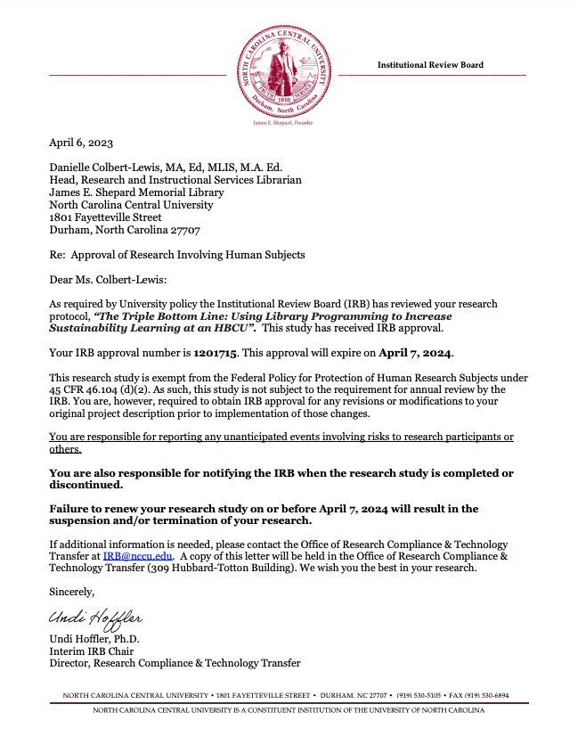

Appendix G: United Nations Sustainability
Development Goals (SDGs)
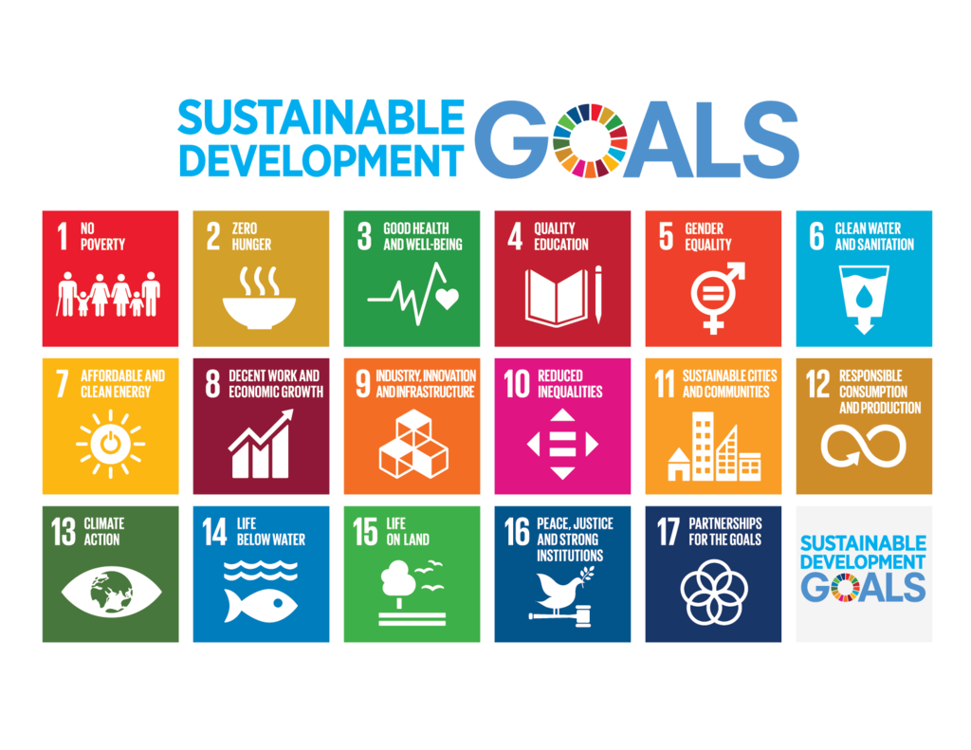

Appendix H: ACRL Program Outcome Events Survey
Please take a few minutes for this brief survey and let us know if, as a result of participating in this event / program…

1. I learned something new from this event or program.
Strongly disagree | Disagree | Neither | Agree | Strongly agree | N/A
2. I feel more confident about using what I just learned.
Strongly disagree | Disagree | Neither | Agree | Strongly agree | N/A
3. I intend to discuss or share with others what I just learned.
Strongly disagree | Disagree | Neither | Agree | Strongly agree | N/A
4. I am more aware of the library’s programs and services.
Strongly disagree | Disagree | Neither | Agree | Strongly agree | N/A
5. What did you like most about this event / program?
6. What other types of events or programs would you be interested in attending?

Appendix I: Overview of Phases in the Study

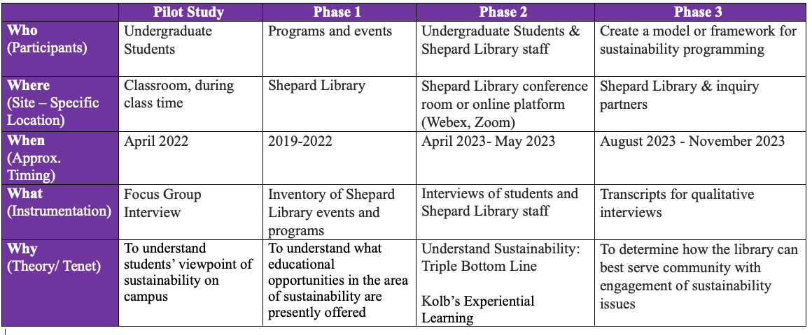

Appendix J: Program Flyers
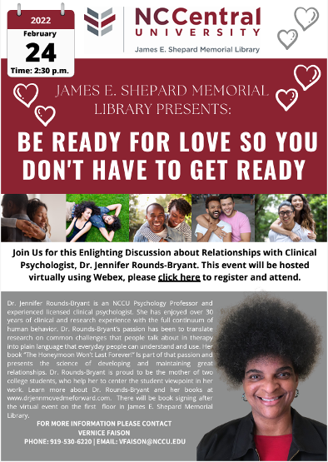

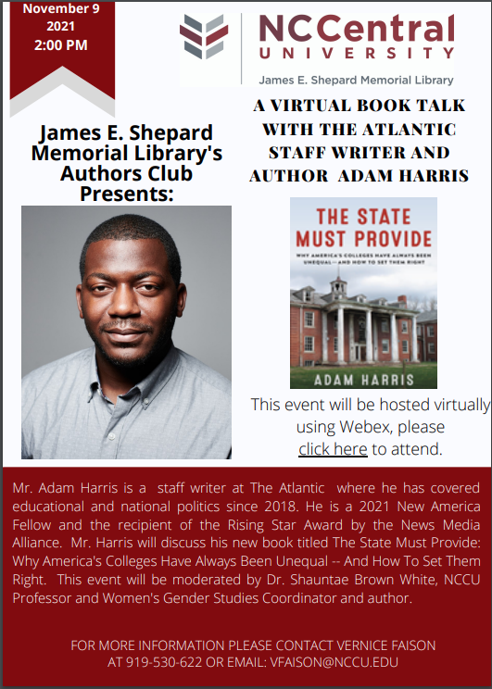

Appendix K: Adam Harris Press Release
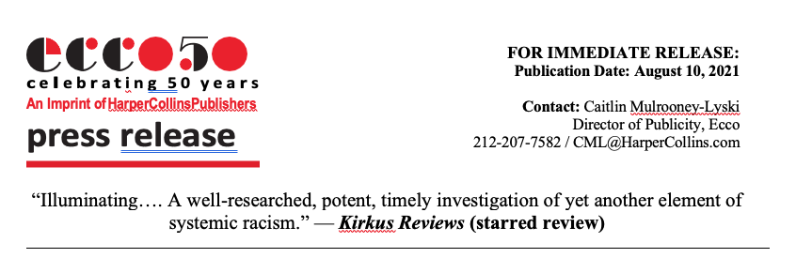
Why America’s Colleges Have Always Been Unequal – and How to Set Them Right
by Adam Harris
(Ecco; On-sale August 10, 2021; ISBN: 978-0062976482; $27.99)
“Sharp and vigorous…. Fluently organized and lucidly written, this thought-provoking exposé is a worthy contribution to the debate over how to make American education more equitable.” —Publishers Weekly
“Adam Harris is a brilliant storyteller. He has used his unique literary gifts to synthesize two centuries of history in order to construct an historical account of higher-education that reads like a novel. The State Must Provide is a book that both taught me so much and also kept me on the edge of my seat. It is an invaluable text from a supremely talented writer.” — Clint Smith, author of How the Word is Passed
“This thought provoking, timely, and engaging read gives space to subject matter that has largely gone ignored and unaddressed, and offers readers much food for thought on the topic of discrimination and systemic racism in higher education.” – Booklist
“A spectacular book—the research alone is a tour de force. Harris makes an indisputable argument about the historical and ongoing role of the state in crippling Black higher education in a book that is passionate and a delight to read.” — Ted Mitchell, President of the American Council on Education and former Under Secretary of the U.S. Department of Education
As our country examines the centuries of structural racial inequality at its foundation, Adam Harris, staff writer at The Atlantic, turns the spotlight on higher education, one of America’s most segregated spaces. In THE STATE MUST PROVIDE: Why America’s Colleges Have Always Been Unequal – and How to Set Them Right (Ecco Hardcover; August 10, 2021; 978-0062976482; $27.99; 272 pages), Harris outlines exactly how racial inequality was built into American higher education from the beginning and how it’s been maintained. THE STATE MUST PROVIDE is an incisive, definitive history, infused with Adam Harris’ incredible reporting, as well as his personal experience as an alumnus of Alabama A&M, an historically Black college.
America’s colleges and universities have a shameful secret: they have never given Black people a fair chance to succeed. From its inception, our higher education system was not built on equality or accessibility, but on educating—and prioritizing—white students. Black students have always been an afterthought. While governments and private donors funnel money into majority white schools, historically Black colleges and universities (HBCUs), and other institutions that have high enrollments of Black students, are struggling to survive, with state legislatures siphoning away federal funds that are legally owed to these schools.
In THE STATE MUST PROVIDE, Adam Harris reckons with the history of a higher education system that has systematically excluded Black people from its benefits, weaving through the legal, social, and political obstacles erected to block equitable education in the United States, studying the Black Americans who fought their way to an education, pivotal Supreme Court cases like Plessy v. Ferguson and Brown v. Board of Education, and the government’s role in creating and upholding a segregated education system. He explores the role that Civil War–era legislation intended to bring agricultural education to the masses had in creating the HBCUs that have played such a major part in educating Black students when other state and private institutions refused to accept them.
THE STATE MUST PROVIDE chronicles higher education’s failed attempts at equality and the long road still ahead as we endeavor to remedy centuries of racial discrimination. Told through a vivid cast of characters, Adam Harris examines what happened before and after schools were supposedly integrated in the twentieth century, and why higher education remains broken to this day. THE STATE MUST PROVIDE is also forward-looking, with Harris offering a daring solution to help solve the underfunding of HBCUs: a redistribution of the endowments of the wealthiest universities in the country – many of which have disproportionately low enrollment of Black students – in the form of reparations. As Harris says, “More equitably funded institutions means more integrated institutions.”
# # #
ABOUT THE AUTHOR: Adam Harris is a staff writer at The Atlantic where he has covered education and national politics since 2018. He was previously a reporter at the Chronicle of Higher Education where he covered federal education policy and historically black colleges and universities. He is a 2021 New America Fellow and the recipient of the Rising Star Award by the News Media Alliance.
THE STATE MUST PROVIDE: Why America’s Colleges Have Always Been Unequal – and How to Set Them Right by Adam Harris
Ecco Hardcover; August 10, 2021; Price: $27.99; 272 pages; ISBN: 978-0062976482
Additional Praise for Adam Harris and The State Must Provide:
"Adam Harris shows how the dark history of America's vaunted higher education system continues to prevent true equality. He's the kind of journalist we most need: meticulous in his research, careful in his thinking, passionate in his vision. This book is powerful, quietly angry, revelatory, and utterly persuasive."
— George Packer, author of Last Best Hope and The Unwinding
“Adam Harris’s definitive and necessary book shows how thoroughly the U.S. has barred Black people from its halls of higher learning, and how high those barriers remain today. Harris’s storytelling is vivid, his reporting is immaculate, and his case is damning. This book is a punch in the gut. Let it also be a line in the sand.” — Ed Yong, author of I Contain Multitudes
Adam Harris Talking Points for THE STATE MUST PROVIDE
- US Higher Ed is Still Segregated in 2021: Despite the federal government mandating desegregated higher education systems—and federal courts reinforcing that mandates since at least 1973—six US states still have not proven they have desegregated their schools. Adam can speak to the historic lack of enforcement, and the impact this continues to have on BIPOC students.
- For the Past 50 Years, States Have Shorted Their HBCUs: There is a chronic pattern of states shirking their legal financial obligations and shorting their HBCUs’ funding. Adam can speak to the racial disparity in state-distributed funding and the hundreds of millions of dollars owed to these schools, which have been shortchanged from the start. Public colleges spend $5 billion less educating students of color in one year than is spent on white students – or roughly $1,000 per year, per student.
- Affirmative Action: Who does it help, how was it dismantled, and why is it so hard to bring back? Adam can speak to the establishment of affirmative action in 1961, the disingenuous way it was dismantled in the name of equality in 1978 and the unique struggles to reinstate it, despite very clear data on the negative impact its absence has had on black enrollment numbers.
- Philanthropy is Not a Cure – 2020 was a record-breaking year for philanthropy to HBCUs, with a record high of a $5M single donation; meanwhile, Bloomberg gave $150M to Johns Hopkins last year (which already has a $4B endowment) for diversity-oriented efforts in graduate level programs. That’s more than any HBCU has ever received in history. Adam can speak to the disparity of private funding and how few large donations are given to HBCUs, which educate 80% of Black judges, 50% of Black lawyers and doctors, and 25% of Black STEM graduates, despite only accounting for 3% of all four year institutions and being woefully underfunded.
- The Case for Reparations – Some of the universities with the largest endowments, like Brown University, Georgetown University and the University of Virginia, either actively relied on slave labor and/or were started by slave owners and those who engaged in the slave trade. Adam can speak to why now is the time to redistribute some of the institutional wealth gained on the backs of Black people, to give more and richer opportunities to Black students today, and how it might be done.
- The Biden Money – HBCUs are getting $2 billion in extra funding across 100 schools in the 2021-22 school year. That’s triple what they normally get, but when you look at the larger picture – Morgan State alone is owed $2.73B by the state in shorted funds – the scale of federal and state harm to HBCUS is enormous and a single, relatively small injection of funds is hardly going to compensate for a century of underfunding.
Appendix L: Social Media Announcement
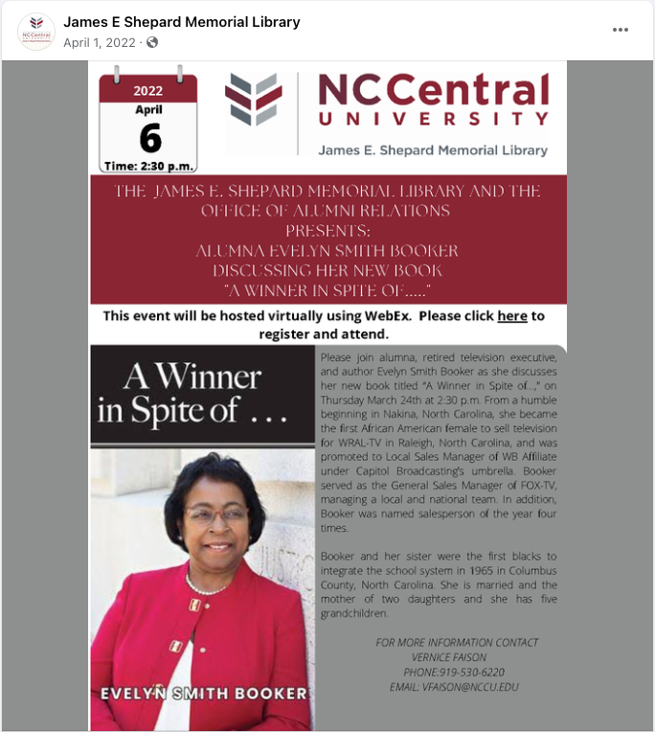

Appendix M: Campus Announcements Messages
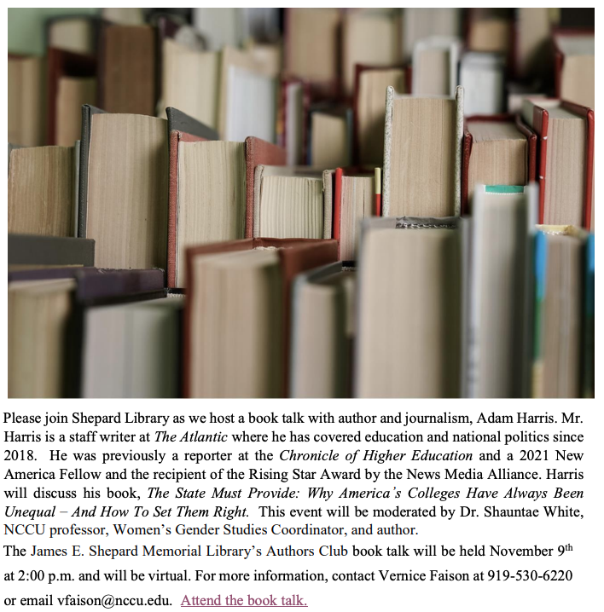

Appendix N: ACRL Project Outcomes Surveys
for Shepard Library Programs 2019-2022
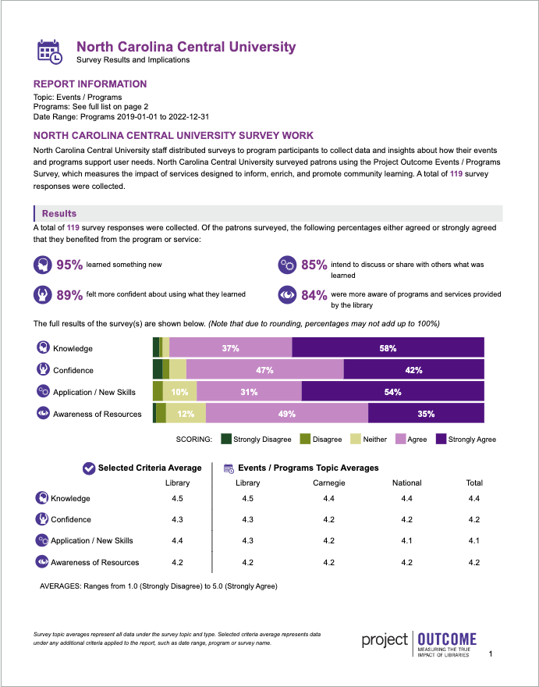

Appendix O: Sustainability and Environmental Resources Survey
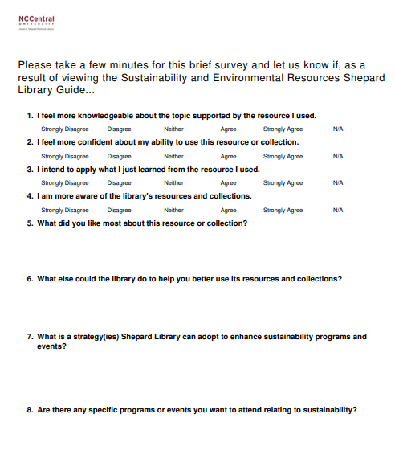
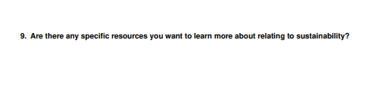

Appendix P: Survey Results from Sustainability and Environmental Resources LibGuide
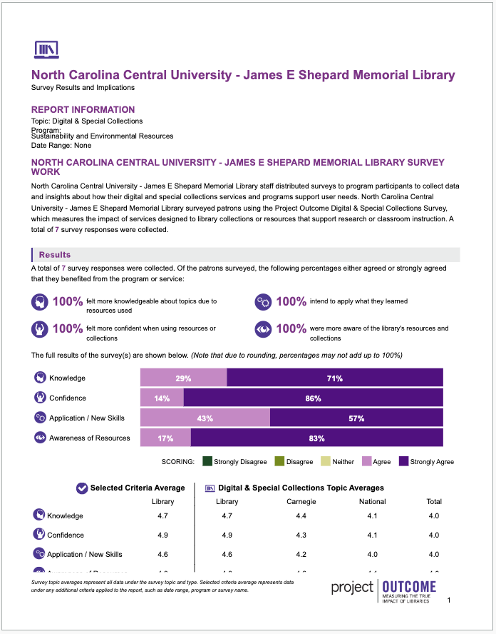

Appendix Q: ChatGPT Examples

You
What are sustainability related topics?

ChatGPT
Certainly, Danielle! Sustainability encompasses a wide range of topics related to environmental, social, and economic well-being. Here are some sustainability-related topics:
- Renewable Energy: This includes solar, wind, hydroelectric, and geothermal energy, which are sustainable alternatives to fossil fuels.
- Climate Change Mitigation and Adaptation: Strategies and actions aimed at reducing greenhouse gas emissions and building resilience to the impacts of climate change.
- Resource Conservation: Efficient use of natural resources such as water, forests, and minerals to ensure their availability for future generations.
- Sustainable Agriculture: Practices that promote soil health, biodiversity, and minimal environmental impact in food production.
- Waste Reduction and Recycling: Efforts to minimize waste generation, promote recycling and composting, and reduce reliance on landfills.
- Circular Economy: Shifting from a linear "take-make-dispose" model to one that emphasizes recycling, reuse, and repurposing of materials.
- Green Building and Sustainable Design: Construction and design practices that minimize energy consumption, reduce waste, and promote occupant health.
- Sustainable Transportation: Encouraging the use of public transit, cycling, walking, and electric vehicles to reduce emissions and congestion.
- Biodiversity Conservation: Protecting and restoring ecosystems, habitats, and endangered species to maintain biodiversity and ecosystem services.
- Corporate Social Responsibility (CSR): Businesses adopting sustainable practices in their operations, supply chains, and community engagement efforts.
These topics are interconnected and require collaborative efforts from governments, businesses, communities, and individuals to achieve a more sustainable future.

You
What is triple bottom line sustainability?

ChatGPT
Triple bottom line (TBL) sustainability is an approach to business and organizational management that evaluates performance based on three interconnected dimensions: economic, social, and environmental. The concept suggests that organizations should not only focus on financial profits (the "bottom line") but also consider their impact on people and the planet.
Here are the three components of the triple bottom line:
- Economic Dimension: This refers to traditional financial measures such as profits, revenues, and costs. In the context of TBL sustainability, the economic dimension considers the long-term financial viability and profitability of an organization. It involves assessing the economic benefits generated by the organization's activities while also considering the costs and risks associated with them.
- Social Dimension: The social dimension of the triple bottom line focuses on the impact of an organization's operations on people, communities, and society at large. This includes aspects such as employee well-being, labor practices, community engagement, human rights, diversity, equity, and social justice. Organizations committed to TBL sustainability strive to create positive social outcomes and address societal issues through their actions and initiatives.
- Environmental Dimension: The environmental dimension encompasses the ecological impact of an organization's activities and operations. It involves evaluating resource consumption, waste generation, pollution, carbon emissions, biodiversity conservation, and environmental stewardship practices. Organizations practicing TBL sustainability seek to minimize their environmental footprint and promote environmental sustainability through measures such as energy efficiency, waste reduction, and the use of renewable resources.
The triple bottom line framework recognizes the interconnectedness of economic, social, and environmental factors and emphasizes the importance of achieving balance and harmony among them. By considering all three dimensions, organizations aim to create value not only for their shareholders but also for society and the environment, thereby contributing to sustainable development and long-term prosperity.

APPENDIX R: THE SUSTAINABLE VALUE FRAMEWORK
SOURCE: HART, S. L., & MILSTEIN, M. B. (2003). CREATING SUSTAINABLE VALUE. ACADEMY OF MANAGEMENT PERSPECTIVES, 17(2), 56-67.
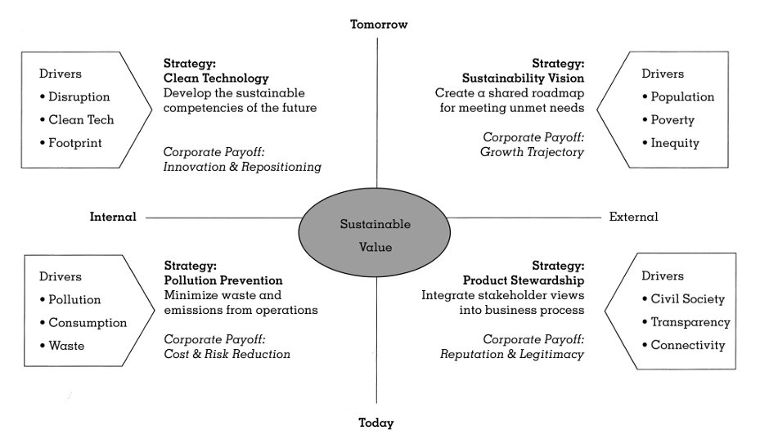

APPENDIX S: MAKING THE CONNECTION TO SUSTAINABILITY PROGRAMMING
