NICOTINE CONTROL OF GERMLINE CELL FATE IN CAENORHABDITIS ELEGANS

by

Robert A. Kobet

A Senior Honors Project Presented to the

Honors College

East Carolina University

In Partial Fulfillment of the

Requirements for

Graduation with Honors

by

Robert A. Kobet

Greenville, NC

May 2015

Approved by:

Xiaoping Pan, PhD

Department of Biology, Thomas Harriot College of Arts & Sciences
Table of contents
Abstract 1
Introduction 2
Methods 4
Results & Discussion 6
Significance/Impact 9
Acknowledgements 10
References 10
Nicotine control of germline cell fate in Caenorhabditis elegans
Abstract
Nicotine dependence is the single largest cause of preventable death in the world, claiming 480,000 lives each year in the US alone, including those caused by secondhand smoke. In this study, we investigated the biological effect of nicotine on germ cell fate specification using the nematode C. elegans germline as a model system.
Wild-type hermaphrodites produce both sperm and oocytes. They are therefore self-fertile. However, a mutant lacking PUF-8 (Pumilio RNA binding protein) and LIP-1 (ERK phosphatase) produce only sperm, resulting in sterility (Mog phenotype) at a permissive temperature (20°C). Remarkably, this puf-8; lip-1 mutant develops germline tumors via the dedifferentiation of spermatocytes at a restrictive temperature (25°C). Using this mutant, we investigate the effect of nicotine on germ cell fate specification. First, we treated puf-8; lip-1 homozygotes with different concentrations of nicotine at 25°C and analyzed the germline phenotypes by germline staining. Interestingly, puf-8; lip-1 mutants exposed to 200 μM or less nicotine developed germline tumors via dedifferentiation as seen in control. However, exposure to doses ranging from 500 to 2000 μM significantly reduced germline tumor frequency in a dose-dependent manner, instead showing the Mog phenotype. Moreover, the same doses in unc-32 glp-1(ar202) gain-of-function mutants at 20ºC similarly decreased tumor frequency from 17% to 5%. These results hypothesize that high nicotine doses reprogram germ cells with germline tumor or oogenic potential into germ cell with sperm fate. Gene expression of several cell fate regulators was significantly increased following exposure of wild-type worms to 500 and 2000 μM dosing solutions. Our results and future plan hopes to address the potential effect of nicotine on the regulatory network controlling cell fate specification in C. elegans as well as other model systems.
Introduction
The nematode Caenorhabditis elegans has been widely studied in biological research due to: 1) its transparency to facilitate the monitoring of biological processes, 2) well-established, tissue-specific fluorescent transgenic markers that can be easily studied in vivo, 3) availability of various specimens and mutants through the Caenorhabditis Genetics Center (CGC) [http://www.cbs.umn.edu/research/resources/cgc], 4) wholly sequenced genome, 5) short lifespan (2-3 weeks) and strong genetic power, and 6) its conserved biochemical aspects of mammalian diseases in vivo (O’Reilly et al, 2014). Its life cycle includes embryogenesis (~12 h) followed by larval stages L1-L4 (~3 days) and ~10 days of adulthood. Sex can be hermaphrodite or male; hermaphrodites produce sperm as larvae and oocytes as adults. These worms can self-fertilize; however, the males produce only sperm throughout their lives.
In the gonad, germline stem cells (GSCs) in the distal region start at their niche, the distal tip cell, and progress linearly towards the proximal end, where terminal differentiation into mature gametes occurs. Throughout the germline, development is tightly regulated by signaling pathways such as the conserved Ras and Notch pathways, whose aberrant signaling can cause uncontrolled germline proliferation and abnormal cell fate. This study aims to examine nicotine’s impact on these conserved regulators of germ cell fate, using the C. elegans germline as a model.
Current literature presents varying insights regarding correlation between nicotine and carcinogenesis. For example, study of the nicotinic acetylcholine receptors (nAChRs) has shown that when activated by nicotine, both carcinogenic and tumor-suppressing pathways may be implicated; case-controlled studies using the Lewis lung cancer model in mice have suggested single nucleotide polymorphisms in the nAChRs may increase the risk of lung cancer with nicotine exposure, but receptor variants in some cases may simultaneously be associated with reduced risk (Grando 2014). Genetic and chemical reprogramming of C. elegans has previously been used as a model for studying cancer phenotypes. A mutation exhibited in human lung cancer patients is the c-Met receptor tyrosine kinase gain-of-function mutation. When expressed in C. elegans, a gain-of-function c-Met transgene (c-MetR988C and c-MetT1010I) results in hyperplastic vulval cell defects characteristic of cancer, and the frequency of this phenotype was enhanced following low-dose nicotine treatment (20 μM) (Siddiqui et al, 2008). Our study further investigates the role of nicotine in carcinogenesis using a similar in vivo model. Other published research on nicotine and carcinogenesis in C. elegans is limited. Here we investigate nicotine’s effect on the MPK-1/ERK signaling and GLP-1/Notch signaling pathways in the C. elegans germline.
Our lab has employed a particular mutant strain, puf-8; lip-1 double mutant, in studying germline stem cell fate. In C. elegans, PUF-8, a member of the Pumilio RNA-binding protein family, post-transcriptionally inhibits let-60/Ras mRNA signaling, an upstream activator of MPK-1/ERK. The Ras-ERK MAPK pathway is deregulated in about one third of human cancers and has become a primary target in anti-cancer therapy due to its role in cell cycle progression, proliferation, and survival (Saxena et al, 2008). LIP-1 is a negative post-translational regulator of Ras-ERK MAPK signaling. At 20ºC, this double mutant strain invariably fails to transition from spermatogenesis to oogenesis, producing a sperm-only (known as “Mog”) phenotype. However, at room temp (25ºC), germline secondary spermatocytes dedifferentiate back into the multipoint state as cancer-like stem cells (Cha et al, 2012). This makes puf-8; lip-1 mutant useful for cancer research. Previous unpublished results show that nicotine has been shown to increase MPK-1/ERK signaling at high doses, and slightly decrease at low doses. We hypothesized that if MPK-1/ERK signaling is increased, puf-8; lip-1 animals may exhibit dedifferentiation in the germline at 20ºC with exposure to nicotine.
The GLP-1/Notch pathway is another conserved pathway known to regulate proliferation, differentiation, cell fate specification, and apoptosis (Artavanis-Tsakonas et al, 1999). Aberrant activation of this pathway has also been implicated in a variety of human cancers. A second temperature-sensitive mutant, unc-32 glp-1(ar202) gain-of-function (gf) mutation, was also studied. These animals are fertile at 20ºC, but exhibit germline tumors at 25ºC (Pepper et al, 2003), similar to the puf-8; lip-1 mutant due to constitutively active GLP-1/Notch signaling promoting the proliferative state and inhibiting meiotic entry. This establishes unc-32 glp-1(ar202) as another potential model for chemical GSC fate reprogramming.
Materials & Methods
The worms used in this experiment were acquired from cultures acquired from the CGC. They were grown on nematode growth medium (NGM) and fed with Escherichia coli (E. coli) strain OP50 seeded on the plates, as is standard protocol for C. elegans culturing. All experiments are performed following embryoisolation of the worm cultures, where age is eliminated as a variable by lysing of the adults with a bleaching solution containing Clorox bleach, 1 N sodium hydroxide, and water, a solution to which the eggs are resistant.
Treatment with nicotine: 98% L-Nicotine solution was obtained from ACROS Organics and diluted with K-medium (aqueous NaCl and KCl solution). The nicotine is introduced to liquid NGM before plating and provides growth medium with nicotine concentrations ranging from 2 μM to 20 mM. Worms were exposed following embryoisolation and larval development from between early larval stage (L1) arrest and late (L4) larval stage to young adulthood. Exposure time was 24 hours for puf-8; lip-1 experiments and 48 hours for glp-1(ar202) experiments.
Analysis:
Phenotype screening
The worms were collected and dissected with a scalpel in solution containing levamisole, a paralytic agent, to expose the organs for observation. Gonad phenotypes were observed through DAPI (4’,6-Diamidino-2-Phenylindole, Dihydrochloride) staining of germline cell nuclei. DAPI staining allows us to distinguish the nuclei of stem cells from spermatocytes and sperm, oocytes, and embryos. Experimental groups were organized by reaction temperature, strain, concentration, and exposure time. The percentages of each phenotype in each group were tabulated and the microscope camera (using the Leica Application Suite software) provided photographic evidence.
Genetic analysis
Wild-type worms were exposed to nicotine in dosing solutions containing 500 and 2000 μM nicotine in tubes containing 80 μL OP50 and diluted to 5 mL with K-media. After 24 hours of exposure from L3, the worms were rinsed with K-media and centrifuged. After removing the supernatant, the worm pellet was frozen in liquid nitrogen.
RNA was extracted using the Ambion mirVana miRNA isolation kit from Life Technologies (Ambion, Austin, TX, USA). The isolated RNA was reverse-transcribed to single-stranded cDNA using an Eppendorf Mastercycler Pro system. The genes were then amplified via qRT-PCR with an Applied Biosystems 7300 Real Time PCR machine. One replicate was performed for genetic analysis.
RESULTS & DISCUSSION
Germline tumor screening in puf-8; lip-1
DAPI staining of dissected gonads of puf-8; lip-1 mutants to 2 μM, 20 μM, 200 μM, and 2000 μM at 20ºC showed no resulting proximal germline tumors characteristic of puf-8; lip-1 at 25ºC. The maximum dose of 20000 μM (20 mM) was found to be toxic to the worms’ development from L1. Nicotine exposure at a wide range of concentrations for 24 hours was thus unable to induce dedifferentiation in a temperature-sensitive mutant with elevated MPK-1/ERK signaling in the proximal germline.
To test the effect of nicotine on the double mutants at the restrictive temperature, puf-8; lip-1 mutants were exposed to intermediate doses of nicotine (500 μM, 1000 μM, 1500 μM, and 2000 μM) from L4 stage for 24 hours at 25ºC. DAPI staining of dissected gonads showed dose-dependent inhibition of the tumor phenotype (Figures 1,2), reducing the number of proximal germline tumors nearly by 50%. The slight increase at the high dose (2000 μM) supports our hypothesis that nicotine at a high dose may increase MPK-1/ERK signaling in the proximal region.

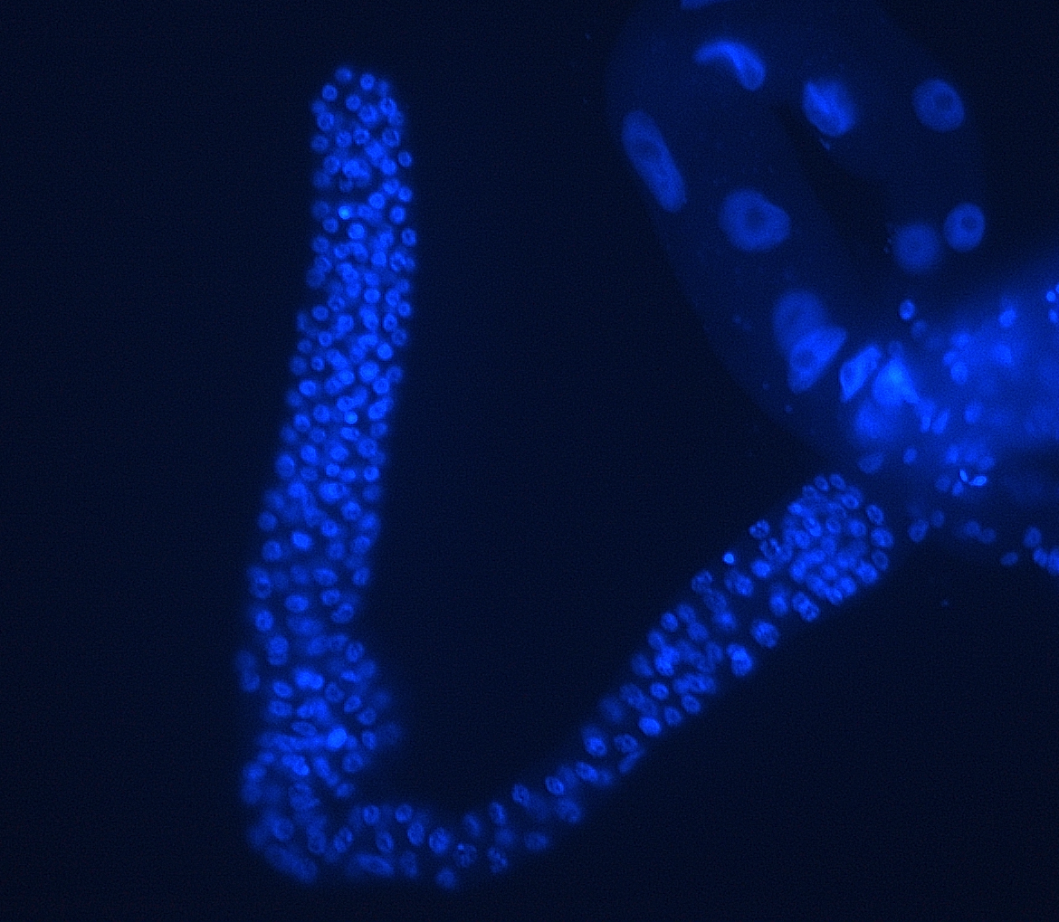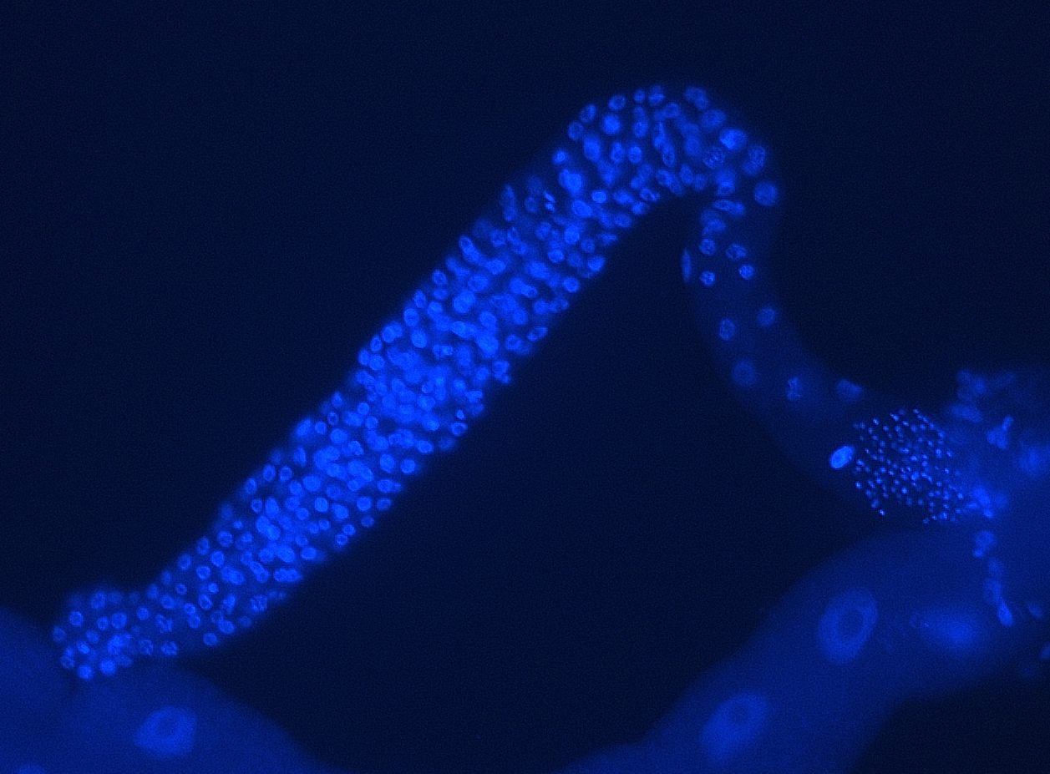
Figure 1: puf-8; lip-1 mutant germline showing proximal germline tumor (left) and sperm-only (Mog) phenotype (right)

Figure 2: Tumor frequency results for puf-8; lip-1 at 25 ºC exposed 24 hrs
Stem cell proliferation screening in glp-1(ar202)
Exposure of L4 stage glp-1(ar202) gain-of-function mutants for 48 hours to the same nicotine doses (500 μM, 1000 μM, 1500 μM, and 2000 μM) produced a similar dose-dependent decrease in tumor phenotypes (Figure 4) as seen in the puf-8; lip-1. These worms instead showed both Mog and germline proliferation defect phenotypes (Figure 5). However, the high nicotine dose was shown to be toxic to L4 worms.

Figure 4: Tumor frequency results for glp-1(ar202) at 20 ºC exposed 48 hrs

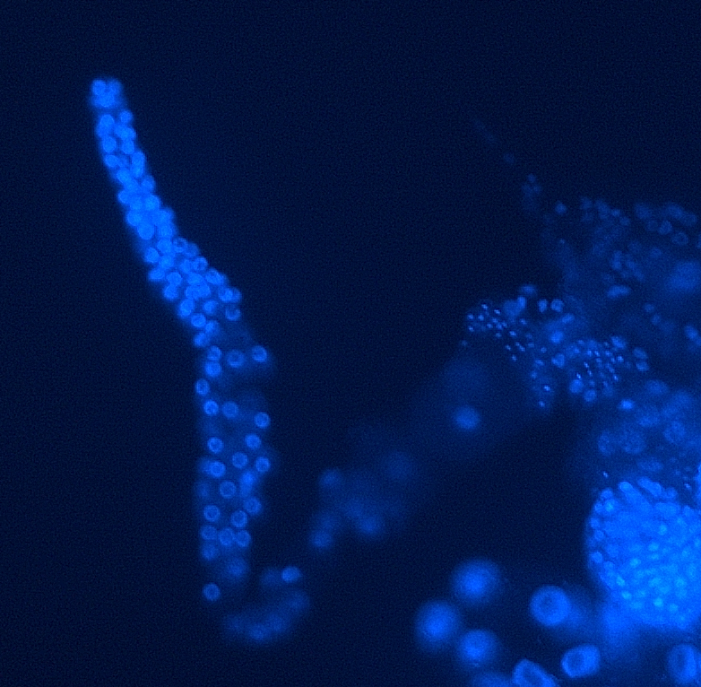
Figure 5: unc-32 glp-1(ar202) mutant germline showing germline proliferation defect
These results show that nicotine has the potential to inhibit constitutively active proliferation signaling and suppress the tumor phenotype. The proliferation defect result in both strains also illustrates a detrimental effect on nicotine on development that may have implications in human tobacco use.
Genetic analysis
Exposure of wild-type worms in control, 500 μM, and 2000 μM dosing solutions produced various effects on the expression of selected germline cell fate-controlling genes, as shown in Figure 6. One replicate was performed, so additional biological replicates are required for conclusive analysis. As in phenotypic analysis of the double mutants, these worms were exposed for 24 hours.

Figure 6: Expression fold changes in wild-type worms at with respect to control
Significance/Impact
The current study primarily investigates a chemical, nicotine, which causes aberrant signaling in the Ras-ERK and GLP-1/Notch signaling pathways, which are implicated in many cases of human cancer. C. elegans is a well-established model organism for functional analysis of bioactive compounds such as nicotine, and our results will provide insight into the impact of nicotine and other components of tobacco on the human body, whose genome contains many conserved regions of the C. elegans genome. Using specimens genetically reprogrammed for increased susceptibility to aberrant phenotypes in the developing germline, we investigate nicotine’s effect on above-mentioned conserved genetic pathways. This research demonstrates chemical reprogramming of stem cells and is carried out with hopes of ultimately identifying and testing causes of disease (specifically cancer) as well as novel anti-cancer drug targets for anti-cancer drug therapy. Previously, C. elegans models have been utilized in the discovery of drugs used to treat diseases such as microbial infections and Alzheimer’s (Ewbank & Zugasti, 2011; Lublin & Link, 2013). These models are promising for future research in this area, and therapeutic methods involving chemical and genetic reprogramming such as stem cell therapy attest to their potential use in medicine.
Acknowledgments
I would like to thank my family and friends for their unrelenting support throughout my time at ECU, my mentors, Dr. Pan and Dr. Lee, for their perpetual support and insight, and my professors, East Carolina University, and the Brody School of Medicine for providing me with the opportunities making this research possible.
References
- O'Reilly, L. P., Luke, C. J., Perlmutter, D. H., Silverman, G. A. and Pak, S. C. (2014) C. elegans in high-throughput drug discovery. Adv. Drug Deliv. Rev. 69-70, 247-253.
- Grando, Sergei A. (2014) Connections of nicotine to cancer. Nature Reviews Cancer 14 419-429.
- Siddiqui, S. S., Loganathan, S., Krishnaswamy, S., Faoro, L., Jagadeeswaran, R., & Salgia, R. (2008). C. elegans as a model organism for in vivo screening in cancer: effects of human c-Met in lung cancer affect C. elegans vulva phenotypes. Cancer Biology & Therapy, 7(6), 856–863.
- Saxena, N., Lahiri, S. S., Hambarde, S., and Tripathi, R. P. (2008) RAS: target for cancer therapy. Cancer Invest. 26, 948-955.
- Cha, D. S., Datla, U. S., Hollis, S. E., Kimble, J. and Lee, M. H. (2012) The Ras-ERK MAPK regulatory network controls dedifferentiation in in Caenorhabditis elegans germline. Biochim. Biophys. Acta 1823, 1847-1855.
- Artavanis-Tsakonas, S., Rand, M. D., and Lake, R. J. (1999) Notch signaling: cell fate control and signal integration in development. Science 284, 770-776.
- Pepper, A. S., Killian, D. J. and Hubbard, E. J. (2003a) Genetic analysis of Caenorhabditis elegans glp-1 mutants suggests receptor interaction or competition. Genetics 163, 115-132.
- Ewbank, J. J. and Zugasti, O. (2011) C. elegans: model host and tool for antimicrobial drug discovery. Dis. Model Mech. 4, 300-304.
- Lublin, A. L. and Link, C. D. (2013) Alzheimer's disease drug discovery: in vivo screening using Caenorhabditis elegans as a model for beta-amyloid peptide-induced toxicity. Drug Discov. Today Technol. 10, 115-119.

