Improving Adherence to Group A Streptococcal Pharyngitis Guidelines to Decrease Unnecessary Antibiotics.
Kayla S. Walker, BSN, RN
DNP Scholarly Project
East Carolina University

Acknowledgements
I would like to thank Dr. Ann Bell for her time, and support throughout this entire journey. I would also like to take the time to thank the Pender County Health Department for allowing me to complete my quality improvement project in their facility. Lastly, I would like to thank my family and friends for their support throughout this journey.

Table of Contents
Abstract 6
Chapter One: Overview of the Problem of Interest 7
Statement of the Problem 8
Justification of the Study 8
Theoretical Framework 9
Assumptions………………………………………………………………………..10
Problem Statement vs. Hypothesis…………………………………………………10
Definitions…………………………………………………………………………11
Summary…………………………………………………………………………...11
Chapter Two: Literature Review and Assessment………………………………………...13
Diagnosis and Management………………………………………………………..13
Improving Antibiotic Prescribing………………………………………………….15
Centor and McIssac Scoring System………………………………………………16
Antibiotic Resistance………………………………………………………………16
Education/Antibiotic Stewardship…………………………………………………17
Summary…………………………………………………………………………..17
Chapter Three: Methodology……………………………………………………………...19
Design……………………………………………………………………………...19
Budget……………………………………………………………………………...19
Setting……………………………………………………………………………...20
Sample……………………………………………………………………………..20
Protection of Human Subjects……………………………………………………..21
Instruments………………………………………………………………………...21
Standardized Process……………………………………………………………...21
Nursing Education………………………………………………………………...22
Data Collection……………………………………………………………………23
Data Analysis……………………………………………………………………...23
Chapter Four: Results……………………………………………………………………..24
Participate Demographics………………………………………………………….24
Intended Outcome………………………………………………………………….25
Findings…………………………………………………………………………….25
Summary…………………………………………………………………………...25
Chapter Five: Implications for Nursing Practice…………………………………………..27
Essential I…………………………………………………………………………..27
Essential II………………………………………………………………………….28
Essential III………………………………………………………………………....28
Essential IV………………………………………………………………………....29
Essential V………………………………………………………………………….30
Essential VI…………………………………………………………………………30
Essential VII………………………………………………………………………..31
Essential VIII……………………………………………………………………….31
Chapter Six: Final Conclusions……………………………………………………………32
Significance of Findings……………………………………………………………32
Project Strengths and Limitations………………………………………………….32
Project Benefits…………………………………………………………………….33
Recommendations for Practice…………………………………………………….34
Summary…………………………………………………………………………...34
References………………………………………………………………………………….35
Appendix A: DNP Timeline………………………………………………………………40
Appendix B: Project Site Approval………………………………………………………..43
Appendix C: Group A Streptococcal Pharyngitis…………………………………………44
Appendix D: Pre-Implementation Chart Analysis………………………………………...45
Appendix E: Post-Implementation Chart Analysis………………………………………..46
Appendix F: PowerPoint Education Presentation………………………………………....48
Appendix G: IRB Approval………………………………………………………………..50
Appendix H: Literature Matrix…………………………………………………………….51

Abstract
Acute pharyngitis is one of the most common upper respiratory infections seen in primary offices, and the most commonly prescribed medications are antibiotics. The most common bacteria causing symptoms of sore throat is group A streptococci and this accounts for 20-30% in children, and 4-15% in adults (Shulman et al., 2012). Utilization of Rapid Antigen Detection Test (RADT) providers can safely avoid the overuse of antibiotics (Shulman et al., 2012). Without laboratory confirmation providers relying on clinical judgement alone are over estimating the disease by 80-95% (Sarrell, Giveon, 2012). In the case at a rural health department a chart analysis concluded providers were prescribing antibiotics 58.3% of the time for negative test results. The purpose of this scholarly project is to improve the adherence of the Infectious Diseases Society of America clinical practice guidelines to group A streptococcal pharyngitis in a local health department to help decrease unnecessary prescribing of antibiotics and decrease potential drug resistance. A retrospective chart analysis was conducted to determine a need assessment. With a need for improvement education and a luncheon was provided for clinical staff. With education and implementation of a new standardized process guideline adherence for group A streptococcal pharyngitis increased from 58.3% to 95% thus, increasing patient safety and decreasing patient cost. Decreasing unnecessary prescribing of antibiotics leads to decrease antibiotic resistance, and quality improvement projects similar to this project and potentially decrease antibiotic resistance by adhering to clinical practice guidelines.
Keywords: GAS pharyngitis, RADT (Rapid Antigen Detection Testing), Centor and McIssac Score.

Chapter One: Overview of the Problem of Interest
Acute pharyngitis is one of the most common upper respiratory infections seen in primary offices, and most commonly treated with antibiotics (Shulman et al., 2012). The most common bacteria causing symptoms of sore throat is group A streptococci and this accounts for 20-30% in children, and five percent to fifteen percent in adults (Shulman et al., 2012). Viruses are the most common cause of acute pharyngitis, and antibiotics are unreasonably prescribed as treatment (Shulman et al., 2012). Furthermore, as many as ten million antibiotic prescriptions per year are directed toward respiratory conditions to which the likelihood of benefit is not medically necessary (Hersh, Jackson, & Hicks, 2013). To decrease the likelihood of prescribing antibiotics for viral illnesses a scoring system, can be utilized to determine if patients should be tested for group A streptococcal pharyngitis (Shulman et al., 2012). After clinical assessment and utilization of the scoring system, laboratory confirmation such as Rapid Antigen Detection Testing (RADT) testing and throat culture is crucial in making an accurate diagnosis, and with negative results, the provider can safely avoid the use of antibiotics (Shulman et al., 2012). Without laboratory confirmation, providers relying on clinical judgement such as fever, and sore throat are over estimating the disease by 80-95% (Sarrell, & Giveon, 2012).
Additionally, clinical practice guidelines for the diagnosis and management of group A streptococcal pharyngitis should be followed to minimize overuse of antibiotics and to decrease the potential for drug resistant bacteria. In the United States, antibiotic resistance affects 2 million people with 23,000 deaths annually (Fleming-Dutra et al., 2016). Thus, antibiotic resistance leads to high medical cost because of prolonged hospitalizations, as well as increased mortality (World Health Organization, 2016). The importance of adhering to clinical practice guidelines is to decrease the unnecessary patient cost, while improving the patient experience and health. The aim of this scholarly project is to improve provider and clinical staff adherence to guidelines to decrease potential drug resistance by implementing a standardized process and guidelines.
Statement of the Problem
The purpose of this scholarly project was to improve adherence to clinical practice guidelines for diagnosis and management of group A streptococcal pharyngitis to decrease the unnecessary prescribing of antibiotics by educating staff, and implementing evidence based clinical practice guidelines. Currently there is not a guideline or protocol being utilized for diagnosis and management of group A strep at rural health department in eastern North Carolina. In fact, a need assessment from electronic health records from December 2016 through February 2017 concluded that 58.3% of patients were given antibiotics with negative rapid strep test results, and no follow-up culture ordered (S. Steele, personal communication, February 2017). Documentation of those with negative results indicated that most patients tested for strep did not meet criteria, such as fever, exudative tonsils, enlarged cervical lymphadenopathy, or scarlet form rash. Furthermore, the majority of the patients tested for group A streptococcal pharyngitis exhibited viral symptoms such as rhinorrhea, congestion, and sore throat. Education for staff members is crucial in decreasing inconsistent prescribing. Educational programs, audit and feedback, and other behavioral approaches have improved antimicrobial prescribing in outpatient settings (Weddle, Goldman, Myers, & Newland, 2016). The aim for this project focuses on educating staff members, chart analysis, and providing feedback to increase adherence to guidelines.
Justification of the Study
The quality improvement project was conducted at a rural public health department in eastern North Carolina. Antibiotic resistance remains a major public health concern, and improvement of proper antibiotic use is a health care quality goal (Hersh, Jackson, & Hicks, 2013). According to Ventola (2015) the Infectious Diseases Society of America (IDSA), Institute of Medicine (IOM), and the federal Interagency Task Force declare multiple drug resistance as a public health threat. In addition, antibiotic prescribing when not warranted adds to the possibility for drug resistance. According to the World Health Organization (2016) providers globally need to change the ways it prescribes antibiotics, because even if new antibiotics are developed, without behavior change drug resistance will continue to remain a threat.
Theoretical Framework
A driving force is warranted to motivate participants to change, while participants restrain from the force being directed towards them (Butts, & Rich, 2015). Utilizing Lewin’s change theory is the force that motivates lasting behavior change. Lewin’s model consists of unfreezing, movement, and refreezing (Butts, & Rich, 2015). Stage one of Lewin’s change theory is unfreezing old behaviors. Unfreezing is a way of destabilizing old behaviors and is a necessity for old behavior to be unlearned (Butts, & Rich, 2015). By unfreezing old behaviors, the providers and staff at a local health department are preparing for a process change while implementing evidence-based guidelines. During this quality improvement project providers and staff unlearned old behaviors that are not consistent with evidence-based practice guidelines. The second stage of Lewin’s change theory is the movement stage, which allows for individuals and groups to switch to a more suitable behavior (Butts, & Rich, 2015). During this stage participates must accept the new plan of action and present the plan in a way that participates are eager to try the change. Lastly, refreezing is the third stage of Lewin’s change theory. Refreezing relates to the individual or group returning to a state of equilibrium (Butts, & Rich, 2015). During this stage, new behaviors are implemented to create change in behavior.
In addition, during the unfreezing stage, the health department will learn to engage in new information and change such as implementing new guidelines and adding new information to encounter forms. Next, decreasing the prescribing of antibiotics for negative group A strep pharyngitis is a continued process after the unfreezing stage and the implementation of a new process. During the moving stage, staff will accept the new behaviors. During the refreezing stage, the health department will be moving from old behaviors of prescribing antibiotics for negative rapid strep tests, to not prescribing medications if medically unnecessary.
Assumptions
Staff members including providers, nurses, and medical assistants will cooperate, and be receptive of educational opportunities, as well as open to new policies and procedures for change. Providing an education session to staff will allow staff members to feel more comfortable with change and provide a rationale for change. The addition of flyers, educational material, and an algorithm will allow staff and providers to continue with the new change.
Problem Statement vs. Hypothesis
Data from a preliminary chart review indicated that 58.3% of the time antibiotics were being prescribed for group A strep pharyngitis when testing is negative (S. Steele, personal communication, February 2017). A preliminary chart review also concluded that negative RADT results were not being followed-up with culture in accordance with the Infectious Diseases Society of America. Educational opportunities will be provided for all clinical staff including providers, nurses, nursing assistants, and lab technicians. After educational opportunities are concluded, and after implementation of clinical practice guidelines, it is the aim of this project to decrease prescribing of antibiotics for group A strep pharyngitis. Decreasing prescribing of antibiotics is one part of the quality improvement process but providing an algorithm for providers and staff to help sustain improvement will be beneficial.
Definitions
GAS pharyngitis: Group A Streptococcal pharyngitis. Group A Streptococcal pharyngitis is the most common bacterial cause of acute pharyngitis and is responsible for 5-15% of sore throats in adults and 20-30% in children (Shulman et al., 2012).
RADT: Rapid Antigen Detection Test. RADT was developed to identify GAS pharyngitis from swabs with a shorter result window than a throat culture (Shulman, et al., 2012). RADT are highly specific and allows for patients to return to work and school sooner and reduce acute associated morbidity (Shulman, et al., 2012).
Centor Score: Scoring system utilized to help determine the need for group A strep testing. This clinical scoring system can help guide treatment for GAS pharyngitis (Fine, Nizet, & Mandl, 2012).
Improving adherence to clinical practice guidelines was the aim of this scholarly project. As a result, increasing adherence for prescribing medication will decrease the possibility of drug resistance. Currently there is not a protocol in place for the proper diagnosis and management of group A streptococcal pharyngitis. The goal of this project is to implement a new standardized process to improve provider adherence to the standard of care. Data from preliminary chart reviews revealed the need for improvement in adherence to clinical practice guidelines. After the clinical problem was identified, evidence was identified and studied to ascertain an appropriate solution would take place.

Chapter Two: Literature Review and Assessment
A comprehensive literature review of evidence-based research was conducted about the overuse of antibiotics, and risk of drug resistance for group A streptococcus pharyngitis utilizing MEDLINE via PubMed, and CINAHL. The following keywords were used: “pharyngitis OR sore throat OR strep throat OR upper respiratory infection” AND “inappropriate prescribing OR over prescribing” AND “drug resistance OR bacterial drug resistance.” The search included guidelines, meta-analyses, randomized controlled studies, and clinical trials. Original search using PubMed revealed 263 articles when utilizing MESH terms of pharyngitis, and drug resistance. Out of the 263 articles, 12 articles were included, and the rest excluded due to information not pertaining to scholarly project. Utilizing the MESH terms of pharyngitis, and inappropriate prescribing in PubMed revealed 12 articles, all 12 articles were included during this search. Utilizing MESH terms of pharyngitis, drug resistance, and inappropriate prescribing revealed 65 articles. Out of 65 articles 26 articles were included, and the others excluded due to lack of information pertaining to scholarly project, and some articles greater than 5 years old.
Diagnosis and Management
One of the significant causes of community associated infections is group A streptococcal (GAS) pharyngitis (Shulman, et al.,2012, Camurdan, Camurdan, Sahin, Ilhan, &Beyazova, 2008). GAS is the most common cause of sore throat in 5%-15% of adults and 20%-30% in children (Shulman, et al., 2012). Although, GAS pharyngitis is considered a nonthreatening disease it can be associated with complications such as acute rheumatic fever, rheumatic heart disease or glomerulonephritis (Al-Hamad, 2015). Evidence-based guidelines can be utilized for the diagnosis and management of this community-associated infection, so antibiotics can be prescribed appropriately. Even with improvements in guidelines for GAS a substantial number of patients continue to receive inappropriate antibiotic prescribing (Shulman, et al., 2012).
The Infectious Diseases Society of America (IDSA) updated the organizations guidelines in 2012 for the diagnosis and management of group A streptococcal pharyngitis to include recommendations for the diagnosis of group A streptococcal pharyngitis swabbing for rapid antigen detection test (RADT), and or culture and clinical findings (Shulman, et al., 2012, Camurdan, et al., 2008, Zoorob, Sidani, Fremont, & Kihlberg, 2012). RADT is readily available and specific to GAS ninety-five percent of the time, and is time efficient (Shulman et al., 2012, Camurdan, et al., 2008). According to guidelines negative RADT should be followed with culture in children and adolescents, and a positive RADT does not necessitate follow-up culture as this test is very specific to group A streptococcus (Shulman et al., 2012). Routine back-up cultures are not needed for adults in normal circumstances because of the low incidence of GAS in adults, and low incidence of complications that arise from GAS (Shulman et al., 2012).
According to IDSA, diagnostic testing should be confirmed prior to initiating antibiotics to reduce overuse (Zoorob et al., 2012). Depending on clinical finding alone overestimates the disease by eighty to ninety percent; these symptoms can include sore throat, erythematous or edematous tonsils (Sarrell, 2012). The American Academy of Family Physicians, and the American College of Physicians recommend using a scoring system such as the modified Centor to evaluate patient’s that should be tested for GAS pharyngitis (Zoorob, 2012). Next, group A streptococcal testing is not indicated for children under the age of three because rheumatic fever is rare (Shulman, et al., 2012). Currently GAS testing is not recommended for children or adults with symptoms of viral illness such as cough, rhinorrhea, or hoarseness (Shulman, et al., 2012). Moreover, after confirmation of positive GAS patients should be prescribed the appropriate antibiotic, and appropriate dose to cure the disease, which usually includes a ten day course of treatment (Shulman, et al., 2012). Lastly, penicillin or amoxicillin remains the antibiotic of choice for treatment of GAS pharyngitis for those without a penicillin allergy (Shulman, et al., 2012).
Improving Antibiotic Prescribing
Group A streptococcal pharyngitis is found in 10%-40% of cases in pediatrics, but antibiotics are prescribed 50%-89% of the cases (Kose, et al., 2016, Llor, Madurell, Balague-Corbella, Gomez, & Cots, 2011). Therefore, studies have shown that providers inappropriately prescribe antibiotics for infections that are caused by viruses, and often times prescribe a broad-spectrum antibiotic that will eradicate all bacteria (Arnold, & Straus, 2005). There are many factors to inappropriate prescribing of antibiotics and some include patients insisting antibiotics, physicians not having the time to explain the course of a viral illness which does not require an antibiotic (Arnold, & Straus, 2005).
Additionally, GAS pharyngitis is highly suspected in the presence of enlarged cervical lymph nodes, and absence of cough and can be ruled out by RADT testing (Kose, et al., 2016). According to Kose, et al. (2016), RADT testing is a valuable asset in determining GAS pharyngitis; however, providers would prescribe antibiotics for negative RADT testing 37.2% of the time. According to another study by Dooling, Shapiro, Van Beneden, Hersh, & Hicks (2014), evidence suggested that providers prescribe antibiotics for pharyngitis sixty percent of the time even in the presence of RADT testing. In fact, viruses cause most cases of pharyngitis as mentioned above. As previously mentioned bacteria caused approximately thirty-seven percent of pharyngitis while sixty percent was prescribed antibiotic indicating overprescribing (Dooling et al., 2014). This study also indicates the importance of adhering to clinical practice guidelines to decrease the inappropriate prescribing of antibiotics.
Centor and McIssac Scoring System
Furthermore, to assist in identifying candidates for GAS pharyngitis testing the modified Centor and McIssac scoring system can be utilized as intervention for antibiotic stewardship (Hersh, Jackson, & Hicks, 2013). Patients who present with two or more of the following criteria should undergo testing for GAS pharyngitis: absence of cough, tonsil exudates or swelling, fever, swollen cervical lymph nodes, and younger than 15 years old (Hersh, Jackson, & Hicks, 2013). Antibiotic stewardship interventions are known to improve appropriate prescribing; provider education along with an audit of performance can also enhance appropriate prescribing of antibiotics (Gerber, 2013).
Antibiotic Resistance
Overuse of antibiotics and inappropriate use can lead to possible side effects, and drug resistance (Llor, et al., 2011). “In the United states, at least 2 million antibiotic-resistant illnesses and 23,000 deaths occur each year, at a cost to the U.S. economy of at least $30 billion.” (Harris, hicks, & Qaseem, 2016, p. 425). In fact, many institutions are creating antibiotic stewardship programs to optimize the prescribing of antibiotics, reduce treatment related costs, improve clinical outcomes and safety, and reduce drug resistance (Lee, Cho, Jeong, & lee, 2013). Next, inappropriate antibiotic use for acute respiratory tract infections is a major contributor to antibiotic resistance, and an urgent public health threat (Harris, Hicks, & Qaseem, 2016). The public health goal is shifting from preventing group A streptococcal pharyngitis complications to minimizing inappropriate use of antibiotics to contain antibiotic resistance (Cohen et al., 2015).
Inappropriate prescribing for pharyngitis has continued to emerge of drugs resistance which in turn increases morbidity, mortality, and health-care costs (Palla, Khan, Gilani, & Marra, 2012). The implementation of clinical practice guidelines for group A streptococcal pharyngitis is one method to decrease the incidence of antibiotic resistance and prevent future consequences such as, multidrug resistant bacterial pathogens, and the development of clostridium difficile (Principi, & Esposito, 2016). In the recent years, there have been substantial deficiencies of the availability and development of new antibiotics thus increasing drug resistance; however, implementation of antibiotic stewardship programs strives to improve prescribing habits (Principi, & Esposito, 2016). Finally, judicious use of antibiotics in patients with GAS is critical in the prevention in antibiotic resistance, and in the reduction of adverse consequences (Shapiro, Lindgren, Neuman, & Fine, 2017).
Education/Antibiotic Stewardships
Most cases of pharyngitis are caused by viruses instead of bacteria, and education is key to making correct management decisions. Therefore, antibiotic resistance can be potentially reduced by informing and educating patient’s and parents about the lack of benefits of antibiotics for viral illnesses (Huang, Morlock, Lee, Chen, & Chou, 2005) and appropriate antibiotic use (Weddle et al., 2016). Additionally, antibiotic stewardship programs targeted toward providers have shown some success as well as education with audit and feedback have improved antibiotic prescribing in the outpatient care setting (Weddle et al., 2016).
A variety of factors contributes to the over prescribing of antibiotics; however, research suggest that some providers prescribe antibiotics in fear that a patient may be suffering from group A streptococcal pharyngitis, and if left untreated may cause other complications (Sarrell, & Giveon, 2012). Often antibiotic are prescribed out of fear of not treating adequately, and facing patients who demand antibiotic prescriptions (Dorzin, et al., 2017). As a result, diagnostic uncertainty may increase antibiotic prescribing when patient’s present with fever and no other objective signs of infection such as an increase in WBC’s (Dorzin, Halaby, Quintos, Noor, & El-Chaar, 2017).

Chapter 3: Methodology
The aim of this quality improvement project is to create a process change that incorporates evidence-based guidelines on the diagnosis and treatment of group A streptococcal pharyngitis. Subsequently, evidence-based guidelines for the diagnosis and management of group A streptococcal pharyngitis are widely available. Therefore, it is essential to educate providers and staff of these guidelines and assist both providers and staff in the implementation of the guidelines. The project outcome is to decrease inappropriate antibiotic prescribing. The implementation of this quality improvement project will increase adherence to guidelines and will take place in a rural health department that provides care to adults and children with the diagnosis of group A streptococcal pharyngitis.
Design
The implementation of this quality improvement project is to increase the adherence to clinical practice guidelines for diagnosis and management of group A streptococcal pharyngitis to decrease possible antimicrobial resistance. Algorithms, and provider education were utilized to implement guidelines and assure adherence and sustainability. Pre and posttest quality improvement project utilizing chart audits was implemented over an 8-week period.
Budget
The budget for this project included printing of education materials such as flyers or pamphlets via personal printer. Colored copies were given to each member that attended the educational luncheon. An algorithm was created and laminated for each provider, and clinical area. An educational luncheon was provided for all clinical staff. The finalized budget for this project was five hundred dollars.
Setting
The project was implemented in a rural public health department in southeastern North Carolina. The current guidelines for diagnosis and management of group A streptococcal pharyngitis is not being utilized at this health department. The aim was to implement an algorithm of guidelines as well as education to the provider and staff. The algorithm included clinical practice guidelines for diagnosis and management of group A streptococcal pharyngitis, and allowed easy decision making for the provider, see appendix. The health department employs one family nurse practitioner, two registered nurses, and one medical assistant that utilize the material for managing group A streptococcal pharyngitis.
Sample
A retrospective chart audit was used to gather information. Selection criteria for reviewed charts was a convenience sample consisting of patients of all ages and who had negative rapid strep testing. The diagnosis codes for group A pharyngitis were selected to check adherence to guidelines for management. Initial chart audits utilized information from September-November 2016, and post chart audit after education utilized data from September-November 2017. Initial chart reviews from September-November 2016 selected patients with negative rapid strep test and compared this data to the clinical practice guidelines. The results demonstrated that 58.3% of patients with negative RADT testing received antibiotics.
In September 2017, an educational opportunity was offered to clinical staff to include the Infectious Diseases Society of America’s (IDSA) clinical practice guidelines for group A streptococcal pharyngitis. Next, post chart review was conducted weekly for eight weeks after the educational luncheon to compare results with guidelines. Once all education and chart reviews were completed, a comparison was made to evaluate the change in use of unnecessary antibiotics for group A strep.
Protection of Human Subjects
All human rights were reserved throughout the scholarly project. During the implementation of the scholarly project all nurses, providers, and clinical site names were not disclosed. Furthermore, during implementation and review of charts, all protected patient health data was kept confidential no patient protected health information was utilized. Each patient was reviewed by laboratory findings of rapid strep test, and then if correct treatment was administered.
Instruments
The instruments used in this project included a data collection tool as well as an algorithm of clinical practice guidelines for group A strep pharyngitis. The IDSA published the clinical practice guidelines for the treatment and management of group A streptococcal pharyngitis which was utilized to support a process change. During data collection, a tool collected information on whether Rapid Antigen Detection Test (RADT) was positive or negative, and if positive the correct treatment was administered. Next, the tool collected if the RADT was negative, if a follow-up culture ordered, and also if correct treatment was administered. The tool was utilized to combine data for a comparative analysis to determine improvement in adherence of the practice guideline.
Standardized Process
A standardized process was unavailable at a rural health department at the start of this scholarly project. Therefore, a process change was also developed from evidence-based literature. The project administrator discussed the process change and use of an algorithm with clinical staff, and the director of nursing for approval. Collaboratively, the project administrator and the staff at the project site developed an algorithm to incorporate guidelines into practice on a daily basis. After completion of the first draft of the algorithm, it was reviewed by the director of nursing at the local health department as well as the nurse practitioner who acted as the site champion for consideration. After the first draft, the algorithm was revised to include both adults and children. After revision, and discussion with the director of nursing and the nurse practitioner the algorithm was approved for clinical practice at the health department.
As a result, the new standardized process included an algorithm for clinical staff and providers which allows easy access to a step by step quick reference of the current guidelines on how to diagnose and manage group A streptococcal pharyngitis (See Appendix C). In addition to the algorithm, educational material was posted throughout the clinic.
Education Nursing Staff
All clinical staff including providers, and the director of nursing attended an education luncheon provided by the project administrator. A PowerPoint was created by the project administrator and was approved by the director of nursing of the health department (Appendix F & G). The PowerPoint was provided to each participate in attendance for the lunch and learn. The providers and nurses were also provided with an algorithm for office use, and an additional copy to put out for display in the clinic. A total of 25 staff members attended the educational opportunity with 3 providers present. After initiation of the project the project administrator returned weekly for chart review as well as to ascertain no issues or questions had arisen.
Data Collection
Data collection started one week after initiation of education to staff members. The project administrator visited the health department weekly from September to November 2017 for chart reviews. Weekly results were accumulated by the project administrator and the lead laboratory technician and were recorded in a data collection tool. Results were retrieved by utilizing the key word rapid strep, and pharyngitis. During this process, careful consideration was given to not obtain any patient protected health information. Each week the chart reviews utilized the same key words, and the process for gathering information was the same. Using this filter allowed the project administrator to see all patients with group A streptococcal testing, the results, and if correct diagnosis and treatment were initiated.
Data Analysis
A preliminary data collection was obtained to provide a baseline for areas that needed improvement, and this was conducted over an eight-week period with weekly chart reviews. During implementation of the project new data was gathered to determine if the new standardized process was going effective, and if it increased compliance. All results from preliminary reviews as well as the current review were compared to determine the effectiveness of the project. This comparison was presented in a percentage to help the administrator see the behavior change. Preliminary chart review indicated 58.3% of patients with negative rapid strep tests received antibiotics when most likely antibiotics were not indicated. After implementation of education to providers and staff the post-implementation chart review revealed ninety-five percent of negative strep test did not receive antibiotics and were offered culture.

Chapter 4: Results
Participate Demographics
Education for clinical staff was conducted during September 2017 to include, four providers, two lab technicians, ten nurses, four nursing assistants, and the director of nursing. The clinical staff participates ranged in ages from 22-70 with degrees ranging from diploma nursing with certificate to master’s degree nursing. Next, the participation rate for the educational opportunity was 90% as two providers were unable to attend the educational luncheon.
During pre-implementation which occurred from December 2016-Februrary 2017, 19 patients met the criteria for inclusion for the project. The criteria included a CPT code of 87880 (rapid antigen detection test), and diagnosis of pharyngitis. The post-implementation which was completed from September 2017-November 2017 consisted of 31 patients who met the same criteria. The participates of this study ranged in age from 4-44. Group A pharyngitis is a common bacterium and most commonly in children with an incidence rate of 20-30% (Shulman, et al., 2012). Thus, the majority of patients encountered during implementation range in ages from 4-12 years. The ethnic groups consisted of Caucasian, African American, and Hispanic, and the majority of insurances billed were Medicaid, and very few private insurances.
Intended Outcome
The intended outcome for this scholarly project was to increase provider adherence to group A streptococcal pharyngitis to decrease the unnecessary use of antibiotics to decrease antimicrobial resistance. The outcome was to educate clinical staff including providers, lab technicians, and nurses about the guidelines from the Infectious Diseases Society of America and develop a standardized process for the diagnosis and management of group A streptococcal pharyngitis. The standardized process would include the implementation of an algorithm provided to staff and providers to utilize in addition to amending the encounter form to include a throat culture.
Findings
Education was the initial process of this quality improvement project and 90% participation was received. The health department acknowledged the evidence-based guidelines as beneficial to the clinic and provided support to implement a new standardized process. Furthermore, the clinical practice algorithms depicting a clinical protocol were provided to staff and providers after the educational luncheon with detailed step-by-step instructions for adhering to guidelines. Next, the results of pre-implementation chart analysis revealed 58.3% of patients received antibiotics with negative RADT with adherence rate of 41.7%. (Table 1).
Table 1. Pre-implementation results
Negative RADT | 12 participates
Positive RADT | 7 participates
Treated with antibiotics with negative RADT | 7 participates
** After preliminary data was concluded 58.3% of patient’s received antibiotics when testing warranted no use of antibiotics.
The post-implementation chart analysis results revealed an increase in staff adherence to guidelines and only 4.55% of patients received antibiotics with negative RADT increasing to a 95% adherence rate (Table 2). When comparing the pre and post data the adherence rate increased by 53.3%. According to the Infectious Diseases Society of America (IDSA) recommendations include follow-up throat culture on children and adolescence (Shulman, et al., 2012). Adherence rate of 100% for ordering follow-up cultures on negative RADT in patients who met criteria for follow-up culture.
Table 2. Post-implementation results
Negative RADT | 22 participates
Positive RADT | 9 participates
Antibiotics received with negative RADT | 1 participate
** After education implementation only 4.55% of participates received antibiotics with negative RADT results

Implementing a new standardized process increased the provider adherence to evidence-based clinical practice guidelines. Additionally, increasing provider adherence will decrease the prescribing of unnecessary antibiotics, and increase patient safety from the harm of potential drug interactions.

Chapter 5: Implications for Nursing Practice
The goal of this scholarly project was to implement clinical practice guidelines to increase provider adherence for management of group A streptococcal pharyngitis to decrease unnecessary use of antibiotics and to decrease antimicrobial resistance. Moreover, the implications for practice include a decrease in unnecessary overuse of antibiotics and educating patients about appropriate use of antibiotics. In fact, The American Association of Colleges of Nursing (AACN), developed DNP essentials to outline the elements and competencies that must be present in the Doctor of Nursing Practice degree (American Association of Colleges of Nursing, 2006). Utilization of these essentials can guide improvement in clinical practice. The DNP essentials discussed below address the foundational competencies core to all advanced nursing practice roles (AACN, 2006). The DNP essentials will be discussed and how implications for practice will be addressed.
Essential I: Scientific Underpinnings for Practice
The utilization of essential I is to integrate nursing science with knowledge utilizing nursing theories to develop and evaluate new practice approaches (AACN, 2006). This essential is the foundation for quality improvement projects. This quality improvement project utilized scientific underpinnings to explore Lewin’s change theory and how to apply it to make a change in increasing guidelines. Implications for practice include developing new practice approaches that incorporate clinical practice guidelines to improve the quality of care. These new approaches or process improvements can be utilized at a systems level throughout healthcare to help implement guideline adherence. Implications for practice also include further research and studies to build the science behind decreasing antibiotic prescribing for patients diagnosed with group A streptococcal pharyngitis.
Essential II: Organization and Leadership for Quality Improvement and Systems Thinking
The AACN, defines essential II as developing and evaluating approaches that meet current and future needs of patient populations by ensuring accountability for quality of healthcare and patient safety (AACN, 2006). This essential is completed by leading quality improvement initiatives, patient safety initiatives, cost effective initiatives and implementing system-wide practice to improve care (AACN, 2006). In addition, utilization of quality improvement projects can assist healthcare in improving patient safety and improving cost effective care. Implementing adherence to group A streptococcal pharyngitis guidelines will increase patient safety and decrease patient cost while addressing the call for quality improvement, patient safety, and cost-effective initiatives. According to the World Health Organization (WHO) (2016), antibiotic resistance leads to high medical cost because of prolonged hospitalizations, as well as increased mortality. Initiating other quality improvement projects assisting in antibiotic stewardship in the future will help eliminate healthcare cost and decrease the potential adverse effects of antibiotics that are not necessarily needed. Other health departments or primary care offices can utilize these principles in this project to help increase antibiotic stewardship.
Essential III: Clinical Scholarship and Analysis Methods for Evidence Based Practice
The third AACN essential is clinical scholarship and method analysis for evidence-based practice. Essential III is utilized by collecting appropriate and accurate data, analyzing the data, designing evidence-based guidelines, predicting outcomes, and finally disseminating findings to improve outcomes (AACN, 2006). This essential completes the scholarly project process, in collecting and analyzing data to increase adherence to guidelines. Implications for future practice include continued research and usage of evidence-based practice guidelines. Blue Cross Blue Shield of North Carolina (BCBSNC) is monitoring adherence to guidelines by basing reimbursement for group A streptococcal pharyngitis on RADT testing for treatment (A. Bell, personal communication, April 2018). BCBSNC is also implementing new quality metrics to include all children diagnosed and treated with antibiotics should have a rapid strep test (Blue Cross Blue Shield of North Carolina, 2018). By utilizing evidence-based guidelines antibiotics can safely be administered by testing with rapid strep test or culture.
Essential IV: Information Systems
Essential IV utilizes information systems and technology to improve and support patient care and health systems as well as provide leadership (AACN, 2006). Future implications include utilizing electronic health records (EHR) to gather data for specific outcomes. Utilizing these electronic health records can monitor and alert the provider of adherence to guidelines. The usage of EHR’s will allow the provider to track data periodically to maintain 95% adherence rate. Utilization of EHRs will also allow providers to maintain quality metrics set forth by insurance companies. This scholarly project was able to use EHR’s to gather necessary data for patients with positive RADT, and diagnoses of pharyngitis. System technology helps support patient continuity between visits to allow providers to see a possible trend. Advanced practice nurses can utilize this technology to audit patient records and determine if evidence-based practice guidelines are being followed.
Essential V: Healthcare Policy for Advocacy
Essential V implies that an engagement in healthcare policy is central to implementing healthcare systems that meet the needs of its patients (AACN, 2006). Implications to practice include advocacy for patient care as well as health policy. During the implementation of this project the ultimate goal was to advocate for patient safety. Prescribing antibiotics when not needed increase potential harm for patients. Future practices should include programs to increase antibiotic stewardships and can utilize the process of this scholarly project to sustain change. Future implications to practice include implementing new agency policies for group A streptococcal pharyngitis, and follow-up cultures. Public health organizations are partnering with providers and facilities to promote education on antibiotic resistance, patient safety and increasing antibiotic stewardships to decrease resistance (Trivedi, & Pollack, 2014). Implementing the new agency policy aligns with antibiotic stewardships by decreasing antibiotic resistance and increasing patient safety.
Essential VI: Interprofessional Collaboration
Essential IV demonstrates interprofessional collaboration for improving patient and population health outcomes (AACN, 2006). The implementation of this project used education as a method to assure staff comprehended the information given. It is important when implementing new changes to have effective communication and interprofessional skills. Utilizing interprofessional skills allows each member of the health care team to work together to complete on common goal. The goal is to increase safety and patient satisfaction while making sure the patient is holistically cared for.
Essential VII: Clinical Prevention and Population
Essential VII demonstrates clinical prevention and population health for improving the nation’s health (AACN, 2006). The implementation of these factors will help achieve the national goal by improving the health status of populations in the United States (AACN, 2006). Implications to practice include educating oneself on clinical practice guidelines to improve the health of populations. Guidelines are evidence-based and are based on the most important and latest evidence available. The Centers for Disease Control and Prevention (CDC) (2017) advise that providers be diligent when prescribing antibiotics to reduce possible harm to the patient. All evidence-based guidelines should be followed to when prescribing antibiotics to improve the health of populations (CDC, 2017). Providers following guidelines can improve the health status of populations by adhering to these guidelines.
Essential VIII: Advanced Nursing Practice
Essential VIII specifies the foundation for practice in competencies in the DNP program (AACN, 2006). This is also the basis for nurse practitioner practice utilizing assessment, and evaluation (AACN, 2006). Implications for future practice include continued research for evidence-based therapeutic interventions that will increase patient outcomes. Utilizing evidence-based guidelines will help advanced nurses decrease negative patient outcomes and increase patient satisfaction and safety. Providing education on current evidence-based guidelines on group A streptococcal pharyngitis increases patient safety by decreasing possible antibiotic resistance.

Chapter 6: Final Conclusions
The importance of the findings of this quality improvement project of decreasing antibiotics for group A streptococcal pharyngitis will potentially decrease antimicrobial resistance and can be utilized in the general population. Although, this quality improvement project showed an immense increase in guideline adherence there are still limitations to every project. Furthermore, the limitations can be utilized and studied to increase the likelihood of other projects of this nature to be more successful.
Significance of Findings
The application of applying evidence-based guidelines in clinical practice is essential to guide quality care. Applying the clinical practice guidelines for diagnosis and management of group A streptococcal pharyngitis in a local health department demonstrated significant improvement in provider adherence to practice guidelines for prescribing of antibiotics. With this increase in provider adherence utilizing Lewin’s change theory many health departments and primary care offices can utilize the same process in assuring evidence-based guidelines are followed.
Project Strengths and Limitations
There were several strengths observed during the implementation of the project. One strength noted was the acceptability of the staff to a new standardized process. The staff was eager to learn about the clinical practice guidelines and implement lasting changes to benefit patient safety. The staff were accepting of implementing guidelines into practice and implementing new changes to the encounter form. The staff was also eager to implement a new process of adding follow-up cultures for patients with negative RADT that meet the criteria.
There were several limitations observed during the implementation of this scholarly project which could have had a potentially significant impact on the project. One limitation found was all providers were unable to attend educational luncheon. Two providers were unable to attend the initial educational opportunity but received the information at a later date. This scholarly project utilized providers by educating the importance of antimicrobial use. About 90% of the staff were educated prior to implementation, and the other 10% were educated during the course of implementation.
Another limitation observed was potential bias. The setting of this scholarly project took place at a rural health department and since this is a rural area the project may not be a complete representation of the general public. This was a small convenience sample of the patients seen only at one health department with few providers which may not be indicative of other provider training and thoughts on diagnosis and management of group A streptococcal pharyngitis.
Furthermore, time was another limitation observed during the implementation of this scholarly project. The project was implemented during a three-month period and may not show an accurate representation of the actual number of patients seen with group A streptococcal pharyngitis as group A streptococcal pharyngitis is most often seen in late fall to early spring (Mayo Clinic, 2018). The difference in the time and months may have been another limitation. The pre-implementation chart analysis was conducted during the months of December through February, and the post-implementation chart analysis was conducted during the months of September through November.
Project Benefits
After findings and results were finalized for this scholarly project it was determined that a significant increase in guideline adherence was accomplished. An increase in provider adherence to guidelines increased from 58.3% to 95% compliance. Other benefits included the addition of follow-up throat cultures for negative RADT for those patients who met guideline criteria. Follow-up guidelines were not usual practice prior to this quality improvement project, but with this added feature patients are safely being prescribed antibiotics.
Recommendations for Practice
Practice recommendations after completion of this quality improvement project include utilizing this information in other health departments to increase antibiotic stewardship. Antibiotic stewardship programs are targeted towards providers to help appropriately prescribe antibiotics and education with feedback has been shown to improve antibiotic prescribing (Weddle et al., 2016). Offering antibiotic stewardship programs to family practice sites as well as other health departments will potentially increase adherence to clinical practice guidelines.
Increasing adherence to antibiotic prescribing in the outpatient setting is vital to prevent unnecessary prescribing of antibiotics to ensure antimicrobial resistance does not occur. Educating providers, staff, and patients about the importance of antibiotic prescribing is a way to increase clinical practice guideline adherence. Utilizing evidence-based guidelines to group A streptococcal pharyngitis is recommended and essential to facilitate knowledge on correct treatment. The aim of this quality improvement project was to reduce the antibiotic prescribing for negative Rapid Detection Antigen Test (RADT) results. A new standardized process was utilized to help facilitate this new process to sustain lasting behavior change. This standardized process can be used in future situations to maintain adherence to clinical practice guidelines.
References
Al-Hamad, A. M. (2015). Streptococcal throat. therapeutic options and macrolide resistance. Saudi Medical Journal, 36(9), 1128.
American Association of Colleges of Nurses. (2006). The Essentials of Doctoral Education for Advanced Nursing Practice. Retrieved from: www.aacnnursing.org/Portals/42/Publications/DNPessentials.pdf
Arnold, S. R., & Straus, S. E. (2005). Interventions to improve antibiotic prescribing practices in ambulatory care. The Cochrane Database of Systematic Reviews, (4), CD003539.
Blue Cross Blue Shield of North Carolina. (2018). BCBSNC Childhood HEDIS Mesaures of Focus. Retrieved from: https://www.bluecrossnc.com/sites/default/files/document/attachment/providers/public/pdfs/news-and-information/news/Provider%20HEDIS%20Measures%20FINAL.pdf#search=Pharyngitis%20pharyngitis
Camurdan, A. D., Camurdan, O. M., Ok, I., Sahin, F., Ilhan, M. N., & Beyazova, U. (2008). Diagnostic value of rapid antigen detection test for streptococcal pharyngitis in a pediatric population. International Journal of Pediatric Otorhinolaryngology, 72(8), 1203-1206. doi:10.1016/j.ijporl.2008.04.008
Cohen, J. F., Cohen, R., Levy, C., Thollot, F., Benani, M., Bidet, P., & Chalumeau, M. (2015). Selective testing strategies for diagnosing group A streptococcal infection in children with pharyngitis: A systematic review and prospective multicentre external validation study. CMAJ : Canadian Medical Association Journal, 187(1), 23. Retrieved from: https://www-ncbi-nlm-nih-gov.jproxy.lib.ecu.edu/pmc/articles/PMC4284164/
Dooling, K. L., Shapiro, D. J., Van Beneden, C., Hersh, A. L., & Hicks, L. A. (2014). Overprescribing and inappropriate antibiotic selection for children with pharyngitis in the united states, 1997-2010. JAMA Pediatrics, 168(11), 1073-1074. doi:10.1001/jamapediatrics.2014.1582
Dorzin, S., Halaby, C., Quintos, M., Noor, A., & El-Chaar, G. (2017). Antimicrobial stewardship program using plan-do-study-act cycles to reduce unjustified antibiotic prescribing in children admitted with asthma exacerbation. The Journal of Pediatric Pharmacology and Therapeutics, 22(6), 436-443. doi 10.8563/1551-6776-22.6.436
Fine, A., Nizet, V., & Mandl, K. (2012). Large-Scale Validation of the Centor and McIssac Scores to Predict Group A Streptococcal Pharyngitis. Archives of Internal Medicine, 172(11), 847-852. doi 10.1001/archinternmed.2012.950
Fleming-Dutra, K.E., Hersh, A.L., Shapiro, D.J., Bartoces, M., Enns,E.A., File, T.M., Finkelstein, J.A., Gerber, J.S., Hyun, D.Y., Linder, J.A., Lynfield, R., Margolis, D.J., May, L.S., Merenstein, D., Metlay, J.P., Newland, J.G., Piccirillo, J.F., Roberts, R.M., Sanchez, G.V., Suda, K.J., Thomas, A., Woo, T.M., Zetts, R.M., Hicks, L.A. (2016). Prevalence of Inappropriate Antibiotic Prescriptions Among US Ambulatory Care Visits, 2010-2011. JAMA. 2016;315(17):1864-1873. doi:10.1001/jama.2016.4151
Gerber, J. S., Prasad, P. A., Fiks, A. G., Localio, A. R., Grundmeier, R. W., Bell, L. M., . . . Zaoutis, T. E. (2013). Effect of an outpatient antimicrobial stewardship intervention on broad-spectrum antibiotic prescribing by primary care pediatricians: A randomized trial. Jama, 309(22), 2345-2352. doi:10.1001/jama.2013.6287
Harris, A. M., Hicks, L. A., Qaseem, A., High Value Care Task Force of the American College of Physicians and for the Centers for Disease Control and Prevention, & for the High Value Care Task Force of the American College of Physicians and for the Centers for Disease Control and Prevention. (2016). Appropriate antibiotic use for acute respiratory tract infection in adults: Advice for high-value care from the American college of physicians and the centers for disease control and prevention. Annals of Internal Medicine, 164(6), 425. doi:10.7326/M15-1840
Hersh, A. L., Jackson, M. A., Hicks, L. A., American Academy of Pediatrics Committee on Infectious Diseases, & the COMMITTEE ON INFECTIOUS DISEASES. (2013). Principles of judicious antibiotic prescribing for upper respiratory tract infections in pediatrics. Pediatrics, 132(6), 1146-1154. doi:10.1542/peds.2013-3260
Huang, N., Morlock, L., Lee, C., Chen, L., & Chou, Y. (2005). Antibiotic prescribing for children with nasopharyngitis (common colds), upper respiratory infections, and bronchitis who have health-professional parents. Pediatrics, 116(4), 826-832. doi:10.1542/peds.2004-2800
Kose, E., Sirin, S., Akca, D., Yildiz, K., Elmas, C., Baris, M., & Anil, M. (2016). The effect of rapid antigen detection test on antibiotic prescription decision of clinicians and reducing antibiotic costs in children with acute pharyngitis. Journal of Tropical Pediatrics, 62(4), 308-315. doi:10.1093/tropej/fmw014
Lee, C., Cho, I., Jeong, B., & Lee, S. (2013). Strategies to Minimize Antibiotic Resistance. International Journal of Environmental Research and Public Health, 10(9), 4274-4305. doi:10.3390/ijerph10094274.
Llor, C., Madurell, J., Balagué-Corbella, M., Gómez, M., & Cots, J. M. (2011). Impact on antibiotic prescription of rapid antigen detection testing in acute pharyngitis in adults: A randomised clinical trial. The British Journal of General Practice : The Journal of the Royal College of General Practitioners, 61(586), e244-251. doi:10.3399/bjgp11X572436
Mayo Clinic. (2018). Strep throat. Retrieved from: https://www.mayoclinic.org/diseases-conditions/strep-throat/symptoms-causes/syc-20350338
Palla, A. H., Khan, R. A., Gilani, A. H., & Marra, F. (2012). Over prescription of antibiotics for adult pharyngitis is prevalent in developing countries but can be reduced using McIsaac modification of centor scores: A cross-sectional study. BMC Pulmonary Medicine, 12(1), 70-70. doi:10.1186/1471-2466-12-70
Principi, N., & Esposito, S. (2016). Antimicrobial stewardship in paediatrics. BMC Infectious Diseases, 16(1), 424. doi:10.1186/s12879-016-1772-z
Sarrell, E., & Giveon, S. (2012). Streptococcal pharyngitis: A prospective study of compliance and complications. ISRN Pediatrics. doi: 10.5402/2012/796389.
Shapiro, D., Lindgren, C., Neuman, M., & Fine, A. (2017). Viral features and testing for streptococcal pharyngitis. Pediatrics, 139(5), E20163403. Retrieved from http://pediatrics.aappublications.org.jproxy.lib.ecu.edu/content/139/5/e20163403.long
Shulman, S.T., Bisno, A.L., Clegg, H.W., Gerber, M.A., Kaplan, E.L., Lee, G., Martin, J.M., Van Beneden, C. (2012). Clinical practice guideline for the diagnosis and management of group A streptococcal pharyngitis: 2012 update by Infectious Diseases Society of America. Clinical Infectious Diseases: An Official Publication of the Infectious Diseases Society of America, 55(10), doi:10.1093/cid/cis629.
Trevedi K., & Pollack, L. (2014). The role of public health in antimicrobial stewardship in healthcare. Clinical Infectious Diseases, 59(3), doi:10.1093/cid/ciu544
Ventola, C. (2015). The antibiotic resistance crisis. Pharmacy and Therapeutics. 40(4). Retrieved from: https://www.ncbi.nlm.nih.gov/pmc/articles/PMC4378521/
Weddle, G., Goldman, J., Myers, A., Newland, J. (2016). Impact of educational intervention to improve antibiotic prescribing for nurse practitioners in a pediatric urgent care center. Journal of Pediatric Health Care 31(2). Retrieved from: http://www.sciencedirect.com.jproxy.lib.ecu.edu/science/article/pii/S0891524516301602
World Health Organization. (2016). Antibiotic Resistance. Retrieved from http://www.who.int/mediacentre/factsheets/antibiotic-resistance/en/
Zoorob, R., Sidani, M. A., Fremont, R. D., & Kihlberg, C. (2012). Antibiotic use in acute upper respiratory tract infections. American Family Physician, 86(9), 817. Retrieved from http://www.aafp.org.jproxy.lib.ecu.edu/afp/2012/1101/p817.html

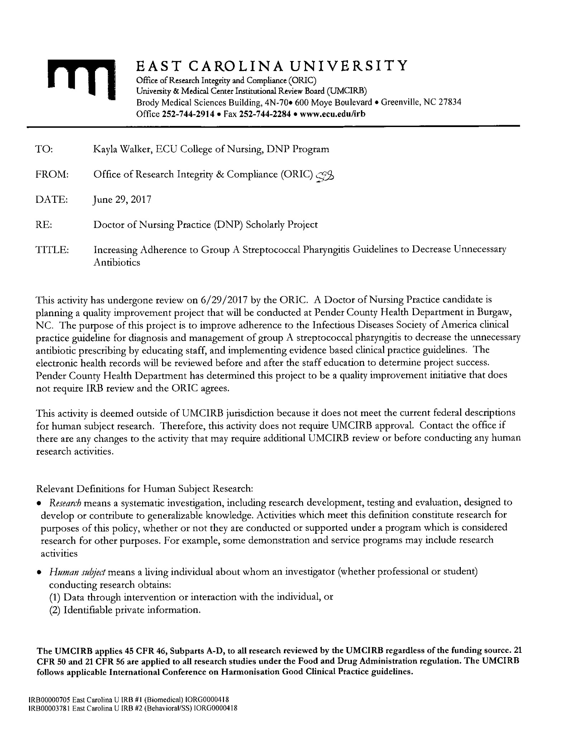
Appendix A
DNP Timeline
Scholarly Practicum I: Nursing 8269
February 2017
- Project proposal rough draft due

- Work on finding project site, and site champion.

- Research guidelines for framework of this project.

- Meet with librarian for assistance with searching/mesh words.
March 2017
- Establish project committee including site champion and site supporters.

- Obtain site approval or clarify contract between ECU and site.

- Complete DNP timeline

- Obtained Curriculum Vita from site champion.

- Complete CITI training.
April 2017
- First draft of final paper due.

- Final Formal Paper presenting the project idea, background information, literature review, and plans for implementation

- Submit Scholarly Practicum time log with 125 hours to reflect progress toward the DNP essentials

Scholarly Practicum II: Nursing 8272 – 125 project hours
May 2017
- Meet with Shirley Steele, DON to incorporate scoring system, and check list into EHR.

- IRB approval from Pender County Health Department

- Start retrospective chart review from November 2016-April 2017.
June 2017
- Create education materials,
- Obtain permission to use educational materials and any tools used in project.

July 2017
- Obtain IRB Approval from ECU

- Finalize budget and funding for project.

- Complete design of project, interventions, and evaluation measures.

- Submit Formal paper detailing project in its entirety.

- Submit the Scholarly Practicum time log of 125 hours.

Scholarly Practicum III: Nursing 8274 – 125 project hours
August 2017
- Ensure education materials, EHR , and staff are ready for implementation

- Educate staff on clinical practice guidelines, offer luncheon, and DON to make mandatory for all staff to attend.

- Ensure all education material is up and being presented.
September – October 2017
- Implementation of project
November 2017
- Promote completion of evaluation and prepare information to disseminate.

- Submit formal paper that includes the implementation, barriers/limitations, data analysis, and outcome results

- Submit Scholarly Practicum time log of 125 hours to blackboard.

Scholarly Practicum IV: Nursing 8277 – 125 project hours
January 2018
- Finish data/outcome evaluations
- Formal paper for committee review entire project including conclusions and recommendations for change.
February – April 2018
- Create poster presentation.

- Present project outcomes at Pender County Health Department

- Upload the final paper into ScholarShip repository

- Close appropriate IRB Approvals

- Final semester time log verifying completion of at least 125 hours toward project

Appendix B
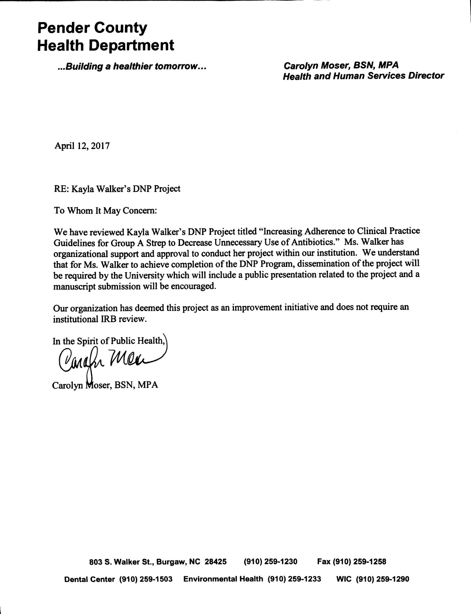
Project Site Approval
Appendix C
Provider Algorithm

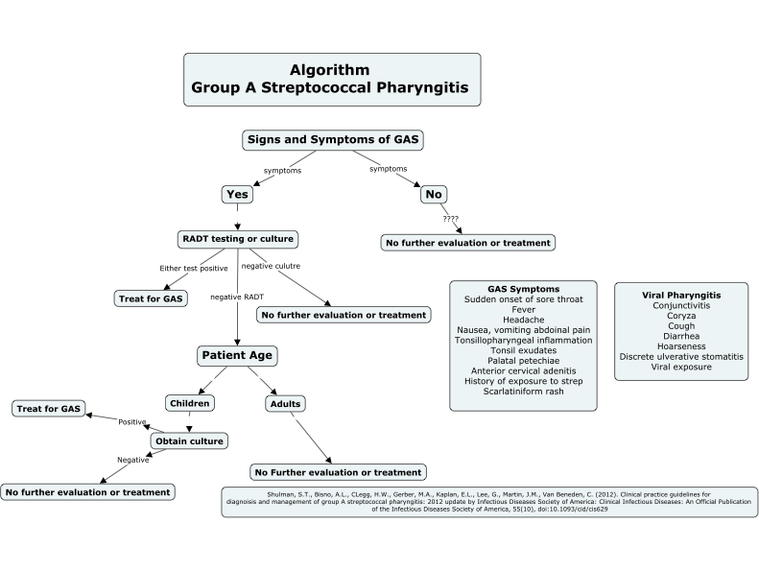

Appendix D
Pre-implementation Chart Analysis
Date 2016 | Patient | RADT Postive Y or N | RADT Negative Y or N | Abx Y or N | Correct Treatment | Treatment
12/12-12/19 | 1 | YES | NO | YES | YES | Amoxicillin
 | 2 | No | YES | YES | NO | Amoxicillin
12/26-1/9 | 1 | NO | YES | NO | YES (Culture) | NONE
 | 2 | NO | YES | YES | NO | Amoxicillin
 | 3 | NO | YES | YES | NO | Amoxicillin
1/9-1/23 | 1 | NO | YES | NO | YES | NONE
 | 2 | NO | YES | YES | NO | Amoxicillin
 | 3 | YES | NO | YES | YES | Amoxicillin
 | 4 | NO | YES | YES | NO | Script given not taken
 | 5 | YES | NO | YES | YES | Penicillin V
 | 6 | NO | YES | YES | NO | Amoxicillin
 | 7 | YES | NO | YES | YES | Penicillin V
 | 8 | NO | YES | NO | YES | NONE
1/23-2/6 | 1 | YES | NO | YES | YES | Amoxicillin
 | 2 | NO | YES | YES | NO | Amoxicillin
 | 3 | YES | NO | YES | YES | Amoxicillin
 | 4 | NO | YES (Culture Negative) | NO | YES | NONE
 | 5 | YES | NO | YES | YES | Penicillin V
 | 6 | NO | YES (Culture Negative) | NO | YES | NONE

Appendix E
Post-implementation Chart Analysis
Date | Patient | RADT Postive Y or N | RADT Negative Y or N | Abx Y or N | Correct Treatment | Treatment
9/11-9/15 | 1 | YES | NO | YES | YES | Amoxicillin
 | 2 | No | YES | NO | YES | NONE
9/18-9/22 | 1 | NO | YES | NO | YES (Culture) | NONE
 | 2 | NO | YES | NO | YES | NONE
 | 3 | NO | YES | NO | YES | NONE
9/25-10/2 | 1 | NO | YES | NO | YES | NONE
 | 2 | NO | YES | YES | NO | Amoxicillin
 | 3 | YES | NO | YES | YES | Amoxicillin
 | 4 | NO | YES | YES | NO | Script given not taken
 | 5 | YES | NO | YES | YES | Penicillin V
 | 6 | NO | YES | NO | YES | NONE
 | 7 | YES | NO | YES | YES | Penicillin V
 | 8 | NO | YES | NO | YES | NONE
10/2-10/16 | 1 | YES | NO | YES | YES | Amoxicillin
 | 2 | NO | YES | NO | YES | NONE
 | 3 | YES | NO | YES | YES | Amoxicillin
 | 4 | NO | YES (Culture Negative) | NO | YES | NONE
 | 5 | YES | NO | YES | YES | Penicillin V
 | 6 | NO | YES (Culture Negative) | NO | YES | NONE
 | 7 | NO | YES | NO | YES | NONE
 | 8 | NO | YES (Culture Negative) | NO | YES | NONE
 | 9 | YES | NO | YES | YES | Penicillin V
10/15-10/30 | 1 | NO | YES | NO | YES | NONE
 | 2 | NO | YES | NO | YES | NONE
 | 3 | YES | NO | YES | YES | Amoxicillin
 | 4 | NO | YES (Positive Culture) | YES | YES | Amoxicillin
 | 5 | NO | YES | NO | YES | NONE
 | 6 | NO | YES (Positive Culture) | YES | YES | Amoxicillin
 | 7 | NO | YES | NO | YES | NONE
10/30-11/3 | 1 | NO | YES | NO | YES | NONE

Appendix F

PowerPoint Education

Appendix G
PowerPoint Education

Appendix H
IRB Approval
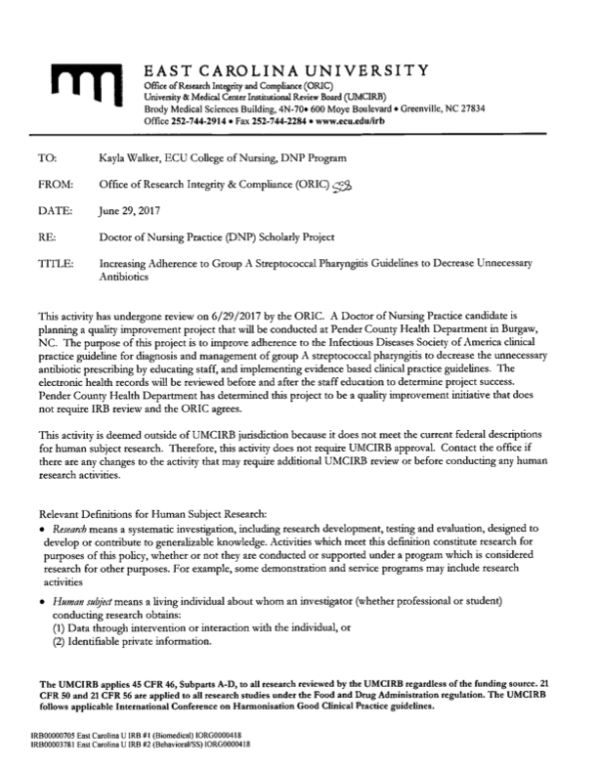

Appendix I
Literature Matrix

Levels of Evidence
Level 1 - Systematic review & meta-analysis of randomized controlled trials; clinical guidelines based on systematic reviews or meta-analyses
Level 2 - One or more randomized controlled trials
Level 3 - Controlled trial (no randomization)
Level 4 - Case-control or cohort study
Level 5 - Systematic review of descriptive & qualitative studies
Level 6 - Single descriptive or qualitative study
Level 7 - Expert opinion
Student:  Kayla Walker | Course:  NURS 8269 | Faculty Lead:  Dr. Ann Bell | Date:  3/2/16 | Project:  Improving provider adherence to clinical practice guidelines for group A strep in a local health department to decrease unnecessary use of antibiotics
Article (APA Citation) | Level of Evidence  (I to VII) | Data/Evidence  Findings | Conclusion | Use of Evidence in EBP Project Plan  (Include your evaluation, strengths/limitations, and relevance)
Lee, C.-R., Cho, I. H., Jeong, B. C., & Lee, S. H. (2013). Strategies to Minimize Antibiotic Resistance. International Journal of Environmental Research and Public Health, 10(9), 4274–4305. http://doi.org.jproxy.lib.ecu.edu/10.3390/ijerph10094274 | Level IV | Antibiotic use can increase the emergence of antibiotic resistant bacteria and reducing prescribing is one effective way to eliminate drug resistance. | To prevent overuse and misuse of antibiotics a formalized practical guideline for appropriate antibiotic prescribing should be developed and followed. | Follow clinical practice guidelines for prescribing antibiotics, and initiate antibiotic stewardship programs.
Shulman, S.T., Bisno, A.L., Clegg, H.W., Gerber, M.A., Kaplan, E.L., Lee, G., Martin, J.M., Van Beneden, C. (2012). Clinical practice guideline for the diagnosis and management of group A streptococcal pharyngitis: 2012 update by infectious diseases society of America. Clinical Infectious Diseases: An Official Publication of the Infectious Diseases Society of American, 55(10), doi:10.1093/cid/cis629. | Level I | Implementing clinical practice guidelines to help diagnose and manage group A strep pharyngitis. | Following guidelines will decrease the unnecessary use of antibiotics for group A strep pharyngitis. | Following these guidelines in a rural health department will minimize the use of antibiotics inappropriately. Currently no practice guidelines in place. Preliminary chart review revealed 40% of negative rapid strep tests were prescribed antibiotics.
Arnold, S. R., & Straus, S. E. (2005). Interventions to improve antibiotic prescribing practices in ambulatory care. The Cochrane Database of Systematic Reviews, (4), CD003539. | Level I | 39 studies examined the effects of printed educational material for physicians as well as educational opportunities to address the overuse of antibiotics for viral illnesses. | No single educational opportunity can be recommended for all behaviors when prescribing antibiotics. | During implementation of the evidence based project, educational opportunities will be offered to clinical staff at a local health department in hopes of decreasing prescribing for viral illnesses.
Kose, E., Sirin Kose, S., Akca, D., Yildiz, K., Elmas, C., Baris, M., & Anil, M. (2016). The effect of rapid antigen detection test on antibiotic prescription decision of clinicians and reducing antibiotic costs in children with acute pharyngitis. Journal of Tropical Pediatrics, 62(4), 308-315. doi:10.1093/tropej/fmw014 | Level IV | The study was used to investigate the effects of RADT testing for group A streptococcal pharyngitis. | A decrease in the amount of antibiotics used when utilizing RADT testing. | The health department will incorporate a tool in the EHR to allow providers to determine if RADT testing should be conducted.
Llor, C., Madurell, J., Balagué-Corbella, M., Gómez, M., & Cots, J. M. (2011). Impact on antibiotic prescription of rapid antigen detection testing in acute pharyngitis in adults: A randomised clinical trial. The British Journal of General Practice : The Journal of the Royal College of General Practitioners, 61(586), e244-251. doi:10.3399/bjgp11X572436 | Level II |  | Even with negative RADT testing physicians prescribed antibiotics 30% of the time. The use of RADT did decrease this amount. | Implementation of utilizing a scoring system for RADT and then education to staff about negative results and the reliability of the test.
Harris, A. M., Hicks, L. A., Qaseem, A. (2016). Appropriate antibiotic use for acute respiratory tract infection in adults: Advice for high-value care from the American college of Physicians and the centers for Disease Control and Prevention. Annals of Internal Medicine, 164(6), 425. doi:10.7326/M15-1840 | Level I | A literature review of antibiotic use for viral acute respiratory infections | Providers should test patients that are highly suspected of having group A strep, and should only prescribe antibiotics for positive results. | Decreasing the amount of antibiotics prescribed for viral pharyngitis by education.
Hersh, A. L., Jackson, M. A., Hicks, L. A., American Academy of Pediatrics Committee on Infectious Diseases, & the COMMITTEE ON INFECTIOUS DISEASES. (2013). Principles of judicious antibiotic prescribing for upper respiratory tract infections in pediatrics. Pediatrics, 132(6), 1146-1154. doi:10.1542/peds.2013-3260 | Level I | This article focuses on the appropriate prescribing for URIs. Offers principles for providers to follow. | These principles can be used to promote educational efforts for providers about guidelines about judicious antibiotic prescribing. | Utilizing this educational opportunity will help the staff and providers in a rural health department be more judicious about prescribing antibiotics.
Gerber, J. S., Prasad, P. A., Fiks, A. G., Localio, A. R., Grundmeier, R. W., Bell, L. M., . . . Zaoutis, T. E. (2013). Effect of an outpatient antimicrobial stewardship intervention on broad-spectrum antibiotic prescribing by primary care pediatricians: A randomized trial. Jama, 309(22), 2345-2352. doi:10.1001/jama.2013.6287 | Level II | Clinician education for antibiotic prescribing for viral illnesses. | Clinician education with audit feedback decreased the risk of inappropriate prescribing. | The implementation stage of the project will incorporate education and audit with feedback.
Weddle, G., Goldman, J., Myers, A., & Newland, J. (2017). Impact of an educational intervention to improve antibiotic prescribing for nurse practitioners in a pediatric urgent care center. Journal of Pediatric Health Care, 31(2), 184-188. doi:10.1016/j.pedhc.2016.07.005 | Level IV | To determine if educational opportunities improve the overall prescribing of antibiotics. | Education opportunities improved antibiotics prescribing. | Additional stewardship interventions are needed to continue the decrease in unnecessary prescribing of antibiotics.
Sarrell, E. M., & Giveon, S. M. (2012). Streptococcal pharyngitis: A prospective study of compliance and complications. ISRN Pediatrics, 2012, 1-8. doi:10.5402/2012/796389 | Level II
Fleming-Dutra, K. E., Hersh, A. L., Shapiro, D. J., Bartoces, M., Enns, E. A., File, T. M., . . . Hicks, L. A. (2016). Prevalence of inappropriate antibiotic prescriptions among US ambulatory care visits, 2010-2011. Jama, 315(17), 1864-1873. doi:10.1001/jama.2016.4151 | Level II | Upper respiratory infections are often prescribed antibiotics at the highest rate. | The need for an outpatient antibiotic stewardship program. | Helping a rural health department with prescribing of antibiotics for pharyngitis.
Camurdan, A. D., Camurdan, O. M., Ok, I., Sahin, F., Ilhan, M. N., & Beyazova, U. (2008). Diagnostic value of rapid antigen detection test for streptococcal pharyngitis in a pediatric population. International Journal of Pediatric Otorhinolaryngology, 72(8), 1203-1206. doi:10.1016/j.ijporl.2008.04.008 | Level IV | Highly sensitive RADT results allow proper medication. | With a high sensitivity, a provider can safely say yes or no to antibiotics. | Educating staff and providers about the sensitivity of results in hopes of reducing the amount of prescriptions for negative RADT.
Al-Hamad, A. M. (2015). Streptococcal throat. therapeutic options and macrolide resistance. Saudi Medical Journal, 36(9), 1128. | Level VII

