POLYPHARMACY AMONG OLDER ADULTS IN PRIMARY CARE
by
Marlene B. Whaley

Paper submitted in partial fulfillment of the
requirements for the degree of

Doctor of Nursing Practice

East Carolina University
College of Nursing

Date Finalized

Helene Reilly 11/19/18

Signature Faculty Coordinator Date

Acknowledgments
The author would like to acknowledge Dr. Helene Reilly and Dr. Carol Ann King for guiding and ensuring the successful completion of this Doctor of Nursing Practice project. The author would also like to acknowledge her husband, Matthew Whaley, for his never-ending support and encouragement.

Dedication
I would like to dedicate this manuscript to my grandfather, Seth Thomas Blizzard (“Snowball”). He has always believed in me and pushed me to never stop learning. He is my moral compass and confidant and has inspired my nursing career from the beginning.
Abstract
Polypharmacy among community-dwelling older adults was identified as a significant problem facing primary care providers. Medication reconciliation was identified as a necessary process to aptly identify polypharmacy. Screening Tool of Older Person’s potentially inappropriate Prescriptions (STOPP) and Screening Tool to Alert doctors to the Right Treatment (START) are evidence-based and assist primary care providers to identify potentially inappropriate prescribing (PIP) and potential prescribing omissions (PPO). A Doctor of Nursing Practice (DNP) quality improvement project was implemented in a primary care site. Clinical staff were educated on systematic medication reconciliation. Primary care providers were educated on the use of STOPP and START. Progress was evaluated using the Plan, Do, Study, Act (PDSA) Rapid Cycle of Improvement. Older adults comprised 25% of the patients seen by the providers during the data collection periods. After the education, results demonstrated there was a slight decrease in the number of charts with a comprehensive medication reconciliation performed; however, the percentage of patients experiencing polypharmacy, PIP, and PPO decreased. In conclusion, STOPP and START criteria are evidence-based, easy to use, and effective for improving prescribing quality and decreasing health care costs when used with older adults in primary care. STOPP and START criteria were recommended to be made available and referenced by all primary care providers within the larger health center. Future quality improvement initiatives should focus on implementing additional strategies to ensure that a comprehensive medication review is completed at every older adult patient encounter.
Keywords: quality improvement; polypharmacy; older adult; medication adherence; adverse drug reaction; inappropriate prescribing; potential prescribing omission

Table of Contents
Acknowledgments 2
Dedication 3
Abstract 4
Chapter I: Overview of the Problem of Interest 10
Background Information 10
Figure 1 Percentage of Prescription Drug Use by Age in the United States,
2007-2010 11
Significance of Clinical Problem (Needs Assessment) 12
Questions Guiding Inquiry (PICO) 13
Population 13
Intervention 13
Comparison 13
Outcome(s) 13
Summary 13
Chapter II: Review of the Literature Evidence 14
Literature Appraisal Methodology 14
Sampling strategies 14
Figure 2 Flow Diagram of Study Selection 15
Evaluation criteria 16
Literature Review Findings 16
Polypharmacy association with ADRs 16
Medication reconciliation 16
STOPP and START criteria 16
Other methods 17
Limitations of Literature Review Process 18
Discussion 18
Conclusion of findings 18
Advantages and disadvantages of findings 18
Utilization of findings in practice change 18
Summary 19
Chapter III: Theory and Concept Model for Evidence-based Practice 20
Concept Analysis 20
Theoretical Framework 21
Figure 3 Lewin’s (1951) Change Model 22
Evidence-Based Practice Change Theory 22
Figure 4 PDSA Model 23
Triple Aim Outcomes 23
Summary 24
Chapter IV: Pre-implementation Planning 25
Project Purpose 25
Project Management 25
Organizational readiness for change 25
Inter-professional collaboration 25
Risk management assessment 26
Organizational approval process 27
Information technology 27
Cost Analysis of Materials Needed for Project 27
Table 1 DNP Project Budget 27
Plans for Institutional Review Board Approval 28
Plan for Project Evaluation 28
Demographics 28
Outcome measurement 28
Instruments 28
Evaluation tool 29
Data analysis 29
Data management 29
Summary 29
Chapter V: Implementation Process 30
Setting 30
Participants 30
Implementation Process 30
Figure 5 DNP Project Design using PDSA Model & Lewin’s Change Theory
of Nursing. 31
Plan Variation 31
Summary 32
Chapter VI: Evaluation of the Practice Change Initiative 33
Participant Demographics 33
Figure 6 Project Participant Demographics 34
Intended Outcome(s) 34
Findings 34
Table 2 Medication Reconciliation Performed per Facility Protocol 35
Figure 7 Pre- and Post-Implementation Results 35
Summary 36
Chapter VII: Implications for Nursing Practice 37
Practice Implications 37
Essential I: Scientific underpinnings for practice 37
Essential II: Organization and systems leadership for quality
improvement and systems thinking 37
Essential III: Clinical scholarship and analytical methods for
evidence-based practice 37
Essential IV: Information systems/technology and patient care
technology for the improvement and transformation of healthcare 38
Essential V: Healthcare policy for advocacy in healthcare 38
Essential VI: Interprofessional collaboration for improving patient
and population health outcomes 38
Essential VII: Clinical prevention and population health for
improving the nation’s health 38
Essential VIII: Advanced nursing practice 39
Summary 39
Chapter VIII: Final Conclusions 40
Significance of Findings 40
Project Strengths 40
Project Limitations 41
Project Benefits 41
Improved outcomes 41
Efficiencies 41
Financial implications 42
Practice Recommendations 42
Final Summary 42
References 44
Appendix A: Literature Review Matrix 49
Table A1 Literature Review Matrix 49
Table A2 Levels of Evidence 59
Appendix B: Letters of Support 60
Appendix C: Institutional Review Board (IRB) Approval 64
Appendix D: Tools 65
Appendix E: STOPP and START Guidelines 69
Appendix F: Timeline 77

Polypharmacy among Older Adults in Primary Care
Chapter I: Overview of the Problem of Interest
The goal of the Doctor of Nursing Practice (DNP) quality improvement project was to address a known clinical problem through evidence-based solutions. The purpose of this chapter was to provide the reader with an overview of polypharmacy among older adults in primary care.
Background Information
Polypharmacy was most often defined, by authors in the current literature, as one person taking five or more daily medications (Anderson, Foster, Freeman, Luetsch, & Scott, 2017; Brown, 2016; Martial, Mantel-Teeuwisse, & Jansen, 2013; Projovic et al., 2016; Reeve, Low, & Hilmer, 2016). Older adults, or patients aged 65 years or greater, consumed more medications than any other age group as shown in Figure 1 (CDC/NCHS, 2014). Polypharmacy was shown to be the most consistent and strongest predictor of adverse drug reactions (ADRs) among community-dwelling older adults (Brown, 2016; Hill-Taylor et al., 2013; Marcum et al., 2012; Pedros, Formiga, Corbella, & Arnau, 2016; Projovic et al., 2016). In the United States, from 2007-2009, ADRs were responsible for approximately 100,000 emergency hospitalizations of older adults (Budnitz, Lovegrove, Shehab, & Richards, 2011). Older adults were more susceptible to ADRs due to many population-specific factors, including age-related changes in pharmacokinetics and pharmacodynamics and the presence of multiple comorbidities.

Figure 1. Percentage of prescription drug use by age in the United States, 2007-2010. Adapted from Health, United States, 2013: With Special Feature on Prescription Drugs, by CDC/NCHS, 2014, U.S. DHHS, p. 21.
Authors in the current literature posited that polypharmacy was often associated with potentially inappropriate prescribing (PIP) and potential prescribing omissions (PPO). PIP occurred when the risks associated with prescribing a medication outweighed the potential benefits. PPO occurred when a patient did not receive a medication indicated for the treatment or prevention of a disease (Brown, 2016; Gallagher et al., 2011; Hill-Taylor et al, 2013; Hudhra et al., 2016; Tommelein et al., 2015).
Several tools were established to identify PIP and PPO in the clinical setting, including the Beers’ Criteria, Improved Prescribing in the Elderly Tool (IPET), Prescribing Appropriateness Index (PAI), Zhan’s Criteria, French Consensus Panel List, Screening Tool of Older Person’s potentially inappropriate Prescriptions (STOPP) and Screening Tool to Alert doctors to the Right Treatment (START), Australian Prescribing Indicators Tool, and Norwegian General Practice (NORGEP) Criteria. There were pros and cons for each tool (Elliott & Stehlik, 2013; O’Connor, Gallagher, & O’Mahony, 2012).
Significance of Clinical Problem (Needs Assessment)
A preliminary interview with the Medical Director at a Federally Qualified Migrant Health Center, in a rural, underserved area, revealed that medication reconciliation scores were down at several clinic sites. The goal of medication reconciliation or review was to make the most accurate medication list possible for the patient. Medication reconciliation was a necessary step to identify patients suffering from polypharmacy and to avoid medication errors, omissions, duplications, dosing errors, and drug interactions (Coletti et al., 2015; Heyworth et al., 2013; Molokhia & Majeed, 2017). According to the audit reports obtained from the electronic health record (EHR) to comply with Medicare Meaningful Use criteria, medication reconciliation was done 77% of the time by all providers across the health center.
Initial informal interviews with four providers at four different clinics at the health center indicated that polypharmacy was a significant problem among older adult patients. One provider reported that almost all his older adult population are on five or more medications (C. Pate, personal communication, September 11, 2017). Another provider reported that she often finds older adults are placed on new medications to treat ADRs from old medications and it creates a vicious cycle (K. Sandlin, personal communication, September 8, 2017). All four providers indicated that they were willing to use a validated and reliable tool to augment their prescribing practices with older adults (C. Pate, L. Lafata, K. Sandlin, & D. Lamb, personal communication, September 11, 2017).
According to audit reports, from January 1, 2016 to September 1, 2017, 15.6% of the patients at the health center were age 65 years or older. As a practicing primary care provider at the same health center, the author reviewed 100 personal patient charts over a two-week period to promote quality assurance and provide further evidence of need for this project at this health center. Only older adult patient charts were reviewed and 80% met the definition of polypharmacy, 58% were on at least one medication that was potentially inappropriate according to STOPP guidelines, and 46% had a PPO according to START guidelines.
Question Guiding Inquiry (PICO)
In community-dwelling older adults, how effective are STOPP and START versus provider clinical judgment alone at identifying and decreasing the incidence of polypharmacy, PIP, and PPO?
Population. Community dwelling older adults, aged 65 years or greater.
Intervention. The intervention was education of providers on the use of STOPP and START.
Comparison. The frequency of polypharmacy, PIP, and PPO with older adult patients was compared before, using clinical judgment alone, and after the education was received.
Outcome(s). The outcomes of interest were if the frequency of polypharmacy, PIP, and PPO with older adult patients decreased or not after the education was received.
Summary
Authors in the current literature and data from the health center suggested that polypharmacy was a significant problem among community-dwelling older adults both nationally and locally. Evidence-based interventions known to address this problem were desperately needed at the health center. Therefore, after the clinical problem was defined evidence needed to be appraised to ascertain an appropriate solution.

Chapter II: Review of the Literature Evidence
Systematic appraisal of the current literature was necessary to identify evidence-based solutions to the issue of polypharmacy among older adults. Appraisal of the literature required well-crafted sampling strategies and evaluation criteria. The limitations of the literature review process were considered when reviewing the findings and drawing conclusions.
Literature Appraisal Methodology
A systematic literature review of the Cumulative Index to Nursing and Allied Health Literature (CINAHL) database was conducted to identify the information currently available on polypharmacy in the older adult population and interventions currently in use to address this issue in the primary care setting.
Sampling strategies. Keywords explored included: polypharmacy combined with aged, elderly, older adult, or geriatric. Articles were only reviewed if they were published between August 1, 2007 and January 15, 2018 and if the articles were written in English. Based on initial review of abstracts and application of inclusion and exclusion criteria, only 13 articles were kept. Three additional articles were identified through review of references. Subsequently, the keywords STOPP and START was searched with the same search criteria for English language and dates of publication. This search resulted in 73 articles and based on review of abstracts and inclusion and exclusion criteria, only five articles were kept. The flow diagram in Figure 2 offers more detail regarding study selection.

Figure 2. Flow Diagram of Study Selection.
Evaluation criteria. Studies that met exclusion and inclusion criteria were evaluated for results or data findings and the authors’ conclusions. The relevance of the evidence to the DNP Project was then determined. Appendix A includes a Literature Review Matrix of articles kept with levels of evidence identified.
Literature Review Findings
Polypharmacy association with ADRs. Polypharmacy among community-dwelling older adults was strongly associated with ADRs. ADRs are frequently preventable and frequently result in a financial strain on health systems through an increase in hospital admissions and associated morbidity (Brown, 2016; Budnitz et al., 2011; Hill-Taylor et al., 2013; Kim & Parish, 2017; Marcum et al., 2012; Molokhia & Majeed, 2017; O’Connor, et al., 2012; Pedros et al., 2016; Projovic et al., 2016).
Medication reconciliation. To identify polypharmacy, the importance of medication reconciliation cannot be overstated. This process can be undertaken by the provider or delegated to clinical staff. A reconciled medication list can assist the provider to identify patients suffering from polypharmacy and avoid medication errors (Coletti et al., 2015; Heyworth et al., 2013; Molokhia & Majeed, 2017; Uhl, Muth, Gerlach, Schoch, & Muller, 2018).
STOPP and START criteria. The STOPP and START criteria are evidence-based and have been used to review the medication profiles of community-dwelling older patients in Europe, Asia, and North America according to a systematic review conducted by Hill-Taylor et al. (2013). STOPP consists of 80 criteria that help healthcare personnel systematically identify PIP and START consists of 34 criteria that identify PPO (O’Mahony et al., 2015). The STOPP and START criteria appeared to be more sensitive than the Beers criteria (Bahat et al., 2017; Elliott & Stehlik, 2013; Hill-Taylor et al, 2013). Unlike the Beers criteria, the STOPP and START criteria were drafted to be able to be used as a checklist, which makes use of the STOPP and START criteria uniquely quick (Kim & Parish, 2017). Authors in the current literature found the tool was effective in improving prescribing quality, clinical, humanistic, and economic outcomes (Kim & Parish, 2017; Hill-Taylor et al., 2016; Manias, Kusljic, & Lam, 2015).
Primary care providers have been found to be the main driver for de-prescribing because of their large influence on patient decisions about their health care (Reeve et al., 2016). According to a systematic review conducted by Hill-Taylor et al. (2016), both STOPP and START have been validated and show good inter-rater reliability with both pharmacists and physicians. A systematic review also concluded that more study is needed using STOPP and START in interventions to detect PIP in community-dwelling older adults prior to entrance into acute care facilities or emergency departments (O’Mahony et al., 2015).
Other methods. While the literature offered great support for tools, like STOPP and START, researchers also cautioned the provider not to rely solely on these tools when prescribing. There were several methods that prescribers can utilize in practice to optimize the use of medications in addition to a prescribing tool. EHRs were essential to monitor prescribing practices and regularly review patients’ medication regimens. In addition, interprofessional collaboration was essential, such as the use of expert pharmacist review (Anderson et al., 2017; Brown, 2016; Molokhia & Majeed, 2017; O’Connor et al., 2012; Tommelein et al., 2015; Verdoorn, Kwint, Faber, Gussekloo, & Bouvy, 2015). One study also found that decreasing provider exposure to drug promotional material (e.g., time with drug representatives) decreased the incidence of polypharmacy and PIP (Projovic et al., 2016).

Limitations of Literature Review Process
Only one database was searched for information which means some relevant literature may have been missed. Only one reviewer was involved in the process which increases risk of bias. Older, but potentially relevant articles and articles in other languages were not searched.
Discussion
Conclusion of findings. Polypharmacy comes with a bad connotation because it is closely linked with adverse drug reactions, particularly among older adults. A comprehensive medication reconciliation was necessary to identify polypharmacy and clinical staff should be trained in this process. STOPP and START guidelines were an evidence-based clinical tool that can be utilized to identify polypharmacy that is associated with PIP and PPO but should not be used in isolation of other proven effective strategies. Primary care providers were in an excellent position to use tools like STOPP and START to deprescribe with their patients.
Advantages and disadvantages of findings. An advantage of findings was that authors in the current literature agreed that STOPP and START was an effective and easy to use clinical tool in the primary care setting. A disadvantage of findings was that if a systematic medication review process is not undertaken first, then polypharmacy, PIP, and PPO cannot be accurately identified by any tool. Another disadvantage was that expert pharmacist review in collaboration with the primary care provider was considered one of the most effective strategies to decrease polypharmacy but is a costly enterprise as it involves hiring a clinical pharmacist.
Utilization of findings in practice change. Training clinical staff on the importance and process of a comprehensive medication reconciliation assisted the provider to readily identify polypharmacy. Discussion regarding expert pharmacist review with the Medical Director at the project site revealed that this was once a resource offered to primary care providers at the health center but was not financially sustainable and the clinical pharmacist was lost in a budget cut. Therefore, utilization of the STOPP and START criteria in a primary care practice was projected to be a financially feasible option to provide primary care providers with an evidence-based guideline to improve patient outcomes, decrease practice costs, and add to the clinical data available on the use of the tool.
Summary
Sampling strategies and evaluation criteria were detailed. Literature review findings were discussed along with limitations of the literature review process. Author conclusions, advantages and disadvantages of the literature review findings, and a discussion on how to translate the proposed intervention into the targeted practice environment were presented. After ascertaining an appropriate solution, a theoretical framework and concept analysis was needed to guide project implementation.

Chapter III: Theory and Concept Model for Evidence-based Practice
Theory and research must always undergird practice. An analysis of all the relevant concepts and Kurt Lewin’s Change Theory of Nursing were explored and related to the practice change. The evidence-based practice change model followed to implement this quality improvement project was also studied.
Concept Analysis
Many researchers and clinicians examining polypharmacy posited that polypharmacy should not be defined as a certain number of drugs or medications prescribed to the patient; rather, the definition should be expanded or changed to the prescribing of any unnecessary drug or maintaining a drug on an active medication list that is no longer needed or appropriate (Hudhra et al., 2015; Molokhia & Majeed, 2017). Therefore, the terms PIP and PPO were often explored as contributing to and occurring simultaneously with polypharmacy. However, the risk factor most strongly associated with high-risk prescribing in the literature was the number of drugs prescribed. Molokhia and Majeed (2017) found that “patients on more than 10 medications were at a nearly three-fold increase in high-risk prescribing compared with those receiving only one or two medications” (p. 3). Therefore, the definition of polypharmacy agreed upon by most authors in the current literature was the prescribing of five or more daily medications for one patient (Anderson et al., 2017; Brown, 2016; Kim & Parish, 2017; Projovic et al., 2016; Reeve et al., 2016).
ADRs were any response to a drug which was unintended. ADRs include drug-drug interactions, medication side effects, allergic reactions, and unintentional overdoses. Other effects included adverse effects due to medication-delivery methods and vaccine reactions. ADRs were a direct result of clinical care. (Brown, 2016; Budnitz et al., 2011; Hill-Taylor et al., 2013; Kim & Parish, 2017; Marcum et al., 2012; Molokhia & Majeed, 2017; O’Connor et al., 2012; Pedros et al., 2016; Projovic et al., 2016).
Older adults were consistently defined in the literature as those aged 65 years and older. This term was used interchangeably with elderly and aged (Brown, 2016; Budnitz et al., 2011; Elliott & Stehlik, 2013; Gallagher, et al., 2011; Hill-Taylor et al., 2013; Marcum et al., 2012; Molokhia & Majeed, 2017; O’Connor et al., 2012; O'Mahony, et al., 2015; Pedros et al., 2016; Projovic et al., 2016; Reeve et al., 2016; Tommelein, et al., 2015).
Adherence or compliance was defined as the degree to which a patient follows a provider’s healthcare advice. Authors in the current literature often used these concepts to refer specifically to medication adherence. Nonadherence to medications was a common complication of polypharmacy. Reasons for nonadherence were numerous, including; financial burden, side effects, regimen complexity, and lack of understanding of the importance of medication. Performing a comprehensive medication reconciliation was a systematic way to assess patient medication adherence and discuss reasons for nonadherence at the same time (Brown, 2016).
Theoretical Framework
Kurt Lewin’s Change Theory of Nursing guided and supported this DNP project. Lewin identified three stages through which change agents must proceed before change becomes part of a system (Figure 3). In stage one, unfreezing occurred. Providers were encouraged to move away from the standard practice of prescribing only based on clinical judgement. In stage two, moving, implementation of the STOPP and START guidelines into practice occurred. Finally, in stage three, refreezing occurred. This is when the STOPP and START guidelines became the new standard of practice (Mitchell, 2013).

Figure 3. Lewin’s (1951) Change Model. Adapted from “Selecting the Best Theory to Implement Planned Change” by G. Mitchell, 2013, Nursing Management, 20(1) p. 33.
Evidence-based Practice Change Theory
The Plan, Do, Study, Act (PDSA) Model also guided implementation of this quality improvement project. In healthcare settings, new ideas were often introduced on a large scale without sufficient testing, which can have a negative impact on the organization (Byrne, Xu, & Carr, 2015; HRSA, 2011). The PDSA Model in Figure 4 was one of the most common tools used to test quality improvement ideas prior to full implementation. The model was a systematic step-by-step approach that encourages learning, reflection, and validation throughout implementation of a quality improvement project. The four stages of the PDSA Model were:
- Plan – the problem (polypharmacy) was identified, the change to be implemented was defined (use of the STOPP and START guideline to augment the providers clinical judgment in prescribing), and goals were established (educate clinical staff on medication reconciliation and decrease the incidence of polypharmacy in the older adult population at the health center through the provision of an evidence-based tool)
- Do – the change was implemented
- Study – outcomes were critically appraised and a reflection on what was learned was undertaken
- Act – the next change cycle was planned incorporating modifications based on the data (Byrne et al., 2015; HRSA, 2011; HWTAC, 2015; Stikes & Barbier, 2013)
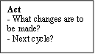


Study
- Complete analysis
- Compare to prediction
- Summarize learnings
Do
- Carry out the plan
- Document the problems, unexpected findings
- Begin data analysis
Plan
- Objectives
- Question and predictions
- Plan to carry out the cycle

Figure 4. PDSA Model. Adapted from Testing for Improvement, by HRSA, 2011, U.S. DHHS, p. 5.
Triple Aim Outcomes
The Institute for Healthcare Improvement developed a framework that described an approach to optimize health system performance. The framework was called the “Triple Aim” and focused on the following three dimensions: improving the patient experience of care (including quality and satisfaction); improving the health of populations; and reducing the per capita cost of health care (IHI, 2017). This DNP Project addressed all three dimensions. Reducing polypharmacy among older adults improved the quality of patient care and the health of the older adult population. A reduction in polypharmacy also decreased ADRs; thereby, easing the burden on healthcare costs.
Summary
The concepts of polypharmacy, ADRs, older adults, and adherence were defined and analyzed. Lewin’s Change Theory of Nursing and the PDSA Model provided a framework for implementing this DNP project in practice. This DNP project also met Triple Aim objectives. After a theoretical basis for the DNP project was established, pre-implementation planning could begin.

Chapter IV: Pre-implementation Planning
A comprehensive plan for DNP project implementation was necessary to obtain an Institutional Review Board (IRB) waiver. Planning also ensured needed materials and costs of implementation were acknowledged. A detailed plan also provided a clear purpose for the project and evaluation criteria to ensure outcomes were met.
Project Purpose
The purpose of this DNP project was to decrease the incidence of polypharmacy among older adults through identification of PIP and PPO by utilizing the STOPP and START guidelines in a primary care clinic that is part of a larger federally qualified migrant health care center.
Project Management
Organizational readiness for change. Email communication with the two participating primary care providers revealed they were receptive to using an evidence-based tool in their practice proven to improve the quality of care provided to their patients. Providers who chose not to participate were primarily concerned that the project implementation would take up too much of their time.
Inter-professional collaboration. The Medical Director at the health center agreed to be the lead project community member. He was the contact person for questions about the health center and gave approval for project implementation. The two participating primary care providers were an Adult-Geriatric Nursing Practitioner and a Family Nurse Practitioner at the project site. The providers agreed to implement the STOPP and START criteria with their panel of patients.
Risk management assessment. The strengths of the project included that the author was a primary care provider at the project site; therefore, familiar with the layout of the health center, an expert in navigating the electronic health record, and knowledgeable about the needs of the organization and its constituents. The organization’s providers were open to quality assurance measures and quality improvement initiatives. The project was evidence-based and cost-effective. While implementation took place on a small scale at one clinic, the project has the potential for a much larger impact if it is expanded throughout the health center in the future.
A weakness of the project was the time limitation. The DNP project was implemented in an eight-week time frame, but through PDSA cycles every two weeks, the author ensured that the project met objectives.
An opportunity existed because a new iCloud EHR system was being created in the health center at the time of project implementation. If the project demonstrated improved outcomes for patients and positive feedback was received on the ease of use of the tool from the providers, then the STOPP and START criteria could be implemented into the new EHR system. This would function much like a medication interaction “pop-up,” which most new EHR vendors provided.
Threats to implementation included technology failure. If the EHR were to go down during the period of project implementation this would significantly impact the effectiveness of STOPP and START guidelines and ability of clinical staff to perform a comprehensive medication reconciliation. Provider illness was also a concern. There would be significantly less data to review if one of the participating providers were to be out of work for a significant amount of time.
Organizational approval process. The author, a practicing primary care provider at the health center, met with the Medical Director and Chief Executive Officer to discuss the project purpose and logistics. There was interest and a need for the project idea in the health center (see Appendix B for project site letter of support).
Information technology. The project required use of the organization’s EHR. The EHR was where the clinical staff documented the medication reconciliation. The providers documented any medication regimen adjustments made based on STOPP and START guidelines or the clinical rationale for deviating from the guidelines. All pertinent data for project evaluation was obtained by the author from the EHR.
Additional use of technology included development of a PowerPoint presentation to present the education on medication reconciliation to the clinical staff. Email communication between project participants took place throughout all phases of the project.
Cost Analysis of Materials Needed for Project
Even if the STOPP and START guidelines were not implemented into the EHR, then using the paper tool is an inexpensive option as demonstrated in the project budget in Table 1.
Table 1
DNP Project Budget
Line Item | Unit Cost | Quantity | Total
Supplies
Paper | $0.03 | 16 | $0.48
Ink cartridge | $30.00 | 1 | $30.00
Staples | $3.00 | 1 | $3.00
Total |  |  | $33.48
Plans for IRB Approval
The author expected this quality improvement project to be exempt from IRB review. A quality activities worksheet was completed by the author and submitted to the Office of Research Integrity and Review at East Carolina University (ECU). An IRB waiver was obtained for this project from ECU on March 19, 2018 (see Appendix C).
Plan for Project Evaluation
Demographics. The only demographic data to be collected were the patients’ age and gender (see DNP Project Data Collection Tool in Appendix D). To protect the anonymity of patients age 90 and above, age was reported in aggregate form only. Patients were assigned to one of two mutually exclusive categories, those 65 years old or greater and those less than 65 years old. This data is presented in Figure 6.
Outcome measurement. Pre- and post-implementation chart audits were conducted with selection criteria to include patients age 65 years or older seen in the clinic by the two participating providers. The goal was to include all older adult patients seen by the two providers in the eight-week implementation period. From January 1, 2016 to January 1, 2017 15.6% of the patients at the health center were age 65 years or older. The two providers average seeing 20 patients per work day. This would be a total of approximately 800 patients seen in the eight-week project implementation period; 15.6% of 800 total patients would be 125 older adult patients. Therefore, the DNP student anticipated reviewing 125 charts from May through July 2017 and 125 charts from May through July 2018.
Instruments. According to O’Mahony et al. (2015), STOPP and START criteria hold a non-commercial license (see Appendix E). STOPP and START were the only explicit criteria for which reliability have been assessed and they appeared to have good usability (Elliott & Stehlik, 2013).
Evaluation tool. A DNP project data collection tool, presented in Appendix D, was created and used by the author to collect needed data from the EHR and the participating providers.
Data analysis. Chart reviews were conducted to determine, pre- and post-project implementation, the percentage of charts with a comprehensive medication reconciliation performed per facility protocol, the number of patients experiencing polypharmacy and the number experiencing PIP or PPO according to STOPP and START guidelines.
Data management. Data was obtained from a password protected EHR located in the healthcare facility. Data was collected by the author and only de-identified information was transcribed. Data was maintained by the author on personal, password-protected, laptop and flash drive for seven months. Data files were deleted from laptop and flash drive upon completion of the DNP program. Following the evaluation of the chart audits, a poster presentation was developed to disseminate findings at the project site and offer recommendations for future improvement. The poster presentation was also presented to the faculty at ECU College of Nursing.
Summary
The proposed DNP project implementation was projected to occur over an eight-week period. The beginning planning stages occurred in DNP I, continued through acquiring IRB approval in DNP II, implementation in DNP III, and lastly evaluation and dissemination in DNP IV (see Appendix F). After planning was complete and IRB and faculty approval was obtained the implementation process began.
Chapter V: Implementation Process
The following chapter details the actual DNP project implementation process. A description of the project’s setting and project participants was provided. Then variation from the plan was explained.
Setting
This project was concerned with community-dwelling older adults in the primary care setting. A federally-qualified, migrant health center in rural North Carolina was chosen for project implementation. The specific project site was one primary care clinic within the health center.
Participants
Inclusion criteria were being a participating provider or clinical staff, which included two Nurse Practitioners, four Licensed Practical Nurses (LPNs) and two Certified Nursing Assistants (CNAs). Exclusion criteria were any clinical staff the DNP student had managerial authority over, which included one CNA.
Inclusion criteria for the pre-implementation and post-implementation chart reviews were that the patients be age 65 years or older and be evaluated by one of the two participating providers between May 29, 2017 and July 24, 2017 and May 28, 2018 and July 23, 2018.
Implementation Process
A PowerPoint presentation for clinical staff on the importance and process of medication reconciliation was presented at a monthly staff meeting (see Appendix D). The two providers were trained one on one in the use of the STOPP and START tools with older adults. The providers were encouraged to either change the prescribing plan in accordance with STOPP and START guidelines or document why change was not appropriate for the patient or situation. Progress was evaluated every two weeks using the PDSA rapid cycle of improvement. See Figure 5 for a visual representation of project design.
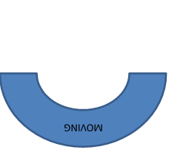
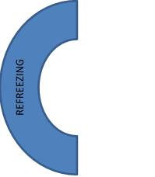
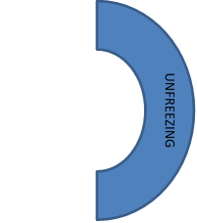

Figure 5. DNP Project Design using PDSA Model & Lewin’s Change Theory of Nursing.
Plan Variation
Unfortunately, one of the participating providers in the DNP project was diagnosed with cancer and had to undergo radiation treatment during the implementation period. This reduced the total number of patients seen by the provider in the eight-week implementation period; subsequently, there were fewer older adult patients seen than originally expected. Fortunately, the provider did not require a leave of absence and still agreed to project participation.

Summary
The primary care practice setting was described along with project participant characteristics. The implementation process was detailed along with plan variations encountered. Project outcomes were continuously evaluated throughout the implementation process through PDSA cycles and then a summative evaluation was also completed.
Chapter VI: Evaluation of the Practice Change Initiative
Evaluation is an important and necessary part of any practice change initiative. Multiple PDSA cycles were completed throughout project implementation to ensure project participants were comfortable with the process of medication reconciliation and use of the STOPP and START tool to aid clinical decision making. After completion of project implementation, a summative evaluation of project data obtained from pre- and post-implementation chart audits was completed.
Participant Demographics
There were two primary care providers who were trained on and utilized the STOPP and START guidelines with their older adult patients during the project implementation period. They were an Adult-Geriatric Nurse Practitioner (A-GNP) with three years of experience in the current professional role and a Family Nurse Practitioner (FNP) with 13 years of experience in the current professional role. Clinical staff who were educated on the importance and process of medication reconciliation included four LPNs and two CNAs.
Pre- and post-implementation chart audits demonstrate similar participant demographics. As demonstrated in Figure 6 approximately 25% of the patients seen by the participating providers during the data collection periods were older adults. There were twice as many older adult females as there were older adult males.

Figure 6. Project Participant Demographics
Intended Outcome(s)
The DNP student anticipated that, after the quality improvement initiative was implemented, the percentage of charts with a comprehensive medication reconciliation performed per facility protocol would increase. The DNP student also anticipated that the number of patients experiencing polypharmacy and the number experiencing PIP or PPO according to STOPP and START guidelines would decrease.
Findings
Data was extracted from the project site’s EHR from May 29, 2017 through July 24, 2017, before project implementation, and from May 28, 2018 through July 23, 2018, after project implementation. The data from the two eight-week data collection periods were compared and there was a slight decrease in the number of charts with a comprehensive medication reconciliation performed per facility protocol (see Table 2). As anticipated, the percentage of patients experiencing polypharmacy, PIP, and PPO decreased as shown in the graphic presentation of findings in Figure 7.

Table 2
Medication Reconciliation Performed per Facility Protocol
 | 2017 | 2018
Patients >/=65 years | 220 | 190
Appropriate Medication Reconciliation | 214 | 181
% | 97 | 95

Figure 7. Pre- and Post-Implementation Results. Implementation involved use of STOPP and START guidelines in clinical decision-making by primary care providers. Total number of older adult patient charts reviewed with appropriate medication reconciliation performed: 214 from 2017 and 181 from 2018. PIP = potentially inappropriate prescription; PPO = potential prescribing omission.
The three-question, post-implementation survey (see Appendix D) given to the two participating providers demonstrated that new and seasoned nurse practitioners are experienced using guidelines to augment their clinical judgement when prescribing medications for older adult patients. The two participating providers indicated they were “likely” or “very likely” to continue to utilize STOPP and START guidelines to augment clinical judgment when prescribing medications for older adult patients after project participation.
Summary
Demographic information for DNP project participants were presented. Intended outcomes were described followed by project findings. In the next chapter, project implications for nursing practice are explored.
Chapter VII: Implications for Nursing Practice
The eight DNP Essentials established by the American Association of Colleges of Nursing “are the foundational outcome competencies deemed essential for all graduates of a DNP program regardless of specialty or functional focus” (AACN, 2006, p. 8). The following chapter will outline how the DNP project met these essentials.
Practice Implications
Essential I: Scientific underpinnings for practice. The DNP student conducted a quality, systematic literature review to provide the background and significance of the clinical problem of interest. The evidence obtained from the literature review guided development of a quality improvement initiative to bridge from research to practice. Kurt Lewin’s Change Theory of Nursing provided the theoretical basis for the project and the relevant concepts were explored by the DNP student as part of the literature review. The PDSA Model was the evidence-based practice change model the DNP student utilized to implement the project and evaluate outcomes.
Essential II: Organizational and systems leadership for quality improvement and systems thinking. The DNP project was established to meet the needs of older adults in primary care. Principles of business, finance, economics, and health policy were used to develop and implement a DNP project that improved the quality of care delivered to older adults at the project site. The goal for continuation of the project was to implement the quality improvement initiative at all primary care sites within the larger health center. The DNP student created a budget for the project and performed a cost-benefit analysis. The DNP student also completed the process to obtain an ECU IRB waiver for the quality improvement project.
Essential III: Clinical scholarship and analytical methods for evidence-based practice. The DNP project met the Institute for Healthcare Improvement’s Triple Aim outcomes. The DNP project promoted safe, timely, effective, efficient, equitable, and patient-centered care. Information technology and research methods were used appropriately to analyze data from practice, design an evidence-based project, and predict and analyze outcomes. The DNP student disseminated findings from evidence-based practice and research to improve healthcare outcomes.
Essential IV: Information systems/technology and patient care technology for the improvement and transformation of healthcare. The DNP student analyzed and communicated the need to incorporate the clinical decision-making tool for medication management of older adult patients into the EHR to the healthcare system leaders. The DNP student demonstrated the conceptual ability and technical skills to extract patient data from the practice’s EHR as part of project implementation and evaluation. The DNP student strictly followed all ethical and legal requirements while obtaining and using patient data.
Essential V: Healthcare policy for advocacy in healthcare. Current legislation concerning independent practice for nurse practitioners was critically analyzed by the DNP student as it applies to all avenues of practice. Independent practice would increase access to quality care for all patients, including the aggregate of concern in this project.
Essential VI: Interprofessional collaboration for improving patient and population health outcomes. The DNP project was carried out through collaboration with clinical support staff and the Chief Medical Officer, who acted as the site champion. A clinical pharmacist was consulted in the early stages of project planning. The DNP student acted as the leader of the interprofessional team in the analysis of a complex practice issue.
Essential VII: Clinical prevention and population health for improving the nation’s health. Epidemiological data were analyzed related to polypharmacy among older adults. The DNP project addressed gaps in the medication reconciliation process and promoted health/prevented disease among older adults experiencing polypharmacy in primary care.
Essential VIII: Advanced nursing practice. The DNP project was designed, implemented, and evaluated based on nursing science and other sciences. Through advanced levels of clinical judgment patient outcomes were improved. The DNP student guided, mentored, and supported fellow Advanced Practice Registered Nurses (APRNs) to achieve excellence in nursing practice. The student used conceptual and analytical skills to evaluate the links among practice, organizational, population, fiscal, and policy issues throughout project design, implementation, and evaluation.
Summary
The DNP Essentials were used by the DNP faculty and student to guide project planning, implementation, and appraisal of outcomes. The DNP project focused on application of available evidence in clinical practice and the student successfully accomplished all DNP Essentials.
Chapter VIII: Final Conclusions
The findings of the DNP quality improvement project were clinically significant to nursing practice. Project strengths and limitations were discussed along with project benefits. Recommendations for future project development were offered.
Significance of Findings
The number of charts with a comprehensive medication reconciliation performed per facility protocol was well above Medicare Meaningful Use requirements in pre- and post-implementation chart reviews (C. Holmes, personal communication, September 7, 2018). However, the education delivered to clinical staff did not increase the frequency of appropriate medication reconciliation as anticipated. Staff who do not routinely complete medication reconciliation were less likely to perform the process per facility protocol. Also, staff dealing with time constraints were less likely to perform the medication reconciliation process appropriately.
The findings of this DNP project demonstrated use of STOPP and START guidelines effectively decreased the percentage of older adult patients experiencing polypharmacy, PIP, and PPO. Overall, STOPP and START guidelines were found to be evidence-based, inexpensive, effective, and easy to use with older adult patients in a primary care clinic. In addition, the DNP project demonstrated that Nurse Practitioners (NPs) are in an excellent position to develop and implement quality improvement initiatives in rural, primary care settings.
Project Strengths
The DNP project was guided and supported by a theory and a quality improvement model for change. The intervention was evidence-based and inexpensive. Support for the DNP project from all project participants was an asset throughout development and implementation.
Project Limitations
The first limitation of this DNP project was time constraint. The project implementation phase was only eight weeks long. This limited amount of time potentially affects project fidelity. Typically, clinics are allotted more time to adopt, implement and ensure sustainability of a quality improvement project.
Generalizability of DNP project findings is another limitation. The project was completed in a small, rural clinic that is part of a larger health organization. The results may not be generalizable to all community-dwelling older adults or primary care providers.
Project Benefits
Improved outcomes. The project contributes to the available evidence on use of STOPP and START guidelines in clinical practice. Specifically, the findings demonstrate that the guidelines decreased the incidence of polypharmacy, PIP, and PPO with older adults in a rural, primary care clinic. The reduction of polypharmacy, PIP, and PPO results in less ADRs for older adults and decreased morbidity and mortality.
Efficiencies. The STOPP and START guidelines were found to be inexpensive and easy to use in this DNP project, which are critical components to transfer any innovation from research into practice. The amount of time required to use the guidelines in practice was not overwhelming to the busy NPs.
Use of the PDSA Model allowed for formative evaluation throughout project implementation. To enhance project efficiency, the DNP student attempted to identify and address issues with the medication reconciliation process or use of STOPP and START guidelines early and frequently.
Financial implications. The health cost savings for this project were significant. Less health care dollars were used to purchase potentially inappropriate medications and to treat subsequent ADRs, which often require hospitalization. The brief DNP project avoided one hospitalization for an older adult due to an ADR with a result of up to $14,000 in cost savings (Sultana, Cutroneo, & Trifiro, 2013). Identifying PPO also decreased health care dollars spent by treating patients with medications known to prevent or minimize illness or long-term consequences of disease. The benefits of using the STOPP and START guidelines greatly outweighed the nominal time constraint on the NPs.
Practice Recommendations
Training on use of STOPP and START guidelines should be provided to all primary care providers within the federally-qualified health center. If possible, the guidelines should be incorporated into the facility’s EHR for convenience and improved adherence. NP input should be obtained for any future quality improvement initiatives within the health center. Finally, future training classes on medication reconciliation should include strategies that focus on float staff who do not routinely perform medication reconciliation. Additionally, providers are the last person to review the patient chart before finalization; therefore, they are in an excellent position to ensure the medication reconciliation was charted according to facility protocol.
Final Summary
Polypharmacy among community-dwelling older adults is a significant problem facing primary care providers. Polypharmacy is strongly associated with ADRs, which contribute to increased health care costs, morbidity, and mortality. STOPP and START guidelines were an evidence-based, inexpensive, effective and user-friendly way to improve prescribing quality and decrease health care costs when used with older adults in primary care. This DNP quality improvement project was completed to enhance clinical practice, contribute to knowledge dissemination, and further the understanding of polypharmacy among older adults in primary care.
References
American Association of Colleges of Nursing (AACN). (2006). The essentials of doctoral education for advanced nursing practice. Washington, DC: AACN. Retrieved from http://www.aacnnursing.org/Portals/42/Publications/DNPEssentials.pdf
Anderson, K., Foster, M., Freeman, C., Luetsch, K., & Scott, I. (2017). Negotiating “unmeasurable harm and benefit”: Perspectives of general practitioners and consultant pharmacists on deprescribing in the primary care setting. Qualitative Health Research, 27(13), 1936-1947. doi: 10.1177/1049732316687732
Bahat, G., Bay, I., Tufan, A., Tufan, F., Kilic, C., & Karan, M. (2017). Prevalence of potentially inappropriate prescribing among older adults: A comparison of the beers 2012 and screening tool of older person’s prescriptions criteria version 2. Geriatric Gerontology International, 17, 1245-1251. doi: 10.1111/ggi.12850
Brown, L. (2016). Untangling polypharmacy in older adults. Medsurg Nursing, 25(6), 408-411.
Budnitz, D., Lovegrove, M., Shehab, N., & Richards, C. (2011). Emergency hospitalizations for adverse drug events in older Americans. New England Journal of Medicine, 365(21), 2001-2012.
Byrne, J., Xu, G., & Carr, S. (2015). Developing an intervention to prevent acute kidney injury: Using the plan, do, study, act (PDSA) service improvement approach. Journal of Renal Care, 41(1), 3-8.
Centers for Disease Control and Prevention (CDC) / National Center for Health Statistics (NCHS). (2014). Health, United States, 2013: With special feature on prescription drugs. Hyattsville, MD: United States Department of Health & Human Services. Retrieved from https://www.cdc.gov/nchs/data/hus/hus13.pdf
Coletti D., Stephanou, H., Mazzola, N., Conigliaro, J., Gottridge, J., & Kane, J. (2015). Patterns and predictors of medication discrepancies in primary care. Journal of Evaluation in Clinical Practice, 21(5), 831-839. doi:10.1111/jep.12387
Elliott, R. & Stehlik, P. (2013). Identifying inappropriate prescribing for older people. Journal of Pharmacy Practice & Research, 43(4), 312-319.
Gallagher, P., Lang, P., Cherubini, A., Topinkova, E., Cruz-Jentoft, A., Errasquin, B., Madlova, P., Gasperini, B., Baeyens, H., Baeyens, J., Michel, J., & O’Mahony, D. (2011). Prevalence of potentially inappropriate prescribing in an acutely ill population of older patients admitted to six European hospitals. European Journal of Clinical Pharmacology, 67, 1175-1188. doi: 10.1007/s00228-011-1061-0
Health Resources & Services Administration (HRSA). (2011). Testing for improvement. Rockville, MD.: United States Department of Health & Human Services. Retrieved from https://www.hrsa.gov/quality/toolbox/508pdfs/testingforimprovement.pdf
Health Workforce Technical Assistance Center (HWTAC). (2015). Rapid cycle quality improvement (RCQI): A resource guide to accelerate improvement efforts for health resources and services administration (HRSA) grantees. Rensselaer, NY: School of Public Health, University at Albany, State University of New York. Retrieved from www.healthworkforceta.org
Heyworth, L., Clark, J., Marcello, T., Paquin, A., Stewart, M., Archambeault, C., & Simon, S. (2013). Aligning medication reconciliation and secure messaging: qualitative study of primary care providers' perspectives. Journal of Medical Internet Research, 15(12), e264. doi: 10.2196/jmir.2793
Hill-Taylor, B., Sketris, I., Hayden, J., Byrne, S., O’Sullivan, D., & Christie, R. (2013). Application of the STOPP/START criteria: A systematic review of the prevalence of potentially in appropriate prescribing in older adults, and evidence of clinical, humanistic, and economic impact. Journal of Clinical Pharmacy and Therapeutics, 38, 360-372. doi: 10.1111/jcpt.12059
Hill-Taylor, B., Walsh, K., Stewart, S., Hayden, J., Byrne, S., & Sketris, I. (2016). Effectiveness of the STOPP/START (Screening Tool of Older Persons’ potentially inappropriate Prescriptions/Screening Tool to Alert doctors to the Right Treatment) criteria: Systematic review and meta-analysis of randomized controlled studies. Journal of Clinical Pharmacy and Therapeutics, 41, 158-169. Doi: 10.1111/jcpt.12372
Hudhra, K., Garcia-Caballos, M., Casado-Fernandez, E., Jucja, B., Shabani, D., Bueno-Cavanillas, A. (2015). Polypharmacy and potentially inappropriate prescriptions identified by Beers and STOPP criteria in co-morbid older patients at hospital discharge. Journal of Evaluation in Clinical Practice, 22, 189-193. doi: 10.1111/jep.12452
Institute for Healthcare Improvement (IHI). (2017). IHI triple aim initiative: Overview. Institute for Healthcare Improvement. Retrieved from http://www.ihi.org/Engage/Initiatives/TripleAim/Pages/default.aspx
Kim, J. & Parish, A. (2017). Polypharmacy and medication management in older adults. Nursing Clinics of North America, 52, 457-468. doi: 10.1016/j.cnur.2017.04.007
Manias, E., Kusljic, S., & Lam, D. (2015). Use of the Screening Tool of Older Persons’ Prescriptions (STOPP) and the Screening Tool to Alert doctors to the Right Treatment (START) in hospitalized older people. Australasian Journal of Ageing, 34(4), 252-258. doi: 10.1111/ajag.12186
Marcum, Z., Amuan, M., Hanlon, J., Aspinall, S., Handler, S., Ruby, C., & Pugh, M. (2012). Prevalence of unplanned hospitalizations caused by adverse drug reactions in older veterans. Journal of the American Geriatrics Society, 60(1), 34-41. doi: 10.1111/j.1532-5415.2011.03772.x
Martial, L., Mantel-Teeuwisse, A., & Jansen, P. (2013). Priority medicines for Europe and the world, “a public health approach to innovation:” Update on 2004 background paper. WHO. Retrieved from http://www.who.int/medicines/areas/priority_medicines/BP7_3Elderly.pdf?ua=1
Mitchell, G. (2013). Selecting the best theory to implement planned change. Nursing Management, 20(1), 32-37.
Molokhia, M. & Majeed, A. (2017). Current and future perspectives on the management of polypharmacy. BioMed Central (BMC) Family Practice, 18, 70-79. doi: 10.1186/s12875-017-0642-0
O’Connor, M., Gallagher, P., & O’Mahony, D. (2012). Inappropriate prescribing: Criteria, detection, and prevention. Drugs Aging, 29(6), 437-452.
O'Mahony, D., O'Sullivan, D., Byrne, S., O'Connor, M., Ryan, C., & Gallagher, P. (2015). STOPP/START criteria for potentially inappropriate prescribing in older people: Version 2. Age and Ageing, 44(2), 213–218. doi: 10.1093/ageing/afu145
Pedros, C., Formiga, F., Corbella, X., & Arnau, J. (2016). Adverse drug reactions leading to urgent hospital admission in an elderly population: Prevalence and main features. European Journal of Clinical Pharmacology, 72, 219-226. doi: 10.1007/s00228-015-1974-0
Projovic, I., Vukadinovic, D., Milovanovic, O., Jurisevic, M., Pavlovic, R., Jacovic, S, Jankovic, S., & Stefanovic, S. (2016). Risk factors for potentially inappropriate prescribing to older patients in primary care. European Journal of Clinical Pharmacology, 72, 93-107. doi: 10.1007/s00228-015-1957-1
Reeve, E., Low, L., & Hilmer, S. (2016). Beliefs and attitudes of older adults and carers about deprescribing of medications: A qualitative focus group study. British Journal of General Practice, e552-e560. doi: 10.3399/bjgp16X685669
Stikes, R. & Barbier, D. (2013). Applying the plan-do-study-act model to increase the use of kangaroo care. Journal of Nursing Management, 21, 70-78. doi: 10.111/jonm.12021
Sultana, J., Cutroneo, P., & Trifiro, G. (2013). Clinical and economic burden of adverse drug reactions. Journal of Pharmacology and Pharmacotherapeutics, 4(Suppl1), S73-S77. doi: 10.4103/0976-500X.120957
Tommelein, E., Mehuys, E., Petrovic, M., Somers, A., Colin, P., & Boussery, K. (2015). Potentially inappropriate prescribing in community-dwelling older people across Europe: A systematic literature review. European Journal of Clinical Pharmacology, 71, 1415-1427. doi: 10.1007/s00228-015-1954-4
Uhl, M., Muth, C., Gerlach, F., Schoch, G., & Muller, B. (2018). Patient-perceived barriers and facilitators to the implementation of a medication review in primary care: A qualitative thematic analysis. BMC Family Practice, 19(3). doi: 10.1186/s12875-017-0707-0
Verdoorn, S., Kwint, H., Faber, A., Gussekloo, J., & Bouvy, M. (2015). Majority of drug-related problems identified during medication review are not associated with STOPP/START criteria. European Journal of Clinical Pharmacology, 71, 1255-1262. doi: 10.1007/s00228-015-1908-x
Appendix A
Literature Review Matrix
Table A1 Literature Review Matrix
Student:  Marlene Whaley | Course:  NURS 8266-601 | Faculty Lead:  Dr. Ann King | Date:  8/2017 – 11/2017 | Project:  Polypharmacy with Older Adults in Primary Care
Article (APA Citation) | Level of Evidence  (I to VII) | Data/Evidence  Findings | Conclusion | Use of Evidence in EBP Project Plan  (Include your evaluation, strengths/limitations, and relevance)
Anderson, K., Foster, M., Freeman, C., Luetsch, K., & Scott, I. ((2017). Negotiating “unmeasurable harm and benefit”: Perspectives of general practitioners and consultant pharmacists on deprescribing in the primary care setting. Qualitative Health Research, 27(13), 1936-1947. doi: 10.1177/1049732316687732 | VI | Using focus group methodology & the Framework Method for thematic analysis, 2 major themes were discerned from the data – working through uncertainty & risk perception as a frame of reference | Findings provide important insights when devising methods for advancing & supporting deprescribing in primary care | - Good qualitative study  - Identifies barriers to describing for providers
Bahat, G., Bay, I., Tufan, A., Tufan, F., Kilic, C., & Karan, M. (2017). Prevalence of potentially inappropriate prescribing among older adults: A comparison of the beers 2012 and screening tool of older person’s prescriptions criteria version 2. Geriatric Gerontology International, 17, 1245-1251. doi: 10.1111/ggi.12850 | VI | - PIM prevalence detected by STOPP version 2 was higher than that of the Beers 2012 criteria  - Leading drug classes for PIM were identified | - STOPP version 2 was more successful than Beers 2012 to detect PIM  - Patients with multiple drug use, multiple comorbidities and more dependency were more likely to have PIM requiring special attention during prescription | - STOPP criteria version 2 are more successful than Beers 2012 to detect PIM
Brown, L. (2016). Untangling polypharmacy in older adults. Medsurg Nursing, 25(6), 408-411. | VII | Definition of polypharmacy, its causes & consequences | Identifies tools like STOPP/START, nurses, & pharmacists as solutions to polypharmacy | - Supports the existence of the problem  - Supports utilization of STOPP/START  - Weakest level of evidence
Budnitz, D., Lovegrove, M., Shehab, N., & Richards, C. (2011). Emergency hospitalizations for adverse drug events in older Americans. New England Journal of Medicine, 365(21), 2001-2012. | VI | - Drugs most commonly associated with ADRs were warfarin, insulins, oral antiplatelet agents, & oral hypoglycemic agents  - Over 99,000 emergency hospitalizations occurred each year for ADRs in older adults | - Most emergency hospitalizations for ADRs in older adults are due to a few commonly used drugs  - Improved management of antithrombotic & antidiabetic drugs has the potential to reduce hospitalizations for ADRs in older adults | - Supports the existence of the problem
Byrne, J., Xu, G., & Carr, S. (2015). Developing an intervention to prevent acute kidney injury: Using the plan, do, study, act (PDSA) service improvement approach. Journal of Renal Care, 41(1), 3-8. | VI | Of 113, participants, 92% received no advice, 77% wanted more advice, & only 17% said they would feel comfortable to stop their own medication without medical consent | The PDSA cycle offered a very useful framework to evaluate the current service delivery & to test & generate new ideas for the development of an intervention | Supports use of PDSA in QI
Centers for Disease Control and Prevention (CDC) / National Center for Health Statistics (NCHS). (2014). Health, United States, 2013: With special feature on prescription drugs. Hyattsville, MD: United States Department of Health & Human Services. Retrieved from https://www.cdc.gov/nchs/data/hus/hus13.pdf | I | - Special feature on prescription drug use & polypharmacy | - Polypharmacy is greatest among older adults | - Explores polypharmacy as a national health problem  - Strongest level of evidence
Coletti D., Stephanou, H., Mazzola, N., Conigliaro, J., Gottridge, J., & Kane, J. (2015). Patterns and predictors of medication discrepancies in primary care. Journal of Evaluation in Clinical Practice, 21(5), 831-839. doi:10.1111/jep.12387 | VI | - Despite high rates of self-reported adherence, patients reported taking fewer medications than the number of active medications in their medical record (3.79 vs.  4.83, P < 0.001).  - Discrepancies were associated with lower health literacy, poorer physical health status & subjective well-being, & poorer adherence to the regimen patients believed they had been prescribed | - Findings suggest a complex relation between treatment adherence & medication discrepancies  - Patient well-being & regimen complexity work in tandem to create discordance between patient & provider medication plans  - Simplifying regimens when possible & attending to patient life satisfaction may improve adherence to a regimen constructed jointly between patient & provider | - Highlights the importance of medication reconciliation
Elliott, R. & Stehlik, P. (2013). Identifying inappropriate prescribing for older people. Journal of Pharmacy Practice & Research, 43(4), 312-319. | VII | Overview of the tools for identifying (& avoiding) PIP & their application in clinical practice & research | - No tool provides an absolute measure of PIP & each has strengths & limitations  - Supplement tools with clinical judgement when used in clinical practice | -STOPP/START is only a guideline, does not replace clinical judgement or expert pharmacist review  - Weakest level of evidence
Gallagher, P., Lang, P., Cherubini, A., Topinkova, E., Cruz-Jentoft, A., Errasquin, B., Madlova, P., Gasperini, B., Baeyens, H., Baeyens, J., Michel, J., & O’Mahony, D. (2011). Prevalence of potentially inappropriate prescribing in an acutely ill population of older patients admitted to six European hospitals. European Journal of Clinical Pharmacology, 67, 1175-1188. doi: 10.1007/s00228-011-1061-0 | VI | - The overall prevalence of PIM using STOPP was 51.3%  - The overall prevalence of PPO using START was 59.4%  - Polypharmacy predicted the presence of PIMs using STOPP  - Increasing co-morbidity & age >/= 85 years predicted PPOs | - PIMs & PPOs is highly prevalent | - Supports the existence of the problem  - Positively correlates PIMs with polypharmacy  - Positively correlates advancing age & increased # of co-morbidities with PPOs
Health Resources & Services Administration (HRSA). (2011). Testing for improvement. Washington, D.C.: United States Department of Health & Human Services. Retrieved from https://www.hrsa.gov/quality/toolbox/508pdfs/testingforimprovement.pdf | VII | - Provides an overview of proven methods used for testing changes to  a health care system for improving that system  - Describes the importance of testing changes prior to their implementation.  - Hypothetical case studies are provided to exemplify the benefits of using best practices for testing  changes made to a health care system | Stresses the  importance of testing a change before its implementation & describes proven approaches &  methods for testing that are used by experienced QI teams | Offers support for PDSA Model in QI projects
Health Workforce Technical Assistance Center (HWTAC). (2015). Rapid cycle quality improvement (RCQI): A resource guide to accelerate improvement efforts for health resources and services administration (HRSA) grantees. Rensselaer, NY: School of Public Health, University at Albany, State University of New York. Retrieved from www.healthworkforceta.org | VII | - RCQI is a robust methodology that ensures  organizations can accomplish measurable  & meaningful results in a timely fashion  - Provides QI teams with clear, well-defined goals | - RCQI is a simple but powerful tool that supports professionals &  students in achieving improved outcomes  - Staying focused on  these 3 questions and using the iterative process of testing through  PDSA holds the greatest potential for improved outcomes &  Processes  - This model has been successfully used by a wide array of  health care professionals & educators across the country &  around the world  - RCQI can support improved educational  experiences, which can, in turn, ensure positive student outcomes—  preparing students to excel as health professionals upon completion  of their education & training | Offers support for use of RCQI & PDSA cycles in QI
Heyworth, L., Clark, J., Marcello, T., Paquin, A., Stewart, M., Archambeault, C., & Simon, S. (2013). Aligning medication reconciliation and secure messaging: qualitative study of primary care providers' perspectives. Journal of Medical Internet Research, 15(12), e264. doi: 10.2196/jmir.2793 | VI | - Experiences & perceptions elicited from providers during in-depth interviews were organized into 12 overarching themes  - Providers generally recognized medication reconciliation as a valuable component of primary care delivery & all agreed that medication reconciliation following hospital discharge is a key priority  - Most providers favored delegating the responsibility for medication reconciliation to another member of the staff, such as a nurse or a pharmacist  - All providers felt that use of secure messaging improved their clinical workflow  - All providers thought that a virtual medication reconciliation system, such as one using secure messaging could  reduce ADRs | - Although providers recognize the importance and value of ambulatory medication reconciliation, various factors make it difficult to execute this task effectively, particularly among complex or elderly patients & patients with complicated social circumstances  - Many providers favor enlisting the support of pharmacists or nurses to perform medication reconciliation in the outpatient setting  - In general, providers are enthusiastic about the prospect of using secure messaging for medication reconciliation, particularly during transitions of care, & believe a system of virtual medication reconciliation could reduce ADRs | - Supports the importance of medication reconciliation  - Suggests that it is an appropriate  task to delegate
Hill-Taylor, B., Sketris, I., Hayden, J., Byrne, S., O’Sullivan, D., & Christie, R. (2013). Application of the STOPP/START criteria: A systematic review of the prevalence of potentially in appropriate prescribing in older adults, and evidence of clinical, humanistic, and economic impact. Journal of Clinical Pharmacy and Therapeutics, 38, 360-372. doi: 10.1111/jcpt.12059 | V | - STOPP/START criteria were reported to be more sensitive than the more-frequently used Beers criteria in 6 studies  - all studies reported the prevalence of PIP  - 1 study reported an 85% increased risk of ADRs in patients with PIP  - 3 studies in Ireland documented the direct costs of PIP | - STOPP/START has been used extensively to review medication profiles of community-dwelling older adults  - Observational studies have reported the prevalence & predictors of PIP  - STOPP/START are more sensitive than Beers criteria  - Limited evidence was found related to the clinical & economic impact of STOPP/START | - Supports the existence of the problem  - Recommends the use of STOPP/START in clinical practice
Hill-Taylor, B., Walsh, K., Stewart, S., Hayden, J., Byrne, S., & Sketris, I. (2016). Effectiveness of the STOPP/START (Screening Tool of Older Persons’ potentially inappropriate Prescriptions/Screening Tool to Alert doctors to the Right Treatment) criteria: Systematic review and meta-analysis of randomized controlled studies. Journal of Clinical Pharmacy and Therapeutics, 41, 158-169. doi: 10.1111/jcpt.12372 | V | - STOPP criteria reduced PIM rates in 4 randomized controlled trials from 4 different countries  - STOPP/START criteria use reduces falls, delirium episodes, hospital length-of-stay, care visits, & medication costs  - No evidence that STOPP/START use improves quality of life or mortality | - STOPP/START improves prescribing quality, clinical, humanistic, & economic outcomes  - Additional research using the tools with frail elderly & community-dwelling primary care patients is needed | - Recommends use of the tool with community-dwelling primary care patients  - Demonstrates STOPP/START does improve outcomes
Hudhra, K., Garcia-Caballos, M., Casado-Fernandez, E., Jucja, B., Shabani, D., Bueno-Cavanillas, A. (2015). Polypharmacy and potentially inappropriate prescriptions identified by Beers and STOPP criteria in co-morbid older patients at hospital discharge. Journal of Evaluation in Clinical Practice, 22, 189-193. doi: 10.1111/jep.12452 | VI | - The # of prescribed drugs was a risk factor for PIP  - PIP frequency was higher in patients who received >12 medications  - Each additional medication increased the risk of PIP by 14 or 15% | - To reduce PIP focus on management of polypharmacy  - Medication review is highly recommended for patients taking >6 drugs | - Positively correlates PIP with polypharmacy  - Recommend medication review for any patient on >6 medications
Institute for Healthcare Improvement (IHI). (2017). IHI triple aim initiative: Overview. Institute for Healthcare Improvement. Retrieved from http://www.ihi.org/Engage/Initiatives/TripleAim/Pages/default.aspx | VII | The IHI Triple Aim is a framework developed by the Institute for Healthcare Improvement that describes an approach to optimizing health system performance | It is IHI’s belief that new designs must be developed to simultaneously pursue three dimensions, called the “Triple Aim”:  Improving the patient experience of care (including quality & satisfaction);  Improving the health of populations; &  Reducing the per capita cost of health care | Details of the IHI Triple Aim
Kim, J. & Parish, A. (2017). Polypharmacy and medication management in older adults. Nursing Clinics of North America, 52, 457-468. doi: 10.1016/j.cnur.2017.04.007 | VII | - Describes polypharmacy in detail  - Describes causes & risk factors for polypharmacy  - Suggests use of Beers & STOPP criteria in practice  - Suggests use of non-pharmacologic strategies | - Polypharmacy is a common clinic issue in older adults  - Nurses should refer to Beers Criteria & STOPP criteria when questioning the appropriateness of an older adult’s medications | - Lowest level of evidence  - Supports existence of the problem  - Supports use of STOPP/START  - Recommends use of non-pharmacologic strategies to treat common symptoms
Manias, E., Kusljic, S., & Lam, D. (2015). Use of the Screening Tool of Older Persons’ Prescriptions (STOPP) and the Screening Tool to Alert doctors to the Right Treatment (START) in hospitalized older people. Australasian Journal of Ageing, 34(4), 252-258. doi: 10.1111/ajag.12186 | VI | - 1 PIM was 51% prevalent (ASA)  - 1 PPO was 74% (statin)  - 24% of PIMs identified were possibly associated with an adverse clinical outcome for patients | Inappropriate prescribing is a problem in the elderly | - Supports the existence of the problem  - Due to retrospective design, staff members could not explain/justify the use of PIMs or PPOs
Marcum, Z., Amuan, M., Hanlon, J., Aspinall, S., Handler, S., Ruby, C., & Pugh, M. (2012). Prevalence of unplanned hospitalizations caused by adverse drug reactions in older veterans. Journal of the American Geriatrics Society, 60(1), 34-41. doi: 10.1111/j.1532-5415.2011.03772.x | VI | - Most common ADRs in veterans in this study were bradycardia, falls, & mental status changes  - Approximately 80% of veterans were exposed to polypharmacy | ADRs are a common cause of unplanned hospitalization in older veterans, are frequently preventable, & are associated with polypharmacy | - Supports the existence of the problem  - Positively correlates ADRs with polypharmacy
Martial, L., Mantel-Teeuwisse, A., & Jansen, P. (2013). Priority medicines for Europe and the world, “a public health approach to innovation:” Update on 2004 background paper. WHO. Retrieved from http://www.who.int/medicines/areas/priority_medicines/BP7_3Elderly.pdf?ua=1 | I | - Growth of the older adult population is pronounced  - Polypharmacy is a global health problem  - Under-prescribing also occurs among older adults | - Medication reconciliation or review is necessary  - Older adults respond to medications differently  - Mediation adherence should be improved among older adults | - Evidence of polypharmacy as a global health problem  - Strongest level of evidence
Mitchell, G. (2013). Selecting the best theory to implement planned change. Nursing Management, 20(1), 32-37. | VII | Planned change in nursing practice is necessary for a wide range of reasons, but it can be challenging to implement | - Understanding & using a change theory framework can help change agents to increase the likelihood of success  - This article considers three change theories & discusses how one can be used in practice | Support for use of Lewin’s Change Theory  in QI
Molokhia, M. & Majeed, A. (2017). Current and future perspectives on the management of polypharmacy. BioMed Central (BMC) Family Practice, 18, 70-79. doi: 10.1186/s12875-017-0642-0 | VII | Incidence of polypharmacy has increased | Further trials on impact of technology-based solutions & the use of different professional groups to impact patients with polypharmacy is needed | - Supports the existence of the problem  - Weakest level of evidence
O’Connor, M., Gallagher, P., & O’Mahony, D. (2012). Inappropriate prescribing: Criteria, detection, and prevention. Drugs Aging, 29(6), 437-452. | V | - Descriptions of the inappropriate prescribing detection tools most frequently cited in the literature  - Discussion of other measures commonly used in the detection & prevention of PIP in older people & the evidence supporting their use | - Several tools are described & their usefulness in practice  - Literature suggests combining screening tools with Comprehensive Geriatric Assessment, Expert Pharmacist Review, Prescriber Education, Audit & Feedback, & Computerized Provider Order Entry with Clinical Decision Support | - Several good screening tools, including STOPP/START criteria are available  - Tools should be combined with ADE risk factor analysis, better prescribing education, & expert pharmacist review, combined with emerging software technologies  - Review did not detail the methods used to identify studies for inclusion/exclusion or the search strategy used
O'Mahony, D., O'Sullivan, D., Byrne, S., O'Connor, M., Ryan, C., & Gallagher, P. (2015). STOPP/START criteria for potentially inappropriate prescribing in older people: Version 2. Age and Ageing, 44(2), 213–218. doi: 10.1093/ageing/afu145 | VI | - An expert panel agreed on a final list of 114 criteria: 80 STOPP criteria & 34 START criteria  - This represents an overall 31% increase in STOPP/START criteria compared with version 1 | - STOPP/START version 2 criteria have been expanded and updated to minimize inappropriate prescribing in older people  - These criteria are based on an up-to-date literature review & consensus validation among a European panel of experts | - Actual STOPP/START criteria Version 2
Pedros, C., Formiga, F., Corbella, X., & Arnau, J. (2016). Adverse drug reactions leading to urgent hospital admission in an elderly population: Prevalence and main features. European Journal of Clinical Pharmacology, 72, 219-226. doi: 10.1007/s00228-015-1974-0 | VI | - 86% of patients were exposed to polypharmacy  - ADRs were most commonly caused by renin-angiotensin system inhibitors, anti-thrombotics &/or NSAIDs, & Vitamin K antagonists | - 1 out of 30 urgent admissions for elderly were ADR-related  - Most cases of ADRs were related to polypharmacy | - Supports the existence of the problem  - Positively correlates PIP with polypharmacy  - results are not generalizable
Projovic, I., Vukadinovic, D., Milovanovic, O., Jurisevic, M., Pavlovic, R., Jacovic, S, Jankovic, S., & Stefanovic, S. (2016). Risk factors for potentially inappropriate prescribing to older patients in primary care. European Journal of Clinical Pharmacology, 72, 93-107. doi: 10.1007/s00228-015-1957-1 | IV | - Identified major risk factors for PIP, including: sedentary lifestyle, improper nutrition, active smoking or heavy alcohol consumption, polypharmacy, & frequent contacts between the patient’s PCP & pharmaceutical sales representatives  - Identified factors that decreased the risk of PPOs, including having a PCP in a smaller practice, organ system damage by disorders, & frequent specialist visits | - Avoid polypharmacy, use nonpharmacologic measures to improve lifestyle habits & decrease the exposure of physicians to drug promotional material to reduce the risk of PIP in older adults  - Smaller work environments for PCP & more frequent specialist visits if appropriate may reduce the incidence of PPOs | - Positively correlates PIP with polypharmacy  - Smaller work environments were identified as a modifiable protective factor for PPOs
Reeve, E., Low, L., & Hilmer, S. (2016). Beliefs and attitudes of older adults and carers about deprescribing of medications: A qualitative focus group study. British Journal of General Practice, e552-e560. doi: 10.3399/bjgp16X685669 | VI | - The willingness of older adults & caregivers to de-prescribe was influenced by their perception of the appropriateness of that medication, fear of withdrawal, dislike of taking medication, & the having a process for withdrawal  - The patient’s PCP was identified as a strong influence both for & against medication withdrawal | - Discussions between healthcare professionals & the older adult or caregiver about de-prescribing should address reasons for de-prescribing  - PCPs should be aware of their major influence on patients & regularly discuss medication appropriateness | - Identifies some barriers to de-prescribing for older adults & caregivers  - Recommends frequent communication between PCP & older adult &/or caregiver regarding medication appropriateness
Stikes, R. & Barbier, D. (2013). Applying the plan-do-study-act model to increase the use of kangaroo care. Journal of Nursing Management, 21, 70-78. doi: 10.111/jonm.12021 | IV | Four months post-implementation, the use of kangaroo care increased by 31%. | - Staff surveys demonstrated a decrease in the perceived barriers to kangaroo care as well as an increase in kangaroo care  - Application of PDSA Model was successful in meeting the goal of increasing the use of kangaroo care  - Use of the PDSA Model framework encourages learning, reflection & validation throughout implementation  - PDSA Model is a strategy that can promote the effective use of innovative practices in nursing | Supports the use of PDSA in QI
Tommelein, E., Mehuys, E., Petrovic, M., Somers, A., Colin, P., & Boussery, K. (2015). Potentially inappropriate prescribing in community-dwelling older people across Europe: A systematic literature review. European Journal of Clinical Pharmacology, 71, 1415-1427. doi: 10.1007/s00228-015-1954-4 | V | - Risk factors associated with PIP prevalence were polypharmacy, poor functional status, & depression  - Drug groups most often involved in PIP were anxiolytics, antidepressants, & NSAIDs & anti-rheumatic products | - PIP prevalence in European community-dwelling older adults is high  - Most common risk factors for PIP were identified | - Systemic review of observational studies  - Common risk factors for PIP  - PIP prevalence in community-dwelling older adults is high
Uhl, M., Muth, C., Gerlach, F., Schoch, G., & Muller, B. (2018). Patient-perceived barriers and facilitators to the implementation of a medication review in primary care: A qualitative thematic analysis. BMC Family Practice, 19(3). doi: 10.1186/s12875-017-0707-0 | VI | Identified barriers & facilitators for 4 main topics regarding the implementation of medication reviews  in primary care | Findings suggest patients regard medication reviews as beneficial & expect indications for their medicines to be checked | - Qualitative study  - Suggests barriers & facilitators to implementation of medication reviews (or medication reconciliation)
Verdoorn, S., Kwint, H., Faber, A., Gussekloo, J., & Bouvy, M. (2015). Majority of drug-related problems identified during medication review are not associated with STOPP/START criteria. European Journal of Clinical Pharmacology, 71, 1255-1262. doi: 10.1007/s00228-015-1908-x | VI | 81% of drug-related problems identified by community pharmacists were not associated with STOPP/START criteria | - Majority of drug-related problems of community-dwelling older patients was not associated with STOPP/START criteria  - Health care providers cannot solely depend on the STOPP/START criteria to identify drug-related problems in primary care | - STOPP/START is only a guideline, does not replace clinical judgement or expert pharmacist review  - Researchers did not have access to medical records (diagnoses, lab values) & did not directly apply the STOPP/START criteria
Note. ADR = Adverse Drug Reaction(s); PCP = Primary Care Provider; PDSA = Plan, Do, Study, Act; PIM = Potentially Inappropriate Medication; PIP = Potentially Inappropriate Prescribing; PPO = Potential Prescribing Omission; QI = Quality Improvement; STOPP/START = Screening Tool of Older Person’s potentially inappropriate Prescriptions/Screening Tool to Alert doctors to the Right Treatment
Table A2 Levels of Evidence
Level I | Systematic review & meta-analysis of randomized controlled trials; clinical guidelines based on systematic review or meta-analyses
Level II | One or more randomized controlled trials
Level III | Controlled trial (no randomization)
Level IV | Case-control or cohort study
Level V | Systematic review of descriptive & qualitative studies
Level VI | Single descriptive or qualitative study
Level VII | Expert opinion
Note. Adapted from Evidence-based Practice in Nursing and Healthcare: A Guide to Best Practice, by B. Melnyk & E. Fineout-Overholt, 2011. Copyright 2011 by Lippincott, Williams, & Wilkins.
Appendix B
Letters of Support
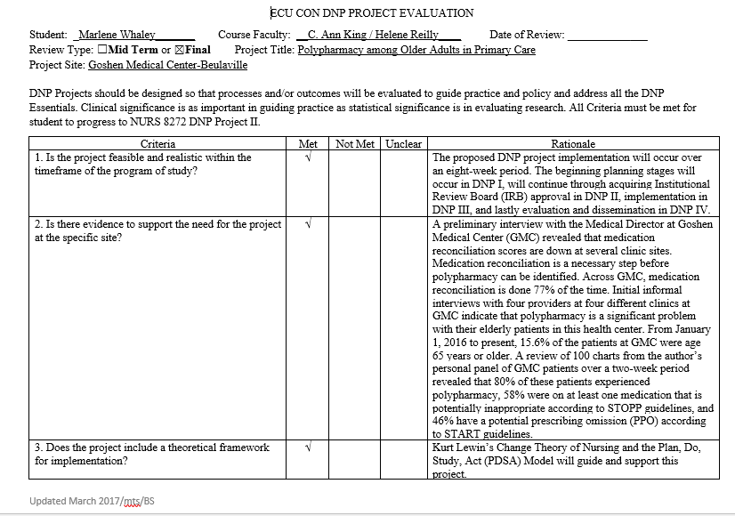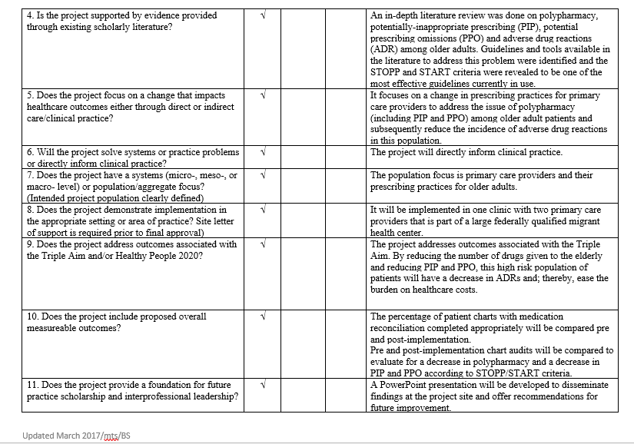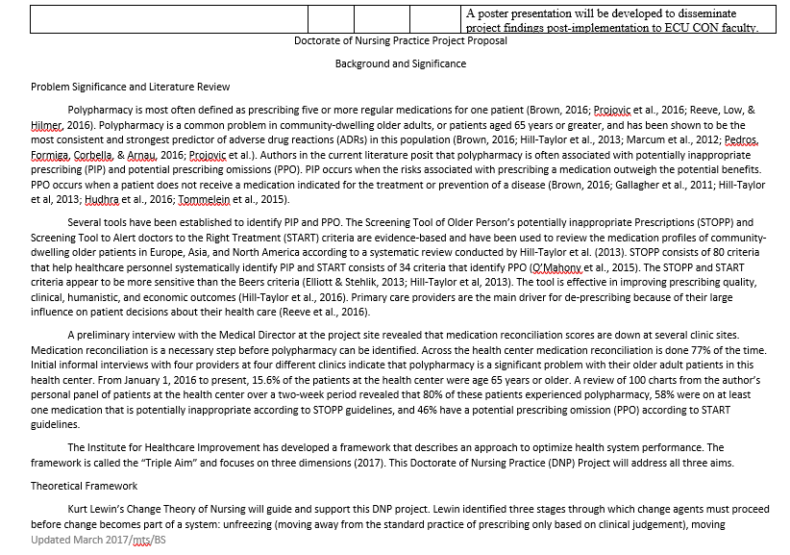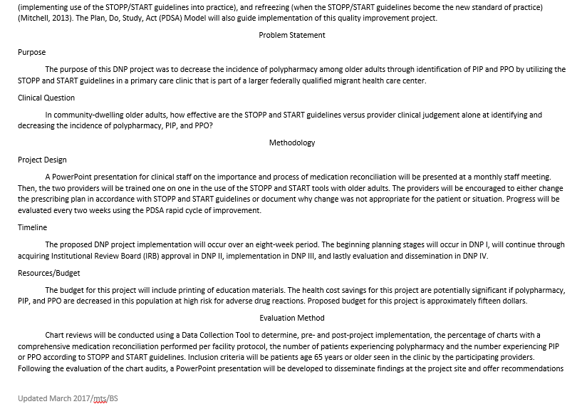

[This image has been removed.]

[This image has been removed.]

Appendix C
Institutional Review Board Approval
[This image has been removed.]

Appendix D
Tools
Doctor of Nursing Practice (DNP) Project Data Collection Tool
Demographic and Project-Specific Questions
for Pre- and Post-Implementation Chart Audits
- Is the patient aged 65 years or greater?
  - Yes
  - No
- What is the patient’s gender?
  - Male
  - Female
- Was a comprehensive medication reconciliation performed with the older adult according to facility policy?
  - Yes
  - No
- How many routine/chronic medications is the older adult patient currently taking?
____________________
- Is the older adult patient on any potentially inappropriate medication according to STOPP criteria, which the provider did not provide a clinical rationale for continuing?
  - Yes
  - No
- If the answer to Question 5 is Yes, then list the inappropriate medication classification(s).
- Is the older adult patient not on any potentially beneficial medication according to START criteria, which the provider did not provide a clinical rationale for omitting?
  - Yes
  - No
- If the answer to Question 7 is Yes, then list the omitted mediation classification(s).
Demographic and Project-Specific Questions for Participating Providers
- How many years has each participating provider been practicing in their current professional role? Round up to the nearest whole year.
____________________
- Did the provider use any guidelines or tools to augment their clinical judgement when prescribing medications for their older adult patients prior to project participation?
  - Yes
  - No
- How likely is the participating provider to continue to utilize STOPP/START guidelines to augment their clinical judgement in prescribing medications for their older adult patients after project completion?
1 2 3 4 5
Very Unlikely Unlikely Not Sure Likely Very Likely

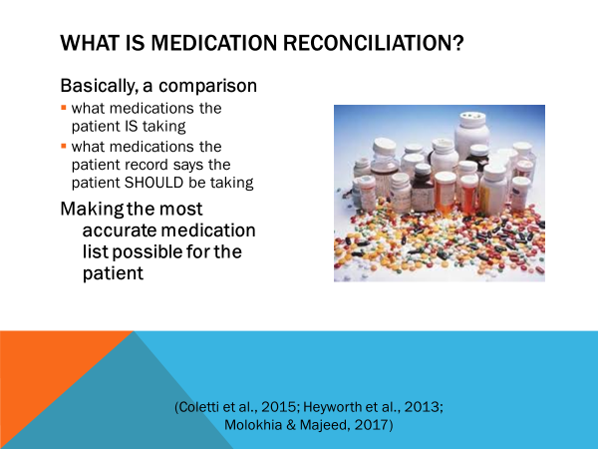
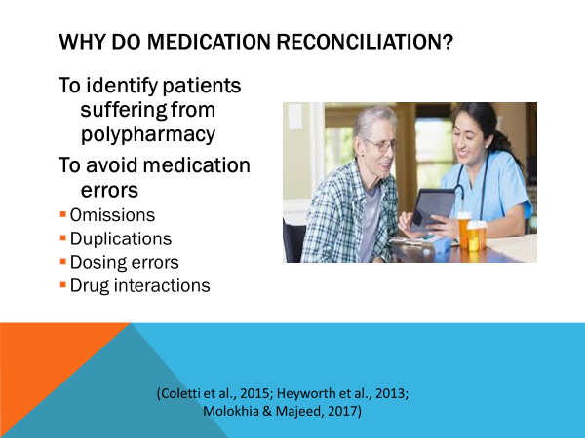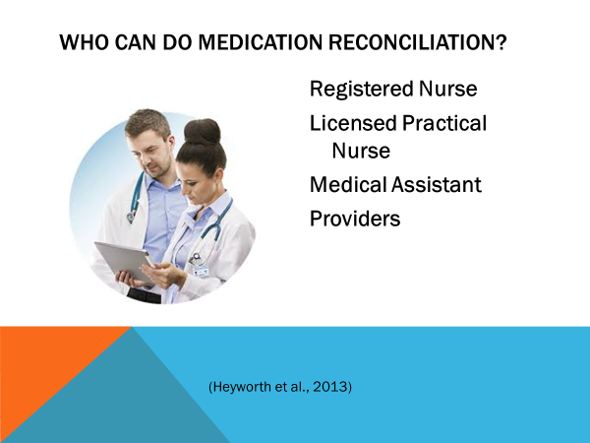
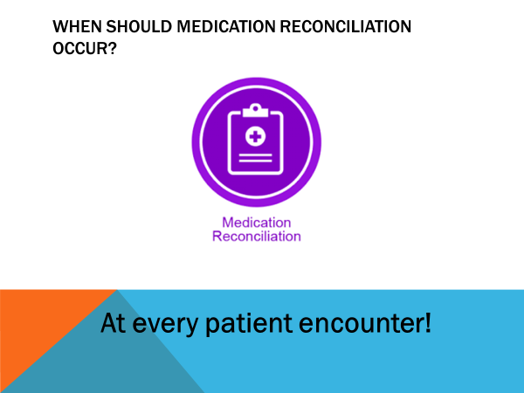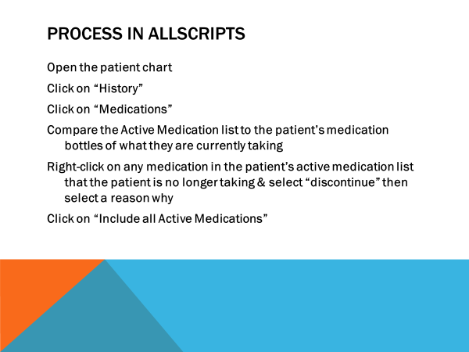
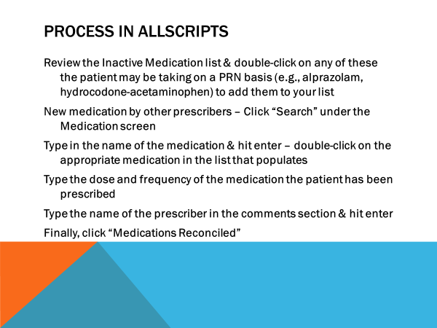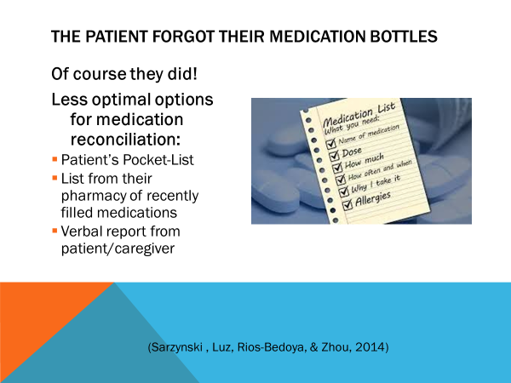
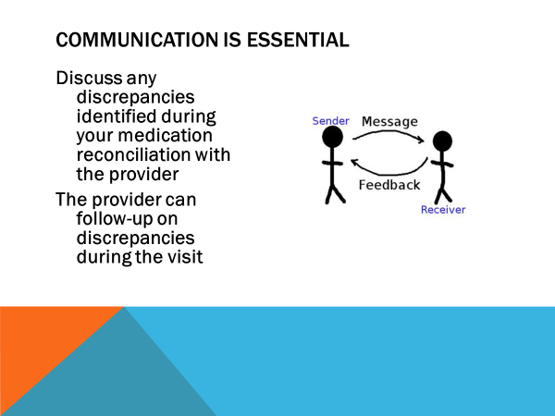
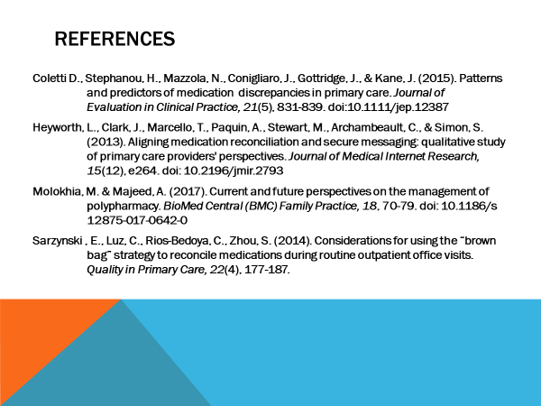

Appendix E
STOPP and START Guidelines
The STOPP and START criteria are part of an Open Access article with a non-commercial license, which permits non-commercial re-use, distribution, and reproduction in any medium, provided the original work is properly cited.
STOPP Guidelines
MEDICATION INDICATION
There is no evidence-based clinical indication for the medication | STOP
The medication has been prescribed beyond the recommended duration, where treatment durations is well-defined | STOP
Duplicate drug class prescription | STOP one & optimize monotherapy prior to considering a new agent
CARDIOVASCULAR SYSTEM
Heart failure with normal systolic ventricular function | STOP digoxin – no evidence of benefit
NYHA Class III or IV heart failure | STOP verapamil or diltiazem – risk of worsening heart failure
Beta-blocker in combination with verapamil or diltiazem | STOP one – risk of heart block
Beta-blocker with bradycardia (<50/min), type II heart block, or complete heart block | STOP – risk of complete heart block, asystole
Amiodarone as 1st line antiarrhythmic in supraventricular tachyarrhythmias | STOP – higher risk of side effects than beta-blockers, digoxin, verapamil, or diltiazem)
Loop diuretic as 1st line treatment for HTN | STOP – safer, more effective alternatives
Loop diuretic for dependent ankle edema without clinical, biochemical evidence or radiological evidence of heart failure, liver failure, nephrotic syndrome, or renal failure | STOP – leg elevation &/or compression stockings more appropriate
Thiazide diuretic with current significant hypokalemia (serum K+ <3.0 mmol/l), hyponatremia (Na+ <130 mmol/l), hypercalcemia (corrected serum calcium >2.65mmol/l) or with a history of gout | STOP – all can be precipitated by thiazide diuretic
Loop diuretic for treatment of HTN with concurrent urinary incontinence | STOP – may exacerbate incontinence
Centrally-acting antihypertensive | STOPP – unless there is a clear intolerance of or lack of efficacy with other classes
ACEI or ARB with hyperkalemia | STOP
Aldosterone antagonist (spironolactone) with concurrent potassium-conserving drugs (ACEI, ARB, triamterene) | STOP or monitor serum K+ at least every 6 months
Phosphodiesterase type-5 inhibitors in severe heart failure characterized by hypotension (SBP <90 mmHg) or concurrent nitrate therapy for angina | STOP – risk of cardiovascular collapse
ANTIPLATELET/ANTICOAGULANT DRUGS
Long-term ASA at doses > 160mg per day | STOP – increased risk of bleeding, no evidence for increased efficacy
ASA with a history of peptic ulcer disease without concomitant PPI | STOP – risk of recurrent peptic ulcer
ASA, Plavix, dipyridamole, Vit K antagonists, direct thrombin inhibitors, or factor Xa inhibitors with concurrent significant bleeding risk (uncontrolled severe HTN, bleeding diathesis, recent non-trivial spontaneous bleeding) | STOP – high risk of bleeding
ASA (+) Plavix as secondary stroke prevention | STOP – unless patient has a coronary stent(s) inserted in the previous 12 months or concurrent acute coronary syndrome or has a high-grade symptomatic carotid arterial stenosis (no evidence of added benefit over Plavix alone)
ASA (+) Vit K antagonist, direct thrombin inhibitor or factor Xa inhibitors in patients with chronic A. Fib. | STOP – no added benefit from ASA
Antiplatelet agents with Vit K antagonist, direct thrombin inhibitor, or factor Xa inhibitors in patients with stable coronary, cerebrovascular, or peripheral artery disease | STOP – no added benefit from dual therapy
Ticlopidine in any circumstances | STOP – Plavix & prasugrel have similar efficacy, stronger evidence, & few side effects
Vit K antagonist, direct thrombin inhibitor, or factor Xa inhibitors for 1st DVT without continuing provoking risk factors for >6 months | STOP
Vit K antagonist, direct thrombin inhibitor, or factor Xa inhibitors for 1st PE without continuing provoking risk factors for >12 months | STOP
NSAID in combination with Vit K antagonist, direct thrombin inhibitor, or factor Xa inhibitors | STOP – risk of major GI bleed
NSAID in combination with antiplatelet agents without PPI prophylaxis | STOP – increased risk of peptic ulcer disease
CENTRAL NERVOUS SYSTM AND PSYCHOTROPIC DRUGS
TCAs with dementia, narrow angle glaucoma, cardiac conduction abnormalities, prostatism, or prior history of urinary retention | STOP
TCAs as 1st line antidepressant treatment | STOP – higher risk of adverse drug reactions than with SSRIs or SNRIs
Neuroleptics with moderate-marked antimuscarinic/anticholinergic effects (chlorpromazine, clozapine, flupenthixol, fluphenzine, pipothiazine, promazine, zuclopenthixol) with a history of prostatism or previous urinary retention | STOP
SSRI with current or recent significant hyponatremia (Na+ <130 mmol/l) | STOP
Benzodiazepines for >/= 4 weeks | STOP – no indication for longer treatment; risk of prolonged sedation, confusion, impaired balance, falls, road traffic accidents; wean gradually
Antipsychotics (except quetiapine or clozapine) with parkinsonism or Lewy Body Disease | STOP – risk of severe extra-pyramidal symptoms
Anticholinergics/antimuscarinics to treat extra-pyramidal side effects of neuroleptic medications | STOP
Anticholinergics/antimuscarinics in patients with delirium or dementia | STOP
Neuroleptic antipsychotic in patients with behavioral and psychological symptoms of dementia | STOP – unless symptoms are severe & other non-pharmacological treatments have failed (increased risk of stroke)
Neuroleptics as hypnotics | STOP – unless sleep disorder is due to psychosis or dementia
Acetylcholinesterase inhibitors with known history of persistent bradycardia (<60 beats/min), heart block, recurrent unexplained syncope or concurrent treatment with drugs that reduce heart rate (beta-blockers, digoxin, diltiazem, verapamil) | STOP
Phenothiazines as 1st line treatment | STOP – safer & more effective alternatives exist
Levodopa or dopamine agonists for benign essential tremor | STOP – no evidence of efficacy
1st-generation antihistamines | STOP
RENAL SYSTEM
(the following drugs are potentially inappropriate in older adults with acute or chronic kidney disease with renal function below particular levels of eGFR)
Digoxin at long-term dose >125 mcg/day if eGFR <30 | STOP
Direct thrombin inhibitors (dabigatran) if eGFR <30 | STOP
Factor Xa inhibitors if eGFR <15 | STOP
NSAIDs if eGFR <50 | STOP
Colchicine if eGFR <10 | STOP
Metformin if eGFR <30 | STOP
GASTROINTESTINAL SYSTEM
Prochlorperazine or metoclopramide with Parkinsonism | STOP
PPI for uncomplicated peptic ulcer disease or erosive peptic esophagitis at full therapeutic dosage for >8 weeks | STOP or reduce dosage
Drugs likely to cause constipation (anticholinergic drugs, oral iron, opioids, verapamil, aluminum antacids) in patients with chronic constipation where non-constipating alternatives are available | STOP
Oral elemental iron doses >200 mg daily | STOP
RESPIRATORY SYSTEM
Theophylline as monotherapy for COPD | STOP
Systemic corticosteroids instead of inhaled corticosteroids for maintenance therapy in moderate-severe COPD | STOP
Anti-muscarinic bronchodilators with a history of narrow angle glaucoma or bladder outflow obstruction | STOP
Non-selective beta-blocker with a history of asthma requiring treatment | STOP
Benzodiazepines with acute or chronic respiratory failure | STOP
MUSCULOSKELETAL SYSTEM
NSAID other than COX-2 selective agents with history of peptic ulcer disease or GI bleed, unless with concurrent PPI or H2 antagonist | STOP
NSAID with severe HTN or severe heart failure | STOP
Long-term NSAID use (>3 months) for symptom relief of OA pain where acetaminophen has not been tried | STOP
Long-term corticosteroids (>3 months) as monotherapy for RA | STOP
Corticosteroids for OA | STOP
Long-term NSAID or colchicine (>3 months) for chronic treatment of gout where there is no contraindication to a xanthine-oxidase inhibitor (allopurinol) | STOP
COX-2 selective NSAIDs with concurrent cardiovascular disease | STOP
NSAID with concurrent corticosteroids without PPI prophylaxis | STOP
Oral bisphosphonates in patients with current or recent history of upper GI disease | STOP
UROGENITAL SYSTEM
Antimuscarinic drugs with dementia or chronic cognitive impairment or narrow-angle glaucoma or chronic prostatism | STOP
Selective alpha-1 selective alpha blockers in those with symptomatic orthostatic hypotension or micturition syncope | STOP
ENDOCRINE SYSTEM
Sulphonylureas with a long duration of action with type II DM | STOP
TZDs in patients with heart failure | STOP
Beta-blockers in DM with frequent hypoglycemia | STOP
Estrogens with history of breast cancer or VTE | STOP
Oral estrogens without progesterone in patients with intact uterus | STOP
Androgens in absence of primary or secondary hypogonadism | STOP
DRUGS THAT PREDICTABLY INCREASE THE RISK OF FALLS IN OLDER ADULTS
Benzodiazepines | STOP
Neuroleptic drugs | STOP
Vasodilator drugs (alpha-1 blockers, CCBs, long-acting nitrates, ACEIs, ARBs) with persistent postural hypotension | STOP
Hypnotic Z-drugs (zolpidem) | STOP
ANALGESIC DRUGS
Oral or transdermal strong opioids as 1st line therapy for mild pain | STOP
Use of regular opioids without concomitant laxative | STOP
Long-acting opioids without short-acting opioids for breakthrough pain | STOP
ANTIMUSCARINIC/ANTICHOLINERGIC DRUG BURDEN
Concomitant use of 2/more drugs with antimuscarinic/anticholinergic properties (bladder antispasmodics, intestinal antispasmodics, TCAs, 1st generation antihistamines) | STOP
START Guidelines
CARDIOVASCULAR SYSTEM
Vit K antagonist or direct thrombin inhibitors or factor Xa inhibitors with chronic A. Fib. | START
ASA (75mg-160mg daily) with chronic A. Fib. where above are contraindicated | START
Antiplatelet therapy with history of coronary, cerebral, or peripheral vascular disease | START
Antihypertensive therapy where SBP consistently >160 mmHg (>140 mmHg if DM) &/or DBP > 90 mmHg | START
Statin therapy with history of coronary, cerebral, or peripheral vascular disease, unless status is end-of-life or > 85 years | START
ACEI with systolic heart failure or coronary artery disease | START
Beta-blocker with ischemic heart disease | START
Appropriate beta-blocker with stable systolic heart failure | START
RESPIRATORY SYSTEM
Regular inhaled B2 agonist or antimuscarinic bronchodilator for mild to moderate asthma or COPD | START
Regular inhaled corticosteroid for moderate-severe asthma or COPD, where FEV1 <50% of predicted value & repeated exacerbations requiring treatment with oral corticosteroids | START
Home continuous oxygen with documented chronic hypoxemia (SaO2 <89%) | START
CENTRAL NERVOUS SYSTEM & EYES
L-DOPA or a dopamine agonist in idiopathic Parkinson’s disease with functional impairment & resultant disability | START
Non-TCA antidepressant drug in presence of persistent major depressive symptoms | START
Acetylcholinesterase inhibitor for mild-moderate Alzheimer’s dementia or Lewy Body dementia | START
Topical prostaglandin, prostamide or beta-blocker for primary open-angle glaucoma | START
SSRI (or SNRI or pregabalin if SSRI contraindicated) for persistent severe anxiety that interferes with independent functioning | START
Dopamine agonist (ropinirole or pramipexole) for RLS, once iron deficiency & severe renal failure have been excluded | START
GASTROINTESTINAL SYSEM
PPI with severe GERD or peptic stricture requiring dilatation | START
Fiber supplements for diverticulosis with a history of constipation | START
MUSCULOSKELETAL SYSTEM
DMARD with active, disabling RA | START
Bisphosphonates & Vit D & Calcium in patients with long-term systemic corticosteroid therapy | START
Vit D & Calcium in patients with known osteoporosis &/or previous fragility fracture(s) &/or BMD T-scores > -2.5 in multiple sites | START
Bone anti-resorptive or anabolic therapy in patients with documented osteoporosis, where no pharmacological or clinical status contraindication exists | START
Vit D supplement in older adults who are housebound or experiencing falls or with osteopenia | START
Xanthine-oxidase inhibitors (allopurinol) with history of recurrent episodes of gout | START
Folic acid supplement in patients taking methotrexate | START
ENDOCRINE SYSTEM
ACEI or ARB in DM with evidence of renal disease (dipstick protein or microalbuminuria >30mg/24hr) with or without serum biochemical renal impairment | START
UROGENITAL SYSTEM
Alpha-1 receptor blocker with symptomatic prostatism, where prostatectomy is not considered necessary | START
5-alpha reductase inhibitor with symptomatic prostatitism, where prostatectomy is not considered necessary | START
Topical vaginal estrogen or vaginal estrogen pessary for symptomatic atrophic vaginitis | START
ANALGESICS
High-potency opioids in moderate-severe pain, where Tylenol, NSAIDs, or low-potency opioids are not appropriate to the pain severity or have been ineffective | START
Laxatives in patients receiving opioids regularly | START
VACCINES
Seasonal  trivalent influenza vaccine annually | START
Pneumococcal vaccine at least once after age 65 | START
Note. STOPP = Screening Tool of Older Person’s potentially inappropriate Prescriptions; NYHA = New York Heart Association; HTN = hypertension; ACEI = angiotensin converting enzyme inhibitor; ARB = angiotensin II receptor blockers; SBP = systolic blood pressure; START = Screening Tool to Alert doctors to the Right Treatment; ASA = aspirin; PPI = proton pump inhibitor; Vit = vitamin; A. Fib. = atrial fibrillation; DVT = deep vein thrombosis; PE = pulmonary embolus; NSAID = non-steroidal anti-inflammatory drug; GI = gastrointestinal; TCA = tricyclic antidepressant; SSRI = selective serotonin reuptake inhibitor; SNRI = serotonin/norepinephrine reuptake inhibitor; eGFR = estimated glomerular filtration rate; COPD = chronic obstructive pulmonary disease; RA = rheumatoid arthritis; OA = osteoarthritis; DM = diabetes mellitus; TZD = thiazolidinedione; VTE = venous thromboembolism; CCB = calcium channel blocker; DBP = diastolic blood pressure; FEV1 = forced expiratory volume; RLS = restless leg syndrome; GERD = gastroesophageal reflux disease; DMARD = disease modifying anti-rheumatic drug; BMD = bone mineral density. Adapted from “STOPP/START Criteria for Potentially Inappropriate Prescribing in Older People: Version 2,” by D. O'Mahony, D. O'Sullivan, S. Byrne, M. O'Connor, C. Ryan, & P. Gallagher, 2015, Age and Ageing, 44(2), Appendix 3 & 4.

Appendix F
Timeline
NURS 8269: DNP Project I | NURS 8272: DNP Project II
- August 28, 2017 – Submitted ECU CITI Refresher Training certificate  - September 4-November 27, 2017 – created bi-monthly reflective journal entries  - September 5-8, 2017 – DNP Intensives  - September 11, 2017 – Performed Needs Assessment with Site Champion/Medical Director  - September 15, 2017 – Submitted DNP Project Proposal & Timeline  - October 8, 2017 - DNP Project Data Collection Tool approved; permission to use STOPP/START guidelines not required; PowerPoint on the importance & the process of medication reconciliation approved  - October 13, 2017 – Submitted first draft of DNP Project Paper  - October 16, 2017 – Submitted midterm DNP Project Time Log  - October 31, 2017 – DNP Project Summary Proposal form signed by Dr. Skipper  - November 6, 2017 – Final DNP Project Paper approved by Dr. King  - November 17, 2017 – Submitted Site Champion CV & Project Team Member Approval form & Project Site Approval form  - November 20, 2017 – Submitted Final DNP Project Time Log verifying completion of at least 125 hours toward project reflecting DNP Essentials met by the activity | - January 16, 2018-April 23, 2018 – created bi-monthly reflective journal entries  - February 12, 2018 – Quality & Research Worksheet completed; DNP Project Data Collection Tool, PowerPoint presentation, & STOPP/START guidelines submitted  - February 19-22, 2018 – DNP Intensives  - March 12, 2018 – Submitted midterm DNP Project Paper & Time Log  - March 19, 2018 – e-Pirate process completed but not submitted; IRB Review Packet submitted  - March 29, 2018 – IRB waiver obtained  - April 9, 2018 – Final DNP Project Paper approved by Dr. Reilly  - April 24, 2018 – Submitted Final DNP Project Time Log verifying completion of at least 125 hours toward project reflecting DNP Essentials met by the activity
NURS 8274: DNP Project III | NURS 8277: DNP Project IV
- May 21, 2018-July 26, 2018 – created bi-monthly reflective journal entries  - May 21, 2018 – PPT Education Session with staff on Medication Reconciliation; provider training in use of STOPP & START  - May 28, 2018-July 23, 2018 – Evaluated progress every 2 weeks using PDSA rapid cycle of improvement  - June 11-15, 2018 – DNP Intensives  - June 18, 2018 – Submitted midterm DNP Project Paper & Time Log  - July 16, 2018 – Final DNP Project Paper approved by Dr. Reilly  - July 26, 2018 – Submitted Final DNP Project Time Log verifying completion of at least 125 hours toward project reflecting DNP Essentials met by the activity  - July 26, 2018 – Completed pre- & post-implementation chart audits of patients who met inclusion criteria & began evaluation of results | - August 27, 2018-November 29, 2018 – create bi-monthly reflective journal entries  - September 10-13, 2018 – DNP Intensives  - September 9, 2018 – Evaluate project outcomes including all final data analysis & conclusion; develop strategies for further project implementation & evaluation; submit dissemination plan  - October 5, 2018 – Submit midterm DNP Project Paper & Time Log  - October 15, 2018 – Draft of poster presentation of DNP Project  - October 24, 2018 – Disseminate project outcomes to GMC with poster presentation  - November 8, 2018 – Present poster presentation of DNP Project at ECU  - November 27, 2018 – Have Final DNP Project Paper approved by Dr. Reilly  - November 29, 2018 – Submit Final DNP Project Time Log verifying completion of at least 125 hours toward project reflecting DNP Essentials met by the activity; Upload Final DNP Project Paper into ScholarShip repository  - November 29, 2018 – Withdraw appropriate IRB Approvals
Note. DNP = Doctor of Nursing Practice; ECU = East Carolina University; CITI = Collaborative Institutional Training Committee; STOPP/START = Screening Tool of Older Person’s potentially inappropriate Prescriptions/Screening Tool to Alert doctors to the Right Treatment; CV = Curriculum Vitae; IRB = Institutional Review Board; PDSA = Plan, Do, Study, Act.

