Improving Nurse Education on Using a Warm Compress During the Second Stage of Labor to Reduce Perineal Trauma

Kori Simmons Dunigan
College of Nursing, East Carolina University
NURS 8277
Dr. Megan Dillon
July 19, 2023

Abstract
Nursing education can be presented in various modalities to create change within the nursing population successfully. This project utilizes presentations, posters, and in-person coaching to increase the consistent use of warm compresses while pushing with patients. This was done to decrease the rate of third- and fourth-degree lacerations at one facility within a large, high-risk hospital system. The education provided for the nurses was built on proven evidence-based practices that are known to prevent perineal trauma. Warm compresses were specifically addressed at this facility due to a lack of previous education on this topic. During implementation, supplies, including warm compresses and grapeseed oil for perineal massage, were continually stocked in labor rooms for convenient access during deliveries. The findings from this project show an increased use of warm compresses after education and live in-person coaching. 100% of the nurses who completed the post-survey found this project and the increased availability of supplies helpful.
Keywords. perineal trauma, third- and fourth-degree laceration, nursing education, coaching, warm compress, perineal massage

Table of Contents
Section I: Introduction.….……………………………………………….…………………….… 5
Background………………………………………………………………………….…… 5
Organizational Needs Statement……………………………………………………….….5
Problem Statement………………………………………………………………………...8
Purpose Statement…………………………………………………………………………9
Section II: Evidence…………………………………………………………………………….....9
Literature Review………………………………………………………………….………9
Evidence-Based Practice Framework……………………………………………………14
Ethical Consideration and Protection of Human Subjects……………………………….15
Section III. Project Design……………………………………………………………………….16
Project Site and Population………………………………………………………………16
Project Team……………………………………………………………………………..18
Project Goals and Outcome Measures…………………………………………...………18
Implementation Plan…………………………………………………………………..…20
Timeline………………………………………………………………………………….20
Section IV. Results and Findings………………………………………………………………...22
Results……………………………………………………………………………………22
Discussion of Major Findings……………………………………………………………23
Section V. Interpretation and Implications………………………………………………………24
Costs and Resource Management………………………………………………………..24
Implications of the Findings……………………………………………………………..26
Implications for Patients…………………………………………………………27
Implications for Nursing Practice………………………………………………..27
Impact for Healthcare System…………………………………………....………27
Sustainability……………………………………………………………………………..28
Dissemination Plan………………………………………………………………………28
Section VI. Conclusion…………………………………………………………………………..29
Limitations and Facilitators……………………………………………………………...29
Recommendations for Others……………………………………………………………30
Recommendations for Further Study……………………...……………………………..31
Final Thoughts…………………………………………………………………………...32
References……………………………………………………………………………….……....34
Appendices…………………………………………………………………….…………………36
Appendix A: Literature Search Log…………...………………………….……………...36
Appendix B: Literature Matrix.……………………………………………….…………37
Appendix C: Driver Diagram….…………………………………………………………38
Appendix D: Timeline…………………………………………………………………...39
Figure 1: PSI-18 and PSI-19 Data from Quarter 1 2022 vs. Quarter 1 2023……….…....40
Figure 2: Perineal Trauma with and without Instrumentation………………………..….41
Figure 3: Qualtrics Survey Results on Use of Warm Compresses……………………....42
Figure 4: Qualtrics Survey Results on if this Project was Helpful…………………...….43
Appendix E: Itemized Budget……………………………………………………..…….44

Section I. Introduction
Background
Bringing a new baby into the world is often thought of as one of the most significant moments in a parent’s life. Much focus is placed on the mother until she delivers, wherein that focus shifts to the newborn. When discussing the birth story, a topic many new moms tend to shy away from is perineal tears, especially regarding third- and fourth-degree lacerations. A third-degree laceration is classified as a perineal injury involving the anal sphincter. It is further identified as 3a, where less than 50% of the external anal sphincter is torn, 3b, where more than 50% is torn, and 3c, where both the external and internal anal sphincter is torn (Cichowski & Rogers, 2016). A fourth-degree laceration is perineal trauma involving both the external and internal anal sphincter and the anal epithelium (Cichowski & Rogers, 2016).
This kind of trauma can result in extensive physical pain, urinary problems, and fecal incontinence. This trauma can also lead to psychological barriers such as anxiety and postpartum depression, lowered self-esteem, a feeling of isolation, and embarrassment. Additionally, these obstacles can cause hardships in intimacy and future family planning (Darmody et al., 2020). Throughout the second stage of labor, or the pushing stage, nurses and obstetric providers can implement interventions to decrease the likelihood of having a third- or fourth-degree tear and prevent many of the abovementioned obstacles.
Organizational Needs Statement
Metrics provided by the National Perinatal Information Center (NPIC) indicate that the number of third and fourth-degree obstetric traumas is significantly higher at this location compared to the average number of traumas at other non-academic regional hospitals. During the second quarter of 2022, the rate of perineal trauma with instrumentation was 23.5% compared to the average of 10% at similar locations (National Perinatal Information Center, 2022). The Agency for Healthcare Research and Quality (AHRQ) provides specific quality indicators and recommendations for practice (Agency for Healthcare Research and Quality [AHRQ], 2017). Patients must first be identified based on their risk factors for obstetric lacerations to decrease the rate of third- and fourth-degree tears. Risk factors associated with perineal trauma include both modifiable and non-modifiable factors. Modifiable risk factors include operative delivery with a vacuum or forceps, having epidural anesthesia, getting a midline episiotomy (an incision between the vaginal opening and the anus to facilitate delivery), using oxytocin for induction of labor, persistent occiput posterior position, or fetal head malposition, and delivery in stirrups (AHRQ, 2017). Non-modifiable risk factors include a birth weight greater than four kilograms, being a first-time mom, maternal age less than twenty-one, pushing for longer than one hour, and experiencing shoulder dystocia, which means the shoulder became stuck during delivery (AHRQ, 2017). According to these factors, most deliveries are at risk for perineal trauma.
During the second stage of labor, techniques such as allowing time for perineal thinning, avoiding operative deliveries with forceps or vacuum devices, avoiding episiotomies, providing perineal massage, utilizing lateral birth positions, and implementing warm packs to the perineal area both during pushing and in-between pushes decrease the rate of perineal trauma (AHRQ, 2017). At delivery, it is up to the physician to avoid instrumentation for operative delivery and episiotomies; however, the nurse can advocate for the patient and implement all other recommended interventions. Of these interventions, the one least commonly utilized at this facility is providing a warm pack to the perineal area during and between pushing. Using a warm compress during the second stage of labor does not cause harm and is linked to improved obstetric outcomes (Aasheim et al., 2017). On average, the number of women who experience a third- or fourth-degree laceration is lower among patients who receive a warm compress during the pushing stage of labor (Aasheim et al., 2017).
The project topic is a process improvement that focuses on enhancing nurse education on the importance of a warm compress during the second stage of labor to decrease the rate of third- and fourth-degree lacerations at a large not-for-profit hospital in central North Carolina. At this facility, there has not been extensive education on implementing warm packs during the second stage of labor. Many nurses have not been using them consistently, or in some cases, at all. The warm packs are also not always stocked in each delivery room, which provides an extra barrier to implementation. ARHQ (2017) states that the minimal educational recommendation on preventing perineal trauma is once upon hire and annually for all staff involved in obstetric care. This organization has recognized the gap in nurse education on preventing third- and fourth-degree lacerations and voiced concern over the growing need for an intervention.
Various studies have been completed on utilizing training and education as a benchmark for lowering the rate of perineal trauma. One study used interprofessional education with simulation-based education, evaluated by pre-and post-tests (Marko et al., 2019). Initially, this study defined the current rate of perineal trauma within the targeted locations and described how they differed from other facilities. They then used evidence-based research to educate the staff on interventions such as a warm compress to decrease the rate of perineal trauma and further created simulations to facilitate learning. They used a pre-test and post-test design to evaluate the providers. After a year, this hospital system effectively lowered the rate of severe perineal lacerations by over 33% (Marko et al., 2019). This study shows that provider education is essential in preventing third- and fourth-degree lacerations.
Healthy People 2030 is a national organization focusing on setting and achieving goals to improve overall health and well-being (Healthy People 2030, 2016). This need would improve outcomes related to maternal, infant, and child health (MICH) in Healthy People 2030. Reducing the rate of perineal trauma has the potential to decrease the proportion of women who experience postpartum depression (MICH-D01) and decrease the rate of severe maternal complications during hospitalization (MICH-05) (Healthy People 2030, 2016).
This process improvement project correlates with the Institute for Healthcare Improvement’s Quadruple Aim Measures of improving the patient experience, enhancing population health, optimizing costs, and elevating provider satisfaction (Bodenheimer & Sinksy, 2014). Decreasing the rate of perineal trauma would improve population health through the standardization of care with the consistent use of a warm compress during the second stage of labor. It would decrease the cost of care by utilizing evidence-based interventions already available within the facility. It would improve provider satisfaction by providing better access to tools and reducing extensive repairs. Additionally, it would enhance the patient experience by improving outcomes and safety (Bodenheimer & Sinsky, 2014).
Problem Statement
This facility has a higher-than-average rate of third- and fourth-degree lacerations compared to similar facilities. At this site, there has not been extensive training or education on preventing perineal trauma, including using a warm compress. Warm compresses are not consistently being used at this facility during the second stage of labor, even though it has been shown to decrease the rate of perineal trauma when used alongside other preventative measures. Many times, warm compresses are not readily available in every delivery room. Based on the metrics available through the NPIC within the hospital system, measures need to be taken to lower the third- and fourth-degree laceration rate at this location.
Purpose Statement
The purpose of this Doctor of Nursing Practice (DNP) Project is to increase the consistent use of a warm compress during the second stage of labor through nurse education and, in turn, lower the rate of perineal trauma at this facility. Education on utilizing cost-effective, evidence-based resources is vital to preventing perineal trauma. Increasing nurse education and decreasing the rate of perineal trauma should also aid in the transition into parenthood and decrease many obstacles commonly seen alongside third- and fourth-degree lacerations during the postpartum period.
Section II. Evidence
Literature Review
An extensive literature search was completed to determine the best way to prevent perineal trauma and the steps that should be taken to implement these findings. The search terms identified through this process are listed in Appendix A, along with the inclusion/exclusion criteria rationale. Search terms included ("perineal laceration" or "third degree tear" or "fourth degree tear" or "trauma") and ("warm compress"), ("perineal techniques" or "second stage" or "warm compress") and ("perineal trauma" and "warm"), ("safety" or "outcome" or "labor") and ("perineal trauma" and "warm compress"), ("perineal laceration" and "warm compress"), as well as ("perineal laceration" or "third degree tear" or "fourth degree tear" or "trauma") and ("warm compress"). These specific parameters, such as "perineal" or "labor," were placed because the results were too numerous and not specific to labor trauma.
These keyword searches were done over PubMed and the Cochrane Library databases from June 2022 to September 2022. Various limits were placed on the articles, such as being written within the last six years and being available in English. Articles that met inclusion criteria had evidence to support using warm compresses or nurse education. Articles that were excluded from these searches included inconclusive evidence or redundant information. Seventeen resources were found, and after applying inclusion and exclusion criteria, while maintaining high evidence levels above Evidence Levels III and removing any overlap, only seven articles remained. The level of evidence was necessary for completing the literature search because it added to the project's validity. Level I research includes systematic reviews, meta-analyses, and randomized-controlled trials (Pruka, 2022). Level II evidence is gathered from well-designed randomized control trials, and Level III includes studies such as quasi-experimental designs. As the level of evidence increases in number, the strength of the evidence decreases, to evidence such as expert opinions or descriptive and qualitative studies (Pruka, 2022).
The seven remaining articles were read in their entirety to determine relevance to the project topic and proposed implementation plan. Many articles helped to validate the using a warm compress during the second stage of labor; however, four of the seven articles provided concrete evidence that a warm compress should be used to prevent perineal trauma. These articles are further explained in Appendix B. The evidence provided by these articles was very high, either Evidence Level I or II, with two systematic reviews, a literature review, and a quasi-experimental pre-post design. Of the four, one article specifically addressed an intervention, besides simply using the warm compress, to increase the usage rate and decrease the incidence of third- and fourth-degree lacerations. In this resource, the independent variable was educational strategies, and the dependent variable was provider adherence (Marko et al., 2019). The remaining articles offered significant evidence and commonality in preventing perineal trauma with a warm compress and advocated for widespread use.
Current State of Knowledge
AHRQ provides specific quality indicators and recommendations for best practices (AHRQ, 2017). According to AHRQ (2017), the current expectation is that all obstetric care staff are educated on preventing perineal trauma at a minimum of once upon hire and then annually. Interventions that should be included are utilizing a warm compress during the second stage of labor, applying perineal massage, and pushing in lateral positions. Failure to implement these findings increases the rate of perineal trauma. It can result in extensive physical pain, urinary problems, fecal incontinence, psychological barriers such as anxiety and postpartum depression, lowered self-esteem, a feeling of isolation, embarrassment, and hardships in intimacy and future family planning, among countless other obstacles (Darmody et al., 2020).
Using a warm compress during the second stage of labor is linked to improved obstetric outcomes and causes no harm (Aasheim et al., 2017). On average, the number of women who experience a third- or fourth-degree laceration is lower among patients who receive a warm compress during the pushing stage of labor (Aasheim et al., 2017). Based on the findings from the literature, it should be standard practice for every institution or birthing center to implement these measures to reduce perineal trauma. These interventions should be utilized during every delivery, especially with those considered high-risk for third- and fourth-degree lacerations. Current Approaches to Solving Population Problem(s)
Throughout the literature, it is made clear that utilizing a warm compress during the second stage of labor has significant implications for decreasing the rate of perineal trauma in the form of third- and fourth-degree lacerations. As far as solving the problem, many resources state that it should be done; however, they do not give concrete ideas of how to make a change within an organization so that providers adhere to the guidelines. Each article states that provider education is essential in preventing perineal trauma. Aasheim et al. (2017) is a systematic review that explains various studies that have been completed and their outcomes. During these studies, educational strategies were utilized to inform the provider that a warm compress should be used on every patient. Additionally, Darmody et al. (2020) clearly state that healthcare providers who are in a position to care for laboring mothers need to be educated on the outcomes of perineal trauma to prevent it from happening or to educate mothers if they do experience a third- or fourth-degree laceration.
Out of the research that has been completed, one quasi-experimental pre-post group design has been done, examining the rate of perineal lacerations, and utilizing a mixed-modality educational program for reducing perineal trauma (Marko et al., 2019). This study provides a benchmark for provider education. It is the hallmark study for which this project is based due to the overwhelming similarities between this multi-hospital system and the partnering organization.
During this study, pre-program perineal laceration rates were established, labor and delivery staff participating in the study were identified, and a pre-test was administered to determine knowledge, performance, and safety in the form of a survey (Marko et al., 2019). Once this data was collected, education was provided through team-based simulation. They used evidence-based research to educate the staff on warm compresses, laboring down, positioning, and perineal support. After education and simulation, a post-test was administered, and post-program perineal laceration rates were examined. After a year, this hospital system effectively lowered the rate of severe perineal lacerations by over 33% (Marko et al., 2019). The results of this study indicate that education is vital in reducing the rate of third- and fourth-degree lacerations.
Based on collaboration with the project site and in reviewing data provided through the NPIC, it was determined that hands-on staff education is essential in combatting perineal trauma. The literature shows that warm compresses during the second stage decrease the rate of third- and fourth-degree lacerations. At this site, warm compresses are available, but should be used more consistently.
It is known, at this site, that nurses are more often utilizing perineal massage and positioning techniques; however, they are less frequently using warm compresses. Looking at the metrics provided by the NPIC, it is evident that this facility is lacking in preventing perineal trauma compared to other facilities. There is a known gap in education on warm compresses in this facility; therefore, increasing staff knowledge of the importance is this project's focus.
Evidence to Support the Intervention
The multi-modal educational approach is the ideal intervention for the partnering organization and the targeted population based on a long-standing record of experiences at this facility. Each staff member learns differently, and the teaching will be reinforced each time the staff is educated. The more frequently education is reinforced, the more likely staff will be to use the education and transition into practice (Marko et al., 2019). During the project implementation, information will be presented to the staff through in-person training and access to a PowerPoint presentation created by the education department. Staff will also be provided with a poster that describes how they can decrease the rate of perineal trauma and the importance of doing so. These posters will be hanging in three high-traffic areas on the unit and will be explained during morning and evening huddles. Reminder cards will be laminated and placed in each delivery room, taped to the computer monitor. Direct, hands-on, nurse coaching will also be implemented during both shifts to ensure that warm compresses are utilized.
By being present on the unit, the staff will be constantly reminded of the education and the difference they can make in their patients’ birth experiences. Reminders will be provided during morning and evening huddles and safety rounds, daily at 10:00 am/pm and 4:00 am/pm. Since everyone in this unit works on different schedules, having the information in the form of posters and an easily accessible PowerPoint presentation will be ideal for reaching all team members. Marko et al. (2019) highly supported providing multiple modalities for staff education, where they utilized testing, hard-copy educational materials, and team simulations and drastically decreased the incidence of perineal trauma.
Evidence-Based Practice Framework
Execution of this project will be done by utilizing the plan-do-study-act (PDSA) operational framework, which allows for implementing a plan and revisiting it over time to find ways to improve it (AHRQ, 2015). The PDSA provides a process to break down implementation into steps, evaluate the outcomes, find ways to improve it, and then implement again based on those findings. The “Plan” includes deciding how the project will be implemented and what outcomes will be achieved. This phase includes the research that has been completed and the project tools that have been created. The “Do” will encompass executing the plan or implementation. During this phase, observation is critical in understanding how the team members will react to the proposed plan and how likely they are to participate. “Study” will take place after implementation to determine what went well and what needs to be improved to meet the goal. This will take place continually and in-person after implementation begins to ensure staff opinions are heard. This will be done through interactions and conversations with peers. The “Act” phase will conclude whether the PDSA was successful or if there are areas that need to be improved. This phase will allow for reflection on project continuation and dissemination.
During the implementation of this project, a formal PDSA will be completed at the beginning of each month with the site champion at least two to three times after looking over the metrics of third- and fourth-degree lacerations at this facility. During implementation, mini, informal PDSAs will occur continually with the nursing staff on the unit.
This project will be executed by employing nurse education through a PowerPoint presentation, posters around the unit as a reminder of the education, and direct hands-on coaching. Based on what is seen after this intervention, changes may be needed to make education more effective (AHRQ, 2015). The results will be studied to see if the goal has been met, and action will be taken in the form of continuation or change. Once implementation has been completed, a post-survey will be sent to the nursing staff to determine the effectiveness based on their perspective.
Ethical Consideration & Protection of Human Subjects
During implementation, staff will be educated that every patient, regardless of their assumed risk, should be treated equally using a warm compress during the second stage of labor to prevent perineal trauma. Based on the literature, using a warm compress does not cause harm and is linked to improved obstetric outcomes. Ensuring that every staff member is educated will increase the likelihood of using the warm compress and decrease the rate of perineal trauma. There is the potential that certain staff members are absent for the education; however, this will be addressed through easy access to the presentation, posters, and hands-on coaching throughout implementation.
The Collaborative Institutional Training Initiative, or CITI, explains its mission is to foster integrity and advancement for universities, healthcare institutions, and research organizations (Collaborative Institutional Training Initiative [CITI], n.d.). In preparation for the formal approval process, CITI modules were completed, thoroughly explaining what is considered research and the federal regulations for protecting research subjects (CITI, n.d.). Modules completed in this program focused on social and behavioral research, including topics such as ethical principles, informed consent, privacy, and confidentiality, assessing risk, vulnerable populations, and research-based in educational settings. These modules provided a greater understanding of what is considered research versus quality improvement and provided solid background information on regulations and the protection of subjects.
This project addresses a known gap in care. Based on the nature of this project, it would not be considered research but rather a process improvement involving nurse education. The purpose of the project is to educate nursing staff on preventing perineal trauma with interventions known to help. An Institutional Review Board (IRB) Quality Improvement/Program evaluation tool provided by the University was completed, which determined this project would not need a formal IRB approval and deemed the project a quality improvement project. This tool was available as a Qualtrics Survey and addressed questions on project funding, use of experimental drugs, project scope, and risks. A clinical project proposal was completed for the project site, which was submitted and reviewed by the nursing research chairperson. A meeting with the research counsel at the project site was completed on November 22nd, 2022 and gave the final approval of this quality improvement project.
Section III. Project Design
Project Site and Population
The project site is a large, not-for-profit healthcare system located in central North Carolina whose mission is to improve the health of communities. The unit involved in this project is a twenty-one-bed labor and delivery floor that, on average, delivers 300 babies per month. This unit is staffed by a total of 65 nurses, including travelers and nurse residents who are in training. The patient population is a combination of both low and high-risk pregnant women.
Description of the Setting
This hospital is in a substantial city and is one of two major hospital systems in the area. The labor and delivery unit is located on the fourth floor and offers private patient rooms with the option for labor tubs in nine available rooms. This unit is connected to the obstetric emergency department, which has eight triage rooms staffed by one to two nurses. There is a locker room, a break room, two nurse’s stations at opposite ends of the hall with access to multiple computers, and two large supply closets on either end of the unit.
Description of the Population
The population of nurses at this facility range in experience from newly graduated nurses being trained through a residency program to nurses working in labor and delivery for over 30 years. A significant number of these nurses are Baccalaureate prepared, and the remaining Associate prepared nurses are in the process of obtaining their bachelor’s degrees. Most nurses who have been practicing on this unit for at least five years are working on dayshift, and most new-grad nurses or nurses who are new to the unit are working on the night shift. There are traveling nurses on both shifts; however, the regular full or part-time staff makes up most of the unit. Surgical technologists and certified nursing assistants are responsible for stocking the rooms. There are two assistant nurse managers for each shift and one unit manager for the entire unit. The director of Women’s and Children’s Services is next in the chain of command and is one of the project facilitators.
Project Team
The project team includes the director of Women’s and Children’s Services, who will oversee the project from the site, faculty, who will oversee the project from the University, and the project leader, who will plan, implement, and manage the project. Other project team members include clinical nursing educators who have assisted in providing educational materials, the nursing research chair member who has helped with project approval, and the nursing manager and assistant nurse managers who fully support and advocate for project implementation on the unit. On the unit, the nurses will be vastly instrumental in using the knowledge gained from the training, and support staff will be essential in ensuring that the rooms are fully stocked.
Project Goals and Outcome Measures
This project aims to increase the consistent use of a warm compress during the second stage of labor through nurse education and, in turn, lower the rate of perineal trauma at this facility. Nurses will be thoroughly educated and encouraged to use warm compresses with hard copy education and in-person coaching. Data on third- and fourth-degree lacerations with and without instrumentation will be gathered through the NPIC and compared to previous months. Nurses will also be encouraged to share their experience on the education and their use of a warm compress before and after being educated.
Description of the Methods and Measurement
Education will be provided using an available PowerPoint presentation, posters around the unit, and reminder cards in each room. In-person coaching will be done on the unit at least three times per week. At the end of each month, metrics gathered through the National Perinatal Information Center will be reviewed, evaluated, and further utilized for changes that should take place. At the end of implementation, a Qualtrics survey will be provided for the nurses to complete rating their educational experience and use of warm compresses during the second stage of labor. Results from this survey will be collected and recorded in an Excel spreadsheet. From this data, it will be made clear the percentage of time nurses used warm compresses before and after being educated on the importance of it and the potential impact on this patient population.
Discussion of the Data Collection Process
The data collected through the NPIC will count every delivery at this facility that resulted in a third- or fourth-degree laceration during each month. It will show the numbers broken down into deliveries with and without instrumentation in the form of vacuum or forceps-assisted deliveries. This data will further be demonstrated in the form of a line-chart to show the progression over time. The Excel spreadsheet that this information is provided on is only accessible through the Site Champion, the Director of Women’s services and is password protected. The metrics provided by this software will impact this project by further demonstrating increased nurse education, the need for re-education, and compliance with preventing perineal trauma. Ideally, if steps to decrease perineal trauma are being taught and used, the number of traumatic lacerations should decrease. Data will also be collected through a Qualtrics survey at the end of implementation to determine if the education was helpful and if it increased the usage of warm compresses during the second stage of labor. The responses will be recorded in an Excel spreadsheet, and the percentage of warm-pack use will be averaged and compared to the reported percentage of use prior to education. This data will provide meaningful information on the outcomes of the education.
Implementation Plan
Staff will be encouraged to view the available PowerPoint on reducing perineal trauma during the early stages of implementation. Information presented on the posters around the unit and in the breakroom will be explained during the dayshift and nightshift huddle and safety rounds. To reach all staff members, teaching will be completed during multiple shifts, including day and night. Reminder cards will be placed in every delivery room on the computer monitor to ensure that each person sees it and is reminded to complete each intervention to reduce perineal trauma. In-person coaching will occur on the unit with each upcoming delivery at various times throughout the week. During implementation, nurse input will be considered for potential changes that need to occur for better outcomes. After the first four weeks of implementation have been completed, metrics will be assessed, and a meeting will occur with the site champion to determine if changes need to be made. A formal PDSA will take place at the beginning of each month for a total of three times to assess for gaps or opportunities for improvement. After twelve weeks, a Qualtrics survey will be administered to the nursing staff, where they will be able to determine if the education was helpful and if they are now more likely to use a warm compress.
Timeline
From May to August 2022, information was gathered on the project topic, a literature search and literature matrix was completed on the evidence found, and the project site was secured. The project site champion was identified, and meetings occurred between the team leader and site champion to discuss the project's background and what could be done to improve the use of warm compresses at this facility. Additionally, meetings occurred throughout these months with the project faculty to determine the best steps to take for project approval through the IRB at the University. The CITI modules were also completed during this time.
From August through December 2022, this project was formally classified as a quality improvement project by the University and therefore did not need to go through formal IRB approval, the team leader presented information to the research counsel at the project site for approval, and approval was gained through the project site IRB. Project tools, such as posters, reminder cards, and tackle boxes were created and prepared for implementation. During this time, monthly meetings occurred with the project site champion and the project faculty separately to fine-tune the implementation plan. During these meetings a PDSA would be created based on nurse adherence to information provided and the rate of perineal trauma recorded over the previous month. A driver diagram was created from the information gathered to facilitate project progression. This diagram is outlined in Appendix C.
Project implementation began on January 9th, 2023. During the first week, staff were reminded of the available PowerPoint on decreasing perineal trauma, posters were placed in three locations around the unit, and reminder cards were placed in each delivery room. The posters posted in the breakroom and on the unit will be presented during pre-shift huddles and safety rounds on each shift two to three times weekly. Throughout each month, feedback will be gathered from the staff. At the beginning of February, a PDSA will be completed, and staff will continue to be educated twice per week. March will follow the same timeline unless opportunities for improvement are realized and can be added to implementation. The twelve weeks of implementation were completed by the end of March, so April was used for distributing and analyzing results from the Qualtrics survey and reviewing metrics from the NPIC to determine if the rate of perineal trauma is any lower after staff education.
From May 2023 until July 2023, information was disseminated both at the project site and the University. Findings based on the Qualtrics survey as well as information provided through the NPIC were discussed during the research council meeting at the project site and were further explained and presented at the Research Symposium held by the project site. A formal poster presentation was presented for the University explaining the project and the project outcomes. The timeline for this project is further outlined in Appendix D.
Section IV. Results and Findings
Over the course of project implementation, data were collected to determine the rates of perineal trauma with instrumentation (PSI-18) and the rates of perineal trauma without instrumentation (PSI-19). Data were collected from January through March of 2023 and compared to data from January through March of 2022. Data trends for both quarters can be found in Figure 1. Both quantitative data, including rates of perineal trauma, and qualitative data were collected in the form of a Qualtrics survey provided for nurses to take at the end of project implementation. The survey responses gave valuable information on the use of warm compresses and the nurses' opinion on whether the project was beneficial.
Results
During project implementation, quantitative data were continually gathered through the NPIC at the project site. Figure 2 shows a graphic representation of the findings compared to the first quarter of 2022. The graph depicts January, February, and March of 2022 and 2023 and the rate of perineal trauma recorded during those months. During January, or the first month of project implementation, the rate of PSI-18 and PSI-19 were 16.7% and 2.8%, respectively. This was compared to 16.7% and 3.2% in 2022. In the second month of project implementation the rate of PSI-18 and PSI-19 incidences were 0% and 0%, compared to 0% and 0.8% in 2022. During the third month of implementation, the rates were 28.6% for PSI-18 data and 2.8% for PSI-19 data, compared to 18.2% and 1.5% in 2022.
Reviewing the specific deliveries that had severe perineal lacerations, many of them also had contributing factors known as risk factors for third and fourth-degree lacerations, including primiparous moms, macrosomia, post-term gestation, and shoulder dystocia. Another interesting finding was that out of the births that resulted in perineal trauma, around half had documented using warm compresses during the second stage of labor.
Throughout project implementation, qualitative data were obtained through constant feedback from nurses and providers on the unit. All the nurses and providers who voiced their opinions on this project were fully supportive. They even gave examples of how they believed it had helped reduce perineal trauma in their own experience. After implementation, a Qualtrics survey was provided for the nurses to participate in, where twenty-one nurses provided feedback. The survey gave nurses the opportunity to state how often they used warm compresses before and after this project. The survey also assessed if nurses found this project and increased availability of supplies to be helpful. These results are further outlined in Figure 3 and Figure 4.
Discussion of Major Findings
The literature findings suggest a significant difference in the number of third and fourth-degree lacerations after one year of interventions with nursing education (Marko et al., 2019). The results from this twelve-week implementation period did not show any significant change in the number of severe perineal lacerations; however, given more time, it would be interesting to see the nurse education's final impact on the perineal trauma rate. The increased usage of warm compresses before and after implementation suggest that the education was successful and impacted the nurses on the unit. This is reassuring in the sense that increased use of warm compresses is correlated with decreased rates of third and fourth-degree lacerations. These findings are consistent with decreased rates of perineal trauma seen over time.
An interesting finding during implementation was that there was a higher rate of perineal trauma among night shift and travel nurses. These findings indicated a gap in care and provided valuable information for moving forward with unit education. After these findings from the first month of project implementation, more time was spent with night shift and travel nurses to convince them of the importance of providing these interventions for patients. During the second month of implementation, there were zero incidences of perineal trauma with instrumentation or the use of forceps or vacuum-assisted deliveries. During the third month of project implementation, there was an increased use of forceps or vacuum-assisted deliveries, and an increased number of PSI-18 and PSI-19 incidences.
Throughout implementation, there was a significant increase in the number of times the use of a warm compress was documented during the second stage of labor. Based on chart review and feedback from nurses, the number of documented cases vastly increased over time. Most of the nurses who were educated on this function in the chart were unaware that there was a place to document the use of a warm compress while pushing with a patient. They were generally surprised and began using this function more as implementation progressed.
Over the course of the twelve weeks, there was also increased buy-in voiced by both nurses and providers. They all agreed that this project was necessary and instantly saw changes in their practice. Nurses began utilizing the interventions they were educated on, and providers began asking for warm compresses and grapeseed oil during deliveries to decrease severe tears.
Section V. Interpretation and Implications
Costs and Resource Management
Prior to implementation, there were costs accrued for supplies to prepare for project implementation. Costs were also added as the project progressed, and there was an increased need for warm compresses and grapeseed oil. While preparing for implementation, tackle boxes were purchased to place in each room. The boxes cost $4.17 per box and came in packs of six. Four packs of tackle boxes were purchased for this site, totaling $100.08. Printed educational supplies were also factored into the budget. Three posters were printed for $14.50 per poster, totaling $43.50, and forty reminder cards were printed, totaling $36.80. Double-sided tape was purchased for $3.21, and Command Strips totaled $8.64.
Things like warm compresses and grapeseed oil were factors already factored into the unit’s budget. The cost did not make much of a difference in how many of these items were needed to fulfill project needs initially or needs post-implementation. During implementation, around 250 warm compresses were purchased by the unit at $1.15 per pack, which totaled $287.50. Around 44 bottles of grapeseed oil were utilized during implementation at $5.00 per bottle, costing $220.00. After factoring in four hours per week needed by a registered nurse for twelve weeks at $32.00 per hour, the grand total for project expenses was $1,211.73. Appendix E shows an itemized budget for this project as a graphic representation.
Another factor to consider with completing this project was all the hours spent on research, project development, collaboration, implementation, management, project revisions, and final analysis of findings. A total of 500 hours were placed toward completing this project over fifteen months. Considering the timeline, project research and development took place during the first few months, collaboration took place continually with the project faculty and project site champion, and implementation occurred over twelve weeks. During implementation, project management played a significant role in ensuring everything was on track and formal PDSAs were completed, where project revisions were considered. Over the final months, the results were analyzed to determine project findings and implications for future practice.
To recreate this project on a larger scale, it would be wise to save time at the beginning of implementation and reach all staff members with an educational video. An educational video would save the time of the project leader by decreasing the number of times spent explaining the project as well as the time of the viewer in the number of times they would need to take time out of their shift to listen to the same education. This would be in addition to in-person coaching, two to three times per week for at least one hour, ensuring that all staff were educated on the proper information. Additionally, the organization could save money by not utilizing tackle boxes in every room but instead having a designated area to stock the supplies in each room.
Regardless of what this project costs, this education is needed and is evidenced by literature to decrease the perineal trauma rate. Warm compresses decrease the incidence of third and fourth-degree lacerations and should be used with every delivery regardless of their assumed risk. This education and utilization of supplies should be done in every labor and delivery unit as a standard of care. The benefits of decreasing perineal trauma vastly outweigh the cost of supplies, staff, and time. In the future, a policy based on these findings should be created to ensure all patients are treated with the best possible care.
Implications of the Findings
This project was incredibly impactful in the way that it increased the rate of warm compress usage and increased the knowledge of the nurses on the unit regarding evidence-based interventions that can be used to decrease perineal trauma. If continued long-term, this project could drastically decrease the number of third and fourth-degree lacerations. In the future, this project can potentially reduce perineal trauma and increase patient, nurse, and provider satisfaction.
Implications for Patients. There are substantial implications for patients based on increased knowledge of proven interventions to decrease third and fourth-degree lacerations. Reducing perineal trauma is incredibly impactful in terms of the patient experience. Primarily, it can decrease the rate of perineal trauma. Additionally, it can provide quicker recovery times, less physical pain, and avoid urinary and fecal incontinence due to a severe tear. Other implications for patients include decreased rates of anxiety and postpartum depression and preventing feelings of isolation, lowered self-esteem, embarrassment, hardships in intimacy, and difficulties in future family planning.
Implications for Nursing Practice. As a result of increased training and coaching on reducing perineal trauma, nurses will be well-equipped with evidence-based knowledge to help care for their patients. This will lead to increased nurse satisfaction, giving nurses a feeling of great accomplishment knowing they helped to prevent a severe laceration for their patient. The increased education on preventing severe lacerations may also prompt other nurses to participate in quality improvement projects to make an impact on their unit.
Impact for Healthcare System(s). Decreased rates of third and fourth-degree lacerations at this site have vast implications with decreasing healthcare costs and increasing patient satisfaction. Fewer severe lacerations would lead to fewer suturing supplies used, shorter perineal repair times, and fewer complications associated with longer hospital stays. This kind of change has the potential to help with hospital accreditation, recognition, and reimbursement. The healthcare system has everything to gain from increased nurse education, especially as it relates to improving quality patient care.
Sustainability
This project is incredibly sustainable at this location because of the overwhelming staff support. The nurses and providers all have buy-in to continue this project, and it can be easily continued with the posters displayed around the unit and the reminder cards in each room. One nurse has volunteered as the future site champion and has decided that she wants to take on the responsibility of ensuring all the supplies are continually stocked in each delivery room. There has also been increasing support from the support staff, including certified nursing assistants and scrub technologists, to help restock the supplies when the site champion cannot do so.
Approval by management at this location is also a great facilitator in continuing this project past implementation. Management will continue to encourage nurses to utilize their available resources to decrease the rate of severe lacerations. Fortunately, the Site Champion is also the Director of Women's services who supports the continuation of unit education and encouragement of nurses using warm compresses with every delivery.
Dissemination Plan
The dissemination of project findings will first occur at the project site. A PowerPoint presentation was created to discuss implementation and project findings. These slides were presented during the Research Council meeting on May 23rd, 2023. During this meeting, the research Chairperson for this facility and representatives from across the state were educated on this project and its implications for future practice. A poster presentation was also presented at the project site for the Research Symposium, which was held on June 9th, 2023. During this time, executives across the company were educated on this project and its future implications. The results of this project will also be shared with the labor and delivery unit in the form of graphs on a poster that will be displayed for each staff member to view.
The project planning, implementation, and findings were also presented for the College of Nursing as a podium presentation on July 11th, 2023. During this presentation, members of the College of Nursing were present and were permitted to ask questions regarding this project. Additionally, findings were submitted to the ScholarShip for approval and publication.
Section VI. Conclusion
Limitations and Facilitators
During project implementation, various limitations were identified during PDSA cycles with the Site Champion. These limitations were addressed, and education delivery was modified to overcome these barriers. One of the limitations that was faced initially was nurse and provider buy-in. Prior to being educated on the importance of using warm compresses while pushing with patients, many nurses and providers were unaware of the implications. After being educated and thoroughly explaining how they can facilitate trauma-free deliveries, nurses and providers were excited to use them. Another barrier that was faced was reaching all the nurses on the unit. It was challenging to reach all the night shift nurses due to scheduling. Once this barrier was identified, more time was spent educating night shift nurses. In this unit, during implementation, there seemed to be a constant rotation of new nurses and an influx of new travel nurses. This also made it difficult to reach everyone with the education. Again, more time was spent educating the newer and travel nurses to combat this obstacle.
There were also facilitators during project implementation that assisted in providing successful outcomes. One of the very influential facilitators during this project was the project site approval and support. Since the project Site Champion was the Director of Women's services, getting approval from the nurse manager and the assistant nurse managers was simple. Having the Director's support for this project facilitated a seamless implementation phase. It was also beneficial that the supply contact person was accommodating and easy to contact. She made sure plenty of warm compresses and grapeseed oil were available so that they could be restocked in each room when needed. Another facilitator that was found after initial education was the nurse and provider buy-in. After being educated, they were excited to help reduce perineal trauma and encouraged their peers to do the same.
Recommendations for Others
If this project were recreated at another location, it would be helpful to include education in the form of a video that nurses could watch whenever it was convenient for them. It would be a good idea to send this video to all the nurses on the unit and encourage them to view it early in the implementation phase. This modality, in addition to the posters and in-person coaching, would be a way to ensure all staff are reached with the appropriate education needed to ensure the project was successful. It would also be beneficial to provide more information on when and how to use the interventions correctly rather than just listing them.
Another recommendation would be to involve staff in the implementation process early on. Educating the support staff on restocking supplies at the beginning of project implementation would cut down drastically on the time the Site Champion spent making sure every room had what it needed. This time could be spent with more hands-on education and coaching on the unit. Involving the nurses in this project early on would greatly benefit the project's outcomes. It is crucial to entrust nurses to help spread the information and encourage their peers, so they feel they are helpful and have a hand in creating change in the unit. The more the nurses are involved in implementation, the more likely they will be to utilize the tools presented to them to improve the rate of perineal trauma.
Since this project is very straightforward and the outcome measures are clearly defined, this project could easily be implemented on a larger scale with the involvement of specific site champions. Having the buy-in from someone like the Director or even the unit manager and having at least one person on each unit to educate the nurses and ensure supplies are stocked appropriately would be the significant components to recreating a successful implementation phase. This project could be taken to other sites within the same company first and included in corporate education. From there, other hospital systems may want to adopt the same education for their nurses to help decrease the rate of third and fourth-degree lacerations.
The projected outcomes of this project are straightforward, and the steps to achieve them are simple; therefore, it is highly sustainable for this project to be continued past the implementation period. The education provided during project implementation can potentially create vast long-term impacts among patients in this setting. Long-term, this education can create change in the unit to reduce the number of third and fourth-degree lacerations and is a powerful tool that should be utilized throughout healthcare systems as a standard of care. According to AHRQ (2017), the minimal educational recommendation on preventing perineal trauma is once upon hire and annually for all staff involved in obstetric care. Nurses should be given the knowledge to provide the best possible outcomes for their patients, and it is the organization's responsibility to provide that education.
Recommendations For Further Study
In the healthcare system, where outcomes are largely based on the care nurses provide, it is essential to utilize standardized educational opportunities. Nurse education can be utilized in any context to enhance patient outcomes. If nurses are unaware of the steps to take to care for a patient, it would be difficult to expect them to provide the best care. Further, if nurses are unaware of interventions that can be taken to prevent perineal trauma, they will not utilize the tools. Nurse education is ongoing and should be constantly revised to include the most up-to-date information for providing quality patient care. Based on recommendations from the AHRQ as well as outcomes from this project, nurses should be educated on decreasing perineal trauma upon hire and annually at a minimum (AHRQ, 2017). Additionally, travel nurses should also be educated upon hire or annually at minimum. This project could be done in other locations or taken corporately within the hospital system.
Based on the literature and the findings from this quality improvement project, on-site coaching is a strong educational tool that can be done in any unit and is a positive way to embark on creating change within a unit. Having a person to go to with questions or concerns regarding implementation is vital in ensuring trust and increasing compliance with the education. Providing reminders throughout the shift creates opportunities for instilling the habit of using warm compresses while pushing with patients and could be used in many other healthcare settings. Future studies could consider determining how costly perineal trauma can be for the organization and the patient to determine the cost effectiveness of preventing perineal trauma with warm compresses. There were also limited studies in the literature on the long-term outcomes of increasing nurse education of utilizing strategies to decrease perineal trauma. Further, studies conducted on the implementation and long-term outcomes would be beneficial to improving nursing practice.
Final Thoughts
Nursing education should be utilized in every context, regardless of the unit or type of nursing. On labor and delivery, nurses should continually be educated on interventions they should be taking to reduce perineal trauma, including the use of a warm compress while pushing with patients. This intervention has been shown to decrease the rate of third and fourth-degree lacerations. Even though the data provided during the implementation phase did not show a drastic change in the number of severe lacerations, it has the potential to create that change over time. Lower numbers of third and fourth-degree lacerations increase patient, nurse, and provider satisfaction and provide positive outcomes for hospital systems regarding recognition and accreditation.
Based on outcomes from this project, utilizing posters, presentations, and live in-person coaching are all educational modalities that successfully create change within the nursing population. Therefore, a multi-modal education approach has proven to be beneficial in generating measurable outcomes and should be utilized consistently. Nurses do have the power to enact change and provide positive patient outcomes. Implications from this quality improvement project are clear. Nurse education should be continued across healthcare. Specifically, regarding this project, nurses should continue to be educated on using warm compresses, perineal massage with grapeseed oil, lateral birthing positions, and laboring down as tools to decrease perineal trauma.
References
Aasheim, V., Nilsen, A. B., Lukasse, M., & Reinar, L. M. (2017). Perineal techniques during the second stage of labour for reducing perineal trauma. Cochrane Database of Systematic Reviews. https://doi.org/10.1002/14651858.cd006672
Agency for Healthcare Research and Quality. (2015). Plan-do-study-act (PDSA) directions and examples. AHRQ. Retrieved from https://www.ahrq.gov/health-literacy/improve/precautions/tool2b.html
Agency for Healthcare Research and Quality. (2017). Toolkit for using the AHRQ quality indicators. AHRQ. Retrieved from https://www.ahrq.gov/patient-safety/settings/hospital/resource/qitool/index.html
Bodenheimer, T., & Sinsky, C. (2014). From triple to quadruple aim: Care of the patient requires care of the provider. The Annals of Family Medicine, 12(6), 573–576. https://doi.org/10.1370/afm.1713
Cichowski, S., & Rogers, R. (2016). Practice bulletin no. 165: Prevention and management of obstetric lacerations at vaginal delivery. The American College of Obstetricians and Gynecologists, 128(1). https://doi.org/10.1097/aog.0000000000001523
CITI. (n.d.). Collaborative institutional training initiative. CITI Program. Retrieved from https://www.citiprogram.org/members/index.cfm?pageID=147#view
Darmody, E., Bradshaw, C., & Atkinson, S. (2020). Women's experience of obstetric anal sphincter injury following childbirth: An integrated review. Midwifery, 91. https://doi.org/10.1016/j.midw.2020.102820
Healthy People 2030. (2016). Pregnancy and childbirth. Pregnancy and Childbirth - Healthy People 2030. Retrieved from https://health.gov/healthypeople/objectives-and-data/browse-objectives/pregnancy-and-childbirth
Marko, E. K., Fausett, M. B., Deering, S., Staat, B. C., Stormes, S., Freund, E., & Maxwell, G. L. (2019). Reducing perineal lacerations through team-based simulation. Simulation in Healthcare: The Journal of the Society for Simulation in Healthcare, 14(3), 182–187. https://doi.org/10.1097/sih.0000000000000378
NPIC. (2022). Informing change in perinatal outcomes. National Perinatal Information Center. Retrieved from https://www.npic.org/
Pruka, A. (2022). Research hub: Evidence based practice toolkit: Levels of evidence. WSU. Retrieved from https://libguides.winona.edu/ebptoolkit/Levels-Evidence

Appendix A
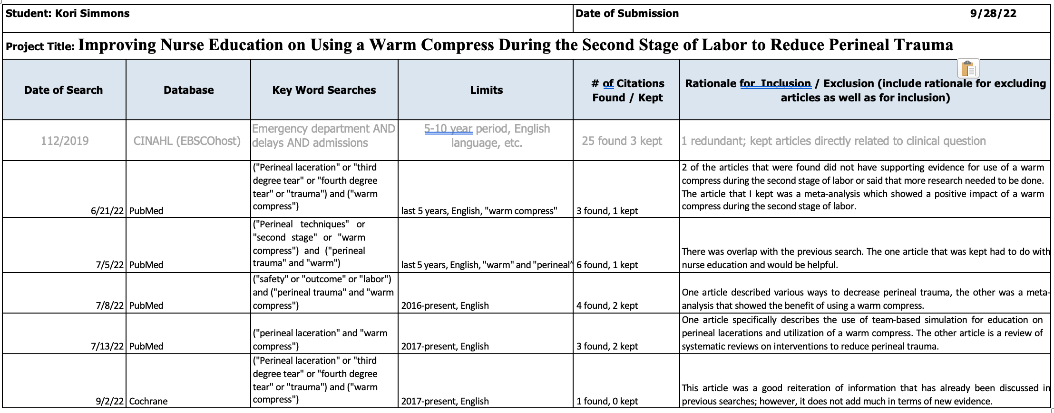
Literature Search Log

Appendix B
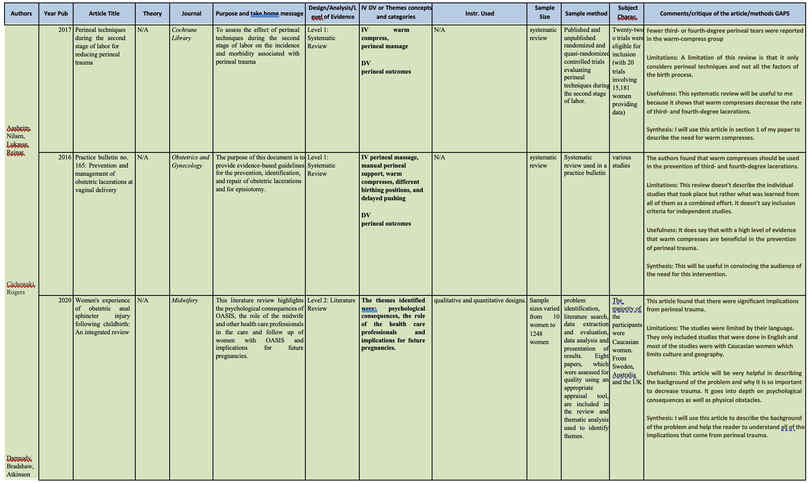
Literature Matrix
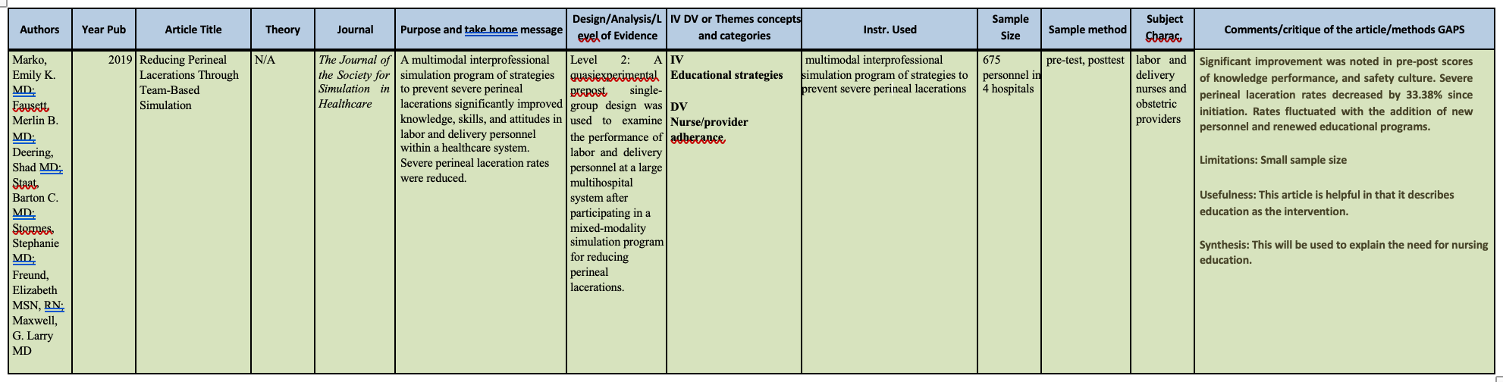

Appendix C
Driver Diagram
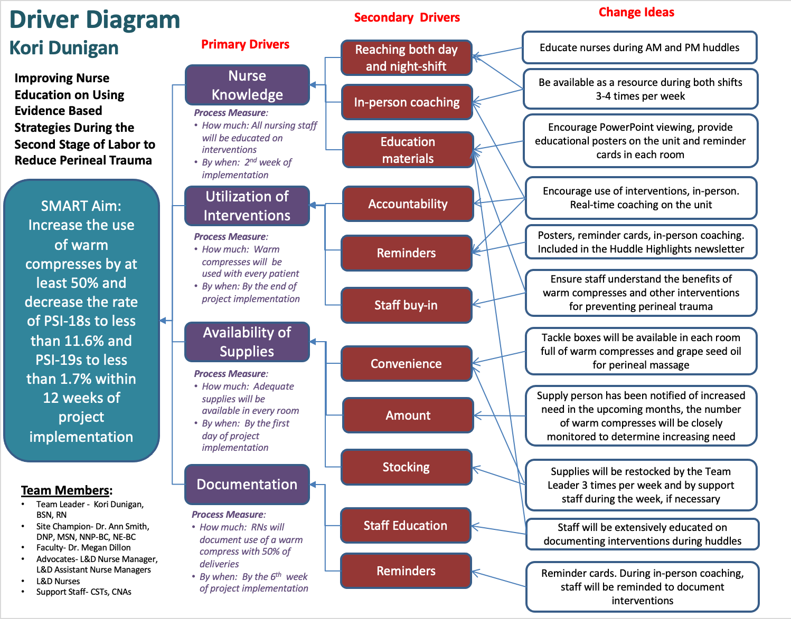

Appendix D
Timeline
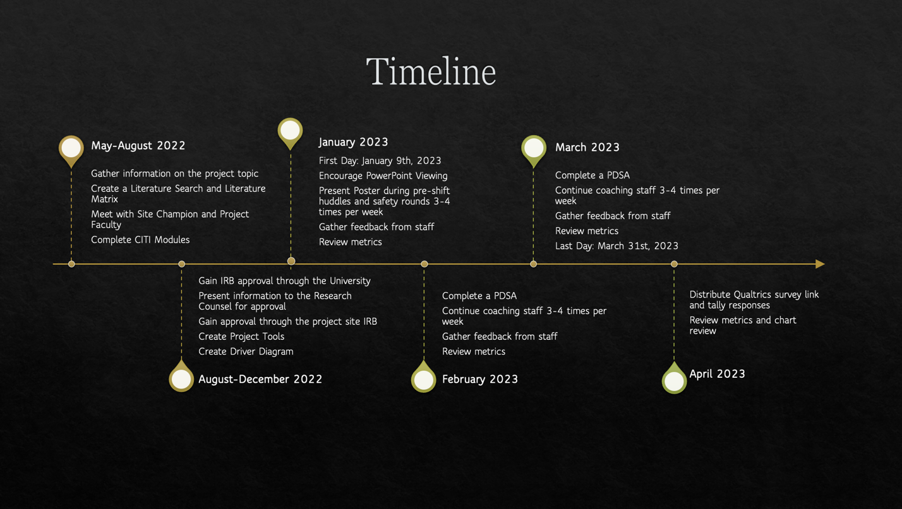

Figure 1
PSI-18 and PSI-19 Data from Quarter 1 2022 vs. Quarter 1 2023

Note. This figure represents the number of third- and fourth-degree lacerations that occurred both with and without instrumentation during the first quarter of 2022 compared to the first quarter of 2023 during implementation.
Figure 2
Rate of Perineal Trauma with and without Instrumentation Pre- and Post-Implementation

Note. This graph represents the number of third- and fourth-degree lacerations both with and without instrumentation, broken down into months. This figure further breaks down the data from 2022 compared to the data from 2023, during implementation.

Figure 3
Qualtrics Survey Results on Use of Warm Compresses Before and After Implementation

Note. This figure shows the responses gathered from the Qualtrics survey that was distributed to the nurses to take after implementation had completed. It shows how often nurses used warm compresses both before and after implementation.
Figure 4
Qualtrics Survey Results on if this Project was Helpful

Note. This figure shows the number of nurses that found the increased availability of supplies and training helpful. These responses were gathered from the Qualtrics survey that was administered post-implementation.
Appendix E
Itemized Budget
Project Itemized Budget
Project Expenses
ITEM | COST | QUANTITY | TOTAL
Tackle Boxes | $4.17 | 24 | $100.08
Poster | $14.50 | 3 | $43.50
Reminder Cards | $0.92 | 40 | $36.80
Double Sided Tape | $3.21 | 1 | $3.21
Command Strips | $0.96 | 9 | $8.64
Warm Compress | $1.15 | 250 | $287.50
Grapeseed Oil | $5.00 | 44 | $220.00
RN hourly | $32.00 | 16 | $512.00
 |  | Total | $1,211.73

