Group β Streptococcus Education for Pregnant Women at a Birth Center
Mandesa M. Smith, CNM
East Carolina University

Abstract
Group β Streptococcus (GBS) is an anaerobic Gram-positive bacteria that can colonize the genitourinary tract and place the newborn at risk for infection during the intrapartum and postnatal period. Due to this risk of vertical transmission, pregnant women are screened between 35 and 37 weeks gestation for GBS colonization. To prevent newborn GBS disease, intrapartum intravenous prophylactic antibiotics are administered. Failure to screen and treat for the bacterium can lead to early-onset GBS disease in the newborn.
In a freestanding birth center in North Carolina (NC), Certified Nurse-Midwives (CNMs) educate their clients about GBS colonization and management during the intrapartum period. During April, May, and June of 2016 only 60% (3/5), 75% (3/4), and 43% (3/7) respectively of the women at the facility received adequate GBS prophylaxis during labor. The purpose of this Doctor of Nursing Practice (DNP) project was to increase the percentage of women with GBS colonization who receive sufficient GBS prophylaxis during the intrapartum period.
A GBS patient education algorithm was implemented for use by CNMs at the birthing center. CNMs were provided printed patient education materials from the Centers for Disease Control and Prevention (CDC) and the American College of Nurse-Midwives (ACNM) on GBS screening and prophylaxis between 35 and 37 weeks gestation. Following a 90-day implementation period, the percentage of patients that received sufficient GBS prophylaxis increased from 56.52% (13/23) to 58.6% (17/29). Post implementation there was a rise in sufficient GBS prophylaxis and the CNMs perceived an improvement in patient knowledge about GBS.
Keywords: Group Beta streptococcus in pregnancy, patient education and counselling, obstetric patient education and counselling.

Acknowledgements
The author wishes to thank her Doctor of Nursing Practice (DNP) advisors Dr. Nanette Lavoie-Vaughan and Dr. Dianne Marshburn for their extensive advice and support; Dr. Ginger Breedlove, who first suggested and discussed the topic and for team leadership; Dr. Tracey Robertson-Bell for discussing the topic; Jualeah Early, CNM, for discussing the topic and assisting with data collection; Elizabeth Tyson, CNM, for assisting with data collection; and Jane Houston, DNP, CNM, and Derek Adrian, DVM for their editing skills. Without the assistance of these people, this DNP project could not have been accomplished.

Table of Contents
Abstract 2
Acknowledgements 3
Table of Contents 4
Chapter One: Introduction 6
Problem Statement 7
Justification of Problem 8
Definition of Terms 8
The Triple Aim 9
Summary 10
Chapter Two: Literature Review 11
Introduction 11
Patient Education 12
Group β Streptococcus 13
Limitations 15
Theoretical Framework 16
Summary 18
Chapter Three: Methodology 19
Introduction 19
Project Design 19
Setting 19
Sample 20
Method 20
Protection of Human Subjects 23
Instruments 24
Resources and Budget 24
Data Collection 25
Data Analysis 25
Summary 26
Chapter Four: Results 27
Introduction 27
Demographics 27
Findings 28
Feedback from Certified Nurse-Midwives 29
Summary 30
Chapter Five: Discussion 31
Review of the Problem 31
Significance of the Findings 31
Implications for Healthcare 32
Implications for the Freestanding Birth Center 34
Assumptions, Strengths, and Barriers 35
Implications for Practice 37
Conclusion 37
References 39
Appendices 46
Appendix A: GBS Prophylaxis 46
Appendix B: Literature Review 48
Appendix C: GBS PowerPoint Presentation 64
Appendix D: GBS Patient Education 71
Appendix E: Organizational Approval 74
Appendix F: East Carolina University IRB Approval 75
Appendix G: DNP Project Timeline 76
Appendix H: Data Collection Tools 77
Appendix I: Data Tables 78
Appendix J: Doctor of Nursing Practice Essentials 81

Chapter One: Introduction

Group β Streptococcus (GBS), an anaerobic Gram-positive bacterium, was the cause of the majority of the cases of early neonatal morbidity and mortality in the United States throughout the 1970s (Fox, 2016). Newborns are exposed by vertical transmission from the mother’s genitourinary or gastrointestinal tract during the intrapartum period. Ten to 30% of women are colonized with GBS in their rectovaginal area (American College of Obstetricians and Gynecologists [ACOG], 2011, p. 1019). Research in the 1980s focused on evaluating the efficacy of intravenous (IV) antibiotic administration in women during labor to combat this leading cause of death (ACOG, 2011). Based on the positive results of these studies, the American Congress of Obstetricians and Gynecologists (ACOG) and the Centers for Disease Control and Prevention (CDC) released guidelines for intrapartum prophylaxis to avert GBS infection in the newborn. In 1997, the American Academy of Pediatrics (AAP) released similar recommendations on GBS prophylaxis (Verani, McGee, & Schrag, 2010). The CDC (2014b) indicated that the favored antibiotic for GBS prophylaxis is the intravenous administration of penicillin (ACOG 2011). In 2002 the guidelines were changed to state that all pregnant women should be screened for GBS colonization between 35 and 37 weeks gestation (Appendix A) (CDC, 2014b; Verani et al., 2010). Despite the most current guidelines, GBS is still the most common infectious source for morbidity and mortality in term newborns in the United States (Verani et al., 2010).
Early-onset GBS infection (infection within the first week of life) of the newborn usually results in sepsis or pneumonia, with symptoms of “fever, difficulty feeding, irritability or lethargy, difficulty breathing, and blue-ish color to skin” presenting within 24 hours of birth (CDC, 2016c, para. 2). Meningitis can also occur with early-onset GBS infection, but is generally seen with late-onset (between the first week and three months of life) disease (ACOG, 2011; CDC, 2016d). GBS is diagnosed in newborns via culturing blood and spinal fluid samples. Chest radiographs may also aid in the diagnosis of pneumonia. Neonatal GBS infection is typically treated with intravenous administration of penicillin or ampicillin, though additional supportive treatments may be needed with more serious disease (CDC, 2016a).

Problem Statement

There is a freestanding birth center in central North Carolina that provides care to low-risk pregnant women. The primary providers at the birth center are CNMs, who believe women should have access to equitable, compassionate, ethical healthcare that is high in quality and respects the natural lifecycle (American College of Nurse-Midwives [ACNM], 2004). While CNMs are well versed about newborn GBS disease risks and guidelines for appropriate care, there are no standardized evidence-based education tools regarding the disease in place at the project site. Instead, the CNMs have complete discretion. An identified quality indicator of concern for this birth facility was the frequency at which clients receive insufficient or no intrapartum GBS prophylaxis. Failure to sufficiently treat places the newborn at risk for perinatal GBS infection, which can result in sepsis, pneumonia, or meningitis. The purpose of this Doctor of Nursing Practice (DNP) project was to provide standardized evidence-based GBS education to clients at the time of GBS screening (between 35 and 37 weeks gestation) with the intent of decreasing the percentage of GBS positive clients that receive insufficient or no prophylaxis for the bacterium during labor.

Justification of Problem
“A pregnant woman who tests positive for group β strep bacteria and gets antibiotics during labor has only a 1 in 4,000 chance of delivering a baby who will develop group B strep disease, compared to a 1 in 200 chance if she does not” (CDC, 2016b, para.1). During April, May, and June of 2016, only 60.00% (3/5), 75.00% (3/4), and 42.86% (3/7), respectively of the GBS-positive women at the freestanding birth center received sufficient GBS prophylaxis for GBS colonization during pregnancy (Early, 2016, p. 4). Lack of treatment is unnecessarily putting the newborns of these women at risk for early onset GBS infection (CDC, 2016c, para. 2).

Definition of Terms
Certified Nurse-Midwife (CNM): “registered nurses who graduated from a nurse-midwifery education program accredited by the Accreditation Commission for Midwifery Education (ACME) and passed a national certification examination to receive the professional designation of certified nurse-midwife” (American College of Nurse-Midwives [ACNM], 2012a, p. 1). CNMs provide a wide array of healthcare options for women throughout the lifespan.
ACNM (2012a) states the following:
These services include primary care, gynecologic and family planning services, preconception care, care during pregnancy, childbirth and the postpartum period, care of the normal newborn during the first 28 days of life, and treatment of male partners for sexually transmitted infections (p.2).
Group B Streptococcus (GBS): an anaerobic Gram-positive bacteria that is the main culprit for early-onset neonatal sepsis in the United States (Fox, 2016; Verani et al., 2010).
Group B Streptococcus (GBS) prophylactic treatment: the first line agents are penicillin and ampicillin. If the woman is allergic to Penicillin, she must be administered cefazolin, clindamycin, or vancomycin depending on the severity of the woman’s allergy to penicillin and the susceptibility of the GBS (CDC, 2016e).
Intrapartum: labor and birth of a fetus (National Institute for Health and Care Excellence [NICE], 2014, para 1).
Insufficient treatment: client colonized with GBS in the rectovaginal area received prophylactic antibiotics less than four hours prior to birth (Verani et al., 2010).
No treatment: client colonized with GBS in the rectovaginal area received no prophylactic antibiotics prior to birth (Siegel, 1988).
Sufficient treatment: client colonized with GBS in the rectovaginal area received prophylactic antibiotics ≥ four hours prior to birth (Verani et al., 2010).
Vertical transmission: the woman with a rectovaginal area colonized with disease transferring the bacterium to the newborn during a vaginal birth (Verani et al., 2010).

The Triple Aim
The Institute for Healthcare Improvement (IHI) Triple Aim is a method that was created to better “health system performance” (IHI, 2017, para. 1). The three components of Triple Aim are “improving the patient experience of care (including quality and satisfaction); improving the health of populations; and reducing the per capita cost of health care” (IHI, 2017, para. 1). Triple Aim is a systematic method that attempts to improve the health care system at all levels.
This project intends to improve quality of care by ensuring that all clients are informed about GBS and the importance of standard of care for all women between 35 and 37 weeks gestation. In addition, women who screen positive will be encouraged to agree to intrapartum GBS prophylactic treatment, which requires arrival at the center at least four hours prior to birth (CDC, 2016b). Currently, this facility has not had any newborns contract GBS infections (Early, 2016).
Lastly, in regard to cost savings, the CDC reports that prior to introducing GBS prophylactic treatment during labor, the U.S. spent $294 million providing medical care for newborns with GBS disease (CDC, 2016f). Oster et al. (2014) estimate that despite current CDC guidelines, 2,295 neonates will contract GBS disease within their first three months of life, which cost $110.9 million in medical care. Out of the 2,295 neonates, they estimate that 117 of these neonates will die. Of the 2,178 that will live, 154 will have mild long-term disability (7 out of 100), 294 will have moderate long-term disability (13 out of 100), and 168 will have severe long-term disability (8 out of 100) (Oster et al., 2014).

Summary
Pregnant women who screen positive for GBS colonization in pregnancy should receive GBS prophylactic treatment during the intrapartum period to reduce the risk of transmission to their newborns. Disease transmission to the newborn can result in the development of early or late-onset GBS disease. At a freestanding birth center in North Carolina, some of the clients that screen positive for GBS colonization are not receiving sufficient or any treatment for GBS prophylaxis, therefore putting their newborns at risk for GBS disease. With the implementation of this project, the goal is that more women who screen positive for GBS will receive sufficient GBS prophylaxis and that none of their newborns will contract GBS disease.

Chapter Two: Literature Review

Introduction
Two topics pertained to this DNP project: patient education and GBS prophylaxis in labor. Based on these two main areas, the literature review is composed of articles from three search engines, Google Scholar, PubMed, and UptoDate. The key words used for the search in Google Scholar were “patient education and counseling,” “obstetric patient education and counseling,” and “Group Beta Streptococcus in pregnancy.” The publication date was limited to 2011 onward. These key words were chosen because this project focused on GBS in pregnancy and patient education. The first search using “patient education and counseling” resulted in 24,200 articles with four articles identified that pertained to nurses providing patient education and mechanisms that can be used to provide patient education. The second search using “obstetric patient education and counseling” resulted in 17,300 articles with two articles related exactly to providing patient education in the area of obstetrics. The final search using “Group Beta Streptococcus in pregnancy” resulted in 17,200 articles, and seven were found to discuss GBS prophylaxis and neonatal GBS infection (Appendix B).
A literature search was performed in PubMed using the key words “patient education and obstetric”, “Group Beta Streptococcus and Pregnancy”, and “patient education and GBS in pregnancy.” These key words were chosen with the objectives of finding information about GBS in pregnancy, patient education mechanisms for obstetric patients, and patient education on GBS. The publication date was set at 2011 and later. A search using keywords “patient education and obstetric” resulted in 194 articles, and one was reviewed as pertinent to the project based on its being full text, high in quality, and pertaining to obstetric education. Secondary key words “group beta Streptococcus and pregnancy” were used in this search, which resulted in 30 articles; one was original work pertaining to GBS management. A final search used key words “patient education and GBS in pregnancy.” This search resulted in six articles, and one article was deemed appropriate based on specific details of this project and present clinical guidelines (Appendix B).
Lastly, a literature search was performed in UpToDate using the key words “Group Beta Streptococcus in pregnancy.” The search resulted in 121 articles. Two of the articles identified with a focus on GBS and pregnancy were used (Appendix B).

Patient Education
Patient education is defined as the provider ensuring the patient has sufficient, comprehensible information so he/she can make an informed decision about his/her health. The patient has expert knowledge about his/her life (Fahlberg, 2015). Patients that are well-educated about a condition that pertains to them are more likely to follow the recommended treatment plan (Martin, 2015). When a patient decides not to follow the recommended treatment, it is not a failure on the part of the provider. The client is responsible for his/her decisions and the consequences that coincide with it (Fahlberg, 2015).
Patient education can be provided in a multitude of ways, one being printed documents. The objective of a printed health education tool is to expand the patient’s understanding of his or her health, while also providing a reference for later questions (Heilman, 2013). Evidence-based brochures have been shown to increase the client’s comprehension of a condition compared to having no written information offered by the provider, and are superior to multimedia formats of education (Dugas, et al., 2012; Friedman, Cosby, Boyko, Hatton-Bauer & Turnbull, 2011; Wilson et al., 2012;). Furthermore, the evidence suggests that information can be best disseminated when an oral conversation is supplemented with printed health education materials that the provider also explains to the patient (Dugas et al., 2012; Friedman et al., 2011; Heilman, 2013). The addition of illustrations within the printed document can make it even more helpful to client (Heilman, 2013).

Group β Streptococcus
The second topic that pertains to this project is the screening for and prophylactic treatment of GBS colonization during pregnancy and the intrapartum period to prevent vertical transmission of the bacterium. The primary risk factor for early-onset GBS in the newborn is active colonization of the mother’s rectovaginal area with GBS, which has been shown to be present in 10% to 30% of pregnant women world-wide (ACOG, 2011; Baker, 2016; Melin, 2011; Puopolo & Baker, 2017). Preterm birth (birth before 37 weeks gestation), prolonged rupture of membranes (≥ 18 hours), infection of the amniotic fluid or uterus, previous history of newborn GBS infection, presence of GBS bacteriuria, and “young maternal age and black race” are additional risk factors (ACOG, 2011, p. 2; Baker, 2016; Puopolo & Baker, 2017). These additional risk factors are used to evaluate whether intrapartum GBS prophylaxis is needed if woman’s GBS status is unknown (Baker, 2016).
Pregnant women between 35 and 37 weeks gestation should be screened for GBS colonization, unless a urinary infection with GBS has been previously identified (ACOG, 2011; Ahmadzia, Heine & Brown, 2013; Baker, 2016, Melin, 2011; Puopolo & Baker, 2017). GBS culture has poor predictive value beyond 5 weeks, so screening should not occur before this period (Baker, 2016). Proper swabbing for culture should include both the vaginal introitus and anal sphincter (ACOG, 2011; Ahmadzia et al., 2013; Baker, 2016; Melin, 2011; Puopolo & Baker, 2017). If GBS colonization is identified in a mother, she should be treated with antibiotics, preferably penicillin, during the intrapartum period (ACOG, 2011; Ahmadzia et al., 2013; Melin, 2011; Baker, 2016; Puopolo & Baker, 2017). Between 2006 and 2009, only 63% of the women who had a term newborn with early-onset GBS infection were screened for GBS colonization during their pregnancy (Ahmadzia et al., 2013).
Early-onset GBS infection in newborns usually occurs within the initial six days of the newborn’s life, but most of the signs present themselves within the first 24 hours of life (Madhi et al., 2013; Melin, 2011). Early-onset GBS disease is the most common cause of morbidity and mortality amongst newborns, affecting approximately 1,050 newborns per year (Fairlie, Zell, & Schrag, 2013, p. 570). After vertical transmission of the bacterium to the neonate during the intrapartum period, GBS can imbed in the pulmonary epithelial and endothelial cells, before ultimately transferring into the bloodstream. This can lead to pneumonia, sepsis, and, less frequently, meningitis. Meningitis is usually seen in newborns with late-onset GBS infection at about one month of age (Madhi et al., 2013; Melin, 2011).
To reduce the risk of vertical transmission of GBS from the mother to the fetus during labor and birth, intravenous antibiotics are administered to the pregnant woman during the intrapartum period (Melin, 2011). Penicillin is the primary prophylactic treatment of choice, though ampicillin is listed as an acceptable alternative option (ACOG, 2011; Baker, 2016; Fairlie et al., 2013; Melin, 2011). The research shows women who receive penicillin or ampicillin less than four hours prior to birth are more likely to have a newborn that develops early-onset GBS (Baker, 2016; Fairlie et al., 2013). Infusing antibiotics four or more hours prior to birth has an 85% rate of success at impeding early-onset GBS (Fairlie et al., 2013, p. 570). One research study found that one-third of women received intrapartum prophylaxis less than four hours prior to birth. Of these women, 14% were given intrapartum prophylaxis due to the medical staff’s failure to administer the antibiotics when they had sufficient time (Fairlie et al., 2013).
If a woman has a known mild allergy to penicillin or ampicillin, clindamycin or cefazolin can be used instead (ACOG, 2011; Baker 2016; Fairlie et al., 2013). GBS has become very resistant to clindamycin; therefore, cefazolin is preferred over clindamycin for women who have a penicillin allergy (Fairlie et al., 2013). The chances of a woman finding out that she is allergic to penicillin during the intrapartum is about 0.7% to 4% (ACOG, 2011). The risk of an anaphylactic reaction is 4/10,000 to 4/100,000. Based on these statistics, the benefits of preventing early-onset GBS infection in the newborn drastically offset the risk of an allergic reaction to the woman and her fetus during the intrapartum (ACOG, 2011). Since the implementation of the CDC guidelines, infant mortality and morbidity related to GBS disease have decreased significantly, specifically an 85% decrease in early-onset GBS disease (Burns & Plumb, 2013; Fairlie et al., 2013).

Limitations
One of the challenges to this literature review was that most articles that discussed patient education were a lower level of evidence. In addition, some of the articles under the terms searched included discussions of patient education, but it was not the focus of the article. Additionally, the majority of the articles pertaining to GBS in pregnancy did not pertain to treatment during the intrapartum. Instead, many of the articles focused on creating a vaccine or on culture collection. Finally, many of the articles pertained to populations in countries where the CDC guidelines are not the standard of care.
In the United Kingdom, the standard of care for GBS management is different from the US guidelines. Per National Institute for Health and Care Excellence (NICE) guidelines, women are provided benzylpenicillin, which is the first line agent, during the intrapartum if they have had a previous baby infected with GBS or have been diagnosed with GBS colonization (bacteriuria or infection) during the current pregnancy. If the woman is allergic to penicillin, clindamycin should be offered per the NICE guidelines (2012). These women are treated at the start of labor until the birth of their newborn. Women in preterm labor with ruptured membranes should be offered intrapartum GBS prophylaxis. Lastly, the NICE guidelines do not recommend routine antenatal screening for GBS due to unknown clinical and financial efficacy in their target demographic (NICE, 2017).

Theoretical Framework
Two theories shape the theoretical framework for this DNP project: the Adult Learning Theory and the Health Promotion Model. The Adult Learning Theory and the Health Promotion Model have been used in previous studies as the theoretical foundation for patient education. Papadakos et al. (2014) used the Adult Learning Theory to create a tool named “3Ws and an H,” to assist providers in creating useful patient education resources. Vadaparampil, Hutchins and Quinn (2012) created a distance learning from named Educating Nurses about Reproductive Issues in Cancer Healthcare (ENRICH) with the Adult Learning Theory as the theoretical framework which allowed the oncology nurses to effectively educate their clients about their health and obtain and improve their care. Lastly the Adult Learning Theory was also used by Suter, Suter, and Johnston (2011) in the creation of their telehealth tool. The tool was developed to assist in the care those with chronic illness that were getting home heath assistance. The telehealth tool was effective at educating patients and their caregivers about symptom identification and management, plus when to call for telehealth assistance.
The Health Promotion Model was used for the theoretical framework for a study on encouraging exercise and a study on educating patients about diabetes. Esposito and Fitzpatrick (2011) investigated nurses’ beliefs and behaviors in regard to exercise and whether they educated their patients to exercise. Esposito and Fitzpatrick (2011) found a positive correlation between the nurses’ health promotion opinion about exercise and educating their clients about exercise and incorporating it in their plan of care. Kelley, Chiasson, Downey, and Pacaud (2011) created an electronic Health system to educate patients with type II diabetes. The tool increased the patients’ comprehension about diabetes, self-care activities, and how to lower their blood sugars. The researchers noticed a decrease in the type II diabetics Hemoglobin A1Cs (Kelley et al., 2011). Based on the previous studies it is appropriate to use the Adult Learning Theory and the Health Promotion Model for this project. The Health Promotion Model is based on the idea that a person’s characteristics and life events affect his/her behavior (Syx, 2008). Within this model are four major concepts: the person, the environment, health, and nursing. The person is the individual that is the primary focus of the model (Butts & Rich, 2015). For this project, the sample population is pregnant women between 35 and 37 weeks gestation receiving care at the freestanding birth center. The environment is “the physical, interpersonal and economic circumstances in which persons live” (Butts & Rich, 2015, p. 399). Health is considered a “positive high-level state” (Butts & Rich, 2015, p. 399). It is defined by the person, and the person has to be driven to better his/her health. The person also has to be motivated to avoid, sense, and alleviate sickness and protect his/her current health (Butts & Rich, 2015). Based on this model, the CNM must provide recommendation for the gold standard prophylactic treatment in pregnant women who culture positive for GBS colonization to protect their newborns from early-onset GBS disease. The last major concept is nursing. It is nursing’s responsibility to make patients aware of their health, encourage healthy life changes, and help patients cope with health barriers. Advanced practice nurses have a responsibility to their clients to encourage health promotion (Butts & Rich, 2015). This reinforces the need of CNMs at the freestanding birth center to inform their patients about screening for GBS colonization and the importance of GBS prophylaxis during the intrapartum.

Summary
This project focuses on two topics: patient education and GBS in pregnancy. The literature review reflected many ways to educate a client. Evidence supports that one of the effective ways to educate a patient is the use of written material, such as brochures and handouts. For these materials to be most effective, they should be discussed with the client. Time should be allowed for questions, and the materials should be sent home for future referencing.
In addition, evidence in the literature consistently showed that women should be screened for GBS colonization during their pregnancy as a best practice. The standard of care for those that screen colonized for the bacterium include receiving antibiotics, preferably penicillin, during the intrapartum. This is done to prevent early-onset and late-onset GBS disease in the newborn. GBS disease in the newborn can present as pneumonia, sepsis, or meningitis and even lead to death.

Chapter Three: Methodology

Introduction
The purpose of this chapter is to provide information about the project design, the clinical setting of the project, the sample of clients, and the project methodology. The purpose of this project was to increase the CNMs’ knowledge about GBS, which would enable them to better educate their clients, and add to their decision making regarding management of pregnant clients with GBS colonization. Therefore, the clinical question was: would the implementation of standardized evidence-based education about GBS and the potential health implications of GBS infection within the newborn (sepsis, pneumonia, or meningitis) at a freestanding birth center increase the percentage of pregnant clients colonized with GBS receiving sufficient GBS prophylaxis during labor?

Project Design
This DNP project used a pre- and post-descriptive design. It was a descriptive design because the sample population were being evaluated on whether they received sufficient GBS prophylaxis (Research Methodology, 2016). It was also a pre- and post- design because it includes a comparison of data being collected prior to and after the intervention to determine if an improvement occurred.

Setting
The location for this project is a freestanding birth center in North Carolina with an average of 30 births per month. Currently seven full-time CNMs and two as needed (PRN) CNMs work at the birth center. CNMs have access to penicillin, ampicillin, cefazolin, and vancomycin, so they can appropriately treat women who screen positive for GBS colonization prophylactically during the intrapartum.

Sample
Participants for the project were the providers (seven full-time CNMs and two PRN CNMs) who were caring for women being seen at the birth center. Population focus included women of childbearing age who were between 35 and 37 weeks gestation. The anticipated number of women who would meet criteria to be seen during the project was 180. The demographic population at the birth center consisted of mostly Caucasian women who live in North Carolina. However, women of African American, Asian, and Hispanic decent also received care at the birth center. Women seen at the birth center for care were considered as having a low-risk or medium- risk pregnancy.

Method
The project lead educated the CNMs, ancillary staff (medical assistance, registered nurses), and center management team about GBS, GBS screening, and GBS management during pregnancy using a PowerPoint presentation at a clinical staff meeting on April 20, 2017 (Appendix C). The CNMs and ancillary staff were given the opportunity to ask questions at the completion of the presentation. In addition, they were given a copy of the GBS patient education materials, which were provided to their patients for reading and reviewing (Appendix D).
During the presentation the CNMs received a paper copy of the GBS Patient Education Algorithm (see Figure 1) to guide the patient education process, materials about GBS screening and prophylaxis, and the patient education materials for a visual aid: a) “Indications and non-indications for intrapartum antibiotic prophylaxis to prevent early-onset group B streptococcal (GBS) disease,” b) “Recommended regimens for intrapartum antibiotic prophylaxis for prevention of early-onset group B streptococcal disease,” c) “Group B Strep: What you need to know,” and, d) “Group B Strep in pregnancy” (ACNM, 2015; ACOG, 2011; CDC, 2010; CDC, 2014a) (Appendices A & D). In addition, a copies of the “Indications and non-indications for intrapartum antibiotic prophylaxis to prevent early-onset group B streptococcal (GBS) disease” and “Recommended regimens for intrapartum antibiotic prophylaxis for prevention of early-onset group B streptococcal disease” were made available in all clinic rooms (ACOG, 2011; CDC, 2010). After the CNM education session, the CNMs educated their clients by distributing and reviewing the “Group B Strep: What you need to know” and “Group B Strep in pregnancy” on May 1, 2017 (ACNM, 2015; CDC, 2014a) (Appendix D).

Figure 1. GBS Patient Education Algorithm
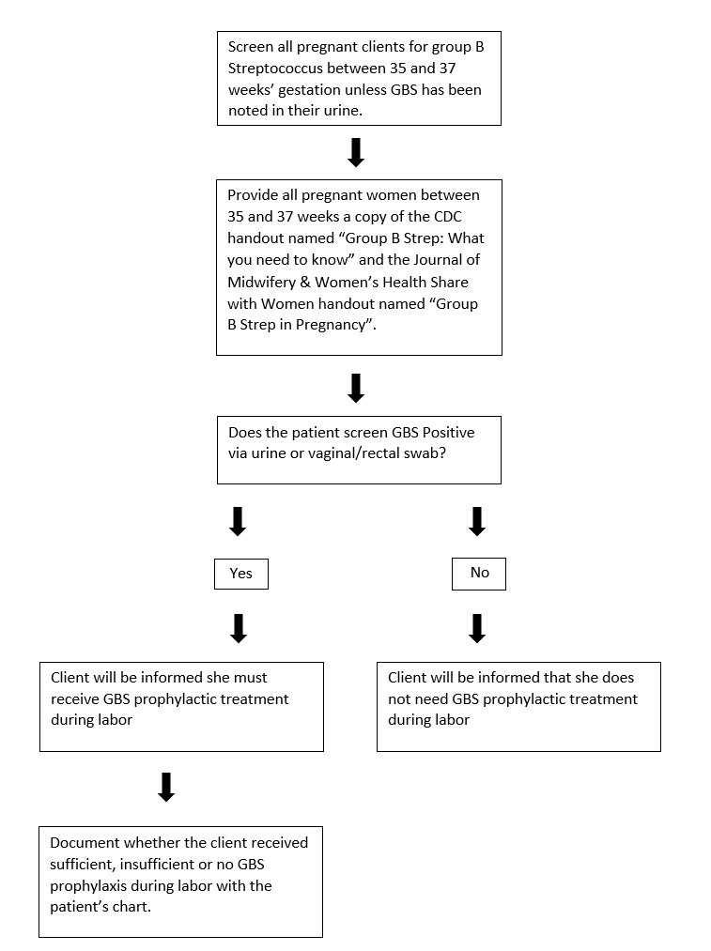
Figure 1. Algorithm for implementing patient education on group β Streptococcus (GBS) screening and intrapartum prophylaxis within a birth center

The quality of the improvement project was evaluated using the Plan-Do-Study-Act (PDSA) cycle (Agency for Healthcare Research and Quality, 2013). Data were collected at the end of each month and shared with the CNMs at their clinical staff meetings. The CNMs were re-educated about the GBS patient education algorithm, standard of education regarding GBS at 30 and 60 days after project implementation, and opportunities for improvement were identified. The main barrier identified during the implementation was the CNM remembering to provide the education. As a follow-up the CNMs were informally reminded on the use of the algorithm on a weekly basis. When new employees were hired they were educated about the quality improvement project and the algorithm during their orientation. These steps were implemented to ensure all the CNMs educated their clients about GBS using the algorithm.
During the Study phase of the PDSA cycle, data were collected and evaluated at three months pre intervention and post intervention. In the Act phase and at the completion of the project, the CNMs and project lead evaluated project barriers, improvement opportunities, and sustainability. Additionally, 90 days after project implementation, the CNMs assessed whether the intervention should be continued at the freestanding birth center and whether any improvements needed to be made.

Protection of Human Subjects
Organization approval was obtained at the freestanding birth center prior to implementing the project (Appendix E). The proposal was also reviewed by East Carolina University’s Institutional Review Board (IRB) and deemed as non-human subject research (Appendix F). The clients’ information at the freestanding birth center was de-identified by a designated CNM at the birth center. Aggregate monthly data were provided by the designated CNM and included the total number of women who birthed that month, the total number of women colonized with GBS, and the number of women who had sufficient, insufficient, or no GBS prophylaxis.

Instruments
Patient education handouts from the CDC and ACNM were used to educate the pregnant women at the freestanding birth center about GBS colonization and GBS prophylaxis. The CDC is part of the U.S. Department of Health and Human Services and use science to protect the health, welfare, and safe haven of Americans by providing health information to the population (CDC, 2017). The ACNM is the professional organization for CNMs and certified midwives (CMs) (Varney, 1997). The organization’s core values are excellence, evidence-based care, formal education, inclusiveness, women-centered care, and respect of physiologic processes, primary care, partnership, advocacy, and global outreach. These values are met by performing research and spreading knowledge (ACNM, 2012b).
The patient education handouts that were used include “Group B Strep: What you need to know” and “Group B Strep in pregnancy” (ACNM, 2015; CDC, 2014a) (Appendix D). Based on the intent and purpose that information created by the CDC and ACNM their resources are reliable, valid, and evidence-based. Materials obtained from these organizations were available on organization websites at no cost.

Resources and Budget
The freestanding birth center was estimated to assist approximately 30 women per month to give birth during 2017 (J. Early, personal communication, March 15, 2017). Data were collected post-intervention from May 1 to July 31. Therefore, an estimated 180 pregnant women would receive the patient education materials during data the three-month data collection for this project.
Pertaining to the actual cost of the project, 173 women birthed post intervention and they received two educational handouts. Therefore, 519 color copies at a cost of 11 cents per copy were printed at the project site. The freestanding birth center spent $57.09 plus tax on color paper documents (Staples, 2014).

Data Collection
Three months (February 2017 to April 2017) of pre-existing data were collected prior to project implementation (Appendix G). GBS treatment data was retrieved from a de-identified data collection tool created by the freestanding birth center, and categorized as sufficient, insufficient, or no treatment (Appendix H). Post intervention de-identified data were collected at the end of each month.

Data Analysis
The descriptive statistics used to evaluate the data were percentages and frequency. A monthly comparison of the percentages and frequency of clients colonized with GBS that had sufficient, insufficient, or no GBS prophylaxis was performed prior to implementing the project. After the project was implemented, the same factors were compared at the end of each month to evaluate whether there was improvement. Significance could not be calculated because the sample size was small. The mean and standard deviation were calculated at the end of data collection for pre and post project data.
By the end of the project, it was expected that more pregnant women who screened colonized for GBS would receive sufficient GBS prophylaxis during labor and that fewer women would receive insufficient or no GBS prophylaxis. This would decrease the risk of newborn early-onset GBS infection in the patient population. In addition to evaluating the data, barriers to project implementation and areas for improvement were investigated.

Summary
The objective of this DNP project was to increase the number of pregnant women with GBS at a freestanding birth center in North Carolina who receive sufficient GBS prophylactic treatment during labor. By educating the providers about GBS and intrapartum GBS prophylaxis, plus the implementation of an algorithm providing clients at 35 to 37 weeks gestation with the GBS evidence-based education handout “Group B Strep: What you need to Know,” an improvement in sufficient GBS prophylaxis was expected. To evaluate the effectiveness of providing standardized evidence-based education, the number of women who had sufficient, insufficient, or no GBS prophylaxis prior to and after the implementation of the evidence-based education was compared. Barriers and areas for improvement were evaluated at 30 and 60 days post intervention.

Chapter Four: Results

Introduction
The objective of this project was to increase the percentage of pregnant women colonized with GBS getting sufficient prophylactic treatment during the intrapartum period. Data were collected and evaluated at the end of each month following implementation. Using the PDSA Cycle review process at 30, 60, 90 days, data were shared with the CNMs, and barriers were discussed.

Demographics
Five full-time CNMs, one PRN CNM, ancillary staff (medical technician and two registered nurses) and the center management team attended the initial education session on April 20th, 2017. The group found the session beneficial, especially the ancillary staff and the center management team, because they shared that they were deficient in knowledge about GBS and GBS prophylaxis. During May, two full-time CNMs had to be educated separately because one was a full-time new hire, and one was not present at the initial education session. At 30 days post implementation (end of May) PDSA review cycle all the CNMs and ancillary staff were present. The algorithm, education materials, barriers and pre and post data were reviewed. At the 60 days post implementation (end of June) PDSA review cycle, seven CNMs and the ancillary staff were present for the meeting. The algorithm, education materials, barriers and post data were again reviewed. An improvement was discussed between May and June data. Ninety days post implementation (end of July), seven CNMs were present for the meeting. The algorithm, education materials, and barriers were reviewed. The data across the three months post implementation was discussed, and project continuation was considered.
The population sample included 73 females pre project implementation and 100 females post project implementation. During the pre-implementation period, 23 women were GBS positive. Over the three months post-implementation 29 women were GBS positive. All of these women received prenatal and intrapartum care from the birth center CNMs.

Findings
Three months prior to implementation of the GBS patient education algorithm, there were 26 births in February, 22 in March, and 25 in April for a total of 100 births over the three month period. (Appendix I). Of the 73 women, 23 (31.5%) were colonized with GBS. Thirteen (56.52%) of these GBS positive women received sufficient GBS prophylaxis during the intrapartum period. February had the highest percentage of sufficient GBS prophylaxis with 60% and had the lowest number of GBS positive women (Appendix I).
Over the three-month period following the initial GBS education session there were 31 births in May, 37 births in June, and 32 in July. Of the 100 women, 29 (29%) were screened positive for GBS. Of the 29 women who were GBS positive, 17 (58.62%) received sufficient GBS prophylaxis during the intrapartum period. The highest percentage and number of clients that received sufficient GBS prophylaxis occurred in the second month (June) post project implementation with 76.92% (10). June also had the highest number of births (37) and percentage that were GBS positive (35.14%) (Appendix I).
The data showed one third of the sample pre and post implementation were colonized with GBS. There was an increase in sufficient GBS prophylaxis during the intrapartum period post implementation. The percentage of GBS positive women who received sufficient GBS prophylaxis post implementation was 58.6% compared to 56.5% pre implementation. Therefore over the three-month period there was a 2.1% increase in sufficient GBS prophylaxis.

Feedback from Certified Nurse-Midwives
Following the 90-day implementation, the CNMs shared that they used IV ampicillin for GBS prophylaxis and would continue to track the number of women who receive sufficient, insufficient, and no GBS prophylaxis. They used IV ampicillin because it was cheaper and does not burn during administration in comparison to penicillin. The CNMs plan to continue to track GBS statistics to evaluate quality of care at the site.
The CNMs provided feedback on the use of the patient education algorithm and to continue use as standard of practice at the site. Feedback from CNMs included a perceived increase in the patient’s understanding of their GBS status and the importance of GBS prophylaxis. GBS positive clients appeared to call during early labor verses active labor because they were GBS positive and wanted sufficient GBS prophylaxis. Clients would state that they wanted to come in earlier for intrapartum evaluation. The clients also seemed more informed about the risks to the baby stemming from insufficient or no GBS prophylaxis. Finally, the clients seemed more consistent at documenting GBS home sepsis management for the newborn.
The CNMs reported that having a tangible reference that reinforced the information on GBS to the clients was beneficial. One of the CNMs thought it would be beneficial to add information about what was involved in a GBS workup for a newborn should signs of infection occur. Another CNM suggested adding information about newborn gut flora due to client perception that administering IV antibiotics to the mother during labor negatively affects the newborn gut, despite it being sterile.
At the freestanding birth center, women are admitted intrapartal when they are in active labor. The CNMs stated a barrier to the project was remembering to provide the information, and some GBS positive clients had a precipitous birth or a short phase of active labor. They stated the medical technician did help remind them to provide clients with the GBS education handouts. Some clients could not get sufficient GBS prophylaxis during the intrapartum period because their total labor or active labor was less than four hours long.

Summary
One third of the birth center clients screened GBS positive pre and post implementation. Post implementation there was an increase in the percentage of women that received sufficient GBS prophylaxis during the intrapartum period. Due to the increase in sufficient GBS prophylaxis and the perceived benefit of a tangible reference to supplement GBS education, the CNMs at the freestanding birth center decided to continue use of the algorithm and data collection. The CNMs requested that additional information be added about how the newborn’s gut flora is affected by intrapartum antibiotics and the medical management for newborns suspected with a GBS infection.

Chapter Five: Discussion

Review of the Problem
Ten to 30% of pregnant women are colonized with GBS in their rectovaginal area (ACOG, 2011). A newborn birthed by a GBS positive woman has a one in 200 chance of becoming infected with GBS if the mother does not receive intrapartum GBS prophylaxis, with that risk decreasing to one in 4000 with sufficient prophylaxis (CDC, 2016b, para.1). Newborn GBS disease can lead to sepsis, pneumonia, meningitis, or death (Madhi et al., 2013; Melin, 2011).
At a freestanding birth center in North Carolina, CNMs provide full scope midwifery care for women. Prior to the project, the CNMs had no standardized approach to client GBS education. During April, May, and June of 2016, only 60.00% (3/5), 75.00% (3/4), and 42.86% (3/7) respectively of the GBS positive women at the freestanding birth center received sufficient GBS prophylaxis during the intrapartum period (Early, 2016, p. 4). The purpose of the project was to provide a standardized evidence-based GBS education to clients at the time of GBS screening to increase the percentage of GBS positive women who received sufficient GBS prophylaxis during the intrapartum period.

Significance of the Findings
The theoretical framework used to guide the project was the Adult Learning Theory and Health Promotion Model. The CNMs expressed the need for clients to be screened for GBS and referred to the evidence-based GBS education handouts, which was supported by the Adult Learning Theory. The objective of educating the clients about GBS screening and GBS prophylaxis was supported by the Health Promotion Model because the intent was to reduce risk of GBS vertical transmission to the newborn, thus improving health.
Results from the project implementation demonstrated that approximately one third of the sample was colonized with GBS which is consistent with the reported prevalence in the pregnant population (ACOG, 2011). In addition, there was a slight increase (2.1%) in the percentage of GBS positive women who received sufficient GBS prophylaxis during the intrapartum period. This improvement may be due to the GBS education algorithm. The CNMs did report that the clients seemed more knowledgeable about GBS in pregnancy, GBS prophylaxis, and the risk to their newborn.

Implications for Healthcare
In reference to the Triple Aim theory, this project aimed to improve the quality of healthcare for GBS positive women and their newborns, while reducing potential healthcare costs. The quality of the healthcare was improved by providing quality GBS patient education. The CNMs noticed that their clients seemed more informed about their GBS status and GBS prophylaxis. Anecdotal feedback reflect that clients with GBS colonization notified their CNM earlier in the labor process with a desire to get sufficient GBS prophylaxis.
In regard to the cost of administering antibiotics during the intrapartum, the freestanding birth center orders from McKesson Pharmaceuticals. To administer the antibiotics, the CNMs need 100cc bags of normal saline (NS), IV tubing, IV start kit, and an 18-gauge IV catheter. A quantity of 96 normal saline 100cc bags costs $3.81. A 50 count of IV start kits with a Tegaderm dressing costs $1.15. A 50 count of IV tubing costs $0.67, and a 100 count of 18-gauge IVs 100 costs $22.89. A 10 count of penicillin G 5 million milliunits costs $383. 09. A 10 count of ampicillin 1 gram costs $75.00. A 10 count of vancomycin costs $10.84 (McKesson Corporation, 2016). Per El Helali et al. (2012), a hospital pays $1.52 per 5 million units of penicillin. Therefore, antibiotic infusion for intrapartum GBS prophylaxis is a low cost intervention.
In contrast, the medical expenses due to GBS infection of the newborn can be quite costly. The estimated direct cost of acute care due to early-onset GBS infection is $17,833 per newborn, while late-onset GBS infection can cost $20,698. These estimates are based on the hospital expenses for newborns with meningitis, septicemia, and pneumonia (Oster et al., 2014). Because of this vast difference in expense, it is economically sound to administer intrapartum antibiotics for GBS prophylaxis rather than risk treating a newborn with early-onset or late-onset GBS. Therefore, providing sufficient GBS prophylaxes during the intrapartum to improve health and reduce healthcare costs is imperative.
The health of our newborns and healthcare costs can also be positively affected by the development of a GBS vaccine. Researchers are developing a GBS vaccine to reduce neonatal GBS disease on an international level, as GBS infection is the leading cause of neonatal death across the globe (Kobayashi et al., 2016; Oster et al., 2014; Verani et al., 2010). A GBS vaccine would be beneficial for newborns that are born to women with insufficient or no GBS prophylaxis (Kobayashi et al., 2016). Routine immunization with the vaccine would be implemented at 28 weeks gestation (Oster et al., 2014). The estimated cost of the vaccine would be as high as $100 per vaccine or as low as $10-30 per vaccine (Kobayashi et al., 2016; Oster et al., 2014). The vaccine could be 50% to 90% effective at preventing newborn GBS disease in term newborns (Kobayashi et al., 2016, p. 23). This vaccine could be incorporated into the GBS Patient Education Algorithm, further reducing the risk of newborn GBS infection.

Implications for the Freestanding Birth Center
Following the project implementation phase, the CNMs at the freestanding birth center decided to continue to use the GBS patient education algorithm as the standard for educating clients about GBS. In addition, GBS statistics on whether the GBS positive women receives sufficient, insufficient, or no GBS prophylaxis will be collected as a quality indicator. These statistics are shared with the collaborating hospital and medical director. The CNMs also plan to continue using ampicillin as their drug of choice for GBS prophylaxis.
The CNMs saw benefits of having a tangible resource for their clients. It was suggested that additional education components be added to the GBS education process. Based on the CNMs’ recommendations information about intrapartum antibiotics and the effect on newborn gut flora plus information about newborn GBS workup should be added to the patient education materials.
The CNMs, medical technician, registered nurses, and the center management team were present at the initial education session and the 90 day review. The birth center team shared that they found the QI project informational and they lacked knowledge about GBS. The CNMs did state the medical technician was helpful in regard to reminding them to provide clients with the GBS education handouts because she assisted with lab collection. It was important to include the whole team because everyone interacts with the clients on a regular basis. There is an opportunity for others to ensure that the clients received all their resources.
Implementation of the patient education algorithm did not affect when the CNMs admitted GBS positive clients during the intrapartum period. Clients were admitted in active labor and provided GBS prophylaxis based on the recommended regimen (Appendix A). Intrapartum admission is not recommended until the client is in active labor, which is 5 to 6 cm. The risk of early admission or admission in the latent phase are arrests, cesarean birth, fever, and use of interventions such as oxytocin and intrauterine pressure catheters (ACOG, 2017). ACOG (2014) states that cervical change during active labor for nulliparous women can be 0.5cm/hour to 0.7cm/hour and 0.5cm/hour to 1.3cm/hour for multiparous women. Therefore, some women can have an active labor stage less than four hours. If any of these women are GBS positive, they would not get sufficient GBS prophylaxis based on appropriate intrapartum admission criteria.

Assumptions, Strengths, and Barriers
Three assumptions must be considered with this project. When the GBS swab was given, the client collected the sample accurately and provided it with informed consent. The client was correctly educated about GBS screening and treatment by her CNM. Lastly, the education provided at the beginning of the project affected how the CNMs educated their clients about GBS post-implementation.
Clinical written education materials have been shown to assist individuals with providing clinical informed consent. Only having a conversation with a provider can be insufficient (Hall, Prochazka, & Fink, 2012). Strengths of this project include that it empowers clients to be active decision makers in their care, and it is low cost. The core of the project was the CNM providing and reviewing the GBS education materials with the clients, and ensuring that the clients understood GBS in pregnancy and intrapartum GBS prophylaxis. The only costs associated with project implementation were staff time, and the cost of color copies.
During project implementation, there were barriers. They included CNMs forgetting to provide the education materials, there was also no formal mechanism to assess the client’s reading and understanding of the materials, high staff turnover, and some women had an active labor phase less than four hours. There are avenues to potentially resolve these barriers.
To improve the CNMs compliance with disbursing the education materials, a check box reminder could be added to the “to-do list” as a reminder in the electronic medical record (EMR). The “to-do list “is a tool used by the birth center to remind CNMs of information they must review per trimester. Patient chart audits could be performed to assess for compliance (White & Kenton, 2013).
There was no mechanism to ensure that the clients read or understood the materials. This issue could be resolved by using motivational interviewing to assess competency when the GBS laboratory results are being reviewed at the following visit. Motivational interviewing is a patient-focused approach to counseling patients into executing a behavior change (Östlund, Wadensten, Kristofferzon, & Häggström, 2015). This may encourage GBS positive women to come to the birth center during the intrapartum in time to receive sufficient GBS prophylaxis.
During the post-implementation time period four CNMs were hired and one CNM left the practice. While the newly hired CNMs were trained on the project, it is possible that they experienced “information overload” during their orientation. Therefore, they were less likely to remember to provide the clients with the GBS education materials.
Lastly, some women’s active labor phase was less than four hours. Clients are educated on the signs of active labor, and that guides when they come to the birth center. If it is suspected that the GBS positive woman may have a short active labor phase due to obstetric history, it would be beneficial for the woman to arrive to the birth center in early labor, so she can receive sufficient GBS prophylaxis, thus reducing the risk of a newborn GBS infection.

Implications for Practice
One of the underlying principles of nursing is patient education. Advanced practice nurses have an ethical obligation to inform their patients about procedures and protect their rights (Farmer & Lundy, 2017). Based on the results of this project, patients need to be verbally educated by their providers about their health. This requires up to date knowledge, showing the importance of continuing education (White & Kenton, 2013). In addition, providers need to have tangible, reputable, and most importantly, client-oriented resources available to supplement the verbal education. Lastly, the information needs to be reviewed at a following visit to ensure patient understanding, so clients can make an informed decision about their healthcare (Hall et al., 2012).
When implementing a practice change, it is important to measure provider compliance. Providers’ accountability includes the evaluation of the quality of the care provided, including patient education. Reviewing patient EMRs and patient experience surveys can be used to track the quality of care provided and compliance. A review of the patient’s EMR can assess whether documentation of GBS education materials were given by checking the “to-do list” (U.S. Centers for Medicare & Medicaid Services, 2017; White & Keaton, 2013). The patient experience surveys can be used to assess for the quality of specific components of patient’s care (U.S. Centers for Medicare & Medicaid Services, 2017). Patients could be asked how well they were educated about GBS and whether they received written materials educating them about GBS in pregnancy.

Conclusion
This quality improvement project focused on patient education algorithm with the intent to increase the percentage of GBS positive women that received sufficient GBS prophylaxis. Implementation of the patient education algorithm provided a standardized approach for CNMs in providing care to pregnant women who were at risk for having a GBS infected newborn. Post project implementation, there was a small improvement of 2.1% increase in sufficient GBS prophylaxis. To ensure compliance in use of the algorithm in patient education, the addition of a check box to the “to-do list” in the EMR is recommended to verify that the education materials were given to the client. The addition of check box would provide a way to evaluate from quality improvement perspective compliance in utilization of the algorithm. .
In regard to healthcare expenditures, it is important for researchers to create an effective GBS vaccine and for providers to be aware of the cost of their decision making. For example, ampicillin costs less than penicillin, and both medications are appropriate for GBS prophylactic treatment. Plus the cost of GBS prophylaxis is substantially less than treatment for newborn GBS infection. Through the use of a standardized GBS patient education algorithm, CNMs can improve the quality of patient care and decrease health care costs, especially once the GBS vaccine can incorporated into the algorithm.

References

Agency for Healthcare Research and Quality (2013). Plan-do-study- act (PDSA) cycle. Retrieved from https://innovations.ahrq.gov/qualitytools/plan-do-study-act-pdsa-cycle
Ahmadzia, H. K., Heine, P., & Brown, H. L. (2013). GBS screening: An update on guidelines and methods. Contemporary OB/GYN, 58(7), 40-48.
American College of Nurse-Midwives. (2004). Philosophy of the American College of Nurse Midwives. Retrieved from http://www.midwife.org/index.asp?bid=59&cat=2&button=Search&rec=49
American College of Nurse-Midwives. (2012a). Midwifery: Evidence-based practice. A summary of research on midwifery practice in the United States. Retrieved from http://www.midwife.org/acnm/files/cclibraryfiles/filename/000000002128/midwifery%20evidence-based%20practice%20issue%20brief%20finalmay%202012.pdf
American College of Nurse-Midwives (2012b). ACNM vision, mission and core values. Retrieved from http://www.midwife.org/ACNM/files/ACNMLibraryData/UPLOADFILENAME/000000000269/ACNM%20Vision%20Mission%20Core%20Values%20April%202012.pdf
American College of Nurse-Midwives. (2015). Group B Strep in pregnancy. Journal of Midwifery & Women’s Health, 60(5), 657-658.
American College of Nurse-Midwives (n.d. b). Our history. Retrieved from http://midwife.org/Our-History
American College of Obstetricians and Gynecologists [ACOG] (2011). Prevention of early-onset group B Streptococcal disease in newborns. Committee Opinion No.485. Obstetrics & Gynecology, 117, 1019-1027.
American College of Obstetricians and Gynecologists [ACOG] (2014). Obstetric care consensus: Safe prevention of primary cesarean birth. Obstetrics & Gynecology, 123(1), 693-711.
American College of Obstetricians and Gynecologists [ACOG] (2017). Approaches to limit intervention during labor and birth. Committee Opinion No. 687. Obstetrics & Gynecology, 129, e20-8.
Baker, C. J. (2016). Neonatal group B streptococcal disease: Prevention. Retrieved from https://www.uptodate.com/contents/neonatal-group-b-streptococcal-disease-prevention?source=search_result&search=Neonatal%20group%20B%20streptococcal%20disease&selectedTitle=3~150
Burns, G., & Plumb, J. (2013). GBS public awareness, advocacy, and prevention—what’s working, what’s not and why we need a maternal GBS vaccine. Vaccine, 31(4), D58-D65.
Butts, J. B., & Rich, K. L. (Eds.). (2015). Philosophies and Theories for Advanced Nursing Practice (2nd ed.). Burlington, MA: Jones & Bartlett Learning.
Centers for Disease Control and Prevention (2010). Indications and nonindications for intrapartum antibiotic prophylaxis to prevent early-onset group B streptococcal (GBS) disease. Retrieved from https://www.cdc.gov/groupbstrep/guidelines/downloads/indications.pdf
Centers for Disease Control and Prevention. (2014a). Group B Strep: What you need to know. Retrieved from http://www.cdc.gov/groupbstrep/downloads/gbs_patient_info.pdf
Centers for Disease Control and Prevention. (2014b). Group B Strep: Overview of 2010 guidelines. Retrieved from https://www.cdc.gov/groupbstrep/guidelines/new-differences.html
Centers for Disease Control and Prevention. (2016a). Group B Strep (GBS): Diagnosis and treatment. Retrieved from http://www.cdc.gov/groupbstrep/about/diagnosis.html
Centers for Disease Control and Prevention. (2016b). Group B Strep (GBS): Fast facts. Retrieved from http://www.cdc.gov/groupbstrep/about/fast-facts.html
Centers for Disease Control and Prevention. (2016c). Group B Strep (GBS): Symptoms and complications. Retrieved from http://www.cdc.gov/groupbstrep/about/symptoms.html
Centers for Disease Control and Prevention. (2016d). Group B Strep (GBS): Types of infection. Retrieved from http://www.cdc.gov/groupbstrep/about/infection.html
Centers for Disease Control and Prevention. (2016e). Group B Strep (GBS): Questions & answers about implementation the 2010 guidelines for obstetric providers. Retrieved from https://www.cdc.gov/groupbstrep/clinicians/qas-obstetric.html
Centers for Disease Control and Prevention. (2016f). Group B Strep (GBS): Clinical Overview. Retrieved from https://www.cdc.gov/groupbstrep/clinicians/clinical-overview.html
Centers for Disease Control and Prevention. (2017). CDC organization. Retrieved from https://www.cdc.gov/about/organization/cio.htm
Dugas, M., Shorten, A., Dubé, Wassef, M., Bujold, E., & Chaillet, N. (2012). Decision aid tools to support women’s decision making in pregnancy and birth: A systematic review and meta-analysis. Social Science & Medicine, 74(12), 1968-1978.
Early, J. (2016). Baby + Company Cary quality report July 2016. Cary, NC: Jualeah Early.
El Helali, N., Giovangrandi, Y., Guyot, K., Chevet, K., Gutmann, L., & Durand-Zaleski, I. (2012). Cost and effectiveness of intrapartum Group B Streptococcus polymerase chain reaction screening for term deliveries. Obstetrics & Gynecology, 119(4), 822-829.
Eposito, E. M., & Fitzpatrick, J. J. (2011). Registered nurses’ beliefs of the benefits of exercise, their exercise behavior and their patient teaching regarding exercise. International Journal of Nursing Practice, 17(4), 351-356.
Fahlberg, B. (2015). “No education about me without me”: A shared decision-making approach to patient education. Nursing, 45(2), 15-16.
Fairlie, T., Zell, E. R., & Schrag, S. (2013). Effectiveness of intrapartum antibiotic prophylaxis for prevention of early-onset group B Streptococcal disease. Obstetrics & Gynecology, 121(3), 570- 577.
Farmer, L., & Lundy, A. (2017). Informed consent: Ethical and legal considerations for advanced practice nurses. The Journal of Nurse Practitioners, 13(2), 124-130.
Friedman, A. J., Cosby, R., Boyko, S., Hatton-Bauer, J., & Turnbull, G. (2011). Effective teaching strategies and methods of delivery for patient education: A systematic review and practice guideline recommendations. Journal of Cancer Education, 26(1), 12-21.
Fox, A. (2016). Bacteriology- Chapter twelve streptococci groups A, B, D and others enterococcus faecalis. Retrieved from http://www.microbiologybook.org/fox/streptococci.htm
Institute for Healthcare Improvement (2017). Initiatives. Retrieved from http://www.ihi.org/Engage/Initiatives/TripleAim/Pages/default.aspx
Kelley, H., Chiasson, M., Downey, A., & Pacaud, D. (2011). The clinical impact of eHealth on the self-management of diabetes: A double adoption perspective. Journal of Association for Information Systems, 12(3), 208-234.
Kobayashi, M., Vekemans, J., Baker, C. J., Ratner, A. J., Le Doare, K. & Schrag, S. J. (2016). Group B Streptococcus vaccine development: Present status and future consideration, with emphasis on perspectives for low and middle income countries. F1000Research, 5, 2355.
Hall, D. E., Prochazka, A. V., & Fink, A. S. (2012). Informed consent for clinical treatment. Canadian Medical Association Journal, 184(5), 533-541.
Heilman, C. B. (2013). Readability of patient education materials. World Neurosurgery, 80(5), E109-E110.
Madhi, S. A. Dangor, Z., Heath, P. T., Schrag, S., Izu, A., Meulen, A. S., & Dull, P. M. (2013). Considerations for a phase-III trial to evaluate a group B Streptococcus polysaccharide-protein conjugate vaccine in pregnant women for the prevention of early- and late-onset invasive disease in young-infants. Vaccine, 31S, D52-D57.
Martin, J. N. (2015). Patient education. Gale Encyclopedia of Senior Health: A guide for seniors and their care givers (2nd ed.). Farmington Hills, MI: Gale Cengage Learning.
McKesson Corporation (2016). Supply manager. Retrieved from https://mms.mckesson.com/5
Melin, P. (2011). Neonatal group B streptococcal disease: from pathogenesis to preventive strategies. Clinical Microbiology and Infection, 17(9), 1294–1303.
National Institute for Health and Care Excellence (2012). Neonatal infection (early onset): antibiotics for prevention and treatment. Retrieved from https://www.nice.org.uk/guidance/cg149/chapter/1-guidance#intrapartum-antibiotics-2
National Institute for Health and Care Excellence (2014). Intrapartum care for healthy women and babies. Retrieved from https://www.nice.org.uk/guidance/cg190.
National Institute for Health and Care Excellence (2017). Antenatal care for uncomplicated pregnancies. Retrieved from https://www.nice.org.uk/guidance/cg62/chapter/1-Guidance#screening-for-infections
Oster, G., Edelsberg, J., Hennegan, K., Lewin, C., Narasimhan, V., Slobod, K., Edwards, M. S., & Baker, C. J. (2014). Prevention of group B streptococcal disease in the first 3 months of life: Would routine maternal immunization during pregnancy be cost-effective? Vaccine, 32(37), 4778-4785.
Östlund, A., Wadensten, B., Kristofferzon, M., & Häggström, E. (2015). Motivational interviewing: experiences of primary care nurses trained in the method. Nurse Education in Practice, 15(2), 111-118.
Papadakos, C., Papadakos, J., Catton, P., Houston, P., McKernan, P., & Friedman, A. J. (2014). From theory to pamphlet: The 3Ws and an H process for the development of meaningful patient education resources. Journal of Caner Education, 29(2), 304-310.
Puopolo, K. M., & Baker, C. J. (2017). Patient education: Group B streptococcus and pregnancy (beyond the basics). Retrieved from https://www.uptodate.com/contents/group-b-streptococcus-and-pregnancy-beyond-the-basics
Research Methodology (2016). Descriptive research. Retrieved from http://research-methodology.net/research-methodology/research-design/conclusive-research/descriptive-research/
Siegel, J. D. (1988). Prophylaxis for neonatal group b streptococcus infections. Seminars in Perinatology, 22(1), 33-49.
Staples (2014). Print & marketing services. Retrieved from http://www.staples.com/sbd/content/copyandprint/copiesanddocuments.html
Suter, P., Suter, N. & Johnston, D. (2011). Theory-based telehealth and patient empowerment. Population Health Management, 14(2), 87-92.
Syx, R. L. (2008). The practice of patient education: The theoretical perspective. Orthopaedic Nursing, 27(1), 50-56.
U.S. Centers for Medicare and Medicaid Services (2017). Consumer assessment of healthcare providers & systems (CAHPS). Retrieved from https://www.cms.gov/Research-Statistics-Data-and-Systems/Research/CAHPS/
Vadaparampil, S. T., Hutchins, N. M., Quinn, G. P. (2012). Reproductive health in the adolescent and young adult cancer patient: An innovative training program for oncology nurses. Journal of Cancer Education, 28(1), 197-208.
Varney, H. (1997). Varney’s Midwifery (3rd ed.) Sudbury, MA: Jones & Bartlett Publishers.
Verani, J. R., McGee, L., & Schrag, S. J. (2010). Prevention of perinatal group B Streptococcal disease: Revised guidelines from CDC, 2010. Retrieved from http://www.cdc.gov/mmwr/preview/mmwrhtml/rr5910a1.htm
White, P. & Kenton, K. (2013). Use of electronic medical record-based tools to improve compliance with cervical cancer screening guidelines: Effect of an educational intervention on physicians’ practice patterns. Journal of Lower Genital Tract Disease, 17(2), 175-181
Wilson, E. A. H., Makoul, G., Bojarski, E. A., Bailey, S. C., Waite, K. R., Rapp, D. N., . Wolf, M. S. (2012). Comparative analysis of print and multimedia health materials: A review of the literature. Patient Education and Counseling, 89(1), 7-14.

Appendices

Appendix A: GBS Prophylaxis
“Indications and nonindications for intrapartum antibiotics prophylaxis to prevent early-onset group B streptococcal (GBS) disease” (CDC, 2010).
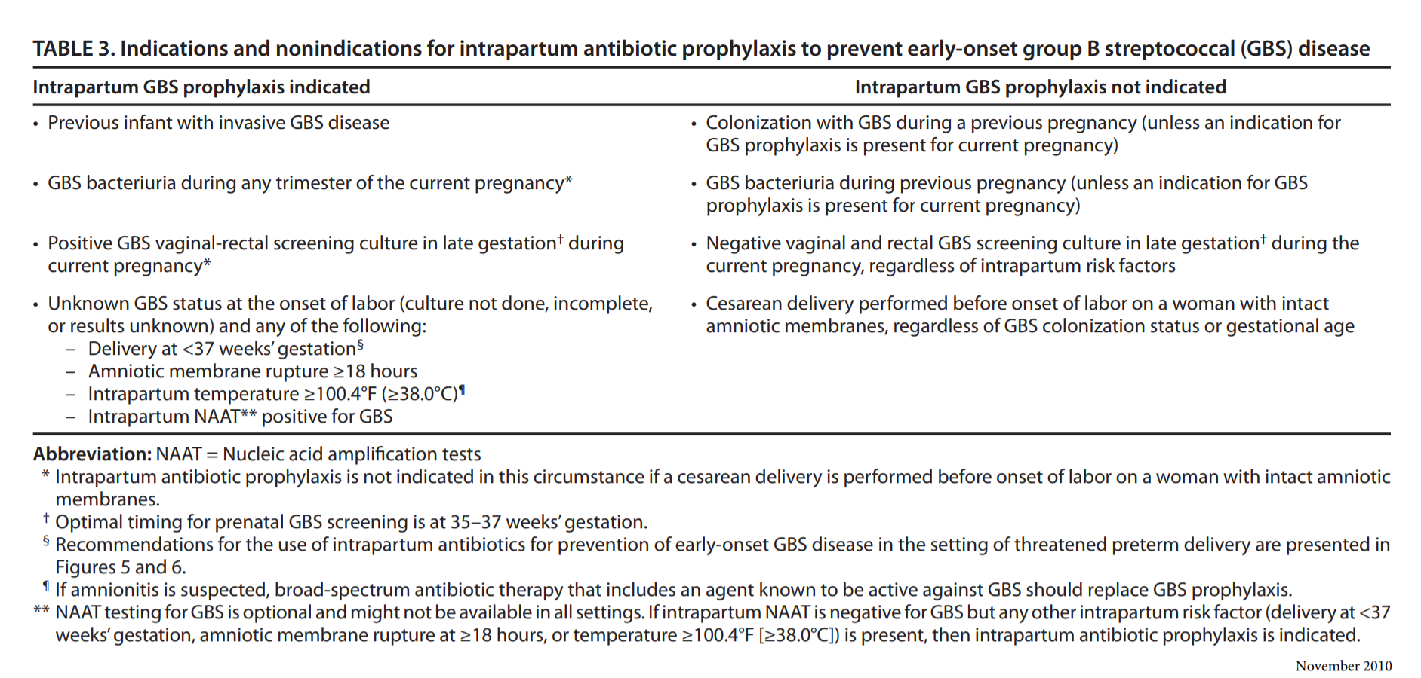

“Recommended regimens for intrapartum antibiotic prophylaxis for prevention of early-onset group B streptococcal disease” (ACOG, 2011, p. 1024).

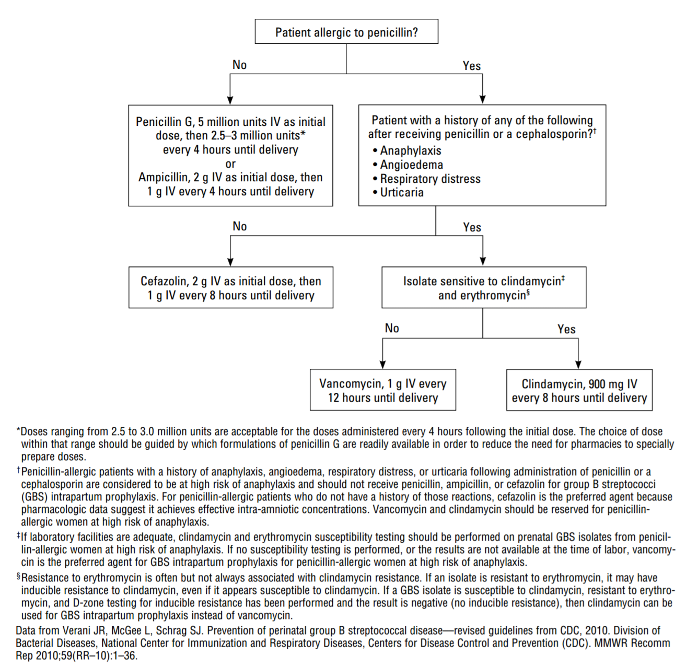

Appendix B: Literature Review
Literature review pyramids
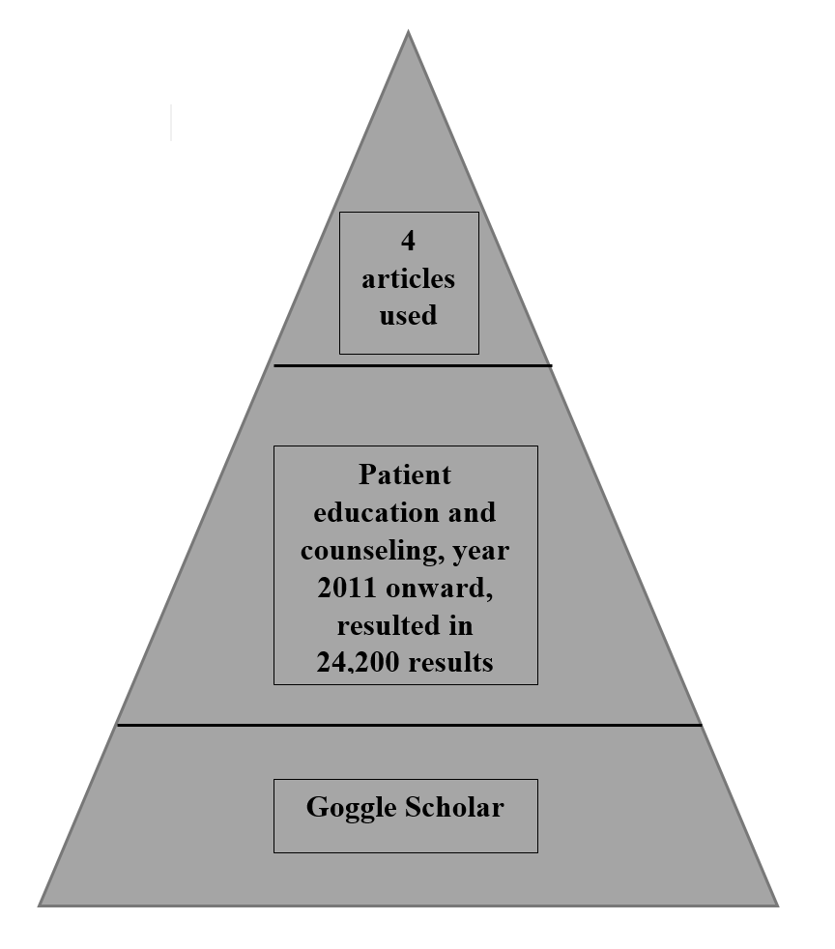
Google Scholar
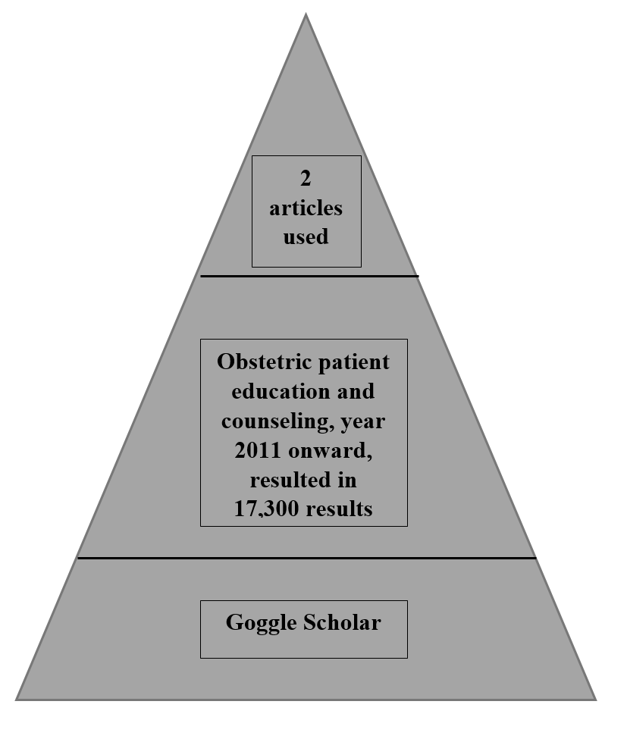
Google Scholar
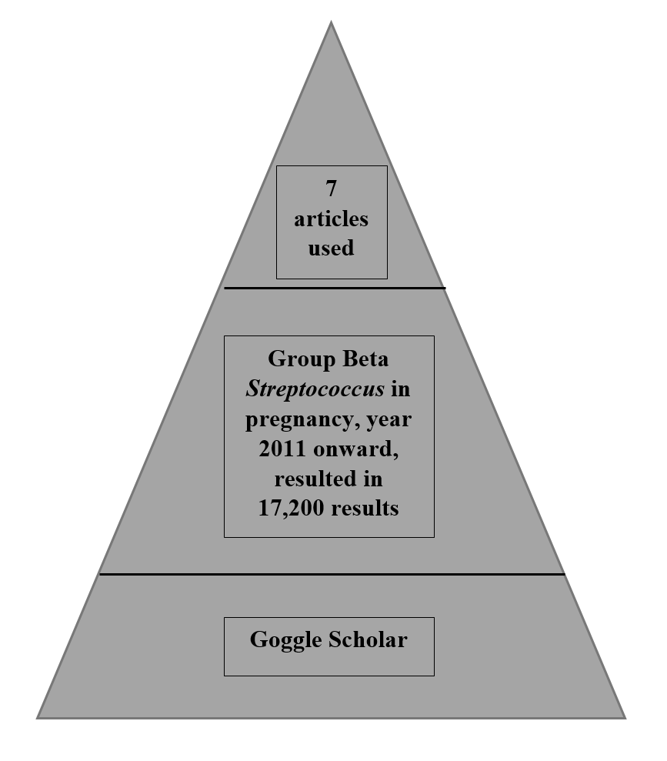
Google Scholar
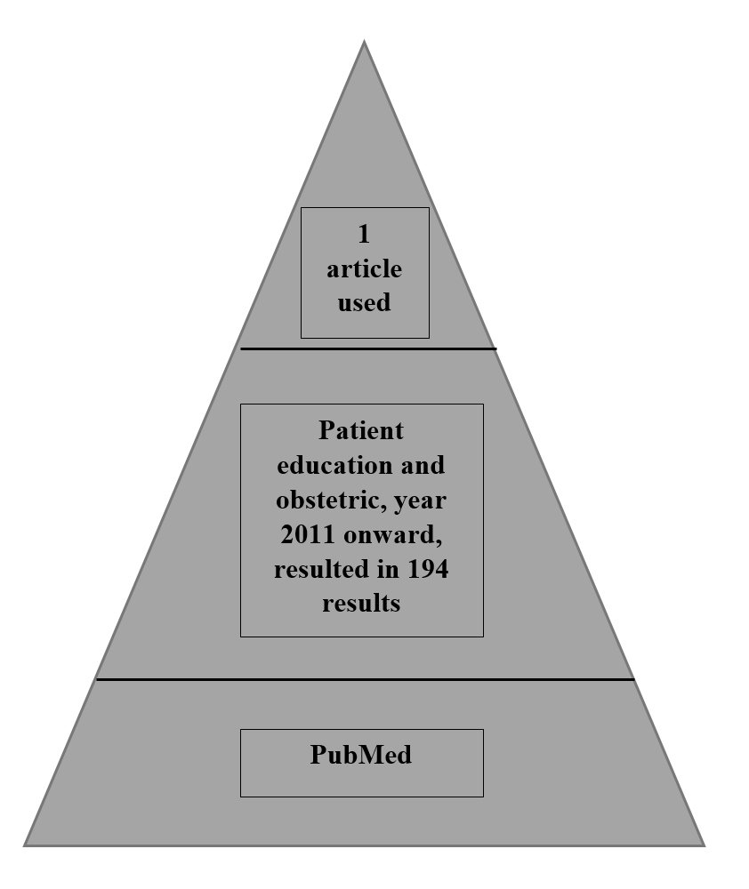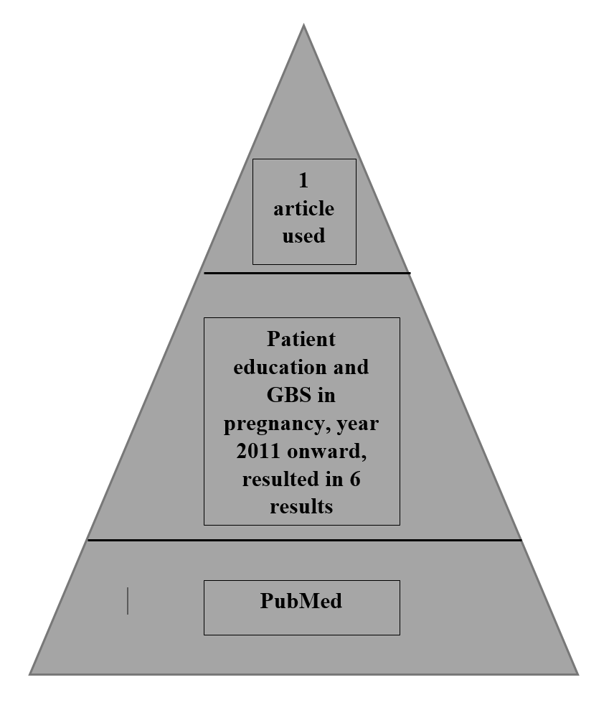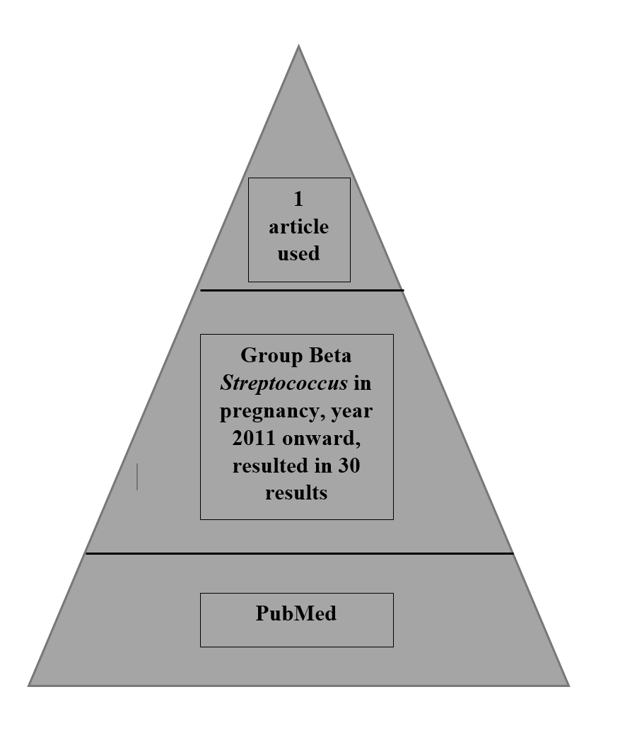

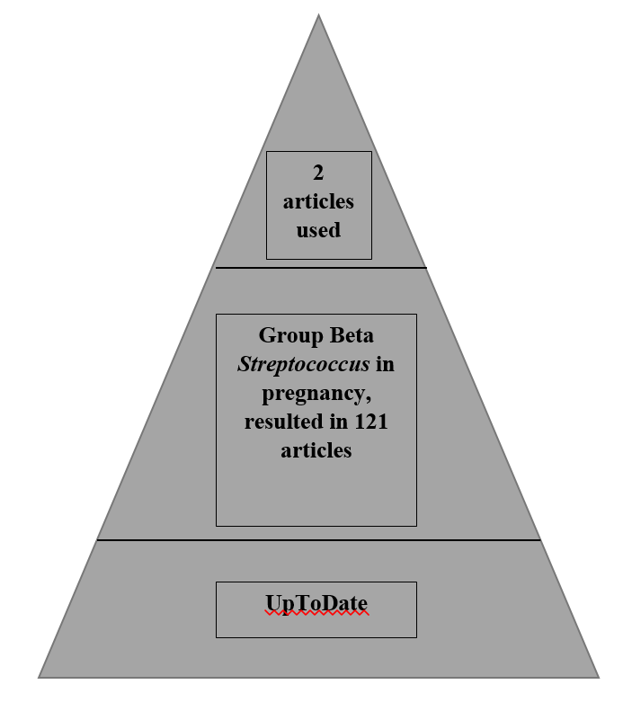

Literature review matrix
Student: Mandesa M. Smith | Course: DNP I & II | Faculty Lead: Dr. D. Marshburn | Date: | Project: Implementing evidence-based education about group β Streptococcus to pregnant women at a freestanding birth center
Article (APA Citation) | Level of Evidence  (I to VII) | Data/Evidence  Findings | Conclusion | Use of Evidence in EBP Project Plan
Ahmadzia, H. K., Heine, P., & Brown, H. L. (2013). GBS screening: An update on guidelines and methods. Contemporary OB/GYN, 58(7), 40-48. | Level 1 | In the 1970s 2/1000 live births ended up with a newborn with early-onset GBS.  It dropped to 0.3/1000 live births in 2008.  A prospective cohort analysis showed that 63% of term mothers and 44% of preterm mothers had appropriate GBS screening from 2006-2009. During this time period 160/400,000 infants had early-onset GBS sepsis.  Amongst the newborns that had early-onset GBS disease, 81% had mothers that screened negative for GBS.  GBS is screened by using PCR amplification. It is greater than 90% sensitivity. | Since implementation of the CDC guidelines there has been a drastic decrease in neonatal early-onset GBS sepsis.  Correct collection of a GBS culture is swabbing the vagina and rectum. Providers need to be collecting samples accurately and/or correctly educate their clients.  PCR amplification can be used to get rapid testing for GBS. | GBS screening guidelines  History of GBS infection in the newborn  Collection of GBS culture  Strong resource
Baker, C. J. (2016). Neonatal group B streptococcal disease: Prevention. Retrieved from https://www.uptodate.com/contents/neonatal-group-b-streptococcal-disease-prevention?source=search_result&search=Neonatal%20group%20B%20streptococcal%20disease&selectedTitle=3~150 | Level 1 | Between 10% and 40% of pregnant women are colonized with GBS.  Universal screening is recommended in the USA  Pregnant women should be screened for GBS in their rectovaginal area between 35 and 37 weeks gestation.  Those that have GBS bacteriuria do not need to be screened between 35 and 37 weeks gestation.  The negative predictive value of GBS cultures performed ≤5 weeks before delivery is 95 to 98 percent, but declines after five weeks.  Women that screen colonized for GBS or have GBS bacteriuria should receive prophylactic antibiotic treatment during the intrapartum.  GBS positive women that are having a cesarean and have intact membranes do not need GBS prophylaxis.  Women in preterm labor should be screened for GBS colonization and receive GBS prophylaxis if their GBS status is unknown or positive.  Women that are GBS unknown and have any of the following should receive GBS prophylaxis:  - Women with intrapartum fever (≥100.4ºF, ≥38ºC)  - Rupture of membranes > 18 hours  - Labor < 37 weeks gestation  - Previous child with GBS disease  Antibiotics used for GBS prophylaxis:  - Penicillin 5 million initial dose then 2.5-3 million q 4 hours or ampicillin 2g initial dose then 1g q 4 hours. Must be in the woman’s system ≥ 4 hours prior to birth.  - Mild allergy to penicillin- Cefazolin q 4 hours.  - Severe allergy to penicillin- clindamycin or vancomycin. | 10%-40% of pregnant women are colonized with GBS  Universal screening is recommended from 35-37 weeks gestation unless it is already in the woman’s urine.  Appropriate screening includes swabbing the vagina and rectum.  GBS screen results are not predictive beyond 5 weeks.  Women that screen positive need intrapartum prophylactic antibiotics.  Women having a cesarean that are GBS positive do not need GBS prophylaxis unless their water breaks prior.  Women that are GBS unknown and have any of the following should receive GBS prophylaxis:  - Women with intrapartum fever (≥100.4ºF, ≥38ºC)  - Rupture of membranes > 18 hours  - Labor < 37 weeks gestation  - Previous child with GBS disease  Medications used for GBS prophylaxis are penicillin, ampicillin, cefazolin, clindamycin and vancomycin depending on allergy to penicillin.  Penicillin and ampicillin are preferred. | GBS culture  GBS risk factors  GBS prophylaxis/treatment  Strong resource
Fahlberg, B. (2015). “No education about me without me”: A shared decision-making approach to patient education. Nursing, 45(2), 15-16. | Level VI | Patient educators need to factor what the patient already knows and what works for their lifestyle.  They need to find gaps in their knowledge that may have resulted in the problem.  Nurses can investigate outcomes and modify their plan of care as needed.  Shared decision making is important to patient education | Shared decision making is important to patient education  Patients know what is best for their life, so patient education needs to be modified to their needs. | Use: Clients are experts at what works for them and their life.  A limitation is that only one client was used for the study.
Friedman, A. J., Cosby, R., Boyko, S., Hatton-Bauer, J. & Turnbull, G. (2011). Effective teaching strategies and methods of delivery for patient education: A systematic review and practice guideline recommendations. Journal of Cancer Education, 26(1), 12-21. | Level I | The least effective way to educate a patient is only using verbal teaching and discussion.  An effective teaching tool is computer technology. It has a positive influence on patient knowledge, anxiety and satisfaction.  Education materials that are more effective than verbal teaching are the following:  - Audiotapes  - Videotapes  - Written materials (ensure appropriate reading level)  - Lectures  One of the better ways to educate cancer patients is using patient-specific information. Patients gain more knowledge, have less anxiety, and greater satisfaction.  Structured teaching is better than ad hoc teaching.  Provide culturally competent teaching | Patient-specific information is better than general information for patients with cancer.  There are multiple effective ways to provide patient education  Verbal teaching is not effective  Structured patient education should be provided.  Provide culturally competent teaching.  Written materials are an effective teaching tool at the appropriate reading level. | Use: best way to educate patients.  Limitation:  - Studies did not always use valid tools.  - Details about some of the interventions were not well described.  - The studies used mixed significance.  - Teaching strategies were not equal in quality.
Heilman, C. B. (2013). Readability of patient education materials. World Neurosurgery, 80(5), E109-E110. | Level V | Printed patient health education materials is used to increase their knowledge.  Printed patient health education materials, plus a discussion with their provider and an opportunity to ask questions is the most effective way to increase patient knowledge. | An effective way to education patients is by having a discussion with the patient with the addition of printed health information, plus an opportunity for the patient to ask questions and receive answers. | Use: How to best educate clients.  Limitation: Needs more resources to support information.
Martin, J. N. (2015). Patient education. Gale Encyclopedia of Senior Health: A guide for seniors and their care givers (2nd ed.). Farmington Hills, MI: Gale Cengage Learning | Level VII | Providers need to ensure that patients have enough high quality health information, so they have make informed healthcare decisions.  Another term for being informed in regard to one’s health is health literacy  In order to be informed patients need to know the reason they need treatment, their treatment options, and what may happen if they do not receive treatment.  Forms of patient education materials are brochures and pamphlets just to name a few. | Patients benefit from informed healthcare decision making.  Providers benefit by making sure their patients are informed.  Informed healthcare decision making means that patients know why they need treatment, their treatment options, and what may occur if they do not receive treatment.  Brochures and pamphlets can be used for patient education materials. | Used: written materials can be used for patient education.  Importance/definition of informed decision making.  Limitation: Low level of evidence.
Melin, P. (2011). Neonatal group B streptococcal disease: from pathogenesis to preventive strategies. Clinical Microbiology and Infection, 17(9), 1294–1303. | Level 1 | Universal GBS screening between 35-37 weeks gestation is more than 50% more effective at preventing early-onset GBS than no screening.  In 2002 the CDC recommended universal screening based the fact just listed.  Those that screen positive need to have prophylactic antibiotics during labor.  Those that have an unknown GBS status receive prophylactic antibiotics based on risk factors.  Since implementation of the new CDC guidelines there has been a 27% (0.47 to 0.34/1000 live births) drop in the number of cases of early-onset GBS in the newborn.  No universal screening in Europe  The most effective way to prevent early-onset GBS in the newborn would be a GBS vaccine for the pregnant mothers.  The article reviewed CDC guidelines for GBS screening and prophylaxis. | The current CDC guidelines prevent many cases of newborn early-onset GBS.  Due to its imperfection, the creation of a maternal vaccine against GBS needs to be created. | History of GBS  Current GBS guidelines  Need for a GBS vaccine
Puopolo, K. M., & Baker, C. J. (2017). Patient education: Group B streptococcus and pregnancy (beyond the basics). Retrieved from https://www.uptodate.com/contents/group-b-streptococcus-and-pregnancy-beyond-the-basics | Level 1 | GBS is a bacteria that can be found in the lower digestive tract, vagina and urinary tract.  1/3 or ¼ of pregnant women are colonized with GBS in their digestive tract and vagina, therefore all women should be screened for GBS between 35 and 37 weeks gestation.  GBS in the urinary tract causes urinary tract infections, therefore a urine culture should be collected at the first prenatal visit.  In order to prevent the transmission of GBS to the newborn during labor, IV antibiotics should be given prophylactically during the intrapartum.  The antibiotic that should be administered prophylactically should be penicillin unless the woman is allergic. | GBS is a bacteria found in the lower digestive tract and the vagina. It can be also found in the urine. It can be transmitted to the newborn during labor, so administer IV antibiotics (preferably penicillin) during the intrapartum. | Information about GBS prevalence, and GBS prophylaxis.
The American Congress of Obstetricians and Gynecologists. (2011). Prevention of early-onset group B Streptococcal disease in newborns. Committee Opinion No.485. Obstetrics & Gynecology, 117, 1019-1027. | Level 1 | Factors associated with newborn early-onset GBS disease:  - Pregnant woman screens positive for GBS in the rectovaginal area between 35 and 37 weeks gestation and/or has GBS bacteriuria.  - Newborn is born prior to 37 weeks gestation  - Prolonged rupture of membranes (≥ 18 hours)  - Intra-amniotic infection  - Young maternal age  - Black race  - Newborn is birthed from a mother that has had a previous newborn with GBS-infection or was heavily colonized with GBS.  Risk factors that should be evaluated if the pregnant woman is in labor and GBS status is unknown:  - Intrapartum temperature greater than or equal to 100.4°F (greater than or equal to 38.0°C)  - Birth prior to 37 weeks gestation  - Rupture of membranes ≥ 18 hours  Candidates for intrapartum antibiotic prophylaxis- pregnant women with GBS colonization in their rectovaginal area or urine. Women that have an unknown GBS status with risk factors.  Medications used for GBS prophylaxis  - Penicillin is primary antibiotic; ampicillin is an alternative  - Erythromycin is not recommended  - If allergic to penicillin prescribe Cefazolin, Clindamycin or Vancomycin depending on the severity of the penicillin allergy.  GBS culture collection- swab lower vagina and rectum  No GBS prophylaxis needed if client is having a cesarean unless rupture of membranes occurs prior.  Management of GBS with preterm labor- administer antibiotics unless client screens negative for GBS  Secondary prevention of early onset GBS- includes diagnostic evaluation (blood culture, CBC with diff, chest radiograph, and lumbar puncture), and antibiotics. | Risk factors for newborn early-onset GBS disease: colonization in rectovaginal area or urine.  Candidates for GBS prophylaxis are pregnant women that are colonized for the bacterium and those with an unknown GBS status, but have risk factors.  Medications used for GBS prophylaxis are penicillin, ampicillin, cefazolin, clindamycin and vancomycin (depends on whether the client is allergic to penicillin).  To screen for GBS, the vagina and rectum need to be swabbed between 35 and 37 weeks gestation.  No GBS prophylaxis needed if client is having a cesarean unless rupture of membranes occurs prior.  Management of GBS with preterm labor- administer antibiotics unless client screens negative for GBS  Secondary prevention of early onset GBS- includes diagnostic evaluation and antibiotics. | Used: GBS screen, prophylaxis, and risk factors
Wilson, E. A. H., Makoul, G., Bojarski, E. A., Bailey, S. C., Waite, K. R., Rapp, D. N., . Wolf, M. S. (2012). Comparative analysis of print and multimedia health materials: A review of the literature. Patient Education and Counseling, 89(1), 7-14. | Level 1 | Fourteen studies evaluated patient preference in regard to patient education. They found the following:  - 3 articles resulted in favor for printed material  - 5 articles resulted in favor for multimedia  - 6 articles did not find a significant difference in favor for a particular tool for patient education.  Twenty-four studies evaluated patient knowledge based on education source. The results showed:  - One article resulted in favor for printed material  - 12 articles resulted in favor for multimedia  - 12 articles resulted in no difference between printed and multimedia  - The results do not equal 24 because there were multiple comparisons performed in one study.  Five of the studies looked at anxiety and they did not find a difference between printed and multimedia materials.  Thirty studies were collected for this article and 56 comparisons were made between print and multimedia education materials. 54% of the comparisons showed no beneficial difference between printed and multimedia materials. | Printed material and multimedia material result in equal outcomes in regard to more patient knowledge, less patient anxiety, and improved patient behavior.  Patients need to be involved in their health education.  Printed and multimedia educational tools need to be at an appropriate literacy level to be useful. | Use: Printed material is as good as multimedia  Ensure education materials are not above reading literacy of clients.

Appendix C: GBS PowerPoint Presentation

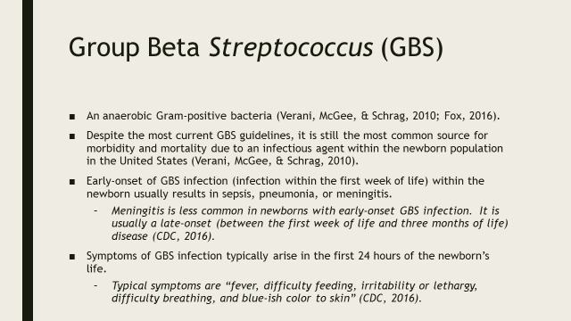
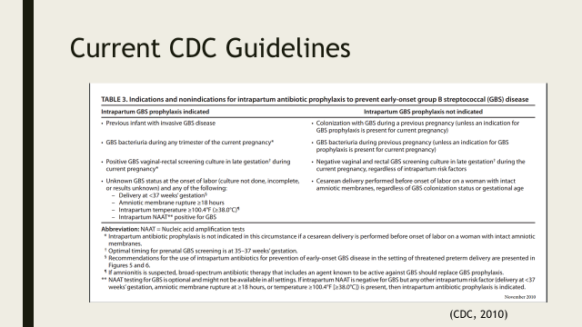
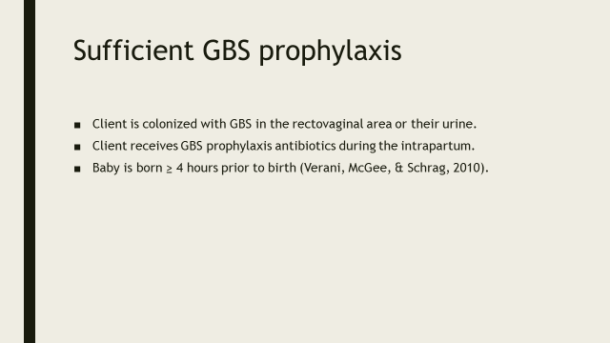
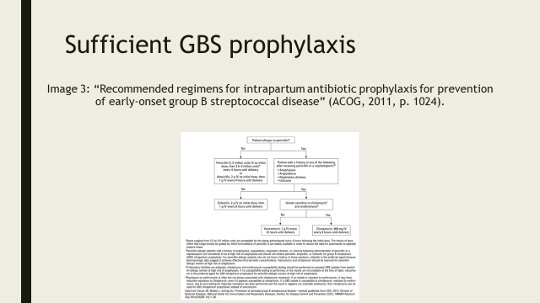
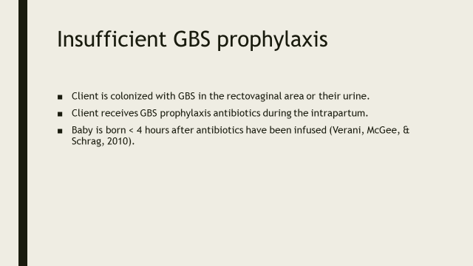
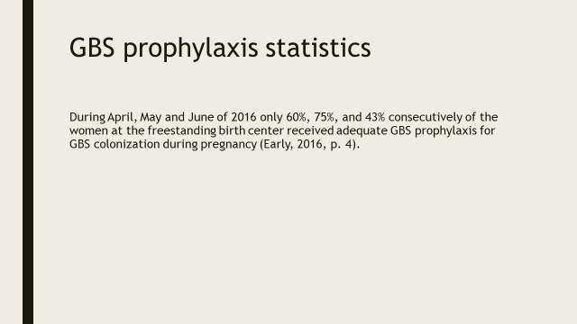
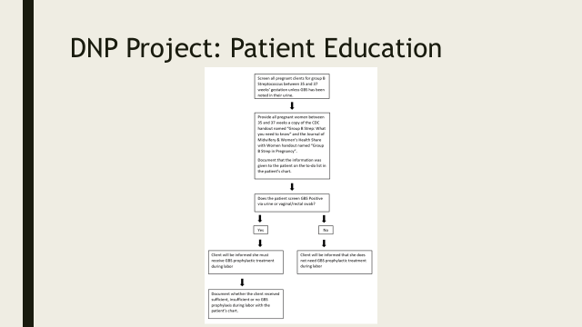
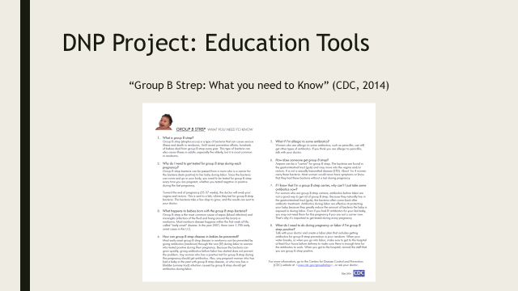
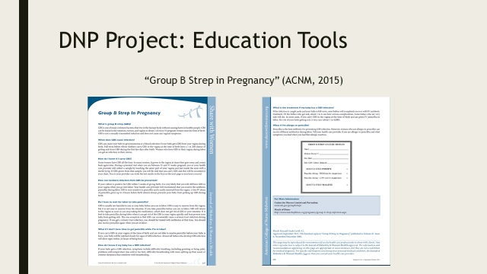
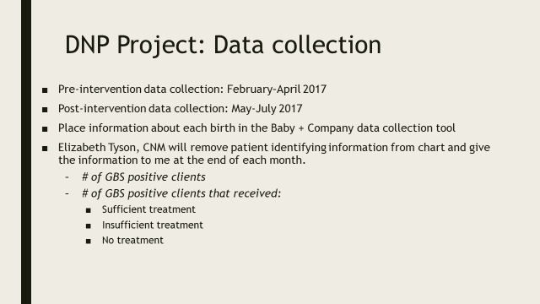
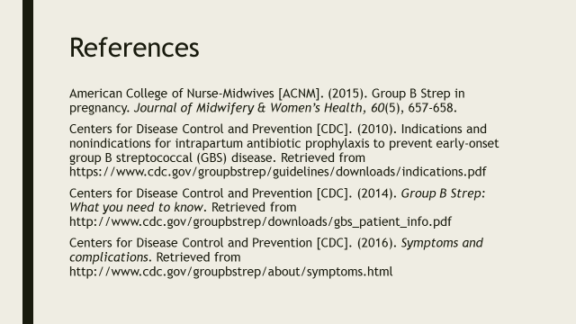
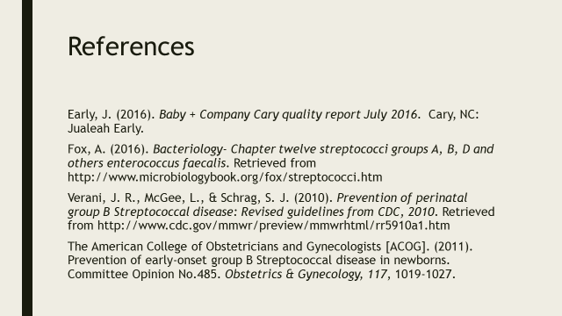

Appendix D: GBS Patient Education
Image 1: “Group B Strep: What you need to Know” (CDC, 2014a)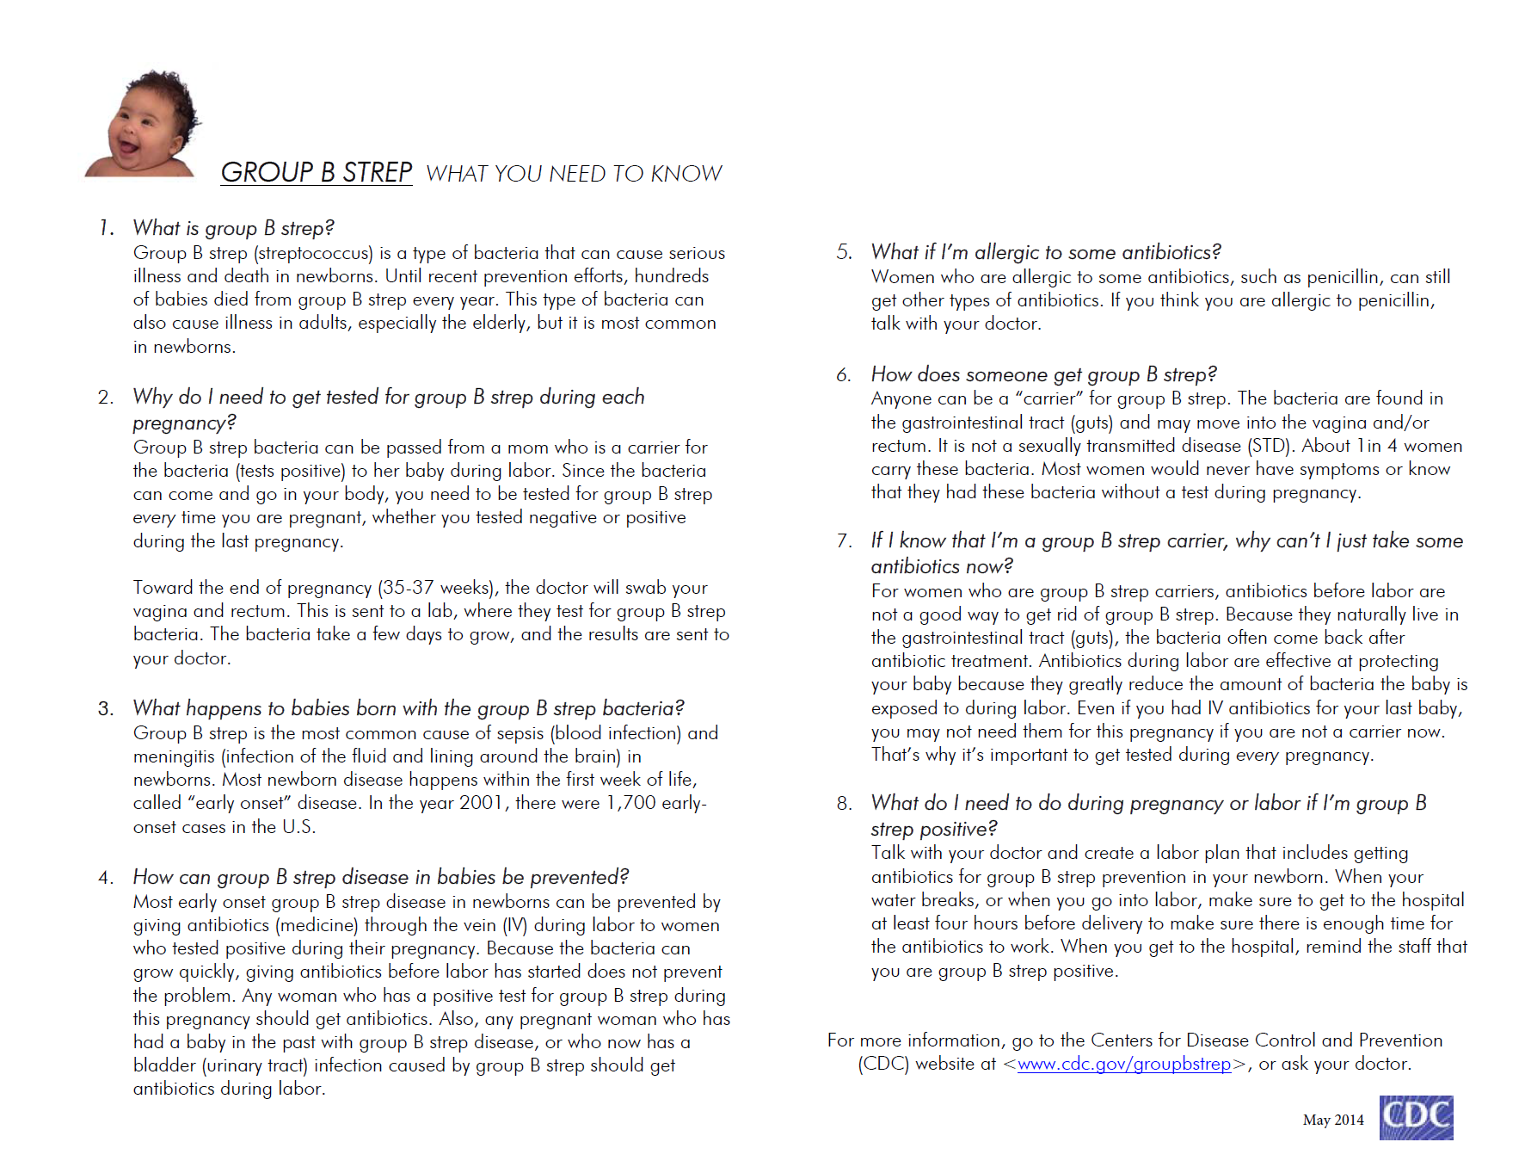

Image 2: “Group B Strep in Pregnancy” (ACNM, 2015).

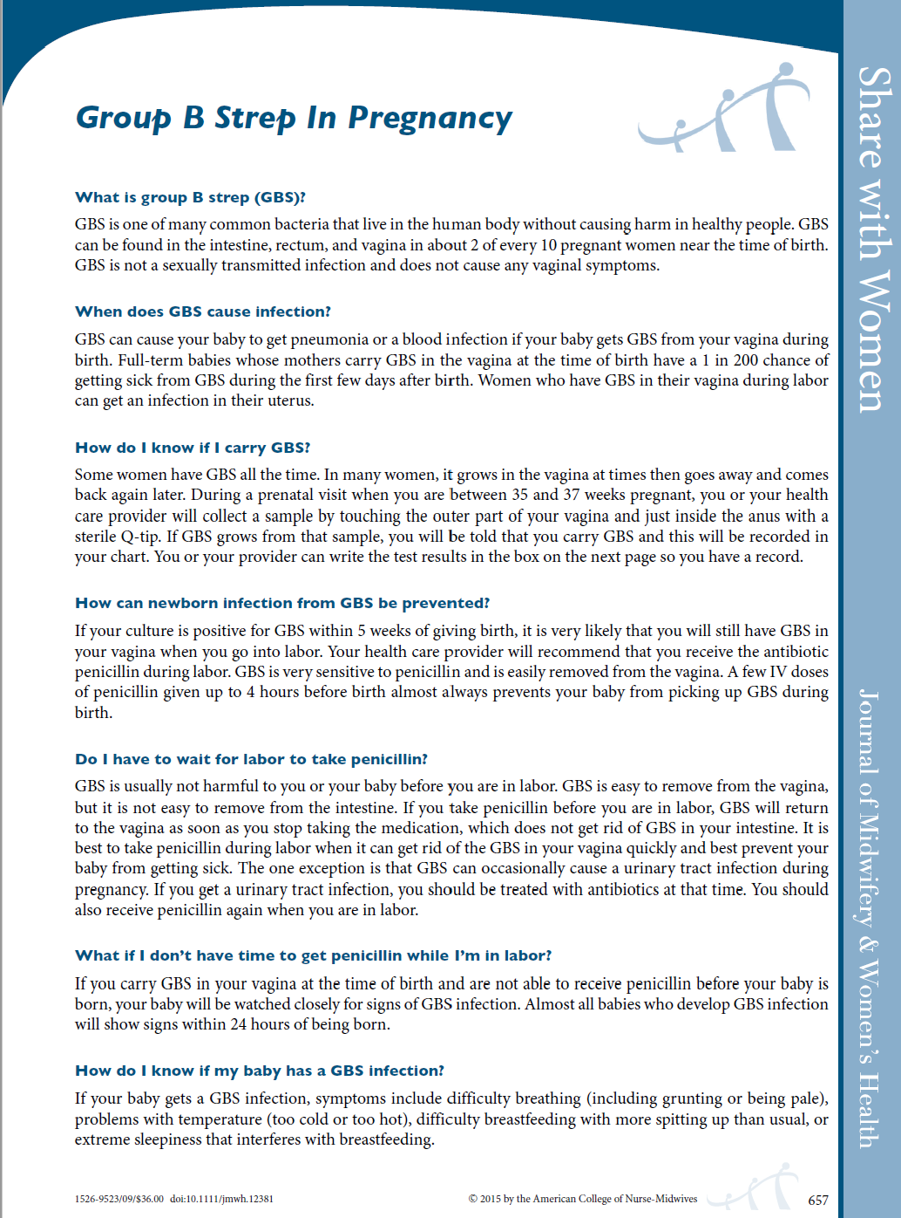
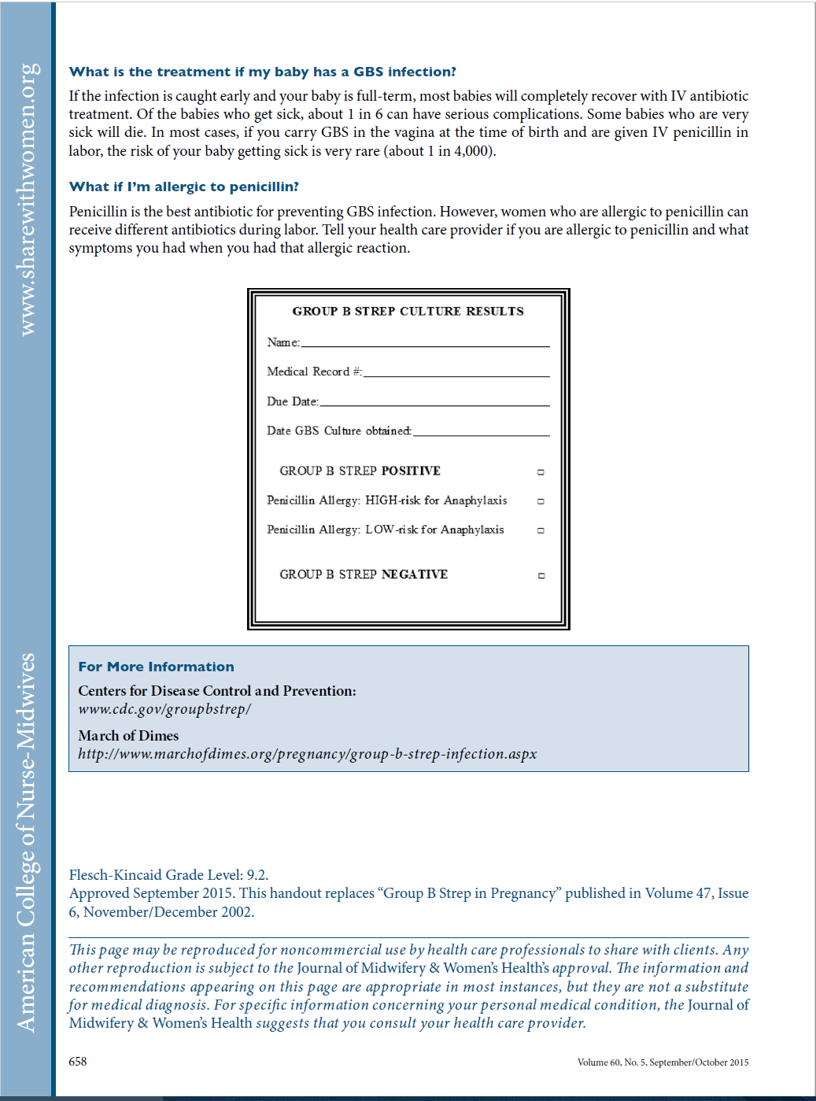

Appendix E: Organizational Approval
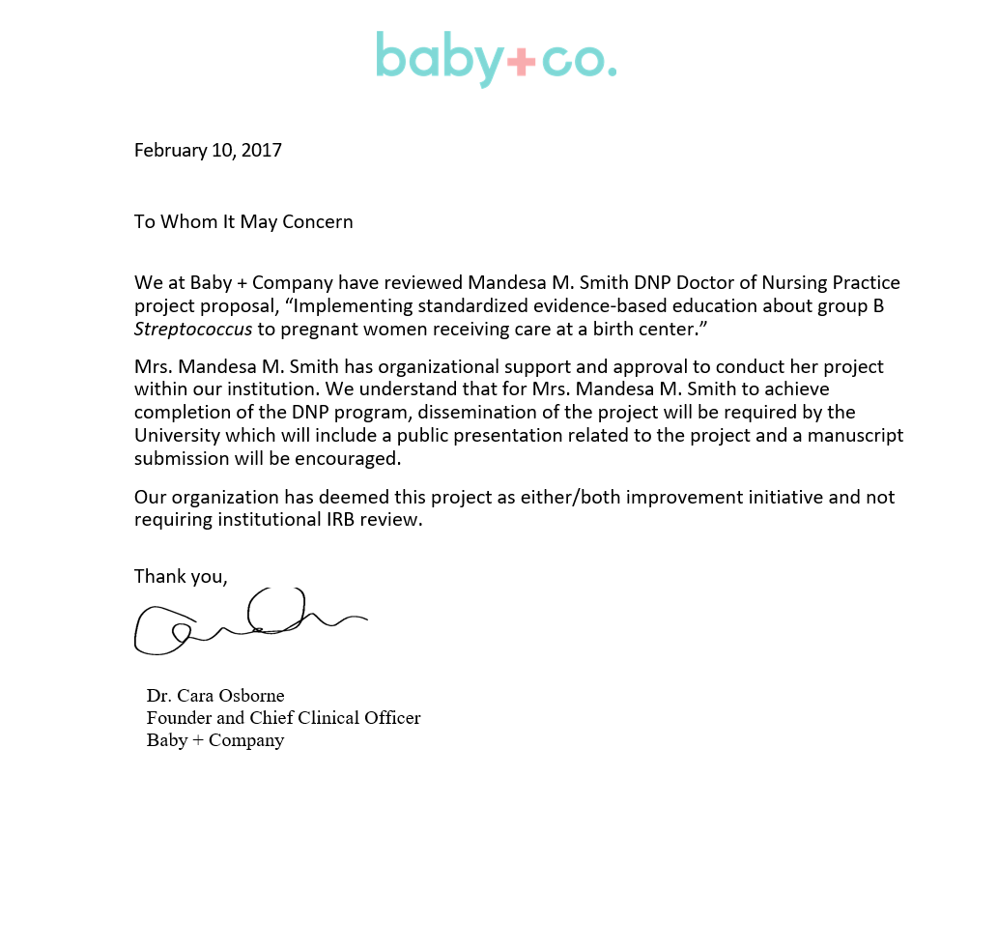

Appendix F: East Carolina University IRB Approval
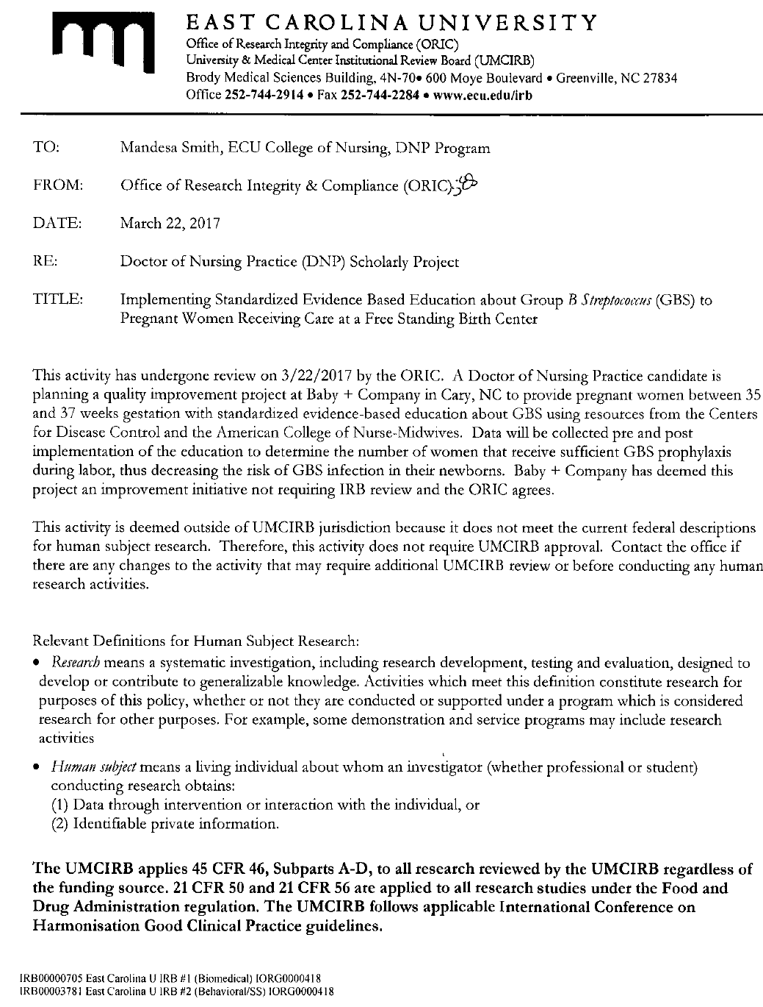

Appendix G: DNP Project Timeline
Date | Planning | Pre-Implementation | Implementation | Evaluation
October 2016 | Project approval
November 2016 | Submit final DNP project paper
February 2017 |  | Initiate pre-intervention data collection
March 2017 | IRB approval
April 20th 2017 |  | Educate CNMs about GBS patient education
April 30th 2017 |  | End pre-intervention data collection
May 1st 2017 |  |  | Implement project  Initiate post-intervention data collection
June 2017 (1st staff meeting for the month) |  |  | Re-educate CNMS about GBS patient education (30 days after project implementation)
July 2017 (1st staff meeting for the month) |  |  | Re-educate CNMS about GBS patient education (60 days after project implementation)
July 31st 2017 |  |  | Last day of post-intervention data collection
August 2017 |  |  |  | Evaluate data
September 2017 |  |  |  | Initiate completion of final paper and DNP poster
October 2017 |  |  |  | Close IRB approval

Appendix H: Data Collection Tools

Appendix I: Data Tables
Table 1

Table 2

Table 3

Appendix J: Doctor of Nursing Practice Essentials

 | Description | Demonstration of Knowledge
Essential I  Scientific Underpinning for Practice | Competency – Analyzes and uses information to develop practice  Competency -Translates research to improve practice  Competency -Integrates research, theory, and practice to develop new approaches toward improved practice and outcomes | - Analyzed information about GBS in pregnancy.  - Analyzed information about how best to provide patient education.  - Objective of project was to increase the percentage sufficient GBS prophylaxis  - Integrated Health Promotion Model and Adult Learning Theory into the framework of this DNP project.
Essential II  Organizational & Systems Leadership for Quality Improvement & Systems Thinking | Competency –Develops and evaluates practice based on science and integrates policy and humanities  Competency –Assumes and ensures accountability for quality care and patient safety  Competency -Demonstrates critical and reflective thinking  Competency -Advocates for improved quality, access, and cost of health care; monitors costs and budgets  Competency -Develops and implements innovations incorporating principles of change  Competency - Effectively communicates practice knowledge in writing and orally to improve quality
  - Use of CDC guidelines as part of algorithm
  - Used PDSA cycle to evaluate whether algorithm was being implemented
  - Critical thinking- creation of GBS patient education algorithm.
  - Lower cost of healthcare by encouraging GBS prophylaxis to reduce the risk of newborn GBS infection, which is most costly
  - April 20th 2017– education session for CNMs, ancillary staff, and center management team on GBS in pregnancy and GBS prophylaxis.
  - Disseminated project poster presentation to CNMs, ancillary staff, and center management team on November 2nd, 2017. Opportunities for improvement were shared.
Essential III  Clinical Scholarship & Analytical Methods for Evidence-Based Practice | Competency - Critically analyzes literature to determine best practices  Competency - Implements evaluation processes to measure process and patient outcomes  Competency - Designs and implements quality improvement strategies to promote safety, efficiency, and equitable quality care for patients  Competency - Applies knowledge to develop practice guidelines  =  Competency - Collaborate in research and disseminate findings | - Literature review on GBS and patient education  - Data collection tool- assessed for sufficient, insufficient, and no GBS prophylaxis.  - Created GBS patient education algorithm to increase sufficient GBS prophylaxis.  - Used knowledge about GBS in pregnancy and patient education tools to create algorithm.  - DNP project disseminated to CNMs, ancillary staff, and center management team on November 2nd, 2017.
Essential IV  Information Systems – Technology & Patient Care Technology for the Improvement & Transformation of Health Care | Competency - Design/select and utilize software to analyze practice and consumer information systems that can improve the delivery & quality of care | - Excel spreadsheet used to collect data
 | Description | Demonstration of Knowledge
Essential V  Health Care Policy of Advocacy in Health Care | Competency- Analyzes health policy from the perspective of patients, nursing and other stakeholders  Competency – Provides leadership in developing and implementing health policy  Competency – Educates stakeholders regarding policy  Competency- Participates in policy agendas that assist with finance, regulation and health care delivery  Competency – Advocates for equitable and ethical health care | - Created and implemented GBS patient education algorithm.  - Birthing center started to track specific GBS statistics due to the initiation of the DNP project.  - Algorithm educates patients about the current standard of care for GBS in pregnancy.  - Implemented standardized education practice on the topic GBS in pregnancy  - Educated CNMs about the cost of GBS prophylaxis verses the cost of newborn GBS infection treatment  - Sufficient GBS prophylaxis was encouraged because it is equitable and ethical health care.
Essential VI  Interprofessional Collaboration for Improving Patient & Population Health Outcomes | Competency – Provide leadership to interprofessional care teams  Competency – Consult intraprofessionally and interprofessionally to develop systems of care in complex settings | - Educated medical technician and registered nurses about GBS in pregnancy and GBS prophylaxis.  - Medical technician reminded CNMs to provide patients with GBS patient education materials.  - Consulted with CNMs about ways to strengthen algorithm.  - Reviewed with CNMs barriers to algorithm.
Essential VII  Clinical Prevention & Population Health for Improving the Nation’s Health | Competency- Integrates epidemiology, biostatistics, and data to facilitate individual and population health care delivery  Competency – Synthesizes information & cultural competency to develop & use health promotion/disease prevention strategies to address gaps in care  Competency – Evaluates and implements change strategies of models of health care delivery to improve quality and address diversity | - Discussed rate of GBS colonization amongst pregnant women in the US.  - GBS prophylaxis education encouraged health promotion and disease prevention.  - The intent of algorithm was to increase sufficient GBS prophylaxis thus improving quality of care.
Essential VIII  Advanced Nursing Practice | Competency – Design, implement & evaluate nursing interventions to promote quality  Competency – Develop & maintain patient relationships  Competency –Demonstrate advanced clinical judgment and systematic thoughts to improve patient outcomes  Competency – Mentor and support fellow nurses  Competency- Provide support for individuals and systems experiencing change and transitions  Competency –Use systems analysis to evaluate practice efficiency, care delivery, fiscal responsibility, ethical responsibility, and quality outcomes measures | - The algorithm and data collection tools were created to improve the quality of care in regard to GBS in pregnancy and evaluate CNM care in regard to GBS prophylaxis.  - Promote patient relationship through education  - Intent of algorithm was to improve patient outcomes by reducing the risk of GBS infection to the newborn.  - PDSA- re-educated CNMs 30 and 60 days post implementation.  - Informal re-education was performed weekly.  - Data collection tool was created in Excel to track sufficient, insufficient, and no GBS prophylaxis. It also kept track of how many clients birthed for the month and how man clients screened GBS positive.

