RISKS FOR CANCER SCREENING IN PRIMARY CARE
by
Katherine Lynn Russell-Ladd

Paper submitted in partial fulfillment of the
requirements for the degree of

Doctor of Nursing Practice

East Carolina University
College of Nursing

Date Finalized
April 23rd 2019

Signature Faculty Coordinator Date

Signature Program Director Date

Acknowledgments
I would like to thank my husband, parents, and family. I apologize that I had to sacrifice time with you. I appreciate the assistance Dr. King provided with this work, her guidance was priceless. I have a great appreciation for the friends I accumulated throughout this program, who provided support in the strides one must take to complete a challenging lengthy program. I cannot neglect to mention Dr. Kellam who was invaluable in refining this work to the more polished professional version it is today.

Dedication
I would like to dedicate this work to my deceased grandparents and living relatives. Especially my Grandfather, who set aside funds that permitted initiation of higher levels of education. It was inspiring to recall past encouragement from loved ones. For each of my eye rolls at family mentioning this program would be worth it, when complete, I apologize.
One motivation to prevent cancer was my father’s successful treatment for colon cancer. He was fortunate to have a provider who recommended screening tests. The issue hits home in another way, as I have already had a precancerous skin lesion removed. In families where cancer is prevalent, screening not only saves lives, but prevents painful lengthy battles with challenging malignancies.

Abstract
Background: While numerous task force recommendations are in place, cancer still remains a major global health problem. Gaps in modern screening methods for cancer were noted among patients in primary care. Accessing information from patients can enable appropriate screening tests to occur, and prevent or discover malignant tissues in earlier stages.
Methods: A quality improvement project was designed to develop a cancer screening questionnaire tool for use in primary care. The questionnaire was distributed to patients in a primary care clinic in Southeastern North Carolina. Use of the questionnaire enabled a more comprehensive approach to screening patients for cancer. Accompanying algorithm sheets were available to the provider to assist in interpreting the screening results based on guidelines.
Results: Of the fifty patient visits to the primary care office, all patients were participants. Eight of those fifty were referred for more advanced screening.
Conclusions: This project determined that employing an inclusive process for cancer screening resulted in a more comprehensive screening approach.
Key words: Cancer, cancer screening in primary care, colorectal cancer, breast cancer, lung cancer, cervical cancer.

Table of Contents
Acknowledgments 2
Dedication 3
Abstract 4
Chapter One: Overview of the Problem of Interest 10
Background Information 10
Significance of Clinical Problem 10
Question Guiding Inquiry (PICO) 11
Population 11
Intervention 11
Comparison 11
Outcomes 11
Summary 12
Chapter Two: Review of the Literature Evidence 13
Methodology 13
Sampling strategies 13
Evaluation criteria 13
Literature Review Findings 15
Findings Pertaining to Cancer Types 16
Limitations of Literature Review Process 19
Discussion 19
Conclusions of findings 19
Advantages and disadvantages of findings 19
Utilization of findings in practice 19
Summary 20
Chapter Three: Theory and Concept Model for Evidence-based Practice 21
Concept Analysis 21
Theoretical Framework 23
Application to practice change 24
Evidence-Based Practice Change Theory 25
Application to practice change 25
Summary 26
Chapter Four: Pre-implementation Plan 27
Project Purpose 27
Project Management 27
Organizational readiness for change 27
Inter-professional collaboration 28
Risk management assessment 28
Organizational approval process 29
Information technology 29
Cost Analysis of Materials Needed for Project 29
Plans for Institutional Review Board Approval 30
Plan for Project Evaluation 30
Demographics 30
Outcome measurement 30
Evaluation tool 30
Data analysis 31
Data management 31
Summary 31
Chapter Five: Implementation Process 32
Setting 32
Participants 32
Recruitment 32
Implementation Process 33
First PDSA 34
Second PDSA 34
Plan Variation 35
Summary 35
Chapter Six: Evaluation of the Practice Change Initiative 36
Participant Demographics 36
Intended Outcome(s) 36
Findings 37
Summary 37
Chapter Seven: Implications for Nursing Practice 38
Practice Implications 38
Essential I: Scientific underpinnings for practice 38
Essential II: Organization and systems leadership for quality
improvement and systems thinking 39
Essential III: Clinical scholarship and analytical methods for EBP 40
Essential IV: Information systems/technology and patient care
technology for the improvement and transformation of healthcare 41
Essential V: Healthcare policy for advocacy in healthcare 41
Essential VI: Interprofessional collaboration for improving patient
and population health outcomes 42
Essential VII: Clinical prevention and population health for
improving the nation’s health 42
Essential VIII: Advanced nursing practice 43
Summary 43
Chapter Eight: Final Conclusions 45
Significance of Findings 45
Project Strengths and Limitations 45
Strengths 45
Limitations 46
Project Benefits 47
Recommendations for Practice 47
Final Summary 48
References 50
Appendix A: Evidence Matrix 53
Appendix B: Program Evaluation with Program Director’s Approval…………………….58
Appendix C: Screening tool 63
Appendix D: Evidence Algorithm 64
Appendix E: PowerPoint for Clinic Education 68
Appendix F: Letter of Support from Site 72
Appendix G: IRB approval letter 73
Appendix H: Data 76

Chapter One: Overview of the Problem of Interest
When discovered early, cancerous tissue may be eradicated simply through surgery. Identifying risk factors that necessitate increased screening procedures is an important step in discovering cancer in its initial stages. The aim of this project is to assist primary care providers in performing a simple, thorough cancer screening. The goal of this project is to increase the number of patients screened for cancer, and integrate practice improvements into primary care practice. Through early identification and intervention, overall cancer mortality and morbidity can be reduced.
Background Information
Although numerous websites exist and multiple preventative tasks forces have developed goals to decrease cancer, it is still a rampant issue. Globally, cancer accounts for approximately 8.2 million deaths (Vaisson et al., 2018). The authors described how appropriate screening reduces cancer-related mortality. Vaisson et al. reported cancer screening death reductions occur if sufficient numbers of patients from the target population participate. Determining a target population is an issue appropriately addressed in primary care (Vaisson et al., 2018).
Significance of Clinical Problem
A gap exists between new methods of cancer screening among patients in primary care compared to current screening protocols. Sharma, Hostetter, Morrison, Wang, and Siegel (2016) reported the US Preventative Services Task Force (USPSTF) provides screening recommendations for numerous forms of cancer. Although the USPSTF published recommendations there is wide variability of provider adherence to the guidelines (Sharma et al., 2016). Many providers base screenings on age, family history, and date of last screening. Numerous providers have no focused cancer risk questionnaire; thus, cancer screening may merely be the provider questioning the patient.
Question Guiding Inquiry Population, Intervention, Comparison, and Outcome (PICO)
Population. The population are patients of a primary care physician.
The physician’s practice is located in Wilmington, North Carolina. Wilmington is a coastal town with a population size near 200,000. The population for this project will be all of the patients of the practice, as anyone can be screened for cancer.
Intervention. The intervention includes increasing the number of patients screened for cancer. The goal of the screening would be to determine appropriate cancer screening tests the patient should undergo. Screening can be facilitated using a printed screening checklist tool. The checklist for patients to complete and the staff and provider to review. While the checklist is a tool used within this project, the intervention is to increase cancer screening per guidelines for the patients of this practice.
Comparison. The comparison of the project involves taking into account there was no screening tool in place. The method of screening involved the provider assessing the patient’s history. The provider scanned computer files for when the last screening was complete for mammogram and colonoscopy. This mammogram and colonoscopy information was usually obtained by a medical assistant. After implementation the author compared the number of patients who completed the screening questionnaire and were referred or received indicated screening for colorectal, cervical, breast, and lung cancers with the total number of patients seen during the project implementation period.
Outcome. The optimal result of the project was consistent use of the checklist screening tool and an increase in patients who are screened for cancer. A second desired result was follow-up using an algorithm, based on the screening checklist results. Through meetings held with staff important workflow changes were tracked to evaluate the effectiveness of the project interventions. The efficacy of project interventions were important to increase so the project will be easier to maintain over time. Overall, screening is completed with a goal of averting preventable deaths, although it is easily recognized that a more obtainable goal is to increase the number of patients screened using current guidelines.
Summary
Patients benefit from early detection of cancer. Provider recognition of patients at risk for cancer is essential. Many providers benefit from a simplified screening process. A PICO assessment identified the population, intervention, comparison, and outcomes for this project. Noting the discrepancy from USPSTF and CDC recommendations and provider actions, a literature review helped develop an evidence-based project.

Chapter Two: Review of the Literature
To determine methods currently in use for cancer screening, a literature review was conducted. In this review the writer explored evidence-based practice to improve patient adherence to cancer screenings. The literature review also explored areas in which providers lacked confidence regarding cancer screenings. The pertinence of items explored is discussed in this section.
Methodology
Sampling strategies.
A search of the literature was performed via Pubmed using the search MeSH terms “cancer communication” and “cancer screening”. The results yielded 565 items. Search filters were placed to limit the search to meta-analyses and systematic reviews. This narrowed the search to 372 items. Next, exclusion criteria were applied to exclude the material published greater than five years ago. New search parameters reduced the results to 198 items. Abstracts of 24 articles pertinent to the subject were assessed. Articles were selected that described multiple types of cancer. Refer to Appendix A for an organized break down of the literature search including less prominent articles used in this work.
Works excluded focused predominately on cancer screening among specific cultures. Sixteen articles among the Pubmed search addressed concerns for minority cultures, or Non-Western nations: rationale for exclusion was lack of generalizability. Based on titles 174 articles did not appear relevant to screening practices. A systematic review authored by Peterson et al. (2016) had the greatest relevance because it described multiple forms of cancer.
Evaluation criteria.
The Peterson et al. (2016) article was level one on the evidence levels pyramid because it is a systematic review. The authors of this journal article searched the literature to determine adherence to cancer screenings. They found that provider emphasis on screening improved compliance. The relevance of this article to this project is most patients do not seek cancer screening, thus provider recommendations for cancer screening is important. The strengths of the Peterson article included review of studies about diverse populations. Limitations of the Peterson review were articles that relied on patient reported adherence to cancer screening.
The Hamilton et al. (2017) article ranks level one for evidence. The authors of this article performed a PubMed, EMBASE, Web of Science, PsycINFO, CINAHL, and Cochrane Library search. They identified peer reviewed articles about primary care providers and genetic testing for breast, or colorectal cancer (Hamilton et al., 2017). The relevance of this article is that providers lack confidence in administering cancer screening. One strength of this article was its investigation into studies regarding cancers with high mortality rates. However, this could also be a limitation as the authors felt more work could be focused on other forms of cancer.
An article by Paalosalo-Harris and Skirton (2016) is level one because it is a systematic review. The authors searched CINAHL, Medline, AMED, and PsychInfo to identify behaviors associated with breast cancer prevention or its early detection. The relevance to this DNP project involves the author’s findings that patients were more likely to adopt screening administered by health professionals. The article also noted that patients were unlikely to adopt personal screening and lifestyle methods. This finding indicates that provider prompting is very important. Strength of the Paalosalo-Harris and Skirton article was the quality of the articles reviewed. Primary limitation was its use of descriptive, not experimental studies.
Lawler et al. (2018) was a level one, because it is a systematic research gap review. The authors sought to determine where research about colon cancer can be further developed. The relevance to this project revolves around the risk factors and treatment options noted in the article. The strength of the Lawler et al. article was its thorough review of colon cancer. The authors stated that their work was limited by low numbers of colon cancer patients participating in randomized control trials.
Literature Review Findings
Although cancer screening is available, it is infrequently employed. Peterson et al. (2016) reported that despite benefits, cancer screening is underutilized in the United States and worldwide. Peterson and colleagues concluded the following are helpful screening tools: cytology for cervical cancer, mammography for breast cancer, fecal occult blood testing (FOBT), sigmoidoscopy, colonoscopy, fecal immunochemical test (FIT) for colorectal cancer, and low dose helical computed tomography for lung cancer. Given the ability of screening tests to reduce cancer morbidity and mortality, improving adherence to cancer screening is critically important to public health (Peterson et al, 2016). Without proper screening to determine which tests patients may need, important cancer examinations can be overlooked.
When providers determine a patient is at risk, they order screening. Research indicates when a provider suggests a patient needs enhanced screening, it increases the likelihood of the patient completing the tests. Patients may be more likely to feel they financially qualify for a procedure if their provider recommends it. Peterson et al. (2016) posited that provider to patient communication regarding screening tests is one of the strongest modifiable roles in cancer screening behavior.
Although many providers are familiar with the screenings tools noted above, some may not use cancer risks screening in their practice. Hamilton et al. (2017) found that primary care providers reported limitations in their knowledge about basic genetics and confidence in collecting and interpreting family history data. Providers must be prepared to determine which individuals qualify for specific forms of screening tests. In time genetic testing may be utilized more frequently. Genetic testing in risk stratification indicated necessary screening tests for patients with high disease risk (Hamilton et al, 2017). The article reports combining this technology along with traditional risks factors leads to patient-specific screening tests.
Literature Findings Pertaining to Different Types of Cancer
An article by Paalosalo-Harris and Skirton (2016) noted breast cancer screening practices important for providers to consider. The article found that women who felt they were at a high risk for breast cancer were more likely to adhere to mammogram screening. When women at high risk for breast cancer were identified, medication changes were thought to be an appropriate course of treatment (Paalosalo-Harris and Skirton, 2016). The authors found women at high risk decided to discontinue use of hormone replacement therapy due to an increased risk of breast cancer. Paalosalo-Harris and Skirton also cited studies in which women with increased breast cancer risks began taking the chemoprevention treatment of tamoxifen. Family history or genetic testing helps determine if the individual will benefit from chemoprevention with hormone receptor therapy.
Information about colon cancer was obtained from an article by Lawler et al. (2018). The Lawler article described colon cancer risk factors including hereditary genetic risk factors. Lawler et al. reported that up to 45% of colon cancers are linked to lifestyle factors. According to Lawler et al. lifestyle factors linked to colon cancer included low dietary fiber intake, high red or processed meat intake, obesity, physical inactivity and alcohol consumption. These lifestyle factors should be addressed when counseling a patient about colon cancer.
Lawler et al. (2018) also reported that the United States Preventive Services Task Force recommends use of aspirin in primary colon cancer prevention. The authors observed there is compelling evidence for aspirin as a chemopreventive intervention in high-risk patients for colon cancer. Lawler et al. indicated a lack of awareness of aspirin’s chemopreventive effects among 50% of primary care physicians surveyed, even for high-risk populations (eg, Lynch syndrome carriers). This finding proved to be beneficial as guidance strategies for providers.
The majority of cervical cancers can be attributed to the Human Papillomavirus (HPV). While the ability to test for HPV has altered cervical cancer screening it does not eliminate the need for screening by the Papanicolaou test. Bukowska-Durawa and Luszczynska (2014) reported major barriers to cervical cancer screening include negative associations with examination procedures and collecting results; the personal characteristics of the patient were another barrier noted. The article found that communication skills training for health professionals and primary care physicians conducting cervical cancer screening can address patients’ psychosocial barriers (Bukowska-Durawa and Luszcyzynska, 2014).
It is commonly accepted that smoking tobacco causes lung cancers. Thus, a history of tobacco smoking should be used as the major risk for screening. Slatore, Sullivan, Pappas, and Humphrey (2014) reported screening for lung cancer with low-dose computed tomography is widely recommended for adults who are or were heavy smokers. Slatore et al. found an undesired consequence of the CT lung cancer screening was patient distress about false positives. This unintended consequence suggests clinicians consider tailoring their communication strategies to prevent distress following false positive results (Slatore et al., 2014).
Limitations of Literature Review Process
Literature search strategies for high levels of evidence may limit the number of results. Searches for high levels of evidence yield some exhaustive systematic reviews. However, literature that yields the most helpful information supporting a project’s research, may not fit the high levels of evidence criteria. The literature investigation did not produce results with a broad range of suggestions on how to positively influence provider screening techniques.
Discussion
Conclusion of findings.
Although many screening tools are available providers may need help focusing on which ones are most applicable to certain patients. Hamilton et al. (2017) wrote that providers may not feel comfortable performing cancer screening to suggest appropriate testing. Another idea that can be constructed, based on the literature, is providers may not use all available cancer testing. Thus, it is appropriate to construct a tool for providers to employ as a helpful intervention. Such a tool might simplify the task of proposing appropriate patient screening.
When patients are notified they are at high risk for cancer they may be more likely to participate in screening practices. Both Bukowska-Durawa and Luszczynska (2014) and Slatore et al. (2014) emphasized the importance of addressing the psychological factors that affect cancer screening. Many patients experience discomfort with screening procedures, and anxiety while waiting for test results. Supporting patients regarding psychological factors is another role appropriate for providers to develop. With certain tests providers may prepare patients for the possibility of false positives. Provider education regarding chemopreventive cancer strategies was a theme noted in both the Lawler et al. (2018) and the Paalosalo-Harris and Skirton (2016) articles.
Advantages and disadvantages of findings.
Providers might benefit in learning new ways to screen patients for cancer. Specifically, providers may be inappropriately testing for cancer. A tool to assist providers is a streamlined approach to achieve this goal. Providers may not be current on new recommendations or screening adjuncts judging from the evidence provided by the Hamilton et al. (2017) article. This project’s aim is to help providers screen patients for cancer. This aim may be accomplished by identifying provider learning needs.
The disadvantages include underutilization of available resources. Peterson et al. (2016) note cancer screening is underutilized. This finding suggests providers employ a streamlined approach. Provider discomfort with cancer screening noted by Hamilton et al. (2017) could be alleviated with a more organized tactic. Helpful approaches ease the burden of providing cancer screening counseling. Hamilton et al. accounts of provider discomfort may indicate provider unfamiliarity with follow-up screening recommendations. This indicates providers may benefit from a streamlined approach to current guidelines.
Utilization of findings in practice.
The findings can be translated into the project’s target practice environment by recognizing this is a broad problem. The intervention, a paper-based screening questionnaire, is a simple tool that providers give patients. Instead of accessing many resources, a provider could consult the algorithm, accompanying the tool, for the most current recommendations. A primary care office could become an ideal setting to institute cancer screening.
Summary
The literature review indicated cancer screening presents problems to providers. Providers may experience discomfort with this process. Providers may be underusing cancer screening modalities, although they are readily available. Provider inexperience with new cancer screening techniques prevents technological advances incorporation. Theoretical concepts could be used to help patients and providers adhere to screening recommendations.

Chapter Three: Theory and Concept Model for Evidence-based Practice
Pender’s Health Promotion model is applicable to this project. Specifically, the greater the commitment to a specific plan of action the more likely health-promoting behaviors will be maintained over time (Alligood, 2014). Even when providers excel at cancer screening and follow through, at times the issue is on behalf of the patient. Providers must emphasize the importance of screening tests. Providers must also help patients identify ways to complete diagnostic screenings. The Pender theory can be employed to help patients at great risk for cancer adhere to plans for increased testing.
Concept Analysis
One important concept noted throughout this work is cancer. Cancer screening reflects attitudes toward adherence. Provider’s interaction with patients regarding cancer screening is a significant theme of this work. The goal of this project is to increase the frequency of cancer screening and simplify its process.
Cancer: An abnormal growth of cells that can result in death. The National Cancer Institute (n.d.) defines cancer as a disease of abnormal cells that divide without control and can invade nearby tissues, possibly spreading to other areas of the body through blood and lymph. This disease is difficult to treat, and ease of treatment often relates to the stage of the disease progression at which the disorder is discovered.
Cancer screening: A procedure in which (typically) a health care provider questions or tests a patient for predisposing factors, family history, personal history, or other risk factors for cancer. National Cancer Institute (n.d.) reports screening tests can sometimes detect cancer prior to symptoms appearing. National Cancer Institute reports there are many forms of cancer screening including physical examination with history taking, laboratory tests, imaging procedures, and genetic testing.
Provider communication: Can be defined as verbal or non-verbal interactions with a medical provider. Medical providers typically include physicians, physician’s assistants, nurse practitioners, nurse anesthetists, nurse midwives, or other advanced practice providers. Nurses, lab technologists, medical assistants, or other health provider staff may also provide communication with the patient, typically under the direction of the provider. Hamilton et al. (2017) associate provider communication with discussions that are useful in risk-stratification decisions for the frequency and/or modality of screening tests regarding cancer.
Genetic testing: The United States National Institute of Health (NIH) (2018) reported that genetic testing is a medical test that identifies changes in chromosomes, genes, or proteins, to confirm or rule out a suspected genetic condition or help determine a person’s chance of developing or passing on a genetic disorder. NIH reported there are more than 1000 genetic tests. According to the NIH, genetic tests can be completed using a sample of blood, hair, skin, amniotic fluid, or other tissue such as a smear from a person’s cheek of their mouth.
Tool: An object used to simplify a process or activity. For the purpose of this project the tool will be a checklist paper that patients complete to assist the provider in screening the patient for cancer. Throughout medicine tools are often devices that simplify the daily tasks of healthcare workers.
Algorithm: The algorithm in this project will be based on the questions in the tool checklist. The algorithm will help provide follow up guidance based on answers to tool questions. Algorithm (2018) in the Meriam-Webster dictionary is defined as a step-by-step procedure for solving a problem or accomplishing an end. Algorithms often display items in flow charts for ease of use. Algorithms using multiple flow charts based on patient responses will be used in this work.
Theoretical Framework
The theoretical framework used in this work is the Pender Health Promotion model. The model was created by Nora Pender in 1982 and is considered a nursing middle range theory (Alligood, 2014). The Health Promotion Model’s major assumption is to emphasize the active role of the patient in managing health behaviors by modifying their environment (Alligood, 2014). There are seven major assumptions within the theory related to person, environment, and health.
The major assumptions of the theory are simplified in the following paragraph. According to Pender, persons create conditions through which they can express their own health potential, have competencies, and value growth in directions (Alligood, 2014). Pender also implied individuals seek to actively regulate their own behavior, and interact with their environment (Alligood, 2014). Person-environment interaction is essential to change as shared by Pender in the Alligood text. Pender also reported health care providers exert an influence on persons throughout the lifespan (Alligood, 2014).
Within Pender’s model there are fourteen theoretical assertions. Assumptions three through six of Pender’s model relate to self-efficacy and perceived barriers. Assumptions one, two, and seven discuss prior experience influencing one’s views on current issues. The model takes into account how internal and external influences can determine a person’s health behaviors.
These assertions explain how health promotion is motivated by the desire to enhance well-being and to actualize human potential (Alligood, 2014). Assertion nine, ten, eleven, and fourteen are most suitable to this DNP project. Assertion nine states that families, peers, and health care providers are important sources of interpersonal influences that can increase or decrease commitment to and engagement in health-promoting behavior (Alligood, 2014). Assertion ten involves situational stimuli in the external environment increasing or decreasing commitment to or participation in health-promoting behavior (Alligood, 2014). Assumption eleven assumes the greater the commitment to a specific plan of action, the more likely health-promoting behaviors are to be maintained over time (Alligood, 2014). Assumptions 12 and 13 involve conflicting actions on the individual. Lastly, assumption fourteen indicates that persons can modify cognitions, affect, and the interpersonal and physical environments to generate incentives for health behaviors (Alligood, 2014).
Application to practice change.
Applying the Pender model to this project involves determining what aspects can be used to influence patients. According to Alligood (2014) Pender reported families, peers, and health care providers are important influences on health-promoting behavior. These significant influences should be considered in patient’s adherence to cancer screening timelines. Health care providers can motivate patients to complete timely cancer screening, particularly if they recognize at-risk patients.
Although Pender’s assumption regarding situational stimuli may encompass external factors such as transportation or financial issues. Situational stimuli could include patient teaching to motivate testing adherence. Beyond situational stimuli, providers can help patients develop means to overcome what Pender refers to as competing demands. Providers possess the knowledge and ability to involve interprofessional resources, such as social work, that can help patients overcome competing demands.
Pender’s assumption fourteen appears to place a large amount of faith in the patient’s ability to adapt. Providers can support patient adaptation by emphasizing ease of treatment when cancer is discovered early. Providers help patients increase their commitment to health promotion behaviors, particularly recommended testing. Recommend screening may be simplified using a screening tool that indicates a patient’s the risk factors.
EBP Change Theory
The change theory used in this project is Kurt Lewin’s Change Management theory. This theory has been incorporated in business for more than half a century and has been noted in recent nursing change projects. Lewin asserted that individuals and groups of individuals are influenced by restraining forces, or obstacles that counter driving forces, aimed at keeping the status quo (Wojciechowski, Pearsall, Murphy, and French, 2016). Lewin wrote that changing the status quo requires organizations to execute planned change activities in three-steps(Wojciechowski et al., 2016).
Lewin’s three step model involves unfreezing, changing, and refreezing. Lewin described unfreezing as creating problem awareness and undoing the current equilibrium; including educating, challenging status quo, and demonstrating issues or problems (Wojciechowski et al., 2016). According to Wojciechowski et al., Lewin detailed the changing phase involved seeking alternatives, demonstrating benefits of change, and decreasing forces that affect change negatively (e.g., brainstorming, role modeling new ways, coaching, training). Finally, Wojciechowski et al. wrote that Lewin’s concept of refreezing included integrating and stabilizing a new equilibrium into a system so it becomes habit and resists further change.
Application to practice change.
Lewin’s work involves changing how people respond to a new process. Wojciechowski et al. (2016) reported Lewin's Change Management Theory is a common theory used by nurses across specialty areas for various quality improvement projects. Successful use of the Lewin theory in quality improvement projects, indicates effective use in this project. Lewin’s theory has also proven relevant in business, therefore could benefit the business portion of a physician’s practice.
Lewin’s theory supports that the provider’s office may be attached to their current method of screening, creating a barrier to change. An education session for the practice was meant to address office attachment. Educating staff about the screening tool’s importance will help to unfreeze the status quo. Staff education also emphasizes incorporating appropriate guidelines to increase cancer screening adherence. Next the change step will cause the office to begin using the tool and algorithm. The refreezing portion will require follow-up on tool effectiveness. According to Wojciechowski et al. (2016) Lewin suggested that one should celebrate success, re-train, and monitor Key Performance Indicators in the refreezing phase.
Summary
Pender’s theoretical framework was explored. Its application to this practice project was described. Lewin’s change theory was also analyzed, including its use in practice and this project. Now that this work has explored theories to employ when implementing this project, it may determine how pre-implementation planning should begin.
Chapter Four: Pre-implementation Planning
Project pre-implementation occurred between May 2018 and August 2018. The institutional review board submission was completed between June 2018 and July 2018. A tool screening sheet and follow-up algorithm papers were created to be used in the clinical setting affiliated with the project (see appendices C and E). During the pre-implementation period, it was decided to focus on four types of cancer.
Project Purpose
The purpose of this project is to increase cancer screening in a primary care practice. The project aims to implement a screening process that identifies patients who need cancer screenings based on identified risk and develop a process to follow up when cancer risks factors are identified. The project’s objective is to help the provider meet a Healthy People 2020 goal. Specifically, to increase the proportion of people who receive screenings for cervical, colorectal, breast, and lung cancer.
Project Management
Organizational readiness for change. The organization appeared ready for change as evidenced by the physician’s openness to quality improvement projects. The physician identified cancer screening as a concern at the clinic. Clinic staff seemed slightly reluctant to participate. The medical assistant reported she was faced with many duties, and did not appear pleased to be given another task to complete. To increase readiness, a teaching session was planned using a PowerPoint. This session was designed to educate staff about using the tool (see appendix G). The teaching session occurred in September of 2018, at the practice site for clinic staff. The staff in attendance were the office manager and the Physician. A separate teaching session was given later in September for the medical assistant, who was on vacation during the first session.
Inter-professional collaboration. The project’s University team members included the author/project team lead and the faculty team lead. The project’s clinic team members included the physician, a medical assistant, and the office manager. The project’s team lead studied the clinical organization, developed a plan to assist the organization in change, implemented the project, and analyzed the results to determine the value the project serves towards future quality improvement. The faculty team lead guided the project, instructed the team leader about appropriate measures to conduct the project. The faculty team lead also ensured printed scholarly work was reflective of peer reviewed journal level work. The work was approved by the director of the DNP program (see appendix B).
The office manager at the clinical site was to distribute and collect the paper screening tool. The medical assistant was responsible for analyzing the results to flag for physician need to follow-up. The medical assistant was also be tasked with helping patients complete the form, such as answering patient questions. The physician will use algorithm and clinical knowledge to advise the patient how to proceed, if follow up tests are indicated.
Risk management assessment. A risk management assessment of the clinic site was completed using the Strengths, Weaknesses, Opportunities, and Threats (SWOT) analysis. The Hutchinson Encyclopedia (2018) reports strengths and weaknesses comprise an internal analysis, while opportunities and threats look at external factors of an organization.
Strengths: The staff have the experience to implement the project. One strength, (although a weakness of the community) is the need to decrease cancer prevalence in the Wilmington area. Weaknesses: One identified weakness was the medical assistant did not appear highly receptive to implementing a new screening process.
Opportunities: External opportunities afforded to the project include guidance from the faculty team lead. The office offers adequate facilities to work with patients. Student supplied provisions, and help with supply usage was an opportunity.
External threats: included the community prevalence of cancer death. A patient’s lack of motivation to obtain screening could threaten the project. Staff may fail to distribute the screening tool. The staff may not care to build the tool into their workflow. The staff could be resistant to changing the screening method.
Organizational approval process. The process of obtaining approval for this project included reaching out to the physician/owner of the practice. This process was completed via email. Next a formal meeting occurred in which the author worked with the physician to identify practice problems that could benefit from quality improvement. Contracts were sent from the University and were completed by the physician. The physician approved a preliminary plan for the project in the form of a proposal; and a letter of support was developed, authorized, and submitted (see appendix H).
Information technology. The technological impact of this project is changing a process for the clinic staff. Although cancer screening dates still need to be documented in the electronic record, this new process provides staff with a focused way to obtain the information. The process also makes it possible for multiple cancer needs to be identified, to prevent overlooking one.
Cost Analysis of Materials Needed for Project
Costs associated with the project include paper to print the screening tool at $40. Lamination of the algorithm for extended use costs around $ 26.65 at FedEx Office. A meal for staff to present the Power Point presentation cost around $60. Costs for the project site did not accrue, as the physician owns the practice and the building. No cost could be invoiced for the presentation site as it occurred in the physician owned practice office.
Plans for Institutional Review Board Approval
Institutional Review Board (IRB) approval plans began in May of 2018 through the East Carolina University IRB. The initial task was to complete the ePirate registration. This task included answering many questions about the author and submitting a Curriculum Vitae. To obtain IRB approval it was necessary to submit the project tools for review. Approval from the Director of the Program was also submitted with other IRB materials along with the initial project proposal completed in the first term of the project process.
Plan for Project Evaluation
Demographics. The demographic data of the patients were not included as part of the data collected on the questionnaire. However, the demographic of age was a factor in the project. Patients to be given the questionnaire were to be between the ages of 18 and 89.
Outcome measurement. The project goal is to increase the number of patients screened using current guidelines. This goal can be met using a screening tool which enables users to screen patients for USPSTF recommended screening tests for cancer. Identifying those at risk enables a provider to appropriately advise patients of follow-up. Facilitating a streamlined process can increase the number of patients screened using current guidelines. A focused approach serves to assure patients receive screening for an increased number of cancer screenings.
Evaluation tool. The evaluation screening tool (appendix D) contains questions about patient history, family history, and screenings performed for cancer. After completion the tool is evaluated for risk factors. The results were calculated using an Excel spreadsheet (appendix F).
Data analysis. Data analysis was performed using frequency counts of the completed surveys. Descriptive data were analyzed to identify the number of patients that completed the survey versus the number of patients seen during project implementation. The data were examined to determine if the follow-up algorithm led to orders for advanced screening test, using an excel spreadsheet.
Data management. The data was stored on a password-protected personal computer. It will be deleted at the end of the program. The data stored was assigned a number that was printed on the hard copy screening tool. The numbers were assigned based on when they were submitted. The hard copies remain at the practice site with the patient’s chart material, in case the provider needs to refer to them at a later time.
Summary
The IRB process enabled the learner to assure the project was appropriate for human subjects. In performing a SWOT analysis prior to implementation, an appropriate fit to conduct the project was noted. Possible challenges and strengths were identified. The means to address future problems and conduct the project were recognized. The next phase of the project is implementation.
Chapter Five: Implementation Process
The implementation phase of the project occurred between September 2018 and November 2018. The staff of the clinic were provided with an education session to explain the use of the tool and algorithm. The purpose of the project was explained. The data collected during the implementation period was number of patients completing the survey, and if referral occurred. The survey papers were to be administered to patients ages 18-89.
Setting
The setting this project took place in was an internal medicine clinic. The physician is the sole advanced care provider for the office and cares for adult clients. The patient appointment mix is chronic care examinations and acute illness visits. It was decided to administer the survey at both types of visits, as it was noted the patient records would benefit from updating. Although screening is a typical item to address at wellness examinations, the project creator felt the clinic and project would benefit from utilizing the survey at both visits.
Participants
The exclusion criteria for survey participants were those less than 18 years, and older than 89. This was based on these populations being considered vulnerable research participants. The project was in theory thought to be more generalizable using a common age range of subjects. Inclusion criteria included patients of the clinic seen over the project time frame. The patients were able to voluntarily participate.
Recruitment
The recruitment process involved having the staff ask patients if they could complete the questionnaire. The patients were notified it was part of an educational project with East Carolina University, but their confidential data would not be disclosed. The patients were informed no patient identifying information would be collected for the University. The patients were advised the information they provided would be used to update their medical records, and thus assist the physician in medical decision making. No patients were financially rewarded or coerced to participate.
Implementation Process
In the initial implementation PowerPoint teaching presentation, the purpose of the project was explained. The teaching session took place over a period of approximately 20 minutes, in the physician’s office. The purpose of a DNP project in general was explained including the IRB approval process. How to complete the screening tool was demonstrated. The algorithms and relationship to sections of the screening tool were reviewed. The presenter left the floor open for questions. The physician desired clarification concerning educating the patients regarding the purpose the project serves the university. The presenter notified the physician as a quality improvement project it looks to improve on processes. It was decided to educate the patient that their personal information would not be used in the project. A separate shorter session was provided solely for the medical assistant, with less detail on DNP projects, and more detail relating to administration of the screening questionnaire.
The office was supplied with copies of the questionnaire. The physician was provided with the laminated algorithms. A notebook was furnished to keep patient information confidential, and shielded. The staff were to assign a number to each questionnaire then collect this in a list. The questionnaires were to be stored with paper charts or shredded at office discretion. The physician wanted the information collected on the questionnaires added to the patient’s electronic medical record, this task was completed by clinic staff.
Once questionnaires were distributed to patients, the project creator reviewed completed questionnaires to assure the project was successful. The creator questioned if the physician had any questions regarding the algorithms. The physician felt determining the need for increased screening was fairly simple for most of the patients involved in the project. The physician had prior knowledge of how to guide the patient in advanced screening. Plan-Do-Study-Act cycles were conducted to address concerns the project creator noted. The Institute of Healthcare Improvement (IHI) (2018) describes PDSA cycles as scientific methods for analyzing change. The IHI (2018) divulged a PDSA cycle is accomplished by planning, trying, observing the results, and acting on what is discovered.
First Plan-Do-Study-Act (PDSA) cycle. After a major natural disaster occurred in the area, it was recognized clinic staff had little familiarity with implementing the project. A plan was made to reeducate the staff. A second condensed education session was completed. The physician and staff were educated on administering the questionnaire. The office was instructed the collection of information would include how many patients completed the questionnaire and a count of those referred for additional testing related to the use of the questionnaire. It was noted the medical assistant still felt too much pressure in administering the questionnaire.
Second PDSA cycle. Upon recognition of the CMA’s reluctance to participate a PDSA was implemented. The CMA reported extra work related to the influenza vaccination season. The Physician decided to accept the responsibility of completing the sheet to calculate the number of patients who participated in the project. The CMA and office manager were tasked with passing out the questionnaires and assigning a number to the paper. The number would correspond on the form the Physician completed tallying the participants. Soon afterwards the Physician did not seem bothered by the task, and seemed happy with the progress.
Throughout the project the student collected data on the number of patients seen. Also, data collection occurred on the number of patients who completed the questionnaire. The student also determined how many participants received follow-up screening after completion of the questionnaire.
Plan Variation
The implementation timeframe was shorted due to natural disaster. A category 3-4 hurricane was predicted to hit the area, around the time the staff were prepared to administer the questionnaires. The clinic (setting of the project) was forced to begin preparations for the hurricane and the project was essentially postponed. The hurricane made landfall as a category 1, but lingered in the area for more than a day and caused major damage. The area in which the clinic is located was without power and internet for days. The clinic sustained damages, therefore, actual implementation among patients was postponed until early October.
In the planning period of this project the author assumed the office staff would be responsible for much of the project. The author envisioned the staff being accountable for collecting paperwork and maintaining a count of the number of participants. This idea was based on activities noted in larger practices. There was variation in this plan in the setting of this project, as the physician took on this responsibility.
Summary
Implementation occurred after the teaching session. Unseen challenges arose during implementation. Staff found the patient history collection process benefited from information obtained in the questionnaires. In the next chapter practice change will be evaluated.
Chapter Six: Evaluation of the Practice Change Initiative
This chapter provides an overview of the project participants, and an in-depth look at the outcomes of the project. The findings of the project are discussed and when evaluating practice change initiatives the chapter will focus on if project findings corresponded with predicted goals.
Participant Demographics
Surveys were collected from 50 patients throughout the months of October and November of 2018. The survey was completed by all patients seen in that time frame. As strategized in the planning stage, no demographic data was collected by the author for the project. Initial IRB application indicated the project take place without collecting any patient identifying data. The patients’ names were obtained on the surveys for the benefit of clinic staff, the project author did not collect or store the surveys, but reviewed them within the project office setting.
Intended Outcomes
Consistent use of the checklist screening tool and an increase in patients screened for cancer was a goal of the project. As all of the patients seen during the project time frame completed the screening survey, the outcome of consistent use was met. Another desired result was follow-up using an algorithm, based on the screening checklist results. The provider reported using the algorithm sporadically and indicated for many patients was able to easily discern a need for additional testing.
Monthly meetings with staff helped evaluate the success of project implementation. The outcome of maintaining the project beyond its initial approved time was not achieved. The physician was not compelled to continue the project beyond the implementation period. An intended outcome of the project was to increase the number of patients screened using current guidelines. As the project utilized current guidelines this goal was accomplished.
Findings
All fifty patients seen at the clinic during implementation were screened for breast, colon, cervical, and lung cancers. Of that fifty, eight were referred for more screenings. Of the eight referred, four were for colonoscopies and four for mammograms. Twenty-nine patients completed the survey screening tool in October. Twenty-one surveys were obtained from patients during November until data collection termination on December 4th 2018.
Improvement occurred in the number of patients screened for cancer. Prior to implementation the provider reported each patient was not screened on each visit for cancer, including some during well care visits. There was not only an increase in the number of patients screened, but an increase in the number of cancers for which the patients were screened. The provider reporting mostly screening for last colonoscopy and/or mammogram prior to beginning the project, due to finding these blank in the EMR.
Summary
Goals to increase guideline recommended screening set by the author for this project were accomplished during implementation. As each patient seen in the clinic was screened using the survey tool there was an increase in the number of patients screened during this period. Current guidelines were utilized and easier to incorporate using the tools provided in the project implementation.
Chapter Seven: Implications for Nursing Practice
The Doctor of Nursing Practice is a relatively new advanced nursing degree. Development of unifying guidelines for Doctor of Nursing Practice (DNP) programs occurred when the American Association of Colleges of Nursing developed the essentials of doctoral education for advanced nursing practice. The aforementioned essentials contain eight competencies that according to the American Association of Colleges of Nursing (AACN) (2006) outline the curricular elements that are to be present in programs conferring the DNP degree. These essentials not only impart guidance on areas DNP programs should focus, but topics a DNP final project should incorporate.
Practice Implications
This section of the project seeks to define practice implications based on the DNP essentials. Each AACN DNP essential will be introduced. A basic understanding of the AACN’s goals will assist the reader in relating these to this project. Defining the implications to practice assures the project remains oriented on DNP goals.
Essential I: Scientific underpinnings for practice. The AACN (2006) discussed how nursing possesses a wide array of scientific knowledge. Sciences referred to as the foundation of nursing practices include human biology, genomics, the science of therapeutics, the psychosocial sciences, and the science of complex organizational structures (AACN, 2006). One question on the survey screening tool in this project was regarding genetic testing. Utilizing genetic questioning can incorporate genomics into this project in the future. Incorporating genetic testing leaves the project open to how this testing may have a greater presence in the future.
The AACN (2006) also discussed how nursing has developed its own significant body of scientific knowledge. The AACN (2006) referred to nursing middle range theories and concepts as the basis of nursing science. The nursing theory by Pender mentioned in this work can be used to motivate patients. This work could be further developed using the Pender model.
Although a fairly recent addition to scientific work, quality improvement projects are gaining momentum in health care as many offer cost or time saving initiatives. This work was a quality improvement project focusing on improving the process of cancer screening in primary care. Utilizing the tools developed in this project can promote guideline recommended screening along with a more inclusive way of obtaining information from patients. This project employed scientific information available through evidence-based practice journal articles to determine areas for improvement. Taking advantage of guidelines from the USPSTF allowed the work to utilize recommendations from evidenced based research.
Essential II: Organization and systems leadership for quality improvement and systems thinking. AACN (2006) recognized that DNP graduates are not only proficient in patient care delivery, but also possess the knowledge to conceptualize new care delivery methods. DNP graduates should also be competent in creating and sustaining quality improvement activities (AACN, 2006). The project developed a more effective and inclusive way to screen for cancer. Continued use in the clinic would have been beneficial at identifying patients with cancer screening needs.
Identifying the need for improvement among the population the graduate serves is cited by the AACN (2006) as a skill acquired in DNP programs. This project assessed the needs of the area regarding an increased prevalence of cancer. The practice site did not have a policy in place regarding cancer screening, and a screening tool was created to address this. Sustained use of survey screening tool, or implementation of its use in other clinics could facilitate increased cancer screening.
The AACN (2006) also recommended the capacity to incorporate cost-effectiveness into planning of quality improvement projects, to assure future stability. The screening tool is a cost-effective way to screen as it is merely a piece of paper, making it simple to include in day to day work of many clinics. Throughout the project Plan-Do-Study-Act quality improvement strategies were incorporated. Continued use of the screening tool PDSAs could be used to refine the project. No ethical issues were noted during implementation.
Essential III: Clinical scholarship and analytical methods for EBP. This element of the essentials denotes the DNP graduate incorporate evidence from research into practice. The AACN (2006) reported this element is in place to improve the reliability of health care practices. Dissemination of the research findings throughout the project enabled the author to demonstrate leadership for promotion, implementation, and evaluation best practice. Dissemination of findings enables the DNP graduate to share evidence-based practice information to improve health care outcomes (AACN, 2006). The East Carolina University poster project presentation in April of 2019 enabled the author to disseminate findings. There is opportunity to disseminate the project at conferences in the future. The author was also able to disseminate project findings to colleagues at the East Carolina University Spring 2019 DNP Intensives.
The AACN (2006) reported the DNP leader should be able to interpret, apply, and share findings from evidence-based literature. Use of the algorithm allows continued dissemination of evidence-based cancer recommendations. These cancer recommendations were developed based on literature reviews and research, particularly from the CDC and USPSTF. With changes to recommendations in the future it would be important to incorporate new guidelines into the algorithm, and possibly modify the survey screening tool. Throughout the project data was also collected to interpret, apply, and share. The data of the number of patients screened and the number of patients referred to advanced testing was collected.
Essential IV: Information systems/technology and patient care technology for the improvement and transformation of healthcare. DNP programs prepare students to adequately use information technology to improve patient healthcare (AACN, 2006). These programs enable graduates to apply new knowledge and assess the effectiveness of systems currently in place in practice (AACN, 2006). Much of the information systems education in DNP programs empowers the graduate to perform effective administrative and leadership activities in practice. Incorporating this project into electronic medical record (EMR) software might defeat the ease of use. The algorithm tool could be incorporated into an EMR, thus making it easily accessible in multiple locations at any time.
Essential V: Healthcare policy for advocacy in healthcare. DNP graduates have the capacity to engage in the development and implementation of health policy at all levels (AACN, 2006). DNP programs prepare graduates to critically analyze health policy proposals, and related issues. This project enabled critical analysis of policies related to cancer. Continued use of project tool would permit analysis of policies throughout time.
DNP programs prepare graduates to advocate for the nursing profession within the policy and healthcare communities (AACN, 2006). This project enabled a DNP learner to display what can be accomplished in a DNP project and how projects look to healthcare. Promoting the project to other providers or policymakers helps to expand the understanding of how the DNP program functions. Advanced practice nurses can influence policy by serving as leaders and helping to create policies.
Throughout the development of this project an increased prevalence of cancer noted was in the area. Although not in line with the traditional notion of a health disparity, this could be considered one. The recommendations of this work to address this disparity were consistent cancer screenings based on guidelines.
Essential VI: Interprofessional collaboration for improving patient and population health outcomes. The AACN (2006) reports effective interprofessional teams function in a highly collaborative fashion, and the AACN are proponents of DNP graduates’ capacity to lead such teams. DNP programs prepare graduates to employ effective communication and collaborative skills in the development and implementation of practice models (AACN, 2006). This project required the author to collaborate with a CMA, MD, and practice manager. Having led people in these roles in implementation of the project could benefit future project implementation, and leading interprofessional teams.
Essential VII: Clinical prevention and population health for improving the nation’s health. The AACN (2006) reports implementation of clinical prevention and population health is central to achieving a national goal of improving the health status of the U.S. population. The AACN (2006) defined clinical prevention as health promotion and risk reduction/illness prevention. Defining population health as including aggregate, community, environmental/occupations, and cultural/socioeconomic dimensions of health (AACN, 2006). The prevention strategies of this project might contribute to population health by addressing the prevalence of cancer in the community.
An essential component of beginning this project was performing an assessment into the needs of the community. To align with AACN (2006) goals of investigating environmental issues and addressing the issues by synthesizing concepts the project may need to evolve to include more types of cancer in the future. An inclusive cancer screening tool not only helps the provider offer a well-rounded approach, but assists the patient to note they may need to address this form of health promotion and disease prevention.
Essential VIII: Advanced nursing practice. Although DNP programs prepare graduates to evaluate healthcare through a new prospective, the AACN (2006) regards that many DNP programs also help to address the growth of specialization in nursing. The AACN (2006) recommends DNP graduates should be able to conduct a comprehensive and systematic assessment of health and illness. While this project taught the author how to conduct such assessments, in the future incorporating this knowledge in other ways may provide greater benefit to the science of nursing than focusing on maintaining project outcomes.
The implications this project can have on advanced practice include utilizing the screening tool to provide a more thorough cancer screening. The recommendations for use of this screening tool would be in the primary care setting. Nursing education implications regarding this project include enforcing guidelines for cancer screening, and that guidelines may change but staying abreast of changes and implementing it into practice will benefit patients. Post implementation recommendations for hiring organizations in assisting DNP graduates with transition to practice would be similar to those of Master’s level Nurse practitioners. With notable regards to DNP graduates, supporting the quest for quality improvement and acknowledging the graduate may possess a broader knowledge of healthcare systems is important for hiring organizations.
Summary
In order for DNP programs to be amalgamated by competencies they must adopt a unifying plan. That plan can be noted in the AACN’s DNP essentials. Throughout DNP programs learners are confronted with the DNP essentials. Upon presenting a final DNP project, the rationale for each DNP objective becomes more tangible and clear.
Chapter Eight: Final Conclusions
Following guideline proposed recommendations facilitates a targeted approach to patient care. Preventative screenings for cancer can negate the negative sequela that can arise from a cancer diagnosis. This project utilized preventative screening guidelines from the USPSTF and CDC in an attempt to increase cancer screening in a primary care clinic.
Significance of Findings
The clinical significance of performing this project included patient screening for an increased number of cancers. All patients of the clinic over the implementation period were screened. The questionnaire screening tool allowed patients to be assessed using a method that was mutually inclusive of different types of cancers and nearly effortless to administer. This project determined that employing a more inclusive process for cancer screening resulted in a more comprehensive screening approach.
Project Strength and Limitations
Strengths. The strengths of this project include the questionnaire tool that permits ease of use in implementing and distributing. The project also offers a concise follow up algorithm for providers to utilize with the questionnaire tool. The project is relatively inexpensive to implement in clinical practice. The project enables providers to institute a low effort screening tool that is more inclusive of different types of cancer.
The algorithm follow-up tool may enable providers to note appropriate recommendations for follow-up screenings they may not have been aware of. For instance, the author encountered providers unaware of low dose CT scanning recommendations for specific patients with a cigarette smoking history. The algorithm tool provides a more streamlined process than performing a search of resources. Research reflects some providers are not up-to-date on their screening practices. Incorporating an updated tool permits appropriate screenings to occur.
Limitations. The major limitation of this project is towards continued implementation. This project experienced barriers to change. The practice did not see it beneficial to continue the project post implementation. The practice did not want to deal with the responsibility of continuing to copy, distribute, and analyze the survey tools. The medical assistant did not possess full buy in into the project, due to the project implementation period coinciding with the start of influenza season the project site had conflicting obligations.
Another conflicting factor with implementation was the presence of a hurricane during the time period implementation was set to occur. Roof, floor, and a patient visit room damage occurred. Not only did the hurricane cause physical damage to the project site and prevent patient visits from occurring during the projected time period. The hurricane also preoccupied the practice, consuming staff time with setting up repairs. The level of focus and ability to appreciate the project may have been limited due to the hurricane damage consuming the practice’s schedule and considerations.
The size of the practice limited the number of participants. A larger size population of sample patients may have yielded a higher number of referrals for advanced screenings. Implementing the project at multiple practice sites may have provided more data to analyze. Collecting data prior to implementation of number of patients screened would have yielded data for comparison. A larger practice would have more providers to provide feedback regarding the project.
An additional major limitation encountered in implementation was a limited number of cancers the project screened for. The provider indicated a need for prostate cancer screening included in the screening questionnaire. Inclusion of a greater number of cancers may have increased the number of participants referred for advanced screening. Inclusion of more cancers would also create a more thorough project. The number of cancers was limited for ease of project implementation.
Project Benefits
The major benefit attained from this project was the number of patients screened for cancer. All patients seen in the clinic during implementation participated. In total fifty patients were screened. Of the fifty, eight were referred for colonoscopy or mammography.
This project bears a low-cost threshold with adequate financial value and great patient care value. The project utilizes low cost technology to screen. The project bears a low productivity cost. Due to the low cost and ease of copying the screening tool to distribute the project has easy sustainability. Benefits were identified in a more comprehensive screening approach.
The project has benefit to the customer experience. Participants may note their provider is questioning of cancers and history in which has not occurred in the past. Thus, patients may note a more comprehensive care experience. The greatest benefit would be noted in patients with cancers found early and with ease of treatment.
Recommendations for Practice
Utilization of a questionnaire screening tool allows patients to participate in cancer screening. Implementation of this screening tool compares to the use of depression screening questionnaires or developmental screening questionnaires among pediatric patients; which are common practice in primary care. The author recommends completion of a more inclusive screening tool to include screening for a greater number of cancers. Assessing for an increased number of malignancies could prove advantageous in primary care.
Goals to submit an abstract to present this project for other advanced practice nurses, or to a journal are in place. A poster presentation, at the University affiliated with this project, took place on April 11th 2019. The poster displayed the significance, methods, outcomes, and impact to practice of the project. The poster presentation allowed dissemination of the project to commence among a scholarly community.
The author feels with modification the tool will prove lucrative for implementation in future practice. An International Statistical Classification of Diseases and Related Health problems of Z12 exist for an encounter for screening for malignant neoplasms. This International Statistical Classification of Diseases and Related Health code allows for providers to bill for the service of screening. The ability to bill for the service provides financial rationale towards incorporating into practice.
Final Summary
Cancer is a terrifying subject, albeit one with a major global prevalence. Research into this topic indicated primary care screenings possess inadequacies. Outcomes of this project indicate ease of use of a paper screening tool to increase the number of patients screened for cancer in primary care. This project proved to be feasible and with little net cost.
Future implementation with a more inclusive number of cancers could yield greater benefits. Despite advances in cancer treatment diagnosis at an early or pre-cancerous stage is often the most cost effect and successful course. Questioning patients of history is a useful way to do so, and a questionnaire was identified as a time saving way to perform this action.
Identifying barriers to use is recommended for future implementation. The PDSA method proved an effective tool towards addressing barriers. Nursing science theories also proved beneficial in addressing change. Basing a screening tool on multiple national recommendations offers a more thorough screening for patients. Participants will note benefit if early diagnosis is achieved, as well as in being screened for a greater number of cancers. Quality improvement DNP projects target processes that profit from change, cancer screening was a process identified by this project.

References
Algorithm. (2018). In Meriam-Webster online. Retrieved from https://www.merriam-webster.com/dictionary/algorithm
Alligood, M. R. (2014). Nursing theorists and their work (8th ed.). St. Louis, Missouri: Elsevier/Mosby.
Association of Colleges of Nursing. (2006). The essentials for doctoral education for advanced nursing practice. Washington, DC: Author.
Bukowska-Durawa, A., & Luszczynska, A. (2014). Review: Cervical cancer screening and psychosocial barriers perceived by patients. A systematic review. Contemporary Oncology, 18(3), 153. doi:10.5114/wo.2014.43158
Hamilton, J. G., Abdiwahab, E., Edwards, H. M., Fang, M., Jdayani, A., & Breslau, E. S. (2017). Primary care providers’ cancer genetic testing-related knowledge, attitudes, and communication behaviors: A systematic review and research agenda. Journal of General Internal Medicine, 32(3), 315-324. 10.1007/s11606-016-3943-4
Institute of Healthcare Improvement. (2018). How to improve: Science of improvement: Testing changes [Data file]. Retrieved from www.ihi.org/resources/Pages/ HowtoImprove/ScienceofImprovementTestingChanges.aspx
Katapodi, M.C., Viassolo, V., Caiata-Zufferey, M., Nikolaidis, C., Bührer-Landolt, R., Buerki, N., … Chappuis, P.O. (2017). Cancer predisposition cascade screening for hereditary breast/ovarian cancer and Lynch syndromes in Switzerland: Study protocol. JMIR Research Protocols, 6(9), 184. doi: 10.2196/resprot.8138
Lawler, M., Alsina, D., Adams, R.A., Anderson, A.S., Brown, G., Fearnhead, N.S., …Tomlinson, I. (2018). Critical research gaps and recommendations to inform research prioritisation for more effective prevention and improved outcomes in colorectal cancer. Gut BMJ 67(1), 179-193. doi.10.1136/gutjnl-2017-315333
Nahar, V. K., Allison Ford, M., Brodell, R. T., Boyas, J. F., Jacks, S. K., Biviji-Sharma, R., . . . Bass, M. A. (2016). Skin cancer prevention practices among malignant melanoma survivors: A systematic review. Journal of Cancer Research and Clinical Oncology, 142(6), 1273-1283. 10.1007/s00432-015-2086-z
National Cancer Institute. (n.d.). About cancer [Data file]. Retrieved from https://www.cancer.gov
National Institute of Health. (2018). Your guide to understanding genetic conditions [Data file]. Retrieved from https://ghr.nlm.nih.gov/primer/testing/genetictesting
Paalosalo-Harris, K., & Skirton, H. (2016). Mixed method systematic review: The relationship between breast cancer risk perception and health-protective behaviour in women with family history of breast cancer. Journal of Advanced Nursing, 73(4), 760. 10.1111/jan.13158
Peterson, E. B., Ostroff, J. S., DuHamel, K. N., D'Agostino, T. A., Hernandez, M., Canzona, M. R., & Bylund, C. L. (2016). Impact of provider-patient communication on cancer screening adherence: A systematic review. Preventive Medicine, 93, 96-105. 10.1016/j.ypmed.2016.09.034
Reis, L. O., Billis, A., Zequi, S. C., Tobias-Machado, M., Viana, P., Cerqueira, M., & Ward, J. F. (2014). Supporting prostate cancer focal therapy: a multidisciplinary International Consensus of Experts ('ICE'). Aging Male, 17(2), 66-71. doi:10.3109/13685538.2014.895319
Sharma, A., Hostetter, J., Morrison, J., Wang, K., & Siegel, E. (2016). Focused decision support: A data mining tool to query the prostate, lung, colorectal, and ovarian cancer screening trial dataset and guide screening management for the individual patient. Journal of Digital Imaging, 29(2), 160-164. doi: 10.1007/s10278-015-9826-0
Slatore, C. G., Sullivan, D. R., Pappas, M., & Humphrey, L. L. (2014). Patient-centered outcomes among lung cancer screening recipients with computed tomography: A systematic review. Journal of Thoracic Oncology, 9(7), 927-934. doi:10.1097/JTO.0000000000000210
SWOT analysis. (2018). In Helicon (Ed.), The Hutchinson unabridged encyclopedia with atlas and weather guide. Abington, UK: Helicon. Retrieved from http://jproxy.lib.ecu.edu/login?url=https://search.credoreference.com/content/entry/heliconhe/swot_analysis/0?institutionId=4258
Vaisson, G., Witteman, H.O., Bouck, Z., Bravo, C.A., Desveaux, L., Llovet, D., Presseau, J., Saragosa, M., Taljaard, M., Umar, S., Grimshaw, J.M., Tinmouth, J., & Ivers, N.M. (2018). Testing behavior change techniques to encourage primary care physicians to access cancer screening audit and feedback reports: Protocol for a factorial randomized experiment of email content. JMIR Research Protocols, 17(2). doi: 10.2196/resprot.9090.
Wojciechowski, E., Pearsall, T., Murphy, P., & French, E. (2016). A case review: Integrating lewin's theory with lean's system approach for change. Online Journal of Issues in Nursing, 21(2), 1A. doi:10.3912/OJIN.Vol21No02Man04

Appendix A
Evidence Matrix
Student:  Russell-Ladd | Course:  8269 | Faculty Lead:  C.A. King | Date:  Spring 2019 | Project:  Risks for Cancer Screening in  Primary Care
Article (APA Citation) | Level of Evidence  (I to VII) | Data/Evidence  Findings | Conclusion | Use of Evidence in EBP Project Plan  (Include your evaluation, strengths/limitations, and relevance)
Peterson, E. B., Ostroff, J. S., DuHamel, K. N., D'Agostino, T. A., Hernandez, M., Canzona, M. R., & Bylund, C. L.  Impact of provider-patient communication on cancer screening adherence: A systematic review. | Level 1 | Searched literature to determine adherence to screening. | Provider emphasis on screening improves compliance | Relevance: that most patients will not seek out own cancer screening  Strengths: looked at studies using diverse populations  Limits: per the article, studied articles relied on patient reported adherence rates
Hamilton, J. G., Abdiwahab, E., Edwards, H. M., Fang, M., Jdayani, A., & Breslau, E. S. (2017). Primary care providers’ cancer genetic testing-related knowledge, attitudes, and communication behaviors: A systematic review and research agenda | Level 1 | PCPs do not feel secure in providing genetic screening and family risk factor screening for cancer | PCPs can benefit from advancing their knowledge and ability to incorporate genetic screening into cancer screening. | Relevance: an item to include in cancer screening  Strengths: looked at studies about cancers with high mortality rate  Limits: The authors felt more work could be focused on other forms of cancer.
Paalosalo-Harris, K., & Skirton, H. (2016). Mixed method systematic review: The relationship between breast cancer risk perception and health-protective behaviour in women with family history of breast cancer | Level 1 | Findings that patients were more likely to adopt screening administered by health professionals. | Breast cancer risk communication needs to be cultivated to further support individuals in understanding and accepting their actual risk | Relevance: Patients more likely to have screening test if they are aware they are at high risk for cancer.  Strengths: the quality of the articles used.  Limits: use of descriptive articles, the authors felt a more thorough analysis could be yielded utilizing experimental analyses.
Lawler, M., Alsina, D., Adams, R.A., Anderson, A.S., Brown, G., Fearnhead, N.S., …………..Tomlinson, I. (2018). Critical research gaps and recommendations to inform research prioritisation for more effective prevention and improved outcomes in colorectal cancer. | Level 1 | Information pertaining to colon cancer risk factor identification and prevention. | That more work can be performed in certain areas of colon cancer research. | Relevance: Helpful means to identify risks and treatments.  Strengths: Review of numerous sources.  Limitations: number of patients with colon cancer willing to participate in trials.
Nahar, V. K., Allison Ford, M., Brodell, R. T., Boyas, J. F., Jacks, S. K., Biviji-Sharma, R., . . . Bass, M. A. (2016). Skin cancer prevention practices among malignant melanoma survivors: A systematic review. | Level 1: systematic review | Data regarding skin cancer risks and prevention. | Need for intensifying intervention strategies to reduce the risk of skin cancer | Relevance: Skin cancer prevention strategies based on screening.  Strengths: good review of recommendations  Limitations: Not enough prevention strategies
Bukowska-Durawa, A., & Luszczynska, A. (2014). Review: Cervical cancer screening and psychosocial barriers perceived by patients. A systematic review | Level 1: systematic review | Psychological and personal factors play a role in cancer screening, especially for cervical cancer. | Providers must determine ways to provide the psychological support needed to enable this screening. | Relevance: ideas to increase patient adherence to cancer screening.  Strengths: provides insight into barriers  Limitations: per author, the different methods used in studies that were reviewed
Slatore, C. G., Sullivan, D. R., Pappas, M., & Humphrey, L. L. (2014). Patient-centered outcomes among lung cancer screening recipients with computed tomography: A systematic review | Level 1: systematic review | CT scan useful in lung cancer screening. | Patients may have un-needed distress over false positives. | Relevance: informs providers that tailoring their discussion regarding this testing may need to involve false positives.  Strengths: Reviewing abstract of more than 8000 articles.  Limitations: may have missed relevant results, and much of the results come from European screening trials therefore it is unclear how generalizable these results would be in the United States.
Katapodi, M.C., Viassolo, V., Caiata-Zufferey, M., Nikolaidis, C., Bührer-Landolt, R., Buerki, N., ……….. Chappuis, P.O. (2017). Cancer predisposition cascade screening for hereditary breast/ovarian cancer and Lynch syndromes in Switzerland: Study protocol | Level 4: Case control study | Collection of data on those with a genetic disorder. | Family predisposition to cancer leads to important testing for germline mutations in relatives. | Relevance: information about screening capabilities using genetic testing.  Strengths: Provides insight into family cancer genetics  Limitation: small sample size based on family members of those found to have cancer with a specific genetic mutation
Martinez-Alonzo, M., Carles-Lavilla, M., Perez-Lacasta, M.J., Pons-Rodriguez, A., Garcia, M. & Rue, M. (2017). Assessment of the effects of decision aids about breast cancer screening: a systematic review and meta-analysis. | Level 1 | Searched literature on decision aids for breast cancer | The use of decision aids increased the proportion of women making an informed decision by 14%. | Relevance: the algorithm in this project is similar to a decision aid for providers.  Strengths: first systematic review of the subject  Limitation: small number of studies
Hersch, J.K., Nickel, B.L., Ghanouni, A., Jansen, J., & McCaffery, K. (2017). Improving communication about cancer screening: moving towards informed decision making. | Level 1, systematic review | Variation in modalities and benefits to harm cause differences in recommendations on how screening should be offered. | Individuals should be given the opportunity to make informed decisions about screening. | Relevance: Discussion of false positives in project. Also algorithm provides some help in informing patients.  Strengths: Provides insight into reasons people may neglect screenings.  Limitation: does not clearly define its methods.
Lafata, J.E., Shay, L.A., & Winship, J.M. (2017). Understanding the influence and impact of patient-clinician communication in cancer care. | Level 1 | Patient clinician communication is central to care outcomes. | More research on observed patient outcomes is needed. | Relevance: Little noted.  Strengths: Focused on shared decision making.  Limitation: reviewed two systematic reviews, so did not pursue a large amount of actual data collection.
Saver, B.G. (2017). Persuasive interventions for controversial cancer screening recommendations: Testing a novel approach to help patients make evidence-based decisions. | Level IV | Recorded vignettes of MD-pt discussions about CA screening, then surveyed participants at intentions. | The video changed participants intentions. | Relevance: Provider counseling can impact pt decision making.  Strengths: Participants viewed both a paper and verbal counseling. Verbal was superior.  Limitation: small sample size of 62. No control group available.
Schapira, M.M., Sprague, B.L., Klabunde, C.N., Tosteson, A.N., Bitton, A., et al. (2016). Inadequate systems to support breast and cervical cancer screening in primary care practice. | Level IV | Survey of means to remind patients of screening needs. | Less than half use EHR reminders. | Relevance: not significant to project.  Strengths: Offers interesting thoughts in reminding patients about screening.  Limitations: surveys to providers.
Hirai, K., Ishikawa, Y., Fukuyoshi, J., Yonekura, A., Harada, K., Shibuya, D., . . . Saito, H. (2016). Tailored message interventions versus typical messages for increasing participation in colorectal cancer screening among a non-adherent population: A randomized controlled trial. | Lever IV | One group given tailored messages one generic. | Tailored message group had higher cancer screening rate. | Relevance: That cancer education should be tailored to the patient’s history and lifestyle.  Strengths: Provides ideas on how to target patients.  Limitations: suburban setting of study, with limited age ranges of participants. Previous studies have not had similar results using similar methods.
Veldwijk, J., PhD, Essers, B. A. B., PhD, Lambooij, M. S., PhD, Dirksen, C. D., PhD, Smit, H. A., PhD, & de Wit, G. Ardine, PhD. (2016;). Survival or mortality: Does risk attribute framing influence decision-making behavior in a discrete choice experiment? | Level 4 | Looked at how participants viewed survival and mortality of cancer. | When cancer risks are presented in relation to survival, participants have a better reaction. | Relevance: used a questionnaire  Strengths: looks at ways to word counseling  Limitations: took place among a Dutch population
Armstrong, K., Kim, J. J., Halm, E. A., Ballard, R. M., & Schnall, M. D. (2016). Using lessons from breast, cervical, and colorectal cancer screening to inform the development of lung cancer screening programs: Lessons for lung cancer screening. | Level 1 | Attempted of determine eligibility information to guide screening guidelines | Early detection is important. Lung cancer screening can use models from other cancers. | Relevance: contains important information about screening for diseases in the project.  Strengths: provides thought provoking insight.  Limitations: is difficult to replicate
Arnold, C. L., Rademaker, A., Wolf, M. S., Liu, D., Lucas, G., Hancock, J., & Davis, T. C. (2016). Final results of a 3-year literacy-informed intervention to promote annual fecal occult blood test screening. | Level 4 | 3 different methods to increase colorectal cancer screening. | Nurse education with f/u call most effective. | Relevance: provides ideas on ways to increase screening  Strengths: offered different methods  Limitations: was predominantly tested in rural FQHC clinics, may not be readily generalizable.
Emanuel, A. S., Kiviniemi, M. T., Howell, J. L., Hay, J. L., Waters, E. A., Orom, H., & Shepperd, J. A. (2015). Avoiding cancer risk information. | Level 4 | Examined if avoidance of cancer risk information corresponds with avoidance of cancer screening | 39% of those surveyed report they would “rather not know their chance of getting cancer” | Relevance: provides rationale for why patients may decline to participate in this project  Strengths: Proved psychological factors prevent cancer screening  Limitations: author report the survey had very broadly written questions.
Parker, L. M., Rychetnik, L., & Carter, S. M. (2015). The role of communication in breast cancer screening: A qualitative study with australian experts. | Level 7 | 33 experts interviewed about breast screening | Lack of consistentcy among experts about breast screening communication with consumers. | Relevance: little  Strengths: expert opinions  Limitations: lack of consensus.
El‐Shami, K., Oeffinger, K. C., Erb, N. L., Willis, A., Bretsch, J. K., Pratt‐Chapman, M. L., . . . Cowens‐Alvarado, R. L. (2015). American cancer society colorectal cancer survivorship care guidelines. | Level 1 | Evidence based guidelines for risk based health care for survivors | Survivors need high-quality comprehensive, coordinated care | Relevance: insight into recommending care of cancer survivors.  Strengths: Found enough evidence to provide consensus based guidelines  Limitations: authors report lack of clinical trials among this population

Appendix B
Program Evaluation with Program Director’s Approval of Project
ECU CON DNP PROJECT EVALUATION
Student: _Katherine Lynn Russell-Ladd_ Course Faculty: ____Dr. King____ Date of Review: __4/23/18______ Review Type: ☐Mid Term or ☒Final Project Title:_Cancer Screenings in Primary Care__ Project Site: Dr. Bhat’s Office__

DNP Projects should be designed so that processes and/or outcomes will be evaluated to guide practice and policy and address all the DNP Essentials. Clinical significance is as important in guiding practice as statistical significance is in evaluating research. All Criteria must be met for student to progress to NURS 8272 DNP Project II.
Criteria | Met | Not Met | Unclear | Rationale
1. Is the project feasible and realistic within the timeframe of the program of study? |  |  |  | Breakdown appears feasible, should not require an intense IRB review. A checklist form should not present a significant learning curve to instruct staff on use.
2. Is there evidence to support the need for the project at the specific site? |  |  |  | Minimal screening was occurring. Also in the county cancer deaths are greater than in surrounding counties.
3. Does the project include a theoretical framework for implementation? |  |  |  | Pender’s Health Promotion model regarding health promoting behaviors, and commitment to execute.
4. Is the project supported by evidence provided through existing scholarly literature? |  |  |  | CDC (2015) and USPSTF support screening for cancer.
5. Does the project focus on a change that impacts healthcare outcomes either through direct or indirect care/clinical practice? |  |  |  | To increase cancer screening to find cancer at earlier treatable phases/precancer.
6. Will the project solve systems or practice problems or directly inform clinical practice? |  |  |  | Practice issue noted that cancer screening could be more thorough at site.
7. Does the project have a systems (micro-, meso-, or macro- level) or population/aggregate focus? (Intended project population clearly defined) |  |  |  | Population defined as New Hanover county residents, whom cancer rates exceed surrounding counties.
8. Does the project demonstrate implementation in the appropriate setting or area of practice? Site letter of support is required prior to final approval) |  |  |  | Site letter has not been obtained at this point. Community member agreement form complete.
9. Does the project address outcomes associated with the Triple Aim and/or Healthy People 2020? |  |  |  | Healthy people 2020: C-1 through C-20. Particularly: C-15 through C-19 language regarding screening.
10. Does the project include proposed overall measureable outcomes? |  |  |  | Measurable outcomes would be for the clinic to initiate a systematic process for cancer screenings of patients, along with be able to use the algorithms to determine appropriate interventions or follow-up. Increase number of patients identified as needed more screening.
11. Does the project provide a foundation for future practice scholarship and interprofessional leadership? |  |  |  | A form with an accompanying algorithm is pretty easy to maintain the use of in the clinic implemented in. This learner could utilize this form in other future practice.

Significance of problem
A gap exists between new methods of screening for cancer risk with patients in a primary care clinic, and the screening protocols currently in use. Although numerous providers are lacking in proper utilization or in exercising screening recommendations, one internal medicine clinic in Wilmington, North Carolina was open to participating in this Doctor of Nursing practice project, to improve upon their screening practices. Accessing the appropriate information from patients can enable providers to order suitable screening tests, thus prevent cancer or discover malignant tissue in early stages. As this work will detail, cancer mortality rates are an issue requiring focus locally, and it is time to address this problem with a primary care approach.
Relevance to intended population
According to New Hanover County North Carolina (2015) cancer is the leading cause of death. New Hanover County North Carolina (2015) also reports higher mortality from colon cancer than peer counties. New Hanover County North Carolina (2015) declare the Colon Cancer mortality rate is 12.3 per 100,000 persons, while peer counties range from 10.4 to 11.5. Granting the statistics are not alarmingly diverse, it still indicates this is an important topic to address with county residents.
Literature review of current evidence
A literature review may be of assistance in identifying issues pertinent to address via project interventions. Peterson et al. (2016) divulge the following are helpful screening tools: cytology for cervical cancer, mammography for breast cancer, along with fecal occult blood testing (FOBT), sigmoidoscopy, colonoscopy, fecal immunochemical test (FIT) for colorectal cancer, and low dose helical computed tomography for lung cancer. Peterson et al. (2016) declare given the ability of screening tests to reduce cancer morbidity and mortality, that improving adherence to cancer screening is of critical importance to public health. Neglecting to properly screen to determine which tests patients may need, can cause important cancer examinations to be overlooked.
Theoretical Framework
Pender’s Health Promotion model is the theory intended for use in this project. Specifically, an important element of the theory is the greater the commitments to a specific plan of action, the more likely health-promoting behaviors are to be maintained over time (Alligood, 2014). Even when providers excel at screening and follow through regarding cancer, at times the issue is on behalf of the patient. It is important that providers emphasize importance of screening tests, and help patients identify ways to complete these diagnostics. The Pender theory can be exploited to help patients adhere to plans for increased testing, if at greater risk for cancer.

Problem Statement
Purpose
The purpose of this project is to increase cancer screening in the selected primary care practice. The project also aims to develop and implement a screening process that identifies patients who need cancer screenings based on identified risks and develop a process to follow up when cancer risk factors are identified and screening is indicated. The project has an objective to assist the provider in meeting Healthy People 2020 (2018) goals of increasing the proportion of people receiving: cervical cancer screening, colorectal cancer screening, and breast cancer screening. The proposed algorithm aims to help the provider easily meet Healthy People 2020 (2018) goals of: increasing the proportion of adults who were counseled by their providers about mammograms, Pap tests, and colorectal cancer screening.
Clinical Question
Will the primary care clinic increase cancer screenings as indicated by the CDC guidelines for breast, colorectal, cervical, and lung cancers after the development and integration of a cancer screening process into the clinic operations.
Methodology
Project Design
Upon meeting with the clinic staff, the author identified practice issues that would benefit from a quality improvement project. Cancer screening was noted to be one issue appropriate to address. The PDSA rapid cycle of improvement will be utilized to facilitate the clinic process improvements. The “Do” section of the cycle will be addressed using a paper screening tool for patients to complete. The tool will question of family history of cancer, previous screenings, and of risk factors applicable to certain types of cancer. Laminated papers will be used to interpret the necessary follow up for the answers to the screening questions. The “Do” portion of the cycle also necessitates the author instruct staff on using the laminated algorithm to determine future follow up screening, based on cancer risk factors identified by the screening questionnaire. A teaching program is the intended method to educate staff on the use of the questionnaire and laminated algorithms. The “Study” portion of the PDSA will be completed by determining the number of patients who completed the survey, determine if the staff correctly identified the appropriately indicated cancer screenings, and if the patient was referred for or completed the indicated screenings. The “Act” section of the PDSA cycle will entail the development of policies and office procedures to hardwire the improvements into the everyday office workflow to promote cancer screening into routine practice based on current cancer screening guidelines.
Timeline
Obtaining IRB approval should occur in summer 2018. Providing the teaching session and implementation of the tool should take place in Fall 2018. Assessing the effectiveness of the tool and presenting the project and findings is set to transpire in Spring 2019.
Resources, budget
Paper, laminating, and provide a meal for the clinic teaching session should cost less than or close to $300
Evaluation Method
Evaluation of objectives
The outcomes will include the number of patients who completed the screening questionnaire and were referred or received indicated cancer screenings compared with the total number of patients seen in the project implementation weeks. Additionally, the PDSA office staff meeting summaries will track important workflow changes that were attempted and evaluated for effectiveness. All clinic process changes will be captured and evaluated through the PDSA process. The overall project objective is to increase the number of patients who receive the evidence-based cancer screenings in this primary care practice.

DNP I Faculty comments/discussion: ☒Met 100% OR ☐Did not meet 100%. Explain:

Action Plan: What does the student need to do to meet the unmet needs? Student action plan should include the specific areas needing additional development with specific dates of completion. Student will continue to refine the project proposal until approved:

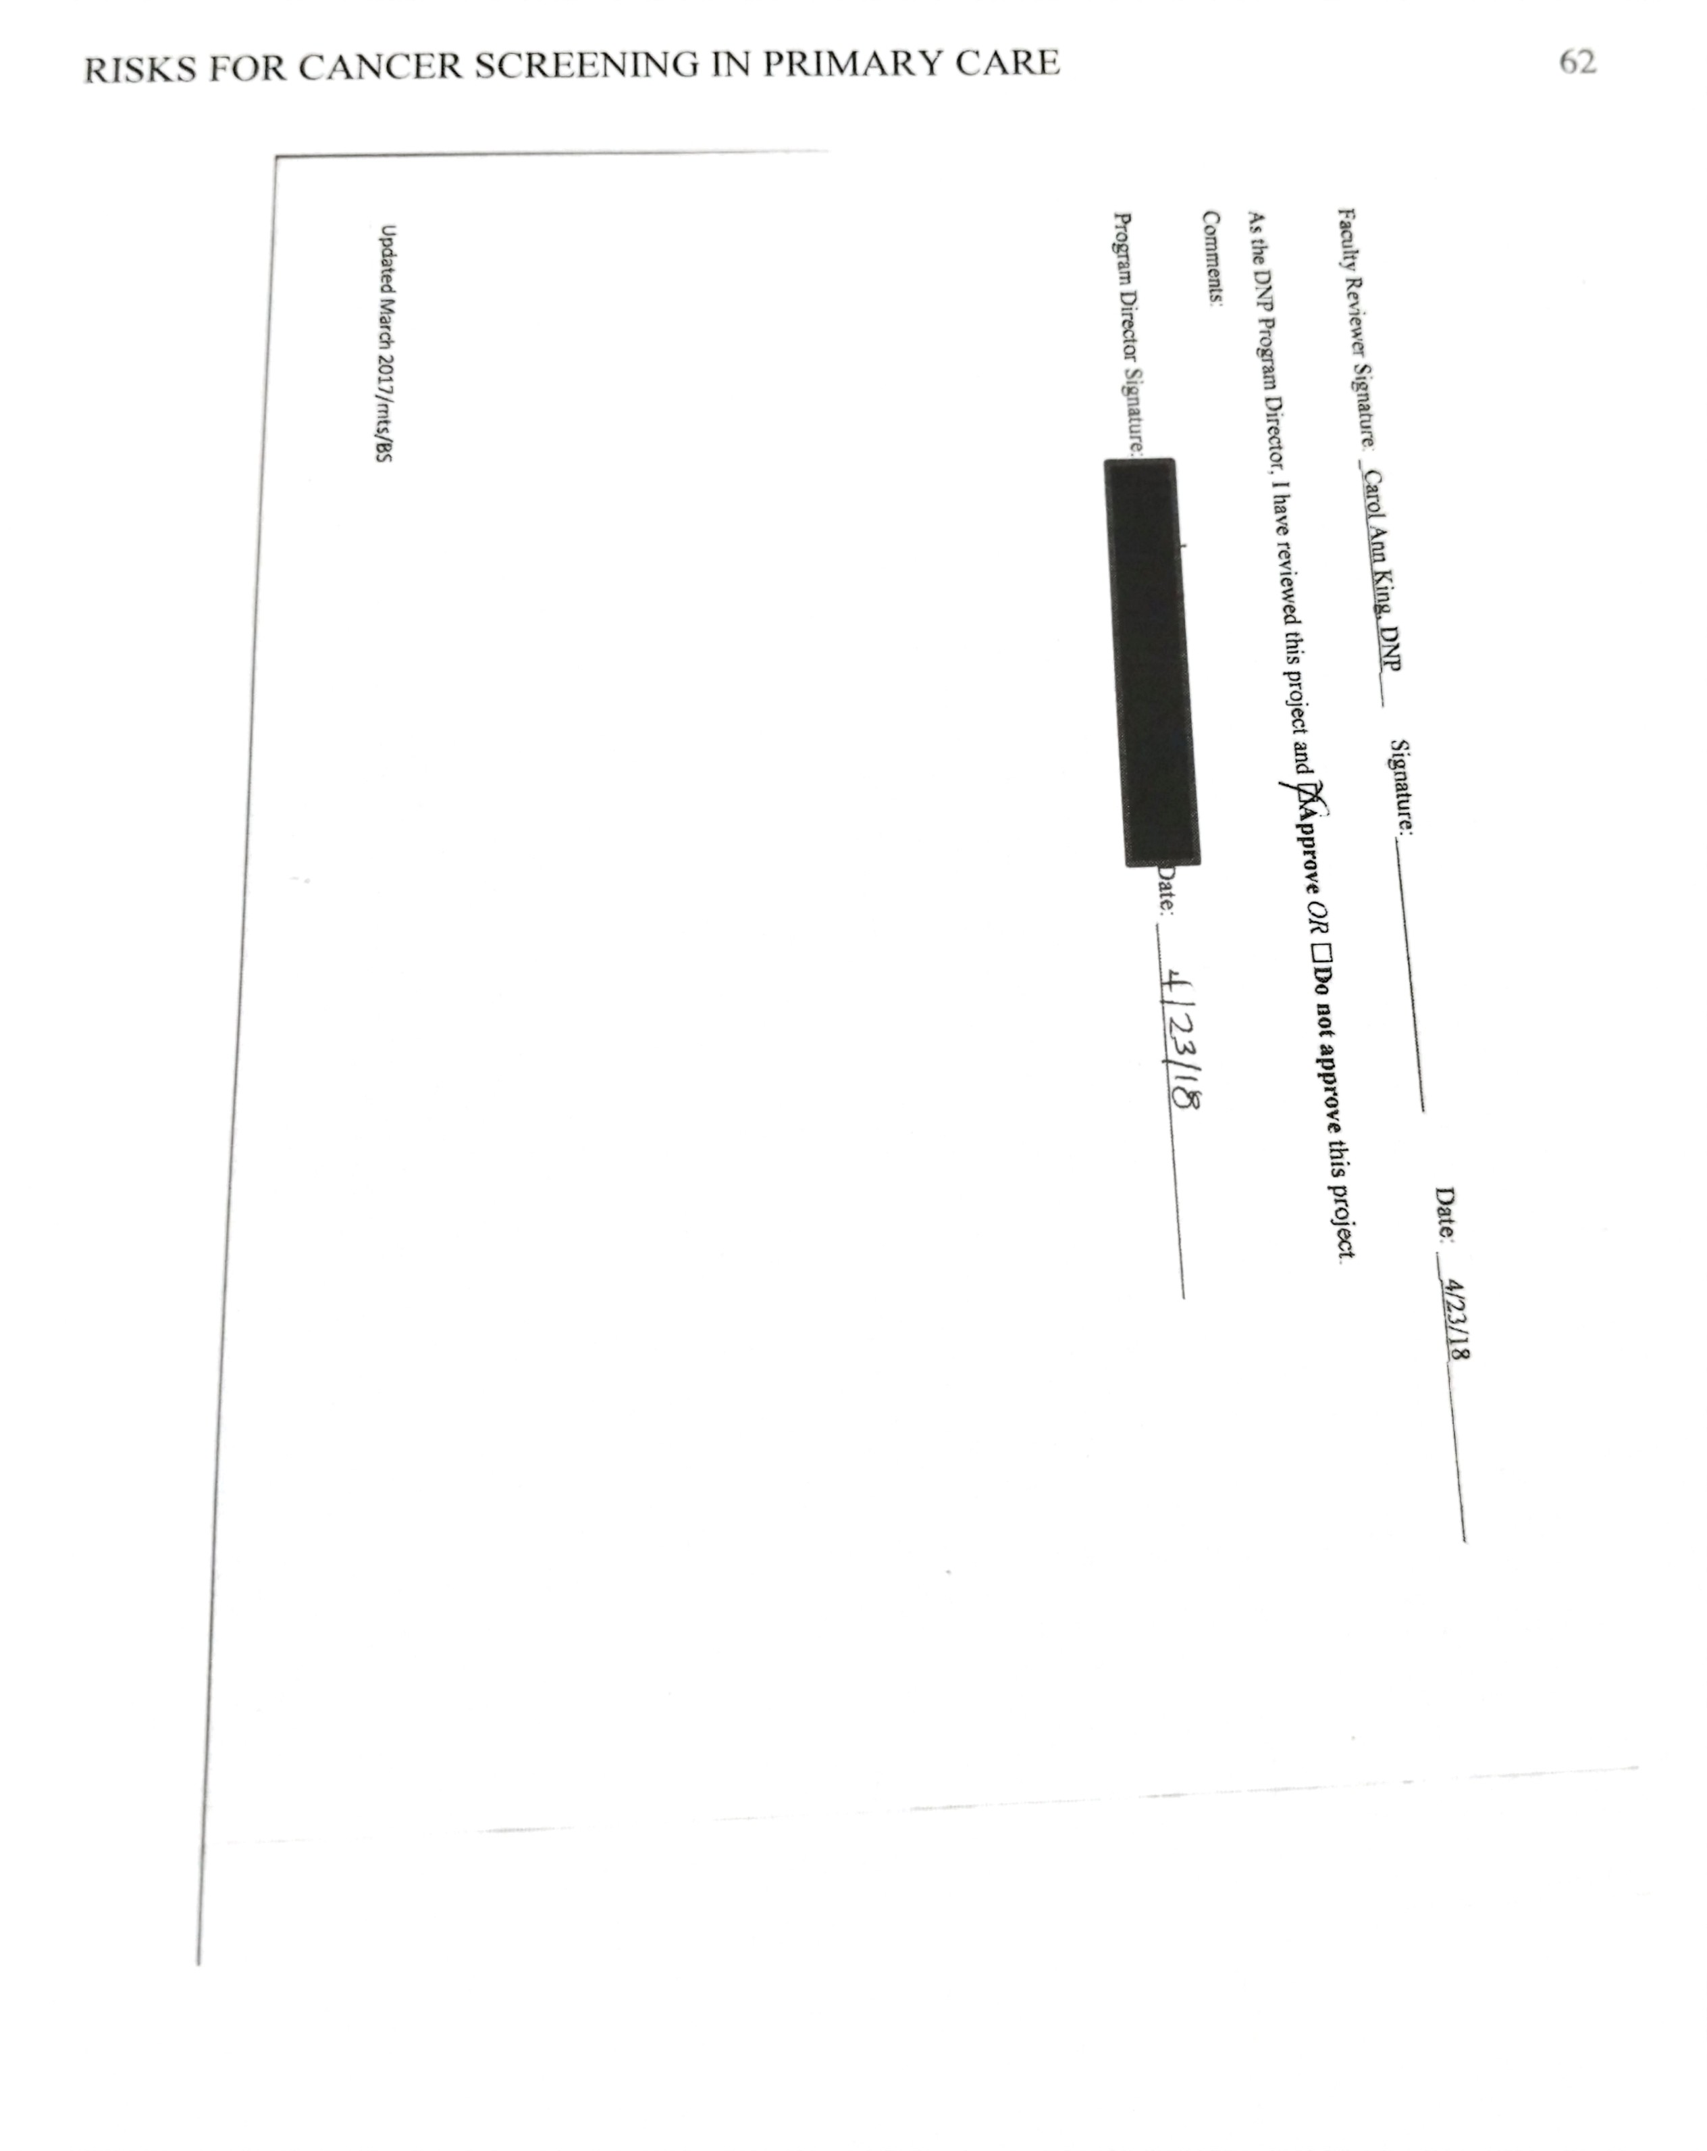

Appendix C
Screening tool

Appendix D
Algorithm
Developed by: Katherine Lynn Russell-Ladd
FNP Student: East Carolina University
Questions 1: Patient with Colon Cancer before age 50
(Question 2 will help determine if due for colonoscopy)
Yes No
Need colonoscopy at least 10yrs prior to age family member DXed
1stdegree relative: likely genetic testing candidate
Helpful to provide provider and family w/ patho results
May need colonoscopy every 1-5 yrs
Asymptomatic Age greater than 85, or life expectancy <10 years
Without any family hx of colon CA
Family hx of colon CA <50yr
Determine last colonoscopy & Refer to GI

Possible candidate for fecal immunoc -hemical test
Likely may stop screening, unless otherwise notified

Repeat colonoscopy every 5 yrs, or as recommended by performing provider

Question 3: Date of last Pap smear, any abnormal findings or hx of cervical cancer
- Less than age 21: no cervical cancer screening needed

- Age 21-65

No abnormal findings, continue every 3 yrs
Abnormal findings

May require increased screening or colposcopy, gyn referral appropriate

- Women age 30-65 may choose pap smear with hpv every 5 years, in the place of q 3 yr paps

- For family history, exposure to Diethylstillbestrol in utero, HIV or immunosuppression, and a personal history of may require increased monitoring

- Women over 65
Lower grade in past 10 years, follow gyn protocols
For CIN 2 or 3 continue screening x 20 yr after result
Cease cervical screening
Normal cervical screening in previous 10 yr
Abnormal screening

Question 4: Breast cancer age 45 or younger
Family history
Family hx

Yes No Patient diagnosed with breast CA
May opt for prophylactic mastectomy
May benefit from earlier mammography combined with MRI
With insurance should qualify for genetic testing
Follow recommendations of oncologist
Annual mammography for females beginning at age 50, or age 40-44 if the patient chooses

Question 6: History of cigarette use

With family hx of lung CA
Yes
1ppd x 30 year
2ppdx 15yrs, 3ppd x 10 years
<30ppd hx or quit >15yr ago, no CT
Lowers threshold for lowdose CT of lungs

Screening with low dose CT scan annually

Question 10: Genetic Cancer Testing Positive
Follow up on what the results were and order test as recommended
Appendix E
PowerPoint for Clinic Education

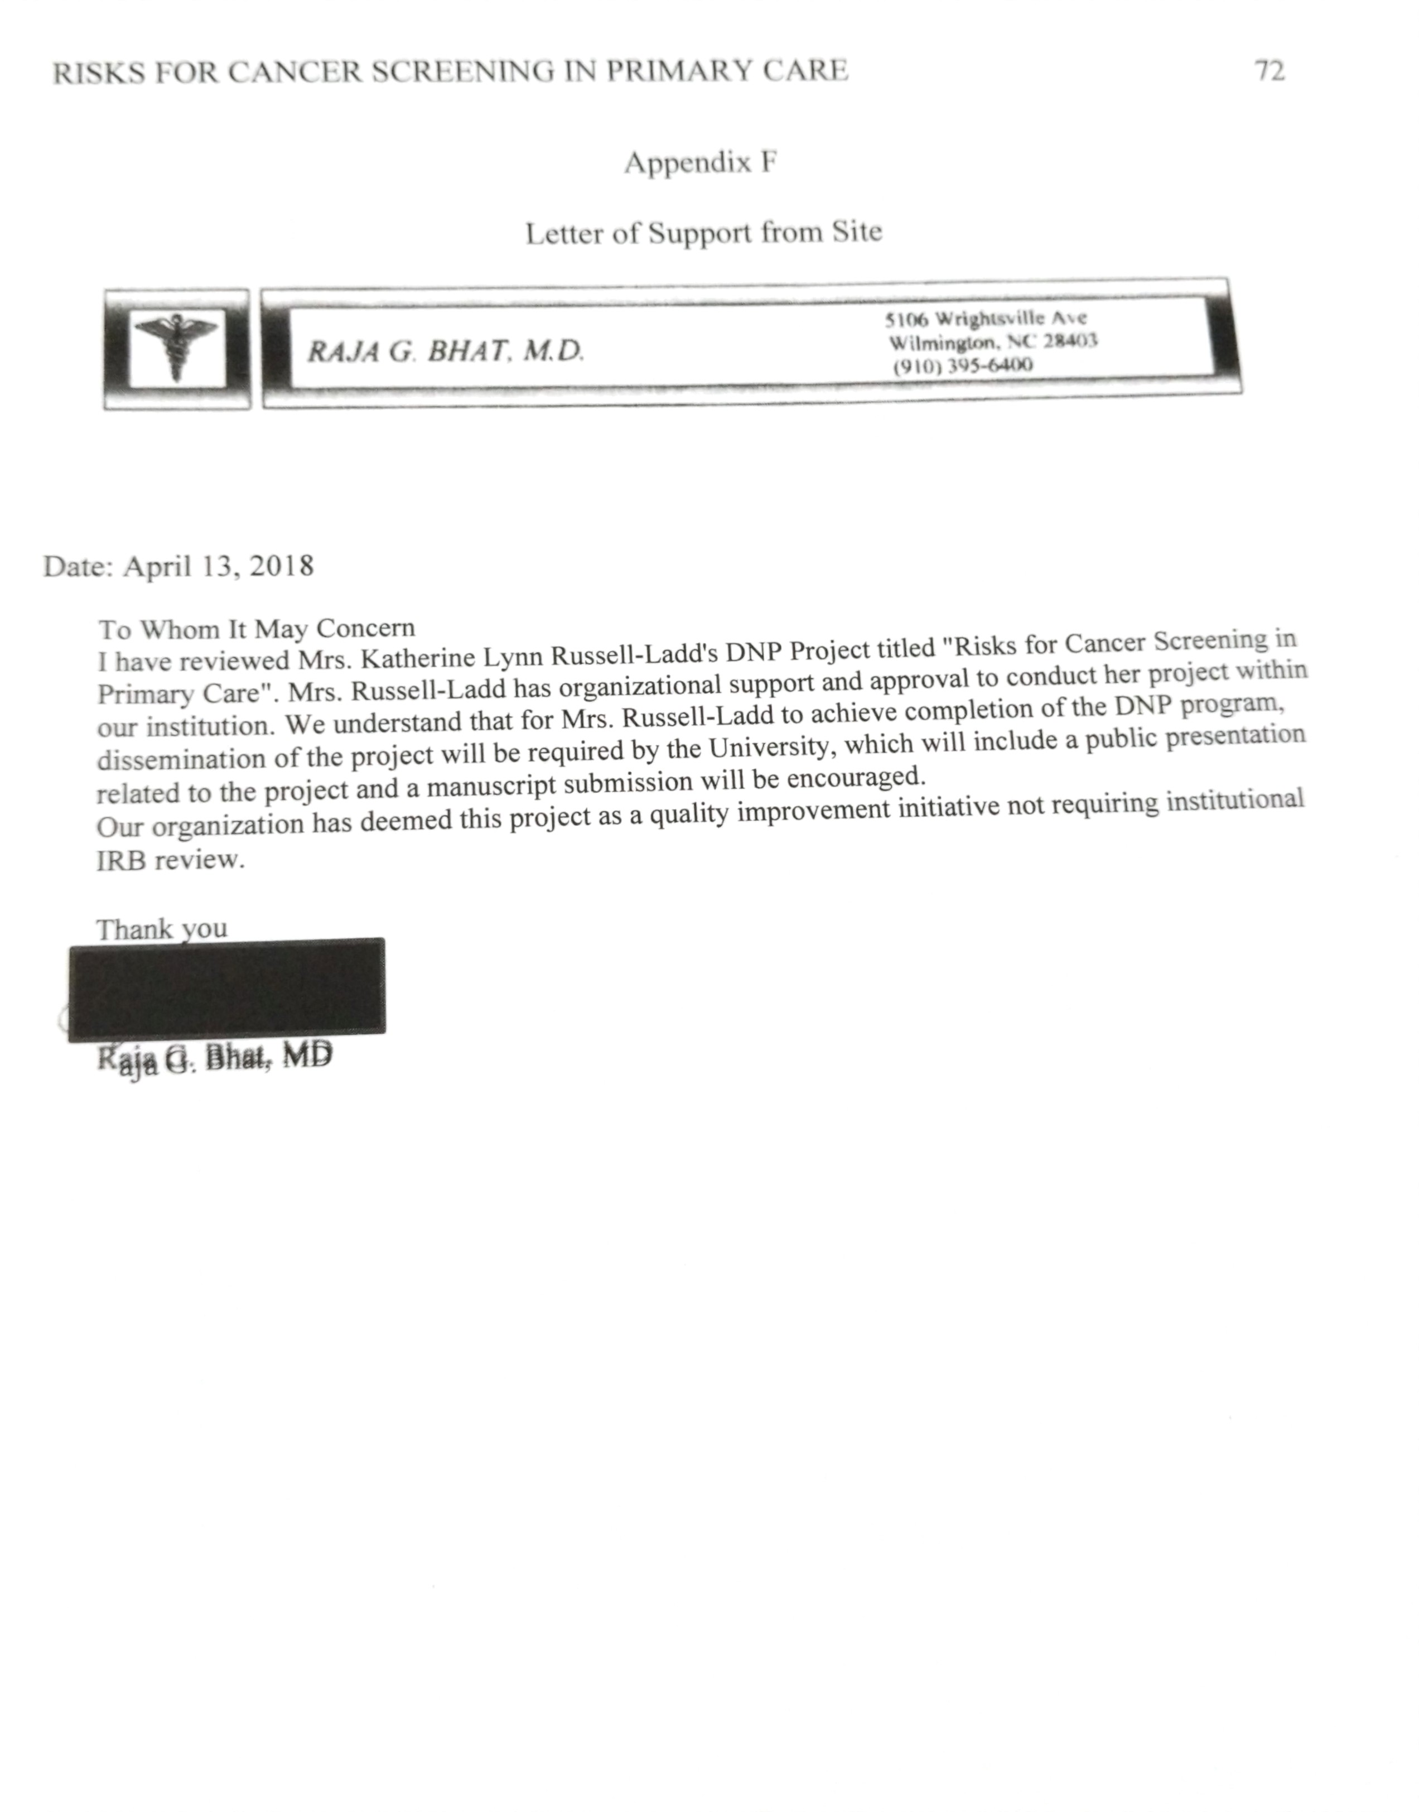
Appendix G
Institutional Review Board Approval 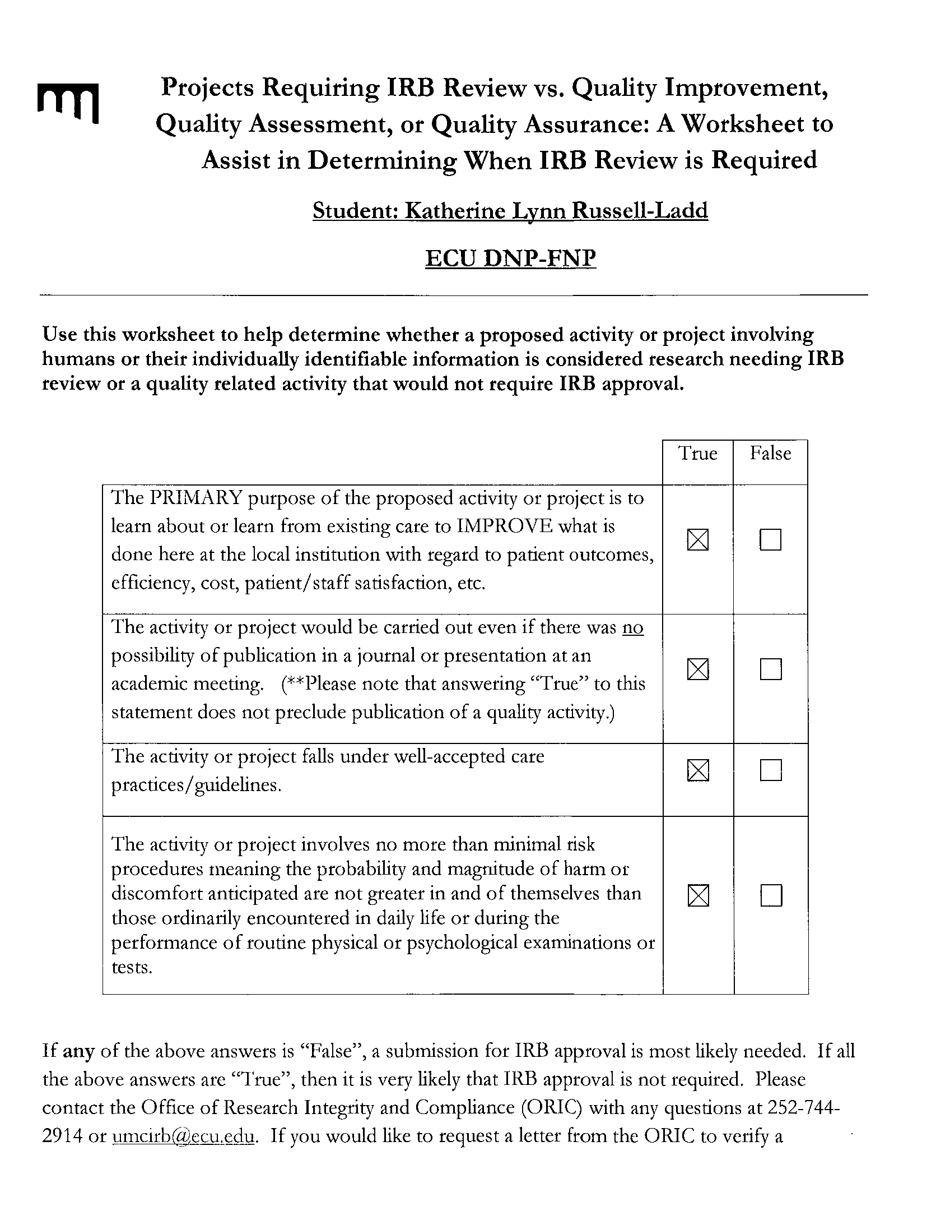
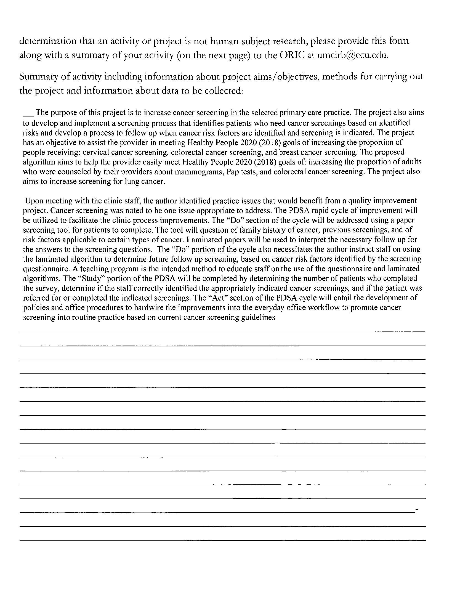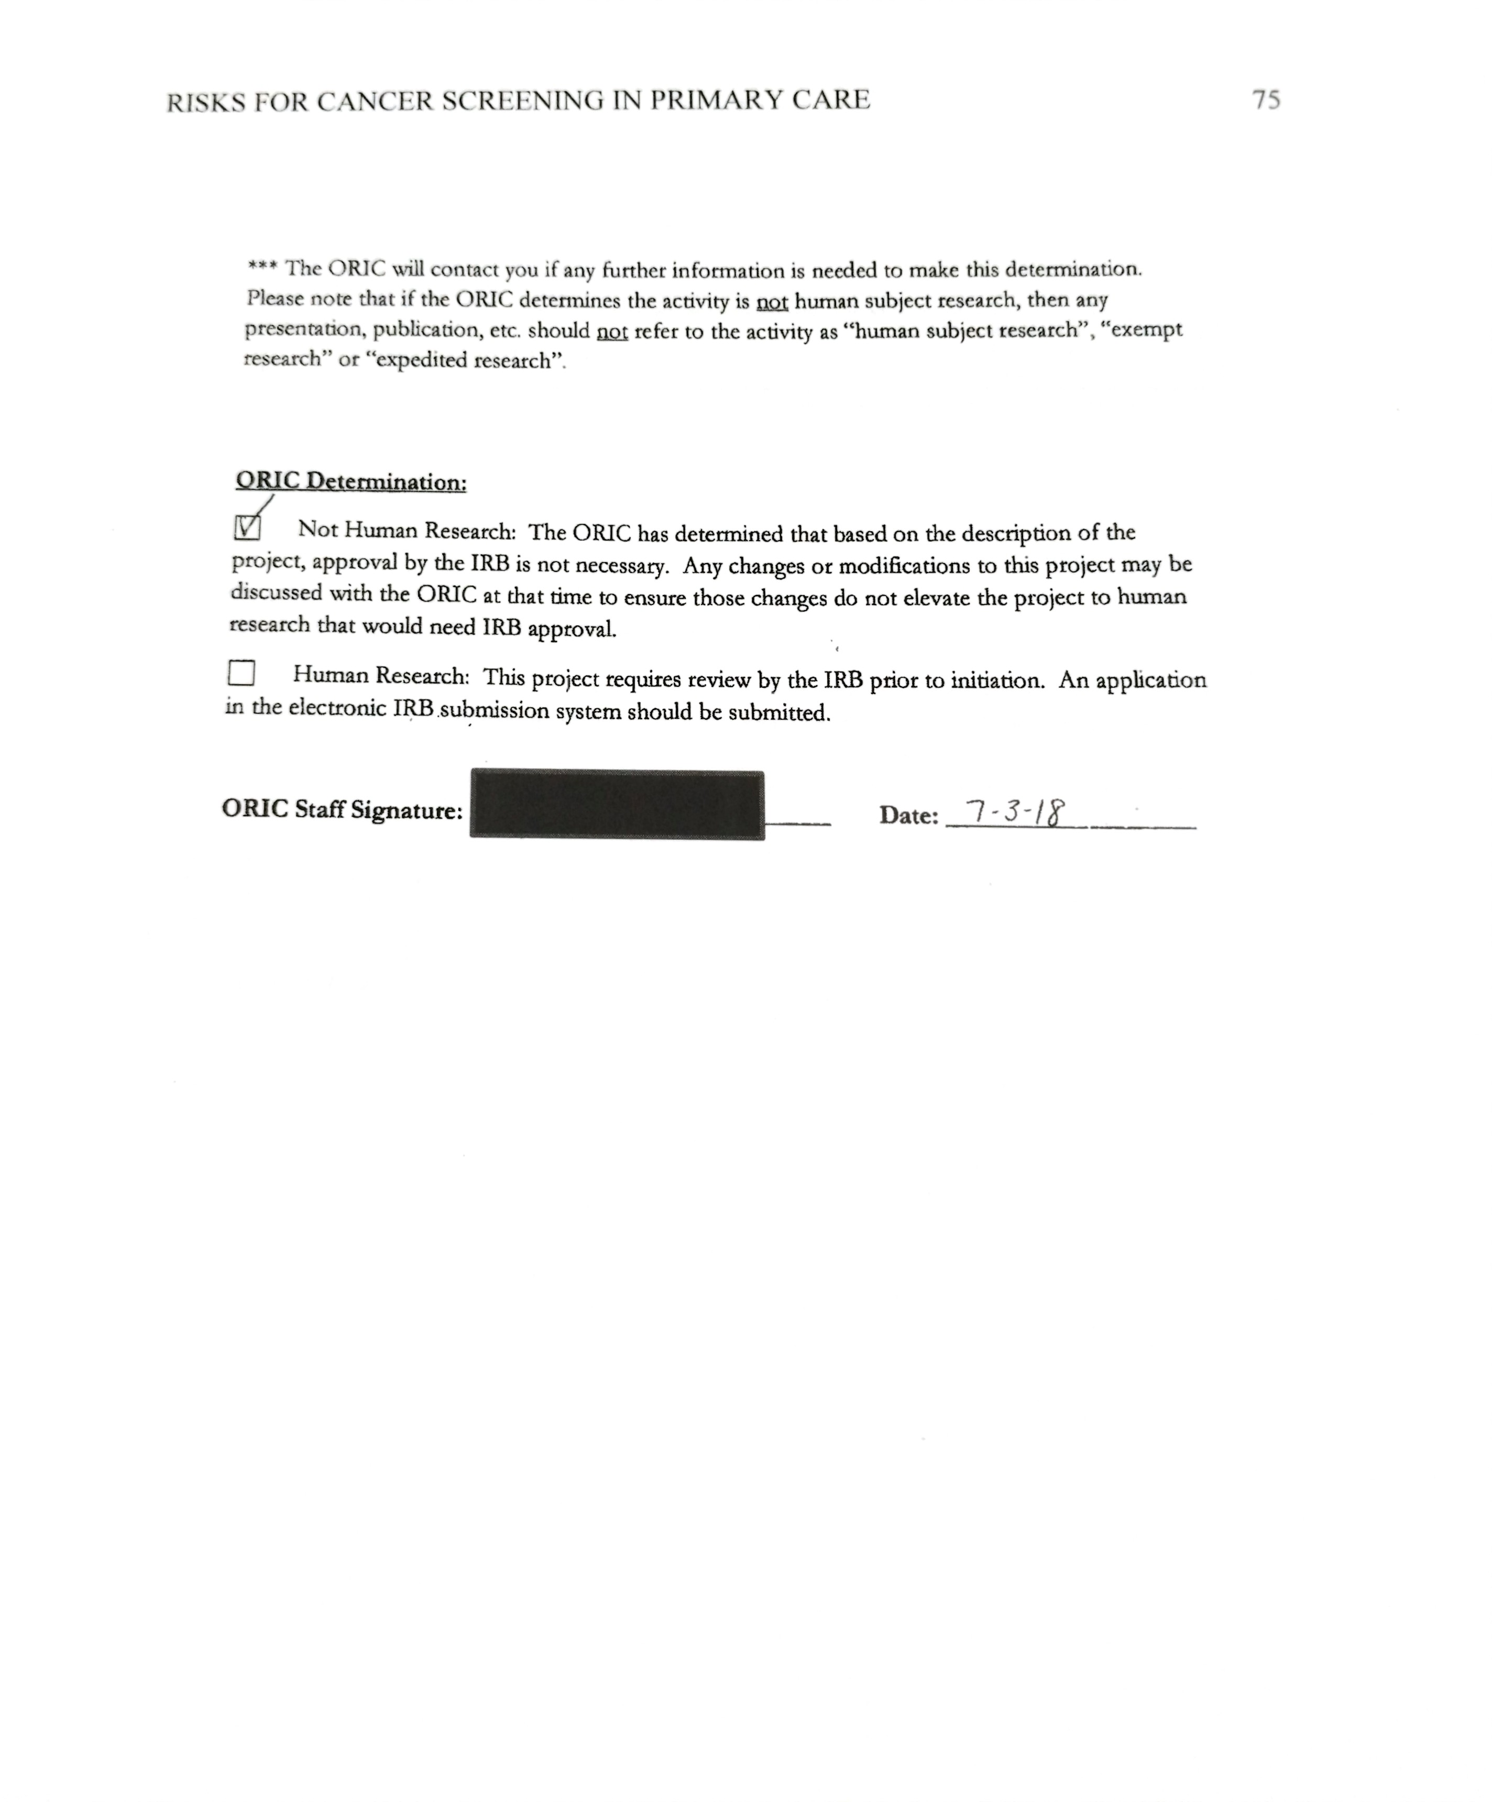

Appendix H

Data

Random #ed patient | Breast cancer screen | Last colonoscopy | Smoking history
Patient # 1 | Yes | Yes | Yes
Patient # 2 | No | Yes | Yes
Patient # 3 | N/A | No | No
Patient # 4 | No | N/A | Yes
Patient # 5 | No | No | No
Patient # 6 | Yes | Yes | Yes
Patient # 7 | N/A | No | No
Patient # 8 | No | No | Yes
Total Screened | 2 | 3 | 5
Patient Cancer Screening Random Audit Prior to Project

Percent Screened Prior to Project

Month | Screened for all cancers on survey tool | Referred for colonoscopy | Referred for mammography
October-November | 29 | 3 | 0
November-December | 21 | 1 | 4
Total | 50 | 4 | 4
Screenings and Referrals During Project Implementation

Number of Patients Screened Over Project Implementation

Pre-Project and During Project Cancer Screening Percentages

